# Carbon + Biodiversity Pilot Round 2

Application Guide

December 2021

© Commonwealth of Australia 2021

**Ownership of intellectual property rights**

Unless otherwise noted, copyright (and any other intellectual property rights) in this publication is owned by the Commonwealth of Australia (referred to as the Commonwealth).

**Creative Commons licence**

All material in this publication is licensed under a [Creative Commons Attribution 4.0 International Licence](https://creativecommons.org/licenses/by/4.0/legalcode) except content supplied by third parties, logos and the Commonwealth Coat of Arms.

Inquiries about the licence and any use of this document should be emailed to [copyright@awe.gov.au](mailto:copyright@awe.gov.au).



**Cataloguing data**

This publication (and any material sourced from it) should be attributed as: DAWE 2021, *Carbon + Biodiversity Pilot Round 2: Application Guide*, Department of Agriculture, Water and the Environment, Canberra, December.

This publication is available at <https://www.agriculture.gov.au/ag-farm-food/natural-resources/landcare/sustaining-future-australian-farming>

Inquiries can be made by email at agstewardship@awe.gov.au.

Department of Agriculture, Water and the Environment

GPO Box 858 Canberra ACT 2601

Telephone 1800 900 090

Web [awe.gov.au](https://www.awe.gov.au/)

**Disclaimer**

The Australian Government acting through the Department of Agriculture, Water and the Environment has exercised due care and skill in preparing and compiling the information and data in this publication. Notwithstanding, the Department of Agriculture, Water and the Environment, its employees and advisers disclaim all liability, including liability for negligence and for any loss, damage, injury, expense or cost incurred by any person as a result of accessing, using or relying on any of the information or data in this publication to the maximum extent permitted by law.

**Acknowledgements**

We thank Professor Andrew Macintosh, Dr Dean Ansell, Professor Don Butler and Marie Waschka from the Australian National University (ANU) for their assistance in preparing this document.

## Acknowledgement of Country

We acknowledge the Traditional Owners of Country throughout Australia and their continuing connection to land, sea and community. We pay our respects to them and their cultures and to their elders past, present and emerging.

Contents

Acknowledgement of Country 3

1. Role of the Application Guide 5

2. Making an application 6

3. Steps to applying through the NSTP 8

Step 1. Register on NSTP 8

Step 2. Map proposed planting areas 8

Step 3. Personal details and project area address 12

Step 4. Planting area information 13

Step 5. Freight costs 16

Step 6. Nominate bid price and submit 16

4. Questions and feedback 18

## Role of the Application Guide

The *Carbon + Biodiversity Pilot Round 2: Application Guide* (Application Guide) has been developed to help farmers who want to apply to participate in Round 2 of the Agriculture Stewardship – Carbon + Biodiversity Pilot (C+B Pilot).

All applications to the C+B Pilot must be made through the National Stewardship Trading Platform (NSTP): [www.agsteward.com.au](http://www.agsteward.com.au).

The NSTP requires applicants to:

* map their proposed planting areas on their property using the online mapping tools;
* provide details of the proposed planting areas; and
* estimate the cost of establishing and managing the plantings.

The web portal also provides applicants with:

* indicative information on whether proposed planting areas may be ineligible under the C+B Pilot because they have contained forest cover in the previous 7 years; and
* estimates of the amount of carbon dioxide (in tonnes of CO2) that could be sequestered in the proposed plantings under average climate conditions over 25 years.

The CO2 sequestration estimates are provided on a cumulative basis for 25 years and for each year of the 25-year period. This information is intended to help applicants plan projects.

The Application Guide provides applicants with a step-by-step guide on how the complete an application through the NSTP.

Prior to preparing an application, applicants should read the C+B Pilot Guidelines and associated C+B Pilot documentation, including the applicable C+B Planting Protocol and the C+B Price Guide. These documents are available on the [Agriculture Stewardship Package C+B Pilot website](https://www.awe.gov.au/agriculture-land/farm-food-drought/natural-resources/landcare/sustaining-future-australian-farming/carbon-biodiversity-pilot).

## Making an application

All C+B Pilot applications must be made through the National Stewardship Trading Platform (NSTP): [www.agsteward.com.au](http://www.agsteward.com.au).

There are six steps involved in making an application.

1. Register on the NSTP.
2. Map your proposed C+B planting areas.
3. Provide your personal details (and the details of the entity on behalf of which you are making the application) and the address of the property on which the project will be located.
4. For each planting area:
   1. provide information on the condition of the planting area;
   2. nominate the type of planting you intend to undertake (local vegetation community planting or simple mixed native planting); and
   3. provide details of the proposed planting and estimates of the establishment and recurrent management costs.
5. Estimate freight costs (if you want to include them in the assessment of your biodiversity payment offer).
6. Nominate a bid price for the biodiversity payment offer (this is optional) and submit the application.

It is important that the information you submit is as accurate as possible. The submission of inaccurate information could distort the outcomes from the C+B Pilot and undermine its ability to achieve its objectives. The cost estimates are of particular importance as they will be used to generate biodiversity payment offers and rank projects in the selection process. Due to this, all applicants are asked to:

1. undertake proper project planning before submitting an application through the NSTP;
2. give appropriate thought and consideration to the information they submit; and
3. to the extent possible, ensure the cost estimates that are submitted accurately reflect the likely costs associated with undertaking the proposed project.

Please read the box below about the duty of utmost good faith that applies to all participants in the C+B Pilot and the legal implications of submitting false or misleading information.

**Duty to ensure submitted information is accurate**

Applicants are required to act with the utmost good faith in their engagements with the C+B Pilot, including in applying to participate through the NSTP. This duty requires proponents to act reasonably, honestly and with propriety, and with due regard to what the Australian Government is trying to achieve with the C+B Pilot.

Knowingly providing inaccurate information in an application is likely to constitute a breach of this duty and could result in your exclusion from the C+B Pilot. It could also result in the termination of any agreement you may be offered under the C+B Pilot.

Applicants should note that making false or misleading statements, or providing false or misleading information, in an application is an offence under Chapter 7 of the Commonwealth *Criminal Code*, carrying maximum penalties of up to 12 months imprisonment.

## Steps to applying through the NSTP

### Step 1. Register on NSTP

* Registering on the NSTP provides you with access to the full range of tools on the platform, including the ability to create and save applications.
* To register:
  1. go to the NSTP landing page at: [www.agsteward.com.au](http://www.agsteward.com.au);
  2. click on the ‘Register’ button at the top right of the landing page, shown in the image below; and
  3. fill out the registration form, read and accept the terms and conditions, and then click on ‘create’ (NB: you will need to enter an email address and retrieve a verification code from your email account to complete the form).

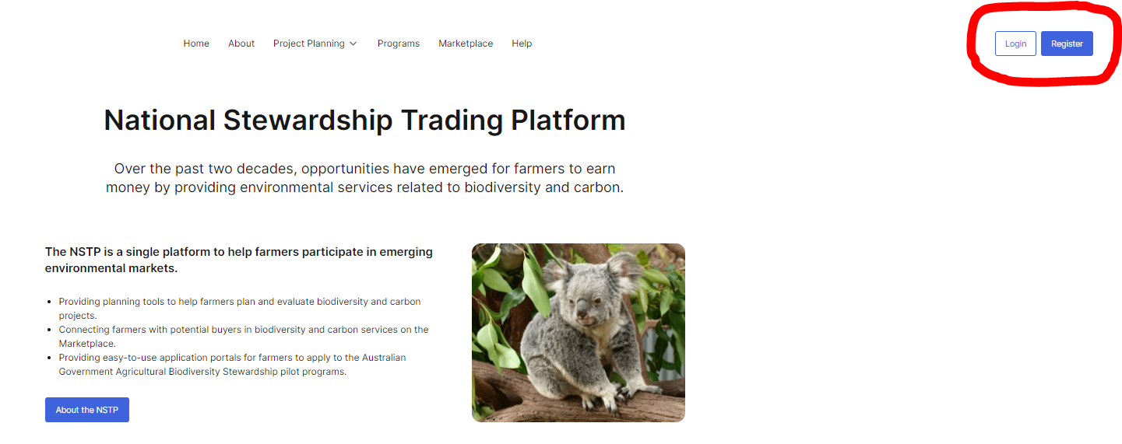

### Step 2. Map proposed planting areas

* To map your proposed planting areas, you first need to navigate to the NSTP mapping page. To do this:
  1. Click on the ‘Project Planning’ tab at the top of the NSTP landing page, circled and numbered 1 in the image below.
  2. A drop down box will appear and you should click on ‘Carbon+Biodiversity Pilot (C+B)’, circled and numbered 2 in the image below.
  3. You will be taken to the Carbon+Biodiversity Pilot landing page, where you should read the overview of the Pilot to ensure you understand the eligibility requirements.

If you haven’t already, you should read the C+B Pilot Guidelines and associated C+B Pilot documentation, which are available on the [Agriculture Stewardship Package C+B Pilot website](https://www.awe.gov.au/agriculture-land/farm-food-drought/natural-resources/landcare/sustaining-future-australian-farming/carbon-biodiversity-pilot).

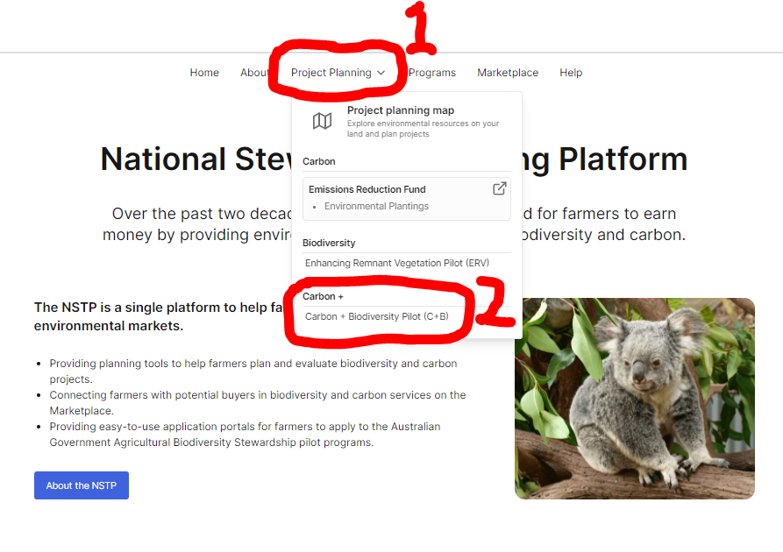

* 1. Near the bottom of the Carbon+Biodiversity Pilot landing page, there are maps of the six participating natural resource management (NRM) regions (see image below). Click on the map of your region.

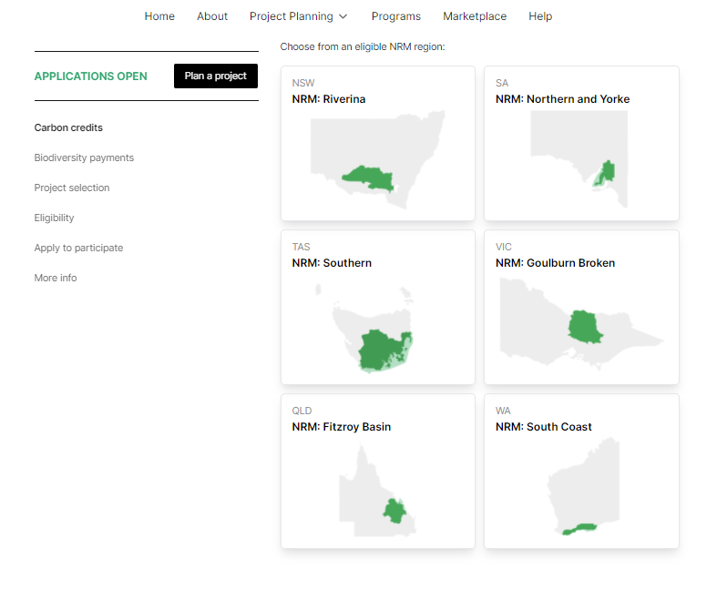

* Once on the mapping page, locate your property using your mouse or by entering your address in the search box shown below (numbered 1).
* Having located your property, you can use the data layers to see indicative information on the areas of your property that may be ineligible under the C+B Pilot because they have contained forest cover in the previous 7 years. You do this using the toggle circled in red (and numbered 2) in the image below. To see the map layer, move the toggle to the right.
  + - Under the Emissions Reduction Fund, for an area of land to be eligible under the environmental plantings method, it must not have had forest cover in the previous 5 years and must not have been subject to clearing of a native forest within 7 years (or 5 years if there has been a change of ownership).

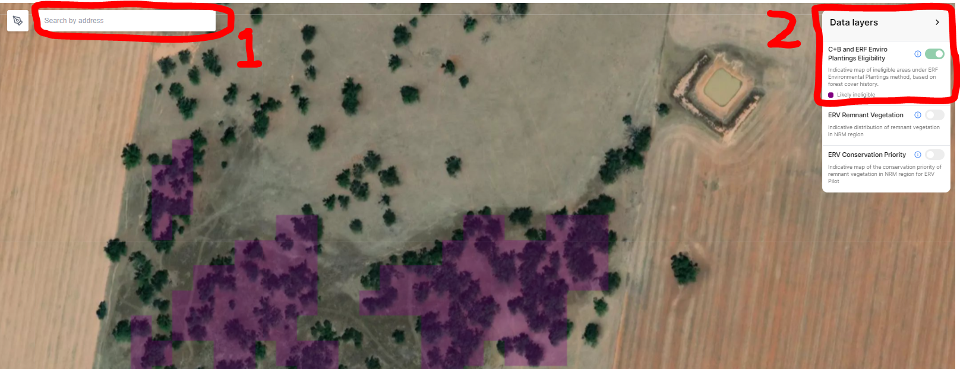

* After planning your project, you need to map your proposed planting areas. You do this by clicking on the pen icon circled in red in the image below.

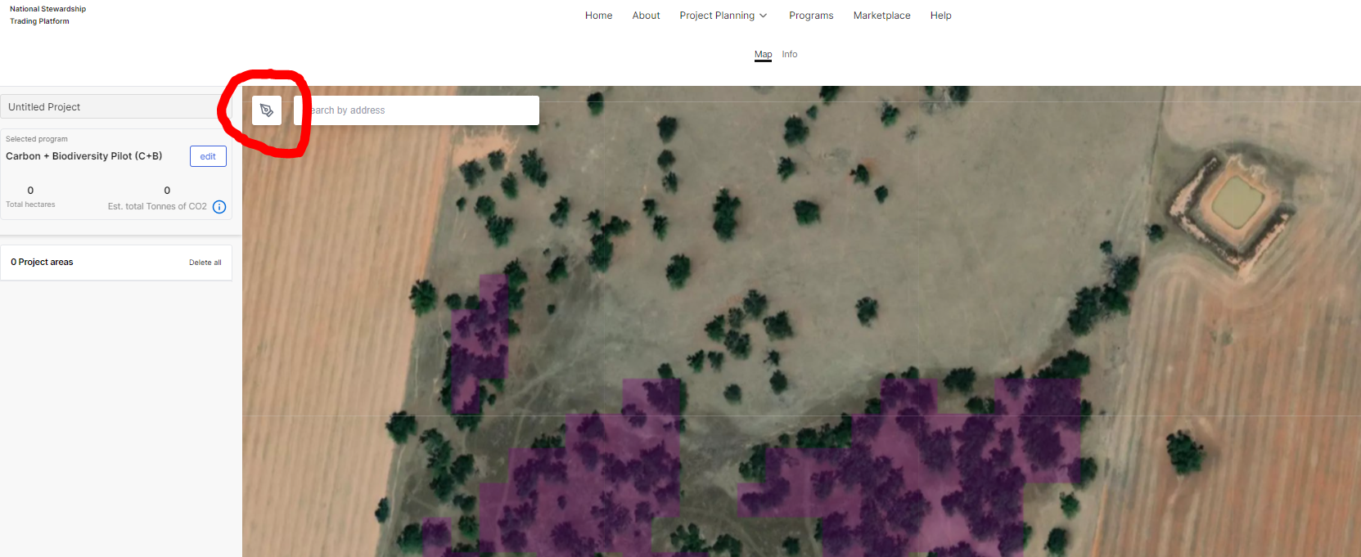

* After clicking on the pen icon, draw a polygon around the proposed planting area as shown below. To close the polygon and complete the mapped area, click on the first point. In the example below, the first point is circled in red. Repeat this step for each of your proposed planting areas.

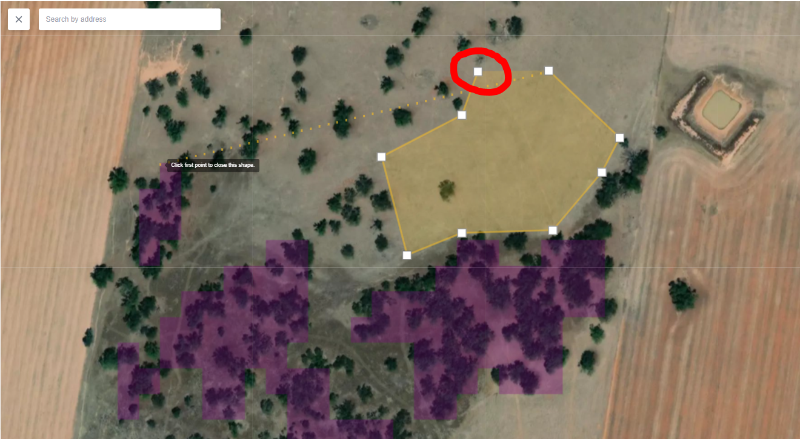

* Once you complete mapping your proposed planting areas, your are ready to proceed to the application form. To do this, click on the ‘Apply Now’ button at the bottom left of the screen, circled in red and numbered 1 in the image below. Note that, for each planting area, you are provided with:
  1. the estimated size of the area (in hectares);
  2. the proportion of the area that is likely to be eligible on the basis of the forest cover requirements noted above; and
  3. an indicative estimate of the amount of carbon dioxide (in tonnes of CO2) that could be sequestered in the proposed plantings under average climate conditions over 25 years.

This information is provided at the left of the screen, in the area circled in red and numbered 2 in the image below

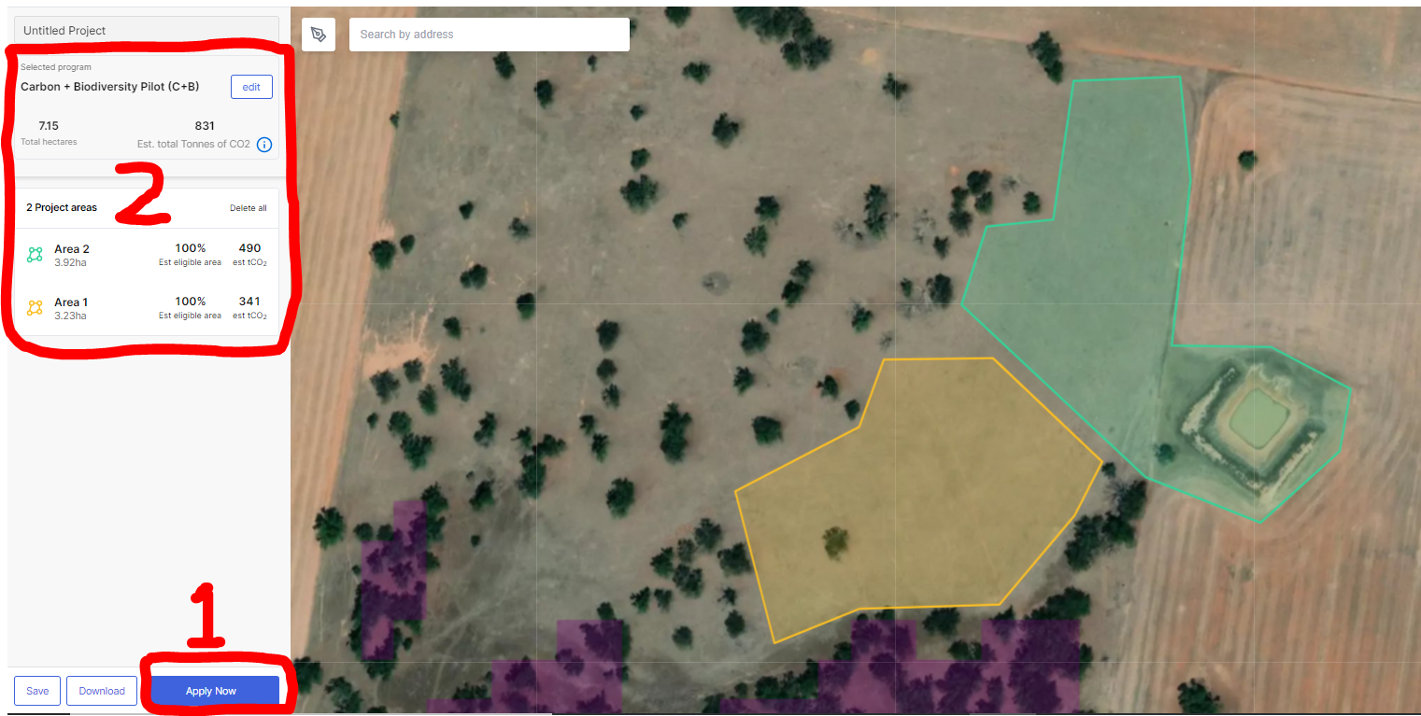

### Step 3. Personal details and project area address

* Having clicked on the ‘Apply Now’ button, you will be taken to the first part of the C+B Application Form, titled ‘Project info’ (see image below). Here, you will be asked to provide:
  1. the name and Australian Business Number (ABN) of the applicant;
  2. the name, email and phone number of the primary contact for the application;
  3. name, email and phone number of a secondary contact for the application (optional); and
  4. the address of the property on which the proposed project will be located.
* Note that, on the right of this page, summary information is provided on your planting areas. This includes indicative *annual* estimates of the amount of CO2 that could be sequestered in the proposed plantings under average climate conditions over 25 years. This information is contained in a downloadable CSV file, which is accessed by clicking on the link shown in the area marked in red below.

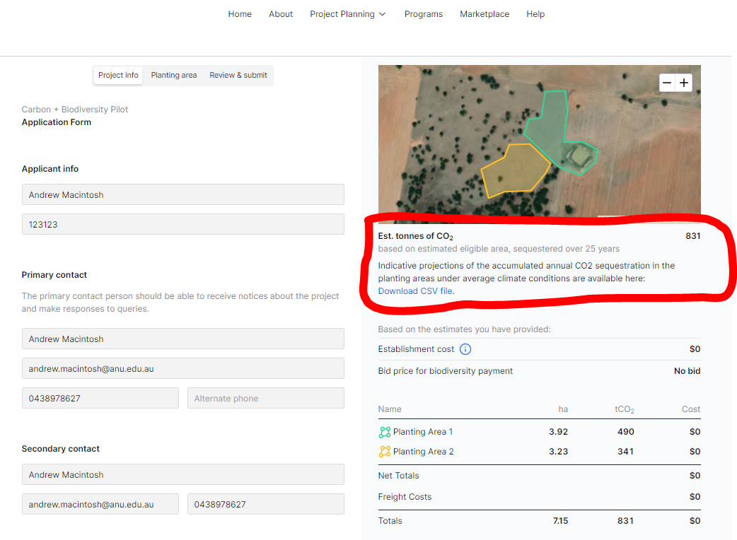

* In addition to providing the above details, the ‘Project info’ page requires you to:
  1. indicate your commitment to act in good faith in your engagements with the C+B Pilot, including in making the application;
  2. confirm you own, lease or have exclusive native title rights over the property or properties on which the project will be located (if you are a lessee, the term of your lease must run at least for the 25 year C+B project period, otherwise you must apply jointly with the holder of the freehold title); and
  3. nominate the desired length of your permanence period under the Emissions Reduction Fund.
     + Under the Emissions Reduction Fund, participants must choose between a 25-year or 100-year permanence period. If participants opt for a 100-year permanence period, a 5% risk of reversal buffer is applied when calculating their ACCU entitlements. If participants opt for a 25-year permanence period, both the 5% risk of reversal buffer and a 20% permanence period discount are applied. Applicants should note that the 20% permanence period discount is not considered when calculating biodiversity payment offers under the C+B Pilot. This is to ensure the C+B Pilot does not provide higher payment offers to projects with shorter permanence periods.
* After you have answered these questions, click the ‘Next’ button at the bottom of the page.

### Step 4. Planting area information

* Having clicked on the ‘Next’ button, you will be taken to the second part of the C+B Pilot Application Form, titled ‘Planting area’ (see image below).
* Here you are asked questions about each of your proposed planting areas. Details of each planting area are provided in the box circled in red in the image below. Answer the questions that follow for the relevant listed planting area.

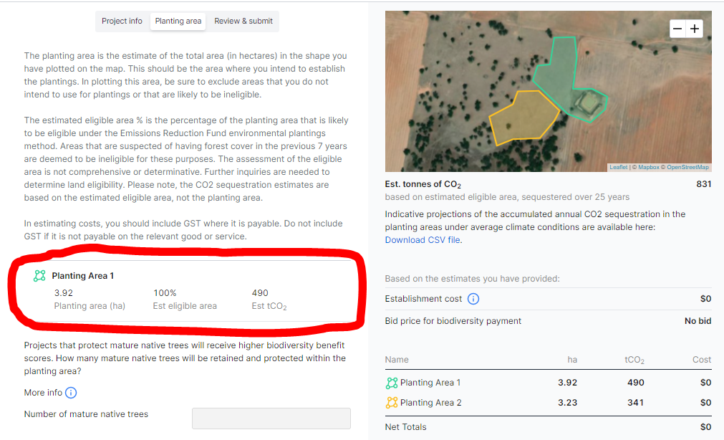

* For each planting area, you will be asked to:
  1. provide information on the number of mature trees in the planting area and the proportion of the planting area that is currently native pastures, crops, weeds, improved pastures and ‘other’;
  2. nominate the type of planting you intend to undertake (local vegetation community planting or simple mixed native planting); and
  3. provide details of the proposed planting and estimates of the establishment and recurrent management costs.
* The questions regarding the plantings and costings are divided into five parts.

#### *Part 1: Site Preparation – weed control*

You are asked whether and how you intend to undertake pre-planting weed control, the number of weed treatments you intend to undertake and the estimated total cost of these treatments.

#### *Part 2: Planting*

You are asked for details on:

1. the area you intend to plant using tubestock and seed;
2. the number of seedlings and amount of seed you intend to use;
3. the estimated total cost of the seedlings and seed; and
4. the estimated costs of labour and other items (e.g. equipment hire) associated with putting the seedlings and seed in the ground.

#### *Part 3: Soil Preparation*

You are asked for details on how you will prepare the soil for the plantings, divided into:

1. Manual digging – area of the plantings where manual digging will be used and the estimated cost; and
2. Mechanical (e.g. ripping or discing) – area of the plantings where mechanical soil preparation will be used and the estimated cost of the mechanical preparation.

#### *Part 4: Planting Protection*

You are asked for details on whether and how you intend to protect the plantings, divided into fencing, tree guards or no protection (you can opt for both fencing and tree guards).

If you opt for fencing, you will need to provide the following details.

1. The length of fencing (in metres) and the estimated cost of the fencing wire, intermediate posts/pickets and droppers.
2. The number of strainer assemblies and their estimated total cost.
3. The number of gates and their estimated total cost.
4. The cost of any additional materials.
5. An estimate of the labour and other installation costs.

If you opt for tree guards, you will need to provide details of the number of guards, their estimated cost (materials only) and an estimate of the labour and other installation costs.

#### *Part 5: Recurrent management activities*

You are asked whether you intend to undertake any of the three eligible recurrent management activities: weed control; pest control; and post-establishment watering.

If you opt for weed control, you will need to provide:

1. details on the number of hours of weeding you intend to undertake each year in the first 3 years of the project, above what you are already required to undertake, and an estimate of the all-inclusive cost per hour of the proposed weeding over this period (e.g. labour plus materials, including chemicals); and
2. details on the number of hours of weeding you intend to undertake each year in the remaining contract period (i.e. years 4-25), above what you are already required to undertake, and an estimate of the all-inclusive cost per hour of the proposed weeding over this period (based on what it would currently cost, in 2021 dollar terms).

If you opt for pest control, you will need to provide:

1. details on the number of hours of pest control you intend to undertake each year in the first 3 years of the project, above what you are already required to undertake, and an estimate of the all-inclusive cost per hour of the proposed pest control over this period (e.g. labour plus materials); and
2. details on the number of hours of pest control you intend to undertake each year in the remaining contract period (i.e. years 4-25), above what you are already required to undertake, and an estimate of the all-inclusive cost per hour of the proposed pest control over this period (based on what it would currently cost, in 2021 dollar terms).

If you opt for post-establishment watering, you will need to provide an estimate of the annual watering costs in first 3 years following planting establishment (i.e. the cost each year over this 3 year period).

### Step 5. Freight costs

* After providing the information on your planting areas, you are asked whether you want to include freight costs. This is at the bottom of the ‘Planting area’ part of the Application Form.
* If you wish to include freight costs, you need to provide the following.

1. Details of the total freight kilometres – i.e. the total combined freight distance for all relevant deliveries. For example, if you need to have fencing materials delivered 50km and tubestock delivered 100km, the total freight kilometres is 150km.
2. An estimate of the total cost of the freight.

### Step 6. Nominate bid price and submit

* The last part of the C+B Application Form is the ‘Review & submit’ page. There are four parts to this page.

1. You are given the opportunity to submit a bid price for the biodiversity payment to improve the competitiveness of your application.
2. You are required to consent to the use of the information you have provided in the form for the purposes of the C+B Pilot assessment process.
3. You are given the opportunity to provide additional comments on your application that might be relevant to the assessment.
4. Submission of the application by clicking on the ‘Submit’ button at the bottom of the page.

* Nominating a bid price for the biodiversity payment is a way of increasing the competitiveness of your application, thereby increasing your chances of receiving a biodiversity payment offer. You are not required to nominate a bid price – it is strictly optional.
* You can submit a bid price in the space provided on the ‘Review & submit’ page marked in red in the image below.

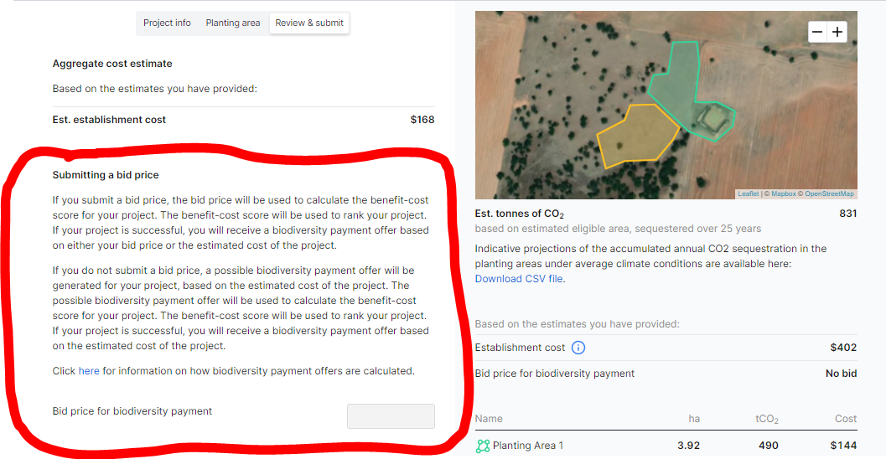

* There are two other ways of improving the competitiveness of your application.

1. Providing in-kind contributions to the project. This can be done by submitting lower cost estimates in your application.
2. Design projects that are likely to generate the maximum possible biodiversity benefits (e.g. considering their type, size, shape and location, their association with threatened species and ecosystems, their contributions to connectivity and corridors and their proximity to watercourses).

## Questions and feedback

Any questions or feedback about this document should be sent to [agstewardship@awe.gov.au](mailto:agstewardship@awe.gov.au) or you can contact the Department of Agriculture, Water and the Environment on 1800 329 055.