

Celebrating Australia’s Migratory Waterbirds and their habitats
Showcasing Australia’s Flyway Site Network

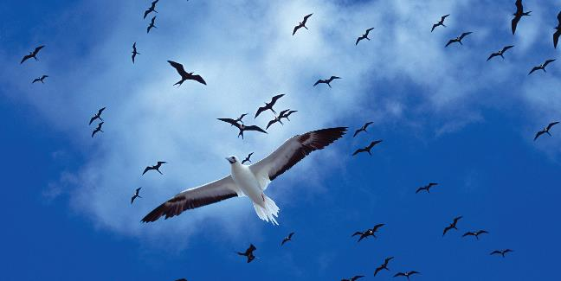

© Commonwealth of Australia, 2017.

Celebrating Australia’s Migratory Waterbirds and their habitats — Showcasing Australia’s Fly way Site Network is licensed by the Commonwealth of Australia for use under a Creative Commons Attribution 4.0 International licence with the exception of the Coat of Arms of the Commonwealth of Australia, the logo of the agency responsible for publishing the report, content supplied by third parties, and any images depicting people. For licence conditions see: http://creativecommons.org/licenses/by/4.0/au/

This report should be attributed as ‘Celebrating Australia’s Migratory Waterbirds and their habitats — Showcasing Australia’s Flyway Site Network, Commonwealth of Australia 2017’.

The Commonwealth of Australia has made all reasonable efforts to identify content supplied by third parties using the following format ‘© Copyright, [name of third party]’.

Disclaimer

The views and opinions expressed in this publication are those of the authors and do not necessarily reflect those of the Australian Government or the Minister for the Environment and Energy.

Cover: Seabirds in flight over North Keeling Island (Department of the Environment and Energy)
Back cover: View of the wetland areas from along the boardwalk (Department of the Environment and Energy)

Contents
1. Introduction 4
2. Corner Inlet, Victoria 8
3. Hunter Estuary Wetlands Ramsar Site, New South Wales 10
4. Kakadu National Park, Northern Territory 13
5. Logan Lagoon, Tasmania 16
6. Moreton Bay, Queensland 18
7. Pitt Water - Orielton Lagoon, Tasmania 21
8. Ord River Floodplain, Western Australia 24
9. The Coorong and Lakes Alexandrina and Albert, South Australia 27
10. Forrestdale and Thomsons Lakes, Western Australia 30
11. Port Phillip Bay (Western Shoreline) and Bellarine Peninsula, Victoria 32
12. Western Port, Victoria 35
13. Bowling Green Bay, Queensland 38
14. Currawinya National Park, Queensland 41
15. Discovery Bay, Victoria 45
16. Great Sandy Strait, Queensland 47
17. Shallow Inlet Marine and Coastal Park, Victoria 50
18. Shoalwater and Corio Bays, Queensland 52
19. Eighty-mile Beach, Western Australia 55
20. Roebuck Bay, Western Australia 57
21. South-East Gulf of Carpentaria: Karumba Smithburne (Delta Downs), Queensland 60
22. South-East Gulf of Carpentaria: Nijinda Durlga (Tarrant), Queensland 62
23. Adelaide International Bird Sanctuary, South Australia 64
24. Ashmore Reef Commonwealth Marine Reserve 66
25. Pulu Keeling National Park 68
26. Nominating a new site to the Flyway Site Network 70

Figure 1: Black-winged Stilt (Himantopus himantopus) (Department of the Environment and Energy)
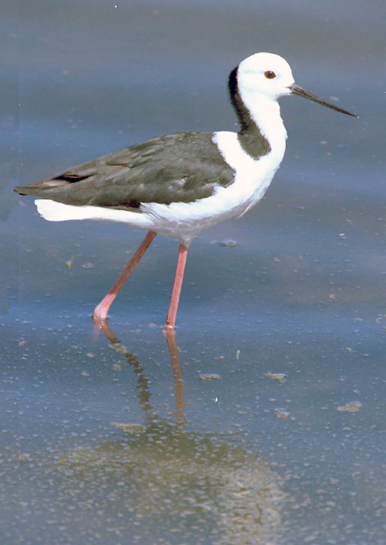

Introduction
Australia lies at the southern end of the East Asian — Australasian Flyway (EAAF) and provides important habitat for millions of migratory waterbirds each year. The EAAF is one of nine major migratory waterbird flyways around the globe. It extends from within the Arctic Circle in Russia and Alaska, southwards through East and South-east Asia, to Australia and New Zealand in the south, encompassing 22 countries. Migratory waterbirds share this flyway with 45 per cent of the world’s human population.
The EAAF is home to over 50 million migratory waterbirds—including shorebirds, Anatidae (ducks, geese and swans), seabirds and cranes many of which are globally threatened such as the Eastern Curlew (Numenius madagascariensis).
For over 40 years, Australia has played an important role in international cooperation to conserve migratory birds in the East Asian — Australasian Flyway, entering into bilateral migratory bird agreements with Japan in 1974, China in 1986 and the Republic of Korea in 2006. Each of these agreements provides for the protection and conservation of migratory birds and their important habitats, protection from take or trade except under limited circumstances, the exchange of information, and building cooperative relationships.
Australia is also a signatory to the Convention on Wetlands of International Importance (www.ramsar.org). The Ramsar Convention, as it is commonly known, is an intergovernmental treaty dedicated to the conservation and wise use of wetlands.
The Ramsar Convention focuses on conservation of important habitats. Parties are committed to identifying wetlands that qualify as internationally significant against a set of criteria, nominating these wetlands to the List of Wetlands of International Importance (the Ramsar List) and ensuring the maintenance of the ecological character of each listed Ramsar site.
Australia has 65 Wetlands of International Importance that cover a total of approximately 8.1 million hectares. Many of Australia’s Ramsar sites were nominated and listed using waterbird-based criteria, and in some of these cases migratory shorebirds are a major component of the waterbird numbers (e.g. Roebuck Bay and Eighty-mile Beach Ramsar Sites in Western Australia).
The Australian Government recognises that habitat loss and degradation is a significant threat to many of our migratory waterbirds, and the conservation of important sites both within Australia and along their migration routes is essential to their survival. Many pressures are contributing to this degradation, of which population growth and associated coastal development are of particular concern. As some migratory waterbird populations decrease, there is a growing need to minimise threats to the remaining habitats that are critical for their ongoing survival.

East Asian - Australasian Flyway Partnership
The Partnership for the Conservation of Migratory Waterbirds and the Sustainable Use of their Habitats in the East Asian — Australasian Flyway (East Asian
Australasian Flyway) was launched on 6 November 2006. A Ramsar regional initiative, the Partnership is an informal and voluntary collaboration of effort focusing on protecting migratory waterbirds, their habitat and the livelihoods of people dependant on them.
Flyway Partners include countries, intergovernmental agencies, international non-government organisations and the international business sector. A cornerstone of the Partnership is the establishment of a network of internationally important sites for migratory waterbirds throughout the EAAF. The Partnership operates via working groups and task forces and meets every two years to discuss important issues facing migratory waterbirds and their habitats.
More information about the Partnership is available at: www.eaaflyway.net

East Asian - Australasian Flyway Site Network
The East Asian — Australasian Flyway Site Network is a voluntary, non-binding, collaborative project involving over 130 sites across 22 countries. ^e Flyway Site Network has been operating since 1996 under the Asia-Pacific Migratory Waterbird Conservation Strategy and is now supported by the East Asian — Australasian Flyway Partnership.
The Flyway Site Network represents a unique opportunity for national governments, non-government organisations and site managers in the Flyway to work together to achieve more effective conservation and protection of migratory waterbirds. The Network provides for internationally important sites to be included in a broad-based conservation arrangement across the Flyway. Through the Flyway Site Network, national governments, site managers and local stakeholders can work cooperatively to achieve positive conservation outcomes to protect migratory waterbirds.
The conservation of migratory waterbirds is dependent on the appropriate management of a comprehensive network of internationally important sites. Increasing the number of sites in the Network will enhance its overall effectiveness.
This publication showcases 24 East Asian — Australasian Flyway Partnership Network Sites in Australia, many of which are Ramsar sites, including Roebuck Bay in north-west Western Australia, Moreton Bay in Queensland, Logan Lagoon in Tasmania and Corner Inlet in Victoria. Flyway Network Sites may be designated regardless of tenure or protected status and several Australian sites are privately managed, e.g. by Indigenous communities. Along with migratory waterbirds, the Flyway Site Network also protects many Australian endemic, threatened and migratory species and threatened ecological communities.
Further information on Australian wetlands, Ramsar sites, migratory birds and the East Asian — Australasian Flyway Partnership can be found on the Department’s website: www.environment.gov.au
Figure 2: Common Greenshank (Tringa nebularia) (Department of the Environment and Energy)
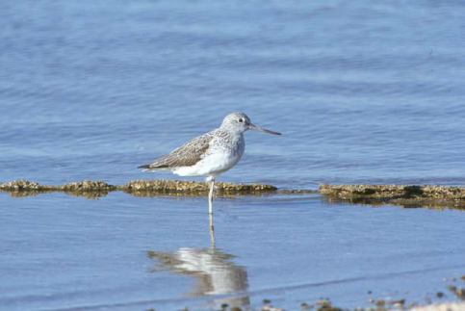
Figure 3: Location of 24 Australian Flyway Network Sites
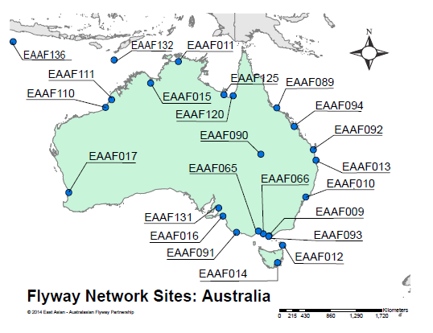
Legend:
EAAF009 — Corner Inlet | EAAF014 — Pitt Water — Orielton Lagoon
EAAF066 — Western Port | EAAF093 — Shallow Inlet Marin52 e and Coastal Park
EAAF125 — South-East Gulf of Carpentaria: Nijinda Durlga (Tarrant) | EAAF010 — Hunter Estuary Ramsar Site
EAAF015 — Ord River Floodplain | EAAF089 — Bowling Green Bay
EAAF094 — Shoalwater and Corio Bays | EAAF131 — Adelaide International Bird Sanctuary
EAAF011 — Kakadu National Park | EAAF016 — The Coorong, Lake Alexandria and Lake Albert
EAAF090 — Currawinya National Park | EAAF110 — Eight Mile Beach
EAAF132 — Ashmore Reef Commonwealth Marine Reserve | EAAF012 — Logan Lagoon
EAAF017 — Forrestdale and Thomsons Lake | EAAF091 — Discovery Bay Coastal Park
EAAF111 — Roebuck Bay | EAAF136 — Pulu Keeling National Park
EAAF013 — Moreton Bay | EAAF065 — Port Phillip Bay (Western shoreline) and Bellarine Peninsula
EAAF092 — Great Sandy Strait | EAAF120 — South-East Gulf of Carpentaria: Karumba Smithburne (Delta Downs)

Corner Inlet, Victoria
The Corner Inlet Ramsar site is the most southerly marine embayment and tidal mudflat system of mainland Australia.
Ramsar designation: 15 December 1982
EAAFP Flyway Site designation: 25 March 1996
Location: The Corner Inlet Ramsar site is located on the south-east coast
of Victoria.
Size: 67,186 hectares
Key species: Eastern Curlew, Grey Plover, Curlew Sandpiper, Red-necked Stint, Double-banded Plover, Bar-tailed Godwit, Red Knot, Sanderling,
Little Tern

The Corner Inlet Ramsar site is bounded to the west and north by the South Gippsland coastline, in the south-east by a series of barrier islands and sandy spits lying end to end and separated by narrow entrances, and to the south by the hills of Wilsons Promontory. Corner Inlet includes the chain of barrier islands, multiple beach ridges, lagoons and swamps, tidal creeks, tidal deltas, and tidal washovers.
The mainland coast and several sandy islands are covered with mangroves, saltmarshes, sandy beaches and very extensive intertidal mudflats. The area contains the only extensive bed of the Broad-leafed Seagrass in Victoria.
The islands of Corner Inlet, although not rich in plant diversity, are of high biogeographical significance as a result of their geological history and connectivity to the mainland during ice ages. The islands also contain significant areas of saltmarsh and mangroves, both of which are communities of very limited distribution.
Figure 4: Adult breeding Little Tern (Sternula albifrons) in flight (Graeme Chapman)
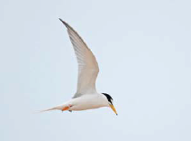
Corner Inlet supports more than 390 species of marine invertebrates and 390 species of native flora. The Ramsar site also has a high diversity of bird species with thirty-two shorebird species recorded.
Corner Inlet provides extensive tidal flats that are exposed at low tide, which are important feeding areas for shorebirds. It is estimated that nearly 50 per cent of the overwintering migratory shorebirds in Victoria occur in Corner Inlet.
Nationally threatened species utilising the Ramsar site include Red Knot (Calidris canutus), Eastern Curlew (Numenius madagascariensis), Curlew Sandpiper (Calidrisferruginea) and Bar-tailed Godwit (Limosa lapponica).
Corner Inlet was used traditionally by Indigenous people and many archaeological sites including scarred trees, burial sites, artefact scatters, shell middens and camps have been found. Currently, the Ramsar site is used for biological conservation, ports with servicing facilities for off-shore oil and natural gas exploration, commercial fishing, recreational fishing, and other recreational activities. Diving is popular around the numerous shipwreck sites in Corner Inlet and around the barrier islands.

Hunter Estuary Wetlands Ramsar Site, New South Wales
Community education, wetland conservation and wise use principles are actively promoted by the Hunter Wetlands Centre Australia, a very important part of this New South Wales Ramsar site.
Ramsar designation: 21 February 1984
EAAFP Flyway Site designation: 25 March 1996
Location: Near Newcastle in New South Wales
Size: 2,968 hectares
Key species: Eastern Curlew, Sharp-tailed Sandpiper, Broad-billed Sandpiper, Black-tailed Godwit, Common Greenshank, Terek Sandpiper,
Bar-tailed Godwit, Ruddy Turnstone, Lesser Sand Plover, Curlew Sandpiper

Figure 5: Birdlife at the Hunter Wetlands Centre (Department of the Environment and Energy)
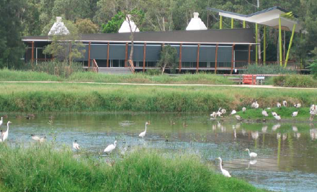
The Hunter Estuary Wetlands Ramsar site consists of two components — the Kooragang component in the estuary of the Hunter River, and the Hunter Wetlands Centre Australia. These components are not adjacent to each other but they have hydrological and wildlife links.
Habitats at Kooragang include mangrove forests, samphire saltmarsh, paperbark and she oak forests, brackish swamps, mudflats and sandy beaches. Hunter Wetlands Centre Australia is a small but unique complex of wetland types largely surrounded by urban development. This previously degraded site has been restored to semi-permanent freshwater and brackish ponds and marshes, freshwater swamp forests and a coastal estuarine creek.
Figure 6: Green and Golden Bell Frog (Litoria aurea) (Frank Lemckert SFNSW)
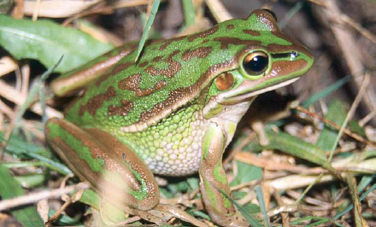
Figure 7: Little Egret (Egretta garzetta) (Department of the Environment and Energy)
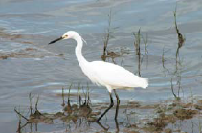
Figure 8: Red-neckedAvocets (Recurvirostra novaehollandiae) (Department of the Environment and Energy)
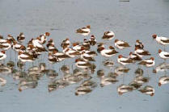
The Ramsar site provides important feeding, roosting and refuge habitat for waterbirds and is a stopover site for migratory species, many of which are listed under international agreements. The site regularly supports a significant proportion of the Eastern Curlew (Numenius madagascariensis) and Red-necked Avocet (Recurvirostra novaehollandiae) populations.
Threatened species found within the site include the Green and Golden Bell Frog (Litoria aurea), Red Goshawk (Erythrotriorchis radiates), Estuary Stingray (Dasyatisfluviorum) and Australasian Bittern (Botaurus poiciloptilus).
The Ramsar site was traditionally used by Indigenous groups and there are numerous middens and campsites scattered throughout the area. The Kooragang component is currently used for recreational and nature-based activities. The Hunter Estuary Wetlands Ramsar site has a Sister Site collaborative relationship with Kushiro wetlands in Hokkaido, Japan.

Kakadu National Park, Northern Territory
One of Australia's most iconic wetlands features a diversity of important cultural and ecological values.
Ramsar designation: 12 June 1980
EAAFP Flyway Site designation: 25 March 1996
Location: Approximately 220 kilometres east of Darwin in the Northern Territory
Size: 1,979,766 hectares
Key species: Magpie Goose, Marsh Sandpiper, Little Curlew, Common Sandpiper, Australian Pratincole, Sharp-tailed Sandpiper

Kakadu National Park stretches from the mangrove-fringed tidal plains in the north to vast floodplains, lowland hills and the sandstone cliffs of the Arnhem Land escarpment.
It is home to one third of Australia’s bird species including Magpie Geese (Anseranas semipalmata), egrets, Wandering Whistling Ducks (Dendrocygna arcuata) and Brolga (Grus rubicundus). Kakadu supports 20 per cent of Australia’s native freshwater fish species and nearly 1,600 plant species.
Figure 9: Pair of Brolgas (Grus rubicundus) (Department of the Environment and Energy)
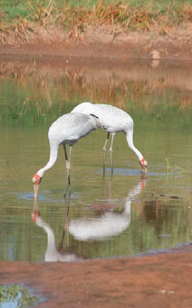
Figure 10: Indigenous rock art at Ubirr Rock in the World Heritage listed Kakadu National Park (Department of the Environment and Energy)
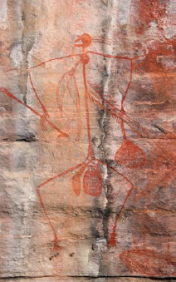
Kakadu National Park is also a World Heritage Site and is one of very few places listed for both its cultural and natural values. The land and its people have always been linked. Kakadu has one of the greatest concentrations of rock art sites in the world, and one of the longest historical records of occupation by a group of people.
The park features a successful model of joint management between the Aboriginal Traditional Owners and the Australian Government’s Director of National Parks. The Aboriginal people of Kakadu (known as Bininj in the north and Mungguy in the south) work together with park staff to combine traditional skills and knowledge with contemporary park management, enabling the park to be managed in accordance with world’s best management practices.
The Bininj/Mungguy are proud to share their country with visitors. Each year up to 225,000 people visit Kakadu National Park to see Indigenous art sites, bushwalk, birdwatch and go on boat cruises of the wetlands of Kakadu.
You can take a virtual tour of Kakadu National Park Ramsar Site at the following link: http://www.environment.gov.au/water/topics/wetlands/database/virtual-tours/2-vt/index.html
Figure 11: Aerial view over Kakadu National Park (Department of the Environment and Energy)
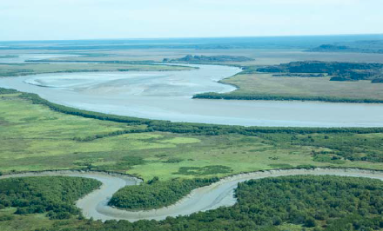
Figure 12: Nourlangie Rock and Anbangbang billabong, Kakadu National Park (Department of the Environment and Energy)
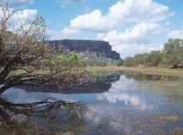
Figure 13: Magpie Geese (Anseranas semipalmata) (Department of the Environment and Energy)
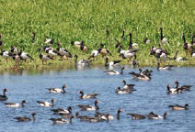

Logan Lagoon, Tasmania
Thousands of shorebirds visit an island wetland in Bass Strait on their annual migration between the northern and southern hemispheres.
Ramsar designation: 16 November 1982
EAAFP Flyway Site designation: 25 March 1996
Location: On the south-east corner of Flinders Island in Bass Strait, Tasmania
Size: 2,257 hectares
Key species: Curlew Sandpiper, Red-necked Stint, Eastern Curlew,
Double-banded Plover

Logan Lagoon Ramsar Site is enclosed within the Logan Lagoon Conservation Area and is part of the extensive eastern Flinders Island parallel dune—coastal barrier system.
The site is an excellent, regionally representative example of a coastal estuarine wetland system, and comprises a diverse range of seasonal and permanent marshlands, grass and heathlands, forests, and woodlands, many of which support threatened species.
Figure 14: Black Swans (Cygnus atratus) and cygnets (Department of the Environment and Energy)
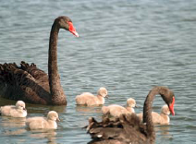
Figure 15: Common Greenshank (Tringa nebularia) (Georgina Steytler)
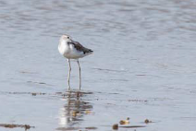
More than 160 bird species have been recorded on Flinders Island, many of which occur in the Ramsar site which is an important part of the East Asian — Australasian Flyway. Twenty-one migratory shorebirds have been recorded at the site including significant numbers of Red-necked Stint (Calidris ruficollis), Common Greenshank (Tringa nebularia), Eastern Curlew (Numenius madagascariensis), Bartailed Godwit (Limosa lapponica) and Double-banded Plover (Charadrius bicinctus). Other non-avian fauna with conservation value that use the site for foraging, breeding, or as habitat refuge include the threatened Dwarf Galaxias (Galaxiella pusilla).
The site is used for conservation, education, research, and recreation activities including walking, sightseeing, bird watching, off-road vehicle driving and beach fishing.
Figure 16: Red-necked Stint (Calidris ruficollis) feeding at the high tide mark (Graeme Chapman)
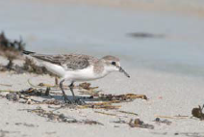

Moreton Bay, Queensland
One of Australia's most important sites for the critically endangered Eastern Curlew.
Ramsar designation: 22 October 1993
EAAFP Flyway Site designation: 25 March 1996
Location: The Moreton Bay Ramsar site is located in and around Moreton Bay, east of Brisbane in Queensland.
Size: 113,314 hectares
Key species: Eastern Curlew, Whimbrel, Grey-tailed Tattler, Pacific Golden Plover, Bar-tailed Godwit, Curlew Sandpiper, Lesser Sand Plover,
Red-necked Stint, Sharp-tailed Sandpiper

Figure 17: Aerial view of Bribie Island and Bells Creek on the outskirts of Caloundra in the Moreton Bay Ramsar wetland area (Department of the Environment and Energy)
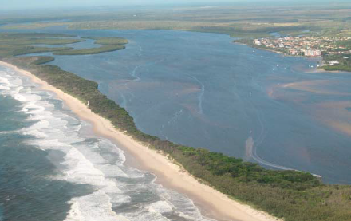
Moreton Bay is a semi-enclosed basin bounded on its eastern side by large sand islands. Islands in the site include all of Moreton Island, and parts of North and South Stradbroke Islands, Bribie Island and the Southern Bay Islands.
Other parts of the site include waters and tributaries of Pumicestone Passage, some intertidal and subtidal areas of the western bay, southern bay and sandy channels of the Broadwater region, marine areas and sand banks within the central and northern bay and some ocean beach habitats.
Wetlands on the site include seagrass and shoals in the eastern banks, tidal flats and associated estuarine assemblages within the Pumicestone Passage, mangroves and saltmarsh in the southern bay, coral communities of the eastern bay, freshwater wetlands and peatland habitats on the Bay Islands and ocean beaches and foredunes on Moreton Island.
The extensive mangrove and tidal flats provide a nursery for fish and crustaceans, and also support birds and other marine life. The sandflats provide roosting sites for migratory birds.
The site supports more than 50,000 migratory shorebirds during their non-breeding season. At least 43 species of waterbirds use the intertidal habitats, including 30 migratory species listed on international conservation agreements. The site is regularly monitored by the Queensland Wader Study Group and these data have been critical to understanding patterns and declines of several migratory shorebird species.
Figure 18: Aerial view of North Stradbroke Island and Jumpin Pin Channel, part of the Moreton Bay Ramsar wetland area (Department of the Environment and Energy)
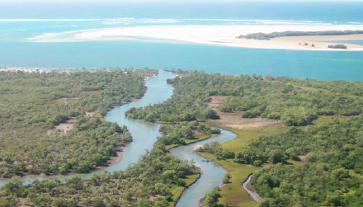
Figure 19: Lathams Snipe (Gallinago hardwickii) feeding in the shallow water at Buckleys Hole on Bribie Island (Graeme Chapman)
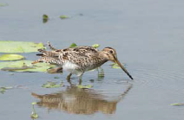
Figure 20: Mangrove and saltmarsh wetlands (Department of the Environment and Energy)
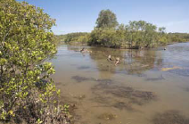
Moreton Bay Ramsar site has a close collaborative Sister Site relationship with Yatsu-higata near Narashino City, Japan. The close proximity of the wetlands to Brisbane and other populated areas makes the site a popular recreation area for tourism, birdwatching, water based recreation, scuba diving, four wheel driving, camping and boating. Parts of the site are conservation reserves. Commercial activities such as shipping, transport and fishing also occur within the site.
Moreton Bay Ramsar site lies in the traditional estate of a number of Indigenous groups including the Kabi Kabi, Jagera and Turrbal, Quandamooka (Ngugi, Noonucle, Gorenpul), and Yugambeh and Ngarang-Wal/Kombumeri. Evidence from these excavations and other archaeological sites discovered in Moreton Bay indicates that fishing, the collection of shellfish and the gathering of local food plants were important activities for Indigenous peoples living in the region.

Pitt Water - Orielton Lagoon, Tasmania
Pitt Water - Orielton Lagoon is the most southerly site included on the Flyway Site Network of the East-Asian - Australasian Flyway Partnership.
Ramsar designation: 16 November 1982
EAAFP Flyway Site designation: 25 March 1996
Location: The site is located on the south-east coast of Tasmania, approximately 20 kilometres east of the city of Hobart.
Size: 3,334 hectares
Key species: Eastern Curlew, Red-necked Stint, Curlew Sandpiper,
Double-banded Plover, Caspian Tern, Little Tern

Figure 21: Caspian Tern (Hydroprogne caspia) flying overhead (Georgina Steytler)
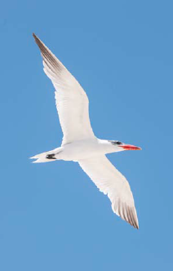
Pitt Water is an almost land-locked body of tidal salt water with a narrow entrance to Frederick Henry Bay. Orielton Lagoon is separated from Pitt Water by a causeway constructed in 1868. The whole area is protected from the open sea by a large mid-bay spit and associated dunefield.
Most of the Ramsar site is open water fringed by saltmarsh communities, mudflats and rocky shores. The large areas of tidal mud and sand flats leaves extensive areas exposed as suitable feeding areas for migratory shorebirds.
Figure 22: Pair of Great Crested Grebes (Podiceps cristatus) (Department of the Environment and Energy)
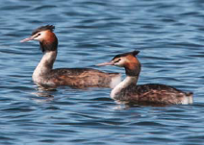
The vegetation communities present include succulent saline herbland, saline sedgeland/ rushland and coastal grassland. The site provides breeding habitat for a number of beach-nesting shorebirds including the Caspian Tern (Hydroprogne caspia) and Red-capped Plover (Charadrius ruficapillus). Migratory birds that utilise the Ramsar wetland include the Eastern Curlew (Numenius madagascariensis), Bar-tailed Godwit (Limosa lapponica), Common Greenshank (Tringa nebularia), Curlew Sandpiper (Calidrisferruginea), Double-banded Plover (Charadrius bicinctus) and Red-necked Stint (Calidris ruficollis). Threatened species listed in Tasmania recorded at the site include the Great-crested Grebe (Podiceps cristatus), Fairy Tern (Sternula nereis) and Little Tern (Sternula albifrons).
Figure 23: Scenery around the Ramsar listed wetland of Pitt Water-Orielton Lagoon between the townships of Cambridge and Sorell in Tasmania (Department of the Environment and Energy)
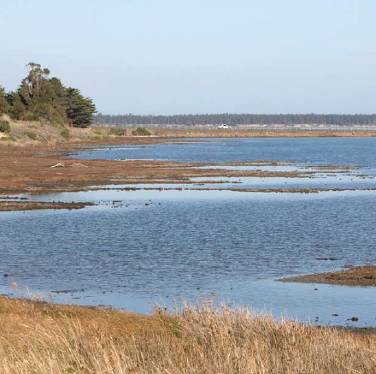
Pitt Water-Orielton Lagoon was traditionally used by Indigenous people of the area and the Ramsar site contains some middens and other evidence of Indigenous occupation. Currently the area has a diversity of land uses including pasture grazing, forestry, irrigated cropping, residential development, shellfish aquaculture, recreation and nature conservation.
Figure 24: Small flock of Red-capped Plovers (Charadrius ruficapillus) landing on the shore (Georgina Steytler)
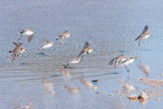

Ord River Floodplain, Western Australia
The Ord River Floodplain is the best example of a grass-dominated wetland in Western Australia.
Ramsar designation: 7 June 1990
EAAFP Flyway Site designation: 25 March 1996
Location: North-west Western Australia, near the town of Wyndham
Size: 141,453 hectares
Key species: Little Curlew, Australian Pratincole, Oriental Pratincole,
Wood Sandpiper, Marsh Sandpiper, Sharp-tailed Sandpiper

The Ord River Floodplain Ramsar site, in north-east Western Australia, is a floodplain and estuarine wetland system. Parry Lagoons, at the southern end of the site, has broad floodplains that periodically flood and dry out and permanent waterholes. North of the lagoons, the site includes the Ord River Estuary leading into the Cambridge Gulf. The north-east end of the site heads around the coast to include a series of extensive intertidal creeks and flats known as the False Mouths of the Ord. The upstream portion of the floodplain and river tends to be freshwater, and becomes more saline as the river approaches the Cambridge Gulf and falls under tidal influence.
Mangroves are the most common vegetation in the site, extending from the False Mouths of the Ord to the upstream sections of the estuary. The mangroves form narrow fringes along the intertidal areas, with saltmarsh on higher ground. The intertidal mangroves support many species of birds and bats, and are a breeding area for banana prawns.
The Parry Lagoon floodplains are dominated by grassland, the lower Ord River and Parry Creek by riparian woodland, and the permanent waterholes by aquatic vegetation.
Over 200 species of birds have been recorded within the site including waterfowl, migratory shorebirds, mangrove birds and terrestrial species. The site supports the nationally threatened Australian Painted Snipe (Rostratula australis).
Figure 25: Overview of Paddys Lagoon on the Ord River Floodplain from atop Telegraph Hill (Department of the Environment and Energy)
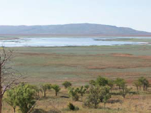
Figure 26: Freshwater crocodile (Crocodylus johnsoni) sunbaking beside the Ord River in the Ord River Floodplain wetland area (Department of the Environment and Energy)
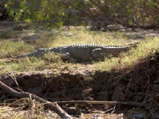
The wetlands are habitat for many diadromous fish species (that require migration between marine and more freshwater environments some time during their life), including the nationally threatened species Freshwater Sawfish (Pristispristis), Green Sawfish (Pristis zijsron) and Northern River Shark (Glyphisgarricki). Reptiles that use the site include the Freshwater Crocodile (Crocodylusjohnsoni) and Saltwater Crocodile (Crocoylus porosus).
The Ord River Floodplain Ramsar site lies within the boundaries of six Indigenous language groups: Miriuwung, Gajerrong, Dulbung, Guluwaring, Djangade and Biambarr. The site contains Indigenous burial sites, artefact scatters, quarries, paintings and ceremonial sites.
The Lower Ord River and the False Mouths of the Ord are popular destinations for locals and visitors for recreational fishing, crabbing and boating. Parry Lagoons is also important for passive recreational activities such as bird watching and bush walking. Nature based commercial tourism is an important source of income for the region.
Figure 27: Comb-crested Jacana (Irediparra gallinacea) (Chris Purnell)
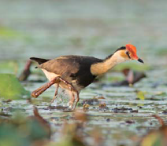
Figure 28: Birdlife amongst the water lilies at Marlgu Billabong on the Ord River Floodplain (Jim Mollison)
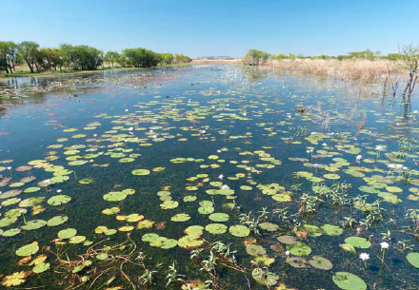

The Coorong and Lakes Alexandrina and Albert, South Australia
This unique mosaic of 23 wetland types has received substantial publicity in recent years due to its significance as the end point of the Murray-Darling Basin.
Ramsar designation: 1 November 1985
EAAFP Flyway Site designation: 25 March 1996
Location: At the downstream end of the Murray River, in south-east
South Australia
Size: 140,500 hectares
Key species: Caspian Tern, Curlew Sandpiper, Red-necked Stint,
Sharp-tailed Sandpiper, Sanderling, Common Greenshank

The Coorong and Lakes Alexandrina and Albert Ramsar site is a long, shallow brackish to hyper-saline lagoon that stretches for 140 kilometres in length. It is separated from the Southern Ocean by a narrow sand dune peninsula. The Lakes Alexandrina and Albert are comprised of fresh to brackish/saline waters.
Figure 29: Coastline of the Coorong National Park at Long Point near Meningie (Department of the Environment and Energy)
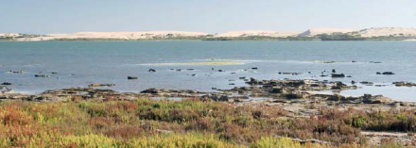
The site provides habitat for over 100 species that utilise the wetland habitat — with a total of 307 species recorded with 1 km of the site boundary. Annual monitoring up until 2012 indicates that between 71,000 and 329,000 waterbirds are supported within the Ramsar site including Australian Pelican (Pelecanus conspicllatus), Australian Painted Snipe (Rostratula australis), Australian Shelduck (Tadorna tadornoides), Banded Stilt (Cladorhynchus leucocephalus) and Grey Teal (Anasgracilis). The Ramsar site supports 57 wetland-dependent species that are listed on international migratory agreements, including species such as Red-necked Stint (Calidris ruficollis) and Curlew Sandpiper (Calidrisferruginea). The site also supports 43 species of fish, such as Murray Hardyhead (Craterocephalus fluviatilis), Yarra Pygmy Perch (Nannoperca obscura), Pouched Lamprey (Geotria australis) and the Short-headed Lamprey (Mordacia mordax).
Figure 30: Australian Pelicans (Pelecanus conspicllatus) on the coastline of the Coorong National Park at Long Point near Meningie (Department of the Environment and Energy)
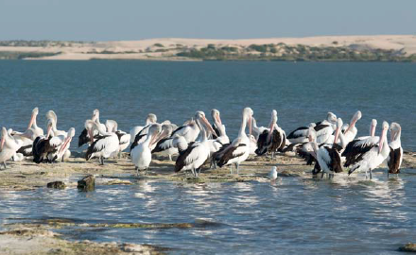
The site also contains (in part) the critically endangered ‘Swamps of the Fleurieu Peninsula’ ecological community, as well as the threatened Gahnia sedgeland ecosystem and a number of nationally listed plant species. The site is also significant because it forms the only estuarine habitat in the Murray-Darling Basin, consists of a unique mosaic of 23 Ramsar wetland types, including intertidal mud, sand or salt flats, coastal brackish/ saline lagoons, permanent freshwater lakes, permanent freshwater marshes/pools, shrub-dominated wetlands and is the only access point for diadromous fish species within the Basin.
The area is popular for recreational activities such as fishing, camping, boating, walking, bird watching, canoeing, sailing, water-skiing, picnicking and research. The area also supports tourism, commercial fishing and farming.
The Ngarrindjeri Indigenous people have a long association with the Coorong and Lower Lakes and the site has great cultural significance for them. They retain these close links with the wetland and its biodiversity through these cultural links.
Figure 31: Murray River mouth near Goolwa in the Coorong National Park (Department of the Environment and Energy)
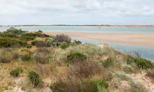
Figure 32: Coastline of the Coorong National Park at Long Point near Meningie (Department of the Environment and Energy)
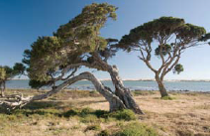

Forrestdale and Thomsons Lakes, Western Australia
The sediments of Thomsons Lake are between 30,000 and 40,000 years old, which are the oldest lake sediments discovered in Western Australia to date.
Ramsar designation: 7 June 1990
EAAFP Flyway Site designation: 25 March 1996
Location: Southern outskirts of Perth metropolitan area, south-western Australia.
Size: Forrestdale Lake: 246 hectares; Thomsons Lake: 538 hectares
Key species: Curlew Sandpiper

Forrestdale Lake is located in the City of Armadale and Thomsons Lake is located in the City of Cockburn both of which lie within the southern Perth metropolitan area, in Western Australia. The lakes are surrounded by medium density urban development and some agricultural land.
Figure 33: Healthy Banksia at the Forrestdale and Thomsons Lakes Ramsar site near Armadale (Department of the Environment and Energy)
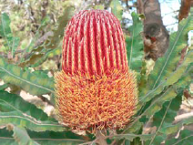
Forrestdale and Thomsons Lakes are fresh/brackish, seasonal wetlands, predominately fed by groundwater. Forrestdale Lake usually dries out by mid-summer whereas Thomsons Lake retains water longer and in some years does not dry completely. These lakes are the best remaining examples of brackish, seasonal lakes with extensive fringing sedgeland, typical of the Swan Coastal Plain.
Figure 34: Overview of the Forrestdale and Thomsons Lakes Ramsar site near Armadale (Department of the Environment and Energy)
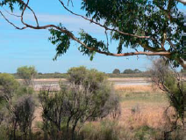
Forrestdale and Thomsons Lakes are situated in sand dune systems and contain large areas of open water fringed by rushes and bulrushes, behind which are trees tolerant of seasonal waterlogging. The higher ground around the lakes supports open woodland. The lakes provide important habitat for waterbirds on the Swan Coastal Plain with 72 species of waterbird occurring at the two lakes and 21 of them breeding. Twenty-one species of migratory waterbirds protected by international migratory bird conservation agreements have been recorded at the lakes, including significant numbers of Curlew Sandpiper (Calidris ferruginea).
Forrestdale Lake was traditionally an important tortoise hunting site for indigenous peoples from as far away as Pinjarra, 50 kilometres to the south. Contemporary uses of the Ramsar site include bird watching, nature walks, horse riding and general recreation.

Port Phillip Bay (Western Shoreline) and Bellarine Peninsula, Victoria
The natural and artificial wetlands of this unique site combine to make it the most important area in Victoria for migratory shorebirds.
Ramsar designation: 15 December 1982
EAAFP Flyway Site designation: 31 January 2001
Location: Near Geelong in Victoria
Size: 22,897 hectares
Key species: Red-necked Stint, Curlew Sandpiper, Eastern Curlew,
Common Greenshank, Sharp-tailed Sandpiper, Grey Plover,
Ruddy Turnstone, Double-banded Plover

Figure 35: Critically endangered Orange-bellied Parrot (Neophema chrysogaster) (Graeme Chapman)
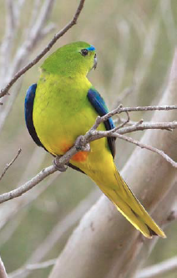
The Port Phillip Bay (Western Shoreline) and Bellarine Peninsula Ramsar site is comprised of many different wetland types including freshwater lakes, mangrove-lined estuaries, seasonal freshwater swamps, sewage ponds, saltmarshes, intertidal mudflats and seagrass beds. The site comprises six distinct areas that include Point Cook/Cheetham, Werribee/Avalon, Point Wilson/Limeburners Bay, Swan Bay, Mud Islands, and the Lake Connewarre Complex. The Swan Bay tidal flats near Geelong provide important habitat for a range of migratory birds and as such have developed a Sister Site relationship with Fujimae tidal flat near Nagoya City, Japan.
A large number of waterbird species have been recorded at the site including Australian Pied Oystercatchers (Haematopus longirostris), Banded Stilts (Cladorhynchus leucocephalus), Red-necked Stints (Calidris ruficollis), Sharp-tailed Sandpipers (Calidris acuminate), Australasian Shovelers (Anas rhynchotis), Red-necked Avocets (Recurvirostra novaehollandiae), Blue-billed Ducks (Oxyura australis) and Freckled Ducks (Stictonetta naevosa).
Figure 36: Ruddy Turnstone (Arenaria interpres) walking along the rocks (Georgina Steytler)
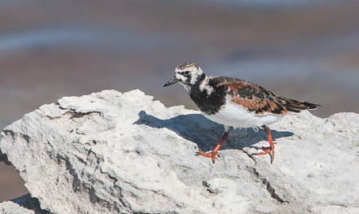
Figure 37: Shoreline vegetation and view across Swan Bay near Queenscliff (Department of the Environment and Energy)
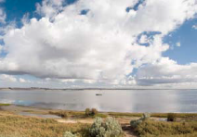
Figure 38: Red-necked Stint (Calidris ruficollis) (Chris Purnell)
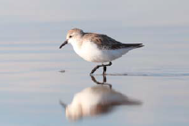
The Ramsar site supports a range of biodiversity. A number of nationally threatened species are known to occur there — the Australasian Bittern (Botaurus poiciloptilus), Orange-bellied Parrot (Neophema chrysogaster), Australian Painted Snipe (Rostratula australis), Fairy Tern (Sternula nereis). The critically endangered Orange-bellied Parrot, in particular, uses habitat around Port Phillip Bay during winter. Over 50 species of fish have been recorded in Swan Bay (a component of the Ramsar site) and the seagrass beds are an important feeding and nursery ground for commercially important fish species. There are a number of important Indigenous sites within the wetlands, including burial sites, middens and artefacts. The oldest known midden in the area is at least 5,000 years old. More than three million people live around Port Phillip Bay and the area is used for recreation, nature conservation, sewage treatment, aquaculture, fishing and salt production.

Western Port, Victoria
The Ramsar site regularly supports about 10,000 to 15,0000 migratory shorebirds, and periodically supports 1,0000 to 3,000 ducks and 5,000 to 10,000 Black Swans.
Ramsar designation: 15 December 1982
EAAFP Flyway Site designation: 31 January 2001
Location: Southern Victoria east of Port Phillip Bay
Size: 59,950 hectares
Key species: Sharp-tailed Sandpiper, Common Greenshank, Curlew Sandpiper, Red-necked Stint, Eastern Curlew, Double-banded Plover,
Little Tern

Figure 39: Pair of Fairy Terns (Sternula nereis) copulating near their nest site on the beach (Graeme Chapman)
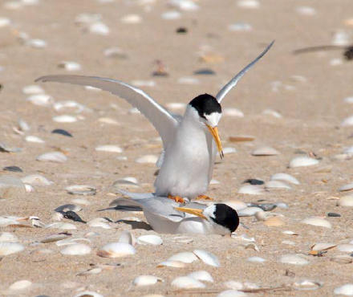

Western Port is a large bay in southern Victoria incorporating around 260 kilometres of coastline, connected to Bass Strait by a wide channel between Flinders and Phillip Island, and a narrow channel between San Remo and Phillip Island. Six rivers from the north and east of the catchment flow into the northern and eastern shores of Western Port and several minor rivers and creeks on the eastern slopes of the Mornington Peninsula drain into the western shores.
The Ramsar site has a wide variety of habitat types, ranging from deep channels, seagrass flats, intertidal mudflats, extensive mangrove thickets and saltmarsh vegetation. The White Mangrove (Avicennia marina) communities within Western Port are the most well-developed and extensive in Victoria, and are the only large communities situated so far from the Equator.
Figure 40: Male Chestnut Teal (Anas castanea) (Department of the Environment and Energy)
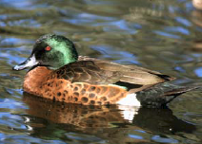
Figure 41: Bar-tailed Godwits (Limosa lapponica) (Chris Purnell)
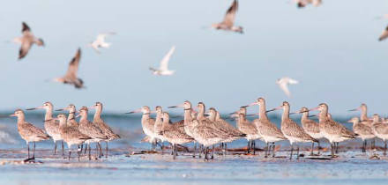

Western Port is one of the most important areas for shorebirds in Victoria and the site supports numerous migratory species listed under international migratory bird conservation agreements. High numbers of Eastern Curlew (Numenius madagascariensis), Whimbrel (Numinusphaeopus), Bar-tailed Godwit (Limosa lapponica), Grey-tailed Tattler (Tringa brevipes), Common Greenshank (Tringa nebularia) and Terek Sandpiper (Xenus cinereus) have been recorded at the site. Nationally threatened species that utilise Western Port include the Orange-bellied Parrot (Neophema chrysogaster), Swift Parrot (Lathamus discolour), Southern Right Whale (Eubalaena australis), and Humpback Whale (Megaptera novaeangliae). The site supports the globally threatened Fairy Tern (Sternula nereis) which is listed on the IUCN Red List of Threatened Species.
A number of Indigenous cultural heritage sites on the shores of Western Port have been identified. Currently, Western Port is used for commercial fishing and recreational activities such as boating, swimming and fishing.

Bowling Green Bay, Queensland
The site regularly supports significant numbers of Great Knot and
Red-necked Stint.
Figure 42: Dugong (Dugong dugon) feeding, Great Barrier Reef (Commonwealth of Australia (GBRMPA))
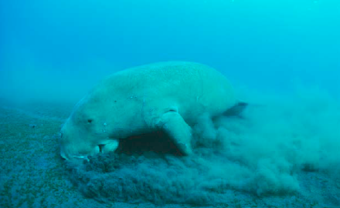
Ramsar designation: 22 October 1993
EAAFP Flyway Site designation: 10 July 2006
Location: South-east of Townsville, central Queensland
Size: 35,500 hectares
Key species: Great Knot, Red-necked Stint

The Bowling Green Bay Ramsar site is located 21 km north-east of Ayr, Queensland. The site plays a major role in protection of this area from erosion by cyclones. A diverse complex of coastal wetland systems occur at the site. These include inter-tidal seagrass beds, mangrove woodlands and saline saltpan communities on the coast, and brackish to freshwater wetlands inland. Thin fringes of low Rhizophora mangrove communities in the intertidal zone are backed by complex patterns of saltmarsh and saltwater couch grasslands. Extensive areas of forest and woodland, and some closed forest, occur on the mountainous areas and the coastal dune system.
The site has unusually low rainfall for the region, with most rain falling in summer. The heavy rain of the summer wet season provides freshwater into the site, reducing the salinities of the shallow inshore marine areas, the surface soils of the saltpans and the mangrove areas.
The Haughton River and many creeks feed into the wetland system. Groundwater is stored in two main aquifers that recharge from direct infiltration over the delta from rainfall, river flow and flood.
Figure 43: Saltwater Crocodile (Crocodylus porosus) (Department of the Environment and Energy)
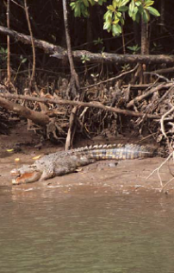
Figure 44: Intermediate Egret (Ardea intermedia) (Department of the Environment and Energy)
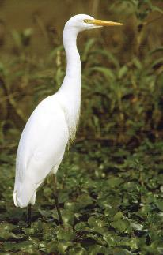
Of the 300 birds known to occur in the site, almost half are known to breed within it. The site is an important habitat for a number of the migratory species listed on international conservation agreements, including Great Knot (Calidris tenuirostris) and Red-necked Stint (Calidris ruficollis).
The intertidal and subtidal seagrass beds provide feeding habitat for the nationally threatened Green Turtle (Chelonia mydas) and the internationally threatened Dugong (Dugong dugon). Barramundi (Lates calcarifer) breed in the freshwater swamps of the site. Saltwater Crocodiles (Crocodylus porosus) also inhabit the site.
The bulk of the site comprises a portion of Bowling Green Bay National Park. The site holds significant cultural, spiritual and provisioning value for local Indigenous Australians and is an important site for scientific research. The site is used for conservation and recreation, such as fishing, camping, bushwalking and bird watching. Commercial and recreational harvesting of prawns and Mud Crab also occur within the site.
Figure 45: Terek Sandpipers (Xenus cinereus), along with a pair of Curlew Sandpipers (Calidris ferruginea), perched on a rock (Graeme Chapman)
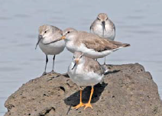

Currawinya National Park, Queensland
During drought conditions, the permanent lakes and waterholes are important wildlife refugia for amphibians, fish, reptiles and waterbirds.
Ramsar designation: 11 March 1996
EAAFP Flyway Site designation: 10 July 2006
Location: Approximately one kilometre from Hungerford
Size: 151,300 hectares
Key species: Sharp-tailed Sandpiper

The Currawinya Lakes Ramsar site is a complex landscape, containing a river, dunefields, lakes, alluvial plains, claypans, saltpans, springs, creeks and deeply weathered ranges. It has some of the most diverse wetland types in inland Australia, with largely unmodified near permanent and intermittent saline and freshwater wetlands, including the Great Artesian Basin springs. These artesian springs occur on the margins of the Great Artesian Basin as vents for the natural discharge of artesian water. The Great Artesian Basin is one of the largest artesian groundwater basins in the world. It underlies approximately one-fifth of Australia, covers a total area of over 1,711,000 square kilometres and has an estimated total water storage of 64,900 million megalitres.
More than 70 artesian springs in five broad groups have been identified on the site, mostly in the Hoods Range area to the east of Lake Numalla, with isolated springs in low dunefields to the east and south of Lake Numalla. All spring groups except one contain both active and inactive mounded and non-mounded (water) springs.
The two largest water bodies within the Ramsar site, Lake Numalla and Lake Wyara, are markedly different. Lake Numalla, fed by the Paroo River via Carwarra Creek during floods, is fresh and turbid while, Lake Wyara is saline and generally clear. Lake Numalla is also a semi-permanent water body, whereas Lake Wyara dries regularly and becomes a vast saltpan.
Figure 46: Australian Darter (Anhinga novaehollandiae) drying wings (Department of the Environment and Energy)
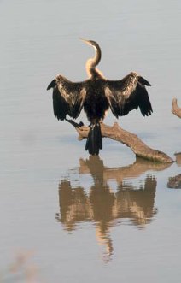
Figure 47: Aerial view of the Paroo River wetlands (Department of the Environment and Energy)
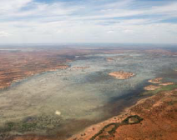
Figure 48: Sharp-tailed Sandpiper (Calidris acuminata) (Chris Purnell)
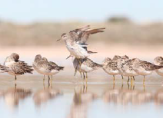
Figure 49: Freckled Duck (Stictonetta naevosa) (Department of the Environment and Energy)
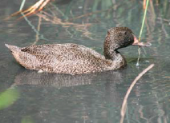
Currawinya also contains two of just three permanent waterholes (Caiwarro and Corni Paroo) on the Paroo River downstream of Eulo.
The range of wetland habitats within the Ramsar site supports an array of native fauna, particularly an abundance and diversity of waterbird species. The Currawinya Lakes are of international significance as part of an inland route for migratory shorebirds from East Asia, providing important summer feeding areas. The water bodies support substantial waterbird breeding events (particularly for pelicans, gulls, terns, cormorants and swans), as well as providing refuge habitat in drought conditions for birds, amphibians, reptiles and native fish. The Currawinya Lakes Ramsar site supports a high abundance of waterbirds, with over 200 bird species recorded from the site, and counts in excess of 100,000 individuals recorded on several occasions.
Numerous plant communities are found within Currawinya Lakes, with sandplains dominated by mulga and poplar box low open woodlands; gidgee and yapunyah woodlands on alluvial plains; mulga, bastard mulga, and turpentine mulga shrublands on the ranges and hills; and low, open shrublands and sedgelands on dunefields and claypans.
Currawinya Lakes is highly significant to local Indigenous communities for its archaeological, traditional and contemporary values. The site includes stone arrangements, native wells, scarred trees (trees with bark removed for canoes and shields), stone artefacts and burial grounds.
Contemporary use of the area is limited by its remote location. A number of nature-based, low-impact recreational activities occur within the site, including nature walks and drives, wildlife watching, camping, canoeing and fishing.

Discovery Bay, Victoria
The site includes a range of coastal environments including rugged cliffs, extensive beaches, mobile dune fields, wetlands and woodland forest communities.
Ramsar designation: Not designated as a Ramsar site
EAAFP Flyway Site designation: 10 July 2006
Location: 320 kilometres south-west of Melbourne, Victoria.
Size: 10,460 hectares
Key species: Sanderling, Little Tern

The coastal landforms of Discovery Bay include beaches, coastal cliffs, headlands and dune fields. The coastline is a dynamic high-energy system. The Glenelg River Estuary and Long Swamp is recognised as a nationally important wetland. Long Swamp is a shallow freshwater wetland fed by a ground water aquifer in the Discovery Bay dune barrier system. The Glenelg Estuary is a large estuarine system consisting of the main channel of the Glenelg River and a side lagoon called Oxbow Lake.
There are three main vegetation types within Discovery Bay: coastal dune scrub complexes on sands and limestone headlands, dry and wet heaths and swamps, and mallee and woodland eucalypt communities.
Figure 50: Sanderling (Calidris alba) feeding on beach (Joyce Gross)
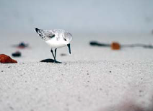
Figure 51: Breeding adult Hooded Plover (Thinornis rubricollis) (Graeme Chapman)
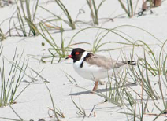
Discovery Bay Coastal Park is an important breeding area for the endemic Hooded Plover (Thinornis rubricollis) and supports more than 1% of the global population. Sanderling (Calidris alba) use the whole of the coastal strip but there are concentrations around the Glenelg River mouth.
Discovery Bay has a long history of Aboriginal use dating back at least 11,300 years BP. Significant Aboriginal archaeological sites recorded for Discovery Bay include extensive shell middens, earth oven remains and numerous lithic materials such as edge ground axes, basalt grinding stones and flint artefacts.
The greatest concentration of middens occurs between the freshwater swamps and the sea at the western end of Discovery Bay. Most sites are within 100m of the beach.
Discovery Bay Coastal Park is popular for walking, sightseeing and scenic drives. Numerous recreational activities are undertaken, including: camping, fishing, diving, surfing, water skiing and cycling. There are special areas for dune buggy driving, horse riding and walking dogs on leads.

Great Sandy Strait, Queensland
The largest and least disturbed sand passage estuary in south-east Queensland is a significant site for a number of internationally listed migratory species.
Ramsar designation: 14 June 1999
EAAFP Flyway Site designation: 10 July 2006
Location: In south-east Queensland between the mainland and Fraser Island
Size: 93,160 hectares
Key species: Terek Sandpiper, Grey-tailed Tattler, Bar-tailed Godwit,
Lesser Sand Plover, Whimbrel, Eastern Curlew

The Great Sandy Strait Ramsar site includes many different types of wetlands and occurs at the transition between tropical and temperate zones which results in a rich biodiversity. The site also supports rare patterned fens that, alongside those adjacent to the Ramsar boundary, are the only known sub-tropical fens and the only known examples in the world of patterned fens flowing into tidal wetlands. The sand passage estuary lies between the mainland and the World Heritage-listed Fraser Island. Fraser Island has formed sufficiently close to the mainland to block the flow of a substantial river system, creating a doubleended estuary with a shifting (though relatively stable) pattern of mangroves, sand banks and mud islands.
Figure 52: Beach Stone Curlew (Esacus magnirostris) on Fraser Island (Department of the Environment and Energy)
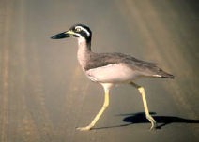
The Great Sandy Strait is a significant site in the East Asian — Australasian Flyway for migrating shorebirds. It supports at least 25 migratory species. Numbers of shorebirds have been recorded at over 20,000, large numbers of Eastern Curlew (Numenius madagascariensis) gathering here. Wetlands along Great Sandy Strait support more than 1% of the total world population of the following species: Eastern Curlew, Grey-tailed Tattler (Tringa brevipes), Lesser Sand Plover (Charadrius mongolus), Whimbrel (Numenius phaeopus), Bar-tailed Godwit (Limosa lapponica), and Pied Oystercatcher (Haematopus longirostris). The site also provides feeding habitat for four nationally threatened marine turtle species, as well as Dugongs (Dugong dugon). It supports the nationally vulnerable Humpback Whale (Megaptera novaeangliae) during its southward migration to Antarctic waters.
Figure 53: Tail of a Humpback Whale (Megaptera novaeangliae) near Fraser Island (Dave Paton)
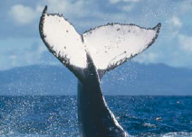
The Great Sandy Strait is highly valued for commercial fishing, recreational fishing, boating and tourism related activities. The site is also of significance to Traditional Owners. The site is part of the traditional lands of the Butchulla Nation (including Wondunna clan), and is currently used by these people.
Figure 54: Large-leafed mangrove on Fraser Island (Department of the Environment and Energy)
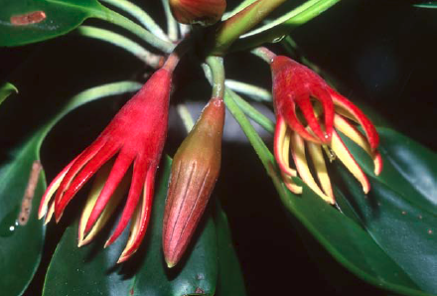
Figure 55: Fwatthumba Creek, Fraser Island (Department of the Environment and Energy)
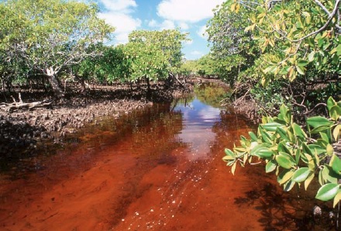

Shallow Inlet Marine and Coastal Park, Victoria
The extensive mudflats and sandy intertidal areas provide excellent habitat for shorebirds.
Ramsar designation: Not designated as a Ramsar site
EAAFP Flyway Site designation: 10 July 2006
Location: North-west of Wilson’s Promontory, near the small town of Sandy Point.
Size: 2,300 hectares
Key species: Double-banded Plover, Curlew Sandpiper, Sanderling,
Red-necked Stint, Eastern Curlew

Shallow Inlet is a large, wave-dominated estuary in mostly unmodified condition, on Victoria’s south-eastern coastline near Wilson’s Promontory. The site includes Shallow Inlet Marine and Coastal Park, the Flora and Fauna Reserve along the western shoreline, on islands in the inlet, and the Shallow Inlet Saltmarsh Flora and Fauna Reserve along the eastern shoreline. Both Reserves are managed as part of the Park. The site also covers the part of the Waratah Bay — Shallow Inlet Coastal Reserve east of Sandy Point township.
The extensive mudflats and sandy intertidal areas provide excellent habitat for shorebirds. Over 16,000 shorebirds are recorded in summer, representing 22 species. In particular, Shallow Inlet is an internationally important site for five species of migratory shorebird: Double-banded Plover (Charadrius bicinctus), Red-necked Stint (Calidris ruficollis), Sanderling (Calidris alba), Curlew Sandpiper (Calidris ferruginea) and Eastern Curlew (Numenius madagascariensis). Eastern Curlew, is listed critically endangered under national environmental law. The site also supports significant numbers of Pacific Golden Plover (Pluvialisfulva) and the endemic Hooded Plover (Thinornis rubricollis).
Shallow Inlet is popular for recreational activities such as fishing, sailboarding, camping and picnicking.
Figure 56: Greater Crested Terns (Thalasseus bergii) (Department of the Environment and Energy)
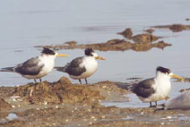
Figure 57: Pacific Golden Plover (Pluvialis fulva) (Department of the Environment and Energy)
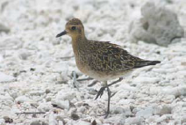
Figure 58: Shallow Inlet is popular for recreational activities such as fishing, sailboarding, camping and picnicking (Department of the Environment and Energy)
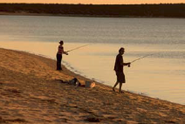

Shoalwater and Corio Bays, Queensland
The area represents one of a very few large estuarine systems that retains
a relatively undisturbed catchment.
Ramsar designation: 11 March 1996
EAAFP Flyway Site designation: 10 July 2006
Location: About 50 km north of Rockhampton, Queensland
Size: 239,100 hectares
Key species: Eastern Curlew, Whimbrel, Bar-tailed Godwit, Terek Sandpiper, Grey-tailed Tattler, Australian Pied Oystercatcher

The Shoalwater and Corio Bays Area Ramsar site includes approximately 330 km of coastline (including islands), and is located about 50 km north of Rockhampton, Queensland. The majority of the site is set around Shoalwater Bay in the Shoalwater Bay Military Training Area (SWBTA) and includes adjacent lands and marine waters from Broome Head in the north to the southern boundary of the SWBTA. The other component of the site includes the intertidal areas of Corio Bay in the south.
The area contains a wide diversity of landscape types including undulating lowlands and hills, riverine plains, swamps, estuarine inlets, old beach ridges, dunes, sand beaches flanked by coastal cliffs, and intertidal sand and mudflats. The wetland types on the site include freshwater lagoons, swamps and streams, leading into marine, estuarine and intertidal wetlands.
Figure 59: Mangroves at low tide (Department of the Environment and Energy)
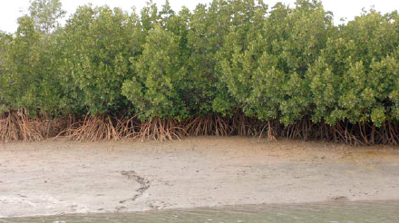
The site is located in a zone where the temperate climate merges into tropical and sub-tropical climates. The climatic gradient, diversity of geomorphology and condition of the site has resulted in a rich diversity of species.
Figure 60: Eastern Curlew (Numenius madagascariensis) (Dan Weller)
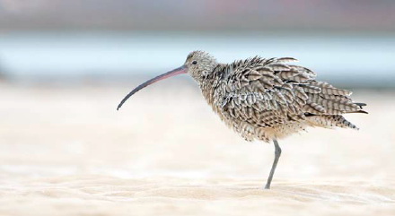
Figure 61: Great Knot (Calidris tenuirostris) (Chris Purnell)
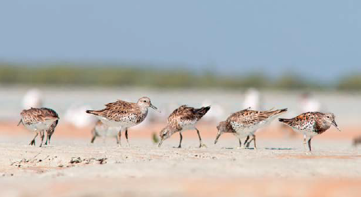
The Shoalwater and Corio Bays Area Ramsar site provides feeding and roosting for at least 77 waterbird species, including substantial numbers of migratory shorebirds (26 species). The site supports over 20,000 waterbirds in summer and a number of migratory bird species protected under international conservation agreements have been recorded at the site. The site has been identified as being of international importance to the migratory Eastern Curlew (Numenius madagascariensis), Whimbrel (Numeniusphaeopus) Bar-tailed Godwit (Limosa lapponica ssp. baueri), Terek Sandpiper (Xenus cinereus), Grey-tailed Tattler (Tringa brevipes) and Australian Pied Oystercatcher (Haematopus longirostris). A range of other wetland birds and shorebirds feed and breed in the area.
The Shoalwater Bay area has been gazetted as a Defence Practice Area under the Defence Act 1903, and is used primarily for defence activities. Corio Bay is part of Queensland’s Byfield National Park used primarily for conservation and recreation activities. The area is part of the traditional lands of the Darumbal people. The dune fields contain archaeological sites including shell middens, scatters of stone tools and dinner camp sites.

Eighty-mile Beach, Western Australia
Each year hundreds of thousands of migratory birds use northern Western Australia as a stopover point on their northward and southward migration.
Ramsar designation: 7 June 1990
EAAFP Flyway Site designation: 4 March 2013
Location: Between Port Headland and Broome in northern Western Australia
Size: 175,487 hectares
Key sites: Bar-tailed Godwit, Red Knot, Great Knot, Red-necked Stint, Sanderling, Sharp-tailed Sandpiper, Curlew Sandpiper, Eastern Curlew, Common Greenshank, Grey-tailed Tattler, Terek Sandpiper, Ruddy Turnstone, Little Curlew, Greater Sand Plover, Oriental Plover, Grey Plover, Oriental Pratincole, Caspian Tern

Eighty-mile Beach Ramsar Site is comprised of two separate areas, Eighty-mile Beach extending 220 kilometres along the coastline from Cape Missiessy to Cape Keraudren and the adjacent intertidal mudflats of Mandora Salt Marsh 40 kilometres to the east.
Figure 62: Eighty Mile Beach Ramsar Wetland, Western Australia (Department of the Environment and Energy
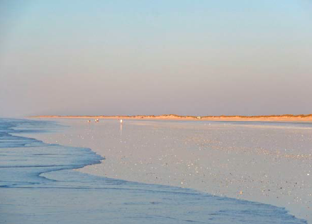
Eighty-mile Beach includes extensive white sand beaches, tidal mudflats, sand dunes and the most inland occurrence of mangroves in Western Australia. Mandora Salt Marsh contains peat deposits estimated to be about 7,000 years old and contains one of only two inland mangrove communities in Australia.
Mound springs from water deep within the Broome sandstone aquifer rises through fractures in the rock, resulting in permanent mostly fresh surface water that supports unusual plant assemblages. The permanence of these freshwater wetlands makes them extremely important to biodiversity in the arid area, providing habitat and drinking water in an otherwise dry environment.
Figure 63: Mixed flock of migratory shorebirds (Chris Purnell)
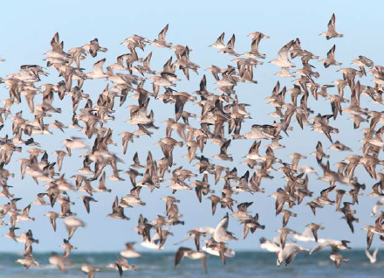
Eighty-mile Beach is part of the East Asian — Australasian Flyway Network and contains the most important wetland area for shorebirds in Australia. The site supports up to 336,000 birds, and is considered to be the most important site in Australia for migratory shorebirds on their southward migration between August and November each year. In addition, there is a record of 2.88 million Oriental Pratincoles (Glareola maldivarum) on the beach in February 2004.
Eighty-mile Beach is used for recreation including four-wheel driving, motorcycling, fishing and shell collecting. Mandora Salt Marsh is mainly used for cattle grazing. The site is traditionally part of Karajarri Country in the north, Nyangumarta Country in the south and Ngarla Country in the southern end of Eighty-mile Beach.

Roebuck Bay, Western Australia
It is the fourth most important site for shorebirds in Australia in terms of absolute numbers and the most important in terms of the number of species it supports in internationally significant numbers.
Ramsar designation: 7 June 1990
EAAFP Flyway Site designation: 4 March 2013
Location: Immediately east of the town of Broome, Western Australia
Size: 34,119 hectares
Key species: Bar-tailed Godwit, Black-tailed Godwit, Red Knot, Great Knot, Red-necked Stint, Curlew Sandpiper, Sanderling, Eastern Curlew, Little Curlew, Whimbrel, Common Greenshank, Grey-tailed Tattler, Terek Sandpiper, Ruddy Turnstone, Asian Dowitcher, Greater Sand Plover,
Oriental Plover, Lesser Sand Plover, Grey Plover

The Roebuck Bay Ramsar site is located near Broome in north-western Australia. Roebuck Bay has a very large tidal range which exposes around 160 square kilometres of mudflat, covering most of the Ramsar site. Waters more than 6 m deep at low tide are excluded from the site. The eastern edge of the site is made up of microscale linear tidal creeks.
The site receives tidal seawater as well as fresh surface and groundwater, and the balance between the two influences the residual groundwater salinity and the distribution of plants and animals. Mangrove swamps line the eastern and southern edges of the site, and extend up into the linear tidal creeks. They are important nursery areas for marine fishes and crustaceans, particularly prawns.
The intertidal mud and sand flats support a high abundance of bottom dwelling invertebrates, which are a key food source for waterbirds. The site is one of the most important migration stopover areas for shorebirds in Australia and the East Asian Australasian Flyway. For many shorebirds, Roebuck Bay is the first Australian landfall they reach on southward migration.
Figure 64: Mixed flock of Bar-tailed Godwits (Limosa lapponica) and Great Knots (Calidris tenuirostris) flying off the beach at the Broome Bird Observatory, Roebuck Bay (Georgina Steytler)
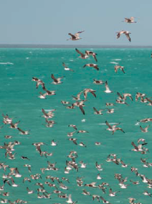
The total numbers of shorebirds using the site each year is estimated at over 300,000. The northern beaches and Bush Point provide important high tide roost sites.
Figure 65: Coastal rocks of the Roebuck Bay wetlands area in the early morning light (Department of the Environment and Energy)
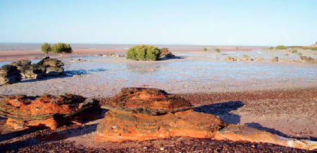
Figure 66: Close up of the ancient rock formations of the Roebuck Bay wetland area near Broome (Department of the Environment and Energy)
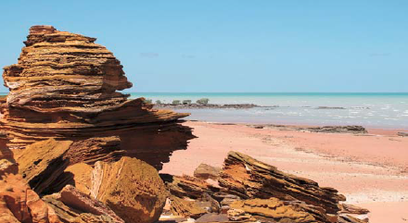
The site is used for recreational or tourism activities such as fishing, crabbing, sightseeing and bird watching. Broome Bird Observatory, a small reserve at the northern end of the site, engages in shorebird research and public education. Research conducted at Roebuck Bay has greatly expanded our knowledge on migratory shorebirds, their population trends and migration.
Roebuck Bay lies in the traditional estate of indigenous people belonging to both Jukun and Yawuru groups. The site was an important area for seasonal meetings, exchanging gifts, arranging marriages and settling disputes. Numerous shellfish middens, marking former camping places, can still be seen along coastal cliffs and dunes. Indigenous people continue to make extensive use of Roebuck Bay’s natural resources for activities such as gathering shellfish, fishing and hunting.

South-East Gulf of Carpentaria: Karumba Smithburne (Delta Downs), Queensland
The site, managed by the Kurtijar People, supports the highest density of migratory shorebirds in the South-East Gulf of Carpentaria shorebird area.
Ramsar designation: Not designated as a Ramsar site
EAAFP Flyway Site designation: 24 December 2014
Location: Immediately north of the township of Karumba.
Size: 20,000 hectares
Key species: Great Knot, Red Knot, Black-tailed Godwit, Eastern Curlew, Greater Sand Plover

The larger South-East Gulf of Carpentaria shorebird area is a near-continuous area of waterbird habitat extending for about 350 km along the Gulf coast. The nominated site comprises one of the most important sections of the larger South-East Gulf of Carpentaria shorebird area, with high densities of migratory shorebirds, and includes extensive intertidal mud and sand flats backed by mangroves, bare salt flats and some shelly beaches.
Over 20,000 migratory shorebirds of at least 20 species feed and roost in the site, and some travel on to south-eastern Australia and also to New Zealand. The site supports internationally important numbers of Red Knot (Calidris canutus), Black-tailed Godwit (Limosa limosa) and Greater Sand Plover (Charadrius leschenaultii); it also supports substantial numbers of two globally threatened species: the Eastern Curlew (Numenius madagascariensis) and Great Knot (Calidris tenuirostris). Additionally, the site supports many other waterbirds such as terns and herons, some known or suspected to be migratory.
Figure 67: View of Delta Downs coastline (Roger Jaensch and CLCAC)
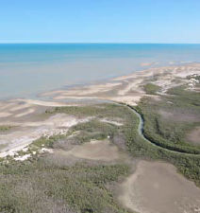
The climate is hot (often over 30° C) and humid with high rainfall in summer-autumn (December — April) but with little or no rain in other seasons and slightly cooler temperatures. The area is subject to cyclones (on average about one or two per year); wind and storm surges with the cyclones may cause significant but small-scale changes to coastal landforms.
The Kurtijar Aboriginal (indigenous) people maintain connections to the site through their cultural traditions, operation of a cattle-raising enterprise on Delta Downs and other visitations. The Kurtijar and other Aboriginal people of the region have strong spiritual associations with the Gulf coastal country and continue to harvest some of its plant and animal resources. These values are reinforced through activities of the Normanton Land and Sea Rangers, a program of the Carpentaria Land Council Aboriginal Corporation (CLCAC), and through educational programs in local schools.

South-East Gulf of Carpentaria: Nijinda Durlga (Tarrant), Queensland
The site comprises a portion of the Nijinda Durlga Indigenous Protected Area as well as adjacent marine waters.
Ramsar designation: Not designated as a Ramsar site
EAAFP Flyway Site designation: 7 October 2016
Location: Approximately 30 km north of the township of Burketown
Size: 40,000 hectares
Key species: Great Knot, Red Knot, Bar-tailed Godwit, Curlew Sandpiper, Eastern Curlew, Greater Sand Plover, Lesser Sand Plover

The site comprises an important section of the larger South-East Gulf of Carpentaria shorebird area, with two major roosts of migratory shorebirds, and includes extensive intertidal mud and sand flats backed by mangroves, bare salt flats and some shelly beaches. The length of coastline included in the site is approximately 38 km and the site lies between Tarrant Point and Kangaroo Point but excludes both.
The catchment area is part of the Gulf Plains bioregion, is flat to gently-sloped and is traversed by numerous creeks and rivers, many of which split into diverging (in some cases re-joining) channels as they pass through broad alluvial plains before reaching the coast. Large quantities of sediment sourced inland are deposited in and near the site by Gulf Plains Rivers. Mangroves help stabilise the sediment and protect the coast from impacts of storms and cyclones.
Over 6,000 migratory shorebirds of at least 16 species feed and roost in the site, and based on leg flag re-sightings in other parts of the South-East Gulf, some presumably travel on to south-eastern Australia and/or to New Zealand. The site supports internationally important numbers of Great Knot (Calidris tenuirostris), as well as substantial numbers of several threatened species: Eastern Curlew (Numenius madagascariensis), Curlew Sandpiper (Calidris ferruginea) and Great Knot (all listed critically endangered in Australia); Red Knot (Calidris canutus) and Lesser Sand Plover (Charadrius mongolus) (endangered in Australia); and Greater Sand Plover (Charadrius leschenaultii) and Bar-tailed Godwit (Limosa lapponica baueri) (vulnerable in Australia). Additionally, the site supports many other waterbirds such as terns and herons.
The Indigenous Gangalidda and Garawa Peoples maintain connections to the site through their cultural traditions and other visitations. The Gangalidda and Garawa and other Aboriginal Peoples of the region have strong spiritual associations with the Gulf coastal country and continue to harvest some of its plant and animal resources. These values are reinforced through activities of the Gangalidda and Garawa Land and Sea Rangers, a program of the Carpentaria Land Council Aboriginal Corporation, and through educational programs in local schools.
European association with the site has been limited, partly because there is no all-weather road access to the site and access on unformed tracks only briefly in the dry season. Fishing activities in the site occur seasonally, including recreational and small-scale commercial fishing.
Figure 68: Aerial view of the Gulf of Carpentaria coastline (Department of the Environment and Energy)
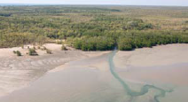

Adelaide International Bird Sanctuary, South Australia
The mosaic of marine, coastal, inland and man-made habitats provide important feeding and roosting areas for migratory waterbirds, particularly shorebirds.
Ramsar designation: Not designated as a Ramsar site
EAAFP Flyway Site designation: 16 December 2016
Location: North of Adelaide, extending to the Upper Gulf St Vincent
Size: 37,069 hectares
Key species: Curlew Sandpiper, Sharp-tailed Sandpiper, Red Knot,
Eastern Curlew, Bar-tailed Godwit, Red-necked Stint, Whiskered Tern

Figure 69: Birdwatching is a popular activity at the Adelaide International Bird Sanctuary (Narelle Montgomery)
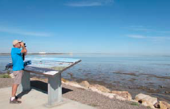
Figure 70: Bar-tailed Godwit (Limosa lapponica) (Chris Purnell)
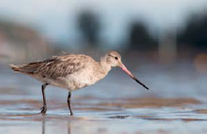
The Adelaide International Bird Sanctuary, also known as the Samphire Coast, is a highly productive and ecologically significant ecosystem. The mosaic of marine, coastal, inland and man-made habitats provide important feeding and roosting areas for migratory waterbirds, particularly shorebirds. These habitats include: expansive tidal flats, mangrove forests, seagrass meadows, tidal saltmarshes, salt evaporation pans, artificial stormwater detention wetlands and effluent water treatment ponds and a seasonal freshwater lake.
This area supports nationally and internationally significant numbers of migratory and resident shorebirds. At least 52 shorebird species, including 37 migratory species, have been recorded in the Adelaide International Bird Sanctuary area.
In addition to its value to shorebirds, the Adelaide International Bird Sanctuary is important habitat for many other coastal birds and seabirds, including the Samphire Thornbill (also known as Slender-billed Thornbill (Acanthiza iredalei), Elegant Parrot (Neophema elegans), Rock Parrot (Neophema petrophila), Little Egret (Egretta garzetta) and Fairy Tern (Sternula nereis).
The Adelaide International Bird Sanctuary is part of the EPBC-listed (Environment Protection and Biodiversity Conservation Act 1999) subtropical and temperate coastal saltmarsh threatened ecological community, and contains the largest area of critical habitat for the nationally vulnerable Bead Samphire (Tecticorniaflabelliformis). It also supports many regionally significant species, including coastal-dependent reptiles and rare butterflies.

Ashmore Reef Commonwealth Marine Reserve
It is the largest of only three emergent oceanic reefs present within the north-eastern Indian Ocean, and is the only oceanic reef in the region with vegetated islands.
Ramsar designation: 21 October 2002
EAAFP Flyway Site designation: 16 December 2016
Location: North-eastern Indian Ocean
Size: 58,3000 hectares
Key species: Sooty Tern, Crested Tern, Bridled Tern, Common Noddy,
Brown Bobby, Lesser Frigatebird, Bar-tailed Godwit, Common Greenshank, Grey-tailed Tattler, Ruddy Turnstone, Sanderling, Grey Plover, Greater Sand Plover

Ashmore Reef is the region’s largest emergent reef. The Reserve contains two extensive lagoons, extensive mobile channelled carbonate sand flats, shifting sand cays, an extensive reef flat, and a number of vegetated islands — East, Middle and West Islands (total land area ~55 ha).
Figure 71: Flock of mixed terns (Department of the Environment and Energy)
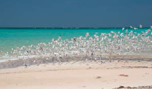
Figure 72: Brown Boobies (Sula leucogaster) (Department of the Environment and Energy)
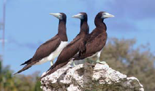
The Ashmore islands are regarded as supporting some of the most important seabird colonies on the North West Shelf, Australia. It has been estimated that the Reserve supports in the order of 100,000 breeding seabirds of 16 species and four heron species. Large colonies of Sooty Tern (Sterna fuscata), Greater Crested Tern (Sterna bergii), Bridled Tern (Sterna anaethetus), Common Noddy (Anous stolidus), Brown Booby (Sula leucogaster) and Lesser Frigatebirds (Frigata ariel) breed on the islands. Smaller breeding colonies of Black Noddy (Anous minutus) and Lesser Noddy (Anous tenuirostris) also occur on the islands.
The Reserve provides important habitat for many migratory shorebirds that use the Reserve’s islands and sand cays as feeding and resting areas. Flocks of migratory shorebirds at the Reserve have been estimated to total on occasion at least 18,000 birds. Thirty species of migratory shorebird have been recorded on Ashmore Reef. Bar-tailed Godwit (Limosa lapponica), Common Greenshank (Tringa nebularia), Sanderling (Calidris alba), Grey Plover (Pluvialissquatarola), Greater Sand Plover (Charadrius leschenaultii), Grey-tailed Tattler (Tringa brevipes) and the Ruddy Turnstone (Arenaria interpres) have been recorded using the Reserve in numbers of international significance (more than 1% of the East Asian — Australasian Flyway population). A number of these migratory shorebirds are listed threatened under national environmental law: Curlew Sandpiper (Calidrisferruginea), Eastern Curlew (Numenius madagascariensis), Great Knot (Calidris tenuirostris) and Red Knot (Calidris canutus).

Pulu Keeling National Park
The site regularly supports more than 30,000 pairs of Red-footed Booby; up to 15,000 Common Noddy and 3,000 Greater and Lesser Frigatebirds.
Ramsar designation: 17 March 1996
EAAFP Flyway Site designation: 6 January 2017
Location: North-eastern Indian Ocean, 3,685 km west of Darwin
Size: 2,602 hectares
Key species: Red-footed Bobby, Greater Frigatebird, Lesser Frigatebird, Common Noddy

The Cocos (Keeling) Islands are a group of 27 coral islands forming two atolls 24 kilometres apart and located 2,900 kilometres northwest of Perth in the Indian Ocean. North Keeling Island, with an area of just 1.2 square kilometres, is part of the Cocos Islands. The Ramsar site includes the marine area surrounding the Island along with the terrestrial area of North Keeling Island, matching the boundary of Pulu Keeling National Park.
As an island atoll in its most natural state, North Keeling is a significant biological resource and is internationally important for the conservation of biodiversity. The Ramsar site is one of the few remaining islands where rats have not yet been introduced, and is generally unaffected by feral animals.
The island has a tall forest of pisonia, coconuts, an extensive stand of ironwood, pemphis, and endemic pandanus, amongst other species.
The Ramsar site is also an internationally significant seabird colony. Fifteen species of birds recorded on the Island are listed under international migratory bird agreements and 15 seabird species use the atoll for nesting. The breeding colony of the dominant bird species, the Red-footed Booby (Sula sula), is one of the largest in the world. It is also the main locality of the endemic Cocos Buff-banded Rail (Hypotaenidia philippensis andrewsi).
The island is home to a number of crabs including the Robber Crab (Birgus latro) and Red Crab (Gecarcoidea natalis). Green Turtles (Chelonia mydas) also occasionally nest on North Keeling Island. Some 525 fish species are recorded from the Cocos Islands, including the angelfish, which has only been recorded from these islands and Christmas Island. There are no mammals on the island, although marine mammals visit the surrounding waters.
The Cocos (Keeling) Islands were not inhabited until 1825, although their existence was known of prior to this. The islands were the only coral islands visited by Charles Darwin in 1836, and were a key feature in the development of his theory of coral reef formation. The wreck of the SMS Emden, a WWI German battleship, is off the southern side of the island and is a protected site.
Current use of the Ramsar site includes scientific research, and tourism activities such as scuba diving, snorkelling and surfing.
Figure 73: Coastline view of North Keeling Island (Department of the Environment and Energy)
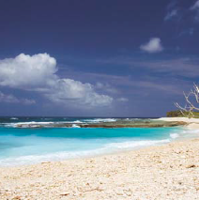

Nominating a new site to the Flyway Site Network

Benefits of being part of the Site Network
The Flyway Site Network has been operating since 1996 and provides the primary foundation for implementation of international cooperative efforts to conserve migratory waterbirds in the East Asian — Australasian Flyway.
Being part of the Flyway Site Network will give national and international recognition on sites of specially declared areas of migratory waterbird importance.
The Flyway Site Network can provide a mechanism for developing broader and more effective information and knowledge bases to assist Site Managers. This mechanism will give Site Managers opportunities for information, knowledge and practical experience that might not otherwise be available. Being part of the Flyway Site Network can also open up greater opportunities for Site Managers to seek funding to support conservation measures for their sites.
Participation in the Flyway Site Network provides an opportunity for encouraging greater local participation in conservation activities at the site. Local communities can contribute substantial effort and support for conservation and protection of the site. Community engagement in site conservation and sustainable management is essential if sites are to be managed in harmony with the values of both the environment and broader community needs.

Criteria for inclusion in the Flyway Site Network
To be considered for inclusion in the Flyway Site Network, the Partnership has adopted the following criteria:
a. Convention on Wetlands (Ramsar, Iran, 1971) criteria for internationally important sites modified for migratory waterbirds. That is:
i. Criterion 2: A wetland should be considered internationally important if it supports vulnerable, endangered, or critically endangered species or threatened ecological communities.
ii. Criterion 5: A wetland should be considered internationally important if it regularly supports 20,000 or more waterbirds.
iii. Criterion 6: A wetland should be considered internationally important if it regularly supports 1% of the individuals in a population of one species or subspecies of waterbird.
b. The staging criteria as applied under the Asia-Pacific Migratory Waterbird Conservation Strategy. That is:
i. A staging site should be considered internationally important if it regularly supports 0.25% of individuals in a population of one species or subspecies of waterbirds on migration.
ii. A staging site should be considered internationally important if it regularly supports 5,000 or more waterbirds at one time during migration.
c. Under exceptional circumstances a site can be nominated if it supports migratory waterbirds at a level or stage of their life cycle important to the maintenance of flyway populations. Justification of such nominations will be considered by the Partnership on a case by case basis.

Flowchart for nominating a new site
1. Local Government/Management Authority, NGO, non-governmental Partner, Governmental Partner
  - Identification of potential sites for the Network, by reviewing available data and determining which sites meet the Criteria
2. Local Government/Management Authority, NGO, non-governmental Partner, Governmental Partner
  - For the selected site, preparation of a Site Information Sheet (SIS) including a boundary map
3. Local Government/Management Authority
  - Consultation on site nomination at the local scale, with stakeholders including site mangers, management authorities and relevant organizations
4. National Government Partner
  - Consultation on site nomination at the state/ national scale with stakeholders including scholars and relevant authorities
  - Finalising the SIS and boundary map for the site nomination
  - Submission of SIS and map to the EAAFP Secretariat with a letter requesting that the site be included in the Network
5. EAAFP Secretariat
  - Secretariat conducts an in-house review, then refers the nomination to the Working Group chairs and/or at least three relevant experts
  - (for 14 days) to seek comments on the provided justification of the criteria met and other scientific aspects of the nomination.
6. EAAFP Secretariat & nominating Government Partner
  - Communication to finalize the SIS with further clarification or additional information as dictated by outcomes of the independent review.
7. EAAFP Chair
  - The Secretariat advises the Chair of the Partnership on the nomination, showing the results of the review process, and requests the Chair to endorse the nomination by writing formally to the nominating Partner about the official inclusion of the site in the Network.
8. EAAFP Secretariat
  - The Certificate of Participation for the new Network site is prepared and delivered to the nominating Partner at around the same time as the notification.
  - Notification to all Partners about the inclusion of the site in the Network
9. Government Partner & Local Government/ Management Authority
  - Announcement of the inclusion of the site in the Network
  - Delivery of the Certificate to the local government and/or management authority, with a small presentation ceremony where possible

Developing Sister Sites
The Flyway Site Network not only identifies and includes sites of international importance for migratory waterbirds to promote improved protection and management, but also aims to link those sites through sharing information and capacity building.
The EAAFP Sister Site Program brings together Flyway Network sites in different countries that share species to encourage increased awareness of their shared migratory waterbirds and link sites through collaborative activities to promote the conservation of these birds. It is designed to offer a better chance to be engaged with other sites in the Flyway Site Network to conduct collaborative research and monitoring on shared species and exchange information and experience, which is critical for site managers and decision makers to reinforce conservation action. Capacity building is an important element of sister site relationships and exchange visits can help site managers learn new and innovative approaches to different aspects of site management, from visitor centre development to participatory wetland management techniques.
The EAAFP encourages further cooperation between existing or potential Network sites. The present list may not include all the arrangements and diverse activities in place along the Flyway.

Table 1 Existing sister site arrangements and other collaborative activities involving Network sites in the East Asian - Australasian Flyway
Country | Local government or management authority | Site name
China | Dandong City | Yalujiang National Nature Reserve
Republic of Korea | Changwon City | Junam Reservoir
China | Qiqihar City | Zhalong National Nature Reserve
Australia | Brisbane City | Moreton Bay, Boondall wetlands
Australia | Newcastle City | Hunter River Estuary Wetlands
Republic of Korea | Suncheon City | Suncheon Bay
Japan | Nagoya City | Fujimae Tidal Flat
Republic of Korea | Seocheon County | Yubudo Tidal Flat
New Zealand | Pukorokoro Miranda Naturalist Trust | Firth of Thames
Japan | Osaki City, Miyagi Prefecture | Kejo-numa
Republic of Korea | Goyang City | Janghang Wetland Protected area
Japan | Narashino City Chiba prefecture | Yatsu-higata
Japan | Kushiro City, Hokkaido | Kushiro Wetland
Japan | Izumi City, Kagoshima Prefecture | Arasaki
Australia | Greater Geelong City | Swan Bay Tidal Flats
Singapore | National Parks Board of Singapore | Sungei Buloh Wetland Reserve

Figure 74: Aerial view of EAAFP125 South-east Gulf of Carpentaria: Nijinda Durlga (Tarrant) (Roger Jaensch and CLCAC)
