National Guidance on the Management of Whale and Dolphin Incidents in Australian Waters

© Commonwealth of Australia 2013

Copyright   
This work is copyright. You may download, display, print and reproduce this material in unaltered form only (retaining this notice) for your personal, non-commercial use or use within your organisation. Apart from any use as permitted under the Copyright Act 1968, all other rights are reserved. Requests and enquiries concerning reproduction and rights should be addressed to Department of Sustainability, Environment, Water, Populations and Communities, Public Affairs, GPO Box 787 Canberra ACT 2601 or email public.affairs@environment.gov.au

Disclaimer   
The views and opinions expressed in this publication do not necessarily reflect those of the Australian Government or the Minister for Sustainability, Environment, Water, Population and Communities.

While reasonable efforts have been made to ensure that the contents of this publication are factually correct, the Commonwealth does not accept responsibility for the accuracy or completeness of the contents, and shall not be liable for any loss or damage that may be occasioned directly or indirectly through the use of, or reliance on, the contents of this publication.

Image credit: Tasmanian Department of Primary Industries, Parks, Water and Environment

Executive summary

Australians have long recognised the importance of whales and dolphins (cetaceans) in our marine ecosystems. It is important that relevant jurisdictions around Australia are supported to deliver ‘best practice’ when preparing for, and responding to, cetacean incidents. This will help enhance the efforts to protect these animals across Australia into the future. For the purpose of this document, the term ‘incident’ refers to entanglement and stranding of cetaceans.

The information gathered in this document provides a series of ‘best practice’ principles to support cetacean conservation and management agencies, and help them to confidently face the challenge of managing whale and dolphin incidents.

It is acknowledged that local issues and particular operational circumstances require a localised approach. As such, the guidelines in this document are intended to be used in conjunction with local technical manuals and standard operating procedures and protocols.

This document was jointly developed by the Australian Government, the state and Northern Territory governments, and the New Zealand Government—who together have shared responsibility for cetacean conservation and management.

Special acknowledgement is extended to government officials from Western Australia for their guidance and knowledge in regard to disentanglement and euthanasia procedures, and to government officials from Tasmania and New Zealand for their knowledge and experience with mass strandings.

The guiding principles, highlighted at the beginning of each section, seek to establish current ‘best practice’ for the management of whale and dolphin entanglements and strandings.

Introduction

Australia’s oceans are home to at least 45 species of whales and dolphins that live in or migrate through our waters. Some of these species are permanent residents, while others are occasional visitors, migrating from their summer feeding grounds in the Antarctic to the warmer waters of the Australian coast during the winter.

Australians have long recognised the importance of whales and dolphins to our unique marine ecosystems, and believe that it is essential to ensure the survival of these mammals long into the future. Jurisdictions around Australia implement a range of conservation measures to protect whales and dolphins.

Despite these various conservation measures, whales and dolphins still become sick, injured, stranded or entangled. State and territory governments take an active and lead role in responding to such incidents. These responses are taken seriously and each jurisdiction is committed to the effective and efficient management of incidents when whales and dolphins are in distress.

The expert skill and knowledge of jurisdictional staff responsible for the management of these complex events as part of their routine activities has underpinned the development of the guidance document.

This document, National Guidance on the Management of Whale and Dolphin Incidents in Australian Waters, was developed jointly by all Australian, state and territory governments that have responsibility for cetacean conservation.

Aim of the guidance document

This document aims to:

* establish best practice guiding principles for the management of incidents where whales and dolphins are in distress. This includes situations where animals:
* are entangled in human made materials
* are stranded on the shore or entrapped in bays/lagoons and potentially unable to return to the ocean
* need palliative care or
* need to be euthanised as the most humane response option
* reinforce safety as the highest priority and ensure all people engaged in incidents act accordingly at all times
* ensure whales and dolphins, regardless of their condition, are treated with respect and care during these incidents to ensure their welfare is maximised
* establish a foundation for informing the public about best practice whale and dolphin incident response.

Role of the guidance document

This guidance document provides governments with an overarching framework to prepare for and respond to incidents involving whales and dolphins in distress.

It is acknowledged that local issues and particular operational circumstances require a localised approach. This document is not intended as a replacement for operational documents within jurisdictions (e.g. technical manuals or standard operating procedures) but for guidance in the future development or revision of these documents against a nationally agreed set of best practice principles.

An important guiding principle is the promotion of cross jurisdictional support for dealing with disentanglements and strandings. Sharing of information and resources (when needed) between jurisdictions is important in preparing for and managing the diverse range of incidents that can occur—particularly when these events take place over an extended period of time or where an animal travels across jurisdictional boundaries.

Whale and dolphin incidents

This guidance applies to whales and dolphins in distress (including when sick, injured, stranded or entangled). Managing these incidents is the responsibility of governments around Australia. For the safety of both people and animals, these incidents should only be responded to and managed by appropriately trained, experienced and authorised personnel.

Disentanglements

Whale and dolphin entanglements occur when an animal becomes entangled in debris or fishing nets, shark barrier nets, mooring lines, the ropes of lobster or cray pots, aquaculture equipment and monofilament fishing line. In these situations animals can either be free swimming or held statically in position by the entanglement. At specific times of the year, large whales often become entangled as they migrate along and near to the coast. Dolphins and small whales may become entangled at any time throughout the year and once entangled, can travel over great distances. In some instances animals have also been known to free themselves.

An entangled animal can develop serious health complications, such as infections and necrosis from lacerations, and become emaciated due to the effect of the entanglement on normal behaviour patterns.

Disentanglement is a process of deliberate intervention to free an animal. There are various methods for undertaking disentanglement.

Strandings

Stranding is usually a natural phenomenon that is not fully understood. A common view is that a stranding takes place when a whale or dolphin runs aground or becomes entrapped and is unable to return to open water.

There are numerous theories associated with strandings but in most cases the cause is unknown. Navigational error, unusual bathymetric or geographic features, impaired health, shipstrike and extreme weather events have been identified as possible factors that may cause an animal or a number of animals to strand. Social herding behaviour has also been identified as a contributing factor to mass stranding events.

There are many cases of successful rescues involving whales (particularly toothed) and dolphins. However, there are many cases when rescue has not been possible or successful, particularly incidents involving baleen whales, such as humpbacks, or larger toothed whales, such as sperm whales. Palliative care and/or euthanasia of animals is considered to be the most humane approach when rescue or rehabilitation is not possible.

Managing incidents

|  |
| --- |
| KEY GUIDING PRINCIPLES   * Human safety is the highest priority and is not compromised in order to respond to whales and dolphins in distress. All precautions are taken to protect people when responding to an incident. The incidents are often high risk environments. * The second priority for incident response is animal welfare. * Only experienced, authorised and appropriately trained personnel should engage in/manage whale and dolphin incident responses. They must be fit for work and have access to and use appropriate personal protective clothing and equipment. * Incidents should be fully evaluated and response requirements should be planned and implemented through an Incident Control System. * The public (including volunteer groups) should only participate in whale or dolphin incident responses under the supervision of the incident control officer or designated proxy. * Responses should be well considered and based on tried and proven techniques and professional judgement. Responses should not be influenced by uninformed public perception as the incident response plays out. * An approach limit of 300 metres to a live animal that is stranded, entangled or distressed should be upheld by the response agency for vessels not involved in the incident response. An approach limit of 30 metres should be upheld on the shore. * While a response is underway, unanticipated and known risks should be assessed on an ongoing basis and appropriate mitigation measures implemented. This may include the immediate suspension of the response. |

Occupational health and safety

There are a common set of issues that relate to the management of all whale and dolphin incidents. These issues include occupational health and safety, animal welfare, incident control systems, communicating and liaising with the media and the public (including volunteer organisations), cross jurisdictional support, specialist training and research to determine cause and to inform future management actions.

These issues vary depending on the complexity of the situation and can include a multiple large whale standing event within close proximity to a densely populated area, a heavily entangled animal accompanied by a calf, through to more simple situations where a single healthy animal is stranded between tides and requires very little attention. While tried and tested response practices can effectively support a rescue, response planning and preparation must have sufficient contingencies for unanticipated developments. Information sharing, timely networking and a philosophy of continued improvement is crucial to an effective response strategy.

Entanglements and stranding events can present a range of hazards to those involved in rescue and recovery operations. The animals are wild, powerful, unpredictable and, regardless of size, are capable of inflicting injury or death—particularly if harassed or when distressed.

The degree of risk to responders increases dramatically when the operational environment involves:

* unstable and unpredictable work platforms, such as vessels, surf zone
* an active or mobile and potentially powerful animal
* rope, line, net etc. entangling the animal
* a close encounter with a wild animal
* inclement weather and sea conditions.

Further, the risk of infection from whales and dolphins through airborne transfer or other bacterial contamination needs to be understood and addressed, particularly when dealing with an unhealthy or injured animal.

Any emergency response can present as a complex situation where challenging and dangerous situations can arise without notice. All persons that enter these environments have a duty of care to exercise safe work practices at all times in order to care for themselves and for those that they are working alongside.

Entanglements and stranding incidents are often considered to be emergency situations. Response actions, including the deployment of experienced, authorised and/or appropriately trained officers, the use of proper procedures and practices and the supply of appropriate safety gear (personal protective equipment and other specialist items), should significantly mitigate any risks.

While a response agency is expected to react in a timely way, this should not compromise the health and safety of response teams but be based on:

* a sound understanding of what is required in order to keep participants safe
* tried and proven safety procedure and practices, and most importantly
* a culture of safety consciousness throughout the response.

Without this approach there is an increased risk of failure to deliver the desired outcome of a successfully recovered animal without the injury or death of a response participant.

Each incident is unique and subject to a range of variables including:

* complexity of the incident (number and type of animals, location, nature of the problem)
* individual temperament of an animal and species
* level of training, experience and the capacity of the immediate response agency
* availability and suitability of equipment required to manage the situation
* operational environment—access to site, state of the sea, tides and weather
* availability and number of trained officers and volunteers.

Animal ethics and welfare

|  |
| --- |
| KEY GUIDING PRINCIPLES   * All response activities must be conducted in a manner that is consistent with ethical standards. This applies to all situations and for the entire duration of an incident—including when undertaking research (e.g. necropsies) and when disposing of a carcass following the administration of palliative care and/or euthanasia. * A decision to release an animal should be based on an assessment of the state (e.g. condition and circumstances) of the animal as being optimal for survival on release, whether release is logistically possible and that environmental conditions are suitable. * Stranded animals can, in some circumstances, be maintained ashore to provide an opportunity for their health to improve or the environmental conditions to become suitable for release. * Only in exceptional circumstances should animals be taken to specialised care facilities for rehabilitation. At no time should such animals be publicly displayed. * Allowing natural processes to take their course, combined with the provision of palliative care, is considered a reasonable response to a dying stranded animal. * In the event that euthanasia is proposed, it should be ensured that: * all other options have been considered * there is a safe working environment * the decision to euthanise an animal to terminate its suffering when death is imminent or inevitable is made by an expert (a suitably experienced veterinarian or an experienced marine mammal expert) * personnel are appropriately trained to undertake the necessary actions * there is appropriate supervision (a veterinarian or marine mammal expert). * Carcass analysis should include the collection of evidence to allow an assessment of shipstrike, bycatch or entanglement as a possible cause or contributing factor to the stranding. * Disposal of a carcass must be undertaken sensitively and professionally and in consultation with relevant stakeholders and local communities. * Disposal might not be required if site is remote and appropriate. |

Making well informed decisions to protect the welfare of whales and dolphins that are entangled, stranded or when they require palliative care or euthanasia is key to the successful implementation of an incident response. Animals in these situations are often in distress and should be treated with respect and care at all times—including post mortem.

The objective of any incident involving live animals is the successful release or recovery of the whale or dolphin. To do this an assessment of the state of health of the animal needs to be made. Circumstances, such as the poor health of an animal, unacceptable risk to human safety, poor environmental conditions (e.g. bad weather) or logistical constraints (e.g. remoteness, accessibility), may not make this possible. In these cases decisions will need to be made by the agency responsible for managing the incident as to the best course of action and can include:

* making a considered decision not to launch a detailed response. That is, let nature take its course
* monitoring the situation in order to respond when the situation improves
* rendering palliative care
* euthanising the animal.

When administering palliative care, euthanasia or dealing with the carcass of an animal, responders must remain sensitive to the welfare of the animal and to the emotional impact that any action may have on observers. This includes cases where there is a cultural link between a species and a local community. All actions must be consistent with ethical standards.

Incident control

|  |
| --- |
| KEY GUIDING PRINCIPLES   * All whale and dolphin incidents should be managed in a systematic way, using an incident control system that is appropriate to the prevailing circumstances—relevant factors include scale of the incident, location, species, complexity of incident, health and safety risks, availability of personnel and timing. * The standard control system used nationally is the Australasian Inter-Service Incident Management System (AIIMS). * At the commencement of an incident, an Incident Control System, including the appointment of an incident controller, should be implemented. * Volunteers who are working within the incident control system should be valued and recognised as integral to building the capability of a stranding or entanglement response. |

Many of Australia’s emergency response agencies use the incident control system structure of the Australian Inter-Service Incident Management System (AIIMS) for managing their response to an emergency situation.

Whale and dolphin incidents vary in complexity and any response must have the capacity to be varied to suit the circumstances. An incident control system is based upon a flexible but well understood organisational structure that can be scaled according to the size and complexity of the situation.

An incident control system aims (among other things) to:

* focus on objectives
* bring together incident response expertise
* provide a safe working environment for the welfare of people involved in the incident response
* effectively and efficiently control the incident
* ensure everyone involved in responding to the incident understands their role and the chain of command
* ensure effective communication is established and maintained.

This approach is most suited to the response requirements for whale and dolphin incidents, which require a safe working environment, sound incident control measures (including chain of command), appropriate communication protocols and adequate resource support.

The four main functions within an incident control system are:

Incident controller

An incident controller is responsible for the overall management of the incident and is appointed by the responsible government agency. The incident controller prepares objectives upon which subsequent planning will be based. It is the incident controller’s responsibility to approve an Incident Action Plan and assess all requests for personnel or resources.

Operations

A designated Operations Officer is established to deploy resources at the incident and is responsible for the control of operations in accordance with the Incident Action Plan.

Planning

A designated Planning Officer supports the incident by collection and analysis of incident information, forecasts outcomes, designates personnel and resources, develops strategies to manage the incident and prepares the Incident Action Plan.

Logistics

A designated Logistics Officer supports the incident, with the responsibility for services (first aid, food and fuel), materials, equipment and communications.

Figure 1 shows a generic incident control system structure with the four main functions. It is important to note that multiple roles within the incident control system can be filled by the same person depending on the complexity of the incident and their level of expertise. For cetacean incidents the structure requires input from a marine mammal expert.

Figure 1: Generic ICS structure

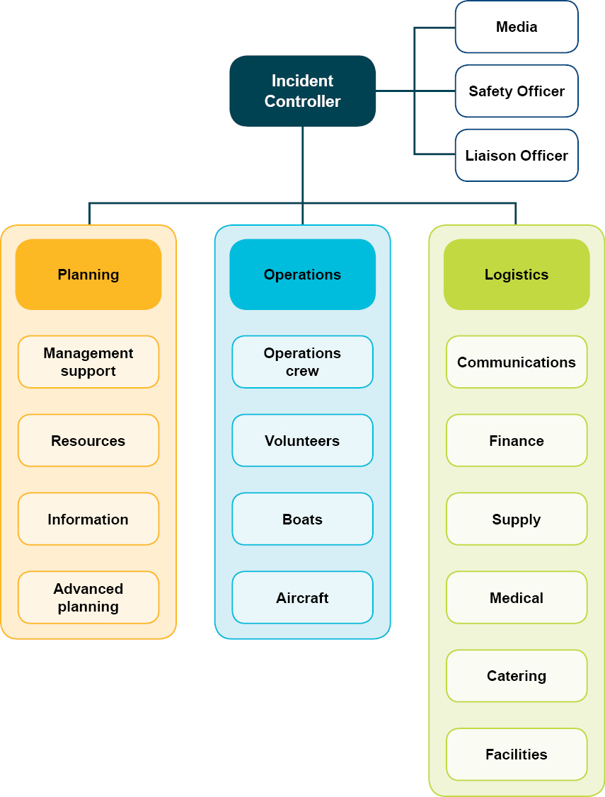

The public, volunteers and the media

|  |
| --- |
| KEY GUIDING PRINCIPLES   * Entangled or stranded whales or dolphins must be reported as soon as possible to the relevant government agency. * The public and volunteer organisations should never attempt disentanglement or to refloat a stranded whale or dolphin unless appropriate supervision or approved advice is available from the response agency. * Established government-media working relationships help to ensure that the public is accurately and regularly informed about incident responses. * Community engagement and targeted public and media education campaigns are important in raising awareness of cetacean incidents and rescue procedures. |

Whales and dolphins hold a unique place in the human imagination and attract significant public and media interest when they become stranded, entangled or found in a state of distress.

This interest can manifest in large numbers of media personnel, onlookers and volunteers gravitating to a whale or dolphin incident. As a consequence, incident responders need to be prepared to both manage such situations and, where appropriate, take advantage of the opportunities that they present.

The media can assist in communicating key response and conservation messages at critical phases of the response to numerous target audiences.

The public and volunteer organisations should only be involved in a large whale incident or a mass stranding when under the supervision of the agency responsible for managing the incident.

It is acknowledged that under some circumstances—for example, a person in a remote location encounters a small stranded dolphin—assistance may be rendered without agency supervision. However, any form of assistance must consider the risks to the person and to the welfare of the animal.

The public and volunteers

The importance of public involvement in an incident response should not be underestimated. The public, whether through formal volunteer organisations, as individuals or as a community group, can provide invaluable support to an incident response that may otherwise not be available. These can include “must do” but low risk activities, such as wetting down stranded animals, managing stores or assisting with catering services.

Public participation in any incident response must be consistent with the laws that prevail within the jurisdiction in question or at the discretion of the incident controller.

Active involvement of members of the public allows for effective information dissemination about the incident within the community. For example, when an incident takes place close to a small town, engaging the community can also generate an improved sense of community, build a greater understanding of incident response processes and improve public understanding of management decisions. Community involvement can build agency and community relationships that can contribute to cetacean conservation management in the future through activities, such as sightings data and incident reporting.

Public participation in an incident response must be managed with public safety as a priority over the rescue of an animal. Whales and dolphins can be extremely dangerous when in distress and can act aggressively and unpredictably, potentially creating dangerous situations for those in close proximity. Members of the public involved as volunteers must be made aware of these risks and of the response priorities, and have them reinforced throughout a response.

The media

The media often demonstrate a strong interest in any incident involving whales or dolphins. If cooperative arrangements are put in place, the media can play a valuable role for the response team by communicating key information on the status of the incident and the outcome to the public. This can be particularly important where the outcome is unlikely to be positive and a need exists to articulate the difficulty of the circumstances and foreshadow the likelihood of the death of the animal.

The media coverage that an incident receives will generally depend on the actions taken by the responsible agency, the scale of the incident, where it takes place and the type of animal involved. Where cetacean incidents are concerned, the public is highly vigilant and an event can also attract national and international audiences.

Through working closely with the media, response agencies can influence messages to not only provide newsworthy items in a timely way but also to minimise any inaccurate reporting and assist with incident management.

Cross jurisdictional support

|  |
| --- |
| KEY GUIDING PRINCIPLES   * Cross jurisdictional information sharing should be encouraged to support improved incident response management. * Formal cooperative arrangements between jurisdictions could enhance incident response confidence and capability. |

Cross jurisdictional cooperation and support in relation to whale and dolphin incidents is useful. As with other emergency response situations, there are benefits in establishing consistent response approaches, sharing information, and where necessary and logistically possible, sharing resources—hence the use of a national standard for emergency response, such as the Australian Inter-service Incident Management System.

Due to the unpredictable nature of whale and dolphin incidents, it is difficult for jurisdictions to be experienced and prepared for all types of events. Historically, Tasmania has more often dealt with mass strandings compared with the other states, who more typically respond to single strandings of large whales and entanglements.

As both human and cetacean populations increase, it can reasonably be assumed that there will be an increase in the frequency of adverse human-cetacean interactions. This will increase the demand on agency response resources and may test agency capacity to respond to new types of events.

Entangled animals may cross jurisdictional boundaries, requiring a response by more than one agency at different intervals or the pooling of resources to manage the incident across boundaries.

This suggests clear benefits in response agencies realising the efficiencies afforded by shared access to specialist resources.

Training—national standards for whale and dolphin incident response

|  |
| --- |
| KEY GUIDING PRINCIPLES   * All persons involved in or expected to become involved in whale and dolphin incident responses should hold nationally accredited competencies (for entanglements) or training appropriate to the tasks they are expected to undertake. * Members of an incident control system must be appropriately trained. * Adequate numbers of specialist trainers should share the training workload and all response agencies should hold the knowledge required to appropriately prepare for and respond to whale and dolphin incidents. * Training programs should include practical experience and opportunities to train with response agencies on incidents in other regions, jurisdictions or countries should be encouraged. * Opportunities to make available trained, qualified and experienced staff to other jurisdictions to assist with incident responses, training and mentoring should be explored. |

As with any emergency response program, relevant and effective training is important for safe and successful operations.

In order to effectively respond to potentially complex whale and dolphin incidents and to mitigate risks within potentially unpredictable and often remote operational environments, a broad set of skills, knowledge and experience is required.

Agencies currently require personnel to qualify under training programs that have existing national accreditation—for example, safety at sea, and vessel master qualifications. However, there are a number of activities such as strandings reponse training and large whale disentanglement training which is not nationally accredited. To ensure that training standards are consistent across jurisdictions consideration should be given to the further development of a set of core competencies for whale and dolphin incident response training which could be accredited under a national program.

A cetacean incident control team should comprise a combination of staff that have been trained in, and qualified under, the following:

* incident control system training
* marine mammal biology
* sample collection and curation
* large whale disentanglement training
* strandings response training
* boat handling
* first aid
* administration
* occupational health and safety
* public and media relations.

Accreditation of these key areas of expertise will improve capability across jurisdictions and provide an increased level of confidence that those involved in incident response are adequately trained, and able to carry out their duties to a set of preferred standards.

Research

|  |
| --- |
| KEY GUIDING PRINCIPLES   * Response preparation should include building the capacity of the response agency to gather information and collect samples when an incident takes place. * This includes having appropriate equipment on hand and staff trained in the use/deployment of this equipment. * Information to improve future incident responses should be recorded and shared to support continuous improvement by agencies, volunteers and the public. |

Responding to whale and dolphin incidents allows for the collection of data and information that is often otherwise not available through necropsies, biopsy samples and photographs. Such information can improve the way in which future incident responses are conducted and contribute to whale and dolphin conservation. The findings of sample analyses may improve understanding of factors contributing to the incident, and may help to identify a pattern of events that can inform management responses.

Benefits can also be accrued through the use of tracking devices on entangled animals to follow movement during the response and to provide immediate and longer term data in the event of a successful release. Tracking devices may also be deployed on animals released from strandings to monitor survival and behaviour post-release.

Techniques for dealing with incidents change and our understanding of whale and dolphin behaviour improves through incident response. While the tried and proven techniques should remain the foundation, the testing of the effectiveness and efficiencies of new procedures, techniques, equipment and reporting systems will continue to improve response capability.

Whale and dolphin incident hotlines

Whales and dolphins are highly mobile animals, capable of high speed and able to stay at depths for long periods of time. This often makes it difficult to maintain visual contact and, due to this, follow up action, such as reconnecting with the animals is difficult if not impossible. Timely, accurate information on location, direction and speed of entangled animals is therefore invaluable in assisting agencies to find the animals following a report and for them to respond with improved efficiency. Timely information is also critical when responding to live stranding events, increasing the chance of release and survival or limiting suffering.

There is a public expectation that relevant government agencies have the capacity to respond in a timely manner once an incident is reported, irrespective of the time. The hotlines listed on page 42 have been established to ensure that details of any incident can be passed to the relevant response agency in a timely manner.

Disentanglements

|  |
| --- |
| KEY GUIDING PRINCIPLES   * At no time, regardless of skill, knowledge or experience, should a person put themselves at risk by entering the water to attempt to disentangle a whale or dolphin, or by pulling attached entangled gear on board a vessel. * Entangled marine animals pose an extremely high risk of entangling personnel if in the water or if entangling material is taken on board a vessel. This is an extremely dangerous situation. * In the event of a person falling overboard, all operations should be suspended and attention diverted immediately to retrieve the person. |

Introduction

The incidence of whale and dolphin entanglements is increasing over time in Australian waters. A range of fishing gear and marine debris are the main cause of whales becoming entangled. An entangled animal can be at severe threat of injury or death.

As outlined previously, all measures must be taken to protect all persons who are involved in incident response. It must be continually stressed that the welfare of people takes priority over the rescue or release of an animal.

Each jurisdiction in Australia is committed to responding to an entanglement incident where it is deemed appropriate and Australia has well established protocols for dealing with entangled whales and dolphins.

An animal is suitable for disentanglement when the assessment officer is confident that the situation has been appropriately assessed and where it can be undertaken safely. International Whaling Commission criteria can be used as a basis for assessment and is found in the report from the Second International Whaling Commission Workshop on Large Whale Entanglement on the Commission’s website: [www.iwc.int/entanglement](http://www.iwc.int/entanglement). Each disentanglement operation is also influenced by factors such as location, weather (sea conditions) and other logistical considerations, such as the time required to deploy resources from another location. It is important to consider every incident on a case-by-case basis.

Prevention

|  |
| --- |
| KEY GUIDING PRINCIPLES   * Information sharing and cooperative arrangements between regulatory agencies, resource users and other interested stakeholders can help to mitigate the risk of whale and dolphin incidents. * Targeted public and media education campaigns can help raise awareness of the risks some human activities, marine debris and some marine infrastructure may pose to whales and dolphins. * Mitigation measures and strategies should be regularly reviewed and should be informed by appropriate research programs. |

The best solution to entanglement is prevention. Prevention avoids unnecessary harm to animals, removes the risk to the people involved in disentanglements and allows for resource deployment in other areas of cetacean conservation management.

These guidelines do not deal with the various approaches to prevention. However, cooperation between jurisdictions and relevant industries is encouraged to develop strategies and mechanisms to reduce and prevent entanglements.

There are a number of good examples where this kind of collaboration is happening with some success. The Victorian Southern Rock Lobster Code of Practice is available at: [www.oceanwatch.org.au/wp-content/uploads/2013/04/Rock-Lobster-VIC-COP_2013.pdf](http://www.oceanwatch.org.au/wp-content/uploads/2013/04/Rock-Lobster-VIC-COP_2013.pdf) ,and the Western Australian Rock Lobster Fishery Codes of Practice for Reducing Large Whale Entanglements is available at: [www.dec.wa.gov.au/management-and-protection/marine-environment/whales-and-dolphins.html](http://www.dec.wa.gov.au/management-and-protection/marine-environment/whales-and-dolphins.html)

The Environment Protection and Biodiversity Conservation Act (1999) Marine Debris Threat Abatement Plan also sets out a series of actions that could be undertaken to reduce the impact of marine debris on cetaceans. More information is available on the Australian Government Department of Sustainability, Environment, Water and Communities website at: [www.environment.gov.au/biodiversity/threatened/publications/tap/pubs/marine-debris-threat-abatement-plan.pdf](http://www.environment.gov.au/biodiversity/threatened/publications/tap/pubs/marine-debris-threat-abatement-plan.pdf)

While the cause of an entanglement is easily determined—for example, ropes or nets are evident—all entanglement responses should include an attempt to understand how and why the animal became entangled and what can be done to prevent a reoccurrence.

It is also considered important for government agencies to be kept aware of the whereabouts of marine debris and other potential risks that are observed within the marine environment. This will assist with preventing entanglements in the future. This is a key role of community groups and relevant marine based industries.

Preparedness

As with most operations, good preparation is the key to success. This is particularly the case when it comes to the effectiveness of responses to entanglement incidents. Effective disentanglement efforts rely on response teams being trained well in advance of any incidents, specialist equipment being on hand and maintained in a state of readiness, and resources available to be deployed quickly to increase the chance of survival of the animal or to limit its suffering.

Appropriate preparation for dealing with disentanglements includes the following steps:

* acquisition and maintenance of appropriate equipment and stores (and where necessary strategically locating these items)
* development of agreed standard operating procedures
* training and team building (including pre-season drills)
* maintenance of an information-sharing network.

Equipment

|  |
| --- |
| KEY GUIDING PRINCIPLES   * Sufficient stores and equipment should be held and maintained in a state of readiness to respond to entanglements promptly and efficiently. |

Responding to disentanglements requires a specialised range of equipment. Most, if not all, animals that are entangled are in the water. Response agencies require quick and easy access to suitably appointed vessels that are capable of navigating localised sea conditions and adequately accommodating response teams. More specialised equipment, such as ropes and floats for attaching to an animal to slow its movement, cutting equipment and tracking devices also need to be on hand.

The type/amount of equipment and stores, and where equipment and stores are located, will vary between agencies depending on resources, capacity to respond and areas of likely incidents.

Knowledge of where additional specialist equipment can be sourced is also useful in being prepared.

Standard operating procedures

|  |
| --- |
| KEY GUIDING PRINCIPLES   * Standard operating procedures should reflect procedures that are well established and effective. |

Agencies actively involved in cetacean incident response need to establish and maintain their own standard operating procedures or field manuals. These documents, which may vary depending on operational and policy requirements, ensure that all procedures practiced across a jurisdiction are practiced consistently where practicably possible. The procedures aim to maintain OH&S standards and build a response capability that is considered the most effective and efficient at that time.

In most instances, standard operating procedures that have been adopted within individual jurisdictions can be applied nationwide. However, as with any operational activity, there remains the need to allow for local flexibility. Depending on circumstances, it also remains important to continue to test new procedures and techniques as new challenges are identified and as new information comes to hand.

National disentanglements network

|  |
| --- |
| KEY GUIDING PRINCIPLES   * Information-sharing networks help to ensure that knowledge transfer and professional learning occurs on a regular basis and is ongoing. |

Established information-sharing networks are instrumental in facilitating informative and productive exchanges among agencies. They help to keep people informed of current activities and new developments. These networks can also be drawn upon—for their combined knowledge and experience—to help guide an active response, when needed.

The sharing of information is considered important to build capacity, improve current techniques, learn about new techniques and analyse case studies to review the management of incident responses. Information sharing is crucial within a continual improvement operational environment.

Entanglement response

While each entanglement is different, there are four broad stages to a response:

* initial reporting of the entanglement
* assessment of the incident to determine if disentanglement is an option
* the disentanglement response
* wrap-up.

These stages are illustrated in Figure 2 and discussed below.

Report of the entanglement

|  |
| --- |
| KEY GUIDING PRINCIPLES   * When an entanglement is first reported, sufficient information should be obtained to allow an appropriate initial response. |

On the receipt of a report that a whale or dolphin is entangled, the relevant government agency needs to manage a process to confirm the report. This will assist with making a decision to respond or not, and if a response is initiated, allow for the response to be enacted efficiently. The initial contact should gather as much information as possible including:

* caller’s details—including phone number
* time of sighting
* specific location of the animal—including landmarks or preferably latitude and longitude
* direction and speed of movement of the animal (if the animal is moving)
* swell and wind direction (if this can be determined/known)
* any information to help identify the species and the nature of incident—including a description of any line, rope, floats etc
* size and condition of the animal—for example, injured (type of injury), alive, dead or decayed
* whether digital photos or video are available
* accessibility of site—for example, boat ramps, marinas or jetties.

Depending on the source, official confirmation may only be possible through the deployment of agency resources, including vessel and/or aircraft. If the entanglement can’t be confirmed, then the situation should be monitored until a confirmation is received or a determination made for no further action.

Figure 2: Disentanglement approach

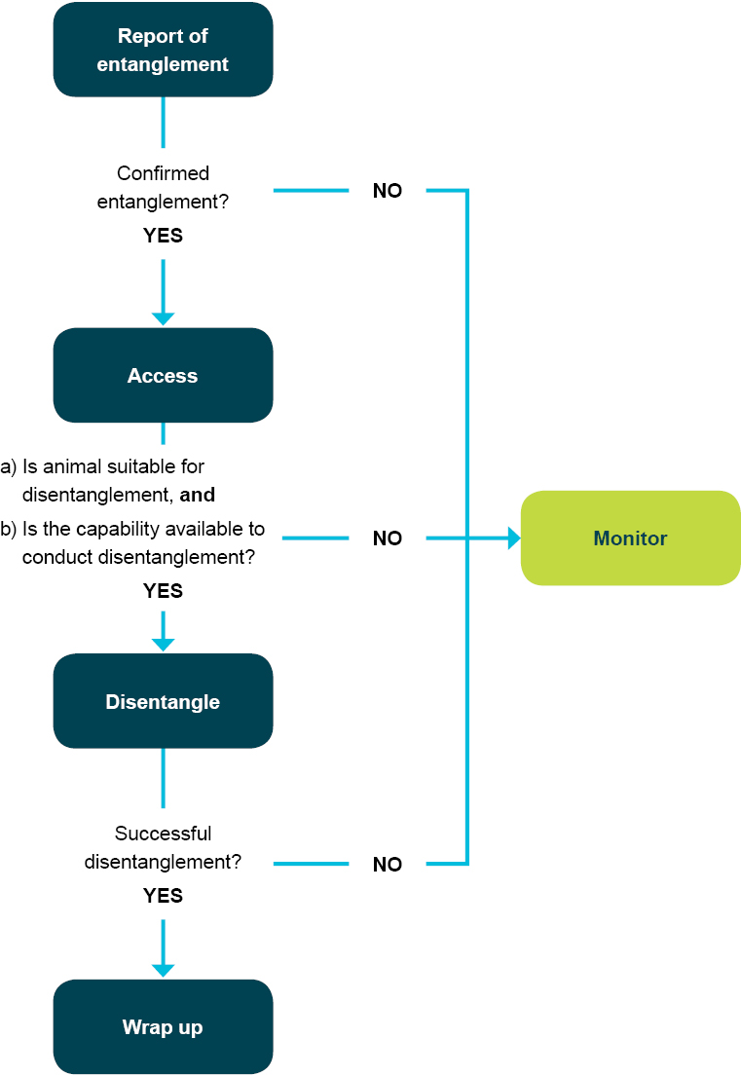

Assessment of the incident

In the case of a confirmed entanglement, the next stage is assessing the suitability of the animal for disentanglement and ensuring appropriate resources are available to conduct the disentanglement. If the animal is not suitable for release and the resources are not available, the situation should be monitored.

In determining the suitability of a disentanglement response, the following criteria (developed by the International Whaling Commission) can be used to assist with the decision making process:

* Consider the gear configuration and characteristics, including:
* the likelihood that the whale will shed the obstruction without intervention
* the type of obstruction—for example, rope, netting, monofilament line, long line with hooks or floats
* the amount of gear attached to the animal and how much is trailing
* is the whale or dolphin anchored or free swimming.
* Consider the potential impact on the population or stock:
* endangered status.
* What is the current impact of the entanglement on the health/wellbeing of the animal?
* Consider the potential of the entanglement to further impact the animal, including the:
* extent of the entanglement
* likelihood of the animals injuries becoming worse
* severity of the injuries
* age class of the animal
* effect of the entanglement on whale behaviour—for example, mobility and feeding
* presence of other animals—such as, a mother or calf, other adults or predators
* the location or time of year (is the animal likely to be fasting?)
* the animal’s reproductive status (is the animal pregnant or lactating?).

In addition to the animal being assessed as suitable for disentanglement, the capability of the agency to respond to the incident needs to also be assessed. The process can include:

* assessing the level of risk to those that would be involved in the operation including:
* identifying hazards
* estimating the likelihood of an adverse impact on a person
* considering the consequences—such as the extent of injury or death
* determining (from this) the degree of risk (risk rating)
* identifying any mitigation measures (may be more than one) that can be applied to reduce the risk rating
* assessing the new level of risk
* determining that the risk is at a level that the response (or that component of the response) can now go ahead.
* the availability of appropriately trained and qualified personnel
* the availability of other required resources—for example, vessels and specialist equipment
* the suitability of the environmental conditions to a response—for example, time of day, sea state, location and distance from shore.

If any of these requirements cannot be satisfactorily answered, disentanglement should not be attempted.

Disentanglement

|  |
| --- |
| KEY GUIDING PRINCIPLES   * Standard operating procedures and localised technical manuals and protocols should be followed. However, there must be sufficient flexibility to adjust responses to meet the requirements of individual incidents. * Risk assessment is a key element of any response strategy and risks should be reviewed, as required, throughout the response period. |

There are a wide range of variables that can apply to an entanglement incident. As mentioned, consideration must be given to the size of an animal, the complexity associated with the entanglement, whether the animals are anchored or free swimming and importantly the time of day.

Disentangling large animals, such as humpback whales and southern right whales, is substantially different to dealing with smaller animals. Large whales are extremely powerful—they can become entangled as they migrate and are often travelling quickly while entangled.

The process for disentangling large whales is often based around a technique called ‘kegging’. This process aims to slow the progress of the whale through accelerating fatigue, and to keep the whale at the surface for long enough to enable the disentanglement team to safely approach the whale and effectively remove the entanglement with minimum disturbance to the whale.

Managing agencies should refer to standard operating procedures and/or localised technical manuals when undertaking a response and seek expert advice when confronted with an extraordinary situation. Under certain circumstances it may mean that a response is not possible because it is unsafe and the rescue is aborted.

Monitoring

|  |
| --- |
| KEY GUIDING PRINCIPLES   * Rescued animals should be monitored, as far as practicable, to inform future incident responses and future research. * Samples and other material taken from animals should be collected and analysed to inform future compliance, education, conservation and research activities. |

Upon the successful completion of the rescue phase, the condition of the animal should, where possible, be monitored for as long as is necessary. This may mean following the animal, maintaining a reasonable distance of 100 m, where possible, for as long as weather/daylight permits or until the response team is satisfied that the animal is moving, breathing and behaving normally.

Satellite tracking of individuals to determine longer term success and validate response efforts is a useful tool and should be considered where the opportunity arises through research programs or the availability of tracking technology and equipment.

All material taken from the animal should also be analysed to determine its source and, if need be, held for a period of time to support any compliance investigations that might emerge.

Wrap-up and debrief

|  |
| --- |
| KEY GUIDING PRINCIPLES   * All incident responses should be documented and include a formal debriefing process to support continuous improvement on the part of response agencies. * Key lessons should be shared through information-sharing networks. * All incident responses should be fully documented and records kept securely. |

Regardless of whether the animal was released or not, all operations should be followed by a debrief to facilitate discussion and support for all involved, improve on future operations at a jurisdictional or incident control level and prepare to share information and experience through appropriate networks.

A wrap-up will provide an opportunity to assess the:

* level of preparedness of the responsible agency
* timeliness of the response
* usefulness of the equipment
* adequacy of staffing
* adequacy of response team’s skills base
* animals response behaviour
* overall process in general for the incident response
* procedures and equipment, in general, in order to determine if any changes can be made that could improve future responses.

Where possible, the disentanglement should be videoed for learning and record keeping purposes.

Following on from the response, the entangling gear should be examined to identify the type of gear and, potentially, the location where the animal was likely to have become entangled.

This information will be useful in improving prevention measures, identifying types of fishery gear that may lead to future entanglements and to develop techniques to reduce entanglement and/or assist in disentanglement activities. If it is suspected that the entanglement may have been as a result of non-compliant activity, the material should be retained to support any investigation and subsequent prosecution action. Documentation should be compiled during and after the event and include:

* the initial report
* the initial assessment
* incident report of the actions undertaken
* final outcomes
* images of the whale, including any identifying features such as callosity pattern, dorsal fin or flukes and the entangling gear
* lessons learnt (including safety issues) and recommendations for improvements.

Strandings

|  |
| --- |
| KEY GUIDING PRINCIPLES   * The public, including volunteer groups, should only participate in a whale or dolphin stranding response under the supervision of the incident control officer or designated proxy. * This can be within a formal incident control structure or through contact with the relevant agency where immediate public intervention is required—for example a simple single dolphin stranding in a remote location. * The response agency should implement an approach limit of 300 metres to a live animal that is stranded, entangled or distressed for vessels not involved in the incident response. An approach limit of 30 metres should be upheld on the shore. |

Introduction

While the most common form of stranding involves a single animal, often animals strand in large groups. Mass strandings within Australian waters usually involve toothed whales, such as pilot whales, dolphins, false killer whales and sperm whales.

The term stranding—also referred to as beach washed—can also be applied to an animal found dead either on shore or floating nearby.

Baleen whales, such as humpback and southern right whales, are particularly difficult to deal with in stranding situations. They are extremely large animals and almost impossible to move safely without harming the animal.

Mass strandings that involve large numbers of whales or dolphins also require a different approach to single small animal strandings, particularly when dealing with live animals. This usually requires the deployment of significant resources, which should initiate a more structured response to appropriately manage the event.

All stranding responses need to have sufficient flexibility to respond according to the situation. If this is not done effectively, the outcomes are likely to be either a failed attempt at rescue, or the consumption of resources that could otherwise be deployed elsewhere.

In some situations, palliative care and/or euthanasia of an animal is considered to be the most humane approach when rescue is not possible or practicable. Under these circumstances, it is considered important to undertake systematic sampling techniques to assist with identifying contributing factors that caused the stranding of the animal but also contribute to species conservation management.

Prevention

|  |
| --- |
| KEY GUIDING PRINCIPLES   * Information sharing and cooperative arrangements between regulatory agencies, resource users and other interested stakeholders can help to mitigate the risk of whale and dolphin incidents. * Targeted public and media education campaigns can help raise awareness of the risks some human behaviours, marine debris and some marine infrastructure may pose to whales and dolphins. * Mitigation measures and strategies should be regularly reviewed and should be informed by appropriate research programs. |

Whales and dolphins strand for a range of reasons and there is limited understanding about this phenomena. A lack of information about why an animal strands makes any attempt at preventing or predicting standings difficult, if not impossible, to achieve.

If an animal strands as a result of natural processes—that is poor health or impacts from predation—then it is reasonable to concede that nothing could have been done to prevent the event. At this point, a decision can be taken to let nature run its course, attempt a rescue or intervene through the application of euthanasia.

If it becomes likely that a stranding is imminent—that is, a sick animal within a pod that may lead otherwise healthy animals ashore as a result of the illness of one individual—then prevention may be possible through intervention.

Further, where the cause of frequent localised strandings becomes evident—that is, regular occurrence of propeller scars, internal injury/ haemorrhaging—then prevention measures should be explored and, where practicably possible, implemented. Measures can include targeted educational activity, designating shipping routes outside migration paths and/or the introduction of speed limits within critical habitat.

Prevention measures should include investing time into gathering information that will assist with determining the cause of death and an improved understanding of why the animal stranded.

Preparedness

Being prepared in advance of an incident is a critical component of any stranding response. To do so effectively, response teams must be trained in advance, specialist equipment should be maintained in a state of readiness and resources need to be deployed quickly in order to increase the chance of survival of the animal or to limit suffering.

Depending on demand across a jurisdiction, resources may need to be duplicated at key locations along the coast or at regional centres.

Alternatively, a core set of resources may be held more centrally with pre-arranged deployment capability, regardless of where the response is required. Appropriate preparation for dealing with stranding events includes the following steps:

* purchase and maintenance of equipment
* development of agreed standard operating procedures
* training
* liaison with vets
* consideration of tenure and access issues
* preparation for cultural issues
* establishment of a national strandings network.

Equipment

|  |
| --- |
| KEY GUIDING PRINCIPLES   * Sufficient stores and equipment should be held and maintained in a state of readiness to respond to strandings promptly and efficiently. * Response agencies should put in place arrangements to access heavy machinery and haulage equipment and marine equipment, such as vessels, when required. |

Responding to cetacean incidents can require a specialised range of equipment, which can include:

* personal protective equipment safety equipment for personnel
* purpose built trailers to move animals along beaches or to a more suitable release site
* heavy earthmoving equipment for creating artificial lagoons or for the purpose of carcass disposal
* 4WD vehicles and vessels to access coastal locations and move people to and from a remote site.

In most instances, more common items will be required, such as buckets and sheets to assist with maintaining the welfare of an animal or large numbers of animals. The number of sets of equipment and locations for storage will vary between jurisdictions depending on resources and likely areas of incidents. All equipment needs to be maintained in working order and be ready for deployment. Stores should be checked at the close of each incident response and replacements obtained where required.

Standard operating procedures

|  |
| --- |
| KEY GUIDING PRINCIPLES   * Standard operating procedures should reflect procedures that are well established and effective. |

Jurisdictions actively involved in cetacean incident response maintain their own standard operating procedures or field manuals that provide operational guidance throughout an incident response. They ensure that all procedures are practiced consistently across a jurisdiction where practicably possible and are usually based on tried and proven techniques. A primary objective of a standard operating procedure is to maintain OH&S standards for all employees and to build into an existing program a response capability that is considered the most effective and efficient at that time.

Depending on operational and jurisdictional policy requirements and the type of localised response demands, these manuals may vary in degree of complexity between jurisdictions.

For those states that are heavily involved in mass stranding responses, standard operating procedures are likely to be well advanced. Similarly, for those jurisdictions that are regularly responding to entangled whales, standard operating procedures are also likely to have evolved over time into comprehensive documents.

Ongoing information sharing will allow jurisdictions to evolve existing standard operating procedures such that they reflect best practice procedures that are applied consistently nationwide—notwithstanding the need to observe and cater for operational and jurisdictional policy requirements.

Liaison with vets

|  |
| --- |
| KEY GUIDING PRINCIPLES   * Communication with veterinarians experienced with cetacean incident management should be sought by the response agency as required and appropriate. |

Vets play an important role in providing guidance to response agencies about the health and welfare of animals. Their role can be either an overseeing role or they may be actively engaged in assisting the response. They are also considered an important contributor to the conduct of necropsies and in the coordination of other sampling efforts. They are able, and very often willing, to assist with rescue activities, undertake work on recently deceased animals and where practicably possible sample carcasses that are discovered on beaches.

While veterinary services are available in some parts of the Australian coast, there is currently a lack of vets with experience in marine mammal biology and sampling procedures. The availability of vets with specialist knowledge to assist with proper sampling and analysis will increasingly become a priority as demand for information continues to increase.

The information obtained may not only provide for improved handling of stranding events but may ultimately lead to an improved understanding of the reason behind strandings.

Other cetacean conservation oriented knowledge may also be gained as a result of sound sampling techniques such aspopulation dynamics through analyses of genetic material.

Consideration of tenure and access issues

|  |
| --- |
| KEY GUIDING PRINCIPLES   * Response agencies should work proactively with local communities, coastal land owners and local councils to allow access when strandings occur. |

Standings can occur anywhere along Australia’s vast coastline. Regardless of the specific characteristics of the stranding site, an effective response requires unimpeded access for the purpose of getting response equipment to the site and establishing a command and/or operational centre to support the response. In many instances, this will involve the use of private land or land held by parties not responsible for the stranding response.

When an animal either dies or is discovered dead, and cannot be left to deteriorate naturally or disposed of at sea, a burial is required.

If the animal is large, burial can only take place if the substrate is suitable for earthworks. This may also apply to a mass stranding where it is logistically difficult to relocate large numbers of dead animals. For smaller animals that can be easily transported, consideration should be given to the most appropriate burial site.

When an incident takes place on, or adjacent to, land or a marine area that is vested in the government for the purpose of conservation management—that is, a protected area—it can be reasonably assumed that a stranding response may impact on natural and/or cultural values that exist within these areas. As a consequence, protection measures need to be applied to prevent additional damage to the site as a result of the response.

Preparation for cultural issues

|  |
| --- |
| KEY GUIDING PRINCIPLES   * Aboriginal communities should be consulted and involved in stranding responses where this has been identified by the community in question as appropriate. * This requires a pro-active approach by response agencies to communities in areas where the likelihood of strandings or entanglements is high. |

Aboriginal communities have a long history with Australia’s marine and coastal environments. In many instances these communities still have an association with, or traditional ownership over, coastal lands and sea country and as a consequence remain actively involved in social activities, such as hunting, gathering and the conduct of ceremonies.

In acknowledging these cultural linkages, it is important that advice is sought from aboriginal communities and traditional owners on what the community requirements are in relation to any whale or dolphin incident response.

Aboriginal interests in cetacean incident response can vary depending on the cultural linkages that communities have with these animals. In some communities, members have totemic linkages with marine mammals. Response agencies are encouraged to actively consult with local communities to determine their level of interest in a stranding event. This will be particularly important if an animal requires euthanasia or burial and if so whether a ceremony is required.

Land access issues and community cultural needs and responsibilities should be considered either in advance of an event (if possible) or on a case-by-case basis.

National strandings network

|  |
| --- |
| KEY GUIDING PRINCIPLES   * Information-sharing networks help to ensure that knowledge transfer and professional learning occurs on a regular basis and is ongoing. |

Sharing information is important to build capacity, exchange experiences for managing stranding events, improve current techniques, learn about new techniques and analyse case studies to review the management of incident responses.

Established information-sharing networks such as the Disentanglement Network, have demonstrated the benefits that can be accrued through facilitating informative and productive exchanges among relevant agencies. These networks keep people informed of current happenings and new developments, and also play a key role in guiding real time active responses where the need exists to import knowledge and experience.

Strandings response

While each stranding event is different, there are three broad stages to a response:

* the initial response, which includes information gathering and validation of the incident
* a direct response, which can include release, transport, holding and rehabilitation, monitoring, palliative care or euthanasia
* the wrap up or debrief/s.

These stages are illustrated in Figure 3 and discussed below.

Figure 3: Strandings approach

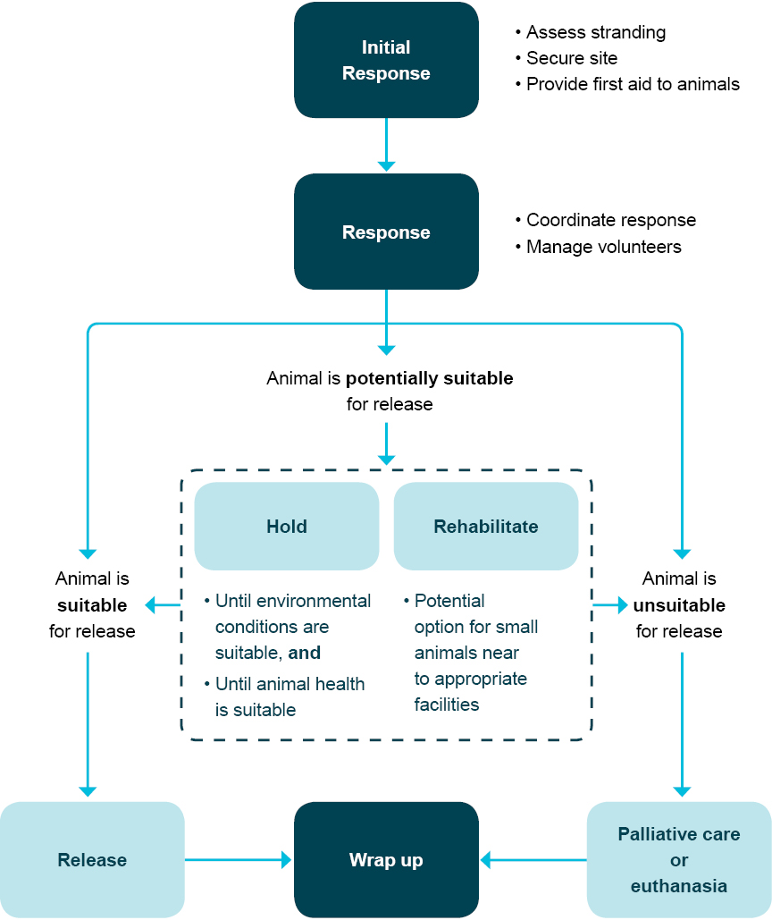

Initial response

|  |
| --- |
| KEY GUIDING PRINCIPLES   * When a stranding is first reported, sufficient information should be obtained to allow an appropriate initial response. * Risk assessment is a key element of any response strategy and risks should be reviewed as required, throughout the response period. |

On the receipt of a report that a whale or dolphin is stranded, the relevant government agency needs to manage a process to confirm the report. This will assist with making a decision to respond or not and, if a response is initiated, allow for the response to be enacted efficiently. The initial contact should gather as much information as possible, including:

* caller’s details—including phone number
* time of sighting
* location of the stranding—including landmarks or preferably latitude and longitude
* any information to help identify the species and the nature of incident, including number, type and condition of animals—that is,injured, alive, dead or decayed
* environmental conditions at the stranding site
* number of people (if any) present at the site
* whether digital photos or video are available
* accessibility of site—including vehicles and vessels, and land tenure.

Occasionally, official confirmation of the event and the stranding details may only be possible through the deployment of agency resources, such as vessel and/or aircraft.

Once formal confirmation is obtained and an incident control system is established, the incident controller must take control of the stranding site as soon as possible and undertake an analysis of the situation.

This process should include:

* assessing the site for danger to personnel, onlookers and the stranded animal/s
* scene evaluation—noting geography; weather conditions, including forecast, tidal movement and sea conditions; species of whale or dolphin involved, including particulars, such as size, condition, behaviour; number of dead and alive animals; where they are located and accessibility of site (land and sea).

Note: Information such as this is important to gather and disseminate as soon as can be practicably arranged, as it is critical in determining initial actions to take and to initiate planning for ongoing response activity.

* securing stranded animals so that further risk of injury and stress is minimised to the greatest extent possible
* applying first aid to stranded animals
* preventing any free-swimming animals close to the shore from stranding, if it is possible to do so safely
* instigating a search along the coast nearest to the stranding site to check for other animals that may be a part of the stranded group’s pod (if the event is a mass stranding) and monitor these animals to ensure that they do not strand
* monitoring and recording, as per details of scene evaluation above. This may include taking blood samples, and collecting information on pulse rates, respiration and behaviour of the stranded animals
* alerting media liaison and keeping informed.

Response

Strandings are complex incidents with many variables. However, in responding to a stranding there are three general scenarios that are often played out:

* Release of animals that are in suitable condition.
* Holding or rehabilitation (local, that is lagoon, and remote, that is, suitable rehab facilities) of animals that are potentially suitable for release, noting that this is usually only possible for small animals in some situations.
* palliative care or euthanasia of animals that are considered unsuitable for release.

|  |  |
| --- | --- |
| What to do for first aid: | What not to do for first aid: |
| * Keep the animals cool and shaded. * Cover with wet sheets and keep the animal wet by dousing with water, avoiding the blowhole. * Avoid loud noises and unnecessary movement and do not touch animals more than necessary to keep the animals as calm as possible. * Stay well clear of the mouth, tail and blowhole. * Keep the animal upright if possible. | * Do not put your safety or the safety of others at risk. * Do not stand close to the tail or head. * Do not cover the blowhole. * Do not pour water into the blowhole. * Do not touch the animal more than necessary—do not push or pull on the flippers, flukes or head. * Do not apply sunscreen, even if the animal’s skin is burnt. |

Release

|  |
| --- |
| KEY GUIDING PRINCIPLES   * Animals should be released where their health is good, the environmental conditions are suitable and there are sufficient people available to support their release. * Where possible, animals should be tagged (by the most appropriate method available) prior to release. * Post-release monitoring—for an agreed period of time—should be conducted where possible to check the welfare of the animal; allow for an immediate response, should there be a re-stranding, and monitor survival. |

Release of stranded animals should be attempted when the health of the animals is good, the environmental conditions are suitable and there are sufficient people available. The release of animals is more appropriate for toothed whales and dolphins. Large baleen whales—including calves—usually strand when sick or seriously injured. Attempting to move them or tow them out to sea invariably causes stress and may cause further, and more serious, injuries to the whale. In the case of a stranded calf, such as humpback or minke, due consideration must be given to the merits of attempting release, as it is highly unlikely that the calf will successfully reconnect with the adult female if forcibly returned to the sea. It is more likely that the calf will drown, re-strand or be attacked by predators.

In terms of health, animals are suitable for release when they are surfacing to breathe, able to swim, orientated, remain upright unassisted and are free of serious injuries. These animals should be maintained in the water until a release is feasible. In the case of a mass stranding, animals should be kept in groups if possible. Animals must be determined to be healthy by a suitably trained or experienced person, for example a marine mammal vet or an experienced marine mammal scientist/officer, prior to release.

When re-floated, a stranded whale or dolphin should be supported in order to keep its blowhole above water. After being immobilised on land, the animal is likely to have difficulty in swimming upright and may re-strand or asphyxiate, if not supported. After a long period ashore, it may need to be supported before it regains equilibrium and condition. Under some circumstances, and for small cetaceans, a range of manipulative techniques may be employed to assist with the animals’ recovery, such as gently rocking the animal.

For mass strandings, it is ideal to release animals as a cohesive group. Where this is not possible due to site specific conditions, individuals can be released sequentially. Manoeuvring animals, for example by boat, may be required to get the animals out to sea. This should be followed up with post-release monitoring to ensure animals do not re-strand.

Post-release monitoring

|  |
| --- |
| KEY GUIDING PRINCIPLES   * Rescued animals should be monitored, as far as practicable, to inform future incident responses and future research. * Samples and other material taken from animals should be collected and analysed to inform future compliance, education, conservation and research activities. |

Upon the successful completion of the rescue phase, the condition of the animal should, where possible, be monitored for as long as is necessary. This may mean following the animal, maintaining a reasonable distance of 100 m, where possible, for as long as weather/daylight permits or until the response team is satisfied that the animal is moving, breathing and behaving normally.

Satellite or other forms of tracking—roto-tags, livestock tags or even short-term marking with paint sticks—of individuals to determine longer term success and validate response efforts is a useful tool. This should be considered where opportunity arises through research programs or the availability of tracking technology and equipment.

Coastal searches of adjacent areas should be undertaken in order to detect instances of re-stranding—flights or land searches.

Holding and rehabilitation

|  |
| --- |
| KEY GUIDING PRINCIPLES   * Stranded animals are held to provide an opportunity for their health to improve or the environmental conditions to become suitable for release. * Only in exceptional circumstances should animals be taken to specialised care facilities for rehabilitation. At no times should such animals be publicly displayed. |

In some situations, the immediate release of stranded animals may not be possible. First aid and palliative care—used in this instance to alleviate pain and symptoms, without eliminating the cause—should be provided to maximise the chances of later release. This should include:

* maintaining the airways of animals and ensuring the blowhole is kept clear
* reducing the stress on animals by increasing support and buoyancy
* controlling dehydration, sun burn (do not apply sunburn cream) and hyperthermia
* minimising unnecessary stress to the animals.

One option for circumstances where conditions are not suitable for release is to hold the animals until a release is possible. Holding can be done at the stranding site or at an alternative site, such as calmer or deeper water, in the case of animals which are suitable for transport—that is, small enough to move safely. Holding provides the opportunity to maintain or improve the health and strength of animals, and for environmental conditions to improve. In certain circumstances, rehabilitation of small animals may be undertaken at specialised care facilities. This is an option when:

* it has been determined by an expert that there is a good chance that with proper care the animal can be restored to good health
* expert (whale and dolphin) veterinary care is available
* appropriate facilities are available and equipped for the species of whale or dolphin
* arrangements can be made to transport the animals safely and quickly, without adversely compromising the animals health
* sufficient funds are available to undertake the rehabilitation
* there is no intention that the animal is to be displayed for commercial purposes.

It should be noted that large animals, and in particular large baleen whales, are not suitable for rehabilitation due to their size and the logistical constraints associated with moving them safely and without harm. Large baleen whales most often strand when sick and/or in poor condition, which means they may not be suitable for release. These animals will be either subject to palliative care with natural death of the animal imminent or death through euthanasia.

Palliative care and euthanasia

|  |
| --- |
| GUIDING PRINCIPLES   * Allowing natural processes to take their course, combined with the provision of palliative care, is considered a reasonable response to a dying stranded animal. * A decision by an expert—a suitably experienced veterinarian or an experienced marine mammal expert—to euthanise an animal to terminate its suffering when death is imminent or inevitable is considered both reasonable and responsible. * In the event that euthanasia is proposed, it should be ensured that: * all other options have been considered * there is a safe working environment * personnel are appropriately trained to undertake the necessary actions * there is appropriate supervision (a veterinarian or marine mammal expert). |

In certain situations, the successful release of stranded whales and dolphins is not possible. It is the responsibility of the managing agencies of the incident to determine the best option to maximise the welfare of animals and to demonstrate the humane management of a stricken wild animal. The two options are palliative care where death is imminent or euthanasia.

Making a decision that rescue is not possible is a reasonable response. There are a set of both definitive and subjective criteria that managing agencies should consider in making the decision not to make a rescue attempt. These are:

|  |  |
| --- | --- |
| DEFINITIVE CRITERIA | SUBJECTIVE CRITERIA |
| * Disabling physical injuries—for example, dislocated or broken tailstock, wounds penetrating the thorax or abdomen or extensive deep lacerations to the body surface—or emaciation. * Copious haemorrhaging from the mouth, blowhole, genital opening or anus. * A rectal temperature of 42°C or above. * Severe blistering and sloughing or skin disease covering a large portion of the body surface. * Loss of reflexes—for example blowhole, eyelids, corneal, genital and tongue withdrawal. * Loss of jaw tone. * Protruding penis in males. * Animals having spasms. | * OH&S risk assessment concludes the risk to officers’ safety is too high. * Poor environmental conditions making rescue impossible. * Insufficient rescuers/resources. * Cost benefit analysis. |

The final decision to provide palliative care or to euthanise an animal should always be based on advice from an experienced veterinarian or marine mammal scientist/officer, with the overriding aim of ensuring the most humane approach is taken.

Once it is decided that euthanasia is required, it should be carried out as soon as possible to avoid prolonging the animal’s suffering. There are various options for euthanasia that may be used which have been endorsed by the International Whaling Commission and include:

* intravascular injection
* firearm
* implosion technique.

Deciding on which method is the most appropriate depends on the size of the animal, its location, availability of suitably qualified persons and the capacity of the managing agency.

Intravascular injection may be suitable for animals smaller than eight metres in length, but due consideration must be given to appropriate carcass disposal to avoid secondary poisoning issues. Euthanasia by firearm is also generally appropriate for animals smaller than six metres in length. The implosion technique is appropriate for adult baleen whales.

All techniques require suitably qualified persons and the implementation of approved safety standards. Relevant state, territory and Commonwealth laws will need to be observed prior to the conduct of euthanasia on a cetacean.

Data collection and disposal

Data collection

|  |
| --- |
| KEY GUIDING PRINCIPLES   * Information should be collected from stranding events to improve scientific understanding of stranding related deaths and cetacean health and ecology more generally. * Necropsies, if undertaken, must be carried out or overseen by an experienced cetacean veterinarian or by a suitably experienced marine mammal expert. * Response agencies should follow national protocols for the collection and storage of data and samples from stranded marine mammals. * Carcass analysis should include the collection of evidence to allow an assessment of ship strike, bycatch or entanglement as a possible cause or contributing factor to the stranding. * Sampling results must be reported to the responsible agency and should be shared within established strandings networks. |

There are various levels of information that can be collected from simple sampling to full necropsy. The incident controller should determine on a case-by-case basis the appropriate level of information to collect. This will often depend on the condition of the carcass, the location of the event, safety aspects and if an adequate level of expertise is available at the time.

When a necropsy is conducted, it is important to ensure that it is undertaken or overseen by experienced or qualified marine mammal experts. The Standardised Protocols for the Collection of Biological Samples from Stranded Cetaceans (2006) should be referred to when undertaking necropsies and can be downloaded from the Australian Government Department of Sustainability, Environment, Water and Communities website at: [www.environment.gov.au/coasts/publications/cetacean-protocols/index.html](http://www.environment.gov.au/coasts/publications/cetacean-protocols/index.html)

Where a full necropsy is not possible, sampling should be prioritised in the following order:

* data to inform cause of death
* disease and health issues
* contaminants
* biological samples for the condition of the animal
* other biological samples.

The data from necropsies and subsequent sampling should be stored in a central location and the results should be shared with both a strandings network and the veterinary network to build knowledge and capacity with regard to strandings, any associated incident and the ongoing conservation of the species.

Disposal

|  |
| --- |
| KEY GUIDING PRINCIPLES   * Disposal of a carcass must be undertaken sensitively and professionally and in consultation with relevant stakeholders and local communities. * Disposal might not be required if the site is remote and appropriate. |

Disposal of dead animals can be a difficult issue, particularly where the animals are large and difficult to transport or where in an inaccessible location. Options for disposal include burial, at sea disposal or letting natural processes, such as on site decomposition, take their course.

The decision about the most appropriate method of disposal will need to be made by the incident controller based on the particular circumstances. It is critical in this process that disposal is undertaken sensitively and professionally with continued respect for the animal—particularly taking into account the presence of onlookers and any cultural requirements.

Liaison with the local authorities, such as council; protected area management agencies, including marine parks if disposal at sea; indigenous groups and other land owners is essential prior to carcass disposal or leaving it in situ.

Prior to chemical euthanasia being undertaken, it is important that a proper disposal plan is established. Particular consideration must be given to appropriate burial of carcasses euthanised via intravascular injection to avoid secondary poisoning issues.

Wrap-up

|  |
| --- |
| KEY GUIDING PRINCIPLES   * All incident responses should be documented and include a formal debriefing process to support continuous improvement on the part of response agencies. * Key lessons should be shared through information-sharing networks. * All incident responses should be fully documented and records kept securely. |

All operations should be followed by a debrief to analyse the operation, acknowledge any successes and to improve on future operations. A debrief will provide an opportunity to discuss the:

* response team’s level of preparedness
* timeliness of the response
* usefulness of the equipment
* adequacy of staffing levels
* adequacy of the response team’s skills base
* animal’s response behaviour
* overall process in general for the incident response
* procedures and equipment, in general, in order to determine if any changes can be made that could improve future responses.

Where possible, the stranding response should be video recorded for learning purposes. A comprehensive stranding report should be produced, including the sequence of events, biological information collected and a summary of the stranding outcome. A video recording also significantly supports reporting arrangements and may be used to actually revisit the event in the future if required. Documentation should be compiled during and after the event and include:

* the initial report
* the initial assessment
* incident report of the actions undertaken
* final outcomes
* photographs of the whale, including any identifying features, such as dorsal fin or flukes, any injuries or other signs of distress
* sample register.

A storage and distribution system should also be established to ensure the protection of all documents and ensure that relevant response agencies are afforded the opportunity to learn from more recent experiences.

Conclusion

Responses to cetacean incidents are expected to increase in frequency as whale and dolphin populations increase. This includes pressures that arise through increased vessel traffic and as marine debris and other human made material continue to interfere with natural behaviours of cetaceans.

In order to minimise the impacts on individuals and populations, cetacean conservation management agencies and other stakeholders have a duty of care to respond effectively and timely when an incident is reported.

The key messages promoted through this guidance document include:

* the non-compromising requirement for safety to be foremost in the minds of response agencies and practiced accordingly
* as demonstrated through the existing disentanglement network, information-sharing networks should be utilised and supported
* support for cross-jurisdictional resource-sharing helps improve capacity and builds operational confidence
* all jurisdictions need to establish a high order of preparedness that can be followed by the execution of a systematic and timely approach to incident response.

Through the use of this guidance document, it is anticipated that cetacean incident response in relation to disentanglements and strandings will continue to improve and ultimately contribute to the ongoing conservation management of cetaceans in Australian waters.

|  |
| --- |
| Contact details  Whale and dolphin incidents should be reported to the relevant agency as soon as possible.  New South Wales Office of Environment and Heritage  Contact: (02) 9415 3333 www.environment.nsw.gov.au  Northern Territory Department of Natural Resources, Environment, The Arts and Sport:  Contact: 1800 453 941 www.nt.gov.au/nreta/  Queensland:  Contact: 1300 ANIMAL (1300 264 625)  South Australian Department for Environment and Natural Resources:  Contact: 1300 650 411 www.environment.sa.gov.au  Tasmanian Department of Primary Industries, Parks, Water and Environment:  Contact: 0427 WHALES (0427 942 537) www.dpipwe.tas.gov.au  Victorian Department of Sustainability and Environment:  Contact: 1300 136 017 www.dse.vic.gov.au  Western Australian Department of Environment and Conservation:  Contact: (08) 9474 9055 www.dec.wa.gov.au  Australian Government Department of Sustainability, Environment, Water, Population and Communities  [www.environment.gov.au/coasts/species/cetaceans/legislation/notification.html](http://www.environment.gov.au/coasts/species/cetaceans/legislation/notification.html)  Great Barrier Reef Marine Park Authority  [www.gbrmpa.gov.au/about-the-reef/animals/whales-and-dolphins](http://www.gbrmpa.gov.au/about-the-reef/animals/whales-and-dolphins) |