Commonwealth Environmental Water
2011–12 Business Plan

September 2011

Contents
1. Overview 5
1.1 About the business plan 5
1.2 Approach in 2011−12 5
2. Commonwealth environmental water−management and relationships 7
2.1 The Commonwealth Environmental Water Holder 7
2.2 The Environmental Water Branch 7
2.3 Organisational relationships 8
2.3.1 Environmental water partners 9
2.3.2 Department of Sustainability, Environment, Water, Population and Communities 9
2.3.3 Murray–Darling Basin Authority 9
2.3.4 Environmental Water Scientific Advisory Committee 10
2.3.5 Environmental Water Management Services Panel 10
2.4 Communications and stakeholder engagement 10
3. Water use 12
3.1 Statutory obligations 12
3.2 Management framework for the use of Commonwealth environmental water 12
3.2.1 Management framework 12
3.2.2 Active management 12
3.3 Decisions on the use of Commonwealth environmental water 13
3.3.1 Developing options for the use of water 13
3.3.2 Assessing potential actions 13
3.3.3 Seeking local and expert advice 13
3.3.4 Delivery arrangements 13
3.4 Environmental water delivery 13
3.4.1 Water shepherding 14
3.5 Cost sharing in water use 14
3.6 Monitoring and evaluation of the use of water 15
4. Portfolio Management 16
4.1 The holdings 16
4.2 Managing the portfolio 16
4.2.1 Maintaining the register 16
4.2.2 Administering water accounts 17
4.2.3 Making water available for use 17
4.2.4 Review and trade of the holdings and operating rules 17
5. Governance, financial management and accountability 19
5.1 Budget and financial management 19
5.1.1 The Environmental Water Holdings Special Account 19
5.2 Asset Management 20
5.2.1 Register of holdings 20
5.2.2 Market information 20
5.3 The annual report 20
5.4 Compliance 21
5.4.1 Confidentiality of information and conflicts of interest 21
5.4.2 Information management 21
5.4.3 Knowledge management 23
5.4.4 Internal reporting 23
5.4.5 Risk management 23
6. Glossary 25
Appendix A Structure of the Commonwealth Environmental Water Branch 27
Appendix B Environmental Water Partners 28
Appendix C Defining environmental assets 30
Appendix D Criteria for assessing environmental watering actions 31

Overview
This business plan has been prepared to support the management of Commonwealth environmental water during 2011−12.
We welcome your views on the 2011–12 business plan.
Please forward your comments to ewater@environment.gov.au

About the business plan
The Commonwealth Environmental Water Holder (CEWH) is supported in meeting statutory obligations by the Department of Sustainability, Environment, Water, Population and Communities (the Department). The relevant functions are set out in Part 6 of the Water Act 2007 (Cth) (the Act):
- manage the Commonwealth environmental water holdings
- administer the Environmental Water Holdings Special Account.
The business plan will guide 2011–12 activities so that we deliver efficient management of the Commonwealth’s environmental water, so as to maximise environmental outcomes, and meet obligations under the Act and other relevant legislation. This plan builds on business plans prepared in previous years.
The plan provides an overview for 2011–12, including priority activities and addresses:
- functions and relationships
- use of environmental water, including the criteria for assessing 2011–12 environmental watering actions
- management of the environmental water holdings
- governance and financial management arrangements.

Approach in 2011−12
Commonwealth environmental water is being used to help achieve a healthy, working Basin. It is improving the health of ecological assets and contributing to river flows that connect the Basin and support ecological processes.

In the three years to the end of 2010−11, more than 550 gigalitres of Commonwealth environmental water has been delivered to rivers, wetlands and floodplains of the Murray-Darling Basin, supporting the health of ecosystems and providing habitat for birds, fish and frogs. In 2011−12, the use of Commonwealth environmental water is expected to focus on improving the health and resilience of Basin ecosystems, continuing to build on the benefits of high river flows and the environmental watering that occurred last year.
In 2011–12, the priorities are to:
- use Commonwealth environmental water to meet environmental needs, while ensuring that decision making is carried out in a consistent, rigorous, transparent and accountable manner
- develop water use options and work towards resolving operational or institutional constraints to the delivery of water, including taking a more strategic approach with the development of 12 month and five year water use plans
- further enhance internal capabilities for the effective management of Commonwealth environmental water, including finalising an environmental asset database and scope an Environmental Water Management System and associated standard business and information processes
- provide input into Murray-Darling Basin planning, particularly the Basin Plan, and aligning the management of Commonwealth environmental water with the proposed Basin Plan and environmental watering plan
- further develop the approach to managing the portfolio of Commonwealth environmental water assets, including considering a trading strategy
- implement a monitoring, evaluation and reporting framework to provide a strategic approach to evaluating the use of Commonwealth environmental water
- implement water shepherding arrangements that provide for legal protection, effective use and accurate accounting of Commonwealth environmental water used in unregulated rivers, including implementing arrangements under NSW and Queensland water shepherding agreements
- increase stakeholder and community engagement activities by improving the provision of information, more actively seeking local suggestions for water use and by strengthening and fostering new relationships across the Basin.
Further information on Commonwealth environmental water is available from http://www.environment.gov.au/ewater/ and from the Commonwealth environmental water annual and outcomes reports which are available on the website.

Commonwealth environmental water−management and relationships
This section describes arrangements for the management of Commonwealth environmental water, including the relationships between the CEWH, the Department, environmental water partners and the MDBA.

The Commonwealth Environmental Water Holder
Decisions on the use of Commonwealth environmental water are made by the CEWH, which is a statutory position established under the Act.
The CEWH is appointed under s. 115 of the Act with statutory functions set out in Part 6 of the Act, which are performed on behalf of the Commonwealth. The position holder must be engaged under the Public Service Act 1999. Mr Ian Robinson was appointed to this position in 2008.
Section 107 of the Act provides that the CEWH is not subject to direction from the Minister or Secretary in relation to exercising any powers to purchase, dispose of and otherwise deal in water and water access rights. Any directions that have been given, that do not relate to matters under ss. 105(2) (a)-(c), must be reported in the CEWH annual report pursuant to s. 114 (refer to Section 5.3). The Minister may also make operating rules (s. 109) about water trading. Operating rules are intended to provide general direction on water trading.

The Environmental Water Branch
Support to the CEWH is provided by the Environmental Water Branch (EWB) which is based within the Department.
The EWB was established to ensure that the necessary expertise is available to manage Commonwealth environmental water. Staff have expertise in areas including science, engineering, river operations, economics, information technology and accounting. The structure of EWB is shown in Appendix A.
The Department meets the costs of employing the staff from Commonwealth budget appropriations. The Department provides funding for departmental expenses and provides a range of support services, including corporate and financial management services functions.
The House of Representatives (Standing Committee on Regional Australia) released a report in May 2011: “Of drought and flooding rains−Inquiry into the impact of the Guide to the Murray-Darling Basin Plan.” This report made recommendations about Commonwealth environmental water which are currently being considered by the Government.

Organisational relationships
The EWB’s relationships with other organisations contribute to the efficient and effective management of environmental water. Figure 1 shows the working relationships with the CEWH, other parts of the Department, MDBA, environmental water partners and external advisors.
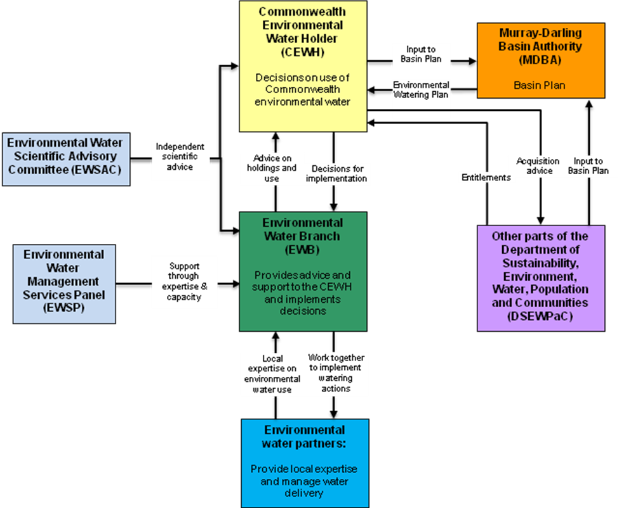
Figure 1 Key environmental water responsibilities

Environmental water partners
The EWB works with an extensive network of environmental water partners to support watering decisions and actions. In particular, partners provide information and knowledge at the local level on environmental water needs, conditions and options for managing water delivery. Environmental water partners also undertake watering actions which involve Commonwealth environmental water and monitor the outcomes.

Environmental water partners are located in catchments across the Basin and include other environmental water managers, catchment management authorities, state agencies, environmental water advisory groups, river operators, scientific organisations and site managers. A current list of partners is provided at Appendix B. We welcome suggestions from anyone about new delivery arrangements or alternate uses of water.

Department of Sustainability, Environment, Water, Population and Communities
The Water Efficiency Division in the Department manages the Restoring the Balance in the Murray–Darling Basin and the Sustainable Rural Water Use and Infrastructure programs, which are part of the Australian Government’s Water for the Future initiative. These programs acquire entitlements which become part of the Commonwealth’s environmental water holdings.
In 2011–12, EWB will continue to work with the Water Efficiency Division to inform the approach to water acquisitions. Advice to the Department on water acquisitions will be provided by the CEWH.
The Water Reform Division in the Department is responsible for coordinating a national approach on research and modelling strategies for water, as well as developing frameworks for monitoring river and wetland health (including as they relate to Australia’s international obligations), the identification of high ecological value aquatic ecosystems, and providing advice on the water market, water charge and trading rules.

Murray–Darling Basin Authority
The MDBA is responsible under the Act for developing the Basin Plan−a strategic plan for the integrated and sustainable management of water resources across the Murray–Darling Basin. The Basin Plan will include an environmental watering plan. Commonwealth environmental water holdings must be managed in accordance with this environmental watering plan once the Basin Plan is adopted. The MDBA must consult with the CEWH and other environmental water managers in developing and implementing the environmental watering plan (ss. 28–29).
The MDBA is responsible for monitoring and evaluating the effectiveness of the Basin Plan, including the environmental watering plan. Once the Basin Plan is adopted the CEWH will have reporting obligations to the MDBA.
The MDBA also manages a portfolio of environmental water that has been secured by The Living Murray program, to be used for the watering of six ‘icon sites’ in the Murray River system. The EWB is represented on The Living Murray environmental watering group, which advises the MDBA on the use of The Living Murray water. The involvement of EWB in the environmental watering group helps to coordinate the use of environmental water from the Commonwealth, The Living Murray and state sources.

Environmental Water Scientific Advisory Committee
The Environmental Water Scientific Advisory Committee (EWSAC) was established to advise the CEWH and EWB on:
- methods for determining relative priority of environmental assets
- areas that merit additional investigation, including additional research
- assessment of the benefits of the use of environmental water.
The EWSAC is chaired by Professor Barry Hart. It comprises scientists and experts in fields such as hydrology, limnology, river operations management, river and floodplain ecology, and the management of aquatic ecosystems.

Environmental Water Management Services Panel
The EWB has established an environmental water management services panel comprising firms with expertise in a range of fields including river operations, water management, monitoring and evaluation, information management, hydrology and ecology, portfolio management and communications. The panel is used to procure services and expertise to support the management of environmental water.

Communications and stakeholder engagement
The objectives of the communications and stakeholder engagement activities of EWB in 2011–12 are to:
- support transparent and accountable management of Commonwealth environmental water
- improve public understanding of the use of Commonwealth environmental water
- strengthen relationships with partners and other stakeholders to support efficient and effective delivery of Commonwealth environmental water.
The EWB has developed channels for communication and stakeholder engagement through its network of environmental water partners. In addition, we actively participate in a range of water management forums, such as customer service committees.
In 2011−12, we will seek to increase engagement with stakeholders and the community and will also seek to make information about environmental watering more accessible to the public through the following activities:
- continuing with a stakeholder committee, which brings together groups with an interest in the use of Commonwealth environmental water in the Basin
- improvement of the Commonwealth environmental water website, which includes detailed information about environmental watering in each catchment throughout the Basin. The website also includes information about environmental water needs and options for environmental water delivery, includes photos and video, and provides an avenue for people to make comments and suggestions on the use of Commonwealth environmental water
- regularly meeting with stakeholders on a catchment-by-catchment basis, and with peak bodies
- providing information about environmental watering actions and management through the Annual Reports and Outcomes Reports
- providing regular electronic updates to stakeholders on environmental watering actions
- issuing local media releases on environmental watering actions and outcomes
- preparing more comprehensive stakeholder contact lists.

Water use
This section provides information on the development and selection of environmental watering actions, delivery of environmental water, and monitoring and evaluation of outcomes.

Statutory obligations
Commonwealth environmental water held in the Murray-Darling Basin is required to be managed for the purpose of protecting or restoring the environmental assets of the Murray-Darling Basin. Defining environmental assets is discussed in Appendix C.
Commonwealth environmental water is to be managed in accordance with relevant environmental water plans (the Basin environmental watering plan and plans listed in relevant regulations), any operating rules that the Minister has made, and any environmental watering schedules to which the CEWH is party.

Management framework for the use of Commonwealth environmental water

Management framework
The management of held environmental water is a relatively new function and subject to the uncertainties of changing water availability and environmental conditions. In this context, an adaptive management approach is being taken to the use of Commonwealth environmental water.
Adaptive management is being undertaken at three levels: immediate, intermediate and long term timescales. The EWB is establishing an adaptive management cycle at each level including the steps of planning, objective setting, monitoring and evaluation, and review.

Active management
Commonwealth environmental water is being actively managed so that environmental objectives can be achieved with the minimum amount of water. Active management includes using infrastructure to deliver water; working with river operators to better manage environmental flows; using carryover arrangements and transferring water allocations between catchments to where it is needed most. Trading of Commonwealth environmental water is an additional management option.
Active management means that there are many possible options and decision points. The option to use water at a particular time and place is assessed relative to the benefits achievable under other options, including benefits achievable in future years and elsewhere in the Basin. Accordingly, the use of water in a particular year needs to be assessed against options for use that may be available in the future or at other sites through the carryover of water or trade of water.
As part of active management, additional works and measures may be required to deliver water to some environmental assets. The need for works or measures will be considered in consultation with delivery partners.

Decisions on the use of Commonwealth environmental water
Decisions on the use of Commonwealth environmental water are made by the CEWH. These decisions are informed by advice from delivery partners, EWB and EWSAC.
Decisions on water use are made through the following steps:

Developing options for the use of water
Potential watering options are identified in cooperation with state agencies, other environmental water managers, local groups (such as catchment management authorities, natural resource management boards and environmental water advisory groups) and landholders. We welcome additional suggestions including in relation to alternate sites and delivery arrangements.

Assessing potential actions
The Commonwealth’s aim in using environmental water is to achieve the best outcomes for the whole Basin. Decisions on use are guided by the Framework for determining Commonwealth environmental watering actions at: http://www.environment.gov.au/ewater/publications/cewh-framework.html. Under the framework, potential watering actions are assessed against the following criteria:
- the ecological significance of the asset to be watered
- the expected ecological outcomes from the proposed watering action
- the potential risks of the proposed watering action at the site and at connected locations
- the long-term sustainability of the asset, including appropriate management arrangements
- the cost-effectiveness and operational feasibility of undertaking the watering.
More detailed criteria for assessing environmental watering actions are at Appendix D.

Seeking local and expert advice
In making decisions on Commonwealth environmental water use, local expertise and advice from the EWSAC and river operators is obtained, including on the environmental need, current conditions and potential delivery arrangements.

Delivery arrangements
A key part of the development of a watering action is negotiating arrangements with partners to deliver the water and monitor the outcomes.

Environmental water delivery
Following decisions on use, EWB will enter into arrangements with the relevant Basin state governments, and with other environmental water holders or catchment management authorities, to optimise delivery of water for the environment. The delivery phase also involves coordination with river operators.
In regulated rivers, water is delivered as river flows or moved to the location it is needed using water trading. As the volume of water held for the environment increases, in-stream watering will become critical for efficient delivery of water to meet environmental objectives. In unregulated rivers, water shepherding will be required to ensure that in-stream environmental flows are directed to priority environmental needs and are protected from consumption.
Water may be delivered as river flows or managed through infrastructure to particular sites or potentially pumped from the river to a site. Use of water in these ways must be within operational arrangements which take account of the delivery constraints of infrastructure and rivers.

Water shepherding
Water-shepherding arrangements provide for the legal protection, effective use and accurate accounting of Commonwealth environmental water in unregulated rivers. These arrangements are required to ensure that the substantial Commonwealth investment under Water for the Future is protected and the objectives of the Act are met.
Agreements are in place with the New South Wales and Queensland governments to develop water shepherding arrangements. A key principle in implementing these arrangements is that entitlements and allocations held by water users will not be enhanced nor diminished as a result of water shepherding. Affected stakeholders will be consulted on the proposed approach to water shepherding prior to permanent changes being implemented.

Cost sharing in water use
There is considerable Commonwealth investment in the acquisition of the environmental water holdings. The provision of this water assists the states meet their water and natural resource objectives. In regard to the provision of funding for costs the following principles will apply:
- The value of the water provided by contributing parties to achieve land and water management objectives should be recognised in cost sharing discussions.
- Other contributions (for example on-site management costs) will also be taken into account.
- Use of Commonwealth environmental water will be underpinned by a value for money principle. This will ensure that maximum environmental outcomes are achieved from available resources. If an action is not cost effective then it will not proceed.
- Any agreed Commonwealth funding contributed must supplement, not substitute for, the existing funding provided by delivery partners.
- All parties should be open and transparent when reporting on costs associated with the management of environmental water.
- Cost sharing arrangements must be based on achieving efficiency and be flexible and sustainable in the long term.

Monitoring and evaluation of the use of water
On 1 June 2011 a discussion paper on a proposed monitoring, evaluation and reporting (MER) framework was released for public comment. The discussion paper proposes a long term, systematic approach to MER at the operational, intervention and program levels, and seeks to meet the objectives of:
- supporting accountability and good governance
- supporting adaptive management
- helping to build foundational knowledge.
The discussion paper on the proposed framework is at: http://www.environment.gov.au/ewater/outcomes/

In 2011−12, prior to the implementation of the MER framework, there remains an immediate need to undertake monitoring to support the reporting of outcomes through the year. This monitoring will include:
- operational monitoring completed by delivery partners for all watering to ensure that actions are undertaken in accordance with planned objectives and risks are managed
- ecological monitoring undertaken when activities by states, catchment management authorities and others exist and are coincidental with the monitoring needs of watering actions
- ecological response monitoring with Commonwealth funding at a small number of key sites
- photo point monitoring, webcams and inundation mapping with Commonwealth funding to provide broad coverage of watering actions across the Basin in an economical way.

Portfolio Management
This section details the key activities for managing the Commonwealth’s portfolio of water holdings.

The holdings
Under the Act, the holdings are defined as water access rights, water delivery rights, irrigation rights or other similar rights, interests in relation to such rights, and rights held in trust or donated, owned by the Commonwealth for the performance of the environmental water function. The sources of the holdings are:
- Commonwealth purchases of water rights
- water saved or acquired from Commonwealth funding of irrigation improvements or other activities
- annual allocations against entitlements in the holdings (this could include trade or donations).
A summary of the portfolio is provided on the Commonwealth environmental water website at www.environment.gov.au/ewater, and is updated monthly.

Water rights held by the Commonwealth retain the same legal characteristics that existed before acquisition. While entitlements are managed for the environment rather than consumption, the Commonwealth is subject to the same allocations, fees, and carryover rules as other entitlement holders.

Managing the portfolio

Maintaining the register
Under s. 105(2)(c) of the Act, the CEWH is required to maintain an up-to-date record of the holdings in the form of a register. The register is a list of each water right (or entitlement or licence) held and the credits available to their associated water-allocation accounts−an entitlement register and a water-account register. See section 5.2 for further details on the register.
Water allocations accruing to the holdings, transfers and water use are reported on water accounts for each licence (water right) issued by the relevant state agency or irrigation corporation. The EWB will regularly review these accounts and use the information to update the holdings register.
The holdings register will be used in conjunction with allocation announcements and forecasts made by state agencies, historic allocation announcements and climate forecasts to forecast likely future water-holding positions. These forecasts will be kept updated and will assist with determining the most effective watering opportunities.

Administering water accounts
Water accounts held for each water right in the portfolio have characteristics that differ in:
- the conditions on using allocations
- processes for ordering water
- linkages to water-use approvals
- rules and processes for trading water allocations
- water-accounting rules, such as carryover, maximum-use provisions and water-order debiting.
Water allocations may be transferred between various accounts to achieve an improved environmental outcome. For example, when a decision is made to use water it is generally transferred to a delivery partner for the agreed use. The water required for a particular water use action may be sourced from a range of titles. Transfers may also take place to improve the opportunities for carryover.
In 2011–12, EWB will continue to monitor developments with respect to the rules and arrangements applying to water rights and their water accounts, and will support simplified and more timely transfer processes for all water users.

Making water available for use
The arrangements for making water available for use will depend on the rules of the relevant jurisdiction or corporation, the preferences of the delivery partners, the location of the watering activity, and the trade-offs between efficiency and flexibility. The main options are:
- link the holding account to the delivery partner’s works or water delivery approval, thus allowing the partner to order water under the terms of an agreement
- transfer allocations to a partner’s account, providing them with the authority to use it under an agreement
- use term transfers or tagged trading to transfer allocations to a watering partner, and to allow them to use water under the terms of an agreement.
During 2010–11, the principal method of making water available for use was through trade-allocation transfers. In 2011–12, various approaches will again be assessed to determine the optimal method for managing use of water.

Review and trade of the holdings and operating rules
Section 106 of the Act allows the CEWH to dispose of water (allocations) and holdings (water rights) in limited circumstances.
The CEWH may only dispose of allocations and/or entitlements if:
- the allocations are not required to meet environmental objectives in a given water accounting period and cannot be carried over to the next accounting period−s. 106(1); or
- the proceeds of the disposal (of either allocations or water rights) are used to purchase water (either allocations or water rights) that improves the capacity of the holdings to meet the environmental objectives−s. 106(2).
The Act allows the Minister to make operating rules by legislative instrument that may relate to the trading of the holdings. These rules can relate to purchasing, disposing of, and otherwise dealing in water and water access rights, either directly or through contractual arrangements.
The approach to trade, carryover and operating rules will be developed during 2011−12. A key part of this process will be consultation with stakeholders and a discussion paper is being prepared to support this consultation.

Governance, financial management and accountability
This section describes budget and financial management arrangements, administration of the environmental water holdings special account, the register of holdings and reporting arrangements.

Budget and financial management
The Environmental Water Holdings Special Account (the Special Account) is established under s. 111 of the Act and administered in accordance with the Act and Part 4 of the Financial Management and Accountability Act 1997 (Cth). Entitlements in the holdings are administered assets and liabilities of the Department.
The functions and activities of EWB are conducted in accordance with established Departmental financial arrangements. The Department has made arrangements to support the CEWH in the following areas:
- financial systems for managing expenses
- the holdings register and the Special Account
- legal and technical advice on Commonwealth environmental water functions
- the provision of funding for Departmental expenses.

The Environmental Water Holdings Special Account
The Act specifies that the CEWH is to administer the Special Account on behalf of the Commonwealth. The CEWH may delegate some or all of this administration to a Senior Executive Officer in accordance with s. 117 of the Act.
Section 112 of the Act specifies the allowable credits, which are:
- appropriations for the Special Account
- amounts received by the Commonwealth in the performance of the CEWH’s functions
- amounts received from Basin states
- amounts received from the sale of property paid for from the special account
- donations.
Allowable debits are specified in ss. 113(2–3) of the Act, and comprise the costs and expenses incurred in performing statutory functions and meeting the expenses of administering the Special Account. The largest costs are holding and use costs, which comprise fixed and variable fees and charges paid to infrastructure owners and water management agencies. The variable component depends on the annual amount of water allocated to the entitlement and the amount of water used.
The Act requires the CEWH to report annually on the management of the Special Account. This will be undertaken in conjunction with the Department, which is required to report on the Special Account in its financial statements.
The Special Account is audited as part of the audit of the Department’s financial statements.

Asset Management

Register of holdings
Section 4.2.1 advised that the CEWH under s. 105(2)(c) of the Act is required to maintain a register of holdings. The register provides information on:
- acquired entitlements
- water-delivery activities
- transfer and trading records
- allocation account management.
Figure 2 below is a schematic diagram of the register.
In 2011-12, an Environmental Watering Management System (EWMS) is being scoped. The EWMS will provide greater capacity and functionality to manage a larger portfolio of water assets. It will include the information captured in the present register of holdings and extend it to include information on water use and a database of environmental assets. The environmental assets database is being developed by EWB and the MDBA and is expected to be operational by the end of 2011–12.

Market information
Data on the trade in water entitlements and allocations is recorded in state-managed registers. This information is used in relation to:
- valuation of the holdings
- identification of opportunities for trading allocations and entitlements
- responding to requests for information.

The annual report
The CEWH is required to provide the Minister with an annual report as soon as practicable following 30 June of each year−s. 114(1). The annual report must provide information on achievements against the objectives of the environmental watering plan, management of the Special Account, and any directions that the Minister and the Secretary have given to the CEWH−s. 114(2).
The annual report is published in the Department’s annual report in accordance with the Public Service Act 1999 (Cth).

Compliance
The CEWH and EWB must comply with the legislative obligations, procedures and policies of the Australian Government and the Department. The CEWH has specific obligations under the Act in addition to obligations under the:
- Financial Management and Accountability Act 1997, such as to ensure efficient, effective and ethical use of Commonwealth resources
- Financial Management and Accountability Regulations 1997, such as the Commonwealth Procurement Guidelines
- Department Chief Executive Instructions, such as financial delegations
- other relevant legislation including the Public Service Act 1999 and the Freedom of Information Act 1982.

Confidentiality of information and conflicts of interest
The procedures and policies of the Australian Government and the Department apply for the handling of confidential information and conflicts of interest. The services of an expert probity advisor have been engaged to provide assurance of the compliance with relevant government policies and legislation.

Information management
The EWB maintains records in accordance with the requirements of the Freedom of Information Act 1982, the Department and the Australian Government, including:
- any directions from the Minister or the Secretary, and the response to those directions
- watering agreements, the activities undertaken through those watering agreements, and their outcomes
- dealings in holdings and holdings allocations
- advice received on environmental watering priorities.

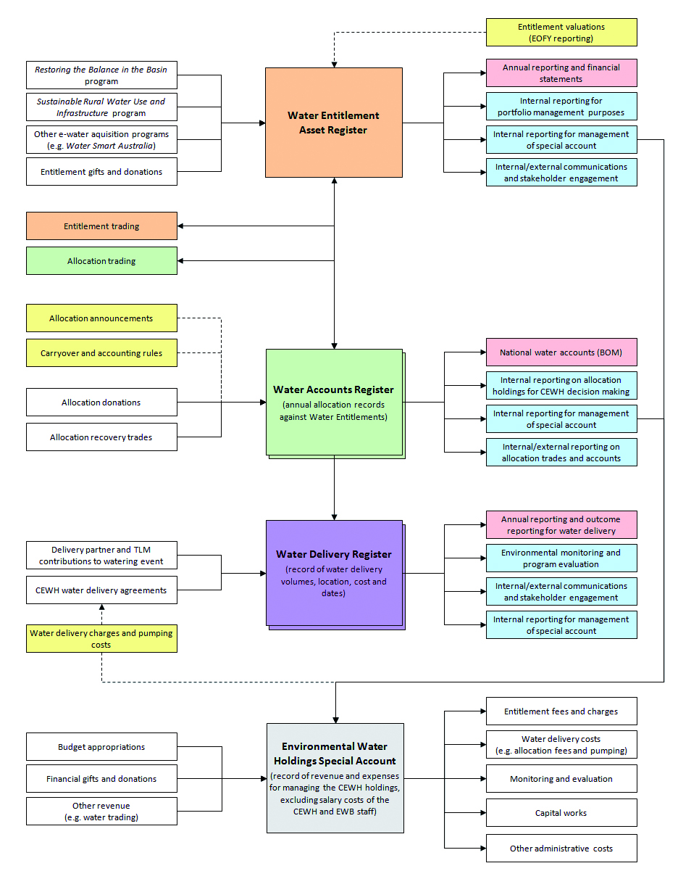
BOM = Australian Government Bureau of Meteorology; CEWH = Commonwealth Environmental Water Holder; EOFY = end of financial year; EWB = Environmental Water Branch; TLM = The Living Murray
Figure 2 A schematic of the environmental water holdings register showing information management and data flow

Knowledge management
In 2011–12, EWB’s knowledge needs are focused around three key themes:
- systematic decision making
- ecological requirements and response to flow
- operational and portfolio management of environmental water, including hydrometric data.
These needs will be pursued through EWB’s knowledge and research strategy, as well as through the National Water Knowledge and Research Plan.
The EWB will also work with relevant organisations and research initiatives to obtain knowledge and pursue research opportunities, including CSIRO’s Ecological Responses to Altered Flow Regimes Cluster, the National Environmental Research Program, the Bureau of Meteorology and the MDBA, among others.
In 2011–12, a major focus will be to progress the development of systematic approaches to decision making in order to prioritise environmental water use across the Basin as an integrated system. Knowledge of ecological requirements and response, as well as operational and portfolio management, will directly inform these approaches, as well as allowing for adaptive management, monitoring of outcomes and efficient and effective use of environmental water. Access to hydrometric data will also support these processes.
The EWB will continue to use and improve information on the environmental assets in the Murray-Darling Basin. This work will be undertaken with the MDBA and in consultation with other Commonwealth entities, Basin state governments, environmental water holders and managers, local groups (such as catchment management authorities), landholders and research institutions.

Internal reporting
The EWB will ensure that the Department and the Minister are kept regularly informed about:
- the use of Commonwealth environmental water holdings
- forecast positions in relation to the holdings and their use
- the development of tools and resources to assist us in meeting any statutory requirements.

Risk management
The development and implementation of risk management guidance is a key instrument supporting good governance in decision-making across the range of Commonwealth environmental watering activities. Managing the risks associated with the Commonwealth watering activities helps to ensure:
- that there are minimum unintended impacts
- that maximum environmental outcome is achieved
- that there is efficient and effective use of environmental
- there is a high standard of stewardship of Commonwealth assets.
Prior to the use of any Commonwealth environmental water, EWB undertakes appropriate risk identification, assessment and management to ensure that all risks are appropriately identified, assessed, treated and mitigated. The approach is in accordance with the Australian standard for risk management (AS/NZS ISO 31000) and is informed by a range of sources, including information from delivery partners, on-ground delivery officers and the local community. It takes into account information on previous water use at the site and at connected locations downstream. Risk assessments are updated regularly as new information arises or situations change.
The EWB generally enters into arrangements with relevant Basin state governments, and with other environmental water managers or catchment management authorities to facilitate the delivery of environmental water, including appropriate risk mitigation measures. These delivery partners work with river operators to arrange for the release of the water, or in unregulated rivers, to implement water shepherding. In these cases, the Commonwealth does not have direct control over the release of water, and so there are responsibilities on the other authorities who undertake on-ground management.
Where inundation of land may create risk to people or property, the Commonwealth seeks assurance that the following management actions are undertaken prior to water delivery:
- all potentially affected landowners and nearby communities are made aware of the proposed watering event, its extent, duration and timing through appropriate communication channels (e.g. media, written notification) as soon as the details of the proposed action have been confirmed
- the consent of all potentially affected landowners has been obtained (or is provided for through prior agreement, including through easements)
- adequate monitoring of flow conditions is in place prior to and for the duration of the event
- sufficient operational control exists to enable immediate cessation of an event due to unforeseen circumstances.
Subject to the nature of the event, additional management actions are undertaken as required, in cooperation with water delivery partners.
All watering events are subject to appropriate mitigation controls. Any watering event with an unacceptable level of risk (after mitigation measures are applied) will not proceed.
In circumstances where EWB has a more direct role in water delivery through the engagement of river and other infrastructure operators, including contractors, EWB will ensure that all relevant risks are adequately mitigated through arrangements with those parties.

Glossary
Allocation | A volume of water allocated for use in any year under a water right.
Basin Plan | The plan for water management in the Murray–Darling Basin under Part 2 of the Water Act 2007 (Cth), to be developed by the Murray–Darling Basin Authority and passed into legislation by the Minister.
Entitlement | Common name for a water right issued under state and territory legislation.
Environmental watering plan | Part of the Basin Plan that deals with managing water designated for the protection and restoration of environmental assets, as detailed in s. 28 of the Water Act 2007 (Cth).
Holdings | All water rights owned by the Commonwealth, except those that are not for the purpose of water management under the Water Act 2007 (Cth). The holdings include all Commonwealth-owned water rights that are held for the purpose of protecting or restoring environmental assets.
Gigalitres (GL) | One billion litres, or one square kilometre of one-metre-deep water.
Operating rules | The Minister may, with the approval of the Australian Parliament, make operating rules that provide general direction to the Commonwealth Environmental Water Holder around water trading. This is found in s. 109 of the Water Act 2007 (Cth).
Planned environmental water | Water or water rights designated for specific environmental purposes under state water-management regimes.
Southern-connected rivers | Rivers located within the southern part of the Murray–Darling Basin with permanent (or near permanent) hydrologic connection, allowing water from upstream catchments to be used in downstream catchments. The major southern-connected rivers include:  - Murray River  - Murrumbidgee River  - Darling River downstream of Menindee Lakes  - Goulburn River  - other rivers of northern Victoria within the Murray–Darling Basin.
Special account | The Environmental Water Holdings Special Account established under s. 111 of the Water Act 2007 (Cth), which is to be managed by the Commonwealth Environmental Water Holder.
Tagged trading | A trading arrangement under which every allocation under a water right is made available for use in a catchment that is different from the source catchment.  - The water right retains its original source location and characteristics.  - A person who has obtained a water right by tagged trading owns the water right in the source catchment, but may also need a water-use right in the delivery catchment.  - Intrastate tagged trades are made under state legislation. Interstate trades are made under state legislation and the Murray–Daring Basin Agreement.
Term transfer | A fixed-term transfer of allocations under a water right to another person.
Water right | Any water right (or share in a water right) conferred under state law to hold or take a nominal volume of water from a water resource, usually in the form of an annual allocation. The actual volume of each allocation varies from year to year, depending on the amount available.  Water rights issued in each state are referred to by different names:  - entitlement (New South Wales)  - water share (Victoria)  - supplemented allocation (Queensland)  - water-holding allocation (South Australia).
Water shepherding | Water shepherding provides for the legal protection, effective use and accurate accounting of Commonwealth environmental water to ensure that the substantial Commonwealth investment under Water for the Future is protected and the objectives of the Water Act 2007 (Cth) are met.
Water trading | Transfer of water or a water right from one person to another. Water trading includes purchasing, disposing of, and otherwise dealing in water and water rights.
Water year | The 12-month period during which a volume of water is allocated to a water right. The water year is typically 1 July – 30 June, with some exceptions in the northern Murray–Darling Basin.

Appendix A
Structure of the Commonwealth Environmental Water Branch
The CEWH is supported by the Environmental Water Branch (EWB) which is based within the Department of Sustainability, Environment, Water, Population and Communities. At September 2011, EWB comprised five sections:
- Environmental Water Policy
- Program Evaluation and Reporting
- Water Holdings and Portfolio Management
- Northern Basin Delivery
- Southern Basin Delivery.
The Environmental Water Policy section provides advice on the development of improved business and operational frameworks for the Commonwealth’s environmental water, provides secretariat services to the Environmental Water Scientific Advisory Committee, and coordinates EWB input to the MDBA as they develop the Basin Plan.
The Program Evaluation and Reporting section’s key responsibilities are the evaluation of the uses of Commonwealth environmental water, reporting and information management. This includes the design and implementation of the monitoring and evaluation program, and public reporting, including the Commonwealth environmental water website, annual report and business plan.
The Water Holdings and Portfolio Management section is responsible for the administration of the water holdings register and the Environmental Water Holdings Special Account. This includes budgeting for, and reporting on, the holdings and associated costs. The section also manages the water portfolio, which includes advising on its composition, acquisitions, trading and carryover strategies.
The two delivery sections, Northern Basin Delivery and Southern Basin Delivery, provide advice to the CEWH on environmental priorities for the use of Commonwealth environmental water, and organise the delivery and monitoring of that water in conjunction with delivery partners.
The Northern Basin Delivery Section is responsible for environmental watering in the northern part of the Murray-Darling Basin, comprising the Darling River catchment upstream of Menindee Lakes including its tributaries in NSW and Queensland and the Lachlan River catchment in NSW. This section is also responsible for providing advice and arrangements for protection of the Commonwealth’s environmental water in unregulated systems.
The Southern Basin Delivery Section is responsible for environmental watering in the southern Basin, comprising Victoria, South Australia, the rest of New South Wales and the Australian Capital Territory. This section provides advice to The Living Murray environmental watering group.

Appendix B
Environmental Water Partners
“Environmental Water Partners” means: any person or entity with which there is a relationship that supports the management of Commonwealth environmental water, including entities engaged indirectly through other partners.

South Australia
- Department for Water
- Department of Environment and Natural Resources.
Regional and local land managers
- South Australian Murray-Darling Basin Natural Resource Management Board
- Overland Corner Branch of the Natural Heritage Trust
- Overland Corner Wetland Rehabilitation Group
- Wetlands Habitat Trust and Paiwalla Pty Ltd.

Victoria
- Department of Sustainability and Environment
- Parks Victoria.
Regional and local land managers
- Mallee Catchment Management Authority
- Overland Corner Branch of the Natural Heritage Trust
- North East Catchment Management Authority
- Goulburn-Broken Catchment Management Authority
- Sunraysia Bird Monitors.
Water management authority
- Goulburn-Murray Water
- Coliban Water.

New South Wales
- Office of Environment and Heritage (including NSW Parks and Wildlife Service) – Department of Premier and Cabinet
- NSW Office of Water (Department of Primary Industries)
- NSW Fisheries (Department of Primary Industries).
Regional and local land managers
- Murrumbidgee Catchment Management Authority
- Murray Catchment Management Authority
- Central West Catchment Management Authority
- Environmental water advisory groups
- Murray-Darling Wetlands Ltd
- Forests NSW
- Private landholders.
Water management authority
- NSW State Water Corporation
- Murray Irrigation Limited
- Murrumbidgee Irrigation Limited.

Queensland
- Department of Environment and Resource Management.
Water management authority
- Border Rivers Commission
- Border Rivers Environmental Water Network.

Research Institutions
- Murray-Darling Freshwater Research Centre
- Charles Sturt University
- University of New South Wales
- CSIRO
- South Australian Research and Development Institute.

Australian Government
- Murray-Darling Basin Authority.

Appendix C
Defining environmental assets
Under the Water Act 2007 (Cth) (the Act), environmental assets are defined to include:
- water-dependent ecosystems
- ecosystem services
- sites with ecological significance.
Commonwealth environmental water is to be managed for the purpose of protecting or restoring the environmental assets so as to give effect to relevant international agreements.
The relevant international agreements are the:
- Convention on Wetlands of International Importance (Ramsar Convention)
- Convention on Biological Diversity (Biodiversity Convention)
- United Nations Convention to Combat Desertification (Desertification Convention)
- United Nations Framework Convention on Climate Change (Climate Change Convention)
- Convention on the Conservation of Migratory Species of Wild Animals (Bonn Convention)
- migratory bird agreements that Australia has signed with China, Japan and South Korea.
The Act further defines relevant international agreements as any other international convention to which Australia is a party, and that is relevant to the use and management of the Murray-Darling Basin water resources and is prescribed by the regulations of the Act.
The range of actions that would give effect to these agreements is very broad; for example, although specific wetlands in the Basin are listed under the Ramsar Convention, this convention requires signatory states to generally promote the wise use of all wetlands within their territory. Similarly, the Biodiversity Convention requires signatory states to promote the protection of ecosystems and natural habitats, and the maintenance of viable populations of species in natural surroundings.

Appendix D
Criteria for assessing environmental watering actions
In undertaking its activities, the Commonwealth Environmental Water Holder (CEWH) is required to act consistently with the requirements of the Water Act 2007 (Cth) (the Act). The relevant functions are outlined in s. 105. This includes a requirement that the environmental water holdings be managed in accordance with the environmental watering plan of the Murray-Darling Basin Authority (MDBA). Close consultation is occurring with the MDBA to ensure that use of Commonwealth water is consistent with the emerging objectives of the environmental watering plan that is currently being developed.
A long-term framework for the prioritisation of environmental water allocations has been prepared in consultation with delivery partners, interested stakeholders and experts, and the Environmental Water Scientific Advisory Committee.
The framework includes ecological objectives that will change under the different water availability scenarios (extreme dry, dry, median, wet as outlined in Table 1 below). Proposed watering actions will need to be supported by available evidence, and be consistent with current water availability scenarios and the framework.
Commonwealth environmental water is being acquired to supplement existing flows. Proposals for use of the water will not be agreed to if this use substitutes for other water uses, including historical system operations (e.g. provision of water for conveyance, stock and domestic, or planned environmental water).
Through adaptive management processes, the CEWH will consider any opportunities for a more informed and diverse range of water uses as knowledge and modelling. All
proposals will be assessed against the criteria listed here.
- The ecological significance of the asset(s)
Issues to be considered:
- the presence of threatened species and ecological communities, and listed migratory species
- ecological and conservation values of the asset(s), including those recognised by international agreements.
- The expected ecological outcomes from the proposed watering action
Issues to be considered:
- how well defined and realistic the objectives are for the proposed watering action
- the consistency of these objectives with the overall CEWH ecological objectives for the current forecast water availability scenario
- the current health of the asset(s)
- the improvement in health of the asset(s) expected from the watering action
- the Basin-wide significance of the ecological response from the watering action;
- any secondary environmental effects expected to result from the watering action (e.g. connected system benefits)
- the change in the health of the asset(s) expected if environmental water is not provided.
- The potential risks of the proposed watering action at the site and at connected locations
Issues to be considered will include:
- how thoroughly the potential risks have been assessed for the proposed watering
- the adequacy of measures proposed to minimise these risks
- the likelihood and consequence of variance from the expected ecological outcome (including negative impacts on biota and water quality).
- The long-term sustainability of the asset(s) including appropriate management arrangements
Issues to be considered will include:
- the adequacy of long-term management and delivery arrangements
- the existence of complementary natural resource management activities supporting the long-term management arrangements, including those that improve water quality
- the effectiveness of monitoring, evaluation and reporting arrangements for the watering activity including clear links to the defined objectives.
- The cost-effectiveness and operational feasibility of undertaking the watering
Issues to be considered will include:
- the amount of Commonwealth water and resources needed, including relative to the contribution of the state and delivery partner, the arrangements for the delivery of water to the asset(s), including the potential for transmission losses and the adequate accounting of flows
- opportunity to supplement natural flows or other water releases
- the operational feasibility of undertaking the watering action (e.g. channel capacity, infrastructure constraints, etc).
Table 1 Ecological objectives in different water availability scenarios
 | Extreme dry | Dry | Median | Wet
Ecological watering objectives | - Avoid damage to key environmental assets | - Ensure ecological capacity for recovery | - Maintain ecological health and resilience | - Improve and extend healthy and resilient aquatic ecosystems
Management objectives | - Avoid critical loss of threatened species and communities  - Maintain key refuges  - Avoid irretrievable damage or catastrophic events | - Support the survival and growth of threatened species and communities, including limited small-scale recruitment  - Maintain diverse habitats  - Maintain low-flow river and floodplain functional processes in sites and reaches of priority assets | - Enable growth, reproduction and small-scale recruitment for a diverse range of flora and fauna  - Promote low-lying floodplain–river connectivity  - Support medium-flow river and floodplain functional processes | - Enable growth, reproduction and large-scale recruitment for a diverse range of flora and fauna  - Promote higher floodplain–river connectivity  - Support high-flow river and floodplain functional processes
Management actions | - Water refugia and sites supporting threatened species and communities  - Undertake emergency watering at specific sites of priority assets  - Use carryover volumes to maintain critical needs | - Water refugia and sites supporting threatened species and communities  - Provide low flow and freshes in sites and reaches of priority assets  - Use carryover volumes to maintain follow-up watering | - Prolong flood/high-flow duration at key sites and reaches of priority assets  - Contribute to the full range of in-channel flows  - Use carryover to provide optimal seasonal flow patterns in subsequent years | - Increase flood/high-flow duration and extent across priority assets  - Contribute to the full range of flows, including over bank  - Use carryover to provide optimal seasonal flow patterns in subsequent years
Back cover
Published by the Department of Sustainability, Environment, Water, Population and Communities
© Commonwealth of Australia 2011
This work is copyright. Apart from any use as permitted under the Copyright Act 1968, no part may be reproduced by any process without prior written permission from the Commonwealth.
Requests and inquiries concerning reproduction and rights should be addressed to: Commonwealth Copyright Administration Attorney General’s Department Robert Garran Offices, National Circuit, Barton, ACT 2600, or posted at www.ag.gov.au/cca.

www.environment.gov.au/water/policy-programs/cewh

