Commonwealth Environmental Water
2010–11 outcomes report

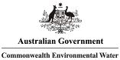

© Commonwealth of Australia 2012
This work is copyright. Apart from any use as permitted under the Copyright Act 1968, no part may be reproduced by any process without prior written permission from the Commonwealth. Requests and enquiries concerning reproduction and rights should be addressed to Department of Sustainability, Environment, Water, Population and Communities, Public Affairs, GPO Box 787 Canberra ACT 2601 or email public.affairs@environment.gov.au
ISBN 978-1-921733-49-9
Outcomes Report – Overall Context

The primary objective of Commonwealth environmental water use is to protect and restore the environmental assets of the Murray–Darling Basin. This means improving the conditions of the whole ecosystem including its connected elements. A healthier Basin will be more sustainable for the communities and industries that rely upon it.

The 2010–11 Commonwealth Environmental Water Outcomes Report provides information on early results from water use, including the impacts on particular plant and animal species. These results are important not just because of the species themselves but because these are indicators of wider river and wetland health and associated benefits.
For example, increased numbers of native fish indicate improved water quality and recovering native vegetation along rivers will improve bank stability and reduce soil erosion.
Commonwealth Environmental Water has supported important scientific monitoring on the responses to environmental flows. For example, biofilms such as algae and microorganisms were monitored in parts of the Murrumbidgee as these organisms are often the first to respond and recover from stress caused by low flows. Improved knowledge about the immediate responses to environmental water use can inform future actions.
To take advantage of local knowledge and expertise, the Commonwealth has partnered with community groups, catchment management authorities and state agencies to implement the watering programs. Such partnerships are critical to ensure that local knowledge and expertise are included in the assessment of options.

Outcomes Report – Overall Context 2

Introduction 4

Commonwealth environmental water 6
- How Commonwealth environmental water was used in 2010–11 7
- How environmental water is used in different conditions 9

Southern Murray–Darling Basin 10
- Murrumbidgee River System 12
  - Murrumbidgee monitoring 15
- Using Commonwealth environmental water to improve water
quality and provide fish habitat 17
- Fish monitoring in the Edward–Wakool 19
- Hattah Lakes 21
- Carpark Lagoons 22
- Lower Lakes and the Coorong 23

Northern Murray–Darling Basin 25
- Lachlan River System 26
- Macquarie Marshes 27
- Gwydir Wetlands 29
- Warrego River 30

Case study: Waterbird outcomes 31

Acknowledgments 33
References 35
Introduction

This outcomes report provides information on the early results of the use of Commonwealth environmental water in 2010–11 and revisits some key areas where water was delivered in earlier years.

The 2010–11 water year was characterised by a significant change in rainfall and river flow conditions across the Murray–Darling Basin. After one of the most severe droughts on record the Basin received substantially above-average rainfall. Some areas of the Basin, including catchments in northern Victoria and southern Queensland, received record rainfall, with floods occurring in the Murray, Barwon–Darling, Murrumbidgee, Goulburn, Ovens, Campaspe, Loddon and many other rivers in the Basin.
The approach to the use of Commonwealth environmental water had to adapt during the year to provide the best possible environmental outcomes under rapidly changing circumstances. The pattern of rainfall was unusual with modest inflows in the winter/early spring period (up to October) and very high rainfall and river flows during late spring/summer (late October 2010 to February 2011). In combination with an increased size of Commonwealth environmental water holdings, this provided for a large increase in the amount of Commonwealth environmental water available for use.
In 2010–11 more than 387 gigalitres of Commonwealth environmental water was delivered to environmental assets across the Basin. Water was used primarily to capitalise on the ecological benefits of high rainfall and increased river flows experienced across the Basin. The aim of Commonwealth environmental watering was to support the ecological recovery of riverine and wetland communities following years of extended drought.
Given the very wet conditions, Commonwealth environmental water was only a small proportion of total river flows. In many cases this makes it difficult to directly attribute outcomes to the additional water. The information provided in this report does however indicate that Commonwealth environmental water contributed to some key outcomes including:
- contributing to river flows through the southern-connected Basin that support key system processes including nutrient cycling and the export of salt from the Basin
- contributing to river flows that connect and support rivers, wetlands and floodplains of the Murrumbidgee, Lower Darling and Lachlan catchments
- supporting water bird breeding at key sites across the Basin
- supporting fish communities affected by blackwater in the Edward–Wakool system and Murrumbidgee river.

The large natural flows in 2010–11 met many environmental demands, meaning that it was not necessary in many areas to supplement or extend the flows. More than 300 gigalitres of water was carried over for use in subsequent years.
Commonwealth environmental water will be available in 2011–2012 to continue to support ecological recovery and build resilience in environmental assets. Many areas of the Basin were affected by low flows for an extended period, so it will take some years to see the expected improvement in environmental health.
The large increase in available water in 2010–11 highlighted the importance of partnerships to the delivery of Commonwealth environmental water. Environmental water partners (including community groups, catchment management authorities and state agencies) provided expertise and knowledge about local conditions, the water needs of environmental assets and information that supported the efficient and effective delivery of water.
The assistance provided to us is greatly appreciated and we look forward to building on these relationships into the future.

Ian Robinson
Commonwealth Environmental Water Holder
John Gorton Building, King Edward Terrace, Parkes ACT 2600
GPO Box 787, Canberra ACT 2601
Tel: + 61 2 6275 9245 Fax: + 61 2 6274 2360
Email: ian.robinson@environment.gov.au
Commonwealth environmental water

River regulation and extraction of water has changed river flows in the Murray–Darling Basin. Changes in flow volume and timing have led to increases in salinity, blue–green algal blooms and affect water quality, wetlands, red gum forests, native fish and waterbirds.
Healthy rivers are essential to underpinning the economy and a vibrant Basin community. Without sufficient water the Basin’s ecosystems will continue to deteriorate, threatening the viability of industries, cities and towns.
The Australian Government is implementing its Water for the Future initiative to better balance the water needs of communities and the environment. This includes acquiring water for the environment and investing in more efficient irrigation infrastructure. Water rights acquired by the Australian Government become Commonwealth environmental water. Commonwealth environmental water will help meet an environmentally sustainable limit on water use to be set in the Murray–Darling Basin Authority’s final Basin Plan.
Commonwealth environmental water at the end of 2010–11 accounted for less than 3 per cent of the total long-term average river flows in the Murray–Darling Basin. The water is of particular value because it is additional environmental water that in many cases can be actively managed over different sites and time.

Active management
Commonwealth environmental water is being actively managed in response to changing conditions. Active management includes:
- delivering water to complement river flows from rainfall
- using infrastructure to deliver water
- working with river operators to better manage environmental flows
- holding carryover for use in future years
- transferring water allocations between catchments to where it is needed most
- future trading of water (both sale and acquisition).

In planning watering actions, local expertise and advice from catchment management authorities and river operators is obtained with respect to environmental need, current conditions and potential delivery arrangements. The feasibility and cost of delivering water, and risks such as flooding and blackwater are also taken into account. This approach provides for effective and efficient use of environmental water so that environmental objectives can be achieved with the minimum amount of water.
- How Commonwealth environmentAL water was used in 2010–11

The southern-connected Basin experienced one of its wettest years on record in 2010–11 and the timing of rainfall was unusual. Below average rainfall was experienced early in the year followed by significant summer rainfall (figure 1). Inflows to the River Murray system were more than twice the long-term average. The southern system had the wettest summer on record with Renmark recording more than five times its seasonal average of rain. There were also exceptional and prolonged wet conditions during spring and summer, and several systems experienced record or near record flow events.
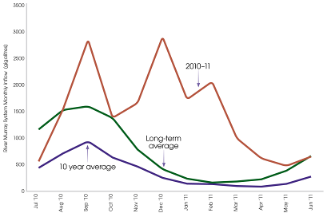
Figure 1: Inflows to the southern-connected Basin in 2010–11 (excluding Snowy and Darling River inflows) (Source: Murray–Darling Basin Authority 2011).

The approach to Commonwealth environmental watering varies depending on Basin conditions and the volume of water available (see table 1). From the first use of Commonwealth environmental water in 2009 through to the spring of 2010, conditions across most of the Basin were extremely dry and water was primarily used to provide drought refuges and avoid permanent damage to key environmental assets.
The change to wetter conditions across the Basin from the spring of 2010 to autumn 2011 meant the focus of water use shifted to support ecological recovery following the drought. This was done by capitalising on the environmental benefits of rainfall by building on natural river flows, in particular by piggy-backing on rainfall through summer and providing river freshes in autumn and early winter when rainfall was lower.
A total of 387 gigalitres of Commonwealth environmental water was delivered in 2010–11. More than 340 gigalitres was provided as river flows to connect the system and support ecological processes, with the remainder used at key environmental assets such as wetlands.
Figure 2 shows the location and volumes delivered in 2010–11. For details of all watering actions undertaken in 2010–11 please refer to the 2010–11 Commonwealth Environmental Water annual report which can be found at: www.environment.gov.au/ewater

Ecological watering objectives | Extreme Dry | Dry | Moderate | Wet | Very Wet
Ecological watering objectives | Avoid damage to key environmental assets | Ensure ecological capacity for recovery | Maintain ecological health and resilience of aquatic ecosystems | Improve the health and resilience of aquatic ecosystems | Build future capacity to support ecological health resilience
Table 1: Ecological objectives for the use of Commonwealth environmental water under different water resource availability scenarios.
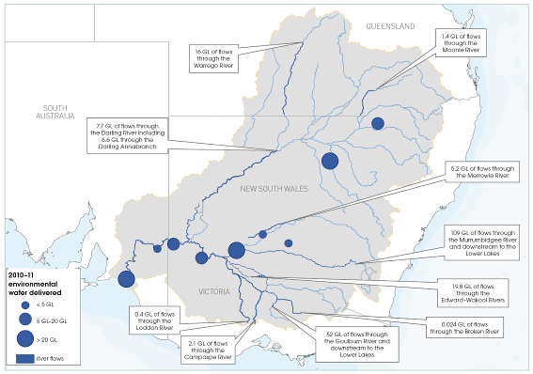
Figure 2: Summary of Commonwealth environmental watering for 2010–11.

- How environmental water is used in different conditions

The flora and fauna of Australia have evolved to take advantage of the variable natural flows of our aquatic ecosystems. Different flow regimes provide different ecosystem functions that cumulatively meet requirements for the survival and development of water-dependant species. Environmental water can improve ecosystem health by providing more natural flow and inundation conditions that allow different ecological processes to occur.

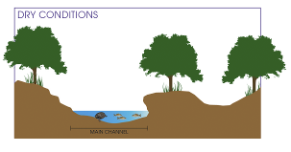 | During droughts there may be no connection between wetlands across a landscape. Environmental water directed from the main channel may provide low flows, flushing waterholes, improving water quality, and providing refuges for plants and animals.
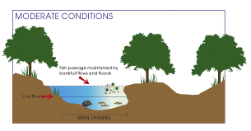 | In moderate conditions when there is low flow in the main channel, environmental water may be used to provide in-channel river flows. This increases connectivity along the river channel and may improve the amount of habitat available by engaging secondary channels.
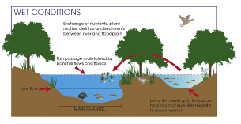 | During wetter times environmental water may be used to improve the connectivity between floodplain wetlands and the main channel. This is important for exchange of nutrients, sediments and genetic material to support biodiversity. Environmental water may be used to maintain water levels in wetlands and floodplains by piggy-backing on peak flows or slowing the recession following the peak. The opportunities for overbank flows may be limited by delivery constraints, such as channel or outlet capacity and the need to avoid undesired flooding of private land or infrastructure.
Figure 3: Examples of how Commonwealth environmental water may be used under different climate scenarios (adapted from Mussared 1997).
Southern MURRAY–DARLING Basin

The southern Murray-Darling Basin includes the Murray, Murrumbidgee, Edward–Wakool, Kiewa, Ovens, Goulburn, Broken, Campaspe, Loddon, Avoca, and the Lower Darling (south of Menindee Lakes) river catchments.
These are highly-regulated rivers that flow through a variety of landscapes. The headwaters of the Murray, the Murrumbidgee and Goulburn catchments originate in the wetter, cooler climate of the Australian Alps before flowing westward into the warmer, drier climate of the floodplains. The catchments in the southern Murray-Darling Basin are generally cooler than the northern catchments with the highest rainfall occurring in winter and spring.
Watering actions during 2010–11 in the Murrumbidgee, Edward–Wakool, Murray, Goulburn, Campaspe, Loddon and Darling Anabranch all contributed to river flows from the upper reaches of each of these catchments through to the Murray Mouth. More than 315 gigalitres was delivered to sites within the southern Murray–Darling Basin as river flows.
Providing water as river flows supports connecting processes that benefit the whole system, as well as the health of specific environmental assets. This is because the degree of river-floodplain connectivity regulates the amount of terrestrial material, including sediments, nutrients, and dissolved and particulate organic matter that is transported into the river system (Tockner et al. 1999). Connectivity allows the movement of carbon and nutrients from the floodplain to the river channel and is likely to be a key process that helps environmental assets recover following drought (Lake 2003).
In the Murrumbidgee River two river flow actions were undertaken in 2010–11. The first action in late summer delivered 58 gigalitres of water as river flows to provide suitable habitat for water-dependant species following detrimental impact from blackwater. The second action in winter 2011 delivered more than 161 gigalitres of water providing river flows right through the Murrumbidgee system and as far downstream as the Murray Mouth (see page 12).
Dr Skye Wassens from Charles Sturt University has been monitoring the ecological response to this action:
... the biggest benefit is actually to do with connectivity, so when you release a large slug of water you are connecting the wetlands that border the river to the river, and you are creating this sort of pathway for animals, aquatic animals and nutrients and energy to move around the system and to sort of re-organise themselves. So creating connectivity during a large flow is really critical to allow organisms back into wetlands that have been dry. And also to allow the movement of nutrients and carbon that have been accumulating in wetlands during those dry periods to move back into river systems which feed some of those riverine food chains that many organisms depend on.
Dr Skye Wassens, 2011
In the Lower Darling, 47 gigalitres was delivered as river flows to the Great Darling Anabranch (of which six gigalitres was Commonwealth environmental water), providing connection through to the River Murray for the first time in nearly a decade. This water inundated wetlands and floodplains along the anabranch, contributing to a range of benefits including improved habitat for breeding of fish, birds and frogs and the regeneration of vegetation.
Fifty-two gigalitres was also provided as river flows from the Goulburn River downstream to the Murray Mouth, delivered in conjunction with 29 gigalitres directed to the Lower Lakes.
Mr Wayne Tennant, Goulburn–Broken Catchment Management Authority, Strategic River Health Manager has seen some of the benefits of Commonwealth environmental water:
Since the high flows, the river has been teeming with aquatic life, especially macro-invertebrates, which will provide another important food source for our native fish stocks.
Wayne Tennant, quote from Goulburn–Broken Catchment Management Authority media release 25 October 2010

At the Lower Lakes this water delivery provided benefits to aquatic ecosystems and contributed to the health of the river system. This included contributing to maintaining an open Murray Mouth to export salt, providing valuable nutrients to aquatic communities, and helping the movement of fish species. The benefits of these flows are reflected in improved conditions at the Lower Lakes and Coorong as outlined on page 23.

- Murrumbidgee RIVER SYSTEM

There were significant rainfall events through spring 2010 and summer 2011 in the Murrumbidgee catchment, with a major flood in the upper and mid-river reaches in December 2010 which inundated large areas of floodplain – some of which had not been inundated for up to 10 years. The flood peaked at nearly 280 gigalitres per day at Gundagai on 4 December 2010 (figure 4). There have only been 12 floods that have exceeded this level in the past 125 years (New South Wales Office of Water 2011).
In 2010–11 the focus of Commonwealth environmental water delivery in the Murrumbidgee catchment was to restore connectivity along the river and to adjacent wetlands and floodplains. The aim was to protect and restore the wetland vegetation communities, improve river red gum forest and black box woodland communities, and maintain and improve ecosystem condition in the Murrumbidgee River channel. The Sustainable Rivers Audit has previously rated the overall ecosystem health of the Murrumbidgee catchment as very poor (Murray–Darling Basin Authority 2008).
More than 193 gigalitres of Commonwealth environmental water was delivered in five separate actions within the Murrumbidgee catchment in 2010–11.
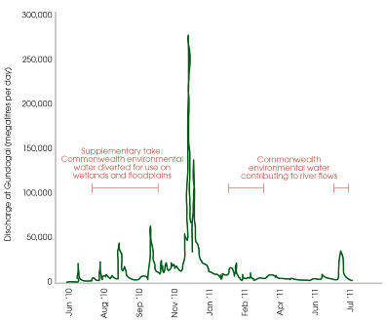
Figure 4: Timing of Commonwealth environmental water use in the Murrumbidgee River 2010–11.

Lowbidgee
Following small rainfall events early in 2010–11 more than 20 gigalitres of Commonwealth environmental water was delivered to wetlands in the Lowbidgee floodplain, including at Yanga National Park and Murrumbidgee Valley Nature Reserve. This action was aimed at extending inundation to improve wetland vegetation health including river red gum, black box and lignum communities. The action was followed by significant inflows from summer rainfall.
Monitoring of major waterbird colonies in the North Redbank system was undertaken in December 2010, February and March 2011 by New South Wales Office of Environment and Heritage and Charles Sturt University. Large egret and cormorant colonies in Tarwille and Steam Engine Swamp were still active in February 2011 and additional waterbird colonies were located at Two Bridges Swamp, in Yanga National Park, and in Nap Nap Swamp in the Nimmie–Caira system (Thomas et al. 2011).

The Lowbidgee Floodplain is home to the most significant population of the nationally vulnerable southern bell frog in New South Wales; however, due to a lack of water across the Floodplain in recent dry years the population has declined to very low numbers.
We now have these vulnerable frogs breeding in numerous wetlands in the Lowbidgee, and just recently researchers have re-discovered them in the mid-Murrumbidgee wetlands.
The recent flooding has provided the frogs with the opportunity to move away from drought refuge habitats and return to historic and preferred habitat areas which have been dry for many years.
Successful breeding and the survival of young frogs is necessary for the population to recover and this is dependent on having wetland habitat.
James Maguire (New South Wales Office of Environment and Heritage) taken from Water for the Environment News, June 2011.

Murrumbidgee River flows – February to March 2011
As floodwater from the December 2010 flows receded and drained off the floodplain, the water quality in the Murrumbidgee River deteriorated. The blackwater generated had very low dissolved oxygen levels, which affects the ability of fish to inhabit these systems. Between late February and March 2011 approximately 58 gigalitres of Commonwealth environmental water was delivered to promote low-lying floodplain to river connectivity, support medium flow river and floodplain functional process and improve water quality, particularly for fish, in the Murrumbidgee River downstream of Maude Weir. Some of the benefits of using Commonwealth environmental water in this way are outlined on page 19.

Murrumbidgee River flows – June 2011
The mid-Murrumbidgee wetlands provide vital habitat and refuges for many threatened and migratory species of waterbird, frogs and other wildlife, including the nationally listed threatened southern bell frog.
Modelled natural flows show that there is a strong seasonal redistribution of flows in the Murrumbidgee River resulting from river regulation. As evidenced in figure 5, autumn and early winter is a period when river flows have been severely affected by development as rain and inflows are captured in dams.
At Gundagai, summer and autumn flows have been increased by river regulation and flows during winter and spring have been reduced (Frazier et al. 2003; Frazier and Page 2006; Murray 2008). The regulation of flows has also affected the frequency and duration of inundation of the mid-Murrumbidgee wetlands. For wetlands between Gundagai and Hay, with river connections higher than the level of regulated flows, there has been a halving of the average frequency of inundation (Frazier et al. 2003).
The overall response of frogs and aquatic vegetation to the flooding in summer 2010–11 from rainfall in the mid-Murrumbidgee wetlands was poor compared to areas that had been subject to a more frequently managed inundation (Wassens and Amos 2011). Scientists monitoring wetland conditions throughout the year recommended follow-up flooding to ensure the recovery of aquatic plant communities (Wassens and Amos 2011). The June 2011 watering action sought to address this by providing a follow-up wetting that would enable water to persist in the wetlands over winter and through to spring.
In June 2011 nearly 110 gigalitres of Commonwealth environmental water was delivered to a watering action managed by New South Wales Office of Water, the New South Wales Office of Environment and Heritage and State Water Corporation, which totalled 161 gigalitres (including 23 gigalitres from The Living Murray program, 21 gigalitres from the New South Wales Environmental water allowance and 8 gigalitres from private donations) targeting the mid-Murrumbidgee wetlands.
It is estimated that approximately 120 gigalitres of water from the June 2011 watering event reached the South Australian border, extending the benefits of the flows into the Murray system as far downstream as South Australia’s Lower Lakes and Coorong.
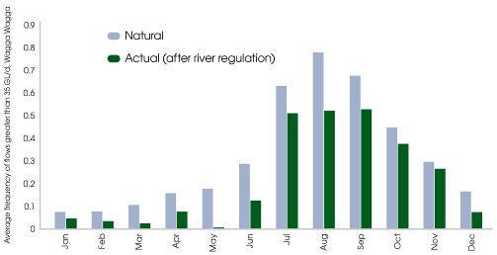
Figure 5: Seasonal comparison of without development and Actual flows of >35 gigalitres/day at Wagga Wagga: Mid-Murrumbidgee Wetlands (Source: Whitten and Bennett 2000).
- murrumbidgee monitoring

Aquatic vegetation, water quality, frogs, fish, and waterbirds were monitored in the mid-Murrumbidgee wetlands on three occasions between June (pre-flood) to August (post flood) by Charles Sturt University. The response to date has been as expected, with a stronger ecological response likely to be detected following further monitoring into summer.
Early results from the watering action reported by Charles Sturt University include:
- Water quality was assessed as good at all of the inundated wetlands with no evidence of low dissolved oxygen (blackwater) or high salinity at any of the wetlands.
- Vegetation cover remains low but there is evidence of germination by an increasing number of aquatic and semi-aquatic species which suggests that at least some species are beginning to recover following drought.
- Waterbirds were abundant with 26 species recorded. Dabbling ducks and fish-eating waterbirds such as little pied and little black cormorants were dominant.
- Fish communities were surveyed at seven wetlands in August. In contrast to earlier studies two native fish, carp gudgeon and Australian smelt, dominated fish communities and the native juvenile carp gudgeon were observed at a number of wetlands.
- Frog species, particularly the winter and early spring active frog species, including spotted marsh frog and plains froglet, have commenced breeding and egg masses were observed.
- Water rats were recorded at two of the wetlands that received environmental flows; this is the first time that this native species has been recorded in the mid-Murrumbidgee wetlands between Narrandera and Hay.
- Biofilm response to the environmental flow showed a short-term benefit to in channel communities, immediately following the watering event.

The first report by Charles Sturt University on this action has been made available on our website. A second report monitoring the response through summer will be available in the autumn of 2012.
A time-lapse webcam was also installed at Sunshower Lagoon, near Darlington Point, to help monitor ecological responses of this lagoon to the flows: www.environment.gov.au/ewater/gallery/webcam-sunshower.html

BIOFILMS
Biofilms are a group of algae, fungi and microorganisms that cover rocks, wood and sediments in aquatic systems. Biofilms are fundamental part of nutrient and biogeochemical processes and are a major food resource for higher order organisms including crustaceans, insects and some fish (Wassens et al. 2011). Often they are the first organisms to respond to and recover from stress. Information about biofilms can therefore help determine the response of the system to environmental water.

- using Commonwealth environmental water to improve water quality and provide fish habitat

Blackwater events occur naturally as a result of rapid breakdown of leaf litter from the forest floor causing water discolouration. The breakdown of leaf litter plays an important ecological role as it provides nutrients back into the river system thereby promoting the growth of many aquatic organisms (figure 6). However, at times, including after large floods, this process can be too vigorous resulting in very low dissolved oxygen levels that can have a detrimental impact on fish.
The unprecedented flows in spring and summer 2010–11 resulted in blackwater with low dissolved oxygen in many locations across the Murray and Murrumbidgee catchments. The severity and extent of the blackwater events were a result of these widespread floods washing a large accumulation of organic material (built up from years of drought) into the rivers. The low dissolved oxygen levels were also exacerbated by higher temperatures as the flooding continued into summer (Whitworth et al. 2011).
Measures to mitigate the blackwater event were taken where possible, but in many cases large volumes of additional water could not be used to dilute the blackwater event as most rivers were operating at full capacity or overbank.
Nevertheless, Commonwealth environmental water was used to reduce some of the short-term effects of blackwater and improve fish habitat. In February and March 2011, 58 gigalitres was delivered to the Murrumbidgee River so as to provide suitable habitat for water-dependent species downstream of Maude Weir.
In the Edward–Wakool system, Commonwealth environmental water was delivered in Wakool River during January to February 2011 to ameliorate the effects of a severe blackwater event. Water was delivered to the river through irrigation channels, providing refuge habitat for fish, including the nationally listed threatened Murray cod.
The Pastoral Times (Deniliquin, Tuesday 5 July 2011) reported:
When blackwater was a problem earlier this year they [the Murray Catchment Authority using Commonwealth environmental water] shot extra flows down the Syphon and saved the lives of countless fish around Deniliquin.

The Murray Catchment Management Authority and Charles Sturt University have undertaken monitoring that shows the creation of small refuges using Commonwealth environmental water (with dissolved oxygen levels above critical thresholds) improved the survival chances of fish (Watts et al. 2011).
In particular, monitoring by the Murray Catchment Management Authority and the NSW Department of Primary Industries confirmed the success of this watering action, showing that Murray cod were present in the upper Wakool River after the blackwater event. In other locations where delivery of freshwater was not possible, Murray cod were not detected.
It is important to note that Commonwealth environmental water will not always be able to be used to respond to blackwater events. Blackwater to some degree is a natural part of the ecological process and in major floods or droughts there will be a limit to what can be achieved. Environmental water can nonetheless improve water quality over the long-term and in some areas respond to particular quality problems.
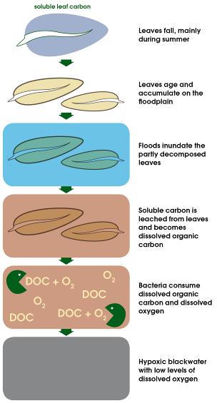
Figure 6: A schematic of the development of hypoxic blackwater (modified from Whitworth et al. 2011).
- Fish monitoring in the Edward–Wakool

Commonwealth Environmental Water is funding a fish monitoring project by scientists from the Narrandera Fisheries Centre (New South Wales Department of Primary Industries) and the Murray Catchment Management Authority.
This project seeks to provide a better understanding of how fish respond to flows and, therefore, how environmental water can be best managed in the Edward–Wakool system and elsewhere. The project has two components:
- electro-fishing, which tells us about the types and numbers of fish present
- acoustic tagging, which is used to track the movement of fish through the system.

Scientists have implanted a total of up to 140 Murray cod, golden perch, silver perch and carp with acoustic tags and monitored their movement in the Wakool River, Yallakool Creek and Edward River.
A number of studies have shown that movement is an important part of the breeding cycle for Murray cod (Humphries 2005; Lintermans 2007; Rodgers and Ralph 2011). It is thought that native fish move upstream immediately before spawning occurs to compensate for the downstream drift experienced by newly hatched fish larvae (Humphries, 2005). Other reasons for fish movement could be to find food, to avoid unfavourable conditions (such as blackwater) and colonisation of new habitats. These results are being used to help plan for environmental watering in the Edward–Wakool system in the future.
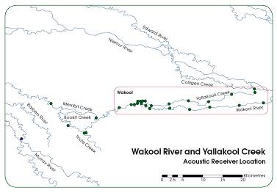
Figure 7 (a): Map showing where the fish, including Murray cod, were studied in the Edward–Wakool system and the location of fish tracking receivers (the green dots).
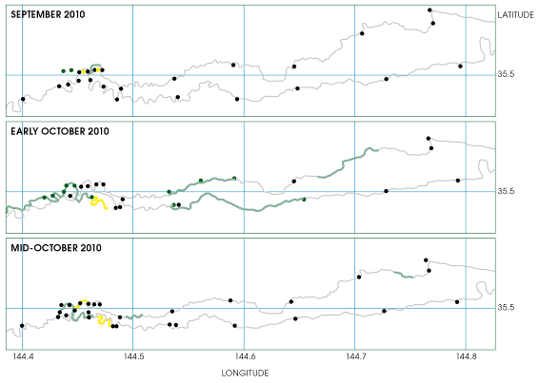
Figure 7 (B): The figures show the results from the acoustic fish tagging in the area of the Wakool river and Yallakool creek (area shown in Figure 7A). The black dots indicate the locations of fish tracking receivers. The longer the bold green line, the faster each individual fish is moving. The figures show that the native fish congregate in refuge pools when flows are low and steady (September 2010). When higher flows come through the system, fish move quickly up and down the river (early October 2010) before returning to the refuge pools when flows drop away (mid-October 2010). Commonwealth environmental water was used in January 2011 to provide refuge habitat for fish which reduced mortality.

The sequence of images in figure 7 (B) show fish moving in response to river flows in the Wakool system from September 2010 to October 2010.
Video footage of the sequence can be seen on the Commonwealth Environmental Water website at: www.environment.gov.au/ewater/southern/murray/fish-monitoring-project.html

- Hattah Lakes

Hattah Lakes is a complex of 20 freshwater lakes located approximately 50 kilometres south-east of Mildura, Victoria. The site is recognised nationally under the Directory of Important Wetlands in Australia and 12 of the lakes are recognised internationally under the Convention on Wetlands of International Importance. Hattah Lakes provides important feeding, nesting and breeding habitat for waterbird species and supports river red gum forests fringing the wetlands.
Nine gigalitres of water was delivered in early 2010–11 while the area was still experiencing drought conditions. This action built on environmental watering in 2008–09 and 2009–10, during which more than nine gigalitres of water was delivered to help maintain wetland communities through the drought.
The benefits of maintaining the site through drought were demonstrated by monitoring undertaken following the return of wetter conditions.
In 2011 a total of 31 waterbird species were recorded, including: Australasian shoveler (Anas rhynchotis); eastern great egret (Ardea modesta), hardhead (Aythya australis); musk duck (Biziura lobata); nanekeen night heron (Nycticorax caledonicus); pied cormorant (Phalacrocorax varius), whiskered tern (Chlidonias hybridus) and white-bellied sea-eagle (Haliaeetus leucogaster). (Cook et al. 2011)
Five species of frogs were also recorded, including three species that recruited successfully. River red gum and black box stand condition improved, with increased foliage (Robertson 2011).

- CARpARK LAGOONS

The Carpark Lagoons located on the Katarapko Floodplain near Berri, are a good example of where a relatively small amount of Commonwealth environmental water has been used repeatedly to achieve positive ecological outcomes. In October to November 2010, 154 megalitres of Commonwealth environmental water was provided to this area to provide habitat for threatened fish, support long-lived vegetation, and provide potential breeding habitat and conditions for frogs. This follows on from water in 2009 (0.2 gigalitres).
The South Australian Department of Environment and Natural Resources conducted monitoring surveys during 2010 to assess the ecological response of waterbirds, fish, frogs and vegetation. A total of nine species of waterbirds were recorded including water little pied cormorants, grey teal and hardhead ducks. These results indicate that there was a large amount of open water available as habitat and suitable food availability for these species. Species suited to shallow water and mud such as ibis, herons and spoonbills were recorded in lower numbers around the wetland as it dried down. Australian wood ducks and grey teal were observed with young, demonstrating the availability of suitable breeding habitat (Suitor 2011).
A total of 1,422 fish from nine species (seven native and two exotic) were observed from Carpark Lagoons including the small bodied native unspecked hardyhead (13 per cent of catch) and the large bodied golden perch which was present in small numbers in all sampling rounds and at all sites (Suitor 2011).
Four species of frogs were also identified during frog night-call surveys (these were peron’s tree frog, eastern sign-bearing froglet, eastern banjo frog, spotted grass frog). Vegetation monitoring of the condition of black box and river red gum demonstrated that trees were in moderate to good health during this survey period. This demonstrates how Commonwealth environmental water is being used to maintain and improve the health of long-lived vegetation (Suitor 2011).
Overall these results indicate that the high flow events promoted a range of environmental benefits, including tree growth, waterbird breeding, lateral and longitudinal connectivity of the river, floodplain and wetland habitat and provided ideal conditions for fish movement.

- LOWER LAKES AND THE COORONG

The Lower Lakes and Coorong have a diverse range of freshwater, estuarine and marine habitats. Many of the plants and animals found in this region are unique and many internationally migratory birds are also found here.
In early 2010 water levels in the Lower Lakes reached unprecedented low levels (figure 8), reflecting low inflows through the Basin during the extended drought. The impact of low water levels was significant, resulting in a ceasing of flows through the Murray Mouth, high salinity levels (figure 9) and poor water quality, particularly in Lake Albert, and high acid sulphate soil risks.
The 2010–11 flows in the River Murray were the best since 1993, delivering important environmental outcomes including the refilling of the Lower Lakes for the first time in four years. Commonwealth environmental water contributed to these flows.
Monitoring under the Murray Futures program, jointly funded by the Australian Government and South Australia, demonstrated some key outcomes for the Lower Lakes and Coorong during 2010–11:
- normal water levels for the first time in four years, which alleviated many of the acid sulphate soil risks and provided habitat for birds and other wildlife
- flows through the Murray Mouth, exporting salt and other nutrients
- improved circulation between the lakes and into the Coorong which improved water quality, including improved salinity levels in Lake Albert (figure 9)
- a higher abundance of fish in the first two weeks of the monitoring program in comparison with the combined results of the previous three years of monitoring data.

Although 2010–11 saw significant improvements in environmental conditions at the Lower Lakes and Coorong, recovery will take many years. This is reflected for example in the poor water quality that continues to affect Lake Albert (figure 9), with salinity levels many times higher than levels typically regarded as normal for freshwater environments.
The contribution of Commonwealth environmental water relative to the flows created by high rainfall during the year was small. However, environmental water will make an on-going contribution to these systems in the future including making them more resilient to future droughts.
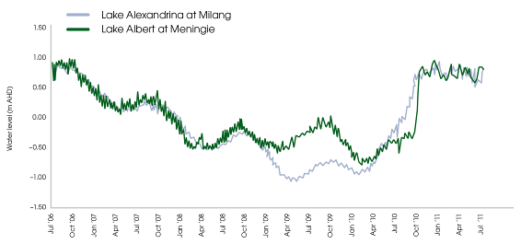
Figure 8: Water levels in Lake Alexandrina and Lake Albert between July 2006 and June 2011 (Data sourced from Murray–Darling Basin Authority 2011).
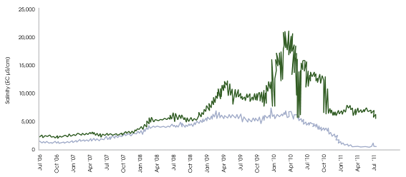
Figure 9: Salinity levels in Lake Alexandrina and Lake Albert between January 2004 and November 2011 (Data sourced from Murray–Darling Basin Authority 2011).

Northern Murray–Darling Basin

The northern Murray–Darling Basin encompasses an area of approximately 640,000 square kilometres, including southern Queensland and northern New South Wales, west of the Great Dividing Range. It includes the rivers and tributaries of the Balonne, Culgoa, Macintyre, Dumaresq, Severn, Gwydir, Namoi, Castlereagh, Lachlan, Macquarie, Bogan, Warrego and Paroo.
River flows in this region are naturally highly variable, typified by droughts and flooding rains.
The northern Basin in 2010–11 has both permanent and ephemeral wetlands including internationally listed sites such as Macquarie Marshes and Gwydir Wetlands. These wetlands are important breeding sites and provide food sources for thousands of plants and animals.
Commonwealth environmental water was used in wet conditions across the northern Basin. A number of actions were undertaken to provide in-stream benefits and improve system connectivity in the Barwon–Darling, Warrego and Moonie catchments.
As most wetlands rely on water delivered by rivers or creeks, many of the northern Basin watering actions conducted this year aimed at enhancing river flows from rainfall.
The objectives of these watering actions included:
- supporting the growth, reproduction and large-scale recruitment for a diverse range of flora and fauna
- promoting higher floodplain-river connectivity
- supporting high flow river and floodplain functional processes.

- LACHLAN RIVER SYSTEM

During 2010–11 the Lachlan catchment experienced its first significant flows in more than a decade. Significant rainfall in the catchment caused large volumes of water to flow through to the Great Cumbung Swamp at the end of the system.
A total of seven gigalitres of Commonwealth environmental water was delivered to sites and provided as river flows within the Lachlan catchment during the year.
During spring and summer, Commonwealth environmental water was used to build on natural flows in Merrowie Creek to support a colonial nesting bird breeding event at Cuba Dam. At least 10,000 pairs of straw-necked ibis were recorded with high resolution digital vertical photography (Lachlan Riverine Working Group 2011). This water flowed through into the nationally significant Lake Tarwong, which had not held water since 2000. Lignum and a range of aquatic plants, such as milfoil, azolla and nardoo responded to the good conditions (New South Wales Office of Environment and Heritage 2011a).
The improved catchment conditions also resulted in the beeping toadlet, the spotted marsh frog and the banjo frog being recorded by New South Wales Office of Environment and Heritage staff. In addition, the Sloane’s froglet (listed as vulnerable under the New South Wales Threatened Species Conservation Act 1995) was recorded near Tom’s Lake in the Upper Merrowie Creek system (New South Wales Office of Environment and Heritage 2011a).
Commonwealth environmental water was also used in Merrimajeel Creek to support the first significant waterbird breeding event in the Booligal wetlands since 2000. Approximately 64,000 straw-necked ibis and around 1,000 glossy ibis nests were recorded (New South Wales Office of Environment and Heritage 2011a). This event resulted in approximately 120,000 young straw-necked ibis successfully fledged (New South Wales Office of Environment and Heritage 2011a; Lachlan Riverine Working Group 2011).
Since the flows occurred, large numbers of glossy ibis have been seen foraging in the Booligal wetlands. Royal spoonbills, white ibis and freckled ducks were also observed nesting in and around the colony. Grebes, cormorants and several other duck species, including the threatened blue billed duck, also responded to the good breeding conditions (New South Wales Office of Environment and Heritage 2011a).
To build upon improved catchment conditions, delivery of further Commonwealth environmental water into both Merrowie and Merrimajeel Creeks commenced during winter 2011 and continued into spring.

- macquarie Marshes

In 2010–11 more than 900 gigalitres of water from significant rainfall reached the Macquarie Marshes. This water filled the marshes for the first time in over a decade and inundated 175,000 hectares. As a result of the water flows more than 100,000 pairs of colonial nesting waterbirds bred in 12 colonies during the year.
Twenty-five gigalitres of Commonwealth environmental water and 110 gigalitres of environmental water from the New South Wales Government was delivered in March and April 2011 to the Marshes to extend the period of inundation and support the success of colonial waterbird breeding (figure 10).
This watering action contributed to the completion of the significant waterbird breeding event and supported the continued ecological function of a wide range of vegetation communities including river red gums, fish and frogs. In effect, the water was used to make sure that the event was not abruptly concluded (figure 10).
More than 25 species of waterbird were observed breeding. The most numerous were the ibis and egrets which both completed two cycles of nesting. Thirty-five thousand straw-necked ibis nests were observed in the first cycle and double that number in the second cycle. Fifty thousand egret nests were observed in the second cycle including great, intermediate and little egrets (New South Wales Office of Environment and Heritage 2011a).
Vegetation response to watering was also positive with water couch and mixed marsh responding well to inundation. Importantly the river red gum canopy has generally shown an increase in density in large areas in the northern Marshes. There were also positive responses for frog breeding and opportunities for native fish dispersal were provided (New South Wales Office of Water 2011b).
This is a good example of coordination of different types of environmental water. Figure 10 shows how New South Wales environmental water and Commonwealth environmental water were coordinated to essentially smooth out flows to the Marshes. This has resulted in improved environmental outcomes compared to what would otherwise have been achieved.
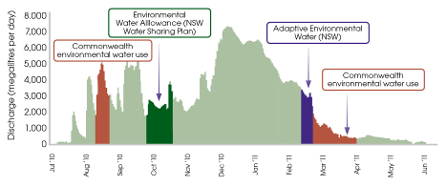
Figure 10: Hydrograph showing the timing of Commonwealth environmental watering to the Macquarie Marshes during 2010–11 (Source: New South Wales Office of Environment and Heritage 2011b).

- Gwydir Wetlands

During 2010–11 the Gwydir catchment experienced more moderate flows relative to other parts of the Basin. Even so, the Gwydir Wetlands were inundated by inflows from rainfall for the first time in over a decade. The Sustainable Rivers Audit has previously rated the overall health of the Gwydir Valley catchment as being poor (Murray–Darling Basin Authority 2008).
In spring 2010, three gigalitres of water was used to top up river flows. This watering action aimed to help boost soil moisture and vegetation growth in the area. A further 10 gigalitres was delivered from February to March 2011 which aimed to support six to eight months of continuous wetland inundation to promote the recovery of wetland vegetation and create habitat for threatened and migratory species.
In combination with natural flows, environmental water inundated 10,000 hectares of wetland vegetation, including one of the largest stands of water couch remaining in New South Wales, as well as large areas of marsh club rush and coolibah woodland, both listed ecological communities under the New South Wales Threatened Species and Conservation Act 1995 (Department of Sustainability, Environment, Water, Population and Communities 2011).
This watering action was also designed to prime the wetlands so that when more widespread inundation does occur, it is more likely to trigger breeding of migratory waterbirds such as the glossy ibis, cattle egret and white ibis.
Monitoring conducted in October 2010 indicated coolibah woodlands, lignum and cooba stands showed evidence of recruitment in response to the environmental flows, with young seedlings and vigorous new growth recorded across the wetland system. Marsh club rush stands also increased by at least 10 per cent (New South Wales Office of Environment and Heritage 2011a).
Seventy-five waterbird species were observed in the wetlands in March 2011, including the Australasian bittern and the Australian painted snipe. Of these, six migratory species are listed under international agreements. One such bird, the Latham’s snipe, migrates from as far away as Japan. Species including purple swamphens, dusky moorhens, masked lapwing, black winged stilt and many duck varieties were also observed nesting across inundated areas of the Gwydir Wetlands (New South Wales Office of Environment and Heritage 2011a).

- Warrego RIVER

The Warrego catchment received above average rainfall in summer 2010–11. Summer streamflow at Cunnamulla in the mid-catchment was the third highest by volume in the past 20 years.
Several Commonwealth environmental watering events through summer assisted the connection of waterholes in the upper and middle reaches and provided beneficial flows to the lower Warrego tributaries and Yantabulla Swamp.
A total of 16 gigalitres of Commonwealth environmental water was provided as in-stream flows within the Warrego catchment during the year. Since 2009 more than 32 gigalitres of Commonwealth environmental water has been used to complement natural flows in the Warrego and Nebine catchments. This water made a small but valuable contribution to the ecological benefits of flow events in these systems.
In the Upper Warrego in 2010–11 Commonwealth environmental water complemented natural flow events that occurred (figure 11), with benefits including reconnection of waterholes in the Warrego River.
In the Lower Warrego, water contributed to the first post-winter flow in October 2010, which is known to be a critical spawning cue for native fish species in this system (Balcombe et al. 2006). During March to April 2011, Commonwealth environmental water was used to contribute to a follow-up event that supported flows in lower level effluent channels in the Warrego River distributary system.
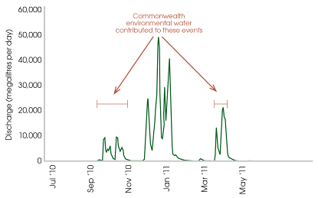
Figure 11: Lower Warrego flows (at Cunnamulla) in 2010–11 and timing of the use of Commonwealth environmental water (Data sourced from Queensland Department of Environment and Resource Management 2011).

Case study: Waterbird outcomes

The wetlands of the Murray–Darling Basin support threatened bird species (including the Australasian bittern and Australian painted snipe) and migratory bird species (such as the great egret, cattle egret and marsh sandpiper). Wetlands also provide important habitat and breeding sites for a number of other waterbirds. Commonwealth environmental water has contributed to outcomes for waterbirds across the Basin, including supporting the completion of colonial waterbird breeding events (figure 12).
Much of the flow in the Basin in 2010–11 resulted from extremely wet conditions, but this was supplemented with additional environmental water.
More than 100,000 hectares of the Macquarie Marshes have been inundated with water since spring 2010 and more than 100,000 nesting pairs of colonial waterbirds bred in the wetlands.
In the Booligal Wetlands approximately 120,000 young straw-necked ibis fledged after one of the biggest successful waterbird breeding events in these wetlands. Waterbirds were also breeding in the Murray, Murrumbidgee, Lowbidgee, Paroo, Narran and Gwydir wetlands including straw-necked ibis, royal spoonbills, cormorants, crested grebes, magpie geese, blue-billed ducks, Australasian bitterns, nankeen night herons, great egrets and glossy ibis.
The Commonwealth is working closely with researchers, New South Wales Office of Environment and Heritage, the State Water Corporation, the New South Wales Office of Water and local landholders to manage and monitor waterbird sites.
The Director of the Australian Wetlands and River Centre at the University of New South Wales, Professor Richard Kingsford, is a scientist whose research over the last 20 years has focussed on waterbirds, wetlands and rivers in arid Australia. Professor Kingsford manages an aerial waterbird survey program that covers about a third of the continent and spans each of the southern states.
Professor Kingsford explains that increased flows at waterbirds sites benefit more than just the waterbirds (Kingsford 2011):
The waterbird community has responded spectacularly to the recent floods throughout the Murray–Darling Basin. They have been particularly affected by the lack of flows in the rivers but the floods have stimulated the entire food web resulting in top predators such as waterbirds capitalising on the food resources that come with flooding augmented by water held by Commonwealth Environmental Water.
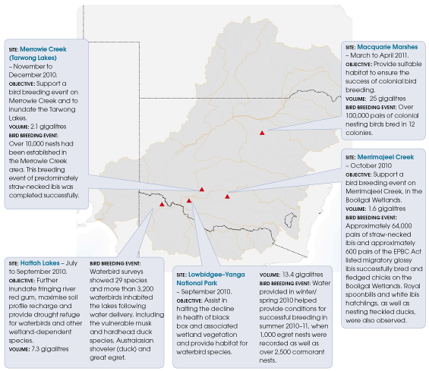
Figure 12: Key Commonwealth environmental watering actions in 2010–11 that supported bird breeding events.

acknowledgments

We would like to thank the following environmental water partners as well as the numerous landholders who have contributed to the management of environmental water through ideas and suggestions as well as delivery of environmental water and monitoring of the results.

Australian Government
Murray–Darling Basin Authority

Queensland
Department of Environment and Resource Management

New South Wales
Border Rivers–Gwydir Catchment Management Authority
Environmental Contingency Allowance Operational Advisory Committee (Gwydir)
Department of Primary Industries (Fisheries)
Jimaringle–Cockran Creek Landholder Group
Lachlan Catchment Management Authority
Lachlan Riverine Working Group
Lower Murray–Darling Catchment Management Authority
Macquarie Environmental Flows Reference Group
Murray Catchment Management Authority
Murray–Lower Darling Environmental Water Advisory Group
Murray Irrigation Limited
Murrumbidgee Catchment Management Authority
Murrumbidgee Environmental Water Advisory Group
Namoi Catchment Management Authority
NSW Office of Environment and Heritage
NSW Office of Water
NSW State Water Corporation

Victoria
Coliban Water
Goulburn Broken Catchment Management Authority
Goulburn–Murray Water
Mallee Catchment Management Authority
North Central Catchment Management Authority
North East Catchment Management Authority
Victorian Department of Sustainability and Environment
Victorian Environmental Water Holder

South Australia
SA Department for Water
SA Department of Environment and Natural Resources
SA Murray–Darling Basin Natural Resources Management Board

References
Balcombe, S., Arthington, A., Foster, N., Thoms, M., Wilson, G. and Bunn, S. (2006), Fish assemblages of an Australian dryland river: abundance, assemblage structure and recruitment in the Warrego River, Murray–Darling Basin, Marine and Freshwater Research, 57, pp. 619–633.
Cook, D., Jolly, K. and Osler, D. (2011). The Living Murray Condition Monitoring: Waterbird surveys of Lindsay, Mulcra and Wallpolla Island and the Hattah Lakes 2010/2011. Report for the Mallee Catchment Management Authority as part of a Murray–Darling Basin Authority funded project. Australian Ecosystems, Patterson Lakes, Victoria.
Department of Sustainability, Environment, Water, Population, and Communities (2011), Wetlands Australia, National Wetlands update, issue no. 19, Canberra, ACT.
Frazier, P. and Page, K. (2006), The effect of river regulation on floodplain wetland inundation, Murrumbidgee River, Australia, Marine and Freshwater Research, 57, pp. 133–141.
Frazier, P., Page, K., Louis, J., Briggs, S. and Robertson, A. (2003), ‘Relating wetland inundation to river flow using Lansat TM data’, International Journal of Remote Sensing, 24, pp. 3755–3770.
Goulburn Broken Catchment Management Authority media release: ‘Breathing life back into our rivers’, 25 October 2010. <www.gbcma.vic.gov.au/default.asp?ID=news_events&post=231&tpl=news_full> viewed 2 December 2011.
Government of South Australia, Department for Water media release: ‘Flows bring exciting results for wildlife in the Lower Lakes’, 4 April 2011.<www.waterforgood.sa.gov.au/wp-content/uploads/2011/04/web-ready-mr_flows-bring-exciting-results-ll.pdf > viewed 2 December 2011.
Humphries, P. (2005), ‘Spawning time and early life history of Murray cod, Maccullochella peelii (Mitchell) in an Australian river’, Environmental Biology of Fishes, 56, pp. 129–151.
Lachlan Riverine Working Group: Lachlan Environmental Water Quarterly Newsletter, March 2011, 3 pp.
Lake, P.S. (2003), ‘Ecological effects of perturbation by drought in flowing waters’, Freshwater Biology, 48, pp. 1161–1172.
Lintermans, M. (2007), Fishes of the Murray–Darling Basin; An introductory guide, Murray–Darling Basin Authority, Canberra ACT, 80 pp.
Murray, P.A. (2008), Murrumbidgee wetlands resource book, Report prepared for the Murrumbudgee Catchment Management Authority, 111 pp.
Murray–Darling Basin Authority (2008), Sustainable Rivers Audit – Report 1: A report on the ecological health of rivers in the Murray–Darling Basin, 2004–2007, 396 pp.
Mussared, D. (1997), Living on Floodplains, The Cooperative Research Centre for Freshwater Ecology, Report prepared for The Murray–Darling Basin Commission.
New South Wales Office of Water (2011), Review of water management during the 2010 flood events in the Tumut River and Murrumbidgee River, August 2011.
New South Wales Office of Environment and Heritage (2011a), Environmental water use in New South Wales, annual report 2010−11.
New South Wales Office of Environment and Heritage newsletter: Water for the Environment News, June 2011, 7 pp.
New South Wales Office of Environment and Heritage (2011b), Progress report on the Macquarie Marshes autumn 2010 environmental watering event. Unpublished report from New South Wales Office of Environment and Heritage to Commonwealth Environmental Water.
Robertson, P. (2011), Monitoring the response of frog populations to autumn 2010 environmental watering at Lindsay–Wallpolla Islands and Hattah Lakes. Report for the Mallee Catchment Management Authority as part of the Murray–Darling Basin Authority funded project 1603.
Rodgers, K. and Ralph, T. J. (editors) (2011), Floodplain wetland biota in the Murray–Darling Basin: water and habitat requirements, New South Wales Department of Environment, Climate Change and Water, 220 pp.
Suitor, L. (2011). Ecological survey results for Carpark Lagoons 2010–11. South Australian Department of Environment and Natural Resources.
Thomas, R., Spencer, J.A., Wassens, S., Lu, Y., Wen, L., Hunter, S., Iles, J. and Kobayashi, Y. (2011), Environmental flow monitoring in the Lowbidgee wetlands and Macquarie Marshes in 2010–11. Testing wetland resilience: monitoring the response of iconic wetlands to reflooding following historic drought project, Progress report for the NSW Catchment Action Program, Office of Environment and Heritage, Sydney, and Charles Sturt University, Wagga Wagga, March 2011.
Tockner, K., Pennetzdorfer, D., Reiner, N., Schiemer, F. and Ward, J. V. (1999), ‘Hydrological connectivity, and the exchange of organic matter and nutrients in a dynamic river-floodplain system’, Danube, Austria, Freshwater Biology, 41, pp. 521–535.
Wassens, S. and Amos, C. (2011), Assessing the resilience of frog communities within river red gum forest: Final Report. Report prepared for NSW Office of Environment and Heritage, Department of Premier and Cabinet, May 2011, Institute for Land, Water and Society, Charles Sturt University, 19 pp.
Wassens, S., Watts, R., Howitt, J., Spencer, J., Zander, A. and Hall, A. (2011), Monitoring of ecosystem response to the delivery of environmental water in the Murrumbidgee system, Report prepared for Department of Sustainability, Environment, Water, Population and Communities, October 2011, Institute for Land, Water and Society, Charles Sturt University, 46 pp.
Watts, R., Howitt, J., Kopf, K., Conallin, J. (2011), Dilution flows: lessons learned from the delivery of environmental water to the Edward–Wakool system via irrigation escapes, Presentation to the Department of Sustainability, Environmental, Water, Population and Communities.
Whitten, S. M. and Bennett, J. W. (2000), Farmer Perceptions of Wetlands and Wetland Management on the Murrumbidgee River between Wagga Wagga and Hay Including Mirrool Creek, University College UNSW, Canberra.
Whitworth, K., Williams, J., Lugg, A. and Baldwin, D. (2011),
A prolonged and extensive hypoxic blackwater event in the southern Murray–Darling Basin, Final report prepared for the Murray–Darling Basin Authority by The Murray–Darling Freshwater Research Centre and NSW DPI (Fisheries), MDFRC Publication 30/2011, June, 127 pp.

