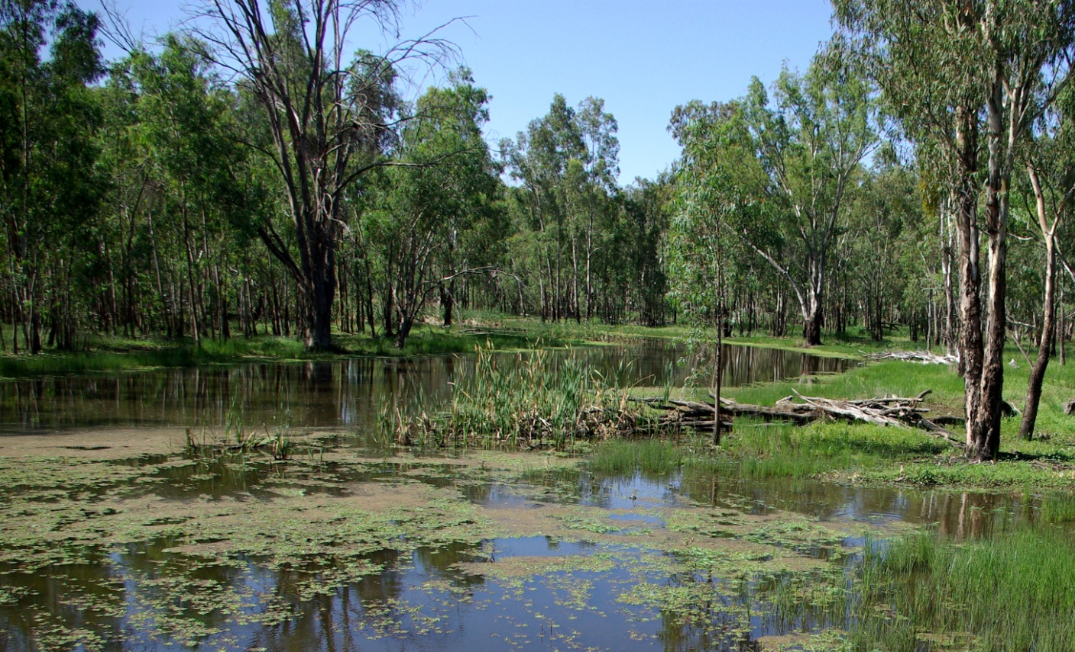

**Commonwealth Environmental Water Office  
2011-12 Outcomes Report**

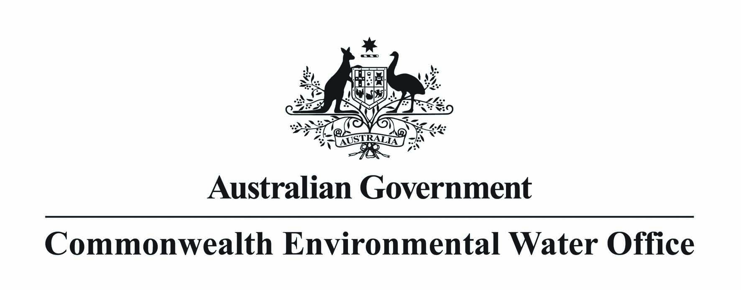



© Commonwealth of Australia 2013

This work is copyright. Apart from any use as permitted under the Copyright Act 1968, no part may be reproduced by any process without prior written permission from the Commonwealth. Requests and enquiries concerning reproduction and rights should be addressed to the Department of Sustainability, Environment, Water, Population and Communities, Public Affairs, GPO Box 787 Canberra ACT 2601 or email public.affairs@environment.gov.au

ISBN 978-1-921733-69-7

CONTENTS

Summary 2

Commonwealth environmental water 2

Commonwealth environmental water objectives 2

Decisions on use of Commonwealth environmental water 2

Working with others to deliver Commonwealth environmental water 2

Active management of Commonwealth environmental water 2

Use of Commonwealth environmental water in 2011-12 2

Southern Basin catchment outcomes 2

Murrumbidgee catchment 2

Northern Victorian rivers 2

Murray catchment 2

Northern Basin catchment outcomes 2

Gwydir catchment 2

Lachlan catchment 2

Macquarie catchment 2

Border Rivers and Namoi catchments 2

Northern Basin unregulated catchments 2

Outlook for 2012–13 2

Resources 2

Monitoring and evaluation reports 2

Acknowledgements 2

Case studies

Ecosystem responses to environmental flows in the Murrumbidgee system, 2011.............10

Providing fish refuge from the impact of poor-quality water in the River Murray..................13

Ecosystem responses to environmental flows in Colligen Creek.........................................15

# Summary

In 2010, the Murray–Darling Basin (the Basin) experienced its wettest year on record. Heavy rainfall continued into 2011 and resulted in significant flooding in many parts of the Basin. The high rainfall and high flows have helped the environmental recovery of many catchments that had suffered from the long-term drought conditions prior to 2010. Commonwealth environmental water was used during 2011–12 to support those recovery processes. It also helped to reduce the impacts of environmental threats in some catchments, such as poor water quality resulting from the higher than average rainfall.

In 2011–12, 680 gigalitres of Commonwealth environmental water were delivered together with environmental water from state and Australian government agencies including the New South Wales Office of Environment and Heritage (Riverbank program), the Victorian Environmental Water Holder, and the Living Murray program, as well as nongovernment organisations such as the Nature Foundation South Australia and Healthy Rivers Australia. Between 2009 to 30 June 2012, 1233 gigalitres of Commonwealth environmental water have been delivered for the environment across the Basin.

The Commonwealth Environmental Water Office (the Office) carried 615 gigalitres of water over into 2012–13, with the majority in the northern Basin catchments due to the heavy rainfall experienced during 2011–12. Over the longer term, it is expected that the percentage of Commonwealth environmental water carried over will be similar to that of other licence holders. It is anticipated that the amount of Commonwealth environmental water carried over will vary from year to year, depending primarily on how wet or dry conditions are within catchments. In very wet conditions, it is expected larger carryover may occur due to having greater allocations and environmental requirements being met through natural conditions.

Since 2009, Commonwealth environmental water has helped to provide flows for the Basin that have:

* sustained wetland and native plant refuges to help animals and plants survive the drought conditions that prevailed across the Basin prior to 2010
* mitigated the impact of poor water quality in the River Murray, Edward–Wakool system and Murrumbidgee River by diluting oxygen-depleted water and providing refuges for native fish
* supported native bird and fish breeding through improved water quality and increased volume and duration of flows
* improved water quality through the export of salt, sediments and nutrients out of the system
* connected rivers, wetlands and floodplains to improve habitat for breeding and migration of native animals
* improved the health of native plants, including river red gums.

This report outlines the environmental benefits that have resulted from Commonwealth environmental watering in the Basin in 2011–12. The report includes case studies, which highlight the results of monitoring projects in the Murray and Murrumbidgee catchments. These show that environmental watering is achieving a broad range of benefits for the many native plant and animal communities that rely on healthy habitat within these catchments to survive.

The activities described in the report also demonstrate how we worked closely with stakeholders, including our delivery partners and environmental water holders, to actively manage environmental water during a year when many catchments were experiencing wet conditions. We are very grateful for the time, expertise, advice and feedback provided by our delivery partners, other environmental water holders, members of our advisory panels, regional advisory groups who invite us to participate in their processes, and the many landowners who work with us to plan, manage and monitor the use of environmental water in the Basin.

Further details of the activities undertaken by the Office in 2011–12 are available in the Commonwealth environmental water annual report 2011–12 and on the Office website at [www.environment.gov.au/ewater/](http://www.environment.gov.au/ewater/).

David Papps

Commonwealth Environmental Water Holder

# Commonwealth environmental water

The Australian Government has acquired water entitlements in the Basin through a combination of investments in water-saving infrastructure, water purchases and other water recovery programs. These water entitlements are managed by the Commonwealth Environmental Water Holder to provide additional water for the environment.

## Commonwealth environmental water objectives

The primary objective of Commonwealth environmental water use is to protect and restore the rivers, wetlands and other environmental assets of the Basin. About 40 per cent of the Basin’s natural river flow is diverted for human use, including for irrigation, in an average nondrought year. Over time, reduced flows have caused environmental problems, including increased salinity, declining water quality, increased algal blooms, declining riverine vegetation (including river red gums), diminished native fish and bird populations, and poor wetland health.

Commonwealth environmental water contributes to flows that connect Basin rivers, wetlands and floodplains. It also improves water quality and supports a range of environmental processes such as breeding and growing cycles of native plants and animals. Commonwealth environmental water contributes to providing healthy rivers, strong local communities and productive economies.

## Decisions on use of Commonwealth environmental water

Throughout each year, the Commonwealth Environmental Water Holder, supported by the Office, determines how much water will be used for each catchment, the intended outcomes of using environmental water, and the triggers or conditions for using the water. During 2011–12 these decisions enabled the Office to participate in 32 environmental watering actions across 14 Basin catchments.

Decisions by the Commonwealth Environmental Water Holder are guided by the environmental, operational and management conditions within the catchment, environmental watering objectives (see Table 1) and the Framework for determining Commonwealth environmental water use, which includes assessment criteria for determining environmental water use.

The framework will be adapted in accordance with the Murray–Darling Basin Plan Environmental Watering Plan. The framework is available at [www.environment.gov.au/ewater/publications/cewh-framework.html](http://www.environment.gov.au/ewater/publications/cewh-framework.html).

Table 1 Environmental objectives and actions under different condition scenarios

|  |  |  |  |  |  |
| --- | --- | --- | --- | --- | --- |
|  | Environmental conditions within the catchment | | | | |
|  | Extreme dry | Dry | Moderate | Wet | Very wet |
| Environmental watering objectives | Avoid damage to key environmental assets | Ensure environmental capacity for recovery | Maintain environmental health and resilience | Improve the health and resilience of water environments | Build future capacity to support environmental health and resilience |
| Carryover management actions | Use carryover volumes to maintain critical needs | Use carryover volumes to maintain follow-up watering | Use carryover to provide optimal seasonal flow patterns in subsequent years | Use carryover to provide optimal seasonal flow patterns in subsequent years | Use carryover to provide reserves for future years |

The environmental outcomes and benefits of watering actions that are achieved depend on the type (size, duration) and pattern (timing, previous flows) of flows experienced in each system during the year. Environmental assets (such as floodplains, wetlands and river channels) that are likely to benefit from maintaining or enhancing different kinds of flows are shown in Figure 1. Where required, the decision may include allowing drying to occur in a way that benefits environmental assets and is consistent with their required wetting and drying cycles.

## Working with others to deliver Commonwealth environmental water

State governments, other environmental water holders, landholders, natural resource management boards, catchment management authorities, local environmental groups and others (see the Acknowledegments section of this report) are involved in Commonwealth environmental water management and delivery. The Office is committed to effective collaboration and engagement with stakeholders to improve environmental water outcomes. Stakeholders help to determine where and how the water is best used, deliver the water and monitor the outcomes.

The active management of a number of Commonwealth environmental watering actions to adapt to wet conditions during 2011–12 demonstrates the effect and importance of these relationships.

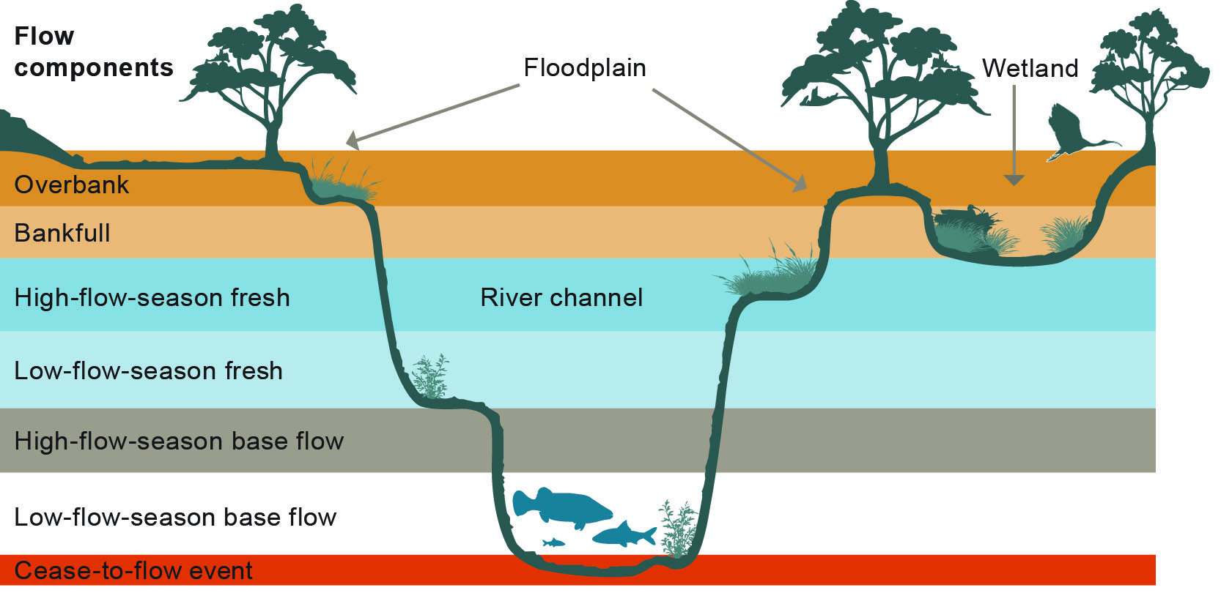

Source: Murray–Darling Basin Authority 2011

Figure 1 Flow components and their influence on different parts of the river channel and its floodplain

## Active management of Commonwealth environmental water

Commonwealth environmental water is actively managed so that environmental objectives are met with the appropriate amount of water. Active management includes coordinating opportunities to use environmental water in combination with river flows, using infrastructure to deliver water, working with river operators to better manage environmental flows, and transferring water allocations between connected catchments to where it is most needed.

The options for managing water in catchments include delivering it to environmental assets within the current year, carrying it over to future years by leaving it in storage (where possible) or trading it. The Office produces and regularly updates Portfolio management statements that identify the Office’s approach. These statements are available at [www.environment.gov.au/ewater/management/portfolio.html](http://www.environment.gov.au/ewater/management/portfolio.html).

Active management also includes working with our delivery partners to react in a timely and effective manner to changing environmental conditions within a catchment. During 2011–12, active management resulted in a number of Commonwealth environmental watering actions being suspended or ceased in certain areas in response to increased natural flows and high rainfall, which met the needs of the environment. Active management also allows for environmental water to be provided quickly when required, such as providing flows to improve water quality for native fish.

# Use of Commonwealth environmental water in 2011-12

In 2011–12, the Basin experienced heavy rainfall, resulting in high river flows and natural floods. These conditions built on the record-breaking wet conditions of the previous year and substantially helped the recovery of environmental assets affected by the 2000–10 drought.

The high rainfall resulted in high allocations for 2011–12. Commonwealth environmental water was used to support environmental recovery processes brought on by wet conditions, by contributing to favourable environmental conditions in which native plants and animals could breed and grow. Commonwealth environmental water was also actively managed to mitigate poor water quality (blackwater) that resulted from natural flooding. The blackwater posed a threat to some native animals—particularly fish (see Case study 2).

The volume of water allocations made against the Commonwealth holdings in 2011–12 was 980 gigalitres. In addition, 331 gigalitres of water were available from carryover from 2010–11, bringing the total volume of Commonwealth environmental water available for use to 1311 gigalitres. Of this:

* 680 gigalitres were delivered as part of 2011–12 watering actions together with water from other environmental water holders including state and federal government agencies and other nongovernment organisations.
* after evaporative losses, 615 gigalitres were carried over into 2012–13 for future use. The majority of this carryover was in the northern Basin, due to the wet conditions experienced during 2011–12.

Further information on how the Office manages carryover in the Basin can be found in fact sheets on the Office’s website: [www.environment.gov.au/ewater/management/carryover.html](http://www.environment.gov.au/ewater/management/carryover.html).

Information on the environmental watering actions undertaken by other environmental water holders and management authorities in the Basin can be obtained by contacting them directly or visiting their web sites (see the Acknowledgements section).

# Southern Basin catchment outcomes

## Murrumbidgee catchment

During 2011–12, the Office partnered with the New South Wales Office of Environment and Heritage to provide flows for the lower Murrumbidgee River and Lowbidgee floodplain. A total of 83 gigalitres of Commonwealth environmental water was delivered in conjunction with additional environmental water held by the New South Wales Office of Environment and Heritage. These watering actions built on the environmental watering actions and natural flows that occurred in the Murrumbidgee catchment during 2010–11.

The environmental water was used to support native plant communities, including river red gum and black box forests, lignum and native reed in the wetland areas of North Redbank. These provide habitat for many native animals—including the southern bell frog and the fishing bat, and birds, such as the great egret, glossy ibis, blue-billed duck, Nankeen night heron, cormorants and Australasian bittern. Environmental water also promoted spawning for small-bodied native fish. More information on the outcomes from these watering actions is provided in Case study 1.

The Murrumbidgee environmental watering actions were actively managed in response to the extreme weather conditions experienced in the catchment during 2011–12. For example, the largest Commonwealth environmental watering action was suspended from late February to mid-May 2012, due to heavy rainfall that triggered significant natural flooding in the catchment during March 2012.

**Case study 1 Ecosystem responses to environmental flows in the Murrumbidgee system, 2011**

A team led by Charles Sturt University, with support from the New South Wales Office of Environment and Heritage, assessed the response of native plants, animals and water quality in the mid-Murrumbidgee river channel and wetlands to Commonwealth environmental water delivery. It was found that environmental watering had benefited native animals, plants and water quality within the filled wetlands. Benefits included:

* improving water quality within wetlands
* assisting in the recovery of native plant communities
* improving habitat for native frog breeding and growth, especially barking marsh frogs and spotted marsh frogs
* enabling wetlands to retain water throughout the year, which appeared to result in native fish being favoured (through movement into wetlands, successful spawning, etc.) over introduced fish. The native species included carp gudgeon, Australian smelt, unspecked hardyheads, Murray–Darling rainbow fish and bony bream
* supporting waterbird breeding, with a small number of nests recorded in Gooragool, Yarrada and McKennas lagoons.

The key short-term benefits of environmental watering within the river channel included:

* significantly reducing the amount of algae at several sites, most likely due to the scouring effect of increased water flow; this scouring process releases nutrients and food into the water and provides an important resource for downstream native plants and animals
* increasing the types of insects in the Tumut River immediately after the environmental flow; these provide food for other animals such as fish, frogs and birds.

More detail on the monitoring results of environmental watering in the Murrumbidgee system in 2011 can be found in the final monitoring report at [www.environment.gov.au/ewater/publications/ecosystem-response-monitoring-murrumbidgee-2.html](http://www.environment.gov.au/ewater/publications/ecosystem-response-monitoring-murrumbidgee-2.html).

## Northern Victorian rivers

The northern Victorian rivers area includes the catchments of the Goulburn, Broken, Campaspe, Loddon and Ovens rivers and Broken Creek. A total of 152 gigalitres of Commonwealth environmental water was provided throughout these catchments during 2011–12. Each watering action was designed to complement the use of environmental water held by the Victorian Environmental Water Holder and The Living Murray program, and was delivered by catchment management authorities and Goulburn–Murray Water. Many of these actions were also designed to achieve environmental outcomes at multiple sites, particularly the Lower Murray River system in South Australia. Environmental watering improved habitats for aquatic plants and animals, and supported large-scale breeding by waterbirds such as ibis, swan, spoonbill and egret species.

***Broken River***

In 2011–12, the Commonwealth Environmental Water Holder provided 0.05 gigalitres to the Broken river system, which contributed to maintaining healthy native vegetation in riverbank areas. This water also connected areas of river habitat to improve the ability of native fish, such as Murray cod, to move within the system, breed and grow.

***Broken Creek***

Ten gigalitres of Commonwealth environmental water were provided during 2011–12 to the Broken Creek catchment. This contributed to improving water quality and providing native fish habitat during the migration and breeding season, particularly for large-bodied fish such as Murray cod. This watering action was actively managed to respond to changing catchment conditions. It was suspended at the end of February 2012 due to natural high flows in the catchment and recommenced at the beginning of May 2012.

***Campaspe River***

During 2011–12, more than 6.5 gigalitres of Commonwealth environmental water were used in the Campaspe River in combination with additional water provided by The Living Murray program to maintain native plant communities in riverbank areas and provide cues for native fish breeding. It also contributed to flows that improved connections between river areas, and covered snags to benefit native fish and insects.

***Goulburn River***

Commonwealth environmental water was provided to the Goulburn River during 2011–12. A total of 133.9 gigalitres was used in combination with water from The Living Murray program to maintain native plants, providing habitats in which native animals, particularly insects and fish such as golden perch, could breed and grow. This environmental water also provided flows that contributed to environmental benefits in the Murray River channel, Lower Lakes and Coorong. Watering was suspended in February 2012 in response to high rainfall in the catchment.

***Loddon River***

The Loddon River received 1.5 gigalitres of Commonwealth environmental water in combination with additional water provided by the Victorian Environmental Water Holder during 2011–12. This helped improve water quality and connect the habitats of native fish communities in the river, including Murray cod, golden perch and silver perch, so that they could move within the river, breed and grow. These flows also enhanced the regeneration of river red gums and other native plants in the catchment.

***Ovens River***

The 0.07 gigalitres of Commonwealth environmental water provided to the Ovens River catchment during 2011–12 contributed to maintaining the extent and diversity of native plant communities in riverbank areas. It also contributed to maintaining habitat for native fish, enabling them to breed and grow.

## Murray catchment

A total of 343.4 gigalitres of Commonwealth environmental water was delivered across the Murray catchment in 2011–12 in conjunction with water from the New South Wales Office of Environment and Heritage, the Nature Foundation South Australia and Healthy Rivers Australia. Similar to the watering actions undertaken in the northern Victorian catchments, many of these actions were designed to achieve environmental outcomes at multiple sites, including the Lower Murray River system in South Australia. This water use was actively managed to respond to heavy rainfall and natural floods. The delivery of Commonwealth environmental water was suspended in all areas where there was the potential for natural flooding to occur, creating risks to property.

***Lower Murray River Valley—Coorong, Lower Lakes and Murray Mouth***

The Commonwealth provided 195.9 gigalitres of environmental water to increase flows to South Australia to support the management and improvement of aquatic habitat in the Murray River channel, Lakes Alexandrina and Albert (the Lower Lakes) and the Coorong, and to increase flows over the barrages and out through the Murray Mouth.

These environmental watering actions assisted the management of variable water levels in the Lower Lakes and Coorong. This in turn helped manage water salinity and nutrient levels, which influence the recovery and growth of important food sources for waterbirds and habitat for native fish. The actions also contributed to connecting areas of river habitat to promote the migration and breeding of native fish including golden perch, congolli, Murray hardyhead and common galaxias. The Office commissioned monitoring of the ecological response to Commonwealth environmental watering in the Lower Murray River channel in 2011–12. The monitoring was undertaken by the South Australian Research and Development Institute, and the results will be made available from the Office website.

Commonwealth environmental water was also used in the River Murray to help provide refuges for native fish and dilute low-oxygen water (blackwater) that was flowing into the River Murray from the Murrumbidgee River (see Case study 2).

**Case study 2 Providing fish refuge from the impact of poor-quality water in the River Murray**

Floods can wash organic material, such as leaf litter, into wetlands and waterways. When this organic matter decays, it darkens the water, turning it black (known as ‘blackwater’). As the organic matter decays, oxygen held in the water is sometimes consumed faster than it can be replenished. Water with low levels of oxygen can stress or kill native fish.

The inundation of floodplain areas along the Murrumbidgee River following heavy rainfall during March and April 2012 led to significant areas of blackwater in the Murrumbidgee River. This water had the potential to severely affect aquatic animals when it flowed into the River Murray. Because the lower Murrumbidgee River was already in a state of natural flooding, environmental water was not used to help dilute areas of poor water quality. Commonwealth environmental water was, therefore, provided to maintain flows in the River Murray at levels that would help to dilute the blackwater flowing into the River Murray from the Murrumbidgee River.

***Snapshot of monitoring results on 8 May 2012***

Figure 2 shows a snapshot of monitoring results from six sites on the River Murray, recorded on 8 May 2012. The map shows that the flows in the Murray and lower Murrumbidgee, which included a contribution of Commonwealth environmental water, mitigated the impacts of blackwater flowing from the Murrumbidgee River into the River Murray.

The flows of environmental water were not able to fully counteract the negative impacts of the poor-quality water entering the River Murray. However, they did maintain river flows at levels that assisted in maintaining or improving water quality, and provided important refuges for native fish.

The boxes in the figure describe the water at the six monitoring sites.

***Box 1— River Murray upstream, healthy water***: Just upstream from the junction of the Murray and Murrumbidgee rivers, 17.7 gigalitres per day were flowing down the River Murray, which included approximately 4 gigalitres of Commonwealth environmental water. The oxygen levels in this water were good, and supported native fish communities.

***Box 2—Murrumbidgee River upstream, poor-quality water***: The lower Murrumbidgee River remained in a state of natural flooding, with 18.7 gigalitres of water containing low levels of oxygen flowing into the River Murray per day. The dissolved oxygen levels were below critical thresholds, and could stress or kill native fish.

***Boxes 3–5—downstream of the Murray–Murrumbidgee junction, increased mixing of water***: The dilution flows from the River Murray had a remarkably quick effect on water quality, with immediate substantial mixing occurring within 170 metres of the junction with the Murrumbidgee River. Within and across the water column, areas of improved levels of oxygen (in the blue and green areas) would provide refuge from those areas of oxygen below critical thresholds (in the red and yellow areas) for native fish such as Murray cod.

***Boxes 4–5—from 0.5–1 kilometre downstream, increased mixing of water***: This provided improved oxygen levels and suitable habitat for native fish.

***Box 6—five kilometres past the Murray–Murrumbidgee junction, healthy water:*** Five kilometres downstream of the Murray–Murrumbidgee junction, there is a complete mixing of water from the two rivers, and oxygen levels have improved to a level that is suitable for native fish.

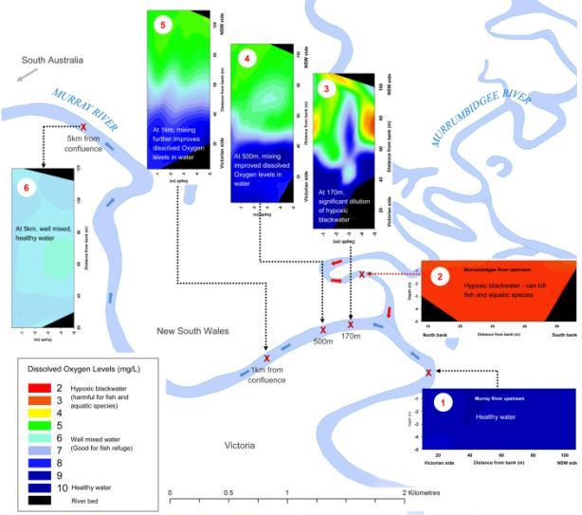

Figure 2 Monitoring Commonwealth Environmental Water in the River Murray - Snapshot on 8th May

***Mid-Murray–Wakool River, Colligen and Jimaringle–Cockran creeks***

A total of 147.5 gigalitres of Commonwealth environmental water was provided to the mid-Murray catchment during 2011–12. Working with local landholders, the New South Wales Office of Environment and Heritage, the Murray Catchment Management Authority and Charles Sturt University, environmental water was used in:

* Colligen Creek and Wakool River to improve water quality, help connect areas of the river and creek systems, and provide habitat for native fish to breed and grow. The results from the monitoring undertaken by Charles Sturt University for the Office for this watering action are provided in Case study 3 and are available in more detail from [www.environment.gov.au/ewater/publications/ecosystem-response-monitoring-natural-edward-wakool.html](http://www.environment.gov.au/ewater/publications/ecosystem-response-monitoring-natural-edward-wakool.html). Staff from the New South Wales Office of Environment and Heritage have also monitored frogs in the mid Murray since 2009–10. In 2010–11 and 2011–12, 11 frog species were identified across the system, including the wrinkled toadlet and southern bell frog. This compared to the eight species detected during initial surveys conducted in 2009–10 (Healy 2012).
* Jimaringle–Cockran creeks, as a follow-up to the watering action in 2010–11, to maintain and improve the health of native plant communities in the system, particularly, fringing river red gum and black box. This in turn provided good-quality habitat for native fish, frogs, birds and other native animals. The involvement of local landholders has been critical to the successful planning, delivery and use of environmental water in this area.

**Case study 3 Ecosystem responses to environmental flows in Colligen Creek**

The Edward–Wakool river system is a major anabranch and floodplain of the River Murray in southern New South Wales. This system has high native species richness and diversity, including threatened fishes, frogs, mammals and riparian plants.

The Edward–Wakool river system had periods of minimal or no flow between February 2006 and September 2010. Between September 2010 and March 2011 a number of large natural flow events occurred in the river system, caused by heavy rainfall in the catchment (Figure 3).

In November 2011, 5.5 gigalitres of Commonwealth environmental water (in combination with 1.7 gigalitres of environmental water held by the New South Wales Office of Environment and Heritage) were delivered to Colligen Creek to encourage the migration and breeding of native fish, and to maintain and improve the habitats within the creek.

Charles Sturt University monitored Colligen Creek and three nearby rivers that did not receive environmental water, to enable the different sites to be compared. Short-term ecosystem responses to the environmental watering in Colligen Creek were assessed by comparing results from November 2011, before the environmental watering, to those from December 2011, immediately after the watering.

Early results showed that after the watering in Colligen Creek:

* there was an increase in the breeding of carp gudgeon, a small native fish
* there was an increase in the types of microscopic organisms that are eaten by native fish in the creek
* the levels of microscopic plants and algae, which are important food for fish and other animals, were maintained.

The following findings will be made clearer when the final results of the monitoring are available:

* there was no evidence of increased breeding of Murray cod, although they were present in the creek
* there was a decrease in the numbers and types of macroinvertebrates (e.g. water insects, worms, snails) in the creek immediately after the environmental flow. This pattern may change when longer term responses are examined.

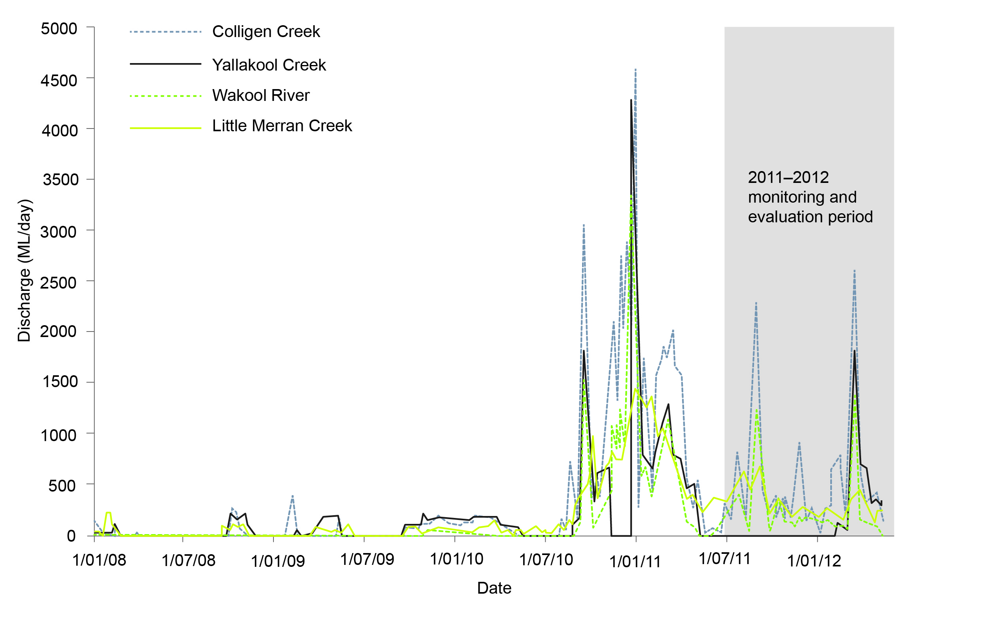

ML = megalitres

Note: The monitoring and evaluation period in 2011–12 is shaded.

Figure 3 Daily discharge between 1 January 2008 and 13 May 2012 in four rivers in the Edward–Wakool river system: Colligen Creek (below regulator), Yallakool Creek (offtake regulator), Wakool River (offtake regulator) and Little Merran Creek (Franklings bridge).

# Northern Basin catchment outcomes

Across the Murray–Darling Basin there are wetlands of national and international importance, critical for successful breeding of many thousands of nesting waterbirds. In the northern Basin these wetlands include Narran Lakes (near Walgett), Gwydir Wetlands (near Moree), Macquarie Marshes (near Warren) and the Booligal Wetlands on the Lower Lachlan (near Hillston).

Watering actions in the Gwydir, Lachlan and Macquarie catchments were managed in cooperation with the New South Wales Office of Environment and Heritage, the State Water Corporation, the New South Wales Department of Primary Industries (including the New South Wales Office of Water, Fisheries New South Wales and Catchment Management authorities), local advisory groups, landholders and scientists. Commonwealth environmental water was often delivered in conjunction with environmental water from New South Wales Office of Environment and Heritage.

### Gwydir catchment

Commonwealth environmental water totalling 1.2 gigalitres was delivered in conjunction with New South Wales environmental water and natural flows in 2011–12 to contribute to inundation of core areas in the Gwydir Wetlands. The action aimed to build on the last two years of high flows in the catchment, which have promoted the recovery of vegetation and maintained habitat for threatened and migratory bird and animal species. Watering was suspended in October 2011 in response to Bureau of Meteorology forecasts of above-average rainfall, to avoid contributing to flooding.

### Lachlan catchment

Between June and December 2011, 20.1 gigalitres of Commonwealth environmental water were delivered to the Booligal Wetlands and Merrowie Creek.

Environmental water delivered to Merrowie Creek connected wetland habitat for colonial nesting birds such as straw-necked ibis, helped create breeding habitat for Sloane’s froglet near Tom’s Lake, and contributed to improving the health of native plant and waterbird communities at Lake Tarwong.

The Australian and New South Wales governments provided environmental water to the Booligal Wetlands, including Merrimajeel and Muggabah creeks, which contributed to improving the health of native plant communities such as river red gums and lignum. The environmental watering also contributed to providing foraging habitat for waterbirds (e.g. glossy, white and straw-necked ibis, and blue-billed and freckled duck), and supported extensive waterbird breeding in the wetlands.

Further use of Commonwealth environmental water in the Lachlan catchment ceased for the second half of the year as a result of heavy rainfall and high river flows that satisfied the remaining water requirements for the system.

### Macquarie catchment

A total of 40 gigalitres of Commonwealth environmental water was provided to the Macquarie Marshes from September 2011 to January 2012.

Commonwealth environmental water was delivered with environmental water from the New South Wales Office of Environment and Heritage, and contributed to continuing the recovery and regeneration of native plant communities, particularly degraded areas of river red gum woodlands. Environmental water was also used to help protect wetland habitat and ensure the breeding success of waterbirds, including glossy ibis and egrets. Environmental water also helped to suppress weed growth (e.g. roly-poly).

This watering use had ceased before the widespread rainfall in early March 2012 that resulted in natural floods in the catchment.

### Border Rivers and Namoi catchments

During 2011–12, environmental water needs in the Border Rivers and Namoi River catchments were met by high rainfall. Consequently, no Commonwealth environmental water was delivered in the regulated part of these catchments.

### Northern Basin unregulated catchments

*Border Rivers catchment*

One gigalitre of unregulated water was used in the Severn River, Queensland, to support natural flows during the summer period. Contributions of Commonwealth environmental water in this catchment aimed to support flows that promote native fish movement and maintain high-value waterholes and riverbank native plant communities within the Sundown National Park.

*Condamine–Balonne catchment*

Commonwealth environmental water during 2011–12 was used to support natural flows generated by rainfall in upstream catchment areas. During the summer period three gigalitres were used to contribute to in-channel flows in the lower Balonne system. This included the first flow of the season, which connected the Balonne River with its network of distributary channels, and watering actions that provided inflows to Narran Lakes. The environmental water supported inundation of the lower Balonne floodplain and extensive waterbird breeding in Narran Lakes.

A further 0.06 gigalitres were used to provide flows in Nebine Creek, a waterway that enters low in the system and infrequently contributes flows into the Darling River. This creek contains waterholes that provide important refuge to native animal communities during dry periods.

The Commonwealth’s contribution to instream flows in the Condamine–Balonne catchment reflects water that was previously extracted from the river for irrigation during natural (unregulated) flows. The use of Commonwealth environmental water in the catchment aims to contribute to a more naturally variable flow regime, and to provide benefits to instream and floodplain native plants and animals.

*Moonie catchment*

In December 2011, 1.4 gigalitres of Commonwealth environmental water were used in the Moonie River during the first significant flow event since winter. The action supported migration and spawning cues for a number of native fish communities found in the catchment. Environmental water was used before the high natural flows in the catchment that were caused by very heavy rainfall in late January to early February 2012.

*Warrego catchment*

In the Warrego catchment 33.88 gigalitres of Commonwealth environmental water were provided in 2011–12, comprising:

* 16 gigalitres used from entitlements held in Queensland to support natural flows that reconnected waterholes and provided a strong cue for the migration and breeding of native fish. Environmental water also supported natural flows that connected the main river to important waterbird habitat in the Cuttaburra Basin
* 17.8 gigalitres from holdings in New South Wales, which provided benefits to instream plants and animals in the lower Warrego and Darling rivers through enhanced flows (8.1 gigalitres). The remaining 9.7 gigalitres provided flows to important waterbird habitat and key floodplain plant communities, including coolabah, black box and lignum, on the Warrego Western Floodplain in the Toorale National Park – State Conservation Area. This supported threatened and endangered bird and fish species, including brolga, rainbow bee-eater, great egret, glossy ibis, purple-spotted gudgeon and olive perchlet.

# Outlook for 2012–13

Rainfall forecasts are tending to indicate a return to normal or drier than normal conditions in a number of Basin catchments during 2012–13 (Bureau of Meteorology 2012). To manage Commonwealth environmental water effectively, the Office prepares annual water-use options for dry, normal and wet circumstances. The 2012–13 water-use options have been developed by the Office with advice and contributions from more than 25 stakeholder groups.

In the southern connected Basin (which includes the Murrumbidgee, lower Murray River valley, mid-Murray region and northern Victorian rivers catchments) the water-use options include a focus on improving our ability to achieve environmental outcomes at multiple sites, including the Lower Lakes and the Coorong. In the northern Basin catchments the water-use options focus on continuing to build on the improved environmental conditions, which have resulted from the past two years of wetter conditions. This may also mean allowing drying to occur at some sites in a way that is consistent with natural wetting and drying cycles.

The options identified for each catchment are not exhaustive, and we welcome advice from Basin communities on how Commonwealth environmental water can best be managed, including further suggestions on the water-use options. Copies of the options documents are available from [www.environment.gov.au/ewater/publications/index.html#use-options](http://www.environment.gov.au/ewater/publications/index.html#use-options).

During 2012–13, the Office will continue to implement its monitoring, evaluation, reporting and improvement framework. New monitoring projects will be undertaken in selected Basin catchments during 2012–13, and are designed to align with the proposed water-use options. This work continues to be an important way of demonstrating the value of using Commonwealth environmental water to protect and restore the environmental assets of the Basin.

The Office is committed to further developing our relationships with our stakeholders, including delivery partners and environmental water holders, and improving our transparency and accountability to the Basin community. These relationships are critical to our ability to secure good environmental outcomes in the Basin.

# Resources

Australian Government Department of Sustainability, Environment, Water, Population and Communities (2011). Australian Government response to the House of Representatives Standing Committee on Regional Australia’s report Of drought and flooding rains: inquiry into the impact of the guide to the Murray–Darling Basin Plan in regional Australia. [www.environment.gov.au/water/publications/mdb/gov-response-basin-plan-inquiry.html](http://www.environment.gov.au/water/publications/mdb/gov-response-basin-plan-inquiry.html)

Australian Government Department of Sustainability, Environment, Water, Population and Communities (2012). Portfolio Budget statements 2012–13. [www.environment.gov.au/about/publications/budget/2012/pubs/pbs-portfolio-budget-statements-2012-13.pdf](http://www.environment.gov.au/about/publications/budget/2012/pubs/pbs-portfolio-budget-statements-2012-13.pdf)

Bureau of Meteorology (2012). Record-breaking La Niña events: an analysis of the La Niña life cycle and the impacts and significance of the 2010–11 and 2011–12 La Niña events in Australia. [www.bom.gov.au/climate/enso/history/La-Nina-2010-12.pdf](http://www.bom.gov.au/climate/enso/history/La-Nina-2010-12.pdf)

Bureau of Meteorology (2012). Seasonal streamflow forecasts—date: October to December 2012. [www.bom.gov.au/water/ssf/index.shtml](http://www.bom.gov.au/water/ssf/index.shtml)

Commonwealth Environmental Water (2011). Commonwealth environmental water 2011–2012 business plan. [www.environment.gov.au/ewater/publications/cew-business-plan-2011-12.html](http://www.environment.gov.au/ewater/publications/cew-business-plan-2011-12.html)

Commonwealth Environmental Water (2011). Commonwealth environmental water—trading arrangements, discussion paper. [www.environment.gov.au/ewater/publications/water-trade-discussion-paper.html](http://www.environment.gov.au/ewater/publications/water-trade-discussion-paper.html)

Commonwealth Environmental Water (2011). A framework for determining Commonwealth environmental water use. [www.environment.gov.au/ewater/publications/cewh-framework.html](http://www.environment.gov.au/ewater/publications/cewh-framework.html)

Commonwealth Environmental Water (2012). Commonwealth environmental water 2010–11 outcomes report. [www.environment.gov.au/ewater/publications/cewh-outcomes-report-2010-11.html](http://www.environment.gov.au/ewater/publications/cewh-outcomes-report-2010-11.html)

Commonwealth Environmental Water (2012). Commonwealth environmental water: monitoring, evaluation, reporting and improvement framework. [www.environment.gov.au/ewater/publications/ewater-monitoring-evaluation.html](http://www.environment.gov.au/ewater/publications/ewater-monitoring-evaluation.html)

Commonwealth Environmental Water (2012). Commonwealth environmental water carryover from 2011-12 into 2012-13. [www.environment.gov.au/ewater/publications/carryover-report-2012.html](http://www.environment.gov.au/ewater/publications/carryover-report-2012.html)

Healy S (2012). Frog numbers and diversity improve during recent floods and environmental flows in the Murray. In: Wetlands Australia: September 2012, issue no. 21. [www.environment.gov.au/water/publications/environmental/wetlands/wetlands-australia/wa21/pubs/wetlands-australia-issue21.pdf](http://www.environment.gov.au/water/publications/environmental/wetlands/wetlands-australia/wa21/pubs/wetlands-australia-issue21.pdf)

House of Representatives Standing Committee on Regional Australia (2011). Of drought and flooding rains: inquiry into the impact of the guide to the Murray–Darling Basin Plan in regional Australia. [www.aph.gov.au/Parliamentary_Business/Committees/House_of_Representatives_Committees?url=ra/murraydarling/report.htm](http://www.aph.gov.au/Parliamentary_Business/Committees/House_of_Representatives_Committees?url=ra/murraydarling/report.htm)

New South Wales Department of Primary Industries, Office of Water (2012). Proposed arrangements for shepherding environmental water in New South Wales—draft for consultation. [www.water.nsw.gov.au/Water-management/Water-recovery/Water-shepherding/default.aspx#propose](http://www.water.nsw.gov.au/Water-management/Water-recovery/Water-shepherding/default.aspx#propose)

New South Wales Office of Environment and Heritage (2012). Waterbirds flock back to the Gwydir Wetlands. [www.environment.nsw.gov.au/media/DecMedia12050104.htm](http://www.environment.nsw.gov.au/media/DecMedia12050104.htm)

New South Wales Office of Environment and Heritage (2012). Waterbirds return as the Gwydir floods. <http://brg.cma.nsw.gov.au/uploads/ECA/WaterbirdsRetnGwydirFloods_0712.pdf>

Murray–Darling Basin Authority (2011). The proposed ‘environmentally sustainable level of take’ for surface water of the Murray–Darling Basin: methods and outcomes, MDBA publication no 226/11. <http://download.mdba.gov.au/proposed/ESLT_MDBA_report.pdf>

# Monitoring and evaluation reports

Wassens S and Spencer J (2012). Monitoring of ecosystem responses to a major natural flood in autumn 2012. Institute for Land, Water and Society, Charles Sturt University and New South Wales Office of Environment and Heritage. Report 3. Prepared for the Commonwealth Environmental Water Office. [www.environment.gov.au/ewater/publications/ecosystem-response-monitoring-natural-flood.html](http://www.environment.gov.au/ewater/publications/ecosystem-response-monitoring-natural-flood.html)

Wassens S, Watts RJ, Spencer J, Howitt J, McCasker N, Griese V, Burns A, Croft R, Zander A, Amos C and Hall A (2012). Monitoring of ecosystem responses to the delivery of environmental water in the Murrumbidgee system. Institute for Land, Water and Society, Charles Sturt University, Report 2. Prepared for the Commonwealth Environmental Water Office. [www.environment.gov.au/ewater/publications/ecosystem-response-monitoring-murrumbidgee-2.html](http://www.environment.gov.au/ewater/publications/ecosystem-response-monitoring-murrumbidgee-2.html)

Watts RJ, Kopf RK, Hladyz S, Grace M, Thompson R, McCasker N, Wassens S, Howit, JA and Conallin J (2012). Monitoring of ecosystem responses to the delivery of environmental water in the Edward–Wakool river system, 2011–2012. Institute for Land, Water and Society, Charles Sturt University, Report 1. Prepared for the Commonwealth Environmental Water Office. [www.environment.gov.au/ewater/publications/ecosystem-response-monitoring-natural-edward-wakool.html](http://www.environment.gov.au/ewater/publications/ecosystem-response-monitoring-natural-edward-wakool.html)

# Acknowledgements

Mr Ian Robinson, the first Commonwealth Environmental Water Holder, moved from the position in May 2012 to take up other duties in the Australian Government. Mr Robinson played the pivotal role in establishing the new function of the Office from 2008. This marks an important contribution to reform in the Basin and institution-building in the Australian Government.

We respectfully acknowledge the Traditional Owners, their Elders past and present, their Nations of the Murray–Darling Basin, and their cultural, social, environmental, spiritual and economic connection to their lands and waters.

We would also like to thank the following environmental water partners and the numerous landholders who have contributed to the management of environmental water through ideas and suggestions, as well as delivery of environmental water and monitoring of the results.

**Australian Government**

* Murray–Darling Basin Authority
* The Living Murray program, administered by the Murray–Darling Basin Authority

**Queensland**

* Department of Natural Resources and Mines (former
* Department of Environment and Resource Management)

**New South Wales**

* Border Rivers–Gwydir Catchment Management Authority
* Department of Primary Industries (Fisheries New South Wales)
* Department of Primary Industries (New South Wales Office of Water)
* Environmental Contingency Allowance Operational Advisory Committee (Gwydir)
* Jimaringle–Cockran Creek Landholder Group
* Lachlan Catchment Management Authority
* Lachlan Riverine Working Group
* Lower Murray–Darling Catchment Management Authority
* Macquarie Environmental Flows Reference Group
* Murray Catchment Management Authority
* Murray Irrigation Limited
* Murray–Lower Darling Environmental Water Advisory Group
* Murrumbidgee Catchment Management Authority
* Murrumbidgee Environmental Water Advisory Group
* Namoi Catchment Management Authority
* Office of Environment and Heritage
* State Water Corporation
* Wakool River Association

**Victoria**

* Department of Sustainability and Environment
* Goulburn Broken Catchment Management Authority
* Goulburn–Murray Water
* Loddon Environmental Water Advisory Group
* Mallee Catchment Management Authority
* North Central Catchment Management Authority
* North East Catchment Management Authority
* Victorian Environmental Water Holder

**South Australia**

* Department of Environment, Water and Natural Resources (former Department for Water and Department of Environment and Natural Resources)
* Nature Foundation South Australia
* Healthy Rivers Australia
* SA Water
* South Australia Murray–Darling Basin Natural Resources Management Board

**Research institutions**

* Charles Sturt University
* Commonwealth Scientific and Industrial Research Organisation (CSIRO)
* Murray–Darling Freshwater Research Centre
* South Australian Research and Development Institute
* University of New South Wales

**External advice panels**

* Commonwealth Environmental Water Scientific Advisory Panel
* Commonwealth Environmental Water Stakeholder Reference Panel