Natural Capital Economics

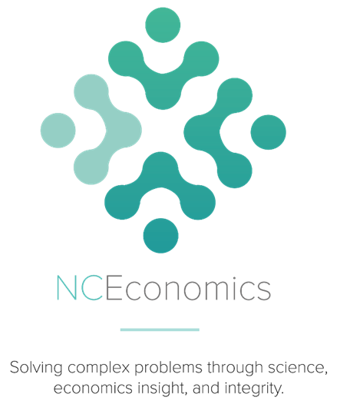

Review of the Commonwealth Environmental Water Holder’s   
operations and business processes

Prepared for the

Commonwealth Environmental Water Holder

by

Dr R Neil Byron

14 November 2017

On behalf of the

Independent External Review Panel

Final. 4 September 2017

Citation:

Natural Capital Economics (2017).

Review of the Commonwealth Environmental Water Holder’s operations and business processes

Contact:

Neil Byron

Director

Natural Capital Economics

[neil.byron@nceconomics.com](mailto:neil.byron@nceconomics.com)

# Executive summary

**A reference panel of experts (the Review Panel) were commissioned by the Commonwealth Environmental Water Holder (CEWH) to undertake an evaluation of the extent to which the CEWH’s operation and business processes represent best practice (the Review). After reading public and internal documents about the processes, activities and performance of the CEWH and the supporting Commonwealth Environmental Water Office (the Office), and engaging with a diverse array of stakeholders across the Murray-Darling Basin (the Basin), the Review Panel is firmly of the opinion that:**

The CEWH has established a strong platform for continuing to effectively and efficiently deliver the Commonwealth’s Environmental Water Holdings to the target areas, and that substantial environmental benefits, that would not otherwise have occurred, are being achieved.

**The CEWH operates in partnership with other water holders and managers of planned environmental water, river managers and infrastructure operators (usually formal and long term), and with regional Natural Resource Management (NRM) bodies, landholders and community groups (usually ad hoc and less formal). These partnerships operate within a variable and uncertain operating space.**

**Two phases were undertaken during the Review. The first (internally-focussed) phase of the Review concludes that CEWH now has all the necessary processes in place for responsible, effective and informed decision-making, and for compliance with the requisite legal frameworks and standards. The Review finds:**

* Essential portfolio management functions (stewardship, planning, delivery, and Monitoring Evaluation Reporting and Improvement (MERI)) are all guided by appropriate, clear, well-designed protocols.
* Data management systems are adequate but will need to continually evolve.
* Threat and risk assessments are regularly and thoroughly conducted, and have been effectively used in design and implementation of operations.
* Appropriate governance arrangements are in place, aligning accountabilities with responsibilities and ensuring high standards of transparency (except in areas where CEWH must rely on the professionalism and competency of independent delivery partners).
* The enabling functions (mainly partnerships, communications and engagement) are adequate but could be improved.

The second (externally-focussed) phase of the Review revealed widespread and broad-based recognition that the CEWH’s partnerships – in which the CEWH is the largest but not “in command” – are contributing to the restoration of the ecological health of the Basin. Stakeholders realistically understand that this process may take decades and needs to scale-up from specific iconic sites or reaches, to a landscape and basin-wide scale.

Suggestions and opportunities for how the management of the Commonwealth environmental water holdings could improve also emerged from the stakeholder consultations. The Review Panel concluded that the following opportunities for improvement warrant further consideration by the CEWH regarding their practicality and utility:

* Closer coordination between agencies whenever this contributes to greater overall effectiveness and efficiency for each. A frequent message was: “Manage jointly as if there was **one bucket of environmental water*,*** whenever doing so is worthwhile”.
* Closer, broader and deeper engagement with local and regional communities, through multiple channels (not just via existing hierarchical and inter-departmental structures), which recognises the importance of **local knowledge and expertise** in planning of environmental watering events, monitoring of *ex ante* condition, and delivery and *ex post* consequences. This should encourage locally a sense of “ownership” of environmental watering, and hence commitment and support for the CEWH’s functions. The CEWH has many supporters across the Basin who hold local knowledge and expertise, and who would like to contribute to a shared vision of ’protecting and restoring the Basin’s environmental assets’. Some stakeholders feel excluded and are unaware of the mechanisms to provide input or feedback.
* Strengthen existing informal relationships, not through formal contracts or hierarchy, but through **information flows** among a large, dispersed and diverse network of interested parties. Greater communication among stakeholders and with the public about intended and actual outcomes is important, including full and frank discussion about actions that did not achieve the expected outcomes. Stakeholders urged CEWH to try to encourage the ***continuity*** of relationships when feasible.
* Creating a protocol or informal code of behaviour among delivery partners, which resembles the rules of a joint venture, such as keeping all parties informed about matters that could affect them, “no surprises”, mutual respect, sharing the credit for achievements and increasing the benefits to the system as a whole, rather than to individual participants.
* Greater use of external scientific monitoring, local “citizen science” and “traditional Indigenous knowledge” to inform and improve planning and delivery, to demonstrate effectiveness and share lessons learnt. Incorporating the use of new technologies, such as smartphones and the Internet that have changed how information can be collected, curated and shared.
* Greater willingness to undertake environmental activities that are complementary to environmental watering (e.g. pests and weed control, riparian restoration), where it will deliver better environmental outcomes in line with the functions of the CEWH under the *Water Act 2007* (Cth, the Water Act) and Basin Plan 2012 (Basin Plan). Consideration should be given to partnerships with Indigenous people where both environmental and social/cultural outcomes can be achieved simultaneously with mutual benefit.

**No evidence was found to suggest any deficiencies in probity, fiduciary responsibility, asset security or accountability arrangements under law. Business practices are already of very high standard.**

**Overall, there are some opportunities for some fine-tuning of the CEWH’s internal structures and processes to reinforce and strengthen the types of networked relationships that are essential for effective, efficient operations in the complex systems of the Basin for the foreseeable future. The unique challenge of meeting the goals and objects of the Water Actthrough partnerships and networks may require greater flexibility, engagement and empathy than in other Australian Government agencies.**

Contents

Executive summary i

1. Background, purpose and approach 1

1.1. Background 1

1.2. Purpose of this review 3

1.3. Conduct of the Review 3

2. The Challenge 4

2.1. The Essential Functions of the CEWH 4

2.2. Governance arrangements 5

2.3. Relationships and other enabling functions 6

2.4. Internal values and culture 6

3. The internal review of processes and performance 9

3.1. Achievements 9

4. Consultations with external stakeholders 18

4.1. Who are the stakeholders 18

4.2. Stakeholders’ suggested areas of potential improvement 23

5. Findings and opportunities for improvement 25

5.1. Conclusion 28

Documents and other materials cited and reviewed 30

Appendix 1 Terms of reference 31

Appendix 2 Review arrangements 32

Appendix 3 Terms of reference cross referenced to internal processes 33

Appendix 4 Evaluation of the NSW Environmental Water Management Program 2006-2013 - selected findings 35

### Background, purpose and approach

#### Background

The CEWH operates within an extremely complex domestic and international policy environment. Although most of the Review focuses on matters within Australia, under the Water Act,the CEWH is partly responsible for giving effect to relevant international agreements to address the threat to the Basin’s water resources, such as the RAMSAR Convention. Moreover, the Australian Government has committed to the United Nations Agenda 2030 and to the Sustainable Development Goals (SDG) and their Targets. SDG 6 on Clean Water and Sanitation, and in particular Target 6.6, is relevant for the CEWH and the Murray-Darling Basin Authority (MDBA) as agencies responsible for implementing the Basin Plan:

*By 2020, protect and restore water-related ecosystems, including mountains, forests, wetlands, rivers, aquifers and lakes.*

A key finding from the inland water theme of the 2016 State of the Environment report was:

*The Murray-Darling Basin Plan came into effect in late 2012. This plan sets long-term limits on the amount of water allocated to consumptive use, and specifies plans and frameworks covering water trading, water quality and environmental water provisions. Early indications are that environmental watering in the* Basin, *along with the effects of natural floods, contributes to ecological benefits for stream metabolism, macroinvertebrates, vegetation, frogs and fish.*

The context is inherently complex. The Basin is a complex natural biophysical system (with different social and economic overlays) covering a vast geological area across Queensland (Qld), New South Wales (NSW), Victoria (Vic), the Australian Capital Territory (ACT) and South Australia (SA). Although scientific knowledge of the Basin environment is advanced compared to international standards, there is still a high degree of uncertainty, including about the specific watering requirements of particular elements of specific ecosystems that will enable restoration and recovery. There is no pre-existing “instruction manual” that could inform a best practice guide for environmental water delivery because nothing similar has been attempted on this spatial or temporal scale, in an environment with significantly altered landscapes, intense agricultural production and such extreme natural variability.

The CEWH manages the Commonwealth environmental water holdings, which are comprised of rights and entitlements created and defined under state law. The state frameworks were set up to support the delivery of irrigation water to agricultural crops and town water supply. The CEWH is required to use existing state or privately-owned infrastructure to deliver environmental water, which were designed, managed and regulated for consumptive use.

Not only is scientific understanding of these complex interacting systems still evolving but so are society’s demands and expectations. This juxtaposition necessitates that managers of these complex interacting systems have the freedom to innovate. The statutory functions of the CEWH under the Water Actframework were drafted a decade ago and reviewed by an independent panel in 2014. However, they remain prescriptive to protect the integrity of the functions of the Office. The prescriptive nature of the law may inadvertently inhibit flexibility and adaptive management. Institutions also need to adapt over time, which is difficult when the law is prescriptive, making it more difficult to revise and adapt with time and experience. In contrast, other legal and administrative arrangements which are verbal or ambiguous can create different challenges.

The CEWH is an integral and essential component of a large, multi-jurisdictional management system striving towards a healthy working Basin environment. The functions of the CEWH are performed by planning for and delivering Commonwealth environmental water, for the purpose of protecting and restoring the Basin’s environmental assets, within the context of Ecologically Sustainable Development. If the role of the CEWH can consistently be performed effectively and efficiently, the functions will increasingly become understood and respected as a legitimate, rational, constructive and stable contributor to Basin-wide (and national) goals. But we are still on this journey.

To enhance this journey, the CEWH needs to be a long-term durable institution with support across most (but not necessarily all) stakeholder groups. It will be essential for the CEWH to demonstrate, consistently over time (e.g. over wet seasons and droughts, through economic booms and recessions) that in undertaking its functions certain standards are upheld. For example:

***No harm:*** do nothing to degrade target or non-target ecosystems or species, or in a socio-economic sense (e.g. to life and property).

***Effectiveness:*** that use of water allocations and other resources has made significant, proven, worthwhile and valuable improvement to environmental outcomes across the Basin, cumulatively over a vast scale and for extended periods of time, rather than isolated cases.

***Efficiency***: not only that interventions are cost-effective but the most cost-effective that is feasible (getting maximum bang for the buck!). Ensuring that water reaches the designated targets and doesn’t get lost or misappropriated. The public will expect the CEWH to be transparent and accountable, demonstrating evidence of efficiency.

***Resilience:*** increasing the ability of both ecosystems and of ecosystem management systems to withstand external pressures or to bounce back or bounce forward after an external shock occurs, on many different spatial and time scales.

***Equity:*** sharing of costs and benefits across jurisdictions and interest groups including, where possible, Indigenous communities where this is consistent with the environmental imperative.

Establish and extend CEWH’s ***social licence to operate*:** building engagement and empathy, as well as ensuring that practices comply with the CEWH’s statutory and regulatory requirements (Australian Government and each of the Basin States) to reinforce formal and legal authority.

***Partnerships:*** working collaboratively in this context would probably be the most effective and efficient, if there was a choice. But in reality, it is the *only* option. As a result, formal and informal institutional relationships with dozens of organisations, including governments, non-government organisations (NGOs), private companies, peak industry associations, indigenous owners and academics really matter.

#### Purpose of this review

The CEWH determined to assemble the independent external Review Panel to assess operational and business processes of the Office to determine whether they represent best practice (Phase 1) and consult broadly with external stakeholders to assess their perceptions (Phase 2). From this, the Review Panel was to prepare for the CEWH a report, regarding the overall performance and effectiveness of the Office and how it could be improved in the context of the existing Basin-wide management regime.

This report is therefore part performance review, “assurance report” and feedback from an extensive (but not exhaustive) consultation process with many types of stakeholders across the Basin.

The Terms of Reference are attached at Appendix 1. Appendix 2 provides the Review arrangements, which includes details of the membership of the Review Panel and the roles and contributions of members.

#### Conduct of the Review

Phase 1 of the Review began with an extremely comprehensive desktop scrutiny of more than 100 reports and literature provided by the Office, including all relevant legislation. The Review has had free access to extensive documentation underlying the design and formulation of policies, key frameworks, procedures, and subsequent decisions by CEWH, including sensitive internal documents as well as frank briefings within the Office and externally.

At its first meeting, the full Review Panel agreed on procedures, timing and an information gathering strategy, including the type of evidence required and how best to assemble it (e.g. who to meet with, where).

Approximately 45 face-to-face meetings with delivery partners and other stakeholders were then conducted, in Deniliquin, Shepparton, Renmark, Melbourne, Sydney, Brisbane and Canberra. In addition, approximately 30 telephone interviews were conducted, including with people in remote locations in the lower Darling and across the northern basin from the Macquarie to the Condamine, between late July until early September.

The Review Panelis grateful to all those individuals and organisations that gave so generously of their time and expertise to inform this Review. Without them, the Review would have had to rely on its own analysis to inform and support the assessments with little corroboration or validation from partners and stakeholders. That so many people volunteered so much is a testament to the very high regard awarded both to the CEWH and to the functions performed.

The Review Panelis satisfied that it has developed a comprehensive picture of CEWH’s governance, protocols, procedures and behaviours and has been able to summarise and explore (but not necessarily resolve) the contentious areas raised by stakeholders.

### The Challenge

The CEWH is likely to be confronted by numerous challenges, now, in the next five years, and possibly beyond, in performing the statutory role and functions because the operational context is inherently complex.

The role of the CEWH appears to consist of four interrelated groups of functions.

#### The Essential Functions of the CEWH

The four “essential functions” of the CEWH as prescribed in the Water Act, Basin Plan and related documents - the reasons for the existence of the position - are as follows.

1. Stewardship of the Commonwealth environmental water portfolio (right, entitlements, licences, etc.) with a current market value of approximately $3 billion. This requires continuous monitoring of how much water is held, where, and under what conditions. A related responsibility is ensuring, where possible, that the Commonwealth’s portfolio is not misappropriated.
2. Planning for environmental watering across the Basin, together with many others in a broad, multi-jurisdiction, multi-agency, multi-level, inter-dependent process, coordinated by the MDBA, which has responsibility for the Basin-wide environmental watering strategy. The Strategy considers both the watering requirements of target ecosystems and the likely water availability, resulting in annual and multi-year indicative plans[1].
3. Portfolio management consisting of water use, carryover or trade
   1. Delivery of a planned volume of environmental water taking into account a number of factors, including:

* when and where the water is required
* the most efficient and cost-effective means
* the most appropriate water source and delivery method
* alone or in partnership with other water holders or sources of water, including environmental water (held or planned by other agencies)
* in conjunction with delivery partners (such as River Operators and managers of water infrastructure)
* without causing unreasonable, adverse third party impacts or unintended environmental consequences; and/or
  1. a decision to carryover part of each year’s allocation in any catchment, for use in subsequent years, where existing rules permit; and/or
  2. a decision to trade allocations (water entitlements or allocations) on the water market:
* if, when or where there is no strong case for its currently foreseeable delivery to environmental assets downstream, and
* if there is a serious risk of loss if it is not sold, and
* where the income from sales will enable purchase of additional (or more useful) water for use at another time and place, or
* for proceeds of trade of water allocations, to invest in environmental activities that are complementary to the delivery of environmental water and will achieve equal or better environmental outcomes.

1. Monitoring, evaluation and reporting on the use of the Commonwealth environmental water holdings to demonstrate environmental outcomes (short and long-term) to inform adaptive portfolio management in future years. This occurs in conjunction with scientists, local (including Indigenous) communities, government agencies and delivery partners (Schedule 12 of the Basin Plan details CEWH’s monitoring responsibilities, along with responsibilities of Basin States).

Managing the Commonwealth’s environmental water portfolio is extraordinarily complex, as it includes many inter-dependencies and requires close relationships between the Australian Government and Basin State agencies to be maintained. Each jurisdiction has unique institutional arrangements, as well as unique biophysical, social and economic conditions. The CEWH was born into a complex, contentious and already congested field in 2008.

#### Governance arrangements

Governance arrangements are in place to guide and oversee the performance of the four essential functions, to ensure:

* articulation of a clear vision and long-term strategy
* clear lines of responsibility and accountability, recognising and respecting the responsibilities of other agencies (the four Basin States and Australian Government) with which the CEWH must interact and cooperate
* compliance with all relevant legislation and regulations, in all jurisdictions where the CEWH operates
* probity and fiduciary responsibility required by the Commonwealth *Public Governance, Performance and Accountability Act 2013* (PGPA Act), which establishes systems of governance and accountability for public resources, which are essential and non-negotiable
* effective risk assessment and risk management processes
* appropriate structures and resources (staff, funds, etc.) to perform the essential functions.

The CEWH must comply with all pertinent Commonwealth law and rules set by the Department of the Environment and Energy, as well as theWater Act, which established the CEWH and its functions. As mentioned above, the CEWH is also part of the “big picture” strategy formulation for the Basin, involving the Commonwealth, four states and ACT.

#### Relationships and other enabling functions

The CEWH needs to have strong relationships with many partner organisations, without which the statutory functions could not be performed. The absence of stable constructive partnerships would present a significant threat to successful operation. The partnerships should demonstrate strength of purpose, commitment, longevity, transparency and accountability in the parties’ respective roles and responsibilities. These relationships may include formal agreements, such as the CEWH’s established Partnership Agreements, or protocols, procedures, data systems, communications systems and stakeholder engagement.

Conventionally, some of these relationships might be formalised by enforceable legal contracts. It is debatable whether the environmental watering schedules provided for in section 106 of the Water Act meet this standard, in practice*.* However, the variable, complex, multi-party, multiple-dependency context requires some type of more-adaptable network arrangement – a web of influence, with many different alternatives and pathways for achieving outcomes – might be more appropriate (Slaughter 2017). The Reference Panel were unable to find a map or organogram of the CEWH’s critical relationships (of which there are many; see *delivery* above) and nor were the Panel able to create such a map. The Panel has prepared a simple Social Network Analysis showing some of the inter-relationships in Section 4.

#### Internal values and culture

The values held and displayed within the Office are critical to the ability of CEWH and the Office to forge and sustain relationships with key partners, as well as to meet its statutory obligations. These include values and ethics (e.g. integrity); accountability; transparency; accessibility; confidence; openness to new ideas; appetite for risk; cultural sensitivity; willingness and capability to communicate effectively; and assertiveness matched by modesty, among others.

It is within this area that the CEWH has an opportunity to instil, maintain and reinforce the practices, processes and behaviours among staff in the Office that help foster strong and effective long-term relationships with very diverse partners, which will in turn enable the achievement of the objects of the Water Act and Basin Plan. There is little legislative guidance on the workplace culture, or on how and with whom the CEWH should enter into partnerships to deliver mutually-agreed outcomes. Indeed, there is flexibility, and choices *need* to be made. The nature of the CEWH’s role and functions is quite unlike that of most other Australian Government agencies, so it is not automatic that a generic or default workplace culture will be an ideal match for this very atypical situation.

The position and activities of the CEWH are contentious (and likely to remain so for some time yet) because of the value of the assets managed, the social importance of the tasks undertaken, recent controversies (such as about the legitimacy of water diversions from the Barwon Darling) and the fact that the benefits produced are almost exclusively *public* goods and services. These benefit whole communities and society in general, but no particular individual or group. Moreover, public environmental benefits are difficult to quantify, even in physical terms, and extremely difficult to quantify in financial or economic terms[2]. Moreover, they compete with consumptive water use which has more evident social and economic benefits, regionally and nationally, and has well organised representatives to protect and advance these private interests.

In terms of demonstrating “effectiveness and efficiency”, some suggest estimating economic values for the outcomes from environmental watering using approaches such as payment for ecosystem services. However, the Review Panel believes that a smarter and more effective route would be to document the value to community in qualitative terms through case studies and anecdotes, by direct engagement with Basin communities, first-hand experiences and observation and through third party endorsements.[3]

The Review strongly endorses the conclusion of the NSW Office of Environment and Heritage report on the ***Evaluation of the NSW Environmental Water Management Program 2006-2013*** (OEH 2015):

*‘The Environmental Watering Management Program operates in a complex and uncertain world, featuring many interacting elements, constant change which is often irreversible, nonlinear interactions between elements and no clearly defined boundaries to the systems being managed. Multi-disciplinary research into complexity provides insights to guide future directions for the EWMP. These include a nurturing of creativity, distributed leadership, clearly defined and shared objectives, the use of multiple scenarios to predict impact and benefit, and transparent and constructive communication about successes and failures.’*

One of the objectives of this Review is to discuss options for dealing with the matters that are within the direct control of the CEWH. Across the four essential functions, governance, external relationships and office culture, there are developments that could further enhance the CEWH’s performance operating in the much broader domain where the CEWH has little control, but potentially some influence and capacity to deliver acceptable environmental outcomes more efficiently.

Effective governance of natural resources should be sustainable. Nobel Laureate Lin Ostrom (1990) observed many diverse institutional arrangements for managing natural resources, and identified eight principles for sustainable governance of natural resources in large-scale systems. Ostrom’s Principles – outlined below – have informed this Review:

Defined boundaries: implies a clear arrangement of rights and obligations of each participating governance actor. Every actor has a common understanding of rules and regulations governing shared use of the resource. Regulations are to be unambiguous and non-conflicting, to avoid misinterpretation and disagreement arising from unclear authority and limitations.

Justified appropriation: refers to fair distribution of benefits by the designated users to acknowledge each actor’s intention and interest.

Collective choice: Any actor can propose revisions or amendments to operational arrangements.

Applied sanctions: enforce penalties or sanctions for any violation of the mutually agreed rules and regulations. Sanctions and penalties should be proportionate, and their enforcement should be by neutral parties.

A mechanism to solve disagreements: among users, participants or officials is essential.

Monitoring: is a mechanism to assess the system, ensuring the regulations are implemented, users are accountable, and the governance sustained. In complex arrangements, relationships between users are institutionalised through a nested enterprise, in which the functions of use, monitoring, legal enforcement, setting boundaries, and solving disagreements are assigned to multi layered enterprises.

So although the CEWH’s tasks are complex, vast and unprecedented there are some sources of useful guidance. But the way ahead seems more feasible with a network approach and nested hierarchies (or what Ostrom called “poly-centric governance”), than with conventional linear management systems designed for smaller, simpler tasks. Landcare is a possible model at a very local scale. Even traditionally hierarchical organisations like the police force have embraced “Neighbourhood Watch” in addition to prior roles and functions, so there may be similar scope for the CEWH to engage widely and get support and useful information from the interested citizenry.

### The internal review of processes and performance

The Review Panel examined what has been done over the past decade, including governance arrangements and the evolution and current operation of administrative and operational processes within the Office to deliver the four essential functions described above, and the governance arrangements. Firstly, the Review Panel have examined the existing processes for decision-making, planning and portfolio management, including carryover and trading. The Panel have assessed the logic and structure of each of these processes to determine whether there are any significant deficiencies or missing processes. Secondly, the Review Panel have addressed the actual performance and outcomes achieved by the implementation of these processes, to confirm that the processes are actually used and satisfactorily deliver the expected outcomes. The following Section deals with Phase 2 of the Review, which discusses external stakeholders’ perceptions of successes and deficiencies particularly over the past five years.

#### Achievements

The Reference Panel considers that since the inception of the statutory office of the CEWH, all essential processes have been established and are now fully operational. For example:

* Environmental Watering Management System (EWMS) as a database for portfolio management.
* Environmental Assets Database to record water delivery and its consequences
* Long Term Intervention Monitoring Program
* protocols for occasional and transparent trade in allocations
* a comprehensive risk management strategy that applies across all operations
* an engagement strategy that includes partnership agreements, advisory and consultative groups, local engagement officers (LEOs), a client-relations management system, a comprehensive (but uni-directional) website and a communications strategy.

After careful examination of the documents listed in Appendix 3 and additional documents provided by the Office, this Review strongly endorses the findings of the Australian National Audit Office in their 2013 audit into *Commonwealth Environmental Watering Activities* (particularly as summarised on pages 16-18), which concluded that all necessary processes are in place for compliance with the CEWH’s statutory obligations.

There is nothing the Reference Panel has observed that suggests any note-worthy flaws in process.

The Review Panel was impressed by the logic, thoroughness and completeness of the Office’s internal position papers and policy statements that were examined. For example, the process of developing and exercising partnerships to deliver environmental water is thorough, rational, professional and well-documented. However, there are some areas for gradual improvement with experience, as circumstances change and new opportunities arise.

There is no basis to suspect that undertakings conducted by the CEWH to determine potential third-party impacts from environmental watering actions do not conform to best practice in their thoroughness and attention to detail.

The Operational Monitoring reports reveal many instances of sensible adaptation to changing circumstances *during* the watering events as should be expected.

Acquittal reports are comprehensive, objective and self-critical as they should be.

Similarly, the threat and risk assessments are not only of sound design and content, but also implemented in practice, consistently, in accordance with accepted best practice. Many instances of this have been recorded in the internal documents listed in Appendix 3.

One aspect that the ANAO concluded was still too early to assess, was the monitoring and evaluation framework. The ANAO concluded:

*‘it is difficult to apportion the outcomes achieved from* ***Commonwealth*** *environmental water, from that of total river flows* (or from the consequences of actions of other entities)*. The adoption of the MERI process will better position the CEWO to establish meaningful key performance indicators and demonstrate the environmental outcomes of watering activities and ultimately, the extent to which water holdings have been used to protect and restore the Basin’s environmental assets.’ (emphasis and comment added)*

The Long Term Intervention Monitoring Program (LTIM) seems to have been worthwhile, effective and well done. However, a few minor points are worth noting. The LTIM report from Melbourne University 2015/16 did not seem particularly positive: *‘All matters reported at least some probable benefits of CEW delivered to the lower GB system in 2015/16’* (see page 3, emphasis added), even though this was a large and expensive watering. In comparison, Ecological’s report on the Gwydir 2015-16 is much more positive:

*‘The long term environmental watering strategy being employed in the Gwydir river system continues to be effective… The combined deliveries… helped ensure the survival of aquatic species…during periods of little or no river flow... This highlights the positive ecological outcomes that can be achieved by using relatively small amounts of environmental water delivered at critical times* (p. 20)’

Such contrasting conclusions raise the question whether these assessments accurately reflect real differences in performance, or whether there is some degree of heterogeneity across sites and/or non-standardisation between monitoring bodies in how conclusions have been reached and expressed.

Essential functions (stewardship, planning, delivery and MERI) are all guided by appropriate, clear, well-designed protocols.

Appropriate governance arrangements are in place, aligning accountabilities with responsibilities and ensuring high standards of transparency.

|  |
| --- |
| Finding 1: In terms of the functions described in Section 2 above, all the necessary *processes* exist. |

The enabling functions (dealing with partnerships and engagements) are adequate but could be improved, including by small changes in Office culture.

In terms of performance (i.e. how effective the application of the above processes has been), the Review Panel was impressed by what the documentation revealed concerning planning and portfolio management, including delivery, trade and carryover which are discussed in detail below.

Planning

The Review notes that the planning processes are necessarily complex and comprehensive given the challenging and contentious context in which the CEWH operates. These processes are different in each Basin State, and highly variable even within states, in terms of who is involved, the extent and nature of local input, the type of planning, the quality of the process and its outcomes. But overall, the evidence is quite clear that the planning process is thorough and consistently applied. Moreover, where expected outcomes are not achieved in a specific watering (e.g. because of significant unexpected weather events), there is rigorous feedback and active learning. Continuous improvement and adaptive management have been built into the planning processes over time.

Delivery

The CEWH (usually in conjunction with others) is responsible for the delivery of water that has delivered real improvements in ecological conditions. Water delivered has not caused environmental harm, or adverse third-party impacts along the way from water storage to target. This is a remarkable achievement given the delivery challenges – dependencies, uncertainties in deliveries and sometimes the lack of commitment or enthusiasm by others to assisting with environmental watering. Again, results are not always ideal, but this is inevitable. The important feature is that the CEWH and delivery partners have continuous dialogue about outcomes and potential for improvement with ongoing fine-tuning built into the process. That said, numerous challenges persist, including the relaxation of physical constraint in the Southern Connected Basin and the facilitation of shepherding in the northern basin. Recent events, such as allegations of misappropriation of the Commonwealth’s environmental water has led to public inquiries that may give further impetus to resolve outstanding issues.

Carryover

To date, the carryover arrangements appear to have accommodated environmental water but perhaps there hasn’t yet been a serious test of the arrangements (e.g. a serious wet season and major spills, when we might expect there to be calls, again, for all spills to be counted as environmental water). That is another reason to keep stressing the issue of equity of treatment between consumptive and environmental water, which have the same entitlement attributes. In accordance with Basin State commitments under the Basin Plan reforms, it is crucial, for many reasons, that Commonwealth environmental water retains the same attributes as consumptive water[4] and that holders of like entitlements are treated equally and provided the same management tools, for example, carryover, delivery, trade, costs, access and fungibility.

**Figure 1** shows that carryover has increased over the past decade as the Commonwealth environmental water holdings were progressively recovered. The CEWH manages the portfolio making decisions to accumulate reserves by carryover water in years where, for example, watering actions are scheduled to commence in winter following the end of a water accounting year. However, there is a risk that if not thoroughly explained, carryover could be interpreted by some critics as suggesting that the CEWH either cannot effectively utilise, or doesn’t require, the volumes of water recovered by the Australian Government, which is unfounded.

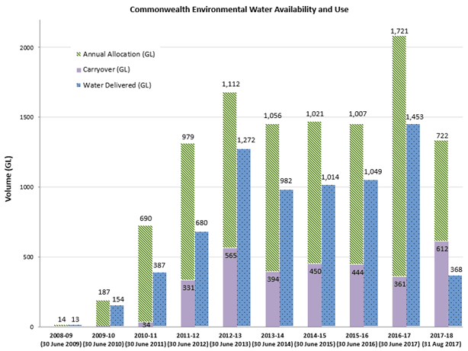

**Figure 1 **Commonwealth Environmental Water Availability and Use at 31 August 2017****

|  |
| --- |
| Finding 2: Carryover strategy has been implemented effectively, responsibly, transparently and within existing rules (notwithstanding some assertions to the contrary, which in the Review Panel’s opinion are ill-founded). |

|  |
| --- |
| Finding 3: More effort in active communication and explanation of carry-over decision-making might be warranted and useful. |

Trade

In the past five years, the CEWH has conducted three sales of annual allocations (one each in the Gwydir, Peel and Goulburn river systems) after extensive preparation and due diligence. These seem to have been mutually beneficial to buyers and seller. In fact, there is widespread and broad-based support across the Basin for CEWH to consider trade whenever warranted. Nobody seems to expect it to be frequent or regular in recognition of the fact that the Commonwealth environmental water holdings were expressly acquired to be used for environmental purposes. The combination of conditions that could lead to a decision to either buy or sell partial allocations in a particular valley are discussed in the CEWH’s annual planning documents, available on the Internet for those who have the time and capacity to find them. However, more direct communication and greater clarity of the Basin Plan water trading rules could be useful.

Research into the effects of minimum parcel size impressed the Review Panel as thorough and well-reasoned and the findings were subsequently vindicated. Results from each of the sales seem to have been similar – mutually beneficial to buyers (agricultural producers, especially in short term), as well as to the CEWH and longer term environmental outcomes.

Operating rules are comprehensive and sensible, although there are instances that appear to be overly restrictive or that require extensive levels of analysis and documentation. These instances suggest requirements in excess of what would apply for trade in other Commonwealth assets of similar value (for example, to Future Fund investments, Reserve Bank trading in Foreign Exchange, or the Clean Energy Finance Corporation).[5] Although the Water Act has recently been reviewed, the Review Panel expects that the trade restrictions in the Act will eventually have to be relaxed and amended, as they presumably exist to give public reassurance during the initial phase of CEWH’s existence. With time, we expect that “earned autonomy” will be conferred on the basis of experience and performance; that is, greater freedom to act more quickly or to trade larger amounts of water.

Eventually the public and the irrigation industry may come to see such trade by the CEWH as normal and will progressively learn to anticipate when the CEWH may trade. For example, under what seasonal and market conditions, what history of local environmental watering and in what sort of price range (floor price and ceiling price). But that level of “normalcy” will only occur if trade becomes a more common tool used by the CEWH, rather than a few times per decade.

|  |
| --- |
| Finding 4: The processes for water trade – preparations, checklists, compliance, risk assessments, operational monitoring – are very thorough, deliberate and measured, with high standards of probity and no evidence or claims of malfeasance. Every step has been clearly documented.  The necessary processes and procedures now exist and work effectively. |

Issues arising

The unregulated rivers in the northern basin have predominantly rules-based water entitlements (and few small storage-based entitlements), which are more complex than the entitlement frameworks set up by Basin States to manage water resources in the regulated rivers in the Southern Connected Basin. It also presents huge opportunities to have great environmental benefits if done well. Unfortunately, some prerequisites for the use of existing entitlements (as defined) to achieve desired objectives, especially in some important wetlands, lie outside of CEWH’s control and even influence.

|  |
| --- |
| Finding 5: Those parties within the Australian Government and state agencies who have the capacity to resolve outstanding issues are well aware of the need for timely and effective resolution. The CEWH should continue to encourage that process. |

Governance and accountability

The issue of who is ultimately responsible for environmental outcomes across the Basin, emerged externally (Productivity Commission 2017 Issues Paper (pp. 17-18) and the National Water Commission’s 2014 report). The MDBA sets priorities (with advice from many others); CEWH and the Basin States must respond and deliver on the outcomes but only to the extent state’s delivery agencies assist and enable. There are many other smaller contributors, including the Victorian Environmental Water Holder (VEWH), the NSW Office of Environment and Heritage (OEH) which manages all environmental water in NSW, The Living Murray program[6] and various environmental watering trusts and NGOs.

While the CEWH’s formal partnership arrangements appear to be working well to date, responsibility and accountability are, to say the least, fragmented. Although CEWH has the largest environmental water portfolio and the broadest mandate, the position has little direct authority or control despite considerable influence in some instances (“relatively toothless, but with a loud voice”).

To function effectively and efficiently, complex man-made systems (e.g. energy grids) need to have an entity who is ultimately accountable for the long-term outcomes of the entire system and who has matching authority and resources. If the MDBA is ultimately responsible for Basin-wide (including environmental) outcomes, it seems that CEWH’s responsibility to the MDBA, Parliament and public is to play its part to the greatest extent practicable – in a large coalition of formal and informal partnerships.

A complication in this case is that while additional water is usually necessary to restore the environmental outcomes in rivers and wetlands in the Basin, it may not always be sufficient to achieve the desired environmental outcomes. Other factors (like land-use practices) can affect outcomes but do not involve added water and lie well beyond CEWH’s control (or even that of the MDBA). Under the Water Act, water entitlements or allocations can be traded for money and *vice versa*. The proceeds of allocation trade can be used to fund environmental activities. However, where water entitlements are sold only additional water entitlements can be bought. The challenge is to have explicit prioritised demands (prepared by MDBA in consultation with CEWH and others) and to match them with actual and potential supplies of water (and occasionally other inputs).

Notwithstanding the partnership agreements and good relations with delivery partners to date, there is potential for “blame-shifting”, “cost-shifting” and possibly gaming of the CEWH. Again, this emphasises the fact that CEWH operates with water assets (water entitlements water rights) created and defined differently by each Basin States, and within systems that were designed and operated for consumptive use – a different and partly incompatible purpose. The process to adapt the pre-2007 system for managing rivers primarily for irrigation, to a new system that accommodates and supports environmental goals, still has far to go. Negotiations and adjustment may take a decade or more and will continue to be contentious, as evidenced by recent events in NSW and related ongoing Inquiries.

The quest for a performance metric?

How can the CEWH demonstrate that a reasonable fist is being made of a very challenging task, of a scope and magnitude which has never been attempted anywhere in the world before? The CEWH operates within a complex multi-jurisdictional system with:

* huge scientific uncertainties, in ecology, climate, geomorphology, etc. (although hydrology data and models are now world-class)
* a great and erratically changing variety of ecological outcomes and priorities across sites – the watering needs of frogs, fish, trees and birds are seldom identical – even at a specific site and even within each group of organisms
* changing social expectations about what is important to whom, where and why – and all in the form of unpriced public goods, which once produced are available to everyone. The outcomes at Ramsar sites, for example, are *International* public goods (paid for by Australian taxpayers but of global benefit)
* significant social, economic, legal (third-party) and regulatory constraints.

Working out an effective, efficient and feasible Basin-wide watering plan is inherently complex and difficult. It is made even more difficult by the absence of an agreed performance metric that might readily convey outcomes, without having to list all the species of fish, frogs, birds and trees that may have benefited from each watering event in each site in each jurisdiction. There are no agreed aggregation methods yet[7] that would enable assessment and reporting on multiple geographical (from specific wetland, to catchment, state or Basin scale) or time scales. The CEWH and MDBA focus on watering individual assets and extrapolate the results to use as indicators or proxies to determine Basin-wide environmental condition.

Best science and local engagement

There may need to be a balance between engaging with leading scientists – using best available science which is laudable and rational, and required under the Water Act – and engaging with local communities, including farmers, landholders and traditional owners, which is also required under the Act. The CEWH will benefit if all groups who have valuable expertise and insights have a pathway to contribute to CEWH decision-making recognising that the nature of their contributions can differ. The CEWH currently incorporates feedback from local communities into decision-making priorities through a variety of ways, including local committees and through state-based forums.

While the LTIM is impressive, at times the LTIM Framework paper seems to suggest that the purpose of collecting data is to improve models of how ecosystems function under diverse conditions and how they respond to different intensities, durations and timing of watering events. This appears to some non-scientists as though the CEWH is assembling all available evidence into cause-and-effect models, which confer more “predictability” and future usefulness (perhaps) in a decision-support system.

Some elements of this modelling-focus do not sit well with some members of local communities,[8] who find this technical approach alienating. The approach can fail to recognise and respect their knowledge and insights, which may not fit well into formal mathematical models. Some community members are uncomfortable at the thought of scientists, at a computer in Canberra, making decisions about the fate of “their” rivers and wetlands, based on models which may or may not be consistent with their perceptions of reality. The Review Panel confirms that the CEWH needs *both* excellent science *and* strong commitment to local participation in decision-making. It is essential to do both without alienating either constituency.

Because of natural variability, it may be decades rather than years before local inputs of knowledge and expertise becomes redundant (if ever). But even then, local participation in informing local decisions will still be valuable for engagement, community support and social licence (as expressly noted in Table I of the Communications Strategy).

|  |
| --- |
| Finding 6: The Review Panel sees real wisdom in the CEWH’s approach so far, in building “social licence to operate” (SL2O) in addition to statutory licence, and requirement, to operate. This will underpin the resilience of the functions and the agency. |

In summary, Phase 1 of the Review concludes that the necessary processes, checks and balances are in place and are being followed. The systems are in place to control what is within the CEWH’s control, and the Office performs its functions to a consistently high standard.

However, the concern that emerges for the Review Panel is that many of the key determinants of success lie outside of this domain. Although the internal processes are excellent, comprehensive and well implemented, as they only deal with *some* of the determinants of success (while the majority are external and remain somewhat chaotic or haphazard) there will be difficulties. The Review Panel concludes that there is little need for, or obvious potential for, improvements in the *internal* business processes and procedures, except as they relate to external relationships with stakeholders.

Phase 2 of the Review is important as it shows that what happens external to the CEWH’s office and the relationships with external stakeholders, which shape their interactions and inter-dependencies, and are even more critical for success than the internal processes analysed and evaluated in Phase 1.

### Consultations with external stakeholders

#### Who are the stakeholders

The Review Panel conducted 74 interviews with individuals or groups representing stakeholder organisations (Figure 2). Summaries prepared from each conversation were grouped into classifications of issues raised by stakeholder groups with common priorities, interests and concerns. The summaries of views and observations expressed by each interviewee are not included, but the repeated messages that emerged once grouped are clear. The groupings were subsequently confirmed by Principal Component Analysis and Social Network Analysis, which are discussed further and illustrated below.

The consultations found that most stakeholders have no line-of-sight to the internal processes of the CEWH, or the reasons behind and process of CEWH decision-making. The Review Panel believes this is why stakeholder comments focused on their observations and experience of their interactions with the CEWH and their perceived positive and negative impacts of CEWH decisions. Additionally, the CEWH’s internal processes and deliberations (discussed in phase 1) are largely invisible to external stakeholders, except for those who are directly involved, such as delivery partners and state agencies that engage in similar processes in their jurisdictions.

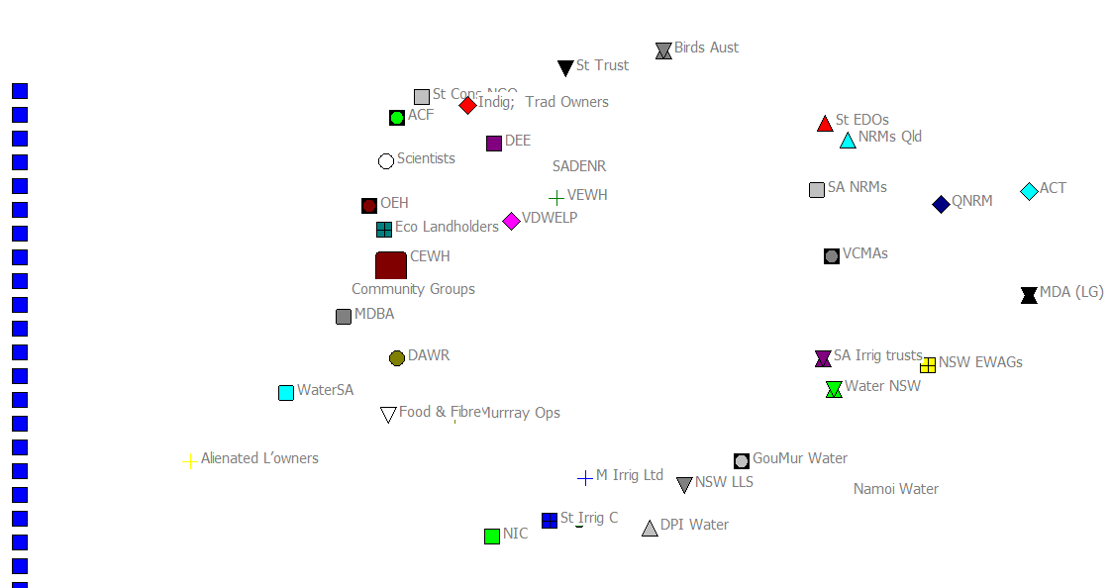

Figure 2 **Stakeholders consulted for the Review**

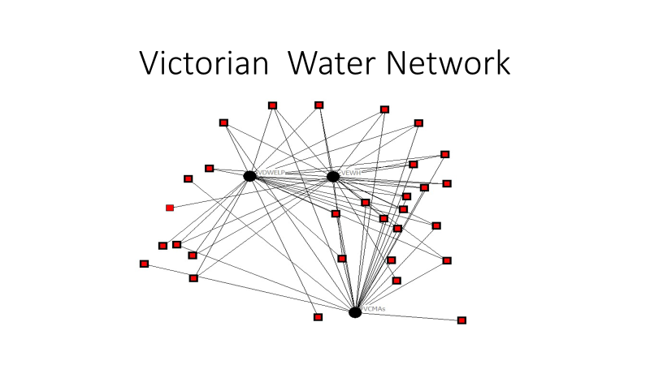

Figure 3 **Social Network diagram for the Victorian Water Network**

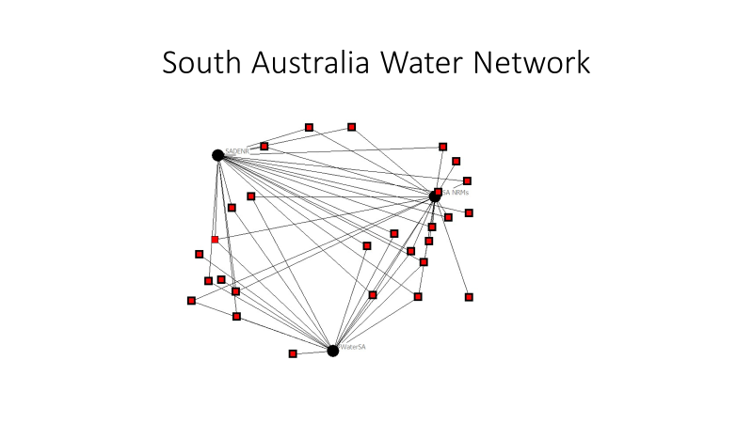

Figure 4 **Social Network diagram for the South Australian Water Network**

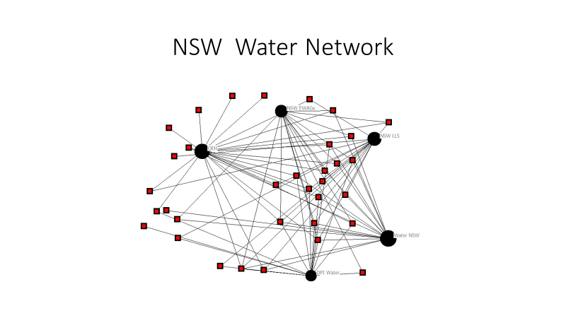

Figure 5 **Social Network diagram for the New South Wales Water Network**

As can be seen from the above “Social Networks” diagrams (**Figure 3, Figure 4** and **Figure 5**), the nature, structure and composition of institutional water networks differs greatly between the three states that the CEWH engages with most regularly.[9] The “machinery of government” in a particular state may facilitate environmental watering that is more effectively planned and delivered than in others. However, each state determines its own structures without reference to the CEWH or consideration of how its own structures could facilitate or hinder the CEWH’s operations. This is an example of factors completely beyond CEWH’s control or influence that profoundly affect the CEWH’s capacity to fulfil the tasks and objectives required by the Water Act and the Basin Plan.

There is a diverse constellation of other government agencies (at multiple levels), private sector operations and industry associations, NGOs and others that the CEWH and the Office routinely interact with. For the purposes of this analysis, similar groups have been aggregated into state NRM bodies, conservation/biodiversity trusts, Environmental Defenders Offices’, and Conservation Councils in each state (**Figure 6**). Like organisations are clustered in **Figure 6** because the network analysis algorithm maps all entities according to the density and intensity of their interactions. The analysis has clustered conservation-focussed organisations in the top left quadrant, irrigation-focussed organisations in the bottom right quadrant, and regional NRM bodies between or in the top right quadrants. The message of this diagram is the number and diversity of organisations the CEWH interacts with, including many that are crucial to the effectiveness of the CEWH’s operations.

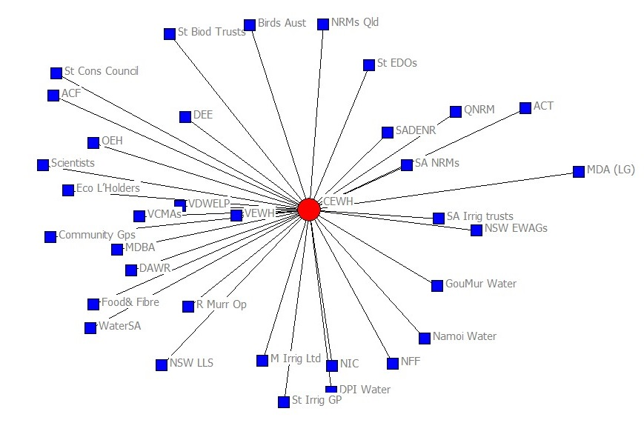

Figure 6 **Social Network diagram of connections of the CEWH to stakeholders**

**Figure 7** shows that in aggregate, the network analysis for 38 groups of stakeholders (with many sub-networks within groups) illustrates the complexity of the networks involved, when many but not all of the groups interact with each another, not just with the CEWH or Basin State agencies.

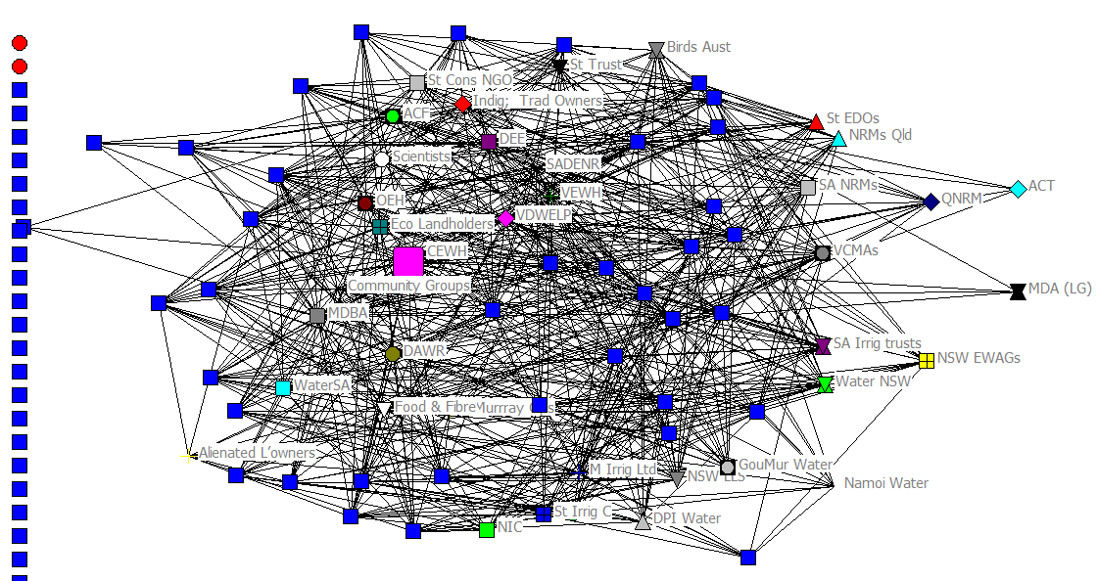

Figure 7 **Social Network diagram of connections between the CEWH, Basin States and other stakeholder groups consulted**

These Social Network diagrams do not *prove* anything but they do help illustrate the complexity and the clustering of the relationships. They also reveal that there are a few outliers who do not seem to be as involved in the network (others rarely talk or listen to them) even though some may have much potential value to contribute.

The research of Sayer et al (2016) in large, complex, inter-dependent, landscape-scale multi-stakeholder and multi-level systems suggests that long-term success requires agreement on the challenges (including clear cause-effect relationships), alignment of goals among stakeholders and agreement on processes (who, what, where, when and how).

|  |
| --- |
| Finding 7: Our consultations suggest there is now broad alignment on the challenges and the goals of environmental watering. |

The responses of stakeholders have been broadly categorised as:

1. “highly supportive” (Yes! And also…)
2. “supportive with qualifications” (yes, But don’t forget…)
3. (at the other extreme) “hostile” (No, because...).

Of course, the bulk of the population, who are not particularly informed and involved with, Basin planning, environmental watering or are geographically distant from the Basin, lie between categories B and C. These stakeholders were not consulted during the Review, which focussed on stakeholders who are directly involved and informed at present.

The largest, Group A includes:

* Aboriginal people, especially Traditional Owners, who seek more environmental watering but with even wider scope and purpose, and to have more involvement in decision-making
* environmental NGOs at all levels from local to national who seek more environmental watering sooner and more often
* ecologically-minded landowners who would like to see more inputs of local knowledge and experience into environmental watering decisions
* some government agencies, at regional, state and national level
* many environmental scientists who would like to see more watering and also more, longer and more detailed monitoring programs.

Group B includes most of the river managers and operators of irrigation infrastructure [10], the peak irrigator bodies and, to a lesser extent, other agriculture groups, who would all like to see environmental goals achieved but preferably through complementary measures where possible, rather than using more water. Many stakeholders in now perceive that being environmentally responsible is an important part of irrigation’s social licence.

The third and much smaller Group C includes alienated landowners (dispersed across the basin but particularly in the Mid-Murray and lower Goulburn) and arguably certain agencies and individuals within a state government otherwise supportive of the CEWH and environmental watering.

Delivering great outcomes effectively and efficiently will retain the support of stakeholders who are already positively inclined to the role of the CEWH and will also attract the undecided, while encouraging some undecided or ambivalent stakeholders to move towards the positive end of the spectrum.

#### Stakeholders’ suggested areas of potential improvement

Almost every stakeholder consulted by the Review Panel had suggestions on how to improve the CEWH’s processes for the essential functions of stewardship, planning, delivery and MERI relevant to their state, district or valley, although not all suggestions were similar.

Adaptive management and flexibility to innovate

Many stakeholders commented on the amount and complexity of pertinent legislation in all jurisdictions often comparing it to a maze or a straitjacket. Many suggested that some processes could and probably will be progressively streamlined. There is a perception that there could be *too much* emphasis within the Office on process and compliance, which occasionally leads to unnecessary and unwarranted delays and complications. Or more importantly, an inability to grasp an important but ephemeral opportunity to deliver or trade water. Their assertion is that too much focus on process may lead to excessive caution (some said “risk-averse”, others “timid”). This makes the CEWH and the Office less flexible, innovative and adaptable than they might otherwise be, or than is expected by many of these stakeholders, especially now that the concept and application of environmental water is widely accepted. This perception may well be incorrect – as most of these comments were made by stakeholders with limited experience of government, law or operations, including probity requirements. Stakeholders offered numerous plausible explanations for why this might be the case. However, being plausible does not make the perception correct. The perception that performance is inhibited by excessive caution appeared in a few contexts:

1. The preparations for trade in relatively small amounts of annual allocations was extremely thorough and almost fastidious. The overall effect could have been to make the transactions slower and more cumbersome than necessary. Almost all stakeholders now accept the case for the CEWH to trade in allocations.[11] The point of contention that remains is how often, how much is traded and how each trade can be explained to all stakeholders as sensible and beneficial. It appears that unless the process of trading can be streamlined, it is unlikely to become a routine, normal and accepted practice.
2. The “Good Neighbour” policy has much to commend it. One alleged consequence is that the CEWH may forego opportunities for excellent outcomes in favour of reducing potential third-party impacts.
3. The LTIM is very highly regarded. However, some perceive that it is slowed down by processes that make it less useful for annual planning than expected (noting that it is designed for long-term monitoring, not short-term).

|  |
| --- |
| **Finding 8:** The Review Panel was not persuaded that caution over the past 5-10 years was excessive or unwarranted. Rather the Panel considers it was wise and probably essential. |

The expectation is that as processes mature over time and as public confidence grows there will be greater scope for innovation and more assertive pursuit by the CEWH of the Basin Plan’s objectives.

To repeat, of the many stakeholders interviewed in five jurisdictions, no-one raised issues or concerns about compliance or probity, except if they thought compliance was disproportionate, having unintended adverse consequences or stifling innovation, which suggested streamlining or simplification was needed.

Some stakeholders referred to the legislated requirement to practice “adaptive management”. The Review Panel perceive this as management that requires flexibility to undertake small experiments, occasionally make mistakes, and learn from them to build up a workable body of practice, experience and precedents. Prescriptive legislation is the antithesis of adaptive management. In reality, adaptive management is essential for effective natural resource management across the Basin due to its variable nature. However, this conflicts with legal requirements that prescribe the manner that the CEWH’s functions should be performed. Adaptive management in environmental watering is made even more difficult if the delivery systems designed and managed to deliver consumptive water cannot be adapted or changed to facilitate environmental watering. This is why almost all stakeholders agreed that environmental water holders’ relationships with river managers and operators are vital.

### Findings and opportunities for improvement

The Review Panel appreciates the difficulty and complexity of the CEWH’s role and functions and applauds how much has been achieved, despite the significant challenges.

The Findings identified in the two preceding sections are reproduced below:

**Finding 1**: In terms of the functions described in Section 2 above, all the necessary processes exist.

Finding 2: Carryover strategy has been implemented effectively, responsibly, transparently and within existing rules (notwithstanding a few assertions to the contrary, which seem to be ill-founded, in the Review Panel’s opinion).

Finding 3: More effort in active communication and explanation of carry over decision-making might be warranted and useful.

Finding 4: The processes for water trade – preparations, checklists, compliance, risk assessments, operational monitoring – are very thorough, deliberate and measured, with high standards of probity and no evidence or claims of malfeasance. Every step has been clearly documented.

Finding 5: Those parties within the Australian Government and state agencies who have the capacity to resolve outstanding issues are well aware of the need for timely and effective resolution. The CEWH should continue to encourage that process.

Finding 6: The Review Panel sees real wisdom in the CEWH’s approach so far, in building “social licence to operate” in addition to statutory licence, and requirement, to operate. This will underpin the resilience of the functions and the agency.

Finding 7: Our consultations suggest there is now broad alignment on the challenges and the goals of environmental watering.

**Finding 8:** The Review Panel was *not* persuaded that caution over the past 5-10 years was excessive or unwarranted. Rather the Panel considers it was wise and probably essential.

These findings should not be interpreted as criticisms or the identification of “failures” in the CEWH’s business processes or operations. Overall, the CEWH model is remarkably successful but there is always scope for improvement.

Because the CEWH’s internal business processes in place are sound and the governance structures more than adequate, The Review Panel see little need, or obvious potential, for improvements in the internal business processes and procedures except as they relate to external relationships with stakeholders. Improvements the Office could make to how it’s structured and operated would:

* increase the emphasis on effective collaboration and hence improve the probability of long-term positive environmental impacts
* more clearly demonstrate the effectiveness and efficiency in doing so, and thus
* increase and broaden the existing community support.

Unlike many other facets of the CEWH’s role which lie beyond the CEWH’s control and influence, the internal operations and workplace culture, particularly as they relate to partnerships, engagement and public perceptions are directly manageable.

Many lessons from the Review emerged from the stakeholder consultations. Several important issues and insights emerged in the discussions. The Review Panel suggests the following opportunities for improvement that could be made to benefit the CEWH’s operations:

1. Understand all the actors involved in environmental watering across the Basin and their respective roles and responsibilities. A few existing relationships appear fraught, and performance impaired, simply because roles and functions were not clarified initially and relations began on misunderstandings. As many stakeholders told us, enduring relationships of trust are between individuals, not between organisations or departments. The CEWH’s formal partnerships, along with the *ad hoc* professional relationships, have enabled many successful collaborations for environmental watering. Conversely, the occasional absence of relationships due to turnover is problematic, for example if key personnel moved and the relationship faltered.
2. Recognise the value of local knowledge and expertise and facilitate its incorporation into portfolio management. Local knowledge is critical to achieving the objectives of the Basin Plan, so it is important that structures and relationships support rather than inhibit bi-directional information flows. The CEWH’s portfolio decision-making is extremely challenging and requires the CEWH to have access to accurate, detailed and timely data. The Review Panel believes that Information Technology (e.g. Internet, smartphones) could revolutionise the CEWH’s data-gathering and information dissemination.
3. Manage environmental watering across the Basin as a system not as discrete events and through a network, or consortium-like arrangement, as opposed to individual entities in linear hierarchical relationships. The CEWH is the only institution that is required by law to take a Basin-wide approach to environmental watering. The Review Panel was impressed by recent analysis of the superiority of networks over hierarchies for dealing with complex systems (Slaughter 2017). Successful resilient networks are based on frequent flows of relevant information and mutual trust are critical to the CEWH’s operations.
4. Adopt a network approach to managing environmental water across the Basin with the multiple players in government (Commonwealth, state, regional and local) and spanning private sector, NGOs, philanthropic groups and community groups, if agreement can be reached. Observing the unwritten “network protocols” of sharing information generously to strengthen the network and building trust, confidence and resilience could then come into play. Not only must the partner organisations have trust and confidence in the CEWH and the Office; trust must be reciprocated. The Review Panel heard evidence suggesting that the Office lacks confidence in regards to some of the communications made with organisations it interacts with routinely. The Review Panel emphasises the importance of building and maintaining real partnerships as opposed to the short-term commercial procurement of services.
5. The network must include like-minded groups committed to better environmental outcomes across the Basin, but which do not focus specifically or exclusively on water, such as regional NRM bodies and traditional landowners. Most stakeholders on the ground view environmental water as important, but as only one aspect of the system which needs to be better integrated with other complementary resource management. Opportunities for win-win collaboration seem likely to emerge, if parties look to shared benefits rather than pursuing a single objective or mechanism in isolation. The Review Panel accepts the premise that a broad-based, inclusive, opt-in network is likely to enhance the reach of environmental watering and increase its effectiveness and efficiency without compromising goals or accountability of central bodies like the CEWH, VEWH and OEH.
6. Local Engagement officers (LEOs) have an important role in building bridges and relationships. They have the potential to connect to other state agencies with like responsibilities and others with knowledge, interest and passion who may contribute volunteer time and effort. The LEOs help keep everyone in the loop, avoid surprises and ensure information disseminates throughout the network as fast and as far as possible. The CEWH and the Office should foster continuity and build relationships, bringing regional people with expertise and interest into the network. This would lessen down-side risks and contribute to greater success, both technically and in local-ownership and support. For example, the Bureau of Meteorology now taps into weather records compiled on thousands of farms to create more complete spatial coverage, rather than relying solely on official weather stations. Think TripAdvisor! A RiverCare or WetlandCare network in each valley across the Basin, consisting of thousands of volunteers across the Basin, with smartphones, cameras, video and GPS that could be the eyes and ears of CEWH, out in communities. The relationship would be based on shared goals, mutual respect and trust, rather than monetary. These citizen science volunteers could be birdwatchers, recreational fishers, Indigenous people, farmers and teachers or just interested members of the public. They could deliver masses of self-validating, timely data to inform decision-making. Like other coordinators of successful networks, the responsibility of the CEWH would simply be to be a facilitator that empowers their allies (nodes) by accepting, curating and sharing information and data across the network.
7. Attribution is important. It is difficult to identify the CEWH’s unique and separate achievements from everything else that is happening in the Basin. The alternative, in a network approach, is to share credit for successes among all members of the environmental watering alliance who are involved. This recognises that the CEWH is just one large and important cog in the system, who endeavours to perform the function effectively, efficiently, equitably and accounting for risk on a Basin-scale. The CEWH should collaborate with any who are willing and capable, even if many determinants of Basin-wide success are beyond the direct control of the position.
8. Data Management is challenging. The data requirements to inform the CEWH’s decision-making are very demanding, in volume, accuracy and timeliness. Although current systems like the EWMS, the EAD and web portal are adequate now, they may come under pressure, or there may be ways to upgrade them as technologies improve. Quality information management systems are important for adaptive management, science and communications, being integral to portfolio management – delivery, trade, carryover and environmental activities. Similarly, the CEWH has an extensive and potentially very valuable multimedia library but these always need to be curated and continuously refreshed. For example, the existing portal could be updated, making it a two-way web portal, which would be an effective way to engage with widely-dispersed stakeholders, enabling two-way communication.
9. MERI is crucial to the entire Basin reform to demonstrate the CEWH’s operations are effective and efficient in delivering on the Basin Plan’s environmental outcomes of achieving healthy wetlands, communities and economies, at Basin-wide scale into the future. There are two elements – local engagement, endorsement and enthusiasm (as discussed above) and scientific endorsement. Making the CEWH’s MERI system (verification of e-water deliveries, impacts and consequences) as great as it can be, could ultimately determine the future of the position and function of CEWH.

#### Conclusion

The Review Panel finds itself in strong agreement with many conclusions of the 2015 report of the NSW *Evaluation of the Environmental Watering Management Program* (Appendix 4).

Overall, the CEWH model is remarkably successful but there is scope for improvement. The adaptive management model is working broadly and will continue to improve with accumulation of experience. In the longer term, the CEWH’s statutory functions will become widely understood. There will be more knowledge and experience on all sides and stronger relationships with partners and the public, especially if a network model is adopted and effectively developed.

The CEWH has also been effective in building a social licence to operate, in part because the Good Neighbour Policy has resulted in the CEWH not being seen as too assertive. But perhaps now it is time to start exercising that social licence more, in dealing with the contentious issues identified through the consultations, such as, what decisions would be made in the next major drought.

Finding the right balance between top-down and bottom-up governance is still being worked out. Stakeholders at different levels have different perspectives on how governance structures should be arranged. While institutional arrangements for the CEWH make it difficult to shape the policy and legislative operating environment, there is an expectation among stakeholders that the CEWH could take a lead role in Basin Plan reforms in the future. This would be consistent with maintaining a vital, but not domineering, role **within** the network. The CEWH’s role in future need not be one of greater control but rather of more effective information sharing with the Basin community.

*S*ometimes a certain degree of adverse impact (small, localised, short term) is essential to achieve much greater benefits or wider scale or longer term. The CEWH will soon run out of low hanging fruit and will have to make, explain and defend some tough calls. Negotiating easements or time shares, or even *ex gratia* payments for prior informed consent of landowners and other injured parties are among the tools to expedite such decisions.

Aspects of communications can be improved as formal communications (print and television media) rapidly become less important, as people source information and ideas from networks like Facebook and Twitter. Third-party endorsements (from local NGOs, businesses and community leaders) are much more influential than self-promotion, which is why **engagement and relationships** are so crucial for the CEWH to maintain. Formal media may reinforce pre-existing public perceptions but much of the information sharing comes from the direct experiences of individuals with personal networks.

For the foreseeable future, there will be a minor group of stakeholders with entrenched views, who will oppose environmental watering and will not engage with the CEWH. While they should not be ignored, they should not become a reason for the CEWH to fail to be as effective and efficient as possible in achieving the ultimate goal of environmental watering to protect and restore the environmental assets of the Basin.

# Documents and other materials cited and reviewed

ANAO (2013) Commonwealth Environmental Watering Activities. ANAO, Canberra

Borgatti, SP, MG Everett and LC Freeman, (2002) Ucinet 6 for Windows: Software for Social Network Analysis. Harvard, MA: Analytic Technologies

CoA (2016) Water Act 2007 (with amendments to 11/11/16) COA Canberra

CoA (2012) Basin Water Plan 2012. CoA Canberra

Environmental Water Governance Team of OEH of NSW (2015) Evaluation of NSW Environmental Water Management Program. Sydney

First Peoples’ Water Engagement Council (2012) Policy Framework. Report to National Water Commission, Canberra.

Fullerton, T (2017) *First shots Fired in latest outbreak of water wars.* The Australian 5/8/17 p 26

MDBA (2014) Murray Darling Basin water reforms: Framework for evaluating progress. MDBA, Canberra

Ostrom, Elinor. 1990. Governing the commons: the evolution of institutions for collective action.

Productivity Commission (2017) Issues Paper for review of water reforms. Canberra

SA Murray Darling NRM Board (2016) Environmental Watering Outcomes, 2014-15, DEWNR, Adelaide.

Sayer JA, C Margules, AK Boedhihartono, T Sunderland, JD Langston, J Reed, R Riggs, LE Buck, BM Campbell, K Kusters C Elliott, PA Minang, A Dale, H Purnomo, JR Stevenson, P Gunarso, A Purnomo (2016) *Measuring the effectiveness of landscape approaches to conservation and development*. Sustainability Science DOI 10.1007/s11625-016-0415-z

Slaughter, A-M. (2017) The Chess-Board and the Web: Strategies of connection in a networked world. Yale University Press, Yale

Taylor, KS, BJ Moggridge and A Poelina (2017) *Australian Indigenous Water Policy and the impacts of the ever-changing political cycle.* Aust Journal of Water Resources

VEWH (2016) Environmental Watering in Victoria 2015-16. VEWH, Melbourne.

Wier, JK, DRJ Crew and JL Crew (2013) *Wetland Forest Culture: indigenous activity for management change in the southern Riverina, NSW.* Aus J of Environmental Management.

Wier, JK, SL Ross, DRJ Crew, and JL Crew (2013) *Cultural Water and the Edward/Kolety and Wakool river system.* Research Report, AIATIS Centre for Land and Water Research, Canberra

### Appendix 1 Terms of reference

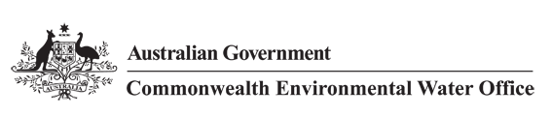

Review of the Commonwealth Environmental Water Holder. The objective of this Review is to evaluate the extent to which the Commonwealth Environmental Water Holder (CEWH) operations and business processes represent best practice. In particular the review will examine the following matters:

* Transparency and accountability of the CEWH
* Extent to which the CEWH partakes in adaptive management and uses contemporary science to support its actions
* Effectiveness of the CEWH in meeting its statutory obligations
* Trade by the CEWH
* CEWH business processes and frameworks
* Third party impacts from environmental watering
* Relationships that the CEWH has with state jurisdictions including water delivery arrangements
* The use of information management systems in supporting the CEWH
* Constraints on the CEWH including both internal and external administrative and regulatory constraints
* Internal controls - special account priorities and environmental water management priorities (use, carryover and trade)

**Out of scope for the review**

Issues relating to Murray-Darling Basin Plan implementation are beyond the scope of this review. This includes matters relating to water recovery in the Basin and any potential socioeconomic/third party impacts of the Basin Plan.

The review will also not consider broader decisions of the Australian Government such as changes to legislation or administrative orders.

Finally, issues relating to the Government's international obligations under the Ramsar Convention are also excluded from the review.

### Appendix 2 Review arrangements

Lead Reviewer

Dr Neil Byron (Former Commissioner at Productivity Commission responsible for environment, agriculture and natural resource management issues (1998 to 2010).

**Review Panel members:**

* Governance – Mr Peter Cochrane (over 20 years’ experience in public policy and private sector; former Director of National Parks).
* Practitioner – Mr Denis Flett (Chair, VEWH; Former CEO, Goulburn-Murray Water)
* Industry – Mr Gavin McMahon (Chair of National Irrigators Council; CEO of Central Irrigation Trust in South Australia; chairman of South Australian River Communities).
* Community – Ms Alex Anthony (former Chair of Murray CMA and LLS; Former a/g Chair of the LLS Board of Chairs)
* Academic – Dr Steve Morton (Honorary Fellow with Charles Darwin University in Alice Springs; Chair, Scientific Advisory Panel to the Lake Eyre Basin Ministerial Forum; Deputy Chair, Territory Natural Resource Management).

**Members of the Review Panel performed 5 main roles through the phases of this review;**

1. Providing expert advice on the substantive content of the review at an initial phase drawing on each member’s specialised knowledge and experience, as well as their wider general understanding of how the CEWH operates within the wider THE BASIN context (based on their prior experience and available documentation, including the reading material circulated for that meeting);
2. Providing suggestions about who to consult with (identifying priorities) about which specific issues, to ensure comprehensive coverage of all of the ToR of the Review;
3. Where and when possible, participating in the interviews/information-gathering processes that provide the evidence base for the assessment of the Panel from late July till end August;
4. Periodically exchange information within the Review team including teleconferences; and
5. Contributing to a wrap up meeting in Mid-late September to consider and provide comment/critique and improvement of a first draft report compiled by Neil Byron, and subsequent comments on the final draft.

**While all members of the Review Panel contributed significantly and generously to this Review (and are generally supportive of the Findings) they bear no responsibility (individually or collectively) for the contents and do not necessarily agree with everything contained in this report.**

### Appendix 3 Terms of reference cross referenced to internal processes

| Terms of Reference | business processes and frameworks |
| --- | --- |
| Extent to which the CEWH pRACTICES adaptive management and uses contemporary science to INFORM its DECISIONS AND actions | Long Term Intervention Monitoring Project (LTIM) - Logic and Rationale Document  Commonwealth Environmental Water - Monitoring, Evaluation, Reporting and Improvement Framework  Environmental Water Knowledge and Research Project (EWKR)  The Environmental Water Outcomes Framework  Portfolio Management Planning (annual)  Hydrological modelling advice and reporting (THE BASINA)  Basin-scale evaluation of Commonwealth environmental water |
| Effectiveness of the CEWH in meeting its statutory obligations | Framework for Determining Commonwealth Environmental Water Use  Portfolio Management Planning (annual) |
| Trade by the CEWH | Commonwealth Environmental Water Trading Framework  Annual process for developing, trading-off and implementing portfolio management options at a Murray-Darling Basin scale  Post Trade Review |
| CEWH business processes and frameworks  Internal controls - special account priorities and environmental water management priorities (use, carryover and trade)  Transparency and accountability of the CEWH | Managing the Commonwealth Environmental Water Portfolio  Framework for Determining Commonwealth Environmental Water Use  Portfolio Management Planning Framework  Water Use Decision Process  Weekly Operational Monitoring Report  Monthly report on water and financial holdings managed by the Commonwealth Environmental Water Holder  Periodic reporting on current water allocations and trade opportunities  Watering Action Acquittal Report  Annual reporting – Statement of Assurance, Annual Performance Statement, Legislative Reporting (*Water Act 2007*)  Portfolio Risk Assessment (Bi-annual)  Communications - The Pulse, Annual Catchment Specific Snapshots, Media releases and engagement |
| Third party impacts from environmental watering | Good Neighbour Policy |
| CEWH’S Relationships with state jurisdictions including water delivery arrangements | Partnership agreements (formal)  Informal partnerships  Participation on Basin Plan implementation groups such as the Sustainable Diversion Limit Adjustment Assessment Committee and the Basin Plan Implementation Committee. |
| The use of information management systems in supporting the CEWH | Environmental Watering Management System (EWMS)  Environmental Assets Database (EAD)  Environmental Matter Mapping Application (EMMA) |
| Constraints on the CEWH, including both internal and external administrative and regulatory constraints | *Water Act 2007*, Basin Plan 2012, Basin-wide Environmental Watering Strategy  Basin State legislative and operational frameworks |

### Appendix 4 Evaluation of the NSW Environmental Water Management Program 2006-2013 - selected findings

The Evaluation of the NSW Environmental Water Management Program 2006-2013 evaluated the environmental water management program (EWMP) undertaken by the NSW Office of Environment and Heritage (OEH) in the period July 2006 to June 2013.

‘The EWMP operates in a complex and uncertain world. Like most conservation programs, the EWMP is embedded in a larger socio-ecological system and possesses many of the characteristics of what have become known as ‘wicked problems’. Wicked problems generally lack clear solutions, because each problem is linked to other problems and the nature and identity of each cannot be isolated. They feature many interacting elements, constant change which is often irreversible, nonlinear interactions between elements and no clearly defined boundaries to the system.

Research (Game et al. 2013) into complexity across several disciplines provides insights to guide future directions for the EWMP. Commonly accepted notions of best practice, adaptive management and standardized planning approaches ignore the realities of complex systems. These realities are that there is no ‘right’ solution (rather, there are trade-offs that appear more or less acceptable depending on perspectives) and that measuring performance can be problematic.

Features of a program responding to the challenges of complexity include:

**•** nurturing of creativity: encourage a willingness to disrupt existing behaviours and respond openly to competing and creative options

**•** distributed leadership: decentralize strategic analysis and acknowledge the need for diverse inputs to decision-making

• clearly defined and shared objectives that leave space for flexibility in how tasks are achieved

• use of multiple scenarios to predict the likely impact and benefit of management strategies

• transparent and constructive communication about successes and failures.

The novelty of the EWMP meant that the initial priorities were to determine the scope of the new responsibilities and then identify the associated roles and allocate them across OEH. This approach relied on individuals across existing work teams developing a shared purpose—a typical bottom-up approach. Its strength was the practical focus brought early to developing effective practices. Its weakness was the lack of a clear identity at the corporate level. Over time, the organisational structure has recognised and consolidated the EWMP. It has matured into a credible and effective program, either incorporating or identifying the need for features consistent with managing complex systems.

As the EWMP blended several programs, it is only one of many contributors to the larger Murray-Darling Basin program, as defined by the Basin Plan. There are substantial efficiencies possible from developing institutional arrangements that encourage, rather than stymie, collaboration and creativity to deliver improved outcomes at the Basin scale. The leadership challenge is to recognise potential and foster flexibility.’

1. The coordination role via the Southern Connected Basin Environmental Watering Committee (SCBEWC) - currently convened by MDBA) is not a mandated MDBA role and could be managed by the CEWH (or River Murray Operations) as it is essentially an environmental water holder - River Murray system operations and coordination forum. In future, the CEWH could assert greater leadership in planning environmental watering in the Basin.
2. Other, much larger, Commonwealth investments to generate public goods (e.g. education, defence, health care) seem to be less contentious, perhaps because they already have broad stakeholder and public support (and hence multi-party-political support), or simply because they have been present for longer.
3. Our reasons can be elaborated, but briefly, such valuations are lengthy and expensive – even for just one or two attributes at a single site – and are rarely definitive. Rather than resolve controversy they usually stimulate a different controversy about the validity and credibility of the estimate.
4. Accepting that this not always the case, e.g. for certain Victorian environmental water which preceded Basin plan water recovery.
5. Perhaps they are more akin to ACMA sales of Spectrum Licenses (which are far bigger and much less common than allocations trade).
6. The Living Murray (TLM) is an intergovernmental entity created in 2005 – a partnership between the Commonwealth (now represented by the MDBA) and the Basin State governments. TLM has acquired approximately 500 GL of environmental water and focusses on 6 Icon sites along the River Murray.
7. The Australian Bureau of Statistics and the Wentworth Group, with regional NRM Chairs are developing proxies or indicators of the health or condition of ecosystems, as well as their spatial extent, that can be aggregated or compared temporally and spatially.
8. Nor perhaps some managers of environmental water and river operators – the appropriate blend of experience and judgement or planning models being used for (or confused with) operations.
9. Social Network diagrams have not been provided for Qld or the ACT.
10. The most appropriate generic terms to use for the various players is not straightforward, given the different institutional arrangements and terminology among state jurisdictions. River manager/operator, or similar words, is important to reflect that the bulk of the CEWH’s water for the environment is held and used within regulated river systems in the Southern Connected Basin, notwithstanding the significance of unregulated flows, particularly in the Northern Basin. The 'river management' role is critical, as is the state level 'resource manager' role, whether it is about ensuring the integrity of state shares, or entitlements within state jurisdictions. The environmental water holder - river manager/operator relationship is also critical at both Basin and system/state levels and is one area where the CEWH could take a stronger leadership role. Separating the MDBA roles of river operations and Basin plan regulator also appears to be important.
11. Some also expect to see, in due course, some trade in entitlements to rationalise what they perceive as the non-optimal portfolio of Commonwealth environmental water holdings recovered by the Commonwealth.