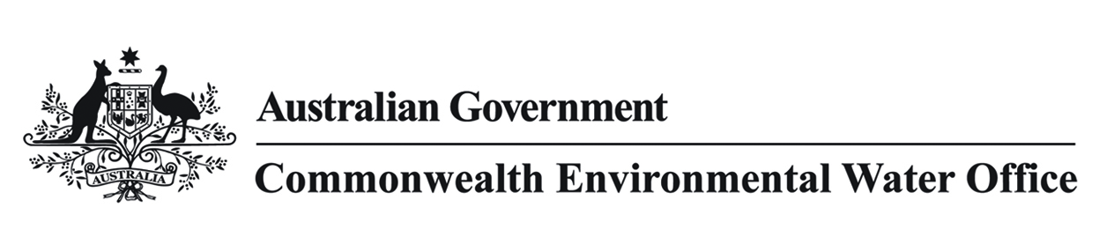

# Carp in the Murray-Darling Basin and Commonwealth environmental water

This statement provides an overview on carp in the Murray-Darling Basin, current efforts to manage the species and the role of the Commonwealth environmental water.

## Key points

* Carp are an abundant invasive fish species that has been contributing to environmental degradation across the Murray-Darling Basin since the 1960s.
* The Australian Government recently announced a $15 million investment to develop a National Carp Control Plan to support the potential release of the carp-specific herpesvirus, which could help manage carp abundance in the Murray-Darling Basin.
* The introduction of a biological control mechanism to tackle the pervasive carp problem will be an important complement to existing natural resource management and environmental watering programmes that are helping to build the resilience of native fish populations.
* Environmental water is focussed on re-establishing more natural variable river flows, by reconnecting Basin rivers with floodplains and wetlands and creating the right conditions to support healthy populations of native fish.
* Carp populations benefit much more from natural flooding events, than small, targeted environmental watering. This is supported by monitoring of Commonwealth environmental water, which has found native fish are spawning and recruiting in response to environmental flows, providing more competition for carp.

## Background

### What are carp?

Carp are an invasive fish species that is widespread and abundant across the Murray-Darling Basin. They are highly adaptable and have biological features that allow populations to increase rapidly. Carp now account for up to 90% of fish biomass in some areas of the Basin.

### Why are carp an issue in the Murray-Darling Basin?

Carp contribute to environmental degradation in the Basin. Reported impacts from carp include reduction in water quality, river bank damage and may contribute to algae blooms. The increased spread of carp and its impact on freshwater habitat has come at the expense of native fish species and aquatic vegetation.

### What is being done to manage carp?

Following years of testing, Australian scientists have determined that using the naturally occurring carp herpesvirus as a biological control agent could significantly reduce the number of carp in our freshwater systems.

Considerable work is required before a release of the carp herpesvirus could occur, including further research into how to manage the release and clean up and other ecological impacts, as well as legislative approvals and community consultation.

The combination of a biological control mechanism, as envisaged through the release of the virus, and an improved environmental flow regime would enormously impact the likelihood of a positive future for native fish in the Basin. Environmental water continues to be particularly important to increase native fish populations and target any reduction in carp numbers.

A range of activities are also currently being implemented to support carp management. For example, carp exclusions screens have been installed at a number of wetlands in the Basin.

### How is carp considered in the management of Commonwealth environmental water?

Analysis of historical records show that carp populations benefit much more from natural flooding events, than from smaller volume, asset-targeted environmental watering actions. Although any benefit to carp from environmental watering is likely to be small, environmental water planning is a very considered and managed process, involving a comprehensive risk assessment. Every watering event is evaluated on whether the benefits to native species will outweigh those of carp.

If the benefits to carp are found to outweigh the benefits to native species, we simply do not water.

Accordingly, all environmental watering events are designed to benefit native species over carp. Carp can take advantage of environmental flows, but this does not diminish the importance of our efforts to improve the environmental conditions that favour native species, in particular re-establishing flow regimes that provide the breeding cues and feeding opportunities that native fish rely on. We know that using the right volumes of water at the right time and in the right locations improves environmental conditions for native fish, which unlike carp, have quite particular seasonal flow requirements for breeding and feeding.

### How is Commonwealth environmental water benefiting native fish populations?

Monitoring of Commonwealth environmental water use is showing that native fish are spawning and recruiting in response to environmental flows, providing greater competition for carp in our rivers and wetlands. For example, monitoring of environmental watering in the Murrumbidgee during 2014–15 found that native fish, including the critically endangered Silver Perch, Murray Cod and Australian Smelt, spawned in response to watering. Results also indicated low larval counts of invasive species including carp.

Environmental water is also being used to improve the overall resilience of the ecosystems – that is, ensuring the rivers and wetlands are in good condition to promote diverse and healthy native plants, fish, waterbirds and other animals.