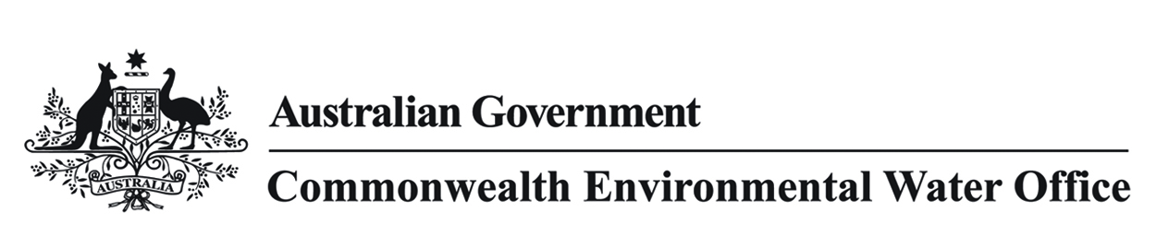

# Commonwealth environmental water use in the Murray-Darling Basin during dry conditions

## Key points

* Like all water users, Commonwealth and State water holders and managers must grapple with the challenge of variable seasonal conditions whilst determining the best way to protect and restore the rivers, floodplains and wetlands of the Murray-Darling Basin.
* Extended dry conditions commonly result in high demands for water resources both for agriculture and the environment, whilst a series of wet years or successful watering events typically result in lower demands.
* During dry times, there is often no connection between rivers and adjoining floodplains and wetlands. In these circumstances water holders and managers must work together to prevent critical loss of key species and irreversible environmental damage, with the little water that we have available.
* This involves highly targeted and discrete environmental watering actions such as maintaining low flows to manage water quality by flushing waterholes and directing small volumes of water from the main river channels to providing refuges for plants and animals in wetlands and channel systems.

## Background

* Extended dry conditions present a number of challenges across the Basin, the primary one being that priority is given to making water available for use in our homes, farms and industry. Meanwhile, other water users such as farmers, businesses and environmental water holders and managers are allocated much smaller amounts of water.
* Just like irrigators, environmental water holders and manager plan for the likelihood of reduced water allocations by deliberately using carry over (where it is available) from the previous water year, to support the environment during a forecast dry year.
* In a dry year with reduced water allocations, our goal is to ensure critical ecosystem process and native vegetation, fish and bird populations are able to withstand the prospect of extended dry conditions, by using Commonwealth environmental water to support in-channel, wetlands, deep river pools and low elevation floodplain habitat.
* These habitats provide important refuges that provide habitat that helps plants and animals survive the bad times so they can flourish in the good times. We plan for these species to repopulate wetland and river systems in wetter years. In rivers, refuges are chosen because they can be managed with relatively low volumes of water and can retain water for long periods, providing critical habitat for important species. They are also located in areas that will allow fish and animals to move back into the river system in wetter years.
* It is true that some rivers naturally dry up and while this places stress on the river system it’s important to recognise these ecosystems have evolved to cope with wet and dry conditions which are both important for the maintenance of their values. While droughts may see our rivers looking in bad shape in natural circumstances, most rivers recover. However, the Basin’s river systems are now highly modified. In today’s environment, it is more difficult for rivers to bounce back because so much water is extracted from them to sustain towns and businesses.
* The Commonwealth Environmental Water Holder’s priority is to make the most of the limited water that is available, to support Australia’s wetlands of international importance (Ramsar listed wetlands) such as Barmah and Millewa forests, Macquarie Marshes, Narran Lakes, Hattah Lakes, and the Coorong, Lower Lakes and Murray Mouth, and other sites that support nationally threatened species and migratory including wetlands throughout the Lower Murrumbidgee, Victorian-NSW Mallee region and South Australian Riverland.
* The potential trade (disposal or acquisition) of temporary water to help meet environmental demands is regularly reviewed however, the Commonwealth Environmental Water Holder does not have any immediate plans to trade because of the moderate to potentially high demands for environmental water across the Basin as a result of the dryer conditions forecast. Updates on the management of Commonwealth water holdings including any intention to trade is updated quarterly on our web site.

**Other resources:**

## See latest information about Commonwealth environmental water in Basin storages, allocations and carryover and water use

[www.environment.gov.au/water/cewo/about-commonwealth-environmental-water](http://www.environment.gov.au/water/cewo/about-commonwealth-environmental-water)

How Commonwealth environmental water holdings are managed:

[www.environment.gov.au/system/files/resources/1a947b47-08ac-453b-901e-4ed59c0b76cc/files/managing-cew-portfolio.pdf](http://www.environment.gov.au/system/files/resources/1a947b47-08ac-453b-901e-4ed59c0b76cc/files/managing-cew-portfolio.pdf)

Commonwealth Environmental Water Office Trading Framework:

[www.environment.gov.au/water/cewo/publications/water-trading-framework-dec2014](http://www.environment.gov.au/water/cewo/publications/water-trading-framework-dec2014)

Bureau Of Meteorology Water forecasts

<http://www.bom.gov.au/water/>

Real time river information

NSW, Water NSW <http://realtimedata.water.nsw.gov.au/water.stm>

Vic, Goulburn-Murray Water https://waterline.g-mwater.com.au/waterstatus/#ST@G409ACM

SA, Murray-Darling Basin Authority River Murray Operations & South Australian Department of Environment, Water and Natural Resources http://livedata.mdba.gov.au/

## Qld (Border Rivers, Warrego Moonie and Condamine Balonne) <https://water-monitoring.information.qld.gov.au/host.htm>