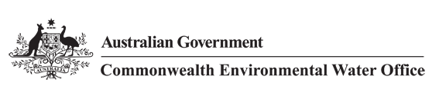

**Senate Select Committee Inquiry into the Murray-Darling Basin Plan**

**Supplementary submission by the**

**Commonwealth Environmental Water Holder**



John Gorton Building King Edward Terrace Parkes ACT 2600

GPO Box 787 Canberra ACT 2601 | 02 6275 9245

<http://www.environment.gov.au/water/cewo>

## Executive Summary

To assist the Senate Select Committee on the Murray-Darling Basin Plan in its inquiries, I am providing a supplementary submission on the Commonwealth’s environmental water activities.

In my role as Commonwealth Environmental Water Holder, I am responsible for the management of the Commonwealth environmental water holdings. This function is governed by the *Water Act 2007*, the Basin Plan and subsidiary documents, such as the *Basin-wide environmental watering strategy* and *Basin annual environmental watering priorities*. I am also subject to the same state government regulations, fees, allocations, carryover and other rules as apply to equivalent entitlements held by other water users.

I am committed to being a diligent, responsive and prudent water manager. I do not waste water. Rather, I am focussed on maximising outcomes across rivers, wetlands and floodplains from the use of the entire Commonwealth environmental water portfolio. This includes the considered use of the tools available to all water users, such as carryover and trade, and the application of adaptive management with:

* clear objectives;
* robust planning and decision-making processes;
* meaningful engagement with other water users, river operators, land managers and local communities; and
* monitoring programmes to assess effectiveness and inform future decisions.

Strategies to maximise outcomes include using a parcel of water multiple times as it flows through the river system; coordinating with other sources of water (such as environmental water managed by state governments and consumptive water deliveries); and delivering water at seasonally-appropriate times (for example, in response to natural rainfall cues), recognising that drying periods for wetlands are necessary in the Australian landscape.

However, I do not seek to maximise environmental outcomes at any cost. I have established a ‘good neighbour’ policy, which guides my management of Commonwealth environmental water. The central principle of this policy is ‘first, do no harm’. A precautionary approach is taken to managing environmental water, so that there is no material impairment of the interests of landholders and other water users. In particular:

* I have not and will not place water orders that would flood private land without the consent of the landholder. For example, I place orders at below allowable delivery limits to provide a buffer in the case of unexpected inflows. In addition, river operators will not deliver environmental flows above the limits that apply to all water deliveries, including irrigation orders.
* Commonwealth environmental water does not and cannot fill up dams to the exclusion of others. Commonwealth environmental water carryover into 2015–16 was equivalent to approximately 2 per cent of the capacity of public water storages across the Murray-Darling Basin. In five of the last seven years I have, on average across the Basin, used more and carried over less than other water users.
* Commonwealth environmental water does not increase competition for channel capacity. This is because it is not ‘new’ water in the system, but existing water entitlement used for a different purpose. Because environmental watering is often undertaken at a different time of year to irrigation orders, it can actually reduce competition for channel capacity. In the event of channel capacity becoming limited, I can usually be flexible about how and when environmental water is ordered, so as to minimise any potential impact on others. However, at times of critical environmental need, the Commonwealth may assert its rights to access its share of channel capacity, just as the previous owner of the water would have done.
* I assess the risk of environmental watering causing negative environmental impacts. For example, environmental water delivery aims to avoid conditions that may result in a blackwater event (that is, water with low levels of dissolved oxygen), with water also held in reserve as a mitigation measure to dilute the event should one occur. Commonwealth environmental water has never contributed to or caused a significant blackwater event.
* I am committed to working with local communities and interested stakeholders on the design and implementation of watering actions and listening in order to understand peoples’ issues and concerns. This commitment is supported by six Local Engagement Officers that live and work in local Basin communities.

When trading water, the primary purpose is to improve environmental outcomes. However, I have regard to social and economic outcomes by considering the impacts of any trading action on the market. This includes consideration of volumes that have the potential to disrupt other market activity given the seasonal demand for temporary water, ensuring timely and early information is provided to the market about my trading intentions, and undertaking and reporting on trades in a timely and efficient manner.

The recovery and management of Commonwealth environmental water is not the main driver of temporary water prices. Independent expert analysis has identified there are many factors influencing water prices with the primary driver being water availability (that is, water allocations and rainfall).

The decline in the environmental health of the Murray-Darling Basin has occurred over many decades. Reversing this decline is a long-term process. Nonetheless, early monitoring is showing that Commonwealth environmental water is already being used effectively to achieve positive environmental outcomes and contribute to the mandated objectives and outcomes in the Basin Plan and the Basin-wide environmental watering strategy. The delivery of Commonwealth environmental water, along with other sources of water, has for example:

* supported native fish survival, breeding and migration
  1. 2014 saw the largest golden perch breeding event in the Goulburn River since the floods in 2010
  2. record numbers (over 10 times the number recorded in recent history) of the threatened Murray hardyhead were found in the South Australian Riverland in 2015
* supported native waterbird breeding and feeding habitat
  1. environmental watering supported the completion of colonial waterbird breeding events in the Macquarie Marshes in 2010–11, the Gwydir Wetlands in 2012 and Yanga National Park in 2014.
* improved the condition of vegetation such as river red gum forests and woodlands
  1. in 2013 the Lachlan River was reconnected to lakes, creeks and wetlands throughout the catchment, providing benefits to 60,000 hectares of floodplain wetlands and inundating river red gums, black box, lignum and other wetland vegetation communities.
  2. in 2013–14, watering of the Mallowa Wetlands in the Gwydir catchment saw the native vegetation biomass 25 times higher than in areas that had not been watered.
* improved water quality through the flushing of salt, sediments and excess nutrients out of the Basin through the Murray Mouth
  1. On average two million tonnes of salt needs to be flushed from the Basin each year. Commonwealth environmental water contributed to flushing approximately 18 per cent of this required salt in 2011–12 and 30 per cent in 2012–13.

The primary purpose of Commonwealth environmental water is to provide the environmental outcomes envisaged by the Basin Plan with other elements of the water reform process targeting socio-economic outcomes. However, environmental water does provide significant complementary socio-economic benefits including: improvements in water quality (especially salinity), reductions in channel capacity competition, and recreational and tourism benefits through support to activities such as camping, bird watching and fishing.

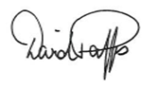

Mr David Papps

Commonwealth Environmental Water Holder

29 January 2016

Contents

Executive Summary 2

Introduction 6

Managing Commonwealth environmental water – efficient and effective use 7

Objectives for environmental watering 7

Commonwealth environmental water planning 8

Environmental water delivery 9

Carryover and trade 9

Amending Commonwealth environmental water trading provisions 11

Benefits of environmental water 13

Monitoring programmes 13

Environmental outcomes 13

Social and economic benefits 15

Avoiding negative impacts on people, property and the environment 18

Inundating private land and infrastructure 18

Channel capacity 19

Carry-over 19

Impacts on the market 21

Environmental damage 21

Environmental water management in the Coorong, Lower Lakes and Murray Mouth 24

Case Studies 27

Case Study 1: Responding to natural cues in the River Murray 27

Case Study 2: Adaptive management and localism in practice in the Goulburn River 29

Case Study 3: Working together to support the recovery of the Murray hardyhead 32

Case Study 4: Providing fish refuge from the impact of poor-quality water in the River Murray 33

Case Study 5: Environmental Watering in the Gwydir Wetlands 35

Appendix A – Commonwealth Environmental Water Outcomes Framework 36

Appendix B – Commonwealth Environmental Water Portfolio Management Framework 39

## Introduction

1. On 24 June 2015, the Senate resolved to establish the Select Committee on the Murray-Darling Basin Plan. The committee is to inquire into the positive and negative impacts of the Murray-Darling Basin Plan and associated Commonwealth programmes on regional communities.
2. The Commonwealth Environmental Water Holder lodged a submission to the Inquiry on 18 September 2015 (submission no. 45). The submission provided an overview of the management of Commonwealth environmental water.
3. This supplementary submission has been prepared in response to key issues raised by community members (both in public submissions received by the Committee and at the Committee’s public hearings) that relate to Commonwealth environmental water. This includes:
   1. the efficient and effective use of environmental water
   2. Commonwealth environmental water trading provisions
   3. the benefits of environmental water
   4. avoiding negative impacts of environmental water
   5. environmental water management in the Coorong, Lower Lakes and Murray Mouth.

## Managing Commonwealth environmental water – efficient and effective use

1. Community members have raised concerns about the Commonwealth Environmental Water Holder ‘wasting water’. These include concerns that there is a lack of clear objectives or purpose; with environmental water being delivered at the wrong time of the year or out-of-sync with natural conditions (e.g. too much water being delivered in dry conditions); and that water is being stockpiled in storages, when it could instead be sold to irrigators.
2. The Commonwealth Environmental Water Holder is a diligent, responsive and prudent operator. The Commonwealth environmental water portfolio is managed efficiently and effectively, focused on maximising beneficial outcomes through water delivery, carry-over and trade. This involves having:
   1. clear objectives and targets
   2. planning and decision-making approaches that include management of risks
   3. collaboration and cooperation with other water users and river operators
   4. effective engagement with communities
   5. robust monitoring, evaluation and reporting processes.

### Objectives for environmental watering

1. The Basin Plan’s **environmental watering plan** establishes the objectives, processes and principles that guide the management of environmental water in the Murray-Darling Basin. The Commonwealth Environmental Water Holder is obligated to act consistent with the environmental watering plan.
2. The environmental watering plan’s overall objectives can be summarised as:
   1. protect and restore the Basin’s water-dependent ecosystems (that is, the rivers, wetlands and floodplains of the Basin, and the native plants and animals they support)
   2. protect and restore the functions that underpin these ecosystems
   3. ensure these ecosystems are able to withstand threatening impacts.
3. The environmental watering plan also sets broad targets to measure progress towards meeting the objectives. Up to 2019, the focus is on ‘no environmental loss or degradation’. From 2019 onwards, it is expected there will be broad environmental improvements.
4. The **Basin-wide environmental watering strategy** provides the next level of detail on the environmental objectives and targets. It describes the environmental outcomes expected over the next decade as a result of implementing the Basin Plan and associated water reforms. These outcomes focus on four components: river flows and connectivity; native vegetation; waterbirds; and native fish. Examples of the expected outcomes include:
   1. a 20–25% increase in waterbirds
   2. a 10–15% increase in mature Murray cod and golden perch at key sites
   3. maintenance of the current area and condition (and in some regions, improved condition) of river red gum, black box, coolabah and lignum communities
   4. improved overall flow, such as 10% more flow in the Barwon-Darling, 30% more flow in River Murray and 30–40% more flow to the Murray mouth.
5. The Commonwealth Environmental Water Holder is also obligated to act consistent with the strategy.
6. At a catchment scale, **long-term watering plans** are being prepared by Basin state governments. The plans will identify the key rivers and wetlands in each catchment, and the objectives, targets and environmental watering requirements for each river or wetland. These plans are being developed over the coming years. In the meantime, environmental water managers will continue to draw on information from a large number of existing documents that describe environmental watering requirements for specific wetlands and catchments, as well as local knowledge and monitoring results.
7. Prior to the start of each water year, **annual environmental watering priorities** are prepared by Basin state governments (for each catchment) and by the Murray-Darling Basin Authority (for the Basin as a whole). The annual priorities inform Commonwealth environmental water portfolio management planning.
8. The environmental objectives, outcomes and targets in the Basin Plan’s environmental watering plan and the Basin-wide environmental watering strategy are all long-term. However, individual environmental watering actions are undertaken over much shorter timeframes. Therefore, it is necessary to identify the short-term outcomes that will contribute to these longer-term objectives.
9. The **Commonwealth Environmental Water Outcomes Framework** identifies outcomes that can be expected from Commonwealth environmental watering over time periods of:
   1. less than one year (1 year outcomes)
   2. between one and five years (5 year outcomes).
10. When these shorter-term outcomes are achieved over multiple years, the best available science indicates that they will cumulatively contribute to meeting the longer term objectives and outcomes in the Basin Plan and the Basin-wide environmental watering strategy (see Appendix A for more detail).

### Commonwealth environmental water planning

1. Commonwealth environmental water planning is primarily driven by supply—how much water is available—and demand—what are the environment’s needs.
2. Environmental water demands change in response to changing conditions.
   1. In wet conditions, the purpose of environmental water is to improve environmental condition, for example, by improving habitat, breeding opportunities, and food sources to increase populations of native fish and water birds.
   2. Under drought conditions, the environmental demand for water can be variable. Floodplain areas that have received water over the past couple of years and are in good condition may require a drying period—in this case, their demands are low. However, many wetlands and rivers would have naturally received water in all but the very driest of years. Under drought conditions, these will continue to have high water demands. Environmental watering is typically focussed on supporting these needs, which include low flows, flushing waterholes, improving water quality, and providing refuges for plants and animals.
3. Similarly, the water available to meet environmental demands changes in response to rainfall and inflows. Under drought conditions, water availability is reduced, and disproportionately so for the environment. The dominant source of water for the environment is **planned environmental water[1]**. Under most water resource plans, planned environmental water availability is reduced by a greater proportion than water for consumptive use. As with other entitlement holders, Commonwealth environmental water holdings receive lower allocations.
4. Further information on how the Commonwealth environmental water is managed under different supply and demand scenarios is provided in Appendix B.

### Environmental water delivery

1. Environmental watering typically aims to follow natural cues such as rainfall events and natural inflows. Natural cues are often critical for triggering breeding or movement of native species and occur across the whole year, including winter. By responding to natural cues, it assists in ensuring outcomes are optimised through:
   1. appropriate timing, magnitude, duration and frequency of watering events
   2. avoiding the creation of ‘artificial’ outcomes that cannot be sustainably managed
   3. providing a sound ecological underpinning to environmental water.
2. However, it is not always possible or desirable to restrict environmental water delivery to responding to natural flow events. Environmental watering is undertaken in a working and highly managed river system. The extent to which natural cues are followed is guided by the overarching objectives and what is possible within existing constraints and operating arrangements. Also, many wetlands are in poor ecological health and the ‘normal’ wetting-drying cycle may have to be manipulated to assist in restoration and recovery (that is, provide flows to assets at a higher frequency to restore health, than what would be required to simply maintain health).
3. An example of how environmental watering is informed by natural cues in a relatively dry year is provided in *Case Study 1: Responding to natural cues in the River Murray*.

### Carryover and trade

1. Environmental water is not filling up storages or being needlessly stockpiled. Carrying over water does not indicate that it is surplus to environmental requirements.
2. Carryover is an essential management tool for any water user, including the Commonwealth, as a prudent risk management strategy. It allows users to reserve water in good years to mitigate the risk of environmental damage during drier periods. It can also be used to water wetlands or river red gums in late winter and early spring, ahead of most of the increases to seasonal allocations for many entitlement types.
3. Commonwealth environmental water carryover into 2015–16 was equivalent to approximately 2 per cent of the capacity of public water storages across the Murray-Darling Basin. In the southern Basin, this supported early season delivery in the Murray and supplemented the lower allocations. In the northern Basin, where there is more of a boom-bust cycle, water accounts are managed through continuous accounting. This has meant environmental water accounts have been managed over multiple years, with water still available to meet environmental demands in some catchments that have not had an allocation since mid 2013.
4. Carryover limits are set by Basin state governments and apply to all entitlement holders, including the Commonwealth. No water holder can fill up dams to the exclusion of other water users.
5. Where environmental needs have been met or better environmental outcomes can be achieved, there may be opportunities to sell water and reinvest the proceeds in another catchment or in a future year.
6. Trading opportunities are weighed against the need to deliver water to meet current environmental water needs and the need to carryover water to meet demands in the next water year. During dry periods, factors that may increase the need to retain allocations (instead of selling them) include:
   1. during a drought its duration is unknown and there is significant uncertainty over future water availability
   2. environmental demands become increasingly urgent the longer a drought continues (as environmental water requirements include a maximum dry spell that should not be exceeded to avoid irretrievable loss or damage)
   3. during a prolonged drought, if water needs to be acquired to meet urgent environmental demands, there is likely to be limited water available to buy and high prices.
7. In November 2015, the Commonwealth Environmental Water Holder sold 22.864 gigalitres (GL) of water allocations in the Goulburn catchment of Victoria. Environmental conditions and water availability at the time guided the decision to trade. There was sufficient Commonwealth environmental water available through carryover from 2014–15 and annual allocations to continue building environmental resilience in the Goulburn to allow the sale. The level of environmental water use at this time was in line with naturally drying conditions.
8. Of the 22.864 GL sold, more than 95% (21.864 GL) was bought by Victorian Goulburn and Murray irrigators. The remaining 1 GL was sold to primary producers in South Australia.
9. Further information on the trade of Commonwealth Environmental Water including the Commonwealth Environmental Water Holder’s Trading framework is available at <https://www.environment.gov.au/water/cewo/trade>

## Amending Commonwealth environmental water trading provisions

1. Several submissions and witnesses at the public hearings commented on the Commonwealth Environmental Water Holder’s ability to trade Commonwealth environmental water and supported providing greater flexibility in how the revenue from selling water can be used. This has included using the revenue to invest in environmental works and measures and fund the Commonwealth Environmental Water Holder’s operational costs.
2. Other submissions and witnesses oppose such changes to the Commonwealth Environmental Water Holder’s trading provisions due to concerns this would reduce the volume of water available to the environment, while creating an incentive for government agencies to defund existing programs and make the Commonwealth Environmental Water Holder responsible for funding unlimited ‘environmental activities’.
3. These issues were considered by the Expert Panel that conducted the Independent Review of the *Water Act 2007*. The Panel recommended amending the *Water Act 2007* to:
   1. enable the sale of water that is not required for the environment and if retained in the Commonwealth Environmental Water Holder’s account, would result in future water allocations to being reduced due to account limits being reached (that is, water would be foregone). The change expands on existing provisions that allow the sale of water that is not required, and if carried over in storage would result in the water being forfeited due to limits on the amount of water that can be carried over.
   2. allow the sale of water allocations and use the revenue to invest in environmental activities, and/or purchase water, where this is expected to improve environmental outcomes. This is because in some circumstances the intended environmental outcomes from the use of Commonwealth environmental water can be more effectively achieved by investing in works and measures that are complementary to environmental water use, and not always by purchasing additional water. Potential environmental activities must be targeted to Commonwealth environmental water use, rather than duplicating existing programs, and could include fishways that enable native fish to move to and from a wetland or along a river, and carp control measures such as exclusion screens that reduce the number of carp that damage native vegetation and compete with native fish in a wetland. Additional safeguards were also recommended, including:
      1. trading activity should not impact on the achievement of sustainable diversion limits in the long-term
      2. trade revenue cannot be used to fund operational expenses, such as holding and delivery fees and charges.
   3. require the Commonwealth Environmental Water Holder to publish information on the trade of Commonwealth environmental water in its annual report.
4. The Expert Panel did not support expanding Commonwealth environmental water trading provisions to allow the use of trade revenue to cover operational costs or trading for the purpose of achieving social or economic outcomes. The Panel had formed the view that such changes would represent a significant variation to the functions of the Commonwealth Environmental Water Holder and would significantly compromise the achievement of the Act’s objects.
5. For example, if the Commonwealth Environmental Water Holder were required to meet its operational costs (including fees and charges from the use of its water) from the proceeds of water trade, significant and regular trades to the consumptive pool would be required. This would result in reduced volumes being available for the environment and increase consumptive use over time, conflicting with the object of the Act to ensure the return to environmentally sustainable levels of extraction for water resources that are overallocated or overused.
6. The Panel also noted the position put forward during consultations with industry groups that Commonwealth Environmental Water Holder operating costs should be treated as a community service obligation and paid through consolidated revenue. Industry groups noted that if the Commonwealth Environmental Water Holder was required to pay for operating costs through trade revenue, the water would be purchased by irrigators; thus all operating costs would effectively be paid by irrigators.
7. The Australian Government supports the Water Act Review’s three recommendations in relation to the Commonwealth Environmental Water Holder trading provisions. The Water Amendment (Review Implementation and Other Measures) Bill, which seeks to give effect to the recommendations, has been introduced into the Australian Parliament. The bill can be located at <http://www.aph.gov.au/Parliamentary_Business/Bills_Legislation/Bills_Search_Results/Result?bId=r5595> and the amendments relating to CEWH are located at Part 1, Schedule 4 of the bill.
8. The Australian Government’s response to the Water Act Review also committed that “the Commonwealth Environmental Water Holder will undertake public consultation on how the greater flexibility in the use of trade revenue will be exercised”, subject to the Bill being passed.

## Benefits of environmental water

1. Community members and stakeholders have raised concerns about the evidence to date of the benefits of environmental watering and adequacy of monitoring programmes.

### Monitoring programmes

1. To assess the outcomes from environmental water, the Commonwealth Environmental Water Holder has established a robust monitoring, evaluation, reporting and improvement programme. This includes:
   1. operational monitoring for all Commonwealth environmental watering actions that involves collecting on-ground data about the environmental water delivery action such as volumes, timing, duration, location, flow rates and river heights.
   2. intervention monitoring that aims to understand the environmental response to a watering action. This includes a $30 million 5-year intervention monitoring programme being undertaken at seven select areas across the Basin. The seven areas provide maximum possible coverage of where Commonwealth environmental watering will occur and complement, rather than duplicate, monitoring activities already being undertaken by others including Basin states and the Murray-Darling Basin Authority. The selected areas are Junction of the Warrego and Darling rivers; the Gwydir river system; the Lower Lachlan river system; the Murrumbidgee river system; Edward-Wakool river system; the Goulburn River and the Lower Murray River. Monitoring is undertaken by consortium teams, led by Australia’s leading research institutions and involving locally based land and water managers.
2. The Commonwealth Environmental Water Holder is not the only entity investing in environmental monitoring and evaluation activities under the Basin Plan. Commonwealth Environmental Water Office staff work with colleagues from state governments and the Murray-Darling Basin Authority to ensure the most efficient monitoring programmes are in place to allow information to be captured once, but used for multiple purposes.

### Environmental outcomes

1. The decline in the environmental health of the Murray-Darling Basin has occurred over many decades. Reversing this decline is a long-term process and, in many cases, it will take many years before lasting environmental changes can be achieved. The Basin-wide environmental watering strategy outlines outcomes that are expected within the next decade. However, the strategy notes that widespread restoration of the Basin’s environment and wildlife populations “will likely take 20 or more years”.
2. Nonetheless, early monitoring is showing positive results from environmental watering. Since 2009, over 5000 GL of Commonwealth environmental water has been delivered to rivers, wetlands and floodplains of the Murray-Darling Basin. This water, along with other sources of environmental water, has supported a range of outcomes for native fish, waterbirds, vegetation and water quality.
3. **Native fish breeding**: Native fish spawning has been observed following Commonwealth environmental watering in the Gwydir, Lachlan, Murrumbidgee, Murray, and Goulburn rivers and off-channel wetlands. This has included Murray cod, golden perch, silver perch, Murray hardyhead, bony bream, spangled perch, eel-tailed catchfish, river blackfish, Murray River rainbow fish, Australian smelt and carp gudgeon. See also *Case Study 2: Adaptive management and localism in practice in the Goulburn River* for outcomes on golden perchspawning and *Case Study 3: Working together to support the recovery of the Murray hardyhead*.
4. **Native fish habitat and movement:** Commonwealth environmental water has provided flows that connect fish habitat, allowing native fish to move between breeding, feeding and refuge habitats. For example, in October 2014, environmental water delivered to the Mehi River and Carole Creek in the Gwydir catchment flowed through to the Barwon-Darling. This provided 10 days of opportunity for fish to move through the fishway on the Brewarrina weir, which had previously been closed off for several months due to very low-nil flows. See also *Environmental water management in the Coorong, Lower Lakes and Murray Mouth*.
5. **Salinity management**: Over the last three years, Commonwealth environmental water has contributed 100% of the barrage flows to the Coorong between November and May. These flows have contributed to the flushing of salt from the Basin and restoring salinity levels in the Coorong’s North Lagoon. On average two million tonnes of salt needs to be flushed from the Basin each year to maintain water quality and limit land degradation. Commonwealth environmental water contributed to flushing approximately 18 per cent of this required salt in 2011–12 and 30 per cent for 2012–13.
6. **Reducing blackwater:** Floods can wash organic material, such as leaf litter, into wetlands and waterways. When this organic matter decays, it darkens the water (known as ‘blackwater’) and dissolved oxygen is sometimes consumed faster than it can be replenished. Water with low levels of oxygen can stress or kill native fish. Over the last three years, environmental watering in the lower Broken Creek has supported continuous flow through to the River Murray. Monitoring and modelling undertaken during 2012–14 provides strong evidence that, without these environmental flows, dissolved oxygen concentration in Rices Weir pool would have been dangerously low for extended periods and likely to have resulted in critical conditions leading to fish kills.
7. In April 2012, Commonwealth environmental water provided a refuge for fish and aquatic animals from naturally occurring hypoxic blackwater in the Edward–Wakool, as well as providing refuges downstream in the River Murray (see *Case Study 4: Providing fish refuge from the impact of poor-quality water in the River Murray*).
8. **Vegetation:** The delivery of environmental water helps maintain aquatic and floodplain vegetation that provide habitat for a range of animals and stabilise river banks. During the millennium drought (2009 and early 2010), Commonwealth environmental water targeted river red gum survival and resulted in improved canopy cover and tree health in the lower Murray. Following the floods of 2010 and 2011, Commonwealth environmental water was focussed on supporting the recovery and improving the condition of vegetation communities. This included environmental water benefitting over 60,000 hectares of floodplain wetlands in the lower Lachlan in winter 2013, including inundating black box, lignum and other wetland vegetation communities. Landholders and the NSW Office of Environment and Heritage observed a positive vegetation response, which persisted well after the watering event concluded. In 2013–14, Commonwealth environmental water was delivered to the Mallowa Wetlands in the Gwydir catchment. Monitoring showed a positive response from native vegetation, with the biomass 25 times higher in areas that had been watered. Landholders reported a high diversity of waterbirds using the wetland, some not seen for many years.
9. **Waterbird breeding:** Environmental water provided to support water bird breeding is often delivered at the end of the breeding event to delay wetland drying and enable the birds to successfully complete the breeding cycle and the young birds to fledge (be old enough to fly). This has included environmental water supporting breeding events:
   1. in the Macquarie Marshes in 2010–11, with 25 waterbird species observed breeding, including egrets and straw-necked ibis completing two breeding events
   2. in the Gwydir wetlands in 2012 (see *Case Study 5: Environmental Watering in the Gwydir Wetlands*)
   3. in Yanga National Park, Murrumbidgee catchment, in 2014, allowing hundreds of egrets, night herons and cormorants to complete their breeding cycles, including the first breeding event for internationally-recognised great egrets in the Park since 2011.
10. **Frogs:** Numerous frog species have been found to breed after the delivery of environmental water. These frog species include the: Pobblebonk frog, Peron’s tree frog, Wrinkled Toadlet, Barking Marsh frog, Spotted Marsh frog, Inland Banjo frog, Plains froglet, Salmon-striped frog, Long-thumbed frog, Broad-palmed frog, Eastern sign-bearing froglet and Southern Bell frog. Environmental water is also restoring habitat for frogs. For example, following the environmental flow in 2013, the endangered southern bell frog was recorded in the lower Lachlan Swamp for only the second time since the 1970s.
11. **Turtles:** Three freshwater turtle species (Macquarie River, eastern long-necked and broad-shelled turtle) were observed in the lower Murrumbidgee wetlands and Western Lakes during sampling from October 2013 to April 2014. This indicates that Commonwealth environmental water provides suitable habitat for all three species. Additionally, the presence of one Macquarie River turtle hatchling and multiple eastern long-necked turtle hatchlings indicates the occurrence of turtle breeding.

### Social and economic benefits

1. Environmental water has provided demonstrable social, cultural and economic benefits.

#### Benefits to other water user from delivering water early in the year

1. Environmental water is often delivered in response to natural triggers, such as naturally occurring flow events. This means the timing of environmental water is often different from the timing of irrigation deliveries. In the southern Basin, significant volumes are delivered in winter and spring, prior to the start of the irrigation season. While environmental water is delivered in winter and spring is for environmental outcomes, it also provides benefits for other water users. Delivering water early in the water year can:
   1. increase the free space in dams available to capture inflows. This in-turn increases the availability of water for other water users. Preliminary modelling indicates early water delivery in the River Murray is expected to benefit water users in all states (New South Wales, South Australia and Victoria).
   2. reduce water losses in the system under standard river operations, resulting in improvements in state water resource shares
   3. reduce competition for channel capacity during periods of peak agricultural demands.

#### Trading environmental water

1. Similar to the delivery of environmental water, the trading of Commonwealth environmental water must be undertaken for environmental purposes. However, it can also provide benefits to other market participants. For example, in January 2014, 10 GL of Commonwealth environmental water allocations were sold in the Gwydir catchment of northern New South Wales. Conditions for a sale of temporary water allocations in the Gwydir were favourable at the time because:
   1. the needs of the environment had largely been met and there was sufficient environmental water to sell some allocation without affecting the ability to meet current and foreseeable environmental requirements
   2. there was strong demand for water from irrigators due to drier than normal conditions.
2. The Commonwealth Environmental Water Holder accepted offers from 16 bidders, which were from a range of primary industries including cotton, beef, wheat and pulse crops. The sale of the water generated a return of $3.217 million. The sale enabled producers to buy water when temperatures were high and rainfall was low, allowing them to either finish off their crops or to improve crop quality or yield.

#### Water quality

1. As noted above, Commonwealth environmental water has provided improved water quality throughout the Basin. In addition to supporting environmental outcomes, improved water quality also supports economic outcomes.
2. For example, salinity in the River Murray has real and measurable economic costs. Managing salinity is important to all water users and ensures that water is suitable for drinking, agriculture, recreation and the environment. That is why for almost 30 years, the Australian and state governments of the Murray-Darling Basin have been working together to manage salinity in the Basin.
3. The long-term salinity target for the River Murray has been set at less than 800 EC (electrical conductivity units) for 95 per cent of the time measured at the town of Morgan in South Australia. In 2010, the salinity target was met for the first time. Since then, salinity has been maintained within this target.
4. The additional environmental water provided under the Basin Plan to date has contributed to these improved salinity outcomes. Modelling undertaken for the *General Review of Salinity Management in the Murray–Darling Basin* found the additional environmental water provided under the Basin Plan environmental flows will, over the long-term, reduce salinity at Morgan by 56 EC. Modelling also suggests that environmental water could extend the period over which the Basin Salinity Target can be met into the future without further interventions. See Table 1 for a comparison of modelled salinity levels with and without the Basin Plan.

Table 1: Modelling of salinity levels in the Lower Murray, with and without the additional environmental water provided under the Basin Plan. Exceedance of salinity targets is highlighted in red.[2]

|  |  |  |  |  |  |
| --- | --- | --- | --- | --- | --- |
| Reporting site and target value | 2015 | |  | 2050 | |
| Without Basin Plan | With Basin Plan |  | Without Basin Plan | With Basin Plan |
| Morgan  (800 EC) | 735 | 686 |  | 787 | 741 |
| Murray Bridge  (830 EC) | 770 | 738 |  | 840 | 806 |
| Milang (1000 EC) | 1257 | 865 |  | 1358 | 954 |

1. Salt interception schemes assist in reducing river salinity by intercepting highly saline groundwater before it enters the river. There are 18 salt interception schemes across the Basin that pump about half a million tonnes of salt away from the River Murray every year. The benefit of having additional environmental water in the system means there are opportunities to trial different operating arrangements for the salt interception schemes, which may have operational cost savings.

#### Benefits for recreational activities

1. Commonwealth environmental water supports recreational fishing by supporting the breeding, migration, condition and survival of native fish in the Basin. This increases the number of native fish, such as Murray cod and golden perch, which are important to many Basin communities. Environmental watering can also improve the vegetation on surrounding riverbanks, providing overall amenity values.
2. Commonwealth environmental water increases water levels, which can promote tourism and recreational activities such as kayaking and camping.
3. Commonwealth environmental watering has also been timed to avoid disruption to important social events, such as fishing events in the Goulburn and Murray that occur around the opening of the Murray cod fishing season and require more stable water levels. Such adjustments are made without compromising the achievement of environmental outcomes.

#### Benefits to Indigenous Nations

1. Water is intrinsically linked to the cultural and spiritual identity of Aboriginal people. Healthy waterways enable Aboriginal people to carry out their cultural and economic activities, including fishing, hunting, ceremonies, following songlines and accessing medicinal plants and herbs.
2. There are opportunities to deliver Commonwealth environmental water at different times, places, rates or volumes to support these cultural values and activities, while still providing the same environmental benefits. The Commonwealth Environmental Water Holder is working with interested Aboriginal communities to explore these opportunities.

## Avoiding negative impacts on people, property and the environment

1. Several submissions and witnesses raised concerns about potential negative impacts from the management of environmental water including flooding, carryover, channel capacity, market impacts, and environmental damage.
2. As a member of the Basin community, the Commonwealth Environmental Water Holder is committed to being a ‘good neighbour’. Operating effectively in a working river system where much of Australia’s food and fibre is produced requires that the management of environmental water must co-exist with agricultural production in a mutually respectful and harmonious manner. The Commonwealth Environmental Water Holder’s Good Neighbour Policy is a set of practices that guide the management of Commonwealth environmental water. The Policy aims to promote mutually beneficial relationships with other water users and landholders, but always in a way that is consistent with statutory obligations.
3. The central principle of the Policy is to ‘first, do no harm’. A precautionary approach is taken to managing environmental water, so that there is no material impairment of the interests of landholders and water users. All decisions are informed by comprehensive risk assessments, which draw on previous results captured through effective monitoring activities.

### Inundating private land and infrastructure

1. The Commonwealth Environmental Water Holder has not and will not place water orders that would flood private land, without the consent of the landholder. River operators will not deliver environmental flows above the operational limits that apply to all water deliveries, including irrigation orders. If potentially unacceptable impacts on private property are identified, we will negotiate with affected landholders to avoid or minimise any potential problems and obtain consent to watering events.
2. Where there has been a risk of third party impacts or inconveniences, environmental flows have been limited to levels below operational thresholds to avoid these. For example:
   1. Within the Murrumbidgee catchment, target river flows have been reduced and watering actions postponed to avoid inundation of private land and infrastructure.
   2. In the Gwydir catchment, flows into the Gwydir and Mallowa wetlands have been delayed or suspended during cropping periods to avoid impacting on harvesting activities.
   3. In the River Murray, environmental flows have been restricted to a maximum of 15,000 megalitres/day downstream of Yarrawonga weir to minimise impacts to third party property, particularly in the Bullatale Creek area.
   4. In consultation with state government agencies, regional managers and river operators, environmental water managers have not used water for augmenting natural high flows where there was a risk that this would cause costly delays to work programs (e.g. at the Chowilla regulator, Koondrook Forest, Lake Victoria outlet) and scheduled maintenance (e.g. in Millewa forest, Eildon Dam and the River Murray locks and weirs).

### Channel capacity

1. In some places, the height and depth of the river (that is the ‘channel capacity’) is not large enough to allow every user to order their water at the same time. Competition for ‘channel capacity’ can limit users from accessing the water they need, when they need it.
2. Commonwealth environmental water does not increase competition for channel capacity. Environmental water is not ‘new’ water in the system, but existing water entitlement that is being used for a different purpose.
3. In the event of channel capacity becoming limited, the Commonwealth Environmental Water Holder can usually be flexible about how and when environmental water is ordered, so as to minimise any potential impact on others. However, at times of critical environmental need, the Commonwealth may assert its rights to access its share of channel capacity, just as the previous owner of the water would have done.
4. As noted above, environmental water is often needed at a time outside of the irrigation season—in these cases, environmental watering can reduce competition for channel capacity. When environmental water is being delivered at the same time as consumptive water, delivery of Commonwealth environmental water is frequently limited to using the remaining channel capacity (capacity after all other water orders are accommodated). Examples of this include delivery through the Barmah Choke in 2014–15. By only using the space that is not required, irrigators’ water orders are met without competition from Commonwealth environmental water.
5. Where irrigation needs use up all available channel capacity, environmental water holders often work with river operators to see if the consumptive water can be delivered in a way that supports environmental outcomes. For example, in 2014–15, local environmental demands coincided with planned water releases in the Goulburn and Campaspe rivers for downstream users that were expected to use the available channel capacity. Instead of seeking to deliver environmental water at this time, river operators released the 250 GL of water for downstream users in a pattern that could also achieve some of the desired environmental outcomes.

### Carry-over

1. Carryover limits apply to all entitlement holders, including the Commonwealth, and no water holder can fill up dams to the exclusion of other water users. The volume of Commonwealth environmental water carried over each year represents a small percentage of available storage capacity in the Basin. For example, the volume of water carried over into 2015–16 was the equivalent of approximately 2 percent of available storage (see for current volumes of Commonwealth environmental water, as a percentage of available storage).
2. In five out of the seven years between 2008–09 and 2014–15, the Commonwealth has used more and carried over less of its available water relative to other water users.

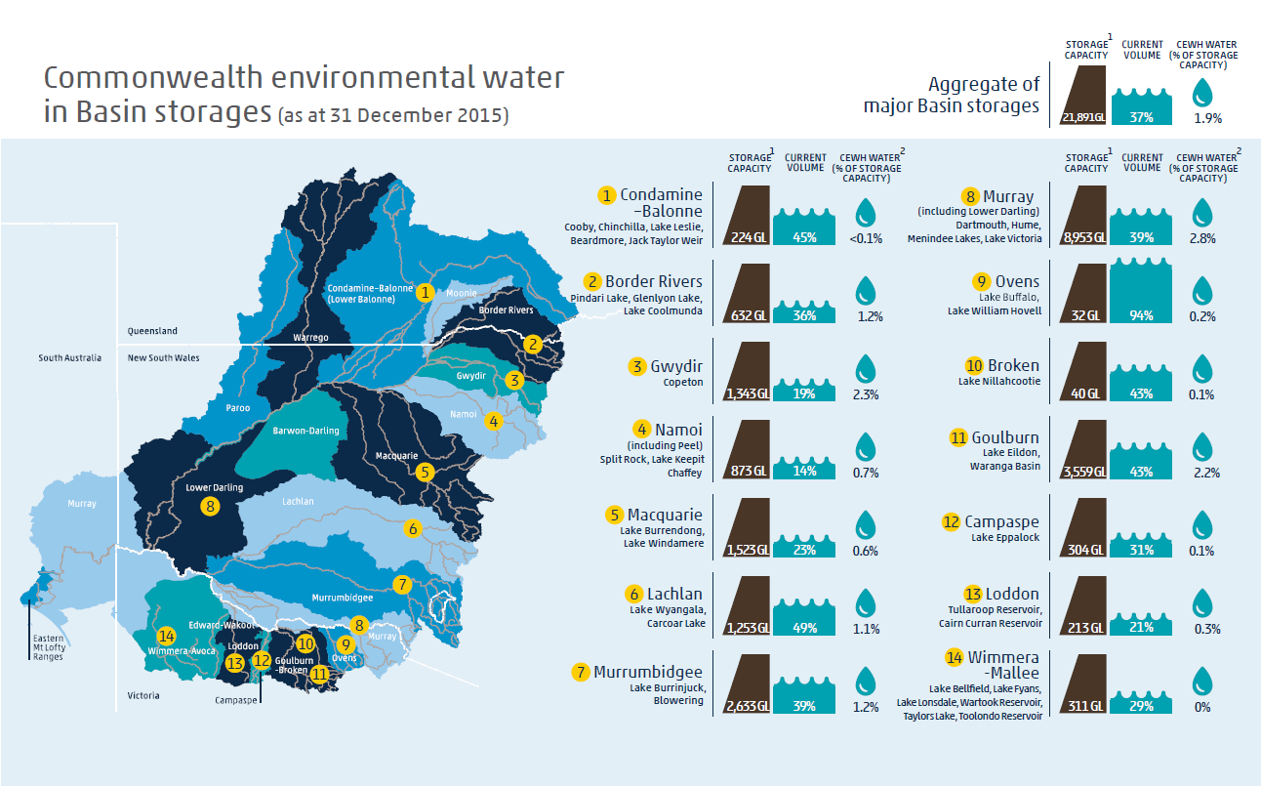**Figure 1:** Commonwealth environmental water allocations (as at 31 December 2015) as a percentage of storage capacity in the Basin.

**1** The storage capacity and current volumes in this chart exclude dead storage. Storage data sourced from the Bureau of Meteorology website at: <http://water.bom.gov.au/waterstorage/awris/?ref=ftr#urn:bom.gov.au:awris:common:codelist:region.drainagedivision:murraydarling>

**2** The CEWH Water volume reflects the Commonwealth’s current water account balances. It does not include allocation that has already been delivered or that has been transferred to delivery partners for delivery.

### Impacts on the market

1. [A discussion paper on the trade of Commonwealth environmental water](http://www.environment.gov.au/ewater/publications/water-trade-discussion-paper.html) was released for consultation from November 2011 to May 2012. Forty four submissions were received from a range of stakeholders. Whilst there was broad general support for trade, nearly three-quarters of respondents noted the size of the Commonwealth environmental water holdings and potential market impacts of trade. In response, the Commonwealth environmental water trading framework was developed to ensure that the Commonwealth Environmental Water Holder’s trading activities have regard to social and economic outcomes and consider impacts on the market, including any third-party impacts.
2. Allocation prices in 2015–16 have reached around $300 per megalitre in the southern Basin. Recent independent and expert analyses[3] of the changes in water prices have indicated that:
   1. Although prices are now higher than in recent years, they are not all-time highs and largely reflect the current climatic conditions. During the drought, temporary water prices reached $1100 per megalitre in 2007–08 and maintained levels of around $500 per megalitre in 2008–09 (prior to the Commonwealth holding significant volumes of entitlement).
   2. Water availability is the primary driver of market prices. This includes both the water allocated to entitlements and local rainfall events (historical and forecast). There is an inverse relationship between the volume of available allocations and prices.
   3. A move to different commodities (such as cotton, nuts and fruit), which have a higher financial return per megalitre used, has increased the demand for water and the willingness of some irrigators to pay higher allocation prices.
   4. The expansion in permanent plantations (including nuts and fruit), which have relatively fixed water demands, further increases the willingness of irrigators to pay high allocation prices when the allocation yield of their held entitlement is insufficient to meet temporal demands.
   5. There have also been changes to the capital investment and risk management strategies of some irrigators, which have affected the supply-demand balance in the market. Many irrigators who have sold their entitlements to the Commonwealth are still looking to irrigate at the same level, however they are now seeking to secure this water through the temporary market.

### Environmental damage

1. Environmental water has been demonstrated to significantly improve water quality, reduce pests and weeds and increase bank stability if managed in a well thought out way. However, if mismanaged, environmental water can exacerbate environmental problems. Some if these issues, such as blackwater and changes in riverbanks from erosion and deposition, are natural processes, though the frequency and/or severity of the events has been increased as a result of changes to land and water use over the past century. The extent to which environmental water delivery is the cause of or a contributing factor to these issues is typically very minor. Regardless, it is still important to reduce the occurrence of these issues as much as possible through thorough planning, risk management and on ground monitoring.
2. For every environmental watering decision, a comprehensive risk assessment is undertaken that includes consideration of the risk of causing environmental harm. The Commonwealth Environmental Water Office’s risk management guidelines specifically cover potential issues such as adverse water quality (including blackwater), spread of invasive species and bank erosion and slumping.
3. Operational monitoring is undertaken for every action. In consultation with delivery partners, environmental watering actions are adjusted, suspended or cancelled should adverse outcomes be identified. In addition to operational monitoring, volumes of environmental water are held in reserve to be deployed should adverse water quality events, such as blackwater, occur.

#### Blackwater

1. The delivery of Commonwealth environmental water has never caused nor contributed to a significant blackwater event.
2. Many blackwater events in the southern Basin have been incorrectly assumed to have been caused by environmental water releases. However, these were caused by releases for consumptive use purposes (e.g. blackwater events and fishkills occurred in the summer of 2009 in the Edward–Wakool system following ‘stock and domestic’ releases) or by large floods that occurred after prolonged droughts (e.g. the Murray blackwater event in late 2010 and early 2011; and the 2012 blackwater in the Murrumbidgee and Murray). In these latter cases, Commonwealth environmental water was used to reduce the severity of these blackwater events (see *Case Study 4: Providing fish refuge from the impact of poor-quality water in the River Murray*).

#### Invasive species

1. Pest species such as carp and feral pigs are considered a significant risk to the environmental outcomes that can be achieved by environmental watering. The risk of increasing pest species and weeds is carefully considered before undertaking watering actions with the location and timing of the watering varied to reduce the spread of pest species.
2. For every watering decision, the Commonwealth Environmental Water Holder assesses the “long-term sustainability of the targeted asset(s) including appropriate management arrangements”. This assessment includes consideration of “the existence of complementary natural resource management activities that support the long-term management arrangements”. These natural resource management activities include culls of feral animals such as foxes, pigs, goats and horses and fencing of river banks to manage bank erosion from stock accessing the river.

#### Bank erosion

1. While erosion is a natural process in streams and on floodplains, many human activities have led to an increase in its occurrence and severity, including but not limited to, broader catchment changes, such as changes to land management practices and river operations for consumptive purposes. Relevant to environmental water management, processes that may trigger dramatic changes in erosion-prone landscapes include the maintenance of flows at constant levels (that is, no variability in flow height) and rapid rates of rise and fall in river height.
2. Streams at highest risk of erosion are those from which riparian vegetation has been removed. Many riverbanks have reduced vegetation cover after the millennium drought. The large floods that followed the drought then further exacerbated erosion problems and contributed to making the river banks unstable.
3. Commonwealth environmental water delivery patterns have been adjusted to consider bank stability. This includes a greater emphasis on providing water to increase bank vegetation, increasing the flow variability and reducing the rate at which water heights rise and fall (see *Case Study 2: Adaptive management and localism in practice in the Goulburn River)*.

## Environmental water management in the Coorong, Lower Lakes and Murray Mouth

1. A large number of submissions and several witnesses at public hearings expressed strong views about the management of the Coorong, Lower Lakes and Murray Mouth (CLLMM). There was a lot of discussion around managing the area at a higher level of salinity, removing the barrages and how to determine what would be the natural state of this region.
2. There are different opinions on whether the Lower Lakes were predominantly freshwater, estuarine or saline before European settlement. The weight of evidence suggests that the lakes were mainly fresh, with short periods where some flows from the sea entered the lakes.[4]
3. The ecology of the CLLMM has changed significantly since European settlement due to a number of interventions including the construction of the barrages and the significant reduction in flows from upstream water extraction. New ecosystems have been established, which are of environmental significance.
4. The Coorong and Lakes Alexandrina and Albert are listed as internationally important under the Ramsar Convention. The listing was made in 1985, meeting eight of the nine listing criteria. The wetlands:
   1. support over 80 species of threatened or migratory birds (including three species that are nationally-listed as endangered or critically endangered) and is ranked in the six most significant waterbird sites in Australia
   2. provide critical fish habitats including important nursery and feeding areas for commercial and non-commercial fish species (including three nationally listed threatened species)
   3. comprise a unique mosaic of 23 wetland types
   4. are central to the culture and spiritual beliefs of Ngarrindjeri people, who are the Traditional Owners of the land.
5. The importance of increased environmental water for outcomes within the CLLMM has been well recognised within the Basin Plan. Freshwater outflows from the Lower Lakes and an open Murray Mouth promotes connectivity, improves estuarine habitats and promotes the flux of nutrients in the Coorong. Commonwealth environmental water has already contributed to improved outcomes in the region, particularly in terms of managing salinity levels in the Coorong, which benefits both aquatic vegetation and fish. For example
   1. Commonwealth environmental watering has extended the optimal habitat conditions for fish in the south lagoon of the Coorong. During 2012 to 2015, Commonwealth environmental water enabled barrage flows to be maintained from November to May each year, during a period of the year when barrage flows would have otherwise ceased. Hydrodynamic modelling has demonstrated that this continuity of barrage flow into the Coorong increased the area of suitable habitat for the native fish species, including Mulloway, Tamar goby and Yelloweye mullet. For Mulloway, which is particularly sensitive to salinity, environmental water delivered during 2012–13 increased the available area of suitable habitat in the Coorong by up to 30 kilometres.
   2. Fish monitoring at the Murray Barrages in South Australia during October 2014 and January 2015 recorded large numbers of congolli and common galaxias, continuing a positive trajectory in their abundance since the return of flow in 2010. Over 90% of all individuals sampled were newly recruited young-of-year, which can be attributed to increased connectivity between the Lower Lakes and Coorong throughout 2014–15. Enhanced spawning during this period is also the result of increased numbers of reproductively mature adults, which can be attributed to connectivity provided over years.
6. To maximise the outcomes from environmental water, it is also important to have complementary and seasonally appropriate operating strategies for managing water levels in the Lower Lakes and flows through the barrages. Management of the lakes and barrages is a responsibility of the South Australian government.
7. Removal of the barrages would be detrimental to the Lower Lakes and Coorong and inconsistent with Australia’s obligations under the Ramsar Convention. Without significant increases in the volumes of water made available for the environment under the Basin Plan, removal of the barrages would not return the system to its natural state. Removal of the barrages would make it increasingly difficult to manage freshwater releases into the Coorong.
8. However, there are opportunities to improve the management of the lakes and barrages.
9. For example, reduced variability in the lakes’ water levels has greatly reduced the distribution and diversity of aquatic and fringing vegetation. When the Lower Lakes are managed within a lower water level envelope, the additional water allocated to achieving environmental benefit for the system is able to flow through the barrages into the Coorong and through the Murray Mouth to maintain tidal exchange. This will better manage salinity levels in the North Lagoon and northern end of the Southern Lagoon of the Coorong, connect freshwater and estuarine environments, and allow upstream and downstream movement of fish. It will also improve the fringing vegetation around the Lower Lakes by providing it with the appropriate water regime. The Murray-Darling Basin Authority identified in the 2015–16 Basin annual environmental watering priority the need to increase the variability of the lake water levels.
10. There is also potential for increased transparency around the operational planning and management of barrage releases. A lack of transparency can limit the information available to support real-time management decisions, including the management of risks and consideration of environmental trade-offs with competing priorities. To address these issues the Commonwealth Environmental Water Office is engaging with the South Australian Department of the Environment, Water and Natural Resources to establish a process to formalise planning and operational management for the CLLMM. This process will aim to integrate the research, strategies and operational policies/tools developed through the CLLMM Recovery project and to reflect the objectives of the Basin Plan.
11. The Australian Government has also committed up to $160.3 million to assist South Australia in implementing the *Long-term Plan for the Coorong Lower Lakes and Murray Mouth*. The Long term Plan is a 20 year road map for the future of this internationally important site. Through the Coorong Lower Lakes and Murray Mouth Recovery Project, South Australia has developed a suite of management actions designed to implement the Long-term Plan. These management actions include: helping to restore Coorong Lagoons, lake and lake shore habitat through salinity management, revegetation, pest management and fencing; reintroducing native fish and constructing fishways; creating a wetland at Meningie to restore the foreshore; undertaking research into acid sulfate soil to help improve restoration and management of the lakes; preparing a monitoring and adaptive management framework and conducting monitoring; updating the ecological character description of the site and developing a site operations manual; investigating options to improve Lake Albert Water Quality and undertaking community engagement including with the Ngarrindjeri people.

## Case Studies

### Case Study 1: Responding to natural cues in the River Murray

In winter 2015, a novel approach to using environmental water to respond to natural hydrological cues was trialled for the first time in the River Murray. Environmental water releases from one of the main storages on the river, Hume Dam, were guided by inflows to mimic a proportion of the modelled natural flow downstream (that is, a modelled estimate of the seasonal flows downstream of Hume Dam, if the dam was not present). Releases in June and July were managed to below channel capacity to extend the period of bank drying and to avoid affecting infrastructure works and public access for firewood collection programs. Similarly, from August onwards, flows were managed to a target of 15,000 ML/day (with a buffer up to 18,000 ML/day), to minimise any third party impacts. This meant releases followed the pattern but not the magnitude of the modelled natural flow (see ).

In October, operational releases increased and environmental water took advantage of the higher flows to provide a series of freshes to support native fish spawning, including golden perch and silver perch. The flows contributed to the growth of Moira grass and other aquatic vegetation in the Millewa Forest. It also supported the breeding of over a thousand pairs of birds including the Australian white and straw-necked ibis, royal spoonbills, eastern great egrets, Australian darters and little pied cormorants. A significant proportion of the entire population of Australasian bitterns and little bitterns were found to be inhabiting, and likely breeding, in Barmah-Millewa Forest during and after the flow event.

The majority of the water moved down to South Australia (providing benefits to the Edward Wakool River system en route), along with return flows from other tributaries. This supported outcomes throughout the catchment, including fish movement along the length of the River Murray (downstream of Hume Dam).

Other benefits from adopting this novel approach include better alignment in meeting environmental demands, particularly in restoring flow seasonality; mimicking of natural hydrological patterns of variability and unpredictability; reduced administrative burden as some operational decisions are automated; and greater certainty for other water users, river operators and water holders on how environmental water will be used and the basis for decisions.

Figure 2: Hydrograph of actual flows relative to modeled natural and what releases would have been in the absence of environmental water in the River Murray downstream of Yarrawonga weir between June and November 2015. Channel capacity at Yarrawonga is 10,000 ML/day. *Adapted from hydrological data provided by the Murray-Darling Basin Authority*.

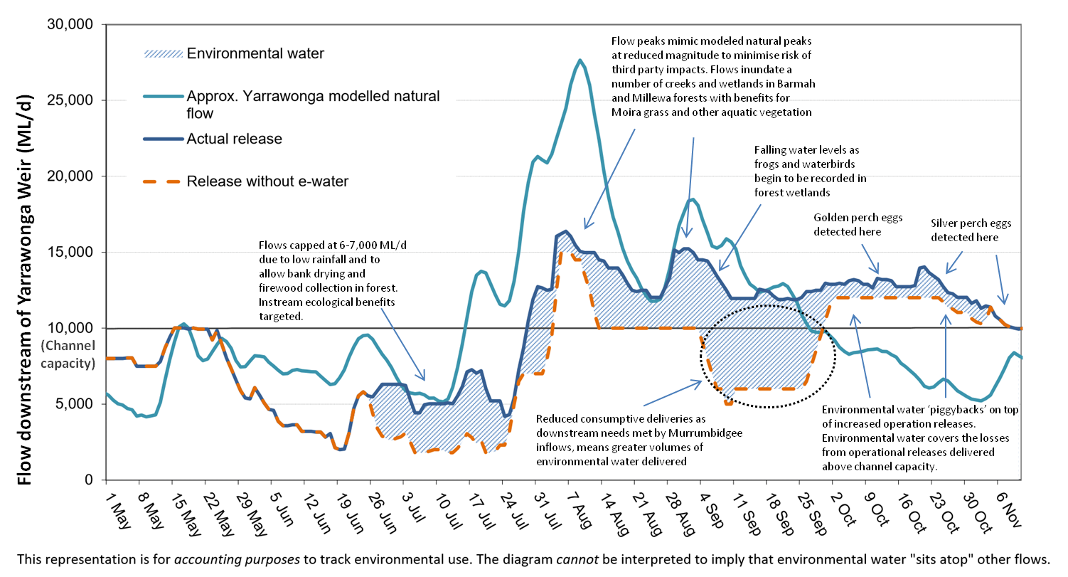

### Case Study 2: Adaptive management and localism in practice in the Goulburn River

Adaptive management is important in reducing uncertainty and supporting the continual improvement of environmental water management. This is relevant not only in managing for environmental outcomes but also in responding to operational issues and community concerns. For example, the design and delivery of environmental water in the Goulburn River in the Murray-Darling Basin has evolved significantly since 2012–13. A large number of lessons have been learnt in terms of the timing, height and duration of flow events to achieve desired outcomes for native fish, bank vegetation and geomorphology. A number of practices have also been put in place to address community concerns which include the risk of bank slumping and notching, the disruption of local angling events and irrigators’ access to pumps (). The adapting of practice required the collective efforts of the local catchment management authority (Goulburn-Broken Catchment Management Authority), the three environmental water managers operating in the catchment (the Commonwealth Environmental Water Holder, the Victorian Environmental Water Holder and The Living Murray program) and the river operator, Goulburn Murray Water, to review the environmental monitoring results of the previous year as well as community issues raised, and redesign the delivery to respond to the findings. The involvement of the river operators is particularly important—the operator is responsible for bulk water releases to meet needs in downstream catchments (referred to as ‘inter-valley transfers), and these have been managed to complement environmental water releases and support the achievement of environmental flow requirements. The river operator also plays an important communications role as it notifies river diverters of upcoming releases via letters, emails, phone calls and/or sms alerts. This communication has proved important in providing sufficient warning time for irrigators to plan their watering needs around environmental flow events during which their pumps are not accessible. The progressive changes made to environmental flow delivery in the Goulburn River from 2012 to 2015 have resulted in both an improvement in the achievement of environmental outcomes and a decrease in concerns from irrigators.

As illustrated in , environmental flows in the Goulburn River are coordinated with releases from storages to meet consumptive demands in downstream valleys (referred to as inter-valley transfers). In 2012–13 ((a)), environmental flows were primarily focused on spring freshes to stimulate the spawning of golden perch and support the recovery of in-channel vegetation, which had suffered declines during the millennium drought and 2010 flood. No golden perch spawning was detected, possibly due to the peak height of the flow being too low (noting that conditions were very dry during spring and summer 2012–13 ((a)). At the same time, landholders reported bank slumping following high flows early in the water year, and bank notching during the delivery of environmental flows. Anglers also complained about environmental flows disrupting the opening of the Murray cod fishing season at the start of December. Environmental water managers commissioned an investigation into the cause of bank slumping and notching. The slumping was caused in part by the lack of semi-aquatic vegetation on the riverbanks due to the preceding drought followed by large floods. The notching was believed to be a result of maintaining the flow at a constant height for extended periods.

In response to lessons learned in 2012–13, a spring fresh targeting golden perch spawning in 2013–14 ((b)) was delivered with a higher peak than the previous year. A second fresh was provided to encourage semi-aquatic vegetation to recolonize the banks. To avoid notching, water levels were not held at the same height for greater than five days and peak height was varied between the two freshes. The freshes were timed either side of the opening of the Murray cod fishing season, to provide stable river conditions for anglers. The first freshes in November successfully triggered long distance migration of native fish and a golden perch spawning event. New growth of semi-aquatic native vegetation was observed in the weeks after the two environmental flows. However, community concerns continued to be raised around bank slumping as well as irrigators having limited access to pumps due to high water levels for extended periods of time. In planning for the 2014–15 water year ((c)), advice was sought from scientists involved in monitoring in the Goulburn River on improving the ecological responses to the flows. They suggested that a sequence of ‘events’ or flows would increase the likelihood of a positive fish response. A longer duration fresh with a gradual recession targeting semi-aquatic vegetation outcomes was delivered earlier in the year to support vegetation growth and condition before the onset of warmer weather in summer. This also aimed to be a ‘priming flow’ to support fish condition prior to the subsequent fresh targeting native fish spawning in November. The earlier timing of the first spring fresh also minimized the delivery of environmental flows during the warmer months when irrigation demand can be higher. The second fresh commenced two weeks later which provided an opportunity for irrigation before river levels rose again. This relatively short and sharp fresh targeted at fish spawning was completed prior to the opening of the cod fishing season. In response to these changes the largest golden perch spawning event since floods in 2010 was observed following the second fresh. No significant community concerns were raised in relation to environmental flows and anglers reported the fishing was ‘the best in years’.

**Figure 3:** Hydrograph of environmental flows in the Goulburn River, Victoria over three successive years: (a) 2012–13; (b) 2013–14; and (c) 2014–15 illustrating adaptive management of the approach in response to scientific advice and community concerns. *Adapted from hydrological data provided by Goulburn-Murray Water*.





### Case Study 3: Working together to support the recovery of the Murray hardyhead

The Murray hardyhead is a small native fish found only within the floodplains of the southern Murray-Darling Basin. It was once widespread and abundant in the Murray and Murrumbidgee river systems but has suffered a serious population decline over the past 50 years, and is now nationally endangered. The Murray hardyhead is identified as a key native species in the Basin-wide environmental watering strategy. The Strategy specifically identifies the need to establish 3–4 additional populations of Murray hardyhead.

In 2012, Murray hardyhead that had been bred in captivity by the Murray-Darling Freshwater Research Centre, were re-introduced to two wetlands in the South Australian Riverland, near Berri. Following conservation efforts by South Australian government agencies and the delivery of Commonwealth environmental water, monitoring at the two sites in February 2015 identified record numbers of Murray hardyhead. This promising monitoring result presented an ideal opportunity to relocate a portion of the Murray hardyhead and establish a new population.

The Mallee Catchment Management Authority has been working to restore wetlands in the Victorian Mallee using Commonwealth and Victorian environmental water. Monitoring in 2013–14 identified one of these restoration sites, Brickworks Billabong, as providing suitable habitat for Murray hardyhead. This followed the installation of a new regulator to allow more natural wetting and drying cycles in the wetland and the delivery of environmental water to promote the establishment of aquatic vegetation that would provide habitat and food for Murray hardyhead.

In preparation for the fish being translocated, additional environmental water was delivered to Brickworks Billabong to further boost habitat and enhance food supply. This was then followed by the Murray-Darling Freshwater Research Centre and South Australian government staff capturing and relocating a sub-population of Murray hardyhead from the Riverland to Brickworks Billabong in March 2015. Approximately 2500 Murray hardyhead were carefully transferred into an oxygenated water-holding trailer, designed specifically for the transportation of live fish, and generously provided by the Victorian Department of Environment, Land, Water and Planning.

Early results indicate that the translocation appears to have been successful, with monitoring in August 2015 detecting juvenile Murray hardyhead (estimated to be 2–3 months old). These juveniles are likely to be the first generation off-spring of the translocated fish.

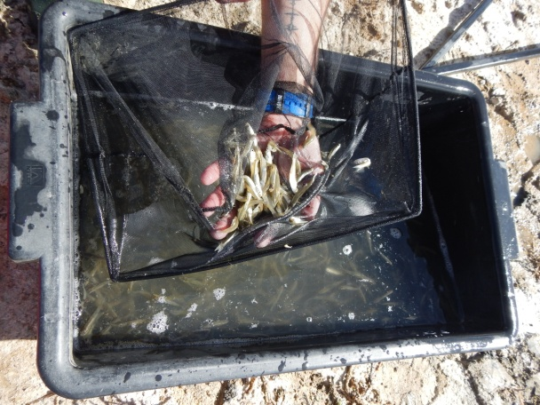

**Image 1:** Murray hardyhead captured from Dishers Creek in the South Australian Riverland (Department of the Environment).

### Case Study 4: Providing fish refuge from the impact of poor-quality water in the River Murray

The inundation of floodplain areas along the Murrumbidgee River following heavy rainfall during March and April 2012 led to significant areas of blackwater. This water had the potential to severely affect aquatic animals when it flowed into the River Murray. Commonwealth environmental water was provided to maintain flows in the River Murray at levels that would help to dilute the blackwater flowing into the River Murray from the Murrumbidgee River. Monitoring results from six sites on the River Murray in May 2012 showed that the flows in the Murray and lower Murrumbidgee mitigated the impacts of blackwater flowing from the Murrumbidgee River into the River Murray. Whilst environmental flows were not able to fully counteract the negative impacts of the poor water quality, they did maintain river flows at levels that assisted in maintaining or improving water quality, and provided important refuges for native fish.

Figure 4: A snapshot of monitoring results for dissolved oxygen levels at six sites on the River Murray

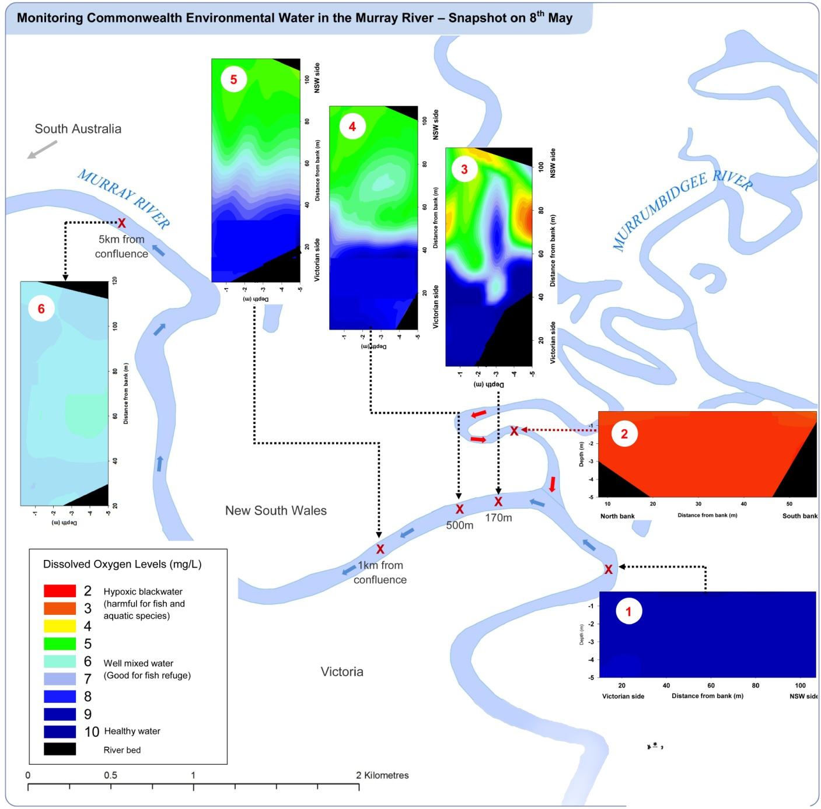

**Box 1— River Murray upstream, healthy water:** Upstream from the junction of the Murray and Murrumbidgee rivers, 17.7 gigalitres per day were flowing down the River Murray, which included approximately 4 gigalitres of Commonwealth environmental water. The oxygen levels in this water were good, and supported native fish communities.

**Box 2—Murrumbidgee River upstream, poor-quality water:** The lower Murrumbidgee River remained in a state of natural flooding, with 18.7 gigalitres of water containing low levels of oxygen flowing into the River Murray per day.

**Boxes 3–5—downstream of the Murray–Murrumbidgee junction, increased mixing of water:** The dilution flows from the River Murray improved water quality by providing substantial mixing. Within and across the water column, areas of improved levels of oxygen (in the blue and green areas) would provide refuge from those areas of oxygen below critical thresholds (in the red and yellow areas) for native fish such as Murray cod.

**Boxes 4–5—from 0.5–1 kilometre downstream, increased mixing of water:** This provided improved oxygen levels and suitable habitat for native fish.

**Box 6—five kilometres past the Murray–Murrumbidgee junction, healthy water:** Five kilometres downstream of the Murray–Murrumbidgee junction, there is a complete mixing of water from the two rivers, and oxygen levels have improved to a level that is suitable for native fish.

## 

### Case Study 5: Environmental Watering in the Gwydir Wetlands

The Gwydir Wetlands support some of the largest waterbird breeding colonies recorded in Australia and are recognised as a refuge for waterbirds in dry times. From 2010 to 2013 unregulated flows inundated large areas of the Gwydir Wetlands triggering large-scale waterbird breeding. Small volumes of Commonwealth and New South Wales environmental water were delivered from 2010 to 2013. This supported bird breeding, improved the condition of core wetlands and helped with the recovery of wetland and floodplain vegetation after the millennium drought. This included providing environmental water at a critical time in 2012 to enable birds to finish their breeding event. This resulted in the first successful ibis breeding in the wetland since 1998. During this time birdlife was abundant across the wetlands with many juvenile ibis, egret and heron species from the 2011–12 breeding season remaining in the wetlands to feed and grow.

Commonwealth environmental water was approved for use in the Gwydir wetlands in 2013–14. However, this water was not delivered as there were not sufficient natural flows to justify additional environmental water. The local community advised it was better for the wetlands to undergo an environmentally beneficial drying phase as the wetlands would natural dry out at times.

While Commonwealth environmental water was not delivered to the Gwydir wetlands in 2013–2014 other important wetlands within the Gwydir system received Commonwealth environmental water providing ongoing bird habitat in this region. 32 GL was delivered to the Mallowa Wetlands, Mehi River and Carole Creek. Landholders reported a high diversity of waterbirds using the wetlands, some not seen for many years.

In 2014–15, 30 gigalitres of Commonwealth environmental water was delivered to the Gwydir wetlands to support connectivity and vegetation recovery including the recovery of the critically endangered Marsh Club-rush sedgeland community that had been burnt in 2014. This water was delivered in conjunction with 30 gigalitres of NSW environmental water. Monitoring also showed breeding of waterbirds in the Gwydir Wetlands during these flows. Nine waterbird species were recorded with young; this compares with only three species recorded in the previous 2013–14 water year. Small numbers of nesting Australian white ibis (around 20 pairs), cormorants, darters (12 pairs), magpie geese (more than 25 pairs) and at least five pairs of plumed whistling-ducks were recorded in the Waterbird Lagoon on the Gwydir Wetlands State Conservation Area. Wandering whistling-ducks, a species more common in Northern Australia, were also recorded breeding in the Lower Gwydir.

Commonwealth environmental water will continue to be delivered to the Gwydir region in the future to improve the ecological health and support waterbird breeding and habitat.

## Appendix A – Commonwealth Environmental Water Outcomes Framework

The Commonwealth Environmental Water Outcomes Framework is available at <https://www.environment.gov.au/water/cewo/publications/environmental-water-outcomes-framework> and is summarised in the below table.

Table : The 1 and 5 year expected outcomes from Commonwealth environmental water and how they will contribute to Basin outcomes [*note that the expected outcomes of the Basin-wide environmental watering strategy will be achieved through the efforts of all governments in implementing the Basin Plan, and not solely through Commonwealth environmental water. The monitoring of the Basin-wide environmental watering strategy outcomes is the responsibility of the Murray-Darling Basin Authority*].

|  |  |  |  |  |  |  |
| --- | --- | --- | --- | --- | --- | --- |
| **Basin Plan Objectives** | **Basin Outcomes** | | | **Basin-wide Environmental Watering Strategy – Expected Outcomes** | **5 year Expected Outcomes** | **1 year Expected Outcomes** |
| Biodiversity  (Basin Plan S. 8.05) | Ecosystem diversity | | |  | * Species diversity |  |
|  |
| Species diversity | Vegetation | | * Maintenance of the current extent of river red gum, black box, coolibah forest and woodlands; existing large communities of lignum; and non-woody communities near or in wetlands, streams and on low-lying floodplains * Maintain the current condition of lowland floodplain forests and woodlands of river red gum, black box and coolibah * Improved condition of southern river red gum | * Vegetation diversity * Growth and survival | • Reproduction • Condition  • Germination • Dispersal |
| Macroinvertebrates | |  | * Macroinvertebrate diversity |  |
| Fish | | * Improved distribution of key short and long-lived fish species across the Basin * Improved breeding success for short-lived species, long-lived species and mulloway * Improved populations of short-lived species, long-lived species, Murray cod and golden perch | * Fish diversity * Larval and juvenile recruitment | • Condition  • Larval abundance • Reproduction |
| Waterbirds | | * Maintained current species diversity of all current Basin waterbirds and current migratory shorebirds at the Coorong * Increased abundance with a 20–25 per cent increase in waterbirds by 2024 * Improved breeding events for colonial nesting waterbird species and an increase in nests and broods for other waterbirds | * Waterbird diversity * Waterbird population condition (Abundance and Population structure) | * Survival and condition * Chicks * Fledglings |
| Other vertebrate diversity | |  | * Adult abundance | * Young |
| Ecosystem Function  (Basin Plan S. 8.06) | Connectivity | | | * Maintained base flows - at least 60 per cent of natural levels * Improved overall flow * Maintained connectivity in areas where it is relatively unaffected * Improved connectivity with bank-full and/or low floodplain flows * Maintain the Lower Lakes above sea level |  | * Hydrological connectivity including end of system flows |
| * Improved movement with more native fish using fish passages |  | * Biotic dispersal and movement |
|  |  | * Sediment transport |
| Process | | |  |  | * Primary productivity (of aquatic ecosystems) * Decomposition * Nutrient and carbon cycling |
|  |
|  |
| Water quality | | Chemical |  |  | * Salinity * Dissolved oxygen * pH * Dissolved organic carbon |
| Biological |  |  | * Algal blooms |
| Resilience  (Basin Plan S. 8.07) | Ecosystem resilience | | |  | * Population condition   1. individual refuges   2. landscape refuges   3. ecosystem recovery | * Individual survival and condition (Individual refuges) * Individual condition (Ecosystem resistance) |
|  |
|  |
|  |

Below is an example of how the framework applies to native fish:

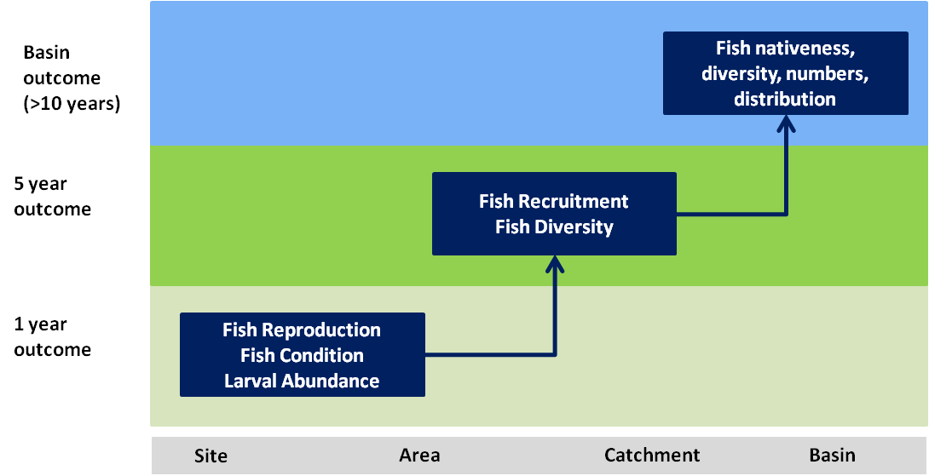

#### Expected outcomes for fish in less than one year

Murray cod and golden perch are found at a site with suitable habitat. Australian smelt and gudgeons are found at another site within the catchment. These fish need to be in a healthy condition to reproduce. Condition of fish contributes to the abundance of larvae and the capacity to reproduce. These outcomes can generally be achieved in less than one year.

#### Expected outcomes for fish in one to five years

Having healthy fish reproduce is only part of the picture. These larvae and juveniles need to be abundant enough to reach a sufficient life stage to successfully reach adulthood and reproduce. In general this takes longer than one year and is at a broader spatial scale. Larval and juvenile survival is an important contributor to fish diversity. Fish diversity can also be achieved by maintaining the condition of fish at individual sites. Supporting different native fish species through condition and larval and juvenile recruitment at multiple areas contributes to native fish diversity at the catchment scale.

#### Whole of Basin outcome for fish

Commonwealth environmental water is provided to multiple catchments. Where watering achieves outcomes for fish, the outcomes framework can be used to infer a contribution to Basin scale outcomes over a much longer timeframe e.g. a healthy adult native fish population that has increased across the Basin.

The Basin has many diverse aquatic environments. The outcomes associated with fish species endemic to particular catchments (e.g. the limited range of purple spotted gudgeons) could also be used to infer Basin scale outcomes as we know that any improvement in these species within their limited range represents an improvement in this particular species across the Basin.

## Appendix B – Commonwealth Environmental Water Portfolio Management Framework

The influence of environmental demand and water availability on the purpose of Commonwealth environmental water management.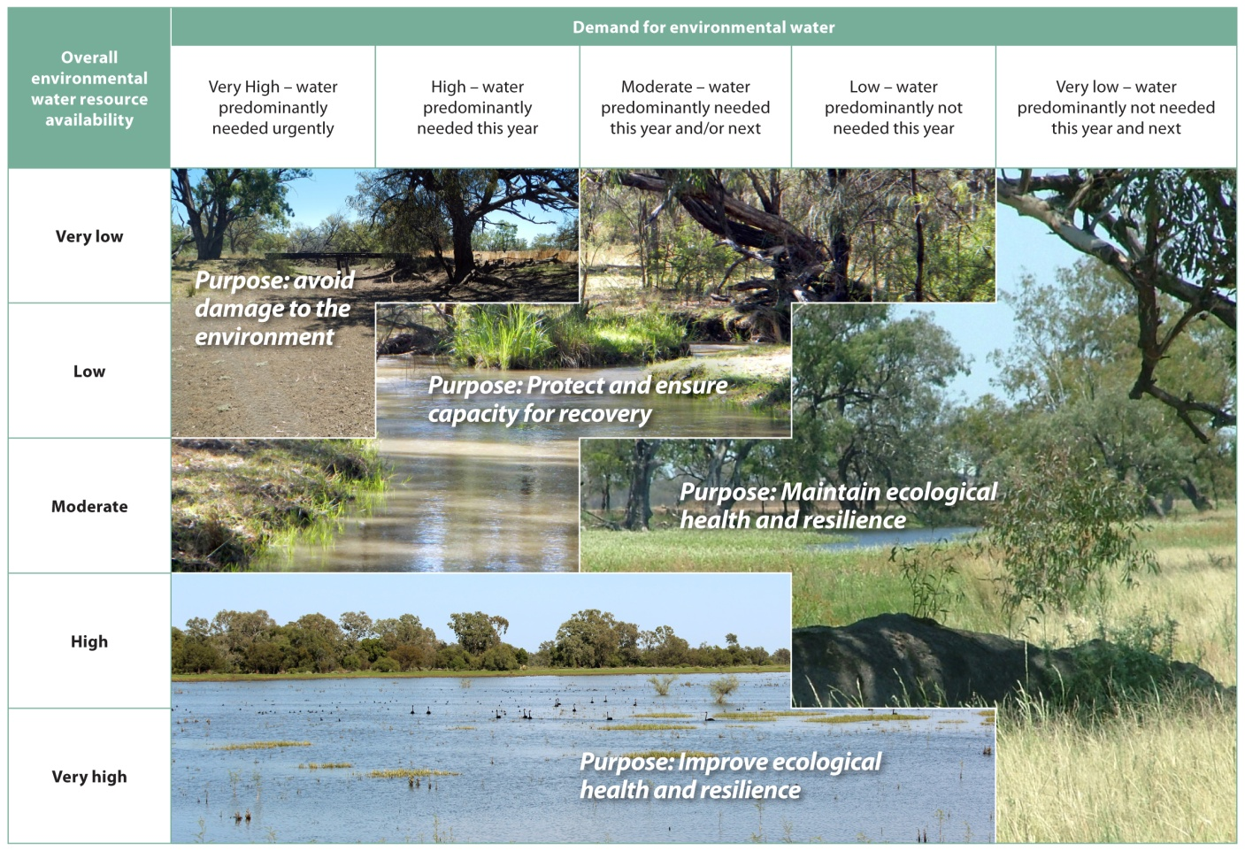

Examples of how environmental demand and water availability shape planning for the mix of portfolio management options for maximising environmental outcomes in different conditions (each scenario represent generic examples and the specific approach taken in individual catchments and conditions will vary).

|  |  |  |  |  |  |
| --- | --- | --- | --- | --- | --- |
| **Overall environmental water resource availability** | **Demand for environmental water** | | | | |
| **Very High – water predominantly needed urgently** | **High – water predominantly needed this year** | **Moderate – water predominantly needed this year and/or next** | **Low – water predominantly not needed this year** | **Very low - water predominantly not needed this year and next** |
| **Very low** | ***Purpose: avoid damage to the environment***  **Extended dry conditions**   * + Water availability may be insufficient to meet all environmental demands   + Use a high proportion of limited allocations in targeted manner (e.g. individual wetlands, base flows)   + Carryover a small proportion or no allocations   + Investigate opportunity to purchase allocations by exception, to assist in meeting urgent and critical demands |  | ***Purpose: Protect and ensure***  ***capacity for recovery*** | **Transitioning from wet period to dry**   * + Water availability typically sufficient to meet demands   + Allow drying to occur and use a low-moderate proportion of available allocations as needed(e.g. for base flows)   + Carryover a moderate proportion of allocations to meet minimum requirements in coming years   + An opportunity for sale of allocations, subject to: * Environmental demands being met * Sufficient carryover to meet future demands * Market conditions |  |
| **Low** | **Moderate or average conditions**   * + Environmental demands and water availability broadly match   + Use a moderate to high proportion of available allocations (e.g. for base flows through to limited overbank flows)   + Carryover a low to moderate proportion of available allocations   + Investigate opportunity for allocation sale or purchase, depending on needs and market conditions |  | ***Purpose: Maintain ecological health and resilience*** |
| **Moderate** |  |  |  |
| **High** | **Extended wet conditions**   * + Water availability typically in excess of that required to meet demands   + Use a limited proportion of high allocations (e.g. base flows)   + Carryover a high proportion of available allocations   + Investigate opportunity for allocation sale, market likely to be limited   **Wet period following dry period**   * + Water availability typically sufficient to meet demands   + Use a moderate proportion of available allocations for a range of flow types, focused on connected and multiple-site watering events   + Carryover a moderate proportion of allocations   + An opportunity for purchasing allocations to use or carryover, subject to market conditions | | |
| **Very high** | ***Purpose: Improve ecological health and resilience*** | | | |

1. Planned environmental water is often described as ‘rules-based’ environmental water and can be made up of flows released from storages, dam spills, inflows from tributaries or water in a river that is protected from extraction by the rules within a water resource plan. It differs from ‘held environmental water’, which is water available for the environment under a water access right, a water delivery right or an irrigation right.
2. Source: <http://www.mdba.gov.au/sites/default/files/pubs/General-Review-of-Salinity-Management.pdf>
3. Barth, L., Gormly, R. And Olszak, C. (2015) ‘Changing supply and demand for water in the southern MDB and the impact on water market prices’ *Water* 42(5), Australian Water Association.

   Carr, R. (2015) ‘Drought and water markets: how allocation water markets can support production and environmental outcomes’ *Water* 42(5), Australian Water Association.
4. <http://www.mdba.gov.au/sites/default/files/pubs/FS_barrages.pdf>