| Plans for 2015-16 are now available Front cover of planning approach document  Information about our plans for nine areas across the Murray-Darling Basin is available on our website. Latest outcomes of Commonwealth environmental water- brochure http://www.environment.gov.au/system/files/monitored-outcomes.jpg  Commonwealth Environmental Water Office [Monitored Outcomes for 2014-15](http://www.environment.gov.au/water/cewo/publications/monitored-outcomes-2014-15) brochure is available on our website.  Environmental watering outcomes from our Partners:   * [Reflections – environmental watering in Victoria in 2013-14](http://www.vewh.vic.gov.au/news-and-resources/resource-library/annual-watering-booklets) * [Environmental water use in New South Wales: Outcomes 2013-14](http://www.environment.nsw.gov.au/publications/environmentalwater/140811-env-water-outcomes-1314.htm) * [The Living Murray 2013–14 Environmental Watering Report](http://www.mdba.gov.au/media-pubs/publications/TLM-EW-report-2013-14) |
| --- |

# Commonwealth Environmental Water Holder Update, spring 2015

## Our latest planning process is now complete. This year, we have developed comprehensive multi-year plans in consultation with our State counterparts, river operators, the Murray Darling Basin Authority, scientists engaged in monitoring as well as local environmental water advisory groups and committees.

Like all water users, Commonwealth and State water holders and managers must grapple with variable seasonal conditions whilst determining the best way to protect and restore the rivers, floodplains and wetlands of the Murray-Darling Basin.

Working together enables us to identify the environmental demands in each catchment. We then look at how to manage the water holdings (through water use, carryover and trade) to best match the available supply of water with the environmental demands across the Basin.

The plans for Commonwealth environmental water use during 2015–16 are ambitious. We intend to maximise the use of limited allocations as well as carryover (where it is available) for rivers, floodplains and wetlands across the Basin. In doing so, we hope to see a continuation of improved environmental outcomes in the key locations that have received environmental water in past water years. Additionally, Commonwealth water will be made available to Victoria, South Australia and New South Wales for a series of environmental flows within the River Murray (in the Mid–Murray and Lower Murray, from Hume Dam through to the Coorong, Lower Lakes and Murray Mouth).

Much of this water has been deliberately carried over to allow us to meet early season demands and supplement flows generated by the States, with a few watering events completed during winter and the vast majority planned for spring and summer.

Our goal is to ensure native vegetation, fish and birds are able to withstand the prospect of dry conditions, by using Commonwealth environmental water to support in-channel, wetland and low elevation floodplain habitat.

Meanwhile, we continue to use water to enhance flows in the Northern Unregulated Rivers (the Condamine-Balonne, Warrego, Moonie, Barwon-Darling and Border Rivers).

| Watering Availability- Decisions to Date  River Murray   * River Murray channel from Hume Dam including Coorong, Lower Lakes and Murray Mouth * Barmah Millewa Forest (both VIC and NSW) primarily Millewa Forest near Deniliquin during late winter and spring * Gunbower Creek, Victoria * Locks 7, 8, 9 and 15 weir pool raising (wetland inundation and flows to Potterwalkagee Ck, Lindsay River and Mullaroo Ck) and lowering * Wetland watering in South Australia through the Nature Foundation South Australia and South Australian Murray-Darling Basin NRM Board * Hattah Lakes and Mallee Wetlands, Mildura   Victorian tributaries   * Goulburn River, Shepparton all year, with freshes in winter (complete), spring and autumn * Campaspe River, all year * Loddon River, all year * Ovens River, all year   Edward-Wakool   * Steven’s Weir lowering, Deniliquin during late winter – complete * Permanent and ephemeral creeks and Werai Forest, near Deniliquin during spring through to summer   Murrumbidgee   * Wetlands piggy-back or River channel, Yanco Creek and Lowbidgee Floodplain Wagga Wagga, Narrandera, Balranald primarily during spring   Macquarie Marshes   * Limited release of environmental water to supplement natural flows into the Macquarie River, including those from Coolbaggie Creek and the Bell River, during winter.   Northern Unregulated Rivers   * In-stream flows in the Condamine-Balonne, Warrego, Moonie, Barwon-Darling and Border Rivers. |
| --- |

## Community consultation

Now that plans are in place, all water holders and managers will continue to work together to consult with a range of people to support decision-making based on the prevailing conditions.

My decisions to make water available are influenced by a number of factors including water availability (allocations) the best available science and the insights and experiences of people living and working in the Basin, who know the river system intimately.

Staff from the Commonwealth Environmental Water Office also seek advice from State delivery partners and river operators as well as local environmental water advisory groups and catchment committee representatives.

We regularly attend these and other community forums but 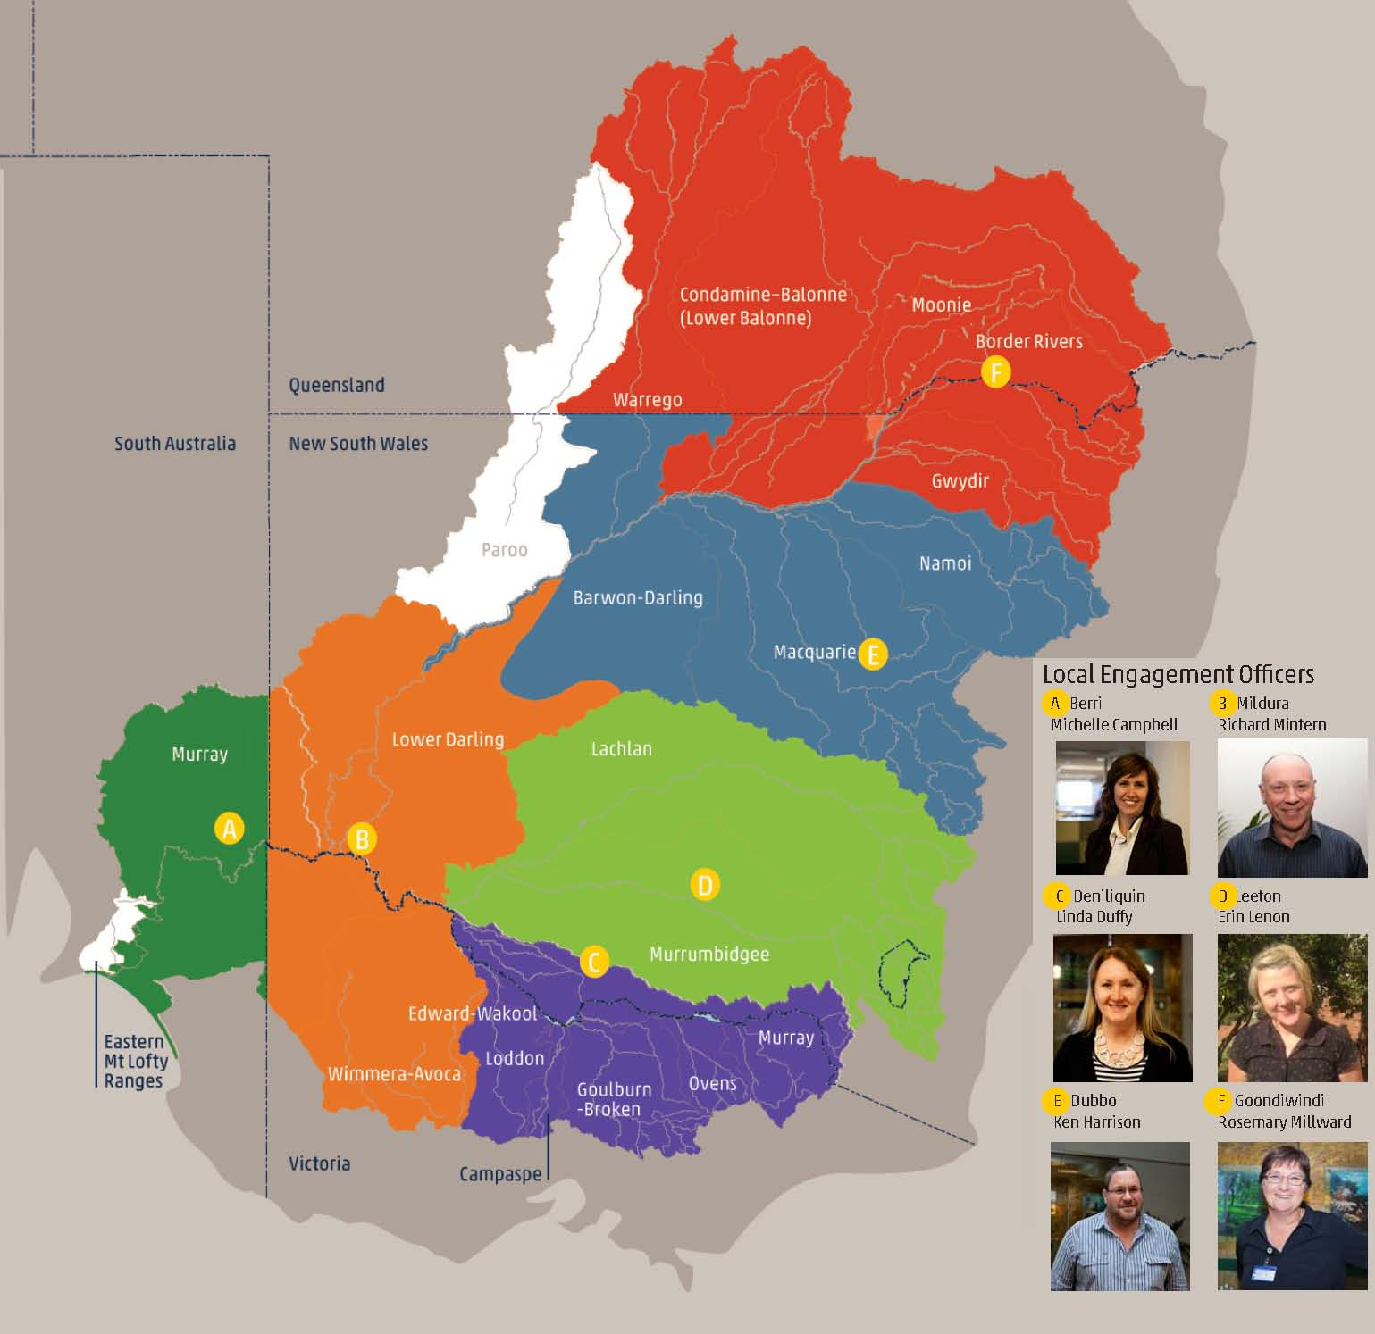I welcome opportunities to discuss the Commonwealth’s involvement in environmental water and its management. If you are interested and/or potentially affected by our planning and decision-making you can get in touch with me or members of my team.

There are six local engagement officers working alongside our State partners and local land and water management officers, providing outreach to local communities throughout the Basin.

For further information, including contact details, see the Local Engagement Officer information on our website. You can also email  [ewater@environment.gov.au](mailto:%20ewater@environment.gov.au) to raise any issues, concerns, proposals and suggestions you may have about the Commonwealth’s involvement in environmental water and its management.

Water supply and carry over

Because of drying conditions across the Basin, there have been limited water allocations to date in many catchments. The Commonwealth does not receive any special conditions or exceptions to its licences and as a result we have had to adjust our planned watering to reflect the seasonal conditions. Most of the water planned for use is the result of strategic carry-over from the previous water year.

Water Trade

The potential trade (disposal or acquisition) of temporary water to help meet environmental demands was considered, however, I do not have any immediate plans to sell allocations because of the moderate to potentially high demands for environmental water across the Basin as a result of the dryer conditions forecast. Updates on the management of Commonwealth water holdings including any intention to trade is updated quarterly on our web site.