

Trade in the Goulburn a win-win
We recently completed our first trade of Commonwealth environmental water in the southern Murray Darling Basin with some 22.864 gigalitres of Commonwealth environmental water allocations sold for a return of $6.458 million.

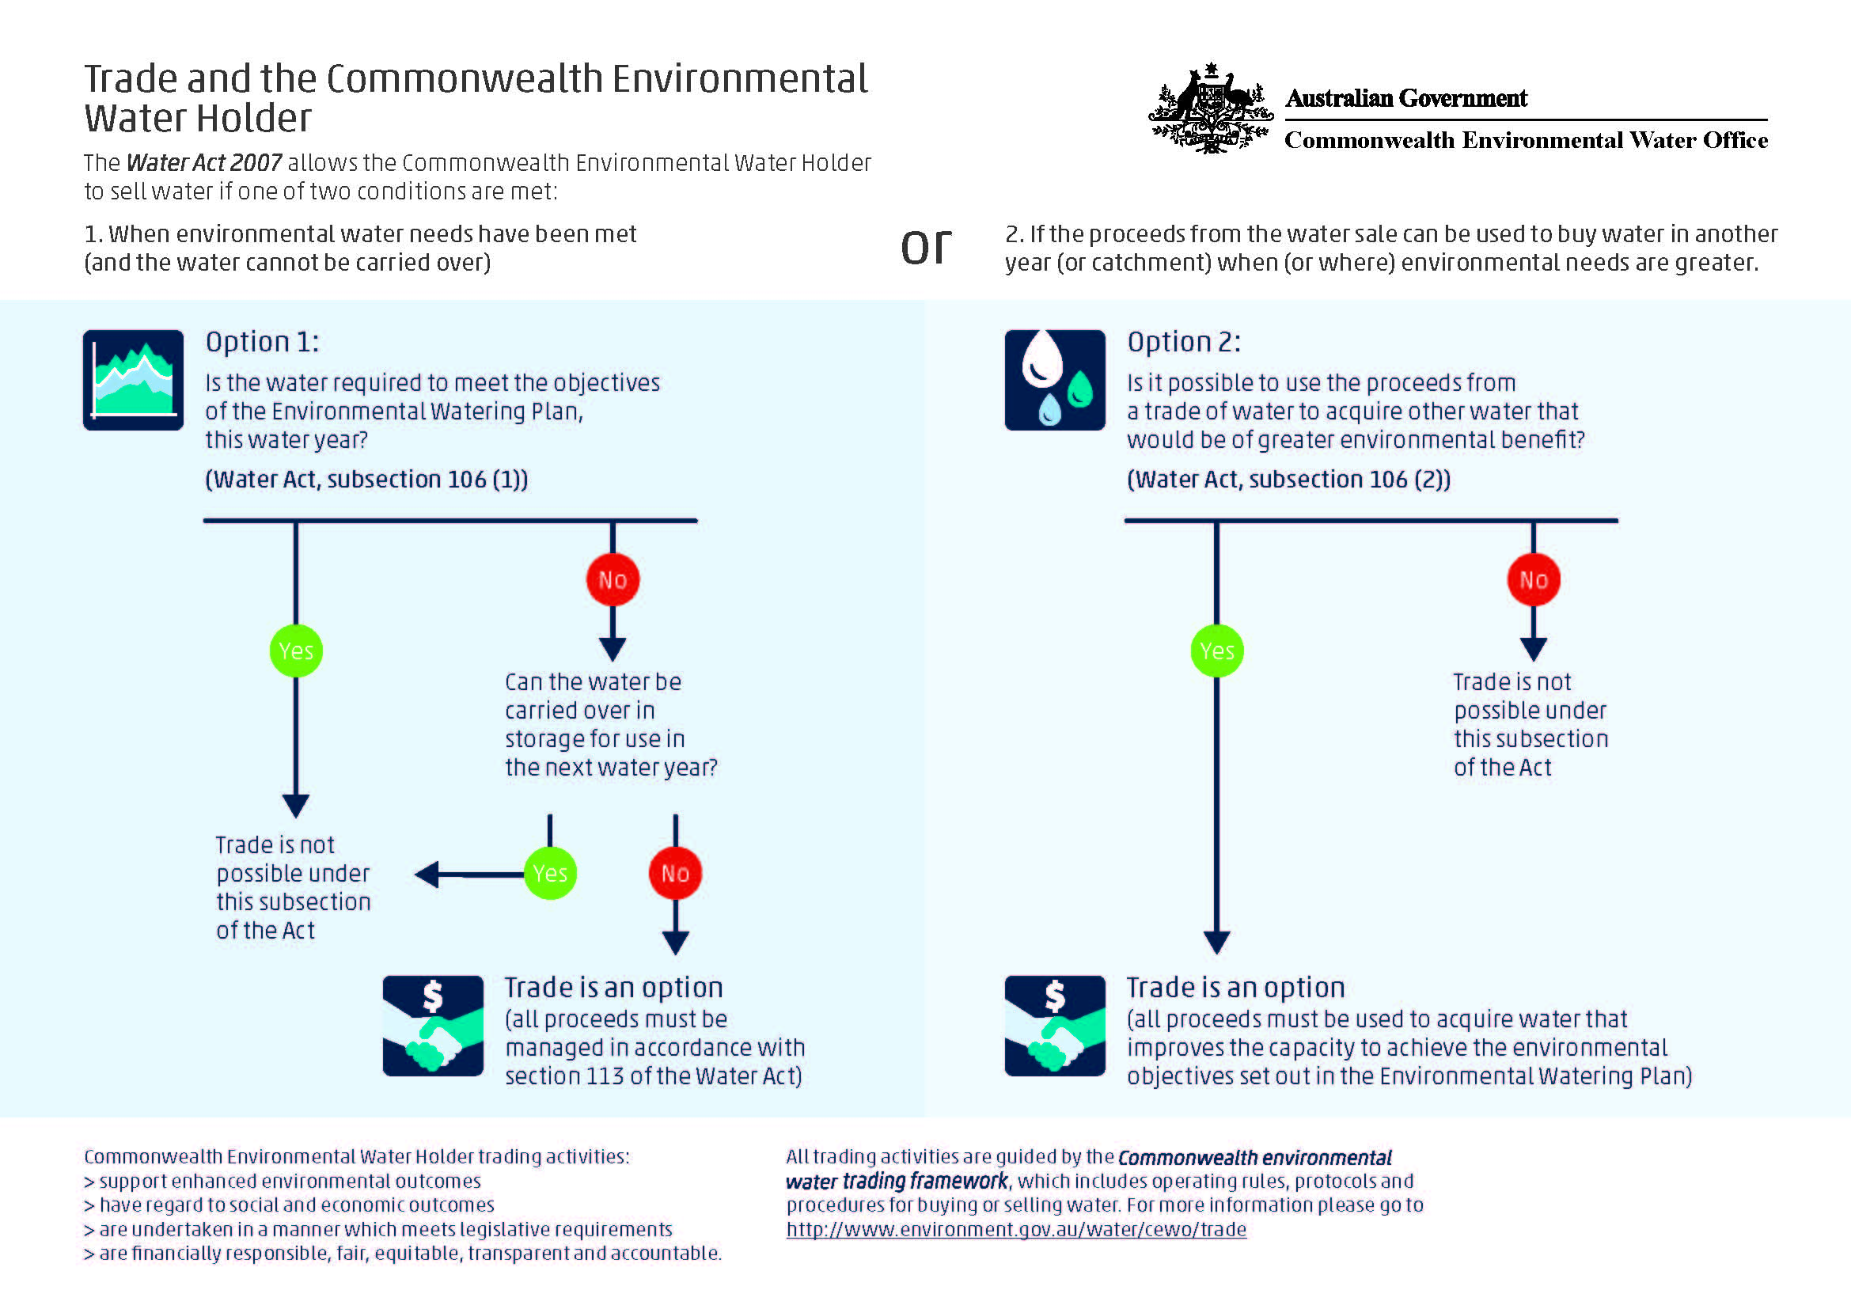

We are currently undertaking a formal evaluation of our processes, in consultation with trade participants. However, we do know that this trade did not negatively affect other sellers in the market – there was more than 320 Victorian Goulburn and Murray regulated river allocations traded (totalling 26 GL at a VWAP of $281 per ML) at the same time as the Commonwealth trade.

Refer to current trade actions on our web site

Commonwealth Environmental Water Holder Update

Summer 2015-2016
As the year draws to a close I would like to take this opportunity to wish you and your family a happy festive season, and encourage everyone to stay safe around our waterways this summer.
On behalf of our State and local delivery partners I would particularly like to thank all the community representatives that have put time and effort into working with us throughout the year. Your knowledge of the system is proving essential to our efforts to protect and restore the rivers floodplains and wetlands particularly in those parts of the system experiencing dry and drought conditions.
My decisions about how best to manage the Commonwealth's water portfolio are influenced by a number of factors including availability (allocations) the best available science and the insights and experiences of people living and working in the Basin, who know their rivers intimately.
Like other water users, environmental water holders and managers must adjust their water management strategies during dry times when allocations are reduced because there is less water available in the system.
This year, we have made the most of the Commonwealth’s holdings by using a combination of water delivery, carryover, and a small trade of allocations, to maximise environmental outcomes.
The dry outlook for the 2015-16 water year meant it was prudent that we used carry over to ensure environmental needs could continue to be met and we have continued to make water available to supplement environmental flows generated by our States and local delivery partners. Meanwhile, the trade of temporary water has also proven to be a useful management tool.
To date we have traded temporary water twice in the North and more recently in the South. These trades have been a win-win for the environment and for those irrigators who took the opportunity to buy much needed water for their farms. Sale proceeds are set aside to allow us to maximise environmental outcomes within the Murray-Darling Basin.

See our webpage for the latest information about Commonwealth environmental water in Basin storages, allocations and carryover and water use

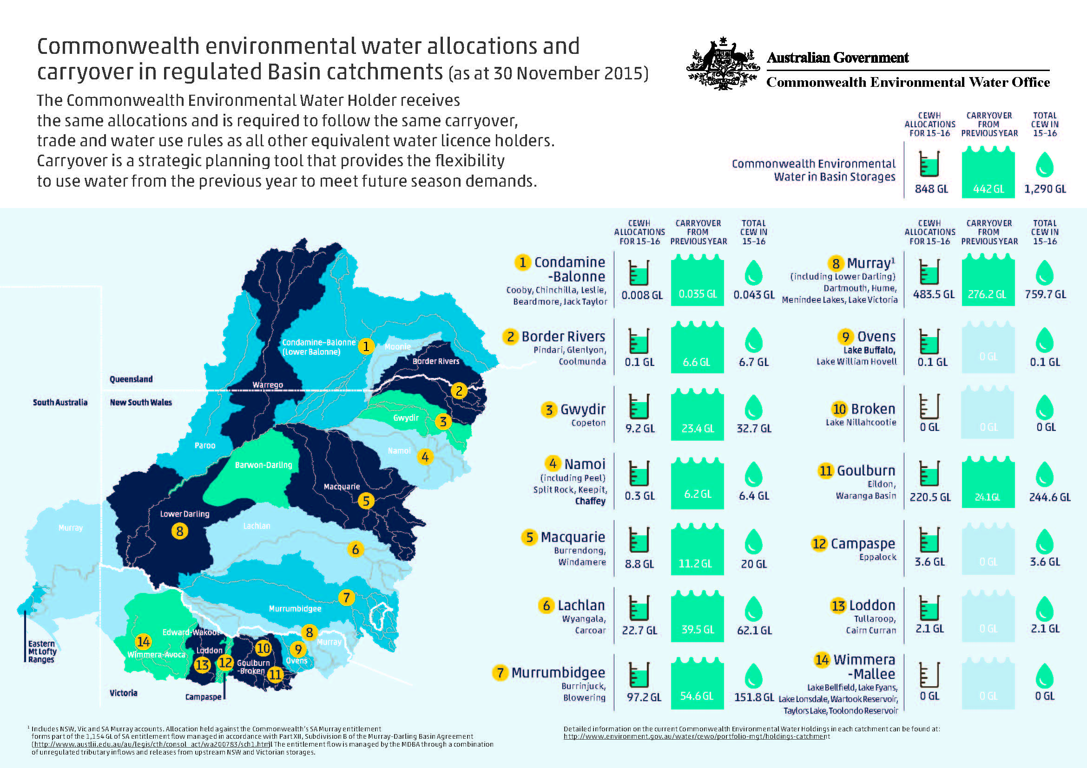

Community consultation
I welcome opportunities to discuss the Commonwealth’s involvement in environmental water and its management. If you are interested and/or potentially affected by our planning and decision-making, you can get in touch with me or members of my team.

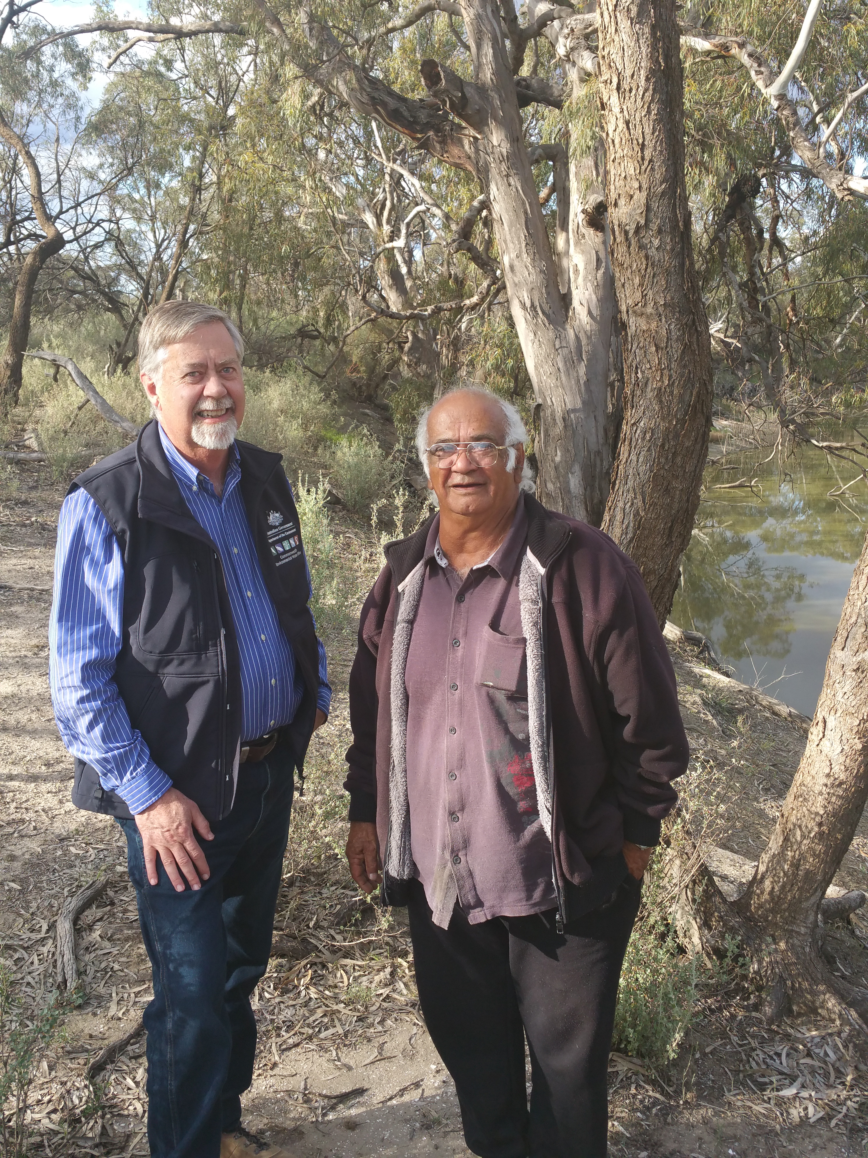
Commonwealth Environmental Water Holder David Papps with Mutti Mutti Elder Barry Pearce, August 2015

Scientists working on our Long Term Intervention Monitoring Projects are continuing to report evidence of fish, vegetation and wildlife outcomes in key locations that have received environmental water. Information about our Long Term Intervention Monitoring Project is available at www.environment.gov.au/water/cewo/monitoring/ltim-project

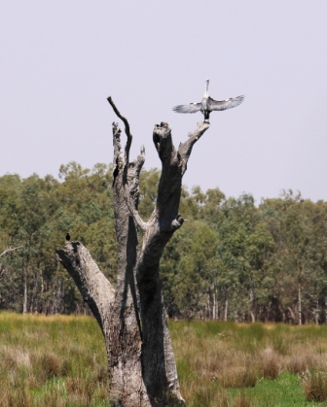
Macquarie Marshes Bird Count
The Macquarie Marshes is an internationally recognised bird habitat that has received environmental water from both New South Wales and the Commonwealth during 2015. Every year wetland ecologists, environmental water managers and local Rangers from NSW National Parks and Wildlife Service converge to take part in a bird count at the Ramsar site. This year, there were over 130 different woodland and wetland bird species identified including several threatened species such as Australasian bitterns and the Painted Snipe.
White Necked Herron, Macquarie Marshes October 2015

Fish Monitoring in the Lachlan and Edward-Wakool
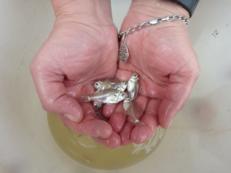
Recent monitoring of larval fish in the Lachlan system has shown evidence of successful spawning of the Flat-headed Gudgeon and the nationally vulnerable Murray cod. Monitoring also confirmed that a population of endangered Olive Perchlet continues to call the central Lachlan home.
In the Edward-Wakool, monitoring again found River Blackfish in the upper Wakool River indicating this area may contain important habitat for these fish. Obscure Galaxias were also found again in Yallakool Creek (first found in the area in 2014) suggesting a population may be established in the creek
Olive Perchlet, Lachlan River, November 2015

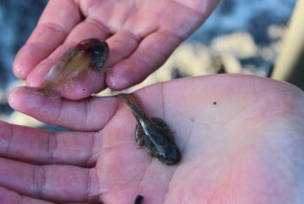
The first record of Southern bell frog in the mid-Murrumbidgee wetlands
Monitoring in the lower Murrumbidgee has found evidence that the nationally endangered Southern Bell Frog is successfully breeding. This year adult, tadpole and juvenile frogs have been detected through the Long Term Intervention Monitoring Program across the Lowbidgee, mid-Murrumbidgee and Yanco Creek system wetlands following Commonwealth environmental watering.
.
Southern bell frog tadpoles, Murrumbidgee, November 2015

Outcomes from the multi-site watering event along the River Murray

‘Whole of system’ watering
Using natural inflow patterns as a 'cue' and coordinating with water delivered by The Living Murray as well as other environmental and operational water deliveries has ensured that the majority of the flows have continued moving through the Murray system, contributing to outcomes in the Edward-Wakool River and all the way to the Lower Lakes and Coorong.
‘Whole of system’ watering includes:
- River Murray channel from Hume Dam including Coorong, Lower Lakes and Murray Mouth
- Barmah Millewa Forest (both VIC and NSW) primarily Millewa Forest near Deniliquin during late winter, spring and into summer
- Locks 2 and 5 weir pool raising
- Locks 7, 8, 9 and 15 weir pool raising (wetland inundation and flows to Potterwalkagee Ck, Lindsay River and Mullaroo Ck) and lowering
- Hattah Lakes, Mildura
- Steven’s Weir lowering and permanent and ephemeral creeks and Werai Forest, near Deniliquin
- Various wetlands of South Australia

Meanwhile, Commonwealth water continues to be made available for use in Victorian catchments (Gunbower Creek and Mallee Wetlands, and Goulburn, Campaspe, Loddon and Ovens Rivers) throughout the year in collaboration with the Victorian Environmental Water Holder and local catchment management authorities.

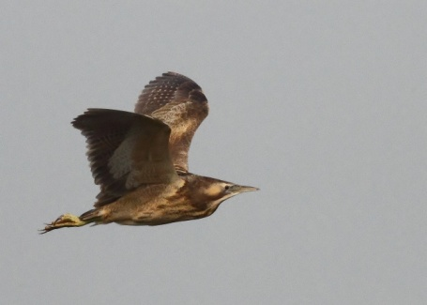
A ‘whole of system’ watering action has been delivered to the River Murray since June 2015. The Commonwealth water being used for this event was mostly carry over from 2014-15, as water allocations for 2015-16 in the New South Wales Murray have been low.
Some of this water was directed into the Barmah and Millewa Forests (both are part of Ramsar sites), contributing to the growth of moira grass and supporting the breeding of over one thousand pairs of water birds including white and straw-necked ibis, spoonbills, eastern great egrets, nankeen night herons, darters and little pied cormorants. Additionally a significant proportion of the global population of Australasian Bitterns and Little Bitterns are inhabiting, and likely breeding, in the forest.
Australasian Bittern
This watering action has also contributed to the spawning of the iconic golden perch and the critically endangered silver perch (EPBC Act) in the Murray region. By increasing the River Murray’s connectivity, environmental water is enabling fish movement via constructed fish ways throughout the entire length of the river. This is good news for the Basin’s 430 000 recreational anglers who are depending on us to restore fish stocks.
Golden perch eggs

Maintaining barrage flow over summer is critical to protect water quality and estuarine habitat for native fish populations in the Coorong.
Above average and average rainfall in recent years and delivery of significant volumes of environmental water have improved conditions in the Lower Lakes and Coorong. However, the Coorong’s recovery remains a priority because increasing salinity levels over summer present a risk of long-term ecological damage.
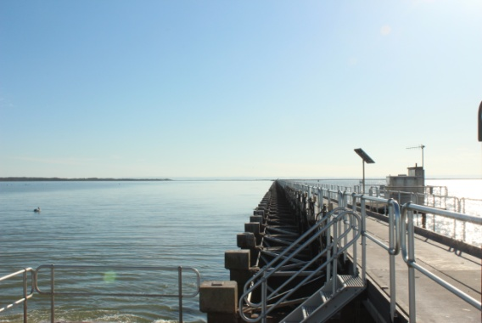
Providing environmental flow into the Coorong while maintaining agreed minimum lake levels remains a priority for the Commonwealth Environmental Water Holder in 2015-16. As such, the Water Holder has entered into a Watering Schedule with South Australian Department of Environment Water and Natural Resources. This schedule includes up to 150 GL of additional Commonwealth environmental water available for the underwriting Lower Lakes above 0.50 m AHD so that continuous barrage flow can be maintained into the Coorong between January and June 2016. This is in addition to the 555 Gigalitres of Commonwealth environmental water delivered to maintain barrage flow to the Lower Lakes to 30 November 2015.
It is the responsibility of South Australian Department of Environment Water and Natural Resources to operate the barrages and manage water in a seasonally appropriate way consistent with the agreed objectives.
The Barrages, Lower Lakes, August 2015

Flows set to occur over summer

Murrumbidgee
Location | River Operator | Real time river information
Yarrada Lagoon | Water NSW | http://realtimedata.water.nsw.gov.au/water.stm
Juanbung Wetlands | Water NSW | http://realtimedata.water.nsw.gov.au/water.stm
North Redbank Wetlands | Water NSW | http://realtimedata.water.nsw.gov.au/water.stm
Yanga N.P. | Water NSW | http://realtimedata.water.nsw.gov.au/water.stm
Eulimbah Wetlands | Water NSW | http://realtimedata.water.nsw.gov.au/water.stm
Waldaira Lagoon, Junction Wetlands | Water NSW | http://realtimedata.water.nsw.gov.au/water.stm

Mid Murray
Gunbower Creek | Goulburn-Murray Water | https://waterline.g-mwater.com.au/waterstatus/#ST@G409ACM
Reed Beds Swamp (Millewa Forest) | Water NSW | N/A

Goulburn-Broken
Lower Broken Creek | Goulburn-Murray Water | https://waterline.g-mwater.com.au/waterstatus/#ST@G404210D

South Australian Murray
South Australian River Murray | Murray-Darling Basin Authority River Murray Operations &South Australian Department of Environment, Water and Natural Resources | http://livedata.mdba.gov.au/
Various South Australian Wetlands | N/A | N/A

We continue to use water to enhance flows in the unregulated rivers of the Northern Basin to ensure native vegetation, fish and birds are able to withstand the prospect of further dry conditions, by using environmental water to support in-channel, wetland and low elevation floodplain habitat. However, water use is contingent on flow triggers (that cannot be predicted or may not occur).

Gwydir
Location | River Operator | Real time river information
Gwydir Wetlands | WaterNSW | http://realtimedata.water.nsw.gov.au/water.stm
Mallowa Creek | WaterNSW | http://realtimedata.water.nsw.gov.au/water.stm
Mehi River | WaterNSW | http://realtimedata.water.nsw.gov.au/water.stm
Carole Creek | WaterNSW | http://realtimedata.water.nsw.gov.au/water.stm

Macquarie
Macquarie River Channel | WaterNSW | http://realtimedata.water.nsw.gov.au/water.stm

Barwon-Darling
Barwon-Darling River | NSW DPI Water | http://realtimedata.water.nsw.gov.au/water.stm

Namoi
Namoi River | WaterNSW | http://realtimedata.water.nsw.gov.au/water.stm

Warrego
Toorale | NSW DPI Water | http://realtimedata.water.nsw.gov.au/water.stm

Border Rivers
Dumaresq, Severn (Qld), Macintyre River, Macintyre Brook | Border Rivers Commission/SunWater | https://water-monitoring.information.qld.gov.au/host.htm

Warrego (Qld)
Upper Warrego River | QDNRM | https://water-monitoring.information.qld.gov.au/host.htm

Moonie
Moonie River | QDNRM | https://water-monitoring.information.qld.gov.au/host.htm

Condamine Balonne
Culgoa, Narran, Birrie, Bokhara | QDNRM, SunWater | https://water-monitoring.information.qld.gov.au/host.htm
Nebine River | QDNRM | https://water-monitoring.information.qld.gov.au/host.htm

