**Hypoxic blackwater events and water quality**

Blackwater can be a natural feature of lowland river systems and occurs during flooding when organic material is washed off the floodplain and into the river system. This can lead to a sudden decrease in the oxygen available to fish and other organisms in our rivers. The black appearance of the water is due to the release of dissolved carbon compounds, including tannins, as the organic matter decays – similar to the process of adding water to tea leaves.

Dissolved oxygen is essential for aquatic organisms which need to breathe underwater. Therefore, widespread blackwater events that degrade water quality and deplete oxygen can result in the death of aquatic organisms such as native fish.

Material carried off the floodplain into rivers can provide the food for the system so that ecological processes can complete their cycles (e.g. fish breeding). However, blackwater events can change water quality, and are detrimental when too much oxygen is removed from the water, called a hypoxic (no oxygen) blackwater event.

**What are the causes of blackwater?**

Blackwater forms when flooding occurs after prolonged dry periods when temperatures are warm and there has been an extensive build-up of organic material such as leaf litter.

Less frequent flooding allows large quantities of organic   
material to accumulate on river banks and floodplains. When this material is washed into waterways in times of flood, increased bacterial activity can result in deoxygenation of the floodwater. This process is more pronounced during summer flooding.

The severity of blackwater events is determined by the

amount, age and type of organic matter in the path of the flood and whether it has been previously submerged in water. Debris from river red gums is particularly problematic as it contains large amounts of dissolved organic carbon. High air and water temperatures also contribute to increased bacterial activity and subsequent lower concentrations of dissolved oxygen in water.

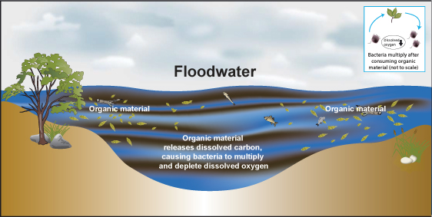

**Primary drivers of blackwater events**

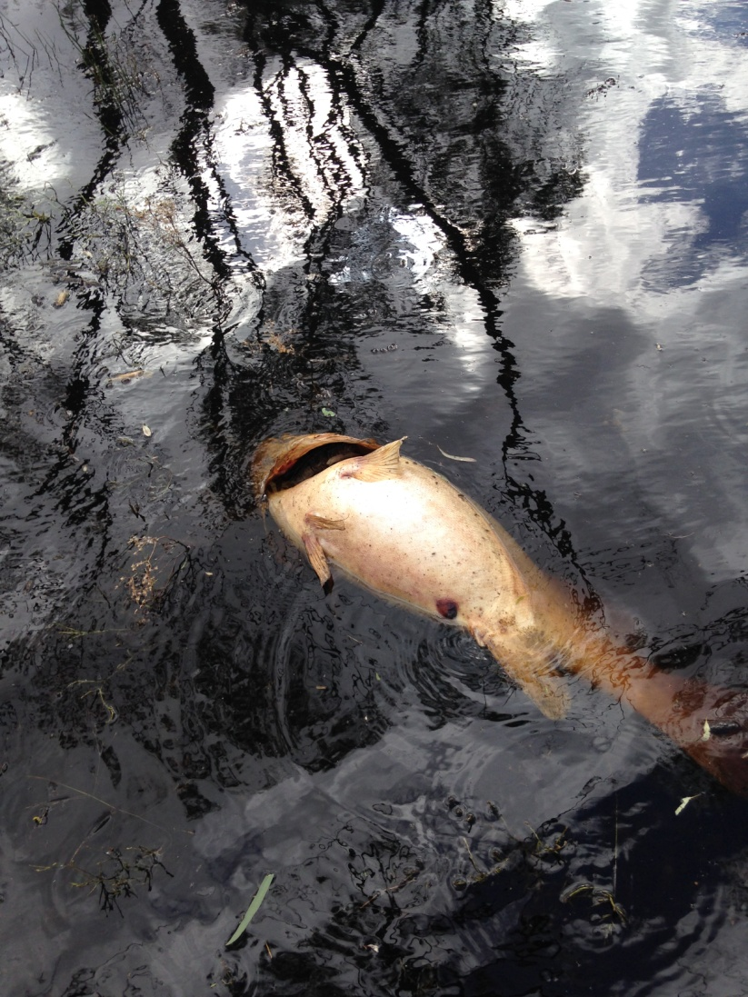

**What are the effects of hypoxic blackwater?**

Hypoxic blackwater usually has short-term harmful impacts on the environment. Low levels of dissolved oxygen, combined with the toxic components of some organic matter, can lead to the death of aquatic organisms.

Native fish and crustaceans are especially vulnerable to   
oxygen deprivation. Fish are sometimes able to escape the most badly affected areas by swimming upstream or downstream. The chemicals released from organic material can also make water bodies more alkaline or acidic, potentially resulting in toxic effects on some aquatic organisms.

Despite short-term effects on aquatic organisms, the floods which lead to blackwater are an essential and valuable part of the long-term health of river, floodplain and wetland ecosystems, particularly after prolonged drought. These events help break down organic material which supply additional nutrients to drive the overall production of river and wetland systems. In the long-term, native fish, waterbirds and other organisms benefit from the increased production that boosts food supplies and supports breeding cycles.

Even during blackwater events, downstream systems benefit from the organic inputs once the water has re-aerated.

Risks to human health are low if direct contact with blackwater is avoided. Thorough cleansing is advised after any contact

Wakool River, New South Wales, Tim Coote

with affected water and discoloured or dead fish should not be eaten because of possible health risks. Blackwater may have social and economic impacts related to the higher costs of treating water for consumption and short-term loss of amenity and recreation opportunities.

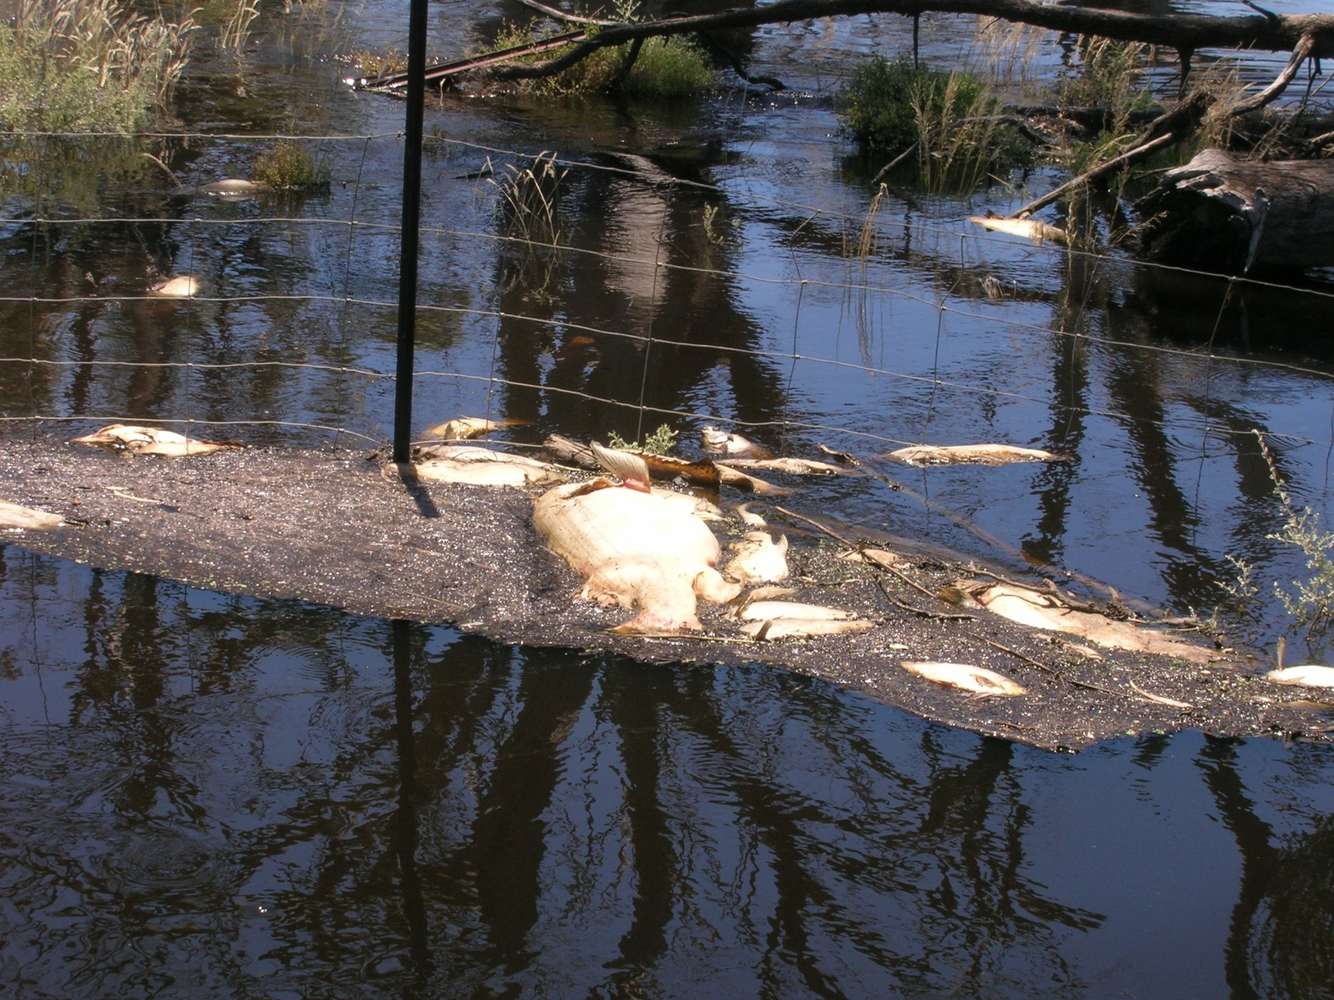

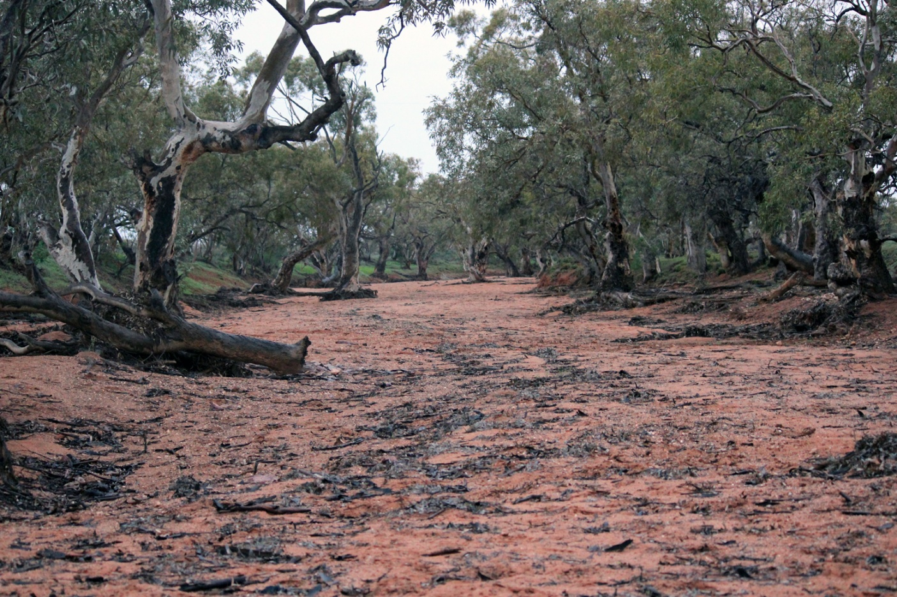

Cropland flooded with blackwater – Wakool River, New South Wales.

**How can blackwater be managed?**

The flooding that leads to blackwater events is a natural feature of Australian river systems and the capacity to prevent and manage the impacts of blackwater is limited. The frequency or severity of such events can be reduced by managing water systems to maintain or reinstate natural wetting and drying cycles and ensuring flows are adequate to reoxygenate water. In temperate areas, regular flooding in winter and spring washes away organic material from floodplains when there are more moderate temperatures and bacterial activity is low.

After floods have receded, releasing environmental water into the system may provide healthy water, creating refuge flows and improving water quality.

Environmental water managers work closely with state and local water managers and communities to develop such strategies.

Further information about Commonwealth environmental water is available at: **www.environment.gov.au/ewater**

**Glossary**

*Carbon:* an element in all living beings and consumed by plant matter as carbon dioxide to produce energy, new organic matter and release oxygen.

*Dissolved oxygen:* a form of oxygen in water which aquatic organisms are able to breathe through specialised respiratory systems.

*Ecosystem:* a specific composition of animals, plants and micro-organisms which interact with one another and their environment.

*Environmental water:* water released from a reservoir to   
maintain downstream water levels, or water retained in a system to satisfy ecological requirements.

*Floodplain:* the portion of a valley next to a river channel which is periodically covered with water during flooding.

**References and further information**

Arthur Rylah Institute for Environmental Research.   
*www.dse.vic.gov.au/arthur-rylah-institute*

Murray-Darling Basin Authority Draft Basin Plan, Water Quality Bulletins, Dissolved Oxygen Maps and Fact Sheet: Blackwater. *www.mdba.gov.au/*

The Murray-Darling Freshwater Research Centre.   
Understanding Blackwater Events and Managed   
Flows in the Edward-Wakool River System.   
*www.mdfrc.org.au/publications/index.html*

National Water Quality Management Strategy.   
*www.environment.gov.au/water/policyprograms/nwqms/index.htm*

**For assistance**

River operators and local water managers coordinate and provide recovery assistance and advice to landholders, communities and industries impacted by natural emergencies.

Those affected by flood and storm damage are urged to contact their State Emergency Service (132 500), and in circumstances of life-threatening emergencies, to call *Triple Zero (000)*.

Address: GPO Box 787, Canberra ACT, 2601

T: 1800 803 772  
E: ewater@environment.gov.au  
W: [www.environment.gov.au/water/cewo](http://www.environment.gov.au/water/cewo)

