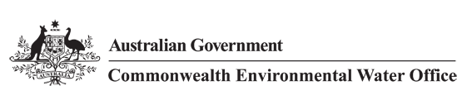

**CEWO Environmental Activities Framework**

**April 2022**

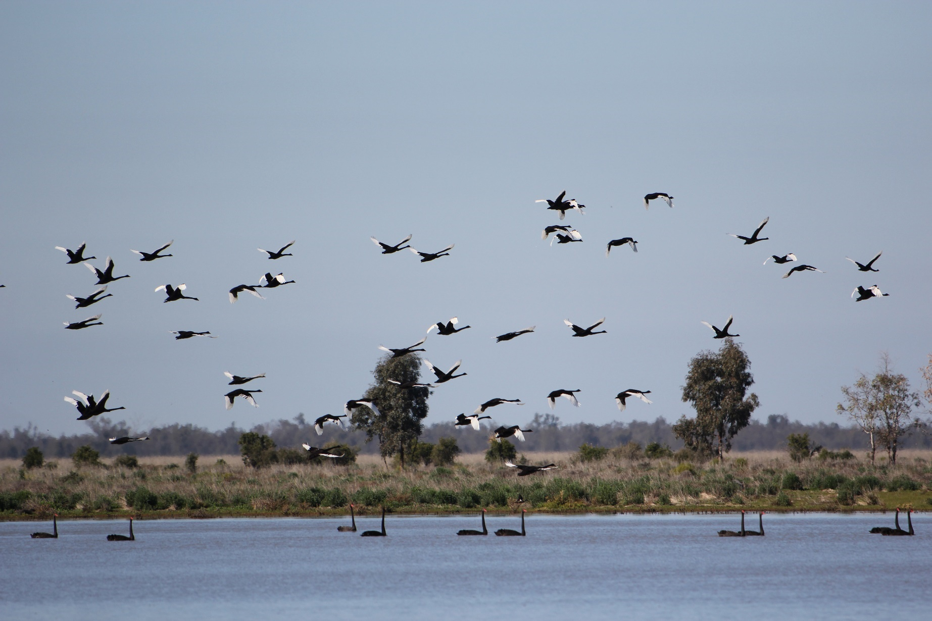

Contents

1. Introduction 1

2. Management of Commonwealth environmental water 1

3. Environmental activities 2

4. Considerations when assessing proposed environmental activities 3

Front cover image credit: Black swans, Great Cumbung Swamp, Lachlan River. Photo by Damian McRae, Commonwealth Environmental Water Office.

The Commonwealth Environmental Water Office respectfully acknowledges the traditional custodians, their Elders past and present, their Nations of the Murray-Darling Basin, and their cultural, social, environmental, spiritual and economic connection to their lands and waters

## 1. Introduction

The Commonwealth Environmental Water Holder (CEWH), established under the Commonwealth *Water Act 2007* (Water Act), is responsible for managing the Commonwealth’s environmental water holdings[1]. The CEWH, in carrying out his or her functions, is assisted by the Commonwealth Environmental Water Office (CEWO).

The CEWH is permitted to dispose of water allocations and use the proceeds of the disposal for environmental activities, but only in limited circumstances. In particular, the CEWH must reasonably believe, at the time of the disposal, that using the proceeds for environmental activities would improve the capacity of the Commonwealth environmental water holdings to be applied to meet the objectives of the environmental watering plan as compared to retaining the water allocation. For transparency, the CEWH is required to report on the use of the proceeds from trade as part of annual reporting requirements.[2]

This CEWO Environmental Activities Framework (CEAF) outlines arrangements relating to the use by the CEWH of the proceeds of a disposal of a water allocation for environmental activities. It describes the general approach that will be taken by the CEWH to identify environmental activities, such as infrastructure works, that could potentially be funded through the sale of water allocations. This document does not constitute an approach to market for quotes, or an invitation for funding applications, nor does it limit the CEWH’s statutory functions, powers, or discretions.

## 2. Management of Commonwealth environmental water

Environmental water is an integral component in maintaining the health of Australian rivers. Environmental water is used to help rivers flow, keep native plants healthy, and support the survival, feeding and breeding of native animals, birds, fish and frogs. Working with local landholders, water advisory groups, scientists, First Nations communities, as well as state and other water managers, the CEWO undertakes ongoing water management planning to inform the CEWH’s delivery and use of environmental water to achieve environmental outcomes (environmental watering). This planning is further complemented by the current on-ground Flow Monitoring, Evaluation and Research Program (Flow-MER Program) which provides important evidence needed to understand how environmental water is helping to maintain, protect, and restore the ecosystems and native species across the Murray–Darling Basin.

The CEWH has three main portfolio management options available to manage the Commonwealth environmental water holdings in the Murray-Darling Basin:

a) ‘Use’ the water allocation available. Examples of use are delivering environmental water down a river, or onto a floodplain or to a wetland, to support native plants, fish, waterbirds, and other aquatic animals. Key considerations when planning the delivery of water are the volume, duration, and timing to maximise environmental outcomes.

b) Carryover water in a storage for use in a subsequent water year. Carryover rules vary across different catchments. Decisions to carryover water can include: to ensure there is water available early in the new water year to meet critical environmental needs (particularly in the southern Basin); to mitigate against low or no future allocations (particularly in the northern Basin); and to add to new allocations and enable a larger watering action.

c) Trade water (dispose or acquire). The disposal of water or Commonwealth environmental water holdings can only occur under specific conditions as defined by the Water Act. For example, where the proceeds of the disposal are used for environmental activities the requirements outlined in this CEAF will need to be met.

The carrying over of water allocations, and the disposal and acquisition of water allocations are both management options that provide flexibility to improve the outcomes achieved from environmental water across years and across the Basin as the proceeds of trade are not tied to funding environmental activities in any particular catchment.

## 3. Environmental activities

As noted above, the CEWH may only dispose of water allocations and use the proceeds to fund environmental activities when certain requirements are met. The key requirement is that using the proceeds for environmental activities would improve the capacity of the Commonwealth environmental water holdings to be applied to meet the objectives of the environmental watering plan.[3]

Under that plan, the overall environmental objectives for the water-dependent ecosystems of the Murray-Darling Basin are:

a) to protect and restore water-dependent ecosystems of the Murray-Darling Basin; and

b) to protect and restore the ecosystem functions of water-dependent ecosystems; and

c) to ensure that water-dependent ecosystems are resilient to climate change and other risks and threats.

Particular objectives for each of these overall environmental objectives are also specified.[4]

The Water Act does not prescribe ‘environmental activities’ or define this term in a limited way (although the paying of certain fees and charges are excluded), which means that there is some flexibility to respond to changing priorities and to fund activities that best meet these objectives based on the conditions, understanding and science at the time.

There are a range of environmental activities that could potentially improve the capacity of the Commonwealth environmental water holdings to be applied to meet the objectives of the environmental watering plan. These environmental activities include those that:

1. improve the efficiency and effectiveness of environmental watering through infrastructure changes; or
2. improve scientific knowledge so as to enable the CEWH to apply the Commonwealth environmental water holdings in a more effective manner and thereby help meet environmental watering plan objectives.

## 4. Considerations when assessing proposed environmental activities

Considerations the CEWH will consider when assessing proposals for environmental activities in the Murray-Darling Basin include:

1. the extent to which the environmental activities would contribute to protecting or restoring the environmental assets of the Murray-Darling Basin to give effect to relevant international agreements. This consideration may include the expected environmental outcomes from the implementation of an environmental activity, including the scale of benefit such as river distance and duration, and confidence of the environmental outcome being achieved;
2. the extent to which the environmental activities would improve the capacity of the Commonwealth environmental water holdings to be applied to meet the objectives of the environmental watering plan[5];
3. the extent to which funding the environmental activities would otherwise be consistent with the performance of the CEWH’s functions and exercise of the CEWH’s powers;
4. the funding amount requested and any co-contribution of funds by the proponent having regard to the nature and distribution of benefits from the activity, including private or commercial benefits and public benefits;
5. whether the project would ordinarily be funded from another source[6] including under the Sustainable Diversion Limit Adjustment Mechanism, the Northern Basin Toolkit, or the Sustainable Rural Water Use and Infrastructure Program;
6. if the funding of infrastructure is involved—whether there are arrangements proposed for the ongoing operation and maintenance of that infrastructure;
7. if the funding of research activities is involved—whether there is a strong link between that research activity and a future use of Commonwealth environmental water; and
8. risks associated with funding the environmental activities, including whether the proponent has experience in successfully conducting the environmental activity.

If the CEWH decides to fund an environmental activity, a decision will be needed on the form of the funding arrangement. Options include providing funding through a grant or undertaking a procurement process. In either case, there are Commonwealth rules and guidelines that need to be complied with[7]. The details of the funding will also need to be worked through with any proponents of environmental activities that the CEWH decides to fund. The requirements and considerations relevant to a particular funding arrangement will be set out in the documentation issued as part of that arrangement.

1. See Part 6 of the Water Act
2. See s 114(2)(ab) of the Water Act
3. See s 106(3)(c) of the Water Act. The disposal must also meet the long‑term annual diversion limit condition (sections 106(3)(b) and sections 106(5) and (6) of the Water Act ). This condition is intended to ensure that the disposal does not impact on the achievement of the long-term average sustainable diversion limits. The CEWH is also subject to other more general requirements relating to the performance of their functions and the exercise of their powers (see, for example, ss 34, 58, 86AE(2) and 105(3) of the Water Act and s 8.03 of the Basin Plan).
4. See ss 8.05, 8.06 and 8.07 of the Basin Plan.
5. Chapter 8 of the Basin Plan.
6. The CEWH will generally not fund projects that would ordinarily be, or are, funded through other Commonwealth agencies, state, or local governments.
7. Examples of these rules and guidelines include the *Commonwealth Procurement Rules 2020* and the *Commonwealth Grants Rules and Guidelines 2017*.