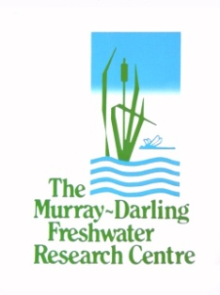

Commonwealth Environmental Water Office  
Long­­­­–Term Intervention Monitoring Project:  
Basin Evaluation Plan

December 2014

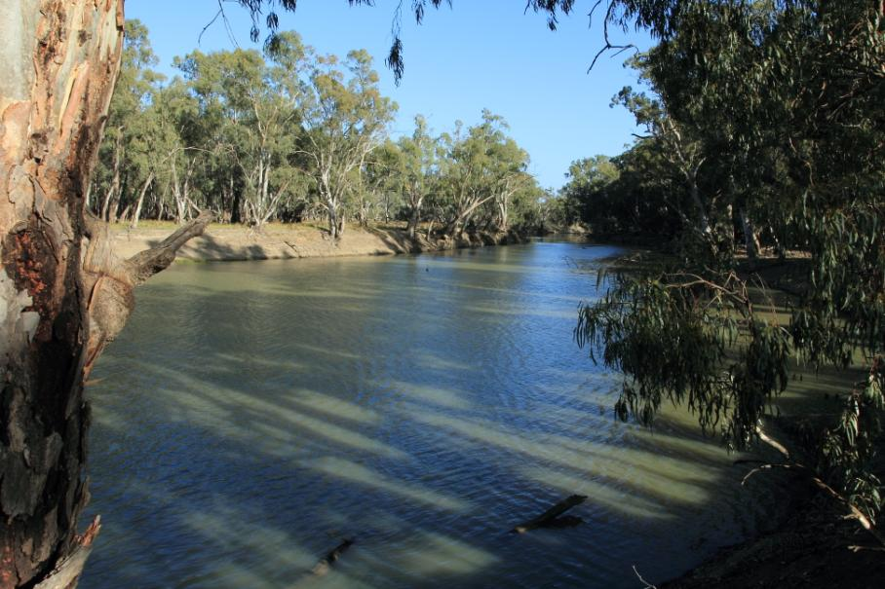**Prepared by:** Ben Gawne, Jane Roots, Jenny Hale, and Mike Stewardson

**CONSOLIDATED VERSION**

**MDFRC Publication 42/2014**

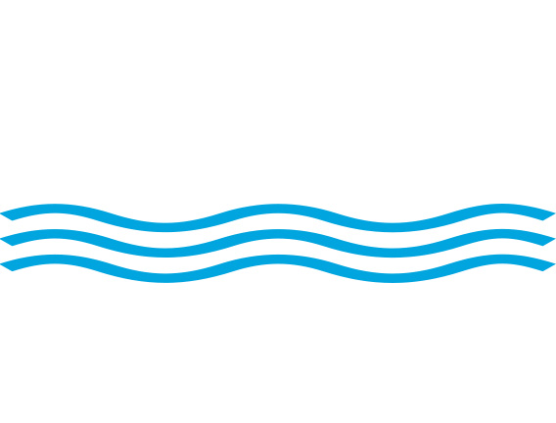

CEWO Long–Term Intervention Monitoring Project: Basin Evaluation Plan

Report prepared for the Commonwealth Environmental Water Office by The Murray–Darling Freshwater Research Centre.

Commonwealth Environmental Water Office

GPO Box 787

Canberra ACT 2601

John Gorton Building

King Edward Terrace

Parkes ACT 2600

Ph: (02) 6274 1111

This report was prepared by The Murray–Darling Freshwater Research Centre (MDFRC). The aim of the MDFRC is to provide the scientific knowledge necessary for the management and sustained utilisation of the Murray–Darling Basin water resources. The MDFRC is a joint venture between the La Trobe University and CSIRO.



For further information contact:

**Ben Gawne**

The Murray–Darling Freshwater Research Centre  
PO Box 991  
Wodonga VIC 3689  
Ph: (02) 6024 9650; Fax: (02) 6059 7531

Email: B.Gawne@latrobe.edu.au  
Web: [www.mdfrc.org.au](http://www.mdfrc.org.au)  
Enquiries: [info@mdfrc.org.au](mailto:info@mdfrc.org.au)

**Report Citation:** **Gawne B, Roots J, Hale J, Stewardson M (2014) Commonwealth Environmental Water Office Long– Term Intervention Monitoring Project: Basin Evaluation Plan. Report prepared for the Commonwealth Environmental Water Office by the** Murray–Darling **Freshwater Research Centre,** MDFRC Publication 42/2014, December, 55pp.

**Cover image: Yanga Creek floodplain, Murrumbidgee. Credit: Ben Gawne, MDFRC.**

Disclaimer:

This project was commissioned and funded by Commonwealth Environmental Water Office.

The views and opinions expressed in this publication are those of the authors and do not necessarily reflect those of the Australian Government or the Minister for the Environment. While reasonable efforts have been made to ensure that the contents of this publication are factually correct, the Commonwealth does not accept responsibility for the accuracy or completeness of the contents, and shall not be liable for any loss or damage that may be occasioned directly or indirectly through the use of, or reliance on, the contents of this publication.

© Commonwealth of Australia 2014. This work is copyright. Apart from any use as permitted under the *Copyright Act 1968*, no part may be reproduced by any process without prior written permission from the Commonwealth. Requests and enquiries concerning reproduction and rights should be addressed to Department of the Environment, Public Affairs, GPO Box 787 Canberra ACT 2601 or email [public.affairs@environment.gov.au](mailto:public.affairs@environment.gov.au).

Document history and status

|  |  |  |  |  |
| --- | --- | --- | --- | --- |
| Version | Date Issued | Reviewed by | Approved by | Revision type |
| Draft 1 | 24 October 2014 | MDFRC | Jane Roots | Internal |
| Draft 2 | 27 November 2014 | MDFRC | Ben Gawne | Internal |
| Final | 11 December 2014 | MDFRC | Ben Gawne | Internal |

Distribution of copies

|  |  |  |
| --- | --- | --- |
| Version | Quantity | Issued to |
| Draft | 1xPDF and Word | Sam Roseby |
| Final | 1xPDF and Word | Sam Roseby |

**Filename and path: U:\projects\CEWO\CEWH Long–Term Monitoring Project\486 LTIM Stage 2 - 2014-2019 Basin Evaluation\Basin Evaluation Plan**

**Authors: Ben Gawne, Jane Roots, Jenny Hale, Mike Stewardson**

**Author affiliation(s):** The Murray-Darling Freshwater Research Centre, Independent Aquatic Ecologist, University of Melbourne.

**Project Manager: Jane Roots**

**Client:** Commonwealth Environmental Water Office

**Project Title:** CEWO Long–Term Intervention Monitoring Project Stage 2

**Document Version:** Final

**Project Number:** M/BUS/499

**Contract Number: PRN 1213-0427**

**This report, the** CEWO Long–Term Intervention Monitoring Project: Basin Evaluation Plan is an amalgamation of the following Basin Evaluation Plans:

* CEWO Long–Term Intervention Monitoring Project: Basin Evaluation – Part A: Evaluation Framework, which was released in January 2014 (MDFRC publication 29/2014)
* CEWO Long–Term Intervention Monitoring Project: Basin Evaluation – Part B: Implementation, released in August 2014 (MDFRC publication 35/2014), and
* CEWO Long–Term Intervention Monitoring Project: Basin Evaluation – Part C: Project Management and Governance, released in August 2014 (MDFRC Proposal 486).

Contents

1 Introduction 1

1.1 LTIM Project objectives 1

1.2 Purpose of Basin Evaluation 1

1.3 Basin Evaluation scope 2

2 Approaches to evaluation 4

2.1 The Outcomes Framework 4

2.2 Conceptual models 5

2.3 Types of analysis 6

2.4 Multi-year evaluations 7

2.5 Inferring Basin outcomes at unmonitored sites 9

2.6 Basin Evaluation process 10

3 Evaluating Basin Matters: individual approaches for each matter 12

3.1 Ecosystem diversity 12

3.2 Fish population(s) 14

3.3 Vegetation diversity 16

3.4 Water quality and stream metabolism 18

3.5 Aggregation of Selected Area biodiversity outcomes (generic diversity) 21

3.6 Hydrology – flow regime 23

3.7 Hydrological connectivity 24

3.8 Summary 25

4 Evaluating Basin Matters – integrated evaluation 27

4.1 Biodiversity 27

4.2 Resilience 28

4.3 Ecosystem function 30

4.4 Basin Evaluation 31

5 Pilot Basin Evaluation 33

5.1 Why 33

5.2 What 33

5.3 How 33

6 Adaptive management of Basin Evaluation 35

6.1 Annual forums 35

6.2 Technical review 35

7 Project governance and team 36

7.1 Project management structure and responsibilities 36

7.2 Basin Matter team structure and responsibilities 38

8 Timeline and schedule 40

8.1 Timeline 40

8.2 Milestone schedule 41

9 Project risk assessment 44

10 Project quality plan 44

10.1 Data storage and management 44

10.2 Document management 44

10.3 Reporting and communication 45

References 50

Appendix A - Outcomes Framework 52

Appendix B – Project team skills and experience 53

List of tables

Table 1. Basin Matters under the Long–Term Intervention Monitoring project 3

Table 2: Basin Plan environmental and water quality objectives for water-dependent ecosystems (modified from COA 2012). 4

Table 3. Linkages between Basin Matters and Basin Plan objectives. 25

Table 4. Scope of CEWO short-term monitoring projects. 33

Table 5: Timeline of main Basin Evaluation Plan activities: 2014-15 to 2018-19. Critical pathways shown in red arrows. 40

Table 6: Milestone schedule for the implementation of the Basin Evaluation Plan for the period 2014-15 to 2019-20 41

Table 7: Recording of comments on draft reports 45

List of figures

Figure 1. Spatial scale of the CEWO Environmental Water Outcomes Framework and its relationship to Basin-scale Evaluation. 5

Figure 2. An illustration of the high-level influences on the ecological outcome from an environmental watering action. 7

Figure 3: An illustration of the way a hypothetical model could be applied iteratively to generate a series of outcomes from different flow regimes over a five year period. 8

Figure 4: An illustration of a hypothetical model of a long-term response to environmental watering where the greatest influence is from watering in the most recent year with progressively weaker influence from watering in previous years. 9

Figure 5. The process for using Selected Area outcomes to generate Basin-scale outcomes. 11

Figure 6. Schematic of key elements in the LTIM Project Standard Protocol: Ecosystem Type. 13

Figure 7. Schematic of key elements in the LTIM Project Standard Protocol: Fish (River). Note that the evaluation questions have changed slightly to accommodate the existing project parameters. 15

Figure 8. Schematic of key elements in the LTIM Project Standard Protocol: Vegetation Diversity. 17

Figure 9. Schematic of key elements in the LTIM Project Standard Protocol: Stream metabolism and water quality. 20

Figure 10. Schematic of the relationship between field measures, data analysis and evaluation. 23

Figure 11. Schematic of key elements in the LTIM Project: Biodiversity Evaluation. 28

Figure 12. Schematic of key elements in the LTIM Project: Resilience Evaluation. 29

Figure 13. Schematic of key elements in the LTIM Project: Ecosystem Function Evaluation. 30

Figure 14. Relationship between each Basin Matter and the Basin Evaluation Report. 31

Figure 15. Relationship between the Pilot Basin Evaluation and other project components. 34

Figure 16: Project management structure for the Basin Evaluation 36

Figure 17: Basin Evaluation information flow. 38

# Introduction

The Commonwealth Environmental Water Office (CEWO) Long–Term Intervention Monitoring (LTIM) Project seeks to evaluate the ecological outcomes of the management of Commonwealth environmental water and its contribution to the environmental objectives of the Basin Plan[1]. This evaluation is one step in the adaptive management of Commonwealth environmental water.

The Murray–Darling Freshwater Research Centre (MDFRC) has been engaged by CEWO as Monitoring and Evaluation (M&E) Advisers for the LTIM Project. As part of that role, the MDFRC has developed this Basin Evaluation Plan to guide the long-term, Basin-scale evaluation of the contribution of Commonwealth environmental water to the environmental objectives of the Basin Plan.

## LTIM Project objectives

The LTIM Project will give effect to the monitoring and evaluation elements of the Commonwealth Monitoring, Evaluation, Reporting and Improvement (MERI) Framework (Commonwealth of Australia 2009). The five high level objectives of the LTIM Project (in order of priority) are:

1. evaluate the contribution of Commonwealth environmental watering to the objectives of the Murray–Darling Basin Authority’s (MDBA) Environmental Watering Plan
2. evaluate the ecological outcomes of Commonwealth environmental watering at each of the seven Selected Areas
3. infer ecological outcomes of Commonwealth environmental watering in areas of the Murray–Darling Basin (MDB) not monitored
4. support the adaptive management of Commonwealth environmental water
5. monitor the ecological response to Commonwealth environmental watering at each of the seven Selected Areas.

## Purpose of Basin Evaluation

The purpose of Basin Evaluation is to interpret the data collected from monitoring of Commonwealth environmental watering actions, within a Basin context, to:

* demonstrate the outcomes from Commonwealth environmental water and
* support adaptive management.

Basin Evaluation is the primary means for achieving Objective 1 of the LTIM Project (above) and will also contribute to achieving:

* Objective 2 by reporting on outcomes and providing enhancements, based on the approach to evaluation, that can be applied by M&E Providers in each of the Selected Areas
* Objective 3 by reporting on outcomes and applying findings, to the extent possible, in areas not monitored
* Objective 4 by reporting on findings that inform adaptive management at the area and Basin scale
* Objective 5 by providing the standardised approaches that support Basin Evaluation.

## Basin Evaluation scope

On-ground monitoring will be undertaken at seven Selected Areas across the Basin:

* Gwydir river system (in-stream, wetlands and floodplains)
* Lachlan river system (in-stream and fringing wetlands)
* Murrumbidgee River system (in-stream, fringing wetlands and floodplains)
* Edward–Wakool river system (in-stream and fringing wetlands)
* Goulburn River (in-stream and fringing wetlands)
* Lower Murray River (in-stream, connected wetlands, floodplain and temporary non-connected wetlands)
* junction of the Warrego and Darling rivers.

Monitoring at each of these Selected Areas will inform both Basin Evaluation (as described in this Evaluation Plan) and Selected Area Evaluation. Matters for Basin Evaluation were identified through a process that considered Basin Plan objectives, expected outcomes at the seven Selected Areas and feasibility of implementation as documented in the Logic and Rationale document (Gawne *et al.* 2013) and was informed by the generic cause and effect diagrams (Murray–Darling Freshwater Research Centre 2013). The full suite of Basin Matters initially considered is shown in .

Information collected on matters selected for Basin Evaluation must be comparable across Selected Areas and over the five-year program to allow for integrated analysis. However, as monitoring is also required for Selected Area Evaluation, it is recognised that some data collection methods may be more appropriate at some Selected Areas than at others. To balance the needs of Basin and Selected Area Evaluation, three categories of monitoring methods were developed:

* Category I – Mandatory monitoring with standard protocols, which are required to inform quantitative Basin Evaluation. Matters have been identified for each Selected Area in this category and must be applied in a consistent manner following standard protocols.
* Category II – Optional monitoring with mandatory standard protocols, which may be used to inform quantitative Basin Evaluation in the future. In the event that any of these matters is selected by M&E Providers for implementation at the Selected Area, the standard protocol must be implemented.
* Category III – Optional monitoring with Selected Area specific protocols and mandatory reporting requirements. This includes Selected Area specific monitoring using locally appropriate methods. Reporting requirements for Basin Evaluation must also be implemented.

Standard protocols were developed for each of the category I and II matters (Hale *et al.* 2013) and assigned to each of the Selected Areas (see ). Monitoring and Evaluation Providers adopted these protocols in their M&E Plans, augmenting them where appropriate with Selected Area-specific (category III) monitoring and methods.

Table 1. Basin Matters under the Long–Term Intervention Monitoring project

| Basin Matter1 | Warrego/Darling2 | Gwydir | Lachlan | Murrumbidgee | Edward–Wakool | Goulburn | Lower Murray |
| --- | --- | --- | --- | --- | --- | --- | --- |
| Ecosystem diversity |  |  |  |  |  |  |  |
| Vegetation diversity |  |  |  |  |  |  |  |
| Fish (river) |  |  |  |  |  |  |  |
| Fish (larvae) |  |  |  |  |  |  |  |
| Fish (movement) |  |  |  |  |  |  |  |
| Waterbird breeding |  | 3 | 3 | 3 |  |  |  |
| Waterbird diversity |  |  |  |  |  |  |  |
| Stream metabolism |  | 4 |  |  |  |  |  |
| Hydrology |  |  |  |  |  |  |  |

1 Final list of agreed Basin Matters across Selected Area that will be monitored and evaluated. Not all Basin Matters were able to be funded.

2 **Basin Matters to be included in the Warrego/Darling have been agreed but not yet finalised - these are proposed only.**

3 Contracted as optional – will only proceed in the event of bird breeding and subject to conditions

**4 Water quality component only**

**This Evaluation Plan describes how the data collected from monitoring each of the Basin Matters at the** Selected **Areas will be used to evaluate the outcomes of Commonwealth environmental water at the Basin scale. The proposed approach is based on a conceptual understanding of flow–ecology relationships and will involve both qualitative and quantitative analyses. In general, the outcomes at the Selected Area scale will be used together with data from other sources to derive estimations of the matter both with, and in the absence of, Commonwealth environmental water at the Basin scale.**

# ****Approaches to evaluation****

## The Outcomes Framework

The Basin Plan identifies a number of environmental objectives for water-dependent ecosystems in the Murray–Darling Basin, including Environmental Watering Plan targets to measure progress towards Basin Plan objectives in Schedule 7 and water quality and salinity targets in Schedule 11. These environmental objectives are set at the Basin scale over a decadal time frame. In contrast, environmental water actions are managed at the site, area or valley scale over periods of days, weeks or months. There is a need to link these local outcomes to long-term, Basin-scale changes in environmental condition.

This process is facilitated through the use of the CEWO Environmental Water Outcomes Framework (Appendix A), where local or site-scale outcomes are translated into the four high level environmental objectives generically described as Biodiversity, Ecosystem function, Resilience and Water quality as shown in Table 2.

Table : Basin Plan environmental and water quality objectives for water-dependent ecosystems (modified from COA 2012).

| Basin Plan reference | Basin Plan objective | Referred to throughout as: |
| --- | --- | --- |
| Environmental Watering Plan | to protect and restore water-dependent ecosystems of the Murray-Darling Basin (Basin Plan, Chapter 8, Part 2, 8.04(a)) | Biodiversity |
| to protect and restore the ecosystem functions of water-dependent ecosystems (Basin Plan, Chapter 8, Part 2, 8.04(b)) | Ecosystem function |
| to ensure that water-dependent ecosystems are resilient to climate change and other risks and threats (Basin Plan, Chapter 8, Part 2, 8.04(c)) | Resilience |
| Water Quality and Salinity Plan | to ensure water quality is sufficient to achieve the above objectives for water-dependent ecosystems, and for Ramsar wetlands, sufficient to maintain ecological character (Basin Plan, Chapter 9, Part 3, 9.04 (1) & (2)) | Water quality |

Throughout this document, the objectives described in Table 2 are referred to as the Basin Plan objectives. To support the management of Commonwealth environmental water and the development of the LTIM Project, the Basin Plan objectives have been further classified into 1 year and 5 year expected outcomes as shown in the Outcomes Framework. Although the matters considered within the 1 year and 5 year expected outcomes generally accord with the detailed objectives set out in Chapter 8 of the Basin Plan, they have been framed to support environmental watering, rather than reflect specific provisions of the Basin Plan.

The Basin Evaluation process will quantify the extent to which the expected outcomes of a watering action are achieved and then use the Outcomes Framework to evaluate the extent to which these outcomes contribute to the environmental objectives of the Basin Plan. The spatial scales associated with this process are illustrated in . The expected outcomes are informed by the best available ecological science and are evaluated based on a one-year time frame (short-term outcome) and a one- to five-year time frame (long-term outcome). The process of determining the evaluation questions based on the Outcomes Framework is described in detail in the Evaluation Plan, Part A (Gawne *et al.* 2014).

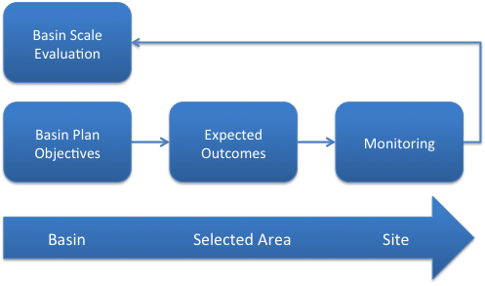

Figure . Spatial scale of the CEWO Environmental Water Outcomes Framework and its relationship to Basin-scale Evaluation.

The Outcomes Framework and the conceptual links between environmental watering outcomes and Basin Plan objectives provide the context for the relationship between the outcomes of individual flow events and achieving Basin-scale environmental objectives. These relationships are an important focus of the LTIM Project evaluation process and form the core of this Evaluation Plan.

## Conceptual models

Conceptual models illustrate the relationships between flow and ecological outcomes. Preliminary conceptual models (cause and effect diagrams) were developed as part of the Logic and Rationale document (Gawne *et al.* 2013). These conceptual models will be refined and used to support three activities for the Basin Evaluation:

* development of predictive capacity
* improved understanding of flow–ecology relationships
* communication of the outcomes of Commonwealth environmental water.

### Development of predictive capacity

The conceptual models produced for the Logic and Rationale document (Gawne *et al.* 2013) sought to summarise the causal relationships between flow and specified outcomes. In order to develop predictive capacity, these conceptual models will be simplified and re-structured as required to use the monitoring information that is available and to meet the needs and objectives of the predictive models. This process will be undertaken by each Basin Matter team as they address their relevant evaluation questions. Each Basin Matter will be using a different approach, as described in Section 3.

### Improved understanding of flow–ecology relationships

As monitoring data are collated and patterns in the data revealed, the conceptual models will provide the foundation for the identification and quantification of key relationships and knowledge gaps. The evaluation process may reveal:

* additional processes that influence the expected, observed and no flow predicted outcomes
* the relative importance of factors that influence outcomes
* the context within which particular factors become important.

New insights like these will require modification of the content and in some instances the structure of the conceptual model over time.

### Communication

Conceptual models will also be important in supporting the development of communication tools. The models can provide a clear, simple visualisation of the relationship between environmental watering and ecological outcomes. Different stakeholders and the need to communicate key messages will require refinement of the conceptual models to ensure that the information is useful, understandable as well as scientifically credible.

## Types of analysis

Three types of analysis have been identified for use in Basin Evaluation. These are briefly described below.

### Aggregative analysis

Aggregation involves synthesising observed outcomes in order to evaluate their contribution to achieving Basin Plan objectives at a larger spatial or longer temporal scale, as described in the Outcomes Framework (Appendix A). This approach is appropriate for the following indicators:

* biodiversity indicators where protecting or restoring species at the site or area scale contributes to Basin-scale biodiversity
* connectivity indicators where the outcome is constrained to the period of the environmental watering and can be evaluated as the aggregated effects of events on the connectivity regime
* primary production and decomposition where the outcome is constrained to the period of the environmental watering and can be evaluated as the accumulated effects of environmental water on long-term rates of metabolism.

### Qualitative analysis

Qualitative analysis is where predictions of outcomes are descriptive or based on conceptual models that only enable directional predictions (increase, decrease or no response). In line with the principles of adaptive management, qualitative evaluation will be based on the conceptual understanding of the influence of Commonwealth environmental water on the matter in question. Qualitative analytical approaches will be used to make predictions about the influence of Commonwealth environmental water on Basin-scale fish populations as the links between Selected Area and Basin scale are only understood on a conceptual basis.

### Quantitative analysis

The term “quantitative analysis” is used to refer to the use of analytical models to generate numerical predictions for the evaluation of outcomes of Commonwealth environmental watering actions. The core of any attempt to evaluate the effectiveness of a watering action is a comparison of two conditions: the system with and without the contribution of Commonwealth environmental water.

It is important that there is sufficient confidence around the outcomes of Commonwealth environmental water and that these are separated from the background noise created by other sources of environmental variability in rivers including year-to-year variation in climate. The monitoring program has been designed to maximise confidence of detecting the effect of environmental watering and minimise the possibility that observations are confounded by other variables. For the Basin Evaluation, data will be used from across multiple sites and multiple Selected Areas to build confidence that the effects detected are indeed produced by environmental watering actions. The confidence associated with this approach is greater than would be possible from evaluation of information from an individual site.

There are three major challenges associated with developing analytical models for quantitative analysis:

1. linking short-term environmental watering responses to five-year changes in the condition of the system
2. developing the capacity to predict the outcomes of a variety of flow scenarios that may occur over a five-year period
3. describing the ecosystem component in a way that can be modelled.

This process will be based on a conceptualisation that predicts that the outcomes of Commonwealth environmental water arise from the interaction between the characteristics of the flow regime and the characteristics of the Selected Area (asset), which includes both its character and condition (Figure 2).

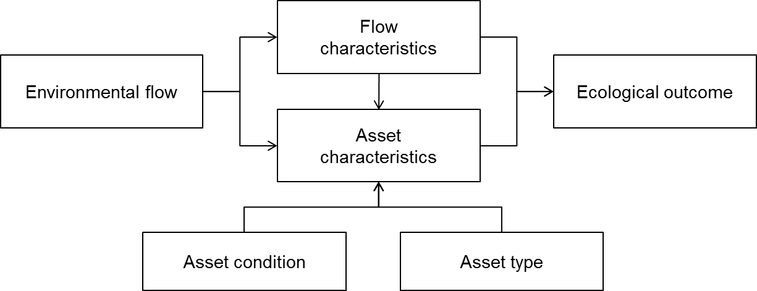

Figure 2. An illustration of the high-level influences on the ecological outcome from an environmental watering action.

## Multi-year evaluations

This section provides an overview of the process for analysing the cumulative outcomes of Commonwealth environmental water. There are two approaches to this challenge.

**Model form 1**

Five year outcomes will involve the development of quantitative models that predict the outcomes of Commonwealth environmental water based on the characteristics of the event and the condition of a component within the system. As with the annual evaluation, each outcome will require a dedicated quantitative model based on the response of a component in a specified condition to a flow with defined characteristics. Repeated applications of these quantitative models will enable prediction of the outcomes of a variety of flow scenarios over a five year period (refer to ). The steps in this process are similar to those for the annual evaluation.

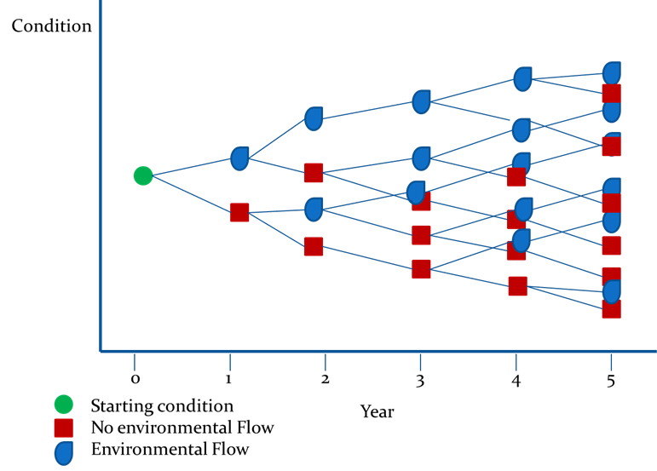

Figure : An illustration of the way a hypothetical model could be applied iteratively to generate a series of outcomes from different flow regimes over a five year period.

One of the challenges associated with this approach is the propagation of uncertainty with each iteration of the analysis which may make it difficult to discriminate between the outcomes expected from different 5 year flow regimes. The engagement with quantitative analysis and domain experts will seek appropriate strategies to deal with this issue.

**Model form 2**

**The second approach may be to consider long-term responses to environmental flows as a time-lagged response. In this instance the model describes the current state of subject as being determined by the most recent flow and incrementally less by previous flow events (**Figure 4**). This approach may be appropriate in situations where the influence of a flow is delayed over a time scale of years or where the response to a flow is cumulative and not a sequence of inter-dependent events.**

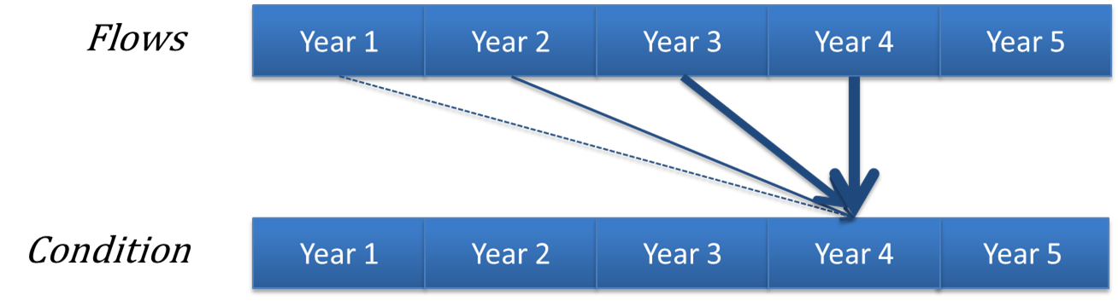

Figure : An illustration of a hypothetical model of a long-term response to environmental watering where the greatest influence is from watering in the most recent year with progressively weaker influence from watering in previous years.

## Inferring Basin outcomes at unmonitored sites

Evaluating outcomes that are not monitored will be based on the watering action objectives and expected Basin outcomes as identified in the Outcomes Framework (Appendix A). The expected outcomes will be developed using the most appropriate process for predicting the outcome; this may be a statistical or conceptual model, or experience derived from previous watering actions in the area.

The expected outcomes will be evaluated in terms of their contribution to Basin Plan objectives through the relationships described in the Outcomes Framework. The first step in the evaluation process will be to assess the likelihood of the expected outcomes being achieved. This will depend on the availability of models and data. In some instances, Basin Plan condition monitoring, remotely sensed data or information generated by other programs may be available to improve the predictions of actual outcomes. In other instances, the only information available will be that related to the delivery of water and the associated hydrological conditions. In these cases, the evaluation will rely on the same predictive processes used to generate the expected outcome and a comparison of the proposed Water Action along with what actually happened.

Evaluating the contribution of Basin outcomes to Basin Plan objectives requires identification of the relationship between the water action outcome and the Basin Plan objective. It will then be necessary to evaluate the significance and likelihood of Commonwealth environmental water contributing to the Basin Plan objective. Assessing the significance can be inferred through a comparison of the long-term expected outcomes of the water action and the outcomes in the absence of the water action. The likelihood of contributing to the Basin Plan objective can be determined from an examination of the flow regime required to achieve the larger scale outcome and the presence of other stressors in the system.

## Basin Evaluation process

Evaluating the management of Commonwealth environmental water is based on a conceptual understanding of the links between the environmental objectives of the Basin Plan and the expected outcomes of environmental watering actions as illustrated in the Outcomes Framework. The Basin Evaluation will use this framework to evaluate the outcomes of Commonwealth environmental water at the Basin scale. These outcomes are part of a hierarchy in which the short-term (less-than-one-year) outcomes of an environmental watering action at a site contribute to longer-term (two- to five-year) outcomes at larger spatial scales.

Each step in the evaluation process will be based on the same starting question, specifically:

*How does the observed outcome of Commonwealth environmental water compare to both the expected outcome and the outcome predicted to occur in the absence of Commonwealth environmental water?*

In line with the Commonwealth MERI framework principles (Commonwealth of Australia 2009), the answer to this question will be based on multiple lines of quantitative and qualitative evidence. These lines and levels of evidence would include direct observations from monitoring data both within the Selected Areas and from other projects, historical data on responses to past flow events and our conceptual understanding of flow–ecology relationships.

Although this Evaluation Plan is focussed on Basin Evaluation and reporting will be primarily at that scale, the process of deriving outcomes at the Basin scale starts with outcomes at the Selected Areas. In some instances, this may be derived by analysis and evaluation undertaken at individual Selected Areas by M&E Providers. However, as data will be required across multiple Selected Areas in a consistent manner, it is likely that there will need to be analysis of primary data from each Selected Area, as well as areas to which the Commonwealth delivers water but does not monitor, to provide the information required to undertake the Basin Evaluation. The process of evaluation is illustrated in Figure 5 and follows the process outlined below:

1. Identify the expected outcome(s) of the watering action.
2. Determine the actual outcome of the watering action, as follows:

a. For Selected Areas where the expected outcome is monitored, monitoring data provides information on the condition of the system with the watering action.

b. For areas where the expected outcome is not monitored, the actual outcome will need to be inferred using multiple lines of evidence including predictions based on conceptual or quantitative models.

1. Predict the condition of the system in the absence of the watering action (no flow). As above, the predicted outcome will need to be inferred using multiple lines of evidence including predictions based on conceptual or quantitative models.
2. Compare and contrast the expected, observed and no flow predicted outcomes to inform an evaluation of the overall outcome of the watering action. An assessment of the critical success factors can then be made, helping to determine whether Commonwealth environmental water could be used more productively in the future. The evaluation may also inform refinements to our understanding of the relationship between flow and ecological condition and/or the approach to monitoring.
3. Integrate the Selected Area outcomes to develop expected, observed and predicted without Commonwealth environmental water outcomes at the Basin scale.

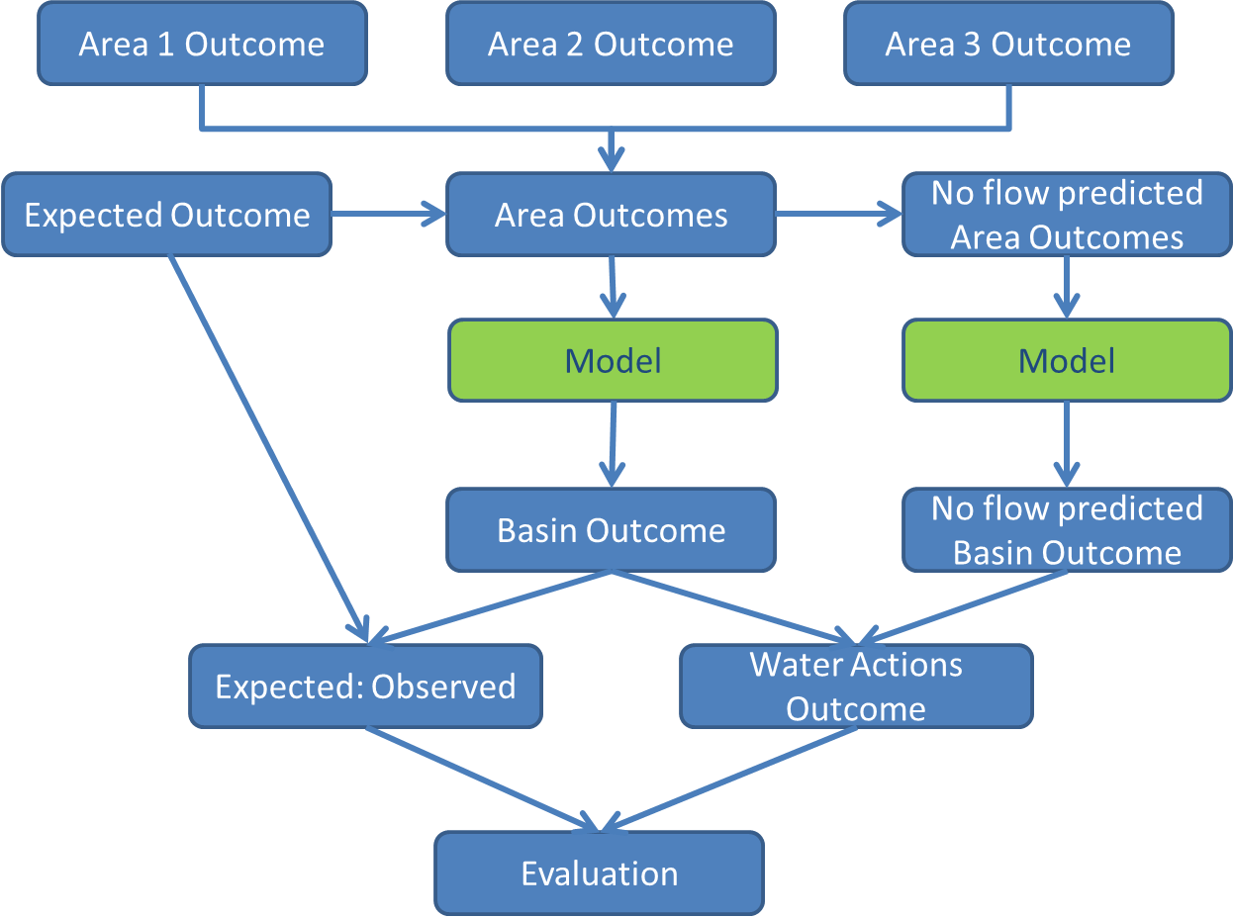

Figure 5. The process for using Selected Area outcomes to generate Basin-scale outcomes.

# Evaluating Basin Matters: individual approaches for each matter

Specialist teams (referred to as Basin Matter teams) will undertake evaluation of individual matters. Given the nature of the data and the various expected outcomes each of these matters addresses, the evaluation process for each matter is described separately in terms of a justification (why), outcomes and deliverables (what) and an outline of the methods to be used (how). Details of the team composition and skill sets are provided in Section 7 and Appendix B.

## Ecosystem diversity

### Why

Ecosystem diversity, or the range of ecosystem types within a specified area, is one element of biodiversity as a whole. Ecosystem diversity underpins CEWO’s capacity to evaluate the extent to which a subset of water-dependent ecosystems have been protected or restored. Evaluating the extent to which the range of water-dependent ecosystem types have been protected or restored contributes to assessing the contribution of Commonwealth environmental water to biodiversity in the Basin as outlined in the Outcomes Framework.

Environmental watering outcomes are likely to vary between different ecosystem types. Outcomes that can be quantified within a Selected Area may be extrapolated to similar ecosystem types in areas that are not monitored. This will facilitate the evaluation of outcomes at unmonitored areas, supporting Basin-scale evaluation.

### What

This component of the Basin Evaluation will address the following short-term (one-year) and long-term (five-year) Basin-scale evaluation question:

* What did Commonwealth environmental water contribute to ecosystem diversity?

The interim Australian National Aquatic Ecosystems (ANAE) Classification (Aquatic Ecosystem Task Group 2012) provides a framework for classifying aquatic ecosystems. This framework was applied across the Murray–Darling Basin (Brooks *et al.* 2014) to produce a consistent classification of aquatic ecosystems across the Basin. Brooks *et al.* (2014) also produced a typology for aquatic ecosystems mapped. The MDB ANAE ecosystem map and typology is yet to be rigorously validated. Ecosystem type will be validated in the field for all sites at which LTIM Project monitoring occurs. The relationship between data collection, analysis, evaluation and reporting is illustrated in Figure 6.

The outputs of the hydrological evaluation will be used to intersect with the map of ecosystem types across the Basin to derive a catalogue of ecosystem types that received Commonwealth environmental water. In addition, an assessment of attribution errors within the ANAE classification that result in erroneous ecosystem type assignment will be undertaken and in year five a report will be produced discussing the ramifications of these errors on assessing Commonwealth environmental water influences on ecosystem diversity. The following outputs will be produced:

* annual evaluation of ecosystem types influenced by Commonwealth environmental water
* an updated ANAE spatial layer for the Selected Areas
* quantitative assessment of the error types within the ANAE classification that may influence our capacity to assess the representativeness of Commonwealth environmental water delivery.

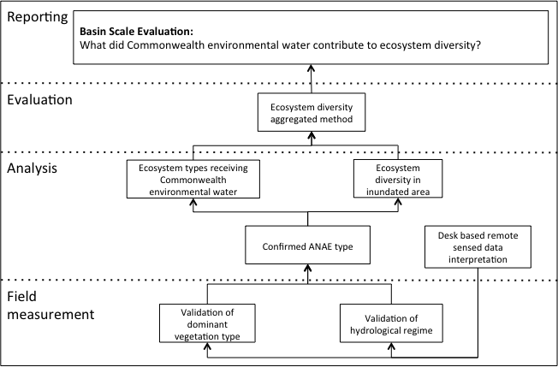

Figure 6. Schematic of key elements in the LTIM Project Standard Protocol: Ecosystem Type.

### How

#### Data

Data inputs to the evaluation of ecosystem type include:

* the interim Australian National Aquatic Ecosystems (ANAE) Classification and typology of the Murray–Darling Basin (Brooks *et al.* 2014)
* the LTIM Project M&E Provider data collected using the LTIM Project Standard Protocol: Ecosystem Type
* spatial representation of watering extent for all Commonwealth environmental water deliveries determined using:
  + the LTIM Project M&E Provider mapping of watering extent
  + delivery partner operational monitoring
  + modelled inundation (see Hydrological connectivity).

#### Developing the evaluation approach

Ecosystem types that receive Commonwealth environmental water will be identified and compared to all ecosystem types known to occur. This will be performed for each Selected Area and cumulatively across all Selected Areas. Information on ecosystem types that receive Commonwealth environmental water outside the Selected Areas will be incorporated into this evaluation where available.

Australian National Aquatic Ecosystems attribution errors identified at monitoring sites will be collated. Consistent errors that can be applied to unmonitored areas will be identified. The ANAE typology of Brooks *et al.* (2014) will be applied to the corrected attributes to create a revised ecosystem type layer for the Basin. A measure of the error rate (e.g. expressed as number of attribution errors per 100 polygons of each ecosystem type) will provide a basis for documenting uncertainty when extrapolating or modelling outcomes at unmonitored sites. The corrected ecosystem type classification will be used as the basis for all subsequent evaluation.

## Fish population(s)

### Why

Native fish diversity, condition, reproduction and recruitment contribute to the biodiversity objectives stated in the Basin Plan. Native fish are affected by flow both directly through cues to migration and reproduction and indirectly through effects on water quality and habitat and through biotic interactions such as competition and predation. This means that fish are an excellent indicator species for the biodiversity outcomes of environmental watering. Fish population data thereby support adaptive management of environmental water. The public interest in fish also means that their presence and information about population change are useful from a communication and engagement perspective for CEWO.

The flow–ecology relationships for Australian native fish in the Basin have been investigated at a number of spatial and temporal scales. This provides a strong foundation for both qualitative and quantitative evaluation of the outcomes of Commonwealth environmental water as well as for input to adaptive management.

### What

This component of the Basin Evaluation will address the following Basin-scale evaluation questions:

* Long-term (five-year) question:
  + What did Commonwealth environmental water contribute to sustaining native fish populations?
* Short-term (one-year) questions:
  + What did Commonwealth environmental water contribute to sustaining native fish reproduction?
  + What did Commonwealth environmental water contribute to sustaining native larval fish growth and survival?
  + What did Commonwealth environmental water contribute to sustaining native fish survival?

Monitoring of fish will occur both as annual surveys (adults) and in response to environmental watering actions (larvae). The relationship between data collection, analysis, evaluation and reporting is illustrated in Figure 7. Data collected at each Selected Area will be collated by the Basin Matter team and analysed both qualitatively (annually for years one to five) and quantitatively (in year five). In year three, a predictive dynamic model will be developed to demonstrate outcomes. This will be refined in years four and five.

An annual report will be submitted to CEWO based on a qualitative evaluation for years one and two, and a combination of qualitative and quantitative evaluation for years three to five, comprising:

* assessment of the response to Commonwealth environmental water to date
* updated conceptual models and recent advancements in knowledge
* updated set of qualitative predictions, in light of planned watering actions.

A quantitative evaluation and prediction tool based on a mathematical model will be produced with a report that includes:

* introduction to the modelling approach
* model parameterisation and parameter estimation for population models; updating the parameters based on watering actions to date
* updated set of candidate population models of flow-response of key life-history types and updated predictions of response to watering actions
* modelling implications for resilience at large scales
* modelling dynamics of diversity; exploring a ‘whole-assemblage’ approach.

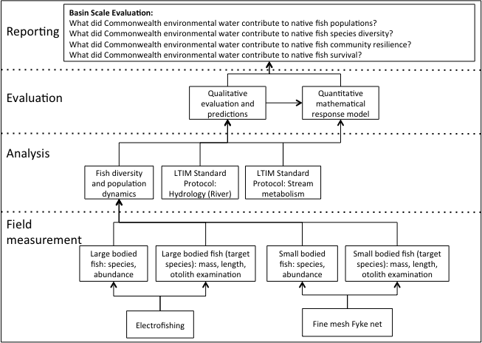

Figure 7. Schematic of key elements in the LTIM Project Standard Protocol: Fish (River). Note that the evaluation questions have changed slightly to accommodate the existing project parameters.

### How

#### Data

The LTIM Project Standard Methods for fish have been designed to provide data appropriate for the evaluation of native fish outcomes at the Basin scale. This will be augmented with a wide spectrum of complementary data sets including (but not limited to): native fish data from past monitoring programs (e.g. the MDBA’s Sustainable Rivers Audit), data collected from current programs (e.g. The Living Murray program) and data that can be extracted from the published scientific literature.

#### Developing the evaluation approach

In the first year a qualitative approach to Basin Evaluation will be developed by synthesising fish responses to watering actions across the Selected Areas. This will include refinement of the conceptual model underpinning our understanding of fish flow–ecology responses. This will determine which ecological responses to Commonwealth environmental watering actions are:

* common across Selected Areas; if responses are similar then we may have some confidence when predicting fish qualitative response to watering actions at the spatial extent of the Basin
* dependent on the Selected Area within which they are delivered, hence which responses need to be better understood if we are to make qualitative predictions of ecological responses outside of Selected Areas.

This qualitative approach will be implemented annually to report on the contribution of Commonwealth environmental water to native fish diversity and populations within the Selected Areas; and to assist in predicting response across the Basin.

Over the five-year period, a mathematical model will be developed to quantitatively evaluate the ecological outcomes for native fish in response to Commonwealth environmental water. Initial outputs from this model will be available from year three, with the model continually refined over years four and five. This model will also support CEWO in understanding the outcomes for fish from a variety of environmental watering and delivery regimes.

Within Selected Areas, as part of the adaptive management of Commonwealth environmental water within those areas, models are required so that:

* uncertainty concerning the answers to the evaluation questions presented in can be quantified and stated to stakeholders (Williams *et al.* 2002)
* we can forecast the long-term consequences of individual watering actions, in order to optimise multi-year watering action scenarios and enhance fish diversity and resilience
* uncertainty in the decision-making process can be accounted for and minimised (Conroy & Petersen 2013; Walters & Holling 1990).

Outside of Selected Areas, where no monitoring of response may be taking place, models will enable calculation of uncertainty in fish response to watering actions delivered throughout the Basin, and how watering actions in one region might affect resilience at broader spatial scales.

## Vegetation diversity

### Why

Vegetation diversity refers to the diversity of plants, including species and the vegetation communities which they form, through all phases of the flow regime relevant to the particular ecosystem (i.e. dry, base flow, fresh, bank-full, overbank). The distribution and abundance of wetland and floodplain plants and vegetation communities are strongly influenced by hydrology and the availability of water (Brock & Casanova 1997; Capon *et al.* 2012; Roberts & Marston 2011). Changes in flow regimes are therefore likely to significantly impact vegetation diversity across multiple scales, from the presence and abundance of local plant species to vegetation composition and structure at ecosystem and landscape scales.

Vegetation diversity was included in the suite of matters for evaluation at the Basin scale because it aligns well with Basin Plan objectives, is known to be flow-sensitive, provides a good short-term response to environmental watering and is easily communicated and valued by the broader community.

### What

This component of the Basin Evaluation will address the following short-term (one-year) and long-term (five-year) Basin-scale evaluation questions:

* What did Commonwealth environmental water contribute to vegetation species diversity?
* What did Commonwealth environmental water contribute to vegetation community diversity?

Monitoring of vegetation diversity will be on an event basis, initiated at wetland, floodplain and riverine sites in response to environmental watering actions. The relationship between data collection, analysis, evaluation and reporting is illustrated in Figure 8. Data collected at the Selected Areas will be collated by the Basin Matter team and analysed to develop a database of plant species and vegetation community responses to Commonwealth environmental water. In addition, models (e.g. species–area curve-based) will be developed to provide estimates of the effect of Commonwealth environmental water on the species richness of flora in areas of the Basin that are not monitored.

The outputs of the Basin Evaluation of vegetation diversity will comprise:

* annual assessment of vegetation diversity at three scales:
  + species/population level – examine responses to environmental water of wetland plant species across Selected Areas to determine commonalities and differences at a species level
  + assemblage level – examine responses to environmental water of plant assemblages within particular habitat types across Selected Areas to determine commonalities and differences
  + landscape level – examine responses to environmental water of vegetation across the wetland landscape of Selected Areas to determine commonalities and differences (e.g. extent of species presence/abundance within wetland, similarity of plant assemblages across habitat types etc.)
* a database of wetland plant species’ presence and responses to watering with respect to functional group and habitat, compiled by aggregating information from the Selected Areas
* development of a predictive tool (e.g. based on species–area relationships) to estimate Commonwealth environmental water contribution to vegetation species diversity across the Basin
* an evaluation of key factors (flow, climate and grazing) that affect vegetation responses to environmental water
* recommendations for future management of Commonwealth environmental water to enhance outcomes for vegetation diversity.

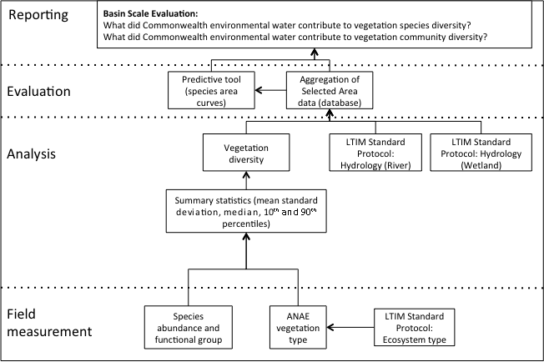

Figure 8. Schematic of key elements in the LTIM Project Standard Protocol: Vegetation Diversity.

### How

#### Data

The LTIM Project standard methods for vegetation have been designed to provide data appropriate for the evaluation of vegetation outcomes at the Basin scale. This will be augmented with a wide spectrum of complementary data sets including those collected under previous environmental watering monitoring programs such as The Living Murray (TLM), the Integrated Monitoring of Environmental Flows (IMEF) and the Narran Lakes monitoring programs.

#### Developing the evaluation approach

There are two separate components to the evaluation of vegetation diversity. The first is an aggregation of data collected at the Selected Areas, augmented by data from past projects, to develop a database of plant species and vegetation community responses (i.e. species composition, richness and abundance) to environmental water. With respect to plant species, this database will build upon the following previously developed functional groups of water-dependent flora (Brock & Casanova 1997):

* amphibious responders (AmR) – plants which change their growth form in response to flooding and drying cycles
* amphibious tolerators (AmT) – plants which tolerate flooding patterns without changing their growth form
* terrestrial damp plants (Tda) – plants which are terrestrial species but tend to grow close to the water margin on damp soils
* terrestrial dry plants (Tdr) – plants which are terrestrial species that don’t normally grow in wetlands but may be encroaching into the area due to prolonged drying.

Various clustering approaches will be used to develop comparable classes at a vegetation community level. The output of this analysis will be a database of plant species and vegetation community responses to environmental water that will be expanded and refined over the five-year monitoring period.

The second component of the Basin Evaluation of vegetation diversity will involve the development of models that will enable predictions to be made about vegetation diversity responses to additional aquatic ecosystems receiving water. This will build on existing work undertaken in the Central Murray region in developing such predictive tools (Alexander *et al.* 2008). These models will be used to generate an estimate of the number of species that have benefited from Commonwealth environmental water at the Basin scale.

The predictive model would be developed and tested in year one, and then refined over the five-year monitoring period as additional data is available for calibration and validation.

## Water quality and stream metabolism

### Why

Water quality is included as a Basin Matter for three reasons:

* it is one of the principal objectives of the Basin Plan
* it is known to respond to changes in flow
* it can be a significant influence on the outcome of a watering action for biota (e.g. fish and invertebrates).

There are instances where the objective of a watering action is the amelioration of reduced water quality (e.g. dissolved oxygen, salinity) to prevent disturbance to an ecosystem.

Stream metabolism refers to the transformation of organic matter and is comprised of two key ecological processes: primary production and decomposition, which generate and recycle organic matter respectively. These processes have a profound effect on ecosystem character and condition through their influence on the capacity of plants to complete their life cycles and the ability of animals to acquire the food resources needed to survive and reproduce.

There is growing evidence to suggest that flow modification has influenced patterns and rates of primary production and decomposition and that these influences have contributed to the decline in the condition of aquatic ecosystems. Therefore, understanding primary production and decomposition responses to environmental watering will be important if these watering actions are to be optimised to contribute to the protection and restoration of water-dependent ecosystems. However, identifying improved water quality and the ideal state for primary production and decomposition is not straightforward. For example, while increased primary production is important for maintaining and restoring ecosystem function and biodiversity, excess primary production leading to large and sustained algal blooms can cause negative impacts to aquatic ecosystems and ecosystem services. Defining these thresholds is an important first step in the evaluation of this matter.

### What

This component of the Basin Evaluation will address the following short-term (one-year) and long-term (five-year) Basin-scale evaluation questions:

* What did Commonwealth environmental water contribute to patterns and rates of decomposition?
  + Increases in rates of decomposition that do not also cause adverse water quality outcomes are beneficial by making organic matter and nutrients available to the ecosystem.
* What did Commonwealth environmental water contribute to patterns and rates of primary productivity?
  + Increases in rates of primary production that do not lead to algal blooms or adverse water quality outcomes are beneficial by increasing the amount of organic matter available to the food web.
* What did Commonwealth environmental water contribute to pH levels?
  + The management of environmental water has the capacity to reduce the frequency or severity of acidification events. This evaluation will report on the outcomes of water actions for which this is an objective.
* What did Commonwealth environmental water contribute to turbidity regimes?
  + The management of environmental water has the capacity to reduce the severity of highly turbid flow events. This evaluation will report on the outcomes of water actions for which this is an objective.
* What did Commonwealth environmental water contribute to salinity regimes?
  + The management of environmental water has the capacity to reduce the severity of periods of high salinity, mix refuge pools in which salinity has led to stratification or ensure a period of low salinity occurs to support recruitment. This evaluation will report on the outcomes of water actions for which this is an objective.
* What did Commonwealth environmental water contribute to dissolved oxygen levels?
  + The management of environmental water has the capacity to reduce the severity of anoxic events such as those associated with blackwater. It is feasible that environmental water could also be used to reduce oxygen levels in instances where water is super-saturated with oxygen, as may occur during algal blooms. This evaluation will report on the outcomes of water actions for which these were objectives.

Stream metabolism and water quality will be monitored using *in situ* loggers deployed over periods that span before, during and after environmental watering. The relationship between data collection, analysis, evaluation and reporting is illustrated in Figure 9. Data from Selected Areas will be aggregated to estimate the effect of Commonwealth environmental water on water quality, primary productivity and decomposition.

The outputs of Basin Evaluation of water quality and stream metabolism will comprise:

* an initial task that explores the concepts of improved water quality, primary production and decomposition, defining thresholds for desired states
* annual assessment of watering action outcomes on water quality, based on the aggregation of data from Selected Areas as well as our conceptual understanding of water quality and data from other programs, to infer water quality outcomes at the Basin scale
* longer-term evaluation of water quality based on aggregation of data across Selected Areas and years to provide estimates of changes to the frequency or magnitude of adverse water quality events (e.g. anoxic conditions) or changes to the transport of material (e.g. salt, nutrient cycling) at the Basin scale
* annual assessment of reach-scale estimates of Gross Primary Production (GPP) and Community Respiration (CR), together with predictions of rates in the absence of Commonwealth environmental water
* longer-term evaluation based on aggregation of data from all Selected Areas across all years to provide an estimate of the amount of organic matter produced and recycled in response to Commonwealth environmental water at the Basin scale.

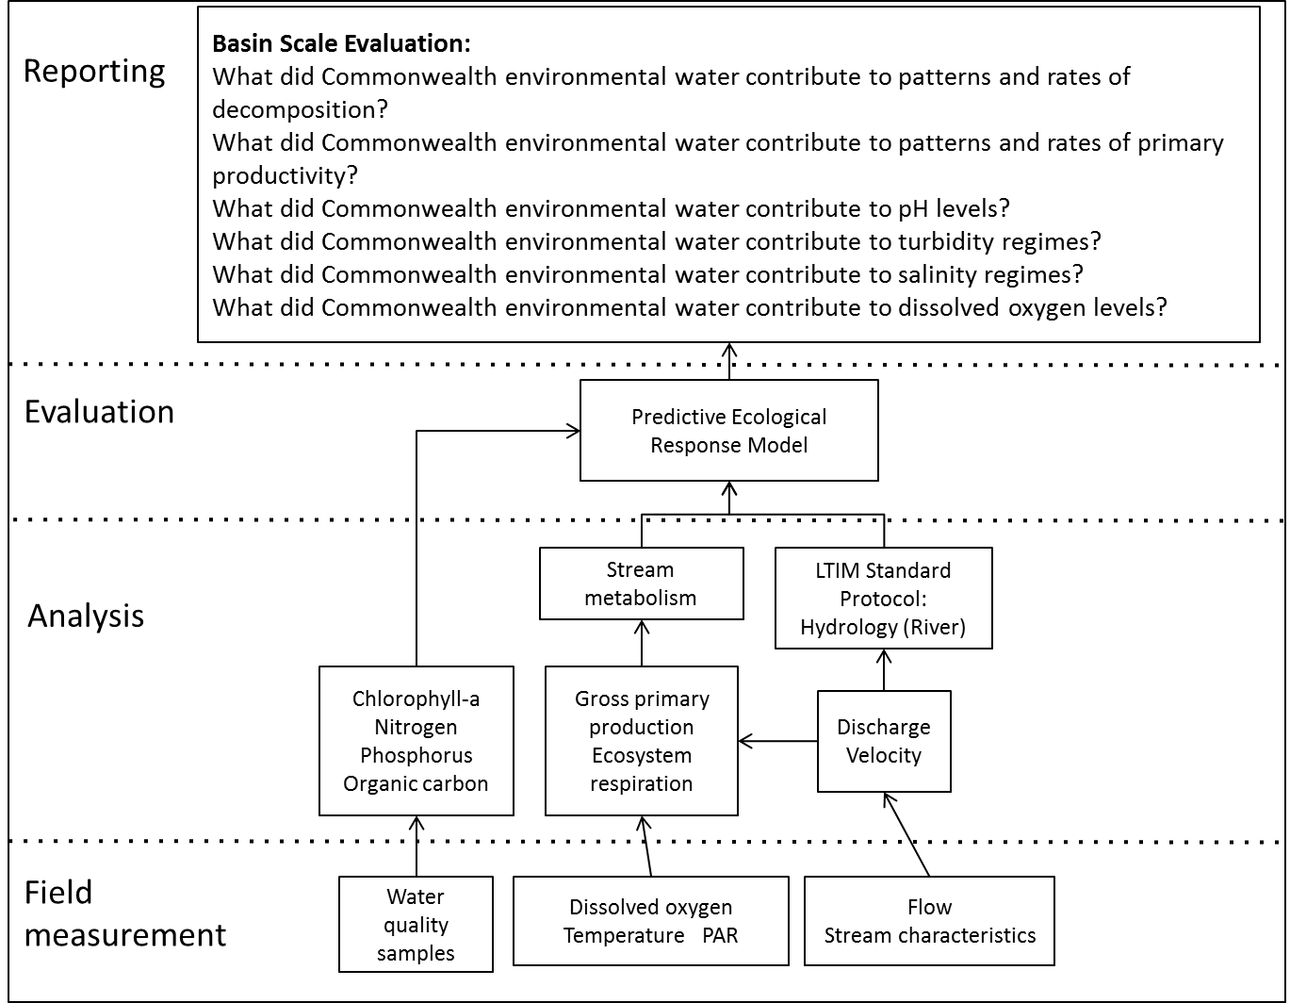

Figure 9. Schematic of key elements in the LTIM Project Standard Protocol: Stream metabolism and water quality.

### How

#### Data

The LTIM Project Standard Methods for water quality and stream metabolism have been designed to provide data appropriate for the evaluation of water quality outcomes at the Basin scale. This will be complemented by water quality monitoring data collected through other relevant programs including:

* short-term monitoring instigated by CEWO and/or MDBA in response to planned watering actions or a potential water-quality event
* data collected continuously as part of the stream gauging network.

#### Developing the evaluation approach

There are no plans to further develop the capacity to predict water quality responses to flow, as the variation in response through time and across the Basin means that levels of uncertainty around the predictions would limit their value.

For stream metabolism, models currently exist to enable prediction of reach-scale metabolism based on changes in dissolved oxygen over the course of 24 hours. There are no habitat preference curves or quantitative models that would enable prediction of the metabolic rates expected at a specified flow, either with environmental watering or the absence of environmental watering. There are, however, conceptual models that describe the relationship between flow and metabolism that would provide a starting point for making predictions to support evaluation.

It is proposed that quantitative models of stream metabolism will be developed that will:

* predict the rate of stream metabolism in the absence of environmental watering at the reach scale for reaches that are monitored
* predict both environmental flow and non-flow rates of stream metabolism at the reach scale for reaches that are not monitored
* support estimation of Basin-scale changes to stream metabolism in response to environmental watering.

Model development will start with refinement of the conceptual models to provide a foundation for the quantitative model development. Existing data and expert elicitation will then be used to convert the conceptual model into a quantitative model (a process known as parameterisation).

## Aggregation of Selected Area biodiversity outcomes (generic diversity)

Commonwealth environmental water is managed to protect and restore species diversity, including the Basin’s threatened and endangered species. This component of the Basin Evaluation will identify the species protected or restored by Commonwealth environmental water that are not included in the evaluation of vegetation or fish. The major faunal groups that are expected to be evaluated include waterbirds, frogs and turtles. However, the scope of evaluation will be limited by the availability of monitoring data.

### Why

One of the Basin Plan objectives is to give effect to relevant international agreements through the integrated management of Basin water resources. In order to achieve this objective, the Basin Plan seeks to protect or restore biodiversity, which includes threatened and endangered species. In addition to fish there are a number of animal species listed as threatened or endangered that would be expected to respond to environmental watering actions. The distribution of these threatened species tends to be restricted. The effects of Commonwealth environmental watering actions on these species can still be evaluated through an aggregation of Selected Area outcomes to provide a Basin Evaluation of the species that have been protected or restored. The major faunal groups that could be included in the evaluation, if data were available, include:

* waterbirds
* frogs
* turtles
* bush birds such as Grey-crowned Babbler (*Pomatostomus temporalis*)
* birds of prey such as White-bellied Sea-eagle (*Haliaeetus leucogaster*)
* bats such as the Southern myotis (*Myotis macropus*)
* other small mammals such as Brush-tailed phascogale (*Phascogale tapoatafa*) and Yellow-footed antechinus (*Antechinus flavipes*).

### What

This component of the Basin Evaluation will address the following Basin-scale evaluation questions:

* Long-term (five-year) question:
  + What did Commonwealth environmental water contribute to other vertebrate populations?
* Short-term (one-year) and long-term (five-year) question:
  + What did Commonwealth environmental water contribute to other vertebrate species diversity?

The analysis will examine changes in species metrics and community composition in response to watering actions to develop lists of species having benefited from Commonwealth environmental water. The species lists for individual Selected Areas and years will be aggregated to provide a list of the species that were protected or restored by Commonwealth environmental water across the Basin.

### How

The evaluation will be based on an aggregation of Selected Area outcomes to generate a list of the species that have benefited from Commonwealth environmental watering actions across the Basin. Predictions will be based on information from systems that do not receive environmental flows and conceptual models.

There is a risk that significant outcomes may not be recorded due to:

* monitoring being focussed on other faunal groups
* the species being rare and/or cryptic
* the specific outcome (e.g. change in individual condition or distribution) not being included in the monitoring.

This is an inevitable risk in the design of any monitoring program and the evaluation will seek to reduce this risk through utilising multiple lines of evidence and conceptual models to support evaluation in the absence of dedicated monitoring information.

There will be a higher level of uncertainty around defining the outcomes for watering actions due to the lack of predictive capacity that would support development of expected and without environmental water outcomes. This will affect the levels of confidence in reporting outcomes and will limit the opportunities for adaptive management, particularly in situations where water actions lead to relatively small changes in biodiversity.

Given the diversity of species that may be included in this section, it is not anticipated that predictions of without environmental water outcomes will be based on quantitative models, rather they will rely on a combination of information from conceptual models or control situations (such as sites that did not receive environmental water). Over time, the information generated by the LTIM Project will be used to refine conceptual models and thereby improve their predictions.

## Hydrology – flow regime

### Why

The flow regime underpins all of the other evaluations and forms the basis for the evaluation of outcomes for biodiversity, ecosystem function and resilience at the Basin scale. In addition, the flow regime is a Basin Matter under the Outcomes Framework that will be evaluated in its own right.

### What

This component informs the evaluation all other Basin Matters, and directly addresses the following short-term (one-year) and long-term (five-year) Basin-scale evaluation question:

* What did Commonwealth environmental water contribute to restoration of the hydrological regime?

Flow regime data are being collected at the Selected Areas by M&E Providers and can be sourced for other areas from the existing streamflow gauging network. These data will be used as inputs to models of flow regime with and without Commonwealth environmental water. The relationship between field measures, data analysis and evaluation is illustrated in Figure 10. The outputs of the Basin Evaluation of flow regime will comprise:

* A statistical report on flow components (cease-to-flow events; base flows; freshes; bank-full flows; and overbank flows) delivered over the duration of the LTIM Project compared with the flow regime under the case where no Commonwealth environmental water was delivered. This description will be provided at key hydrological sites, which are representative of the waterways targeted for Commonwealth environmental watering actions across the Basin. The report will be developed initially for the Selected Areas. It will be extended to other areas receiving Commonwealth environmental water in later years.
* daily streamflow series at key hydrological sites for the actual and modelled without Commonwealth environmental water scenarios.

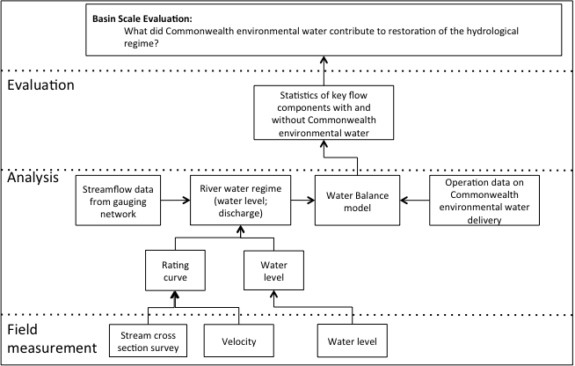

Figure 10. Schematic of the relationship between field measures, data analysis and evaluation.

### How

The flow regime evaluation will be a collaborative undertaking by CEWO, MDBA and MDFRC. The flow actually delivered will be characterised using streamflow gauge measurements that will be collated by MDBA and CEWO.

The estimate of flow without Commonwealth environmental water will be based on release information provided to CEWO by delivery partners. The CEWO will subtract releases from actual flows to describe the flow in the absence of Commonwealth environmental water. This will require that CEWO water delivery be described as part of operational reporting. Developing the specifications for this reporting with CEWO delivery staff and delivery partners will be included as part of the first year of the project plan.

The operational reports on CEWO actions will be converted into hydrological consequences using ratings curves and the river system models developed by MDBA and Basin states. Where available, existing floodplain inundation models may be used. It is anticipated that the capacity to report on hydrological outcomes will evolve over the course of the project. Early on in the project, reporting will be constrained to the information that can be generated by existing rating curves, river system models and other sources. It is anticipated that MDBA will develop additional capacity to model and report on the extent of floodplain inundation over the course of the project.

The changes in the frequency and average duration, magnitude and timing of events will be aggregated up to the Basin scale to provide an evaluation of the influence of Commonwealth environmental water on Basin flow regimes.

## Hydrological connectivity

### Why

Hydrological connectivity contributes to the analysis of outcomes for biodiversity, ecosystem function and resilience at the Basin scale. It underpins evaluations related to floodplain vegetation and wetlands. Hydrological connectivity is also a Basin Matter under ecological function in the Outcomes Framework that will be evaluated as an indicator in its own right.

### What

This component informs the evaluation of all other Basin Matters and directly addresses the following short-term (one-year) and long-term (five-year) Basin-scale evaluation question:

* What did Commonwealth environmental water contribute to hydrological connectivity?

The outputs of Basin Evaluation of hydrology will comprise:

* an annual report on hydrological connectivity, which includes annual and cumulative (i.e. multi-year) statistics related to:
  + lateral connectivity at the Basin and valley scales
  + longitudinal connectivity in the southern and northern basins
* comparison of statistics for the actual conditions and the modelled scenario without Commonwealth environmental water.
* Floodplain inundation extents, in areas where floodplain inundation models currently exist and utilising any additional floodplain inundation models that become available over the life of the project. If MDBA develops the capacity to map inundation extent, this information will underpin reporting on the extent of hydrological connectivity and support evaluation of wetland and floodplain Basin Matters.

### How

Longitudinal connectivity relates to the impacts of Commonwealth environmental water on sustaining flows downstream through the tributary valleys and the entire MDB river network to the lower Darling River and Lower Lakes. In the first instance, the hydrological analysis will be for particular valleys (starting with the Selected Areas) and longitudinal connectivity can be assessed in terms of the effect of Commonwealth environmental watering actions on flow components at the outlet of the valley.

Lateral connectivity relates to the exchange of water between river channels and floodplains or wetlands. Evaluation of lateral connectivity will rely on the available information and modelling capacity and is therefore expected to evolve as MDBA and State Agencies improve their capacity to predict the extent of inundation of wetland and floodplain systems. The development of reporting on lateral connectivity is expected to progress in three steps:

1. Identification of the ecosystems connected and the timing, type and duration of connection. This evaluation will be based on existing floodplain inundation models, analysis of Landsat imagery and information on commence to fill from MDBA and other sources.
2. Calculation of the area of inundation. This will be based on proposed MDBA modelling as it becomes available.
3. Calculation of the volume of water transferred from one ecosystem to another. Volume is routinely used as a hydrological indicator of connectivity but has relevance for only some elements of environmental connectivity. Initially, reporting on volumes may occur at sites where existing hydraulic models are available. Once MDBA develop their floodplain inundation models, volumes may be reported for other areas.

The changes in the frequency and average duration, extent and timing of connections will be aggregated up to the Basin scale to provide an evaluation of the influence of Commonwealth environmental water on hydrological connectivity.

## Summary

Table 3 shows the links between Basin Plan objectives, Basin Matters and their output in terms of scale.

Table . Linkages between Basin Matters and Basin Plan objectives.

|  | **Matter** | **Basin-scale method** | **Output** | **Time frame** |
| --- | --- | --- | --- | --- |
| Biodiversity | Ecosystem diversity | Intersection of hydrology (actual and predicted without Commonwealth environmental water) with ANAE layer. | Identification of aquatic ecosystem types that received Commonwealth environmental water | Annual |
| Vegetation diversity | Aggregation of Selected Area data | The effect of Commonwealth environmental water on plant species richness Basin-wide | Year two with annual refinement |
| Fish populations | Qualitative prediction of Basin-scale fish population responses based on observed (Selected Area) and predicted (un‑monitored areas) responses | The overall effect of Commonwealth environmental water on fish populations at Selected Areas | Annual |
| The predicted outcomes of Commonwealth environmental water on fish populations at all areas and at Basin scale | Five years |
| Ecosystem function | Hydrological connectivity and flow regime | Aggregation of Selected Area data | The effect of Commonwealth environmental water at all Areas to generate a Basin-wide estimate | Annual |
| The effect of Commonwealth environmental water on longitudinal connectivity at the Basin scale |
| Primary production | Aggregation of Selected Area data and predictions from other areas | The effect of Commonwealth environmental water on rates of primary production Basin-wide | Annual |
| Decomposition | Aggregation of Selected Area data and predictions from other areas | The effect of Commonwealth environmental water on rates of decomposition Basin-wide | Annual |
| Resilience | Ecosystem diversity | Same as Biodiversity |  |  |
| Hydrological connectivity | Same as Ecosystem function |  |  |
| Refuge condition | Aggregation of information from identified refuges | The effect of Commonwealth environmental water on refuge condition Basin-wide | Year two with annual refinement |

# Evaluating Basin Matters – integrated evaluation

The three broad environmental objectives of the Basin Plan: biodiversity, ecosystem function and resilience, will also be evaluated.

## Biodiversity

### Why

The Basin Plan seeks to protect and restore biodiversity of the Basin’s water-dependent ecosystems. This includes threatened and endangered species and ecosystems as well as representative populations and communities of native biota. Environmental flows are expected to improve biodiversity through their influence on habitat availability, ecosystem function and resilience.

### What

This component of the Basin Evaluation will address the following Basin-scale evaluation questions:

* What did Commonwealth environmental water contribute to ecosystem diversity?
* What did Commonwealth environmental water contribute to species diversity?

The Basin Evaluation of biodiversity will synthesise and integrate the individual Basin Matter evaluations relevant to the biodiversity objective to provide a measure of the total contribution of Commonwealth environmental water to biodiversity (Figure 11). The outputs of the Basin Evaluation of biodiversity will comprise:

* annual assessment of watering action outcomes on biodiversity based on the aggregation of data from Selected Areas as well as on our conceptual understanding of flow–ecology relationships and data from other programs to infer biodiversity outcomes at the Basin scale
* longer-term evaluation of biodiversity outcomes to explore patterns and trends in biodiversity outcomes of Commonwealth environmental water at two- to five-year time scales. That is, to assess the effects of Commonwealth environmental water on biodiversity in years following watering actions.

### How

This analysis will take the form of a procedural and reporting integration of information from Basin Matter outputs and other information sources. Reported outcomes and modelled predictions from the Basin Evaluation of ecosystem diversity, vegetation diversity, fish populations and generic diversity will be integrated to provide an overall evaluation of the influence of Commonwealth environmental water in protecting or restoring the Basin’s biodiversity.

In the first year, the evaluation will be an integration of reported outcomes, rather than a re-assessment of the original data. As more information becomes available, the outputs from each of the relevant Basin Matters will be used to look for longer-term patterns and trends and assess questions related to biodiversity outcomes in the years following a Commonwealth watering event.

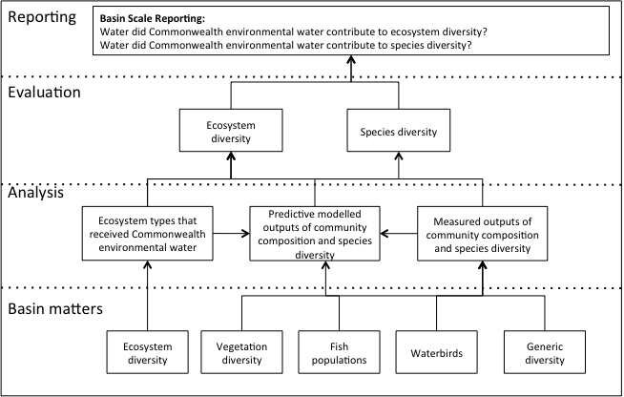

Figure 11. Schematic of key elements in the LTIM Project: Biodiversity Evaluation.

## Resilience

### Why

Resilience is the capacity of a system to respond to disturbance (resist, recover and adapt) while undergoing change so as to still retain essentially the same function, structure and feedbacks and therefore its identity. Environmental flows are expected to:

* protect refugia in order to support the long-term survival and resilience of water-dependent populations of native flora and fauna
* provide wetting and drying cycles at inundation intervals that do not exceed the tolerance of ecosystem resilience or the threshold of irreversible change.

### What

This component of the Basin Evaluation will address the following Basin-scale evaluation questions:

* What did Commonwealth environmental water contribute to ecosystem resilience?
* What did Commonwealth environmental water contribute to population resilience?

The Basin Evaluation of resilience will evaluate the influence of Commonwealth environmental water on water quality in refuges as an indicator of refuge condition, hydrological connectivity as an indicator of the capacity of native biota to survive disturbances and ecosystem diversity as an indicator of system resilience (Figure 12).

The outputs of Basin Evaluation of resilience will comprise:

* the annual assessment of watering actions undertaken in Selected Areas along with the conceptual understanding of resilience and indicators of resilience for aquatic systems will be integrated to describe resilience outcomes at the Basin scale as a result of Commonwealth environmental water
* a longer-term evaluation of Commonwealth environmental water influences on ecosystem resilience to future disturbance (e.g. climate change) and recent disturbance (e.g. drought).

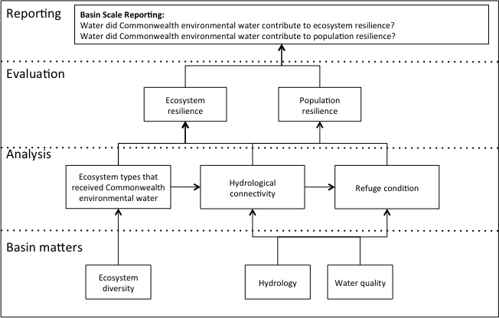

Figure 12. Schematic of key elements in the LTIM Project: Resilience Evaluation.

### How

This analysis will use existing data and reported outputs from the Selected Areas and Basin Matters to derive and explore indicators of resilience (resistance and recovery). Identifying indicators of aquatic ecosystem resilience is an emerging field and in the first instance, reported outcomes at the Selected Area scale will be assessed for their potential for use in qualitatively and quantitatively providing indicators of resilience. The exact nature of this evaluation will be highly dependent on data collected from the Selected Areas. However, it is anticipated that it will be possible to use at least three measures to describe the effect of Commonwealth environmental water on ecosystem resilience:

* water quality of in-channel waterholes as an indicator of the effect of Commonwealth environmental water on refuges
* the extent and duration of hydrological connectivity as an indicator of the capacity of native biota to move to more suitable habitat or refuges
* Basin-wide ecosystem diversity as an indicator of system resilience.

Data from other relevant programs will be incorporated where possible. For example, if the MDBA tree stand condition monitoring of the Basin continues, these data could be used to assess the effect of Commonwealth environmental water on maintaining populations of long-lived organisms as an indicator of ecosystem resilience.

## Ecosystem function

### Why

Ecosystem functions are the hydrological and ecological processes required to sustain an ecosystem through time. Environmental flows are expected to protect or restore a range of ecosystem functions including the exchange of material among parts of the system, movement of biota to enable them to complete their life cycle, the creation and maintenance of habitat and production of food.

### What

This component of the Basin Evaluation will address the following Basin-scale evaluation question:

* What did Commonwealth environmental water contribute to ecosystem function?

The Basin Evaluation of ecosystem function will include an evaluation of the influence of Commonwealth environmental water on patterns of primary production and decomposition, which are both indicators of food availability, as well as an evaluation of hydrological connectivity, which is an indicator of the movement of nutrients, sediment and biota (see Figure 13).

The evaluation of ecosystem function will support the evaluation of both resilience and biodiversity and inform the planning and implementation of Commonwealth environmental watering actions.

The outputs of the Basin Evaluation of resilience will comprise:

* the annual assessment of watering actions undertaken in Selected Areas along with the conceptual understanding of function in aquatic systems, integrated to describe outcomes at the Basin scale as a result of Commonwealth environmental water
* longer-term evaluation of Commonwealth environmental water influences on ecosystem function over periods greater than one year.

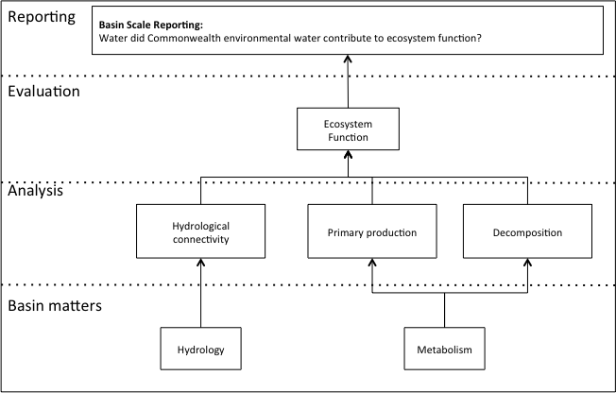

Figure 13. Schematic of key elements in the LTIM Project: Ecosystem Function Evaluation.

### How

This analysis will take the form of a procedural and reporting integration of information from Basin Matter outputs and other information sources. Reported outcomes and modelled predictions from Basin Evaluation of hydrological connectivity and metabolism will be integrated to provide a measure of the total contribution of Commonwealth environmental water to ecosystem function.

In the first year the evaluation will be an integration of reported outcomes, rather than a re-assessment of the original data. As more information becomes available, the outputs from each of the relevant Basin Matters will be used to look for longer-term patterns and trends and assess questions related to ecosystem function outcomes in years following a Commonwealth watering event.

## Basin Evaluation

The outcomes of all the Basin Matter evaluations will be synthesised into an annual Basin Evaluation report (Figure 14). It is difficult to be precise about the form and content of this report, as it will be highly dependent on data collected and the evaluation of individual matters. However, this report will be a high level document that integrates the outcomes of Commonwealth environmental water and addresses the following questions:

* What did Commonwealth environmental water contribute to Basin Plan objectives?
* What have we learned about environmental water delivery?
* How have we improved and can continue to improve our management of environmental water in the Basin?

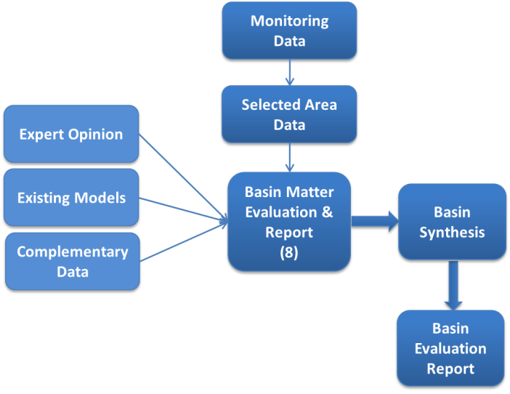

Figure . Relationship between each Basin Matter and the Basin Evaluation Report.

This Basin-level synthesis will take a holistic spatial and temporal view of the outcomes of Commonwealth environmental water, attempting to integrate the evaluation of individual matters over space and the five-year time frame. Trends and synergies between matters (e.g. fish and stream metabolism) will be explored. An assessment of outcomes by ecosystem type will be undertaken across the Basin in the form of a catalogue of observed versus expected outcomes. The Basin Evaluation will consider the extent to which the water requirements of different aquatic ecosystem types and their components and processes have been met.

The evaluation will focus on furthering the understanding of the multiple outcomes of Commonwealth environmental watering and develop a narrative of Basin-scale responses. It is envisioned that the Basin Evaluation report would also contain a non-technical summary that could be used as a stand-alone communication tool for stakeholders and interested members of the public.

# Pilot Basin Evaluation

## Why

As the Basin Evaluation represents a major innovation in the area of environmental watering monitoring and evaluation, issues are likely to arise as the Basin Evaluation Plan is implemented. A Pilot Basin Evaluation will be undertaken in the first year to test the proposed evaluation process in a context where the consequences of problems are limited. The outcome of the Pilot will be a refined and more efficient Basin Evaluation process.

## What

The objectives of the Pilot Basin Evaluation are:

* to synthesise the outcomes of past Commonwealth environmental watering actions using the Outcomes Framework and, to the extent possible, the Basin Matter evaluation methods
* where possible, to assess the information available in the context of the Basin Matter evaluation methods, which would include testing the likelihood of being able to successfully implement the Basin Evaluation methods as described in this plan
* to test and refine the integrated evaluation approach based on existing data.

The Pilot Basin Evaluation will utilise existing data and reports from CEWO’s previously-undertaken environmental watering actions (based on information available from previous monitoring projects and the available Annual Outcomes Reports). The scope of the Pilot Basin Evaluation will include those matters monitored as part of CEWO Short-term Intervention Monitoring projects from 2011–12 and 2012–13. The Pilot Basin Evaluation will prioritise matters which are consistent with those proposed for the LTIM Basin Evaluation (Table 4) but will also evaluate outcomes for other matters monitored where it is appropriate to do so, including information from the Gwydir river system.

Table 4. Scope of CEWO short-term monitoring projects.

|  |  |  |  |  |  |  |
| --- | --- | --- | --- | --- | --- | --- |
| River system | Reports | Vegetation | Fish populations | Hydrology* | Other vertebrates | Water quality |
| **Lower Murray River** | 2011–12 2012–13 |  | ✓ | ✓ | ✓ | ✓ |
| **Edward–Wakool river system** | 2011–12 2012–13 |  | ✓ | ✓ | ✓ | ✓ |
| **Goulburn–Broken river system** | 2012–13 | ✓ | ✓ | ✓ |  | ✓ |
| **Murrumbidgee (Lowbidgee)** | 2011 |  | ✓ | ✓ | ✓ | ✓ |
| **Murrumbidgee river system** | 2011–12 2012–13 | ✓ | ✓ | ✓ | ✓ | ✓ |
| **Murray–Murrumbidgee Rivers – blackwater** | 2012 |  |  |  |  | ✓ |

*Hydrological data will likely vary across the projects.

## How

In order to be useful to the development of the Basin Evaluation process in the first year, the Pilot Basin Evaluation will focus on a limited number of matters as shown in . To enable learnings from the Pilot to be incorporated into evaluation processes and activities for the year one Basin Evaluation, the Pilot Evaluation will be completed by January 2015. To meet this timeline, data collection will commence immediately.

In addition to information from the CEWO short-term monitoring projects, the Pilot Basin Evaluation will use multiple lines of evidence as discussed above, including cause and effect diagrams (Gawne *et al*. 2013) and habitat preference curves.

The Basin Evaluation Synthesis Team will oversee the development of the structure and analysis being undertaken for the Pilot Basin Evaluation.

The relationship between the Pilot Basin Evaluation project and the other components of the Basin Evaluation is shown in Figure 15.

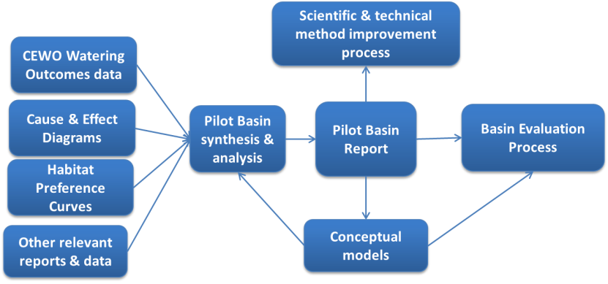

Figure 15. Relationship between the Pilot Basin Evaluation and other project components.

# Adaptive management of Basin Evaluation

Adaptive management is an iterative process to incorporate new knowledge into decision-making. The Basin Evaluation will inform adaptive management of Commonwealth environmental water, but this is a process managed by CEWO and detailed in the Operations Manual (Commonwealth of Australia 2013). In terms of this evaluation plan, adaptive management is considered in the context of improving Basin Evaluation and comprises two core activities:

* annual forums
* technical review.

## Annual forums

An LTIM Project Annual Forum will be run as a two-day workshop each year in Sydney. This forum will provide an opportunity for participants in the LTIM Project to discuss and collaborate on lessons learnt, achievements and technical challenges. As a part of the Annual Forum development and reporting process, data collected at the Selected Area scale for Basin Evaluation will be reviewed by the Basin Evaluation Synthesis Team and, where necessary, refinements made. Key topics relevant to Basin Evaluation for review and discussion may include:

* Standard Methods
  + fit for purpose, difficulties in implementation, suggested refinements or improvements
* frequency and spatial scale of data collection
  + adequacy for informing Basin Evaluation, refinements or amendments required
* Selected Area specific data (Category III methods)
  + use in informing Basin Evaluation, could Basin Evaluation be expanded or altered to include additional measures?
* timeliness of data availability
  + how is data availability influencing project outcomes; how can these be overcome or mitigated? use of conceptual models, complementary data, etc.

The Basin Matter leaders and the Basin Evaluation Synthesis Team will refine how the outcomes of the LTIM Project Annual Forum will be incorporated into the Basin Evaluation.

## Technical review

The Technical Review of the LTIM Project will be completed towards the end of the final year of the project (year five). The aims of the review are to fulfil accountability requirements, collate learning and inform future monitoring and evaluation programs (Commonwealth of Australia 2009). The terms of reference for the Technical Review will be developed in line with current Australian Government policy.

It is anticipated that the Technical Review will occur at two scales:

1. Basin Matters – Basin Matter leaders will be responsible for reviewing the outputs of their individual matters against terms of reference relating to adaptive management.
2. Basin Evaluation – the Project Director will review the Basin Evaluation process as a whole, drawing on the Basin Matter outputs, integration components and assessing the higher level, overall impact aspects of the project.

# Project governance and team

The Basin Evaluation will be undertaken by a consortium team, led by the Murray-Darling Freshwater Research Centre (MDFRC) with contributions from the following partner organisations: CSIRO, Melbourne University, Deakin University, Griffith University, Australian National University and independent consultants.

Summaries of relevant skills and experience for team members are provided at Appendix B.

## Project management structure and responsibilities

The project management structure for the Basin Evaluation is shown in Figure 16.

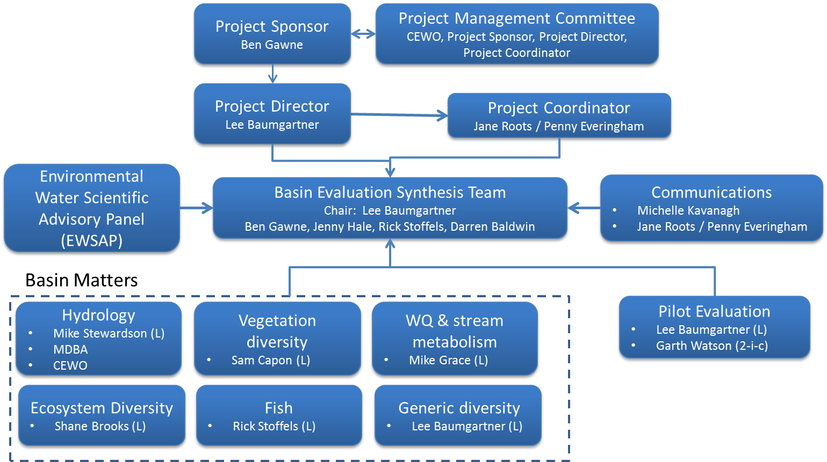

Figure : Project management structure for the Basin Evaluation

**Description of roles and responsibilities**

**Project Sponsor**: Ben Gawne has ultimate accountability for the Basin Evaluation Project including the delivery of all outcomes and outputs. Specific responsibilities include:

* Overarching strategic direction
* Ensuring project scope is fit for purpose and that sufficient resources have been allocated to project
* Ensuring identified outcomes and benefits of Basin Evaluation are achieved and meet the needs of the CEWO
* Resolution of high level issues that have been escalated by Project Director
* Representing the MDFRC at external stakeholder engagement activities where appropriate

**Project Director:** Lee Baumgartner has overall responsibility for the management of all contracted milestones to ensure delivery of outputs and outcomes. This involves directing and as-needed decision making regarding the management of project activities and team members with respect to the implementation of the Basin Evaluation Plan.

Specific responsibilities comprise:

* Overall project management of the Basin Evaluation Project Plan
* Overseeing the completion of contracted deliverables and milestones, including their quality and timeliness
* Ensuring project delivery (outputs within time, budget and quality)
* Managing risks and escalating residual high or severe risks to Project Sponsor
* Providing direction to Basin Matter team leaders regarding project outputs
* Contribute to communications with M&E partners about project outputs and progress

**Project Coordinator:** Jane Roots/Penny Everingham will be responsible for:

* Day to day coordination of project activities including tracking task and due dates
* Organising meetings and secretariat duties
* Coordinating deliverables from multiple team members
* Managing the budget and invoicing procedures
* Completing Progress reporting and general communications
* Maintaining the risk log and risk mitigation processes
* Disseminate information to relevant parties within reasonable timeframes.

**Project Management Committee**: The Basin Evaluation Project Sponsor, Project Director, Project Coordinator and CEWO representatives will form the Project Management Committee. In addition, representatives from other projects (such as the Environmental Water Knowledge Research Project and the Integrated Ecosystem Condition Assessment project which could benefit from links with the LTIM Project) may be involved with the Committee at various times. The Project Management Committee will meet quarterly and be responsible for direction and oversight of the Basin Evaluation. The key objective of this Committee is to ensure the Basin Evaluation meets its objectives and that synergies, learnings and efficiencies are gained between all the large scale environmental projects.

**Basin Evaluation Synthesis Team**: Senior scientists with in-depth knowledge and experience in various aspects of freshwater science as well as monitoring and evaluation will comprise the Basin Evaluation Synthesis Team, with Lee Baumgartner acting as chair. Their role is to draw together the different components of the Basin Evaluation and produce the annual Basin Evaluation Report. This Group will also provide advice to Basin Matter team leaders on the Basin Evaluation and reporting frameworks as well as advice on adaptive management of both environmental water and improved monitoring and evaluation.

**Environmental Water Scientific Advisory Panel** (EWSAP):The Project will draw on the expertise and knowledge of the existing EWSAP, if required, to provide high level scientific and technical advice to the Basin Evaluation Synthesis Team and to possibly to the individual Basin Matter teams on an as-needed basis. It is not foreseen that the advice would be needed frequently, and will be sought as determined by the Basin Evaluation Synthesis Team.

**Communications:** Michele Kavanagh will head the communications team for the Basin Evaluation, together with the Project Coordinator. She will be responsible for drafting communication products for approval by the Project Director and Project Sponsor for a broad range of stakeholders and a non-technical audience.

**Pilot Evaluation**: Lee Baumgartner will lead a team of MDFRC scientists to undertake the Pilot Evaluation. However, as the Pilot Evaluation will be used to inform the Basin-scale Evaluation, it is important that the Basin Evaluation Synthesis Team is involved in developing the structure and focus of the Pilot Evaluation.

## Basin Matter team structure and responsibilities

The project team for the technical components of the Basin Evaluation has been structured around the Basin Matters. The flow of information for Basin Evaluation is illustrated in Figure 17, which demonstrates critical information pathways. Evaluation of Basin Matters and the production of a Basin Evaluation Report is a highly interdependent process. The most critical pathways include the flow of information about hydrology, through the CEWO hydrologist and Selected Area data from M&E Providers.

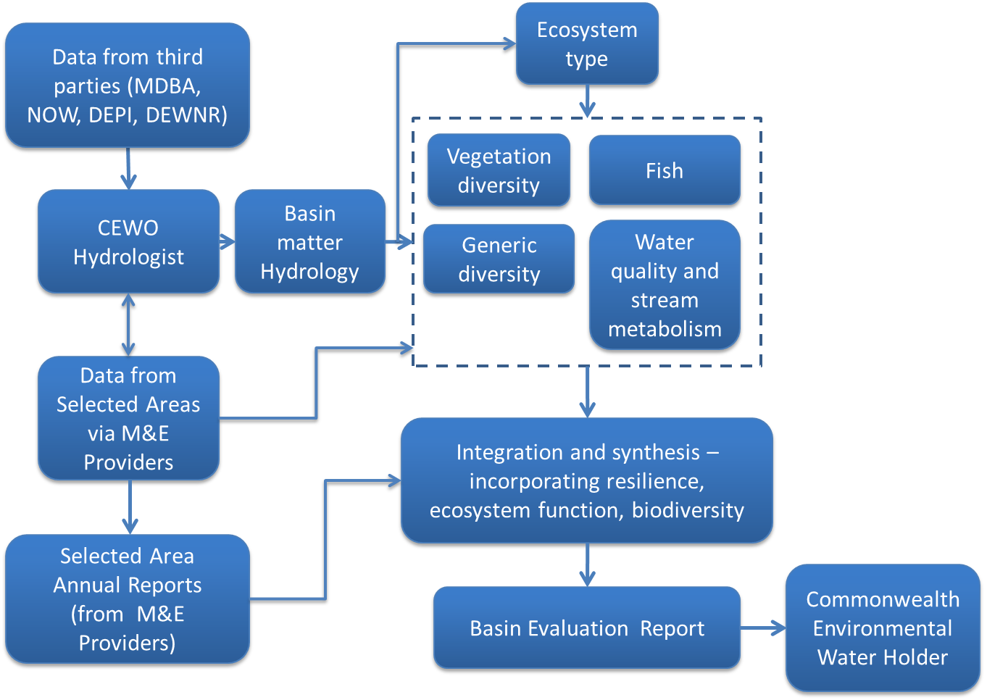

Figure : Basin Evaluation information flow.

The leaders for each Basin Matter are as follows:

* Fish: Dr Rick Stoffels
* Water quality and stream metabolism: Dr Mike Grace
* Vegetation Diversity: Dr Samantha Capon
* Ecosystem diversity: Dr Shane Brooks
* Hydrology: Dr Mike Stewardson
* Generic diversity: Dr Lee Baumgartner

Each Basin Matter leader will be supported by a team who will undertake data analysis, evaluation and reporting activities under the direction of the leader. The Basin Matter leaders will be responsible for:

* Developing their foundation report which provides the background for the evaluation approach;
* Managing the team and outputs with respect to assigning responsibilities and tasks to team members, ensuring milestones are met;
* Managing the quality of the evaluation and providing direction on technical aspects of evaluation;
* Reviewing the outputs of team members and integrating the evaluation for their respective Matter;
* Maintaining communication with the Project Director and other relevant Basin Matter leaders;
* Completing the Summary of Expected Outcomes by February each year;
* Completing the draft Annual Report by end of June each year;
* Completing the final Annual Report by the end of October each year;
* Participating in meetings and discussions with the Basin Evaluation Synthesis Team, with input to Basin synthesis and evaluation.

# Timeline and schedule

## Timeline

Other than the first year when the Pilot Basin Evaluation is undertaken and the initial Basin Matter foundation reports (methodology and workplans) are developed, the schedule of activities for the project will remain consistent throughout the five years as shown in Table 5. The majority of these activities are linked to the Milestones discussed in Section 4.2.

Table : Timeline of main Basin Evaluation Plan activities: 2014-15 to 2018-19[2]. Critical pathways shown in red arrows.



## Milestone schedule

The schedule for the implementation of the Basin Evaluation Plan for the period 2014-15 to 2019-20 is detailed in Table 6.

Table : Milestone schedule for the implementation of the Basin Evaluation Plan for the period 2014-15 to 2019-20

| Milestone | Description | Timing | | | | | |
| --- | --- | --- | --- | --- | --- | --- | --- |
| Year 1 | Year 2 | Year 3 | Year 4 | Year 5 | Year 6 |
| 1. **Pilot Evaluation** | | | | | | | |
| * 1. Pilot Evaluation inception meeting | Meeting held and minutes distributed to all attendees plus CEWO | Sept 2014 |  |  |  |  |  |
| * 1. Pilot Evaluation Progress Report | Progress report on Pilot evaluation submitted | 31 Oct 2014 |  |  |  |  |  |
| * 1. Draft Pilot Evaluation report | Draft report completed | 31 Mar 2015 |  |  |  |  |  |
| * 1. Final Pilot Evaluation report | Final report completed | 30 Apr 2015 |  |  |  |  |  |
| 1. **Basin Matter Analysis & Reporting** | | | | | | | |
| * 1. Basin Matter Foundation Report | Report describing and justifying the approach to analysing Basin scale outcomes | May 2015 |  |  |  |  |  |
| * 1. Basin Matter team leader meeting | One day workshop held to review and discuss expected outcomes for each Basin Matter and implications for Basin Evaluation |  | Feb 2016 | Feb 2017 | Feb 2018 | Feb 2019 | Feb 2020 |
| * 1. Basin Matter – Expected Outcomes report | Expected outcomes draft report completed, outlining model parameters and expected outcomes; including preliminary framework for analysis of Selected Area data |  | 28 Feb 2016 | 27 Feb 2017 | 28 Feb 2018 | 28 Feb 2019 | 28 Feb 2020 |
| * 1. Basin Matter draft report | Draft report for each Basin Matter completed |  | 30 Apr 2016 | 30 Apr 2017 | 30 Apr 2018 | 30 Apr 2019 | 30 Apr 2020 |
| * 1. Final Basin Matter report | Final report completed for each Basin Matter (to accompany Final Basin Evaluation Report) |  | 30 Jun 2016 | 30 Jun 2017 | 30 Jun 2018 | 30 Jun 2019 | 30 Jun 2020 |
| * 1. Annual Basin Hydrology report | Annual report describing the Basin’s flow regime over the previous 12 months | Jul 2015 | Jul 2016 | Jul 2017 | Jul 2018 | Jul 2019 |  |
| 1. **Basin Evaluation** | | | | | | | |
| * 1. Basin Evaluation Planning Workshop | Workshop with key stakeholders, reviewing rationale for Basin Evaluation and finalisation of Basin Evaluation Plan | Oct 2014 |  |  |  |  |  |
| * 1. Expected Outcomes synthesis report | Mid-year report from Basin Evaluation Synthesis Team completed, outlining expected parameters for evaluation based on current conditions and/or previous years’ reports |  | Mar 2016 | Mar 2017 | Mar 2018 | Mar 2019 | Mar 2020 |
| * 1. Basin Evaluation Synthesis Team annual meeting | 1 day meeting / workshop to ascertain focus of annual Basin Evaluation report |  | May 2016 | May 2017 | May 2018 | May 2019 | May 2020 |
| * 1. Draft Basin Evaluation Report | Draft Basin Evaluation report completed |  | 15 Jun 2016 | 15 Jun 2017 | 15 Jun 2018 | 15 Jun 2019 | 1 Jun 2020 |
| * 1. Final Basin Evaluation Report | Final report, incorporating comments from Basin Evaluation team and Annual Forum |  | 31 Aug 2016 | 31 Aug 2017 | 31 Aug 2018 | 31 Aug 2019 | 30 Jun 2020 |
| 1. **Annual Forum** | | | | | | | |
| * 1. Preparation | Forum venue booked, topics agreed, agenda and background papers prepared and distributed | May 2015 | May 2016 | May 2017 | May 2018 | May 2019 |  |
| * 1. Annual Forum | Annual Forum held |  | July 2015 | July 2016 | Jul 2017 | Jul 2018 | Jul 2019 |
| * 1. Outcomes report | A brief written summary completed; containing issues discussed and any directions taken during the Forum. Revised Standard Methods released. |  | Aug 2015 | Aug 2016 | Aug 2017 | Aug 2018 | Aug 2019 |
| 1. **Technical Review** | | | | | | | |
| * 1. Draft outline of (5 year) Technical Review | Draft outline of Technical Review completed |  |  |  |  | Jun 2018 |  |
| * 1. Draft report of the Technical Review of the LTIM Project | Technical Review draft report completed |  |  |  |  |  | 30 Jun 2020 |
| * 1. Final technical review of the LTIM Project report | Technical Review final report completed |  |  |  |  |  | 30 Jun 2020 |

# Project risk assessment

A long-term project involving a number of multi-disciplinary teams working together brings a set of risks to successful completion of the project. Early identification and effective management will be critical to the success of the Basin Evaluation. The information flow for the Basin Evaluation (Figure 17) highlights the critical paths for reporting of Basin scale outcomes of Commonwealth environmental water. In particular, the role of the CEWO hydrologist is critical to achieving the objectives of Basin Evaluation.

A detailed project risk assessment has been prepared and is part of the project management process. As the Basin Evaluation is not directly collecting data, nor involved with the delivery of environmental water, risks to the environment and health and safety of individuals were not considered relevant. The risk assessment identified the following key, high-level risks requiring monitoring and mitigation:

* Natural events prevent the collection of data from one or more Selected Areas resulting in potential for project delays.
* Delays in the provision of data from M&E Providers resulting in delays in completing Basin-scale evaluation.
* Required complementary data for a critical element such as hydrology is unavailable resulting in delays / negative impacts across all Basin-scale evaluation matters.
* No suitable events such as fish breeding occur / are monitored at Selected Areas, impacting on the ability to undertaken Basin-scale evaluation for relevant matters.
* Insufficient data / knowledge is available to build robust predictive models for Basin scale evaluation.

This risk assessment and mitigation strategies will be reviewed and updated quarterly (or more frequently if required) as part of the project management and progress reporting activities.

# Project quality plan

The M&E Advisers are not directly involved in monitoring activities or the collection of data. This is the responsibility of M&E Providers through the Monitoring Data Management System (MDMS), which have processes in place to control the quality of data, collected and input to the MDMS. The project quality plan for Basin Evaluation is focussed on: data storage and management and document management.

## Data storage and management

Data inputs for Basin Evaluation will be sourced from the Monitoring Data Management System (MDMS) using only data that has been subject to QA/QC and is flagged "final". Models and data outputs generated during the Basin Evaluation will be stored in the MDMS, attached to the appropriate spatial units (sites, area, Basin) with compliant metadata. Management of the data will be assisted through MDMS training provided to all users in Year One. Ongoing technical support related to the MDMS is provided throughout the duration of the Project

## Document management

Document management and final custodianship of documents will be vested in MDFRC and are informed by the MDFRC project management system. Draft documents are stored on the MDFRC server which is backed up to La Trobe’s secure servers in Bundoora. MDFRC currently files and stores all project documents on the MDFRC Project Management System. Final reports are lodged on the documentation using STAR Projects, a Star Systems Solutions program purchased by MDFRC electronic library that filters access depending on the client. MDFRC currently archives all documentation in accordance with the Centre’s needs, ranging from Title only through to access to the entire document. MDFRC currently store all documentation in accordance with the guidelines and protocols of the National Archives of Australia. The MDFRC also maintains a library of printed reports.

Individual Basin Matter Team leaders will be responsible for providing MDFRC with documents for storage and archiving.

The development of all reports (Basin Matter reports and the Basin Evaluation Report) includes:

* Clear allocation of roles and responsibilities for the report,
* Description to be in the initial Basin Matter method report, and in the Terms of Reference for the Basin Evaluation Synthesis Team
* Identification of senior author who is responsible for integration and consistency
* Identification of interdependencies
* Timeline, including delivery of:
* Sections
* Drafts to MDFRC and CEWO
* Delivery of final report
* Quality Assurance processes including;
* Version control (table included in document, and file name)
* Peer review. All MDFRC outputs are reviewed by two scientific reviewers who are familiar with the aims of the LTIM Project.
* Responses to feedback from CEWO. The senior author will review comments and develop a summary “response to comments table” for recording the response (see for an example). The senior author will then review the comments and identify any issues requiring clarification. Once clarified, the senior author will then delegate roles to team members and collate responses back into the body of the document and update the table of responses to summarise how feedback has been addressed.

Table : Recording of comments on draft reports

|  |  |  |  |  |
| --- | --- | --- | --- | --- |
| **Reference (chapter / page)** | **Reviewer** | **Review comment** | **Author’s response** | **Action taken** |
|  |  |  |  |  |
|  |  |  |  |  |
|  |  |  |  |  |
|  |  |  |  |  |

The implementation of the CEWO LTIM Project involves a Project Management Committee. The Project Management Committee will meet quarterly to review project progress, project risks and mitigation, as well as identify opportunities to improve efficiency and effectiveness in line with the principles of adaptive management. Members of the Project Management Committee will also have monthly tele-conferences and ensure open and frank communication between the CEWO, other M&E partners and the M&E Advisers.

## Reporting and communication

This section details the reporting and communication activities that will be undertaken as part of the implementation of the Basin Evaluation Plan over the period 2014-15 to 2019-20. The activities cover reporting and communication with the CEWO and parties directly involved in the LTIM Project (M&E Providers and other parties who will contribute to the development of evaluation methods).

Broader stakeholder communication, including communication with the Basin States, environmental flow partners other than the CEWO and the general public are outside the scope of this plan. Broader stakeholder communication for the LTIM Project will be undertaken for Selected Areas by the M&E Providers and for the LTIM Project as a whole by the CEWO.

**Reporting on project outputs and outcomes**

* **Basin Evaluation Report**. The Basin Evaluation Report is the major reporting output associated with this Basin Evaluation Plan and the task of evaluating the contribution of Commonwealth environmental water to the environmental objectives of the Basin Plan. The report will document the cumulative evaluation of the outcomes of Commonwealth environmental water across the Murray-Darling Basin, prepared in accordance with *The Basin Evaluation Plan* – *Part B: Implementation*. The Basin Evaluation Report will be published annually for the duration of the LTIM Project (draft report due in August, with the final report due in October).

The Basin Evaluation Report will have three main audiences, each of whom has different information needs:

1. The environmental water managers who are well informed about environmental watering but who generally are not scientists;
2. Any interested stakeholders, who may have limited knowledge of environmental water management and ecological science; and
3. Scientists for whom the scientific detail is important.

To meet the needs of all three audiences, the Basin Evaluation Report will be structured as follows:

* **An executive summary**: This is a separate, high level communication document which clearly and concisely explains the key outcomes, observations and messages in plain English without getting into scientific detail. It will specifically focus on the ecological response to the Commonwealth environmental water for a public audience (1 to 2 pages);
* **The main report**: a comprehensive document, written in plain English (suitable for a water manager and interested audience) and incorporating scientific concepts and containing the context, evaluation and adaptive management components of the Basin evaluation (around 20 pages). This document will describe outcomes and meaning of the evaluation and provide information and lessons for adaptive management. This report will include an important interpretative section which clearly explains scientific opinion and makes inferences on what the observations and outcomes mean for environmental water management, including translation of monitoring observations to broad ecosystem responses to environmental watering.
* **Appendices**: There will be separate appendices for any detailed results and methods for a technical or academic audience containing each Basin Matter report with the scientific evidence and detailed information on the evaluation undertaken.

The format of the reports will be as follows:

* use the common language provided by the Outcomes Framework, Cause and Effect Diagrams and the standard terms provided by the Operations Manual;
* use consistent language, approach and style throughout the report (except for the appendices);
* any detailed methods and results are to be provided as a separate appendix;
* be clear on monitored, inferred, modelled and observed results;
* be in Microsoft Word format;
* all measurements must be expressed in Australian legal units of measurement;
* be written in plain English (with the common language of the Outcomes Framework prevailing);
* be of a publishable standard;
* cite source references and
* contain opportunistic photos of ecological outcomes from Commonwealth environmental watering where they are made available to MDFRC under the LTIM Project.

The Basin Evaluation Report will be prepared to a standard suitable for publication on the CEWO website.

The draft and final Basin Evaluation Reports will be based on the approach set out above and will be consistent with the Operations Manual, in accordance with the following requirements:

*Evaluation*

1. Evaluate the extent to which the expected outcomes identified in the Basin Evaluation Plan, and identified for environmental watering in the years 2014-15 to 2018—19, have been achieved;
2. Evaluate the outcomes of environmental water use based on available information using one or more of the following approaches:

* monitored results;
* quantitative evaluation;
* qualitative evaluation;
* inferred using scientific opinion and the outcomes framework; or
* inferred using expert scientific opinion and other evidence.

1. Clearly identify which of the above approaches was used for the evaluated outcome;
2. For the expected outcomes identified in the Evaluation Plan, provide clear answers to each relevant evaluation question;
3. Quantify to the fullest extent possible the marginal benefit of Commonwealth environmental water and other held environmental water delivered in conjunction with Commonwealth environmental water;
4. The evaluation of expected outcomes (both less than one year and one to five years) after the first year will need to be cumulative by considering the evaluation of results from the previous years
5. Include, where possible, preliminary findings in relation to one to five year expected outcomes (if necessary these may be supported by qualitative results in the earlier years leading to quantitative evaluation in the later years);

*Adaptive management*

1. Use monitoring and evaluation outcomes and expert scientific opinion to provide implications for future management of Commonwealth environmental water and how to improve for the future;

*Context*

1. Provide the broad context of the environmental conditions across the Basin; and
2. Provide a brief context to the watering actions and links to the expected outcomes from the watering action and previously evaluated outcomes.

* **Technical Review of the LTIM Project**. At the end of a project of this size, it is important to make time to reflect and learn. At the end of year 5 (October 2019), a report will be prepared to fulfil accountability requirements, collate learning and inform future monitoring and evaluation programs in line with current Australian Government policies. Terms of Reference for the review will be determined by the Project Management Committee. It is anticipated that the technical review will address basin Matters as well as the Basin Evaluation process.

**Reporting for project management**

* **Progress reports**. Regular, written progress reports will provide documentation on project progress, formally track progress towards project outcomes and monitor project risks and issues. A written report will be prepared summarising activities completed since the last report, tasks planned for the upcoming period and any emerging risks or issues. Reports will be prepared quarterly and submitted to CEWO in September, December, March and June (last business day of the month) for the duration of the LTIM Project.

**Communication activities relating to the project development**

* **LTIM Project Annual Forum**. Annual forums will provide an opportunity for participants in the LTIM Project to discuss and collaborate on lessons learnt, achievements and technical challenges. The Annual Forums will also help maintain good working relationships between the participating parties (including M&E Providers and M&E Partners). The Annual Forum will be a two-day workshop held in Sydney each year and will be attended by representatives from the M&E Advisers and the Basin Evaluation Synthesis Team, with individual attendees to vary among years depending of the topics to be discussed. In addition to attending the Annual Forum, the M&E Advisers will:
* Work with CEWO to set the agenda and, depending of topics to be discussed, host at least some of the sessions.
* Organise (with the CEWO) the logistics for the Forum, including organising a venue and catering.
* Facilitate the running of the Forum over the two days.
* **Workshop events**. An allowance has been made for the Project Sponsor (Ben Gawne) to attend up to four, one-day workshop type events in Canberra each year for the duration of the LTIM Project. These events will typically include attendance at two EWSAP meetings and two other meetings, although the mix of events may vary.

**Communication for project management**

* **Monthly Project meetings – CEWO and M&E Advisers**. Regular meeting between CEWO and the M&E Advisers will serve to monitor project progress, ensure the project remains on track to deliver against the project outcomes and to discuss and resolve project risks, issues and actions. These meetings will be held as monthly phone meetings for the duration of the LTIM Project. These meetings will be attended by the M&E Adviser Project Director and the Project Coordinator.
* **Quarterly project meetings** – CEWO and M&E Advisers. More formal quarterly meetings between CEWO and the M&E Advisers will serve to acknowledge progress and deliverables and address any cumulative issues which may arise from the monthly update meetings.
* **Biannual LTIM Project leaders’ meetings**. Regular meetings between the leaders of the LTIM Project teams (CEWO, M&E Providers and M&E Advisers) will be held to facilitate collaboration. These meetings will be held as biannual (twice yearly) phone meetings of half a day for the duration of the LTIM Project. These meetings will be attended by the M&E Adviser Project Director and the Project Coordinator.

**Communication of Basin and Area Outcomes to CEWO Stakeholders**

The CEWO need to communicate the outcomes achieved through the management of Commonwealth environmental water at the Selected Area and Basin scale to a variety of stakeholders. In all communication it is critical to consider:

* The audience
* The message
* What the audience is expected to do with the information
* How the message can most effectively be communicated including consideration of the person communicating the message.

Given the diversity of both audiences and messages there will be times when the M&E Advisers may help the CEWO identify the key messages and draft an appropriate narrative. This support can be divided in to two broad categories:

* **Presentations**. The M&E Advisers could help draft presentations describing outcomes and their significance that would be tailored to specific audiences. These presentations could then be presented by either an M&E Adviser team member, M&E Provider team member, or CEWO staff member. In the case of the latter two, the presentations would need to be developed collaboratively to ensure the presenter was comfortable with the information and style of presentation.
* **Printed material and web content**. The Basin Evaluation report will provide a foundation for the development of more targeted communication products. The M&E Advisers could work with the CEWO to identify specific stakeholders and messages and then help craft appropriate outputs including web pages, videos, press releases or fact sheets.

Early in the development of the Basin Matter workplans and the development of the Pilot Evaluation, the Basin Evaluation Synthesis Team will hold a Workshop with key stakeholders (Basin Matter leaders, M&E Provider leaders, M&E Partners and other key individuals) to review the Basin Evaluation process and how the evaluation will unfold. It is recognised that it is vital that there is a good understanding of the opportunities, challenges and expectations of the evaluation process. This workshop will be the first step in a communication and engagement process between the various teams involved in the LTIM evaluation.

References

Alexander P, Nielsen D, Nias D (2008) Response of wetland plant communities to inundation within floodplain landscapes. *Ecological Management and Restoration* **9**, 187-195.

Aquatic Ecosystem Task Group (2012) Aquatic Ecosystems Toolkit: Module 2, Interim Australian National Aquatic Ecosystem Classification Framework. Australian Government Department of Sustainability, Environment, Water, Population and Communities, Canberra, ACT.

Brock MA, Casanova MT (1997) Plant life at the edge of wetlands: ecological responses to wetting and drying patterns. In: Klomp N, Lunt I (eds) *Frontiers in Ecology: Building the Links*, Elsevier Science, Oxford, pp. 181–192.

Brooks S, Cottingham P, Butcher R, Hale J (2014) Murray–Darling Basin aquatic ecosystem classification: Stage 2 report. Peter Cottingham & Associates report to the Commonwealth Environmental Water Office and Murray–Darling Basin Authority, Canberra, ACT.

Capon S, Rolls RJ, James C, Mackay SJ (2012) Regeneration of Floodplain Vegetation in Response to Large-scale Flooding in the Condamine–Balonne and Border Rivers. Australian Rivers Institute, Griffith University, Australia

Commonwealth of Australia (2007) *Water Act*. Commonwealth of Australia, Canberra

Commonwealth of Australia (2009) NRM MERI Framework: Australian Government Natural Resource Management Monitoring, Evaluation, Reporting and Improvement Framework. DEWHA & DAFF, Canberra, ACT

Commonwealth of Australia (2012) Murray-Darling Basin Plan, Federal Register of Legislative Instruments, F2012-L02240

Commonwealth of Australia (2013) Long–Term Intervention Monitoring Project: Project Operations Manual. Commonwealth Environmental Water Office, Canberra, ACT.

Conroy MJ, Petersen JT (2013) *Decision Making in Natural Resource Management: A Structured, Adaptive Approach*, 1st edn. John Wiley and Sons Ltd, Chichester, UK.

Gawne B, Brooks S, Butcher R, Cottingham P, Everingham P, Hale J, Nielsen D, Stewardson M, Stoffels R*.* (2013) Commonwealth Environmental Water Office Long–Term Intervention Monitoring Logic and Rationale Document, Final Report prepared for the Commonwealth Environmental Water Office by The Murray-Darling Freshwater Research Centre, MDFRC Publication 01/2013, May, 109pp

Gawne B, Hale J, Butcher R, Brooks S, Roots J, Cottingham P, Stewardson M, Everingham P*.* (2014) Commonwealth Environmental Water Office Long–Term Intervention Monitoring Project: Evaluation Plan Part A: Framework. Final Report prepared for the Commonwealth Environmental Water Office by The Murray-Darling Freshwater Research Centre, MDFRC Publication 29/2014, January, 61pp.

Gawne B, Roots J, Hale J (2014) Commonwealth Environmental Water Office Long–Term Intervention Monitoring Project: Basin Evaluation Plan – Part C: Project Management and Governance

Hale J, Stoffels RJ, Butcher R, Shackleton M, Brooks S, Gawne B. (2013) Commonwealth Environmental Water Office Long–Term Intervention Monitoring Project – Standard Methods. Final Report prepared for the Commonwealth Environmental Water Office by The Murray-Darling Freshwater Research Centre, MDFRC Publication 29.2/2014, January, 182 pp.

Murray–Darling Freshwater Research Centre (2013) Long-term Intervention Monitoring – Generic Cause and Effect Diagrams. Final Report prepared for the Commonwealth Environmental Water Office by The Murray-Darling Freshwater Research Centre, MDFRC Publication 01.5/2013, May, 163pp.

Roberts J, Marston F (2011) *Water regime for wetland and floodplain plants: a source book for the Murray–Darling Basin*. National Water Commission, Canberra, ACT.

Walters CJ, Holling CS (1990) Large-scale management experiments and learning by doing. *Ecology* **71**, 2060–2068.

Williams BK, Nichols JD, Conroy MJ (2002) *Analysis and Management of Animal Populations: Modelling, Estimation and Decision Making.* Academic Press, London.

Appendix A - Outcomes Framework

The following table summarises Expected Outcomes to be evaluated at the Basin scale (yellow), Expected Outcomes to be monitored as part of LTIM for Basin and/or Selected Area evaluation (*) and Expected Outcomes which can be monitored as options (^).

|  |  |  |  |  |
| --- | --- | --- | --- | --- |
| **Basin Plan objectives** | **Basin Outcomes** | | **Five-year Expected Outcomes** | **One-year Expected Outcomes** |
| **Biodiversity  (Basin Plan S. 8.05)** | **Ecosystem diversity** |  |  |  |
| • **Species diversity** |  |
| **Species diversity** | **Vegetation** | • **Vegetation diversity\*** |  |
|  | • Reproduction |
| • **Condition\*** |
| **• Growth and survival\*** | • Germination • Dispersal**\*** |
| Macro-invertebrates | • Macroinvertebrate diversity |  |
| **Fish** | **• Fish diversity\*** |  |
|  | **• Condition\*** |
|  | **• Larval abundance* • Reproduction\*** |
| **• Larval and juvenile recruitment\*** |  |
| Waterbirds | • Waterbird diversity |  |
| • Waterbird diversity and population condition (abundance and population structure) | • Survival and condition**^** |
|  | • Chicks**^** |
|  | • Fledglings**^** |
| **Other vertebrate diversity** |  | **• Young\*** |
| **• Adult abundance\*** |  |
| **Ecosystem Function**  (Basin Plan S. 8.06) | **Connectivity** |  |  | **• Hydrological connectivity including end of system flows\*** |
|  | **• Biotic dispersal and movement\*** |
|  | • Sediment transport**\*** |
| **Process** |  |  | **• Primary productivity (of aquatic ecosystems)\*** |
|  | **• Decomposition\*** |
|  | • Nutrient and carbon cycling**\*** |
| **Resilience**  (Basin Plan S. 8.07) | **Ecosystem resilience** |  | • Population condition (individual refuges)**^** | • Individual survival and condition (individual refuges)**^** |
| • Population condition (landscape refuges)**^** |  |
|  | • Individual condition (ecosystem resistance) |
| • Population condition (ecosystem recovery) |  |
| **Water quality**  (Basin Plan S. 9.04) | **Chemical** |  |  | **• Salinity\*** |
| **• Dissolved oxygen\*** |
| **• pH\*** |
| • Dissolved organic carbon**^** |
| Biological |  |  | • Algal blooms |

# Appendix B – Project team skills and experience

|  |  |
| --- | --- |
| **Name** | **Dr Ben Gawne** |
| *Project role* | *Project Sponsor* |
| Ben is the Director of the Murray-Darling Freshwater Research Centre. Ben is a freshwater ecologist with experience in ecosystem responses to flow in the Murray-Darling Basin. His research has improved understanding of wetland responses to cycles of flooding and drying and ecosystem functional responses to flow pulses. Ben has also demonstrated an enduring commitment to the communication and adoption of research findings with roles on a range of advisory committees including the NSW River Ecosystem Restoration Program Technical Advisory Committee and the Commonwealth Environmental Waterholder’s Environmental Water Science Advisory Panel. | |

|  |  |
| --- | --- |
| **Name** | **Dr Lee Baumgartner** |
| *Project role* | *Project Director, Chair: Basin Evaluation Synthesis Team, Team Leader: Generic Diversity* |
| Lee will contribute to several components of the project. He has been involved in environmental water activities since 2009. He led the Fisheries NSW components of short term intervention monitoring work in the Murrumbidgee and Edward-Wakool systems. He also contributed to the development of MEP’s across all select areas in NSW. He has an interest and working knowledge of ecosystem linkages and will bring a range of skills and experience to the project. | |

|  |  |
| --- | --- |
| **Name** | **Jennifer Hale** |
| *Project role* | *Basin Evaluation Synthesis Team* |
| Jennifer is an aquatic ecologist with over twenty-five years’ experience having held senior positions in State agencies and universities in Victoria, Tasmania and Western Australia. She is qualified with a Bachelor of Science and a Masters of Business Administration (Technology Management) and is currently completing a Masters of Science in the effects of climate change on wetland ecosystems. Jennifer is an expert in the development and implementation of monitoring and condition assessment methods for use in Australian aquatic ecosystems. She has extensive experience in the evaluation of the effectiveness of interventions on ecological outcomes and communicating this to broad audiences. | |

|  |  |
| --- | --- |
| **Name** | **Dr Darren Baldwin** |
| *Project role* | *Basin Evaluation Synthesis Team* |
| Darren is a biogeochemist based at the Murray-Darling Freshwater Research Centre in Wodonga. His current research examines how natural and human-induced perturbations affect the movement and transformations of carbon and nutrients in aquatic ecosystems. | |

|  |  |
| --- | --- |
| **Name** | **Dr Rick Stoffels** |
| *Project role* | *Basin Matter Leader – Fish; member Basin Evaluation Synthesis Team* |
| Rick is a Research Scientist working for the CSIRO. He is an animal ecologist with undergraduate training in mathematics and ecology, and he is particularly interested in how freshwater fish communities respond to changing environments. A major focus of his research in recent years has been on how fish communities respond to changes in hydrological connectivity, flow regimes, and associated changes in water quality. Since returning to Australia six years ago he has lead several projects that monitor the response of fish communities to flow interventions in both the longitudinal (in-channel flows) and lateral (river-floodplain connectivity) dimensions of riverine ecosystems. | |

|  |  |
| --- | --- |
| **Name** | **Dr Shane Brooks** |
| *Project role* | *Basin Matter Leader – Ecosystem Type* |
| Shane is an aquatic ecologist with a passion for sustainable management and restoration. He has over 25 years of experience investigating the structure and function of river systems in natural and highly modified urban landscapes. He has worked with, and led, collaborative teams of researchers and river managers in projects that synthesise existing data and that collect new data through rigorous monitoring and experimentation. Shane integrates ecology and information technology skills and fluently speaks the language of both fields providing a much needed bridge of understanding between IT professionals, stakeholders and NRM managers in the business of data gathering, evaluation, information sharing and knowledge building. | |

|  |  |
| --- | --- |
| **Name** | **Dr Samantha Capon** |
| *Project role* | *Basin Matter Leader – Vegetation Diversity* |
| Sam has over 16 years’ experience researching the ecology and management of wetland and floodplain vegetation. Her PhD concerned floodplain vegetation responses to flow in the Channel Country and she has since conducted postdoctoral research throughout the Murray-Darling Basin in locations including Narran Lakes, the Lowbidgee, the Goulburn, Hattah Lakes, the Condamine-Balonne and the Barwon-Darling. Her work has focused on patterns of plant and vegetation diversity across multiple scales and the mechanisms that drive these, especially in relation to hydrology. She has led numerous projects and provided expert advice to a range of agencies including the Murray-Darling Basin Authority and the National Water Commission. She is currently President of the Oceania chapter of the International Society of Wetland Scientists. | |

|  |  |
| --- | --- |
| **Name** | **Dr Michael Grace** |
| *Project role* | *Basin Matter Leader – Water Quality and Stream Metabolism* |
| Mike is the Deputy Head, School of Chemistry at Monash University and since 2006, Director of the Water Studies Centre. He has BSc (Honours) & PhD degrees from the University of Melbourne (Chemistry). Using novel techniques in analytical and environmental chemistry, his biogeochemical research links nutrients and pharmaceuticals to water quality deterioration, algal blooms, basal resources for aquatic food-webs and ecosystem functions. His expertise has led to appointments to Australian Government committees and Technical Expert Groups examining the fate of nutrients and developing and assessing plans for aquatic resource management. He regularly reviews for international journals ranging from freshwater ecology to analytical chemistry, in addition to the Australian Research Council. He received an Australian Learning and Teaching Council Citation for Excellence in Teaching (2010). | |

|  |  |
| --- | --- |
| **Name** | **Dr Michael Stewardson** |
| *Project role* | *Basin Matter Leader – Hydrology* |
| Michael has 20 years’ experience working at the interface between research and practice in environmental water management. He has extensive experience in hydrological and hydraulic analysis of river flow regimes and habitat. He has been a member of the Independent Sustainable Rivers Audit Group and represented this group in leading substantial developments of the SRA's hydrological theme for the SRA II assessment. The SRA II hydrology theme assessment had to overcome many of the same challenges confronting the hydrology component of the basin-scale LTIM including patchy data, variable and incomplete hydrological modelling tools, spatial mismatch of different datasets, poor hydrological characterisation of lowland distributary and anabranching river systems, multiple control structures modifying flow distribution, and the multi-dimensional nature of hydrological alteration. Michael has also led the development and implementation of the Victorian Environmental Flows Monitoring and Assessment Program which includes many of the components adopted in the CEWO LTIM including the use of models in evaluation against a counterfactual case where no environmental water is delivered. | |

|  |  |
| --- | --- |
| **Name** | **Dr Jane Roots / Ms Penny Everingham** |
| *Project role* | *Project Coordinator* |
| Jane will be undertaking the Project Coordinator role until January 2015. Jane has been working on and managing riparian and floodplain management projects in the Murray Darling Basin for over 15 years.  Penny Everingham has been working on the Long Term Intervention Monitoring project since 2012 as the Project Manager. She will return to the project in January 2015. | |

1. The Basin Plan has been prepared by the Murray–Darling Basin Authority for subparagraph 44 (2)(c)(ii) of the *Water Act 2007* (Commonwealth of Australia, 2007)
2. Note that the Pilot Evaluation will take in year one only (2014-15) and the first Annual Forum will be in July of Year 2 (2015-16) and the fifth and final Annual Forum will be held in July 2019-20.