

Commonwealth Environmental Water Office

Long Term Intervention Monitoring

Basin Matter - Ecosystem diversity foundation report –revision 2018

**Prepared by:** Shane Brooks

Final Report- revision 2018

**La Trobe Publication 205/2018**

**Basin-Matter— Ecosystem diversity foundation report- revision 2018**

Report prepared for the Commonwealth Environmental Water Office by La Trobe University

For further information contact:

**Nick Bond**

La Trobe University  
PO Box 991   
Wodonga VIC 3689

Ph: (02) 6024 9650

Email: [N.Bond@latrobe.edu.au](mailto:N.Bond@latrobe.edu.au)   
Web: [www.la](http://www.la)trobe.edu.au  
Enquiries: [cfe@latrobe.edu.au](mailto:mdfrc@latrobe.edu.au)

**Report Citation:** Brooks, S (2018) Long Term Intervention Monitoring Basin Matter – Ecosystem diversity foundation report- revision 2018. Final Report prepared for the Commonwealth Environmental Water Office by The Murray-Darling Freshwater Research Centre, La Trobe publication 205/2018, 11pp.

This monitoring project was commissioned and funded by Commonwealth Environmental Water Office.

**Copyright**

© Copyright Commonwealth of Australia, 2018



Long Term Intervention Monitoring Basin Matter – Ecosystem diversity foundation report- revision 2018 (2018) is licensed by the Commonwealth of Australia for use under a Creative Commons By Attribution 3.0 Australia licence with the exception of the Coat of Arms of the Commonwealth of Australia, the logo of the agency responsible for publishing the report, content supplied by third parties, and any images depicting people. For licence conditions see: <http://creativecommons.org/licenses/by/3.0/au/>

This report should be attributed as Brooks, S (2018) Long Term Intervention Monitoring Basin Matter – Ecosystem diversity foundation report- revision 2018. Final Report prepared for the Commonwealth Environmental Water Office by The Murray-Darling Freshwater Research Centre, La Trobe publication 205/2018, 11pp.

.

**Disclaimer**

The views and opinions expressed in this publication are those of the authors and do not necessarily reflect those of the Australian Government or the Minister for the Environment.

**While reasonable efforts have been made to ensure that the contents of this publication are factually correct, the Commonwealth does not accept responsibility for the accuracy or completeness of the contents and shall not be liable for any loss or damage that may be occasioned directly or indirectly through the use of, or reliance on, the contents of this publication.**

**The material contained in this publication represents the opinion of the author(s) only. While every effort has been made to ensure that the information in this publication is accurate, the author(s) and La Trobe University do not accept any liability for any loss or damage howsoever arising whether in contract, tort or otherwise which may be incurred by any person as a result of any reliance or use of any statement in this publication. The author(s) and La Trobe University do not give any warranties in relation to the accuracy, completeness and up-to-date status of the information in this publication.**

Where legislation implies any condition or warranty which cannot be excluded restricted or modified, such condition or warranty shall be deemed to be included provided that the author’s and La Trobe University’s liability for a breach of such condition or warranty is, at the option of La Trobe University, limited to the supply of the services again or the cost of supplying the services again.

**Document history and status**

|  |  |  |  |  |
| --- | --- | --- | --- | --- |
| **Version** | **Date Issued** | **Reviewed by** | **Approved by** | **Revision type** |
| Final | 16/11/2018 | Shane Brooks | Nicole Thurgate | Internal |
| Final | 10/12/2018 | CEWO | Sam Roseby | External |

**Distribution of copies**

|  |  |  |
| --- | --- | --- |
| **Version** | **Quantity** | **Issued to** |
| Draft | 1 x Word | CEWO |
| Final | 1 x PDF 1 x Word | Sam Roseby |

**Filename and path:** G:\SHE - Life Sciences\MDFRC\Projects\CEWO\CEWH Long Term Monitoring Project\499 LTIM Stage 2 - 2014-2019 Basin Evaluation\Basin Matter Evaluation\Basin Matters Foundation Report\updated reports\Ecosystem Diversity Foundation Report 2018 revision

**Author(s):** Shane Brooks

**Author affiliation(s):** LitePC Technology

**Project Manager:** Nicole Thurgate

**Client:** Commonwealth Environmental Water Office

**Project Title:** Basin-Matter— Ecosystem diversity foundation report- revision 2018

**Document Version:** Final revision

**Project Number:** M/BUS/499

**Contract Number:** PRN 1213-0427

Contents

Basin Matter - Ecosystem diversity 5

1 Why? 5

2 What? 5

3 How? 7

3.1 Data 7

3.2 Developing the evaluation approach 7

3.2.1 Annual Evaluation (years 1–5) 7

3.2.2 Cumulative Assessment (years 4 and 5) 8

3.3 Improving Evaluation Capacity 8

4 Risks 9

References 10

Basin Matter - Ecosystem diversity

# Why?

Ecosystem diversity describes the range of different ecosystem types within a specified area and it is an important component of biodiversity as a whole (Figure 1). Principles of ecosystem management suggest that a focus on protecting or restoring ecosystems also preserves valued species, habitats, and critical processes within them in addition to critical ecosystem services that they may provide. Evaluating the extent to which the range of water-dependent ecosystem types have been protected or restored contributes to assessing the contribution of Commonwealth environmental water to biodiversity in the Basin as outlined in the Outcomes Framework.

Environmental watering outcomes will vary among different ecosystem types. Outcomes that can be quantified within a Selected Area may be extrapolated to similar ecosystem types in areas that are not monitored. This will facilitate the evaluation of outcomes at unmonitored areas, supporting Basin-scale evaluation of the impact of Commonwealth environmental water.

Developing understanding for how and why environmental watering outcomes differ among ecosystem types will inform adaptive management by (1) fine tuning expected outcomes from the delivery of environmental water in different ecosystems, and (2) ultimately improving the efficiency, effectiveness and impact of the use of Commonwealth environmental water in the Basin.

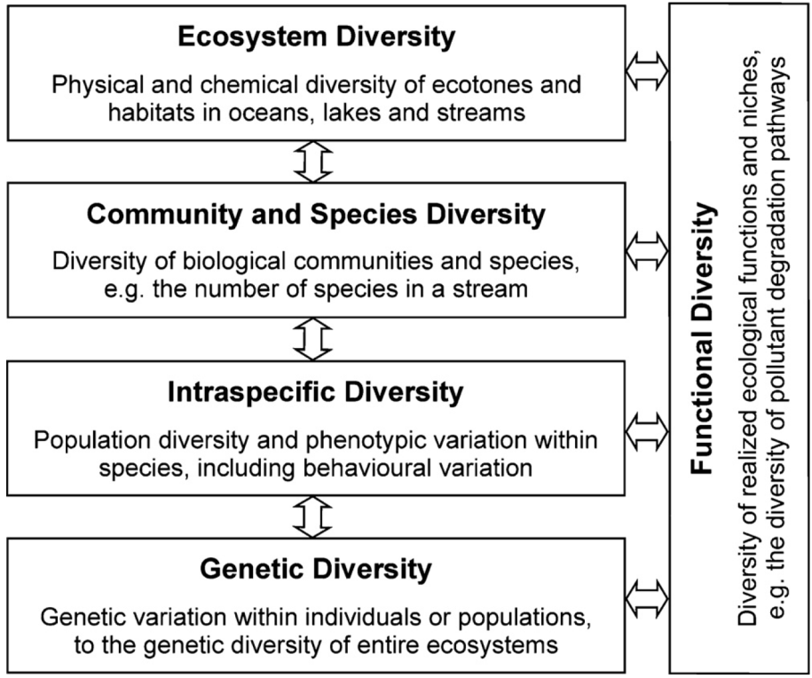

Figure 1. Hierarchical levels of biodiversity in aquatic ecosystems (from Geist 2011)

# What?

This component of the Basin Evaluation will address the following short-term (one-year) and long-term (five-year) Basin-scale evaluation question:

* What did Commonwealth environmental water contribute to ecosystem diversity?

The interim Australian National Aquatic Ecosystems (ANAE) Classification (Aquatic Ecosystem Task Group 2012) provides a framework for classifying aquatic ecosystems. This framework was applied across the Murray–Darling Basin (Brooks *et al.* 2014) to produce a consistent classification of river, wetland and floodplain ecosystem types across the Basin. The MDB ANAE ecosystem map and typology is yet to be rigorously validated. Therefore, ecosystem types within Selected Areas will be confirmed and updated for all sites at which LTIM Project monitoring occurs. An assessment of attribution errors within the ANAE classification that result in erroneous ecosystem type assignment will be undertaken during year five to determine the ramifications of these errors for assessing Commonwealth environmental water influences on ecosystem diversity.

Outputs from Selected Area and Basin hydrological evaluations will be used to intersect with the map of ecosystem types across the Basin to derive a catalogue of ecosystem types influenced by Commonwealth environmental water. Vegetation type is a determining attribute in the ANAE ecosystem typology. The outcomes from the LTIM project vegetation diversity evaluation will be an important consideration when interpreting the contribution of Commonwealth environmental water to ecosystem diversity. The relationship between data collection, analysis, evaluation and reporting is illustrated in Figure 2.

The following outputs will be produced:

* annual report of ecosystem types receiving Commonwealth environmental water at monitored and (where possible) at unmonitored sites
* an updated ANAE ecosystem type GIS layer for the Selected Areas
* a quantitative assessment of errors within the ANAE classification that may influence our capacity to assess the representativeness of Commonwealth environmental water delivery was produced in the first year of LTIM (Brooks 2016).

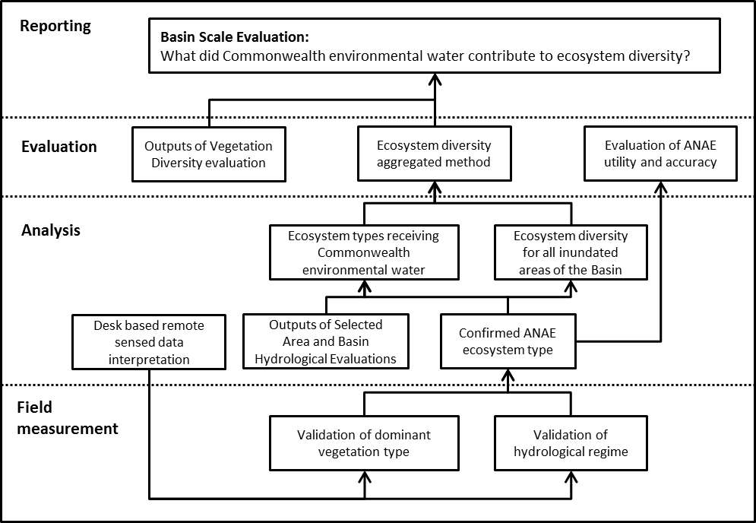

Figure 2. Schematic of key elements in the LTIM Project evaluation for Ecosystem Diversity.

# How?

## Data

Data inputs to the evaluation of ecosystem type include:

* the interim Australian National Aquatic Ecosystems (ANAE) Classification and typology of the Murray–Darling Basin (Brooks *et al.* 2014)
* the LTIM Project M&E Provider data collected using the LTIM Project Standard Protocol: Ecosystem Type at all sampling points
* spatial representation of watering extent for all Commonwealth environmental water deliveries determined using:
  + the LTIM Project M&E Provider mapping of watering extent
  + delivery partner operational monitoring
  + modelled inundation (LTIM Basin Matter: Hydrological connectivity).

Data outputs to inform the evaluation of other basin matters include:

* identification of ecosystem types influenced by Commonwealth environmental water at monitored and unmonitored sites.

## Developing the evaluation approach

The interim ANAE ecosystem classification for the Murray–Darling Basin will be used as the framework for defining and quantifying ecosystem type. The ANAE data set consists of GIS mapping layers that integrate the best available jurisdictional feature mapping for palustrine wetlands, lakes, floodplain and rivers. Typically the mapping is at 1:25,000 to 1:100,000 scales. Any additional aquatic ecosystem mapping undertaken by LTIM M&E Providers will be integrated into the GIS spatial layers and classification.

M&E Providers identify the correct ANAE ecosystem type that applies to each sample point within the Selected Area through application of the LTIM Ecosystem Type Category 1 Standard Method. Any discrepancies with the ANAE data set are identified and collated annually. Consistent errors that can be applied to unmonitored areas will be identified. The ANAE typology of Brooks *et al.* (2014) will be applied to the corrected attributes to create a revised ecosystem type map for the Selected Areas. The corrected ecosystem type classification will be used as the basis for all subsequent evaluation. A measure of the error rate (e.g. expressed as number of attribution errors per 100 polygons of each ecosystem type) will provide a basis for documenting uncertainty when extrapolating or modelling outcomes at unmonitored sites.

### Annual Evaluation (years 1–5)

Ecosystem types that receive Commonwealth environmental water will be identified and compared to all ecosystem types known to occur that could be influenced by environmental flows. This will be performed for each Selected Area and cumulatively across all Selected Areas. Initially, the evaluation will:

1. Identify ecosystems that received Commonwealth environmental water for specific watering actions using inundation data provided by M&E Providers and operational monitoring by delivery partners.
2. Estimate the total population of ecosystem types that *could* be influenced by environmental water deliveries using existing MDBA floodplain inundation modelling (e.g. MDBFIM2) and discharge data.

Existing floodplain inundation modelling is not considered accurate enough to reliably predict the spatial extent of influence of environmental water. The initial evaluation approach will therefore use the models as proof-of-concept only, and focus instead on measured inundation data within Selected Areas. Additional watering events elsewhere in the Basin will be included if the area of inundation can be reliably estimated (e.g. if water is supplied to a discrete wetland). Over the duration of the project it is planned for more accurate inundation extent mapping to be modelled (particularly within Selected Areas) as part of the LTIM Hydrological Connectivity Basin matter evaluation.

These data will be used to construct watering extent maps in GIS that will be intersected with the ANAE mapping layers to determine the ecosystem types influenced by Commonwealth environmental water each year.

### Cumulative Assessment (years 4 and 5)

The types of ecosystems that receive water will vary from year to year in response to water availability and river conditions. Assessments of representativeness or rarity of ecosystem types receiving Commonwealth environmental water are therefore made cumulatively to integrate all watering actions for the duration of the LTIM project. An initial evaluation will be undertaken using data from years 1–4 and then refined in the final year with the incorporation of year 5 data. This staged approach will facilitate the identification of any additional hydrological modelling refinements (see Improving Evaluation Capacity) or complementary data one year prior to the final analysis.

Comparing those ecosystem types influenced by Commonwealth environmental water to all types in the Basin that could potentially receive environmental water will allow an assessment of how representative the watering actions are for ecosystems in the Selected Areas. An assessment of the distribution and frequency of watering of different ecosystem types within the Selected Area will be developed as in an input to inform future CEWO delivery planning. To fully realise this output there will need to be more resourcing for this component in 2019 as current time allocation does not allow for completion.

Vegetation type is an important component of ecosystem type. The cumulative evaluation of ecosystem type will therefore be linked to the LTIM evaluation of vegetation diversity. Vegetation types that are shown to be maintained by Commonwealth environmental water or are shown to change in response to Commonwealth environmental water will be examined in terms of their contribution to ecosystem diversity within Selected Areas and the whole Basin.

## Improving Evaluation Capacity

Over time a number of improvements may be expected to occur that will improve capacity to evaluate environmental flow outcomes on ecosystem diversity. These include;

1. Improved mapping and classification of wetlands. LTIM is specifically contributing to this process through the validation of ecosystem types within each Selected Area to provide a level of ground truthing not previously possible in the application of the interim ANAE classification and typology developed by Brooks *et al.* (2014).
2. The LTIM project hydrological evaluation will develop modelling of watering extent and duration for watering actions within Selected Areas and in unmonitored areas of the Basin. These data will augment observational data provided by M&E Providers and water delivery partners and will increasingly be an important component of the ecosystem diversity evaluation as the models are refined and confidence in them improves.
3. The ecosystem typology provides a framework for extrapolating outcomes to unmonitored sites. Understanding of how biotic and functional responses vary among ecosystem types that are monitored within Selected Areas will permit extrapolation of Selected Area outcomes to watering events that might occur in the same ecosystem types located in other areas of the Basin that are not being monitored. The intersection of ecosystem type and watering extent mapping with be provided as an input to evaluation of other basin matters.

# Risks

* LTIM Hydrological modelling may not produce inundation extent mapping for watering actions. **Mitigation:**  The ecosystem diversity evaluation can still proceed for a subset of watering actions where extent can be determined using M&E Provider data, operational monitoring by delivery partners, observations from land holders and knowledge of past events.
* M&E Providers may not identify correct ecosystem types at monitoring locations (e.g. when wetland extent mapping is unclear). **Mitigation:**  The annual evaluation of ecosystem diversity will tabulate differences in ecosystem boundary mapping and individual ANAE classification attributes for all Sample Point ecosystem type determinations that differ from the 2014 interim ANAE classification. M&E Providers will be given opportunity to confirm the difference before they are integrated into the revised Basin map of ecosystem types.

References

Aquatic Ecosystem Task Group (2012) Aquatic Ecosystems Toolkit: Module 2, Interim Australian National Aquatic Ecosystem Classification Framework. Australian Government Department of Sustainability, Environment, Water, Population and Communities, Canberra.

Brooks S (2016) 2014-15 Basin-scale evaluation of Commonwealth environmental water – Ecosystem Diversity. Final Report prepared for the Commonwealth Environmental Water Office by The Murray–Darling Freshwater Research Centre, MDFRC Publication 106/2016, May, 50pp.

Brooks S, Cottingham P, Butcher R and Hale J (2014) Murray-Darling Basin aquatic ecosystem classification: Stage 2 report. Peter Cottingham & Associates report to the Commonwealth Environmental Water Office and Murray-Darling Basin Authority, Canberra.

Geist J (2011) Integrative freshwater ecology and biodiversity conservation. *Ecological Indicators* **11**: 1507–1516.