

Commonwealth Environmental Water Office

Long Term Intervention Monitoring

Basin Matter – Stream Metabolism and Water Quality foundation report –revision 2018

**Prepared by:** Mike Grace

Final Report- revision 2018

**La Trobe Publication 209/2018**

**Basin-Matter** **Stream Metabolism and Water Quality - revision 2018**

Report prepared for the Commonwealth Environmental Water Office by La Trobe University

For further information contact:

**Nick Bond**

La Trobe University  
PO Box 991   
Wodonga VIC 3689

Ph: (02) 6024 9650

Email: [N.Bond@latrobe.edu.au](mailto:N.Bond@latrobe.edu.au)   
Web: [www.la](http://www.la)trobe.edu.au  
Enquiries: [cfe@latrobe.edu.au](mailto:mdfrc@latrobe.edu.au)

**Report Citation:** Grace, M (2018) Long Term Intervention Monitoring Basin Matter Stream Metabolism and Water Quality foundation report- revision 2018. Final Report prepared for the Commonwealth Environmental Water Office by The Murray-Darling Freshwater Research Centre, La Trobe publication 209/2018, 11pp.

This monitoring project was commissioned and funded by Commonwealth Environmental Water Office.

**Copyright**

© Copyright Commonwealth of Australia, 2018



2016–17 Basin-matterStream Metabolism and Water Quality - revision 2018 (2018) is licensed by the Commonwealth of Australia for use under a Creative Commons By Attribution 3.0 Australia licence with the exception of the Coat of Arms of the Commonwealth of Australia, the logo of the agency responsible for publishing the report, content supplied by third parties, and any images depicting people. For licence conditions see: <http://creativecommons.org/licenses/by/3.0/au/>

This report should be attributed Grace, M (2018) Long Term Intervention Monitoring Basin Matter Stream Metabolism and Water Quality foundation report- revision 2018. Final Report prepared for the Commonwealth Environmental Water Office by The Murray-Darling Freshwater Research Centre, La Trobe publication 209/2018, 11pp..

**Disclaimer**

The views and opinions expressed in this publication are those of the authors and do not necessarily reflect those of the Australian Government or the Minister for the Environment.

**While reasonable efforts have been made to ensure that the contents of this publication are factually correct, the Commonwealth does not accept responsibility for the accuracy or completeness of the contents and shall not be liable for any loss or damage that may be occasioned directly or indirectly through the use of, or reliance on, the contents of this publication.**

**The material contained in this publication represents the opinion of the author(s) only. While every effort has been made to ensure that the information in this publication is accurate, the author(s) and La Trobe University do not accept any liability for any loss or damage howsoever arising whether in contract, tort or otherwise which may be incurred by any person as a result of any reliance or use of any statement in this publication. The author(s) and La Trobe University do not give any warranties in relation to the accuracy, completeness and up-to-date status of the information in this publication.**

Where legislation implies any condition or warranty which cannot be excluded restricted or modified, such condition or warranty shall be deemed to be included provided that the author’s and La Trobe University’s liability for a breach of such condition or warranty is, at the option of La Trobe University, limited to the supply of the services again or the cost of supplying the services again.

**Document history and status**

|  |  |  |  |  |
| --- | --- | --- | --- | --- |
| **Version** | **Date Issued** | **Reviewed by** | **Approved by** | **Revision type** |
| Final | 16/11/2018 | Mike Grace | Nicole Thurgate | Internal |
| Final | 10/12/2018 | CEWO | Sam Roseby | External |

**Distribution of copies**

|  |  |  |
| --- | --- | --- |
| **Version** | **Quantity** | **Issued to** |
| Draft | 1 x Word | CEWO |
| Final | 1 x PDF 1 x Word | Sam Roseby |

**Filename and path:** G:\SHE - Life Sciences\MDFRC\Projects\CEWO\CEWH Long Term Monitoring Project\499 LTIM Stage 2 - 2014-2019 Basin Evaluation\Basin Matter Evaluation\Basin Matters Foundation Report\updated reports\Stream Metabolism Foundation Report 2018 revision

**Author(s):** Mike Grace

**Author affiliation(s):** Monash University

**Project Manager:** Nicole Thurgate

**Client:** Commonwealth Environmental Water Office

**Project Title:** Basin-Matter— Stream metabolism foundation report- revision 2018

**Document Version:** Final revision

**Project Number:** M/BUS/499

**Contract Number:** PRN 1213-0427

Stream metabolism and Water quality

# Why?

Water quality is included as a Basin Matter for three reasons:

* it is one of the principal objectives of the Basin Plan
* it is known to respond to changes in flow
* it can be a significant influence on the outcome of a watering action for biota (e.g. fish and invertebrates).

There are instances where the objective of a watering action is the amelioration of reduced water quality (e.g. dissolved oxygen, salinity) to prevent disturbance to an ecosystem.

Stream metabolism refers to the transformation of organic matter and is comprised of two key ecological processes: primary production and decomposition, which generate and recycle organic matter respectively. These processes have a profound effect on ecosystem character and condition through their influence on the capacity of plants to complete their life cycles and the ability of animals to acquire the food resources needed to survive and reproduce.

There is growing evidence to suggest that flow modification has influenced patterns and rates of primary production and decomposition and that these influences have contributed to the decline in the condition of aquatic ecosystems. Therefore, understanding primary production and decomposition responses to environmental watering will be important if these watering actions are to be optimised to contribute to the protection and restoration of water-dependent ecosystems. However, identifying improved water quality and the ideal state for primary production and decomposition is not straightforward. For example, while increased primary production is important for maintaining and restoring ecosystem function and biodiversity, excess primary production leading to large and sustained algal blooms can cause negative impacts to aquatic ecosystems and ecosystem services. Defining these thresholds is an important first step in the evaluation of this matter.

The continuous water quality monitoring integrated into the LTIM project was restricted to temperature and dissolved oxygen. Other water quality parameters including pH, turbidity and electrical conductivity (salinity – but see below) were typically measured during visits to sites hence that data is often single measurements at intervals of a month or more. Consequently, examining the effect of watering actions on those water quality parameters is unlikely to prove worthwhile. For this reason, it is considered outside the scope of this project. Hence, the question relating to pH has been removed and the consideration of salinity with respect the Murray-Darling Plan is restricted to the specific area targeted by that Plan – the Lower Murray River – where there is continuous monitoring in place that is reported on annually.

# What?

This component of the Basin Evaluation will address the following short-term (one-year) and long-term (five-year) Basin-scale evaluation questions:

* What did Commonwealth environmental water contribute to patterns and rates of decomposition?
  + Increases in rates of decomposition that do not also cause adverse water quality outcomes are beneficial by making organic matter and nutrients available to the ecosystem.
* What did Commonwealth environmental water contribute to patterns and rates of primary productivity?
  + Increases in rates of primary production that do not lead to algal blooms or adverse water quality outcomes are beneficial by increasing the amount of organic matter available to the food web.
* What did Commonwealth environmental water contribute to dissolved oxygen levels?
  + The management of environmental water has the capacity to reduce the severity of anoxic events such as those associated with “black water”. It is feasible that environmental water could also be used to reduce oxygen levels in instances where water is super-saturated with oxygen, as may occur during algal blooms. This evaluation will report on the outcomes of water actions for which these were objectives.
* What did Commonwealth environmental water contribute to salinity regimes?
  + The management of environmental water has the capacity to reduce the severity of periods of high salinity, mix refuge pools in which salinity has led to stratification or ensure a period of low salinity occurs to support recruitment. This evaluation will report on the outcomes of water actions in the Lower Murray by summarising findings from other reports.

Stream metabolism and water quality (principally, dissolved oxygen) will be monitored using *in situ* loggers deployed over periods that span before, during and after environmental watering (Hale et al. 2014). The relationship between data collection, analysis, evaluation and reporting is illustrated in Figure 1. Data from Selected Areas will be aggregated to estimate the effect of Commonwealth environmental water on water quality, primary productivity and decomposition.

The outputs of Basin Evaluation of stream metabolism and water quality will comprise:

* A summary of key thresholds and desired states for water quality, primary production and decomposition, based on a review of existing information.
* annual evaluation of watering action outcomes on salinity effects in the Lower Murray, drawn from the Lower Murray Selected Area Report.
* longer-term evaluation of water quality based on aggregation of data across Selected Areas and years to provide estimates of changes to the frequency or magnitude of adverse water quality events (e.g. anoxic conditions) or changes to the transport of material (e.g. salt, nutrient cycling) at the Basin scale
* annual evaluation of reach-scale estimates of Gross Primary Production (GPP) and Community Respiration (CR), together with predictions of rates in the absence of Commonwealth environmental water
* longer-term evaluation based on aggregation of data from all Selected Areas across all years to provide an estimate of the amount of organic matter produced and recycled in response to Commonwealth environmental water at the Basin scale.

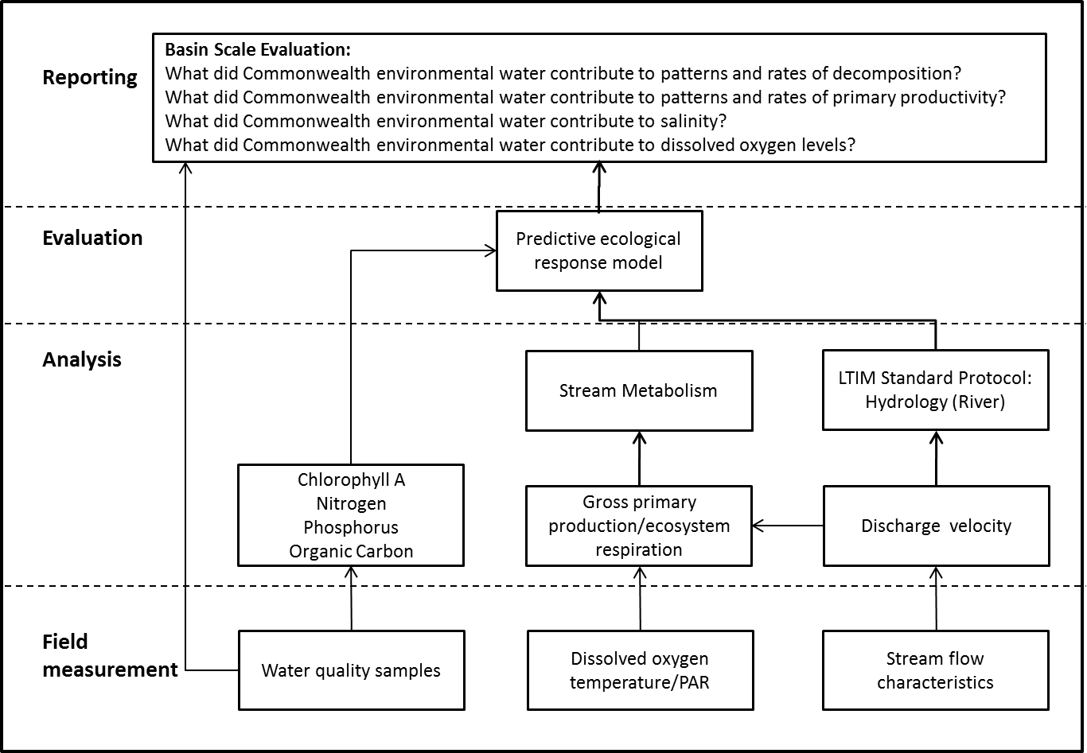

Figure 1. Schematic of key elements in the LTIM Project Standard Protocol: Stream metabolism and water quality.

# How?

## Data

The LTIM Project Standard Methods (see Hale et al. 2014) for stream metabolism and water quality have been designed to provide data appropriate for the evaluation of water quality outcomes at the Basin scale. As noted above, the absence of continuous monitoring data for pH, turbidity and EC/Salinity (with the exception of the Lower Murray Selected Area) mean that these specific parameters are not within the scope of this evaluation, which is now restricted to Dissolved Oxygen concentration. The small amount of data on pH, EC and turbidity may be complemented by water quality monitoring data collected through other relevant programs including short-term monitoring instigated by CEWO and/or MDBA in response to planned watering actions or a potential water-quality event.

The M&E Service Providers will provide daily estimates of gross primary production (GPP), ecosystem respiration (ER) and reaeration rate (KO2) from the diel dissolved oxygen curves for each site. The BASE program (Grace *et al.* 2015) is to be used, and is available, along with an extensive user manual via the Govdex website. The model also provides an uncertainty estimate for each parameter. This program has been updated to BASEv2 which incorporates modifications and improvements as suggested by Song et al. (2016).

In addition to the daily estimates of GPP, ER and KO2, it is also expected that, at all sites where sampling is undertaken, M&E Services Providers will provide hydrological data on:

* Mean River Water Velocity
* Daily Discharge
* And ideally, average river depth.

This information will be important for development of the models.

## Developing the evaluation approach

*There are no plans to further develop the capacity to predict water quality responses to flow*, as the lack of data and the variation in response through time and across the Basin means that levels of uncertainty around the predictions would limit their value.

For stream metabolism, we have developed statistical models to compute reach-scale metabolism based on changes in dissolved oxygen over the course of 24 hours. The ‘BASE’ (Bayesian Stream metabolism Estimation) model will be used by the M&E Service Providers for all catchments to ensure a consistent approach to estimating rates of primary production and ecosystem respiration. The model provides uncertainty estimates for each parameter.

There are no habitat preference curves or quantitative models that would enable prediction of the metabolic rates expected at a specified flow, either with environmental watering or the absence of environmental watering. There are, however, conceptual models that describe the relationship between flow and metabolism that would provide a starting point for making predictions to support evaluation. In addition, models of complex ecological interactions over large spatial and temporal scales have been successfully developed. Members of the Basin Matter Team have developed models that link potentially non-linear responses of ecologically important variables (e.g. stream metabolism) to predictors (e.g. flow provision, nutrient concentrations) that allow model intercepts and slopes to differ among different spatial units (e.g. catchments). The models are based on hierarchical Bayesian calculations and allow the incorporation of uncertainties in measurements and in model parameters to be integrated so that the most appropriate inferences are made. An example is Thomson et al. (2015): Diversity & Distributions (in press; DOI: 10.1111/ddi.12294).

Using these techniques, we will develop quantitative models of stream metabolism that will:

* estimate the rate of stream metabolism in the absence of environmental watering at the reach scale for reaches that are monitored
* predict both environmental flow and non-flow rates of stream metabolism at the reach scale for reaches that are not monitored
* support estimation of Basin-scale changes to stream metabolism in response to environmental watering.

Model development will start with refinement of existing conceptual models to provide a foundation for the quantitative model development. Existing data and expert elicitation may be used to convert the conceptual model into a quantitative model for subsequent estimation, which members of our team have undertaken for other problems (e.g. Kratina, P., Mac Nally, R., Kimmerer, W.J., Thomson, J.R. & Winder, M. (2014) *Journal of Applied Ecology*, **51**, 1066-1074).

In order to apply these models to Areas across the Basin, will require estimates of daily discharge, water velocity and, where tractable, mean reach depth, for scenarios with and without (counterfactual) Commonwealth Environmental Water. It is anticipated that these will be outputs of the Basin Hydrology evaluation.

# Risks

## Data

The major risk associated with data collection is that the prescribed protocols for assessing logger performance are not performed or performed inconsistently with regard to the standard method. All subsequent estimation of daily rates of primary production and ecosystem respiration is entirely contingent upon the quality of the logger data. With the new generation fluorescence-based probes, instrument drift is a much smaller concern than with the older Clark electrodes, but it still must be considered.

## Site-based modelling

The general use of the BASE model for extracting metabolic variables from the diel oxygen data should ensure consistent results across the basin. Short-term effects including the loggers being out of the water under very low flows, loggers being in stratified water columns, again during very low flows, serious biofouling, etc., would occur on an *ad hoc* basis and can (and should) be discussed with Mike Grace.

Modelling of the estimated rates of primary production and respiration as a function of discharge – and particularly, watering events will initially be performed in consultation with the Stream Metabolism team. As noted above, this will fall under the umbrella of the basin-scale modelling efforts. One risk here is that the nutrient and chlorophyll sampling frequency is temporally incompatible with the time frame of changes in metabolic parameters in response to flow events. The importance of this possible temporal mismatch should become evident in the first two years of the program and may lead to a reconsideration of nutrient sampling strategy (e.g. more focus on nutrients during events).

## Basin-scale modelling

Although the estimation of metabolic variables at the site scale is considered a low risk activity, the ability to relate changes in these variables with relevant characteristics of the hydrograph is much more challenging. Within each catchment, there will need to be sufficient watering events at different times of the year to enable distinctions between seasonal effects and the watering events. A major drought may threaten the ability to make such a distinction. As noted above, the Bayesian modelling approach proposed at the basin-scale has been very successful for problems of substantially greater spatial and temporal scope, so we consider this to be at most a moderate risk. Perhaps the largest risk is that the data (metabolic parameters versus flow, with season, nutrients, extent of inundation and antecedent conditions as co-variables) is so noisy that no strong patterns emerge either at a local or a basin-wide scale. However, even this finding would be highly beneficial and may guide different sampling strategies in future.

References

Grace MR, Giling DP, Hladyz S, Caron V, Thompson **R**M and Mac Nally R(2015**)** Fast processing of diel oxygen curves: Estimating stream metabolism with BASE (BAyesian Single-station Estimation). Limnol. Oceanogr. Methods **13** ; doi:[10.1002/lom3.10011](http://dx.doi.org/10.1002/lom3.10011) 103–114**.**

Hale J, Stoffels R, Butcher R, Shackleton M, Brooks S, Gawne B, Stewardson M (2014) Commonwealth Environmental Water Office Long Term Intervention Monitoring Project – Standard Methods. Final Report prepared for the Commonwealth Environmental Water Office by The Murray-Darling Freshwater Research Centre, MDFRC Publication 29.2/2014, January, 175 pp.

Kratina, P., Mac Nally, R., Kimmerer, W.J., Thomson, J.R. & Winder, M. (2014) *Journal of Applied Ecology*, **51**, 1066-1074).

**Song C, Dodds WK, Trentman MT, Rüegg J, Ballantyne F (2016) Methods of approximation influence aquatic ecosystem metabolism estimates. *Limnology and Oceanography: Methods* 14(9), 557–569.**

Thomson, J.R., Maron, M., Grey,M.J., Catterall, C.P., Major, R.E., Oliver, D.L., Clarke, M.F., **Loyn, R.H.,** Davidson, I., Ingwersen, D., Robinson, D., Kutt, A., MacDonald, M.A. and Mac Nally, R. (2015) Avifaunal disarray: quantifying models of the occurrence and ecological effects of a despotic bird species. *Diversity& Distributions* doi:10.1111/ddi.12294