



**Commonwealth Environmental Water Office**

**Long Term Intervention Monitoring Project**

**GWYDIR RIVER SYSTEM SELECTED AREA**

Final Plan, 4 September 2018

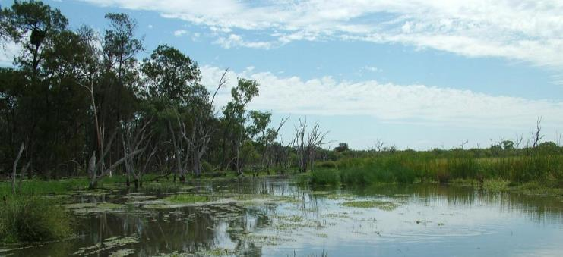

This monitoring project was commissioned and funded by Commonwealth Environmental Water Office.

**Copyright**

© Copyright Commonwealth of Australia, 2014



Commonwealth Environmental Water Office Long Term Intervention Monitoring Project Gwydir River System Selected Area is licensed by the Commonwealth of Australia for use under a Creative Commons By Attribution 3.0 Australia licence with the exception of the Coat of Arms of the Commonwealth of Australia, the logo of the agency responsible for publishing the report, content supplied by third parties, and any images depicting people. For licence conditions see: <http://creativecommons.org/licenses/by/3.0/au/>

This report should be attributed as ‘Commonwealth Environmental Water Office Long Term Intervention Monitoring Project Gwydir River System Selected Area, Commonwealth of Australia 2014’.

**Disclaimer**

The views and opinions expressed in this publication are those of the authors and do not necessarily reflect those of the Australian Government or the Minister for the Environment.

While reasonable efforts have been made to ensure that the contents of this publication are factually correct, the Commonwealth does not accept responsibility for the accuracy or completeness of the contents, and shall not be liable for any loss or damage that may be occasioned directly or indirectly through the use of, or reliance on, the contents of this publication.

**Document control**

|  |  |  |  |
| --- | --- | --- | --- |
| **Version** | **Date** | **Reviewed by** | **Approved by** |
| 1 | 28 Feb 2014 | Darren Ryder, Paul Frazier | Paul Frazier |
| 2 | 16 April 2014 | Darren Ryder, Paul Frazier | Paul Frazier |
| 3 | 23 October 2014 | Darren Ryder, Mark Southwell | Paul Frazier |
| 4 | 12 December 2014 | Mark Southwell | Paul Frazier |
| 5 | 04 September 2018 | Mark Southwell | Paul Frazier |

|  |  |
| --- | --- |
| **Item** | **Details** |
| ELA Project Number | 14ARMNRM-0001 |
| Project Director/s | Paul Frazier, Darren Ryder |
| Project Manager | Mark Southwell |
| Prepared by | Paul Frazier, Darren Ryder, Emma Garraway, Nathalie van der Veer |

Contents

Contents iii

List of Figures iv

List of Tables v

Abbreviations vii

1 Introduction 1

2 Gwydir Selected Area 3

3 Commonwealth Environmental Watering 8

4 Intervention Monitoring Indicators 17

5 Monitoring and Evaluation Schedule 28

6 Communication and Engagement 62

7 Project Management 65

8 References 80

Appendix A Gwydir Selected Area Boundary (Shapefile provided digitally) 80

Appendix B Standard Operating Procedures 82

Appendix C Cause and Effect Diagrams 144

Appendix D Communications Plan 156

Appendix E Quality Assurance Plan i

Appendix F Health, Safety and Environment Plan (HSE Plan) i

List of Figures

Figure 2‑1: Gwydir catchment within the MDB 3

Figure 2‑2: The Gwydir Selected Area 4

Figure 2‑3: Monthly climate averages (Moree Post Office) 5

Figure 3‑1: CEWO environmental watering planning framework 10

Figure 4‑1: Generic CED structure (MDFRC 2013) 25

Figure 5‑1: Gwydir Selected Area monitoring zones 29

Figure 5‑2: Hydrological gauge network 33

Figure 5‑3. Fish (River) to be monitored within the Gwydir River Selected Area 34

Figure 5‑4: Vegetation Diversity Sites 37

Figure 5‑5. Waterbird Diversity monitoring sites within the Gwydir Selected Area 40

Figure 5‑6: CED – microcrustaceans 49

Figure 5‑7: Watercourse areas 53

Figure 5‑8: Hypothetical model of a long-term response to environmental watering based on a created ‘reference condition’ where the greatest influence is from watering in the most recent year with progressively weaker influence from watering in previous years (Source: Gawne et al. 2014) 58

Figure 5‑9: A hypothetical model that will be applied on a year-to-year basis to generate a series of outcomes from different flow regimes over a five year period (Source: Gawne et al. 2014) 58

Figure 7‑1: Project governance structure for the LTIM Project (from CEWO n.d.) 65

List of Tables

Table 2‑1: Mean daily flow for selected Gwydir River gauging sites 7

Table 2‑2: Major weirs and regulators on the Gwydir River 7

Table 3‑1: Flow type function on rivers, wetlands and floodplains (Gawne et al 2013a) 9

Table 3‑2: Expected outcomes from different flow types provided by Commonwealth environmental watering (CEWO 2013c) 10

Table 3‑3: Summary of watering options for the Gwydir Selected Area (Gawne et al. 2013b; CEWO 2013c) 11

Table 3‑4: Expected outcomes for the Lower Gwydir, Gingham and Mallowa watercourses (Gawne et al. 2013b) 13

Table 3‑5: Expected outcomes for the Mehi River and Carole Creek (Gawne et al. 2013b) 14

Table 3‑6: Expected outcomes from the 2013-2014 Commonwealth environmental water (CEWO 2013c) 15

Table 4‑1: Gwydir Selected Area monitoring indicators 17

Table 4‑2: Matrix linking evaluation questions and associated indicators for the Gwydir Selected Area 18

Table 4‑3: Gwydir Selected Area priority monitoring indicators 22

Table 4‑4: Indicator priorities for the Gwydir Selected Area 23

Table 4‑5: Summary of objectives hierarchy, expected outcomes and generic CEDS developed for the broader LTIM project across the basin 26

Table 5‑1: Gwydir Selected Area monitoring zones 29

Table 5‑2: Gauges within zones 32

Table 5‑3: Complimentary data required for the LTIM Project in the Gwydir Selected Area 56

Table 5‑4: Indicator-Zone interactions. SA represents Selected Area. 60

Table 5‑5: Annual field survey cycle 61

Table 6‑1: Progress reporting requirements for the LTIM Project 63

Table 6‑2: Reporting requirements for the LTIM Project 64

Table 7‑1: Primary governance structure – Gwydir Selected Area LTIM Project 65

Table 7‑2: Risk assessment matrix 67

Table 7‑3: Risk likelihood categories 67

Table 7‑4: Risk consequence categories 68

Table 7‑5: Gwydir M&E Plan risk assessment: successful implementation of the LTIM Project 69

Table 7‑6: Gwydir M&E Plan risk assessment: risks to the environment as a result of the LTIM Project 72

Table 7‑7: Gwydir M&E Plan risk assessment: risks to individuals and teams undertaking monitoring activities 74

Abbreviations

|  |  |
| --- | --- |
| Abbreviation | Description |
| ANAE | (Interim) Australian National Aquatic Ecosystems (Classification Framework) |
| ASL | Above Sea Level |
| BoM | Bureau of Meteorology |
| CED | Cause and Effect Diagram |
| CEWH | Commonwealth Environmental Water Holder |
| CEWO | Commonwealth Environmental Water Office |
| EAC OAC | Environmental Contingency Allowance Operations Advisory Committee |
| ELA | Eco Logical Australia Pty Ltd |
| EWP | Environmental Watering Plan (Basin Plan) |
| HSE | Health, Safety and Environment |
| IMEF | Integrated Monitoring of Environmental Flows |
| LTIM Project | Long-Term Intervention Monitoring Project |
| M&E Adviser | Monitoring and Evaluation Adviser |
| M&E Plan | Monitoring and Evaluation Plan |
| M&E Provider | Monitoring and Evaluation Provider |
| M&E Requirements | Monitoring and Evaluation Requirements |
| MDB | Murray-Darling Basin |
| MDBA | Murray-Darling Basin Authority |
| MDFRC | Murray-Darling Freshwater Research Centre |
| MDMS | Monitoring Data Management System |
| MERI | Monitoring, Evaluation, Reporting and Improvement Framework |
| NOW | NSW Office of Water |
| OEH | (NSW) Office of Environment and Heritage |
| QA/QC | Quality Assurance / Quality Control |
| SRA | Sustainable Rivers Audit |
| STIM | Short-term Intervention Monitoring |
| SWC | State Water Corporation (NSW) |
| The Department | Department of the Environment (Commonwealth) |
| UNE | University of New England |

# Introduction

## LTIM context

The Commonwealth Environmental Water Holder (CEWH) is responsible under the *Water Act 2007* for managing Commonwealth environmental water holdings. The holdings must be managed to protect or restore the environmental assets of the Murray-Darling Basin, and other areas where the Commonwealth holds water, so as to give effect to relevant international agreements. The Basin Plan (2012) further requires that the holdings must be managed in a way that is consistent with the Basin Plan’s Environmental Watering Plan. The *Water Act 2007* and the Basin Plan also impose obligations to report on the contribution of Commonwealth environmental water to the environmental objectives of the Basin Plan.

Monitoring and evaluation are critical for supporting effective and efficient use of Commonwealth environmental water. Monitoring and evaluation will also provide important information to support the CEWH in meeting their reporting obligations.

The Long-Term Intervention Monitoring Project (LTIM Project) is the primary means by which the Commonwealth Environmental Water Office (CEWO) will undertake monitoring and evaluation of the ecological outcomes of Commonwealth environmental watering. The LTIM Project will be implemented at seven Selected Areas over a five year period from 2014-15 to 2018-19 to deliver five high-level outcomes (in order of priority):

1. Evaluate the contribution of Commonwealth environmental watering to the objectives of the Murray-Darling Basin Authority’s (MDBA) Environmental Watering Plan
2. Evaluate the ecological outcomes of Commonwealth environmental watering at each of the seven Selected Areas
3. Infer ecological outcomes of Commonwealth environmental watering in areas of the Murray-Darling Basin not monitored
4. Support the adaptive management of Commonwealth environmental water
5. Monitor the ecological response to Commonwealth environmental watering at each of the seven Selected Areas.

To establish long-term arrangements to undertake intervention monitoring at seven Selected Areas within the Murray-Darling Basin, a Monitoring and Evaluation Plan (M&E Plan) has been developed and will be implemented for each Selected Area. To assist with the development of each M&E Plan, the CEWO engaged the Murray-Darling Freshwater Research Centre (MDFRC) as the Monitoring and Evaluation Advisor (M&E Advisor). As the M&E Advisor, the MDFRC assisted with the planning, consultation and scientific development of each M&E Plan. The MDFRC also developed the following reference documents for the development of the M&E Plans to ensure that a high level scope of intervention monitoring underpins the LTIM Project and was developed in context of Commonwealth environmental water:

LTIM Logic and Rationale document (Gawne et al. 2013a) - sets out the overarching design and framework of the LTIM Project

Monitoring and Evaluation requirements for each Selected Area – developed in line with the LTIM Project framework and links to the Basin Plan

LTIM Evaluation Plan - sets out how the Basin-scale (of outcomes of Commonwealth environmental water) and Selected Area questions will be addressed.

The LTIM Logic and Rationale document (Gawne et al. 2013a) sets out the scope and monitoring priorities for ecological responses to Commonwealth environmental water. Predicted likely ecological outcomes were based on:

Basin Plan Environmental Water Plan (EWP) objectives

Cause-effect diagrams that link EWP objectives to flow change

Major flow types (as described in the Basin Plan)

Possible water availability scenarios over the 1-5 year timeframe.

This M&E framework identifies priority monitoring indicators (Category I and II) for the Gwydir Selected Area that relate to key objectives for Basin-scale evaluation (Gawne et al. 2013b).

This document is the M&E Plan for the Gwydir Selected Area.

## Gwydir M&E Plan

The Gwydir M&E Plan details the monitoring and evaluation activities that will be implemented under the LTIM Project for the Gwydir Selected Area. This M&E Plan includes:

* A brief description of the Gwydir Selected Area (Section 2)
* An overview of environmental watering options in the Gwydir Selected Area (Section 3)
* An overview of the monitoring indicators and the relevant Cause Effect Diagrams (CED) (Section 4)
* The schedule of monitoring (Section 5), including:
  + Evaluation questions (Basin-scale and Selected Area)
  + Monitoring schedule (where, what, when, how)
  + Evaluation approach (Basin-scale and Area)
* A communication and engagement strategy (Section 6; 0)
* A project management plan (Section 7), addressing:
  + Project governance and risk assessment
  + Quality Assurance Plan (0)
* A health, safety and environment (HSE) Plan (0).

# Gwydir Selected Area

The Gwydir river system is one of seven Selected Areas for monitoring under the LTIM Project. The Gwydir catchment extends from the Great Dividing Range west to the Barwon River, covering an area of 26,600 square kilometres (Green et al. 2011). Downstream of Moree, the system fans out into a broad alluvial near-terminal floodplain (DECCW 2011) (Figure 2‑1). Numerous anabranches and distributary channels characterise the lower half of the Gwydir basin, with the Mehi River and Moonin Creek to the south, and the Lower Gwydir River, Gingham watercourse and the Carole-Gil Gil Creek system to the north. Commonwealth environmental watering targets assets with expected outcomes downstream (west) of Tareelaroi Weir in the Gwydir floodplain. An overview of the Gwydir catchment, with a focus on the Selected Area, is provided below.

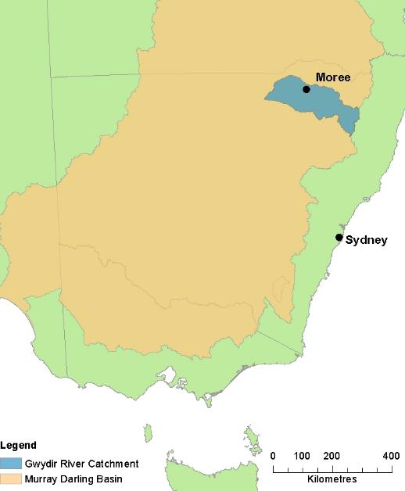

Figure 2‑1: Gwydir catchment within the MDB

The Gwydir Selected Area focuses on the reaches of the Gwydir Watercourse and distributary channels to the west of Tareelaroi Weir. The Gwydir Selected Area (Figure 2‑2) includes:

The Gingham-Gwydir Watercourse

Mehi River and Moonim Creek

The Gwydir River (downstream of Copeton Dam).

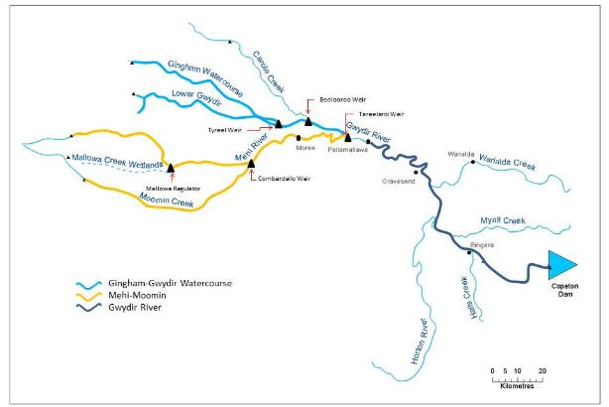

Figure 2‑2: The Gwydir Selected Area

## Climate

Climate across the catchment is sub-tropical in the east to semi-arid in the west. Annual average rainfall varies from around 900 mm at the top of the catchment in the Nandewar Ranges to around 450 mm in the west (Green et al. 2011). The average annual rainfall at Moree is 580 mm (BoM 2014a). Rainfall is summer dominant, with the highest rainfall occurring from October through to March (Figure 2‑3). January and February both receive an average monthly total of 68 mm. Monthly winter rainfall varies between 33-45 mm. Monthly evaporation always exceeds rainfall, with an annual average (Class A pan) evaporation of 2328 mm (BoM 2014b). Summer temperatures are warm to hot, with an average daily temperature of 34 °C (Figure 2‑3).



Mean Monthly temperature (oC)

Figure 2‑3: Monthly climate averages (Moree Post Office)

## Topography

The headwaters of the Gwydir River are sourced near Uralla in northern NSW at an elevation of approximately 1000 m above sea level (ASL). The upper catchment of the Gwydir River is described as montane, before reaching the plains near Gravesend where the floodplain begins to widen. The Horton River, a major tributary of the Gwydir River that drains to the north from the Nandewar Ranges, enters the Gwydir between Bingara and Gravesend. Almost all runoff for the Gwydir catchment occurs along the 300 km reach upstream of Pallamallawa.

West of Pallamallawa the catchment forms the Gwydir near-terminal floodplain, where the elevation is generally less than 200 m ASL. This area of low relief is crossed by numerous palaeochannels. The Gwydir River and its three main distributary channels (the Mehi River and the Moomin and Carole Creeks) carry the within channel flow across the floodplain. Water also flows through shallow depressions or ‘watercourses’ in the floodplain. The western floodplains contribute little or no runoff due to low slopes, absorbent soils and high evaporation (DECCW 2011).

## Physical environment

The Gwydir River downstream of Copeton Dam flows westward, and links a number of smaller catchments. The major Gwydir River tributary is the Horton River. Upstream of Pallamallawa, the Gwydir River contains large gravel-cobble bars that give way to sand bars and splays (Pietsch 2006 in Gawne et al. 2013b).

Diversions to the Mehi River are regulated by the Tareelaroi Weir upstream of Moree. The Mehi River supports a narrow band of riverine woodland dominated by River Red Gum (*E. camaldulensis*), Coolibah, River Cooba and Lignum (*Muehlenbeckia florulenta*) (Green et al. 2011). At Pallamallawa, a flood channel known as the Biniguy Break carries floodwater through to the Mehi River in higher flows. Whittakers Lagoon is a large semi-permanent wetland that receives floodwater from the Mehi River.

Moomin Creek is an anabranch that leaves the Mehi River west of Moree and re-joins it again just upstream of the confluence with the Barwon River. Mongyer Lagoon is a semi-permanent wetland with a regulated connection to Moomin Creek.

The Gwydir Raft is a unique feature of the Gwydir River. It extends for some 15 km along the river downstream of Moree (DECCW 2011). The Raft is the accumulation, over decades, of timber, debris and sediment deposited in the original channel, causing water pooled behind the deposit to spill north into the Gingham Watercourse, and south into the Tyreel Anabranch (Green et al. 2011).

The Lower Gwydir Wetlands refers to the lower Gwydir catchment downstream of Moree which includes the Gingham Watercourse and the Lower Gwydir Watercourse (or the ‘Big Leather Watercourse’). This inland terminal delta forms an alluvial fan of around 20,000 ha. Only during large flood events when the floodplain is inundated does water flow from the wetlands into the Barwon River (Green et al. 2011).

The Gingham Watercourse comprises an area of semi-permanent wetland vegetation as well as extensive areas of floodplain vegetation. The Gingham Waterhole is a permanent lagoon within the main channel. Similar wetland habitats are supported along the Lower Gwydir Watercourse, which is characterised by poorly defined channels and a low gradient (less than one percent).

The Lower Gwydir and Gingham Watercourses contain extensive and significant semi-permanent wetlands, supporting Marsh Club-Rush (*Bolboschoenus fluviatilis*), Water Couch (*Paspalum distichum*), River Cooba and Lignum. The less frequently flooded sections of the wetlands are fringed with Coolibah (Gawne et al. 2013b).

The Gingham-Gwydir watercourse complex contains four Ramsar sites: Goddard’s Lease, Crinolyn and Windella on the Gingham Watercourse and Old Dromana in the Lower Gwydir.

## Hydrology

The natural hydrology of the Gwydir system has been substantially altered with the construction of storages, weirs and regulators. The major storage is Copeton Dam (1364 GL capacity) which was constructed in the 1970s and controls around 55% of inflows. Upstream of Copeton Dam at Bundarra, the long-term average annual flow is 336,300 ML.

The mean daily flow in the Gwydir River is 2,053 ML/day at Pallamallawa where it reaches maximum capacity (Green et al. 2011) before it loses flow to its anabranches and distributary channels in the lower catchment (Table 2‑1). Most flow diversions occur below Pallamallawa where regulation is facilitated by a network of weirs and regulators. Average flows in the Gwydir River and its regulated distributary channels are shown in Table 2‑2.

Table 2‑1: Mean daily flow for selected Gwydir River gauging sites

|  |  |  |  |
| --- | --- | --- | --- |
| **Gauge site** | **Catchment area (km2)** | **Mean daily flow (ML/day)** | **Period of record** |
| Gwydir River (d/s Copeton Dam) | 5,240 | 937 | 1966-2010 |
| Gwydir River at Gravesend | 11,020 | 2,110 | 1950-2010 |
| Gwydir River at Pallamallawa | 12,300 | 2,053 | 1892-2010 |
| Gwydir River at Yarraman Bridge | 12,960 | 1,127 | 1929-2010 |
| Gwydir River at Brageen Crossing | n/a | 183 | 1982-2010 |
| Gwydir River at Millewa | n/a | 71 | 1988-2010 |
| Gingham Watercourse at Teralba | n/a | 221 | 1997-2010 |
| Carole Creek downstream regulator | n/a | 306 | 1939-2010 |
| Mehi River at Moree | n/a | 370 | 1915-2010 |
| Moomin Creek at Glendello | n/a | 287 | 1984-2010 |
| Reference: Green et al. 2011 | | | |

Table 2‑2: Major weirs and regulators on the Gwydir River

|  |  |  |
| --- | --- | --- |
| **Weir** | **Approximate location** | **Purpose** |
| Tareelaroi Weir | Gwydir River 30 km upstream of Moree | Diversions to the Mehi River |
| Boolooroo Weir | Gwydir River downstream of Moree | Diversions to Carole Creek |
| Tyreel Regulator | Gwydir River downstream of Moree | Diversions to Tyreel Anabranch and then to the Lower Gwydir Watercourse |
| Combadello Weir | Mehi River 20 km southwest of Moree | Diversions to Moomin Creek |
| Gundare Regulator | Mehi River 50 km southwest of Moree | Diversions to Mallowa Creek |
| Mallowa Creek Regulator | Mallowa Creek 50 km southwest of Moree | Control of stock and domestic flows along Mallowa Creek |
| Reference: Green et al. 2011 | | |

Within channel flows across the Gwydir Selected Area are carried in the Gwydir River, the Mehi River, and the Moomin Creek. Water also flows over the floodplain in the watercourses. The Gwydir river system Selected Area is highly prone to flooding and extended periods of inundation. Regulation of the system has reduced the frequency of moderate to high flows, as well as increasing the average period between large flows.

Flooding in the Lower Gwydir Wetlands occurs at flows between 5,000 and 10,000 ML/d at Yarraman Bridge (Green et al. 2011), depending on extraction rates and antecedent catchment conditions. There is no simple relationship between river flows at gauges and flooding patterns in the Lower Gwydir wetlands; flows of similar magnitude may inundate substantially different areas (Gawne et al. 2013b).

The Gwydir Regulated River Water Source Water Sharing Plan (WSP) is one of two WSPs that guide water management in the Gwydir Catchment under the *Water Management Act 2000*. It applies to regulated rivers in the catchment including the Gwydir River from Copeton Dam to the Gwydir Raft, the Mehi River, Moomin Creek, Carole Creek and the regulated sections of Gil Gil Creek.

# Commonwealth Environmental Watering

The planning approach for environmental water use options aligns the key aspects of resource availability, expected outcomes from environmental watering actions and the objectives of the Basin Plan. The process aligns water availability with environmental demands in accordance with multi-year ecological and operational considerations (CEWO 2013d).

## What types of watering are proposed?

Planning for the use of Commonwealth environmental water is developed with a planning framework that balances water availability with environmental demand according to on-going ecological and operational considerations. Basin-scale environmental watering needs will largely be based on the Basin’s annual environmental watering priorities developed yearly by the MDBA (CEWO 2013d).

The Environmental Water Outcomes Framework (CEWO 2013b) was developed by the MDFRC to describe the objectives and outcomes from environmental watering. It underpins environmental water management from the planning and delivery stage through to outcomes and communications.

The Basin Plan identified four key environmental objectives for water-dependent ecosystems to protect and restore water-dependent ecosystem of the Murray-Darling Basin (Gawne et al. 2013a). High level objectives (Level 1 objectives) were identified from the Basin Plan; biodiversity, ecosystem function, resilience and water quality. Within each of these Level 1 objectives, a further set of ‘particular’ objectives (Level 2 objectives) were identified. Intermediate and long-term targets from the Basin Plan, which are used to measure progress towards Level 1 objectives, have been used to develop Level 3 objectives.

Environmental water can be used to support four environmentally significant flow types (Gawne et al. 2013a). Each flow type provides different functions in the three water-dependent ecosystem types occurring in the Gwydir river system, by influencing biodiversity, ecosystem function, resilience and/or water quality (Table 3‑1). Expected ecological outcomes of different flow types that may be derived from Commonwealth environmental watering are summarized in Table 3‑2.

Each water year, the CEWO develops a series of water options that may be required in the year to come. Environmental watering actions for the Gwydir river system will be dependent on both the inflow scenarios that aim to meet environmental flow requirements for the Gwydir River, the current availability of Commonwealth environmental water holdings and antecedent conditions. The CEWO planning framework for environmental watering is summarised in Figure 3‑1.

Other sources of environmental water in the Gwydir river system include NSW State Water supplementary flows, Environmental Contingency Allowance and Riverbank Environmental Water Licences. The availability of all environmental water types in the Gwydir river system will be considered when developing water use options (Gawne et al. 2013b), including consideration of the release capacities outlined in the WSP for the Gwydir Regulated River Water Source (2004). It is noted that up to 500 ML/day of inflows downstream of Copeton Dam are protected by the WSP for the Gwydir wetlands, as well as 50% of high unregulated flows. Resource availability (e.g. allocations for both the Commonwealth Environmental Water Holder and other environmental water holders and other natural or unregulated flows) may change over the course of a water year. CEWO will regularly assess resource availability.

Table 3‑1: Flow type function on rivers, wetlands and floodplains (Gawne et al 2013a)

| **Flow type** | **River** | **Wetland** | **Floodplain** |
| --- | --- | --- | --- |
| Base flow | Flow that protects refugia, sustains water quality, productivity and biodiversity | - | - |
| Freshes | In-channel disturbance maintains littoral habitat, scours biofilm and provides longitudinal connectivity  Will affect water quality and ecosystem functions but the effects vary | - | - |
| Bankfull | In-channel disturbance  Influences in-channel and riparian habitat, provides longitudinal connectivity  Sediment transport influences long-term channel form | Only inundates wetlands connected at bankfull, typically those closely connected to parent river  Influence on all water-dependent species habitat, provides some lateral connectivity, major stimulus for primary productivity, decomposition and nutrient cycles  Maintain permanent wetlands as refugia | - |
| Overbank / terminal wetlands | In-channel disturbance  Major influence on in-channel and riparian habitat, provides longitudinal and lateral connectivity, major stimulus for other ecosystem functions  Sediment transport influences long-term channel form | Major influence on ecosystem diversity and habitat, provides connectivity, major stimulus for primary productivity, decomposition and nutrient cycles  Maintain permanent wetlands as refugia | Major influence on ecosystem diversity and habitat, provides connectivity, major stimulus for primary productivity, decomposition and nutrient cycles  Maintain permanent wetlands as refugia  Magnitude of flows is important for differentially inundating low lying and higher areas of the floodplain |

Table 3‑2: Expected outcomes from different flow types provided by Commonwealth environmental watering (CEWO 2013c)

| **Flow type** | **Expected outcomes (2013-2014)** | **Long-term contributions** | **Contribution to Basin Plan objective** |
| --- | --- | --- | --- |
| Base flow | Refuge | Landscape refuge | Resilience |
| Dissolved oxygen | Chemical | Water Quality |
| Base flows and freshes | Waterbird fledging | Landscape bird diversity | Biodiversity |
| Biotic dispersal | Connectivity | Ecosystem function |
| Primary production | Nutrient and carbon cycling |
| Base flows, freshes and overbank | Within ecosystem diversity | Landscape ecosystem diversity | Biodiversity |
| Vegetation condition and reproduction | Vegetation recruitment and extent |
| Fish reproduction  Fish condition | Landscape fish diversity |
| Waterbird survival and condition  Waterbird reproduction | Landscape bird diversity |
| Other vertebrate condition  Other vertebrate reproduction  Other vertebrate growth and survival | Other vertebrates |
| Hydrological connectivity  End of system flows | Connectivity | Ecosystem function |

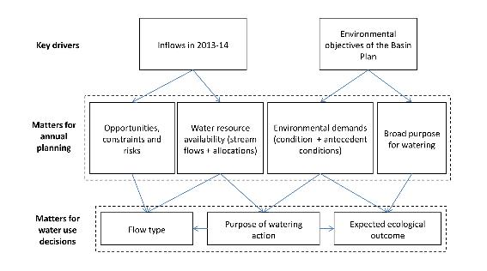

Figure 3‑1: CEWO environmental watering planning framework

Water use options that have been developed for the 2013-2014 water year in the Gwydir watering area are summarised in Table 3‑3. These are based on water resource availability and flow components (base flows, freshes, overbank/ terminal wetlands) (Gawne et al. 2013b).

Table 3‑3: Summary of watering options for the Gwydir Selected Area (Gawne et al. 2013b; CEWO 2013c)

| **Option** | **Site** | Flow Components | **Timing** | **Volume (CEW)** | **Objective** |
| --- | --- | --- | --- | --- | --- |
| 1 | Lower Gwydir and Gingham Watercourses | Base, fresh, over-bank | All year (most likely spring to autumn) | Up to 40 GL (including up to 9.1 GL of supplementary water (if access triggered)) | Contribute to base flows and freshes to support connectivity between wetlands, promote recovery of wetland vegetation, provide habitat for threatened species as well as survival and reproduction opportunities for a range of waterbird and native aquatic species (e.g. fish, frogs, turtles, invertebrates) |
| 2 | Mallowa Wetlands | Base | All year (most likely spring to autumn) | Up to 10 GL | Contribute to base flows and freshers to support hydrological connectivity between wetlands, promote recovery of wetland vegetation, provide habitat for threatened species as well as survival and reproduction opportunities for a range of waterbird and native aquatic species (e.g. fish, frogs, turtles, invertebrates) |
| 3 | Lower Gwydir river channel (downstream of Copeton Dam) | Base | All year (subject to low flow triggers) | Up to 15 GL | Contribute to base flows (i.e. under sustained low inflows provide hydrological connectivity to in-stream habitat), to ensure the persistence of pools as refuge; and to reduce the risk of degrading water quality conditions (particularly low dissolved oxygen levels) |
| 4 | Mehi River system | Base, fresh | All year (most likely spring to autumn) | Up to 20 GL (including up to 9 GL of supplementary water (if access triggered)) | Contribute to naturally occurring fresh flows to support hydrological connectivity and in-channel flow variability, the health of in-stream habitat, water quality, high primary productivity, native aquatic species condition and reproduction |
| 5 | Carole Creek | Base, fresh | All year (most likely spring to autumn) | Up to 5 GL (including up to 1 GL of supplementary water (if access triggered)) | Contribute to naturally occurring fresh flows to support hydrological connectivity and allow fish movement, the health of in-stream habitat, water quality, primary productivity, native aquatic species condition and reproduction |
| 6 | Gwydir Wetlands TBC (focus on water bird reproduction and fledging contingency | Base, fresh | Spring /summer /autumn | Up to 5 GL | If required, contribute to base flows to support key species complete life cycles in low lying wetlands (e.g. bird breeding contingency to support waterbird breeding events to successful completion) |
|  | | | | | |

## What are the expected outcomes?

### Expected outcomes from Commonwealth environmental watering

The Environmental Water Outcomes Framework (CEWO 2013b) was developed by the MDFRC and is used to guide environmental watering. Expected outcomes are the likely ecological response from the delivery of Commonwealth environmental water. Outcomes were based on:

Basin Plan Environmental Water Plan (EWP) objectives

Cause-effect diagrams that link EWP objectives to flow change

Major flow types (as described in the Basin Plan)

Possible water availability scenarios over the 1-5 year timeframe.

The Outcomes Framework categorised expected outcomes as the matters that can be achieved from environmental watering within a one year timeframe (1 year expected outcomes) and a one year to five year timeframe (5 year expected outcomes). These timeframes align with the planning hierarchy for Commonwealth environmental water:

Annual water use options

5 year portfolio management strategies

The 10 year Basin Plan.

Basin outcomes that relate to environmental watering and other levels under the Basin Plan sit below the four broad objectives. The Outcomes Framework provides a basis for demonstrating how environmental water over successive years accumulates over time to provide Basin-scale outcomes.

Spatio-temporal diagrams have been developed for whole of Basin outcomes that illustrate the links across temporal (1 year, 5 year, > 10 year outcomes) and spatial (site, area, catchment, Basin) scales. Each expected outcome from environmental watering is supported by one or more Cause and Effect Diagrams (CEDs) (Section 4). CEDs explain the interaction between flows and the EWP objectives.

Expected outcomes are those that can be achieved from environmental watering within:

A one-year timeframe

A one-to-five year timeframe.

Expected outcomes at the one-year timescale are largely reliant on flow type (base, fresh, bankfull, overbank), as well as the ecology of the receiving water-dependent ecosystem (Gawne et al. 2013a). One-to-five year outcomes are influenced by water availability and flow regime. Four water availability classes were defined; extreme dry, dry, median and wet.

### Expected outcomes in the Gwydir Selected Area

Expected outcomes have been determined for the Gwydir Selected Area (Gawne et al. 2013b) for the Lower Gwydir, Gingham and Mallowa wetlands (Table 3‑4) and the Mehi River and Carole Creek (Table 3‑5). Note that the expected outcomes for the Lower Gwydir, Gingham and Mallowa wetlands are based on infrastructure assisted flows; this flow component has been nominated as ‘discrete wetland inundation’. Watering options for the Gwydir river system will be developed each year by CEWO for the term of the LTIM Project. These options will be developed within the CEWO Outcomes Framework (CEWO 2013b) to ensure that expected outcomes of Commonwealth environmental watering are based around the Basin Plan’s environmental watering objectives (CEWO 2013b).

Table 3‑4: Expected outcomes for the Lower Gwydir, Gingham and Mallowa watercourses (Gawne et al. 2013b)

|  |  |  |  |  |
| --- | --- | --- | --- | --- |
| **Flow component** | **Level 1 objectives** | **Level 2 and 3 objectives** | **Suggested < 1 year outcome** | **Suggested 1- 5 year outcome** |
| Discrete wetland inundation: terminal wetland inundation and infrastructure-assisted bankfull flows in the Gwydir Selected Area | Biodiversity | Ecosystem | Contributes to within ecosystem diversity | Contribute to ecosystem landscape diversity |
| Biodiversity | Vegetation | Contributes to within ecosystem riparian, wetland and floodplain native vegetation diversity, extent and condition | Contributed to landscape vegetation diversity and extent |
| Biodiversity | Fish | Contributes to fish breeding and recruitment | Contributes to native fish populations and diversity |
| Biodiversity | Fish | Recruitment by exotic fish does not increase relative to recruitment by native fish |  |
| Biodiversity | Waterbirds | Supports colonial waterbirds reaching fledging stage | Maintains waterbird populations and contributes to landscape diversity |
| Biodiversity | Waterbirds | Contributes to waterbird condition | Maintains waterbird populations and contributes to landscape diversity |
| Biodiversity | Other vertebrates | Contributes to restoration/protection of frog diversity and condition through provision of habitat to support breeding and recruitment | Affects frog populations |
| Function | Connectivity | Contributes to breeding and recruitment of native fish by facilitating dispersal (before, during and after breeding) | Contributes to landscape fish diversity |
| Water quality | Chemical | Contributes to the maintenance or improvement of water quality to support recruitment, growth and survival of native species (fish, invertebrates, frogs) | Maintains populations of native fish, invertebrates and frogs |
| Resilience | Resilience | Contributes to resistance by affecting within ecosystem diversity | Contributes to resistance by affecting landscape ecosystem diversity |
| Water quality | Chemical  Biological | Contributes to prevention or amelioration of anoxia and algal blooms | Contributes to improved water quality to maintain diversity of key biota (fish, frogs, macroinvertebrates) |

Table 3‑5: Expected outcomes for the Mehi River and Carole Creek (Gawne et al. 2013b)

|  |  |  |  |  |
| --- | --- | --- | --- | --- |
| **Flow component** | **Level 1 objectives** | **Level 2 and 3 objectives** | **Suggested < 1 year outcome** | **Suggested 1- 5 year outcome** |
| Fresh, bankfull | Biodiversity | Vegetation | Contributed to within ecosystem riparian native vegetation diversity, extent and condition | Contributed to landscape vegetation diversity and extent |
| Base flow, fresh, bankfull | Biodiversity | Fish | Contributed to fish breeding and recruitment | Contributes to native fish populations and diversity |
| Base flow, fresh, bankfull | Biodiversity | Fish | Recruitment by exotic fish does not increase relative to recruitment by native fish |  |
| Base flow, fresh, bankfull | Biodiversity | Other vertebrates | Contributed to restoration/protection of frog diversity and condition through provision of habitat to support breeding and recruitment | Contributes to frog populations |
| Fresh, bankfull | Function | Connectivity | Contributed to breeding and recruitment of native fish by facilitating dispersal (before, during and after breeding) | Contributes to landscape fish diversity |
| Base flow, fresh, bankfull | Water quality | Chemical | Contributed to the maintenance or improvement of water quality to support recruitment, growth and survival of native species (fish, invertebrates, frogs) | Maintains populations of native fish, invertebrates and frogs |
| Base flow, fresh, bankfull | Resilience | Resilience | Contributed to the maintenance of refugia for aquatic biota | |
| Base flow, fresh, bankfull | Water quality | Chemical  Biological | Contributed to prevention or amelioration of anoxia and algal blooms | Contributes to improved water quality to maintain diversity of key biota (fish, frogs, macroinvertebrates) |

#### Water use options 2013-2014 for the Gwydir River Valley

The CEWO has released the 2013-14 Commonwealth watering options for the Gwydir River system (CEWO 2013c). This document outlines both the expected 2013-14 and longer term outcomes from the use of Commonwealth environmental water in the Gwydir River valley (Table 3‑6).

Table 3‑6: Expected outcomes from the 2013-2014 Commonwealth environmental water (CEWO 2013c)

| **Flow Type** | **Expected outcomes**  **(2013-14)** | **Contributions to longer term outcomes** | **Contribution to the Basin Plan objective** |
| --- | --- | --- | --- |
| Base flows | Refuge | Landscape refuge | Resilience |
| Dissolved oxygen | Chemical | Water Quality |
| Base flows and  freshes | Waterbird fledging | Landscape bird  Diversity | Biodiversity |
| Biotic dispersal | Connectivity | Ecosystem function |
| Primary production | Nutrient and carbon cycling |
| Base flows, freshes  and overbank | Within ecosystem diversity | Landscape ecosystem diversity | Biodiversity |
| Vegetation condition and reproduction | Vegetation recruitment and extent |
| Fish reproduction  Fish condition | Landscape fish diversity |
| Waterbird survival and condition  Waterbird reproduction | Landscape bird diversity |
| Other vertebrate condition  Other vertebrate reproduction  Other vertebrate growth and survival | Other vertebrates |
| Hydrological connectivity  End of system flows | Connectivity | Ecosystem function |

As part of this process, the Office consulted the following stakeholders:

Environmental Water Scientific Advisory Panel

Murray-Darling Basin Authority

New South Wales Office of Environment and Heritage

New South Wales Office of Water

New South Wales Department of Primary Industries

New South Wales State Water Corporation

Environmental Contingency Allowance Operations Advisory Committee

North West Local Land Services (LLS).

## Practicalities of watering

The delivery of Commonwealth environmental water in the Gwydir River system is complex, given the context of delivery in a river system that contains public and private storages and developed floodplains (MDBA 2012). Constraints within the system may mean that environmental requirements are not met at all times. Flow capacities are reduced in the downstream direction in the Gwydir system, with the greatest contraction in capacity occurring in the Gwydir River proper. Small flow increases in the Gwydir River at Pallamallawa can cause overbank flows downstream.

Release capacities for regulated Commonwealth environmental water are provided in the WSP for the Gwydir Regulated River Water Source. Regulated deliveries of environmental water may not reach all of the Selected Area.

The CEWH will enter into arrangements with the NSW state government and other environmental water holders, managers and authorities (delivery partners) to optimise the delivery of environmental water (CEWO 2013d). To inform monitoring activities, a number of documents and range of data will be required. A number of these documents will be produced by CEWO:

Water use minutes (available via the CEWO Project Manager Team Area Leader)

Consolidated decisions and use information (available via the CEWO Project Manager Team Area Leader)

Operational information (planned and actual) and data on water delivery actions (provided by delivery partners).

Access to operational information will be largely via the Selected Area Working Group; it is essential that good working relationships are maintained with the Gwydir Selected Area Working Group, and discussed further in Section 6.

# Intervention Monitoring Indicators

## Monitoring indicators

Intervention monitoring indicators selected for the Gwydir Selected Area were chosen following extensive local area consultation (Gawne et al. 2013a; Gawne et al. 2013b), whole of Basin consideration of scalable indicators and methods of collection and further Selected Area relevant consultation through the Gwydir Selected Area Working Group and Gwydir LTIM Project team. Basin-scale indicators (Category I) were developed to ensure that Basin-scale evaluation needs are met. In addition, Category II and III indicators have been developed for Selected Area and Basin-scale evaluation with the following definitions:

Category I – Mandatory indicators and standard protocols which are required to inform quantitative Basin Evaluation. Indicators have been identified for each Selected Area in this category and must be applied in a consistent manner following standard protocols;

Category II – Optional indicators with mandatory standard protocols which may be used to inform quantitative Basin Evaluation in the future. In the event that any of these indicators are implemented by M&E Providers at the Selected Area, the standard protocol must be followed; and

Category III – Optional indicators with Selected Area specific protocols and mandatory reporting requirements. This includes Selected Area specific monitoring using locally appropriate methods.

Ten indicators relevant to the Gwydir Selected Area and at the Basin-scale have been developed (Table 4‑1). For this plan river ecosystem types only were selected.

Table 4‑1: Gwydir Selected Area monitoring indicators

| **Monitoring indicator** | **Category** |
| --- | --- |
| Ecosystem Type | I |
| Hydrology (River) | I |
| Fish (River) | I + III |
| Waterbird Breeding | I |
| Vegetation Diversity | II |
| Waterbird Diversity | II |
| Water Quality | II |
| Hydrology (Watercourse) | III |
| Fish (Movement) | II |
| Microcrustaceans | III |
| Macroinvertebrates | lll |

A matrix of evaluation questions (Basin-scale and Selected Area) and the associated indicators for the Gwydir Selected Area is provided in Table 4‑2.

Table 4‑2: Matrix linking evaluation questions and associated indicators for the Gwydir Selected Area

| **Evaluation questions** | **Ecosystem Type** | **Hydrology (River)** | **Fish (River)** | **Waterbird Breeding** | **Vegetation Diversity** | **Waterbird Diversity** | **Water Quality** | **Hydrology (Watercourse)** | **Fish (Movement)** | **Micro-crustaceans** | **Macro-invertebrates** |
| --- | --- | --- | --- | --- | --- | --- | --- | --- | --- | --- | --- |
| What did Commonwealth environmental water contribute to sustainable ecosystem diversity? | ST, LT  Basin |  |  |  |  |  |  |  |  |  |  |
| Were ecosystems to which Commonwealth environmental water was allocated sustained? | ST, LT  Basin |  |  |  |  |  |  |  |  |  |  |
| Was Commonwealth environmental water delivered to a representative suite of ecosystem types? | ST, LT  Basin |  |  |  |  |  |  |  |  |  |  |
| What did Commonwealth environmental water contribute to vegetation species diversity? |  |  |  |  | ST, LT  Gwydir |  |  | ST, LT  Gwydir |  |  |  |
| What did Commonwealth environmental water contribute to vegetation community diversity? |  |  |  |  | ST, LT  Gwydir |  |  | ST, LT  Gwydir |  |  |  |
| What did Commonwealth environmental water contribute to native fish community resilience? |  | LT  Basin  Gwydir | ST  Basin  Gwydir |  |  |  |  |  |  |  |  |
| What did Commonwealth environmental water contribute to native fish survival? |  | ST  Basin  Gwydir | ST  Basin  Gwydir |  |  |  |  |  |  |  |  |
| What did Commonwealth environmental water contribute to native fish populations? |  |  | LT  Basin  Gwydir |  |  |  |  |  | LT  Gwydir |  |  |
| What did Commonwealth environmental water contribute to native fish diversity? |  | LT  Basin  Gwydir | LT  Basin  Gwydir |  |  |  |  |  |  |  |  |
| What did Commonwealth environmental water contribute to native fish reproduction? |  | ST  Basin  Gwydir |  |  |  |  |  |  |  |  |  |
| What did Commonwealth environmental water contribute to native larval fish growth? |  | ST  Basin  Gwydir |  |  |  |  |  |  |  |  |  |
| What did Commonwealth environmental water contribute to native fish dispersal? |  |  |  |  |  |  |  |  | ST  Gwydir |  |  |
| Did environmental water stimulate target species to exhibit movement consistent with breeding behaviour? |  |  |  |  |  |  |  |  | ST  Gwydir |  |  |
| Did environmental water facilitate target species to move/return to refuge habitat? |  |  |  |  |  |  |  |  | ST  Gwydir |  |  |
| What did Commonwealth environmental water contribute to waterbird breeding? |  |  |  | ST, LT  Basin  Gwydir |  |  |  | ST, LT  Gwydir |  |  |  |
| What did Commonwealth environmental water contribute to waterbird chick fledging? |  |  |  | ST, LT  Basin  Gwydir |  |  |  |  |  |  |  |
| What did Commonwealth environmental water contribute to waterbird survival? |  |  |  | ST, LT  Basin  Gwydir |  | ST, LT  Gwydir |  |  |  |  |  |
| What did Commonwealth environmental water contribute to waterbird populations? |  |  |  | LT  Basin  Gwydir |  | LT  Gwydir |  |  |  |  |  |
| What did Commonwealth environmental water contribute to waterbird species diversity? |  |  |  |  |  | LT  Gwydir |  | ST, LT  Gwydir |  |  |  |
| What did Commonwealth environmental contribute to patterns and rates of primary productivity? |  | ST, LT  Basin  Gwydir |  |  |  |  |  |  |  |  |  |
| What did Commonwealth environmental water contribute to temperature regimes? |  | ST, LT  Basin  Gwydir |  |  |  |  | ST, LT  Gwydir |  |  |  |  |
| What did Commonwealth environmental water contribute to pH levels? |  | ST, LT  Basin  Gwydir |  |  |  |  | ST, LT  Gwydir |  |  |  |  |
| What did Commonwealth environmental water contribute to turbidity regimes? |  | ST, LT  Basin  Gwydir |  |  |  |  | ST, LT  Gwydir |  |  |  |  |
| What did Commonwealth environmental water contribute to salinity regimes? |  | ST, LT  Basin  Gwydir |  |  |  |  | ST, LT  Gwydir |  |  |  |  |
| What did Commonwealth environmental water contribute to dissolved oxygen levels? |  | ST, LT  Basin  Gwydir |  |  |  |  | ST, LT  Gwydir r |  |  |  |  |
| What did Commonwealth environmental water contribute to hydrological connectivity? |  | LT  Basin  Gwydir |  |  |  |  |  |  |  |  |  |
| What did Commonwealth environmental water contribute to hydrological connectivity of the Gingham-Gwydir Watercourse and Mallowa Creek Wetlands? |  |  |  |  |  |  |  | ST, LT  Gwydir |  |  |  |
| What did Commonwealth environmental water contribute to microcrustacean productivity? |  |  |  |  |  |  |  |  |  | ST, LT  Basin  Gwydir |  |
| What did Commonwealth environmental water contribute to microcrustacean community composition? |  |  |  |  |  |  |  |  |  | ST, LT  Basin  Gwydir |  |
| What did Commonwealth environmental water contribute to resilience of microcrustacean egg banks? |  |  |  |  |  |  |  |  |  | ST, LT  Basin  Gwydir |  |
| What did Commonwealth environmental water contribute to the timing of microcrustacean productivity and presence of key species in relation to numbers of larval fish? |  |  |  |  |  |  |  |  |  | ST, LT  Basin  Gwydir |  |
| What did Commonwealth environmental water contribute to the timing of microcrustacean productivity and presence of key species in relation to growth of larval fish? |  |  |  |  |  |  |  |  |  | ST, LT  Basin  Gwydir |  |
| What did Commonwealth environmental water contribute to connectivity of microcrustacean and vegetation communities in floodplain watercourses? |  |  |  |  |  |  |  |  |  | ST, LT  Basin  Gwydir |  |
| What did Commonwealth environmental water contribute to macroinvertebrate diversity? |  |  |  |  |  |  |  |  |  |  | ST, LT  Basin  Gwydir |

## Indicator priorities

Priority outcomes were initially identified at regional stakeholder workshops in January 2013 based on the values and outcomes presented (Table 4‑3). The Gwydir Selected Area Working Group also identified key indicators.

Table 4‑3: Gwydir Selected Area priority monitoring indicators

| **Priority monitoring indicator** | **Identified by** |
| --- | --- |
| Gwydir, Gingham and Mallowa wetlands - vegetation diversity | Regional stakeholder workshop Jan 2013 (Gawne et al. 2013b) |
| Gwydir, Gingham and Mallowa wetlands - waterbird survival and condition |
| Mehi River and Carole Creek – fish diversity |
| Holistic/Functional response of key assets to environmental water | Gwydir Selected Area Working Group (Jan-Feb 2014) |
| Broader hydrological considerations |
| Frogs, turtles, snakes |
| Vegetation dynamics |
| Sediments |
| Fish (abundance/diversity, movement, larvae) |

The Gwydir LTIM Project team in consultation with the Gwydir Selected Area Working Group has evaluated the selected indicators and ranked them (Table 4‑4) in terms of relative importance based on:

Potential to meet specified Category I requirements

Relative value for money – linking cost to the likelihood of contributing meaningful monitoring outcomes for the Basin and Selected Area

Importance to the local community (Gawne et al. 2013b) and via the Selected Area Working Group.

Table 4‑4: Indicator priorities for the Gwydir Selected Area

|  |  |  |  |
| --- | --- | --- | --- |
| **KEY** | **Low Return on Investment** | **Moderate Return on Investment** | **High Return on Investment** |

| **Indicator** | **Category** | **Supporting comments** |
| --- | --- | --- |
| Ecosystem Type | I | Verifies or describes the ANAE type for each site. The key environmental asset of the Gwydir is the Watercourse, a complex of small channels, floodplains, and closed depressions (wetlands). Most of this environment doesn’t fit within the current ANAE mapping.  Return on investment (ROI) is moderate. |
| Hydrology (River) | I | A key variable for understanding the flow regime. The relatively good network of gauges across the system facilitates this indicator.  ROI is high. |
| Fish (River) | I | The inclusion of Fish River Category 1 only will provide marginally relevant information at the Selected Area scale due to an absence of comparisons among the distributary network of those channels receiving Commonwealth environmental water and those that do not within a watering year.  ROI with Fish River Category I only indicator is moderate.  When combined, the Category I and III Fish River indicators can provide Selected Area information on fish populations, diversity and condition that are informative of the value of environmental watering.  ROI with these two indicators is high. |
| Fish (River) | III |
| Waterbird Breeding | I | An iconic part of the Selected Area and an indicator that will provide information that can be directly related to CEWO watering. In addition, the use of real-time monitoring devices (RMCam) will permit real-time adaptive flow management and may facilitate improved successful breeding outcomes.  ROI is very high. |
| Vegetation Diversity | II | A core target for environmental watering in the Selected Area. Some of the wetland communities are iconic and important nationally and internationally, including 4 Ramsar sites.  ROI is very high. |
| Waterbird Diversity | II | Linked to Waterbird Breeding this indicator will provide relevant information of bird diversity and response to watering.  ROI is high. |
| Water Quality | II | Water quality monitoring located only in Gwydir River upstream of Tareelaroi providing relevant information on quality of water entering lower Gwydir ecological assets. Location at permanent water and NoW gauged site provides robust data for evaluation questions (including Hydrology River) and security for equipment.  ROI is moderate. |
| Hydrology (Watercourse) | III | The hydrology/hydrodynamics of the Watercourse area is a critical aspect of understanding the system and the response to flows. The tools and devices for understanding this aspect are now available (several Lidar sets, multiple sources of inundation assessment, hydro-dynamic model) and further work can develop these models and data to improve accuracy and derive meaningful information. This indicator is linked to Microcrustaceans, Waterbird Breeding and Diversity and Vegetation Diversity Dynamics  ROI very high. |
| Fish (Movement) | II | This indicator can show fish response as a direct outcome of flow manipulation at short timeframes (annual outcomes). If linked to further understanding of fish behaviour it can contribute significantly to better flow management.  This is relatively expensive so ROI is moderate.  Co-investment from Fisheries NSW and NoW makes ROI moderate. |
| Micro-crustaceans | III | This whole of system approach to understanding the response to flow will lead to better understanding of system function, response and resilience. Similar studies are proposed for the southern Selected Areas (Murrumbidgee/Edward-Wakool). Given the nature of the Gwydir watercourse/floodplain systems, environmental water can inundate substantial areas and lead to high rates of primary and secondary productivity that benefit both the environment and agriculture (primarily grazing) and will be linked in this indicator (nutrients-productivity-microcrustaceans- macroinvertbrates-larval fish-waterbirds). The combined knowledge from all of these similar systems will provide substantial synergies in the outcomes from any single Selected Area. This indicator has substantial support from the Selected Area Working Group.  ROI is very high. |
| Macro-invertebrates | III | This whole of system approach to understanding the response to flow will lead to better understanding of system function, response and resilience. Similar studies are proposed for the southern Selected Areas (Murrumbidgee/Edward-Wakool). Given the nature of the Gwydir watercourse/floodplain systems, environmental water can inundate substantial areas and lead to high rates of primary and secondary productivity that benefit both the environment and agriculture (primarily grazing) and will be linked in this indicator (nutrients-productivity-microcrustaceans-macroinvertbrates-larval fish-waterbirds). The combined knowledge from all of these similar systems will provide substantial synergies in the outcomes from any single Selected Area. This indicator has substantial support from the Selected Area Working Group.  ROI is very high. |

## Cause and Effect diagrams

Cause and effect diagrams (CEDs) are simplified conceptual models that link flows to Basin Plan objectives; they do not attempt to explain all possible relationships or causal factors. CEDs for the LTIM Project were developed in line with the objectives hierarchy approach (Gawne et al. 2013a). They link flow through its influence on a range of causal categories (such as habitat, connectivity processes, disturbance and cues) to the objectives hierarchy and expected outcomes (Table 4‑5). The LTIM Project CEDs identify two broad types of indicators; effect indicators that support reporting of progress against objectives, and causal indicators that support evaluation and adaptive management.

Twenty seven generic CEDs were developed for the LTIM Project; each CED follows the same structure (Figure 4‑1). A CED may relate to other CEDs; these relationships are also depicted. Each CED has been developed based on evidence from water dependent ecosystems in the MDB or, where there are only limited data available, from further afield. It is noted that the CEDs provided are generic with the purpose of predicting environmental outcomes of Commonwealth environmental water (MDFRC 2013). CEDs may need modifications to be applied to the Gwydir Selected Area, and should form part of the adaptive management process.

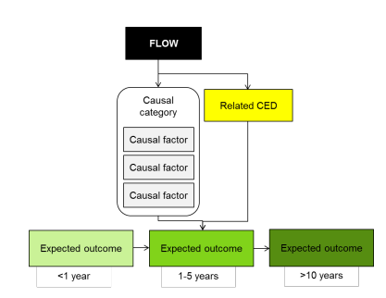

Figure 4‑1: Generic CED structure (MDFRC 2013)

CEDs relevant to the Gwydir Selected Area are highlighted in the Table 4‑5 and provided in 0.

Table 4‑5: Summary of objectives hierarchy, expected outcomes and generic CEDS developed for the broader LTIM project across the basin

| **Level 1**  **Objectives** | **Level 2**  **Objectives** | **Level 3**  **Objectives** | **Expected outcome (1-5 years)** | **Expected outcome (<1 year)** | **Relevant CED (shaded cells relevant to the Gwydir Selected Area)** |
| --- | --- | --- | --- | --- | --- |
| **Biodiversity** | Ecosystem diversity |  |  |  | Landscape Ecosystem Diversity |
| Species diversity |  | Within Ecosystem Diversity |
|  | Vegetation | Vegetation diversity |  | Landscape Vegetation Diversity |
|  | Reproduction  Condition | Vegetation Condition and  Reproduction |
| Growth and survival | Germination  Dispersal | Vegetation Recruitment and  Extent |
|  | Macro-invertebrates | Macroinvertebrate diversity |  | Within Ecosystem Macroinvertebrate Diversity |
|  | Fish | Fish diversity |  | Landscape Fish Diversity |
|  | Condition | Fish Condition |
|  | Larval abundance  Reproduction | Fish Reproduction |
| Larval and juvenile recruitment |  | Fish Larval Growth and Survival |
|  | Waterbirds | Waterbird diversity |  | Landscape Waterbird Diversity |
| Abundance  Population structure | Survival and condition | Waterbird Survival and Condition |
|  | Chicks | Waterbird Reproduction |
|  | Fledglings | Waterbird Recruitment and Fledging |
|  | Other vertebrate diversity |  | Young | Other Vertebrate Reproduction |
| Adult abundance |  | Other Vertebrate Growth and Survival |
| **Ecosystem**  **Function** | Connectivity |  |  | Biotic dispersal  Sediment transport  Nutrient and carbon cycling  Primary productivity  Decomposition | Hydrological Connectivity  (including end of system flows) |
|  | Movement | Biotic Dispersal |
|  | Sediment transport | Sediment Transport |
| Process |  |  | Primary productivity | Primary Production |
|  | Decomposition | Decomposition |
| Nutrient and carbon cycling |  | Nutrient and Carbon Cycling |
| **Resilience** | Ecosystem resilience |  | Population condition | Individual survival and condition | Individual Refuges |
| Population condition |  | Landscape Refuges |
|  | Individual condition | Ecosystem Resistance |
| Population condition |  | Ecosystem Recovery |
| **Water quality** | Chemical |  |  | Salinity | Salinity |
| Dissolved Oxygen | Dissolved Oxygen |
| pH | pH |
| Dissolved organic carbon | Dissolved Organic Carbon |
| Biological |  |  | Algal blooms | Algal Blooms |
| Reference Gawne et al. 2013a | | | | | |

# Monitoring and Evaluation Schedule

This monitoring schedule links the Basin-scale and Selected Area evaluation questions with study design, Standard Methods and Selected Area-specific methods, hypotheses and analytical approach, and where possible shows capacity to scale from site-based to Selected Area/ANAE typology levels.

Hypotheses and analyses included are generalised to address only the evaluation questions for each indicator, and are not exhaustive lists of potential hypotheses for each indicator and interactions among indicators.

Standard Operating Procedures (SOPs) for mandatory and high priority indicators are provided in Appendix B.

## Monitoring zones

The Gwydir Selected Area focuses on the reaches of the Gwydir Watercourse and distributary channels to the west of Tareelaroi Weir (Table 5‑1; Figure 5‑1). The monitoring zones have been selected using a hierarchical set of criteria:

* Is the reach a target for CEWO water deliveries?
* Does the reach have uniform hydro-geomorphic characteristics at the reach scale?
* Are there specific environmental assets targeted for the delivery of CEWO water via a watering option?
* Do the reach physical characteristics and infrastructure allow the discrete delivery of CEWO water?
* Does the reach contain an array of gauging stations (two or more) that permit the description of reach hydrology?

Using this set of criteria, three discrete monitoring zones were selected:

* Gwydir River between Copeton Dam and Tareelaroi Weir
* Gingham-Gwydir Watercourse and Channels from Tareelaroi Weir to Crinolyn and the Homebush Gauges
* Mehi-Moomin from the Tareelaroi d/s to Gundare Regulator and Alma Bridge Gauge.

It should be noted that the infrastructure nominated to define each zone provides a convenient geographic extent for the zone; however, zones also extend laterally from the main mapped channels (Table 5‑1; Figure 5‑1).

Monitoring zones in the watercourse region (Gingham-Gwydir Watercourse and Mehi-Moomin) are all discrete environmental watering target areas. It is not expected that all of these zones will receive Commonwealth environmental water in any given year. As a result, Category 1 monitoring will be concentrated on the zone (Gingham-Gwydir Watercourse) that has the highest chance of getting water in any given year, given that in dry times, watering priorities are likely to be for water into the terminal wetlands.

Table 5‑1: Gwydir Selected Area monitoring zones

|  |  |  |
| --- | --- | --- |
| **Zone** | **Extent** | **Description** |
| Gwydir River | Copeton Dam to Tareelaroi Weir | Single channel meandering river, several tributaries above Gravesend |
| Gingham-Gwydir Watercourse | Tareelaroi Weir to Crinolyn and the Homebush Gauges | Watercourse area consisting of small channels, floodplains and waterholes |
| Mehi-Moomin | Tareelaroi d/s to Gundare Regulator and Alma Bridge Gauge | Small meandering channel and watercourse/floodplain, distributary channel network |

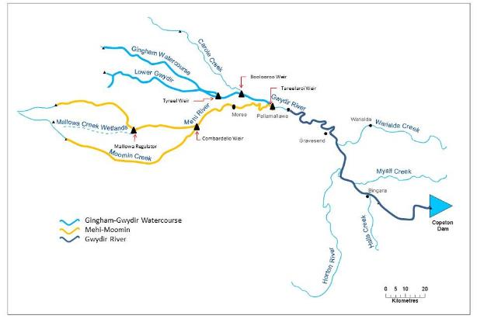

Figure 5‑1: Gwydir Selected Area monitoring zones

## Monitoring schedule - Ecosystem Type

The SOP for Ecosystem Type is provided in Appendix B.1.

### Basin-scale evaluation questions

Short-term (one-year) and long-term (five year) questions:

* What did Commonwealth environmental water contribute to sustainable ecosystem diversity?
* Were ecosystems to which Commonwealth environmental water was allocated sustained?
* Was Commonwealth environmental water delivered to a representative suite of ecosystem types?

### Where

At all sites established for all indicators.

### What

Validate all ANAE categories for all sites or assign an ecosystem type as per the standard methods. Noting the paucity of mapped ANAE data in the Gwydir Selected Area it is likely that the majority of sites will fall outside of existing mapping.

### When

Within 3 months of project commencement. Once only unless new sites are required due to unforeseen circumstances that arise during project operation.

### How

As per the LTIM Project Standard Protocol: Section 2 Ecosystem Type (Hale et al. 2014). Existing high resolution imagery (ADS40), Lidar DEM and fine-scale vegetation mapping will be used as key datasets to help define site polygons.

### Linkages and indicator interactions

This indicator will help to validate the ANAE mapping.

### Analytical approach

Aggregation: list of ecosystem diversity to ensure adequate and representative suite of ecosystems in the Gwydir Selected Area.

Data will be reported following the requirements outlined in the LTIM Project Standard Protocol: Section 2 Ecosystem Type (Hale et al. 2014) and conform to the LTIM Project Data Standard (Brooks & Wealands 2014).

## Monitoring schedule - Hydrology (River)

The SOP for Hydrology (River) is provided in Appendix B.2.

### Basin-scale and Selected Area evaluation questions

Long-term (five year) questions:

* What did Commonwealth environmental water contribute to hydrological connectivity?
* What did Commonwealth environmental water contribute to native fish species diversity?
* What did Commonwealth environmental water contribute to fish community resilience?

Short-term (one year) questions:

* What did Commonwealth environmental water contribute to native fish reproduction?
* What did Commonwealth environmental water contribute to native larval fish growth and survival?

Short-term (one-year) and long-term (five year) questions:

* What did Commonwealth environmental contribute to patterns and rates of primary productivity?
* What did Commonwealth environmental water contribute to temperature regimes?
* What did Commonwealth environmental water contribute to pH levels?
* What did Commonwealth environmental water contribute to turbidity regimes?
* What did Commonwealth environmental water contribute to salinity regimes?
* What did Commonwealth environmental water contribute to dissolved oxygen levels?

### Where

Across the entire Selected Area. The gauge network maintained by NOW in the Selected Area has sufficient distribution and quality to ensure that no additional gauge stations are required for the delivery of the project (Table 5‑2; Figure 5‑2).

Table 5‑2: Gauges within zones

|  |  |  |
| --- | --- | --- |
| **Zone** | **Gauge no.** | **Name** |
| Gwydir | 418026 | D/S Copeton Dam |
| 418012 | Pinegrove |
| 418013 | Gravesend |
| 418001 | Pallamallawa |
| Gingham-Gwydir | 418074 | Gingham @ Teralba |
| 418076 | Gingham @ Tillaloo Bridge |
| 418083 | Gingham @ Wetland Rookery |
| 418077 | Gingham @ Gingham Water Hole |
| 418079 | Gingham @ Gingham Bridge |
| 418063 | Gwydir (south arm) DS Tyreel regulator |
| 418053 | Gwydir River at Brageen |
| 418078 | Gwydir @ Allambie Bridge |
| 418066 | Gwydir @ Millewa |
| 418090 | Gwydir @ Old Dromana Regulator |
| Mehi-Moomin | 418044 | Mehi River D/S Tareelaroi |
| 418087 | Mehi @ Chinook |
| 418002 | Mehi @ Moree |
| 418037 | Mehi D/S Combadello Weir |
| 418085 | Mehi D/S Gundare Regulator #2 |
| 418048 | Moomin @ Combadello |
| 418060 | Moomin @ Glendello |
| 418067 | Moomin @ Clarendon Bridge |
| 418061 | Moomin @ Alma Bridge |

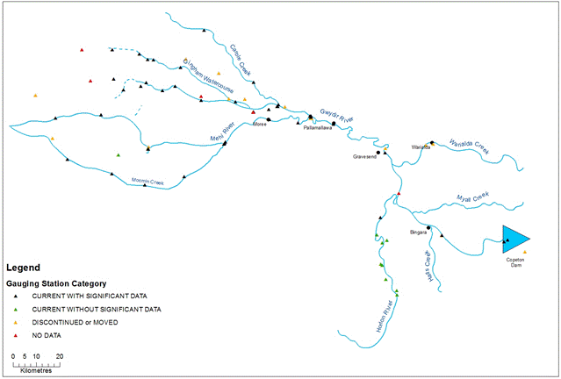

Figure 5‑2: Hydrological gauge network

### What

Sourcing and analysis of hydrological data to understand the system hydrology and character of Commonwealth environmental water and other environmental water deliveries. This indicator assists with understanding hydrological connectivity and duration for several other indicators.

### When

On-going for the duration of the project.

### How

No new gauging stations are to be established. This indicator will require only the standard analysis of system hydrology.

### Linkages and indicator interactions

This indicator links to Vegetation Diversity, Waterbird Breeding (optional), Waterbird Diversity, Fish (River), Water Quality, Microcrustaceans and Hydrology (Watercourse) indicators.

### Analytical approach

See individual indicators for short and long term hypotheses and analyses.

Data will be managed following the requirements outlined in the LTIM Project Standard Protocol: Section 14 Hydrology (River) (Hale et al. 2014) and conform to the LTIM Project Data Standard (Brooks & Wealands 2014).

## Monitoring schedule - Fish (River)

The SOP for River (River) is provided in Appendix B.3.

### Basin-scale and Selected Area evaluation questions

Short-term (one-year) questions:

What did Commonwealth environmental water contribute to native fish community resilience?

What did Commonwealth environmental water contribute to native fish survival?

Long-term (five-year) questions:

What did Commonwealth environmental water contribute to native fish populations?

What did Commonwealth environmental water contribute to native fish diversity?

### Where

The overall design for the Fish (River) indicator has been structured to meet the Category 1 requirements and provide Selected Area specific information. The environmental watering options for the Gwydir system west of Tareelaroi Weir are likely to target different zones for different environmental outcomes over a number of years. However, the reach of the Gwydir River between Tareelaroi Weir and Tyreel Weir selected for Category 1 Fish (River) sampling will be the most likely reach to receive environmental water each year. Category 3 sampling undertaken in the other three western river reaches will help to inform the Selected Area analysis (Figure 5‑3)

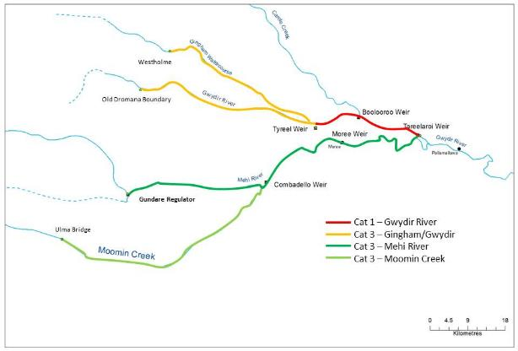

Figure 5‑3. Fish (River) to be monitored within the Gwydir River Selected Area

### What

In each year, Category 1 Fish (River) monitoring will take place in the priority zone west of Tareelaroi Weir following the standard methods (Hale et al. 2014). Otoliths will be collected annually from two opportunistic species within the Category 1 Fish River Selected Area. Otoliths will also be collected in years one and year five from two equilibrium and two periodic species. Equilibrium and Periodic species will be collected within the same zone, but at different locations to the Category 1 Fish River Selected Area so as not to bias the fish community results. In three additional reaches, sampling will be undertaken using Sustainable Rivers Audit (SRA) protocols (Davies et al. 2010). Fish will be sampled at five sites within each zone, using a combination of boat electrofishing (12 x 90 second shots) and un-baited bait traps (n = 10). All fish will be identified, counted, measured and weighed (maximum of 50 individuals per species per electrofishing shot). Although zones are not true replicates (different hydrology, geomorphology), comparisons within and among years of trajectories of change relative to a derived reference condition (SRA metrics) for each zone will provide a robust evaluation of short and long term outcomes from zones receiving Commonwealth environmental water.

Fisheries NSW will be contracted to undertake Fish (River) monitoring.

### When

March each year for the Category 1 reach. March-April each year for the other zones.

### How

As per the standard methods. Non-Category 1 sampling zones will use the same methods as those for Category 1 (without otolith sampling) with the site number reduced from 10 to 5 in each zone to facilitate the analytical approach and optimise costs. A total of 25 sites will be sampled annually.

### Linkages and indicator interactions

This indicator links to Fish (Movement), Hydrology (River) and Microcrustaceans indicators.

### Selected Area scale hypotheses

Short-term (Annual) responses:

1. Mean Total length, Fork length and Mass for each of the 2 target taxa in each of the 3 life history guilds will be greater in the zone(s) receiving Commonwealth environmental water compared with zones not receiving Commonwealth environmental water.
2. SRA metrics “Expectedness”, “Nativeness”, and “Recruitment” of native fish communities will be greater in the zone(s) receiving Commonwealth environmental water compared with zones not receiving Commonwealth environmental water.
3. Age of fish (target taxa in each life history guild) will have a greater range (measure of resilience) in the zone(s) receiving annual Commonwealth environmental watering events compared with zones not receiving Commonwealth environmental water.

Long-term (5 year) responses

1. Mean Total length, Fork length and Mass for each of the 2 target taxa in each of the 3 life history guilds will be greatest year-on-year in zones receiving Commonwealth environmental water compared with zones not receiving Commonwealth environmental water.
2. SRA metrics “Expectedness”, “Nativeness”, and “Recruitment” of native fish communities will be greatest year-on year in zones receiving Commonwealth environmental water.
3. Age of fish (target taxa in each life history guild) will have a greater range year-on year (measure of resilience) in the zone(s) receiving annual Commonwealth environmental watering events.

### Approach to Selected Area scale analyses

Analyses based on Aggregation will be applied at the Basin and Selected Area scales for taxonomic diversity and richness. Additionally, the fish community data will be summarised using the three main SRA Indicators 1) “Expectedness” (a comparison of the existing catch composition with that of historical fish distributions), 2) “Nativeness” (the proportion of native versus alien fishes), and 3) “Recruitment” (the recent reproductive activity of the native fish community). Quantitative analyses will then be applied at the Selected Area scale based on annual watering and a counterfactual approach based on an historical ‘reference’ condition represented by a pre-European fish assemblage (developed by Fisheries NSW). Multi-year analyses will be quantitatively analysed based on year-on-year repeat application of annual models outlined in the Selected Area conceptual model (Figure 5‑8), and a time-lagged trajectory to a pre-defined condition (Figure 5‑9). Uncertainty propagation within and among years will be possible to quantify based on annual comparisons of sites receiving Commonwealth environmental water compared with those sites not watered.

Short-term (Annual) responses:

1. Hypotheses 1, 2 and 3 – Univariate analysis (e.g. ANOVA - main effect – zone) for all taxa, each target taxa, each life history guild, taxa reference richness/diversity.
2. Hypotheses 2 - (diversity-abundance) multivariate analysis (e.g. Permanova, MDS, PCA - factors – zone, target taxa, life history guilds, native/exotic, taxa reference composition).

Long-term (5 year) responses:

1. Hypotheses 4, 5 and 6 – Univariate analysis (main effects – zone, years) for all taxa, each target taxa, each life history guild, taxa reference richness/diversity.
2. Hypotheses 5 - (diversity-abundance) multivariate analysis (factors – zone/years, target taxa, life history guilds, native/exotic, taxa reference composition).

### Selected Area scaling

All zones in the lower Gwydir will have representative reaches sampled annually, with 1 priority zone sampled following the delivery of Commonwealth environmental water. Replicate sites in all zones are within defined study reaches of known length (Table 5.1), facilitating outcomes for entire systems to be determined from data scaled from representative reaches (e.g., abundance of native fish/river km scaled to entire channel system of the same ANAE typology).

## Monitoring schedule – Vegetation Diversity

The SOP for Vegetation Diversity is provided in Appendix B.4.

### Selected Area evaluation questions

Short-term (one-year) and long-term (five year) questions:

What did Commonwealth environmental water contribute to vegetation species diversity?

What did Commonwealth environmental water contribute to vegetation community diversity?

### Where

In targeted wetland communities within the Gingham-Gwydir Watercourse and Mehi-Moomin zones (Figure 5‑4). These sites are part of an ongoing monitoring program conducted by OEH to monitor the response of vegetation diversity to water. The LTIM Project team will undertake cooperative data collection and sharing with OEH. In these sites Commonwealth environmental water will spill onto the watercourse areas.

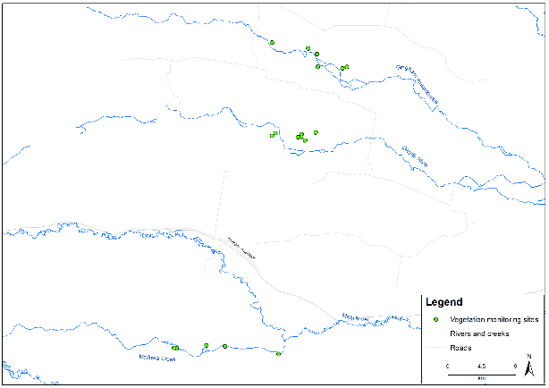

Figure 5‑4: Vegetation Diversity Sites

### What

Survey and analysis for vegetation diversity responses to inundation.

### When

Twice annually before and after the watering season: August-October and March-June.

### How

Survey methods will comply with the OEH data collection protocols for floodplain wetland vegetation monitoring in the Gwydir watercourse (Bowen 2014; Refer to Appendix B.4, Vegetation Diversity SOP). The methodology aligns with the Standard Methods as a Category 2 indicator (Hale et al. 2014).

Surveys will target 18 existing monitoring sites that incorporate Water Couch communities, River Cooba-Lignum, Marsh Club-rush sedgelands and Coolibah woodlands in the Gingham-Gwydir Watercourse. Depending on the community structure a combination of transects and quadrats will be surveyed (Refer to Appendix B.4, Vegetation Diversity SOP). Sites have been established to directly target zones where environmental watering is likely to be delivered. Links to inundation will be developed thought the Hydrology (Watercourse) indicator.

### Linkages and indicator interactions

This indicator links to Microcrustacean and Hydrology (Watercourse) indicators.

This program links to ongoing vegetation monitoring being undertaken by OEH and will provide for collaborative data sharing.

### Selected Area scale hypotheses

Short-term (Annual) responses:

1. The delivery of Commonwealth environmental water to wetland and floodplain areas in the Gingham-Gwydir Watercourse will lead to increased cover and/or richness of wetland vegetation communities.

Long-term (5 year) responses:

1. The delivery of Commonwealth environmental water in the Gingham-Gwydir Watercourse and will lead to increased year-on-year cover and/or richness of wetland vegetation communities.

### Approach to Selected Area scale analyses

Analyses based on Aggregation will be applied at the Basin and Selected Area scales for cover and richness of wetland vegetation communities. Quantitative analyses will be applied at the Selected Area scale to document increased cover and richness of wetland vegetation communities at sites receiving Commonwealth environmental water. Multi-year analyses will be quantitatively assessed based on year-on-year repeat application of annual models outlined in the Selected Area conceptual model (Figure 5‑8). The placement of survey sites has been strategically undertaken to permit quantification of the hydrologic connection and inundation metrics and lead to reduced uncertainty the delivery of Commonwealth water to these sites.

Short-term (Annual) responses:

1. Hypotheses 1 - univariate analysis (main effect – location, inundation, time) cover and richness and multivariate analysis (factors – location, inundation history, time).

Long-term (5 year) responses:

1. Hypotheses 2 - univariate analysis (main effects – location, inundation history, year, time) and multivariate analysis (factors – location, inundation history, year, time).

### Selected Area scaling

Each wetland community within the Gingham-Gwydir Watercourse has been mapped at a fine spatial scale. Linking wetland vegetation community extent to Commonwealth environmental water inundation extent should permit extrapolation the response to the Selected Area. The proposed indicator Hydrology (Watercourse) will document the m2 of inundated ANAE and vegetation hydrology and will facilitate the extrapolation.

## Monitoring schedule - Waterbird Diversity

The SOP for Waterbird Diversity is provided in Appendix B.5.

### Selected Area evaluation questions

Short-term (one-year) and long-term (five year) question:

* What did Commonwealth environmental water contribute to waterbird survival?

Long-term (five-year) questions:

* What did Commonwealth environmental water contribute to waterbird populations?
* What did Commonwealth environmental water contribute to waterbird species diversity?

### Where

A number of sites have been established and monitored in the Gwydir and Gingham Watercourses by OEH staff for a number of years. These areas will be the target of the survey effort (Figure 5‑5).

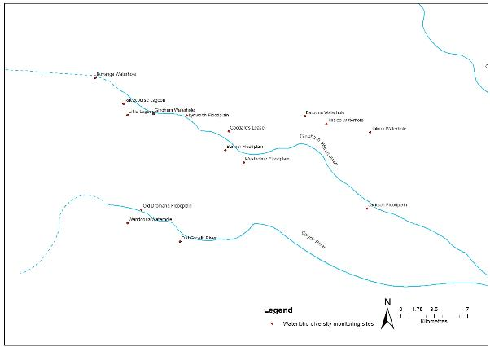

Figure 5‑5. Waterbird Diversity monitoring sites within the Gwydir Selected Area

### What

Sampling for waterbird diversity.

### When

Biannual typically January and April, however, responsive to wetland conditions.

### How

Biannual ground surveys will be undertaken, as per the LTIM Standard Methods (Section 10 Waterbird Diversity, Hale et al. 2014). Here, surveys will be undertaken on both foot and from a vehicle using observation points or transects depending on the size and shape of the wetland. Surveys are undertaken for at least 20 minutes but no more than 1 hour at each wetland, in order to gain a representative no necessarily complete, count of all waterbirds in the wetland.

### Linkages and indicator interactions

This indicator links to Microcrustaceans, Vegetation Diversity and Hydrology (Watercourse) indicators.

### Selected Area scale hypotheses

Short-term (Annual) responses:

1. The delivery of Commonwealth environmental water will lead to increased waterbird survival?

Long-term (5 year) responses:

1. The delivery of Commonwealth environmental water will lead to larger waterbird populations?
2. The delivery of Commonwealth environmental water will lead to increased waterbird diversity?

### Approach to Selected Area scale analyses

Analyses based on Aggregation will be applied at the Basin and Selected Area scales for abundance, richness and diversity of waterbirds. Quantitative analyses will be applied at the Selected Area scale to document increased abundance, richness and diversity of waterbirds at sites receiving Commonwealth environmental water. Multi-year analyses will be quantitatively assessed based on year-on-year repeat application of annual models outlined in the Selected Area conceptual model (Figure 5‑8). The placement of RMCam devices at each location to quantify hydrologic connection and inundation metrics will improve uncertainty in quantifying the delivery of Commonwealth water to target sites.

Short-term (Annual) responses:

1. Hypotheses 1 and 2 - univariate analysis (main effect – site, time) abundance, richness, diversity.
2. Hypotheses 2 - (diversity-abundance) multivariate analysis (factors – site, time).

Long-term (5 year) responses:

1. Hypotheses 2 and 3 - univariate analysis (main effects – target site, year, time).
2. Hypotheses 3 - (diversity-abundance) multivariate analysis (factors – target site, year, time).

### Selected Area scaling

The standard method for Waterbird Diversity reports m2 ANAE area surveyed inundated from Commonwealth environmental water. The proposed indicator Hydrology (Watercourse) will document the m2 of inundated ANAE and vegetation hydrology and will facilitate the scaling of potential colonial waterbird rookery sites to the lower Gwydir.

## Monitoring schedule - Water Quality

The SOP for Water Quality is provided in Appendix B.6.

### Selected Area evaluation questions

Short-term (one-year) and long-term (five year) questions:

* What did Commonwealth environmental water contribute to temperature regimes?
* What did Commonwealth environmental water contribute to pH levels?
* What did Commonwealth environmental water contribute to turbidity regimes?
* What did Commonwealth environmental water contribute to salinity regimes?
* What did Commonwealth environmental water contribute to dissolved oxygen levels?

### Where

At a single station at Pallamallawa near the NOW telemetered gauge in Gwydir River Zone (Copeton Dam to Tareelaroi Weir) to allow evaluation of water quality entering the lower Gwydir system.

### What

*In situ* logging of DO, temperature, EC, pH, turbidity and chlorophyll a at 15 min intervals. The DS5-X multi-probe logger includes a self-cleaning system to reduce fouling of probes and is designed for long-term submersible deployment.

### When

The logger will be deployed to record continuously at this site as it has permanent surface water flow. Deployment periods will therefore align with the commencement and cessation of Commonwealth environmental water delivery.

### How

The design, equipment, collection and processing of data, reporting and QA requirements will follow the LTIM Project Standard Protocol: Section 13 Water Quality (Hale et al. 2014).

### Linkages and indicator interactions

This indicator links to Vegetation Diversity, Waterbird Breeding, Waterbird Diversity, Fish (River) and Hydrology (River and Watercourse) indicators in the lower Gwydir system.

### Selected Area scale hypotheses

Short-term and long-term responses

1. Mean daily water temperature, and daily range in water temperature will decrease during the delivery of Commonwealth environmental water.
2. Mean daily pH, and daily range in pH will decrease during the delivery of Commonwealth environmental water.
3. Mean daily turbidity will increase during the delivery of Commonwealth environmental water.
4. Mean daily EC will decrease during the delivery of Commonwealth environmental water.
5. Mean daily DO concentrations will decrease during the delivery of Commonwealth environmental water.

### Approach to Selected Area scale analyses

Quantitative analyses will be applied at the Selected Area scale to test predicted changes in each water quality variable. Multi-year analyses will be quantitatively assessed based on year-on-year repeat application of annual models outlined in the Selected Area conceptual model (Figure 5‑8).

Short-term and long term responses

1. Hypotheses 1, 2, 3, 4 and 5. Replication derived from randomised daily means of data periods within/outside delivery of Commonwealth environmental water. One-way Anova (WQ variables as dependant variable) comparing among flow periods, and two-way Anova (flow period, years) for long term dataset.

## Monitoring schedule - Hydrology (Watercourse)

The SOP for Hydrology (Watercourse) is provided in Appendix B.7.

### Selected Area evaluation questions

Short-term (one year) and long-term (five year) questions:

* What did Commonwealth environmental water contribute to hydrological connectivity of the Gingham-Gwydir Watercourse Wetlands?
* What did Commonwealth environmental water contribute to Microcrustaceans?
* What did Commonwealth environmental water contribute to Waterbird Diversity and Breeding?
* What did Commonwealth environmental water contribute to Vegetation Diversity?

### Where

In the Gingham-Gwydir Watercourse (Figure 5‑7).

### What

Map the inundation extent resulting from the delivery of Commonwealth environmental watering using Lidar imaging.

Other data on inundation extent and frequency from previous and ongoing work from OEH (Rachel Thomas et al) and Sue Powell (UC PhD thesis), Lidar captures and hydrodynamic modelling from OEH will be used to assist in developing the known and expected inundation extent and volume from given flow events.

### When

Existing sets of Lidar data (already captured) will be used to create an inundation model at targeted areas within the Gingham-Gwydir Watercourse. No new data capture is proposed.

### How

Lidar images will be used to create an inundation model and tied to flow/volume data from the nearest gauge.

The inundation layers will be used in conjunction with other locally established gauges to develop location specific knowledge relating flow volume to inundation.

### Linkages and indicator interactions

This indicator links to Microcrustaceans, Vegetation Diversity, Waterbird Breeding and Waterbird Diversity indicators.

This project will create data relevant to the hydro-dynamic model built by OEH. It will enable calibration and refinement of this model.

### Analysis

GIS based analysis to determine the relationship between inundation event (volume) and inundated area and volume in relation to mapped soil and vegetation regions.

### Approach to Selected Area scale analyses

The Hydrology (Watercourse) method reports m2 ANAE typology and vegetation community inundated from Commonwealth environmental water. The proposed indicator will document the m2 of inundated ANAE and vegetation hydrology and will facilitate the scaling of potential Microcrustaceans, Vegetation Diversity and Waterbird Diversity/Breeding to the Lower Gwydir.

All data provided for this indicator must conform to the data structure defined in the LTIM Data Standard (Brooks & Wealands 2014).

## Monitoring schedule - Fish (Movement)

The SOP for Fish (Movement) is provided in Appendix B.8.

### Selected Area evaluation questions

Short-term (one-year) questions:

* What did Commonwealth environmental water contribute to native fish dispersal?
* Did environmental water stimulate target species to exhibit movement consistent with breeding behaviour?
* Did environmental water facilitate target species to move/return to refuge habitat?

Long-term (five-year) question:

* What did Commonwealth environmental water contribute to native fish populations?

### Where

In the first year of monitoring Fish (Movement) (year 2 of the LTIM monitoring), the monitoring team will select the best reach within the target zones to establish the optimal location/s for fish movement array.

### What

Category II sampling and recording. Fish (Movement) will target movement of one equilibrium species, freshwater catfish (*Tandanus tandanus*) (endangered population Murray-Darling Basin), and one periodic species, spangled perch (*Leiopotherapon unicolor*). Within the Murray Darling Basin, the response of both species to changes in river discharge is poorly understood and to the best of our knowledge neither species is currently being studied elsewhere in the Basin to answer any flow-related questions.

Fisheries NSW in collaboration with NOW will be contracted to undertake Fish (Movement) monitoring.

### When

Ongoing in Years 2 and 3 only (i.e. 2015-16, 2016-17). Following the collection and analysis of Year 1 Category 1 Fish (River) data, the team will select best reach within the target zone to establish fish movement array.

### How

As per the LTIM Project Standard Protocol: Section 8 Fish (Movement) (Hale et al. 2014)

### Linkages and indicator interactions

This indicator links to Fish (River), Water Quality and Hydrology (River) indicators.

### Selected Area scale hypotheses

Short-term (Annual) responses (for target species *Tandanus tandanus* and *Leiopotherapon unicolor*):

1. Fish movement (metres) and rate of movement (metres/day) is positively correlated to the timing of Commonwealth environmental water delivery.
2. Fish home-range is increased during Commonwealth environmental water delivery.
3. The number of habitats utilised by fish will increase Commonwealth environmental water delivery. Commonwealth environmental water delivery results in breeding of target species.

Long-term (5 year) responses:

1. Fish movement (metres) is greatest in years receiving Commonwealth environmental water delivery
2. Increased breeding activity by target species.

### Approach to Selected Area scale analyses

The objective of the Fish (Movement) indicator is to establish an acoustic array to provide ‘acoustic recaptures’ similar to a mark-recapture study, and to define movement cues and habitat use (including refugee during drought) in response to the delivery of Commonwealth environmental water. Fisheries NSW already has in place a data base to manage the large amounts of data likely to be generated. Techniques such as position averaging (e.g. Simpfendorfer et al. 2010) will be used to reduce data processing where possible. Home–range calculations (kernal utilisation distributions), site fidelity (linearity indices), habitat use and rate of movement will be plotted using Eonfusion® (Fisheries NSW hold multiple licences for the software). Eonfusion® will also be used to generate ‘real-time’ video to help in visualising fish movements in relation to flow, season, day-night etc. In addition the above analyses, a model selection approach using linear mixed effect models will be used to determine relationships between movement patterns and environmental variables such as discharge, lagged discharge (number of days since flow event), Julian day, water temperature, sex and length of fish. If breeding related movements do occur, then the locations of fish during this time will be reported as displacement, defined as a representation of the geographical distance and the direction that the fish moved. As freshwater catfish is known to nest on open substrates and in relatively shallow water, we will also attempt to validate nest site locations using underwater cameras.

## Monitoring schedule – Microcrustaceans

The SOP for Microcrustaceans is provided in Appendix B.9.

### Basin-Scale and Selected Area evaluation questions

Short-term (one-year) and long-term (five year) questions:

What did Commonwealth environmental water contribute to microcrustacean productivity?

What did Commonwealth environmental water contribute to microcrustacean community composition?

What did Commonwealth environmental water contribute to resilience of microcrustacean egg banks? (comparing year 1 to year 5)

What did Commonwealth environmental water contribute to the timing of microcrustacean productivity and presence of key species in relation to numbers of larval fish?

What did Commonwealth environmental water contribute to the timing of microcrustacean productivity and presence of key species in relation to growth of larval fish?

What did Commonwealth environmental water contribute to connectivity of microcrustacean and vegetation communities in floodplain watercourses?

### Where

Monitoring sites for microcrustaceans will be located in two target areas in the Selected Area, River channels and Watercourse floodplain areas. The application of standard methods to these target areas provides potential for Basin-scale evaluation and comparisons with other Selected Areas.

The first is the River zone receiving Commonwealth environmental water within each watering year, where the river channel sampling protocol for microcrustaceans will occur at the three locations aligned with Fish (River) sampling to provide explicit links among these indicators and provide an assessment of a functional ecosystem response.

The second zone utilises the wetland/floodplain sampling protocol to sample watercourse inundation that is characterised by an extensive floodplain wetland network and will allow an assessment of connectivity. Sampling will occur within representative sites in each of the dominant wetland vegetation communities inundated by Commonwealth environmental water. The Hydrology Watercourse indicator will facilitate the scaling-up of site based Microcrustacean data (density/L/vegetation type) to the entire inundated area of the watercourse. The focus is on the microcrustacean response to the inundation of water couch and Cooba Lignum communities within Goddard’s Lease Ramsar site, Westholme, Bunnor and Lynworth in the Gingham systems and Water Couch and Marsh Club-Rush communities on Old Dromana in the Gwydir.

This design will allow Basin-scale reporting with replication (n=3) for each of river channel and watercourse habitats and alignment with Fish (River) and Vegetation Diversity.

River sites:

* The Mehi-Moomin system extends from the upstream site at Tareelaroi Weir to lower sites at Gundare Regulator (Mehi) and Moomin Plains (Moomin Creek) gauges. All these sites have all weather access and established NOW telemetered gauges.

Watercourse sites:

* The Gingham-Gwydir zone extends from Tyreel storage as the confluence of these two systems, to lower sites at Crinolyn (Gingham) and Homebush (Gwydir) gauges both of which have all weather access and established NOW telemetered gauges.

The rationale underlying this approach is to seek as much synergy as possible between the components monitoring other vertebrates and wetland fish that also prey on microcrustaceans. Only a single composite sample (comprised or either 5 benthic cores or 5 pelagic buckets) is taken from each site or flow-habitat within a site. This will reduce the overall number of samples for laboratory processing.

### What

Sampling of Microcrustacean populations in both pelagic and benthic habitats. Also, the monitoring of nutrients and metabolism.

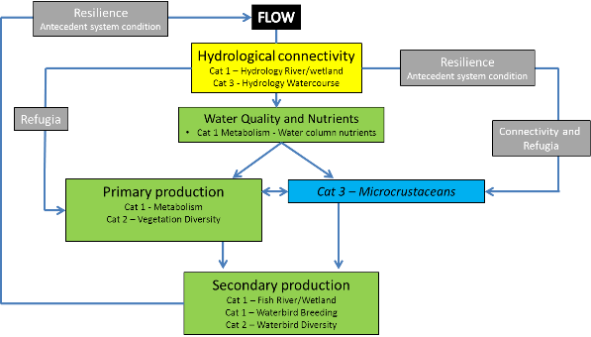

Figure 5‑6: CED – microcrustaceans

### When

At each of the 3 Fish (River) sites, microcrustacean sampling will take place on 4 occasions from October through to April.

At each watercourse site, microcrustacean sampling will take place following watercourse inundation with Commonwealth environmental water, four sample events are planned to follow the inundation and contraction cycle, sampling immediately (days) after inundation, at peak area inundation, and at two times during the drying cycle.

### How

As per the methodology prescribed in the Microcrustacean SOP (Appendix B.9).

### Linkages and indicator interactions

This indicator links to Vegetation Diversity, Waterbird Breeding, Fish (River), Hydrology (River) and Hydrology (Watercourse) indicators.

### Selected Area scale hypotheses

1. The delivery of Commonwealth environmental water will increase the biotic and abiotic resource pools supporting food webs.
2. The delivery of Commonwealth environmental water will shift the trophic position of key taxa.
3. The delivery of Commonwealth environmental water will increase the complexity of food web structure.
4. The delivery of Commonwealth environmental water will increase whole-of-system trophic dynamics (biological productivity, interaction among species, interaction between the system and its biotic and abiotic surroundings).

### Approaches to Selected Area scale analyses

Data for the Basin-scale will be reported following the requirements outlined in the LTIM Project Standard Protocol: Section 12 Metabolism (Hale et al. 2014) and conform to the LTIM Project Data Standard (Brooks & Wealands 2014).

At the Selected Area scale a number of hypotheses that relate to the outcomes of delivery of Commonwealth environmental water are possible.

In river channel habitats, quantitative analyses will be possible for microcrustacean density and community composition for time since watering, with multivariate analyses such as nMDS (and modules including Simper, BioEnv, DISP, PCA) will be used to explore patterns among dependant and covariate variables such as water column nutrient and carbon concentrations, metabolism and larval and adult fish.

In watercourse habitats, quantitative analyses will be possible for microcrustacean density and community composition for time since watering and vegetation community, with multivariate analyses such as nMDS (and modules including Simper, BioEnv, DISP, PCA) will be used to explore patterns among additional measured variables of water column nutrient and carbon concentrations and metabolism.

Watercourse Hydrology will quantify the area of each vegetation community inundated and the volume of inundation (m3) throughout the delivery cycle of Commonwealth environmental water. Linking microcrustacean density to this indicator will facilitate scaling of response from site based (microcrustacean density/m2) to the inundated vegetation asset scale within the Selected Area.

## Monitoring schedule – Macroinvertebrates

The SOP for Macroinvertebrates is provided in Appendix B.9.

### Basin-Scale and Selected Area evaluation questions

Short-term (one-year) and long-term (five year) question:

What did Commonwealth environmental water contribute to macroinvertebrate diversity?

### Where

Macroinvertebrates will be sampled at the same locations as described in Section 5.11 for microcrustaceans.

### What

The sampling of macroinvertebrate communities at sites within the river channels and watercourse areas of the Selected Area.

### When

At each of the 3 Fish (River) sites, macroinvertebrate sampling will take place on 4 occasions from October through to April.

At each watercourse site, macroinvertebrate sampling will take place following watercourse inundation with Commonwealth environmental water, four sample events are planned to follow the inundation and contraction cycle, sampling immediately (days) after inundation, at peak area inundation, and at two times during the drying cycle.

### How

As per the methodology prescribed in the Macroinvertebrate SOP (Appendix B.10).

### Linkages and indicator interactions

This indicator links to Vegetation Diversity, Waterbird Breeding, Fish (River), Microcrustaceans, Hydrology (River) and Hydrology (Watercourse) indicators.

### Selected Area scale hypotheses

1. The delivery of Commonwealth environmental water will increase the diversity of macroinvertebrate communities.
2. The delivery of Commonwealth environmental water will increase whole-of-system trophic dynamics (biological productivity, interaction among species, interaction between the system and its biotic and abiotic surroundings).

### Approaches to Selected Area scale analyses

Data for the Basin-scale will be reported following the requirements outlined in the LTIM Project Standard Protocol: Section 11 Macroinvertebrates (Hale et al. 2014) and conform to the LTIM Project Data Standard (Brooks & Wealands 2014).

At the Selected Area scale a number of hypotheses that relate to the outcomes of delivery of Commonwealth environmental water are possible.

In river channel habitats, quantitative analyses will be possible for macroinvertebrate density and community composition for time since watering, with multivariate analyses such as nMDS (and modules including Simper, BioEnv, DISP, PCA) will be used to explore patterns among dependant and covariate variables such as water column nutrient and carbon concentrations, metabolism and larval and adult fish.

In watercourse habitats, quantitative analyses will be possible for macroinvertebrate density and community composition for time since watering and vegetation community, with multivariate analyses such as nMDS (and modules including Simper, BioEnv, DISP, PCA) will be used to explore patterns among additional measured variables of water column nutrient and carbon concentrations and metabolism.

## Monitoring schedule - Waterbird Breeding (optional)

The SOP for Waterbird Breeding is provided in Appendix B.10.

It is noted that monitoring of Waterbird Breeding is an optional monitoring activity and is event driven.

### Basin-Scale and Selected Area evaluation questions

Short-term (one-year) and long-term (five year) questions:

* What did Commonwealth environmental water contribute to waterbird breeding?
* What did Commonwealth environmental water contribute to waterbird chick fledging?
* What did Commonwealth environmental water contribute to waterbird survival?

Long-term (five-year) question:

* What did Commonwealth environmental water contribute to waterbird populations?

### Where

There are several well-known colonial bird rookeries within the Gingham-Gwydir Watercourse, these rookery areas will be the target of the survey effort (Figure 5‑7).



**Known waterbird breeding sites – Gingham-Gwydir Watercourse**

Figure 5‑7: Watercourse areas

### What

Surveys of colonial bird breeding events and fledgling success using standard methods (Hale et al. 2014).

### When

Monitoring is event driven and will be discussed with CEWO prior being undertaken.

### How

The key rookery sites are well-known in the lower Gwydir Watercourse. We will rely on established communication networks with the key stakeholder communities (LTIM survey staff, landholders, birdwatchers and government department/agency staff) to identify bird breeding events or potential events linked to Commonwealth environmental water. Surveys will be initiated by confirmed commencement of bird breeding events.

At key rookery sites remote camera systems (a combination of online ready units and other camera systems) will be established to monitoring a bird breeding event as required. The camera units will be used to provide ongoing photographic monitoring of a minimum of 5 nesting sites in the selected location to assess breeding success.

On-ground surveys will be conducted monthly at a minimum during the event.

Hydrology will be determined via the Hydrology (Watercourse) indicator.

The monitoring design complies with the standard protocol using fixed cameras (Hale et al. 2014).

### Linkages and indicator interactions

This indicator links to Microcrustacean, Vegetation Diversity and Hydrology (Watercourse) indicators.

### Selected Area scale hypotheses

Short-term (Annual) responses:

1. The delivery of Commonwealth environmental water to key rookery sites in the lower Gwydir will lead to successful nest establishment by colonial waterbirds.
2. The delivery of Commonwealth environmental water to key rookery sites in the lower Gwydir will lead to the successful fledgling of colonial waterbirds.
3. The delivery of Commonwealth environmental water to key rookery sites in the lower Gwydir will lead to increased diversity and abundance of nesting adult colonial waterbirds (link to Waterbird Diversity Indicator).

Long-term (5 year) responses:

1. The delivery of Commonwealth environmental water to key rookery sites in the lower Gwydir will lead to repeated successful nest establishment by colonial waterbirds.
2. The delivery of Commonwealth environmental water to key rookery sites in the lower Gwydir will lead to the repeated successful fledgling of colonial waterbirds.
3. The delivery of Commonwealth environmental water to key rookery sites in the lower Gwydir will lead to increased Selected Area diversity and abundance of adult colonial waterbirds (link to Waterbird Diversity Indicator).

### Approach to Selected Area scale analyses

Analyses based on Aggregation will be applied at the Basin and Selected Area scales for taxonomic diversity and richness, and nesting and fledgling success. Qualitative and quantitative analyses will be applied at the Selected Area scale to document nesting and fledgling success of colonial waterbirds. Multi-year analyses will be quantitatively assessed based on year-on-year repeat application of annual models outlined in the Selected Area conceptual model (Figure 5‑8). The placement of water level recorders at each location to quantify hydrologic connection and inundation metrics will improve uncertainty in quantifying the delivery of Commonwealth water to rookery sites.

Short-term (Annual) responses:

1. Hypotheses 1 and 2 - univariate analysis (main effect – rookery site, season), nesting and fledgling success.
2. Hypotheses 3 - (diversity-abundance) multivariate analysis (factors – rookery site /season).

Long-term (5 year) responses:

1. Hypotheses 4 and 5 - univariate analysis (main effects – rookery site /year/season), nesting and fledgling success.
2. Hypotheses 45 and 6 - (diversity-abundance) multivariate analysis (factors – rookery site /year/season).

### Selected Area scaling

The standard method for Waterbird Breeding reports area (m2) ANAE typology inundated from Commonwealth environmental water. The indicator Watercourse (Hydrology) will document the area (m2) of inundation and vegetation/habitat mapping will facilitate the scaling of potential colonial waterbird breeding sites/success to the lower Gwydir.

## Complimentary data

There are a number of complimentary data sets that will be required for the LTIM Project in the Gwydir Selected Area. These data are listed in the individual SOPs developed for each indicator and summarised in Table 5‑3 below. It is assumed that where CEWO has access to these data, these data will be made available; other data will be accessed via a license agreement with the appropriate agency. These requirements are detailed further in the Communications Plan (Appendix D).

Table 5‑3: Complimentary data required for the LTIM Project in the Gwydir Selected Area

|  |  |  |
| --- | --- | --- |
| **Monitoring indicator** | **Data** | **Relevant stakeholder** |
| Ecosystem type | Mapping output from Brooks et al. (2013)  Regional sources with updated feature mapping and fine-scale resolution vegetation mapping and/or remote sensed data  Recently acquired AS40 data  Satellite imagery (e.g. SPOT6 – panchromatic resolution 1.5 m, multispectral resolution 8 m)  NVIS41_MDB vegetation mapping (NVIS v4.1 updated with CMA mapping by Brooks et al. 2013) | CEWO  Other agencies as necessary e.g. LLS, OEH |
| Fish (River) | SRA data and reporting  Integrated Monitoring of Environmental Flows (IMEF) data and reporting  Rivers Environmental Restoration Program | MDBA  OEH |
| Fish (Movement) |
| Waterbird Breeding | IMEF  Rivers Environmental Restoration Program | OEH |
| Waterbird Diversity |
| Vegetation Diversity | OEH Environmental Flow Monitoring Program  Short-term Intervention Monitoring Project (STIM) data  SRA data and reporting  IMEF data and reporting  Rivers Environmental Restoration Program | OEH  CEWO  MDBA |
| Microcrustaceans | IMEF data and reporting  Rivers Environmental Restoration Program | OEH |
| Water Quality | Existing gauging stations and daily river reports  IMEF data and reporting | MDBA  NOW  OEH |
| Hydrology (River) | Existing gauging stations |
| Hydrology (Watercourse) | OEH inundation mapping  Watercourse Lidar datasets | MDBA  NOW  OEH |

## Evaluation and analytical approach

The CEWO LTIM Project seeks to quantify the outcomes of the management of Commonwealth environmental water and its contribution to achieving the requirements of the Basin Plan. Basin-scale evaluation is pivotal to the LTIM Project, and is to be informed by monitoring from the Gwydir Selected Area.

All Category 1 and 2 indicators have Standard Methods (Hale et al. 2014) and SOPs that define dependant variables, covariates and units for Basin-scale evaluation.

In addition, the study design allows analyses at the Selected Area scale for a number of Category 1 and 2 indicators. The Category 3 indicators in the Gwydir Selected Area of Hydrology (watercourse) and Microcrustaceans have detailed Selected Area evaluation and analytical approaches (see respective SOPs) with the potential for collaboration to develop a Basin-scale approach should a number of independent Selected Areas monitor these indicators using the Standard Methods.

All data will be delivered to the CEWO and Basin to conform to the LTIM Project Data Standard (Brooks & Wealands 2014) and facilitate data management within the LTIM Project Monitoring Data Management System (MDMS).

There are limitations to the analytical approaches for evaluation purposes in response to the Standard Methods applied to Category 1 and 2 indicators in the Gwydir Selected Area. The Selected Area has 3 zones that are spatially independent and geomorphically discrete units, with the evaluation of responses to Commonwealth environmental water often limited to one zone. As such, this design does not generally permit comparisons of outcomes for those sites that receive Commonwealth environmental water compared with those that do not, for indicators of Fish (River) and Vegetation Diversity. This can make short-term (annual) evaluation of outcomes difficult for the Selected Area scale, and may increase the reliance on scientific opinion to assist in the evaluation of Commonwealth environmental water.

Where possible we will apply a number of broad approaches to short-term (Annual) and long-term (Multi-year) analyses to assess the response of individual or suites of indicators to the delivery of Commonwealth environmental water to ecological assets in the Gwydir Selected Area.

1. For selected indicators (e.g., Fish (River) and Vegetation Diversity) we will develop a ‘reference condition’ to facilitate predictions that zones receiving Commonwealth environmental water will have a trajectory towards the reference condition (Figure 5‑8). For example, a reference condition for Fish River metrics (composition, total length, mass, expectedness, nativeness, and recruitment, and age of target taxa) will be developed in conjunction with DPI Fisheries (SRA) and from existing data (Short Term Intervention Monitoring, OEH monitoring) to set annual and long-term targets. Reference condition may need to be developed specific to antecedent condition, with a dry, average and wet extant reference condition used to determine trajectories of change (see Section 5.15). Evaluation of outcomes from Commonwealth environmental water will be determined by differences between the observed and expected outcomes.
2. Long-term (5 year) outcomes will require quantitative models (Figure 5‑8) that define outcomes for each indicator/zone in response to the delivery of Commonwealth environmental water. The repeated application of this model over time seeks to quantify a convergence or divergence in indicator response relative to watering regime (receiving or not receiving Commonwealth environmental water). Statistical approaches for these indicators will be time series-based (space-time substitution), with predicted differences between sites that have received Commonwealth environmental water (and the number of times they have received Commonwealth environmental water) compared with those that do not receive Commonwealth environmental water at the completion of each annual cycle used to evaluate outcomes. Condition assessment (y-axis on Figure 5‑9 is determined from the reference condition approach outlined above).

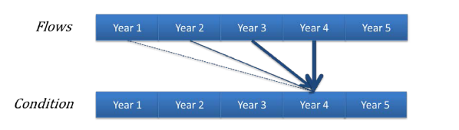

Figure 5‑8: Hypothetical model of a long-term response to environmental watering based on a created ‘reference condition’ where the greatest influence is from watering in the most recent year with progressively weaker influence from watering in previous years (Source: Gawne et al. 2014)

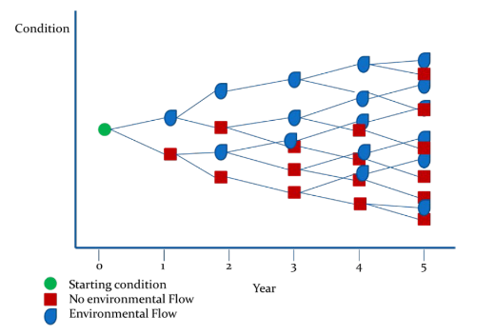

Figure 5‑9: A hypothetical model that will be applied on a year-to-year basis to generate a series of outcomes from different flow regimes over a five year period (Source: Gawne et al. 2014)

### Resilience

One of the aims of the LTIM Project is to understand the role of Commonwealth environmental water in promoting the resilience of the entire Gwydir Selected Area. Resilience is the amount of change a system can undergo (its capacity to absorb disturbance) and remain within the same regime that essentially retains the same function, structure and feedbacks (Walker & Salt 2006). A whole-of-system approach to resilience is required for the LTIM Project in the Gwydir Selected Area to link the extensive list of individual indicators within an ecosystem framework, targeted to hydrological and biological connectivity within and outside the Gwydir system, variability and heterogeneity in structural and functional elements of ecosystems and the cycling of materials and energy. This framework will be developed with stakeholders as a conceptual diagram of ecosystem components (individual indicators and their links), and their ecological thresholds that act as tipping points between ecosystem states. For example, the CED developed for the Microcrustacean indicator (see Figure 5‑6) identifies relationships among hydrologic and watercourse vegetation refuges as key links in the resilience of the system. Building these conceptual models and identifying ecological thresholds through monitoring will form the basis for measuring resilience in the Selected Area.

This framework will outline the adaptive management options that can be taken to manage resilience in the Gwydir system. The Environmental Contingency Allowance Operations Advisory Committee (ECA OAC) for the Gwydir River provides advice to the Commonwealth Environmental Water Office and NSW Office of Environment and Heritage to inform watering decisions. Ryder is an existing member of this Committee and Frazier has requested ex officio membership. This direct contact through the Committee will allow ad hoc and planned changes to the short and long term watering options of the Gwydir system to be responsive to monitoring outcomes such as top-up watering to sustain waterbird breeding events. Membership of this committee also facilitates highly targeted and responsive monitoring to planned Commonwealth environmental watering to ensure all monitoring of events is undertaken.

## Indicator/zone interaction and timing

The focus of the M&E Plan has been to target planned monitoring in the Gwydir River and distributary channels downstream of Tareelaroi Weir (Table 5‑4). Sample design has been aligned within each zone based on the expected outcomes of Commonwealth environmental watering options. However, as the delivery of Commonwealth environmental water may target any, all or none of these zones in a given year the M&E Plan has been designed to maximise potential Selected Area and basin-scale outcomes by allowing for the targeting of any individual zone for several indicators in response to the delivery of water.

The Watering Options for the Selected Area are generally for delivery in spring-summer and early autumn, following the broader pattern of pre-regulation watering cycles. Many of the prescribed sampling times for the Category 1 indicators are in summer-autumn. Given the nature of the timing of expected water delivery and Category 1 requirement the sampling effort is heavily weighted to summer-autumn sampling (Table 5‑5).

The monitoring design (sites, zones, standard methods) has been developed in the knowledge that the delivery of Commonwealth environmental water may co-occur with other environmental (state) and consumptive water, as well as rainfall driven events and flooding. As such, the evaluation of outcomes from Commonwealth environmental water will need to be made relative to antecedent conditions of inundated zones and the proportion of water delivered that is Commonwealth environmental water. Membership of the ECA OAC will inform the Gwydir LTIM Project team of the planned and delivered proportion of Commonwealth environmental water in any release. Hydrologic gauges nominated for use in Hydrology River and proposed methods for Hydrology Watercourse will both facilitate detailed information on antecedent conditions prior to the delivery of environmental water. For example, a Commonwealth environmental water release to top-up a waterbird breeding event can be hydrologically quantified by discharge, area inundated and linked explicitly to breeding success.

Table 5‑4: Indicator-Zone interactions. SA represents Selected Area.

|  |  |  |  |  |  |  |  |  |  |
| --- | --- | --- | --- | --- | --- | --- | --- | --- | --- |
| **Zone** | | **Gwydir Upstream** | | **Gwydir-Gingham** | | | | **Mehi-Moomin** | |
| **Ecosystem Type** | | **River** | **River** | **River** | **Water course** | **River** | **Water course** | **River** | |
| **CEW Delivery Option** | | 3 (1,2,4,5,6) | | 1,6 | | | | 4 | |
| **Reporting** | | **Basin** | **SA** | **Basin** | | **SA** | | **Basin** | **SA** |
| **Indicator** | **Cat.** |  | | | | | | | |
| Ecosystem Type | 1 |  |  |  |  |  |  |  |  |
| Hydrology (River) | 1 |  |  |  |  |  |  |  |  |
| Fish (River) | 1 + 3 |  |  |  |  |  |  |  |  |
| Waterbird Breeding | 1 |  |  |  |  |  |  |  |  |
| Vegetation Diversity | 2 |  |  |  |  |  |  |  |  |
| Waterbird Diversity | 2 |  |  |  |  |  |  |  |  |
| Water Quality | 2 |  |  |  |  |  |  |  |  |
| Hydrology (Watercourse) | 3 |  |  |  |  |  |  |  |  |
| Fish (Movement) | 2 |  |  |  |  |  |  |  |  |
| Microcrustaceans | 3 |  |  |  |  |  |  |  |  |
| Macroinvertebrates | 3 |  |  |  |  |  |  |  |  |

Table 5‑5: Annual field survey cycle

|  |  |  |  |  |  |  |  |  |  |  |  |  |  |
| --- | --- | --- | --- | --- | --- | --- | --- | --- | --- | --- | --- | --- | --- |
| **Month** | **Jan** | **Feb** | **Mar** | **Apr** | **May** | **Jun** | **Jul** | **Aug** | **Sep** | **Oct** | **Nov** | **Dec** | **Comments** |
| **Indicator** |  | | | | | | | | | | | |
| Ecosystem Type |  |  |  |  |  |  |  |  |  |  |  |  | Once only in year 2014 |
| Hydrology (River) |  |  |  |  |  |  |  |  |  |  |  |  | Ongoing, updating regularly from NoW data |
| Fish (River) (C1) |  |  |  |  |  |  |  |  |  |  |  |  | March Annually |
| Fish (River) (C3) |  |  |  |  |  |  |  |  |  |  |  |  | In association with C1 sampling |
| Vegetation Diversity |  |  |  |  |  |  |  |  |  |  |  |  | Twice annually around water season |
| Waterbird Diversity |  |  |  |  |  |  |  |  |  |  |  |  | Event driven, typically January and April |
| Water Quality |  |  |  |  |  |  |  |  |  |  |  |  | Continuously, up to 6-weekly maintenance intervals |
| Hydrology (Watercourse) |  |  |  |  |  |  |  |  |  |  |  |  | Ongoing and following delivery events |
| Fish (Movement) |  |  |  |  |  |  |  |  |  |  |  |  | Only in year 2015 and 2016 |
| Microcrustaceans |  |  |  |  |  |  |  |  |  |  |  |  | Event driven, likely from October to April annually |
| Macroinvertebrates |  |  |  |  |  |  |  |  |  |  |  |  | Event driven, likely from October to April annually |
| Waterbird Breeding (optional) |  |  |  |  |  |  |  |  |  |  |  |  | Event driven, likely summer to autumn |

# Communication and Engagement

## Stakeholder engagement

A stand-alone Project Communications Plan has been developed for the Gwydir Selected Area (Appendix D). This Communications Plan has been developed as a stand-alone document that specifies project communication requirements and stakeholder engagement for the duration of the LTIM Project, with the aim of facilitating effective and efficient communication. It describes the schedule of proposed communication and engagement activities, who is involved, who they will talk to, frequency of communications and roles and responsibilities.

It is highlighted that ELA/UNE via CEWO are currently developing a Memorandum of Understanding with OEH for cooperative resource and information sharing. Other necessary license agreements will be entered into with relevant agencies when monitoring indicators have been finalised.

## CEWO reporting

There are two forms of reporting requirements by M&E Providers to CEWO for the LTIM Project in the Gwydir Selected Area:

* Project reporting (progress)
* Outcomes reporting.

In addition to formal reporting, ELA will maintain good relationships with the CEWO, M&E Advisors and delivery partners to support evaluation and adaptive management throughout the LTIM Project.

### Project progress reporting

Progress reporting requirements for Stage 2 are provided in Table 6‑1, including regular forums and teleconferences.

### Outcomes reporting

The LTIM Project has a number of reporting and information transfer requirements. Table 6‑2 summarises the outcomes reporting and information transfer activities for the LTIM Project, including frequency, timing and responsibility. Note this list covers only operational reporting and information transfer activities only: no external reporting or information transfer activities are specified. It also includes reporting requirements that are the responsibility of the M&E Advisors (being the Annual Basin Evaluation Report).

M&E Providers will also be required to provide other key outputs for monitoring activities in the Gwydir:

* Submit monitoring data in the correct format and according to defined protocols within 1 month of its collection (including the MDMS and the LTIM Project Data Standards (Brooks & Wealands 2014))
* Noting and reporting any incidental observations made during field visits that may contribute to or support Evaluation (Area or Basin) or Adaptive Management. Observations can also include those reported to the M&E Provider by stakeholders. This requirement is ongoing, following observations.

Table 6‑1: Progress reporting requirements for the LTIM Project

|  |  |  |  |  |  |
| --- | --- | --- | --- | --- | --- |
| **Activity type** | **What** | **Frequency** | **Timing / due date** | **Responsibility** | **Description and high level requirements** |
| Project Status Meetings | Phone conference | Monthly | From project inception to submission of final report (October 2019) | M&E Provider | Informal phone catch-up with CEWO Area leader to discuss status of the Gwydir LTIM Project |
| Information transfer | Monitoring data entry | Monthly | Monthly for the duration of the LTIM Project to the Monitoring Data Management System and Data Standard (Brooks & Wealands 2014) | M&E Providers | Processed monitoring data uploaded to the Monitoring Data Management System in accordance with data management protocols, as outlined in the M&E Plan |
| Reporting | Project progress reports: 2014-15 onwards | Quarterly | Sep, Dec, Mar and Jun (last business day of month) for the duration of the LTIM Project | M&E Providers | A written progress report, summarising tasks completed since the last report, tasks planned for the upcoming period, emerging issues etc. The CEWO progress report template will be used |
| Teleconference | Project Leaders Teleconference | Biannual | November and March, each year (3 hours each) | CEWO | Leaders of Project teams |
| Forum | Annual M&E forum | Annual | July, 2015 –2019  (2 days each) | CEWO | M&E Forum to be held each year (Sydney)  Four attendees from each M&E Provider team are to attend to discuss monitoring efforts (issues and solutions), monitoring results and evaluation (Project Director/Manager and three technical leads) |

Table 6‑2: Reporting requirements for the LTIM Project

|  |  |  |  |  |  |  |
| --- | --- | --- | --- | --- | --- | --- |
| **Activity type** | **What** | **Frequency** | **Timing / due date** | **Responsibility** | **Receiver** | **Description and high level requirements** |
| Reporting | Monitoring and  Evaluation Plan | One-off | Draft – Feb 28 2014  Final – 17 Apr 2014 | M&E Providers | CEWO | A plan for monitoring and evaluation in each Selected Area over the five-year period from 2014-15 to 2018-19 |
| Work plan | Annual monitoring work plan | Annually | August (2014-2019) | M&E Providers | CEWO | Annual monitoring work plan that outlines which elements will be implemented over the coming water year, based on information available at the time (including Area condition, water availability and water use options) |
| Annual evaluation plan | Annual evaluation plan | Annually | August (2015-2019) | M&E Providers | CEWO | The annual evaluation plan should outline what evaluation activities will be undertaken over the coming water year, based on anticipated environmental watering actions monitoring data availability |
| Reporting | Area evaluation report | Annually (October) | (Draft – Aug 30  Final – Oct 31)  First report – 2015  Final report – 2019 | M&E Providers | CEWO | A cumulative evaluation of the outcomes of Commonwealth environmental water at each Selected Area, prepared in accordance with the M&E Plan  The report must be prepared in plain English with simple science and be suitable for publication on CEWO website |
| Reporting | Basin evaluation report | Annually | Draft – Aug 30  Final – Oct 31  First report – 2015  Final report – 2019 | M&E Advisers | CEWO | A cumulative evaluation of the outcomes of Commonwealth environmental water at the Basin-scale, based on the Evaluation Plan  The report must be prepared in plain English with simple science and be suitable for publication on CEWO website |
| Information transfer | Monitoring data entry | Monthly | Monthly for the duration of the LTIM Project | M&E Providers | MDMS | Processed monitoring data is uploaded to the MDMS in accordance with the data management protocols | |
| Information transfer | Information exchange | Ongoing and as required | Ongoing and as required for the duration of the LTIM Project | M&E Providers | Delivery partners / Selected Area Working Group | Information exchange on project activities (monitoring, observations, evaluations) and other information that would support the delivery of environmental water | |

# Project Management

## Project governance

The LTIM Project is the primary means for measuring the outcomes of Commonwealth environmental watering in the MDB; as such, a robust framework for ongoing project governance is important for the implementation of the LTIM Project. The LTIM Project governance structure is shown in Figure 7‑1.

The primary line of governance between the CEWO, M&E Providers and M&E Advisor is the Project Manager from each lead agent for the Gwydir Selected Area (Table 7‑1).

Table 7‑1: Primary governance structure – Gwydir Selected Area LTIM Project

| **Project Lead** | **Agent** | **Role of Agent** |
| --- | --- | --- |
| Paul Frazier  Darren Ryder | M&E Provider (ELA/UNE)  Project Directors | Implement M&E Plan  Work with CEWO and delivery partners to demonstrate outcomes and support adaptive management |
| Jenny Hale | M&E Adviser | Technical coordination and oversight  Whole of Basin evaluations of outcomes  Support implementation of M&E Plan |
| Adam Flanagan | CEWO Northern Basin Section | LTIM Project Area lead for the Gwydir |

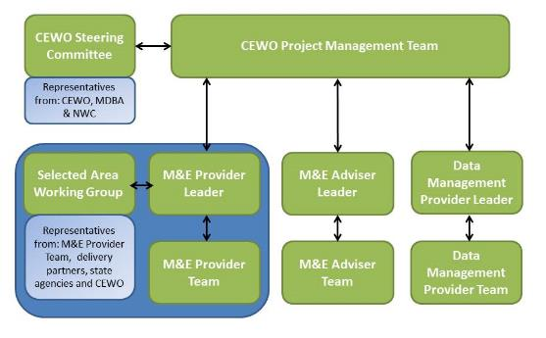

Figure 7‑1: Project governance structure for the LTIM Project (from CEWO n.d.)

### M&E Provider – Project Team

A core project management team has been nominated to coordinate and facilitate delivery of Stage 2 of the CEWO LTIM Project in the Gwydir Selected Area.

#### Project Directors

Project Directors (Dr Paul Frazier and Associate Professor Darren Ryder) will provide strategic and technical input to the project, and are alternative points of contact for CEWO.

#### Project Manager

Mark Southwell is the principal point of contact for the Project and will report to CEWO’s LTIM Project manager for the Gwydir Selected Area (Sam Rosenby). The ELA project manager will ensure the M&E Plan meets the requirements of the contract and is responsible for meeting the project budget and work program. The project manager is also responsible for managing accounting, correspondence and meeting coordination.

#### Senior Practitioner Group & Technical Scientists

The ELA/UNE Project Team will include a team of Senior Practitioners who are recognised experts in their field. This Senior Team will guide the operational monitoring project and undertake aspects of field survey, analysis and reporting. Each member of this team will be assigned a monitoring indicator directly related to their area of expertise.

This team will be supported by a combined ELA/UNE group of technical support scientists, with a range of skills in riverine and floodplain ecology and function. This group will undertake much of the on-ground survey, data handling and some reporting.

## Risk assessment

A risk assessment has been prepared for Gwydir Selected Area LTIM Project, based on this M&E Plan. The purpose of the risk assessment is to identify risks to the successful implementation of the LTIM Project and undertake effective mitigation planning. Three areas of risk were considered:

1. Risks to the success of LTIM Project and the ability to meet project objectives and outcomes (including risks that monitoring activities will not be able to be implemented)
2. Risks to the environment and aquatic ecosystem as a result of LTIM Project activities in the Gwydir Selected Area
3. Risks to the health and safety of personnel undertaking LTIM Project activities in the Gwydir Selected Area.

### Risk assessment process

This risk assessment method is compliant with the Australian/New Zealand AS/NZ 31000:2009: Environmental Risk Management – Principles and Process (Standards Australia 2009), and aligns with the principles of Australian Standard AS/NZS 4360:2004 Risk Management (Standards Australia 2004).

Risk is defined as the combination of the likelihood and consequence of an event or outcome, as demonstrated in (Table 7‑2).

Table 7‑2: Risk assessment matrix

| **LIKELIHOOD** | **CONSEQUENCE** | | | | |
| --- | --- | --- | --- | --- | --- |
| **Negligible** | **Minor** | **Moderate** | **Major** | **Critical** |
| **Almost Certain** | L16 | M10 | H5 | S2 | S1 |
| **Likely** | L17 | M12 | M11 | H6 | S3 |
| **Possible** | L19 | L18 | M13 | H7 | S4 |
| **Unlikely** | L22 | L21 | L20 | M14 | H8 |
| **Rare** | L25 | L24 | L23 | M15 | H9 |

L= low, M=medium, H=High, S=Severe

The likelihood of a risk refers to the probability of a specific event or outcome actually occurring (Table 7‑3); the consequence is the outcome of the action (Table 7‑4).

Table 7‑3: Risk likelihood categories

|  |  |
| --- | --- |
| Likelihood | Description in terms of full operating life of the site |
| Almost Certain | Consequences expected to occur in most circumstances |
| Likely | Consequences will probably occur in most circumstances |
| Possible | Consequences may occur at some time |
| Unlikely | Consequences are not expected occur within the life of the project |
| Rare | Consequences may occur in exceptional circumstances |

Three key areas of risk were considered. For each of these themes, possible risks were identified by considering project specific issues and the proposed monitoring activities. Potential hazards and their subsequent impact were considered (i.e. what could happen). Using the definitions provided above, the likelihood and consequence of the potential impacts where then applied to assign an inherent risk rating. Management and risk mitigation measures are then recommended, and the risk rating method re-applied.

Table 7‑4: Risk consequence categories

|  |  |  |  |  |  |
| --- | --- | --- | --- | --- | --- |
| **Possible risks** | **Consequence** | | | | |
| **Negligible** | **Minor** | **Moderate** | **Major** | **Critical** |
| Undertaking monitoring activities | Monitoring activities undertaken according to M&E Plan, with data from all planned samples available | Minor disruption to the monitoring program with a small number of planned samples (<10%) not collected or data not available | More than 10% of planned samples not collected / available, however sufficient data available for planned analyses | Data from more than 50% of planned samples not collected /available. Limited monitoring outcomes reported | No useable data collected, analyses not possible, no monitoring outcomes reported |
| Environment | Negligible environmental damage | Short term, localised, reversible damage to the environment | Short term, widespread damage to the environment reversible to intensive effort | Long-term damage to the environment and/or risk of continuing environmental damage | Long-term, widespread, irreversible damage |
| Health and safety | Incident requiring first aid treatment | Minor incident requiring treatment by a medical practitioner | Moderate incident requiring short term hospitalisation | Serious incident requiring extensive hospitalisation | A fatality, permanent disability , or multiple people affected by a serious incident |
| Stakeholders | Short-term, isolated complaints from stakeholders | Sustained but isolated complaints from stakeholders Relationship with stakeholder temporarily affected | Sustained complaints from stakeholders Relationship with stakeholder damaged | Short-term but significant complaints from stakeholders Relationship with stakeholder significantly damaged | Sustained and significant complaints from stakeholder Relationship with critical stakeholder irreversible damaged |
| Project objectives | Short delay in achievement of project objectives | Delay in achievement of project objectives | Element or project objective not met | Project objectives not met | Project objectives harmed (negative impact) |

### Risks to success of the project

Table 7‑5 presents the key risks to success of the LTIM Project in the Gwydir Selected and suggests risk mitigation measures. To assist in the identification of risks to successful implementation of the Gwydir M&E Plan, including the ability to meet the project objectives and outcomes, the risk assessment undertaken in the 2013-14 Gwydir Annual Watering Plan (OEH 2013) together with operational considerations for the Gwydir river system (CEWO 2013c) were reviewed and incorporated.

Table 7‑5: Gwydir M&E Plan risk assessment: successful implementation of the LTIM Project

| **Risk** | **Hazard** | **Impact** | **Risk Rating (Inherent)** | **Risk Mitigation Measures** | **Risk Rating (Managed)** |
| --- | --- | --- | --- | --- | --- |
| Unpredictable weather - prolonged natural low flow conditions | Inundation period of system is impacted | Unable to effectively monitor and evaluate LTIM Project objectives | H7 | * Design includes non-event based monitoring to inform the ecological response model and act as pre-flooding data * Annual monitoring plan will consider the long range forecast when developing watering options * If necessary, review asset condition and future priorities for watering | L18 |
| Unpredictable weather – extreme flooding following watering event | Inability to collect monitoring data as access limited | Unable to effectively monitor and evaluate LTIM Project objectives  Potential risk to crops during pre-harvest period | H7 | * Assess CEWO water availability for additional watering opportunities – opportunity for sustained wetland inundation * Survey site design considering flood related accessibility * Survey site subset accessible in all conditions to provide a core dataset – design redundancy * All condition remote monitoring devices used where possible * Local field teams able to respond rapidly to changes in field conditions | L21 |
| Other extreme weather events, i.e. flooding out of season, bushfires | Extreme weather events not considered in watering options | Negative impact on ecological assets | M14 | * Design includes non-event based monitoring to inform the ecological response model and act as pre-flooding data * Annual monitoring plan will consider the long range forecast when developing watering options | L21 |
| Flooding of commercial crops | Damage to commercial crops | May result in long-term landholder obstruction | H8 | * Risk to be assessed in the annual monitoring plan using the Framework for Determining Commonwealth Environmental Water Use * Implement approved communication strategy * Manage water deliveries in response to risk and climatic conditions | L21 |
| Low availability of CEWO environmental water allocations or OEH supplementary flows | Inability to provide environmental watering events outlined in the annual monitoring plan | Short term delay in achieving LTIM Project objectives, mostly in the lower Gwydir system | H7 | * Design includes non-event based monitoring to inform the ecological response model and act as pre-flooding data * Annual monitoring plan will confirm availability of CEWO or OEH Environmental Water allocations when developing watering options | L21 |
| Estimated flow target volumes are substantially incorrect | Inundation of system does not occur | Short term delay in achieving LTIM Project objectives | L20 | * Monitor flow delivery daily and seek adjustments * Revise flow targets, if necessary | L20 |
| Landholder obstruction | Inability to collect monitoring data | Unable to effectively monitor and evaluate LTIM Project objectives | H7 | * Adopt the Code of Practice and the Communications Plan * Field teams to acknowledge importance of landholder / stakeholder engagement; field teams provided with time during surveys for active engagement with landholders * Clear landholder communication plan developed as part of the operational program * Understanding of critical times and pressures for all land managers – survey timing and location design in consideration of landholder constraints * On-going engagement with landholders from field teams and lead scientific teams * Diversified site locations to spread sites across multiple landholder sites – design redundancy * Use of publically owned land for a core subset of sites * Potential landholder engagement for routine project aspects | L20 |
| Landholder violence towards field staff | Field Staff being threatened or injured while undertaking field work | Injury to field staff  Unable to effectively monitor and evaluate LTIM Project objectives | H9 | * Clear landholder communication plan developed as part of the operational program * Understanding of critical times and pressures for all land managers – survey timing and location design in consideration of landholder constraints * On-going engagement with landholders from field teams and lead scientific teams * Use of publically owned land for a core subset of sites * Field staff to exit private land ASAP should they feel threatened by landholder | L24 |
| State Agency – poor engagement | Possible inefficiencies in collecting monitoring data  Poor public image to landholders and the Gwydir community | Unable to effectively monitor and evaluate LTIM Project objectives | M14 | * Communication and data sharing agreement with state agencies * On-going high level engagement to share results, methods refinement and scientific approach * Gwydir Selected Area Working Group established and relationships maintained | L24 |
| Short-term responsiveness to watering events | Inability to collect monitoring data after a flow event | Unable to evaluate LTIM Project objectives | H7 | * Location of the consortium within three hours of the lower Gwydir system maximises responsiveness to environmental watering | L20 |
| Equipment operational failure (e.g. weir infrastructure) | Either unexpected flow event at an inappropriate time or impediment to flows | Negative impact on environmental outcomes | H7 | * Diversified site locations to spread sites across multiple sites – design redundancy * Potential landholder engagement for quick responses to infrastructure maintenance issues * Engagement with infrastructure owners to facilitate quick infrastructure repairs * Build in design flexibility to allow changes in monitoring effort so sites and indicators can be exchanged depending on the location and type of flow event | L20 |
| Unexpected ecological response from environmental watering (e.g. algal blooms, incomplete bird breeding event) | Poor water quality impacts ecological assets i.e. native fish (including threatened species) | Negative impact on ecological outcomes from environmental watering | M13 | * Location of the consortium within three hours of the lower Gwydir system maximises responsiveness to environmental watering * Prompt communication and data sharing with the Commonwealth and state agencies * ELA/UNE consortium expertise in biology and ecology of indicators to provide sound advice | L20 |
| Larger germination and spread of weeds (e.g. Lippia and Hyacinth) | Increased spread of Weeds of National Significance | Negative impact on vegetation communities and asset condition | H6 | * Prompt communication with the Commonwealth, state agencies and relevant landholders * Develop a targeted response plan for Hyacinth, adhering to Integrated Water Hyacinth Control protocols * Discuss voluntary de-stocking to encourage native plant competition in Lippia areas | L18 |
| Reference: OEH 2013; CEWO 2013c | | | | | |

### Risks to the environment

On-ground activities have the potential to negatively impact the environment of the Gwydir Selection Area if not managed appropriately. In particular, the following ecological values were considered during the risk assessment (as identified in Gawne et al. 2013b):

1. Gwydir River and floodplain are included in the Lowland Darling River Endangered Ecological community, listed under the *Fisheries Management Act 2004* (NSW). This areas also supports several threatened species listed under the *Environment Protection and Biodiversity Conservation Act 1999* (EPBC Act):
   * Silver perch (*Bidyanus bidyanus*) listed as Critically Endangered under the EBPC Act
   * Murray Cod (*Maccullochella peelii*) listed as Vulnerable under the EBPC Act
2. The Lower Gwydir and Gingham Watercourses support the largest stand of the threatened marsh club-rush (*Bolboschoenus fluviatilis*) which is listed as Critically Endangered Ecological Community (CEEC) under the NSW *Threatened Species Act 1995* (TSC Act)
3. Lower Gwydir wetlands can support a number of threatened fauna species, listed as migratory under the EPBC Act:
   * Eastern Great Egret (*Ardea alba*)
   * Glossy Ibis (*Plegadis falcinellus*)
4. The Gwydir Wetlands include nationally and internationally important wetlands
   * Gingham and Lower Gwydir (Big Leather) watercourses are a listed Ramsar site.
5. The Mehi River is important for the following native fish:
   * Carp Gudgeon (*Hypseleotris klunzingeri*)
   * Spangled Perch (*Leiopotherapon unicolor*)
   * Bony Bream (*Nematalosa erebi*)
   * Murray Cod (*Maccullochella peelii*) – listed as Vulnerable under the EBPC Act
   * Catfish (*Tandanus tandanus*)
   * Golden perch (*Macquaria ambigua*).

Table 7‑6 presents the identified risks to the environment (including ecological values) associated with undertaking monitoring activities in the Gwydir Selected Area and the recommended risk mitigation measures.

Table 7‑6: Gwydir M&E Plan risk assessment: risks to the environment as a result of the LTIM Project

| **Risk** | **Hazard** | **Impact** | **Risk Rating (Inherent)** | **Risk Mitigation Measures** | **Risk Rating (Managed)** |
| --- | --- | --- | --- | --- | --- |
| Driving in long, dry grass | Starting bushfires | Loss of or damage to biodiversity and property | H6 | * Safe Work Methods Statement to be completed prior to trip and onsite Toolbox Talks prior to commencing work * Contacting relevant landowners prior to fieldwork to identify areas and develop alternative route * Arranging long grass to be cut if alternative route cannot be arranged | M14 |
| Working in threatened ecosystems | Implementing structures in protected areas i.e. National Parks | Loss of or damage to biodiversity and property | M10 | * Identifying areas which will require bathymetric surveys i.e. depth loggers, artificial substrates for stream metabolism * REF is required for any structure (including depth loggers) within National Parks estates | L17 |
| Impacting threatened species and/or habitat in Ramsar wetlands | Loss of or damage to biodiversity and property | H6 | * Standard Operating Procedures for Monitoring Indicators – Vegetation Diversity Fish Larvae * Observe quarantine notices (verbal or written) to prevent the spread of animal diseases (e.g. Anthrax, Bovine Johne’s Disease, Ovine Johne’s Disease, and Equine Influenza) * Assess risk of spread of disease. If required provide for protocol of brush down and wash off boots and vehicle * Map quad bike routes, or utilise existing quad bike routes, to minimise impact to the environment | L18 |
| Field equipment use across the Gwydir Selected Area (e.g. traps used at multiple locations) | Spread of viruses, bacteria (Anthrax), algal spores | H6 | * Standard Operating Procedures for all Monitoring Indicators * Drying out nets before use in different area * Assess risk of spread of disease through a JSEA * If required, provide for protocol of brush down and wash off boots and vehicle * All staff to avoid contact with material that could be potentially contaminated with Anthrax * In areas known to be habitat for threatened species of frogs, hygiene practices are used to avoid the introduction and/or spread of Amphibian Chytrid Fungus | M13 |
| Monitoring threatened flora | Impacting threatened species and/or habitat i.e. vegetation assessments in Coolibah-Blackbox Woodlands, Marsh Club-rush areas | Loss of or damage to biodiversity | M13 | * Standard Operating Procedure for Monitoring Indicator – Vegetation Diversity * Minimise trampling and avoid areas that do not need surveying. Follow requirements of land owner/ manager, incl. government bodies * A scientific licence is required to pick, hold or study native flora * Where possible identify flora species in the field. If a sample is required, take only that needed for identification. Take photos where a sample would affect survival of the individual * If a new location is discovered for a threatened species, note its position and take care not to unnecessarily disturb its root system or habitat * Clean mud and weed propogules off shoes, clothing and vehicle/quad bike tyres prior to leaving an area where possible (particularly where noxious weeds were identified) * Works should be programmed to consider seeding periods and weed locations i.e. lippa * Field staff to sign off on Environmental Site Inspection for prior to undertaken monitoring activities | L18 |
| Monitoring threatened aquatic fauna | Impacting threatened species or damaging habitat i.e. trapping and electrofishing Silver Perch, Murray Cod | Loss of or damage to biodiversity | H7 | * Standard Operating Procedure for Monitoring Indicators – Fish (River) * Ensuring that fish surveys follows the Survey guidelines for Australia's threatened fish. EPBC Act survey guidelines 6.4 * Use minimum impact survey techniques as per survey procedure and required by animal ethics permit * Map quad bike routes, or utilise existing quad bike routes, to minimise impact on the environment * Field staff to sign off on Environmental Site Inspection for prior to undertaken monitoring activities | M14 |
| Monitoring threatened terrestrial fauna | Impacting breeding habitat (waterbirds) | Loss of or damage to biodiversity and property | H6 | * Standard Operating Procedures for Monitoring Indicator – Waterbird Diversity * Minimise trampling and avoid areas that do not need surveys * Use minimum impact survey techniques as per survey procedure and required by animal ethics permit * Field staff to sign off on Environmental Site Inspection for prior to undertaken monitoring activities | L18 |

### Risks to individuals

Table 7‑7 presents the potential risks to the health and safety of personnel undertaking monitoring activities within the Gwydir Selected Area and suggested mitigation measures to management them. The development of mitigation measures are in line with ELA’s Environment, Safety and Quality framework and the Department’s Fieldwork and Safety Guidelines (DSEWPaC 2011). Mitigation measures and procedures are described further in the Health, Environment and Safety Plan (Appendix F).

Table 7‑7: Gwydir M&E Plan risk assessment: risks to individuals and teams undertaking monitoring activities

| **Risk** | **Hazard** | **Impact** | **Risk Rating (Inherent)** | **Risk Mitigation Measures** | **Risk Rating (Managed)** |
| --- | --- | --- | --- | --- | --- |
| Adverse weather conditions | Prolonged rain/flooding | Drowning | H7 | * Safe Work Methods Statement to be completed prior to trip and onsite Toolbox Talks prior to commencing work i.e. checking WaterInfo website * Undertaking JSEA if river conditions rapidly change. * Not entering areas of fast flowing water | M14 |
| Extreme heat/cold | Sunburn or skin burn, hyperthermia or hypothermia | H6 | * Safe Work Methods Statement to be completed prior to trip and onsite Toolbox Talks prior to commencing work * Appropriate PPE * Suitable scheduling & rostering of monitoring activities | M14 |
| Adverse weather activity | Storms-lightning strikes | Burns & shock (potentially fatal) | H9 | * Do not enter site until 1 hour after the storm passes * If on-site vacate the area and/or seek shelter immediately | L23 |
| High winds | Struck from falling objects and vehicle control | M14 | * Undertaking JSEA before driving if conditions rapidly change * Take cover during periods of high winds away from overhead trees/branches * Reduce speed if driving in high winds | L23 |
| Vehicle & driving hazards | Car accident on way to site/onsite | Death, permanent impairment, lost time injury | H8 | * Safe Work Methods Statement to be completed prior to trip and onsite Toolbox Talks prior to driving * Site induction in high risk sectors * All staff will have current first aid qualifications * All vehicles to carry Emergency First Aid Box (includes consumables and bottled water) and sat phone/spot tracker | M15 |
| Vehicle breakdown/ bogged | Isolation, thermal stress, dehydration, hunger | H7 | * Undertaking JSEA before attempting vehicle recovery * 4WD training for field staff * Safe Work Methods Statement to be completed prior to trip and onsite Toolbox Talks prior to driving * All staff will have current first aid qualifications. * All vehicles to carry Emergency First Aid Box (includes consumables and bottled water) and sat phone/spot tracker * Field staff to sign off on Remote Location Vehicle check list | M13 |
| Long distance driving | Wide ranging physical injuries, potentially fatal & vehicle damage | H7 | * Undertaking JSEA Safe Work Methods Statement to be completed prior to trip and onsite Toolbox Talks prior to driving * Two person field teams to ensure that there is a break and swap of drivers every 2 hours * All staff will have current first aid qualifications. * All vehicles to carry Emergency First Aid Box (includes consumables and bottled water) and sat phone/spot tracker | M13 |
| Encountering wildlife | Car accident (with either wildlife, or other vehicles) | H7 | * Avoid driving between dusk and dawn where possible. If you must drive during this time keep an eye on the sides of the road and reduce speed to allow brake time if necessary * Safe Work Methods Statement to be completed prior to trip * All staff will have current first aid qualifications. * All vehicles to carry Emergency First Aid Box (includes consumables and bottled water) and sat phone/spot tracker | M14 |
| Quad-biking | Riding over uneven terrain/marshland | Bike rollover, wide ranging physical injuries, potentially fatal & bike damage | H7 | * Safe Work Methods Statement to be completed prior to trip and onsite Toolbox Talks prior to commencing work * Quad bike training for all field staff * All staff to wear helmets * Only one rider per bike * All staff will have current first aid qualifications * Undertaking JSEA before attempting bike recovery | M14 |
| Riding in flooded terrain | Bogging of bike, isolation, thermal stress, dehydration, hunger & bike damage | H7 | M14 |
| Terrain hazards | Bushfires | Burns, smoke inhalation & potentially fatal | H7 | * Safe Work Methods Statement to be completed prior to trip and onsite Toolbox Talks prior to commencing work * Field teams to carry Bushfire safety plan * Regular updates from BOM website and advice from RFS | M15 |
| Flora & fauna | Plant & insect allergens | Allergic reactions (skin/eye), Hay Fever, respiratory reactions, anaphylactic shock which can be potentially fatal | H7 | * Ensure staff know who their colleagues are with severe allergic reactions, implement allergy management response plan * Be aware of nearest hospital for treatment and have communications available. * Don't expose staff with known allergies to projects where these risks are unaccepted [table to their personal health issues * Standard Operating Procedures - Wildlife survey procedures * Safe Work Methods Statement to be completed prior to trip and onsite Toolbox Talks prior to commencing work * First aid kit to be carried at all times and equipped with a snake bandage * All staff will have current first aid qualifications. * Two persons in the field | M14 |
| Venomous fauna | Poisoning, potentially fatal | H7 | * Safe Work Methods Statement to be completed prior to trip and onsite Toolbox Talks prior to commencing work * First aid kit to be carried at all times and equipped with a snake bandage * All staff will have current first aid qualifications. * Two persons in the field | M14 |
| Fauna related diseases, including exposure to ticks, mosquitoes, leeches and Anthrax | Bites, Infection & Illness | H7 | * Safe Work Methods Statement to be completed prior to trip and onsite Toolbox Talks prior to commencing work * PPE and applying permthrin to field clothing * Performing daily tick checks and removing ticks as soon as they are detected * First aid kit to be carried at all times and equipped with a snake bandages * All staff will have current first aid qualifications * All staff to avoid contact with material that could be potentially contaminated with Anthrax | M14 |
| Remote site hazards | Remote area surveys | Slow response time from external source/services to an injury or incident | H7 | * Safe Work Methods Statement to be completed prior to trip and onsite Toolbox Talks prior to commencing work * Emergency response procedures developed for remote area surveys * Vehicles to be equipped with sat phone/spot tracker, bottled water * Field staff to sign off on Remote Location Vehicle check list * First aid kit to be carried at all times and equipped with a snake bandage * All staff will have current first aid qualifications | M14 |
| Working with others in remote areas | Sexual harassment, bullying, inappropriate behaviour | M15 | * Safe Work Methods Statement to be completed prior to trip and onsite Toolbox Talks prior to commencing work * Two person field team * Prior discussion with landowners, if required. | L23 |
| General field work | Field equipment use (e.g. Traps) | Muscle and back strain, joint injury, Lacerations and other injuries from equipment | H6 | * Safe Work Methods Statement to be completed prior to trip and onsite Toolbox Talks prior to commencing work * PPE * Manual Handling training * Complete JSEA if activity is not specified in the Standard Operating Procedures for the relevant Monitoring indicator * First aid kit to be carried at all times and equipped * All staff will have current first aid qualifications. | M13 |
| Long hours/night work | Musculoskeletal injuries, slips, trips, falls | H6 | * Safe Work Methods Statement to be completed prior to trip and onsite Toolbox Talks prior to commencing work * Adhere to PPE checklist * Wear sturdy shoes, check visibility/take a torch if required * First aid kit to be carried at all times and equipped * All staff will have current first aid qualifications. | M13 |
| Aquatic surveys | Boat usage | Hypothermia, become wet during cold conditions, drowning, damage & injuries. | H7 | * Field staff to have boat licence * All field staff to wear inflatable vest when operating boat * Boat to be equipped with all safety items listed under NSW legislation (Flare/beacon, light, oars, first aid kit) * Safe Work Methods Statement to be completed prior to trip and onsite Toolbox Talks prior to commencing work * Two person project team, only one person in deep water at any time * All staff will have current first aid qualifications. | M14 |
| In-stream/wetland/ bank surveys | Slip / trip leading to injury, being swept downstream, collision with in-stream debris, stuck in mud, drowning. | H7 | * Safe Work Methods Statement to be completed prior to trip and onsite Toolbox Talks prior to commencing work * Wear appropriate shoes if working prolonged periods in inundated wetlands * Two person project team, only one person in deep water at any time. * First aid kit to be carried at all times and equipped * All staff will have current first aid qualifications. | M14 |
| Hazardous substances | Diesel or Ethanol use and handling | Inhalation, ingestion, contact with skin | Medium | * Safe Work Methods Statement to be completed prior to trip and onsite Toolbox Talks prior to commencing work * MSDS to be carried at all times * First aid kit to be carried at all times and equipped * Adhere to PPE checklist | L24 |
| Ergonomic | Manual handling (lifting, bending, reaching, carrying) | Musculoskeletal injuries and back strain, joint injury | H7 | * Safe Work Methods Statement to be completed prior to trip and onsite Toolbox Talks prior to commencing work * Job rotation * Manual handling training and refresher undertaken | M15 |

## Quality Assurance plan

A stand-alone Quality Assurance Plan (Appendix E) has been developed for the Gwydir Selected Area. This Quality Assurance Plan documents quality control and quality assurance procedures for LTIM activities in the Gwydir Selected Area.

## Health, Safety and Environment plan

A stand-alone Health, Safety and Environment Plan (HSE) Plan (Appendix F) has been developed for the Gwydir Selected Area. This HSE Plan describes the procedures and requirements for minimise the risk of injury to persons and harm to the environment as a consequence of the LTIM Project.

# References

|  |
| --- |
| Brooks S., Cottingham P., Butcher R., & Hale J. 2013. *Murray-Darling Basin aquatic ecosystem classification: Stage 2 report*. Peter Cottingham & Associates report to the Commonwealth Environmental Water Office and Murray-Darling Basin Authority, Canberra. |
| Brooks S. & Wealands S. 2014. *Commonwealth Environmental Water Office Long Term Intervention Monitoring Project: Data Standard.* Report prepared for the Commonwealth Environmental Water Office by The Murray-Darling Freshwater Research Centre, MDFRC Publication 29.3/2013 Revised Jan 2014, 29pp. |
| Bureau of Meteorology (BoM). 2014a. Climate statistics for Australian locations. Moree Post Office. Station 053027. Accessed 12 Feb 2014. Available: <http://www.bom.gov.au/climate/averages/tables/cw_053027.shtml>. |
| Bureau of Meteorology (BoM). 2014b. Climate statistics for Australian locations. Moree Aero. Station 053115. Accessed 12 Feb 2014. Available: <http://www.bom.gov.au/climate/averages/tables/cw_053115.shtml>. |
| Commonwealth Environmental Water Office (CEWO) (2013b). The Environmental Water Outcomes Framework V1.0. Commonwealth Environmental Water, December 2013. |
| Commonwealth Environmental Water Office (CEWO). 2013c. Commonwealth environmental water use options 2013-14: Gwydir River Valley. Commonwealth Environmental Water Holder for the Australian Government. |
| Commonwealth Environmental Water Office (CEWO). 2013d. *Framework for Determining Commonwealth Environmental Water Use*. Commonwealth Environmental Water Holder for the Australian Government, May 2013. |
| Commonwealth Environmental Water Office (CEWO). n.d. *Long-Term Intervention Monitoring Project: Project Operations Manual*. |
| Davies, P. E., Harris, J. H., Hillman, T. J., & Walker, K. F. (2010). The sustainable rivers audit: assessing river ecosystem health in the Murray–Darling Basin, Australia. *Marine and Freshwater Research*, *61*(7), 764-777. |
| Department of Environment, Climate Change and Water (DECCW). 2011. *Gwydir Wetlands Adaptive Environmental Management Plan: Synthesis of information projects and actions*. DECCW, Sydney. |
| Gawne B., Brooks S. Butcher R., Cottingham P., Everingham P., Hale J., Nielson D., Stewardson M. & Stoffels R. 2013a. *Long Term Intervention Monitoring Project: Logic and Rationale Document*. V1.0. MDFRC Publication 01/2013. |
| Gawne B., Brooks S., Butcher R., Cottingham P., Everingham P. & Hale J. 2013b. *Long-term Intervention Monitoring Project: Monitoring and Evaluation Gwydir river system requirements for Commonwealth environmental water*. Report prepared for the Commonwealth Environmental Water Office by The Murray-Darling Freshwater Research Centre, MDFRC Publication 01.2/2013. |
| Gawne B., Hale J., Butcher R. Roots J., Brooks S., Cottingham P., Stewardson M. & Everingham P. 2014. *Commonwealth Environmental Water Office Long Term Intervention Monitoring Project: Evaluation Plan*. Final Report prepared for the Commonwealth Environmental Water Office by The Murray-Darling Freshwater Research Centre, MDFRC Publication 29/2014. |
| Green D., Burrell M., Petrovic J., & Moss P. 2011. *Water resources and management overview – Gwydir catchment*. NSW Office of Water, Sydney. |
| Hale J., Stoffels R., Butcher R., Shackleton M., Brooks S. & Gawne B. 2013. *Commonwealth Environmental Water Office Long Term Intervention Monitoring Project – Standard Methods*. Final Report prepared for the Commonwealth Environmental Water Office by The Murray-Darling Freshwater Research Centre, MDFRC Publication 29.2/2014, January, 182 pp. |
| Heupel M.R., Semmens J.M., & Hobday A.J. 2006. Automated acoustic tracking of aquatic animals: scales, design and deployment of listening station arrays. *Marine and Freshwater Research*. 57(1); 1-13. |
| Layman C.A., Araujo M.S., Boucek R., Hammerschlag‐Peyer C.M., Harrison E., Jud Z.R. & Bearhop S. 2012. Applying stable isotopes to examine food‐web structure: an overview of analytical tools. *Biological Reviews.* 87(3); 545-562. Water Australia Occasional Paper 01/01. |
| Murray-Darling Basin Authority (MDBA). 2012. *Assessment of environmental water requirements for the proposed Basin Plan: Gwydir Wetlands.* Licensed from the Murray-Darling Basin Authority, under a Creative Commons Attribution 3.0 Australia Licence. |
| Murray-Darling Freshwater Research Centre (MDFRC). 2013. *Long-term Intervention Monitoring - Generic Cause and Effect Diagrams Final Report*. Prepared for the Commonwealth Environmental Water Office by The Murray-Darling Freshwater Research Centre, MDFRC Publication 01/2013. |
| Ryder D.S. 2004. Response of epixylic biofilm metabolism to water level variability in a regulated floodplain river. *Journal of the North American Benthological Society*. 23(2); 214-223. |
| Ryder D.S., Watts R.J., Nye E., & Burns A. 2006. Can flow velocity regulate epixylic biofilm structure in a regulated floodplain river? *Marine and Freshwater Research.* 57(1); 29-36. |
| Simpfendorfer C.A., Wiley T.R., & Yeiser B.G. 2010. Improving conservation planning for an endangered sawfish using data from acoustic telemetry. *Biological Conservation.* 143(6); 1460-1469. |
| Standards Australia. 2004. Australian Standard AS/NZS 4360:2004 Risk Management. |
| Standards Australia. 2009. *Australian/New Zealand AS/NZ 31000:2009: Environmental Risk Management – Principles and Process*. |
| Walker B. & Salt D. 2006. *Resilience thinking: Sustaining ecosystems and people in a changing world.* Island Press, Washington, DC. |
|  |

Appendix A Gwydir Selected Area Boundary (Shapefile provided digitally)

Appendix B Standard Operating Procedures

# SOP - Ecosystem Type

* 1. **Objectives**

This is a monitoring protocol to validate the interim Australian National Aquatic Ecosystems (ANAE) classification.

* 1. **Indicators**

The monitoring Ecosystem Type will help to validate the interim ANAE mapping.

The interim ANAE framework has been applied to aquatic ecosystems across the Murray Darling Basin using the best available mapping and attribute data (Brooks et al. 2013). The scale and coverage of available mapping and attribute data varied considerably across the Murray Darling Basin and has not yet been validated. There is a need to validate the mapping outputs from Brooks et al. (2013) as they relate to specific sampling sites and the Gwydir Selected Area. The current mapping may be useful within the LTIM project but will not be relied upon until validated.

* 1. **Locations for monitoring**

Validation must be carried out for each ecosystem type that falls within an assessment unit for all other on-ground monitoring indicators completed in the Gwydir Selected Area:

* Fish (River)
* Hydrology (River)
* Vegetation Diversity
* Waterbird Diversity
* Water Quality
* Hydrology (Watercourse)
* Microcrustaceans
* Waterbird Breeding (optional)

Where a site has not been mapped, the typology developed by Brooks et al. (2013) will be used to assign an ecosystem type (see methods below).

* 1. **Timing and frequency**

This validation mapping occurs in Year 1 as a one-off event. Desktop mapping must occur prior to field work. Verification or assignation of a classification will occur after field work.

* 1. **Responsibilities**

The Project Manager of the Gwydir M&E Project Team is responsible for overseeing this procedure. Desktop mapping and updating of any ecosystem type will be undertaken by a GIS Officer. Ground-truthing and validation will be undertaken by an Ecologist.

* 1. **Complementary monitoring and data**

There are a number of complimentary dataset that will be used to aid in identifying aquatic ecosystem types prior to the field validation:

* Mapping output from Brooks et al. (2013)
* Any regional sources with updated feature mapping
* Fine-scale resolution vegetation mapping and/or remote sensed data
* Recently acquired ADS40 data
* Satellite imagery (e.g. SPOT6 – panchromatic resolution 1.5 m, multispectral resolution 8 m)
* NVIS41_MDB vegetation mapping (NVIS v4.1 updated with CMA mapping by Brooks et al. 2013).

It is assumed that where the Commonwealth Environment Water Office has access to these data and that these data will be made available for the purpose of Ecosystem Type assignation in the Gwydir Selected Area. Other data will be accessed via a license agreement with the appropriate agency e.g. the North-West LLS or OEH.

* 1. **Terminology**

For the purposes of the LTIM Project, aquatic ecosystems have been described as rivers, floodplains and wetlands. This is a simplification of four ecosystem classes into three common terms. For the validation protocol the terminology defined by the interim ANAE classification (Aquatic Ecosystem Task Group 2012) is to be applied. The ecosystem classes relevant to the LTIM project are as follows:

* Lacustrine systems (lakes) are open-water dominated systems, characterised by deep, standing or slow-moving water with little or no emergent vegetation (<30% cover) (note this ecosystem class is included as wetlands in LTIM Project Logic and Rational Document, Gawne et al. 2013)
* Palustrine systems are primarily shallow, vegetated, non-channel environments, including billabongs, bogs, swamps, springs, soaks etc. (Included as wetlands in Logic and Rational document)
* Riverine systems are those that are contained within a channel and its associated streamside vegetation. This definition refers to both single channel and multi-channel systems e.g. braided channel networks. The beds of channels are not typically dominated by emergent vegetation, may be naturally or artificially created, periodically or continuously contain moving water, and may form a connecting link between two bodies of standing water (Aquatic Ecosystem Task Group 2012).
  1. **Detailed methods**

Interim ANAE classification shall be undertaken as per the standard methods described in the LTIM Standard Methods (Section 2 Ecosystem Type, Hale et al. 2014). Field sheets are also provided.

The typology used to assign ecosystem types is described in the LTIM Standard Methods (Hale et al. 2014). A unique number (SYSID) for each polygon (wetland, lake, floodplain) or line (river, creek, stream) will identify each mapped unit (Brooks et al. 2013). On ground validation of the interim ANAE classification is required to confirm the aquatic ecosystem types for use in the LTIM program. Where a site has not been mapped the typology developed by Brooks et al. (2013) should be used to assign an ecosystem type (see below).

* 1. **Data analysis**

The spatial unit for which data is reported for this validation is an ANAE feature identified by the ANAE SYSID.

No data analysis is required for this indicator. All data provided for this indicator will be reported following the requirements outlined in the LTIM Project Standard Protocol: Section 2 Ecosystem Type (Hale et al. 2014) and must conform to the data structure defined in the LTIM Data Standard (Brooks & Wealands 2014). The data standard provides a means of collating consistent data that can be managed within the LTIM Monitoring Data Management System (MDMS).

* 1. **Reporting**

Each site ANAE classification will be recorded and provided to the CEWO.

* 1. **Quality assurance/quality control**

Quality control and quality assurance protocols are documented in the Quality Plan developed for the M&E Plan (CEWO 2014).

* 1. **References**

|  |
| --- |
| Aquatic Ecosystem Task Group. 2012. Aquatic Ecosystems Toolkit: Module 2, Interim Australian National Aquatic Ecosystem Classification Framework. Australian Government Department of Sustainability, Environment, Water, Population and Communities, Canberra. |
| Brooks S., Cottingham P., Butcher R., & Hale J. 2013. *Murray-Darling Basin aquatic ecosystem classification: Stage 2 report*. Peter Cottingham & Associates report to the Commonwealth Environmental Water Office and Murray-Darling Basin Authority, Canberra. |
| Brooks S. & Wealands S.R. 2014. *Commonwealth Environmental Water Office Long Term Intervention Monitoring Project: Data Standard*. Report prepared for the Commonwealth Environmental Water Office by The Murray-Darling Freshwater Research Centre. MDFRC Publication 29.3/2013 Revised Jan 2014. |
| Commonwealth Environmental Water Office (CEWO). 2014. *Long Term Intervention Monitoring Project Gwydir River System Selected Area*. Commonwealth of Australia. |
| Gawne B., Brooks S. Butcher R., Cottingham P., Everingham P., Hale J., Nielson D., Stewardson M. & Stoffels R. 2013a. *Long Term Intervention Monitoring Project: Logic and Rationale Document*. V1.0. MDFRC Publication 01/2013. |
| Hale J., Stoffels R., Butcher R., Shackleton M., Brooks S. & Gawne B. 2014. *Commonwealth Environmental Water Office Long Term Intervention Monitoring Project – Standard Methods*. Final Report prepared for the Commonwealth Environmental Water Office by The Murray-Darling Freshwater Research Centre, MDFRC Publication 29.2/2014, January, 182 pp. |

# SOP – Hydrology River

## Objectives

This Hydrology (River) monitoring protocol will provide fundamental hydrological information for Basin-scale and Selected Area evaluation questions and survey timing.

## Related Indicators

This Hydrology (River) indicator links to Vegetation Diversity, Waterbird Diversity, Fish (River), Water Quality, Microcrustaceans, Hydrology (Watercourse) and Waterbird Breeding (optional) indicators.

Monitoring of Hydrology (River) sources and analyses of hydrological data to understand the system hydrology and character of Commonwealth environmental water and other environmental water deliveries. This indicator assists with understanding hydrological connectivity and duration for the other indicators nominated above.

## Locations for monitoring

The gauge network maintained by the NSW Office of Water (NOW) in the Gwydir Selected Area has sufficient distribution and quality to ensure that no additional gauge stations are required for the delivery of the project (Table 5‑2; Figure 5‑2).



**Figure 1: Hydrological gauge network – Gwydir Selected Area**

**Table 1: Gauges within zones, Gwydir Selected Area**

|  |  |  |  |  |  |
| --- | --- | --- | --- | --- | --- |
| **Zone** | **NOW Gauge no.** | **Name** | **Latitude** | **Longitude** | **Datum** |
| Gingham-Gwydir | 418053 | Gwydir River at Brageen | -29.3973 | 149.5465 | GDA94 |
| 418063 | Gwydir (south arm) DS Tyreel regulator | -29.4379 | 149.7783 | GDA94 |
| 418066 | Gwydir @ Millewa | -29.3627 | 149.3736 | GDA94 |
| 418074 | Gingham @ Teralba | -29.3995 | 149.6991 | GDA94 |
| 418076 | Gingham @ Tillaloo Bridge | -29.2714 | 149.4526 | GDA94 |
| 418077 | Gingham @ Gingham Water Hole | -29.2433 | 149.3062 | GDA94 |
| 418078 | Gwydir @ Allambie Bridge | -29.3449 | 149.4307 | GDA94 |
| 418079 | Gingham @ Gingham Bridge | -29.2233 | 149.2685 | GDA94 |
| 418083 | Gingham @ Wetland Rookery | -29.2438 | 149.3319 | GDA94 |
| 418090 | Gwydir @ Old Dromana Regulator | -29.3625 | 149.2018 | GDA94 |
| Gwydir | 418001 | Pallamallawa | -29.477 | 150.1351 | GDA94 |
| 418012 | Pinegrove | -29.895 | 150.6306 | GDA94 |
| 418013 | Gravesend | -29.5819 | 150.3666 | GDA94 |
| 418026 | D/S Copeton Dam | -29.9119 | 150.9067 | GDA94 |
| Mehi-Moomin | 418002 | Mehi @ Moree | -29.4651 | 149.8511 | GDA94 |
| 418037 | Mehi D/S Combadello Weir | -29.5569 | 149.6582 | GDA94 |
| 418044 | Mehi River D/S Tareelaroi | -29.4532 | 150.0336 | GDA94 |
| 418048 | Moomin @ Combadello | -29.5625 | 149.6543 | GDA94 |
| 418058 | Mehi @ Bronte | -29.4773 | 148.9023 | GDA94 |
| 418060 | Moomin @ Glendello | -29.6942 | 149.4785 | GDA94 |
| 418061 | Moomin @ Alma Bridge | -29.6891 | 149.1565 | GDA94 |
| 418067 | Moomin @ Clarendon Bridge | -29.7301 | 149.3047 | GDA94 |
| 418068 | Mehi @ Ballin Boora Ck | -29.4607 | 149.1044 | GDA94 |
| 418070 | Moomin @ Moomin Plains | -29.6352 | 148.9592 | GDA94 |
| 418085 | Mehi D/S Gundare Regulator #2 | -29.5888 | 149.315 | GDA94 |
| 418087 | Mehi @ Chinook | -29.4752 | 149.977 | GDA94 |

## Timing and frequency

On-going for the duration of the LTIM Project.

## Responsibilities

The Project Manager of the Gwydir M&E Project Team is responsible for overseeing this procedure.

## Complementary monitoring and data

NA

## Detailed methods

No new gauging stations are to be established. Data will be downloaded from the NSW Office of Water hydrological data site (<http://realtimedata.water.nsw.gov.au/water.stm>) or directly from the Office of Water.

## Data analysis and reporting

A suitable hydrological modelling package will be used to calculate the following river water regime parameters:

* Daily mean river ‘stage’ water height (mASL)
* Daily mean river discharge (ML/day)
* Travel time (days).

All data provided for this indicator will conform to the data structure defined in the LTIM Data Standard (Brooks & Wealands 2014).

For the Selected Area analysis, hydrology (River) data will be used to assess the level of Hydrological Connectivity throughout the Selected Area. This will be done by defining relationships between upstream and downstream gauges in each monitoring zone to assess the movement of Commonwealth environmental water flows between these gauges. For flows delivered as specific flow hydrographs (i.e. in-channel fish pulses) the actual flow hydrographs will be compared with the planned flow hydrographs to assess the accuracy of the flow delivery.

## Quality assurance/quality control

Quality control and quality assurance protocols are documented in the Quality Plan developed for the M&E Plan (CEWO 2014).

## References

|  |
| --- |
| Brooks S. & Wealands S.R. 2014. *Commonwealth Environmental Water Office Long Term Intervention Monitoring Project: Data Standard*. Report prepared for the Commonwealth Environmental Water Office by The Murray-Darling Freshwater Research Centre. MDFRC Publication 29.3/2013 Revised Jan 2014. |
| Commonwealth Environmental Water Office (CEWO). 2014. *Long Term Intervention Monitoring Project Gwydir River System Selected Area*. Commonwealth of Australia. |
| Hale J., Stoffels R., Butcher R., Shackleton M., Brooks S. & Gawne B. 2014. *Commonwealth Environmental Water Office Long Term Intervention Monitoring Project – Standard Methods*. Final Report prepared for the Commonwealth Environmental Water Office by The Murray-Darling Freshwater Research Centre, MDFRC Publication 29.2/2014, January, 182 pp. |

# SOP – Fish (River)

## Objectives

To assess the contribution of Commonwealth environmental water to fish survival, resilience and diversity at Basin and Selected Area scales.

## Indicators

This Fish (River) indicator links with Fish (Movement), Microcrustaceans and Hydrology (River) indicators.

For Category 1 sampling, Otoliths will be collected annually from two opportunistic species within the Category 1 Fish (River) reach. Otoliths will also be collected in year one and year five from two equilibrium and two periodic species. Equilibrium and periodic species will be collected within the same zone, but at different locations to the Category 1 Fish (River) selected area so as not to bias the fish community results.

Catergory 3 sampling will be undertaken in each of the other three Gwydir western reaches, using Sustainable Rivers Audit (SRA) protocols (Davies et al. 2010). All fish will be identified, counted, measured and weighed (maximum of 50 individuals per species per electrofishing shot).

Dependent variables include:

* Relative abundance estimation
* Population structure data for target species
* Additional data is required for target species – total length or fork length , mass (gm)
* Length-age data

## Locations for monitoring

In each year Category 1 Fish (River) monitoring will take place in the Gwydir River between Tareelaroi weir and Tyreel weir (**Figure 2**), following the standard methods (Hale et al. 2014). The overall design for the Fish (River) indicator has been structured to meet both the Category 1 requirements and provide Selected Area specific information. The extents of each fish sampling reach and how they relate to the broader monitoring zones within the Gwydir River Selected Area is shown in **Table 2**.The environmental watering options for the Gwydir system west of Tareelaroi weir are likely to target different zones for different environmental outcomes over a number of years. However, the reach of the Gwydir River between Tareelaroi weir and Tyreel weir selected for Category 1 Fish (River) sampling will be the most likely reach to receive environmental water each year. Category 3 sampling undertaken in the other three western river reaches will help to inform the Selected Area analysis (**Figure 2**).

The selection of sites within each of the western Gwydir river reaches will be done following a ‘random’ site selection process which involves breaking each reach up into smaller 1km reaches, and then randomly selecting reaches for sampling. Reaches that are selected first are then visited in the field and assessed as to the suitability of that reach for sampling. If a reach is deemed unsuitable for sampling (no water, restricted access), then the next randomly selected reach is visited. This process continues until the required number of sites is chosen. 10 reaches will be sampled for Category 1 Fish (River), and 5 sites in each reach for the Category 3 sampling. This method has been discussed with, and accepted by the M&E Advisors.

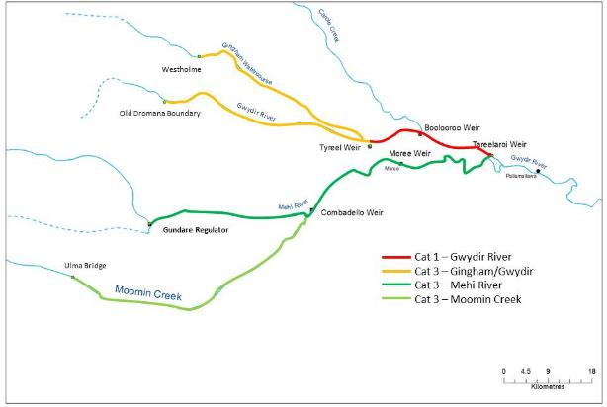

**Figure 2. Location of Fish sampling reaches within the Gwydir River Selected Area**

**Table 2. Fish sampling reach locations within zones and spatial extents**

|  |  |  |  |  |  |
| --- | --- | --- | --- | --- | --- |
| **Target Reach** | **Category sampling** | **Zone** | **Target Reach Extent** | **Longitude** | **Latitude** |
| Gwydir River | 1 | Gingham-Gwydir | Tareelaroi to  Tyreel | -29.4478  -29.4361 | 150.037  149.7785 |
| Gingham-Gwydir (west) | 3 | Gingham-Gwydir | Tyreel to  Westholme and  Old Dromana | -29.4361  -29.2781  -29.3634 | 149.7785  149.4144  149.343 |
| Mehi River | 3 | Mehi-Moomin | Tareelaroi to  Gundare | -29.4478  -29.5891 | 150.037  149.6606 |
| Moomin Creek | 3 | Mehi-Moomin | Combadello to  Ulma Bridge | -29.5569  -29.6894 | 149.6606  149.1566 |

## Timing and frequency

Fish (River) monitoring will be undertaken in March each year for the Category 1 reach; monitoring in other zones will occur in March-April.

## Responsibilities

Fisheries NSW will be sub-contracted by Eco Logical Australia to undertake Fish (River) monitoring.

## Detailed methods

Category 1 Fish (River) sampling will be undertaken following the LTIM Standard Methods (Section 5 Fish (River), Hale et al. 2014). Each site will consist of an 800m stretch of channel, be fixed throughout the LTIM Program, and will not be within 1km of a significant tributary or river infrastructure (e.g. weir). At each site, large bodied fish will be sampled using either boat or backpack electrofishing (depending on the depth and accessibility of the site). A total of 2880 seconds of ‘on-time’ will be undertaken in each reach. Small bodied fish will be sampled using 10 fine-mesh fyke nets set randomly within the site. Detailed methodology is outlined in Hale et al. (2014).

Within the Gwydir River Selected Area, the following species have been targeted for analysis:

* Equilibrium life-history guild – Murray cod
* Periodic life-history guild – golden perch and bony bream
* Opportunistic life-history guild – carp gudgeon and Australian smelt.

For these target species, individuals will be identified, counted, and a random sample of up to 20 individuals will have their total or fork length (mm), and weight (grams) measured. All other species will be identified and counted.

For category 3 reaches sampling will be undertaken using Sustainable Rivers Audit (SRA) protocols (Davies et al. 2010). Fish will be sampled at five sites within each reach, using a combination of boat electrofishing (12 x 90 second shots) and un-baited bait traps (n = 10). All fish will be identified, counted, measured and weighed (maximum of 50 individuals per species per electrofishing shot). Using a subset of the data collected in the Category 1 zone (10 sites) there will be 10 replicate sites within the selected Category 1 reach and 5 sites from each of the remaining 3 reaches.

## Data analysis

Please refer to the LTIM Standard Methods (Section 5 Fish (River), Hale et al. 2014) for prescribed data analysis.

### The Selected Area scale hypotheses

Short-term (Annual) responses:

* Mean Total length, Fork length and Mass for each of the 2 target taxa in each of the 3 life history guilds will be greater in the zone(s) receiving Commonwealth environmental water compared with zones not receiving Commonwealth environmental water
* SRA metrics “Expectedness”, “Nativeness”, and “Recruitment” of native fish communities will be greater in the zone(s) receiving Commonwealth environmental water compared with zones not receiving Commonwealth environmental water
* Age of fish (target taxa in each life history guild) will have a greater range (measure of resilience) in the zone(s) receiving annual Commonwealth environmental watering events compared with zones not receiving Commonwealth environmental water.

Long-term (5 year) responses

* Mean Total length, Fork length and Mass for each of the 2 target taxa in each of the 3 life history guilds will be greatest year-on-year in zones receiving Commonwealth environmental water compared with zones not receiving Commonwealth environmental water
* SRA metrics “Expectedness”, “Nativeness”, and “Recruitment” of native fish communities will be greatest year-on year in zones receiving Commonwealth environmental water
* Age of fish (target taxa in each life history guild) will have a greater range year-on year (measure of resilience) in the zone(s) receiving annual Commonwealth environmental watering events.
  + 1. **The Selected Area scale analyses**

Analyses based on Aggregation will be applied at the Basin and Selected Area scales for taxonomic diversity and richness. Additionally, the fish community data will be summarised using the three main SRA Indicators:

* “Expectedness” - a comparison of the existing catch composition with that of historical fish distributions)
* “Nativeness” - the proportion of native versus alien fishes), and
* “Recruitment” - the recent reproductive activity of the native fish community).

Quantitative analyses will then be applied at the Selected Area scale using a counterfactual approach based on an historical ‘reference’ condition represented by a pre-European fish assemblage (developed by Fisheries NSW). Multi-year analyses will be quantitatively analysed based on year-on-year repeat application of annual models outlined in the Selected Area conceptual model (**Figure 3**), and a time-lagged trajectory to a pre-defined condition (Figure 5‑8: ). Uncertainty propagation within and among years will be possible to quantify based on annual comparisons of sites receiving Commonwealth environmental water compared with those sites not watered.

Short-term (Annual) responses:

* Hypotheses 1, 2 and 3 – Univariate analysis (e.g. ANOVA - main effect – zone) for all taxa, each target taxa, each life history guild, taxa reference richness/diversity
* Hypotheses 2 - (diversity-abundance) multivariate analysis (e.g Permanova, MDS, PCA - factors – zone, target taxa, life history guilds, native/exotic, taxa reference composition).

Long-term (5 year) responses:

* Hypotheses 4, 5 and 6 – Univariate analysis (main effects – zone, years) for all taxa, each target taxa, each life history guild, taxa reference richness/diversity.
* Hypotheses 5 - (diversity-abundance) multivariate analysis (factors – zone/years, target taxa, life history guilds, native/exotic, taxa reference composition).

Two zones in the lower Gwydir will have representative reaches sampled annually, with one priority zone sampled following the delivery of Commonwealth environmental water. Replicate sites in all zones are within defined study reaches of known length, facilitating outcomes for entire systems to be determined from data scaled from representative reaches (e.g., abundance of native fish/river km scaled to entire channel system of the same ANAE typology).



**Figure 3: A hypothetical model that will be applied on a year-to-year basis to generate a series of outcomes from different flow regimes over a five year period (Source: Gawne et al. 2014)**



**Figure 4: Hypothetical model of a long-term response to environmental watering based on a created ‘reference condition’ where the greatest influence is from watering in the most recent year with progressively weaker influence from watering in previous years (Source: Gawne et al. 2014).**

## Reporting

Data for the Basin-scale will be reported following the requirements outlined in the LTIM Data Standard (Hale et al. 2014) and conform to the LTIM Data Standard (Brooks & Wealands 2014).

## Quality assurance/quality control

Quality control and quality assurance protocols are documented in the Quality Plan developed for the M&E Plan (CEWO 2014).

QA/QC activities specific to this protocol include:

* Electrofishers must be experienced operators of units. They should be supervised by Senior Operators on-site, and have obtained their electrofishing certificates through a reputable course.
* Monitoring and Evaluation Providers must have relevant boat licenses.
* It is the responsibility of the Monitoring and Evaluation Providers to have specific fisheries and ethics permits with them while sampling.
* Monitoring and Evaluation Providers must also have experience with appropriate PIT implantation procedures.
* Fyke nets should be checked for holes in either wing- or cod-ends prior to every field trip. Any net with a hole should be repaired or replaced.

## Field team

NSW fisheries will provide the field team for this indicator. All staff will be appropriately qualified, licenced and experienced for all aspects of the sampling.

## References

|  |
| --- |
| Brooks S. & Wealands S.R. 2014. *Commonwealth Environmental Water Office Long Term Intervention Monitoring Project: Data Standard*. Report prepared for the Commonwealth Environmental Water Office by The Murray-Darling Freshwater Research Centre. MDFRC Publication 29.3/2013 Revised Jan 2014. |
| Commonwealth Environmental Water Office (CEWO). 2014. *Long Term Intervention Monitoring Project Gwydir River System Selected Area*. Commonwealth of Australia. |
| Davies, P. E., Harris, J. H., Hillman, T. J., & Walker, K. F. (2010). The sustainable rivers audit: assessing river ecosystem health in the Murray–Darling Basin, Australia. *Marine and Freshwater Research*, *61*(7), 764-777. |
| Gawne B., Hale J., Butcher R. Roots J., Brooks S., Cottingham P., Stewardson M. & Everingham P. 2014. *Commonwealth Environmental Water Office Long Term Intervention Monitoring Project: Evaluation Plan*. Final Report prepared for the Commonwealth Environmental Water Office by The Murray-Darling Freshwater Research Centre, MDFRC Publication 29/2014. |
| Hale J., Stoffels R., Butcher R., Shackleton M., Brooks S. & Gawne B. 2014. *Commonwealth Environmental Water Office Long Term Intervention Monitoring Project – Standard Methods*. Final Report prepared for the Commonwealth Environmental Water Office by The Murray-Darling Freshwater Research Centre, MDFRC Publication 29.2/2014, January, 182 pp. |

# SOP – Vegetation Diversity

## Objectives

This monitoring protocol aims to assess the contribution of Commonwealth environmental water to wetland vegetation diversity, condition and extent.

## Indicators

This Vegetation diversity indicator links to Ecosystem Type, Microcrustacean, and Hydrology (Watercourse) indicators.

This program links to ongoing vegetation monitoring being undertaken by the NSW Office of Environment and Heritage (OEH) and will provide for collaborative data sharing.

## Locations for monitoring

Sites will be located in target wetland communities within the Gingham-Gwydir Watercourse zone (**Figure 5**, **Table 3**). These sites are linked to an ongoing monitoring program conducted by OEH to monitor the response of vegetation diversity to water. The LTIM Project team will undertake cooperative data collection and sharing with OEH. In these sites Commonwealth environmental water will spill onto the watercourse areas.



**Figure 5 Vegetation Diversity – monitoring sites**

**Table 3 Vegetation Diversity – monitoring site locations**

|  |  |  |  |  |  |
| --- | --- | --- | --- | --- | --- |
| **Site Name** | **Target vegetation community** | **Coordinates**  **(zone 55 GDA 94)** | | **Zone** | **Note** |
| **Easting** | **Northing** |
| Bunnor 1 | Watercouch marsh grassland | 728826 | 6760771 | Gingham Watercourse | NPWS Reserve |
| Westholme Couch | Watercouch marsh grassland | 733507 | 6759227 | Gingham Watercourse | NPWS Reserve |
| Westholme Coolibah | Coolibah Woodlands | 732675 | 6760769 | Gingham Watercourse | NPWS Reserve |
| Mungwonga 1 | Watercouch Marsh grassland | 722759 | 6764005 | Gingham Watercourse | NPWS Reserve |
| Lynworth 1 | River Cooba Lignum | 727574 | 6763219 | Gingham Watercourse |  |
| Lynworth 3 | Watercouch marsh grassland | 728716 | 6762487 | Gingham Watercourse |  |
| Old Boyanga | Water couch marsh grassland | 716406 | 6766968 | Gingham Watercourse |  |
| Old Dromana Ramsar 1 | Eleocharis tall sedgelands | 727184 | 6750992 | Lower Gwydir | NPWS Reserve |
| Old Dromana Ramsar 2 | Coolabah Woodland wet understorey | 726747 | 6751789 | Lower Gwydir | NPWS Reserve |
| Old Dromana Ramsar 3 | Watercouch Marsh grassland | 726641 | 6751456 | Lower Gwydir | NPWS Reserve |
| Old Dromana Bolboschenus 1 | Marsh Club-rush tall sedgeland | 723216 | 6751952 | Lower Gwydir | NPWS Reserve |
| Old Dromana Nursery 1 | Coolabah Woodland wet understorey | 726223 | 6751405 | Lower Gwydir | NPWS Reserve |
| Old Dromana Nursery 2 | Coolabah Woodland | 724473 | 6751888 | Lower Gwydir | NPWS Reserve |
| Old Dromana Elders 1-1 | Water couch marsh grassland | 723395 | 6751952 | Lower Gwydir | NPWS Reserve |
| Bungunya_1 | River cooba - lignum | 6723793 | 709823 | Mallowa |  |
| Coombah_1 | River cooba - lignum | 6722614 | 723849 | Mallowa |  |
| Valletta_1 | River cooba - lignum | 6723629 | 716519 | Mallowa |  |
| Valletta_2 | River cooba - lignum | 6725026 | 716262 | Mallowa |  |

## Timing and frequency

Vegetation diversity monitoring shall be undertaken twice annually; before and after the watering season (August-October and March-June). The exact timing of sampling will be largely dependent on the target vegetation communities and expected lag time for response to watering.

## Responsibilities

The Project Manager of the Gwydir M&E Project Team is responsible for overseeing this procedure. Field surveys will be led by an experienced field botanists.

## Complementary monitoring and data

The selected sites for vegetation diversity monitoring are part of an ongoing monitoring program conducted by OEH to monitor the response of vegetation diversity to water. The Gwydir LTIM Project will undertake cooperative data collection and sharing with OEH.

## Detailed methods

Survey methods will comply with the OEH data collection protocols for floodplain wetland vegetation monitoring in the Gwydir watercourse (Bowen 2013) (Appendix 1, 2). The methodology aligns with the Standard Methods as a Category 2 indicator (Hale et al. 2014).

Surveys will target 14 established monitoring sites that incorporate Water Couch communities, River Cooba-Lignum, Marsh Club-rush sedgelands, and Coolibah woodland. Depending on the community structure a combination of transects and quadrats will be surveyed. Floristics will be undertaken at each site twice annually before and after watering. Measures of Tree condition will be recorded during the post watering sampling trip only. All sites have been established to directly target zones where environmental watering is likely to be delivered. Links to inundation will be developed thought the Hydrology (Watercourse) indicator.

## Data analysis

Data analysis methods are provided in Bowen (2013). Refer also to the LTIM Standard Methods (Section 4 Vegetation Diversity, Hale et al. 2014).

The Selected Area scale hypotheses for this indicator are:

Short-term (Annual) responses:

1. The delivery of Commonwealth environmental water to wetland and floodplain areas in the Gingham-Gwydir Watercourse and Mallowa Creek Wetlands will lead to increased cover and/or richness of wetland vegetation communities.

Long-term (5 year) responses:

1. The delivery of Commonwealth environmental water in the Gingham-Gwydir Watercourse and Mallowa Creek Wetlands will lead to increased year-on-year cover and/or richness of wetland vegetation communities.

Analyses based on Aggregation will be applied at the Basin and Selected Area scales for cover and richness of wetland vegetation communities. Quantitative analyses will be applied at the Selected Area scale to document increased cover and richness of wetland vegetation communities at sites receiving Commonwealth environmental water. Multi-year analyses will be quantitatively assessed based on year-on-year repeat application of annual models outlined in the Selected Area conceptual model (Figure 2). The placement of survey sites has been strategically undertaken to permit quantification of the hydrologic connection and inundation metrics and lead to reduced uncertainty the delivery of Commonwealth water to these sites.



**Figure 2: A hypothetical model that will be applied on a year-to-year basis to generate a series of outcomes from different flow regimes over a five year period (Source: Gawne et al. 2014)**

Short-term (Annual) responses:

1. Hypotheses 1 - univariate analysis (main effect – location, inundation, time) cover and richness and multivariate analysis (factors – location, inundation history, time).

Long-term (5 year) responses:

1. Hypotheses 2 - univariate analysis (main effects – location, inundation history, year, time) and multivariate analysis (factors – location, inundation history, year, time).

Each wetland community within the Gingham-Gwydir Watercourse and Mallowa Creek Wetlands has been mapped at a fine scale. Linking wetland vegetation community extent to Commonwealth environmental water inundation extent should permit extrapolation the response to the Selected Area. The proposed indicator Hydrology (Watercourse) will document the m2 of inundated ANAE and vegetation hydrology and will facilitate the extrapolation.

## Reporting

Data for the Basin-scale will be reported following the requirements outlined in the LTIM Standard Methods (Hale et al. 2014). All data provided for this indicator must conform to the data structure defined in the LTIM Data Standard (Brooks & Wealands 2014).

## Quality assurance/quality control

Quality control and quality assurance protocols are documented in the Quality Plan developed for the M&E Plan (CEWO 2014).

## References

|  |
| --- |
| Bowen S. 2013. *NSW OEH Environmental Flow Monitoring Program: Methods for survey and monitoring of flood-dependent vegetation communities*. NSW Government. |
| Brooks S. & Wealands S.R. 2014. *Commonwealth Environmental Water Office Long Term Intervention Monitoring Project: Data Standard*. Report prepared for the Commonwealth Environmental Water Office by The Murray-Darling Freshwater Research Centre. MDFRC Publication 29.3/2013 Revised Jan 2014. |
| Commonwealth Environmental Water Office (CEWO). 2014. *Long Term Intervention Monitoring Project Gwydir River System Selected Area*. Commonwealth of Australia. |
| Hale J., Stoffels R., Butcher R., Shackleton M., Brooks S. & Gawne B. 2014. *Commonwealth Environmental Water Office Long Term Intervention Monitoring Project – Standard Methods*. Final Report prepared for the Commonwealth Environmental Water Office by The Murray-Darling Freshwater Research Centre, MDFRC Publication 29.2/2014, January, 182 pp. |

**Appendix 1 NSW OEH Environmental Flow Monitoring Program: Methods for survey and monitoring of flood-dependent vegetation communities**

**Appendix 2 DECC Field Data Sheets**

Note – iPads will be used in the field to record all data under the following headings.

Site floristics

|  |  |  |  |  |  |  |  |  |  |  |  |  |  |  |  |  |  |  |  |  |
| --- | --- | --- | --- | --- | --- | --- | --- | --- | --- | --- | --- | --- | --- | --- | --- | --- | --- | --- | --- | --- |
| Site Number | Collect | Common name | Scientific name | % Cover | No. | Lower Height | Upper Height | Growth Habits | Strata Type | Exotic | Percent Cover Mid | Percent Cover (Tallest) | waypoint | Photo SW from NE | Photo N from S | Photo NE from SW | Photo S from N | Grazing | Fallen timber (0.04 ha) | Notes |
|  |  |  |  |  |  |  |  |  |  |  |  |  |  |  |  |  |  |  |  |  |
|  |  |  |  |  |  |  |  |  |  |  |  |  |  |  |  |  |  |  |  |  |

Community structure

|  |  |  |  |  |  |  |  |  |  |
| --- | --- | --- | --- | --- | --- | --- | --- | --- | --- |
| Site Number | Sample date | Veg community | >5m canopy % cover | 1-5m understory % cover | <1m ground % cover | Litter % Cover | Lichen/moss % cover | Bare ground % cover | Av length of fallen logs |
|  |  |  |  |  |  |  |  |  |  |
|  |  |  |  |  |  |  |  |  |  |

Aquatic transect

|  |  |  |  |  |  |  |  |  |  |  |  |  |  |  |  |  |  |  |  |  |  |  |  |  |  |  |  |
| --- | --- | --- | --- | --- | --- | --- | --- | --- | --- | --- | --- | --- | --- | --- | --- | --- | --- | --- | --- | --- | --- | --- | --- | --- | --- | --- | --- |
| **Point (m)** |  |  |  | **0** | | | | **1** | | | | **2** | | | | **3** | | | | **4** | | | | **5** | | | |
|  | **Species Code** |  |  |  |  |  |  |  |  |  |  |  |  |  |  |  |  |  |  |  |  |  |  |  |  |  |  |
|  |  |  |  | **HT** | **Fl** | **Fr** | **D** | **HT** | **Fl** | **Fr** | **D** | **HT** | **Fl** | **Fr** | **D** | **HT** | **Fl** | **Fr** | **D** | **HT** | **Fl** | **Fr** | **D** | **HT** | **Fl** | **Fr** | **D** |
| **Site Number** |  | **waypoint** | **Phot nos** |  |  |  |  |  |  |  |  |  |  |  |  |  |  |  |  |  |  |  |  |  |  |  |  |
|  | **Water depth cm** |  |  |  | | | |  | | | |  | | | |  | | | |  | | | |  | | | |
|  |  |  |  |  |  |  |  |  |  |  |  |  |  |  |  |  |  |  |  |  |  |  |  |  |  |  |  |
|  |  |  |  |  |  |  |  |  |  |  |  |  |  |  |  |  |  |  |  |  |  |  |  |  |  |  |  |

Tree Health

|  |  |  |  |  |  |  |  |  |  |  |  |  |  |  |  |  |  |  |  |  |
| --- | --- | --- | --- | --- | --- | --- | --- | --- | --- | --- | --- | --- | --- | --- | --- | --- | --- | --- | --- | --- |
| **comment** | **Tree No** | **Site No** | **Date** | **Plot (0.04 / 0.1ha)** | **OEH tree number** | **from north** | **from east** | **Species** | **Stem No** | **DBH** | **Canopy Extent (m2)** | **%foliage cover** | **%dead canopy** | **Ht (m)** | **No. Hollows** | **No. Nests** | **No dead limbs /total limbs** | **Buds/ Flower/ Fruit** | **Insect damage (L /M / H)** | **Photo Tree canopy** |
|  |  |  |  |  |  |  |  |  |  |  |  |  |  |  |  |  |  |  |  |  |
|  |  |  |  |  |  |  |  |  |  |  |  |  |  |  |  |  |  |  |  |  |
|  |  |  |  |  |  |  |  |  |  |  |  |  |  |  |  |  |  |  |  |  |

Tree Demographics

|  |  |  |  |  |  |  |  |  |  |  |  |  |  |  |  |
| --- | --- | --- | --- | --- | --- | --- | --- | --- | --- | --- | --- | --- | --- | --- | --- |
| Site no | Species | No ind. 0.2-0.5m tall (0.04 ha) | No ind. 0.5 1.3m tall (0.04 ha) | No ind. 1.3-3m tall (0.04 ha) | No ind. 0.2-0.5m tall (0.1 ha) | No ind. 0.5 1.3m tall (0.1 ha) | No ind. 1.3-3m tall (0.1 ha) | No dead trees (0.4 ha) | No live trees (0.4 ha) | No dead trees (0.1 ha) | No live trees (0.1 ha) | Fallen timber (0.04 ha) | Fallen Timber (0.01ha) | entry order | comments |
|  |  |  |  |  |  |  |  |  |  |  |  |  |  |  |  |
|  |  |  |  |  |  |  |  |  |  |  |  |  |  |  |  |
|  |  |  |  |  |  |  |  |  |  |  |  |  |  |  |  |
|  |  |  |  |  |  |  |  |  |  |  |  |  |  |  |  |

Site flooding data

|  |  |  |  |  |  |  |  |  |  |  |  |  |  |
| --- | --- | --- | --- | --- | --- | --- | --- | --- | --- | --- | --- | --- | --- |
| Site No | Date | % Plot flooded | % Plot wet | % open water | Water depth (cm) | %submerged veg | bare ground submerged (%) | Submerged litter (%) | bare ground (%) | litter (%) | Time since previous flood | Time flooded (weeks) | notes |
|  |  |  |  |  |  |  |  |  |  |  |  |  |  |
|  |  |  |  |  |  |  |  |  |  |  |  |  |  |
|  |  |  |  |  |  |  |  |  |  |  |  |  |  |
|  |  |  |  |  |  |  |  |  |  |  |  |  |  |
|  |  |  |  |  |  |  |  |  |  |  |  |  |  |

# SOP – Waterbird Diversity

## Objectives

The Waterbird Diversity monitoring protocol aims to assess the contribution of Commonwealth environmental water contribute to waterbird survival and diversity.

## Indicators

This indicator links to Vegetation Diversity, Microcrustaceans and Hydrology (Watercourse) monitoring indicators.

Colonial bird breeding events and fledgling success will be monitored.

## Locations for monitoring

There are several well-known waterbird rookeries and wetlands that contain diverse waterbird species including migratory species within the Gingham-Gwydir Watercourse; these sites have been routinely monitored by NSW OEH for a number of years (Figure 1). These sites will be monitored through the LTIM project in association with OEH staff.

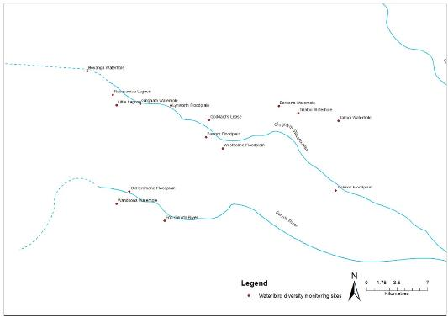

**Figure 1: Watercourse areas for Waterbird Diversity monitoring**

## Timing and frequency

Waterbird Diversity monitoring will be undertaken via two surveys each watering season, however, responsive to wetland conditions.

## Responsibilities

The Project Manager of the Gwydir M&E Project Team is responsible for overseeing this procedure. The field surveys will be led by experienced bird ecologists.

## Complementary monitoring and data

Data from additional sources and monitoring programs may be used to contribute in whole or part to this monitoring protocol. For example, the Eastern Aerial Waterbird Survey (EAWS) may pass over assessment sites and be used to augment ground surveys. There may also be local aerial or ground surveys undertaken under other monitoring programs that should be considered as supplementary data.

## Detailed methods

Biannual ground surveys will be undertaken, as per the LTIM Standard Methods (Section 10 Waterbird Diversity, Hale et al. 2014). Here, surveys will be undertaken on both foot and from a vehicle using observation points or transects depending on the size and shape of the wetland.

Foot surveys will be undertaken by moving around the wetland and observing from various points that are generally spaced so as to be out of sight of each other. At each point all birds are observed and recorded. New birds are recorded enroute to new points and their species and number noted. During the survey, as much of each wetland as possible is accessed, and the percentage of the total wetland observed is recorded. Surveys are undertaken for at least 20 minutes but no more than 1 hour at each wetland, in order to gain a representative no necessarily complete, count of all waterbirds in the wetland.

For large or linear wetlands with good vehicular access, transect surveys will be used. Counts of species observed are recorded as a running tally as the vehicle travels along the transect. The start and end points and times are recorded on the datasheet.

## Data analysis

For ground surveys, the total abundance of each species per wetland and per hectare will be calculated and reported (Section 10, Hale et al. 2014).

### The Selected Area scale hypotheses

Short-term (Annual) responses:

1. The delivery of Commonwealth environmental water will lead to increased waterbird survival?

Long-term (5 year) responses:

1. The delivery of Commonwealth environmental water will lead to larger waterbird populations?
2. The delivery of Commonwealth environmental water will lead to increased waterbird diversity?

### The Selected Area scale analyses

Analyses based on Aggregation will be applied at the Basin and Selected Area scales for abundance, richness and diversity of waterbirds. Quantitative analyses will be applied at the Selected Area scale to document increased abundance, richness and diversity of waterbirds at sites receiving Commonwealth environmental water. Multi-year analyses will be quantitatively assessed based on year-on-year repeat application of annual models outlined in the Selected Area conceptual model (Figure 2). The placement of water level devices at key location to quantify hydrologic connection and inundation metrics will improve uncertainty in quantifying the delivery of Commonwealth water to target sites.

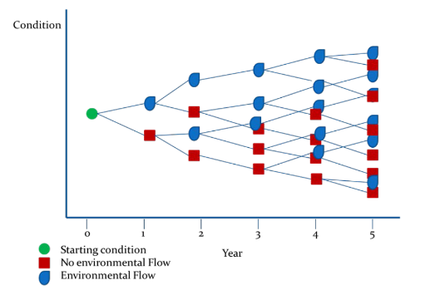

**Figure 2: A hypothetical model that will be applied on a year-to-year basis to generate a series of outcomes from different flow regimes over a five year period (Source: Gawne et al. 2014)**

Short-term (Annual) responses:

1. Hypotheses 1 and 2 - univariate analysis (main effect – site, time) abundance, richness, diversity
2. Hypotheses 2 - (diversity-abundance) multivariate analysis (factors – site, time).

Long-term (5 year) responses:

1. Hypotheses 2 and 3 - univariate analysis (main effects – target site, year, time)
2. Hypotheses 3 - (diversity-abundance) multivariate analysis (factors – target site, year, time).

## Reporting

The standard method for Waterbird Diversity reports m2 ANAE area surveyed inundated from Commonwealth environmental water. The proposed indicator Watercourse Hydrology will document the m2 of inundated ANAE and vegetation hydrology and will facilitate the scaling of potential colonial waterbird rookery sites to the lower Gwydir.

All data provided for this indicator must conform to the data structure defined in the LTIM Data Standard (Brooks & Wealands 2014).

## Quality assurance/quality control

Quality control and quality assurance protocols are documented in the Quality Plan developed for the M&E Plan (CEWO 2014).

QA/QC requirements specific to this protocol include:

1. All Waterbird Diversity surveys will be undertaken by the same experienced observers, where possible, over time to maintain consistency
2. Observers will undergo training prior to undertaking monitoring surveys, including calibration against experienced observers to Measure standardisation of measurements. Training and calibration procedures will be documented in the M&P Plan and relevant records maintained

## References

|  |
| --- |
| Brooks S. & Wealands S.R. 2014. *Commonwealth Environmental Water Office Long Term Intervention Monitoring Project: Data Standard*. Report prepared for the Commonwealth Environmental Water Office by The Murray-Darling Freshwater Research Centre. MDFRC Publication 29.3/2013 Revised Jan 2014. |
| Commonwealth Environmental Water Office (CEWO). 2014. *Long Term Intervention Monitoring Project Gwydir River System Selected Area*. Commonwealth of Australia. |
| Gawne B., Hale J., Butcher R. Roots J., Brooks S., Cottingham P., Stewardson M. & Everingham P. 2014. *Commonwealth Environmental Water Office Long Term Intervention Monitoring Project: Evaluation Plan*. Final Report prepared for the Commonwealth Environmental Water Office by The Murray-Darling Freshwater Research Centre, MDFRC Publication 29/2014. |
| Hale J., Stoffels R., Butcher R., Shackleton M., Brooks S. & Gawne B. 2014. *Commonwealth Environmental Water Office Long Term Intervention Monitoring Project – Standard Methods*. Final Report prepared for the Commonwealth Environmental Water Office by The Murray-Darling Freshwater Research Centre, MDFRC Publication 29.2/2014, January, 182 pp. |

## Waterbird Diversity Data sheet

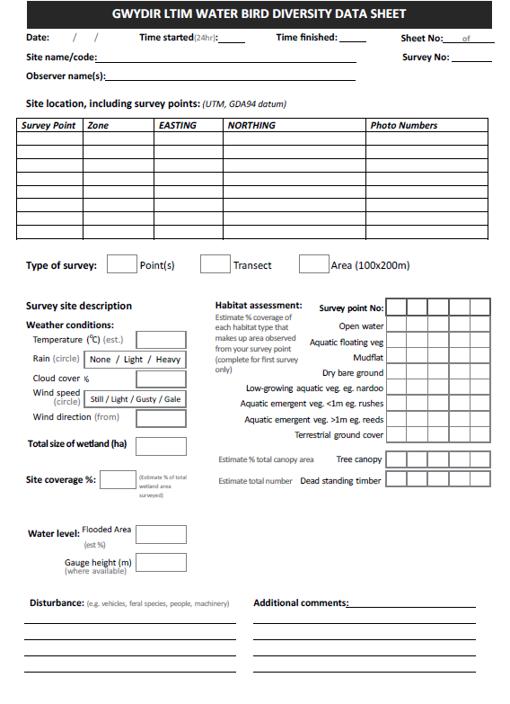

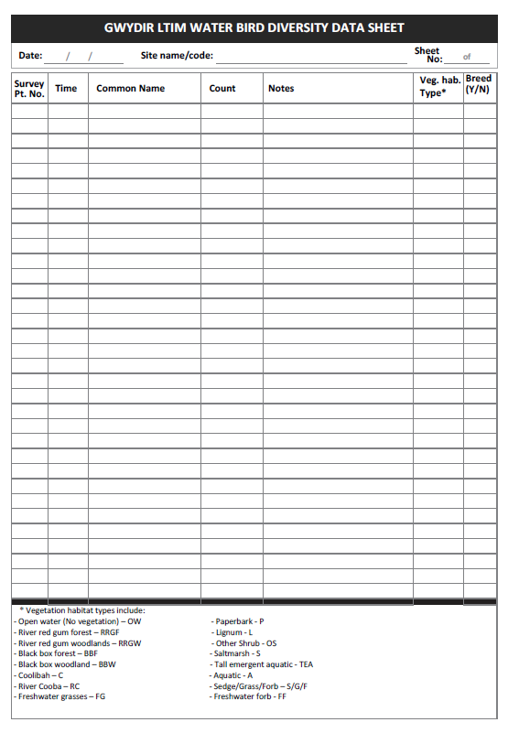

# SOP – Water Quality

## Objectives

The Water Quality monitoring protocol seeks to assess the contribution of Commonwealth environmental water to improved water quality.

## Indicators

Dependant variables:

* Temperature
* pH
* Turbidity
* Salinity
* Dissolved oxygen.

Covariates

* Discharge (ML/day).

## Location for monitoring

A single monitoring site for water quality will be located at single site in the Gwydir River zone (Copeton Dam to Tareelaroi Weir). This location has permanent surface water connectivity in a defined channel and all Commonwealth environmental water delivered to the Gwydir Selected Area must pass through this reach. Locating a single station at Pallamallawa allows all-weather access to a (NoW) telemetered gauged site and provides data on influent water quality to the Gwydir Selected Area throughout all flow deliveries.

## Timing and frequency

Continuous monitoring of dependant variables and covariates (following Section 13 Water Quality, Hale et al. 2014) will occur over a full 12 month cycles. Deployment periods will therefore align with the commencement and cessation of Commonwealth environmental water delivery.

## Specific Equipment (in addition to the Standard Methods – Water Quality)

* Hydrolab DS5-X logger. The DS5-X multi-probe logger includes a self-cleaning system to reduce fouling of probes and is designed for long-term submersible deployment

## Responsibilities

The Project Manager of the Gwydir M&E Project Team is responsible for overseeing this procedure. A field scientist/technician will be responsible for the monitoring and maintenance of loggers and collation of data under the direction of Project Director (Ryder), who will conduct the analyses and reporting.

## Complementary monitoring and data

Hydrological measures of stream discharge are used to inform the interpretation of stream water quality. The existing stream gauge at Pallamallawa (NOW gauge number 418001) will be used to quantify discharge (ML/d).

## Detailed methods

Measurement of the Water Quality indicator will follow the field and laboratory procedures outlined in the LTIM Standard Methods (Hale et al. 2014).

## Data analysis

1. **The Selected Area scale hypotheses**

At the Selected Area scale a number of hypotheses that relate to the outcomes of delivery of Commonwealth environmental water are possible. Selected Area scale hypotheses include:

1. Mean daily water temperature, and daily range in water temperature will decrease during the delivery of Commonwealth environmental water
2. Mean daily pH, and daily range in decrease during the delivery of Commonwealth environmental water
3. Mean daily turbidity will increase during the delivery of Commonwealth environmental water
4. Mean daily EC will decrease during the delivery of Commonwealth environmental water
5. Mean daily DO concentrations will decrease during the delivery of Commonwealth environmental water.
6. **The Selected Area scale analyses**

Quantitative analyses will be applied at the Selected Area scale to document temporal shifts in water quality in periods that Commonwealth environmental water is delivered each year. Long-term year on trends can be analysed based on periods with and without the delivery of Commonwealth environmental water.

Short-term and long term responses:

* Hypotheses 1 to 5 – Replication derived from randomised daily means of data periods within/outside delivery of Commonwealth environmental water. One-way Anova (WQ variables as dependant variable) comparing among flow periods, and two-way Anova (flow period, years) for long term dataset.

## Reporting

Data for the Basin-scale will be reported following the requirements outlined in the LTIM Data Standard (Section 13.9 Water Quality – Data analysis and reporting, Hale et al. 2014) and conform to the LTIM Data Standard (Brooks & Wealands 2014).

## Quality assurance/quality control

Quality control and quality assurance protocols are documented in the Quality Plan developed for the M&E Plan (CEWO 2014). In addition, this method requires a number of QA/QC procedures:

* Calibration and maintenance of sensors and loggers is required at a maximum 6 week interval
* Data correction procedures will be used to account for sensor drift or fouling following periodic calibration.

## References

|  |
| --- |
| Brooks S. & Wealands S.R. 2014. *Commonwealth Environmental Water Office Long Term Intervention Monitoring Project: Data Standard*. Report prepared for the Commonwealth Environmental Water Office by The Murray-Darling Freshwater Research Centre. MDFRC Publication 29.3/2013 Revised Jan 2014. |
| Commonwealth Environmental Water Office (CEWO). 2014. *Long Term Intervention Monitoring Project Gwydir River System Selected Area*. Commonwealth of Australia. |
| Hale J., Stoffels R., Butcher R., Shackleton M., Brooks S. & Gawne B. 2014. *Commonwealth Environmental Water Office Long Term Intervention Monitoring Project – Standard Methods*. Final Report prepared for the Commonwealth Environmental Water Office by The Murray-Darling Freshwater Research Centre, MDFRC Publication 29.2/2014, January, 182 pp. |

# SOP – Hydrology (Watercourse)

## Objectives

The aim of the Hydrology (Watercourse) indicator is to document the extent of inundation caused by Commonwealth environmental watering.

## Indicators

Hydrology (Watercourse) monitoring will map the inundation extent resulting from the delivery of Commonwealth environmental watering.

The Hydrology (Watercourse) indicator links to Vegetation Diversity, Waterbird Diversity, Waterbird Breeding, and Microcrustaceans indicators.

## Locations for monitoring

Hydrology (Watercourse) monitoring will occur in the Gingham-Gwydir Watercourse (Figure 1).

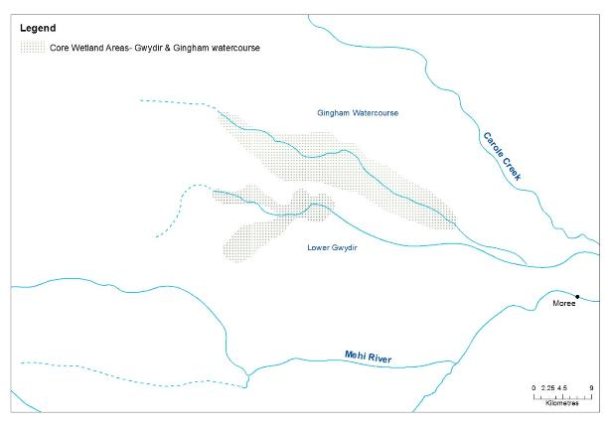

**Figure 1: Watercourse areas - Gwydir Selected Area**

## Timing and frequency

Existing sets of LiDAR data (already captured) will be used to create an inundation model at targeted areas within the Gingham-Gwydir Watercourse. No new data capture is proposed.

## Responsibilities

The Project Manager of the Gwydir M&E Project Team is responsible for overseeing this procedure. A team of GIS officers will complete the data analysis.

## Complementary monitoring and data

Data on inundation extent and frequency from previous and ongoing work (e.g. OEH (Rachel Thomas et al.), Powell (2001; University of Canberra, PhD thesis), LIDAR captures and OEH hydrodynamic modelling) will be used to assist in developing the known and expected inundation extent and volume from given flow events.

## Detailed methods

At present there are a number of fixed camera sites and gauging stations established within key areas of the Gwydir and Gingham wetlands which can be used to monitor water levels. Several new cameras will be established within the wetlands to allow water level monitoring in the vicinity of the bird hide on Bunnor in the Gingham watercourse and near the eastern extent of Gwydir wetlands on Old Dromana. In addition, a number of water depth recorders will be established in the Gwydir wetlands to increase the coverage of water level monitoring within this system.

Water level information from this network of gauges and cameras will then be linked to the LiDAR imagery to allow for an estimation of the extent and volume of water within the wetlands at any given time.

This project will create data relevant to the hydro-dynamic model built by OEH. It will enable calibration and refinement of this model.

## Data analysis and reporting

GIS based analysis to determine the relationship between inundation event (volume) and inundated area and volume in relation to mapped soil and vegetation regions.

The Hydrology (Watercourse) method reports m2 ANAE typology and vegetation community inundated from Commonwealth environmental water. The proposed indicator will document the m2 of inundated ANAE and vegetation hydrology and will facilitate the scaling of potential Microcrustacean, Vegetation Diversity and Waterbird Diversity/Breeding to the lower Gwydir.

All data provided for this indicator must conform to the data structure defined in the LTIM Data Standard (Brooks & Wealands 2014).

### Conceptual definition

This indicator will contain rows of data about a site that is:

*“A defined watercourse potentially inundated by the delivery of environmental water”*

Each row of data will describe:

*“ the extent and volume of inundation by environmental water ”*

### Site linkages

Sites of Hydrology (Watercourse) require the following linkages to other data (where available):

* ANAE stream identifiers to enable linking with framework datasets for future work
* Gauged flow and stage information from relevant gauges

### Data definition

*Each row of data will contain the following columns of information*.

| **Variable** | **Description** | **Type** | **Req** | **Range** | **Example** |
| --- | --- | --- | --- | --- | --- |
| siteId | A single large wetland or a complex of wetlands represented by either a name or polygon within which observations are made | string | Y |  |  |
| sampleDate | Start date (inclusive) that these measures were observed | dateTime | Y |  |  |
| sampleDateEnd | End date (exclusive) that these measures were observed | dateTime | Y |  |  |
| dailyExtent | m^2 | Number  (1 decimals) | N |  | 7 398 765.1 |
| dailyVolume | m^3 | Number  (1 decimals) | N |  | 4 897 967.2 |
| percentDry | Percentage of total area that is dry (zero depth) | Integer | N | [0,100] | 26 |
| percentDepth020 | Percentage of total area that is < 20cm deep | Integer | N | [0,100] | 74 |
| percentDepth040 | Percentage of total area that is 20 to < 40cm deep | Integer | N | [0,100] | 63 |
| percentDepth060 | Percentage of total area that is 40 to < 60cm deep | Integer | N | [0,100] | 25 |
| percentDepth080 | Percentage of total area that is 60 to < 80cm deep | Integer | N | [0,100] | 18 |
| percentDepth100 | Percentage of total area that is 80 to < 100cm deep | Integer | N | [0,100] | 6 |
| percentDeep | Percentage of total area that is >100cm deep | Integer | N | [0,100] | 47 |
| percentCEW | Percent of water contributed by CEWO as percent of total area | Integer | N | [0,100] | 52 |
| qualityCode | Data quality codes (1-5) will need to be applied with the following definitions:  1: Best quality unedited data. Meets operational standards and is considered a good representation of the true value.  2: Good quality. Minimal editing, may include sensor drift correction this is considered a good representation of the true value.  3: Modified or transformed data this is considered A reasonable representation of the true value.  4: Unreliable data - considered a poor representation (e.g. debris effecting sensor, flat batteries)  5: Estimated or modelled data. | Integer | N | [1,5] | 2 |

## Quality assurance/quality control

Quality control and quality assurance protocols are documented in the Quality Plan developed for the M&E Plan (CEWO 2014).

## References

|  |
| --- |
| Brooks S. & Wealands S.R. 2014. *Commonwealth Environmental Water Office Long Term Intervention Monitoring Project: Data Standard*. Report prepared for the Commonwealth Environmental Water Office by The Murray-Darling Freshwater Research Centre. MDFRC Publication 29.3/2013 Revised Jan 2014. |
| Commonwealth Environmental Water Office (CEWO). 2014. *Long Term Intervention Monitoring Project Gwydir River System Selected Area*. Commonwealth of Australia. |
| Powell S. 2001. *Analysis and modelling of the flood pulse and vegetation productivity response in floodplain wetlands*. PhD Thesis, University of Canberra. |

# SOP – Fish (Movement)

## Objectives and hypotheses

The Fish (Movement) monitoring protocol aims to assess the contribution of Commonwealth environmental water to fish population diversity, dispersal and habitat use.

## Indicators

Fish (Movement) will target movement of one equilibrium species, freshwater catfish (*Tandanus tandanus*) (endangered population Murray-Darling Basin), and one periodic species, spangled perch (*Leiopotherapon unicolor*).

The Fish (Movement) indicator links to the Fish (River) indicator.

## Locations for monitoring

In the first year of monitoring Fish (Movement) (year 2 of the LTIM monitoring), the monitoring team will select the best reach within the target zones (**Figure 6**) to establish the optimal location/s for the fish movement array. The receiver design will be established cognisant of the requirements set out in chapter 8 of Hale et al. (2014).

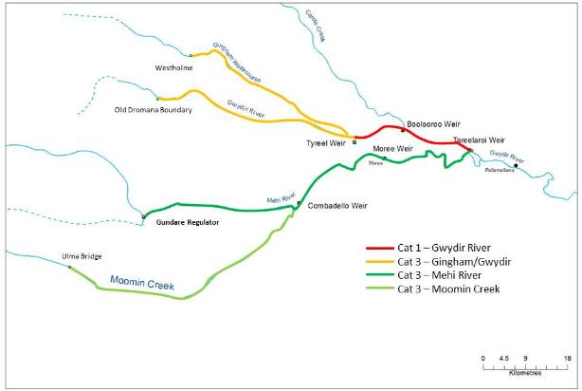

**Figure 6. Location of fish sampling reaches within the Gwydir River Selected Area. Fish (movement) will be targeted in the Category 1 reach**

## Timing and frequency

Fish (Movement) will be undertaken during the second (2015-16) and third (2016-17) years of the project.

## Responsibilities

Fisheries NSW will be sub-contracted by Eco Logical Australia to undertake Fish (Movement) monitoring.

## Detailed methods

Methods for sampling fish (movement) will follow those outlines in the LTIM Standard Methods (Hale et al. 2014). Here, individual fish will be tagged using appropriately sized Vemco tags that are less than 2% of individuals total body weight. Tags will be surgically implanted into the coelomic cavity while fish are under anaesthesia. Total length and fork length (mm) as well as mass (g) of each fish will be recorded. Fish are to be fitted with external, individually numbered dart tags in the dorsal musculature to aid angler identification and facilitate tag returns which is important to understand fate of the fish if it is detected in the future. Resident fish will be sourced from the selected channels, and if insufficient numbers are collected, fish may be relocated from Copeton Dam.

Receiver arrays will be set up along the study reach at intervals sufficient to determine the movement of targeted species (1-5km). The spacing of receivers will be determined after a full assessment of the selected reach by field staff.

## Data analysis

Acoustic receivers will be downloaded quarterly to reduce the possible risk of lost stolen receivers. Data will be analysed following the detailed methods in Hale et al. (2014). Here, movement metrics such as total longitudinal distance (upstream, downstream and total), net longitudinal distance and longitudinal range will be collected for each individual on a monthly basis. The temporal resolution of position collection should be weekly. Home–range calculations (kernal utilisation distributions), site fidelity (linearity indices), habitat use and rate of movement will be plotted using Eonfusion® (Fisheries NSW hold multiple licences for the software). Eonfusion® will also be used to generate ‘real-time’ video to help in visualising fish movements in relation to flow, season, day-night etc. In addition the above analyses, a model selection approach using linear mixed effect models will be used to determine relationships between movement patterns and environmental variables such as discharge, lagged discharge (number of days since flow event), Julian day, water temperature, sex and length of fish. If breeding related movements do occur, then the locations of fish during this time will be reported as displacement, defined as a representation of the geographical distance and the direction that the fish moved. As freshwater catfish is known to nest on open substrates and in relatively shallow water, we will also attempt to validate nest site locations using underwater cameras.

## Reporting

All data provided for this indicator must conform to the data structure defined in the LTIM Data Standard (Brooks & Wealands 2014).

## Quality assurance/quality control

Quality control and quality assurance protocols are documented in the Quality Plan developed for the M&E Plan (CEWO 2014).

## References

|  |
| --- |
| Brooks S. & Wealands S.R. 2014. *Commonwealth Environmental Water Office Long Term Intervention Monitoring Project: Data Standard*. Report prepared for the Commonwealth Environmental Water Office by The Murray-Darling Freshwater Research Centre. MDFRC Publication 29.3/2013 Revised Jan 2014. |
| Commonwealth Environmental Water Office (CEWO). 2014. *Long Term Intervention Monitoring Project Gwydir River System Selected Area*. Commonwealth of Australia. |
| Hale J., Stoffels R., Butcher R., Shackleton M., Brooks S. & Gawne B. 2014. *Commonwealth Environmental Water Office Long Term Intervention Monitoring Project – Standard Methods*. Final Report prepared for the Commonwealth Environmental Water Office by The Murray-Darling Freshwater Research Centre, MDFRC Publication 29.2/2014, January, 182 pp. |

# SOP – Microcrustaceans

## Objectives

This Standard Operating Procedure has been developed in line with the Procedure proposed by Jenkins et al. for Selected Areas in the southern MDB. Application of this standard indicator across a broad geographic range of wetland and channel systems throughout the Basin will facilitate comparisons of microinvertebrate and more broadly ecosystem function responses to Commonwealth environmental water.

## Indicators

Dependant variables:

* Microinvertebrate relative abundance (density/L)
* Microinvertebrate community assemblage

Covariate Indicators

* Hydrology River
* Hydrology Watercourse
* Fish River
* Fish Larvae
* Metabolism
* Vegetation Diversity
* Waterbird Breeding

## Locations for monitoring

Monitoring sites for microinvertebrate will be located in two target areas in the lower Gwydir.

*River sites*

The first is the zone between in the Gwydir River between Tyreelaroi and Tyreel Weirs that is the target zone for Category 1 fish (river) and will receive Commonwealth environmental water within each watering year. Microinvertebrate sampling using the river channel sampling protocol for will occur at the 3 locations aligned with Fish River sampling (below) to provide explicit links among these indicators and provide an assessment of a functional ecosystem response.

|  |  |  |  |  |
| --- | --- | --- | --- | --- |
| Gwydir |  |  | Easting | Northing |
|  | GWR1-C1 | 56J | 209205.00 m E | 6740456.00 m S |
|  | GWR2-C1 | 55J | 783417.00 m E | 6743136.00 m S |
|  | GWR3-C1 | 55J | 775598.00 m E | 6741492.00 m S |

*Watercourse sites*

The second zone utilises the wetland/floodplain sampling protocol to sample the Gingham watercourse at Bunnor and the Gwydir watercourse at Old Dromana that are characterised by an extensive floodplain wetland network and will allow an assessment of connectivity. Sampling will occur within representative sites in each of the dominant wetland vegetation communities inundated by Commonwealth environmental water. In Bunnor sampling will be stratified within water couch, typha and open water habitats. At Old Dromana sampling will be stratified within water couch, marsh clubrush and coolabah sites. Microinvertebrate sample sites in these watercourses will be aligned with the vegetation sample location. The Hydrology Watercourse indicator will facilitate the scaling-up of site based microinvertebrate data (density/L/vegetation type) to the entire inundated area of the watercourse.

This design will allow Basin scale reporting with replication (n=3) for each of river channel and watercourse habitats, and alignment with Fish (River) sites.

The rationale underlying this approach is to seek as much synergy as possible with the fish (river) indicator for channel sites, and the links between watercourse inundation, water chemistry, metabolism and microinvertebrates. Only a single composite sample (comprised or either 5 benthic cores or 5 pelagic buckets) is taken from each site or vegetation habitat within a site. This will reduce the overall number of samples for laboratory processing and align with other Selected Areas.

## Monitoring Design

*Microinvertebrate River*

Two different microinvertebrate sampling gears will be used within the three river channel sites of the Gwydir River zone targeted for Selected Area scale analyses: benthic corer and a pelagic bucket. Five benthic cores will be randomly allocated within the slackwater habitats along a 150m section of river and placed in a single bucket to yield a single ‘benthic’ composite sample from the site.

Five pelagic buckets should be randomly allocated within flowing edge habitats along a 150m section of river and then poured through a net to yield a single ‘flowing pelagic’ composite sample from the site.

Microinvertebrate samples within a site should be collected before the site is disturbed for other sampling.

*Microinvertebrate watercourse*

Two different microinvertebrate sampling gears will be used where possible within the three vegetation communities of each Bunnor and Old Dromana watercourses: benthic corer and a pelagic bucket.

Five benthic cores will be randomly allocated within shallow-edge (<15cm) of each inundated habitat of each vegetation community and then placed in a single bucket to yield a single ‘watercourse benthic’ composite sample from the site. Where surface water >15cm depth is present, five pelagic buckets will be randomly allocated within each inundated habitat of each vegetation community and then poured through a net to yield a single ‘watercourse pelagic’ composite sample from the site.

Microinvertebrate samples within a site should be collected before the site is disturbed for other sampling.

*Watercourse floodplain wetland metabolism*

To replicate the ecosystem function links between nutrients, carbon, metabolism and microinvertebrates, we will collect metabolism (GPP, R, NPP mg/m2/day, Chl a) and water chemistry (DOC, TP, TN, FRP, NOx) metrics in each of the vegetation habitats in each of the 3 watercourse sites. We will follow the standard methods outlined for the indicator Metabolism in the collection and analyses of metabolic and water column nutrient data.

During years 4 and 5 of the project, additional metabolism data will be collected at four of the river channel sites within the Gwydir and Mehi River channels. The same metrics will be calculated for metabolism at these sites as the wetlands sites as outlined above. In addition, a new metric to estimate the amount of organic carbon produced per day per one-kilometre stream reach (kg C/km/day) will be calculated by multiplying the daily rate of GPP (mg O2/L/day) by the cross-sectional stream area (m2) at the nearest gauge station with a conversion factor of 12/32 to convert oxygen gas (O2) molecular mass to carbon (C) atomic mass. The locations of these sites and the water gauges used to calculate organic carbon production per day per kilometre is presented below.

|  |  |  |
| --- | --- | --- |
| Site | DPI Water gauge station | Distance from gauge station |
| GW2 | 418042 (Gwydir D/S Tareelaroi) | 6 km downstream |
| GW4 | 418004 (Gwydir @ Yarraman Br) | 0 km |
| GW6 | 418078 (Gwydir @ Allambie Br) | 0 km |
| ME1 | 418044 (Mehi D/S Tareelaroi) | 3 km downstream |

## Timing and Frequency

At each of the 3 Category 1 Fish River sites, microinvertebrate sampling will take place on 4 occasions from the commencement to the cessation of environmental water delivery (approx. October through to March).

At each watercourse site, microinvertebrate and metabolism-water chemistry sampling will take place following watercourse inundation with Commonwealth environmental water. Four sample events are planned to follow the inundation and contraction cycle, sampling immediately (days) after inundation, at peak area inundation, and at two times during the drying cycle.

## Responsibilities

The Project Manager of the Gwydir M&E Project Team is responsible for overseeing this procedure.

An ecologist will be responsible for the field collation of data and laboratory processing of samples under the direction of Project co-Director (Ryder), who will conduct the analyses and reporting.

Complementary monitoring and data

The following indicators measures in the lower Gwydir will be included as complementary monitoring data to inform the ecosystem function response of each of the river channel and watercourse floodplain wetland systems.

* Hydrology River
* Hydrology Watercourse
* Fish River
* Fish Larvae
* Metabolism
* Vegetation Diversity
* Waterbird Breeding

The cause and effect diagram below demonstrates the functional and food web links provided by microinvertebrate in river channel and floodplain watercourse habitats in the Gwydir Selected Area.



Cat 3 - Microcrustaceans

Cat 3 - Macroinvertebrates

## Detailed methods

1. **Sampling protocol**

The sampling procedure is the same for watercourse and river channels. Benthic corers should be modified slightly from King (2004), the details of which can be found in (Morris 2008). The benthic cores within each site should be collected either in the afternoon or the morning to tie in with other sampling. Collection times should be recorded on the data sheet.

Composite samples (each pelagic and benthic) will be collected at each site. Benthic samples will be collected with a corer (50 mm diameter x 120 mm long, 250 mL volume). At each site, five cores will be collected from randon locations within each site with replicates spaced along a 150m transect. The corer is placed onto the sediment surface, the top is then sealed with a plastic cap and the sediment and overlaying water extracted with the aid of a hardened rubber trowel. The contents of the corer are be emptied into a 4 litre bucket and allowed to settle for at least one hour. Once settled, the supernatant will be poured through a 63 μm sieve to retain microinvertebrate. The retained sample will be washed into a sample jar and stored in ethanol (70% w/v) with rose bengal. To assess the pelagic microinvertebrate community, a composite sample consisting of 10 x 10 litre buckets will be collected at each site. Each bucket should be poured through a plankton sampler (63 μm mesh). Retained samples are stored in ethanol (70% w/v) with rose bengal until time of enumeration.

Metabolism and water chemistry will follow the Metabolism River SOP. Briefly, loggers will be placed in watercourse locations for a minimum 48h period, with water chemistry samples collected at the commencement and end of incubations.

*Equipment*

* Benthic corer (50 mm diameter x 120 mm long, 250 mL volume) and rubber backed spatula;
* Small (4L) bucket with lid for settling benthic cores;
* 63um mesh sieve;
* Squirt Bottle
* 70% ethanol with rose bengal stain;
* Storage jars;
* Data sheets

Specific Equipment (as per Standard Methods – Metabolism)

1. D-opto temp-oxygen loggers and stakes (calibration, cleaning equipment)
2. Filtration and storage jars for nutrient/carbon samples
3. Data sheets

*Laboratory sample processing - microinvertebrate*

Entire samples should be preserved individually in 70% ethanol and returned to the laboratory for microinvertebrate identification and enumeration. Whole samples should be examined in bogorov trays and the contents identified to Class, Order and family level.

Metabolism and water chemistry samples will be processed following the Metabolism SOP.

## Data analysis

At the Selected Area scale a number of hypotheses that relate to the outcomes of delivery of Commonwealth environmental water are possible. We aim to standardise methods and data definitions with the Murrumbidgee and Warrego-Darling Selected Areas to facilitate Basin Scale evaluation.

In river channel habitats quantitative analyses will be possible for microinvertebrate density and community composition for time since watering, with multivariate analyses such as nMDS (and modules including Simper, BioEnv, DISP, PCA) will be used to explore patterns among dependant and covariate variables such as water quality and fish (river).

In watercourse habitats, quantitative analyses will be possible for microinvertebrate density and community composition for time since watering and vegetation community, with multivariate analyses such as nMDS (and modules including Simper, BioEnv, DISP, PCA) will be used to explore patterns among dependant and covariate variables such as water column nutrient and carbon concentrations, metabolism and waterbird breeding/diversity.

Metabolism will be reported in GPP, R, NPP /m2 vegetation community, facilitating outcomes for entire systems to be determined from scaled data (e.g., microinvertebrate density/m3/vegetation community) scaled to entire watercourse systems. Watercourse Hydrology will quantify the area of each vegetation community inundated and the volume of inundation (m3) throughout the delivery cycle of Commonwealth environmental water. Linking microinvertebrate density to this indicator will facilitate scaling of response from site based (microinvertebrate density/m2) to the inundated vegetation asset scale within the Selected Area.

## Reporting

Basin and Selected Area scale reporting will conform to the LTIM Data Standard (Brooks and Wealands 2014) to facilitate data management within the LTIM Monitoring Data Management System (MDMS).

## Conceptual definition

This indicator will contain rows of data about a site that is:

*“ a River site covers a 100m stretch of channel , within which the diversity of habitats are represented and sampled.”*

*“a Watercourse site covers a 100m stretch of inundated floodplain, within which the diversity of habitats are represented and sampled.”*

Each row of data will describe:

*“the characteristics of microcrustacean assemblages based on density of individuals of a specific taxa at the site in the period defined by the date/time range.”*

## Site linkages

Sites of Microcrustaceans require the following linkages to other data (where available):

* site identifiers for representative hydrological indicator data for the river channel
* site identifiers for representative hydrological indicator for the watercourse
* ANAE identifiers to enable linking with framework datasets for future work

## Data definition

*Each row of data will contain the following columns of information*.

| **Variable** | **Description** | **Type** | **Req** | **Range** | **Example** |
| --- | --- | --- | --- | --- | --- |
| siteId | A site that covers a 100m stretch of the channel or watercourse represented by either a name or polygon, within which the diversity of habitats are represented and sampled | string | Y |  | EDWK04_057 |
| siteType | Channel or Watercourse | category | Y |  | Channel |
| sampleDate | Start date (inclusive) that these measures were observed | dateTime | Y |  | 15/05/2014 0:00 |
| sampleDateEnd | End date (exclusive) that these measures were observed | dateTime | Y |  | 15/05/2014 0:00 |
| higherTaxaName | Latin name of order, class, phylum for taxa that cannot be identified to family or below | string | Y |  | Cladocera |
| familyName | Latin name of family | string | N |  | Chydoridae |
| numberIndividuals | total number of individuals (after multiplying up subsamples) | Integer | N | 0 - infinity | 1222 |
| densityIndividuals | total density of individuals (after multiplying up subsamples) | Number (2 decimal places | Y | 0 - infinity | 12.22 |
| sampleType | The types of sampling used to determine the total number of individuals | category |  | Tow net  Sediment core  Schindler-Patalas trap | Tow net |

## Quality Assurance/Quality Control

Quality control and quality assurance protocols are documented in the Quality Plan developed as part of the M&E Plan for all Selected Areas. This method requires a number of QA/QC procedures outlined below:

* All staff will follow the Safe Work Method Statement for field and laboratory work
* Standardisation of microinvertebrate sampling equipment
* Sample exchange between Murrumbidgee and Gwydir teams
* Water chemistry samples will have a QA/QC check via 10% sample exchange with NATA laboratory at the NSW OEH Lidcombe laboratories
* Field duplicate and blank samples will be collected following the Standard Method
* Holding times for water quality samples will follow the procedures provided by the processing laboratory
* Preservation and transport of water quality samples will follow the procedures provided by the processing laboratory.
* Data management will follow the Gwydir QA/QC protocols.

## References

|  |
| --- |
| Brooks S and Wealands S (2014) *Commonwealth Environmental Water Office Long Term Intervention Monitoring Project: Data Standard.* Report prepared for the Commonwealth Environmental Water Office by The Murray-Darling Freshwater Research Centre, MDFRC Publication 29.3/2013 Revised Jan 2014, 29pp. |
| Hale J., Stoffels R., Butcher R., Shackleton M., Brooks S. & Gawne B. 2013. *Commonwealth Environmental Water Office Long Term Intervention Monitoring Project – Standard Methods*. Final Report prepared for the Commonwealth Environmental Water Office by The Murray-Darling Freshwater Research Centre, MDFRC Publication 29.2/2014, January, 182 pp. |

# SOP – Macroinvertebrates

## Objectives

This Standard Operating Procedure has been developed in line with the Procedure proposed by Jenkins et al. for Selected Areas in the southern MDB. Application of this standard indicator across a broad geographic range of wetland and channel systems throughout the Basin will facilitate comparisons of macroinvertebrate and more broadly ecosystem function responses to Commonwealth environmental water.

## Indicators

Dependant variables:

* Macroinvertebrate relative abundance (density/m2)
* Macroinvertebrate community assemblage

Covariate Indicators

* Hydrology River
* Hydrology Watercourse
* Fish River
* Fish Larvae
* Metabolism
* Vegetation Diversity
* Waterbird Breeding

## Locations for monitoring

Monitoring sites for macroinvertebrates will be located in the same locations as sampling for macroinvertebrates, in two target areas in the lower Gwydir.

*River sites*

The first is the zone between in the Gwydir River between Tareelaroi and Tyreel Weirs that is the target zone for Category 1 fish (river) and will receive Commonwealth environmental water within each watering year. Macroinvertebrate sampling using the river channel sampling protocol for will occur at the 3 locations aligned with Fish River sampling (below) to provide explicit links among these indicators and provide an assessment of a functional ecosystem response.

|  |  |  |  |  |
| --- | --- | --- | --- | --- |
| Gwydir |  |  | Easting | Northing |
|  | GWR1-C1 | 56J | 209205.00 m E | 6740456.00 m S |
|  | GWR2-C1 | 55J | 783417.00 m E | 6743136.00 m S |
|  | GWR3-C1 | 55J | 775598.00 m E | 6741492.00 m S |

*Watercourse sites*

The second zone utilises the wetland/floodplain sampling protocol to sample the Gingham watercourse at Bunnor and the Gwydir watercourse at Old Dromana that are characterised by an extensive floodplain wetland network and will allow an assessment of connectivity. Sampling will occur within representative sites in each of the dominant wetland vegetation communities inundated by Commonwealth environmental water. In Bunnor sampling will be stratified within water couch, typha and open water habitats. At Old Dromana sampling will be stratified within water couch, marsh clubrush and coolabah sites. Macroinvertebrate sample sites in these watercourses will be aligned with the vegetation sample location.

This design will allow Basin scale reporting with replication (n=3) for each of river channel and watercourse habitats, and alignment with Fish (River) sites.

The rationale underlying this approach is to seek as much synergy as possible with the fish (river) indicator for channel sites, and the links between watercourse inundation, water chemistry, metabolism and macroinvertebrates. Only a single composite sample (comprised or either 5 benthic cores or 5 pelagic buckets) is taken from each site or vegetation habitat within a site. This will reduce the overall number of samples for laboratory processing and align with other Selected Areas.

## Monitoring Design

*Macroinvertebrate River and watercourse*

Macroinvertebrate indicator monitoring will be conducted following the Standard Operating Procedures in Hale *et al.* (2013).

## Timing and Frequency

At each of the 3 Category 1 Fish River sites, macroinvertebrate sampling will take place on 4 occasions from the commencement to the cessation of environmental water delivery (approx. October through to March).

At each watercourse site, macroinvertebrate sampling will take place following watercourse inundation with Commonwealth environmental water. Four sample events are planned to follow the inundation and contraction cycle, sampling immediately (days) after inundation, at peak area inundation, and at two times during the drying cycle.

## Responsibilities

The Project Manager of the Gwydir M&E Project Team is responsible for overseeing this procedure.

An ecologist will be responsible for the field collation of data and laboratory processing of samples under the direction of Project co-Director (Ryder), who will conduct the analyses and reporting.

Complementary monitoring and data

The following indicators measures in the lower Gwydir will be included as complementary monitoring data to inform the ecosystem function response of each of the river channel and watercourse floodplain wetland systems.

* Hydrology River
* Hydrology Watercourse
* Fish River
* Fish Larvae
* Metabolism
* Vegetation Diversity
* Waterbird Breeding

The cause and effect diagram below demonstrates the functional and food web links provided by macroinvertebrates in river channel and floodplain watercourse habitats in the Gwydir Selected Area.



Cat 3 - Microcrustaceans

Cat 3 - Macroinvertebrates

## Detailed methods

### Sampling protocol

This protocol follows the standard AUSRIVAS protocol of sampling every edge habitat that is present in the sampling reach (Hale *et al.* 2013). This modified method is a replicated procedure where each replicate represents a similar sweep length and contains the same percentage of edge habitat type. For this method, four habitat types are recognised: bare edge, macrophyte beds, snags, and leaf packs.

At a site, the major habitat types will be identified within the reach (bare ground, snags, macrophyte beds, leaf litter deposits) and estimate their relative percent cover within the reach (this estimate will determine how much of each habitat type is sampled from). Each habitat should be sampled to a degree dependent on its occurrence, with a full sample spanning a total of 10m of edge habitat. After sampling has been undertaken the sample will be rinsed to reduce fine sediment and coarse leave and twigs will be washed and removed from the sample. The sample will then be transferred to a sample jar and the sample will be preserved with 70% ethanol.

*Equipment*

* Hand sweep net 250 μm mesh, D-opening of 300mm X 300mm with a depth of 500mm.
* Buckets (2 per person)
* Set of 2 Seives – 10 mm, 250 μm mesh (1 per person)
* 500 ml sample jars (3 per replicate)
* labels

*Laboratory sample processing - macroinvertebrate*

Entire samples should be preserved individually in 70% ethanol and returned to the laboratory for macroinvertebrate identification and enumeration. Whole samples should be examined in bogorov trays and the contents identified to Class, Order and family level.

## Data analysis

At the Selected Area scale a number of hypotheses that relate to the outcomes of delivery of Commonwealth environmental water are possible. We aim to standardise methods and data definitions with the Murrumbidgee and Warrego-Darling Selected Areas to facilitate Basin Scale evaluation.

In river channel habitats quantitative analyses will be possible for macroinvertebrate density and community composition for time since watering, with multivariate analyses such as nMDS (and modules including Simper, BioEnv, DISP, PCA) will be used to explore patterns among dependant and covariate variables such as water quality and fish (river).

In watercourse habitats, quantitative analyses will be possible for macroinvertebrate density and community composition for time since watering and vegetation community, with multivariate analyses such as nMDS (and modules including Simper, BioEnv, DISP, PCA) will be used to explore patterns among dependant and covariate variables such as water column nutrient and carbon concentrations, metabolism and waterbird breeding/diversity.

## Reporting

Basin and Selected Area scale reporting will conform to the LTIM Data Standard (Brooks and Wealands 2014) to facilitate data management within the LTIM Monitoring Data Management System (MDMS).

## Conceptual definition

This indicator will contain rows of data about a site that is:

“ a River site covers a 100m stretch of channel , within which the diversity of habitats are represented and sampled.”

*“a Watercourse site covers a 100m stretch of inundated floodplain,* within which the diversity of habitats are represented and sampled.”

Each row of data will describe:

“the characteristics of *macroinvertebrate* assemblages based on density of individuals of a specific taxa at the site in the period defined by the date/time range.”

## Site linkages

Sites of macroinvertebrates require the following linkages to other data (where available):

* site identifiers for representative hydrological indicator data for the river channel
* site identifiers for representative hydrological indicator for the watercourse
* ANAE identifiers to enable linking with framework datasets for future work

## Data definition

*Each row of data will contain the following columns of information*.

| Variable | Description | Type | Req | Range | Example |
| --- | --- | --- | --- | --- | --- |
| siteId | A site that covers a 100m stretch of the channel or watercourse represented by either a name or polygon, within which the diversity of habitats are represented and sampled | string | Y |  | EDWK04_057 |
| siteType | Channel or Watercourse | category | Y |  | Channel |
| sampleDate | Start date (inclusive) that these measures were observed | dateTime | Y |  | 15/05/2014 0:00 |
| sampleDateEnd | End date (exclusive) that these measures were observed | dateTime | Y |  | 15/05/2014 0:00 |
| higherTaxaName | Latin name of order, class, phylum for taxa that cannot be identified to family or below | string | Y |  | Cladocera |
| familyName | Latin name of family | string | N |  | Chydoridae |
| numberIndividuals | total number of individuals (after multiplying up subsamples) | Integer | N | 0 - infinity | 1222 |
| densityIndividuals | total density of individuals (individuals/m2) | Number (2 decimal places | Y | 0 - infinity | 12.22 individuals/m2 |

## Quality Assurance/Quality Control

Quality control and quality assurance protocols are documented in the Quality Plan developed as part of the M&E Plan for all Selected Areas. This method requires a number of QA/QC procedures outlined below:

* All staff will follow the Safe Work Method Statement for field and laboratory work
* Standardisation of macroinvertebrate sampling equipment
* Sample exchange between Murrumbidgee and Gwydir teams
* Water chemistry samples will have a QA/QC check via 10% sample exchange with NATA laboratory at the NSW OEH Lidcombe laboratories
* Field duplicate and blank samples will be collected following the Standard Method
* Holding times for water quality samples will follow the procedures provided by the processing laboratory
* Preservation and transport of water quality samples will follow the procedures provided by the processing laboratory.
* Data management will follow the Gwydir QA/QC protocols.

## References

|  |
| --- |
| Brooks S and Wealands S (2014) *Commonwealth Environmental Water Office Long Term Intervention Monitoring Project: Data Standard.* Report prepared for the Commonwealth Environmental Water Office by The Murray-Darling Freshwater Research Centre, MDFRC Publication 29.3/2013 Revised Jan 2014, 29pp. |
| Hale J., Stoffels R., Butcher R., Shackleton M., Brooks S. & Gawne B. 2013. *Commonwealth Environmental Water Office Long Term Intervention Monitoring Project – Standard Methods*. Final Report prepared for the Commonwealth Environmental Water Office by The Murray-Darling Freshwater Research Centre, MDFRC Publication 29.2/2014, January, 182 pp. |

# SOP – Waterbird Breeding (optional)

## Objectives

This monitoring protocol aims to understand the contribution of Commonwealth environmental water to colonial waterbird breeding success.

## Indicators

The Waterbird Breeding indicator links to the Microcrustaceans, Vegetation Diversity, and Hydrology (Watercourse) indicators.

Colonial bird breeding events and fledgling success will be monitored.

## Locations for monitoring

There are several well-known colonial bird rookeries within the Gingham-Gwydir Watercourse; these rookery areas will be the target of the survey effort (Figure 5‑71).



**Known waterbird breeding sites – Gingham-Gwydir Watercourse**

**Figure 1: Watercourse areas**

## Timing and frequency

Monitoring of Waterbird Breeding is event driven. The M&E Plan (CEWO 2014) has provided for monitoring of 2-3 Commonwealth environmental water assisted bird breeding events during the 5 year project.

## Responsibilities

The Project Manager of the Gwydir M&E Project Team is responsible for overseeing this procedure. The field surveys will be led by experienced bird ecologists.

## Complementary monitoring and data

Existing breeding information for each Selected Area will be used in the first instance to aid in identifying potential monitoring locations (sites). Diversity data for non-breeding birds will be opportunistically collected during waterbird breeding surveys (see Section 10 of the LTIM Standard Methods: Waterbird Diversity, Hale et al. 2014).

## Detailed methods

The key rookery sites are well-known in the lower Gwydir Watercourse area. We will rely on communication networks with the key stakeholder communities (LTIM survey staff, landholders, birdwatchers and government department/agency staff) to identify bird breeding events or potential events linked to Commonwealth environmental water. Survey will be initiated by identified commencement of bird breeding events and agreement with CEWO to undertake targeted monitoring.

At key rookery sites (approximately 5) 10 fixed cameras will be used to sample representative nesting areas across each selected rookery site.

On-ground surveys will be conducted at least monthly during the events.

Hydrology will be determined via the Hydrology (Watercourse) indicator.

The monitoring design complies with the standard methods using fixed cameras (Hale et al. 2014). Waterbird Species and codes as field recording sheets are also provided.

## Data analysis

Please refer to the LTIM Standard Methods (Section 9 Waterbird Breeding, Hale et al. 2014) for prescribed data analysis.

1. **The Selected Area scale hypotheses**

Short-term (Annual) responses:

1. The delivery of Commonwealth environmental water to key rookery sites in the lower Gwydir will lead to successful nest establishment by colonial waterbirds
2. The delivery of Commonwealth environmental water to key rookery sites in the lower Gwydir will lead to the successful fledgling of colonial waterbirds
3. The delivery of Commonwealth environmental water to key rookery sites in the lower Gwydir will lead to increased diversity and abundance of nesting adult colonial waterbirds (link to Waterbird Diversity Indicator).

Long-term (5 year) responses:

1. The delivery of Commonwealth environmental water to key rookery sites in the lower Gwydir will lead to repeated successful nest establishment by colonial waterbirds
2. The delivery of Commonwealth environmental water to key rookery sites in the lower Gwydir will lead to the repeated successful fledgling of colonial waterbirds
3. The delivery of Commonwealth environmental water to key rookery sites in the lower Gwydir will lead to increased Selected Area diversity and abundance of adult colonial waterbirds (link to Waterbird Diversity Indicator).
4. **The Selected Area scale analyses**

Analyses based on Aggregation will be applied at the Basin-scale and Selected Area scales for taxonomic diversity and richness, and nesting and fledgling success. Qualitative and quantitative analyses will be applied at the Selected Area scale to document nesting and fledgling success of colonial waterbirds. Multi-year analyses will be quantitatively assessed based on year-on-year repeat application of annual models outlined in the Selected Area conceptual model (Figure 2). The placement of water level devices at each location to quantify hydrologic connection and inundation metrics will reduce uncertainty in quantifying the delivery of Commonwealth water to rookery sites.



**Figure 2: A hypothetical model that will be applied on a year-to-year basis to generate a series of outcomes from different flow regimes over a five year period (Source: Gawne et al. 2014)**

Short-term (Annual) responses:

1. Hypotheses 1 and 2 - univariate analysis (main effect – rookery site, season), nesting and fledgling success
2. Hypotheses 3 - (diversity-abundance) multivariate analysis (factors – rookery site /season).

Long-term (5 year) responses:

1. Hypotheses 4 and 5 - univariate analysis (main effects – rookery site /year/season), nesting and fledgling success
2. Hypotheses 4, 5 and 6- (diversity-abundance) multivariate analysis (factors – rookery site /year/season).

## Reporting

The standard method for Waterbird breeding reports area (m2) ANAE typology inundated from Commonwealth environmental water. The indicator Watercourse (Hydrology) will document the area (m2) of inundation and vegetation/habitat mapping will facilitate the scaling of potential colonial waterbird breeding sites/success to the lower Gwydir.

The variables required to be reported for each colony for each survey conducted for Waterbird Breeding are:

* Location (polygon of the colony)
* ANAE Wetlandid
* Size of wetland surrounding colony (ha)
* Number of nests of each species per vegetation type / structural habitat
* Number of nests in each nesting stage for each species
* Estimate of number of nests successfully fledged for each species (i.e. one or more chicks fledged per nest) since last survey
* Estimate of the mean number of chicks thought to have fledged per successful nest for each species, where possible (for nests fledged since last survey)
* Number of adults of each species
* Vegetation type, condition scores
* Observations of colony level disturbance (e.g. predators, other disturbance agents, or probable causes of colony desertion).

All data provided for this indicator must conform to the data structure defined in the LTIM Data Standard (Brooks & Wealands 2014).

## Quality assurance/quality control

Quality control and quality assurance protocols are documented in the Quality Plan developed for the M&E Plan (CEWO 2014).

QA/QC requirements specific to this protocol include:

* All Waterbird Breeding assessments will be undertaken by the same experienced observers, where possible, over time to maintain consistency
* Observers must undergo training prior to undertaking monitoring surveys, including calibration against experienced observers to ensure standardisation of measurements. Training and calibration procedures must be documented in the M&E Plan and relevant records maintained
* A minimum of two staff will be assigned to Waterbird Breeding surveys to minimise the variation associated with different observers. Where there are significant differences in original observer scores, observers will discuss their rationale and where appropriate adjust scores to mutually agreed values.

## References

|  |
| --- |
| Brooks S. & Wealands S.R. 2014. *Commonwealth Environmental Water Office Long Term Intervention Monitoring Project: Data Standard*. Report prepared for the Commonwealth Environmental Water Office by The Murray-Darling Freshwater Research Centre. MDFRC Publication 29.3/2013 Revised Jan 2014. |
| Commonwealth Environmental Water Office (CEWO). 2014. *Long Term Intervention Monitoring Project Gwydir River System Selected Area*. Commonwealth of Australia. |
| Gawne B., Hale J., Butcher R. Roots J., Brooks S., Cottingham P., Stewardson M. & Everingham P. 2014. *Commonwealth Environmental Water Office Long Term Intervention Monitoring Project: Evaluation Plan*. Final Report prepared for the Commonwealth Environmental Water Office by The Murray-Darling Freshwater Research Centre, MDFRC Publication 29/2014. |
| Hale J., Stoffels R., Butcher R., Shackleton M., Brooks S. & Gawne B. 2013. *Commonwealth Environmental Water Office Long Term Intervention Monitoring Project – Standard Methods*. Final Report prepared for the Commonwealth Environmental Water Office by The Murray-Darling Freshwater Research Centre, MDFRC Publication 29.2/2014, January, 182 pp. |

Appendix C Cause and Effect Diagrams

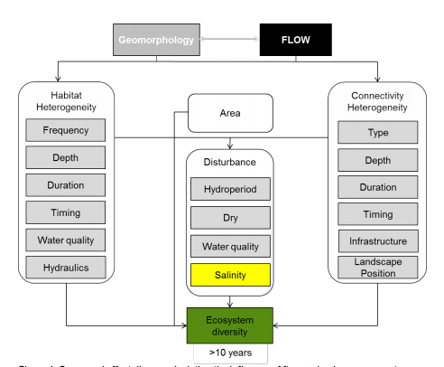

Figure C11‑1: Landscape Ecosystem Diversity CED (MDFRC 2013)

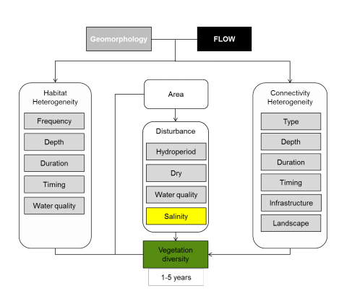

Figure C11‑2: Vegetation Diversity CED (MDFRC 2013)

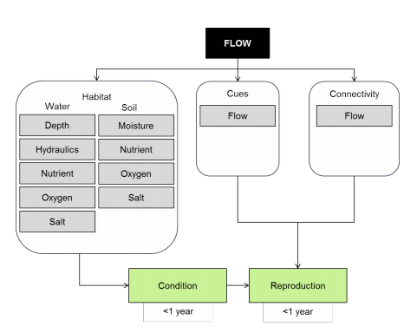

Figure C11‑3: Vegetation Condition and Reproduction CED (MDFRC 2013)

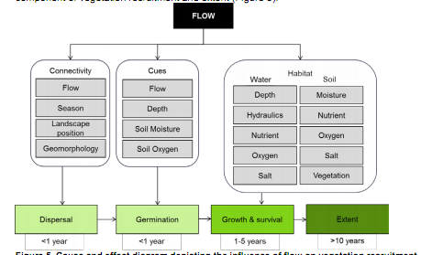

Figure C11‑4: Vegetation Recruitment and Extent CED (MDFRC 2013)

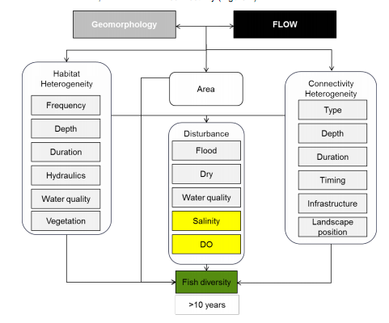

Figure C11‑5: Landscape Fish Diversity CED (MDFRC 2013)

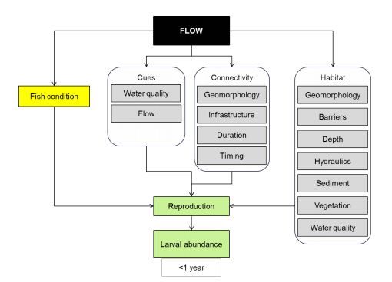

Figure C11‑6: Fish Reproduction CED (MDFRC 2013)

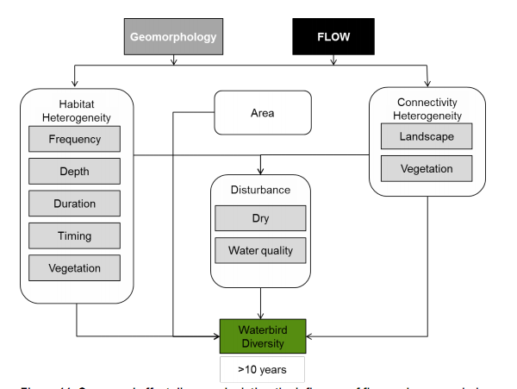

Figure C11‑7: Landscape Waterbird Diversity CED (MDFRC 2013)

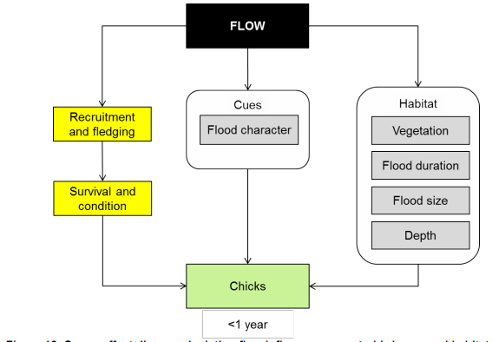

Figure C11‑8: Waterbird Reproduction CED (MDFRC 2013)

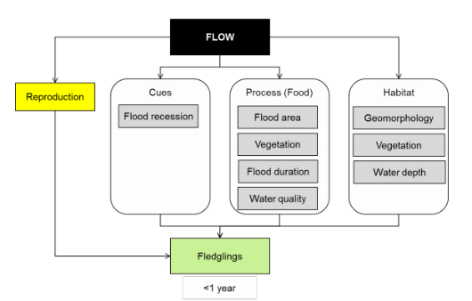

Figure C11‑9: Waterbird Recruitment and Fledging CED (MDFRC 2013)

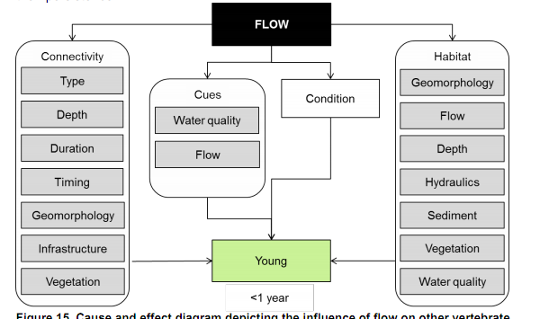

Figure C11‑10: Other Vertebrate Reproduction CED (MDFRC 2013)

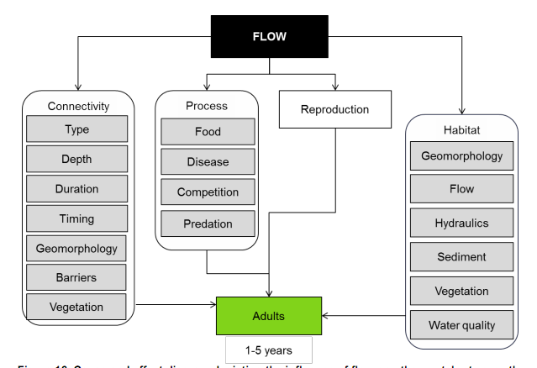

Figure C11‑11: Other Vertebrate Growth and Survival CED (MDFRC 2013)

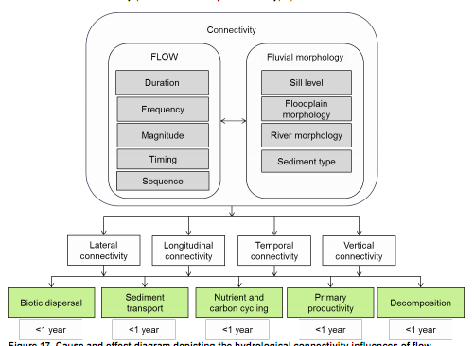

Figure C11‑12: Hydrological Connectivity (including end of system flows) CED (MDFRC 2013)

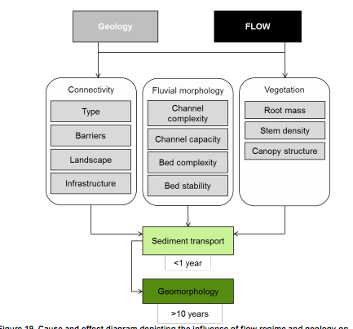

Figure C11‑13: Sediment Transport CED (MDFRC 2013)

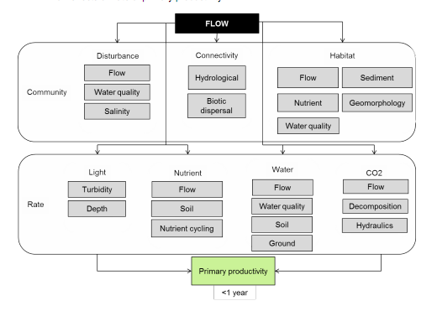

Figure C11‑14: Primary Production CED (MDFRC 2013)

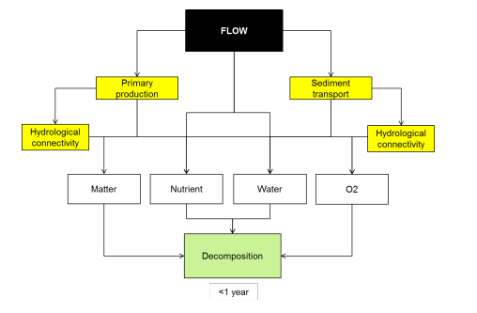

Figure C11‑15: Decomposition CED (MDFRC 2013)

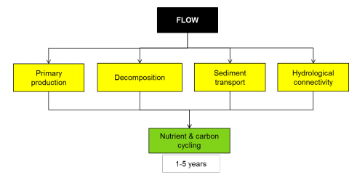

Figure C11‑16: Nutrient and Carbon Cycling CED (MDFRC 2013)

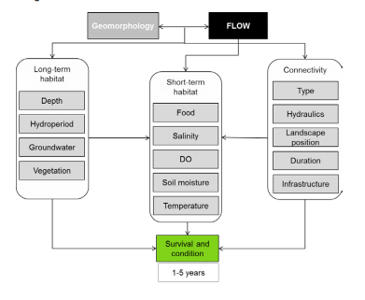

Figure C11‑17: Individual Refuges CED (MDFRC 2013)

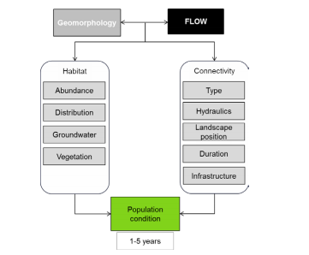

Figure C11‑18: Landscape Refuges CED (MDFRC 2013)

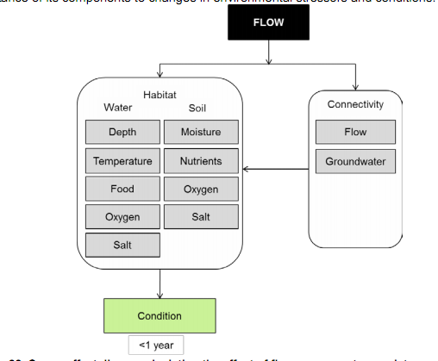

Figure C11‑19: Ecosystem Resistance CED (MDFRC 2013)

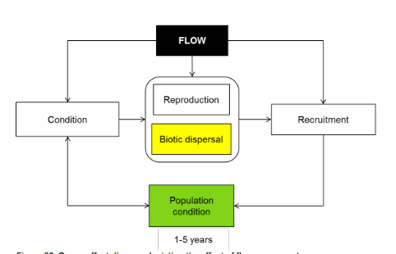

Figure C11‑20: Ecosystem Avoidance and Recovery CED (MDFRC 2013)

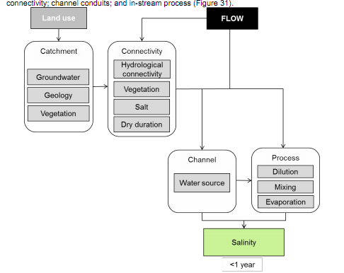

Figure C11‑21: Salinity CED (MDFRC 2013)

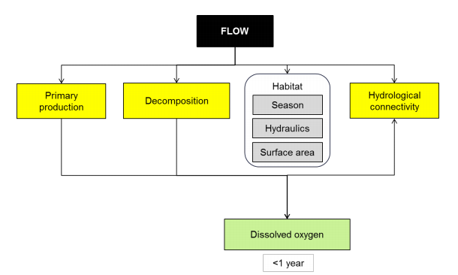

Figure C11‑22: Dissolved Oxygen CED (MDFRC 2013)

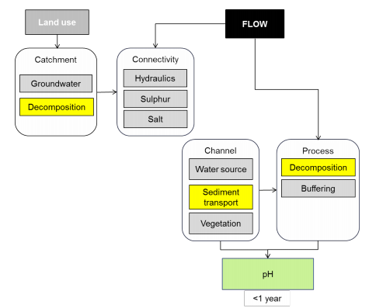

Figure C11‑23: pH CED (MDFRC 2013)

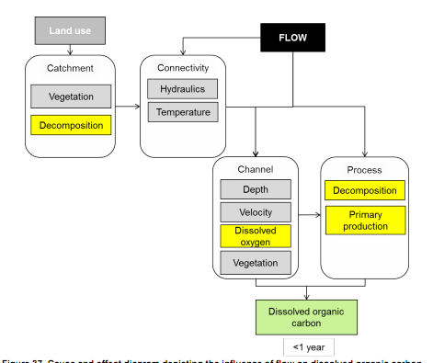

Figure C11‑24: Dissolved Organic Carbon CED (MDFRC 2013)

Appendix D Communications Plan





**Communications Plan**

**Commonwealth Environmental Water Office**

**Long Term Intervention Monitoring Project**

**Gwydir Selected Area**

Version 2, 23 October 2014





|  |  |
| --- | --- |
| **Item** | **Detail** |
| ELA Project Number | 13ARMNRM-0001 |
| Project Director/s | Paul Frazier, Darren Ryder |
| Project Manager | Mark Southwell |
| Prepared by | Emma Garraway |

This document is the Communications Plan for the CEWO LTIM Project for the Gwydir Selected Area. It is to be read in conjunction with the Monitoring and Evaluation Plan for the above project.

Any reviews or changes to this Communications Plan must be recorded in the tables below.

**Document control**

|  |  |  |  |
| --- | --- | --- | --- |
| **Version** | **Date** | **Reviewed by** | **Approved by** |
| 1 | 28 Feb 2014 | Paul Frazier | Paul Frazier |
| 2 | 23 Oct 2014 | Paul Frazier, Darren Ryder | Paul Frazier |
|  |  |  |  |
|  |  |  |  |
|  |  |  |  |

|  |  |
| --- | --- |
| **Version** | **Change since previous issue** |
| 2 | Updated to address CEWO comments |
|  |  |
|  |  |
|  |  |
|  |  |

Contents

**Abbreviations 161**

**1** **Introduction 162**

1.1 Objective 162

1.2 LTIM Project Code of Conduct 162

**2** **Operational communications 164**

**3** **Communications requirements 165**

3.1 Gwydir Selected Area Working Group 165

3.2 Landholder communications 165

3.3 Stakeholder engagement and external communications 166

3.4 Internal communications 168

3.5 Complaints procedure 168

**Appendix A Gwydir Selected Area Working Group Terms of Reference 171**

**Appendix B** **Landholder communication - recording templates 175**

**Appendix C** **Complaints register 157**

Abbreviations

|  |  |
| --- | --- |
| Abbreviation | Description |
| CEWO | Commonwealth Environmental Water Office |
| EAC OAC | Environmental Contingency Allowance Operations Advisory Committee |
| ELA | Eco Logical Australia |
| LLS | Local Land Services |
| LTIM | Long-Term Intervention Monitoring |
| M&E Adviser | Monitoring and Evaluation Adviser |
| M&E Plan | Monitoring and Evaluation Plan |
| M&E Provider | Monitoring and Evaluation Provider |
| MDBA | Murray-Darling Basin Authority |
| MDFRC | Murray-Darling Freshwater Research Centre |
| NOW | NSW Office of Water |
| OEH | (NSW) Office of Environment and Heritage |
| QA/QC | Quality Assurance / Quality Control |
| SWC | State Water Corporation (NSW) |
| UNE | University of New England |

Introduction

This document is the Communications Plan for the CEWO LTIM Project for the Gwydir Selected Area. It is to be read in conjunction with the Monitoring and Evaluation Plan (M&E Plan) for the above project.

**Objective**

The objective of this Communications Plan is to provide the mechanisms to facilitate effective and efficient communication between LTIM Project partners for the Gwydir Selected Area.

This Communications Plan has been developed by the Monitoring and Evaluation Providers (M&E providers) for the Gwydir Selected Area, being the project consortium (Eco Logical Australia Pty Ltd (ELA) and the University of New England (UNE)).

This Communications Plan has been developed to guide and direct communications between project partners for the Gwydir Selected Area and more broadly (i.e. the LTIM Project), including:

The M&E providers (i.e. the ELA/UNE consortium and their subcontractors)

The Commonwealth Environmental Water Office (CEWO)

The Monitoring and Evaluation Advisors (M&E Advisors) (i.e. the Murray-Darling Freshwater Research Centre (MDFRC))

Stage agencies, including NSW Office of Environment and Heritage (OEH) and NSW Fisheries

Delivery partners, including the NSW State Water Corporation

Other key stakeholders and groups, including the Gwydir Environmental Contingency Allowance Operations Advisory Committee (EAC OAC).

**LTIM Project Code of Conduct**

Collaboration and cooperation are vital to the overall success of the LTIM Project (Figure 2‑1). A Code of Conduct has been developed to guide the behaviour of individuals and teams when undertaking monitoring and evaluation activities on behalf of the CEWO.

In all communications related to the LTIM Project, including both operation and external communications, the LTIM Project team will comply with Code of Conduct developed by the CEWO.

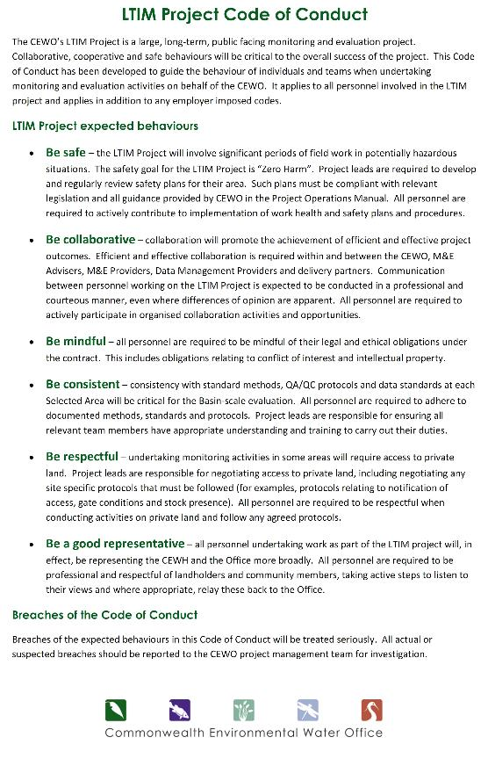

**Figure 11‑1: CEWO LTIM Project Code of Conduct**

Operational communications

An overview of the operational communication activities required for the implementation of the M&E Plan in the Gwydir Selected Area is provided in **Table 11‑1**. Reporting commitments are detailed in the M&E Plan.

**Table 11‑1: Operational communications activities – meetings**

| Activity | Purpose | Attendees (indicative) | Frequency | Responsibility | Engagement process |
| --- | --- | --- | --- | --- | --- |
| Project Meetings | Project progress and outcomes | CEWO  M&E Provider (Project manager plus others as required) | Monthly | M&E Provider | Telephone/Email correspondence |
| M&E Adviser meetings (to M&E Provider) | Project approach, methods and technical guidance | CEWO  M&E Advisers (Project manager plus technical leads)  M&E Providers (Project manager plus technical leads) | As required (initial briefing held December 2013) | M&E Advisers | Workshop or teleconference |
| LTIM Project Managers Group meetings | Collaboration and consistency | CEWO  M&E Providers project managers for each Selected Area | Biannually for the life of the LTIM Project | CEWO | Workshop or teleconference |
| Gwydir Selected Area Working Group meetings | Information and knowledge exchange | Gwydir SAWG | Quarterly for the life of the LTIM Project | M&E Provider for the Gwydir Selected Area | Workshop or teleconference |
| Annual Discussion Forum – Sydney | Technical Collaboration | CEWO  M&E Advisers (Project manager plus technical leads)  M&E Providers (Project manager plus three technical leads) | Annually (five in total) | CEWO | Workshop - Sydney |

Communications requirements

**Gwydir Selected Area Working Group**

The Gwydir Selected Area Working Group will provide a platform for the exchange of information and knowledge that supports the implementation of the M&E Plan for the Gwydir Selected Area.

The membership of the Gwydir Selected Area Working Group has been agreed with by CEWO. A Terms of Reference has been developed by CEWO to which the Gwydir Selected Area Working Group will subscribe (Appendix 1). Gwydir Select Area Working Group membership is provided below (**Table 11‑2**).

The Gwydir Selected Area Working Group has no executive powers, supervisory functions or decision-making authority in relation to the LTIM Project. It is an operational group tasked with a general support and advisory role. Attendance is at the sole discretion of the nominee.

The Gwydir Selected Area Working Group is required to meet quarterly for the duration of the LTIM Project, commencing in the 2014-2015 water year.

**Table 11‑2:** **Selected Area Working Group membership**

|  |  |
| --- | --- |
| Name | Agency/position/role |
| Paul Frazier | Gwydir LTIM Project Director (ELA) |
| Darren Ryder | Gwydir LTIM Project Director (UNE) |
| Mark Southwell | Gwydir LTIM Project Manager (ELA) |
| Adam Flanagan | CEWO (Northern Basin Section) LTIM Project Area Lead for the Gwydir |
| Yoshi Kobayashi | OEH (Scientific Services Division) |
| Debbie Love | OEH (Environmental Water and Floodplains, North West Region) |
| Daryl Albertson | OEH (Gwydir Environmental Water Manager) |
| Jane Humphries | OEH (Wetlands Conservation Officer, Regional Operations Group Moree) |
| Gavin Butler | DPI Fisheries (Scientific Officer, Aquatic Ecosystems Research) |
| Neal Foster | NSW Office of Water |
| Robert Smith | NPWS (NPWS Regional Manager Northern Plains region) |
| Bronwyn Cameron | North Western LLS/Namoi CMA (Catchment Coordinator M&E) |
| Sara Foot | North Western LLS/BRG CMA |
| Paul Hutchings | Gwydir ECA-OAC (current Chair) |
| Glenn Wilson | Gwydir ECA-OAC (Independent Scientist) |

ELA will chair the Gwydir Selected Area Working Group and be responsible for the administration and facilitation of the Group, including providing secretariat duties. All communications to the Gwydir Selected Area Working Group will be via the M&E Provider project manager or directors. Any change to the membership will be agreed between the project manager and CEWO.

**Landholder communications**

For the M&E Project, landholders are individuals and/or organisations where access to or through their land is required to undertake monitoring activities.

Landholder contact details and communications will be established upon approval of final sites. The following principles will be adopted:

* No access to any sites will take place without first contacting the landholder and gaining permission to undertake monitoring activities on their land. Initial access will be sought at least 10 working days before accessing a site for the first time, and then within a timeframe as negotiated with each landholder for subsequent access
* The Project team will invite each landholder to participate in or observe monitoring activities as they chose
* The Project team will discuss with CEWO the availability/accessibility of site specific data for each landholder
* All monitoring activities, including access to sites etc, are to be undertaken so that minimal/nil disturbance to the landholders’ activities, livestock and/or cropping practices occur
* Providing ongoing project updates to landholders as requested
* Where possible, existing tracks shall be used
* Vehicles/machinery to be operated so that any damaged is minimised
* Notify the landholder immediately if any damage occurs (to property or livestock)
* Appropriate approvals/licences shall be sought as necessary, including Scientific Licence and Permit to Work in NPWS Reserves. All field teams shall have copies of relevant licences when undertaking field work
* Take all reasonable care to ensure that weeds or pests are not spread
* Return gates to original position after use.

Contact details for landholders will be established in a register (Appendix B, Table B.1 Landholder contact details register). Any communications with landholders shall be tracked for the duration of the project, including the date of communications, the project team member and any comment/outcome of the communications (Appendix B Table B.2 Landholder communications register). This register will also include a record of any data provided to the landholder. Electronic registers can be maintained.

**Stakeholder engagement and external communications**

An internal process for conveying consistent messaging about the Gwydir LTIM Project in formal settings will be further developed, including consistent branding, review/sign off by CEWO, and a single point of contact (Project Manager) to be established and implemented.

No media communications shall take place without express permission from the Director, Northern Basin Section within CEWO.

It is noted that ELA/UNE are currently developing a Memorandum of Understanding (MoU) with OEH for cooperative resource and information sharing for the LTIM Project. There are a number of complimentary data sets that will be required for the LTIM Project. When monitoring indicators have been finalised, ELA/UNE will access the necessary data (see Section 5 of the M&E Plan) via the appropriate license agreements with the relevant agencies, including:

CEWO

LLS

NSW Fisheries

Murray-Darling Basin Authority

OEH.

The primary form of communication with stakeholders and parties external to the Gwydir Selected Area LTIM Project will be via the Gwydir ECA OAC. Membership of the Gwydir ECA OAC includes representatives from State and Commonwealth agencies, industry and conservation stakeholders, including the:

Aboriginal community

North West Local Land Services (LLS)

Gingham Watercourse landholders

Gwydir Valley Irrigators Association

Independent environmental group

Independent scientists

Department of Primary Industries

Lower Gwydir Water Users Association

NSW Office of Water

NSW OEH

NSW State Water

Department of Environment (observer status).

ELA are currently discussing opportunities for ELA Project Director (Dr Paul Frazier) to participate in the Group, as either a member or as an observer. UNE Project Director Dr Darren Ryder is currently on the ECA OAC in the role of independent scientist. The participation of the M&E Provider in the group will provide a platform for regular project communication and updates to the Group.

The ECA OAC currently host two phone conferences each year, and one face-to-face meeting in Moree. Reporting commitments and engagement undertaken by the ECA OAC include:

Provide input and advice to OEH for the development of the Gwydir Valley Annual Environmental Watering Plan - this plan outlines the priority and potential actions for environmental water delivery in the year

Gwydir Environmental Watering Annual Report – this report summarises environmental water delivered in the water year (including flow and inundation areas) and its outcomes and management implications

Annual Science Forum

State of Wetlands seasonal report – published on the LLS website and provided to affected landholders.

Adaptive management is critical to the management of Commonwealth environmental water and aligns with the different levels of evaluation associated with the use of this water at both the Selected Area and Basin-scale levels. The adaptive feedback loop ensures that CEWO has access to the knowledge and data to support environmental water use in the water. Well-established and maintained relationships with delivery partners and all other key stakeholders are vital to the LTIM Project. The ECA OAC for the Gwydir River is the principal authority for the development of annual watering plans for the Selected Area. Existing membership on this committee by the project leads will allow ad hoc and planned changes to the short and long term watering options of the Gwydir system to be responsive to monitoring outcomes. Membership of this committee also facilitates highly responsive monitoring to planned Commonwealth environmental watering to ensure all monitoring of events is undertaken.

* + 1. **Outcomes reporting**

The LTIM Project has a number of reporting and information transfer requirements. Table 6‑2 summarises the outcomes, reporting and information transfer activities for the LTIM Project, including frequency, timing and responsibility. It also includes reporting requirements that are the responsibility of the M&E Advisors (being the Annual Basin Evaluation Report).

M&E Providers will also be required to provide other key outputs for monitoring activities in the Gwydir:

* Submit monitoring data in the correct format and according to defined protocols within 1 month of its collection
* Noting and reporting any incidental observations made during field visits that may contribute to or support Evaluation (Area or Basin) or Adaptive Management. Observations can also include those reported to the M&E Provider by stakeholders. This requirement is ongoing, following observations.

**Internal communications**

An internal communications procedure will be developed by ELA as part its internal Project Management system. An outline of this internal communications strategy is provided below. The objective of all internal communications is to ensure effective project delivery through timely, transparent and concise dialogue between members of the ELA/UNE project team.

**Complaints procedure**

In the event of any complaints or concerns raised by stakeholder groups or external parties, including landholders, the following process shall be followed:

Record the date of the complaint and any personal details the complainant wishes to provide together with the nature of the complaint

The respective CEWO Project Management Team area leader will be contacted to ensure the CEWO is aware of, and has the opportunity to contribute to, discussions of relevance to the LTIM Project

The Gwydir LTIM Project Director (ELA/UNE) shall be contacted to advise them of the complaint

The Project Team shall consider the most appropriate response to address the complaint as soon as practically possible.

**Table 11‑3: Reporting requirements and information transfer schedule for the LTIM Project**

| **Activity type** | **What** | **Frequency** | **Timing / due date** | **Responsibility** | **Receiver** | **Description and high level requirements** |
| --- | --- | --- | --- | --- | --- | --- |
| Reporting | Monitoring and Evaluation Plan | One-off | Draft – Feb 28 2014  Final – 17 Apr 2014 | M&E Providers (UNE/ELA) | CEWO | A plan for monitoring and evaluation in each Selected Area over the five-year period from 2014-15 to 2018-19 |
| Work plan | Annual monitoring work plan | Annually | August (2015-2019) | M&E Providers (UNE/ELA) | CEWO | Annual monitoring work plan that outlines which elements will be implemented over the coming water year, based on information available at the time (including Area condition, water availability and water use options) |
| Annual evaluation plan | Annual evaluation plan | Annually | August (2015-2019) | M&E Providers (UNE/ELA) | CEWO | The annual evaluation plan should outline what evaluation activities will be undertaken over the coming water year, based on anticipated environmental watering actions monitoring data availability |
| Reporting | Area evaluation report | Annually (October) | Draft – Aug 30  Final – Oct 31  First report – 2015  Final report – 2019 | M&E Providers (UNE/ELA) | CEWO | A cumulative evaluation of the outcomes of Commonwealth environmental water at each Selected Area, prepared in accordance with the M&E Plan  The report must be prepared in plain English with simple science and be suitable for publication on CEWO website |
| Reporting | Basin evaluation report | Annually | Draft – Aug 30  Final – Oct 31  First report – 2015  Final report – 2019 | M&E Advisers | CEWO | A cumulative evaluation of the outcomes of Commonwealth environmental water at the Basin-scale, based on the Evaluation Plan  The report must be prepared in plain English with simple science and be suitable for publication on CEWO website |
| Information transfer | Monitoring data entry | Monthly | Monthly for duration of the LTIM Project | M&E Providers (UNE/ELA) | MDMS | Processed monitoring data is uploaded to the MDMS in accordance with the data management protocols |
| Information transfer (including operational information) | Information exchange | Ongoing and as required | Ongoing and as required for duration of the LTIM Project | M&E Providers (UNE/ELA)  Delivery partners | Delivery partners / Selected Area Working Group / M&E Providers | Information exchange on project activities (monitoring, observations, evaluations) and other information that would support the delivery of environmental water  Operational information collated by delivery partners and provided to M&E Providers |
| Review previous actions | Annual Watering Review | Annually | 2014 - 2019 | CEWO | Delivery partners / / M&E Advisors | Reports that provide a summary of Commonwealth environmental water use throughout the year, the outcomes of the water use and lessons learned, and will incorporate information from delivery partners and M&E Providers |



**Terms of Reference**

**gwydir Selected Area Working Group**

**Long Term Intervention Monitoring Project**

Eco Logical Australia (ELA) with UNE (led by Dr Darren Ryder), have been engaged to prepare and implement the Monitoring and Evaluation Plan for the Gwydir River. For this project ELA is the lead agency. This document provides the Terms of Reference for Stage 1 of the LTIM Project.

**Purpose**

The Gwydir Selected Area Working Group will provide a forum for the exchange of information and knowledge that supports the implementation of the LTIM Project, through effective coordination of environmental watering, and monitoring and evaluation.

**Objectives:**

The Gwydir Selected Area Working Group will facilitate:

Effective coordination between environmental water delivery partners and other relevant monitoring and evaluation projects

Communication to environmental water managers of any information that would improve environmental water management

Exchange of information and knowledge relevant to improving the implementation of the LTIM Project, as well as improve the efficacy of environmental watering activities to support adaptive management on both a short-term (preliminary observations during watering events) and longer-term (evaluation outcomes)

The identification, communication and management of any issues, risks or opportunities relevant to the LTIM Project.

**Membership**

The Gwydir Selected Area Working Group includes agencies involved in the delivery of the Gwydir LTIM Project. It includes organisations directly and indirectly responsible for delivering LTIM Project deliverables and representatives from organisations involved in environmental water planning and delivery.

The Gwydir Selected Area Working Group comprises the following members who have been nominated by ELA (the project lead) and agreed to by the CEWO.  M&E Advisers as well as relevant people from the CEWO Water Use Section may be invited by the CEWO to attend meetings.

|  |  |
| --- | --- |
| **Name** | **Agency/position/role** |
| Paul Frazier | Gwydir LTIM Project Director (ELA)  Chair |
| Darren Ryder | Gwydir LTIM Project Director (UNE) |
| Mark Southwell | Gwydir LTIM Project Manager (ELA) |
| Adam Flanagan | CEWO (Northern Basin Section) LTIM Project Area lead for the Gwydir |
| Yoshi Kobayashi | OEH (Scientific Services Division) |
| Daryl Albertson | OEH (Gwydir Environmental Water Manager) |
| Jane Humphries | OEH (Wetlands Conservation Officer, Regional Operations Group Moree) |
| Gavin Butler | DPI Fisheries (Scientific Officer, Aquatic Ecosystems Research) |
| Neal Foster | NSW Office of Water |
| Rob Smith | NPWS (NPWS Regional Manager Northern Plains region) |
| Bronwyn Cameron | North Western LLS/Namoi CMA (Catchment Coordinator M&E) |
| Sara Foot | North Western LLS/BRG CMA |
| Paul Hutchings  (or new Chair) | Gwydir ECA-OAC (current Chair) |
| Glenn Wilson | Gwydir ECA-OAC (Independent Scientist) |

**Terms of Reference**

The Gwydir Selected Area Working Group will be responsible for supporting strategic direction of the LTIM Project and exchanging information and intelligence to support the LTIM Project and adaptive management. It will:

Actively support and promote the LTIM Project within partner organisations

Review (where appropriate) key project documentation, including evaluation reports

Exchange operational intelligence relevant to the LTIM Project, including intelligence on upcoming watering or monitoring activities

Exchange intelligence relevant to adaptive management of environmental water, including operational observations, monitoring outcomes and evaluation outcomes

Consider stakeholder expectations (where appropriate) of the LTIM Project

Exchange intelligence on any risks, actual or perceived, to the LTIM Project

Communicate key messages of the LTIM Project to organisations involved in environmental water planning and delivery

Document key discussion points and outcomes of Gwydir Selected Area Working Group meetings and distribute these to members (including the CEWO) in the form of minutes.

**Authority**

The Gwydir Selected Area Working Group will be organised, operated and Chaired by ELA.

The Gwydir Selected Area Working Group has no executive powers, supervisory functions or decision-making authority in relation to the LTIM Project. It is an operational group tasked with a general support and advisory role.

**Operations**

The Gwydir Selected Area Working Group will operate in alignment with the following requirements:

*Meetings*

Selected Area Working Group meetings will be held at least twice during Stage 1 (2013-14) and can be attended either via phone or in person, or via earlier comment.

|  |  |  |
| --- | --- | --- |
| **Meeting schedule** | **Date** | **Location** |
| Meeting 1 | 24 January 2014 | Armidale / phone |
| Meeting 2 | TBC | Moree / phone |

*Agendas and Minutes*

ELA will prepare and distribute meeting agendas and minutes. Agendas and minutes from the previous meeting will be distributed no later than five days prior to the meeting.

Where practical, meeting papers will be distributed no later than five days prior to the meeting, and will include:

Agenda

Previous meeting minutes

Any papers for consideration.

Meeting minutes and action items will be distributed within two weeks of the meeting. Immediate actions may be circulated earlier.

*Agenda items*

The following table lists the standard agenda items for the Selected Area Working Group. Members can submit additional items to be included on the agenda at the discretion of the Chair.

|  |  |
| --- | --- |
| **Item** | **Responsibility** |
| Review and accept minutes from last meeting | ELA (Chair) |
| Update on action items from last meeting | Chair and members |
| Update on planned watering activities | Delivery partners, environmental water planning organisations |
| Update on planned monitoring activities | ELA |
| Update on monitoring observations and evaluation outcomes to support adaptive management | ELA |
| Update on community engagement | ELA |
| Other business | All |
| Confirmation of next meeting | ELA (Chair) |

**Grievances:**

Grievances identified within the Selected Area Working Group will be mediated by the Chair. Where a grievance is deemed significant, a member or members of the Selected Area Working Group may be removed from the Selected Area Working Group, at the discretion of the CEWO.

1. Landholder communication - recording templates
   1. Landholder contact details register template

| Site | Property name | Landholder contact | Address | Contact phone number | Preferred method of contact/timing | Comments |
| --- | --- | --- | --- | --- | --- | --- |
|  |  |  |  |  |  |  |
|  |  |  |  |  |  |  |
|  |  |  |  |  |  |  |
|  |  |  |  |  |  |  |
|  |  |  |  |  |  |  |
|  |  |  |  |  |  |  |
|  |  |  |  |  |  |  |
|  |  |  |  |  |  |  |
|  |  |  |  |  |  |  |
|  |  |  |  |  |  |  |
|  |  |  |  |  |  |  |
|  |  |  |  |  |  |  |
|  |  |  |  |  |  |  |

* 1. Landholder communications register template

| Site | Landholder contact | Date | Summary of communications (including any data transfer etc) |
| --- | --- | --- | --- |
|  |  |  |  |
|  |  |  |  |
|  |  |  |  |
|  |  |  |  |
|  |  |  |  |
|  |  |  |  |
|  |  |  |  |
|  |  |  |  |
|  |  |  |  |
|  |  |  |  |
|  |  |  |  |
|  |  |  |  |
|  |  |  |  |
|  |  |  |  |

1. Complaints register
   1. Complaints register template

| Date | Name | Contact details | Nature of complaint | Action taken | Recorded by |
| --- | --- | --- | --- | --- | --- |
|  |  |  |  |  |  |
|  |  |  |  |  |  |
|  |  |  |  |  |  |
|  |  |  |  |  |  |
|  |  |  |  |  |  |
|  |  |  |  |  |  |
|  |  |  |  |  |  |
|  |  |  |  |  |  |
|  |  |  |  |  |  |
|  |  |  |  |  |  |
|  |  |  |  |  |  |

Appendix E Quality Assurance Plan





**Quality Assurance Plan**

**Commonwealth Environmental Water Office**

**Long Term Intervention Monitoring Project**

**Gwydir Selected Area**

Version 1, 23 October 2014





|  |  |
| --- | --- |
| **Item** | **Detail** |
| ELA Project Number | 13ARMNRM-0001 |
| Project Director/s | Paul Frazier, Darren Ryder |
| Project Manager | Nathalie van der Veer |
| Prepared by | Emma Garraway, Darren Ryder |

This document is the Quality Assurance Plan for the CEWO LTIM Project for the Gwydir Selected Area. It is to be read in conjunction with the Monitoring and Evaluation Plan for the above project.

Any reviews or changes to this Communications Plan must be recorded in the tables below.

**Document control**

|  |  |  |  |
| --- | --- | --- | --- |
| **Version** | **Date** | **Reviewed by** | **Approved by** |
| 1 | 23 Oct 2014 | Paul Frazier | Paul Frazier |
|  |  |  |  |
|  |  |  |  |
|  |  |  |  |
|  |  |  |  |

|  |  |
| --- | --- |
| **Version** | **Change since previous issue** |
|  |  |
|  |  |
|  |  |
|  |  |
|  |  |

Contents

**Abbreviations 183**

**1** **Introduction 184**

**2** **Field Equipment 185**

**3** **Data Collection 187**

**4** **Data Storage and Management 189**

**5** **Document Management 190**

**6** **Training 192**

**7** **Self-Auditing 193**

**8** **References 194**

**Appendix A** **Meter Maintenance Log 195**

**Appendix B** **Chain-of-Custody Form 196**

**Appendix C** **Training log 179**

Abbreviations

|  |  |
| --- | --- |
| Abbreviation | Description |
| CEWO | Commonwealth Environmental Water Office |
| ELA | Eco Logical Australia |
| LTIM | Long-Term Intervention Monitoring |
| M&E Plan | Monitoring and Evaluation Plan |
| M&E Providers | Monitoring and Evaluation Providers |
| NoW | NSW Office of Water |
| OEH | (NSW) Office of Environment and Heritage |
| QA/QC | Quality Assurance / Quality Control |
| UNE | University of New England |

Introduction

This document is the Quality Assurance Plan for the Commonwealth Environmental Water Office (CEWO) LTIM Project for the Gwydir Selected Area. It is to be read in conjunction with the Monitoring and Evaluation Plan (M&E Plan) for the above project.

This Quality Assurance Plan has been developed by the Monitoring and Evaluation Providers (M&E providers) for the Gwydir Selected Area, being the project consortium (Eco Logical Australia Pty Ltd (ELA) and the University of New England (UNE)). ELA has its own Quality Assurance System (QA System), based on AS/NZS ISO 9001: 2000. This Plan has been developed based on this QA System.

**Objectives**

This Quality Assurance Plan has been developed in accordance with relevant standards including AS/NZS ISO 10005:2006 and ANZECC (2000). The objective of this Quality Assurance Plan is to document quality control and quality assurance (QA/QC) procedures for monitoring activities in the Gwydir Selected Area, including:

A table of methods for field equipment

Data collection QA/QC requirements

Data storage and management

Document management

Training

Auditing.

Field Equipment

A table listing field equipment required to collect data relevant to Basin-scale evaluation is provided in Table 2‑1, together with specific methods such as calibration requirements and maintenance and calibration logs.

A maintenance log sheet is provided in Appendix D and a Chain-of-Custody Form is provided in Appendix E.

**Table 11‑4: Field equipment and methods QA/QC – Gwydir Selected Area**

| Monitoring indicator | Field Equipment | QA/QC |
| --- | --- | --- |
| Ecosystem Type | GPS and spare batteries  Field vegetation guide  Maps, including assessment site information  SOP  Datasheets |  |
| Vegetation Diversity | GPS and spare batteries  Compass  Maps, including assessment site information  100 m surveyor’s measuring tape(s)  DBH tape  Plastic cattle tags or stamped metal tags pre-prepared as unique identifiers of surveyed trees  Permanent marker pens  Digital camera, spare battery  SOP  DECC field data sheets and/or field computer |  |
| Fish (River) | NSW Fisheries are undertaking all field work and data analysis for this indicator.  Relevant maintenance records and equipment calibration procedures will be undertaken as per NSW Department of Primary Industries’ protocols | |
| Fish (Movement) | NSW Fisheries are undertaking all field work and data analysis for this indicator.  Relevant maintenance records and equipment calibration procedures will be undertaken as per NSW Department of Primary Industries’ protocols | |
| Waterbird Breeding | Field guide  Compass  Camera (35 mm format camera -SLR or dSLR - with 50–150 mm zoom lens, automatic exposure, auto wind-on, or digital equivalent)  Watch  Maps of Selected Area including assessment site information  2B pencils, sharpener and eraser  Hand held tally counter  Binoculars or telescope  RMCams and tripods (five)  Fix cameras (five)  SOP  Field note book or datasheets |  |
| Waterbird Diversity | Field guide  GPS  Camera  Watch  Maps of Selected Area including assessment site information  2B pencils, sharpener and eraser  Hand held tally counter  Binoculars or Telescope and tripod  SOP  Field note book or datasheets |  |
| Microcrustaceans | Benthic corer (50 mm diameter x 120 mm long, 250 mL volume) and rubber backed spatula  Small (4L) bucket with lid for settling benthic cores  63um mesh sieve  Squirt Bottle  70% ethanol with rose bengal stain  Storage jars  Data sheets  SOP  Data sheets | Consistent make/model of corer/sampler among selected areas using microcrustacean method.  Consistent level of taxonomic identification/keys used among selected areas. |
| Water quality | Hydrolab DS5-X logger (the DS5-X multi-probe logger includes a self-cleaning system to reduce fouling of probes and is designed for long-term submersible deployment).  Water quality sensors and loggers. Preferably as a multi-parameter probe, but separate probes for each parameter are acceptable. Note that dissolved oxygen probe must have an optical (fluorescence) sensor.  Tool kit and spare parts for the multi-parameter probe; including spare batteries and calibration fluids  Metal star pickets and star picket driver or mallet.  Means to attach probe to star picket or permanent structure.  GPS  Probe calibration log  Field sheets  Laptop and data cables for connecting to probes / logger  SOP  Data sheets | Sensors placed in location with continuous flow.  Sensor placed at location of NoW Pallmallawa gauge for security.  Calibration and maintenance of sensors and loggers at a maximum 6 week interval.  Data correction procedures will be used to account for sensor drift or fouling following periodic calibration. The initial sensor readings (before cleaning) are compared to a calibrated field meter before removing the monitor sonde for servicing. This initial sensor reading becomes the ending point of the data record since the last servicing, and the field meter reading provides a sense of the reasonableness of the monitor readings and an indication of potential drift and fouling.  If the readings of the monitoring sensor are outside the range of acceptable differences, recalibrating the sensor and/or servicing are required. |
| Hydrology (River) | n/a |  |
| Hydrology (Watercourse) | This monitoring indicator will be undertaken in conjunction with NSW Office of Environmental and Heritage | |

Data Collection

Specify QA/QC arrangements relating to data collection will ensure that the data collected are of a high quality (**Table 11‑5**).

A training log sheet is provided in Appendix F. This training log should be kept with each SOP and a copy provided to the Project Manager.

**Table 11‑5: Data collection QA/QC – Gwydir Selected Area**

| Monitoring indicator | QA/QC – data collection |
| --- | --- |
| Ecosystem Type | GIS analysis by experienced GIS staff  Field survey by qualified ecologist/environmental scientist |
| Vegetation Diversity | All surveys will be led by experienced ecologists. Where possible the same team will be used for each survey to reduce surveyor bias. |
| Fish (River) | NSW Fisheries are undertaking all field work and data analysis for this indicator.  NSW Fisheries will obtain the necessary specific fisheries and ethics permits prior to undertaking any sampling.  Copies of these permits shall be provided to the Project Manager prior to any field work taking place. |
| Fish (Movement) | NSW Fisheries are undertaking all field work and data analysis for this indicator.  NSW Fisheries will obtain the necessary specific fisheries and ethics permits prior to undertaking any sampling.  Copies of these permits shall be provided to the Project Manager prior to any field work taking place. |
| Waterbird Breeding | All Waterbird Breeding assessments within a Selected Area, where possible, will be undertaken by the same experienced observers to maintain consistency over time. All observers will undergo training prior to undertaking monitoring surveys, including calibration against experienced observers to ensure standardisation of measurements. Training and calibration procedures must be documented in the M&E Plan and relevant records maintained.  Identification of difficult to see species will often differ between observers. To minimise the variance associated with different observers, a minimum of two staff are assigned to Waterbird Breeding assessments, particularly when aerial methods are used. Where there are significant differences in original observer scores, observers will discuss their rationale and where appropriate adjust scores to mutually agreed values. For aerial surveys this should be done immediately after flights to get agreement on species identifications. |
| Waterbird Diversity | All Waterbird Diversity assessments within a Selected Area, where possible, will be undertaken by the same experienced observers during the LTIM project to maintain consistency over time. All observers will undergo training prior to undertaking monitoring surveys, including calibration against experienced observers to ensure standardisation of measurements. Training and calibration procedures must be documented in the M&E Plan and relevant records maintained.  Identification of difficult species will often differ between observers. To minimise the variance associated with different observers, a minimum of two staff are assigned to Waterbird Breeding assessments. Where there are significant differences in original observer scores, observers will discuss their rationale and where appropriate adjust scores to mutually agreed values. |
| Microcrustaceans | Standardisation of microcrustacean sampling equipment.  Requirements for NATA accreditation for water quality sampling – all samples will be processed by the NSW OEH Lidcombe laboratories.  Field duplicate and blank samples will be collected following the Standard Method.  Preservation and transport of water quality samples will follow the procedures provided by the processing laboratory.  Entire samples should be preserved individually in 70% ethanol. |
| Water quality | Calibration and maintenance of sensors and loggers is required at a maximum 6 week interval  Data correction procedures will be used to account for sensor drift or fouling following periodic calibration |
| Hydrology (River) | Data will be sourced from existing NoW gauging stations |
| Hydrology (Watercourse) | The data from this monitoring will enable calibration and refinement of the existing hydro-dynamic model built by OEH |

Data Storage and Management

The Commonwealth Environmental Water Office (CEWO) has developed the LTIM data standard to ensure that data collected for the LTIM Project is done so in a structured and consistent manner. The LTIM data standard defines the specific data requirements for the LTIM Project that will be managed by the LTIM Monitoring Data Management System (MDMS) (Brooks & Wealands 2014).

ELA/UNE will store and manage access to primary data for the duration of the LTIM project.

Confidentiality **and Intellectual Property**

The UNE/ELA consortium will align and comply with CEWO’s contract and requirements for confidentiality. All personnel will be aware of confidentiality and communication management requirements.

Ownership of information generated for this project belongs to CEWO.

ELA will develop and maintain an intellectual property register for the duration of the project.

ELA will obtain and abide by all licences and agreements for all complimentary data obtained and used for the LTIM Project. This will also be tracked in the Intellectual Property register.

Document and Data Management

All data will be entered onto ELA’s server as soon as practically possible upon return from the field. All computer data is backed up to a server on a daily basis. ELA utilises a common data backup rotation scheme. Backup rotation schemes allow immediate storage of data in a secure location.

Copies of data sheets will also be scanned onto the server and hard copy records kept. At a minimum, 5% of all data entered will be checked for consistency and accuracy.

As much as possible, data storage will be undertaken in a way to be complimentary to the CEWO MSDS.

All files will be stored according to ELA’s existing file naming protocol (see below).

All derived data submitted for shared evaluation needs will adhere to LTIM data standards and be traceable to raw data. Data that supports shared evaluation needs will be submitted/uploaded within one month of collection, and according to the protocols established by CEWO.

Document Management

The document control processes outlined below are based on ELA’s Quality Control Process, which confirms to the requirements of the AS/NZS ISO 9001:2008 Quality management system.

A document control process has been developed for both internal and external LTIM documents (Table 11‑6). Internal documents will primarily relate to the project and outcomes reporting requirements to CEWO. Each document will follow the specified CEWO reporting templates. All external documents will follow the process outlined below, and in addition:

All external written documentation to be submitted to CEWO (not including emails) will be reviewed by the M&E Adviser (Director) prior to submission

The Approved Branding specification will be adhered to

The delivery of external documents will align and comply with CEWO’s contract and requirements for confidentiality

**Table 11‑6: Document management procedures**

| **Step** | **Description** |
| --- | --- |
| 1. When to make changes | **LTIM Reporting Documents**   * Changes to a document will be made in response to an audit or request by CEWO Project Management Team or M&E Advisers * The M&E Provider Team will refer to the Document & Authority Register to determine who is responsible for document changes and approval * Changes cannot be made until a new copy of the document is saved. The current version will be retained until changes are finalised (and approved, if required) * HSE Documentation (includes Safety procedures, plans, registers and forms) are only undertaken by the M&E Provider team, in collaboration with their HSE Manager to ensure compliance with relevant legislation |
| 1. Changing and approving changes to a document | All members of M&E Provider Team can make changes to a document.  Approval of changes to a document can only be undertaken by the M&E Provider Leads (UNE/ELA)  Any major changes will be discussed with CEWO Project Management Team. |
| 1. Control versions at point of use | The M&E Provider Team will save all new versions of a document using the file naming system outlined in Step 4  Document required by CEWO will follow the relevant CEWO reporting templates and include a version control register  Communicate changes to relevant project personnel and re-issue documents, if required  Printed copies of documents are uncontrolled and should be treated as non-current |
| 1. Legible and readily identifiable | |  | | --- | | The M&E Provider Team will initiate a project folder and file naming system   * Documents for internal use should be in the form “Brief name of document]_[date]_[initials]”, e.g. “Draft M&E Plan_172014_XX” * Version number – this is shown in the Document Tracking box of the report and in the file name: * Use v0, v1, v2 etc to indicate changes in report versions that are sent to the client. Use v0 for the first draft before it goes to the client as v1. Do not restart the numbering when you change from draft to final report status * Use an alphabetical suffix for internal revisions e.g. v1a, v1b, v1c. Do not send files that have the alphabetical suffix to the client * If there are a number of people working on a document simultaneously, add the initials of the author to differentiate documents e.g. v1a_el | |
| 1. Review of documents | A record of the review will be documented on a **Document Register** within the document |
| 1. Archival documents & data | All archival documents & data to be retained for legal or knowledge preservation purposes are to be identified (Archival file) and stored on under nominated folder i.e. driver:\LTIM project\OLD. |

The M&E Providers will develop and maintain an intellectual property register for the duration of the LTIM project.

Training

Training logs will be maintained for all training undertaken as required for monitoring indicators. These logs will be provided in each SOP as required, and copies maintained by the Project Manager. Any training required under the HSE Plan will also be logged.

A training log template is provided in Appendix C.

Self-Auditing

CEWO will be developing and implement an LTIM Project Audit Plan. ELA/UNE will comply and adhere to procedures within that Plan.

The following self-auditing procedures will also be adopted for the LTIM Project (Table 11‑7).

**Table 11‑7: Document management procedures**

| **What** | **When** | **Who** | **Auditing procedure** |
| --- | --- | --- | --- |
| Review monitoring schedule (including SOPs) | At the completion of the first round of monitoring (for each indicator) | Lead technical expert for each indicator | * Review data collected against evaluation questions and overall LTIM Objectives * Identify any deficiencies in data * Discuss with Project Director/s and raise with CEWO as necessary |
| Review M&E Plan (including sub-plans) | At the end of the first year of monitoring | Project Manager | * Identify any deficiencies in data * Discuss with Project Director/s and raise with CEWO as necessary * Update plans as necessary |
| Receipt of feedback (CEWO, Landholders, Stakeholders etc) | Project Manager |
| Receipt of non-conformances, complaints etc | Project Manager | * Discuss with Project Director/s * Notify CEWO Area Leader * Determine appropriate action * Update plans as necessary |

References

|  |
| --- |
| AS/NZS ISO 10005:2006 Quality management systems - Guidelines for quality plans. |
| Australian and New Zealand Environment and Conservation Council (ANZECC). 2000. *Australian guidelines for water quality monitoring and reporting*. Australian and New Zealand Environment and Conservation Council, Canberra, Australia. |
| Brooks S. & Wealands S. 2014. *Commonwealth Environmental Water Office Long Term Intervention Monitoring Project: Data Standard.* Report prepared for the Commonwealth Environmental Water Office by The Murray-Darling Freshwater Research Centre, MDFRC Publication 29.3/2013 Revised Jan 2014, 29pp. |
|  |

1. Meter Maintenance Log

This Log Sheet to be kept with Meter at all times.

|  |  |  |  |  |  |  |
| --- | --- | --- | --- | --- | --- | --- |
| Owner of Meter: | |  | | Serial number: |  | |
| Make and model: | |  | | Date of Last Service: |  | |
| Date of purchase (if known): | |  | |  | | |
|  | | | | | | |
| **Date** | **Time** | **Field Officer** | **Standard/Reagent Expiry date or lot number** | **Calibration 1 (auto or manual; one or multi-point)** | **Parameters calibrated** | **Comments**  **(variation in values/drift)** |
|  |  |  |  |  |  |  |
|  |  |  |  |  |  |  |
|  |  |  |  |  |  |  |
|  |  |  |  |  |  |  |
|  |  |  |  |  |  |  |
|  |  |  |  |  |  |  |
|  |  |  |  |  |  |  |
|  |  |  |  |  |  |  |
|  |  |  |  |  |  |  |
|  |  |  |  |  |  |  |

1. Chain-of-Custody Form

|  |  |  |  |
| --- | --- | --- | --- |
| **Field sampling staff:** | | | |
| **Project name/ID and location:** | | | |
| **Sample dates included:** | | | |
| **Sample sites included:** | | | |
| ____________________ | ____________________ | | ____________________ |
| ____________________ | ____________________ | | ____________________ |
| ____________________ | ____________________ | | ____________________ |
| ____________________ | ____________________ | | ____________________ |
| ____________________ | ____________________ | | ____________________ |
| ____________________ | ____________________ | | ____________________ |
| **Samples sent by:** | | | |
| **Date:** | | **Time: am/pm** | |
| **Location:** | |  | |
| **Sample quantity:** | | **Samples unaltered: yes/no** | |
| **Signed:** | | | |
| **Courier company:** | | | |
| **Receiving laboratory** | | | |
| **Receipt of sample by laboratory from sampling officer or courier:** | | | |
| **Date:** | | **Time: am/pm** | |
| **Location:** | | | |
| **Sample quantity:** | | **Samples unaltered: yes/no** | |

1. Training log

| **Monitoring indicator** | **Training undertaken** | **Date** | **Trainer** | | **Trainee** | | **Comments** |
| --- | --- | --- | --- | --- | --- | --- | --- |
| **Name** | **Signature** | **Name** | **Signature** |
|  |  |  |  |  |  |  |  |
|  |  |  |  |  |  |  |  |
|  |  |  |  |  |  |  |  |
|  |  |  |  |  |  |  |  |
|  |  |  |  |  |  |  |  |
|  |  |  |  |  |  |  |  |
|  |  |  |  |  |  |  |  |
|  |  |  |  |  |  |  |  |
|  |  |  |  |  |  |  |  |
|  |  |  |  |  |  |  |  |
|  |  |  |  |  |  |  |  |
|  |  |  |  |  |  |  |  |
|  |  |  |  |  |  |  |  |

Appendix F Health, Safety and Environment Plan (HSE Plan)



**Health, Safety and Environment Plan**

**Commonwealth Environmental Water Office**

**Long Term Intervention Monitoring Project**

**Gwydir Selected Area**

Version 1, 23 October 2014

|  |  |
| --- | --- |
| **Item** | **Detail** |
| ELA Project Number | 14ARMNRM-0001 |
| Project Director/s | Paul Frazier, Darren Ryder |
| Project Manager | Nathalie van der Veer |
| Prepared by | Emma Garraway |

This document is the Health, Safety and Environment Plan for the CEWO LTIM Project for the Gwydir Selected Area. It is to be read in conjunction with the Monitoring and Evaluation Plan for the above project.

Any reviews or changes to this Health, Safety and Environment Plan must be recorded in the tables below.

**Document control**

|  |  |  |  |
| --- | --- | --- | --- |
| **Version** | **Date** | **Reviewed by** | **Approved by** |
| 1 | 23 Oct 2014 | Paul Frazier | Paul Frazier |
|  |  |  |  |
|  |  |  |  |
|  |  |  |  |
|  |  |  |  |

|  |  |
| --- | --- |
| **Version** | **Change since previous issue** |
|  |  |
|  |  |
|  |  |
|  |  |
|  |  |

**Contents**

**Abbreviations 204**

**Induction Register 205**

**1** **Introduction 206**

1.1 Plan Objectives 206

1.2 Scope 206

1.3 Identifying Legal & Other Requirements 206

1.4 Related documents 206

**2** **HSE Risks 207**

2.1 Risk Identification & Assessment 207

2.2 Risk Register 209

2.3 Safe Work Procedures 209

2.3.1 Procedure for Site Visits 210

**3** **Emergency Responses & Reporting 211**

3.1 Emergency Response 211

3.2 Notifiable Incidents 211

3.2.1 What is a notifiable incident 211

3.2.2 Notification to Regulator 212

3.2.3 Incident Site Preservation 212

3.3 Non-Notifiable/First Aid Incidents 212

3.4 Incident Investigation and Reporting 212

**4** **HSE Roles & Responsibilities 213**

4.1 Project Manager 213

4.2 Field staff 213

4.3 Sub-contractors / Sub-consultants 213

**5** **Training & Competency 214**

5.1 HSE Induction 214

5.2 Skills & Competency 214

5.3 Sub-contractors 214

**6** **Monitoring & Reviews 215**

**Appendix A** **Risk Register 216**

**Appendix B** **Job Safety Environmental Analysis (JSEA) 222**

**Appendix C** **Fieldwork Checklist 225**

**Appendix D** **SWMS 226**

**Appendix E** **SWMS – Toolbox Talks 231**

**Appendix F** **Injury/Incident Report Form 232**

**Appendix G** **Vehicle Inspection Checklist 233**

**Appendix H** **Training log 234**

Abbreviations

|  |  |
| --- | --- |
| Abbreviation | Description |
| CEWO | Commonwealth Environmental Water Office |
| ELA | Eco Logical Australia |
| JSEA | Job Safety and Environment Assessment |
| LTIM | Long-Term Intervention Monitoring |
| M&E Plan | Monitoring and Evaluation Plan |
| M&E Providers | Monitoring and Evaluation Providers |
| NoW | NSW Office of Water |
| OEH | (NSW) Office of Environment and Heritage |
| PPE | Personal Protective Equipment |
| QA/QC | Quality Assurance / Quality Control |
| SOP | Standard Operating Procedure |
| UNE | University of New England |

Induction Register

All field team members are to sign below acknowledging they have read and understood their roles and responsibilities as documented within this HSE Plan.

|  |  |  |
| --- | --- | --- |
| Name | Signature | Date |
|  |  |  |
|  |  |  |
|  |  |  |
|  |  |  |
|  |  |  |
|  |  |  |
|  |  |  |
|  |  |  |
|  |  |  |
|  |  |  |
|  |  |  |
|  |  |  |
|  |  |  |
|  |  |  |
|  |  |  |
|  |  |  |
|  |  |  |
|  |  |  |

1. Introduction

This document is the Health, Safety and Environment Plan (HSE Plan) for the Commonwealth Environmental Water Office (CEWO) LTIM Project for the Gwydir Selected Area. It is to be read in conjunction with the Monitoring and Evaluation Plan (M&E Plan) for the above project.

This HSE Plan has been developed by the Monitoring and Evaluation Providers (M&E providers) for the Gwydir Selected Area, being the project consortium (Eco Logical Australia Pty Ltd (ELA) and the University of New England (UNE)).

**Plan Objectives**

The objectives of this HSE Plan are to:

Identify and address risks to health, safety and the environment that may arise from monitoring activities undertaken during the LTIM Project in the Gwydir Selected Area (Contract 1213-0427), including the provision of job safety and environment assessments (JSEAs)

Identify roles and responsibilities

Provide emergency preparedness and response procedures, including incident reporting

Detail communication and consultation processes as they related to HSE

Describe the process for the review of this HSE Plan and subsequent reporting.

**Scope**

The scope of this HSE Plan is to address activities that will be undertaken for all monitoring indicators as part of the Gwydir LTIM Project, including travelling to and from site.

Locations for field work are nominated in the Standard Operating Procedures (SOPs) prepared for each monitoring indicator, and are not replicated in this document.

**Identifying Legal & Other Requirements**

This HSE Plan has been developed in accordance with the Commonwealth *Work Health and Safety Act 2011*, *Work Health and Safety Regulations 2011* and the Work Health and Safety Codes of Practice 2011, and the relevant NSW legislation.

**Related documents**

This HSE Plan is supported by ELA’s Environment, Safety and Quality Management System (ESQMS) that conforms to:

AS/NZS ISO 14001: 2004 Environmental management systems – Requirements with guidance for use

AS/NZS 4801:2001 Occupational Health & Safety management systems – Requirements with guidance for use

AS/NZS ISO 9001:2008 Quality management system – Requirement.

Where existing ELA procedures and documents are referred to, these documents are provided as an attachment to this HSE Plan.

HSE Risks

Risk management is an integral part of this HSE Plan and good management practice. It is an iterative process consisting of steps, which, when undertaken in sequence, enable continual improvement in decision-making.

ELA has established, implemented and maintained documented procedures for the identification, assessment and control of hazards and risks (Operational Control ESQ_20PR & Risk Management ESQ_21PR procedures). The process for analysing and managing hazards and risks includes:

Establishing the context, including acceptability criteria for the risk analysis

Hazards/aspects identification to determine risk scenarios and select a suitable level of risk evaluation

Evaluating risks by qualitative or quantitative assessment(s) and assigning risk ownership

Recording the risk analysis in the ELA ESQ Risk Register (ESQ_01R)

Managing risks according to their classification of High to achieve levels that are deemed to be as low as reasonably practicable

Utilising the following hierarchy of control:

* + Eliminate the risk scenario
  + Substitution
  + Engineering and process controls
  + Administrative controls or management strategies
  + The use of personal protective equipment (PPE)

Developing and agreeing on further actions or monitoring of the risks, taking into account the hierarchy of controls

Verifying the completion of actions

Re-evaluating the risk and classification as appropriate

Reviewing and updating the ELA ESQ Risk Register (ESQ_01R) over time

Documenting, reporting and communicating the risk information.

**Risk Identification & Assessment**

The risk management process, including the identification of risks and the risk assessment/control process, is outline above and in Chapter 7 of the M&E Plan.

The risk assessment method undertaken for the LTIM Project is compliant with the Australian/New Zealand AS/NZ 31000:2009: Environmental Risk Management – Principles and Process (Standards Australia 2009), and aligns with the principles of Australian Standard AS/NZS 4360:2004 Risk Management (Standards Australia 2004).

Risk is defined as the combination of the likelihood and consequence of an event or outcome, as demonstrated in (Table 7‑2).

**Table 11‑8: Risk assessment matrix**

| **LIKELIHOOD** | **CONSEQUENCE** | | | | |
| --- | --- | --- | --- | --- | --- |
| **Negligible** | **Minor** | **Moderate** | **Major** | **Critical** |
| **Almost Certain** | L16 | M10 | H5 | S2 | S1 |
| **Likely** | L17 | M12 | M11 | H6 | S3 |
| **Possible** | L19 | L18 | M13 | H7 | S4 |
| **Unlikely** | L22 | L21 | L20 | M14 | H8 |
| **Rare** | L25 | L24 | L23 | M15 | H9 |

L= low, M=medium, H=High, S=Severe

The likelihood of a risk refers to the probability of a specific event or outcome actually occurring (Table 7‑3); the consequence is the outcome of the action (Table 7‑4).

**Table 11‑9: Risk likelihood categories**

|  |  |
| --- | --- |
| Likelihood | Description in terms of full operating life of the site |
| Almost Certain | Consequences expected to occur in most circumstances |
| Likely | Consequences will probably occur in most circumstances |
| Possible | Consequences may occur at some time |
| Unlikely | Consequences are not expected occur within the life of the project |
| Rare | Consequences may occur in exceptional circumstances |

Possible risks were identified by considering project specific issues and the proposed monitoring activities. Potential hazards and their subsequent impact were considered (i.e. what could happen). Using the definitions provided above, the likelihood and consequence of the potential impacts were then applied to assign an inherent risk rating. Management and risk mitigation measures are then recommended applying the hierarchy of controls, and the risk rating method re-applied.

**Table 11‑10: Risk consequence categories**

|  |  |  |  |
| --- | --- | --- | --- |
|  | | **Possible risks to** | |
| **Environment** | **Health and safety** |
| **Consequences** | **Negligible** | Negligible environmental damage | Incident requiring first aid treatment |
| **Minor** | Short term, localised, reversible damage to the environment | Minor incident requiring treatment by a medical practitioner |
| **Moderate** | Short term, widespread damage to the environment reversible to intensive effort | Moderate incident requiring short term hospitalisation |
| **Major** | Long-term damage to the environment and/or risk of continuing environmental damage | Serious incident requiring extensive hospitalisation |
| **Critical** | Long-term, widespread, irreversible damage | A fatality, permanent disability , or multiple people affected by a serious incident |

**Risk Register**

A risk register has been developed for monitoring and evaluation activities to identify potential project risks (0). This risk register identifies key personnel responsible for control measures to ensure that the register and associated controls are current, implemented and communicated.

Potentially high risk activities associated with the LTIM Project are listed below (Table 2‑1). Further details are provided in 0.

**Table 11‑11: Potentially high risk activities identified for the LTIM Project – Gwydir Selected Area**

| Potential risk | Site/activity specific |
| --- | --- |
| Exposure to the elements, weather conditions | Generic |
| Vehicles and driving hazards (including remote access, fatigue, towing etc) | Generic |
| Terrain hazards and general site hazards (e.g. slips, trips and falls) | Generic |
| Hazards from flora and fauna, including dead livestock | Generic |
| Hazards to flora and fauna | Generic |
| Water borne illnesses | Generic |
| Manual handling and lifting | Generic |
| Handling and storage of chemicals and equipment | Activity specific |
| Remote surveys | Generic – limited coverage at most sites in the Gwydir Selected Area |
| Bushfire hazards | Generic |

**Safe Work Procedures**

Safe work procedures have been provided for potentially high risk activities and form part of this HSE Plan. Safe work procedures provide directions on how a particular aspect of work is to be carried out safely. They identify hazards and clarify what must be done to eliminate or minimise risks.

Written work safe procedures should be prepared for all potentially hazardous tasks performed and must list any required PPE. The process of developing a written safe work procedure for a hazardous task includes the following four steps:

Determine the overall task that requires a safe work procedure

Break down the task into its basic steps

Identify the hazards associated with each step, and ways to eliminate or minimise the risk to workers from these hazards

Write the safe work procedure – the list of actions that workers must do when performing the task.

Safe work procedures and protocols have been developed for the following activities and provided in 0:

Fatigue management

Manual handling

Bogged vehicle retrieval

Heat/cold induced illnesses and injuries

Hazard chemicals

Fauna related diseases

Bushfire safety

Personal protective equipment

Safe driving.

These procedures will be updated or added too, should any deficiencies or non-conformances be identified during the project (see Section 0).

**Procedure for Site Visits**

Prior to any field-based activities, a review of HSE risks shall be carried out.

A copy of this HSE Plan will be carried by all field teams, and is to be used in conjunction with the SWMS – High Risk ESQ_05F (0) and SWMS - Toolbox Talk ESQ_05cF (0).

The SWMS – High Risk ESQ_05F will be completed and reviewed prior to undertaking any fieldwork by all personnel including consultants and sub-contractors. The SWMS shall include call-in/call-out procedures, emergency contacts,

Toolbox talks must be completed daily on-site. Any new risks identified as part of the Toolbox Talks are to be sent to the Project Manager for inclusion on the risk register.

The following standard practices shall be applied prior to undertaking any fieldwork:

1. All vehicles should be checked for serviceability prior to leaving (ESQ_09F – Remote Location Vehicle Checklist). Vehicle Emergency box & First Aid Kits are to be carried in company & non-company vehicles at all times during field trips.
2. Fit for Work Policy & Procedures (ESQ_04P), Safe Driving Policy (ESQ-7P) and Fatigue Management Plan (ESQ_03PL) are to be adhered to at all times.
3. First Aid Kit must be carried by an individual at all times when away from the vehicle.
4. One member of the team undertaking site visit or field trip must be senior first aid qualified.
5. Drivers must have a current drivers’ licence eligible in Australia.
6. The most recent update of this HSE Plan must be carried in the consultant’s field folder.
7. The completed SWMS – High Risk ESQ_05F and blank copies of the SWMS - Toolbox Talk ESQ_05cF must be carried in the consultant’s field folder. Completed copies must scanned and electronically saved in project file and hard copies placed on the project folder.

A list of first aid equipment is contained in each first aid kit. The field team leader or designated project officer will be responsible for checking the first aid supplies of each kit prior to field work.

All field vehicles carry a Field based First Aid Kit and also an emergency equipment box which includes various supplies and consumables (Bottled water, and non-perishable food) in the event of an emergency.

Emergency Responses & Reporting

**Emergency Response**

The safety of all persons is the immediate priority.

All members of the Project Team must report all injuries or incidents (inclusive of lost time and no lost time) to the Project Manager and ELA’s HS&E Manager within 24 hours and fill in an Injury / Incident Report ESQ_03F (0).

Hazards and near miss incidents are to be reported on the Hazard Form ESQ_06F within one business day to the appropriate ELA Office Manager and ESQ Reps for an investigation to be undertaken. Serious hazards or near miss incidents should be reported immediately to the Office Manager and HS&E Manager (refer to the Risk Management Procedures ESQ_21PR). For environmental incidents (where there was no incident, hazard or near miss to persons), refer to the Non-conformance Procedures ESQ PR46.

**Notifiable Incidents**

The Work Health and Safety (WHS) Act requires that ELA must notify the regulator of any notifiable incidents that arise out of the conduct of the business or undertaking. The primary purpose of incident notification is to enable the regulator to investigate serious incidences and potential contraventions of the WHS Act, as soon as possible.

In the event of a notifiable incident it is the responsibility of the person with management or control of the workplace to ensure, so far as is reasonably practicable, that the site is not disturbed until an inspector arrives or otherwise directs.

The HS&E Manager is to be notified immediately following a notifiable incident. The HS&E Manager will notify the relevant agency of the incident within the required timeframe for notification.

**What is a notifiable incident**

A notifiable incident is an incident involving the ***death of a person****,* ***serious injury or illness of a person or a dangerous incident*.** To assist in determining what type of incident must be notified, ‘serious injury or illness’ and ‘dangerous incident’ are defined in the *WHS Act*.

A ***serious injury or illness*** is one that requires a person to have:

Medical treatment within 48 hours of exposure to a substance

Immediate treatment as an in-patient in a hospital

Immediate treatment for a serious injury or illness such as a serious head injury, a serious burn or a spinal injury and a number of other injuries listed in the WHS Act.

Importantly, it does not matter whether a person actually received the treatment referred to in this definition, just that the injury or illness could reasonably be considered to warrant such treatment.

A ***dangerous incident*** is an incident in a workplace that exposes a worker or any other person to a serious risk to their health or safety emanating from an immediate or imminent exposure to a number of risks. These risks include an uncontrolled escape, spillage or leakage of a substance, an electric shock, a fall from a height or the collapse of a structure.

**Notification to Regulator**

Immediately after the occurrence of a notifiable incident, the HS&E Manager must notify the regulator (relevant State/Territory) by telephone or in writing, by fax or email, whichever is faster. The notification must provide the information required by the regulator. If telephone notification is made, the regulator may request written notice to be provided within 48 hours.

**Incident Site Preservation**

In the event of a notifiable incident, it is the responsibility of the person with management or control of the workplace to ensure, as far as is reasonably practicable, that the site (including any plant, substance, structure or thing associated with the incident) is not disturbed until an inspector arrives or otherwise directs.

This does not prevent the person taking any action to assist an injured person, remove a deceased person, take action that is essential to make the site safe or to minimise the risk of a further notifiable incident occurring, or any action associated with a police investigation or action for which an inspector or the regulator has given permission.

**Non-Notifiable/First Aid Incidents**

Personnel must report all injuries/incidents and near misses to their Manager and the HS&E Manager within 24 hours and fill in an Injury / Incident Report ESQ_03F. Ensure that all first aid treatment is recorded on a First Aid Treatment Log ESQ_25F (refer to the First Aid Procedures ESQ_23PR).

**Incident Investigation and Reporting**

All accidents and dangerous events will be investigated. Investigations must however, be kept objective, factual and free from any attempt to assign blame. The principal benefit of incident investigation is the prevention of a further accident, but there are other advantages such as:

Improved morale by corrective actions that may be implemented

Reduction in lost time, delays and business interruption

Reduction in damage to product and plant

Good documentation as legal preparation.

Carrying out an investigation aimed at identifying the underlying causes of an accident or near miss will require the asking of some basic questions. The importance of concentrating upon the underlying cause(s), rather than the outcome is important. An examination of the workplace and its work procedures and methods will be required as well as the collection of background information. All investigations will be documented on the Incident Investigation Report RSQ_04F and added to the Incident Investigation Register ESQ_04R. The Incident Investigation Register ESQ_04R will be reviewed and any outstanding actions completed by the HS&E Manger monthly and reported to the Board of Directors.

HSE Roles & Responsibilities

**Project Manager**

The Project Manager (of the UNE/ELA consortium) is responsible for the safety relating to all personnel (including sub-contractors/ sub-consultants) engaged in the LTIM Project for the Gwydir Selected Area.

The Project Manager is responsible for ensuring that the following conditions are met by any sub-contractors/ sub-consultants:

* A Sub-consultant Contract and Subcontractor’s Statement is provided for the duration of the LTIM Project
* The sub-contractor / sub-consultant are competent for the tasks to be undertaken, suitably trained, licensed and experienced
* The sub-contractor / sub-consultant and their employees carry out the work in a safe manner, using proper and safe plant and substances, employing systems of work that are safe and environmentally sound, and in which there has been adequate instruction, training and supervision.
* The sub-contractor / sub-consultant are able to demonstrate an awareness of the relevant WHS legislative requirements appropriate to the work to be undertaken and commit to this.

Any sub-contractors/ sub-consultants engaged on the project must submit to the Project Manager, for review and approval, a project-appropriate Safe Work Method Statement (SWMS) (and safe work procedures). Certificates of Currency for all relevant insurances must also be provided.

The Project Manager must monitor the performance of any sub-contractors / sub-consultants against their SWMS and any safe work procedures and work practices.

**Field staff**

All personnel undertaking any field-based activities for the LTIM Project in the Gwydir Selected Area are responsible for:

Understanding and agreeing to comply with the requirements of this HSE Plan, including wearing of PPE as nominated

Advising the Project Manager as they become aware of any hazards/risks

Comply with any actions required to reduce risks, taking into account the hierarchy of controls.

**Sub-contractors / Sub-consultants**

Sub-contractors / sub-consultants are responsible for the management of their employees and the implementation of their HSE Plans. Sub-contractors / sub-consultants must prepare an appropriate HSE Plan and/or SWMS and submit to Project Manager for their review and approval. Alternatively, sub-contractors / sub-consultants may agree to operate under this HSE Plan and associated safe work procedures.

Sub-contractors / sub-consultants must attend a project start-up meeting with Project Manager to ensure all the HSE issues have been communicated and are understood.

Training & Competency

Training needs, and evidence of completion, will be documented and appropriate records maintained for the duration of the LTIM Project. This training needs assessment is to ensure that training required for the safe working of the project is provided to enable field personnel to competently undertake monitoring activities in a safe manner.

**HSE Induction**

All project staff visiting or working on site are required to be provided with induction training prior to commencing work. This induction will be undertaken by the Project Manager or their nominated representative.

Induction training should be documented and appropriate records maintained (see Induction Register, page vi of this HSE Plan).

**Skills & Competency**

Project personnel either visiting or working on site shall be provided with appropriate HSE skills training. Where activities with potentially significant safety or environmental risk are to be undertaken, specialised training in accordance with the Job Safety Environment Analysis (JSEA) shall be provided.

All project staff will have the necessary licences to drive, operate equipment and undertake specialised work as required by law.

Training conducted and training certificates, licences etc shall be documented and appropriate records maintained (0).

**Sub-contractors**

Sub-contractors are responsible for the communication of the HSE Plan and safe work methods to their employees. Sub-contractors shall ensure appropriate records are kept of all inductions, training etc.

Copies of training records and induction logs shall be made available to the Project Manager upon request.

Monitoring & Reviews

The HSE Plan should be reviewed regularly to ensure its currency, that any new risks are captured and adequate mitigation measures provided and existing controls evaluated. Scheduled reviews are nominated in Table 11‑7; however, a review can take place at any time.

If this HSE Plan is reviewed, the document shall be controlled, and all staff previous inducted shall be provided with a copy of the new HSE Plan.

**Table 11‑12: HSE Plan Review**

| **What** | **When** | **Who** | **Audit/review procedure** |
| --- | --- | --- | --- |
| Review HSE Plan | At the completion of the first round of monitoring | Project Manager (with Team Leader for each indicator as required) | * Review risks and controls * Review incidences or non-conformances * Identify any deficiencies in existing controls * Discuss with CEWO as necessary |
| Receipt of feedback (CEWO, Landholders, Stakeholders etc) | Project Manager | * Identify any deficiencies in data * Discuss with Project Director/s and raise with CEWO as necessary * Update plans as necessary |
| Receipt of non-conformances, complaints etc | Project Manager |

Risk Register

| **Mechanism** | **Risk Title** | **Hazards** | **Occurrence Likelihood** | **Consequences** | **Inherent Risk Class** | **Control measures** | **Responsibility for control actions** | **Due Date** | **Sign off** | **Residual risk class** | **JSEA Number** |
| --- | --- | --- | --- | --- | --- | --- | --- | --- | --- | --- | --- |
| **Weather Conditions** | Thermal risk- Extreme Heat | Sunburn, skin cancers, hyperthermia | Likely | Fatality/serious illness/injuries | **HIGH** | Refer to GSA 1- 1B controls. Appropriate PPE, suitable scheduling & rostering of activities | Project Director, Project Manager, Project staff |  |  | **MODERATE** | Working in extreme conditions |
| Thermal risk- Extreme Cold | Hypothermia, skin burns & frost bite. | Likely | Fatality/serious illness/injuries | **HIGH** | Refer to GSA 1C- 1E controls. Appropriate PPE, suitable scheduling & rostering of activities | Project Director, Project Manager, Project staff |  |  | **MODERATE** |
| Prolonged Heavy Rain / Flash flooding | Drowning & physical injury from debris slips & falls. | Likely | Fatality/serious illness | **HIGH** | Refer to GSA 1F. Record any areas of potential flash flooding on the SWMS_Toolbox Talk. Check for any flooding alerts prior to entering site | Project Director, Project Manager, Project staff |  |  | **LOW** |
| Storms-lightning strikes | Burns & Shock, (potentially fatal) | Very unlikely | Fatality/serious illness/injuries | **MODERATE** | Refer to GSA 1G. Do not enter site until 1 hour after the storm passes  If on-site vacate the area and/or seek shelter immediately. | Project Director, Project Manager, Project staff |  |  | **MODERATE** |
| High winds | Struck from falling objects and vehicle control. | Very unlikely | Fatality/serious illness/injuries | **MODERATE** | Refer to GSA 1H. Take cover during periods of high winds away from over head trees/branches. Reduce speed if driving in high winds | Project Director, Project Manager, Project staff |  |  | **LOW** |
| **Vehicles & Driving hazards** | Vehicle Accident on way to survey | Death, Permanent impairment, lost time injury | Unlikely | Fatality/serious illness/injuries | **HIGH** | Refer to GSA 2H. Safe Driving Policy, *Safe Work methods statements, * prior risk analysis of each project, *4WD first Aid Kit, *All field staff have current First Aid qualifications. *Emergency First Aid Box | Project Director, Project Manager, Project staff |  |  | **MODERATE** |  |
| Vehicle accident on site | Permanent impairment, Death, injury, isolation | Unlikely | Fatality/serious illness/injuries | **HIGH** | Refer to GSA 2D-2G. Sat phone, 4WD Car First Aid Kit, Emergency First Aid Box, All staff have current first aid qualifications. Site induction in high risk sectors. SWMS and onsite Toolbox Talks prior to commencing work | Project Director, Project Manager, Project staff |  |  | **MODERATE** |  |
| Vehicle breakdown/ bogged | Isolation, thermal stress, dehydration, hunger | Unlikely | Fatality/serious illness/injuries | **HIGH** | Refer to GSA 2 - 2B. Safe Operating Procedures- Vehicle recovery, 4 WD recovery Kit in all Field based 4WD's, 4WD training for field staff, Safe Driving Policy, Emergency First Aid Box (includes consumables and bottled water, Sat phones, trialling Spot tracker, Safe Work Methods Statement (SWMS) on site Toolbox Talks | Project Director, Project Manager, Project staff |  |  | **MODERATE** | Vehicle recovery |
| Driving long distances - Fatigue | Wide ranging physical injuries, potentially fatal & vehicle damage | Likely | Fatality/serious illness/injuries | **HIGH** | Refer to GSA 2I - 2J. Safe Operating Procedures- Vehicle recovery, 4 WD recovery Kit in all Field based 4WD's, 4WD training for field staff, Safe Driving Policy, Emergency First Aid Box (includes consumables and bottled water, Sat phones, trialling Spot tracker, Safe Work Methods Statement (SWMS) on site Toolbox Talks | Project Director, Project Manager, Project staff |  |  | **MODERATE** |
| Towing trailers & boats | Injury, accident, Collision, Loss of trailer equipment | Unlikely | Short term illness/injury/First Aid | **MODERATE** | Refer to GSA 2M-2N. Safe Driving Policy, Emergency First Aid Box (includes consumables and bottled water, Sat phones, Safe Work Methods Statement (SWMS) | Project Director, Project Manager, Project staff |  |  | **LOW** | Manual Handling, Operating a Boat |
| Encountering wildlife e.g. kangaroos | Car accident (with either wildlife, or other vehicles) | Unlikely | Fatality/serious illness/injuries | **HIGH** | Refer to GSA 2R. Safe Driving Policy, Emergency First Aid Box (includes consumables and bottled water, Sat phones, Safe Work Methods Statement (SWMS) | Project Director, Project Manager, Project staff |  |  | **MODERATE** |  |
| **Terrain hazards** | Rocky, Uneven or slippery Terrain resulting in falls/trips. | Injury – musculoskeletal / soft tissue injury (sprains etc) | Unlikely | Short term illness/injury/First Aid | **MODERATE** | Refer to GSA 3. Emergency First Aid Box (includes consumables and bottled water)mob/sat phones, Safe Work Methods Statement (SWMS) | Project Director, Project Manager, Project staff |  |  | **LOW** |  |
| Bushfires | Burns, Smoke inhalation, potentially fatal | Unlikely | Fatality/serious illness/injuries | **HIGH** | Refer to GSA 3A-3E. SWMS, regular updates from BOM website and advice from RFS, field work policy. Bush regen staff undertaken first response Fire awareness training with annual refresher training | Project Director, Project Manager, Project staff |  |  | **MODERATE** | Bushfire Management |
| **Flora & Fauna** | Plant & Insect Allergens and poisons | Allergic reactions (skin/eye) Hay Fever, respiratory reactions, Anaphylactic shock | Unlikely | Fatality/serious illness/injuries | **HIGH** | Refer to GSA 4D. Ensure staff know who their colleagues are with severe allergic reactions, implement allergy management response plan, ensure epipen or other relevant medication is on hand at all times, be aware of nearest hospital for treatment and have communications available. Don't expose staff with known allergies to projects where these risks are unaccepted[table to their personal health issues | Project Managers, theme team managers and staff |  |  | **MODERATE** |  |
| Venomous Fauna | Poisoning, potentially fatal | Unlikely | Fatality/serious illness/injuries | **HIGH** | Refer to GSA 4. SWMS, Wildlife survey procedures, onsite Toolbox talks, Snake bandages, All staff are qualified in first aid, 2 persons in the field, PPE. | Project Director, Project Manager, Project staff |  |  | **MODERATE** |  |
| Bats / flying foxes | Australian Bat Lyssavirus (ABL) | Very unlikely | Fatality/serious illness/injuries | **MODERATE** | Refer to GSA 4C. Ensure you are vaccinated if you are required to work with flying-foxes/bats regularly. Avoid handling flying-foxes/bats or coming into close contact with them. Suitable clothing & PPE. | Project Director, Project Manager, Project staff |  |  | **MODERATE** |  |
| Ticks, mosquitoes & leeches | Bites, Infection & Illness | Likely | Short term illness/injury/First Aid | **MODERATE** | Refer to GSA 4A-4B. SWMS, proper clothing and applying permethrin to clothing, performing daily tick checks and removing ticks as soon as they are detected | Project Director, Project Manager, Project staff |  |  | **MODERATE** |  |
|  | Walking through vegetated areas | Trampling of flora & fauna, Potential weed spread, Potential spread of soil fungus | Likely | Minor environmental damage | **MODERA** | Avoid trampling areas that do not need inspection.  Clean mud and weeds off shoes, clothing, bags, and the gear and vehicle tyres prior to leaving an area. | Project Director, Project Manager, Project staff |  |  | **MODERATE** |  |
|  | Loss of or damage to biodiversity | Impacts on flora | Likely | Minor environmental damage | **MODERATE** | Minimise trampling and avoid areas that do not need survey. Follow requirements of land owner/ manager, incl. government bodies.  A scientific licence is required for the picking or possession of protected flora, incl. marine plants.  Where possible identify flora species in the field. If a sample is required, take only that needed for identification. Take photos where a sample would affect survival of the individual.  If a new location is discovered for a threatened species, note its position and take care not to unnecessarily disturb its root system or habitat.  Clean mud and weed propogules off shoes, clothing and vehicle tyres prior to leaving an area (particularly where noxious weeds were identified).  Works should be programmed to consider seeding periods and weed locations. This is particularly important when weeds such as Giant Parramatta Grass, St John’s Wort, Fireweed, African Lovegrass, and Chilean Needle Grass are seeding. | Project Director, Project Manager, Project staff |  |  | **MODERATE** |  |
|  | Fish survey work | Ecological impacts | Likely | Environmental damage | **MODERATE** | Ensure field staff are listed either on the NSW DPI Scientific Collection Permit or a project specific fisheries permit.  Ensure field staff are trained in trapping and handling aquatic fauna.  In NSW, additional approvals are required for fish survey works in all Marine Parks or Aquatic Reserves.  Conduct works per permit requirements.  Ref to Aquatic Section: 8 | Project Director, Project Manager, Project staff, subcontractors |  |  | **MODERATE** |  |
| **General Site Hazards** | Site security - intruders | Physical harm - assault | Very unlikely | Long term illness or serious injury | **MODERATE** | WMS, Toolbox talks, engagement of security, client representation where required, emergency procedures | Office Managers, staff |  |  | **LOW** |  |
| Community consultation | Aggressive behaviour from people, assault | Very unlikely | Long term illness or serious injury | **MODERATE** | SWMS, Toolbox talks, engagement of security, client representation where required, emergency procedures | Project Director, Project Manager, Project staff |  |  | **LOW** |  |
| Dumped rubbish - asbestos & needles | Inhalation of asbestos fibres & needle stick injuries | Very unlikely | Long term illness or serious injury | **MODERATE** | Refer to GSA 5A-5B. SWMS, PPE. | Project Director, Project Manager, Project staff |  |  | **LOW** |  |
| Working with others in remote areas | Harassment- sexual, bullying, inappropriate behaviour | Very unlikely | Long term illness or serious injury | **MODERATE** | Refer to GSA 5C. SWMS, 2 person project team, Toolbox talks, spot tracker, mob/sat phone. Prior discussion with client if required. | Project Director, Project Manager, Project staff |  |  | **LOW** |  |
| Working in Isolation / Remote area surveys | Injury to personnel due to no access to emergency contacts or first aid. Slow response time from external source/services to an injury or incident | Unlikely | Fatality/serious illness/injuries | **HIGH** | Refer to GSA 5E. SWMS, 2 person project team, Toolbox talks, spot tracker, mob/sat phone. Prior discussion with client if required. Call in/out procedure. | Project Director, Project Manager, Project staff |  |  | **MODERATE** |  |
| Field Equipment use (e.g. Traps) | Muscle and back strain, joint injury, Lacerations and other Injury from equipment | Unlikely | Long term illness or serious injury | **MODERATE** | Safe operating procedures, Risk assessment, PPE, Tool box talks, regular, scheduled equipment servicing, Manual Handling training. | Site Manager, Site ESQ rep, staff |  |  | **LOW** | Manual Handling |
| Heavy machinery operating on site | Injury/ potently fatal | Unlikely | Fatality/serious illness/injuries | **MODERATE** | Refer to GSA 7 . SWMS, ELA 2 person project team, Toolbox talks, signage, mob/sat phone. | Project Director, Project Manager, Project staff |  |  | **MODERATE** |  |
| Boat usage, Debris Shoreline, Sand bars, Exposure, Sinking, Accidental collision. | Hypothermia, Become wet during cold conditions. Drowning, Explosion, damage & Injuries. | Very unlikely | Fatality/serious illness/injuries | **MODERATE** | Refer to GSA 8A . SWMS, ELA 2 person project team, Toolbox talks, mob/sat phone. | Project Director, Project Manager, Project staff |  |  | **LOW** | To be addressed under subcontractor HSE Plan |
| In-stream/on Bank aquatic surveys | Slip / trip leading to injury, Being swept downstream, Collision with in-stream debris, Drowning. | Unlikely | Fatality/serious illness/injuries | **HIGH** | Refer to GSA 8C-8D. SWMS, ELA 2 person project team, Toolbox talks, mob/sat phone. | Project Director, Project Manager, Project staff |  |  | **MODERATE** | Working around water |
| Aquatic animals | Sting or bite e.g. fish, platypus | Unlikely | Fatality/serious illness/injuries | **HIGH** | Refer to GSA 8F. SWMS, ELA 2 person project team, Toolbox talks, mob/sat phone. | Project Director, Project Manager, Project staff |  |  | **MODERATE** |  |
| Fatigue: Field Survey work- Long hours/night work | Musculoskeletal injuries , slips, trips, falls | Likely | Short term illness/injury/First Aid | **MODERATE** | Effective rostering, maximum work hours. Additional rest breaks. Fatigue Management Plan | Project Manager, Workplace participants, |  |  | **LOW** |  |
| **Hazardous substances** | Chemicals use & handling | Inhalation | Likely | Short term illness/injury/First Aid | **MODERATE** | Refer to GSA 9E-9F. Purchasing procedure, Safe Operating procedures- safe use, handling and storage of chemicals, SWMS, Chemicals register, MSDS on site, Tool box talks, First Aid Kits, spill kits, PPE, All staff have Chem. Cert III qualifications | Project/Site Manager, ESQ Rep, Staff |  |  | **LOW** |  |
| Ingestion | Unlikely | Short term illness/injury/First Aid | **MODERATE** |  |  | **LOW** |  |
| Contact with skin | Likely | Short term illness/injury/First Aid | **MODERATE** |  |  | **LOW** |  |
| Chemical storage | Explosion, spills | Unlikely | Short term illness/injury/First Aid | **MODERATE** |  |  | **LOW** |  |
| **Ergonomic, Manual Handling & Vibration** | Manual handling -(lifting, bending, reaching, carrying) | Musculoskeletal injuries and back strain, joint injury | Unlikely | Fatality/serious illness/injuries | **HIGH** | Refer to GSA 5G. Safe Operating procedures for use of equipment, SWMS, pre start checklist, ensure machinery is regularly services, PPE, Job rotation, manual handling training and refresher undertaken | Project/Site Manager, ESQ Rep, Staff |  |  | **MODERATE** | Manual Handling |
| Vibration | Use of Quad bike etc | Unlikely | Fatality/serious illness/injuries | **HIGH** | Safe Operating procedures for use of equipment, WMS, pre start checklist, ensure machinery is regularly services, PPE, Regular Job rotation with maximum use limits imposed, Manual handling policy, manual handling training and refresher undertaken | Project/Site Manager, ESQ Rep, Staff |  |  | **MODERATE** |
| Over use of field equipment | Hand injury /strains- use of nets | Unlikely | Long term illness or serious injury | **MODERATE** | Safe operating procedures developed for all of this equipment, job rotation, work at own pace, SWMS, PPE, tool box talks, Manual Handling training | Project/Site Manager, ESQ Rep, Staff |  |  | **LOW** |
| **Employee Selection, Training and Competence** | Selection and engagement of employees or sub-contractors who are unsuitable for the position or do not appropriate skills, experience and qualifications to undertake tasks | Potential injury to employees, others sub -contractors or others | Unlikely | Long term illness or serious injury | **MODERATE** | Position descriptions accurately reflecting skills, experience , qualifications required. Merit based EEO selection process undertaken with reference checking. Pre placement medical examinations where required. Annual performance reviews undertaken, Individual and corporate training plan developed annually , staff and subcontractors participate in induction on 1st day of employment. Subcontractor Management Plan and induction process, Project scope accurately identifies tasks and requirements | Employees- Direct Manager, Human Resources Manager, ESQ rep, Consultant Dr (where required), Directors, CSO. Sub -contractors- Project Director, Project Manager, staff, CSO |  |  | **LOW** |  |
| **Noise** | Use of equipment and machinery - | Noise from quad bike - potential hearing loss | Likely | Long term illness or serious injury | **HIGH** | SWMS, Risk assessment prior to commencing work, Tool box talks, PPE, job rotation, Chain saw certs of competency, audio testing and health surveillance, pre -employment medical. PPE examinations | Site Manager, ESQ rep, staff |  |  | **LOW** |  |
|  | Climbing/Falling from a ladder | Musculoskeletal injuries, Slip/trip/fall from height, Eye injury from vegetation / branches, Ladder collapsing / falling over Electric shock from lightning Interaction with ladder | Unlikely | Fatality/serious illness/injuries | **HIGH** | Refer to GSA 6A. Conduct toolbox talk before commencing the task. Ensure that work is carried out in accordance with the Working at Heights Procedure ESQ_30PR and Working at Heights SOP ESQ_10S. | Project Director, Project Manager, Project staff |  |  | **MODERATE** |  |
| Carrying a ladder | Musculoskeletal injury – carrying ladder | Unlikely | Long term illness or serious injury | **MODERATE** | Refer to GSA 6A. Conduct toolbox talk before commencing the task. Ensure that work is carried out in accordance with the Working at Heights Procedure ESQ_30PR and Working at Heights SOP ESQ_10S | Project Director, Project Manager, Project staff |  |  | **LOW** |  |
| Falling branches or nest boxes - striking support staff below | Head injuries, scratches , broken limbs | Unlikely | Long term illness or serious injury | **MODERATE** | Wear hard hats - PPE, maintain communications with team, risk assess the tree prior to work being undertaken. Ensure nest boxes are secured to rope . | Project Director, Project Manager, Project staff |  |  | **LOW** |  |

Job Safety Environmental Analysis (JSEA)

The purpose of the Job Safety Environmental Analysis (JSEA) is to assess the work tasks and consider what the safest way to complete it is. It is a documented process of risk management.

A JSEA is a systematic examination of each job step to identify potential hazards, assess risks and evaluate control measures. It integrates safety, health and the environment into the planning of work and work related activities.

Conducting JSEAs allows the team to gather information to identify hazards associated with each job step, to determine what could potentially go wrong, what are the controls that are currently in place (if any), and what is the level of risk associated with the identified hazards. In addition, preparing a JSEA will determine if safe work procedures are required.

When conducting/preparing a JSEA the following process should be adopted:

Break the activity down into logical steps that are required to complete the job

Consider what may cause injury - identify the hazards

Document controls currently in place to manage the identified hazards

Calculate RISK based on exiting controls in place

Consider each hazards and ascertain the consequence of an incident

Determine the likelihood of the consequence occurring (based on existing controls in place)

Calculate the risk of each hazard (combination of consequence and likelihood)

Establish new controls (if required) appropriate for the risk determined

Calculate residual risk based on new and existing controls

Establish additional or supplementary controls (where required) to achieve appropriate level of risk.

A template for preparing a JSAE is provided below.

* 1. **JSEA Template**

|  |  |  |  |  |  |
| --- | --- | --- | --- | --- | --- |
| **JOB SAFETY ENVIRONMENT ANALYSIS (JSA) TEMPLATE** | | | | | |
| **Company name:** |  | **Date:** |  | **JSA Number:** |  |
| **Site name:** |  | **Supervisor name:** |  | **Permit to work required?** | **Yes / No** |
| **Plant / Area:** | | | **Location:** | | |
| **Scope of JSA:** | | | | | |
| **JSA team member names:** | | | | | |
| **Overall risk associated with JSA:**  *Highest residual risk – this can only be determined after the rest of the JSA is complete* | | | | | |
| **Approved by:**  *Have the appropriate approval levels been obtained?* |  | **Position of approving person:** |  | **Date:** |  |

|  |  |  |  |  |
| --- | --- | --- | --- | --- |
| **JOB SAFETY ANALYSIS (JSA) TEMPLATE** | | | | |
| **Activity**  *Provide a step-by-step breakdown of the task* | **Hazards**  *List all hazards associated with each step* | **Inherent Risk**  *Risk associated with each hazard before any control measures are put in place* | **Controls**  *Measures that need to be taken to eliminate or minimise the risk associated with each hazard* | **Residual Risk**  *Remaining risk associated with each hazard once the control measures have been put into place* |
|  |  |  |  |  |
|  |  |  |  |  |

Source: Training Services Australia

Fieldwork Checklist

| **When** | **Action** | **Responsibility** | **Completed (y/n)** |
| --- | --- | --- | --- |
| **Fortnight prior to Fieldwork** | **Landholder/s contacted (as required)** | Project Manager or their delegate |  |
| **Day Before Fieldwork** | **Daily Weather / Bushfire Checklist (Form 2)**  Bureau of Meteorology 1900 969 900  OR  [www.bom.gov.au](http://www.bom.gov.au)  OR  [www.eldersweather.com.au](http://www.eldersweather.com.au)  AND  Rural Fire Service 1800 679 737  OR  www.rfs.nsw.gov.au | Team Leader or their delegate |  |
| **Daily Trip Plan and Contact Sheet**  Email to ______________________ | Team Leader or delegate |  |
| Check all gear is packed | Team Leader or delegate |  |
| **Day of Fieldwork** | **Vehicle inspection** | Designated driver |  |
| **ON SITE** | **Complete** Toolbox Talk prior to undertaking site work  **Monitor** site conditions (weather, fire, hazards). Cease work if dangerous or no suitable control measures  **Report** near miss/safety incidents/accidents t  **Complete First Aid Record Form for first aid incidents** | Team Leader or delegate |  |
| **POST-FIELDWORK** | **Contact** Project Manager to inform team has left site, daily update (new hazards, incidents, site details) | Team Leader or delegate |  |
| **Report** incidents or near missed (with 24 hours) | Team Leader or delegate |  |
| **Update** JSEA if required | Project Manager |  |
| **Check** equipment and batteries – charge if required | Team Leader and all team members |  |

SWMS

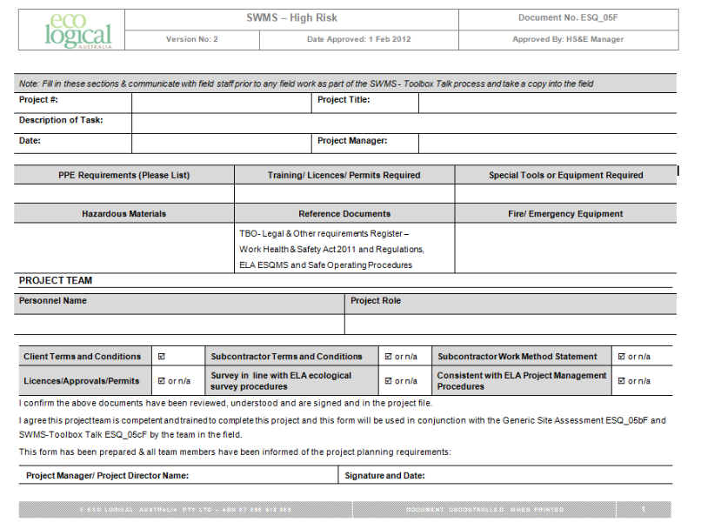

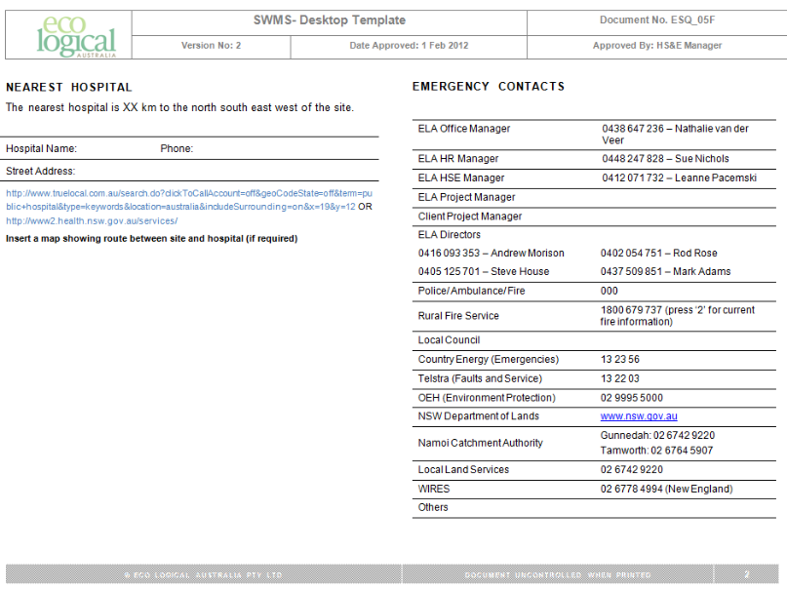

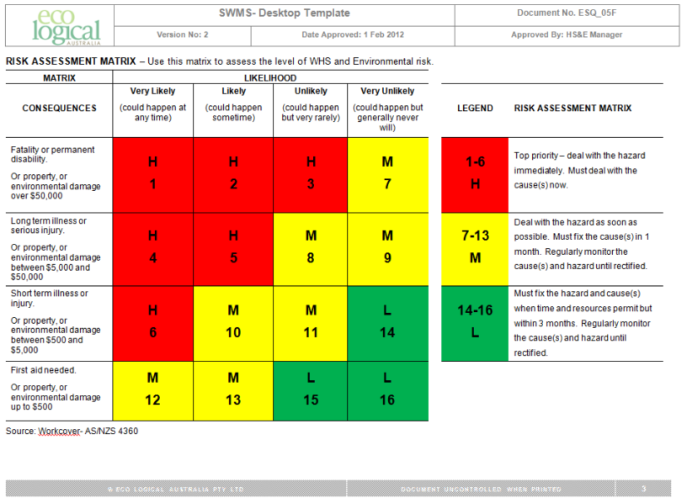

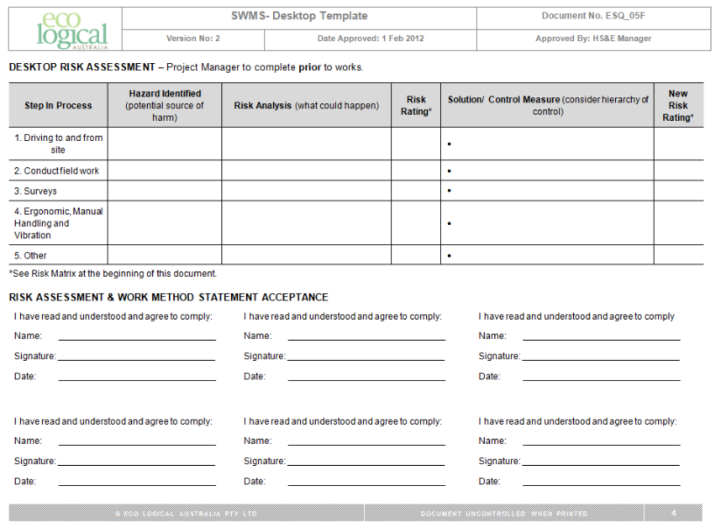

SWMS – Toolbox Talks

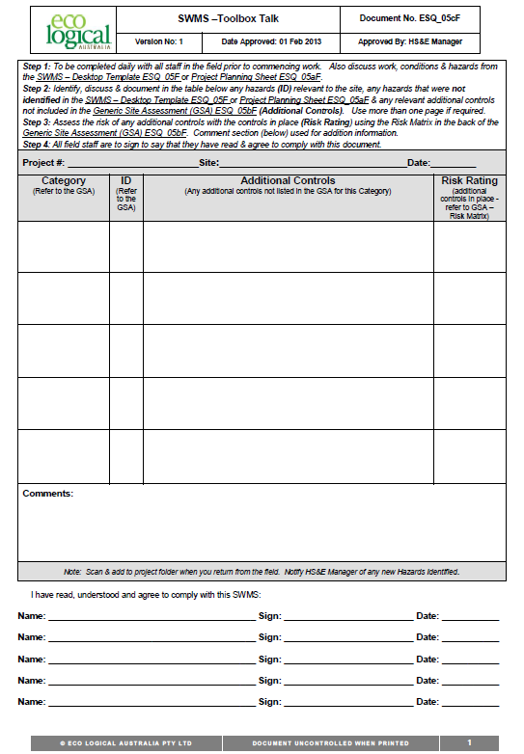

Injury/Incident Report Form

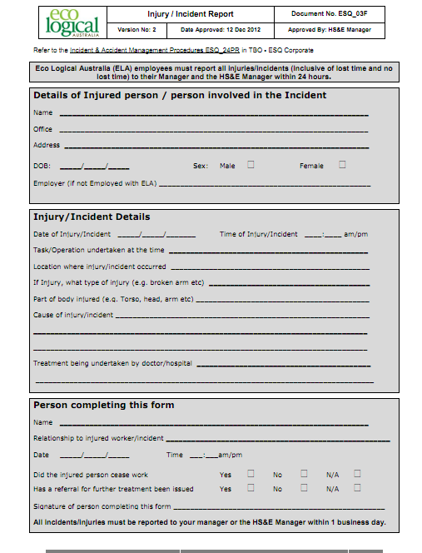

Vehicle Inspection Checklist

|  |  |  |  |  |  |
| --- | --- | --- | --- | --- | --- |
| Vehicle Make | |  | Registration No. | |  |
| Odometer | |  | Date of Inspection | |  |
| Inspection by: | |  |  | | |
|  | | **NAME (print)** | **SIGNATURE** | | |
| **Tick Box Applicable** | | | **YES** | **NO** | **Comments** |
| 1. | Brakes: | |  |  |  |
|  | - Foot brake operating | |  |  |  |
|  | - Hand brake operating | |  |  |  |
| 2. | Light operating and clean | |  |  |  |
| 3. | Indicators working and clean | |  |  |  |
| 4. | Steering – excessive play/vibration | |  |  |  |
| 5. | Windscreen wipers operating | |  |  |  |
| 6. | Windscreen washers operating | |  |  |  |
| 7. | Windscreen/windows damaged | |  |  |  |
| 8. | Windscreen/windows clean | |  |  |  |
| 9. | Horn operating | |  |  |  |
| 10. | Seat belts satisfactory | |  |  |  |
| 11. | Mirrors in good condition | |  |  |  |
| 12. | Tyres: | |  |  |  |
|  | - Correctly inflated | |  |  |  |
|  | - Sufficient tread | |  |  |  |
|  | - Damaged | |  |  |  |
| 13. | Body damage | |  |  |  |
| 14. | Jack and handle | |  |  |  |
| 15. | Wheel brace | |  |  |  |
| 16. | Spare wheel | |  |  |  |
| 17. | Fire extinguisher fitted and charged | |  |  |  |
| 18. | Engine Oil/Hydraulic Oil at Correct Level | |  |  |  |
|  | - Water – Radiator Full | |  |  |  |
|  | - Battery- Secure and water level OK | |  |  |  |
| 19. | Windscreen Washers water containers full | |  |  |  |
| 20. | First Aid Kit Provided and In Good Condition | |  |  |  |
| 21. | Registration Current | |  |  |  |
| 22. | Petrol | |  |  |  |
| **Comments** | | | | | |

Training log

| **Monitoring indicator** | **Training undertaken** | **Date** | **Trainer** | | **Trainee** | | **Comments** |
| --- | --- | --- | --- | --- | --- | --- | --- |
| **Name** | **Signature** | **Name** | **Signature** |
|  |  |  |  |  |  |  |  |
|  |  |  |  |  |  |  |  |
|  |  |  |  |  |  |  |  |
|  |  |  |  |  |  |  |  |
|  |  |  |  |  |  |  |  |
|  |  |  |  |  |  |  |  |
|  |  |  |  |  |  |  |  |
|  |  |  |  |  |  |  |  |
|  |  |  |  |  |  |  |  |
|  |  |  |  |  |  |  |  |
|  |  |  |  |  |  |  |  |
|  |  |  |  |  |  |  |  |
|  |  |  |  |  |  |  |  |



|  |  |  |  |  |
| --- | --- | --- | --- | --- |
| **Head Office**  Suite 4, Level 1  2-4 Merton Street  Sutherland NSW 2232  T 02 8536 8600  F 02 9542 5622 |  | **Sydney**  Level 6  299 Sussex Street  Sydney NSW 2000  T 02 8536 8650  F 02 9264 0717 |  | **St Georges basin**  8/128 Island Point Road  St Georges Basin NSW 2540  T 02 4443 5555  F 02 4443 6655 |
|  |  |  |  |  |
| **Canberra**  Level 2  11 London Circuit  Canberra ACT 2601  T 02 6103 0145  F 02 6103 0148 |  | **NEWCASTLE**  Suites 28 & 29, Level 7  19 Bolton Street  Newcastle NSW 2300  T 02 4910 0125  F 02 4910 0126 |  | **NAROOMA**  5/20 Canty Street  Narooma NSW 2546  T 02 4476 1151  F 02 4476 1161 |
|  |  |  |  |  |
| **COFFS HARBOUR**  35 Orlando Street  Coffs Harbour Jetty NSW 2450  T 02 6651 5484  F 02 6651 6890 |  | **ARMIDALE**  92 Taylor Street  Armidale NSW 2350  T 02 8081 2681  F 02 6772 1279 |  | **MUDGEE**  Unit 1, Level 1  79 Market Street  Mudgee NSW 2850  T 02 4302 1230  F 02 6372 9230 |
|  |  |  |  |  |
| **PERTH**  Suite 1 & 2  49 Ord Street  West Perth WA 6005  T 08 9227 1070  F 08 9322 1358 |  | **WOLLONGONG**  Suite 204, Level 2  62 Moore Street  Austinmer NSW 2515  T 02 4201 2200  F 02 4268 4361 |  | **GOSFORD**  Suite 5, Baker One  1-5 Baker Street  Gosford NSW 2250  T 02 4302 1220  F 02 4322 2897 |
|  |  |  |  |  |
| **DARWIN**  16/56 Marina Boulevard  Cullen Bay NT 0820  T 08 8989 5601 |  | **BRISBANE**  51 Amelia Street  Fortitude Valley QLD 4006  T 07 3503 7193 |  | 1300 646 131  [www.ecoaus.com.au](http://www.ecoaus.com.au) |



