# Turtles and decapods methods

## Overview

These methods describe a customised monitoring strategy to be employed for the following evaluations:

* Area (Category 3) Evaluation of the response of freshwater turtles to Commonwealth environmental water delivery (Zone 1).
* Area (Category 3) Evaluation of the response of freshwater decapods to Commonwealth environmental water (Zone 1).

The evaluation will be opportunistic and limited in scale of interpretation as the sampling can occur for little additional cost in association with the Basin-Scale riverine fish sampling.

## Selected Area Evaluation questions

**Freshwater turtles**

* **Short-term (one-year) and long-term (five year) question:**
* What did Commonwealth environmental water contribute to freshwater turtle (other vertebrate) abundance and diversity?

**Decapods (Freshwater crayfish and shrimp)**

* **Short-term (one-year) and long-term (five year) question:**
* What did Commonwealth environmental water contribute to freshwater decapod abundance and diversity?

The process for evaluating these questions is illustrated in , with components covered by this protocol highlighted in blue.

## Relevant ecosystem types

Rivers & wetlands are the ecosystems relevant to turtles and decapods. This protocol refers only to monitoring rivers.

## Relevant flow types

All flow types are relevant to turtles and decapods.

The area scale (landscape) assessment will not allow an assessment of the outcome of any specific fresh, bankfull or overbank flow event, but represents the overall response of turtle and decapod populations to the combination of natural and managed hydrological conditions experienced across a single zone of the target area over a 5 year period (i.e. Is the population within the selected area improving?).

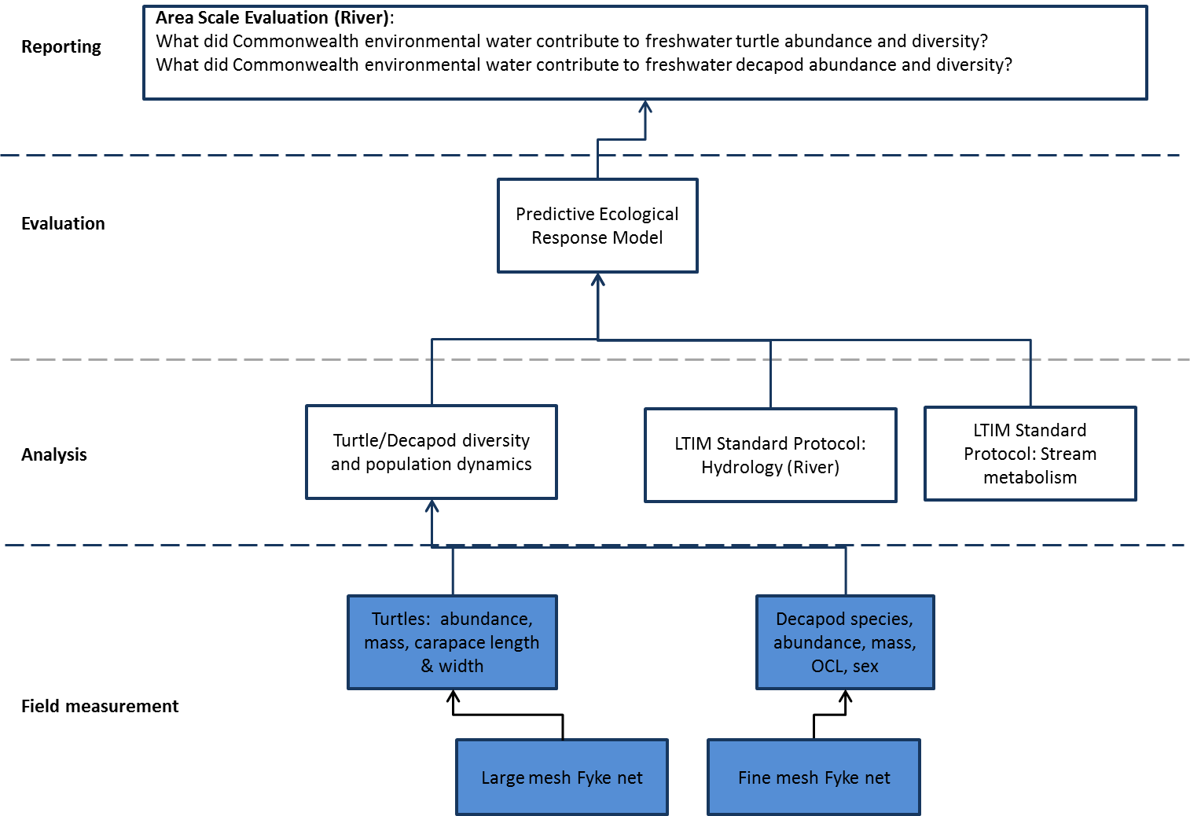

Figure 1: Schematic of key elements of the Lower Lachlan LTIM Protocol: Turtle and Decapod Sampling

## Overview and context

Turtles and yabbies (decapods) form a part of the social fabric of country life – with most people having fond memories of watching turtles and catching yabbies from local wetlands and creeks. Turtles and yabbies also play a significant role in indigenous culture. Downstream of the Lower Lachlan Swamps where the fish populations are dominated by invasive species (e.g. Growns 2001; Price 2009), yabbies can be abundant, and turtles are widespread. Thus turtles and decapods are an important ecosystem attribute of the region.

While riverine turtles rely on stream and riparian zones to complete their life cycles, relatively little is known about the relationship between flow and freshwater turtles (Bodie, 2001). Seasonal patterns of reproduction may be linked to flow (eg Cann 1998) and movement patterns have been observed to be strongly directed by flow with issues noted during fishway development. Changes in aspects of the natural flow regime that alter available physical habitats are of concern (e.g. Tucker et al., 2001), and impounding rivers has been demonstrated to alter dietary composition in a number of species (Tucker et al., 2012).

Aspects of decapod life-history are strongly linked with flow. At a whole of system scale, flow controls the physical habitat available to aquatic organisms in lotic systems and can structure crayfish distributions (e.g. Johnston and Robson, 2009).Floods drive large-scale dispersal and subsequent colonisation of new habitats for freshwater crayfish (Nguyen et al., 2004). Flow also determines the distribution of slackwater microhabitats which are important for decapods. For example, freshwater shrimp utilise slackwater habitats during early life stages in lowland rivers, whereas faster water is used as a dispersal mechanism during ontogeny (Price and Humphries, 2010).

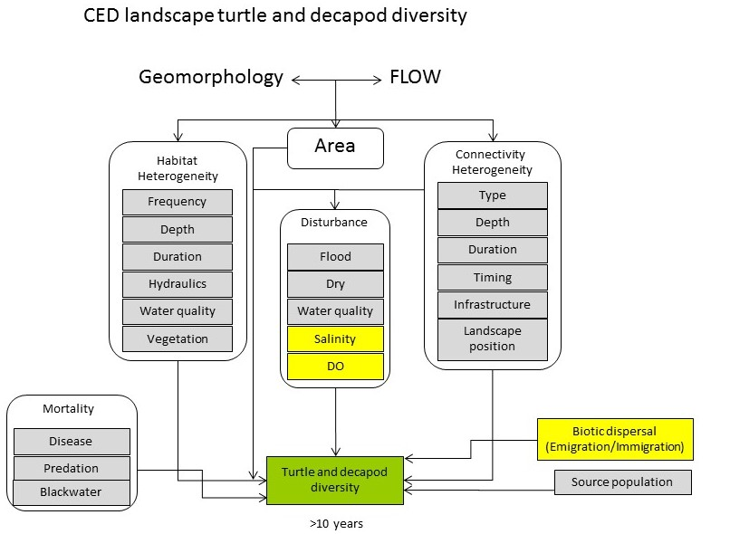

Figure 2. Revised landscape turtle and decapod diversity CED. Yellow boxes indicate other CEDs.

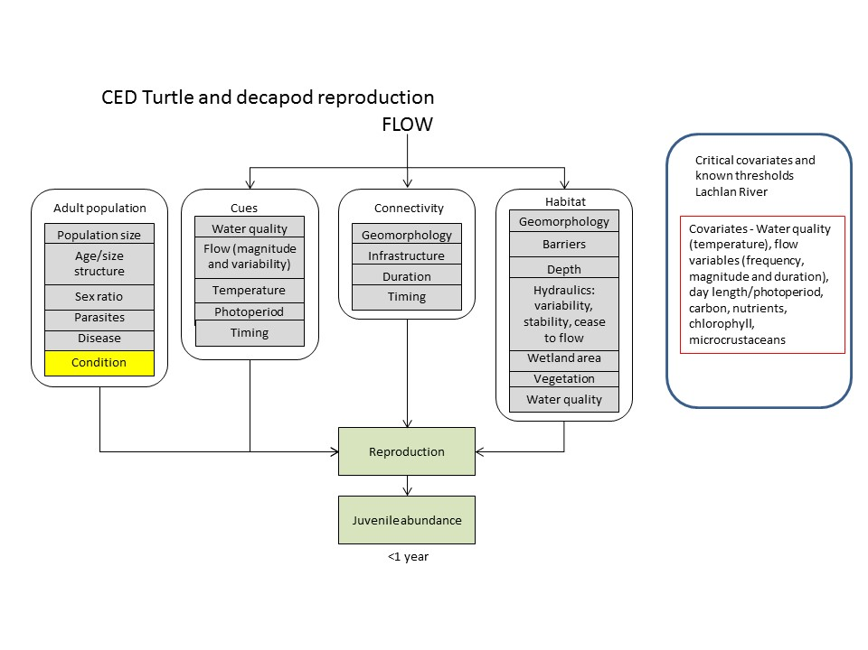

Figure 3. Revised turtle and decapod reproduction CED. Yellow boxes indicate other CEDs.

## Complementary monitoring and data

We are aware of two other projects which plan to collect fish data from within the study area over the study period. The Invasive Animals CRC plans to continue to collect data from the seven sites established by Gilligan *et al*. (2010) between 2015 and 2017 as part of its carp biocontrol M&E program. This project adheres to SRA sampling protocols. The second is a Murray-Darling Basin scale fish assemblage condition monitoring program which will sample within the Lachlan catchment from 2015-2019. Sampling will be undertaken from November to April each year using standardised SRA protocols (MDBA 2012), including targeted sampling of decapods using opera house nets. Turtles will only be recorded as by-catch.

## Monitoring locations

The lower Lachlan selected area can be partitioned into five spatially, geomorphologically and hydrologically distinct river channel zones at a broad landscape scale ();

Zone 1 Lachlan River channel between Brewster Weir and Booligal.

Zone 2 Lachlan River channel between Booligal and Corrong.

Zone 3 Lachlan River channel between Corrong and its terminus in the Great Cumbung Swamp

Zone 4 Merrowie Creek

Zone 5 Torringanny, Box, Merrimajeel and Muggabah Creek system.

Sampling of turtles and decapods will be undertaken within Zone 1 in conjunction with fish sampling when time and resources permit. This zone is situated in the upper reaches of the selected area and this zone will receive Commonwealth environmental water during every year of the LTIM Project.

It is unknown whether turtles and decapod assemblages differ between the remaining zones and Zone 1, but as monitoring is complimentary to that of riverine fish, these other zones will not be monitored as part of the LTIM Project.

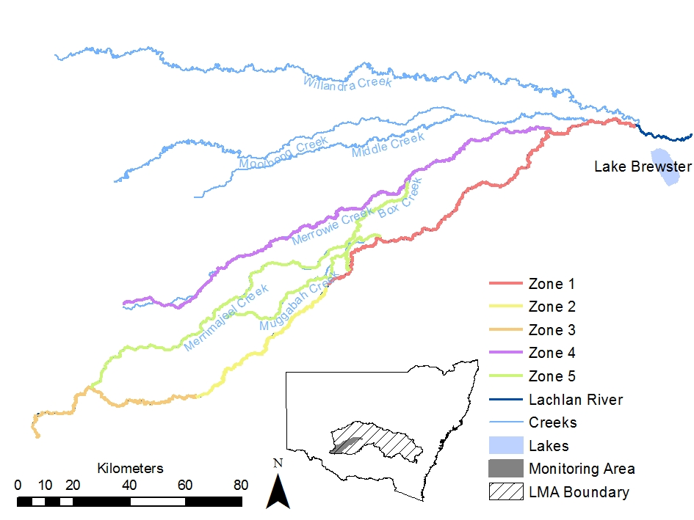

Figure 3 Map showing extent of Lachlan River Selected Area, Basin-scale sampling reach (Zone 1) and additional sampling zones.

There is little historical data available on decapod and turtles assemblages within the focal reach. The sites required for freshwater turtle and decapods monitoring will be matched to those of the Riverine fish sampling (refer Riverine Fish sampling protocols). Zone 1, where the monitoring for freshwater turtles and decapods will take place, extends for approximately 100km from Brewster Weir to the township of Hillston (see Figure 1 in the M&E Plan); however sampling sites will be located below Willandra Weir, which is approximately 20 km downstream Lake Brewster. The 100 km reach specified is the maximum distance within which the 10 riverine fish monitoring sites can be selected () (Hale *et al.* 2013).

## Monitoring timing

Annual sampling for Area-scale assessment of turtles and decapods will be undertaken as part of the fish sampling between March and May each year, as specified by the standard methods (Hale *et al.* 2013).

## Monitoring protocol

### Equipment

* 12 x fine meshed fyke nets (10 plus two spares) per site, with anchors and stakes
* Electrofishing and boating personal protective equipment
* GPS
* GPS coordinates of site structure (passive sample waypoints and electrofishing units)
* Passive sample waypoints determined using random number generator (sample locations within sites)
* Data sheets
* Hanging scales with bag for large turtles (1 - 50 kg capacity with 10 g accuracy) and bench scales with tray for smaller turtles (0-1000 g capacity to 0.1 g accuracy)
* Water quality meter (pH, DO, Temperature, Conductivity, Turbidity)
* Ethics and sampling permits

Additional sampling equipment to Cat 1 requirements (see Section 1.8.2);

* 3 x coarse meshed fyke nets (two plus one spare) per site, with anchors and stakes
* 12 x collapsible shrimp traps (ten plus two spares) per site
* 7 x opera house traps (five plus two spares) per site

### Protocol

**Area-scale annual assessment (Zone 1)**

Annual sampling for basin-scale analysis within zone 1 will follow the standard methods for riverine

fish as specified by Hale *et al.* (2013). The inclusion of turtles and decapods the following additional protocols and augmentations at each site have been proposed;

1. Length data from all turtle species is recorded for all operations of every gear type (with sub-sampling of 10 individuals per species /net or trap).
2. The individual weight of measured individual turtles to be recorded.
3. Two replicate coarse-meshed fyke nets will be set as per the protocols for small-mesh fyke nets to target turtles
4. Ten unbaited collapsible shrimp traps will be set for the duration of the electrofishing operations (minimum of 1.5 hours) to maintain consistency with SRA protocol.
5. Data will be recorded from any turtles collected within the fyke nets to generate data suitable for assessing the response of turtles to environmental flows. Taxa, abundance, carapace length (mm), carapace width (mm), weight (grams) of turtles will be recorded (with subsampling of 10 individuals per net).
6. Five replicate baited opera house traps will be set as per the unbaited shrimp traps to generate CPUE data on decapod crustaceans. Length (occipital-carapace length (mm)) and weight (to 0.1 g) of *Cherax sp.* (yabbies) will be recorded (with subsampling of 10 individuals per trap). Decapods from the families *Paratya* and *Paleamonidae* (shrimps) will not be measured and only enumerated per species / net.

The inclusion of additional gear types (fykes and traps) will add some time on-site for technicians in terms of setting, retrieving and processing, and consequently the additional data collected and subsequent analyses will depend on the resources available.

## Quality Assurance/Quality Control

QA/QC activities specific to this protocol include:

* NSW DPI staff are permitted to sample fish in NSW waters under a NSW Section 37 permit.
* NSW DPI will apply to undertake research on fish under a research authority granted by the NSW Fisheries Animals Care & Ethics Committee.
* Fyke nets, shrimp traps and opera house traps are checked for holes or damage prior to every field trip and during each trip, and damaged nets either repaired or replaced.
* Scales are calibrated following manufacturers specifications prior to every field trip.
* Data will be transferred from field data sheets into intermediate tables within a Microsoft Access database (I&I NSW Freshwater Fish Research Database - FFRD) and the original datasheets stored in fire-proof safes. Data in intermediate tables will be processed through a series of 50 range-checks to identify any outliers and inconsistencies in data recording. All potential errors are referred to the senior operator responsible for data collection at that site for confirmation and/or correction. The corrected intermediate tables are then appended into the FFRD for storage. A level 3 data audit is also undertaken by the supervising scientist after each year’s sampling in order to ensure compliance with sampling protocols.

## Data analysis and reporting

### Generation of metrics and indicators

**Freshwater Turtles**

*Relative abundance*

Raw catch and effort data for each sampling operation (net/trap set) will be recorded. Processed data for turtle abundances will be reported as standardised catch-per-unit-effort (CPUE) per net hour.

*Population structure data*

Morphometric measurements recorded for turtles will be analysed and size distribution information used to indicate whether turtles have recruited.

**Freshwater decapods**

*Relative abundance*

Raw catch and effort data for each sampling operation (net/trap set) will be recorded. Processed data for decapod abundances will be reported as standardised catch-per-unit-effort (CPUE) per net hour.

*Population structure data*

Annual change in length (Occipital Carapace Length) frequency distributions of *Cherax* populations only will be investigated in order to assess response to the provision of environmental water.

### Data analyses

**Selected Area**

***Freshwater turtles***

* **Short-term (one-year) and long-term (five year) question:**
* What did Commonwealth environmental water contribute to freshwater turtle abundance and diversity?

Long term changes in CPUE and diversity of turtles will be analysed using non-parametric PERMANOVA (Primer 6).

***Decapods (Freshwater crayfish and shrimp)***

* **Short-term (one-year) and long-term (five year) question:**
* What did Commonwealth environmental water contribute to freshwater decapod abundance and diversity?

Long term changes in CPUE and diversity of decapods will be analysed using non-parametric PERMANOVA (Primer 6).

## Data management

Following confirmation of the identity of those species where voucher specimens were collected, data will be transferred from field data sheets into intermediate tables within a Microsoft Access database (the I&I NSW Freshwater Fish Research Database - FFRD). Data in intermediate tables will be processed through a series of 50 range-checks to identify any outliers and inconsistencies in data recording. All potential errors are referred to the senior operator responsible for data collection at that site for confirmation and/or correction. The corrected intermediate tables are then appended into the FFRD for storage. A level 3 data audit is also undertaken by the supervising scientist after each year’s sampling in order to ensure compliance with sampling protocols.

The original datasheets will be scanned and copies of the data stored at the University of Canberra. The original data sheets will be stored in fire-proof filing cabinets at the Narrandera Fisheries Centre.

## Health and safety

For details on health and safety please refer to the Workplace Health and Safety Plan for the Lower Lachlan river system Selected Area (WHS 202.1) in appendix 3.

## References

Bodie, J.R. 2001 Stream and riparian management for freshwater turtles.  *Journal of Environmental Management*, 62 (4) 443-455

Cann, J. 1998. Australian Freshwater Turtles. Beaumont Publishing, Singapore, 292pp.

Gilligan, D., Jess, L., McLean, G., Asmus, M., Wooden, I., Hartwell, D., McGregor, C., Stuart, I., Vey, A., Jefferies, M,, Lewis, B., and Bell, K. (2010) Identifying and implementing targeted carp control options for the Lower Lachlan Catchment. Industry & Investment NSW – Fisheries Final Report Series No. 118.

Growns, I. (2001) An assessment of the status of native fish and fish habitats in the Lachlan River. (NSW Fisheries: Sydney).

Growns, I. (2008) The influence of changes to river hydrology on freshwater fish in regulated rivers of the Murray–Darling Basin. Hydrobiologia **596**: 203–211.

Hale, J., Stoffels, R., Butcher, R., Shackleton, M., Brooks, S., and Gawne, B. (2013). Commonwealth Environmental Water Office Long Term Intervention Monitoring Project – Standard Methods. Final Report prepared for the Commonwealth Environmental Water Office by The Murray-Darling Freshwater Research Centre, MDFRC Publication 29.2/2014, January, 182 pp.

Johnston, K., & Robson, B. J. (2009). Habitat use by five sympatric Australian freshwater crayfish species (Parastacidae). *Freshwater biology*, *54*(8), 1629-1641.

MDBA (2012) Sustainable Rivers Audit Protocols: Approved Manual for Implementation Period 8: 2012–13. Murray Darling Basin Authority, Canberra.

Muschal, M., Turak, E., Miller, J., Gilligan, D., Sayers, J., and Healey, M. (2010) Technical Support Document – Riverine Ecosystems: NSW State of the Catchments 2008. NSW MER technical report series. NSW Office of Water, Parramatta.

Nguyen, T. T. T., Austin, C. M., Meewan, M. M., Schultz, M. B., & Jerry, D. R. (2004). Phylogeography of the freshwater crayfish Cherax destructor Clark (Parastacidae) in inland Australia: historical fragmentation and recent range expansion. *Biological Journal of the Linnean Society*, *83*(4), 539-550.

Price, A. (2009) Distribution and Recruitment Patterns of Fish in the Lower Lachlan River. Final report prepared for the Lachlan Catchment Management Authority by the Murray-Darling Freshwater Research Centre, MDFRC Publication 17/2010.

Price, A. E., & Humphries, P. (2010). The role of dispersal and retention in the early life stages of shrimp in a lowland river. *Canadian Journal of Fisheries and Aquatic Sciences*, *67*(4), 720-729.

Tucker, A. D., Limpus, C. J., Priest, T. E., Cay, J., Glen, C., & Guarino, E. (2001). Home ranges of Fitzroy River turtles (Rheodytes leukops) overlap riffle zones: potential concerns related to river regulation. *Biological Conservation*,*102*(2), 171-181.

Tucker, A. D., Guarino, F., & Priest, T. E. (2012). Where lakes were once rivers: contrasts of freshwater turtle diets in dams and rivers of southeastern Queensland. *Chelonian Conservation and Biology*, *11*(1), 12-23.