Standard method: Frogs

Selected area-scale evaluation questions
- Short-term (one year) evaluation questions:
  - What did commonwealth environmental water contribute to breeding and recruitment of other vertebrate (frog) species?
  - What did commonwealth environmental water contribute to provision of habitat to support breeding and recruitment of other vertebrate (frog) species?
  - What did Commonwealth environmental water contribute to the maintenance of refuge habitats for other aquatic vertebrates?
- Long-term (five year) evaluation questions:
  - What did Commonwealth environmental water contribute to other aquatic vertebrates (frog and turtle) diversity and populations?

Figure 1: Schematic of key elements of the LTIM Standard Protocol: Frogs and tadpoles.

Relevant ecosystem types
Wetlands and floodplains.

Relevant flow types
Bankfull, overbank and overbank (infrastructure assisted).

Overview and context
Frogs are sensitive to changes in wetland flooding regimes and respond strongly to environmental releases with large increases in breeding activity. Higher levels of tadpole abundance and recruitment are commonly recorded during managed flood events, e.g. (JA Spencer et al., 2010; J Spencer et al., 2011; S. Wassens et al., 2011; S. Wassens et al., 2012). In many areas managed environmental watering is critical for the persistence of flood sensitive frog species. For example, key populations of the vulnerable (EPBC Act 1999) Southern bell frog were successfully maintained using environmental watering in the Lowbidgee floodplain between 2007 and 2010 (S. Wassens, Hall, Osborne, & Watts, 2010).
Frogs exhibit three key responses to flooding: (1) calling activity, (2) tadpole abundance and development, and (3) metamorphosis. Calling activity is a useful measure of the distribution of frogs with respect to underlying hydrological regimes and wetland characteristics (Skye Wassens, 2010; S. Wassens et al., 2010). Calling indicates a specific environmental watering event has created conditions suitable for attempted breeding by resident species. Monitoring tadpole communities and defining development stages is important when managing water levels, because it allows for estimation of how close tadpoles are to reaching metamorphosis and, as such, can provide an early indicator on the need for top-up watering. Size structure within populations has proven to be a useful indicator as it provides a measure of the number of individuals recruiting into the adult population.
Frog community responses can be assessed at two spatial and temporal scales: (1) broad scale assessment of occupancy patterns within connected wetlands addressing long-term (five year) objectives) and (2) intensive monitoring of tadpole development and recruitment (which can be carried out in association with wetland fish monitoring) at a subset of connected wetlands or in areas where there are known populations of where threatened of local significant species. Note that small and large fyke nets have the highest probability of detecting tadpoles in large wetland systems, so tadpole surveys can be run concurrently with fish surveys with tadpoles being identified in the field at the same time as fish. However, as tadpoles can be difficult to identify, an experienced amphibian ecologist will be present for initial surveys to ensure staff are properly trained.

Type
Connectivity
cues
vegetation
Depth
Habitat
Hydraulics
Geomorphology
Young
Abundance
Community structure
<1 year
1-5 years
1-5 years
Depth
Temperature
Water Quality*
Vegetation
Geomorphology
Duration
Timing
Infrastructure
Condition
FLOW
Flow
Sediment *
Flow
Water Quality
Predation
Years dry
Figure 2: Cause and effect diagram for the response of frogs and their tadpoles to Commonwealth environmental water

Complementary monitoring and data

Covariates
- Wetland productivity.
- Vegetation diversity (Cat 2).
- Wetland hydrology (Cat 1).
- Wetland fish (Cat 1).

Monitoring locations

Zones
The lower Lachlan selected area can be partitioned into five spatially, geomorphologically and hydrologically distinct river channel zones at a broad landscape scale (Figure 2).
Zone 1 Lachlan River channel between Brewster Weir and Booligal.
Zone 2 Lachlan River channel between Booligal and Corrong.
Zone 3 Lachlan River channel between Corrong and its terminus in the Great Cumbung Swamp
Zone 4 Merrowie Creek
Zone 5 Torringany, Box, Merrimajeel and Muggabah Creek system.

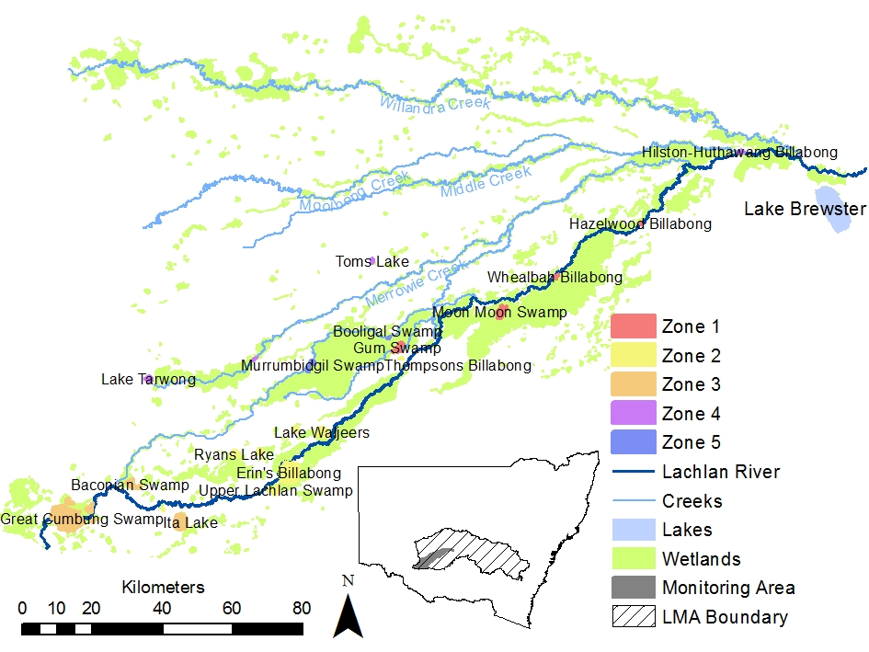
Figure 2. Draft map showing wetland sites and zones

Site placement within the zones

We will aim to survey fifteen sites per year, including intensive wetland sites (Table 1) and on-demand sites. The actual number of sites surveyed in any one year will vary depending upon hydrological conditions, i.e. in dry years, fewer than 15 sites may be surveyed, and in wet years more than 15 sites may be surveyed. As not all sites will be watered each year, a subset of wetland sites from Table 1 will be selected based on their hydrological status. When selecting sites, those that have had previous frog surveys will be given a higher priority.

Intensive wetland sites
Each zone contains several wetlands of national and regional significance, which are listed in the Directory of Important Wetlands (Environment Australia, 2001). Many or all of these wetlands will be targets of CEWO, MDBA or NSW OEH environmental flow deliveries.
Table 1. Intensive wetland sites, possibility of watering and methods being applied
ZONE | SITE | YEARS WATERED OUT OF FIVE | PREVIOUS FROG SURVEYS | METAMORPH SIZE DATA | ADULT SIZE DATA
1 | Gum Swamp | ? |  | x | x
1 | Hazelwood Billabong | ? |  | x | x
1 | Whealbah Billabong | 2/5 |  | x | x
1 | Moon Moon Swamp | 2/5 | x | x | x
2 | Peppermint Swamp | 1/5 |  | x | x
2 | Lake Waljeers | 1/5 |  | x | x
2 | Lake Bullogal | 1/5 | x | x | x
2 | Erin’s Billabong |  |  | x | x
2 | Ryans Swamp |  |  | x | x
3 | Ita Lake | 1/5 | x | x | x
3 | Baconian Swamp | 1/5 |  | x | x
3 | Great Cumbung Swamp (including marginal lakes) | 2/5 | x | x | x
4 | Lake Tarwong | 1/5 |  | x | x
4 | Cuba Dam | 2/5 | x | x | x
4 | Tom’s Lake | 1/5 | x | x | x
5 | Upper Gum Swamp | 1/5 |  | x | x
5 | Booligal Swamp | 2/5 |  | x | x
5 | Murrumbidgil Swamp | 3/5 | x | x | x
5 | Lake Merrimajeel | 1/5 | x | x | x
5 | Lower Gum Swamp | 1/5 |  | x | x

Given that the Booligal Wetland complex (Zone 5) is likely to be the wetland that receives environmental water most regularly, we propose to select wetland monitoring sites within this system for basin-scale assessment. The three wetlands selected within this zone will be fixed for the duration of the project. This is not the same zone as is being sampled for riverine fish (Zone 1), but this choice is unavoidable given that (1) all but one of the wetlands within zone 1 (Moon Moon Swamp) are unlikely to receive regular environmental flows and (2) the riverine channels within zone 5 are largely ephemeral and not suitable for basin-scale assessment of riverine channels.

On-demand sites
On demand sites will be selected based on inundation of intensive wetland sites and will be set after initial selection if re-watered. They will allow a greater understanding of the contribution of commonwealth water to frog habitat and refuge and increase understanding of frog response to watering events and habitat occupancy patterns.

Timing of monitoring
Wetlands will be surveyed three times per year between August and February. This falls across three seasons (winter, spring and summer) allowing for seasonal variation in species. These will be surveyed for adults and metamorphs (Table 1).

Monitoring protocol

Equipment
Frogs
- 4 x Torch or spotlight with a minimum of 300 Lumens.
- Notebook- Pocket notebooks are far easier to manage than A4 datasheets for general surveys.
- Callipers (for size measurement).
- Disposable gloves.
- GPS.
- Watch (record start and finish times).
- Disinfectant hand wash.
- Optional (handheld temperature/ weather station).

Other considerations
All surveyors must adhere to the NSW OEH hygiene protocol. http://www.environment.nsw.gov.au/animals/HygieneProtocolForFrogs.htm
Gloves must be worn when handling frogs as contact with sunscreens and insect repellents etc can cause irritation.

Protocol
Adults and metamorphs (Intensive wetland and on-demand sites)
Assessment of frog communities will be undertaken at intensive wetland sites where fish community assessment is also being completed. Adult frogs and metamorphs will be surveyed within each wetland after dark using a 3x10 minute visual encounter (person minutes) and a 3x1 minute audio survey (S. Wassens et al., 2011; S. Wassens et al., 2012). Timed surveys are easier then set transects because variable water levels over time can make the use of fixed transects impractical.
A 15-30 watt spotlight or torch will be used to search for frogs along the wetland edge and into the surrounding terrestrial habitats. All individuals observed will be identified to species and the number recorded (it is possible to identify individuals without capture). When setting call recorders recording period will be set for 3 x 10 minute sets starting from one hour after sun set.
Breeding and size structure (Intensive wetland sites only)
An estimate of breeding activity will be obtained by measuring a subset of 20 individuals, as size structure can give an indication of the number of recently metamorphosed individuals. It is important to note that growth rates can vary between sites. Limnodynastes tasmaniensis and Limnodynastes fletcheri, two common species across the Lachlan Catchment (Amos, Wassens, & Luck, 2013), will be measured (snout-to-vent length) to give an indication of demographic structure and presence of recent metamorphs. This method was successfully trialled in the Mid-Murrumbidgee between October 2011 and April 2012.
Audio surveys involve listening for the distinct calls of resident frog species, general estimates of the number of calling individuals will be determined using the methodology described by (S. Wassens et al., 2011).
Biophysical surveys (Intensive wetland and on-demand sites)
Rapid on site assessments will be done at each site at the time of each frog survey and based on methodology from (Amos et al., 2013).
Vegetation
Vegetation transects will be used to account for aquatic and riparian vegetation present at each site. Each transect will be spaced 20 metres apart with 1-3 transects per site depending on size of the water body. Sites that have a shore line of <20 m in length will be subject to one transect; sites 20-60 m will be subject to two transects; and sites >60 m will be subject to three transects. Transects are two metres wide and cut directly across the water body, starting from five metres out of the shore to the other side of the wetland or creek line. If that distance is beyond sight, the closest point that vegetation can be identified within sight will be used. In each transect, the most prevalent aquatic vegetation types (>10%), will be identified to species and the percentage cover of each species recorded; less dominant species will be classified into broad categories. Percent cover of litter, bare ground, coarse woody debris, and open water will also be recorded. The number of dead standing timber will be recorded for each transect during the first survey period.

Water quality
Water quality will be measured at three different locations at each site on each survey occasion. Five water quality variables will be measured: temperature (˚C), conductivity (mS/cm), dissolved oxygen (mg/L), pH and turbidity (NTU). Measurements will be made using a handheld YSI within 2-3 m of each other.

Quality Assurance/Quality Control
Field methodology is based on standard protocols developed by Drs Skye Wassens and Jennifer Spencer from repeated surveys in the Lowbidgee and other systems (JA Spencer et al., 2010; J Spencer et al., 2011; S. Wassens et al., 2011; S. Wassens et al., 2012). On all field occasions involving frog surveys, a research assistant trained in frog identification will be present. Species that are not identifiable on site will be photographed and identified using the following field guides (M. Anstis, 2002; Marion Anstis, 2013). Consultation between trained research assistant and frog experts at Charles Sturt University will be used to identify species from photographs.

Data analysis and reporting

Frogs
- Site name.
- Lat/long.
- Time start- time finished.
- Surveyor name.
- Number observed (each species).
- Number calling (each species).
- Size structure- Length of two target individuals.

Presence/absence data for frog species repeatedly collected at a number of wetland locations with varying habitat characteristics, for which data describing variables that define those habitat characteristics are also collected, provide the basis for habitat occupancy modelling. Key data included in such modelling are hydrological variables that describe the wetting drying regime and connectivity of the habitat wetland. Statistical binomial models produced using maximum likelihood estimation that incorporate occupancy and detection variables following the techniques of (MacKenzie et al., 2002) are appropriate for the analysis of frog species that can have low detection probabilities. The outputs of such modelling will provide valuable insight into hydrological factors, both directly and indirectly through related vegetation characteristics that are conducive to providing the habitat conditions favourable to frog recruitment in wet periods and refugia in drier periods.

Data management
Data will be transferred from field data sheets and notebooks into spreadsheet documents. Field data sheets will be scanned and copies provided to the University of Canberra and also Charles Sturt University. Original copies will be stored at Charles Sturt University.

Health and safety
For details on health and safety please refer to the Workplace Health and Safety Plan for the Lower Lachlan river system Selected Area (WHS 202.1) in appendix 3.

References
Amos, C., Wassens, S., & Luck, G. (2013). Assessment of post-flood recovery of frog populations in the Lachlan Catchment. Albury- Wodonga: Institute of Land and Water Society, Charles Sturt University.
Anstis, M. (2002). Tadpoles of south-eastern Australia: Reed New Holland.
Anstis, M. (2013). Tadpoles and Frogs of Australia.
Environment Australia, e. (2001). A Directory of Important Wetlands in Australia (Vol. Third Edition). Canberra, Australia: Environment Australia.
MacKenzie, D. I., Nichols, J. D., Gideon, B. L., Droege, S., Royle, J. A., & Langtimm, C. A. (2002). Estimating Site Occupancy Rates When Detection Probabilities Are Less Than One. Ecology, 83(8), 2248-2255. doi: 10.2307/3072056
Spencer, J., Thomas, R., Wassens, S., Lu, Y., Wen, L., & Iles, J. (2010). Environmental flow monitoring in the Lowbidgee wetlands and Macquarie Marshes in 2009–10. Testing wetland resilience: monitoring the response of iconic wetlands to re-flooding following historic drought project. Progress report for the NSW Catchment Action Program.
Spencer, J., Thomas, R., Wassens, S., Lu, Y., Wen, L., Iles, J., . . . Saintilan, N. (2011). Environmental flow monitoring in the Lowbidgee wetlands and Macquarie Marshes in 2009-10. Testing wetland resilience: monitoring the response of iconic wetlands to re-flooding following historic drought project. NSW Department of Environment, Climate Change and Water, Sydney.
Wassens, S. (2010). Flooding regimes for frogs in lowland rivers of the Murray-Darling Basin. In N. Saintilan & I. Overton (Eds.), Ecosystem response modelling in the Murray-Darling Basin (pp. 213- 227). Collingwood: CSIRO Publishing.
Wassens, S., Hall, A., Osborne, W., & Watts, R. J. (2010). Habitat characteristics predict occupancy patterns of the endangered amphibian Litoria raniformis in flow regulated flood plain wetlands. Austral Ecology, 35(8), 944-955.
Wassens, S., Watts, R., Howitt, J., Spencer, J., Zander, A., & Hall, A. (2011). Monitoring of ecosystem responses to the delivery of environmental water in the Murrumbidgee system Report 1 to the Department of Sustainability, Environment, Water, Population and Communities: Institute of land, Water and Society.
Wassens, S., Watts, R. J., Spencer, J. A., Howitt, J., McCasker, N. A., Griese, V., . . . Hall, A. (2012). Monitoring of ecosystem responses to the delivery of environmental water in the Murrumbidgee system (Vol. Report 2 (May 2012)): Institute for Land, Water and Society, Charles Sturt University.

Supplement 7A: Data sheets
 | Name: |  |  |  |  |  | Surrounding land use (land use within 50m)
 | lat/long |  |  |  |  |  | Cropping
 |  |  |  |  |  |  | Orchard
 | Date: |  |  |  |  |  | Pasture
 | Connection (filled via) |  | Flood runner-river |  |  |  | Grazed forest
 |  |  | Rain fed |  |  |  | Ungrazed forest
 |  |  | Ground water |  |  |  | Surrounding vegetation
 |  |  | Regulator or Pump |  |  |  | Over story species %
 |  |  | Distance to nearest waterbody (m)
 | History |  | Date flooded
 |  |  | Date previously flooded
 |  |  | Hydrology (months wet/year)
 | System type |  | Rain fed depression |  |  |  | Mid storey %
 |  |  | Ground water depression
 |  |  | Back water
 |  |  | Ox bow
 |  |  | Minor stream
 |  |  | River
 |  |  | Canal |  |  |  | Understorey %
 |  |  | Open wetland |  |  |  | tall (>30cm) grasses
 |  |  | Forested wetland |  |  |  | short (<30cm) grasses
 |  |  | Major storage or lake |  |  |  | tall (>30cm) herbs
 |  |  | Area (hectares) |  |  |  | short(<30cm) herbs
 | Comments |  |  |  |  |  | Logs, sticks and litter
 |  |  |  |  |  |  | Bare ground
 |  |  |  |  |  |  | General wetland characteristics
 |  |  |  |  |  |  | % open water
 |  |  |  |  |  |  | % vegetation
 |  |  |  |  |  |  | DST (approx. number)
 |  |  |  |  |  |  | Continuity % fringing
Wetland characteristics TRANSECTS |  |  |  | Tran 1 |  | Tran 2 |  | Tran 3 | Tran 4 | Tran 5 |  | Tran 6
Terrestrial & fringing vegetation |  | tall (>30cm) grasses
 |  | short (<30cm) grasses
 |  | tall (>30cm) herbs
 |  | Short (<30cm) herbs
 |  | logs, sticks and litter
 |  | bare ground
 |  | inundated %
 |  | over hanging %
Soil type |  | sand (check)
 |  | loam (check)
 |  | clay (check)
Tall Emergent aquatic (>50cm)
Short Emergent aquatic (<50cm)
Broadleaf emergent
Attached floating

Free floating
Submerged aquatic

Standing timber
Water quality |  | Temperature
 |  | DO
 |  | Conductivity
 |  | pH
 |  | Turbidity
 |  | Depth (@ 1m)
Sweeps

Hydrology (river): Basin and Selected Area methods

Overview
This protocol describes the methods that will be used for both Basin Evaluation (specified by the CEWO) and the Selected Area Evaluation. While Basin scale methods consider that the hydrological data collected for these methods will inform only the analysis and evaluation of monitoring outcomes for hydrological connectivity, native fish and water quality, the M&E Providers for the Lachlan River system Selected Area consider hydrological data essential to the evaluation of outcomes for all indicators.

Evaluation questions

Basin evaluation questions
This protocol does not directly address specific evaluation questions but is important for informing the analysis and evaluation of outcomes for hydrological connectivity and native fish. It indirectly addresses the following Basin Evaluation questions:
- Long-term (five year) questions:
  - What did Commonwealth environmental water contribute to hydrological connectivity?
  - What did Commonwealth environmental water contribute to native fish species diversity?
  - What did Commonwealth environmental water contribute to fish community resilience?

- Short-term (one year) questions:
  - What did Commonwealth environmental water contribute to native fish reproduction?
  - What did Commonwealth environmental water contribute to native larval fish growth and survival?

- Short-term (one-year) and long-term (five year) questions:
  - What did Commonwealth environmental water contribute to patterns and rates of decomposition?
  - What did Commonwealth environmental contribute to patterns and rates of primary productivity?
  - What did Commonwealth environmental water contribute to temperature regimes?
  - What did Commonwealth environmental water contribute to pH levels?
  - What did Commonwealth environmental water contribute to turbidity regimes?
  - What did Commonwealth environmental water contribute to salinity regimes?
  - What did Commonwealth environmental water contribute to dissolved oxygen levels?

The process for evaluating these questions is illustrated in Figure 1, with components covered by this protocol highlighted in blue.

Selected Area Evaluation questions
This protocol does not directly address specific evaluation questions but is important for informing the analysis and evaluation of outcomes for all of indicators that are relevant to rivers. The indicators for the Lachlan River system Selected Area that will use hydrological (river) data and the relevant hydrological measures are shown in Table 1. It should be noted that waterbird indicators are only relevant to wetlands in the Lower Lachlan. As such the protocol indirectly addresses the following Selected Area evaluation questions:

- Long-term (five year) questions:
  - What did Commonwealth environmental water contribute to sustainable ecosystem diversity?
  - Were ecosystems to which Commonwealth environmental water was allocated sustained?
  - Was water delivered to a representative suite of ecosystem types?
  - What did Commonwealth environmental water contribute to vegetation extent?
  - What did Commonwealth environmental water contribute to microcrustacean community composition?
  - What did Commonwealth environmental water contribute to native fish populations?
  - What did Commonwealth environmental water contribute to native fish species diversity?
  - What did Commonwealth environmental water contribute to fish community resilience?
  - What did Commonwealth environmental water contribute to native fish survival?
  - What did Commonwealth environmental water contribute to sediment transport?
  - What did Commonwealth environmental water contribute to biotic dispersal?
  - What did Commonwealth environmental water contribute to populations of long-lived organisms?

- Short-term (one year) questions:
  - What did Commonwealth environmental water contribute to microcrustacean contribution to the abundance of native larval fish?
  - What did Commonwealth environmental water contribute to microcrustacean contribution to the growth of native larval fish?
  - What did Commonwealth environmental water contribute to microcrustacean contribution to the survival of native larval fish?
  - What did Commonwealth environmental water contribute to connectivity of microcrustacean communities between river and wetlands?
  - What did Commonwealth environmental water contribute to native fish reproduction?
  - What did Commonwealth environmental water contribute to native larval fish growth and survival?
  - What did Commonwealth environmental water contribute to other vertebrate reproduction and recruitment?
  - What did Commonwealth environmental water contribute to other vertebrate survival?

- Short-term (one-year) and long-term (five year) questions:
  - What did Commonwealth environmental water contribute to the condition of floodplain and riparian trees?
  - What did Commonwealth environmental water contribute to vegetation community diversity?
  - What did Commonwealth environmental water contribute to vegetation species diversity?
  - What did Commonwealth environmental water contribute to microcrustacean productivity?
  - What did Commonwealth environmental water contribute to resilience of microcrustacean egg banks?
  - What did Commonwealth environmental water contribute to other vertebrate populations?
  - What did Commonwealth environmental water contribute to other vertebrate species diversity?
  - What did Commonwealth environmental water contribute to hydrological connectivity?
  - What did Commonwealth environmental water contribute to patterns and rates of primary productivity?
  - What did Commonwealth environmental water contribute to patterns and rates of decomposition?
  - What did Commonwealth environmental water contribute to patterns and rates of nutrient cycling?
  - What did Commonwealth environmental water contribute to refuges?
  - What did Commonwealth environmental water contribute to recovery?
  - What did Commonwealth environmental water contribute to fish community resilience?
  - What did Commonwealth environmental water contribute to temperature regimes?
  - What did Commonwealth environmental water contribute to dissolved oxygen levels?

The process for evaluating these questions is illustrated in Figure 2, with components covered by this protocol highlighted in green.
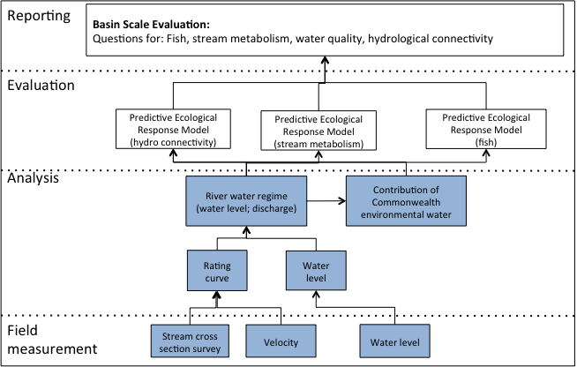
Figure 1: Schematic of key elements of the LTIM Standard Protocol for Basin Evaluation: Hydrology (river).
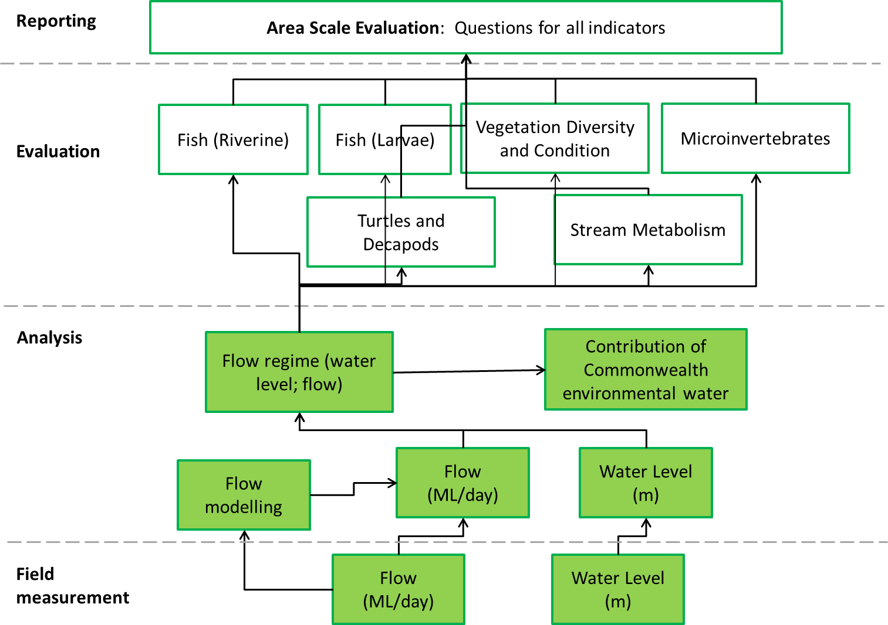
Figure 2. Schematic of key elements of the LTIM protocol for the Area Evaluation: Hydrology (River).

Relevant ecosystem types
Rivers.

Relevant flow types
All.

Table 1. Lachlan River System Selected Area indicators and the hydrological metrics used in the Selected Area Evaluation
INDICATOR | USE IN EVALUATION | HYDROLOGY ATTRIBUTES USED IN EVALUATION
Ecosystem Type (Cat 1) | Basin Scale: Validation of hydrological regime | Permanent or temporary surface water (from long term records)
Vegetation Diversity and condition (Cat 3) | Area Scale: Change in vegetation metrics in relation to watering | presence/absence of water;  water depth,  duration of watering,  frequency of watering
Fish (River) (Cat 3) | Area Scale: Change in fish metrics in relation to stream flow attributes | flood pulse duration and magnitude,  dry spell duration  total flow volume  categorical flow component (base flow, freshes, bankfull and overbank)  hydrograph – environmental water releases and flow from the nearest gauge
Fish (larvae) (Cat 3) | Area Scale: Assessing larval fish metrics against hydrological attributes | watering event extent - timing, duration, peak flow
Stream metabolism (Rivers) (Cat 1) | Area Scale: Correlation between stream gauge height/discharge and; GPP, ER, WQ parameters.  The majority of analyses are likely to be descriptive based on responses to changes in flow, and illustrated using scatterplots. | Stream gauge height/discharge
Turtles and Decapods (Cat 3) | Area Scale: Change in turtle and decapod numbers in relation to stream flow attributes | flood pulse duration and magnitude,  dry spell duration and  total flow volume  categorical flow component categories (base flow, freshes, bankfull and overbank)  hydrograph – environmental water releases and flow from the nearest gauge

Overview and context

Basin scale
At the Basin scale, hydrology (river) is an event based monitoring protocol designed to capture aspects of a rivers water regime that influence behaviour and condition of native fish, stream metabolism, and water quality. In particular, this protocol aims to quantify the effect of Commonwealth environmental water on aspects of river hydrology that are most important for native fish, stream metabolism, and water quality. This protocol is based on a combination of gauging data and hydrological modelling.

Area scale
At the area scale, hydrology (river) is a continuous monitoring protocol designed to capture aspects of a rivers flow regime that will be used to evaluate the effect of Commonwealth environmental water. This protocol is based identifying the attributes that will be used in the evaluation for each of the key indicators within the Lachlan River System Selected Area and comprises a combination of existing gauge data, field measures and hydrological modelling. Key hydrological attributes required are:
- Daily flow data:
  - Presence/absence of water at a site.
  - Frequency and duration of watering.
- River height.

Complementary monitoring and data
Twelve gauging stations currently operate on the Lower Lachlan River system. The locations are listed in Table 2 and are shown in Figure 3. Historical monitoring activities have relied on gauging data to evaluate outcomes of environmental watering. An assessment of the utility of the existing gauging sites is provided in Supplement 8B.
Table 2. Location of gauging stations in the Lower Lachlan River system.
NUMBER | NAME | LAT | LONG
412005 | LACHLAN RIVER AT BOOLIGAL | -33.8695 | 144.8811
412038 | LACHLAN RIVER U/S WILLANDRA WEIR | -33.3497 | 145.876
412039 | LACHLAN RIVER AT HILLSTON WEIR | -33.4873 | 145.504
412045 | LACHLAN RIVER AT CORRONG | -34.2176 | 144.4638
412078 | LACHLAN RIVER AT WHEALBAH | -33.6544 | 145.2488
412163 | MERROWIE CREEK DOWNSTREAM OF OFFTAKE WEIR | -33.3676 | 145.6017
412194 | LACHLAN RIVER AT FOUR MILE WEIR | -34.248 | 144.1987
412196 | LACHLAN RIVER DOWNSTREAM GANOWLIA WEIR (LANES BRIDGE) | -33.3716 | 145.5925
412012 | WILLANDRA @ ROAD BDG | -33.3452 | 145.8803
412042 | WILLANDRA HOMESTEAD | -33.1954 | 145.1217
412187 | WILLANDRA @ YILGA | -33.2222 | 145.5053
412154 | CUMBUNG SWAMP AT END OF SYSTEM | -34.1541 | -143.5950

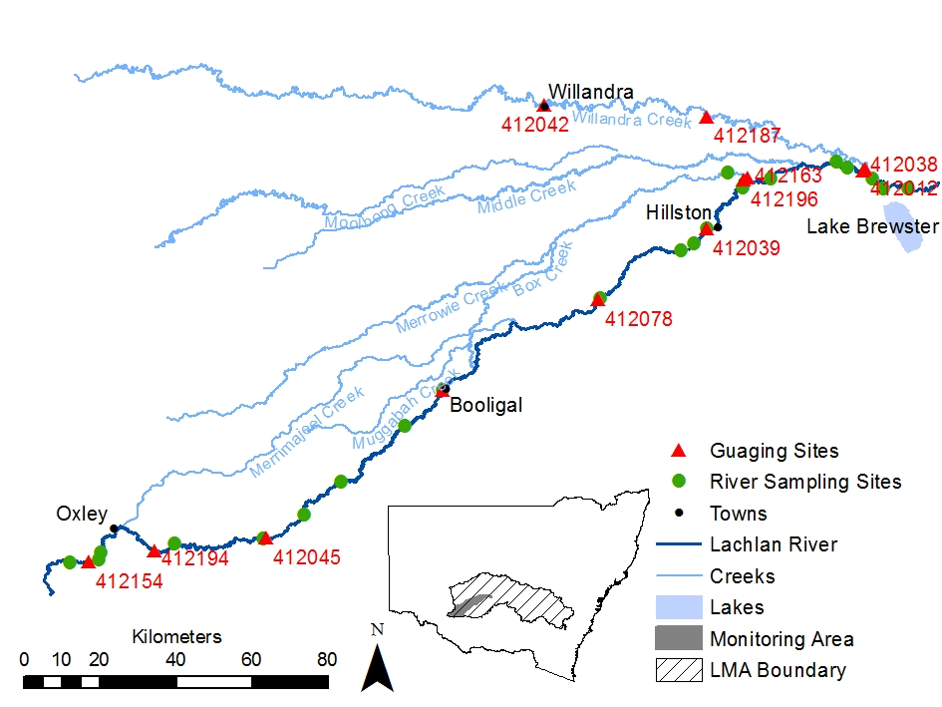
Figure 3. Map of the Lower Lachlan Rivershowing the region that is the focus for the long term intervention monitoring investment from the Commonwealth Environmental Water Office including the location of the gauging stations.

Establishing sites

Zones and sites
The LTIM project for Basin-scale evaluation has adopted a hierarchical approach to sample design (see (Gawne et al. 2013). Briefly, the spatial hierarchy is as follows:
Selected Area → Zone → Site

A ‘zone’ is a subset of a Selected Area that represents a spatially, geomorphological and/or hydrological distinct unit at a broad landscape scale. For example, separate river systems, sub-catchments or large groups of wetlands.
A site is the unit of assessment nested within a zone and for River Hydrology it will be a section of river.

Basin scale site establishment
Basin scale site establishment is based around the Riverine Fish, stream metabolism and water quality protocols. The sample design for the fish protocol involves a minimum of a single zone with 10 sites located within a 100 km stretch of river within the zone.

Area scale site establishment
Selected Area scale site establishment is linked to the area scale evaluation methods for riverine fish, stream metabolism, vegetation condition and diversity, turtles and decapods with sites matched to the sampling locations.

Monitoring locations

Basin evaluation
For the Lachlan River system, the Zone established for the implementation of Category 1 methods for Riverine fish, stream metabolism and water quality is between Willandra Weir and Hillston.
Assessment of the gauging data (Supplement 8B) indicates that the channel transmits flow in a well behaved and predictable manner. All key hydrologic attributes are propagated along the reach (e.g. baseflow, fresh, bankful flow). This suggests it is possible to model flows in this reach to the required accuracy and no new gauging sites will be established as part of the LTIM project. Water level recorders will be installed at with the dissolved oxygen and temperature data recorders at Willanthry and Lane’s Bridge develop a relationship between water levels recorded at the gauging sites and the individual sites.

Selected Area evaluation
Locations will be matched to the sampling locations for riverine fish, stream metabolism, vegetation condition and diversity, microinvertebrates, turtles and decapods. These sites are summarized in Table 3 and shown in Figure 3.

Timing of monitoring
This protocol aims to capture the influence of Commonwealth environmental water and is designed as continuous monitoring. The use of existing gauge data means that monitoring data are available from prior to the arrival of Commonwealth environmental water and continue for the period over which Commonwealth environmental water influences the hydrology of the river and for the period after the Commonwealth environmental water flows have occurred.
Timing of the releases of Commonwealth environmental water (dependent on conditions) and contract establishment means that the installation of water level recorders is unlikely to commence until after the 2014 environmental water releases.

Table 3. River monitoring sites and the source of hydrological data for use in evaluation
SITE | VEGETATION ¹ | RIVERINE FISH | LARVAL FISH | METAB-OLISM | TURTLES AND DECAPODS | HYDROLOGY DATA SOURCE | JUSTIFICATION
Lachlan River @ Benson’s Drop |  | Y |  |  | Y | Flow: Lachlan River at Willandra weir (412038) verified using releases from Lake Brewster  Water Level: Gauging site data | Gauge close to monitoring site
Lachlan River @ Willanthry |  | Y |  | Y | Y | Flow: Modelled flow based on Lachlan River at Willandra weir (412038) and the Willandra Creek at the bridge (412012)  Water Level: Water level recorders installed with stream metabolism monitoring equipment. | Supplement 8B
Lachlan River @ Moora Farm |  | Y |  |  | Y | Modelled flow based on Lachlan River at Willandra weir (412038) and the Willandra Creek at the bridge (412012)  Water Level: Modelled data based on spot measurements of water level during sampling, gauge data and upstream/downstream water level recorders | Supplement 8B
Lachlan River @ Lane’s Bridge |  | Y | Y | Y | Y | Flow: Modelled flow based on Lachlan River at Willandra weir (412038) and the Willandra Creek at the bridge (412012)  Water Level: Water level recorder installed | Supplement 8B
Lachlan River @ Hillston | Y | Y | Y |  | Y | Flow: Gauge at Hillston (412039)  Water Level: Gauging site data | Gauge close to monitoring site
Lachlan River @ Hazelwood | Y |  |  |  |  | Flow: Modelled data between Hillston and Whealbah  Water Level: Modelled data based on observed water level during sampling, gauge data and upstream/downstream water level recorders | No major distributaries, sufficiently good relationship to create model
Lachlan River @ Cowl Cowl |  | Y |  | Y | Y | Flow: Modelled data between Hillston and Whealbah  Water Level: Modelled data based on spot measurements of water level during sampling, gauge data and upstream/downstream water level recorders | No major distributaries, sufficiently good relationship to create model
Lachlan River @ Whealbah |  | Y | Y | Y | Y | Flow: Gauge at Whealbah (412078)  Water Level: Gauging site data | Gauge close to monitoring site
Lachlan River @ Booligal | Y | Y |  |  | Y | Flow: Gauge at Booligal (412005)  Water Level: Gauging site data | Gauge close to monitoring site
Lachlan River @ Boxyards |  |  |  |  |  | Flow: Gauge at Booligal (412005)  Water Level: Gauging site data | Gauge close to monitoring site; no major distributaries.
Lachlan River @ Ulonga |  |  |  |  |  | Flow: Modelled data between Booligal and Corrong  Water Level: Modelled data based on spot measurements of water level during sampling, gauge data and upstream/downstream water level recorders | Gauge close to monitoring site; no major distributaries.  Sufficiently good relationship to create model
Lachlan River @ Corrong |  |  |  |  |  | Flow: Gauge at Corrong (412045)  Water level: gauging site data | Gauge close to monitoring site
Lachlan River @ Braebuck Woolshed |  |  |  |  |  | Flow: Gauge at Four mile weir (412194)  Water Level: Gauging site data | Gauge close to monitoring site
Lachlan River @ Twitcher’s Hut/Geramy | Y |  |  |  |  | Flow: Modelled data based on data from Gauge at Four mile weir (412194) and Cumbung Swamp end of system (412154). Additional data to be provided from water level recorder and linked to cross sections/historical gauging.  Water Level: Water level recorder installed with stream metabolism monitoring equipment. | Sufficiently good relationship to create model except in very large flows where return flows from Merrimajeel Creek may be a problem. However, it is unlikely that CEW releases will be sufficient to create return flow conditions.
Lachlan River @ Boyong |  |  |  |  |  | Flow: Modelled data based on data from Gauge at Four mile weir (412194) and Cumbung Swamp end of system (412154)  Water Level: Modelled data based on spot measurements of water level during sampling, gauge data and upstream water level recorders | Sufficiently good relationship to create model except in very large flows where return flows from Merrimajeel Creek may be a problem
Merrowie Creek |  |  |  |  |  | Flow: Gauge at top end of Merrowie Creek downstream of offtake weir (412163)  Water level: gauging site data | Gauge close to monitoring site
Other |  |  |  |  |  | Flow: TBA, but likely linked to Gauge at top end of Merrowie Creek downstream of offtake weir (412163)  Water Level: TBA, but likely linked to Gauge at top end of Merrowie Creek downstream of offtake weir (412163)
¹ Firm locations not yet provided, these are suggested locations

Monitoring protocol: Water Height

Equipment
Note that the water level loggers in most instances are to be installed with the dissolved oxygen loggers and the equipment serves multiple purposes.
- Water level logger with an accuracy of no less than 1 cm.
- Tool kit and spare parts for the water level sensor; including spare batteries.
- Metal star pickets/structure sufficiently long to be installed in the deepest part of the stream and star picket driver or mallet.
- PVC pipe to create a stilling well (http://www.onsetcomp.com/water_level_stilling_well.html)
- Means to attach the pipe and water level recorder to star picket or permanent structure.
- GPS.
- Staff gauge.
- Laptop and data cables for connecting to probes / logger.
- Field data sheets.
- Camera.
- Boat (for wide or deep streams).
- Life Jackets.
- Data sheets.
- A copy of this protocol.

Preparation
- Prior to deployment in the field, the probe must be calibrated according to manufacturer’s instructions and results of calibration entered into a calibration log.
- Before leaving the office / laboratory the following should be checked for all electronic equipment (sensors, loggers, GPS):
  - Batteries are charged and properly inserted.
  - Previous data downloaded and memory cleared.
  - Check cable and cable connections.
  - Check for any obvious/minor faults on sensors including growth or dirt on the probes.
  - Check contents and condition of probe toolkit.
  - All equipment listed above is present and in functional order.

Site establishment
- Find the site using the point location established in the Monitoring and Evaluation Plan.
- Record the following on the field sheet:
  - River name and ANAE StreamID.
  - Date and time.
  - GPS coordinates (latitude and longitude; GDA94).
  - Name(s) of installation team.
- Identify the deepest point in the stream.
- Install the star picket/structure at the deepest point in the stream ensuring that it is solidly fixed.
- Set the water level logger to record at hourly intervals.
- Deploy water level logger according to manufacturer’s instructions.
- A series of photos of the site and installed structure are to be taken.
- A cross-section of river depth is to be surveyed with the site survey extending up the banks on either side to encompass the bank full area.

Data collection
- Leave recorders deployed for between four and six weeks.
- At each repeat visit:
  - Download data from water level logger to a laptop following manufacturer’s instructions
  - Download barometric pressure data (see Stream Metabolism method)
  - Clean water level recorder and perform routine maintenance if required
- Record any relevant information about the site (changes in site characteristics) since deployment.
- Check water depth manually using a staff gauge.

Quality Assurance/Quality Control

Flow Data from gauging stations
Quality assurance and quality control protocols implemented by the hydrographic agencies responsible for the gauging stations will be relied up for flow data from existing gauging stations.

Calibration and maintenance of water level recorder
Water level loggers records absolute pressure, which is later converted to water level readings using software which takes into account atmospheric pressure. To compensate for barometric pressure changes, a barometric reference will be used. The barometric reference used for the stream metabolism measurements will be used.
Water level sensors may drift during deployment. To check for sensor drift, a reference level is taken at the beginning and end of the deployment.
Maintenance: The logger requires the following periodic maintenance to ensure optimal operation:
- Protect the logger. This logger can be damaged by shock. Always handle the logger with care. The logger may lose its calibrated accuracy or be damaged if it is dropped. Use proper packaging when transporting or shipping the logger.
- Periodically inspect the logger for biofouling. Biological growth on the face of the pressure sensor will throw off the pressure sensor’s accuracy. Organisms that grow inside the sensor nose cone and on the sensor itself can interfere with the sensor’s operation and eventually make the sensor unusable. Check the logger when downloading data for biological growth.

Data analysis and reporting

Daily Mean ‘Stage’ (Water Height)
From gauging sites: The daily mean ‘stage’ will be downloaded from the NSW WaterInfo site (http://waterinfo.nsw.gov.au/). This will be the water level in metres above sea level.
From Water level recorders: The water height is measured at 15 minute intervals from the water level recorder and recorded as meters above zero (to 2 decimal places), where zero is the lowest point in the river at the site. Daily mean ‘stage’ water height is calculated as the mean of the 15 minute data from each day.
- Daily Mean ‘Stage’ Water Height (m) will be recorded electronically.

Daily mean river discharge
From gauging sites: The daily mean discharge (ML/day) will be downloaded from the NSW WaterInfo site (http://waterinfo.nsw.gov.au/).
Modelled data: The daily mean discharge (ML/day) will be calculated using a Source model (eWater) of flow using gauged flow and diversions (where available) as input data. Flow will be calibrated to downstream gauging sites.

Presence/absence of water at a site
Water height (stage) data will be used to determine the presence/absence of water at a site.

Frequency and duration of watering
The frequency and duration of watering event will be established from the flow records at the sites and linked to flow releases from Lake Brewster.

Data management
All data provided for this indicator must conform to the data structure defined in the LTIM Data Standard (Brooks and Wealands 2014). The data standard provides a means of collating consistent data that can be managed within the LTIM Monitoring Data Management System (MDMS).
The spatial unit for which data is reported for this indicator is known as an ‘assessment unit’. The assessment unit for this indicator is the site (river section).
Each row of data provided for this indicator will identify the assessment unit, the temporal extent of the data and a number of additional variables (as guided by this standard method). The exact data structure for this indicator is maintained and communicated in the LTIM Data Standard and will be enforced by the MDMS when data is submitted.

Health and safety
For details on health and safety please refer to the Workplace Health and Safety Plan for the Lower Lachlan river system Selected Area (WHS 202.1) in appendix 3.

References

Supplement 8A: Example Hydrology (River) Stage Height Data Collection Sheet
River name: |  | StreamID
Observers:
Water level logger location (s) (latitude and longitude; GDA94):

Logging start time:
Logging stop time:
Notes:

Supplement 8B: Assessing existing gauging data for use in evaluating outcomes
The Basin methods state that in many cases river hydrology may be available from local gauging stations or other monitoring projects. Such records should only be used if they are near the selected site (i.e. just upstream or within the zone) and if no tributaries exist between the site and the gauging station. This supplement provides an analysis of the gauging data and the ability to use it to model flow at sites between gauging stations.

Approach
The approach used to assess the suitability of existing gauging data for meeting the needs of the evaluation was to review it against set criteria (see below). Flow data from 2003 – 2014 (present) were analysed.
Criteria for the use of gauging data for both the Selected Area and Basin Evaluation are:
- Proximity of gauging site to the sampling location
- Presence absence of tributaries/distributaries between the gauging site and the sampling location
- The ability to model flows at a site using existing gauging data
For the Selected Area Evaluation, consideration is also given to the hydrological metric used in the evaluation and the degree of accuracy required.

Basin Evaluation of riverine fish, stream metabolism and water quality
The Zone selected for the implementation of the Category 1 Riverine Fish methods is between Willandra Weir and Hillston (Refer Method 3: Riverine Fish). Within this Zone, there are gauging sites on the Lachlan River upstream of Willandra Weir and at Hillston. There are three distributary channels between the gauging sites: Willandra Creek (with a gauge immediately downstream of the fork); Middle Creek (ungauged) and Merrowie Creek (with a gauge immediately downstream of the fork) (Figure 3).
The hydrographs from the gauges at Willandra Weir and Hillston (Figure 4) and correlation of the data (Figure 5) show
- Higher flows at the upstream gauging site (upstream of Willandra Weir) than the downstream gauging site (Hillston). This is because:
  - flows above 2,400 ML/day in the Lachlan River upstream of Willandra Weir result in flows commencing in Willandra Creek
  - irrigation extractions occur in this reach particularly over summer periods (most notable for flows between 2011 and 2014)
  - Losses from the Lachlan River to Middle and Merrowie Creek.
  - Overbank flows during large events which do not return to the main channel.
- There is approximately a 3 day travel time from upstream of Willandra Weir to Hillston
- Correlation of data from the two sites is generally very good (Figure 5) and shows a well behaved relationship with hysteretic flows typical of lowland rivers of very low hydraulic gradient.
- The channel transmits flow in a well behaved and predictable manner. All flow components (base flow, fresh, bankfull and overbank flows) are propagated along the reach

Figure 4. Hydrograph from the Lachlan River at Willandra Weir( 412038) and the Lachlan River at Hillston (412039)

Figure 5. Correlation of flow data from the Lachlan River upstream of Willandra Weir and the Lachlan River at Hillston. A three day lag has been applied to Hillston data to account for approximate travel time.

Figure 6. Correlation between modelled and observed flow at Hillston from preliminary modelling. Modelled flow is derived from gauging data and has not been corrected for irrigation demands nor targeted the types of environmental water releases expected.

Figure 7. Double mass curve comparing modelled and observed flow for Hillston. Solid black line represents 1:1.

The well behaved nature of the system means that using the upstream gauge and modelling to allow for travel time and diversions will provide more than adequate hydrologic data at downstream sites. Preliminary modelling of flow at Hillston, without including irrigation demands (Figure 6 and Figure 7) suggests that flow can be modelled along this zone to within 10% accuracy.

Area Evaluation of indicators
The sites at which the category 3 riverine indicators will be applied are listed in Table 4. These sites are located either at, or between gauging stations. Key segments of the river are therefore between Hillston and Whealbah, Booligal and Corrong and Four mile weir to Cumbung swamp. These are assessed as follows.

Hillston to Whealbah
The segment of river between Hillston and Whealbah is a single channel without any tributary inputs or distributaries. The hydrographs from the gauges at Hillston and Whealbah (Figure 8) and correlation of the data from the two sites (Figure 9) show:
- Higher flows at the upstream gauging site (Hillston - 412039) than the downstream gauging site (Whealbah - 412078). This is because:
  - irrigation extractions occur in this reach particularly over summer periods (most notable for flows between 2011 and 2014).
  - Overbank flows during large events which do not return to the main channel.
- There is approximately a 3 day travel time from Hillston to Whealbah.
- The channel transmits flow in a well behaved and predictable manner. All flow components (base flow, fresh, bankfull and overbank flows) are propagated along the reach.
- Correlation of data from the two sites is generally good (Figure 9) and shows a well behaved relationship with some evidence of hysteretic flows typical of lowland rivers of very low hydraulic gradient.
The well behaved nature of this segment of river means that using the upstream gauge and modelling to allow for travel time and diversions will provide more than adequate hydrologic data at downstream sites.

Figure 8. Hydrograph from the Lachlan River at Hillston (412039) and the Lachlan River at Whealbah (412078)

Figure 9. Correlation of flow data from the Lachlan River at Hillston Weir and the Lachlan River at Whealbah. A three day lag has been applied to Hillston data to account for approximate travel time.

Booligal to Corrong
The segment of river between Booligal and Corrong is a complex channel with multiple distributary and interconnecting channels that deliver flow to the complex of wetlands that make up the Lachlan swamp. Historical data from the gauges at Booligal and Corrong have significant periods where the data are classified as being of large uncertainty or the rating table was considered to be unstable. This was particularly noted for the past 10 years of data. For the purposes of this analysis, the past 20 years of data have been used.
In spite of the data limitations, the hydrographs from the gauges at Booligal and Corrong (Figure 10) indicates:
- Generally higher flows at the upstream gauging site (Booligal - 412005) than the downstream gauging site (Corrong - 412045). This is consistent with:
  - Significant losses to the wetland complex in this reach of the river.
  - Overbank flows during large events that do not return to the main channel.
- There is approximately a 10-12 day travel time from Booligal to Corrong.
- The flow components (base flow, fresh, bankfull and overbank flows) are propagated along the reach in spite of the magnitude of flows changing considerably, particularly for flows of more than 1000 ML/day at Booligal.
Correlation of data from the two sites is poor (Figure 11) and shows strongly hysteretic flows which are typical of flood-out reaches of very low gradient lowland rivers.
Using the upstream gauging data and modelling (using Source) to allow for travel time, reach storage, filling of wetland/dead storage and diversions is likely to provide a much better prediction than direct correlation. Categorical data will also be able to be provided to facilitate the evaluation of environmental outcomes. In such a complex system with multiple mobile channels it is unlikely that installing a new gauging site is going to be practical.

Figure 10. Hydrograph from the Lachlan River at Booligal (412005) and the Lachlan River at Corrong (412045).

Figure 11. Correlation of flow data from the Lachlan River at Booligal and the Lachlan River at Corrong. A 12 day lag has been applied to the Corrong data to account for approximate travel time.

Corrong to Four mile weir
The segment of river between Corrong and Four Mile Weir is a single channel with no tributaries or distributaries. Data only exist from the gauge at Four Mile Weir from September 2009 until present. The hydrographs from the gauges at Corrong and Four Mile Weir (Figure 12) indicates:
- Generally higher flows at the upstream gauging site (Corrong – 412045) than the downstream gauging site (Four Mile Weir - 412194). This is consistent with:
  - Overbank flows that do not return to the main channel.
  - Overbank flows commencing at quite low flow rates.
- There is approximately a 7 day travel time from Corrong to Four Mile Weir.
- The flow components (base flow, fresh, bankfull and overbank flows) are propagated along the reach in spite of the magnitude of flows changing considerably.
Correlation of data from the two sites is moderate (Figure 13) and shows hysteretic flows which are typical of very low gradient lowland rivers.
Using the upstream gauging data and modelling to allow for travel time and diversions is likely to provide a reasonable estimate of flow of less than 400 ML/day in this section of the reach using a Source model noting limited period of data available for calibration. Categorical data about the flow components will be able to be accurately provided to facilitate the evaluation of environmental outcomes.

Figure 12: Hydrograph from the Lachlan River at Corrong (412045) and the Lachlan River at Four Mile Weir (412194).

Figure 13. Correlation of flow data from the Lachlan River at Corrong (412045) and the Lachlan River at Four Mile Weir (412194). A 7 day lag has been applied to Corrong data to account for approximate travel time.

Four mile weir to Cumbung End of System
The segment of river between Four Mile Weir and Cumbung End of System comprises a dominant channel with a series of floodplain wetlands terminating in the Great Cumbung Swamp. Merrimajeel Creek rejoins the river between these gauging sites.
Discussions with NOW staff – many years attempting to install gauging in this site and flow gauging is unreliable.

Table 4. Monitoring sites for category 3 indicators and the corresponding upstream and downstream gauging stations.
SITE | VEG¹ | RIVERINE FISH | LARVAL FISH | METAB-OLISM | MICRO-CRUSTACEANS | TURTLES AND DECAPODS | UPSTREAM GAUGING SITE | DOWNSTREAM GAUGING SITE
Lachlan River @ Benson’s Drop |  | Y | Y |  | Y | Y | Willandra weir (412038) verified using releases from Lake Brewster
Lachlan River @ Willanthry |  | Y | Y | Y | Y | Y | Willandra weir (412038) Willandra Creek at the bridge (412012) | Gauge at Hillston (412039)
Lachlan River @ Moora Farm |  | Y |  |  |  | Y | Willandra weir (412038) and the Willandra Creek at the bridge (412012) | Gauge at Hillston (412039)
Lachlan River @ Lane’s Bridge |  | Y |  | Y |  | Y | Willandra weir (412038); Willandra Creek at the bridge (412012) | Gauge at Hillston (412039)
Lachlan River @ Hillston | Y | Y |  |  |  | Y | Gauge at Hillston (412039)
Lachlan River @ Hazelwood | Y |  |  |  |  |  | Gauge at Hillston (412039) | Gauge at Whealbah (412078)
Lachlan River @ Cowl Cowl |  | Y |  | Y |  | Y | Gauge at Hillston (412039) | Gauge at Whealbah (412078)
Lachlan River @ Whealbah |  | Y | Y | Y | Y | Y | Gauge at Whealbah (412078)
Lachlan River @ Booligal |  | Y | Y |  | Y | Y | Gauge at Booligal (412005)
Lachlan River @ Boxyards |  |  |  |  |  |  | Gauge at Booligal (412005) | Flow: Gauge at Corrong (412045)
Lachlan River @ Ulonga |  |  |  |  |  |  | Gauge at Booligal (412005) | Flow: Gauge at Corrong (412045)
Lachlan River @ Corrong |  |  |  |  |  |  | Flow: Gauge at Corrong (412045)
Lachlan River @ Braebuck Woolshed |  |  |  |  |  |  | Four mile weir (412194)
Lachlan River @ Twitcher’s Hut/Geramy | Y |  |  |  |  |  | Four mile weir (412194) | Cumbung Swamp end of system (412154).
Lachlan River @ Boyong |  |  |  |  |  |  | Four mile weir (412194) | Cumbung Swamp end of system (412154)
Merrowie Creek |  |  |  |  |  |  | Merrowie Creek downstream of offtake weir (412163)

Conclusion
On the basis of these analyses we will develop models of the flow in the Lachlan River between gauging stations. Source (eWater) will be used as the modelling platform. For each segment of the river, the input data will be flow from the upstream gauge/s and diversion data (where available) and the model will be calibrated to flow at the downstream gauge.

Hydrology (wetland): Basin and Selected Area methods

Overview
This protocol describes the methods that will be used for both Basin Evaluation (specified by the CEWO) and the Selected Area Evaluation. While Basin scale methods consider that the hydrological data collected for these methods will inform only the analysis and evaluation of monitoring outcomes for hydrological connectivity, waterbirds and native fish, the M&E Providers for the Lachlan River system Selected Area consider hydrological data essential to the evaluation of outcomes for all indicators.

Evaluation questions

Basin Evaluation questions
This protocol does not directly address specific evaluation questions but is important for informing the analysis and evaluation of outcomes for hydrological connectivity, waterbirds and native fish. It indirectly addresses the following Basin Evaluation questions:

- Long-term (five year) questions:
  - What did Commonwealth environmental water contribute to hydrological connectivity?
  - What did Commonwealth environmental water contribute to waterbird populations?
  - What did Commonwealth environmental water contribute to native fish species diversity?
  - What did Commonwealth environmental water contribute to fish community resilience?

- Short-term (one year) questions:
  - What did Commonwealth environmental water contribute to waterbird breeding?
  - What did Commonwealth environmental water contribute to waterbird chick fledging?
  - What did Commonwealth environmental water contribute to waterbird survival?
  - What did Commonwealth environmental water contribute to native fish reproduction?
  - What did Commonwealth environmental water contribute to native larval fish growth and survival?

The process for evaluating these questions is illustrated in Figure 1, with components covered by this protocol highlighted in blue.
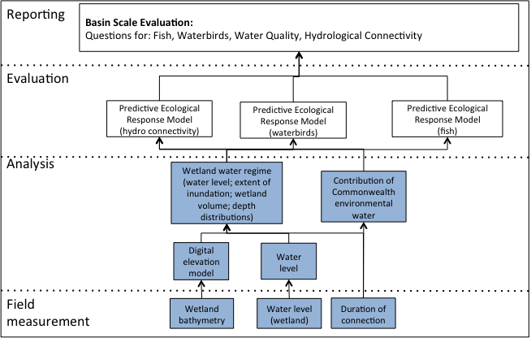
Figure 1: Schematic of key elements of the LTIM Standard Protocol for Basin Evaluation: Hydrology (wetland).

Selected Area evaluation questions
This protocol does not directly address specific evaluation questions but is important for informing the analysis and evaluation of monitoring outcomes for all of indicators. The wetland indicators for the Lachlan River system Selected Area that will use hydrological data and the relevant hydrological measures are shown in
Table 1. As such the protocol indirectly addresses the following Area scale evaluation questions:

- Long-term (five year) questions:
  - What did Commonwealth environmental water contribute to sustainable ecosystem diversity?
  - Were ecosystems to which Commonwealth environmental water was allocated sustained?
  - Was water delivered to a representative suite of ecosystem types?
  - What did Commonwealth environmental water contribute to vegetation extent?
  - What did Commonwealth environmental water contribute to microcrustacean community composition?
  - What did Commonwealth environmental water contribute to native fish populations?
  - What did Commonwealth environmental water contribute to native fish species diversity?
  - What did Commonwealth environmental water contribute to fish community resilience?
  - What did Commonwealth environmental water contribute to native fish survival?
  - What did Commonwealth environmental water contribute to waterbird populations?
  - What did Commonwealth environmental water contribute to waterbird species diversity?
  - What did Commonwealth environmental water contribute to sediment transport?
  - What did Commonwealth environmental water contribute to biotic dispersal?
  - What did Commonwealth environmental water contribute to populations of long-lived organisms?

- Short-term (one year) questions:
  - What did Commonwealth environmental water contribute to microcrustacean contribution to the abundance of native larval fish?
  - What did Commonwealth environmental water contribute to microcrustacean contribution to the growth of native larval fish?
  - What did Commonwealth environmental water contribute to microcrustacean contribution to the survival of native larval fish?
  - What did Commonwealth environmental water contribute to connectivity of microcrustacean communities between river and wetlands?
  - What did Commonwealth environmental water contribute to native fish reproduction?
  - What did Commonwealth environmental water contribute to native larval fish growth and survival?
  - What did Commonwealth environmental water contribute to other vertebrate reproduction and recruitment?
  - What did Commonwealth environmental water contribute to other vertebrate survival?

- Short-term (one-year) and long-term (five year) questions:
  - What did Commonwealth environmental water contribute to the condition of floodplain and riparian trees?
  - What did Commonwealth environmental water contribute to vegetation community diversity?
  - What did Commonwealth environmental water contribute to vegetation species diversity?
  - What did Commonwealth environmental water contribute to microcrustacean productivity?
  - What did Commonwealth environmental water contribute to resilience of microcrustacean egg banks?
  - What did Commonwealth environmental water contribute to waterbird breeding?
  - What did Commonwealth environmental water contribute to waterbird chick fledging?
  - What did Commonwealth environmental water contribute to waterbird survival?
  - What did Commonwealth environmental water contribute to other vertebrate reproduction and recruitment?
  - What did Commonwealth environmental water contribute to other vertebrate survival?
  - What did Commonwealth environmental water contribute to hydrological connectivity?
  - What did Commonwealth environmental water contribute to refuges?
  - What did Commonwealth environmental water contribute to recovery?
  - What did Commonwealth environmental water contribute to fish community resilience?

Table 1. Lachlan River system Selected Area indicators and the hydrological metrics used in the evaluation
INDICATOR | USE IN EVALUATION | HYDROLOGY ATTRIBUTES USED IN EVALUATION
Ecosystem Type (Cat 1) | Basin Scale: Validation of hydrological regime | Permanent or temporary surface water (from long term records)
Tree stand condition (Cat 1) | Basin Scale: Predictive Ecological response model | unspecified
Vegetation Diversity and condition (Cat 3) | Area Scale: Change in vegetation metrics in relation to watering | presence/absence of water;  water depth,  duration of watering,  frequency of watering
Fish (Wetland) (Cat 1) | Basin Scale: Predictive Ecological Response model | unspecified
Fish (Wetland) (Cat 3) | Area Scale: Change in fish metrics in relation to wetland hydrology attributes | flood pulse duration and magnitude,  dry spell duration  total flow volume  categorical flow component (base flow, freshes, bankfull and overbank)
Fish (larvae) (Cat 1) | Basin Scale Predictive Ecological Response Model | unspecified
Fish (larvae) (Cat 3) | Area Scale: Assessing larval fish metrics against hydrological attributes | watering event extent - timing, duration, water depth
Microinvertebrates (Cat 3) | Area Scale: Relationships between the key microcrustacean variables and density and growth of larval fish, flow, river height, time since last inundation, time dry and other covariates will be examined using Bayesian statistics to test a conceptual model of expected relationships. | flow, water depth, time since last inundation, time dry
Turtles and Decapods (Cat 3) | Area Scale: Change in turtle and decapod numbers in relation to wetland hydrology attributes | flood pulse duration and magnitude,  dry spell duration and  total flow volume  categorical flow component categories (base flow, freshes, bankfull and overbank)

Relevant ecosystem types
Wetlands.

Relevant flow types
Bankfull, overbank and overbank (infrastructure assisted).

Overview and context

Basin scale
At the Basin scale, hydrology (wetland) is an event based monitoring protocol designed to capture aspects of a wetland’s water regime that influence behaviour and condition of waterbirds and native fish. In particular, this protocol aims to quantify the effect of Commonwealth environmental water on aspects of wetland hydrology that are most important for waterbirds and native fish. This protocol is based on a combination of field measures and hydrological modelling and comprises:
- Wetland bathymetry (digital elevation model).
- In situ water level loggers.
- River inflows and outflows.

Area scale
At the area scale, hydrology (wetland) is a continuous monitoring protocol designed to capture aspects of a wetlands water regime that will be used to evaluate the effect of Commonwealth environmental water. This protocol is based identifying the attributes that will be used in the evaluation for each of the indicators within the Lachlan River System Selected Area and uses a combination of existing gauge data, field measures and hydrological modelling.

Key hydrological attributes of wetland required to inform the evaluation are:
- Presence/absence of water at a site
- Frequency and duration of watering
- Water depth
- Connection

The protocol therefore comprises:
- Wetland bathymetry (digital elevation model)
- In situ water level loggers
- Fixed point cameras
- River inflows and outflows

Complementary monitoring and data
While in many Selected Areas water level recorders and / or wetland bathymetry are available from other studies or monitoring projects, wetland bathymetry to the accuracy specified by the M&E Advisers for Basin Evaluation is not available in the lower Lachlan system, nor are there operational water level recorders in the wetlands.
Historical monitoring programs have relied on basic bathymetric data (wetland extent and spot measurements of depth) and known depth-area relationships from which volume can be reasonably estimated. These data will be drawn upon for Area Evaluation.
The project will also rely on the systematic mapping of inundation extent being undertaken for the Lower Lachlan River System Selected Area by NSW OEH. These data will be used to establish inundation extent and the dates of wetland connection. The current extent of the inundation mapping is expected to be extended as part of the LTIM Project to encompass the entire area of the Lower Lachlan River System Selected Area and this method relies on those data becoming available.

Establishing sites

Overview
LTIM for Basin-scale evaluation has adopted a hierarchical approach to sample design (see (Gawne et al. 2013). Briefly, the spatial hierarchy for stream metabolism is as follows:
Selected Area → Zone → Site

A ‘zone’ is a subset of a Selected Area that represents a spatially, geomorphological and/or hydrological distinct unit at a broad landscape scale. For example, separate river systems, sub-catchments or large groups of wetlands.
A site is the unit of assessment nested within a zone and in this instance will be a wetland or complex of wetlands.

Basin scale site establishment
Wetland hydrology is required to inform the Basin-scale quantitative evaluation of fish and waterbird responses to Commonwealth environmental water (see LTIM Standard Protocol: Fish (Wetland); LTIM Standard Protocol: Waterbird breeding and LTIM Standard Protocol: Waterbird diversity). The sample design for the fish (wetland) protocol involves a minimum of a single zone with three wetland sites; protocols for waterbirds are more flexible. Wetland hydrology will be undertaken at all sites at which fish and / or waterbirds are monitored.

Area scale site establishment
Wetland hydrology is also required to inform Area-scale evaluation of all wetland based indicator responses to Commonwealth environmental water (see other methods for the Lachlan River system). Area scale site establishment is therefore linked to the sites used for wetland fish, waterbird breeding and diversity, vegetation condition and diversity, microinvertebrates, turtles and decapods monitoring.

Monitoring locations

Locations: Basin scale evaluation
For the Lachlan River system, the Zone established for the implementation of Category 1 methods for wetland and larval fish monitoring is Zone 1 with the three wetlands selected for monitoring being Moon moon swamp, Booligal swamp and Murrumbidgil Swamp. The only wetland to be targeted for waterbird breeding events is Booligal swamp.

Locations: Area scale evaluation
Locations will be matched to the sampling locations for Category 3 methods for wetland fish, waterbird diversity, vegetation condition and diversity, microinvertebrates, turtles and decapods. These sites are summarized in Table 2 and shown in Figure 2.

Table 2. Wetland monitoring sites and the source of hydrological data for use in evaluation
SITE | VEGETATION ¹ | WETLAND FISH | LARVAL FISH | WATER-BIRDS | MICRO-CRUSTACEANS | TURTLES AND DECAPODS | HYDROLOGY DATA SOURCE
Gum swamp |  |  |  |  |  |  | Inundation mapping NSW OEH
Hillston-Hunthawang River/Billabong |  |  |  |  |  |  | Inundation mapping NSW OEH
Hazelwood Billabong | Y |  |  |  |  |  | Inundation mapping NSW OEH
Whealbah Billabong | Y |  |  |  |  |  | Time lapse camera to identify connection
Moon Moon swamp | Y |  |  | Diversity |  |  | DEM established using UAV acquired data and a single water depth logger in the deepest point of the open swamp area
Thompsons Billabong |  |  |  |  |  |  | Inundation mapping NSW OEH
Upper Lachlan Swamp |  |  |  |  |  |  | Inundation mapping NSW OEH
Lower Lachlan swamp |  |  |  |  |  |  | Inundation mapping NSW OEH
Peppermint swamp |  |  |  |  |  |  | Inundation mapping NSW OEH
Lake Waljeers |  |  |  |  |  |  | Inundation mapping NSW OEH
Lake Bullogal | Y |  |  |  |  |  | Inundation mapping NSW OEH
Ryan’s Lake |  |  |  |  |  |  | Inundation mapping NSW OEH
Erin’s Billabong | Y |  |  |  |  |  | Inundation mapping NSW OEH
Lake Ita | Y |  |  |  |  |  | Inundation mapping NSW OEH
Baconian Swamp |  |  |  |  |  |  | Inundation mapping NSW OEH
Great Cumbung Swamp |  |  |  |  |  |  | Inundation mapping NSW OEH
Lignum Lake | Y |  |  | Diversity |  |  | known depth-area relationships  One water depth logger at deepest point  Time lapse camera to identify connection
Marrool Lake | Y |  |  | Diversity |  |  | known depth-area relationships  One water depth logger at deepest point  Time lapse camera to identify connection
Spells Paddock |  |  |  | Diversity |  |  | Wetland extent and depth measurements  One water depth logger at deepest point  Time lapse camera to identify connection
Charlie’s Lake |  |  |  |  |  |  | Inundation mapping NSW OEH
Clear Lake |  |  |  |  |  |  | Inundation mapping NSW OEH
Lake Tarwong |  |  |  |  |  |  | Inundation mapping NSW OEH
Cuba Dam | Y |  |  |  |  |  | Inundation mapping NSW OEH
Tom’s Lake |  |  |  |  |  |  | Inundation mapping NSW OEH
Upper Gum Swamp |  |  |  |  |  |  | Inundation mapping NSW OEH
Booligal Swamp | Y |  |  | Breeding  Diversity |  |  | DEM established using UAV acquired data and 3 water depth loggers distributed throughout swamp
Murrumbidgil Swamp |  |  |  | Diversity |  |  | DEM established using UAV acquired data and 3 water depth loggers throughout swamp
Lake Merrimajeel | Y |  |  |  |  |  | Inundation mapping NSW OEH
Lower Gum Swamp | Y |  |  |  |  |  | Inundation mapping NSW OEH
¹ Firm locations not yet provided, these are suggested locations.

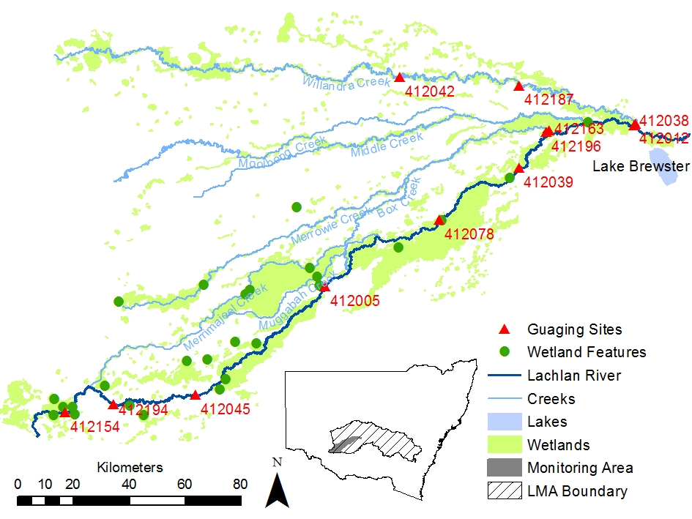
Figure 2. Map showing wetland site locations for all sites monitored within wetland in the Lower Lachlan River System Selected Area.

Timing of monitoring
This protocol aims to capture the wetland hydrology of sites that are monitored for biotic responses as part of the LTIM Project. Monitoring must therefore commence at the time the biological monitoring commences, or the time that Commonwealth environmental water is delivered to the site, whichever is the earlier. Monitoring of wetland hydrology must continue for the duration of biological monitoring or the influence of Commonwealth environmental water on the site, whichever is the later.
Timing of the releases of Commonwealth environmental water (June to August each year) and contract establishment means that the installation of water level recorders is unlikely to commence until after the 2014 environmental water releases.

Wetland bathymetry: Basin Evaluation
Wetland bathymetry is required to develop a digital elevation model (DEM) of sufficient resolution to calculate measures such as extent and duration of inundation and water depth distributions. As existing data are not sufficient to establish a DEM for the three wetlands used for Basin Evaluation survey will be used to collect bathymetric information.

The three wetlands of interest are large (Booligal Swamp = approximately 800 ha; Murrumbidgil Swamp = approximately 200 ha and Moon-moon swamp: 330 ha), with complex bathymetry and at times impenetrable vegetation. Over such sized wetlands, traditional ground based survey is time consuming and costly; LIDAR data collection used a fixed wing aircraft is also costly. The most cost effective option for establishing wetland bathymetry is to use Unmanned Aerial Vehicles (UAV’s) mounted with Near Infrared (NIR) and true colour (RGB) cameras to produce high resolution images and accurate geo-reference Digital Surface Models (DSM).

Details of the data capture and output is included as Supplement 9B, and it is noted that the following specifications have been established:
- Elevation and grid size accuracy to 0.05 m.
- DEM will be referenced to m AHD.
- The lowest point(s) of the wetland will be determined using a suitable software package.

Wetland maximum extent will be estimated as the boundary between the wetland and the surrounding terrestrial land (i.e. the level or sill where further inundation would result in water spilling out of the wetland onto the surrounding land) is not clear.

In-situ logging: Basin and Area Evaluation
Water level loggers are deployed in the deepest part/s of the wetland and set to record water level daily. Loggers are deployed for the entire period that Commonwealth environmental water is influencing the wetland water regime. A number of the wetlands being monitored for the basin scale evaluation have complex bathymetry and therefore require multiple water depth loggers (these are noted in Table 2).

Equipment
- Water level logger with an accuracy of no less than 1 cm.
- Tool kit and spare parts for the water level sensor; including spare batteries.
- Metal star pickets/structure for holding the logger and star picket driver or mallet.
- PVC pipe to create a stilling well (http://www.onsetcomp.com/water_level_stilling_well.html)
- Means to attach probe to star picket or permanent structure.
- GPS.
- Field data sheets.
- Laptop and data cables for connecting to probes / logger.

Protocol
Preparation
- Prior to deployment in the field, the probe must be calibrated according to manufacturer’s instructions and results of calibration entered into a calibration log. Note that it is expected that the loggers used will not require calibration.
- Before leaving the office / laboratory the following should be checked for all electronic equipment (sensors, loggers, GPS):
  - Batteries are charged and properly inserted.
  - Previous data downloaded and memory cleared.
  - Check cable and cable connections.
  - Check for any obvious/minor faults on sensors including growth or dirt on the probes.
  - Check contents and condition of probe toolkit.
  - All equipment listed above is present and in functional order.

Field method
- Record the following on the field sheet:
  - Wetland name and ANAE WetlandID.
  - Date and time.
  - GPS coordinates (latitude and longitude; GDA94).
  - Name(s) of survey team.

- Select appropriate place for deployment of water quality logger noting:
  - Water level logger should be deployed in a position where it can capture the full range of water depths (i.e. at the deepest section of the wetland).
  - If the wetland has a complex bathymetry that results in isolated wetland cells at lower water levels, more than one logger may be required.
  - Sensors can be deployed on suitable existing structures such as water level gauging posts or on star pickets securely embedded in the wetland substrate.

- Deploy loggers according to manufacturer’s instructions.
- Leave loggers deployed for a period of time sufficient to capture the temporal extent of the influence of CEW.
- Retrieve loggers and record date and time on field sheet.
- Record any relevant information, such as changes in site characteristics since deployment.
- Upload data onto laptop following manufacturer’s instructions.
- If loggers are to be immediately re-deployed perform routine maintenance / cleaning as necessary.

Connection: Fixed time lapse cameras
Time lapse cameras are deployed so that they capture the onset of flow into the wetland and to record whole of system responses to watering. Cameras are deployed for the entire period that Commonwealth environmental water is influencing the wetland water regime.

Equipment
- Time lapse cameras that can be programmed according to daylight hours.
- Tool kit and spare parts; including spare batteries.
- Means to attach camera to permanent structure or tree.
- GPS.
- Field data sheets.
- Laptop and data cables for connecting to camera.

Protocol
Preparation
- Prior to deployment in the field, the camera must be set to take photos at the same time each data accounting for changes in day length.
- Before leaving the office / laboratory the following should be checked for all electronic equipment (sensors, loggers, GPS):
  - Batteries are charged and properly inserted.
  - Previous data downloaded and memory cleared.
  - Check cable and cable connections.
  - Check for any obvious/minor faults including growth or dirt on the lens.
  - Check contents and condition of toolkit.
  - All equipment listed above is present and in functional order.

Field method
- Record the following on the field sheet:
  - Wetland name and ANAE WetlandID.
  - Date and time.
  - GPS coordinates (latitude and longitude; GDA94).
  - Name(s) of survey team.

- Select appropriate place for deployment of camera noting:
  - Field of view must encompass the wetland sill/point at which water enters from the stream network.
  - Field of view should also capture areas likely to have visual response to watering.

- Deploy camera according to manufacturer’s instructions.
- Leave camera deployed for a period of time sufficient to capture the temporal extent of the influence of CEW.
- Retrieve cameras and record date and time on field sheet.
- Record any relevant information, such as changes in site characteristics since deployment.
- Upload data onto laptop following manufacturer’s instructions.
- If cameras are to be immediately re-deployed perform routine maintenance / cleaning as necessary.

Duration of connection
The duration for which wetland(s) are connected to adjoining river systems will be determined from reviewing the time lapse photographs to identify the start date of connection and data on which connection ceases. This will be reported in terms of days, including start and finish dates.

Quality Assurance/Quality Control

Precision and accuracy of bathymetric measures and derived DEM
The DSM and DEM will be produced to an accuracy of 4 cm per pixel with vertical resolution of less than 10 cm (Supplement 9B).

Mapping of inundation extent
Spot measurements of water depth during field visits and notes on the extent of inundation will be used to verify the NSW OEH mapping of inundation extent and wetland connection.

Calibration and maintenance of water level recorder
Water level loggers record absolute pressure, which is later converted to water level readings using software which takes into account atmospheric pressure. To compensate for barometric pressure changes, a barometric reference will be used. The barometric reference used for the Stream metabolism measurements will be used.
Water level sensors may drift during deployment. To check for sensor drift, a reference level is taken at the beginning and end of the deployment.
Maintenance: The logger requires the following periodic maintenance to ensure optimal operation:
- Protect the logger. This logger can be damaged by shock. Always handle the logger with care. The logger may lose its calibrated accuracy or be damaged if it is dropped. Use proper packaging when transporting or shipping the logger.
- Periodically inspect the logger for biofouling. Biological growth on the face of the pressure sensor will throw off the pressure sensor’s accuracy. Organisms that grow inside the sensor nose cone and on the sensor itself can interfere with the sensor’s operation and eventually make the sensor unusable. Check the logger periodically for biological growth.

Maintenance of Time Lapse Cameras
Time lapse cameras require the following periodic maintenance to ensure optimal imagery is obtained:
Protect the camera: The camera is robust but should be handled with care to ensure it is not damaged. Strong cabling is required to affix the camera to trees and locks are recommended.
Inspections: Periodic inspections of the camera for spider webs or growths that may impact the quality of the photographs.

Data analysis and reporting
For Basin and Area Evaluation, CatchmentSIM will be used with the water level data and the DEM to calculate the following wetland water regime parameters:
- Duration of connection (days).
- Daily water level (cm).
- Daily extent of inundation (m²).
- Daily wetland volume (m³).
- Wetland depth distributions (calculated a percentage of total wetland area) in the following categories:
  - Dry.
  - 1-20 cm.
  - 20-40 cm.
  - 40-60 cm.
  - 60-80 cm.
  - 80-100 cm.
  - > 100 cm.

For area scale evaluation, review of the time lapse imagery will be used to determine duration of connection (days). In addition, the water level data and bathymetry will be used to calculate the following wetland water regime parameters:
- Duration of connection (days).
- Daily water level (cm).
- Daily extent of inundation (m²).
- Daily wetland volume (m³).

Data management
All data provided for this indicator must conform to the data structure defined in the LTIM Data Standard. The data standard provides a means of collating consistent data that can be managed within the LTIM Monitoring Data Management System (MDMS).
The spatial unit for which data is reported for this indicator is known as an ‘assessment unit’. The assessment unit for this indicator is: the site (wetland).
Each row of data provided for this indicator will identify the assessment unit, the temporal extent of the data and a number of additional variables (as guided by this standard method). The exact data structure for this indicator is maintained and communicated in the LTIM Data Standard and will be enforced by the MDMS when data is submitted.

Health and safety
For details on health and safety please refer to the Workplace Health and Safety Plan for the Lower Lachlan river system Selected Area (WHS 202.1) in Appendix 3 to the M&E Plan.

Supplement 9A: Example Hydrology (wetland) Data Collection Sheet
Wetlandid: |  | Wetland name:
Observers:
Water level logger location (s) (latitude and longitude; GDA94):

Logging start time:
Logging stop time:
Notes:

Supplement 9B: Wetland Bathymetry using Unmanned Aerial Vehicles
Australian UAV (http://www.auav.com.au/) have provided an acceptable quotation to develop a DEM for the three wetlands of the lower Lachlan River System.
Australian UAV operates two class leading fixed wing eBee aircraft, a Cinestar 8 octocopter and a Phantom quadcopter. For this data capture the Sensefly eBee (www.sensefly.com) is recommended as the best available aircraft due to its ability to carry both Near Infrared (NIR) and true colour (RGB) cameras, produce high resolution images and highly accurate geo-referenced Digital Surface Models (DSMs).

The project areas will be flown with a NIR camera at 120m Above Ground Level (AGL) giving an average resolution of approximately 4cm/pixel. NIR imagery will enable easier removal of vegetation from the DSM.

To achieve an accuracy in the x, y and z planes of 40mm, 40mm and 50mm it is necessary to place Ground Control Points (GCPs) in a 250 to 300m grid across the site. GCPs will consist of a white 1m by 1m cross painted onto the ground and ‘surveyed in’ using an RTK GPS unit to determine the x, y, z coordinates at each location.

Data are supplied as an .ecw image file and a GeoTIFF. The Digital Surface Model data is supplied in an ASCII point format and DSM model grid. Contours can be generated if required. The vegetation will be removed from the DSM to produce Digital Elevation Model (DEM). The DEM produced consists of a surface generated by averaging elevations between points remaining after vegetation removal and therefore is an approximation of the land form found beneath the canopy of the plants removed.

Safety and Quality Assurance
Australian UAV maintains a comprehensive quality assurance process that has been specifically designed to cater for large area data capture, processing and management. Integrated with this is our safety management system that incorporates aircraft operation, site personnel safety and reporting. All our staff are trained 4WD recovery, construction site safety, first aid, remote area working and aircraft handling.

Australian UAV is unique in that the company owned and operated by professional waterway scientists and engineers, each with more than 16 years of experience. This experience is important in projects such as this as we understand the required outputs and are therefore able to optimise the data capture to provide the most suitable aerial image tailored to your requirements.

