Commonwealth Environmental Water Office
Long Term Intervention Monitoring Project
Lachlan River System

Appendix 1
Standard Operating Procedures

February 2015

UNIVERSITY OF CANBERRA

Contents:

- ECOSYSTEM TYPE 1
- VEGETATION DIVERSITY AND CONDITION 29
- RIVERINE FISH 59
- LARVAL FISH 82
- WATERBIRD BREEDING 94
- STREAM METABOLISM 115
- FROGS AND TADPOLES 126
- RIVER HYDROLOGY 138
- WETLAND HYDROLOGY 167

Ecosystem Type

Evaluation questions
This is a protocol to validate the interim Australian National Aquatic Ecosystems (ANAE) classification at monitoring sites. The interim ANAE ecosystem typology and classification are relevant to the following Basin evaluation questions:
- Short-term (one-year) and long-term (five year) questions:
  - What did Commonwealth environmental water contribute to sustainable ecosystem diversity?
  - Were ecosystems to which Commonwealth environmental water was allocated sustained?
  - Was Commonwealth environmental water delivered to a representative suite of ecosystem types?
The process for evaluating these questions is illustrated in Figure 1, with components covered by this protocol highlighted in blue.
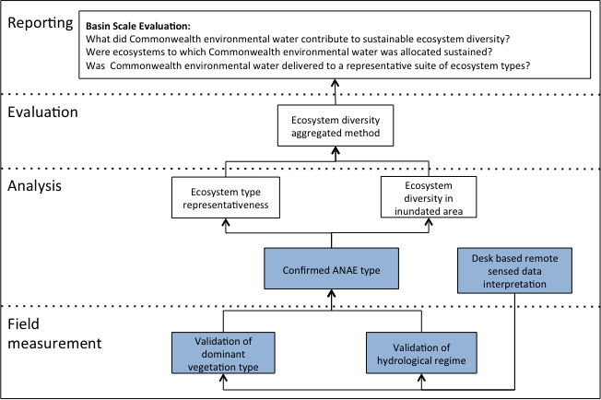
Figure 1: Schematic of key elements of the LTIM Project Standard Protocol: Ecosystem type.

Relevant ecosystem types
Rivers and wetlands. Note that the definition of wetland used in the Logic and Rationale for the LTIM project incorporates palustrine and lacustrine systems as defined in the interim Australian National Aquatic Ecosystem (ANAE) classification. Also note, that while the protocol is to be applied to wetlands on floodplains, it is not currently recommended for broader areas of the floodplain surface.

Relevant flow types
All flow types are relevant to ecosystems.

Overview and context
This method is the field validation if the ANAE classification that is required for the Basin Scale evaluation of ecosystem diversity for the LTIM project. Brooks et al. (2013) applied the interim ANAE framework to aquatic ecosystems across the Murray Darling Basin using the best available mapping and attribute data. Wetland polygons, riverine polygons, and river centre lines were attributed with the majority coverage of each attribute without dividing them further. The scale and coverage of available mapping and attribute data varied considerably across the MDB has not yet been validated by the contributing jurisdictions. There is a need to validate the mapping outputs from Brooks et al. (2013) as they relate to specific sampling sites, and the Selected Areas. The current mapping may be useful within the LTIM project but should not be relied upon until validated. This validation must be carried out at all Selected Areas for each ecosystem type that falls within an assessment unit for all other on-ground monitoring programs:
- LTIM Standard Protocol: Fish (River)
- LTIM Standard Protocol: Fish (Wetland)
- LTIM Standard Protocol: Fish (Larvae)
- LTIM Standard Protocol: Hydrology (River)
- LTIM Standard Protocol: Hydrology (Wetland)
- LTIM Standard Protocol: Macroinvertebrates
- LTIM Standard Protocol: Stream metabolism
- LTIM Standard Protocol: Tree stand condition
- LTIM Standard Protocol: Vegetation diversity
- LTIM Standard Protocol: Waterbirds breeding
- LTIM Standard Protocol: Waterbirds diversity
- LTIM Standard Protocol: Water quality

Complementary monitoring and data
Mapping output from Brooks et al. (2013) or any regional sources with updated feature mapping for the Selected Area, any fine scale resolution vegetation mapping and/or remote sensed data, current aerial photography, satellite imagery (e.g. SPOT6 – panchromatic resolution 1.5 m, multispectral resolution 8 m) and NVIS41_MDB vegetation mapping (NVIS v4.1 updated with CMA mapping by Brooks et al. 2013). These should be used in the first instance to aid in identifying aquatic ecosystem types prior to the field validation.

Interim ANAE classification

Terminology
For the purposes on the LTIM project aquatic ecosystems have been described in the Logic and Rational document as rivers, floodplains and wetlands. This is a simplification of four ecosystem classes into three common terms. For the validation protocol the terminology defined by the interim ANAE classification (Aquatic Ecosystem Task Group 2012) is to be applied. The ecosystem classes relevant to the LTIM project are as follows:
- Floodplain systems are those aquatic systems that are either seasonally or intermittently flooded flat areas that are outside the riverine channels or palustrine/lacustrine systems but that display characteristics of hydric soils or vegetation that are characteristically adapted to the seasonal or intermittent presence of water. Excluded from this protocol.
- Lacustrine systems (lakes) are open-water dominated systems, characterised by deep, standing or slow-moving water with little or no emergent vegetation (<30% cover). (Included as wetlands in Logic and Rational document).
- Palustrine systems are primarily shallow, vegetated, non-channel environments, including billabongs, bogs, swamps, springs, soaks etc. (Included as wetlands in Logic and Rational document).
- Riverine systems are those that are contained within a channel and its associated streamside vegetation. This definition refers to both single channel and multi-channel systems e.g. braided channel networks. The beds of channels are not typically dominated by emergent vegetation, may be naturally or artificially created, periodically or continuously contain moving water, and may form a connecting link between two bodies of standing water (Aquatic Ecosystem Task Group 2012). (Includes riparian systems).
The typology used to assign ecosystem types is presented as a dichotomous key in section 0 and as an extract from Brooks et al. (2013) in section 0.
An example of the mapping output from Brooks et al (2103) for some saline Victorian systems is shown in Figure 2. This highlights some of the potential validation issues that may be encountered. In some cases the data provided for the MDB mapping project included situations were multiple polygons were sub-units of larger polygons. In most cases this is likely to represent a different habitat/vegetation type within a single wetland. In this case, as illustrated below, it is advised to use the larger ecosystem and unique identifier as the assessment ecosystem. Attribute mapping that overlays these polygons (e.g. vegetation, hydrological regime, salinity) may also contain inaccuracies. Confidence measures included in the Brooks et al (2103) mapping product should be used to guide interpretation. Note that it is expected that updated mapping will be made available in coming years as attribute data improves, however the ecosystem typology is considered robust and is less likely to change significantly.

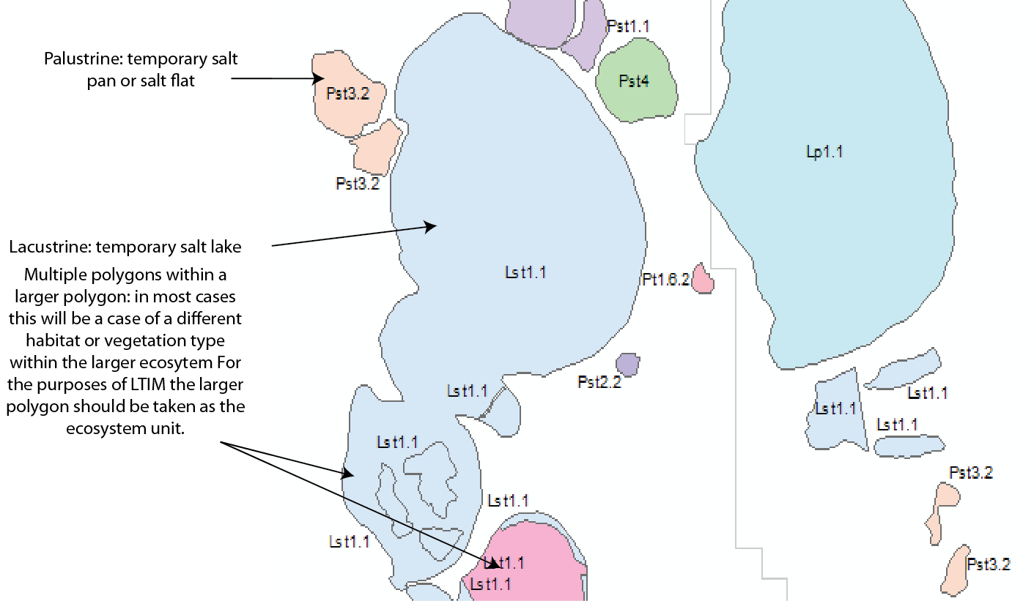
Figure 2: Example of mapping output from Brooks et al. (2013) with areas requiring validation.
A unique number (SYSID) for each polygon (wetland, lake, floodplain) or line (river, creek, stream) identifies each mapped unit (Brooks et al. 2013). On ground validation of the interim ANAE classification is required to confirm the aquatic ecosystem types for use in the LTIM program.

Validation Sites
Validation sites include all sites for other monitoring protocols (i.e. waterbird breeding sites, tree stand condition sites, fish sites, etc.). Where a site has not been mapped the typology developed by Brooks et al. (2013) should be used to assign an ecosystem type de novo (Protocol step 3 below).

Equipment
- Maps of Selected Area including assessment site information.
- Aerial imagery should be as current as possible and of sufficient resolution to identify vegetation.
- Satellite imagery – e.g. SPOT6.
- GPS.
- Datasheets and/or field computer.
- Appropriate safety gear.
- Copy of this protocol.
- Appropriate plant identification field guides.

Protocol
- Prior to field visit, source and review all relevant information relevant to the potential area of influence of Commonwealth environmental water.
- This will include, but not necessarily be limited to, mapping output from Brooks et al. (2013) for the selected area, current aerial imagery (e.g. Google Earth), satellite imagery and fine scale mapping (aquatic ecosystem type and or vegetation mapping) from state agency partners.
- Identify the ecosystems to be assessed and record/locate their unique identifier code.
- If mapped by Brooks et al. (2013) use the SYSID as the unique identifier for each mapped ecosystem.
- If the ecosystem is not mapped then record coordinates (GDA94) of the centre of the ecosystem and either locate compatible GIS mapping or delineate the boundary of the ecosystem using remote sensed data. Contact your Selected Area M&E Advisor to obtain a unique identifier for the ecosystem.
- Using the dichotomous key presented in Supplement B assign an ecosystem type and code to each assessment ecosystem, noting any knowledge gaps that relevant unambiguous classification
- If the aquatic ecosystem is mapped then check if the interim ANAE type allocated to the polygon/line feature representing the ecosystem (see Supplement B) is correct. (Note that is it possible to have lacustrine and palustrine systems located on floodplains and some, or potentially many, of these may not have been captured in the interim ANAE mapping).
- Record the correct interim ANAE type as per the typology in Supplement B.
- Determine locations for ground-truthing, mark on map and note GPS co-ordinates. The ground truthing should be designed to:
- Confirm / identify dominant vegetation type (note the typology is based on dominant vegetation type only, so not all habitat/ vegetation types require ground-truthing).
- Fill any knowledge gaps identified in step 2.
- Be easily and safely accessible.

- Use the information collected in the field to update (if necessary) the ecosystem type as identified in step 4.

Quality Assurance/Quality Control
The dominant vegetation type at each site will be recorded during the initial field campaign. Prior to field assessments, staff will be trained in the methods and a field site used to verify the ability of staff to determine the dominant vegetation. All sites will be verified by a team of two staff and where the classification differs from that of Brooks et al., (2013) standardised photographs of the site will be provided as evidence of the classification.

Data Description
The spatial unit for which data is reported for this validation is an ANAE feature identified by the ANAE SYSID.
Each row of data provided for this validation will identify the ANAE SYSID, the original classification, and the revised classification. The exact data structure for this indicator is maintained and communicated in the LTIM Data Standard and will be enforced by the MDMS when data is submitted.
All data provided for this indicator will conform to the data structure defined in the LTIM Data Standard (Brooks and Wealands 2014). The data standard provides a means of collating consistent data that can be managed within the LTIM Monitoring Data Management System (MDMS).

Health and safety
For details on health and safety please refer to the Workplace Health and Safety Plan for the Lower Lachlan river system Selected Area (WHS 202.1) in appendix 3.

References
Aquatic Ecosystem Task Group. (2012). Aquatic Ecosystems Toolkit: Module 2, Interim Australian National Aquatic Ecosystem Classification Framework. Australian Government Department of Sustainability, Environment, Water, Population and Communities, Canberra.
Batzer, D.P. and Sharitz, R. (2006). Ecology of freshwater and estuarine wetlands. University of California Press.
Boulton, A.J. and Brock, M.A. (1999). Australian freshwater ecology : processes and management / Andrew J. Boulton, Margaret A. Brock. Gleneagles Publishing, Mt Osmond, S. Aust. :
Brooks, S., Cottingham, P., Butcher, R., and Hale, J. (2013). Murray-Darling Basin aquatic ecosystem classification: Stage 2 report. Peter Cottingham & Associates report to the Commonwealth Environmental Water Office and Murray-Darling Basin Authority, Canberra.
Brooks, S. and Wealands, S.R. (2014). Commonwealth Environmental Water Office Long Term Intervention Monitoring Project: Data Standard. Report prepared for the Commonwealth Environmental Water Office by The Murray-Darling Freshwater Research Centre. MDFRC Publication 29.3/2013 Revised Jan 2014.
Cowardin, L.M., Carter, V., Golet, F.C., and LaRoe, E.T. (1979). Classification of Wetlands and Deepwater Habitats of the United States. US Department of the Interior, Fish 7 Wildlife Service, Office of Biological Services, Washington DC 20240.

Supplement A: Example Ecosystem Type Validation field sheet
ECOSYSTEM TYPE VALIDATION FIELD SHEET:  Page ---------------- of ------------------ |  |  |  |  | Selected Area:
Date: |  |  |  |  | Name of recorder:
Mapped ecosystems
SYSID | ANAE Type (code and name) |  | Valid  Y/N | Correct ANAE type (code and name) |  |  | Relevant assessment protocol
e.g. 123456 | Lst1.1: Temporary saline lakes |  | N | Lst1.2: Temporary saline lakes with aquatic beds |  |  | Waterbird breeding
New ecosystems (not mapped by Brooks et al. 2013)
Unique identifier | Location GDA94 | ANAE Type (code and name) |  |  |  | Relevant assessment protocol

Supplement B: Key to MDB interim ANAE Typology
The following terminology explains some of the descriptors used in the typology, and some of the assumptions made in order to simplify the naming convention (modified from Brooks et al. 2013):
Energy (high, low) – pertains to the relative energy of riverine flows resulting from the slope or steepness of the terrain.
Fen and bogs – peatlands (bogs and fen) are created under a range of hydrological and physical conditions. Fens are formed where mineral rich groundwater flows sustain vegetation such as grasses, sedges, reeds, shrubs and trees (Batzer and Sharitz 2006). The alkaline nature of fens and the fact that their primary water source is groundwater, with some surface and rainfall inputs, distinguishes them from bogs, which are dominated by surface water inputs. Bogs are further characterised as supporting Sphagnum moss.
Freshwater – unless specified, aquatic ecosystems are assumed to be freshwater (salinity <3000 mg/L).
Intermittent – used to describe the water regime of periodically inundated types in which inundation is known to be less frequent than annual or seasonal inundation, but more frequent than episodic and ephemeral inundation. Flooding may persist from months to years (Boulton and Brock 1999). Only used in the type name when the inundation requirements of the dominant vegetation associated with the system are able to inform the frequency of inundation, or when waterholes have been identified as being present in a stream.
Lake – an inland body of water, predominantly still or lentic in nature. Cowardin et al. (1979) defines them as being situated in a topographic depression or a dammed river channel, and having less than 30 per cent emergent vegetation. Size may vary but most will exceed eight hectares; those with similar habitats but less than eight hectares can also be included, however, if active wave-formed or bedrock shoreline features makes up all or part of the boundary, or their depth is greater than 2 meters. Ocean-derived salinity is always less than 0.5 parts per thousand, thus separating them from lagoons.
Marsh – a wetland dominated by non-woody emergent vegetation such as sedges, reeds and rushes. Marshes can be shallow or deep with a combination of emergent and submergent vegetation types. They may also have areas of open water in deeper systems, up to 70 per cent of wetland area. Marshes are typically between 0.5 to 2 meters depth, but depth can be highly variable.
Meadow – a wetland dominated by grasses (excluding Phragmites which is typically found in deeper marsh environments) and forbs. Meadows typically have shallow depths in the order of 10 to 50 centimeters. They are rarely permanent, often being filled on a seasonal basis.
Permanent – used to describe the water regime of commonly wet systems (wet >70 per cent of the time). This assumes that for commonly wet lakes, for example, that they have water all year round except during extreme droughts, when they can dry out. Permanent is used as a commonly accepted term (e.g. Ramsar and Queensland typologies).
Saline – ecosystems with a salinity >3000 mg/L.
Streams – ‘streams’ is taken to include rivers, streams and creeks for the purposes of simplifying the naming convention. Rivers are large natural in-channel bodies of moving water (lotic) which have the capacity to structure the surrounding landscape (i.e. alluvial processes). This includes large anabranching systems (e.g. Edward-Wakool Rivers are major anabranches of the River Murray). Streams and creeks, both of which are typically smaller in-channel bodies of moving water, can be either a tributary or distributary of a river.
Swamp – a wetland dominated by woody vegetation, either shrubs and or trees.
Temporary – used to describe the water regime of periodically inundated types when the frequency of inundation is not known, but is less than commonly wet (wet <70% of the time).
Key to MDB interim ANAE types
This typology can be used to validate ecosystem types at which assessments are made for both mapped and unmapped features. It can also be used to identify ecosystems that have not been mapped. For greater detail see section 0.
1a Ecosystem being validated/classified is a line feature, has flowing water and a defined channel..…………………………….Riverine systems got to 2
1b Ecosystem being validated/classified is a polygon feature, typically lacks flowing water and a defined channel………………………………………….go to 5
2a Water regime permanent (surface water >70% of time) ………………………………….…………………………………………………………………………………………..go to 3
2b Water regime temporary (surface water present <70% of time)…………………………………………………………….…………………………………………………….go to 4
3 Landform for ANAE was derived in GIS by intersecting features with the 3sec CSIRO Valley Bottom Flatness and does not require field validation…
Rp1.1: Permanent high energy upland streams
Rp1.2: Permanent transitional zone streams
Rp1.3: Permanent low energy upland streams
Rp1.4: Permanent lowland streams
4 Landform for ANAE was derived in GIS by intersecting features with the 3sec CSIRO Valley Bottom Flatness and does not require field validation…
Rt1.1: Temporary high energy upland streams
Rt1.2: Temporary transitional zone streams
Rt1.3: Temporary low energy upland streams
Rt1.4: Temporary lowland streams
5a. Ecosystem with less than 30% emergent vegetation, large enough to support wave action …………………………….…..Lacustrine systems go to 6
5b. Ecosystem with more than 30% emergent vegetation, or no vegetation. If no vegetation typically shallow and doesn’t develop wave action (i.e. deflation basins, salt flats, clay pans etc.). …………………………………………………………………………………………………………………………………………….........go to 17
6a Water type: fresh .…………………………………………………………………………………………………………………………………………………………………………………………go to 7
6b Water type: saline…………….…………………………………………………………………………………………………………..……………………………………………………………….go to 10
7a Permanent (surface water >70% of time)…………………….…………………………………………………………………………………………………………………………………go to 8
7b Temporary (surface water <70% of time)………………………………………………………………………………………………………………………………………………………go to 9
8a Permanent floodplain lakes, with or without submergent aquatic macrophyte…………………………………………………………………………………………………..
………………………………………………………..………………………………………….……………..…….Lp2.1: Permanent floodplain lakes
………………………………………………………………..…………………………………….……………..….Lp2.2: Permanent floodplain lakes with aquatic beds
8b Permanent non-floodplain lakes, with or without submergent aquatic macrophytes……………………………………………………………………………………………
………………………………………….……………..…………………………………………………………..….Lp1.1: Permanent lakes
…………………………………….…………………………………………………………………………………..Lp1.2: Permanent lakes with aquatic beds
9a Floodplain lakes, with or without submergent aquatic macrophytes………………………………………………………………………………….…………………………….…….
………………………………………………………..…………………………………………….……….……..…Lt2.1: Temporary floodplain lakes
……………………………………………………………….…………………………………….…….………..….Lt2.2: Temporary floodplain lakes with aquatic beds
9b Non- floodplain lakes, with or without submergent aquatic macrophytes …..…………………………………………………………………………………………………………
………………………………………………………..………………………………………….………….…..……Lt1.1: Temporary lakes
……………………………………………………………….…………………………………….………….…..….Lt1.2: Temporary lakes with aquatic beds
10a Permanent saline lakes (surface water >70% of time)……………………………………………………………………..……………………………………………………………go to 11
10b Temporary saline lakes (surface water <70% of time)……………………………………………………………………………………………………………………………………go to 12
11a Floodplain saline lakes, with or without submergent aquatic macrophytes...…………………………………………………………………….…………………………………..
………………………………………………………..………………………………………….……………..…….Lsp2.1: Permanent saline floodplain lakes
…………………………………………………………………………………….……………….……………..…..Lsp2.2: Permanent saline floodplain lakes with aquatic beds
11b Non-floodplain saline lakes, with or without submergent aquatic macrophytes……………………………………………………………………………………………………..
………………………………………………………..………………………………………….……………..…….Lsp1.1: Permanent saline lakes
………………………………………………………………. Lsp1.2: Permanent saline lakes with aquatic beds
12a Temporary saline floodplain lakes, with or without submergent aquatic macrophytes …………………………………………………………………………………………
…………………………………………….…………………………………………………………………….…..….Lst2.1: Temporary saline floodplain lakes
…………………………………….……………..……………………………………………………………………..Lst2.2: Temporary saline floodplain lakes with aquatic beds
12b Temporary saline non-floodplain lakes, with or without submergent aquatic macrophytes……………………………………………………………………………….
………………………………………………………….………………………………………….……………..…….Lst1.1: Temporary saline lakes
………………………………………………………………..…………………………………….……….………….Lst1.2: Temporary saline lakes with aquatic beds
13a The ecosystem is a wetland depression ……………………………………..………………………………………………..…………………………Palustrine systems go to 14
14a Water type: fresh…………………………………………………………………………………………………………………………………………………………………………………………..go to 15
14b Water type: saline………………………………………………………………………………………………………………………………………………………………………………………….go to 20
14c Unspecified, no data.……………………………..…………………………………………… Pu1: Unspecified wetland
15a Permanent springs…………………………………………………………….……………..… Pp5: Permanent springs
15b Permanent (surface water >70% of time), non-springs.…………………………………………………………………………………………………………………………………go to 16
15c Temporary (surface water <70% of time)………………………………………………………………………………………………………………………………………………………go to 23
16a Permanent floodplain wetlands…………………………………………….…………………..……………………………………………………………………………………….…………go to 19
16b Permanent non-floodplain wetlands…………………………………………………………………………………………………………………………………………………….……….go to 18
17a Floodplain swamps - dominated by woody vegetation ……….……………...Pp1.1.1: Permanent floodplain paperbark swamps
17b Floodplain marshes – dominated by non-woody vegetation…………………………….…………………………………………………………………………………………………….
(e.g. Typha, Phragmites, Baumea, Juncus: tall spp typically>1m).……………..…….Pp2.1.1: Permanent floodplain tall emergent marshes
(species typically <1m)…….………………………………………………………….……………..…….Pp2.2.1: Permanent floodplain sedge/grass/forb marshes
………………………………………………………………………………………………….……………..……….Pp2.3.1: Permanent floodplain grass marshes
…………………………………………………………………………………………………….……………..…….Pp2.4.1: Permanent floodplain forb marshes
17c Floodplain wetland, unspecified vegetation........................……………..…Pp4.1: Permanent floodplain wetland

18a Non-floodplain swamps- dominated by woody vegetation …………………Pp1.1.2: Permanent paperbark swamps
18b Non-floodplain marshes, bogs and fens – dominated by non-woody vegetation………………………………………………………………………………………………
(e.g. Typha, Phragmites, Baumea, Juncus: tall spp typically>1m)..……………..…….Pp2.1.2: Permanent tall emergent marshes
(species typically <1m)…….………………………………………………………….……………..…….Pp2.2.2: Permanent sedge/grass/forb marshes
……………………………………………………………………………………………………….……….…….....Pp2.3.2: Permanent grass marshes
…………………………………………………………………………………………………………………….…...Pp2.4.2: Permanent forb marshes
(fen marshes dominant water source is groundwater)....................................... Pp3: Peat bogs and fen marshes
18c Non-floodplain wetland, unspecified vegetation…..….…………………………Pp4.2: Permanent wetland
19a Temporary floodplain swamps and marshes, identified by dominant vegetation type…………………………………………………………………………………………
………………………………………………..…………………………………………….……………..………….Pt1.1.1: Intermittent River red gum floodplain swamp
……………………………………………………………………………………………….……………..………….Pt1.2.1: Intermittent Black box floodplain swamp
……………………………………………………………………………………………….……………..………….Pt1.3.1: Intermittent Coolibah floodplain swamp
……………………………………………………………………………………………….……………..………….Pt1.4.1: Intermittent River Cooba floodplain swamp
……………………………………………………………………………………………….…………….………….Pt1.5.1: Temporary paperbark floodplain swamp
(tree species unidentified)……………………………………………………….……………..……….Pt1.6.1: Temporary woodland floodplain swamp
……………………………………………………………………………………………………………………….Pt1.7.1: Intermittent Lignum floodplain swamps
(e.g. Typha, Phragmites, Baumea, Juncus: tall spp typically>1m)..……………..…….Pt2.1.1: Temporary tall emergent floodplain marsh
(species typically <1m)…….………………………………………………………….……………..…….Pt2.2.1: Temporary sedge/grass/forb floodplain marsh
(water typically <50cm, often seasonally inundated)..………………………………..……Pt2.3.1: Floodplain freshwater meadow
…………………………………………………………………………………………………………………….……Pt3.1.1: Floodplain clay pan
(unspecified vegetation)…………………………………………………………………....……………Pt4.1: Temporary floodplain wetland
19b Temporary non-floodplain swamps, marshes, identified by dominant vegetation type………………………………………………………………………………………
……………………………………………………………………………………………....……………………..…Pt1.1.2: Intermittent River red gum swamp
……………………………………………………………………………………………....……………………..…Pt1.2.2: Intermittent Black box swamp
…………………………………………………………………………………………....………………………....Pt1.3.2: Intermittent Coolibah swamp
………………………………………………………………………………………....……………………………..Pt1.4.2: Intermittent River Cooba swamp
…………………………………………………………………………………………....…………………………..Pt1.5.2: Temporary paperbark swamp
(tree species unidentified)……………………………………………………….……………..……….Pt1.6.2: Temporary woodland swamp
…………………………………………………………………………………………....……………………..……Pt1.7.2: Intermittent Lignum swamps
(e.g. Typha, Phragmites, Baumea, Juncus: tall spp typically>1m)..……………..…… Pt2.1.2: Temporary tall emergent marsh
(species typically <1m)…….………………………………………………………….……………..…….Pt2.2.2: Temporary sedge/grass/forb marsh
(water typically <50cm, often seasonally inundated)..……………………………….…….Pt2.3.2: Freshwater meadow
(lacks vegetation, shallow)………………………………………………………………………….…….Pt3.1.2: Clay pan
(unspecified vegetation)…………………………………………………………………....…………….Pt4.2: Temporary wetland
20a Permanent saline palustrine systems (surface water >70% of time), identify by dominant vegetation type………………………………………………………
………………………………………………………………………………………………………………………….Psp1.1: Saline paperbark swamp
(e.g. samphire)………………………………………………………………………………………………….Psp2.1: Permanent salt marsh
………………………………………………………………………………………………………………………….Psp3.1: Permanent seagrass marsh
………………………………………………………………………………………………………………………….Psp4: Permanent saline wetland (vegetation not specified)
20b Temporary saline palustrine systems (surface water <70% of time) identify by dominant vegetation type ……………………………………………………..
…………………………………………………………………………………………………………………………Pst1.1: Temporary saline swamp
(e.g. samphire)…………………………………………………………………………………………………Pst2.2: Temporary salt marsh
…………………………………………………………………………………………………………………………Pst3.2: Salt pans and salt flats
(vegetation unspecified).…………………………………………………………………………………Pst4: Temporary saline wetland

Typology (extract from Brooks et al. 2013)
Water regime, water type and vegetation are the main attributes used throughout the typology developed by Brooks et al. (2013). It should be noted that only vegetation structure (not dominant vegetation) has been used to help distinguish types for lacustrine and riverine classes. ‘Non-vegetated’ is a valid category for riverine systems as it can represent areas of settlement, or cleared areas. As lacustrine systems are defined on the basis of having less than 30 per cent emergent vegetation, ‘only water’ is considered as a valid attribute category for the dominant vegetation attribute in the typology for lakes. For example, it would not be appropriate to describe a type on vegetation that only occurred over, say, 5 per cent of the site.

Lacustrine systems
The typology proposed for lacustrine systems (Table 30) is based on the following Level 3 ANAE attributes:
- Water type;
- Water regime (water permanency);
- Dominant vegetation (water only);
- Finer vegetation (aquatic bed).
The typology for lacustrine systems also captures if the system is located on a floodplain. A number of types can be aggregated (for example permanent lakes with or without submerged macrophytes can be aggregated up to being called just permanent lakes) and this is explained in the descriptions for each combination of attributes in Table 1. In the typology lacustrine systems are considered freshwater unless stated otherwise in the naming convention. Also lakes are assumed to have no submergent vegetation unless stated in the name convention.

Table 1: Lacustrine types using Level 3 attributes and a location descriptor (floodplain) (from Brooks et al. 2013).
Note: Dominant vegetation and fringing vegetation do not provide any greater separation of types. Codes: Lp = permanent freshwater lacustrine/lakes, Lt = temporary freshwater lacustrine/lakes, Lsp = permanent saline lacustrine/lakes, Lst = temporary saline lacustrine/lakes
WATER TYPE | WATER REGIME | DOMINANT VEGETATION | FINER SCALE VEGETATION | LOCATED ON FLOODPLAIN | TYPE |  |  | DESCRIPTION
Fresh | Commonly wet | Water | No vegetation | No | Lakes | Lp1: Permanent lakes | Lp1.1: Permanent lakes | Includes volcanic lakes, dune lakes, crater lakes, alpine lakes and other inland lakes. Typically greater than 2 metres deep with substantial areas of open water – may have fringing vegetation in littoral zone, but are defined as having less than 30 per cent emergent vegetation and no to limited submergent vegetation. Often greater than 8 ha in size, but smaller systems are also included if they are greater than 2m deep and support wave action.
Fresh | Commonly wet | Water | Aquatic bed | No | Lakes | Lp1: Permanent lakes | Lp1.2: Permanent lakes with aquatic beds | As for Lp1.1 but have substantial areas of submergent macrophytes (e.g. Hattah Lakes). This type of lake is likely to be shallow in areas which support macrophytes.
Fresh | Commonly wet | Water | No vegetation | Yes | Lakes | Lp2: Permanent floodplain lakes | Lp2.1: Permanent floodplain lakes | As for Lp1.1, but lakes located on floodplains.
Fresh | Commonly wet | Water | Aquatic bed | Yes | Lakes | Lp2: Permanent floodplain lakes | Lp2.2: Permanent floodplain lakes with aquatic beds | As for Lp1.2, but lakes located on floodplains.
Fresh | Periodic inundation | Water | No vegetation | No | Lakes | Lt1: Temporary lakes | Lt1.1: Temporary lakes | As for Lp1.1 but tend to be shallower and periodically dries (temporary).
Fresh | Periodic inundation | Water | Aquatic bed | No | Lakes | Lt1: Temporary lakes | Lt1.2: Temporary lakes with aquatic beds | As for Lp1.2; but lakes are temporary.
Fresh | Periodic inundation | Water | No vegetation | Yes | Lakes | Lt2: Temporary floodplain lakes | Lt2.1: Temporary floodplain lakes | As for Lt1.1, with main distinction being location on floodplain with dominant water source assumed to be from parent stream.
Fresh | Periodic inundation | Water | Aquatic bed | Yes | Lakes | Lt2: Temporary floodplain lakes | Lt2.2: Temporary floodplain lakes with aquatic beds | As for Lt1.2, with main distinction being location on floodplain with dominant water source assumed to be from parent stream.
Saline | Commonly wet | Water | No vegetation | No | Saline lakes | Lsp1: Permanent saline lakes | Lsp1.1: Permanent saline lakes | As for Lp1.1, but saline.
Saline | Commonly wet | Water | Aquatic bed | No | Saline lakes | Lsp1: Permanent saline lakes | Lsp1.1: Permanent saline lakes with aquatic beds | As for Lp1.2, but saline. Examples of typical aquatic vegetation include systems with Ruppia.
Saline | Commonly wet | Water | No vegetation | Yes | Saline lakes | Lsp2: Permanent saline floodplain lakes | Lsp2.1: Permanent saline floodplain lakes | As for Lp2.1 but saline.
Saline | Commonly wet | Water | Aquatic bed | Yes | Saline lakes | Lsp2: Permanent saline floodplain lakes | Lsp2.2: Permanent saline floodplain lakes with aquatic beds | As for Lp2.2 but saline.
Saline | Periodic inundation | Water | No vegetation | No | Saline lakes | Lst1: Temporary saline lakes | Lst1.1: Temporary saline lakes | As for Lt1.1, but saline
Saline | Periodic inundation | Water | Aquatic bed | No | Saline lakes | Lst1: Temporary saline lakes | Lst1.2: Temporary saline lakes with aquatic beds | As for Lt1.2, but saline.
Saline | Periodic inundation | Water | No vegetation | Yes | Saline lakes | Lst2: Temporary saline floodplain lakes | Lst2.1: Temporary saline floodplain lakes | As for Lt2.1, but saline.
Saline | Periodic inundation | Water | Aquatic bed | Yes | Saline lakes | Lst2: Temporary saline floodplain lakes | Lst2.2: Temporary saline floodplain lakes with aquatic beds | As for Lt2.2, but saline.

Palustrine systems
The typology proposed for palustrine systems (Table 31) is based on the following Level 3 ANAE attributes:
- Water type;
- Water regime;
- Dominant vegetation (structure);
- Finer scale vegetation (dominant species) (Note this equates to vegetation type/habitat type in LTIM).
The typology for palustrine systems also captures if the system is located on a floodplain. The typology for palustrine systems includes a greater number of types as the potential range of vegetation associations/attributes is greater, as these reflect the greater range or variability in water regime encountered in this ecosystem class. Springs were assigned to individual features as designated in jurisdictional data sets and were assumed to be commonly wet.

Table 2: Palustrine types using Level 3 attributes (from Brooks et al. 2013).
Codes Pp = permanent wetland types, Pt = temporary wetland types, Psp = permanent saline wetland types, Pst = temporary saline wetland types, Pu = unknown
WATER TYPE | WATER REGIME | DOMINANT VEGETATION | FINER SCALE VEGETATION | LOCATED ON FLOODPLAIN | TYPE |  |  |  |  |  | DESCRIPTION
Fresh | Commonly wet | Tree | Paperbark | Yes | Pp1: Permanent swamp forest | Pp1.1: Permanent paperbark swamps |  |  | Pp1.1.1: Permanent floodplain paperbark swamps |  | Permanent wetlands on floodplains; vegetation is emergent and dominated by paperbark.
 |  |  |  | No | Pp1: Permanent swamp forest |  |  |  | Pp1.1.2: Permanent paperbark swamps |  | As for Pp1.1.1, but not on floodplains.
Fresh | Commonly wet | Sedge | Tall emergent aquatic | Yes | Pp2: Permanent marsh | Pp2.1: Permanent tall emergent marshes |  |  | Pp2.1.1: Permanent floodplain tall emergent marshes |  | Permanent wetlands on floodplains; vegetation is dominated by emergent aquatic species, including Typha, Phragmites, Eleocharis, some Juncus species, Includes species ≥1m in height.
 |  |  |  | No | Pp2: Permanent marsh |  |  |  | Pp2.1.2: Permanent tall emergent marshes |  | As for Pp2.1.1, but not on floodplains.
Fresh | Commonly wet | Sedge | Aquatic sedge/grass/forb | Yes | Pp2: Permanent marsh | Pp2.2: Permanent sedge/grass/forb marshes |  |  | Pp2.2.1: Permanent floodplain sedge/grass/forb marshes |  | Permanent wetlands on floodplains; vegetation is emergent, but can also include submergent species as well. Height of emergent species is typically ≤1m – can include species from Carex, Cyperus, Myriophyllum, Triglochin, Eleocharis, Sporobolus, Amphibromus, Pseudoraphis spinescens etc. Includes obligate aquatics as well as amphibious species in littoral zones.
 |  |  |  | No | Pp2: Permanent marsh |  |  |  | Pp2.2.2: Permanent sedge/grass/forb marshes |  | As for Pp2.2.1, but not on floodplains.
Fresh | Commonly wet | Grass/forb | Freshwater grasses | Yes | Pp2: Permanent marsh | Pp2.3: Permanent grass marshes |  |  | Pp2.3.1: Permanent floodplain grass marshes |  | Permanent wetlands on floodplains; vegetation is emergent grass species.
 |  |  |  | No | Pp2: Permanent marsh |  |  |  | Pp2.3.2: Permanent grass marshes |  | As for Pp2.3.1, but not on floodplains.
Fresh | Commonly wet | Grass/forb | Freshwater forb | Yes | Pp2: Permanent marsh | Pp2.4: Permanent forb marshes |  |  | Pp2.4.1: Permanent floodplain forb marshes |  | Permanent wetlands on floodplains; vegetation is emergent forb species.
 |  |  |  | No | Pp2: Permanent marsh |  |  |  | Pp2.4.2: Permanent forb marshes |  | As for Pp2.4.1, but not on floodplains.
Fresh | Commonly wet | Sedge/Grass/  forb | Bogs and fen | No | Pp3: Peat bogs and fen marshes |  |  |  |  |  | Permanent wetlands with emergent sedge, grass or forb. Fen marshes are separated from bog by the presence of Sphagnum and groundwater being the dominant water source.
Fresh | Commonly wet | All remaining | Not specified | Yes | Pp4.1: Permanent floodplain wetland |  |  |  |  |  | Permanent wetlands on floodplains with unspecified vegetation.
 |  |  |  | No | Pp4.2: Permanent wetland |  |  |  |  |  | As per Pp4.1 but not on floodplains.
Fresh | Commonly wet | All remaining | Not specified | All | Pps5: Permanent springs |  |  |  |  |  | Permanent freshwater wetlands in groundwater discharge areas.
Fresh | Periodic inundation | Tree | River red gum | Yes | Pt1:Temporary swamps |  |  | Pt1.1:Intermittent River red gum swamp |  | Pt1.1.1: Intermittent River red gum floodplain swamp | Intermittent River red gum wetland on floodplains; can include both woodland and forest forms.
 |  |  |  | No |  |  |  |  |  | Pt1.1.2: Intermittent River red gum swamp | As for Pt1.1.1, but not on floodplains.
Fresh | Periodic inundation | Tree | Black box | Yes |  |  |  | Pt1.2:Intermittent Black box swamp |  | Pt1.2.1: Intermittent Black box floodplain swamp | Intermittent Black box wetlands on floodplains; have predominantly woodland structure. Occurs on infrequently flooded outwash areas, as a narrow fringe around intermittent lakes, as a woodland across the floor of some deflation basins and as a string of trees following a palaeo-channel (Roberts and Marston 2011).
 |  |  |  | No |  |  |  |  |  | Pt1.2.2: Intermittent Black box swamp | As for Pt1.2.1, but not on floodplains.
Fresh | Periodic inundation | Tree | Coolibah | Yes |  |  |  | Pt1.3:Intermittent Coolibah swamp |  | Pt1.3.1: Intermittent Coolibah floodplain swamp | Intermittent Coolibah wetlands on floodplains; mainly restricted to the north-west of the Basin. Often the dominant tree in infrequently inundated floodplains of northern rivers such as the Darling and Gwydir; forming extensive woodlands. This type may also occur as a riparian fringe beside river channels and around waterholes (Roberts and Marston 2011).
 |  |  |  | No |  |  |  |  |  | Pt1.3.2: Intermittent Coolibah swamp | As for Pt1.3.1, but not on floodplains.
Fresh | Periodic inundation | Tree | River Cooba | Yes |  |  |  | Pt1.4:Intermittent River Cooba swamp |  | Pt1.4.1: Intermittent River Cooba floodplain swamp | Intermittent River Cooba wetlands on floodplains. River Cooba is also known as Belalie and Eumong (Roberts and Marston 2011). Common in the northern Basin.
 |  |  |  | No |  |  |  |  |  | Pt1.4.2: Intermittent River Cooba swamp | As for Pt1.4.1, but not on floodplains.
Fresh | Periodic inundation | Tree | Paperbark | Yes |  |  |  | Pt1.5:Temporary paperbark swamp |  | Pt1.5.1: Temporary paperbark floodplain swamp | As for Pp1.1.1 but temporary.
 |  |  |  | No |  |  |  |  |  | Pt1.5.2: Temporary paperbark swamp | As for Pp1.2.1 but temporary.
Fresh | Periodic inundation | Tree | Other aquatic trees | Yes |  |  |  | Pt1.6:Temporary swamp |  | Pt1.6.1: Temporary woodland floodplain swamp | Temporary wetlands on floodplain with a range of aquatic trees such as Casuarina, Allocasuarina, Eucalyptus ovata.
 |  |  |  | No |  |  |  |  |  | Pt1.6.2: Temporary woodland swamp | As for Pt1.6.1, but not on floodplains.
Fresh | Periodic inundation | Shrub | Lignum | Yes |  |  |  | Pt1.7:Intermittent Lignum swamps |  | Pt1.7.1: Intermittent Lignum floodplain swamps | Temporary Lignum swamps on floodplains.
 |  |  |  | No |  |  |  |  |  | Pt1.7.2: Intermittent Lignum swamps | As for Pt1.7.1, but not on floodplains.
Fresh | Periodic inundation | Sedge | Tall emergent aquatics | Yes | Pt2: Temporary marshes |  |  | Pt2.1: Temporary tall emergent marshes |  | Pt2.1.1: Temporary tall emergent floodplain marsh | Temporary floodplain wetlands dominated by Phragmites, Juncus Typha, Eleocharis, Baumea, etc.
 |  |  |  | No |  |  |  |  |  | Pt2.1.2: Temporary tall emergent marsh | As for Pt2.1.1, but not on floodplains.
Fresh | Periodic inundation | Sedge/grass/ forb | Aquatic sedge/grass/forb | Yes |  |  |  | Pt2.2: Temporary sedge/grass/forb marsh |  | Pt2.2.1: Temporary sedge/grass/forb floodplain marsh | Temporary sedge/grass/forb marshes on floodplains. Marshes tend to be deeper than meadows, ranging anywhere from 20-30 centimetres in depth to up to two metres in depth. Can be vegetated across the whole system or include areas of open water (deeper areas). Includes systems with Eragrostis, Eleocharis, Carex, Cyperus, Paspalum, etc
 |  |  |  | No |  |  |  |  |  | Pt2.2.2: Temporary sedge/grass/forb marsh | As for Pt2.2.1, but not on floodplains.
Fresh | Periodic inundation | Grass/forb | Freshwater grasses, Freshwater forbs | Yes |  |  |  | Pt2.3: Freshwater meadow |  | Pt2.3.1: Floodplain freshwater meadow | Temporary meadows on floodplains, which tend to be shallow typically ranging between 20 to 40 centimetres in depth. Meadows are typically vegetated across whole system, may have scattered trees, shrubs, and or sedges, but are dominated by grasses and forbs.
 |  |  |  | No |  |  |  |  |  | Pt2.3.2: Freshwater meadow | As for Pt2.3.1, but not on floodplains.
Fresh | Periodic inundation | No vegetation/ Water | n/a | Yes | Pt3: Freshwater playas |  |  | Pt3.1:Clay pans |  | Pt3.1.1: Floodplain clay pan | Floodplain clay pans typically less than eight hectares and less than two metres deep. Lack wave action characteristic of lacustrine systems
 |  |  |  | No |  |  |  |  |  | Pt3.1.2: Clay pan | As for Pt3.1.1, but not on floodplains.
Fresh | Periodic inundation | All remaining | Not specified | Yes | Pt4.1: Temporary floodplain wetland |  |  |  |  |  | Temporary wetlands on the floodplain with unspecified vegetation.
 |  |  |  | No | Pt4.2: Temporary wetland |  |  |  |  |  | As for Pt4.1, but not on floodplains.
Saline | Commonly wet | Tree | Paperbark | All | Psp1: Saline swamps |  | Psp1.1: Saline paperbark swamp |  |  |  | Permanent saline paperbark swamps, including Melaleuca halmaturorum.
Saline | Commonly wet | Shrub/sedge/ grass/forb | Saltmarsh | All | Psp2: Salt marsh |  | Psp2.1: Permanent salt marsh |  |  |  | Permanent inland saltmarsh.
Saline | Commonly wet | Grass | Seagrass | All | Psp3: Seagrass marsh |  | Psp3.1: Permanent seagrass marsh |  |  |  | Permanent saline marshes dominated by seagrass.
Saline | Commonly wet | All remaining | Not specified | All | Psp4: Permanent saline wetland |  |  |  |  |  | Permanent saline wetlands with unspecified vegetation.
Saline | Periodic inundation | Tree | All trees | All | Pst1: Saline swamp |  | Pst1.1: Temporary saline swamp |  |  |  | Temporary saline wetlands with tree species.
Saline | Periodic inundation | Shrub/sedge/ grass/forb | Saltmarsh | All | Pst2: Salt marsh |  | Pst2.2: Temporary salt marsh |  |  |  | Temporary inland saltmarsh wetlands.
Saline | Periodic inundation | No vegetation/ water | n/a | All | Pst3: Saline playas |  | Pst3.2: Salt pans and salt flats |  |  |  | Temporary saltpans and playas typically less than eight hectares and less than two metres deep. Lack wave action characteristic of lacustrine systems.
Saline | Periodic inundation | All remaining | Not specified | All | Pst4: Temporary saline wetlands |  |  |  |  |  | Temporary saline wetlands with unspecified vegetation.
Unknown | Unknown | Unknown | Unknown | All | Pu1: Unspecified wetland |  |  |  |  |  | There is no information with which to assign a type.

Riverine systems
The typology for palustrine systems (Table 3) is based on the following Level 3 ANAE attributes:

- Water source,
- Water regime, and
- Landform.

The riverine confinement attribute was also considered for the typology but was found to be highly correlated with the landform attribute and so provided no additional ecological information.

Waterholes are assumed to have been identified in temporary or periodically inundated streams. However, approaches such as designating permanent palustrine features that intersect steams as ‘waterholes’ resulted in a vast (unrealistic) number of features being so assigned. The designation of a feature as a ‘waterhole’ therefore relies on designations from jurisdiction databases.

Including substrate as an attribute in the typology for riverine systems would be informative; however, there is insufficient information available for the MDB to include it at this stage. It may be considered in future iterations of the ANAE framework as it would add useful information on the characteristics of a riverine system (e.g. help define sandy bottom, cobble, boulder or bedrock streams).

Table 3: Riverine types using Level 3 attributes(from Brooks et al. 2013).
Codes: Rp = riverine – permanent streams, Rt = riverine – temporary streams, Rw = riverine – waterholes, Ru = unspecified streams.
WATER SOURCE | WATER REGIME | LANDFORM | TYPE |  | DESCRIPTION
Surface | Commonly wet | High energy upland | Rp1: Permanent streams | Rp1.1: Permanent high energy upland streams | Fast flowing streams with steep gradient (>6%), and dominated by riffles and runs. Often with coarse substrate. Base flow typically maintained except in extreme droughts.
Surface | Commonly wet | Transitional | Rp1: Permanent streams | Rp1.2: Permanent transitional zone streams | Intermediate slope (4-6%) with long runs and riffle zones; pools are infrequent.
Surface | Commonly wet | Low energy upland | Rp1: Permanent streams | Rp1.3: Permanent low energy upland streams | Low gradient (<4%), slow flowing systems, often with a narrow channel on relatively flat land. May lack extensive riffle areas.
Surface | Commonly wet | Lowland | Rp1: Permanent streams | Rp1.4: Permanent lowland streams | Low gradient (<4%),systems that can include both narrow and relatively shallow flowing systems with pool, riffle, run sequences, and large deeper lowland systems with slow flow and no riffle areas. Base flow is maintained in dry periods, except in extreme drought.
Surface | Periodic inundation | High energy upland | Rt1: Temporary streams | Rt1.1: Temporary high energy upland streams | As for Rp1.1, but may be systems which rise and fall rapidly, wetting and drying for varying lengths of times.
Surface | Periodic inundation | Transitional | Rt1: Temporary streams | Rt1.2: Temporary transitional zone streams | As for Rp1.2, but are only periodically wet.
Surface | Periodic inundation | Low energy upland | Rt1: Temporary streams | Rt1.3: Temporary low energy upland streams | As for Rp1.3, but are only periodically wet.
Surface | Periodic inundation | Lowland | Rt1: Temporary streams | Rt1.4: Temporary lowland streams | As for Rp1.4, but are only periodically wet.
All | Commonly wet | All | Rw1: Waterholes |  | Commonly wet remnant pools that are located on periodically wet riverine segments.
All | Unknown | Unknown | Ru1: Unspecified river |  | There is no information with which to assign a type.

Vegetation diversity and condition
This monitoring protocol encapsulates the Category 2 monitoring of vegetation diversity as well as additional components that enable vegetation condition to be determined. This method is, however, a category 3 which allows modifications such as greater alignment with state-based methods.

Evaluation questions
This monitoring protocol addresses the following Area Evaluation questions in relation to vegetation condition and diversity:
- Short-term (one-year) and long-term (five year) questions:
  - What did Commonwealth environmental water contribute to vegetation species diversity?
  - What did Commonwealth environmental water contribute to vegetation community diversity?

- Long term (five year) questions:
  - What did Commonwealth environmental water contribute to populations of long-lived organisms?
- Short term (one-year) questions:
  - What did Commonwealth environmental water contribute to condition of floodplain and riparian trees?
  - What did Commonwealth environmental water contribution to vegetation condition and reproduction?

The process for evaluating these questions is illustrated in Figure 1 and with components covered by this protocol highlighted in blue. The brown boxes for tree recruitment and structure will be implemented in the Lachlan river system Selected Area as they form part of historical monitoring protocols. This information can be collected with little additional field time cost and recruitment of floodplain and riparian species is known to be a key outcome of environmental watering in the region.

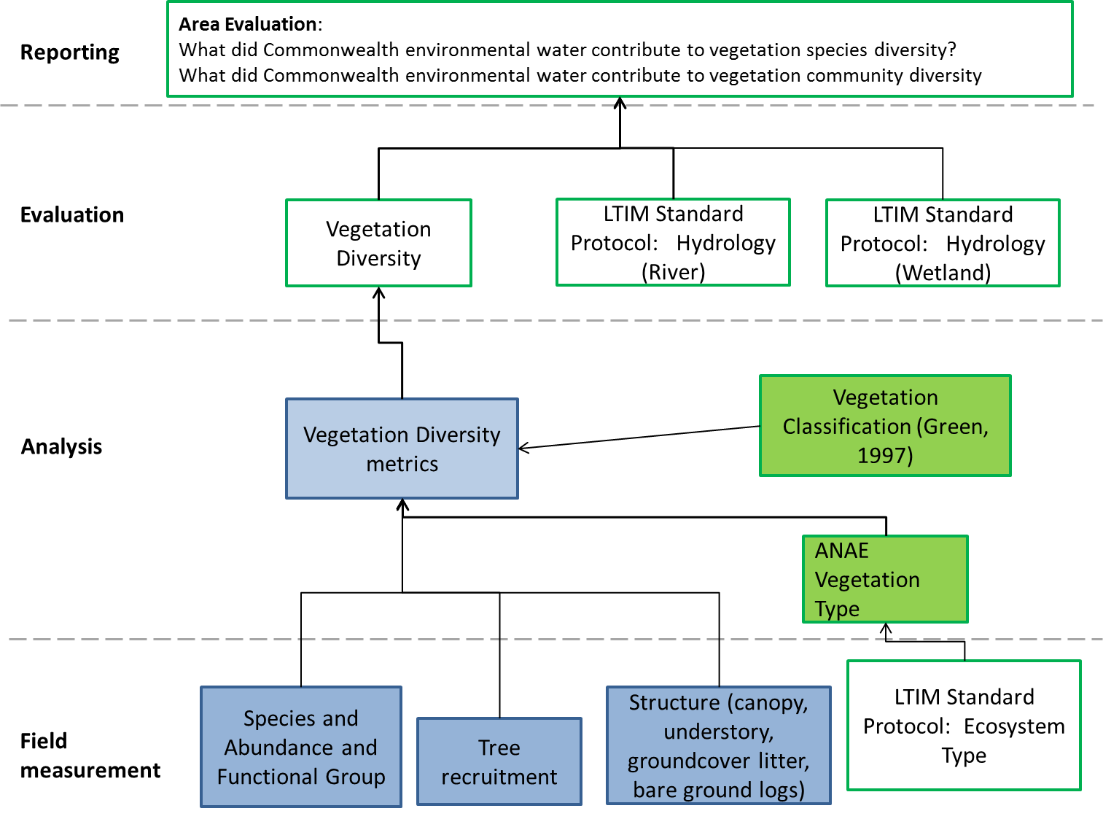
Figure 1. Schematic of key elements of the LTIM Protocol for the evaluation of Vegetation Diversity for the Lower Lachlan river system Selected Area.
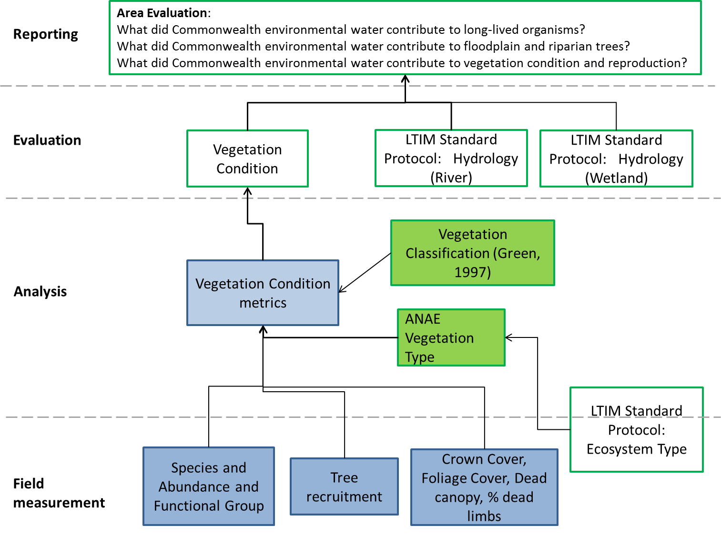
Figure 2. Schematic of key elements of the LTIM Protocol for the evaluation of Vegetation Condition for the Lower Lachlan river system Selected Area.

Relevant ecosystem types
Rivers and wetlands are the relevant ecosystem types for evaluating vegetation diversity and condition.

Relevant flow types
Fresh, bankfull, overbank (infrastructure assisted) are the relevant flow types for evaluating diversity and condition.

Overview and context
The condition, type and diversity of riparian and wetland vegetation communities are strongly influenced in by the frequency and extent of inundation (Brock and Casanova 1997; Kingsford 2000). Floodplain wetlands are major repositories of biodiversity (Kingsford 2000) and support distinct biological communities (Hillman 1986). Wetlands are a major target for ecological rehabilitation driven, at least in part, by environmental water allocations. Wetland vegetation is critical for carbon cycling and provision of food and habitat for water birds, amphibians, fish, terrestrial vertebrates and a variety of other biota (Kingsford and Thomas 1995, 2001; Kingsford and Johnson 1999; Leslie 2001).
Flooding frequency is associated with wetland biota structure and function on the floodplain (Boulton and Lloyd 1992; Jenkins and Boulton 1998). Flooding interacts with plant life-history processes such as dispersal, germination, recruitment, survival, growth, and reproduction. Although some native wetland species can thrive in permanently wetted habitats, flooding of previously dry habitats is a major stimulus to production of water plants and their associated biota such as invertebrates, both of which are important food sources for some waterbird species (Maher and Carpenter 1984; Briggs and Maher 1985).
The Lachlan river system in the study region, is low gradient and includes many paleochannels, anabranches and distributaries, such as Merrowie, Middle and Willandra creeks. There are abundant swamps, lagoons and billabongs associated with the distributaries of the lower river, culminating in the terminal Great Cumbung swamp. The predominant land uses in cleared areas of the floodplain are grazing and dryland and irrigated cropping (cereals, cotton, grapes, wheat and vegetables). However, there are significant areas of native vegetation, including three wetlands of national importance, listed in the Directory of Important Wetlands in Australia; Booligal Wetlands, the Great Cumbung Swamp and Lachlan Swamp. In addition there are other significant wetlands along Merrowie Creek, at Lake Brewster and Lake Cowal (DLWC 1997; Driver et al. 2010).
High-value wetland plant communities present include black box Eucalyptus largiflorens, river cooba (Acacia stenophylla), extensive reed beds (Phragmites australis) and extensive areas of riparian fringing river red gum forest (Eucalyptus camaldulensis) and woodland, including one of the largest stands of river red gum in NSW at the Great Cumbung Swamp. These vegetation communities support breeding events for tens of thousands of colonial nesting birds including straw-necked ibis and glossy ibis, birds listed under international migratory bird agreements including great egret, glossy ibis, sharp-tailed sandpiper, common greenshank, Latham’s snipe, painted snipe and white-bellied sea-eagle and birds listed as vulnerable including the Australasian bittern, blue-billed duck and freckled duck.
The vegetation diversity and condition methods will quantify and interpret the response of key plant species and communities e.g. black box, cooba, river red gum and reed beds in terms of condition, extent and life history responses to the provision of Commonwealth environmental water, taking into account the effects of landscape context, historical flows and land use. Function will be represented by measures of wetland vegetation response, focussed on condition and extent (assessed on-ground). Diversity is assessed on ground through surveys, and validation of these surveys as diversity-assessment tools. The resulting data will build on existing capacity to predict responses of different plant communities and species to alternative environmental flow scenarios delivered to the Lachlan floodplain.
For the Lower Lachlan River system Selected Area, much of the held environmental water delivered is combined with, or subsequent to other flows (e.g. translucent flow, stock and domestic replenishment, natural events or irrigation delivery). The capacity of Commonwealth environmental water to be delivered to specific locations will be similar to other forms of environmental water. In dry years this becomes more difficult, except at locations such as Booligal Swamp where structures such as Lake Brewster and Torrigany Weir enable local, controlled delivery (modelled in Driver et al. 2005).

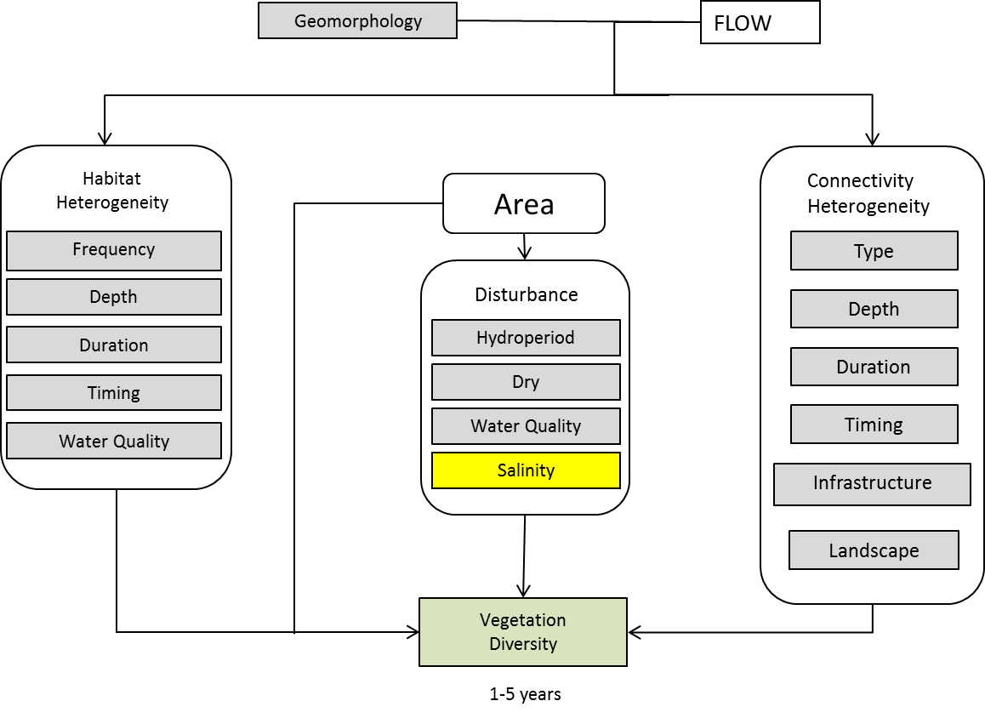
Figure 3. Cause and effect diagram for Vegetation diversity.
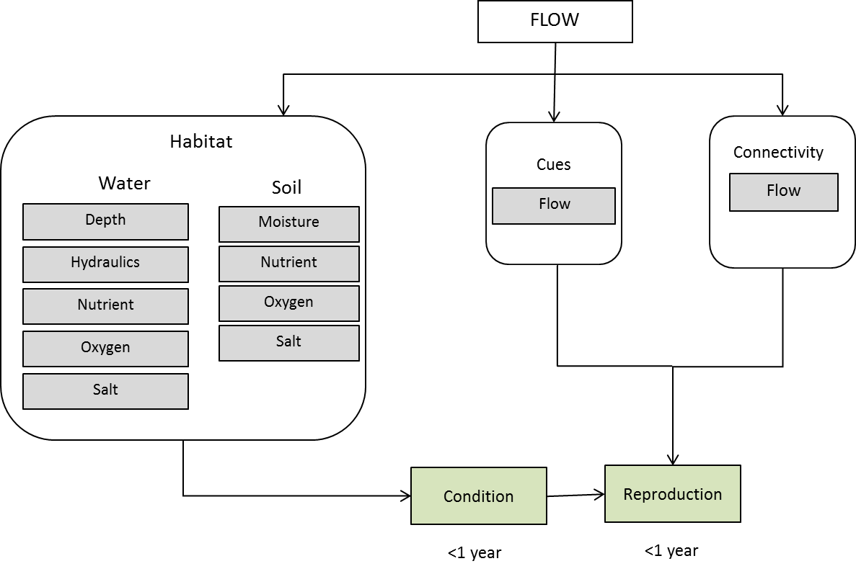
Figure 4. Cause and effect diagram for vegetation condition and recruitment

Complementary monitoring and data
The field measures required for the assessment of vegetation diversity are largely unique to the Lachlan river system Selected Area and are consistent with the Integrated Monitoring of Environmental Flows (IMEF) transect method that has already been employed in the Lachlan (Driver et al 2003) with some modifications based on Bowen (2013). Quadrat (within transect) data will be linked to geomorphic characteristics (sensu Roberts & Dyer (2007)) defined as wet, amphibious and dry. The consistency with the IMEF transect method means that historical data can be used to assist in interpreting the vegetation response to Commonwealth environmental water.

Monitoring locations

Overview
The LTIM Project for Basin Evaluation has adopted a hierarchical approach to sample design (see Gawne et al. 2013). Briefly, the spatial hierarchy for vegetation monitoring is as follows:

Selected Area → Zone → Site → Habitat (vegetation type, open water)

Selection of zone(s)
The vegetation community in the Lachlan river system Selected Area is dominated by woodland communities, with River red gum and Black box/River red gum communities prevalent in areas inundated by Commonwealth environmental water. Lignum and River Cooba are found in mixed stands with Black box and aquatic reeds, grasses and sedges are represented in some wetland sites. There is no way to draw a line along or across the study area that neatly splits the study area for vegetation.

The lack of clear delineation of vegetation types across the Selected Area means that the selection of zones is not supported. Instead, the vegetation response will be measured across the Selected Area and the evaluation stratified by Australian National Aquatic Ecosystem (ANAE) type (Brooks et al. 2013) and by the classification of Green (1997).

Selection of sites
The Selected Area contains several wetlands of national and regional significance as listed in the Directory of Important Wetlands (Environment Australia 2001). Many or all of these wetlands will be targets of CEWO, or NSW OEH environmental flow deliveries (Figure 5). The criteria used to select sites are:
- Accessibility: Each site should be accessible under a range of watering conditions so that monitoring can occur each year.
- Representative: Each site should not be an obvious ecological aberration and in combination, the sites should adequately represent the range of inundation dependent vegetation characteristic of the Selected Area. Vegetation types to be identified using the interim ANAE typology developed for the MDB (see Brooks et al. 2013) is presented in Error! Reference source not found..
- Likelihood of watering: The site must be highly likely to receive Commonwealth environmental water at least once in the next five years. Sample locations will be selected to cover the range of water dependent vegetation communities likely to be affected by Commonwealth Environmental Water within a given Selected Area.
- Bathymetry: Preference should be given to sites with known bathymetry (or DEM) and water level recording infrastructure.
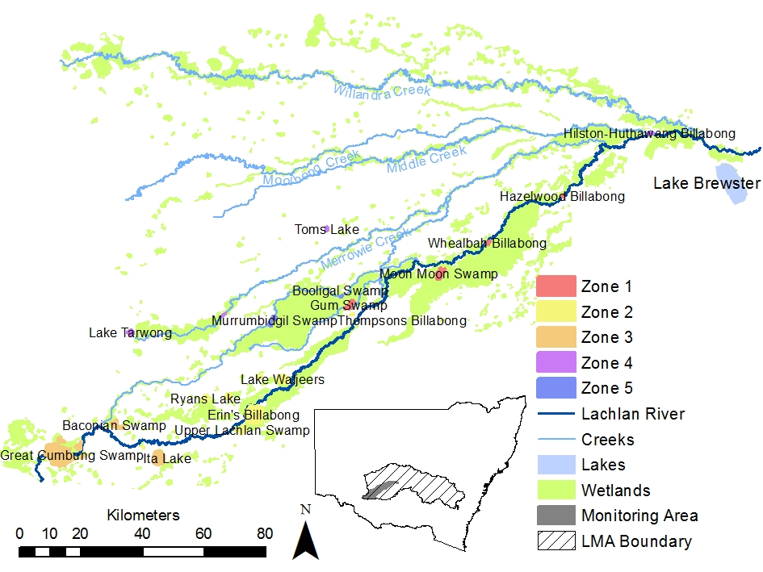
Figure 5. Potential vegetation diversity and condition monitoring sites.
Table 1. Vegetation type and applicability to the Lachlan category 3 vegetation diversity method
COMMONWEALTH CRITERIA | APPLICABILITY TO THE LACHLAN CATEGORY 3 VEGETATION DIVERSITY METHOD
River red gum forest | N/A
River red gum woodland | Yes
Black box forest | N/A
Black box woodland | Yes, but not pure stands, more mixed RRG/BBX woodland in the areas inundated by the Commonwealth environmental water.
Coolibah | Not in the Lachlan
River Cooba | Yes, but in mixed stands as with BBX (e.g. at Whealbah Lagoon).
Unidentified aquatic trees | N/A
Lignum | Yes, in mixed stands, often under RRG (e.g. Murrumbidgil Swamp).
Other shrub | N/A
Tall emergent aquatic (reeds, Phragmites, cumbungi, etc) | Yes. Represented (e.g. in Marrool, currently club rush).
Aquatic sedge/grass/forb | Yes
Freshwater grasses | Warrego Summer Grass is often common, but not dominant
Freshwater forb | No

Fixed site locations among years
Aquatic ecosystems are notoriously variable in space, so if sample size is not large and the sites selected change among years, inter-annual differences may be caused by spatial heterogeneity, not temporal effects. The method presented below relies on the use of fixed sites within and among years. One of the key reasons for this is the need for detailed hydrology at each site, and the resources required to develop flow-inundation relationships at new sites every year or even every few years would be too high. The other key consideration is the availability of existing flow-biota relationships, hydrology and bathymetry at many of the proposed sites. Additionally, the use of fixed sites allows the control of some of the confounding issues described above.

Site locations
Unpublished IMEF analyses indicate that 12 sites represent about 90% of catchment diversity within the Lachlan floodplain (with the study area defined within the site selection criteria described above). Twelve sites along the length of the Lower Lachlan River system Selected Area were selected as core monitoring sites for each year with optional sites that will be monitored depending on time and resources during sampling trips (Table 1). At each site data from replicate plots and transects will be collected.

Table 2. Sites selected for monitoring vegetation diversity and condition in the Lachlan river system Selected Area. Optional sites; which will be surveyed where possible. The clusters include sites from nationally significant wetland complexes (Environment Australia 2001): Booligal Wetlands, Merrowie/Box Creek, Great Cumbung Swamp (GCS) and Lachlan Swamp.
Wetland Complex | Site | Core (C)  Optional (O) | Wetland Transects | Riparian Plots
Booligal Wetlands | Merrimajeel Lagoon | C | 2 | 2
 | Murrumbidgil Swamp | C | 3 | 3
 | Merrowie Creek | C | 2 | 2
 | Moon Moon swamp | C | 2 | 2
Merrowie/Box Creek | Merrowie Creek on Cobb Hwy | O | 0 | 2
 | Lake Tarwong | C | 2 | 4
Lachlan Swamp | Lake Bullogal | C (O) | 2 (2) | 2 (2)
 | The Ville | C | 2 | 2
Great Cumbung Swamp | Marrool Lake | C | 2 | 2
 | Red gum 1. Old Lachlan | C | 2 | 2
 | Red gum 2. Nr Clear Lake | C | 2 | 2
 | Lake Ita inlet channel | O |  | 2
 | Lake Ita RRG | O |  | 2
 | Lignum Lake * | O | Photo observation of IMEF RRG time series only and [optional] birds during events.
Lachlan River Floodplain | Whealbah Billabong | C | 2 | 2
 | Hazelwood Billabong | C | 2 | 2
 | Erin’s Billabong (Lachlan Swamp)* | O | Photo observation of RRG only

Plot size /No of transects
This part of Australia has no forest-level densities of trees (see Specht 1970) and so only woodland communities are recorded. The non-treed community sampling design captures different non treed vegetation communities that occur at different elevations and locations within the wetland and / or river from submerged communities in the river or wetland bed through to emergent or littoral vegetation at the edges of aquatic ecosystems. The treed community sampling design is a minimum of 2 replicate 0.1 ha plots located entirely within the treed community and not encroaching into the adjoining aquatic or littoral vegetation communities see (Bowen 2013).
For treed communities overstorey tree health plots are 20x50 m (0.1ha) is the plot size used in the NSW Office of Environment and Heritage (NSW OEH) method for tree health (Bowen 2013) and is derived from Siverston (2009). For understory floristic survey 20x20 m (0.04ha) is the standard OEH method for floristic vegetation survey (Sivertson 2009).

Timing of field sampling
Sampling will occur both before and following delivery of Commonwealth environmental water. The exact timing of sampling will be largely dependent on the target vegetation communities and expected lag time for response to watering. Commonwealth environmental water is typically delivered in the Lachlan catchment in June – August. As such, sampling is intended to occur March/April, and three months after first fill.

Monitoring Protocol: Non-tree community
This is largely based on the transect method (Driver et al 2003), partly modified for consistency with LTIM and OEH methods applied in the Lachlan. It is applied to the riparian zones of billabongs, just below or within the tree fringe, and starting at the top of the bank for billabongs and finishes within the deeper sections of billabongs (or other floodplain wetlands).

Equipment
- GPS
- 100 m Tape
- Sample bags/project books
- Permanent markers
- Pens
- Hand lens
- Site poles
- Fluorescent spray paint
- Mallet
- 1 x 1 m quadrat
- Field data sheets.
- Camera (with inbuilt GPS)
- Boat (for wide or deep streams).
- Life Jackets
- Waders/wetsuit & boots
- Wetsuit gloves
- A copy of this protocol.

Preparation
- Before leaving the office / laboratory the following should be checked:
  - Batteries are charged and properly inserted.
  - Previous data downloaded and memory cleared.
  - GPS camera recording correctly
  - All equipment listed above is present and in functional order.

Site Establishment
- Find the site using the point location established in the Monitoring and Evaluation Plan.
- Record the following on the field sheet:
  - River or wetland name and ANAE ID.
  - Date and time.
  - GPS coordinates (latitude and longitude; GDA94).
  - Name(s) of installation team.
- Install the initial site marker pole at the high water mark, ensuring that it is solidly fixed.
- Run a tape perpendicular to the bank 100m into the wetland. Install the 2nd marker pole at the end of the tap (or known distance if more practical)

Data Collection
- Each person who will be entering the water is to put on protective clothing (e.g. life jacket plus waders with an external belt, or wetsuits and boots and wetsuit gloves).
- Always start the survey at the highest elevation.
- Attach a 100 m tape to the site marker pole at the start of the first transect and run the tape out towards the end marker pole
- Standing at the starting site marker pole, photograph along the line of the tape, to the right and left of the tape and take a panorama photograph (or set of panoramas)
- Place the one metre square quadrat on the ground or water surface in front of you record the direction from the tap of the quadrat
- For each quadrat, record the following details on the field data sheet:
  - Transect number;
  - Quadrat number;
  - Distance from the start of the transect;
  - Water depth (m);
  - Stock pug (hoof) marks per square metre;
  - Estimated percentage cover of litter/debris;
  - Estimated percentage cover of bare ground/mud;
  - Name of each plant species (if known). If unknown record a Temporary code (e.g. unknown sedge # 1);
  - Estimated percentage cover of each plant species (nearest 10 %, or below about 5 % cover, the nearest 1 % [~ %PFC]), and;
  - the number of individual plants in a quadrat
  - The linear length of fallen timber > 10 cm
  - Median height of individual plant species in a quadrat
  - The life stage of each plant species (Vegetative (V), Flowering (FL), Fruiting (FR), Seeding (S) or Dead (D);
- If you are unsure of taxonomic status remove a specimen, including flowers and fruits if present, and place it in a plastic bag. Ensure that the destructive effects of sampling are minimised, especially with less common species. Label the bag with:
  - Site Number.
  - Site/Wetland Name.
  - Collectors Name(s).
  - Date collected.
  - Temporary code (e.g. unknown sedge # 1).
- Please note these ‘unknown specimens’ should be pressed and preserved as soon as possible for later identification.
- When you return to the office, remove specimens from their bags and tape each plant to a specimen sheet. Label the sheet appropriately. Allow specimens to dry completely before pressing.
- Place the specimen sheets into a plant press.
- Carefully place pressed specimens into a specimen box.
- Contact the NSW Herbarium and advise them in advance of the number of specimens that you will be sending them and the type of analysis that you require.
- Send specimen boxes to the NSW Herbarium for identification, to species level. Naphthalene or toilet soap may be added to the specimen box to prevent specimens being eaten by insects.

Monitoring protocol: Tree Community
This method is based on the NSW OEH method for survey and monitoring of flood dependent vegetation (Bowen, 2013). It is designed to capture quantitative measures of the condition, structure and species composition of flood dependent vegetation communities. It includes measures of:
- Measures of cover.
- Tree recruitment.
- Community Structure.
- Species abundance.
- Functional group.

Equipment
- GPS
- 2 x 100 m Tape
- 4 x hooked sand tent pegs for marking corners of the plot
- Sample bags/project books for collecting plant samples
- Permanent markers
- Pens
- Hand lens
- Site poles
- Fluorescent spray paint
- Mallet
- Aluminium tags
- Galvanised roofing nails
- Hammer
- DBH tape
- Field data sheets
- Field ID books
- Camera (with inbuilt GPS)
- Gumboots or waders
- A copy of this protocol.

Preparation
- Before leaving the office / laboratory the following should be checked:
  - Batteries are charged and properly inserted.
  - Previous data downloaded and memory cleared.
  - GPS camera recording correctly
  - All equipment listed above is present and in functional order.

Site Establishment
- Find the site using the point location established in the Monitoring and Evaluation Plan.
- Record the following on the field sheet:
  - River or wetland name and ANAE ID.
  - Date and time.
  - GPS coordinates (latitude and longitude; GDA94).
  - Name(s) of installation team.
- Install the initial site marker pole at the NE corner of the 0.1 ha plot.
- Plot is oriented north/south (i.e. tape is run 50 m S and 20 m W, starting from the NE corner). Alternate orientation is allowable but must be recorded.
- Install the second site marker pole at the SW corner of the plot
- Mark the corners of the plot with sand pegs and also place markers at the 20m point on the long side of the plot to mark out a nested 0.04 ha plot
- Tag and number each live tree of diameter at breast height (dbh) greater than 10 cm within the 0.1ha plot using aluminium tags and galvanized nails, starting with the tree closest to the NW corner of the plot. Trees within the 0.04 ha plot must be tagged first, before tagging the remaining trees in the 0.1ha plot.

Data Collection: Floristic Data
- Mark out the site using the site establishment protocol (section 1.9.3)
- For the 0.04ha plot record the following details on the field data sheet for all vascular species and each structural component of the vegetation (Tallest stratum, mid-stratum (>1m) and lower (<1 m) stratum).
  - % plot flooded
  - % plot wet soil
  - % open water (including % submerged litter; % submerged bare ground; % submerged vege)
  - % unsubmerged litter
  - % unsubmerged bare ground
  - Average water depth (cm)
  - Species Cover recorded as Foliage Cover (FC) and is the percentage of the sample plot occupied by the vertical projection of foliage and branches (if woody) of a species for in each stratum in which it occurs.
  - Crown Extent (CE) and Canopy openness (CO) for all tree species in the tallest stratum in treed communities
  - the percentage of the sample plot occupied by litter (non-attached plant matter e.g. leaves and branches less than 10 cm diameter) and is recorded as the sum of submerged and non-submerged litter in flooded plots (Note: where plants are dry or dead but can still be identified to species and are attached to the base of the plant, their cover is included in the species cover not in per cent litter)
  - the percentage of the sample plot occupied by bare earth and is recorded as the sum of submerged and non-submerged bare ground in flooded plots.
  - Number of individuals of each species (actual count or estimated number from sub quadrats for superabundant species) in each stratum in which it occurs.
  - Strata type (T=tallest, M=mid (>1m), L = lower (<1 m)
  - Upper height (average) of each species (metres).
  - Lower height (average) of each species (metres)
  - Linear length of fallen timber at site – the total length of fallen timber of diameter >10 cm is recorded.
- If you are unsure of taxonomic status remove a specimen, including flowers and fruits if present, and place it in a plastic bag. Ensure that the destructive effects of sampling are minimised, especially with less common species. Label the bag with:
  - Site Number.
  - Site/Wetland Name.
  - Collectors Name(s).
  - Date collected.
  - Temporary code (e.g., unknown sedge # 1).
- Please note these ‘unknown specimens’ should be pressed and preserved as soon as possible for later identification.
- When you return to the office, remove specimens from their bags and tape each plant to a specimen sheet. Label the sheet appropriately. Allow specimens to dry completely before pressing.
- Place the specimen sheets into a plant press.
- Carefully place pressed specimens into a specimen box.
- Contact the NSW Herbarium and advise them in advance of the number of specimens that you will be sending them and the type of analysis that you require.
- Send specimen boxes to the NSW Herbarium for identification, to species level. Naphthalene or toilet soap may be added to the specimen box to prevent specimens being eaten by insects.

Data Collection: Tree Data
- Mark out the site using the site establishment protocol (section 1.9.3)
- For the 0.1ha plot record the following details on the field data sheet for trees (live or dead) of >10cm dbh
  - Species
  - Tree height (m)
  - Diameter at breast height (dbh) (cm)
  - The location as being within the 0.04 ha sub-plot or within the remainder of the 0.1 ha plot
  - Canopy Extent - CE _{(tree).} This is the 2 dimensional lateral spread (length x width) of the branches and foliage of a live tree, or the limbs of a dead tree, measured from the edge to edge of the remaining bare limbs or branches.
  - Canopy openness - CO _{(tree)}: estimated as the percentage of the sky that is obscured by the canopy (leaves and small branches).
  - Percentage Dead Canopy - DC _{(tree)}: is the percentage of the tree canopy CE _{(tree) that} is dead or severely damaged.
  - Epicormic growth: yes /no Y/N
  - Ratio of dead to live limbs - DLL _{(tree)}: the number of dead major limbs as a ratio of the total number is recorded. Major limbs are limbs arising from the main trunk or from multiple stems but not branches. For example: a tree with 4 major limbs and one dead, DLL = 1 of 4.
  - Breeding status - the presence of flowers (F) and / or buds (B) and or / fruit (Fr)
  - Number of hollows - appropriate for hollow dependent (fauna that can be seen with the aid of binoculars
  - Number of nests is recorded for each numbered tree.
- For the 0.1ha plot the number of trees (live or dead) of each species of <10cm dbh is recorded on the field data sheets
- Linear length of fallen timber at site – the total length of fallen timber of diameter >10cm both within the 0.04 ha and remainder of the 0.1 ha plot.
- Total number of seedlings - stems that are <10 dbh and < 1 m tall and are not sprouting from a coppiced rootstock, are treated as seedlings and the number is recorded separately for the 0.04 ha and remainder of the 0.1 ha plot.
- Total number of saplings - stems that are <10cm dbh and > 1 m tall and are not sprouting from a coppiced rootstock, are treated as saplings and the number is and the number is recorded separately for the 0.04 ha and remainder of the 0.1 ha plot.

Data analysis
Once data have been collected from each site, the following additional steps need to occur
- Check the Calculation of Total Foliage Cover (FC)
Total FC for lower stratum (<1 m) + ∑Species Cover + % litter + %bare ground = 100%, unless lower stratum space is occupied by mid storey emergent tussock form graminoid or spreading shrub species >1m tall (e.g. Lignum, rushes or reeds). Thus ground stratum the FC lower (ground) stratum = ∑Species Cover + % litter + %bare ground = 100% - total ∑FC of these mid stratum species.
In flooded sites total FC lower (ground) stratum includes; submerged vegetation, submerged bare ground and submerged litter.
- Assign functional groups
Plant species are to be grouped into the four following functional groups (Brock and Casanova 1997, Casanova 2011):

- Amphibious responders (AmR) – plants which change their growth form in response to flooding and drying cycles.
- Amphibious tolerators (AmT) – plants which tolerate flooding patterns without changing their growth form.
- Terrestrial damp plants (Tda) – plants which are terrestrial species but tend to grow close to the water margin on damp soils.
- Terrestrial dry plants (Tdr) - those which are terrestrial species which don’t normally grow in wetlands but may be encroaching into the area due to prolonged drying.

The use of these Brock and Casanova 1997 functional groups has been commonly employed in NSW state reporting [e.g. IMEF, Mawhinney 2003, Driver et al. 2010, 2011 and NSW OEH, Bowen 2013), and this will carry through to this method. Variations to the above method, consistent with state methods, will include:

- Measures of diversity based on the % cover of plant species recorded in the field. At least one level of correction will be required because the transect method records on average about 60% of the diversity that would be recorded in ocular surveys (Driver et al. 2014);
- For analysis and survey design vegetation species and communities are also grouped within “functional groups” (described in terms of the response to flooding of their dominant or canopy species) consistent with the definition of a wetland in the NSW Wetlands Policy (2010, following Bowen and Simpson 2010; Bowen 2013 and Thomas et al. 2010).

Functional Group can be generated automatically from species name during data analysis from master list.
- Calculate Crown Cover
Crown cover is a measure used to classify vegetation structural type and is used in the OEH Vegetation Type Standard (Sivertson 2009). It is derived for each species in the over storey stratum of the plot by dividing the sum of canopy extent of all trees of that species by the area of the plot.
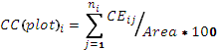
Where there are j = 1 to n_{i} trees of species i in the plot
- Calculate Foliage Cover
Foliage Cover (FC) is the percentage of the sample site occupied by the vertical projection of foliage and branches (Walker and Hopkins 1998). Equivalent to the amount of shadow that would be cast on the ground if there were a light source directly overhead. Also referred to as “canopy cover” (Ayers et al 2009; DECC 2011). To derive percentage foliage cover for the plot FC _{(plot)}, crown cover CC _{(plot)} for each species is multiplied by the average Crown openness (CO) for each species. Crown openness, also known as crown type, is illustrated in Supplement 2C.
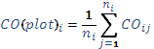
Where there are j = 1 to n_{i} trees of species i in the plot.
So FC for species i for the plot is derived using:
- Calculate Dead canopy percentage for each plot
Dead canopy (plot): is the average DC of all trees of each species for the plot expressed as a per cent.
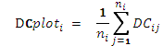
Where there are j = 1 to n_{i} trees in the plot for species i
- Calculate the percentage of dead limbs for the plot
% Dead limbs (total) is calculated as the average % dead limbs as a proportion of total limbs for the plot.

Evaluation
For each survey occasion, Spearman rank correlations will be calculated between the historical dry period frequency and the number of plant species on the banks and in the water to determine the contribution of Commonwealth environmental water to species diversity. Similar analyses will be conducted for abundance and cover of species and function groups. The recruitment and condition of key riparian species (river red gum, black box, coolabah and river cooba) will be analysed with respect to the duration of watering using univariate and graphical methods to determine the contribution of Commonwealth environmental water to populations of long-lived organisms.
For floodplain and riparian vegetation communities (dominated by flood dependent trees in the overstorey) temporal changes in tree canopy condition statistics with Commonwealth environmental watering will be analysed using graphical and univariate analysis methods. Changes in tree condition will be analysed in the context of antecedent wetting, climate (particularly temperature) and seasonal effects. Similar analyses will be conducted using metrics of vegetation community condition which incorporate elements of structure and cover. Multivariate analyses (using measures of dispersion from MDS plots) will be used to detect changes across multiple elements of the vegetation community in relation to the duration of watering.
Multiple regression will be used to determine effects on plant condition and diversity in the context of antecedent wetting, climate (particularly temperature), seasonal effects, adjacent landuse and disturbance.
The use of fixed sites which are monitored each year will provide data with a range of antecedent watering conditions (including sites that are not watered) thus enabling more sophisticated analyses (using Boosted Regression Trees) to be used to determine the effects of watering within the context of antecedent conditions to be determined. Data from IMEF monitoring that occurred in both drought conditions (2002-2009) and wet conditions (1998-2000, 2010/2011) provide key baselines from which to assess the benefit of environmental watering. Because of the effort required, however, analyses for routine reporting will however focus on the recently collected plant data rather than attempting a full analysis of all collected data. In addition, data collected as part of River Red Gum health monitoring in Murrumbidgil Swamp in 2012/13 and vegetation diversity and condition data from Lake Waljeers, Lake Ita and the Great Cumbung Swamp in 2012/13 can also be used to contribute to baseline data.

Data management
Following identification of the species that were unknown, data will be transferred from field data sheets to intermediate tables within a Microsoft Access database. Data in intermediate tables will be verified by QA/QC staff. The original datasheets will be scanned and copies of the data stored at the University of Canberra.

Health and safety
For details on health and safety please refer to the Workplace Health and Safety Plan for the Lower Lachlan river system Selected Area (WHS 202.1) in appendix 3.

References
Ayers D., Seddon, J., Briggs, S., Doyle, S and Gibbons, P. (2009) Interim benchmarks for the Biometric Tool; http://www.environment.nsw.gov.au/resources/nature/Biometric_benchmarks.pdf
Bowen, S. and Simpson, S. L (2010) Changes in extent and condition of the vegetation communities of the Macquarie Marshes floodplain 1991-2008: Final Report to the NSW Wetland Recovery Program. Rivers and Wetlands Unit, Department of Environment Climate Change and Water, NSW, Sydney.
Casanova, M.T. and Brock, M.A. (2000). How do depth, duration and frequency of flooding influence establishment of wetland plant communities? Plant Ecology 147, 237–250
Casanova, M.T. (2011) Using water plant functional groups to investigate environmental water requirements. Freshwater Biology (2011) 56, 2637–2652
Bowen, S. (20133). NSW OEH Environmental Flow Monitoring Program: Methods for monitoring of flood-dependent vegetation communities. Water and Rivers Team, NSW Office of Environmental and Heritage, Sydney .
Brock, M.A. and Casanova, M.T. (1997). Plant life at the edge of wetlands: ecological responses to wetting and drying patterns. In Frontiers in Ecology: Building the Links. Edited by N. Klomp and Lunt. Elsevier Science, Oxford. pp. 181–192.
Brooks, S. and Wealands, S.R. (2014). Commonwealth Environmental Water Office Long Term Intervention Monitoring Project: Data Standard. Report prepared for the Commonwealth Environmental Water Office by The Murray-Darling Freshwater Research Centre. MDFRC Publication 29.3/2013 Revised Jan 2014.
Brooks, S., Cottingham, P., Butcher, R., and Hale, J. (2013). Murray-Darling Basin aquatic ecosystem classification: Stage 2 report. Peter Cottingham & Associates report to the Commonwealth Environmental Water Office and Murray-Darling Basin Authority, Canberra.
Chessman and 17 other authors (2003) Integrated Monitoring of Environmental Flows State Summary Report 1998- 2000. NSW Department of Infrastructure, Planning and Natural Resources
Cunningham S.C., Mac Nally R., Read J., Baker P.J., White M., Thomson J.R., & Griffioen P. (2009) A robust technique for mapping vegetation condition across a major riversystem. Ecosystems, 12, 207‐219. CSIRO publishing.
Department of Environment, Climate Change and Water NSW (2011) Operational Manual for BioMetric 3.1. Department of Environment, Climate Change and Water, NSW Sydney; http://www.environment.nsw.gov.au/papers/BioMetricOpManualV3-1.pdf.
Driver, P. and Knight, C. (2007). Responses of groundcover plants to environmental flows in the Macquarie Marshes in 2005/06. Report to the Macquarie Marshes Environmental Flow Reference Group. Aquatic Science Unit, Environmental Evaluation & Performance Branch, NSW Department of Water and Energy
Driver, P. D., Hardwick, L., Maguire, J. and Lloyd-Jones, P. (2003). Vegetation Survey for Billabongs. Integrated Monitoring of Environmental Flows Methods Manual’. (Chessman, B., Ed.). Scientific and Technical Operating Procedures. New South Wales Department of Infrastructure, Planning and Natural Resources:
Driver, P., Barbour, E. and Michener, K. (2011). An integrated surface water, groundwater and wetland plant model of drought response and recovery for environmental water management. In Chan, F., Marinova, D. and Anderssen, R.S. (eds.) MODSIM2011, 19th International Congress on Modelling and Simulation. Modelling and Simulation Society of Australia and New Zealand, December 2011, pp. 2444-2450. ISBN: 978-0-9872143-1-7.
Driver, P., Chowdhury, S., Wettin, P. and Jones, H. (2005). Models to predict the effects of environmental flow releases on wetland inundation and the success of colonial bird breeding in the Lachlan River, NSW. In: ‘Proceedings of the 4th Annual Stream Management Conference: linking rivers to landscapes. 19-22 October 2004, Country Club Casino, Launceston, Tasmania.’ (Eds. Rutherfurd, I. D., Wiszniewski, I., Askey-Doran, M. J. and Glazik, R.), pp. 192-198
Driver, P.D., Chowdhury, S., Hameed, T., O’Rourke, M. and Shaikh, M. (2010). Ecosystem response models for lower Calare (Lachlan River) floodplain wetlands: managing wetland biota and climate change modelling. In: Ecosystem response modelling in the Murray-Darling Basin (Overton, I. and Saintilan, N., Eds.), CSIRO Publishing, pp. 183-196
Driver, P., Lloyd-Jones, P., & Barbour, E. (2014). Rapid appraisal of groundcover plant diversity and red gum health for the management of Murray Darling Basin wetlands. Proceedings of the 7th Australian Stream Management Conference, Townsville, July 2014.
Gawne, B., Brooks, S., Butcher, R., Cottingham, P., Everingham, P., Hale, J., Nielsen, D.L., Stewardson, M., and Stoffels, R. (2013). Long Term Intervention Monitoring Logic and Rationale. Document Final Report prepared for the Commonwealth Environmental Water Office by The Murray-Darling Freshwater Research Centre.
Gibbons, P., Ayers, D., Seddon, J., Doyle, S. and Briggs, S. (2008). BioMetric 2.0. A Terrestrial Biodiversity Assessment Tool for the NSW Native Vegetation Assessment Tool (formerly Property Vegetation Plan Developer) Operational Manual, NSW Department of Environment and Climate Change and CSIRO Sustainable Ecosystems, Canberra ACT.
Mawhinney, W. A. (2003). Restoring biodiversity in the Gwydir Wetlands through environmental flows. Water Science & Technology 48, 73-81.
OEH 2014 NSW VIS Classification Web 2.1 Public User Manual. http://www.environment.nsw.gov.au/resources/research/140286VISPUM.pdf)
Roberts, J and Dyer, F. (2007) Magnitude of response: selecting sites for monitoring vegetation response to environmental flows. In A.L. Wilson, R.L. Dehan, R.J. Watts, K.J. Page, K.H. Bowmer, A. Curtis (editors) Proceedings of the 5th Australian Stream Management Conference. Australian Rivers, Making a Difference. Charles Sturt University Thurgoona, New South Wales
Roberts, J. and Hale, J. (2013). Monitoring Riparian Zones in the Western Catchment: Round 2 – 2012. A report to the Western Catchment Management Authority.
Sivertsen, D. (2009). Native Vegetation Interim Type Standard, Department of Environment, Climate Change and Water NSW, Sydney
Thomas, R., Bowen, S., Simpson, S., Cox, S., Sims, N., Hunter, S., Lu, Y., Saintilan, N. & Overton, I. (2010). Inundation response of vegetation communities of the Macquarie Marshes in semi-arid Australia. Ecosystem response modelling in the Murray-Darling Basin. CSIRO Publishing, Melbourne, 137-150

.

Supplement 2A: Wetland groundcover survey data sheets.
Wetland Transect Survey

Site information
Date |  | Site Name
Site Code
Recorders
Gauge depth |  | Est Avge Depth
 |  | Est Max Depth
Time since last inundation
Transect 1
AMG grid reference | zone | Easting
 | datum | Northing
Transect Direction
Transect 2
AMG grid reference | zone | Easting
 | datum | Northing
Transect Direction

Photo Notes
Panoramic photo series taken from long-term photo point? y / n
Number of photos________
Start and finish time of photos ____________
Site Sketch
(provide a detailed site sketch including distances of bare, vegetated and wet areas; note location and orientation of transects within broader landscape features)

 | Transect 1
Quadrat ¹ | 1 | 2 | 3 | 4 | 5 | 6 | 7 | 8 | 9 | 10
% Water
% Debris/litter
% Bare ground/mud
% Vegetation Cover
Water depth (m)
Disturbance (%)
Timber length (m)²
Soil Moisture ³

 | Transect 2
Quadrat ¹ | 1 | 2 | 3 | 4 | 5 | 6 | 7 | 8 | 9 | 10
% Water
% Debris/litter
% Bare ground/mud
% Vegetation Cover
Water depth (m)
Disturbance (%)
Timber length (m)²
Soil Moisture ³
¹ equally spaced between 0 m and end of transect ² Total linear length of timber >0. 1 m ³ 0 = dry; 5 = inundated
# | Transect: | Quadrat | 1 |  |  | 2 |  |  | 3 |  |  | 4 |  |  | 5 |  |  | 6 |  |  | 7 |  |  | 8 |  |  | 9 |  |  | 10
 | Species | Stage | # | C | H | # | C | H | # | C | H | # | C | H | # | C | H | # | C | H | # | C | H | # | C | H | # | C | H | # | C | H
* Stage = Vegetative (V), Flowering (FL), Fruiting (FR), Seeding (S) or Dead (D)
# = number of individual plants in 1 x 1 m quadrat; C = % cover to nearest 10% or 1% for < 10%); H = average height of plants

# | Transect: | Quadrat | 1 |  |  | 2 |  |  | 3 |  |  | 4 |  |  | 5 |  |  | 6 |  |  | 7 |  |  | 8 |  |  | 9 |  |  | 10
 | Species | Stage | # | C | H | # | C | H | # | C | H | # | C | H | # | C | H | # | C | H | # | C | H | # | C | H | # | C | H | # | C | H
* Stage = Vegetative (V), Flowering (FL), Fruiting (FR), Seeding (S) or Dead (D)
# = number of individual plants in 1 x 1 m quadrat; C = % cover to nearest 10% or 1% for < 10%); H = average height of plants

Supplement 2B: Measures of cover
In this study cover is measured as “percent foliage cover” and is the area that is covered by a vertical projection of the plants foliage and small branches or the shadow cast on the ground rather than “projected foliage cover” that was suggested in the LTIM standard method. This is applied to ALL vegetation measures in the monitoring (e.g. trees, shrubs, ground, individual species, etc.). An example of “percent foliage cover” is provided in Figure 6.

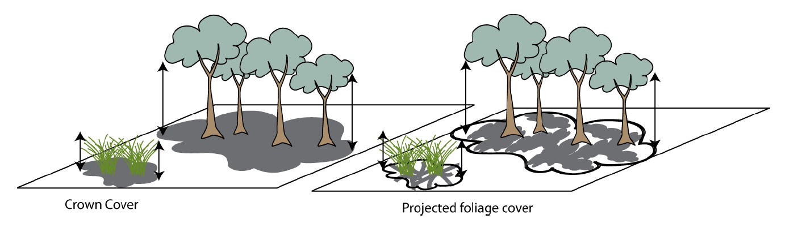
Figure 6. Crown (or canopy) cover (CC, left) and Percent Foliage Cover (%FC, right). The picture (from Roberts and Hale 2013) was intended to represent projected foliage cover on the right but – for the detail shown in this picture – equally well represents %FC; which is what is ultimately reported in this study. CC is a function of crown extent and plot area. CC and Crown Openness at the plot scale are then used to calculate %FC .

Percent foliage cover (%FC) has been chosen as the measure of cover used in this method as projective foliage cover is difficult to measure in the field especially for understorey species.

Note: Difference between projective foliage cover and percent foliage cover:

- Projective foliage cover (pfc) is equivalent to the vertical shadow cast by an individual crown’s photosynthetic material only (leaves, phyllodes, needles)
- Percent foliage cover (%FC) , is equivalent to the amount of shadow that would be cast on the ground if there were a light source directly overhead and consists of both photosynthetic material and small twigs and branches

Supplement 2C: Canopy openness estimate

In some RRG communities CO will be much less than 40 % especially in poor (>80% dead canopy) and intermediate poor (41-80% dead canopy) communities.
Source: DECC (2011) pg. 86. from Figure 6, p. 71 of Walker and Hopkins 1998).

Supplement 2D: Flood Dependent vegetation data sheets (from OEH)

Location |  |  | Survey Name | Plot No. | Recorders
Date |  | Site No.
AMG grid reference | zone datum |  | Easting |  | Northing |  | Position in quadrat
Base Plot size |  | Orientation of 0.1ha plot |  | marked

Structure & Composition (within 0.04 ha quadrat) Site Photo Number
Keith Class |  | NE
Regional Veg Class (BVT) |  | N
BioMetric Type (or NVCA) |  | SW
Flooding Status: |  | S

Land Use  (dominant) | nature travelling forestry grazing grazing / cropping other:  conservation stock route cropping
Land Cover  (upper stratum) | none native environmental native exotic exotic  planting plantation plantation other:
Land Cover  (ground stratum) | none native environmental native exotic exotic  planting plantation crop other:
Age structure | early advanced uneven mature senescent  regeneration regeneration age

Site History | Freq. code | Age code | Land Manager Survey: categories, quantities, comments
Grazing management |  |  | not set rotational / cell  grazed stocked grazing
Farming |  |  | none direct disc plough mouldboard  drill tyned implement rotary hoe
Erosion control |  |  | none contour contour mulching other  cultivation banks
Pasture improvement rates (fertiliser) kg/ha |  |  | none <125 126-250 >250
Pasture improvement rates (lime/dolomite) t/ha |  |  | none <2 2-4 4-7 >7
Timber extraction
(incl. firewood)
Regrowth management
Weed control
Pest animal control
Burning
Frequency: 0=no record, 1=rare (>5yrs), 2=occasional (2-5yrs), 3=frequent (<2yrs). Age: R=recent (<3yrs), NR=not recent (3-10yrs), O=old (>10yrs)

Plot Disturbance | Severity code | Age code | Observational evidence:
Clearing (inc. logging)
Firewood collection
Grazing
Fire damage
Severity: 0=no evidence, 1=light, 2=moderate, 3=severe Age: R=recent (<3yrs), NR=not recent (3-10yrs), O=old (>10yrs)

OEH VEGETATION FIELD SURVEY FORM
SITE No.
Date.

Date:
Flood Dependent Communities – Floristics
(within 0.04 ha quadrat)
Sub-Stratum L M T | Growth form | Field name | Species name | % Cover | No of individuals | Field  No. | Ht (m)
L | - | Ave Water Depth in cm
L | - | Flooding (% of plot)
L | - | Wet Soil (% of plot)
L | - | Litter / submerged Litter
L | - | Bare Ground / Submerged Bare Ground
Growth form:T=tree, M=mallee tree, S=shrub, Y=mallee shrub, Z=heath shrub, C=chenopod shrub,
G=tussock grass, H=hummock grass, D=sod grass, V=sedge, R=rush, E=fern,
F=forb, L=vine, A=cycad, P=palm, X=xanthorrhoea, U=samphire shrub.
OEH VEGETATION FIELD SURVEY FORM
Flood Dependent Communities – Floristics (cont.)
SITE No.
Date:
Datette

Date:
(within 0.04 ha quadrat)
Sub-Stratum L M T Growth form Field name Species name % Cover No of individuals Field  No. Ht (m)ub-stratum | Growth form | Field name | Species name | % Foliage cover | No of Individuals | Field  No. | Ht. (m)
Growth form:T=tree, M=mallee tree, S=shrub, Y=mallee shrub, Z=heath shrub, C=chenopod shrub,
G=tussock grass, H=hummock grass, D=sod grass, V=sedge, R=rush, E=fern,
F=forb, L=vine, A=cycad, P=palm, X=xanthorrhoea, U=samphire shrub.
OEH VEGETATION FIELD SURVEY FORM –
SITE No.
Date:
Datette

Date:
Flood Dependent Communities – tree health and site flooding data. Tree health data
(within 0.04 ha and 0.1 ha quadrat)
Plot 0.04/ 0.1 ha | Tree No | Stem No | Species name | Tag  No | DbH (cm) | Crown Extent (m²) | %  Canopy Openness | %  Dead  Canopy | Ht (m) | Dead limbs /live limbs | Fruit /  Flower / bud  Fr/F /B | hollows | nests

CE=Crown extent (of each tree), CO = Canopy openness the percent of the sky obscured by leaves and small branches
Used to derive %Foliage cover (for tree as a whole), DC Dead canopy % of present foliage that is dead, Limb = main stem from common trunk (i.e. if tree has 4 and 2 are dead = (2/4).

Site Flooding Parameters (within 0.04ha)
% plot flooded | % plot wet (soil) | %open water (surface free of veg) | Av Water depth (cm) | % submerged bare ground | % submerged vegetated (species) | %bare ground (surface) | Time since last flood (<1, 1,2,5,etc,years)

Plot | Species Name (if known) | Seedlings  stems  < 10cm dbh and < 1m tall.) | Saplings  <10cm dbh and > 1m | Plot | Species Name (if known) | Seedlings (<10 cm dbh <1 m tall) | Saplings  < 5cm dbh and > 1m
0.04 ha |  |  |  | 0.1ha
0.04 ha |  |  |  | 0.1 ha
Site Recruitment (within 0.04ha and 0.1 ha)
OEH VEGETATION FIELD SURVEY FORM –
SITE No.
Date:
Datette

Date:
Flood Dependent Communities – tree health and site flooding data.

Tree health data
(within 0.04 ha and 0.1 ha quadrat)
Plot 0.04/ 0.1 ha | Tree No | Stem No | Species name | Tag no | DbH (cm) | CE (m²) | CO | %DC | Ht (m) | Dead limbs /live limbs | Fruit /  Flower / bud  Fr/F /B | hollows | nests
CE=Crown extent (of each tree), CO = Canopy openness the percent of the sky obscured by leaves and small branches used to derive %Foliage cover (for tree as a whole see), DC Dead canopy % of present foliage that is dead, Limb = main stem from common trunk (i.e. if tree has 4 and 2 are dead =(2/4).

Foliage cover (FC) is the percentage of the sample site occupied by the vertical projection of foliage and branches (if woody). This is sometimes also termed per cent foliage cover or projected canopy cover. (Ayers et al 2009).
Projective Foliage Cover is the percentage of the sample site occupied by the vertical projection of foliage only (Walker and Hopkins 1998). Not to be confused with Foliage Cover.
Crown cover (CC) is the percentage of the samples site within the vertical projection of the periphery of crowns. In this case, crowns are treated as opaque. (Ayers et al 2009).
Hollows are defined as in Rayner et al. (2013): cavity with entrance diameter >1cm and depth =/> entrance dimension.

