InstLandWaterSociety Logo RGB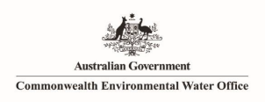

**Commonwealth Environmental Water Office**

**Long-Term Intervention Monitoring Project**

**Murrumbidgee River System Summary Report 2014-18**

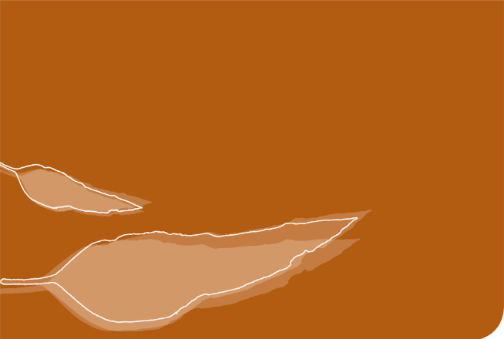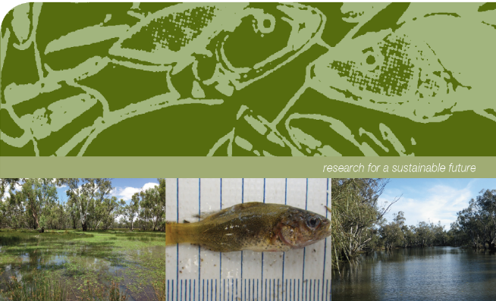

**Commonwealth Environmental Water Office Long-Term Intervention Monitoring Project Murrumbidgee River System Selected Area Summary Report 2014-18.**

Prepared by: Wassens, S.a, Spencer, J.a,b,c, Wolfenden, B.a, Thiem, J.d, Thomas, R.a,b,c, Jenkins, K.a, Hall, A.a, Ocock, J.a,b,c, Kobayashi, Ta,c, Bino, G.b, Davis, T. d, Heath, J c., Kuo, W.c, Amos, C. a,c and Michael, D a.

|  |  |
| --- | --- |
| InstLandWaterSociety Logo RGB | a Institute for Land, Water and Society. Charles Sturt University, PO Box 789, Albury, NSW 2640 |
| CES.png | b Centre for Ecosystem Science, University of New South Wales, Sydney, NSW, 2052 |
| OEH2Colour | c NSW Office of Environment and Heritage, PO Box A290, Sydney South, NSW 1232 |
| TI logo colour rgb | d NSW Trade and Investment Narrandera Fisheries Centre, PO Box 182, Narrandera NSW 2700 |

**Funding:** This monitoring project was commissioned and funded by the Commonwealth Environmental Water Office with additional in-kind support from the NSW Office of Environment and Heritage, Murrumbidgee Local Land Services, and Charles Sturt University. We are grateful to private landholders for allowing access to their properties.

**Copyright:** © Copyright Commonwealth of Australia, 2019

‘Commonwealth Environmental Water Office Long-Term Intervention Monitoring Project Murrumbidgee River System Selected Area Summary Report, 2014-18 is licensed by the Commonwealth of Australia for use under a Creative Commons By Attribution 3.0 Australia licence with the exception of the Coat of Arms of the Commonwealth of Australia, the logo of the agency responsible for publishing the report, content supplied by third parties, and any images depicting people. For licence conditions see: <http://creativecommons.org/licenses/by/3.0/au/>

This report should be attributed as ‘Commonwealth Environmental Water Office Long-term Intervention Monitoring Project Murrumbidgee River System Selected Area Summary Report, Commonwealth of Australia 2019’. The Commonwealth of Australia has made all reasonable efforts to identify content supplied by third parties using the following format ‘© Copyright, [name of third party] ’.

**Disclaimer:** The views and opinions expressed in this publication are those of the authors and do not necessarily reflect those of the Australian Government or the Minister for the Environment and Energy. While reasonable efforts have been made to ensure that the contents of this publication are factually correct, the Commonwealth does not accept responsibility for the accuracy or completeness of the contents, and shall not be liable for any loss or damage that may be occasioned directly or indirectly through the use of, or reliance on, the contents of this publication.

**Acknowledgement**: The Commonwealth Environmental Water Office acknowledges the efforts of all consortium partners in delivering the Murrumbidgee Long-Term Intervention Monitoring Project and preparing this report. The authors of this report as well as the Commonwealth Environmental Water Office respectfully acknowledge the traditional owners, their Elders past and present, their Nations of the Murray-Darling Basin, and their cultural, social, environmental, spiritual and economic connection to their lands and waters. In particular the Wiradjuri, Narri Narri and Muthi Muthi peoples, traditional owners of the land on which this publication is focused.

Monitoring and evaluation of environmental water in the Murrumbidgee Selected Area

The Commonwealth Environmental Water Holder (CEWH) is responsible under the *Water Act 2007* (Commonwealth) for managing Commonwealth environmental water holdings to protect and restore the environmental assets of the Murray-Darling Basin. The Murray-Darling Basin Plan (2012) (referred to hereafter as the Basin Plan) requires that the holdings must be managed in a way that is consistent with the Basin Plan’s Environmental Watering Strategy (MDBA 2014). The Long-Term Intervention Monitoring Project (LTIM Project) is the primary means by which the Commonwealth Environmental Water Office (CEWO) monitors and evaluates the ecological outcomes of Commonwealth environmental watering actions. The LTIM Project is being implemented in the Murrumbidgee catchment along with six other water catchment areas for a five-year period (2014 to 2019) to inform environmental water management and demonstrate outcomes. The monitoring is designed to:

* Evaluate the contribution of Commonwealth environmental watering to the objectives of the Murray-Darling Basin Authority’s (MDBA) Environmental Watering Strategy.
* Monitor and evaluate the ecological outcomes of Commonwealth environmental watering in the Murrumbidgee Selected Area.
* Infer ecological outcomes of Commonwealth environmental watering in areas of the Murray-Darling Basin that are not currently monitored.
* Support the adaptive management of Commonwealth environmental water.

The Murrumbidgee LTIM team is led by Associate Professor Skye Wassens from Charles Sturt University, along with scientists and technicians from the NSW Office of Environment and Heritage, Department of Primary Industries - Fisheries and the University of New South Wales (Centre for Ecosystem Sciences). Funding from the Commonwealth Environmental Water Office supports monitoring of the hydrological and ecological outcomes of watering actions in the river and wetlands of the Murrumbidgee. This report focused on outcomes of watering actions undertaken between 1 July 2017 until 30 June 2018 (the 2017-18 water year), with reference to watering outcomes monitored in previous water years of the project (between 2014 and 2017).

The Murrumbidgee Catchment

The Murrumbidgee catchment in southern NSW, is one of the largest catchments (81,527 km2) in the Murray-Darling Basin (Kingsford *et al.* 2004). Wetlands make up over 4 per cent (370,000 ha) of the catchment, with over 1000 wetlands identified (Murray 2008). Nationally important wetlands, including the mid-Murrumbidgee and Lowbidgee floodplain, cover over 208,000 ha (2.5 per cent of the catchment area).

River monitoring sites

The Murrumbidgee River is over 1,600 km long, with the Murrumbidgee LTIM Project Selected Area covering the lowland section (approximately 786 km). Three key sections of the Murrumbidgee River (Figure 1) are routinely monitored as part of this program. These are:

* the **Narrandera reach (187.3 km)** which starts upstream of the Yanco and Oldman Creek regulators and extends to just above the Tom Bullen storage offtake. This zone includes major Murrumbidgee and Coleambally irrigation off-takes and key populations of Murray cod *Maccullochella peelii*
* the **Carrathool reach (358.0 km)** which is downstream of Tom Bullen storage and major irrigation off-takes. River levels tend to be lower as it is downstream of major irrigation off-takes and is the principle target for in-channel Commonwealth environmental watering actions and,
* the **Balranald reach (241.4 km)** extending from Hay to Boundary Bend downstream of Balranald aligns with the Lowbidgee floodplain. This reach is monitored in year 1 and year 5 to evaluate longer term changes in fish communities.

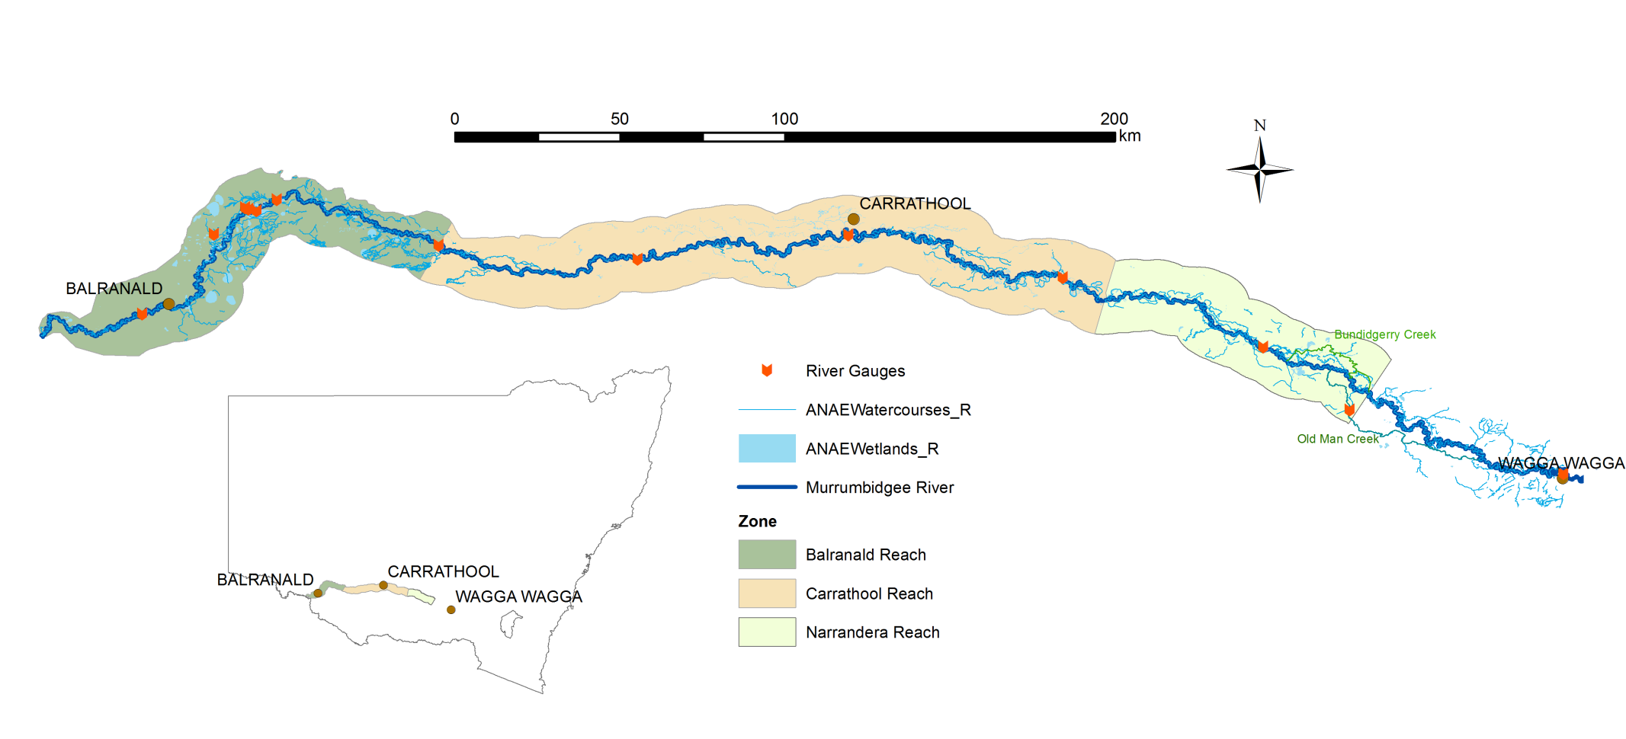Figure 1. Distribution of riverine zones in the Murrumbidgee Selected Area.

Wetland monitoring sites

Wetland and floodplains of the Murrumbidgee catchment are some of the most diverse and important systems in Australia. Six zones were identified, each supporting a unique set of wetland and floodplain habitats, different water requirements and alternative water management options (Figure 2). Due to the very large size of the Murrumbidgee catchment, monitoring is only carried out on twelve wetlands within three zones – the mid-Murrumbidgee, Redbank and Gayini Nimmie-Caira. The six wetland zones are briefly described below.

* **mid-Murrumbidgee wetlands (82,800 ha)** – River red gum forest interspersed with paleochannels (inactive streams filled with sediment) and oxbow lagoons.
* **Redbank (92,504 ha)** – Mosaic of river red gum forest and woodland, spike rush wetlands - divided into two management subzones (north and south Redbank).
* **Gayini Nimmie-Caira (98,138 ha)** – Mosaic of creek lines, paleochannels, open wetlands and lakes dominated by lignum and lignum-black box communities.
* **Fiddlers-Uara (75,285 ha)** – Paleochannels and creek lines bordered by black box.
* **The Western Lakes (3,459 ha)** – Open quaternary lakes with inactive lunettes (crescent-shaped dunes) west of the Lowbidgee floodplain.
* **Pimpara–Waugorah (55,451 ha)** – Mosaic of creek lines, paleochannels and wetlands, with River red gum and black box mostly north of the Murrumbidgee River.

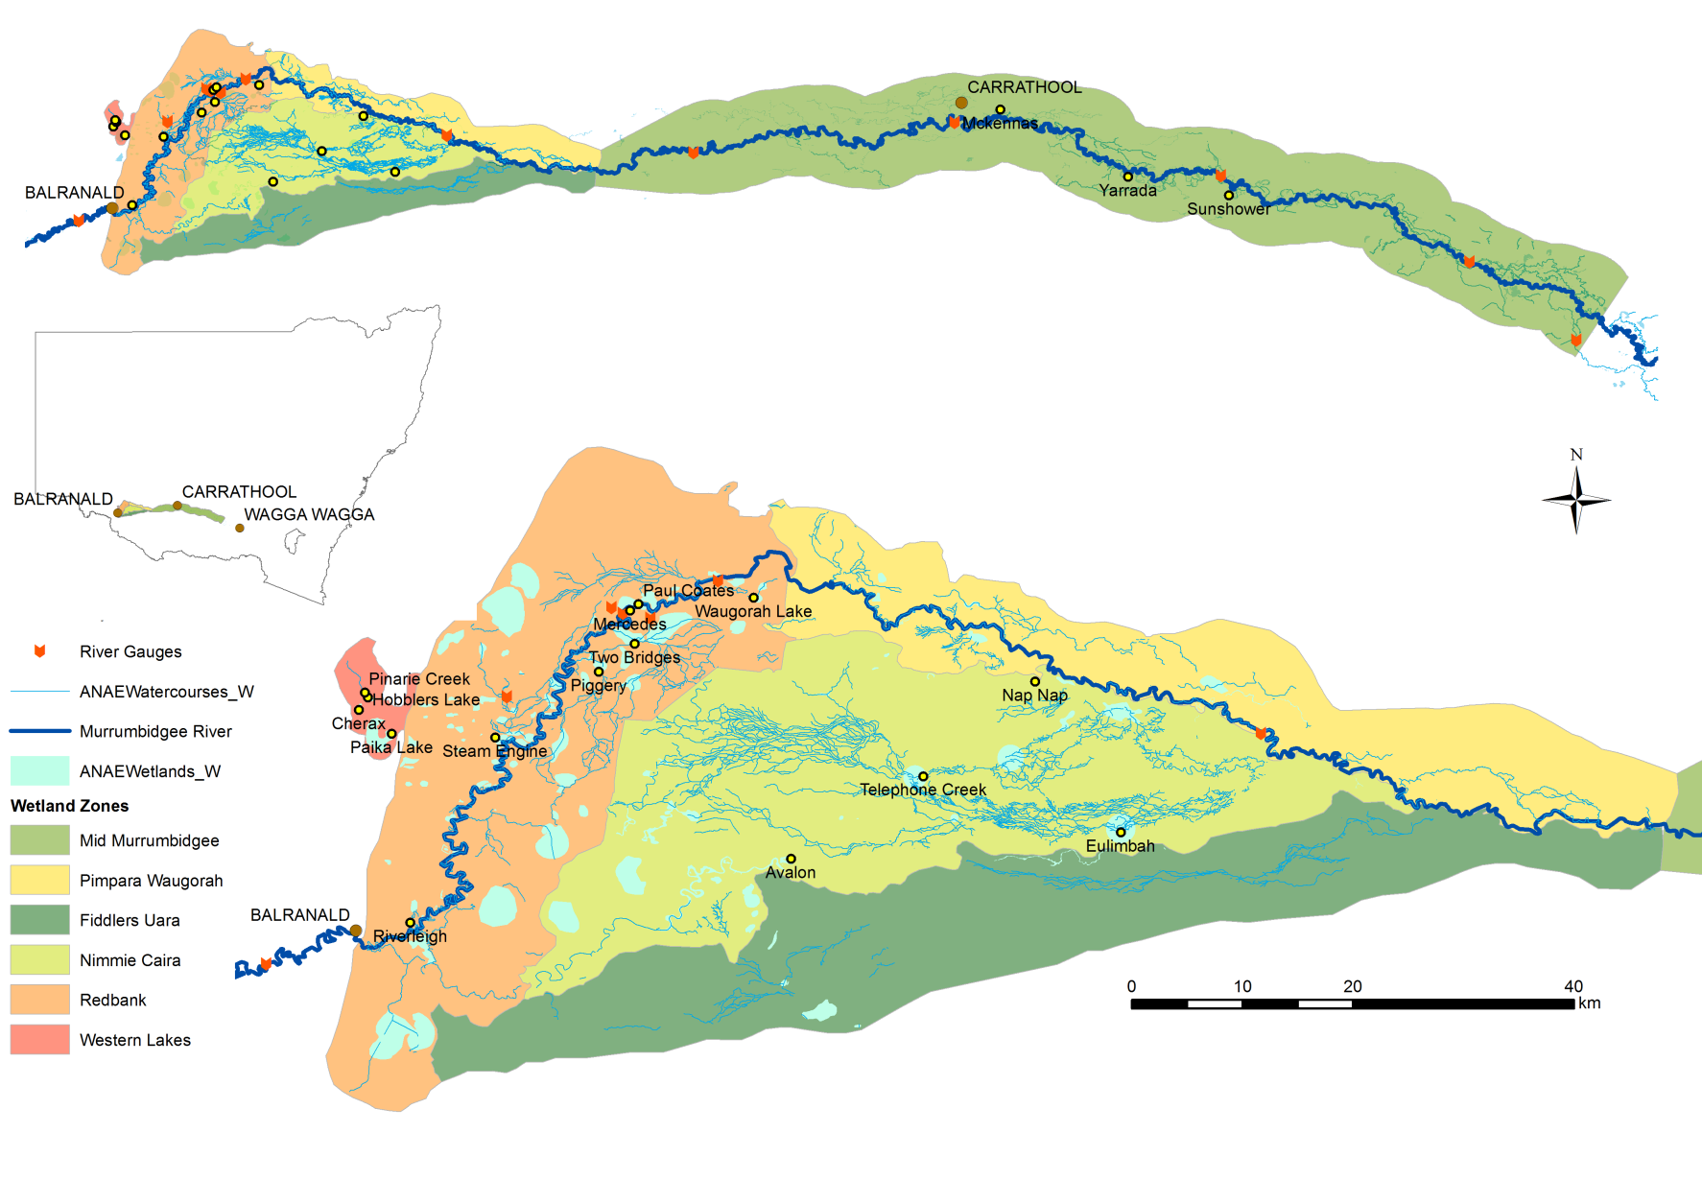

Figure 2. Distribution of wetland zones in the Murrumbidgee Selected Area and locations of twelve monitored wetlands.

|  |
| --- |
| S:\Research\Research Data\Science\v04\R0274_Murrumbidgee_LTIM\Photos\2017-18 Wetland sampling\Vegetation surveys\YART1Nov17scenic4.JPG  Plate 1. Yarradda Lagoonin the mid-Murrumbidgeewetland monitoring zoneis typical of an oxbow lagoon (billabong) with fringing River red gum trees. |
| **S:\Research\Research Data\Science\v04\R0274_Murrumbidgee_LTIM\Photos\2017-18 Wetland sampling\Vegetation surveys\MERJan18_T2 Q13 (3).JPG** |
| Plate 2. Mercedes Swamp in theRedbank wetland monitoring zonefeatures herbaceous aquatic meadows. |
| S:\Research\Research Data\Science\v04\R0274_Murrumbidgee_LTIM\Photos\2016-17 Wetland Sampling\Veg Transects 2016-2017\AVA_NOV_16_T3 (2).JPG |
| Plate 3. Avalon Swamp in Gayini Nimmie-Caria wetland monitoring zone is representative of a lignum - black box wetland vegetation community. |

***Environmental watering in the Murrumbidgee in 2017-18***

Flows within the Murrumbidgee River have undergone significant long-term changes since the construction of large headwater dams and in-channel weirs which allow the river flows to be regulated and water diverted to meet agricultural and consumptive needs. The timing of high flow periods, in particular, has shifted from winter to spring to meet irrigation demands. As a consequence, there have been significant reductions in the frequency of minor (water levels that reach very low lying wetlands and channels) and moderate (water levels that reach wetlands higher on the floodplain) flow pulses (Frazier *et al.* 2005; Frazier *et al.* 2006) (Figure 3). Between 2000 and 2010, a significant drought coupled with increasing consumptive water demand exacerbated the effects of river regulation (Dijk *et al.* 2013), leading to significant declines in the condition of floodplain vegetation (Wen *et al.* 2009). Large-scale flooding occurred in 2010 and 2011 which was followed by years of moderate water availability between 2012 and mid-2016. In 2016-17, there was above average rainfall in the catchment contributing to high tributary inflows and unregulated river flows which inundated significant areas of wetland through the mid-Murrumbidgee and Lowbidgee floodplains between September and November 2016. The 2017-2018 water year saw below average rainfall across much of the Murray-Darling Basin. In the twelve-month period, rainfall across the Murrumbidgee catchment was closer to the long-term average, with about 80 per cent of the mean annual total falling in the upper regions of the catchment. Reasonable water levels in storage dams contributed to moderate water availability.

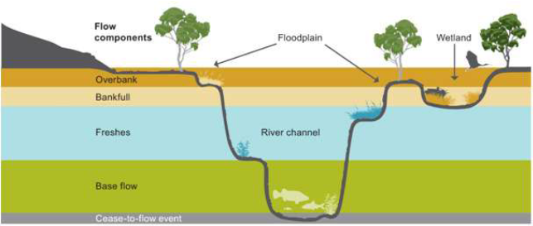

Figure 3. Five flow types and their influence on different parts of the river channel, wetlands and floodplains (MDBA 2011).

History of Commonwealth environmental watering actions in the Murrumbidgee

The volumes of water used in 2017-18 was similar to 2014-15 and 2015-16 (Figure 4). However, the areas where watering actions occurred were different. In 2014-15 and 2015-16, the majority of environmental water was allocated to the Redbank and Gayini Nimmie-Caria wetland systems in the Lower Murrumbidgee floodplain (Lowbidgee). In 2014-15 and 2015-16, only very small volumes of water were used in the middle reaches of the Murrumbidgee (mid-Murrumbidgee) mainly at individual lagoons (Yarradda and Gooragool), while the 2017-18 water actions were specifically targeting a larger number of low-lying wetlands across the mid-Murrumbidgee. This was achieved by releasing environmental water to raise the water level in the Murrumbidgee River to 4.1 m at Wagga Wagga. At this height the flow connected low-lying wetlands while remaining within its banks and well below minor flood level which is 7.3 m at Wagga Wagga.

In 2016-17, heavy rainfall occurred across the Murrumbidgee catchment resulting in very high river flows. These unregulated flows inundated the vast majority of wetlands within the mid-Murrumbidgee and substantial areas of the Lowbidgee floodplain. As a result large amounts of leaf litter (a key source of carbon) entered the river from the floodplain causing hypoxic blackwater. Hypoxic blackwater can occur when water that is high in dissolved carbon (from leaf litter) and nutrients, warms up creating ideal conditions for the rapid growth of bacteria, which then start to consume available oxygen in the water. The majority of the Commonwealth and NSW environmental water use in 2016-17 was used in the main river channel to flush out large amounts of leaf litter to reduce the severity of hypoxic black water. Under these circumstances environmental water was used to dilute carbon and nutrient concentrations in the main river, thereby reducing bacterial growth. (This large watering action is displayed as a pale blue/grey bar in Figure 4 below).

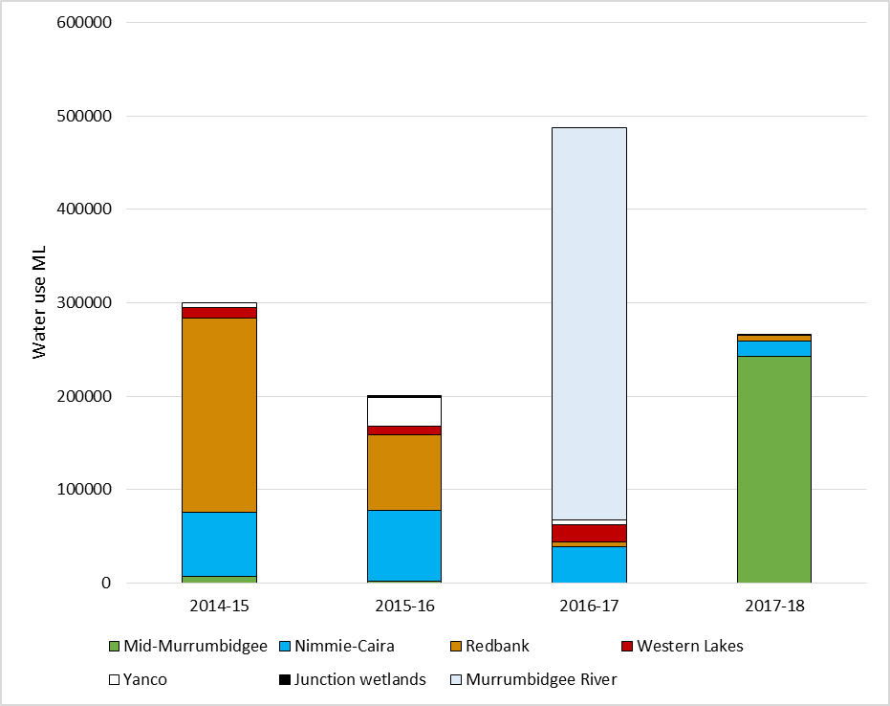

Figure 4. Summary of NSW and Commonwealth environmental watering actions by volume in key management zones in the Murrumbidgee between 2014 and 2018. Total environmental water delivered to the Murrumbidgee Catchment is a combination of Commonwealth licensed environmental Water (CEW), NSW licensed environmental water (NSW) and Environmental Water Allowance (EWA) accrued under the Water Sharing Plan for the Murrumbidgee Regulated River Water Source 2016.Note that there was also substantial unregulated floodplain inundation during 2016-17.

2017-18 Watering Actions

In 2017-18, [water allocations](https://www.waternsw.com.au/__data/assets/pdf_file/0013/131314/Water-Operations-Murrumbidgee-June-2018.pdf) started at 17 per cent for all general security licences (June 2017) and increased through the year to 45 per cent by May 2018 (Water NSW June 2018). The Commonwealth environmental water holder in partnership with NSW delivered 179,248 MLof Commonwealth environmental water and 86,672 ML of NSW environmental water allocation as part of 14 watering actions targeting rivers, wetlands, and creek line habitats in the Murrumbidgee (Table 1).

The mid-Murrumbidgee wetland reconnection started at the end of July and was finished by 1 September 2017. To get water from the river into the nearby target wetlands, the river must achieve a height of 4.0 m at Wagga Wagga which translates into a daily discharge of 22,000 ML/day. Water was therefore released from the dams in July and achieved a flow peak of 22,862 ML/day (4.1 m) at Wagga Wagga and gradually decreased in volume as it travelled downstream to reach 14,159 ML/day at Darlington Point. At this level the flow connected low-lying wetlands while remaining within its banks and well below minor flood level (7.3 m at Wagga Wagga). Once the reconnection flow had been completed, the hydrology of the river at both Wagga Wagga and Carrathool was similar in terms of mean daily discharge rates to those observed in 2014-15 and 2015-16, but much lower than in 2016-17 when heavy rainfall across the catchment resulted in flooding (Figure 5).

Table 1. Summary of environmental water usage from Commonwealth and NSW sources in 2017-18. (Drawn from Watering Action Acquittal Report Murrumbidgee 2017-18 (Commonwealth of Australia 2018)). Shaded rows indicate flows associated with the LTIM Monitoring locations that are evaluated in this report.

|  |  |  |  |  |
| --- | --- | --- | --- | --- |
| Watering actions | Dates  (start/end) | Commonwealth environmental water (ML) | NSW Environmental water (ML) | Total water use  (ML) |
| mid-Murrumbidgee wetlands reconnection | Start: 24/07/2017  End: 01/09/2017 | 159,283 | 76922 | 236,205 |
| Yarradda Lagoon Pumping (1) | Start: 04/07/2017  End: 01/08/2017 | 326 | 500 | 826 |
| Yarradda Lagoon Pumping (2) | Start: 20/11/2017  End: 27/11/2017 | 177 | 0 | 177 |
| Gooragool Lagoon Pumping | Start: 18/07/2017  End: 31/07/2017 | 1426 | 0 | 1426 |
| Gooragool Lagoon offset | Start: 15/06/2018  End: 15/06/2018 | 750 | 750 | 1500 |
| Nimmie-Caira (Southern bell frog) Refuge | Start: 17/04/2018  End: 30/06/2018 | 5,000 | 8,850 | 13,850 |
| Nimmie-Caira Nimmie-Creek (southern bell frog refuge) | Start: 15/12/2017  End: 18/12/2017 | 1,738 | 0 | 1,738 |
| North Redbank wetlands | Start: 09/10/2017  End: 19/10/2017 | 5,528 | 0 | 5,528 |
| Toogimbie IPA Wetlands | Start: 07/11/2017  End: 05/03/2018 | 1,000 | 0 | 1,000 |
| Coonancoocabil lagoon | Start: 11/12/2017  End: 02/01/2018 | 900 | 0 | 900 |
| Oak Creek | Start: 28/12/2017  End: 02/01/2018 | 620 | 0 | 620 |
| Waldaira Lagoon | Start: 09/02/2018  End: 30/04/2018 | 1,500 | 0 | 1,500 |
| Sandy Creek | Start: 17/02/2018  End: 23/04/2018 | 400 | 0 | 400 |
| Tuckerbil Swamp | Start: 09/04/2018  End: 16/04/2018 | 600 | 0 | 600 |
|  | **Total delivered** | **179,248** | **86,672** | **266,270** |

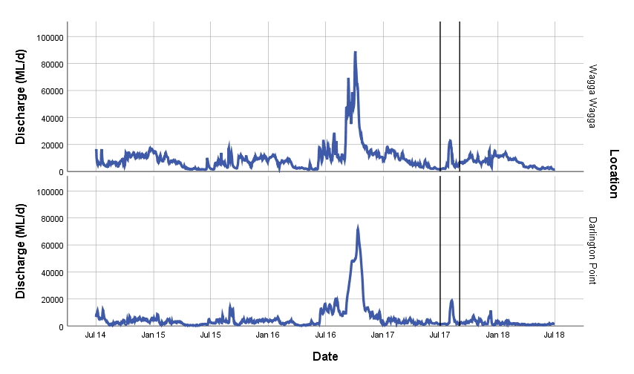

Figure 5. Mean daily discharge in the Murrumbidgee River at Wagga Wagga and Darlington Point (1 July 2014 to 30 June 2018). Vertical bars indicate the approximate start and finish dates of the mid-Murrumbidgee reconnection flow in 2017-18.

***Why were these actions undertaken?***

When planning and delivering environmental water, Commonwealth water managers are required to set clear ecological objectives that align with objectives set out in the Murray-Darling Basin Plan ([the Basin Plan Objectives](https://www.environment.gov.au/system/files/resources/c8a8d2f6-e455-4126-bf75-0fa0c9147736/files/environmental-water-outcomes-framework.pdf)). These relate to biodiversity (the number of individual species supported by environmental water), ecosystem function (for example maintaining productivity and nutrient cycles), ecological resilience (longevity, breeding and recovery of plant and animal populations) and water quality (such as preventing periods of low dissolved oxygen, reducing the risk of algal blooms, and maintaining appropriate salinity levels). In 2017-18, watering actions were delivered to achieve broad ecological objectives (Table 1), in particular:

* maintain extent and protect, and in some cases, improve the condition of in-channel, riparian, floodplain and wetland native vegetation communities;
* provide reproduction and recruitment opportunities for riparian, floodplain and wetland native vegetation communities;
* re-instate a more natural wetting-drying cycle for wetland vegetation;
* support the breeding, recruitment and habitat requirements of birds and native aquatic biota, including frogs, turtles and invertebrates;
* support spawning, recruitment, movement and habitat requirements of native fish, including access to a diversity of in-channel habitats, improving both structural and hydraulic habitat complexity;
* support ecosystem functions, such as dispersal of biota and transfer of abiotic material (e.g. sediment, nutrients and organic matter) that relate to longitudinal and lateral connectivity (i.e. connectivity between the river channel, wetlands and floodplain) to maintain populations; and
* improve ecosystem and population resilience through supporting ecological recovery and maintaining aquatic habitat.

The largest volume of environmental water in 2017-18 was utilised for the mid-Murrumbidgee wetlands reconnection event (236,205 ML) (Table 1 and Figure 5). This action was undertaken to protect and maintain the ecological health and resilience of the mid-Murrumbidgee wetlands, Yanco Creek and adjacent wetlands. Specific watering objectives were to:

* prevent further decline in wetland vegetation extent and condition;
* support reproduction and improved condition in vegetation, waterbirds, native fish and other biota; and
* to support hydrological connectivity, and biotic and nutrient dispersal.

|  |
| --- |
| Why are the mid-Murrumbidgee wetlands so important?  The mid-Murrumbidgee wetlands represents several hundred discrete wetlands and lagoons along the middle reaches of the Murrumbidgee River. The vast majority of these wetlands are located between Gundagai and Hay (Figure 2). The mid-Murrumbidgee wetlands are listed as wetlands of national significance and form part of the grassy aquatic meadows ecosystem (Colloff *et al.* 2014).  Grassy aquatic meadows have declined significantly in the Murrumbidgee Catchment following the construction of dams and weirs which have changed the natural inundation regime, often leaving wetlands dry for longer periods, causing the loss of sensitive aquatic species. The wetlands also provide important nursery habitat for native fish, and are home to native snakes, lizards, turtles, frogs (Plate 4), mammals and waterbirds.  S:\Research\Research Data\Science\v04\R0274_Murrumbidgee_LTIM\Photos\2017-18 Wetland sampling\January18_BW\Southern bell frogs YAR (2).JPG  Plate 4. Yarradda Lagoon is the only wetland in the mid-Murrumbidgee known to support breeding populations of the nationally threatened southern bell frog (*Litoria raniformis*). |

Key outcomes from environmental water use in 2017-18 - mid-Murrumbidgee wetlands reconnection and associated actions

While multiple Commonwealth environmental watering actions were undertaken through the Murrumbidgee in 2017-18, this section focuses on key watering actions that were evaluated as part of the LTIM program in 2017-18: the mid-Murrumbidgee wetlands reconnection (July-August), and pumping into Yarradda Lagoon (July and November) and Gooragool Lagoon (July-August) (see Table 1).

Wetland inundation

The mid-Murrumbidgee reconnection event connected a number of oxbow lagoons between Wagga Wagga and Darlington Point, including four wetlands monitored in this program (Sunshower, Gooragool, Yarradda and McKennas lagoons). With the exception of Sunshower Lagoon, which dried out briefly over winter 2017, the remaining three wetlands retained some water from unregulated flows that inundated large sections of the floodplain in spring 2016. Pumping of environmental water into Yarradda and Gooragool Lagoons was undertaken in early July 2017 and raised water levels by over 80 cm at Gooragool Lagoon and 100 cm at Yarradda Lagoon in preparation for the mid-Murrumbidgee reconnection event. This gradual rise was followed by a rapid increase in water levels as the wetlands reconnected to the main river channel. The increase in water level occurred slightly later and lower at McKennas Lagoon. This was the result of generally lower river levels in the downstream section of the Murrumbidgee River and also obstructions in the inflow channel which reduced the level of connection to the river and prevented McKennas Lagoon from filling to the same extent as sites further up-stream.

Riverine outcomes

Water quality in the Murrumbidgee River remained stable through 2017-18 and was similar to water quality parameters (concentration of dissolved organic carbon, nitrogen, phosphorus and the rates of primary or secondary productivity in the main river channel) reported during normal river operations in 2014-15 and 2015-16. The 2016-17 water year was the exception with heavy rainfall in the upper Murrumbidgee catchment causing large unregulated flows in spring 2016 (see Wassens *et al*. 2018). The relationship between flow and primary and secondary productivity are complex and may be heavily influenced by the interaction between the shape of the river bed and water flow, which influences the availability of warm, slow-flowing habitat that supports higher abundances of zooplankton and also provides refuge for larval fish.

Riverine fish continue to spawn in the Murrumbidgee River with spawning closely linked to water temperature. A combined total of 4,614 fish eggs and larvae were collected in 2017-18. Seven native fish species (Australian smelt *Retropinna semoni*, bony herring *Nematalosa erebi*, carp gudgeon *Hypseleotris* spp., flat-headed gudgeon *Philypnodon grandiceps*, golden perch *Macquaria ambigua*, Murray cod *Maccullochella peelii*, silver perch *Bidyanus bidyanus*) and small numbers of the exotic common carp *Cyprinus carpio* were detected spawning in the Murrumbidgee River in 2017-18. Early stage juvenile Murray River crayfish *Euastacus armatus* and freshwater yabby *Cherax destructor* were also captured in drift nets. Golden perch eggs (1,426 in total), Murray cod larvae (1,063 in total), flat-headed gudgeon larvae (998 in total) and Australian smelt larvae (828 in total) were captured in highest numbers in 2017-18. Numbers of golden perch (Plate 5), silver perch and Murray cod larvae have remained broadly similar across the four sample years, the exception being 2016-17 when there was a large unregulated flow and numbers of larvae were lower for all fish species, a result likely to be attributed to the increase in water volume causing a dilution effect.

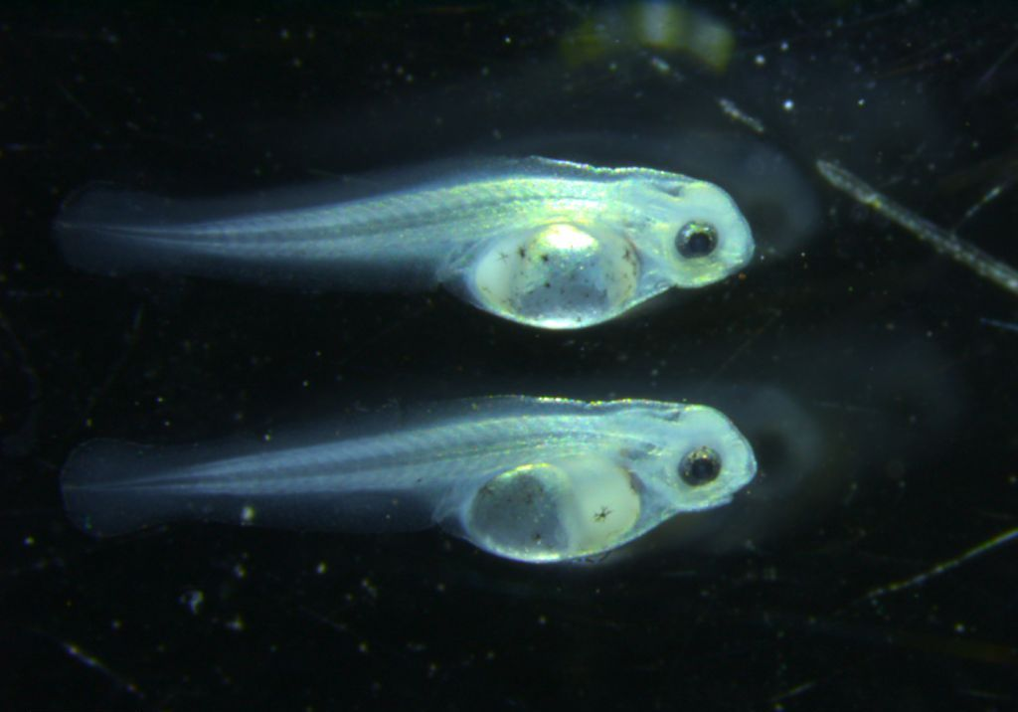

Plate 5. Over one thousand Golden Perch larvae were collected at Murrumbidgee River monitoring sites in 2017-18.

Wetland outcomes

Environmental water has been particularly important in supporting the establishment of aquatic communities in the mid-Murrumbidgee and Lowbidgee floodplains over the 2014-17 period. Commonwealth environmental watering actions since 2014 have contributed to the re-establishment of spiny mud grass *Pseudoraphis spinescens*, common spike rush *Eleocharis acuta* (Plate 6) and two fringing species, lesser joyweed *Alternanthera denticulata* and the culturally significant old man weed *Centipeda cunninghamii* at two of the mid-Murrumbidgee wetlands. By contrast, wetlands that did not receive water were dominated by terrestrial species and had higher cover of the introduced species such as spear thistle *Cirsium vulgare*, as well as greater cover of river red gum *Eucalyptus camaldulensis* seedlings and saplings.

Over the four years of Commonwealth environmental watering there has been an increase in the cumulative number of plant species, especially aquatic species, at monitored wetlands in the mid-Murrumbidgee which indicates that additional species are being detected at the wetland each year (Figure 6). Two new aquatic species, common water milfoil *Myriophyllum papillosum* and floating pondweed *Potamogeton tricarinatus* were recorded at McKennas and Sunshower Lagoons following the mid-Murrumbidgee reconnection event, while curly pondweed *P. crispus* was also recorded at Sunshower Lagoon for the first time. Yarradda Lagoon has shown a steady increase in the number of aquatic species being recruited (Plate 6) with two additional species identified following Commonwealth environmental watering in 2017-18: water primrose *Ludwigia peploides* ssp. *montevidensis* and nardoo *Marsilea drummondii*. Gooragool Lagoon has a high diversity of aquatic species overall, but no new species were identified in 2017-18, suggesting that the vegetation community at this site has been relatively stable over time.

|  |
| --- |
|  |

Figure 6. Species accumulation curve for aquatic species in wetlands in the mid-Murrumbidgee between September 2014 and March 2018.

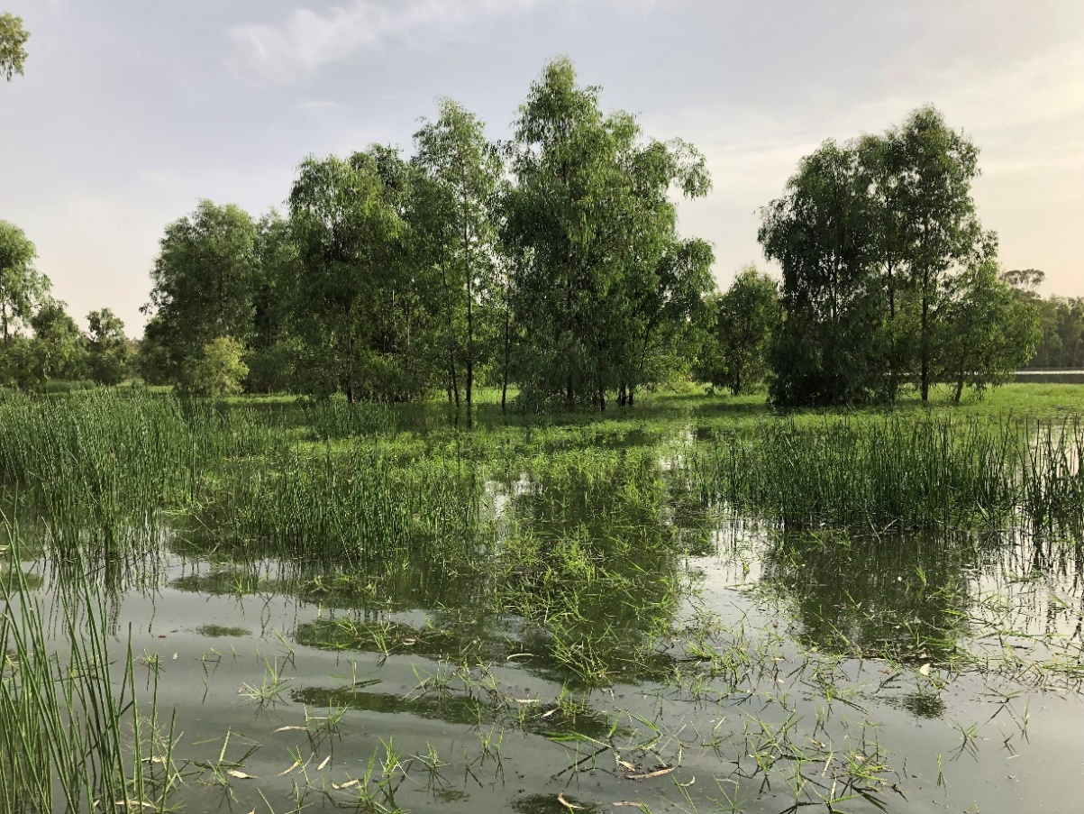

Plate 6. Yarradda Lagoon illustrating aquatic vegetation that has responded to recent watering actions.

Commonwealth environmental watering actions in the mid-Murrumbidgee supported six frog species and three turtle species, including the threatened southern bell frog *Litoria raniformis*. The mid-Murrumbidgee reconnection event (July to August 2017) was associated with an increase in frog calling activity in September 2017, with the spotted marsh frog *Limnodynastes tasmaniensis*, plains froglet *Crinia parinsignifera* and small numbers of southern bell frogs recorded calling at Yarradda Lagoon. The number of adult frogs observed or heard was slightly higher following the 2017-18 watering action compared to results of frog monitoring following the natural unregulated reconnection in 2016-17 at McKennas and Sunshower Lagoons. It is likely that the 2017-18 watering action enhanced the responses from the previous flood year in these sites. Frog calling activity in Yarradda and Gooragool Lagoons was lower compared to previous years. Increasing numbers of carp in some of the wetlands following the natural reconnection in 2016-17 might have contributed to lower frog numbers in Yarradda and Gooragool Lagoons and management actions to reduce carp numbers at these wetlands have now been implemented.

Tadpoles were recorded in all of the mid-Murrumbidgee monitoring sites following the 2017-18 watering actions, but were most abundant at McKennas and Sunshower Lagoons with tadpoles of inland banjo frog *Limnodynastes* *interiors*, spotted marsh frog/barking marsh frog *Limnodynastes* species and Peron’s tree frog *Litoria peronii* all recorded. Low densities of exotic fish in these lagoons may have contributed to the abundant tadpole numbers. Small numbers of southern bell frog tadpoles were recorded at Yarradda Lagoon in 2017-18, while in previous years larger numbers of Peron’s tree frog (Plate 7) and *Limnodynastes* species (spotted marsh frog/barking marsh frogs) were recorded following environmental watering actions.

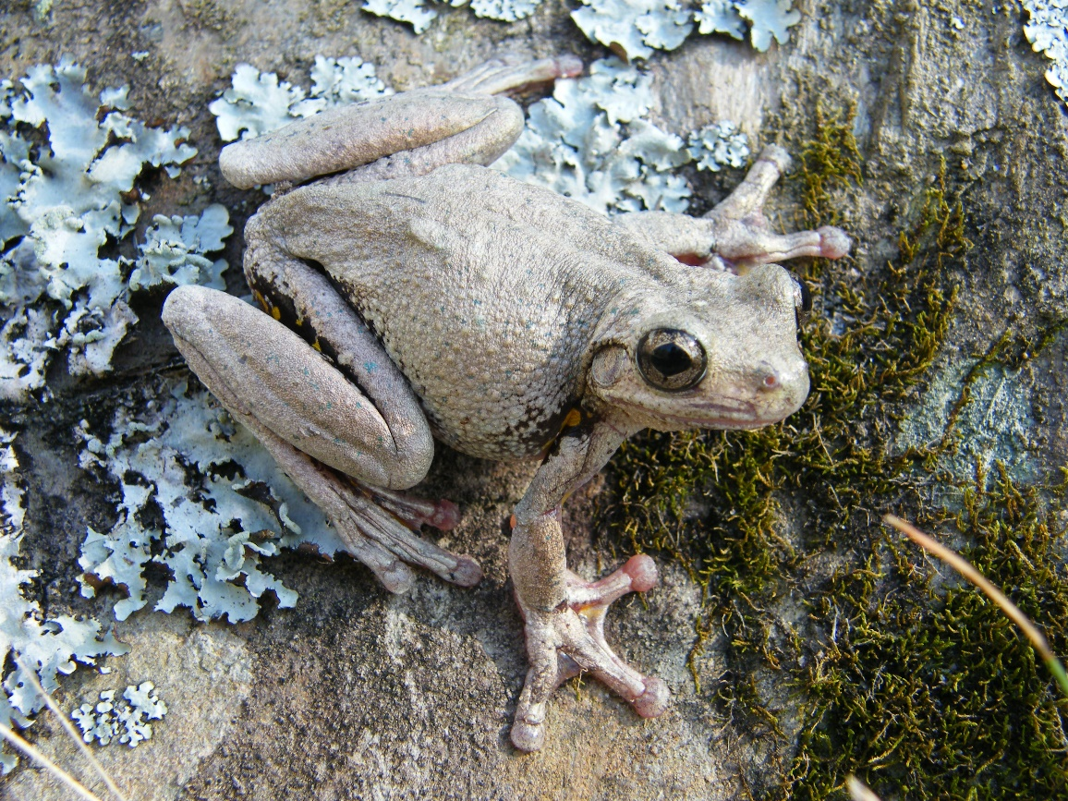

Plate 7. Peron’s Tree Frog is a tree-dwelling species that responds well to environmental watering actions.

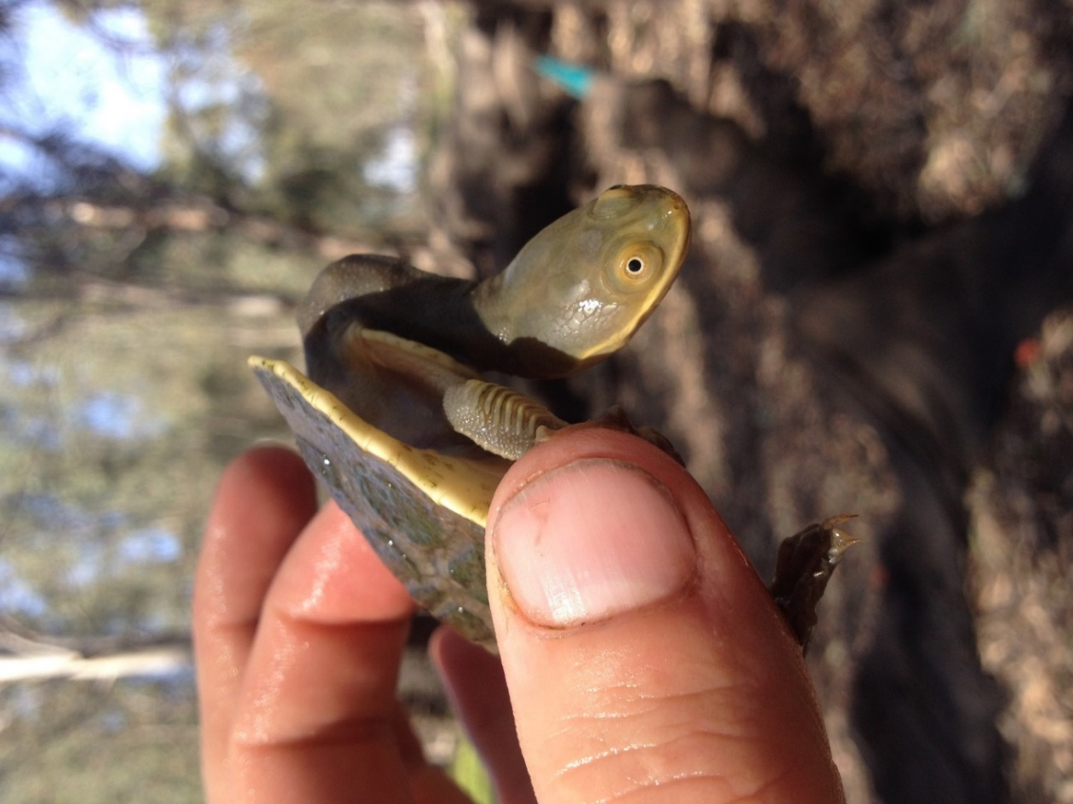

Plate 8. Wetlands provide important nursery habitats for hatchling turtles (Eastern long-neck turtle).

Three turtle species have been recorded in the Murrumbidgee monitoring sites: the Eastern long-neck turtle *Chelodina longicollis* (Plate 8), broad-shelled turtle *Chelodina expansa* and Macquarie River turtle *Emydura macquarii*. While adult turtles can move short distances overland when wetlands dry out, the availability of permanent water holes is important and environmental water was used to maintain a persistent waterbody at Yarradda Lagoon which has held water since December 2014, and at Telephone Creek and Wagourah Lagoon which are permanent lagoons. Foxes have a serious negative impact on turtle hatching success (Spencer and Thomas 2005), but despite these pressures small numbers of hatching turtles were recorded in the mid-Murrumbidgee wetlands following environmental watering in 2017-18.

Overall, 33 species of waterbird were recorded in 2017-18 across the monitoring sites which is slightly lower than previous years and reflects the larger than usual number of wetlands that were dry in 2017-18 compared to previous years. Despite drier conditions overall, four threatened waterbird species were detected during the LTIM and complementary NSW OEH surveys: the Australasian bittern *Botaurus poiciloptilus*, freckled duck *Stictonetta naevosa*, white-bellied sea-eagle *Haliaeetus leucogaster* and Latham’s snipe *Gallinago hardwickii*. Latham’s snipe was detected on the edge of McKennas Lagoon (mid-Murrumbidgee zone) in the September 2017 surveys.

The abundance and diversity of waterbirds can change in response to habitat availability within the Murrumbidgee catchment and can be influenced by conditions at much larger scales, including river basin and continental scales. The total number of waterbird species recorded in the mid-Murrumbidgee sites in 2017-18 (28 species) was lower than in 2016-17 during the flood year (37 species) but higher than in the 2014-15 (17 species) and 2015-16 (26 species) monitoring periods when habitat across the Murrumbidgee catchment was less available.

Waterbirds depend on wetland inundation to provide foraging and breeding habitat. In 2017-18, eight waterbird species were confirmed breeding in the Murrumbidgee area. In the mid-Murrumbidgee, three colonial waterbird species were recorded breeding, the Australasian darter *Anhinga novaehollandiae* and great cormorant *Phalacrocorax carbo* nested at Yarradda Lagoon while the darter and little pied cormorant *Microcarbo melanoleucos* nested at Gooragool Lagoon.

Implications for future management of environmental water

The Murrumbidgee is regarded as a “working river”, much of the channel is used to transfer water from the storage dams to support irrigation communities, towns and cities along its length and the transfer of water into the River Murray through to South Australia. This long history of modification of the river and its floodplain and management of river flows has changed the ecology of the river system and influenced the types of species that have persisted. While we might expect a flow peak in the river would create benefits for in-channel habitat, limitations in the height that the river is allowed to reach due to the presence of privately owned structures on low-lying sections of the floodplain, along with water demand from other water users mean that environmental flows are often restricted to winter months when low water temperatures limit primary and secondary productivity and fall outside spawning periods for native fish.

**Managing native fish in the Murrumbidgee River**

To date, we have identified little evidence to suggest that managing for discrete flow peaks within the monitored reaches of the mid-Murrumbidgee influenced native fish spawning. This might be in part due to the already higher water flows occurring in the mid-Murrumbidgee compared to other parts of the river, with irrigation deliveries creating conditions suitable for spawning throughout the breeding season. Despite slightly more variable flow levels in Carrathool Reach in 2017-18 our monitoring indicated that spawning by golden perch and silver perch was similar to the 2014-17 period. However, we did not detect juvenile golden or silver perch in the Carrathool Reach following these spawning events, which may indicate that the survival of larval perch is low or that we under sample this age class due to secretive behaviour and/or occupation of un-sampled habitats. The abundance of juvenile Murray cod was considerably lower in 2017-18 compared with 2014-15 and 2015-16, but similar to those recorded in 2016-17. The reasons contributing to the poor survival of larval fish through to the juvenile stage remains unknown and requires further investigation.

**Managing floodplain wetlands**

Given the modest volumes of environmental water available in the Murrumbidgee relative to the area of riverine, floodplain and wetland habitats, and the need to support multiple water users, there is limited capacity to restore the natural inundation regime via managed reconnections alone. That is, while low-lying wetlands once had regular reconnections to the river following winter rainfall and spring snow melts, the presence of large storage dams limits how much water the river holds at any given time, meaning that environmental water pulses are often delivered “off peak” during periods of relatively low irrigation demand. While smaller creek and river systems in the Murray-Darling Basin may exhibit increases in the availability of nutrients and subsequent increases in primary (algae and biofilms) and secondary (microinvertebrates) productivity during environmental water releases, the watering actions for the Murrumbidgee frequently occur in the context of an already full river during periods of low water temperatures and with limited availability of shallow, slow flowing habitat. Higher rates of metabolism and secondary productivity are often observed during periods of either very low flow (as is often the case in the Carrathool Reach during summer months) or very high flows which inundate substantial area of floodplain and wetland habitat (as was the case in 2016-17). This provides some evidence for the benefits of large-scale floodplain inundation and reconnection with the river. Further monitoring is being undertaken to better understand these relationships.

The current water management approach for wetlands in the mid-Murrumbidgee focuses on managed pumping of environmental water to key wetlands with occasional river to wetland reconnections (there have been two managed and two unregulated reconnections since 2010). In terms of ecological outcomes per megalitre of water used, pumping has a very high ratio of positive outcomes relative to water volume used, but these benefits are highly localised to individual wetlands that are located in close proximity to the river or suitable irrigation channels and pumps, meaning that a small number of wetlands stay in good condition while others have declined. A combination of pumping water into Yarradda and Gooragool Lagoons (undertaken every year except 2016) along with managed reconnections (2017) have had a positive benefit for native aquatic vegetation communities and have helped to restore a number of key wetland species, including spiny mud grass and tall spike rush. The diversity of aquatic native plants is far higher at Gooragool and Yarradda lagoons that have received environmental water over a number of years, compared to Sunshower and McKennas Lagoons which have received water during unregulated flows in 2016 and the managed reconnection flow in 2017, but are unable to be pumped due to logistical constraints.

In the mid-Murrumbidgee, outcomes for wetland vertebrates, including frogs, turtles and waterbirds varied considerably among survey sites. McKennas and Sunshower Lagoons supported higher numbers of tadpoles and waterbirds but had lower number of frog species and smaller adult populations overall. Frog and tadpole abundance have declined at Yarradda Lagoon over the past four years, with notable declines occurring once the wetland reconnected with the main river channel in 2016-17 and 2017-18. Increasing densities of adult carp may have contributed to the reduced breeding by resident frogs at these sites (although it is noted that the abundance of carp was similar in 2015-16 prior to the unregulated flows and in 2017-18 following the environmental watering actions). Studies investigating the relationship between common carp and tadpoles are limited, but there is evidence that high carp numbers suppress the breeding response of frogs (Kloskowski 2009; Kloskowski 2011; Kaemingk *et al.* 2017) and may be a factor influencing the outcomes of environmental watering actions. However, these relationships are complex as the timing of inundation, wetting and drying patterns can also have a strong influence on frog breeding outcomes. Management actions that include the removal of carp prior to pumping, either through physical removal and/or short-term drying out of the wetland, are likely to have positive benefits for frogs and vegetation.

Key management recommendations

* Breeding in many frog species, including the southern bell frog, is triggered by rising wetland water levels during spring (October and November). Watering actions undertaken from late summer through to winter are important for providing refuge habitat but are unlikely to provide suitable conditions for breeding the following spring. This was observed in the Lowbidgee floodplain during 2017-18 where few tadpoles were recorded. Therefore, to enhance frog breeding activity and frog recruitment, watering actions in early spring should be considered.
* Where the maintenance of refuge habitat is the primary watering objective, complementary management actions including the physical removal of carp in target wetlands as well as the temporary drying of sites should be considered. Carp densities at Yarradda Lagoon have increased over time in conjunction with declines in the abundance of frogs and tadpoles. It is recommended that this system be allowed to dry to remove adult carp.
* In regulated systems, where dry phases may be absent or rare and periods of inflow differ from the historical frequency and timing of inundation, the maintenance of native fish communities through floodplain wetlands is largely provided by persistent waterbodies and/or regular connection to the river channel. Our monitoring has indicated that invasive fish densities are likely to have remained stable in many permanent creek systems in the Lowbidgee floodplain (e.g. Telephone Creek and Wagourah Lagoon. Therefore, management actions that aim to retain water in these types of wetlands will provide long-term benefits to resident native turtle, fish and frog populations.

***Cited literature***

Colloff, M.J., Ward, K.A., and Roberts, J. (2014) Ecology and conservation of grassy wetlands dominated by spiny mud grass Pseudoraphis spinescens in the southern Murray–Darling Basin, Australia. *Aquatic Conservation: Marine and Freshwater Ecosystems* **24**(2), 238-255.

Commonwealth of Australia (2018) Watering Action Acquittal Report Murrumbidgee 2017-18. Canberra.

Dijk, A.I., Beck, H.E., Crosbie, R.S., Jeu, R.A., Liu, Y.Y., Podger, G.M., . . . Viney, N.R. (2013) The Millennium Drought in southeast Australia (2001–2009): Natural and human causes and implications for water resources, ecosystems, economy, and society. *Water Resources Research* **49**(2), 1040-1057.

Frazier, P., and Page, K. (2006) The effect of river regulation on floodplain wetland inundation, Murrumbidgee River, Australia. *Marine and Freshwater Research* **57**(2), 133-141.

Frazier, P., Page, K., and Read, A. (2005) Effects of flow regulation in flow regime on the Murrumbidgee River, South Eastern Australia: an assessment using a daily estimation hydrological model. *Australian Geographer* **36**(3), 301-314.

Kaemingk, M.A., Jolley, J.C., Paukert, C.P., Willis, D.W., Henderson, K., Holland, R.S., . . . Lindvall, M.L. (2017) Common carp disrupt ecosystem structure and function through middle-out effects. *Marine and Freshwater Research* **68**(4), 718-731.

Kingsford, R.T., and Thomas, R.F. (2004) Destruction of wetlands and waterbird populations by dams and irrigation on the Murrumbidgee River in arid Australia. *Environmental Management* **34**(3), 383-396.

Kloskowski, J. (2009) Size-structured effects of common carp on reproduction of pond-breeding amphibians. *Hydrobiologia*, 1-9.

Kloskowski, J. (2011) Impact of common carp Cyprinus carpio on aquatic communities: direct trophic effects versus habitat deterioration. *Fundamental and Applied Limnology/Archiv für Hydrobiologie* **178**(3), 245-255.

Murray, P. (2008) 'Murrumbidgee wetlands resource book.' (Murrumbidgee Catchment Management Authority: New South Wales)

Water NSW (June 2018) Water Operations Report: Murrumbidgee Valley. Vol. 2018. (Water NSW)

Wen, L., Ling, J., Saintilan, N., and Rogers, K. (2009) An investigation of the hydrological requirements of River Red Gum (*Eucalyptus camaldulensis*) Forest, using Classification and Regression Tree modelling. *Ecohydrology* **2**(2), 143-155.