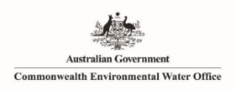

**Commonwealth Environmental Water Office**

**Long-Term Intervention Monitoring Project**

**Murrumbidgee River System Summary Report 2014-19**

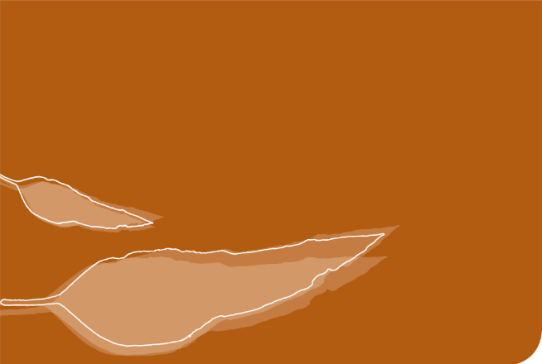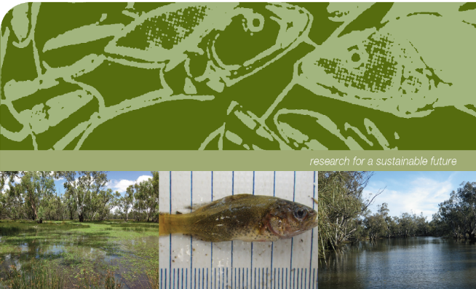

**Commonwealth Environmental Water Office Long-Term Intervention Monitoring Project Murrumbidgee River System Selected Area Summary Report 2014-19.**

Prepared by: Wassens, S.a, Michael, D a, Spencer, J.a,b,c, Thiem, J.d, Thomas, R.a,b,c, Kobayashi, Ta,c, Wolfenden, B.a, Jenkins, K.a, Amos, C. a,c., Hall, A.a, Bourke, G.a, Bino, G.b, Davis, T. d, Heath and J c., Kuo, W.c

|  |  |
| --- | --- |
|  | a Institute for Land, Water and Society. Charles Sturt University, PO Box 789, Albury, NSW 2640 |
| CES.png | b Centre for Ecosystem Science, University of New South Wales, Sydney, NSW, 2052 |
|  | c NSW Planning, Industry and Environment, PO Box 39, Sydney, NSW 2001 |
| TI logo colour rgb | d NSW Trade and Investment Narrandera Fisheries Centre, PO Box 182, Narrandera NSW 2700 |

**Funding:** This monitoring project was commissioned and funded by the Commonwealth Environmental Water Office with additional in-kind support from the NSW Department of Planning, Industry and Environment, Murrumbidgee Local Land Services and Charles Sturt University. We are grateful to private landholders for allowing access to their properties.

**Copyright:** © Copyright Commonwealth of Australia, 2020

‘Commonwealth Environmental Water Office Long-Term Intervention Monitoring Project Murrumbidgee River System Selected Area Summary Report, 2014-19 is licensed by the Commonwealth of Australia for use under a Creative Commons By Attribution 3.0 Australia licence with the exception of the Coat of Arms of the Commonwealth of Australia, the logo of the agency responsible for publishing the report, content supplied by third parties, and any images depicting people. For licence conditions see: <http://creativecommons.org/licenses/by/3.0/au/>

This report should be attributed as ‘Commonwealth Environmental Water Office Long-term Intervention Monitoring Project Murrumbidgee River System Selected Area Summary Report, Commonwealth of Australia 2020’. The Commonwealth of Australia has made all reasonable efforts to identify content supplied by third parties using the following format ‘© Copyright, [name of third party] ’.

**Disclaimer:** The views and opinions expressed in this publication are those of the authors and do not necessarily reflect those of the Australian Government or the Minister for the Environment and Energy. While reasonable efforts have been made to ensure that the contents of this publication are factually correct, the Commonwealth does not accept responsibility for the accuracy or completeness of the contents, and shall not be liable for any loss or damage that may be occasioned directly or indirectly through the use of, or reliance on, the contents of this publication.

**Acknowledgement**: The Commonwealth Environmental Water Office acknowledges the efforts of all consortium partners in delivering the Murrumbidgee Long-Term Intervention Monitoring Project and preparing this report. The authors of this report as well as the Commonwealth Environmental Water Office respectfully acknowledge the traditional owners, their Elders past and present, their Nations of the Murray-Darling Basin, and their cultural, social, environmental, spiritual and economic connection to their lands and waters. In particular the Wiradjuri, Narri Narri and Muthi Muthi peoples, traditional owners of the land on which this publication is focused.

Monitoring and evaluation of environmental water in the Murrumbidgee Selected Area

The Commonwealth Environmental Water Holder (CEWH) is responsible under the *Water Act 2007* (Commonwealth) for managing Commonwealth environmental water holdings to protect and restore the environmental assets of the Murray-Darling Basin. The Murray-Darling Basin Plan (2012) (referred to hereafter as the Basin Plan) requires that the holdings must be managed in a way that is consistent with the Basin Plan’s Environmental Watering Strategy (MDBA 2014). The Long-Term Intervention Monitoring Project (LTIM Project) is the primary means by which the Commonwealth Environmental Water Office (CEWO) monitors and evaluates the ecological outcomes of Commonwealth environmental watering actions. The LTIM Project is being implemented in the Murrumbidgee catchment along with six other water catchment areas for a five-year period (2014 to 2019) to inform environmental water management and demonstrate outcomes. The monitoring is designed to:

* Evaluate the contribution of Commonwealth environmental watering to the objectives of the Murray-Darling Basin Authority’s (MDBA) Environmental Watering Strategy.
* Monitor and evaluate the ecological outcomes of Commonwealth environmental watering in the Murrumbidgee Selected Area.
* Infer ecological outcomes of Commonwealth environmental watering in areas of the Murray-Darling Basin that are not currently monitored.
* Support the adaptive management of Commonwealth environmental water.

The Murrumbidgee LTIM team is led by Associate Professor Skye Wassens from Charles Sturt University, along with scientists and technicians from the newly formed Department of Planning, Industry and Environment (DPIE) (Fisheries and the Biodiversity and Conservation Group), and the University of New South Wales (Centre for Ecosystem Sciences). Funding from the Commonwealth Environmental Water Office supports monitoring of the hydrological and ecological outcomes of watering actions in the river and wetlands of the Murrumbidgee. This summary report focuses on the outcomes of watering actions undertaken during 1st July 2018 to 30th June 2019 (the 2018-19 water year), with reference to watering outcomes monitored in previous water years of the project (2014 - 2018).

The Murrumbidgee Catchment

The Murrumbidgee catchment in southern NSW, is one of the largest catchments (81,527 km2) in the Murray-Darling Basin (Kingsford *et al.* 2004). Wetlands make up over 4 per cent (370,000 ha) of the catchment, with over 1000 wetlands identified (Murray 2008). Nationally important wetlands, including the mid-Murrumbidgee and Lowbidgee floodplain, cover over 208,000 ha (2.5 per cent of the catchment area).

River monitoring sites

The Murrumbidgee River is over 1,600 km long, with the Murrumbidgee LTIM Project Selected Area covering the lowland section (approximately 786 km). Three key sections of the Murrumbidgee River (Figure 1) are routinely monitored as part of this program. These are:

* the **Narrandera reach (187.3 km)** which starts upstream of the Yanco and Oldman Creek regulators and extends to just above the Tom Bullen storage offtake. This zone includes major Murrumbidgee and Coleambally irrigation off-takes and key populations of Murray cod (*Maccullochella peelii*),
* the **Carrathool reach (358.0 km)** which is downstream of Tom Bullen storage and major irrigation off-takes. River levels tend to be lower as it is downstream of major irrigation off-takes and is the principle target for in-channel Commonwealth environmental watering actions and,
* the **Balranald reach (241.4 km)** extending from Hay to Boundary Bend downstream of Balranald aligns with the Lowbidgee floodplain. This reach was monitored in year 1 and year 5 to evaluate longer term changes in fish communities.

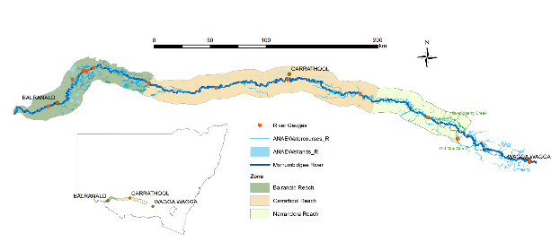Figure 1. Distribution of riverine zones in the Murrumbidgee Selected Area.

Wetland monitoring sites

Wetland and floodplains of the Murrumbidgee catchment are some of the most diverse and important systems in Australia. Six zones were identified, each supporting a unique set of wetland and floodplain habitats (Plate 1), different water requirements and alternative water management options (Figure 2). Due to the very large size of the Murrumbidgee catchment, monitoring is only carried out on twelve wetlands within three zones – the mid-Murrumbidgee, Redbank and Gayini Nimmie-Caira. The six wetland zones are briefly described below.

* **mid-Murrumbidgee wetlands (82,800 ha)** – River red gum forest interspersed with paleochannels (inactive streams filled with sediment) and oxbow lagoons.
* **Redbank (92,504 ha)** – Mosaic of river red gum forest and woodland, spike rush wetlands - divided into two management subzones (north and south Redbank).
* **Gayini Nimmie-Caira (98,138 ha)** – Mosaic of creek lines, paleochannels, open wetlands and lakes dominated by lignum and lignum-black box communities.
* **Fiddlers-Uara (75,285 ha)** – Paleochannels and creek lines bordered by black box.
* **The Western Lakes (3,459 ha)** – Open quaternary lakes with inactive lunettes (crescent-shaped dunes) west of the Lowbidgee floodplain.
* **Pimpara–Waugorah (55,451 ha)** – Mosaic of creek lines, paleochannels and wetlands, with River red gum and black box mostly north of the Murrumbidgee River.

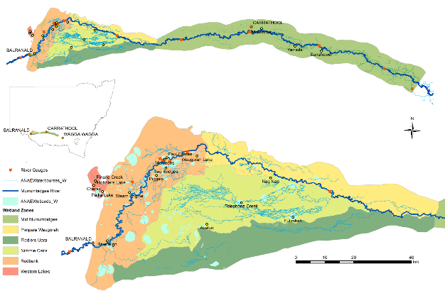

Figure 2. Distribution of wetland zones in the Murrumbidgee Selected Area and location of the twelve monitored wetlands.

|  |  |  |  |  |  |  |
| --- | --- | --- | --- | --- | --- | --- |
| |  |  | | --- | --- | | S:\Research\Research Data\Science\v04\R0274_Murrumbidgee_LTIM\Photos\Vegetation transect photos\Yarradda\YAR_T2 Q30 Jan19.JPG | Yarradda Lagoon –  Oxbow lagoon  mid-Murrumbidgee  January 2019 | | S:\Research\Research Data\Science\v04\R0274_Murrumbidgee_LTIM\Photos\Vegetation transect photos\Eulimbah\EUL_T1 Q30_Jan19.JPG | **Eulimbah Swamp**  **Lignum wetland**  **Gayini Nimmie-Caria**  **January 2019** | | S:\Research\Research Data\Science\v04\R0274_Murrumbidgee_LTIM\Photos\Vegetation transect photos\Two Bridges\TBR TT  Jan19 scenic.JPG | **Two Bridges Swamp**  **Tall emergent aquatic spike**  **rush wetlands**  **Redbank**  **January 2019** |   Plate 1. Examples of environmental watering sites in the Mururmbidgee Selected Area 2019 |

History of Commonwealth environmental watering actions in the Murrumbidgee

Flows within the Murrumbidgee River have undergone significant long-term changes since the construction of large headwater dams and in-channel weirs which allow the river flows to be regulated and water diverted to meet agricultural and consumptive needs. The timing of high flow periods, in particular, has shifted from winter to spring to meet irrigation demands. As a consequence, there have been significant reductions in the frequency of minor (water levels that reach very low lying wetlands and channels) and moderate (water levels that reach wetlands higher on the floodplain) flow pulses (Frazier *et al.* 2005; Frazier *et al.* 2006) (Figure 3). Between 2000 and 2010, a significant drought coupled with increasing consumptive water demand exacerbated the effects of river regulation (Dijk *et al.* 2013), leading to significant declines in the condition of floodplain vegetation (Wen *et al.* 2009). Large-scale flooding occurred in 2010 and 2011 which was followed by years of moderate water availability between 2012 and mid-2016. In 2016-17, there was above average rainfall in the catchment contributing to high tributary inflows and unregulated river flows which inundated significant areas of wetland through the mid-Murrumbidgee and Lowbidgee floodplains between September and November 2016. During 2018-19 there was below average rainfall across the Murray-Darling Basin and watering was undertaken in line with the dry scenario of the Murrumbidgee annual water plan.

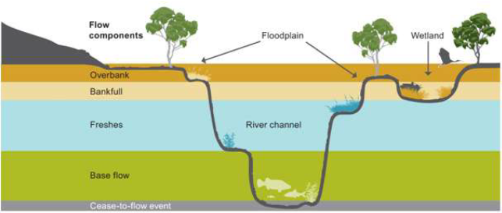

Figure 3. Five flow types and their influence on different parts of the river channel, wetlands and floodplains (MDBA 2011).

***Environmental watering in the Murrumbidgee between 2014 and 2019***

In 2014-15 and 2015-16, the majority of environmental water was allocated to the Redbank and Gayini Nimmie-Caria wetland systems in the Lower Murrumbidgee floodplain (Lowbidgee). In 2014-15 and 2015-16, very small volumes of water were used in the middle reaches of the Murrumbidgee (mid-Murrumbidgee), mainly at individual lagoons (Yarradda and Gooragool), while the 2017-18 water actions targeted a larger number of low-lying wetlands across the mid-Murrumbidgee. In 2018-19, the majority of water was directed to the Redbank wetland system, including Tala and Yanga Lakes. This was achieved by releasing environmental water via the Yanga 1AS regulator and via Nimmie-Caira to increase inundation extents in core wetlands, to maintain aquatic refuge habitats in North Redbank, and to maintain refuge habitat from Nap Nap to Waugorah. The volumes of water used in 2018-19 was marginally lower than the previous four years, and the targeted areas where watering actions occurred also varied from previous years (Figure 4).

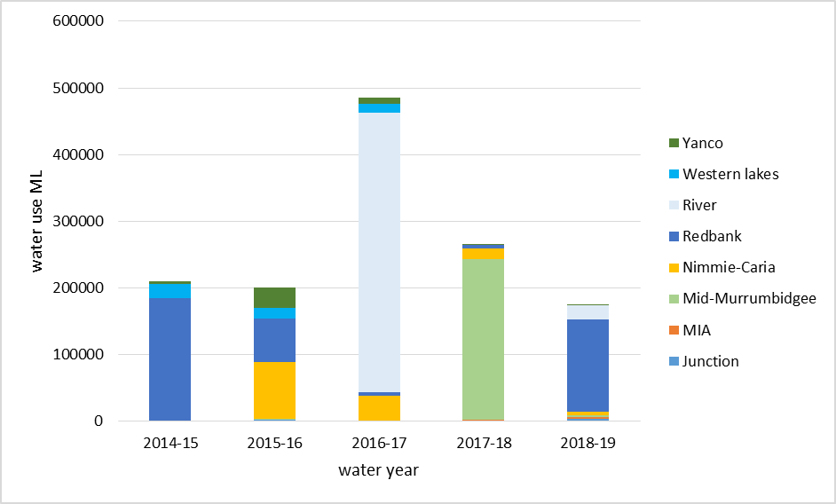

Figure 4. Summary of NSW and Commonwealth environmental watering actions by volume in key management zones in the Murrumbidgee between 2014 and 2019. Total environmental water delivered to the Murrumbidgee Catchment is a combination of Commonwealth licensed environmental Water (CEW), NSW licensed environmental water (NSW) and Environmental Water Allowance (EWA) accrued under the Water Sharing Plan for the Murrumbidgee Regulated River Water Source 2016.Note that there was also substantial unregulated floodplain inundation during 2016-17.

Watering Actions in 2018-19

In 2018-19, the Commonwealth environmental water holder in partnership with NSW and the Murray-Darling Basin Authority delivered 61,795.9 ML of Commonwealth environmental water, 112,708 ML of NSW environmental water and 16,100 ML of The Living Murray (TLM) water allocation as part of watering actions targeting rivers, wetlands, and creek line habitats in the Murrumbidgee Selected Area (Table 1). The largest water allocation was to the Yanga National Park: Yanga Lake top up and system watering which aimed to maintain water levels in Tala and Yanga Lakes and increase inundation extents throughout wetlands in Yanga National Park. This action started in late August 2018 with water delivered via the Yanga 1AS regulator and later the North Caira channel via the Gayini Nimmie-Caira. This action continued until the end of January 2019.

The second largest watering action was Nap Nap Swamp to Waugorah Lagoon, which was designed to trigger breeding by the vulnerable southern bell frog and to top up key refuge habitat for native fish. This action commenced in September 2018 and was managed using NSW Environmental Water Allocation (EWA). The Nimmie-Caira refuge flows were also delivered through critical habitats in the Gayini Nimmie-Caira in December 2018, and aimed to maintain key refuge habitat for native fish, turtles and frogs.

The Lower Murrumbidgee River: Low Dissolved Oxygen management flow was undertaken to reduce the risk of weir stratification and hypoxia and prevent native fish deaths. This actions was triggered in response to low end of system flows and extreme heat wave conditions over January 2019. Yarradda Lagoon was pumped with environmental water from mid-November 2018 to mid-January 2019 following a brief drying period. By April 2019, 23,613 ha of the Lowbidgee floodplain had been inundated. Most of the Lowbidgee inundation extent was distributed in the zones of Redbank and Nimmie-Caira covering 14,833 ha and 5,230 ha respectively. The Yanga National Park water action targeted several wetlands monitored in this program in the North Yanga section of South Redbank: Mercedes Swamp, Two Bridges Swamp and Piggery Lake.

Table 1. Summary of environmental water usage from Commonwealth and other environmental water sources in 2018-19. (Drawn from the Watering Action Acquittal Report Murrumbidgee 2018-19 (Commonwealth of Australia 2019)). Shaded rows indicate flows associated with the LTIM Monitoring locations that are evaluated in this report.

|  |  |  |  |  |  |
| --- | --- | --- | --- | --- | --- |
| Water Reference No. | Watering actions | Dates  (start/end) | Commonwealth environmental water (ML) | Other environmental water (ML) | Total water use  (ML) |
| 10082-02 | Yanga National Park: Yanga Lake top up and system watering (via 1AS) and then via South Caira channel) | Start: 20/08/2018  End: 31/01/2019 | 10,500 | 69,294 NSW EWA | 109,794 |
| 10082-03 | Yanga National Park: Yanga Lake top up (via Gayini Nimmie-Caira) | Start: 19/092018  End: 25/01/2019 | 30,000 |  |
| NSW EWA | Nap Nap Swamp to Waugorah Lagoon | Start: 25/09/2018  End: 02/11/2018 |  | 11,419 NSW EWA | 11,419 |
| 10082-04 | Nimmie-Caira refuge flows | Start: 01/12/2018  End: 25/05/2019 | 1,505 | 2,795 NSW EWA | 4,300 |
| 10082-05 | Mainie Swamp (Junction Wetlands) | Start: 10/10/2018  End: 25/02/2019 | 2,000 |  | 2,000 |
| 10082-06 | Toogimbie IPA Wetlands | Start: 15/10/2018  End: 22/03/2019 | 900 |  | 900 |
| 10082-07 | Waldaira Lagoon (Junction Wetlands) | Start: 24/10/2018  End: 15/03/2019 | 1,700 |  | 1,700 |
| 10082-08 | Yarradda Lagoon Pumping | Start: 16/11/2018  End: 18/01/2019 | 2,013.7 |  | 2,013.7 |
| 10082-09 | Gooragool/Mantangry Lagoon Pumping | Start: 07/02/2019  End: 03/05/2019 | 82.7 |  | 82.7 |
| 10082-10 | North Redbank refuge | Start: 18/09/2018  End: 18/01/2019 | 6,000 | 21,000 NSW EWA | 27,000 |
| 10082-11 | Campbell’s Swamp, McCaughey’s Lagoon and Turkey Flats Swamp (MIA) | Start: 08/11/2018  End: 18/02/2019 | 1,594 |  | 1,594 |
| 10082-12 | Fivebough Swamp (MIA) Wetlands | Start: 25/10/2018  End: 22/03/2019 | 794 |  | 794 |
| 10082-13 | Sandy Creek Wetlands | Start: 29/09/2018  End: 12/01/2019 | 400 |  | 400 |
| 10082-14 | Tuckerbil Swamp (MIA) | Start: 24/10/2018  End: 09/05/2019 | 609.6 |  | 609.6 |
| 10082-15 | Darlington Lagoon | Start: 20/12/2018  End: 1/05/2019 | 396.9 |  | 396.9 |
| 10082-16\* | Lower Murrumbidgee River: Low Dissolved Oxygen management flow | Start: 30/01/2019  End: 09/04/2019 | 3,300 | 16,100 TLM  8,200 NSW EWA | 27,600 |
|  |  | **Total delivered** | **61,795.9** | **128,808** | **190,603.9** |

\*Baldwin DS (2019) Weir stratification and hypoxic water management - Murrumbidgee River 2019. A report prepared for the Commonwealth Environmental Water Office and the Murray-Darling Basin Authority.

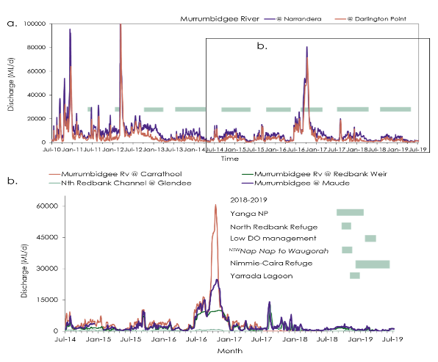

Figure 5. Mean daily discharge in the Murrumbidgee River at Narrandera and Darlington Point (1 July 2010 to 30 June 2019). Note the 2012 discharge peaked at 200,000 ML/d. Green horizontal bars show Commonwealth and NSW environmental water action timing for water years between 2011-12 to 2018-2019; and, b. Mean daily discharge in the Murrumbidgee River between July 2014 to June 2019 at Carrathool, Redbank Weir and downstream of Maude Weir and on the North Redbank Channel at Glendee in relation to the timing of environmental water actions (green horizontal bars) during the survey period (1 July 2018 to 30 June 2019). Data downloaded from the NSW Water Info website.

***Why were these actions undertaken?***

When planning and delivering environmental water, Commonwealth water managers are required to set clear ecological objectives that align with objectives set out in the Murray-Darling Basin Plan ([the Basin Plan Objectives](https://www.environment.gov.au/system/files/resources/c8a8d2f6-e455-4126-bf75-0fa0c9147736/files/environmental-water-outcomes-framework.pdf)). These relate to biodiversity (the number of individual species supported by environmental water), ecosystem function (for example maintaining productivity and nutrient cycles), ecological resilience (longevity, breeding and recovery of plant and animal populations) and water quality (such as preventing periods of low dissolved oxygen, reducing the risk of algal blooms and maintaining appropriate salinity levels).

The largest volume of environmental water in 2018-19 was used to top up Tala Lake and Yanga Lake as part of the Yanga National Park: Yanga Lake top up and system watering action (109,794 ML). This was achieved by delivering water via the 1AS regulator and via Gayini Nimmie-Caira (Table 1 and Figure 5). Specific watering objectives of this action were to:

* maintain and increase the extent and quality of habitat available to golden perch in Tala Lake and Yanga Lake, to avoid potential large scale fish mortality from drying or habitat degradation;
* contribute to native riparian, wetland and floodplain vegetation diversity and condition;
* provide refuge habitat for waterbirds, native fish, frogs and turtles;
* improve hydrological connectivity and water quality; and
* support native fish movement, spawning, recruitment and condition.

Additional objectives from other watering actions in the Murrumbidgee were to:

* maintain critical refuge habitat requirements for waterbirds, native fish, turtles and frogs, including for the vulnerable southern bell frog (e.g. Nap Nap to Waugorah and Nimmie-Caira refuge flows);
* maintain vegetation resilience and condition gained through Commonwealth environmental water delivery; and
* contribute to improving water quality, with the aim of increasing dissolved oxygen to safe levels for native fish and other aquatic fauna and/or preventing dissolved oxygen levels dropping below critical thresholds

Key outcomes from environmental water use in 2018-19

This section focuses on key watering actions that were evaluated as part of the LTIM program in 2018-19, specifically the Yanga Lake top up (August to January), Nimmie-Caira refuge flow, Nap Nap to Waugorah Lagoon and pumping into Yarradda Lagoon (November to January) (see Table 1).

***Riverine outcomes***

With the exception of the Lower Murrumbidgee River dissolved oxygen management flow (WAR 10082-16), no other environmental watering actions were specifically undertaken within the river channel. However, the delivery of environmental and irrigation water, along with inter valley transfers influences the hydrology of the Murrumbidgee River and can be linked to native fish breeding activity. As in previous years, native riverine fish continued to spawn in the Murrumbidgee River with spawning closely linked to water temperature. Nine native fish species (Australian smelt, bony herring, carp gudgeon*,* flat-headed gudgeon, Murray-Darling rainbow fish, river blackfish, golden perch, Murray cod andsilver perch) and two exotic species (common carp and eastern gambusia)were detected spawning in the Murrumbidgee River, representing the highest number of native species detected spawning over the five year monitoring program (Plate 2). A combined total of 4,129 fish eggs and larvae were collected in 2018-19, the most abundant species being Murray cod larvae (1,201 in total), flat-headed gudgeon larvae (1,105 in total) and carp gudgeon larvae (646 in total).

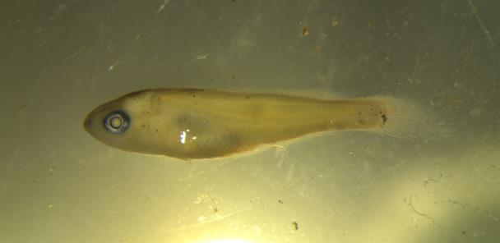

Plate 2. Cod species metalarvae. Captures of Murray cod larvae (1,201 in total) were highest during the 2018-19 water year.

Mid-Murrumbidgee zone - Yarradda Lagoon pumping

Yarradda Lagoon is a large billabong near Darlington Point. This wetland is important because it is representative of the grassy aquatic meadows that were once widespread throughout the mid-Murrumbidgee wetland system between Wagga Wagga and Hay. Water levels at Yarradda Lagoon have been managed by a combination of pumping (during years with lower water availability) and river to wetland reconnections (during years of higher water availability). Pumping water to wetlands can be beneficial because it has minimal water losses and can also help to exclude large exotic carp, which might otherwise affect vegetation establishment and water quality. Water was pumped to Yarradda Lagoon in 2014-15 and 2015-16, followed by unregulated inflows in 2016-17, then pumping and regulated river to wetland connections in 2017-18.

Despite mainly receiving water via pumps, Yarradda Lagoon supports a relatively high diversity of native fish species, including Australian smelt, bony herring, carp gudgeon, flat-headed gudgeon and Murray-Darling rainbowfish, which appear to be able to enter wetlands via pumping infrastructure. Larger bodied native species including silver perch and golden perch entered the wetland during unregulated and regulated river to wetland reconnections in 2016-17 and 2017-18. Unfortunately, very large numbers of adult common carp also entered the wetland during these river reconnections, contributing to declines in tadpole abundance. To reduce the abundance of common carp, Yarradda Lagoon was allowed to dry out naturally in October 2018, followed immediately by pumping in November 2018.

Over 1000 large adult common carp were removed from the wetland via this action leading to a large reduction in the abundance of carp and overall improvement in frog diversity and tadpole numbers. Of particular note, were exceptionally high numbers of Peron’s tree frog (*Litoria peronii*) (Plate 3) tadpoles compared to previous years, a result attributed to lower carp numbers and improvements in aquatic vegetation cover.

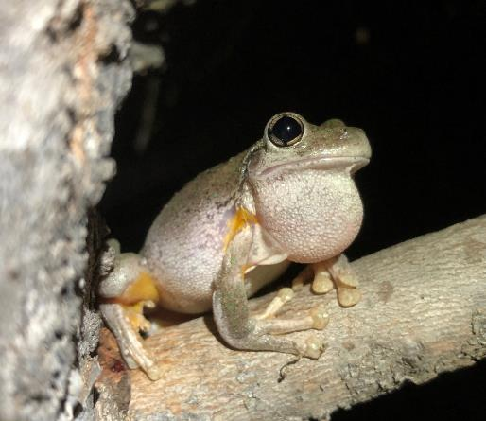

Plate 3. Managing water levels to reduce carp abundance led to significant increases in the abundance of Peron’s tree frog tadpoles in Yarradda Lagoon during the 2018-19 water year.

**Vegetation outcomes**

Commonwealth environmental water was also important in supporting the establishment of aquatic communities in Yarradda Lagoon. Since 2014, environmental watering actions contributed to the re-establishment of spiny mud grass (*Pseudoraphis spinescens*), common spike rush (*Eleocharis acuta*) (Plate 4) and two fringing species, lesser joyweed (*Alternanthera denticulate*) and the culturally significant old man weed (*Centipeda cunninghamii*) (Plate 4). Furthermore, Yarradda Lagoon has shown a steady increase in the number of aquatic species being recruited (Plate 5) with two additional species identified following Commonwealth environmental watering in 2017-18: water primrose (*Ludwigia peploides* ssp. *montevidensis*) and nardoo (*Marsilea drummondii*). By contrast, wetlands that did not receive water were dominated by terrestrial species, had higher cover of the introduced species such as spear thistle (*Cirsium vulgare*), as well as greater cover of river red gum (*Eucalyptus camaldulensis*)seedlings and saplings.

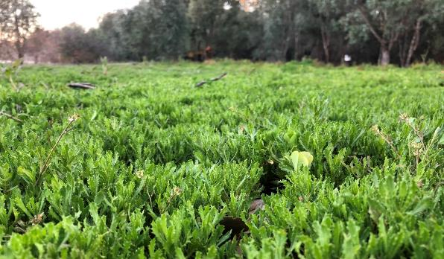

Plate 4. An extensive sward of the culturally important old man weed (*Centipeda cunninghami*) that has established on the banks of Yarradda Lagoon due to the delivery of environmental water.

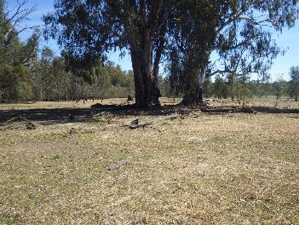

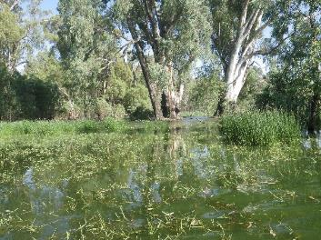

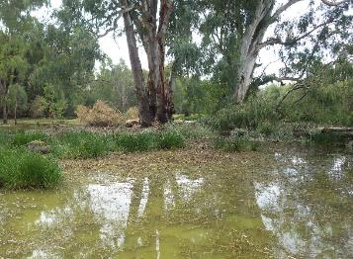

Plate 5. Yarradda Lagoon showing growth of aquatic vegetation response to watering in 2018-19 – Top November 2018, middle January 2019, bottom March 2019.

***Nimmie-Caira - refuge flow and Nap Nap to Waugorah***

Nap Nap Swamp in the north eastern edge of the Gayini Nimmie-Caira supports a key population of the threatened southern bell frog (*Litoria raniformis*) and is an important breeding site for waterbirds. Nap Nap Swamp is important because it is situated at the top of a connected wetland system, with water flowing through Nap Nap Swamp (Plate 6) in a westerly direction across large areas of lignum and river red gum forest before reaching Waugorah Lagoon (Plate 6), a large, deep and permanent waterbody in the Redbank zone, Yanga National Park.

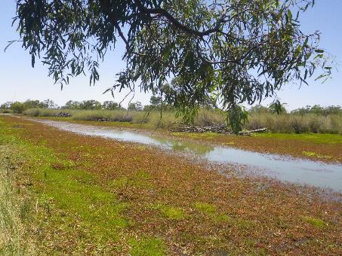

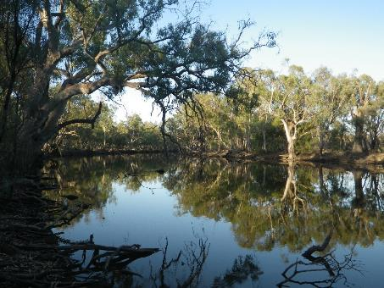

Plate 6. Nap Nap Swamp (top) and Waugorah Lagoon (bottom) January 2019.

Environmental water deliveries through the Nap Nap–Waugorah system commenced in September 2018 and water was maintained in Nap Nap Swamp through spring into autumn 2019. This water delivery built on previous Commonwealth environmental watering actions undertaken in 2015-16 and 2016-17 and were aimed at maintaining populations of the threatened southern bell frog as well as supporting frog and waterbird breeding events.

**Southern bell frogs at Nap Nap**

Since 2014, Commonwealth and NSW watering has contributed to the recovery of the southern bell frog (Plate 7) population at Nap Nap Swamp and a general increase in the presence and abundance of the southern bell frog across wetlands in the lower Murrumbidgee. Environmental water was used to support breeding by the southern bell frog at two key locations within the Gayini Nimmie-Caira, Nap Nap Swamp and Eulimbah Swamp, and to support refuge habitat for southern bell frogs across a larger number of sites including Nimmie Creek, Telephone Creek and Avalon Swamp. It was also used at Yarradda Lagoon in the mid-Murrumbidgee. These outcomes highlight the critical importance of the use of NSW and Commonwealth environmental water to maintain suitable watering regimes at key southern bell frog breeding sites. These actions resulted in high numbers of tadpoles from a variety of species, including the southern bell frog. In March 2019, numbers of southern bell frogs recorded in a 40 minute survey exceeded 300 adults at Nap Nap Swamp. Maintaining large population densities through targeted watering actions at key wetlands will be an important objective in the long-term recovery of this threatened species in the Murrumbidgee Selected Area.

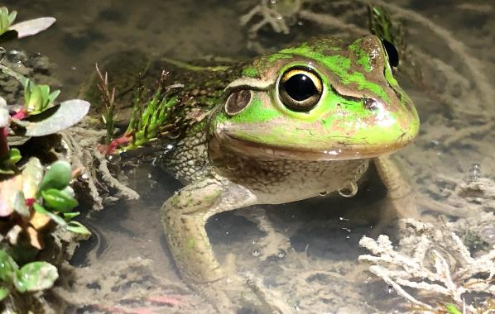

Plate 7. The threatened southern bell frog has been detected on seven wetlands across the Murrumbidgee Selected Area and has shown a steady increase in numbers at several key wetlands.

The 2018-19, environmental watering actions continued to provide suitable conditions for turtles in the Nimmie-Caira zone. During the five year monitoring period, a total of 350 turtles from three species have been recorded across the selected area (Plate 8): the eastern long-neck turtle (*Chelodina longicollis*) (283 in total), broad-shelled turtle (*Chelodina expansa*) (47 in total) and Macquarie turtle (*Emydura macquarii*)(20 in total). While adult turtles can move considerable distance overland when wetlands dry out, the availability of permanent water holes is important. In 2018-19, environmental watering actions maintained persistent waterbodies at Telephone Creek and Waugorah Lagoon, two permanent lagoons that consistently support high turtle numbers. Foxes have a serious negative impact on turtle hatching success (Spencer and Thomas 2005), and although no hatching turtles were recorded in the Murrumbidgee wetlands following environmental watering in 2018-19, small numbers of hatchlings were detected over the five year monitoring period.

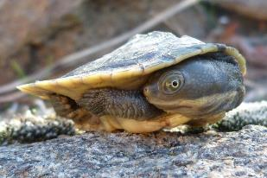 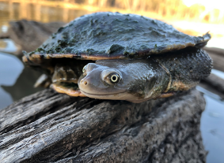

Plate 8. Wetlands provide important nursery habitats for hatchling turtles with permanent lagoons supporting large numbers and up to three species (left: hatchling Macquarie turtle and right: eastern long-neck turtle).

Redbank zone - Yanga National Park: Yanga Lake top up and system watering

The Yanga Lake and system watering action was designed to: 1) support refuge habitat for golden perch (*Macquaria ambigua*) within Tala Lake and associated creek lines, and 2) to increase water levels within Yanga Lake at the end of the flow path within Yanga National Park. This watering action was also expected to have positive outcomes for native fish, frogs, turtles and waterbirds. This was the largest volume of Commonwealth environmental water delivered in 2018-19, and inundated two LTIM monitored wetlands in the Redbank zone (Piggery Lake and Two Bridges Swamp). Frog diversity in the Redbank zone was the highest since monitoring commenced in 2014, largely due to the arrival of southern bell frogsat Two Bridges and Piggery Swamp. Southern bell frogs were historically common in these wetlands but have only occasional been detected in recent years. Overall, the Yanga Lake and system watering maintained suitable habitat and supported breeding for six frog species. Barking marsh frog (*Limnodynastes fletcheri*) and spotted marsh frog (*L. tasmaniensis*) (Plate 7) tadpoles occurred in high numbers (541 individuals) in March 2019, corresponding with sustained high water levels in Two Bridges Swamp. This watering action also supported high turtle numbers with 40 mature eastern long-necked turtles recorded in March 2019.

The environmental flow through Yanga National Park reached eight species of native fish and four invasive species across larval, juvenile and adult stages in Yanga and Tala floodplain environments. Successful floodplain spawning and recruitment of golden perch was detected in Tala Creek and the hatch-dates of recruits over-lapped with environmental water delivery. Neither spawning nor recruitment of golden perch was detected in the main channel of the Murrumbidgee River or in Yanga Lake in 2018-19. However, larval and juvenile Murray cod (*Maccullochella peelii*) were collected drifting from the Murrumbidgee River into the Yanga floodplain system via the environmental flow in November and December 2018 (Kopf *et al.* 2019).

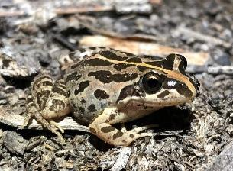 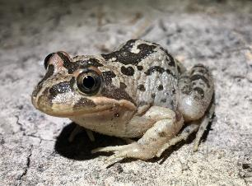

Plate 7. The two most abundant frog species in the Murrumbidgee Selected Area are the spotted marsh frog (left) and barking marsh frog (right).

The Yanga Lake and system watering action also supported a diverse range of waterbird species in 2018-19. Twenty one waterbird species utilised habitat maintained during the environmental watering action at Two Bridges Swamp and 30 species utilised habitats at Piggery Lake. Piggery Lake in particular supported large numbers of fish-eating waterbirds, including Australian pelican (*Pelicanus conspicillatus*), hoary-headed grebe (*Poliocephalus poliocephalus*) and several cormorant species. Seven species of birds of conservation significance were detected in response to theYanga Lake and system watering. These species included the Australasian bittern (*Botaurus poiciloptilus*), magpie goose (*Anseranas semipalmata*), freckled duck (*Stictonetta naevosa*) and white-bellied sea-eagle (*Haliaeetus leucogaster*). The threatened Australasian bittern and Australian little bittern (*Ixobrychus minutus*) were also recorded breeding at Two Bridges Swamp (Herring 2019), while nine colonial nesting waterbird species bred in response to the environmental watering.

Another significant outcome of the watering actions in the Redbank zone, were a number of sightings (21 in total) of the threatened grey snake (*Hemiaspis damelii*)(IUCN Red List). The grey snake is a small, nocturnal, frog-eating species not previously documented for the Murrumbidgee catchment, although it is historically known to occur in the lower Lachlan catchment near Oxley. Wetland-dependant snakes are not a primary focus of the monitoring program, however, incidental records such as these provide evidence of the broader benefits of environmental water in creating suitable habitat and conditions for threatened reptiles.

Implications for future management of environmental water

**Managing native fish in the Murrumbidgee River**

Since monitoring commenced in 2014, we have found little evidence to suggest that managing for discrete flow peaks within the monitored reaches of the mid-Murrumbidgee influenced native fish spawning. This might be in part due to the already higher water flows occurring in the mid-Murrumbidgee compared to other parts of the river, with irrigation deliveries creating conditions suitable for spawning throughout the breeding season. Despite slightly more variable flow levels in Carrathool Reach in 2018-19, our monitoring indicated that spawning by golden perch and silver perch was similar to previous years. However, we did not detect juvenile golden or silver perch in the Carrathool Reach following these spawning events, which may indicate that the survival of larval perch is low or that we under sample this age class due to their secretive behaviour and/or occupation of un-sampled habitats. Interestingly, juvenile golden perch were recorded in floodplain creeks and lakes in the Lowbidgee following the Yanga National Park: Yanga Lake top up and system watering, and there is increasing evidence that these floodplain habitats may be critical for golden perch breeding and recruitment (Kopf *et al.* 2019). The abundance of juvenile Murray cod was considerably lower in 2018-19 compared with 2014-15 and 2015-16, but similar to those recorded in 2016-17. The reasons contributing to the poor survival of larval fish through to the juvenile stage remains unknown and requires further investigation.

**Managing floodplain wetlands**

Given the modest volumes of environmental water available in the Murrumbidgee relative to the area of riverine, floodplain and wetland habitats, and the need to support multiple water users, there is limited capacity to restore the natural inundation regime via managed reconnections alone. The current water management approach for wetlands in the mid-Murrumbidgee focuses on managed pumping of environmental water to key wetlands such as Yarradda Lagoon and Gooragool Lagoon. There is now clear evidence to show that management interventions that allow a short drying period followed by immediate pumping can be effective in removing a significant number of adult common carp from a wetland. These actions contributed to a noticeable increase in frog and tadpole abundance in 2018-19, compared to previous years when large numbers of carp were present in the wetland. Studies investigating the relationship between common carp and tadpoles are limited, but there is strong evidence that high carp numbers suppress the breeding response of frogs (Kloskowski 2009; Kloskowski 2011; Kaemingk *et al.* 2017) and may be a contributing factor influencing the outcomes of environmental watering actions in the Murrumbidgee Selected Area. However, these relationships are complex as the timing of inundation and wetting and drying patterns can also have a strong influence on frog breeding outcomes. Management actions that include the removal of carp prior to pumping, either through physical removal and/or short-term drying out of the wetland, have been shown to have positive benefits for frogs and vegetation and should be implemented when adult carp numbers increase.

Nap Nap Swamp and Eulimbah Swamp provide important refuge habitat for the southern bell frog. The watering regime at Nap Nap Swamp since 2014 has shifted from being dry in the early years (2014-2016) to having received both Commonwealth and NSW environmental water after the 2016 unregulated flood year. These watering actions contributed to increased lignum cover, breeding cues and recruitment of southern bell frogs in the Nimmie-Caira zone and constitute important refuge sites for this threatened species. Maintaining these sites as southern bell frog refuge habitat into the future will be of considerable importance in the long-term management of this species in the Murrumbidgee Selected Area.

The 2018/19 monitoring results also suggest that management decisions to deliver environmental water to inundate and maintain floodplain habits during spring and summer are important to maintain viable native fish populations, and the ecosystem continues to provide food for resident populations of fish and fish-eating waterbirds. Although the golden perch recruitment event in 2018-19 was not widespread, its potential importance to local populations should not be underestimated, especially in a year following fish-kills in the Murrumbidgee River. During the extreme drought conditions and the fish-kills experienced in New South Wales, these inundated floodplain habitats and lakes provide rare refuges of high quality habitat and productivity that attract a diverse waterbird assemblage and contribute to fish spawning, growth and recruitment.

Key management recommendations

* Breeding in many frog species, including the southern bell frog, is triggered by rising wetland water levels during spring (October and November). A positive response to early watering actions was observed for adult southern bell frog numbers and calling activity at several key wetlands (Two Bridges, Piggery and Nap Nap Swamp) in 2018-19. Therefore, watering actions in early spring should be considered to enhance frog breeding activity and frog recruitment.
* Where the maintenance of refuge habitat is the primary watering objective, complementary management actions including the physical removal of carp in target wetlands as well as the temporary drying of sites should be considered. It is recommended that this process is repeated if carp numbers build up and declines in vegetation and tadpole diversity become apparent through long-term monitoring.
* In regulated systems, where dry phases may be absent or rare and periods of inflow differ from the historical frequency and timing of inundation, the maintenance of native fish communities through floodplain wetlands is largely provided by persistent waterbodies and/or regular connection to the river channel. The monitoring program has indicated that invasive fish densities are likely to remain stable in many permanent creek systems in the Lowbidgee floodplain (e.g. Telephone Creek and Waugorah Lagoon). Notwithstanding the point above, management actions that aim to retain water in these types of wetlands will provide long-term benefits to resident native turtles, fish and frog populations.

***Cited literature***

Baldwin, D.S. (2019) Weir stratification and hypoxic water management - Murrumbidgee River 2019. A report prepared for the Commonwealth Environmental Water Office.

Colloff, M.J., Ward, K.A., and Roberts, J. (2014) Ecology and conservation of grassy wetlands dominated by spiny mud grass Pseudoraphis spinescens in the southern Murray–Darling Basin, Australia. *Aquatic Conservation: Marine and Freshwater Ecosystems* **24**(2), 238-255.

Commonwealth of Australia (2019) Watering Action Acquittal Report Murrumbidgee 2018-19. Canberra.

Dijk, A.I., Beck, H.E., Crosbie, R.S., Jeu, R.A., Liu, Y.Y., Podger, G.M., . . . Viney, N.R. (2013) The Millennium Drought in southeast Australia (2001–2009): Natural and human causes and implications for water resources, ecosystems, economy, and society. *Water Resources Research* **49**(2), 1040-1057.

Frazier, P., and Page, K. (2006) The effect of river regulation on floodplain wetland inundation, Murrumbidgee River, Australia. *Marine and Freshwater Research* **57**(2), 133-141.

Frazier, P., Page, K., and Read, A. (2005) Effects of flow regulation in flow regime on the Murrumbidgee River, South Eastern Australia: an assessment using a daily estimation hydrological model. *Australian Geographer* **36**(3), 301-314.

Herring, M. (2019). Bittern Surveys in the Lowbidgee Wetlands: December 2018 – January 2019 Summary Report. Murray Wildlife. Report prepared for NSW Office of Environment and Heritage.

Kaemingk, M.A., Jolley, J.C., Paukert, C.P., Willis, D.W., Henderson, K., Holland, R.S., . . . Lindvall, M.L. (2017) Common carp disrupt ecosystem structure and function through middle-out effects. *Marine and Freshwater Research* **68**(4), 718-731.

Kingsford, R.T., and Thomas, R.F. (2004) Destruction of wetlands and waterbird populations by dams and irrigation on the Murrumbidgee River in arid Australia. *Environmental Management* **34**(3), 383-396.

Kloskowski, J. (2009) Size-structured effects of common carp on reproduction of pond-breeding amphibians. *Hydrobiologia*, 1-9.

Kloskowski, J. (2011) Impact of common carp *Cyprinus carpio* on aquatic communities: direct trophic effects versus habitat deterioration. *Fundamental and Applied Limnology/Archiv für Hydrobiologie* **178**(3), 245-255.

Kopf R.K., Wassens S., McPhan L., Dyer J., Maguire J., Spencer J., Amos C., Kopf S., Whiterod N. (2019). Native and invasive fish dispersal, spawning and trophic dynamics during a managed river-floodplain connection. Commonwealth Environmental Water Office. Murrumbidgee Selected Area.

Murray, P. (2008) 'Murrumbidgee wetlands resource book.' (Murrumbidgee Catchment Management Authority: New South Wales)

Water NSW (June 2018) Water Operations Report: Murrumbidgee Valley. Vol. 2018. (Water NSW)

Wen, L., Ling, J., Saintilan, N., and Rogers, K. (2009) An investigation of the hydrological requirements of River Red Gum (*Eucalyptus camaldulensis*) Forest, using Classification and Regression Tree modelling. *Ecohydrology* **2**(2), 143-155.