###### Hydrology (River)

Introduction

The Hydrology (River) indicator provides in-channel hydrological information on the character of Commonwealth and state environmental water Contributions. This information is directly relevant to several other indicators measured in the Junction of the Warrego and Darling rivers Selected Area (Selected Area) including water quality, stream metabolism, vegetation, waterbirds, fish, and microcrustaceans. The Hydrology (River) indicator also provides information on the degree of hydrological connectivity maintained through the Selected Area during the 2017-18 water year. One specific question was addressed in relation to this indicator:

* What did Commonwealth environmental water contribute to hydrological connectivity?

**Environmental watering in 2017-18**

***Barwon-Darling and northern tributaries***

The 2017-18 water year was characterised by dry conditions and very low river flows throughout the northern tributaries. Three instream flow events including both unregulated and regulated environmental water occurred during July-November 2017, March – April 2018 and May 2018, providing approximately 21,669 ML, 3,446 ML and 13,332 ML of environmental water, respectively, at Louth, downstream of the Selected Area (Appendix B). It is estimated that during each event environmental water made up a significant proportion of these flows (between 24.3% and 99.6%).

***Warrego River***

Flows in the Warrego River during the 2017-18 water year were very low, with water entering the Selected Area during four small flow events in October 2017, December 2017, March-April 2018 and June 2018. Commonwealth environmental water made up 17.3% of the flow event during March-April 2018. Water levels in Boera Dam remained below the Western Floodplain connection level for most of the year with only one brief period of connection to the floodplain observed in December 2017 (Figure A‑1). During the flow event in March-April 2018, the Boera Dam regulating gates were partially opened for a total of 16 days, though flows were restricted to 300 ML/d or less in response to Boera Dam inflows. This event reconnected the waterholes in the lower Warrego system and provided connection through to the Darling River.

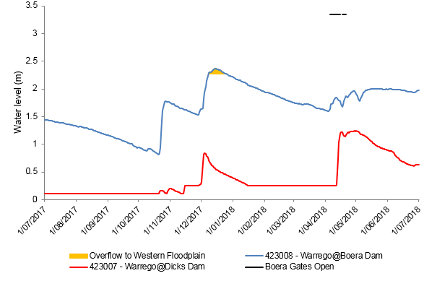

**Figure A‑1: Boera Dam levels during 2017-18 water year and flow to Western Floodplain and/or into lower Warrego channels (gates open).**

Methods

An assessment of the hydrological connectivity experienced along the Darling River within the Selected Area was undertaken by comparing flow regimes at the upstream Weir 19A gauge (425037) with the gauging station at Louth (425004) which is the first reliable gauge downstream of the Selected Area (Figure A‑2, Commonwealth of Australia 2015). This reach was considered to be fully connected when water was flowing past both gauges. For the Warrego River, flows entering the Selected Area were measured by plotting flows past Fords Bridge (Figure A‑2). Flows at 423001–Warrego River @ Fords Bridge (Main channel) were combined with flows past 423002–Warrego River @ Fords Bridge Bywash to give a total flow past Fords Bridge. Connectivity within the lower Warrego channel below Boera Dam was assessed by comparing times when the Boera Dam regulating gates were open (obtained from the Commonwealth environmental water office; Figure A‑3) to water levels at the 423007 – Warrego @ Dicks Dam gauge.

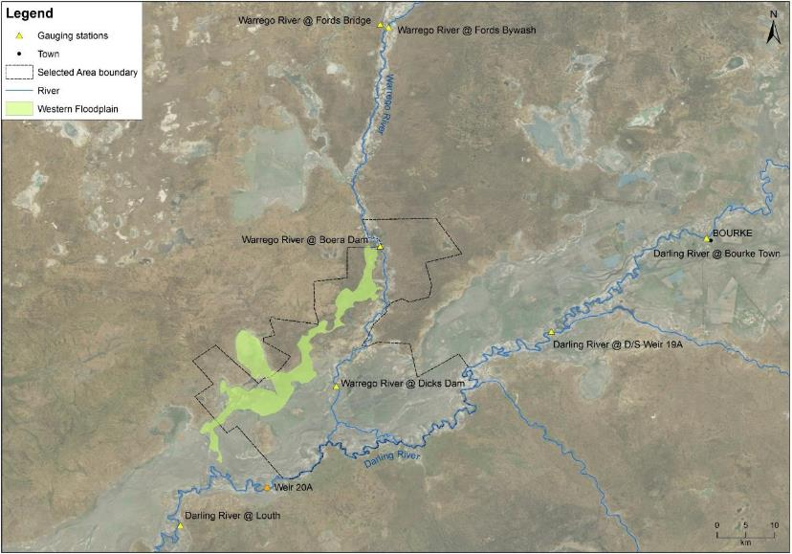

**Figure A‑2: Location of flow gauging stations used in the hydrological connectivity analysis and extent of the Western Floodplain.**

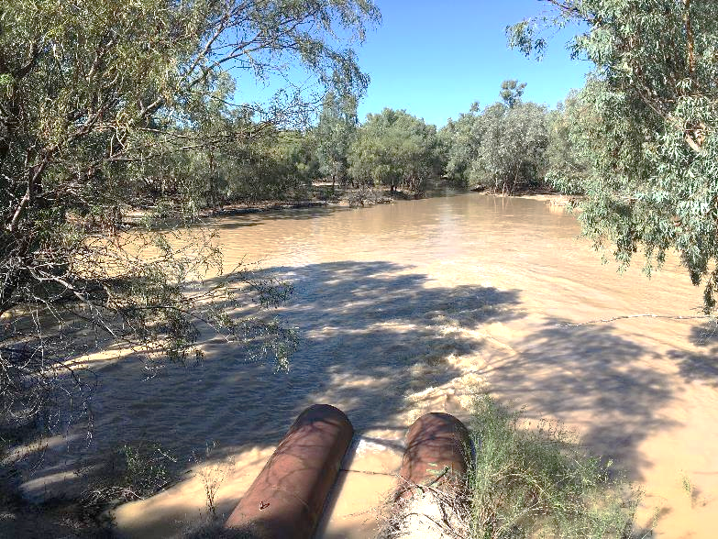

**Figure A‑3: Regulating pipes at Boera Dam discharging water into the lower Warrego River channel.**

Results

**Longitudinal Connectivity**

***Darling River***

Longitudinal connectivity (i.e. overtopping of weir 20A) occurred along the Darling River within the Selected Area for 266 days during 2017-18 (Figure A‑4). The magnitude of flow during these periods of connection was low with flows remaining under 1,600 ML/d for the entire year. Darling River connectivity was mainly driven by three consecutive flow events each containing Commonwealth environmental water (Figure A‑4). In July – November 2017, these flows included a total upstream contribution of 170,670 ML. This comprised regulated Commonwealth and state environmental water from the Border Rivers, Gwydir and Macquarie-Castlereagh River systems along with unregulated Commonwealth environmental water from the Border Rivers (Appendix B). A small peak at Louth was also recorded in early December 2017 which was the result of local rainfall. Total connection through the July 2017 – January 2018 period was 196 days (Figure A‑4). In March – April 2018, 9,162 ML Commonwealth environmental water was accounted for in the Barwon Darling River system from the Condamine-Balonne river system augmented by regulated Commonwealth environmental water from the Namoi, of which 3,446 ML entered the Selected Area (Appendix B). This contributed to 37 days of connection through the Darling River zone of the Selected Area. Connectivity in May – June 2018 was driven by the northern connectivity event comprising Commonwealth and state environmental water delivered from the Queensland Border Rivers and Gwydir catchments. Connectivity along the Darling River within the Selected Area was achieved for over 33 days following delivery of environmental water. This event aimed to provide a small fresh in the Barwon-Darling river down to Wilcannia to improve water quality and increase access to habitat for fish and other aquatic animals in the river.

**Figure A‑4: River flows down the Darling River channel and the timing of longitudinal connectivity in the Selected Area. Dashed environmental flow lines indicate sporadic delivery of environmental water during these times from various upstream sources.**

***Warrego River***

Five flow events entered the Selected Area from the Warrego catchment during the 2017-18 water year (Figure A‑5). This occurred in October 2017, December 2017, March-April 2018 and June 2018. Commonwealth environmental water made up around 17.3% of the water which flowed into the Selected Area down the Warrego River over the March-April 2018 period.

**Figure A‑5: Flow hydrograph for Warrego River at Fords Bridge upstream of the Selected Area. Note gauges 423001 and 423002 have been combined to produce a total flow past Fords Bridge.**

Levels in Boera Dam declined steadily from the beginning of the 2017-18 water year until two small inflows from entered Boera Dam during October – December 2017. The first inflow was too small to overflow to the Western Floodplain and was not noted downstream at Dick’s Dam. The second flow in December caused Boera Dam to fill above the estimated overflow to the Western Floodplain level of 2.26 m for 19 consecutive days in December 2017. Rises at Dicks Dam during this same period suggests that localised rainfall also fell within the Selected Area.

During the April inflow events, the gates at Boera Dam were opened to allow flow through to the Darling River, with connection of the lower Warrego channel occurring after one week. This flow aimed to protect and restore ecosystem functions and aquatic habitats in the Warrego River. The gates were opened to a maximum of 225 ML/d for 11 days (5 – 15 April 2018) and again for five days (17 – 21 April 2018), peaking at 300 ML/d, with volumes based on inflows to Boera Dam. This strategy resulted in connection for 16 days.

**Figure A‑6: Water levels at Boera Dam and Dick’s Dam and periods of longitudinal connection and overflow to the Western Floodplain.**

Discussion

Flows down the Darling River were low throughout the 2017-18 water year due to low rainfall and small contributions from upstream tributaries. Flow peaks remained below 1,600 ML/d in the Selected Area which represent small freshes, being around 5% of bankfull discharge. The extended period of connectivity in 2016-17 was maintained until mid-January 2018 when the Darling River ceased to flow. Hydrology in this section of the Darling River is heavily influenced by weirs, including Weir 19A upstream of the Selected Area and Weir 20A downstream. These provide refuges for riverine animals during no flow periods. Connectivity was restored in April 2018 and May 2018 following two separate flow events that included Commonwealth and state environmental water (Appendix B).

Flow in the Warrego River was sporadic throughout the 2017-18 water year. Consistent with the Toorale environmental watering strategy, there was only one environmental water event in April 2018. Longitudinal connectivity in the lower Warrego River was restored in April for 16 days following a decision to account Commonwealth environmental water against the Warrego River licences (for 16 days and 500 ML). This flow aimed to protect and restore ecosystem functions and aquatic habitats in the Warrego River and improve water quality in the Darling River. There was overflow to the Western Floodplain for 19 days in December 2017 which inundated a small proportion of the floodplain (Appendix D). This was due to localised rainfall, rather than substantial flows from the upper Warrego catchment triggering the Toorale licence.

Conclusion

The 2017-18 water year was characterised by low/baseflow conditions with several small flow events. Full longitudinal connection was experienced through the Darling River zone in the Selected Area for 226 days in the 2017-18 water year and for 16 days in total through the Warrego River within the Selected Area. In the Darling River, connection was driven largely by moderate Commonwealth and state environmental water contributions, while Weir 20A downstream of the Selected Area maintained connection during drier periods. In the Warrego, releases out of Boera Dam including environmental water in April 2017 resulted in connection to the Darling River for 16 days in total.

References

Commonwealth of Australia 2015. *Commonwealth Water Office Long Term Intervention Monitoring Project Junction of the Warrego and Darling rivers Selected Area*, Canberra

###### Hydrology (Northern Tributaries)

Introduction

This chapter examines Commonwealth environmental water in the northern tributaries of the Murray-Darling Basin. In particular, it considers the hydrological influences of Commonwealth environmental water at the Junction of the Warrego and Darling rivers Selected Area (Selected Area) during the 2017-18 water year. This indicator links closely with other hydrology indicators as well as the water quality and metabolism indicators. The specific question addressed in this chapter is:

* What did Commonwealth environmental water from upstream tributaries contribute to hydrological connectivity within the Selected Area?

Northern Tributaries of the Murray Darling Basin

The northern tributaries of the Murray Darling Basin upstream of the Selected Area drain the Great Dividing Range in southern Queensland and northern New South Wales, flowing more than 500 km in a generally westerly direction. The Warrego River catchment defines the western extent of the catchment upstream of the Selected Area, meeting the Darling River at Toorale (Figure B‑1).

Major tributaries upstream of the Selected Area include:

* Warrego River
* Moonie River
* Condamine – Balonne River system
* Border Rivers
* Gwydir River
* Namoi River
* Barwon – Darling River system
* Macquarie River
* Castlereagh River

The stream network, longitudinal connectivity and hydrological behaviour of the northern basin upstream of the Selected Area is complex. Catchments are poorly defined and inconsistently applied and river tributaries alternate between gaining and losing systems through complex interactions with each other and their floodplains. Water management activities are equally complex. The northern tributaries comprise a mixture of regulated, unregulated and ephemeral streams managed across two states with differing government agencies, legislation and policies. The northern tributaries are home to a population of approximately 560,000 people with annual production values of $5.2b and $1.45b for agriculture and irrigated agriculture, respectively ([www.mdba.gov.au](http://www.mdba.gov.au)).

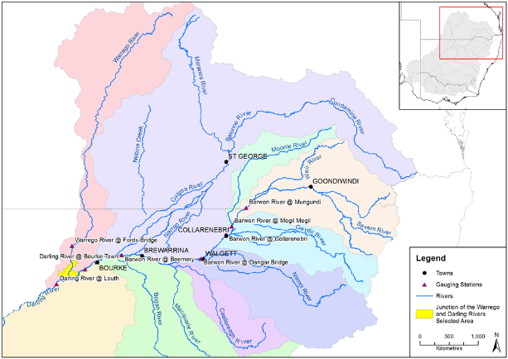

Figure B‑1: Northern Tributaries of the Murray Darling Basin (Commonwealth Environmental Water Office).

Commonwealth environmental water holdings

Total Commonwealth environmental water holdings for the northern tributaries are currently 481,867 ML (Table B‑1). Long Term Average Annual Yield (LTAAY) provides an indication of the long-term reliability of these entitlements and is generally used by the Commonwealth Environmental Water Holder for annual decision-making regarding water use priorities. At the time of writing, LTAAY of Commonwealth environmental water for the northern tributaries upstream of Louth was 278,025 ML. Current Commonwealth environmental water license information is available at:

<http://www.environment.gov.au/water/cewo/about/water-holdings>

Table B‑1: Commonwealth Water Holdings for Northern Tributaries to July 2018 (source Commonwealth Environmental Water Holder).

|  |  |  |  |  |  |  |
| --- | --- | --- | --- | --- | --- | --- |
| Catchment | Regulated (ML) | | Unregulated (ML) | | Total (ML) | |
| Entitlement | LTAAY | Entitlement | LTAAY | Entitlement | LTAAY |
| Condamine-Balonne | 45 | 43 | 172,8811 | 91,1981 | 172,926 | 91,241 |
| Moonie | 0 | 0 | 5,671 | 2,523 | 5,671 | 2,523 |
| Warrego (Qld) | 0 | 0 | 39,455 | 20,096 | 39,455 | 20,096 |
| Warrego (NSW) - Toorale | 0 | 0 | 17,826 | 17,826 | 17,826 | 17,826 |
| Barwon-Darling | 0 | 0 | 28,004 | 28,004 | 28,004 | 28,004 |
| Border Rivers | 19,590 | 6,662 | 19,358 | 7,843 | 38,897 | 14,505 |
| Gwydir2 | 94,033 | 36,737 | 20,451 | 3,886 | 114,484 | 40,623 |
| Namoi | 11,147 | 8583 | 0 | 0 | 11,147 | 8583 |
| Peel | 1,257 | 326 | 0 | 0 | 1,257 | 326 |
| Macquarie2 | 126,224 | 53,014 | 8,292 | 1,741 | 134,516 | 54,755 |
| **Total** | **252,245** | **105,365** | **229,622** | **172,660** | **481,867** | **278,025** |

**Notes:**

1 Includes (all LTAAY): Nebine Creek (3,842 ML); lower Balonne unsupplemented and overland flow: 86,543 ML; Condamine unsupplemented: 227 ML

2 Supplementary Water entitlements in the Gwydir and Macquarie catchments are listed for the purposes of this table as unregulated entitlements

Hydrology within the Selected Area

The hydrology within the Selected Area is governed by flows in either, or both, the Darling River and the Warrego River.

Located in a semi-arid setting, upstream climatic conditions are the key driver of hydrology within the Selected Area, with the easterly catchments capable of providing overbank flows within the Barwon-Darling River. During major events floodwaters may extend along the length of the river system.

During drier times, such as this year, the relationship becomes more complex. From a water management point of view, the Barwon-Darling River system is considered an unregulated stream; however, it is fed by both regulated and unregulated upstream catchments with stream flows, in part, reflecting upstream water management decisions. Further complicating the hydrology is the influence of a series of weir pools, terminal wetlands, anabranches and anastomosing streams.

The Warrego River is essentially unregulated, and due to its semi-arid setting, provides water to the Selected Area intermittently. Within the Selected Area, Warrego flows are further influenced by in-stream structures, such as Boera, Booka, Dicks and Peebles dams.

Commonwealth environmental water in the Warrego may only be accounted for once the individual conditions associated with each entitlement are met. This is usually based on a flow trigger that differs for each entitlement, based on its location and relative security. Depending on chosen watering strategies, Commonwealth environmental water may or may not be accounted for once the flow trigger is reached.

Methods

The downstream passage of Commonwealth environmental water events was observed and assessed using NSW DPI Water real-time flow data for gauging stations located along the Barwon-Darling River system. Mean daily discharge data for the following hydrometric stations was used:

* 416001 – Barwon River at Mungindi
* 422004 – Barwon River at Mogil Mogil
* 422003 – Barwon River at Collarenebri
* 422001 – Barwon River at Walgett
* 422028 – Barwon River at Beemery
* 425003 – Darling River at Bourke
* 425037 – Darling River at Weir 19a
* 425004 – Darling River at Louth

The relationship between these gauging stations and key tributary inflows is shown in Figure B‑2.

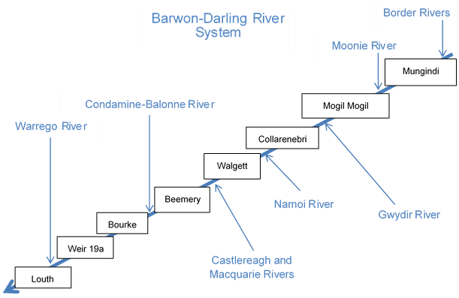

Figure B‑2: Gauging stations and key tributaries on Barwon-Darling River system.

This water year was characterised by small instream freshes that comprised both Commonwealth environmental water and regulated NSW environmental water. To characterise this integrated water management response, the relative contribution of “environmental water” (both Commonwealth and NSW) within each flow event was assessed.

End of system (EOS) Commonwealth environmental water was estimated based on advice from the Department of the Environment and Energy, NSW Department of Industry Water and the CSIRO MDB Sustainable yield project (Table B‑2). The EOS measure was used to estimate the amount of water (as a proportion of the total) which would have made it out of the end of each catchment, considering losses such as evaporation, infiltration etc. It should be noted that while environmental water protection actions like pumping embargo’s influence the movement of environmental water through the system, these were not considered in the current analysis.

Table B‑2: End of System (EOS) flow estimates used to assess downstream passage of Commonwealth environmental water.

|  |  |
| --- | --- |
| Catchment | Applied EOS flow (%) |
| Border Rivers | 80 |
| Moonie | 73 |
| Gwydir | 24 |
| Namoi | 63 |
| Macquarie/Castlereagh | 76 |
| Condamine-Balonne | 37 |
| Barwon-Darling (Mungindi to Bourke) | 80 |
| Warrego | 34 |

Results

2017-18 water year

NSW Department of Industry Water daily flow records (Figure B‑3) were cross-referenced with internal data and operational reports provided by the Commonwealth Environmental Water Office to assess key flow events where environmental water take was accounted in the northern tributaries during the 2017-18 water year. Water ‘take’ is defined as the amount of environmental water accounted during unregulated events where specific streamflow conditions are met to trigger individual environmental water entitlements.

Three flow ‘events’ were identified that included a component of environmental water:

1. 1 July – 29 November 2017.
2. 10 March – 29 April 2018.
3. 4 May – 26 June 2018.

Flow conditions associated with each event is shown below in Figure B‑3.

Figure B‑3: Mean daily 2017-18 flows at gauging stations on the Barwon-Darling River system.

Unregulated Environmental Water Contribution

Flow events where environmental water is accounted can be classified as regulated and unregulated events. During 2017-18, only unregulated environmental water entitlements owned and managed by the Commonwealth Environmental Water Holder were triggered. Unregulated environmental water contribution for each event is presented for each MDB catchment in Table B‑3.

Table B‑3: Unregulated environmental water (EW) events for 2017-18 water year.

|  |  |  |  |  |
| --- | --- | --- | --- | --- |
| Basin Plan Region | Tributary | Unregulated EW take (ML) | Annual Total (ML) | Comments |
| QLD Border Rivers | Dumaresq-Macintyre River | Event 1 – 292 | 641 | Flow Event 1 (July 2017) in Macintyre and Dumaresq Rivers (Qld) |
| Event 1 – 349 | Flow Event 1 (mid October 2017) from Lower Macintyre River (Qld) |
| Severn River | 0 | 0 | No EW take |
| QLD Moonie | Lower Moonie River | Event 1 – 762  Event 2 - 381 | 1,143 | Flow event1 in October and November 2017  Flow event 2 in March 2018 |
| QLD Condamine –Balonne | Lower Floodplain | Event 2 – 3,985 | 3,985 | Flow Event 2 in April 2018.  3,985 ML contributed to in-stream flows reaching the Darling River, |
| QLD Warrego River | Upper | 0 | 0 | No EW take |
| Lower | 3,347 | 3,347 | Two periods of announced take in March and April 2018 fall into Flow Event 2. |
| NSW Gwydir | Mallowa Creek | 0 | 0 | No EW take |
| Mehi River | 0 | 0 | No EW take |
| Carole – Gil Gil Creek | 0 | 0 | No EW take |
| NSW Macquarie-Castlereagh | Macquarie River | 0 | 0 | No EW take |
| NSW Intersecting Streams- Warrego | Lower Warrego River |  | 0 | No EW take |
| NSW Intersecting Streams | Toorale Western Floodplain | 0 | 0 | No EW take |
| NSW Barwon - Darling | Barwon-Darling River | Event 1 – 10,154 | 10,850 | Small fresh of around 400-500 ML/d in July. B class access was available during July on the 'Boomi River Confluence to upstream Mogil Mogil Weir Pool Management Zone' and the 'Downstream Mogil Mogil to Collarenebri'.  A class access was available in the 'Bourke to Louth Zone' (annual share of A class now exhausted). During December some C class access was available at Toorale. A small volume of water was available in the Barwon River during February and March 2018 prior to the embargo taking effect. |
| Event 2 – 696 |

Regulated Environmental Water

Regulated environmental water is not dependent on specific stream flows and may be triggered in response to a wider range of river or environmental management decision criteria. In the northern tributaries, regulated entitlements are owned and managed by both state and federal departments. Regulated environmental water delivered in each regulated river system is presented in Table B‑4.

Table B‑4: Regulated environmental water (EW) delivered in 2017-18.

|  |  |  |  |
| --- | --- | --- | --- |
| Basin Plan Region | Tributary | Regulated EW take (ML)a | Comments |
| QLD Border Rivers | Dumaresq | Event 1 –  3,252 CEWH | Between 2 and 26 October 2017. Total of 3,252 ML. Delivered as stable baseflow (up to 160 ML/d) for three weeks, in conjunction with some small natural inflows. |
| Severn River |  | No EW delivered |
| Dumaresq-Lower Macintyre River NSW | Event 3 –  4,286 CEWH | This release was part of the Northern Connectivity Event delivered between 4 and 20 May 2018. CEWH water contributed to flows at Mungindi for 17 days, with at least 10 days at ~260-428 ML/d followed by 6 day recession ~ 41-193 ML/d. |
| NSW Border Rivers | Severn-Macintyre River | Event 1 –  684 CEWH +  8,000 NSW | NSW water delivered on 21 August. Peaked at 2,079 ML/d (Pindari Dam) on 23 August.  CEWH water delivered on 24 September with NSW 'translucency flow' provisions. Stable baseflows (~ 50 ML/d) until mid-October 2017. |
| NSW Gwydir | Gwydir River | Amounts accounted for in Mehi River and Carole Creek below | |
| Mallowa Creek | 0 | No EW delivered |
| Mehi River | Event 1 –  11,200 CEWH  Event 3 –  9,204 CEWH + 4,956 NSW | Small fresh over 10 days from late Aug 2017  (30/08/10-4/09/17; 7,000 ML).  Small stable baseflow spring 2017  (Late Nov 2017; 4,200 ML).  April 2018 release as part of northern connectivity event provided end of system pulse to Barwon River  (April-May 18; 14,160 ML). |
| Carole – Gil Gil Creek | Event 1 –  800 CEWH +  800 NSW  Event 3 –  3,086 CEWH + 1,662 NSW | Small fresh over 10 days from late Aug 2017  (30/08/10-4/09/17; 800 ML).  Small stable baseflow spring 2017  (Late Nov 2017; 800 ML)  April 2018 release as part of northern connectivity event provided end of system pulse to Barwon River  (April-May 18; 4,748 ML). |
| NSW Namoi | Namoi River | Event 2 –  4,100 CEWH | March – May 2018. 4,100 ML delivered in lower Namoi River. |
| Warrego River | Toorale | 0 | While environmental water management provided connection to the Darling River, no entitlements were acquitted against this licence. |
| NSW Macquarie-Castlereagh | Macquarie River and floodplain | Event 1 –  4,529 combined CEWH & NSWb | Between 19 July and 12 November 2017. Delivered to the Mid Macquarie river and Macquarie Marshes (50,660 CEWH + 83,717 NSW). Regulated take figure is an end of system estimate from CEWO. |

a CEWH is water managed by the Commonwealth Environmental Water Office, NSW is water managed by NSW water departments.

b based on prior CEWO advice, approximately 10,000 ML is estimated to reach the Barwon River.

End-of-system flow event analysis

EOS Commonwealth environmental water figures provide an estimation of the volumetric contribution of upstream environmental water as it passes through the Barwon-Darling system to the Selected Area at Toorale, and further downstream.

Event 1

Event 1 was characterised by a series of instream freshes and flow pulses that occurred from the start of the water year through until the end of November 2017 over a total of 151 days. During this time, unregulated flows including environmental water originating in the Border Rivers and Moonie River were augmented with regulated CEWH and NSW environmental water from the Border Rivers, Gwydir and Macquarie–Castlereagh River systems. Total environmental water accounted and delivered upstream during this period comprised 170,670 ML. Allowing for system losses, this was estimated to contribute 42.9 % of the total flow volume at the Selected Area (Table B‑5).

**Table B‑5: Environmental water flow event 1 (1 July – 29 November 2017) EOS flow assessment.**

|  |  |  |  |  |
| --- | --- | --- | --- | --- |
| Gauging Station | Total Event Discharge | Upstream EW | Estimated EOS EW | |
| ML | ML | ML | % |
| Mungindi | 53,741 | 12,577 | 10,062 | 18.7 |
| Mogil Mogil | 52,293 | 13,339 | 10,616 | 20.3 |
| Collarenebri | 59,496 | 26,139 | 13,709 | 23.0 |
| Walgett | 53,785 | 26,139 | 13,709 | 25.5 |
| Beemery | 54,563 | 160,516 | 18,238 | 33.4 |
| Bourke | 47,692 | 170,670 | 26,361 | 55.3 |
| Weir 19A | 47,337 | 170,670 | 21,669 | 45.8 |
| Louth | 50,514 | 170,670 | 21,669 | 42.9 |

Event 2

Occurring between 10 March and 29 April 2018 (50 days total event duration), Flow Event 2 was underpinned by unregulated environmental water contributions from the Condamine-Balonne River system, some minor flows from the Moonie River augmented by regulated Commonwealth environmental water from the Namoi. Total environmental water accounted and delivered during this period comprised 9,162 ML. Allowing for system losses, this was estimated to contribute 24.3 % of flow volume at the Selected Area (Table B‑6).

On 8 March 2018, the NSW Department of Industry - Water announced temporary restrictions on A, B and C class water access licences in the Barwon-Darling Unregulated River to protect low flows entering the river. The restrictions were extended on 29 March to 28 April 2018.

**Table B‑6: Environmental water flow event 2 (****10 March – 29 April 2018) EOS flow assessment.**

|  |  |  |  |  |
| --- | --- | --- | --- | --- |
| Gauging Station | Total Event Discharge | Upstream EW | Estimated EOS EW | |
| ML | ML | ML | % |
| Mungindi | 4,750 | 0 | 0 | 0.0 |
| Mogil Mogil | 13,098 | 381 | 277 | 2.1 |
| Collarenebri | 12,967 | 381 | 277 | 2.1 |
| Walgett | 13,987 | 381 | 277 | 2.0 |
| Beemery | 13,041 | 4,481 | 2,860 | 21.9 |
| Bourke | 20,095 | 9,162 | 4,892 | 24.3 |
| Weir 19A | 17,711 | 5,062 | 4,311 | 24.3 |
| Louth | 14,157 | 9,162 | 3,446 | 24.3 |

Event 3

Flow Event 3 was a regulated flow event between 4 May and 26 June 2018 (Total event duration 53 days) as part of the Northern Connectivity Event. Total environmental water delivered during this period was 23,232 ML, comprising both Commonwealth environmental water and NSW environmental water from the Queensland Border Rivers and Gwydir catchments. This significantly improved flows in the Barwon-Darling River.

There was a second embargo to protect the northern connectivity flows from 27 April to 22 June for the entire length of the Barwon-Darling for A, B, C class licences. The relative contribution of environmental water was estimated to be 99.6 % of flow volume at the Selected Area (Table B‑7).

**Table B‑7: 2017/18 Environmental water flow event 3 (****4 May – 26 June 2018) EOS flow assessment.**

|  |  |  |  |  |
| --- | --- | --- | --- | --- |
| Gauging Station | Total Event Discharge | Upstream EW | Estimated EOS EW | |
| ML | ML | ML | % |
| Mungindi | 4,653 | 4,286 | 3,429 | 73.7 |
| Mogil Mogil | 8,693 | 4,286 | 3,429 | 39.4 |
| Collarenebri | 19,899 | 23,232 | 19,829 | 99.6 |
| Walgett | 18,768 | 23,232 | 18,702 | 99.6 |
| Beemery | 13,962 | 23,232 | 13,906 | 99.6 |
| Bourke | 13,436 | 23,232 | 13,382 | 99.6 |
| Weir 19A | 11,385 | 23,232 | 11,339 | 99.6 |
| Louth | 13,386 | 23,232 | 13,332 | 99.6 |

Warrego River End of system flows

Within the Warrego catchment, Commonwealth environmental water was accounted during flow event 2. EOS flow assessment at Fords Bridge provides an estimate of the volumes and proportions of Commonwealth Environmental water entering the Selected Area at Boera Dam. During the period 1 April 2018 – 22 May 2018, 6,566 ML flowed past Fords Bridge. Upstream Commonwealth environmental water contributions totalled 3,347 ML. Allowing for EOS losses, this constitutes 17.3 % of the water that flowed past Fords Bridge and into the Selected Area at Boera Dam.

Multi-year comparison

The 2017-18 water year is the fourth year of the LTIM project at the Selected Area. Comparing 2017-18 flows with flows in preceding years, it is apparent that the most significant flow events during 2017-18 were smaller than in previous study years and that Flow Event 3 during 2016-17 still represents a significant event in the study period (Figure B‑4).

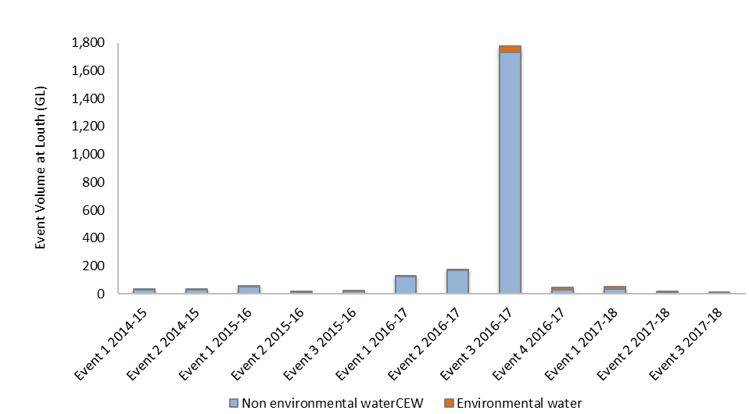

**Figure B‑4: Multi-year comparison of total flow volumes at Louth gauge. Note: 2017-18 flow events include both State and Federal environmental water.**

Like the current year, 2014-15 and 2015-16 water years were characterised by predominantly low flow conditions with occasional small instream flow pulses insufficient to exceed channel capacity. Total volumes for events during each of these years did not exceed 55,000 ML making them similar in magnitude to Flow Event 4 during April 2017. Flow Events 1 and 2 in 2016 were incrementally larger, with total volumes of 129,820 ML and 171,909 ML, respectively. Flow Event 3 in 2016 was approximately an order of magnitude larger than the largest preceding flow (Flow Event 2, 2016) with a total volume of 1,772,486 ML at Louth. All three flow events in 2017-18 would have been considered low/baseflow conditions in previous years.

Total environmental water contributions (as a percentage of total flow) during each event at the Selected Area in 2017-18 were generally greater than Commonwealth environmental water contributions during previous events (Table B‑8). However, discounting the inclusion of NSW environmental water, the end of system Commonwealth environmental water contributions were similar to those observed in comparable flows during preceding years.

**Table B‑8: Multi-year comparison of total flow and estimated environmental flow volumes at Louth gauge.**

|  |  |  |  |  |
| --- | --- | --- | --- | --- |
| Water Year | Flow Event | Total Event Discharge (Louth) | Estimated EOS EW | |
| ML | ML | % |
| 2014-15 | Event 1 | 27,797 | 9,593 | 25.7 |
| Event 2 | 27,394 | 1,135 | 4.0 |
| 2015-16 | Event 1 | 53,501 | 2,824 | 5.0 |
| Event 2 | 12,161 | 428 | 3.4 |
| Event 3 | 15,477 | 6,621 | 30.0 |
| 2016-17 | Event 1 | 129,820 | 7,818 | 6.0 |
| Event 2 | 171,909 | 3,102 | 1.8 |
| Event 3 | 1,772,486 | 42,228 | 2.4 |
| Event 4 | 44,161 | 16,101 | 36.5 |
| 2017-18 | Event 1 | 50,514 | 21,669* | 42.9 |
| Event 2 | 14,157 | 3,446* | 24.3 |
| Event 3 | 13,386 | 13,333* | 99.6 |

* includes CEWH and NSW environmental water

Discussion

The 2017-18 water year was characterised by low/base flow conditions with several small flow events. Average daily discharge peaked at less than 2,000 ML/d at Mogil Mogil, Collarenebri and Bourke at the start of April.

Total unregulated Commonwealth environmental water contributions in 2017-18 was 16,619 ML in tributaries influencing the Selected Area. This was augmented with a further 92,228 ML of regulated Commonwealth environmental water and 94,179 ML of NSW environmental water from upstream tributaries, of which 38,448 ML moved through the Barwon Darling system to the Selected Area. This compares with 69,249 ML during 2016/17, 10,730 ML during 2014/15 and 9,875 ML in 2015-16. This water has contributed to aquatic and terrestrial environmental responses and processes within the Selected Area. In addition, Commonwealth environmental water contributions in the Lower Warrego catchment made up around 17.3 % of the flow entering the Selected Area down the Warrego River during flow event 2.

The proportion of environmental water was highest in Flow Event 3 during May 2018 where it accounted for 99.6% of total event volume, demonstrating the value of the embargo placed on this water as it passed through the Barwon-Darling system. However, environmental water proportions were generally high during Event 1 and Event 2, demonstrating a sound relationship between the coordination of regulated Commonwealth environmental water take and NSW environmental water deliveries.

Conclusion

The 2017-18 water year was characterised by dry conditions and very low river flows throughout the northern tributaries. Three instream flow events including both unregulated and regulated environmental water occurred during July-November 2017, March – April 2018 and May 2018, providing approximately 21,669 ML, 3,446 ML and 13,332 ML of environmental water, respectively, at Louth, downstream of the Selected Area. It is estimated that during each event environmental water made up a significant proportion of these flows (between 24.3% and 99.6%). These results highlight the value of an integrated water management response, and the value of an embargo on instream water access, in maintaining instream longitudinal connection and access to habitat during extended dry conditions.

###### Hydrology (Habitat)

Introduction

The Hydrology (Habitat) indicator documents the degree of hydrological connection of habitats in the channels of the Junction of the Warrego Darling rivers Selected Area (Selected Area) and assesses the relative influence of Commonwealth environmental water on this connection. Along the Darling River, habitats include snags (large woody debris), bench surfaces and anabranch channels. These features have been shown to be important for the storage and supply of nutrients and organic matter (Southwell 2008, Thoms *et al*. 2005, Thoms and Sheldon 1997) and as habitat for native fish and other aquatic species (Crook and Robertson 1999, NSW DPI 2015). They have also been targeted in environmental flow planning to increase habitat availability and facilitate nutrient and carbon cycling (Commonwealth of Australia 2014). The Warrego river below Boera Dam has a complex structure with many channels that carry water at various flow levels (Commonwealth of Australia 2015). Knowledge of their connection during flow events provides information on the amount of available habitat and its connectivity through this reach. This indicator is directly relevant to other indicators measured in the Selected Area including Hydrology (River and Northern Tributaries), Water Quality, and Stream Metabolism. This indicator addresses the following question:

* What did Commonwealth environmental water contribute to in-channel habitat availability and connectivity within the Selected Area?

Environmental watering in 2017–18

***Barwon-Darling and northern tributaries***

The 2017-18 water year was characterised by dry conditions and very low river flows throughout the northern tributaries. Three instream flow events including both unregulated and regulated environmental water occurred during July-November 2017, March – April 2018 and May 2018, providing approximately 21,669 ML, 3,446 ML and 13,332 ML of environmental water, respectively, at Louth, downstream of the Selected Area (Appendix B). It is estimated that during each event environmental water made up a significant proportion of these flows (between 24.3% and 99.6%).

***Warrego River***

Flows in the Warrego River during the 2017-18 water year were very low, with water entering the Selected Area during four small flow events in October 2017, December 2017, March-April 2018 and June 2018. Commonwealth environmental water made up 17.3% of the flow event during March-April 2018. Water levels in Boera Dam remained below the Western Floodplain connection level for most of the year with only one brief period of connection to the floodplain observed in December 2017 (Figure C‑1). During the flow event in March-April 2018, the Boera Dam regulating gates were partially opened for a total of 16 days, though flows were restricted to 300 ML/d or less in response to Boera Dam inflows. This event reconnected the waterholes in the lower Warrego system and provided connection through to the Darling River.



Figure C‑1: Boera Dam levels during 2017-18 water year and flow to Western Floodplain and/or into lower Warrego channels (gates open).

Methods

Darling River habitat inundation

Benches and anabranches were identified through desktop mapping of in-stream habitat and aerial photograph interpretation along the Darling River within the Selected Area (Commonwealth of Australia 2015). Field survey was undertaken to verify the in-stream habitat features and map additional features. In addition to the number and size of individual habitat features present, height above the current water level was noted using a hypsometer to measure the commence-to-inundate level of benches and the commence-to-flow for anabranch channels (Commonwealth of Australia 2015). Commence-to-flow heights were recorded to the nearest vertical metre.

Snag data was obtained from NSW DPI Fisheries that had been collected for the *Fish and Flows in the Northern Basin* Project in 2015 (NSW DPI 2015). The height above the current water level was recorded using a similar method as that used for benches and anabranches. As part of the *Fish and Flows in the Northern Basin* Project snags were classified into four grades of complexity (Figure C‑2).

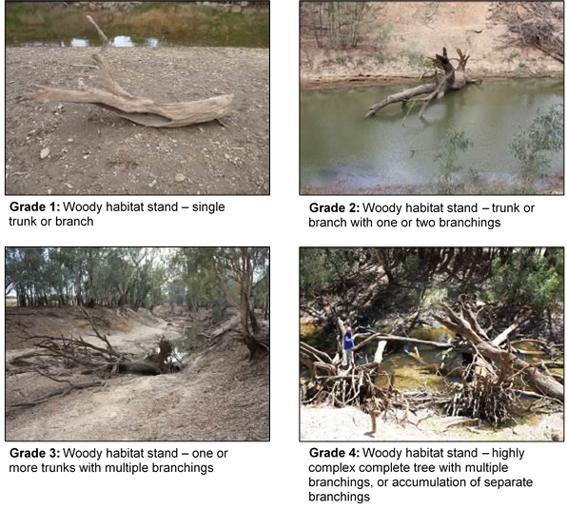

Figure C‑2: Classification system used to grade complexity of snags (NSW DPI 2015).

The vertical commence-to-flow heights of individual habitat features above the current water level at the time of field survey were converted to a gauged height at the nearest river flow gauge. Benches and anabranches upstream of the Warrego River confluence were linked to the Weir 19A (425037) gauge upstream of the Selected Area, while benches and anabranches downstream of the confluence were linked to the gauging station at Louth (425004) (Figure C‑3). Snags for the entire reach of the Darling River within the Selected Area were linked to the Weir 19A gauge only. These gauges were chosen as they best reflected the hydrology of these sections of the Darling River. However, final commence-to-flow discharges were reported at the Bourke Town (425003) gauging station as it has a more comprehensive flow record. To do this, relationships between the Louth and Weir 19A gauging stations and the Bourke Town gauge were identified by plotting respective flows between 400 and 20 000 ML/d at the gauges from 2002 to present (total length of Weir 19A gauge record). Travel time between gauges was considered, with trendlines and associated regression equations of the relationship between gauges calculated (Figure C‑4). These equations were used to express the commence-to-flow discharges measured at the Louth and Weir 19A gauges to the Bourke Town gauge. The commence-to-flow for each anabranch channel was determined using the entry or exit with the highest gauge height to better represent water flow into each channel.



Figure C‑3: Location of the gauging stations used in the hydrology (Habitat) indicator analysis.

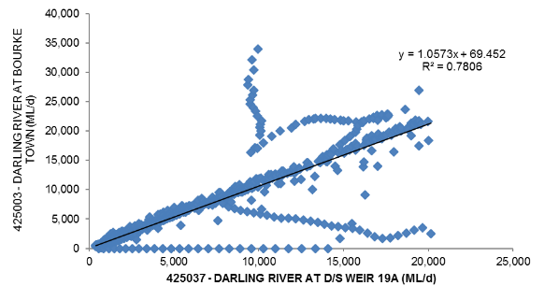

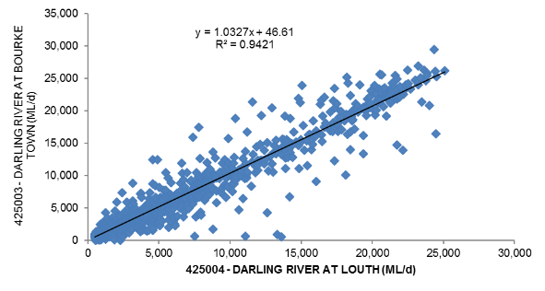

Figure C‑4: Relationships between the Darling River @ Bourke Town gauge and a) Darling River @ Weir 19A and b) Darling River @ Louth gauging stations.

Total organic Carbon (TOC), Nitrogen (TN) and Phosphorus (TP) release rates from in-channel benches observed on the Darling River upstream of Bourke by Southwell (2008), were combined with the duration of time benches in the Selected Area were inundated during 2017–18, to provide an estimate of total nutrient loads contributed to the river from these benches during the water year.

Warrego image analysis

A Landsat ETM satellite image was captured over the site on 29 April 2018. This image was 7 days after a release from Boera Dam that totalled 16 days and peaked at 300 ML/d. Given the reasonably cool weather condition at the time, inundation detected within this image was considered representative of the inundation that would have occurred during this connection event. The image was analysed using density slicing of the mid-infrared band to map the open water extent and thus describe the area of channel inundated at this stage (Frazier and Page 2000).

Results

Darling River

Three flow events occurred in the 2017-18 water year that provided habitat inundation. However, snags were the only habitat type in the Darling River channel that was inundated. Identified benches and anabranches in the Darling River all sit above the maximum flow experienced in 2017-18.

Four snag classes were inundated in the 2017-18 water year (Figure C‑5). The lowest discharge class (<69 ML/d) was inundated for 247 days, accounting for 26% of all snags. The second lowest class (69 – 283 ML/d) was inundated for 142 days across all flow events, while all snags in the 283 – 943 ML/d class were inundated for at least 10 days during the year, with some snags in this class being inundated for longer periods (Figure C‑5). All snags in the 943 – 1,793 ML/d class were inundated for at least one day in April 2018 (Event 2; Table C‑1). This resulted in a total of 30% of snags becoming inundated during 2017-18.

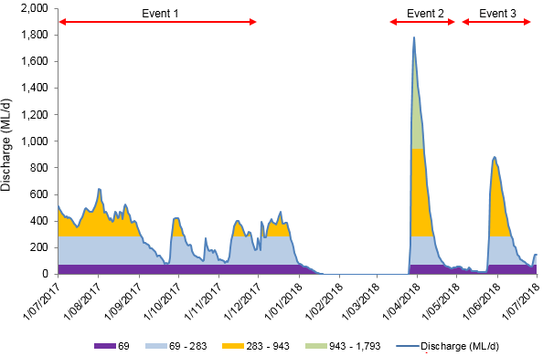

Figure C‑5: Snag inundation in the 2017=18 water year along the Darling River within the Selected Area. Discharge measured at the Bourke Town gauge (NSW 425003).

Table C‑1: Duration and proportion of snags inundated in the Darling River in 2017-18.

|  |  |  |  |
| --- | --- | --- | --- |
| Flow Height Range Bourke to Weir 19A (ML/d) | Snags | Proportion of total snags (%) | Days inundated |
| <69 | 973 | 26.1 | 247 |
| 69 - 283 | 7 | 0.2 | 142 |
| 283 - 943 | 61 | 1.6 | 10 |
| 943 – 1,793 | 83 | 2.2 | 1 |
| 1,793 – 2,692 | 117 | 3.1 | 0 |
| 2,692 – 3,601 | 139 | 3.7 | 0 |
| 3,601 – 4,690 | 188 | 5.0 | 0 |
| 4,690 – 6,001 | 185 | 5.0 | 0 |
| 6,001 – 7,502 | 277 | 7.4 | 0 |
| 7,502 – 9,109 | 232 | 6.2 | 0 |
| 9,109 – 10,854 | 316 | 8.5 | 0 |
| 10,854 – 12,863 | 263 | 7.0 | 0 |
| 12,863 – 14,872 | 281 | 7.5 | 0 |
| 14,872 – 16,775 | 174 | 4.7 | 0 |
| 16,775 – 18,889 | 180 | 4.8 | 0 |
| 18,889 – 21,215 | 114 | 3.1 | 0 |
| 21,215 – 23,542 | 58 | 1.6 | 0 |
| 23,542 – 26,185 | 39 | 1.0 | 0 |
| 26,185 – 29,039 | 29 | 0.8 | 0 |
| 29,039 – 332,69 | 13 | 0.3 | 0 |
| >33,269 | 6 | 0.2 | 0 |

Warrego River

More than 497 ha of the lower Warrego River channel system was inundated within the Selected Area (Figure C‑6-8), measured one week after a flow event peaking at 300 ML/d at the Boera Dam gates. Quantification of the channel network of the lower Warrego river indicated that 88.2 km of the channel was inundated at the time of image capture, accounting for 49% of the total channel network. The length of primary channels inundated was 44.49 km (25% of total), while 43.8 km of secondary channels were inundated (24% of total).

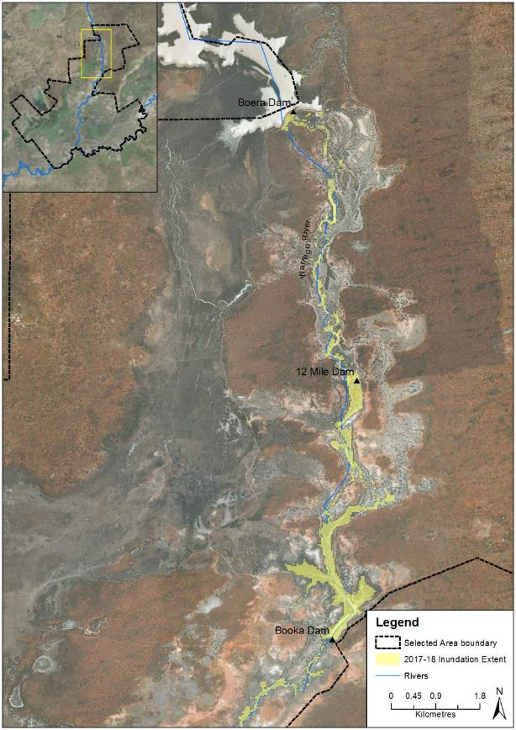

**Figure C‑6: Inundation extent of the lower Warrego River from Boera Dam to Booka Dam in 2017-18.**

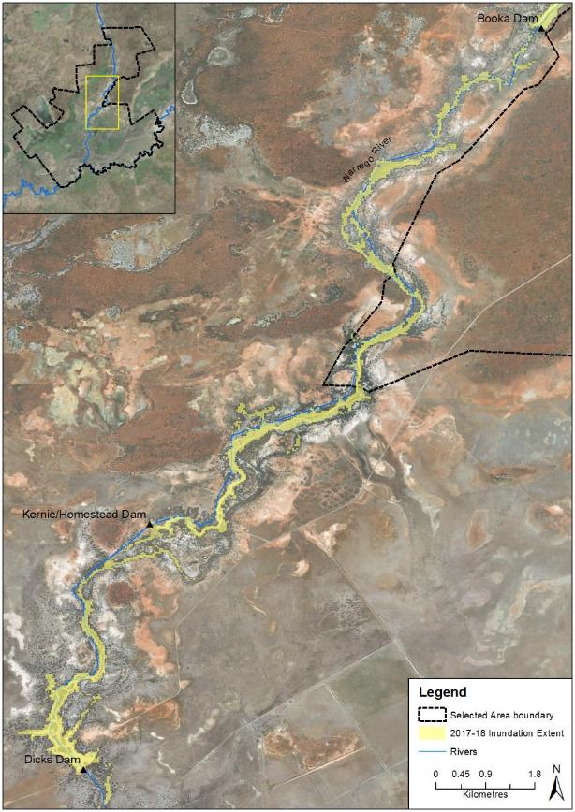

Figure C‑7: Inundation extent of the lower Warrego River from Booka Dam to Dicks Dam in 2017-18.

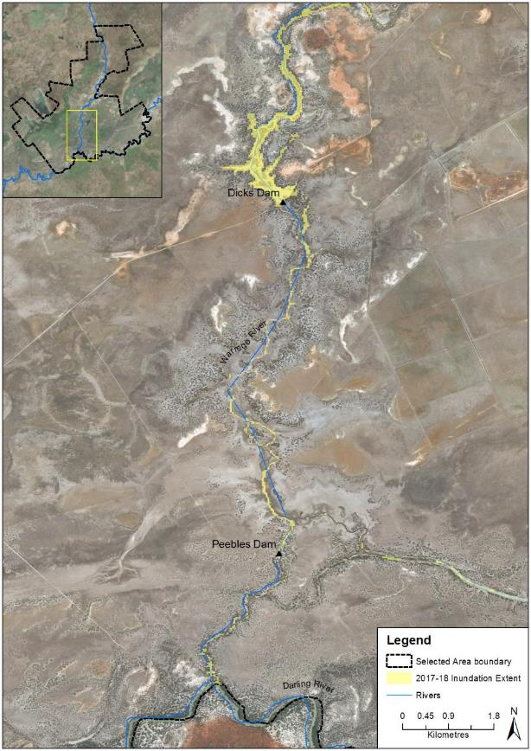

Figure C‑8: Inundation extent of the lower Warrego River from Dicks Dam to the confluence with the Darling River in 2017-18.

Discussion

The small flow pulses that flowed down the Darling River in 2017-18 contributed to the inundation of 1,124 individual snags or around 30% of the total number of snags present. Flow events containing a proportion of Commonwealth environmental water inundated 28% of the total number of snags mapped in the Selected Area along the Darling River reach in the first and last flow events in 2017-18 water year. In each event, Commonwealth environmental water contributed 43% and 100% of flows respectively (Appendix B). In the larger March-April flow event that contained 24.3% Commonwealth environmental water, 30% of snags were inundated. Most of these snags are located on the channel bed (26%) and are hence inundated for most of the time, and the inundation of an additional 151 (4%) individual snags provided a range of benefits to the system. Snags play a major role in geomorphological processes and provide important habitat for aquatic and terrestrial organisms, including shade, refuge from high velocity flow and predators, spawning and nursery sites, and attachment sites for invertebrates (Treadwell 1999, Koehn and Nicol 2014). Snags also have a role in carbon and nutrient processing, by providing a substrate for biofilm development in which the bacterial and fungal components contribute to woody substrate decomposition, providing food for benthic algae, invertebrates and microorganisms that form part of food web for fish species (Treadwell 1999, NSW DPI 2015). Flow events in 2017-18 were too small in magnitude to inundate any of the mapped benches or anabranches in the Darling River channel within the Selected Area. Thus, instream sources of food and nutrients would have played more of a role in sustaining aquatic food webs in the river, rather than external inputs of nutrients and organic matter from riparian habitats this year.

The flow pulse that occurred down the lower Warrego River that peaked at 300 ML/d inundated around 88 km or 49% of the total channel network in this reach during 2017-18. This is compared to 130 km or around 78% of the network that was inundated with a flow peak of 600 ML/d in 2016-17 (Commonwealth of Australia 2017). In 2017-18 around equal lengths of primary and secondary channel were inundated. This highlights the complex nature of the channel network in the lower Warrego, with water flowing through a range of channels, even at relatively low flow levels.

Conclusion

The 2017-18 water year was dominated by low to very low flows in the Darling and Warrego Rivers. During 2017-18, 30% of snags within the Selected Area reach of the Darling River were inundated for at least one day. No benches or anabranches were inundated in the 2017-18 water year. This represents a 90% decline of inundated habitat features compared to the 2016-17 water year, where all mapped benches, anabranches and snags were inundated for at least 23 days. Snags in the lowest height category were inundated for a total of 277 days. In addition to natural flows, Commonwealth environmental flows contributed to this habitat inundation which provided cover for fish and other aquatic animals and substrate for biofilm development.

Analysis of LANDSAT imagery captured following a 300 ML/d flow showed that at this stage 49% of the total channel network was inundated with equal lengths of primary and secondary channels inundated. Using Commonwealth environmental water at this release rate provided access to many channel habitats within this section of the Warrego River provided connectivity through almost half of the channel network.

References

Commonwealth of Australia. 2014. *Commonwealth Environmental Water Office Long Term Intervention Monitoring Project junction of the Warrego and Darling rivers Selected Area; Annual Evaluation Report*, Canberra.

Commonwealth of Australia. 2015. *Commonwealth Water Office Long Term Intervention Monitoring Project Junction of the Warrego and Darling rivers Selected Area: 2014-15 Evaluation Report*, Canberra.

Commonwealth of Australia. 2017. *Commonwealth Water Office Long Term Intervention Monitoring Project Junction of the Warrego and Darling rivers Selected Area: 2016-17 Evaluation Report*, Canberra.

Crook, D.A. and Robertson, A.I. 1999. Relationships between riverine fish and woody debris: implications for lowland rivers. *Marine and freshwater research,* **50***,* 941-953.

Frazier, PS, Page KJ. 2000. Water body detection and delineation with Landsat TM data. *Photogrammetric Engineering and Remote Sensing*, **66**, 1461-1468.

Koehn, J.D. and Nicol, S.J. 2014. Comparative habitat use by large riverine fishes. *Marine and freshwater research* **65***,* 164-174.

NSW Department of Primary Industries (DPI) 2015. *Fish and flows in the Northern Basin: Response of fish to changes in flow in the Northern Murray-Darling – Reach Scale Report*. Prepared for the Murray Darling Basin Authority. NSW DPI, Tamworth.

Southwell, M.R. 2008. *Floodplains as Dynamic mosaics: Sediment and nutrient patches in a large lowland riverine landscape.* PhD Thesis, University of Canberra, Australia

Thoms, M. C. and Sheldon, F. 1997. River channel complexity and ecosystem processes: the Baron-Darling River (Australia). In: N. Clomp and I. Lunt (eds.). *Frontiers in Ecology: Building the Links*. Elsevier, Oxford, pp. 193–206.

Thoms, M.C., Southwell, M.R. and McGinness, H.M. 2005. Floodplain-river ecosystems: Fragmentation and water resource development. *Geomorphology* **71**, 126–138.

Treadwell, S. 1999. Managing snags and large woody debris. In Lovett, S. and Price, P. (eds.)*. Riparian land management guidelines: volume two: on-ground management tools and techniques.* P. 15-22. Land and Water Resources Research and Development Corporation, Canberra.

###### Hydrology (Floodplain)

Introduction

The Hydrology (Floodplain) indicator provides information on the influence of Commonwealth environmental water and/or management decisions on the extent of inundation on the Western Floodplain. This information is directly relevant to a number of other indicators measured in the Junction of the Warrego and Darling rivers Selected Area (Selected Area) including vegetation diversity, waterbird diversity, hydrology (river and channel), stream metabolism and microcrustaceans.

Watering the Western Floodplain is an important aspect of water management in the Selected Area. Apart from being a target for Commonwealth environmental water (Commonwealth of Australia 2014), it also has a separate high flow floodplain water licence (Commonwealth of Australia 2015). Water managers can preferentially direct water down the Western Floodplain to meet watering targets by opening or closing the regulating gates at Boera Dam.

Given this, knowledge of the extent and volume of water directed down the Western Floodplain throughout each water year is essential base information from which to evaluate the success of these watering decisions. The hydrology (floodplain) indicator aims to achieve this, by combining information from a range of sources, to build understanding of relationships between inflows, inundation extent and volumes of water in the Western Floodplain. Specifically, this chapter addresses the following question:

* What did Commonwealth environmental water and management contribute to hydrological connectivity of the Western Floodplain?

**Environmental watering in 2017-18**

Flows in the Warrego River during the 2017-18 water year were very low, with water entering the Selected Area during four small flow events in October 2017, December 2017, March-April 2018 and June 2018. Commonwealth environmental water made up 17.3% of the flow event during March-April 2018. Water levels in Boera Dam remained below the Western Floodplain connection level for most of the year with only one brief period of connection to the floodplain observed in December 2017 (Figure D‑1). During the flow event in March-April 2018, the Boera Dam regulating gates were partially opened for a total of 16 days, though flows were restricted to 300 ML/d or less in response to Boera Dam inflows. This event reconnected the waterholes in the lower Warrego system and provided connection through to the Darling River.

**Previous monitoring outcomes**

Since the project commenced in 2015 inundation on the Western Floodplain was greatest in the 2016-17 water year, with a maximum of 3,839 ha inundated. In the two previous monitoring years, the maximum area inundated was 464 ha which occurred in December 2015. The broad scale flooding in 2016-17 inundated 11 of the 13 vegetation communities present on the floodplain, including large areas of lignum shrubland (1,524 ha), Chenopod shrubland (1,512 ha) and Coolabah woodland (712 ha).

Figure D‑1: Boera Dam levels during 2017-18 water year and flow to Western Floodplain and/or into lower Warrego channels (gates open). Arrows indicate LANDSAT image dates using in the analysis.

Methods

Many data sources were used to build a model of inundation extent and volume in the Western Floodplain of the Warrego River (Commonwealth of Australia 2015). These included:

* Landsat imagery
* Existing vegetation mapping
* Water level records associated with water sensors and gauging stations
* Hydrodynamic model recently developed as part of the LTIM project

These data sources were analysed and combined to produce relationships between inflow, inundation extent and volume. Existing vegetation mapping was used to determine the area of inundation associated with each vegetation community on the Western Floodplain.

Landsat image analysis

All available Landsat 8 images captured during the 2017-18 water year were assessed via the USGS Glovis website (<http://glovis.usgs.gov/>). Those with no cloud cover or other problems were chosen for further analysis. Five images were selected for analysis, being captured on the following dates; 29 September 2017, 22 December 2017, 8 February 2018, 28 March 2018 and 29 April 2018.

The extent of inundation within each image was classified using density slicing of band 6 as described in Frazier and Page (2000). All inundated areas within the extent of the Western Floodplain were mapped, hence, inundation because of rainfall was also included (Figure D‑2). This may potentially overestimate the degree of inundation resulting from overland flow from Boera Dam, but provides a broader picture of Western floodplain wetting during the 2017-18 water year. Each classified inundation image was then intersected with existing vegetation community layers (Commonwealth of Australia 2015) to determine the extent of inundation within each vegetation community at each image capture time.

To estimate the volume of water present in the Western Floodplain at the time of image capture, relationships generated through the hydrodynamic model of the Western Floodplain were used for images on the rising limb of the hydrograph (December 2017).

Average monthly rainfall

Monthly rainfall was generally below the historical average except for Oct-Dec 2017 (Figure D‑2). Rainfall in October was over three times the historical average. These high rainfall amounts are likely to have influenced inundation extents on the Western Floodplain.

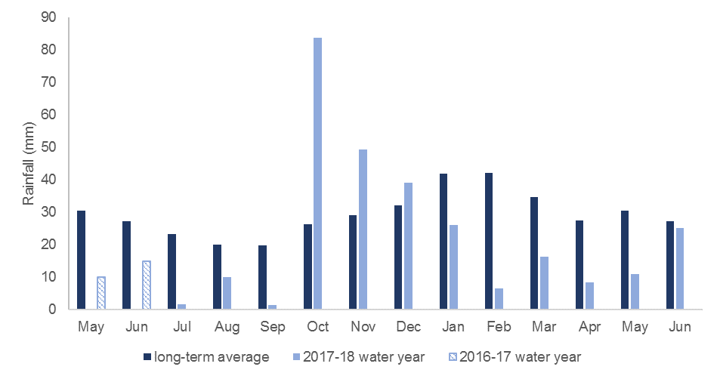

Figure D‑2: Average monthly rainfall for the 2017-18 water year at Bourke compared to long term average monthly rainfall (May and June 2017 also included).

Results and Discussion

Landsat image analysis

Five Landsat image dates were analysed and water was present on the Western Floodplain in only four, with no water detected on the floodplain on 8 February 2018. On the other occasions, inundation ranged from 20.5 ha on the 20 December 2017, to 436.85 ha on 29 September 2017 (Table D‑1). Relating inundation to the water levels in Boera Dam (Figure D‑1), it is likely that the only floodplain inundation from overflows from Boera Dam would have been observed in December 2017. From the inundation pattern in December 2017 (Figure D‑3), inundation derived from Boera Dam is likely to have been restricted to the northern sections of the floodplain, with wetting observed further south, likely derived from local rainfall. The hydrodynamic model suggests that for a similar area of inundation around Boera Dam, a volume of 6 ML would have been spilled onto the floodplain during this event. Inundation observed in the other three times – September 2017 (436.85 ha), March (115.68 ha) and April 2018 (154.78 ha) was likely the result of rainfall alone.

It is likely that only 20.5 ha was inundated by the small connection event (Table D‑1). This inundation event inundated 5 mapped vegetation communities including Coolabah open woodland, lignum shrubland, chenopod shrubland, Coolabah-River Cooba-lignum woodland and anthropogenic herbland (Table D‑1).

Rainfall derived inundation accounted for a much larger area of floodplain inundation with the greatest inundation shown on the September image 2017 (Figure D‑4).

Table D‑1: Inundation extent of vegetation communities on Western Floodplain based on Landsat 8 image analysis.

|  |  |  |  |  |
| --- | --- | --- | --- | --- |
| Vegetation Community | Inundated area (ha) | | | |
| 29-Sept-17 | 22-Dec-17 | 28-Mar-18 | 29-April-18 |
| Anthropogenic herbland | 0.82 | 0.36 | 0.54 | 0.51 |
| Beefwood - Coolabah woodland |  |  |  |  |
| Belah/Black Oak - Western Rosewood - Leopardwood low open woodland | 1.21 |  |  | 1.82 |
| Chenopod low open shrubland - ephemeral partly derived forbland | 40.53 | 2.17 | 23.45 | 16.5 |
| Coolabah - River Cooba - Lignum woodland | 57.70 | 0.79 | 27.24 | 3.39 |
| Coolabah open woodland wetland with chenopod/grassy ground cover | 110.94 | 9.47 | 31.87 | 76.91 |
| Ironwood woodland | 0.51 |  | 0.10 | 0.57 |
| Lignum shrubland wetland | 224.03 | 7.69 | 32.43 | 54.56 |
| Mulga shrubland |  |  |  |  |
| Narrow-leaved Hopbush-Scrub Turpentine-Senna shrubland | 0.27 |  | 0.02 | 0.10 |
| Poplar Box grassy low woodland | 0.35 |  |  | 0.27 |
| Water | 0.39 | .02 | 0.02 | 0.11 |
| **Total area inundated (ha)** | **436.85** | **20.50** | **115.68** | **154.78** |

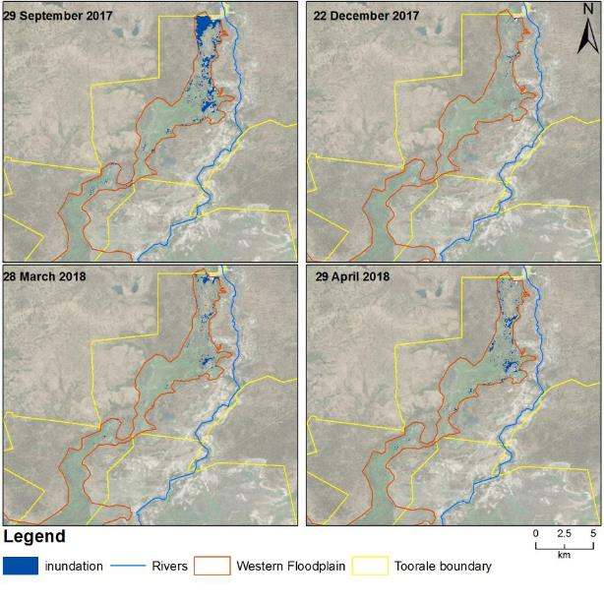

Figure D‑3: Inundation extents on the Western Floodplain.

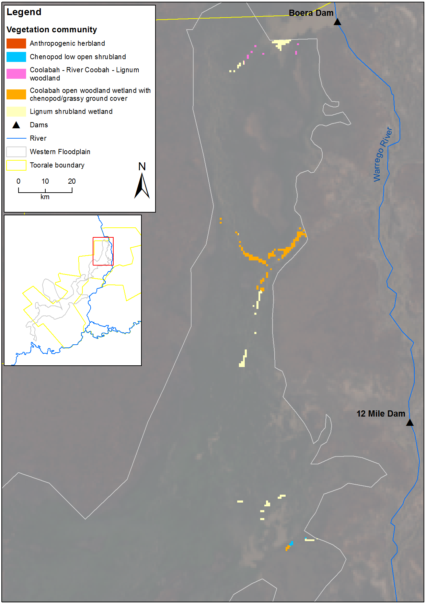

Figure D‑4: Inundation of vegetation communities on the Western Floodplain based on Landsat 8 image analysis of image captured December 2017.

Comparison with previous years

Inundation mapped during the 2017-18 water year was far less than that experienced during the previous year with most of mapped wetting derived from direct rainfall rather than inundation from the channel. The total inundation mapped in the 2017-18 water year was similar to that mapped in 2015-16, however, in 2015-16 most of the water was derived from overland flow (Commonwealth of Australia 2017; Figure D‑5).

Figure D‑5: Boera Dam levels recorded for all years of the LTIM project.

Table D‑2: Maximum area of inundation for each vegetation community for all years of the LTIM project.

|  |  |  |  |  |
| --- | --- | --- | --- | --- |
| Vegetation community | Maximum area inundated (ha) | | | |
| 2017-18 | 2016-17 | 2015-16 | 2014-15 | |
| Anthropogenic herbland | 0.82 | 2.88 |  | 0.09 | |
| Beefwood - Coolabah woodland |  | 0.15 | 0.01 |  | |
| Belah/Black Oak - Western Rosewood - Leopardwood low open woodland | 1.21 | 0.71 | 4.79 |  | |
| Chenopod low open shrubland - ephemeral partly derived forbland | 40.53 | 1512.90 | 16.03 | 0.28 | |
| Coolabah - River Cooba - Lignum woodland | 57.70 | 77.09 | 62.72 | 2.40 | |
| Coolabah open woodland wetland with chenopod/grassy ground cover | 110.94 | 712.94 | 97.34 | 14.27 | |
| Ironwood woodland | 0.51 | 0.41 | 0.01 |  | |
| Lignum shrubland wetland | 224.03 | 1524.80 | 285.75 | 34.84 | |
| Mulga shrubland |  | 0.07 |  |  | |
| Narrow-leaved Hopbush-Scrub Turpentine-Senna shrubland | 0.27 | 3.25 | 0.44 |  | |
| Poplar Box grassy low woodland | 0.35 | 0.25 | 0.09 |  | |

Conclusion

Commonwealth environmental water had no influence on inundation of the Western Floodplain during 2017-18 because of low inflows to Boera Dam, and the management of the dam for other environmental purposes. Inundation extents on the Western Floodplain were low during 2017-18 because of minimal overflow from Boera Dam. While up to 426.5 ha of inundation was detected during the year, this was the result of rainfall. This inundation would have helped maintain inundated vegetation communities and provided temporary water sources for animals, but would have been unlikely to have supported any significant aquatic communities on the floodplain during this water year.

References

Commonwealth Environmental Water Office (CEWO) 2014. *Commonwealth environmental water use options 2014-15: Northern Unregulated Rivers*.

Commonwealth of Australia 2015. *Commonwealth Water Office Long Term Intervention Monitoring Project Junction of the Warrego and Darling rivers Selected Area – Monitoring and Evaluation Plan.* Commonwealth of Australia

Commonwealth of Australia 2017. *Commonwealth Water Office Long Term Intervention Monitoring Project Junction of the Warrego and Darling rivers Selected Area – 2016-17 annual report.* Commonwealth of Australia

Frazier, PS, Page KJ. 2000. Water body detection and delineation with Landsat TM data. *Photogrammetric Engineering and Remote Sensing*, **66**, 1461-1468.

###### Water Quality

Introduction

The Category I Water Quality indicator aims to assess the contribution of Commonwealth environmental water to the improved quality of water in the Darling River within the Junction of the Warrego and Darling Rivers Selected Area (Selected Area). As such this indicator is linked to Stream Metabolism, and Hydrology (River, Northern Tributaries, Channel and Habitat) indicators. Several specific questions were addressed through this indicator within the Darling River zone during the 2017-18 water year:

* What did Commonwealth environmental water contribute to temperature regimes?
* What did Commonwealth environmental water contribute to pH levels?
* What did Commonwealth environmental water contribute to turbidity regimes?
* What did Commonwealth environmental water contribute to salinity regimes?
* What did Commonwealth environmental water contribute to dissolved oxygen levels?
* What did Commonwealth environmental water contribute to algal suppression?

**Environmental watering in 2017-18**

***Barwon-Darling and northern tributaries***

The 2017-18 water year was characterised by dry conditions and very low river flows throughout the northern tributaries. Three instream flow events including both unregulated and regulated environmental water occurred during July-November 2017, March – April 2018 and May 2018, providing approximately 21,669 ML, 3,446 ML and 13,332 ML of environmental water, respectively, at Louth, downstream of the Selected Area (Appendix B). It is estimated that during each event environmental water made up a significant proportion of these flows (between 24.3% and 99.6%).

***Warrego River***

Flows in the Warrego River during the 2017-18 water year were very low, with water entering the Selected Area during four small flow events in October 2017, December 2017, March-April 2018 and June 2018. Commonwealth environmental water made up 17.3% of the flow event during March-April 2018. Water levels in Boera Dam remained below the Western Floodplain connection level for most of the year with only one brief period of connection to the floodplain observed in December 2017 (Figure F‑1). During the flow event in March-April 2018, the Boera Dam regulating gates were partially opened for a total of 16 days, though flows were restricted to 300 ML/d or less in response to Boera Dam inflows. This event reconnected the waterholes in the lower Warrego system and provided connection through to the Darling River.



**Figure E‑1: Boera Dam levels during 2017-18 water year and flow to Western Floodplain and/or into lower Warrego channels (gates open).**

**Previous monitoring**

Three years of water quality monitoring between 2014 and 2017 at two Darling River stations showed the delivery of environmental water contributed to consistent improvements in water quality. The most consistent pattern was a significant reduction in mean daily pH, conductivity and turbidity when compared with periods without Commonwealth environmental water. This reflects the dilution effects provided by environmental water, and the changes in water chemistry associated with the increase in discharge and wetted area of channels. In contrast, elevated conductivity was recorded under the highest reported flows in the 2015-16 water year rather than during the very low flow conditions. This suggests the transport of increased dissolved ions and salts along the Darling River occurred with increased flows rather than salt intrusion into the channel during low flows.

Some unimodal relationships between water quality parameters and discharge were observed suggesting that key thresholds for the inundation of in-channel geomorphic features may exist. Before discharge reached these thresholds, water quality parameters increased with discharge suggesting longitudinal transport and input of materials from upstream catchments, as predicted by the literature (Bayley & Sparks, 1989). After discharge exceeded these key flow thresholds, water quality parameters declined with discharge. This was likely due to the dilution of existing materials as the resuspension of material decreased at higher river stages. In 2015-16, many water quality parameters had their highest recorded values at approximately 500 ML/d, suggesting that this may be a key low-flow threshold for the inundation of in-channel features that subsequently affect water quality in the Darling River under relatively low volume discharges. In 2016-17, the key high-flow threshold for the inundation or connection of geomorphic features was around 5,000 ML/d during a larger flow pulse which peaked around 39,000 ML/d at Bourke. The differences in flow thresholds between years suggest that inter-annual hydrological variability and antecedent flow condition play important roles in water quality variability, highlighting the importance of long-term monitoring in a highly dynamic system to allow multi-year comparisons.

Methods

Darling River long-term stations

Water quality parameters were monitored at two stations in the Darling River zone of the Selected Area that have permanent surface water in a defined channel. The Darling upstream station is located at Darling pump, and all Commonwealth environmental water derived in the upstream tributaries of the Darling Basin (except the Warrego River) passes through this reach (Figure E‑2). The Darling downstream station is located downstream of the confluence of the Warrego and Darling Rivers near Akuna homestead (Figure E‑2). As such, the Darling downstream station can be used to assess the influence of Warrego River flow to the water chemistry of the Darling River.

Continuous monitoring of the dependant variables temperature (°C), pH, turbidity (NTU), conductivity (mS/cm), dissolved oxygen (%) and chlorophyll *a* (μg/L) occurs at the downstream station using a Hydrolab DS5-X logger. Due to probe failure, pH was not monitored during the 2017-18 water year. A PME miniDOT logger was installed to monitor temperature (°C) and dissolved oxygen (%) in the upstream station on 28 March 2017 to replace the Hydrolab DS5-X logger which was lost during flooding in 2016. Another PME miniDOT logger was also deployed at the Darling downstream station to ensure data continuity. Each logger was mounted to a floating pontoon to ensure it was kept under the water but away from obstructions. Each water quality variable was logged at 10 minute intervals. All data was downloaded during each visit or periodically by NPWS staff. Due to issues with power supply, instrument failure at both sites and the permanent loss of the instrument in the Darling upstream station, datasets were partly discontinuous in the 2017-18 water year. Conductivity and discharge data was collated from DPI Water gauge station Darling @ D/S Weir 19a (NSW 425037) for the Darling upstream station and DPI Water gauge station Darling @ Louth (NSW 425004) for the Darling downstream station.

In the 2017-18 water year, three in-channel flow pulses containing Commonwealth environmental water were used to examine responses in water quality parameters (Table E‑1 and Figure E‑3). In addition, water quality data collected late in the 2016-17 water year is reported in this appendix covering the fourth environmental water event (April – May 2017) in 2016-17 water year. As this flow occurred after the field collection of data was undertaken in 2016-17, it is reported here for completeness. All four flow events vary in magnitude, duration and variability in discharge (Table E‑1 and Figure E‑3). Four non-environmental water periods, immediately before environmental water delivery periods, were used to examine differences in water quality indicators between periods of environmental water delivery and non-environmental water periods (Figure E‑3).

Daily means (midnight to midnight) of each water quality parameter were calculated from 10 minute interval data, with analyses based on the temporally independent mean values. Daily means of water quality parameters were analysed using the non-parametric Mann-Whitney U test to examine the differences between environmental water periods and non-environmental water periods where the significance level was set at 0.05. Regression analyses were used to explore relationships between discharge (ML/d) and each water quality parameter to separate the time/season of delivery from the discharge volume.

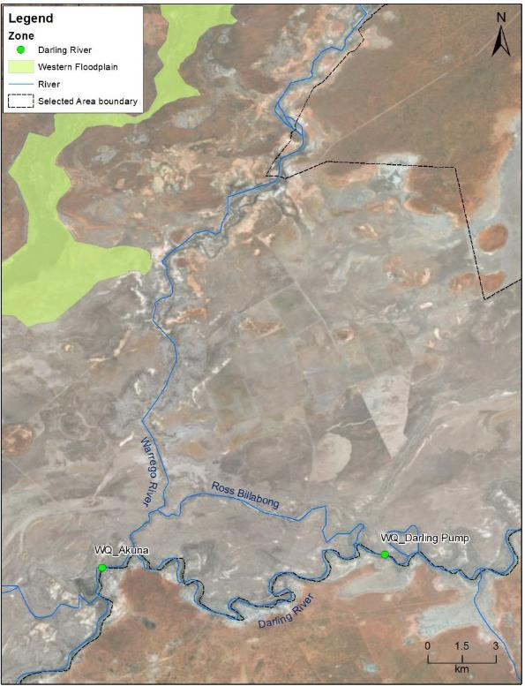

Figure E‑2: Location of two long-term water quality monitoring stations (Cat I) in the Darling River within the Selected Area. WD_Darling Pump is the upstream station and WD_Akuna is the downstream station.

Table E‑1: Environmental Water flow events used in the analysis of water quality indicators in the 2016-17 and 2017-18 water year. See Appendix B for more detail on environmental water contributions.

|  |  |  |  |  |
| --- | --- | --- | --- | --- |
| Water year | Event | Time period | Number of days in water quality analysis (EW, non-EW) | Environmental Water |
| 2016-17 | EW4 | 10/04/2017 to 17/05/2017 (37 days) | 22,22 | Comprised of 21,662 ML (estimated contribution of 2.4%) Commonwealth environmental water from the Condamine-Balonne catchment, Border, Namoi and Macquarie Rivers. |
| 2017-18 | EW1 | 14/10/2017 to 29/11/2017 (46 days) | 19,19 | Part of a larger event (July – November 2017) which comprised 21,669 ML (estimated contribution 42.9%) environmental water including both unregulated and regulated contributions from the Border Rivers, Gwydir and Macquarie-Castlereagh systems. |
| EW2 | 10/03/2018 to 29/04/2018 (50 days) | 25,25 | Comprised of 3,446 ML (estimated contribution 24.3%) environmental water from the Condamine-Balonne and Namoi systems. |
| EW3 | 4/05/2018 | 34,34 | Comprised of 13,332 ML (estimated contribution 99.6%) environmental water delivered from the Border Rivers and Gwydir systems as part of the Northern Connectivity Event. |

Figure E‑3: Mean daily discharge of four Environmental Water (EW) and non-Environmental Water (non EW) periods at Darling @ D/S Weir 19a (NSW425037) and Darling @ Louth (NSW425004).

Results

The Darling River upstream and downstream stations exhibited similar magnitudes of discharge, with a short time lag for downstream flow (Figure E‑3). The discharge patterns of four environmental water periods were influenced by flows along the Darling River zone with portions of environmental water accounted for in upstream tributaries. The peak flow of these four environmental water events ranged from 500 ML/d to 3500 ML/d with different antecedent flow condition prior to each event (Figure E‑4a and Figure E‑5a). Longitudinal connection between the Warrego and Darling due to the opening of Boera Dam gates occurred mid-April 2018 resulting in connection for a total of 16 days (Appendix A).

Mean daily water temperature increased steadily from July to February due to seasonal variation (Figure E‑4b and Figure E‑5b). Mean daily temperature was significantly lower during environmental water delivery periods (Table F‑2). Like previous years, temperature did not have a strong predictable linear relationship with discharge (Figure E‑6a and Figure E‑7a), suggesting seasonal change exerts a stronger influence on temperature than magnitude of flows.

Mean daily turbidity in the downstream station ranged from 22 NTU to 574 NTU during periods with available data (Figure E‑5c) and was of a similar magnitude and variability compared to previous years of the LTIM project (Figure E‑8b and Figure E‑9b). High turbidity levels that exceeded the ANZECC water quality guideline (6-50NTU) were observed in the beginning of EW event 3 and decreased sharply in five days to within the guideline value (Figure E‑5c). The Mann-Whitney U test suggested significantly higher turbidity occurred during EW periods due to the initial high turbidity level in EW event 3 (Table F‑2). A negative correlation between turbidity and discharge was observed in the downstream station (Figure E‑7c).

During 2017-18, mean daily conductivity ranged from 0.1 to 11.7 mS/cm with peak conductivity in the Darling upstream station being higher than previous years (Figure E‑4d, Figure E‑5d, Figure E‑8c and Figure E‑9c). Similar to the 2016-17 water year, there was significantly lower conductivity during EW periods (Table F‑2) and a negative correlation between conductivity and discharge at both stations (Figure E‑6b and Figure E‑7c). In the Darling upstream station, conductivity increased to above the ANZECC water quality guidelines (0.125 and 2.2 mS/cm) during the base flow period before EW event 2 and decreased sharply during EW event 2 over three days to within the water quality guideline value (Figure E‑4c). In the downstream station, the increase in discharge during EW event 2 led to an initial rise in conductivity and then reduced conductivity within seven days. This reduction in conductivity was further improved in EW event 3 and maintained until the end of June 2018 at both stations.

Mean daily dissolved oxygen concentrations ranged from 12% to 127% at both stations (Figure E‑4d and Figure E‑5e) and were outside the ANZECC water quality guideline (85-110% in dissolved oxygen percent) on most days. This is consistent with findings from previous years (Figure E‑8d and Figure E‑9d). There was no significant difference in dissolved oxygen concentrations between environmental water delivery periods and non-environmental water delivery periods (Table F‑2). In 2017-18, environmental water within EW event 1 and 3 contributed to increases in dissolved oxygen in both stations to within the ANZECC guideline trigger value. EW event 2 was during a low flow period and coincided with a reduction in dissolved oxygen concentrations to the lowest recorded values of the year in both stations. However, the relative influence of water entering the Darling river from the Warrego River during this event was low, with no obvious differences noted between the upstream or downstream gauges. Dissolved oxygen had a poor correlation with discharge (Table F‑2), being more variable during low discharge rates (Figure E‑6c and Figure E‑7d).

Chlorophyll *a* concentrations in the downstream station ranged between 3 and 143 µg/L (Figure E‑4f) which was higher than recorded in previous years (Figure E‑9e). Chlorophyll *a* concentrations were highest between July and September 2017 during the naturally variable period of in-channel flows. A negative correlation between chlorophyll *a* and discharge was observed in the downstream station (Figure E‑7e). There is insufficient data for comparisons between EW periods and non-EW periods.

Figure E‑4: Mean daily (a) discharge at Darling @ D/S Weir 19a (NSW425037) on the Darling River system, (b) temperature, (c) conductivity and (d) dissolved oxygen at Darling upstream water quality station. EW represents environmental water. Black line represents all available data from this watering year and red dotted line represents ANZECC guideline trigger value.

Figure E‑5: Mean daily (a) discharge at Darling @ Louth (NSW425004) on the Darling River system, (b) temperature, (c) turbidity, (d) conductivity, (e) dissolved oxygen and (f) chlorophyll *a* at Darling downstream water quality station. EW represents environmental water. Black line represents all available data from this watering year and red dotted line represents ANZECC guideline trigger value.

Table E‑2: Mean standard deviation of measured water quality indicators in Environmental Water delivery periods (EW) and non-Environmental Water delivery periods (non-EW). Mann-Whitney U test and Regression results with significant different at p<0.05*.

|  |  |  |  |  |  |  |  |  |  |
| --- | --- | --- | --- | --- | --- | --- | --- | --- | --- |
| Station | Variable | Unit | EW | | non-EW | | U test | | Regression r2 |
| Mean | ±SD | Mean | ±SD | chi-square | p-value |
| Upstream | Discharge | ML/d | 681.5 | 738.5 | 157.3 | 230.2 | 66.6 | <0.001* | - |
| Temperature | °C | 20.1 | 5.5 | 22.7 | 4.1 | 10.8 | 0.001* | 0.203 |
| Conductivity | mS/cm | 0.9 | 1.0 | 3.2 | 4.2 | 12.277 | <0.001* | 0.225 |
| Dissolved Oxygen | % | 79.0 | 21.6 | 73.8 | 20.1 | 3.84 | 0.1 | 0.009 |
| Downstream | Discharge | ML/d | 679.6 | 638.4 | 207.7 | 273.2 | 59.5 | <0.001* | - |
| Temperature | °C | 20.1 | 5.6 | 22.3 | 4.3 | 7.5 | 0.006* | 0.216 |
| Turbidity | NTU | 70.6 | 115.7 | 32.7 | 2.7 | 8.1 | 0.004* | 0.000 |
| Conductivity | mS/cm | 0.8 | 0.5 | 1.0 | 0.3 | 35.1 | <0.001* | 0.124 |
| Dissolved Oxygen | % | 71.8 | 18.1 | 75.5 | 13.4 | 1.0 | 0.327 | 0.060 |
| Chlorophyll a | µg/L | 10.9 | 3.5 | 9.2 | 5.7 | 4.1 | 0.043 | 0.049 |

Figure E‑6: Regressions between discharge at Darling @ D/S Weir 19a (NSW425037) on the Darling River system and mean daily (a) temperature, (b) conductivity and (c) dissolved oxygen concentrations.

Figure E‑7: Regressions between discharge at Darling @ Louth (NSW425004) on the Darling River system and mean daily (a) temperature, (b) turbidity, (c) conductivity, (d) dissolved oxygen concentrations and (e) chlorophyll *a* concentrations.

Figure E‑8: Mean water quality indicators in the Darling upstream station over the four years of the LTIM project.

Figure E‑9: Mean water quality indicators in the Darling downstream station over the four years of the LTIM project.

Discussion

The four environmental water events (one event in 2016-17 and three events in 2017-18 water year) within the Darling River considered in this appendix were small freshes that aimed to provide longitudinal connectivity, improve water quality and inundate low level habitats. The peak flow of these four environmental water events ranged from 500 ML/d to 3,500 ML/d with different antecedent flow conditions prior to each event. The Darling River upstream and downstream stations exhibited a similar magnitude of discharge and water quality variability in response to contributions of environmental water. The magnitude of flow events in this water year (peak flow around 1,700ML/d) was similar in magnitude with 2015-16 (peak flow around 1,300 ML/d) and 2014-15 (peak flow around 1,900 ML/d) and lower in magnitude than 2016-17 (peak flow around 39,000 ML/d).

In this water year, the delivery of environmental water generally led to significant improvements in conductivity. These processes reflect the dilution effects provided by flow events including environmental water, and the changes in water chemistry associated with the increase in discharge and wetted area of channels. Event 2 led to a significant reduction of conductivity within three days of the commencement of the event. This improvement in conductivity was enhanced further in Event 3 and then maintained for at least three months after the flow at both stations. Flow events containing environmental water have generally led to reductions in conductivity over all years of the LTIM project, except for elevated conductivity associated with a flow event in 2015-16 which peaked at 1,350 ML/d (Commonwealth of Australia 2016). This suggests that increased flows that contain environmental water may inundate low lying in-channel features that subsequently transport ions and suspended sediments into the system, thus driving the influx of materials rather than diluting concentrations. It is proposed that inter-annual hydrological variability and antecedent flow condition play important roles in conductivity variability, highlighting the importance of long-term monitoring in highly dynamic systems.

The Darling downstream station is designed to assess the influence of Warrego flows during longitudinal connectivity of the Warrego and Darling Rivers. Longitudinal connection between the Warrego and Darling due to the opening of Boera Dam gates occurred during event 2 in mid-April 2018 resulting in connection for a maximum of 16 days (Appendix A). During this event, the inputs of water from the Warrego River to the Darling was not obvious on the Louth stream gauge, comparing it to the Weir 19a gauge. There was also no obvious influence of Warrego water on water quality in the Darling River downstream of the confluence during this event. Like previous years, the downstream station had lower conductivity regardless of flow conditions, suggesting that broader spatial patterns are predominantly driven by local characteristics and landscape-scale processes such as local geology and saline inputs. Additional water quality sampling in 2016-17 peak flow event also showed a dilution effect in pH, conductivity, total nitrogen and chlorophyll *a* concentrations by the Warrego inflow (Commonwealth of Australia 2017).

Dissolved oxygen has shown inconsistent responses to flow throughout the LTIM project. In 2017-18, increased discharge during Events 1 and 3 contributed to increased dissolved oxygen concentrations in both stations to within the ANZECC guideline trigger value. This suggests that flow of these magnitudes (peak flow of about 400 ML/d and 800 ML/d respectively at Darling@Weir19a) stimulate primary production measured as dissolved oxygen concentrations. In contrast, during Event 2 (peak flow about 1,600 ML/d at Darling@Weir19a) after two months of constant base flows, dissolved oxygen dropped from 70-80% to below 20% at both stations 15-20 days after this flow commenced. This reduction in dissolved oxygen coincided with an algal outbreak that partly covered the water surface of the Darling River channel in April 2018 (Figure E‑10). Water quality records from short-term spot sampling shortly after Event 2 showed very high turbidity of above 800 NTU and chlorophyll *a* concentration around 30 µg/L on 25 April 2018. There are several possible explanations for this inconsistent response of dissolved oxygen this year. Since Events 1, 2 and 3 were all small fresh events, it is possible that differences in upstream water sources containing different chemical composition may have affected the balance between productivity and respiration, and hence dissolved oxygen concentrations. Secondly, antecedent flow conditions associated with time since flow recession may play an important role in dissolved oxygen dynamics in this system.

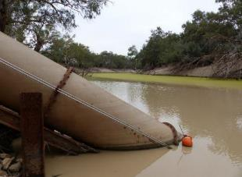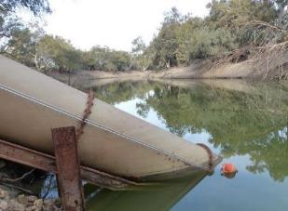

Figure E‑10: Darling Pump water quality site on 25th April 2018 (during Event 2) and 29th June 2018 (during Event 3).

Conclusion

The delivery of environmental water generally led to a reduction in conductivity levels reflecting dilution provided by flows containing environmental water in 2017-18, which is a similar finding to previous years. The improvement in conductivity was more profound during the flow event associated with a natural low flow period. On the other hand, the delivery of environmental water during naturally variable flow periods in 2017-18 did not lead to predictable dissolved oxygen responses. It is proposed that flow source and/or antecedent flow conditions play important roles in dissolved oxygen variability, highlighting the importance of long-term monitoring in highly dynamic system to allow multi-year comparisons.

References

Allan, J.D. and Castillo, M.M., 2007. *Stream ecology: structure and function of running waters*. Springer Science & Business Media.

Commonwealth of Australia. 2015. *Commonwealth Environmental Water Office Long Term Intervention Monitoring Project Junction of the Warrego and Darling rivers Selected Area. 2014-15 annual report*. Commonwealth of Australia, Canberra.

Commonwealth of Australia. 2016. *Commonwealth Environmental Water Office Long Term Intervention Monitoring Project Junction of the Warrego and Darling rivers Selected Area. 2015-16 annual report*. Commonwealth of Australia, Canberra.

Commonwealth of Australia. 2017. *Commonwealth Environmental Water Office Long Term Intervention Monitoring Project Junction of the Warrego and Darling rivers Selected Area. 2016-17 annual report*. Commonwealth of Australia, Canberra.

Junk, W.J., Bayley, P. B., & Sparks, R. E. 1989. *The Flood Pulse Concept in River-Floodplain Systems. P.110-127* In D.P. Dodge (ed.) *Proceedings of the International Large River Symposium*. Can. Spec. Publ. Fish. Aquat. Sci. 106

Sheldon, F., & Fellows, C. S. 2010. Water quality in two Australian dryland rivers: spatial and temporal variability and the role of flow. *Marine and Freshwater Research*, **61(8)**, 864-874.

###### Stream Metabolism

Introduction

The Category I Stream Metabolism indicator aims to assess the contribution of Commonwealth environmental water to improving stream metabolism in the Darling River zone of the Junction of the Warrego and Darling rivers Selected Area (Selected Area). As such, this indicator is linked to Hydrology (River and Northern tributaries), and the Water quality indicators. Two specific questions were addressed through this indicator within the Darling River zone during the 2017-18:

* What did Commonwealth environmental water contribute to patterns and rates of decomposition?
* What did Commonwealth environmental water contribute to patterns and rates of primary productivity?

**Environmental watering in 2017-18**

***Barwon-Darling and northern tributaries***

The 2017-18 water year was characterised by dry conditions and very low river flows throughout the northern tributaries. Three instream flow events including both unregulated and regulated environmental water occurred during July-November 2017, March – April 2018 and May 2018, providing approximately 21,669 ML, 3,446 ML and 13,332 ML of environmental water, respectively, at Louth, downstream of the Selected Area (Appendix B). It is estimated that during each event environmental water made up a significant proportion of these flows (between 24.3% and 99.6%).

***Warrego River***

Flows in the Warrego River during the 2017-18 water year were very low, with water entering the Selected Area during four small flow events in October 2017, December 2017, March-April 2018 and June 2018. Commonwealth environmental water made up 17.3% of the flow event during March-April 2018. Water levels in Boera Dam remained below the Western Floodplain connection level for most of the year with only one brief period of connection to the floodplain observed in December 2017 (Figure F‑1). During the flow event in March-April 2018, the Boera Dam regulating gates were partially opened for a total of 16 days, though flows were restricted to 300 ML/d or less in response to Boera Dam inflows. This event reconnected the waterholes in the lower Warrego system and provided connection through to the Darling River.



**Figure F‑1: Boera Dam levels during 2017-18 water year and flow to Western Floodplain and/or into lower Warrego channels (gates open).**

**Previous monitoring**

The monitoring of water quality and metabolism during 2015-16 revealed positive relationships between rates of gross primary production (GPP), ecosystem respiration (ER), net primary production (NPP) and nutrient concentrations in a range of low volume flow events containing contributions of Commonwealth environmental water (peak flow around 1,300 ML/d). In previous years, increased rates of GPP have been associated with higher discharge events. In turn, higher rates of NPP suggest that flows containing environmental water in the Darling River contribute to an increased supply of inorganic nutrients and carbon that promote pelagic primary production.

Methods

Darling River long-term stations

Stream metabolism parameters (Table F‑1) were monitored at two stations in the Darling River zone of the Selected Area that have permanent surface water in a defined channel. The Darling upstream station is located at Darling pumps, and all Commonwealth environmental water derived in the upstream tributaries of the Darling Basin (except the Warrego River) passes through this site (Figure F‑2). The Darling downstream station is located downstream of the confluence of the Warrego and Darling Rivers near Akuna homestead (Figure F‑2). As such, the Darling downstream station can be used to assess the influence of Warrego River flow to the water chemistry of the Darling River.

Continuous monitoring of the dependant variables temperature (°C) and dissolved oxygen (%) occurred at the two stations using PME miniDOT loggers. Each logger was mounted to a floating pontoon to ensure it was kept under the water but away from obstructions. Each water quality variable was logged at 10 minute intervals. Photosynthetically active radiation (PAR) and barometric pressure were also logged at 10 minute intervals. Daily rates of GPP, ER and NPP were calculated using the BASE2 modelling package (Grace *et al.* 2015). Regression analyses were used to explore relationships between discharge (ML/d) and each stream metabolism indicator to separate the time/season of delivery from the discharge volume. Discharge data was collated from DPI Water gauge station Darling @ D/S Weir 19a (NSW 425037) for the Darling upstream station and DPI Water gauge station Darling @ Louth (NSW 425004) for the Darling downstream station.

In the 2017-18 water year, three in-channel flow pulses containing Commonwealth environmental water were used to examine responses in water quality parameters (Figure F‑3 and Table F‑2). In addition, stream metabolism data collected late in the 2016-17 water year is reported in this appendix covering the fourth environmental water event (April – May 2017) in 2016-17 water year. As this flow occurred after the field collection of data was undertaken in 2016-17, it is reported here for completeness. These four flow events vary in magnitude, duration and variability in discharge (Figure F‑3). Four non-environmental water periods, immediately before environmental water delivery periods, were used to examine differences in stream metabolism indicators between periods of environmental water delivery and non-environmental water periods (Figure F‑3).

Due to issues with power supply, instrument failure (turbidity and biofouling) at both sites and the permanent loss of the instrument in the Darling upstream station during a high flow event in September 2016, datasets were partly discontinuous in the 2016-17 water year. In addition, BASE v2 modelling rejected more than 90% of the data in 2017-18 mainly due to high estimated reaeration coefficient (K) values causing poor model fitting. This resulted in few stream metabolism data available for analysis (Table F‑2). This poor BASE v2 model fitting issue will be addressed in the 2018-19 by using the recently developed BASE v2.3.3 modelling package.

Water nutrient samples (Cat 1) are collected at approximately 6 weekly intervals throughout the year and analysed at the NATA accredited Environmental Analytical laboratories at Southern Cross University.

Table F‑1: Stream metabolism indicators measured in 2017-18 water year at two stations in the Darling River long-term stations.

|  |  |  |  |
| --- | --- | --- | --- |
| Indicators | Parameters | | Units |
| Stream metabolism (Cat I) | i. | Gross Primary Production | mg O2/L/day |
| ii. | Ecosystem Respiration | mg O2/L/day |
| iii. | Net Primary Production | mg O2/L/day |
| Water nutrients (Cat I) | i. | Total Nitrogen | µg/L |
| ii. | Total Phosphorus | µg/L |
| iii | Nitrate-nitrite | µg/L |
| iv. | Filterable Reactive Phosphorus | µg/L |
| v. | Dissolved Organic Carbon | µg/mL |

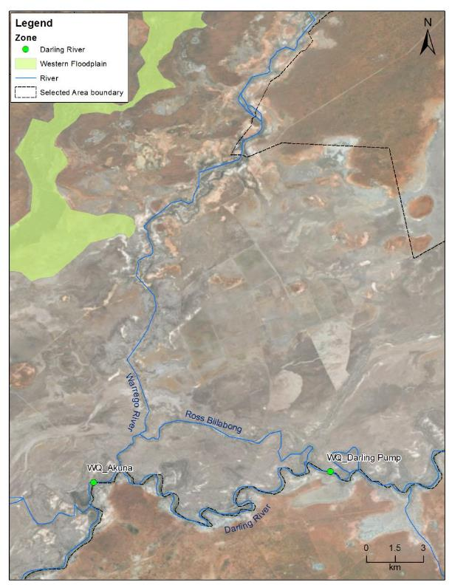

Figure F‑2: Location of two long-term stream metabolism monitoring stations (Cat I) in the Darling River within the Selected Area. WD_Darling Pump is the upstream station and WD_Akuna is the downstream station.

Figure F‑3: Mean daily discharge of four Environmental Water (EW) and non-Environmental Water (non EW) periods at Darling @ D/S Weir 19a (NSW 425037) and Darling @ Louth (NSW 425004).

Table F‑2: Summary of Stream Metabolism (Cat I) data records 2017-18. *Pass represents BASE2 outputs with acceptance criteria of R2<0.9, R-hats<1.1, PPP between 0.1 and 0.9, pD is positive and CV of GPP<50.

|  |  |  |  |  |  |  |  |
| --- | --- | --- | --- | --- | --- | --- | --- |
| Water year | Event | Time period | Environmental Water | Days with metabolism data | | | |
| Period | Pass* | Fail | Total |
| 2016-17 | EW4 | 10/04/2017 | Comprised of 21,662 ML (estimated contribution of 2.4%) Commonwealth environmental water from the Condamine-Balonne catchment, Border, Namoi and Macquarie Rivers. | Upstream (EW) | 1 | 21 | 22 |
| to | Upstream (non-EW) | 4 | 18 | 22 |
| 17/05/2017 | Downstream (EW) | 1 | 21 | 22 |
| (37 days) | Downstream (non-EW) | 3 | 19 | 22 |
| 2017-18 | EW1 | 14/10/2017 | Part of a larger event (July – November 2017) which comprised 21,669 ML (estimated contribution 42.9%) environmental water including both unregulated and regulated contributions from the Border Rivers, Gwydir and Macquarie-Castlereagh systems. | Upstream (EW) | 0 | 19 | 19 |
| to | Upstream (non-EW) | 1 | 18 | 19 |
| 29/11/2017 | Downstream (EW) | 3 | 16 | 19 |
| (46 days) | Downstream (non-EW) | 2 | 17 | 19 |
| EW2 | 10/03/2018 | Comprised of 3,446 ML (estimated contribution 24.3%) environmental water from the Condamine-Balonne and Namoi systems. | Upstream (EW) | 0 | 25 | 25 |
| to | Upstream (non-EW) | 0 | 25 | 25 |
| 29/04/2018 | Downstream (EW) | 2 | 23 | 25 |
| (50 days) | Downstream (non-EW) | 2 | 23 | 25 |
| EW3 | 4/05/2018 | Comprised of 13,332 ML (estimated contribution 99.6%) environmental water delivered from the Border Rivers and Gwydir systems as part of the Northern Connectivity Event. | Upstream (EW) | 3 | 31 | 34 |
| to | Upstream (non-EW) | 3 | 31 | 34 |
| 26/06/2018 | Downstream (EW) | 3 | 31 | 34 |
| (53 days) | Downstream (non-EW) | 1 | 33 | 34 |

Results and discussion

The Darling River upstream and downstream stations experienced a similar magnitude of discharge during this water year, with a short time lag for downstream flow (Figure F‑3). The four events that included environmental water (one event in 2016-17 and three events in 2017-18 water year) within the Darling River considered in this appendix were small fresh events that aimed to provide longitudinal connectivity, improve water quality and inundate low level habitats. The peak flow of these four environmental water events ranged from 500 ML/d to 3,500 ML/d with different antecedent flow condition prior to the events.

The stream metabolism dataset was discontinuous due to a high percentage (93%) of data that did not meet the BASE v2 model output requirements (Table F‑2). This was mainly due high estimated reaeration coefficient (K) value causing poor model fitting. Rates of GPP ranged from 0.32 to 6.71 mg O2/L/day and rates of ER ranged from 0.01 to 22.95 mg O2/L/day (Figure F‑4a and b, and Figure F‑5a and b). NPP was predominantly net heterotrophic throughout the water year from -18.84 to 0.88 mg O2/L/day (Figure F‑4c and Figure F‑5c). In the downstream station, NPP shifted to autotrophy on a few occasions from November 2017 to March 2018, possibly due to an increase in water temperature.

No significant differences in the range of GPP, ER and NPP rates between periods with and without environmental water were detected for either station. This was likely due to insufficient data in this years dataset (Table F‑3). GPP, ER and NPP had a poor correlation with discharge (Table F‑3 and Figure F‑7). We do not have sufficient data to conclude the response of metabolism to each flow event with CEW contribution in this water year. It is hoped that the recently developed BASE v2.3.3 modelling package may be able to include more data from the Selected Area for future evaluations.

Water nutrient samples were collected at approximately 6 weekly intervals throughout the year. TN, TP, FRP and chlorophyll *a* concentrations were consistently above the ANZECC water quality guideline values (Figure F‑6a-g). In both stations, the highest concentrations of TP and FRP were recorded after the Event 1 in mid-December2017, reflecting longitudinal inputs of nutrients. Downstream stations had higher TN, NOx, NH4 and TP from July to December 2017. On the other hand, TN, NOx and NH4 had reduced concentrations during base flow periods. It is suggested that Event 2 in April 2018 diluted nitrogen concentrations in the Darling River which lowered NPP, but stimulated GPP and ER.

Table F‑3: Mean of measured stream metabolism indicators in Environmental Water delivery periods (EW) and non-Environmental Water delivery periods (non-EW). Mann-Whitney U test and Regression results with significant different at p<0.05*.

|  |  |  |  |  |  |  |
| --- | --- | --- | --- | --- | --- | --- |
| Variable | Station | Mean | | U test | | Regression r2 (linear) |
| EW | non-EW | chi-square | p-value |
| GPP | Upstream | 1.901 | 2.901 | 1.038 | 0.308 | 0.039 |
| Downstream | 2.286 | 3.374 | 1.565 | 0.211 | 0.081 |
| ER | Upstream | 7.426 | 9.065 | 1.038 | 0.308 | 0.081 |
| Downstream | 3.427 | 5.591 | 3.704 | 0.054 | 0.000 |
| NPP | Upstream | -5.525 | -6.163 | 0.115 | 0.734 | 0.042 |
| Downstream | -1.142 | -2.217 | 1.333 | 0.248 | 0.000 |
| Discharge | Upstream | 681.5 | 157.3 | - | - | - |
| Downstream | 653.9 | 209.6 | - | - | - |

Figure F‑4: Mean daily (a) gross primary production, (b) ecosystem respiration and (c) net primary production at Darling upstream stream metabolism station. EW represents environmental water. Black dotted line represents discharge (ML/d) data from the nearest gauge station Darling @ D/S Weir 19a (NSW425037).

Event 4 Event 1 Event 2 Event 3

Figure F‑5: Mean daily (a) gross primary production, (b) ecosystem respiration and (c) net primary production at Darling downstream stream metabolism station. EW represents environmental water. Black dotted line represents discharge (ML/d) data from the nearest gauge station Darling @ Louth (NSW425004).

Figure F‑6: Regressions between discharge and mean daily (a) gross primary production, (b) ecosystem respiration and (c) net primary production at Darling upstream stream metabolism station and (d) gross primary production, (e) ecosystem respiration and (f) net primary production at Darling downstream stream metabolism station. All represents all available data from this water year and EW represents environmental water.

Figure F‑7: Concentrations of (a) total nitrogen, (b) nitrate-nitrite, (c) ammonium, (d) total phosphorus, € filterable reactive phosphorus, (f) dissolved organic carbon and (g) chlorophyll *a* (Cat I) from NATA.

Conclusion

In this water year, there is no detectable difference in stream metabolism indicators between environmental water periods and non-environmental water periods. There was also no clear correlation between metabolism indicators and discharge. In general, total nitrogen and total phosphorus concentrations exceeded the ANZECC guideline during the whole water year based on nutrient samples collected in every six weeks, this has been typical of nutrient levels measured in the LTIM project to date. Stream metabolism datasets were discontinuous in the 2017-18 water year due to poor model fitting.

References

Baldwin, D. S., Rees, G. N., Wilson, J. S., Colloff, M. J., Whitworth, K. L., Pitman, T. L., & Wallace, T. A. 2013. Provisioning of bioavailable carbon between the wet and dry phases in a semi-arid floodplain. *Oecologia*, **172(2)**, 539-550.

Commonwealth of Australia. 2017. Commonwealth Environmental Water Office Long Term Intervention Monitoring Project Junction of the Warrego and Darling rivers Selected Area – 2015-16 Final Evaluation Report. Retrieved from

Grace, M. R., Giling, D. P., Hladyz, S., Caron, V., Thompson, R. M., & Mac Nally, R. (2015). Fast processing of diel oxygen curves: Estimating stream metabolism with BASE (BAyesian Single‐station Estimation). *Limnology and Oceanography: Methods*, **13(3),** 103-114.

###### Ecosystem Type

Introduction

The Ecosystem Type indicator contributes to the broader scale evaluation of Commonwealth environmental water’s influence on ecosystem diversity. While primarily designed to inform at larger basin scales, information on the types of ecosystems influenced by Commonwealth environmental water is also useful at the Selected Area scale. Several specific questions were addressed by monitoring Ecosystem Type within the Junction of the Warrego and Darling Rivers Selected Area during the 2017-18 water year:

* What did Commonwealth environmental water contribute to sustainable ecosystem diversity?
* Were ecosystems to which Commonwealth environmental water was allocated sustained?
* Was Commonwealth environmental water delivered to a representative suite of Ecosystem Types?

**Environmental watering in 2017–18**

***Barwon-Darling and northern tributaries***

The 2017-18 water year was characterised by dry conditions and very low river flows throughout the northern tributaries. Three instream flow events including both unregulated and regulated environmental water occurred during July-November 2017, March – April 2018 and May 2018, providing approximately 21,669 ML, 3,446 ML and 13,332 ML of environmental water, respectively, at Louth, downstream of the Selected Area (Appendix B). It is estimated that during each event environmental water made up a significant proportion of these flows (between 24.3% and 99.6%).

***Warrego River***

Flows in the Warrego River during the 2017-18 water year were very low, with water entering the Selected Area during four small flow events in October 2017, December 2017, March-April 2018 and June 2018. Commonwealth environmental water made up 17.3% of the flow event during March-April 2018. Water levels in Boera Dam remained below the Western Floodplain connection level for most of the year with only one brief period of connection to the floodplain observed in December 2017 (Figure G‑1). During the flow event in March-April 2018, the Boera Dam regulating gates were partially opened for a total of 16 days, though flows were restricted to 300 ML/d or less in response to Boera Dam inflows. This event reconnected the waterholes in the lower Warrego system and provided connection through to the Darling River.



**Figure G‑1: Boera Dam levels during 2017-18 water year and flow to Western Floodplain and/or into lower Warrego channels (gates open).**

Methods

The ANAE classification for each sampling site in the Selected Area was mapped using a process of desktop identification and field verification (Commonwealth of Australia 2015). Existing ANAE GIS layers (Brooks *et al*. 2013) were used to assign an Ecosystem Type to each monitoring site, and this was then verified in the field. Sites where existing ANAE mapping did not provide coverage were assigned an ANAE classification using available desktop information and then verified in the field. Field based verification was undertaken following a dichotomous key (Brooks *et al*. 2013).

No new sites were established in the 2017-18 water year.

Results

Monitoring was undertaken at 39 sites within the Selected Area in 2017-18. Two sites ((WD_WF1 and WD_WF2) were dry and therefore not sampled, however they were included in the ecosystem type analysis.

Within the Selected Area, a total of 14 sites (34% of all sites), were inundated during the 2017-18 water year (Table G‑1, Figure G‑2). Three ecosystem types were inundated (Figure G‑3), including F2.2 Lignum shrubland floodplain, Lt2.1 Temporary lake and Rp1.4 Permanent lowland streams. Not all sites within the F2.2 Lignum shrubland were inundated.

**Table G‑1: ANAE Ecosystem Type’s covered by monitoring sites in the Junction of the Warrego Darling rivers Selected Area LTIM Project.**

|  |  |  |
| --- | --- | --- |
| ANAE Typology | Number of sites (All Zones) | Proportion of sites inundated (%) |
| F1.10 Coolibah woodland and forest floodplain | 4 | 0 |
| F1.11 River cooba woodland floodplain | 6 | 0 |
| F1.8 Black box woodland floodplain | 3 | 0 |
| F2.2 Lignum shrubland floodplain | 6 | 50 |
| F2.4 Shrubland floodplain | 6 | 0 |
| Lt2.1 Temporary lake | 7 | 100 |
| Lt2.2 Temporary floodplain lake with aquatic beds | 2 | 0 |
| Pt2.2.1 Temporary sedge/grass/forb floodplain marsh | 3 | 0 |
| Rp1.4 Permanent lowland stream | 4 | 100 |
| **Total** | **41** | **34** |

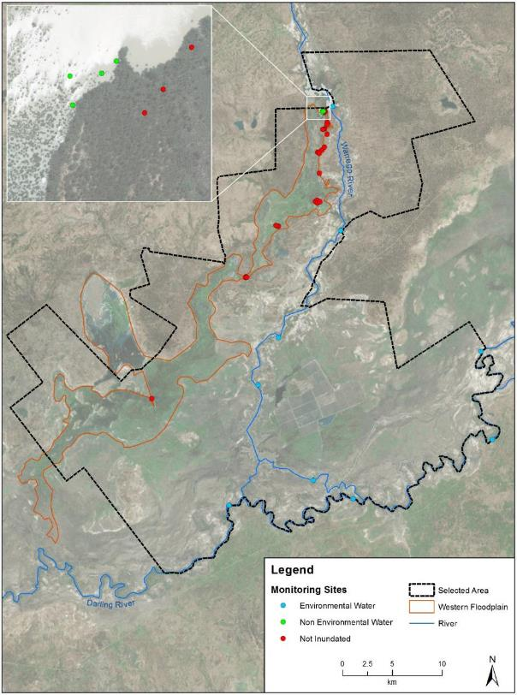

**Figure G‑2: Inundation status of sites sampled in the Selected Area during the 2017-18 water year.**

**Figure G‑3: Distribution of ANAE ecosystem types inundated across the three monitoring zones within the Selected Area.**

Discussion

The types of ecosystems monitored in this project reflect the nature of the delivery of environmental water and the indicators being assessed. While aquatic in-channel habitats are being monitored in the Darling and Warrego River zones, a broader suite of ecosystems including channels, waterholes and floodplains are being monitored on the Western Floodplain.

In 2017-18, 14 sites across three ecosystem types were inundated compared to 38 across all nine ecosystem types in 2016-17. This decrease is a result of significantly reduced floodplain inundation in this water year, with only a short period of floodplain connection from the Warrego river during December 2017. There are 31 sites in the Western Floodplain zone of which only four were inundated in 2017-18, accounting for the 85% decrease in inundated sites from 2016-17.

During the 2016-17 water year, Commonwealth environmental water influenced sites within the Western Floodplain, Warrego River and Darling River zones, inundating all ecosystem types monitored in the Selected Area. In 2017-18, Commonwealth environmental water was constrained to the Warrego and Darling River zones, influencing only 2 of the ecosystem types monitored in Selected Area. Commonwealth environmental water did not contribute to inundation of ecosystem types on the Western Floodplain.

References

Brooks, S., Cottingham, P., Butcher, R, and Hale, J. 2013. Murray-Darling aquatic ecosystem classification: Stage 2 report. Peter Cottingham & Associates report to the Commonwealth Environmental Water Office and Murray-Darling Basin Authority, Canberra.

Commonwealth of Australia. 2015. Commonwealth Environmental Water Office Long Term Intervention Monitoring Project Junction of the Warrego and Darling Rivers Selected Area, Canberra.

###### Vegetation Diversity

Introduction

The vegetation communities of the Warrego River Western Floodplain primarily consist of stands of coolabah (*Eucalyptus coolabah*), black box (*Eucalyptus largiflorens*) and lignum (*Duma florulenta*) that have adapted to increased inundation patterns due to water management structures on Toorale (Hale *et al*. 2008; Capon 2009). Compared with communities in other Northern Basin catchments, vegetation on the Western Floodplain is in relatively good condition (Hale *et al*. 2008). As a result, these communities represent a significant target for Commonwealth environmental water within the Junction of the Warrego and Darling rivers Selected Area (Selected Area). The LTIM project aims to investigate the contribution of Commonwealth environmental water to floodplain vegetation diversity, condition and extent. The monitoring of vegetation diversity in the 2017–18 water year within the selected area was used to address two key questions:

* What did Commonwealth water contribute to vegetation species diversity?
* What did Commonwealth water contribute to vegetation community diversity?

**Environmental watering in 2016-17**

Flows in the Warrego River during the 2017-18 water year were very low, with water entering the Selected Area during four small flow events in October 2017, December 2017, March-April 2018 and June 2018. Commonwealth environmental water made up 17.3% of the flow event during March-April 2018. Water levels in Boera Dam remained below the Western Floodplain connection level for most of the year with only one brief period of connection to the floodplain observed in December 2017 (Figure H‑1). During the flow event in March-April 2018, the Boera Dam regulating gates were partially opened for a total of 16 days, though flows were restricted to 300 ML/d or less in response to Boera Dam inflows. This event reconnected the waterholes in the lower Warrego system and provided connection through to the Darling River.



**Figure H‑1: Boera Dam levels during 2017-18 water year and flow to Western Floodplain and/or into lower Warrego channels (gates open).**

**Previous LTIM monitoring**

Vegetation monitoring in year 1 and 2 of the project detected a link between vegetation response and floodplain inundation, primarily through the promotion of wetland species diversity and cover. During both years, forb species responded rapidly to changes in moisture conditions, showing the largest increase in cover, following inundation, of any plant growth type. Significant flooding of the Western Floodplain with Commonwealth Environmental Water during year 3 stimulated a positive response from floodplain vegetation communities. Favourable growing conditions during the December 2016 survey period resulted in high species richness, cover and dominance measures when compared with previous sampling occasions.

Methods

**2017- 18 water year**

Twenty-four plots were monitored at eight locations throughout the Western Floodplain during September 2017 and May 2018 (Table H‑1; Figure H‑2). Plots were located within four broad wetland vegetation communities that experienced different inundation frequencies (Table H‑1). During the 2017-18 water year all sites were dry at the time of sampling. Vegetation surveys were undertaken following the standard vegetation diversity method (Commonwealth of Australia 2015; Hale *et al*. 2013), where vegetation diversity, structure and cover were recorded within each 0.04 ha plot. Environmental variables including the extent of inundation were also noted.

Species richness and total vegetation cover data were analysed using Poisson regression analysis to investigate the influence of sampling time and vegetation community on these measures. Total vegetation cover for each plot was calculated by adding together the cover of lower and mid strata types, therefore, it was possible to get >100% total cover.

To further explain changes in diversity, individual species were grouped into four functional groups (Brock and Casanova 1997):

* Amphibious responders (AmR)—plants that change their growth form in response to flooding and drying cycles;
* Amphibious tolerators (AmT)—plants that tolerate flooding patterns without changing their growth form;
* Terrestrial damp plants (Tda)—plants that are terrestrial species but tend to grow close to the water margin on damp soils; and
* Terrestrial dry plants (Tdr)—plants that are terrestrial species which don’t normally grow in wetlands but may encroach into the area due to prolonged drying.

Changes in these functional groups were compared between survey times using Poisson regression analysis to test for differences between respective groups.

Changes in vegetation community composition were investigated using multivariate nMDS plots with differences between survey time and vegetation community assessed using PERMANOVA in Primer 6. SIMPER analysis was used to identify the species that were most responsible for driving patterns in the data, with follow up descriptive univariate analysis of these species then undertaken.

Multi-year comparison

Longer-term changes in vegetation species richness were investigated using Poisson regression analysis on species richness data to investigate the influence of inundation, survey time (February 2015, May 2015, October 2015, March 2016, December 2016, April 2017, September 2017 and May 2018) and vegetation community. Changes in vegetation community composition over all survey times were investigated using multivariate nMDS plots with differences between inundation, survey time and vegetation community assessed using PERMANOVA in Primer 6. For nMDS analyses that had large numbers of data points, the ‘distance among centroids’ function was used to group the data by the appropriate factor to aid interpretation of the nMDS plots.

Table H‑1: Sites surveyed in December 2017 and May 2018 for vegetation diversity. Map projection GDA94 Zone 55.

| Vegetation Community | Sites | Eastings | Northings | Inundation | |
| --- | --- | --- | --- | --- | --- |
| Sept-17 | May-18 |
| Coolibah-River Cooba-Lignum woodland | WD1.1 | 6668758 | 347881 | Dry | Dry |
| Coolibah-River Cooba-Lignum woodland | WD1.2 | 6668663 | 347818 | Dry | Dry |
| Coolibah-River Cooba-Lignum woodland | WD1.3 | 6668610 | 347776 | Dry | Dry |
| Coolibah-River Cooba-Lignum woodland | WD2.1 | 6667219 | 347814 | Dry | Dry |
| Coolibah-River Cooba-Lignum woodland | WD2.2 | 6667195 | 347764 | Dry | Dry |
| Coolibah-River Cooba-Lignum woodland | WD2.3 | 6667165 | 347675 | Dry | Dry |
| Chenopod shrubland | WD3.1 | 6658750 | 343962 | Dry | Dry |
| Chenopod shrubland | WD3.2 | 6658762 | 343840 | Dry | Dry |
| Chenopod shrubland | WD3.3 | 6658822 | 343729 | Dry | Dry |
| Chenopod shrubland | WD4.1 | 6660934 | 347121 | Dry | Dry |
| Chenopod shrubland | WD4.2 | 6661041 | 347292 | Dry | Dry |
| Chenopod shrubland | WD4.3 | 6660788 | 347285 | Dry | Dry |
| Coolibah woodland wetland | WD5.1 | 6654363 | 341209 | Dry | Dry |
| Coolibah woodland wetland | WD5.2 | 6654290 | 341161 | Dry | Dry |
| Coolibah woodland wetland | WD5.3 | 6654320 | 341268 | Dry | Dry |
| Coolibah woodland wetland | WD6.1 | 6665179 | 347247 | Dry | Dry |
| Coolibah woodland wetland | WD6.2 | 6665221 | 347382 | Dry | Dry |
| Coolibah woodland wetland | WD6.3 | 6665082 | 347402 | Dry | Dry |
| Lignum shrubland wetland | WD7.1 | 6668699 | 347679 | Dry | Dry |
| Lignum shrubland wetland | WD7.2 | 6668693 | 347608 | Dry | Dry |
| Lignum shrubland wetland | WD7.3 | 6668627 | 347613 | Dry | Dry |
| Lignum shrubland wetland | WD8.1 | 6667685 | 348087 | Dry | Dry |
| Lignum shrubland wetland | WD8.2 | 6667780 | 348055 | Dry | Dry |
| Lignum shrubland wetland | WD8.3 | 6667585 | 348039 | Dry | Dry |

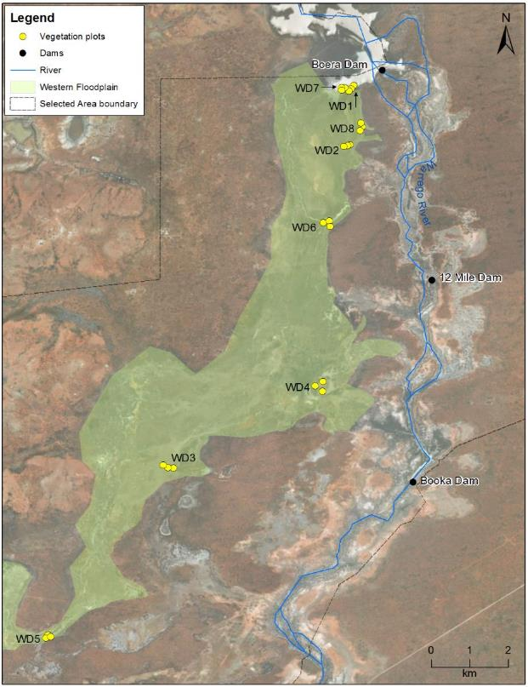

Figure H‑2: Location of vegetation monitoring sites in the Western Floodplain zone.

Results

2017-18 water year

***Species richness, Functional groups & Growth forms***

A total of 89 species from 34 families were recorded within all vegetation plots. Mean species richness (± Std Dev) recorded across all sites during both survey periods was 9.33 ± 3.77 species, down from 17 ± 8.40 species during the 2016-17 water year. This year’s species richness ranged from 3 species (WD5.1 September 2017) to 21 species (WD1.1 September 2017; Figure H‑3). Mean species richness was higher in September 2017 (10.04 ± 3.88 species) than in May 2018 (8.88 ± 3.63 species), however, this difference was non-significant (p=0.24). Vegetation community was found to significantly influence species richness (p=0.004) with Chenopod shrubland (11.08 ± 4.38 species) having the highest mean species richness, followed by Coolibah-River Cooba-Lignum woodland (10.68 ± 3.80 species), Lignum shrubland wetland (9.25 ± 2.63 species) and Coolibah woodland wetland (6.83 ± 2.86 species). While the interaction with survey time and vegetation community was non-significant (p=0.14), Chenopod shrubland was the only vegetation community to increase in species richness between September 2017 and May 2018, with all other communities decreasing between survey times (Figure H‑4). Due to all sites being dry over both sampling periods, there was no influence of inundation on species richness.

There was a significant difference between the mean species richness of the four functional groups during the 2017-18 water year, with the terrestrial groups having higher average richness than amphibious groups (p<0.001; Figure H‑5). The Tdr, Tda and AmR groups showed a decreased in average species richness from the September-17 to the May-18 sampling period, whilst the AmT group had a slight increase over the course of the water year. Although these changes were non-significant (p=0.17). Forbs were the most species rich growth form with 30 species being observed in September 2017 and 25 species in May 2018 (Figure H‑6). Forbs, tussocks grasses, herbs and rushes all showed a decrease in species between survey times, with the largest reduction of 5 species seen in forbs.

Figure H‑3: Mean species richness recorded at each site during the September 2017 and May 2018 surveys.

Figure H‑4: Mean species richness at each of the four vegetation communities during the September 2017 and May 2018 surveys.

Figure H‑5: Mean species richness of each functional group during the September 2017 and May 2018 surveys.

Figure H‑6: Total number of species per growth form recorded during the September 2017 and May 2018 surveys.

*Vegetation cover*

The average total cover (± Std Dev) for all sites during both survey periods was 31 ± 18%, ranging from 14 ± 7% (WD3 in May 2018) to 61 ± 15% (WD8 in September 2017). Mean total cover was higher in September 2017 (38 ± 20%) than in May 2018 (24 ± 11%), however this was non-significant (p=0.1). Vegetation community was found to significantly influence mean total cover (p<0.05), where Lignum shrubland wetland (39 ± 17%) and Coolibah-River Cooba-Lignum woodland (35 ± 19%) had a significantly higher mean cover than Chenopod shrubland (28 ± 20%) and Coolibah woodland wetland (23 ± 10% p<0.01). Chenopod shrubland sites showed the greatest reduction in cover across the 2017-18 water year, reducing from 37 ± 26% in September 2017 to 18 ± 6% in May 2018 (Figure H‑7). This was caused by a large reduction in the cover of *Eleocharis* species at four of six sites in September 2017 compared to the May 2018 survey period (Figure H‑8). However, there were no significant reduction in cover in any communities. Due to all sites being dry over both sampling periods, there was no influence of water on total cover.

Figure H‑7: Mean vegetation cover of four different vegetation communities during the September 2017 and May 2018 surveys.

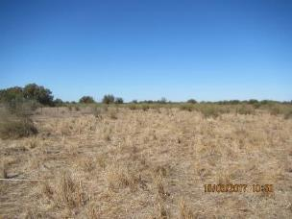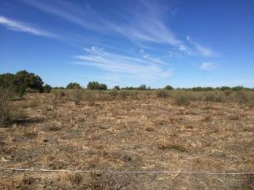

Figure H‑8: *Eleocharis* species total cover reduced at WD4-1 in the Chenopod shrublands community from September 2017 (left) to May 2018 (right).

*Vegetation composition*

Vegetation composition was further assessed using multivariate analyses of species abundance data. The nMDS plot shows separation between data grouped by vegetation community (Figure H‑9). The Chenopod shrubland sites showed more spread in multidimensional space, suggesting more variation in species composition, whereas the other three communities grouped more closely suggesting more similar species composition. PERMANOVA analysis confirmed significant differences between vegetation communities (Pseudo-F=11.13, p=0.001), while sampling period was found to have no significant effect on vegetation composition data (Pseudo-F=1.34, p=0.222). SIMPER analysis revealed that lignum and Warrego grass (*Paspalidium jubiflorum*) were the main two species influencing variation between vegetation types. Creeping knotweed (*Persicaria prostrata*) and the *Eleocharis* species had a large effect on the separation of the Chenopod shrublands from the other vegetation communities (Figure H‑9, Table H‑2).

Figure H‑9: nMDS plot with the data grouped by vegetation community.

Table H‑2: Vegetation species contributing most of the similarity between groups based on vegetation community.

|  |  |  |  |
| --- | --- | --- | --- |
| Grouping | Species | % contribution | Cumulative % contribution |
| Coolibah-River Cooba-Lignum woodland | Lignum | 27.54 | 27.54 |
| River cooba | 23.15 | 50.69 |
| Warrego grass | 13.37 | 64.06 |
| Coolibah | 7.3 | 71.36 |
| Chenopod shrubland | Creeping knotweed | 25.07 | 25.07 |
| *Eleocharis* species | 21.81 | 46.88 |
| Warrego grass | 8.89 | 55.77 |
| Lignum | 6.93 | 62.7 |
| Coolibah woodland wetland | Coolibah | 29.86 | 29.86 |
| *Eleocharis* species | 27.32 | 57.18 |
| Lignum | 20.42 | 77.6 |
| Warrego grass | 7.84 | 85.44 |
| Lignum shrubland wetland | Lignum | 37.47 | 37.47 |
| Creeping knotweed | 18.34 | 55.81 |
| Warrego grass | 9.36 | 65.17 |
| Twin-leaved bedstraw | 5.09 | 70.26 |

Multi-year Comparison

***Species richness***

Mean species richness was highest during the August 2015 (20.33 ± 4.67 species) and December 2016 (20.08 ± 10.15 species) survey periods (Figure H‑10). Since December 2016, mean species richness has decreased to the lowest levels recorded in May 2018 (8.88 ± 3.64 species). Overall, across all sampling times, wet sites (16.40 ± 8.41 species) had significantly higher richness than dry sites (14.19 ± 6.08 species; P<0.001). There was also a significant difference detected between vegetation communities (P<0.001) and a significant interaction between vegetation communities and inundation status (P<0.001). Coolibah-River Cooba-Lignum woodland sites showed significantly higher richness at wet sites (23.83 ± 3.66 species) than dry sites (13.40 ± 4.92 species; p<0.001), while Chenopod shrubland and Coolibah woodland sites showed a non-significant increase when sites were wet (Figure K-9). In contrast, Lignum shrubland sites, showed a slight decrease in species richness when sites were wet.

Figure H‑10: Mean Species richness measured during the eight survey periods undertaken in the LTIM project.

Figure H‑11: Mean species richness of the four vegetation communities split by inundation status across years 1-4 of the LTIM project.

***Vegetation Cover***

Mean vegetation cover has remained relatively stable throughout the LTIM project, except during December 2016, where mean cover peaked at 80 ± 32% in response to significant floodplain inundation (Figure H‑12). As with species richness, mean vegetation cover has steadily declined since December 2016, to the lowest levels of the project in May 2018 (24 ± 11%). Poisson modelling detected a significant influence of both vegetation community (p<0.0001), and inundation status (p<0.0001), with a significant interaction between these two factors (p<0.0001). Wet sites showed significantly higher mean vegetation cover in Coolibah-River Cooba-Lignum woodland (p<0.05), Chenopod shrublands (p<0.05) and Coolibah woodland wetland communities (p<0.05) than dry sites (Figure H‑13). In contrast, Lignum shrubland communities were lower in vegetation cover in wet sites (38 ± 30%) compared to dry sites (48 ± 22%), but this trend was non-significant (p=0.2). As the lignum shrubland sites are in the higher flooding frequency areas, the reduced cover is likely the result of standing water in these sites that reduces visible vegetation cover when the surveys were undertaken.

Figure H‑12: Mean vegetation cover measured during the eight survey periods undertaken in the LTIM project.

Figure H‑13: Mean total cover of the four vegetation communities split by inundation status across years 1-4 of the LTIM project.

***Vegetation composition***

There was no clear grouping of data in relation to sample time when community composition data from all years were analysed together (Figure H‑14). Wet sites in August 2015 and dry sites in December 2016 showed the most scatter of all the sites, influenced by only having two sites in each grouping. September 17 and May 18 sites displayed the closest grouping out of all sampling periods, most likely due to both periods containing only dry sites with no substantial change in species composition between these surveys (Figure K-11). PERMANOVA showed that inundation status (Pseudo-F=4.63, p=0.001), vegetation community (Pseudo-F=20.26, p=0.001) and survey period (Pseudo-F=7.42, p=0.001) all significantly influenced the community composition data.

Figure H‑14: nMDS plot of vegetation composition data grouped by the eight sampling times and inundation status. Symbols represent the centroids of the sites in each group.

Discussion

In the 2017-18 water year, the Western Floodplain experienced the driest conditions since the commencement of the LTIM project, with all sites being dry during both surveys. These dry conditions saw average species richness reduced to the lowest level since surveys began in February 15. Similarly, mean vegetation cover also fell to the lowest levels during the May 2018 survey. Thus, it appears the increased vegetation productivity observed in the 2016-17 water year, following significant spring inundation in 2016, has finished and dry condition patterns now dominate (Figure H‑15). This is a natural feature of boom and bust systems such as the Warrego and reflects the low inflows into the Selected Area, as well as the below average rainfall experienced during 2018 (Appendix D). While the overall health of the vegetation communities appears to have reduced during sampling in 2017-18, Some species, such as lignum still appear to be in relatively good health (Figure H‑16). This reflects lignum’s ability to maintain its conditions for longer periods following inundation, being able to access moisture stores from deeper within the soil profile than other shallow rooted forb and herb species present on the floodplain. Periodic inundation over the last few years appears to have ensured these species have retained their resilience, allowing them to persist during the current dry period.

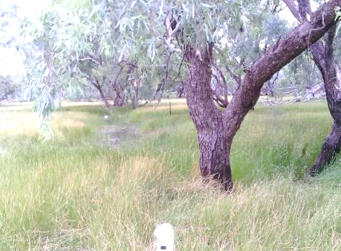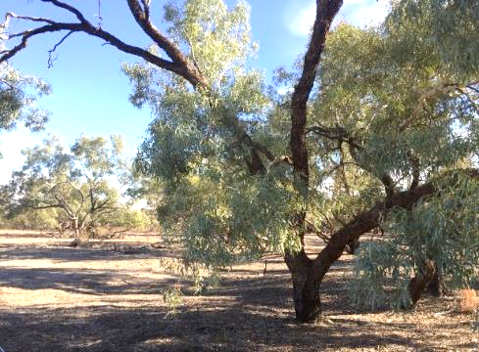

Figure H‑15: Coolibah Woodland site 5.2 during the December 2016 (left) and May 2018 (right) surveys.

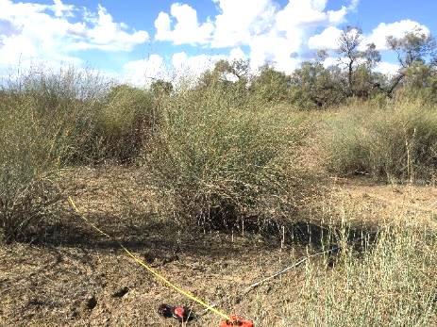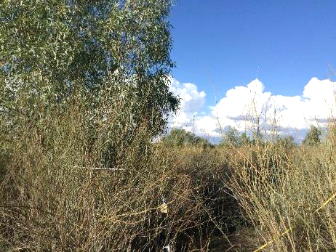

Figure H‑16: Lignum plants at plots 7.3 (left) and 8.2 (right) in May 2018.

While no significant seasonal patterns were observed in 2017-18, both richness and cover declined between survey periods. Different responses were observed between vegetation communities with Chenopod shrublands showing an increase in mean species richness, whereas the other communities showed a consistent decrease in both species richness and cover. Even with an increase in species richness, the cover within Chenopod shrubland sites decreased. This was most notable within the *Eleocharis* species found at these sites (Figure H‑8). As in previous years, species from the terrestrial functional groups were more prevalent at sites, with forbs making up the greatest proportion of species present on the floodplain.

Considering all vegetation data collected over the duration of the LTIM project, inundation appears to be the dominant factor influencing vegetation patterns on the Western Floodplain, with the nature of the response varying between vegetation communities. Inundation has tended to increase both richness and vegetation cover at sites within Coolibah-River Cooba-Lignum woodland, Chenopod shrublands and Coolibah woodland wetland communities. However, within Lignum shrubland communities, inundation appears to reduce species richness and vegetation cover. Sites within the Lignum shrubland communities are located within higher frequency inundation areas adjacent to Boera Dam and next to the eastern embankment and as a result have typically been partially or fully inundated during surveys undertaken in wetter times (Figure H‑17). At these sites, the presence of standing water often limits the visibility of ground cover species, can initially inhibit the growth of vegetation species, and reduce the cover and richness of species present. Once these sites dry, favourable growing conditions then occur, with a concomitant increase in species richness and vegetation cover.

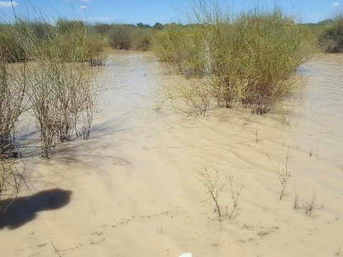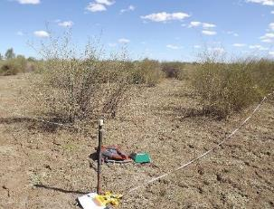

Figure H‑17: Lignum shrubland wetland site 7.2 during the December 2016 (left) and April 2017 (right) surveys.

Conclusion

The condition of vegetation communities on the Western Floodplain has declined during the 2017-18 water year due to extremely low inflows and below average rainfall in 2018. Species richness and vegetation cover were at the lowest levels observed in the LTIM project. Placed in the larger context of all years of survey, this year’s data strengthens the conclusion that inundation strongly influences vegetation patterns on the Western Floodplains and highlights the boom and bust nature of the Warrego system in the Selected Area.

References

Brock, M.A. and Casanova, M.T. 1997. Plant life at the edge of wetlands: ecological responses to wetting and drying patterns. In N. Klomp and Lunt (Eds.), *Frontiers of Ecology; Building the Links* (pp. 181–192). Oxford, England: Elsevier Science.

Capon, S 2009. *Flow dependent Ecosystems of Toorale Station: Ecological character, condition and issues associated with the decommissioning water resources infrastructure.* Australian Rivers Institute, Griffith University

Commonwealth of Australia 2015. *Commonwealth Water Office Long Term Intervention Monitoring Project; Junction of the Warrego and Darling rivers Selected Area.* Commonwealth of Australia, Canberra.

Hale, J., Roberts, J., Page, K. and Kobryn, H. 2008. *Riparian Zone Management in the Western Catchment Phase 2: Intersecting Stream.* A report to the Western Catchment Management Authority.

Hale, J., Stoffels, R., Butcher, R., Shackleton, M., Brooks, S. & Gawne, B. 2013. *Commonwealth Environmental Water Office Long Term Intervention Monitoring Project – Standard Methods.* Final Report prepared for the Commonwealth Environmental Water Office by The Murray Darling Freshwater Research Centre, MDFRC Publication 29.2/2014, January, 182 pp.