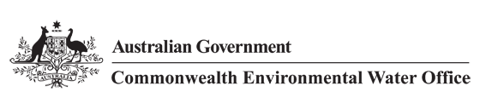



**Commonwealth Environmental Water Office**

**Long Term Intervention Monitoring Project**

**JUNCTION OF THE WARREGO AND DARLING RIVERS SELECTED AREA**

2017-18 Evaluation Report



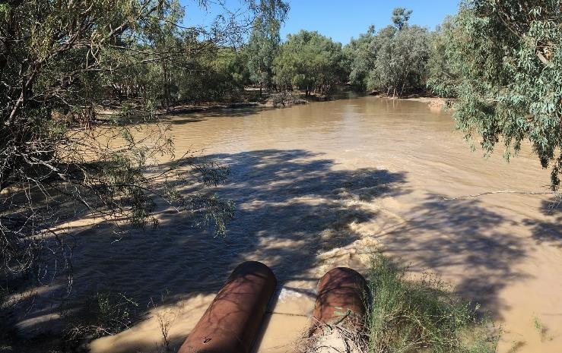



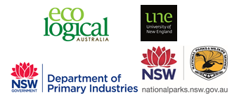

This monitoring project was commissioned and funded by Commonwealth Environmental Water Office, with in-kind support from NSW Office of Environment and Heritage.

**Copyright**

© Copyright Commonwealth of Australia, 2018



Commonwealth Environmental Water Office Long Term Intervention Monitoring Project Junction of the Warrego and Darling rivers Selected Area is licensed by the Commonwealth of Australia for use under a Creative Commons By Attribution 3.0 Australia licence with the exception of the Coat of Arms of the Commonwealth of Australia, the logo of the agency responsible for publishing the report, content supplied by third parties, and any images depicting people. For licence conditions see: <http://creativecommons.org/licenses/by/3.0/au/>

This report should be attributed as ‘Commonwealth Environmental Water Office Long Term Intervention Monitoring Project Junction of the Warrego and Darling rivers Selected Area – 2017-18 Evaluation Report, Commonwealth of Australia 2018’.

**Disclaimer**

The views and opinions expressed in this publication are those of the authors and do not necessarily reflect those of the Australian Government or the Minister for the Environment.

While reasonable efforts have been made to ensure that the contents of this publication are factually correct, the Commonwealth does not accept responsibility for the accuracy or completeness of the contents, and shall not be liable for any loss or damage that may be occasioned directly or indirectly through the use of, or reliance on, the contents of this publication.

**DOCUMENT TRACKING**

|  |  |
| --- | --- |
| Item | Detail |
| Project Name | Long Term Intervention Monitoring Project – Junction of the Warrego and Darling rivers Selected Area |
| Project Number | 8328 |
| Project Manager | Dr Mark Southwell  (02) 8081 2688  92 Taylor Street, Armidale NSW 2350 |
| Prepared by | Dr Mark Southwell, Ronnie Hill, Linden Burch, Matt Elsley, Rob Cawley, Tim Henderson (ELA)  Dr Paul Frazier (2-rog)  Assoc. Prof Darren Ryder, Dr Wing Ying Tsoi (UNE)  Dr Gavin Butler and Tom Davis (DPI Fisheries) |
| Reviewed by | Dr Mark Southwell, Assoc. Prof Darren Ryder |
| Approved by | Dr Paul Frazier |
| Status | Final |
| Version Number | 2 |
| Last saved on | 29 January 2019 |
| Cover photo | Regulating pipes at Boera Dam letting water into the lower Warrego River, April 2018 (photo by D. McKenzie) |

Acknowledgements

This document has been prepared by Eco Logical Australia Pty Ltd with support from Associate Professor Darren Ryder and Dr Wing Ying Tsoi from the University of New England, Dr Paul Frazier from 2-rog consulting, Dr Gavin Butler and Tom Davis from DPI Fisheries and staff from NSW Office of Water. The project team would like to thank the NPWS staff at Toorale National Park and State Conservation Area for their assistance and cooperation. We would also like to acknowledge Dr Fiona Dyer and the Lachlan LTIM team for the loan of dissolved oxygen and temperature loggers.

Acknowledgement of Country

The authors of this report as well as the Commonwealth Environmental Water Office respectfully acknowledge the traditional owners, their Elders past and present, their Nations of the Murray-Darling Basin, and their cultural, social, environmental, spiritual and economic connection to their lands and waters. In particular the Barkindji, Murrawarri, Ngemba and Ngiyampaa peoples, traditional owners of the land on which this publication is focused.

|  |
| --- |
| **Disclaimer** *This document may only be used for the purpose for which it was commissioned and in accordance with the contract between Eco Logical Australia Pty Ltd and the Department of the Environment and Energy. The scope of services was defined in consultation with the Department of the Environment and Energy, by time and budgetary constraints imposed by the client, and the availability of reports and other data on the subject area. Changes to available information, legislation and schedules are made on an ongoing basis and readers should obtain up to date information.*  *Eco Logical Australia Pty Ltd accepts no liability or responsibility whatsoever for or in respect of any use of or reliance upon this report and its supporting material by any third party. Information provided is not intended to be a substitute for site specific assessment or legal advice in relation to any matter. Unauthorised use of this report in any form is prohibited.* |

Template 29/9/2015

**Document control**

|  |  |  |  |
| --- | --- | --- | --- |
| Version | Date | Reviewed by | Approved by |
| 1 | 24/08/2018 | Assoc. Prof Darren Ryder | Dr Paul Frazier |
| 2 | 15/11/2018 | Dr Mark Southwell | Dr Paul Frazier |

|  |  |
| --- | --- |
| Item | Details |
| ELA Project Number | 8328 |
| Project Director/s | Dr Paul Frazier, Assoc. Prof Darren Ryder |
| Project Manager | Dr Mark Southwell |
| Prepared by | Dr Paul Frazier, Assoc. Prof Darren Ryder, Dr Mark Southwell, Dr Wing Tsoi, Linden Burch, Ronnie Hill, Tim Henderson, Matt Elsley, Rob Cawley, Dr Gavin Butler and Tom Davis |

Contents

Executive summary viii

1 Monitoring and evaluation of environmental water in the Junction of the Warrego and Darling rivers Selected Area 1

1.1 Introduction 1

1.2 Junction of the Warrego and Darling rivers Selected Area 1

1.3 Water Management 4

2 Environmental watering actions in 2017-18 6

3 Key outcomes from environmental water use 8

3.1 Expected Outcomes 8

3.2 Darling River Flows and Ecosystem Function 11

3.3 Warrego River Flows and Inundation 12

3.4 Water Quality 13

3.5 Ecosystem types and vegetation 15

3.6 Biodiversity 17

3.7 Resilience 19

3.8 Summary 19

4 Implications for Future Management of Commonwealth environmental water 21

5 References 22

**Appendix A – Hydrology (River)**

**Appendix B – Hydrology (Northern Tributaries)**

**Appendix C – Hydrology (Habitat)**

**Appendix D – Hydrology (Floodplain)**

**Appendix E – Water Quality**

**Appendix F – Stream Metabolism**

**Appendix G – Ecosystem Type**

**Appendix H – Vegetation Diversity**

List of figures

Figure 1‑1: The location of the Junction of the Warrego and Darling rivers Selected Area within the Murray-Darling Basin showing upstream catchments. 2

Figure 1‑2: Junction of the Warrego and Darling river Selected Area monitoring zones. 3

Figure 2‑1: Monthly rainfall at Bourke Airport for 2017-18 compared to the long-term mean (Source: http://www.bom.gov.au/climate/data/index.shtml). 6

Figure 2‑2: Mean maximum temperatures for the Bourke Airport during 2017-18 compared to the long-term mean (Source: http://www.bom.gov.au/climate/data/index.shtml). 7

Figure 3‑1: Mean daily flow at gauging stations on Barwon-Darling River system (1 July 2017 - 30 June 2018). Events used in the analysis of northern tributary contributions are outlined in red. 11

Figure 3‑2: Comparison of flow events containing Commonwealth environmental water (CEW) from years 1 to 3 of the project measured at Louth gauge. 12

Figure 3‑3: Water level at Boera and Dicks Dams and periods of longitudinal connection and overflow to Western Floodplain. 13

Figure 3‑4: Mean daily (a) discharge at Darling @ Louth (NSW425004) on the Darling River system, (b) conductivity and (c) Dissolved Oxygen at the Darling downstream water quality station. EW represents environmental water. Black line represents all available data from this watering year and red dotted line represents ANZECC guideline trigger value. 14

Figure 3‑5: Darling Pump water quality site on 25th April 2018 (during Event 2) and 29th June 2018 (during Event 3). 15

Figure 3‑6: Examples of ecosystem types inundated by environmental water in the Selected Area during the 2017-18 water year. Temporary Lake (left) and permanent lowland stream (right). 16

Figure 3‑7: Coolibah Woodland site 5.2 during the December 2016 (left) and May 2018 (right) surveys. 16

Figure 3‑8: Lignum plants at plots 7.3 (left) and 8.2 (right) in May 2018. 17

Figure 3‑9: Black swans (Cygnus atratus) and yellow-billed spoonbills (Platalea flavipes) observed during the April 2018 survey at Booka Dam. 18

Figure 3‑10: A water holding frog (Cyclorana platycephala) which was observed for the first time during the April 2018 survey at Booka Dam. 18

List of tables

Table 1‑1: Junction of the Warrego and Darling rivers Selected Area monitoring zones. 4

Table 3‑1: Summary of long term expected outcomes from environmental watering in the northern unregulated river. Source: Commonwealth of Australia (2017). 9

Table 3‑2: Expected outcomes from the use of Commonwealth environmental water in 2017-18 relevant to the Selected Area. WUM refers to the specific Water Use Minute for the Commonwealth environment water event in question. 10

*Blank page*

Executive summary

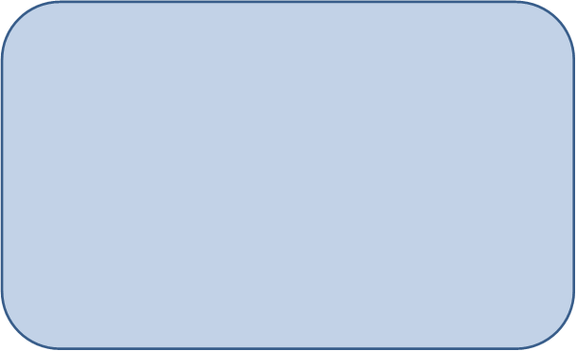

**Contributions of Commonwealth environmental water in 2017-18**

***Darling River zone***

* Commonwealth environmental water contributed to three small flow events down the Darling River zone, which provided connecting flows through to Louth.
* These flows provided access for river biota to a small proportion of snags and helped to maintain water quality through the year.

***Warrego River zone***

* Conditions were dry within the Warrego River zone with only a single 16 day period of connecting flow down the river channel and minimal inundation of the Western Floodplain.
* Commonwealth environmental water made up 17.3% of water entering the Selected Area down the Warrego in March – April 2018
* The managed flow down the lower Warrego River inundated previously dry aquatic refuges, stimulated foodwebs to support the breeding of some native fish species, and supported a small number of frogs and waterbirds.

The Junction of the Warrego and Darling rivers Selected Area (Selected Area) encompasses the Toorale National Park and State Conservation Area managed by NSW OEH. Inflows of Commonwealth environmental water to the Selected Area via the Darling River from upstream tributaries have also been evaluated.

The Selected Area is complex in terms of its ecosystems, hydrology and the way in which Commonwealth environmental water is accounted and managed both within the Selected Area and within upstream tributaries. Most of the Commonwealth environmental water that influences the site is held as unregulated entitlements in the Border Rivers, Moonie, Condamine Balonne, Barwon Darling and Castlereagh and Warrego Rivers. Regulated deliveries from the Border Rivers, Gwydir, Namoi and to a lesser extent Macquarie catchments have the potential to influence flows in the Selected Area, particularly during periods of low flow in the Barwon – Darling system. Other water management actions, such as the release of stock and domestic flows, rainfall rejection flows and embargos on upstream pumping also influence flows in the Darling River through this zone.

Flows down both the Darling and Warrego Rivers were low throughout 2017 – 18 due to low rainfall and small contributions from upstream tributaries. In addition, waterholes within the Warrego River dried over summer and the floodplain remained dry for most of the year. During the 2017 – 18 water year, three small instream flow events occurred in the Darling with both unregulated and regulated environmental water contributing approximately 21,669 ML in July – November 2017, 3,446 ML in March – April 2018 and 13,333 ML in May 2018, measured at Louth, downstream of the Selected Area. The May 2018 flow was part of the Northern Connectivity Event, a regulated environmental water delivery from the Border Rivers and Gwydir catchments that was protected through the system with a pumping embargo. It is estimated that during each event environmental water made up a significant proportion of these flows (between 24.3% and 99.6%). These flows helped to maintain hydrological connection through the Selected Area for 73% of the time.

Flow in the Warrego River, upstream of the Selected Area, was sporadic throughout the 2017 – 18 water year, with Commonwealth environmental water contributing 3,347 ML (17.3%) to a flow event in April – May 2018. During the flow event in March – April 2018, the Boera Dam regulating gates were partially opened for a total of 16 days, though flows were restricted to 300 ML/d or less in response to Boera Dam inflows. This event reconnected the waterholes in the lower Warrego system and provided connection through to the Darling River. There was overflow to the Western Floodplain for 19 days in December 2017 which inundated a small proportion of the floodplain. This was due to localised rainfall, rather than substantial flows from the upper Warrego catchment triggering the Toorale licence.

**Key Outcomes**

*Flows and Ecosystem functioning*

* Flows were low in 2017-18 with only one short period of connection in the Warrego River and Western Floodplain zones. This flow refilled previously dry waterholes in the lower Warrego, allowing aquatic species such as fish, frogs and waterbirds to recolonise these sites. Flows in the Darling River were below 1,600 ML/d throughout the whole water year which is around 5% of bankfull capacity in the Selected Area.
* Commonwealth environmental water increased the connectivity of the Darling River zone, and contributed to connections in the Warrego River zone during the 2017-18 water year. Maintaining connection is important to allow animals to travel up and down the river and to maintain water quality.
* Thirty percent of the total number of snags in the Darling River zone were inundated providing habitat for biota. Approximately half the length of the Warrego channel network was inundated from the managed flow released down the Warrego channel.

*Water Quality*

* Increased flows down the Darling River zone improved water quality parameters such as conductivity through dilution due to higher discharge. This has been a consistent trend over the 4 years of the LTIM project.
* The response of dissolved oxygen to flow was more variable during 2017-18 than it has been over the LTIM project. This was likely influenced by variation in source catchment water quality effecting the balance between productivity and respiration. The Northern Connectivity Event increased dissolved oxygen concentrations which were previously low in the Darling River reach.
* The connection event down the Warrego River had little influence on flows or water quality in the Darling River downstream of the Warrego and Darling rivers confluence, likely due to minimal water making it to the confluence down the Warrego.

*Biodiversity*

* Commonwealth environmental water inundated sites within the Warrego and Darling river channels, representing two of the ecosystem types monitored.
* Recruits of many native fish species were surveyed in the Warrego River following the connection event in April 2018. The age of golden perch recruits suggest that they spawned upstream and were transported downstream into the Selected Area.
* Low numbers of waterbirds and frogs were observed during and after the Autumn 2018 connection event. This likely reflects the regionally dry conditions, as well as the colder conditions influencing frog activity.
* Floodplain vegetation reduced in groundcover and richness in 2017-18 due to the dry conditions. Mid-storey species such as lignum appeared in better condition than the groundcover, displaying the benefits of flooding during 2016-17.

*Resilience*

* The ecology of the Selected Area appears to be resilient and well adapted to the boom and bust nature of the area. While more productive floodplain habitats were not inundated during 2017-18, the diversity of frog communities remained high in Warrego channel habitats at the start of the water year when they were inundated. This emphasises the value of these refuge habitats for maintaining resilient aquatic communities.
* Fish species in the lower Warrego River showed resilience, quickly recolonising and recruiting in waterholes once they became inundated.

**Implications for Commonwealth environmental water management**

* Flow conditions in the Northern basin did not allow the CEWO to address all of their watering priorities relevant to the Selected Area in 2017-18 (Commonwealth of Australia 2017). Inflows into Boera Dam down the Warrego River were insufficient to allow any management of water levels within the dam to promote flows onto the Western Floodplain. The vegetation communities on the Western Floodplain are in the poorest condition they have been in since the LTIM project began, although some mid-layer species such as lignum have maintained condition since inundation in 2016. Even so, if low river flows, below average rainfall and above average temperatures persist, reductions in the condition of mid-storey species are likely. Given the current state of these vegetation communities, wetting of the Western Floodplain should be a critical priority in 2018-19.
* The transport of native fish recruits into the Selected Area from upstream during the April 2018 connection event down the Warrego, highlights the importance of providing longitudinal connectivity in this system. Providing suitable conditions (in terms of water levels, water quality and productive foodwebs) to support these recruits and then allow them to move through the Warrego and into the Darling River may also be important for the health of fish populations at broader basin wide scales. High priority should be given to providing replenishing flows to the lower Warrego in 2018-19, given the presence of good numbers of young of year native fish presently in this reach.
* The embargo placed on the water access during the flow event down the Darling in March – April 2018 helped to maximise the movement of this flow through the Selected Area. This flow had the highest magnitude for the water year, and inundated the greatest proportion of in-channel habitat within the Selected Area for the year. The use of embargos to protect small fresh events, especially following periods of low flows, is encouraged.

# Monitoring and evaluation of environmental water in the Junction of the Warrego and Darling rivers Selected Area

## Introduction

This report presents the monitoring and evaluation results from the Junction of the Warrego and Darling rivers Selected Area (Selected Area) during the 2017-18 water year. The monitoring is being undertaken as part of the Long Term Intervention Monitoring Project (LTIM Project) funded by the Commonwealth Environmental Water Office (CEWO). The LTIM Project is being implemented at seven Selected Areas over a five-year period from 2014-15 to 2018-19 to deliver five high-level outcomes:

1. Evaluate the contribution of Commonwealth environmental watering to the objectives of the Murray-Darling Basin Authority’s (MDBA) Environmental Watering Plan.
2. Evaluate the ecological outcomes of Commonwealth environmental watering at each of the seven Selected Areas.
3. Infer ecological outcomes of Commonwealth environmental watering in areas of the Murray-Darling Basin not monitored.
4. Support the adaptive management of Commonwealth environmental water.
5. Monitor the ecological response to Commonwealth environmental watering at each of the seven Selected Areas.

While results specific to the Junction of the Warrego and Darling rivers Selected Area are reported here, a broader Basin Scale analysis including results from all seven Selected Areas will be produced by the Centre for Freshwater Ecosystems at La Trobe University.

The report describes the Selected Area watering actions and the ecological outcomes of the application of Commonwealth environmental water in the Selected Area during 2017-18. Detailed analysis, methods and results are presented in the Appendices referred to in the main report.

## Junction of the Warrego and Darling rivers Selected Area

The Selected Area is located around 80 km south-west of Bourke in north western NSW (Figure 1‑1). The Selected Area is contained within the boundary of the Toorale National Park (NP) and State Conservation Area (SCA) (Figure 1‑2). The Selected Area is approximately 92,000 ha, and receives flow from both the Darling and Warrego river systems. The Darling River catchment drains the north westerly portion of the Murray-Darling Basin and has a total catchment area of 699,500 km2. Most of its tributaries (Macquarie, Castlereagh, Namoi, Gwydir, Macintyre and Condamine-Balonne Rivers) drain from the Great Dividing Range in northern New South Wales and southern Queensland, and provide relatively high amounts of runoff to the catchment. In contrast, other catchments such as the Warrego and the Paroo Rivers to the west, drain more arid, flat catchments and only flow intermittently during periods of high rainfall in their upper catchments, usually manifesting downstream as slow-moving floods of relatively long duration. The Selected Area shows high climatic variability, with low annual rainfall and high evaporation.

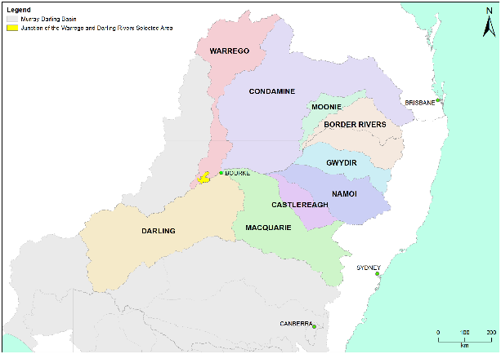

Figure 1‑1: The location of the Junction of the Warrego and Darling rivers Selected Area within the Murray-Darling Basin showing upstream catchments.

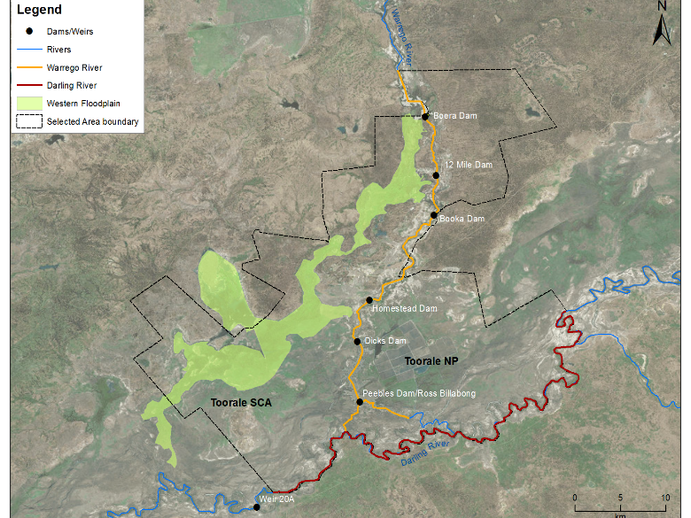

Figure 1‑2: Junction of the Warrego and Darling river Selected Area monitoring zones.

Within the Selected Area, three monitoring zones have been defined (Table 1‑1; Figure 1‑2). These zones represent discrete regions of the Selected Area in terms of their geomorphology, hydrology, environmental assets, environmental watering targets and expected outcomes from Commonwealth environmental water.

Table 1‑1: Junction of the Warrego and Darling rivers Selected Area monitoring zones.

|  |  |  |  |
| --- | --- | --- | --- |
| Zone | Extent | Description | Potential target flow types for monitoring |
| Western Floodplain | The Western Floodplain of the lower Warrego River from Boera Dam offtake to the Darling River. | A large floodplain surface heavily dissected by small flood runners. Floodwaters inundate this floodplain from overflows at Boera Dam. | Overbank – infrastructure assisted |
| Warrego River | The lower Warrego River channel extending from the northern boundary of Toorale National Park to the junction with the Darling River, including Ross Billabong. | A single meandering channel that decreases in bankfull capacity downstream. Flows in this lower section of the Warrego River are controlled by a series of six in-channel structures, the lower of which (Peebles Dam) diverts water into Ross Billabong. | Base flows  Freshes up to 6001 ML/d |
| Darling River | The Darling River from the eastern boundary of the Toorale National Park near Hells Gate to Weir 20A downstream of the western boundary of Toorale State Conservation Area. | A single meandering channel that has a bankfull height ranging 12-15 m. The bankfull channel is complex and there are a series of natural rock bars and a weir at the downstream end of the reach that influence flows along this section of the river. | Base flows  Freshes:  300 – 500 ML/d  1,000-5,000 ML/d  5,000-10,000 ML/d  10,000-30,000 ML/d |
| 1 This capacity is likely to increase to 900 ML/d with the completion of the Toorale infrastructure project. | | | |

## Water Management

Over the last 150 years, the hydrology of the Warrego River within the Selected Area has been highly modified. Six dams have been constructed to provide stock and domestic water supply, irrigate the Western Floodplain to improve pasture growth, and more recently to provide water storage for irrigated agriculture (Figure 1‑2). Since the establishment of Toorale NP and SCA in 2008, the condition of some dams has degraded, several becoming fully breached (Aurecon 2009). The characteristics and status of these dams are outlined below (Gawne et al. 2013):

1. Boera Dam: a large storage of approximately 3000 ML, likely to have been established since the 1870s. Water persists for around 12 months after filling without further inflows from local runoff. Management of this dam can preferentially divert water down the Western Floodplain.
2. 12 Mile Dam: less than 1,000 ML in volume, this dam has been recently breached and not reinstated.
3. Booka Dam: approximately 1,000 ML.
4. Keernie (Homestead) Dam: 1,500 – 2,000 ML (Breached).
5. Dicks Dam: 500 – 1,000 ML.
6. Peebles Dam: a large storage just upstream of the junction of the Warrego and Darling rivers. This is the most permanent of the storages and was previously used for irrigation. The storage holds approximately 10,000 ML and is connected to Ross Billabong, an adjacent floodplain depression. At present the outlet gates are permanently opened to allow flows through to the Darling River downstream.

These dams have been retrospectively licenced under the provision of the NSW *Water Act 1912*. This includes separate licenced amounts for the Warrego River at 8.1 GL long term average annual yield (LTAAY), the Western Floodplain (accounted at Boera Dam) at 9.7 GL (LTAAY) and the Darling River at 7.6 GL (LTAAY). These licences are managed by the Commonwealth environmental water holder. Conditions placed on these licences determine how Commonwealth environmental water can be managed within the Selected Area. This is especially true for the licences specified at Boera Dam. Before these licences can be accessed, downstream demand to the Darling River must be met during times of low flow. That is, if sustained inflows are entering Boera Dam, and the Darling River flow at Louth is below 330 ML/d, then water must be let through the regulator pipes on Boera Dam and all downstream dams on the Warrego to flow to the Darling River until flows at Louth have reached 330 ML/d. Once this has been achieved, the CEWO can choose whether to continue to release water down the lower Warrego channel, therefore activating their Warrego River licence, or close the regulator gates, and hold water in Boera Dam to divert water to the Western Floodplain. If flows in the Darling exceed 330 ML/day at Louth, the CEWO can access a high flow floodplain licence to divert water to the Western Floodplain. The CEWO have developed a 5-year Water Use Strategy for Toorale to aid decision making surrounding the operation of Commonwealth environmental water at this site.

Unlike other Selected Areas, Commonwealth environmental water that flows into the Junction of the Warrego and Darling rivers Selected Area is primarily unregulated, and is thus reliant on rainfall, flows and water management decisions in upstream tributaries. The Border Rivers, Gwydir, Namoi and to a lesser extent Macquarie tributaries are exceptions to this, whereby regulated environmental water has the potential to influence flows in the Selected Area, particularly during periods of low flow in the Barwon-Darling system. Other water management actions, such as the release of stock and domestic flows, rainfall rejection flows and embargos on upstream pumping also influence flows in the Selected Area.

Adding to the complexity of environmental water accounting and delivery in the Selected Area is the fact that the Selected Area, and its upstream tributaries, fall into multiple water planning areas, each with their own discreet rules, licence types and accounting procedures. Thus, tracking Commonwealth environmental water between and through these areas is challenging.

Use of Commonwealth Toorale entitlements is expected to contribute to the following on-park outcomes at Toorale and/or in the Darling River downstream:

* support periods of high primary productivity triggered by unregulated flow events and carbon and nutrient cycling.
* support wetland and aquatic vegetation condition and diversity.
* support waterbird survival and condition and diversity.
* inundate and connect in-channel habitat associated with riffles, pools, bars and anabranches to support movement and biotic dispersal.
* maintain water quality and carbon/nutrient cycling processes.
* provide hydrological connectivity and improve end-of-system flows.

# Environmental watering actions in 2017-18

The 2017-18 water year was characterised by dry conditions and very low river flows throughout the northern Basin. The last significant flow through most of the catchment occurred in the summer of 2016-17 (Commonwealth of Australia 2017) since then, flows in the Darling River have been below one third of bankfull. During 2017-18, monthly rainfall at Bourke was variable compared with long-term means. Rainfall was below average in all months but October – December 2017 (Figure 2‑1). Rainfall in October was over four times the average rainfall for that month. Mean maximum temperatures were close to the long-term mean at the start of the water year (July-November), and generally above average over the December – June (Figure 2‑2).

Figure 2‑1: Monthly rainfall at Bourke Airport for 2017-18 compared to the long-term mean (Source: <http://www.bom.gov.au/climate/data/index.shtml>).

Figure 2‑2: Mean maximum temperatures for the Bourke Airport during 2017-18 compared to the long-term mean (Source: <http://www.bom.gov.au/climate/data/index.shtml>).

Three instream flow events including both unregulated and regulated environmental water occurred during July - November 2017, March - April 2018 and May 2018, providing approximately 14,401 ML, 2,870 ML and 13,333 ML of environmental water, respectively, at Louth, downstream of the Selected Area. It is estimated that during each event environmental water made up a significant proportion of these flows (between 20.3% and 99.5%). Inflows at the start of the water year helped to maintain flow in the Darling up until mid-January when flows ceased in the Selected Area. Inflows in March and April 2018 provided connection through the system, these flows were protected by an embargo on instream water access. The embargo restricted pumping on A, B and C class licences in the Barwon-Darling River to protect low flows that were entering the river from 8 March – 28 April 2018. Environmental water delivered in May 2018 was part of the Northern Connectivity Event delivered in a period of low flow, with environmental water released from dams in the Border Rivers and Gwydir catchments. This environmental water release was also protected by an embargo that was put in place to protect this flow from the 27 April to 22 June. The embargo was for the A, B and C class licences for the entire length of the Barwon-Darling River and was effective in protecting flow that reached as far downstream as the Menindee Lakes.

Flows in the Warrego River was sporadic throughout the 2017-18 water year and were low in magnitude compared to the 2016-17 year when a significant flow pulse moved through the system in July – November 2016. As a result, Boera Dam levels remained below the Western Floodplain overflow height all year, except for one 19-day period in December 2017 when a small rainfall event led to inundation of a small proportion of the floodplain (less than 20 ha). This small flow event was due to localised rainfall, rather than substantial discharge from the upper Warrego catchment triggering the Toorale licence. The largest flow down the Warrego River this water year occurred in April - May 2018 and contained 21.6 % Commonwealth environmental water from upstream licences. Anticipating inflows would be great enough to trigger Toorale licences, the gates on Boera Dam, were opened for a period of 16 days. This flow restored longitudinal connectivity in the lower Warrego River, replenished the previously dry waterholes downstream of Boera Dam and provided connection to the Darling River. Due to lower than expected inflows into Boera Dam, no water was acquitted against the Toorale Warrego River licence during this event.

# Key outcomes from environmental water use

## Expected Outcomes

The Selected Area falls within the Northern Unregulated Rivers region where the majority of Commonwealth environmental water holdings provide access to unregulated flows. The CEWO have defined several expected outcomes from the use of Commonwealth environmental water in the Northern Unregulated Rivers, that link to the outcomes of the Basin-wide Environmental Watering Strategy developed by the Murray-Darling Basin Authority (Commonwealth of Australia 2017, Table 3‑1). More specifically, the CEWO outlined several active management priorities for 2017-18 relevant to the Selected Area (Commonwealth of Australia 2017). These were to:

* Inundate Toorale Western Floodplain by enhancing overflow from Boera Dam to the Western Floodplain. This was given high urgency.
* Provide a fresh to inundate snags and benches, enable some fish recruitment along the Barwon-Darling by using Toorale Warrego entitlements to enhance Darling Flows to 6,000 ML/d at Louth for 20 days. This was given a high urgency.
* Provide a dry spell breaking small pulse along extended reach of the Barwon-Darling River, by using end of system regulated flows in a tributary catchment. This was given a moderate urgency.

The evaluation of Commonwealth environmental water, and its management in the Selected Area during 2017-18, is structured around these broader objectives and priorities, with the specific outcomes associated with each Commonwealth environmental watering event provided in Table 3‑2.

Table 3‑1: Summary of long term expected outcomes from environmental watering in the northern unregulated river. Source: Commonwealth of Australia (2017).

|  |  |  |  |
| --- | --- | --- | --- |
| BASIN-WIDE OUTCOMES  (Outcomes in red link to the Basin-wide Environmental Watering Strategy) | EXPECTED OUTCOMES FOR NORTHERN UNREGULATED RIVERS ASSETS | | |
| IN-CHANNEL ASSETS | OFF-CHANNEL ASSETS | |
| Wetlands, lagoons and billabongs | Anabranches and effluent creeks |
| VEGETATION | Maintain riparian and in-channel vegetation condition, growth and survival | Maintain and improve wetland vegetation condition, growth and survival in targeted sites. Maintain floodplain vegetation (with use of unregulated holdings and flows). | |
| WATERBIRDS |  | Maintain foraging, roosting and breeding habitats at targeted sites on the floodplain to support waterbirds. | |
| FISH | Provide flows that improve habitat conditions and support different life stages (migration, spawning, recruitment, refuge) | Support natural flow variability and connectivity between the river channel, wetlands anabranches and floodplains | |
| INVERTEBRATES | Provide habitat (e.g. pools and riffles) and conditions (low flows, freshes, scouring flows) to maintain /improve micro and macroinvertebrate condition and diversity. | | |
| OTHER VERTEBRATES | Provide habitat and conditions to support survival and recruitment of native aquatic fauna (e.g. platypus, native water rat, frogs, turtles) | | |
| CONNECTIVITY | Support longitudinal connectivity in the major unregulated streams | Support lateral and longitudinal (anabranches) connectivity between the river and wetlands and floodplains | |
| PROCESSES | Support primary production, nutrient and carbon cycling and biotic dispersal and movement | | |
| WATER QUALITY | Maintain water quality within channels and pools | Support more natural water temperature, flow regimes and connectivity to support nutrient cycling and water quality benefits | |
| RESILIENCE | Provide refuge habitat for fish and other aquatic fauna | | |

Table 3‑2: Expected outcomes from the use of Commonwealth environmental water in 2017-18 relevant to the Selected Area. WUM refers to the specific Water Use Minute for the Commonwealth environment water event in question.

| Flow Type | Expected outcomes for 2017-2018 | Contributions to longer term objectives | Contribution to the following Basin Plan objective | Where these outcomes achieved in 2017-18? |
| --- | --- | --- | --- | --- |
| Fresh in Warrego River zone (WUM152-09) | *Primary*  End of system connectivity  Fish reproduction  Biotic dispersal and movement  *Secondary*  Nutrient and sediment cycling | Connectivity  Fish diversity  Process | Biodiversity  Ecosystem function  Biodiversity | **Yes**, Commonwealth environmental water contributed to a flow event in the Warrego River in March-April 2018. The management of Commonwealth water once this water entered Boera Dam also provided connectivity through the lower Warrego channel for 16 days. There was evidence of breeding and recruitment in many native fish species, enhancing their population structure. This flow also re-inundated previously dry waterholes and habitat within the lower Warrego river channel. |
| Base Flows and Freshes in Darling River zone (WUM 111-49) | *Primary*  Connectivity  Flow variability  Habitat refuges  *Secondary*  Nutrient and sediment cycling  Water quality (Salinity, algal blooms) | Chemical  Connectivity  Process | Water quality  Ecosystem function | **Yes**, Commonwealth environmental water contributed to connectivity that occurred for 73% of the time through the Darling River zone. Flows including environmental water improved conductivity within the Selected Area. These flows also inundated around 30% of snags in the reach providing habitat and substrate for biofilm growth. |

## Darling River Flows and Ecosystem Function

Flows down the Darling River were low throughout the 2017-18 water year due to low rainfall and small contributions from upstream tributaries (Appendix A). Flow peaks remained below 1,600 ML/d in the Selected Area which represent small freshes, being around 5% of bankfull discharge. An extended period of connectivity from 2016-17 was maintained until mid-January 2018 when the Darling River ceased to flow at Bourke and Louth (Figure 3‑1). Total unregulated Commonwealth environmental water take in 2017-18 was 16,619 ML in tributaries influencing the Selected Area. This was augmented with a further 92,228 ML of regulated Commonwealth environmental water and 94,179 ML of NSW environmental water from upstream tributaries, of which 38,448 ML moved through the Barwon-Darling system to the Selected Area (Appendix B). Three instream flow events including both unregulated and regulated environmental water occurred during July - November 2017, March - April 2018 and May 2018, providing approximately 21,669 ML, 3,446 ML and 13,332 ML of environmental water, respectively, at Louth, downstream of the Selected Area. It is estimated that during each event environmental water made up a significant proportion of these flows (between 24.3% and 99.6%). These flows in 2017-18 were similar in magnitude to flows in years 1 and 2 of the project, but the March-April 2018 flow was primarily environmental water owing to the highly regulated nature of this connection event. (Figure 3‑2)

During 2017-18, 30% of snags within the Darling River zone of the Selected Area were inundated for at least one day (Appendix C). No benches or anabranches were inundated in the 2017-18 water year. This represents a 90% decline of inundated habitat features compared to the 2016-17 water year, where all mapped benches, anabranches and snags were inundated for at least 23 days. Snags in the lowest height category were inundated for a total of 277 days. In addition to natural flows, Commonwealth environmental flows contributed to this habitat inundation which provided cover for fish and other aquatic animals and substrate for biofilm development.

Figure 3‑1: Mean daily flow at gauging stations on Barwon-Darling River system (1 July 2017 - 30 June 2018). Events used in the analysis of northern tributary contributions are outlined in red.

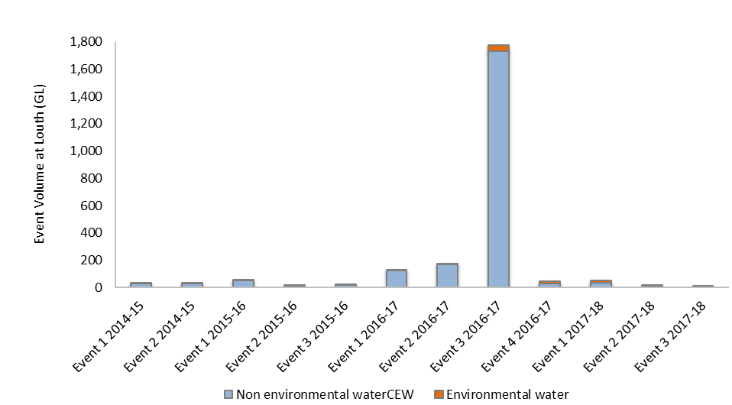

Figure 3‑2: Comparison of flow events containing Commonwealth environmental water (CEW) from years 1 to 3 of the project measured at Louth gauge.

## Warrego River Flows and Inundation

Flows in the Warrego River during the 2017-18 water year were very low, water entered the Selected Area during four small flow events in October 2017, December 2017, March-April 2018 and June 2018. Commonwealth environmental water made up 17.3% of the flow during March-April 2018. Water levels in Boera Dam remained below the Western Floodplain connection level for most of the year with only one brief period of connection to the floodplain observed in December 2017 (Figure 3‑3; Appendix D). This was due to localised rainfall, rather than substantial flows from the upper Warrego catchment triggering the Toorale licence. During the flow event in April-May 2018, the Boera Dam regulating gates were partially opened for a total of 16 days, though flows were restricted to 300 ML/d or less in response to Boera Dam inflows. This event reconnected the waterholes in the lower Warrego system and provided connection through to the Darling River.

More than 497 ha of the lower Warrego River channel system was inundated within the Selected Area, measured one week after a flow event peaking at 300 ML/d at the Boera Dam gates during April 2018 (Appendix C). Quantification of the channel network of the lower Warrego river indicated that 88.2 km of the channel was inundated at the time of image capture, accounting for 49% of the total channel network. The length of primary channels inundated was 44.4 km (25% of total), while 43.8 km of secondary channels were inundated (24% of total).

Commonwealth environmental water had no influence on inundation of the Western Floodplain during 2017-18 because of low inflows to Boera Dam, and the management of the dam for other environmental purposes. Inundation extents on the Western Floodplain were low during 2017-18 because of minimal overflow from Boera Dam. While up to 426.5 ha of inundation was detected during the year, this was the result of local rainfall. In contrast, river derived flows contributed to around 20 ha of inundation, which inundated 5 vegetation communities on the floodplain. Total inundation in 2017-18 would have helped maintain inundated vegetation communities and provided temporary water sources for animals, but would have been unlikely to have supported any significant aquatic communities on the floodplain during this water year.

Figure 3‑3: Water level at Boera and Dicks Dams and periods of longitudinal connection and overflow to Western Floodplain.

## Water Quality

In 2017-18, flows containing environmental water generally led to a significant reduction in water conductivity at Louth (Figure 3‑4). This response reflects the dilution effects provided by inflow, and the changes in water chemistry associated with the increase in discharge and wetted area of channels. Event 2 led to a significant reduction in conductivity within three days of the commencement of the event. This improvement in conductivity was enhanced further in Event 3 and then maintained for at least three months after the flow at both stations. Flow events containing environmental water have generally led to reductions in conductivity over all years of the LTIM project, except for elevated conductivity associated with a flow event in 2015-16 which peaked at 1,350 ML/d (Commonwealth of Australia 2016). This 2015-16 flow was a small fresh event that was larger than the previous flows of that year. It also contained inflows from the Namoi river which may have contained water with higher conductivity. Increased conductivity in this flow may have also reflected an increased flux of material from low lying in-channel features into the system, without the flow being large enough to dilute these concentrations as appears to happen at flows of larger magnitude. It is proposed that inter-annual hydrological variability and antecedent flow condition play important roles in conductivity variability, highlighting the importance of long-term monitoring in highly dynamic systems.

(b)

Figure 3‑4: Mean daily (a) discharge at Darling @ Louth (NSW425004) on the Darling River system, (b) conductivity and (c) Dissolved Oxygen at the Darling downstream water quality station. EW represents environmental water. Black line represents all available data from this watering year and red dotted line represents ANZECC guideline trigger value.

Dissolved oxygen has shown inconsistent responses to flow throughout the LTIM project. In 2017-18, increased discharge during Events 1 and 3 contributed to increased dissolved oxygen concentrations in both stations to within the ANZECC guideline trigger value (Figure 3‑4). This suggests that flow of these magnitudes (~ 1,000 ML/d) stimulate primary production. In contrast, during Event 2 after two months of constant base flows, dissolved oxygen dropped from 70-80% to below 20% at both stations 15-20 days after this flow commenced. This reduction in dissolved oxygen coincided with an algal outbreak that partly covered the water surface of the Darling River channel in April 2018 (Figure 3‑5). Water quality records from short-term spot sampling on 25th April 2018,soon after Event 2, showed a very high turbidity of above 800 NTU and high chlorophyll *a* concentrations around 30 µg/L. High Chlorophyll a concentrations during this flow were likely a result of the increased algal growth, with low dissolved oxygen levels perhaps linked to oxygen depletion associated with algal decay. There are several possible explanations for this inconsistent response of dissolved oxygen in 2017-18. Since Events 1, 2 and 3 were all small fresh events, it is possible that differences in upstream water sources, each containing different chemical composition, may have affected the balance between productivity and respiration, and hence dissolved oxygen concentrations. Secondly, antecedent flow conditions associated with time since flow recession and season may play an important role in dissolved oxygen dynamics in this system. Continued monitoring of water quality in the Darling River will strengthen our understanding of dissolved oxygen responses to flow in this system.

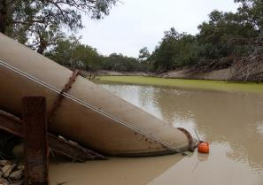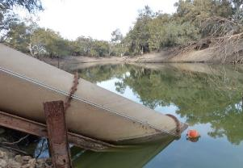

Figure 3‑5: Darling Pump water quality site on 25th April 2018 (during Event 2) and 29th June 2018 (during Event 3).

Longitudinal connection between the Warrego and Darling due to the opening of Boera Dam gates occurred during Event 2 in mid-April 2018 and resulted in connection for a maximum of 16 days (Appendix A). During this event, the inputs of water from the Warrego River to the Darling was not obvious on the Louth stream gauge, comparing it to the Weir 19a gauge. There was also no obvious influence of Warrego water on water quality in the Darling River downstream of the confluence during this event.

Stream metabolism datasets were discontinuous in the 2017-18 water year, with over 90% of the data rejected by the BASE v.2 metabolism model. This was mainly due high estimated reaeration coefficient (K) values causing poor model fitting. Based on the available data, there was no detectable difference in stream metabolism parameters between flow periods with and without environmental water. In general, total nitrogen and total phosphorus concentrations exceeded the ANZECC guideline during the whole water year based on nutrient samples collected every six weeks, this has been typical of nutrient levels measured in the LTIM project to date. This is typical in northern basin rivers with high sediment and associated nutrient loads (Oliver *et al.* 2004). There was also no clear correlation between metabolism and nutrient parameters and discharge.

## Ecosystem types and vegetation

During the 2017-18 water year, Commonwealth environmental water influenced sites within the Warrego and Darling river zones representing two ecosystem types monitored in the project, as defined by the Australian National Aquatic Ecosystem (ANAE) Classification Framework (Brooks et al. 2013; Appendix G). These sites were located within the Warrego and Darling River zones, as no environmental water was delivered to the Western Floodplain (Figure 3‑6). A small number of sites were inundated in the northern section of the Western Floodplain due to overflow from Boera Dam. This represents an 85% decrease in inundated sites compared to 2016-17.

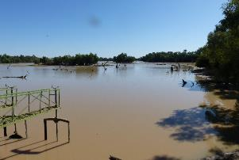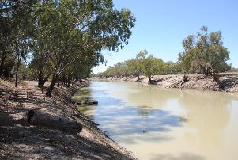

Figure 3‑6: **Examples of ecosystem types inundated by environmental water in the Selected Area during the 2017-18 water year. Temporary Lake (left) and permanent lowland stream (right).**

Vegetation monitoring sites within the Western Floodplain received no inundation during the 2017-18 water year, with only minimal inundation of vegetation communities overall. These dry conditions saw average species richness reduced to the lowest level since surveys began in February 2015. Similarly, mean vegetation cover in May 2018 also fell to the lowest levels. Thus, it appears the increased vegetation productivity observed in the 2016-17 water year, following significant spring inundation in 2016, has finished and dry condition patterns now dominate (Figure 3‑7). This is a natural feature of boom and bust systems, such as the Warrego, and reflects the low inflows into the Selected Area, as well as the below average rainfall experienced during 2018 (Appendix D). While species richness and the cover of many vegetation species appears to have reduced during sampling in 2017-18, some species, such as lignum still appear to be in relatively good health (Figure 3‑8). This reflects lignum’s ability to maintain its condition for longer periods following inundation, being able to access moisture stores from deeper within the soil profile than other shallow rooted forb and herb species present on the floodplain.

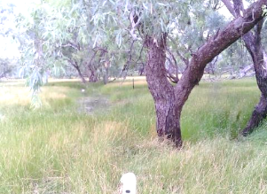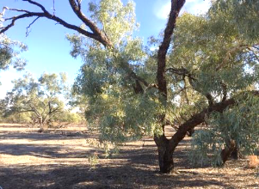

Figure 3‑7: Coolibah Woodland site 5.2 during the December 2016 (left) and May 2018 (right) surveys.

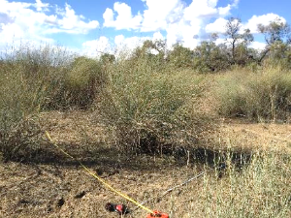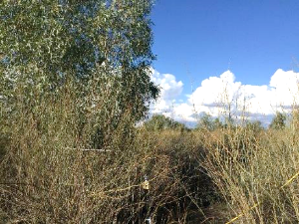

Figure 3‑8: Lignum plants at plots 7.3 (left) and 8.2 (right) in May 2018.

## Biodiversity

In accordance with the Monitoring and Evaluation plan for the Selected Area (Commonwealth of Australia 2015), surveying was undertaken for all indicators during 2017-18. Surveys for waterbird diversity, frog diversity, fish diversity, macroinvertebrate and microinvertebrate indicators were undertaken around the Warrego river flow event in April 2018. Given the relatively late timing of this flow compared to reporting timelines, it was agreed that detailed analysis and reporting for these indicators would be reported in the 2018-19 annual report. However, where possible, preliminary findings for these indicators are provided below.

In total, 75 bird species were recorded during waterbird surveys undertaken in October 2017, April 2018 and June 2018. Of these, 25 species could be categorised as waterbirds, raptors or reed-inhabiting passerines (Figure 3‑9). No species listed under any international migratory agreements were observed, however, the white bellied sea eagle (*Haliaeetus leucogaster*) is listed as vulnerable under the NSW TSC Act. Overall waterbird numbers were lower than observed in previous years, due primarily to the dry regional conditions experienced over the 2017-18 water year. However, as in previous years, Boera Dam had the highest richness and abundance of birds of any of the sites surveyed this year. Waterbird abundance and richness were greatest during the June 2018 survey after the environmental water had been through the system.

Like birds, frog surveys were carried out during October 2017, April 2018 and June 2018. A total of 12 frog species were observed or heard during the 2017-18 water year, with the green tree frog (*Litoria caerulea*) the most abundant species. Compared to previous years, frog activity was low, presumably the result of the drier and colder conditions during each survey. The water holding frog (*Cyclorana platycephala*) was observed for the first time during the April 2018 survey at Booka Dam (Figure 3‑10). The greatest species richness and abundance of frogs were observed during the October 2017 survey, when water levels in the Warrego waterholes were low but still present. Warmer conditions during this survey likely contributed to the increased frog activity. During the April 2018 survey, frogs were only noted at Booka dam where 6 species were observed or heard. During the June 2018 survey only one spotted grass frog (*Limnodynastes tasmaniensis*) was observed at Booka dam. No frogs were heard or observed at any other site during the June 2018 survey, likely a result of reduced frog activity during winter.

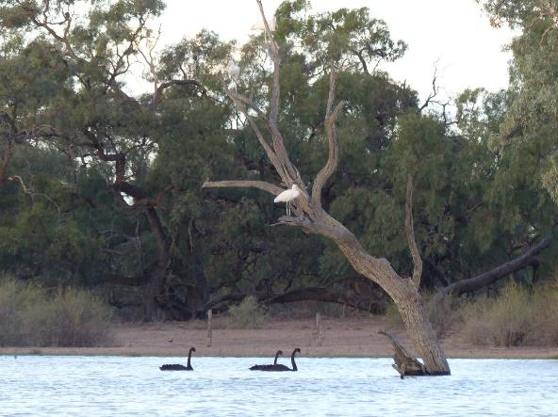

Figure 3‑9: Black swans (*Cygnus atratus*) and yellow-billed spoonbills (*Platalea flavipes*) observed during the April 2018 survey at Booka Dam.

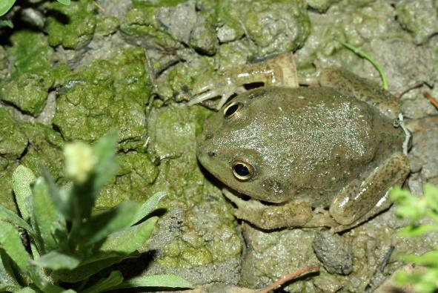

Figure 3‑10: A water holding frog (*Cyclorana platycephala*) which was observed for the first time during the April 2018 survey at Booka Dam.

Fish diversity was monitored in June after the connection event in April 2018. Fish were surveyed at four of the five Warrego River sites, with no fish being caught in Ross Billabong. This may reflect the low water levels in Ross Billabong at the time restricting fish movement into this waterhole upon wetting. Low numbers of native spangled perch (*Leiopotherapon unicolor)*, bony herring (*Nematolosa erebi)*, Hyrtl’s catfish (*Neosilurus hyrtlii)* were caught with juveniles of all species present apart from Hyrtl’s catfish. Low numbers of common carp (*Cyprinus carpio)* and goldfish (*Carassius auratus)* were also captured, suggesting a small instream spawning event occurred for these species. Relatively large numbers of juvenile golden perch (*Macquaria ambigua*) (lengths between 24-74 mm) were captured from all four sites sampled. Given these sites were dry before the connection flow, these fish were likely spawned upstream of the Selected Area and drifted into the reach. Preliminary analysis suggest that based on the lengths of these golden perch recruits, spawning was likely to have occurred between 30-40 days before surveying, coinciding with the start of the flow event in the upper Warrego catchment in early March.

## Resilience

The drier conditions in 2017-18 in the Selected Area placed stress on the ecological communities that inhabit the area. This was most obvious in the floodplain vegetation, which reduced in both cover and species richness during this period. Having said that, the plants and animals of the Selected Area have adapted to cope with high temporal variation (booms and busts) in resource availability (Kingsford et al. 2010). While the groundcover on the floodplain receded, the health of mid-storey species such as lignum appeared better, and seemed to be still showing the positive influence of inundation in 2016-17. Similarly, while floodplain habitats, remained dry in 2017-18, frog diversity observed at the start of the year, remained high within Warrego River channel sites.

While flows through the lower Warrego channel were restricted to one 16 day pulse in 2017-18, this short period of connection appeared to stimulate breeding and recruitment within several native fish species, including golden perch, spangled perch and bony herring. This is encouraging and suggests that these species are well adapted to take advantage of even the shortest connection events to boost or at least maintain their population. As has been suggested in previous LTIM reports (Commonwealth of Australia 2016) individuals of large bodied fish such as golden perch, appear to be growing slower and maturing earlier to allow them to take advantage of connection events to spawn at an earlier age, than in other areas of the Murray Darling Basin. Given that this section of the Warrego channel was dry before this flow, it is highly likely that juvenile fish surveyed post flow entered the reach via upstream drift. It is these characteristics of our native fauna that allow them to persist in river systems like the Warrego, with highly variable flow regimes.

## Summary

Conditions in the Selected Area during 2017-18 were dry, with minimal flows onto the Western Floodplain and small in-channel fresh events through both the Warrego and Darling river channels. Warrego channel flows were confined to 16 days of connection provided by a flow release from Boera Dam including Commonwealth environmental water. This flow reinstated aquatic habitat for animals in the lower Warrego, inundating around half the channel network downstream of Boera Dam, which supported native fish recruits and relatively low numbers of frogs and waterbirds. The relatively late timing of this flow event in Autumn, coupled with the very dry regional conditions, likely limited the response of frogs and waterbirds. The condition of groundcover vegetation on the Western Floodplain declined because of the dry conditions during 2017-18, but mid-storey species such as lignum still appear in good condition, maintaining the benefits of flooding in the previous water year.

Three flow events containing between 24.3 and 99.6% environmental water occurred down the Darling River channel in 2017-18 including the Northern Connectivity Event in April 2018, which provided connection throughout the Barwon-Darling channel. These events provided access to around 30% of the total number of snags in the reach which provide cover for fish and other aquatic animals and substrate for biofilm development. These events also generally led to improvements in water conductivity, whereas the response of dissolved oxygen to these flows was more variable. This is likely a reflection of the variations in the source of the water from upstream catchments and the influence of temperature.

# Implications for Future Management of Commonwealth environmental water

Flow conditions in the Northern basin did not allow the CEWO to address all watering priorities relevant to the Selected Area in 2017-18 (Commonwealth of Australia 2017). Inflows into Boera Dam down the Warrego River were insufficient to allow management of water levels within the dam to promote flows onto the Western Floodplain. The vegetation communities on the Western Floodplain are in the poorest condition they have been in since the LTIM project began. This is especially true for groundcover species that rely on more frequent wetting to maintain condition. Mid-storey species such as lignum appear to be more resilient, having maintained condition since the larger inundation event in 2016-17. Even so, if low river flows, below average rainfall and above average temperatures persist, reduction in the condition of mid-storey species is likely. Given the current state of these vegetation communities, wetting of the Western Floodplain should be a high priority in 2018-19.

The small, managed fresh event down the lower Warrego River in 2017-18 was successful at stimulating breeding and recruitment of native fish species. This is consistent with monitoring results from previous flow events that have stimulated breeding and recruitment of a range of fish species. The flow in April-May of this water year inundated and connected the previously dry channel network below Boera Dam. Given this dry channel conditions and the age of the recruits surveyed, it appears as if, at least for golden perch, individuals were spawned upstream and then transported with the flow downstream into the Selected Area. This highlights the importance of maintaining longitudinal connectivity through the system. Providing suitable conditions (in terms of water levels, water quality and productive foodwebs) to support these recruits and then allow them to move through the Warrego and into the Darling River may also be important for the health of fish populations at broader basin wide scales. High priority should be given to providing replenishing flows to the lower Warrego in 2018-19, given the presence of good numbers of young of year native fish presently in this reach.

Due to the Boera Dam gates only being partially opened in the managed release and the dry lower Warrego system, only minimal connection to the Darling River was achieved. Therefore, the influence of this water on flow conditions in the Darling river downstream was also minimal, with no noticeable change in Darling river water quality downstream of the confluence. Without greater inflows to the Warrego, management impacts were limited in this instance.

The embargo placed on the water access during the flow event down the Darling in March-April 2018 helped to maximise the movement of this flow through the Selected Area. This flow had the highest magnitude for the water year and inundated the greatest proportion of in-channel habitat within the Selected Area for the year. The utilisation of embargos to protect small fresh events, especially following periods of low flows, is encouraged as a mechanism to increase longitudinal connectivity and water quality in the system.

The managed Northern Connectivity Event provided large-scale connection of the Barwon-Darling River from Mungindi to the Menindee Lakes. Within the Selected Area, it provided additional access to habitat such as snags, and improved conductivity and dissolved oxygen levels, increasing dissolved oxygen to within ANZECC guidelines. Monitoring over the past 4 years of the LTIM project has shown flow events down the Darling typically improve water quality. If low flows and dry conditions prevail, consideration of additional managed flow events such as the Northern Connectivity Event should be considered.

# References

Aurecon. 2009. *Toorale Station Decommissioning Plan Volume 1*. Prepared for the Department of Environment, Water, Heritage and Arts.

Brooks, S., Cottingham, P., Butcher, R., & Hale, J. 2013. *Murray-Darling Basin aquatic ecosystem classification: Stage 2 report*. Peter Cottingham & Associates report to the Commonwealth Environmental Water Office and Murray-Darling Basin Authority, Canberra.

Commonwealth of Australia 2015. *Commonwealth Water Office Long Term Intervention Monitoring Project Junction of the Warrego and Darling rivers Selected Area – Monitoring and Evaluation Plan.* Commonwealth of Australia, Canberra

Commonwealth of Australia 2016. *Commonwealth Water Office Long Term Intervention Monitoring Project Junction of the Warrego and Darling rivers Selected Area – 2015-16 Evaluation Report.* Commonwealth of Australia, Canberra

Commonwealth of Australia 2017. Commonwealth Environmental Water Portfolio Management Plan: Northern Unregulated Rivers 2017–18. Commonwealth of Australia, Canberra

Gawne B., Brooks S., Butcher R., Cottingham P., Everingham P. & Hale J. 2013. *Long-term Intervention Monitoring Project: Monitoring and Evaluation Requirements: Junction of the Warrego and Darling rivers*. Report prepared for the Commonwealth Environmental Water Office by The Murray-Darling Freshwater Research Centre, MDFRC Publication 01.2/2013.

Oliver R., Grace, M., Olley, J. and Cooper B. 2004. Chapter 13: Water Quality. In Breckwoldt, R., Boden, R and Andrew, J (eds) The Darling. Murray Darling Basin Commission, Canberra, Australia.