



**Commonwealth Environmental Water Office**

**Long Term Intervention Monitoring Project**

**JUNCTION OF THE WARREGO AND DARLING RIVERS SELECTED AREA**

Version 2, 4 March 2015

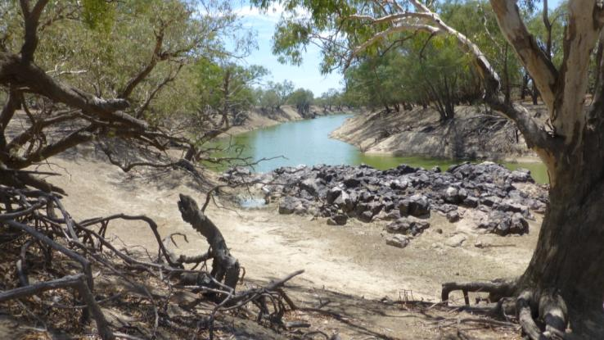

This monitoring project was commissioned and funded by Commonwealth Environmental Water Office.

**Copyright**

© Copyright Commonwealth of Australia, 2014



Commonwealth Environmental Water Office Long Term Intervention Monitoring Project Junction of the Warrego and Darling rivers Selected Area is licensed by the Commonwealth of Australia for use under a Creative Commons By Attribution 3.0 Australia licence with the exception of the Coat of Arms of the Commonwealth of Australia, the logo of the agency responsible for publishing the report, content supplied by third parties, and any images depicting people. For licence conditions see: <http://creativecommons.org/licenses/by/3.0/au/>

This report should be attributed as ‘Commonwealth Environmental Water Office Long Term Intervention Monitoring Project Junction of the Warrego and Darling rivers Selected Area, Commonwealth of Australia 2014’.

**Disclaimer**

The views and opinions expressed in this publication are those of the authors and do not necessarily reflect those of the Australian Government or the Minister for the Environment.

While reasonable efforts have been made to ensure that the contents of this publication are factually correct, the Commonwealth does not accept responsibility for the accuracy or completeness of the contents, and shall not be liable for any loss or damage that may be occasioned directly or indirectly through the use of, or reliance on, the contents of this publication.

**Document control**

|  |  |  |  |
| --- | --- | --- | --- |
| **Version** | **Date** | **Reviewed by** | **Approved by** |
| 1 | 19 January 2015 | Darren Ryder, Mark Southwell, Paul Frazier | Paul Frazier |
| 2 | 11 February 2015 | Mark Southwell | Mark Southwell |
|  |  |  |  |

|  |  |
| --- | --- |
| **Item** | **Details** |
| ELA Project Number | 434 |
| Project Director/s | Paul Frazier, Darren Ryder |
| Project Manager | Mark Southwell |
| Prepared by | Paul Frazier, Darren Ryder, Mark Southwell, Emily Southwell |

Contents

List of Figures iv

List of Tables vi

Abbreviations viii

1 Introduction 1

2 Junction of the Warrego and Darling rivers Selected Area 3

3 Commonwealth Environmental Watering 11

4 Intervention Monitoring Indicators 23

5 Monitoring and Evaluation Schedule 32

6 Communication and Engagement 75

7 Project Management 78

8 References 91

Appendix A Junction of the Warrego and Darling rivers Selected Area Boundary (Shapefile provided digitally) 94

Appendix B Standard Operating Procedures 96

Appendix C Cause and Effect Diagrams 163

Appendix D Communications Plan 176

Appendix E Quality Assurance Plan 197

Appendix F Health, Safety and Environment Plan (HSE Plan) 226

List of Figures

Figure 2‑1: The location of the selected area within the Murray-Darling Basin showing upstream catchments. 3

Figure 2‑2: The Junction of the Warrego and Darling Rivers Selected Area bounded by the Toorale NP and SCA. Figures represent the licenced water entitlements at each point. 4

Figure 2‑3: Monthly climate averages (Bourke Post Office) 5

Figure 2‑4 Existing infrastructure influencing the hydrology within the Selected Area 6

Figure 2‑5 A breach in the western embankment on the lower western floodplain (photo: D.Ryder) 7

Figure 2‑6 Flood channel in the upper section of the Western Floodplain bordered by lignum, river cooba and coolibah (photo D.Ryder) 8

Figure 2‑7 Boera Dam with regulator pipes in foreground, western floodplain bywash to the left and main Warrego river flowpath to the right (photo D.Ryder) 9

Figure 3‑1. Decision tree for considering Toorale Warrego Commonwealth environmental water 17

Figure 4‑1: Generic CED structure (MDFRC 2013) 29

Figure 5‑1 Junction of the Warrego and Darling rivers Selected Area monitoring zones 33

Figure 5‑2. NOW gauging stations and water level recorders in the vicinity of the Selected Area 37

Figure 5‑3 Location of Water quality sensors and sampling sites 39

Figure 5‑4 Stream Metabolism sites 41

Figure 5‑5: Vegetation Diversity Sites 43

Figure 5‑6 NOW gauging stations used for the Category III Hydrology (River) indicator 45

Figure 5‑7 Location of Western Floodplain and water sensors 47

Figure 5‑8 Location of Water quality sensors and sampling sites 53

Figure 5‑9 Stream Metabolism sites 55

Figure 5‑10 Location of Dams and weirs within the Junction of the Warrego and Darling Selected Area 57

Figure 5‑11 Microcrustacean sampling sites within the Warrego River and Western Floodplain zones 60

Figure 5‑12: CED – Microcrustaceans 61

Figure 5‑13: Hypothetical model of a long-term response to environmental watering based on a created ‘reference condition’ where the greatest influence is from watering in the most recent year with progressively weaker influence from watering in previous years (Source: Gawne et al. 2014) 69

Figure 5‑14: A hypothetical model that will be applied on a year-to-year basis to generate a series of outcomes from different flow regimes over a five year period (Source: Gawne et al. 2014) 69

Figure 7‑1: Project governance structure for the LTIM Project (from CEWO n.d.) 78

List of Tables

Table 2‑1 Darling Basin headwater storages (Thoms and Sheldon 2000) 10

Table 3‑1: Flow type function on rivers, wetlands and floodplains (Gawne et al 2013a) 12

Table 3‑3 Commonwealth environmental water holding in Darling tributaries upstream of the Selected Area (excluding the Warrego) (adapted from CEWO 2014) 13

Table 3‑4 Commonwealth water holdings in the Warrego and Darling catchments compared to annual flow volumes. Data range 1972-2013. 14

Table 3‑5: Summary of watering options relevant to the Junction of the Warrego and Darling rivers Selected Area (Gawne et al. 2013b; CEWO 2014) 15

Table 3‑6: Expected outcomes for the Darling River (Gawne et al. 2013b) 19

Table 3‑7: Expected outcomes for the Warrego River (Gawne et al. 2013b) 20

Table 3‑8 Target flow bands for Commonwealth environmental water identified for the Darling River within the Selected Area 21

Table 3‑9: Expected outcomes from the 2014-2015 Commonwealth environmental water (CEWO 2014). Outcomes relevant to the Selected Area are shaded. 21

Table 4‑1: Junction of Warrego and Darling Rivers Selected Area monitoring indicators 23

Table 4‑2: Matrix linking evaluation questions and associated indicators for the Junction of the Warrego and Darling rivers Selected Area. ST = Short term Question, LT= Long term question, Basin = Basin scale, WD = Selected Area scale. 24

Table 4‑3: Summary of objectives hierarchy, expected outcomes and generic CEDS developed for the broader LTIM project across the basin 30

Table 5‑1: Junction of the Warrego and Darling rivers Selected Area monitoring zones 33

Table 5‑2: NSW Office of Water Gauges and the zones to which they relate. 36

Table 5‑3 Locations of water level recorders within the Selected Area 37

Table 5‑4 NOW gauging stations within upstream catchments. 46

Table 5‑5: Complementary data required for the LTIM Project in the Junction of the Warrego and Darling rivers Selected Area 67

Table 5‑6: Indicator-Zone interactions. SA represents Selected Area. 72

Table 5‑7: Annual field survey cycle for indicators measured in the Darling River zone. 73

Table 5‑8 Annual field survey cycle for indicators measured in years 2-5 of the project within the Warrego River and Western Floodplain zones. 74

Table 6‑1: Progress reporting requirements for the LTIM Project 76

Table 6‑2: Reporting requirements for the LTIM Project 77

Table 7‑1: Primary governance structure – Junction of the Warrego and Darling rivers Selected Area LTIM Project 78

Table 7‑2: Risk assessment matrix 80

Table 7‑3: Risk likelihood categories 80

Table 7‑4: Risk consequence categories 81

Table 7‑5: Junction of the Warrego and Darling rivers M&E Plan risk assessment: successful implementation of the LTIM Project 82

Table 7‑6: Junction of the Warrego and Darling rivers M&E Plan risk assessment: risks to the environment as a result of the LTIM Project 84

Table 7‑7: Junction of the Warrego and Darling rivers M&E Plan risk assessment: risks to individuals and teams undertaking monitoring activities 85

Abbreviations

|  |  |
| --- | --- |
| Abbreviation | Description |
| ANAE | (Interim) Australian National Aquatic Ecosystems (Classification Framework) |
| ASL | Above Sea Level |
| BoM | Bureau of Meteorology |
| CED | Cause and Effect Diagram |
| CEWH | Commonwealth Environmental Water Holder |
| CEWO | Commonwealth Environmental Water Office |
| DO | Dissolved oxygen |
| DOC | Dissolved organic carbon |
| EAC OAC | Environmental Contingency Allowance Operations Advisory Committee |
| EC | Electrical conductivity |
| ELA | Eco Logical Australia Pty Ltd |
| EWP | Environmental Watering Plan (Basin Plan) |
| FRP | Filterable reactive phosphorus |
| HSE | Health, Safety and Environment |
| IMEF | Integrated Monitoring of Environmental Flows |
| LTIM Project | Long-Term Intervention Monitoring Project |
| M&E Adviser | Monitoring and Evaluation Adviser |
| M&E Plan | Monitoring and Evaluation Plan |
| M&E Provider | Monitoring and Evaluation Provider |
| M&E Requirements | Monitoring and Evaluation Requirements |
| MDB | Murray-Darling Basin |
| MDBA | Murray-Darling Basin Authority |
| MDFRC | Murray-Darling Freshwater Research Centre |
| MDMS | Monitoring Data Management System |
| MERI | Monitoring, Evaluation, Reporting and Improvement Framework |
| NOW | NSW Office of Water |
| OEH | (NSW) Office of Environment and Heritage |
| QA/QC | Quality Assurance / Quality Control |
| SRA | Sustainable Rivers Audit |
| STIM | Short-term Intervention Monitoring |
| SWC | State Water Corporation (NSW) |
| The Department | Department of the Environment (Commonwealth) |
| TN | Total nitrogen |
| TP | Total phosphorus |
| UNE | University of New England |

# Introduction

## LTIM context

The Commonwealth Environmental Water Holder (CEWH) is responsible under the *Water Act 2007* for managing Commonwealth environmental water holdings. The holdings must be managed to protect or restore the environmental assets of the Murray-Darling Basin, and other areas where the Commonwealth holds water, so as to give effect to relevant international agreements. The Basin Plan (2012) further requires that the holdings must be managed in a way that is consistent with the Basin Plan’s Environmental Watering Plan. The *Water Act 2007* and the Basin Plan also impose obligations to report on the contribution of Commonwealth environmental water to the environmental objectives of the Basin Plan.

Monitoring and evaluation are critical to support effective and efficient use of Commonwealth environmental water. Monitoring and evaluation will also provide important information to support the CEWH to meet their reporting obligations.

The Long-Term Intervention Monitoring Project (LTIM Project) is the primary means by which the Commonwealth Environmental Water Office (CEWO) will undertake monitoring and evaluation of the ecological outcomes of Commonwealth environmental watering. The LTIM Project will be implemented at seven Selected Areas over a five year period from 2014-15 to 2018-19 to deliver five high-level outcomes (in order of priority):

1. Evaluate the contribution of Commonwealth environmental watering to the objectives of the Murray-Darling Basin Authority’s (MDBA) Environmental Watering Plan
2. Evaluate the ecological outcomes of Commonwealth environmental watering at each of the seven Selected Areas
3. Infer ecological outcomes of Commonwealth environmental watering in areas of the Murray-Darling Basin not monitored
4. Support the adaptive management of Commonwealth environmental water
5. Monitor the ecological response to Commonwealth environmental watering at each of the seven Selected Areas.

To establish long-term arrangements to undertake intervention monitoring at seven Selected Areas within the Murray-Darling Basin, a Monitoring and Evaluation Plan (M&E Plan) has been developed and will be implemented for each Selected Area. To assist with the development of each M&E Plan, the CEWO engaged the Murray-Darling Freshwater Research Centre (MDFRC) as the Monitoring and Evaluation Advisor (M&E Advisor). As the M&E Advisor, the MDFRC assisted with the planning, consultation and scientific development of each M&E Plan. The MDFRC also developed the following reference documents for the development of the M&E Plans to ensure that a high level scope of intervention monitoring underpins the LTIM Project and was developed in context of Commonwealth environmental water:

* LTIM Logic and Rationale document (Gawne et al. 2013a) - sets out the overarching design and framework of the LTIM Project
* Monitoring and Evaluation requirements for each Selected Area – developed in line with the LTIM Project framework and links to the Basin Plan
* LTIM Evaluation Plan - sets out how the Basin-scale (of outcomes of Commonwealth environmental water) and Selected Area questions will be addressed.

The LTIM Logic and Rationale document (Gawne et al. 2013a) sets out the scope and monitoring priorities for ecological responses to Commonwealth environmental water. Predicted likely ecological outcomes were based on:

* Basin Plan Environmental Water Plan (EWP) objectives
* Cause-effect diagrams that link EWP objectives to flow change
* Major flow types (as described in the Basin Plan)
* Possible water availability scenarios over the 1-5 year timeframe.

This M&E framework identifies priority monitoring indicators (Category I and II) for the Junction of the Warrego and Darling rivers Selected Area that relate to key objectives for Basin-scale evaluation (Gawne et al. 2013b).

This document is the M&E Plan for the Junction of the Warrego and Darling rivers Selected Area.

## Junction of the Warrego and Darling rivers M&E Plan

The Junction of the Warrego and Darling rivers M&E Plan details the monitoring and evaluation activities that will be implemented under the LTIM Project for the Junction of the Warrego and Darling rivers Selected Area. This M&E Plan includes:

* A brief description of the Junction of the Warrego and Darling rivers Selected Area (Section 2)
* An overview of environmental watering options in the Junction of the Warrego and Darling rivers Selected Area (Section 3)
* An overview of the monitoring indicators and the relevant Cause-Effect Diagrams (CED) (Section 4)
* The schedule of monitoring (Section 5), including:
* Evaluation questions (Basin-scale and Selected Area)
* Monitoring schedule (where, what, when, how)
* Evaluation approach (Basin-scale and Area)
* A communication and engagement strategy (Section 6; )
* A project management plan (Section 7), addressing:
* Project governance and risk assessment
* Quality Assurance Plan ()
* A health, safety and environment (HSE) Plan ().

# Junction of the Warrego and Darling rivers Selected Area

The Junction of the Warrego and Darling rivers is one of seven Selected Areas for monitoring under the LTIM Project, located around 80 km south-west of Bourke in North western NSW (Figure 2‑1). The Junction of the Warrego and Darling rivers Selected Area is contained within the boundary of the Toorale National Park and State Conservation Area (Figure 2‑2). The Selected Area is approximately 92,000 ha in size, and receives flow from both the Darling and Warrego River systems. The Darling River catchment drains the north westerly portion of the Murray-Darling Basin and has a total catchment area of 699,500 km2. Most of its tributaries (Macquarie, Castlereagh, Namoi, Gwydir, Macintyre and Condamine-Balonne Rivers) drain from the Great Dividing Range in northern New South Wales and southern Queensland, and provide relatively high runoff to the catchment. In contrast, other catchments such as the Warrego and the Paroo Rivers to the west, drain more arid, flat catchments and only flow intermittently during periods of high rainfall in their upper catchments, usually manifesting downstream as slow moving floods of relatively long duration. Generally speaking, the Selected Area shows high climatic variability, with low annual rainfall and high evaporation. An overview of the Darling and Warrego catchments, with a focus on the Selected Area, is provided below.

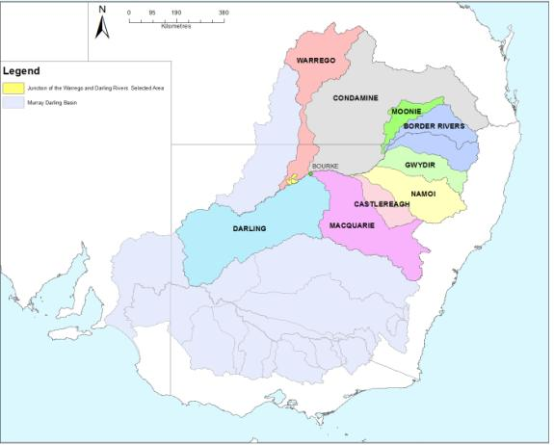

Figure 2‑1: The location of the selected area within the Murray-Darling Basin showing upstream catchments.

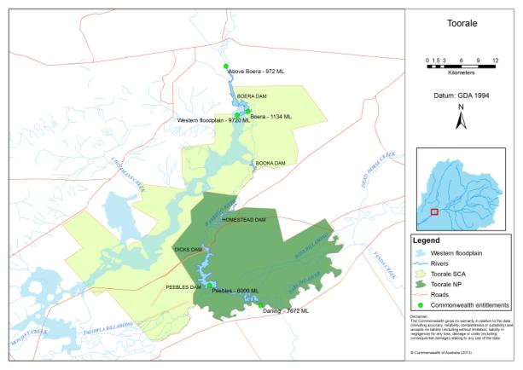

Figure 2‑2: The Junction of the Warrego and Darling Rivers Selected Area bounded by the Toorale NP and SCA. Figures represent the licenced water entitlements at each point.

## Climate

Climate across the Darling catchment is sub-tropical in the east to semi-arid in the west. Annual average rainfall varies from around 770 mm in Stanthorpe at the top of the catchment to around   
260 mm at Wilcannia in the west (Southwell 2008). The average annual rainfall at Bourke, approximately 80 km upstream of the Selected Area is 354 mm (BoM 2014a). Rainfall is summer dominant, with the highest rainfall occurring from December through to March (Figure 2‑3). February shows the highest mean monthly rainfall of 42 mm and September the lowest at 20 mm. Monthly evaporation always exceeds rainfall, with an annual average (Class A pan) evaporation of 1854 mm (BoM 2014a). Summer temperatures are hot, with mean daily maximum temperature of 35 °C (Figure 2‑3).

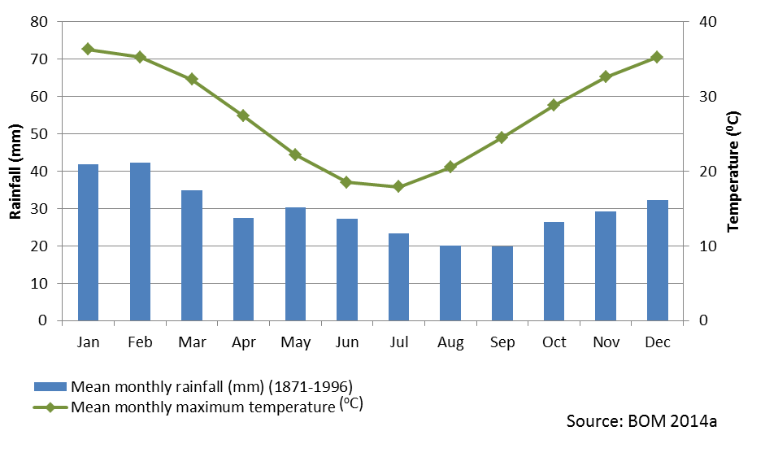

Figure 2‑3: Monthly climate averages (Bourke Post Office)

## Physical environment

The Selected Area is covered by six physiographic regions, being the Alluvial Plains of the Darling and Warrego Rivers, Playas and Basins of the backplains of the Darling and Warrego Rivers, Plains bordering the Darling River, Dunefields, Rolling Downs and Lowland, and Tablelands (Hazelton and Johnson 1972 in Gowens et al. 2012). In all, around two-thirds (62,000 ha) of the Selected Area is considered as floodplain with the remaining third (30,000 ha) classed as dryland (Gowens et al. 2012). The following sections outline the characteristic physical and vegetative features of the Darling and Warrego River systems.

### Darling River

In its upper catchment, the Darling River and its tributaries drain relatively high relief sections of the Great Dividing Range. However, relief soon reduces as the river flows westward, and in the vicinity of the Selected Area, the river drains a flat, semi-arid landscape with expansive floodplains. Here the Darling takes the form of a typical semi-arid river, with a deep, narrow main channel, steep banks and high sinuosities (>2) (Thoms et al. 2004). The main Darling channel and its riparian zones show high geomorphic complexity, with physical features such as deep pools, shallow runs, in-channel benches, rock bars and large woody debris forming important physical habitats and storage areas for organic material (Boys and Thoms 2006, Sheldon and Thoms 2006). These habitats support a diverse fish population with 23 native species from 10 families and 7 exotic species recorded in the Darling basin (Gerhke and Harris 2004).

The Darling River channel is bordered by river red gum (*Eucalyptus camaldulensis)* woodlands, in which river red gums and coolibah (*Eucalyptus coolabah)* form the overstory,river cooba *(Acacia stenophylla)* and lignum (*Muehlenbeckia florulenta)* form the mid and understory, and a number ofherb species such as Darling pea (*Swainsona greyana*), common sneezeweed (*Centipeda cunninghamii*), joyweed (*Alternanthera species*) and the introduced smooth mustard (*Sisymbrium erysimoides*) form the groundcover (Westebrooke, Leversha and Kerr 2004). These woodlands provide significant inputs of litter and organic matter that is temporarily stored on in-channel benches along the river, and then incorporated into riverine food webs during in-channel flow pulses (Sheldon and Thoms 2006). Many of these in-channel benches are inundated at relatively low flow levels, thus forming potential targets for environmental flow deliveries (Southwell 2008).

There are several natural wetlands within the Selected Area along the Darling River, these include: Ross Billabong in the lower reaches of the Warrego River; and Talowa Billabong, a billabong/distributary system which comes off the Darling River downstream of the Warrego Confluence.

A 2000 ha irrigation area was established on the Darling River floodplain in the east of the Selected Area in 1980 (Aurecon 2009) before the area was designated as National Park (Figure 2‑4). This area is now effectively cut off from the surrounding floodplain by levee banks and will not be influenced by environmental water in the future unless decommissioning of this structure takes place.

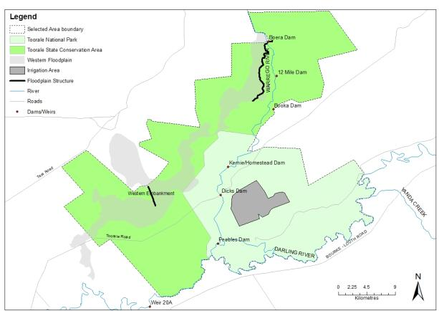

Figure 2‑4 Existing infrastructure influencing the hydrology within the Selected Area

### Warrego River

In its lower reaches, the Warrego River resembles a complex of braided channels flowing through the floodplain. Within the Selected Area, a main channel winds its way south to the Darling River, bordered to the west by an extensive floodplain system known as the Western Floodplain. Channel bank sediments consist of fine grained sandy silt and clay material with numerous bar and bench features (Holz et al. 2008). While natural waterholes are a feature of the Warrego channel in the Queensland section of the river (Holz et al 2008), there are no natural waterholes within the boundary of the Selected Area. Instead, a series of seven in-channel dams control water flow down the channel and create a longitudinal series of weir pools during times of river flow (Figure 2‑2). These weir pools now form important in-channel refugia for aquatic organisms during periods of no surface water flow (Capon 2009). Their presence has also significantly changed the inundation frequency of the surrounding floodplain, with a tenfold increase in inundation frequency as a result of water diverted down the Western Floodplain at Boera Dam (Cox et al. 2012).

The Western Floodplain begins to the north of the Selected Area and is inundated by water breaking from the Warrego channel in the vicinity of Boera Dam (Figure 2‑2). The floodplain then runs in a south westerly direction, and during times of high river flows surface water enters the Darling River 15-20 km downstream of the Toorale SCA boundary (Figure 2‑2). In its upper sections, the Western Floodplain is constrained by natural sand hills to the west, and a man-made training embankment and access road to the east, which restricts the return of water from the floodplain back into the Warrego channel (Figure 2‑4). Water flow is also diverted within the southern areas of the floodplain by a western embankment, a man-made embankment that diverts water into the neighbouring Uteara property and into several old stock dams on Toorale (Cox et al. 2012). There are currently breaches in this embankment that now provide greater connectivity of water to the lower sections of the floodplain (Figure 2‑5).

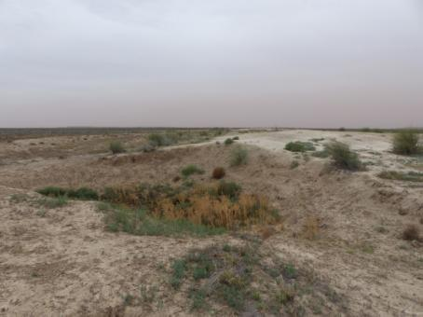

Figure 2‑5 A breach in the western embankment on the lower western floodplain (photo: D.Ryder)

The Western Floodplain supports a range of vegetation species including coolibah, river cooba, black box (*Eucalyptus largiflorens),* lignum along depressions (Figure 2‑6), patches of perennial grasses including *Eragrostis setifolia*, saltbush (*Atriplex spp.*) and copperburs, and forbs and grasses such as cut leaf medic (*Medicago laciniata*), nardoo (*Marsilea spp*.) and ribbed spike rush (*Eleocharis plana*) as groundcover (Capon 2009). These floodplain habitats along with the weir pools within the Warrego channel have been shown to support waterbirds, including the brolga (*Grus rubicundus*) which is listed as Vulnerable in the NSW Threatened Species Conservation Act 1995 (Capon 2009), and another five species of conservation concern in the Western Division of NSW; pied cormorant (*Phalacrocorax varius*), darter (*Anhinga melanogaster*), Australian pelican (*Pelecanus conspicillatus*), great egret (*Ardea alba*) and royal spoonbill (*Platalea regia*) (Shelley, 2003 cited in Capon 2009).

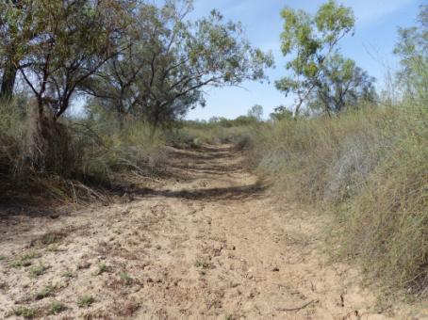

Figure 2‑6 Flood channel in the upper section of the Western Floodplain bordered by lignum, river cooba and coolibah (photo D.Ryder)

## Hydrology

Hydrological variability is a feature of the rivers in the Darling Basin, with long periods of low to no flow, punctuated with episodic flooding events. This is amplified by climatic conditions such as the El Niño–Southern Oscillation (ENSO). As such, flows in the Darling and Warrego Rivers are highly variable and are strongly correlated with the Southern Oscillation Index (SOI). The long-term flows in the Darling and Warrego Rivers do show some seasonality, with higher flows usually occurring during the summer and autumn months from December to April.

The hydrology of the Junction of the Warrego and Darling rivers Selected Area has been highly modified from its natural state. Although the Warrego catchment is still relatively unregulated upstream, in-channel flows are now controlled by seven dams within the Selected Area. The characteristics of these dams are outlined below (Gawne et al. 2013b):

1. Boera Dam: a large storage of approximately 3000 megalitres, likely to have been established since the 1870s. Water persists for around 12 months after filling in the absence of further inflows from local runoff
2. 12 Mile Dam: less than 1000 megalitres in volume, this dam has been recently breached and not reinstated.
3. Booka Dam: approximately 1000 megalitres
4. Mumpher (Broken) Dam
5. Keernie (Homestead) Dam: 1500 – 2000 megalitres (Breached)
6. Dicks Dam: 500 – 1000 megalitres
7. Peebles Dam: a large storage just upstream of the junction of the Warrego and Darling rivers. This is the most permanent of the storages and was previously used for irrigation. The storage holds approximately 10 000 megalitres and is connected to Ross Billabong, an adjacent floodplain depression.

Boera Dam (Figure 2‑7) has significantly influenced flows onto the Western Floodplain with up to 70% of Warrego River flows now diverted down the Western Floodplain every second year on average (Aurecon 2009). This has increased from a 20 year average recurrence interval (ARI) for the western floodplain under natural conditions. Although the frequency of inundation of the Western Floodplain has increased with development, the Warrego River is still an ephemeral stream, with low to no flow occurring for around half the time. In addition, Peebles Dam on the lower Warrego River has been created specifically to divert water into Ross Billabong, a large floodplain depression to the east. Historically, water was pumped from Ross Billabong for irrigated agricultural use on the Toorale property. Ross Billabong predominantly holds water from the Warrego River when the Warrego is flowing, however during periods of high flow in the Darling River, water enter Ross Billabong via an upstream flood channel, and therefore during these times Ross Billabong will be a mixture of water from both systems.

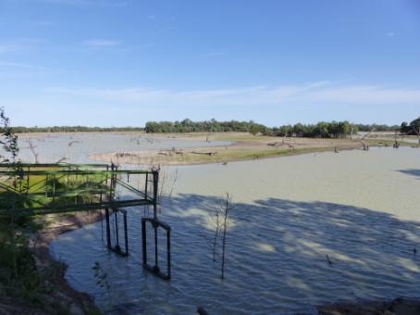

Figure 2‑7 Boera Dam with regulator pipes in foreground, western floodplain bywash to the left and main Warrego river flowpath to the right (photo D.Ryder)

The Toorale property which makes up the Selected Area was purchased by the NSW Government in 2008 with the objective of returning the property’s water entitlements back to the river and decommissioning the in-channel structures (dams) along the Warrego River (Capon 2009). This decommissioning plan has not yet been finalised. Changes to these structures will significantly influence the hydrology of the lower Warrego River and its floodplains, and their connection with the Darling River.

Flows down the Darling River have been reduced as a result of water resource development in its catchment, especially in the Border Rivers and Gwydir sub-catchments. There are twelve major headwater dams with a combined storage capacity of 5048 GL that significantly influence the flows along the Darling River upstream of Bourke (Table 2‑1). The greatest reduction (50%) is in small flows (around 1 year ARI) with less change observed in large to medium flows (Thoms et al. 2004). Darling River flows within the Selected Area are controlled by a low level weir (weir 20A) downstream of the Warrego and Darling River confluence, which backs up water along the majority of the Selected Area during low flows (P.Terrill, pers comm).

Although the amount and nature of flows have been influenced by upstream structures, the delivery of water to and within the Junction of the Warrego and Darling rivers Selected Area is essentially unregulated, dependent on rainfall and natural flows rather than from specific water releases from dams. This has implications for the use and monitoring of Commonwealth Environmental water in this Selected Area.

Table 2‑1 Darling Basin headwater storages (Thoms and Sheldon 2000)

|  |  |  |  |  |  |
| --- | --- | --- | --- | --- | --- |
| **Dam** | **Date completed** | **River system** | **A. Storage capacity (ML)** | **B. Mean annual inflow (ML)** | **Ratio of**  **A to B** |
| Beardmore |  | Condamine | 81000 |  |  |
| Coolmunda | 1968 | Macintyre | 75200 | 25000 | 3.01 |
| Glenlyon | 1976 | Pike Ck | 261000 | 76000 | 3.43 |
| Leslie  Pindari | 1985  1962–96 | Sandy Ck  Severn | 108000  312000 | 186000 | 1.68 |
| Copeton | 1976 | Gwydir | 1364000 | 450000 | 3.03 |
| Split Rock | 1987 | Manila | 397000 | 113000 | 3.51 |
| Keepit | 1960 | Namoi | 423000 | 420000 | 1.00 |
| Chaffey | 1979 | Peel | 62000 | 63000 | 0.98 |
| Burrendong | 1967 | Macquarie | 1678000 | 750000 | 2.24 |
| Windamere | 1984 | Cudgegong | 368000 | 54000 | 6.81 |

# Commonwealth Environmental Watering

The planning approach for environmental water use options aligns the key aspects of resource availability, expected outcomes from environmental watering actions and the objectives of the Basin Plan. The process aligns water availability with environmental demands in accordance with multi-year ecological and operational considerations (CEWO 2013a).

## What types of watering are proposed?

Planning for the use of Commonwealth environmental water is developed with a planning framework that balances water availability with environmental demand according to on-going ecological and operational considerations. Basin-scale environmental watering needs will largely be based on the Basin’s annual environmental watering priorities developed yearly by the MDBA (CEWO 2013a).

The Environmental Water Outcomes Framework (CEWO 2013b) was developed by the MDFRC to describe the objectives and outcomes from environmental watering. It underpins environmental water management from the planning and delivery stage through to outcomes and communications.

The Basin Plan identified four key environmental objectives to protect and restore water-dependent ecosystem of the Murray-Darling Basin (Gawne et al. 2013a). High level objectives (Level 1 objectives) were identified from the Basin Plan; biodiversity, ecosystem function, resilience and water quality. Within each of these Level 1 objectives, a further set of ‘particular’ objectives (Level 2 objectives) were identified. Intermediate and long-term targets from the Basin Plan, which are used to measure progress towards Level 1 objectives, have been used to develop Level 3 objectives.

Environmental water can be used to support four environmentally significant flow types (Gawne et al. 2013a). Each flow type provides different functions in the three water-dependent ecosystem types occurring in the Warrego and Darling rivers Selected Area, by influencing biodiversity, ecosystem function, resilience and/or water quality (). .

The catchment upstream of the Junction of the Warrego Darling rivers Selected Area is essentially unregulated, with the exception of four sub catchments, being the Border Rivers, Gwydir, Namoi and Macquarie. Of these catchments only the Gwydir represents any real potential influence the Selected Area in terms of end of system Commonwealth environmental flows. Unlike other catchments, the majority of water needed to meet the Commonwealth environmental watering requirements cannot be delivered by upstream impoundment releases, rather licencing conditions relating to stream flow limit water extraction to ensure water is retained within the system and delivered opportunistically during natural flow events. The Commonwealth holds water entitlements at various locations within the Selected Area (Figure 2‑2) and these become active when certain flow conditions (thresholds) are met under each licence class. Commonwealth environmental water is accounted for when flow thresholds are met for each flow access class (A, B or C) from the beginning of the year, and then all flows thereafter until the maximum proposed volumes are exhausted (CEWO 2014).

Table 3‑1: Flow type function on rivers, wetlands and floodplains (Gawne et al 2013a)

| **Flow type** | **River** | **Wetland** | **Floodplain** |
| --- | --- | --- | --- |
| Base flow | Flow that protects refugia, sustains water quality, productivity and biodiversity | - | - |
| Freshes | In-channel disturbance maintains littoral habitat, scours biofilm and provides longitudinal connectivity  Will affect water quality and ecosystem functions but the effects vary | - | - |
| Bankfull | In-channel disturbance  Influences in-channel and riparian habitat, provides longitudinal connectivity  Sediment transport influences long-term channel form | Only inundates wetlands connected at bankfull, typically those closely connected to parent river  Influence on all water-dependent species habitat, provides some lateral connectivity, major stimulus for primary productivity, decomposition and nutrient cycles  Maintain permanent wetlands as refugia | - |
| Overbank / terminal wetlands | In-channel disturbance  Major influence on in-channel and riparian habitat, provides longitudinal and lateral connectivity, major stimulus for other ecosystem functions  Sediment transport influences long-term channel form | Major influence on ecosystem diversity and habitat, provides connectivity, major stimulus for primary productivity, decomposition and nutrient cycles  Maintain permanent wetlands as refugia | Major influence on ecosystem diversity and habitat, provides connectivity, major stimulus for primary productivity, decomposition and nutrient cycles  Maintain permanent wetlands as refugia  Magnitude of flows is important for differentially inundating low lying and higher areas of the floodplain |

Commonwealth environmental water directly influencing flows within the Junction of the Warrego and Darling rivers Selected Area comes from two sources. The first is from the end-of-system flows originating in the Darling River Basin tributaries upstream of the Selected Area. As discussed above, these are from both unregulated, and to a lesser extent regulated tributaries. Total holdings, measured as the long-term average annual yield (LTAAY) upstream of the Selected Area on the Darling River and tributaries are around 165.4 GL (Table 3‑2). It is anticipated that this Commonwealth environmental water will influence the ‘base flow’ and ‘freshes’ flow type components within the Selected Area. The second source of Commonwealth environmental water is from the water entitlements in the Warrego River. These consist of 8 GL (LTAAY) in the Queensland portions of the catchment, and 17.8 GL (LTAAY) of entitlements at Toorale. The majority of this water is passed along the lower reaches of the Warrego River, and eventually into the Darling River. In high flow conditions the water is passed along the lower reaches of the Warrego Floodplain. Up to 8.1 GL is available annually to be passed along the Warrego River at a rate of up to 600 MLd-1. When total flow volume in the Warrego exceeds 9.7 GL the Commonwealth environmental water can be used explicitly for diversion onto the Western Floodplain.

Table 3‑2 Commonwealth environmental water holding in Darling tributaries upstream of the Selected Area (excluding the Warrego) (adapted from CEWO 2014)

|  |  |  |  |
| --- | --- | --- | --- |
| **Unregulated in-stream and EOS flows** | **Long term average annual yield (GL)** | **Route by which water enters Barwon-Darling Channel** | **Forecast water availability for 2014-15 (GL)1** |
| Qld Border Rivers – Severn | 0.5 | Residual EOS flows from water harvesting events | Up to 2.0 |
| Qld Border Rivers – Macintyre | 1.3 | up to 5.2 |
| Moonie River (Qld) | 1.1 | up to 1.4 |
| Nebine Creek (Qld) | 1.0 | up to 5.9 |
| Condamine (Qld) | 0.2 | Via Culgoa/Birrie Rivers | Up to 0.2 |
| Lower Balonne (Qld) | 40 | up to 108.5 |
| NSW Barwon-Darling | 22.3 | Removal of extraction at Collarenebri and Toorale | up to 59.4 |
| **Total unregulated** | **66.4** |  | **Up to 182.6** |
| **Potential Regulated (EOS) flows** | | | |
| Border Rivers (NSW+QLD) | 4.8 | Regulated actions in main stem, tributaries | 6.6 |
| Gwydir | 36.2 | Mehi River, Carole Creek via Gil Gil Ck | 20 approved |
| Namoi | 5.4 | In-stream – EOS Flows | 6.2 |
| Macquarie | 52.6 | Murra Creek and other effluent creeks | None approved |
| **Total regulated** | **99** |  | **32.8** |

1 Maximum amount able to be used under entitlement conditions subject to trigger flows. These amounts also take into account carryover from previous years.

When these holdings are compared against the annual flow volumes of the Warrego and Darling Rivers in the vicinity of the Selected Area, it is clear that the Warrego holdings make up a greater proportion of the total flow (Table 3‑3). Therefore, there is a greater potential to detect the influence of Commonwealth environmental water in this part of the Selected Area. For this reason, many of the Selected Area based indicators are focused on the Warrego River and Western Floodplain.

Table 3‑3 Commonwealth water holdings in the Warrego and Darling catchments compared to annual flow volumes. Data range 1972-2013.

|  |  |  |  |  |
| --- | --- | --- | --- | --- |
| Flow variable | **Warrego** | | **Darling** | |
| Warrego @ Fords Bridge(GL/yr) | Total Warrego holdings (25.8 GL) to annual flow | Darling @ Bourke (GL/yr) | Total Darling upstream holdings (165.4 GL) to annual flow |
| Mean | 78.78 | 33% | 2,049 | 8% |
| Median | 54.21 | 48% | 1,232 | 13% |
| 10th %ile | 7.96 | 324% | 169 | 98% |
| 90th %ile | 181.6 | 14% | 5,103 | 0.3% |
| No. of years holdings > annual flow |  | 10 of 27 |  | 3 of 27 |

Each water year, the CEWO develops a series of water options that may be taken in the year to come. These water options are prepared for the full range of catchment inflow scenarios that may occur given the highly variable nature of rainfall experienced across the Murray-Darling Basin (CEWO 2014). The main determinants for Environmental watering actions for the river system include the antecedent conditions, the magnitude and pattern of individual flow events, and the current availability of Commonwealth environmental water entitlements (CEWO 2014).

Water use options that have been developed for the 2014-2015 water year in Junction of the Warrego and Darling rivers Selected Area are summarised in Table 3‑4. These are based on water resource availability and flow components (base flows, freshes, overbank/ terminal wetlands) (Gawne et al. 2013b).

Table 3‑4: Summary of watering options relevant to the Junction of the Warrego and Darling rivers Selected Area (Gawne et al. 2013b; CEWO 2014)

| **Option** | **Site** | Flow Components | **Timing** | **Volume (CEW)** | **Objective** |
| --- | --- | --- | --- | --- | --- |
| 1 | Barwon-Darling catchment (dependent on actual flows and may include fringing wetlands and in-channel assets) | Base, fresh, bankfull, over-bank | Anytime in 2014–15 subject to trigger flows | Up to 24.3 GL (expected 2014-15 subject to trigger flows) | Increase in-stream support for natural river flows (baseflows, bankfull and overbank components), contribute to a more naturally variable flow regime and improve the resilience of aquatic biota, ecosystem functions, and the resilience of the system. |
| 2 | Barwon-Darling catchment (in-channel assets plus, depending on unregulated flows, may also include fringing wetlands fed by sub-bankfull flows) | Base, fresh | Anytime in 2014–15 subject to suitable unregulated flows | Volumes will be dependent on availability of Commonwealth environmental water in tributaries, flow rates that can be delivered to the end of system and unregulated events and trigger flows. | To enhance inflows into the Barwon-Darling and/or reduce extraction of natural low to moderate fresh flows in the system to support in-stream environmental outcomes outlined in Option 1 (above), including providing refuge habitat and migration opportunities for native fish. |
| 3 | Moonie, Borders Rivers, Condamine-Balonne, Nebine Creek and Warrego River | Base, fresh, bankfull, overbank | Anytime in 2014–15 subject to trigger flows | Up to 139.1 GL based on Commonwealth holdings as of May 2014. Actual volume will depend on trigger flows. | Contribute to base flows (i.e. under sustained low inflows provide hydrological connectivity to in-stream habitat), to ensure the persistence of pools as refuge; and to reduce the risk of degrading water quality conditions (particularly low dissolved oxygen levels). |
| 4 | In-channel assets of the lower Warrego River (Toorale National Park/State Conservation Area) and Darling River below the junction with the Warrego | Base, fresh, bankfull | Anytime in 2014–15 subject to trigger flows | Up to 16.2 GL. | To maximise hydrological connectivity of in-stream fresh flows through the lowest reaches of the Warrego River and to the Darling River by opening gates in Boera Dam and other downstream storages on the Warrego River at Toorale. This will allow the passage of flows derived from the Commonwealth’s river diversion licences on the Warrego River at Toorale. |
| 5 | Toorale Western Floodplain | Bankfull, overbank | Anytime in 2014–15 subject to trigger flows | Up to 9.7 GL (actual volume will depend on trigger flows/access opportunities) | Support the condition and reproduction of floodplain and semi-permanent wetland vegetation communities; waterbird survival and condition; and provide dispersal opportunities for aquatic biota. |

In addition to these annual watering options, the CEWO in collaboration with NSW Office of Environment and Heritage (OEH) has developed a 5 year strategy for the use of Toorale Warrego Commonwealth Environmental Water. As part of this strategy, a decision tree has been developed which will guide the use of Commonwealth water in the Selected Area (Figure 3‑1). Through this process, several watering priorities have been identified which will be targeted depending on the prevailing weather and flow conditions. Essentially, if downstream demand in the Darling River is high, then providing flows through the lower Warrego channel to the Darling confluence will be prioritised, unless the demand on the Western Floodplain is also high, in which case flows will be shared evenly between the Warrego channel and Western Floodplain. Factors that may affect these decisions are; in-stream demand in the Darling River; the length of time since Darling River flows have been in target range, Darling River water quality issues; environmental demand in Darling and Murray Rivers; and in-stream demand in the lower Warrego River. The process of prioritising the use of Warrego Commonwealth environmental water using this strategy will be done on an event by event basis when the Warrego River flows.

## What are the expected outcomes?

### Expected outcomes from Commonwealth environmental watering

The Environmental Water Outcomes Framework (CEWO 2013b) was developed by the MDFRC and is used to guide environmental watering. Expected outcomes are the likely ecological response from the delivery of Commonwealth environmental water. Outcomes were based on:

* Basin Plan Environmental Water Plan (EWP) objectives
* Cause-effect diagrams that link EWP objectives to flow change
* Major flow types (as described in the Basin Plan)
* Possible water availability scenarios over the 1-5 year timeframe.

The Outcomes Framework categorised expected outcomes as the matters that can be achieved from environmental watering within a one year timeframe (1 year expected outcomes) and a one year to five year timeframe (5 year expected outcomes). These timeframes align with the planning hierarchy for Commonwealth environmental water:

* Annual water use options
* 5 year portfolio management strategies
* The 10 year Basin Plan.

Basin outcomes that relate to environmental watering and other levels under the Basin Plan sit below the four broad objectives. The Outcomes Framework provides a basis for demonstrating how environmental water over successive years accumulates over time to provide Basin-scale outcomes.

Spatio-temporal diagrams have been developed for whole of Basin outcomes that illustrate the links across temporal (1 year, 5 year, > 10 year outcomes) and spatial (site, area, catchment, Basin) scales. Each expected outcome from environmental watering is supported by one or more Cause and Effect Diagram (CEDs) (Section 4). CEDs explain the interaction between flows and the EWP objectives.

**HFA – Special additional high flow access licence**

**URA – Unregulated river access licence**

**No**

^ In moderate events residual volumes in excess of ~16 GL Commonwealth environmental water may be available to the WF during high Darling River demand

Expected inflows to Boera Dam:

* after stock and domestic refill, and flow to Darling (licence ) requirements subtracted

**Downstream environmental demand:**

**Darling River in-stream demand:**

* **0-14,000 ML/d peak flow (observed / forecast) on the Darling at Louth**
* **Time since flows in above range observed; frequency in recent year(s)**
* **Water quality in Darling (e.g. blackwater, blue green algal blooms)**
* **Will Warrego flows exacerbate or mitigate Darling water quality issues?**

**Lower Darling / River Murray demand:**

* **High in-stream flow demand**
* **Potential to contribute to downstream demands; low Commonwealth environmental water availability in southern-connected Basin**

**Warrego River (on Toorale) demand:**

* **drought refugia replenishment**
* **fish passage, riparian vegetation watering requirements**
* **water quality in Warrego flows**

**Western Floodplain (WF)**

**environmental demand:**

* **time since last significant floodplain wetting event; maintaining average historical floodplain flows**
* **frequency, duration of wetting events in recent years**
* **drying period required/beneficial**
* **wetland vegetation condition**
* **Maintain waterbird feeding habitat and/or breeding event**

**Western Floodplain**

**High downstream demand**

**Yes**

**No**

**Considerations**

**Small (8-16 GL)**

**Large (>26 GL)**

**Very high WF demand**

**Yes**

**No**

**High WF demand**

**Yes**

**No**

**Even split OR Darling if WF drying needed**

**Prioritise WF**

**Deliver first WF against the HFA licence**

**Prioritise d/s needs**

**Deliver first against URA, take all available account balance**

**Unreg flows to the WFP likely to exceed asset demands & HFA licence account balance**

**Deliver first against the URA: take all available account balance**

**balance**

**Yes**

**Minimise use of URA: maximise**

**carryover and availability for next 2 years**

**Maintain carryover on URA licence**

**Prioritise d/s needs**

**(8-16 GL)**

**Even split of all available water to WF and d/s**

**High downstream demand**

**Moderate^ (16-26 GL)**

**Event size**

**Darling/ lower Warrego**

Figure 3‑1. Decision tree for considering Toorale Warrego Commonwealth environmental water

**HFA – Special additional high flow access licence**

**URA – Unregulated river access licence**

Expected outcomes are those that can be achieved from environmental watering within:

* A one-year timeframe
* A one-to-five year timeframe.

Expected outcomes at the one-year timescale are largely reliant on flow type (base, fresh, bankfull, overbank), as well as the ecology of the receiving water-dependent ecosystem (Gawne et al. 2013a). One-to-five year outcomes are influenced by water availability and flow regime. Four water availability classes were defined; extreme dry, dry, median and wet.

### Expected outcomes in the Junction of the Warrego and Darling rivers Selected Area

Expected outcomes have been determined for the Junction of the Warrego and Darling rivers Selected Area (Gawne et al. 2013b) for the Darling River (Table 3‑5) and the Warrego River (Table 3‑6). Watering options for the Northern Unregulated Rivers will be developed each year by CEWO for the term of the LTIM Project. These options will be developed within the CEWO Outcomes Framework (CEWO 2013b) to ensure that expected outcomes of Commonwealth environmental watering are based around the Basin Plan’s environmental watering objectives (CEWO 2013b).

More specific flow bands have been identified by the CEWO for the Darling River in the Selected Area that may be most influenced by Commonwealth environmental water. These flows are in the ‘base flows’ and ‘freshes’ flow components below 30,000 MLd-1 at Bourke (Table 3‑7). These flow bands have been identified through the review of a number of flow ecology studies within the vicinity of the Selected Area (Boys 2007, Mitrovic et al. 2011, Sheldon and Thoms 2006, Southwell 2008).

Table 3‑5: Expected outcomes for the Darling River (Gawne et al. 2013b)

|  |  |  |  |  |
| --- | --- | --- | --- | --- |
| **Flow component** | **Level 1 objectives** | **Level 2 and 3 objectives** | **Suggested < 1 year outcome** | **Suggested 1- 5 year outcome** |
| Base flow, Freshes | Resilience | Resilience | Affects refugia for aquatic biota. | As for < 1 year outcome |
| Freshes, Bankfull | Biodiversity | Ecosystem | Affects within ecosystem diversity | Affects ecosystem landscape diversity |
| Freshes, Bankfull | Biodiversity | Vegetation | Affects riparian native vegetation condition. | Affects vegetation diversity and extent |
| Freshes, Bankfull | Biodiversity | Fish | Fish breeding and recruitment | Affects native fish population, diversity and condition. |
| Freshes, Bankfull | Biodiversity | Other vertebrates | Affects frog and turtle condition and breeding and recruitment | Maintain or improve frog and turtle populations |
| Freshes, Bankfull | Function | Connectivity | Dispersal of native fish (before, during and after breeding) | Maintain or improve landscape fish and other vertebrate diversity |
| Freshes | Function | Connectivity | Maintain in-channel benches |  |
| Freshes | Function | Process | Affects biofilm productivity | As for < 1 year outcome |
| Freshes, Bankfull | Water quality | Chemical | Affects water quality | Affects populations of native fish, invertebrates and frogs |
| Freshes | Water quality | Chemical  Biological | Contribute to prevention or amelioration of anoxia and algal blooms |  |
| Base flow, Freshes | Resilience | Resilience | Affects refugia for aquatic biota. | As for < 1 year outcome |
| Freshes, Bankfull | Biodiversity | Ecosystem | Affects within ecosystem diversity | Affects ecosystem landscape diversity |

Table 3‑6: Expected outcomes for the Warrego River (Gawne et al. 2013b)

|  |  |  |  |  |
| --- | --- | --- | --- | --- |
| **Flow component** | **Level 1 objectives** | **Level 2 and 3 objectives** | **< 1 year outcome** | **1- 5 year outcome** |
| Base flow, Freshes and Overbank (infrastructure assisted) | Biodiversity | Ecosystem | Affects within ecosystem diversity | Affects ecosystem landscape diversity |
| Freshes and Overbank (infrastructure assisted) | Biodiversity | Vegetation | Affects riparian, wetland and floodplain native vegetation condition | Affects vegetation diversity and extent |
| Base flow, Freshes and Overbank (infrastructure assisted) | Biodiversity | Fish  (see resilience) | Affects native fish condition | Affect native fish populations and diversity |
| Freshes and Overbank (infrastructure assisted) | Biodiversity | Fish | Affects native fish breeding and recruitment | Affects native fish populations and diversity |
| Freshes and Overbank (infrastructure assisted) | Biodiversity | Water birds | Affects water bird condition | Affects waterbird populations |
| Freshes and Overbank (infrastructure assisted) | Biodiversity | Other vertebrates | Affects frog and turtle condition and supports breeding and recruitment | Affects frog and turtle populations |
| Freshes | Function | Connectivity | Maintain in-channel benches |  |
| Base flow, Freshes and Overbank (infrastructure assisted) | Function | Process | Affects biofilm productivity |  |
| Overbank (infrastructure assisted) | Function | Process | Affects floodplain vegetation productivity |  |
| Base flow | Resilience | Resilience | Refugia for aquatic biota | As for < 1 year outcome |
| Overbank (infrastructure assisted) | Resilience | Resilience | Affects viability of seedbank/rhizomes and long-lived vegetation | Maintain landscape vegetation diversity |
| Freshes | Water quality | Chemical | Affects water quality in refuge pools | Affects diversity of key biota (fish, frogs, macroinvertebrates) |

Table 3‑7 Target flow bands for Commonwealth environmental water identified for the Darling River within the Selected Area

|  |  |  |
| --- | --- | --- |
| **Flow Type** | **Flow Band** | **Expected Outcomes** |
| Freshes | 1,000-5,000 MLd-1 | - Connection of in-channel low flow refugia  - Inundation of low level habitat (large wood and benches)  - Limited Sediment/nutrient transfer  - Limited movement of aquatic species |
| Freshes | 5,000-10,000 MLd-1 | - Connection of entire stream network  - Inundation of large wood and mid-level benches  - Sediment/nutrient transfer  - Movement and reproduction of aquatic species |
| Freshes | 10,000-30,000 MLd-1 | - Inundation of large wood and high-level benches  - Sediment/nutrient transfer  - Reproduction of large bodied fish species requiring access to woody debris  - Suppression of toxic cyanobacterial blooms |

#### Water use options 2014-2015 for the Northern Unregulated Rivers

The CEWO has released the 2014-15 Commonwealth watering options for the Barwon-Darling and Queensland unregulated streams (CEWO 2014). This document outlines both the expected 2014-15 and longer term outcomes from the use of Commonwealth environmental water in the Northern Unregulated Rivers (Table 3‑8). It should be noted that not all these outcomes are relevant to the Junction of the Warrego and Darling rivers Selected Area (see shading in Table 3‑8)

Table 3‑8: Expected outcomes from the 2014-2015 Commonwealth environmental water (CEWO 2014). Outcomes relevant to the Selected Area are shaded.

| **Flow Type** | **Expected outcomes for 2014–15** | **Contributions to longer term objectives** | **Contribution to the following Basin Plan objective** |
| --- | --- | --- | --- |
| Base flows and freshes | Individual survival and condition (individual refuges and ecosystem resistance) | Ecosystem resilience | Resilience |
| Freshes | Salinity  Dissolved oxygen  pH  Dissolved organic carbon | Chemical | Water quality |
| Freshes and bankfull | Nutrient and carbon cycling | Process | Ecosystem function |
| Freshes, bankfull and overbank | Fish reproduction  Fish condition | Fish diversity | Biodiversity |
| Bankfull and overbank | Vegetation reproduction  Vegetation condition | Vegetation diversity | Biodiversity |
| Bankfull and overbank | Waterbird survival and condition | Waterbird diversity and population condition |  |
| Waterbird chicks  Waterbird fledglings | Waterbird diversity |  |
| All flow types | Hydrological connectivity including end of system flows | Connectivity | Ecosystem function |
|  | Biotic dispersal and movement |  |  |
|  | Primary productivity (of aquatic ecosystems) | Process |  |

As part of this process, the Office consulted the following stakeholders:

* Environmental Water Scientific Advisory Panel
* Murray-Darling Basin Authority
* New South Wales Office of Environment and Heritage
* New South Wales Office of Water
* New South Wales Department of Primary Industries
* New South Wales State Water Corporation
* Environmental Contingency Allowance Operations Advisory Committee
* North West Local Land Services (LLS).

## Practicalities of watering

The delivery of Commonwealth environmental water to, and within the Junction of the Warrego and Darling rivers Selected Area is complex, given the highly variable and unregulated nature of the flow regime, the potential for upstream abstractions of flows and the significant natural flows losses in upstream systems. Constraints in the upstream Darling Basin and within the system may mean that environmental requirements are not met at all times as the duration of flows may be limited to the duration of tributary inflows.

The CEWH will enter into arrangements with the NSW state government and other environmental water holders, managers and authorities (delivery partners) to optimise the delivery of environmental water (CEWO 2013a). To inform monitoring activities, a number of documents and range of data will be required. A number of these documents will be produced by CEWO:

Water use minutes (available via the CEWO Project Manager/ Team Area Leader)

Consolidated decisions and use information (available via the CEWO Project Manager/ Team Area Leader)

Operational information (planned and actual) and data on water delivery actions (provided by delivery partners).

Access to operational information will be largely via the Selected Area Working Group; it is essential that good working relationships are maintained with the Junction of the Warrego and Darling rivers Selected Area Working Group, and this is discussed further in Section 6.

# Intervention Monitoring Indicators

## Monitoring indicators

Intervention monitoring indicators selected for the Junction of the Warrego and Darling Rivers Selected Area were chosen following extensive local area consultation (Gawne et al. 2013a; Gawne et al. 2013b), whole of Basin consideration of scalable indicators and methods of collection and further Selected Area relevant consultation through the Selected Area Working Group and LTIM Project team. Basin-scale indicators (Category I) were developed to ensure that Basin-scale evaluation needs are met. In addition, Category III indicators have been developed for Selected Area and Basin-scale evaluation with the following definitions:

* Category I – Mandatory indicators and standard protocols which are required to inform quantitative Basin Evaluation. Indicators have been identified for each Selected Area in this category and must be applied in a consistent manner following standard protocols; and
* Category III – Optional indicators with Selected Area specific protocols and mandatory reporting requirements. This includes Selected Area specific monitoring using locally appropriate methods.

Ten indicators relevant to the Junction of the Warrego and Darling rivers Selected Area and at the Basin-scale have been developed (Table 4‑1).

Table 4‑1: Junction of Warrego and Darling Rivers Selected Area monitoring indicators

| **Monitoring indicator** | **Category** |
| --- | --- |
| Ecosystem Type | I |
| Hydrology (River) | I |
| Vegetation Diversity | I |
| Water Quality | I and III |
| Stream Metabolism | I and III |
| Hydrology (Northern tributaries) | III |
| Hydrology (Floodplain) | III |
| Hydrology (Channel) | III |
| Hydrology (Habitat) | III |
| Fish (Channel) | III |
| Microcrustaceans | III |
| Waterbird Diversity | III |
| Frogs | III |

A matrix of evaluation questions (Basin-scale and Selected Area) and the associated indicators for the Junction of the Warrego and Darling Rivers Selected Area is provided in Table 4‑2.

Table 4‑2: Matrix linking evaluation questions and associated indicators for the Junction of the Warrego and Darling rivers Selected Area. ST = Short term Question, LT= Long term question, Basin = Basin scale, WD = Selected Area scale.

| **Evaluation questions** | **Ecosystem Type** | **Vegetation Diversity** | **Hydrology (River)** | **Stream Metabolism** | **Water Quality** | **Hydrology (Northern tributaries)** | **Hydrology (Selected Area)** | **Fish (Channel)** | **Micro-crustaceans** | **Waterbird Diversity** | **Frogs** |
| --- | --- | --- | --- | --- | --- | --- | --- | --- | --- | --- | --- |
| What did Commonwealth environmental water contribute to sustainable ecosystem diversity? | ST, LT  Basin |  |  |  |  |  |  |  |  |  |  |
| Were ecosystems to which Commonwealth environmental water was allocated sustained? | ST, LT  Basin |  |  |  |  |  |  |  |  |  |  |
| Was Commonwealth environmental water delivered to a representative suite of ecosystem types? | ST, LT  Basin |  |  |  |  |  |  |  |  |  |  |
| What did Commonwealth environmental water contribute to hydrological connectivity? |  |  | LT  Basin  W-D |  |  |  |  |  |  |  |  |
| What did Commonwealth environmental water contribute to native fish species diversity? |  |  | LT  Basin  W-D |  |  |  |  | LT  W-D |  |  |  |
| What did Commonwealth environmental water contribute to fish community resilience? |  |  | LT  Basin  W-D |  |  |  |  | LT  W-D |  |  |  |
| What did Commonwealth environmental water contribute to native fish reproduction? |  |  | ST  Basin  W-D |  |  |  |  |  |  |  |  |
| What did Commonwealth environmental water contribute to native larval fish growth and survival? |  |  | ST  Basin  W-D |  |  |  |  |  |  |  |  |
| What did Commonwealth environmental contribute to patterns and rates of primary productivity? |  |  | ST, LT  Basin  W-D | ST, LT  Basin  W-D |  |  |  |  |  |  |  |
| What did Commonwealth environmental water contribute to temperature regimes? |  |  | ST, LT  Basin  W-D |  | ST, LT  Basin  W-D |  |  |  |  |  |  |
| What did Commonwealth environmental water contribute to pH levels? |  |  | ST, LT  Basin  W-D |  | ST, LT  Basin  W-D |  |  |  |  |  |  |
| What did Commonwealth environmental water contribute to turbidity regimes? |  |  | ST, LT  Basin  W-D |  | ST, LT  Basin  W-D |  |  |  |  |  |  |
| What did Commonwealth environmental water contribute to salinity regimes? |  |  | ST, LT  Basin  W-D |  | ST, LT  Basin  W-D |  |  |  |  |  |  |
| What did Commonwealth environmental water contribute to dissolved oxygen levels? |  |  | ST, LT  Basin  W-D |  | ST, LT  Basin  W-D |  |  |  |  |  |  |
| What did Commonwealth environmental water contribute to algal suppression? |  |  | ST, LT  W-D |  | ST, LT  W-D |  |  |  |  |  |  |
| What did Commonwealth environmental water contribute to vegetation species diversity? |  | ST, LT  Basin  W-D |  |  |  |  | ST, LT  W-D |  |  |  |  |
| What did Commonwealth environmental water contribute to vegetation community diversity? |  | ST, LT  Basin  W-D |  |  |  |  | ST, LT  W-D |  |  |  |  |
| What did Commonwealth environmental water contribute to patterns and rates of decomposition? |  |  | ST, LT  Basin  W-D | ST, LT  Basin  W-D |  |  |  |  |  |  |  |
| What did Commonwealth environmental water from upstream tributaries contribute to hydrological connectivity within the Selected Area? |  |  |  |  |  | ST, LT  W-D |  |  |  |  |  |
| What did Commonwealth environmental water contribute to hydrological connectivity along the Warrego River channel? |  |  |  |  |  |  | ST, LT  W-D |  |  |  |  |
| What did Commonwealth environmental water contribute to in-channel habitat availability along the Darling River? |  |  |  |  |  |  | ST, LT  W-D |  |  |  |  |
| What did Commonwealth environmental water contribute to hydrological connectivity of the Western Floodplain? |  |  |  |  |  |  | ST, LT  W-D |  |  |  |  |
| What did Commonwealth environmental water contribute to microcrustacean productivity? |  |  |  |  |  |  |  |  | ST, LT  Basin  W-D |  |  |
| What did Commonwealth environmental water contribute to microcrustacean community composition? |  |  |  |  |  |  |  |  | ST, LT  Basin  W-D |  |  |
| What did Commonwealth environmental water contribute to connectivity of microcrustacean and vegetation communities in floodplain watercourses? |  |  |  |  |  |  |  |  | ST, LT  Basin  W-D |  |  |
| What did Commonwealth environmental water contribute to waterbird survival? |  |  |  |  |  |  |  |  |  | ST, LT  W-D |  |
| What did Commonwealth environmental water contribute to waterbird populations? |  |  |  |  |  |  |  |  |  | LT  W-D |  |
| What did Commonwealth environmental water contribute to waterbird species diversity? |  |  |  |  |  |  |  |  |  | LT  W-D |  |
| What did Commonwealth environmental water contribute to other vertebrate condition? |  |  |  |  |  |  |  |  |  |  | ST, LT  Basin  W-D |
| What did Commonwealth environmental water contribute to other vertebrate reproduction? |  |  |  |  |  |  |  |  |  |  | ST, LT  Basin  W-D |
| What did Commonwealth environmental water contribute to other vertebrate community resilience? |  |  |  |  |  |  |  |  |  |  | LT  Basin  W-D |
| What did Commonwealth environmental water contribute to other vertebrate species diversity? |  |  |  |  |  |  |  |  |  |  | LT  Basin  W-D |

## Cause and Effect diagrams

Cause and effect diagrams (CEDs) are simplified conceptual models that link flows to Basin Plan objectives; they do not attempt to explain all possible relationships or causal factors. CEDs for the LTIM Project were developed in line with the objectives hierarchy approach (Gawne et al. 2013a). They link flow through its influence on a range of causal categories (such as habitat, connectivity processes, disturbance and cues) to the objectives hierarchy and expected outcomes (Table 4‑3). The LTIM Project CEDs identify two broad types of indicators; effect indicators that support reporting of progress against objectives, and causal indicators that support evaluation and adaptive management.

Twenty seven generic CEDs were developed for the LTIM Project; each CED follows the same structure (Figure 4‑1). A CED may relate to other CEDs; these relationships are also depicted. Each CED has been developed based on evidence from water dependent ecosystems in the MDB or, where there are only limited data available, from further afield. It is noted that the CEDs provided are generic with the purpose of predicting environmental outcomes of Commonwealth environmental water (MDFRC 2013). CEDs may need modifications to be applied to the Junction of the Warrego and Darling rivers Selected Area, and should form part of the adaptive management process. CEDs relevant to the Junction of the Warrego and Darling rivers Selected Area are highlighted in the Table 4‑3 and provided in Appendix C.

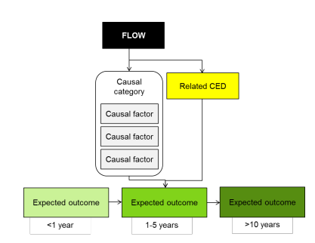

Figure 4‑1: Generic CED structure (MDFRC 2013)

Table 4‑3: Summary of objectives hierarchy, expected outcomes and generic CEDS developed for the broader LTIM project across the basin

| **Level 1**  **Objectives** | **Level 2**  **Objectives** | **Level 3**  **Objectives** | **Expected outcome (1-5 years)** | **Expected outcome (<1 year)** | **Relevant CED (shaded cells relevant to the Junction of Warrego and Darling rivers Selected Area)** |
| --- | --- | --- | --- | --- | --- |
| **Biodiversity** | Ecosystem diversity |  |  |  | Landscape Ecosystem Diversity |
| Species diversity |  | Within Ecosystem Diversity |
|  | Vegetation | Vegetation diversity |  | Landscape Vegetation Diversity |
|  | Reproduction  Condition | Vegetation Condition and  Reproduction |
| Growth and survival | Germination  Dispersal | Vegetation Recruitment and  Extent |
|  | Macro-invertebrates | Macroinvertebrate diversity |  | Within Ecosystem Macroinvertebrate Diversity |
|  | Fish | Fish diversity |  | Landscape Fish Diversity |
|  | Condition | Fish Condition |
|  | Larval abundance  Reproduction | Fish Reproduction |
| Larval and juvenile recruitment |  | Fish Larval Growth and Survival |
|  | Waterbirds | Waterbird diversity |  | Landscape Waterbird Diversity |
| Abundance  Population structure | Survival and condition | Waterbird Survival and Condition |
|  | Chicks | Waterbird Reproduction |
|  | Fledglings | Waterbird Recruitment and Fledging |
|  | Other vertebrate diversity |  | Young | Other Vertebrate Reproduction |
| Adult abundance |  | Other Vertebrate Growth and Survival |
| **Ecosystem**  **Function** | Connectivity |  |  | Biotic dispersal  Sediment transport  Nutrient and carbon cycling  Primary productivity  Decomposition | Hydrological Connectivity  (including end of system flows) |
|  | Movement | Biotic Dispersal |
|  | Sediment transport | Sediment Transport |
| Process |  |  | Primary productivity | Primary Production |
|  | Decomposition | Decomposition |
| Nutrient and carbon cycling |  | Nutrient and Carbon Cycling |
| **Resilience** | Ecosystem resilience |  | Population condition | Individual survival and condition | Individual Refuges |
| Population condition |  | Landscape Refuges |
|  | Individual condition | Ecosystem Resistance |
| Population condition |  | Ecosystem Recovery |
| **Water quality** | Chemical |  |  | Salinity | Salinity |
| Dissolved Oxygen | Dissolved Oxygen |
| pH | pH |
| Dissolved organic carbon | Dissolved Organic Carbon |
| Biological |  |  | Algal blooms | Algal Blooms |
| Reference Gawne et al. 2013a | | | | | |

# Monitoring and Evaluation Schedule

This monitoring schedule links the Basin-scale and Selected Area evaluation questions with study design, Standard Methods and Selected Area-specific methods, hypotheses and analytical approach, and where possible shows capacity to scale from site-based to Selected Area/ANAE typology levels.

Hypotheses and analyses included are generalised to address only the evaluation questions for each indicator, and are not exhaustive lists of potential hypotheses for each indicator and interactions among indicators.

Standard Operating Procedures (SOPs) for mandatory and high priority indicators are provided in .

## Monitoring zones

The Junction of the Warrego and Darling rivers Selected Area focuses on the reaches of the Warrego and Darling Rivers contained within the boundary of the Toorale National Park and Toorale State Conservation Area (c.f. Figure 2‑2). The monitoring zones have been selected using a hierarchical set of criteria:

* Does the reach have uniform hydro-geomorphic characteristics?
* Is the reach a target for CEWO water deliveries?
* Are there specific environmental assets targeted for the delivery of CEWO water via a watering option?
* Do the physical characteristics and infrastructure of reaches allow the discrete delivery of CEWO water?
* Does the reach contain an array of gauging stations (two or more) that permit the description of reach hydrology?

Using this set of criteria, three discrete monitoring zones were selected (Figure 5‑1):

* The Western Floodplain of the lower Warrego River
* The lower Warrego River channel extending from the northern boundary of the Toorale NP to its confluence with the Darling River, including Ross Billabong
* The Darling River from the eastern boundary of the Toorale NP to Weir 20A

These zones represent distinct and discrete regions of the Selected Area in terms of their geomorphology, hydrology, environmental assets, environmental targets and expected outcomes from Commonwealth environmental water. The delivery of Commonwealth environmental water to the monitoring zones relies on unregulated upstream entitlements during natural flow events. Thus, at this site, Commonwealth environmental water is water that remains in the system instead of being extracted. The largest influence of Commonwealth environmental water is on base flows and freshes up to 30,000 MLd-1 in the Darling River and infrastructure assisted overbank flows to the Warrego’s Western Floodplain.

Table 5‑1: Junction of the Warrego and Darling rivers Selected Area monitoring zones

|  |  |  |  |
| --- | --- | --- | --- |
| **Zone** | **Extent** | **Description** | **Potential target flow types for monitoring** |
| Western Floodplain | The Western Floodplain of the lower Warrego River from Boera Dam off take to the Darling River | A large floodplain surface heavily dissected by small flood runners. Floodwaters inundate this floodplain from overflows at Boera Dam. | Overbank – infrastructure assisted. |
| Warrego River | The lower Warrego River channel extending from the northern boundary of Toorale National Park to the junction with the Darling River, including Ross Billabong | A single meandering river that decreases in bankfull capacity downstream. Flows in this lower section of the Warrego River are controlled by a series of six in-channel structures, the lower of which (Peebles Dam) diverts water into Ross Billabong. | Base flows  Freshes up to 600 MLd-1 |
| Darling River | The Darling River from the eastern boundary of the Toorale National Park near Hells Gate to Weir 20A downstream of the western boundary of Toorale State Conservation Area. | A single meandering channel that has a bankfull height ranging 12-15 m. The bankfull channel is complex and there are a series of natural rock bars and a weir at the downstream end of the reach that influence flows along this section of the river. | Baseflows  Freshes:  1,000-5,000 MLd-1  5,000-10,000 MLd-1  10,000-30,000 MLd-1 |

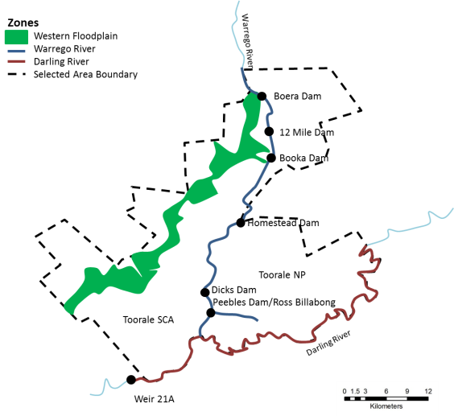

Figure 5‑1 Junction of the Warrego and Darling rivers Selected Area monitoring zones

## Monitoring Approach

The Monitoring and Evaluation Plan for the Junction of the Warrego and Darling rivers Selected Area has been designed to capture the variable nature of flow in the Selected Area and the relative contribution of Commonwealth environmental water from the Darling and Warrego Catchments. Due to the more persistent presence of water within the Darling River, Category I indicators have been targeted in this zone and will be measured predominantly through long term sensors deployed within the river channel. Given the relatively large proportion of Commonwealth environmental water in the Warrego System, the majority of the Category III indicators have been focused on the Warrego channel and Western Floodplain zones, as these zones provide the greatest potential to detect an ecological response from Commonwealth environmental water. Given the ephemeral nature of the Warrego flow regime, event-based monitoring of these indicators will be undertaken with sampling events scheduled before, during and after individual Commonwealth environmental water events when they occur. A total of three events will be sampled from years 2-5 of the project.

This plan was developed based on historical flow patterns, and the relative proportion of Commonwealth environmental water and related intervention outcomes likely in the system. However, given the highly variable nature of the system flows the plan may require reallocation of resources if extended dry conditions persist for the first two monitoring years. If this occurs we expect to work with CEWO and the M&E Advisors to reallocate resources to optimise monitoring outcomes in years 3-5.

## Category I indicators

### Monitoring schedule - Ecosystem Type

The SOP for Ecosystem Type is provided in Appendix B.1.

#### Basin-scale evaluation questions

Short-term (one-year) and long-term (five year) questions:

* What did Commonwealth environmental water contribute to sustainable ecosystem diversity?
* Were ecosystems to which Commonwealth environmental water was allocated sustained?
* Was Commonwealth environmental water delivered to a representative suite of ecosystem types?

#### Where

At all sites established for all indicators.

#### What

Validate all ANAE categories for all sites or assign an ecosystem type as per the standard methods. Noting the paucity of mapped ANAE data in the Junction of the Warrego and Darling rivers Selected Area it is likely that the majority of sites will fall outside of existing mapping.

#### When

Within 6 months of project commencement. Once only unless new sites are required due to unforeseen circumstances that arise during project operation.

#### How

As per the LTIM Project Standard Protocol: Section 2 Ecosystem Type (Hale *et al.* 2014). Existing high resolution imagery, Lidar DEM and fine-scale vegetation mapping will be used as key datasets to help define site polygons through a desk-top analysis. Field verification will then be undertaken to confirm initial classifications.

#### Linkages and indicator interactions

This indicator will help to validate the ANAE mapping.

#### Analytical approach

Aggregation: list of ecosystem diversity to ensure adequate and representative suite of ecosystems in the Junction of the Warrego and Darling rivers Selected Area.

Data will be reported following the requirements outlined in the LTIM Project Standard Protocol: Section 2 Ecosystem Type (Hale *et al.* 2014) and conform to the LTIM Project Data Standard (Brooks & Wealands 2014).

### Monitoring schedule - Hydrology (River)

The SOP for Hydrology (River) is provided in Appendix B.2.

#### Basin-scale and Selected Area evaluation questions

Long-term (five year) questions:

What did Commonwealth environmental water contribute to hydrological connectivity?

What did Commonwealth environmental water contribute to native fish species diversity?

What did Commonwealth environmental water contribute to fish community resilience?

Short-term (one year) questions:

What did Commonwealth environmental water contribute to native fish reproduction?

What did Commonwealth environmental water contribute to native larval fish growth and survival?

Short-term (one-year) and long-term (five year) questions:

What did Commonwealth environmental contribute to patterns and rates of primary productivity?

What did Commonwealth environmental water contribute to temperature regimes?

What did Commonwealth environmental water contribute to pH levels?

What did Commonwealth environmental water contribute to turbidity regimes?

What did Commonwealth environmental water contribute to salinity regimes?

What did Commonwealth environmental water contribute to dissolved oxygen levels?

What did Commonwealth environmental water contribute to algal suppression?

#### Where

Hydrology (River) will assess hydrology across the entire Selected Area. Long-term gauging stations operated by NSW Office of Water (NOW) are located in the Warrego River upstream of the Selected Area at Fords Bridge on the Warrego, and also at Boera Dam at the northern end of the Selected Area. There are also three gauging stations on the Darling River at Bourke, Weir 19A and Louth (Table 5‑2; Figure 5‑2).

Table 5‑2: NSW Office of Water Gauges and the zones to which they relate.

|  |  |  |  |  |  |
| --- | --- | --- | --- | --- | --- |
| **Zone** | **NOW Gauge Number** | **Gauge name** | **Latitude** | **Longitude** | **Datum** |
| B | 423001 | Warrego @ Fords Bridge | −29.7526 | 145.4276 | GDA94 |
| B | 423002 | Warrego @ Fords Bywash | −29.7568 | 145.4408 | GDA94 |
| B | 423008 | Warrego @ Boera Dam | −30.09945 | 145.4278 | GDA94 |
| C | 425003 | Darling @ Bourke Town | −30.0861 | 145.9387 | GDA94 |
| C | 425037 | Darling @ D/S Weir 19A | −30.2326 | 145.6957 | GDA94 |
| C | 425004 | Darling @ Louth | −30.5347 | 145.1150 | GDA94 |

At present there are also a number of water level sensors that have been placed along the Western Floodplain and the Darling River within the Selected Area that are being maintained by NOW staff (Neal Foster; Figure 5‑2; Table 5‑3)

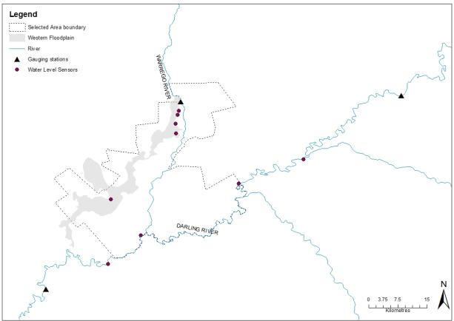

Figure 5‑2. NOW gauging stations and water level recorders in the vicinity of the Selected Area

Table 5‑3 Locations of water level recorders within the Selected Area

|  |  |  |  |  |
| --- | --- | --- | --- | --- |
| **Zone** | **Water sensor location** | **Latitude** | **Longitude** | **Datum** |
| Western Floodplain | Site 1 WF | -30.1210 | 145.4229 | GDA94 |
| Site 2 WF | -30.1311 | 145.4204 | GDA94 |
| Site 3 WF | -30.1513 | 145.4158 | GDA94 |
| Site 4 WF | -30.1737 | 145.4163 | GDA94 |
| Site 5 WF | -30.3268 | 145.2650 | GDA94 |
| Darling River | Weir 19A | -30.2335 | 145.7119 | GDA94 |
| Hells Gate | -30.2901 | 145.5616 | GDA94 |
| Acuna Homestead | -30.4098 | 145.3345 | GDA94 |
| Weir 20A | -30.4764 | 145.2593 | GDA94 |

#### What

Sourcing and analysis of hydrological data to understand the system hydrology and character of Commonwealth environmental water entering the site. This indicator assists with understanding hydrological connectivity and duration, and is linked to several other indicators.

#### When

On-going for the duration of the project.

#### How

No new gauging stations are to be established. This indicator will require only the standard analysis of system hydrology.

#### Linkages and indicator interactions

This indicator links to Vegetation Diversity, Hydrology (Northern tributaries and Seleted Area), Fish (Channel), Water Quality, Stream Metabolism, Microcrustaceans and Frog indicators.

#### Analytical approach

This indicator will be used to provide context for a number of other indictors. See individual indicators for short- and long-term hypotheses and analyses.

Data will be managed following the requirements outlined in the LTIM Project Standard Protocol: Section 14 Hydrology (River) (Hale *et al.* 2014) and conform to the LTIM Project Data Standard (Brooks & Wealands 2014).

### 

### Monitoring schedule - Water Quality

The SOP for Water Quality is provided in Appendix B.3.

#### Selected Area evaluation questions

Short-term (one-year) and long-term (five year) questions:

What did Commonwealth environmental water contribute to temperature regimes?

What did Commonwealth environmental water contribute to pH levels?

What did Commonwealth environmental water contribute to turbidity regimes?

What did Commonwealth environmental water contribute to salinity regimes?

What did Commonwealth environmental water contribute to dissolved oxygen levels?

What did Commonwealth environmental water contribute to algal suppression?

#### Where

Category I Water quality will be conducted in the Darling River zone at two locations - near the ‘Yanda’ homestead (-30.34906, 145.57685) and near the ‘Akuna’ homestead (-30.40978, 145.33438; Figure 5‑3). These are sites representative of the zone and were selected due to their proximity to NPWS residences to allow for ease of access for probe cleaning (and water chemistry sample collection). The Akuna site is located downstream of the Warrego confluence and can be used to assess the influence of Warrego River flow to the water chemistry of the Darling River. Their location will also allow weekly monitoring of the stations by NPWS staff to minimise vandalism.

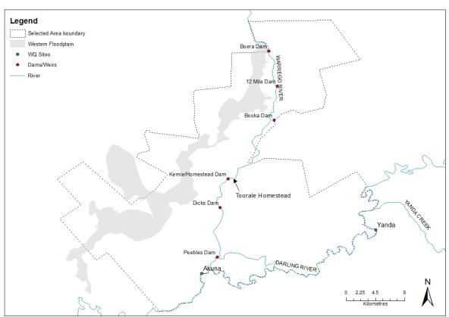

Figure 5‑3 Location of Water quality sensors and sampling sites

#### What

For category I Water Quality, *in situ* logging of DO, temperature, EC, pH, turbidity and chlorophyll *a* (10 min intervals) at each location will be carried out using a Hydrolab DS5-X logger. The DS5-X multi-probe logger includes a self-cleaning system to reduce fouling of probes and is designed for long-term submersible deployment.

#### When

Loggers will be deployed continuously at Category I sites in the Darling River as they have permanent surface water flow.

#### How

The design, equipment, collection and processing of data, reporting and QA requirements for Category I Water Quality follow the LTIM Project Standard Protocol: Section 13 Water Quality (Hale et al. 2014). Water Quality will be determined by the placement of two DS5-X loggers in the Darling River where permanent surface water is present.

#### Linkages and indicator interactions

This indicator links to Fish (Channel), Stream Metabolism, Waterbird diversity, Microcrustaceans, Frogs, and Hydrology (River, Northern tributaries, Channel and Habitat) indicators.

#### Selected Area scale hypotheses

Short-term and long-term responses

1. Mean daily water temperature, and daily range in water temperature will decrease during the delivery of Commonwealth environmental water.
2. Mean daily pH, and daily range in pH will decrease during the delivery of Commonwealth environmental water.
3. Mean daily turbidity will increase during the delivery of Commonwealth environmental water.
4. Mean daily EC will decrease during the delivery of Commonwealth environmental water.
5. Mean daily DO concentrations will decrease during the delivery of Commonwealth environmental water.
6. Mean daily algal concentrations will decrease during the delivery of Commonwealth environmental water.

#### Approach to Selected Area scale analyses

Quantitative analyses will be applied at the Selected Area scale to test predicted changes in each water quality variable. Multi-year analyses will be quantitatively assessed based on year-on-year repeat application of annual models outlined in the Selected Area conceptual model ().

Short-term and long term responses

1. Hypotheses 1-6. Replication derived from randomised daily means of data periods within/outside delivery of Commonwealth environmental water. One-way Anova (WQ variables as dependant variable) comparing among flow periods, and two-way Anova (flow period, years) for long term dataset.

### Monitoring schedule – Stream Metabolism

The SOP for Stream Metabolism is provided in Appendix B.4.

#### Basin and Selected Area scale evaluation questions

Short-term (one-year) and long-term (five year) questions:

What did Commonwealth environmental water contribute to patterns and rates of decomposition?

What did Commonwealth environmental water contribute to patterns and rates of primary productivity?

#### Where

Category I Stream metabolism will be measured at two locations in the Darling River Zone using Hydroloab DS5-X loggers in combination with the Water quality indicator (Figure 5‑4). A weather station measuring light (PAR) and barometric pressure will be established at the Toorale Homestead within the Selected Area (Figure 5‑4).

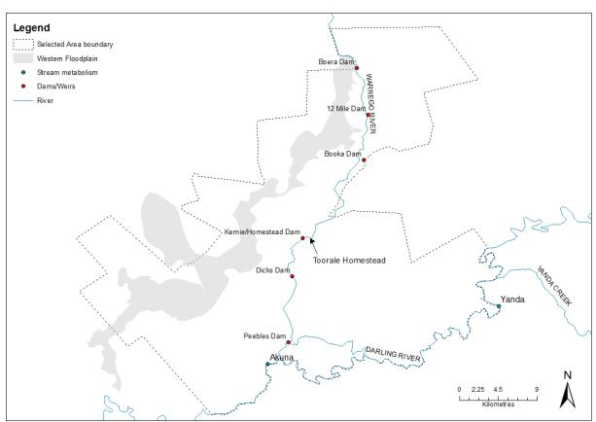

Figure 5‑4 Stream Metabolism sites

#### What

*In situ* continuous monitoring stations for temperature and dissolved oxygen (DO) deployed for the duration of the 5-year monitoring program. In addition, approximately 6-weekly collection of water samples for total nitrogen (TN), total phosphorus (TP), nitrate-nitrite (NOx), ammonium (NH4), filterable reactive phosphorus (FRP) and dissolved organic carbon (DOC).

#### When

Temperature and DO will be logged continuously at 10 minute intervals. PAR and Barometric pressure will be logged at 10 minute intervals throughout the 5 year period as required for Category 1 metabolism. Water quality samples will be collected at approximately 6 weekly periods.

#### How

Category I Metabolism will follow the standard methods outlined in Hale et al. 2013 and collected using continuously submerged Hydrolab DS5-X loggers (10-minute intervals) at two locations on the Darling River with water chemistry samples collected on a 6-weekly basis. Water samples will be processed in the NSW Office of Water NATA accredited laboratories.

#### Linkages and indicator interactions

This indicator links to Hydrology (River and Habitat), Water Quality, and Fish (Channel) indicators.

#### Basin and Selected Area scale hypotheses

Short-term and long-term responses

1. Mean daily DO concentrations will decrease during the delivery of Commonwealth environmental water compared with pre-water delivery concentrations.
2. Concentrations of TN, TP, NOx, NH4, FPR and DOC will decrease during the delivery of Commonwealth environmental water compared with pre-water delivery concentrations.
3. Rates of decomposition will increase with the delivery of Commonwealth environmental water compared with pre-water delivery rates.
4. Rates of primary productivity will decrease with the delivery of Commonwealth environmental water compared with pre-water delivery rates.

#### Approach to Selected Area scale analyses

Quantitative analyses will be applied at the Selected Area scale to test predicted changes in Dissolved Oxygen, nutrients, decomposition and primary productivity. Multi-year analyses will be quantitatively assessed based on year-on-year repeat application of annual models outlined in the Selected Area conceptual model ().

Short-term and long term responses

1. Hypotheses 1-4. Replication derived from randomised daily means of data periods within/outside delivery of Commonwealth environmental water (Basin scale) and pre-, during- and post-delivery for event-based sampling (Selected Area scale). One-way Anova (GPP, ER, NPP, water chemistry as dependant variables) comparing among flow periods, and two-way Anova (flow period, years) for long term dataset for Basin scale assessment. Selected Area scale assessment will be determined by one-way Anova comparing among flow periods (pre-, during- and post-flow delivery), and two-way Anova (flow period, years) for long term dataset.

### Monitoring schedule – Vegetation Diversity

The SOP for Vegetation Diversity is provided in Appendix B.5.

#### Selected Area evaluation questions

Short-term (one-year) and long-term (five year) questions:

What did Commonwealth environmental water contribute to vegetation species diversity?

What did Commonwealth environmental water contribute to vegetation community diversity?

#### Where

In targeted wetland communities within the Western Floodplain zone (Figure 5‑5). Sites will be concentrated in the northern areas of the Western Floodplain as these areas represent the sites most likely to be influenced by Commonwealth environmental water. Sites selection will be based on both wetland vegetation community and flooding frequency.

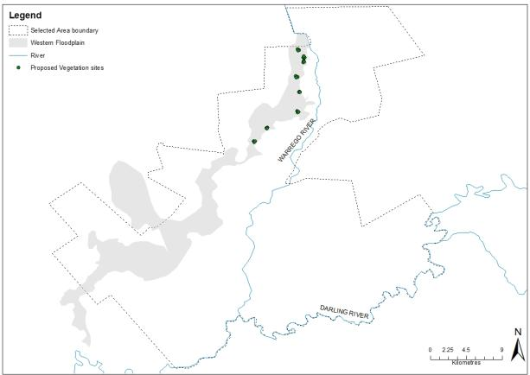

Figure 5‑5: Vegetation Diversity Sites

#### What

Survey and analysis for vegetation diversity responses to inundation.

#### When

Twice annually before and after the watering season: August-October and March-June.

#### How

Survey methods conform to with the Standard Methods as a Category II indicator (Hale et al. 2014).

Surveys will target 8 monitoring sites that incorporate Coolibah - River Cooba - Lignum woodlands, Coolibah open woodlands, Lignum shrublands and Chenopod low open shrublands in the Western Floodplain. These sites have been established to directly target zones where environmental watering is likely to be delivered. At each site, three 20 x 20m plots will be sampled. The 0.04ha plot size is standard for surveying floristics (Sivertsen 2009) and is consistent with previous vegetation monitoring within the Selected Area (Gowans et al. 2012). At each site, measures of species abundance, structure, tree recruitment and site flooding will be measured. Projected foliage cover will be used to define cover (Hale et al.2014).

#### Linkages and indicator interactions

This indicator links to Microcrustacean and Hydrology (Floodplain) indicators.

#### Selected Area scale hypotheses

Short-term (Annual) responses:

1. The delivery of Commonwealth environmental water to wetland and floodplain areas in the Western Floodplain will lead to increased cover and/or richness of wetland vegetation communities.

Long-term (5 year) responses:

1. The delivery of Commonwealth environmental water to wetland and floodplain areas in the Western Floodplain and will lead to increased year-on-year cover and/or richness of wetland vegetation communities.

#### Approach to Selected Area scale analyses

Analyses based on Aggregation will be applied at the Basin and Selected Area scales for cover and richness of wetland vegetation communities. Quantitative analysis will be applied at the Selected Area scale to document increased cover and richness of wetland vegetation communities at sites receiving Commonwealth environmental water. Multi-year analyses will be quantitatively assessed based on year-on-year repeat application of annual models outlined in the Selected Area conceptual model (). The placement of survey sites will be strategically undertaken to permit quantification of the hydrologic connection and inundation metrics and lead to reduced uncertainty in the delivery of Commonwealth water to these sites.

Short-term (Annual) responses:

1. Hypotheses 1 - univariate analysis (main effect – location, inundation, time) cover and richness and multivariate analysis (factors – location, inundation history, time).

Long-term (5 year) responses:

1. Hypotheses 2 - univariate analysis (main effects – location, inundation history, year, time) and multivariate analysis (factors – location, inundation history, year, time).

#### Selected Area scaling

Each wetland community within the Western Floodplain has been mapped at a fine spatial scale. Linking wetland vegetation community extent to Commonwealth environmental water inundation extent should permit extrapolation to the Selected Area scale. The proposed indicator Hydrology (Floodplain) will document the m2 of inundated ANAE and vegetation hydrology and will facilitate the extrapolation.

## Category III indicators

### Monitoring schedule - Hydrology (Northern tributaries)

The SOP for Hydrology (Northern tributaries) is provided in Appendix B.6.

#### Basin-scale and Selected Area evaluation questions

Short-term (one-year) and long-term (five year) questions:

What did Commonwealth environmental water from upstream tributaries contribute to hydrological connectivity within the Selected Area?

#### Where

The Hydrology (Northern tributaries) indicator will use NOW gauges located in upstream tributaries which best reflect the contribution of each tributary to flows entering the Selected Area (Figure 5‑6;Table 5‑4).

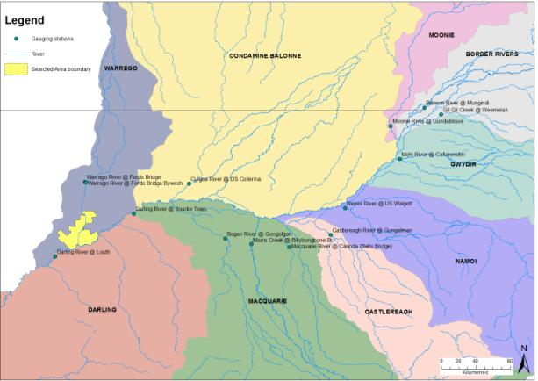

Figure 5‑6 NOW gauging stations used for the Category III Hydrology (River) indicator

Table 5‑4 NOW gauging stations within upstream catchments.

| **Gauge no.** | **Gauge Name** | **Catchment** | **Latitude** | **Longitude** |
| --- | --- | --- | --- | --- |
| 416001 | Barwon River @ Mungindi | Border Rivers | -28.9762 | 148.9848 |
| 417001 | Moonie River @ Gundablouie | Moonie | -29.1671 | 148.6305 |
| 416027 | Gil Gil Creek @ Weemelah | Gwydir | -29.0488 | 149.1599 |
| 418055 | Mehi River @ Collarenebri | Gwydir | -29.5130 | 148.7241 |
| 419091 | Namoi River @ US Walgett | Namoi | -30.0279 | 148.1529 |
| 420020 | Castlereagh River @ Gungalman | Castlereagh | -30.3088 | 147.9999 |
| 421012 | Macquarie River @ Carinda (Bells Bridge) | Macquarie | -30.4347 | 147.5696 |
| 421107 | Marra Creek @ Billybongbone Br | Macquarie | -30.4032 | 147.1710 |
| 421023 | Bogan River @ Gongolgon | Bogan | -30.3472 | 146.8978 |
| 422006 | Culgoa River @ DS Collerina | Condamine Balonne | -29.7735 | 146.5179 |
| 423001 | Warrego River @ Fords Bridge | Warrego | -29.7526 | 145.4276 |
| 423002 | Warrego River @ Fords Bridge Bywash | Warrego | -29.7568 | 145.4408 |
| 425003 | Darling River @ Bourke Town | Darling | -30.0861 | 145.9387 |
| 425004 | Darling River @ Louth | Darling | -30.5347 | 145.1151 |

#### What

This indicator will provide a better understanding of the contributions of Commonwealth environmental water from upstream tributaries to the Darling River reaches of the Selected Area, by establishing a working model of these inputs. This will provide a broader understanding of the contributions of commonwealth environmental water in the Northern Basin. In addition, this indicator will assist with understanding hydrological connectivity and duration for several other indicators.

#### When

On-going for the duration of the project.

#### How

No new gauging stations are to be established. This indicator will require only the standard analysis of system hydrology.

#### Linkages and indicator interactions

This indicator links to Hydrology (River, Channel and Habitat), Metabolism and Water Quality indicators.

#### Selected Area scale hypotheses

Long-term responses

1. Commonwealth environmental water from upstream tributaries will make up the largest proportion of flows during times of low flow within the Selected Area.

#### Analytical approach

Standard hydrological analyses will be used to determine relationships between end-of-system Commonwealth environmental water flows from upstream tributaries and flows entering the Selected Area. These relationships will inform a basic working hydrological model of upstream inputs of Commonwealth environmental water from upstream tributaries to the Selected Area. This indicator will also provide context for a number of other indictors. See individual indicators for short- and long-term hypotheses and analyses.

### Monitoring schedule - Hydrology (Floodplain)

The SOP for Hydrology (Floodplain) is provided in Appendix B.7.

#### Basin-scale and Selected Area evaluation questions

Short-term (one-year) and long-term (five year) questions:

What did Commonwealth environmental water contribute to hydrological connectivity of the Western Floodplain?

What did Commonwealth environmental water contribute to Microcrustacean productivity?

What did Commonwealth environmental water contribute to Microcrustacean community composition?

What did Commonwealth environmental water contribute to vegetation diversity?

#### Where

In the Western Floodplain zone (Figure 5‑7).

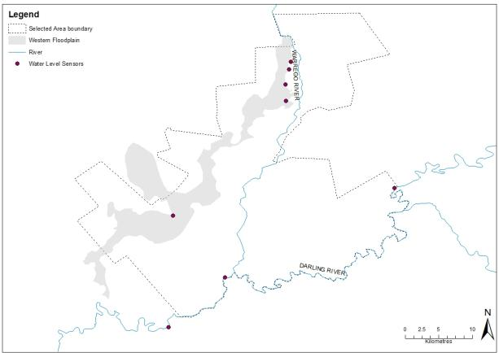

Figure 5‑7 Location of Western Floodplain and water sensors

#### What

Map the inundation extent and frequency resulting from the delivery of Commonwealth environmental watering using Lidar imaging, existing water level sensors on the floodplain and previous inundation mapping.

Other data on inundation extent and frequency from previous and ongoing work from OEH (Steven Cox, Rachel Thomas et al.), Lidar captures and hydrodynamic modelling from OEH will be used to assist in developing the known and expected inundation extent and volume from given flow events.

#### When

On-going for the duration of the project.

#### How

Lidar images and previous inundation mapping will be used to create an inundation model tied to flow/volume data from the nearest gauge.

The inundation layers will be used in conjunction with other locally established gauges to develop location specific knowledge relating flow volume to inundation.

#### Linkages and indicator interactions

This indicator links to Vegetation Diversity, Hydrology (River and channel), Metabolism (Cat III) and Microcrustaceans indicators.

#### Selected Area scale hypotheses

Short and long-term responses

1. Inundation extent and duration on the Western Floodplain will increase with Commonwealth environmental water.

#### Analytical approach

GIS based analysis to determine the relationship between inundation event (volume) and inundated area and volume in relation to mapped soil and vegetation regions.

### Monitoring schedule - Hydrology (Channel)

The SOP for Hydrology (Channel) is provided in Appendix B.8.

#### Basin-scale and Selected Area evaluation questions

Short-term (one-year) questions:

What did Commonwealth environmental water contribute to native fish community resilience?

What did Commonwealth environmental water contribute to native fish survival?

Long-term (five-year) questions:

What did Commonwealth environmental water contribute to native fish populations?

What did Commonwealth environmental water contribute to native fish diversity?

What did Commonwealth environmental water contribute to other vertebrate community resilience?

What did Commonwealth environmental water contribute to other vertebrate species diversity?

Short-term (one-year) and long-term (five year) questions:

What did Commonwealth environmental water contribute to hydrological connectivity along the Warrego River channel?

What did Commonwealth environmental contribute to patterns and rates of decomposition and primary productivity?

What did Commonwealth environmental water contribute to temperature regimes?

What did Commonwealth environmental water contribute to pH levels?

What did Commonwealth environmental water contribute to turbidity regimes?

What did Commonwealth environmental water contribute to salinity regimes?

What did Commonwealth environmental water contribute to dissolved oxygen levels?

What did Commonwealth environmental water contribute to other vertebrate condition?

What did Commonwealth environmental water contribute to other vertebrate reproduction?

#### Where

Hydrology (channel) will assess hydrology within the Warrego River zone. Long-term gauging stations operated by NSW Office of Water (NOW) are located in the Warrego River upstream of the Selected Area at Fords Bridge, and also at Boera Dam at the northern end of the Selected Area. (Table 5‑2; Figure 5‑2). Additional loggers within this zone will facilitate stage discharge information downstream to the Darling confluence.

#### What

This component will provide a better understanding of the connectivity of the channel and dams along the Warrego River within the Selected Area. This component will assist with understanding hydrological connectivity and duration for several other indicators.

#### When

On-going for the duration of the project.

#### How

This component will involve combining known and measured key flow restrictions (culverts, breached dams etc.) along the Warrego Channel, with current and past hydrological data to build a model of flow connectivity within this zone of the Selected Area. This will be done using both existing information of flow restrictions with additional surveying and depth loggers if required. These critical levels will be linked to both gauges within the Selected Area (Boera Dam) and also upstream (Fords Bridge).

#### Linkages and indicator interactions

This indicator links to Hydrology (River), Fish (Channel), Water Quality, Metabolism (Cat III) Microcrustaceans and Frog indicators.

#### Selected Area scale hypotheses

Short and long-term responses

1. Longitudinal connectivity down the Warrego River channel will increase with Commonwealth environmental water.

#### Analytical approach

Data gained from this indicator will be linked to hydrological data obtained through the Hydrology (River, Floodplain and Habitat) indicators through a working model, to assess the additional influence of Commonwealth environmental water on connectivity of various habitats within the Selected Area. In this way we will be able to determine the additional connectivity provided by Commonwealth environmental water.

### Monitoring schedule - Hydrology (Habitat)

The SOP for Hydrology (Selected Area) is provided in Appendix B.9.

#### Basin-scale and Selected Area evaluation questions

Short-term (one-year) and long-term (five year) questions:

What did Commonwealth environmental water contribute to in-channel habitat availability along the Darling River?

What did Commonwealth environmental contribute to patterns and rates of primary productivity?

What did Commonwealth environmental water contribute to salinity regimes?

What did Commonwealth environmental water contribute to dissolved oxygen levels?

What did Commonwealth environmental water contribute to algal suppression?

#### Where

Hydrology (habitat) will assess the degree of in-channel habitat connectivity within the Darling River zone. Long-term gauging stations operated by NSW Office of Water (NOW) are located on the Darling River at Bourke, Weir 19A and Louth (Table 5‑2; Figure 5‑2).

At present there are also a number of water level sensors that have been placed along the the Darling River within the Selected Area that are being maintained by NOW staff (Neal Foster; Figure 5‑2; Table 5‑3)

#### What

Hydrology (Habitat) will assess the connectivity of in-channel habitats including benches, anabranches and large wood along the Darling channel. This will provide a reach scale picture of connectivity and habitat availability along the Darling River within the Selected Area.

#### When

On-going for the duration of the project. Mapping of in-channel habitats within the Darling River zone to be undertaken during year 1 of the project.

#### How

A field based survey of in-channel benches and large wood will be undertaken in the Darling River zone and the number, area and inundation height calculated for each habitat type following methods outlined in Boys (2007) and Southwell (2008). This will be verified using Lidar Imagery, and existing cross sectional information where possible. Anabranch commence-to–flow heights will also be established through field survey.

This information will be combined with current flow data to establish the connectivity and availability of different in channel habitats, and the influence of Commonwealth environmental water.

#### Linkages and indicator interactions

This indicator links to Hydrology (River and Northern tributaries), Water Quality, and Stream Metabolism indicators.

#### Selected Area scale hypotheses

Short and long-term responses

1. Connectivity of anabranch channel along the Darling River will increase with Commonwealth environmental water.
2. Inundation of in-channel benches along the Darling River will increase with Commonwealth environmental water.
3. Availability of large wood in the channel of the Darling River will increase with Commonwealth environmental water.

#### Analytical approach

Data gained from this indicator will be linked to hydrological data obtained through the Hydrology (River, Northern tributaries and Floodplain) indicators through a working model, to assess the additional influence of Commonwealth environmental water on connectivity of various habitats within the Selected Area. In this way we will be able to determine the additional connectivity provided by Commonwealth environmental water.

### Monitoring schedule - Water Quality

The SOP for Water Quality is provided in Appendix B.10.

#### Selected Area evaluation questions

Short-term (one-year) and long-term (five year) questions:

What did Commonwealth environmental water contribute to temperature regimes?

What did Commonwealth environmental water contribute to pH levels?

What did Commonwealth environmental water contribute to turbidity regimes?

What did Commonwealth environmental water contribute to salinity regimes?

What did Commonwealth environmental water contribute to dissolved oxygen levels?

#### Where

Category III Water Quality will be conducted along the Warrego River zone. Sampling will take place in three dams along the lower Warrego River; Boera Dam, Booka Dam and Peebles Dam/Ross Billabong (Figure 5‑8). These locations represent the largest and most permanent refuges in this system, and will be the focus of many of the Category III indicators.

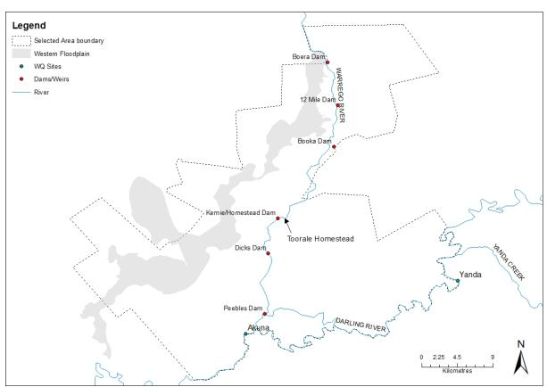

Figure 5‑8 Location of Water quality sensors and sampling sites

#### What

Water quality will be sampled at regular intervals throughout flow events (pre-, during- and post-flow), from the locations described above. Temperature-PAR loggers will be installed at each of the three dams to monitor light and temperature stratification throughout the delivery of Commonwealth environmental water.

#### When

Deployment periods for Category III Water Quality will align with the commencement and cessation of Commonwealth environmental water delivery in the Warrego River channel and Western Floodplain zones.

Samples will be collected twice during year 1 of the project and then before, during and after three flow events down the Warrego River system over the remaining four years of the project.

#### How

Where surface water is only present following events, a Hydrolab Quanta multi-probe will be used to characterise the water quality at each site in the Warrego River and Western Floodplain. Hobo PAR-temperature loggers will be placed in each of the three sites (dams) on the Warrego River at 0.5m depth intervals to characterise the vertical light and temperature regime throughout flow events.

#### Linkages and indicator interactions

This indicator links to Fish (Channel), Stream Metabolism, Waterbird diversity, Microcrustaceans, Frogs, and Hydrology (River, Floodplain and channel) indicators.

#### Selected Area scale hypotheses

Short-term and long-term responses

1. Mean daily water temperature, and daily range in water temperature will decrease during the delivery of Commonwealth environmental water.
2. Mean daily pH, and daily range in pH will decrease during the delivery of Commonwealth environmental water.
3. Mean daily turbidity will increase during the delivery of Commonwealth environmental water.
4. Mean daily EC will decrease during the delivery of Commonwealth environmental water.
5. Mean daily DO concentrations will decrease during the delivery of Commonwealth environmental water.

#### Approach to Selected Area scale analyses

Quantitative analyses will be applied at the Selected Area scale to test predicted changes in each water quality variable. Multi-year analyses will be quantitatively assessed based on year-on-year repeat application of annual models outlined in the Selected Area conceptual model ().

Short-term and long term responses

1. Hypotheses 1, 2, 3, 4 and 5. Replication derived from randomised daily means of data periods within/outside delivery of Commonwealth environmental water. One-way Anova (WQ variables as dependant variable) comparing among flow periods, and two-way Anova (flow period, years) for long term dataset.

### Monitoring schedule – Stream Metabolism

The SOP for Stream Metabolism is provided in Appendix B.11.

#### Basin and Selected Area scale evaluation questions

Short-term (one-year) and long-term (five year) questions:

What did Commonwealth environmental water contribute to patterns and rates of decomposition?

What did Commonwealth environmental water contribute to patterns and rates of primary productivity?

#### Where

Category III Stream Metabolism will be carried out at three locations within each of the Warrego River and Western Floodplain zones. In the Warrego River, D-Opto loggers will be placed in Boera Dam, Booka Dam, and Peebles Dam, and in inundated floodplain areas witihin the Western Floodplain to align with Vegetation Diversity sampling locations that have annual inundation patterns (Figure 5‑9). A weather station measuring light (PAR) and barometric pressure will be established at the Toorale Homestead within the Selected Area (Figure 5‑9).

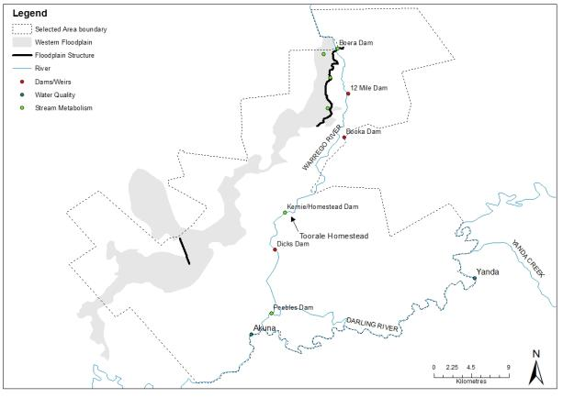

Figure 5‑9 Stream Metabolism sites

#### What

Event-based collection of water samples for total nitrogen (TN), total phosphorus (TP), nitrate-nitrite (NOx), ammonium (NH4), filterable reactive phosphorus (FRP) and dissolved organic carbon (DOC) at Warrego River and Western Floodplain sites. *In situ* spot measurements will be taken for pH, temperature, turbidity and electrical conductivity (EC) at Category III sites during event-based sampling.

#### When

PAR and Barometric pressure will be logged at 10 minute intervals throughout the 5 year period as required for Category I and III metabolism. Event-based sampling for Category III Metabolism is based on the design of 3 sampling periods; pre-, during- and post-event. Logging of DO and temperature at each of the inundated Category III sites will be for a minimum 48h incubation to capture two complete diurnal cycles for each of the 3 sampling periods. Water quality samples will be collected at the commencement and completion of incubations of each sampling period at Category III sites in the Warrego River and Western Floodplain.

#### How

Category III Metabolism will follow the standard methods outlined in Hale et al. 2013 through periodic deployment of D-Opto DO loggers for a minimum of 48h incubations (10 minute intervals), with water chemistry collected at the commencement and completion of each incubation period. Water samples will be processed in the NSW Office of Water NATA accredited laboratories.

#### Linkages and indicator interactions

This indicator links to Hydrology (River, Floodplain and Channel), Water Quality, Fish (Channel), and Microcrustaceans indicators.

#### Basin and Selected Area scale hypotheses

Short-term and long-term responses

1. Mean daily DO concentrations will decrease during the delivery of Commonwealth environmental water compared with pre-water delivery concentrations.
2. Concentrations of TN, TP, NOx, NH4, FPR and DOC will decrease during the delivery of Commonwealth environmental water compared with pre-water delivery concentrations.
3. Rates of decomposition will increase with the delivery of Commonwealth environmental water compared with pre-water delivery rates.
4. Rates of primary productivity will decrease with the delivery of Commonwealth environmental water compared with pre-water delivery rates.

#### Approach to Selected Area scale analyses

Quantitative analyses will be applied at the Selected Area scale to test predicted changes in Dissolved Oxygen, nutrients, decomposition and primary productivity. Multi-year analyses will be quantitatively assessed based on year-on-year repeat application of annual models outlined in the Selected Area conceptual model ().

Short-term and long term responses

1. Hypotheses 1-4. Replication derived from randomised daily means of data periods within/outside delivery of Commonwealth environmental water (Basin scale) and pre-, during- and post-delivery for event-based sampling (Selected Area scale). One-way Anova (GPP, ER, NPP, water chemistry as dependant variables) comparing among flow periods, and two-way Anova (flow period, years) for long term dataset for Basin scale assessment. Selected Area scale assessment will be determined by one-way Anova comparing among flow periods (pre-, during- and post-flow delivery), and two-way Anova (flow period, years) for long term dataset.

### Monitoring schedule - Fish (Channel)

The SOP for River (Fish) is provided in Appendix B.12.

#### Basin-scale and Selected Area evaluation questions

Short-term (one-year) questions:

What did Commonwealth environmental water contribute to native fish community resilience?

What did Commonwealth environmental water contribute to native fish survival?

Long-term (five-year) questions:

What did Commonwealth environmental water contribute to native fish populations?

What did Commonwealth environmental water contribute to native fish diversity?

#### Where

The overall design for the Fish (Channel) indicator has been structured to provide Selected Area specific information. This indicator will be sampled in 5-7 locations in pools behind structures in the Warrego River zone and at the junction with the Darling as these provide the most permanent refugia within this zone (Figure 5‑10).

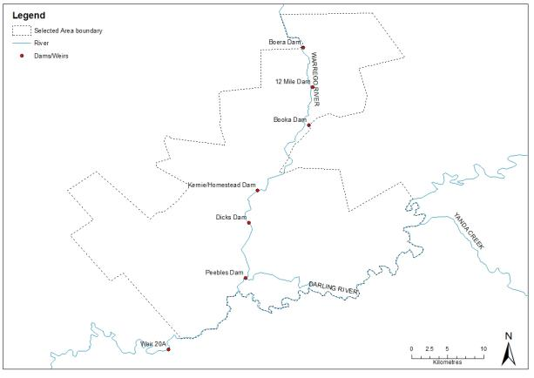

Figure 5‑10 Location of Dams and weirs within the Junction of the Warrego and Darling Selected Area

#### What

Both small and large bodied fish will be assessed using Sustainable Rivers Audit (SRA) protocols (Davies et al. 2010). Fish will be sampled using a combination of boat electrofishing (12 x 90 second shots) un-baited bait traps and Fyke nets. All fish will be identified, counted, measured and weighed (maximum of 50 individuals per species per electrofishing shot).

Fisheries NSW will be contracted to undertake Fish (Channel) monitoring.

#### When

Three events in years 2-5 of the monitoring program, with 2 samples (pre- and post-flow) per event.

#### How

Using Sustainable Rivers Audit (SRA) protocols (Davies et al. 2010). Fish will be sampled using a combination of boat electrofishing (12 x 90 second shots), un-baited bait traps, and fyke nets.

#### Linkages and indicator interactions

This indicator links to Hydrology (River and Channel), Water Quality, Metabolism (Cat I and III) and Microcrustaceans indicators.

#### Selected Area scale hypotheses

Short-term (Annual) responses:

1. SRA metrics “Expectedness”, “Nativeness”, and “Recruitment” of native fish communities will increase over a flow event as a result of Commonwealth environmental water.
2. The relative abundance of ‘young of year’ fish will increase over a flow event as a result of Commonwealth environmental water.
3. Evidence of fish spawning will be detected after each flow event sampled as a result of Commonwealth environmental water.

Long-term (5 year) responses

1. SRA metrics “Expectedness”, “Nativeness”, and “Recruitment” of native fish communities will increase year-on year as a result of Commonwealth environmental water.

#### Approach to Selected Area scale analyses

Analyses based on Aggregation will be applied at the Selected Area scale for taxonomic diversity and richness. Additionally, the fish community data will be summarised using the three main SRA Indicators 1) “Expectedness” (a comparison of the existing catch composition with that of historical fish distributions), 2) “Nativeness” (the proportion of native versus alien fishes), and 3) “Recruitment” (the recent reproductive activity of the native fish community). Quantitative analyses will then be applied at the Selected Area scale based on annual watering and a counterfactual approach based on an historical ‘reference’ condition represented by a pre-European fish assemblage (developed by Fisheries NSW). Multi-year analyses will be quantitatively analysed based on year-on-year repeat application of annual models outlined in the Selected Area conceptual model (Figure 5‑13), and a time-lagged trajectory to a pre-defined condition (Figure 5‑14). Uncertainty propagation within and among years will be possible to quantify based on annual comparisons of sites receiving Commonwealth environmental water compared with those sites not watered.

Short-term (Annual) responses:

1. Hypotheses 1, 2 and 3 – Univariate analysis (e.g. ANOVA - main effect - sampling time) for all taxa, each target taxa, each life history guild, taxa reference richness/diversity.
2. Hypotheses 2 - (diversity-abundance) multivariate analysis (e.g. Permanova, MDS, PCA - factors – sampling time, target taxa, life history guilds, native/exotic, taxa reference composition).

Long-term (5 year) responses:

1. Hypotheses 4, – Univariate analysis (main effects – sampling time, years) for all taxa, each target taxa, each life history guild, taxa reference richness/diversity.

### Monitoring schedule – Microcrustaceans

The SOP for Microcrustaceans is provided in Appendix B.13.

#### Selected Area evaluation questions

Short-term (one-year) and long-term (five year) questions:

What did Commonwealth environmental water contribute to microcrustacean productivity?

What did Commonwealth environmental water contribute to microcrustacean community composition?

What did Commonwealth environmental water contribute to connectivity of microcrustacean and vegetation communities in floodplain watercourses?

#### Where

Monitoring sites for microcrustaceans will be located in the Warrego River and Western Floodplain zones. The application of standard methods to these target areas provides potential for Basin-scale evaluation and comparisons with other Selected Areas.

Three locations within the Warrego River zone will be sampled for microcrustaceans using the river channel sampling protocol. This will occur in Boera Dam, Booka Dam and Peebles Dam/Ross Billabong (Figure 5‑11).

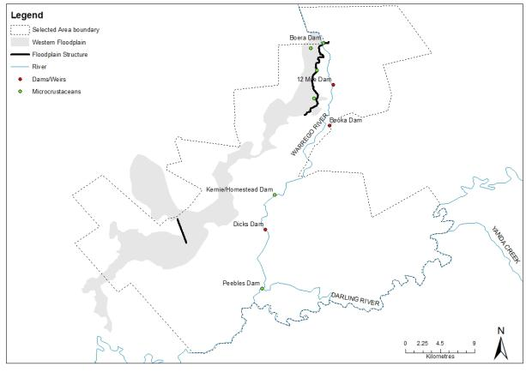

Figure 5‑11 Microcrustacean sampling sites within the Warrego River and Western Floodplain zones

An additional three sites within the Western Floodplain will be sampled using the wetland/floodplain sampling protocol. Sampling will occur within representative sites in each of the dominant wetland vegetation communities inundated by Commonwealth environmental water (Figure 5‑11). The Hydrology (Floodplain) indicator will facilitate the scaling-up of site based Microcrustacean data (density/L/vegetation type) to the entire inundated area of the floodplain.

This design will allow reporting with replication (n=3) for each of river channel and floodplain habitats and alignment with Fish (Channel), Vegetation Diversity, Metabolism and Frogs.

#### What

The rationale underlying this approach is to seek as much synergy as possible between the components monitoring other vertebrates and wetland fish that also prey on microcrustaceans (Figure 5‑12). Only a single composite sample (comprised of either 5 benthic cores or 5 pelagic buckets) is taken from each site or flow-habitat within a site. This will reduce the overall number of samples for laboratory processing.

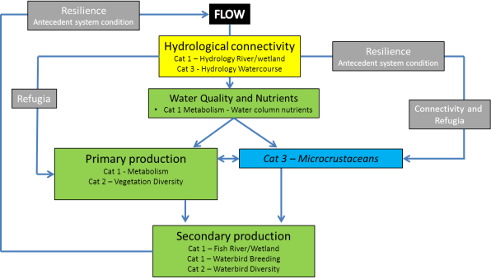

Figure 5‑12: CED – Microcrustaceans

#### When

Twice during year 1 of the project (Feb, May) then event based, three times per event (before, during, after) for three events over the remaining four years.

#### How

As per the methodology prescribed in the Microcrustacean SOP (Appendix B.13).

#### Linkages and indicator interactions

This indicator links to Vegetation Diversity, Fish (Channel), Hydrology (River and channel), Metabolism and Frog indicators.

#### Selected Area scale hypotheses

1. The delivery of Commonwealth environmental water will increase the density of pelagic and benthic microcrustaceans.
2. The delivery of Commonwealth environmental water will increase the Family-level diversity of microcrustaceans
3. The delivery of Commonwealth environmental water will increase the biotic and abiotic resource pools supporting food webs.
4. The delivery of Commonwealth environmental water will shift the trophic position of key taxa.
5. The delivery of Commonwealth environmental water will increase the complexity of food web structure.
6. The delivery of Commonwealth environmental water will increase whole-of-system trophic dynamics (biological productivity, interaction among species, interaction between the system and its biotic and abiotic surroundings).

#### Approaches to Selected Area scale analyses

Data will be reported following the requirements outlined in the LTIM Project Standard Protocol: Section 12 Metabolism (Hale et al. 2014) and conform to the LTIM Project Data Standard (Brooks & Wealands 2014).

At the Selected Area scale a number of hypotheses that relate to the outcomes of delivery of Commonwealth environmental water are possible.

In river channel habitats, quantitative analyses will be possible for microcrustacean density and community composition for time since watering, with multivariate analyses such as nMDS (and modules including Simper, BioEnv, DISP, PCA) will be used to explore patterns among dependant and covariate variables such as water column nutrient and carbon concentrations, metabolism and larval and adult fish.

In floodplain habitats, quantitative analyses will be possible for microcrustacean density and community composition for time since watering and vegetation community, with multivariate analyses such as nMDS (and modules including Simper, BioEnv, DISP, PCA) will be used to explore patterns among additional measured variables of water column nutrient and carbon concentrations and metabolism. Hydrology (Floodplain) will quantify the area of each vegetation community inundated and the volume of inundation (m3) throughout the delivery cycle of Commonwealth environmental water. Linking microcrustacean density to this indicator will facilitate scaling of response from site based (microcrustacean density/m2) to the inundated vegetation asset scale within the Selected Area.

### Monitoring schedule - Waterbird Diversity

The SOP for Waterbird Diversity is provided in Appendix B.14.

#### Selected Area evaluation questions

Short-term (one-year) and long-term (five year) question:

What did Commonwealth environmental water contribute to waterbird survival?

Long-term (five-year) questions:

What did Commonwealth environmental water contribute to waterbird populations?

What did Commonwealth environmental water contribute to waterbird species diversity?

#### Where

Waterbird diversity will be undertaken at three sites within the Warrego River zone, Boera Dam, Booka Dam and Peebles Dam/Ross Billabong and opportunistically on the Western Floodplain ()

#### What

Sampling for waterbird diversity.

#### When

Twice during year 1 of the project (Feb, May) then on an event by event basis, three times per event (before, during, after) for three events over the remaining four years). Opportunistically on the Western Floodplain during inundation events.

#### How

Ground surveys will be conducted on both foot and from a vehicle using observation points or transects depending on the size and shape of the wetland. Surveys will be undertaken for at least 20 minutes but no more than 1 hour at each wetland, in order to gain a representative no necessarily complete, count of all waterbirds in the wetland.

#### Linkages and indicator interactions

This indicator links to Microcrustaceans, Vegetation Diversity and Hydrology (River and Channel) indicators.

#### Selected Area scale hypotheses

Short-term (Annual) responses:

1. The delivery of Commonwealth environmental water will lead to increased waterbird survival

Long-term (5 year) responses:

1. The delivery of Commonwealth environmental water will lead to larger waterbird populations
2. The delivery of Commonwealth environmental water will lead to increased waterbird diversity

#### Approach to Selected Area scale analyses

Analyses based on Aggregation will be applied at the Selected Area scale for abundance, richness and diversity of waterbirds. Quantitative analyses will be applied at the Selected Area scale to document increased abundance, richness and diversity of waterbirds at sites receiving Commonwealth environmental water. Multi-year analyses will be quantitatively assessed based on year-on-year repeat application of annual models outlined in the Selected Area conceptual model (Figure 5‑13).

Short-term (Annual) responses:

1. Hypotheses 1 and 2 - univariate analysis (main effect – site, time) abundance, richness, diversity.

Long-term (5 year) responses:

1. Hypotheses 2 and 3 - univariate analysis (main effects – target site, year, time).
2. Hypotheses 3 - (diversity-abundance) multivariate analysis (factors – target site, year, time).

### Monitoring schedule - Frogs

The SOP for Frogs is provided in Appendix B.15.

#### Selected Area evaluation questions

Short-term (one-year) and long-term (five year) question:

What did Commonwealth environmental water contribute to other vertebrate condition?

What did Commonwealth environmental water contribute to other vertebrate reproduction?

Long-term (five-year) questions:

What did Commonwealth environmental water contribute to other vertebrate community resilience?

What did Commonwealth environmental water contribute to other vertebrate species diversity?

#### Where

Frog Sampling will be targeted at three locations within the Warrego River zone, Boera Dam, Booka Dam and Peebles Dam/Ross Billabong and opportunistically on the Western Floodplain ()

#### What

Sampling for frogs.

#### When

Twice during year 1 of the project (Feb, May) then on an event by event basis, three times per event (before, during, after). Opportunistically on the Western Floodplain during inundation events.

#### How

Adult frog surveys will be carried out following the protocols developed for the LTIM project by Wassen et al. Here 2x20 minute visual encounter (person minutes) transects and a 6 x 1 minute audio survey will be undertaken at each site after dark. A 15-30 watt spotlight or torch will be used to search for frogs along the wetland edge and into the surrounding terrestrial habitats. All individuals observed will be identified to species and the number recorded.

#### Linkages and indicator interactions

This indicator will link to Hydrology (River and Channel), Fish (Channel), Water quality and Microcrustaceans.

#### Selected Area scale hypotheses

Short-term (Annual) responses:

1. The delivery of Commonwealth environmental water will lead to increased frog species diversity
2. The delivery of Commonwealth environmental water will stimulate frog breeding

Long-term (5 year) responses:

1. The delivery of Commonwealth environmental water will lead to larger frog populations
2. The delivery of Commonwealth environmental water will lead to increased frog diversity

#### Approach to Selected Area scale analyses

Analyses based on Aggregation will be applied at the Selected Area scale for abundance, richness and diversity of frogs. Quantitative analyses will be applied at the Selected Area scale to document increased abundance, richness and diversity of frogs at sites receiving Commonwealth environmental water. Multi-year analyses will be quantitatively assessed based on year-on-year repeat application of annual models outlined in the Selected Area conceptual model (Figure 5‑13).

Short-term (Annual) responses:

1. Hypotheses 1 and 2 - univariate analysis (main effect – site, time) abundance, richness, diversity.

Long-term (5 year) responses:

1. Hypotheses 3 and 4 - univariate analysis (main effects – target site, year, time).
2. Hypotheses 4 - (diversity-abundance) multivariate analysis (factors – target site, year, time).

## Complementary data

There are a number of complementary data sets that will be required for the LTIM Project in the Junction of the Warrego and Darling rivers Selected Area. These data are listed in the individual SOPs developed for each indicator and summarised in Table 5‑5 below. It is assumed that where CEWO has access to these data, these data will be made available; other data will be accessed via a license agreement with the appropriate agency. These requirements are detailed further in the Communications Plan (Appendix D).

Table 5‑5: Complementary data required for the LTIM Project in the Junction of the Warrego and Darling rivers Selected Area

|  |  |  |
| --- | --- | --- |
| **Monitoring indicator** | **Data** | **Relevant stakeholder** |
| Ecosystem type | Mapping output from Brooks et al. (2013)  Regional sources with updated feature mapping and fine-scale resolution vegetation mapping and/or remote sensed data  Recently acquired AS40 data  Satellite imagery (e.g. SPOT6 – panchromatic resolution 1.5 m, multispectral resolution 8 m)  NVIS41_MDB vegetation mapping (NVIS v4.1 updated with CMA mapping by Brooks et al. 2013) | CEWO  Other agencies as necessary e.g. LLS, OEH |
| Fish | SRA data and reporting  Integrated Monitoring of Environmental Flows (IMEF) data and reporting  Rivers Environmental Restoration Program | MDBA  OEH  NSW DPI |
| Vegetation Diversity | OEH Environmental Flow Monitoring Program  SRA data and reporting  IMEF data and reporting  Rivers Environmental Restoration Program | OEH  CEWO  MDBA |
| Microcrustaceans | IMEF data and reporting  Rivers Environmental Restoration Program | OEH |
| Water Quality | Existing gauging stations and daily river reports  IMEF data and reporting | MDBA  NOW  OEH |
| Hydrology (River) | Existing gauging stations |
| Hydrology (Selected Area) | OEH inundation mapping  Floodplain Lidar datasets | MDBA  NOW  OEH |

## Evaluation and analytical approach

The CEWO LTIM Project seeks to quantify the outcomes of the management of Commonwealth environmental water and its contribution to achieving the requirements of the Basin Plan. Basin-scale evaluation is pivotal to the LTIM Project, and is to be informed by monitoring from the Junction of Warrego and Darling rivers Selected Area.

All Category I indicators have Standard Methods (Hale et al. 2014) and SOPs that define dependant variables, covariates and units for Basin-scale evaluation.

In addition, the study design allows analysis at the Selected Area scale for a number of Category I indicators. The Category III indicators in the Junction of Warrego and Darling rivers Selected Area; hydrology (Northern tributaries, Floodplain, Channel and Habitat), fish (Channel), stream metabolism, water quality, waterbird diversity, frogs and Microcrustaceans have detailed Selected Area evaluation and analytical approaches (see respective SOPs) with the potential for collaboration to develop a Basin-scale approach should a number of independent Selected Areas monitor these indicators using the Standard Methods.

All data will be delivered to the CEWO and will conform to the LTIM Project Data Standard (Brooks & Wealands 2014) and facilitate data management within the LTIM Project Monitoring Data Management System (MDMS).

There are limitations to the analytical approaches for evaluation purposes in response to the Standard Methods applied to Category I indicators in the Junction of Warrego and Darling rivers Selected Area. The Selected Area has 3 zones that are spatially independent and geomorphically discrete units, with the evaluation of responses to Commonwealth environmental water often limited to one zone. As such, this design does not generally permit comparisons of outcomes for those sites that receive Commonwealth environmental water compared with those that do not. This can make short-term (annual) evaluation of outcomes difficult for the Selected Area scale.

Where possible we will apply a number of broad approaches to short-term (Annual) and long-term (Multi-year) analyses to assess the response of individual or suites of indicators to the delivery of Commonwealth environmental water to ecological assets in the Junction of Warrego and Darling rivers Selected Area.

1. For selected indicators (e.g., Fish (Channel) and Vegetation Diversity) we will develop a ‘reference condition’ to facilitate predictions that zones receiving Commonwealth environmental water will have a trajectory towards the reference condition (Figure 5‑13). For example, a reference condition for Fish (Channel) metrics (composition, total length, mass, expectedness, nativeness, and recruitment, and age of target taxa) will be developed in conjunction with DPI Fisheries (SRA) and from existing data (e.g. Gowans et al. 2012) to set annual and long-term targets. Reference condition may need to be developed specific to antecedent condition, with a dry, average and wet extant reference condition used to determine trajectories of change (see Section 5.7). Evaluation of outcomes from Commonwealth environmental water will be determined by differences between the observed and expected outcomes.
2. Long-term (5 year) outcomes will require quantitative models (Figure 5‑13) that define outcomes for each indicator/zone in response to the delivery of Commonwealth environmental water. The repeated application of this model over time seeks to quantify a convergence or divergence in indicator response relative to watering regime (receiving or not receiving Commonwealth environmental water). Statistical approaches for these indicators will be time series-based (space-time substitution), with predicted differences between sites that have received Commonwealth environmental water (and the number of times they have received Commonwealth environmental water) compared with those that do not receive Commonwealth environmental water at the completion of each annual cycle used to evaluate outcomes. Condition assessment (y-axis on Figure 5‑14) is determined from the reference condition approach outlined above.

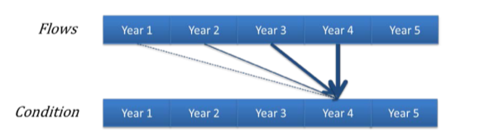

Figure 5‑13: Hypothetical model of a long-term response to environmental watering based on a created ‘reference condition’ where the greatest influence is from watering in the most recent year with progressively weaker influence from watering in previous years (Source: Gawne et al. 2014)

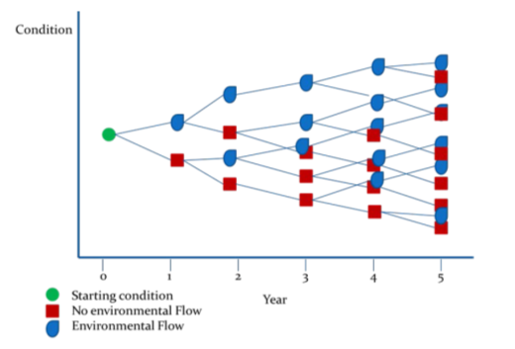

Figure 5‑14: A hypothetical model that will be applied on a year-to-year basis to generate a series of outcomes from different flow regimes over a five year period (Source: Gawne et al. 2014)

### Resilience

One of the aims of the LTIM Project is to understand the role of Commonwealth environmental water in promoting the resilience of the entire Junction of Warrego and Darling rivers Selected Area. Resilience is the amount of change a system can undergo (its capacity to absorb disturbance) and remain within the same regime that essentially retains the same function, structure and feedbacks (Walker & Salt 2006). A whole-of-system approach to resilience is required for the LTIM Project in the Junction of Warrego and Darling rivers Selected Area to link the extensive list of individual indicators within an ecosystem framework, targeted to hydrological and biological connectivity within and outside the Warrego-Darling system, variability and heterogeneity in structural and functional elements of ecosystems and the cycling of materials and energy. This framework will be developed with stakeholders as a conceptual diagram of ecosystem components (individual indicators and their links), and their ecological thresholds that act as tipping points between ecosystem states. For example, the CED developed for the Microcrustacean indicator (see Figure 5‑12) identifies relationships among hydrologic and floodplain vegetation refuges as key links in the resilience of the system. Building these conceptual models and identifying ecological thresholds through monitoring will form the basis for measuring resilience in the Selected Area.

This framework will outline the adaptive management options that can be taken to manage resilience in the Warrego and Darling systems. Findings from the Junction of the Warrego and Darling rivers Selected Area M&E project will be disseminated through the projects Working Group. Membership on this working group by representatives from OEH, NOW, LLS, CEWO, NPWS, NSW Fisheries, and the Australian Floodplains Association will allow ad hoc and planned changes to the short and long term watering options of the Junction of the Warrego and Darling rivers Selected Area to be responsive to monitoring outcomes such as ensuring water quality is maintained in the system.

## Indicator/zone interaction and timing

The focus of the M&E Plan is to target Commonwealth environmental water in each of the three zones within the Selected Area (Table 5‑6). Sample design has been aligned within each zone based on the expected outcomes of Commonwealth environmental watering options. However, as the Commonwealth environmental water may vary in any one year, the sampling has been designed to maximise potential selected area and basin-scale outcomes by allowing for targeting any individual zone for several indicators in response to the presence of Commonwealth environmental water.

The watering options for the Selected Area are generally for flows to occur in spring-summer and to continue through summer until all Commonwealth environmental water is accounted for. The annual sampling design is quite different between the two Warrego and Darling River zones, in response to the contrasting likelihood of flows occurring in each system. For the category I indicators along with Hydrology (Northern tributaries and Habitat) measured in the Darling, they will be monitored continuously for the duration of the project as there is a high likelihood of water being present in the Darling channel throughout (Table 5‑7). For the Warrego River and Western Floodplain zones, Hydrology (River, Floodplain, and Channel) will be measured continuously, whenever water is present within the system. Sampling for Vegetation Diversity on the Western Floodplain will be undertaken twice annually for the duration of the project (Table 5‑7). For the event based indicators, these will be measured twice during the first year of the project (2014-15), then during a further three flow events from years 2-5 of the project (Table 5‑7). Timing of sampling for these event based indicators will be assessed in year 2 of the project, and may be refined in conjunction with the CEWO depending on the past and potential future flows in the Warrego System.

The monitoring design (sites, zones, standard methods) has been developed in the knowledge that Commonwealth environmental water will occur as rainfall driven events and flooding and to a lesser degree from end-of–system deliveries of Commonwealth environmental water from upstream tributaries. As such, the evaluation of outcomes from Commonwealth environmental water will need to be made relative to antecedent conditions of inundated zones and the proportion of water that is determined to be Commonwealth environmental water. ELA will be reliant on the CEWO to establish clear definitions of what constitutes a Commonwealth environmental water event. Hydrologic gauges nominated for use in the Hydrology indicators will both facilitate detailed information on antecedent conditions prior to the occurrence of environmental water. For example, Commonwealth environmental water that spills onto the Western Floodplain can be hydrologically quantified by discharge, area inundated and linked explicitly to breeding success.

Table 5‑6: Indicator-Zone interactions. SA represents Selected Area.

|  |  |  |  |  |  |  |  |
| --- | --- | --- | --- | --- | --- | --- | --- |
| **Monitoring Zone** | | **Darling River Channel** | | **Warrego River Channel** | | **Western Floodplain** | |
| **Ecosystem Type** | | *River* | *River* | *River* | *River* | *Floodplain* | *Floodplain* |
| **CEW watering Option** | | *1-2* | | *3-4* | | *5* | |
| **Monitoring Indicator** | **Cat.** | ***Basin*** | ***SA*** | ***Basin*** | ***SA*** | ***Basin*** | ***SA*** |
| Ecosystem type | I |  |  |  |  |  |  |
| Vegetation Diversity | I |  |  |  |  |  |  |
| Hydrology (River) | I |  |  |  |  |  |  |
| Stream metabolism | I & III |  |  |  |  |  |  |
| Water quality | I & III |  |  |  |  |  |  |
| Hydrology (Northern tributaries) | III |  |  |  |  |  |  |
| Hydrology (Floodplain) | III |  |  |  |  |  |  |
| Hydrology (channel) | III |  |  |  |  |  |  |
| Hydrology (Habitat) | III |  |  |  |  |  |  |
| Fish (Channel) | III |  |  |  |  |  |  |
| Micro-crustaceans | III |  |  |  |  |  |  |
| Waterbird Diversity | III |  |  |  |  |  |  |
| Frogs | III |  |  |  |  |  |  |

Table 5‑7: Annual field survey cycle for indicators measured in the Darling River zone.

|  |  |  |  |  |  |  |  |  |  |  |  |  |  |
| --- | --- | --- | --- | --- | --- | --- | --- | --- | --- | --- | --- | --- | --- |
| **Month** | **Jan** | **Feb** | **Mar** | **Apr** | **May** | **Jun** | **Jul** | **Aug** | **Sep** | **Oct** | **Nov** | **Dec** | **Comments** |
| **Indicator** |  | | | | | | | | | | | |
| Ecosystem Type |  |  |  |  |  |  |  |  |  |  |  |  | Once only in year 2015 |
| Hydrology (River) |  |  |  |  |  |  |  |  |  |  |  |  | Ongoing, updating regularly from NoW data |
| Hydrology (Northern tributaries) |  |  |  |  |  |  |  |  |  |  |  |  | Ongoing and following delivery events |
| Hydrology (habitat) |  |  |  |  |  |  |  |  |  |  |  |  | Habitat Mapping undertaken in year 2015 |
| Stream Metabolism (C1) |  |  |  |  |  |  |  |  |  |  |  |  | Continuously, up to 6-weekly maintenance intervals |
| Water Quality (C1) |  |  |  |  |  |  |  |  |  |  |  |  | Continuously, up to 6-weekly maintenance intervals |

Table 5‑8 Annual field survey cycle for indicators measured in years 2-5 of the project within the Warrego River and Western Floodplain zones.

| **Month** | **Jan** | **Feb** | **Mar** | **Apr** | **May** | **Jun** | **Jul** | **Aug** | **Sep** | **Oct** | **Nov** | **Dec** | **Comments** |
| --- | --- | --- | --- | --- | --- | --- | --- | --- | --- | --- | --- | --- | --- |
| **Indicator** |  | | | | | | | | | | | |
| Ecosystem Type |  |  |  |  |  |  |  |  |  |  |  |  | Once only in year 2015 |
| Hydrology (River) |  |  |  |  |  |  |  |  |  |  |  |  | Ongoing, updating regularly from NoW data |
| Hydrology (Floodplain) |  |  |  |  |  |  |  |  |  |  |  |  | Ongoing and following delivery events |
| Hydrology (channel) |  |  |  |  |  |  |  |  |  |  |  |  | Ongoing and following delivery events |
| Vegetation Diversity |  |  |  |  |  |  |  |  |  |  |  |  | Twice annually around water season |
| Stream Metabolism (C3) |  |  |  |  |  |  |  |  |  |  |  |  | Event driven, likely from October to April annually |
| Water Quality (C3) |  |  |  |  |  |  |  |  |  |  |  |  | Event driven, likely from October to April annually |
| Fish (Channel) (C3) |  |  |  |  |  |  |  |  |  |  |  |  | Event driven, likely from October to April annually |
| Microcrustaceans |  |  |  |  |  |  |  |  |  |  |  |  | Event driven, likely from October to April annually |
| Waterbird Diversity |  |  |  |  |  |  |  |  |  |  |  |  | Event driven, likely from October to April annually |
| Frogs |  |  |  |  |  |  |  |  |  |  |  |  | Event driven, likely from October to April annually |

# Communication and Engagement

## Stakeholder engagement

A stand-alone Project Communications Plan has been developed for the Junction of Warrego and Darling rivers Selected Area (Appendix D). This Communications Plan has been developed as a stand-alone document that specifies project communication requirements and stakeholder engagement for the duration of the LTIM Project, with the aim of facilitating effective and efficient communication. It describes the schedule of proposed communication and engagement activities, who is involved, who they will talk to, frequency of communications and roles and responsibilities.

It is highlighted that ELA/UNE via CEWO are currently developing a Memorandum of Understanding between CEWO and OEH for cooperative resource and information sharing. Other necessary license agreements will be entered into with relevant agencies when monitoring indicators have been finalised.

## CEWO reporting

There are two forms of reporting requirements by M&E Providers to CEWO for the LTIM Project in the Junction of the Warrego and Darling rivers Selected Area:

* Project reporting (progress)
* Outcomes reporting.

In addition to formal reporting, ELA will maintain good relationships with the CEWO, M&E Advisors and delivery partners to support evaluation and adaptive management throughout the LTIM Project.

### Project progress reporting

Progress reporting requirements for Stage 2 are provided in Table 6‑1, including regular forums and teleconferences.

### Outcomes reporting

The LTIM Project has a number of reporting and information transfer requirements. Table 6‑2 summarises the outcomes reporting and information transfer activities for the LTIM Project, including frequency, timing and responsibility. Note this list covers only operational reporting and information transfer activities only: no external reporting or information transfer activities are specified. It also includes reporting requirements that are the responsibility of the M&E Advisors (being the Annual Basin Evaluation Report).

M&E Providers will also be required to provide other key outputs for monitoring activities in the Junction of the Warrego and Darling Rivers:

* Submit monitoring data in the correct format and according to defined protocols within 1 month of its collection (including the MDMS and the LTIM Project Data Standards (Brooks & Wealands 2014))
* Noting and reporting any incidental observations made during field visits that may contribute to or support Evaluation (Area or Basin) or Adaptive Management. Observations can also include those reported to the M&E Provider by stakeholders. This requirement is ongoing, following observations.

Table 6‑1: Progress reporting requirements for the LTIM Project

|  |  |  |  |  |  |
| --- | --- | --- | --- | --- | --- |
| **Activity type** | **What** | **Frequency** | **Timing / due date** | **Responsibility** | **Description and high level requirements** |
| Project Status Meetings | Phone conference | Monthly | From project inception (Feb 2015) to submission of final report (October 2019) | M&E Provider | Informal phone catch-up with CEWO Area leader to discuss status of the Junction of Warrego and Darling rivers LTIM Project |
| Information transfer | Monitoring data entry | Monthly | Monthly for the duration of the LTIM Project to the Monitoring Data Management System and Data Standard (Brooks & Wealands 2014) | M&E Providers | Processed monitoring data uploaded to the Monitoring Data Management System in accordance with data management protocols, as outlined in the M&E Plan |
| Reporting | Project progress reports: 2014-15 onwards | Quarterly | Sep, Dec, Mar and Jun (last business day of month) for the duration of the LTIM Project | M&E Providers | A written progress report, summarising tasks completed since the last report, tasks planned for the upcoming period, emerging issues etc. The CEWO progress report template will be used |
| Teleconference | Project Leaders Teleconference | Biannual | November and March, each year (3 hours each) | CEWO | Leaders of Project teams |
| Forum | Annual M&E forum | Annual | July, 2015 –2019  (2 days each) | CEWO | M&E Forum to be held each year (Sydney)  Four attendees from each M&E Provider team are to attend to discuss monitoring efforts (issues and solutions), monitoring results and evaluation (Project Director/Manager and three technical leads) |

Table 6‑2: Reporting requirements for the LTIM Project

|  |  |  |  |  |  |  |
| --- | --- | --- | --- | --- | --- | --- |
| **Activity type** | **What** | **Frequency** | **Timing / due date** | **Responsibility** | **Receiver** | **Description and high level requirements** |
| Reporting | Monitoring and  Evaluation Plan | One-off | Draft – 15 Jan 2015  Final – 31 Jan 2015 | M&E Providers | CEWO | A plan for monitoring and evaluation in each Selected Area over the five-year period from 2014-15 to 2018-19 |
| Work plan | Annual monitoring work plan | Annually | August (2015-2019) | M&E Providers | CEWO | Annual monitoring work plan that outlines which elements will be implemented over the coming water year, based on information available at the time (including Area condition, water availability and water use options) |
| Annual evaluation plan | Annual evaluation plan | Annually | August (2015-2019) | M&E Providers | CEWO | The annual evaluation plan should outline what evaluation activities will be undertaken over the coming water year, based on anticipated environmental watering actions monitoring data availability. |
| Reporting | Area evaluation report | Annually (October) | (Draft – Aug 30  Final – Oct 31)  First report – 2015  Final report – 2019 | M&E Providers | CEWO | A cumulative evaluation of the outcomes of Commonwealth environmental water at each Selected Area, prepared in accordance with the M&E Plan  The report must be prepared in plain English with simple science and be suitable for publication on CEWO website. |
| Reporting | Basin evaluation report | Annually | Draft – Aug 30  Final – Oct 31  First report – 2015  Final report – 2019 | M&E Advisers | CEWO | A cumulative evaluation of the outcomes of Commonwealth environmental water at the Basin-scale, based on the Evaluation Plan  The report must be prepared in plain English with simple science and be suitable for publication on CEWO website |
| Information transfer | Monitoring data entry | Monthly | Monthly for the duration of the LTIM Project | M&E Providers | MDMS | Processed monitoring data is uploaded to the MDMS in accordance with the data management protocols | |
| Information transfer | Information exchange | Ongoing and as required | Ongoing and as required for the duration of the LTIM Project | M&E Providers | Delivery partners / Selected Area Working Group | Information exchange on project activities (monitoring, observations, evaluations) and other information that would support the delivery of environmental water | |

# Project Management

## Project governance

The LTIM Project is the primary means for measuring the outcomes of Commonwealth environmental watering in the MDB; as such, a robust framework for ongoing project governance is important for the implementation of the LTIM Project. The LTIM Project governance structure is shown in .

The primary line of governance between the CEWO, M&E Providers and M&E Advisor is the Project Manager from each lead agent for the Junction of the Warrego and Darling rivers Selected Area ().

Table 7‑1: Primary governance structure – Junction of the Warrego and Darling rivers Selected Area LTIM Project

| **Project Lead** | **Agent** | **Role of Agent** |
| --- | --- | --- |
| Paul Frazier  Darren Ryder | M&E Provider (ELA/UNE)  Project Directors | Implement M&E Plan  Work with CEWO and delivery partners to demonstrate outcomes and support adaptive management |
| Jenny Hale | M&E Adviser | Technical coordination and oversight  Whole of Basin evaluations of outcomes  Support implementation of M&E Plan |
| Christine Mercer | CEWO Area Leader | Manage LTIM Project  Lead adaptive management  Planning and decisions of Commonwealth environmental water |

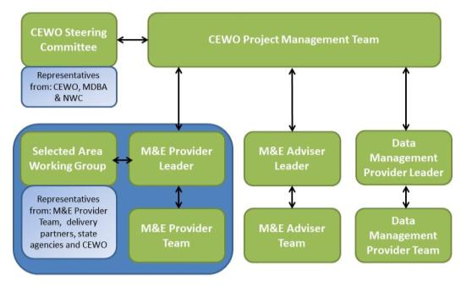

Figure 7‑1: Project governance structure for the LTIM Project (from CEWO n.d.)

### M&E Provider – Project Team

A core project management team has been nominated to coordinate and facilitate delivery of Stage 2 of the CEWO LTIM Project in the Junction of the Warrego and Darling rivers Selected Area.

#### Project Directors

Project Directors (Dr Paul Frazier and Associate Professor Darren Ryder) will provide strategic and technical input to the project, and are alternative points of contact for CEWO.

#### Project Manager

Project manager (Mark Southwell) is the principal point of contact for the Project and will report to CEWO’s LTIM Project manager for the Junction of the Warrego and Darling rivers Selected Area (Christine Mercer). The ELA project manager will ensure the M&E Plan meets the requirements of the contract and is responsible for meeting the project budget and work program. The project manager is also responsible for managing accounting, correspondence and meeting coordination.

#### Senior Practitioner Group & Technical Scientists

The ELA/UNE Project Team will include a team of Senior Practitioners who are recognised experts in their field. This Senior Team will guide the operational monitoring project and undertake aspects of field survey, analysis and reporting. Each member of this team will be assigned a monitoring indicator directly related to their area of expertise.

This team will be supported by a combined ELA/UNE group of technical support scientists, with a range of skills in riverine and floodplain ecology and function. This group will undertake much of the on-ground survey, data handling and some reporting.

## Risk assessment

A risk assessment has been prepared for the Junction of the Warrego and Darling rivers Selected Area LTIM Project, based on this M&E Plan. The purpose of the risk assessment is to identify risks to the successful implementation of the LTIM Project and undertake effective mitigation planning. Three areas of risk were considered:

1. Risks to the success of the LTIM Project and the ability to meet project objectives and outcomes (including risks that monitoring activities will not be able to be implemented)
2. Risks to the environment and aquatic ecosystem as a result of LTIM Project activities in the Junction of the Warrego and Darling rivers Selected Area
3. Risks to the health and safety of personnel undertaking LTIM Project activities in the Junction of the Warrego and Darling rivers Selected Area.

### Risk assessment process

This risk assessment method is compliant with the Australian/New Zealand AS/NZ 31000:2009: Environmental Risk Management – Principles and Process (Standards Australia 2009), and aligns with the principles of Australian Standard AS/NZS 4360:2004 Risk Management (Standards Australia 2004).

Risk is defined as the combination of the likelihood and consequence of an event or outcome, as demonstrated in ().

Table 7‑2: Risk assessment matrix

| **LIKELIHOOD** | **CONSEQUENCE** | | | | |
| --- | --- | --- | --- | --- | --- |
| **Negligible** | **Minor** | **Moderate** | **Major** | **Critical** |
| **Almost Certain** | L16 | M10 | H5 | S2 | S1 |
| **Likely** | L17 | M12 | M11 | H6 | S3 |
| **Possible** | L19 | L18 | M13 | H7 | S4 |
| **Unlikely** | L22 | L21 | L20 | M14 | H8 |
| **Rare** | L25 | L24 | L23 | M15 | H9 |

L= low, M=medium, H=High, S=Severe

The likelihood of a risk refers to the probability of a specific event or outcome actually occurring (); the consequence is the outcome of the action ().

Table 7‑3: Risk likelihood categories

|  |  |
| --- | --- |
| Likelihood | Description in terms of full operating life of the site |
| Almost Certain | Consequences expected to occur in most circumstances |
| Likely | Consequences will probably occur in most circumstances |
| Possible | Consequences may occur at some time |
| Unlikely | Consequences are not expected occur within the life of the project |
| Rare | Consequences may occur in exceptional circumstances |

Three key areas of risk were considered. For each of these themes, possible risks were identified by considering project specific issues and the proposed monitoring activities. Potential hazards and their subsequent impact were considered (i.e. what could happen). Using the definitions provided above, the likelihood and consequence of the potential impacts where then applied to assign an inherent risk rating. Management and risk mitigation measures are then recommended, and the risk rating method re-applied.

Table 7‑4: Risk consequence categories

|  |  |  |  |  |  |
| --- | --- | --- | --- | --- | --- |
| **Possible risks** | **Consequence** | | | | |
| **Negligible** | **Minor** | **Moderate** | **Major** | **Critical** |
| Undertaking monitoring activities | Monitoring activities undertaken according to M&E Plan, with data from all planned samples available | Minor disruption to the monitoring program with a small number of planned samples (<10%) not collected or data not available | More than 10% of planned samples not collected / available, however sufficient data available for planned analyses | Data from more than 50% of planned samples not collected /available. Limited monitoring outcomes reported | No useable data collected, analyses not possible, no monitoring outcomes reported |
| Environment | Negligible environmental damage | Short term, localised, reversible damage to the environment | Short term, widespread damage to the environment reversible to intensive effort | Long-term damage to the environment and/or risk of continuing environmental damage | Long-term, widespread, irreversible damage |
| Health and safety | Incident requiring first aid treatment | Minor incident requiring treatment by a medical practitioner | Moderate incident requiring short term hospitalisation | Serious incident requiring extensive hospitalisation | A fatality, permanent disability , or multiple people affected by a serious incident |
| Stakeholders | Short-term, isolated complaints from stakeholders | Sustained but isolated complaints from stakeholders Relationship with stakeholder temporarily affected | Sustained complaints from stakeholders Relationship with stakeholder damaged | Short-term but significant complaints from stakeholders Relationship with stakeholder significantly damaged | Sustained and significant complaints from stakeholder Relationship with critical stakeholder irreversible damaged |
| Project objectives | Short delay in achievement of project objectives | Delay in achievement of project objectives | Element or project objective not met | Project objectives not met | Project objectives harmed (negative impact) |

### Risks to success of the project

presents the key risks to success of the LTIM Project in the Junction of the Warrego and Darling rivers Selected Area and suggests risk mitigation measures.

Table 7‑5: Junction of the Warrego and Darling rivers M&E Plan risk assessment: successful implementation of the LTIM Project

| **Risk** | **Hazard** | **Impact** | **Risk Rating (Inherent)** | **Risk Mitigation Measures** | **Risk Rating (Managed)** |
| --- | --- | --- | --- | --- | --- |
| Unpredictable weather - prolonged natural low flow conditions | Inundation period of system is impacted | Unable to effectively monitor and evaluate LTIM Project objectives | H7 | * Design includes non-event based monitoring to inform the ecological response model and act as pre-flooding data * Annual monitoring plan will consider the long range forecast when developing watering options * If necessary, review asset condition and future priorities for watering | L18 |
| Unpredictable weather – extreme flooding following watering event | Inability to collect monitoring data as access limited | Unable to effectively monitor and evaluate LTIM Project objectives  Potential risk to crops during pre-harvest period | H7 | * Survey site design considering flood related accessibility * Survey site subset accessible in all conditions to provide a core dataset – design redundancy * All condition remote monitoring devices used where possible * Local field teams able to respond rapidly to changes in field conditions | L21 |
| Other extreme weather events, i.e. flooding out of season, bushfires | Extreme weather events not considered in watering options | Negative impact on ecological assets | M14 | * Design includes non-event based monitoring to inform the ecological response model and act as pre-flooding data * Annual monitoring plan will consider the long range forecast when developing watering options | L21 |
| State Agency – poor engagement | Possible inefficiencies in collecting monitoring data  Poor public image to landholders and the local community | Unable to effectively monitor and evaluate LTIM Project objectives | M14 | * Communication and data sharing agreement with state agencies * On-going high level engagement to share results, methods refinement and scientific approach * Junction of the Warrego and Darling rivers Selected Area Working Group established and relationships maintained | L24 |
| Short-term responsiveness to watering events | Inability to collect monitoring data after a flow event | Unable to evaluate LTIM Project objectives | H7 | * Location of the consortium within nine hours of the Selected Area maximises responsiveness to environmental watering. * Arrangements with NPWS staff onsite to collect some data * Many indicators being measured by continuously logging sensors | L20 |
| Equipment operational failure (e.g. weir infrastructure) | Either unexpected flow event at an inappropriate time or impediment to flows | Negative impact on environmental outcomes | H7 | * Diversified site locations to spread sites across multiple sites – design redundancy * Potential landholder engagement for quick responses to infrastructure maintenance issues * Engagement with infrastructure owners to facilitate quick infrastructure repairs * Build in design flexibility to allow changes in monitoring effort so sites and indicators can be exchanged depending on the location and type of flow event | L20 |
| Field Sensor theft | Data sensors deployed remotely stolen or tampered with | Failure to collect data | M14 | * Park Ranger visual check of equipment on a regular basis * Locate sensors in ‘relatively’ safe locations within the study area. | L24 |
| Unexpected ecological response from environmental watering (e.g. algal blooms, incomplete bird breeding event) | Poor water quality impacts ecological assets i.e. native fish (including threatened species) | Negative impact on ecological outcomes from environmental watering | M13 | * Prompt communication and data sharing with the Commonwealth and state agencies * ELA/UNE consortium expertise in biology and ecology of indicators to provide sound advice | L20 |
| Failure to obtain complimentary data | Possible inefficiencies in accessing project data | Do not have sufficient data to meet reporting requirements | M14 | * Majority of complimentary data (Flow data, satellite imagery) obtainable through public sources | L20 |
| Staff resourcing, staff turnover | Insufficient staff numbers to undertake project tasks. Loss of information continuity between staff over time | Failure to collect data and undertake reporting. | M15 | * Work program established in early stages of project to ensure staff are prioritised to work on the project * Draw upon staff from other ELA offices to ensure availability of qualified staff to undertake project | L24 |

### Risks to the environment

On-ground activities have the potential to negatively impact the environment of the Junction of the Warrego and Darling rivers Selected Area if not managed appropriately. In particular, the following ecological values were considered during the risk assessment (as identified in Gawne et al. 2013b):

1. The Darling River in the vicinity of the Selected Area supports one threatened species listed under the *Environment Protection and Biodiversity Conservation Act 1999* (EPBC Act):
   * Murray Cod (*Maccullochella peelii*) listed as Vulnerable under the EBPC Act
2. The Western Floodplain of the Warrego River supports some areas of Coolibah-black box woodland, which is listed as an Endangered Ecological Community (EEC) within the Darling Riverine Plains and Brigalow Belt South bioregions under the NSW *Threatened Species Conservation Act 1995* (TSC Act).
3. The Warrego River and Western Floodplain supports the Brolga (*Grus rubicundas*) which is listed as vulnerable under the NSW *Threatened Species Conservation Act 1995* (TSC Act). A further five species are of conservation concern in the Western Division of NSW due to their rarity and limited breeding opportunities; pied cormorant (*Phalacrocorax varius*), darter (*Anhinga melanogaster*), Australian pelican (*Pelecanus conspicillatus*), great egret (*Ardea alba*) and royal spoonbill (*Platalea regia*)

presents the identified risks to the environment (including ecological values) associated with undertaking monitoring activities in the Junction of the Warrego and Darling rivers Selected Area and the recommended risk mitigation measures.

Table 7‑6: Junction of the Warrego and Darling rivers M&E Plan risk assessment: risks to the environment as a result of the LTIM Project

| **Risk** | **Hazard** | **Impact** | **Risk Rating (Inherent)** | **Risk Mitigation Measures** | **Risk Rating (Managed)** |
| --- | --- | --- | --- | --- | --- |
| Driving in long, dry grass | Starting bushfires | Loss of or damage to biodiversity and property | H6 | * Safe Work Methods Statement to be completed prior to trip and onsite Toolbox Talks prior to commencing work * Contacting relevant landowners prior to fieldwork to identify areas and develop alternative route * Arranging long grass to be cut if alternative route cannot be arranged | M14 |
| Working in threatened ecosystems | Implementing structures in protected areas i.e. National Parks | Loss of or damage to biodiversity and property | M10 | * Identifying areas which will require bathymetric surveys i.e. depth loggers, artificial substrates for stream metabolism * REF is required for any structure (including depth loggers) within National Parks estates | L17 |
| Monitoring threatened flora | Impacting threatened species and/or habitat i.e. vegetation assessments in Coolibah-Blackbox Woodlands | Loss of or damage to biodiversity | M13 | * Standard Operating Procedure for Monitoring Indicator – Vegetation Diversity * Minimise trampling and avoid areas that do not need surveying. Follow requirements of land owner/ manager, incl. government bodies * A scientific licence is required to pick, hold or study native flora * Where possible identify flora species in the field. If a sample is required, take only that needed for identification. Take photos where a sample would affect survival of the individual * If a new location is discovered for a threatened species, note its position and take care not to unnecessarily disturb its root system or habitat * Clean mud and weed propogules off shoes, clothing and vehicle/quad bike tyres prior to leaving an area where possible (particularly where noxious weeds were identified) * Works should be programmed to consider seeding periods and weed locations * Field staff to sign off on Environmental Site Inspection for prior to undertaken monitoring activities | L18 |
| Monitoring threatened aquatic fauna | Impacting threatened species or damaging habitat i.e. trapping and electrofishing Murray Cod | Loss of or damage to biodiversity | H7 | * Standard Operating Procedure for Monitoring Indicators – Fish (Channel) * Ensuring that fish surveys follows the Survey guidelines for Australia's threatened fish. EPBC Act survey guidelines 6.4 * Use minimum impact survey techniques as per survey procedure and required by animal ethics permit * Field staff to sign off on Environmental Site Inspection for prior to undertaken monitoring activities | M14 |
| Monitoring threatened terrestrial fauna | Impacting breeding habitat (waterbirds) | Loss of or damage to biodiversity and property | H6 | * Standard Operating Procedures for Monitoring Indicator – Waterbird Diversity * Minimise trampling and avoid areas that do not need surveys * Use minimum impact survey techniques as per survey procedure and required by animal ethics permit * Field staff to sign off on Environmental Site Inspection for prior to undertaken monitoring activities | L18 |

### Risks to individuals

presents the potential risks to the health and safety of personnel undertaking monitoring activities within the Junction of the Warrego and Darling rivers Selected Area and suggested mitigation measures to management them. The development of mitigation measures are in line with ELA’s Environment, Safety and Quality framework and the Department’s Fieldwork and Safety Guidelines (DSEWPaC 2011). Mitigation measures and procedures are described further in the Health, Environment and Safety Plan (Appendix F).

Table 7‑7: Junction of the Warrego and Darling rivers M&E Plan risk assessment: risks to individuals and teams undertaking monitoring activities

| **Risk** | **Hazard** | **Impact** | **Risk Rating (Inherent)** | **Risk Mitigation Measures** | **Risk Rating (Managed)** |
| --- | --- | --- | --- | --- | --- |
| Adverse weather conditions | Prolonged rain/flooding | Drowning | H7 | * Safe Work Methods Statement to be completed prior to trip and onsite Toolbox Talks prior to commencing work i.e. checking WaterInfo website * Undertaking JSEA if river conditions rapidly change. * Not entering areas of fast flowing water | M14 |
| Extreme heat/cold | Sunburn or skin burn, hyperthermia or hypothermia | H6 | * Safe Work Methods Statement to be completed prior to trip and onsite Toolbox Talks prior to commencing work * Appropriate PPE * Suitable scheduling & rostering of monitoring activities | M14 |
| Adverse weather activity | Storms-lightning strikes | Burns & shock (potentially fatal) | H9 | * Do not enter site until 1 hour after the storm passes * If on-site vacate the area and/or seek shelter immediately | L23 |
| High winds | Struck from falling objects and vehicle control | M14 | * Undertaking JSEA before driving if conditions rapidly change * Take cover during periods of high winds away from overhead trees/branches * Reduce speed if driving in high winds | L23 |
| Vehicle & driving hazards | Car accident on way to site/onsite | Death, permanent impairment, lost time injury | H8 | * Safe Work Methods Statement to be completed prior to trip and onsite Toolbox Talks prior to driving * Site induction in high risk sectors * All staff will have current first aid qualifications * All vehicles to carry Emergency First Aid Box (includes consumables and bottled water) and sat phone/spot tracker | M15 |
| Vehicle breakdown/ bogged | Isolation, thermal stress, dehydration, hunger | H7 | * Undertaking JSEA before attempting vehicle recovery * 4WD training for field staff * Safe Work Methods Statement to be completed prior to trip and onsite Toolbox Talks prior to driving * All staff will have current first aid qualifications. * All vehicles to carry Emergency First Aid Box (includes consumables and bottled water) and sat phone/spot tracker * Field staff to sign off on Remote Location Vehicle check list | M13 |
| Long distance driving | Wide ranging physical injuries, potentially fatal & vehicle damage | H7 | * Undertaking JSEA Safe Work Methods Statement to be completed prior to trip and onsite Toolbox Talks prior to driving * Two person field teams to ensure that there is a break and swap of drivers every 2 hours * All staff will have current first aid qualifications. * All vehicles to carry Emergency First Aid Box (includes consumables and bottled water) and sat phone/spot tracker | M13 |
| Encountering wildlife | Car accident (with either wildlife, or other vehicles) | H7 | * Avoid driving between dusk and dawn where possible. If you must drive during this time keep an eye on the sides of the road and reduce speed to allow brake time if necessary * Safe Work Methods Statement to be completed prior to trip * All staff will have current first aid qualifications. * All vehicles to carry Emergency First Aid Box (includes consumables and bottled water) and sat phone/spot tracker | M14 |
| Quad-biking | Riding over uneven terrain/marshland | Bike rollover, wide ranging physical injuries, potentially fatal & bike damage | H7 | * Safe Work Methods Statement to be completed prior to trip and onsite Toolbox Talks prior to commencing work * Quad bike training for all field staff * All staff to wear helmets * Only one rider per bike * All staff will have current first aid qualifications * Undertaking JSEA before attempting bike recovery * Carry portable communications (UHF radio, satellite phone) when biking in areas without mobile reception * Staff working in teams when using quad-bikes. | M14 |
| Riding in flooded terrain | Bogging of bike, isolation, thermal stress, dehydration, hunger & bike damage | H7 | M14 |
| Terrain hazards | Bushfires | Burns, smoke inhalation & potentially fatal | H7 | * Safe Work Methods Statement to be completed prior to trip and onsite Toolbox Talks prior to commencing work * Field teams to carry Bushfire safety plan * Regular updates from BOM website and advice from RFS | M15 |
| Flora & fauna | Plant & insect allergens | Allergic reactions (skin/eye), Hay Fever, respiratory reactions, anaphylactic shock which can be potentially fatal | H7 | * Ensure staff know who their colleagues are with severe allergic reactions, implement allergy management response plan * Be aware of nearest hospital for treatment and have communications available. * Don't expose staff with known allergies to projects where these risks are unaccepted [table to their personal health issues * Standard Operating Procedures - Wildlife survey procedures * Safe Work Methods Statement to be completed prior to trip and onsite Toolbox Talks prior to commencing work * First aid kit to be carried at all times and equipped with a snake bandage * All staff will have current first aid qualifications. * Two persons in the field | M14 |
| Venomous fauna | Poisoning, potentially fatal | H7 | * Safe Work Methods Statement to be completed prior to trip and onsite Toolbox Talks prior to commencing work * First aid kit to be carried at all times and equipped with a snake bandage * All staff will have current first aid qualifications. * Two persons in the field | M14 |
| Fauna related diseases, including exposure to ticks, mosquitoes, leeches and Anthrax | Bites, Infection & Illness | H7 | * Safe Work Methods Statement to be completed prior to trip and onsite Toolbox Talks prior to commencing work * PPE and applying permthrin to field clothing * Performing daily tick checks and removing ticks as soon as they are detected * First aid kit to be carried at all times and equipped with a snake bandages * All staff will have current first aid qualifications * All staff to avoid contact with material that could be potentially contaminated with Anthrax | M14 |
| Remote site hazards | Remote area surveys | Slow response time from external source/services to an injury or incident | H7 | * Safe Work Methods Statement to be completed prior to trip and onsite Toolbox Talks prior to commencing work * Emergency response procedures developed for remote area surveys * Vehicles to be equipped with sat phone/spot tracker, bottled water * Field staff to sign off on Remote Location Vehicle check list * First aid kit to be carried at all times and equipped with a snake bandage * All staff will have current first aid qualifications | M14 |
| Working with others in remote areas | Sexual harassment, bullying, inappropriate behaviour | M15 | * Safe Work Methods Statement to be completed prior to trip and onsite Toolbox Talks prior to commencing work * Two person field team * Prior discussion with landowners, if required. | L23 |
| General field work | Field equipment use (e.g. Traps) | Muscle and back strain, joint injury, Lacerations and other injuries from equipment | H6 | * Safe Work Methods Statement to be completed prior to trip and onsite Toolbox Talks prior to commencing work * PPE * Manual Handling training * Complete JSEA if activity is not specified in the Standard Operating Procedures for the relevant Monitoring indicator * First aid kit to be carried at all times and equipped * All staff will have current first aid qualifications. | M13 |
| Long hours/night work | Musculoskeletal injuries, slips, trips, falls | H6 | * Safe Work Methods Statement to be completed prior to trip and onsite Toolbox Talks prior to commencing work * Adhere to PPE checklist * Wear sturdy shoes, check visibility/take a torch if required * First aid kit to be carried at all times and equipped * All staff will have current first aid qualifications. | M13 |
| Aquatic surveys | Boat usage | Hypothermia, become wet during cold conditions, drowning, damage & injuries. | H7 | * Field staff to have boat licence * All field staff to wear inflatable vest when operating boat * Boat to be equipped with all safety items listed under NSW legislation (Flare/beacon, light, oars, first aid kit) * Safe Work Methods Statement to be completed prior to trip and onsite Toolbox Talks prior to commencing work * Two person project team, only one person in deep water at any time * All staff will have current first aid qualifications. | M14 |
| In-stream/wetland/ bank surveys | Slip / trip leading to injury, being swept downstream, collision with in-stream debris, stuck in mud, drowning. | H7 | * Safe Work Methods Statement to be completed prior to trip and onsite Toolbox Talks prior to commencing work * Wear appropriate shoes if working prolonged periods in inundated wetlands * Two person project team, only one person in deep water at any time. * First aid kit to be carried at all times and equipped * All staff will have current first aid qualifications. | M14 |
| Hazardous substances | Diesel or Ethanol use and handling | Inhalation, ingestion, contact with skin | Medium | * Safe Work Methods Statement to be completed prior to trip and onsite Toolbox Talks prior to commencing work * MSDS to be carried at all times * First aid kit to be carried at all times and equipped * Adhere to PPE checklist | L24 |
| Ergonomic | Manual handling (lifting, bending, reaching, carrying) | Musculoskeletal injuries and back strain, joint injury | H7 | * Safe Work Methods Statement to be completed prior to trip and onsite Toolbox Talks prior to commencing work * Job rotation * Manual handling training and refresher undertaken | M15 |

## Quality Assurance plan

A stand-alone Quality Assurance Plan (Appendix E) has been developed for the Junction of the Warrego and Darling rivers Selected Area. This Quality Assurance Plan documents quality control and quality assurance procedures for LTIM activities in the Selected Area.

## Health, Safety and Environment plan

A stand-alone Health, Safety and Environment Plan (HSE) Plan (Appendix F) has been developed for the Junction of the Warrego and Darling rivers Selected Area. This HSE Plan describes the procedures and requirements to minimise the risk of injury to persons and harm to the environment as a consequence of the LTIM Project.

# References

|  |
| --- |
| Aurecon 2009. *Toorale Station Decommissioning Plan Volume 1*. Prepared for the Department of Environment, Water, Heritage and Arts. |
| Brooks S. & Wealands S. 2014. *Commonwealth Environmental Water Office Long Term Intervention Monitoring Project: Data Standard.* Report prepared for the Commonwealth Environmental Water Office by The Murray-Darling Freshwater Research Centre, MDFRC Publication 29.3/2013 Revised Jan 2014, 29pp. |
| Bowen, S. 2013. *NSW OEH Environmental Flow Monitoring Program: Methods for survey and monitoring of flood-dependent vegetation communities.* Office of Environment and Heritage. Unpublished report. |
| Boys CA 2007, *Fish habitat association in a large dryland river of the Murray-Darling Basin Australia.* PhD Thesis, University of Canberra, Australia |
| **Boys, C.A., Thoms, M.C 2006**. A hierarchical scale approach to the assessment of fish assemblages and their habitat associations in large dryland rivers. Hydrobiologia, 572, 11-31. |
| Bureau of Meteorology (BoM). 2014a. Climate statistics for Australian locations. Bourke Post office. Station 048013. Accessed 16 Oct 2014. Available: <http://www.bom.gov.au/climate/averages/tables/cw_048013_All.shtml> |
| Capon, S. 2009. *Flow-dependent Ecosystems of Toorale Station: Ecological character, condition and issues associated with decommissioning water resources infrastructure.* Australian Rivers Institute, Griffith University. |
| Commonwealth Environmental Water Office (CEWO). 2014. Commonwealth environmental water use options 2014-15: Northern Unregulated Rivers. Commonwealth Environmental Water Holder for the Australian Government. |
| Commonwealth Environmental Water Office (CEWO) 2013a. *Framework for Determining Commonwealth Environmental Water Use*. Commonwealth Environmental Water Holder for the Australian Government, May 2013. |
| Commonwealth Environmental Water Office (CEWO) 2013b. *The Environmental Water Outcomes Framework V1.0*. Commonwealth Environmental Water, December 2013. |
| Commonwealth Environmental Water Office (CEWO). n.d. *Long-Term Intervention Monitoring Project: Project Operations Manual*. |
| Cox, S.J., Thomas, R.F. & Lu, Y. 2012. *Flooding patterns of Toorale: the confluence of the Warrego and Darling rivers.* Office of Environment and Heritage, Sydney. Unpublished report. |
| Davies, P. E., Harris, J. H., Hillman, T. J., & Walker, K. F. 2010. The sustainable rivers audit: assessing river ecosystem health in the Murray–Darling Basin, Australia. *Marine and Freshwater Research*, *61*(7), 764-777. |
| Gerhke, P. & Harris, J. 2004. Fish in the Darling system. In: R. Breckwoldt, R. Boden and J. Andrews (eds.). *The Darling*. Murray-Darling Basin Commission, Canberra, pp. 260-279. |
| Gawne B., Brooks S. Butcher R., Cottingham P., Everingham P., Hale J., Nielson D., Stewardson M. & Stoffels R. 2013a. *Long Term Intervention Monitoring Project: Logic and Rationale Document*. V1.0. MDFRC Publication 01/2013. |
| Gawne B., Brooks S., Butcher R., Cottingham P., Everingham P. & Hale J. 2013b. *Long-term Intervention Monitoring Project: Monitoring and Evaluation Requirements: Junction of the Warrego and Darling rivers*. Report prepared for the Commonwealth Environmental Water Office by The Murray-Darling Freshwater Research Centre, MDFRC Publication 01.2/2013. |
| Gawne B., Hale J., Butcher R. Roots J., Brooks S., Cottingham P., Stewardson M. & Everingham P. 2014. *Commonwealth Environmental Water Office Long Term Intervention Monitoring Project: Evaluation Plan*. Final Report prepared for the Commonwealth Environmental Water Office by The Murray-Darling Freshwater Research Centre, MDFRC Publication 29/2014. |
| Gosner, K. L. (1960). A simplified table for staging anuran embryos and larvae with notes on identification. *Herpetologica*, 183-190. |
| Gowans, S., Milne, R., Westbrooke, M. & Palmer, G. 2012. *Survey of Vegetation and Vegetation Condition of Toorale*. Prepared for the NSW Government Office for Environment and Heritage. University of Ballarat, Mt Hellen. 199pp. |
| Hale J., Stoffels R., Butcher R., Shackleton M., Brooks S. & Gawne B. 2014. *Commonwealth Environmental Water Office Long Term Intervention Monitoring Project – Standard Methods*. Final Report prepared for the Commonwealth Environmental Water Office by The Murray-Darling Freshwater Research Centre, MDFRC Publication 29.2/2014, January, 182 pp. |
| Holz, L., Barma, D. & Wettin, P. 2008. Warrego River Scoping Study. WMA Water, Sydney. |
| Mitrovic, S.M., Hardwick, L. & Dorani, F. 2011. Use of flow management to mitigate cyanobacterial blooms in the Lower Darling River, Australia. *Journal of Plankton Research*. 33; 229-241 |
| Murray-Darling Freshwater Research Centre (MDFRC). 2013. *Long-term Intervention Monitoring - Generic Cause and Effect Diagrams Final Report*. Prepared for the Commonwealth Environmental Water Office by The Murray-Darling Freshwater Research Centre, MDFRC Publication 01/2013. |
| Sheldon, F. and Thoms, M. C. (2006). Geomorphic In-channel Complexity: the key to organic matter retention in large dryland rivers? *Geomorphology* **77**: 270-285. |
| Southwell MR 2008, *Floodplains as Dynamic mosaics: Sediment and nutrient patches in a large lowland riverine landscape.* PhD Thesis, University of Canberra, Australia |
| Standards Australia. 2004. Australian Standard AS/NZS 4360:2004 Risk Management. |
| Standards Australia. 2009. *Australian/New Zealand AS/NZ 31000:2009: Environmental Risk Management – Principles and Process*. |
| Thoms, M., Hill, S., Spry, M., Chen, X. Y., Mount, T. and Sheldon, F. 2004. The Geomorphology of the Barwon-Darling Basin. In: R. Breckwoldt, R. Boden and J. Andrews (eds.). *The Darling*. Murray-Darling Basin Commission, Canberra, pp. 68-105. |
| Thoms, M. C. and Sheldon, F. 2000. Water resource development and hydrological change in a large dryland river: the Barwon-Darling River Australia. *Journal of Hydrology* **228**: 10-21. |
| Walker, B. & Salt, D. 2006. *Resilience Thinking; Sustaining Ecosystems and People in a Changing World.* Island Press, New York. |
| Westbrooke, M., Leversha, J. & Kerr, M. 2004. The vegetation of the Darling basin. In: R. Breckwoldt, R. Boden and J. Andrews (eds.). *The Darling*. Murray-Darling Basin Commission, Canberra, pp. 142-169. |

Junction of the Warrego and Darling rivers Selected Area Boundary (Shapefile provided digitally)

Standard Operating Procedures

* 1. Ecosystem Type SOP
  2. Hydrology (River) SOP
  3. Water quality (Cat I) SOP
  4. Stream Metabolism (Cat I) SOP
  5. Vegetation Diversity SOP
  6. Hydrology (Northern tributaries) SOP
  7. Hydrology (Floodplain) SOP
  8. Hydrology (Channel) SOP
  9. Hydrology (Habitat) SOP
  10. Water quality (Cat III) SOP
  11. Stream Metabolism (Cat III) SOP
  12. Fish (Channel) SOP
  13. Microcrustaceans SOP
  14. Waterbird Diversity SOP
  15. Frogs SOP

# B1. SOP – Ecosystem Type

## Objectives

This is a monitoring protocol to validate the interim Australian National Aquatic Ecosystems (ANAE) classification.

## Indicators

The monitoring of Ecosystem Type will help to validate the interim ANAE mapping.

The interim ANAE framework has been applied to aquatic ecosystems across the Murray Darling Basin using the best available mapping and attribute data (Brooks et al. 2013). The scale and coverage of available mapping and attribute data varied considerably across the Murray Darling Basin and has not yet been validated. There is a need to validate the mapping outputs from Brooks et al. (2013) as they relate to specific sampling sites and the Junction of the Warrego and Darling rivers Selected Area. The current mapping may be useful within the LTIM project but will not be relied upon until validated.

## Locations for monitoring

Validation must be carried out for each ecosystem type that falls within an assessment unit for all other on-ground monitoring indicators completed in the Junction of the Warrego and Darling rivers Selected Area:

* Vegetation Diversity
* Hydrology (River)
* Hydrology (Northern tributaries)
* Hydrology (Floodplain)
* Hydrology (Channel)
* Hydrology (Habitat)
* Stream Metabolism
* Water Quality
* Fish (Channel)
* Microcrustaceans
* Waterbird Diversity
* Frogs

Where a site has not been mapped, the typology developed by Brooks et al. (2013) will be used to assign an ecosystem type.

## Timing and frequency

This validation mapping will occur primarily in Year 1, but also throughout the project when additional sites are monitored. Desktop mapping must occur prior to field work. Verification or assignation of a classification will occur after field work.

## Responsibilities

The Project Manager of the Junction of the Warrego and Darling rivers M&E Project Team is responsible for overseeing this procedure. Desktop mapping and updating of any ecosystem type will be undertaken by a GIS Officer. Ground-truthing and validation will be undertaken by an Ecologist.

## Complementary monitoring and data

There are a number of complementary datasets that will be used to aid in identifying aquatic ecosystem types prior to the field validation:

* Mapping output from Brooks et al. (2013)
* Any regional sources with updated feature mapping
* Fine-scale resolution vegetation mapping and/or remote sensed data
* Satellite imagery (e.g. SPOT6 – panchromatic resolution 1.5 m, multispectral resolution 8 m)
* NVIS41_MDB vegetation mapping (NVIS v4.1 updated with CMA mapping by Brooks et al. 2013).

It is assumed that where the Commonwealth Environment Water Office has access to these data that these data will be made available for the purpose of Ecosystem Type assignation in the Junction of the Warrego and Darling rivers Selected Area. Other data will be accessed via a license agreement with the appropriate agency e.g. the Western LLS or OEH.

## Terminology

For the purposes of the LTIM Project, aquatic ecosystems have been described as rivers, floodplains and wetlands. This is a simplification of four ecosystem classes into three common terms. For the validation protocol the terminology defined by the interim ANAE classification (Aquatic Ecosystem Task Group 2012) is to be applied. The ecosystem classes relevant to the LTIM project are as follows:

* Lacustrine systems (lakes) are open-water dominated systems, characterised by deep, standing or slow-moving water with little or no emergent vegetation (<30% cover) (note this ecosystem class is included as wetlands in LTIM Project Logic and Rational Document, Gawne et al. 2013)
* Palustrine systems are primarily shallow, vegetated, non-channel environments, including billabongs, bogs, swamps, springs, soaks etc. (Included as wetlands in Logic and Rational document)
* Riverine systems are those that are contained within a channel and its associated streamside vegetation. This definition refers to both single channel and multi-channel systems e.g. braided channel networks. The beds of channels are not typically dominated by emergent vegetation, may be naturally or artificially created, periodically or continuously contain moving water, and may form a connecting link between two bodies of standing water (Aquatic Ecosystem Task Group 2012)
* Floodplain systems are those aquatic systems that are either seasonally or intermittently flooded flat areas that are outside the riverine channels or palustrine/lacustrine systems but that display characteristics of hydric soils or vegetation that are characteristically adapted to the seasonal or intermittent presence of water.

## Detailed methods

Interim ANAE classification shall be undertaken as per the standard methods described in the LTIM Standard Methods (Section 2 Ecosystem Type, Hale et al. 2014). Field sheets are also provided.

The typology used to assign ecosystem types is described in the LTIM Standard Methods (Hale et al. 2014). A unique number (SYSID) for each polygon (wetland, lake, floodplain) or line (river, creek, stream) will identify each mapped unit (Brooks et al. 2013). On ground validation of the interim ANAE classification is required to confirm the aquatic ecosystem types for use in the LTIM program. Where a site has not been mapped the typology developed by Brooks et al. (2013) should be used to assign an ecosystem type.

## Data analysis

The spatial unit for which data are reported for this validation is an ANAE feature identified by the ANAE SYSID.

No data analysis is required for this indicator. All data provided for this indicator will be reported following the requirements outlined in the LTIM Project Standard Protocol: Section 2 Ecosystem Type (Hale et al. 2014) and must conform to the data structure defined in the LTIM Data Standard (Brooks & Wealands 2014). The data standard provides a means of collating consistent data that can be managed within the LTIM Monitoring Data Management System (MDMS).

## Reporting

Each site ANAE classification will be recorded and provided to the CEWO.

## Quality assurance/quality control

Quality control and quality assurance protocols are documented in the Quality Plan developed for the M&E Plan (CEWO 2014).

## References

|  |
| --- |
| Aquatic Ecosystem Task Group. 2012. Aquatic Ecosystems Toolkit: Module 2, Interim Australian National Aquatic Ecosystem Classification Framework. Australian Government Department of Sustainability, Environment, Water, Population and Communities, Canberra. |
| Brooks S., Cottingham P., Butcher R., & Hale J. 2013. *Murray-Darling Basin aquatic ecosystem classification: Stage 2 report*. Peter Cottingham & Associates report to the Commonwealth Environmental Water Office and Murray-Darling Basin Authority, Canberra. |
| Brooks S. & Wealands S.R. 2014. *Commonwealth Environmental Water Office Long Term Intervention Monitoring Project: Data Standard*. Report prepared for the Commonwealth Environmental Water Office by The Murray-Darling Freshwater Research Centre. MDFRC Publication 29.3/2013 Revised Jan 2014. |
| Commonwealth Environmental Water Office (CEWO). 2014. *Long Term Intervention Monitoring Project Junction of the Warrego and Darling rivers Selected Area*. Commonwealth of Australia. |
| Gawne B., Brooks S. Butcher R., Cottingham P., Everingham P., Hale J., Nielson D., Stewardson M. & Stoffels R. 2013a. *Long Term Intervention Monitoring Project: Logic and Rationale Document*. V1.0. MDFRC Publication 01/2013. |
| Hale J., Stoffels R., Butcher R., Shackleton M., Brooks S. & Gawne B. 2014. *Commonwealth Environmental Water Office Long Term Intervention Monitoring Project – Standard Methods*. Final Report prepared for the Commonwealth Environmental Water Office by The Murray-Darling Freshwater Research Centre, MDFRC Publication 29.2/2014, January, 182 pp. |

# B2. SOP – Hydrology (River)

## Objectives

This Hydrology (River) monitoring protocol will provide fundamental hydrological information for Basin-scale and Selected Area evaluation questions and survey timing.

## Related Indicators

This Hydrology (River) indicator links to Vegetation Diversity, Fish (Channel), Stream Metabolism, Water Quality, Microcrustaceans, Hydrology (Northern tributaries, Floodplain, Channel, Habitat), Waterbird Diversity and Frogs indicators.

Monitoring of Hydrology (River) sources and analyses of hydrological data will help to understand the system hydrology and character of Commonwealth environmental water entering the site. This indicator assists with understanding hydrological connectivity and duration for the other indicators nominated above.

## Locations for monitoring

This indicator will utilize a number of NSW Office of Water (NOW) gauging stations and water level recorders in close proximity to the Selected Area (Category I method; **Error! Reference source not found.**; **Figure** ). The gauge network maintained by NOW in the Junction of the Warrego and Darling rivers Selected Area has sufficient distribution and quality to ensure that no additional gauge stations are required for the delivery of the project.

Table 1: Gauges and water level sensors within zones, Junction of Warrego and Darling rivers Selected Area

|  |  |  |  |  |  |
| --- | --- | --- | --- | --- | --- |
| **Zone** | **NOW Gauge Number** | **Gauge/sensor name** | **Latitude** | **Longitude** | **Datum** |
| B | 423001 | Warrego @ Fords Bridge | −29.7526 | 145.4276 | GDA94 |
| B | 423002 | Warrego @ Fords Bywash | −29.7568 | 145.4408 | GDA94 |
| B | 423008 | Warrego @ Boera Dam | −30.09945 | 145.4278 | GDA94 |
| C | 425003 | Darling @ Bourke Town | −30.0861 | 145.9387 | GDA94 |
| C | 425037 | Darling @ D/S Weir 19A | −30.2326 | 145.6957 | GDA94 |
| C | 425004 | Darling @ Louth | −30.5347 | 145.1150 | GDA94 |
| A | Water level sensor | Site 1 WF | -30.1210 | 145.4229 | GDA94 |
| A | Water level sensor | Site 2 WF | -30.1311 | 145.4204 | GDA94 |
| A | Water level sensor | Site 3 WF | -30.1513 | 145.4158 | GDA94 |
| A | Water level sensor | Site 4 WF | -30.1737 | 145.4163 | GDA94 |
| A | Water level sensor | Site 5 WF | -30.3268 | 145.2650 | GDA94 |
| C | Water level sensor | Weir 19A | -30.2335 | 145.7119 | GDA94 |
| C | Water level sensor | Hells Gate | -30.2901 | 145.5616 | GDA94 |
| C | Water level sensor | Acuna Homestead | -30.4098 | 145.3345 | GDA94 |
| C | Water level sensor | Weir 20A | -30.4764 | 145.2593 | GDA94 |

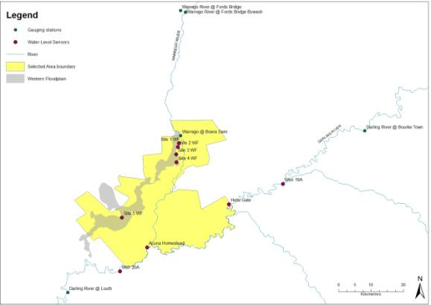

**Figure 1: Hydrological gauge network – Junction of the Warrego and Darling rivers Selected Area**

## Timing and frequency

On-going for the duration of the LTIM Project.

## Responsibilities

The Project Manager of the Junction of the Warrego and Darling rivers M&E Project Team is responsible for overseeing this procedure.

## Detailed methods

No new gauging stations are to be established. Data will be downloaded from the NSW Office of Water hydrological data site (<http://realtimedata.water.nsw.gov.au/water.stm>) or directly from the Office of Water.

## Data analysis and reporting

A suitable hydrological modelling package will be used to calculate the following river water regime parameters:

Daily mean river ‘stage’ water height (mASL)

Daily mean river discharge (ML/day)

Travel time (days).

All data provided for this indicator will conform to the data structure defined in the LTIM Data Standard (Brooks & Wealands 2014).

Hydrology (River) data will be used to assess the level of hydrological connectivity throughout the Selected Area. Relationships between upstream and downstream gauges in each monitoring zone will be determined and threshold levels that provide hydrological connectivity will be determined. These thresholds will be used to assess the movement of Commonwealth environmental water between these gauges and the duration and volume of Commonwealth environmental water moving through the site will be quantified each year. Comparing these flows to other flows in the Selected Area each year, the additional hydrological connectivity provided by Commonwealth environmental water will be determined. Relationships between NoW gauging stations and water level loggers present throughout the Selected Area will also be established to provide for a more accurate assessment of hydrological connectivity within the Selected Area.

## Quality assurance/quality control

Quality control and quality assurance protocols are documented in the Quality Plan developed for the M&E Plan (CEWO 2014).

## References

|  |
| --- |
| Brooks S. & Wealands S.R. 2014. *Commonwealth Environmental Water Office Long Term Intervention Monitoring Project: Data Standard*. Report prepared for the Commonwealth Environmental Water Office by The Murray-Darling Freshwater Research Centre. MDFRC Publication 29.3/2013 Revised Jan 2014. |
| Commonwealth Environmental Water Office (CEWO). 2014. *Long Term Intervention Monitoring Project Junction of the Warrego and Darling rivers Selected Area*. Commonwealth of Australia. |

|  |
| --- |
| Gawne B., Brooks S., Butcher R., Cottingham P., Everingham P. & Hale J. 2013. *Long-term Intervention Monitoring Project: Monitoring and Evaluation Requirements: Junction of the Warrego and Darling rivers*. Report prepared for the Commonwealth Environmental Water Office by The Murray-Darling Freshwater Research Centre, MDFRC Publication 01.2/2013. |

|  |
| --- |
| Hale J., Stoffels R., Butcher R., Shackleton M., Brooks S. & Gawne B. 2014. *Commonwealth Environmental Water Office Long Term Intervention Monitoring Project – Standard Methods*. Final Report prepared for the Commonwealth Environmental Water Office by The Murray-Darling Freshwater Research Centre, MDFRC Publication 29.2/2014, January, 182 pp. |

# B3. SOP – Water Quality (Category I)

## Objectives

The Water Quality monitoring protocol seeks to assess the contribution of Commonwealth environmental water to improved water quality.

## Indicators

Dependant variables:

Temperature

pH

Turbidity

Salinity

Dissolved oxygen

Chlorophyll *a*

Covariates

Discharge (ML/d)

Water level (m)

Stream metabolism involves the collection of dissolved oxygen and temperature from stream sites. We will coordinate sites to allow stream metabolism and water quality monitoring from the same locations.

## Location for monitoring

Category I Water quality will be conducted in the Darling River zone at two locations - near the ‘Yanda’ homestead (-30.34906, 145.57685) and near the ‘Akuna’ homestead (-30.40978, 145.33438; **Figure** ). These locations have permanent surface water connectivity in a defined channel and all Commonwealth environmental water delivered from the Northern tributaries must pass through this reach. These are sites representative of the zone and were selected due to their proximity to NPWS residences to allow for ease of access for probe cleaning (and water chemistry sample collection). The Akuna site is located downstream of the Warrego confluence and can be used to assess the influence of Warrego River flow to the water chemistry of the Darling River. Their location will also allow regular maintenance of the stations by NPWS staff to minimise vandalism.

## Timing and frequency

Continuous monitoring of dependant variables and covariates (following Section 13 Water Quality, Hale et al. 2014) will occur over a full 12 month cycle. Deployment periods will therefore align with the commencement and cessation of Commonwealth environmental water delivery. Loggers will be deployed continuously at Category I sites in the Darling River as they have permanent surface water flow. Loggers will be removed, cleaned and calibrated at 6-weekly intervals as required.



**Figure 2: Location of Water Quality stations on the Darling River**

## Specific Equipment (in addition to the Standard Methods – Water Quality)

Hydrolab DS5-X logger. The DS5-X multi-probe logger includes a self-cleaning system to reduce fouling of probes and is designed for long-term submersible deployment for Category I sites.

Power source (solar panel) and 3G telemetry equipment associated with the power and data transfer of Hydrolab DS5-X Logger (assuming suitable 3G coverage)

## Responsibilities

The Project Manager of the Junction of the Warrego and Darling rivers M&E Project Team is responsible for overseeing this procedure. A field scientist/technician will be responsible for the monitoring and maintenance of loggers and collation of data under the direction of Project Director (Ryder), who will conduct the analyses and reporting.

## Complementary monitoring and data

Hydrological measures of stream discharge are used to inform the interpretation of stream water quality. The existing stream gauge and depth logger network outlined in Hydrology (River) will be used.

## Detailed methods

Measurement of the Water Quality indicator will follow the field and laboratory procedures outlined in the LTIM Standard Methods (Hale et al. 2014).

## Data analysis

### The Selected Area scale hypotheses

At the Selected Area scale a number of hypotheses that relate to the outcomes of delivery of Commonwealth environmental water are possible. Selected Area scale hypotheses include:

1. Mean daily water temperature, and daily range in water temperature will decrease during the delivery of Commonwealth environmental water
2. Mean daily pH, and daily range in decrease during the delivery of Commonwealth environmental water
3. Mean daily turbidity will increase during the delivery of Commonwealth environmental water
4. Mean daily EC will decrease during the delivery of Commonwealth environmental water
5. Mean daily DO concentrations will decrease during the delivery of Commonwealth environmental water
6. Mean daily Chlorophyll a concentrations will decrease during the delivery of Commonwealth environmental water.

### The Selected Area scale analyses

Quantitative analyses will be applied at the Selected Area scale to document temporal shifts in water quality in periods that Commonwealth environmental water is delivered each year. Long-term year on trends can be analysed based on periods with and without the delivery of Commonwealth environmental water.

Short-term and long term responses:

Hypotheses 1 to 6 – Replication derived from randomised daily means of data periods within/outside delivery of Commonwealth environmental water. One-way Anova (WQ variables as dependant variable) comparing among flow periods, and two-way Anova (flow period, years) for long term dataset.

## Reporting

Data for the Basin-scale will be reported following the requirements outlined in the LTIM Data Standard (Section 13.9 Water Quality – Data analysis and reporting, Hale et al. 2014) and conform to the LTIM Data Standard (Brooks & Wealands 2014).

## Quality assurance/quality control

Quality control and quality assurance protocols are documented in the Quality Plan developed for the M&E Plan (CEWO 2014). In addition, this method requires a number of QA/QC procedures:

Calibration and maintenance of sensors and loggers will be carried out at a maximum 6 week interval as required.

Data correction procedures will be used to account for sensor drift or fouling following periodic calibration.

## References

|  |
| --- |
| Brooks S. & Wealands S.R. 2014. *Commonwealth Environmental Water Office Long Term Intervention Monitoring Project: Data Standard*. Report prepared for the Commonwealth Environmental Water Office by The Murray-Darling Freshwater Research Centre. MDFRC Publication 29.3/2013 Revised Jan 2014. |
| Commonwealth Environmental Water Office (CEWO). 2014. *Long Term Intervention Monitoring Project Junction of the Warrego and Darling rivers Selected Area*. Commonwealth of Australia. |
| Hale J., Stoffels R., Butcher R., Shackleton M., Brooks S. & Gawne B. 2014. *Commonwealth Environmental Water Office Long Term Intervention Monitoring Project – Standard Methods*. Final Report prepared for the Commonwealth Environmental Water Office by The Murray-Darling Freshwater Research Centre, MDFRC Publication 29.2/2014, January, 182 pp. |

# B4. SOP – Stream Metabolism (Category I)

## Objectives

The Stream Metabolism monitoring protocol seeks to assess the contribution of Commonwealth environmental water to improved water quality.

## Indicators

Dependant variables:

* Dissolved oxygen
* Temperature
* Photosynthetically active radiation (PAR)
* Barometric pressure
* Chlorophyll-a
* Total nitrogen
* Nitrate-nitrite (NOx)
* Ammonium (NH4)
* Total phosphorous
* Filterable Reactive Phosphate (PO4)
* Dissolved organic carbon.
* Covariates
* Discharge (ML/d)
* Average depth (m).

## Location for monitoring

Category I Stream metabolism will be measured at two locations (near the ‘Yanda’ homestead (-30.34906, 145.57685) and near the ‘Akuna’ homestead (-30.40978, 145.33438; **Figure** ) in the Darling River Zone using Hydroloab DS5-X loggers in combination with the Water quality indicator. The DS5-X multi-probe logger includes a self-cleaning system to reduce fouling of probes and is designed for long-term submersible deployment. A weather station measuring light (PAR) and barometric pressure will be established at the Toorale Homestead within the Selected Area.

## Timing and frequency

Temperature and DO will be logged continuously at 10 minute intervals at Category I sites. PAR and Barometric pressure will be logged at 10 minute intervals throughout the 5 year period as required for Category I (and Category III) stream metabolism. Water quality samples will be collected at approximately 6 weekly periods at Category I sites.

## Specific Equipment (in addition to the Standard Methods – Water Quality)

* Hydrolab DS5-X logger. The DS5-X multi-probe logger includes a self-cleaning system to reduce fouling of probes and is designed for long-term submersible deployment.
* PAR-Barometric pressure weather station to be deployed at Toorale homestead.
* Power source (solar panel) and 3G telemetry equipment associated with the power and data transfer of Hydrolab DS5-X Logger (assuming suitable 3G coverage)

## Responsibilities

The Project Manager of the Junction of the Warrego and Darling rivers M&E Project Team is responsible for overseeing this procedure. A field scientist/technician will be responsible for the monitoring and maintenance of loggers and collation of data under the direction of Project Director (Ryder), who will conduct the analyses and reporting.

## Complementary monitoring and data

Hydrological measures of stream discharge are used to inform the calculation and interpretation of stream water quality. The existing NoW stream gauge at Bourke Town (425003) on the Darling River will be used to quantify discharge (ML/d).

## Detailed methods

Measurement of the Stream Metabolism indicator will follow the field and laboratory procedures outlined in the LTIM Standard Methods (Hale et al. 2014). Here, DO will be measured using an optical (fluorescence) dissolved oxygen sensor and this, along with temperature, will be logged at 10 minute intervals. DO and temperature sensors will be calibrated on site. Probes will be cleaned and serviced at sufficient intervals to maintain accurate readings. Servicing intervals will be determined based on the telemetered data, with irregularities in data measurements indicating the need for cleaning and servicing.

In addition, water quality samples will be taken at 6 weekly intervals in sample containers, processed on site, and then transported back to a NATA accredited laboratory for nutrient analysis.

## Reporting

Data for the Basin-scale will be reported following the requirements outlined in the LTIM Data Standard (Section 13.9 Stream Metabolism – Data analysis and reporting, Hale et al. 2014) and conform to the LTIM Data Standard (Brooks & Wealands 2014).

## Quality assurance/quality control

Quality control and quality assurance protocols are documented in the Quality Plan developed for the M&E Plan (CEWO 2014). In addition, this method requires a number of QA/QC procedures:

Calibration and maintenance of sensors and loggers is required at a maximum 6 week interval

Data correction procedures will be used to account for sensor drift or fouling following periodic calibration.

## References

|  |
| --- |
| Brooks S. & Wealands S.R. 2014. *Commonwealth Environmental Water Office Long Term Intervention Monitoring Project: Data Standard*. Report prepared for the Commonwealth Environmental Water Office by The Murray-Darling Freshwater Research Centre. MDFRC Publication 29.3/2013 Revised Jan 2014. |
| Commonwealth Environmental Water Office (CEWO). 2014. *Long Term Intervention Monitoring Project Junction of the Warrego and Darling rivers Selected Area*. Commonwealth of Australia. |
| Hale J., Stoffels R., Butcher R., Shackleton M., Brooks S. & Gawne B. 2014. *Commonwealth Environmental Water Office Long Term Intervention Monitoring Project – Standard Methods*. Final Report prepared for the Commonwealth Environmental Water Office by The Murray-Darling Freshwater Research Centre, MDFRC Publication 29.2/2014, January, 182 pp. |

# B5. SOP – Vegetation Diversity

## Objectives

This monitoring protocol aims to assess the contribution of Commonwealth environmental water to floodplain vegetation diversity, condition and extent.

## Indicators

This Vegetation diversity indicator links to Ecosystem Type, Microcrustaceans, and Hydrology (Selected Area) indicators.

## Locations for monitoring

Sites will be located in target wetland communities within the Western Floodplain zone (**Figure** ; **Error! Reference source not found.**). The northern section of the Western Floodplain will be targeted as these areas represent the sites most likely to be influenced by Commonwealth environmental water. Sites selection will be based on both wetland vegetation community and flooding frequency.



**Figure 3: Vegetation Diversity sites within the Western Floodplain**

**Table 2:**  **Vegetation Diversity - monitoring site locations**

|  |  |  |  |  |
| --- | --- | --- | --- | --- |
| **Site Name** | **Target vegetation community** | **Target inundation frequency (years)** | **Longitude** | **Latitude** |
| WD1.1 | Coolibah-River Cooba-Lignum woodland | High (<1) | -30.1052 | 145.4143 |
| WD1.2 | Coolibah-River Cooba-Lignum woodland | High (<1) | -30.1042 | 145.4127 |
| WD1.3 | Coolibah-River Cooba-Lignum woodland | High (<1) | -30.1058 | 145.4131 |
| WD2.1 | Coolibah-River Cooba-Lignum woodland | Low (2-5) | -30.1176 | 145.4195 |
| WD2.2 | Coolibah-River Cooba-Lignum woodland | Low (2-5) | -30.1191 | 145.4189 |
| WD2.3 | Coolibah-River Cooba-Lignum woodland | Low (2-5) | -30.1187 | 145.42 |
| WD3.1 | Chenopod shrubland | High (<1) | -30.1925 | 145.3787 |
| WD3.2 | Chenopod shrubland | High (<1) | -30.1927 | 145.3777 |
| WD3.3 | Chenopod shrubland | High (<1) | -30.1934 | 145.3783 |
| WD4.1 | Chenopod shrubland | Low (2-5) | -30.1735 | 145.412 |
| WD4.2 | Chenopod shrubland | Low (2-5) | -30.1753 | 145.4124 |
| WD4.3 | Chenopod shrubland | Low (2-5) | -30.1746 | 145.4136 |
| WD5.1 | Coolibah woodland wetland | High (<1) | -30.209 | 145.3638 |
| WD5.3 | Coolibah woodland wetland | High (<1) | -30.2078 | 145.3632 |
| WD5.2 | Coolibah woodland wetland | High (<1) | -30.208 | 145.365 |
| WD6.1 | Coolibah woodland wetland | Low (2-5) | -30.1346 | 145.4108 |
| WD6.2 | Coolibah woodland wetland | Low (2-5) | -30.1355 | 145.4128 |
| WD6.3 | Coolibah woodland wetland | Low (2-5) | -30.1359 | 145.4112 |
| WD7.1 | Lignum shrubland wetland | High (<1) | -30.152 | 145.4147 |
| WD7.2 | Lignum shrubland wetland | High (<1) | -30.1528 | 145.4143 |
| WD7.3 | Lignum shrubland wetland | High (<1) | -30.1527 | 145.4154 |
| WD8.1 | Lignum shrubland wetland | Low (2-5) | -30.1139 | 145.4192 |
| WD8.2 | Lignum shrubland wetland | Low (2-5) | -30.114 | 145.4207 |
| WD8.3 | Lignum shrubland wetland | Low (2-5) | -30.1124 | 145.4197 |

## Timing and frequency

Vegetation diversity monitoring shall be undertaken twice annually; in February and May in year 1 and then before and after the watering season (August-October and March-June) in years 2 to 5. The exact timing of sampling will be largely dependent on the target vegetation communities and expected lag time for response to watering.

## Responsibilities

The Project Manager of the Junction of the Warrego and Darling rivers M&E Project Team is responsible for overseeing this procedure. Field surveys and data analysis will be undertaken by experienced field botanists.

## Complementary monitoring and data

A comprehensive survey of vegetation distribution and condition was undertaken in 2012 by Cowans et al (2012). Information from this survey will be used as a comparative baseline throughout the project.

## Detailed methods

Survey methods conform to with the Standard Methods as a Category II indicator (Hale et al. 2014).

Surveys will target 8 monitoring sites that incorporate Coolibah - River Cooba - Lignum woodlands, Coolibah open woodlands, Lignum shrublands and Chenopod low open shrublands in the Western Floodplain. These sites have been established to directly target zones where environmental watering is likely to be delivered. At each site, three 20 x 20m plots will be sampled. The 0.04ha plot size is standard for surveying floristics (Sivertsen 2009) and is consistent with previous vegetation monitoring within the Selected Area (Gowans et al. 2012).

At each site, measures of species abundance, structure, tree recruitment, and site flooding will be measured (Appendix 1). Projected foliage cover will be used to define cover (Hale et al. 2014).

## Data analysis

Data analysis methods will follow those defined in Section 4: Vegetation Diversity of the LTIM Standard Methods ((Hale et al. 2014).

The Selected Area scale hypotheses for this indicator are:

Short-term (Annual) responses:

* The delivery of Commonwealth environmental water to wetland and floodplain areas in the Western Floodplain will lead to increased cover and/or richness of wetland vegetation communities

Long-term (5 year) responses:

* The delivery of Commonwealth environmental water to wetland and floodplain areas in the Western Floodplain and will lead to increased year-on-year cover and/or richness of wetland vegetation communities.

Analyses based on Aggregation will be applied at the Basin and Selected Area scales for cover and richness of wetland vegetation communities. Quantitative analyses will be applied at the Selected Area scale to document increased cover and richness of wetland vegetation communities at sites receiving Commonwealth environmental water. Multi-year analyses will be quantitatively assessed based on year-on-year repeat application of annual models outlined in the Selected Area conceptual model (Figure 2). The placement of survey sites has been strategically undertaken to permit quantification of the hydrologic connection and inundation metrics and lead to reduced uncertainty the delivery of Commonwealth water to these sites.



**Figure 4: A hypothetical model that will be applied on a year-to-year basis to generate a series of outcomes from different flow regimes over a five year period (Source: Gawne et al. 2014)**

Short-term (Annual) responses:

1. Hypotheses 1 - univariate analysis (main effect – location, inundation, time) cover and richness and multivariate analysis (factors – location, inundation history, time).

Long-term (5 year) responses:

1. Hypotheses 2 - univariate analysis (main effects – location, inundation history, year, time) and multivariate analysis (factors – location, inundation history, year, time).

Linking wetland vegetation community extent to Commonwealth environmental water inundation extent should permit extrapolation the response to the Selected Area. Reporting

Data for the Basin-scale will be reported following the requirements outlined in the LTIM Standard Methods (Hale et al. 2014). All data provided for this indicator must conform to the data structure defined in the LTIM Data Standard (Brooks & Wealands 2014).

## Quality assurance/quality control

Quality control and quality assurance protocols are documented in the Quality Plan developed for the M&E Plan (CEWO 2014).

## References

|  |
| --- |
|  |
| Brooks S. & Wealands S.R. 2014. *Commonwealth Environmental Water Office Long Term Intervention Monitoring Project: Data Standard*. Report prepared for the Commonwealth Environmental Water Office by The Murray-Darling Freshwater Research Centre. MDFRC Publication 29.3/2013 Revised Jan 2014. |
| Commonwealth Environmental Water Office (CEWO). 2014. *Long Term Intervention Monitoring Project Junction of the Warrego and Darling rivers Selected Area*. Commonwealth of Australia. |

|  |
| --- |
| Gowans, S., Milne, R., Westbrooke, M. & Palmer, G. 2012. *Survey of Vegetation and Vegetation Condition of Toorale*. Prepared for the NSW Government Office for Environment and Heritage. University of Ballarat, Mt Hellen. 199pp. |

|  |
| --- |
| Hale J., Stoffels R., Butcher R., Shackleton M., Brooks S. & Gawne B. 2014. *Commonwealth Environmental Water Office Long Term Intervention Monitoring Project – Standard Methods*. Final Report prepared for the Commonwealth Environmental Water Office by The Murray-Darling Freshwater Research Centre, MDFRC Publication 29.2/2014, January, 182 pp. |
| Sivertsen, D. (2009) *Native Vegetation Interim Type Standard*. Department of Environment, Climate Change and Water, NSW Sydney. |

**Appendix 1 Field Data Sheets**

Note – iPads will be used in the field to record all data under the following headings.

Species abundance

|  |  |  |  |  |  |  |  |  |  |  |  |  |  |  |
| --- | --- | --- | --- | --- | --- | --- | --- | --- | --- | --- | --- | --- | --- | --- |
| Site Number | Collect | Common name | Scientific name | % Cover | Mean Height | Upper Height | Exotic | waypoint | Photo SW from NE | Photo N from S | Photo NE from SW | Photo S from N | Grazing | Notes |
|  |  |  |  |  |  |  |  |  |  |  |  |  |  |  |
|  |  |  |  |  |  |  |  |  |  |  |  |  |  |  |

Community structure

|  |  |  |  |  |  |  |  |  |  |  |
| --- | --- | --- | --- | --- | --- | --- | --- | --- | --- | --- |
| Site Number | Sample date | Veg community | >5m canopy % cover | 1-5m understory % cover | <1m ground % cover | Litter % Cover | Lichen/moss % cover | Bare ground % cover | Fallen timber (0.04 ha) | Av length of fallen logs |
|  |  |  |  |  |  |  |  |  |  |  |
|  |  |  |  |  |  |  |  |  |  |  |

Tree Recruitment

|  |  |  |  |  |  |  |  |  |  |  |
| --- | --- | --- | --- | --- | --- | --- | --- | --- | --- | --- |
| Site no | Species | No ind. 0.2-0.5m tall (0.04 ha) | No ind. 0.5 1.3m tall (0.04 ha) | No ind. 1.3-3m tall (0.04 ha) | No ind. 0.2-0.5m tall (0.1 ha) | No ind. 0.5 1.3m tall (0.1 ha) | No ind. 1.3-3m tall (0.1 ha) | No dead trees (0.4 ha) | No live trees (0.4 ha) | comments |
|  |  |  |  |  |  |  |  |  |  |  |
|  |  |  |  |  |  |  |  |  |  |  |
|  |  |  |  |  |  |  |  |  |  |  |
|  |  |  |  |  |  |  |  |  |  |  |

Site flooding data

|  |  |  |  |  |  |  |  |  |  |  |  |  |  |
| --- | --- | --- | --- | --- | --- | --- | --- | --- | --- | --- | --- | --- | --- |
| Site No | Date | % Plot flooded | % Plot wet | % open water | Water depth (cm) | %submerged veg | bare ground submerged (%) | Submerged litter (%) | bare ground (%) | litter (%) | Time since previous flood | Time flooded (weeks) | notes |
|  |  |  |  |  |  |  |  |  |  |  |  |  |  |
|  |  |  |  |  |  |  |  |  |  |  |  |  |  |
|  |  |  |  |  |  |  |  |  |  |  |  |  |  |
|  |  |  |  |  |  |  |  |  |  |  |  |  |  |
|  |  |  |  |  |  |  |  |  |  |  |  |  |  |

# B6. SOP – Hydrology (Northern tributaries)

## Objectives

The aim of the Hydrology (Northern tributaries) indicator is to document the relative contribution of upstream end-of-system Commonwealth environmental water to flows through the Darling River zone of the Selected Area.

## Indicators

The Hydrology (Northern tributaries) indicator links to Hydrology (River, Channel, Habitat, Floodplain), Water Quality and Stream Metabolism indicators.

## Locations for monitoring

The Hydrology (Northern tributaries) indicator will use NOW gauges located in upstream tributaries which best reflect the contribution of each tributary to flows entering the Selected Area (**Error! Reference source not found.**; **Figure 2**).

**Table 3: NOW gauging stations within upstream tributaries**

|  |  |  |  |  |
| --- | --- | --- | --- | --- |
| **Gauge no.** | **Gauge Name** | **Tributary** | **Latitude** | **Longitude** |
| 416001 | Barwon River @ Mungindi | Border Rivers | -28.9762 | 148.9848 |
| 417001 | Moonie River @ Gundablouie | Moonie | -29.1671 | 148.6305 |
| 416027 | Gil Gil Creek @ Weemelah | Gwydir | -29.0488 | 149.1599 |
| 418055 | Mehi River @ Collarenebri | Gwydir | -29.5130 | 148.7241 |
| 419091 | Namoi River @ US Walgett | Namoi | -30.0279 | 148.1529 |
| 420020 | Castlereagh River @ Gungalman | Castlereagh | -30.3088 | 147.9999 |
| 421012 | Macquarie River @ Carinda (Bells Bridge) | Macquarie | -30.4347 | 147.5696 |
| 421107 | Marra Creek @ Billybongbone Br | Macquarie | -30.4032 | 147.1710 |
| 421023 | Bogan River @ Gongolgon | Bogan | -30.3472 | 146.8978 |
| 422006 | Culgoa River @ DS Collerina | Condamine Balonne | -29.7735 | 146.5179 |
| 423001 | Warrego River @ Fords Bridge | Warrego | -29.7526 | 145.4276 |
| 423002 | Warrego River @ Fords Bridge Bywash | Warrego | -29.7568 | 145.4408 |
| 425003 | Darling River @ Bourke Town | Darling | -30.0861 | 145.9387 |
| 425004 | Darling River @ Louth | Darling | -30.5347 | 145.1151 |

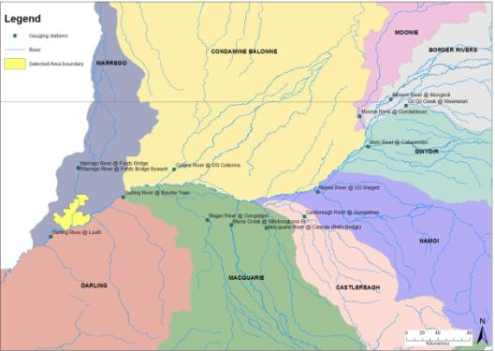

**Figure 2: NOW gauging stations in upstream tributaries**

## Timing and frequency

Ongoing throughout the project.

## Responsibilities

The Project Manager of the Junction of the Warrego and Darling rivers M&E Project Team is responsible for overseeing this procedure. Experienced technicians will undertake data collation and analysis under the direction of the Project Manager (Southwell).

## Detailed methods

The influence of Commonwealth environmental water at the Junction of the Warrego and Darling Rivers Selected Area is dependent on unregulated, and to a lesser extent regulated flows from a number of upstream tributaries (Gawne et al. 2013). Given the relatively short period of time that Commonwealth entitlements have been available in the northern Basin, the relative influence of flows from each tributary in contributing to different flow components, and how best to ‘shepherd’ these environmental flows through the system for maximum benefit remains unclear. The Hydrology (Northern tributaries) indicator will inform this, by quantifying the relative contributions of the end of system flows coming out of each upstream tributary to hydrological connectivity (frequency and duration of flows) within the Junction of the Warrego and Darling rivers Selected Area. In this way, a model of flow contributions will be established.

## Data analysis and reporting

Standard hydrological analysis will be used to determine relationships between end-of-system Commonwealth environmental water flows out of upstream tributaries and flows entering the Selected Area. These relationships will inform a basic working hydrological model of upstream inputs of Commonwealth environmental water from upstream tributaries to the Selected Area. This indicator will also provide context for a number of other indictors. See individual indicators for short and long term hypotheses and analyses.

## Conceptual definition

This indicator will contain rows of data about a site that is:

*“An end-of-system gauging station in an upstream tributary”*

Each row of data will describe:

*“The contribution of flow at the site to flows in the Selected Area”*

## Site linkages

Sites of Hydrology (Floodplain) require the following linkages to other data (where available):

* ANAE stream identifiers to enable linking with framework datasets for future work

## Data definition

*Each row of data will contain the following columns of information*.

| **Variable** | **Description** | **Type** | **Req** | **Range** | **Example** |
| --- | --- | --- | --- | --- | --- |
| siteId | A single large wetland or a complex of wetlands represented by either a name or polygon within which observations are made | string | Y |  |  |
| sampleDate | Start date (inclusive) that these measures were observed | dateTime | Y |  |  |
| sampleDateEnd | End date (exclusive) that these measures were observed | dateTime | Y |  |  |
| dailystage | Daily mean river ‘stage’ water height (metres) | Number  (3 decimals) | Y | (0,+) | 1.532 |
| dailyVolume | Daily mean river Discharge (ML/d) | Number  (2 decimals) | Y | (0,+) | 23.546 |
| ContributiontoSA | Did this flow contribute to flows in Selected Area? | string | Y | [Y,N] | N |
| Volumecontributed | What volume was contributed to flows in the SA (ML/d) | Number  (3 decimals) | Y | (0,+) | 1.532 |
| Volumeloss | What was the estimated loss between site and Selected Area (ML/d) | Number  (3 decimals) | Y | (0,+) | 1.532 |
| Traveltime | Time taken for flow to travel to Selected Area (days) | Integer | Y | (0,+) | 5 |

## Quality assurance/quality control

Quality control and quality assurance protocols are documented in the Quality Plan developed for the M&E Plan (CEWO 2014).

## References

|  |
| --- |
|  |
| Commonwealth Environmental Water Office (CEWO). 2014. *Long Term Intervention Monitoring Project Junction of the Warrego and Darling rivers Selected Area*. Commonwealth of Australia. |

|  |
| --- |
| Gawne B., Brooks S., Butcher R., Cottingham P., Everingham P. & Hale J. 2013. *Long-term Intervention Monitoring Project: Monitoring and Evaluation Requirements: Junction of the Warrego and Darling rivers*. Report prepared for the Commonwealth Environmental Water Office by The Murray-Darling Freshwater Research Centre, MDFRC Publication 01.2/2013. |

# B7. SOP – Hydrology (Floodplain)

## Objectives

The aim of the Hydrology (Floodplain) indicator is to document the extent of inundation resulting from Commonwealth environmental watering.

## Indicators

Hydrology (Floodplain) monitoring will map the inundation extent resulting from the delivery of Commonwealth environmental watering on the Western Floodplain

The Hydrology (Floodplain) indicator links to Vegetation Diversity, Waterbird Diversity, Hydrology (River and channel), Stream Metabolism and Microcrustacean indicators.

## Locations for monitoring

Hydrology (Floodplain) monitoring will be undertaken in the Western Floodplain zone (**Figure 3**).

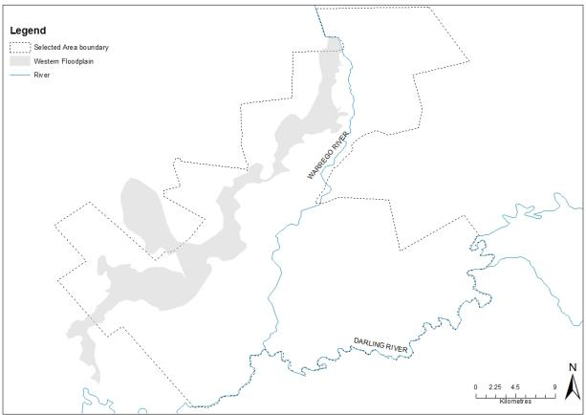

**Figure 3: Location of the Western Floodplain zone in the Selected Area**

## Timing and frequency

Existing sets of LiDAR data (already captured) will be used to create an inundation model for the Western Floodplain. No new data capture is proposed.

## Responsibilities

The Project Manager of the Junction of the Warrego and Darling rivers M&E Project Team is responsible for overseeing this procedure. A team of GIS officers will complete the data analysis under the direction of the Project Director (Frazier).

## Complementary monitoring and data

Data on inundation extent and frequency from previous and ongoing work (e.g. OEH (Cox, Thomas et al.), will be used to assist in developing the known and expected inundation extent and volume from given flow events.

## Detailed methods

At present there is a fixed camera at Boera Dam along with a number of water level loggers established within key areas of the Western Floodplain which can be used to monitor water levels. In addition, a number of water depth recorders will be established on the Western Floodplain to increase the coverage of water level monitoring within this system.

Water level information from this network of gauges and cameras will then be linked to the LiDAR imagery to allow for an estimation of the extent and volume of water on the Western Floodplain at any given time.

## Data analysis and reporting

GIS based analysis to determine the relationship between inundation event (volume) and inundated area, and volume in relation to mapped soil and vegetation regions.

The Hydrology (Floodplain) method reports m2 ANAE typology and vegetation community inundated from Commonwealth environmental water. The proposed indicator will document the m2 of inundated ANAE and vegetation hydrology and will facilitate the scaling of potential Microcrustacean and Vegetation Diversity to the Selected Area.

All data provided for this indicator must conform to the data structure defined in the LTIM Data Standard (Brooks & Wealands 2014).

## Conceptual definition

This indicator will contain rows of data about a site that is:

*“A defined watercourse potentially inundated by the delivery of environmental water”*

Each row of data will describe:

*“ the extent and volume of inundation by environmental water ”*

## Site linkages

Sites of Hydrology (Floodplain) require the following linkages to other data (where available):

* ANAE stream identifiers to enable linking with framework datasets for future work
* Gauged flow and stage information from relevant gauges.

## Data definition

*Each row of data will contain the following columns of information*.

| 1. **Variable** | 1. **Description** | 1. **Type** | 1. **Req** | 1. **Range** | 1. **Example** |
| --- | --- | --- | --- | --- | --- |
| siteId | A single large wetland or a complex of wetlands represented by either a name or polygon within which observations are made | String | Y |  |  |
| sampleDate | Start date (inclusive) that these measures were observed | dateTime | Y |  |  |
| sampleDateEnd | End date (exclusive) that these measures were observed | dateTime | Y |  |  |
| dailyExtent | m^2 | Number  (1 decimals) | N |  | 7 398 765.1 |
| dailyVolume | m^3 | Number  (1 decimals) | N |  | 4 897 967.2 |
| percentDry | Percentage of total area that is dry (zero depth) | Integer | N | [0,100] | 26 |
| percentDepth020 | Percentage of total area that is < 20cm deep | Integer | N | [0,100] | 74 |
| percentDepth040 | Percentage of total area that is 20 to < 40cm deep | Integer | N | [0,100] | 63 |
| percentDepth060 | Percentage of total area that is 40 to < 60cm deep | Integer | N | [0,100] | 25 |
| percentDepth080 | Percentage of total area that is 60 to < 80cm deep | Integer | N | [0,100] | 18 |
| percentDepth100 | Percentage of total area that is 80 to < 100cm deep | Integer | N | [0,100] | 6 |
| percentDeep | Percentage of total area that is >100cm deep | Integer | N | [0,100] | 47 |
| percentCEW | Percent of water contributed by CEWO as percent of total area | Integer | N | [0,100] | 52 |
| qualityCode | Data quality codes (1-5) will need to be applied with the following definitions:  1: Best quality unedited data. Meets operational standards and is considered a good representation of the true value.  2: Good quality. Minimal editing, may include sensor drift correction this is considered a good representation of the true value.  3: Modified or transformed data this is considered A reasonable representation of the true value.  4: Unreliable data - considered a poor representation (e.g. debris effecting sensor, flat batteries)  5: Estimated or modelled data. | Integer | N | [1,5] | 2 |

## Quality assurance/quality control

Quality control and quality assurance protocols are documented in the Quality Plan developed for the M&E Plan (CEWO 2014).

## References

|  |
| --- |
| Brooks S. & Wealands S.R. 2014. *Commonwealth Environmental Water Office Long Term Intervention Monitoring Project: Data Standard*. Report prepared for the Commonwealth Environmental Water Office by The Murray-Darling Freshwater Research Centre. MDFRC Publication 29.3/2013 Revised Jan 2014. |
| Commonwealth Environmental Water Office (CEWO). 2014. *Long Term Intervention Monitoring Project Junction of the Warrego and Darling rivers Selected Area*. Commonwealth of Australia. |

# B8. SOP – Hydrology (Channel)

## Objectives

The aim of the Hydrology (channel) indicator is to document the degree of connectivity resulting from Commonwealth environmental watering along the Warrego River channel.

## Indicators

Hydrology (Channel) monitoring will map the flowpaths along the Warrego River channel and determine the hydrological connectivity as a result of the delivery of Commonwealth environmental watering.

The Hydrology (channel) indicator links to Waterbird Diversity, Hydrology (River and Watercourse), Fish (Channel), Water quality (Cat III), metabolism (Cat III), Microcrustaceans and Frogs indicators.

## Locations for monitoring

Hydrology (Channel) monitoring will be undertaken in the Warrego River zone. Long-term gauging stations operated by NSW Office of Water (NOW) in the Warrego River upstream of the Selected Area at Fords Bridge on the Warrego, and also at Boera Dam at the northern end of the Selected Area will inform the amount of Commonwealth environmental water entering the zone.

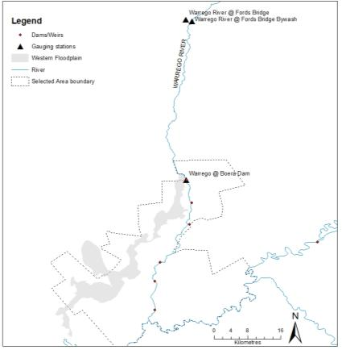

Peebles Dam/ Ross Billabong

Boera Dam

Booka Dam

Homestead Dam

Dicks Dam

12 Mile Dam

**Figure 4: Gauging stations and Dams located on the Lower Warrego River channel.**

## Timing and frequency

Ongoing throughout the project

## Complementary monitoring and data

Data on inundation extent and frequency from previous work (Cox et al. 2012; Holz et al 2008, Aurecon 2009) will be used to assist in developing the known and expected hydrological connectivity through the Warrego River channel during flow events.

## Responsibilities

The Project Manager of the Junction of the Warrego and Darling rivers M&E Project Team is responsible for overseeing this procedure. Experienced technicians will undertake data collation and analysis under the direction of the Project Manager (Southwell).

## Detailed methods

The Lower Warrego River takes on an anastomosing channel form, with multiple channels and by-washes carrying water through the system. These channels will be mapped using existing aerial photographs and imagery to provide a map of the channel network. This will include some channels in upper sections of the Northern Floodplain which connect back into the Warrego channel through pipes in the northern embankment. The next step will be to determine the channel networks hydrology, by utilising a number of existing water level loggers and known levels (Dams/weirs) throughout the system. A differential GPS will be used to tie in these water level loggers with the gauging station at Boera Dam. Additional water level loggers may be implemented to improve the relationships with flow and connectivity in this system. Waterhole permanence will also be determined using water level loggers, cameras and field validation.

## Data analysis

* + 1. **The Selected Area scale hypotheses**

At the Selected Area scale a number of hypotheses that relate to the outcomes of delivery of Commonwealth environmental water are possible. Selected Area scale hypotheses include:

1. Hydrological connectivity in the channels of the Lower Warrego River will increase with Commonwealth environmental water
2. The persistence of waterholes in the Lower Warrego River will increase with Commonwealth environmental water.
   * 1. **The Selected Area scale analyses**

Quantitative analyses will be applied at the Selected Area scale to document temporal shifts in the presence and connectedness of water in periods that Commonwealth environmental water is delivered each year. Long-term year on year trends can be analysed based on periods with and without the delivery of Commonwealth environmental water.

Short-term and long term responses:

* Hypotheses 1-2 – Relative increases in the persistence and connections provided with the addition of Commonwealth environmental water, compared to times without.

All data provided for this indicator must conform to the data structure defined in the LTIM Data Standard (Brooks & Wealands 2014).

## Data reporting

### Conceptual definition

This indicator will contain rows of data about a site that is:

*“A defined watercourse potentially inundated by the delivery of environmental water”*

Each row of data will describe:

*“ the extent and volume of inundation by environmental water ”*

### Site linkages

Sites of Hydrology (channel) require the following linkages to other data (where available):

* Gauged flow and stage information from relevant gauges

### Data definition

*Each row of data will contain the following columns of information*.

| 1. **Variable** | 1. **Description** | 1. **Type** | 1. **Req** | 1. **Range** | 1. **Example** |
| --- | --- | --- | --- | --- | --- |
| siteId | A single channel or waterhole represented by either a name or polygon within which observations are made | string | Y |  |  |
| sampleDate | Start date (inclusive) that these measures were observed | dateTime | Y |  |  |
| sampleDateEnd | End date (exclusive) that these measures were observed | dateTime | Y |  |  |
| percentinudated | Percentage of total channel or waterhole inundated | Integer | N | [0,100] | 81 |
| Dayswet | No of days water has been present within site | Integer | N |  | 5 |
| Daysdry | No of days since water was present within site | Integer | N |  | 143 |
| percentCEW | Percent of water contributed by CEWO as percent of total area | Integer | N | [0,100] | 52 |

## Quality assurance/quality control

Quality control and quality assurance protocols are documented in the Quality Plan developed for the M&E Plan (CEWO 2014).

## References

|  |
| --- |
| Aurecon 2009. *Toorale Station Decommissioning Plan Volume 1*. Prepared for the Department of Environment, Water, Heritage and Arts.  Brooks S. & Wealands S.R. 2014. *Commonwealth Environmental Water Office Long Term Intervention Monitoring Project: Data Standard*. Report prepared for the Commonwealth Environmental Water Office by The Murray-Darling Freshwater Research Centre. MDFRC Publication 29.3/2013 Revised Jan 2014. |
| Commonwealth Environmental Water Office (CEWO). 2014. *Long Term Intervention Monitoring Project Junction of the Warrego and Darling rivers Selected Area*. Commonwealth of Australia. |
| |  | | --- | | Cox, S.J., Thomas, R.F. & Lu, Y. 2012. *Flooding patterns of Toorale: the confluence of the Warrego and Darling rivers.* Office of Environment and Heritage, Sydney. Unpublished report. | | Holz, L., Barma, D. & Wettin, P. 2008. Warrego River Scoping Study. WMA Water, Sydney. | | |

# B9. SOP – Hydrology (Habitat)

## Objectives

The aim of the Hydrology (Habitat) indicator is to document the degree of connection of in-channel habitat resulting from Commonwealth environmental watering.

## Indicators

Hydrology (Habitat) monitoring will quantify the connection of in-channel habitats within the Darling River channel.

The Hydrology (Habitat) indicator links to Hydrology (River and Upstream tributaries), Water quality, and Stream metabolism indicators.

## Locations for monitoring

Hydrology (Habitat) monitoring will be undertaken in the Darling River zone within the Selected Area. Long-term gauging stations operated by NSW Office of Water (NOW) located in the Darling River at Bourke and Louth will be used to quantify river flows through the zone. In addition, there are several water level sensors that have been placed along the Darling River within the Selected Area that are being maintained by NOW staff (**Figure 5**).

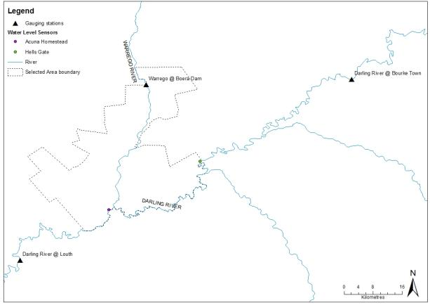

**Figure 5: Location of gauging stations and water level sensors along the Darling River zone**

## Timing and frequency

Throughout the project

## Responsibilities

The Project Manager of the Junction of the Warrego and Darling rivers M&E Project Team is responsible for overseeing this procedure. Experienced technicians will undertake field data collection and data analysis under the direction of the Project Manager (Southwell).

## Complementary monitoring and data

There are several ongoing projects funded under the MDBA’s northern Basin strategy that will generate information relevant to this indicator. The project team is keen to collaborate with these projects to maximise the outcomes of all projects and minimise duplication of effort.

## Detailed methods

Initial desk-top mapping of in-stream habitat (benches, anabranch channels, large woody debris) will be undertaken using high resolution aerial photography and Lidar. These maps will then be validated in the field following the methods outlined in Boys (2007) and Southwell (2008). In addition to the number and size of individual habitats present, the commence-to-inundate (or commence-to-fill in the case of anabranch channels) will be measured in the field using a combination of hypsometer measurements and cross sectional surveys. The vertical commence-to-inundate height of individual habitats above the present water level at the time of measurement will be converted to a gauged height at the nearest gauging station. Once this has occurred, relationships will be determined between river flow and the number and area of habitats inundated at the reach or zone scale.

## Data analysis

### The Selected Area scale hypotheses

At the Selected Area scale a number of hypotheses that relate to the outcomes of delivery of Commonwealth environmental water are possible. Selected Area scale hypotheses include:

1. The inundation of in-channel bench surfaces along the Darling River channel will increase with the delivery of Commonwealth environmental water
2. The inundation of large Woody Debris within the Darling River channel will increase with the delivery of Commonwealth environmental water
3. The hydrological connection of anabranch channels along the Darling River will increase with the delivery of Commonwealth environmental water.

### The Selected Area scale analyses

Quantitative analyses will be applied at the Selected Area scale to document temporal shifts in the connection of habitats in periods that Commonwealth environmental water is delivered each year. Long-term year on year trends can be analysed based on periods with and without the delivery of Commonwealth environmental water.

Short-term and long term responses:

* Hypotheses 1-3 – Basic descriptive statistics comparing the amount of connected habitat with the addition of Commonwealth environmental water, compared to times without.

All data provided for this indicator must conform to the data structure defined in the LTIM Data Standard (Brooks & Wealands 2014).

## Data reporting

### Conceptual definition

This indicator will contain rows of data about a site that is:

*“A defined habitat type potentially inundated by the delivery of environmental water”*

Each row of data will describe:

*“ the number and extent of habitat inundated by environmental water ”*

### Site linkages

Sites of Hydrology (channel) require the following linkages to other data (where available):

* Gauged flow and stage information from relevant gauges

### Data definition

*Each row of data will contain the following columns of information*.

| 1. **Variable** | 1. **Description** | 1. **Type** | 1. **Req** | 1. **Range** | 1. **Example** |
| --- | --- | --- | --- | --- | --- |
| siteId | A habitat type found within the Darling River zone | string | Y | Bench, Anabranch,  Large Woody debris | Bench |
| sampleDate | Start date (inclusive) that these measures were observed | dateTime | Y |  |  |
| sampleDateEnd | End date (exclusive) that these measures were observed | dateTime | Y |  |  |
| percentinudated | Percentage of total no of habitat type inundated | Integer | N | [0,100] | 81 |
| areainundated | Area of habitat type inundated (m2) | Integer | N |  | 5 |
| percentCEW | Percent of water contributed by CEWO as percent of total area | Integer | N | [0,100] | 52 |

## Quality assurance/quality control

Quality control and quality assurance protocols are documented in the Quality Plan developed for the M&E Plan (CEWO 2014).

## References

|  |
| --- |
| Brooks S. & Wealands S.R. 2014. *Commonwealth Environmental Water Office Long Term Intervention Monitoring Project: Data Standard*. Report prepared for the Commonwealth Environmental Water Office by The Murray-Darling Freshwater Research Centre. MDFRC Publication 29.3/2013 Revised Jan 2014. |
| Commonwealth Environmental Water Office (CEWO). 2014. *Long Term Intervention Monitoring Project Junction of the Warrego and Darling rivers Selected Area*. Commonwealth of Australia. |
| |  | | --- | | Boys CA 2007, *Fish habitat association in a large dryland river of the Murray-Darling Basin Australia.* PhD Thesis, University of Canberra, Australia | | Southwell MR 2008, *Floodplains as Dynamic mosaics: Sediment and nutrient patches in a large lowland riverine landscape.* PhD Thesis, University of Canberra, Australia | | |

# B10. SOP – Water Quality (Category III)

## Objectives

The Water Quality monitoring protocol seeks to assess the contribution of Commonwealth environmental water to improved water quality.

## Indicators

Dependant variables:

Temperature

pH

Turbidity

Salinity

Dissolved oxygen

Chlorophyll *a*

Covariates

Discharge (ML/d)

Water level (m)

Stream metabolism involves the collection of dissolved oxygen and temperature from stream sites. We will coordinate sites to allow stream metabolism and water quality monitoring from the same locations.

## Location for monitoring

Category III water quality will be conducted along the Warrego River zone. Sampling will take place in three dams along the lower Warrego River; Boera Dam, Booka Dam and Peebles Dam/Ross Billabong. These locations represent the largest and most permanent refuges in this system, and will be the focus for many of the Category III indicators (**Figure 6**).

## Timing and frequency

The collection of Water Quality parameters will align with the commencement, delivery and cessation of Commonwealth environmental water delivery in the Warrego River channel and Western Floodplain zones where possible. Samples will be collected twice during year 1 of the project (Feb, May) and then before, during and after each of three flow events down the Warrego River system over the remaining four years of the project.

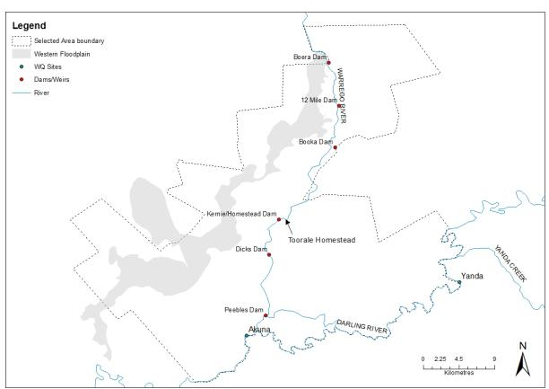

**Figure 6: Warrego River dams where Category III Water Quality will be monitored.**

## Specific Equipment (in addition to the Standard Methods – Water Quality)

Hydrolab Quanta multiprobe for *in situ* spot measurements of water quality for Category III sites.

Hobo PAR-Temperature loggers for vertical profiles on each of the three dam locations on the Warrego River.

## Responsibilities

The Project Manager of the Junction of the Warrego and Darling rivers M&E Project Team is responsible for overseeing this procedure. A field scientist/technician will be responsible for the deployment, monitoring and maintenance of loggers and collation of data under the direction of Project Director (Ryder), who will conduct the analyses and reporting.

## Complementary monitoring and data

Hydrological measures of stream discharge are used to inform the interpretation of stream water quality. The existing stream gauge and depth logger network outlined in Hydrology (River, floodplain and channel) will be used.

## Detailed methods

Measurement of the Water Quality indicator will follow the field and laboratory procedures outlined in the LTIM Standard Methods (Hale et al. 2014).

## Data analysis

### The Selected Area scale hypotheses

At the Selected Area scale a number of hypotheses that relate to the outcomes of delivery of Commonwealth environmental water are possible. Selected Area scale hypotheses include:

1. Mean daily water temperature, and daily range in water temperature will decrease during the delivery of Commonwealth environmental water
2. Mean daily pH will decrease during the delivery of Commonwealth environmental water
3. Mean daily turbidity will increase during the delivery of Commonwealth environmental water
4. Mean daily EC will decrease during the delivery of Commonwealth environmental water
5. Mean daily DO concentrations will decrease during the delivery of Commonwealth environmental water.

### The Selected Area scale analyses

Quantitative analyses will be applied at the Selected Area scale to document temporal shifts in water quality in periods that Commonwealth environmental water is delivered each year. Long-term year on year trends can be analysed based on periods with and without the delivery of Commonwealth environmental water.

Short-term and long term responses:

* Hypotheses 1 to 5 – Replication derived from randomised daily means of data periods pre, during and post delivery of Commonwealth environmental water. Two-way Anova (WQ variables as dependant variable) comparing location (3 river sites) and flow period (pre, during, post), and two-way Anova (flow period, years) for long term dataset.

## Reporting

Data for this indicator will be reported following the requirements outlined in the LTIM Data Standard (Section 13.9 Water Quality – Data analysis and reporting, Hale et al. 2014) and conform to the LTIM Data Standard (Brooks & Wealands 2014).

## Quality assurance/quality control

Quality control and quality assurance protocols are documented in the Quality Plan developed for the M&E Plan (CEWO 2014). In addition, this method requires a number of QA/QC procedures:

## References

|  |
| --- |
| Brooks S. & Wealands S.R. 2014. *Commonwealth Environmental Water Office Long Term Intervention Monitoring Project: Data Standard*. Report prepared for the Commonwealth Environmental Water Office by The Murray-Darling Freshwater Research Centre. MDFRC Publication 29.3/2013 Revised Jan 2014. |
| Commonwealth Environmental Water Office (CEWO). 2014. *Long Term Intervention Monitoring Project Junction of the Warrego and Darling rivers Selected Area*. Commonwealth of Australia. |
| Hale J., Stoffels R., Butcher R., Shackleton M., Brooks S. & Gawne B. 2014. *Commonwealth Environmental Water Office Long Term Intervention Monitoring Project – Standard Methods*. Final Report prepared for the Commonwealth Environmental Water Office by The Murray-Darling Freshwater Research Centre, MDFRC Publication 29.2/2014, January, 182 pp. |

# B11. SOP – Stream Metabolism (Category III)

## Objectives

The Stream Metabolism monitoring protocol seeks to assess the contribution of Commonwealth environmental water to improved water quality.

## Indicators

Dependant variables:

Dissolved oxygen

Temperature

Photosynthetically active radiation (PAR)

Barometric pressure

Chlorophyll-a

Total nitrogen

Nitrate-nitrite (NOx)

Ammonium (NH4)

Total phosphorous

Filterable Reactive Phosphate (PO4)

Dissolved organic carbon.

Covariates

Discharge (ML/d)

Average depth (m).

## Location for monitoring

Category III Stream Metabolism will be carried out at three locations within each of the Warrego River and Western Floodplain zones. In the Warrego River, D-Opto loggers will be placed in Boera Dam, Booka Dam, and Peebles Dam/Ross Billabong, and in floodplain depressions on the Western Floodplain to align with Vegetation Diversity sampling locations that have annual inundation patterns. A weather station measuring light (PAR) and barometric pressure will be established at the Toorale Homestead within the Selected Area.

## Timing and frequency

PAR and Barometric pressure will be logged at 10 minute intervals throughout the 5 year period as required for Category I and III metabolism. Event-based sampling for Category III Metabolism is based on the design of 3 sampling periods; pre-, during- and post- Commonwealth water delivery event. Logging of DO and temperature at each of the inundated Category III sites will be for a minimum 48h incubation to capture two complete diurnal cycles for each of the 3 sampling periods. Water quality samples will be collected at the commencement and completion of 48h incubations for each sampling period at Category III sites in the Warrego River and Western Floodplain.

## Specific Equipment (in addition to the Standard Methods – Water Quality)

D-Opto Dissolved Oxygen loggers

PAR-Barometric pressure weather station to be deployed at Toorale homestead.

## Responsibilities

The Project Manager of the Junction of the Warrego and Darling rivers M&E Project Team is responsible for overseeing this procedure. A field scientist/technician will be responsible for the monitoring and maintenance of loggers and collation of data under the direction of Project Director (Ryder), who will conduct the analyses and reporting.

## Complementary monitoring and data

Hydrological measures of stream discharge and water level are used to inform the calculation and interpretation of stream metabolism and water quality. The existing NoW stream gauges at Fords Bridge, and the Hydrology Channel and Floodplain Category III indicators will be used to quantify discharge (ML/d) and water level for Category III Metabolism data.

## Detailed methods

Measurement of the Stream Metabolism indicator will follow the field and laboratory procedures outlined in the LTIM Standard Methods (Hale et al. 2014). Here, DO will be measured using an optical (fluorescence) dissolved oxygen sensor, and this along with temperature will be logged at 10 minute intervals. DO and temperature sensors will be calibrated on site, before being deployed for at least 48 hours on each sampling occasion. PAR and barometric pressure will also be logged at 10 minute intervals (see Category I Metabolism)

In addition, water quality samples will be collected during each sampling occasion in suitable water quality sampling containers, processed on site, and then transported back to a NATA accredited laboratory for nutrient analysis.

## Data analysis

### The Selected Area scale hypotheses

At the Selected Area scale a number of hypotheses that relate to the outcomes of delivery of Commonwealth environmental water are possible. Selected Area scale hypotheses include:

1. Rates of Decomposition will increase during the delivery of Commonwealth environmental water?
2. Rates of primary productivity will increase during the delivery of Commonwealth environmental water?

### The Selected Area scale analyses

Quantitative analyses will be applied at the Selected Area scale to document temporal shifts in water quality in periods that Commonwealth environmental water is delivered each year. Long-term year on trends can be analysed based on periods with and without the delivery of Commonwealth environmental water.

## Reporting

Data for the Basin-scale will be reported following the requirements outlined in the LTIM Data Standard (Section 13.9 Stream Metabolism – Data analysis and reporting, Hale et al. 2014) and conform to the LTIM Data Standard (Brooks & Wealands 2014).

## Quality assurance/quality control

Quality control and quality assurance protocols are documented in the Quality Plan developed for the M&E Plan (CEWO 2014). In addition, this method requires a number of QA/QC procedures:

* Data correction procedures will be used to account for sensor drift or fouling following periodic calibration.

## References

|  |
| --- |
| Brooks S. & Wealands S.R. 2014. *Commonwealth Environmental Water Office Long Term Intervention Monitoring Project: Data Standard*. Report prepared for the Commonwealth Environmental Water Office by The Murray-Darling Freshwater Research Centre. MDFRC Publication 29.3/2013 Revised Jan 2014. |
| Commonwealth Environmental Water Office (CEWO). 2014. *Long Term Intervention Monitoring Project Junction of the Warrego and Darling rivers Selected Area*. Commonwealth of Australia. |
| Hale J., Stoffels R., Butcher R., Shackleton M., Brooks S. & Gawne B. 2014. *Commonwealth Environmental Water Office Long Term Intervention Monitoring Project – Standard Methods*. Final Report prepared for the Commonwealth Environmental Water Office by The Murray-Darling Freshwater Research Centre, MDFRC Publication 29.2/2014, January, 182 pp. |

# B12. SOP – Fish (Channel)

## Objectives

To assess the contribution of Commonwealth environmental water to fish survival, resilience and diversity at the Selected Area scale.

## Indicators

The Fish (Channel) indicator links with Microcrustaceans, Water quality, Stream Metabolism and Hydrology (River and Channel) indicators.

Fish sampling will be undertaken before and after selected environmental water releases using modified Sustainable Rivers Audit (SRA) protocols (Davies et al. 2010). All fish will be identified, counted, measured (maximum of 50 individuals per species per site). Individuals (maximum of 50 individuals per species per site) of two or three “periodic” species will be weighed to assess changes in relative condition.

Otoliths will be collected from young-of-year of two “periodic” and two “opportunistic” species within the selected area post environmental water releases.

Dependent variables include:

* Relative abundance estimation
* Population structure for target species
* Length-weight (total length or fork length, weight (g)
* Breeding and recruitment (otolith)

## Locations for monitoring

Fish (Channel) monitoring will be undertaken in the Warrego River zone. The overall design for the Fish (Channel) indicator will provide Selected Area specific information. Given the uncertainty of the timing of environmental water releases in the system, the Fish (Channel) sampling will target specific flow events within pools behind structure within the Warrego River and also at the confluence of the Darling and Warrego Rivers. Sites will include Boera Dam, 12 Mile Dam, Booka Dam, Homestead Dam, Dicks Dam and Peebles Dam/Ross Billabong (**Figure 7**). These sites provide the most permanent refugia within this zone and also include some sites which have been previously sampled by Fisheries NSW.

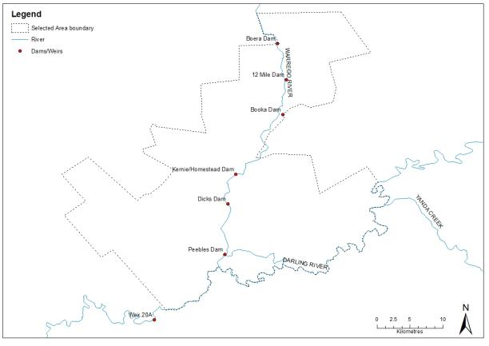

**Figure 7: Dams on the Warrego River where fish (Channel) sampling will be undertaken**

## Timing and frequency

All sampling is event-based and will be undertaken within the Warrego River selected area before and after Commonwealth environmental watering events. Sampling will occur on two occasions (pre-, and post-flow) around three events in years 2-5 of the LTIM project. Pre-flow sampling will be undertaken prior to environmental water arriving in the selected area at sites that have sufficient water. Post-flow sampling will occur in the following late-summer/autumn. The post-flow sample will to aim to quantify the outcome of any flow driven recruitment.

## Responsibilities

Fisheries NSW will be sub-contracted by Eco Logical Australia to undertake Fish (Channel) monitoring.

## Complementary monitoring and data

Fisheries NSW are also undertaking fish sampling as part of an MDBA funded fish monitoring program. There are several sites in this program that are located within the Selected Area.

## Detailed methods

Sampling will be undertaken using modified Sustainable Rivers Audit (SRA) protocols (Davies et al. 2010). Fish will be sampled at four to seven sites (number of sites determined by water levels), twice around a watering event, and across three events. Sampling will involve a combination of boat electrofishing, un-baited bait traps and fyke nets (n = 6). Boat electrofishing will involve 12 x 90 second shots and bait traps (n = 10) will be soaked for up to two hours concurrently during electrofishing operations. Three each of two sizes of double-winged fyke nets (small mesh and large mesh) will be set overnight at each site. Seine netting (where possible) will also be undertaken as required to capture young-of-year at or near sample sites. All fish (up to maximum of 50 individuals at the one site) captured within samples will be identified, counted, and measured. Individuals (maximum of 50 individuals per species per site) of two or three periodic species (Golden Perch and Bony Herring and/or Spangled Perch) will also be weighed to assess relative condition before and after watering events.

Otolith from young-of-year of up to four species (80 total) will be collected in the two post-watering event samples (160 both samples) to assess the timing of breeding in relation to Commonwealth environmental water releases. The four species will include two periodic (Golden Perch and Bony Herring and/or Spangled Perch) and two opportunistic species (carp gudgeon and Australian smelt).

## Data analysis

### The Selected Area scale hypotheses

Short-term (event-based) responses:

1. Mean Total length, Fork length, Mass and Condition for each of the two or three target taxa (Golden Perch, Bony Herring and/or Spangled Perch) will be greater following the release of Commonwealth environmental water within the selected area.
2. SRA metrics “Expectedness”, “Nativeness”, and “Recruitment” of native fish communities will be higher post release of Commonwealth environmental water within the selected area
3. A greater abundance of young-of-year will be present following the release of Commonwealth environmental water within the selected area.

### The Selected Area scale analyses

To accommodate for the ephemeral nature of the Warrego system which limits the potential area available to sample (particularly for ‘before’ samples), a finite population correction (**fpc**) factor will applied to the data before analysis to allow for the potential that greater than 5% of the population was captured. The **fpc** factor is used to adjust a variance estimate for an estimated mean or total, so that this variance only applies to the portion of the population that is not in the sample.

The fish community data will then be summarised using the three main SRA Indicators:

1. “Expectedness” - a comparison of the existing catch composition with that of historical fish distributions,
2. “Nativeness” - the proportion of native versus alien fishes, and
3. “Recruitment” - the recent reproductive activity of the native fish community.

Quantitative analyses will then be applied using a counterfactual approach based on an historical ‘reference’ condition represented by a pre-European fish assemblage (developed by Fisheries NSW). Multi-sample analyses will be based around the repeat application of models. Models outputs will be compared between samples around events to assess the immediate effect of Commonwealth environmental water releases, and also where applicable, among years to determine if there are changes across longer temporal scales.

Relative body condition of each of the target species will be calculated using the length and weight data collected for individual fish. Changes in relative condition will be then examined around watering events (before and after samples) as well as among events. Fish with high body condition are typically more resistant to negative environmental factors and have greater reproductive potential.

Back-calculation based on counts of otolith rings will be used to determine the links between water releases and spawning. Growth rates will also be compared for “periodic” species among events.

Short-term (Annual) responses:

1. Hypotheses 1, 2 and 3 – Univariate analysis (e.g. ANOVA - main effect – time) for all taxa, each target taxa, each life history guild, taxa reference richness/diversity.
2. Hypotheses 2 - (diversity-abundance) multivariate analysis (e.g Permanova, MDS, PCA - factors – time, target taxa, life history guilds, native/exotic, taxa reference composition).

## Reporting

Data for the Warrego selected area will be reported following the requirements outlined in the LTIM Data Standard and conform to the LTIM Data Standard (Brooks & Wealands 2014).

## Quality assurance/quality control

Quality control and quality assurance protocols are documented in the Quality Plan developed for the M&E Plan (CEWO 2014).

QA/QC activities specific to this protocol include:

* Electrofishers must be experienced operators of units. They should be supervised by Senior Operators on-site, and have obtained their electrofishing certificates through a reputable course.
* Monitoring and Evaluation Providers must have relevant boat licenses.
* It is the responsibility of the Monitoring and Evaluation Providers to have specific fisheries and ethics permits with them while sampling.
* Fyke nets will be checked for holes in either wing- or cod-ends prior to every field trip. Any net with a hole will be repaired or replaced.

### Field team

Fisheries NSW will provide the field team for this indicator. All staff will be appropriately qualified, licenced and experienced for all aspects of the sampling.

## References

|  |
| --- |
| Brooks S. & Wealands S.R. 2014. *Commonwealth Environmental Water Office Long Term Intervention Monitoring Project: Data Standard*. Report prepared for the Commonwealth Environmental Water Office by The Murray-Darling Freshwater Research Centre. MDFRC Publication 29.3/2013 Revised Jan 2014. |
| Commonwealth Environmental Water Office (CEWO). 2014. *Long Term Intervention Monitoring Project Junction of the Warrego and Darling rivers Selected Area*. Commonwealth of Australia. |
| Davies, P. E., Harris, J. H., Hillman, T. J., & Walker, K. F. (2010). The sustainable rivers audit: assessing river ecosystem health in the Murray–Darling Basin, Australia. *Marine and Freshwater Research*, *61*(7), 764-777. |

# B13. SOP – Microcrustaceans

## Objectives

The microcrustacean indicator will aim to assess the contribution of Commonwealth environmental watering to microcrustacean abundance and diversity.

## Indicators

Dependant variables:

* Microcrustacean relative abundance (density/L)
* Microcrustacean community assemblage.

Covariate indicators:

* Hydrology (River)
* Hydrology (Floodplain)
* Hydrology (Channel)
* Fish (Channel)
* Frogs
* Vegetation Diversity.

## Locations for monitoring

Monitoring sites for microcrustaceans will be located in two target areas in the Selected Area; River channels of the Warrego River and the Western Floodplain. The application of standard methods to these target areas provides potential for Basin scale evaluation and comparisons with other Selected Areas.

The first is the River zone receiving Commonwealth environmental water, where the river channel sampling protocol for microcrustaceans will occur at the three locations aligned with Fish (Channel) sampling to provide explicit links between these indicators and provide an assessment of a functional ecosystem response.

The second zone utilises the wetland/floodplain sampling protocol to sample the Western Floodplain inundation that is characterised by an extensive floodplain wetland network and will allow an assessment of connectivity. Sampling will occur within representative sites in each of the dominant wetland vegetation communities inundated by Commonwealth environmental water. The Hydrology (Floodplain) indicator will facilitate the up-scaling of site based microcrustacean data (density/L/vegetation type) to the entire inundated area of the watercourse. The focus is on the microcrustacean response to the inundation of the Coolibah - River Cooba - Lignum communities of the Western Floodplain.

This design will allow reporting with replication (n=3) for each of river channel and floodplain habitats and alignment with Fish (Channel), and Vegetation Diversity.

River sites:

* Boera Dam, Booka Dam and Peebles Dam/Ross Billabong on the Warrego River.

Floodplain site:

* Coolibah - River Cooba - Lignum communities of the Western Floodplain that experience most frequent inundation.

The rationale underlying this approach is to seek as much synergy as possible between the components monitoring other vertebrates (frogs) and fish that also prey on microcrustaceans. A single representative composite sample (comprised or either 5 benthic cores or 5 pelagic buckets) is taken from each site or flow-habitat within a site. This will reduce the overall number of samples for laboratory processing.

## Monitoring Design

### Microcrustaceans (River)

Two different sampling approaches will be used within the three river sites of the zone targeted for Selected Area scale analyses: benthic corer and a pelagic bucket. Five benthic cores will be randomly allocated within the slackwater habitats and then placed in a single bucket to yield a single ‘slackwater benthic’ composite sample from the site.

Five pelagic buckets will be randomly allocated within flowing edge habitats of each site and then poured through a net to yield a single ‘flowing pelagic’ composite sample from the site.

Microcrustacean samples within a site will be collected before the site is disturbed for other sampling.

### Microcrustaceans (Floodplain)

Two different microcrustacean sampling approaches will be used within the three sites of the zone targeted for Selected Area scale analyses: benthic corer and a pelagic bucket.

Five benthic cores will be randomly allocated within the shallow-edge of each inundated habitat of each vegetation community and then placed in a single bucket to yield a single ‘wetland benthic’ composite sample from the site. Five pelagic buckets will be randomly allocated within each inundated habitat of each vegetation community and then poured through a net to yield a single ‘wetland pelagic’ composite sample from the site.

Microcrustacean samples within a site will be collected before the site is disturbed for other sampling.

### Floodplain wetland metabolism

To replicate the ecosystem function links between nutrients, carbon and metabolism and microcrustaceans, we will collect nutrient and metabolism metrics in each of the three river and floodplain sites. We will follow the standard methods outlined for the Category III Metabolism indicator in the collection and analyses of metabolic and water column nutrient data.

## Timing and Frequency

At each of the 3 river sites, microcrustacean sampling will be undertaken twice in year 1 (February and April), and then three times (pre-, during, and post-flow) for event based sampling. This will allow microcrustacean sampling to be undertaken through the inundation cycle of Commonwealth environmental water, following the inundation and contraction cycle.

## Responsibilities

The Project Manager of the Warrego-Darling M&E Project Team is responsible for overseeing this procedure.

An aquatic ecologist will be responsible for the field collation of data and laboratory processing of samples under the direction of Project Director (Ryder), who will conduct the analyses and reporting.

## Complementary monitoring and data

The following indicators measures in the Warrego-Darling will be included as complementary monitoring data to inform the ecosystem function response of each of the river channel and watercourse floodplain wetland systems:

* Hydrology (River)
* Hydrology (Floodplain)
* Hydrology (Channel)
* Fish (Channel)
* Vegetation Diversity

The cause and effect diagram below (**Figure 8**) demonstrates the functional and food web links provided by microcrustaceans in river channel and floodplain watercourse habitats in the Junction of the Warrego and Darling rivers Selected Area.



**Figure 8: Cause and effect diagram – microcrustaceans**

## Detailed methods

### Sampling protocol

The sampling procedure is the same for wetlands and river channels. Benthic corers will be modified slightly from King (2004), the details of which can be found in (Morris 2008). The benthic cores within each site will be collected either in the afternoon or the morning to tie in with other sampling. Collection times will be recorded on the data sheet.

Composite samples (pelagic and benthic) will be collected at each site in association with either fish and other vertebrate or connectivity monitoring. Benthic samples will be collected with a corer (50 mm diameter x 120 mm long, 250 mL volume). At each site, five cores will be collected from random locations within each site with replicates spaced at least 20 m apart. The corer will be placed onto the sediment surface, the top sealed with a plastic cap and the sediment and overlaying water extracted with the aid of a hardened rubber trowel. The contents of the corer will be emptied into a 4 litre bucket and allowed to settle for at least one hour. Once settled, the supernatant will be poured through a 63 μm sieve to retain microcrustaceans. The retained sample will be washed into a sample jar and stored in ethanol (70% w/v) with rose bengal. To assess the pelagic microcrustacean community, a composite sample consisting of 10 x 10 litre buckets will be collected at each site. Each bucket will be poured through a plankton net (63 μm mesh). Retained samples will be stored in ethanol (70% w/v) with rose bengal until time of enumeration.

*Equipment*

* Benthic corer (50 mm diameter x 120 mm long, 250 mL volume) and rubber backed spatula
* Small (4 L) bucket with lid for settling benthic cores
* 63 um mesh sieve
* Squirt bottle
* 70% ethanol with rose bengal stain
* Storage jars
* Data sheets.

*Specific Equipment (as per Standard Methods – Metabolism)*

* D-Opto LDO/temperature logger (n=12).

### Laboratory sample processing

Entire samples will be preserved individually in 70% rose bengal ethanol and returned to the laboratory for microcrustacean identification and enumeration. Whole samples will be examined in bogorov trays and the contents identified to family level (cladocerans), order and class (copepods).

## Data analysis

Data for the Basin-scale will be reported following the requirements outlined in the LTIM Standard Protocol: Section 12.11 Metabolism – Data analysis and reporting, Hale et al. (2014) and conform to the LTIM Data Standard (Brooks & Wealands 2014).

At the Selected Area scale a number of hypotheses that relate to the outcomes of delivery of Commonwealth environmental water are possible.

In river channel habitats quantitative analyses will be possible for microcrustacean density and community composition for time since watering, with multivariate analyses such as nMDS (and modules including Simper, BioEnv, DISP, PCA) will be used to explore patterns among dependant and covariate variables such as water column nutrient and carbon concentrations, metabolism and larval and adult fish.

In floodplain habitats, quantitative analyses will be possible for microcrustacean density and community composition for time since watering and vegetation community, with multivariate analyses such as nMDS (and modules including Simper, BioEnv, DISP, PCA) will be used to explore patterns among additional measured variables of water column nutrient and carbon concentrations and, metabolism.

Hydrology (Floodplain) will quantify the area of each vegetation community inundated and the volume of inundation (m3) throughout the delivery cycle of Commonwealth environmental water. Linking microcrustacean density to this indicator will facilitate scaling of response from site based (microcrustacean density/m2) to the inundated vegetation asset scale within the Selected Area.

## Reporting

Selected Area scale reporting will conform to the LTIM Data Standard (Brooks & Wealands 2014) to facilitate data management within the LTIM Monitoring Data Management System (MDMS).

## Conceptual definition

This indicator will contain rows of data about a site that is:

*“ a River site covers a 100m stretch of channel , within which the diversity of habitats are represented and sampled.”*

*“a Floodplain site covers a 100m stretch of inundated floodplain, within which the diversity of habitats are represented and sampled.”*

Each row of data will describe:

*“the characteristics of microcrustacean assemblages based on density of individuals of a specific taxa at the site in the period defined by the date/time range.”*

## Site linkages

Sites of Microcrustaceans require the following linkages to other data (where available):

* site identifiers for representative hydrological indicator data for the river channel
* site identifiers for representative hydrological indicator for the watercourse
* ANAE identifiers to enable linking with framework datasets for future work

## Data definition

*Each row of data will contain the following columns of information*.

| Variable | Description | Type | Req | Range | Example |
| --- | --- | --- | --- | --- | --- |
| siteId | A site that covers a 100m stretch of the channel or watercourse represented by either a name or polygon, within which the diversity of habitats are represented and sampled | string | Y |  | EDWK04_057 |
| siteType | Channel or Watercourse | category | Y |  | Channel |
| sampleDate | Start date (inclusive) that these measures were observed | dateTime | Y |  | 15/05/2014 0:00 |
| sampleDateEnd | End date (exclusive) that these measures were observed | dateTime | Y |  | 15/05/2014 0:00 |
| sampleType | The types of sampling used Benthic/pelagic | category |  | Pelagic or Benthic | Benthic |
| higherTaxaName | Latin name of order, class, phylum for taxa that cannot be identified to family or below | string | Y |  |  |
| className | Name of class used for grouping in the analysis | string | Y |  | Branchiopoda |
| subClass | Latin name of Subclass | string | Y |  | Phyllopoda |
| Order | Latin name of order | string | Y |  | Cladocera |
| Taxa Richness | Number of taxa per sample | Number (0 decimals) | Y | 0 - infinity | 20 |
| densityIndividuals | total density of Class, subClass, Order - individuals/L | Number (2 decimal places | Y | 0 - infinity | 3,000 ind. L-1 |

## Quality Assurance/Quality Control

Quality control and quality assurance protocols are documented in the Quality Plan developed for the M&E Plan (CEWO 2014). This method requires a number of QA/QC procedures outlined below:

Standardisation of microcrustacean sampling equipment

Requirements for NATA accreditation for water quality sampling for a sub-sample of each site/trip to verify laboratory processes.

Field duplicate and blank samples will be collected following the Standard Method

Holding times for water quality samples will follow the procedures provided by the processing laboratory

Preservation and transport of water quality samples will follow the procedures provided by the processing laboratory.

## References

|  |
| --- |
| Brooks S. & Wealands S. 2014. *Commonwealth Environmental Water Office Long Term Intervention Monitoring Project: Data Standard.* Report prepared for the Commonwealth Environmental Water Office by The Murray-Darling Freshwater Research Centre, MDFRC Publication 29.3/2013 Revised Jan 2014, 29pp. |
| Commonwealth Environmental Water Office (CEWO). 2014. *Long Term Intervention Monitoring Project Junction of the Warrego and Darling rivers Selected Area*. Commonwealth of Australia. |
| Hale J., Stoffels R., Butcher R., Shackleton M., Brooks S. & Gawne B. 2014. Commonwealth Environmental Water Office Long Term Intervention Monitoring Project – Standard Methods. Final Report prepared for the Commonwealth Environmental Water Office by The Murray-Darling Freshwater Research Centre, MDFRC Publication 29.2/2014, January, 182 pp. |
| King, A. J. 2004. ‘Density and distribution of potential prey for larval fish in the main channel of a floodplain river: pelagic versus epibenthic meiofauna.’ *River Research and Applications* 20.8: 883-897. |
| Morris, P. 2008. Microinvertebrate community response to changing water regimes in the Macquarie Marshes, NSW, Australia. PhD thesis, UNE. |

# B14. SOP – Waterbird Diversity

## Objectives

The Waterbird Diversity monitoring protocol aims to assess the contribution of Commonwealth environmental water contribute to waterbird survival and diversity.

## Indicators

This indicator links to Vegetation Diversity, Microcrustaceans and Hydrology (River and Channel) monitoring indicators.

## Locations for monitoring

Waterbirds will be monitored at 3 sites along the Warrego River zone; Boera Dam, Booka Dam and Peebles Dam/Ross Billabong, in association with other Category III indicators (**Figure 9**).



**Figure 9: Location of Dams within the Warrego River. Waterbirds will be monitored in Boera Dam, Booka Dam and Peebles Dam/Ross Billabong.**

## Timing and frequency

Waterbird Diversity monitoring will take twice in year 1 (February and April), and then three times (pre-, during, and post-flow) for event based sampling in years 2-5.

## Responsibilities

The Project Manager of the Junction of the Warrego and Darling rivers M&E Project Team is responsible for overseeing this procedure. The field surveys will be led by experienced bird ecologists.

## Complementary monitoring and data

Data from additional sources and monitoring programs may be used to contribute in whole or part to this monitoring protocol. For example, the Eastern Aerial Waterbird Survey (EAWS) may pass over assessment sites and be used to augment ground surveys. There may also be local aerial or ground surveys undertaken under other monitoring programs that should be considered as supplementary data.

## Detailed methods

Surveys will be undertaken on both foot and from a vehicle using observation points or transects depending on the size and shape of the wetland.

Foot surveys will be undertaken by moving around the wetland and observing from various points that are generally spaced so as to be out of sight of each other. At each point all birds are observed and recorded. New birds are recorded enroute to new points and their species and number noted. During the survey, as much of each wetland as possible is accessed, and the percentage of the total wetland observed is recorded. Surveys are undertaken for at least 20 minutes but no more than 1 hour at each wetland, in order to gain a representative no necessarily complete, count of all waterbirds in the wetland.

For large or linear wetlands with good vehicular access, transect surveys will be used. Counts of species observed are recorded as a running tally as the vehicle travels along the transect. The start and end points and times are recorded on the datasheet.

## Data analysis

For ground surveys, the total abundance of each species per wetland and per hectare will be calculated and reported (Section 10, Hale et al. 2014).

## The Selected Area scale hypotheses

Short-term (Annual) responses:

1. The delivery of Commonwealth environmental water will lead to increased waterbird survival?

Long-term (5 year) responses:

1. The delivery of Commonwealth environmental water will lead to larger waterbird populations?
2. The delivery of Commonwealth environmental water will lead to increased waterbird diversity?

## The Selected Area scale analyses

Analyses based on Aggregation will be applied at the Basin and Selected Area scales for abundance, richness and diversity of waterbirds. Quantitative analyses will be applied at the Selected Area scale to document increased abundance, richness and diversity of waterbirds at sites receiving Commonwealth environmental water. Multi-year analyses will be quantitatively assessed based on year-on-year repeat application of annual models outlined in the Selected Area conceptual model (**Figure 10**). The placement of water level devices at key location to quantify hydrologic connection and inundation metrics will improve uncertainty in quantifying the delivery of Commonwealth water to target sites.

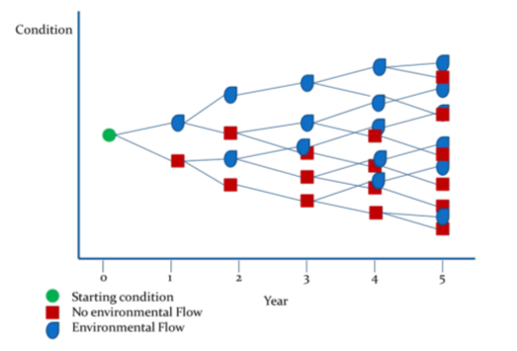

**Figure 10: A hypothetical model that will be applied on a year-to-year basis to generate a series of outcomes from different flow regimes over a five year period (Source: Gawne et al. 2014)**

Short-term (Annual) responses:

1. Hypotheses 1 and 2 - univariate analysis (main effect – site, time) abundance, richness, diversity
2. Hypotheses 2 - (diversity-abundance) multivariate analysis (factors – site, time).

Long-term (5 year) responses:

1. Hypotheses 2 and 3 - univariate analysis (main effects – target site, year, time)
2. Hypotheses 3 - (diversity-abundance) multivariate analysis (factors – target site, year, time).

## Reporting

The standard method for Waterbird Diversity reports m2 ANAE area surveyed inundated from Commonwealth environmental water. The proposed indicator Hydrology (Floodplain) will document the m2 of inundated ANAE and vegetation and will facilitate the scaling of potential colonial waterbird rookery sites.

All data provided for this indicator must conform to the data structure defined in the LTIM Data Standard (Brooks & Wealands 2014).

## Quality assurance/quality control

Quality control and quality assurance protocols are documented in the Quality Plan developed for the M&E Plan (CEWO 2014).

QA/QC requirements specific to this protocol include:

* All Waterbird Diversity surveys will be undertaken by the same experienced observers, where possible, over time to maintain consistency
* Observers will undergo training prior to undertaking monitoring surveys, including calibration against experienced observers to ensure standardisation of measurements. Training and calibration procedures will be documented in the MEP and relevant records maintained

## References

|  |
| --- |
| Brooks S. & Wealands S.R. 2014. *Commonwealth Environmental Water Office Long Term Intervention Monitoring Project: Data Standard*. Report prepared for the Commonwealth Environmental Water Office by The Murray-Darling Freshwater Research Centre. MDFRC Publication 29.3/2013 Revised Jan 2014. |
| Commonwealth Environmental Water Office (CEWO). 2014. *Long Term Intervention Monitoring Project Junction of the Warrego and Darling rivers Selected Area*. Commonwealth of Australia. |
| Gawne B., Hale J., Butcher R. Roots J., Brooks S., Cottingham P., Stewardson M. & Everingham P. 2014. *Commonwealth Environmental Water Office Long Term Intervention Monitoring Project: Evaluation Plan*. Final Report prepared for the Commonwealth Environmental Water Office by The Murray-Darling Freshwater Research Centre, MDFRC Publication 29/2014. |
| Hale J., Stoffels R., Butcher R., Shackleton M., Brooks S. & Gawne B. 2014. *Commonwealth Environmental Water Office Long Term Intervention Monitoring Project – Standard Methods*. Final Report prepared for the Commonwealth Environmental Water Office by The Murray-Darling Freshwater Research Centre, MDFRC Publication 29.2/2014, January, 182 pp. |

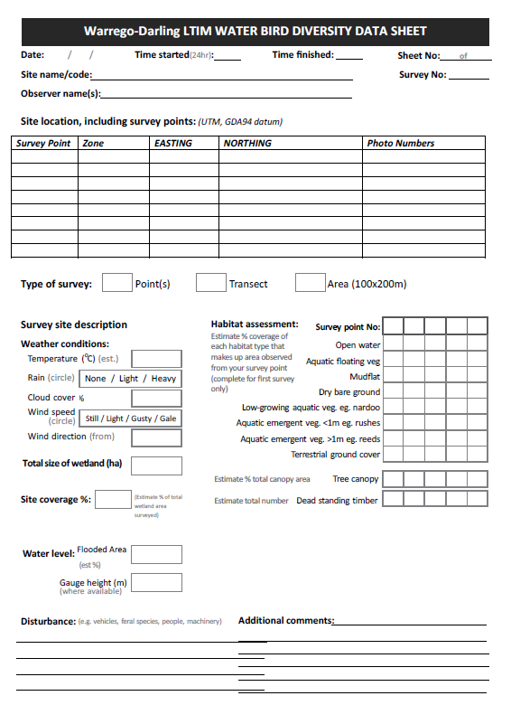

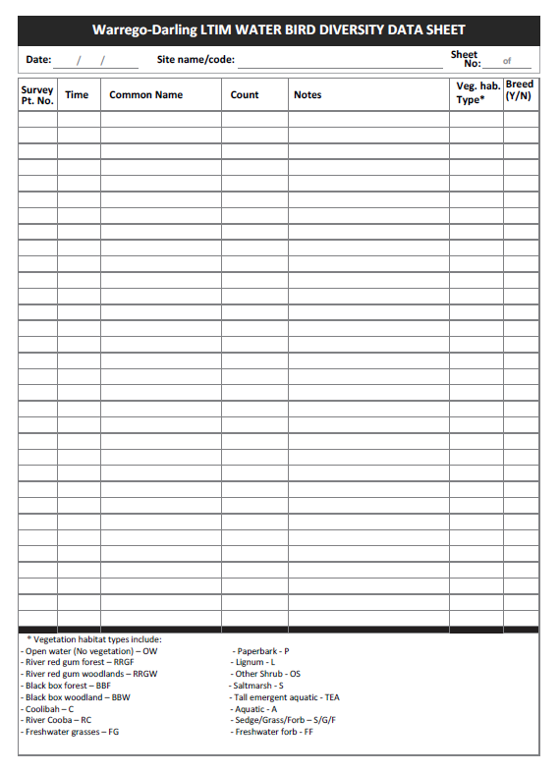

# B15. SOP – Frogs

## Objectives

The Frogs monitoring protocol aims to assess the contribution of Commonwealth environmental water to Frog recruitment, survival and diversity.

## Indicators

This indicator links to Microcrustaceans, Water Quality and Hydrology (River and Channel) monitoring indicators.

## Locations for monitoring

Frogs will be monitored at 3 sites along the Warrego River zone; Boera Dam, Booka Dam and Peebles Dam/Ross Billabong, in association with other Category III indicators (**Figure 11**).



**Figure 11: Location of Dams within the Warrego River. Frogs will be monitored in Boera Dam, Booka Dam and Peebles Dam/Ross Billabong.**

## Timing and frequency

Frog monitoring will take twice in year 1 (February and April), and then three times (pre-, during, and post-flow) for event based sampling in years 2-5.

## Responsibilities

The Project Manager of the Junction of the Warrego and Darling rivers M&E Project Team is responsible for overseeing this procedure. The field surveys will be led by experienced ecologists.

## Complementary monitoring and data

The following indicators measured in the Warrego-Darling will be included as complementary monitoring data to inform the ecosystem function response of the river channel:-

* Hydrology (River)
* Hydrology (channel)
* Fish (Channel)

## Detailed methods

Event based surveys will be undertaken, as per the LTIM Standard Methods reported in the Murrumbidgee LTIM document (Wassen et al 2014). Here, Adult frogs and metamorphs will be surveyed at each site after dark using a 2x20 minute visual encounter (person minutes) and a 6 x 1 minute audio survey. Start and finish times will be recorded to allow for frog abundance to be standardised as frogs/minute. All individuals observed will be identified to species and the number recorded.

A 15-30 watt spotlight or torch will be used to search for frogs along the wetland edge and into the surrounding terrestrial habitats. All individuals observed will be identified to species and the number recorded (it is possible to identify individuals without capture).

Audio surveys involve listening for the distinct calls of resident frog species. General estimates of the number of calling individuals will be determined using the methodology described in (Wassens *et al.* 2011).

## Data analysis

### The Selected Area scale hypotheses

Short-term (Annual) responses:

1. The delivery of Commonwealth environmental water will lead to increased frog species diversity
2. The delivery of Commonwealth environmental water will stimulate frog breeding

Long-term (5 year) responses:

1. The delivery of Commonwealth environmental water will lead to larger frog populations
2. The delivery of Commonwealth environmental water will lead to increased frog diversity

### The Selected Area scale analyses

Analyses based on Aggregation will be applied at the Selected Area scale for abundance, richness and diversity of frogs. Quantitative analyses will be applied at the Selected Area scale to document increased abundance, richness and diversity of frogs at sites receiving Commonwealth environmental water. Multi-year analyses will be quantitatively assessed based on year-on-year repeat application of annual models outlined in the Selected Area conceptual model (**Figure 12**).

Short-term (Annual) responses:

1. Hypotheses 1 and 2 - univariate analysis (main effect – site, time) abundance, richness, diversity.

Long-term (5 year) responses:

1. Hypotheses 3 and 4 - univariate analysis (main effects – target site, year, time).
2. Hypotheses 4 - (diversity-abundance) multivariate analysis (factors – target site, year, time).



**Figure 12: Hypothetical model of a long-term response to environmental watering based on a created ‘reference condition’ where the greatest influence is from watering in the most recent year with progressively weaker influence from watering in previous years (Source: Gawne et al. 2014).**

## Reporting

All data provided for this indicator must conform to the data structure defined in the LTIM Data Standard (Brooks & Wealands 2014).

## Conceptual definition

This indicator will contain rows of data about a site that is:

*“ a single wetland represented by either name or polygon within which observations are made.”*

Each row of data will describe:

*“the abundance and other characteristics of a specific frog species within that site for the defined date range.”*

## Site linkages

Sites of Frogs require the following linkages to other data (where available):

* site identifiers for representative hydrological indicator data for the river channel
* ANAE identifiers to enable linking with framework datasets for future work

## Data definition

*Each row of data will contain the following columns of information*.

| **Variable** | **Description** | **Type** | **Req** | **Range** | **Example** |
| --- | --- | --- | --- | --- | --- |
| siteId | a single wetland represented by either name or polygon within which observations are made | string | Y |  | WD_Booka |
| sampleDate | Start date (inclusive) that these measures were observed | dateTime | Y |  | 15/05/2014 0:00 |
| sampleDateEnd | End date (exclusive) that these measures were observed | dateTime | Y |  | 15/05/2014 0:00 |
| Speciesname | Latin name of species | string | Y |  |  |
| numberIndividuals | total number of individuals observed per minute | Integer | Y | 0 - infinity |  |
| Numbercalling | Mean number of individuals calling of replicate counts | Number (2 decimal places) | Y | 0 - infinity | 12.22 |

## Quality assurance/quality control

Quality control and quality assurance protocols are documented in the Quality Plan developed for the M&E Plan (CEWO 2014).

QA/QC requirements specific to this protocol include:

* All frog surveys will be undertaken by the same experienced observers, where possible, over time to maintain consistency
* Observers will undergo training prior to undertaking monitoring surveys, including calibration against experienced observers to ensure standardisation of measurements. Training and calibration procedures will be documented in the MEP and relevant records maintained

## References

|  |
| --- |
| Brooks S. & Wealands S.R. 2014. *Commonwealth Environmental Water Office Long Term Intervention Monitoring Project: Data Standard*. Report prepared for the Commonwealth Environmental Water Office by The Murray-Darling Freshwater Research Centre. MDFRC Publication 29.3/2013 Revised Jan 2014. |
| Commonwealth Environmental Water Office (CEWO). 2014. *Long Term Intervention Monitoring Project Junction of the Warrego and Darling rivers Selected Area*. Commonwealth of Australia. |
| Gawne B., Hale J., Butcher R. Roots J., Brooks S., Cottingham P., Stewardson M. & Everingham P. 2014. *Commonwealth Environmental Water Office Long Term Intervention Monitoring Project: Evaluation Plan*. Final Report prepared for the Commonwealth Environmental Water Office by The Murray-Darling Freshwater Research Centre, MDFRC Publication 29/2014. |
| Wassen S., Jenkins K., Spencer, J., Theim, J., Bino, G., Lennon, E., Thomas, R., Kabyashi, T., Baumgartner, L., Brndis, K., Wolfenden, B, Hall, A., Watson, M. & Scott, N. 2014. *Murrumbidgee Selected Area: Monitoring and Evaluation Plan.* Commonwealth of Australia. |

Wassens, S., Watts, R., Howitt, J., Spencer, J., Zander, A. and Hall, A. (2011). Monitoring of ecosystem responses to the delivery of environmental water in the Murrumbidgee system. Report to DSEWPaC. Albury, Institute of land, Water and Society. Report 1.

**Field Data sheets**

|  |  |  |
| --- | --- | --- |
| Warrego-Darling Frog Data sheet | | |
| Site: | | **Date:** |
| Observer: | **Time start:** | **Time end:** |

**Visual Encounter**

|  |  |  |
| --- | --- | --- |
| **Species** | **Count** | **Count/minute** |
|  |  |  |
|  |  |  |
|  |  |  |
|  |  |  |
|  |  |  |
|  |  |  |
|  |  |  |
|  |  |  |
|  |  |  |
|  |  |  |

**Calling**

|  |  |
| --- | --- |
| **Species** | **Count** |
|  |  |
|  |  |
|  |  |
|  |  |
|  |  |
|  |  |
|  |  |
|  |  |
|  |  |

Appendix C Cause & Effects Diagrams

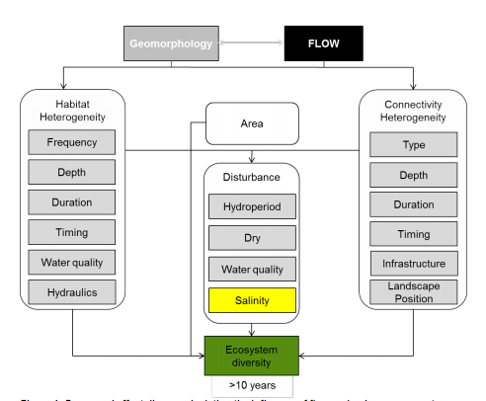

Figure C0‑1: Landscape Ecosystem Diversity CED (MDFRC 2013)

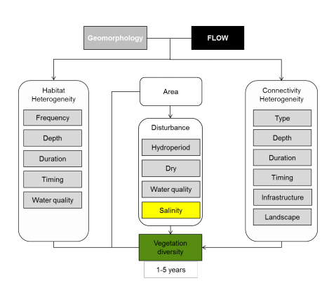

Figure C0‑2: Vegetation Diversity CED (MDFRC 2013)

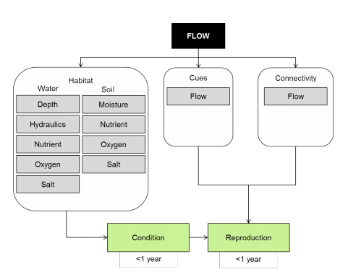

Figure C0‑3: Vegetation Condition and Reproduction CED (MDFRC 2013)

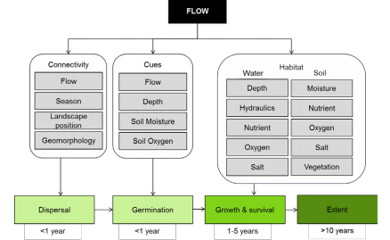

Figure C0‑4: Vegetation Recruitment and Extent CED (MDFRC 2013)

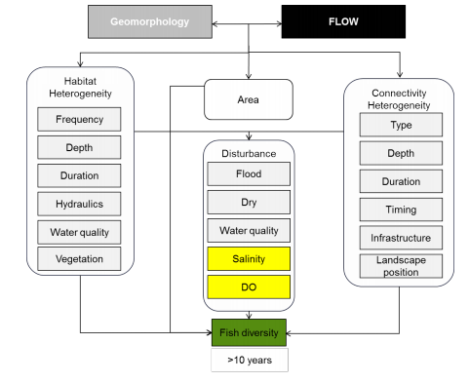

Figure C0‑5: Landscape Fish Diversity CED (MDFRC 2013)

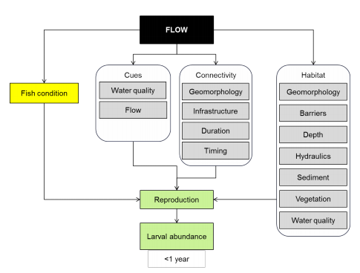

Figure C0‑6: Fish Reproduction CED (MDFRC 2013)

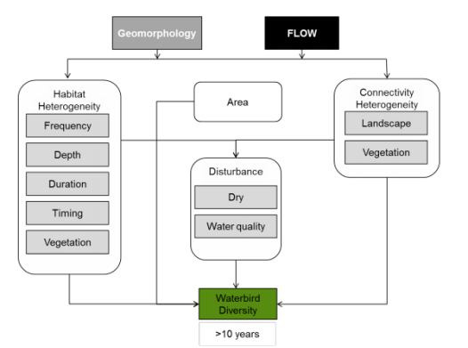

Figure C0‑7: Landscape Waterbird Diversity CED (MDFRC 2013)

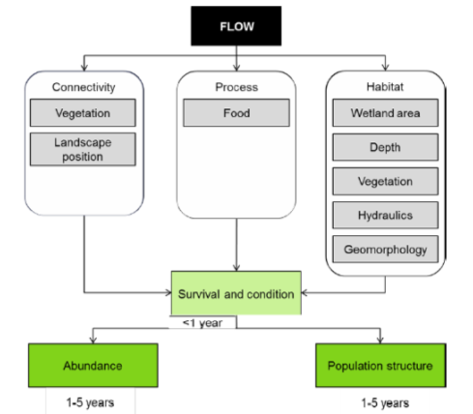

Figure C0‑8: Waterbird Survival and Condition CED (MDFRC 2013)

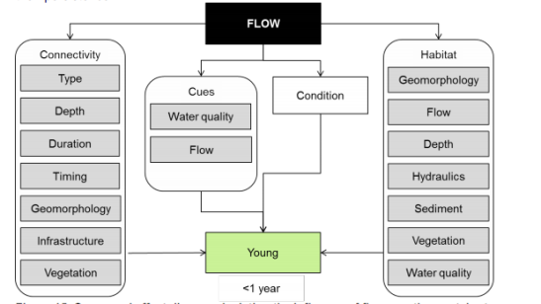

Figure C0‑9: Other Vertebrate Reproduction CED (MDFRC 2013)

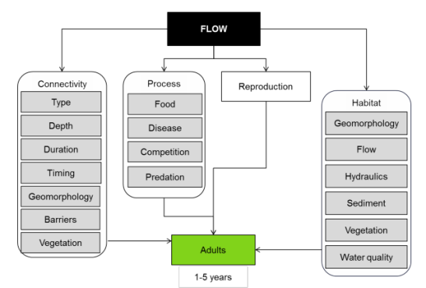

Figure C0‑10: Other Vertebrate Growth and Survival CED (MDFRC 2013)

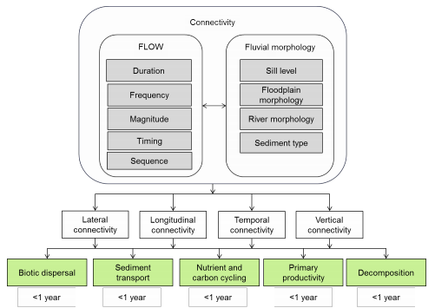

Figure C0‑11: Hydrological Connectivity (including end of system flows) CED (MDFRC 2013)

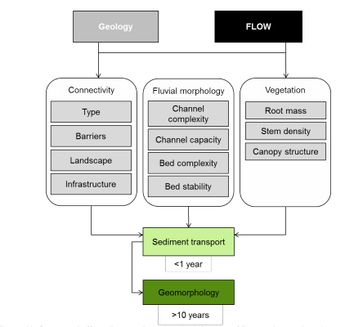

Figure C0‑12: Sediment Transport CED (MDFRC 2013)

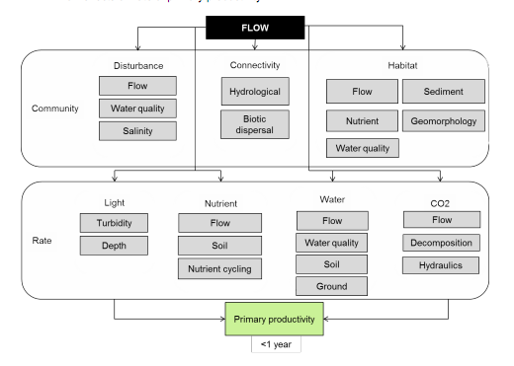

Figure C0‑13: Primary Production CED (MDFRC 2013)

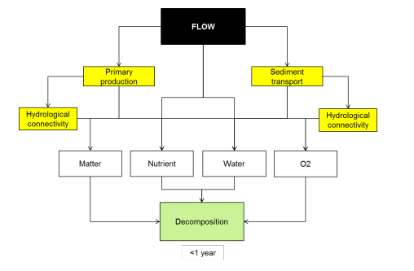

Figure C0‑14: Decomposition CED (MDFRC 2013)

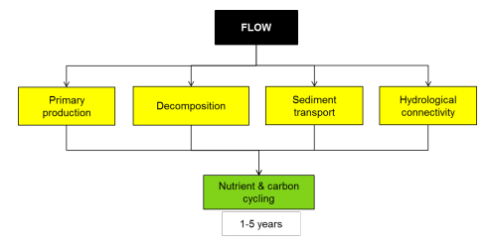

Figure C0‑15: Nutrient and Carbon Cycling CED (MDFRC 2013)

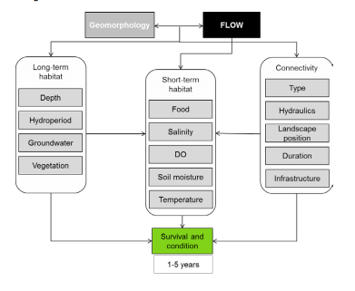

Figure C0‑16: Individual Refuges CED (MDFRC 2013)

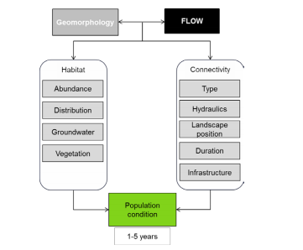

Figure C0‑17: Landscape Refuges CED (MDFRC 2013)

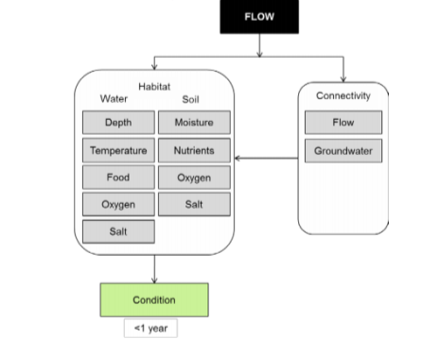

Figure C0‑18: Ecosystem Resistance CED (MDFRC 2013)

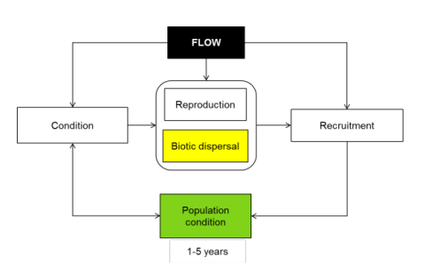

Figure C0‑19: Ecosystem Avoidance and Recovery CED (MDFRC 2013)

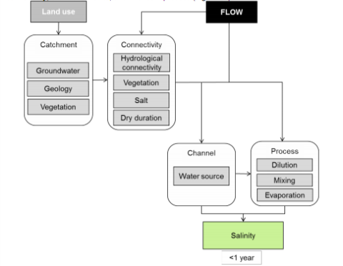

Figure C0‑20: Salinity CED (MDFRC 2013)

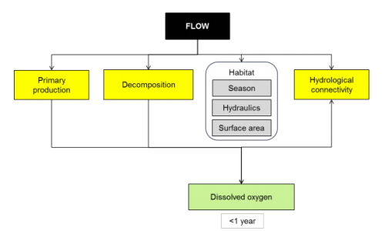

Figure C0‑21: Dissolved Oxygen CED (MDFRC 2013)

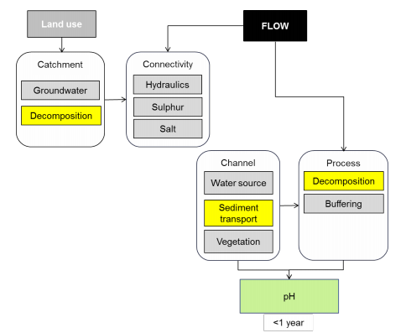

Figure C0‑22: pH CED (MDFRC 2013)

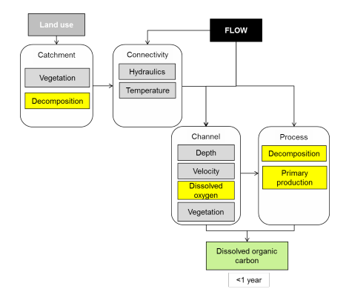

Figure C0‑23: Dissolved Organic Carbon CED (MDFRC 2013)

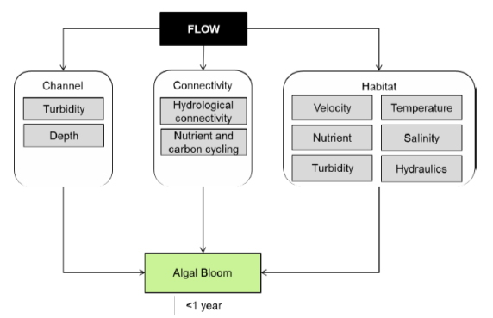

Figure C0‑24: Algal Blooms CED (MDFRC 2013)

Appendix D Communications Plan





**Communications Plan**

**Commonwealth Environmental Water Office**

**Long Term Intervention Monitoring Project**

**Junction of the Warrego and Darling rivers Selected Area**

Version 1, 20 January 2015



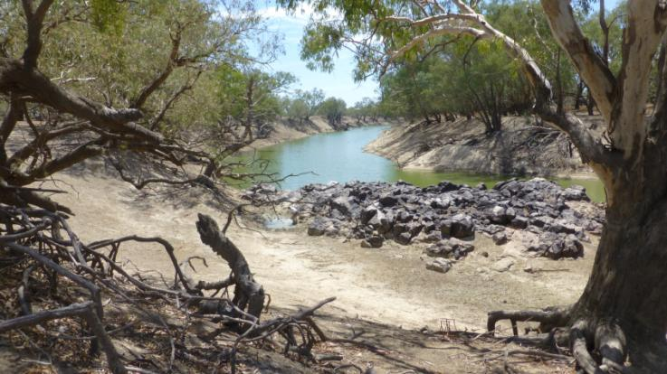

|  |  |
| --- | --- |
| **Item** | **Detail** |
| ELA Project Code | 434 |
| Project Director/s | Paul Frazier, Darren Ryder |
| Project Manager | Mark Southwell |
| Prepared by | Mark Southwell |

This document is the Communications Plan for the CEWO LTIM Project for the Junction of the Warrego and Darling rivers Selected Area. It is to be read in conjunction with the Monitoring and Evaluation Plan for the above project.

Any reviews or changes to this Communications Plan must be recorded in the tables below.

**Document control**

|  |  |  |  |
| --- | --- | --- | --- |
| **Version** | **Date** | **Reviewed by** | **Approved by** |
| 1 | 20 Jan 2015 | Mark Southwell | Paul Frazier |
| 2 | 11 Feb 2015 | Mark Southwell | Mark Southwell |
|  |  |  |  |
|  |  |  |  |
|  |  |  |  |

|  |  |
| --- | --- |
| **Version** | **Change since previous issue** |
| 2 | Updated page numbers to make consistent with M&E plan |
|  |  |
|  |  |
|  |  |
|  |  |

Contents

**Abbreviations 180**

**1** **Introduction 181**

1.1 Objective 181

1.2 LTIM Project Code of Conduct 181

**2** **Operational communications 183**

**3** **Communications requirements 184**

3.1 Junction of the Warrego and Darling rivers Selected Area rivers Working Group 184

3.2 Landholder communications 185

3.3 Stakeholder engagement and external communications 186

3.4 Internal communications 187

3.5 Complaints procedure 187

**Appendix A 190**

**Terms of Reference 190**

**Junction of The Warrego and darling rivers Selected Area Working Group 190**

**Long Term Intervention Monitoring Project 190**

**1** **Purpose 190**

**2** **Objectives: 190**

**3** **Membership 190**

**4** **Terms of Reference 191**

**5** **Authority 192**

**6** **Operations 192**

**Appendix B** **Landholder communication - recording templates 194**

**Appendix C** **Complaints register 196**

Abbreviations

|  |  |
| --- | --- |
| Abbreviation | Description |
| CEWO | Commonwealth Environmental Water Office |
| NPWS | NSW National Park and Wildlife Service |
| ELA | Eco Logical Australia |
| LLS | Local Land Services |
| LTIM | Long-Term Intervention Monitoring |
| M&E Adviser | Monitoring and Evaluation Adviser |
| M&E Plan | Monitoring and Evaluation Plan |
| M&E Provider | Monitoring and Evaluation Provider |
| MDBA | Murray-Darling Basin Authority |
| MDFRC | Murray-Darling Freshwater Research Centre |
| NOW | NSW Office of Water |
| OEH | (NSW) Office of Environment and Heritage |
| QA/QC | Quality Assurance / Quality Control |
| SWC | State Water Corporation (NSW) |
| UNE | University of New England |

# Introduction

This document is the Communications Plan for the CEWO LTIM Project for the Junction of the Warrego and Darling rivers Selected Area. It is to be read in conjunction with the Monitoring and Evaluation Plan (M&E Plan) for the above project.

## Objective

The objective of this Communications Plan is to provide the mechanisms to facilitate effective and efficient communication between LTIM Project partners for the Junction of the Warrego and Darling rivers Selected Area.

This Communications Plan has been developed by the Monitoring and Evaluation Providers (M&E providers) for the Junction of the Warrego and Darling rivers Selected Area, being the project consortium (Eco Logical Australia Pty Ltd (ELA) and the University of New England (UNE)).

This Communications Plan has been developed to guide and direct communications between project partners for the Junction of the Warrego and Darling rivers Selected Area and more broadly (i.e. the LTIM Project), including:

* The M&E providers (i.e. the ELA/UNE consortium and their subcontractors)
* The Commonwealth Environmental Water Office (CEWO)
* The Monitoring and Evaluation Advisors (M&E Advisors) (i.e. the Murray-Darling Freshwater Research Centre (MDFRC))
* State agencies, including NSW Office of Environment and Heritage (OEH) NSW Fisheries, NSW Office of Water (NOW),and NSW National Parks and Wildlife Service (NPWS)
* Other key stakeholders and groups, including the Western Local Land Services, and Toorale Joint Management Advisory Committee.

## LTIM Project Code of Conduct

Collaboration and cooperation are vital to the overall success of the LTIM Project (Figure 1‑1). A Code of Conduct has been developed to guide the behaviour of individuals and teams when undertaking monitoring and evaluation activities on behalf of the CEWO.

In all communications related to the LTIM Project, including both operation and external communications, the LTIM Project team will comply with Code of Conduct developed by the CEWO.

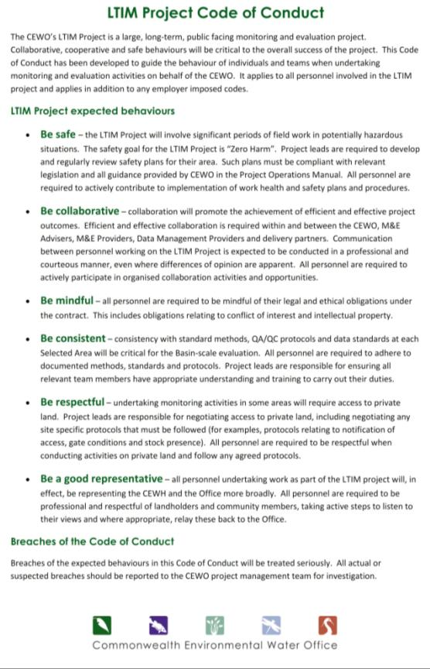

**Figure 1‑1: CEWO LTIM Project Code of Conduct**

# Operational communications

An overview of the operational communication activities required for the implementation of the M&E Plan in the Junction of the Warrego and Darling rivers Selected Area is provided in Table 2‑1. Reporting commitments are detailed in the M&E Plan.

**Table 2‑1: Operational communications activities – meetings**

| Activity | Purpose | Attendees (indicative) | Frequency | Responsibility | Engagement process |
| --- | --- | --- | --- | --- | --- |
| Project Meetings | Project progress and outcomes | CEWO  M&E Provider (Project manager plus others as required) | Monthly | M&E Provider | Telephone/Email correspondence |
| M&E Adviser meetings (to M&E Provider) | Project approach, methods and technical guidance | CEWO  M&E Advisers (Project manager plus technical leads)  M&E Providers (Project manager plus technical leads) | As required | M&E Advisers | Workshop or teleconference |
| LTIM Project Managers Group meetings | Collaboration and consistency | CEWO  M&E Providers project managers for each Selected Area | Biannually for the life of the LTIM Project | CEWO | Workshop or teleconference |
| Junction of the Warrego and Darling rivers Selected Area Working Group meetings | Information and knowledge exchange | W-D SAWG | Quarterly for the life of the LTIM Project | M&E Provider for the Junction of the Warrego and Darling rivers | Workshop or teleconference |
| Annual Discussion Forum – Sydney | Technical Collaboration | CEWO  M&E Advisers (Project manager plus technical leads)  M&E Providers (Project manager plus three technical leads) | Annually (five in total) | CEWO | Workshop - Sydney |

# Communications requirements

## Junction of the Warrego and Darling rivers Selected Area rivers Working Group

The Junction of the Warrego and Darling rivers Selected Area rivers Working Group will provide a platform for the exchange of information and knowledge that supports the implementation of the M&E Plan for the Junction of the Warrego and Darling rivers Selected Area.

The membership of the Junction of the Warrego and Darling rivers Selected Area Working Group has been agreed with by CEWO. A Terms of Reference has been developed by CEWO to which the Junction of the Warrego and Darling rivers Working Group will subscribe (Appendix 1). Junction of the Warrego and Darling rivers Working Group membership is provided below (Table 3‑1).

The Junction of the Warrego and Darling rivers Selected Area Working Group has no executive powers, supervisory functions or decision-making authority in relation to the LTIM Project. It is an operational group tasked with a general support and advisory role. Attendance is at the sole discretion of the nominee.

The Junction of the Warrego and Darling rivers Selected Area Working Group is required to meet quarterly for the duration of the LTIM Project, commencing in the 2014-2015 water year.

ELA will chair the Junction of the Warrego and Darling rivers Selected Area Working Group and be responsible for the administration and facilitation of the Group, including providing secretariat duties. All communications to the Junction of the Warrego and Darling rivers Selected Area Working Group will be via the M&E Provider project manager or directors.

**Table 3‑1:** **Selected Area Working Group membership**

|  |  |
| --- | --- |
| Name | Agency/position/role |
| Paul Frazier | Junction of the Warrego and Darling rivers Selected Area LTIM Project Director (ELA) |
| Darren Ryder | Junction of the Warrego and Darling rivers Selected Area LTIM Project Director (UNE) |
| Mark Southwell | Junction of the Warrego and Darling rivers Selected Area LTIM Project Manager (ELA) |
| Christine Mercer | CEWO (M&E Section) |
| Ken Harrison | CEWO (Local Engagement Officer) |
| Gavin Butler | DPI Fisheries (Scientific Officer, Aquatic Ecosystems Research) |
| Anthony Townsend | DPI Fisheries (Senior Fisheries Manager, Environmental Flow - north) |
| Neal Foster | NSW Office of Water |
| Andrew Wall | NPWS (NPWS Bourke Area Manager) |
| Peter Berney | NPWS (NPWS regional ecologist) |
| Bernard Davis | NPWS (Toorale Senior Field Supervisor) |
| Erlina Compton | Western Local Lands Service |
| Justin McClure | Australian Floodplain Association |
| Jon Marshall | QLD DITSIA |
| Stephen Howarth | Toorale Joint Management Advisory Committee |

## Landholder communications

For the M&E Project, landholders are individuals and/or organisations where access to or through their land is required to undertake monitoring activities. The majority of monitoring activities at the Junction of the Warrego and Darling rivers Selected Area will be undertaken on land managed by NSW NPWS. Access to some sites however, will require travel through private land.

Landholder contact details and communications will be established upon approval of final sites. The following principles will be adopted:

* No access to any sites will take place without first contacting the landholder and gaining permission to undertake monitoring activities on their land. Initial access will be sought at least 10 working days before accessing a site for the first time, and then within a timeframe as negotiated with each landholder for subsequent access
* The Project team will invite each landholder to participate in or observe monitoring activities as they chose
* The Project team will discuss with CEWO the availability/accessibility of site specific data for each landholder
* All monitoring activities, including access to sites etc, are to be undertaken so that minimal/nil disturbance to the landholders’ activities, livestock and/or cropping practices occur
* Providing ongoing project updates to landholders as requested
* Where possible, existing tracks shall be used
* Vehicles/machinery to be operated so that any damaged is minimised
* Notify the landholder immediately if any damage occurs (to property or livestock)
* Appropriate approvals/licences shall be sought as necessary, including Scientific Licence and Permit to Work in NPWS Reserves. All field teams shall have copies of relevant licences when undertaking field work
* Take all reasonable care to ensure that weeds or pests are not spread
* Return gates to original position after use.

Contact details for landholders will be established in a register (, Table ). Any communications with landholders shall be tracked for the duration of the project, including the date of communications, the project team member and any comment/outcome of the communications ( Table ). This register will also include a record of any data provided to the landholder. Electronic registers can be maintained.

## Stakeholder engagement and external communications

An internal process for conveying consistent messaging about the Junction of the Warrego and Darling rivers LTIM Project in formal settings will be further developed, including consistent branding, review/sign off by CEWO, and a single point of contact (Project Manager) to be established and implemented.

No media communications shall take place without express permission from the Director, Monitoring and Evaluation Section within CEWO.

It is noted that ELA/UNE are currently developing a Memorandum of Understanding (MoU) with OEH for cooperative resource and information sharing for the LTIM Project. There are a number of complementary data sets that will be required for the LTIM Project. When monitoring indicators have been finalised, ELA/UNE will access the necessary data (see Section 5 of the M&E Plan) via the appropriate license agreements with the relevant agencies, including:

* CEWO
* LLS
* NSW Fisheries
* Murray-Darling Basin Authority
* OEH

The primary form of communication with stakeholders and parties external to the Junction of the Warrego and Darling rivers Selected Area LTIM Project will be via the Selected Area Working Group.

* + 1. **Outcomes reporting**

The LTIM Project has a number of reporting and information transfer requirements. summarises the outcomes, reporting and information transfer activities for the LTIM Project, including frequency, timing and responsibility. It also includes reporting requirements that are the responsibility of the M&E Advisors (being the Annual Basin Evaluation Report).

M&E Providers will also be required to provide other key outputs for monitoring activities in the Warrego-Darling:

* Submit monitoring data in the correct format and according to defined protocols within 1 month of its collection
* Noting and reporting any incidental observations made during field visits that may contribute to or support Evaluation (Area or Basin) or Adaptive Management. Observations can also include those reported to the M&E Provider by stakeholders. This requirement is ongoing, following observations.

## Internal communications

An internal communications procedure will be developed by ELA as part its internal Project Management system. An outline of this internal communications strategy is provided below. The objective of all internal communications is to ensure effective project delivery through timely, transparent and concise dialogue between members of the ELA/UNE project team.

## Complaints procedure

In the event of any complaints or concerns raised by stakeholder groups or external parties, including landholders, the following process shall be followed:

* Record the date of the complaint and any personal details the complainant wishes to provide together with the nature of the complaint
* The respective CEWO Project Management Team area leader will be contacted to ensure the CEWO is aware of, and has the opportunity to contribute to, discussions of relevance to the LTIM Project
* The Junction of the Warrego and Darling rivers Selected Area LTIM Project Director (ELA/UNE) shall be contacted to advise them of the complaint
* The Project Team shall consider the most appropriate response to address the complaint as soon as practically possible.

**Table 3‑2: Reporting requirements and information transfer schedule for the LTIM Project**

| **Activity type** | **What** | **Frequency** | **Timing / due date** | **Responsibility** | **Receiver** | **Description and high level requirements** |
| --- | --- | --- | --- | --- | --- | --- |
| Reporting | Monitoring and Evaluation Plan | One-off | Draft – Feb 14 2015  Final – Feb 28 2015 | M&E Providers (UNE/ELA) | CEWO | A plan for monitoring and evaluation in each Selected Area over the five-year period from 2014-15 to 2018-19 |
| Work plan | Annual monitoring work plan | Annually | August (2015-2019) | M&E Providers (UNE/ELA) | CEWO | Annual monitoring work plan that outlines which elements will be implemented over the coming water year, based on information available at the time (including Area condition, water availability and water use options) |
| Annual evaluation plan | Annual evaluation plan | Annually | August (2015-2019) | M&E Providers (UNE/ELA) | CEWO | The annual evaluation plan should outline what evaluation activities will be undertaken over the coming water year, based on anticipated environmental watering actions monitoring data availability |
| Reporting | Area evaluation report | Annually (October) | Draft – Aug 30  Final – Oct 31  First report – 2015  Final report – 2019 | M&E Providers (UNE/ELA) | CEWO | A cumulative evaluation of the outcomes of Commonwealth environmental water at each Selected Area, prepared in accordance with the M&E Plan  The report must be prepared in plain English with simple science and be suitable for publication on CEWO website |
| Reporting | Basin evaluation report | Annually | Draft – Aug 30  Final – Oct 31  First report – 2015  Final report – 2019 | M&E Advisers | CEWO | A cumulative evaluation of the outcomes of Commonwealth environmental water at the Basin-scale, based on the Evaluation Plan  The report must be prepared in plain English with simple science and be suitable for publication on CEWO website |
| Information transfer | Monitoring data entry | Monthly | Monthly for duration of the LTIM Project | M&E Providers (UNE/ELA) | MDMS | Processed monitoring data is uploaded to the MDMS in accordance with the data management protocols |
| Information transfer (including operational information) | Information exchange | Ongoing and as required | Ongoing and as required for duration of the LTIM Project | M&E Providers (UNE/ELA)  Delivery partners | Delivery partners / Selected Area Working Group / M&E Providers | Information exchange on project activities (monitoring, observations, evaluations) and other information that would support the delivery of environmental water  Operational information collated by delivery partners and provided to M&E Providers |
| Review previous actions | Annual Watering Review | Annually | 2015 - 2019 | CEWO | Delivery partners / / M&E Advisors | Reports that provide a summary of Commonwealth environmental water use throughout the year, the outcomes of the water use and lessons learned, and will incorporate information from delivery partners and M&E Providers |

Appendix A Terms of Reference

**JUNCTION OF THE WARREGO AND DARLING RIVERS**

**SELECTED AREA WORKING GROUP**

**LONG TERM INTERVENTION MONITORING PROJECT**

Eco Logical Australia (ELA) with UNE (led by Dr Darren Ryder), have been engaged to prepare and implement the Monitoring and Evaluation Plan for the Junction of the Warrego and Darling rivers Selected Area. For this project ELA is the lead agency. This document provides the Terms of Reference for Stage 1 of the LTIM Project.

1. Purpose

The Junction of the Warrego and Darling rivers Selected Area Working Group will provide a forum for the exchange of information and knowledge that supports the implementation of the LTIM Project, through effective coordination of environmental watering, and monitoring and evaluation.

1. Objectives

The Junction of the Warrego and Darling rivers Selected Area Working Group will facilitate:

* Effective coordination between environmental water delivery partners and other relevant monitoring and evaluation projects
* Communication to environmental water managers of any information that would improve environmental water management
* Exchange of information and knowledge relevant to improving the implementation of the LTIM Project, as well as improve the efficacy of environmental watering activities to support adaptive management on both a short-term (preliminary observations during watering events) and longer-term (evaluation outcomes)
* The identification, communication and management of any issues, risks or opportunities relevant to the LTIM Project.

1. Membership

The Junction of the Warrego and Darling rivers Selected Area Working Group includes agencies involved in the delivery of the Junction of the Warrego and Darling rivers LTIM Project. It includes organisations directly and indirectly responsible for delivering LTIM Project deliverables and representatives from organisations involved in environmental water planning and delivery.

The Junction of the Warrego and Darling rivers Selected Area Working Group comprises the following members who have been nominated by ELA (the project lead) and agreed to by the CEWO.  M&E Advisers as well as relevant people from the CEWO Water Use Section may be invited by the CEWO to attend meetings.

|  |  |
| --- | --- |
| **Name** | **Agency/position/role** |
| Paul Frazier | Junction of the Warrego and Darling rivers LTIM Project Director (ELA)  Chair |
| Darren Ryder | Junction of the Warrego and Darling rivers LTIM Project Director (UNE) |
| Mark Southwell | Junction of the Warrego and Darling rivers LTIM Project Manager (ELA) |
| Christine Mercer | CEWO (M&E Section) |
| Ken Harrison | CEWO (Local engagement officer) |
| Gavin Butler | DPI Fisheries (Scientific Officer, Aquatic Ecosystems Research) |
| Anthony Townsend | DPI Fisheries (Senior Fisheries Manager, Environmental Flow - north) |
| Neal Foster | NSW Office of Water |
| Andrew Wall | NPWS (NPWS Bourke Area Manager) |
| Bernard Davis | NPWS (Toorale Senior Field Supervisor) |
| Peter Berney | NPWS (NPWS regional ecologist) |
| Erlina Compton | Western Local Lands Service |
| Justin McClure | Australian Floodplain Association |
| Jon Marshall | QLD DITSIA |
| Stephen Howarth | Toorale Joint Management Advisory Committee |

1. Terms of Reference

The Junction of the Warrego and Darling rivers Selected Area Working Group will be responsible for supporting strategic direction of the LTIM Project and exchanging information and intelligence to support the LTIM Project and adaptive management. It will:

Actively support and promote the LTIM Project within partner organisations

Review (where appropriate) key project documentation, including evaluation reports

Exchange operational intelligence relevant to the LTIM Project, including intelligence on upcoming watering or monitoring activities

Exchange intelligence relevant to adaptive management of environmental water, including operational observations, monitoring outcomes and evaluation outcomes

Consider stakeholder expectations (where appropriate) of the LTIM Project

Exchange intelligence on any risks, actual or perceived, to the LTIM Project

Communicate key messages of the LTIM Project to organisations involved in environmental water planning and delivery

Document key discussion points and outcomes of Junction of the Warrego and Darling rivers Selected Area Working Group meetings and distribute these to members (including the CEWO) in the form of minutes.

1. Authority

The Junction of the Warrego and Darling rivers Selected Area Working Group will be organised, operated and Chaired by ELA.

The Junction of the Warrego and Darling rivers Selected Area Working Group has no executive powers, supervisory functions or decision-making authority in relation to the LTIM Project. It is an operational group tasked with a general support and advisory role.

1. Operations

The Junction of the Warrego and Darling rivers Selected Area Working Group will operate in alignment with the following requirements:

**Meetings**

Selected Area Working Group meetings will be held at least twice during Stage 1 (2013-14) and can be attended either via phone or in person, or via earlier comment.

|  |  |  |
| --- | --- | --- |
| **Meeting schedule** | **Date** | **Location** |
| Meeting 1 | 18 December 2014 | Armidale / phone |
| Meeting 2 | TBC | Armidale / phone |

**Agendas and Minutes**

ELA will prepare and distribute meeting agendas and minutes. Agendas and minutes from the previous meeting will be distributed no later than five days prior to the meeting.

Where practical, meeting papers will be distributed no later than five days prior to the meeting, and will include:

* Agenda
* Previous meeting minutes
* Any papers for consideration.

Meeting minutes and action items will be distributed within two weeks of the meeting. Immediate actions may be circulated earlier.

**Agenda items**

The following table lists the standard agenda items for the Selected Area Working Group. Members can submit additional items to be included on the agenda at the discretion of the Chair.

|  |  |
| --- | --- |
| **Item** | **Responsibility** |
| Review and accept minutes from last meeting | ELA (Chair) |
| Update on action items from last meeting | Chair and members |
| Update on planned watering activities | Delivery partners, environmental water planning organisations |
| Update on planned monitoring activities | ELA |
| Update on monitoring observations and evaluation outcomes to support adaptive management | ELA |
| Update on community engagement | ELA |
| Other business | All |
| Confirmation of next meeting | ELA (Chair) |

**Grievances:**

Grievances identified within the Selected Area Working Group will be mediated by the Chair. Where a grievance is deemed significant, a member or members of the Selected Area Working Group may be removed from the Selected Area Working Group, at the discretion of the CEWO.

Appendix B Landholder communication - recording templates

## Landholder contact details register template

| Site | Property name | Landholder contact | Address | Contact phone number | Preferred method of contact/timing | Comments |
| --- | --- | --- | --- | --- | --- | --- |
|  |  |  |  |  |  |  |
|  |  |  |  |  |  |  |
|  |  |  |  |  |  |  |
|  |  |  |  |  |  |  |
|  |  |  |  |  |  |  |
|  |  |  |  |  |  |  |
|  |  |  |  |  |  |  |
|  |  |  |  |  |  |  |
|  |  |  |  |  |  |  |
|  |  |  |  |  |  |  |
|  |  |  |  |  |  |  |
|  |  |  |  |  |  |  |
|  |  |  |  |  |  |  |



## Landholder communications register template

| Site | Landholder contact | Date | Summary of communications (including any data transfer etc) |
| --- | --- | --- | --- |
|  |  |  |  |
|  |  |  |  |
|  |  |  |  |
|  |  |  |  |
|  |  |  |  |
|  |  |  |  |
|  |  |  |  |
|  |  |  |  |
|  |  |  |  |
|  |  |  |  |
|  |  |  |  |
|  |  |  |  |
|  |  |  |  |
|  |  |  |  |
|  |  |  |  |

Appendix C Complaints register

* 1. Complaints register template

| Date | Name | Contact details | Nature of complaint | Action taken | Recorded by |
| --- | --- | --- | --- | --- | --- |
|  |  |  |  |  |  |
|  |  |  |  |  |  |
|  |  |  |  |  |  |
|  |  |  |  |  |  |
|  |  |  |  |  |  |
|  |  |  |  |  |  |
|  |  |  |  |  |  |
|  |  |  |  |  |  |
|  |  |  |  |  |  |
|  |  |  |  |  |  |
|  |  |  |  |  |  |

Appendix D Quality Assurance Plan





**Quality Assurance Plan**

**Commonwealth Environmental Water Office**

**Long Term Intervention Monitoring Project**

**Junction of the Warrego and Darling rivers Selected Area**

Version 1, 20 January 2014





|  |  |
| --- | --- |
| **Item** | **Detail** |
| ELA Project Number | 434 |
| Project Director/s | Paul Frazier, Darren Ryder |
| Project Manager | Mark Southwell |
| Prepared by | Mark Southwell |

This document is the Quality Assurance Plan for the CEWO LTIM Project for the Junction of the Warrego and Darling rivers Selected Area. It is to be read in conjunction with the Monitoring and Evaluation Plan for the above project.

Any reviews or changes to this Communications Plan must be recorded in the tables below.

**Document control**

|  |  |  |  |
| --- | --- | --- | --- |
| **Version** | **Date** | **Reviewed by** | **Approved by** |
| 1 | 20 Jan 2015 | Mark Southwell | Paul Frazier |
| 2 | 11 Feb 2015 | Mark Southwell | Mark Southwell |
|  |  |  |  |
|  |  |  |  |
|  |  |  |  |

|  |  |
| --- | --- |
| **Version** | **Change since previous issue** |
| 2 | Updated page numbers to make consistent with overall M&E Plan |
|  |  |
|  |  |
|  |  |
|  |  |

Contents

**Abbreviations 210**

**1** **Introduction 211**

1.1 Objectives 211

**2** **Field Equipment 212**

**3** **Data** Collection **215**

**4** **Data Storage and Management 217**

4.1 Confidentiality and Intellectual Property 217

4.2 Document and Data Management 217

**5** **Document Management 218**

**6** **Training 220**

**7** **Self-Auditing 221**

**8** **References 222**

**Appendix A** **Meter Maintenance Log 223**

**Appendix B** **Chain-of-Custody Form 224**

**Appendix C** **Training log 225**

Abbreviations

|  |  |
| --- | --- |
| Abbreviation | Description |
| CEWO | Commonwealth Environmental Water Office |
| ELA | Eco Logical Australia |
| LTIM | Long-Term Intervention Monitoring |
| M&E Plan | Monitoring and Evaluation Plan |
| M&E Providers | Monitoring and Evaluation Providers |
| NoW | NSW Office of Water |
| OEH | (NSW) Office of Environment and Heritage |
| QA/QC | Quality Assurance / Quality Control |
| UNE | University of New England |
| NPWS | NSW National Parks and Wildlife Service |

# Introduction

This document is the Quality Assurance Plan for the Commonwealth Environmental Water Office (CEWO) LTIM Project for the Junction of the Warrego and Darling rivers Selected Area. It is to be read in conjunction with the Monitoring and Evaluation Plan (M&E Plan) for the above project.

This Quality Assurance Plan has been developed by the Monitoring and Evaluation Providers (M&E providers) for the Junction of the Warrego and Darling rivers Selected Area, being the project consortium (Eco Logical Australia Pty Ltd (ELA) and the University of New England (UNE)). ELA has its own Quality Assurance System (QA System), based on AS/NZS ISO 9001: 2000. This Plan has been developed based on this QA System.

## Objectives

This Quality Assurance Plan has been developed in accordance with relevant standards including AS/NZS ISO 10005:2006 and ANZECC (2000). The objective of this Quality Assurance Plan is to document quality control and quality assurance (QA/QC) procedures for monitoring activities in the Junction of the Warrego and Darling rivers, including:

* A table of methods for field equipment
* Data collection QA/QC requirements
* Data storage and management
* Document management
* Training
* Auditing.

# Field Equipment

A table listing field equipment required to collect data relevant to Basin-scale evaluation is provided in Table 2‑1, together with specific methods such as calibration requirements and maintenance and calibration logs.

A maintenance log sheet is provided in Appendix A and a Chain-of-Custody Form is provided in Appendix B.

**Table 2‑1: Field equipment and methods QA/QC – Junction of the Warrego and Darling rivers Selected Area**

| Monitoring indicator | Field Equipment | QA/QC |
| --- | --- | --- |
| Ecosystem Type | GPS and spare batteries  Field vegetation guide  Maps, including assessment site information  SOP  Datasheets |  |
| Vegetation Diversity | GPS and spare batteries  Compass  Maps, including assessment site information  100 m surveyor’s measuring tape(s)  DBH tape  Plastic cattle tags or stamped metal tags pre-prepared as unique identifiers of surveyed trees  Permanent marker pens  Digital camera, spare battery  SOP  DECC field data sheets and/or field computer |  |
| Fish (Channel) | NSW Fisheries are undertaking all field work and data analysis for this indicator.  Relevant maintenance records and equipment calibration procedures will be undertaken as per NSW Department of Primary Industries’ protocols | |
| Frogs | Torch or spotlight with a minimum of 300 Lumens  Notebook- Pocket notebooks are far easier to manage than A4 datasheets for general surveys  Callipers (for size measurement)  Disposable gloves  GPS  Watch (record start and finish times)  Disinfectant ( see NSW OEH hygiene protocol for frogs) | All surveyors must adhere to the NSW OEH hygiene protocol for frogs, or other state approved hygiene protocol. http://www.environment.nsw.gov.au /animals/HygieneProtocolForFrogs.htm |
| Stream Metabolism | Sample containers and appropriate preservatives (sourced from laboratory)  0.2 μm filters and suitable filtering device (e.g. syringe filter) for dissolved nutrients and carbon  47 mm glass fibre (GFC) filters and suitable filtering device for chlorophyll-a  Water quality meter(s) with pH, turbidity and electrical conductivity probes  Deionised water for sample blanks  Eskies and ice for sample preservation and storage  Datasheets and/or field computer | Prior to deployment in the field, the probe(s) must be calibrated according to manufacturers instructions and results of calibration entered into a calibration log. |
| Waterbird Diversity | Field guide  GPS  Camera  Watch  Maps of Selected Area including assessment site information  2B pencils, sharpener and eraser  Hand held tally counter  Binoculars or Telescope and tripod  SOP  Field note book or datasheets |  |
| Microcrustaceans | Benthic corer (50 mm diameter x 120 mm long, 250 mL volume) and rubber backed spatula  Small (4L) bucket with lid for settling benthic cores  63um mesh sieve  Squirt Bottle  70% ethanol with rose bengal stain  Storage jars  Data sheets  SOP  Data sheets | Consistent make/model of corer/sampler among selected areas using microcrustacean method.  Consistent level of taxonomic identification/keys used among selected areas. |
| Water quality | Hydrolab DS5-X logger (the DS5-X multi-probe logger includes a self-cleaning system to reduce fouling of probes and is designed for long-term submersible deployment).  Water quality sensors and loggers. Preferably as a multi-parameter probe, but separate probes for each parameter are acceptable. Note that dissolved oxygen probe must have an optical (fluorescence) sensor.  Tool kit and spare parts for the multi-parameter probe; including spare batteries and calibration fluids  Metal star pickets and star picket driver or mallet.  Means to attach probe to star picket or permanent structure.  GPS  Probe calibration log  Field sheets  Laptop and data cables for connecting to probes / logger  SOP  Data sheets | Sensors placed in location with continuous flow.  Sensor placed in the vicinity of NPWS homesteads at ‘Acuna’ and ‘Yanda’ for security.  Calibration and maintenance of sensors and loggers at a maximum 6 week interval.  Data correction procedures will be used to account for sensor drift or fouling following periodic calibration. The initial sensor readings (before cleaning) are compared to a calibrated field meter before removing the monitor sonde for servicing. This initial sensor reading becomes the ending point of the data record since the last servicing, and the field meter reading provides a sense of the reasonableness of the monitor readings and an indication of potential drift and fouling.  If the readings of the monitoring sensor are outside the range of acceptable differences, recalibrating the sensor and/or servicing are required. |
| Hydrology (River) | n/a |  |

# Data Collection

Specify QA/QC arrangements relating to data collection will ensure that the data collected are of a high quality (Table 3‑1).

A training log sheet is provided in Appendix C. This training log should be kept with each SOP and a copy provided to the Project Manager.

**Table 3‑1: Data collection QA/QC – Junction of the Warrego and Darling rivers Selected Area**

| Monitoring indicator | QA/QC – data collection |
| --- | --- |
| Ecosystem Type | GIS analysis by experienced GIS staff  Field survey by qualified ecologist/environmental scientist |
| Vegetation Diversity | All surveys will be led by experienced ecologists. Where possible the same team will be used for each survey to reduce surveyor bias. |
| Fish (River) | NSW Fisheries are undertaking all field work and data analysis for this indicator.  NSW Fisheries will obtain the necessary specific fisheries and ethics permits prior to undertaking any sampling.  Copies of these permits shall be provided to the Project Manager prior to any field work taking place. |
| Frogs | All surveys will be led by experienced ecologists. Where possible the same team will be used for each survey to reduce surveyor bias. All surveyors will adhere to the NSW OEH hygiene protocol for frogs, or other state approved hygiene protocol. <http://www.environment.nsw.gov.au/animals/HygieneProtocolForFrogs.htm> |
| Waterbird Diversity | All Waterbird Diversity assessments within a Selected Area, where possible, will be undertaken by the same experienced observers during the LTIM project to maintain consistency over time. All observers will undergo training prior to undertaking monitoring surveys, including calibration against experienced observers to ensure standardisation of measurements. Training and calibration procedures must be documented in the MEP and relevant records maintained.  Identification of difficult species will often differ between observers. To minimise the variance associated with different observers, a minimum of two staff are assigned to Waterbird Breeding assessments. Where there are significant differences in original observer scores, observers will discuss their rationale and where appropriate adjust scores to mutually agreed values. |
| Microcrustaceans | Standardisation of microcrustacean sampling equipment.  Requirements for NATA accreditation for water quality sampling – all samples will be processed by the NSW OEH Lidcombe laboratories.  Field duplicate and blank samples will be collected following the Standard Method.  Preservation and transport of water quality samples will follow the procedures provided by the processing laboratory.  Entire samples should be preserved individually in 70% ethanol. |
| Water quality | Calibration and maintenance of sensors and loggers is required at a maximum 6 week interval  Data correction procedures will be used to account for sensor drift or fouling following periodic calibration |
| Hydrology (River) | Data will be sourced from existing NoW gauging stations |
| Hydrology (Floodplain) | Data will be sourced from existing data sets (LiDAR) as well as from water level sensors deployed at the site. |
| Hydrology (Northern tributaries) | Data will be sourced from existing NoW gauging stations |
| Hydrology (Channel) | Data will be gained from existing NoW gauging stations and water level recorders deployed at the site. Surveying will be undertaken by experienced personnel to tie all water level recorders in to a common benchmark. |
| Hydrology (Habitat) | Observers with geomorphological experience will be used to identify and map in-channel habitat. |

# Data Storage and Management

The Commonwealth Environmental Water Office (CEWO) has developed the LTIM data standard to ensure that data collected for the LTIM Project is done so in a structured and consistent manner. The LTIM data standard defines the specific data requirements for the LTIM Project that will be managed by the LTIM Monitoring Data Management System (MDMS) (Brooks & Wealands 2014).

ELA/UNE will store and manage access to primary data for the duration of the LTIM project.

Confidentiality **and Intellectual Property**

The UNE/ELA consortium will align and comply with CEWO’s contract and requirements for confidentiality. All personnel will be aware of confidentiality and communication management requirements.

Ownership of information generated for this project belongs to CEWO.

ELA will develop and maintain an intellectual property register for the duration of the project.

ELA will obtain and abide by all licences and agreements for all complimentary data obtained and used for the LTIM Project. This will also be tracked in the Intellectual Property register.

Document and Data Management

All data will be entered onto ELA’s server as soon as practically possible upon return from the field. All computer data is backed up to a server on a daily basis. ELA utilises a common data backup rotation scheme. Backup rotation schemes allow immediate storage of data in a secure location.

Copies of data sheets will also be scanned onto the server and hard copy records kept. At a minimum, 5% of all data entered will be checked for consistency and accuracy.

As much as possible, data storage will be undertaken in a way to be complimentary to the CEWO MSDS.

All files will be stored according to ELA’s existing file naming protocol (see below).

All derived data submitted for shared evaluation needs will adhere to LTIM data standards and be traceable to raw data. Data that supports shared evaluation needs will be submitted/uploaded within one month of collection, and according to the protocols established by CEWO.

# Document Management

The document control processes outlined below are based on ELA’s Quality Control Process, which confirms to the requirements of the AS/NZS ISO 9001:2008 Quality management system.

A document control process has been developed for both internal and external LTIM documents (). Internal documents will primarily relate to the project and outcomes reporting requirements to CEWO. Each document will follow the specified CEWO reporting templates. All external documents will follow the process outlined below, and in addition:

All external written documentation to be submitted to CEWO (not including emails) will be reviewed by the M&E Provider (Director) prior to submission

The Approved Branding specification will be adhered to

The delivery of external documents will align and comply with CEWO’s contract and requirements for confidentiality

**Table 5‑1: Document management procedures**

| **Step** | **Description** |
| --- | --- |
| 1. When to make changes | **LTIM Reporting Documents**   * Changes to a document will be made in response to an audit or request by CEWO Project Management Team or M&E Advisers * The M&E Provider Team will refer to the Document & Authority Register to determine who is responsible for document changes and approval * Changes cannot be made until a new copy of the document is saved. The current version will be retained until changes are finalised (and approved, if required) * HSE Documentation (includes Safety procedures, plans, registers and forms) are only undertaken by the M&E Provider team, in collaboration with their HSE Manager to ensure compliance with relevant legislation |
| 1. Changing and approving changes to a document | All members of M&E Provider Team can make changes to a document.  Approval of changes to a document can only be undertaken by the M&E Provider Leads (UNE/ELA)  Any major changes will be discussed with CEWO Project Management Team. |
| 1. Control versions at point of use | The M&E Provider Team will save all new versions of a document using the file naming system outlined in Step 4  Document required by CEWO will follow the relevant CEWO reporting templates and include a version control register  Communicate changes to relevant project personnel and re-issue documents, if required  Printed copies of documents are uncontrolled and should be treated as non-current |
| 1. Legible and readily identifiable | |  | | --- | | The M&E Provider Team will initiate a project folder and file naming system   * Documents for internal use should be in the form “Brief name of document]_[date]_[initials]”, e.g. “Draft M&E Plan_172014_XX” * Version number – this is shown in the Document Tracking box of the report and in the file name:  1. Use v0, v1, v2 etc to indicate changes in report versions that are sent to the client. Use v0 for the first draft before it goes to the client as v1. Do not restart the numbering when you change from draft to final report status 2. Use an alphabetical suffix for internal revisions e.g. v1a, v1b, v1c. Do not send files that have the alphabetical suffix to the client 3. If there are a number of people working on a document simultaneously, add the initials of the author to differentiate documents e.g. v1a_el | |
| 1. Review of documents | A record of the review will be documented on a **Document Register** within the document |
| 1. Archival documents & data | All archival documents & data to be retained for legal or knowledge preservation purposes are to be identified (Archival file) and stored on under nominated folder i.e. driver:\LTIM project\OLD. |

The M&E Providers will develop and maintain an intellectual property register for the duration of the LTIM project.

# Training

Training logs will be maintained for all training undertaken as required for monitoring indicators. These logs will be provided in each SOP as required, and copies maintained by the Project Manager. Any training required under the HSE Plan will also be logged.

A training log template is provided in Appendix C.

# Self-Auditing

CEWO will be developing and implement an LTIM Project Audit Plan. ELA/UNE will comply and adhere to procedures within that Plan.

The following self-auditing procedures will also be adopted for the LTIM Project ().

**Table 7‑1: Document management procedures**

| **What** | **When** | **Who** | **Auditing procedure** |
| --- | --- | --- | --- |
| Review monitoring schedule (including SOPs) | At the completion of the first round of monitoring (for each indicator) | Lead technical expert for each indicator | * Review data collected against evaluation questions and overall LTIM Objectives * Identify any deficiencies in data * Discuss with Project Director/s and raise with CEWO as necessary |
| Review M&E Plan (including sub-plans) | At the end of the first year of monitoring | Project Manager | * Identify any deficiencies in data * Discuss with Project Director/s and raise with CEWO as necessary * Update plans as necessary |
| Receipt of feedback (CEWO, Landholders, Stakeholders etc) | Project Manager |
| Receipt of non-conformances, complaints etc | Project Manager | * Discuss with Project Director/s * Notify CEWO Area Leader * Determine appropriate action * Update plans as necessary |

# References

|  |
| --- |
| AS/NZS ISO 10005:2006 Quality management systems - Guidelines for quality plans. |
| Australian and New Zealand Environment and Conservation Council (ANZECC). 2000. *Australian guidelines for water quality monitoring and reporting*. Australian and New Zealand Environment and Conservation Council, Canberra, Australia. |
| Brooks S. & Wealands S. 2014. *Commonwealth Environmental Water Office Long Term Intervention Monitoring Project: Data Standard.* Report prepared for the Commonwealth Environmental Water Office by The Murray-Darling Freshwater Research Centre, MDFRC Publication 29.3/2013 Revised Jan 2014, 29pp. |
|  |

 Appendix A Meter Maintenance Log

This Log Sheet to be kept with Meter at all times.

|  |  |  |  |  |  |  |
| --- | --- | --- | --- | --- | --- | --- |
| Owner of Meter: | |  | | Serial number: |  | |
| Make and model: | |  | | Date of Last Service: |  | |
| Date of purchase (if known): | |  | |  | | |
|  | | | | | | |
| **Date** | **Time** | **Field Officer** | **Standard/Reagent Expiry date or lot number** | **Calibration 1 (auto or manual; one or multi-point)** | **Parameters calibrated** | **Comments**  **(variation in values/drift)** |
|  |  |  |  |  |  |  |
|  |  |  |  |  |  |  |
|  |  |  |  |  |  |  |
|  |  |  |  |  |  |  |
|  |  |  |  |  |  |  |
|  |  |  |  |  |  |  |
|  |  |  |  |  |  |  |
|  |  |  |  |  |  |  |
|  |  |  |  |  |  |  |
|  |  |  |  |  |  |  |

Appendix B Chain-of-Custody Form

|  |  |  |  |
| --- | --- | --- | --- |
| Field sampling staff: | | | |
| Project name/ID and location: | | | |
| Sample dates included: | | | |
| Sample sites included: | | | |
| ____________________ | ____________________ | | ____________________ |
| ____________________ | ____________________ | | ____________________ |
| ____________________ | ____________________ | | ____________________ |
| ____________________ | ____________________ | | ____________________ |
| ____________________ | ____________________ | | ____________________ |
| ____________________ | ____________________ | | ____________________ |
| Samples sent by: | | | |
| Date: | | Time: am/pm | |
| Location: | |  | |
| Sample quantity: | | Samples unaltered: yes/no | |
| Signed: | | | |
| Courier company: | | | |
| Receiving laboratory | | | |
| Receipt of sample by laboratory from sampling officer or courier: | | | |
| Date: | | Time: am/pm | |
| Location: | | | |
| Sample quantity: | | Samples unaltered: yes/no | |

Appendix C Training Log

| **Monitoring indicator** | **Training undertaken** | **Date** | **Trainer** | | **Trainee** | | **Comments** |
| --- | --- | --- | --- | --- | --- | --- | --- |
| **Name** | **Signature** | **Name** | **Signature** |
|  |  |  |  |  |  |  |  |
|  |  |  |  |  |  |  |  |
|  |  |  |  |  |  |  |  |
|  |  |  |  |  |  |  |  |
|  |  |  |  |  |  |  |  |
|  |  |  |  |  |  |  |  |
|  |  |  |  |  |  |  |  |
|  |  |  |  |  |  |  |  |
|  |  |  |  |  |  |  |  |
|  |  |  |  |  |  |  |  |
|  |  |  |  |  |  |  |  |
|  |  |  |  |  |  |  |  |
|  |  |  |  |  |  |  |  |

Appendix F Health, Safety and Environment Plan (HSE Plan)





**Health, Safety and Environment Plan**

**Commonwealth Environmental Water Office**

**Long Term Intervention Monitoring Project**

**Junction of the Warrego and Darling rivers Selected Area**

Version 1, 12 January 2015



|  |  |
| --- | --- |
| **Item** | **Detail** |
| ELA Project Code | 434 |
| Project Director/s | Paul Frazier, Darren Ryder |
| Project Manager | Mark Southwell |
| Prepared by | Mark Southwell |

This document is the Health, Safety and Environment Plan for the CEWO LTIM Project for the Junction of the Warrego and Darling rivers Selected Area. It is to be read in conjunction with the Monitoring and Evaluation Plan for the above project.

Any reviews or changes to this Health, Safety and Environment Plan must be recorded in the tables below.

**Document control**

|  |  |  |  |
| --- | --- | --- | --- |
| **Version** | **Date** | **Reviewed by** | **Approved by** |
| 1 | 12 Jan 2015 | Mark Southwell | Paul Frazier |
| 2 | 11 Feb 2015 | Mark Southwell | Mark Southwell |
|  |  |  |  |
|  |  |  |  |
|  |  |  |  |

|  |  |
| --- | --- |
| **Version** | **Change since previous issue** |
| 2 | Updated page numbers to make consistent with M&E plan |
|  |  |
|  |  |
|  |  |
|  |  |

**Contents**

**Abbreviations 202**

**Induction Register 203**

**1** **Introduction 204**

1.1 Plan Objectives 204

1.2 Scope 204

1.3 Identifying Legal & Other Requirements 204

1.4 Related documents 204

**2** **HSE Risks 206**

2.1 Risk Identification & Assessment 206

2.2 Risk Register 208

2.3 Safe Work Procedures 208

2.3.1 Procedure for Site Visits 209

**3** **Emergency Responses & Reporting 210**

3.1 Emergency Response 210

3.2 Notifiable Incidents 210

3.2.1 What is a notifiable incident 210

3.2.2 Notification to Regulator 211

3.2.3 Incident Site Preservation 211

3.3 Non-Notifiable/First Aid Incidents 211

3.4 Incident Investigation and Reporting 211

**4** **HSE Roles & Responsibilities 212**

4.1 Project Manager 212

4.2 Field staff 212

4.3 Sub-contractors / Sub-consultants 212

**5** **Training & Competency 213**

5.1 HSE Induction 213

5.2 Skills & Competency 213

5.3 Sub-contractors 213

**6** **Monitoring & Reviews 214**

**Appendix A** **Risk Register 215**

**Appendix B** **Job Safety Environmental Analysis (JSEA) 221**

B.1 JSEA Template 222

**Appendix C** **Fieldwork Checklist 224**

**Appendix D** **SWMS 226**

**Appendix E** **SWMS – Toolbox Talks 231**

**Appendix F** **Injury/Incident Report Form 232**

**Appendix G** **Vehicle Inspection Checklist 233**

**Appendix H** **Training log 234**

Abbreviations

|  |  |
| --- | --- |
| Abbreviation | Description |
| CEWO | Commonwealth Environmental Water Office |
| ELA | Eco Logical Australia |
| JSEA | Job Safety and Environment Assessment |
| LTIM | Long-Term Intervention Monitoring |
| M&E Plan | Monitoring and Evaluation Plan |
| M&E Providers | Monitoring and Evaluation Providers |
| NoW | NSW Office of Water |
| OEH | (NSW) Office of Environment and Heritage |
| PPE | Personal Protective Equipment |
| QA/QC | Quality Assurance / Quality Control |
| SOP | Standard Operating Procedure |
| UNE | University of New England |
| NPWS | NSW National Parks and Wildlife Service |

Induction Register

All field team members are to sign below acknowledging they have read and understood their roles and responsibilities as documented within this HSE Plan.

|  |  |  |
| --- | --- | --- |
| Name | Signature | Date |
|  |  |  |
|  |  |  |
|  |  |  |
|  |  |  |
|  |  |  |
|  |  |  |
|  |  |  |
|  |  |  |
|  |  |  |
|  |  |  |
|  |  |  |
|  |  |  |
|  |  |  |
|  |  |  |
|  |  |  |
|  |  |  |
|  |  |  |
|  |  |  |

# Introduction

This document is the Health, Safety and Environment Plan (HSE Plan) for the Commonwealth Environmental Water Office (CEWO) LTIM Project for the Junction of the Warrego and Darling rivers Selected Area. It is to be read in conjunction with the Monitoring and Evaluation Plan (M&E Plan) for the above project.

This HSE Plan has been developed by the Monitoring and Evaluation Providers (M&E providers) for the Junction of the Warrego and Darling rivers Selected Area, being the project consortium (Eco Logical Australia Pty Ltd (ELA) and the University of New England (UNE)).

## Plan Objectives

The objectives of this HSE Plan are to:

Identify and address risks to health, safety and the environment that may arise from monitoring activities undertaken during the LTIM Project in the Junction of the Warrego and Darling rivers Selected Area (Contract 1213-0427), including the provision of job safety and environment assessments (JSEAs)

Identify roles and responsibilities

Provide emergency preparedness and response procedures, including incident reporting

Detail communication and consultation processes as they related to HSE

Describe the process for the review of this HSE Plan and subsequent reporting.

## Scope

The scope of this HSE Plan is to address activities that will be undertaken for all monitoring indicators as part of the Junction of the Warrego and Darling rivers Selected Area LTIM Project, including travelling to and from site.

Locations for field work are nominated in the Standard Operating Procedures (SOPs) prepared for each monitoring indicator, and are not replicated in this document.

## Identifying Legal & Other Requirements

This HSE Plan has been developed in accordance with the Commonwealth *Work Health and Safety Act 2011*, *Work Health and Safety Regulations 2011* and the Work Health and Safety Codes of Practice 2011, and the relevant NSW legislation.

## Related documents

This HSE Plan is supported by ELA’s Environment, Safety and Quality Management System (ESQMS) that conforms to:

* AS/NZS ISO 14001: 2004 Environmental management systems – Requirements with guidance for use
* AS/NZS 4801:2001 Occupational Health & Safety management systems – Requirements with guidance for use
* AS/NZS ISO 9001:2008 Quality management system – Requirement.

Where existing ELA procedures and documents are referred to, these documents are provided as an attachment to this HSE Plan.

1. HSE Risks

Risk management is an integral part of this HSE Plan and good management practice. It is an iterative process consisting of steps, which, when undertaken in sequence, enable continual improvement in decision-making.

ELA has established, implemented and maintained documented procedures for the identification, assessment and control of hazards and risks (Operational Control ESQ_20PR & Risk Management ESQ_21PR procedures). The process for analysing and managing hazards and risks includes:

* Establishing the context, including acceptability criteria for the risk analysis
* Hazards/aspects identification to determine risk scenarios and select a suitable level of risk evaluation
* Evaluating risks by qualitative or quantitative assessment(s) and assigning risk ownership
* Recording the risk analysis in the ELA ESQ Risk Register (ESQ_01R)
* Managing risks according to their classification of High to achieve levels that are deemed to be as low as reasonably practicable

Utilising the following hierarchy of control:

* + Eliminate the risk scenario
  + Substitution
  + Engineering and process controls
  + Administrative controls or management strategies
  + The use of personal protective equipment (PPE)
* Developing and agreeing on further actions or monitoring of the risks, taking into account the hierarchy of controls
* Verifying the completion of actions
* Re-evaluating the risk and classification as appropriate
* Reviewing and updating the ELA ESQ Risk Register (ESQ_01R) over time
* Documenting, reporting and communicating the risk information.

## Risk Identification & Assessment

The risk management process, including the identification of risks and the risk assessment/control process, is outline above and in Chapter 7 of the M&E Plan.

The risk assessment method undertaken for the LTIM Project is compliant with the Australian/New Zealand AS/NZ 31000:2009: Environmental Risk Management – Principles and Process (Standards Australia 2009), and aligns with the principles of Australian Standard AS/NZS 4360:2004 Risk Management (Standards Australia 2004).

Risk is defined as the combination of the likelihood and consequence of an event or outcome, as demonstrated in (Table 2‑1).

**Table 2‑1: Risk assessment matrix**

| **LIKELIHOOD** | **CONSEQUENCE** | | | | |
| --- | --- | --- | --- | --- | --- |
| **Negligible** | **Minor** | **Moderate** | **Major** | **Critical** |
| **Almost Certain** | L16 | M10 | H5 | S2 | S1 |
| **Likely** | L17 | M12 | M11 | H6 | S3 |
| **Possible** | L19 | L18 | M13 | H7 | S4 |
| **Unlikely** | L22 | L21 | L20 | M14 | H8 |
| **Rare** | L25 | L24 | L23 | M15 | H9 |

L= low, M=medium, H=High, S=Severe

The likelihood of a risk refers to the probability of a specific event or outcome actually occurring (Table 2‑2); the consequence is the outcome of the action (Table 2‑3).

**Table 2‑2: Risk likelihood categories**

|  |  |
| --- | --- |
| Likelihood | Description in terms of full operating life of the site |
| Almost Certain | Consequences expected to occur in most circumstances |
| Likely | Consequences will probably occur in most circumstances |
| Possible | Consequences may occur at some time |
| Unlikely | Consequences are not expected occur within the life of the project |
| Rare | Consequences may occur in exceptional circumstances |

Possible risks were identified by considering project specific issues and the proposed monitoring activities. Potential hazards and their subsequent impact were considered (i.e. what could happen). Using the definitions provided above, the likelihood and consequence of the potential impacts were then applied to assign an inherent risk rating. Management and risk mitigation measures are then recommended applying the hierarchy of controls, and the risk rating method re-applied.

**Table 2‑3: Risk consequence categories**

|  |  |  |  |
| --- | --- | --- | --- |
|  | | **Possible risks to** | |
| **Environment** | **Health and safety** |
| **Consequences** | **Negligible** | Negligible environmental damage | Incident requiring first aid treatment |
| **Minor** | Short term, localised, reversible damage to the environment | Minor incident requiring treatment by a medical practitioner |
| **Moderate** | Short term, widespread damage to the environment reversible to intensive effort | Moderate incident requiring short term hospitalisation |
| **Major** | Long-term damage to the environment and/or risk of continuing environmental damage | Serious incident requiring extensive hospitalisation |
| **Critical** | Long-term, widespread, irreversible damage | A fatality, permanent disability , or multiple people affected by a serious incident |

## Risk Register

A risk register has been developed for monitoring and evaluation activities to identify potential project risks (Appendix A). This risk register identifies key personnel responsible for control measures to ensure that the register and associated controls are current, implemented and communicated.

Potentially high risk activities associated with the LTIM Project are listed below (Table 2‑4). Further details are provided in (Appendix A).

**Table 2‑4: Potentially high risk activities identified for the LTIM Project – Junction of the Warrego and Darling rivers**

| Potential risk | Site/activity specific |
| --- | --- |
| Exposure to the elements, weather conditions | Generic |
| Vehicles and driving hazards (including remote access, fatigue, towing etc) | Generic |
| Terrain hazards and general site hazards (e.g. slips, trips and falls) | Generic |
| Hazards from flora and fauna, including dead livestock | Generic |
| Hazards to flora and fauna | Generic |
| Water borne illnesses | Generic |
| Manual handling and lifting | Generic |
| Handling and storage of chemicals and equipment | Activity specific |
| Boating | Activity specific |
| Remote surveys | Generic – limited phone coverage at most sites in the Junction of the Warrego and Darling rivers |
| Bushfire hazards | Generic |

**Safe Work Procedures**

Safe work procedures have been provided for potentially high risk activities and form part of this HSE Plan. Safe work procedures provide directions on how a particular aspect of work is to be carried out safely. They identify hazards and clarify what must be done to eliminate or minimise risks.

Written work safe procedures should be prepared for all potentially hazardous tasks performed and must list any required PPE. The process of developing a written safe work procedure for a hazardous task includes the following four steps:

* Determine the overall task that requires a safe work procedure
* Break down the task into its basic steps
* Identify the hazards associated with each step, and ways to eliminate or minimise the risk to workers from these hazards
* Write the safe work procedure – the list of actions that workers must do when performing the task.

Safe work procedures and protocols have been developed for the following activities and provided in Appendix A:

* Fatigue management
* Manual handling
* Bogged vehicle retrieval
* Heat/cold induced illnesses and injuries
* Hazard chemicals
* Fauna related diseases
* Bushfire safety
* Personal protective equipment
* Safe driving.

These procedures will be updated or added too, should any deficiencies or non-conformances be identified during the project (see Section 6).

### Procedure for Site Visits

Prior to any field-based activities, a review of HSE risks shall be carried out.

A copy of this HSE Plan will be carried by all field teams, and is to be used in conjunction with the SWMS – High Risk ESQ_05F () and SWMS - Toolbox Talk ESQ_05cF ().

The SWMS – High Risk ESQ_05F will be completed and reviewed prior to undertaking any fieldwork by all personnel including consultants and sub-contractors. The SWMS shall include call-in/call-out procedures, emergency contacts,

Toolbox talks must be completed daily on-site. Any new risks identified as part of the Toolbox Talks are to be sent to the Project Manager for inclusion on the risk register.

The following standard practices shall be applied prior to undertaking any fieldwork:

1. All vehicles should be checked for serviceability prior to leaving (ESQ_09F – Remote Location Vehicle Checklist). Vehicle Emergency box & First Aid Kits are to be carried in company & non-company vehicles at all times during field trips.
2. Fit for Work Policy & Procedures (ESQ_04P), Safe Driving Policy (ESQ-7P) and Fatigue Management Plan (ESQ_03PL) are to be adhered to at all times.
3. First Aid Kit must be carried by an individual at all times when away from the vehicle.
4. One member of the team undertaking site visit or field trip must be senior first aid qualified.
5. Drivers must have a current drivers’ licence eligible in Australia.
6. The most recent update of this HSE Plan must be carried in the consultant’s field folder.
7. The completed SWMS – High Risk ESQ_05F and blank copies of the SWMS - Toolbox Talk ESQ_05cF must be carried in the consultant’s field folder. Completed copies must scanned and electronically saved in project file and hard copies placed on the project folder.

A list of first aid equipment is contained in each first aid kit. The field team leader or designated project officer will be responsible for checking the first aid supplies of each kit prior to field work.

All field vehicles carry a Field based First Aid Kit and also an emergency equipment box which includes various supplies and consumables (Bottled water, and non-perishable food) in the event of an emergency.

1. Emergency Responses & Reporting

## Emergency Response

The safety of all persons is the immediate priority.

All members of the Project Team must report all injuries or incidents (inclusive of lost time and no lost time) to the Project Manager and ELA’s HS&E Manager within 24 hours and fill in an Injury / Incident Report ESQ_03F ().

Hazards and near miss incidents are to be reported on the Hazard Form ESQ_06F within one business day to the appropriate ELA Office Manager and ESQ Reps for an investigation to be undertaken. Serious hazards or near miss incidents should be reported immediately to the Office Manager and HS&E Manager (refer to the Risk Management Procedures ESQ_21PR). For environmental incidents (where there was no incident, hazard or near miss to persons), refer to the Non-conformance Procedures ESQ PR46.

## Notifiable Incidents

The Work Health and Safety (WHS) Act requires that ELA must notify the regulator of any notifiable incidents that arise out of the conduct of the business or undertaking. The primary purpose of incident notification is to enable the regulator to investigate serious incidences and potential contraventions of the WHS Act, as soon as possible.

In the event of a notifiable incident it is the responsibility of the person with management or control of the workplace to ensure, so far as is reasonably practicable, that the site is not disturbed until an inspector arrives or otherwise directs.

The HS&E Manager is to be notified immediately following a notifiable incident. The HS&E Manager will notify the relevant agency of the incident within the required timeframe for notification.

### What is a notifiable incident

A notifiable incident is an incident involving the ***death of a person****,* ***serious injury or illness of a person or a dangerous incident*.** To assist in determining what type of incident must be notified, ‘serious injury or illness’ and ‘dangerous incident’ are defined in the *WHS Act*.

A ***serious injury or illness*** is one that requires a person to have:

Medical treatment within 48 hours of exposure to a substance

Immediate treatment as an in-patient in a hospital

Immediate treatment for a serious injury or illness such as a serious head injury, a serious burn or a spinal injury and a number of other injuries listed in the WHS Act.

Importantly, it does not matter whether a person actually received the treatment referred to in this definition, just that the injury or illness could reasonably be considered to warrant such treatment.

A ***dangerous incident*** is an incident in a workplace that exposes a worker or any other person to a serious risk to their health or safety emanating from an immediate or imminent exposure to a number of risks. These risks include an uncontrolled escape, spillage or leakage of a substance, an electric shock, a fall from a height or the collapse of a structure.

### Notification to Regulator

Immediately after the occurrence of a notifiable incident, the HS&E Manager must notify the regulator (relevant State/Territory) by telephone or in writing, by fax or email, whichever is faster. The notification must provide the information required by the regulator. If telephone notification is made, the regulator may request written notice to be provided within 48 hours.

### Incident Site Preservation

In the event of a notifiable incident, it is the responsibility of the person with management or control of the workplace to ensure, as far as is reasonably practicable, that the site (including any plant, substance, structure or thing associated with the incident) is not disturbed until an inspector arrives or otherwise directs.

This does not prevent the person taking any action to assist an injured person, remove a deceased person, take action that is essential to make the site safe or to minimise the risk of a further notifiable incident occurring, or any action associated with a police investigation or action for which an inspector or the regulator has given permission.

## Non-Notifiable/First Aid Incidents

Personnel must report all injuries/incidents and near misses to their Manager and the HS&E Manager within 24 hours and fill in an Injury / Incident Report ESQ_03F. Ensure that all first aid treatment is recorded on a First Aid Treatment Log ESQ_25F (refer to the First Aid Procedures ESQ_23PR).

## Incident Investigation and Reporting

All accidents and dangerous events will be investigated. Investigations must however, be kept objective, factual and free from any attempt to assign blame. The principal benefit of incident investigation is the prevention of a further accident, but there are other advantages such as:

* Improved morale by corrective actions that may be implemented
* Reduction in lost time, delays and business interruption
* Reduction in damage to product and plant
* Good documentation as legal preparation.

Carrying out an investigation aimed at identifying the underlying causes of an accident or near miss will require the asking of some basic questions. The importance of concentrating upon the underlying cause(s), rather than the outcome is important. An examination of the workplace and its work procedures and methods will be required as well as the collection of background information. All investigations will be documented on the Incident Investigation Report RSQ_04F and added to the Incident Investigation Register ESQ_04R. The Incident Investigation Register ESQ_04R will be reviewed and any outstanding actions completed by the HS&E Manger monthly and reported to the Board of Directors.

1. HSE Roles & Responsibilities

## Project Manager

The Project Manager (of the UNE/ELA consortium) is responsible for the safety relating to all personnel (including sub-contractors/ sub-consultants) engaged in the LTIM Project for the Junction of the Warrego and Darling rivers.

The Project Manager is responsible for ensuring that the following conditions are met by any sub-contractors/ sub-consultants:

* A Sub-consultant Contract and Subcontractor’s Statement is provided for the duration of the LTIM Project
* The sub-contractor / sub-consultant are competent for the tasks to be undertaken, suitably trained, licensed and experienced
* The sub-contractor / sub-consultant and their employees carry out the work in a safe manner, using proper and safe plant and substances, employing systems of work that are safe and environmentally sound, and in which there has been adequate instruction, training and supervision.
* The sub-contractor / sub-consultant are able to demonstrate an awareness of the relevant WHS legislative requirements appropriate to the work to be undertaken and commit to this.

Any sub-contractors/ sub-consultants engaged on the project must submit to the Project Manager, for review and approval, a project-appropriate Safe Work Method Statement (SWMS) (and safe work procedures). Certificates of Currency for all relevant insurances must also be provided.

The Project Manager must monitor the performance of any sub-contractors / sub-consultants against their SWMS and any safe work procedures and work practices.

## Field staff

All personnel undertaking any field-based activities for the LTIM Project in the Junction of the Warrego and Darling rivers are responsible for:

* Understanding and agreeing to comply with the requirements of this HSE Plan, including wearing of PPE as nominated
* Advising the Project Manager as they become aware of any hazards/risks
* Comply with any actions required to reduce risks, taking into account the hierarchy of controls.

## Sub-contractors / Sub-consultants

Sub-contractors / sub-consultants are responsible for the management of their employees and the implementation of their HSE Plans. Sub-contractors / sub-consultants must prepare an appropriate HSE Plan and/or SWMS and submit to Project Manager for their review and approval. Alternatively, sub-contractors / sub-consultants may agree to operate under this HSE Plan and associated safe work procedures.

Sub-contractors / sub-consultants must attend a project start-up meeting with Project Manager to ensure all the HSE issues have been communicated and are understood.

1. Training & Competency

Training needs, and evidence of completion, will be documented and appropriate records maintained for the duration of the LTIM Project. This training needs assessment is to ensure that training required for the safe working of the project is provided to enable field personnel to competently undertake monitoring activities in a safe manner.

## HSE Induction

All project staff visiting or working on site are required to be provided with induction training prior to commencing work. This induction will be undertaken by the Project Manager or their nominated representative.

Induction training should be documented and appropriate records maintained (see Induction Register, page vi of this HSE Plan).

## Skills & Competency

Project personnel either visiting or working on site shall be provided with appropriate HSE skills training. Where activities with potentially significant safety or environmental risk are to be undertaken, specialised training in accordance with the Job Safety Environment Analysis (JSEA) shall be provided.

All project staff will have the necessary licences to drive, operate equipment and undertake specialised work as required by law.

Training conducted and training certificates, licences etc shall be documented and appropriate records maintained (Appendix H).

## Sub-contractors

Sub-contractors are responsible for the communication of the HSE Plan and safe work methods to their employees. Sub-contractors shall ensure appropriate records are kept of all inductions, training etc.

Copies of training records and induction logs shall be made available to the Project Manager upon request.

1. Monitoring & Reviews

The HSE Plan should be reviewed regularly to ensure its currency, that any new risks are captured and adequate mitigation measures provided and existing controls evaluated. Scheduled reviews are nominated in ; however, a review can take place at any time.

If this HSE Plan is reviewed, the document shall be controlled, and all staff previous inducted shall be provided with a copy of the new HSE Plan.

**Table 6‑1: HSE Plan Review**

| **What** | **When** | **Who** | **Audit/review procedure** |
| --- | --- | --- | --- |
| Review HSE Plan | At the completion of the first round of monitoring | Project Manager (with Team Leader for each indicator as required) | * Review risks and controls * Review incidences or non-conformances * Identify any deficiencies in existing controls * Discuss with CEWO as necessary |
| Receipt of feedback (CEWO, Landholders, Stakeholders etc) | Project Manager | * Identify any deficiencies in data * Discuss with Project Director/s and raise with CEWO as necessary * Update plans as necessary |
| Receipt of non-conformances, complaints etc | Project Manager |

1. Risk Register

| **Mechanism** | **Risk Title** | **Hazards** | **Occurrence Likelihood** | **Consequences** | **Inherent Risk Class** | **Control measures** | **Responsibility for control actions** | **Due Date** | **Sign off** | **Residual risk class** | **JSEA Number** |
| --- | --- | --- | --- | --- | --- | --- | --- | --- | --- | --- | --- |
| **Weather Conditions** | Thermal risk- Extreme Heat | Sunburn, skin cancers, hyperthermia | Likely | Fatality/serious illness/injuries | **HIGH** | Refer to GSA 1- 1B controls. Appropriate PPE, suitable scheduling & rostering of activities | Project Director, Project Manager, Project staff |  |  | **MODERATE** | Working in extreme conditions |
| Thermal risk- Extreme Cold | Hypothermia, skin burns & frost bite. | unlikely | Fatality/serious illness/injuries | **HIGH** | Refer to GSA 1C- 1E controls. Appropriate PPE, suitable scheduling & rostering of activities | Project Director, Project Manager, Project staff |  |  | **MODERATE** |
| Prolonged Heavy Rain / Flash flooding | Drowning & physical injury from debris slips & falls. | Likely | Fatality/serious illness | **HIGH** | Refer to GSA 1F. Record any areas of potential flash flooding on the SWMS_Toolbox Talk. Check for any flooding alerts prior to entering site | Project Director, Project Manager, Project staff |  |  | **LOW** |
| Storms-lightning strikes | Burns & Shock, (potentially fatal) | Very unlikely | Fatality/serious illness/injuries | **MODERATE** | Refer to GSA 1G. Do not enter site until 1 hour after the storm passes  If on-site vacate the area and/or seek shelter immediately. | Project Director, Project Manager, Project staff |  |  | **MODERATE** |
| High winds | Struck from falling objects and vehicle control. | Very unlikely | Fatality/serious illness/injuries | **MODERATE** | Refer to GSA 1H. Take cover during periods of high winds away from over head trees/branches. Reduce speed if driving in high winds | Project Director, Project Manager, Project staff |  |  | **LOW** |
| **Vehicles & Driving hazards** | Vehicle Accident on way to survey | Death, Permanent impairment, lost time injury | Unlikely | Fatality/serious illness/injuries | **HIGH** | Refer to GSA 2H. Safe Driving Policy, *Safe Work methods statements, * prior risk analysis of each project, *4WD first Aid Kit, *All field staff have current First Aid qualifications. *Emergency First Aid Box | Project Director, Project Manager, Project staff |  |  | **MODERATE** |  |
| Vehicle accident on site | Permanent impairment, Death, injury, isolation | Unlikely | Fatality/serious illness/injuries | **HIGH** | Refer to GSA 2D-2G. Sat phone, 4WD Car First Aid Kit, Emergency First Aid Box, All staff have current first aid qualifications. Site induction in high risk sectors. SWMS and onsite Toolbox Talks prior to commencing work | Project Director, Project Manager, Project staff |  |  | **MODERATE** |  |
| Vehicle breakdown/ bogged | Isolation, thermal stress, dehydration, hunger | Unlikely | Fatality/serious illness/injuries | **HIGH** | Refer to GSA 2 - 2B. Safe Operating Procedures- Vehicle recovery, 4 WD recovery Kit in all Field based 4WD's, 4WD training for field staff, Safe Driving Policy, Emergency First Aid Box (includes consumables and bottled water, Sat phones, trialling Spot tracker, Safe Work Methods Statement (SWMS) on site Toolbox Talks | Project Director, Project Manager, Project staff |  |  | **MODERATE** | Vehicle recovery |
| Driving long distances - Fatigue | Wide ranging physical injuries, potentially fatal & vehicle damage | Likely | Fatality/serious illness/injuries | **HIGH** | Refer to GSA 2I - 2J. Safe Operating Procedures- Vehicle recovery, 4 WD recovery Kit in all Field based 4WD's, 4WD training for field staff, Safe Driving Policy, Emergency First Aid Box (includes consumables and bottled water, Sat phones, trialling Spot tracker, Safe Work Methods Statement (SWMS) on site Toolbox Talks | Project Director, Project Manager, Project staff |  |  | **MODERATE** |
| Towing trailers & boats | Injury, accident, Collision, Loss of trailer equipment | Unlikely | Short term illness/injury/First Aid | **MODERATE** | Refer to GSA 2M-2N. Safe Driving Policy, Emergency First Aid Box (includes consumables and bottled water, Sat phones, Safe Work Methods Statement (SWMS) | Project Director, Project Manager, Project staff |  |  | **LOW** | Manual Handling, Operating a Boat |
| Encountering wildlife e.g. kangaroos | Car accident (with either wildlife, or other vehicles) | Unlikely | Fatality/serious illness/injuries | **HIGH** | Refer to GSA 2R. Safe Driving Policy, Emergency First Aid Box (includes consumables and bottled water, Sat phones, Safe Work Methods Statement (SWMS) | Project Director, Project Manager, Project staff |  |  | **MODERATE** |  |
| **Terrain hazards** | Rocky, Uneven or slippery Terrain resulting in falls/trips. | Injury – musculoskeletal / soft tissue injury (sprains etc) | Unlikely | Short term illness/injury/First Aid | **MODERATE** | Refer to GSA 3. Emergency First Aid Box (includes consumables and bottled water)mob/sat phones, Safe Work Methods Statement (SWMS) | Project Director, Project Manager, Project staff |  |  | **LOW** |  |
| Bushfires | Burns, Smoke inhalation, potentially fatal | Unlikely | Fatality/serious illness/injuries | **HIGH** | Refer to GSA 3A-3E. SWMS, regular updates from BOM website and advice from RFS, field work policy. Bush regen staff undertaken first response Fire awareness training with annual refresher training | Project Director, Project Manager, Project staff |  |  | **MODERATE** | Bushfire Management |
| **Flora & Fauna** | Plant & Insect Allergens and poisons | Allergic reactions (skin/eye) Hay Fever, respiratory reactions, Anaphylactic shock | Unlikely | Fatality/serious illness/injuries | **HIGH** | Refer to GSA 4D. Ensure staff know who their colleagues are with severe allergic reactions, implement allergy management response plan, ensure epipen or other relevant medication is on hand at all times, be aware of nearest hospital for treatment and have communications available. Don't expose staff with known allergies to projects where these risks are unaccepted[table to their personal health issues | Project Managers, theme team managers and staff |  |  | **MODERATE** |  |
| Venomous Fauna | Poisoning, potentially fatal | Unlikely | Fatality/serious illness/injuries | **HIGH** | Refer to GSA 4. SWMS, Wildlife survey procedures, onsite Toolbox talks, Snake bandages, All staff are qualified in first aid, 2 persons in the field, PPE. | Project Director, Project Manager, Project staff |  |  | **MODERATE** |  |
| Bats / flying foxes | Australian Bat Lyssavirus (ABL) | Very unlikely | Fatality/serious illness/injuries | **MODERATE** | Refer to GSA 4C. Ensure you are vaccinated if you are required to work with flying-foxes/bats regularly. Avoid handling flying-foxes/bats or coming into close contact with them. Suitable clothing & PPE. | Project Director, Project Manager, Project staff |  |  | **MODERATE** |  |
| Ticks, mosquitoes & leeches | Bites, Infection & Illness | Likely | Short term illness/injury/First Aid | **MODERATE** | Refer to GSA 4A-4B. SWMS, proper clothing and applying permethrin to clothing, performing daily tick checks and removing ticks as soon as they are detected | Project Director, Project Manager, Project staff |  |  | **MODERATE** |  |
|  | Walking through vegetated areas | Trampling of flora & fauna, Potential weed spread, Potential spread of soil fungus | Likely | Minor environmental damage | **MODERA** | Avoid trampling areas that do not need inspection.  Clean mud and weeds off shoes, clothing, bags, and the gear and vehicle tyres prior to leaving an area. | Project Director, Project Manager, Project staff |  |  | **MODERATE** |  |
|  | Loss of or damage to biodiversity | Impacts on flora | Likely | Minor environmental damage | **MODERATE** | Minimise trampling and avoid areas that do not need survey. Follow requirements of land owner/ manager, incl. government bodies.  A scientific licence is required for the picking or possession of protected flora, incl. marine plants.  Where possible identify flora species in the field. If a sample is required, take only that needed for identification. Take photos where a sample would affect survival of the individual.  If a new location is discovered for a threatened species, note its position and take care not to unnecessarily disturb its root system or habitat.  Clean mud and weed propogules off shoes, clothing and vehicle tyres prior to leaving an area (particularly where noxious weeds were identified).  Works should be programmed to consider seeding periods and weed locations. This is particularly important when weeds such as Giant Parramatta Grass, St John’s Wort, Fireweed, African Lovegrass, and Chilean Needle Grass are seeding. | Project Director, Project Manager, Project staff |  |  | **MODERATE** |  |
|  | Fish survey work | Ecological impacts | Likely | Environmental damage | **MODERATE** | Ensure field staff are listed either on the NSW DPI Scientific Collection Permit or a project specific fisheries permit.  Ensure field staff are trained in trapping and handling aquatic fauna.  In NSW, additional approvals are required for fish survey works in all Marine Parks or Aquatic Reserves.  Conduct works per permit requirements.  Ref to Aquatic Section: 8 | Project Director, Project Manager, Project staff, subcontractors |  |  | **MODERATE** |  |
| **General Site Hazards** | Site security - intruders | Physical harm - assault | Very unlikely | Long term illness or serious injury | **MODERATE** | WMS, Toolbox talks, engagement of security, client representation where required, emergency procedures | Office Managers, staff |  |  | **LOW** |  |
| Community consultation | Aggressive behaviour from people, assault | Very unlikely | Long term illness or serious injury | **MODERATE** | SWMS, Toolbox talks, engagement of security, client representation where required, emergency procedures | Project Director, Project Manager, Project staff |  |  | **LOW** |  |
| Dumped rubbish - asbestos & needles | Inhalation of asbestos fibres & needle stick injuries | Very unlikely | Long term illness or serious injury | **MODERATE** | Refer to GSA 5A-5B. SWMS, PPE. | Project Director, Project Manager, Project staff |  |  | **LOW** |  |
| Working with others in remote areas | Harassment- sexual, bullying, inappropriate behaviour | Very unlikely | Long term illness or serious injury | **MODERATE** | Refer to GSA 5C. SWMS, 2 person project team, Toolbox talks, spot tracker, mob/sat phone. Prior discussion with client if required. | Project Director, Project Manager, Project staff |  |  | **LOW** |  |
| Working in Isolation / Remote area surveys | Injury to personnel due to no access to emergency contacts or first aid. Slow response time from external source/services to an injury or incident | Unlikely | Fatality/serious illness/injuries | **HIGH** | Refer to GSA 5E. SWMS, 2 person project team, Toolbox talks, spot tracker, mob/sat phone. Prior discussion with client if required. Call in/out procedure. | Project Director, Project Manager, Project staff |  |  | **MODERATE** |  |
| Field Equipment use (e.g. Traps) | Muscle and back strain, joint injury, Lacerations and other Injury from equipment | Unlikely | Long term illness or serious injury | **MODERATE** | Safe operating procedures, Risk assessment, PPE, Tool box talks, regular, scheduled equipment servicing, Manual Handling training. | Site Manager, Site ESQ rep, staff |  |  | **LOW** | Manual Handling |
| Heavy machinery operating on site | Injury/ potently fatal | Unlikely | Fatality/serious illness/injuries | **MODERATE** | Refer to GSA 7 . SWMS, ELA 2 person project team, Toolbox talks, signage, mob/sat phone. | Project Director, Project Manager, Project staff |  |  | **MODERATE** |  |
| Boat usage, Debris Shoreline, Sand bars, Exposure, Sinking, Accidental collision. | Hypothermia, Become wet during cold conditions. Drowning, Explosion, damage & Injuries. | Very unlikely | Fatality/serious illness/injuries | **MODERATE** | Refer to GSA 8A . SWMS, ELA 2 person project team, Toolbox talks, mob/sat phone. | Project Director, Project Manager, Project staff |  |  | **LOW** | To be addressed under subcontractor HSE Plan |
| In-stream/on Bank aquatic surveys | Slip / trip leading to injury, Being swept downstream, Collision with in-stream debris, Drowning. | Unlikely | Fatality/serious illness/injuries | **HIGH** | Refer to GSA 8C-8D. SWMS, ELA 2 person project team, Toolbox talks, mob/sat phone. | Project Director, Project Manager, Project staff |  |  | **MODERATE** | Working around water |
| Aquatic animals | Sting or bite e.g. fish, platypus | Unlikely | Fatality/serious illness/injuries | **HIGH** | Refer to GSA 8F. SWMS, ELA 2 person project team, Toolbox talks, mob/sat phone. | Project Director, Project Manager, Project staff |  |  | **MODERATE** |  |
| Fatigue: Field Survey work- Long hours/night work | Musculoskeletal injuries , slips, trips, falls | Likely | Short term illness/injury/First Aid | **MODERATE** | Effective rostering, maximum work hours. Additional rest breaks. Fatigue Management Plan | Project Manager, Workplace participants, |  |  | **LOW** |  |
| **Hazardous substances** | Chemicals use & handling | Inhalation | Likely | Short term illness/injury/First Aid | **MODERATE** | Refer to GSA 9E-9F. Purchasing procedure, Safe Operating procedures- safe use, handling and storage of chemicals, SWMS, Chemicals register, MSDS on site, Tool box talks, First Aid Kits, spill kits, PPE, All staff have Chem. Cert III qualifications | Project/Site Manager, ESQ Rep, Staff |  |  | **LOW** |  |
| Ingestion | Unlikely | Short term illness/injury/First Aid | **MODERATE** |  |  | **LOW** |  |
| Contact with skin | Likely | Short term illness/injury/First Aid | **MODERATE** |  |  | **LOW** |  |
| Chemical storage | Explosion, spills | Unlikely | Short term illness/injury/First Aid | **MODERATE** |  |  | **LOW** |  |
| **Ergonomic, Manual Handling & Vibration** | Manual handling -(lifting, bending, reaching, carrying) | Musculoskeletal injuries and back strain, joint injury | Unlikely | Fatality/serious illness/injuries | **HIGH** | Refer to GSA 5G. Safe Operating procedures for use of equipment, SWMS, pre start checklist, ensure machinery is regularly services, PPE, Job rotation, manual handling training and refresher undertaken | Project/Site Manager, ESQ Rep, Staff |  |  | **MODERATE** | Manual Handling |
| Vibration | Use of Quad bike etc | Unlikely | Fatality/serious illness/injuries | **HIGH** | Safe Operating procedures for use of equipment, WMS, pre start checklist, ensure machinery is regularly services, PPE, Regular Job rotation with maximum use limits imposed, Manual handling policy, manual handling training and refresher undertaken | Project/Site Manager, ESQ Rep, Staff |  |  | **MODERATE** |
| Over use of field equipment | Hand injury /strains- use of nets | Unlikely | Long term illness or serious injury | **MODERATE** | Safe operating procedures developed for all of this equipment, job rotation, work at own pace, SWMS, PPE, tool box talks, Manual Handling training | Project/Site Manager, ESQ Rep, Staff |  |  | **LOW** |
| **Employee Selection, Training and Competence** | Selection and engagement of employees or sub-contractors who are unsuitable for the position or do not appropriate skills, experience and qualifications to undertake tasks | Potential injury to employees, others sub -contractors or others | Unlikely | Long term illness or serious injury | **MODERATE** | Position descriptions accurately reflecting skills, experience , qualifications required. Merit based EEO selection process undertaken with reference checking. Pre placement medical examinations where required. Annual performance reviews undertaken, Individual and corporate training plan developed annually , staff and subcontractors participate in induction on 1st day of employment. Subcontractor Management Plan and induction process, Project scope accurately identifies tasks and requirements | Employees- Direct Manager, Human Resources Manager, ESQ rep, Consultant Dr (where required), Directors, CSO. Sub -contractors- Project Director, Project Manager, staff, CSO |  |  | **LOW** |  |
| **Noise** | Use of equipment and machinery - | Noise from quad bike - potential hearing loss | Likely | Long term illness or serious injury | **HIGH** | SWMS, Risk assessment prior to commencing work, Tool box talks, PPE, job rotation, Chain saw certs of competency, audio testing and health surveillance, pre -employment medical. PPE examinations | Site Manager, ESQ rep, staff |  |  | **LOW** |  |
|  | Climbing/Falling from a ladder | Musculoskeletal injuries, Slip/trip/fall from height, Eye injury from vegetation / branches, Ladder collapsing / falling over Electric shock from lightning Interaction with ladder | Unlikely | Fatality/serious illness/injuries | **HIGH** | Refer to GSA 6A. Conduct toolbox talk before commencing the task. Ensure that work is carried out in accordance with the Working at Heights Procedure ESQ_30PR and Working at Heights SOP ESQ_10S. | Project Director, Project Manager, Project staff |  |  | **MODERATE** |  |
| Carrying a ladder | Musculoskeletal injury – carrying ladder | Unlikely | Long term illness or serious injury | **MODERATE** | Refer to GSA 6A. Conduct toolbox talk before commencing the task. Ensure that work is carried out in accordance with the Working at Heights Procedure ESQ_30PR and Working at Heights SOP ESQ_10S | Project Director, Project Manager, Project staff |  |  | **LOW** |  |
| Falling branches or nest boxes - striking support staff below | Head injuries, scratches , broken limbs | Unlikely | Long term illness or serious injury | **MODERATE** | Wear hard hats - PPE, maintain communications with team, risk assess the tree prior to work being undertaken. Ensure nest boxes are secured to rope . | Project Director, Project Manager, Project staff |  |  | **LOW** |  |

1. Job Safety Environmental Analysis (JSEA)

The purpose of the Job Safety Environmental Analysis (JSEA) is to assess the work tasks and consider what the safest way to complete it is. It is a documented process of risk management.

A JSEA is a systematic examination of each job step to identify potential hazards, assess risks and evaluate control measures. It integrates safety, health and the environment into the planning of work and work related activities.

Conducting JSEAs allows the team to gather information to identify hazards associated with each job step, to determine what could potentially go wrong, what are the controls that are currently in place (if any), and what is the level of risk associated with the identified hazards. In addition, preparing a JSEA will determine if safe work procedures are required.

When conducting/preparing a JSEA the following process should be adopted:

* Break the activity down into logical steps that are required to complete the job
* Consider what may cause injury - identify the hazards
* Document controls currently in place to manage the identified hazards
* Calculate RISK based on exiting controls in place
* Consider each hazards and ascertain the consequence of an incident
* Determine the likelihood of the consequence occurring (based on existing controls in place)
* Calculate the risk of each hazard (combination of consequence and likelihood)
* Establish new controls (if required) appropriate for the risk determined
* Calculate residual risk based on new and existing controls
* Establish additional or supplementary controls (where required) to achieve appropriate level of risk.

A template for preparing a JSAE is provided below.

* 1. **JSEA Template**

|  |  |  |  |  |  |
| --- | --- | --- | --- | --- | --- |
| **JOB SAFETY ENVIRONMENT ANALYSIS (JSA) TEMPLATE** | | | | | |
| **Company name:** |  | **Date:** |  | **JSA Number:** |  |
| **Site name:** |  | **Supervisor name:** |  | **Permit to work required?** | **Yes / No** |
| **Plant / Area:** | | | **Location:** | | |
| **Scope of JSA:** | | | | | |
| **JSA team member names:** | | | | | |
| **Overall risk associated with JSA:**  *Highest residual risk – this can only be determined after the rest of the JSA is complete* | | | | | |
| **Approved by:**  *Have the appropriate approval levels been obtained?* |  | **Position of approving person:** |  | **Date:** |  |

|  |  |  |  |  |
| --- | --- | --- | --- | --- |
| **JOB SAFETY ANALYSIS (JSA) TEMPLATE** | | | | |
| **Activity**  *Provide a step-by-step breakdown of the task* | **Hazards**  *List all hazards associated with each step* | **Inherent Risk**  *Risk associated with each hazard before any control measures are put in place* | **Controls**  *Measures that need to be taken to eliminate or minimise the risk associated with each hazard* | **Residual Risk**  *Remaining risk associated with each hazard once the control measures have been put into place* |
|  |  |  |  |  |
|  |  |  |  |  |

Source: Training Services Australia

1. Fieldwork Checklist

| **When** | **Action** | **Responsibility** | **Completed (y/n)** |
| --- | --- | --- | --- |
| **Fortnight prior to Fieldwork** | **Landholder/s contacted (as required)** | Project Manager or their delegate |  |
| **Day Before Fieldwork** | **Daily Weather / Bushfire Checklist (Form 2)**  Bureau of Meteorology 1900 969 900  OR  [www.bom.gov.au](http://www.bom.gov.au)  OR  [www.eldersweather.com.au](http://www.eldersweather.com.au)  AND  Rural Fire Service 1800 679 737  OR  www.rfs.nsw.gov.au | Team Leader or their delegate |  |
| **Daily Trip Plan and Contact Sheet**  Email to ______________________ | Team Leader or delegate |  |
| Check all gear is packed | Team Leader or delegate |  |
| **Day of Fieldwork** | **Vehicle inspection** | Designated driver |  |
| **ON SITE** | **Complete** Toolbox Talk prior to undertaking site work  **Monitor** site conditions (weather, fire, hazards). Cease work if dangerous or no suitable control measures  **Report** near miss/safety incidents/accidents t  **Complete First Aid Record Form for first aid incidents** | Team Leader or delegate |  |
| **POST-FIELDWORK** | **Contact** Project Manager to inform team has left site, daily update (new hazards, incidents, site details) | Team Leader or delegate |  |
| **Report** incidents or near missed (with 24 hours) | Team Leader or delegate |  |
| **Update** JSEA if required | Project Manager |  |
| **Check** equipment and batteries – charge if required | Team Leader and all team members |  |

1. SWMS

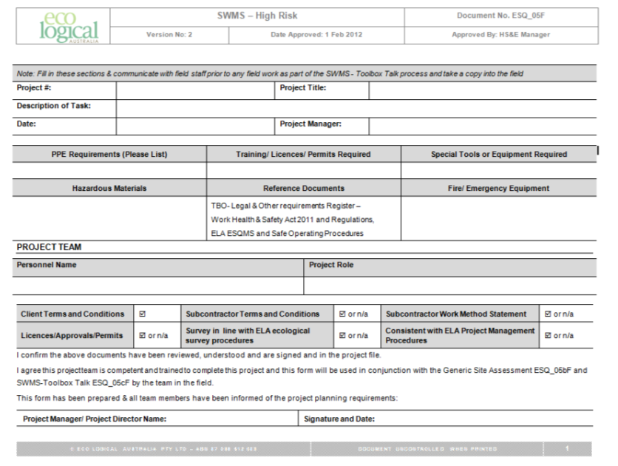

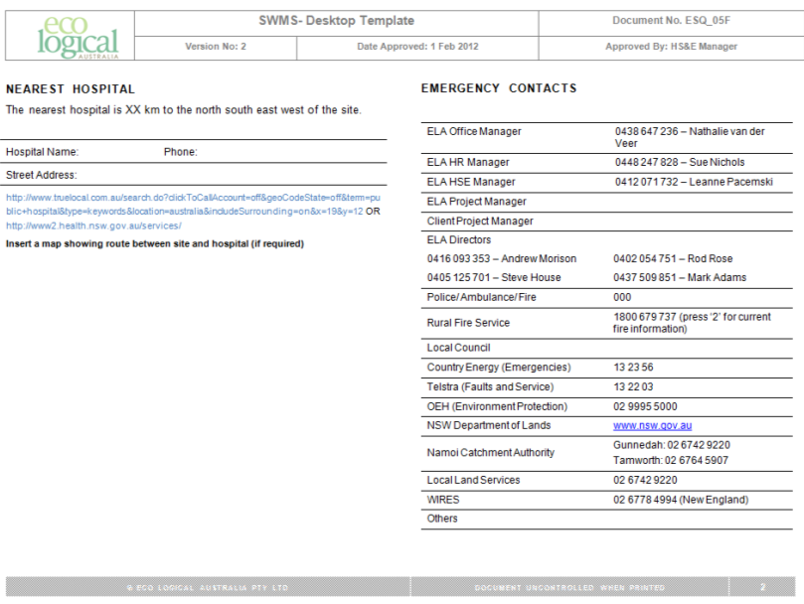

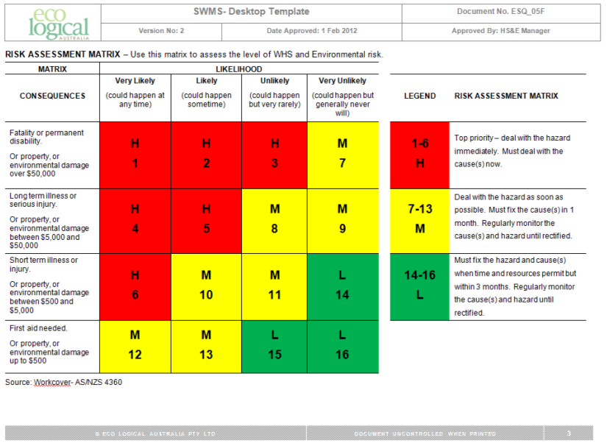

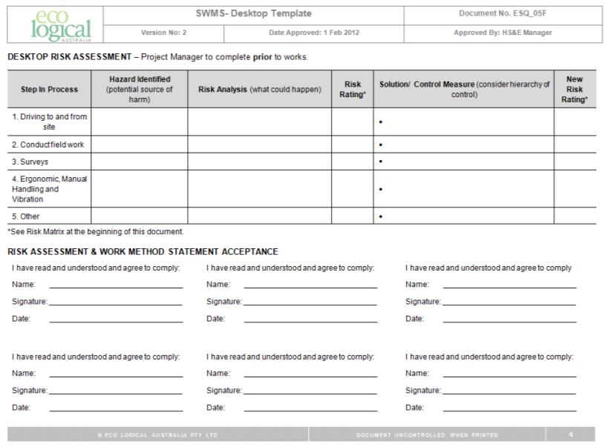

1. SWMS – Toolbox Talks

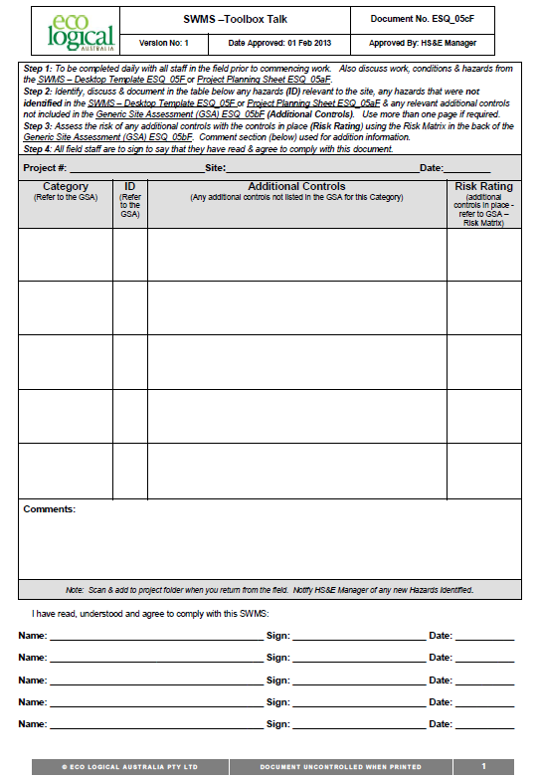

1. Injury/Incident Report Form

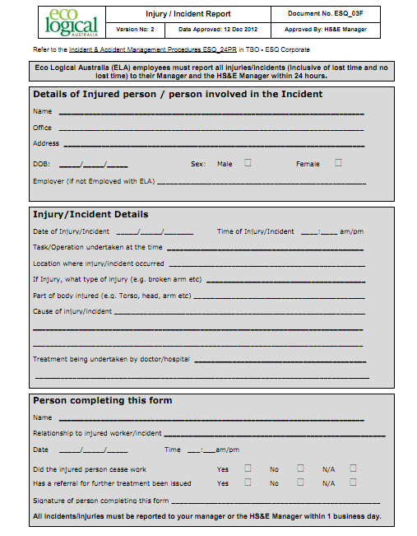

1. Vehicle Inspection Checklist

|  |  |  |  |  |  |
| --- | --- | --- | --- | --- | --- |
| Vehicle Make | |  | Registration No. | |  |
| Odometer | |  | Date of Inspection | |  |
| Inspection by: | |  |  | | |
|  | | **NAME (print)** | **SIGNATURE** | | |
| **Tick Box Applicable** | | | **YES** | **NO** | **Comments** |
| 1. | Brakes: | |  |  |  |
|  | - Foot brake operating | |  |  |  |
|  | - Hand brake operating | |  |  |  |
| 2. | Light operating and clean | |  |  |  |
| 3. | Indicators working and clean | |  |  |  |
| 4. | Steering – excessive play/vibration | |  |  |  |
| 5. | Windscreen wipers operating | |  |  |  |
| 6. | Windscreen washers operating | |  |  |  |
| 7. | Windscreen/windows damaged | |  |  |  |
| 8. | Windscreen/windows clean | |  |  |  |
| 9. | Horn operating | |  |  |  |
| 10. | Seat belts satisfactory | |  |  |  |
| 11. | Mirrors in good condition | |  |  |  |
| 12. | Tyres: | |  |  |  |
|  | - Correctly inflated | |  |  |  |
|  | - Sufficient tread | |  |  |  |
|  | - Damaged | |  |  |  |
| 13. | Body damage | |  |  |  |
| 14. | Jack and handle | |  |  |  |
| 15. | Wheel brace | |  |  |  |
| 16. | Spare wheel | |  |  |  |
| 17. | Fire extinguisher fitted and charged | |  |  |  |
| 18. | Engine Oil/Hydraulic Oil at Correct Level | |  |  |  |
|  | - Water – Radiator Full | |  |  |  |
|  | - Battery- Secure and water level OK | |  |  |  |
| 19. | Windscreen Washers water containers full | |  |  |  |
| 20. | First Aid Kit Provided and In Good Condition | |  |  |  |
| 21. | Registration Current | |  |  |  |
| 22. | Petrol | |  |  |  |
| **Comments** | | | | | |

1. Training log

| **Monitoring indicator** | **Training undertaken** | **Date** | **Trainer** | | **Trainee** | | **Comments** |
| --- | --- | --- | --- | --- | --- | --- | --- |
| **Name** | **Signature** | **Name** | **Signature** |
|  |  |  |  |  |  |  |  |
|  |  |  |  |  |  |  |  |
|  |  |  |  |  |  |  |  |
|  |  |  |  |  |  |  |  |
|  |  |  |  |  |  |  |  |
|  |  |  |  |  |  |  |  |
|  |  |  |  |  |  |  |  |
|  |  |  |  |  |  |  |  |
|  |  |  |  |  |  |  |  |
|  |  |  |  |  |  |  |  |
|  |  |  |  |  |  |  |  |
|  |  |  |  |  |  |  |  |
|  |  |  |  |  |  |  |  |



|  |  |  |  |  |
| --- | --- | --- | --- | --- |
| **Head Office**  Suite 4, Level 1  2-4 Merton Street  Sutherland NSW 2232  T 02 8536 8600  F 02 9542 5622 |  | **Sydney**  Level 6  299 Sussex Street  Sydney NSW 2000  T 02 8536 8650  F 02 9264 0717 |  | **St Georges basin**  8/128 Island Point Road  St Georges Basin NSW 2540  T 02 4443 5555  F 02 4443 6655 |
|  |  |  |  |  |
| **Canberra**  Level 2  11 London Circuit  Canberra ACT 2601  T 02 6103 0145  F 02 6103 0148 |  | **NEWCASTLE**  Suites 28 & 29, Level 7  19 Bolton Street  Newcastle NSW 2300  T 02 4910 0125  F 02 4910 0126 |  | **NAROOMA**  5/20 Canty Street  Narooma NSW 2546  T 02 4476 1151  F 02 4476 1161 |
|  |  |  |  |  |
| **COFFS HARBOUR**  35 Orlando Street  Coffs Harbour Jetty NSW 2450  T 02 6651 5484  F 02 6651 6890 |  | **ARMIDALE**  92 Taylor Street  Armidale NSW 2350  T 02 8081 2681  F 02 6772 1279 |  | **MUDGEE**  Unit 1, Level 1  79 Market Street  Mudgee NSW 2850  T 02 4302 1230  F 02 6372 9230 |
|  |  |  |  |  |
| **PERTH**  Suite 1 & 2  49 Ord Street  West Perth WA 6005  T 08 9227 1070  F 08 9322 1358 |  | **WOLLONGONG**  Suite 204, Level 2  62 Moore Street  Austinmer NSW 2515  T 02 4201 2200  F 02 4268 4361 |  | **GOSFORD**  Suite 5, Baker One  1-5 Baker Street  Gosford NSW 2250  T 02 4302 1220  F 02 4322 2897 |
|  |  |  |  |  |
| **DARWIN**  16/56 Marina Boulevard  Cullen Bay NT 0820  T 08 8989 5601 |  | **BRISBANE**  51 Amelia Street  Fortitude Valley QLD 4006  T 07 3503 7193 |  | 1300 646 131  [www.ecoaus.com.au](http://www.ecoaus.com.au) |



