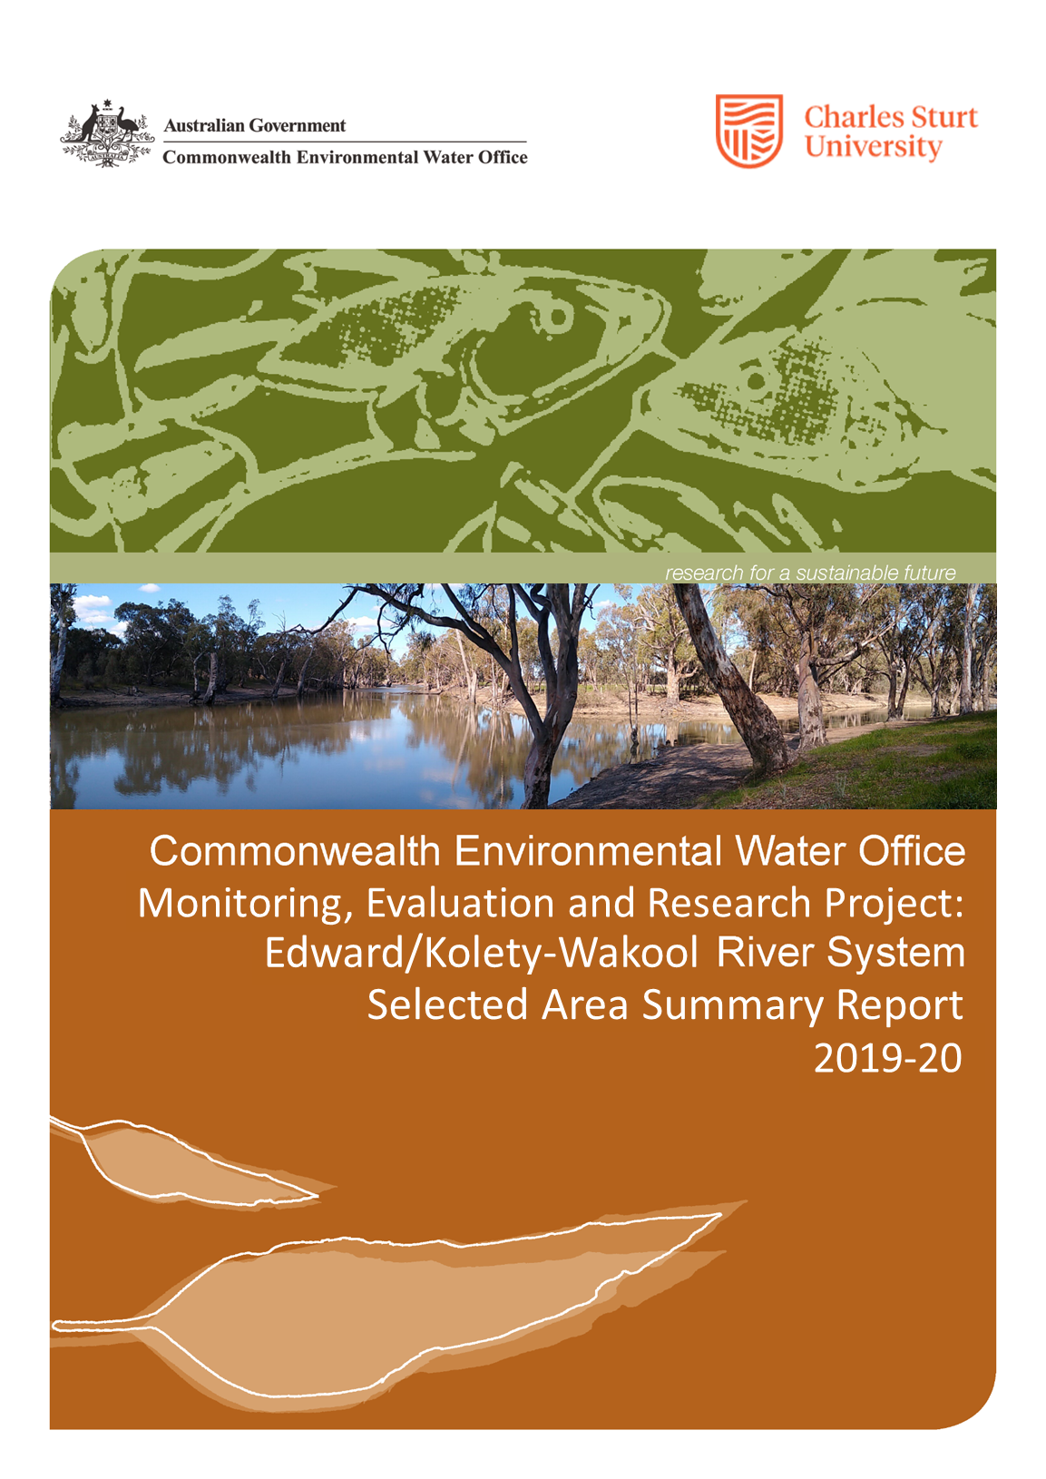
Copyright © Copyright Commonwealth of Australia, 2020

‘Commonwealth Environmental Water Office Long Term Intervention Monitoring Project: Edward/Kolety-Wakool River System Selected Area Summary Report, 2019-20 is licensed by the Commonwealth of Australia for use under a Creative Commons By Attribution 3.0 Australia licence with the exception of the Coat of Arms of the Commonwealth of Australia, the logo of the agency responsible for publishing the report, content supplied by third parties, and any images depicting people. For licence conditions see: http://creativecommons.org/licenses/by/3.0/au/
Disclaimer:
The views and opinions expressed in this publication are those of the authors and do not necessarily reflect those of the Australian Government or the Minister for the Environment. While reasonable efforts have been made to ensure that the contents of this publication are factually correct, the Commonwealth does not accept responsibility for the accuracy or completeness of the contents, and shall not be liable for any loss or damage that may be occasioned directly or indirectly through the use of, or reliance on, the contents of this publication.
Citation:
This report should be attributed as
Watts R.J., Bond N.R, Duncan M., Healy S., Liu X., McCasker N.G., Siebers A., Sutton N., Thiem J.D., Trethewie J.A., Vietz G., Wright D.W. (2020). ‘Commonwealth Environmental Water Office Monitoring, Evaluation and Research Project: Edward/Kolety-Wakool River System Selected Area Summary Report, 2019-20’. Report prepared for Commonwealth Environmental Water Office. Commonwealth of Australia.
The Commonwealth of Australia has made all reasonable efforts to identify content supplied by third parties using the following format ‘© Copyright.
 | Institute for Land, Water and Society  Charles Sturt University  PO Box789, Albury, NSW 2640
 | NSW Department of Primary Industries  Narrandera Fisheries Centre,  PO Box 182, Narrandera NSW 2700
 | NSW Department of Planning, Industry and Environment  PO Box 363, Buronga NSW 2739
 | School of Life Sciences  La Trobe University  PO Box 821,Wodonga 3689
 | Streamology  Waterway science and management
 | Edward-Wakool Angling Association
Cover photo: Confluence of Yallakool-Wakool during Commonwealth environmental watering action on 27 August 2019. Photo by Damian McRae, CEWO.

Monitoring and evaluation of environmental water in the Edward/Kolety-Wakool Selected Area
Background
The Commonwealth Environmental Water Office (CEWO) Monitoring, Evaluation and Research (MER) Program (2019-2022) replaces monitoring and research activities under the Long-Term Intervention Monitoring (LTIM) and Environmental Water Knowledge and Research (EWKR) projects (2014-2019). The MER Program provides the critical evidence that is required to understand how water for the environment is helping maintain, protect, and restore the ecosystems and native species across the Murray–Darling Basin (MDB) and informs management of Commonwealth water for the environment. The MER Program consists of evaluation, research and engagement at a Basin-scale and monitoring, evaluation, research and engagement across seven Selected Areas within the MDB.
This report summarises the key outcomes of monitoring and evaluation, research, communications and engagement that were undertaken in the Edward/Kolety-Wakool (EKW) Selected Area in 2019-20. Further details are available in a technical report (Watts et al. 2020). This project was undertaken as a collaboration between Charles Sturt University, NSW DPI (Fisheries), NSW Department of Planning, Industry and Environment, La Trobe University and Streamology. One of the research projects was undertaken in partnership with the Edward-Wakool Angling Association as a citizen science project.
Edward/Kolety-Wakool Selected Area
The EKW system is a large anabranch system of the Murray River in the southern MDB. The system begins in the Millewa Forest and travels north and northwest before discharging back into the Murray River (Figure 1). It is a complex network of interconnected streams, ephemeral creeks, flood-runners, wetlands and floodplain forests and woodlands. The area supports a productive agricultural community, has a rich and diverse Indigenous history, and supports recreational activities such as fishing, bird-watching and bush-walking. Aboriginal nations, including the Wamba Wamba or Wemba Wemba, Perrepa Perrepa or Barapa Barapa, and Yorta Yorta Nations, maintain strong connections to the country.
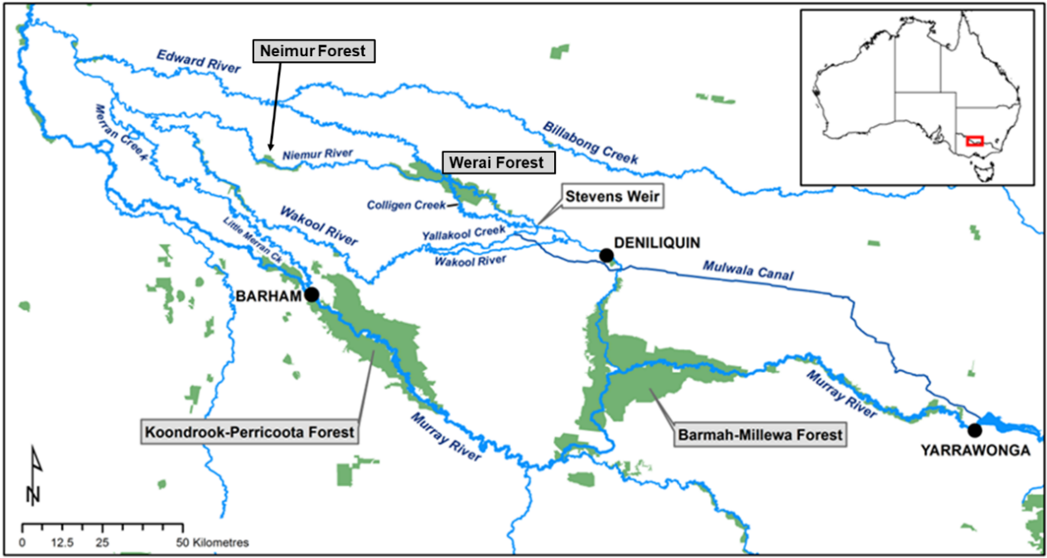
Figure 1. Map showing the main rivers in the Edward/Kolety-Wakool system. (Source: Watts et al. 2013)
The Edward/Kolety-Wakool (EKW) system is important for its high native species richness and diversity including threatened and endangered fish, frogs, mammals, and riparian plants. It is listed as an endangered ecosystem, as part of the ‘aquatic ecological community in the natural drainage system of the lower Murray River catchment’ in New South Wales (NSW Fisheries Management Act 1994). The Barmah-Millewa Forest, Koondrook-Perricoota Forest and Werai Forest (Figure 1) make up the NSW Central Murray Forests Ramsar site (NSW Office of Environment and Heritage 2018), being one of the matters of national environmental significance to which the EPBC Act applies. Werai Forest is a culturally significant area and is in the process of being established as an Indigenous Protected Area, and the Niemur Forest is part of the Murray Valley National Park. The multiple streams and creeks in the EKW system provide important refuge and nursery areas for fish and other aquatic organisms, and adult fish regularly move between this system and other parts of the Murray River.
The EKW system includes three broad aquatic ecosystem types (Figure 2):
- Permanently flowing Edward/Kolety River and semi-permanent Colligen-Niemur, Yallakool Creek and Wakool River. These systems support biodiversity and provide drought refugia for aquatic biota.
- Floodplain forests and woodlands. The aquatic ecosystems in these forests are culturally significant and are important habitats for larval and juvenile fish, support breeding colonies of birds, and are potentially a source of carbon for the river system.
- Ephemeral and intermittent creeks including Tuppal, Jimaringle, Cockran and Gwynnes Creeks. These creeks provide habitat connectivity and support threatened and vulnerable species.
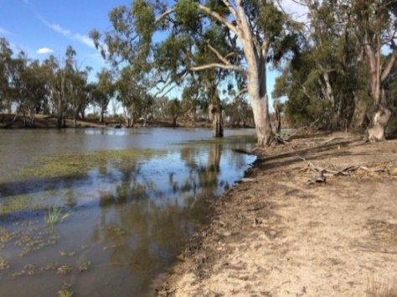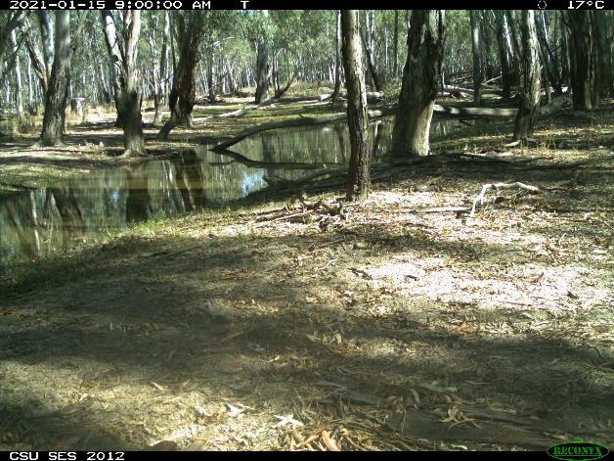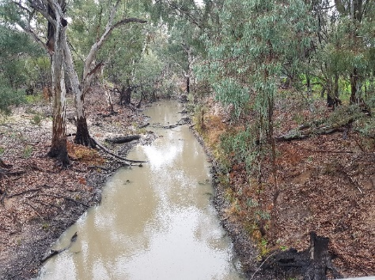
Figure 2. Photos showing the diversity of aquatic ecosystem types in the Edward/Kolety-Wakool system. Left: A permanent section of the Wakool River. Middle: Flood runner in Werai Forest. Right: Tuppal Creek.

Water management in the Edward/Kolety-Wakool system
The EKW system plays a key role in the operations and ecosystem function of the Murray River, connecting upstream and downstream ecosystems. The main source of Commonwealth environmental water for the EKW system is from the Murray River. Stevens Weir, the main flow regulating structure within the system, creates a weir pool that enables environmental water to be delivered to the Colligen-Niemur system, Yallakool Creek, Wakool River, Edward/Kolety River and Werai Forest. Water diverted from Lake Mulwala into the Mulwala Canal can also be delivered into the system through ‘escapes’ or outfalls managed by the irrigator-owned company Murray Irrigation Limited. Delivery of regulated instream flows to the EKW system are managed within regular operating ranges, as advised by river operators to avoid third party impacts. Regulated flows remain within the channel, with small freshes connecting low-lying in-channel features such as backwaters. This limits the types of flows that can be achieved under current operating ranges to in-channel base flows and freshes. During higher unregulated flows there is connectivity between the river channels, floodplains and the forests.

Environmental watering in the Edward/Kolety-Wakool Selected Area in 2019-20
Since 2009, Commonwealth environmental water has been delivered to the EKW system as base flows and freshes, has contributed to the recession of flow events, and contributed to flows in ephemeral watercourses (Table 1). Water has also been delivered from irrigation canal escapes to create local refuges during hypoxic blackwater events. The watering actions in ephemeral creeks were undertaken jointly with NSW DPIE. To date it has not been possible to deliver large within channel freshes or overbank flows due to operational constraints in the system. In addition to watering actions specifically targeted for the EKW system, water from upstream Commonwealth environmental watering actions and actions that are targeted for downstream watering actions transit through the EKW system in some years.
Table 1. Summary of environmental watering actions and unregulated overbank flows in the Edward/Kolety-Wakool system from July 2009 to June 2020.
Type of watering  action | Water year
 | 2009-10 | 2010-11 | 2011-12 | 2012-13 | 2013-14 | 2014-15 | 2015-16 | 2016-17 | 2017-18 | 2018-19 | 2019-20
In-channel environmental watering actions
Base flows and small freshes
Contribute to recession
Maintain winter base flows
Large within channel freshes¹
In channel environmental watering actions using irrigation infrastructure
Flows from canal escapes during hypoxic events
Flows in ephemeral streams²
Watering forests
Unregulated overbank flows
Flooding forests and/ or floodplains
¹ Delivery of large within channel freshes to the Wakool River and Yallakool Creek is not possible under current operational constraints
^{2.}Some of the watering actions in ephemeral creeks are done jointly with NSW Department of Planning, Industry and Environment

Three Commonwealth environmental watering actions were delivered in 2019-20 in the Wakool-Yallakool system and the Colligen-Niemur system (Table 2) as per Water Use Minute 10083. The reporting period commenced in May 2019 to enable an evaluation of the May to August 2019 winter watering action. Some of the water during these actions was sourced as return flows from the Southern Connected Flow in the Murray River that influenced flows in the EKW system from 28 August to 9 September 2019, and 23 September to 1 October 2019. CEW was also delivered to Pollack Swamp and Tuppal Creek in 2019-20, but these actions were not evaluated as part of the MER project.
This report focusses on watering actions 1 and 3 (Table 2). Watering action number 1 was a winter base flow. Watering action 3 (spring fresh) from 28 August to 22 December 2019 was partitioned into 5 components. The hydrographs for Yallakool Creek, Wakool River and Colligen Creek show the contribution of Commonwealth environmental water (Figure 3). There was minimal environmental water delivered to the upper Wakool River (Figure 3). There was an unregulated flow in May/June 2020 (Figure 3).

Table 2. Planned Commonwealth environmental watering actions in Yallakool Creek, mid- and lower Wakool River, and Colligen-Niemur system in 2019-20. This report focusses on watering action 1 and 3 (highlighted).
 | Action | Dates | Objective
1 | Winter base flow | 15/05/19 9/08/19 | For native fish condition and movement, vegetation in-channel, longitudinal connectivity; refuge habitat during irrigation shut-down period
2 | Winter spring transition | 10/08/19 - 27/08/19 | At this time, there was no operational demand. CEW was used to prevent water levels reducing to low levels for a short period between action 1 and action 3.
3a | Winter/ spring early fresh | 28/08/19 4/09/19 | To provide early season rise in river level to contribute to connectivity, water quality, stimulating early growth of in-stream aquatic vegetation, pre-spawning condition of native fish and/or spawning in early spawning native fish.
3b | Early spring elev base flow | 5/09/19 22/09/19 | To maintain nesting habitat for Murray Cod, and inundation for aquatic vegetation growth.
3c | Late spring fresh | 23/09/19 - 11/10/19 | To promote silver perch spawning, influence and encourage fish movement, may be coordinated with wider Murray River actions to maximise benefit. May also assist with dispersal of larvae and juveniles of a number of fish species.
3d | Late spring elevated base flow | 12/10/19 - 30/11/19 | To influence and encourage fish movement. May also assist with dispersal of larvae and juveniles of a number of fish species.
3e | Recession | 1/12/19 22/12/19 | Slow recession for instream water plants

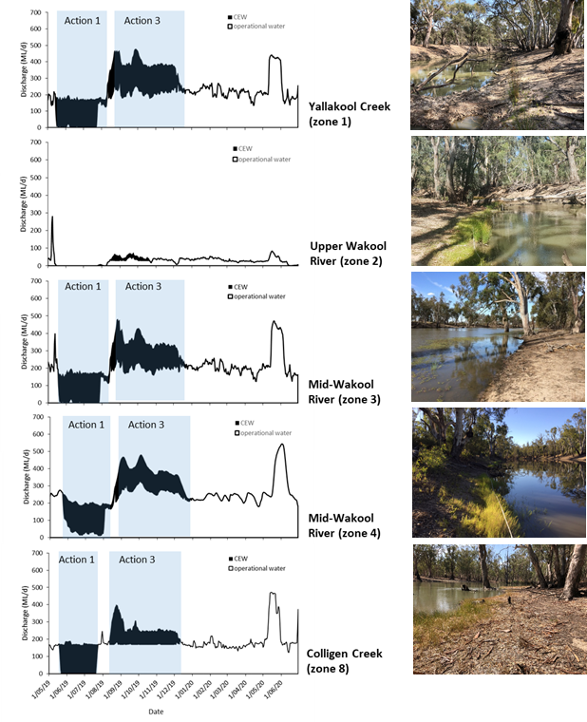
Figure 3. Hydrographs of zone 1 Yallakool Creek, zones 2, 3 and 4 in the Wakool River, and zone 8 Colligen Creek from 1 May 2019 to 30 June 2020. The portion of the hydrographs coloured black is attributed to the delivery of CEW. The blue shaded sections indicate environmental watering actions 1 and 3.

Key outcomes from environmental water use
Monitoring and evaluation
The monitoring was undertaken using methods and approaches described in the Edward/Kolety-Wakool MER Plan (Watts et al 2019a). An evaluation of the outcomes of Commonwealth environmental watering actions in 2019-20 was undertaken for the following indicators: Hydrology, water quality and carbon, stream metabolism, aquatic and riverbank vegetation, and fish movement, reproduction, recruitment, and fish community.
Responses to Commonwealth environmental water were evaluated in two ways:
- Indicators that respond quickly to flow (e.g. water quality, stream metabolism, fish movement and spawning) were evaluated for their response to individual watering actions. When possible, indicators were modelled to compare responses with and without environmental water.
- Indicators that respond over longer time frames (e.g. riverbank and aquatic vegetation, fish recruitment, fish community) were evaluated for their long-term response to environmental watering regimes over 6 years of the LTIM/MER project (2014-2020). This was undertaken by evaluating responses over multiple years, and/or comparing responses in reaches that received environmental water to reaches that received none or minimal environmental water.
Responses to the 2019 winter watering action
Winter watering maintained longitudinal connectivity of habitat: Sections of the Wakool-Yallakool and Colligen-Niemur systems regularly experience periods of cease to flow during winter when regulators are closed during operational shutdown. The winter watering action in 2019 maintained continuity of flows in Yallakool Creek, the mid and lower Wakool River, and Colligen-Niemur system (Figure 4). In the absence of environmental water there would have been an extended period of cease to flow in these rivers. The upper Wakool River did not receive environmental water and experienced a cease to flow from mid-May to the end of July 2019 (Figure 3). Maintaining longitudinal connectivity and preventing cease to flow in winter has many ecosystem benefits including; preventing exposure of acid sulphate soils and maintaining water quality in the lower section of the Wakool river; enabling fish to move into and out of the river system; maintaining local habitat for sedentary fish and other aquatic organisms over winter; preventing frost damage of aquatic plants; and limiting exposure of rhizomes to damage by pigs.
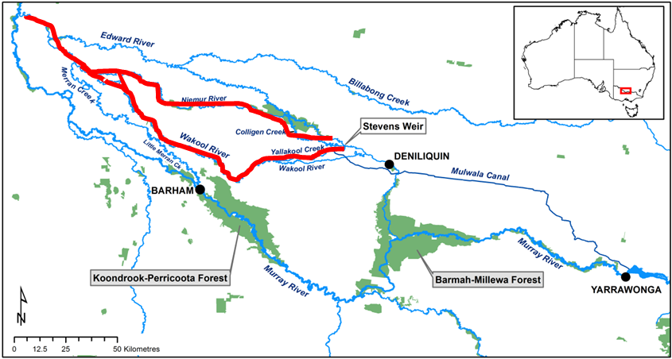
Figure 4. Map of the Edward/Kolety-Wakool system showing the length of river where connectivity was maintained (in red) due to winter watering action 1 in Wakool-Yallakool system and Colligen Creek.
Winter watering increased primary productivity: Healthy aquatic ecosystems need key ecological processes of photosynthesis and respiration to occur to generate new biomass (which becomes food for organisms higher up the food chain), and to break down plant and animal detritus and to recycle nutrients to enable growth to occur. The winter watering action had a significant beneficial effect on gross primary productivity (GPP), calculated as the amount of organic carbon produced per day (kg C/day) (more ‘food’ is better) (Figure 5). The size of the beneficial impact was related to the proportion of the flow attributed to environmental water, with high proportional effects of environmental water in winter at a time when there would have otherwise been none or very little operational water in the system. Maintaining flow during winter can help maintain populations of zooplankton and other invertebrates that feed on phytoplankton and periphyton, and in turn, this increases food availability for fish and other higher order consumers during periods in which food availability might otherwise be low.
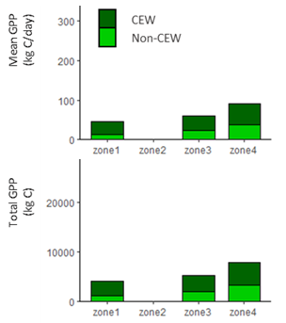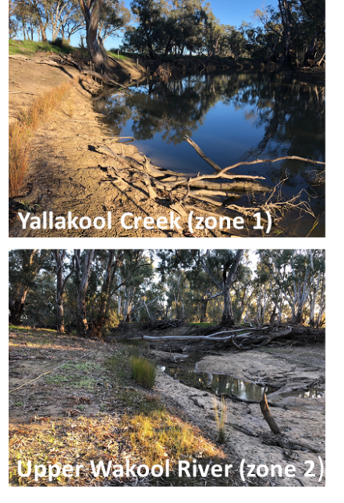
Figure 5. Left: The average daily production of carbon (kg C/day) and total production of carbon (kg C) over 86 days of the winter watering action at sites in Yallakool Creek (zone 1) and the Wakool River (zones 3, 4). The upper Wakool River (zone 2) did not receive environmental water in winter 2019. Light green indicates the production attributed to operational water (non-CEW), and dark green indicates the production attributed to environmental water (CEW). Right top: Yallakool Creek (zone 1) during the winter watering action in 2019. Right bottom: The upper Wakool River (zone 2) during cease to flow in winter 2019 (no environmental water).
Winter watering increased opportunities for movement of fish: Adult golden perch, silver perch and Murray cod were tagged and their movements from August 2017 to August 2019 were studied using acoustic tracking. On average, tagged fish moved further in winter 2019 during the winter watering action compared to winter 2018 when there was a cease to flow. Tagged silver perch moved between 0.0–10.8 km in 2019 compared to 0.0–5.8 km in winter 2018. Tagged golden perch moved between 0.0–15.1 km in winter 2019 compared to zero km in winter 2018. Occupation of Yallakool Creek zone 1 by golden perch was enabled during winter watering in 2019 in comparison to winter 2018 (no watering), indicating that increased habitat was both available and utilised during the watering event. The movement data from tagged fish were used to develop a model comparing movement with and without environmental water (Figure 6). The results suggest that fish have a higher probability of movement with CEW than without CEW. Silver perch responded more to winter watering than golden perch and Murray cod (Figure 6).
Figure 6. Modelled probability of golden perch, silver perch and Murray cod movement as determined by acoustic tracking, in relation to flow with and without CEW in the Edward/Kolety-Wakool system in 2017 and 2018. Fish have a higher probability of movement with CEW than without CEW.

Responses to the 2019 spring watering action
Spring watering increased lateral connectivity: The spring watering action in 2019-20 increased the maximum discharge in Yallakool Creek, the mid- and lower Wakool River, and Colligen-Niemur system compared to operational flows. Hydraulic modelling undertaken for 25 reaches (each 4 km long) showed that this action increased lateral connectivity by inundating low lying wetlands and other in-channel features, increasing the total wetted area of riverbank compared to operational flows. Increasing the extent and duration of lateral connectivity can play an important role in river productivity, increasing dissolved carbon released from the sediment, leaves, and vegetation. Increased inundation of the riverbank triggers germination and growth of aquatic and riverbank plants, which provide habitat for invertebrates, frogs and fish. A comparison of the modelled inundated area for a 170 ML/day operational flow and a 450 ML/day environmental flow in a reach of the Wakool River (Figure 7), shows the increase in inundated area and connectivity during the environmental flow. Results of hydraulic modelling for other reaches in the EKW system are presented in Watts et al. (2015).
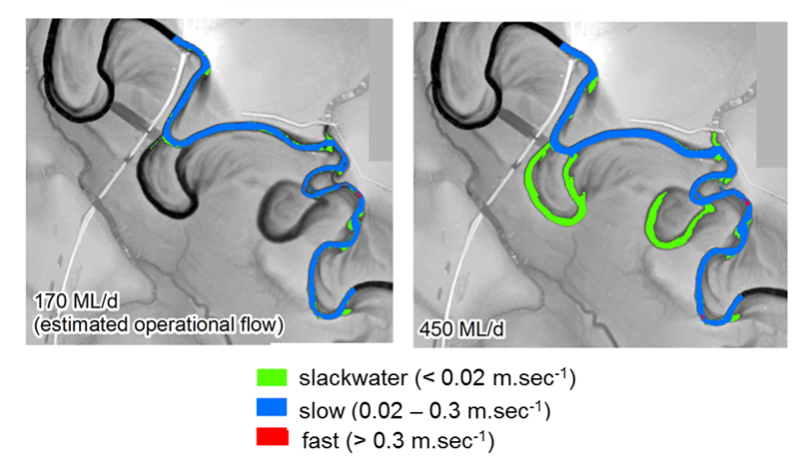
Figure 7. Results of hydraulic modelling for a 4 km reach of the Wakool River near the Wakool-Barham Road showing difference in inundated area modelled for 170 ML/day operational flow (left) and 450 ML/day environmental flow (right) that was similar discharge to the peak of the watering action in September 2019.
Spring watering maintained good water quality: The expected seasonal variation in water temperature and dissolved oxygen (DO) was observed in 2019-20, with lower temperatures and higher DO in winter, and higher temperatures and lower DO during the hotter months (Figure 8). Increased water temperature in summer decreases oxygen solubility and increases the rate of microbial processes.
The spring watering action helped to maintain good water quality and resulted in no adverse outcomes. DO was consistently higher in zones that received environmental water than in the upper Wakool River (zone 2) that received low operational base flows and almost no environmental water (Figure 8).
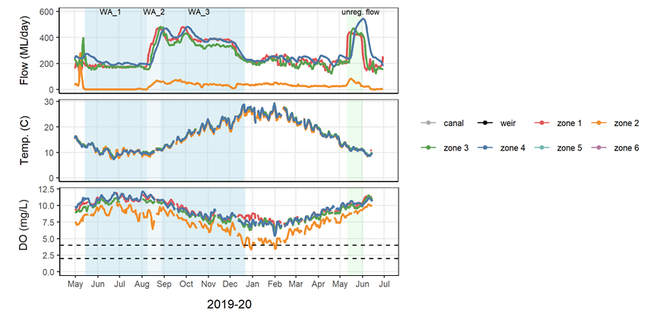
Figure 8. Daily discharge (ML/day), temperature (°C), and dissolved oxygen (DO) concentrations (mg/L) at sites in the Wakool-Yallakool system from May 2019 to June 2020. Dashed lines indicate DO range of concern for fish. Many fish species become stressed when DO is below 4 mg/L, and fish deaths can occur when DO is less than 2 mg/L.
Water quality is critical for the health of the river ecosystem and the local communities that rely on river water. In the smaller tributaries of the EKW system there is a risk of temperature-induced hypoxia during heatwaves. In the upper Wakool River there were several days in summer 2020 when water temperature exceeded 25°C, DO was below the range of concern for fish (4 mg/L)(Figure 8), and excessive algae growth was observed (Figure 9). Several days of low DO were also recorded in the Niemur River where a pulse of dark coloured water was observed (Figure 9) associated with a small increase in dissolved organic carbon (DOC). Small inputs of DOC to the river can be beneficial for the food web, however during heatwaves there is increased risk of hypoxia. Regular monitoring of water quality ensures that water managers are informed before critical levels are reached so watering actions can be considered.
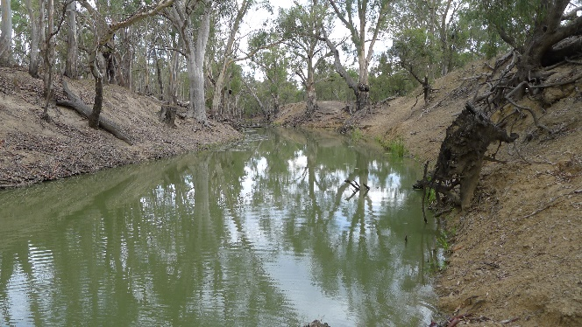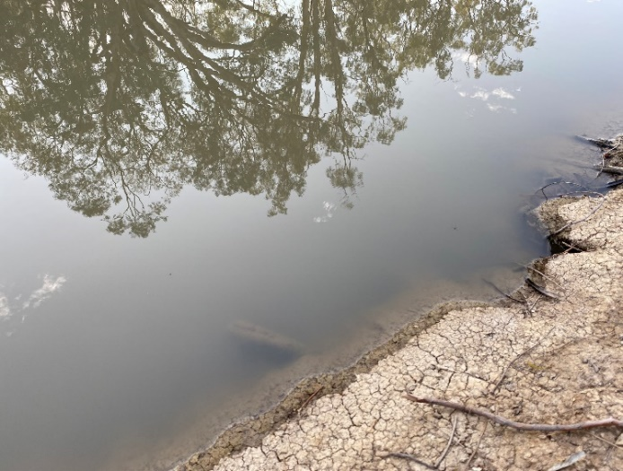
Figure 9. Poor water quality was observed in the upper-Wakool River system (left) and in the Niemur River near the Moulamein Rd Bridge (right) between the end of January and late February 2020. (Photo: Xiaoying Liu)
Spring watering increased productivity: The spring watering action had a significant beneficial effect on gross primary productivity (GPP) in zones that received environmental water. Overall carbon production and consumption during the spring action was higher than the winter action (page 8) because the spring action was longer (116 days spring action vs. 86 days winter action), and there are higher rates of GPP and ER during warmer months. The increased lateral connectivity during the spring action inundated low lying areas within the channel, resulting in increased production and consumption of carbon (Figure 10), supporting the food web.
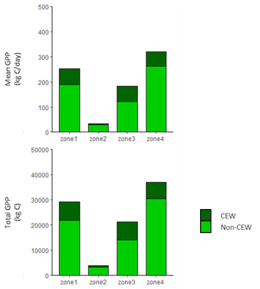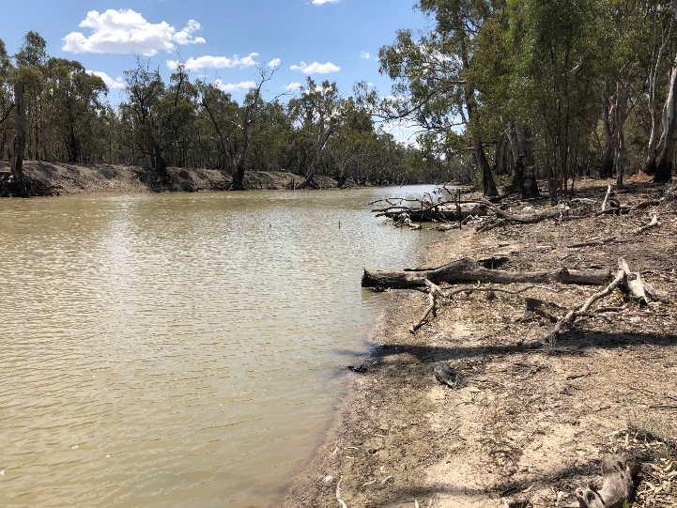
Figure 10. The average daily production of carbon (kg C/day) and total production of carbon (kg C) over 116 days of the spring watering action. The upper Wakool River (zone 2) received minimal environmental water. Light green indicates production attributed to operational water (non-CEW), and dark green indicates production attributed to environmental water (CEW). Right: Wakool River (zone 4) during the spring watering action.
Spring watering increased germination, flowering and dispersal of riverbank plants: The spring watering action increased inundation of riverbanks (page 9) and provided opportunities for germination, flowering and dispersal of riverbank plants.
In September grasses at the edge of the water were inundated and created habitat for frogs; Crinia signifera and C. parinsignifera were heard calling at several sites in Yallakool Creek and Colligen Creek. In October, water couch was starting to green up, the common spikerush (Eleocharis acuta) was emerging at a site in Colligen Creek (Figure 11, left), macroalgae Chara was abundant, and stem fragments of water milfoil (Myriophyllum sp.) that had been broken off during the spring flow were observed at the water’s edge at sites in zones 3 and 4 (mid Wakool River). In November as the water receded, Chara had partially dried on the riverbank but was flourishing in the water (Figure 11, middle), the stem fragments of milfoil observed in October had taken root (Figure 11, right), and the spike rush were flowering.
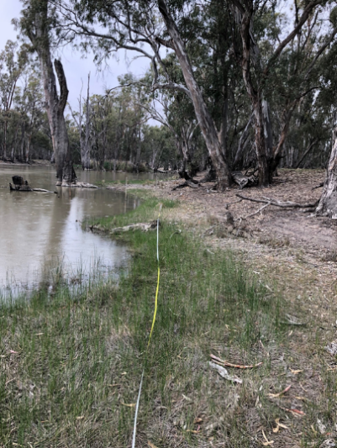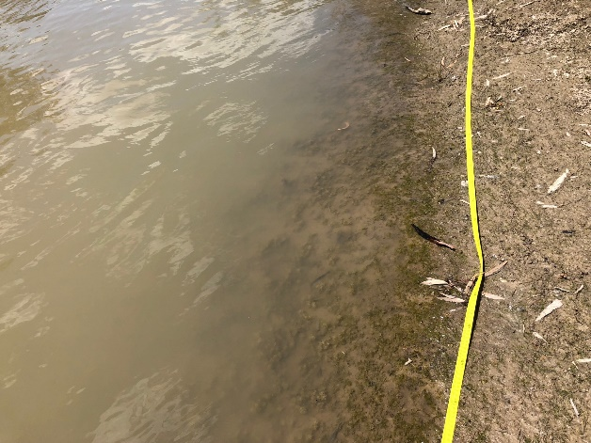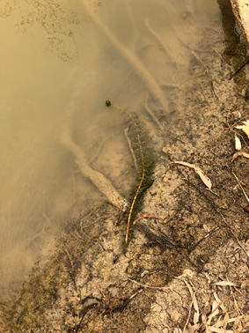
Figure 11. Left: The sedge Eleocharis acuta emerging in Colligen Creek in October 2019. Middle: The macroalgae Chara abundant in November 2019. Right: Stem fragments of water milfoil taking root in the mid-Wakool River.
Spring watering increased spawning in some fish species: The diversity and abundance of fish eggs and larvae is monitored across the spring-summer spawning period (Figure 12) to identify which fish species have successfully spawned, and under what hydraulic and temperature conditions they spawned.
In 2019-20 larvae of nine fish species were recorded (Figure 12). The species in order of abundance were carp gudgeon, Murray cod, Australian smelt, flathead gudgeon, bony herring, obscure galaxias, river blackfish, unspecked hardyhead, and carp. Significantly more bony herring larvae and Australian smelt larvae were found in river zones that received environmental water compared to the upper Wakool River that did not receive environmental water. Australian smelt is a pelagic, early spawning species that may benefit from the increased discharge and higher water velocity during environmental watering actions. There was no evidence of golden or silver perch spawning, possibly because the water temperature may have not been warm enough during the watering action to elicit a spawning response.
Environmental water may have also supported range expansion in river blackfish. Over the LTIM/MER project river blackfish larvae (Figure 12) have typically been detected only in the upper Wakool River (zone 2). However, in 2019-20 we detected river blackfish larvae in the Wakool River (zone 3) for the first time, an indication that the distribution and range of river blackfish may be slowly expanding.
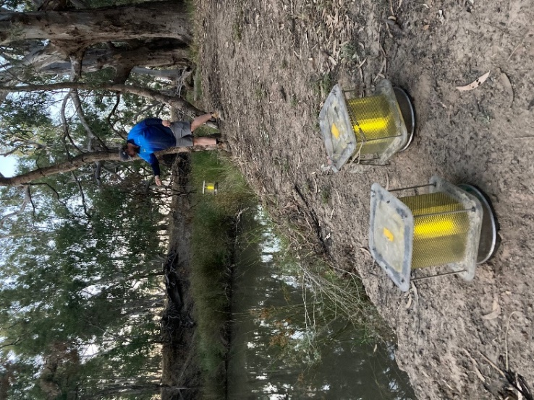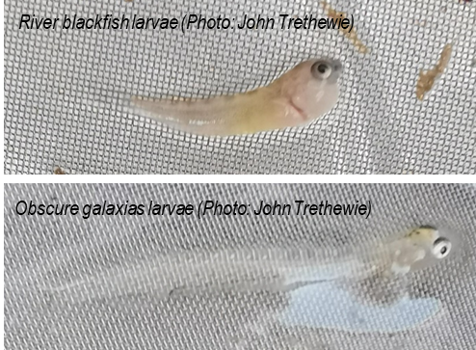
Figure 12. Left: Setting light traps to monitor fish spawning. Right: Larvae of river blackfish and obscure galaxias from the Edward/Kolety-Wakool system.
Responses over multiple years of environmental watering
Environmental watering is supporting long-term recovery of aquatic and riverbank plants: Aquatic and riverbank plants play an important role in the functioning of aquatic ecosystems, supporting riverine food webs and providing habitat for waterbugs, frogs, birds and fish. The water regime in a river can affect the survival, growth and maintenance of plants, particularly those that live under the water (submerged), or those that live on the lower part of the riverbank and tolerate wetting and drying (amphibious plants).
The unregulated flood in 2016 significantly reduced the number of aquatic and riverbank plant taxa across all study sites. Since the flood there has been a partial recovery, with more taxa present in zones that have received environmental water. However, the number of species has not yet recovered to the same levels as prior to the flood. The number of taxa was consistently lower in zone 2 (upper Wakool River), which has received minimal or no environmental water.
The large unregulated flood in 2016 decimated submerged plants and macroalgae, and there has been recovery of these groups since 2017-18 (Figure 13). In 2019-20 the percent cover of submerged taxa increased in zones that received environmental water, but reduced in the upper Wakool River that experienced a cease to flow in winter 2019. The change was particularly notable for Chara, a submerged macroalgae that provides food and habitat for many aquatic animals. The percent cover of Chara increased in all zones that received the winter and spring watering actions (Figure 13).
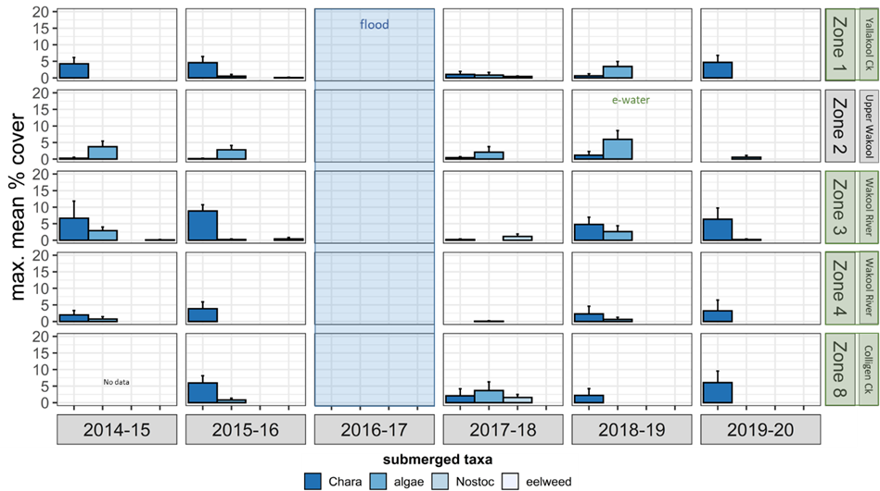
Figure 13. Mean percent cover of four submerged plant taxa monitored monthly across five hydrological zones in the Edward/Kolety-Wakool system between 2014 and 2020. Blue shading indicates the year of the flood in 2016. Green shading of zone names indicates that zones 1, 3, 4 and 8 received environmental water every year. Zone 2 received minimal no environmental water, with the exception being in 2018-19, as indicated.
Amphibious plants have begun to recover in all river zones since the 2016 flood. The response has not been uniform across river zones or taxa. The common spikerush (Eleocharis sp.) was the dominant taxa in Colligen Creek prior to the flood, but tolerated the flooding and has maintained a similar percent cover across all years. In contrast, floating pondweed (Potamogeton tricarinatus), milfoil (Myriophyllum sp.) and other amphibious plants that were abundant in the mid-Wakool River in 2015 (Figure 14) but were killed by the flooding in 2016, are recovering very slowly, with some early signs of recovery evident in zones that have received environmental water.
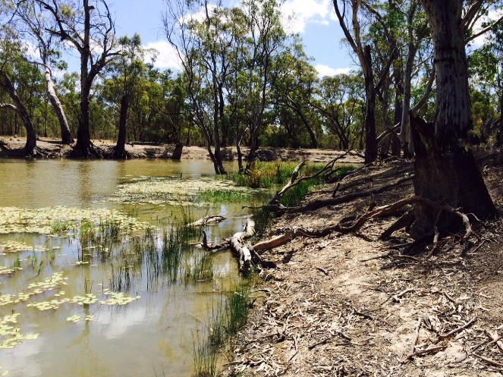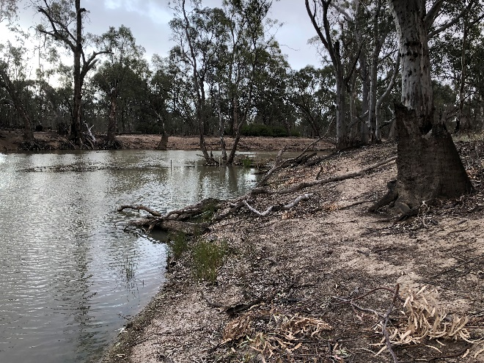
Figure 14. Left: Amphibious plants in the mid Wakool River in November 2015 prior to the 2016 flood. Right: The same site in November 2019, showing there has been only minor recovery of amphibious plants.
Environmental watering is supporting fish recruitment: Fish recruitment monitoring in the EKW system is focused on juvenile Murray cod, silver perch and golden perch. Juveniles include both young-of-year (YOY) and 1 year old (1+) fish. This monitoring enables comparison of the abundance and growth rates of juvenile of these three species from four river zones in response to environmental watering.
In 2019-20 Murray cod recruits were detected in the mid Wakool River (zones 3 and 4) for first time since 2015-16 (Figure 15). The winter 2019 watering action may have assisted the movement of adult Murray cod into the mid Wakool River, with the spring 2019 watering action supporting the survival and recruitment of larvae. Growth (mm per day) of YOY Murray cod in 2019 was similar to previous years, except to 2017-18 immediately following the flood when growth was higher due to abundant food resources. In 2019-20, Murray cod 1+ recruits were at their highest abundance since monitoring began, silver perch 1+ recruits were at a low abundance and YOY silver perch recruits were not detected. No golden perch recruits were detected in 2019-20, which is consistent previous years of monitoring.
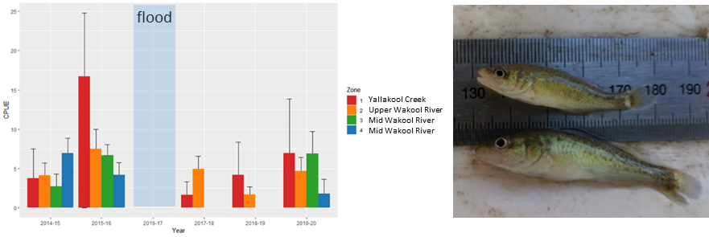
Figure 15. Mean (+SE) catch per unit effort (CPUE; number of fish caught per 10 000 seconds of electrofishing) of young-of-year Murray cod in the Edward/Kolety-Wakool river zones from 2014-20. Right: Juvenile Murray cod (Maccullochella peelii) from Yallakool Creek (Photo: John Trethewie, Charles Sturt University)
Environmental watering is supporting recovery of the fish community: Monitoring of the fish community was undertaken only in the mid Wakool River in 2020. System-wide fish community surveys were undertaken in year 1 (2014-15) and year 5 (2018-19) of the LTIM program and will take place in 2021-22 of the MER program.
Eight native species and two alien fish species of fish were captured during fish community sampling in the mid Wakool River in 2019-20 (Figure 16). The golden perch population continues to exhibit no recruitment, and is predominantly comprised of large adults. Murray cod relative abundance and biomass continue to increase following fish kills in 2016. Bony herring were present at the highest relative abundance observed in the program, reflecting a strong spawning and recruitment year. Typical annual fluctuations were observed in small bodied generalist species. Flathead gudgeon population has not recovered since the flood, although this species was in low abundance prior to the flood. The abundance of introduced fish species was low. Eastern gambusia were absent, almost no carp recruits were recorded, and there was decreased abundance and biomass of adult carp (Figure 16).
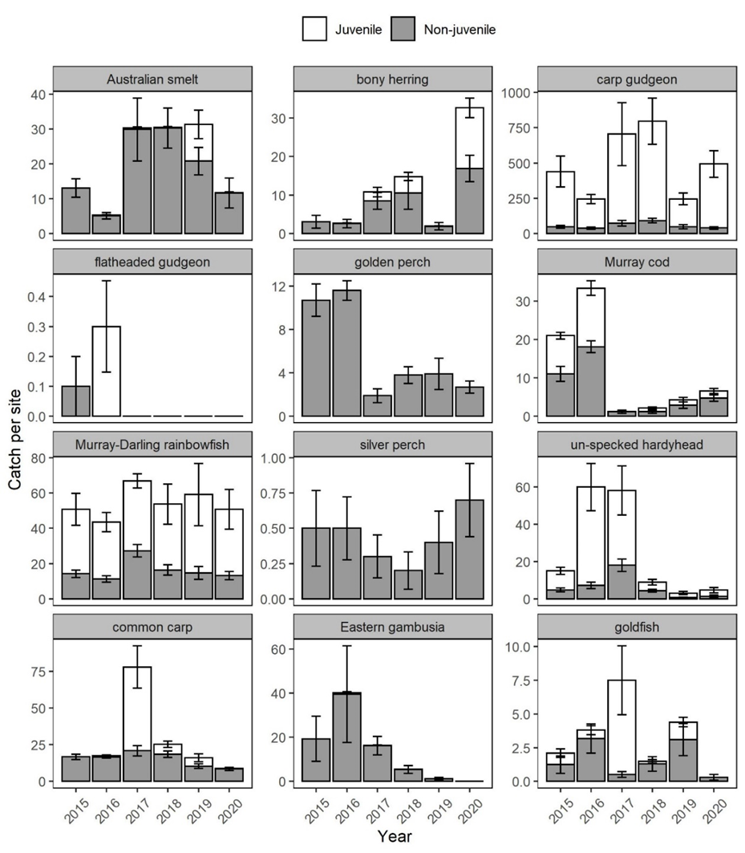
Figure 16. Catch per site (number of fish; mean ± SE) for each fish species within the Edward/Kolety-Wakool river system target reach, sampled from 2015–2020. Cumulative stacked bars separate the catch of juveniles (white bars) and non-juveniles (grey bars).

Research
The focus of the research program is the reach of the Edward/Kolety River from Stevens Weir to downstream of Werai Forest. This area was selected because it has not been monitored as part of the LTIM/MER program and there are considerable knowledge gaps that need to be addressed to inform the future delivery of environmental water to the Edward/Kolety River and the management of environmental water in relation to the Werai Forest. The research program integrates physical, ecological, and social research that will address questions relating to managed flows in the Edward/Kolety River and the operation of Stevens Weir. The research examines physical aspects (e.g. lateral connectivity and physical form) as well as river productivity, wetland plant emergence and survival, turtle movement and condition, and fish spawning. In addition, a project using a targeted e-DNA approach was undertaken to determine the presence and spatial distribution of threatened, uncommon and iconic or rare taxa that have not been the target of the LTIM/MER monitoring. A social research project will link with the biophysical research, to examine stakeholder attitudes to and acceptance of, the concept and use of Commonwealth environmental water. Some of the research components have different reporting timelines.
The research will be undertaken throughout the MER program (2019-2022), and research outcomes will be integrated in the final MER report in 2022. Here we report on four components of the research program: physical habitat, primary productivity, fish spawning, and e-DNA research.
Edward/Kolety River physical habitat research
We investigated the impacts of flow events on physical habitat of the riverbank in two reaches of the Edward/Kolety River and one reach in Colligen Creek. Questions addressed were:
- What are the features of the flow regime and river operations that drive erosion and deposition?
- What are the features of flow regime and river operations that affect riverbank vegetation and aquatic vegetation cover?
Unmanned Aerial Vehicle (UAV) technology was used to capture high resolution aerial imagery to process with photogrammetry methods to produce detailed digital elevation models (DEMs), DEMs of Difference (DEMODs) to quantify changes in bank condition, and riparian vegetation maps displaying spatial and temporal differences in riparian vegetation associated with flow event.
In the Edward/Kolety downstream of Stevens Weir there is a deep notch in parts of the riverbank that corresponds with the prolonged invariable operational flow of approximately 2500 ML/day (Figure 17). The duration of inundation above the notch and the speed of drawdown of flow events were found to be critical in determining the extent of erosion, due to the fact that saturation plays a key role in determining the volume of erosion. For example, at one site in the Edward/Kolety River there was extended erosion following a flow that was >20 days duration above the notch (Figure 17). In comparison, an unregulated flow that was <7 days duration above the notch resulted in much less erosion.
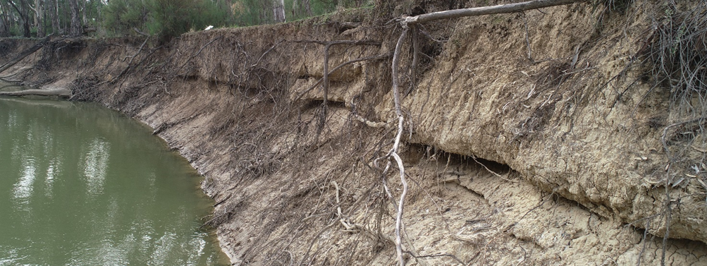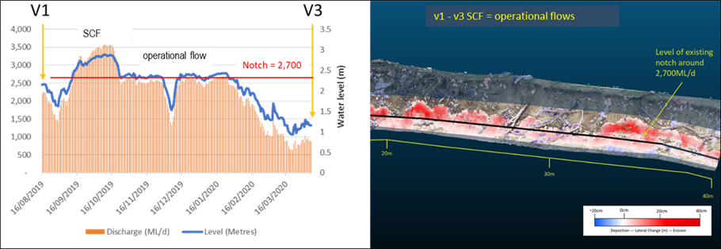
Figure 17. Left: Drone photograph taken on 07/04/2020 highlighting the notch in the riverbank in the Edward/Kolety River downstream of Stevens Weir. Right: Bank erosion shown in the Digital Elevation Models of Difference (DEMODs) following a flow event that was >20 days duration above the notch. Blue areas indicate deposition and red indicates erosion.
The position of the notch relative to the water level of subsequent flow delivery is a critical variable in the scale and pattern of the erosion response. It is the combination of the following processes in sequence that are the driving force behind channel widening resulting from mass-failure events; a) Prolonged invariable summer operational flows create a deep notch and drying of the upper bank, and b) Environmental water or unregulated flows that inundate the bank above the notch saturate the upper bank and can result in large quantities of unstable sediment following the flow recession. Preparation of the bank during operational flows plays a critical role in driving erosion events throughout the entire year and in years following. Prolonged inundation (>30 days) during spring also appeared to reduce riparian vegetation cover in the section of bank above the zone relating to 3,000 ML/day discharge in the Edward/Kolety River downstream of Stevens Weir.
Flows which resulted in the most deposition relative to erosion were unregulated flows during the winter months. This was due to the source of the water delivered during this period (high percent of tributary flows), and the range of these flows (between 500 - 3,000 ML/day). Environmental water actions that are delivered with a gradual draw-down of the receding limb are also likely to result in higher deposition and less erosion due to mass-failure events. However, this will have a limited beneficial impact if summer operational flows are not re-designed.
This study highlights the important role that historic flow patterns play on influencing future erosion events. In systems like the Edward/Kolety River, where historic flow patterns have led to excessive notching within channels, the influence of environmental water actions or unregulated flows on bank condition cannot be studied in isolation. To be able to correctly assess the outcome of environmental actions on riverbanks, the impacts of operational flow strategies must be considered and addressed. If the management of operational flows does not change, then the potential benefits to bank condition as a result of environmental watering actions-will not materialise. If this is not possible to change operational flow delivery then environmental flow deliveries need to be designed with the position of the existing notch considered, with close attention to the rate of flow recession to minimise mass-failure events.
Edward/Kolety River primary productivity research
The stream metabolism monitoring for LTIM/MER project to date has focussed on in-channel flow in tributaries in the Wakool-Yallakool system. The aim of this new research was to advance understanding of Gross Primary Production (GPP) and Ecosystem Respiration (ER) in the Edward/Kolety River downstream of Stevens Weir, due to potential for flows to inundate parts of Werai Forest, connecting low-lying floodplains, anabranches and floodplain wetlands and runners that sometimes return discharge back into the river. The main research question was ‘How does variation in the flow regime downstream of Stevens Weir drive changes in rates of GPP, ER and net ecosystem production (NEP, GPP – ER) in the Edward/Kolety River?’.
GPP, ER and NEP were calculated for one site upstream of Werai Forest and one site downstream of the forest. The downstream site integrates a reach of the Edward/Kolety River bordering Werai Forest as well as outflows from Werai Forest. This research is ongoing, and unfortunately there was not enough useable data in 2019-20 to answer the research question at this stage of the research. However, the most notable trends in the available data were a greater occurrence of high GPP and ER events at the site downstream of Stevens Weir when compared with the site downstream of Werai Forest, and a seasonal progression from higher to lower GPP/ER ratios from summer to winter 2020. There was little correlation between other potential indicators of inundation within the forest (% inundation, daily rainfall) and changes in GPP or ER rates.
Examination of Sentinel satellite imagery (Figure 18) suggests that low-lying areas prone to inundation are more likely to occur in the centre of Werai Forest than along the Edward/Kolety River. These inundated floodplain wetlands within Werai Forest may act as a strong “sink” for nutrients and carbon (i.e. retained within the system and either incorporated into organism biomass or deposited) rather than exported downstream to support in-channel respiration. Thus, we predict that much of the carbon cycled during inundation of the forest may be both produced and consumed within shallow, slow-flowing anabranches and inundated floodplains, and may not be reflected in oxygen cycles within the river.
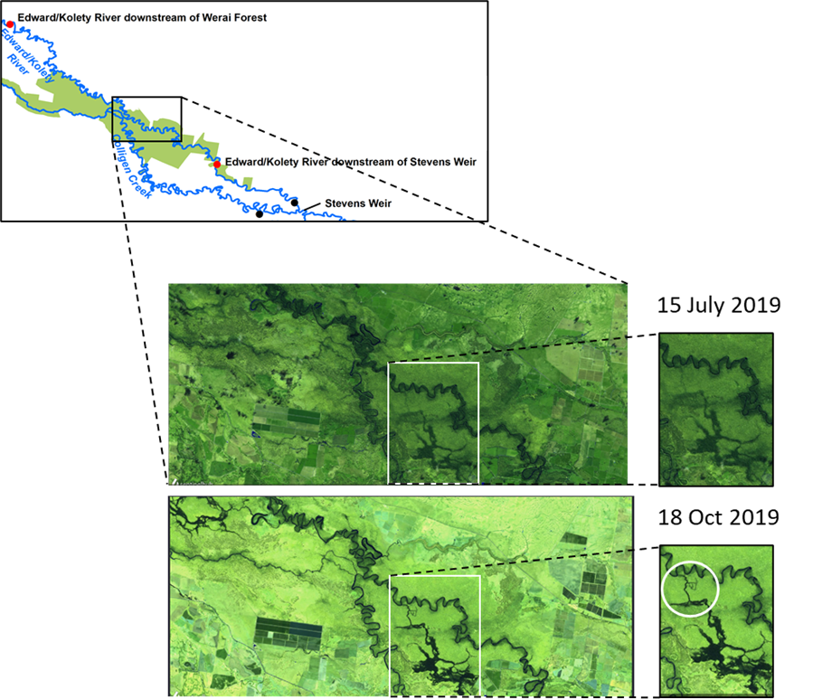
Figure 18. False-colour Sentinel imagery of the Edward/Kolety River adjacent to Werai Forest (large map shows location of imaged area within the Edward/Kolety-Wakool Selected Area). Inset images show expanded view of inundated areas within Werai Forest in relation to the Edward/Kolety River. The progression of water through the forest from August 2019 to October 2019 is evident in the images. The image from 18 October 2019 shows connection of Werai Forest outflows into the Edward/Kolety River (white circle).

A more comprehensive understanding of how inundation events from anabranch and connection flows influences whole-river metabolism will require monitoring of several sites within Werai Forest. We recommend that a campaign/intervention monitoring type of study be undertaken during a flow event >2700 ML/day that inundates low lying parts of Werai forest and is likely to return flows to Colligen Creek or the Edward/Kolety River. The evaluation of primary productivity associated with the event would be enhanced by the installation of temporary gauges to collect data on the inflows to the forest. Analysis of Sentinel images would also quantify extent of inundation within Werai Forest. This research is focussed on the Werai Forest, and the lessons learned from this project may be transferrable to other low lying forested areas within the Edward/Kolety-Wakool system, such as Koondrook Perricoota Forest.

Fish spawning research in the Edward/Kolety River
Throughout the LTIM/MER fish monitoring there has been no evidence of golden perch spawning and only a very small number of silver perch larvae recorded in Wakool-Yallakool system. Local fishers had previously observed golden perch congregating in the Edward/Kolety River downstream of Stevens Weir during late spring, prompting the establishment of this research project. The aim of the research was to determine if golden perch and silver perch spawn in the Edward/Kolety River downstream of Steven’s Weir. The project was undertaken as a citizen science project through collaboration between Charles Sturt University and the Edward-Wakool Angling Association. The MER program funded the field work and employment of EWAA members on the project. Members of EWAA from Deniliquin undertook drift net sampling (Figure 19) at three sites in the Edward/Kolety River once per week over a period of twenty-two weeks in 2019-20, and samples were analysed at Charles Sturt University.
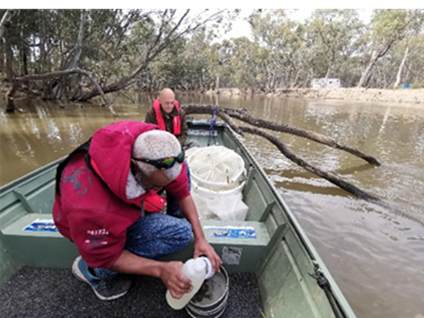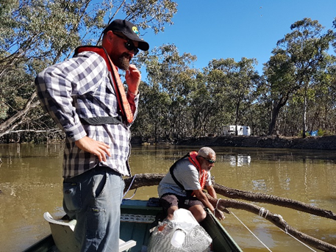
Figure 19: Members of the Edward/Kolety River fish spawning research team setting drift nets and retrieving and preserving samples. Left: Dan Hutton and Anthony Jones (EWAA). Right: John Trethewie (CSU) and Anthony Jones (EWAA).
In 2019-20 there was no indication of golden or silver perch spawning at the three study sites in the Edward/Kolety River as evidenced by the lack of eggs or larvae of golden perch and silver perch. Regardless of this result, further monitoring over a longer period of time is warranted as these are long-lived species that may not spawn every year. The project demonstrated that collaboration between researchers and community groups is an effective way to undertake research and engage the local community, draw on local expert knowledge, provide local employment and training, and make cost savings and reduced carbon emissions due to reduced travel.
Targeted eDNA research to identify presence and spatial distribution of threatened, uncommon and iconic species
The aim of this research was to use a targeted, single species eDNA method to identify the presence and spatial distribution of threatened, uncommon and iconic species in the Edward/Kolety-Wakool system. This approach allows flexibility in the choice of the target gene to maximise the chance that the target species can be detected and differentiated from congeneric species.
Water samples were collected from 10 sites (Figure 20); six MER fish monitoring sites and four additional sites in the Edward/Kolety River. PCR assay design was already available for platypus. The research successfully developed PCR assay designs for six additional species; Murray cod, trout cod, silver perch, dwarf flathead gudgeon, freshwater catfish and Murray crayfish. The assays were tested for specificity by comparing DNA from the target species and closely related species. Redfin perch were not a target species, however this invasive species was included in the study because the PCR assay for this species was already available.
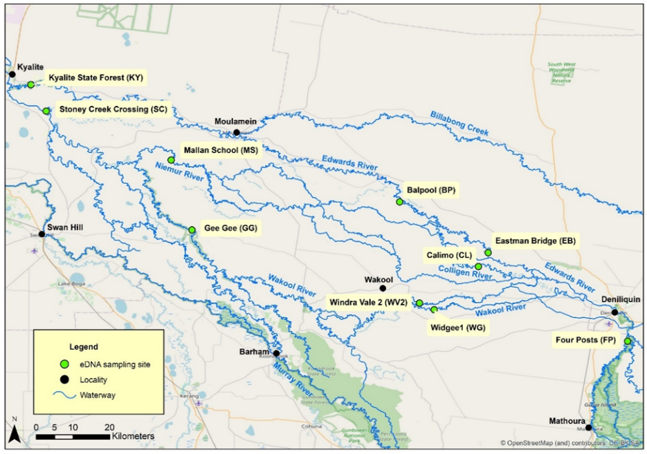
Figure 20. Map showing the location of eDNA sampling sites within the Edward/Kolety-Wakool system.
Murray cod were detected at 8 of 10 sites and trout cod were detected at 4 of 10 sites, with the highest proportion of positive detections in the upper Edward/Kolety River at Four Posts Reserve (Figure 21). Silver perch were detected in 7 of 10 sites, however there was a lower proportion of positive replicates of silver perch per sample per site than Murray cod (Figure 21). Redfin perch were detected at a single site. Platypus were not detected at any sites, however two samples were determined to be false positives and this will be sequenced to check if the qPCR product is platypus. Dwarf flathead gudgeon, freshwater catfish and Murray crayfish were not detected at any of the 10 sites.
Developing eDNA assays is time consuming and expensive, particularly if there are complications in primer development, such as a lack of variability in the target gene between related species. However, we concluded that once assays have been developed and tested, targeted eDNA is an effective method to detect the presence of rare and threatened species. It is particularly suitable to document the distribution of species that are inefficiently sampled by other methods. We recommend future work explores occupancy modelling to enable detection probabilities to be estimated. This eDNA approach could potentially be used to identify population expansion as a result of environmental watering.
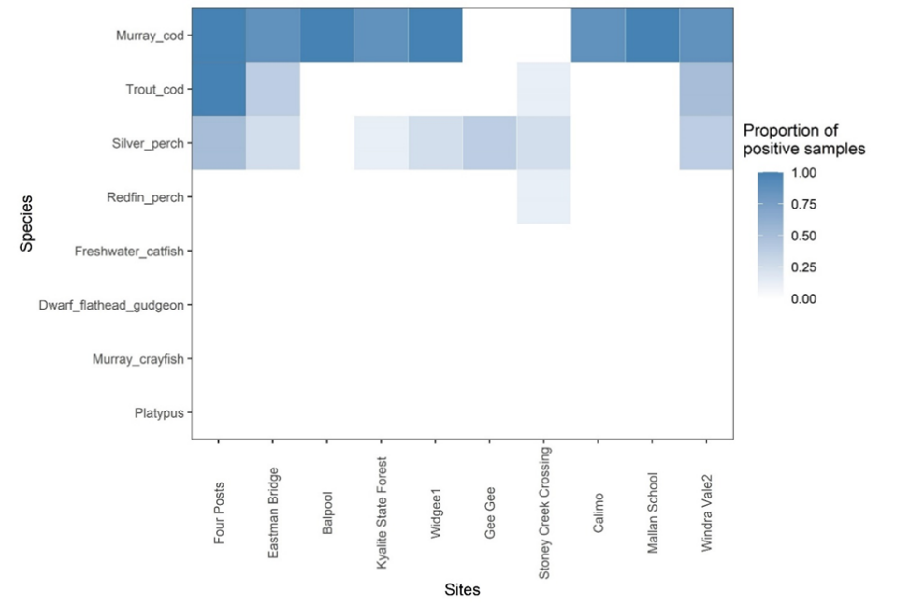
Figure 21. An overview of species detections from eDNA assays, represented as the proportion of positive samples for each of the target species detected across ten study sites.
Communications and engagement
The EKW Environmental Flows Team is committed to undertaking collaborative projects and sharing the findings of monitoring and research with others. Information about the Edward/Kolety-Wakool MER program is shared through reports, newsletters, the FLOW-MER website (https://flow-mer.org.au/selected-area-edward-kolety-wakool/), the Charles Sturt University Edward/Kolety-Wakool website (https://www.csu.edu.au/research/ilws/research/environmental-water/edwardkolety-wakool-mer), and refereed scientific journal publications. We organise or participate in events to communicate the project findings to managers and the local community. Updates on the monitoring and research are given to the Edward/Kolety-Wakool Environmental Water Reference Group twice per year. Through collaboration with managers and other stakeholders the results from the Edward/Kolety-Wakool MER program are used to inform the adaptive management of environmental water. Findings from this project have contributed to annual and long-term watering plans for the system.
A key aspect of our engagement strategy is to partner with community organisations on collaborative projects. In August 2019 we initiated a research project on turtle populations in the Edward/Kolety River in partnership with the Yarkuwa Indigenous Knowledge Centre. We are examining how river flows and connectivity of wetlands affects the movement and condition of turtles (Figure 22). Stories on this turtle research project featured in newsletter 2 and newsletter 5 (https://www.environment.gov.au/water/cewo/publications/edward-kolety-wakool-mer-newsletters).
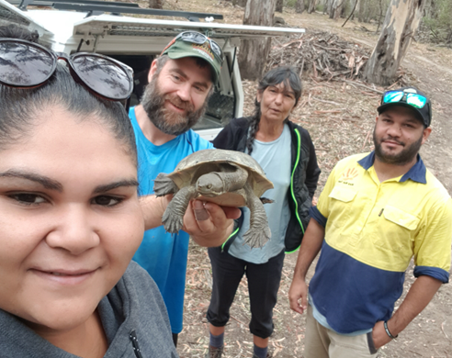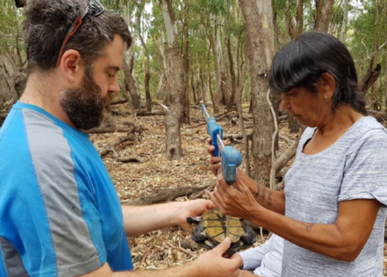
Figure 22. Left: The turtle research team (Photo: Liticia Ross). Right: Measuring the length of a turtle shell (Photo: Graham Stockfeld)
In September 2019 we initiated a research project on fish spawning research in partnership with the Edward-Wakool Angling Association (see story on page 19 of this report). Local EWAA member Dan Hutton, who coordinated the EWAA field work, said that “employing locals with appropriate skills and knowledge to undertake the field work ensures multiple successful outcomes. The collaboration has provided local employment and training, program cost savings and ensures monitoring results and findings are quickly communicated to the local community. This research provides an important platform for valuable local input into management of the local waterways’’.
A community field day was held on Saturday 14th December 2019 at Werai Forest (Figure 23) to give the local community an opportunity to see how monitoring is done, learn about the findings and share their experiences and knowledge. It was a beautiful sunny day and 40 people attended including Indigenous Elders and their families, members of the Edward-Wakool Angling Association (EWAA) and their families, local landholders, and staff from Charles Sturt University, La Trobe University, NSW Department of Planning Industry and Environment, and the Commonwealth Environmental Water Office. The day went very well and it was great to see everyone enjoying themselves. The turtle research team demonstrated how to set turtle nets, the EWAA fish research team demonstrated setting of larval drift nets, and microscopes were available for viewing a selection of fish larvae and bugs. There was lots of great conversations and sharing of ideas and knowledge.
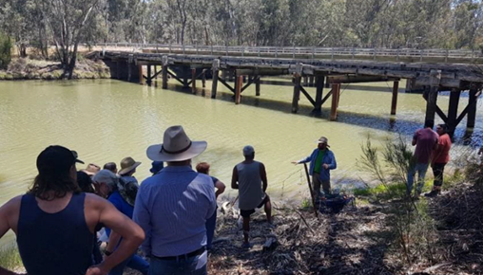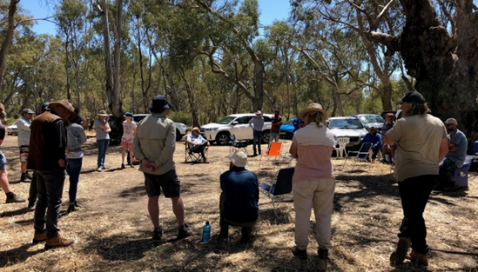
Figure 23. Community field day at Werai Forest, December 2019.
These community engagement events have been highly successful and more are planned for the remainder of the MER project. Unfortunately, due to COVID pandemic travel restrictions in early 2020, a series of school workshops planned in collaboration with Western Murray Land Improvement Group had to be postponed. Other events will be undertaken at a later date.

Implications for management of environmental water
The Edward/Kolety-Wakool system plays an important role in the mid-Murray River system. The complex network of interconnected streams, ephemeral creeks, flood-runners, wetlands and floodplain forests in the EKW system provide a wide variety of habitats for aquatic life including aquatic plants, waterbugs, tadpoles and frogs, fish and waterbirds. Due to the geomorphological complexity of the system, relatively small volumes of environmental water (compared to Murray River flows) can create flow pulses that inundate low lying areas, providing food and creating newly inundated habitats.
The results from the MER program have demonstrated that there have been many positive outcomes of environmental watering actions in the EKW system. The winter watering action in 2019 maintained connectivity of habitat, maintained water quality, increased primary productivity, and increased opportunities for movement of fish. By maintaining connectivity and local habitat over winter for sedentary fish species and other aquatic organisms, the winter watering action likely contributed to the ongoing fish recruitment outcomes, fish population outcomes, and aquatic plant recovery observed in 2019-20. The spring watering action in 2019 increased lateral connectivity, maintained good water quality, increased river productivity, increased germination, flowering and dispersal of riverbank plants, and increased spawning in some fish species. These outcomes support the long-term recovery of the ecosystem and make the ecosystem resilient to endure future disturbances, such as drought or floods.
There have been some notable outcomes that have not yet been observed in the EKW system in response to environmental watering. Eggs or larvae of golden perch have not been detected over the 6 years of LTIM/MER, and there has been only a very small number of silver perch eggs and larvae found. The presence of juvenile silver perch in the EKW system does, however, indicate that successful spawning and recruitment of this species is occurring in the southern MDB, but most likely at a much broader geographic scale than the Edward/Kolety Selected Area (see Tonkin et al. 2019). The life cycle of golden and silver perch is considered to require unimpeded flowing water habitats encompassing at least 100’s of kilometres. Therefore delivering environmental water to maintain connectivity within the EKW system and between the EKW system and the mid-Murray River will ensure that bi-directional movement of juveniles and adults of both species will continue to help support recovery of fish populations in the EKW system (Thiem et al. 2017). CEWO’s overarching objective for environmental watering for fish populations in the EKW system was to provide flows to “support habitat (including longitudinal connectivity and bench inundation), food sources and promote increase movement/dispersal, recruitment and survival/condition of native fish” (CEWO 2019). The strategy of maintaining connectivity with the Murray is consistent with objectives.
Another notable absence in the observed environmental outcomes in the EKW system is the limited ability for environmental water to be delivered to low lying areas in Werai Forest, Neimur Forest or Koondrook Perricoota Forest to create pulses of carbon to the river ecosystem. The absence of flows connecting forests is evident in Table 1 that summarises the environmental watering actions undertaken in the Edward/Kolety-Wakool system from July 2009 to June 2020. We recommend that CEWO pursue options to deliver environmental water actions downstream of Stevens Weir (>2700 ML/day) to inundate low lying part of Werai forest. This type of action would likely result in some return flows to either Colligen Creek or the Edward/Kolety River, and the benefits of small inundation events in Forests could be evaluated.
Recommendations for future management of environmental water
A summary of recommendations from previous Edward/Kolety-Wakool LTIM annual reports (Watts et al. 2015, 2016, 2017, 2018, 2019b) and the extent to which they have been implemented to improve the planning and delivery of Commonwealth environmental water are summarised in Table 3. Details of CEWO adaptive management response and actions undertaken to implement these recommendations are outlined in previous reports.
Table 3. Summary of recommendations from Edward/Kolety-Wakool LTIM annual reports 2014-15, 2015-16, 2016-17, 2017-18 and 2018-19 showing year implemented. R = recommendation number.
Recommendation | Year(s) recommended | Year(s) implemented
- Consider a trial to increase the delivery of environmental water to the upper Wakool River | 2014-15 (R3)  2015-16 (R6)  2016-17 (R5) | 2018-19
- Consider the implementation of an environmental watering action in the Edward/Kolety River to target golden perch and silver perch spawning. | 2014-15 (R8)  2015-16 (R4)  2016-17 (R4)  2017-18 (R3) | Not yet implemented
- In collaboration with stakeholders explore options to implement a short duration environmental flow trial in late winter/spring 2016 at a higher discharge than the current constraint of 600 ML/d at the Wakool-Yallakool confluence. This would facilitate a test of the hypothesis that larger in-channel environmental watering action will result in increased river productivity.  Implement a second flow trial in-channel fresh in late winter or early spring that exceeds the current normal operating rules, to increase the lateral connection of in-channel habitats and increase river productivity. The earlier timing of flows would help to prime the system and thus increase the outcomes of subsequent watering actions delivered later in spring or early summer. | 2014-15 (R7)  2015-16 (R3)  2017-18 (R4)  2018-19 (R3) | 2018-19
- Each year plan to deliver at least one flow event with higher than normal operating discharge to the upper Wakool River. This may include delivery of water through the Wakool offtake regulator or via the Wakool escape | 2018-19 (R1) | 2018-19
- Increase the duration of the recession of environmental watering actions relative to the Yallakool Creek environmental watering actions in 2012-13 and 2013-14 | 2014-15 (R1)  2015-16 (R8) | 2015-16  2016-17  2017-18
- Consider the delivery of continuous base environmental flows during autumn and winter to promote the temporal availability and continuity of instream habitat | 2014-15 (R4)  2015-16 (R2)  2016-17 (R3) | Winter 2017
- Implement a second trial of continuous base winter environmental flow (no winter cease to flow) in tributaries of the Edward/Kolety-Wakool system to promote the temporal availability and continuity of instream habitat to benefit fish and other aquatic animals and assist recovery of submerged aquatic plants. | 2017-18 (R2) | Winter 2019
- Avoid long periods of constant flows by introducing flow variability into environmental watering actions.  Include variation in the timing of environmental watering actions among water years to promote the temporal availability and continuity of instream habitat to benefit fish and other aquatic animals and assist the recovery of submerged aquatic plants in the system. | 2014-15 (R2)  2015-16 (R5)  2018-19 (R2) | 2015-16  2016-17  2018-19
- Implement environmental watering actions for freshes in spring and early summer (October to December) that include flow variability up to a magnitude of + 125 to 150 ML/d. Undertake trials to improve understanding of the magnitude of variability that provides beneficial ecosystem outcomes. | 2017-18 (R1)
- Explore options to implement in-channel pulses at any time of the year to connect additional in-channel habitats and increase river productivity. | 2018-19 (R4) | Not yet implemented
- Continue to include a water use option in water planning that enables environmental water to be used to mitigate adverse water quality events | 2014-15 (R5)  2015-16 (R7) | 2014-15  2015-16  2016-17  2017-18  2018-19
- If there is an imminent hypoxic blackwater event during an unregulated flow and the quality of source water is suitable, water managers in partnership with local landholder and community representatives should take action to facilitate the earlier release of environmental water on the rising limb of the flood event to create local refuges prior to DO concentrations falling below 2 mgL⁻¹. | 2016-17 (R1) | Not yet implemented
- Trial a carefully managed environmental watering action through Koondrook-Perricoota Forest via Barbers Creek to improve the productivity of the mid and lower Wakool River system. | 2017-18 (R5) | Not yet implemented via Barbers Ck
- Explore and develop a range of options for the delivery of environmental water during times of drought to ensure connectivity of habitat and avoid damage to key environmental assets. Inform the community of the factors limiting water delivery in extreme drought. | 2018-19 (R5) | Not yet implemented
- Set watering action objectives that identify the temporal and spatial scale at which the response is expected and are realistic given the magnitude of watering actions proposed | 2014-15 (R6) | ongoing
- Undertake a comprehensive flows assessment for the tributaries of the Edward/Kolety-Wakool system to better inform future decisions on environmental watering in this system. | 2014-15 (R9)  2015-16 (R1) | Partly undertaken
- Collaborate with other management agencies and the community to maximise the benefits of Commonwealth environmental watering actions | 2014-15 (R10) | ongoing
- The installation of a DO logger on a gauge downstream of Yarrawonga and upstream of Barmah-Millewa Forest should be considered a priority. Consideration should also be given to installing DO loggers, both upstream and downstream of other forested areas that influence water quality in the Edward/Kolety-Wakool system | - (R2) | Not yet implemented
- Undertake in-channel habitat mapping for key reaches of the Edward/Kolety-Wakool system, which could then be combined with existing hydraulic modelling to facilitate learning about this system | 2016-17 (R6) | Implemented in part by NSW DPI
- The CEWO and other relevant agencies undertake a review of the 2016 flood and subsequent hypoxic blackwater event in the Murray system and support further research into understanding these events | 2016-17 (R7) | 2017
Recommendations from 2019-20 watering actions
We continue to endorse the recommendations from previous LTIM reports as summarised in Table 3. In addition, we outline the following 11 flow recommendations to improve the planning and delivery of Commonwealth environmental water in the Edward/Kolety-Wakool system.
Recommendations for small in-channel freshes
Recommendation 1: Although small watering actions have provided a beneficial outcome for the riverine ecosystem productivity, it is highly probable that reconnecting backwaters and the floodplain to the river channel would result in much larger positive outcomes. It is recommended that, when possible, consideration be given to providing a more variable flow regime in the Edward/Kolety-Wakool system in future years.
Recommendation 2: Deliver a series of freshes to all rivers in all major tributaries of the Edward/Kolety-Wakool system to increase the wetted area of the bank. Late winter/early spring freshes that inundate slackwater areas, in-channel benches or low lying areas of riverbank within the channel will trigger emergence of river bank vegetation. Following the recession of flows, these damp banks provide ideal conditions for plants to establish and grow prior to the onset of hotter weather in summer that can quickly dry out the river banks.
Recommendation 3: In years with high water availability, consider a late spring/early summer pulse, immediately after Murray cod larvae have left the nest, to support food resources for Murray cod larvae while at the same time providing opportunities for spawning to occur in silver perch and golden perch.
Recommendation 4: Consider adaptive use of water to coincide with high Murray River flows to maximise attraction/immigration of upstream migrating juvenile golden perch and silver perch in late summer. The probability of silver perch moving into and then staying in other more upstream tributaries of the Murray River (Goulburn and Campaspe rivers) is elevated in March-May (Koster et al. 2020), so delivering attraction flows in the Edward?kolety-Wakool river system at this time or before (e.g. January-March) may be optimal for this more downstream tributary.
CEWO Adaptive Management Response: The CEWO agrees that late winter/early spring pulses are important for a range of outcomes, including vegetation, native fish and connectivity. When flows in the Murray River may focus on late spring/early summer pulses, the CEWO will examine the delivery of two pulses into the Edward/Kolety system – one in late winter/early spring and another synchronised with Murray River flows in late spring/early summer.

Recommendations for flows to mitigate poor water quality events
Recommendation 5: In watering years where risk of hypoxic blackwater events is probable, consider how CEW watering actions could be used to mitigate effects on fish populations. One option to explore could be use of flows to encourage movement out of high risk reaches.
Recommendations for winter flows
Recommendation 6: Delivery of environmental water had the greatest proportional effect during winter low-flow periods. We recommend that discharge and wetted area are maintained during low flow periods to maintain zooplankton and other invertebrates that feed on phytoplankton and periphyton, and in turn increases food availability for fish and other higher order consumers during periods in which food availability might otherwise be low.
Recommendation 7: Prevent negative impacts of a-seasonal cease-to-flow events by delivering winter base flows to promote temporal availability and continuity of instream habitat for aquatic vegetation. This will have minimise damage from damage from frost and livestock if the system is shut down during the winter, and result in positive benefits for the survival and maintenance of aquatic and riverbank vegetation.
Recommendation 8: Prevent negative impacts of a-seasonal cease-to-flow events by delivering winter base flows to promote temporal availability and continuity of instream habitat for fish. Evidence from 2019-20 monitoring indicates this has positive benefits for the survival and local retention of juvenile fish.
CEWO Adaptive Management Response: The ability to prevent winter cease-to-flow conditions in the Yallakool-Wakool and Colligen-Niemur systems is not controlled by the CEWO. The opportunity to provide winter base flows is determined by the need to undertake annual maintenance on Stevens Weir. The CEWO will continue to work with WaterNSW to identify opportunities to deliver winter base flows in the Edward/Kolety River system.

Flow recommendations for the upper Wakool River
Recommendation 9: Undertake watering actions to improve the aquatic and riverbank vegetation outcomes in the Upper Wakool River. Deliver larger freshes with increased variability to enable riverbank vegetation to establish and be maintained.
Recommendation 10: Deliver elevated base flows to the Upper Wakool River from September-December to maximise nesting and spawning opportunities for Murray cod. Record catches of larvae have been recorded when this type of watering action is delivered. This type of flow delivery should be supported with subsequent winter base flows throughout the Selected Area to maximise retention and survival of YOY in the region.
CEWO Adaptive Management Response: The CEWO increased flows into the upper Wakool River system during summer and autumn 2021, primarily to improve water quality in this reach. The CEWO is interested to see if the monitoring also shows any change in vegetation and fish outcomes as a result of these increased flows.

CEWO Adaptive Management Response: A number of the recommendations above are linked to recommendations for aquatic and riverbank vegetation outcomes. The CEWO will seek to implement these recommendations via multi-objective watering actions, as it has done so in the past.

Flow recommendations for Edward/Kolety River downstream of Stevens Weir
Recommendation 11: We recommend that options for a high flow event downstream of Stevens Weir (>2700 ML/day) that inundates low lying part of Werai forest and is likely to return flows to either Colligen Creek or the Edward/Kolety River are explored. During this action a campaign/intervention monitoring type of study should be undertaken to evaluate primary productivity responses and link with research on aquatic plants being undertaken as part of the MER integrated research project. The action would be enhanced by the installation of temporary gauges to collect data on the inflows to the forest. Analysis of Sentinel images would also quantify extent of inundation within Werai Forest.
CEWO Adaptive Management Response: Options for delivering environmental water to Werai Forest are being explored. There are issues around delivery and gauging of water that need to be resolved.
Acknowledgements
The authors of this report as well as the Commonwealth Environmental Water Office respectfully acknowledge the traditional owners of the Murray-Darling Basin, their Elders past and present, their Nations, and their cultural, social, environmental, spiritual and economic connection to their lands and waters. We are honoured to work on the ancestral lands of the Wamba Wamba or Wemba Wemba, and Perrepa Perrepa or Barapa Barapa People. We recognise their unique ability to care for Country and their deep spiritual connection to it. We honour Elders past and present whose knowledge and wisdom has ensured the continuation of culture and traditional practices. We are committed to genuinely partner and meaningfully engage with Traditional Owners and Aboriginal communities to support the protection of Country, the maintenance of spiritual and cultural practices and their broader aspirations in the 21st century and beyond
We extend our thanks to the Edward/Kolety-Wakool Environmental Water Reference Group, Wakool River Association, Edward/Kolety-Wakool Angling Association, Yarkuwa Indigenous Knowledge Centre Aboriginal Corporation, the Colligen and Niemur Group, Western Murray Land Improvement Group, and landholders in the Edward/Kolety-Wakool river system for their keen interest in this project and for providing access to monitoring sites on their properties.
Thanks to staff from Commonwealth Environmental Water Office, NSW Department of Planning, Industry and Environment, Murray Local Land Services, WaterNSW, Murray-Darling Basin Authority, Murray Irrigation Limited for providing water planning information and access to hydrological and water use data.
Fieldwork and/or laboratory work was led by John Trethewie, Chris Smith, Sascha Healy, and Xiaoying Liu, with assistance from Joe Briggs, Allen Brooks, Alec Buckley, Tom Butterfield, Dale Campbell, Brandon Cooper, Jonathon Doyle, Roseanne Farrant, Tracy Hamilton, Dan Hutton, Anthony Jones, Zac McCullock, Nathan McGrath, Cameron McGregor, Jarryd McGowan, Nick O’Brien, Warren Parson, Matt Pihkanen, Rohan Rehwinkel, Liticia Ross, Lachlan Spalding, Jackson Wilkes Walburn and Ian Wooden.
Maps were prepared by Simon McDonald and Deanna Duffy (Charles Sturt University Spatial Analysis Unit), Rod Martin (NSW DPI) and Ian Wooden (NSW DPI). Statistical analyses of fish movement data was undertaken by Ben Stewart-Koster and Ameneh Shobeirinejad (Griffith University). John Pengelly (CSIRO) processed carbon and nutrient samples. Larval and juvenile fish sampling was carried out under NSW Fisheries license (larval fish P19/0006-1.0, juvenile fish P19/0051). Projects were approved by the CSU Animal Care and Ethics Committee (larval fish surveys: A19260, recruitment surveys: A19384). Sampling in the Murray Valley National Park was permitted under the National Parks and Wildlife Act 1974 (Scientific License: SL101403). Adult fish surveys were conducted by DPI Fisheries under Fisheries NSW Animal Care and Ethics permit 14/10.
This project was funded by the Commonwealth Environmental Water Office with in-kind contributions from Charles Sturt University, NSW Department of Primary Industries, NSW Office of Environment and Heritage. Project partners: Charles Sturt University, NSW Fisheries, NSW Department of Planning, Industry and Environment, La Trobe University, Streamology, Yarkuwa Indigenous Knowledge Centre, Edward-Wakool Anglers Association, Western Murray Land Improvement Group.

References
New South Wales Office of Environment and Heritage (2018) Murray and Lower Darling Catchments: Annual environmental watering priorities 2018-19. NSW Office of Environment and Heritage.
Watts R.J., Bond N.R, Healy S., Liu X., McCasker N.G., Siebers A., Sutton N., Thiem J.D., Trethewie J.A., Vietz G., Wright D.W. (2020). ‘Commonwealth Environmental Water Office Monitoring, Evaluation and Research Project: Edward/Kolety-Wakool River System Selected Area Technical Report, 2019-20’. Report prepared for Commonwealth Environmental Water Office. Commonwealth of Australia.
Watts R.J., Bond N.R, Grace M.R., Healy S., Howitt J.A., Liu X., McCasker N.G., Thiem J.D., Trethewie J.A., Wright D.W. (2019b) ‘Commonwealth Environmental Water Office Long Term Intervention Monitoring Project: Edward/Kolety-Wakool River System Selected Area Technical Report, 2018-19’. Report prepared for Commonwealth Environmental Water Office. Commonwealth of Australia.
Watts R., McCasker, N, Howitt, J, Liu X, Trethewie J, Allan C, Thiem J, Duncan M, Healy S, Bond N, Van Dyke J, Vietz G, Donges M. (2019a) Commonwealth Environmental Water Office: Edward/Kolety-Wakool Selected Area Monitoring, Evaluation and Research Plan 2019-22. Report to the Commonwealth Environmental Water Office.
Watts R.J., McCasker N., Howitt J.A., Thiem J., Grace M., Kopf R.K., Healy S., Bond N. (2016) Commonwealth Environmental Water Office Long Term Intervention Monitoring Project: Edward/Kolety-Wakool River System Selected Area Evaluation Report, 2015-16. Report prepared for Commonwealth Environmental Water Office. Commonwealth of Australia.
Watts R.J., McCasker N., Howitt J.A., Thiem J., Grace M., Kopf R.K., Healy S., Bond N. (2017) Commonwealth Environmental Water Office Long Term Intervention Monitoring Project: Edward/Kolety-Wakool River System Selected Area Evaluation Report, 2016-17. Report prepared for Commonwealth Environmental Water Office. Commonwealth of Australia.
Watts R., McCasker N., Thiem J., Howitt J., Grace M., Kopf R., Healy S. and Bond N. (2015) Commonwealth Environmental Water Office Long Term Intervention Monitoring Project: Edward/Kolety-Wakool Selected Area Technical Report, 2014-15. Prepared for Commonwealth Environmental Water Office.
Watts R.J., McCasker N.G., Howitt J.A., Thiem J.D., Grace M.R., Trethewie J.A., Healy S., Bond N.R. (2018). Commonwealth Environmental Water Office Long Term Intervention Monitoring Project: Edward/Kolety-Wakool River System Selected Area Summary Report, 2017-18. Report prepared for Commonwealth Environmental Water Office. Commonwealth of Australia.
Thiem J.D., Wooden I.J., Baumgartner L.J., Butler G.L., Forbes J.P. and Conallin J. (2017) Recovery from a fish kill in a semi-arid Australian river: Can stocking augment natural recruitment processes? Austral Ecology 42, 218-226.
Tonkin Z., Stuart I., Kitchingman, A., Thiem, J.D, Zampatti, B., Hackett, G., Koster, W., Koehn, J., Morrongiello, J., Mallen-Cooper, M. & Lyon, J. (2019) Hydrology and water temperature influence recruitment dynamics of the threatened silver perch Bidyanus bidynaus in a regulated lowland river. Marine and Freshwater Research 70(9), 1333-1344.

