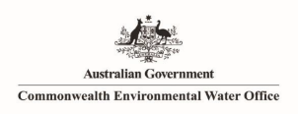

**Commonwealth Environmental Water Office**

**Monitoring, Evaluation and Research Program**

**Murrumbidgee River System Summary Report 2019-20**

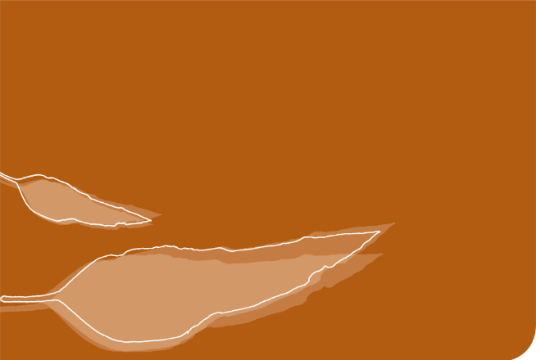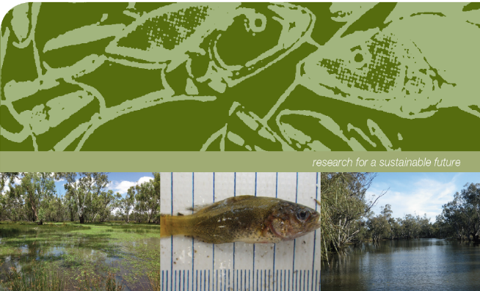

**Commonwealth Environmental Water Office Monitoring, Evaluation and Research Program Murrumbidgee River System Summary Report 2019-20.**

Prepared by: Wassens, S.a, Michael, D a, Spencer, J.a,b,c, Thiem, J.d, Thomas, R.a,b,c, Kobayashi, Ta,c, Amos, C. a,c.,  Hall, A.a, Bourke, G.a, Bino, G.b, Wright, D. d, Heath J c., Turner, A. and Kuo, W.c

|  |  |
| --- | --- |
|  | a Institute for Land, Water and Society. Charles Sturt University, PO Box 789, Albury, NSW 2640 |
| CES.png | b Centre for Ecosystem Science, University of New South Wales, Sydney, NSW, 2052 |
|  | c NSW Planning, Industry and Environment, PO Box 39, Sydney, NSW 2001 |
| TI logo colour rgb | d NSW Trade and Investment Narrandera Fisheries Centre, PO Box 182, Narrandera NSW 2700 |

**Funding:** This monitoring project was commissioned and funded by the Commonwealth Environmental Water Office with additional in-kind support from the NSW Department of Planning, Industry and Environment, Murrumbidgee Local Land Services and Charles Sturt University. We are grateful to private landholders for allowing access to their properties.

**Copyright:** © Copyright Commonwealth of Australia, 2020

‘Commonwealth Environmental Water Office Monitoring, Evaluation and Research Program Murrumbidgee River System Summary Report, 2019-20 is licensed by the Commonwealth of Australia for use under a Creative Commons By Attribution 3.0 Australia licence with the exception of the Coat of Arms of the Commonwealth of Australia, the logo of the agency responsible for publishing the report, content supplied by third parties, and any images depicting people. For licence conditions see: <http://creativecommons.org/licenses/by/3.0/au/>

This report should be attributed as ‘Commonwealth Environmental Water Office Monitoring, Evaluation and Research Program Murrumbidgee River System Summary Report, Commonwealth of Australia 2020’. The Commonwealth of Australia has made all reasonable efforts to identify content supplied by third parties using the following format ‘© Copyright, [name of third party] ’.

**Disclaimer:** The views and opinions expressed in this publication are those of the authors and do not necessarily reflect those of the Australian Government or the Minister for the Environment and Energy. While reasonable efforts have been made to ensure that the contents of this publication are factually correct, the Commonwealth does not accept responsibility for the accuracy or completeness of the contents, and shall not be liable for any loss or damage that may be occasioned directly or indirectly through the use of, or reliance on, the contents of this publication.

**Acknowledgement**: The Commonwealth Environmental Water Office acknowledges the efforts of all consortium partners in delivering the Murrumbidgee Monitoring, Evaluation and Research Program and preparing this report. The authors of this report as well as the Commonwealth Environmental Water Office respectfully acknowledge the traditional owners, their Elders past and present, their Nations of the Murray-Darling Basin, and their cultural, social, environmental, spiritual and economic connection to their lands and waters. In particular the Wiradjuri, Nari Nari and Muthi Muthi peoples, traditional owners of the land on which this publication is focused.

Monitoring and evaluation of environmental water in the Murrumbidgee Selected Area

The Monitoring, Evaluation and Research (MER) Program is the primary means by which the Commonwealth Environmental Water Office (CEWO) monitors and evaluates the ecological outcomes of Commonwealth environmental watering actions. The MER Program builds on the previous Long Term Intervention Monitoring (LTIM) Project (2014-19) and is being implemented in the Murrumbidgee catchment for a three-year period (2019-22) to inform environmental water management and demonstrate watering outcomes.

The Murrumbidgee MER team is led by Associate Professor Skye Wassens from Charles Sturt University, along with scientists and technicians from the Department of Planning, Industry and Environment (DPIE) (Fisheries and Environment, Energy and Science), and the University of New South Wales (Centre for Ecosystem Sciences). Funding from the CEWO supports monitoring of the hydrological and ecological outcomes of watering actions in the river and wetlands of the Murrumbidgee. This summary report focuses on the outcomes of watering actions undertaken from 1st July 2019 to 30th June 2020 (the 2019-20 water year), with reference to watering outcomes from the previous LTIM period (2014 - 2019).

The Murrumbidgee Catchment

The Murrumbidgee catchment in southern NSW is one of the largest catchments (81,527 km2) in the Murray-Darling Basin (Kingsford *et al.* 2004). Over 1,000 wetlands make up over 4 per cent (370,000 ha) of the catchment (Murray 2008). Nationally important wetlands, including the mid-Murrumbidgee and Lowbidgee floodplain, cover over 208,000 ha (2.5 per cent of the catchment area).

River monitoring sites

The Murrumbidgee River is over 1,600 km long, with the MER Program Selected Area covering the lowland section (approximately 786 km). Three key sections may be monitored as part of this program (Figure 1). These are:

* the **Narrandera reach (187.3 km)** starting upstream of the Yanco and Oldman Creek regulators extending to just above the Tom Bullen storage offtake. This zone includes major Murrumbidgee and Coleambally irrigation off-takes and key populations of Murray cod,
* the **Carrathool reach (358.0 km)** downstream of Tom Bullen storage and major irrigation off-takes. River levels tend to be lower, and it is the principle target for in-channel Commonwealth environmental watering actions and,
* the **Balranald reach (241.4 km)** extending from Hay to Boundary Bend downstream of Balranald and aligned with the Lowbidgee floodplain. This reach is monitored to evaluate longer term changes in fish communities.

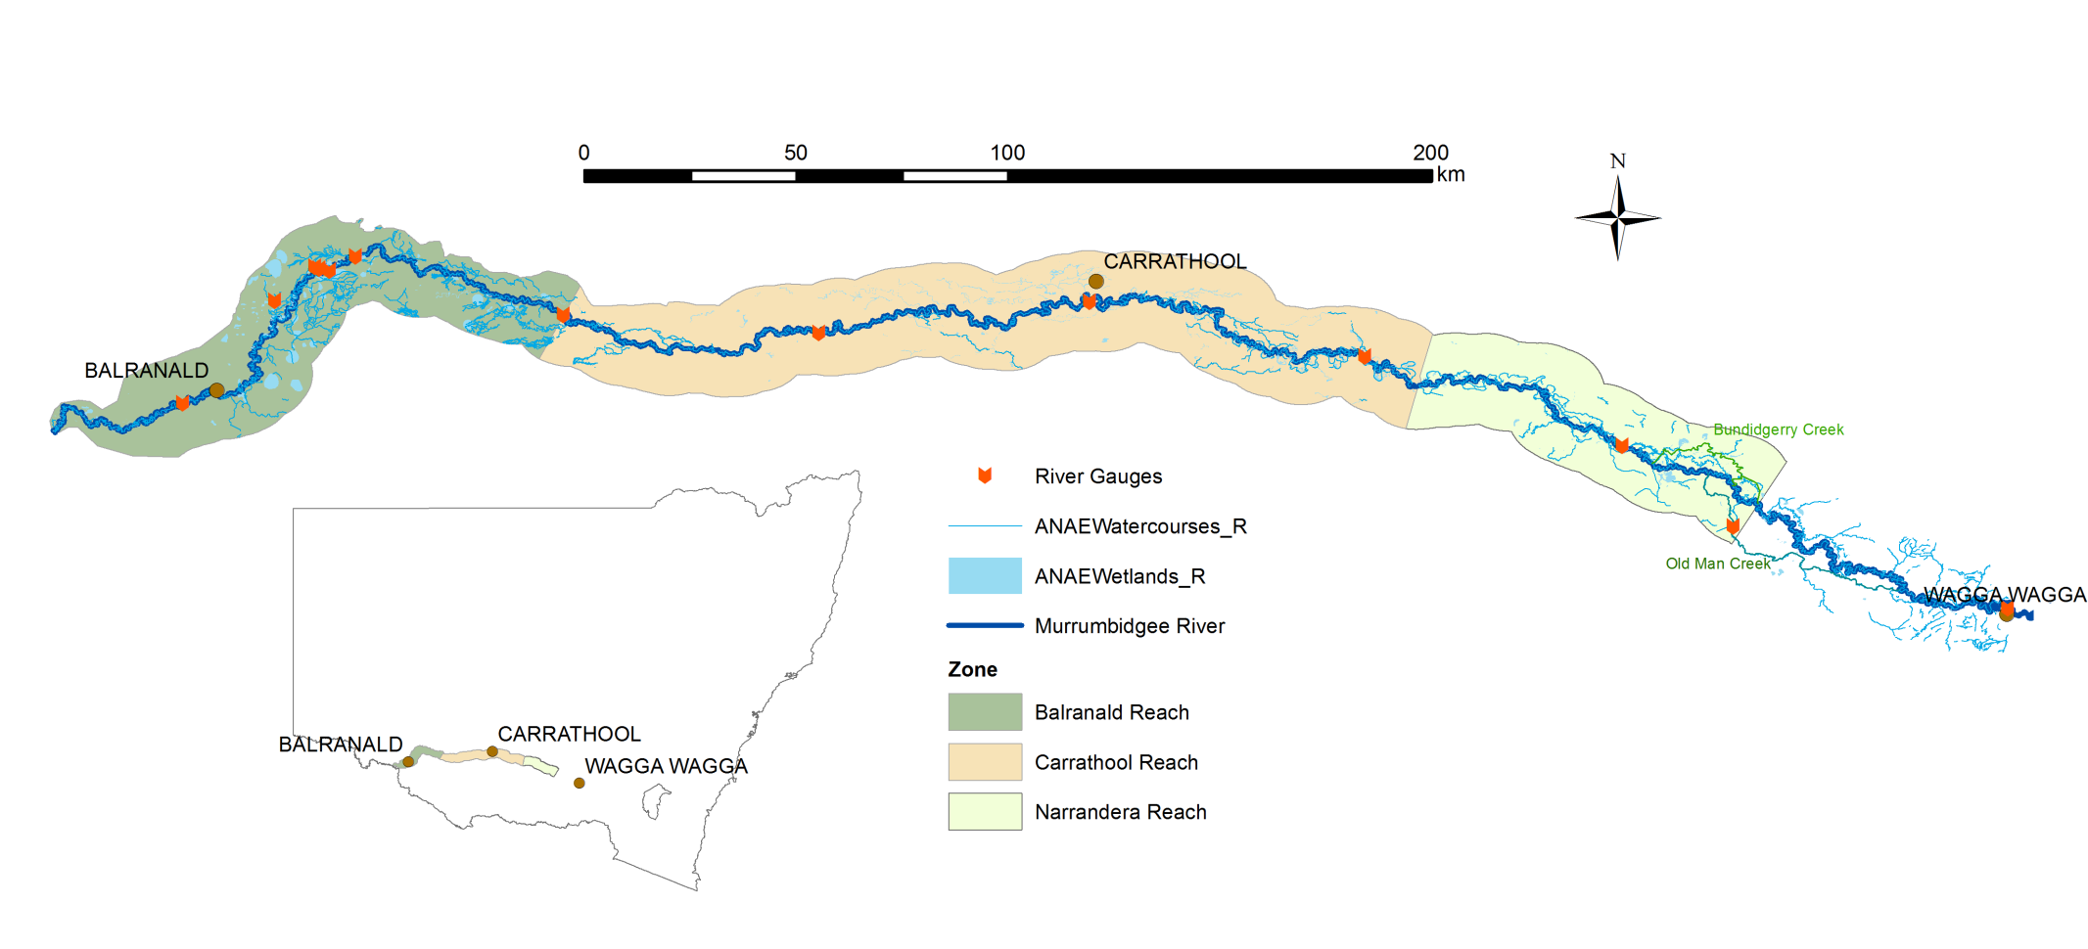Figure 1. Distribution of riverine zones in the Murrumbidgee Selected Area.

Wetland monitoring sites

Wetland and floodplains of the Murrumbidgee catchment are some of the most diverse and important systems in Australia. Six zones were identified, each supporting a unique set of wetland and floodplain habitats (Plate 1), and with different water requirements and water management options (Figure 2). Due to the very large catchment size, monitoring is only routinely conducted at twelve wetlands within three zones – the mid-Murrumbidgee, Redbank and Gayini Nimmie-Caira. The six wetland zones are:

* **mid-Murrumbidgee wetlands (82,800 ha)** – River red gum forest interspersed with paleochannels (inactive streams filled with sediment) and oxbow lagoons.
* **Redbank (92,504 ha)** – Mosaic of river red gum forest and woodland, spike rush wetlands - divided into two management subzones (north and south Redbank).
* **Gayini Nimmie-Caira (98,138 ha)** – Mosaic of creek lines, paleochannels, open wetlands and lakes dominated by lignum and lignum-black box communities.
* **Fiddlers-Uara (75,285 ha)** – Paleochannels and creek lines bordered by black box.
* **The Western Lakes (3,459 ha)** – Open quaternary lakes with inactive lunettes (crescent-shaped dunes) west of the Lowbidgee floodplain.
* **Pimpara–Waugorah (55,451 ha)** – Mosaic of creek lines, paleochannels and wetlands, with River red gum and black box mostly north of the Murrumbidgee River.



Figure 2. Wetland zones in the Murrumbidgee Selected Area and location of monitored wetlands.

|  |  |
| --- | --- |
| Oxbow lagoon, mid-Murrumbidgee S:\Research\Research Data\Science\v04\R0274_Murrumbidgee_LTIM\Photos\Vegetation transect photos\Yarradda\YAR_T2 Q30 Jan19.JPG | Lignum wetland, Gayini Nimmie-CairaS:\Research\Research Data\Science\v04\R0274_Murrumbidgee_LTIM\Photos\Vegetation transect photos\Eulimbah\EUL_T1 Q30_Jan19.JPG |
| Permanent creeks, Gayini Nimmie-Caira and Redbank | Tall emergent aquatic spike rush wetland, Redbank.S:\Research\Research Data\Science\v04\R0274_Murrumbidgee_LTIM\Photos\Vegetation transect photos\Two Bridges\TBR TT  Jan19 scenic.JPG |
| Plate 1. Examples of environmental watering sites in the Murrumbidgee 2019-20 | |

History of Commonwealth environmental watering actions in the Murrumbidgee

Flows in the Murrumbidgee River have undergone significant long-term changes since the construction of large headwater dams and in-channel weirs. In particular, the timing of high flows has shifted from winter to spring to meet irrigation demands. As a result there have been significant reductions in the frequency of minor and moderate flow pulses (Frazier *et al.* 2005; Frazier *et al.* 2006) (Figure 3). Between 2000 and 2010, a significant drought coupled with increasing consumptive water demand exacerbated the effects of river regulation (Dijk *et al.* 2013), leading to significant declines in the condition of floodplain vegetation (Wen *et al.* 2009). Large-scale flooding in 2010-11 was followed by moderate water availability between 2012 and mid-2016. In 2016-17, above average rainfall contributed to high tributary inflows and unregulated river flows which inundated significant areas of mid-Murrumbidgee and Lowbidgee floodplain. This was followed by below average rainfall across the Murray-Darling Basin in 2018-19 and 2019-20 and watering activity was consistent with the very dry scenario of the Murrumbidgee annual water plan.

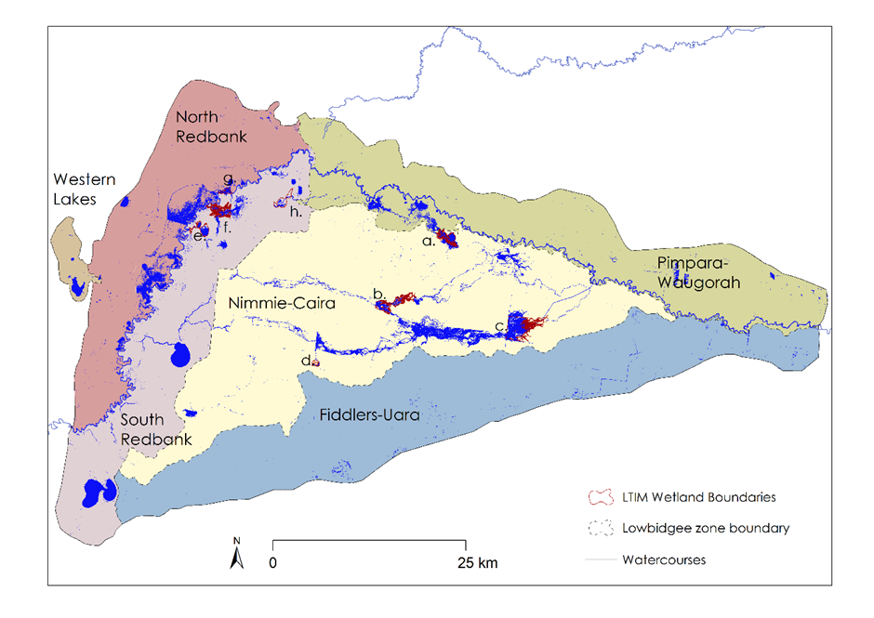

Figure 3. Distribution of the cumulative inundated area total across the Lowbidgee floodplain during the July 2019 and June 2020 period based on inundation maps classified from Sentinel-2 satellite images.

***Environmental watering in the Murrumbidgee in 2019-20***

In 2014-15 and 2015-16, environmental water was largely allocated to the Redbank and Gayini Nimmie-Caira wetland systems, and small volumes were used in the mid-Murrumbidgee, mainly at individual lagoons. The 2017-18 water actions targeted a larger number of low-lying wetlands across the mid-Murrumbidgee, and in 2018-19 water was largely used in the Redbank wetland system, including Tala and Yanga Lakes. In 2019-20 watering actions primarily targeted individual wetlands in the mid-Murrumbidgee and refuge flows to Gayini Nimmie-Caira, North Redbank and Yanga National Park (Figure 4).

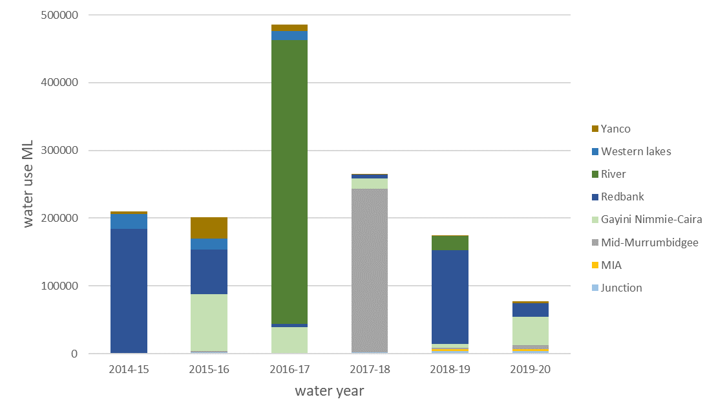

Figure 4. Summary of NSW and Commonwealth environmental watering actions by volume in key management zones between 2014 and 2020.

Watering Actions in 2019-20

The Commonwealth environmental water holder in partnership with NSW delivered 48,335 ML of Commonwealth environmental water and 32,158 ML of NSW environmental water as part of watering actions targeting wetland and floodplain habitats in the Murrumbidgee Selected Area (Table 1). The largest water allocation was to the Gayini Nimmie-Caira and Tala Creek System refuge flows which aimed to maintain critical refuge habitat and provide opportunities for breeding and recruitment of threatened southern bell frogs at key sites in Gayini Nimmie-Caira. This action ran from late October to late December 2019, and again briefly in late January 2020 to maintain water levels for bird breeding.

Smaller volumes were used to inundate key wetlands in the mid-Murrumbidgee, aiming to maintain critical refuge habitat for waterbirds, native fish, frogs, turtles and other water-dependent animals, and to support native vegetation growth and maintain condition. Several key wetlands received water via pumps designed to exclude large exotic carp, including Yarradda and Sunshower Lagoons.

Table 1. Summary of environmental water usage from Commonwealth and other environmental water sources in 2019-20. (Drawn from the Watering Action Acquittal Report Murrumbidgee 2019-20 (Commonwealth of Australia 2020)). Shaded rows indicate flows associated with the MER Program locations that are evaluated in this report.

|  |  |  |  |  |  |
| --- | --- | --- | --- | --- | --- |
| Water Reference No. |  | Watering actions | Dates  (start/end) | Commonwealth environmental water (ML) | Total water use (ML) |
| 10082-18 | Mid-Murrumbidgee | Gooragool and Mantangry Lagoons | Start: 19/09/2019  End: 16/01/2020 | 2,251 | 2,451 |
| 10082-19 | Darlington Lagoon | Start: 19/09/2019  End: 27/09/2019 | 142 | 142.2 |
| 10082-20 | Yarradda Lagoon | Start: 18/09/2019  End: 10/12/2019 | 2,000 | 2,000 |
| 10082-31 | Sunshower Lagoon | Start: 01/12/2019  End: 27/01/2020 | 513.5 | 513 |
| 10082-21 | Gayini Nimmie-Caira | Gayini Nimmie-Caira (SBF breeding) and Tala Creek System refuge flows + bird breeding top up | Start: 23/10/2019  End: 05/02/2020 | 18,000 | 41,313 |
| 10082-25 | Toogimbie IPA | Start: 24/02/2020  End: 07/06/2020 | 500 | 1,000 |
| 10082-28 | Redbank | Yanga NP refuge | Start: 30/11/2019  End: 18/12/2020 | 2,963 | 2,963 |
| 10097-04 | Yanga NP refuge – Shaws/Waugorah Lake complex (supplementary) | Start: 16/05/2020  End: 18/05/2020 | 151 | 151 |
| 10082-22 | North Redbank refuge – middle system core wetlands | Start: 28/11/2019  End: 20/12/2019 | 11,010 | 11,010 |
| 10097-03 | North Redbank refuge – upper system core wetlands (inc. supplementary water) | Start: 16/05/2020  End: 04/06/2020 | 1,442 | 6,091 |
| 10082-23 | Junction Wetlands | Waldaira Lagoon (Junction Wetlands) | Start: 04/11/2019  End: 23/01/2020 | 1,500 | 1,500 |
| 10082-24 | Mainie Swamp | Start: 21/10/2019  End: 31/01/2020 | 2,000 | 2,000 |
| 10082-26 | MIA | MIA wetlands | Start: 14/10/2019  End: 15/04/2020 | 3,612 | 3,612 |
| 10082-27 | Yanco | Wanganella Swamp | Start: 13/10/2019  End: 28/01/2020 | 2,250 | 2,250 |
| MBG18/19-10 |  | Coleambally Irrigation refuge | Start: 10/10/2019  End: 30/01/2019 | 3496 (NSW EWA) | 3496 |
|  |  |  | **Total delivered** | **48,335** | **80,493** |

***Why were these actions undertaken?***

Watering actions endeavour to meet specific ecological objectives developed by Commonwealth water managers that are consistent with the objectives set out in the Murray-Darling Basin Plan ([the Basin Plan Objectives](https://www.environment.gov.au/system/files/resources/c8a8d2f6-e455-4126-bf75-0fa0c9147736/files/environmental-water-outcomes-framework.pdf)). These relate to biodiversity (the number of individual species supported by environmental water), ecosystem function (for example maintaining productivity and nutrient cycles), ecological resilience (longevity, breeding and recovery of plants and animals) and water quality (such as preventing periods of low dissolved oxygen, reducing the risk of algal blooms and maintaining appropriate salinity levels).

Given limited water allocations under a very dry scenario (Water NSW 2020), the majority of watering actions in 2019-20 used small volumes to target key wetlands. These actions focused on several primary objectives:

* Maintain critical refuge habitat for waterbirds, native fish (including established golden and silver perch), frogs (including the threatened southern bell frog), turtles and other water dependent animals;
* Support native aquatic vegetation growth and maintain condition, and consolidate improvements in the ecological character, condition and resilience of native vegetation communities (Darlington Lagoon); and
* Maintain Ramsar ecological character and important waterbird foraging and breeding habitat, in particular for Australasian bittern and other listed migratory species (Fivebough Tuckerbil).

Additional objectives from the larger Gayini Nimmie-Caira and Tala Creek, Yanga National Park and North Redbank refuge flows were to:

* Support the ecological character, condition and resilience of vegetation communities;
* Provide opportunities for breeding and recruitment of the threatened southern bell frog at key sites in Gayini Nimmie Caira to reduce the risk of local population extinction; and
* Prevent River red gum encroachment/recruitment at Two Bridges Swamp by drowning out these trees.

Key outcomes from environmental water use

This section highlights the key outcomes from environmental water use in 2019-20, including monitoring outcomes, research findings and reflections on communication and engagement activities.

Table 2. Murrumbidgee environmental watering outcomes at a glance.

|  |  |  |
| --- | --- | --- |
| Basin Objective | Target indicator | Outcome of CEWO watering actions |
| **Lateral connectivity** | Floodplain inundation | 48,335 GL delivered  14,859 ha of the Lowbidgee floodplain inundated (CEWO and NSW environmental water) |
| **Biodiversity** | Aquatic vertebrate diversity | Six frog species recorded |
| Breeding by vulnerable southern bell frogs recorded |
| Vegetation diversity | Increased species richness of water dependent plant species |
| Native fish diversity | Six native fish species recorded - including golden perch and Murray cod |
| Waterbird diversity | 67 waterbird species recorded |
| Seven waterbird species listed under international migratory bird agreements including sharp-tailed sandpiper, long-toed stint, common greenshank were recorded. |
| Three threatened waterbird species, freckled duck, blue-billed duck and Australasian bittern were recorded |
| **Resilience** | Native fish species breeding | Breeding and recruitment of seven native fish species, including silver perch recorded |
| Aquatic vertebrate diversity | Refuge for three turtle species maintained |
| **Water quality** | Wetland and River water quality | Water quality remained within acceptable range |

Mid-Murrumbidgee– wetland pumping

### Key points

* Pumping allows for strategic targeted inundation of critical wetlands using smaller volumes of environmental water and is a key management tool during years of low water availability.
* Screened pumps combined with management of water levels can help keep carp and other unwanted exotic fish out of wetlands
* Two wetlands (Yarradda and Sunshower) were managed using pumping in 2019-20, both had very low numbers of exotic fish and showed strong positive responses of aquatic vegetation, frogs and waterbirds following Commonwealth Environmental Watering actions.
* A third wetland system - Mantangery-Gooragool Lagoon was also pumped in order to maintain critical habitat for golden perch and other native fish species. However, the presence of native fish meant that water level manipulation to remove carp was not feasible.

### Summary

Four wetland complexes in the mid-Murrumbidgee were inundated in 2019-20 as part of managed pumping actions, with three sites evaluated as part of this program. These were Yarradda Lagoon which has been managed using a combination of pumping and river to wetland reconnections since 2014, Sunshower Lagoon which was pumped for the first time in 2019-20, and a third action was undertaken at the Mantangery and Gooragool Lagoons.

In addition to reducing water use, pumping water to wetlands can help to exclude large exotic carp, which might otherwise affect water quality and vegetation growth. Both Yarradda and Sunshower Lagoons were filled using pipes with a screened inlet which prevents larger fish, including common carp from entering the wetland. While the Gooragool-Mantangery action targeted persistent lagoons that were known to support golden perch. Excluding carp from wetlands can improve water quality, increase vegetation growth and establishment and increase breeding success for frogs, but in some cases actions to exclude carp must be balanced with risks to other native fish species – particularly golden perch which often occur in persistent wetlands and creek lines.

**Vegetation outcomes**

Delivery of environmental water into Sunshower Lagoon in 2019-20 supported growth of aquatic plants and contributed to an increase in vegetation species richness, with new aquatic species recorded along monitored transects and additional new species recorded elsewhere in the wetland (Plate 2). Commonwealth environmental water was also important to support the establishment of aquatic vegetation communities in Yarradda Lagoon. Yarradda Lagoon has received environmental water in five of six years since 2014, bringing it closer to matching the long-term annual inundation pattern. This has contributed to the re-establishment of four vegetation species, including the culturally significant old man weed and recruitment of two additional aquatic species. It is likely that exclusion of carp from Yarradda and Sunshower Lagoons may increase the rate of vegetation establishment by reducing disturbance and damage caused by benthic feeding (Vilizzi et al. 2015).

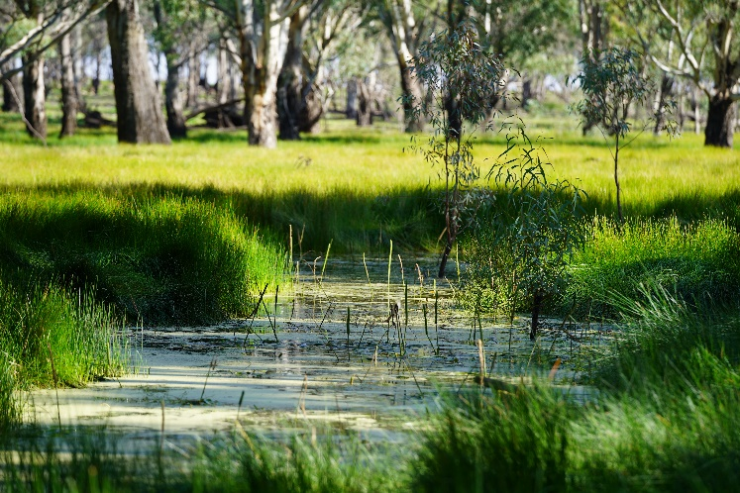

Plate 2. Strong vegetation response at Sunshower Lagoon March 2020 three months after managed pumping.

**Frogs**

Frogs and tadpoles have also benefited from environmental watering actions in Yarradda and Sunshower Lagoons, but as expected tadpole numbers were low in Gooragool-Mantangery Lagoons where carp abundance was high. Six species of frog were recorded following managed water delivery into Sunshower and Yarradda. The threatened southern bell frog was first recorded at Yarradda in 2015 and was recorded at Sunshower for the first time since 2010. Tadpoles of three species were recorded from Sunshower and Yarradda, including Peron’s tree frog and inland banjo frog tadpoles (Plate 3), while no tadpoles were recorded following pumping at Gooragool-Mantangery where carp were abundant.

|  |  |
| --- | --- |
| S:\Research\Research Data\Science\v04\R0274_Murrumbidgee_LTIM\Photos\2019-20 Wetland Sampling\GB_Nov19\WAG_BanjoFrog_Nov19.jpg | S:\Research\Research Data\Science\v04\R0274_Murrumbidgee_LTIM\Photos\2019-20 Wetland Sampling\GB_Mar20\SUN_processing4_Mar20.jpg |

Plate 3. Inland bango frog (*Limnodynastes interios*) adult (left) and tadpole (right) from Sunshower Lagoon.

**Native Fish**

One interesting outcome from screened pumping is the number of small -bodied native fish that continue to enter the wetlands. Yarradda Lagoon continues to support a relatively high diversity of small native fish species, including Australian smelt, bony herring, carp gudgeon, flat-headed gudgeon and Murray-Darling rainbowfish. Following top up flows into the lagoon In 2019-20, four species of native fish were detected, and the abundance of flat-headed gudgeon has increased compared to previous years (Plate 4), while the abundance of two exotic fish species (carp and gambusia) remain low, with fewer individuals recorded following pumping in 2019-20 compared to previous years. Sunshower Lagoon had been dry for the three years prior to refilling and no fish were recorded- a combination of finer screens and initially low dissolved oxygen in the wetland may have reduced opportunities for the establishment of fish, however large numbers of tadpoles and other aquatic species were recorded.

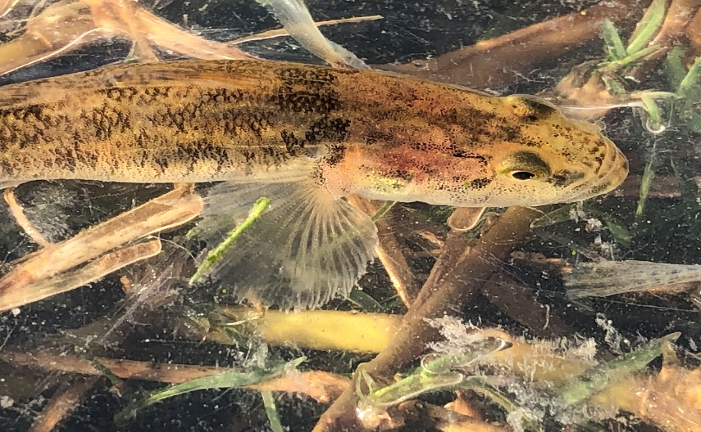

Plate 4. The Flat-headed gudgeon from Yarradda Lagoon has increased following top up flows.

**Waterbirds**

A total of 67 waterbird species were recorded across the Murrumbidgee Selected Area in 2019-2020 during the ground surveys and complementary monitoring, including seven bird species listed under one or more international migratory bird agreements: sharp-tailed sandpiper *Calidris acuminata*, long-toed stint *Calidris subminuta*, common greenshank *Tringa nebularia*, marsh sandpiper *Tringa stagnatilis*, red-necked stint *Calidris ruficollis*, wood sandpiper *Tringa glareola* and Caspian tern *Hydroprogne caspia*. Two NSW listed species (NSW *Biodiversity Conservation Act 2016*) were also detected during the February 2020 surveys. Freckled duck *Stictonetta naevosa* were observed at Suicide Swamp and Eulimbah Swamp (Nimmie-Caira zone), and blue-billed duck *Oxyura australis* were observed at Suicide Swamp (Plate 3). Endangered Australasian bitterns (Commonwealth EPBC Act, NSW BC Act) were also recorded at Eulimbah Swamp over summer 2020 (A. Borrell, MDWWG, pers. obs, January 2020). While the abundance of waterbirds were low compared to previous years, breeding activity was recorded for some waterbird species, including grey teal, black swans, Australasian grebes, Australasian darters, little pied and little black cormorants and royal spoonbills.

***Continuing southern bell frog recovery***

### Key outcomes

* Southern bell frogs are a threatened (Commonwealth *Environment Protection Biodiversity Conservation Act 1999*) water dependent species whose strong holds occur in the lower Murrumbidgee floodplain.
* Commonwealth and NSW environmental water allowances have been used to support the recovery of southern bell frog populations after their near extinction during the Millennium drought.
* Environmental water was used to ensure the survival of individuals by maintaining persistent refuge habitats and promoting breeding and population recovery by creating suitable breeding habitats.
* Watering actions targeting southern bell frogs also supported a range of other threatened species including the Australasian bittern, freckled duck, blue-billed duck and grey snake.

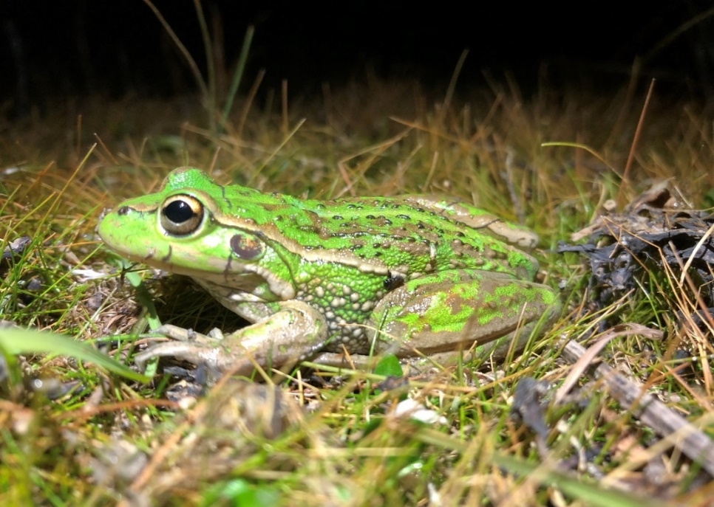

Plate 5. Southern bell frog populations at key wetlands have increased over the past few years.

***Summary***

As in previous years, Commonwealth and NSW environmental water has been managed to support successful breeding and increase survival of frog species, with a particular focus on the threatened southern bell frog. Commonwealth and NSW environmental water is actively managed to support long-term recovery of southern bell frog populations in the mid and lower Murrumbidgee. In 2019-20, environmental water triggered breeding, supported tadpole survival through to metamorphosis and provided refuge habitats to protect individuals through autumn and winter. These watering actions built on previous successful actions and targeted two key populations within Gayini Nimmie-Caira (Nap Nap Swamp and Eulimbah Swamp) provided refuge habitat for southern bell frogs more broadly. These actions have resulted in widespread southern bell frog recruitment through Gayini Nimmie-Caira (Figure 5). Subsequently, large numbers of juvenile and adult southern bell frogs were recorded at both Eulimbah and Nap Nap Swamps, with smaller numbers recorded at Telephone Creek and at two monitored wetlands in the Redbank Zone (Mercedes and Two Bridges).

Figure 5. Numbers of southern bell frogs at environmental watering sites in the Murrumbidgee.

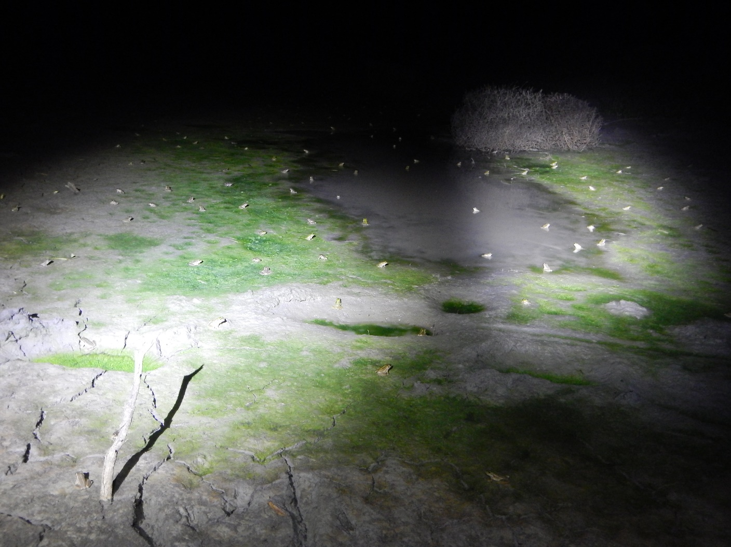

Plate 6. 100s of juvenile southern bell frogs were detected at Nap Nap Swamp in Gayini Nimmie-Caira following Commonwealth environmental watering actions (Photo: Anna Turner).

Floodplain refugia

* Refugia are habitats that are critical to the survival of water dependent plants and animals during extended dry periods
* During dry conditions Commonwealth environmental water managers, in consultation with land managers, scientists and the community prioritise the delivery of water to key refuge sites

In 2019-20, environmental watering actions maintained water levels at multiple refuge sites including Yarradda Lagoon, Waugorah Lagoon, Avalon Dam and Telephone Creek. All three freshwater turtles species found in the Murrumbidgee - broad-shelled, eastern long-necked and Macquarie turtles were detected with over half the turtles recorded at Waugorah Lagoon in 2019-20 being broad-shelled turtles (Plate 7).

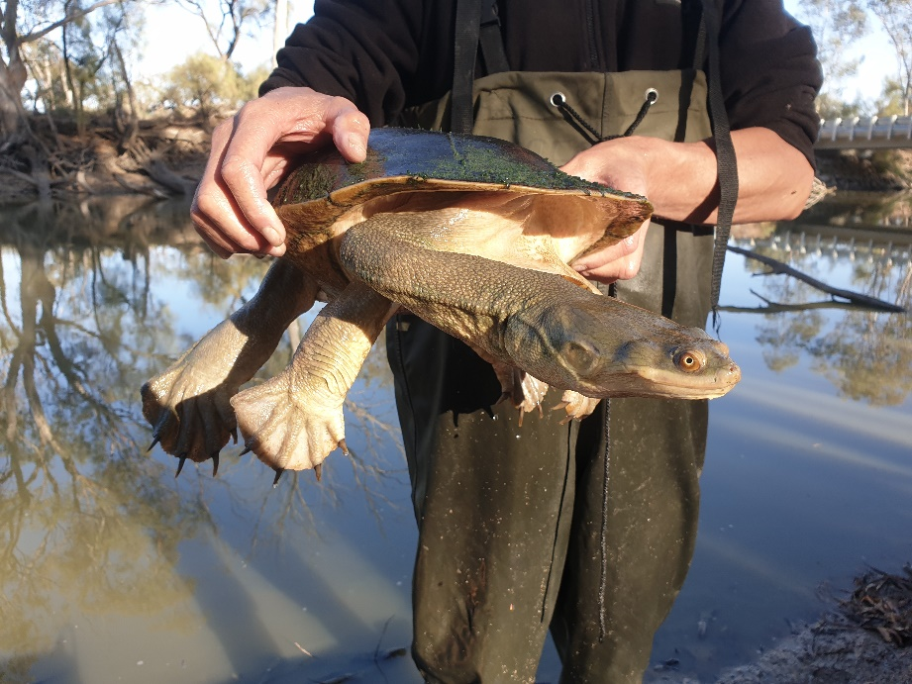

Plate 7. Watering actions provided suitable refuge habitat for turtles including broad-shelled turtles at Waugorah Lagoon.

***Riverine outcomes***

No environmental watering actions in 2019-20 were undertaken specifically targeting the river channel. However, the delivery of environmental and irrigation water influences the hydrology of the Murrumbidgee River and can be linked to native fish breeding activity. As in previous years, native riverine fish continued to spawn in the Murrumbidgee River with spawning closely linked to water temperature. Six native fish species (Australian smelt, carp gudgeon*,* flat-headed gudgeon, golden perch, Murray cod andsilver perch) and one exotic species (common carp)were detected spawning in the Murrumbidgee River. A combined total of 1,106 fish eggs and larvae were collected in 2019-20, the most abundant species being Australian smelt eggs and larvae (622 total) and Murray cod larvae (347).



Plate 8. Larval golden perch was detected spawning in the Murrumbidgee River in 2019-2020.

Research findings

Vegetation benchmarking

Environmental watering actions are influencing wetland water regimes across the Murrumbidgee. The timing, duration and depth of flows play a key role in structuring aquatic vegetation communities. This project is working to establish a benchmark of vegetation condition in wetlands receiving or likely to receive environmental water in future. This data will act as a quantitative reference point against which future CEWO watering actions can be evaluated, using the established survey transects and photo points to enable comparison of aquatic vegetation communities in response to watering over time.

Communications and engagement

The CEWO requires all Selected Area providers to engage stakeholders and utilise local knowledge and expertise to inform the design and evaluation of Commonwealth environmental watering actions. The Murrumbidgee MER Program guidelines for developing and improving communication and engagement activities within the Murrumbidgee Selected Area are described in the [MER Communications Plan](file:///D:/Users/swassens/Documents/Community%20Engagement/Comms%20Strategy/20200206-Murrumbidgee%20MER%20communication%20plan_Final.docx). The key communication objectives as outlined in the Communications Plan are:

* Build community awareness of the ecological, cultural and economic importance of the Murray-Darling river system, floodplain environments and associated wetland ecosystems;
* Increase community capacity, knowledge and awareness of the Murrumbidgee MER Program, river and wetland health and flow management complexity;
* Provide key stakeholders, community groups and end users with timely feedback on the ecological outcomes of environmental watering actions;
* Influence best practice water management, and attitudes towards the delivery of environmental water in Australia; and
* Develop strong partnerships with private landholders, land managers and traditional owners across the mid to lower Murrumbidgee region.

In 2019-20 communication and engagement activities included establishing a social media presence (Twitter and Instagram accounts), producing a quarterly online newsletter (The Bidgee Bulletin), producing and distributing a Program calendar, contributing content to the Flow-MER website and updating the Program website. Demand for the 2019-20 water year calendar outstripped supply and the print run for the 2020-21 calendar was doubled. A presentation scheduled for the Murrumbidgee Field Naturalists May meeting was deferred due to COVID-19 restrictions, and was conducted via the Zoom online platform in September. Planned community field days are also on hold due to COVID-19 restrictions.

The MER team is working with NPWS and staff from Griffith Clontarf School to provide short term employment opportunities to Clontarf Indigenous graduates. After employing one graduate in March 2020, we recognised that the prolonged recruitment process (contracts, tax forms) limits access, with graduates stepping forward at the last minute. The MER team have recently introduced a cadetship as part of a CSU program that offers Indigenous Australian students the chance to gain hands-on experience in a professional area that matches their field of study.

Implications for future management of environmental water

**Managing floodplain wetlands**

Environmental water delivery in 2019-20 took place under a very dry scenario (Murrumbidgee Annual Water Plan). Under these conditions, watering actions largely focused on maintenance of critical refuge habitat for water dependent animals and of vegetation condition and resilience in key wetland and floodplain habitats.

In the mid-Murrumbidgee, managed pumping was used to deliver environmental water to monitored wetlands including Yarradda, Sunshower and Gooragool Lagoons. Yarradda and Sunshower received water via screened pipes designed to exclude large exotic carp following either a brief (Yarradda) or longer (Sunshower) dry period. Pumping of wetlands in the Mid-Murrumbidgee is proving to be a highly effective strategy for maintaining biodiversity and building resilience of floodplain wetlands during dry conditions. The capacity to exclude large carp appears to have improved vegetation response and contributed to increased breeding success of frogs.

**Managing flows for southern bell frogs**

Over the past two years, environmental watering actions have specifically targeted southern bell frog populations by providing winter refuge and summer breeding habitats. Running larger, longer duration flows such as the Nap Nap to Wagourah watering actions have proved to be particularly successful in triggering breeding and supporting recruitment. These actions also support a range of other important wetland species including endangered Australasian bitterns and grey snakes. A similar watering strategy was undertaken in the Redbank zone in 2018-19, and showed some promise in creating habitat for southern bell frogs and as well as breeding by Australian bitterns and golden perch. Similar actions are recommended in the future.

***Cited literature***

Colloff, M.J., Ward, K.A., and Roberts, J. (2014) Ecology and conservation of grassy wetlands dominated by spiny mud grass Pseudoraphis spinescens in the southern Murray–Darling Basin, Australia. *Aquatic Conservation: Marine and Freshwater Ecosystems* **24**(2), 238-255.

Commonwealth of Australia (2019) Watering Action Acquittal Report Murrumbidgee 2018-19. Canberra.

Dijk, A.I., Beck, H.E., Crosbie, R.S., Jeu, R.A., Liu, Y.Y., Podger, G.M., . . . Viney, N.R. (2013) The Millennium Drought in southeast Australia (2001–2009): Natural and human causes and implications for water resources, ecosystems, economy, and society. *Water Resources Research* **49**(2), 1040-1057.

Frazier, P., and Page, K. (2006) The effect of river regulation on floodplain wetland inundation, Murrumbidgee River, Australia. *Marine and Freshwater Research* **57**(2), 133-141.

Frazier, P., Page, K., and Read, A. (2005) Effects of flow regulation in flow regime on the Murrumbidgee River, South Eastern Australia: an assessment using a daily estimation hydrological model. *Australian Geographer* **36**(3), 301-314.

Herring, M. (2019). Bittern Surveys in the Lowbidgee Wetlands: December 2018 – January 2019 Summary Report. Murray Wildlife. Report prepared for NSW Office of Environment and Heritage.

Kaemingk, M.A., Jolley, J.C., Paukert, C.P., Willis, D.W., Henderson, K., Holland, R.S., . . . Lindvall, M.L. (2017) Common carp disrupt ecosystem structure and function through middle-out effects. *Marine and Freshwater Research* **68**(4), 718-731.

Kingsford, R.T., and Thomas, R.F. (2004) Destruction of wetlands and waterbird populations by dams and irrigation on the Murrumbidgee River in arid Australia. *Environmental Management* **34**(3), 383-396.

Kloskowski, J. (2009) Size-structured effects of common carp on reproduction of pond-breeding amphibians. *Hydrobiologia*, 1-9.

Kloskowski, J. (2011) Impact of common carp *Cyprinus carpio* on aquatic communities: direct trophic effects versus habitat deterioration. *Fundamental and Applied Limnology/Archiv für Hydrobiologie* **178**(3), 245-255.

Kopf R.K., Wassens S., McPhan L., Dyer J., Maguire J., Spencer J., Amos C., Kopf S., Whiterod N. (2019). Native and invasive fish dispersal, spawning and trophic dynamics during a managed river-floodplain connection. Commonwealth Environmental Water Office. Murrumbidgee Selected Area.

Murray, P. (2008) 'Murrumbidgee wetlands resource book.' (Murrumbidgee Catchment Management Authority: New South Wales)

Vilizzi, L., A. Tarkan, and G. Copp. (2015) Experimental evidence from causal criteria analysis for the effects of common carp *Cyprinus carpio* on freshwater ecosystems: a global perspective. *Reviews in Fisheries Science & Aquaculture* **23**, 253-290.

Water NSW (June 2018) Water Operations Report: Murrumbidgee Valley. Vol. 2018. (Water NSW)

Water NSW (2020) Annual Operations Plan: Murrumbidgee Valley 2019-20. (Water NSW)

Wen, L., Ling, J., Saintilan, N., and Rogers, K. (2009) An investigation of the hydrological requirements of River Red Gum (*Eucalyptus camaldulensis*) Forest, using Classification and Regression Tree modelling. *Ecohydrology* **2**(2), 143-155.