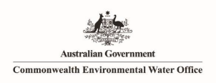InstLandWaterSociety Logo RGB

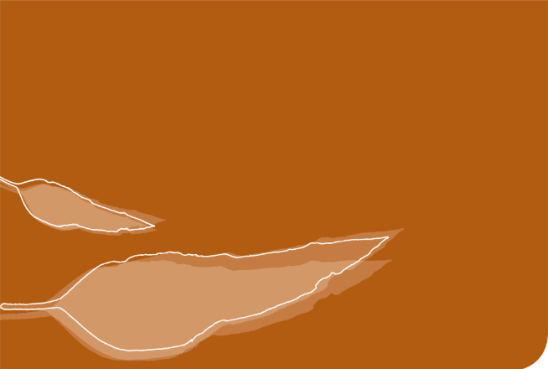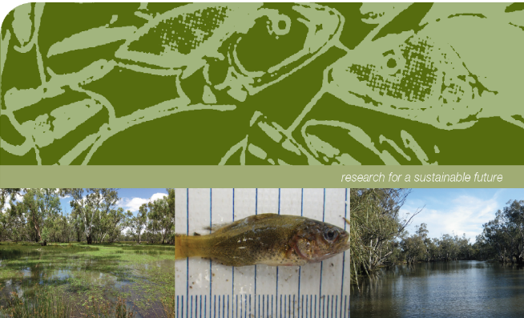

**Commonwealth Environmental Water Office**

**Monitoring, Evaluation and Research Program**

**Murrumbidgee River System Technical Report 2014-2020**

**Commonwealth Environmental Water Office Monitoring, Evaluation and Research Program Murrumbidgee River System Technical Report, 2014-20.**

Prepared by: Wassens, S.a, Michael, D.a Spencer, J.a,b,c, Thiem, J.d, Thomas, R.a,b,c, Kobayashi, Ta,c, , Bourke, G. a, Bino, G.b, Brandis, K. a,c,, Turner, A a, Wright, D.d, Heath, J c., Kuo, W.c, Amos, C. a,c and  Hall, A.a

|  |  |
| --- | --- |
| InstLandWaterSociety Logo RGB | a Institute for Land, Water and Society, Charles Sturt University, PO Box 789, Albury, NSW 2640 |
| CES.png | b Centre for Ecosystem Science, University of New South Wales, Sydney, NSW, 2052 |
|  | c NSW Planning, Industry and Environment, PO Box 39, Sydney, NSW 2001 |
| TI logo colour rgb | d NSW Trade and Investment Narrandera Fisheries Centre, PO Box 182, Narrandera NSW 2700 |

**Funding:** This monitoring project was commissioned and funded by Commonwealth Environmental Water Office with additional in-kind support from the NSW Department of Planning, Industry and Environment, Murrumbidgee Local Land Services, and Charles Sturt University. We are grateful to private landholders for allowing access to their properties.

**Copyright:** © Copyright Commonwealth of Australia, 2021

‘Commonwealth Environmental Water Office Monitoring, Evaluation and Research Program Murrumbidgee River System Technical Report 2014-20 is licensed by the Commonwealth of Australia for use under a Creative Commons By Attribution 3.0 Australia licence with the exception of the Coat of Arms of the Commonwealth of Australia, the logo of the agency responsible for publishing the report, content supplied by third parties, and any images depicting people. For licence conditions see: <http://creativecommons.org/licenses/by/3.0/au/>

**Disclaimer:** The views and opinions expressed in this publication are those of the authors and do not necessarily reflect those of the Australian Government or the Minister for the Environment and Energy. While reasonable efforts have been made to ensure that the contents of this publication are factually correct, the Commonwealth does not accept responsibility for the accuracy or completeness of the contents, and shall not be liable for any loss or damage that may be occasioned directly or indirectly through the use of, or reliance on, the contents of this publication.

**Acknowledgement**: The Commonwealth Environmental Water Office acknowledges the efforts of all consortium partners in delivering the Murrumbidgee Monitoring, Evaluation and Research Program and preparing this report. The authors of this report as well as the Commonwealth Environmental Water Office respectfully acknowledge the traditional owners, their Elders past and present, their Nations of the Murray-Darling Basin, and their cultural, social, environmental, spiritual and economic connection to their lands and waters. In particular the Wiradjuri, Nari Nari and Muthi Muthi peoples, traditional owners of the land on which this publication is focused.

|  |  |
| --- | --- |
| **Section contributors** | **Authors** |
| Hydrology | Rachael Thomas and Jessica Heath |
| Riverine and larval fish | Jason Thiem, Daniel Wright and Gilad Bino |
| Wetland fish | Damian Michael and Skye Wassens |
| Stream metabolism | Yoshi Kobayashi and Gaye Bourke |
| Water quality, nutrients and carbon | Damian Michael and Gaye Bourke |
| Frogs and Turtles | Damian Michael, Anna Turner, Gilad Bino |
| Vegetation Diversity | Skye Wassens |
| Waterbird Diversity | Jennifer Spencer, Skye Wassens, Carmen Amos and Kate Brandis |

**Citation:** This report should be attributed as:

Wassens, S. Michael, D. Spencer, J, Thiem, J., Thomas, R., Kobayashi, T, , Bourke, G., Bino, G., Brandis, K., Turner, A, Wright, D., Heath, J., Kuo, W., Amos, C. and Hall, A. (2021) Commonwealth Environmental Water Office Monitoring, Evaluation and Research Program Murrumbidgee River System Technical Report, 2014-20. Report prepared for the Commonwealth Environmental Water Office

Source: Licensed from the Commonwealth Environmental Water Office, under a Creative Commons Attribution 3.0 Australia License

**Authors:** Wassens, S. Michael, D. Spencer, J, Thiem, J., Thomas, R., Kobayashi, T, , Bourke, G., Bino, G., Brandis, K., Turner, A, Wright, D., Heath, J., Kuo, W., Amos, C. and Hall, A.

**Published**: Commonwealth of Australia

The Commonwealth of Australia has made all reasonable efforts to identify content supplied by third parties using the following format ‘© Copyright, [name of third party]’.

**Document history and status**

|  |  |  |  |  |  |
| --- | --- | --- | --- | --- | --- |
| **Revision** | **Date** | **Description** | **By** | **Review** | **Approved** |
| First draft |  |  | Wassens |  |  |
| Second draft |  |  | Wassens |  |  |
| Third draft |  |  | Michael |  |  |
| Final draft |  |  | Michael | 11/12/2020 |  |
| Final | 13/01/2021 |  | Wassens |  |  |

Table of Contents

1. Introduction 1

2. Murrumbidgee River system Selected Area and zones 3

3. Environmental water delivered in 2019-20, context and expected outcomes 10

4. Evaluation of Commonwealth Environmental Watering Actions 15

4.1 Wetland hydrology 15

4.2 Wetland water quality 43

4.3 Vegetation diversity 49

4.4 Wetland fish 68

4.5 Frogs and turtles 85

4.6 Waterbird Diversity 113

4.7 Riverine water quality 137

4.8 Stream metabolism 147

4.9 Larval fish 157

5. Evaluation of the 2019-20 Watering actions-conclusions and management implications 174

6. References 180

7. Appendices 186

# Introduction

The Commonwealth Environmental Water Holder (CEWH) is responsible under the *Water Act 2007* (Commonwealth) for managing Commonwealth environmental water holdings to protect and restore the environmental assets of the Murray-Darling Basin (MDB). The *Murray-Darling Basin Plan (2012)* (referred to hereafter as the Basin Plan) further requires that the holdings must be managed in a way that is consistent with the Basin Plan’s Environmental Watering Plan. The *Water Act 2007* and the Basin Plan also impose obligations to report on the contribution of Commonwealth environmental water to the environmental objectives of the Basin Plan. Monitoring and evaluation are critical to effectively and efficiently use Commonwealth environmental water, supporting the CEWH’s reporting obligations in addition to demonstrating overall effectiveness at meeting conservation objectives.

The Monitoring, Evaluation and Research program (MER program) builds on the previous Long Term Intervention Monitoring (LTIM) program (2014 - 2019). In order to protect the integrity of the long-term dataset that was developed under the LTIM program (Wassens *et al.* 2018) much of the methodology employed in this program is a direct continuation of the previous LTIM program. The MER program is the primary framework by which the Commonwealth Environmental Water Office (CEWO) monitors and evaluates the ecological outcomes of Commonwealth environmental watering and its objectives. The MER program will continue to be implemented at seven Selected Areas over a three year period (2019 - 2020 to 2021 - 2022) to inform environmental water management and demonstrate high-level outcomes (in order of priority):

* Evaluate the contribution of Commonwealth environmental watering to the objectives of the Murray-Darling Basin Authority’s (MDBA) Environmental Watering Plan
* Evaluate the ecological outcomes of Commonwealth environmental watering at each of the seven Selected Areas
* Infer ecological outcomes of Commonwealth environmental watering in areas of the MDB not monitored
* Support the adaptive management of Commonwealth environmental water
* Monitor the ecological response to Commonwealth environmental watering at each of the seven Selected Areas.

This evaluation report describes the ecological outcomes of environmental watering actions in the Murrumbidgee Selected Area undertaken in 2014-15 to 2019-20. This report draws on information presented in the **Murrumbidgee Monitoring and Evaluation Plan (M&EP)** (Wassens *et al.* 2014a).

# Murrumbidgee River system Selected Area and zones

The Murrumbidgee Catchment in southern NSW, is one of the largest catchments (81,527 km2) in the Murray-Darling Basin (Kingsfordand Thomas 2004). Wetlands make up over 4 per cent (370,000 ha) of the catchment, with over 1,000 individual wetlands identified (Murray 2008). Nationally important wetlands, including the mid-Murrumbidgee and Lowbidgee floodplain, cover over 208,000 ha (2.5 per cent of the catchment area). For the purposes of the assessment of environmental water requirements and identification of monitoring zones, three key areas are identified for the Murrumbidgee (Gawne *et al.* 2013). Each area is identified by the MDBA as a “*key environmental asset within the Basin”* and *“important site for the determination of the environmental water requirements of the Basin*” (Murray-Darling Basin Authority 2012). They are:

* The Lower Murrumbidgee River (in-channel flows)
* The mid-Murrumbidgee River wetlands and
* The Lower Murrumbidgee (Lowbidgee) floodplain

Monitoring zones represent areas with common ecological and hydrological attributes. We identified separate zones for riverine and wetland habitats across the Murrumbidgee Selected Area. In most cases, we aimed to align zones with existing classifications by the MDBA and NSW Department of Planning, Industry and Environment. In order to align closely with established management units across the Murrumbidgee Selected Area, we have taken a broad scale approach to the selection of zones, focusing on large scale differences in hydrology, vegetation and faunal communities. It is noted that our zones cover large areas, and, in the case of wetland zones, there remains considerable heterogeneity within as well as between zones. As a result, higher levels of replicate monitoring locations are required in some zones to enable statistical evaluation of ecological outcomes.

***Riverine zones***

The Murrumbidgee River is over 1,600 km long, with the MER Program Selected Area covering the lowland section (approximately 786 km) (Wassens *et al.* 2014a). In the Murrumbidgee River we have identified three zones that have a degree of hydrological uniformity that can be accurately estimated using the existing gauge network (Table 2‑1). The zone classification also takes into account key inflows (tributaries) and outflows (distributaries and irrigation canals) (Table 2‑1).

* **Narrandera reach (187.3 km)** – Starts upstream of the Yanco and Oldman Creek regulators and extends to just above the Tom Bullen storage offtake. This zone includes major Murrumbidgee and Coleambally irrigation off-takes, also key populations of Murray cod.
* **Carrathool reach (358.0 km)** – Downstream of Tom Bullen storage and major irrigation off-takes, reduced influence of irrigation flows, principle target for in-channel Commonwealth environmental watering actions.
* **Balranald reach (241.4 km)** – Extends from Hay to Boundary Bend down stream of Balranald and aligns with the Lowbidgee floodplain.

Table ‑ Summary of 2019-20 monitoring activities and locations in the Murrumbidgee River

|  |  |  |  |  |  |  |  |
| --- | --- | --- | --- | --- | --- | --- | --- |
| Site Name | Zone | ANAE classification | Stream metabolism | Nutrients & carbon | Larval fish C1 | Larval Fish SA | Fish community (C1) |
| Yarradda (River) |  |  |  | X | X | X | X |
| McKennas (River) | Carrathool | Permanent lowland streams | X | X | X | X | X |
| Bringagee |  | X | X | X | X |
| Birdcage |  |  |  |  | X |
| Gundaline claybar |  |  |  |  | X |
| Gundaline US |  |  |  |  | X |
| Hay Boat Ramp |  |  |  |  |  |
| Pevensey |  |  |  |  |  |
| Rudds Point |  |  |  |  | X |
| Toganmain DS |  |  |  |  | X |
| Toganmain Homestead |  |  |  |  | X |
| Toganmain US |  |  |  |  | X |
| Wyreema |  |  |  |  |  |
| The Dairy | Narrandera | Permanent lowland streams |  |  |  | X |  |
| Euroley Bridge |  |  |  | X |  |
| Narrandera |  |  |  | X |  |
| Buckingbong Station |  |  |  |  |  |
| Berembed Weir DS |  |  |  |  |  |
| Gogeldrie Weir US |  |  |  |  |  |
| Lamonts Beach |  |  |  |  |  |

US = upstream, DS = downstream, River = distinguishes site from comparable Wetland site with the same name see Table 2-2, C1 = Category 1 LTIM standard methods, C3 = Category 3 LTIM standard methods).

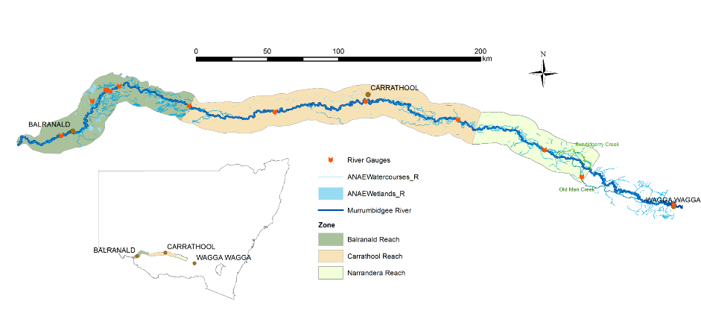

Figure 2‑ Distribution of riverine zones in the Murrumbidgee Selected Area.

***Wetland zones***

Identification of zones across floodplain habitat is more complex than in riverine systems, due to the diversity of aquatic habitats, complexity of hydrological regimes (spatiotemporal variability of flows), diversity of vegetation types and presence of flow control structures (water management units). Ultimately, we opted for very broad zones, dominant vegetation type, faunal communities and expected ecological responses (Table 2‑2). These align with the management units identified by NSW OEH and are recognised by the MDBA and CEWO. Zones were classified for the two key wetland regions: the mid-Murrumbidgee wetlands (Murray 2008) and the Lower Murrumbidgee (Lowbidgee) floodplain (Murrumbidgee Catchment Management Authority 2009).

These regions are split into six broad zones (Figure 2‑2):

* **mid-Murrumbidgee wetlands (82,800 ha)** – River red gum forest interspersed with paleochannels and oxbow lagoons
* **Pimpara–Waugorah (55,451 ha)** – Mosaic of creek lines, paleochannels and wetlands, with River red gum and black box mostly north of the Murrumbidgee River
* **Redbank (92,504 ha)** – Mosaic of river red gum forest and woodland, spike rush wetlands - divided into two management subzones (north and south Redbank)
* **Nimmie-Caira (98,138 ha)** – Mosaic of creek lines, paleochannels, open wetlands and lakes dominated by lignum and lignum-black box communities
* **Fiddlers-Uara (75,285 ha)** – Paleochannels and creek lines bordered by black box
* **The Western Lakes (3,459 ha)** – Open quaternary lakes with inactive lunettes west of the Lowbidgee floodplain

Table ‑ Summary of monitoring activities and locations across three zones in the Murrumbidgee Selected Area

|  |  |  |  |  |  |  |  |
| --- | --- | --- | --- | --- | --- | --- | --- |
| Site Name | Site abbreviation | Zone | ANAE classification | Fish community (C3) | Frogs, tadpoles, turtles | Waterbird Diversity | Vegetation Diversity |
| Gooragool Lagoon | GOO | mid-Murrumbidgee | Permanent floodplain wetland | X | X | X | X |
| McKennas Lagoon | MCK | Intermittent River red gum floodplain swamp | X | X | X | X |
| Sunshower Lagoon | SUN | Intermittent River red gum floodplain swamp | X | X | X | X |
| Yarradda Lagoon | YAR | Intermittent River red gum floodplain swamp | X | X | X | X |
| Avalon Swamp | AVA | Nimmie-Caira | Temporary floodplain lakes | X | X | X | X |
| Eulimbah Swamp | EUL | Temporary floodplain wetland | X | X | X | X |
| Nap Nap Swamp | NAP | Intermittent River red gum floodplain swamp | X | X | X | X |
| Telephone Creek | TEL | Permanent floodplain wetland | X | X | X | X |
| Mercedes Swamp | MER | Redbank | Intermittent River red gum floodplain swamp | X | X | X | X |
| Piggery Lake | PIG | Permanent floodplain tall emergent marshes | D | D | D | X |
| Two Bridges Swamp | TBR | Intermittent River red gum floodplain swamp | D | X | X | X |
| Waugorah Lagoon | WAG | Permanent floodplain wetland | X | X | X | X |



Figure 2‑2 Distribution of wetland zones in the Murrumbidgee Selected Area and locations of key wetlands.

# Environmental water delivered in 2019-20, context and expected outcomes

Climate and watering context

Flows within the Murrumbidgee River have undergone significant long-term changes since the construction of large headwater dams and in-channel weirs, which allow the river flows to be regulated and diverted to meet agricultural and consumptive needs. The timing of high flow periods, in particular, has shifted from winter to spring to meet irrigation demands and there have been significant reductions in the frequency of minor and moderate flow pulses (Frazier *et al.* 2005; Frazier *et al.* 2006). Between 2000 and 2010 a significant drought event coupled with increasing consumptive water demand exacerbated the effects of river regulation (Dijk *et al.* 2013) leading to significant declines in the condition of floodplain vegetation (Wen *et al.* 2009).

Large-scale flooding occurred between 2010 and 2011, followed by moderate water availability between 2012 and mid-2016. In 2016-17, there was above average rainfall in the catchment contributing to increasing tributary inflows and unregulated river flows which inundated significant areas of wetland through the mid-Murrumbidgee and Lowbidgee floodplains between September and November 2016. The 2017-18 and 2018-19 water years saw below average rainfall across much of the MDB. In the 2019-2020 water year, the Murrumbidgee catchment received less than 50% of the long-term average annual rainfall, however with watering actions undertaken within the low water availability scenarios with a small amount of floodplain habitat in the Lowbidgee.

***2019-20 Watering Actions***

In 2019-20, the Commonwealth environmental water holder in partnership with NSW delivered 48,335 ML of Commonwealth environmental water and 32,158 ML of NSW water for the environmental as part of 15 watering actions targeting rivers, wetlands, and creek line habitats in the Murrumbidgee Selected Area (Table 3-1).

Two planned watering actions (10082-29 and 10082-30) did not proceed due to various concerns (Table 3-1). Water actions took place from spring 2019 until winter 2020, commencing in September 2019 in the mid-Murrumbidgee with pumped deliveries to four wetlands (Mantangry/Gooragool, Wilbriggie (Darlington Lagoon) and Yarradda Lagoons). Sunshower Lagoon also received a pumped water delivery following completion of infrastructure in December 2019. These actions aimed to inundate these wetlands, with the primary objectives of: (1) Maintain critical refuge habitat for waterbirds, native fish (including established golden and silver perch), frogs, turtles and other water dependent animals and threatened species (including superb parrot and southern bell frog), (2) Support native aquatic vegetation growth and maintain condition, and (3) Consolidate improvements in the ecological character, condition and resilience of native vegetation communities (Wilbriggie Lagoon).

Two further environmental water actions began in October and November 2019 respectively, the Gayini Nimmie-Caira, southern bell frog and Tala Creek System Refuge flow (41,313 ML), and the smaller North Redbank Refuge flow (11,010 ML). The Gayini Nimmie-Caira water action aimed to maintain critical refuge habitat, support vegetation communities and provide breeding and recruitment opportunities for threatened southern bell frog populations at key sites. A maintenance flow to support bird breeding was released in late January (3,000 ML). The North Redbank Refuge action targeted key sites including Narwie, Athon, Paika east and Murrundi, with the primary objectives: (1) maintain critical refuge habitat for water dependent animals, and (2) maintain and improve wetland vegetation.

The North Redbank Refuge and Yanga Refuge also received supplementary flows delivered in mid-May. These water actions targeted Glen Dee Swamp and Lake Marimley Forest (North Redbank), and Shaw’s Swamp and Wagourah Lake (Yanga).

Additional objectives from other watering actions (Table 3-2) in the Murrumbidgee were to:

* Maintain Ramsar ecological character and important waterbird foraging and breeding habitat, for Australasian bitterns and other listed migratory species (MIA wetlands - Fivebough and Tuckerbil);
* Maintain and improve wetland vegetation condition and resilience for Mercedes and Pococks which have been dry for several years and may risk vegetation and habitat change if drying continues; and
* Prevent River red gum encroachment/recruitment at Two Bridges Swamp (Yanga NP refuge).

Table ‑ *Summary of environmental water usage from Commonwealth and other environmental water sources in 2019-20. (Drawn from Watering Action Acquittal Report Murrumbidgee 2019-20 (Commonwealth of Australia 2020)). Shaded rows* indicate flows associated with the MER Monitoring locations that are evaluated in this report.

|  |  |  |  |  |  |
| --- | --- | --- | --- | --- | --- |
| Water Reference No. | Watering actions | Dates  (start/end) | Commonwealth environmental water (ML) | Other environmental water (ML) | Total water use  (ML) |
| 10082-18 | Gooragool and Mantangry Lagoons pumping | Start: 09/09/2019  End: 16/01/2020 | 2,251.3 | 200 NSW AEW | 2,451 |
| 10082-19 | Wilbriggie Lagoon pumping | Start: 19/09/2019  End: 27/09/2019 | 142.2 |  | 142.2 |
| 10082-20 | Yarradda Lagoon pumping | Start: 18/09/2019  End: 10/12/2019 | 2,000 |  | 2,000 |
| 10082-21 | Gayini Nimmie-Caira, SBF breeding and Tala Creek System refuge flows | Start: 23/10/2019  End: 29/12/2019  Start: 27/01/2020  End: 05/02/2020 | 18,000 | 23,313 NSW EWA | 41,313 |
| 10082-22 | North Redbank refuge | Start: 28/11/2019  End: 23/01/2020 | 11,010 |  | 11,010 |
| 10082-23 | Waldaira Lagoon pumping | Start: 04/11/2019  End: 22/03/2019 | 1,500 |  | 1,500 |
| 10082-24 | Mainie Swamp pumping | Start: 21/10/2019  End: 31/01/2020 | 2,000 |  | 2,000 |
| 10082-25 | Toogimbie pumping | Start: 24/02/2020  End: 07/06/2020 | 500 | 500 NSW AEW | 1,000 |
| 10082-26 | MIA wetlands | Start: 14/10/2019  End: 15/04/2020 | 3,612 |  | 3,612 |
| 10082-27 | Wanganella Swamp pumping | Start: 13/10/2019  End: 28/01/2020 | 2,250 |  | 2.250 |
| 10082-28 | Yanga NP refuge | Start: 30/11/2019  End: 18/12/2019 | 2,963 |  | 2,963 |
| 10082-29 | Coonancoobil – did not proceed | Start:  End: | 0 |  | 0 |
| 10082-30 | Oak Creek – did not proceed | Start:  End: | 0 |  | 0 |
| 10082-31 | Sunshower Lagoon pumping | Start: 01/12/2019  End: 27/01/2020 | 513.5 |  | 513.5 |
| 10097-03 | North Redbank refuge supplementary flow | Start: 16/05/2020  End: 04/06/2020 | 1,442 | 1,831 NSW EWA  2,818 NSW AEW | 6,091 |
| 10097-04 | Yanga NP refuge supplementary flow | Start: 16/05/2020  End: 18/05/2020 | 151 |  | 151 |
| NSW DPIE-EES | NSW Action EWA to Coleambally Irrigation refuge sites with no CEW component. | Start: 18/10/2019 End: 30/01/2020 |  | 3496 | 3496 |
|  |  | Total delivered | 48,335 | 32,158 ML | 80,493 ML |

Table ‑ Summary of Commonwealth environmental watering actions and objectives in 2019-20. Adapted from (Commonwealth of Australia 2020).

|  |  |  |
| --- | --- | --- |
| Water Reference No | Watering actions | Objectives (primary and secondary as at delivery) |
| 10082-18 | Gooragool/Mantangry Lagoon | * Maintain critical refuge habitat for waterbirds, native fish (including established golden and silver perch), frogs, turtles and other water dependent animals; * Support native aquatic vegetation growth and maintain condition. |
| 10082-19 | Wilbriggie Lagoon | * Maintain critical refuge habitat for waterbirds, native fish, frogs, turtles, other water dependent animals and threatened species such as the superb parrot (EPBC Act vulnerable); * Consolidate improvements in the ecological character, condition and resilience of native vegetation communities. |
| 10082-20 | Yarradda Lagoon | * Maintain critical refuge habitat for waterbirds, native fish, frogs (including the threatened southern bell frog), turtles and other water dependent animals; * Support native aquatic vegetation growth and maintain condition. |
| 10082-21 | GNC refuge, SBF breeding and Tala Creek System refuge | * Maintain critical refuge habitat for waterbirds, native fish (including known golden perch populations in the Tala Creek system), turtles, frogs (including the threatened southern bell frogs), and other water dependent animals; * Support the ecological character, condition and resilience of vegetation communities; * Provide opportunities for breeding and recruitment of the threatened southern bell frog at key sites in Gayini Nimmie-Caira to reduce the risk of local population extinction. |
| 10082-22 | North Redbank refuge | * Maintain critical refuge habitat for waterbirds, native fish, frogs, turtles and other water dependent animals; * Maintain and improve wetland vegetation condition and resilience. |
| 10082-23 | Waldaira Lagoon (Junction Wetlands) | * Maintain critical refuge habitat for waterbirds, native fish, frogs, turtles and other water dependent animals; * Maintain and improve wetland vegetation condition and resilience. |
| 10082-24 | Mainie Swamp (Junction Wetlands) | * Maintain critical refuge habitat for waterbirds, native fish, frogs, turtles and other water dependent animals; * Maintain and improve wetland vegetation condition and resilience. |
| 10082-25 | Toogimbie IPA | * Maintain critical refuge habitat for waterbirds, native fish, frogs (including the threatened southern bell frog), turtles and other water dependent animals; * Maintain and improve wetland vegetation condition and resilience. |
| 10082-26 | MIA Wetlands | * Maintain critical refuge habitat for waterbirds, native fish, frogs (including the threatened southern bell frog), turtles and other water dependent animals; * Maintain and improve wetland vegetation condition and resilience; * In addition for Fivebough and Tuckerbil – to maintain Ramsar ecological character and important waterbird foraging and breeding habitat, in particular for Australasian bitterns and other listed migratory species. |
| 10082-27 | Wanganella Swamp | * Provide critical refuge habitat for waterbirds, native fish, frogs, turtles and other water dependent animals; * Prevent loss of aquatic vegetation species and support the ecological character, condition and resilience of vegetation communities. |
| 10082-28 | Yanga NP refuge | * Maintain critical refuge habitat for waterbirds, native fish, frogs (including the threatened southern bell frog), turtles and other water dependent animals; * Maintain and improve wetland vegetation condition and resilience, including for Mercedes and Pococks which have been dry for several years and may risk vegetation and habitat change if drying continues; * Prevent River red gum encroachment/recruitment at Two Bridges Swamp. |
| 10082-29 | Coonancoocabil | *CANCELLED – delivery to site was delayed and then cancelled due to unresolved concerns:   * Cars dumped at site required removal prior to delivery; * Carp removal options (drying/attractant flow/screens) unresolved; * Concern regarding head difference between regulator and weir pool being too great and likely to cause scouring. |
| 10082-30 | Oak Creek | *CANCELLED - 1000 ML was approved for this action by Director CBS on 30 October 2019. In discussions with NSW DPIE – Biodiversity and Conservation on 25 November 2019, it was decided not to proceed with this action due to the current limited knowledge of the site, difficulties accessing the site and lack of metering – need hydrographer. |
| 10082-31 | Sunshower Lagoon | * Provide critical refuge habitat for waterbirds, native fish, frogs, turtles and other water dependent animals; * Support native vegetation condition and resilience. |
| 10097-03 | North Redbank refuge – supp flows | * Provide critical refuge habitat for waterbirds, native fish, frogs, turtles and other water dependent animals; * Support native vegetation condition and resilience. |
| 10097-04 | Yanga refuge – sup flows | * Provide critical refuge habitat for waterbirds, native fish, frogs, turtles and other water dependent animals; * Support native vegetation condition and resilience. |

# Evaluation of Commonwealth Environmental Watering Actions

## Wetland hydrology

Prepared by Dr Rachael Thomas (DPIE-EES) and Dr Jessica Heath (DPIE- EES)

***Introduction***

Commonwealth environmental water was delivered to wetlands through the mid-Murrumbidgee, Gayini Nimmie-Caira, and Redbank zones to “inundate wetland and refuge habitats” in the Murrumbidgee catchment. Floodplain wetlands in the Murrumbidgee Selected Area have been identified as being part of the managed floodplain which could be actively managed with water recovered for the environment to improve lateral connectivity (MDBA 2014).

Flooding is the most influential driver of floodplain wetland ecosystems (Bunn and Arthington 2002). Floodplain wetlands in semi-arid regions are governed by variable flow regimes which produce diverse inundation patterns over large areas and time scales (Thomas *et al.* 2015). Aspects of the flood pulse with ecological significance include the inundation magnitude (extent), duration, timing, inter-flood dry interval and frequency of pulses (Walker *et al.* 1995). These inundation regime components are known to be important for vegetation (Roberts and Marsden 2011) and waterbird breeding (Kingsford and Auld 2005) in floodplain wetlands. For these reasons, targeted wetland inundation is the primary focus for environmental water managers.

Inundation extent is a useful indicator of environmental watering outcomes in floodplain wetlands where flooding from river flows varies widely in space and over time (Thomas *et al*. 2015). Extent provides a measure of the inundated area of the floodplain and an inundation map shows the distribution of the area across the landscape at a point in time. A time series of inundation maps enables us to measure the pattern of inundation and drying.

**Relevant watering actions and objectives**

We report on the inundation outcomes within the surveyed wetlands of the Murrumbidgee Selected Area that were targeted for inundation by the Commonwealth and NSW environmental water actions during 2019-20 (Table 4‑1and Figure 4‑1b). Environmental watering occurred throughout the year starting with water actions targeting lagoons in the Mid-Murrumbidgee zone which continued into January 2020. The Gayini Nimmie-Caira zone began receiving environmental water in late October 2019 with the aim to inundate critical refuge habitat for waterbirds, fish, frogs, and other water dependent fauna. Water actions that produced inundation in wetlands continued in January-February 2020 to provide opportunities for waterbirds and frogs to breed. North Redbank water actions began in early November and continued to late December 2019 to inundated wetlands with the aim to maintain critical refuge habitat for waterbirds, fish, frogs, and other water dependent fauna, as well as to maintain wetland vegetation communities, and to improve their condition and resilience. Supplementary flows were delivered to different wetland locations within the North Redbank region (Table 4‑1 and Figure 4‑1b) in May 2020 (16-18th), with the addition of NSW e-water (EWA & AEW) to these flows during May and June 2020. Water actions for the South Redbank region (Yanga National Park) were delivered in early December 2019 via the Yanga 1AS regulator to inundate wetlands in the northern part of the park to again provide critical refuge habitat for waterbirds, fish, frogs and other water dependent fauna while at the same time maintain wetland vegetation communities. Supplementary flows were delivered in May 2020 which targeted inundation of different wetland locations in the northern part of Yanga

National Park (Table 4‑1 and Figure 4‑1b).

*Table 4‑1 Summary of 2019-2020 Commonwealth and NSW environmental water actions with objectives providing inundation in the surveyed wetlands of the Murrumbidgee Selected Area.*

|  |  |  |
| --- | --- | --- |
| Water Action Reference No. | Target Asset | Water Delivery Timing |
| 10082-18 | Gooragool and Mantangry Lagoons | Start: 09/09/2019  End: 16/01/2020 |
| 10082-19 | Wilbriggie Lagoon | Start: 19/09/2019  End: 27/09/2019 |
| 10082-20 | Yarradda Lagoon | Start: 18/09/2019  End: 10/12/2019 |
| 10082-21 | Gayini-Nimmie-Caira Refuge, SBF Breeding, and Tala Ck System Refuge including Nap Nap and Eulimbah Swamp | Start: 23/10/2019  End: 29/12/2019  27/01/2020-05/02/2020 bird breeding maintenance |
| 10082-22 &10097-03 | North Redbank Refuge – middle system core wetlands & North Redbank refuge – upper system core wetlands (inc. supp flows) | Start: 2/11/2019  End: 20/12/2019  Start: 16/05/2020  End: 04/06/2020 |
| 10082-28 & 10097-04 | Yanga NP Refuge & Yanga refuge – supp flows, including partial fill Two Bridges and Mercedes | Start: 30/11/2019  End: 18/12/2019  Start:16/05/2020  End:18/05/2020 |
| 10082-31 | Sunshower Lagoon | Start: 1/12/2019  End: 27/01/2020 |

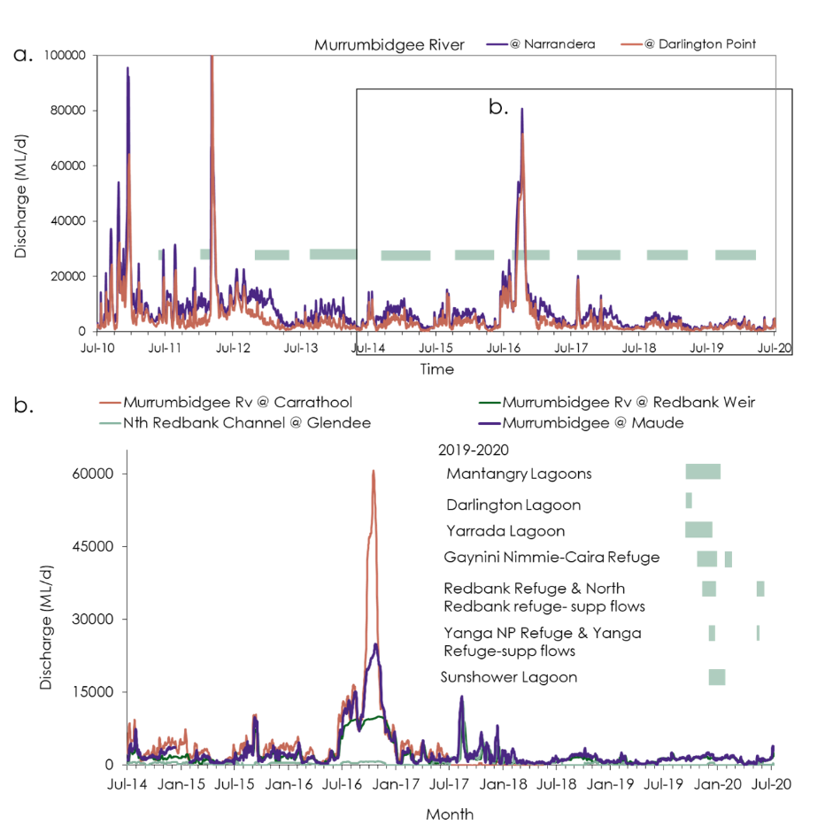

Figure 4‑1a. Mean daily discharge in the Murrumbidgee River at Narrandera and Darlington Point between 1 July 2010 to 30 June 2020. The 2012 discharge peaked at 200,000 ML. Green horizontal bars show Commonwealth and NSW environmental water action timing for water years since 2011-12 to 2019-2020; and, b. Mean daily discharge in the Murrumbidgee River between July 2014 and June 2020 at Carrathool, Redbank Weir and downstream of Maude Weir and on the North Redbank Channel at Glendee in relation to the timing of environmental water delivery water actions (green horizontal bars) during survey period (1 July 2018 to 30 June 2020). Data downloaded from the NSW Water Info website.

**Evaluation Questions**

Did Commonwealth Environmental Water contribute to inundation extent in the wetlands of the Mid-Murrumbidgee and Lower Murrumbidgee floodplain?

***Methods***

**Inundation mapping**

Using methods developed by Thomas *et al.* (2015) we mapped floodplain wetland inundation across sections of the Murrumbidgee Selected Area. We used images from the Sentinel-2 satellite, a multispectral sensor like Landsat but with increased resolution (spatial: 10m x 10m pixel; temporal: 5-day revisit; spectral: 13 bands). Images were automatically downloaded by NSW DPIE from the Copernicus Sentinel Open Access Hub (<https://scihub.copernicus.eu/dhus/#/home> ) as orthorectified images. NSW DPIE processed these images to standardised surface reflectance (Flood *et al*. 2013). We used as many available image observations as possible from July 2019 to June 2020.

From each satellite image observation NSW DPIE automatically generated a water index (Fisher *et al*. 2016) and the NDVI vegetation index. We used these indices to classify inundation as classes of open water, water mixed with vegetation, and dense vegetation cover that was inundated (Thomas *et al.* 2015). For each map inundated pixels were allocated a value of one (1). This method has been previously used to monitor inundation extents in the Lowbidgee floodplain (Spencer *et al.* 2011; Thomas *et al.* 2012, and 2013; Thomas and Heath 2014; Spencer *et al*. 2018; Thomas *et al.* 2019). For observation dates affected by some cloud we manually reclassified areas of cloud shadow that were incorrectly detected as water.

**Data analysis**

We used inundation map observations to estimate inundation extents. An inundation map observation provided a snapshot of inundation extent and its distribution at a point in time. Within the Lowbidgee we tabulated the inundated areas for the entire Lowbidgee floodplain and for each wetland zone (Nimmie-Caira, Redbank (North and South), Pimpara-Waugorah, Fiddlers and Western Lakes) from each inundation map. We tabulated the inundated areas from each inundation map for each of the MER surveyed wetlands where discrete wetland boundaries had been previously delineated (Hall et al. 2019, excludes Gooragool, Mantangry and Wilbriggie (previously referred to as Darlington) Lagoons), estimated the percentage area inundated and plotted them over time. For each of the surveyed wetlands with a delineated boundary we calculated inundation metrics: maximum % inundated and its season, number of days inundated for a specified % area inundated, the time since last maximum inundated area and the inundation frequency (number of times inundated to >20% in last 6 years for Lowbidgee wetlands and 5 years for mid-Murrumbidgee lagoons).

We also provided an overview of the total area of Lowbidgee floodplain inundated during the 2014-2015 to 2019-2020 water years. These inundation extents represent the cumulative area of the floodplain inundated at least once in the water year. We used a spatial overlay of all inundation maps in the water year to count the number of times a pixel was inundated and then all counts greater than zero were recoded to a new value of one to create a map of the cumulative area of the floodplain inundated in the water year.

***Results***

**Lowbidgee Floodplain - Annual Inundation Outcome**

A total of 14,859 ha of the Lowbidgee floodplain were inundated during 2019-20, decreasing by almost half (40%) of the extent of the previous water year (Figure 4‑2). Most of the Lowbidgee inundation extent was distributed in the zones of Redbank (45% of the total inundated area) and Nimmie-Caira (33% of the total inundated area) covering 6,690 ha and 4,838 ha respectively, mostly as a result of environmental flow deliveries (Figure 4‑2 and Figure 4‑3). Inundation extent in the Redbank zone (6,690 ha) was a 59% reduction of the previous year and includes the large inundated areas of Yanga (~800 ha) and Tala (~600 ha) Lakes which were inundated from flows that occurred in previous years (Figure 4‑2 and Figure 4‑3). In contrast inundation extent in the Nimmie-Caira was about the same inundation extent as the previous year (4838 ha) (Figure 4‑2 and Figure 4‑3).

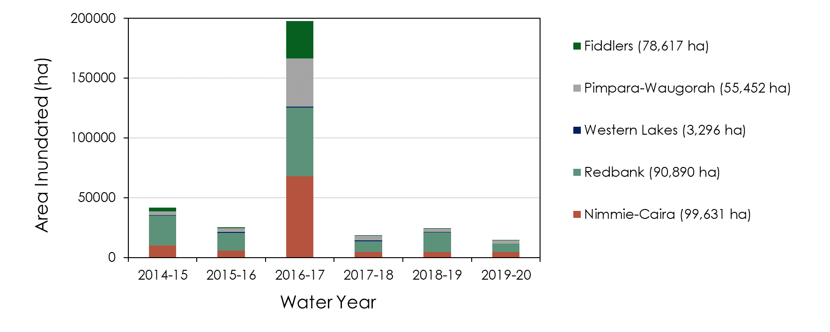

Figure 4‑2 Annual cumulative total area (ha) of the floodplain inundated for the Lowbidgee floodplain and wetland zones for the water years from 2014-2015 to 2019-2020.

Figure 4‑3 Distribution of the cumulative inundated area total across the Lowbidgee floodplain during the July 2019 and June 2020 period based on inundation maps classified from Sentinel-2 satellite images. MER surveyed wetlands: a. Nap Nap Swamp, b. Telephone Creek, c. Eulimbah Swamp, d. Avalon, e. Piggery Lake, f. Two Bridges Swamp, and g. Mercedes Swamp (boundary includes Pocock’s Swamp) and h. Wagourah Lagoon.

Inundation remained distributed across the Lowbidgee floodplain from the previous year’s environmental flow deliveries decreasing over August-October 2019 to 3,795 ha with the majority of water in the landscape confined to large open water lakes and small wetlands prior to the start of the 2019-20 environmental flow deliveries (23 Oct 2019) (Figure 4‑4 and Figure 4‑5 . Inundated area across the Lowbidgee floodplain began to peak in very late spring (27 Nov 2019) as a result of environmental water delivery through the Nimmie-Caira zone (Figure 4‑6). Inundation extent then reached a maximum extent of 8,858 ha in early summer (17 Dec 2019) with environmental flow delivered through the wetlands of the Redbank zone. Over January 2020 inundation extent contracted in all zones, and then as a result of target environmental water delivered expanded again in February 2020 and then again in May-June 2020 (Figure 4‑7).

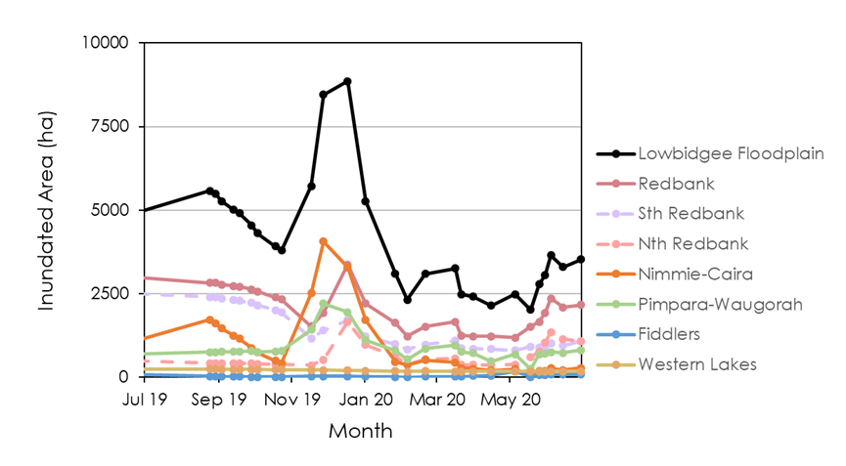

Figure ‑*Inundated areas over time during 2019-2020 for the Lowbidgee zones including the Redbank zone sub-regions (south and north).*

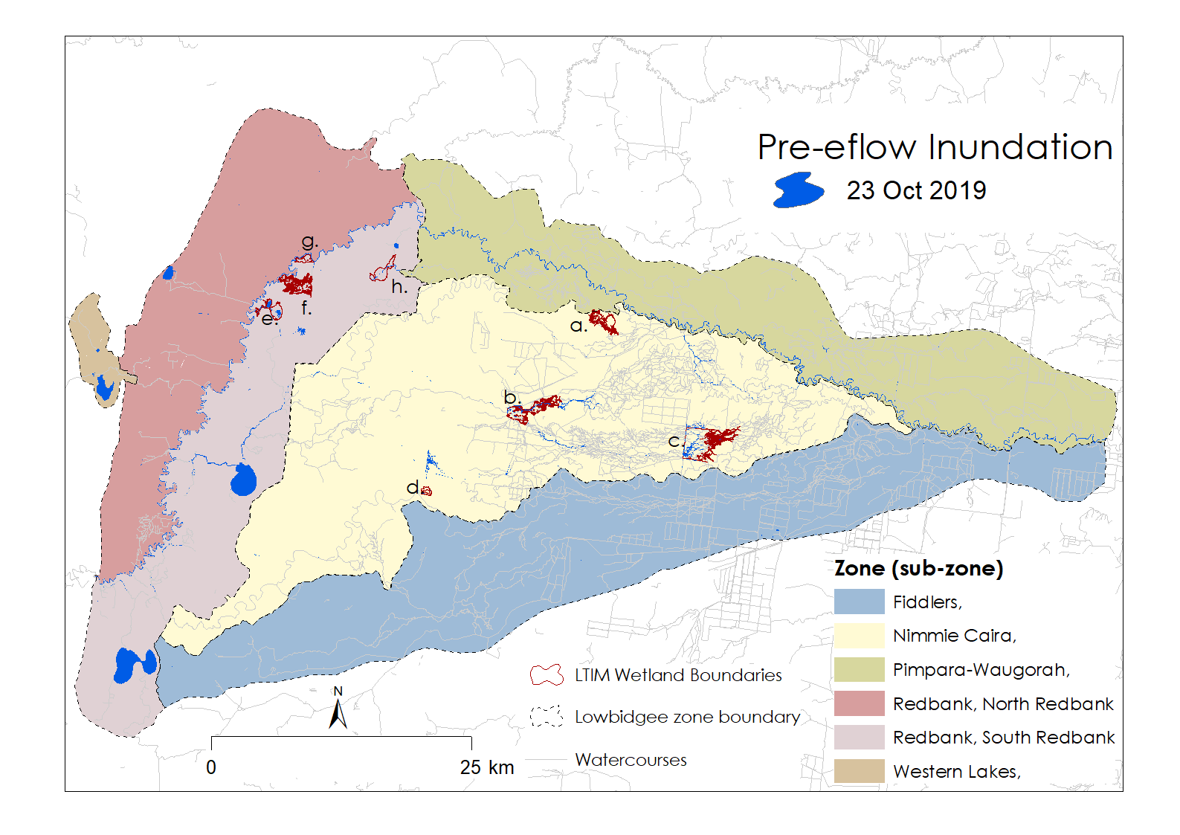Figure 4‑5 Inundation extent prior to environmental flow deliveries (23 October 2019) across the Lowbidgee zones and surveyed wetlands (a-h)

Table 4‑2 Inundation metrics for the surveyed wetlands targeted for inundation by the Gayini Nimmie-Caira Refuge flow for 2019-20 water year.

|  |  |  |  |  |  |
| --- | --- | --- | --- | --- | --- |
| Wetland | % inundated prior to eflow | Max. % inundated & Season | Duration (%inundated, time) | Last inundation peak (time since, date) | No. of times inundated >20% in 6 years |
| Nap Nap Swamp | 0% | 99%  Late Spring, 17 Nov 19 | 99%, 30 days  >30%, 4 months | 1 year,  Nov-18 | 4 |
| Telephone Creek | 11% | 54%  Early summer 17 Dec 19 | 54%, 20 days | 2 months,  Sep-19 | 6 |
| Eulimbah Swamp | 10% | 84%  Late spring 27 Nov 19 | 50%, 45 days | 5 months,  Jun-19 | 6 |
| Avalon Swamp | 7% | 11%  Early summer 17 Dec 19 | 11%, <15days | 4 months,  Aug-19 | 5 |
| Waugorah Lagoon | 7% | 26%  Mid-summer, 01 Jan 20 | 26%, <15 days | 4 months  Sep-17 | 5 |

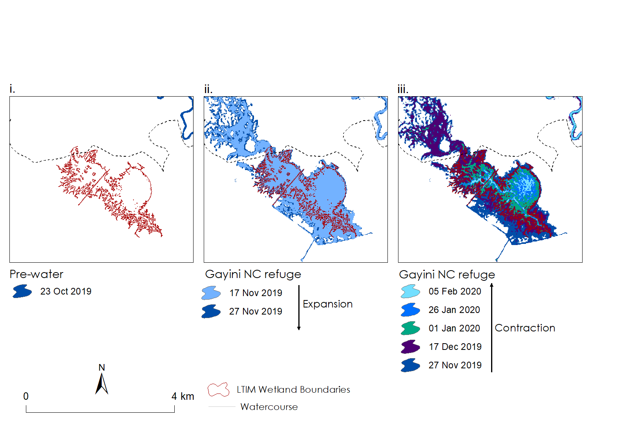

*Figure 4‑6 Inundation progression in Nap Nap Swamp (a.) in the* *Gayini Nimmie-Caira Zone during: i. pre-environmental flow conditions, 23 October 2019; ii. inundation expansion, November-December 2019 as a result of the Gayini Nimmie-Caira refuge water action; and iii. inundation contraction, December 2019 – February 2020. The date at the top of the legend represents the smallest extent in the inundation sequence.*

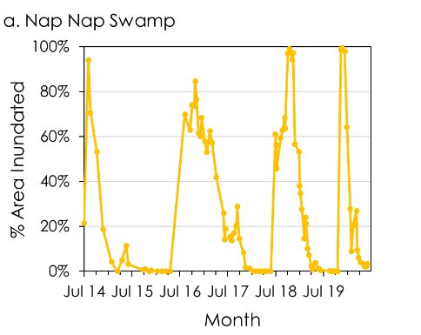

*Figure 4‑7 Percentage area inundated between July 2014 and June 2020 for the MER (LTIM) surveyed wetland site a. Nap Nap Swamp in located in the Nimmie-Caira Zone.*

Whilst Waugorah Lagoon is in the South Redbank region, it received flows from the Gayini Nimmie-Caira Refuge Flow water action (23 Oct – 29 Dec 2019) inundating it to 26% of its boundary in January 2019, an increase from its pre-environmental water percentage inundated of 7% (and Figure 4‑9-i-ii). This inundated area lasted for a short period of time, less than a fortnight and then contracted during February 2020 before expanding again in March as a result of further environmental flow deliveries (Figure 4‑8).

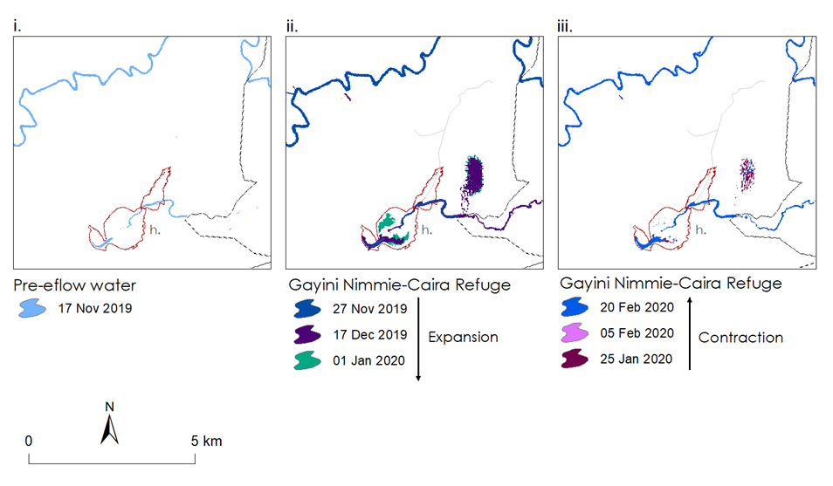

*Figure 4‑8 Inundation progression in and around Waugorah Lagoon (h.) showing: i. pre-environmental supplementary flow conditions 17 Nov 2019; ii. inundation expansion from the Gayini Nimmie-Caira Refuge water action; and iii. inundation contraction, 30 May-14 June 2020.*

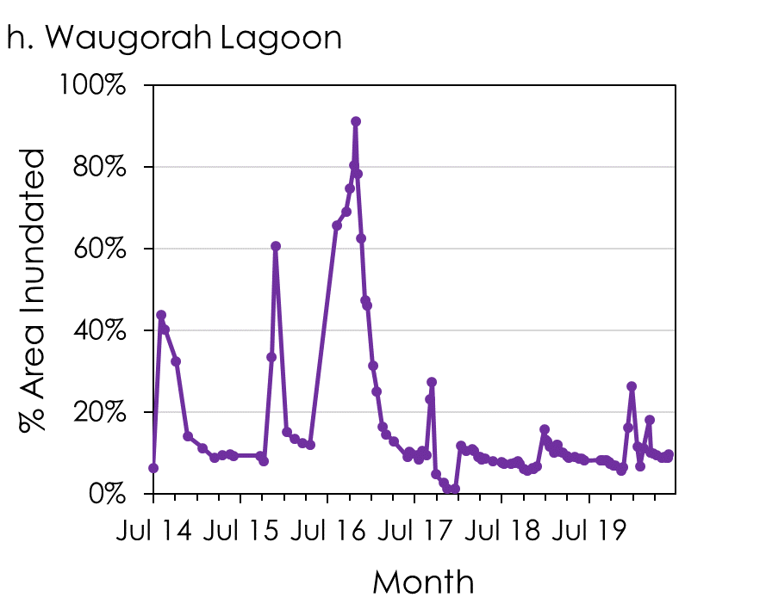

*Figure 4‑9 Percentage area inundated between July 2014 and June 2020 for the MER (LTIM) surveyed wetland site (h.) Waugorah Lagoon, located in South Redbank (North Yanga)*

Prior to the environmental water deliveries of 2019-20 Telephone Creek received flows that began in the previous water year and inundated about 30% of its boundary on the 20 August 2019 contracting to about 11% on 23 October 2019 (Table 4‑2, Figure 4‑10 and Figure 4‑11). As a result of Gayini Nimmie-Caira Refuge flow, inundation extent in Telephone Creek increased to 35% on 17 Nov 2019 and then again on the 27 Nov 2019 when inundated reached the maximum extent of 54% of Telephone Creek which lasted for about 20 days (Table 4.2, Figure 4‑10 and Figure 4‑11). During the summer months there was rapid contraction to 7% by the end of February 2020 which remained until June 2020. This meant that up to 20% of Telephone Creek was inundated for 45 days (17 Nov 2019 -01 Jan 2020). In the past six years Telephone Creek almost completely dried out between floods twice (Dec 17-Apr-18 and Apr -Jun 19) and so this 2019-2020 water year was the second time Telephone Creek was inundated after having almost completely drying out in the last six years (Figure 4‑10 and Figure 4‑11). Telephone Creek has been flooded six times in the last six years after contracting to less than 20% of its boundary (Table 4.2, and Figure 4‑10).

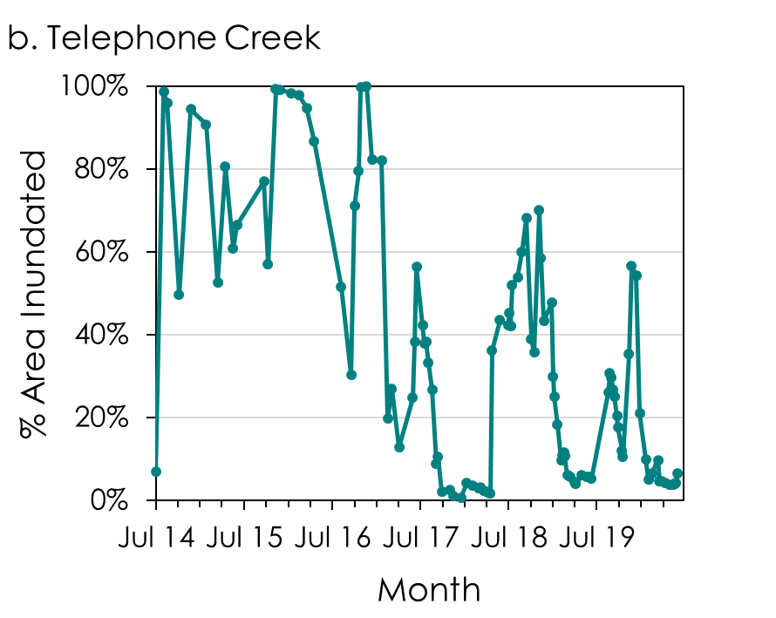

Figure 4‑10 Percentage area inundated between July 2014 and June 2020 for the MER (LTIM) surveyed wetland site b. Telephone Creek located in the Gayini Nimmie-Caira Zone.

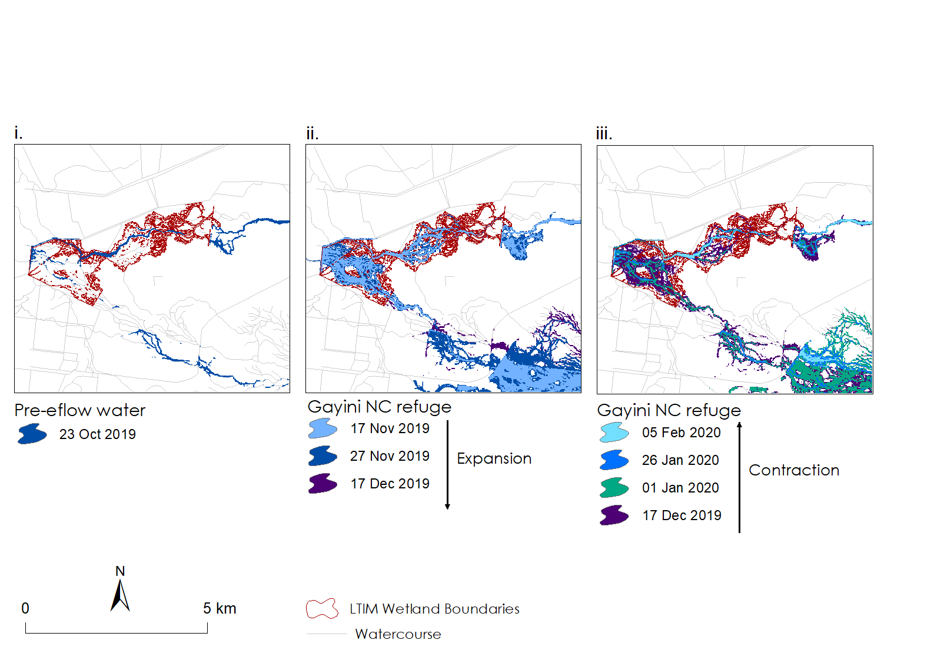

*Figure 4‑11 Inundation progression in Telephone Creek (b.) in the Gayini Nimmie-Caira Zone during: i. pre-environmental flow conditions, 23 October 2019; ii. inundation expansion, Nov-Dec 2019 as a result of* *Gayini Nimmie-Caira refuge water action; and iii. inundation contraction, Dec 2019 to Feb 2020 during the Gayini Nimmie-Caira refuge flow. The date at the top of the legend represents the smallest extent in the inundation sequence.*

Inundation extent in Eulimbah Swamp continued to contract between July and October 2019 after the environmental water action in the previous water year produced a flood peak five months prior to this water year (10082-04, 01 Dec 2018 – 30 Jun 2019) (Figure 4‑12 and Figure 4‑12). On the 23 October 2019 Eulimbah Swamp was 10% full prior to the Gayini Nimmie-Caira Refuge flow, with water confined to the braided channel network. After environmental flows began on 23 October 2019 inundation extent of Eulimbah Swamp increased to 71% on 17 November 2019 and then increased again to its maximum extent of 84% on 17 December, spilling into the floodplain to the north. About 50% of Eulimbah Swamp was inundated for 45 days which then contracted to 13% over January 2020. On 5 Feb 2020 inundation extent in Eulimbah Swamp expanded again to almost 30% which then contracted to <10% by March 2020 (Figure 4‑12). This is the sixth time in six years that Eulimbah Swamp has been inundated to greater than 20% of its boundary.

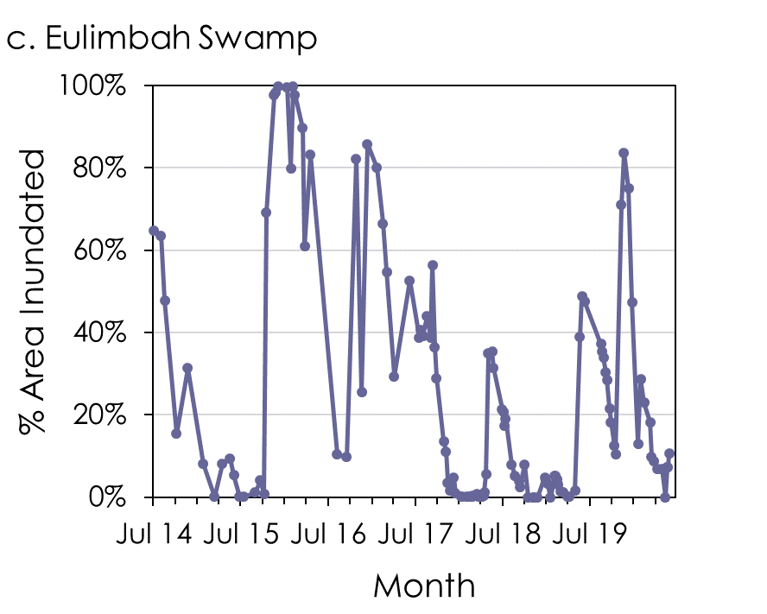

*Figure 4‑12 Percentage area inundated between July 2014 and June 2020 for the MER (LTIM) surveyed wetland site (c.) Eulimbah Swamp located in the Nimmie-Caira Zone.*

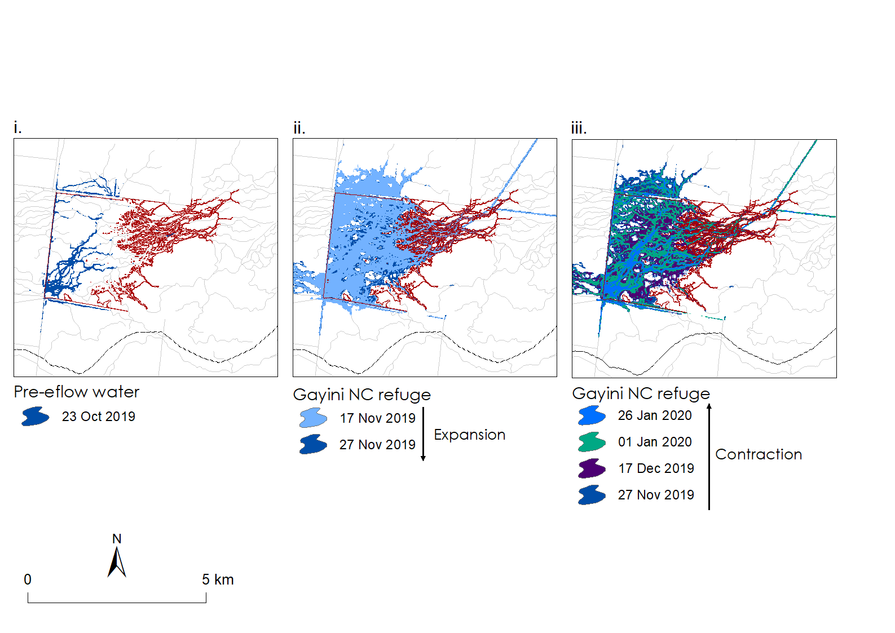

*Figure 4‑13 Inundation progression in Eulimbah Swamp (c.) in the* *Gayini Nimmie-Caira Zone during: i. pre-environmental flow conditions, 23 October 2019; ii. inundation expansion in Nov 2019 during Gayini Nimmie-Caira refuge flow; and iii. inundation contraction, Nov 2019 to Jan 2020. The date at the top of the legend represents the smallest extent in the inundation sequence.*

Prior to the 2019-20 Gayini Nimmie-Caira refuge flow, 30% of Avalon Swamp was inundated on 29 August 2019 by flows that started in the previous water year (2018-19) (Figure 4‑14). Avalon Swamp had mostly dried out to 7% by 27 November 2019 with water confined to Avalon Dam (Table 4.2 and Figure 4‑14). Inundation extent expanded again to 11% of Avalon Swamp’s boundary on 17 December 2019 with an overflow extending south into part of Avalon Swamp but which lasted for less than 15 days (Figure 4‑15 and Figure 4‑15-ii). This then contracted back to the dam by 1 Jan 2020 (Figure 4‑15-iii). Avalon Swamp has been inundated to at least 20% of its boundary five times in the last five years however there was a 1 year and 8.4 month dry spell between February 2017 and October 2018 (Figure 4‑14).

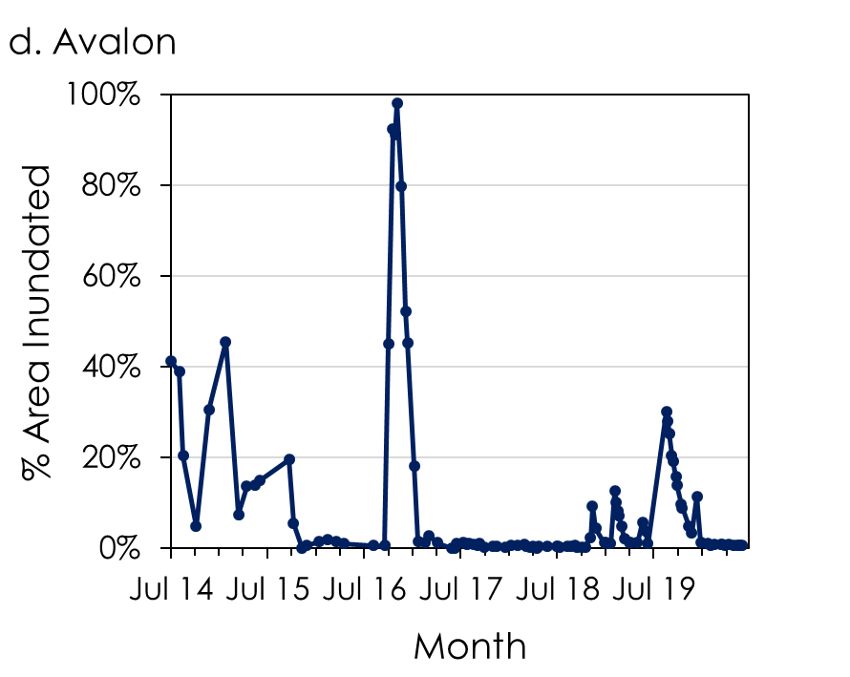

*Figure 4‑14 Percentage area inundated between July 2014 and June 2020 for the MER (LTIM) surveyed wetland site d. Avalon Swamp located in the* *Gayini Nimmie-Caira Zone.*

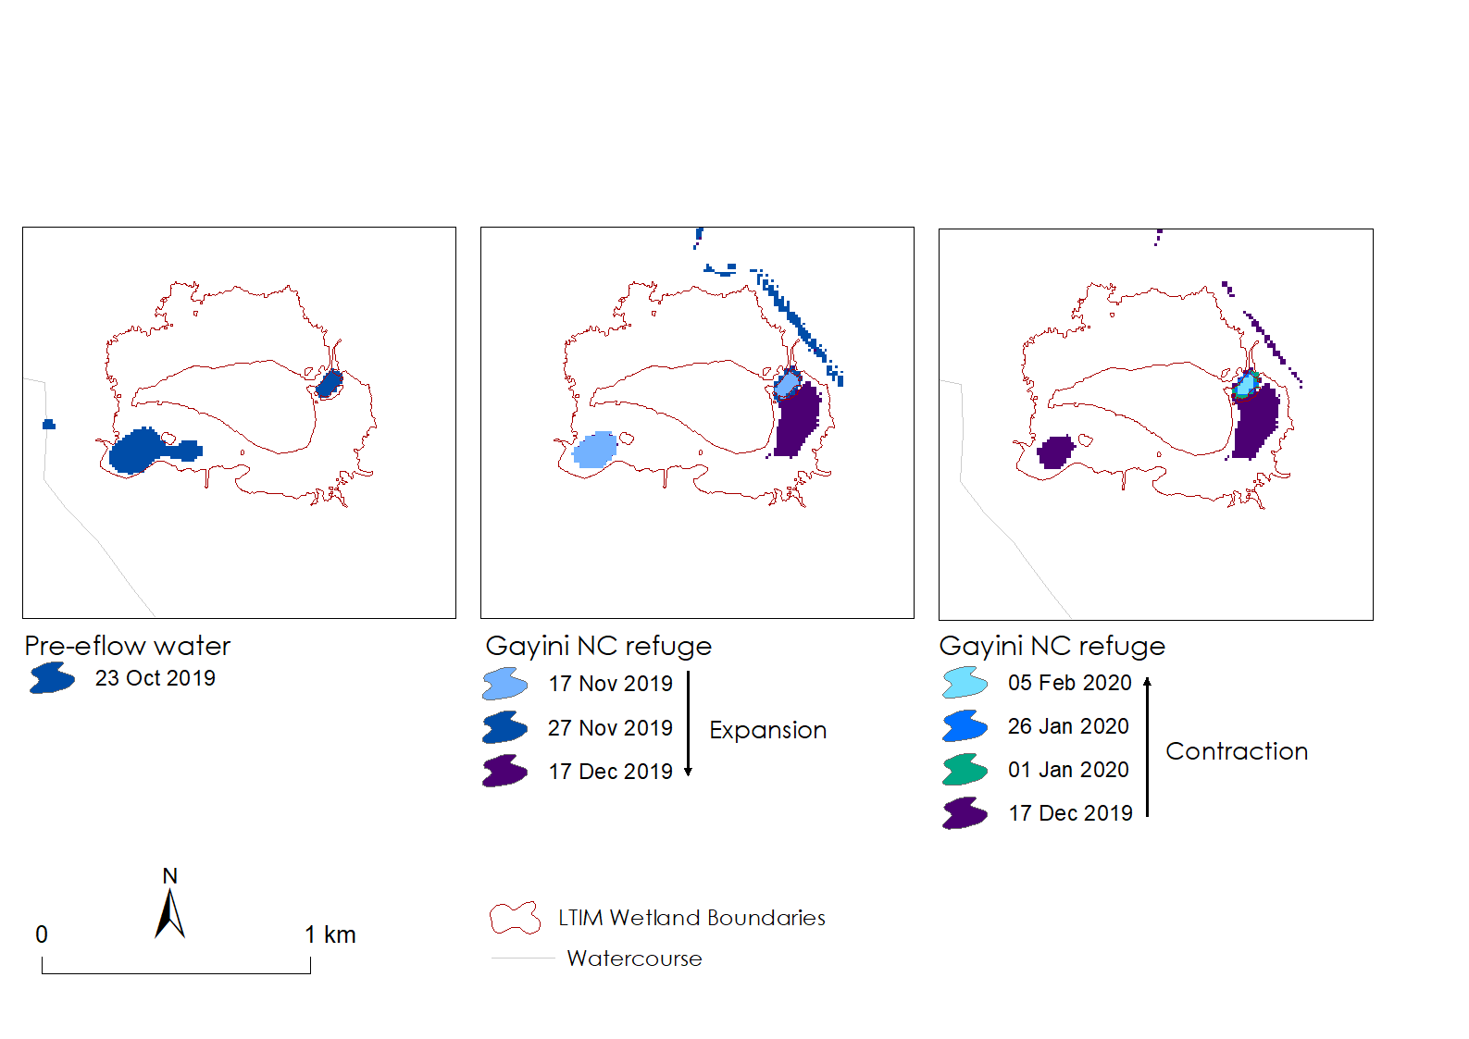

*Figure 4‑15 Inundation progression in Avalon Swamp (d.) in the* *Gayini Nimmie-Caira Zone during: i. pre-environmental flow conditions, 23 Oct -27 Nov 2019; ii. inundation expansion on 17 December 2019; and iii. inundation expansion, in February 2019 during the Nimmie-Caira refuge flow. The date at the top of the legend represents the smallest extent in the inundation sequence.*

**Redbank Zone - Water Action Inundation Outcomes**

As a result of the Yanga National Park (NP) Refuge water action and supplementary flows, an overall cumulative total of 925 ha of South Redbank (Yanga NP) were inundated over the water action period (30 Nov 19 – 18 Dec 2019; 16-18 May 2020) (Figure 4‑17). The Yanga NP refuge water action in early summer 2019 targeted MER surveyed wetlands in the North Yanga section of South Redbank: Two Bridges Swamp, Mercedes Swamp (includes Pocock’s Swamp) and Piggery Lake (Table 4‑3 and Figure 4‑17). Prior to the environmental flow delivery conditions of the main wetland targets in North Yanga were dry, with the exception of Piggery Lake (Table 4‑3, Figure 4‑17-i-ii. and Figure 4‑18-e) and so the maximum inundated area that occurred in mid-December was a direct result of the water action (Figure 4‑42-ii). Inundation contracted during January 2020 (Figure 4‑42-iii and Figure 4‑42). Piggery Lake was partially inundated prior to the 2019-20 environmental water delivery as a result of flows from the previous water year but was not inundated any further by the Yanga NP water action instead continued to dry down (Table 4‑3, Figure 4‑17-i-ii and Figure 4‑18-e). From the previous year’s environmental water delivery at least Piggery Lake was inundated for just over a year and it was the third time inundated more than 20% in 6 years (Table 4‑3 and Figure 4‑18-e). Two Bridges was inundated by the Yanga NP water action to a maximum of 50% of its boundary on 17 December 2019 after having been dry since May 2019, however, up to 50% of the wetland was inundated for less than a fortnight (Table 4‑3, Figure 4‑17-ii and Figure 4‑18-f). It was the fifth time the wetland was inundated more than 20% of it boundary from a dry state in the last six years (Table 4‑3 and Figure 4‑18-f). On 17 December 2019 Mercedes Swamp was inundated to 85% of its boundary, which included Pocock’s Swamp from a dry state. Almost 50% of Mercedes Swamp was inundated for 15 days and about 35% was inundated for 40 days (Table 4‑3, Figure 4‑17-ii and Figure 4‑18-g). This 2019-20 water action meant it was the fifth time the wetland was inundated more than 20% from a dry state in the last six years (Table 4‑3 and Figure 4‑18-g).

*Table 4‑3 Inundation metrics for the surveyed wetlands targeted for inundation by the Yanga National Park Refuge flow for 2019-20 water year.*

|  |  |  |  |  |  |  |
| --- | --- | --- | --- | --- | --- | --- |
| Wetland | % flooded prior to eflow | Max. % flooded & Season | Duration (% flooded, time) | Last flood peak (time since, date) | No. of times flooded >20% in 6 years | |
| Piggery Lake | 28% | na, contracting from Sep-18 peak | [50%, 1.05 years from Sep-18] | [Sep-18, na] | | 3 |
| Two Bridges Swamp | 0% | 50%,  Early summer, 17 Dec 19 | 40-50% < 15 days | Nov-18, 1.08 years | | 5 |
| Mercedes Swamp | 0% | 85%,  Early summer, 17 Dec 19 | 36%, 40 days | Nov-18, 1.08 years | | 5 |

*Figure 4‑17 Inundation progression during the Yanga NP refuge water action in 2019-2020 showing: i. pre-environmental flow conditions, 23 October 2019; ii. inundation expansion, 17 Nov to 17 Dec 2019; and inundation contraction, 17 Dec 26 Jan 2020 in wetlands within South Redbank (North Yanga). MER (LTIM) surveyed wetlands of the Redbank zone: e. Piggery Lake, f. Two Bridges Swamp, and g. Mercedes Swamp.*

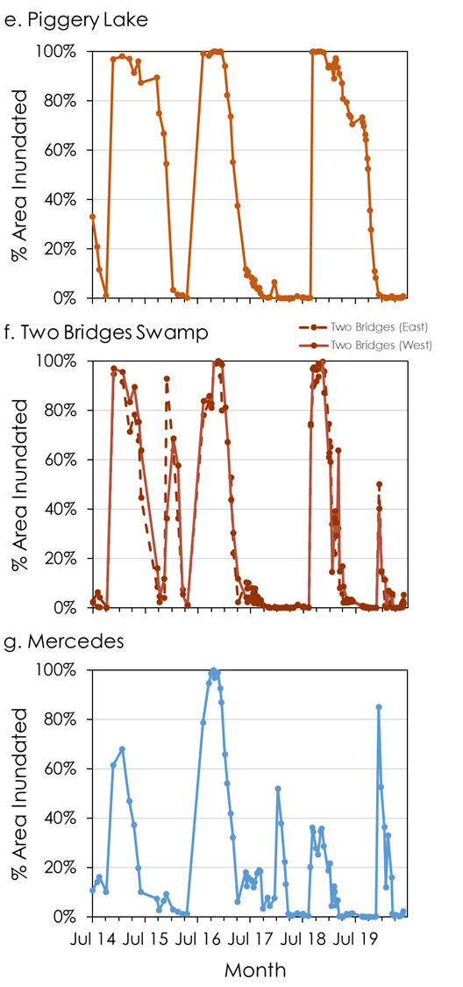

*Figure 4‑18 Percentage area inundated between July 2014 and June 2020 for MER (LTIM) surveyed wetland sites in South Redbank (North Yanga) of the Redbank zone: e. Piggery Lake, f. Two Bridges Swamp, and g. Mercedes Swamp.*

In May 2020 there was a supplementary flow to the December 2019 Yanga National Park refuge flow, successfully inundating wetlands located in the North Yanga portion of South Redbank: Shaw’s Swamp and Waugorah Lake, the latter not to be confused with the MER (LTIM) surveyed wetland Waugorah Lagoon (h.) (Figure 4‑18).

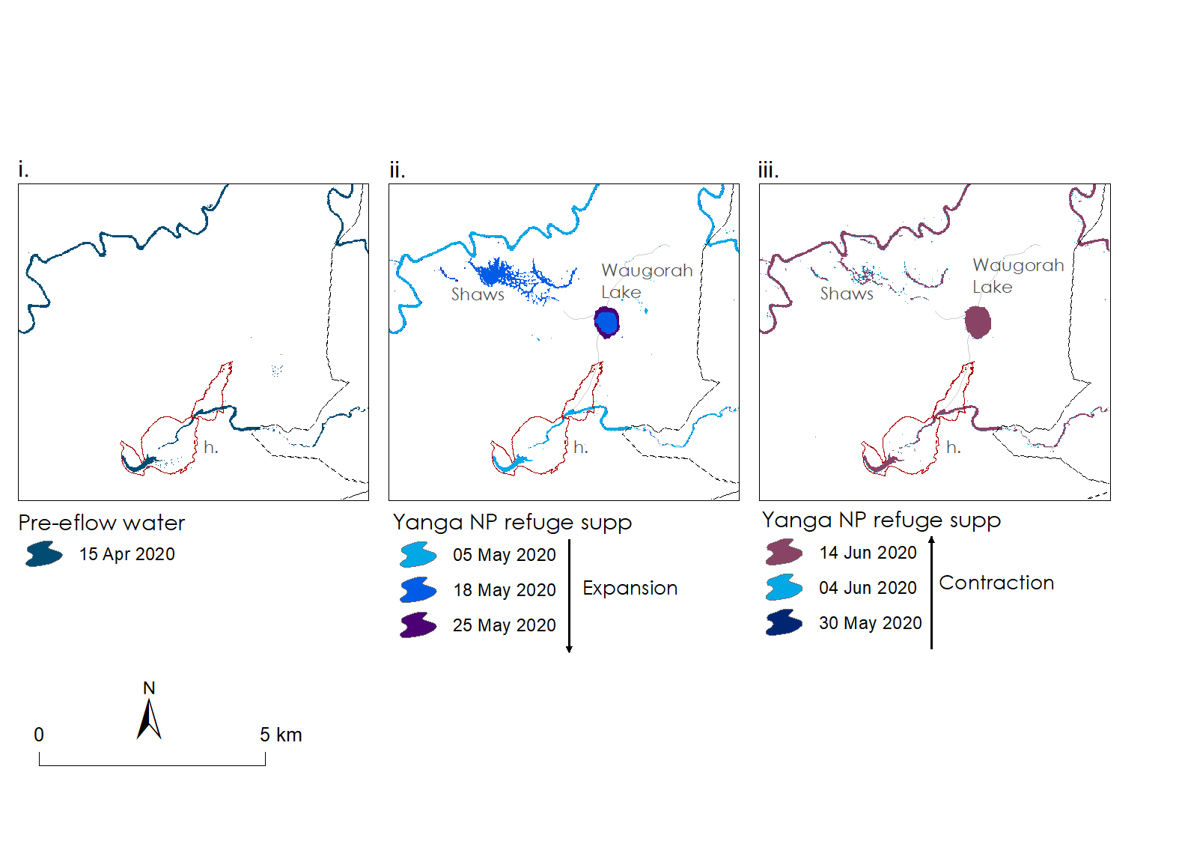

*Figure 4‑18* *Inundation progression in and around Waugorah Lagoon (h.) in Yanga NP showing: i. pre-environmental supplementary flow conditions15 Apr 2020; ii. inundation expansion, 5-25 May 2020; and iii. inundation contraction, 30 May-14 June 2020.*

As a result of the North Redbank Refuge water action and supplementary flows, an overall cumulative total of 4,272 ha of North Redbank were inundated over the water action period (02 Nov 19 – 20 Dec 2019; 16 May - 04 June 2020). The prevailing conditions of the North Redbank region prior to environmental flow delivery were dry (Figure 4‑19-i). Inundation extent increased in late November 2019 and reach a maximum inundation extent of 2,461 ha on 17 December 2019 reaching the wetlands in Narwie East, Athen, Steam Engine Swamp and Murrundi (Figure 4‑19-ii). In January 2020, as inundation progressed southwards to expand the extent in Murrundi, inundation extent in the wetlands to the north (Narwie East, Athen, Steam Engine Swamp) contracted (Figure 4‑19-iii). The supplementary flows delivered from mid-May 2020 successfully inundated the river red gum forests of Marimley and Glen Dee Swamps (Figure 4‑19-iv)

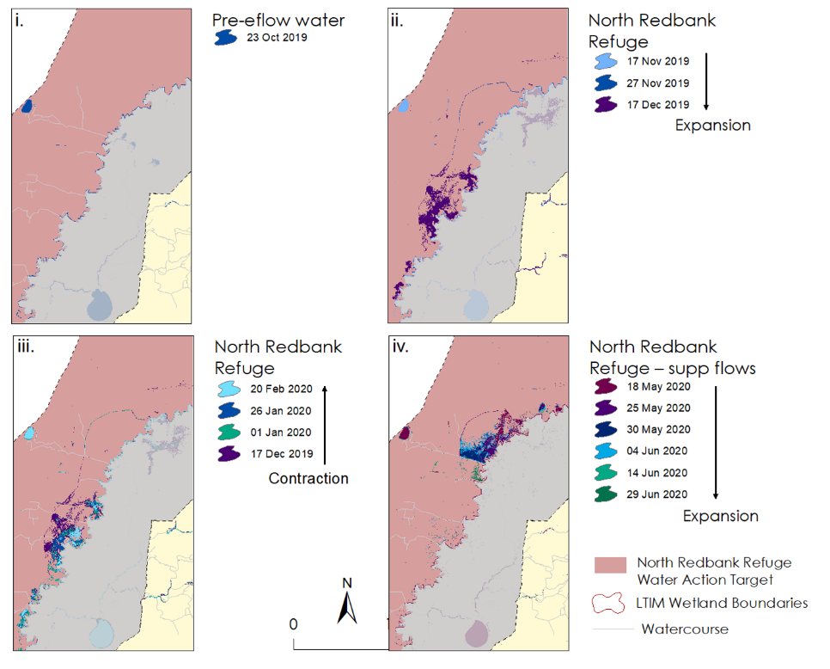

*Figure 4‑19 Inundation progression and expansion outcomes in the targeted areas of North Redbank region i. pre-environmental North Redbank Refuge flow water action, ii. inundation expansion from the North Redbank Refuge flow water action, iii. Inundation contraction and, iv. inundation expansion outcomes other wetland assets targeted by NSW environmental water delivered in May-June 2020 and a small amount of supplementary flow.*

**Mid-Murrumbidgee Zone – Water Action Inundation Outcomes**

Yarradda Lagoon, in the mid-Murrumbidgee Zone, was 26% full prior to the 2019-20 pumping water action, 18 Sep 2019, which was remnant water from the previous water year’s water action (Table 4‑4, Figure 4‑20 and Figure 4‑21-i). About 40% of Yarradda Lagoon was inundated in early October 2019 and reached its maximum at 80% of its boundary by early-December 2019 (Table 4‑4, Figure 4‑21-ii). Inundation extent contracted to about 40% in early February which meant that about 40% of Yarradda Lagoon was inundated for just over four months (Figure 4‑20 and Figure 4‑21-iii). By June 2020 about 30% of Yarradda Lagoon remained inundated. This was the fifth year in five years that Yarradda Lagoon was inundated to at least 50% of its boundary (Table 4‑4, Figure 4‑20).

*Table 4‑4 Inundation metrics for the surveyed wetlands in mid-Murrumbidgee zone targeted for inundation by environmental flow water actions for the 2019-20 water year noting that McKenna’s Lagoon was not targeted for environmental water delivery.*

|  |  |  |  |  |  |
| --- | --- | --- | --- | --- | --- |
| Wetland | % inundated prior to eflow | Max. % inundated & Season | Duration (%inundated, time) | Last inundation peak (time since, date) | No. of times inundated >20% in 5 years |
| Yarradda Lagoon | 26% | 80%  Early summer, 7 Dec 19 | 40%, 4.2 months | 11 months, Jan-19 | 5 |
| Sunshower Lagoon | 0% | 26%  Late summer, 22 Feb 20 | 20%, 5.3 months | 2.5 years, Aug-17 | 3 |
| McKenna’s Lagoon | na | na | na | 3 years, Aug-17 | 2 |

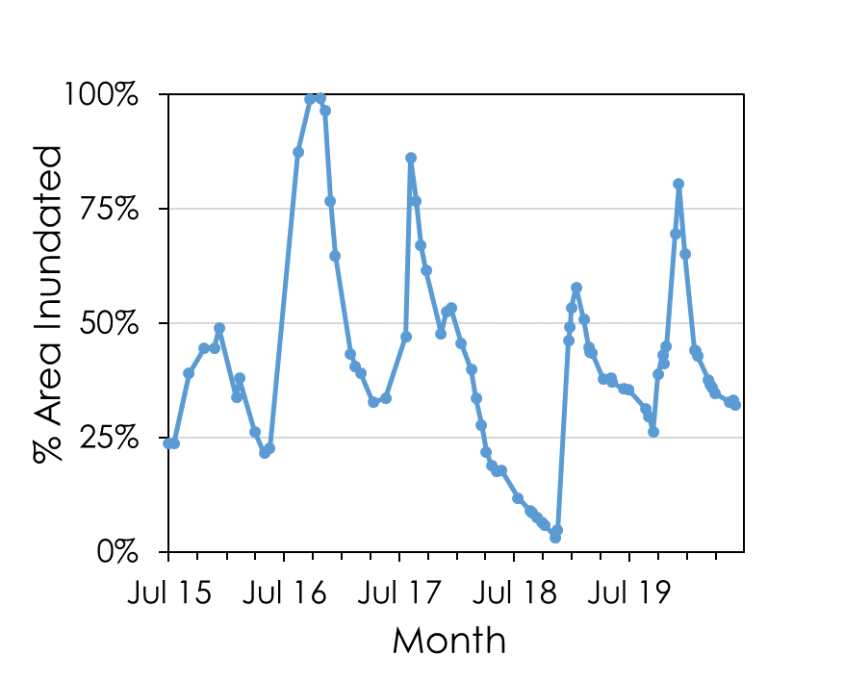

*Figure 4‑20* *Percentage area inundated in Yarradda Lagoon of the mid-Murrumbidgee zone between July 2015 and June 2020.*

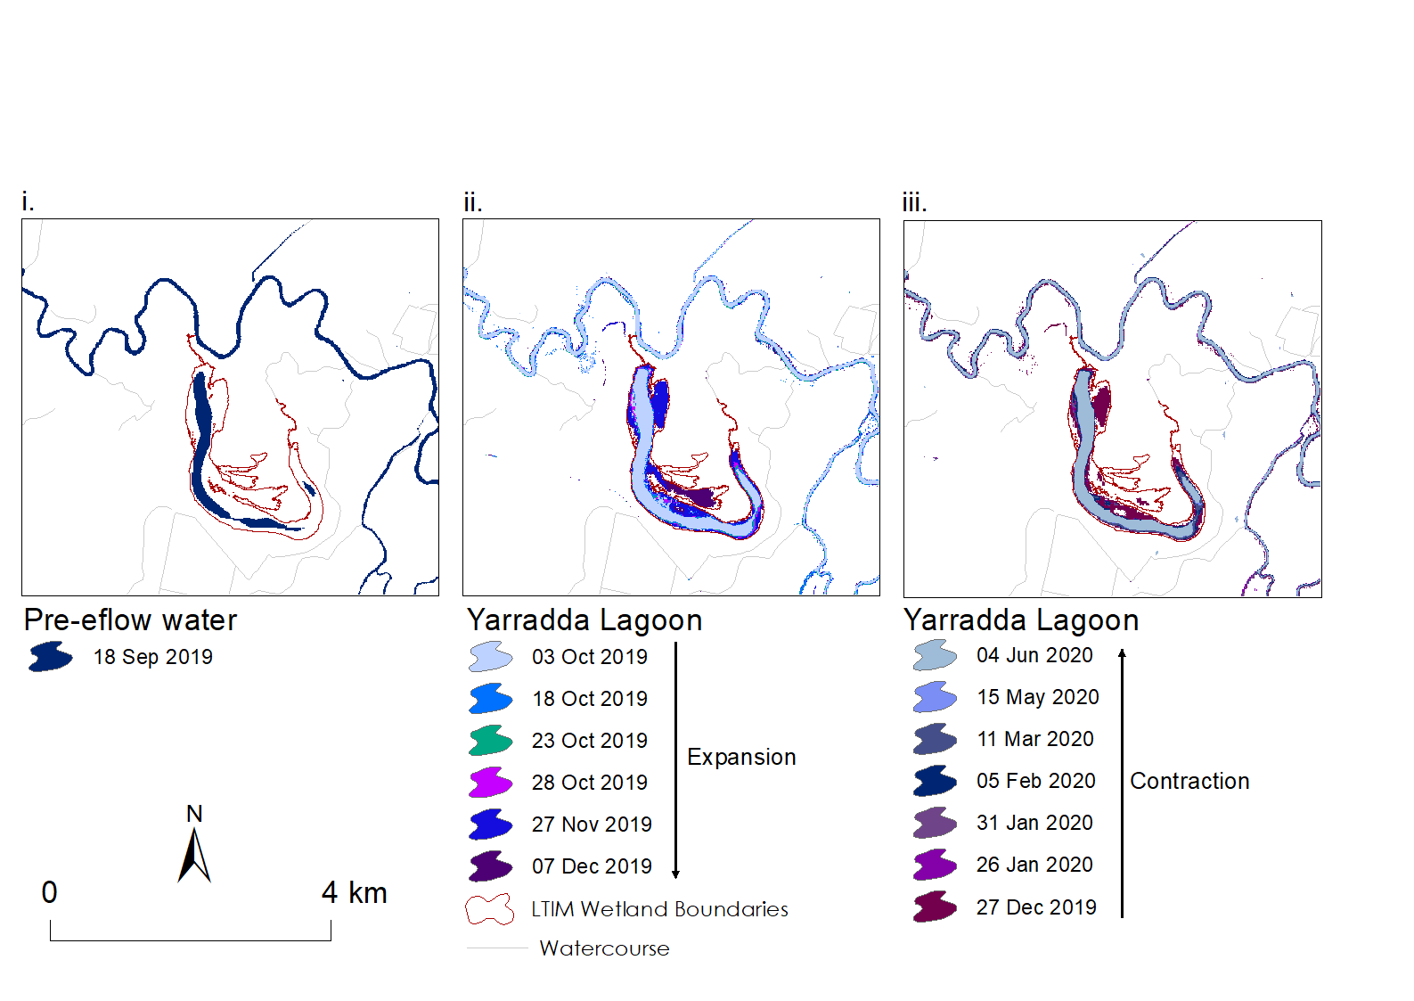

*Figure 4‑21 Inundation progression in Yarradda Lagoon of the mid-Murrumbidgee zone during i. pre-environmental flow conditions, 18 Sep 2019; ii. inundation expansion from Oct to Dec 2019 as a result of the Yarradda Lagoon water action; and iii. inundation contraction, from late Dec 2019 to June 2020. The date at the top of the legend represents the smallest extent in the inundation sequence.*

Sunshower Lagoon was targeted for inundation by environmental flows in the 2019-2020 water year (Table 4‑4, Figure 4‑22). Prior to the 2019-20 pumping water action, 29 Nov 2019, Sunshower Lagoon was dry (Table 4‑4, Figure 4‑22 and Figure 4‑23-i). About 20% of Sunshower Lagoon was inundated on 24 December 2019 and reached its maximum of 26% on 22 February 2020 (Figure 4‑22 and Figure 4‑23-ii). Inundation extent plateaued over the months to May 2020 which meant that about 20% of Sunshower Lagoon was inundated for just over five months (Figure 4‑22 and Figure 4‑23-iii). The last flood that occurred in Sunshower Lagoon was in the 2017-18 water year and so this was the first time in two years that Sunshower Lagoon was inundated to at least 20% of its boundary and the third time inundated in five years (Table 4‑4, Figure 4‑22).

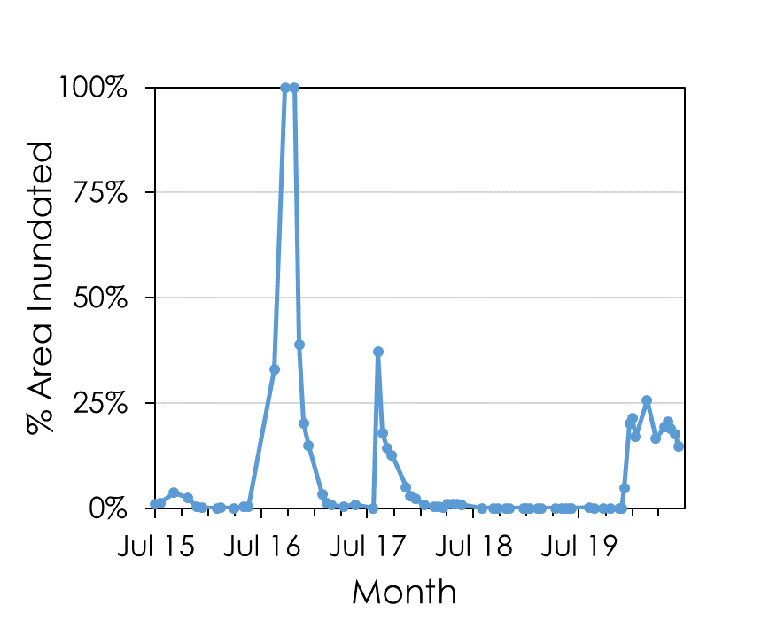

*Figure 4‑22* *Percentage area inundated in Sunshower Lagoon of the mid-Murrumbidgee zone between July 2015 and June 2020.*

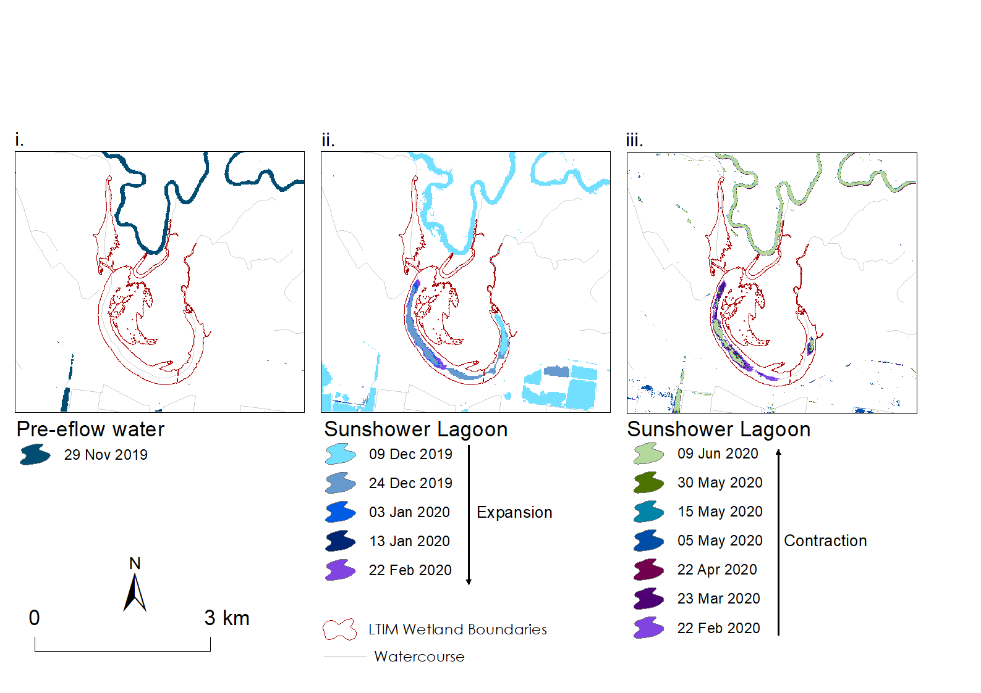

*Figure 4‑23 Inundation progression in Sunshower Lagoon of the mid-Murrumbidgee zone during i. pre-environmental flow conditions, 29 Nov 2019; ii. inundation expansion from Dec 2019 to Feb 2020 as a result of the Sunshower Lagoon water action; and iii. inundation contraction, Feb-Jun 2020. The date at the top of the legend represents the smallest extent in the inundation sequence.*

McKenna’s Lagoon was again not targeted for inundation by environmental flows in the 2019-20 water year. The last flood peak occurred 3 years ago and it has been dry for 2.5 years, since January 2018 (Table 4‑4 and Figure 4‑24). In the last five year McKenna’s lagoon has been inundated to at least 20% of its boundary twice (Table 4‑4 and Figure 4‑24).

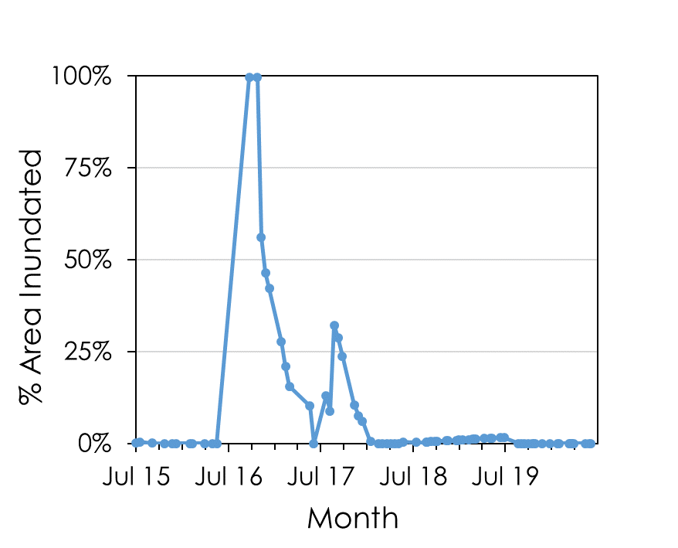

*Figure 4‑24 Percentage area inundated in McKenna’s Lagoon of the mid-Murrumbidgee zone between July 2015 and June 2020.*

***Discussion***

**What did Commonwealth environmental water contribute to wetland inundation extent?**

Commonwealth environmental water actions, combined with NSW environmental water, achieved inundation outcomes in targeted core wetlands in the mid-Murrumbidgee zone, and the Gayini Nimmie-Caira and Redbank zones of the Murrumbidgee Selected Area.

Environmental flows were successfully used to increase inundation extent in core wetlands to create aquatic refuge habitat critical for biota during the forecasted hot and dry conditions of 2019-2020. Inundation from environmental flows successfully increased lateral connectivity between the core wetlands that are distributed through the lignum dominated floodway of the Gayini Nimmie-Caira zone and the river red gum forests of the North and South Redbank regions (Figure 4‑3). Pumping water actions in the Mid-Murrumbidgee zone successfully reconnected lagoons to the river. Whilst the area of wetland inundated was small compared to the entire floodplain, there were good outcomes because a high proportional area (>50%) of the individual core wetlands was inundated when, without environmental flows, they would have been dry.

Inundation occurred in the targeted wetlands as expected given the prevailing dry conditions: inundation reached the targeted wetlands, but inundated areas were small and inundation duration was relatively short. In some locations, inundation has extended into unexpected areas because in the past they would not have been flooded by the small flow volumes used this water year due to levee banks. One such example is Eulimbah Swamp where inundation has spilled into the northern floodplain which is a re-occurring pattern from the previous water year. Usually this inundation pattern would only occur during very large floods or when there is a levee breech. But as the land use and water management changes throughout the Gayini Nimmie-Caira so too will the pattern of flood distribution. Inundation may become distributed into unexpected locations unless they become targeted wetland assets for improved lateral connectivity in the future.

Many of the wetlands within the Murrumbidgee Selected Area require seasonal inundation of sufficient duration to maintain a diverse mosaic of plant communities that transition between a characteristic wet and dry phase in response to the inundation regime. Before river regulation many of these floodplain wetlands would have been connected to the river annually during flooding in the winter and spring months (Frazier et. al. 2005). Some wetlands could possibly have remained partially or fully inundated for up to a year or more making aquatic habitats available all year round in some years. For example, fifty percent of Piggery Lake was inundated for just over a year, with it drawing down this water year to provide critical aquatic habitats for a wide range of different fauna. The water actions delivered in 2019-20 contributed to maintaining the required inundation regime of annual wetting and drying, whilst it affected small areas of core wetlands it also connected many wetland habitats together across large areas. For the MER (LTIM) survey sites being the fifth or sixth year of flooding after drying in as many years, environmental flows contributed to a more natural wetting and drying cycle required for their long-term persistence. However, inundation duration is also critical for the completion of the life history stages of flora and fauna. During the 2019-20 water year, inundation duration was relatively short due to the dry conditions. In the Lowbidgee wetlands inundation lasted for between 20-40 days but for relatively small proportional areas (<50%). In the mid-Murrumbidgee, inundation lasted for between 4.2 and 5.3 months but for small inundated proportions of the wetlands (40% and 20%). Whilst different groups of floodplain wetlands are sensitive to variable flooding regimes, based on our current knowledge most wetland plants require at least three month of inundation duration to maintain vigorous growth (Roberts and Marston 2011).

For wetlands that do not receive flooding, the character of the wetland is likely to change from aquatic species to rainfall dependent species and/or woody plant species (Thomas *et al.* 2010, Bino, *et al.* 2011; Capon and Reid, 2016; Wassens *et al.* 2017). For example, whilst Yarradda Lagoon has been inundated from almost a dry state five times in the last 6 years, for four of these flood events, including this water year, the increased inundation extent to >75% lasted for a very short period of time (< a month). This may make it vulnerable to river red gum encroachment from saplings that most likely established after the large flood of 2012 or terrestrialisation. To avoid river red gum encroachment inundation of river red gum seedling needs to occur very early in seeding life (soon after germination or within three months), with sufficient water depth to ensure it overtops the seedling height and for a sufficient length of time (at least two months) (Campbell et. al, in prep.). McKenna’s Lagoon has been inundated only twice in the last five years and has had a recent dry spell of 2.5 years conditions more suited to plant species that do not rely on flooding but can grow successfully on rainfall and which now dominate this wetland due to altered flooding regimes (Wassens *et al.* 2017).

Our capacity to restore the required inundation regime across the entire Murrumbidgee Selected Area with only environmental flows is limited because the volumes of environmental water available are relatively small compared to those required to inundate the full extent of all floodplain and wetland habitats, frequently and for long periods of time. Despite this, environmental flows may provide the only opportunity for primary productivity, nutrient and carbon cycling, and biotic dispersal and movement. For the wetlands that would have otherwise remained dry this water year if not for environmental flows, the resulting inundation was essential for maintaining critical refuge habitats for waterbirds, native fish and frogs, for supporting the condition and resilience of vegetation communities, and for providing recruitment opportunities of the threatened southern bell frog to reduce the risk of local population extinction.

## Wetland water quality

Prepared by Dr Damian Michael (CSU) and Gaye Bourke (CSU)

***Introduction***

Water quality varies naturally over time, echoing shifts in air temperature, salinisation, aquatic photosynthesis and hydrology. Aquatic organisms can tolerate some variability in physicochemical conditions (Poff *et al.* 1997), however, exceeding tolerance limits can result in impaired growth or reproduction, or mortality (Heugens *et al.* 2001; Bunn *et al.* 2002). Environmental conditions such as extreme heat, limited water movement (stratification) and wetland drying can contribute to changes in physicochemical conditions and result in poor water quality.

In 2019-20, 6 deliveries of Commonwealth environmental water contributed to water quality outcomes in the MER monitored wetlands. These watering actions targeted the majority of MER monitored wetlands in the mid-Murrumbidgee and Gayini Nimmie-Caira zones, and three of the monitored wetlands in the Redbank zone. Wetlands received environmental flows via a combination of pumped and regulated actions (see Table 4‑5).

There were no specific watering objectives related to wetland water quality, however, water quality contributes to the objective “to improve ecosystem and population resilience through supporting ecological recovery and maintaining aquatic habitat.” We evaluated the effectiveness of 2019-20 environmental water deliveries by comparing observed ranges of 1) wetland and riverine physicochemical parameters and 2) riverine concentrations of carbon, nutrients and chlorophyll-a, against the previous five years’ (2014-19) data.

### Commonwealth environmental water is evaluated against the following criteria:

What did Commonwealth environmental water contribute to wetland water quality?

Methods

Wetland water quality monitoring was conducted four times between September 2019 and March 2020 (September, November, January and March) on all occasions when water level is greater 10 cm. Three wetlands in the Gayini Nimmie-Caira zone were unable to be accessed during the March monitoring period due to covid-19 access restrictions. Monitoring includes measurements of physicochemical parameters (temperature (°C), electrical conductivity (EC, μS/cm), turbidity (NTU), pH and dissolved oxygen (mg/L)) at three randomly chosen locations at each wetland site using a calibrated water quality meter (Horiba U-52G).

Water quality outcomes are compared with data from the previous five year period (2014-19) and evaluated against pre-2014 water quality data collected for the Murrumbidgee catchment, noting that ANZECC water quality guidelines are not available for wetlands in south-eastern Australia. Correlations between wetland water depth and water quality measurements are presented.

Results

Physicochemical measurements from wetland sites in 2019-20 were largely consistent with data collected during the previous five year period (2014-19) and remained within the upper and lower ranges of pre-2014 measurements (Table 4‑5, Figure 4‑25, Figure 4‑26, Figure 4‑27and Figure 4‑28,). In 2019-20, measurements across all wetlands were broadly consistent with previous years. Most wetlands displayed some variation in all measures between years, consistent with periods of wetting and drying. Sunshower Lagoon had notably lower dissolved oxygen and conductivity readings in 2019-20 following a drying period between January 2018 and December 2019. Permanent and regularly watered wetlands, particularly Waugorah and Yarradda Lagoons, display the least fluctuation in all measures between all years. As in previous years turbidity was significantly related to wetland water depth (Table 4‑6). Other measures (pH, conductivity and dissolved oxygen) were not significantly related to wetland water depth.

Table ‑ Pre-2014, 2014-2019 and 2019-2020 median, minimum and maximum and number of samples for water quality measurements collected across all wetlands in the Murrumbidgee Selected Area.

|  |  |  |  |  |
| --- | --- | --- | --- | --- |
| Indicator | Conductivity  mS cm-1 | pH | Turbidity  NTU | DO  mg L-1 |
| Pre-2014  Median  (5th – 95th) | 0.229  (0.126 - 0.655) | 7.93  (7.05 - 9.41) | 94.8  (3.0 - 409.5) | 8.79  (2.55 - 19.48) |
| #samples | 365 | 356 | 355 | 329 |
| 2014-19  Median  (min-max) | 0.27  (0.10 – 0.52) | 7.93  (6.34 – 8.87) | 79.88  (13.49 – 896.08) | 9.76  (1.48 – 15.44) |
| #samples | 154 | 154 | 152 | 153 |
| 2019-20  Median  (min-max) | 0.22  (0.12 – 0.36) | 7.41  (5.97 – 8.16) | 124.80  (54.83 – 198.42) | 8.90  (2.99 – 11.47) |
| #samples | 30 | 30 | 30 | 30 |

Table ‑ Correlations (2-tailed) between physicochemical measurements and wetland depth for composited water quality data collected between September 2014 and March 2020 (*significant at P <0.01).

|  |  |  |  |  |
| --- | --- | --- | --- | --- |
| Indicator | Conductivity mS cm-1 | pH | Turbidity  NTU | DO  mg L-1 |
| Coefficient | -0.141 | .031 | -0.264* | -0.104 |
| Significance | 0.069 | 0.695 | 0.001 | 0.181 |
| N | 167 | 167 | 165 | 166 |

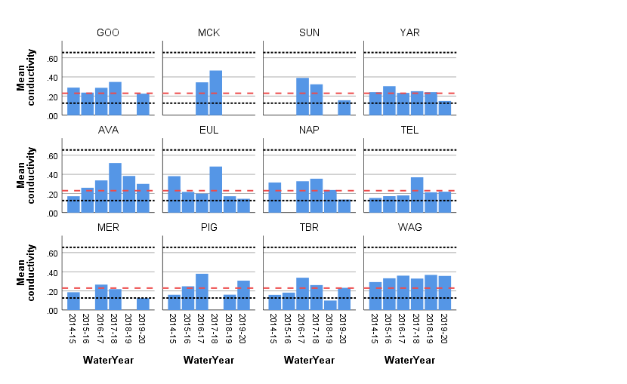

Figure ‑ Mean water conductivity (mS cm-1) for each wetland between September 2014 and March 2020. Samples are averaged across three sites at each wetland. Missing error bars indicate wetlands that were not surveyed on that respective watering year due to low water levels. Dashed (red) lines indicate median and dotted (black) lines 5th and 95th percentiles of pre-2014.

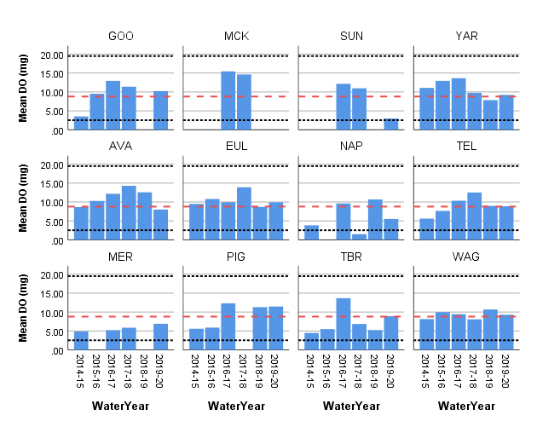

Figure ‑ Mean dissolved oxygen (mg) for each wetland between September 2014 and March 2020. Samples are averaged across three sites at each wetland. Missing error bars indicate wetlands that were not surveyed on that respective watering year due to low water levels. Dashed (red) lines indicate median and dotted (black) lines 5th and 95th percentiles of pre-2014.

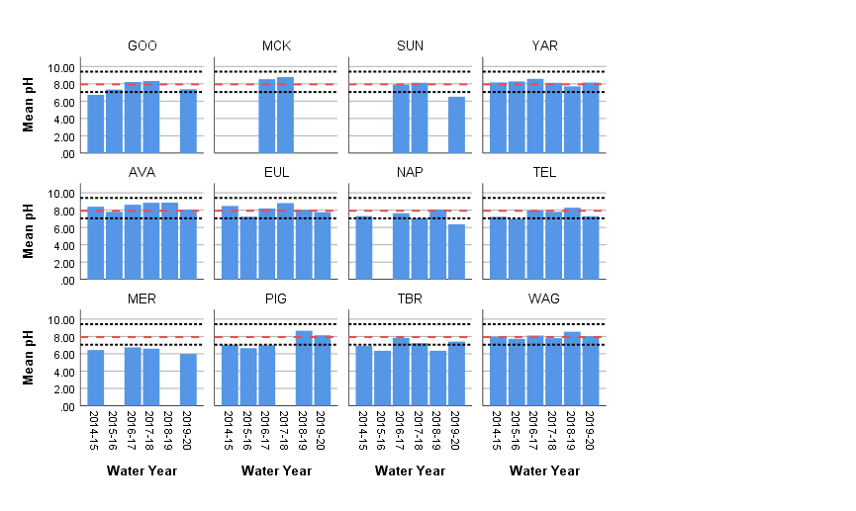

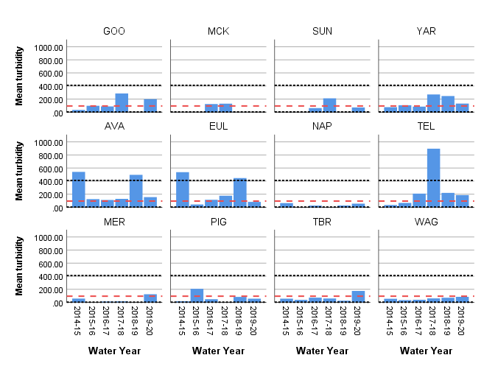Figure ‑ Mean pH for each wetland between September 2014 and March 2020. Samples are averaged across three sites at each wetland. Missing error bars indicate wetlands that were not surveyed on that respective watering year due to low water levels. Dashed (red) lines indicate median and dotted (black) lines 5th and 95th percentiles of pre-2014.

Figure ‑ Mean turbidity (NTU) for each wetland between September 2014 and March 2020. Samples are averaged across three sites at each wetland. Missing error bars indicate wetlands that were not surveyed on that respective watering year due to low water levels. Dashed (red) lines indicate median and dotted (black) lines 5th and 95th percentiles of pre-2014.

Discussion

### What did Commonwealth environmental water contribute to wetland water quality?

Declining water quality associated with wetland drying is a feature of ephemeral wetlands and is observed regularly across the MER monitored wetlands. As expected, declining water levels in some wetlands across the six year monitoring period have resulted in some episodes of poor water quality, however, there has been no net decline in water quality over time.

Turbidity is highly variable between wetlands, reflecting differences in wetland drying regimes at the time of sampling. Turbidity is influenced by a range of biological and physical processes including sediment suspension, inorganic and organic matter and algal production. High productivity during a wetland’s draw-down phase can contribute to high turbidity levels and is a normal part of a wetland’s water quality dynamics.

In 2019-20 pumped water delivery maintained moderate-high water levels at Yarradda Lagoon in the mid-Murrumbidgee, which has held water since allowed to dry down (for carp management) in September 2018. These watering actions have extended a period of good water quality that commenced with the first pumped water delivery at this wetland site in 2017.

Pumping infrastructure was recently installed at Sunshower Lagoon in the mid-Murrumbidgee and the first pumped water delivery took place in December 2019 ending a two year dry period. An initial period of poor water quality was anticipated in light of the long dry period, large amount of organic material present and extreme heat at the time of water delivery. Water quality monitoring in January 2020 showed very low levels of dissolved oxygen and below average pH consistent with hypoxic blackwater. Blackwater is a short term natural event that occurs in floodwater when decomposition of organic material present (such as accumulated leaf litter) causes deoxygenation of the water. Subsequent water quality monitoring showed a steady increase in dissolved oxygen in the following months following water delivery.

## Vegetation diversity

Prepared by Dr Skye Wassens (CSU)

Introduction

The composition and diversity of wetland plant communities is influenced by a range of hydrological and geomorphological metrics. Over long time frames the composition and species richness of wetland plant communities is influenced by the frequency of inundation (Reid *et al.* 2011), with dry periods that exceed the long-term average often leading to losses from both the extant species pool and the seedbank (Brock *et al.* 2003). At shorter time frames, the duration of inundation, water depth, day-length and temperature can all influence the patterns of growth and flowering of wetland plants (Brock *et al.* 1997; Casanova *et al.* 2000).

The most significant long-term contribution of CEWO to vegetation community diversity is therefore through the maintenance of appropriate watering regimes that support the establishment, growth and reproduction of a mix of perennial and annual species, while characteristics of annual watering actions (timing, duration and inundation extent) can influence which annual species germinate and the growth rates of perennial species within a given year. Species richness tends to be more variable over time then community composition.

In 2019-20 the largest volume of Commonwealth environmental water was delivered through the Gayini Nimmie-Caira (GNC Refuge, SBF Breeding, and Tala Ck System Refuge) which inundated or partially inundated monitoring sites through the GNC as well as Wagourah Lagoon in the Redbank system (Table 4‑7). Pumping of individual wetlands was undertaken in the Mid-Murrumbidgee at Yarradda, Gooragool and Sunshower.

Table ‑ Summary of environmental watering actions that influence the hydrological regimes of the 12 monitored wetlands during the monitoring period.

|  |  |  |  |
| --- | --- | --- | --- |
| Water Action Reference | Event | Monitoring sites | Objectives |
| 10082-18 | Gooragool and Mantangry Lagoons Pumping | Gooragool Lagoon | Support native aquatic vegetation growth and maintain condition |
| 10082-31 | Sunshower Lagoon Pumping | Sunshower Lagoon | support native vegetation condition and resilience |
| 10082-20 | Yarradda Lagoon Pumping | Yarradda Lagoon | Support native aquatic vegetation growth and maintain condition. |
| 10082-28 | Yanga NP Refuge | Two Bridges, Mercedes Swamp, Piggery Swamp | Maintain wetland vegetation condition and resilience  Prevent River red gum encroachment |
| 10082-21 | GNC Refuge, SBF Breeding, and Tala Ck System Refuge | Waugorah Lagoon  Nap Nap Swamp  Eulimbah swamp  Telephone Creeks,  Avalon Swamp. | Support the ecological character, condition and resilience of vegetation communities. |

### Commonwealth environmental water is evaluated against the following criteria:

* Did Commonwealth environmental water contribute to vegetation species diversity?
* Did Commonwealth environmental water contribute to vegetation community diversity?

Methods

Despite some variability in the composition of overstory species, which consist of a mix of river red gum and black box, understory communities across the 12 wetlands broadly fell into three key groups (Figure 4‑29); Lignum-black box-red gum wetlands (Nap Nap, Telephone Creek, Avalon in the Gayini Nimmie-Caira and Waugorah Lagoon in the Redbank zone); tall emergent aquatic wetlands characterised by an understory of spike rush (*Eleocharis* species),and fringing river red gum (Mercedes, Two Bridges and Piggery Swamp in the Redbank Zone). All four of the wetlands in the mid-Murrumbidgee are classified as river red gum woodland with deeper open ox-bow lagoons and fringing river red gum (Sunshower, Gooragool, Yarradda, McKennas).

Over the past 6 years environmental water has influenced the hydrological regime along the vegetation transects and had subsequent impacts on the species composition and percent cover of key species. Monitoring of vegetation communities is undertaken four times per year (September, November, January and March) and commenced in September 2014 (Wassens *et al.* 2014a, Wassens et al 2019). Surveys are conducted at twelve wetlands, with data collected along two to three fixed transects per wetland starting at the high-water mark and terminating at the centre of the wetland. Each transect contains three or five, 10 metre quadrats depending on transect length. Data on the percentage cover of each species, open water, bare ground, leaf litter, and logs > 10 cm, tree canopy crown cover, water depth (cm) and soil moisture is recorded within each quadrat.

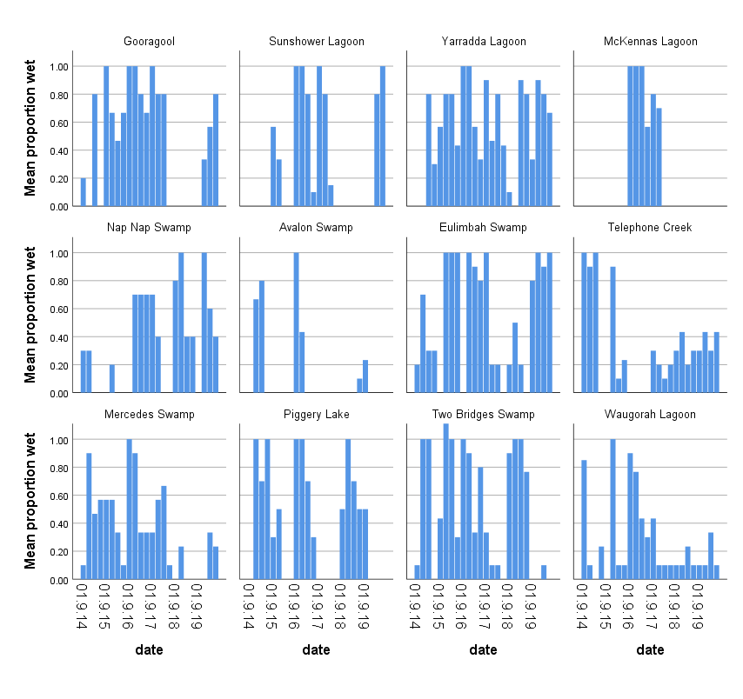*Figure 4‑29 Water regimes along vegetation transects. Figure represents the proportion of quadrats (1 = all quadrats wet and 0 = no quadrats wet) that contained water during the survey.*

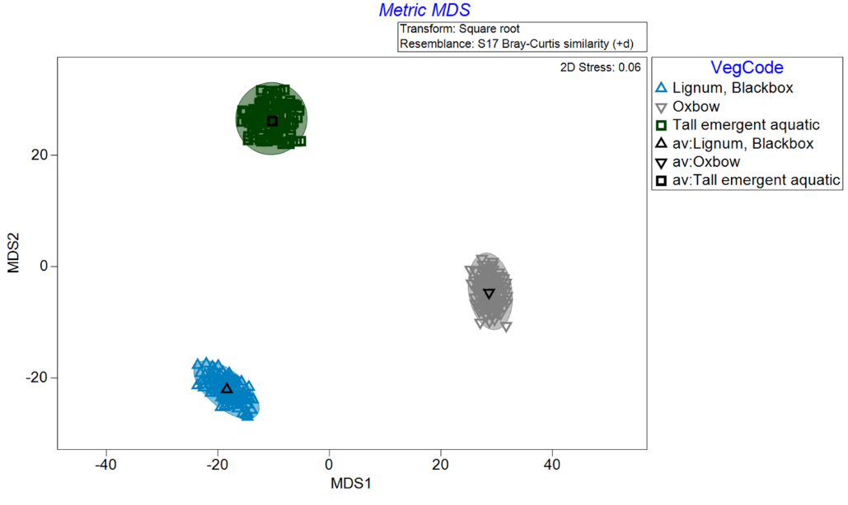

Figure ‑ Bootstrap averages of community types presented within a metric MDS plot indicate that distinct sets of vegetation species group within the three dominant community types.

### Data analysis

Comparisons of community structure and species diversity were undertaken using Primer version 7 (Clarke *et al.* 2006). The percentage cover of each species was SquareRoot transformed before analysis. Resemblance matrices were developed using Bray Curtis similarities (zero inflated +0.01). Analysis of similarities (ANOSIM) was used to compare community composition between wetlands, water years and wet-dry phases. SIMPER is used to identify the species that contribute most to differences between sites (Anderson 2005). Bootstrap procedures were undertaken on percent cover data to test significant difference between vegetation community types (Lignum-Black Box, Tall Emergent, and oxbow lagoons) and to test differences in community cover during wet and dry phases within each group. Generalised Linear Models were used to compare species richness between the mean proportion of survey quadrats that inundated and species richness (n).

Results

### Commonwealth environmental water contribution to vegetation species diversity

Overall species richness of water dependent species increased within all vegetation communities with respect to the proportion of the survey quadrats that were inundated by CEWO water (GLM 154.398, p <0.001) (Table 4‑8). There was also a significant interaction between the proportion of the quadrats wet and vegetation community type- with species richness increasing most strongly in black box lignum and tall emergent spike rush communities following wetland inundation (Figure 4‑31), As expected the diversity of terrestrial species declined significantly with an increasing proportion of quadrats inundated (GLiM 45.760, p <0.001), when all species are considered in a single measure of species richness, the declining diversity of terrestrial species is to some extent offset by the increasing diversity of water dependent species leading to no net change in species richness in response to wetland inundation overall (GLiM 3.912, p =0.141) although diversity patterns did differ between communities.

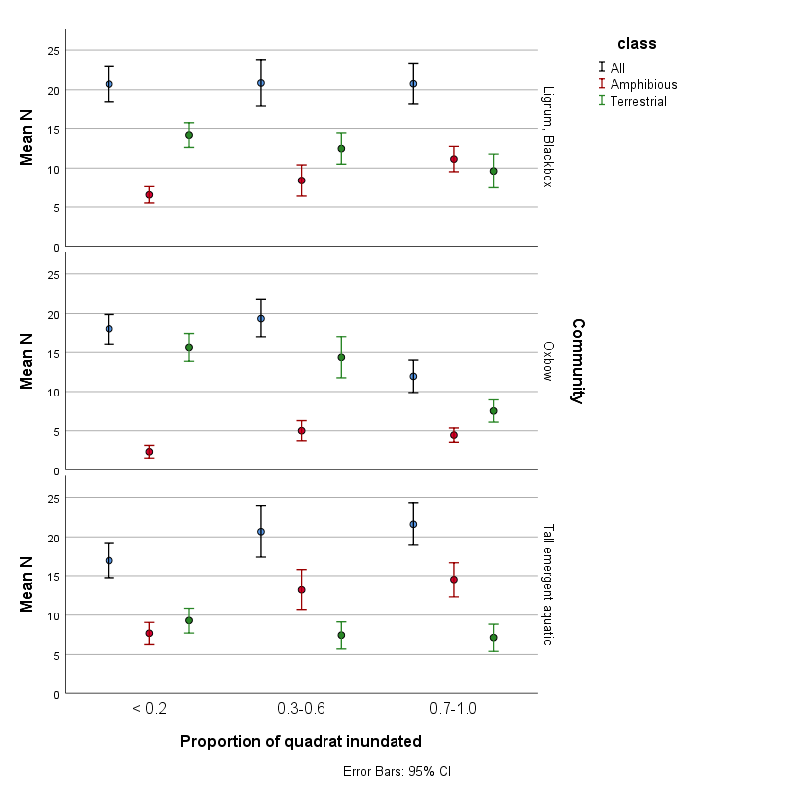

*Figure 4‑31 Mean species richness for all species and water dependant species (amphibious)with the proportion of survey quadrats inundated during the survey.*

Table 4‑8 Generalised Linear Model comparing overall species richness (all species), species richness of water dependent (amphibious) and terrestrial species

|  |  |  |  |  |
| --- | --- | --- | --- | --- |
| **Tests of Model Effects** | | | | |
| **Class** | **Source** | **Type III** | | |
| Wald Chi-Square | df | Sig. |
| All | (Intercept) | 12455.298 | 1 | 0.000 |
| Proportion quadrats inundated | 3.912 | 2 | 0.141 |
| Community | 17.079 | 2 | 0.000 |
| Proportion quadrats inundated * Community | 22.009 | 4 | 0.000 |
| Amphibious | (Intercept) | 2674.654 | 1 | 0.000 |
| Proportion quadrats inundated | 48.760 | 2 | 0.000 |
| Community | 111.798 | 2 | 0.000 |
| Proportion quadrats inundated * Community | 3.064 | 4 | 0.547 |
| Terrestrial | (Intercept) | 5549.717 | 1 | 0.000 |
| Proportion quadrats inundated | 45.795 | 2 | 0.000 |
| Community type | 37.640 | 2 | 0.000 |
| Proportion quadrats inundated * Community | 10.386 | 4 | 0.034 |
|  | | | | |

### mid-Murrumbidgee wetland recovery actions

Three watering actions were undertaken targeting vegetation recovery in the mid-Murrumbidgee, with pumping actions being undertaken in Yarradda, Sunshower and Gooragool Lagoons in spring and summer 2019. The primary objectives of these actions with respect to vegetation were to “*Support native aquatic vegetation growth and maintain condition*”.

These actions build on previous Commonwealth environmental watering actions that aimed to restore natural seasonal inundation regimes through river to wetland reconnection flows (Gooragool, Sunshower, Yarradda and Mckennas in 2017-18) which followed on from an unregulated reconnection in 2016-17 and by targeted pumping and managed draw down (Yarradda and Gooragool Lagoons 2014 to 2019). Pumping infrastructure was installed at Sunshower Lagoon in 2019 to allow for targeted inundation. Pumping at both Yarradda and Sunshower can be undertaken in a manner that restricts entry of large carp into the wetlands.

Overall the species richness of water dependant species is higher and has increased at a faster rate at Yarradda and Gooragool Lagoons which have been watered in most years (Figure 4‑32).However, there is evidence that environmental watering actions at Sunshower in 2017-18 and 2019-20 did contribute to an increase in species richness, three new aquatic species, common water milfoil (*Myriophyllum papillosum)*, floating pondweed (*Potamogeton tricarinatus*), and curly pondweed (*P. crispus*) were identified at Sunshower following environmental watering actions in 2017-18 and duck weed (*Lemna disperma*) identified from the vegetation survey transects in 2019-20. It should also be noted that additional species including starfruit (*Damasonium minus*) and tall spike rush (*Eleocharis spaculata*) were recorded in areas just outside of the set survey transects and the overall vegetation response across the entire wetland demonstrates clear capacity for vegetation recovery at this site.

Yarradda Lagoon has shown a steady increase in the number of aquatic species richness between 2014 and 2019, with numbers starting to stabilise in 2019-20. It is worth noting that the number of water depend species recorded in 2019-20 is now similar to those recorded during the IMEF surveys in 2000-01 prior to the millennium drought (Wassens 2016) although the percentage cover of key species particularly spiny mud grass, tall spike rush and common spike rush is still lower. It is expected that now established the percent cover of these key species will increase with repeat watering.

|  |
| --- |
|  |

Figure ‑ Species accumulation curve for aquatic species in wetlands in the mid-Murrumbidgee relative to mean water depth (cm) between September 2014 and March 2020 (Site codes: MCK = McKennas Lagoon, SUN = Sunshower Lagoon, GOO = Gooragool Lagoon, YAR = Yarradda Lagoon). Grey bars unregulated inundation, Blue managed environmental flows.

### Did Commonwealth environmental water contribute to vegetation community diversity?

In 2019-20 environmental water was used to support vegetation communities at 7 of the 12 long term monitoring sites. While each of these wetlands represents a distinct community in its own right (ANOSIM R 0.805, p <0.001), the vegetation communities within each of the wetlands can be further classified into three broad groups which are relatively stable through wet and dry phases – these are oxbow lagoons in the mid-Murrumbidgee, lignum-black box wetlands through Gayini Nimmie-Caira and tall emergent spike rush communities which are close to the main river channel within the Redbank zone. As noted in previous years, environmental water is the principle driver of aquatic vegetation communities and there is a clear shift in community composition at both the wetland and community following environmental watering. The relationship between community composition and watering regime differed between community types. Overall community composition differed significantly with respect to the degree that the wetland was inundated at the time of survey for all three communities (Table 4‑9, Figure 4.33). However, the relationship with the partially wet category differed to the vegetation communities. For example, within lignum - black box community composition during partial inundation, did not differ significantly from those in dry phases, while in oxbows and tall spike rush communities, partial inundation did not differ significantly from those of wet phases. This most likely reflects differences in the types of species that colonise wetlands during draw down phases, lignum -black box systems tend to be dominated by fast growing annual species that colonise mud flats as the wetlands draw down, while river red gum spike rush communities contain a greater percentage of perennial species particularly spike rush that persists for extended periods fulling drawdown.

Table 4‑9 *ANOSIM comparison between vegetation community composition on occasions when less than 20% of survey quadrats were inundated ( dry), 30-60% of quadrats inundated (partially) and > 70% of quadrats inundated (wet).*

|  |  |  |  |
| --- | --- | --- | --- |
| **Group** | **Watering status** | **R** | **p** |
| lignum-black box  ANOSIM R 0.177, p <0.001 | Dry, Partial | 0.017 | 0.311 |
| Dry, Wet | 0.308 | 0.001 |
| Partial, Wet | 0.149 | 0.003 |
| Oxbow ANOSIM R 0.271, p <0.001 | Dry, Partial | 0.226 | 0.053 |
| Dry, Wet | 0.357 | 0.001 |
| Wet, Partial | -0.029 | 0.602 |
| tall emergent  ANOSIM R 0.275, p <0.001 | Dry, Partial | 0.268 | 0.001 |
| Dry, Wet | 0.388 | 0.001 |
| Wet, Partial | 0.13 | 0.121 |

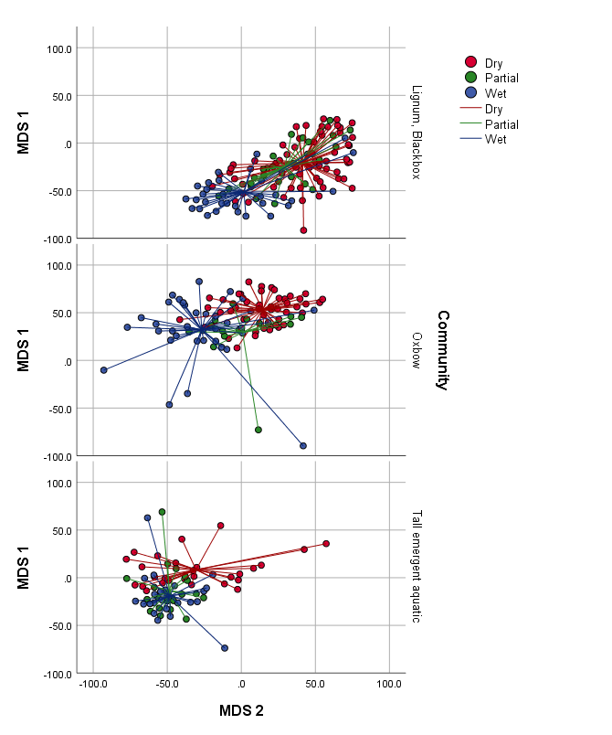

*Figure 4‑33 MDS visualisation of community composition within each community type during dry, partially wet and wet phases. Overlapping points are most similar while distant points represent less similar community composition. Lines represents centroids of the data cloud.*

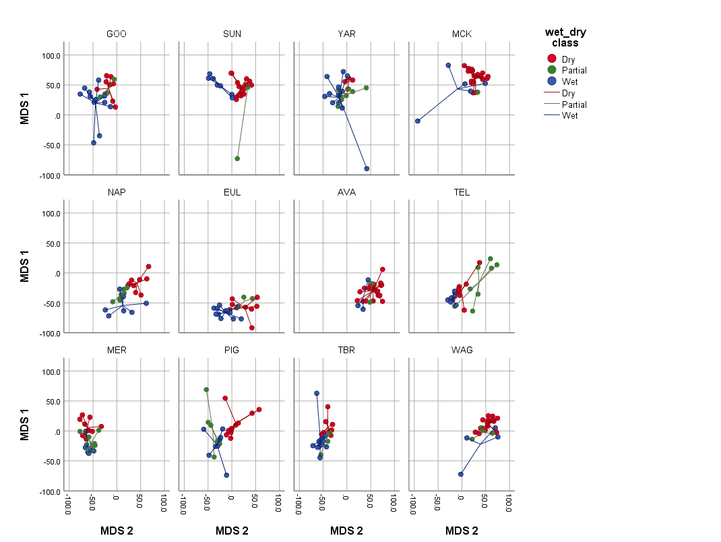

*Figure 4‑34 Metric multidimensional scaling plot of wetland vegetation community composition within the three water management zones during wet and dry phases between September 2014 and March 2019. The greater the overlap the more similar the wet and dry phases are between vegetation communities (BB lignum = Nimmie-Caira wetlands, emergent = Redbank wetlands, and oxbow = mid-Murrumbidgee wetlands).*

Despite the dynamic shift in vegetation community composition during wetting and drying phases, the overall mix of species within communities has remained relatively stable over the past 6 years, maintaining clearer differences in species composition between vegetation communities and within vegetation communities during dry (no environmental water and wet (environmental water phases) across all 12 monitoring sites.

Based on SIMPER analysis of all data collected between 2014 and 2020, native water dependant species contributed highly to vegetation communities following environmental water. In particular, old man weed (*Centipeda cunninghamii*), lesser joyweed (*Alternanthera denticulata*)*,* common spike rush (*Eleocharis acuta*), tall spike rush (*Eleocharis sphacelata*), nardoo (*Marsilea drummondii*), water primrose (*Ludwigia peploides*), and common water milfoil (*Myriophyllum papillosum*) (Table 4‑10). While a mix of native water dependent and terrestrial species contributed most to the composition of wetlands during their dry phase, including crumb weed (*Dysphania pumilio*), caustic weed (*Chamaesyce drummondii*). Old man weed was also relatively abundant at dry sites, particularly in the months following environmental watering.

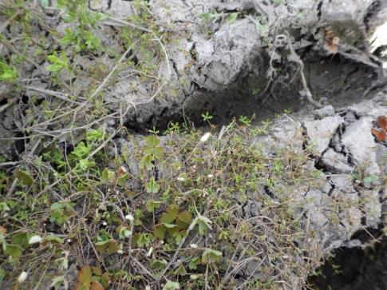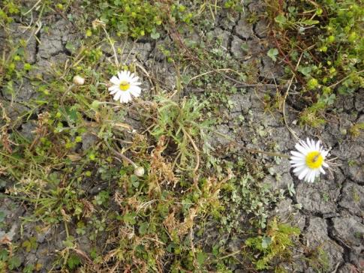Plate 4‑1 Diversity of native species including nardoo, narrow nardoo, old man weed, swamp daisy and mouse tails following Commonwealth Environmental watering at Avalon swamp September 2019

|  |  |  |
| --- | --- | --- |
| *D:\Users\swassens\Desktop\Vegetation transect photos\Eulimbah\EUL T2 Q50 Sep 19.JPG* | *D:\Users\swassens\Desktop\Vegetation transect photos\Eulimbah\EUL T2 Q50 Nov 19 (2).JPG* | *D:\Users\swassens\Desktop\Vegetation transect photos\Eulimbah\EUL T2 Q50 Mar20.JPG* |

Plate 4‑2 Changes in vegetation community and cover at Eulimbah Swamp transect 2. Left: September 2019. Mid: November 2019. Right: March 2020.

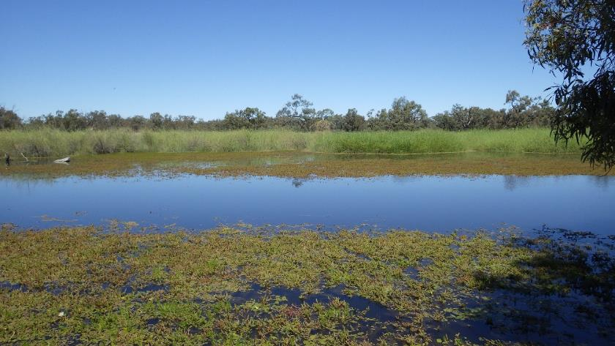Table 4‑10 SIMPER comparisons of vegetation communities while wetlands are wet (environmental water and unregulated flows) and dry in each vegetation community.

|  |  |  |  |  |  |
| --- | --- | --- | --- | --- | --- |
| **Species supported by environmental water** | **Av. Abundance\*** | **% contribution** | **Species occurring during dry phases** | **Av. Abundance\*** | **% contribution** |
| **Tall spike rush community** | | | | | |
| *Eleocharis sphacelata* | 1.73 | 14.53 | *Centipeda cunninghamii* | 1.17 | 15.91 |
| *Eleocharis acuta* | 1.4 | 12.58 | *Eleocharis acuta* | 0.92 | 7.91 |
| *Marsilea drummondii* | 1.09 | 9.8 | *Persicaria decipiens* | 0.7 | 7.19 |
| *Ludwigia peploides* | 1.05 | 7.99 | *Marrubium vulgare* | 0.67 | 6.42 |
| *Alternanthera denticulata* | 0.68 | 4.18 | *Marsilea drummondii* | 0.6 | 6.26 |
| *Myriophyllum papillosum* | 0.76 | 4.13 | *Eucalyptus camaldulensis* | 0.52 | 5.55 |
| *Pratia concolor* | 0.65 | 4.1 | *Eleocharis sphacelata* | 0.66 | 5.19 |
| *Persicaria decipiens* | 0.63 | 3.91 | *Ludwigia peploides* | 0.63 | 4.81 |
| *Centipeda cunninghamii* | 0.62 | 3.89 | *Dysphania pumilio* | 0.63 | 4.73 |
| *Azolla filiculoides* | 0.78 | 3.42 | *Alternanthera denticulata* | 0.5 | 4.06 |
| *Ranunculus undosus* | 0.65 | 3.22 | *Chamaesyce drummondii* | 0.4 | 2.72 |
| **Oxbow lagoons** | | | | | |
| *Eucalyptus camaldulensis* | 0.92 | 17.03 | *Eucalyptus camaldulensis* | 1.09 | 5.68 |
| *Eleocharis acuta* | 0.93 | 12.81 | *Calotis scapigera* | 0.8 | 3.35 |
| *Centipeda cunninghamii* | 0.8 | 8.92 | *Cirsium vulgare\** | 0.89 | 3.24 |
| *Alternanthera denticulata* | 0.72 | 8.64 | *Atriplex semibaccata* | 0.76 | 3.14 |
| *Atriplex semibaccata* | 0.58 | 6.44 | *Polygonum aviculare\** | 0.67 | 2.16 |
| *Cynodon dactylon* | 0.51 | 4.37 | *Centipeda cunninghamii* | 0.57 | 1.73 |
| *Pseudoraphis spinescens* | 0.62 | 4.06 | *Lactuca serriola\** | 0.56 | 1.65 |
| *Chamaesyce drummondii* | 0.46 | 3.61 | *Cynodon dactylon\** | 0.5 | 1.48 |
| *Persicaria prostrata* | 0.51 | 3.34 | *Chamaesyce drummondii* | 0.43 | 1.25 |
| *Calotis scapigera* | 0.41 | 2.95 | *Phyla canescens\** | 0.41 | 1.19 |
| **Lignum-Black Box communities** | | | | | |
| *Duma florulenta* | 1.42 | 21.98 | *Duma florulenta* | 1.36 | 5.03 |
| *Centipeda cunninghamii* | 0.85 | 9.46 | *Centipeda cunninghamii* | 0.98 | 2.81 |
| *Eleocharis acuta* | 0.67 | 5.24 | *Marsilea drummondii* | 0.95 | 2.77 |
| *Marsilea drummondii* | 0.64 | 5.18 | *Chenopodium nitrariaceum* | 0.67 | 2.17 |
| *Eleocharis pusilla* | 0.7 | 4.67 | *Mentha australis* | 0.6 | 1.88 |
| *Chenopodium nitrariaceum* | 0.53 | 4.18 | *Alternanthera denticulata* | 0.64 | 1.66 |
| *Ludwigia peploides* | 0.56 | 3.84 | *Verbena supina\** | 0.61 | 1.47 |
| *Alternanthera denticulata* | 0.52 | 3.65 | *Heliotropium europaeum\** | 0.68 | 1.42 |
| *Eucalyptus camaldulensis* | 0.36 | 2.59 | *Dysphania pumilio* | 0.55 | 1.27 |
| *Sclerolaena divaricata* | 0.43 | 2.42 | *Eleocharis pusilla* | 0.54 | 0.92 |
| *Myriophyllum papillosum* | 0.42 | 2.19 | *Chamaesyce drummondii* | 0.4 | 0.85 |
| TN = terrestrial native species, TI = Terrestrial introduced species, AN = water dependent native species  * Higher average abundance indicates a greater overall contribution to the percentage cover of all | | | | | |
|  | | | | | |

Discussion

There were five key watering actions undertaken in 2019-20 that influenced the hydrology of the 12 monitored wetlands, 11 of the 12 monitoring sites had at least one quadrat inundated in 2019-20, although only seven wetlands received significant CEWO water in 2019-20. With larger scale inundation occurring at Yarradda, Gooragool, Sunshower in the mid-Murrumbidgee, and Nap Nap and Eulimbah in the Gayini Nimmie-Caira, there was partial inundation at Two Bridges and Mercedes Lagoons in the Redbank system. Overall, these watering actions were successful in achieving the stated objectives with respect to vegetation, but outcomes varied between individual wetlands. Richness of water dependant species was significantly higher in wetlands that received environmental water and increased with respect to the percentage of the survey quadrats that were inundated. Watering actions in the mid-Murrumbidgee at Sunshower and Yarradda Lagoons were successful in maintaining the diversity of water dependent species. Importantly, Yarradda Lagoon now supports a similar species richness as it did prior to the millennium drought (Wassens, Ning 2016), although the overall cover of key species - spiny mudgrass and tall spike rush species remains patchy, most likely due to these perennial species being relatively slow growing taking longer to re-establish via vegetative growth which will lead to a gradual increase in percentage cover over time. Watering actions in Sunshower Lagoon have also increased the cover of spiny mudgrass although the patchy distribution of clumps of mudgrass means that the full extent of vegetation establishment is not always captured along the vegetation transects.

### Management implications

Watering actions targeting Avalon Swamp inundated a small section of the main wetland although for a very short duration. The flow was sufficient to trigger emergence of a diversity of water dependent species, but mainly those specialised in colonising mud flat habitats during draw down such as Nardoo and old man weed. However, the very short inundation period meant that growth and reproduction opportunities for these species was limited and other water dependant species previously recorded at the wetland including common spike rush and water primrose were absent. Future watering actions should aim to achieve complete inundation of the main wetland for approximately 8 weeks, to support the growth and reproduction of key species.

There is a clear relationship between the number of quadrats that were inundated and the diversity of water dependent species. In the Gayini Nimmie-Caira, Avalon and Telephone Creek, while receiving some top up flows from the permanent dam and creek line, have received limited inundation of the larger wetland area which typically supports the greatest diversity of water dependent species. Likewise, Wagourah Lagoon spills into a substantial area of lignum and river coobah which supports a high diversity of water dependent species when inundated. The larger lignum wetland complex of both Wagourah and Telephone Creek has contained water on only 30% of survey occasions, inundating these less frequently watered areas during years of high water availability should be a priority.

Pumping environmental water into wetlands within the mid-Murrumbidgee can limit the biomass of carp entering the wetland, which in turn can improve germination and establishment of water dependent plant species. In the mid-Murrumbidgee, there is some evidence that excluding carp, and undertaking annual inundation, may be particularly effective in establishing areas of spiny mudgrass and spike rush. There is growing evidence that excluding carp from both Yarradda and Sunshower Lagoons has supported vegetation establishment. However, during natural reconnections, it is likely that these wetlands will again be recolonised by large carp. In these instances, managed drawdowns in autumn or winter may be required to again reduce carp biomass and support vegetation establishment.

## Wetland fish

Prepared by Dr Damian Michael (CSU), Gaye Bourke (CSU), Dr Skye Wassens (CSU)

Introduction

River regulation has altered natural flow patterns, reducing the frequency and duration of small to medium natural flow events and preventing regular connections between the river and off-channel habitats (Arthington *et al.* 2003; Balcombe *et al.* 2006b). This loss of connectivity prevents movement between river and floodplain and reduces the availability of permanent off-channel habitats, which has contributed to a significant decline in native fish in the Murrumbidgee Catchment. Native fish communities in the Murrumbidgee catchment are highly degraded, displaying declines in distribution, abundance and species richness (Gilligan 2005). In particular, small-bodied floodplain species such as the Murray hardyhead (*Craterocephalus fluviatilis*), southern pygmy perch (*Nannoperca australis*), southern purple-spotted gudgeon (*Mogurnda adspersa*) and olive perchlet (*Ambassis agassizii*) that were historically abundant throughout Murrumbidgee River wetland habitats are now considered locally extinct (Gilligan 2005). In addition, introduced species such as common carp (*Cyprinus carpio*) can dominate fish captures and are reported to form up to 80% of the total fish biomass in some locations (Gilligan 2005).

During the 2019-20 water year, Commonwealth environmental water was delivered to seven of the 12 MER monitored wetlands in the mid-Murrumbidgee, Gayini Nimmie-Caira and Redbank to support native vegetation communities, and maintain critical refuge habitat for native aquatic biota (Table 4‑11). In the mid-Murrumbidgee, watering actions included pumped delivery to Gooragool, Yarradda and Sunshower Lagoons. Although not a regularly monitored MER site Mantangry Lagoon was monitored on all four monitoring occasions during the 2019-20 water year when a watering action was used aiming to maintain critical refuge habitat for native fish, including established golden perch. This site is now routinely monitored in place of McKennas Lagoon which has remained dry for the past two years). Water was subsequently released from Mantangry via a connecting channel to inundate neighbouring Gooragool Lagoon.

Table ‑ Summary of environmental watering actions that influenced wetland fish diversity during the 2019-20 monitoring period.

|  |  |  |  |
| --- | --- | --- | --- |
| Water Action Reference | Event | Site | Objectives |
| 10082-18 | Gooragool and Mantangry Lagoons pumping | Gooragool Mantangry | Maintain critical refuge habitat for waterbirds, native fish (including established golden and silver perch), frogs, turtles and other water dependent animals; |
| 10082-19 | Wilbriggie Lagoon pumping | Wilbriggie Lagoon | Maintain critical refuge habitat for waterbirds, native fish, frogs, turtles, other water dependent animals and threatened species such as the superb parrot (EPBC Act vulnerable); |
| 10082-20 | Yarradda Lagoon Pumping | Yarradda | Maintain critical refuge habitat for waterbirds, native fish, frogs (including the threatened southern bell frog), turtles and other water dependent animals; |
| 10082-21 | Gayini Nimmie-Caira Refuge, southern bell frog breeding, and Tala Creek System refuge | Nap Nap  Avalon  Telephone Creek  Eulimbah | Maintain critical refuge habitat for waterbirds, native fish (including known golden perch populations in the Tala Creek system), turtles, frogs (including the threatened southern bell frogs), and other water dependent animals; |
| 10082-28 | Yanga NP refuge | Mercedes  Two Bridges | Maintain critical refuge habitat for waterbirds, native fish, frogs (including the threatened southern bell frog), turtles and other water dependent animals; |
| 10097-04 | Yanga refuge – supp flows | Provide critical refuge habitat for waterbirds, native fish, frogs, turtles and other water dependent animals; |
| 10082-31 | Sunshower Lagoon | Sunshower | Provide critical refuge habitat for waterbirds, native fish, frogs, turtles and other water dependent animals; |

### Evaluation Questions

* What did Commonwealth environmental water contribute to native fish populations and native fish diversity?
* What did Commonwealth environmental water contribute to native fish community resilience and native fish survival?

Methods

Wetland fish communities were monitored across three zones (Redbank, Gayini Nimmie-Caira and mid-Murrumbidgee) on four sampling occasions (September, November, January and March) during the 2019-20 water year. Access restrictions related to the covid-19 pandemic meant that three sites in Gayini Nimmie-Caira (Eulimbah Swamp, Avalon Dam and Telephone Creek) could not be monitored during the March survey period. In the mid-Murrumbidgee, Mantangry Lagoon was monitored throughout the field season and Wilbriggie (Darlington Lagoon) was monitored in November 2019 when the lagoon held sufficient water for nets to be deployed.

Detailed survey methodology is contained in Wassens *et al.* (2014a, 2019). Wetland fish are surveyed using a combination of two large and two small fyke nets which are set overnight. The fish Catch-Per-Unit Effort (CPUE) is based on the number of fish collected standardised by mean net soak time (NB: nets can only be set when water depths are above 30cm). The total CPUE for all four nets is summed to create a single catch per unit effort for each site per sampling occasion.

### Recruitment

The proportion of the measured catch represented by recruits was estimated for each site survey using the following criteria: Large-bodied and generally longer-lived species (max. age >3 years) were considered recruits when length was less than that of a one year-old. Small-bodied and generally short-lived species that reach sexual maturity in less than one year were considered recruits when length was less than average length at sexual maturity. Recruitment lengths were derived from published scientific literature, or by expert opinion when literature was not available (Table 4‑12).

Table ‑ Size limits used to distinguish new recruits for each species. Values represent the length at 1 year of age for longer-lived species or the age at sexual maturity for species that reach maturity within 1 year.

|  |  |
| --- | --- |
| Species | Estimated size at 1 year old or at sexual maturity (fork or total length) |
| ***Native species*** |  |
| Australian smelt | 40 mm (Pusey *et al.* 2004) |
| bony herring | 67 mm (Cadwallader 1977) |
| carp gudgeon | 35 mm (Pusey *et al.* 2004) |
| flat-headed gudgeon | 58mm (Pusey *et al.* 2004; Llewellyn 2007) |
| golden perch | 75 mm (Mallen-Cooper 1996) |
| Murray cod | 222 mm (Gavin Butler, *Unpublished data*) |
| Murray-Darling rainbowfish | 45 mm (Pusey *et al.* 2004: for *M. duboulayi*) |
| silver perch | 75 mm (Mallen-Cooper 1996) |
| un-specked hardyhead | 38 mm (Pusey *et al.* 2004) |
| ***Introduced species*** |  |
| common carp | 155 mm (Vilizzi and Walker 1999) |
| gambusia | 20 mm (McDowall 1996) |
| goldfish | 127 mm (Lorenzoni *et al.* 2007) |
| oriental weather loach | 76 mm (Wang *et al.* 2009) |

Results

### What did Commonwealth environmental water contribute to native fish populations and native fish diversity?

A total of 27,831 fish were captured in wetland fyke nets during 2019-2020, which was significantly lower than the five year average (2014-19: 58,836). Fish were captured at nine of the 12 MER monitored sites that held sufficient water for nets during one or more of the four sampling periods. Six native and four introduced fish species were recorded across the MER wetland sites (Table 4‑13). Notable observations included Murray cod captured at Avalon Swamp. Other native fish species included carp gudgeon, which was widespread and very abundant, Australian smelt, flat-headed gudgeon and bony herring. Murray-Darling rainbowfish were infrequently recorded during the 2019-20 water year. Of the introduced species, common carp, eastern gambusia and European goldfish were all widespread and abundant across all of the wetlands. The Oriental weatherloach was recorded in low abundance and redfin perch were not detected. Native species diversity was highest in wetlands that had an area of permanent water (including Avalon Dam and Waugorah Lagoon), or wetlands where water levels were maintained with environmental flows (e.g. Yarradda Lagoon and Eulimbah Swamp) (Figure 4‑35).

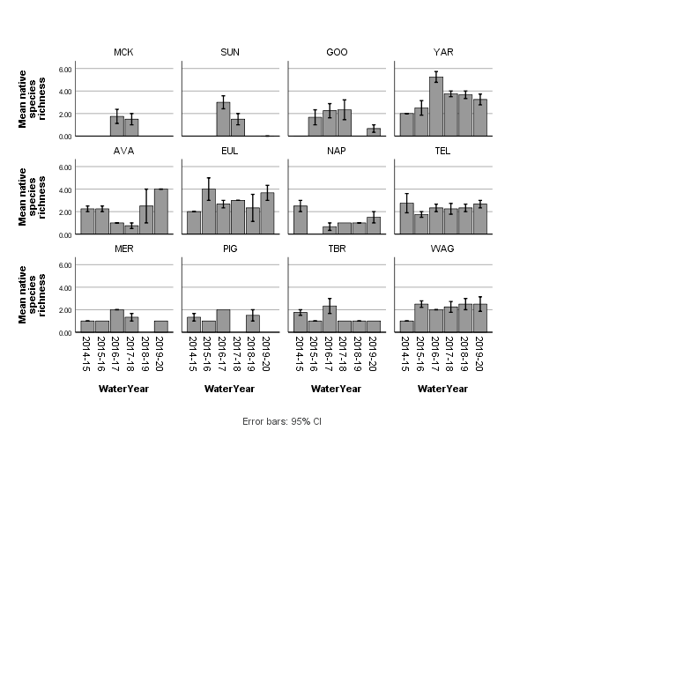

Figure ‑ Native fish species richness between 2014 and 2020 at the 12 monitored wetlands (blank value indicates that the wetland did not hold water during that year)

Table ‑ Total number of individuals recorded in 2019-20/total for 2014-20 at each of the 12 monitoring sites.

|  |  |  |  |  |  |  |  |  |  |  |  |  |
| --- | --- | --- | --- | --- | --- | --- | --- | --- | --- | --- | --- | --- |
|  | **Gooragool Lagoon** | **McKennas Lagoon** | **Sunshower Lgoon** | **Yarradda Lagoon** | **Avalon Swamp** | **Eulimbah Swamp** | **Nap Nap Swamp** | **Telephone Creek** | **Mercedes Swamp** | **Piggery Lake** | **Two Bridges Swamp** | **Waugorah Lagoon** |
| **Murray cod** |  |  |  |  | 2/4 | 0/4 |  |  |  |  |  |  |
| **golden perch** | 0/2 | 0/3 | 0/7 | 0/4 |  | 0/1 |  | 0/3 |  |  |  |  |
| **silver perch** |  |  |  | 0/7 |  |  |  |  |  |  |  |  |
| **Australian smelt** | 0/27 | 0/4 | 0/257 | 37/  198 | 34/39 | 7/125 | 0/15 | 8/174 |  |  | 0/2 | 3/22 |
| **bony herring** | 0/112 |  |  | 72/  438 | 1/294 | 68/  414 | 32/39 | 41/431 |  | 0/4 | 0/137 | 40/  176 |
| **carp gudgeon** | 75/  7773 | 0/393 | 0/376 | 479/  16496 | 156/  13105 | 13/  3824 | 3615/  6736 | 796/  9262 | 162/  520 | 0/6595 | 3/  15333 | 6724/  32283 |
| **flat-headed gudgeon** | 0/1 |  |  | 82/  173 | 54/55 | 6/14 |  |  |  | 0/2 |  |  |
| **Murray-Darling rainbowfish** |  | 0/22 | 0/49 | 0/285 | 0/1 | 2/49 |  | 0/125 | 0/4 | 0/63 | 0/19 | 1/86 |
| **un-specked hardyhead** |  |  | 0/1 | 0/6 |  | 0/22 |  |  |  | 0/1 |  |  |
| **common carp** | 4910/  6179 | 0/  4032 | 0/  3702 | 147/  5319 | 4/6116 | 297/  16601 | 243/  10089 | 208/  5048 | 267/  3579 | 0/5125 | 7789/  41131 | 167/  13681 |
| **gambusia** | 12/  4943 | 0/961 | 0/739 | 10/  7371 | 401/  3946 | 1/926 | 3/1981 | 8/8647 | 18/  4895 | 0/5221 | 0/  31344 | 57/  765 |
| **goldfish** | 236/  640 | 0/28 | 0/33 | 94/  688 | 123/  272 | 6/553 | 266/  391 | 9/364 | 1/20 | 0/230 | 2/1677 | 3/924 |
| **oriental weatherloach** | 19/31 | 0/2 | 0/2 | 4/7 | 1/52 | 2/63 | 7/55 | 2/49 | 1/225 | 0/949 | 0/3877 | 0/35 |
| **redfin perch** | 0/2 | 0/1 |  | 0/1 |  |  |  |  |  |  |  |  |

**Key: Total 2014-20**

|  |  |
| --- | --- |
|  | 1-100 |
|  | 101-1000 |
|  | 1001 – 10000 |
|  | >10000 |

Figure ‑ Mean catch per unit effort (CPUE) (+ 95% CI) of native species by zone. Note that for clarity the y-axis are on differing scales.

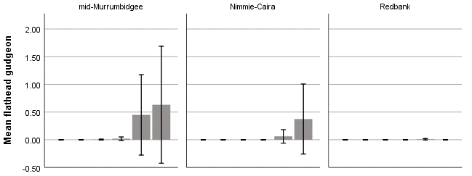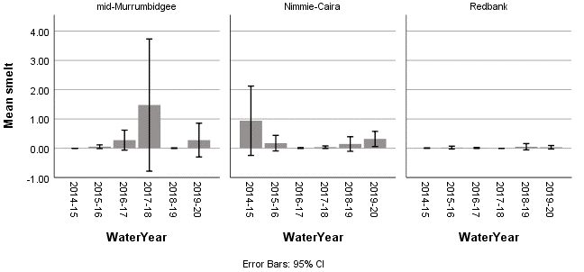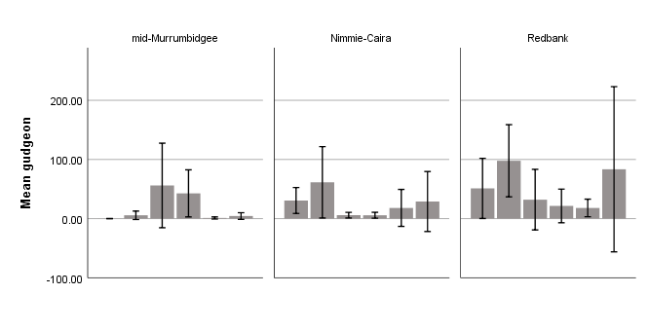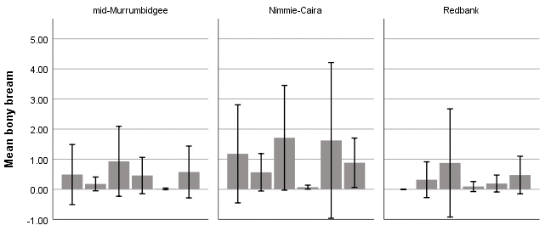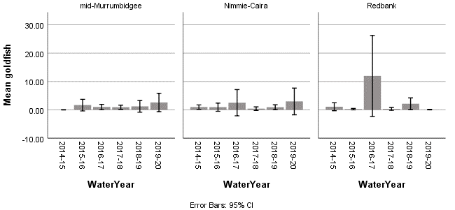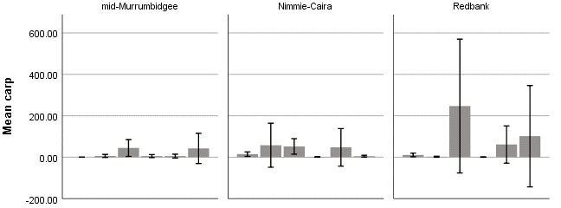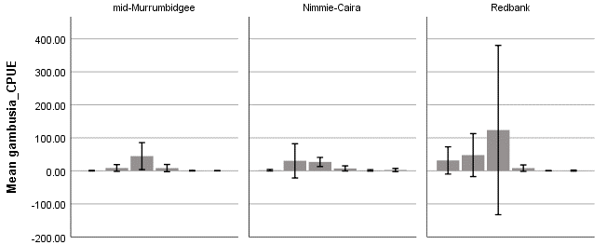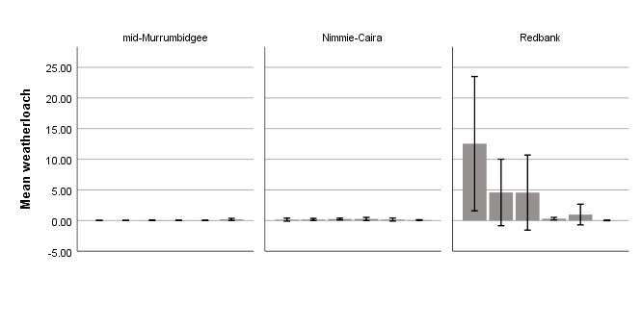

*Figure 4‑37 Mean catch per unit effort (CPUE) (+ 95% CI) of introduced species by zone. Note that for clarity the y-axis are on differing scales.*

### What did Commonwealth environmental water contribute to native fish community resilience and native fish survival?

Body size of six native and four exotic species were measured over the 2019-20 season. Of the small-bodied native fish measured, most species were dominated by juveniles, including carp gudgeon (91% juvenile), flatheaded gudgeon (86% juvenile) and Australian smelt (61% juvenile) (Table 4‑14). The bony herring catch was dominated by non-juveniles (63%), and two native large-bodied Murray cod were recorded (both juveniles). Higher proportions of juvenile native fish were associated with persistent or regularly watered wetlands, in particular Avalon Dam, Eulimbah Swamp and Telephone Creek in Gayini Nimmie-Caira (Figure 4.14). For introduced species, large-bodied common carp and goldfish were dominated by juveniles (97 and 96% respectively), and small-bodied gambusia and weatherloach captures were dominated by non-juveniles (84 and 86% respectively).

The proportions of juveniles for 2019-2020 remained largely consistent with the previous five years for introduced species and most native fish species, with the exception of Australian smelt, where the proportion of juveniles increased from 13% (2014-19) to 61% (2019-20). This pattern is consistent across all water years with proportions of juveniles largely stable across introduced species and most native species, with the exception of one or two small-bodied native species (primarily Australian smelt and bony herring) where the proportions of juveniles varies between water years.

Table ‑ Number of native and exotic fish and their proportion by age class 2019-20.

|  |  |  |  |
| --- | --- | --- | --- |
|  |  | Proportion of measured | |
| **Native species** | **Total measured** | **Non-Juvenile** | **Juvenile** |
| Australian smelt | 89 | 0.39 | 0.61 |
| bony herring | 209 | 0.63 | 0.37 |
| carp gudgeon | 599 | 0.09 | 0.91 |
| Flat-headed gudgeon | 117 | 0.14 | 0.86 |
| Murray-Darling rainbowfish | 3 | 0.67 | 0.33 |
| golden perch | 0 | - | - |
| Murray cod | 2 | 0.00 | 1.00 |
| silver perch | 0 | - | - |
| un-specked hardyhead | 0 | - | - |
| **Introduced species** |  |  |  |
| common carp | 822 | 0.04 | 0.96 |
| gambusia | 172 | 0.81 | 0.19 |
| goldfish | 320 | 0.03 | 0.97 |
| oriental weatherloach | 36 | 0.89 | 0.11 |
| redfin perch | 0 | - | - |
| **Grand Total** | **2369** |  |  |

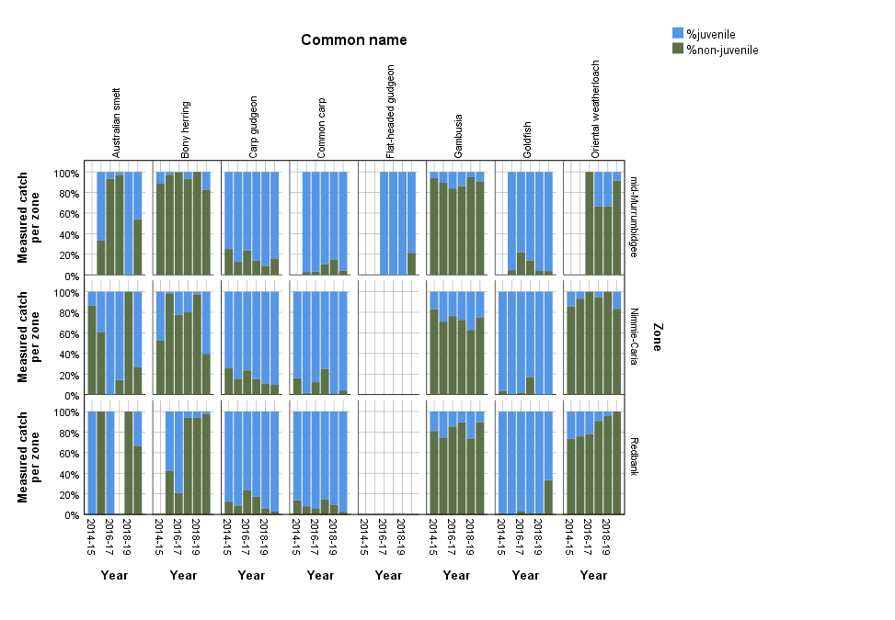

Figure ‑ Percentage of juveniles and non-juveniles within the measured catch for commonly occurring native and exotic wetland fish species from 2014-2020. Blank value indicates that the species was not detected in that zone during that year.

### Pumped and in-channel water delivery in the mid-Murrumbidgee

Since 2014, environmental water has been delivered to monitored wetlands in the mid-Murrumbidgee via in-channel flows, river reconnections and pumps. Yarradda Lagoon received environmental water via pumps in 2014-15, followed by a river reconnection (2016-17 and 2017-18). More recently, the lagoon was deliberately dried to remove large common carp (October 2018) and has since been refilled and maintained by pumping. The subsequent detection of small-bodied native fish suggests that these species are able to enter the lagoon via the pumps which are screened to exclude large common carp. The other monitored wetlands (McKennas, Sunshower, Gooragool and Mantangry) have primarily received water from intermittent river reconnection events or in-channel flows; pumping to Gooragool has occurred for a number of years, but it wasn’t until December 2019 when pumping infrastructure was installed at Sunshower Lagoon.

Native fish diversity at Yarradda Lagoon reached 8 species in 2016-17 following an unregulated river reconnection event (Figure 4.35) when silver and golden perch entered the wetland. Following subsequent draw down as refilling native fish diversity has remained high at Yarradda, with seven small-bodied species detected following pumped water delivery, including carp gudgeon, rainbowfish, flatheaded gudgeon and Australian smelt.

Interestingly, fish abundances at Yarradda Lagoon were low in 2019-20 compared to the previous five year average (Table 4‑13) . This reflects lower than average captures of introduced fish species with common carp captures (CPUE 2.97) lower than the five year average (CPUE 18.53) and gambusia captures (CPUE 0.19) also low compared to the five year average (CPUE 23.14). Two previously detected small native fish (Murray Darling rainbowfish, unspecked hardyhead) were not captured during 2019-20, however flat-headed gudgeon was detected in high numbers (CPUE 1.42) during 2019-20, compared to the five year average (CPUE 0.46).

At Sunshower Lagoon, water has been received via a combination of natural and managed river reconnection events with intermittent dry periods. Pumping infrastructure was installed in December 2019 with the first delivery of pumped environmental water received on completion. No fish have been recorded since pumped water delivery commenced.

The 2019-20 Gooragool watering action raised the water level at Mantangry Lagoon prior to releasing water via a connecting channel to inundate Gooragool Lagoon. Recent monitoring at Mantangry Lagoon recorded six native and four introduced fish species including adult golden perch. This action aimed to create conditions to support golden perch recruitment in Gooragool Lagoon. Subsequent monitoring at Gooragool during 2019-20 recorded small numbers of one native species (carp gudgeon) and high abundances of common carp (mean CPUE 123.78). No golden perch were recorded (Figure 4‑40).

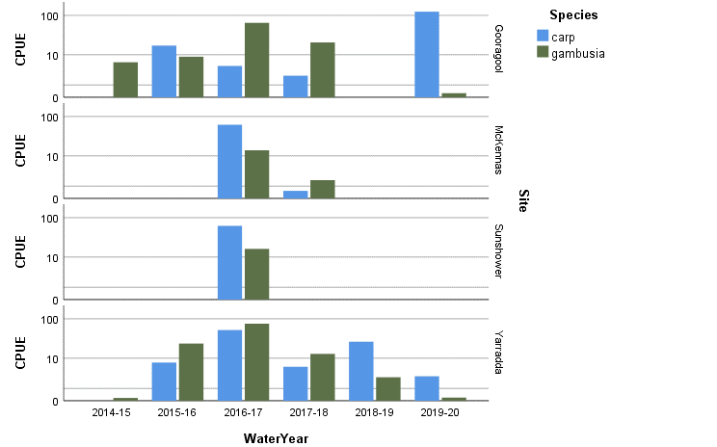

Figure ‑ *Catch per unit effort (CPUE) for introduced fish species in monitored wetlands in the mid-Murrumbidgee. *Note logarithmic scale used. (Blank value indicates that the wetland did not hold water that year).*

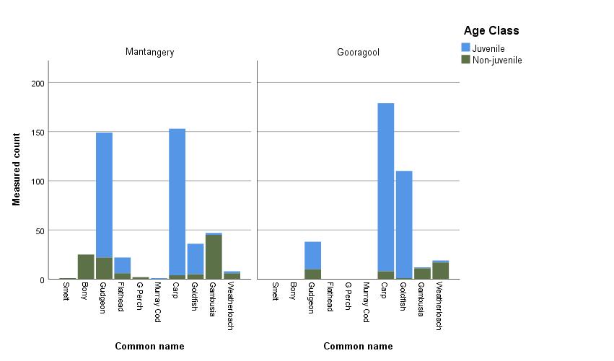Figure ‑ Age class for measured fish captured at Mantangry and Gooragool Lagoons in the mid-Murrumbidgee in 2019-20

Discussion

Consistent with findings from the previous five year monitoring period, wetland fish communities across the Murrumbidgee remain in poor condition, and are dominated by opportunistic generalist species. The more sensitive floodplain specialist species remain absent. The loss of persistent off-channel waterbodies has been identified as a key factor contributing to the declining abundance of wetland specialists including the Murray hardy head, purple spotted gudgeon and olive perchlet (Closs *et al.* 2005). Commonwealth environmental water is used to restore aspects of the natural hydrological regime that have been lost because of river regulation; this includes watering actions to increase the duration and frequency of inundation to maintain suitable habitats for native fish (Commonwealth of Australia 2018). The targeted watering actions delivered in 2019-20 have focused on maintaining suitable habitats and supporting native fish recruitment. These efforts have built on the previous five year period by maintaining persistent and regularly watered wetlands and have contributed to increased native fish diversity in floodplain wetlands.

### What did Commonwealth environmental water contribute to native fish populations and native fish diversity?

In 2019-20 six out of 23 previously recorded native species (Gilligan 2005) were observed during MER wetland monitoring activities. Most of the native species currently occurring in wetlands are flow generalists that either colonise wetlands from the main river during periods of reconnections, including via lateral connection with the river or via irrigation infrastructure, or are resident within persistent pools and lagoons on the floodplain. Therefore, a range of factors including the number and location of wetlands that are watered can influence the diversity of native wetland fish in a given year. However, native fish diversity in persistent and regularly watered wetlands has remained high in 2019-20, consistent with the pattern observed over the previous five year monitoring period.

The two flow responder species; silver and golden perch, were not recorded at the main MER monitored wetlands in 2019-20 when watering actions largely consisted of infrastructure assisted deliveries, rather than the large unregulated flows and river reconnection events of previous water years. Monitoring at Mantangry Lagoon recorded the presence of adult golden perch, however no golden perch were detected in Gooragool Lagoon following the release of water from Mantangry Lagoon into Gooragool via the connecting channel.

### What did Commonwealth environmental water contribute to native fish community resilience and native fish survival?

Consistent with the previous five years, young of year small-bodied native and introduced species were recorded at most wetlands during 2019-20. There is some year-to-year variability in the proportion of the measured catch that fell into juvenile size classes across species, although the high proportion of juvenile native carp gudgeon detected has remained consistently high across all years. One variation in 2019-20 was the higher number of non-juvenile bony herring compared to juveniles. No evidence of golden perch spawning and recruitment was detected at Gooragool Lagoon. However, golden perch young-of-year were recorded in Tala Creek in the lower Redbank in November 2019 after the Yanga and Tala Lake golden perch watering action (December 2018) resulted in a small successful golden perch recruitment event (Kopf *et al*. 2019). Follow up watering actions will be required to maintain water quality within Tala Creek and associated creek lines and lakes in order to support Golden perch recruitment and survival.

Most of the wetlands monitored under this program are functionally dry between inundation events except for persistent wetlands at Avalon Swamp, Telephone Creek and Waugorah Lagoon. Additionally, Eulimbah Swamp has also been watered relatively frequently and water levels at Yarradda Lagoon have been maintained since it was dried to reduce the biomass of adult carp in November 2018.

Water delivery via pumped infrastructure was commenced at Sunshower Lagoon in December 2019. Although small-bodied native fish appear to have survived entry to Yarradda Lagoon through pumping and were detected in the lagoon immediately following water delivery, no fish were recorded at Sunshower during January and March monitoring activities. However, Yarradda Lagoon retained small pools of water and was refilled immediately following carp removal, whereas Sunshower Lagoon had been completely dry for around 20 months prior to pumped water delivery in December. The hot, dry conditions and volume of leaf litter present also combined to produce an initial period of poor water quality at Sunshower Lagoon.

The 2019-20 monitoring results suggest that management decisions to deliver environmental water to inundate and maintain wetland habitats during spring and summer are important to maintain viable native fish populations. During drought conditions and periods of low water availability the targeted use of environmental water to protect wetland habitats and productivity contribute to fish spawning, growth and recruitment. However, when carp biomass becomes high, drawing down the waterbody followed by pumping or managed water delivered via carp screens may be required. Evidence from this program is that these managed draw downs, when carefully planned can have positive impact on native fish diversity.

### Management implications – Gooragool Lagoon

Despite the intention that environmental watering actions improve conditions for native biota such as wetland vegetation, birds, frogs, turtles and fish, it may be difficult to avoid incidental and unintended benefits for introduced invasive species such as the common carp (Conallin *et al* 2012).

Large carp were observed congregating at the Mantangry Lagoon channel outlet prior to release (Conallin, pers comm). Previous studies on carp movements in response to environmental and physiological cues have suggested that rising water temperatures, floodplain chemical cues and reproductive status may trigger fish movement (Jones & Stuart 2009; Conallin *et al* 2012).

Proposed management options at Gooragool Lagoon include a drying period to remove large carp, installation of carp screens, and trialling a series of stranding flows to reduce the numbers of large breeding carp entering the wetland.

## Frogs and turtles

Prepared by Dr Damian Michael (CSU), Dr Gilad Bino (UNSW), Anna Turner (CSU) and Dr Skye Wassens (CSU)

***Introduction***

Frogs have declined on a global scale due to multiple stressors (Skerratt *et al.* 2007; Scheele *et al.* 2019), and several species have declined considerably within parts of the Murray-Darling Basin (Wassens 2008; Mac Nally *et al.* 2014). Environmental watering actions are therefore important for recovering frog populations and can be used to provide persistent refuge habitat during periods of low water availability, or to create shallow temporary standing water to provide breeding habitat and suitable environments to support recruitment of tadpoles and young turtles into the adult population.

In 2019-20, Commonwealth environmental water was primarily delivered to wetlands in the mid-Murrumbidgee and Gayini Nimmie-Caira wetland zones (Table 4‑15). The Gayini Nimmie-Caira refuge flows, Nap Nap to Wagourah flow (NSW) and pumping actions in the mid-Murrumbidgee all had specific objectives related to outcomes for frogs and turtles. In particular, the watering actions in Gayini Nimmie- Caira were specifically targeted towards maintaining populations of the vulnerable southern bell frog (EPBC Act) and are a continuation of a series of watering actions that have been undertaken since 2008 specifically aimed at recovering this threatened population in the Murrumbidgee Selected Area.

Table ‑ Summary of environmental watering actions that influenced frog diversity during the 2019-20 monitoring period.

|  |  |  |
| --- | --- | --- |
| Water Action Reference | Event | Objectives |
| 10082-28 | Yanga National Park refuge | Maintain critical refuge habitat for waterbirds, native fish, frogs (including the threatened southern bell frog), turtles and other water dependent animals. |
| 10082-21 | Gayini Nimmie-Caira refuge, SBF breeding and Tala Creek System refuge | Maintain critical refuge habitat for waterbirds, native fish (including for known golden perch populations in the Tala Ck system), frogs (including the threatened southern bell frog), turtles and other water dependent animals.  Provide opportunities for breeding and recruitment of the threatened southern bell frog at key sites in Gayini Nimmie Caira to reduce the risk local population extinction |
| 10082-20 | Yarradda Lagoon Pumping | Maintain critical refuge habitat for waterbirds, native fish, frogs (including the threatened southern bell frog), turtles and other water dependent animals. |
| 10082-18 | Gooragool Lagoon Pumping | Maintain critical refuge habitat for waterbirds, native fish (including established golden and silver perch), frogs, turtles and other water dependent animals. |
| 10082-19 | Wilbriggie Lagoon | Maintain critical refuge habitat for waterbirds, native fish, frogs, turtles, other water dependent animals and threatened species such as the superb parrot (EPBC Act vulnerable). |
| 10082-31 | Sunshower Lagoon Pumping | Provide critical refuge habitat for waterbirds, native fish, frogs, turtles and other water dependent animals. |

### Evaluation Questions

* Did Commonwealth environmental water contribute to other aquatic vertebrates (frog and turtle) diversity and populations?
* Did Commonwealth environmental water contribute to the provision of habitat to support breeding and recruitment of other vertebrates?
* Did Commonwealth environmental water contribute to the maintenance of refuge habitats?

***Methods***

Since 2014, frogs and tadpoles have been monitored across twelve wetlands on four occasions each year (September, November, January and March), except when wetlands were dry or water levels were too low to deploy nets. Detailed survey methodology is outlined in Wassens *et al.* (2014a, Wassens et al 2019). Two additional wetlands in the mid-Murrumbidgee zone, Willbriggie (previously called Darlington Point) and Mantangry Lagoon were also monitored during the 2019-20 water year, although Willbriggie was only surveyed once in November 2019. Adult frogs were surveyed after dark using two 20 minute transects where all frogs observed or heard calling were recorded. Tadpoles were surveyed in conjunction with wetland fish, using a combination of two large and two small fyke nets that were set overnight for an average of 14 hours. When water levels were too low to set large fyke nets, two smaller D-fyke nets were deployed instead. Tadpole Catch-Per-Unit Effort (CPUE) was calculated for each wetland based on the number of tadpoles collected divided by the average time all four fyke nets remained in the water at each site per sampling period (net soak time).

### Data analysis

To test whether adult frog abundance, calling activity and tadpole CPUE varied among water years and wetlands zones we used Generalised Linear Mixed Effect models with wetland zone, month, and water year as fixed factors and site as a random factor. As a response variable, adult frog observations, tadpoles and calling activity were combined as a presence or absence variable. We also considered average water temperature, average water depth and three principal components of fish species abundance, vegetation cover, and water quality. We examined all possible explanatory variable combination (n=32) and evaluated for significant associations using a model averaging approach weighted by model fit using the corrected Akaike information criterion (AICc; Grueber *et al.* (2011). Model averaging allows to account for uncertainty when multiple models are plausible and provides a robust method to estimate associations with possible explanatory variables (Grueber *et al.* 2011). Models were developed using the ‘glmer’ function in the ‘lme4’ package (Bates *et al.* 2014) in R version 4, (R Development Core Team 2014). Model averaging was accomplished using the ‘dredge’ and ‘model.avg’ functions in the MuMIn package (Barton 2015). To compare size distributions of the three turtle species detected during the six-year program we used a Mann-Whitney U test.

***Results***

### What did Commonwealth environmental water contribute to other aquatic vertebrates (frog and turtle) diversity and populations?

### Frog species richness

A total of six frog species were recorded during the 2019-20 water year, plains froglet (*Crinia parinsignifera*), barking marsh frog (*Limnodynastes fletcheri),* spotted marsh frog (*Limnodynastes tasmaniensis*), inland banjo frog (*Limnodynastes interioris*), Peron’s tree frog (*Litoria peronii*), and southern bell frog (*Litoria raniformis*). The number of frog species recorded in 2019-20 was consistent with the overall number of frog species recorded in the Murrumbidgee Selected Area over the previous five years.

Frog species richness varied between zones (P < 0.001) and years (P < 0.001), largely reflecting the number of wetlands that contained water during each survey period (Figure 1). The average number of frog species recorded in the mid-Murrumbidgee was lowest in the years when only a small number of monitoring sites were watered (e.g. 2018-2019). In 2019-20, frog species richness was highest in the mid-Murrumbidgee zone, largely due to detection of southern bell frog, inland banjo frog and barking marsh frog from Sunshower Lagoon (Figure 4.41), a wetland which received water via recently installed pumping infrastructure. Encouragingly, frog species richness also remained relatively high in the Nimmie-Caira and Redbank zones (Figure 4.42), and key wetlands such as Yarradda Lagoon, Eulimbah Swamp, Nap Nap Swamp and most wetlands in the Redbank zone supported similar frog species as during the previous watering year (2018-2019) (Figure 4.42).

*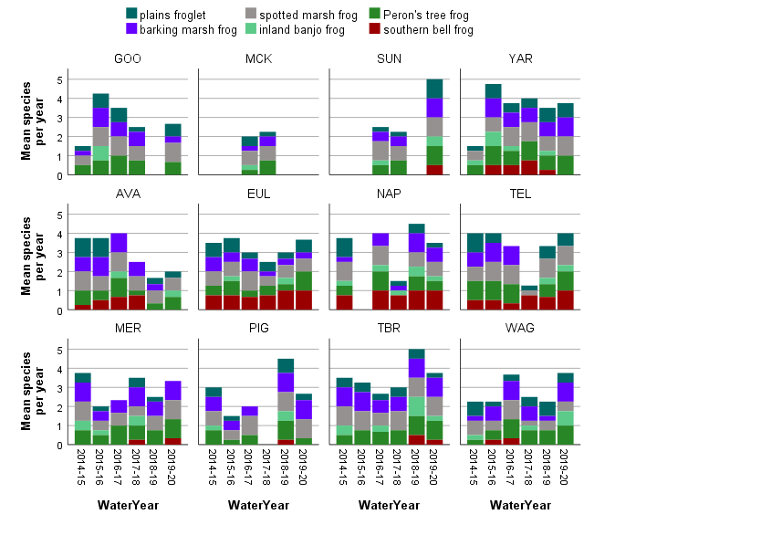**Figure 4‑41 Mean frog species richness (+SE) per wetland (n=12) within each wetland zone between 2014 and 2020.*

Figure 4‑42 Presence of frog species over four survey periods at each of the 12 monitored wetlands in the Murrumbidgee Selected Area between 2014-15 and 2019-20. Mid-Murrumbidgee wetlands (top row) (GOO Gooragool, MCK McKennas, SUN Sunshower, YAR Yarradda); Nimmie-Caira (middle row) (AVA Avalon, EUL Eulimbah, NAP Nap Nap, TEL, Telephone Creek); Redbank (bottom row) (MER Mercedes, PIG Piggery, TBR Two Bridges, WAG Waugorah Lagoon).

### Frog abundance

Overall, Commonwealth environmental watering actions contributed to 7,212 adult frog observations between September 2014 and March 2020, including 1,765 southern bell frog observations (Table 4‑16). The mean abundance of adult frog species varied between sites and water years, with the majority of observations being attributed to the two most prevalent species - the spotted marsh frog and barking marsh frog (Figure 4‑43). The two species were detected in high numbers in key wetlands (e.g. Gooragool Lagoon, Two Bridges Swamp and Piggery Lake), particularly during the 2016-17 water year. During the 2019-20 water year, southern bell frog numbers were again above average at Nap Nap Swamp, a result attributed to the Nap Nap to Wagourah refuge flow. Small numbers of adult southern bell frogs were also detected at Telephone Creek and Eulimbah in Nimmie-Caira; Two Bridges and Mercedes in the Redbank zone, and for the first time in almost a decade, southern bell frogs were heard calling in Sunshower Lagoon in the mid-Murrumbidgee as a result of the pumping water actions.

Table ‑ Summary statistics for the number of adult frog observations between 2014 and 2020 in the Murrumbidgee Selected Area.

|  |  |  |  |  |
| --- | --- | --- | --- | --- |
| **Species name** | **Maximum per year** | **Total Sum** | **Mean per site** | **Standard deviation** |
| plains froglet | 13 | 172 | 0.65 | 1.69 |
| barking marsh frog | 255 | 2056 | 7.73 | 26.03 |
| spotted marsh frog | 295 | 2579 | 9.70 | 27.44 |
| inland banjo frog | 7 | 30 | 0.11 | 0.59 |
| Peron's tree frog | 95 | 610 | 2.29 | 7.09 |
| southern bell frog | 341 | 1765 | 6.64 | 38.12 |

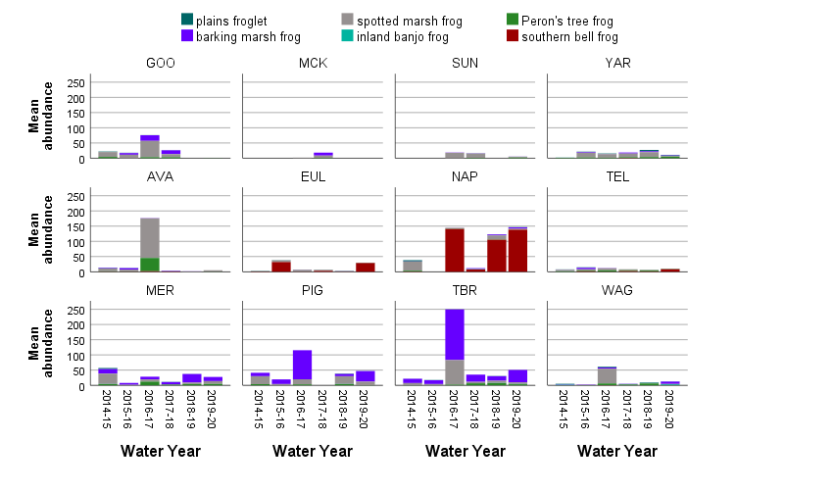

*Figure 4‑43 Mean adult frog abundance at each of the 12 monitored wetlands in the Murrumbidgee Selected Area between 2014-15 and 2019-20. (top row) (GOO Gooragool, MCK McKennas, SUN Sunshower, YAR Yarradda), Nimmie-Caira (middle row) (AVA Avalon, EUL Eulimbah, NAP Nap Nap, TEL, Telephone Creek). Redbank (bottom row) (MER Mercedes, PIG Piggery, TBR Two Bridges, WAG Wagourah Lagoon).*

### Species-specific responses

Plains froglet (Crinia parinsignifera)

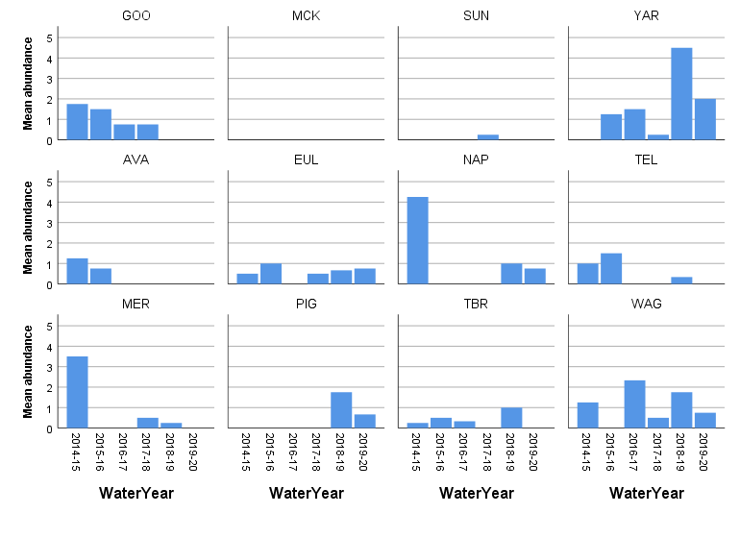The plains froglet is one of the most widespread frog species across the Murrumbidgee Selected Area. However, due to their small size and cryptic behaviour, adult frogs are not often encountered during nocturnal surveys. Annual detections of this species average at 0.65 individuals per site (Table 4‑16). In a similar trend to previous years, we detected significant differences in adult plains froglet numbers between water years and survey months (Table 4‑17). Plains froglet numbers were lowest during the 2016-17 unregulated flood year and the 2017-18 water year but returned to similar numbers during the last two water years (2018-19 and 2019-20) (Figure 4‑43). Similar patterns emerged when we examined plains froglet presence (by combining tadpole, adults and calling data). Detection of plains froglet increased with average water depth and detected less often during the 2016-17 and 2017-18 water years and less often during the survey months of January and March (Table 2‑1, Table 4‑17, Figure 4‑44).

Figure ‑ Mean number of plains froglet adults detected across water years in each wetland (n = 12) in the Murrumbidgee Selected Area.

Table ‑ Generalised linear mixed effect model considering all significant explanatory variables for the plains froglet.

|  |  |  |  |
| --- | --- | --- | --- |
| Predictors | Log-Odds | CI | p |
| (Intercept) | 3.80 | 2.08 – 5.53 | **<0.001** |
| Water depth | 0.03 | 0.01 – 0.06 | **0.001** |
| **Survey period** | | | |
| November | -1.75 | -3.20 – -0.30 | **0.018** |
| January | -3.93 | -5.47 – -2.39 | **<0.001** |
| March | -4.04 | -5.67 – -2.41 | **<0.001** |
| **Water year** | | | |
| 2015-16 | -0.66 | -2.10 – 0.77 | 0.366 |
| 2016-17 | -3.76 | -5.54 – -1.99 | **<0.001** |
| 2017-18 | -2.80 | -4.36 – -1.24 | **<0.001** |
| 2018-19 | -1.45 | -2.89 – -0.01 | **0.048** |
| 2019-20 | -1.28 | -2.68 – 0.13 | 0.075 |

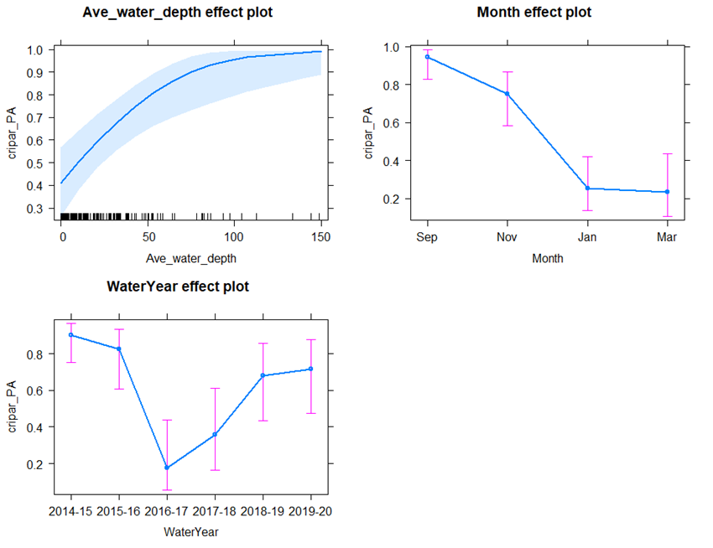

Figure ‑ Overall trends in plains froglet detection (presence/absence) in relation to water depth, survey month and water years between 2014-15 and 2019-20 in the Murrumbidgee Selected Area.

### Barking marsh frog (Limnodynastes fletcheri)

The barking marsh frog was one of the most commonly detected species (2056 observations in total) in the Murrumbidgee Selected Area (Table 4‑16). However, this species was most abundant in the Redbank zone where it was relatively abundant at Mercedes Swamp, Piggery Lake and Two Bridges Swamp (Figure 4‑46). Although we found no significant year effects (Table 4), this species was detected in high abundance during the 2016-17 unregulated water year and less often in the Nimmie-Caira zone (Figure 4‑47). GLMMs indicated water temperature (positive) and the first two vegetation components (negative) were significantly associated with presence of barking marsh frog. Interpretation of vegetation principal components suggested positive association with soil moisture, open water and amphibious cover and negative association with bare ground, terrestrial dry and leaf litter cover (Table 4‑18).

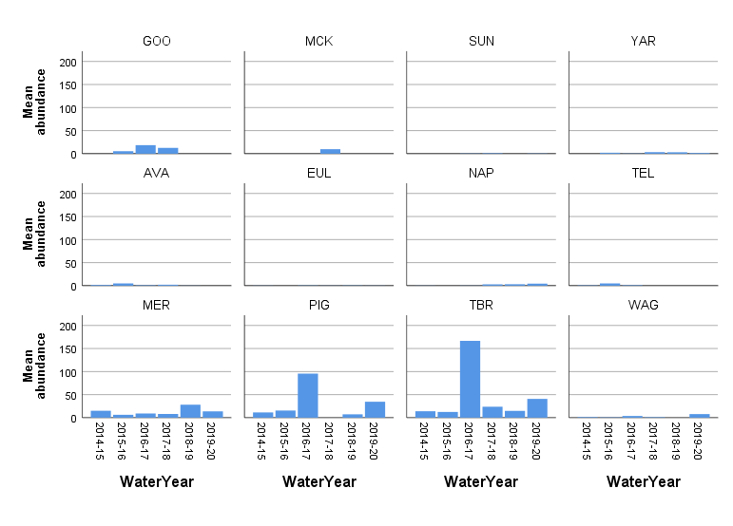Figure ‑ Mean number of barking marsh frog adults detected across water years in each wetland (n = 12) in the Murrumbidgee Selected Area.

Table ‑ Results of the generalised linear model for the barking marsh frog

|  |  |  |  |
| --- | --- | --- | --- |
| Predictors | Odds Ratios | CI | p |
| (Intercept) | 0.22 | 0.03 – 1.34 | 0.099 |
| Water temperature | 1.11 | 1.03 – 1.20 | 0.008 |
| **Vegetation principal components** | | | |
| VegPC1 | 0.72 | 0.55 – 0.95 | 0.018 |
| VegPC2 | 0.64 | 0.44 – 0.92 | 0.017 |

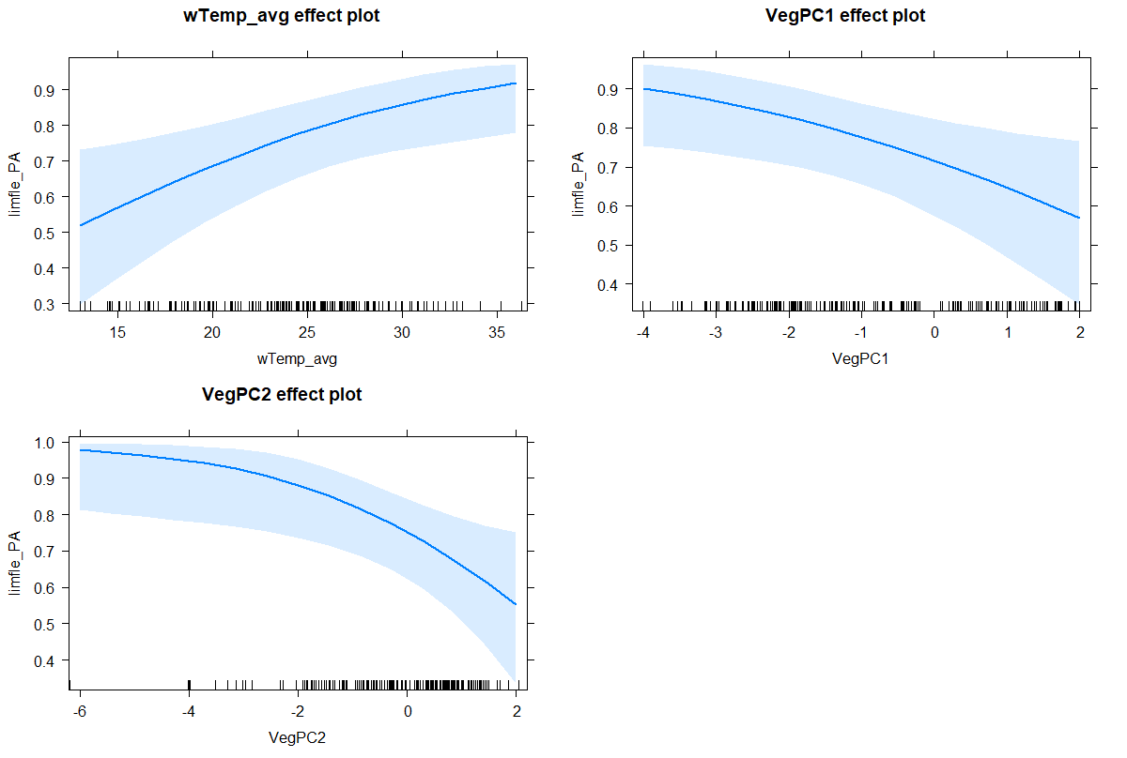

Figure ‑ Overall trends in barking marsh frog detection (presence/absence) in relation to water temperature and vegetation principal components representing positive associations with soil moisture, open water and amphibious cover and negative associations with bare ground, terrestrial dry and leaf litter cover and between 2014-15 and 2019-20 in the Murrumbidgee Selected Area.

### Spotted marsh frog (Limnodynastes tasmaniensis)

The Spotted marsh frog was the most abundant (total of 2579 observations) and widespread species detected across wetland sites in the Murrumbidgee Selected Area (Table 4‑16). This species was detected in high numbers during the 2016-17 water year and particularly from Gooragool Lagoon, Avalon Dam, Two Bridges Swamp and Wagourah Lagoon (Figure 4‑49). Given its ubiquitous distribution and relative abundance, spotted marsh frog presence did not vary across water year, survey month or wetland zone (Table 4‑19) but was negatively associated with the first principal component of vegetation cover (i.e., positively associated with soil moisture, open water and negatively associated with leaf litter and bare ground (Figure 4‑49).

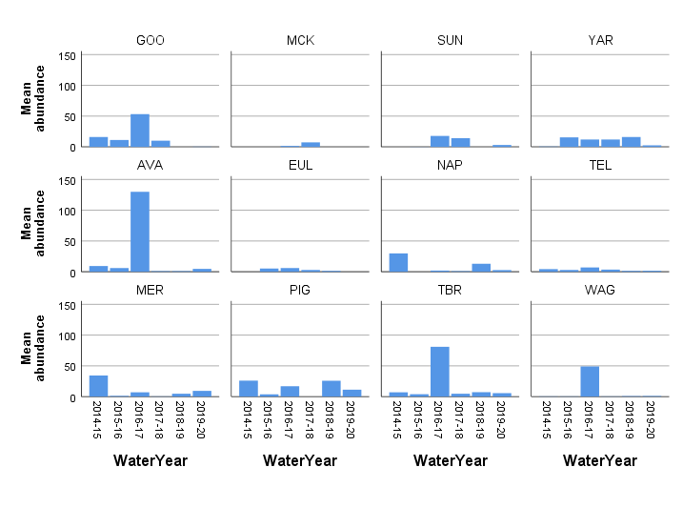

Figure ‑ Mean number of spotted marsh frog adults detected across water years in each wetland (n = 12) in the Murrumbidgee Selected Area.

Table ‑ Generalised linear mixed model for the spotted marsh frog.

|  |  |  |  |
| --- | --- | --- | --- |
| **Predictors** | **Log-Odds** | **CI** | **p** |
| (Intercept) | 6.33 | 3.43 – 11.69 | **<0.001** |
| VegPC1 | 0.64 | 0.45 – 0.90 | **0.010** |

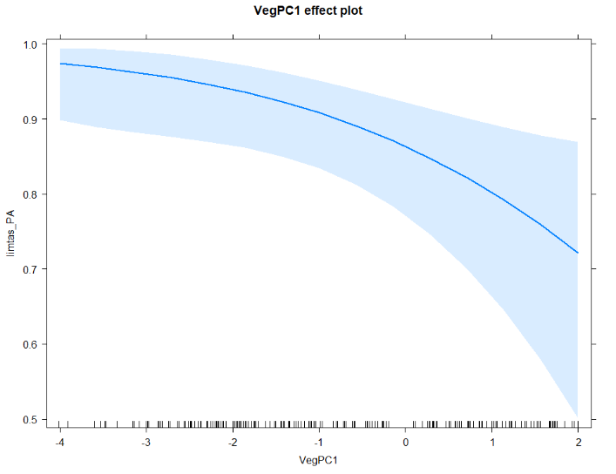

Figure ‑ Overall trends in spotted marsh frog detection (presence/absence) in relation to vegetation principal component (PC1) representing a positive association with soil moisture, open water and a negative associated with leaf litter and bare ground between 2014-15 and 2019-20 in the Murrumbidgee Selected Area.

### Inland banjo frog (Limnodynastes interioris)

Adult inland banjo frogs were only detected on 30 occasions between 2014-15 and 2019-20 (Table 4‑16). Adult frogs were detected at eight wetlands, primarily in the Redbank and Nimmie-Caira wetland zones, where numbers were highest at Wagourah Lagoon during the 2019-20 water year (Figure 4‑50). The best predictors of inland banjo frog presence were the first two principal components of water quality (Table 6) and lower numbers in January compared to September (Figure 4‑51). Interpretation of the principal components of water quality suggested possible negative associations with water pH and DO, and positive association with turbidity (Figure 4‑43).

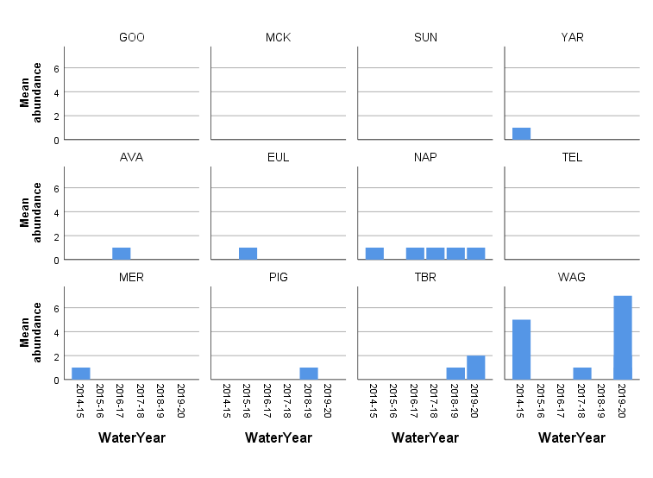

Figure ‑ Mean number of inland banjo frog adults detected across water years in each wetland (n = 12) in the Murrumbidgee Selected Area.

Table ‑ Generalised linear model for the inland banjo frog.

|  |  |  |  |
| --- | --- | --- | --- |
| Predictors | Odds Ratios | CI | p |
| Intercept | 0.38 | 0.18 – 0.78 | **0.008** |
| Survey period | | | |
| Nov | 0.84 | 0.33 – 2.14 | 0.711 |
| Jan | 0.30 | 0.10 – 0.89 | 0.030 |
| Mar | 0.43 | 0.14 – 1.35 | 0.150 |
| Water quality PCs | | | |
| WQPC1 | 0.62 | 0.47 – 0.81 | 0.001 |
| WQPC2 | 3.34 | 1.38 – 8.06 | 0.007 |

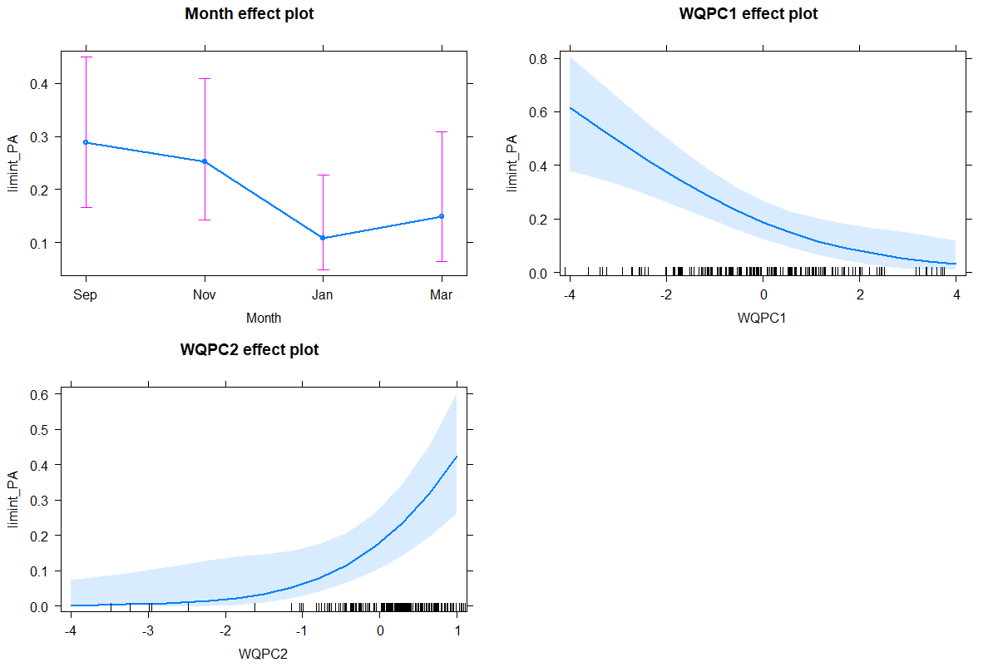

Figure ‑ Overall trends for the inland banjo frog (presence/absence) in relation to survey month and water quality representing negative associations with water pH and DO, and positive associations with turbidity between 2014-15 and 2018-19 in the Murrumbidgee Selected Area.

### Peron’s tree frog (Litoria peronii)

A total of 610 adult Peron’s tree frogs were detected between 2014-15 and 2019-20 in the Murrumbidgee Selected Area (Table 4‑16). This species was detected on all wetland sites during the six-year monitoring period. However, adults were generally only consistently detected at Yarradda Lagoon in the mid-Murrumbidgee zone and all wetlands in the Redbank zone. Interestingly, large numbers of adult Peron’s tree frogs were detected at Avalon Dam during the 2016-17 water year (Figure 4‑52). The best predictors of Peron’s tree frog presence were survey month, first PC of water quality, second PC of vegetation cover and average water temperature (Table 4‑21). Interpretation of PC’s suggested negative associations with water pH and DO, and positive association with amphibious vegetation and leaf litter and crown cover and negative association with terrestrial dry cover (Figure 4‑53).

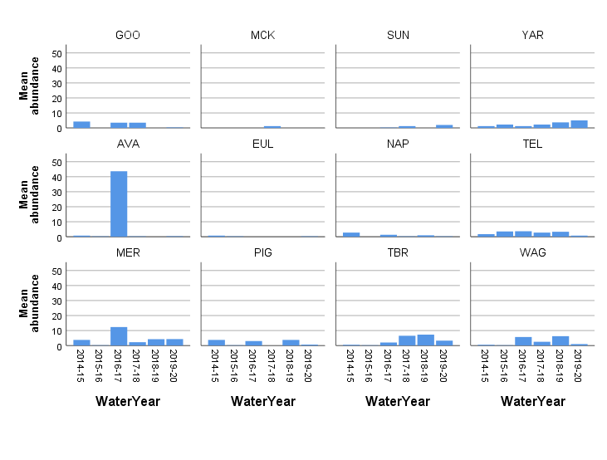

Figure ‑ Mean number of Peron’s tree frog adults detected across water years in each wetland (n = 12) in the Murrumbidgee Selected Area.

Table ‑ Generalised linear model for Peron’s tree frog.

|  |  |  |  |
| --- | --- | --- | --- |
| Predictors | Odds Ratios | CI | p |
| Intercept | 0.07 | 0.00 – 1.11 | 0.059 |
| Survey period | | | |
| Month [Nov] | 1.92 | 0.27 – 13.72 | 0.514 |
| Month [Jan] | 0.20 | 0.03 – 1.26 | 0.086 |
| Month [Mar] | 0.13 | 0.03 – 0.61 | 0.009 |
| WQPC1 | 0.68 | 0.49 – 0.93 | 0.017 |
| VegPC2 | 0.71 | 0.47 – 1.06 | 0.093 |
| Average water temperature | 1.25 | 1.06 – 1.46 | 0.007 |

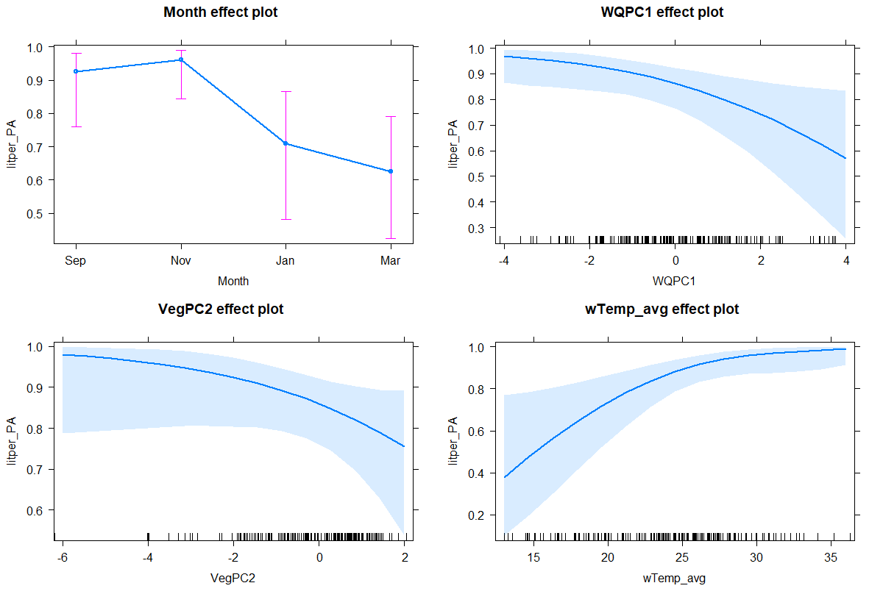

Figure ‑ Overall trends for Peron’s tree frog (presence/absence) in relation to survey month, water quality, vegetation and water temperature. The WQ and Veg PCs represent negative associations with water pH and DO, positive association with amphibious vegetation and leaf litter and crown cover and negative association with terrestrial dry cover between 2014-15 and 2018-19 in the Murrumbidgee Selected Area.

### Southern bell frog (Litoria raniformis)

A total of 1765 adult southern bell frogs were observed during the six-year monitoring period (Table 4‑16). Adult southern bell frogs were predominantly detected in Nimmie-Caira, where numbers are relatively high at Nap Nap Swamp and Eulimbah Swamp (Figure 4‑54). Since the 2016-17 water years, adult detections at Nap Nap Swamp have remained stable due to watering actions aimed at maintaining populations in this wetland zone. Positive associations were noted with water temperature and were highest in the Nimmie-Caira zone (Table 4‑22, Figure 4‑56).

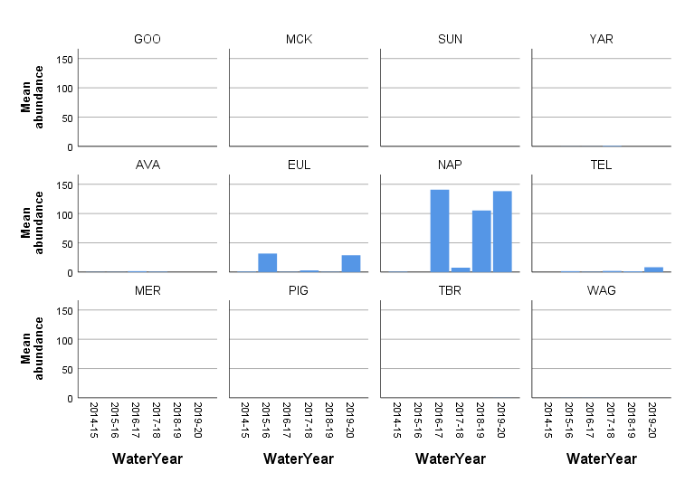

Figure ‑ Mean number of southern bell frog adults detected across water years in each wetland (n = 12) in the Murrumbidgee Selected Area.

|  |  |  |  |
| --- | --- | --- | --- |
| **Predictors** | **Odds Ratios** | **CI** | **p** |
| (Intercept) | 0.01 | 0.00 – 0.13 | 0.001 |
| Nimmie-Caira | 50.51 | 5.58 – 457.46 | <0.001 |
| Redbank | 1.73 | 0.20 – 15.21 | 0.621 |
| Average water temperature | 1.16 | 1.05 – 1.28 | 0.002 |
| FHPC2 | 1.47 | 0.95 – 2.28 | 0.084 |

Table ‑ Generalised linear model for the southern bell frog.

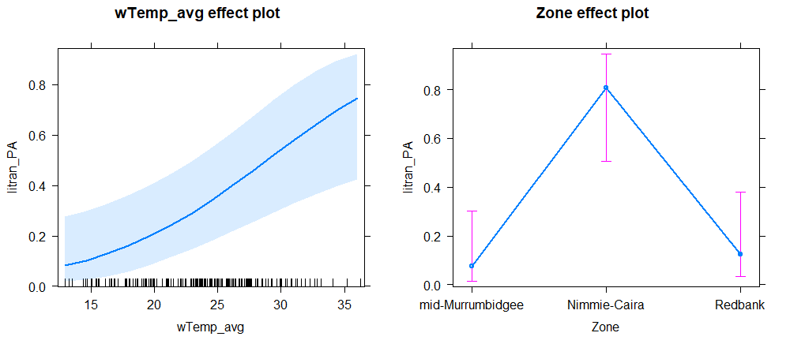

Figure ‑ Overall trends for the southern bell frog (presence/absence) in relation to water temperature and zone between 2014-15 and 2019-20 in the Murrumbidgee Selected Area.

### What did Commonwealth environmental water contribute to the provision of habitat to support breeding and recruitment of other vertebrates?

### Frog breeding response

Frog calling activity is seasonal and call phenology varies according to species (Saenz, *et al* 2016). Some species such as the plain’s froglet call year-round, whereas species such as the inland banjo frog and southern bell frog call periodically during the spring and summer months. Calling activity was relatively low in Redbank during the 2019-20 water year (Figure 4‑56), largely due to the lack of watering actions in this wetland zone. By contrast, in Nimmie-Caira, the Nap Nap to Wagourah refuge flow resulted in relatively good calling activity in all resident species, particularly in the southern bell frog populations at Eulimbah, Nap Nap and Telephone Creek. Similarly, pumping actions in the mid-Murrumbidgee resulted in exceptionally good calling activity by all resident frog species, including the first calling records of threatened southern bell frogs at Sunshower Lagoon in ten years. This encouraging outcome resulted from the installation of pumping infrastructure and the delivery of Commonwealth environmental watering actions in 2019-20 (Figure 4‑56).

Table ‑ Summary statistics for the number of male frog calls and tadpole CPUE recorded between September 2014 and March 2020 in the Murrumbidgee Selected Area (Note tadpoles of Limnodynastes species are grouped as they cannot be identified in the field).

|  |  |  |  |  |
| --- | --- | --- | --- | --- |
| **Species name** | **Maximum per year** | **Total Sum** | **Mean per site** | **Std. Deviation** |
| **Calling activity** | | | | |
| plains froglet | 75 | 1716 | 6.45 | 13.26 |
| barking marsh frog | 60 | 858 | 3.23 | 8.52 |
| spotted marsh frog | 135 | 1831 | 6.88 | 18.16 |
| inland banjo frog | 22 | 119 | .45 | 2.30 |
| Peron's tree frog | 50 | 863 | 3.24 | 7.30 |
| southern bell frog | 70 | 536 | 2.02 | 8.37 |
| **Tadpoles** | | | | |
| plains froglet | 0.21 | 0.8 | 0.003 | 0.02 |
| *Limnodynaste*s species | 44.59 | 233.2 | 0.95 | 5.07 |
| inland banjo frog | 13 | 58 | 0.24 | 1.35 |
| Peron's tree frog | 41.58 | 126.09 | 0.51 | 3.25 |
| southern bell frog | 2.63 | 13.22 | 0.05 | 0.29 |

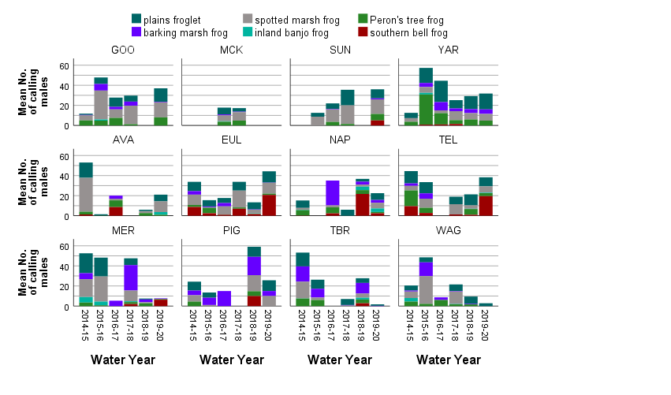

Figure ‑ Calling activity (mean count) of resident frog species at each of the 12 LTIM wetlands in the Murrumbidgee Selected Area between 2014-15 and 2019-20. (top row) (GOO Gooragool, MCK McKennas, SUN Sunshower, YAR Yarradda), Nimmie-Caira (middle row) (AVA Avalon, EUL Eulimbah, NAP Nap Nap, TEL, Telephone Creek). Redbank (bottom row) (MER Mercedes, PIG Piggery, TBR Two Bridges, WAG Wagourah Lagoon).

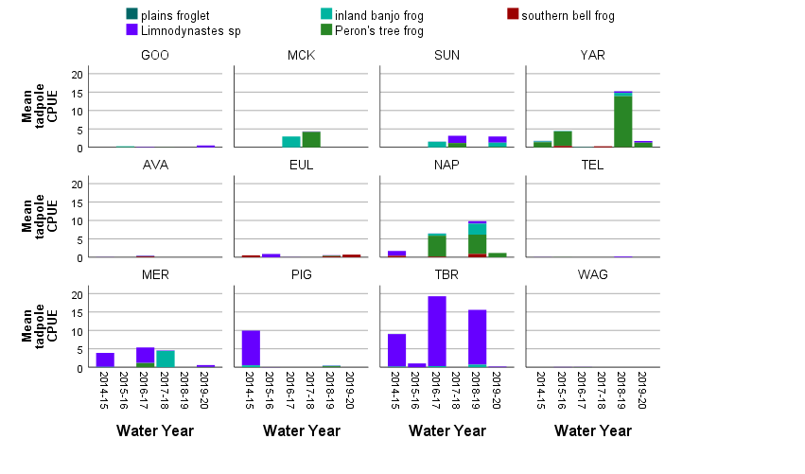A combination of Commonwealth environmental watering actions and unregulated flows resulted in the detection of 6,695 tadpoles, constituting six species, between September 2014 and March 2019. *Limnodynastes* spp. and Peron’s tree frog tadpoles were the most abundant species detected (Table 4‑23), with a maximum of 499 individuals recorded at Yarradda in 2018-19. This record number of tadpoles was a direct result of the 2018-19 Yarradda pumping watering action. In 2019-20, 299 tadpoles of three-four species were recorded (*Limnodynastes* spp. were not identified to species level). This is considerably lower than the previous year (Figure 4‑57) but is likely due to fewer watering actions in the Redbank zone, where high tadpole numbers are often detected at Two Bridges and Piggery Lake. Another positive outcome of the 2019-20 Sunshower Lagoon pumping action was the detection of 37 inland banjo frog tadpoles (Figure 4‑57), which were the only tadpole records for this species during the water year. Similarly, southern bell frog tadpoles were only detected from Eulimbah Swamp in November 2019. Peron’s tree frog tadpoles were detected at several wetlands where they were relatively abundant including Nap Nap Swamp and Yarradda Lagoon (Figure 4‑57).

Figure ‑ Mean tadpole abundance (Catch Per Unit Effort) for each of the 12 LTIM wetlands in the Murrumbidgee Selected Area between 2014-15 and 2018-19. (top row) (GOO Gooragool, MCK McKennas, SUN Sunshower, YAR Yarradda), Nimmie-Caira (middle row) (AVA Avalon, EUL Eulimbah, NAP Nap Nap, TEL, Telephone Creek). Redbank (bottom row) (MER Mercedes, PIG Piggery, TBR Two Bridges, WAG Wagourah Lagoon).

### Turtle breeding response

Three species of freshwater river turtle occur in the Murrumbidgee Selected Area, of which the eastern long-necked turtle is routinely captured each watering year. This widespread species accounted for approximately ~80% of all turtle captures between 2014-15 and 2019-20, followed by the broad-shelled turtle (~15% of all captures) and the Macquarie River turtle (5.2% of all captures). Turtles are a long-lived animal and breeding success is influenced to some extent by food availability in the wetland during preceding years, and also rates of fox predation, with foxes taking over 90% of eggs in some areas (Robley *et al* 2016). During the 2014-15 to 2019-20 survey period, a broad range of age cohorts of the eastern long-necked turtle were detected across all three zones. This species exhibited the broadest age range of all turtle species across all water years. A wide range of age cohorts of the broad-shelled turtle was detected in the mid-Murrumbidgee, whereas predominantly mature individuals of the broad-shelled turtle were detected in the Redbank zone. During the 2019-20 water year, two of the largest broad-shelled turtles measured during the program were captured at Waugorah Lagoon, a wetland where this species is consistently recorded. Both juvenile and adult Macquarie River turtles were detected in the mid-Murrumbidgee and Redbank zones over the course of the program. However, this species was not detected in any zone during the 2019-20 water year. Unlike previous years, especially the unregulated flood year of 2016-17, no juvenile turtles of any species were detected during the 2019-20 water year (Figure 4‑58).

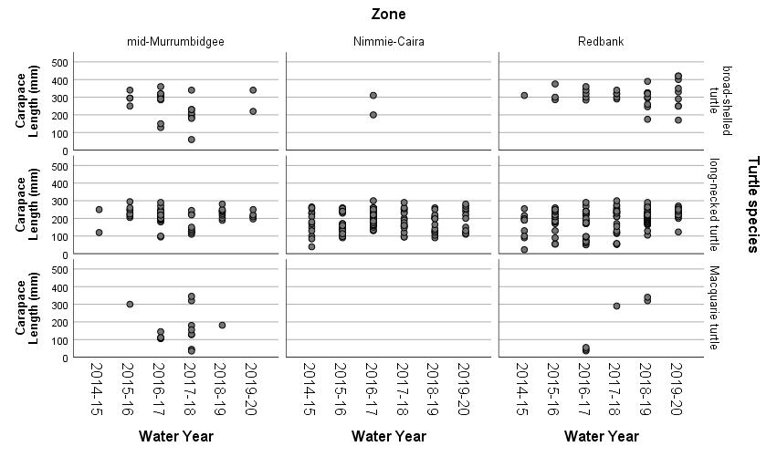

Figure ‑ Size distribution of individual turtles caught between 2014 and 2020 in each wetland zone.

***What did Commonwealth environmental water contribute to the maintenance of refuge habitats?***

Persistent off-channel waterbodies are important for the long-term management of frog and turtle populations and serve a role in maintaining populations during dry periods. Three of the 12 monitoring sites are considered to be refuge habitats, these are Yarradda Lagoon in the mid-Murrumbidgee, Telephone Creek in the Nimmie-Caira and Waugorah Lagoon in the Redbank system.

During the 2014-15 to 2019-20 survey period a total of 387 turtles from three species were recorded (broad-shelled turtle = 58, long-necked turtle = 309, Macquarie River turtle = 20). This represents an additional 39 records during the 2019-20 water year which is a low capture rate compared to previous years and may reflect drier than average conditions with fewer wetlands being inundated especially in the Redbank system which often supports high turtle abundances. Turtles have been detected at all 12 wetlands, although numbers are only consistently high at Yarradda Lagoon, Nap Nap Swamp and Two Bridges Swamp. Yarradda Lagoon, Gooragool Lagoon and Waugorah Lagoon were the only wetlands to support all three species (Figure 4‑59).

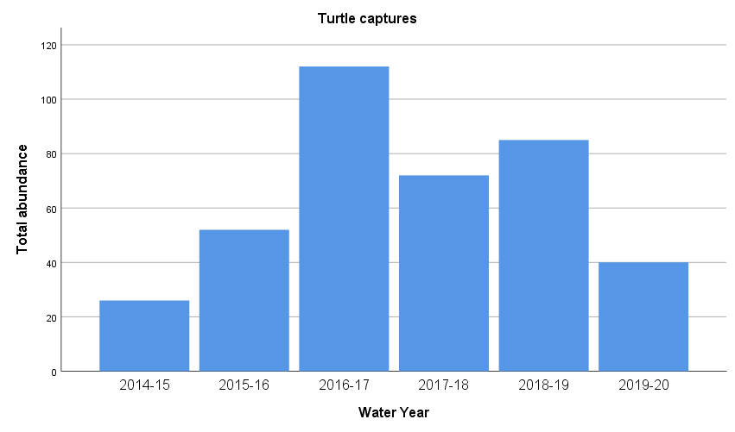Figure ‑ Total abundance of three freshwater turtle species in the Murrumbidgee Selected Area between 2014-15 and 2019-20 watering years.

In 2019-20, environmental watering actions included pumping water from the river into three lagoons in the mid-Murrumbidgee (Gooragool, Sunshower and Yarradda) which built on previous water actions in this zone and the natural flood event in 2016-17. The cumulative effects of these watering actions resulted in consistent numbers of turtles being recorded, especially eastern long-necked turtles and broad-shelled turtles. Environmental watering actions at Yarradda Lagoon resulted in the detection of a broad-shelled turtle, whereas pumping into Sunshower Lagoon resulted provided suitable condition to detect eastern long-necked turtles.

Watering actions in the Nimmie-Caira did not translate to high turtle detections, although the eastern long-necked turtle was recorded at Avalon Dam and Telephone Creek. In the Redbank zone, several wetlands either did not receive environmental water, or held water for a limited period. The long-term watering strategy of maintaining persistent refuge habitats is particularly important for long-lived species including turtles, large-bodied native fish and southern bell frogs. The refuge wetlands support a higher diversity of turtles compared to the non-permanent wetlands, Yarradda and Waugorah Lagoons support all three species, while Telephone Creek is an important refuge for broad-shelled turtles in the Nimmie-Caira (Figure 4‑60).

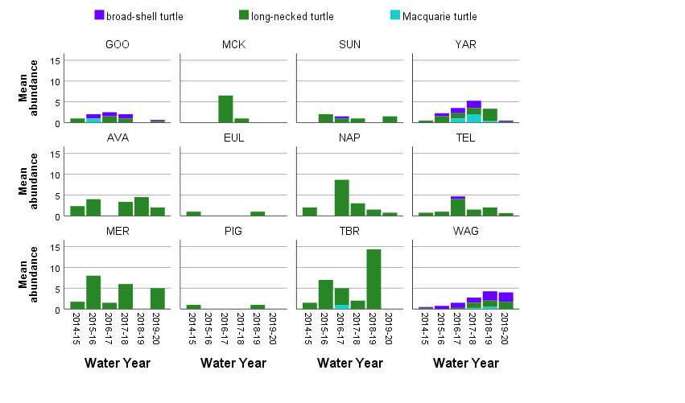Figure ‑ Turtle abundance across the five water years at each monitoring location (mid-Murrumbidgee wetlands (upper), Nimmie-Caira (mid) and Redbank (lower) zones).

***Discussion***

### What did Commonwealth environmental water contribute to other aquatic vertebrates (frog and turtle) populations?

The focus of Commonwealth environmental watering actions in 2019-20 was the inundation of wetlands in the Nimmie-Caira (Nap Nap to Waugorah NSW EWA and Nimmie-Caira refuge flows (CEWO)) and pumping into Yarradda Lagoon and Sunshower Lagoon (CEWO). These actions had clear benefits for frogs and turtles in targeted wetlands and were successful in achieving the objective of supporting breeding and habitat requirements (Table 4‑24).

During the six-year monitoring period, the overall numbers of adult frogs peaked in 2016-17, coinciding with extensive floodplain inundation due to a combination of unregulated flows complimented by managed environmental water. This outcome highlights the critical importance of large-scale inundation in driving large recruitment and population booms, which may increase the resilience of frog and turtle populations in the longer term. As demonstrated in 2016-17, watering actions that inundate continuous areas of floodplain habitat increase hydrological diversity and the availability of breeding habitats for frogs, turtles and waterbirds. In 2017-18, the limited area of inundation and declining water levels contributed to low tadpole abundance across the Nimmie-Caira and Redbank, despite the large mid-Murrumbidgee reconnection event that occurred. However, large numbers of tadpoles from a variety of species were recorded in Nap Nap Swamp in 2018-19 as a result of the Nimmie-Caira refuge flow, and in Two Bridges Swamp following the Yanga Lake top up and system watering, demonstrating that over the five years CEWO water management has contributed to the overall resilience of the system. Limited watering actions in the Redbank zone in 2019-20 limited frog and turtle monitoring at key wetlands. However, pumping actions in the mid-Murrumbidgee resulted in maintaining frog and turtle diversity and also resulted in the first calling records of the threatened southern bell frog in Sunshower Lagoon.

Since 2014, southern bell frogs have been recorded at seven of the 12 long-term monitoring sites, while breeding (tadpoles and juveniles) was detected at three sites (Nap Nap Swamp and Eulimbah Swamp in the Nimmie- Caira, and Yarradda Lagoon in the mid-Murrumbidgee). These three wetland systems are core habitats for southern bell frogs providing both breeding and refuge habitat. Commonwealth environmental water has been used successfully over the five year period to maintain and grow these key populations, which may require ongoing adaptive management to ensure population numbers don’t have negative effects on other floodplain frog species.

In the mid-Murrumbidgee, outcomes for frogs varied considerably among survey sites. In 2017-18, following a managed Commonwealth environmental water reconnection, McKennas and Sunshower Lagoons supported high abundances of tadpoles, but had low diversity of frogs and smaller adult populations overall, both of these wetlands along with Gooragool Lagoon were dry throughout 2018-19 and no frogs were recorded, which lowered the overall average frog diversity in the mid-Murrumbidgee.

At Yarradda Lagoon frog and tadpole abundance has been variable over time. Frog and tadpole numbers were highest in 2014-15 after the wetland was filled via pumping which limited the biomass of large carp. However, frog and tadpole numbers declined when the wetland reconnected with the main river channel in 2016-17 through unregulated flows, and in 2017-18 via a managed reconnection. In 2018, we predicted that the very high biomass of adult carp that entered the wetlands during the unregulated flows might have contributed to the reduced breeding by resident frogs. In 2018, Yarradda Lagoon was dried briefly to remove large carp and then refilled during 2018-19 and 2019-20. These actions were successful in increasing tadpole abundance, particularly in the summer breeding Peron’s tree frog. Very small numbers of southern bell frog tadpoles were also recorded. This reinforces our belief that management actions to remove carp prior to pumping will have a positive impact on frogs. However, while the draw down did not impact turtle abundance, a single broad-shelled turtle was recorded in 2019-20, suggesting it is possible for individuals to recolonise periodically dry wetlands. Unlike previous years, no juvenile turtles of any species were detected during the 2019-20 water year, this is likely to reflect drier than average conditions and the focus of watering being in the maintenance of refuge habitats rather than inundation of key nursery habitats such as Mercedes and Two Bridges swamp.

Evidence for successful maintenance of refuge habitats was also noted for turtles at Telephone Creek and Waugorah Lagoon, with Waugorah Lagoon being consistently important for the broad-shelled turtle, which is generally rare within wetlands of the Murrumbidgee. Maintaining water levels at key refuge sites (e.g. Wagourah Lagoon) over the summer will be important for maintaining turtle numbers. Ongoing fox control at key wetlands will also be important for maximising nesting success.

*Table 4‑24 Summary of watering actions with outcomes targeting frog and turtle habitat and responses*

|  |  |  |  |
| --- | --- | --- | --- |
| Events | Expected outcomes | Measured outcomes | Was the objective achieved |
| Yanga National Park: Yanga Lake top up and system watering (via 1AS  Nap Nap to Waugorah Lagoon (NSW EWA)  Nimmie-Caira refuge flows  Avalon Dam, Eulimbah, Telephone Creek  Yarradda and Gooragool Lagoon Pumping | Support reproduction and improved condition vegetation, waterbirds, native fish and other biota  Support the breeding, recruitment and habitat requirements of birds and native aquatic biota, including frogs, turtles and invertebrates;  Support the habitat requirements of waterbirds, native fish and other aquatic animals. | Six frog and three turtle species were recorded in 2018-19, including the vulnerable (EPBC Act) southern bell frog which is the same as previous years.  Breeding activity for all six frog species known to occur across the monitoring sites was recorded in response to Commonwealth environmental water*.* | Yes |

## Waterbird Diversity

Prepared by Dr Jennifer Spencer, Dr Skye Wassens, Carmen Amos and Dr Amelia Walcott

Introduction

The Murrumbidgee Selected Area supports a large diversity of waterbird habitats including lignum shrublands, river red gum forest, and semi-permanent lakes and lagoon habitats. Previous monitoring in the Murrumbidgee Selected Area has shown overbank flows and wetland connecting flows can result in increases in waterbird abundance and species richness including threatened and/or migratory species of conservation significance (Wassens *et al.* 2020).

The Lowbidgee Floodplain is a priority asset for waterbirds in the Murray-Darling Basin as it supports a large diversity and abundance of waterbirds, and major colonial waterbird breeding (MDBA 2014). During large-scale flooding this region can support large colonies of ibis, egrets, and pelicans (Brandis *et al.* 2011; Spencer *et al*. 2018). The Mid-Murrumbidgee wetlands consist of creek lines, lagoons and wetland depressions fringed by river red gum which also provide waterbird habitat, including small colonies of cormorants and darters (Briggs and Thornton 1999; Wassens *et al*. 2020).

A large proportion of annual watering events in the Murrumbidgee Selected Area include objectives for waterbird outcomes. These objectives can include providing refuge habitat during extended dry conditions, seasonal habitat for migratory and resident shorebird species, and threatened species, including the nationally endangered Australasian bittern *Botaurus poiciloptilus* (Commonwealth EPBC Act 1999), and where possible, supporting active breeding colonies.

Relevant watering actions and objectives

There were eight environmental water actions in the Murrumbidgee Selected Area which had objectives for waterbirds in the 2019-2020 water year (see Table 4‑25). Four of these watering actions were focused on the Mid-Murrumbidgee zone over the September 2019 – January 2020 period. This included targeted delivery of environmental water to Wilbriggie (Darlington), Yarradda and Sunshower Lagoons. Additional Commonwealth environmental water was delivered to the Murrumbidgee Irrigation Area (MIA) wetlands, primarily targeting the Fivebough-Tuckerbil Ramsar site, McCaughey’s Lagoon (Murrumbidgee Valley National Park) along with Campbell’s Swamp (not monitored) and Turkey Flat (not monitored). There were also three separate Lowbidgee watering actions for the North Redbank, Yanga National Park (South Redbank) and Gayini (Nimmie-Caira) wetland zones in late spring into summer months (Table 4‑25).

Table ‑. Summary of Commonwealth and NSW environmental water actions in the Murrumbidgee Selected Area that had objectives for waterbird outcomes over spring and summer 2019-2020.

|  |  |  |
| --- | --- | --- |
| Water Action Reference | Event | Objectives |
| 10082-28 | Yanga National Park refuge | Maintain critical refuge habitat for waterbirds, native fish, frogs (including the threatened southern bell frog), turtles and other water dependent animals. |
| 10082-21 | Gayini Nimmie-Caira refuge, SBF breeding and Tala Creek System refuge | Maintain critical refuge habitat for waterbirds, native fish (including for known golden perch populations in the Tala Creek system), frogs (including the threatened southern bell frog), turtles and other water dependent animals. |
| 10082-20 | Yarradda Lagoon Pumping | Maintain critical refuge habitat for waterbirds, native fish, frogs (including the threatened southern bell frog), turtles and other water dependent animals. |
| 10082-18 | Gooragool Lagoon Pumping | Maintain critical refuge habitat for waterbirds, native fish (including established golden and silver perch), frogs, turtles and other water dependent animals. |
| 10082-19 | Wilbriggie (Darlington) Lagoon | Maintain critical refuge habitat for waterbirds, native fish, frogs, turtles, other water dependent animals and threatened species such as the superb parrot (Cmwlth EPBC Act vulnerable). |
| 10082-31 | Sunshower Lagoon Pumping | Provide critical refuge habitat for waterbirds, native fish, frogs, turtles and other water dependent animals. |
| 10097-03 | North Redbank Refuge | Provide critical refuge habitat for waterbirds, native fish, frogs, turtles and other water dependent animals. |
| 10082-26 | MIA Wetlands | Maintain critical refuge habitat for waterbirds, native fish, frogs (including the threatened southern bell frog), turtles and other water dependent animals foraging and breeding habitat, in-particular for Australasian bittern and many other listed migratory species |

Evaluation Questions

The responses of waterbirds to watering actions across the Murrumbidgee Selected Area in 2019-2020 were assessed against three key evaluation questions to determine the extent to which the expected outcomes were achieved:

* What did Commonwealth environmental water contribute to waterbird species diversity?
* What did Commonwealth environmental water contribute to waterbird abundance?
* What did Commonwealth environmental water contribute to waterbird breeding?

Methods

The Murrumbidgee waterbird ground surveys are part of long-term monitoring now coordinated by NSW DPIE-EES (formerly by the NSW Office of Environment and Heritage and previous departments) (Spencer *et al*. 2018). Annual ground surveys have been done each spring to complement long-term aerial waterbird surveys coordinated by the University of New South Wales (UNSW) (Porter *et al*. 2019). Both programs collect information on the number of waterbird species, abundance and breeding activity in important waterbird habitats in the NSW Murray-Darling Basin including the Lowbidgee Floodplain.

Waterbird ground surveys were completed in 36 sites across the Murrumbidgee Selected Area in October 2019 and February 2020. The February 2020 surveys were the first-year system-wide ground surveys have been completed in the Murrumbidgee Selected Area over summer months. In total 26 sites in the Lowbidgee Floodplain were surveyed from 21-24 October 2019 and from 24-27 February 2020 (Plate 4-3, Figure 4‑61). Ten sites in the Mid-Murrumbidgee Wetlands sites were surveyed from 8-10 October 2019 and from 18-20 February 2020 (Plate 4‑4, Figure 4‑62).

The ground survey sites included the 12 core wetland monitoring sites that have been surveyed quarterly through the Murrumbidgee LTIM program (2014-19) (Wassens *et al.* 2020) and now through the Murrumbidgee MER program. The 36 ground survey sites include a range of habitat types including lakes, lagoons and creek lines fringed by river red gum, spike-rush river red gum wetlands, lignum shrublands and black-box wetlands (Plate 4‑4). There were eight sites in the Nimmie-Caira zone (including Gayini and neighbouring Nap Nap station), 14 sites in the Redbank zone (six sites in North Redbank and eight sites in South Redbank (Yanga National Park)), and four sites in the Western Lakes (see Figure 4‑61, Appendix 1). In the Mid-Murrumbidgee wetland zone six of the ten sites are in the Murrumbidgee Valley National Park and one site (Narrandera SF lagoon) is located in the Murrumbidgee Valley Regional Park (Figure 4‑62, Appendix 1)

More than half of the survey sites were dry during the October 2019 and February 2020 survey periods (Appendix 1). Five survey sites in the Mid-Murrumbidgee Wetlands (Yarradda Lagoon, Wilbriggie (Darlington) Lagoon, Gooragool Lagoon, Sunshower Lagoon and McCaughey’s Lagoon) (Figure 4‑62) received Commonwealth environmental water in 2019-2020. Additional environmental water was delivered to parts of the Gayini (Nimmie-Caira), Yanga National Park and North Redbank systems over late spring-summer 2019-2020 as part of managed refuge flows after the completion of the spring ground surveys (Table 4‑25).

The delivery of environmental water resulted in increases in inundated area in 11 of the survey sites at the time of the summer surveys relative to conditions observed during the spring surveys. This included Gooragool, Yarradda, Sunshower and McCaughey’s lagoons (Mid-Murrumbidgee), Eulimbah, Nap Nap, Suicide (Nimmie-Caira), Mercedes, Murrundi and Steam Engine swamps, and Wagourah Lagoon (Redbank). There was also residual water from the previous environmental watering actions in 2016-17 and 2018-19 in some survey sites including Paika Lake in the Western Lakes, and Yanga, Piggery and Wagourah lakes in the Redbank zone. Although these three lakes in South Redbank (Yanga National Park) had dried down by the time of the February 2020 surveys (Figure 4‑61).

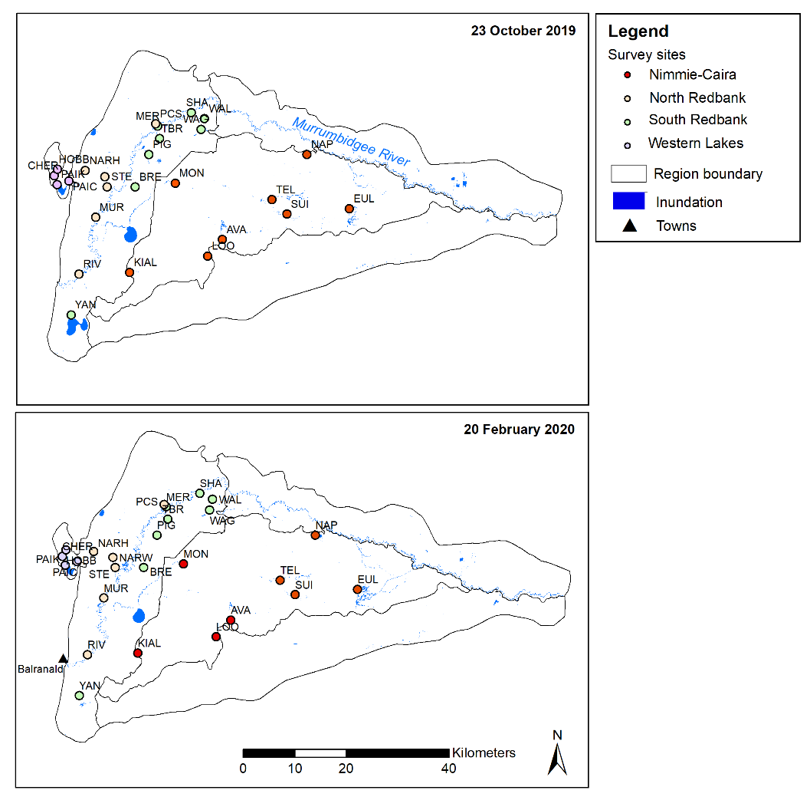Figure 4‑62 Distribution of the 26 waterbird survey sites in the Lowbidgee Floodplain and inundated areas at the time of the October 2019 and February 2020 surveys (see Appendix 1for explanation of site codes).

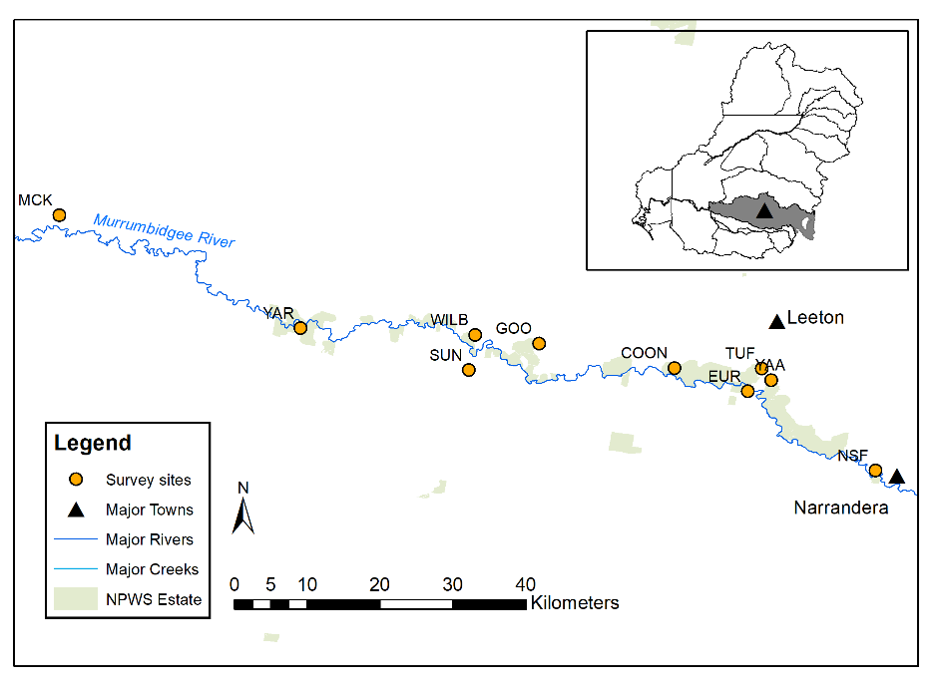

Figure 4‑63 Locations of the 10 waterbird survey sites in the Mid-Murrumbidgee wetland zone (see Appendix 1 for explanation of site codes).

Methods used during the biannual surveys are outlined in Wassens *et al.* (2019) and Spencer *et al*. (2018). Briefly, waterbird species are counted at each survey site with binoculars and/or telescope on at least two survey occasions (over separate days) in each survey period. Dry sites are only surveyed once. Two observers spend a minimum of 20 minutes, and not more than one hour at each survey site. This data is used to estimate the number of waterbird species and maximum count of each species per survey site.

Incidental observations of waterbird species were also completed as part of the Murrumbidgee MER project at the same time as the frog and fish wetland surveys at the 12 fixed monitoring sites. Additional waterbird monitoring undertaken over the September 2019 to March 2020 period included ground surveys at six active colony sites in the Murrumbidgee Selected Area undertaken by DPIE-EES staff and as part of Murray-Darling Wetland Working Group (MDWWG) surveys in the Gayini Nimmie-Caira. The colony ground surveys were conducted on foot, or using small kayaks, to estimate total number of nests for each species, stage of nesting, evidence of mortality and collect information on water depths in each colony to inform water management (see detailed methods in Wassens *et al.* 2019).

|  |  |
| --- | --- |
| Eulimbah Swamp (Gayini Nimmie Caira)  Jan 2020 | Steam Engine (north Redbank) Oct 2019 |
| Waugorah Lagoon (South Redbank) Jan 2020 | Mercedes Swamp Jan 2020 (South Redbank) |

Plate 4‑3. A range of wetland habitats are surveyed as part of ground surveys in the Lowbidgee Floodplain

In order to determine the extent to which the Commonwealth environmental watering actions achieved their objectives with respect to waterbird communities in the Murrumbidgee Selected Area, we considered three key aspects of the waterbird response: 1) species richness (number of waterbird species and number of functional groups), 2) number and abundance of waterbird functional groups, 3) maximum waterbird abundance recorded in each surveyed wetland in each survey period and 4) waterbird breeding activity (number of breeding species, number of broods/nests and number of active colonies).

|  |  |
| --- | --- |
| Yarradda Jan 2020 | Gooragool Jan 2020 |
| Mckennas Jan 2020 | Sunshower Jan 2020 |

Plate 4‑4. Waterbird ground survey sites in the Mid-Murrumbidgee Wetlands include a variety of river red gum lagoons and depressions

Results

***Waterbird species richness***

In total 67 waterbird species were recorded across the Murrumbidgee Selected Area in 2019-2020 during the biannual ground surveys and complementary monitoring (see Appendix 2). This included seven bird species listed under one or more international migratory bird agreements: sharp-tailed sandpiper *Calidris acuminata*, long-toed stint **Calidris subminuta,** common greenshank Tringa nebularia, marsh sandpiper Tringa stagnatilis, red-necked stint Calidris ruficollis, wood sandpiper Tringa glareola and Caspian tern Hydroprogne caspia. Two NSW listed species (*Biodiversity Conservation Act 2016*) were also detected during the February 2020 surveys. Freckled duck Stictonetta naevosa were observed at Suicide Swamp and Eulimbah Swamp (Nimmie-Caira zone), and blue-billed duck Oxyura australis were observed at Suicide Swamp (Plate 4‑5). Endangered Australasian bitterns (Commonwealth EPBC Act, NSW BC Act) were also recorded at Eulimbah Swamp over summer 2020 (A. Borrell, MDWWG, pers. obs, January 2020).

More than half of the waterbird ground survey sites were dry during the spring 2019 (67% of sites) and summer 2020 (56% of sites) surveys (Appendix 1). Sites that held water from the previous water year or sites that had received environmental water prior to the ground surveys supported a diverse range of waterbird species. During the spring 2019 surveys 46 waterbird species were observed across the Murrumbidgee Selected Area and 50 species were detected in the summer 2020 surveys.

When compared to previous annual spring surveys total species richness was relatively high during the 2019-2020 surveys considering the very dry conditions (Figure 4‑61). Waterbirds were largely restricted to sites that held residual water from the previous water year or had been inundated with environmental water over spring and/or summer. In total 43 waterbird species were detected in the Lowbidgee survey sites during the spring 2019 surveys, and 50 species were detected during the summer 2020 surveys. The 2019 spring survey results were consistent with the long-term average number of waterbird species recorded in annual spring surveys of the Lowbidgee Floodplain from 2014-2019 (43 species on average, ranging from 38-47 species, 47 species were recorded in spring 2017) (Figure *4‑63*). Fewer waterbird species were recorded in the Mid-Murrumbidgee Wetlands in the 2019-2020 surveys, with 22 species observed in spring 2019 and 24 species in summer 2020. This was consistent with the long-term average number of waterbird species recorded in the Mid-Murrumbidgee Wetlands from 2014-2019 (22 species on average during annual spring surveys, ranging from 14-27 species, 27 species were recorded in spring 2017) (Figure 4‑63 and

Figure 4‑64).

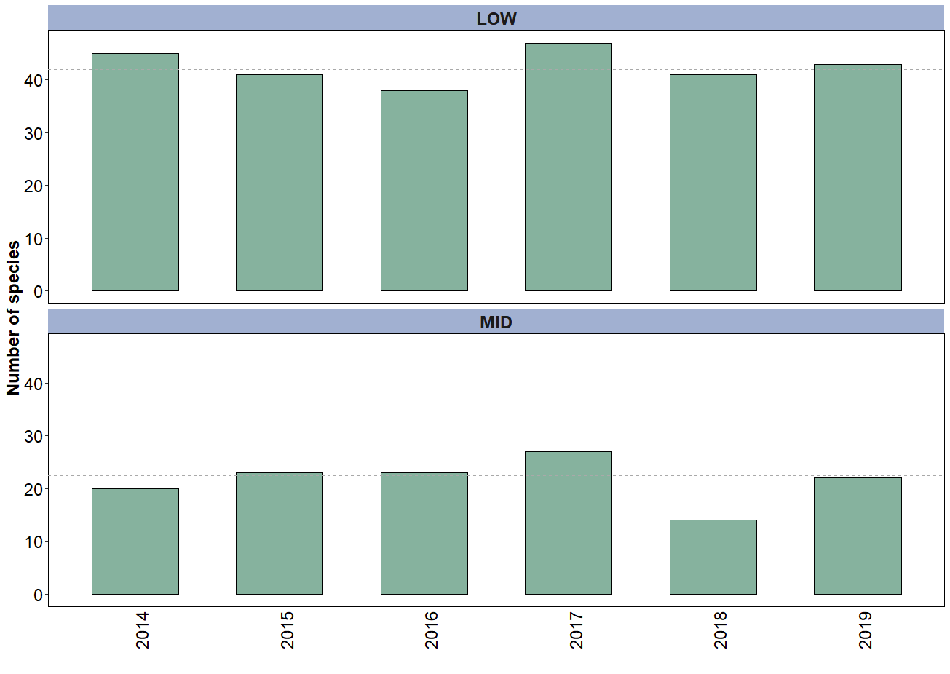

*Figure 4‑64**Total number of waterbird species recorded during spring ground surveys completed each October from 2014-19 in the Lowbidgee (LOW) Floodplain (upper) and Mid-Murrumbidgee (MID) Wetlands (lower) (the dotted line represents the median number of waterbird species observed over the 2014-2019 period).*

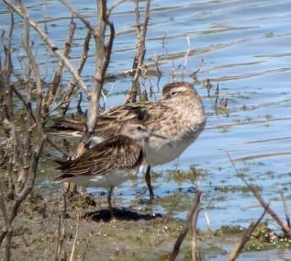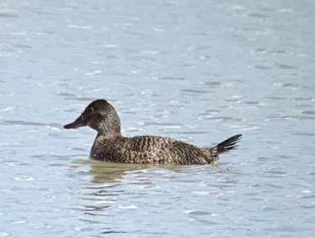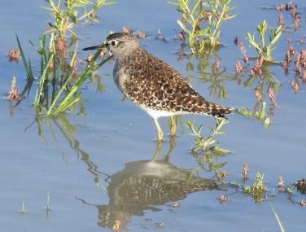

*Plate 4‑5 Left: Blue-billed ducks (female pictured) were recorded at Suicide Swamp in the summer 2020 surveys. Mid: Migratory sharp-tailed sandpipers (back) and a long-toed stint (front) were recorded at Eulimbah Swamp in the spring 2019 surveys (Credit Carmen Amos, DPIE-EES). Right: Migratory wood sandpipers were recorded at both Eulimbah and Suicide swamps during the February 2020 surveys (Credit: Skye Davis, Macquarie University).*

The sites in Yanga National Park (South Redbank) supported the most species (32 species) at the time of the spring 2019 surveys with fewer species recorded during the summer 2020 surveys (only 14 species) (Figure 4‑64). In comparison total species richness in the other Murrumbidgee wetland zones was low in spring 2019. We detected some increases in total number of species in the February 2020 surveys in the Gayini (Nimmie-Caira) and North Redbank zones in response to spring and summer environmental watering (Figure 4‑64). The total number of waterbird species detected in the Mid-Murrumbidgee Wetlands and Western Lakes was consistent over the spring and summer surveys. No additional flows were delivered to the Western Lake in 2019-2020 and waterbirds observed in this zone were only observed in residual areas of inundation in Paika Lake (Figure 4‑61).

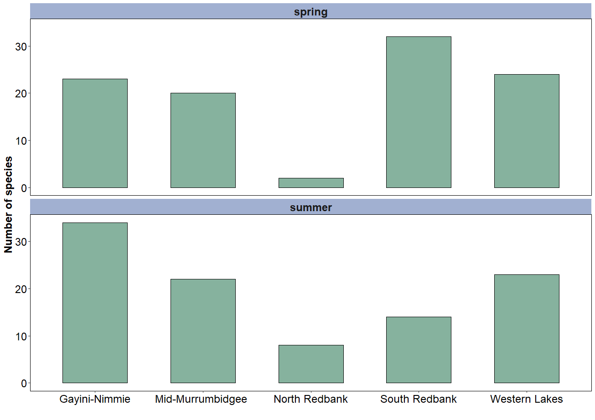

*Figure 4‑65**Total number of waterbird species recorded in in each wetland zone in the Murrumbidgee Selected Area during the spring 2019 and summer 2020 ground surveys.*

***Waterbird abundance***

Overall total waterbird abundance was low during the spring 2019 and summer 2020 ground surveys in the Murrumbidgee Selected Area (Figure 4‑65 and Figure 4‑66). This response reflected the very dry conditions and limited wetland habitat availability observed across the Lowbidgee Floodplain (Figure 4‑61) and Mid-Murrumbidgee Wetlands at the time of the surveys. The only exception was high numbers of dabbling ducks, fish-eating waterbirds and resident shorebirds recorded feeding in residual water in Yanga Lake (Figure 4‑61) in October 2019 which inflated the total numbers of waterbirds recorded in the South Redbank system compared to previous spring surveys (Figure 4‑66) and the other wetland zones (Figure 4‑65).

Overall patterns of waterbird abundance reflected the availability of inundated wetland habitat. The most abundant waterbird groups recorded in both survey periods were dabbling ducks and fish-eating waterbirds (Figure 4‑65). Environmental water was delivered to parts of North Redbank, South Redbank (Yanga National Park) and Gayini Nimmie-Caira after the spring surveys were completed (see Table 4‑25).

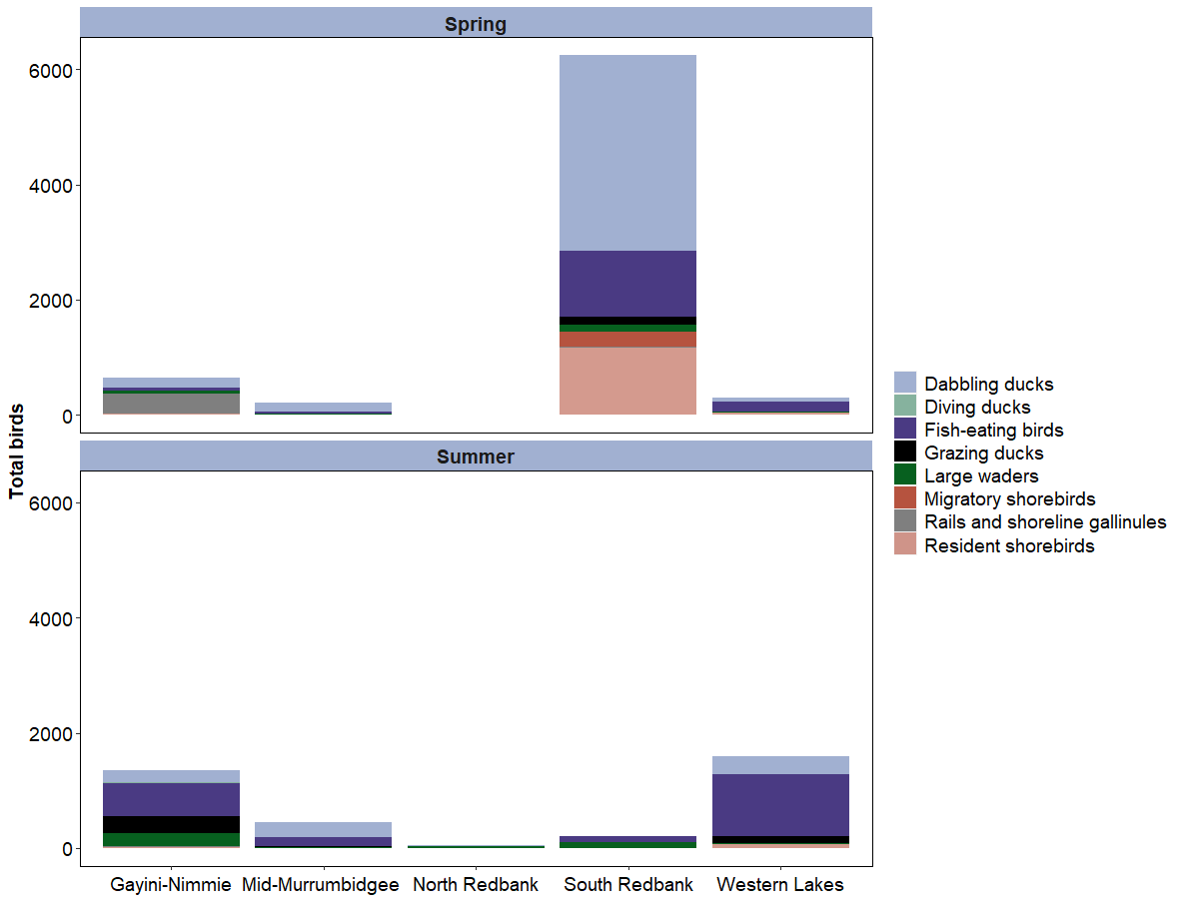

*Figure 4‑66**Total number of waterbirds observed in each of the Murrumbidgee Selected Area zones during the spring 2019 and summer 2020 ground surveys.*

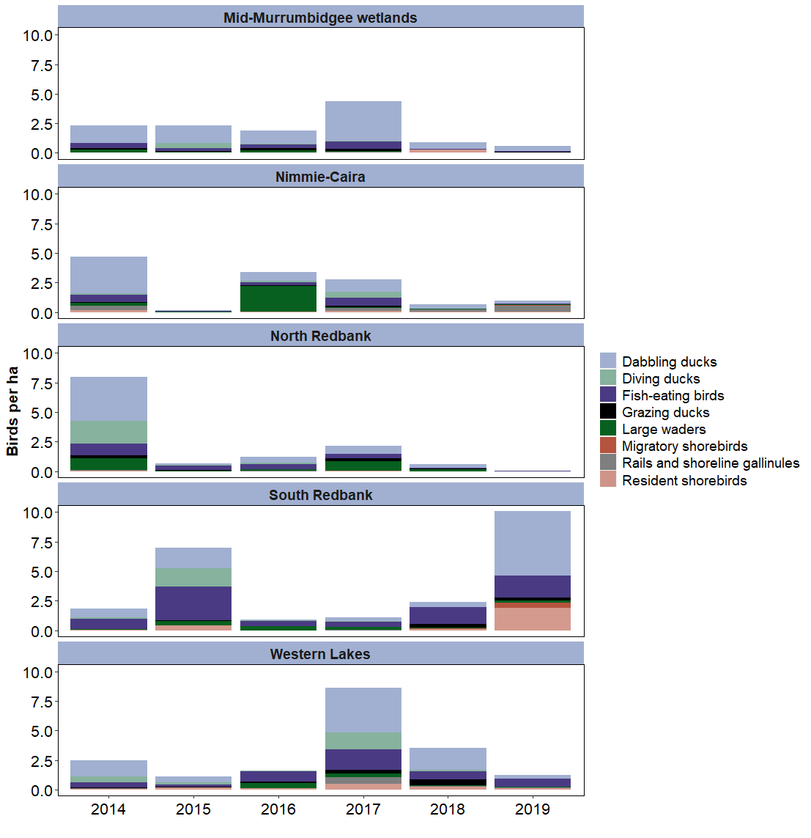*Figure 4‑67**Waterbird abundance (presented as abundance of each waterbird guild per hectare) recorded in the five wetland zones each spring between 2014 and 2019.*

Where wetland habitat persisted into late summer we observed an increase in waterbird abundance in individual sites that received environmental water relative to the spring surveys (see section below). For instance, in the Gayini Nimmie- Caira zone there were increases in waterbird abundance recorded in the summer surveys due to large flocks of Australian wood duck *Chenonetta jubata* (grazing waterfowl), Australian pelican *Pelecanus conspicillatus* (fish-eating waterbirds) and Pacific black duck *Anas* superciliosa (dabbling ducks) recorded specifically at Suicide Swamp (Figure 4‑61) which was inundated with environmental water over spring and summer months.

***Waterbird breeding***

Overall waterbird breeding activity was low in the Murrumbidgee Selected Area in 2019-2020. Active nests and/or broods were only detected in 11 waterbird species across eight sites in total in the Murrumbidgee Selected Area in the 2019-2020 ground surveys. This included: Australasian darter *Anhinga novaehollandiae* (four sites), Australasian grebe *Tachybaptus novaehollandiae* (Wilbriggie Lagoon), Australian white ibis *Threskiornis moluccus* (Eulimbah Swamp), Australian wood duck (Avalon Swamp), black swan *Cygnus atratus* (Eulimbah Swamp), grey teal *Anas gracilis* (Sunshower Lagoon)*,* little pied cormorant *Microcarbo melanoleucos* (three sites), little black cormorant *Phalacrocorax sulcirostris* (House Creek), Pacific black duck (Coonacoocabil Lagoon, Telephone Creek), royal spoonbill *Platalea regia* (Eulimbah Swamp) and white-faced heron *Egretta novaehollandiae* (House Creek).

No breeding activity was detected during UNSW’s aerial survey of the Lowbidgee Floodplain on the 16 October 2019 or during DPIE-EES ground surveys completed in October and November 2019. Small-scale colonial-waterbird nesting was detected at six wetlands that received environmental water in 2019-2020 and these sites were active over the December to March 2020 period. This included small numbers of nesting darters and cormorants recorded at Narwie in North Redbank (ten nests), Telephone Creek (six nests) and House Creek (five nests) in the Gayini (Nimmie-Caira), and Yarradda (11 nests) and Gooragool (five nests) Lagoons in the Mid-Murrumbidgee Wetlands. A small colony of Australian white ibis and royal spoonbill (around 30 to 40 ibis nests in total and four spoonbill nests) established in Eulimbah Swamp in January 2020. The Eulimbah colony was first detected in mid-January (A. Borrell, MDWWG, pers. obs) when the ibis nests had eggs and the colony was near completion by late February with most young ibis were at flying stage (C. Amos, DPIE-EES pers obs) (Plate 4‑6).

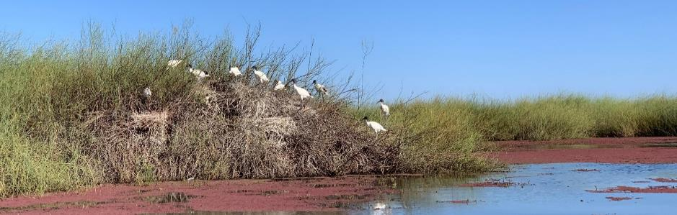

Plate 4‑6 Eulimbah Swamp ibis colony, Gayini (Nimmie-Caira), February 2020. (Credit: Carmen Amos, NSW DPIE-EES).

***Waterbird responses to 2019-2020 watering actions***

***Mid-Murrumbidgee Wetlands***

In 2019-2020 the delivery of environmental water inundated wetland habitat in the Mid-Murrumbidgee wetland zone influencing waterbird communities in five of the 10 surveys sites. Watering actions in the Mid-Murrumbidgee Wetlands were undertaken with the objectives to “maintain or provide critical refuge habitat for waterbirds, native fish, frogs, turtles and other water-dependent animals” (Table 4‑25). Watering actions occurred in spring and summer, with Wilbriggie (Darlington) and Yarradda Lagoons receiving environmental water prior to the spring surveys. By the time of the summer surveys three additional sites had been inundated by environmental water over summer months (Sunshower, Gooragool and McCaughey’s lagoons).

Wilbriggie (WILB) and Yarradda (YAR) Lagoons supported the most species and abundance of waterbirds during the spring surveys after the lagoons received environmental water over September 2019 (Figure 4‑67). Wilbriggie Lagoon only held residual water and few waterbirds during the summer surveys. Yarradda Lagoon was inundated with environmental water with a pumped delivery between September and December 2019 and still held high water levels during the February 2020 surveys. Waterbird species richness and total abundance was similar in Yarradda Lagoon in both survey periods, although there was an increase in fish-eating waterbirds in the summer surveys (Figure 4‑67) and this site supported small number of nesting darters (11 nests in total).

Sunshower Lagoon (SUN) received environmental water in December 2019 and this action resulted in an increase in waterbird species including dabbling, diving and grazing ducks, and smaller numbers of fish-eating waterbirds including grebes, cormorants and herons (Figure 4‑67). Gooragool Lagoon (GOO) was dry during the spring 2019 surveys and received environmental water in December 2019 filling the lagoon which supported an overall increase in the number and abundance of individual waterbird species, predominately dabbling ducks and large waders. Gooragool Lagoon also supported a small number of nesting little pied cormorants and Australasian darters during the summer surveys (five nests in total). We also observed an increase in waterbird diversity and abundance at McCaughey’s Lagoon (YAA) in response to environmental water delivery (MIA Wetlands watering action)( see table 3.1). During the summer surveys this site supported dabbling ducks, fish-eating waterbirds, large waders (spoonbills and herons) and rails and shoreline gallinules (waterhens) (Figure 4‑67).

Water levels remained relatively stable at Coonacoocabil Lagoon (COO) over the two survey periods and this site supported small numbers of dabbling ducks and fish-eating waterbirds. Turkey Flats (TUF) held only residual water during both survey periods and supported a small number of dabbling ducks, large waders and rails (Figure 4‑67). Euroley (EUR). McKennas (MCK) and Narrandera State Forest (NSF) lagoons remained dry during the spring 2019 and summer 2020 surveys and no waterbirds were detected at these sites in either survey period (Figure 4‑67).

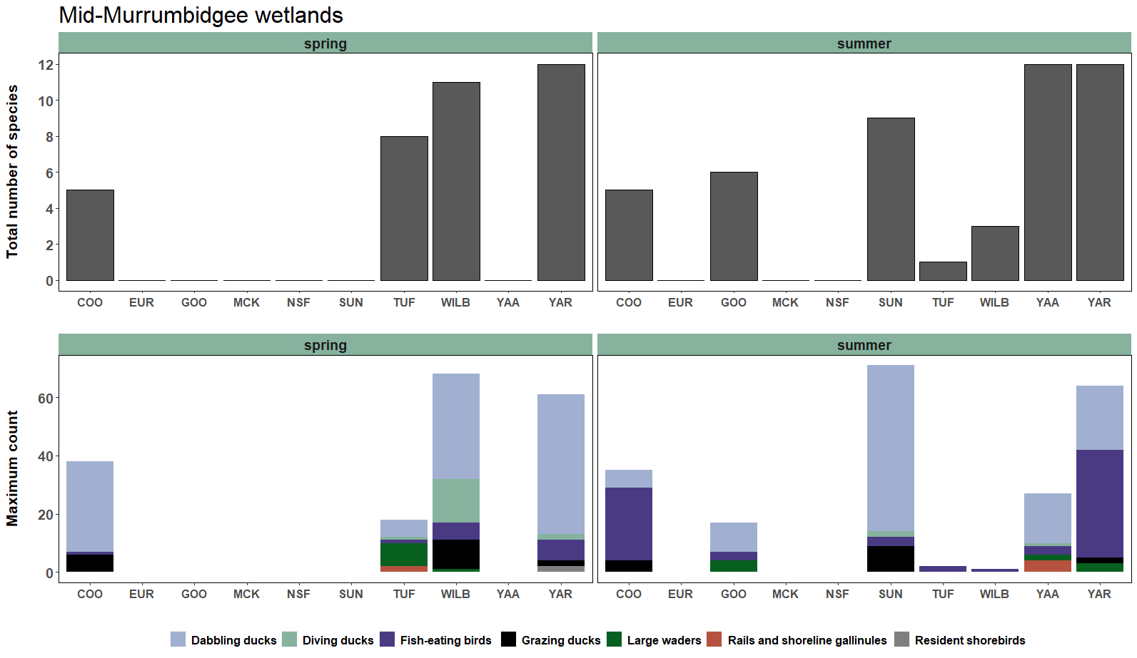

Figure 4‑68Total number of waterbird species (upper) and maximum count of each waterbird functional group (lower) recorded in each survey site in the Mid-Murrumbidgee Wetlands in the spring 2019 and summer 2020 surveys. See Appendix 1 for explanation of site codes.

***Gayini Nimmie-Caira Wetlands***

There were two periods of watering undertaken in the Gayini Nimmie-Caira in 2019-2020 as part of the Gayini Nimmie-Caira refuge watering action. This included the main Gayini Nimmie-Caira refuge watering action from late October to late December 2019 and a smaller delivery targeting deeper sections of Eulimbah Swamp as part of a small top-up flow from late January to early February 2020. The Gayini Nimmie-Caira refuge watering action aimed to “maintain critical refuge habitat for waterbirds, native fish, frogs, turtles and other water-dependent animals” (Table 4‑25).

The second period of water delivery in the Gayini Nimmie-Caira increased the water level in Eulimbah Swamp and pushed water from Eulimbah through to Suicide Swamp over late January to early February 2020. This delivery resulted in increases in the diversity and abundance of waterbirds in the Gayini Nimmie-Caira wetland zone (Figure *4‑65*), particularly in Suicide Swamp (SUI) where small but notable increase in fish-eating waterbirds and resident shorebirds were recorded (Figure 4‑68). Vulnerable, blue-billed duck and freckled duck (NSW BC Act 2016) and migratory wood sandpipers were also recorded at Suicide Swamp during the summer surveys. The Gayini Nimmie-Caira refuge watering action supported a small colony of Australian white ibis and royal spoonbill in Eulimbah Swamp (EUL) which was active from January to March 2020 (see waterbird breeding section above).

Nap Nap Swamp (NAP) was dry at the time of the spring surveys but was inundated as part of the main Gayini Nimmie-Caira environmental water action over late spring and early summer and supported large waders, fish-eating waterbirds, dabbling ducks and grazing ducks in the summer surveys (Figure 4‑68). Water levels remained relatively stable at Telephone Creek (TEL) over the two survey periods and this site supported small numbers of fish-eating waterbirds including small numbers of nesting darters and little pied cormorants (six nests). Avalon Swamp (AVA) was also inundated as part of the Gayini-Nimmie-Caira watering action after the spring surveys but this site had dried back over summer and supported few waterbirds at the time of the summer surveys (Figure 4‑68). Both Kia Lake (KIAL) and Loorica Lake (LOO) in the Nimmie-Caira wetland zone were dry during 2019-2020 and no waterbirds were detected at these sites in either survey period (Figure 4‑68).

***Redbank***

Most wetlands in the Redbank system were either dry or drawing down during the spring and summer surveys (Figure 4‑61, Appendix 2). There was limited environmental watering undertaken in the Redbank wetland zone in 2019-2020 with two small separate watering actions for Yanga National Park and North Redbank delivered from late spring into summer months. These watering actions aimed to “maintain or provide critical refuge habitat for waterbirds, native fish, frogs, turtles and other water-dependent animals” (Table 4‑25).

Mercedes Swamp in Yanga National Park (South Redbank) was dry during the spring surveys but received a small flow prior to the summer surveys and water levels also increased at Wagourah Lagoon as a result of the Gayini Nimmie-Caira refuge watering action which included flows delivered through Nap Nap to Wagourah (see section on Nimmie-Caira wetland zone above). This resulted in increases in number and diversity of waterbirds in Mercedes Swamp (MER) in the summer surveys, but numbers of waterbirds were low in Wagourah Lagoon (WAG) during both survey periods (Figure 4‑69).

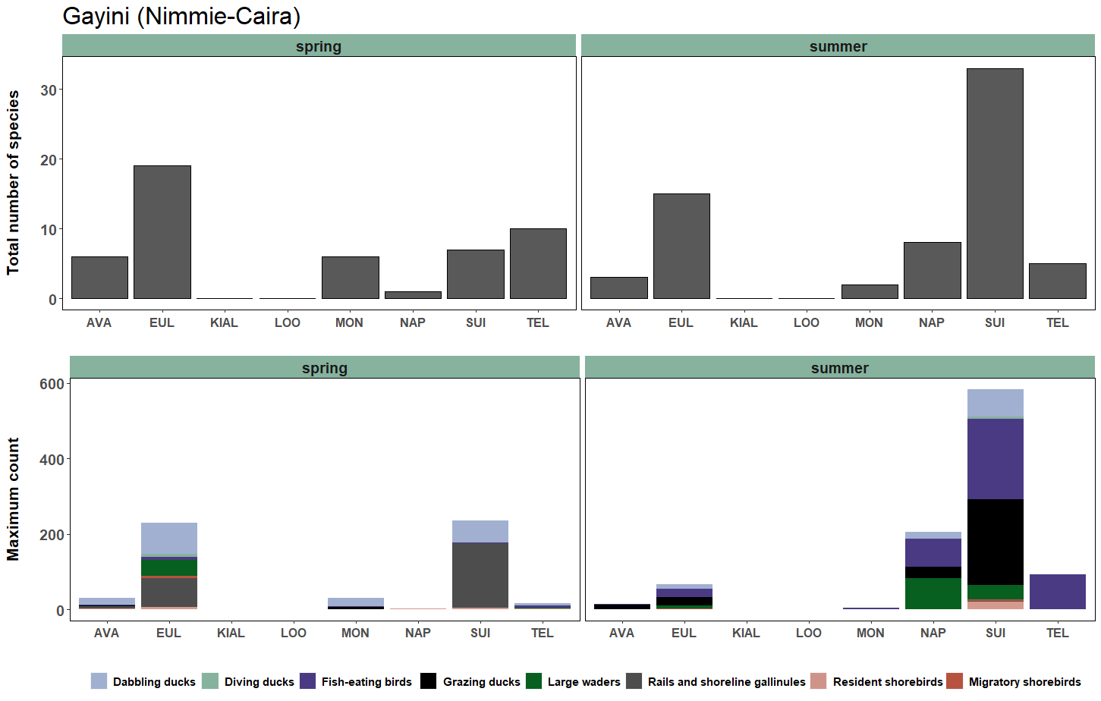

Figure ‑Total number of waterbird species (upper) and maximum count of each waterbird functional group (lower) recorded in each survey site in the Gayini (Nimmie-Caira) and neighbouring Nap Nap station in the spring 2019 and summer 2020 surveys. See Appendix 1 for explanation of site codes.

Many sites in South Redbank were dry over spring-summer 2019-2020 (Figure 4‑61). Yanga Lake (YAN) contained a small amount of water during the spring ground surveys but was dry during the summer surveys. Wagourah Lake (WAL) and Piggery Lake (PIG) were also dry by the time of the summer surveys (Figure 4‑69). Despite low water levels in the spring surveys we recorded a high number of species and individuals at Yanga Lake, including Australian pelicans, resident and migratory shorebirds, and dabbling ducks (Figure 4‑69). The shorebird species were feeding on the edge of the lake on areas of mudflat and this included a flock of 200 migratory sharp-tailed sandpipers. Piggery Lake also supported a relatively high diversity of waterbirds during its draw down phase in spring although total waterbird abundance was low (Figure 4‑69). Two Bridges Swamp was partially inundated with environmental water as part of the Yanga National Park refuge watering action in December 2019 and incidental surveys undertaken as part of the routine wetland surveys in late January 2020 surveys recorded small numbers of waterbirds including ibis, herons and ducks using residual pools (D. Michael, CSU, pers. obs) but by the time of the February surveys this site was largely dry. Breer (BRE) and Shaws (SHA) swamps were dry during the ground surveys and very few waterbirds were detected at these sites (Figure 4‑69).

Overall waterbird diversity and abundance in the North Redbank system was also low in the spring and summer surveys (Figure 4‑70). There were some increases in waterbirds, including spoonbills and ibis (large waders) at Steam Engine Swamp (STE) and Murrundi Swamp (MUR), which received environmental water prior to the summer surveys as part of the North Redbank watering action (Figure 4‑70). Narwie Swamp was also inundated by this watering action and supported a small colony of little pied cormorants and Australasian darters (10 nests). Paul Coates Swamp (PCS), Riverleigh Swamp (RIV) and the other ground survey sites in Narwie (Narwie West (NARW) and Narwie Homestead Swamp (NARH)) remained dry during both survey periods and very few waterbirds were recorded at these sites (Figure 4‑70).

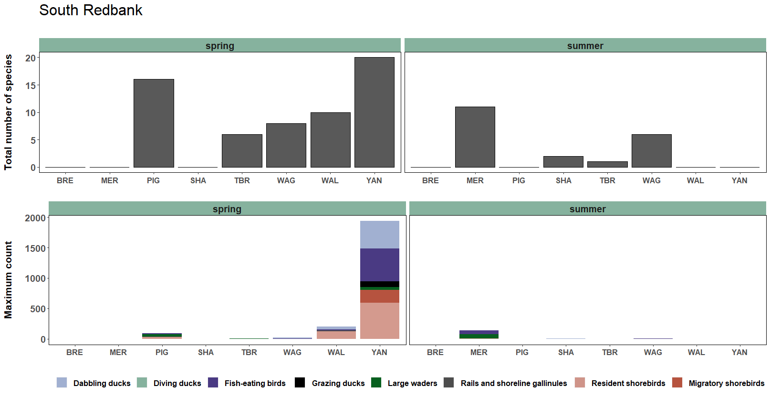

*Figure 4‑70**Total number of waterbird species (upper) and maximum count of each waterbird functional group (lower) recorded in each survey site in the South Redbank system (Yanga National Park) in the spring 2019 and summer 2020 surveys. See Appendix 1 for explanation of site codes.*

*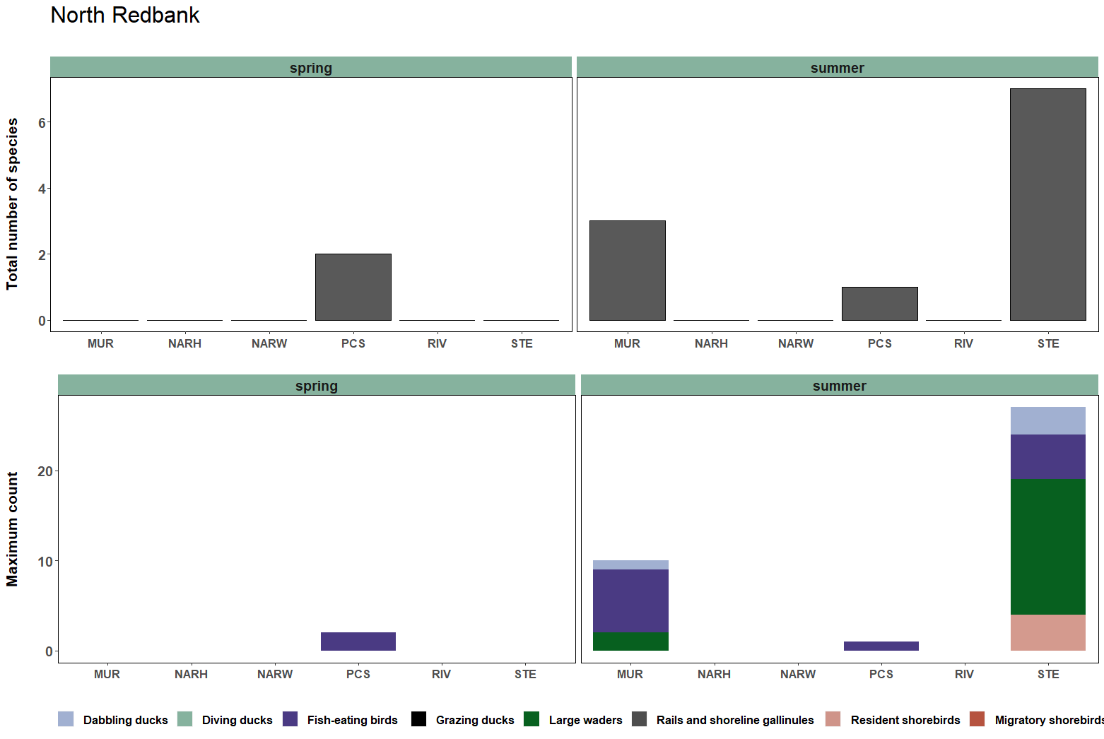**Figure 4‑71**number of waterbird species (upper) and maximum count of each waterbird functional group (lower) recorded in each survey site in the North Redbank system in the spring 2019 and summer 2020 surveys. See Appendix 1 for explanation of site codes*.

Discussion

****What did Commonwealth environmental water contribute to waterbird species richness, abundance and breeding activity?****

Wetland habitat availability was low in the Murrumbidgee Selected Area and across the Murray -Darling Basin in 2019-2020. Commonwealth and NSW environmental water actions in the Murrumbidgee Catchment largely aimed to maintain or provide core refuge habitat to support water-dependent animals including waterbird species. The provision of refuge habitat is critical during dry years as it provides essential habitat for water-dependent animals to survive extended dry periods.

Our spring and summer surveys provided evidence that this refuge watering approach can provide outcomes for waterbirds in very dry periods. Environmental water was delivered to inundate and maintain wetland habitats and the results of the ground surveys showed that waterbirds actively responded to these small watering actions. Increases in the number of waterbird species and abundance were observed in ten monitored wetlands that received environmental water in the Lowbidgee Floodplain and Mid-Murrumbidgee Wetlands. The drawdown of residual wetland habitat at Yanga Lake, Piggery Lake, Wagourah Lake and Paika Lake that were inundated by environmental water in the previous water year (Paika Lake last inundated in 2016-17) also created areas of suitable habitat for a range of waterbird species including migratory shorebirds.

Despite the dry conditions, the total number of waterbird species detected in spring 2019 was similar to the results of previous annual spring surveys. The 2019-2020 environmental watering actions supported breeding activity in at least 11 waterbird species and at least 10 conservation-dependent waterbird species including the nationally endangered Australasian bittern (EPBC Act), vulnerable freckled duck and blue-billed duck (NSW BC Act 2016) and seven species listed on one or more international migratory bird agreements. While the number of waterbird species identified was relatively high, total waterbird abundance and breeding activity was low reflecting the very dry conditions and comparatively small areas of wetland habitat that were available. Small-scale colonial waterbird breeding was recorded in six wetlands that received environmental water over spring and summer months. This included successful fledging of a small number of Australian white ibis and royal spoonbills at Eulimbah Swamp in the Gayini Nimmie-Caira in late February 2020. The Eulimbah colony was first detected in mid-January 2020 and additional flows were delivered to this site to extend the duration of wetland inundation at this at this site.

****Implications for management of environmental water****

Watering actions were undertaken in the Murrumbidgee Catchment in 2019-2020 with a view of maintaining or providing critical refuge habitat for water-dependent fauna species, specifically frog, native fish and turtle species, which are less mobile than waterbird species and, therefore, more at risk of suffering local extinctions during extended dry periods. Our waterbird ground surveys provided evidence that these types of refuge watering actions can also benefit waterbird species particularly when flows are timed in spring and summer months.

Waterbird abundance tended to be higher at newly inundated wetlands during our spring and summer surveys, for example, waterbird communities were diverse and abundant following inundation of Suicide, Eulimbah and Nap Nap swamps in the Nimmie-Caira zone, and Willbriggie, Sunshower and Yarradda lagoons in the Mid-Murrumbidgee zone. More permanent creek lines such as Telephone Creek, Monkem Creek and Wagourah Lagoon, which were also inundated with environmental water supported a less diverse waterbird community but act as critical refuge habitat for native fish, frogs and turtles. The draw-down of large floodplain lake systems including Yanga Lake can provide high value foraging habitat for waterbird species, demonstrating environmental watering actions can benefit waterbird communities across multiple watering years. Timing the drawdown of lakes to dry down on spring or late summer also coincides with the movement patterns of migratory shorebirds and so these management actions can have benefits for waterbird populations that extend well beyond the Murrumbidgee Catchment.

Where possible, and subject to available allocations, future management of environmental water to create refuge habitat for waterbirds during dry periods should also consider watering floodplain and wetland sites earlier in spring rather than late summer and increasing the duration of wetland inundation in temporary habitats into autumn. This was done successfully at Eulimbah Swamp, where top-up flows were delivered to maintain water levels into early autumn 2020. This approach may have supported greater numbers of waterbirds overall in wetlands that received environmental water in the 2019-2020 water year.

## Riverine water quality

Prepared by Dr Damian Michael (CSU) and Gaye Bourke (CSU)

***Introduction***

In river systems, habitat suitability is influenced by water quality, including both physiochemical conditions and concentrations of dissolved nutrients and carbon. Variation in flow can contribute to alterations in physicochemical parameters and nutrient concentrations (Watts *et al*. 2009). Although biota are generally resilient to fluctuations in water quality (Poff *et al.* 1997), large perturbations such as hypoxic blackwater events or in-stream algal blooms can have widespread negative impacts for riverine biota (McCarthy *et al.* 2014). Fortunately, such events are infrequent and may sometimes be offset with carefully timed environmental water delivery.

### Relevant watering actions and objectives

During the 2019-20 water year, a total of 80,493ML of environmental water (48,335 ML of Commonwealth environmental water) was deliveredvia in-channel and pumped flows to inundate wetlands in the Murrumbidgee Selected Area.River flows peaked at Carrathool at a discharge rate of 4,069 ML d-1 on 25 January 2020. There were no specific 2019-20 objectives related to riverine water quality, therefore we explored differences in water quality across the past six years of water quality monitoring.

We compared observed ranges of: 1) physicochemical measures, and 2) concentrations of carbon, nutrients and chlorophyll-a recorded at three sites along the Carrathool reach of the Murrumbidgee River between October and December 2019, with results from the previous five year monitoring period (2014-2019), and against data collected in the Murrumbidgee River from the pre 2014 period. Where applicable we also compared these findings against published water quality guidelines for lowland streams in south-eastern Australia (ANZECC 2000).

***Evaluation Questions***

* Did Commonwealth environmental water affect the cycling of nutrients and carbon in the Murrumbidgee River during 2019-20?

***Methods***

River water quality was monitored six times between October and December 2019, coinciding with the larval fish monitoring program. Measurements of physicochemical parameters (electrical conductivity (EC, mS cm-1), turbidity (NTU), pH and dissolved oxygen (mg L-1)) were taken at three randomly-chosen locations at each site using a calibrated water quality meter (Horiba U-52G). Dissolved oxygen was also monitored continuously at McKennas River site in the Carrathool reach. Duplicate water samples were collected and later analysed for dissolved organic carbon (DOC, mg L-1), chlorophyll-a (CHLA, µg L-1), total nitrogen (TN, µg L-1), total phosphorus (TP, µg L-1), filterable reactive phosphorus (FRP, µg L-1), ammonia (NH3, µg L-1) and oxidised nitrogen (NOX, µg L-1) (Wassens *et al.* 2015).

### Data analysis

To test for differences between water years, all water quality parameters were analysed using a multivariate general linear model with Tukey HSD post hoc test. Water year (n=6) was treated as a fixed factor in the analysis. The error for the test included a random intercept. Results were considered significant at P < 0.05. Indicative ranges of expected values are calculated as the 50th (median), 5th and 95th percentiles from pre-2014 river observations. ANZECC water quality guidelines (ANZECC 2000) are also indicated (Table 4‑26).

Table ‑ ANZECC (2000) water quality trigger guidelines and median, 5th and 95th percentile data collected prior to 2014. *ANZECC trigger guidelines for lowland rivers in south-east Australia.

|  |  |  |  |  |  |  |  |  |
| --- | --- | --- | --- | --- | --- | --- | --- | --- |
| **Indicator** | **NOx**  **µg L-1** | **FRP**  **µg L-1** | **Chl-a**  **µg L-1** | **DOC**  **mg L-1** | **Cond.**  **mS cm-1** | **pH** | **Turbidity**  **NTU** | **DO**  **mg L-1** |
| ANZECC (2000) trigger* | 500 | 50 | 5 | NA | 2.2 | 6.5-8 | 6-50 | (90-110%) |
| Median (5th-95th) | 79.9  (3.80-217.49) | 4.40  (2.51-8.58) | 9.6  (3.9-19.9) | 3.59  (2.16-10.69) | 0.095  (0.064-0.179) | 7.61  (7.21-8.19) | 39.4  (15.79-76.65) | 9.61  (7.64-10.86) |
| No. of samples  (n) | 39 | 39 | 43 | 43 | 48 | 48 | 47 | 48 |

***Results***

During the 2019-20 water year, physicochemical conditions (Table 4‑27) and water nutrient concentrations (Table 4‑28) remained broadly within the expected range and were generally similar to the median figures for the previous five year period (2014-19). Consistent with results from previous years, there was some variation in most measured parameters among monitoring years (Figure 4‑71, Figure 4‑72 and Figure 4‑73).

Table 4‑27 Physicochemical parameters comparing ANZECC (2000) water quality trigger guidelines* and median, min and max recordings from 2014-19 and 2019-20 river monitoring. The number of samples (n) is the total number of data points recorded from 3 river sites in the Carrathool reach during each period (2014-19 and 2019-20). *ANZECC trigger guidelines for lowland rivers in south-east Australia.

|  |  |  |  |  |
| --- | --- | --- | --- | --- |
| **Indicator** | **Cond. mS cm-1** | **pH** | **Turbidity NTU** | **DO mg L-1** |
| ANZECC (2000) trigger* | 2.2 | 6.5-8 | 6-50 | (90-110%) |
| 2014-19  Median (min-max) | 0.087  (0.051-0.208) | 7.68  (5.94-8.75) | 52.9  (6.4-253) | 8.91  (2.92-11.26) |
| No. of samples  (n) | 90 | 90 | 89 | 90 |
| 2019-20  Median (min-max) | 0.0565  (0.044-0.098) | 7.8  (5.95-8.03) | 56.3  (44.9-85.6) | 9.28  (7.78-10.1) |
| No. of samples  (n) | 18 | 18 | 18 | 18 |

Table 4‑28 Water nutrient concentrations comparing ANZECC (2000) water quality trigger guidelines* and median, min and max recordings from 2014-19 and 2019-20 river monitoring. The number of samples (n) is the total number of samples collected from 3 river sites in the Carrathool reach during each period (2014-19 and 2019-20). *ANZECC trigger guidelines for lowland rivers in south-east Australia.

|  |  |  |  |  |  |  |
| --- | --- | --- | --- | --- | --- | --- |
| **Indicator** | **NOx**  **µg L-1** | **FRP**  **µg L-1** | **Chl-a**  **µg L-1** | **DOC**  **mg L-1** | **TP µg L-1** | **TN µg L-1** |
| ANZECC (2000) trigger* | 500 | 50 | 5 | NA | NA | NA |
| 2014-19  Median (min-max) | 2  (0-360) | 2  (0.7-110) | 6  (1.5-29.5) | 2.2  (0.47-14.3) | 41.5  (13.95-285) | 305  (159-1600) |
| No. of samples  (n) | 67 | 67 | 73 | 67 | 67 | 67 |
| 2019-20  Median (min-max) | 3.25  (2-7.5) | 1.25  (1-2) | 3.75  (2-6) | 1.72  (1.3-2.5) | 50  (40-80.5) | 265  (220-365) |
| No. of samples  (n) | 18 | 18 | 18 | 18 | 18 | 18 |

Conductivity was relatively low in 2019-20 compared to the median for the previous five-year period, dropping below the previous five year minimum during the December monitoring period. Levels of pH remained stable and consistent with previous years. Turbidity was also stable across the monitoring period, displaying a similar median but less variation between minimum and maximum measures compared to the previous five year period which included a spike in turbidity during 2017-18 monitoring. Dissolved oxygen measures remained within the pre-2014 5th–95th percentiles and displayed low variation during the 2019-20 monitoring period (Figure4‑71)*.*

Results of water nutrient analyses were generally slightly lower than the 2014-19 results. However, the 2014-19 monitoring period included the 2016-17 flood year when high river water levels during October 2016 were reflected in high concentrations of NH3, FRP, DOC, TN and TP. This is demonstrated by the high maximum levels across all nutrient parameters recorded for 2014-19 in comparison to 2019-20. The large variation in water parameters across years is likely due to differences in river discharge, especially during periods of high river water levels.

Table 4‑29 General linear model results for water quality data collected for the Carrathool Zone for the 2014-15, 2015-16, 2016-17, 2017-18, 2018-19 and 2019-20 water years. Significance levels are *p<0.05, **p<0.01, ***p<0.001

|  |  |  |  |  |  |
| --- | --- | --- | --- | --- | --- |
| Measure |  |  | Water Year | | |
|  | ***Type III Sum of Squares*** | ***Mean Square*** | ***df*** | ***F value*** | ***Sig.*** |
| **Total N** | 2150849.707 | 537712.427 | 4 | 15.024 | .000 |
| **Total P** | 69274.831 | 17318.708 | 4 | 16.507 | .000 |
| **NH3** | 39089.448 | 9772.362 | 4 | 8.827 | .000 |
| **NOx** | 130818.642 | 32704.661 | 4 | 8.344 | .000 |
| **FRP** | 18065.300 | 4516.325 | 4 | 17.753 | .000 |
| **Chl-a** | 526.938 | 131.735 | 4 | 4.768 | .002 |
| **DOC** | 259.961 | 64.990 | 4 | 16.828 | .000 |
| **Cond.** | 0.086 | 0.017 | 5 | 20.740 | .000 |
| **pH** | 6.587 | 1.317 | 5 | 5.330 | .000 |
| **DO** | 97.472 | 19.494 | 5 | 11.107 | .000 |
| **Turb.** | 11731.369 | 2346.274 | 5 | 2.712 | .024 |

Figure 4‑71 Mean ± standard error for physicochemical parameters (conductivity, dissolved oxygen, pH and turbidity) measured on six occasions between October and December during 2014-15, 2015-16, 2016-17, 2017-18, 2018-19 and 2019-20.

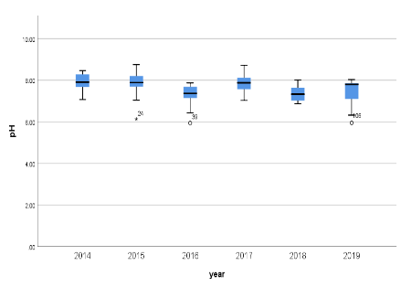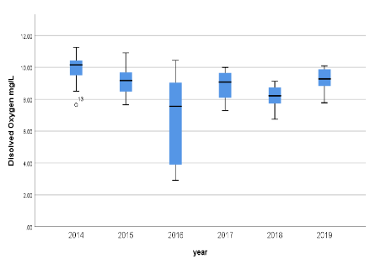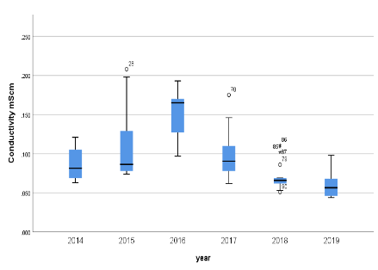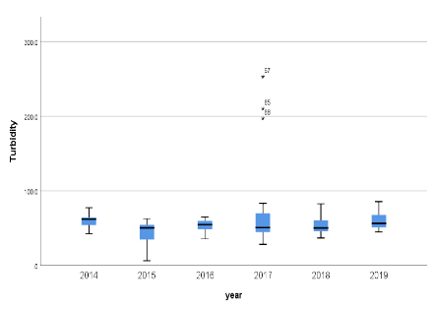

|  |
| --- |
|  |
|  |
|  |

Figure 4‑73 Concentrations of dissolved organic carbon (DOC) mgL-1, total phosphorous (TP)µL-1, total nitrogen (TN) µL-1  in water samples collected on six occasions between October and December during each of 2014-15, 2015-16, 2016-17, 2017-18, 2018-19 and 2019-20.

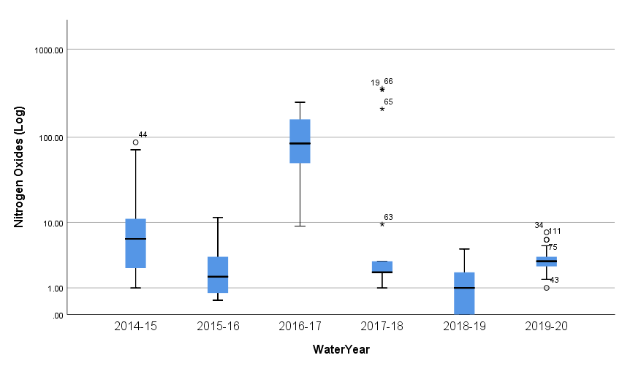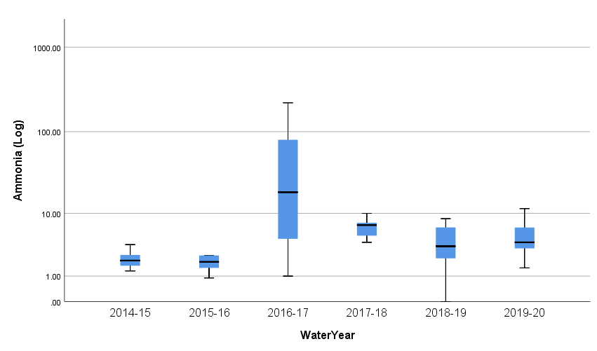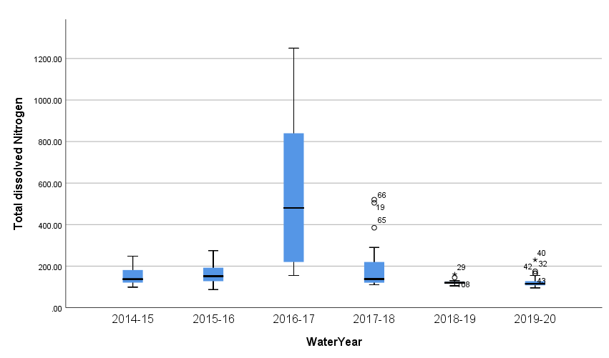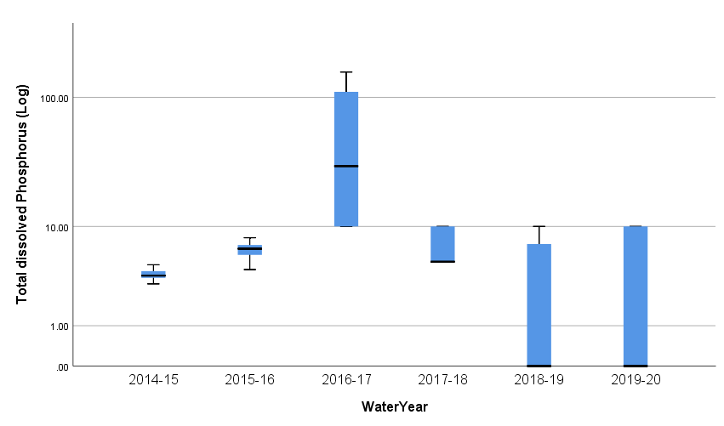

*Figure 4‑74 Concentrations of bioavailable nutrients (filterable reactive phosphorus – FRP; oxidised nitrate/nitrite – NOx; and ammonia – NH3) in water samples collected on six occasions between October and December during each of 2014-15, 2015-16, 2016-17, 2017-18, 2018-19 and 2019-20. Data are the mean of three sites ± standard error of the mean. Dashed (red) lines indicate median and dotted (black) lines 5th and 95th percentiles of pre-2014 data collected for river sites in Murrumbidgee.*

**Discussion**

### How did Commonwealth environmental water affect the cycling of nutrients and carbon in the Murrumbidgee River during 2019-20?

During the 2019-20 water year, water quality in the Narrandera reach of the Murrumbidgee River remained within acceptable limits throughout the monitoring period. As expected under dry conditions, riverine nutrient concentrations remained low during 2019-20 compared to the pre-2014 levels. Apart from a peak in nutrient and carbon levels associated with the widespread unregulated flows across large floodplain areas in 2016-17, and the smaller wetland to river reconnection in 2017-18, riverine nutrient levels have been relatively low across the six-year monitoring period.

Like other rivers in the Murray-Darling Basin, the Murrumbidgee River contains lower median concentrations of nutrients compared to other floodplain rivers across the world (Grace 2016). Rainfall runoff, especially when rain coincides with low-river flows, could have the potential to temporarily augment nutrient loadings and support increased production. The role of rainfall runoff and tributary inflows as drivers of enhanced productivity are not well understood. Large areas of floodplain in the Murrumbidgee catchment are developed for agriculture (Kingsford *et al.* 2004). Agricultural activities that augment available nutrients in soils can be an important source of nutrients e.g. (Brodie *et al.* 2005). However, river red gum (*Eucalyptus camaldulensis*) leaves also rapidly leach highly bioavailable orthophosphate upon inundation (Baldwin 1999).

## Stream metabolism

Prepared by Dr Yoshi Kobayashi (NSW DPIE) and Gaye Bourke (CSU)

***Introduction***

Stream metabolism is a measure of the amount of energy or carbon produced and consumed by river food webs. It includes rates of gross primary production (GPP: autotrophic carbon production) by algae and aquatic macrophytes as well as rates of ecosystem respiration (ER: heterotrophic carbon consumption) by all stream aquatic organisms. Metabolism can be calculated using the diurnal change in dissolved oxygen due to these two processes, accounting for the effects of temperature, light and the availability of nutrients and carbon (Young *et al.* 2008). As the key variable controlling these drivers (Poff and Zimmerman 2010), flow exerts a fundamental influence over rates of metabolism. Changes to the flow regime that affect any one of these drivers can alter the amount and quality of energy supplied to aquatic consumers (Young *et al.* 2008), with likely cascading effects on the dynamics of food webs and water quality (Marcarelli *et al.* 2011). Thus, understanding the relationship between flow and metabolism helps provide a scientific rationale for the mechanism of environmental flow deliveries that support basic ecosystem functions and water quality conditions at the river-scale.

Between September 2019 and June 2020, a total of 60,493 ML environmental water (including 48,335 ML of Commonwealth environmental water) was delivered along the Murrumbidgee River channel. During the same period, river flows peaked at Carrathool at a discharge rate of 4,069 ML d-1 on 25 January 2020. Long-term watering plans for the Murrumbidgee River forecast in-channel deliveries of Commonwealth and NSW environmental water to support habitat and riverine productivity for fish and other aquatic organisms. We investigated the relationships between river discharge rate and stream metabolism parameters and discuss these findings with regard to future deliveries of Commonwealth environmental water.

***Methods***

Stream metabolism was estimated using the LTIM Category 1 Standard Method (Hale et al. 2014). Metabolism was surveyed at one site in the Carrathool (primarily October – April) zone concurrent with the larval fish monitoring and as part of the Category 1 and Category 3 ecosystem metabolism monitoring. At the site, water temperature (°C) and dissolved oxygen (DO, O2 mg L-1) were logged at ten-minute intervals using a calibrated DO datalogger (Zebra-Tech Ltd, Nelson, NZ) attached to a float and chain secured mid-stream to a snag. Issues with datalogger battery failure affected the collection of water temperature and DO data during the initial period of logger deployment, reducing the number of days over which data were collected during October and November 2019.

Photosynthetically active radiation (PAR, µmol m-2 s-1) and barometric pressure (atm) were logged at the same interval by nearby weather stations (Hobo U30; Onset Computer Corporation, MA, USA). Data for daily mean discharge rate (ML d-1) was obtained from a nearby gauge station (gauge number: 41000281) operated by the NSW state government (<https://realtimedata.waternsw.com.au/>; accessed 12 June 2020).

### Data analysis

Daily rates of ecosystem metabolism were estimated using the BASE modelling package in the statistical-computing environment R (Grace *et al.* 2015) modified to incorporate improvements proposed by Song *et al.* (2016) and packaged in R (Giling *et al*. 2018). The method of the data analysis assumes a well-mixed water column (Grace and Imberger 2006). The terms and definitions in ecosystem metabolism and organic carbon balances used in this report are summarised in Table 4‑30.

Table ‑ Terms and definitions in ecosystems metabolism and organic carbon balances.

|  |  |  |
| --- | --- | --- |
| **Term** | **Definition** | **Unit** |
| Gross primary production (GPP) rate | Photosynthesis of autotrophic organisms, estimated using the BASE modelling package | mg O2 L-1 d-1 |
| Ecosystem respiration (ER) rate | Respiration of both autotrophic and heterotrophic organisms, estimated using the BASE modelling package | mg O2 L-1 d-1 |
| Net ecosystem production (NEP) rate | Balance between GPP and ER, estimated as [GPP – ER], and may be positive or negative | mg O2 L-1 d-1 |
| GPP:ER ratio | GPP:ER > 1 indicates an autotrophic state and GPP:ER < 1 indicates a heterotrophic state |  |
| GPP carbon loading rate and  ER carbon usage rate | GPP (or ER) expressed in terms of amount of carbon, estimated as [GPP (or ER) × 0.375* × daily discharge (ML)]  *12 mg C ÷ 32 mg O2 =0.375 in order to convert from mass of oxygen to mass of carbon | kg C d-1 |
| NEP carbon loading rate | NEP expressed in terms of amount of carbon, estimated as [GPP carbon loading rate – ER carbon usage rate], and may be positive or negative | kg C d-1 |
| Overall NEP carbon load | NEP expressed in terms of total amount of carbon, estimated as the sum of the daily NEP carbon load (=NEP carbon loading rate x 1 d) for the entire monitoring period, and may be positive or negative | kg C |

We used a non-parametric Spearman’s rank correlation (*rs*) analysis to examine if there were significant relationships between the river discharge rate and the stream metabolism parameters examined during this study and between the annual median daily flow rate and the annual median GPP:ER ratio at the Carrathool site over the entire water-year period (the years 2014-20) (see Wassens *et al*. 2020 for the 2014-19 data). Statistical analyses were performed using the statistical-computing environment ‘R’ (R Development Core Team 2014), with a significance level of *P*=0.05.

***Results***

### 2019-20 monitoring period

Between 28 September 2019 and 20 April 2020, the daily mean discharge rate ranged from 294 to 4069 ML d-1 (*n*=206), with a relatively high discharge period in November and December 2019, followed by three peaks and troughs.

During the corresponding period, the daily mean DO concentration ranged from 3.1 to 10.0 mg O2 L-1 (*n*=150), with the lowest concentration observed on 18 March 2020 (Figure 4‑75a). Of the 150 DO concentration observations, a total of 106 observations (i.e. 106 days) passed the selected-area model selection criteria and were available for the assessment of stream metabolism from the Carrathool Zone logger. Overall, the rates of GPP and ER varied temporarily, ranging from 0.55-1.94 and 0.37-1.91 mg O2 L-1 d-1, respectively (Figure 4‑75b). The relatively high GPP:PR ratio (>1) and positive NEP rates were observed February 2020 onwards while the low GPP:PR ratio (<1) and negative NEP rates were observed frequently between December 2019 and January 2020 (Figure 4‑75c and d).

Table ‑ Summary statistics for stream metabolism at the Carrathool site in the Murrumbidgee River between October 2014 and April 2020 (GPP: Gross Primary Production; ER: Ecosystem Respiration). Note these data are calculated with the revised BASE function.

|  |  |  |  |  |  |  |
| --- | --- | --- | --- | --- | --- | --- |
| **Water Year** | **2014-**  **15** | **2015-**  **16** | **2016-**  **17** | **2017-**  **18** | **2018-**  **19** | **2019-**  **20** |
| **1/10/14**  **–**  **18/3/15** | **1/10/15**  **–**  **30/4/16** | **23/11/16**  **–**  **1/5/17** | **25/10/17**  **–**  **23/4/18** | **25/9/18**  **–**  **16/4/19** | **28/9/19**  **–**  **20/4/20** |
| **Number of available**  **observations (number of**  **missing observations)** | 151  (14) | 195  (12) | 117  (33) | 178  (14) | 198  (0) | **106**  **(44)** |
| **GPP rate (mg O2 L-1 d-1)**  **median**  **[range]** | 1.14  [0.42-2.85] | 1.28  [0.41-13.45] | 1.24  [0.71-2.88] | 1.33  [0.26-5.25] | 1.20  [0.20-8.56] | **0.99**  **[0.55-1.94]** |
| **ER rate (mg O2 L-1 d-1)**  **median**  **[range]** | 1.3  [0.09-6.12] | 1.58  [0.59-26.82] | 1.49  [0.26-3.47] | 1.53  [0.11-3.96] | 1.30  [0.13-4.81] | **0.94**  **[0.37-1.91]** |
| **Discharge rate (ML d-1)**  **median**  **[range]** | 3,126  [383-7,361] | 3,069  [373-5,892] | 4,399  [551-60,737] | 1,056  [223-8,148] | 1,871  [373-4,533] | **1,256**  **[294-4,069]** |

|  |  |
| --- | --- |
|  |  |
|  |  |

Figure ‑ Temporal changes in discharge rate, dissolved oxygen (DO) concentration and stream metabolism parameters at the Carrathool site from September to April 2020: **a)** discharge rate (open circles with dotted lines) and DO concentration (closed circles with solid lines). Two battery failure (B.F.) periods are indicated with arrowed horizontal solid lines enclosed with vertical dotted lines, **b)** rates of gross primary production (GPP)(closed circles with solid lines) and ecosystem respiration (ER)(open circles with dotted lines), **c)** GPP:ER ratio, and **d)** rate of net ecosystem production (NEP).

In terms of stream metabolism expressed in organic carbon, both the rates of GPP carbon loading and ER carbon usage were significantly positively correlated with the discharge rate (*rs*=0.93 and 0.91, respectively; for both *P*<0.001, *n*=106) (Figure 4‑76). The GPP:ER ratio was, however, significantly negatively corrected with the discharge rate (*rs*=-0.24, *P*=0.013, n=106). There was no significant correlation between the NEP carbon loading rate and the discharge rate (*rs*=-0.16, *P*=0.109, *n*=106). The overall (cumulative) NEP carbon load was approximately 987 kg C for the entire monitored period of the water year 2019-20. Thus, the sum of daily NEP carbon load for the 106-day available observations between September 2019 and April 2020 was positive at the Carrathool site.

|  |  |
| --- | --- |
|  |  |
|  |  |

Figure ‑ Discharge rate and stream metabolism parameters at the Carrathool site between September and April 2020 (n=106): **a)** gross primary production (GPP) carbon loading rate, b**)** ecosystem respiration (ER) carbon usage rate, **c)** GPP:ER ratio, and **d)** net ecosystem production (NEP) carbon loading rate.

### 2014-2020 monitoring period

A bivariate plot of the annual median discharge rates and the annual median GPP:ER ratio for the years 2014-20 is shown in Figure 4‑77. The annual median GPP:ER ratio at the Carrathool site was 1.05 for the year 2019-20, slightly higher than the values observed for the years 2014-19 (range: 0.81-0.92). Although the annual median GPP:ER ratio tended to decrease with increasing the annual median discharge rate, the relationship between them was not significant (*rs*=-0.42, *P*=0.356, *n*=6).

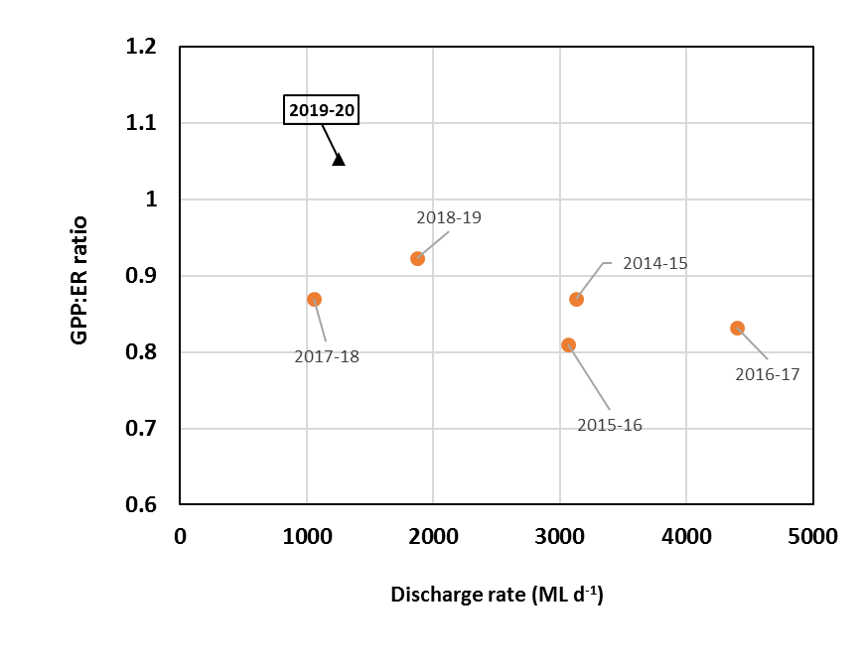

Figure ‑ Annual median discharge rate (ML d-1) and ratio of annual median gross primary productivity (GPP) and annual median ecosystem respiration (ER) at the Carrathool site in the Murrumbidgee River for the six water years 2014-20 (see Table 4‑31).

***Discussion***

### 2019-20 monitoring period

During 2019-20, the GPP and ER rates remained low, varying within the range observed for the preceding five water years (2014-19). As noted previously (Wassens *et al.* 2020), rates of stream metabolism in the Murrumbidgee River are generally low, compared to those in other rivers in the Murry-Darling Basin (Grace 2020). The relatively low rates in the Murrumbidgee River is said to correspond with apparently low nutrient availability but may also involve a system-scaling effect (Wassens *et al*. 2020). Further detailed studies are warranted to elucidate causal factors. Although the annual median GPP and ER values were also the lowest since the water year 2014-15, the annual median GPP: ER ratio was just above one (1.05), indicating a slightly autotrophic state of the river channel for the 2019-20 monitoring period.

In terms of organic carbon dynamics, which is thought to have direct relevance to the structure and function of river food webs (Grace 2020), our results suggest that more organic carbon are produced and transported downstream with increasing river flows, as inferred from the positive relationship between discharge rate and GPP carbon loading rate. However, this also corresponds to more usage (or consumption) of organic carbon, as inferred from the positive relationship between discharge rate and ER carbon usage rate. Interestingly, the NEP carbon loading rate can be either positive or negative, irrespective of discharge rate. Thus, the net balance of organic carbon production and usage seems to be flow independent. Cole (2013) states that whole system respiration (R) often exceed GPP in a large range of freshwater and marine ecosystems and the only way to explain this excess R is to have some of the external, terrestrial supply of organic matter actively respired within the water body. In this regard, there may be external inputs of organic matter to the river channel at a wide range of discharge rates upstream of the Carrathool site, contributing to the observed net negative NEP.

### 2014-2020 monitoring period

The comparison of the annual median GPP:ER ratio against the annual median discharge rate for the six water years (2014-20) showed that the annual median GPP:ER ratio remained low at the Carrathool site. In particular, the ecological implications of ER exceeding GPP (or GPP:ER ratio <1). As previously stated, the low GPP:ER ratio alone is unlikely to indicate the likelihood of extremely low DO or hypoxic conditions. We would need to consider other environmental factors concurrently.

Long-term watering plans for the Murrumbidgee River forecast in-channel deliveries of environmental water to support habitat and riverine productivity for fish. Stream metabolism measures aspects of the carbon dynamics at a fundamental level of food chains. We are uncertain about the efficiency of carbon transfer from algae and aquatic macrophytes to fish. Nevertheless, based on the present results, the in-channel GPP most likely increases with river flows that carry environmental waters, which is thought to be beneficial for the species that constitute river food webs including fish. Despite the observed flow-independent nature of daily NEP carbon loading rate, the overall NEP carbon load for the entire monitoring period of the water year 2019-20 was positive. For the management of environmental waters in Murrumbidgee River, it would be very important to maintain the long-term view of watering plans for the Murrumbidgee River. This is because the degree of irreversibility of impaired ecosystem structure and function most likely depends on a time scale of impacts and the efficacity of intervention and monitoring programmes by the management authorities.

## Larval fish

Prepared by Dr Jason Thiem, Dr Daniel Wright (NSW DPI Fisheries) and Dr Gilad Bino (UNSW)

***Introduction***

The duration, magnitude and timing of flows play a critical role in the viability of native fish populations, strongly influencing adult spawning and subsequent survival and growth of larvae (King *et al.* 2016). The larvae stage is the most critical and vulnerable part of a fish’s life history, with larval fish survival highly dependent on hydrology, which influences habitat availability (Copp 1992), water temperature (Rolls *et al.* 2013), larval dispersal (Gilligan *et al.* 2003) and microinvertebrate abundance for first feed (King 2004). Commonwealth environmental water deliveries that aim to promote native fish responses can increase reproductive opportunities and enhance larval survival, thereby improving recruitment to the wider population. Understanding the critical links between flows, fish spawning and larval fish survival is essential for managing environmental water that aims to support and enhance native fish populations.

Use of a specifically designed hydrograph that targets groups of fish species with similar reproductive strategies could benefit a range of species in a given water year (Baumgartner *et al.* 2014). For example, increased flows may inundate river or wetland habitat, needed by small-bodied generalist species or large-bodied nesting species for reproduction, while also releasing nutrients and increasing productivity of microinvertebrates, a key prey item for the first feed of all species of native fish (Devries *et al.* 1998). Alternatively flow peaks may be used to trigger reproduction directly in flow-dependant species, such as golden perch (*Macquaria ambigua*) and silver perch (*Bidyanus bidyanus*) (King *et al.* 2009; King *et al.* 2016). In this monitoring program we aimed to determine the seasonal timing of native fish reproduction within the Murrumbidgee Selected Area, and the biotic and abiotic factors associated with spawning and early survival of fish larvae. Spawning data collected during 2014 to 2018 (LTIM Years 1- 5) (Wassens *et al.* 2019) are included for comparison. Category 1 fish community sampling data collected from the Carrathool zone only in 2015 to 2019 (Wassens *et al.* 2015; Wassens *et al.* 2016; Wassens *et al.* 2019) and 2020 are also included to provide some information on the translation of spawning into young-of-year recruitment.

***Relevant watering actions and objectives***

In 2019-20 the Murrumbidgee River experienced no flows specifically targeting native fish in-channel spawning, however the hydrology in the sampling zone was heavily impacted by Commonwealth environmental water actions targeting mid and lower Murrumbidgee wetlands between 9 September 2019 – 7 June 2020, as well as irrigation releases and downstream delivery targets*.* In this section we describe the range of fish responses observed during 2019-20, and contrast these with the responses from previous years of monitoring.

***Evaluation Questions***

This monitoring program is also required to address the following evaluation questions related to Commonwealth environmental watering actions:

* Did Commonwealth environmental water contribute to native fish populations?
* Did Commonwealth environmental water contribute to native fish reproduction?

***Methods***

Larval fish were collected using methods described by (Wassens *et al.* 2014a, 2019). Larval fish sampling was undertaken at three riverine sites within the Carrathool hydrological zone (Figure *4‑77*). Eight larval drift nets and ten quatrefoil light traps were set overnight at each riverine site. Equipment and methods were consistent with those described by Hale *et al.* 2014, with the addition of five additional larval drift nets set at each site to adequately sample commonly encountered larvae such as Murray cod (*Maccullochella peelii*). Sampling was undertaken fortnightly from 21 October until 18 December 2019, resulting in six sampling events at each of the three sites. These data were compared with data collected from the same sites and using the same methods in the previous watering years 2014 to 2018 (Wassens *et al.* 2015; Wassens, 2018; Wassens *et al.* 2016). Where possible, eggs were live-picked and enumerated from drift net samples in the field, and a subset of these were hatched in river water at ambient temperatures. Larvae were subsequently identified to species in the laboratory. The remaining samples collected from both light traps and drift nets were

*Figure 4‑77 Locations of larval fish in-channel sampling sites on the Murrumbidgee River, encompassing the Carrathool (Yarradda (YRR), Bringagee (BRI) and McKennas (MKR)) hydrological zone.*

preserved in 90% ethanol for later laboratory identification (using keys described in Serafini *et al.* 2004).

A sub-sample of larvae hatched from live-picked eggs as well as preserved eggs, comprising both golden perch and silver perch, and representing all possible combinations of sites and sampling events, were submitted to the Australian Genome Research Facility (AGRF). Nucleic acid extraction and subsequent verification of species assignment was based on dual-direction sequencing following Polymerase Chain Reaction (PCR) amplification. Genetic assignment of golden perch and silver perch was generally consistent with laboratory identification based on morphological characteristics, and species assignment to egg captures was scaled for each site and trip based on the ratios of hatched and identified larvae and eggs.

**Data analysis**

Fish surveys were summarised by species for each combination of site, sampling event and method, with fish numbers represented as total catch of larvae. Juveniles and adults were excluded from analysis and reporting because sampling effort was not consistent for these groups and numbers were too low to allow further analysis. Daily stream gauging data was obtained from Carrathool (gauge 410078). Water temperature data was obtained from a data logger located at the McKennas site, or where gaps in data existed, from the nearest gauge site. To determine differences in larval fish catch between years (2014-19), drift net and light trap data were analysed separately using a one-way fixed factor (year as a factor) Permutational Multivariate Analysis of Variance (PERMANOVA) as in Anderson *et al.* (2008). Raw data were initially fourth root transformed and the results used to produce a similarity matrix using the Bray-Curtis resemblance measure. All tests were considered significant at *P* < 0.05. No significant differences were identified, so follow-up SIMPER tests used to identify individual species contributions to average dissimilarities were not required.

To evaluate golden perch and silver perch larval responses (egg presence in drift nets) to hydrology and water temperature, we used a generalized linear mixed-effect modelling approach to examine the (binary) probability of periodic species spawning. We evaluated four possible environmental explanatory variables measured during each of the sampling events: average daily discharge, weekly change in average daily discharge, average daily water temperature, and weekly change in average daily water temperature. We also included year of survey to detect trends and survey site as a random effect component. Spawning responses were modelled as binomial response variable based on the presence or absence of eggs in the catch. We examined all possible explanatory variable combination (n=32) and evaluated for significant associations using a model averaging approach weighted by model fit using the corrected Akaike information criterion (AICc; Grueber *et al.* (2011)). Model averaging accounts for uncertainty when multiple models are plausible and provides a robust method to estimate associations with possible explanatory variables (Grueber *et al.* 2011). Models were developed using the ‘glmer’ function in the ‘lme4’ package (Bates *et al.* 2014) in R version 4.0.2 (R Development Core Team 2014). Model averaging was accomplished using the ‘dredge’ and ‘model.avg’ functions in the MuMIn package (Barton 2015).

Category 1 fish community data, as per Hale *et al.* (2014), collected from the focal zone in 2015-2020 (encompassing Yarradda, Bringagee and McKennas larval sampling sites), were examined to determine whether spawning in any watering year translated into young-of-year recruitment. Specifically, length-frequency plots were used to indicate the presence of new recruits as a proportion of the sampled populations.

Results

A combined total of 1,106 fish eggs and larvae were collected during the 2019 sampling encompassing the 2019/20 watering year. Six native fish species (Australian smelt *Retropinna semoni,* carp gudgeon *Hypseleotris spp.,* flatheaded gudgeon *Philypnodon grandiceps,* golden perch, Murray cod, silver perch)and one alien species (common carp *Cyprinus carpio)* were detected spawning in the Murrumbidgee River in 2019 Additionally, early stage juvenile freshwater yabbies were captured in drift nets Australian smelt eggs and larvae (n=622), Murray cod larvae (n=347), golden perch eggs and larvae (n=61) and flat-headed gudgeon larvae (n=10) were captured in the highest abundances. While golden perch eggs were captured at two sites and silver perch eggs at one site, golden perch larvae (n=2) were only captured at one site and silver perch larvae were undetected. Compared to the previous year (2018), eggs and larvae numbers had notably increased for Australian smelt and decreased for carp gudgeon and flatheaded gudgeon in 2019.

While PERMANOVA analysis initially indicated that abundances of fish larvae and eggs differed between years for drift nets (*Pseudo-F5*,17 = 4.437, *P*=0.004) and light traps (*Pseudo-F5*,17 = 4.673, *P*<0.001), pair-wise comparisons between specific sets of years revealed no significant differences for either method (p>0.05).

Captures of eggs and larvae peaked at distinct water temperatures for each species over the five-year study. For example, bony herring, carp gudgeon, flatheaded gudgeon, Murray-Darling rainbowfish and silver perch were predominantly caught at water temperatures above the median of 22.1 °C. In contrast, Australian smelt, Murray cod, common carp, Eastern gambusia, golden perch and redfin perch were predominantly captured at or below median water temperatures of 22.1 °C (Figure 4‑78). Australian smelt and common carp exhibited the widest breadth of capture temperatures (Figure 4‑79).

*Table 4‑32 Raw (unstandardised) total captures of eggs and larvae from combined larval drift nets and light traps separated by sampling site pooled across all sampling events in 2019.*

|  |  |  |  |  |  |  |
| --- | --- | --- | --- | --- | --- | --- |
|  |  | **Carrathool** | | | | |
|  |  | Yarradda | Bringagee | | McKennas | |
| ***Native fish species*** | | | | | | |
| Australian smelt | eggs |  | | 5 | | 2 |
|  | larvae | 158 | | 210 | | 247 |
| Carp gudgeon | larvae | 3 | | 1 | |  |
| Murray cod | larvae | 100 | | 139 | | 108 |
| Flat-headed gudgeon | larvae | 3 | | 5 | | 2 |
| Golden perch | eggs | 46 | | 13 | |  |
|  | larvae | 2 | |  | |  |
| Silver perch | eggs | 4 | |  | |  |
| Unidentified | eggs | 54 | | 1 | | 1 |
| ***Alien fish species*** | | | | | | |
| Common carp |  |  | | 1 | | 1 |
| ***Other*** | | | | | | |
| Freshwater yabby | juvenile | 9 | | 6 | | 3 |

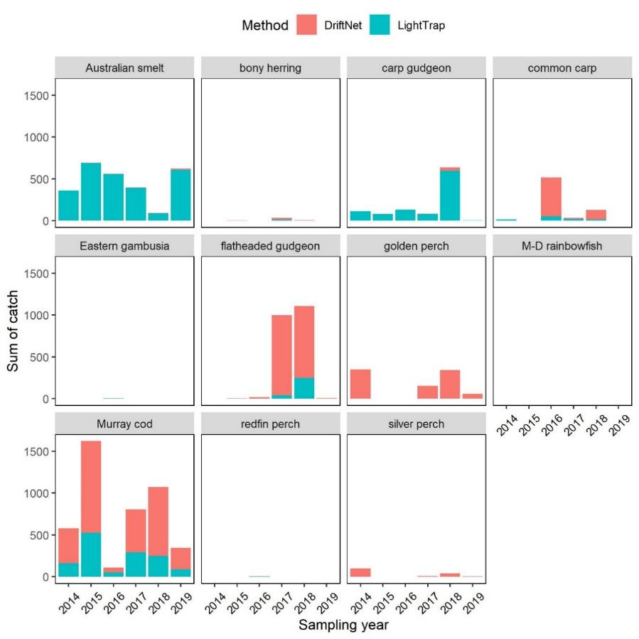

Figure ‑ Larval drift net and light trap total catches across three sampling sites within the Carrathool hydrological zone and six sampling events.

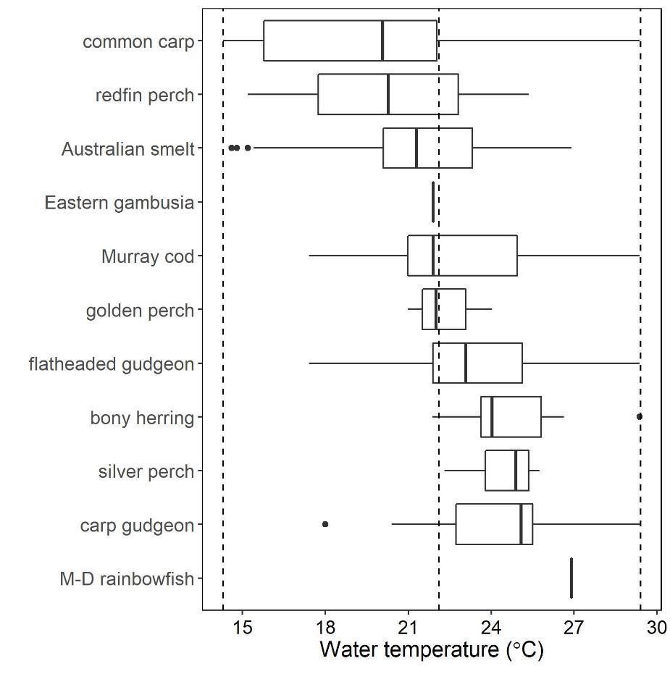

*Figure 4‑79 Indicative water temperature at the time of capture of eggs and larval fish in the Murrumbidgee River from 2014-2019 inclusive. Minimum, median and maximum water temperatures observed for the study period are represented by dashed vertical lines. Data are represented as median, 25th and 75th percentiles (box) and 5th and 95th percentiles (whisker). Fish species are ordered by median capture temperature.*

In relation to the entire sampling period from 2014-2019, Murray cod larvae captures were reduced in 2019, but above the lowest levels recorded (Figure 4‑78). This pattern was similar for golden perch and silver perch, which had lower egg counts in 2019 than in 2014, 2017 and 2018, although they were still at detectable levels. This contrasts to 2015 and 2016 when golden perch and silver perch eggs were absent (Figure 4‑80). There was evidence for an association between golden perch spawning and changes in daily water temperature over the previous week, with spawning probability increasing at negative change in daily water temperature (Figure 4‑81; Table 4‑33). Data points driving this pattern were golden perch egg detections at all three sites after a temperature change of -6°C from 28 to 22°C when flows had increased from ~ 1000 to 5000 ML day-1 in December 2017 (water temperature, which tends to increase throughout spring-summer, will typically decrease temporarily during a flow pulse). For silver perch spawning, an association with daily water temperature was found, where spawning probability increased at higher daily water temperatures (Figure 4‑81; Table 4‑34).

All fish captured as eggs and larvae in the Carrathool zone during 2019 were represented in the fish community sampling undertaken in March 2020, except for flatheaded gudgeon. Five additional species were also captured in the fish community sampling; bony herring, Eastern gambusia, goldfish, Murray-Darling rainbowfish, and unspecked hardyhead (Table 4‑35). New recruits of the most abundant species were generally present in the river, with the exception of golden perch and Eastern gambusia, and the proportions of new recruits for large bodied species were generally low compared to other sampling years.

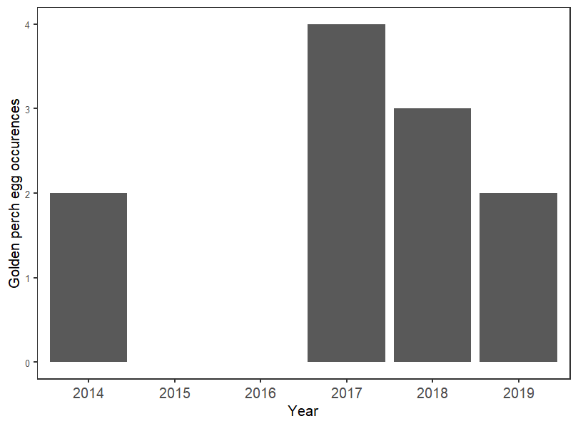

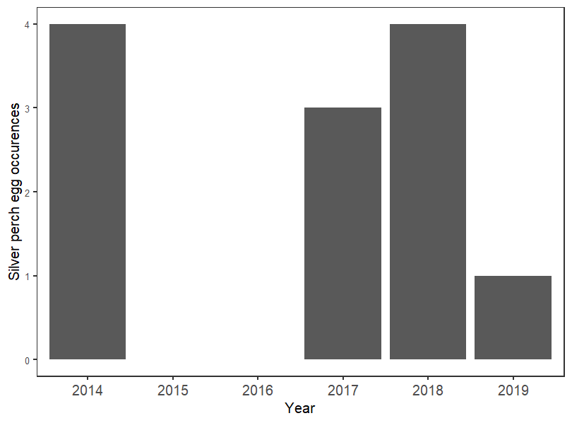

*Figure 4‑80. Variation in the spawning of golden perch and silver perch among sampling years in the Murrumbidgee River.*

*Table 4‑33 Model-averaged coefficients explaining the probability of golden perch spawning in relation to average daily water temperature (wtemp), weekly change in daily water temperature (Chwtemp), average daily discharge (discharge), weekly change in daily discharge (Chdischarge), and year.*

|  |  |  |  |
| --- | --- | --- | --- |
| **Predictors** | **Odds Ratios** | **Std. Error** | **p** |
| (Intercept) | 0.06 | 0.56 | **<0.001** |
| Chwtemp | 0.29 | 0.45 | **0.005** |
| year | 1.63 | 0.39 | 0.208 |
| discharge | 0.46 | 0.83 | 0.345 |
| Chdischarge | 2.53 | 0.97 | 0.338 |
| wtemp | 1.23 | 0.52 | 0.684 |
| **Observations** | **108** |  |  |

*Table 4‑34 Model-averaged coefficients explaining the probability of silver perch spawning in relation to average daily water temperature (wtemp), weekly change in daily water temperature (Chwtemp), average daily discharge (discharge), weekly change in daily discharge (Chdischarge), and year.*

|  |  |  |  |
| --- | --- | --- | --- |
| **Predictors** | **Odds Ratios** | **Std. Error** | **p** |
| (Intercept) | 0.06 | 0.60 | **<0.001** |
| Chdischarge | 3.21 | 0.72 | 0.105 |
| wtemp | 3.57 | 0.53 | **0.016** |
| discharge | 0.46 | 0.89 | 0.387 |
| year | 1.07 | 0.39 | 0.859 |
| Chwtemp | 1.07 | 0.39 | 0.872 |
| **Observations** | **108** |  |  |

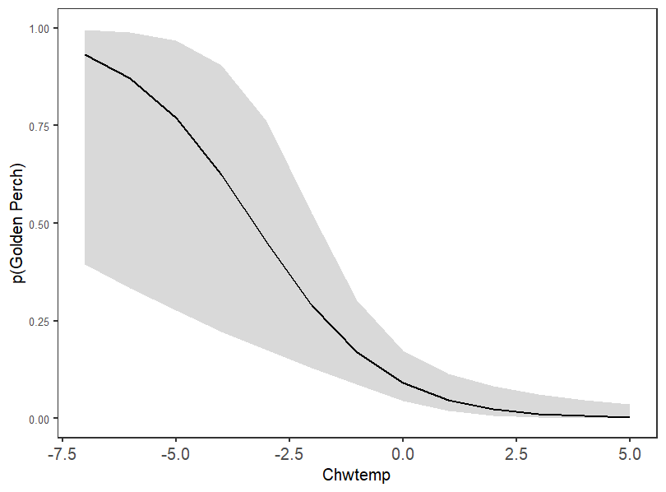

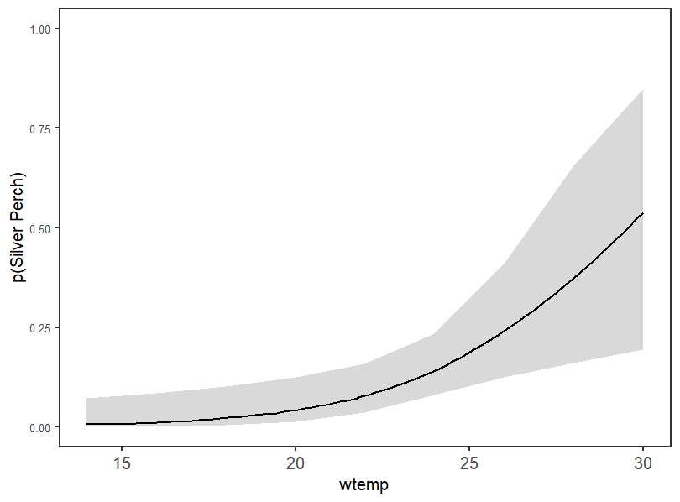

*Figure 4‑81 Predictive relationship generated from a model-averaged coefficient describing the spawning probability (p; y-axis) for golden perch (weekly changes in daily water temperature, Chwtemp) and silver perch (daily water temperature, wtemp)(Table 4‑33). Data were collected over six watering years (2014-19) using larval drift nets in the Murrumbidgee River and probabilities are based on the presence/absence of drifting egg captures.*

*Table 4‑35 Summary of fish captured during Category 1 standardised sampling in 2015-2020 in the Murrumbidgee LTIM project. BE = boat electrofishing, SFN = small fyke net and BT = bait trap.*

|  |  |  |  |  |  |  |  |  |  |  |  |  |  |  |  |  |  |  |  |  |  |  |  |  |  |
| --- | --- | --- | --- | --- | --- | --- | --- | --- | --- | --- | --- | --- | --- | --- | --- | --- | --- | --- | --- | --- | --- | --- | --- | --- | --- |
| Fish species | 2015 | | | | 2016 | | | | 2017 | | | | 2018 | | | | 2019 | | | |  | 2020 | | | |
|  | BE | SFN | BT | **Total** | BE | SFN | BT | **Total** | BE | SFN | BT | **Total** | BE | SFN | BT | **Total** | BE | SFN | BT | **Total** | BE | | SFN | BT | **Total** |
| ***native species*** |  |  |  |  |  |  |  |  |  |  |  |  |  |  |  |  |  |  |  |  |  | |  |  |  |
| Australian smelt | 109 | 26 |  | **135** | 335 | 4 |  | **339** | 297 | 103 |  | **400** | 41 | 3 |  | **44** | 145 |  |  | **145** | 54 | | 1 |  | **55** |
| bony herring | 438 | 2 |  | **440** | 360 |  |  | **360** | 170 | 2 |  | **172** | 737 |  |  | **737** | 514 |  |  | **514** | 40 | |  |  | **40** |
| carp gudgeon | 9 | 205 | 18 | **232** | 22 | 704 | 39 | **765** | 13 | 567 | 40 | **620** | 9 | 1173 | 5 | **1187** | 11 | 75 | 2 | **88** | 4 | | 431 |  | **435** |
| flatheaded gudgeon |  |  |  | **0** |  |  |  | **0** |  | 2 |  | **2** | 3 | 22 |  | **25** |  |  |  | **0** |  | |  |  | **0** |
| golden perch | 39 |  |  | **39** | 28 |  |  | **28** | 37 |  |  | **37** | 38 |  |  | **38** | 41 |  |  | **41** | 29 | | 1 |  | **30** |
| Murray cod | 126 | 5 |  | **131** | 155 |  |  | **155** | 68 | 1 |  | **69** | 153 | 1 |  | **154** | 201 |  |  | **201** | 145 | | 1 |  | **146** |
| Murray-Darling rainbowfish | 162 | 401 |  | **563** | 131 | 136 |  | **267** | 86 | 61 |  | **147** | 41 | 133 |  | **174** | 38 | 29 |  | **67** | 8 | | 40 |  | **48** |
| silver perch | 1 |  |  | **1** |  |  |  | **0** | 3 |  |  | **3** | 2 |  |  | **2** | 6 |  |  | **6** | 7 | |  |  | **7** |
| un-specked hardyhead | 4 | 2 |  | **6** | 4 |  |  | **4** | 1 | 2 |  | **3** |  |  |  | **0** | 1 |  |  | **1** |  | |  |  | **0** |
| ***alien species*** |  |  |  |  |  |  |  |  |  |  |  |  |  |  |  |  |  |  |  |  |  | |  |  |  |
| common carp | 112 |  |  | **112** | 63 |  |  | **63** | 313 | 1 | 6 | **320** | 162 |  |  | **162** | 120 |  |  | **120** | 93 | |  |  | **93** |
| Eastern gambusia | 8 | 735 | 1 | **744** | 11 | 493 | 1 | **505** | 6 | 371 |  | **377** |  | 440 | 2 | **442** | 4 | 165 |  | **169** | 6 | | 227 | 3 | **236** |
| goldfish | 11 |  |  | **11** | 3 |  |  | **3** | 6 |  |  | **6** | 5 | 1 |  | **6** |  |  |  | **0** | 3 | |  |  | **3** |
| redfin perch |  |  |  | **0** |  |  |  | **0** | 1 |  |  | **1** |  |  |  | **0** |  |  |  | **0** |  | |  |  | **0** |

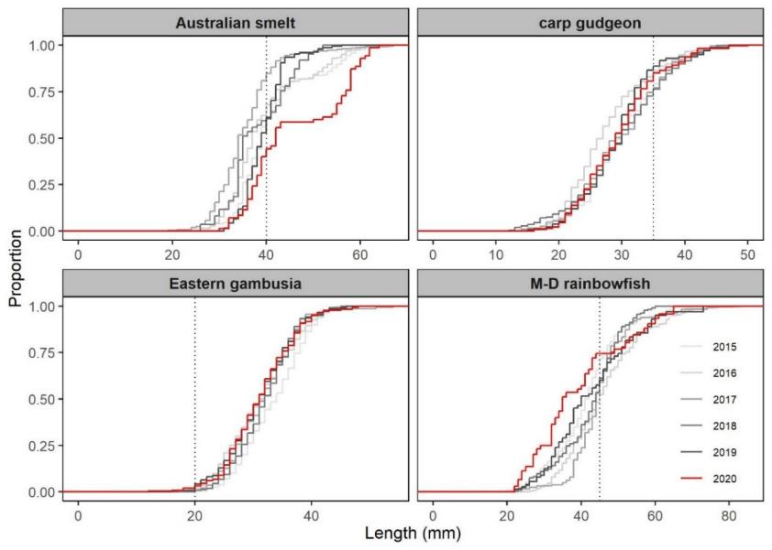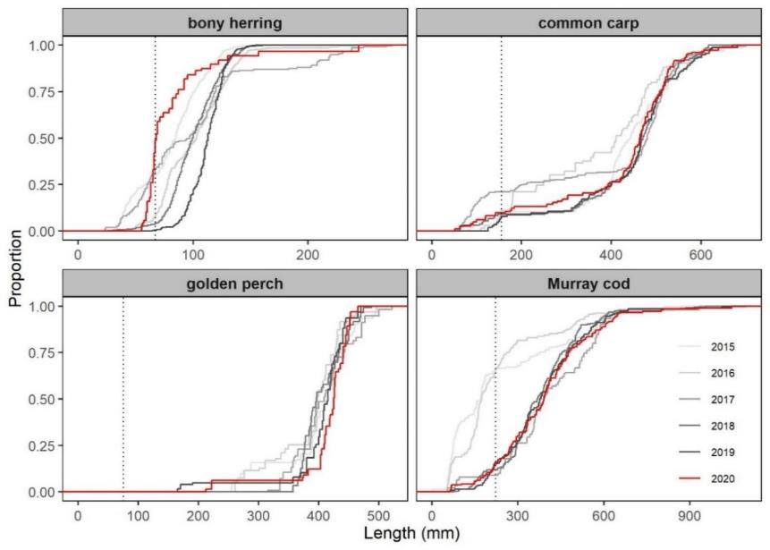*Figure 4‑82 Length-frequency comparison among years (2015-2020) of the four most abundant small-bodied fish species captured during Category 1 fish community sampling in the Murrumbidgee River. The dashed line indicates approximate size at sexual maturity.*

*Figure 4‑83 Length-frequency comparison among years (2015-2020) of the four most abundant medium-large bodied fish species captured during Category 1 fish community sampling in the Murrumbidgee River. The dashed line indicates approximate size at one-year of age*

***Discussion***

***What did Commonwealth environmental water contribute to native fish reproduction?***

Commonwealth environmental water was not specifically delivered to support native fish in-channel spawning outcomes in the focal zone during 2019-20, however Commonwealth environmental watering actions influenced the hydrology of the Murrumbidgee River and created connectivity between the river and low-lying floodplain wetlands in the mid and lower Murrumbidgee. Under the observed flows, in 2019, we identified spawning of six native and one alien fish species at the single hydrological zone monitored. Predictive relationships were further developed for the flow-cued spawning species, golden perch and silver perch. Spawning of both golden perch and silver perch were detected at the Carrathool zone in 2019, however there was no evidence of recruitment, for either species, following these spawning events. Murray cod young-of-year (YOY) proportional abundance was reduced compared with 2014-15 and 2015-16; remaining at the low levels observed in 2016-17, 2017-18 and 2018-19.

The drivers contributing to the continued low YOY recruitment exhibited by Murray cod in the Murrumbidgee River remain elusive. But in-channel flows at optimal temperatures promote Murray cod growth, in theory via increased foraging potential (Stoffels *et al.* 2019), which should improve the success of larvae transitioning to juvenile and adult stages. The reasons behind consecutive years (2017, 2018 and 2019) of golden perch and silver perch spawning not translating to recruitment in this section of the river system, are also yet to be fully elucidated. For the fourth continuous year, no juvenile golden perch were captured within the monitored reach during annual community sampling, although Golden Perch young of year have been detected in associated floodplain surveys for example Kopf et al (2018). While one juvenile silver perch was captured in 2014-15 and two in 2018-19, none were captured from 2015-16, 2016-17, 2017-18 and 2019-20. Interestingly, large numbers of golden perch YOY have been recorded in floodplain wetlands and lakes following Commonwealth environmental watering actions in previous years (Kopf *et al.* 2019). Off-channel habitats can provide nursery areas for golden perch juveniles to develop, which highlights the importance of off-channel and wetland watering events to support golden perch populations (Stuart and Sharpe 2019). While stocking of golden perch does occur within the region, recent evidence suggests that stocking only contributes 14% to golden perch populations in the Narrandera zone (Forbes *et al.* 2016). Stocking of silver perch does not occur within the Murrumbidgee River. It is therefore likely that adult populations, which are contributing to spawning in both species, are comprised of wild adults spawned and recruited locally, given the number of impassable barriers within the system. Therefore, successful recruitment of silver perch and golden perch must have occurred within the Murrumbidgee River at some point in the past, in order to generate adult populations of both species. Further work is needed to understand the drivers of successful recruitment, the key locations which support juveniles and the causes for the recent failures in recruitment.

Prior to commencing the current monitoring program, it was predicted that in-channel freshes would promote spawning in golden perch and silver perch. However, model predictions, based on six years of monitoring in the Murrumbidgee Selected Area, indicate that spawning for silver perch was strongly associated with temperatures but not with elevated flows, with little evidence to support predicted increased probability of spawning with increasing river levels. Results from the current study, therefore, are not entirely consistent with recent findings by King *et al.* (2016) who identified that spawning of silver perch was positively influenced by both temperatures and increasing flows in the Murray River.

In the case of golden perch, spawning was closely associated with daily changes in water temperature. Negative temperature changes were linked to increased spawning probability. This pattern was driven by golden perch eggs being present at all sites when water temperature dropped significantly from 28 to 22°C in conjunction with a flow rise in 2017. Negative temperature changes may be an artefact of in-channel freshes bringing cooler waters opposed to the temperature increases which generally occur in rivers over the spring season. It is also possible that this particular in-channel fresh may have led to golden perch spawning regardless of the direction or presence of a temperature change and so the results presented here must be interpreted cautiously. The influence of abiotic factors on golden perch spawning in the Murrumbidgee River reported here differs to that documented by King *et al.* (2016) in the Murray River, where increased temperature and flow positively influenced spawning.

It is worthwhile noting that spawning, of both silver perch and golden perch, has occurred independently of any discernible river level rise and at stable bankfull summer irrigation flows in the Murray River e.g. (Gilligan *et al.* 2003; King *et al.* 2005; Koster *et al.* 2014). Further, golden perch have been observed to exhibit substantial flexibility in both spawning and recruitment responses (Mallen-Cooper *et al.* 2003; Balcombe *et al.* 2006a; Balcombe *et al.* 2009). The evidence presented to date, therefore, does not refute a spawning response of either species to in-channel freshes. Rather, the concept of river level rises per se as a flow-cued spawning trigger may be too prescriptive. In the Murrumbidgee and mid-Murray rivers, for example, the broad definition of in-channel freshes is generally met all summer as a result of irrigation releases. Therefore, appropriate hydraulic conditions for spawning may be present for protracted periods, rather than during discrete events, such as delivered ‘rises’ from environmental water releases. In the absence of high irrigation flows, however, it may be that delivered ‘rises’ would be required to meet the threshold requirements for spawning. We anticipate that continued monitoring of flow-cued spawning responses will strengthen the predictive relationships, established here, for the Murrumbidgee Selected Area. This will, in turn, facilitate development of transferable information, for management of spawning of native freshwater species, applicable to other un-monitored sections of the Murrumbidgee River.

# Evaluation of the 2019-20 Watering actions-conclusions and management implications

Very dry conditions occurred through 2019-20 water year and watering actions were undertaken in line with a low water availability scenario. Environmental water deliveries were the lowest since the monitoring program began in 2014 (Figure 5.84). In total Commonwealth environmental water holder in partnership with NSW delivered 48,335 ML of Commonwealth environmental water and 32,158 ML of NSW environmental water as part of watering actions targeting wetland and floodplain habitats in the Murrumbidgee. The largest water allocation was to the Gayini Nimmie-Caira and Tala Creek System refuge flows which aimed to maintain critical refuge habitat and provide opportunities for breeding and recruitment of threatened southern bell frogs at key sites in Gayini Nimmie-Caira (Table 5.36). This action ran from late October to late December 2019, and again briefly in late January 2020 to maintain water levels for bird breeding. Smaller volumes were used to inundate key wetlands in the mid-Murrumbidgee, aiming to maintain critical refuge habitat for waterbirds, native fish, frogs, turtles and other water-dependent animals, and to support native vegetation growth and maintain condition. Several key wetlands received water via pumps designed to exclude large exotic carp, including Yarradda and Sunshower Lagoons.

Despite the very small volumes of water available for the environment in 2019-20 ecological outcomes from Commonwealth environmental water delivery were positive and watering objectives at monitored wetlands were broadly achieved (Table 5.37). The restoration of annual watering to wetlands at key wetlands within the mid and lower Murrumbidgee floodplain has contributed to the recovery of vegetation communities as well as increasing abundance and occurrence of southern bell frogs. Current research programs undertaken within the MER program have highlighted that some vegetation communities within the Lowbidgee floodplain are undergoing a drying trend due to reduced water availability. Identification of these areas and development of watering plans and delivery strategies that might support some of these areas should be a priority for 2021.

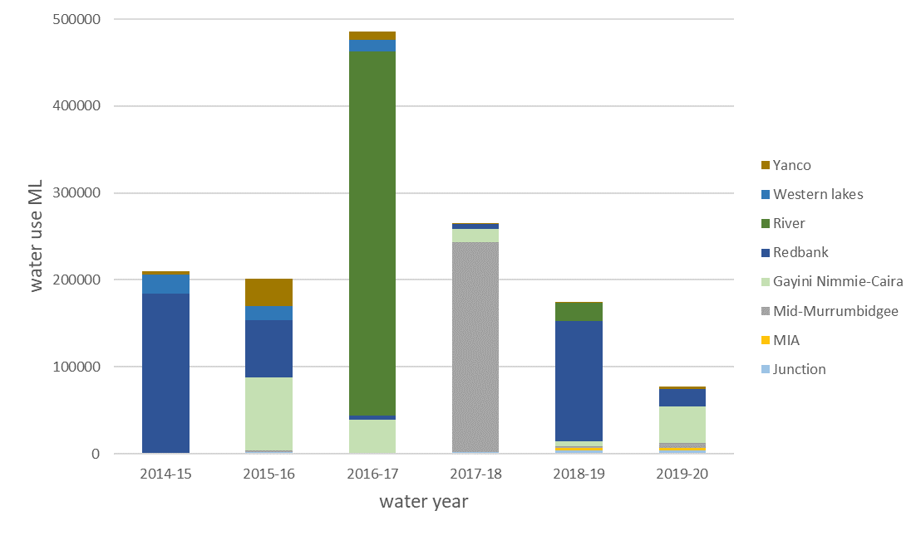

*Figure 5.84 Summary of NSW and Commonwealth environmental watering actions by volume in key management zones between 2014 and 2020.*

Table 5‑36 Summary of outcomes for monitored watering actions

|  |  |  |
| --- | --- | --- |
| Watering actions | Summary Objectives (primary and secondary as at delivery) | Outcomes |
| 10082-18 Gooragool/Mantangry Lagoon | * Maintain critical refuge habitat for waterbirds, native fish (including established golden and silver perch), frogs, turtles and other water dependent animals; * Support native aquatic vegetation growth and maintain condition. | * Adult golden perch detected in Mantangry but not in Gooragool following reconnection. * No evidence of golden perch recruitment * High abundances of carp recorded in Gooragool lagoon may have contributed to poor recruitment outcomes for golden perch * Future watering actions aimed at excluding carp from Gooragool lagoon may improve outcomes for native fish and frogs * Vegetation responses to environmental water were positive and vegetation remains in good condition |
| 10082-20 Yarradda Lagoon | * Maintain critical refuge habitat for waterbirds, native fish, frogs (including the threatened southern bell frog), turtles and other water dependent animals; * Support native aquatic vegetation growth and maintain condition. | * Southern bell frogs were not detected during the surveys but are known to be present on site * Tadpoles of inland banjo and Perons tree frog were recorded * Vegetation responses to environmental water were positive and vegetation remains in good condition |
| 10082-31 Sunshower Lagoon | * Provide critical refuge habitat for waterbirds, native fish, frogs, turtles and other water dependent animals; * Support native vegetation condition and resilience. | * Southern bell frog recorded following wetland inundation * Low fish diversity and few exotic species * Very strong response of aquatic vegetation including spiny mudgrass and common spike rush |
| 10082-21 GNC refuge, SBF breeding and Tala Creek System refuge | * Maintain critical refuge habitat for waterbirds, native fish turtles, frogs), and other water dependent animals; * Support the ecological character, condition and resilience of vegetation communities; * Provide opportunities for breeding and recruitment of the threatened southern bell frog at key sites to reduce the risk of local population extinction. | * Active nest for waterbirds recorded including cormorants, darters, ibis and royal spoon bills * Very high abundances of southern bell frogs and high levels of recruitment recorded following environmental water delivery * Very strong aquatic vegetation response at key wetlands with high native diversity, smaller than expected volume of water delivered to Avalon swamp limited opportunities for recruitment by key water depend species |
| 10082-28 Yanga NP refuge  and Yanga refuge – sup flows | * Maintain critical refuge habitat for waterbirds, native fish, frogs (including the threatened southern bell frog), turtles and other water dependent animals; * Maintain and improve wetland vegetation condition and resilience * Prevent River red gum encroachment/recruitment at Two Bridges Swamp. | * Waugorah Lagoon continues to act as a key refuge for freshwater turtles with all three species recorded. * Southern bell frog recorded at Mercedes swamp following environmental water delivery * Very strong aquatic vegetation response with high native diversity |

*Table 5-37 Summary of key wetland outcomes in 2019-20 and implications for management of environmental water in the Murrumbidgee Selected Area*

|  |  |  |
| --- | --- | --- |
| **Target indicator** | **Key outcomes of Environmental watering actions** | **Implications for future water actions** |
| Hydrology | * A total of 76,997ML of environmental water (48,335 ML of Commonwealth environmental water) was delivered*,* targeting wetland and floodplain habitats in the Murrumbidgee Selected Area * A total of 14,859 ha of the Lowbidgee floodplain was inundated. Most inundation extent was distributed in the Redbank (45% of total inundated area) and Nimmie-Caira (33% total inundated area) zones, covering 6,690 ha and 4,838 ha respectively. * An overall cumulative total of 925 ha of South Redbank (Yanga NP), and 4,272 ha of North Redbank, were inundated over the water action period * In 2019-20 pumped environmental water delivery maintained moderate-high water levels at Yarradda Lagoon (mid-Murrumbidgee) * Pumping infrastructure was recently installed at Sunshower Lagoon (mid-Murrumbidgee) and the first pumped environmental water delivery took place in Dec 2019. | * Commonwealth and NSW environmental water delivery was undertaken in line with a dry water availability scenario and was used to maintain critical refuge habitats and provide foraging opportunities for resident species, thus avoiding local extinctions and ecological degradation during dry periods. * Environmental flows successfully increased inundation extent and lateral connectivity between core wetlands, to create aquatic refuge habitat critical for biota. * Water management ensured effective, targeted delivery of environmental water to critical habitats during a period of low water availability |
| Water quality | * Physicochemical measurements from wetland sites in 2019-20 were largely consistent with data collected during the previous five-year period (2014-19) and remained within acceptable upper and lower ranges reflecting that wetlands are in good condition. * Water quality monitoring in Jan 2020 at Sunshower Lagoon showed very low levels of dissolved oxygen and below average pH consistent with hypoxic blackwater. This was expected given that the wetland had been dry since 2017. | * The moderate-high water levels at Yarradda Lagoon has extended a period of good water quality that commenced with the first pumped water delivery at this wetland site in 2017. * Sunshower lagoon was inundated in late December 2019. Water quality monitoring in January 2020 showed very low levels of dissolved oxygen and below average pH consistent with hypoxic blackwater. However, subsequent monitoring showed a steady increase in dissolved oxygen in the months following water delivery. Delivering water earlier in spring is recommended to more closely match natural inundation and will reduce the risk of hypoxic black water events in the future. |
| Vegetation diversity | * Increased species richness of water dependent plant species * Watering actions targeting Avalon swamp inundated a small section of the main wetland although for a very short duration. The flow was enough to trigger emergence of a diversity of water dependent species, but rapid drying may have limited opportunities for reproduction. | * Inundation from environmental flows is essential for supporting the condition and resilience of vegetation communities. * Future watering actions targeting Avalon Swamp should aim to achieve complete inundation of the main wetland, to support the growth and reproduction of key species including nardoo. |
| Fish Spawning | * From multi-year data, golden perch spawning was related to weekly changes in water temperature, while silver perch spawning was linked to elevated water temperatures. * In conjunction with the 2019-20 flows, six native fish (including golden and silver perch) and one alien fish species spawned in the monitored Carrathool hydrological zone. | * **In the mid-Murrumbidgee suitable spawning conditions for silver and golden perch occur during routine water delivery.** * **Few young of year golden and silver perch are recorded within the main river channel (see Fish community next section)** |
| Fish Community | * Fish abundances and species richness results in the 2019-20 fish community sampling closely resembled those from past years. * Native Australian smelt, bony herring, carp gudgeon, golden perch, Murray cod, silver perch and Murray-Darling rainbowfish fish species were sampled. * Adults, rather than juveniles, dominated collections of large-bodied native fish species golden perch and Murray cod. | * Poor recruitment to the juvenile stage was found for large-bodied native fish species within the main river channel although young of year golden perch have been detected in floodplain wetlands.      * Locations/water delivery options could be investigated to improve off-channel nursery habitat for golden and silver perch. |
| Frogs and Turtles | * Six frog species were recorded across monitoring sites with breeding activity occurring for all six frog species, including the vulnerable southern bell frog * Large numbers of southern bell frog juveniles and tadpoles were recorded at Nap Nap Swamp. Overall, southern bell frog numbers have increased steadily in response to environmental watering actions over the Selected Area since monitoring commenced. **numbers** * Three freshwater turtle species, including broad-shelled, eastern long-necked and Macquarie turtles, were detected at key refuge sites, with an additional 39 records during the 2019-20 water year. Turtles have been detected at all 12 wetlands. | * The long-term watering management that has increased the frequency of inundation through Gayini Nimmie Caira and Redbank systems has been successful in recovering the local southern bell frog population * The combination of watering actions targeted at maintaining refuge habitat, complemented by larger deliveries during spring and summer has been successful in maintaining, and at some locations, increasing southern bell frog populations and should be continued * Maintaining persistent refuge habitats is important for long-lived species including turtles – however evidence of turtle recruitment remains limited most likely due to high levels of nest predation. Complimenting watering actions with predator control or investigating opportunities for head-starting which can involve collecting eggs to hatch in captivity before release of hatchlings may be required to maintain ageing turtle populations in the future |
| Waterbirds | * 67 waterbird species were recorded * Seven waterbird species listed under international migratory bird agreements including sharp-tailed sandpiper, long-toed stint, common greenshank were recorded * Three endangered waterbird species, freckled duck, blue-billed duck and Australasian bittern recorded * Increases in the total number of waterbird species and total waterbird abundance were recorded in 10 wetland sites that received environmental water over spring-summer 2019/2020. * Small-scale colonial waterbird breeding was recorded in six sites that received environmental water in 2019/2020 including parts of North Redbank and Gayini (Nimmie-Caira) that received refuge flows and lagoons in the Mid-Murrumbidgee that were filled with environmental water through pumping actions. | * Where possible, and subject to available allocations, future management of environmental water to create refuge and foraging habitat for waterbirds during dry periods, could also consider watering wetland sites earlier in spring to increase productivity the availability of shallow water and mudflats as well as supporting longer duration inundation duration of floodplain inundation. |
| Stream metabolism | * Although the GPP and ER rates remained low during 2019-20, the annual median GPP: ER ratio was just above one (1.05), indicating a slightly autotrophic state of the river channel for the 2019-20 monitoring period. | * GPP and ER rates show little variation in response to riverine water management in the reach sampled. |

Implications for future management of environmental water

Managing floodplain wetlands

Environmental water delivery in 2019-20 took place under a very dry scenario (Murrumbidgee Annual Water Plan). Under these conditions, watering actions largely focused on maintenance of critical refuge habitat for water dependent animals and of vegetation condition and resilience in key wetland and floodplain habitats.

In the mid-Murrumbidgee, managed pumping was used to deliver environmental water to monitored wetlands including Yarradda, Sunshower and Gooragool Lagoons. Yarradda and Sunshower received water via screened pipes designed to exclude large exotic carp following either a brief (Yarradda) or longer (Sunshower) dry period. Pumping of wetlands in the Mid-Murrumbidgee is proving to be a highly effective strategy for maintaining biodiversity and building resilience of floodplain wetlands during dry conditions. The capacity to exclude large carp appears to have improved vegetation response and contributed to increased breeding success of frogs.

Managing flows for southern bell frogs

Over the past two years, environmental watering actions have specifically targeted southern bell frog populations by providing winter refuge and summer breeding habitats. Running larger, longer duration flows such as the Nap Nap to Wagourah watering actions have proved to be particularly successful in triggering breeding and supporting recruitment. These actions also support a range of other important wetland species including endangered Australasian bitterns and grey snakes. A similar watering strategy was undertaken in the Redbank zone in 2018-19 and showed some promise in creating habitat for southern bell frogs as well as breeding by Australian bitterns and golden perch. Similar actions are recommended in the future although care is required not to over water key wetlands.

# References

Anderson, M.J. (2005) Permutational multivariate analysis of variance. Department of Statistics, University of Auckland, Auckland.

ANZECC (2000) Australia and New Zealand guidelines for fresh and marine water quality. Australian and New Zealand environment and conservation council and Agriculture and resource management council of Australia and New Zealand, Canberra.

Arthington, A.H., and Pusey, B. (2003) Flow restoration and protection in Australian rivers. *River Research and Applications* **19**(5-6), 377-395.

Balcombe, S.R., Arthington, A.H., Foster, N.D., Thoms, M.C., Wilson, G.G., and Bunn, S.E. (2006b) Fish assemblages of an Australian dryland river: abundance, assemblage structure and recruitment patterns in the Warrego River, Murray–Darling Basin. *Marine and Freshwater Research* **57**(6), 619-633.

Baldwin, D.S. (1999) Dissolved organic matter and phosphorus leached from fresh and ‘terrestrially’ aged river red gum leaves: implications for assessing river–floodplain interactions. *Freshwater Biology* **41**(4), 675-685.

Barton, K. (2015) MuMIn: Multi-Model Inference. R package version 1.15.1. (http://CRAN.R-project.org/package=MuMIn)

Bates, D., Maechler, M., Bolker, B., and Walker, S. (2014) lme4: Linear mixed-effects models using Eigen and S4. *R package version* **1**(7), 1-23.

Bino, G., Sisson, S. A., Kingsford, R. T., Thomas, R. F. and Bowen, S., (2015). Developing state and transition models of floodplain vegetation dynamics as a tool for conservation decision-making: a case study of the Macquarie Marshes Ramsar wetland. *Journal of Applied Ecology* **52**, 654-664.

Brandis, K., Ryall, S., Kingsford, R. (2011). *Lowbidgee 2010/2011* *Colonial Waterbird Breeding.* Australian Wetlands and Rivers Centre, UNSW.

Briggs, S.V. and Thornton, S.A. (1999). Management of water regimes in River Red Gum Eucalyptus camaldulensis wetlands for waterbird breeding. *Australian Zoologist* **31**(1): 187-197.

Brock, M.A., Nielsen, D.L., Shiel, R.J., Green, J.D., and Langley, J.D. (2003) Drought and aquatic community resilience: the role of eggs and seeds in sediments of temporary wetlands. *Freshwater Biology* **48**(7), 1207-1218.

Brock, M.A., and Casanova, M.T. (1997) Plant life at the edge of wetlands: ecological responses to wetting and drying patterns. In Frontiers in ecology: building the links. (Eds. N Klomp and I Lunt). (Oxford, UK)

Brodie, J.E., and Mitchell, A.W. (2005) Nutrients in Australian tropical rivers: changes with agricultural development and implications for receiving environments*. Marine and Freshwater Research* **56**(3), 279-302.

Bunn, S.E., and Arthington, A.H. (2002) Basic principles and ecological consequences of altered flow regimes for aquatic biodiversity. *Environmental Management* **30**(4), 492-507. [In English]

Cadwallader, P.L. (1977) J.O. Langtry's 1949-50 Murray River investigations. Fisheries and Wildlife Division, Victoria.

Campbell, C.J. 1, Capon, S.J., James, C.S., Durant, R.A., Morris, K., Thomas, R.F., Nicol, J.M., Nielsen, D. L. Stoffels, R. and Gehrig, S. L. (In prep.). Contrasting establishment strategies amongst three dominant tree species of Australian desert floodplains. Appendix V4.5 in Murray-Darling Basin Environmental Water Knowledge and Research Project, Vegetation Theme Research Report.

Capon, S.J. and Reid, M.A. (2016) Vegetation resilience to mega‐drought along a typical floodplain gradient of the southern Murray‐Darling Basin, Australia. *Journal of Vegetation Science* **27**, 926-937.

Casanova, M.T., and Brock, M.A. (2000) How do depth, duration and frequency of flooding influence the establishment of wetland plant communities? *Plant Ecology* **147**(3), 237-250.

Clarke, K.R., and Gorley, R.N. (2006) ' PRIMER v6: User Manual/Tutorial.' (PRIMER-E: Plymouth)

Christidis, L., and Boles, W. (2008). *Systematics and Taxonomy of Australian Birds*. CSIRO Publishing, Colllingwood, VIC, Australia.

Closs, G. P., Balcombe, S. R., Driver, P., McNeil, D. G., and Shirley, M. J. (2005) The importance of floodplain wetlands to Murray–Darling fish: what's there? what do we know? what do we need to know. In 2006: Native fish and wetlands of the Murray–Darling Basin: action plan, knowledge gaps and supporting papers. Proceedings of a workshop held in Canberra ACT (pp. 7-8).

Cole, J.J. (2013) Freshwater Ecosystems and the Carbon Cycle. Excellence in Ecology 18, International Ecology Institute, Oldendorf/Luhe, Germany.

Commonwealth of Australia (2018a) Watering Action Acquittal Report Murrumbidgee 2017-18. Canberra. Canberra act.

Commonwealth of Australia (2018b) Commonwealth Environmental Water Portfolio Management Plan: Murrumbidgee River Valley 2019–20. Canberra, ACT.

Dijk, A.I., Beck, H.E., Crosbie, R.S., Jeu, R.A., Liu, Y.Y., Podger, G.M., . . . Viney, N.R. (2013) The Millennium Drought in southeast Australia (2001–2009): Natural and human causes and implications for water resources, ecosystems, economy, and society. *Water Resources Research* **49**(2), 1040-1057.

Fisher, A., Flood, N. and Danaher, T. (2016) Comparing Landsat water index methods for automated water classification in eastern Australia. *Remote Sensing of Environment* **175**, 167-182.

Flood, N., Danaher, T., Gill, T., and Gillingham, S. (2013) An operational scheme for deriving standardised surface reflectance from Landsat TM/ETM+ and SPOT HRG imagery for eastern Australia. *Remote Sensing* **5**, 83–109.

Frazier, P., Page, K. and Read, A. (2005) Effects of flow regulation in flow regime on the Murrumbidgee River, South Eastern Australia: an assessment using a daily estimation hydrological model. *Australian Geographer* **36**(3), 301-314.

Frazier, P., and Page, K. (2006) The effect of river regulation on floodplain wetland inundation, Murrumbidgee River, Australia. *Marine and Freshwater Research* **57**(2), 133-141.

Gawne, B., Brooks, S., Butcher, R., Cottingham, P., Everingham, P., and Hale, J. (2013) Long term intervention monitoring project monitoring and evaluation requirements Murrumbidgee River system for Commonwealth environmental water. Final report prepared for the Commonwealth Environmental Water Office. Wodonga.

Giling, D., Mac Nally, R., Bond, N., and Grace, M. (2018) User guide for package ‘BASEmetab’ 2018-10-30, <https://github.com/dgiling/BASEmetab/blob/master/> vignettes/BASEmetab.pdf

Grace, M. (2020) 2018–19 and Five Year Basin scale evaluation of Commonwealth environmental water — Stream Metabolism and Water Quality. Final Report prepared for the Commonwealth Environmental Water Office by La Trobe University, in preparation.

Grace, M. (2016) Basin-scale evaluation of Commonwealth environmental water - Stream Metabolism and Water Quality. Final Report prepared for the Commonwealth Environmental Water Office by The Murray–Darling Freshwater Research Centre. Murray-Darling Freshwater Research Centre.

Grace, M.R., and Imberger, S.J. (2006) Stream Metabolism: Performing & Interpreting Measurements. Water Studies Centre Monash University, Murray Darling Basin Commission and New South Wales Department of Environment and Climate Change.

Grace, M.R., Giling, D.P., Hladyz, S., Caron, V., Thompson, R.M., and Mac Nally, R. (2015) Fast processing of diel oxygen curves: Estimating stream metabolism with BASE (BA yesian S ingle‐station E stimation). *Limnology and Oceanography*: *Methods* **13**(3), 103-114.

Grueber, C., Nakagawa, S., Laws, R., and Jamieson, I. (2011) Multimodel inference in ecology and evolution: challenges and solutions. *Journal of evolutionary biology* **24**(4), 699-711.

Gilligan, D. (2005) Fish communities of the Murrumbidgee catchment: status and trends. NSW Department of Primary Industries. Fisheries final report series (75), 138.

Hale, J., Stoffels, R., Butcher, R., Shackleton, M., Brooks, S., Gawne, B., and Stewardson, M. (2014) Commonwealth Environmental Water Office Long Term Intervention Monitoring Project – Standard Methods. Final Report prepared for the Commonwealth Environmental Water Office by The Murray-Darling Freshwater Research Centre, MDFRC Publication 29.2/2014, January.

Hall, A., Thomas, R.F., and Wassens, S. (2019). Mapping the maximum inundation extent of lowland intermittent riverine wetland depressions using LiDAR. *Remote Sensing of Environment*, **233**

Heugens, E.H.W., Hendriks, A.J., Dekker, T., Straalen, N.M.v., and Admiraal, W. (2001) A review of the effects of multiple stressors on aquatic organisms and analysis of uncertainty factors for use in risk assessment. Critical Reviews in Toxicology **31**(3), 247-284.

Kingsford, R.T., and Auld, K.M. (2005) Waterbird breeding and environmental flow

management in the Macquarie Marshes, arid Australia. *River Research and Applications* **21**(2-3), 187-200.

Kingsford, R.T., and Thomas, R.F. (2004) Destruction of wetlands and waterbird populations by dams and irrigation on the Murrumbidgee River in arid Australia. *Environmental Management* **34**(3), 383-396.

Kopf, R.K., Wassens S., McPhan L., Dyer J., Maguire J., Spencer J., Amos C., Kopf S., Whiterod N. (2019). Native and invasive fish dispersal, spawning and trophic dynamics during a managed river-floodplain connection. Commonwealth Environmental Water Office. Murrumbidgee Selected Area.

Llewellyn, L. (2007). Spawning and development of the Flat-headed Gudgeon Philypnodon grandiceps (Krefft, 1864)(Teleostei: Eleotridae). *Australian Zoologist*, **34**(1), 1-21.

Lorenzoni, M., Corboli, M., Ghetti, L., Pedicillo, G., and Carosi, A. (2007). Growth and reproduction of the goldfish Carassius auratus: a case study from Italy. In Biological invaders in inland waters: Profiles, distribution, and threats (pp. 259–273). Springer, Netherlands.

Mac Nally, R., Nerenberg, S., Thomson, J. R., Lada, H., and Clarke, R. H. (2014). Do frogs bounce, and if so, by how much? Responses to the ‘Big Wet’ following the ‘Big Dry’ in south‐eastern Australia. *Global Ecology and Biogeography*, **23**(2), 223-234.

MDBA (2014) *Basin-wide environmental watering strategy.* Murray-Darling Basin Authority. November 2014.

Mallen-Cooper, M. (1996). Fishways and Freshwater Fish Migration in South-Eastern Australia. University of Technology, Sydney 429 pp.

McDowall, R.M. (1996). Freshwater Fishes of South-Eastern Australia. Reed Books, Chatswood, NSW.

Marcarelli, A.M., Baxter, C.V., Mineau, M.M., and Hall Jr, R.O. (2011) Quantity and quality: unifying food web and ecosystem perspectives on the role of resource subsidies in freshwaters. *Ecology* **92**(6), 1215-1225.

McCarthy, B., Zukowski, S., Whiterod, N., Vilizzi, L., Beesley, L., and King, A. (2014) Hypoxic blackwater event severely impacts Murray crayfish (Euastacus armatus) populations in the Murray River, Australia. *Austral Ecology* **39**(5), 491-500.

Murray-Darling Basin Authority (2012) 'Assessment of environmental water requirements for the propsed Basin Plan: Mid-Mururmbidgee River Wetlands.' (Murray–Darling Basin Authority for and on behalf of the Commonwealth of Australia Canberra)

Murray, P. (2008) 'Murrumbidgee wetlands resource book.' (Murrumbidgee Catchment Management Authority: New South Wales)

Poff, N.L., Allan, J.D., Bain, M.B., Karr, J.R., Prestegaard, K.L., Richter, B.D., . . . Stromberg, J.C. (1997) The natural flow regime. *BioScience* **47**(11), 769-784.

Poff, N.L., and Zimmerman, J.K.H. (2010) Ecological responses to altered flow regimes: a literature review to inform the science and management of environmental flows. Freshwater *Biology* **55**(1), 194-205.

R Development Core Team (2014) R: a language and environment for statistical computing. (R Foundation for Statistical Computing: Vienna, Austria.)

R Core Team (2020). R: A language and environment for statistical computing. R Foundation for Statistical Computing, Vienna, Austria. URL <https://www.R-project.org/>.

Porter, J.L, Kingsford, R.T., and Brandis, K. (2019). *Aerial Survey of Wetland Birds in Eastern Australia – October 2019 Annual Summary Report.* Centre for Ecosystem Science, University of New South Wales and Office of Environment and Heritage, NSW.

Pusey, B., Kennard, M., and Arthington, A. (2004). Freshwater fishes of north-eastern Australia. CSIRO publishing.

Roberts, J. and Marston, F. (2011) Water regime for wetland and floodplain plants. A source book for the Murray-Darling Basin., National Water Commission. Canberra.

Robley, A., Howard, K., Lindeman, M., Cameron, R., Jardine, A., & Hiscock, D. (2016). The effectiveness of short-term fox control in protecting a seasonally vulnerable species, the Eastern Long-necked Turtle (*Chelodina longicollis*). Ecological Management & Restoration, 17(1), 63-69.

Reid, M., and Capon, S. (2011) Role of the soil seed bank in vegetation responses to

environmental flows on a drought-affected floodplain. *River Systems* **19**(3), 249-259.

Saenz, D., Fitzgerald, L. A., Baum, K. A., & Conner, R. N. (2006). Abiotic correlates of anuran calling phenology: the importance of rain, temperature, and season. Herpetological Monographs, 20(1), 64-82.

Scheele, B.C., Frank P., Skerratt, L.F., Berger L., Martel, A.N, Beukema, W., Acevedo, A.A et al. (2019). Amphibian fungal panzootic causes catastrophic and ongoing loss of biodiversity. *Science* **363**(6434), 1459-1463.

Skerratt, L. F., Berger, L., Speare, R., Cashins, S., McDonald, K. R., Phillott, A. D., ... and Kenyon, N. (2007). Spread of chytridiomycosis has caused the rapid global decline and extinction of frogs. *EcoHealth*, ***4***(2), 125-134.

Song, C., Dodds, W.K., Trentman, M.T., Rüegg, J., and Ballantyne IV, F. (2016) Methods of approximation influence aquatic ecosystem metabolism estimates. *Limnology and Oceanography: Methods* **14**(9), 557-569.

Spencer, J.A., Thomas, R.F., Wassens, S., Lu, Y., Wen, L., Bowen, S., Iles, J., Hunter, S., Kobayashi, Y., Alexander, B. and Saintilan, N. (2011) Testing wetland resilience: monitoring and modelling of flows in the Macquarie Marshes and Lowbidgee wetlands in 2009-11. Final unpublished report for the NSW Catchment Action Program.

Spencer, J., Ocock, J., Amos, C., Borrell, A., Suter, S., Preston, D., Hosking, T., Humphries, J., Hutton, K., Berney, P., Lenon, E., Brookhouse, N., Keyte, P., Dyer, J., and Lenehan, J. (2018). *Monitoring Waterbird Outcomes in NSW: Summary Report 2016-17.* Unpublished report. NSW Office of Environment and Heritage, Sydney.

Stoffels, R, Weatherman, K, Bond N, Thiem, J, Butler, G, Morrongiello J, Keller Kopf, R, McCasker N, Zampatti B, Ye, Q, Broadhurst, B. 2019. Effects of river flows and temperature on the growth dynamics of Murray cod and golden perch. Technical report prepared for The Murray-Darling Basin Joint Governments Representatives.

Stuart, IG, Sharpe, CP. 2020. Riverine spawning, long distance larval drift, and floodplain recruitment of a pelagophilic fish: A case study of golden perch (*Macquaria ambigua*) in the arid Darling River, Australia. Aquatic Conservation: Marine and Freshwater Ecosystems **30**, 675– 690.

Thomas, R.F., Bowen, S., Simpson, S.L., Cox, S.J., Sims, N.C., Hunter, S.J. and Lu, Y. (2010) Inundation response of vegetation communities of the Macquarie Marshes in semi-arid Australia. In Saintilan, N. and Overton, I. (eds) Ecosystem Response Modelling in the Murray Darling Basin. CSIRO Publishing, Melbourne.

Thomas, R.F. and Cox, S. (2012) Lowbidgee Floodplain Inundation Mapping and Monitoring Summary 2011-2012, OEH. Sydney.

Thomas, R.F., Cox, S. and Ocock, J. (2013) Lowbidgee Floodplain Inundation Mapping Summary 2012-2013, OEH. Sydney.

Thomas, R.F. and Heath, J. (2014) Lowbidgee Floodplain Inundation Extent Monitoring. Summary 2013-2014. August 2014, OEH. Sydney.

Thomas, R.F., Heath, J., Kuo, W. and Honeysett, J. (2020) Inundation outcomes of environmental water use in NSW, 2018-2019 Unpublished report. NSW Department of Planning, Industry and Environment, Sydney.

Thomas, R.F., Heath, J., Maguire and Cox, S. (2014) Lowbidgee floodplain Wetland Region and Water Management Area Boundaries Version 3. NSW Office of Environment and Heritage, Sydney.

Thomas, R.F., Kingsford, R.T., Lu, Y., Cox, S.J., Sims, N.C. and Hunter, S.J., (2015) Mapping inundation in the heterogeneous floodplain wetlands of the Macquarie Marshes, using Landsat Thematic Mapper. *Journal of Hydrology* **524**, 194-213.

Vilizzi, L., and Walker, K.F. (1999). Age and growth of the common carp, Cyprinus carpio, in the River Murray, Australia: validation, consistency of age interpretation, and growth models. *Environmental Biology of Fishes* **54**(1), 77–106.

Walker, K.F., Sheldon, F., and Puckridge, J.T, (1995) An ecological perspective on large dryland rivers. *Regulated Rivers: Research and Management* **11**, 85-104.

Wang, K., Ling, O., Li, Q., Cheng, F. and Xu, H. (2009). Primary study on the age and growth of *Misgurnus anguillicaudatus* and *Paramisgurnus dabryanus* in the area of Suzhou. *Journal of Shanghai Ocean University* (English abstract accessed on 10 Aug 2015 at: <http://en.cnki.com.cn/Article_en/CJFDTotal-SSDB200905007.htm>).

Wassens, S., Jenkins, K., Spencer, J., Thiem, J., Kobayashi, T., Bino, G., . . . Hall, A. (2014a) 'Murrumbidgee Monitoring and Evaluation Plan ' (Commonwealth of Australia Canberra)

Wassens, S., Michael, D.R., Spencer, J., Thiem, J., Kobayashi, T., Bino, G., Thomas, R., Brandis, K., Hall, A., and Amos, C. (2019). *Murrumbidgee Monitoring, Evaluation and Research Plan.* Commonwealth of Australia 2019.

Wassens, S., Michael, D., Spencer, J.,Thiem, J., Thomas, R., Kobayashi, T., Jenkins, K., Wolfenden, B., Hall, A., Bourke, G., Bino, G., Davis, T., Heath, J., Kuo, W., Amos, C. and Brandis, K. (2020*). Commonwealth Environmental Water Office Long-Term Intervention Monitoring project Murrumbidgee River System Selected Area evaluation. Technical Report, 2014-19.* Report prepared for the Commonwealth Environmental Water Office.

Wassens, S., Ning, N., Hardwick, L., Bino, G. and Maguire, J., (2017). Long-term changes in freshwater aquatic plant communities following extreme drought. *Hydrobiologia* **799**, 233-247.

Wassens, S., Spencer, J., Thiem, J., Wolfenden, B., Jenkins, K., Hall, A., . . . Lenon, E. (2016) Commonwealth Environmental Water Office Long-Term Intervention Monitoring Project Murrumbidgee River System evaluation report 2014-16. Institute for Land, Water and Society, Albury.

Wassens, S., Spencer, J., Wolfenden, B., Thiem, J., Thomas, R., Jenkins, K., Brandis, K., Lenon, E., Hall, A., Ocock, J., Kobayashi, T, Bino, G., Heath, J c., and Callaghan, D.(2018)*. Long-Term Intervention Monitoring Project Murrumbidgee River System evaluation report 2014-17.* Report to the Commonwealth Environmental Water Office.

Wassens, S., Thiem, J., Spencer, J., Bino, G., Hall, A., Thomas, R., Wolfenden, B., Jenkins, K., Ocock, J., Lenon, E., Kobayashi, T., Heath, J., and Cory, F. (2016) *Long-term Intervention Monitoring Murrumbidgee Selected Area 2014-15.* Report to the Commonwealth Environmental Water Office.

Wassens, S., Thiem, J., Spencer, J., Bino, G., Hall, A., Thomas, R., . . . Cory, F. (2015) 'Long Term Intervention Monitoring Murrumbidgee Selected Area 2014-15. Technical report (Commonwealth of Australia Canberra)

Watts, R., Allan, C., Bowmer, K.H., Page, K.J., Ryder, D.S., and AWilson, A.L. (2009) Pulsed Flows: a review of environmental costs and benefits and best practice. National Water Commission, Canberra.

Wen, L., Ling, J., Saintilan, N., and Rogers, K. (2009) An investigation of the hydrological requirements of River Red Gum (Eucalyptus camaldulensis) Forest, using Classification and Regression Tree modelling. *Ecohydrology* **2**(2), 143-155.

Wulder, M.A., Ortlepp, S.M., White, J.C. and Maxwell, S., (2008) Evaluation of Landsat-7 SLC-off image products for forest change detection. *Canadian Journal of Remote Sensing* **34**, 93-99

Young, R.G., Matthaei, C.D. and Townsend, C.R. (2008) Organic matter breakdown and ecosystem metabolism: functional indicators for assessing river ecosystem health. *Journal of the North American Benthological Society*, **27**(3), 605-625.

# Appendices

Appendix 1 Waterbird ground survey sites in the Lowbidgee Floodplain and Mid-Murrumbidgee Wetlands and summary of their inundation status during the spring and summer 2019-2020 ground surveys (see Figures 1 and 2 for site locations).

| **Murrumbidgee MER Zone** | **Site Code** | **Site Name** | **Oct 2019** | **Feb 2020** |
| --- | --- | --- | --- | --- |
| Gayini (Nimmie-Caira) | AVA | Avalon Swamp | Residual | Dry |
| Gayini (Nimmie-Caira) | EUL | Eulimbah Swamp | Wet | Wet |
| Gayini (Nimmie-Caira) | KIAL | Kia Lake | Dry | Dry |
| Gayini (Nimmie-Caira) | LOO | Loorica Lake | Dry | Dry |
| Gayini (Nimmie-Caira) | MON | Monkem Creek | Wet | Wet |
| Gayini (Nimmie-Caira) | NAP | Nap Nap Swamp | Dry | Wet |
| Gayini (Nimmie-Caira) | SUI | Suicide Swamp | Dry | Wet |
| Gayini (Nimmie-Caira) | TEL | Telephone Creek | Wet | Wet |
| Mid-Murrumbidgee | COO | Coonacoocabil Lagoon | Wet | Wet |
| Mid-Murrumbidgee | EUR | Euroley Lagoon | Dry | Dry |
| Mid-Murrumbidgee | GOO | Gooragool Lagoon | Dry | Wet |
| Mid-Murrumbidgee | MCK | McKennas Lagoon | Dry | Dry |
| Mid-Murrumbidgee | NSF | Narrandera State Forest Lagoon | Dry | Dry |
| Mid-Murrumbidgee | SUN | Sunshower Lagoon | Dry | Wet |
| Mid-Murrumbidgee | TUK | Turkey Flats | Residual | Residual |
| Mid-Murrumbidgee | YAA | McCaughey’s Lagoon | Dry | Wet |
| Mid-Murrumbidgee | YAR | Yarradda Lagoon | Wet | Wet |
| Mid-Murrumbidgee | WILB | Wilbriggie (Darlington) Lagoon | Wet | Residual |
| Redbank (North) | MUR | Murrundi Swamp | Dry | Wet |
| Redbank (North) | NARH | Narwie Homestead Swamp | Dry | Dry |
| Redbank (North) | NARW | Narwie West Swamp | Dry | Dry |
| Redbank (North) | PCS | Paul Coates Swamp | Dry | Dry |
| Redbank (North) | RIV | Riverleigh Swamp | Dry | Dry |
| Redbank (North) | STE | Steam Engine Swamp | Dry | Wet |
| Redbank (South) | BRE | Breer Swamp | Dry | Dry |
| Redbank (South) | MER | Mercedes Swamp | Dry | Wet |
| Redbank (South) | PIG | Piggery Lake | Wet | Dry |
| Redbank (South) | SHA | Shaws Swamp | Dry | Dry |
| Redbank (South) | TBR | Two Bridges Swamp | Residual | Residual |
| Redbank (South) | WAG | Waugorah Lagoon | Wet | Wet |
| Redbank (South) | WAL | Waugorah Lake | Wet | Dry |
| Redbank (South) | YAN | Yanga Lake | Wet | Dry |
| Western Lakes | HOBB | Hobblers – Penarie | Dry | Dry |
| Western Lakes | PAIC | Paika Creek | Dry | Dry |
| Western Lakes | PAIK | Paika Lake | Wet | Wet |
| Western Lakes | CHER | Cherax Swamp | Dry | Dry |

Appendix 2 Wetland-dependent bird species recorded in the Murrumbidgee Selected Area in the 2019-2020 ground surveys.

| **Functional Groupa** | **Common Name** | **Scientific Nameb** |
| --- | --- | --- |
| Dabbling ducks | Australasian shoveler | *Anas rhynchotis* |
|  | Chestnut teal | *Anas castanea* |
|  | Freckled duck | *Stictonetta naevosa*  v |
|  | Grey teal | *Anas gracilis \** |
|  | Pacific black duck | *Anas superciliosa \** |
|  | Pink-eared duck | *Malacorhynchus membranaceus* |
| Diving ducks | Black swan | *Cygnus atratus \** |
|  | Blue-billed duck | *Oxyura australis*  v |
|  | Dusky moorhen | *Gallinula tenebrosa* |
|  | Eurasian coot | *Fulica atra* |
|  | Hardhead | *Aythya australis* |
|  | Musk duck | *Biziura lobate* |
| Fish-eating birds (piscivores) | Australasian bittern | *Botaurus poiciloptilus* Ee |
|  | Australasian darter | *Anhinga novaehollandiae \** |
|  | Australasian grebe | *Tachybaptus novaehollandiae \** |
|  | Australian gull-billed tern | *Gelochelidon macrotarsa* |
|  | Australian pelican | *Pelecanus conspicillatus* |
|  | Azure kingfisher | *Ceyx azureus* |
|  | Cattle egret | *Bubulcus ibis* |
|  | Caspian tern | *Hydroprogne caspia* J |
|  | Eastern great egret | *Ardea alba modesta* |
|  | Great cormorant | *Phalacrocorax carbo* |
|  | Great crested grebe | *Podiceps cristatus* |
|  | Hoary-headed grebe | *Poliocephalus poliocephalus* |
|  | Intermediate egret | *Ardea intermedia* |
|  | Little black cormorant | *Phalacrocorax sulcirostris \** |
|  | Little egret | *Egretta garzetta* |
|  | Little pied cormorant | *Microcarbo melanoleucos \** |
|  | Pied cormorant | *Phalacrocorax varius* |
|  | Sacred kingfisher | *Todiramphus sanctus* |
|  | Silver gull | *Chroicocephalus novaehollandiae* |
|  | Whiskered tern | *Chlidonias hybrida* |
|  | White-faced heron | *Egretta novaehollandiae \** |
|  | White-necked heron | *Ardea pacifica* |
| Grazing ducks | Australian shelduck | *Tadorna tadornoides* |
|  | Australian wood duck | *Chenonetta jubata \** |
| Large waders | Australian white ibis | *Threskiornis moluccus \** |
|  | Glossy ibis | *Plegadis falcinellus* |
|  | Royal spoonbill | *Platalea regia \** |
|  | Straw-necked ibis | *Threskiornis spinicollis* |
|  | Yellow-billed spoonbill | *Platalea flavipes* |
| Migratory shorebirds | Common greenshank | *Tringa nebularia* JCR |
|  | Long-toed stint | *Calidris subminuta* JCR |
|  | Marsh sandpiper | *Tringa stagnatilis* JCR |
|  | Red-necked stint | *Calidris ruficollis* JCR |
|  | Sharp-tailed sandpiper | *Calidris acuminata* JCR |
|  | Wood sandpiper | *Tringa glareola* JCR |
| Rails and shoreline gallinules | Australian spotted crake | *Porzana fluminea* |
|  | Black-tailed native-hen | *Tribonyx ventralis* |
|  | Purple swamphen | *Porphyrio porphyrio* |
| Raptors | Black kite | *Milvus migrans* |
|  | Brown falcon | *Falco berigora* |
|  | Nankeen kestrel | *Falco cenchroides* |
|  | Spotted harrier | *Ninox novaeseelandiae* v |
|  | Southern boobook | *Circus assimilis* |
|  | Swamp harrier | *Circus approximans* |
|  | Whistling kite | *Haliastur sphenurus* |
|  | White-bellied sea-eagle | *Haliaeetus leucogaster* |
| Reed-inhabiting passerines | Australian reed-warbler | *Acrocephalus australis* |
|  | Golden-headed cisticola | *Cisticola exilis* |
|  | Little grassbird | *Megalurus gramineus* |
| Resident shorebirds | Black-fronted dotterel | *Elseyornis melanops* |
|  | Black-winged stilt | *Himantopus leucocephalus* |
|  | Masked lapwing | *Vanellus miles* |
|  | Red-capped plover | *Charadrius ruficapillus* |
|  | Red-kneed dotterel | *Erythrogonys cinctus* |
|  | Red-necked avocet | *Recurvirostra novaehollandiae* |

This list for the Murrumbidgee Selected Area includes species detected during the biannual waterbird ground surveys completed in October 2019 and February 2020, event-based colony surveys completed by NSW DPIE-EES and MDWWG, and incidental waterbird species detected during Murrumbidgee MER quarterly fish and frog wetland surveys.

aFunctional groups as described by Hale *et al.* (2014).

b Nomenclature follows Christidis and Boles (2008).Conservation status: v = vulnerable, e = endangered (NSW BC Act 2016), E = Endangered (Cmwlth EPBC Act 1999), J = Japan-Australia Migratory Bird Agreement (JAMBA), C = China-Australia Migratory Bird Agreement (CAMBA), Republic of Korea-Australia Migratory Bird Agreement (ROKAMBA).

*Breeding activity (presence of active nests and/or broods) detected.