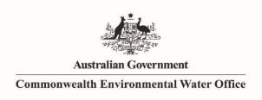 

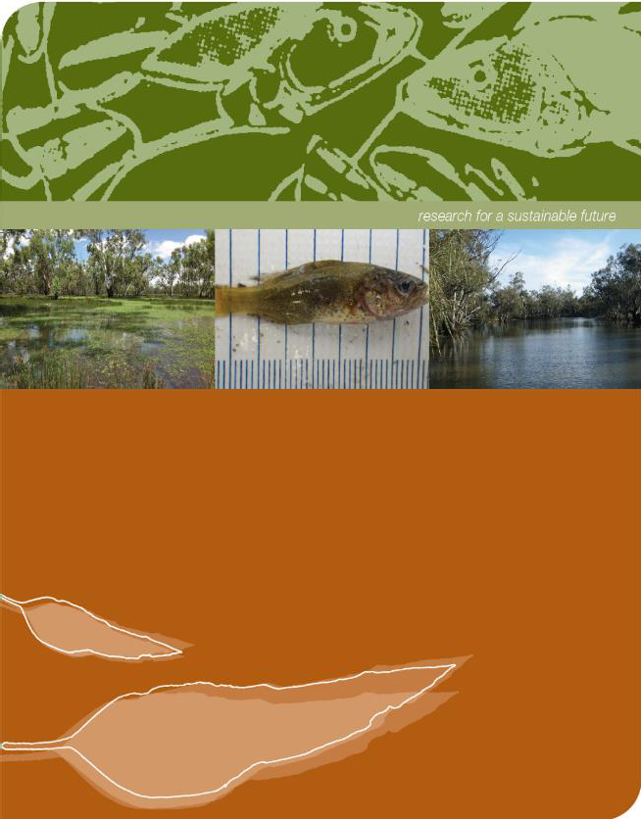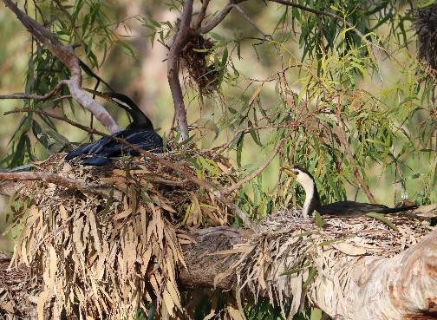

**Commonwealth Environmental Water Office**

**Murrumbidgee River System - Category 3 waterbird breeding monitoring summary report**

**July 2021**

## Commonwealth Environmental Water Office Murrumbidgee River System – Category 3 waterbird breeding monitoring summary report July 2021

Prepared by: Spencer, J.a,b,c, Michael, D a, Brandis, K.b, Francis, R. b, and Wassens, S.a

|  |  |
| --- | --- |
|  | a Institute for Land, Water and Society. Charles Sturt University, PO Box 789, Albury, NSW 2640 |
| CES.png | b Centre for Ecosystem Science, University of New South Wales, Sydney, NSW, 2052 |
|  | c NSW Planning, Industry and Environment, PO Box 39, Sydney, NSW 2001 |

**Funding:** This monitoring project was commissioned and funded by the Commonwealth Environmental Water Office with additional in-kind support from the NSW Department of Planning, Industry and Environment, Murrumbidgee Local Land Services and Charles Sturt University. We are grateful to private landholders for allowing access to their properties.

**Copyright:** © Copyright Commonwealth of Australia, 2021

‘Commonwealth Environmental Water Office Murrumbidgee River System - Category 3 waterbird breeding monitoring summary report June 2021 is licensed by the Commonwealth of Australia for use under a Creative Commons By Attribution 3.0 Australia licence with the exception of the Coat of Arms of the Commonwealth of Australia, the logo of the agency responsible for publishing the report, content supplied by third parties, and any images depicting people. For licence conditions see: <http://creativecommons.org/licenses/by/3.0/au/>

This report should be attributed as ‘Commonwealth Environmental Water Office Murrumbidgee River System – Category 3 waterbird breeding monitoring summary report July 2021, Commonwealth of Australia 2021’. The Commonwealth of Australia has made all reasonable efforts to identify content supplied by third parties using the following format ‘© Copyright, [name of third party] ’.

**Disclaimer:** The views and opinions expressed in this publication are those of the authors and do not necessarily reflect those of the Australian Government or the Minister for the Environment and Energy. While reasonable efforts have been made to ensure that the contents of this publication are factually correct, the Commonwealth does not accept responsibility for the accuracy or completeness of the contents, and shall not be liable for any loss or damage that may be occasioned directly or indirectly through the use of, or reliance on, the contents of this publication.

**Acknowledgement**: The Commonwealth Environmental Water Office acknowledges the efforts of all consortium partners in delivering the Murrumbidgee Flow MER Monitoring Project and preparing this report. The authors of this report as well as the Commonwealth Environmental Water Office respectfully acknowledge the traditional owners, their Elders past and present, their Nations of the Murray-Darling Basin, and their cultural, social, environmental, spiritual and economic connection to their lands and waters. In particular the Wiradjuri, Narri Narri and Muthi Muthi peoples, traditional owners of the land on which this publication is focused.

# Introduction

Colonial waterbird species, including ibis, herons, pelicans, egrets and cormorants, can nest in large numbers within floodplain wetlands. The Lowbidgee floodplain is one of the most important colonial nesting waterbird breeding sites in the Murray-Darling Basin (Kingsford and Thomas 2004; MDBA 2014). Eulimbah and Telephone Bank Swamps are the main areas that support large ibis colonies in the Gayini Nimmie- Caria. The neighbouring Redbank wetlands, which includes Yanga National Park, can also support large egret, heron and cormorant colonies. In the mid-Murrumbidgee while egret, heron, spoonbill and cormorant colonies were previously common in multiple locations (Briggs and Thornton 1999), only smaller, mainly cormorant colonies, have been detected in this region in recent years (Wassens et al. 2018).

Under the approved Murrumbidgee MER Monitoring and Evaluation Plan for 2019- 2022 (Wassens et al. 2019) there is provision to undertake event-based waterbird breeding monitoring during years where active colonies are detected. Monitoring of waterbird breeding sites plays a critical role supporting water management decisions, particularly with respect to water delivery needed to maintain the depth and extent of inundation in colony sites and surrounding foraging habitats so that waterbirds can fledge their young successfully.

We use two approaches to evaluate waterbird breeding responses to environmental watering actions across the Murrumbidgee Selected Area see (Wassens et al. 2019):

* *Waterbird Breeding (Category 1)* targeting large ibis colonies in the Gayini (Nimmie-Caira) wetland zone and elsewhere in the Murrumbidgee Selected Area as required.
* *Waterbird Breeding (Category 3)* targeting egret, heron, spoonbills, cormorant, pelican and smaller ibis breeding sites in the Redbank, Gayini (Nimmie-Caira) and Mid-Murrumbidgee wetland zones to support the Murrumbidgee Selected Area evaluation.

The Category 3 methods differ to the Category 1 approach in that they focus on collecting data on the locations of all active colonies including total numbers of nests of each species and do not include quantitative measures of breeding success which are included in the Category 1 methods. The stage of breeding and water levels are

collected during both Category 1 and 3 methods, which can be used to inform water delivery to colony sites where needed.

Note that this report provides a summary of outcomes of the Category 3 monitoring undertaken in 2020-2021. More detailed evaluation of waterbird breeding outcomes will be presented in the Murrumbidgee MER annual report.

# Relevant watering actions and objectives

Large areas of the Lowbidgee floodplain received Commonwealth and NSW environmental water over winter 2020 including areas known to support waterbird breeding and feeding habitat in Gayini Nimmie-Caira, South Redbank (Yanga National Park) and North Redbank (see Plate 1). Follow-up watering actions over spring and summer 2020-2021 were delivered to extend the inundation of colony sites.

There were four main watering actions that had objectives for supporting colonial waterbird breeding in the 2020-2021 water year:

* **Gayini Nimmie-Caira Floodways:** Environmental watering commenced in late July 2020 inundating wetlands through the Gayini Nimmie-Caira system west to Yanga National Park. Active colonies were detected in October 2020 annual and ground surveys with Commonwealth and NSW water for the environment delivered over summer months to maintain water levels in active colony sites.
* **Yanga National Park:** Environmental watering commenced in early July 2020 to fill the northern section of Yanga through to Yanga Lake joining with flows from the Gayini Wetlands by late November 2020. Maintenance flows were delivered from the late December 2020 to mid-February 2021 period to support active waterbird colonies and Australasian bittern breeding in the northern section of Yanga National Park.
* **North Redbank System:** Water for the environment was delivered from mid- August 2020 onwards to achieve whole of system watering. The wetlands in the central North Redbank system filled from early November 2020 with top- up flows from mid- to late December 2020.
* **Yarradda Lagoon:** Water for the environment was pumped into Yarradda Lagoon, in the Mid-Murrumbidgee wetlands, from early November to mid- December 2020.

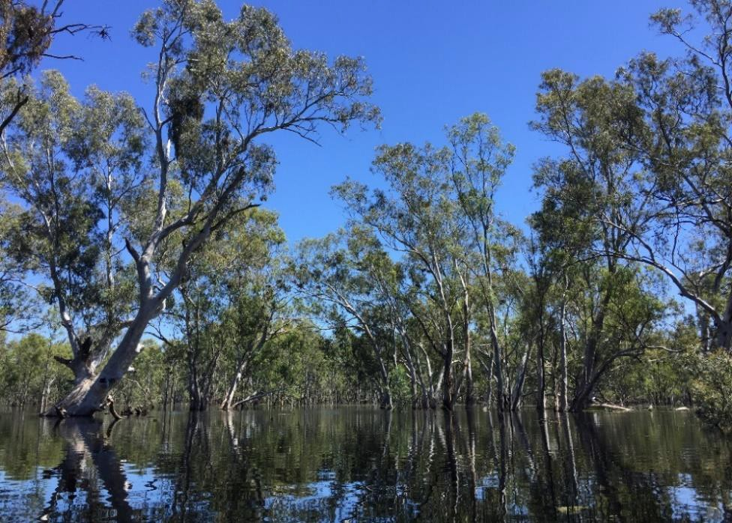 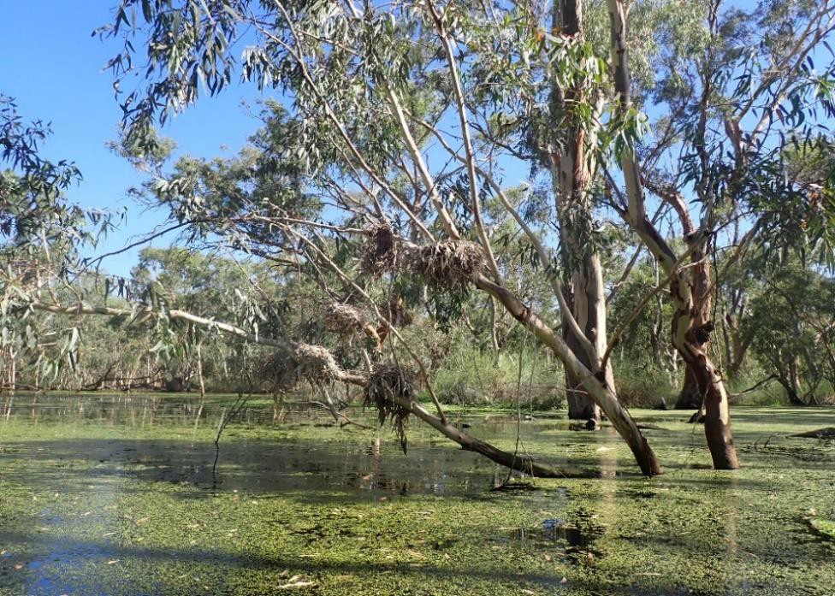

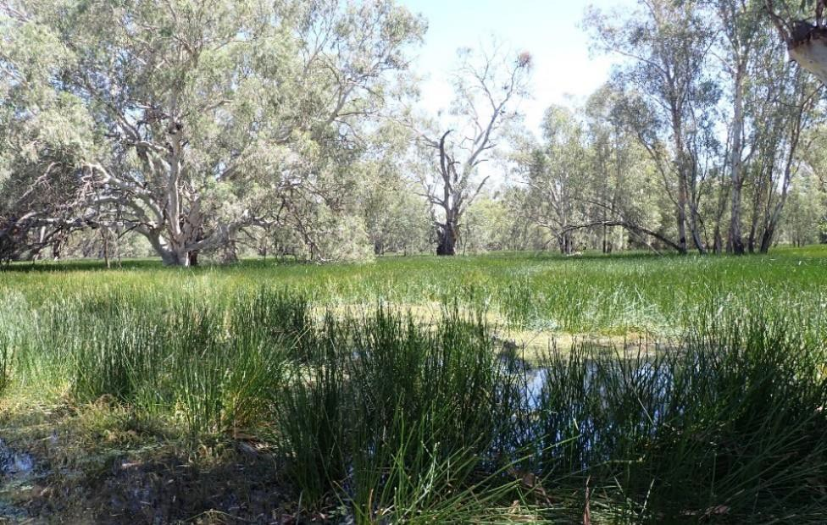 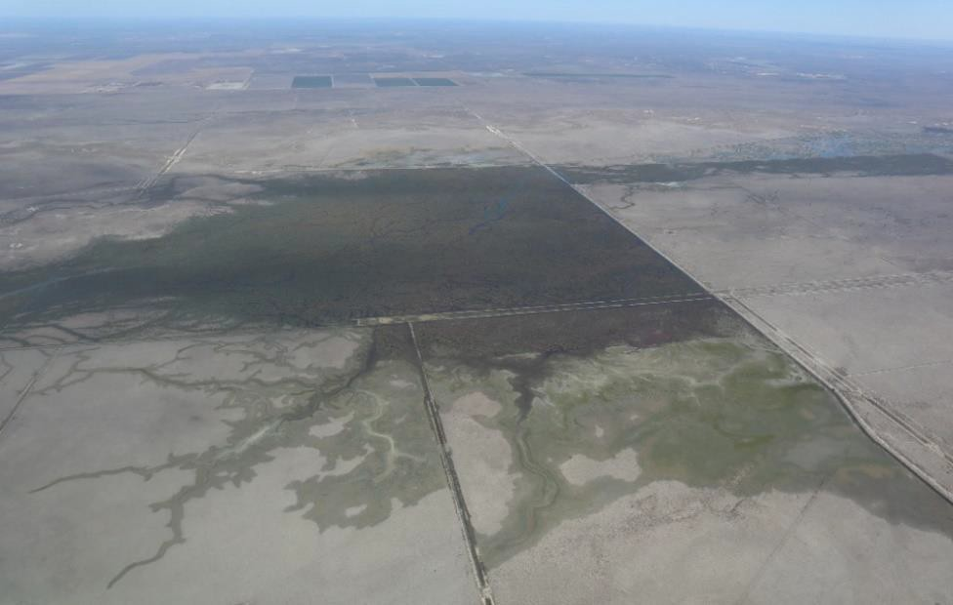

**Plate 1** (*Clockwise from top left)*: Tarwille Swamp, Yanga National Park, October 2020 (Credit: Ali Borrell), Cormorant nests, Nap Nap Swamp, January 2021 (Credit: Sarah Talbot), Aerial view of Eulimbah Swamp and Suicide floodway, December 2020 (Credit: Ali Borrell), Two Bridges Swamp, Yanga National Park, January 2021 (Credit: S. Talbot, CSU).

### Evaluation Questions

The responses of waterbirds to environmental watering actions in the 2020-2021 water year were assessed against two key evaluation questions to determine the extent to which the objectives were achieved.

* + *Did Commonwealth environmental water contribute to waterbird breeding?*
  + *What did Commonwealth environmental water contribute to waterbird fledging and survival?*

# Methods

Waterbird surveys were completed over spring and summer months in 2020-2021 to document the location, size, number of breeding species and stage of nesting in active colonies in the Lowbidgee Floodplain and Mid-Murrumbidgee Wetlands. As done in 2016-2017 (Wassens et al. 2018), a range of monitoring methods were used to assess waterbird breeding responses to wetland inundation in the Murrumbidgee River Selected Area including aerial surveys, repeat ground surveys and drone- based surveys (see Table 1).

**Table 1.** Summary of waterbird monitoring coverage in the Murrumbidgee Selected Area in 2020-2021. ^Reproductive success data was only collected at Cat 1 montoring sites (Eulimbah Swamp).

|  |  |  |  |  |  |
| --- | --- | --- | --- | --- | --- |
| **Data type** | **Oct** | **Nov** | **Dec** | **Jan** | **Feb** |
| Waterbird species richness Waterbird abundance Breeding species (partly)  Location of active colonies & estimates of colony size | Spring ground surveys  UNSW annual spring aerial surveys |  | Colony aerial survey |  | Summer ground surveys |
| Colony size Breeding species Stage of nesting Water levels  Water quality issues  Impact of predation/disease | **Cat 3:** Colony ground surveys as part of annual spring surveys |  | **Cat 3:** Colony ground surveys | **Cat 3:** Colony ground surveys | **Cat 3:** Colony ground surveys as part of summer  surveys |
|  | Colony drone surveys completed in the Gayini Nimmie-Caria wetlands | | | |
| Reproductive success data^ |  | | | |
| **Cat 1:** Detailed nest monitoring (fortnightly visits) of large ibis colony in Eulimbah Swamp^ | | | |

### Aerial surveys

The University of New South Wales (UNSW) completed an aerial survey on 13 October 2020 which provided information on colony activity across the Lowbidgee floodplain. This aerial survey was completed as part of the long-running Annual Waterbird Surveys of Eastern Australia (Porter et al. 2020) and MDBA funded aerial surveys that UNSW coordinate each spring (see Kingsford et al. 2020). The Flow-MER contingency funding supported a follow-up aerial survey in a fixed-wing aircraft of the Lowbidgee floodplain on 18 December 2020. During the colony aerial survey North and South Redbank and Gayini-Nimmie Caira wetland areas were flown over repeatedly specifically to check for waterbird colony activity.

### Ground surveys

Initial colony ground assessments were completed at known historical colony sites (35 in total) during annual spring ground surveys at fixed wetland monitoring sites (see Appendix 1) undertaken in October 2020 across the Mid-Murrumbidgee Wetlands (12-15 October 2020) and Lowbidgee Floodplain (19-21 October 2020). Follow-up Category 3 colony ground surveys were completed in 18 colony sites over 7-11 December 2020 and 12-15 January 2021 (see Table 1).

Additional colony information was collected in the Gayini Nimmie-Caria wetlands as part of Murray-Darling Wetland Working Group (MDWWG) monthly waterbird surveys led by Ali Borrell and through additional drone surveys completed by UNSW (funded by NSW DPIE-EES) in January and February 2021(see further details herein). Summer ground surveys were completed across the Mid-Murrumbidgee Wetlands (15-18 February 2021) and Lowbidgee Floodplain (22-25 February 2021), which included the final round of Category 3 monitoring at 18 colony sites.

Category 3 colony ground survey were done on foot or from a kayak or four-wheel drive vehicle and waterbirds were observed using binoculars and/or telescopes.

During each ground survey, detailed assessment of a colony site was made to include estimates of colony extent, total number of nests of each species and stage of nesting (nest building, eggs, early (<2 weeks old) or late (>2 weeks old) nestling stages, or fledglings), water depths and evidence of predation or other mortality.

Survey coverage was staggered across spring and summer months to ensure that the largest Category 3 sites (around 250 to 2,500 nests in size (see Table 2)), were

visited at around monthly intervals (see Table 1). Observations of non-colonial waterbird species and their breeding activity were also recorded during the colony ground surveys.

UNSW coordinated fortnightly visits to the Eulimbah ibis (Figure 1) colony in the Gayini Wetlands to document reproductive success, stage of nesting and site conditions as part of Category 1 monitoring over November 2020-February 2021, which included repeat drone surveys to document colony extent (Table 1). Briefly, the Category 1 methods involve monitoring a sub-set of nests throughout the breeding period (six trips in total) to assess reproductive success in relation to a range of environmental variables including water depth and water quality (also measured).

Note that the results of the Category 1 monitoring at Eulimbah Swamp will be presented in the final Murrumbidgee Selected Area report for 2020-2021. For more details on the Category 1 and Category 3 colony monitoring methods see the Murrumbidgee Selected Area Monitoring and Evaluation Plan (Wassens et al. 2019).

### Drone surveys

Additional drone surveys were conducted by Gayini-Nimmie-Caira Land Managers and UNSW over the 2020-2021 season to assess waterbird breeding activity in parts of the Gayini Wetlands. Active nests were observed at Suicide Swamp during the aerial survey on 18 December 2020. The colony location in Suicide Swamp was difficult to survey on ground due to the dense lignum vegetation so drone surveys were undertaken to allow for an estimation of colony size and stage of nesting. Note that no active nesting was detected in Telephone Swamp during the drone surveys or during the aerial survey. UNSW flew transects over Suicide Swamp on the 5 January and 2 February 2021 with the aim of identifying breeding species, number of nests and stage of nesting (Francis and Brandis 2021). The drone was flown at 60m height, with an overlap of 75-80%, to acquire photography (see example in Plate 2) as per established drone survey methods for waterbird colonies documented in Lyons et al. (2018). The images were orthomosaiced and then inspected to manually count active waterbird nests. Species were identified based on their plumage and breeding stage was determined based on group behaviour (e.g. trampling, incubating or creching), and from sightings of eggs or chicks in nests (see further detail in Francis and Brandis 2021).

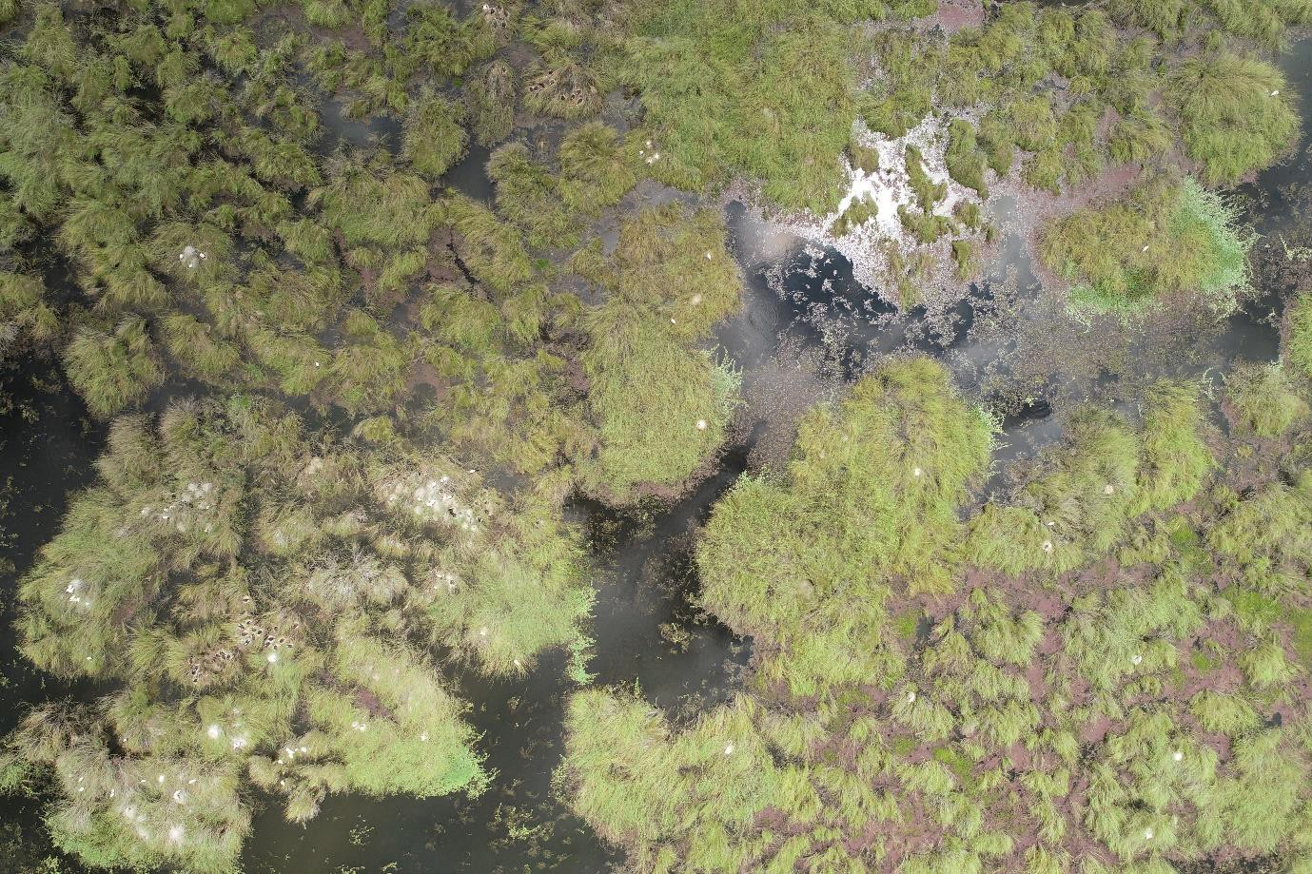

**Plate 2.** Active ibis and spoonbill nests detected at Suicide Swamp during drone survey on 5 January 2021 (Credit. R. Francis, UNSW).

# Results and Discussion

## What did Commonwealth environmental water contribute to waterbird breeding?

We detected 20 active waterbird colonies in the Murrumbidgee Selected Area during the October 2020 to February 2021 period. In total there were 17 sites that supported colonial waterbird nesting in the Lowbidgee Floodplain (see Figure 1, Table 2) and three active colonies in the Mid-Murrumbidgee Wetlands (Table 2). This included the large ibis colony at Eulimbah Swamp in the Gayini Wetlands monitored by UNSW, and five medium-sized and 14 much smaller-sized ibis, egret, spoonbill, heron and cormorant sites across the rest of the Murrumbidgee Selected Area (see Table 2).

In total 13 colonially-nesting species were recorded breeding including Australian white ibis, royal spoonbill, yellow-billed spoonbill, straw-necked ibis, glossy ibis, little pied cormorant, little black cormorant, Australasian darter, great cormorant, nankeen night-heron, white-necked heron, eastern great egret and intermediate egret. Nationally endangered Australasian bittern and NSW listed blue-billed duck

and freckled duck were also recorded at several sites in the Lowbidgee floodplain during the 2020-21 spring and summer waterbird surveys.

Most the colonies (16 sites in the Lowbidgee, two sites in the Mid-Murrumbidgee) were detected after the completion of the aerial and ground surveys completed from mid-October to mid-December 2020. During ground surveys completed in mid- January and late February 2021 most colony sites were completed or near completion with fledglings observed in several sites (Table 2). Nesting activity was also confirmed at Breer Swamp and Tala Lake in the Lowbidgee Floodplain, and Yarradda Lagoon in the Mid-Murrumbidgee Wetlands during the January surveys.

Only a small number of new nests were observed at Nap Nap Swamp and House Creek during the late February 2021 surveys (Figure 1, Table 2).

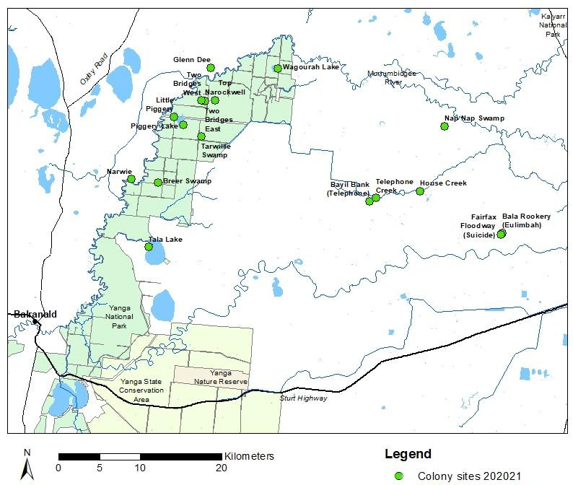

**Figure 1.** Overview of 17 colony locations in the Lowbidgee floodplain that supported waterbird breeding in the 2020-21 water year. There were a further 13 inactive colony sites across the Lowbidgee Floodplain that were checked in the 2020-21 surveys (see Appendix 1).

**Table 2.** Summary of active colony sites and monitoring coverage over spring and summer 2020-2021. Note Gayini wetland names will be updated in future reporting. *Results of UNSW monitoring of Eulimbah Swamp will also be reported separately as part of annual reporting. ^Colony size category: large colonies (>5000 nests), medium-sized colonies (>250-<5000 nests) and small (<250 nests) colonies.

|  |  |  |  |  |  |
| --- | --- | --- | --- | --- | --- |
| **Wetland region** | **Colony site** | **Colony size category^** | **Number of colonially- nesting species** | **Est. number of nests** | **Summary of observations** |
| **Gayini-Nimmie** | Eulimbah Swamp* | Large | 6 | 18,600 | Category 1 fortnightly repeat monitoring of large ibis colony and drone surveys coordinated by UNSW. Small number of nesting royal  spoonbill and cormorants also present. |
| **Redbank** | Tarwillie Swamp | Medium | 10 | 2,600 | Colony first established in mid-October. December aerial and ground surveys found colony grown substantially and large number of great egrets, cormorants and herons nesting at this site. Late  February surveys found nests had nearly completed with fledglings observed. |
| Two Bridges East | Medium | 2 | 250 | Colony first established in mid-October. Cormorant nests well advanced by mid-December and fledglings observed during late February surveys. |
| Two Bridges West | Medium | 5 | 550 | Colony first established in mid-October. Cormorant nests well advanced by mid-December but new great egret nests detected. Some egret nests still with chicks during late February survey. |
| Top Narockwell | Medium | 3 | 480 | Number of nests grown since mid-October surveys and site supported large numbers of nesting cormorants and white-necked herons in mid-December. No nesting birds observed during late  February survey. |
| **Gayini-Nimmie** | Telephone Creek | Medium | 9 | 670 | Large number of nankeen night-heron fledglings, number of active cormorant nests during February survey. Some mortality in great cormorant nests was observed in the February survey. |
| Nap Nap Swamp | Medium | 8 | 280 | Colony first established in mid-October. In late February most nests of egrets, herons, spoonbills had completed and there were new cormorant and Australian white ibis nests with small chicks. Water levels had dropped considerably since mid-January surveys. |
| **Redbank** | Breer Swamp | Small | 2 | 5 | No activity detected during October or February ground surveys or December aerial survey. Small number of fledging spoonbills and cormorants observed during late December bittern surveys  (Herring, M., pers. obs., December 2020). |
| Glenn Dee Swamp | Small | 2 | 140 | Large cormorant colony, advanced chicks during December visit and large number of fledglings during January survey. Very shallow in parts (0.2-0.3m) and almost completely dry by late February. |

|  |  |  |  |  |  |
| --- | --- | --- | --- | --- | --- |
| **Wetland region** | **Colony site** | **Colony size category^** | **Number of colonially-**  **nesting species** | **Est. number of nests** | **Summary of observations** |
|  | Little Piggery | Small | 2 | 20 | Small number of active cormorant nests in mid-December. No nesting observed during late February surveys. |
| Narwie | Small | 2 | 10 | Small number of active cormorant nests in mid-December and mid-January surveys. No nesting birds observed during late February survey. |
| Piggery Lake | Small | 4 | 70 | Small number of active cormorant and darter nests in October- February period. Fledglings and large chicks observed during late February surveys. |
| Tala Lake | Small | 1 | Unknown | No activity detected during October ground or aerial surveys. Small number of used empty nests observed during late February  survey. Large number of roosting cormorants also observed at this time. |
| Wagourah Lake | Small | 1 | 20 | No activity detected during October surveys. Small number of active cormorant nests in mid-December survey. No nesting birds observed during February survey. |
| **Gayini-Nimmie** | House Creek | Small | 4 | 65 | Small number of active spoonbill and cormorant nests during October - December surveys. Active cormorant and darter nests still present during late February survey. |
| Suicide Floodway | Small | 5 | 425 | New area with active ibis, spoonbill and night heron nests detected in December aerial surveys. UNSW drone surveys in early January and early February documented total number of nests (Francis and  Brandis 2021). |
| Telephone Bank | Small | 2 | 50 | Small number of white ibis suspected building nests here in mid- November surveys and areas of nesting night herons also observed (A. Borrell pers. obs., November 2020). No active nests observed during early January UNSW drone survey. |
| **Mid-Murrumbidgee** | Yarradda Lagoon (Mid- bidgee) | Small | 2 | 15 | No active nests observed in October or early December ground surveys. Nesting darters and cormorants observed during mid- January and late February surveys. |
| Gooragool Lagoon (Mid- bidgee) | Small | 1 | 20 | Small number of cormorant nests detected in early October. Water levels low here in late November and most of the site was dry  during February surveys. |
| Yarradda West (Midbidgee) | Small | 2 | 10 | Small number of cormorant nests detected in early December ground survey. Juvenile darters and cormorants observed during late February survey. |

# Conclusions

Our monitoring documented widespread waterbird breeding in the Murrumbidgee River system in 2020-2021 following delivery of environmental water with 13 species recorded nesting across 20 colony sites. This outcomes differs from previous breeding events in that it was supported solely through environmental water. In the past breeding has been triggered by unregulated flows, with the colonies supported by water for the environment through to completion. For example, colonial waterbird breeding was recorded at 30 sites across the Lowbidgee floodplain in 2016-2017 (Wassens et al. 2018).

The colonial nesting waterbird breeding response following environmental water delivery in the Lowbidgee was the largest event recorded in the Murray-Darling Basin in 2020-2021. The 2020-2021 event was also the largest breeding event initiated and maintained purely with water for the environment. Managed flows delivered over winter months to inundate large areas of floodplain wetlands across the Gayini Nimmie-Caria and adjoining Redbank system were effective at priming the system before waterbird breeding began in spring 2020. Equally important was the continued delivery of NSW and Commonwealth environmental water over summer 2020-2021 to ensure water levels were maintained in key colony sites in the Gayini Nimmie-Caria wetlands and the northern part of Yanga National Park. These top-up flows were important for allowing waterbirds to raise their young from small chicks observed in the spring and early summer surveys through to fledglings observed in the late summer surveys.

# References

Briggs, S. and Thornton (1999). Management of water regimes in River Red Gum *Eucalyptus camaldulensis* wetlands for waterbird breeding. Australian Zoologist **31**(1): 187-197.

Francis, R., and Brandis, K. (2021). 2021 Drone surveys Suicide Swamp. Final report to the NSW Department of Planning, Industry and Environment – Environment, Energy and Science. Centre for Ecosystem Science, University of New South Wales, Sydney.

Lyons, M., Brandis, K., Callaghan, C., McCann, J., Mills, C., Ryall, S. and Kingsford, R. (2018).

Bird interactions with drones, from individuals to large colonies. Australian Field Ornithology **35**: 51-56.

Kingsford, R.T., Porter, J.L., Brandis, K. and Ryall, S. (2020). Aerial surveys of waterbirds in Australia. Scientific Data **7**:172 [<https://doi.org/10.1038/s41597-020-0512-9>]

Kingsford, R.T., and Thomas, R.F. (2004). Destruction of wetlands and waterbird populations by dams and irrigation on the Murrumbidgee River in arid Australia. Environmental Management **34**: 383-396.

MDBA (2014). *Basin-wide environmental watering strategy.* Murray-Darling Basin Authority.

November 2014.

Porter, J.L., Kingsford, R.T., Francis, R. and Brandis, K. (2020). *Aerial Survey of Wetland Birds in Eastern Australia: October 2020 Annual Summary Report*. Centre for Ecosystem Science, School of Biological, Earth and Environmental Sciences, University of NSW, Sydney and NSW Department of Planning Industry & Environment.

Wassens, S., Michael, D.R., Spencer, J., Thiem, J., Kobayashi, T., Bino, G., Thomas, R., Brandis, K., Hall, A., and Amos, C. (2019). *Murrumbidgee Monitoring, Evaluation and Research Plan.* Commonwealth of Australia 2019.

Wassens, S., Spencer, J., Wolfenden, B., Thiem, J., Thomas, R., Jenkins, K., Brandis, K., Lenon, E., Hall, A., Ocock, J., Kobayashi, T, Bino, G., Heath, J c., and Callaghan, D. (2018)*. Long- Term Intervention Monitoring Project Murrumbidgee River System evaluation report 2014-17.* Report to the Commonwealth Environmental Water Office.

# Acknowledgements

The Murrumbidgee waterbird monitoring was funded through Flow-MER — the

Commonwealth Environmental Water Office’s Monitoring, Evaluation and Research Program and NSW Department of Planning, Industry and Environment – Environment, Energy and Science. Our thanks to the Nari Nari for allowing access to the Gayini Wetlands and to Jamie Woods and Tara Dixon (Nari Nari Tribal Council) for supporting our monitoring. We also thank Lowbidgee landholders for permitting access to other sites in the Nimmie-Caira and the North Redbank wetlands. Ground surveys were completed by Damian Michael, Sarah Talbot, Gaye Bourke (CSU), Ali Borrell (Murray-Darling Wetlands Working Group), Chris Belcher (Ecosystems), Amelia Walcott, Simon Husher, James Maguire, Rex Conallin (NSW DPIE-EES) and Roxane Francis (UNSW). The December aerial survey was undertaken by Tim Dugan (NPWS Park Air), Ali Borrell (MDWWG), Simone Carmichael (NPWS), Jessica Heath (Water and Wetlands, DPIE-EES), Michele Groat and Helen Owens (CEWO). Drone surveys of Suicide Swamp were done by Roxane Francis with assistance of Skye Davis and Simon Gorta (UNSW). The colony ground surveys are done under NSW NPWS Scientific Licencing and NSW DPIE-EES and UNSW animal care and ethics committee approvals. The drone survey methods are approved under UNSW animal care and ethics committee approval. Our thanks to Eva Moore (CSU) for her assistance with the 2020-2021 data entry.

# Appendices

### Appendix 1 Waterbird ground survey sites

|  |  |  |  |  |  |
| --- | --- | --- | --- | --- | --- |
| **Murrumbidgee MER Zone** | **Site Code** | **Site Name^** | **Fixed sites for biannual surveys** | **Known colony site** | **Active in 2020-2021**  **water year** |
| Gayini (Nimmie-Caira) | AVA | Avalon Swamp | Yes | Yes | No |
| Gayini (Nimmie-Caira) | EUL | Eulimbah Swamp | Yes | Yes | Yes |
| Gayini (Nimmie-Caira) | KIAL | Kia Lake | Yes |  |  |
| Gayini (Nimmie-Caira) | KIAS | Kia Swamp | Yes |  |  |
| Gayini (Nimmie-Caira) | LOO | Loorica Lake | Yes | Yes | Yes |
| Gayini (Nimmie-Caira) | NAP | Nap Nap Swamp | Yes | Yes | Yes |
| Gayini (Nimmie-Caira) | SUI | Suicide Swamp | Yes | Yes | Yes |
| Gayini (Nimmie-Caira) | TEL | Telephone Creek | Yes | Yes | Yes |
| Mid-Murrumbidgee | BEJ | Berry Jerry | Yes |  |  |
| Mid-Murrumbidgee | NSF | Narrandera SF | Yes |  |  |
| Mid-Murrumbidgee | COO | Coonacoocabil | Yes |  |  |
| Mid-Murrumbidgee | YAA | Yanga Ag (McCaugheys) | Yes |  |  |
| Mid-Murrumbidgee | TUK | Turkey Flats | Yes |  |  |
| Mid-Murrumbidgee | EUR | Euroley | Yes |  |  |
| Mid-Murrumbidgee | MOL | Molleys Lagoon | Yes |  |  |
| Mid-Murrumbidgee | DRY | Dry Lake | Yes | Yes | No |
| Mid-Murrumbidgee | SUN | Sunshower Lagoon | Yes |  |  |
| Mid-Murrumbidgee | GOO | Gooragool Lagoon | Yes | Yes | Yes |
| Mid-Murrumbidgee | YAR | Yarradda Lagoon | Yes | Yes | Yes |
| Mid-Murrumbidgee | MCK | McKennas Lagoon | Yes | Yes | No |
| Mid-Murrumbidgee | WILB | Wilbriggie (Darlington) Lagoon | Yes |  |  |
| North Redbank | MUR | Murrundi | Yes |  |  |
| North Redbank | NARH | Narwie Homestead Swamp | Yes |  |  |
| North Redbank | NARW | Narwie West | Yes |  |  |
| North Redbank | PCS | Paul Coates Swamp | Yes | Yes | No |
| North Redbank | RIV | Riverleigh | Yes | Yes | No |
| North Redbank | STE | Steam Engine Swamp | Yes | Yes | No |
| South Redbank | BRE | Breer Swamp | Yes | Yes | Yes |
| South Redbank | LPG | Little Piggery | Yes | Yes | Yes |

|  |  |  |  |  |  |
| --- | --- | --- | --- | --- | --- |
| **Murrumbidgee MER Zone** | **Site Code** | **Site Name^** | **Fixed sites for biannual surveys** | **Known colony site** | **Active in 2020-2021**  **water year** |
| South Redbank | MER | Mercedes Swamp | Yes | Yes | No |
| South Redbank | MON | Monkem Creek | Yes |  |  |
| South Redbank | PIG | Piggery Lake | Yes | Yes | Yes |
| South Redbank | POC | Pococks Swamp | Yes | Yes | No |
| South Redbank | SHA | Shaws Swamp | Yes |  |  |
| South Redbank | TBR | Two Bridges Swamp | Yes | See below |  |
| South Redbank | WAG | Waugorah Lagoon | Yes | Yes | No |
| South Redbank | WAL | Waugorah Lake | Yes | Yes | Yes |
| South Redbank | YAN | Yanga Lake | Yes | Yes | No |
| South Redbank | NST | North Stallion | Yes | Yes | No |
| Western Lakes | HOBB | Hobblers – Penarie | Yes |  |  |
| Western Lakes | PAIC | Paika Creek | Yes | Yes | No |
| Western Lakes | PAIK | Paika Lake | Yes | Yes | No |
| Western Lakes | CHER | Upper Cherax Swamp | Yes |  |  |
| Gayini (Nimmie-Caira) | HOU | House Creek | No | Yes | Yes |
| Gayini (Nimmie-Caira) | TEB | Telephone Bank | No | Yes | Yes |
| North Redbank | GDEE | Glenn Dee | No | Yes | Yes |
| North Redbank | NAR | Narwie Colony | No | Yes | Yes |
| North Redbank | TORI | Tori Swamp | No | Yes | No |
| South Redbank | TALA | Tala Lake | No | Yes | Yes |
| South Redbank | TALC | Tala Creek | No | Yes | No |
| South Redbank | TARW | Tarwillie Swamp | No | Yes | Yes |
| South Redbank | TOPN | Top Narockwell | No | Yes | Yes |
| South Redbank | TBRE | Two Bridges (East) | No | Yes | Yes |
| South Redbank | TBRW | Two Bridges (West) | No | Yes | Yes |
| South Redbank | YCR | Yanga Creek | No | Yes | No |

^ Dry colony sites in the 2020-2021 surveys are shaded