Characterising the ecological effects of changes in the ‘low-flow hydrology’ of the Barwon-Darling River

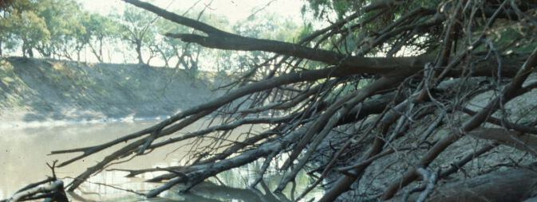

Fran Sheldon

*Australian Rivers Institute*

*Griffith University*

Advice to the Commonwealth Environmental Water Holder Office

October 2017



# Executive Summary

Variations in the magnitude, frequency, timing and duration of flow pulses are both physically and biologically significant aspects of the flow regime in river systems; such that flow variability underpins river ecosystem function and integrity. In many studies of river systems, and the impacts of water resource development on flow regimes, there has been a tendency to focus on impacts at the high flows part of the flow regime. However, low flows and small flow pulses are equally important parts of the flow regime, and particularly so in rivers such as the Barwon-Darling that high levels of unpredictability at the higher discharge end of the flow regime, with faunal and floral populations maintained by the more frequent small flow pulse events.

Water resource development and water management has modified flow regimes across nearly the entire Murray–Darling Basin, including the northern Barwon–Darling River and its associated tributaries. In 1996 it was recognised that associated with water resource development in the northern basin there had been a decrease in annual and daily volumes along the Barwon-Darling, increased rates of flood recession (related to pumping for irrigation), decreases in the frequency of small flow pulses and marked changes in the character of flood frequencies.

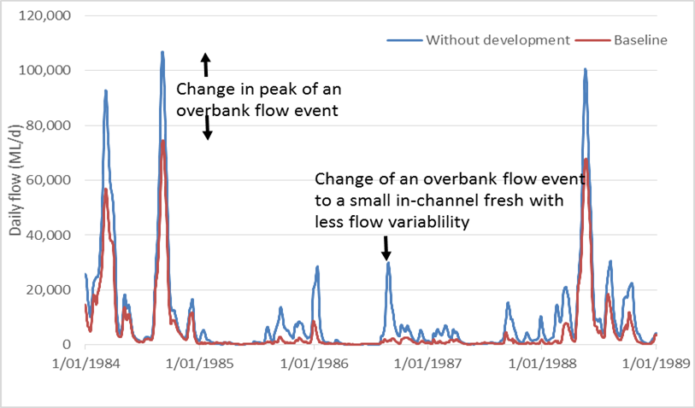

*Daily flows of the Darling River at Bourke over a five year period from 1984 to 1989 (modelled without development conditions and baseline conditions). From MDBA (2016).*

In the period 2000-2017 there was an increase in the length of dry spells (length of cease to flow) compared with the previous 10 year period (1990-1999), and this was most pronounced downstream of Bourke. Increasing cease to flow periods in this section of the Barwon-Darling will have had impacts on water quality and the successful spawning and recruitment of many small native fish. Periods of no flow can cause stratification of standing water bodies, which can induce hypoxic or anoxic conditions in lower parts of the water column and provide conditions conducive to algal blooms in surface waters. In some reaches low stable water levels contribute to an increase in saline in-flows from local groundwater aquifers, which can further exacerbate the declining water quality in refugial pools, not only by increasing measured conductivity but also by assisting in the flocculation from suspension of clay particles which can increase water clarity and stimulate algal blooms – which can further reduce oxygen levels.

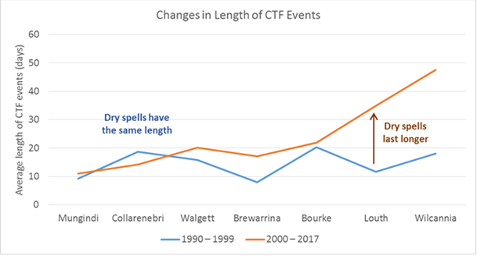

*Comparison of average length of dry spells from upstream to downstream, (MDBA 2016)*

Numerous studies since 1992 have identified a similar threshold for low flows in the Barwon-Darling as ecologically significant; these are flows at around the 80th percentile (approximately 250 ML/day at Walgett, 510 ML/day at Brewarrina, 450-500 ML/day at Bourke, 1,200 ML/day at Louth and 350-400 ML/day at Wilcannia) equating to the small pulses required to maintain water quality and provide some opportunity for spawning and recruitment in small native fish and invertebrates. Comparing modelled natural and modelled baseline development data with actual observed data suggests there has been a marked decrease in both the frequency and number of small flow pulses along the Barwon-Darling River since 1990 compared to natural conditions, with the biggest change for those low-flow events of extended duration, for example a 500ML/day event at Bourke with a 50 day duration has suffered the most impact, with the same magnitude event for shorter durations less impacted. This reduction in the duration of small flow events (as well as their frequency) is significant as the longer duration events are critical for successful spawning and recruitment of many native fish species. Under current management rules small flow pulse events of 1 day duration can be achieved in 100% of years for Walgett, Bourke and Wilcannia, however, small flow pulse events of more than 10 days duration occurred in fewer years, and the incidence of multiple small-flow events in any one year were even fewer. Most of the smaller fish have egg hatching times of between 2-10 days, so sustained small pulse events of durations less than 20 days are unlikely to result in successful breeding of these short lived fish. While successful spawning is one component, the larvae need to grow and recruit into the population as juveniles, to do this they require access to food and habitat. It is likely that successful and sustained recruitment of the smaller fish species in the Barwon-Darling will only result from small flow pulses of either extended duration >25 days or a series of repeated small-flow pulses within a year. So, while spawning itself may be successful with flows of shorter duration, recruitment failures will cause populations to become vulnerable to local extinction, particularly for species with life-spans of less than 3 years.

With increasing time between small flow pulses the importance of refugial pools as key sites in the maintenance and long-term survival of many aquatic organisms in the Barwon-Darling increases. Any activities, such as pumping from these pools (above the levels required for stock and domestic use), that decrease water levels further, or remove small inflows from tributaries threatens the persistence and ecological health of the waterholes. Most sensitive to pumping from restricted pools may be the section of channel below Bourke and around Tilpa, sections in this reach are prone to complete drying and the reach also contains the highest incidence of saline inflows, in this regard any pumping (apart from that required for stock and domestic) should not be allowed below Bourke in the absence of flow of a required threshold.

One option suggested for returning small flow pulses to the river is to remove access to A Class pumping licences and swap the volume access of these A Class licences into the B Class range (>1000 ML/day at Bourke and Louth). While this may well have the result of increasing the frequency and duration of small flow pulses it will also serve to increase the pressure on the moderate flow pulses, shifting the impact further along the hydrological gradient. Moderate flow pulses of >1000 ML/day provide greater opportunities for fish dispersal and migration and also provide spawning and recruitment opportunities for a broader range of fish species.

Flow variability across the hydrological spectrum is key to the maintenance of ecological integrity in the Barwon-Darling. We understand very little about the ecology of these low flow periods in the Barwon-Darling, we have no detailed information on the thresholds at which the ecosystem starts to decline during no flow events or even the dominant form of carbon (terrestrial leaf litter or algae and phytoplankton) that drives food webs in the system.

Table of Contents

Executive Summary 2

1 Flow, and flow variability in the Barwon-Darling River system 5

1.1 Concepts of flow variability 5

1.2 The importance of flow variability and the Barwon-Darling River system 7

1.3 A conceptual model of flow variability and ecologically relevant flow phases in the Barwon-Darling 10

1.4 Flows of ecological relevance in the Barwon-Darling 16

2 Modifications to flow regimes in the Barwon-Darling system 18

2.1 A landscape perspective of flow in the Barwon-Darling 19

2.2 Frequency and duration of dry spells 22

2.2.1 Understanding the changes 22

2.2.2 Ecological impacts 25

2.3 Frequency and duration of small flow pulses (~80th percentile of natural flows) 30

2.3.1 Understanding the changes 30

2.3.2 Ecological impacts 31

3 Flow management options 36

3.1 Small flow pulses 36

3.2 Protection of refugial pools 39

3.3 Ecological impacts of changes to CTP’s 40

4 Recommendations for further work 40

5 References 41

# Flow, and flow variability in the Barwon-Darling River system

## Concepts of flow variability

Why is flowing water so important for river systems? Flow has been described as the *maestro* conducting the orchestra that is the diversity and function of stream and river ecosystems (Walker et al. 1995), flowing water has an over-riding influence on both the physical and ecological aspects of all rivers and streams (Poff and Ward 1989; Bunn and Arthington, 2002). Variations in the magnitude, frequency, timing, duration and rate of change of flow pulses are biologically significant aspects of flow in a river system; such that flow variability underpins river ecosystem function and integrity (Walker et al. 1995; Puckridge et al. 1998).

In their hydrological classification of Australian rivers and streams Kennard et al. (2010) classified the Barwon-Darling system as “*unpredictable summer dominated flows, highly intermittent*” suggesting the system has a high variability of flows including periods of zero flow, and floods, which are more likely to occur in the summer months. Hydrological variability, seen through the extremes of floods and drought has always been a feature of the Barwon-Darling River system (Thoms et al. 2004). In fact, the high level of variability in the flows of the Darling River fascinated, and dominated, the lives of the early settlers in the region, so much that in 1886 a paper on the “History of Floods in the River Darling” was presented to the Royal Society of New South Wales. The focus at that time was on the navigable pass of paddle steamers and the following section has been re-written here for the context of the remainder of this report – the high inter-decadal variability of flow in the Barwon-Darling and its impact on water resource development and ultimately ecological integrity of the system.

*“…. The “Eliza Jane” steamer left Morgan, in South Australia, in May 1883 and did not reach Bourke until June 1886, although in the interval five short floods had passed down the river, in each of which she moved forward a little. These floods are shown in the diagram* (Figure 1) *as five of the eight little floods in the interval. If, then, we leave out of consideration the little floods, there were forty months in ten years during which it was navigable, and during this periods the river was practically not navigable for three years at a stretch, May 1883 – June 1886; but a reference to the diagram will show that during the previous ten years, 1866-1876, the conditions for navigation were much more favourable, and I think I will be able to show you that during the next ten years the river will be in a better condition than during the past, although dry seasons must always play a conspicuous part in the history of the river Darling.” ….. (from H.C. Russell, “Notes upon the History of Floods in the Darling River).*

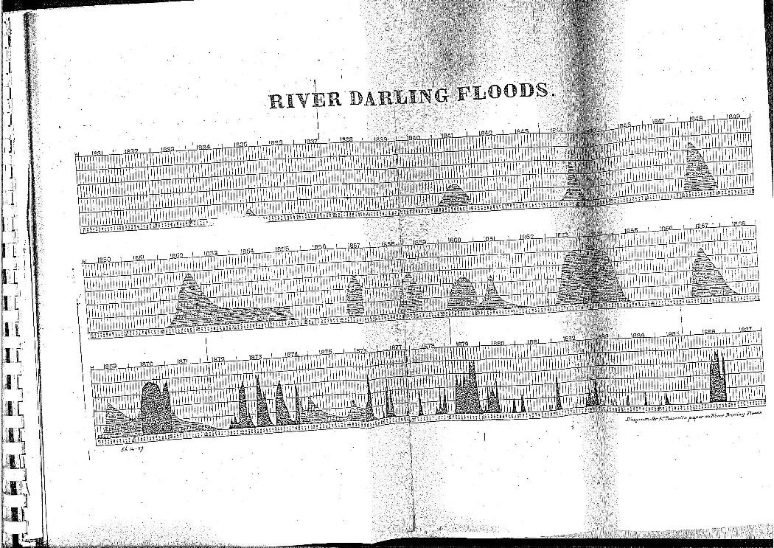

Figure 1: Darling river stage height recorded at Bourke (?) between 1831 and 1887 (from H.C. Russell, “Notes upon the History of Floods in the Darling River)

One of the key distinctions between perennial and temporary freshwater riverine systems is the spatial and temporal fragmentation of the flowing water habitat in temporary systems – of which the Darling is essentially one (Larned et al., 2010). Spatial (longitudingal and lateral) fragmentation of the aquatic habitat reflects local geomorphology and can be measured as the physical distance between aquatic ‘patches’ (Olden et al., 2001), where ‘aquatic patches’ are the refugial waterholes and pools, or disconnected reaches of river channels, while the temporal component of the fragmentation reflects the flow regime and can be measured as the time between the connection of refugial pools, waterholes and isolated reaches. For freshwater organisms the sequences (including frequency, magnitude and duration) of spatial and temporal connection and disconnection of suitable aquatic habitat patches occur over a range of temporal scales, from long-term geomorphic change, through erosion and deposition, to the short-term changes driven by flow pulses.

Variations in river flow occur over a range of temporal scales (Figure 2). Walker et al. (1995) recognised three distinct temporal ‘scales’ of flow. The ‘flow pulse’ (Figure 2a) which represents a flow event important for maintaining ecological processes such as nutrient cycling, breeding and spawning responses, and dispersal (Leigh et al. 2010). Flow pulses in large dryland rivers occur at different frequencies; relatively frequent flows (e.g. 1 year return) may be important for connectivity along river channels and refreshing aspects of water quality in pools and isolated reaches (Poff et al. 1997), less-frequent but larger flow pulses (eg. 2-5 year interval) connect more of the channel network allowing for larger scale dispersal and migration, more sustained breeding and spawning responses of fish and invertebrates, and replenishment of riparian soil moisture which is important for maintaining healthy riparian vegetation communities. The least frequent flow pulses are the large floods (>10 year return interval), these large events are important for providing water to floodplain vegetation, connecting floodplain waterholes and wetlands and stimulating large scale breeding and recruitment events for waterbirds and fish. For every flow pulse, the preceding ‘flow history’, or antecedent conditions, is also important. Flood pulses occurring after extended periods of no flow will elicit a different biotic response to those occurring after a series of similar pulses (Leigh et al. 2010) (Figure 2b). Sequences of flow pulses over longer time scales generate the ‘flow regime’ of a river system (Figure 2c).

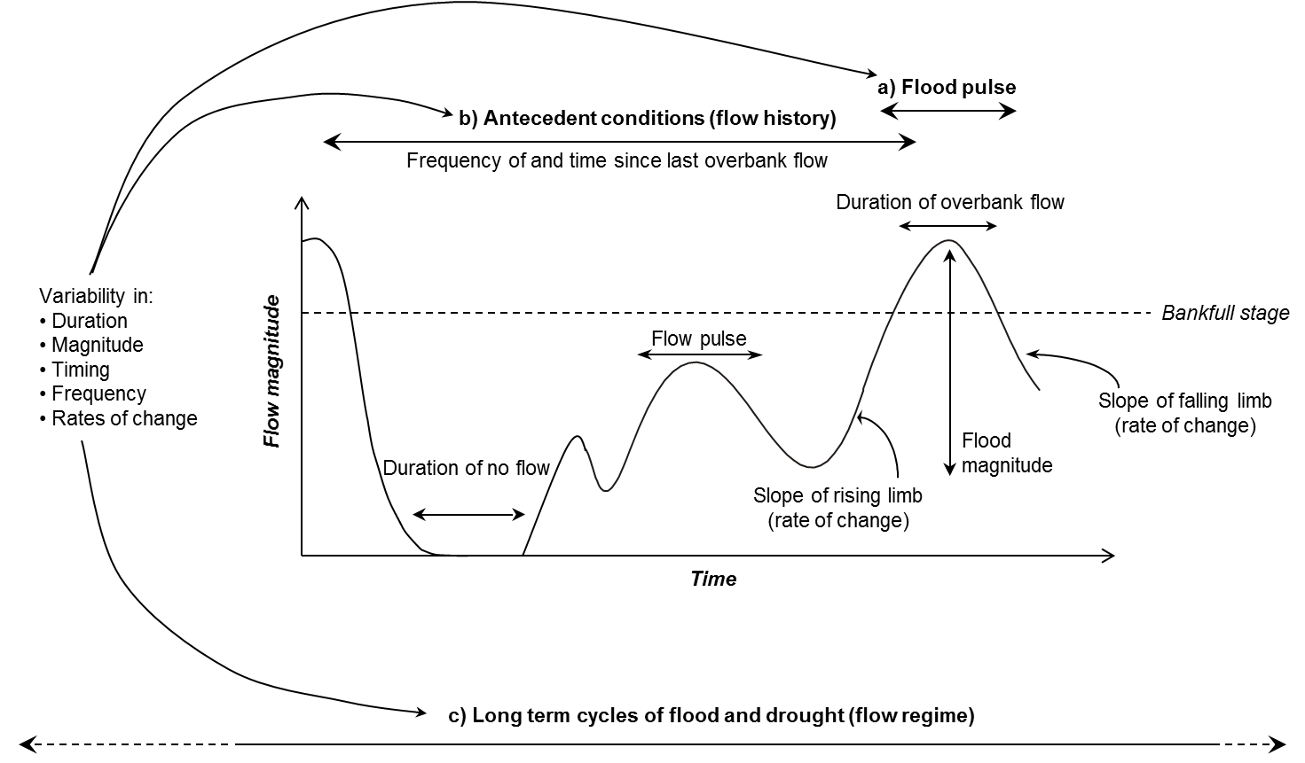

Figure 2: Various features of the (a) flood pulse, (b) flow history and (c) flow regime that have ecological significance. From Leigh et al. (2010), modified from Walker et al. (1995).

## The importance of flow variability and the Barwon-Darling River system

Flow occurs across a continuum of variability but we can recognise a number of distinct flow phases in the long-term flow regime; (i) the *flood phase* where the water level is high enough to inundate high level channels, floodplain waterbodies, and even the floodplain proper (ii) the *flow phase*, determined by the passage of flow pulses of varying magnitude and duration, where sections of the channel are connected by flowing water and, finally, (iii) the *disconnected or low-flow phase* where there is either no flow along a connected channel or water is restricted to disconnected sections of river channel, refugial waterholes and pools. Each flow ‘phase’ is important and it is the variability between, and within, these flow phases that maintains the ecosystem health of river systems. So, recognising that hydrological variability, extreme at times, is an inherent feature of the Barwon-Darling River system, the importance of flow (and flow variability) can be articulated under the four principles of Bunn and Arthington (2002).

***Principle 1: Flow is a major determinant of physical habitat in streams and rivers, which is a major determinant of biotic composition;***

Floods and high flows: The out of channel floods and extreme high flows in the Barwon-Darling river drive large scale geomorphic processes and, over time through erosion and deposition, are responsible for creating the billabongs, anabranches and floodplain wetlands of the larger Darling floodplain – macrohabitats (Figure 3; Sheldon and Thoms, 2004);

In-channel flow pulses: In the Barwon-Darling River system flow and flow variability within the main channel drive in-channel habitat complexity. The in-channel river environment of the Barwon–Darling, below the floodplain, is ‘complex’; along its length the channel cross-section shows large inset benches as prominent morphological features (Figure 4). These ‘benches’ represent flow pulses of different magnitude and provide surfaces for vegetation growth between flow pulses and habitat for the accumulation of organic matter (Sheldon and Thoms 2006). Flow regulation, or a reduced in flow variability, can decrease this channel complexity leading to a more homogenous channel shape (Sheldon and Thoms, 2006).

Small flow pulses and no flow periods: Low flows include the small flow pulses and the stable no flow periods where water can remain within the channel (some sections may dry with extensive no flow). Small flow pulses are important in inundating microhabitats within the channel (such as snags and the roots of riparian trees) (Figure 5) – these habitats are important breeding sites for fish and invertebrates. Low flows and no-f flow periods maintain aquatic habitat in critical refugia (such as waterholes, pools and isolated channel reaches).

***Principle 2: Aquatic species have evolved life history strategies primarily in direct response to the natural flow regimes of a specific river or stream;***

Floods and high flows: a number of native fish present in the Barwon-Darling are known to use high flow events and overbank floods to undertake large-scale migrations, triggered by the extensive connection of riverine habitat. These overbank flow events are also triggers for spawning in many riverine fish, germination events for riparian and floodplain vegetation (recruitment often requires follow up rains), and waterbird breeding and recruitment in floodplain wetlands. They also stimulate zooplankton production (emerging from floodplain soils) which fuel the massive breeding of fish and waterbirds associated with flooding. Many species in dryland river systems have life cycles that ultimately depend on the large overbank flood events, even though they are not seasonal or regular.

In-channel flow pulses: While large overbank flow events are not seasonal or regular many species have life history strategies that can utilise the more frequent within channel flow pulses. Most fish within the Barwon-Darling will spawn in response to in-channel flow events, and while some fish and many invertebrates are likely to reproduce seasonally in response to temperature the recruitment of juveniles into the population will be stronger associated within in-channel flows in response the increased habitat availability and increased food availability.

Small flow pulses and no flow periods: While small flow pulses and no-flow periods are not often associated with reproductive response in riverine species there is evidence that some fish and freshwater mussels will preferentially reproduce when water levels are low and stable. These periods are also vital for the life cycle of many zooplankters who will set resistant stages.

|  |  |
| --- | --- |
| Figure 3: Aerial photograph of the Darling River corridor and floodplain downstream from Wilcannia showing habitats ‘created’ by high flow events (from Sheldon and Thoms 2004) | Figure 4: The channel of the Barwon-Darling showing horizontal bench surfaces highlighted by arrows (from Sheldon and Thoms 2004) |
| Figure 5: Microhabitats in the main channel of the Darling River at Wilcannia (from Sheldon and Thoms, 2004). |

***Principle 3: Maintenance of natural patterns of longitudinal and lateral connectivity is essential to the viability of populations of many riverine species;***

The connection and disconnection dynamics in riverine systems, through changes in discharge, has been shown to influence the diversity of algal, microinvertebrate, macroinvertebrate and fish assemblages (eg. Boulton and Lake, 1992a; Boulton and Lake 1992b; Boulton et al. 1992; Jenkins and Boulton, 2003; Arthington et al. 2005; McGregor et al. 2005; Marshall et al. 2006). Likewise, the periodic connection and disconnection of aquatic habitats mediate ecosystem function, for example the sequential wetting and drying of stream and floodplain soils can cause pulsed releases of nutrients (Baldwin and Mitchell 2000; McIntyre et al. 2009; Gallo et al. 2014; Woodward et al. 2015) and hot spots of decomposition and microbial activity (Larned et al. 2010).

Floods and high flows: floods and high flow events connect large sections of the channel network longitudinally, floodplain aquatic habitats (billabongs and anabranches) laterally and replenish moisture in riverbanks and associated alluvial habitats (course substrate), and while the latter are not abundant in the Barwon-Darling there are areas of rocky outcrop, course gravel and sand. These flow events are ecologically important for the breeding, migration and dispersal of fish and turtles, increased abundance of invertebrates, breeding and recruitment opportunities for waterbirds in floodplain waterbodies, the release of nutrients from inundated floodplain soils, and the replenishing of riparian and floodplain moisture with positive outcomes for vegetation health and large scale ecosystem production (fish, waterbirds, invertebrates).

In-channel flow pulses: While in-channel flow events are smaller than the large floods they are vital for rivers such as the Barwon-Darling, the connect isolated parts of the channel network, assist in maintaining water quality parameters in ranges suitable for aquatic biota, allow dispersal of aquatic organisms and replenishing soil moisture of riparian areas for riparian vegetation health. Given these events are naturally more frequent than the larger flows they are crucial for maintaining populations of fish, invertebrates and turtles – while the number of recruits associated with smaller in-channel pulses may not be as great as the large overbank and high in-channel flows – they will ensure population survival.

Small flow pulses and no flow periods: Small localised flow pulses and no-flow periods are also a crucial component of the overall flow-regime. For example, there is evidence that some fish and invertebrates use the stable water levels of the disconnected and low flow phase for reproduction.

***Principle 4: The invasion and success of exotic and introduced species in rivers is facilitated by the alteration of flow regime.***

Alteration to the flow regime of most rivers in the Murray-Darling Basin has been implicated in the establishment and success of a number of alien fish species. It is difficult to disentangle if this reflects a preference by the invader for the new modified flow regime, or that the modified flow regime has reduced the abundance of native species to such an extent that has allowed the invaders ‘room’ to move in. The most destructive invader in the Barwon-Darling river system currently is the Common Carp (*Cyprinus carpio*). Carp were first noticed in the river in large numbers in the late 1970’s (Gehrke and Harris, 2004). Carp in the Barwon-Darling compete with native species for food and habitat, they are also prone to damaging river banks and making river habitats less preferable for native species, there is a strong association between the increase in carp abundance in the Barwon-Darling and the decline in abundance of native catfish, who are benthic species and whose habitat is disturbed by carp feeding actions.

## A conceptual model of flow variability and ecologically relevant flow phases in the Barwon-Darling

While the focus of this report is essentially on low flows and small flow pulses, these flow ‘phases’ need to be considered in the broader context of flow and its influence on the ecology of the Barwon-Darling as ecological response in hydrologically variable rivers, like the Barwon-Darling, operate across broad spatial and temporal scales (Puckridge et al. 1998; Kingsford, 2006).

***Overbank flows or floods*** (Figure 8) **are important for reconnecting the river with its floodplain** – which is important for sediment and nutrient transfer. Overbank flows provide water to floodplain wetlands and waterbodies, soil moisture to floodplain vegetation - which can act as a germination and recruitment trigger, and opportunities for landscape scale dispersal of aquatic biota. Inundated floodplain habitats are often focal breeding sites for waterbirds and other terrestrial animals.

***In-channel flow pulses*** (Figure 9) **are important for reconnecting river reaches** and moderating water quality in previously disconnected reaches or weir pools, providing opportunities for spawning and recruitment of fish. The increased turbidity and water movement associated with in-channel flows can reduce the concentrations of nuisance algae (green and cyanobacteria) in the water column. These in-channel pulses are also important for increasing habitat availability – also required for spawning and recruitment of fish and invertebrates. NSW DPI (2015) showed the increase in availability of snag habitat (Figure 6) and in-channel bench surfaces (Figure 7) associated with in-channel flow pulses of different magnitudes.

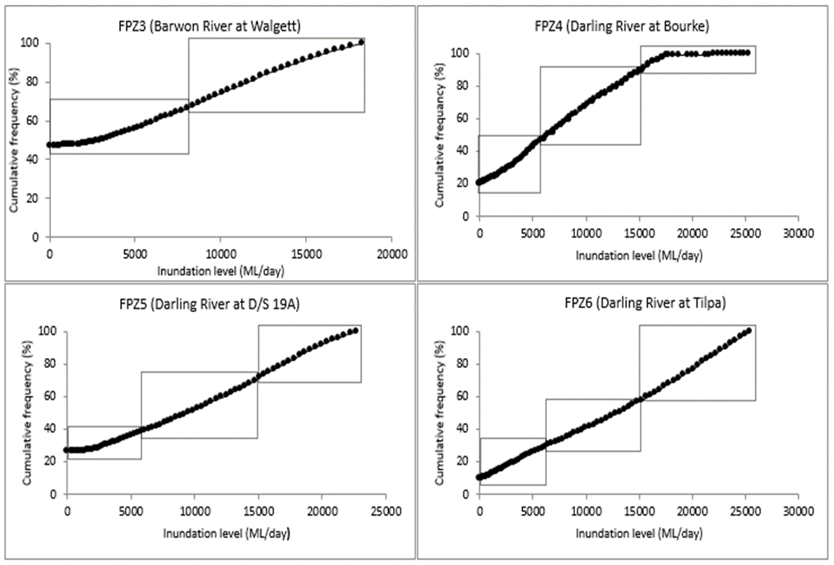

Figure 6: Relationship between snag inundation and flow (flow components represented by boxes moving left to right: small pulse, large pulse and bankfull) (from NSW DPI, 2015).

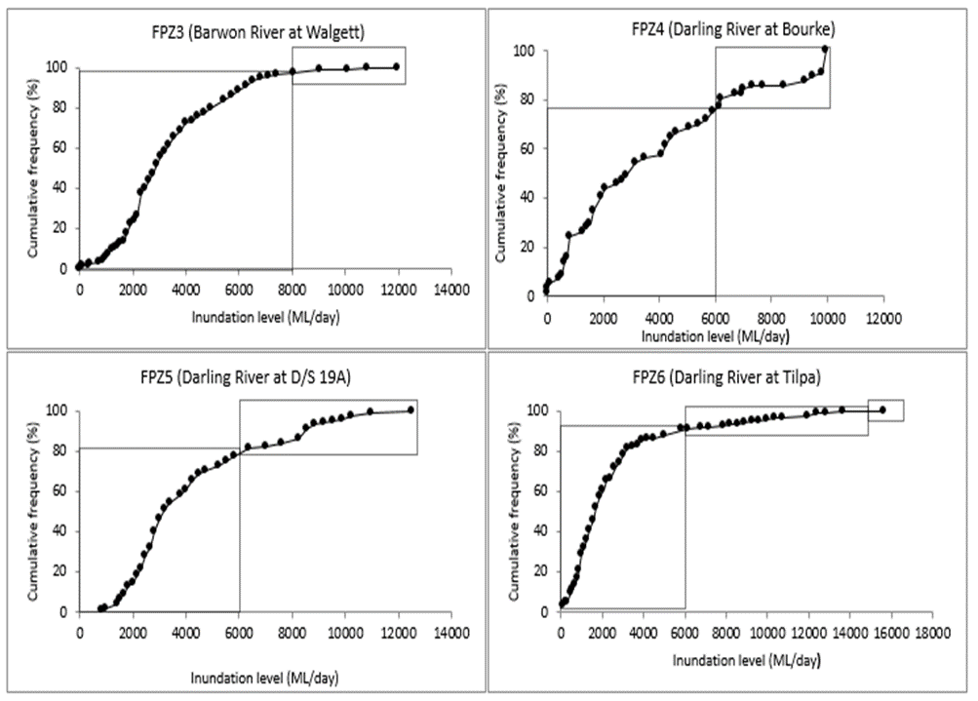

Figure 7: Relationship between bench inundation and flow (flow components represented by boxes moving left to right: small pulse, large pulse and bankfull) (From NSW DPI 2015)

While **s*mall flow pulses and no-flow periods*** (Figure 10) are often overlooked as important in river systems they **play a vital part in the overall hydrological variability of the river**. Rolls et al. (2010) summarised the importance of low flows in four principles, extending the concepts of Bunn and Arthington (2002):

Principle 1: Low flows control the extent of physical aquatic habitat, thereby influencing the composition and diversity of biota, trophic structure, and carrying capacity;   
Principle 2: Low flows mediate changes in habitat conditions, which in turn, drive patterns in the distribution and recruitment of biota;   
Principle 3: Low flows affect the sources and exchange of energy in riverine ecosystems, thereby affecting ecosystem production and biotic composition;   
Principle 4: Low flow restricts connectivity and diversity of habitat, increases the importance of refugia, and drives multiscale patterns in biotic diversity.

Given the hydrological variability of the Barwon-Darling and the associated variable lengths of time between large flow pulses and floods (even under natural flow conditions) refugial aquatic habitat within the river channel network is critical for the maintenance of healthy populations of many aquatic organisms (Sheldon et al. 2012). The NSW DPI summarised the number of refuge pools in the Barwon-Darling between Walgett and Wilcannia recording more than 1000 refuge pools along the 1116km section of river, the pools had an average depth of around 4.5m and ranged from 8.8-19.7 ML in size (Table 1). This suggests that while the Barwon-Darling is essentially a temporary river in respect to discharge, it is not with respect to surface water availability and the maintenance of aquatic habitat in the system is obviously highly important for the survival of many taxa.

Table 1: Total number of refuge pools recorded between Walgett and Wilcannia (from NSW DPI 2015).

|  |  |  |  |  |  |
| --- | --- | --- | --- | --- | --- |
| **Zone** | **Zone Length (km’s)** | **Total number** | **Total surface area (Ha)** | **Mean depth (m)** | **Average Pool Size (ML)** |
| Walgett - Brewarrina | 279 | 297 | 51.5 | 5.1 | 8.8 |
| Brewarrina - Bourke | 207 | 216 | 55.9 | 4.5 | 11.7 |
| Bourke - Tilpa | 355 | 374 | 157 | 4.7 | 19.7 |
| Tilpa - Wilcannia | 275 | 182 | 65.1 | 4.5 | 16.1 |

In dryland rivers, such as the Barwon-Darling, where there can be extended periods of no, or very little, flow the refugial pools are vital aquatic habitat for the survival of both aquatic and terrestrial fauna (Sheldon et al. 2010). During periods of extended low flow the water quality of refugial pools can be a significant issue for resident biota. When water levels are low and stable local water quality can reflect localised conditions (Sheldon and Fellows, 2010). In the Barwon-Darling, low stable water levels have been associated with saline inflows in some weir pools, which not only increases the conductivity of the refugial pool but also increases the flocculation of fine sediment from the water column (reduces turbidity) which in turn increases light penetration and increases the likelihood of algal blooms, including blooms of cyanobacteria.

|  |
| --- |
| **Key Points:**   * **The maintenance of ecologically healthy refugial habitat during periods of low and no flow is vital for the long-term ecological health of a river system – maintaining healthy populations of aquatic flora and fauna that can then respond to periods of higher flow** * **Small flow pulses are vital for the maintenance of refugial habitat by reducing conductivity, destroying stratification and flushing algal blooms** * **Small flow pulses are vital for maintaining healthy populations of small bodied fish, who spawn and recruit during small in-channel flow events.** |

|  |
| --- |
|  |
|  |

Figure 8: Conceptual model of the ecological relevance of overbank flow events depicted as (a) a cross sectional perspective and (b) a landscape perspective.

|  |
| --- |
|  |
|  |

Figure 9: Conceptual model of the ecological relevance of in-channel flow pulses depicted as (a) a cross sectional perspective and (b) a landscape perspective.

|  |
| --- |
|  |
|  |

Figure 10: Conceptual model of the ecological relevance of the low flow phase depicted as (a) a cross sectional perspective and (b) a landscape perspective.

## Flows of ecological relevance in the Barwon-Darling

Using the conceptual models of ‘phases of flow’, ecologically relevant flow bands for the Barwon-Darling can be determined (Table 2). This information has been collated from a number of studies of the Barwon-Darling undertaken since 1992. To provide a perspective on the relationships between these flow phases and the overall flow regime of the Barwon-Darling River, the representative discharge for each flow phase has been mapped onto the long-term hydrograph of the Darling River at Wilcannia showing monthly discharge (ML) from 1913 until 1979 (Figure 11). The impact of water resource development on these flow bands is discussed in Section 2.

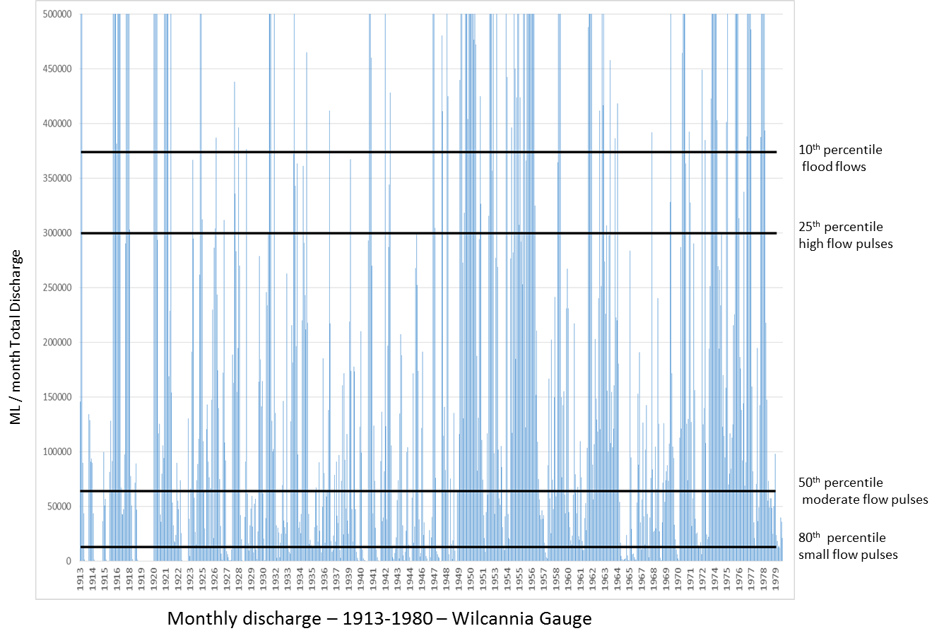

Figure 11: Monthly flow data (ML) for the Darling River at Wilcannia

Table 2: Ecologically relevant flow thresholds (ML/day) for different gauged sites within the Barwon-Darling river system.

|  |  |  |  |  |  |  |
| --- | --- | --- | --- | --- | --- | --- |
|  |  | Gauge Station – Discharge ML/day | | | | |
| Flow Band | Flow Description | Walgett | Brewarrina | Bourke | Louth | Wilcannia |
| Low Flows  (Figure 6) | Riparian Flows – minimum flows for reaches to remain connected (Interim Northwest Unregulated Flow Plan, 1992) | 700 | 550 | 390 | 280 | 150 |
| Small In-channel Flow Pulse  (Figure 6) | Critical discharge (ML/day) required to suppress persistent stratification and *Anabaena circinalis* growth in the Barwon-Darling River (from Mitrovic et al. 2010) |  | 510 | 450 |  | 350 |
|  | 80th percentile (without development) flows required to inundate low-level in-channel surfaces and associated habitat – important for maintenance of fish and invertebrate populations and water quality mediation (from Carlisle, 2017) | 261 | 346 | 440 | 401 | 361 |
|  | Flows that enhance spawning in low-flow spawning specialist fish, such as olive perchlet (endangered) and other small bodies fish (see Humphries and Walker 2013). | 500 |  | 500 | 350 |  |
| Moderate In-channel Flow Pulse  (Figure 7) | 50th percentile flows required to inundate low to mid- level in-channel surfaces and associated habitat – important for within-channel connectivity, fish and invertebrate dispersal, nutrient transfer and water quality mediation (from Thoms et al. 1996) |  |  | 2,500 | 5,500 | 2,000 |
|  | Threshold flows required for spawning and migration of Golden Perch – duration of flows at this threshold >10 days (Stuart and Sharpe, 2017) |  | 3,000 |  |  |  |
|  | Algal Suppression Flows: Access to uncontrolled/unregulated flows is managed to achieve a flow of at least 2,000ML/day for 5 days at Wilcannia in the period October to April inclusive, unless a flow of at least this size has occurred within the preceding months (Interim Northwest Unregulated Flow Plan, 1992). |  |  |  |  | 2,000 |
| Large In-channel Flow Pulse  (Figure 7) | 25th percentile flows required to inundate mid-high level in-channel surfaces and associated habitat – important for fish and invertebrate breeding, riparian vegetation health, mediate nutrient transfer from unwetted to wetted surfaces (from Thoms et al. 1996) |  |  | 9,500 | 10,500 | 10,000 |
| Fish Migration Flows: Access to uncontrolled/unregulated flows is managed to achieve a target flow of at least 14,000 ML/day at Brewarrina and/or 10,000ML/day at Bourke for 5 days in the months September to February inclusive, unless 2 such flows have occurred within this period (Interim Northwest Unregulated Flow Plan, 1992). |  | 14,000 |  |  | 10,000 |
| 10th percentile flows required to inundate mid-high level in-channel surfaces and associated habitat – important for fish and invertebrate breeding, riparian vegetation health, mediate nutrient transfer from unwetted to wetted surfaces (from Thoms et al. 1996) |  |  |  |  |  |
| Overbank Floods  (Figure 8) | Discharge (ML/day) required to inundate 50% of the floodplain wetlands and provide opportunities for large scale waterbird and fish breeding events, maintenance of floodplain vegetation health and large scale nutrient transfer from unwetted to wetted surfaces (from Cooney 1994). |  | 19,000 | 30,000 |  | 21,000 |

# Modifications to flow regimes in the Barwon-Darling system

Water resource development and water management has modified flow regimes across nearly the entire Murray–Darling Basin, including the northern Barwon–Darling River and its associated tributaries (MDBA, 2016). To varying degrees many of the tributaries of the Barwon–Darling are regulated by dams, weirs and private diversions – these tributaries are important sources of flow during large events, and their regulation and development has an impact on flows in the Barwon-Darling (MDBA, 2016). The impact of flow storage and flow diversions on the hydrology of the Barwon-Darling River system has been recognised for decades. The Interim Unregulated Flow Management Plan for the North-West (which included the Barwon-Darling) was released in 1992, in response to the massive algal bloom in the Barwon-Darling in late 1991 (Bowling and Baker, 1996). In 1996 the “Scientific Panel Assessment of Environmental Flows for the Barwon-Darling River” (Thoms et al. 1996) explored flow change within the system up until 1996 and suggested there had been (i) a decrease in annual and daily volumes along the Barwon-Darling, (ii) increased rates of flood recession leading to bank instability (see Thoms and Sheldon, 2002), (iii) decreases in the rate of rise during flood pulses due to pumping, adding to the increased stability of river levels at low flow, (iv) a decrease in flood duration, particularly a decrease in the duration of the smaller flow pulses that occur between the larger floods and (v) a marked change in the character of flood frequencies. The extent of impact of development was evident in the late 1990’s, with comparisons of modelled natural and 1993-1994 diversion level data (IQQM Models) suggesting that in 1996 between Mungindi and Wilcannia there had been a decrease of roughly 30% in mean annual flow and a decrease of between 25% (Walgett) and 73% (Wilcannia) in median annual flow.

In the Barwon-Darling itself water extraction occurs as either large volumes that are diverted from the river during flow events for use in irrigated agriculture, or small volumes that are diverted for stock and domestic water including for towns (MDBA, 2016). Large diversions are either extracted directly from the river using pumps or harvested as floodplain runoff, in both cases water is often transferred to large private off-river storages; diversions are only allowed when flows reach levels specified in water licences (i.e. pumping thresholds), as stipulated under the current “Water Sharing Plan” (Water Sharing Plan for the Barwon-Darling Unregulated and Alluvial Water Sources) (MDBA, 2016).

A large proportion of studies linking flow with ecology in the Barwon-Darling have focussed on either the changes at the higher end of the flow distribution, those flows that are vital for inundating floodplain water bodies and stimulating larger breeding events of fish and waterbirds, or the flow required for water quality enhancement, such as the flows required to suppress algal blooms in weir pools (eg. Mitrovic et al. 2006) (Table 2). Thoms et al. (1996) focussed their assessment of the environmental flow requirements for the Barwon-Darling on in-channel flows and identified a number of flow thresholds and different recurrence intervals that inundated ecologically significant portions of the river channel surface and associated wetlands were relevant (Table 2), with these significant discharge thresholds mapped onto the long-term hydrograph of the Darling River at Wilcannia (Figure 11). The more recent Sustainable Diversion Limits for the Northern Murray-Darling Basin report (Hale et al. 2014) which reviewed the environmental water requirements in the Northern Basin Review focussed on indicators that were volumetrically significant, greater than 500 ML/day) and were derived in the context of setting ‘Sustainable Diversion Limits’ and therefore did not focus on low flows.

Hydrological changes in the Barwon-Darling are likely associated with water resource development and water management, across each of the ecologically relevant flow bands (Table 2 and Figure 12). Using modelled flow data for a five year period, Figure 13 highlights the impact of water resource development on these flow bands, particularly the small and moderate in-channel flow pulses.

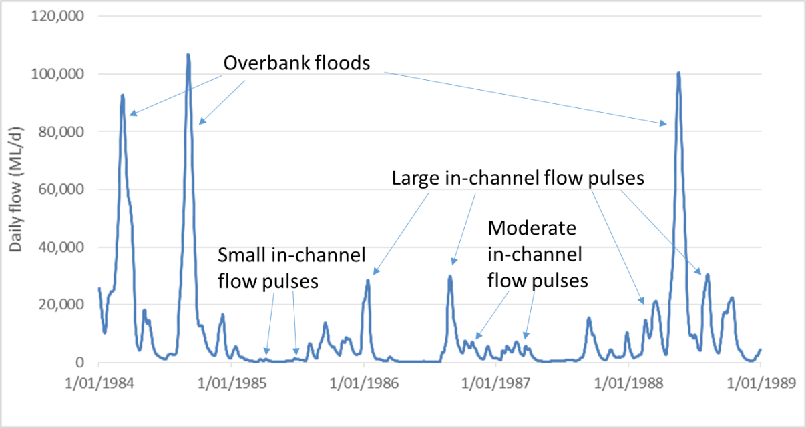

Figure 12: Daily flows (ML/day) for the Darling River at Bourke over a five year period between 1984 and 1989 modelled without development conditions (from MDBA, 2016). Ecologically relevant flows (as per Table 1) are mapped onto the hydrograph.



Figure 13: Daily flows of the Darling River at Bourke over a five year period from 1984 to 1989 (modelled without development conditions and baseline conditions). From MDBA (2016).

|  |
| --- |
| **Key Point:**   * **Water resource development in the Barwon-Darling has decreased the frequency, magnitude and duration of small in-channel flow events (80th percentile) and increased the frequency and duration of no flow periods** |

## A landscape perspective of flow in the Barwon-Darling

While it is tempting to think of flow in the Barwon-Darling in isolation of its tributaries, the tributaries play a very important role in providing in-channel flows at different times of the year and at different frequencies. Leigh et al (2010) showed how the terminal floodplain wetlands on some of the tributary rivers to the Barwon-Darling were important components of the hydrological landscape (Figure 14). Prior to any water abstraction or diversion, these wetlands would have acted as ‘sponges’ or ‘buckets’ absorbing smaller pulses along the tributary rivers and then ‘spilling’ into the main channel of the Barwon-Darling when full. Water abstraction and diversion for irrigation has changed the way in which most of these terminal wetlands function hydrologically at the landscape scale (Figure 15), the western Paroo and Warrego floodplains remain relatively hydrologically intact. Fewer flow pulses make their way through the eastern and northern wetlands and into the main channel of the Barwon-Darling which impacts on the overall flow variability of the Barwon-Darling system.

|  |
| --- |
| **Key Points:**   * **Flow variability in the Barwon-Darling is complicated and needs to be considered at a landscape scale** * **While small in-channel flow pulses are often delivered to the Barwon-Darling reach by flows from tributaries with direct connections to the channel (no terminal wetlands), the capacity for low flows to build to larger flow events depends on landscape scale hydrological factors** |

|  |
| --- |
|  |

Figure 14: Functional role of tributary terminal wetlands in the hydrological landscape of the Barwon-Darling river system - the Murray-Darling Basin showing significant wetlands and floodplain ecosystems (from Leigh et al. 2010).

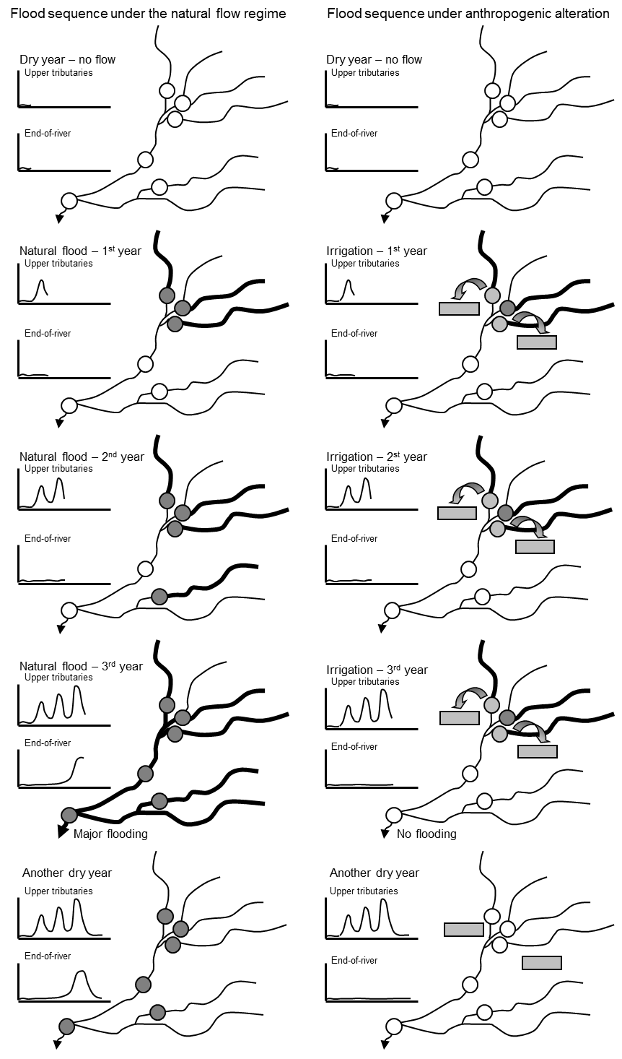

Figure 15: Sequential flooding: conceptual diagram for major tributaries, rivers and wetlands of a large river system (e.g. Murray Darling Basin). In the left panel, from top to bottom, a five-year sequence of a dry year, three floods and another dry year is depicted under natural (anthropogenically unmodified) flow conditions, where floodplain and terminal wetlands (closed circles) are progressively filled from uplands to lowlands (thick lines). This culminates in major flooding of rivers and wetlands in the third flood year, followed by a year of receding in-channel water levels but sustained aquatic habitat in the wetland refugia. This is contrasted with the same sequence under an irrigation scenario: upland wetlands are filled during the first flood year, but water is removed for irrigation (closed rectangles) so that lower wetlands do not fill and major flooding of the system does not eventuate, even after three consecutive years of upland flooding. From Leigh et al. (2010)

## Frequency and duration of dry spells

### Understanding the changes

In their assessment of waterhole persistence in the Lower Balonne and Barwon-Darling system DISITI (2015) suggested the critical no-flow threshold for waterhole persistence was 350 days. This value was specific to the Lower Balonne and reflected the no flow spell causing a major loss of aquatic habitat due to the drying of key waterholes or aquatic refugia. DISITI (2015) did not extend this to the Barwon-Darling as the combination of weir pools and very deep waterholes, combined with regular tributary inflows from the east, means they retain water for extended periods (more than 1000 days under modelled scenarios). The exception to this is the Darling River Tilpa reach (second to last reach in map below), which was observed to run dry during the Landsat record (since 1988) with a no flow period of 182 days (MDBA pers comm). This, however, is based on natural levels of evaporation and does not reflect waterhole persistence if there is pumping from disconnected reaches or weir pools. The report also did not consider the ecological impacts of just retaining water within waterholes and not re-instating any pattern of connectivity between waterholes, through small flow pulses, which would allow migration and dispersal of aquatic fauna and reset water quality parameters within waterholes.

Using the flow data for gauges throughout the Barwon-Darling river system for the period 1989-2017 there are obvious spatial patterns in the dry spell data with a greater number of dry spells occurring at sites further upstream (Figure 16a-e). Interestingly, at the lower end of the catchment the length of dry spells was longer for the period 2000-2017 compared with the 10 year 1990-1999 (Figure 16e). While there were more dry spells across a year in the upper reaches of the system, the average length of dry spell increased markedly as you moved downstream, with the furthermost gauge site, Wilcannia, had fewer total dry spells but the dry spells lasted the longest at this downstream site (Figure 16f). There were also different patterns in the total number of dry spells and average dry spell length in the 1989-2000 time period compared to the 2001-2017 time period, with the latter having a vastly greater number of dry spells across the catchment (Figure 16). This corresponds to the period of the “Millenium Drought” where rainfall in the upstream catchment was some of the lowest on record (Figure 17); it is therefore difficult to determine if this increased number of dry spells throughout the catchment could be related to changes in flow access rules or reflect natural patterns of flow variability that can result in wetter and drier than normal periods. However, using the long-term flow record Leigh et al (2010) showed there was a strong relationship between flows in the Barwon-Darling and the Southern Oscillation Index (SOI), which give an indication of the development and intensity of El Niño or La Niña events in the Pacific Ocean. Sustained negative SOI values (<-7) often indicate El Niño periods (reduction in winter and spring rainfall across Eastern Australia and the Top End) whereas sustained positive SOI values (>7) are typical of La Niña (increased probability of wetter conditions in eastern and northern Australia). When the average number of dry spells per year was plotted against the average SOI there were obvious patterns (Figure 18). From 1989-2000 negative SOI values were associated with an increased number of dry spells, as would be expected under El Niño conditions which tend to be drier than normal, while positive SOI values were associated with fewer dry spells as expected under La Niña conditions (Figure 18). Interestingly from 2001-2010 this pattern no longer held, while negative SOI values from 1989-2000 (and from the long-term flow record: Leigh et al. 2010) were associated with increased number of dry spells, positive SOI values from 2001-2017 were also associated with dry spells. These differences were statistically significant; there was no difference between the 1989-2000 and 2001-2017 time periods in the annual average number of dry spells when the SOI was strongly negative (<-7) – suggesting wetter than normal periods (t = 2.8, df = 12 , p>0.05) whereas the difference between the 1989-2000 and 2001-2017 time periods in the annual average number of dry spells when the SOI was strongly positive (>7), suggesting drier than average conditions, was highly significant (t = 2.05, df = 26 , p<0.01). Given the strong correlation between flow patterns and SOI from the long-term flow record (Leigh et al. 2010) it is likely the difference in the correlation between dry spells and SOI for the 2001-2017 period reflects the increased level of extractions from the Barwon-Darling during this time.

|  |  |
| --- | --- |
| (a) | (b) |
| (c) | (d) |
| (e) | |
| (f) | |

Figure 16: Total number of dry spells per month for the gauging station sites at (a) Brewarrina, (b) Bourke, (c) Louth and (d) Wilcannia, (e) the comparison of average length of dry spells from upstream to downstream, and (f) the relationship between the average number of dry spells for each gauge across between 1989-2017 and the average length of a dry spell (from MDBA Unpublished data).

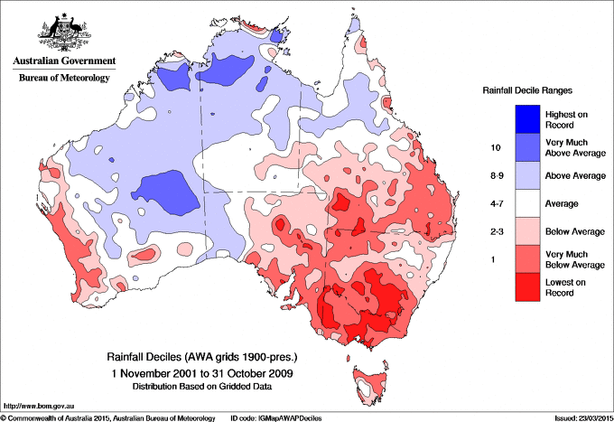

Figure 17: Rainfall deciles at the peak of the Millennium Drought (2001 to 2009), showing below-average to record-low rainfall across much of southwest and southeast Australia, extending to cover much of eastern Australia at the peak, including the major capital cities (except Darwin) (from www.bom.gov.au).

|  |  |
| --- | --- |
| (a) | (b) |
| (c) | |

Figure 18: (a) Total number of dry spells for gauging station sites along the Barwon-Darling for the time periods 1989-2000 and 2001-2017; (b) average dry spell length for gauging station sites along the Barwon-Darling for the time periods 1989-2000 and 2001-2017; (c) relationship between the average annual Southern Oscillation Index (SOI) value and the average number of dry spells for all above gauge locations along the Barwon-Darling river.

### Ecological impacts

So, what is the ecological significance of increasing the number of dry spells in a river such as the Barwon-Darling? In an unseasonal river, such as the Barwon-Darling, periods of higher than average flows are known to be important breeding and recruitment events for many invertebrates, fish, turtles and waterbirds and provide flows that can replenish soil moisture for riparian trees. Increasing the frequency of dry spells, and by default reducing the frequency and duration in in-channel flows, will impact the water quality of refugial pools and restricted river reaches, have measurable impacts on the abundance of native fish populations, turtle populations, macroinvertebrate diversity and abundance and reduced the health of riparian trees.

Periods of no flow can have a marked influence on the water quality of refguial pools and river reaches, particularly during warmer months (Figure 19). Standing water can undergo stratification, where surface waters heat and become significantly less dense that lower parts of the water column, essentially separating the pool into two vertically stratified waterbodies. While conditions in the surface waters can remain tolerable to many taxa, with higher oxygen concentrations due to algal photosynthesis and warmer surface water temperatures, conditions in the bottom water layer can pose problems for fauna with often anoxic or severely hypoxic conditions developing, high levels of nutrients and low light. In some reaches low stable water levels contribute to an increase in saline in-flows from local groundwater aquifers, this increase in salinity can further exacerbate the declining water quality in refugial pools, not only by increasing measured conductivity but also by assisting in the flocculation from suspension of clay particles which can increase water clarity and stimulate algal blooms – which can further reduce oxygen levels (Bowling and Baker, 1996; Dunlop et al. 2005).

The ecological impacts of high conductivity in refugial pools can be severe, high conductivity (and therefore high levels of salt in the water) causes physiological stress in freshwater organisms. Most freshwater plants and animals will begin to show physiological stress at salinities of more than 1gL-1, with severe impacts above 3.5gL-1 and few freshwater biota persist above 10gL-1. Due to natural saline inflows from shallow groundwater at low in-channel water levels the pools downstream of Bourke start to approach the 3.5gL-1 salinity threshold after extended low flow periods (MDBA pers comm). In 2014, after about 120 days of low flows the salinity in the pools downstream of Bourke peaked at about 17,000 uS/cm or roughly 12 gL-1. Threshold salinities reported in Dunlop et al. (2005) suggest that these salinities would have been lethal to nearly all native freshwater fish and many adults, although some species have higher tolerances as adults.

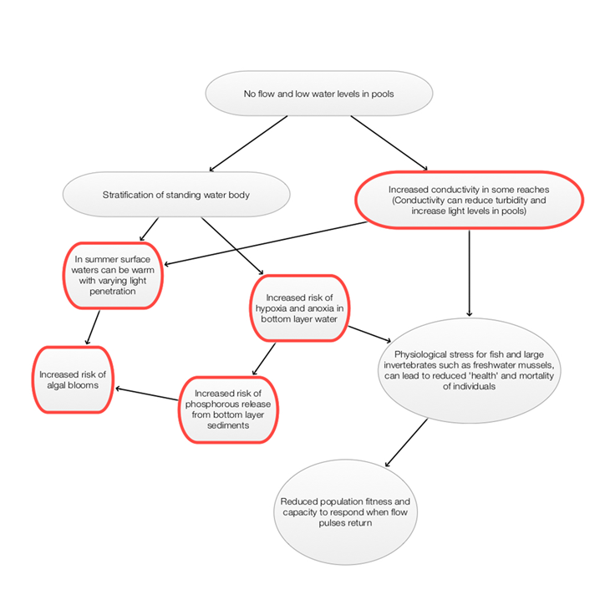

Figure 19: Conceptual model showing the impact of no flow periods on water quality, and the resulting impact on aquatic fauna.

|  |
| --- |
| (a) |

|  |
| --- |
| (b) |

Figure 20: Conceptual model showing (a) the impact of no flow periods on water quality, and (b) the resulting impact on aquatic fauna.

Extended periods of no flow are therefore detrimental to the long term viability of native fish and invertebrate populations through (i) the impacts of declining water quality which can directly cause mortality to adults, juveniles or eggs, (i) reduced availability of habitat for spawning and recruitment and, (iii) in many cases, the absence of triggers for spawning and recruitment (Figure 20). While the impacts of low flows on fish have been well documented, relatively little is known about their impacts on invertebrates and especially the larger invertebrates such as the iconic river mussels. We do know, however, that river mussels are susceptible to anoxia and poor water quality (Sheldon and Walker 1989), so any declines in water quality that resulted in low oxygen levels for extended durations along the bed of the river could have extremely negative consequences for the viability of freshwater mussel populations (Figure 20). Extended periods without flow also increase the extent of habitat fragmentation and population isolation, isolated populations of organisms are more vulnerable to disturbance events which can cause localised extinctions.

|  |
| --- |
| **Key Points**   * **There has been an increase in the frequency and duration of cease to flow (no flow) periods in the Barwon-Darling since 2000, and this has been significant downstream of Bourke** * **During no flow periods aquatic fauna are restricted to waterholes, pools and reaches bounded by the weirs on the Barwon-Darling with little capacity to move longitudinally along the river channel, during these times local water quality conditions become important** * **No flow periods are associated with increased salinity levels in some reaches of the river, associated with increased saline discharge from local groundwater – increased salinity can:**   + **cause mortality of individuals, particularly juvenile fish**   + **cause mortality of benthic (bottom dwelling organisms such as freshwater mussels), as saline water (bring more dense) will tend to sit on the bottom of standing water bodies** * **No flow periods are associated with increased incidence of algal blooms which can further reduce water quality parameters, such as dissolved oxygen**   + **Through photosynthesis algal blooms can cause high dissolved oxygen concentrations during the day but during the night, in the absence of photosynthesis, increased respiration can cause severe hypoxia or anoxia in standing waters, resulting in fish and invertebrate mortality** * **No flow periods provide limited access to diverse habitats, such as snags and woody debris, and limited opportunities for successful breeding and recruitment for most aquatic organisms** |

## Frequency and duration of small flow pulses (~80th percentile of natural flows)

### Understanding the changes

Small flow pulses, the approximately 80th percentile flows at different gauges, are the ‘low flows’ of the Barwon-Darling system. Low flows are an important component of hydrological variability in large rivers (Rolls et al. 2010) and in systems such as the Barwon-Darling the small in-channel flow pulses are vital for punctuating dry spell periods and providing water to refugial pools and reaches. In reviewing the modelled natural and modelled baseline development data compared to the observed data it is obvious that there has been a marked decrease in both the frequency and number of small flow pulses along the Barwon-Darling River since 1990 compared to natural conditions (Figure 21). The biggest change appears to be for those low-flow events of extended duration, for example a 500ML/day event at Bourke with a 50 day duration has suffered the most impact, with the same magnitude event for shorter durations less impacted (Figure 21). This is significant as the longer duration events are critical for successful spawning and recruitment of many native fish species. Likewise, the number of events of the longer duration at both Bourke and Wilcannia, suffered the greatest impact.

|  |  |
| --- | --- |
|  |  |
|  |  |

Figure 21: Comparison of modelled “natural”, “baseline development” and “observed” frequency (left column) and number of no flow events (right column) for the Darling River at Bourke (top panels) and Wilcannia (bottom panels).

### Ecological impacts

Tightly linked with extending the period of no flow is the reduction in the frequency and duration of small in-channel flow pulses, critical for the reproduction and survival of many aquatic organisms (Table 2). During periods of no flow water quality in the refugia pools and channels can decline causing algal blooms and mortality of fauna susceptible to low oxygen levels (Figure 19), it is the small flow pulses that can provide the flushing flows required to disrupt algal blooms, or prevent their formation. These small in-channel flow pulses are also vital for the long-term survival of a range of small bodied, short-lived, fish (Table 3). Small flow pulses also provide longitudinal connection along the channel network, increased access to a range of habitats, and a stimulus for spawning in some fish (Figure 22; Table 3).

|  |
| --- |
| (a) |

|  |
| --- |
| (b) |

Figure 22: Conceptual model showing (a) the impact of small flow pulses on native fish and (b) freshwater mussel populations.

Table 3: Summary of flow relevant spawning parameters for a some of the freshwater fish inhabiting the Barwon-Darling River (sourced from .

|  |  |  |  |  |  |  |  |  |
| --- | --- | --- | --- | --- | --- | --- | --- | --- |
| **Common Name** | **Scientific Name** | **Spawning time** | **Spawning Temp** | **Spawning habitat** | **Hatching time** | **Fecundity** | **Spawing and Flow** | **Notes** |
| Olive perchlet | *Ambassis agassizii* | Sep-Dec | 23-25oC | Prefer submerged aquatic vegetation; require substrate | 5-7 days | Low | Low flow or small flow pulse | Opportunisitic, short-lived, mature early, low fecundity, repeat spawner |
| Western Carp Gudgeon | *Hypseleotris klunzingeri* | Sep-Dec | >22oC | Prefer submerged aquatic vegetation; require substrate | 1-2 days |  | Low flow or small flow pulse | Opportunisitic, short-lived, mature early, low fecundity, repeat spawner |
| Crimson Spotted Rainbowfish | *Melanotaenia fluviatilis* | Sep-Mar | >20oC | Prefer submerged aquatic vegetation; require substrate | 7 days |  | Low flow or small flow pulse |  |
| Purple-spotted gudgeon | *Mogurnda adspersa* | Nov-Mar |  | Prefer submerged aquatic vegetation; require substrate | 3-9 days |  | Low flow or small flow pulse |  |
| Flathead Gudgeon | *Philypnodon grandiceps* | Sep-Mar |  | Benthic spawner | 4-6 days |  | Low flow or small flow pulse |  |
| Australian Smelt | *Retropinna semoni* | Jul-Mar | >15oC | Demersal eggs that settle to substrate | 10 days |  | Low flow or small flow pulse |  |
| Hyrtl’s Tandan | *Neosilurus hyrtlii* |  |  | Demersal eggs that settle to substrate | 60 hours |  | Stable flow |  |
| Freshwater catfish | *Tandanus tandanus* | Sep-Mar | >20oC | Eggs laid in ‘nest’ on substrate | 7 days |  | Stable flow | Can have multiple spawning events in one season |
| Bony Bream | *Nematalosa erebi* | Oct-Feb |  | Pelagic eggs |  | High | Low flow or small flow pulse | Very tolerant of low oxygen and high salinity |
| Silver perch | *Bidyanus bidyanus* |  |  | Pelagic spawner |  |  |  | Slow growing and long lived |
| Spangled Perch | *Leiopotherapon unicolor* | Nov-Mar | Rise in water temperature needed | Migration upstream and spawn on rising river levels | 2 days |  | Spawning trigger – rise in water depth |  |
| Murray Cod | *Maccullochella peelii* | Sep-Nov | Rising water temperature and increased photperiod | Require hard substrates such as snags or logs for adhesive eggs | 25 days development |  | Will spawn annually regardless of flow, but will migrate upstream to spawn if there is spring flow, potentially more successful juvenile recruitment with spring flow due to increased availability of food resources | Annual spawner |
| Golden Perch | *Macquaria ambigua* | Sep-Mar | Variable | Planktonic eggs | 24-36 hours |  | Generally need a spring or summer flow to stimulate spawning, potentially more successful juvenile recruitment with spring flow due to increased availability of food resources | High fecundity |

While small in-channel flow pulses are important for mediating water quality parameters in pools and waterholes if they are infrequent and of insufficient duration that may only act to move ‘batches’ of saline water (salt slugs) further downstream to impact a different reach, rather than diluting the saline water and preventing further ecological damage. Saline water is more dense and therefore heavier than freshwater and so will tend to remain in the bottom layers of standing water bodies, to dilute such saline slugs sufficient discharge (>500mL/day) of moderate duration (more than 10 days) is likely required.

While there have been few studies looking at the direct effect of in-channel flows on macroinvertebrates in the Barwon-Darling Sheldon and Walker (1998) found the diversity and abundance of macroinvertebrates in channel environments outside of weir pools to be highest on snag habitats, with the highest diversity and abundance in weir pools occurring in submerged vegetation. There is evidence from other dryland rivers in Australia that an increase in the abundance of macroinvertebrates is linked to flow pulses (see Marshall et al. 2006). Therefore, even small in-channel flow pulses of sufficient duration are likely to increase the availability of invertebrates as a food source for a range of aquatic organisms.

Reducing the frequency of small pulses along the channel network will have the effect to not only increase the frequency of poor water quality in refugia and restricted channel sections but potentially increase the frequency of algal blooms (Bowling and Baker 1996), reduce the frequency of successful spawning in the small bodied native fish and potentially increase the mortality of a range of other aquatic organisms.

|  |
| --- |
| **Key Points**   * **There has been an decrease in the frequency and duration of small in-channel flow events (80th percentile) in the Barwon-Darling since 2000, and again, this has been significant downstream of Bourke** * **Small in-channel flow pulses are vital for mediating water quality parameters by:**   + **Destroying stratification that may have occurred in standing water**   + **Suppressing the formation of algal blooms which can have detrimental impacts on the dissolved oxygen concentration of standing waters**   + **Diluting salinity in standing waters, particularly in the reaches around Tipla and Louth where saline groundwater inflows occur when in-channel water levels are low.** * **Small in-channel flow pulses increase access to habitat (such as snags and woody debris) and this provide increase resources for fish and other aquatic organisms** * **Small in-channel flow pulses are required for the successful spawning of a number of small bodied native fish (eg. Olive perchlet, Gudgeons, Crimson Spotted Rainbowfish Australian Smelt), these pulses need to:**   + **Occur at a frequency that allows these short lived fish to reproduce successfully in their life-time, thereby maintaining population numbers**   + **Have a duration that is long enough not only for spawned eggs to hatch, but for the larvae to successful recruit into the population as juveniles.** * **Small in-channel flow pulses are also essential for maintaining the diversity and abundance of aquatic macroinvertebrates (eg. prawns, mussels and aquatic insects) which form a vital food resource for fish and waterbirds.** |

# Flow management options

Alterations to the natural flow regimes of rivers, through regulation, abstraction or diversion, is seen as the most pervasive threat to the ecological integrity of rivers and their associated riverine wetlands (Bunn and Arthington, 2002). In the Barwon-Darling flows under developed conditions are overall much lower than would have been observed under natural conditions, they are reduced in magnitude and sometimes duration, with small flow pulses often lost altogether which has the effect of increasing the time between flow events and increasing the periods of no flow (MDBA, 2016). Increased stability of baseflow and reduction of flow variability is known to lead to (i) excessive growth of aquatic macrophytes or phytoplankton leading to algal blooms, (ii) reductions in fish abundance and often fish health – leading to reduced population viability, and (iii) increased standing crop and reduced diversity of macroinvertebrates (Bunn and Arthington 2002). Reduction in the frequency, duration and magnitude of the small flow pulses increases ecological ‘stress’ on refugial pools as small in-channel pulses reset water quality conditions, reduce phytoplankton biomass and allow small scale dispersals between pools for aquatic biota.

There have been numerous studies aimed at setting flow ‘rules’ and options for the maintenance of ecological health in the Barwon-Darling system. The 1992 Interim unregulated flow management plan for the North-West (DWR 1992) attempted to set guidelines around commence to pump thresholds and these have been revisited in a number of plans in the years since. The most recent being the Northern Basin River process (MDBA 2016) which focussed more broadly on longitudinal and lateral connectivity throughout the system using flow nodes and as a result focussed more heavily on larger discharges >5000 ML/day. While flows of this magnitude are indeed critical for the long-term maintenance of ecological integrity in the Barwon-Darling it is the small in-channel flow pulses <1500 ML/day that provide the sustenance to the system in between the larger drinks. Without these small pulses there will not be any fish to respond to the larger watering events.

## Small flow pulses

Flows around the 80th percentile are seen as the critical small flow pulses required to both suppress persistent stratification of refugial pools and reduce and suppress the growth of cyanobacteria *Anabaena circinalis* (Mitrovic et al. 2010). These flows equate to approximately 250 ML/day at Walget, 510 ML/day at Brewarrina, 450-500 ML/day at Bourke, 1,200 ML/day at Louth and 350-400 ML/day at Wilcannia. These flows comprise the “small flow pulses” that under natural conditions were frequent along the river channel. Given their importance in controlling refugial water quality and their influence on the successful spawning of small native fish (Table 3) they are seen as key elements of the environmental watering requirements of the northern basin (MDBA 2016). One of the key suggested performance indicators of low flows within the section of the Barwon-Darling between Mungindi and Wilcannia is not only the discharge of the flow event but the duration of the discharge. These durations have been mostly ‘modelled’ on the hatching time of fish eggs – so fish that are stimulated to spawn by the rising waters of a small flow pulse have sufficient time for those eggs to hatch. As can be seen from Table 4 the percentage success of achieving small-flow pulses with durations of greater than 1 day are not high. While small flow pulse events of 1 day duration were achieved in 100% of years for Walgett, Bourke and Wilcannia, small flow pulse events of more than 10 days duration occurred in fewer years, and the incidence of multiple small-flow events in any one year were even fewer.

This is significant given (a) the length of time required for fish to commence breeding, (b) spawn successfully and (c) have the eggs hatch. Most of the smaller fish have egg hatching times of between 2-10 days (Table 3), so sustained small pulse events of durations less than 20 days are unlikely to result in successful breeding of these short lived fish. While successful spawning is one component, the larvae need to grow and recruit into the population as juveniles, to do this they require access to food and habitat. Therefore, flow pulses that last only as long as it takes for the eggs to hatch will serve no benefit to the larvae and juveniles who need habitat and food for growth and recruitment into the adult population. It is likely that successful recruitment of the smaller fish species in the Barwon-Darling will only result from small flow pulses of either extended duration >25 days or a series of repeated small-flow pulses within a year. So, while spawning itself may be successful, recruitment failures will cause populations to become vulnerable to local extinction, particularly for species with life-spans of less than 3 years.

Table 4: Environmental low flow indicator performance (Orange means the indicator was not met) (from CEWP, 2017 and Carlile, 2017)



Table 5: Impacts on water quality and successful fish spawning and recruitment of two low-flow management options (from CEWP, 2017 and Simpson, 2017).

|  |  |  |  |
| --- | --- | --- | --- |
| Flow level | Duration | Impact on water quality | Impact on fish |
| 80th percentile  (250 ML/day at Walget, 510 ML/day at Brewarrina, 450-500 ML/day at Bourke, 1,200 ML/day at Louth and 350-400 ML/day at Wilcannia.) | 7-14 days | Reduce or destroy stratification; provide algal suppression, reduce conductivity (although can move the saline slug downstream), increase oxygen concentrations | Stimulate spawning but potentially not long enough for successful hatching and recruitment of juveniles. |
| 500ML/Day (Bourke) for 50 consecutive days, with a peak of 1,500 ML/day for 14 consecutive days | 50 days small pulse; 14 days moderate flow pulse | Reset water quality; algal flushing flows; dilution of conductivity in pools | Provide greatly increased opportunities for spawning and recruitment of a broad range of native fish. The 50 day window of small flow pulse flows would provide both spawning and recruitment opportunities for short-lived small native fish. The increased duration of higher flows would provide increased connectivity along the river channel with increase spawning success sin longer lived fish (Table 3). |

|  |
| --- |
| **Key Points:**   * **Small in-channel flow pulses (approximately 80th percentile flows) are essential for maintaining water quality, maintaining healthy populations of fish and invertebrates and providing opportunities for short-lived fish and invertebrates to complete their life cycles and maintain their presence in the local population (avoid localised extinction).** * **The duration and frequency of these 80th percentile flows have been reduced downstream of Bourke since at least 2000** * **These flows need to be protected and therefore reinstated into the long-term flow regime of the Barwon-Darling** * **Flow management rules need to ensure that these in-channel flow pulses occur with sufficient duration to not only allow breeding but also recruitment to ensure population viability.** |

## Protection of refugial pools

With increasing time between small flow pulses the importance of refugial pools as key sites in the maintenance and long-term survival of many aquatic organisms in the Barwon-Darling increases. Although large sections of the Barwon-Darling channel do not completely dry, as in other dryland rivers (see Sheldon et al. 2012), the channel becomes restricted between long, thin, weir pools which themselves act in a manner similar to refugial waterholes. Any activities, such as pumping from these pools (above the levels required for stock and domestic use), that decrease water levels further, or remove small inflows from tributaries threatens the persistence and ecological health of the waterholes. Most sensitive to pumping from restricted pools may be the section of channel below Bourke and around Tilpa, sections in this reach are prone to complete drying and the reach also contains the highest incidence of saline inflows, in this regard any pumping (apart from that required for stock and domestic) should not be allowed below Bourke in the absence of flow of a required threshold.

One of the threats to the integrity of the refugial sections of the Barwon-Darling is the “imminent flows access” where A and B water access licensees may apply for access to refugial pool water when flows are expected to exceed the bottom of that Class within three weeks (Class A access) or two weeks (Class B access). If water levels are reduced in refugial pools, even for 2-3 weeks, this could have enormous impacts on the resident biota. Reductions in water level reduce the available habitat, increase competition for limited resources and further reduce water quality, particularly in sections subject to saline inflows. Many of the resident biota would not survive 3 weeks of hypoxic conditions or high conductivities.

|  |
| --- |
| **Key points:**   * **When natural inflows are low the maintenance of the ecological integrity of the restricted pools and waterholes is vital** * **These habitats provide the refuge for adults of a range of fauna and their persistence is essential if populations of organisms are to increase once flows return to the system.** * **Water levels in these refugial pools during periods of no flow need to be protected from pumping.** |

## Ecological impacts of changes to CTP’s

One option suggested for returning small flow pulses to the river is to remove access to A Class pumping licences and swap the volume access of these A Class licences into the B Class range (>1000 ML/day at Bourke and Louth). While this may well have the result of increasing the frequency and duration of small flow pulses it will also serve to increase the pressure on the moderate flow pulses, shifting the impact further along the hydrological gradient. Moderate flow pulses of >1000 ML/day provide greater opportunities for fish dispersal and migration and also provide spawning and recruitment opportunities for a broader range of fish species.

|  |
| --- |
| Key point:   * To protect in-channel flow pulses, one option may be to turn all A Class licences into B Class and thereby increase the commence to pump threshold. While this will certainly protect the small in-channel flows (80th percentile) it will shift the pressure to the moderate in-channel flow pulses (>1000 ML/day at Bourke) and these flow pulses provide breeding and recruitment opportunities for a broader range of taxa as well as access to more habitat within the channel |

# Recommendations for further work

1. To understand the vulnerability of the channel section below Bourke to increased periods of no flow and reduced water levels there is a need to explore the relationship between water levels and saline inflows in the section of the Barwon-Darling below Bourke.
   1. What are the thresholds at which saline water enters
   2. What are the tolerances of aquatic fauna and flora to salinity in the Barwon-Darling
2. While many of the recommended flow durations are based on the hatching time of fish eggs there is limited information on the conditions required for successful recruitment in the small bodied native fish of the Barwon-Darling. If flows are increased for spawning and hatching and then they return to stable pool levels what is the impact on survival and subsequent population structure?
3. There are competing scientific views on the major carbon source fuelling the food webs of the Barwon-Darling; given the large loads of leaf litter present in the channel – allochthonous sources (leaves and woody debris) have often been seen as the major carbon source, whereas in the equally turbid dryland rivers of the Lake-Eyre Basin benthic algae have been shown to be the dominant carbon source. Understanding the basics of the food web during times of low flow would provide useful insights into the functioning of the ecosystem.
4. Unfortunately, carp are now a significant element in the overall ecosystem functioning of the Barwon-Darling and we have little basic ecological information of the role they are playing. This is an enormous knowledge gap as protecting low flows from water resource development may have the adverse effect of allowing increased breeding opportunities not only for native fish, but also for carp. The balance between increasing spawning opportunities for carp against those for natives needs to be understood.

# References

Arthington, A. H., S. R. Balcombe, G. A. Wilson, M. C. Thoms, and J. C. Marshall. 2005. Spatial and temporal variation in fish assemblage structure in isolated waterholes during the 2001 dry season of an arid-zone floodplain river, Cooper Creek, Australia. Marine and Freshwater Research 56:1-11.

Baldwin, D. S., and A. M. Mitchell. 2000. The effects of drying and re‐flooding on the sediment and soil nutrient dynamics of lowland river–floodplain systems: a synthesis. Regulated Rivers: Research and Management 16:457-467.

Brennan, S, O'Brien, M, Thoms, M and Maher, S 2002, The physical character and flow criteria for wetlands along the Barwon-Darling river system, CRC for Freshwater Ecology Technical Report

Boulton, A. J., and P. S. Lake. 1992b. The ecology of two intermittent streams in Victoria, Australia. II Comparisons of faunal composition between habitats, rivers and years. Freshwat. Biol. 27:99-121.

Boulton, A. J., and P. S. Lake. 1992b. The ecology of two intermittent streams in Victoria, Australia. III Temporal changes in faunal composition. Freshwat. Biol. 27:123-138.

Boulton, A. J., C. G. Peterson, N. B. Grimm, and S. G. Fisher. 1992. Stability of an aquatic macroinvertebrate community in a multiyear hydrologic disturbance regime. Ecology 73:2192-2207.

Bowling, L., and P. Baker. 1996. Major cyanobacterial bloom in the Barwon-Darling River, Australia, in 1991, and underlying limnological conditions. Marine and Freshwater Research 47:643-657.

Bunn, S. E., and A. H. Arthington. 2002. Basic principles and ecological consequences of altered flow regimes for aquatic biodiversity. Environmental Management 30:492-207.

CEWP 2017. Commonwealth Environmental Water Portfolio Management Plan: Northern Unregulated Rivers 2017–18, Commonwealth of Australia, 2017. You can find it here: https://www.environment.gov.au/system/files/resources/c026065b-bec2-4b92-a4c8-f025a5b99add/files/portfolio-mgt-plan-northern-unreg-2017-18.pdf

Cooney, T. 1994. Barwon Darling River Riparian Health Report: Wetlands Inundation. NSW Department of Water Resouces, Sydney.

Dunlop, J., G. McGregor, and N. Horrigan. 2005. Potential impacts of salinity and turbidity in riverine ecosystems: Characterisation of impacts and a discussion of regional target setting for riverine ecosystems in Queensland.

DWR. 1992. Interim unregulated flow management plan for the North-West. Department of Water Resources, Parramatta

Gallo, E. L., K. A. Lohse, C. M. Ferlin, T. Meixner, and P. D. Brooks. 2014. Physical and biological controls on trace gas fluxes in semi-arid urban ephemeral waterways. Biogeochemistry 121:189-207.

Gehrke, P., and J. H. Harris. 2004. Fish in the Darling River System. Pages 260-277 in R. Breckwoldt, R. Boden, and J. Andrew, editors. The Darling. Murray-Darling Basin Commission, Canberra.

Hale, J. Sheldon, F. Balcombe, S. and Capon, S. 2014. Reviewing the scientific basis of environmental water requirements in the Condamine-Balonne and Barwon-Darling. Report to the Murray-Darling Basin Authority.

Humphries, P. and K.F. Walker (2013). Ecology of Australian Freshwater Fishes. CSIRO Publishing.

Jenkins, K. M., and A. J. Boulton. 2003. Connectivity in a dryland river: short-term aquatic microinvertebrate recruitment following floodplain inundation. Ecology 84:2708-2723.

Kennard, M., B. Pusey, J. D. Olden, S. J. Mackay, J. L. Stein, and N. Marsh. 2010. Classification of natural flow regimes in Australia to support environmental flow management. Freshwater Biology 55:171-193.

Kingsford, R. 2006. *Ecology of Desert Rivers*. Cambridge University Press, Melbourne.

Larned, S. T., T. Datry, D. B. Arscott, and K. Tockner. 2010. Emerging concepts in temporary-river ecology. Freshwater Biology 55:717-738.

Leigh, C., F. Sheldon, R. T. Kingsford, and A. H. Arthington. 2010. Sequential floods drive 'booms' and wetland persistence in dryland rivers: a synthesis. Marine and Freshwater Research 61:896-908.

Marshall, J. C., F. Sheldon, M. Thoms, and S. Choy. 2006. The macroinvertebrate fauna of an Australian dryland river: spatial and temporal patterns and environmental relationships. Marine and Freshwater Research 57:61-74.

McGregor, G. B., J. C. Marshall, and M. C. Thoms. 2006. Spatial and temporal variation in algal-assemblage structure in isolated dryland river waterholes, Cooper Creek and Warrego River, Australia. Marine and Freshwater Research 57:453-466.

McIntyre, R. E. S., M. A. Adams, and P. F. Grierson. 2009. Nitrogen mineralization potential in rewetted soils from a semi-arid stream landscape, north-west Australia. Journal of Arid Environments 73:48-54.

MDBA. 2016. Assessment of environmental water requirements: Barwon–Darling river system. Licensed from the Murray‒Darling Basin Authority under a Creative Commons Attribution 3.0 Australia Licence

Mitrovic, S. M., B. C. Chessman, L. C. Bowling, and R. H. Cooke. 2006. Modelling suppression of cyanobacterial blooms by flow management in a lowland river. River Research and Applications 22:109-114.

NSW DPI 2015, Fish and flows in the Northern Basin: responses of fish to changes in flows in the Northern Murray–Darling Basin, report prepared for MDBA by the NSW Department of Primary Industries, Tamworth

Olden, J. D., D. A. Jackson, and P. R. Peres-Neto. 2001. Spatial isolation and fish communities in drainage lakes. Oecologia 127:572-585.

Poff, N. L., and J. V. Ward. 1989. Implications of streamflow variability and predictability for lotic community structure: a regional analysis of streamflow patterns. Can. J. Fish. Aquat. Sci 46:1805-1818.

Poff, N. L., J. D. Allan, M. B. Bain, J. R. Karr, K. L. Prestegaard, B. D. Richter, R. E. Sparks, and J. C. Stromberg. 1997. The natural flow regime: A paradigm for river conservation and restoration. BioScience 47:769-784.

Puckridge, J., F. Sheldon, K. Walker, and A. Boulton. 1998. Flow variability and the ecology of large rivers. Marine and Freshwater Research 49:55-72.

Puckridge, J. T., K. F. Walker, and J. F. Costelloe. 2000. Hydrological persistence and the ecology of dryland rivers. Regulated Rivers: Research and Management 16:385-402.

Sheldon, F., S. E. Bunn, J. M. Hughes, A. H. Arthington, S. R. Balcombe, and C. S. Fellows. 2010. Ecological roles and threats to aquatic refugia in arid landscapes: dryland river waterholes. Marine and Freshwater Research 61:885-895.

Sheldon, F., and C. S. Fellows. 2010. Water quality in two Australian dryland rivers: spatial and temporal variability and the role of flow. Marine and Freshwater Research 61:864-874.

Sheldon, F., and M. C. Thoms. 2004. The Darling River corridors.in R. Breckwoldt, R. Boden, and J. Andrew, editors. The Darling. Murray-Darling Basin Commission, Canberra.

Sheldon, F., and K.F. Walker 1998. Spatial distribution of littoral invertebrates in the lower Murray-Darling River system, Australia. Marine and Freshwater Research 49:171-182.

Sheldon, F., and K. F. Walker. 1989. Effects of hypoxia on oxygen consumption by two species of freshwater mussel (Unionacea:Hyriidae) from the River Murray. Australian Journal of Marine and Freshwater Research 40:491-499.

Thoms, M. C., and F. Sheldon. 2000. Water resource development and hydrological change in a large dryland river: the Barwon-Darling River, Australia. Journal of Hydrology 228:10-21.

Thoms, M. C., F. Sheldon, and P. Crabb. 2004. A hydrological perspective on the Darling River. Pages 332-347 in R. Breckwoldt, R. Boden, and J. Andrew, editors. The Darling. Murray-Darling Basin Commission, Canberra.

Walker, K. F., F. Sheldon, and J. T. Puckridge. 1995. A perspective on dryland river ecosystems. Regul. Riv. 11:85-104.

Woodward, K. B., C. S. Fellows, S. M. Mitrovic, and F. Sheldon. 2015. Patterns and bioavailability of soil nutrients and carbon across a gradient of inundation frequencies in a lowland river channel, Murray–Darling Basin, Australia. Agriculture, Ecosystems and Environment 205:1-8.