Quick reference guide: identifying legal timber from Chile
This quick reference guide supports the Country Specific Guideline for Chile. These documents may be used by businesses importing regulated timber products from Chile to Australia to carry out their due diligence in accordance with the Illegal Logging Prohibition Act 2012 and the Illegal Logging Prohibition Regulation 2012.
The Country Specific Guideline provides detailed information on the control of pathways for timber harvested and originating from within Chile and informs Australian importers of what is considered legal timber. It is only applicable for timber products with a Chilean origin of harvest.

What does legal timber look like in Chile?
There are several legal instruments that regulate commercial forestry in Chile:
- Decree Law No. 701 of 1974 on Forest Development regulates activities undertaken on lands preferentially suitable for forestry and degraded lands, and encourages forestation.
- Law No. 20.283 of 2008 on Recovery of Native Forest and Forest Development (often referred to as the Native Forest Law) provides incentives to various stakeholders, including small forest owners, to establish native trees. It aims to protect, recover, and improve native forests.
- Forest Act No. 4.363 of 1931 of the Ministry of Territories and Colonization regulates logging in general terms and provides a mandate to protect forests (including the establishment of national parks and reserves).
- Law No. 19.300 of 1994 on General Bases of the Environment aims to protect native forests, and provides requirements for Environmental Impact Assessment (EIA) systems.
These instruments set out the requirements that must be met in utilising Chile’s forests and establish sanctions for those who do not comply with the laws and regulations. They form part of the legal framework enforced by Chile’s National Forestry Corporation (Corporación Nacional Forestal – CONAF).
All forest harvesting activities must be pre-authorised by CONAF. To harvest most Chilean forests (including native forests and plantation forests), a timber producer must submit a formal forest management plan (i.e. a native forest management plan, or a plantation management plan) to CONAF.
Where a native forest management plan is covered by Law No. 19.300 of 1994 and its associated regulations (i.e. the harvesting is being undertaken on fragile soils, or in native forests where endangered species are present), an EIA approved by the Ministry of the Environment (Ministerio de Medio Ambiente) is required. Importers can check the status of any EIA by visiting: http://seia.sea.gob.cl/busqueda/buscarProyecto.php (although the site is in Spanish).
All commercial timber must also have a ‘free transit guide’ (guías de libre tránsito) attesting to the legal origin of the wood. These certificates are valid for a limited period of time and need to accompany any timber being transported.
The main legality documents that are available to and should be requested by Australian importers include:
- Timber from native forests:
  - A Native Forest Management Plan (approved by CONAF)
  - A Free Transit Guide (applicable to any native forest products being transported within Chile)
  - An EIA approved by the Ministry of the Environment (only required in certain exceptional circumstances)

- Timber from plantation forests:
  - A Plantation Management Plan (approved by CONAF)
  - Delivery orders, invoices or forest certification documents (eg CERTFOR-PEFC or Forest Stewardship Council (FSC) documents)
- All timber products:
  - Single Export Document – Acceptance for Processing (Documento Único de Salida – Aceptación a Trámite- DUS–AT)

More information
For further information please refer to the Country Specific Guideline for Chile.

Examples of documents
An example of a Single Export Document – acceptance for processing (Documento Único de Salida – Aceptación a Trámite- DUS–AT) form that exporters must submit to the Chile National Customs Service is provided below.
An example of a ‘free transit guide’ (guías de libre tránsito) certificate issued by CONAF for native forest primary products is provided below. This certificate proves the legal origin of the wood, which is mandatory for the transportation of native forest primary products within Chile, at any stage of the utilisation process.
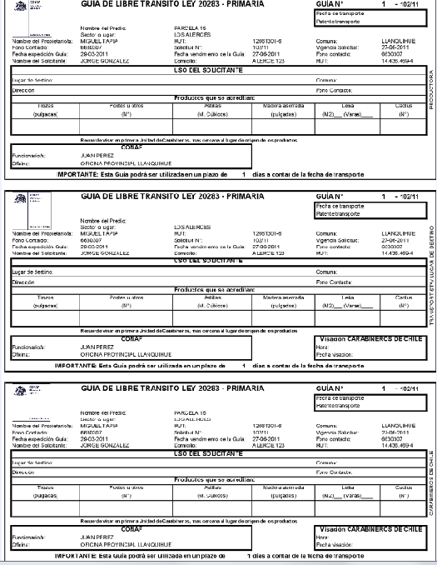
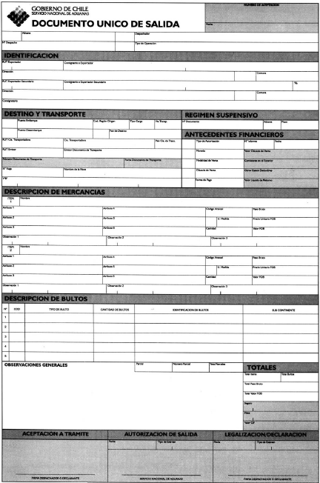

Who should I contact for further information?
Australian Government  Department of Agriculture, Water and the Environment  GPO Box 858  Canberra ACT 2601  Phone: +61 2 6272 3933  agriculture.gov.au/illegallogging  illegallogging@agriculture.gov.au | Chilean Government  National Forestry Corporation (CONAF)  Paseo Bulnes 285, apt 501  Santiago, Chile  Phone: +562 266 30446  www.conaf.cl  fiscalizacion.forestal@conaf.cl

