# Requirements and conditions for approved arrangement class 19.1: non-commodity for containerised cargo clearance

Version 5.0

© Commonwealth of Australia 2020

**Ownership of intellectual property rights**

Unless otherwise noted, copyright (and any other intellectual property rights) in this publication is owned by the Commonwealth of Australia (referred to as the Commonwealth).

**Creative Commons licence**

All material in this publication is licensed under a [Creative Commons Attribution 4.0 International Licence](https://creativecommons.org/licenses/by/4.0/legalcode) except content supplied by third parties, logos and the Commonwealth Coat of Arms.

Inquiries about the licence and any use of this document should be emailed to [copyright@awe.gov.au](mailto:copyright@awe.gov.au).



**Cataloguing data**

This publication (and any material sourced from it) should be attributed as: Requirements and conditions for approved arrangement class 19.1: non-commodity for containerised cargo clearance, Canberra, July. CC BY 5.0.

ISBN: 978-1-76003-425-9

This publication is available at <https://www.agriculture.gov.au/import/arrival/arrangements/requirements#class-19>

Department of Agriculture, Water and the Environment

Postal address GPO Box 858 Canberra ACT 2601

Telephone 1800 900 090

Web [awe.gov.au](http://agriculture.gov.au/)

**Disclaimer**

The Australian Government acting through the Department of Agriculture, Water and the Environment has exercised due care and skill in preparing and compiling the information and data in this publication. Notwithstanding, the Department of Agriculture, Water and the Environment, its employees and advisers disclaim all liability, including liability for negligence and for any loss, damage, injury, expense or cost incurred by any person as a result of accessing, using or relying on any of the information or data in this publication to the maximum extent permitted by law.

## **Version control**

| Date | Version | Amendments | Approved by |
| --- | --- | --- | --- |
| 18/05/2016 | 1.0 | First version of document created for transition of NCCC to approved arrangements framework under the Biosecurity Act 2015 | Compliance Assessment and Management |
| 13/12/2016 | 2.0 | Updated to include new terminology for packaging material statement and packing declaration requirements as part of NCCC codes. Updated non-conformities list to align with Minimum Documentary and Import Declaration Requirements Policy | Compliance Assessment and Management |
| 27/04/2018 | 3.0 | Requirements updated to reflect changes implemented as part of phase 2 AEP reform (23 June 2018). Changes include new concern types, refined requirements and new reporting guidelines to the requirements. | Assessment Policy and Projects |
| 26/08/2019 | 4.0 | Updating policy into Requirements and Conditions in accordance with legislative requirements. | Legislative Reform and Assessment Policy |
| 20/05/2020 | 4.1 | Update to reflect department name change. | Legislative Reform and Assessment Policy |
| 13/07/2020 | 4.2 | Minor update to wording and to improve understanding of conditions. | Legislative Reform and Assessment Policy |
| 12/07/2021 | 5.0 | Inclusion of khapra beetle requirements for containers. | Assessment Policy |

Contents

Version control iii

About this document v

Declaration v

Definitions v

Supporting documents v

Monitoring of compliance v

Operating a Class 19.1 approved arrangement 1

Purpose 1

Scope 1

Class 19.1 Prerequisite requirements 1

Conditions for operating a Class 19.1 approved arrangement 2

Appendix 1: Reporting guide 6

Non-commodity concern statements 6

Unpack destination postcodes 6

Non-commodity general declaration questions 6

Non-commodity biosecurity concerns 8

Exceptions 9

Self-declaring consignments for department intervention 9

Appendix 2: Declaration 10

Tables

Table 1 Concern types 8

Table 2 Concern type hierarchy 9

Figures

Figure 1 Non-commodity question 1 7

Figure 2 Non-commodity question 2 8

Figure 3 Detailed activities for FCL/FCX/LCL consignments 10

## About this document

This document sets out the requirements and conditions that must be met before the relevant Director will consider approval for the provision of biosecurity activities under section 406 of the *Biosecurity Act 2015*, otherwise known as an approved arrangement. It also sets out the conditions to be met for the operation of a Class 19.1 approved arrangement.

When operating under this arrangement the biosecurity industry participant is responsible for complying with each condition as set out in this document.

Unless specified otherwise, any references to ‘the department’ or ‘departmental’ means the Department of Agriculture, Water and the Environment.

Information on approved arrangements, department contact details and copies of relevant approved arrangement documentation is available on the [approved arrangements](http://www.agriculture.gov.au/import/arrival/arrangements) page on the department’s website.

### Declaration

The approved arrangement manager is required to complete the Appendix 2: Declaration and return it to the department via email to [broker.accreditation@awe.gov.au](mailto:broker.accreditation@awe.gov.au).

### Definitions

Terms used in this document are defined in the [approved arrangements glossary](http://www.agriculture.gov.au/import/arrival/arrangements/glossary) and the Biosecurity Act 2015. This document refers to AQIS where AQIS remains current in IT systems.

### Supporting documents

Ensure you understand and comply with the requirements and conditions for establishing and operating an approved arrangement. Read this document in conjunction with the most current online versions of:

* [Approved arrangements general policies](http://www.agriculture.gov.au/import/arrival/arrangements/general-policies)
* [Minimum documentary and import declaration requirements policy](http://www.agriculture.gov.au/import/arrival/clearance-inspection/documentary-requirements/minimum-document-requirements-policy)
* [Non-commodity information requirements policy](http://www.agriculture.gov.au/import/arrival/clearance-inspection/documentary-requirements/non-commodity_information_requirements_policy)
* [Compliance classifications for broker class approved arrangements.](http://www.agriculture.gov.au/import/arrival/arrangements/requirements/compliance-classifications)

### Monitoring of compliance

Compliance with the conditions of operating a class 19.1 approved arrangement is monitored in accordance with the [approved arrangements general policies](http://www.agriculture.gov.au/import/arrival/arrangements/general-policies).

The department will notify the biosecurity industry participant where non-compliance with the conditions has been detected.

A full list of compliance classifications may be found on the [Compliance classifications for Broker class approved arrangements](http://www.agriculture.gov.au/import/arrival/arrangements/requirements/compliance-classifications).

## Operating a Class 19.1 approved arrangement

### Purpose

The class 19.1 approved arrangement is for the assessment of non-commodity documentation and management of non-commodity biosecurity concerns associated with goods imported as containerised sea freight.

### Scope

Biosecurity activities performed under a class 19.1 approved arrangement are limited to the assessment of non-commodity documentation and non-commodity biosecurity concerns in accordance with the department’s [Non-commodity information requirements policy](http://www.agriculture.gov.au/import/arrival/clearance-inspection/documentary-requirements/non-commodity_information_requirements_policy) (including the [non-commodity BICON case](http://biconnet.daff.gov.au/BICONWeb/ImportConditions/Questions/EvaluateCase?elementID=0000088555&elementVersionID=104)) and the [Minimum documentary and import declaration requirements policy](http://www.agriculture.gov.au/import/arrival/clearance-inspection/documentary-requirements/minimum-document-requirements-policy).

Activities covered under this arrangement include:

* assessing documentation for full container load (FCL), full container multiple house bills (FCX) and less than a container load (LCL) sea freight
* assessing unpack destination postcodes for FCL and FCX sea freight (metro/rural/split)
* assessing container origin for khapra beetle concerns and unpack destination postcodes (rural/grain growing) for FCL and FCX sea freight
* answering ICS general declaration questions
* applying an AQIS concern type in the Department of Home Affairs [Integrated cargo system](https://www.border.gov.au/Busi/Carg/Inte) (ICS) to generate a biosecurity direction in the Agriculture import management system (AIMS) which will be used for the assessment and management of non-commodity biosecurity risk
* receiving biosecurity directions generated by AIMS and ensuring that the directions are complied with.

### Class 19.1 Prerequisite requirements

**Section 79 of Biosecurity Regulation 2016, stipulates the requirements that the Director must be satisfied that a proposed arrangement meets – both at the time of application and during the life of the arrangement. To demonstrate the biosecurity industry participant has the capability, equipment and facilities necessary to carry out the biosecurity activities covered by the arrangement, the following prerequisite requirements must be evident at the time of application for and the operation of a class 19.1 NCCC approved arrangement.**

**Requirement 1: The biosecurity industry participant must have obtained a branch ID from the Department of Home Affairs, be a registered client in the ICS enabling them to lodge import declarations, and provide the branch ID to the department as part of the application.**

**Requirement 2:** The biosecurity industry participant must have a minimum of one employed or contracted person who is accredited to undertake activities under the class 19.1 approved arrangement.

**Requirement 3:** When applying for an approved arrangement, the biosecurity industry participant must notify the [department](mailto:broker.accreditation@awe.gov.au) of the accredited persons that will perform the approved activities on behalf of the biosecurity industry participant. They must include their customs broker licence number as part of the application.

Training and accreditation obligations under the approved arrangement are available at [Training and accreditation for approved arrangements, broker accreditation.](http://www.agriculture.gov.au/import/arrival/arrangements/training-accreditation#broker-accreditation)

### Conditions for operating a Class 19.1 approved arrangement

**The class 19.1 NCCC approved arrangement is subject to the following conditions that must be complied with.**

#### General conditions

**Condition 1:** All accredited persons employed or contracted by the biosecurity industry participant must maintain their accreditation as stipulated by the [Training and accreditation for broker approved arrangements (class 19.1 and class 19.2)](http://www.agriculture.gov.au/import/arrival/arrangements/training-accreditation#broker-accreditation) policy, including completing [Continued biosecurity competency](http://www.agriculture.gov.au/import/arrival/arrangements/training-accreditation#broker-accreditation) (CBC) training each CBC period (1 April to 31 March).

**Condition 2:** The biosecurity industry participant must ensure all employed or contracted persons lodging full import declarations are accredited at the time of lodgement.

**Condition 3:** The biosecurity industry participant must notify the department in writing within 15 working days regarding any of the following matters:

* details of accredited persons who join or depart the approved arrangement
* when the approved arrangement ceases to employ or contract at least one accredited person
* when the contact details or the approved arrangement manager for the approved arrangement changes.

**Condition 4:** The biosecurity industry participant must notify the department in writing within 15 working days of becoming aware of any change of status, of the biosecurity industry participant or their associates (including accredited persons) relevant to the operation of the approved arrangement, not previously been notified to the department in relation to:

* conviction of an offence or order to pay a pecuniary penalty under the Biosecurity Act, Customs Act 1901, Criminal Code or Crimes Act 1914
* debt to the Commonwealth that is more than 28 days overdue under the Biosecurity Act, Customs Act 1901, Criminal Code or Crimes Act 1914
* refusal, involuntary suspension, involuntary revocation/cancellation or involuntary variation of an import permit, approved arrangement site, or approved arrangement under the Biosecurity Act.

**Condition 5:** The department must be notified of any [reportable biosecurity incident](http://www.agriculture.gov.au/biosecurity/legislation/reportable-incident) as soon as practicable, in accordance with the determination made by the Director of Biosecurity.

**Condition 6:** The biosecurity industry participant must provide site access to biosecurity officers, biosecurity enforcement officers and department approved auditors to perform the functions and exercise the powers granted to them by the Biosecurity Act or another law of the Commonwealth.

**Condition 7:** The biosecurity industry participant must provide departmental biosecurity officers, auditors or department-approved auditors with facilities and assistance as requested, and any required documents (including electronic documents), records or items relevant to the audit.

**Condition 8:** The biosecurity industry participant must allow departmental biosecurity officers, auditors or department-approved auditors to examine documents (including electronic documents) and collect evidence of compliance and non-compliance with approved arrangement conditions by performing actions such as copying documents and taking photographs.

#### Operating conditions

**Condition 9:** Only accredited persons are to assess all non-commodity documentation, khapra beetle concerns for containers and unpack destination postcodes for FCL/FCX and LCL sea freight utilising the most current versions of the:

* [Minimum documentary and import declaration requirements policy](http://www.agriculture.gov.au/import/arrival/clearance-inspection/documentary-requirements/minimum-document-requirements-policy)
* [Non-commodity information requirements policy](http://www.agriculture.gov.au/import/arrival/clearance-inspection/documentary-requirements/non-commodity_information_requirements_policy)
* [BICON import conditions](http://www.agriculture.gov.au/import/online-services/bicon).

**Condition 10:** Accredited persons must provide information in the import declaration that accurately reflects the consignment noting that all necessary information fields that are specific to biosecurity are completed as required by the [Minimum documentary and import declaration requirements policy](http://www.agriculture.gov.au/import/arrival/clearance-inspection/documentary-requirements/minimum-document-requirements-policy).

**Condition 11:** Accredited persons must be in possession of all the documents required per relevant BICON import conditions and the [Non-commodity information requirements policy](http://www.agriculture.gov.au/import/arrival/clearance-inspection/documentary-requirements/non-commodity_information_requirements_policy).

**Condition 12:** Accredited persons must be in possession of documentation that meets the [Minimum documentary and import declaration requirements policy](http://www.agriculture.gov.au/import/arrival/clearance-inspection/documentary-requirements/minimum-document-requirements-policy) prior to the full import declaration being lodged under the approved arrangement.

**Condition 13:** Accredited persons must present all documentation assessed to generate an automated direction for a consignment to the department at the initial request for documentation (this includes providing documentation in the Cargo online lodgement system (COLS).

**Condition 14:** Accredited persons must correctly answer the department’s non-commodity general declaration questions in the ICS and declare all non-commodity concern types. The method of reporting must comply with condition 10 and Appendix 1: Reporting guide.

**Condition 15:** Accredited persons must enter an approved arrangement site number into the AQIS Location field in the ICS for concern types other than BCOM, BNCC or KPRA to ensure that a location is assigned to the biosecurity direction. The approved arrangement site location must be an appropriate Class 1 to perform the directed biosecurity activity.

For a list of approved arrangement sites and their premises ID, see [sites operating under an approved arrangement](http://www.agriculture.gov.au/import/arrival/arrangements/sites#vic1.1) on the department’s website.

**Condition 16:** Accredited persons mustenter the treatment provider’s AQIS/agriculture entity identifier (AEI) in the AEI field in the ICS where a consignment has been treated by an offshore treatment provider, to address BICON conditions for the relevant biosecurity concern (i.e. non-commodity and/or hitchhiker pests). AEI numbers must be entered in accordance with [Entity Identifier webpage.](https://www.agriculture.gov.au/import/arrival/clearance-inspection/documentary-requirements/entity-identifier)

**Condition 17:** The biosecurity industry participant must ensure that biosecurity directions generated by AIMS are carried out or arranged to be carried out within the designated AIMS direction timeframe.

The biosecurity industry participant is responsible for the goods (as the primary receiver of AIMS directions) and must do the following required by the direction:

* arrange inspection activities
* provide non-broker approved arrangements with biosecurity directions to be carried out within the designated AIMS direction timeframe (e.g. inspection/treatment location)
* provide third parties other than approved arrangement sites with biosecurity directions to be carried out within the designated AIMS direction timeframe (e.g. transport/logistics providers who move containers)
* present any documentation as specified on AIMS directions when directed.

**Condition 18:** Where a consignment has bypassed biosecurity control, the biosecurity industry participant must be able to provide evidence that all relevant directions were passed onto third parties within the designated AIMS direction timeframe.

**Condition 19:** The biosecurity industry participant and/or accredited persons must not manipulate biosecurity goods management to gain a favourable and preferred outcome.

**Condition 20:** If an accredited person requests amendment to documentation, they must document the time, date, type of request and amendment made and the time, date and response from the issuer of the document. The accredited person must retain the correspondence as part of the documentation clearance of the consignment.

#### Administration and management conditions

**Condition 21:** For every import declaration lodged by a biosecurity industry participant, the following records and documents must be maintained for a minimum of 5 years from the date the document assessment was conducted:

* import declaration number
* container cleanliness declaration
* packing declaration or valid documents containing unacceptable packaging materials statements, Timber/bamboo packaging and ISPM15 statements
* annual packing declaration (where appropriate)
* treatment certificate (where required)
* documents that have been used in the decision-making process, such as bills of lading, commercial invoices or cartage advices
* evidence of amendments to documentation used in the clearance of the consignment in accordance with **Condition 20**
* evidence of the premises ID used
* record of the accredited person who performed the assessment and lodgement
* any other relevant documentation and records—for example, records of providing biosecurity directions to third parties.

**Condition 22:** The biosecurity industry participant must maintain records of their accredited persons. The records must be up to date and include CBC completion records.

**Condition 23:** Records and/or documents must be made available to the department when requested within one business day or a timeframe specified by the department.

Any request for further documentation for assessment after the initial request is considered a new document assessment.

## Appendix 1: Reporting guide

### Non-commodity concern statements

Refer to the [Non-commodity information requirements policy](http://www.agriculture.gov.au/import/arrival/clearance-inspection/documentary-requirements/non-commodity_information_requirements_policy) to determine the non-commodity concerns to be addressed for each specific cargo type.

### Unpack destination postcodes

The Department of Agriculture, Water and the Environment uses postcode classifications to manage the risk associated with unpack destinations for sea containers. There are 4 postcode classifications:

* metropolitan
* rural
* split (part metropolitan, part rural)
* grain growing.

To check if a postcode is metropolitan, rural, split or grain growing see the [postcode classification search](http://www.agriculture.gov.au/import/online-services/delivery-postcode/summary) on the department’s website.

### Non-commodity general declaration questions

When assessing and managing a consignment under this approved arrangement, accredited persons must answer the department’s non-commodity general declaration questions in the ICS based on their assessment of cargo type, container origin for khapra beetle concerns, documentation and unpack location postcode. These questions are described as AQIS declaration questions in the ICS.

The non-commodity declaration questions are specific to the cargo type applicable to the import declaration.

#### Question 1 (Question ID 6 or 8)

The first non-commodity declaration question relates to accreditation and registration for the approved arrangement.

A ‘Yes’ answer must be given if both:

* the individual lodging the import declaration is an accredited person under the approved arrangement
* the accredited person is lodging the import declaration on behalf of the biosecurity industry participant covered by the AA.

In all other cases, a ‘No’ answer must be given, and the consignment will be referred to the department for assessment.

****Figure 1 Non-commodity declaration question 1****

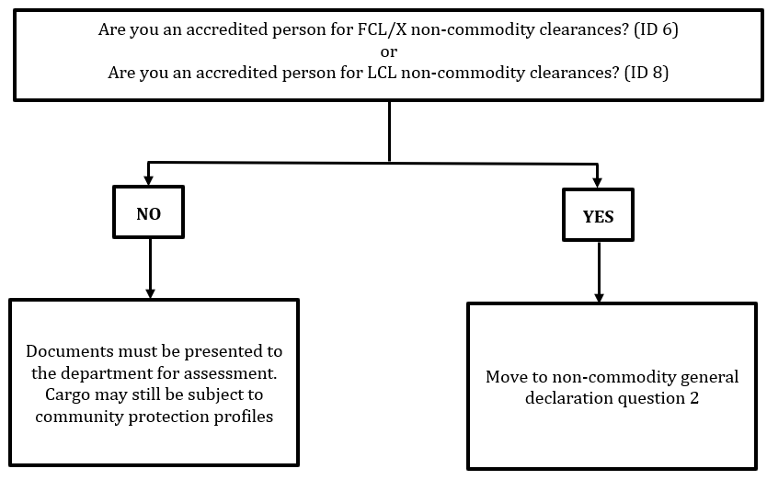

#### Question 2 (Question ID 7 or 9)

The second non-commodity declaration question relates to the accredited person’s assessment of the consignment in relation to:

* the non-commodity documentation accompanying it
* unpack destination for FCL/X consignments.

A ‘Yes’ answer must be given if:

* the consignment is covered by non-commodity documentation assessed by an accredited person as acceptable to address khapra beetle risk (when applicable) and non-commodity concern statements
* for FCL/X consignments, the consignment is being unpacked at a metropolitan postcode with the department’s authority for delivery.

In all other cases, a ‘No’ answer must be given.

Figure 2 Non-commodity declaration question 2

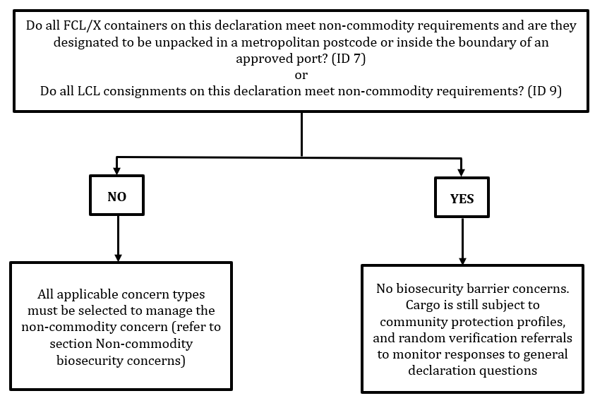

### Non-commodity biosecurity concerns

When an accredited person answers ‘No’ to the second non-commodity general declaration question they must declare all applicable concern types as described in Table 1. All concern types are outcome based, which allows the accredited person to select the appropriate outcome to manage the biosecurity risk. For example, for untreated timber packaging there are three concern types to select from to manage the biosecurity risk. Only one timber concern type is required to be entered.

Note: In the ICS, concern types are located in the AQIS concern type field, in the Import declaration header create screen.

****Table 1**** Concern

|  |  |  |  |  |
| --- | --- | --- | --- | --- |
| Concern type | Concern | Description | Cargo type | Outcome |
| BCOM | Broker referred: commodity issues | Department assessment required. To be used to refer concerns with a commodity line that has not been referred to the department through ICS community protection profiles or concerns regarding the authenticity of the commodity documentation. | For all cargo types | Document processing required (applies to all lines) |
| BNCC | Broker referred: non-commodity issues | Department assessment required. To be used to refer non-commodity concerns other than listed or would like the non-commodity concerns assessed by the department due to the outcome required not being available—for example, external container inspection. | For all cargo types | Document processing required |
| KPRA | Khapra beetle risk not managed offshore | Department assessment required. FCL/X not treated for khapra beetle or treatment certificate is unacceptable (for containers packed in a khapra beetle country and destined to be unpacked in a grain growing area in Australia). | FCL/X | Document processing required |
| RURL | Rural unpack location | FCL/X destined to be unpacked at a non-metropolitan location. For containers that meet the need for an external inspection only, the BNCC code needs to be included with the RURL designation at lodgement. | For cargo types—FCL, FCX | Inspection—rural tailgate |
| PCIN | Packaging/cleanliness—inspection | Declared unacceptable packaging material and/or nil container cleanliness statement. | For cargo types—FCL, FCX, LCL | Cargo inspection |
| PCTG | Packaging/cleanliness—tailgate | Declared unacceptable packaging material and/or nil container cleanliness statement. | For cargo types—FCL, FCX | Tailgate |
| PDIN | Packing declaration—inspection | Packing declaration concerns. Nil packing declaration or it does not comply with the Minimum documentary and import declaration requirements policy. | For cargo types—FCL, FCX, LCL | Cargo inspection |
| PDTG | Packing declaration—tailgate | Packing declaration concerns. Nil packing declaration or it does not comply with the Minimum documentary and import declaration requirements policy. | For cargo types—FCL, FCX | Tailgate |
| TFUM | Timber—fumigate | Untreated timber/bamboo packaging. | For cargo types—FCL, FCX, LCL | Fumigation (CH3Br 48g/M3 24hr 21C or above) |
| TINS | Timber—inspect | Untreated timber/bamboo packaging. | For cargo types—FCL, FCX, LCL | Cargo inspection |
| TDIS | Timber—dispose | Untreated timber/bamboo packaging. | For cargo types—FCL, FCX, LCL | Disposal permission—non-commodity |

AIMS creates a non-commodity line per container (starting at line 6,000). When a concern type is entered (except for BCOM), AIMS will direct the non-commodity lines according to the concern type outcome. AIMS will generate a biosecurity direction based on the concern type to manage the biosecurity risk associated with the non-commodity component of the consignment.

When two or more concern types are selected, the biosecurity direction will be based on the concern type hierarchy described in Table 2.

For example, if an accredited person selects both RURL and PCIN, the system will automatically add the non-commodity line to the entry and apply the direction associated with the highest concern type in the hierarchy to that line. In this case, the concern type ranked highest in the hierarchy is RURL, so AIMS will apply the associated direction for RURL which is ‘Inspection – rural tailgate’.

Table 2 Concern type hierarchy

| Concern type | Hierarchy |
| --- | --- |
| BCOM | n/a |
| BNCC; KPRA | 1 |
| RURL | 2 |
| TINS; PCIN; PDIN | 3 |
| PCTG; PDTG | 4 |
| TFUM; TDIS | 5 |

Note: 1 = highest, 5 = lowest

Figure 3 Detailed activities for FCL/FCX/LCL consignments

Diagram

Detailed activities for FCL/FCX/LCL consignments*Exemptions apply; **Excludes bamboo

### Exemptions

Some consignments and cargo types are exempt from aspects of the non-commodity requirements. For a full list of exceptions see [Non-commodity information requirements policy](https://www.agriculture.gov.au/import/arrival/clearance-inspection/documentary-requirements/non-commodity_information_requirements_policy).

Importers are responsible for providing evidence that acceptable packaging and dunnage was used in the consignment and advising the department of any contamination or noncompliance packaging or evidence of pests found when unpacking the containers.

### Self-declaring consignments for department intervention

When the biosecurity industry participant (BIP)/accredited person has concerns that are not able to be managed using a specific non-commodity concern type, or tariff profile questions do not provide appropriate scope for providing a commodity’s biosecurity concern, then the broker referred concern types must be used. The two concern types are: **BCOM** to refer commodity, and **BNCC** to refer non-commodity concerns. By self-declaring (volunteering) consignment for department intervention, the FID will be assessed by a biosecurity officer. When submitting documentation via COLS, provide reasons for volunteering the consignment.

**BCOM:** An accredited person may use the BCOM concern type to identify a concern not otherwise identified about the commodity and ensure the consignment is referred to the department for assessment. For example, BCOM should be used:

* when commodity profile questions do not declare a biosecurity concern
* when an AEI has been entered and there are concerns with an offshore treatment certificate. Refer to the [Entity identifier webpage for further details.](https://www.agriculture.gov.au/import/arrival/clearance-inspection/documentary-requirements/entity-identifier)

**Note:** BCOM is not required when a treatment provider is deemed unacceptable as the system will automatically identify and refer these consignments when the AEI is entered.

**BNCC:** is appropriate when the specific non-commodity concern codes do not provide a suitable outcome to manage the risk. For example, BNCC should be used:

* when a consignment is being split to a metro and rural delivery locations so only some containers require Rural Tailgate inspections, or
* when a container destined for a rural destination unpack contains hard frozen, ISO tank or dangerous goods and therefore should have an external container inspection only, or
* when the existing packaging, packing or timber/bamboo concern types do not appropriately identify and/or manage the biosecurity risk.

## Appendix 2: Declaration

Please complete the following declaration and return it to the department via email to [broker.accreditation@awe.gov.au](mailto:broker.accreditation@awe.gov.au):

|  |  |  |
| --- | --- | --- |
| I, | | Job title: |
| Legal entity name (must match ABN/ACN name): | | Branch ID: |
| ABN: | ACN: | Requirements and conditions for approved arrangement class 19.1: non-commodity for containerised cargo (Version 4.2) |

Declare that:

1. I have the authority to act on behalf of the legal entity listed above.
2. I have read and understood the *Requirements and conditions for approved arrangement class 19.1: non-commodity for containerised cargo (Version 4.2)* and agree to carry out biosecurity activities in accordance with them.
3. I acknowledge that by not meeting the conditions the legal entitymay be subject to regulatory action as described in the *Approved arrangements general policies* and *Compliance classifications for broker class approved arrangements*, in accordance with the *Biosecurity Act 2015*, which may include the suspension or revocation of the approved arrangement.
4. I understand that giving false or misleading information is a serious offence punishable by up to 12 months imprisonment.

|  |  |
| --- | --- |
| Signed: | Date: |