Building resilience through ecological literacy, connection and community
Claudia Benn, 2024 Nuffield Drought Resilience Scholar, Queensland
Nuffield Australia project number 2402
July 2026
© Commonwealth of Australia 2026
Ownership of intellectual property rights
Unless otherwise noted, copyright (and any other intellectual property rights) in this publication is owned by the Commonwealth of Australia (referred to as the Commonwealth).
Creative Commons licence
All material in this publication is licensed under a Creative Commons Attribution 4.0 International Licence except content supplied by third parties, logos and the Commonwealth Coat of Arms.

Cataloguing data
This publication (and any material sourced from it) should be attributed as: Benn, C 2026, Building resilience through ecological literacy, connection and community, report prepared for Nuffield Australia and the Department of Agriculture, Fisheries and Forestry, Canberra. CC BY 4.0.
This publication is available at Nuffield Australia Scholar Reports and at agriculture.gov.au/Drought Resilience Scholarship Program.
Drought Resilience Scholarship Program
The program is funded by the Australian Government’s Future Drought Fund. In submitting this report, the 2024 Nuffield Scholar Claudia Benn has agreed to Nuffield Australia and the Department of Agriculture, Fisheries and Forestry publishing this material in its edited form.
Claudia Benn
‘Mt Kingsley’, 4518 Arcadia Valley Road, Injune QLD 4454
Telephone 0400 769 290
Email claudia.ann.benn@gmail.com
Nuffield Australia
38 Walker Drive, Worongary QLD 4213
Web Nuffield.com.au
Email enquiries@nuffield.com.au
Department of Agriculture, Fisheries and Forestry
GPO Box 858 Canberra ACT 2601
Telephone 1800 900 090
Web agriculture.gov.au
Disclaimer
The views and opinions expressed in this publication are those of the authors and do not necessarily represent the views of Nuffield Australia, the Australian Government or the portfolio ministers for the Department of Agriculture, Fisheries and Forestry.
The content of this publication does not constitute advice to any third party. Although due care and skill have been applied in the preparation and compilation of the information and data in this publication, no reliance may be placed on it by any other party. No representation expressed or implied is made by Nuffield Australia or the Australian Government as to the currency, accuracy, reliability, completeness or fitness for purpose of the information contained in this publication. The reader should rely on its own inquiries to independently confirm any information and comment on which they may intend to act.
Nuffield Australia, the Commonwealth of Australia, its officers, employees, agents and the other parties involved in creating this report disclaim, to the maximum extent permitted by law, responsibility to any other party for any liability, including liability for negligence and for any loss, damage, injury, expense or cost incurred by any person as a result of accessing, using or relying upon any of the information or data in the publication.
Acknowledgement of Country
We acknowledge the continuous connection of First Nations Traditional Owners and Custodians to the lands, seas and waters of Australia. We recognise their care for and cultivation of Country. We pay respect to Elders past and present, and recognise their knowledge and contribution to the productivity, innovation and sustainability of Australia’s agriculture, fisheries and forestry industries.

Executive Summary
Resilience is the capacity to adapt, evolve and re-balance in the face of change and challenges. As climate extremes intensify and farmers and agricultural systems confront increasing pressures from drought, market volatility, soil degradation and societal expectations, resilience has become a critical theme for the future of farming in Australia.
Through global travel and personal experiences, lessons emerged from people, livestock and landscapes that brought to light key traits for building resilient individuals, communities and ecosystems. For me, these include accepting change, being adaptable, embracing complexity, supporting diversity and facilitating community, connection and intergenerational knowledge transfer. I believe at the heart of these traits lies a common thread: relationships between biological communities including soil, microbes, plants, animals and people.
Just as microbes communicate with plants and animals pass down nutritional knowledge, our farming communities thrive on networks of shared experience and support. The same traits that sustain natural ecosystem balance can help us build farming cultures capable of weathering change, together.
While drought resilience is a focus, I have approached it with a much broader lens, encompassing personal, ecological and communal sustainability across generations.
A disconnect to our land and community is a greater risk to rangelands than drought (Graham Finlayson, Regenerating Rangelands Conference, 2024).
Case studies from Australia, New Zealand, Turkey, Georgia, France, Canada and Zimbabwe highlight how farmers are drawing on science, lived experiences and lessons from nature to shape their farming systems. From shepherding in the French Alps to reconnecting producers and consumers in Canada, these examples demonstrate that there is no single method, only a shared mindset of continual learning through observation, connection, and creativity.
Importantly, this report does not prescribe specific management practices. Instead, it shares the lessons that have challenged the way I think and farm, inviting a shift towards farming with nature and embracing complexity and deep connection in our systems. It encourages readers to observe their landscape, build ecological literacy, and consider our role as stewards of natural ecosystems and food producers for our wider communities.
Keywords: Resilience, Ecological literacy, Biodiversity, Connection

Contents
Executive Summary iii
Foreword 1
Acknowledgements 5
Objectives 6
Introduction 7
1 Is nature fragile? 8
Adaptability and control 10
2 Adapting to adversity 11
3 Embracing complexity 14
4 Supporting diversity 17
Nutritional wisdom and phytochemical richness 21
Shepherding 25
5 Building community 28
Crop communities 29
The Jena Experiment 30
6 Fostering intergenerational resilience 31
White Gum Wool 33
Microbial inheritance in plants 35
7 Human connection – the heart of resilience 37
Conclusion 41
Recommendations 42
Embrace change 42
Build ecological literacy 42
Foster complexity and diversity 42
Prioritise connection and community 42
References 43
Bibliography 45

Tables
Table 1 Travel itinerary 3
Figures
Figure 1 Claudia Benn (author) on Mt Kingsley 1
Figure 2 David Benn, Chris Benn, Claudia Benn and Miles Burow, Mt Kingsley 2
Figure 3 Our Global Focus Program group visiting a vineyard in Georgia 5
Figure 4 Miles Burow, Claudia Benn and New South Wales grazier David Marsh 8
Figure 5 New life – grass regenerating after a fire 9
Figure 6 New life - mushrooms emerging from cow manure on a clay pan 9
Figure 7 Kununurra farmer Fritz Bolten in his corn crop 12
Figure 8 Our Global Focus Program group with farmer Rob Fletcher at the Dr Trouble headquarters in Zimbabwe 12
Figure 9 Exploring soil life with New South Wales farmer Jake Chandler 13
Figure 10 A depiction of the relationship between diversity, complexity and ecosystem resilience (source: Bullock et al. 2022) 14
Figure 11 A visual representation of different root architectures, depths and functional roles (source: Lemke & Desalle 2023) 18
Figure 12 Diverse, multispecies pastures in Tasmania 18
Figure 13 Diverse, multispecies pastures in Tasmania with dairy farmer Mark Lambert 19
Figure 14 Comparison of lamb daily weight gains on multispecies versus monoculture forage (source: Watershed Landcare Incorporated 2020) 19
Figure 15 Cattle browsing on an emu apple tree 20
Figure 16 A steer browsing on brigalow regrowth 20
Figure 17 Free choice mineral trailer on Mt Kingsley 21
Figure 18 Different mineral compartments of the free choice trailer 22
Figure 19 Cows accessing the free choice mineral trailer 22
Figure 20 Grazing of cobbler’s peg along a fenceline, Mt Kingsley 24
Figure 21 Miles Burow and Joseph Boussion shepherding in the mountains in France 25
Figure 22 Shepherding in the French Alps 26
Figure 23 The Jena Experiment (source: The Jena Experiment 2002) 30
Figure 24 Calves grazing and learning alongside their mothers at Mt Kingsley 31
Figure 25 White Gum Wool yarn samples (source: White Gum Wool n.d.) 33
Figure 26 Nan’s merino flock 34
Figure 27 Aerobic and anaerobic microbial brewing tanks with Matt Marshall 36
Figure 28 Attending the Territories for Life Pastoralism Consortium, Istanbul 37
Figure 29 Discovering the passion and traditions connected to food and wine and Georgia 38
Figure 30 Discovering the passion and traditions connected to food and wine and Georgia 38
Figure 31 Our Global Focus Program experiencing Georgian food, wine and hospitality 39
Figure 32 Tannis and Derek Axten in front of their grain grading and flour mill facility 40
Figure 33 A total grazing system at Fishburn Ranch, Alberta 40

Foreword
I am a grazier and agronomist living in Arcadia Valley, Central Queensland; however, my career journey began in the health industry. I started as a registered nurse, where I developed a deep appreciation for the medical industry and all that modern medicine has done, and continues to do, for society. Despite this, I could not help but wonder about root causes and preventative approaches (such as nutrition) to many of our modern diseases. Once you delve into the world of nutrition, it is no stretch to realise that healthy people come from healthy food, which comes from healthy farms and soils.
The nation that destroys its soil destroys itself (Franklin D. Roosevelt).
The similarities between human health and soil, plant and animal health are no coincidence. Each has closely co-evolved over time with microorganisms, and each depends on being part of a connected and well-functioning biological community. Exploring this space showed me that agriculture was the industry I wanted to be in, and I went on to study a Bachelor of Sustainable Agriculture at the University of Queensland. After graduating, I worked as an agronomist across Southeast Queensland and Northern New South Wales, most recently for FARM Agronomy and Resource Management.
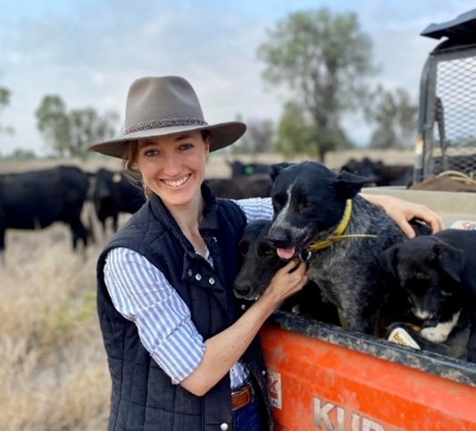
Figure 1 Claudia Benn (author) on Mt Kingsley
At the beginning of my Nuffield journey, my partner Miles and I moved back to my family’s cattle property ‘Mt Kingsley’ in Arcadia Valley, where we are now integrating into the family business with my parents, David and Chris Benn. Together we run a 400-head Angus breeding herd and fatten the progeny to meet the grass-fed, organic market. It has been an incredible opportunity to experiment and implement many of the ideas I have learned during my time as an agronomist and throughout my Nuffield travels.
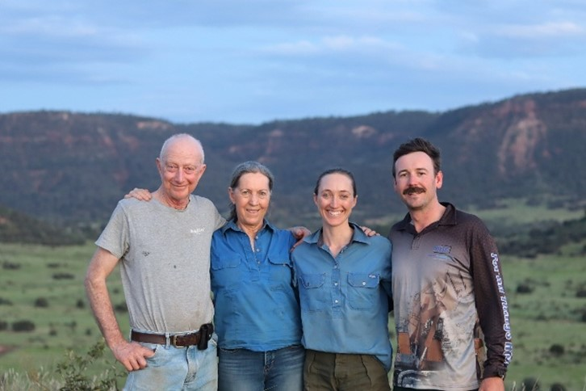
Figure 2 David Benn, Chris Benn, Claudia Benn and Miles Burow, Mt Kingsley
The motivation for this topic stemmed from my curiosity about building resilience, exploring the world of biological relationships (between soil, microbes, plants, animals and people), and finding a balance between long-term ecosystem health and productivity. This report is based on lessons I have learnt from observing resilience in nature, people and farming systems around the world, and what this has taught me about coming home to build resilience in myself and our future in farming with nature.
One thing I know for sure is that we still know so little about the complexity and intelligence of the natural world that we are part of, and what a humbling and wondrous thing that is. If there is one thing you take from this, I hope that is it. I hope I have succeeded in sparking curiosity and sharing the magic of biological communities with those who read this report. I hope it inspires new perspectives about our place in the natural world and our future in food production.
Happy farming.

Table 1 lists countries, places, farmers, industry representatives, educators and researchers visited throughout my travels. Every person listed here has contributed invaluable insights, knowledge and stories that have helped me to formulate my thoughts and assisted in achieving the objectives of this project.
Table 1 Travel itinerary
Travel date | Location | Visits and contacts
12 to 21 February 2024 | Tasmania, Australia | Farm visits and meetings:  - Robin Tait (Farm Ecologist)  - Steph & Sam Trethewey (Tas Ag Co)  - Mark Lambert (Sunnyside)  - Dave Roberts-Thompson (Van Diemen Bulbs)  - Dr Nan Bray (White Gum Wool)  Events:  - Grassroots Festival & farm tours 2024
8 to 20 March 2024 | Brazil: Campo Grande, Bonito and Pantanal Wetlands | - Contemporary Scholars Conference (CSC) and post CSC tour
19 to 28 April 2024 | New Zealand | Farm visits and meetings:  - Ewen & Paula Campbell (EcoFarm Aotearoa)  - Pablo Gregorini (Lincoln University)  - Simon Osbourne (Doyleston) & Nigel Greenwood  - Andrew Bowmar (Lees Valley Station)  - Steve Wilkins (FAR)  - Allan Richardson (Avalon Genetics)  - Carlos & Nadia Bagrie (Royalburn)  - Slim, Janina, Jono & Ruby (Kurow Farm)  - Charles Merfield (Merfield Agronomy)  - Andrea Murphy (Image Holdings)
2 June to 16 July 2024 | Western Australia, Zimbabwe, England, Netherlands and Georgia | - Global Focus Program
11 to 16 July 2024 | Istanbul, Turkey | Conference and meetings:  - ICCA Pastoralism Consortium  - Engin Yilmaz (Yolda Initiative)
17 to 20 July 2024 | Romania | Farm visits:  - Sergio Antunes & Arnaud Charmetant (Vectr Farms)  - Jim McCarthy (Southern Harvest)
21 to 30 July 2024 | France | Farm visits:  - Camille Descatoire (Organic Market Garden)  - Joseph Boussion (Shepherd)
2024 to 2025 | Queensland, Australia | Farm visits and meetings:  - Peter & Nikki Thompson, Emma & Gus King (Echo Hills)  - Dale Retschlag (Netley Grazing)  - Peter Attard (Shingle Hut)  - Ross O’Reilly (High Valley Dawn)  - Matt Marshall (Crescent Nine Pastoral)  - Fran & Damien Lyons (Basalt River Station)  - Michael & Michelle Lyons (Wambiana Station)  - Jamie Gordon & Garlone Moulin (Mt Pleasant)  - Jodi, Donald & Wendy Brown (Latrobe Station)  - Adam & Stacey Curcio (Natural Impact Advisory & Cultivating Wellness)  - Andrew & Tali Brownlie (Andalia Pastoral)  - Simon Mattsson (Soil Land Food)  Events:  - Roots to Wellness: Exploring Plant Function and Human Health 2024  - Regenerating Rangelands - Cunnamulla 2024  - CQ Connect Dung Beetle Field Day 2025
18 to 28 February 2025 | New South Wales, Australia | Farm visits and meetings:  - Treen & Mark Swift (Kebby & Watson)  - Ross & Dimity Thompson (Millah Murrah Angus)  - Caitlin & Ed Herbert (Gundamain Pastoral)  - Jake & Gemma Chandler (Tumbleton Farm)  - David & Mary Marsh (Allendale)  - Jim & Em Alexander (Long Grass)  - Jake & Anne Wolki (Wolki Farm)  - Catherine Marriot  - Stephanie & Marty Tabone  - Michael & Millie Taylor (Taylor’s Run)  - Ben Poschelk (Wellingrove Station)  - Pippa & Dion Jones (Enmore)  Events:  - Wilmot Field Day
26 May to 7 June 2025 | Canada: Alberta and Saskatchewan | Farm visits and meetings:  - Graeme & Heather Finn (Southern Cross Livestock)  - Renny Grilz (Blazing Star Wildflower Seed Company)  - Ian Hnatowich (Wanuskewin Park)  - Ross & Christine MacDonald (98 Ranch)  - Derek & Tannis Axten (Axten Farms)  - Casey, Jaclyn, Gwen & Galen Toews (Fishburn Ranch)  - Uriel (Palmer Ranch)  - Cody & Julia Spencer (Sweetgrass Bison)
8 to 16 June 2025 | USA: Nebraska and Virginia | Farm visits:  - Jaclyn, Blaine & Charlie Wilson (Flying Diamond Ranch)  - Daniel & Morgan Firth Griffith (Timshel Wildland)  Online meetings:  - Dr Fred Provenza  - Mette Duedahl Hoyer (Ingelby Farms)  - Ann Adams (Holistic Management)
13 to 20 July 2025 | Queensland and New South Wales | Australian Focus Program

Acknowledgements
A heartfelt thank you to the Nuffield Australia team for all you do to run the Nuffield program, and for providing a network with a breadth and depth beyond what I could have imagined. Thank you to the Australian Government’s Future Drought Fund for so generously granting me this opportunity that has changed my life both personally and professionally.
Thank you to my Nuffield Australia 2024 cohort; it has been a pleasure to share this journey with you. A special thank you to the nine scholars I travelled with on my Global Focus Program. Of all my Nuffield experiences, thanks to you all, this will remain a highlight.
To every single person who gave their time to talk to me, host me and openly show me their operations – thank you for your generosity, your willingness to share and your hospitality. Your contribution to my learning and this program has been incredibly valuable and deeply appreciated.
I have had some wonderful mentors along the way to whom I am extremely grateful. You have been regular sounding boards, provided feedback and personal and professional encouragement when needed. In particular, thank you to Jane Slattery, Robin Tait, Nan Bray, Dale Retschlag, Jim and Em Alexander, Ian Moss, Adam Curcio and Fred Provenza.
Thank you to my parents, David and Chris Benn, for so warmly welcoming Miles and I into the family business, for encouraging my interests in the agricultural space and for being continually open to my never-ending list of new ideas.
Finally, my deepest thank you to Miles for his endless support throughout the highs and lows of this journey. It certainly was a team effort made possible by all you did in the background, so thank you for your ongoing encouragement. I look forward to a future in farming with you.
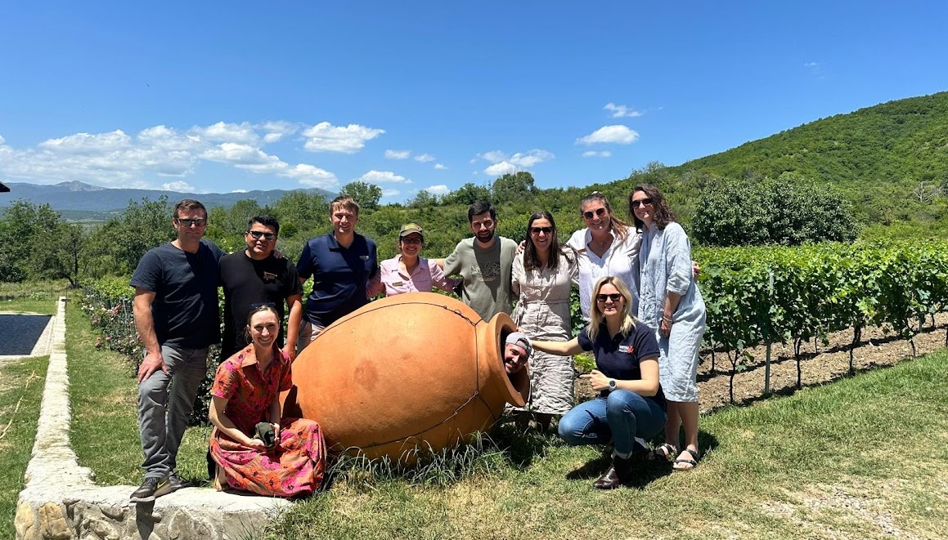
Figure 3 Our Global Focus Program group visiting a vineyard in Georgia

Objectives
My project aims were to:
- Identify key traits that contribute to the resilience of natural ecosystems.
- Explore our connection to and understanding of the ecosystems we farm within.
- Share global examples of how farmers have incorporated these traits into their farming systems, and how building ecological literacy has resulted in the adaptation of management practices.
- Encourage farmers to be curious, open, connected and creative when it comes to ‘farming with nature’.

Introduction
Droughts (and other seasonal extremes) in Australia significantly impact farm viability, animal welfare, ecosystem health and stability, rural communities and mental health. We are living in an era of rapid environmental and social change, and as a result, adaptability and resilience have emerged as necessary traits to survive and thrive in the agricultural industry.
At the time of writing this report, regions in Southern Australia are experiencing the worst drought in decades, while areas across Northern Queensland have experienced record-breaking floods; both with devastating impacts to the land, livestock and people. This, combined with domestic and global market and trade volatility, rising input costs and declining biodiversity and soil health, raises significant concerns for the resilience of farming systems and broader ecosystems.
According to the American Psychological Association (n.d.), “resilience is the process and outcome of successfully adapting to difficult or challenging life experiences, especially through mental, emotional and behavioural flexibility”. Therefore, it is not necessarily about avoiding challenges but being able to navigate through them and emerge stronger or more capable. According to Holling (1973), “ecological resilience is the capacity of an ecosystem to absorb disturbance and still retain its basic structure and function”.
While this report explores building drought resilience in farming systems, it is important to note that for me, resilience is all-encompassing. To build drought resilience, one must build personal, communal, environmental and financial resilience. It is also important to note that it spans beyond an individual, a single farm, or a single generation. I believe it requires connection, collaboration and a commitment to building resilience that may not be wholly realised in our lifetime.
This report draws links between observed examples of resilience in the natural world, highlighting what I have learnt from these examples about building resilience in my own life and farming system. It also discusses global examples of how farmers are incorporating this knowledge into their personal contexts.
I have discovered that the common theme at the heart of these lessons is the importance of connection, community and relationships. Not just to ourselves and the people around us, but with all levels of biological communities. The purpose of this report is not to provide practice or management recommendations, but more importantly, to highlight the value in building context-specific ecological literacy, getting to know our systems, and challenging us to be curious, connected and creative when it comes to on farm practice change.

1 Is nature fragile?
Nature is neither cruel nor kind, she just is (Harris 2023).
Environmental concerns are rising in Australia, with 72% of the population expressing concern about climate change and the state of the environment in a 2021 Climate Action Survey – increasing from 34% a decade earlier (Griffith News 2022). Like many, I was troubled by our impact on the natural world early on. My concern grew with the bombardment of messages around climate change, natural disasters, catastrophic weather events, the impact of excessive greenhouse gas emissions, and the list goes on. Combine this with a spotlight on the agricultural industry for our contribution to declining environmental conditions, and it is no surprise that a heavy sense of responsibility, fear and urgency settled on my shoulders, like many.
This is one of the risks of modern environmental fear-based messaging. While it can certainly drive change, it can also create an unrealistic sense of urgency and responsibility to fix everything immediately. I felt as though the natural world was crumbling, and it was a mad scramble to find ‘the answers’ to glue it back together faster than we are pulling it apart. As a farmer and agronomist, this led to an impossible journey of seeking solutions to some of our greatest ecological and agricultural challenges. The idea was to learn from experts how microbes, plants and animals function, then implement that knowledge to both sustain food production and reverse the environmental trajectory. Simple. Until endless conflicting research and opinions proved the one thing I am now sure of – we still know so little about the inner workings of an infinitely complex system, and there is no recipe for ‘fixing’ the environmental challenges we are facing.
I once felt an obligation to do things to heal the land (a worthy aim), but over time, I now find I am an observer watching the land heal itself. I believe that even damaged ecosystems have the evolutionary knowledge to once more be diverse and elaborate, if we change ourselves (Marsh, pers. comm., 2025).
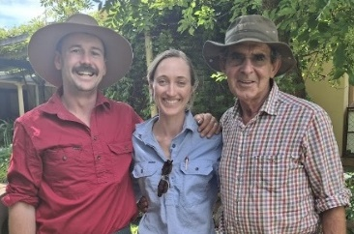
Figure 4 Miles Burow, Claudia Benn and New South Wales grazier David Marsh
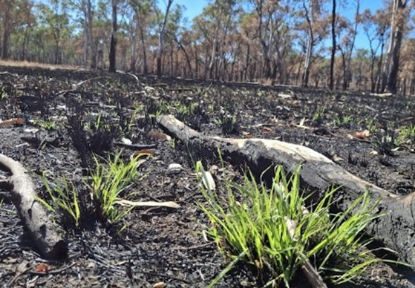
Figure 5 New life – grass regenerating after a fire
At the beginning of this journey, I believed that nature was fragile and needed us to repair it, but is it? I now believe that nature can be incredibly resilient. This realisation transported me from fear to hope. I am not denying our impact, for which we need to take responsibility and action, but I suspect it is our way of life that is far more fragile. Nature does not need us, but we certainly need it. If humans no longer existed, ecosystems would recover and find abundance and diversity in ways we could not dream of. Jamie Gordon and Garlone Moulin (‘Mt Pleasant’, Queensland) stated that “nature is incredibly robust, we just do not allow it the opportunity to show its strength. It can take pulse pressures, but not ongoing low-grade pressure” (Gordon & Moulin, pers. comm., 2024).
Perhaps it is not nature that needs to keep adapting to us, but we who must adapt and build resilience to thrive within this dynamic and complex world. Jane Slattery (friend, mentor, founder of SezuSpecial and co-founder of Natural Intelligence Farming) stated, “We are the ones that need to build resilience to stay here. The world needs people that can work with it” (Slattery, pers. comm., 2025).
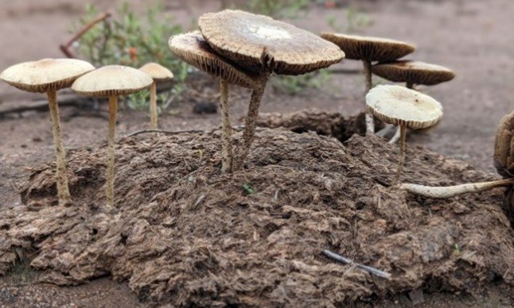
Figure 6 New life - mushrooms emerging from cow manure on a clay pan
Many of us have experienced the wonder of nature’s resilience in how life explodes after drought-breaking rain, how seeds lie dormant for decades waiting for the right conditions, how trees grow in fragmented boulders, and how fish and frogs reappear in dams after a long dry. These observations led me to the realisation - a key trait contributing to nature’s resilience is that it is incredibly adaptable.

Adaptability and control
Ecosystems constantly seek equilibrium by adapting and responding to the pressures applied, whether they be environmental or human induced. Hence, the trajectory of farms is a symptom of our management and nature’s ability to adapt and find a new equilibrium in the face of the change applied. It is certainly a risk that the ‘nature is resilient’ narrative can “let humans off the hook, underestimating the severity and permanence of thresholds being crossed in the Anthropocene. Systems may shift into novel, degraded states” (Curcio, pers. comm., 2025).
The new balance found by nature as it adapts may not align with our production and profitability expectations or environmental goals. It could mean moving down the plant succession ladder, increased pest and disease pressure or greater inputs required to maintain production. Once this progression begins, we tend to respond by trying to further manipulate or control how nature expresses itself, and so the cycle begins.
Constant change can feel threatening, and many cultures link stability and control with progress and prosperity. The agricultural revolution was a turning point that gave humans greater influence over food sources, reshaping the land to meet our needs. It also set the stage for a greater perceived sense of control over the natural world and a desire to understand, predict, shape and stabilise it. Combine this with unrealistic expectations about production, profitability or environmental outcomes, and we can find ourselves in an unsustainable and vulnerable production system. As in life, as in nature, change is the only constant.
From this, I have learnt the importance of recognising what I do have control over - which is how I choose to adapt and build personal resilience, and of course, how my farming practices impact the expression of nature’s adaptability. “We need to trust ourselves enough to get out of the way. Nature knows what it is doing” (Slattery, pers. comm., 2025).

2 Adapting to adversity
A smooth sea never made a skilled sailor (Franklin D. Roosevelt).
Resilience conversations vary considerably depending on context. Regions like the United Kingdom and the European Union focused on the environmental aspect, while conversations in Zimbabwe and Georgia centred more around governance, food security and education. Regardless of context or severity, common threads appeared and it was from those who had adapted and strengthened in the face of adversity that I learnt a lot about building personal resilience.
For me, this begged the question - can we build resilience without experiencing some level of adversity? In an environmental context, does seasonal adversity play a role in strengthening an ecosystem in the long run? Do we need to experience drought to build drought resilience? Ecosystems adapt over time through cycles of stress. These are natural and inescapable parts of life. To accept the challenges we face and to take the opportunity to learn, adapt and evolve is a step towards building resilience in ourselves, and as a result, our surroundings.
Just as natural systems have evolved to withstand and at times benefit from changing or adverse conditions, we too can learn from these adaptive strategies. Some of nature’s response mechanisms include:
- The natural selection of resilient plant and animal species and traits.
- Strengthening existing (and encouraging the formation of new) biological relationships and communities for enhanced survival.
- Co-evolutionary relationships and epigenetic changes.
- Shifts in dominant species and biodiversity balance.
By embracing change and adversity as a natural part of life and learning from nature’s adaptability, I wonder if we can build our resilience and cultivate farming systems that are better equipped to thrive in an ever-changing world. Russell Cooke from Red Range Stock Licks in Kununurra stated that “hard times have built resilience, and good things will come from it” (Cooke, pers. comm., 2024).
Farmers globally are adapting in response to change and building resilience through adversity. For example, farmers in Kununurra have trialled, built and invested in many different industries over decades to adapt to climate, isolation and logistical challenges. While not always easy, the common goal is working cohesively to support the communal and agricultural progression of the region. Fritz and Andrea Bolten are one example of many in the area who focus on building long-term resilience into their personal and business lives. They have trialled well over 20 crops to identify new industry opportunities for the region, continually thinking creatively and progressively, with a strong community and personal resilience focus that raises the entire region.
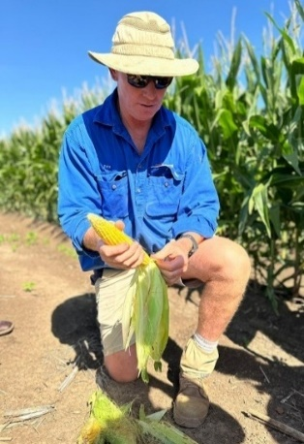
Figure 7 Kununurra farmer Fritz Bolten in his corn crop
Zimbabwean farmer Rob Fletcher has also adapted personally and professionally during challenging times. When he and his family could not leave their home, Rob began experimenting with old family chilli sauce recipes, making chilli for friends and family. It soon became a commercial venture, now exporting internationally. As Rob describes, “a beautiful thing came from considerable hardship”. Rob’s kind, forgiving heart, his generous community focus and his ability to redefine himself and his family business during challenging times are admirable.
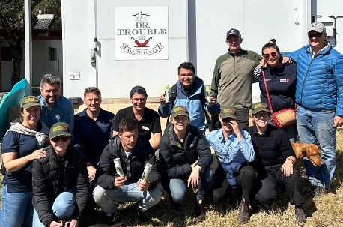
Figure 8 Our Global Focus Program group with farmer Rob Fletcher at the Dr Trouble headquarters in Zimbabwe
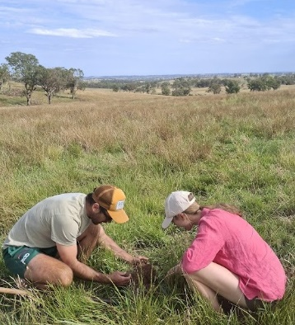
Figure 9 Exploring soil life with New South Wales farmer Jake Chandler
According to NSW farmer Jake Chandler, “we learn more from the troubles and difficulties in life than the successes.” (Chandler, pers. comm., 2025)
As a personal reflection, I have typically been fearful of change and adversity. I wanted to hit pause while personal or seasonal conditions were favourable. Ironically, avoidance made change even more challenging. Many of my greatest lessons throughout this experience have come from people’s willingness to be vulnerable and share their stories about navigating adversity and building personal resilience. It was from people sharing experiences about death, illness, unsuccessful business ventures, natural disasters, pandemics, political corruption, financial hardship, droughts, floods, market crashes, and everything in between that provided me with an entirely new perspective on navigating life’s challenges.
I have learnt that how I respond to change in life impacts how I respond as a farmer in an environmental context. By accepting adversity and change as inevitable parts of life, as nature does, I can better choose how I respond, adapt and transform not just as an individual, but as a steward of a resilient, adaptable farming system.
The oak fought the wind and was broken, the willow bent when it must and survived (Robert Jordan).

3 Embracing complexity
To every complex question there is a simple answer - and it is clever, neat, and wrong (H. L. Mencken).
In addition to nature’s remarkable ability to respond and adapt to change, embracing complexity is another key strength contributing to its resilience. While humans are good at managing complicated, we often struggle to manage complex (Wehlburg, pers. comm., 2023). Uncertainty and complexity can be intimidating, and we want to explain the inexplicable. Knowledge is power. The more we know about how nature works, the more we can either work with it, or in many cases, manipulate it to achieve our desired outcomes.
The motivation to understand something so complex has naturally resulted in a reductionist approach. This certainly makes the overwhelming complexity of life feel more manageable; however, nature’s interconnectedness provides a level of unpredictability that a reductionist approach alone cannot fully capture. We seek answers about nature by looking for patterns, linearity and simplicity in something that is neither linear nor simple (Buhner 2004a). Reductionism has enabled incredible discoveries in the biological world; however, it should also be balanced with systems thinking (Curcio, pers. comm., 2025).
Just as a well-woven spider web cannot be easily unravelled, ecosystems rely on interconnected relationships to maintain balance (Wehlburg, pers. comm., 2023). We have unintentionally oversimplified the natural systems that sustain us, thereby reducing their ability to adapt and display resilience. Despite the richness of diversity of life on earth, 75% of the world’s food comes from just 12 plant species and 5 animal species (WWF 2019).
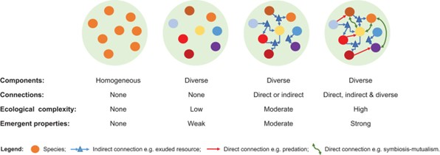
Figure 10 A depiction of the relationship between diversity, complexity and ecosystem resilience (source: Bullock et al. 2022)
Plant nutrition is a prime example of oversimplification in our farming systems which has negatively impacted microbe-plant relationships. Plant nutrient uptake is a co-evolved process involving a phenomenon called rhizophagy (White et al. 2018). Kempf (2020) describes rhizophagy as a cycle where specific microbes are taken up into the plant root cells, and nutrients and cellular components are extracted for plant use. Surviving microbes are released back into rhizosphere with exudates required to rebuild, a food source, and chemical signals indicating what nutrients the plant requires next.
This finding challenges the view that plants only passively absorb soluble nutrients. Instead, they actively interact and communicate with their microbiome through the mutually beneficial exchange of resources. An incredible example of co-evolution and complex relationships.
To look at nitrogen management specifically, Dr Christine Jones explains that legumes are not the only means of fixing atmospheric nitrogen. This process can occur inside non-leguminous plant leaves, stems, roots or via free-living microorganisms in the soil, provided there is a healthy, active and diverse microbiome. Where you have good fungi, you will have good nitrogen fixation in the soil (Jones, pers. comm., 2024).
Agronomist and international educator Joel Williams explains that naturally, plants will take up more complex molecules containing nitrogen in the form of bacteria, amino acids, proteins, peptides and other exudates, rather than just simplified forms like nitrate and ammonium (Williams, pers. comm., 2024). Therefore, instead of using energy to build proteins out of soluble nitrogen (for example nitrate and ammonium), plants can use amino acids, peptides and proteins directly. This is a far more energy-efficient way of supplying nitrogen as it requires less metabolic processing within the plant.
Nitrate and ammonium are naturally found in low concentrations in soil (Williams, pers. comm., 2024). Therefore, soil tests that only measure for nitrate and or ammonium miss entire fractions of more complex, nitrogen-containing compounds available for plant uptake. As a result, soluble nitrogen is often recommended, and excess nitrogen uptake in plants can cause nutrient antagonism and reduce lignin formation and cell structure. This can result in a higher risk of pest and disease attack, lodging and increased drought susceptibility.
Many agricultural pastures and crops certainly do suffer from nitrogen deficiencies, and soluble forms of nitrogen are often useful inputs to address such deficiencies. However, the root cause can be a symptom of an oversimplified system, characterised by reduced microbial activity, diversity, soil organic matter and disrupted plant-microbe relationships.
Plant geneticist Dr Walter Goldstein discovered that modern corn varieties have a significantly reduced ability to form symbiotic relationships with soil microbes (Goldstein 2022). Through targeted breeding, Dr Goldstein developed corn varieties that effectively form relationships with nitrogen-fixing bacteria, despite not being a legume. Without chemical inputs, these corn varieties also developed deeper root systems, better nutrient acquisition ability, natural pest resistance, higher nutrient density and yields on par with conventional varieties.
Many farmers visited across Australia, New Zealand, and Brazil are now incorporating this understanding of plant nutrition into their farming practices through the use of biological fertilisers.
Some examples of biological products include:
- Aerobic (containing microbes that grow in oxygenated conditions)
- Anaerobic (containing microbes that grow in low/no oxygen conditions)
- Vermi-products (worm by-products)
- Stimulants (metabolites, food sources, carbon sources and more)
While the product type, recipe and application methods vary from farmer to farmer, anecdotal outcomes reported include:
- Increased brix readings (i.e., nutrient density)
- Drought and frost tolerance
- Preferential grazing by livestock
- Increased pest and disease resilience
- General plant health and vigour
Bio-fertilisers are one example where anaerobic microbes are brewed with food sources and minerals to create a stable product containing beneficial microbes, metabolites, stimulants, nutrients, carbon and more. Queensland farmers Peter Attard and Dale Retschlag (among others) have experimented with various forms of bio-fertilisers. Peter and Dale are also supplementing livestock with microbial and mineral brews to improve feed utilisation, rumination efficiency and general stock health. Dale observed a 15% reduction in forage intake when he started supplementing his livestock with a microbial brew, without any loss in weight gains (Retschlag, pers. comm., 2024). This level of improved feed efficiency could significantly improve drought resilience in grazing systems.
These examples illustrate the intricate complexities of natural systems and the risk of oversimplified nutritional programs threatening the balance, adaptability and resilience of well-connected biological relationships. I visited many farmers who are becoming increasingly aware of these relationships and are finding creative ways to support complexity and incorporate biology into their cropping and livestock systems.

4 Supporting diversity
Plants transform dirt into soil, and diverse mixtures of plants transform soil into homes, grocery stores, and pharmacies for all life on earth (Dr Fred Provenza).
Complexity and diversity go hand in hand. Monocultures are uncommon in natural environments and create more vulnerable ecosystems susceptible to collapse. Despite this, modern agriculture often strives to eliminate unwanted diversity to grow a monoculture crop or pasture, then continues to fight the diversity that tries to creep back into the system to re-balance itself.
The conventional high-input version of agriculture I found to be unsatisfying as it led to simplified communities. Regenerative agriculture refers to management that allows the innate capacity of communities to be more diverse, to be expressed (Marsh, pers. comm., 2025).
Management practices that can increase diversity include:
- Companion cropping, intercropping and diversifying crop rotations.
- Multi-species cover crops or forages.
- Grazing management to support vegetation diversity.
- Stimulating microbial diversity and using biological inputs.
- Integrating multiple livestock species.
- Stacking enterprises or value-adding products.
- Supporting a diverse workforce.
Vegetation diversity provides differences in plant biomass, nutritional profiles, microbiomes and root architectures, and play varying roles related to:
- Nutrient cycling: accumulating specific nutrients and mobilising resources from the soil profile.
- Soil health: improving aeration, structure and water infiltration, reducing erosion, stimulating a diverse and active microbiome.
- Pest and disease control: supporting predatory insects, enhancing plant and microbial protection mechanisms and reducing pathogen prevalence.
- Ecosystem services: pollination, carbon sequestration, weed suppression and providing food and habitat for birds, insects and wildlife.
Many species with unique and overlapping roles allow for self-regulation and reduce the vulnerability of a system. If one species declines, others compensate to maintain balance. Essentially, diversity is nature’s insurance policy, spreading the risk to increase adaptability and resilience.

Every plant has a role and is there for a reason. They are wonderful indicators of the state of the soil, and we can learn a lot about underlying soil conditions by observing what grows well in a particular area (McCaman 2013). Some plants develop mechanisms to acquire a specific mineral more efficiently (e.g. copper), giving them a competitive advantage to thrive in copper-deficient soils. Therefore, spraying out these plants without any other soil or plant remediation strategies will not address the underlying copper deficiency that is creating the ideal conditions for these plants to thrive, and so they will continue to return.
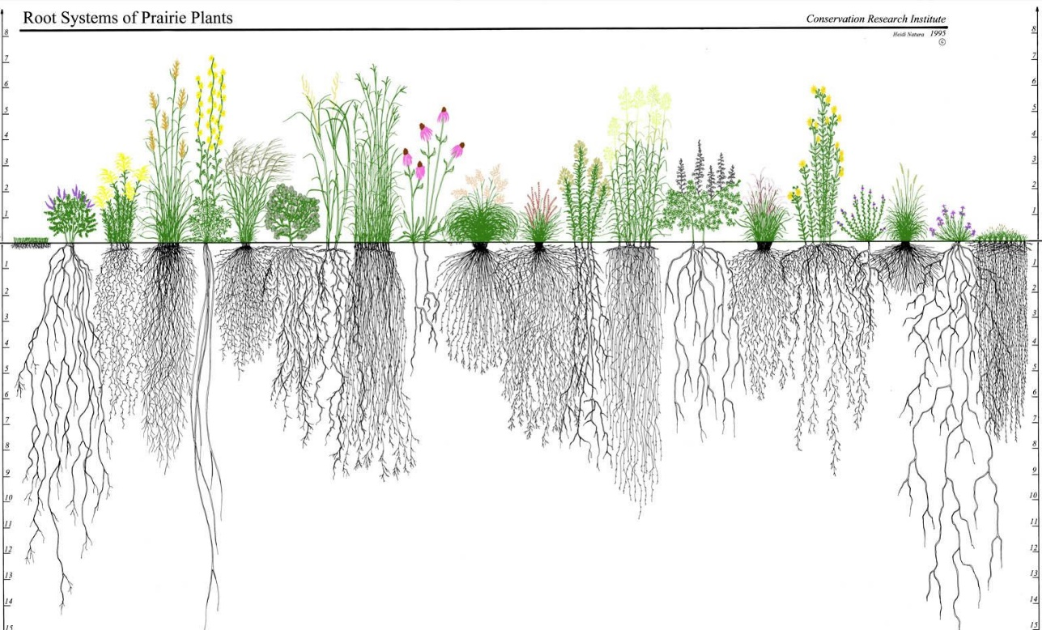
Figure 11 A visual representation of different root architectures, depths and functional roles (source: Lemke & Desalle 2023)
Many farmers are now learning to read the landscape and value these natural cues. This information can also be used when determining crop or pasture species to plant, by aiming to replace the role of the indicator species (or weed) with something more productive or palatable. From a livestock perspective, the value of diverse forage species is being increasingly recognised in terms of the potential to improve soil health, animal health and production and profitability.
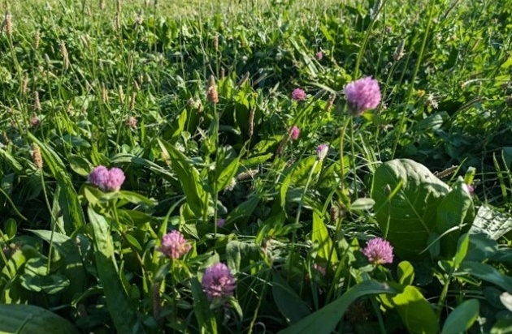
Figure 12 Diverse, multispecies pastures in Tasmania
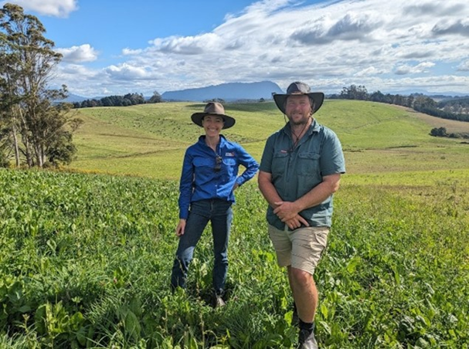
Figure 13 Diverse, multispecies pastures in Tasmania with dairy farmer Mark Lambert
On-farm trials in Gulgong, New South Wales, recorded significant improvements in sheep weight gains grazing a six-species forage mix of barley, field peas, faba beans, forage brassica, tillage radish and turnip, compared to single-species barley forage (Watershed Landcare Incorporated 2020).
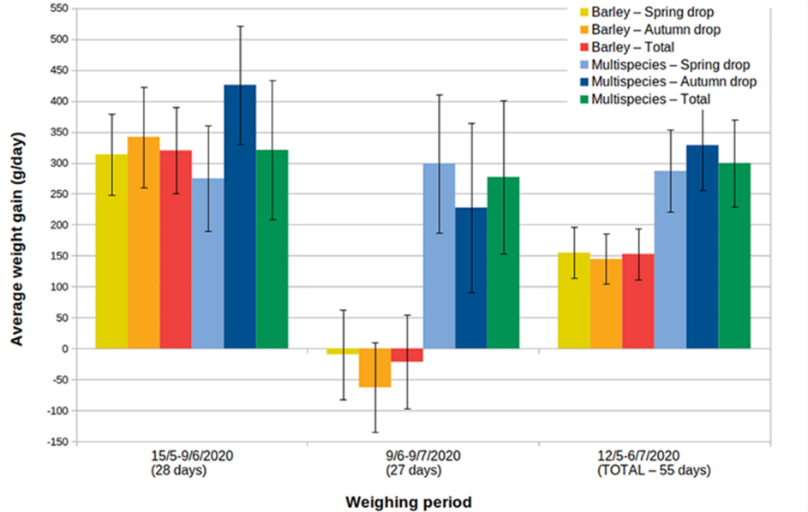
Figure 14 Comparison of lamb daily weight gains on multispecies versus monoculture forage (source: Watershed Landcare Incorporated 2020)
Note: The overall weight gain over 55 days was significantly greater in the multispecies forage (for both age groups), compared to the single-species forage.

Take the time to observe livestock, and they will teach you about the importance of diversity. You may notice animals selectively grazing or browsing plant species that are not traditionally considered productive or palatable. Are we undervaluing the importance of all kinds of diversity in grazing systems? For animal health, as well as more subtle contributions to ecosystems like microbial activity, soil health, wildlife food and habitats, frost protection, soil stabilisation and more.
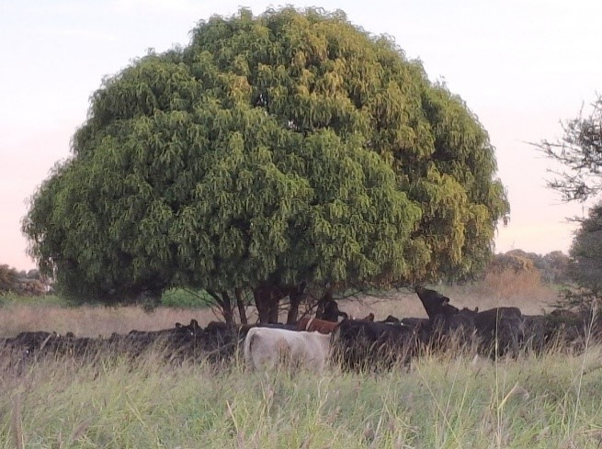
Figure 15 Cattle browsing on an emu apple tree
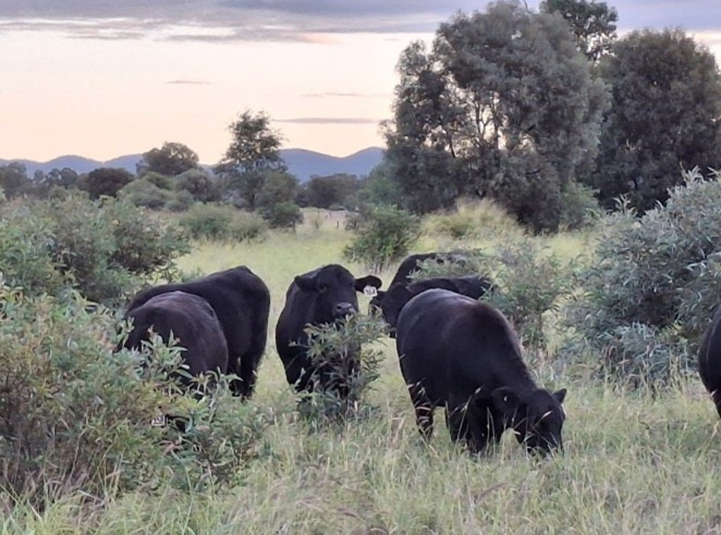
Figure 16 A steer browsing on brigalow regrowth

Nutritional wisdom and phytochemical richness
Nutritional wisdom is a term coined by researcher, internationally renowned author and valued mentor, Dr Fred Provenza, Professor Emeritus at Utah State University. It refers to a process of post-ingestive flavour feedback at the cellular level, which provides information to the animal and guides them to select the appropriate combinations of feed to meet their dietary needs (Provenza 2018). Provenza found that through this feedback loop, animals have the innate ability to select feeds that will balance protein, energy, fat, minerals and utilise secondary compounds. For example, sheep deficient in phosphorus preferentially selected feeds high in phosphorus, demonstrating their ability to link flavour with the positive post-ingestive effects of replenishing a deficiency (Provenza 2018).
Some farmers in Australia are incorporating this knowledge into their supplementation program in the form of free-choice minerals, allowing livestock to self-select to balance deficiencies. We have created a free-choice mineral trailer on our property, containing separate compartments of calcium, sulphur, magnesium, phosphorus, copper, zinc, sea salt, and powdered humates. When consuming a multi-mineral lick to address a single mineral deficiency, the animal is also consuming other minerals that are not required, which can lead to overconsumption and mineral antagonism. This can further exacerbate any imbalances or deficiencies. Ideally, the goal is to support vegetation diversity and biochemical richness so livestock can balance nutrition through diet without the need for mineral supplementation; however, I believe this method of supplementation is still valuable in the interim.
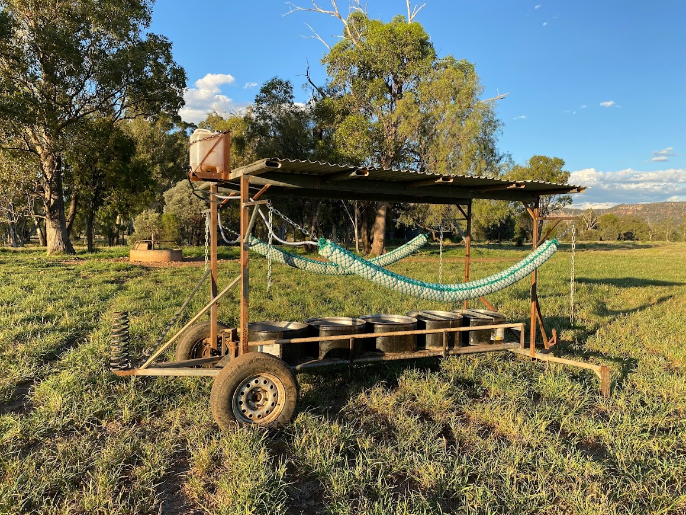
Figure 17 Free choice mineral trailer on Mt Kingsley
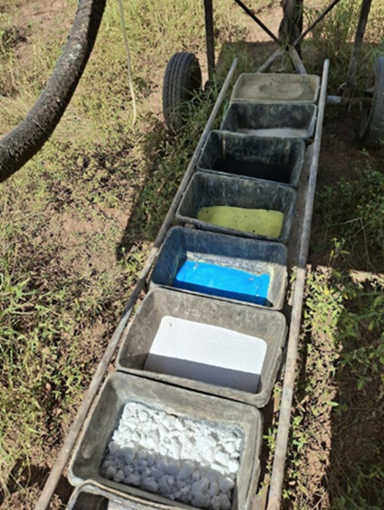
Figure 18 Different mineral compartments of the free choice trailer
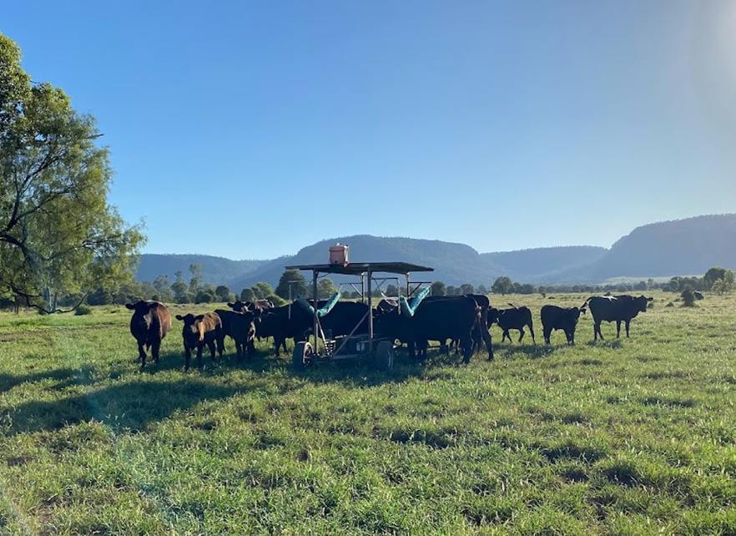
Figure 19 Cows accessing the free choice mineral trailer

While livestock nutrition has typically focused on balancing protein, energy and minerals, there is also an increasing understanding of the role of phytochemicals (secondary compounds produced by plants) in animal and human health. Within the plant, they help to defend against herbivores, pathogens and environmental stressors, provide a form of communication between plants, and attract pollinators and seed dispersers.
According to Naturopath Stacey Curcio, a single leaf can contain hundreds of phytochemicals, each with 50+ different biological functions (Curcio, pers. comm., 2024). The entourage effect means that the benefit is greater when consuming the entire plant with all these compounds together, rather than isolating one component.
Animals can self-medicate both prophylactically and therapeutically using plants, thanks to these unique arrays of phytochemical compounds (Provenza 2018). Bitter-tasting (and sometimes toxic) compounds such as alkaloids and tannins often deter grazing because they signal toxicity or reduced digestibility. However, when animals experience nutrient deficiencies or health challenges, they may actively seek out these phytochemical-rich plants for self-medication.
Provenza (2018) found that when sheep were infected with intestinal parasites, they increased their consumption of tannin-rich plants, effectively using it as a form of self-medication to combat parasite load. Provenza (2018) notes that cattle with access to diverse, phytochemically rich forages experienced fewer health problems and better overall productivity.
This adaptive behaviour highlights the complex relationship between phytochemicals and diet selection, where livestock balance palatability and functional benefits to maintain health and therefore performance. When diet lacks diversity, choice and biochemical richness, animals are more likely to be reliant on external supplements and medications, reducing the resilience of grazing systems.
At the Grassroots Festival in Tasmania, 2024, Dr Pablo Gregorini from Lincoln University in New Zealand explained that biochemical diversity trumps yield in plants; however, in recent times, yield has been selected to trump biochemical diversity. Pasture and forage species have been selectively bred for yield and palatability to increase intake and digestibility, at the cost of phytochemical richness and associated functional and health benefits (Gregorini, pers. comm., 2024).
At the same event, Dr Christine Jones explained that diets high in secondary compounds (typically higher in herbages than in grasses) also build microbial diversity in the gut. This increases the ability to digest other feeds, improving feed conversion efficiency and immunity (Jones, pers. comm., 2024).
I have observed nutritional wisdom at play on our property when a mob of weaners stripped the leaves off a patch of cobbler’s peg, typically considered a weed. The nutritional profile of cobbler’s peg showed significantly higher protein and mineral levels compared to our dominant pasture species, buffel grass. It also contains over 300 phytochemicals with numerous health benefits (Kuo, et al. 2021).
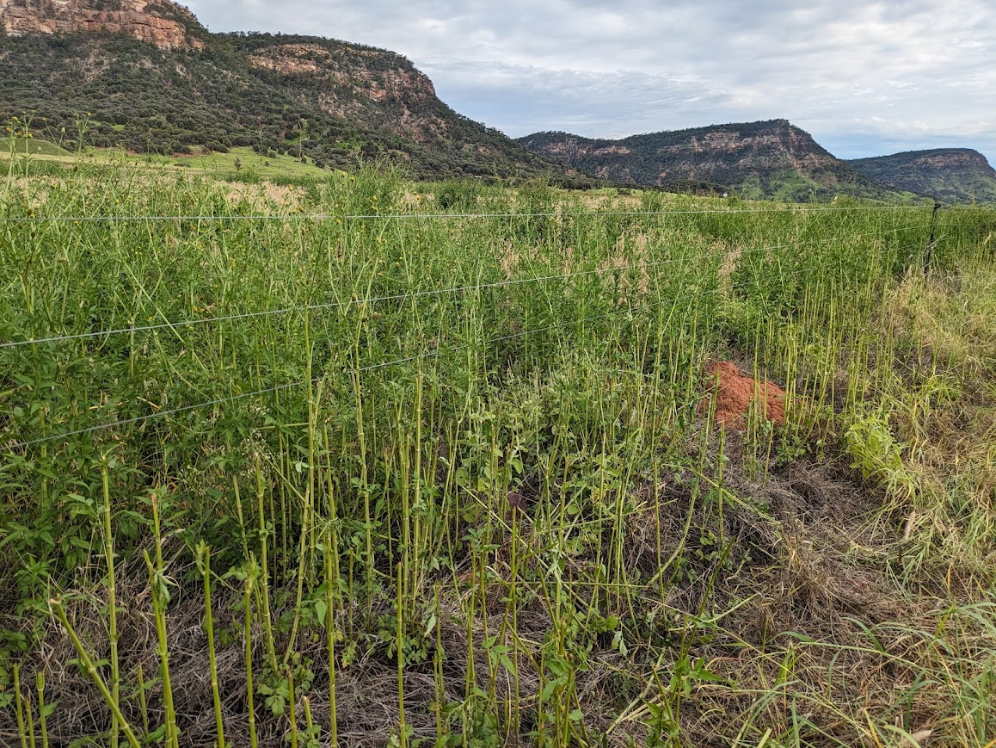
Figure 20 Grazing of cobbler’s peg along a fenceline, Mt Kingsley
Beyond cobbler’s peg, I have observed cattle eating wait-a-while, Mayne’s pest, fleabane, wild gooseberry and other herbages typically considered weeds, some of which can even be toxic at higher doses. All in average seasons with ample pasture available. What are they selecting for, when, and why?
Even if I could match nutritional profiles of soil and leaf samples with dung, hair, blood or tissue samples, I will still never know why cattle select specific plants at specific times. And more importantly, maybe I do not need to know.
As valued friend and mentor Dr Nan Bray said, “It is risky to draw conclusions because in doing so we make assumptions and stop looking and listening for other explanations” (Bray, pers. comm., 2024).
Could getting comfortable in a state of wondering help us see unexpected possibilities in nature’s complexity? A humbling realisation is that cattle (and all animals and plants) know far more than we ever will about what they need, why they need it and how to balance their own nutritional and health needs, so let us instead consider how we can facilitate that.

Shepherding
Interestingly, shepherds have been using this experiential knowledge for thousands of years. Shepherding is one of the oldest professions in the world and is an incredible example of the connection between people, landscapes, plants, animals (livestock, dogs, wildlife, predators) and environmental conditions. It requires constant observation, adaptation and connection between all components. Spending four days in the French Alps with shepherd, author and 2024 Nuffield scholar Joseph Boussion, his son, dogs, and flock was an example of so many of these learnings coming together.
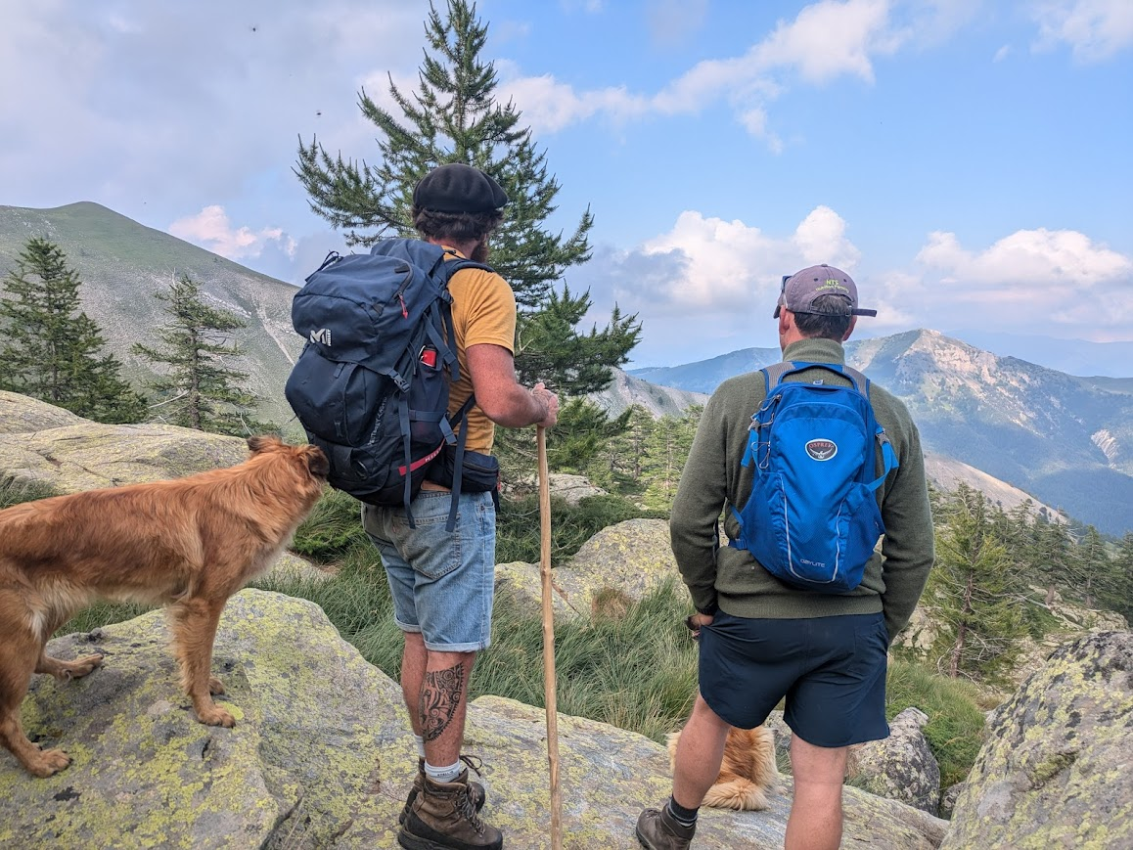
Figure 21 Miles Burow and Joseph Boussion shepherding in the mountains in France
Joseph would plan the grazing route each day, ensuring the livestock got access to a balanced diet for health and production. This required an incredibly in-depth local knowledge of the rangeland, individual plants, vegetation mixes, sheep and goat nutritional requirements, behavioural patterns throughout the day, weather conditions, predator behaviour and much more. Often, the plan had to be quickly adapted depending on the behaviour of the sheep.
Joseph would continually look for feedback as to how and where to graze each day. For example, he would notice physiological signs in the sheep that indicated they had consumed too much protein or energy the day before, then he would adjust where they would go the following day to allow them access to the vegetation required to balance that.
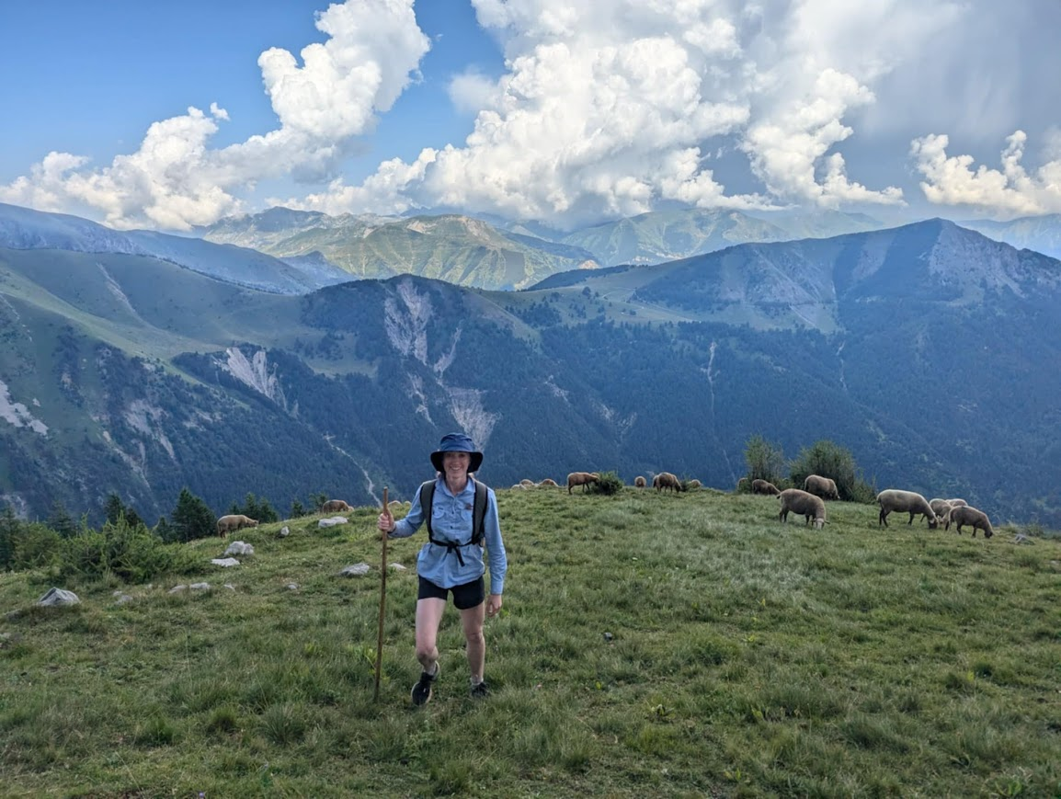
Figure 22 Shepherding in the French Alps
It appeared that grass was a lesser component of the sheep’s diet; herbs being the majority, which is considerably different from most grazing systems in Australia. Joseph explained that some plants with high fibre can take three days to digest, so the following day the sheep eat less of them. During the rest and rumination time in the middle of the day, Joseph pointed out that when chewing their cud, the number of chews per minute tells you the amount of roughage they have consumed and how well they are ruminating. It also determines how long they will ruminate and rest for during the day. This provides feedback as to what vegetation is best suited for the afternoon graze to balance fibre intake from earlier in the day.
Shepherds stimulate appetite by planning mealtimes and meal order to increase intake of less desirable species, while taking into consideration animal behaviour. Meuret & Provenza (2014) explain in The Art and Science of Shepherding that “the main thing is to plan a grazing circuit that allows animals to encounter a diversity of forages and in an order that boosts their appetite”.
Shepherds will identify vegetation areas and palatability, linking that knowledge with meal phases such as appetite stimulators, appetite moderators, first course, booster, second course and dessert. These meal phases are arranged in a specific order to optimise intake and nutritional balance in a grazing circuit. Not only are shepherds grazing based on livestock nutritional and health requirements, but Joseph also explained that it is vital to preserve the condition of the land, as that determines the season next year.
The rationale behind herd management is not solely aimed at optimising animal production. It is embedded in a systemic and agroecological approach, where zootechnical performance, behavioural learning of animals, and the sustainability of pastoral ecosystems are inseparable. (Boussion, pers. comm., 2025).
Just as we have simplified the complex interactions of nutrient uptake and plant-microbe interactions, so too have we overlooked and oversimplified the importance of vegetation diversity, biochemical richness and the art of nutritional wisdom in modern grazing systems. The bond, care and mutual respect between the sheep, dogs and Joseph was incredible. The sheep listened, and so did Joseph. They live and learn together, the epitome of connection, community, diversity and local knowledge within a complex system. While most of our grazing systems in Australia are significantly different to shepherding in the French mountains, there are still many lessons we can incorporate. By practising curiosity and creativity, we can deepen our knowledge of the land and livestock in our care and find ways to incorporate this into modern grazing systems.

5 Building community
When one tugs at a single thing in nature, they find it attached to the rest of the world (John Muir).
While acceptance, adaptability, complexity and diversity all contribute to nature’s resilience, I believe the way these traits come together through connection and community is the defining factor. You cannot have a resilient community without resilient individuals and strong relationships. Biological relationships and communities between soil, microbes, plants, animals and people are critical to life as we know it. And yet, a common perspective in modern agricultural systems and one I have had myself is one of resource scarcity and competition.
This worldview has become ever more pervasive in the West, where the accent is on the individual, manufactured scarcity, and competition. That was not the case historically in the East and in Indigenous cultures, where the accent was on the group, abundance, and cooperation (Provenza, pers. comm., 2025).
An example of this thinking is that all plants compete to rob moisture, nutrients, sunlight and space for individual survival. While I believe competition is still a necessary component for evolving survival traits, this blanket statement contradicts the notion that the natural order trends towards complexity and biodiversity. Could plants be more communal than we care to believe?
Plant-microbial connections provide an excellent example of what is possible within co-evolved communities. Fungi can connect and interact with plant roots, acting as a rich underground network and far extending the reach of root systems. The network allows communication and resource sharing between plant communities in exchange for carbohydrates and other compounds synthesised by the plant.
In The Hidden Life of Trees, Wohlleben (2016) describes how trees within a forest utilise these networks to support each other. For example, ‘mother trees’ (older, larger trees) act as central hubs in the networks and support younger trees by transferring resources. This transfer can also work in reverse. Even after being cut down, the stumps of some trees can remain alive for years (despite not being able to photosynthesise) thanks to neighbouring trees continuing to support their elders. Interestingly, this phenomenon does not only occur amongst the same species of tree.
Aside from resource exchange, this network also provides a platform for communication. If insects attack one tree, it will send distress signals through the fungal network (or air) to warn surrounding trees (Babikova et al. 2013). In response, the surrounding trees can activate their defence mechanisms, which might include releasing bitter or toxic compounds in their leaves to reduce the palatability to the attacking insect.
Trees experiencing dry conditions can communicate the need to conserve moisture via the fungal network, triggering surrounding trees to close their stomata, limit moisture loss and prepare for upcoming drought (Elians 2024). The mycorrhizal network then facilitates the partitioning of water among trees (Russell et al. 2025).
Wohlleben’s research challenges the belief that plants are solitary and passive organisms, arguing that forests function as social communities that engage in incredibly complex interactions facilitated by fungal networks. They actively work together to maintain the diversity, health and longevity of the entire forest.
From a drought resilience context, the effects of these plant-microbe networks contribute immensely to vegetation resilience during dry times. At the RCS Convergence Conference in 2022, Walter Jehne (Australian soil scientist and climate biologist) described how fungi form glomalin, which is the glue that holds soil particles and minerals together for good soil structure and porosity (Jehne, pers. comm., 2022). An effective water cycle requires pore space connectivity deep into the profile, meaning fungal glomalin production fundamentally changes the hydrology of soil, improving both infiltration and rainfall capture.
At the same conference, John Kempf (Advancing Eco Agriculture) explained how plant roots can access water to a 70μm (micrometre) thickness around a soil particle, whereas mycorrhizal fungi can access water to a 30μm thickness (Kempf, pers. comm., 2022). Bacteria can access even more than this and combined with the sharing of resources between biology and plants, shows how an active and diverse microbial community can significantly contribute to vegetation drought resilience.

Crop communities
In an agricultural setting, at the Grassroots Festival in Tasmania 2024, Joel Williams explained how legumes and cereals can form symbiotic relationships through biological connections (Williams, pers. comm., 2024). Cereals are nitrogen hungry and scavenge nitrogen in the form of amino acid exudates from legumes, which then stimulates the legume to fix more nitrogen. Because of this relationship, legume and cereal mixes are more efficient at capturing nitrogen then a monoculture of legumes (Rodriguez et al. 2020). In return, cereals can release specific root exudates which break down and chelate particular trace element compounds, improving uptake for both the cereals and legumes.
Reciprocal nutrient exchange enhances the growth and health of both plant types, showing how different plant families can form symbiotic relationships and create a community motivated by joint survival. Williams says these multispecies mixes interact more as a community than in competition, but that is entirely reliant on active and diverse microbial communities (Williams, pers. comm., 2024). Dr Christine Jones explains that if seeds germinate with a healthy microbiome and mycorrhizal network, they can easily establish in what we would previously have considered to be a ‘competitive environment’ (Jones, pers. comm., 2024). Community and connection build resilience.
Williams also refers to how domestic crop varieties have been selectively bred for high yield above other traits, which has resulted in carbon being allocated to above-ground biomass at the cost of below-ground communities and microbial relationships (Williams, pers. comm., 2024). This can have significant unintended consequences on the formation of plant-microbial communities and the associated functions (e.g., nutrient cycling, nutrient uptake, plant immunity, soil carbon, microbial diversity and pest and disease resilience), thereby increasing input reliance.

The Jena Experiment
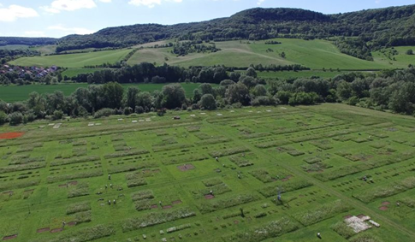
Figure 23 The Jena Experiment (source: The Jena Experiment 2002)
Note: The purpose of this study is to research how plant diversity influences ecosystem functions and outcomes over time.
The Jena Experiment is one of the world’s longest-running biodiversity studies, starting in 2002 in Germany and running for over 2 decades. The study has found that plots with over 16 plant species have triple the carbon storage, built topsoil 2.7 times faster, supported 45% more pollinators, and recovered from drought twice as fast as the monoculture plots.
Equally as interesting is the change in relationships over time. Initially, species competed for resources but then began to actively cooperate by developing sophisticated networks below ground. Soil analyses revealed that extensive mycorrhizal networks formed, connecting plants and transitioning the relationship from one of competition to one of community. “The most productive combinations were the ones that had time to adapt to each other” (The Jena Experiment 2002).
The observed relationship transition was as follows:
- Years 1–2: competitive establishment
- Years 3–4: cooperation patterns emerge
- Years 5–7: stable resource-sharing networks form
- Years 8+: maximum ecosystem services achieved
This shows how biological relationships not only boost productivity but also contribute to building communities, how communities lead to complexity and diversity, and how these traits build resilience in a system.
Could competitive plant relationships be a function of oversimplified agricultural systems? Leading to a loss of complexity and diversity and a breakdown of the biological relationships needed for resilient communities? What if we focused on community, not competition, and if these networks and relationships were reinstated?
The patterns we see in plant and microbial communities directly transfer to human communities. Resilience is not just an individual trait, but a communal one. Just as forests rely on fungal networks and a level of altruism, farming families and rural communities must also build resilience through connection and information sharing.

6 Fostering intergenerational resilience
As farmers and agronomists, we are very good at optimising yields this season, but what about profitability and sustainability for the next 20, 50, 200 years? (Ian Moss, FARM Agronomy and Resource Management).
Resilience extends beyond us, our farm or even our generation. It is about building personal resilience, embracing connection and community in all facets of life, engaging in active knowledge transfer and supporting the next generation to grow. According to Casey Toews from Fishburn Ranch in Alberta, Canada, “we must value resilience over time and not just in the short term, but it is difficult to put a dollar value on that. It is easy to take a few shortcuts for short-term cash flow, but this could impact long-term economic or environmental resilience which is much harder to measure.”
There is much we can learn from microbes, plants and animals about the value of intergenerational and peer-to-peer learning channels, and the role these play in our rural communities and agricultural industry. Livestock possess fascinating social structures that facilitate knowledge transfer, localised adaptation and intergenerational resilience. In our intergenerational breeder mob, we often see animals from the same year cohort and with consecutive or close tag numbers coming through the yards together, or grazing side by side out in the paddocks. They likely bonded as calves, came through the yards together at branding, were weaned together, and now graze side by side with their own calves. What impact could this social structure and behaviour have on the transfer of nutritional wisdom, localised adaptations and even animal health and productivity?
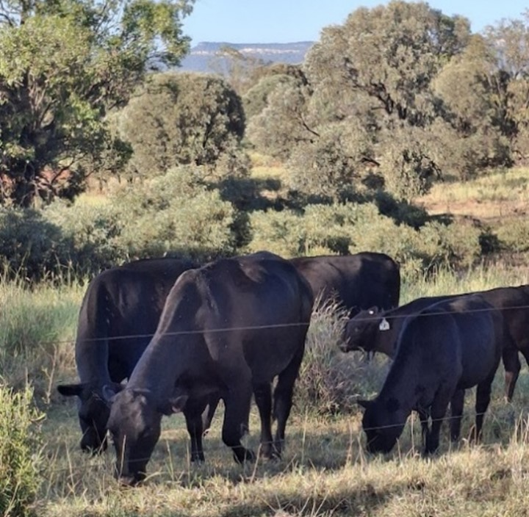
Figure 24 Calves grazing and learning alongside their mothers at Mt Kingsley

Provenza (2018) explains that animals will naturally roam in extended families. Social learning, particularly between mothers and offspring but also peer-to-peer, ensures animals acquire foraging and behavioural skills for environmental adaptability. Lambs raised with their mothers learnt which plants were safe by mimicking foraging behaviours (Provenza 2018). Lambs separated from their mothers were less adept at selecting a nutritionally balanced diet and more likely to consume harmful plants.
Interestingly, even experienced (but unrelated) animals introduced into naïve herds can act as mentors, assisting the group to learn how to forage effectively in a new environment. This social learning dynamic shows that foraging behaviour is not just an individual trait, but a group phenomenon.
Intergenerational adaptations can also be physiological. Epigenetics explores how learned behaviours and environmental influences shape genetic expression and physiology, without changing the DNA itself (Thompson, Nilsson & Skinner 2020). “The genes of animals and humans (and other living organisms) are in constant dialogue with their environment” (Massey 2017).
Some epigenetic changes can be passed down to offspring, meaning that an individual’s experiences can shape the health, behaviour and resilience of future generations (Provenza 2018). The transfer of nutritional information begins before birth, as flavours from the mother’s diet transfer to the offspring via amniotic fluid and then milk, exposing offspring to specific tastes early in life (Provenza 2018).
Studies where lambs born to ewes that consumed saltbush during pregnancy exhibited changes in kidney structure and function, enhancing their ability to process high-salt diets (Chadwick, Williams, Philip & Revell 2009). Provenza (2018) also found that calves exposed to mature forages in utero eat more, grow better and digest mature forages more efficiency than calves not exposed. These findings demonstrate how local adaptability can be built through the generations.
In a preliminary trial at Mt Kingsley, we recorded double the daily weight gains over two months when weaners were returned to their breeding mob post-weaning (once their mother’s milk had dried up), compared to those kept separate. There is an unrealised potential to improve animal health, welfare, feed efficiency and localised adaptability by acknowledging the influence of social factors and knowledge transfer. Dr Nan Bray is a merino wool farmer in Tasmania who has been exploring exactly this and discovering the benefits of incorporating it on farm.

White Gum Wool
Nan is an ocean physicist turned merino wool farmer in Oatland, Tasmania. Nan has navigated an incredible, and at times challenging, journey learning how to farm her way. In the process, Nan has formed deep connections and transformed herself and her business, her flock and the landscape. One of Nan’s pivotal moments was when she stopped looking for the expert and started relying on her observations, knowledge and connection to the sheep and land (Bray, pers. comm., 2024). This led to her transition from a conventional wool system (with meat as a secondary product), to moving up the supply chain and selling yarn directly to customers.
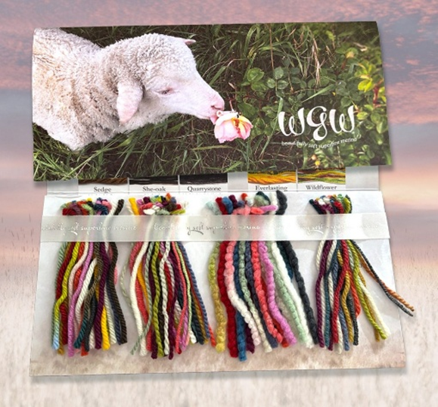
Figure 25 White Gum Wool yarn samples (source: White Gum Wool n.d.)
The story behind White Gum Wool is one of mamas and babies, of diversity and abundance, and of ethics - for the land, the animals and the people involved in making this yarn. (White Gum Wool n.d.).
White Gum Wool is produced with three key commitments including excellence in nutrition, a conservation land ethic, and thoughtful animal welfare. At the core of the system’s success is Nan’s connection to the livestock and land. “We do not even have empathy for ourselves, let alone our animals or land.” For Nan, much of the process has been about learning to step back, trust the livestock, and allow the human-animal-land connections to be restored.
The flock grazes as a cohesive social group on predominantly native pastures in one intergenerational flock, where “their social structure is well established, and successive generations have had the benefit of being taught nutritional wisdom by their mothers. Sheep are highly social animals, and keeping families together means the sheep are just plain happier.” Nan spent years shepherding her flock across the farm, observing and learning about connection, nutritional wisdom, vegetation biodiversity, grazing habits and social behaviours. According to Nan’s observations, it takes two the three years for young to learn foraging habits from their mother.
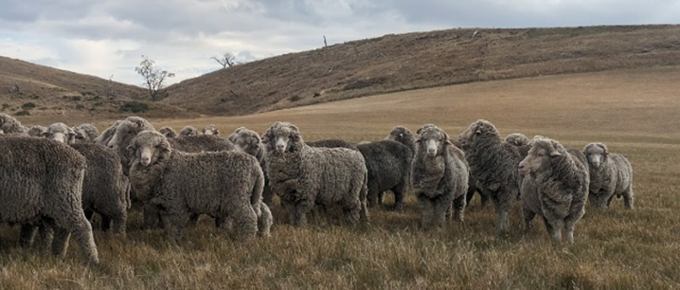
Figure 26 Nan’s merino flock
For at least a couple of years, I’ve been convinced that my flock is locally adapted to their home. The term 'locally adapted' is not rhetoric; it has a specific meaning in the context of animal behaviour. Locally adapted animals know how to thrive in their environment—where to find shelter, water, and the plants they need to stay healthy. Babies absorb nutritional knowledge in the womb from their mama’s food choices, and hit the ground already attuned to the forages they will need as they grow (Bray, pers. comm., 2024).
Today, there is no weaning, docking or mulesing. The sheep are kept through to old age, die on the property and are buried with trees planted on top as part of a revegetation project. Moving up the supply chain and developing the White Gum Wool brand to sell quality yarn directly was essential for this to be a financially viable option. It has created a considerable point of difference in the wool market, appealing to ethically conscious shoppers and aligning with Nan’s deep connection to the flock.
Since adapting grazing management practices, lowering the stocking rate, supporting biodiversity and facilitating nutritional wisdom in an intergenerational flock, Nan has noticed significant changes in flock health. There has been no need to treat for intestinal worms, and very few animals die of health-related issues anymore. The reduced worm burden and improved nutrition mean the sheep do not scour and still have their tails to swish flies, significantly reducing the prevalence of flystrike. Organic or synthetic fly treatment options are still utilised when required.
Nan has reported a 27% increase in wool production per sheep, a 30% increase in fertility, easier lambing, significantly reduced internal parasite treatment and improved general health. Interestingly, since moving to a system where sheep live out their natural life on the farm, Nan found that older sheep (into their teens) still produce excellent quality wool. The length can be 10% shorter, but no change in strength, quantity or colour. These improvements in production parameters and efficiencies have compensated for the reduced stocking rate required to maintain vegetation diversity and facilitate ‘a conservation land ethic’.
Nan Bray and her brand White Gum Wool are a unique and inspiring example of what is possible when curiosity is paired with connection, humility, observation and innovation. From exceptional animal welfare with a focus on health, nutrition and social behaviours, to landscape conservation, a value-adding business model and strong interconnectedness throughout, Nan has forged an exciting path towards a new way of farming with nature.

Microbial inheritance in plants
The horizontal and vertical flow of information also occurs in the plant and microbial world. While many of us are aware of the importance of the microbiome to people and animals, according to Dr Christine Jones, plants also have a unique microbiome (Jones, pers. comm., 2024). In a process called microbial inheritance, a parent plant will transfer an entire community of microorganisms to the seed as it develops (Jones, pers. comm., 2024). This package contains specialised symbionts that will form the foundations of the microbiome of the new plant, helping it grow and adapt.
According to Dr Jones, a single barley seed can be packaged with 9 billion microbes. As the seed germinates, the microbes colonise the developing seedling, creating symbiotic relationships for the lifetime of that plant (conditions dependent). The health, immunity and success of that plant is directly related to the diversity of the microbiome it develops and maintains throughout its life (Jones, pers. comm., 2024). A healthy and diverse ecosystem results in an increased sharing of microorganisms amongst, and a more complex microbiome for all involved. This is further passed on to the next generation of seeds, contributing to a stronger and more resilient community with each generation.
Factors like soil fertility, fertiliser and chemical use, soil disturbance, seed treatments and many other management factors also impact the health of a plant’s microbiome. Sourcing quality seed raised from a healthy plant in healthy, microbially active soil can provide the plant with a significant head start, thanks to the microbiome it carries. Given this, we might want to consider the impact of applying fungicides to seeds.
Matt Marshall from Crescent Nine Pastoral, Springsure, Queensland has experienced firsthand the possibilities of supporting microbial inheritance in plants. Matt grows irrigated and dryland hay and grain alongside a bull stud and commercial cattle enterprise. Matt’s entire operation is certified organic, and his fertiliser regime consists of composted manure pellets and liquid microbial and nutritional applications. Matt brews both aerobic and anaerobic microbes with a variety of minerals, and applies these products via seed dressings, liquid injection and foliar applications. Matt regularly sap tests his irrigated lucerne and uses this information to tailor bio-fertiliser applications to target specific nutritional deficiencies. Matt explained that because the products he brews are so biologically active, as is the soil environment, the crops respond very quickly to bio-fertiliser applications.
While the bio-fertiliser and microbial applications are a key ingredient, Matt explains that he cannot vouch enough for multi-species cover cropping and the impact on soil health, mineral cycling, nutrient availability and building a healthy microbiome. “We still do not know how it all works in the soil, we just know it does”. The health of the system is evident in the quality of Matt’s products. We have bought lucerne and multispecies hay from Matt for years, and it is always preferentially selected by our cattle compared to any other supply of hay, regardless of the type. The cattle know.
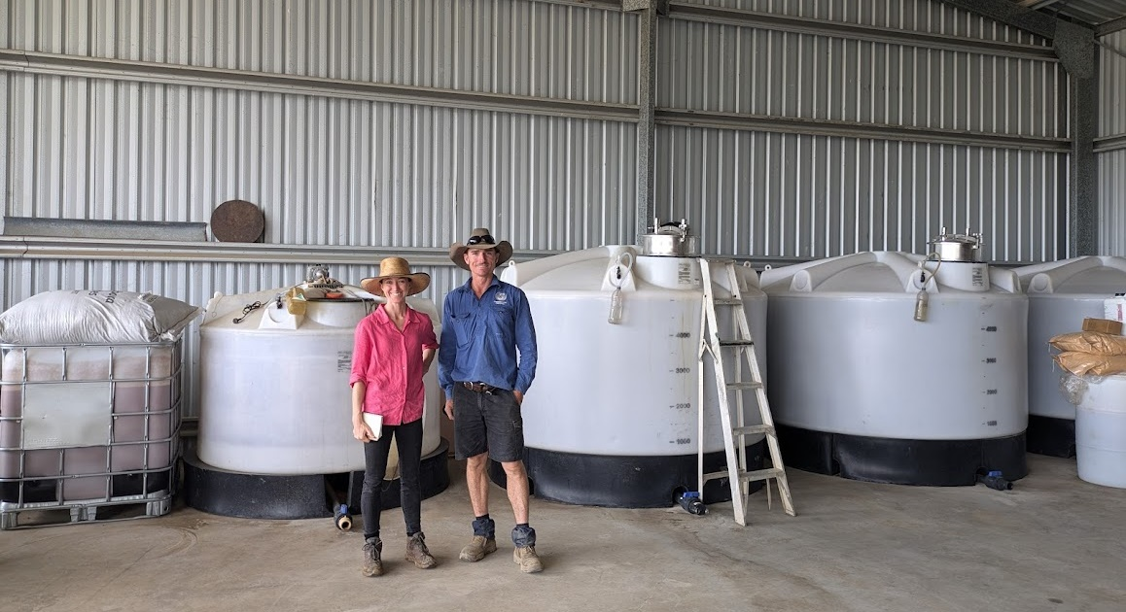
Figure 27 Aerobic and anaerobic microbial brewing tanks with Matt Marshall
Matt has also experienced the benefits of microbial inheritance. Years ago, Matt bought low-quality Condamine wheat seed that did not yield well and only achieved 9-10% protein. Each year, they retained seed and in 2024, the wheat harvested pushed 16% protein in a certified organic system with no synthetic nitrogen. The variety has even been de-registered because it was not considered high enough quality or protein, yet Matt has been able to drastically improve the quality of the seed through a healthy, active and diverse soil and plant microbiome. According to Matt, “the quality of the seed has improved every year and now it is through the roof”.
How to achieve this will look different for every farmer and context, but Matt is showing the enormous potential that can be realised when we acknowledge and work with natural processes and biological communities.
Intergenerational resilience is as much about social resilience as it is about ecological resilience. Many rural communities are struggling, and Australia is not alone in this trend. Parts of Canada and the United States are experiencing similar shifts due to extensification, fewer family farms and mechanisation. Just as livestock rely on learned behaviours and social structures to adapt, our farming communities benefit from social memory, peer-to-peer learning and support networks. The wisdom of previous generations, the courage of early adopters, and the power of shared stories shape not just land management decisions but the resilience of rural life itself.
I urge us all to consider our role in the flow of information vertically (generationally) and horizontally (peer-to-peer), and how we are contributing to building resilience for the next generation. Not only is it about passing on experiences, but also providing encouragement to question, challenge, think critically and creatively and provide the space to try, ‘fail’, learn, evolve and adapt.
According to New Zealand farmer Simon Osbourne, “it is not about teaching people what to do or how to do it, but how to think. If we can facilitate lateral and creative thinking, that will go a long way towards building intergenerational resilience” (Osbourne, pers. comm., 2024).

7 Human connection – the heart of resilience
Having explored the complexity, intelligence and resilience of the natural world, where do we fit in?
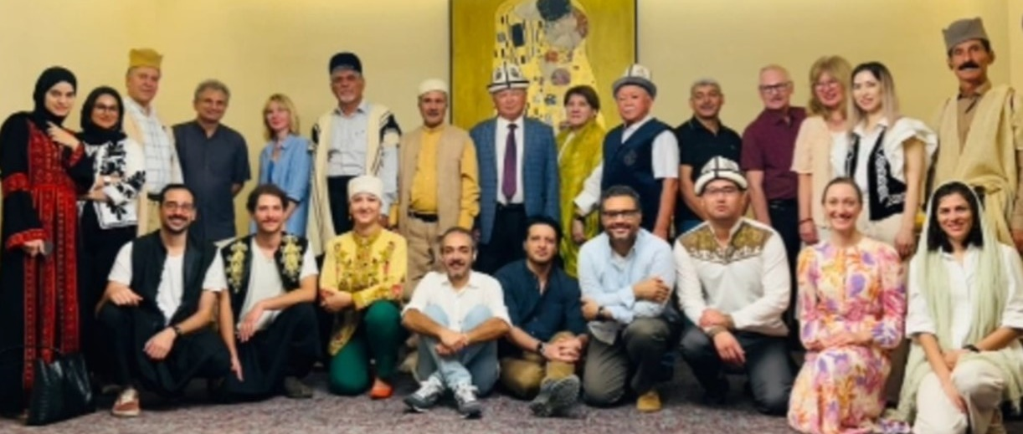
Figure 28 Attending the Territories for Life Pastoralism Consortium, Istanbul
In Turkey, during a Consortium exploring protecting Territories for Life and traditional pastoralism, I discovered there was no direct translation for the word ‘landscape’ among nomadic pastoralist tribes in Turkey and Jordan. When members of the tribe describe places, they do not necessarily use visual or physical features like we do such as soil type, vegetation or topography. Instead, they describe moments and feelings tied to specific locations. They carry not only individual memories, but also generational stories passed down over time. For example, a place might be marked by where a grandmother passed, where a baby was born or where the goats were lost the previous year. They could take you straight to the physical location, but it is felt and remembered in a deeply connected and personal way. They walk within it, while we tend to walk on it.
This example struck me as the perfect representation of people being a tightly woven component of an ecosystem. It is defined by stories, feelings, life and death, culture and extended families – human and non-human. Memories are embedded in the ‘landscape’ for generations. As Provenza (2018) suggests, we’ve broken linkages with the planet that sustains us.
People are members, not masters, of nature’s communities. We have forgotten that wild plants, insects, fish, birds, and mammals are our extended family. What we do to them we do to ourselves (Provenza 2018).
Like the pastoralists of Turkey and Jordan who relate to land through feeling and generational memory, in Georgia, connections are expressed through food, wine and tradition. Relationships are formed and deepened over long, slow lunches. When making wine, there is a deep connection to the entire production and consumption process. From the way they grow the grapes to the 8000-year-old tradition of fermenting wine in Qvevri (clay vessels buried underground), connection is foundational. The Georgians were proud to share and savour the result with new and old friends. For many of the winemakers, their ‘why’ was about the relationships and connections with those who consume it.
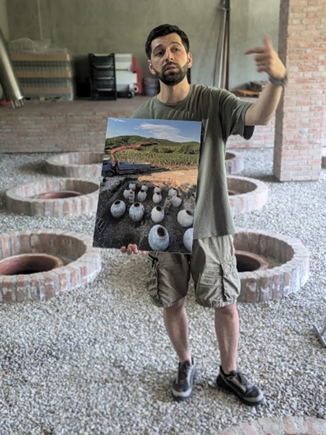
Figure 29 Discovering the passion and traditions connected to food and wine and Georgia
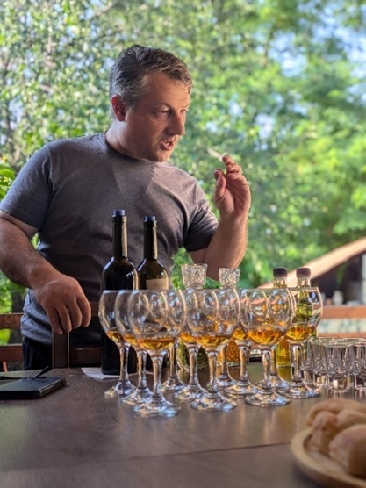
Figure 30 Discovering the passion and traditions connected to food and wine and Georgia
What is our culture around food production and consumption in Australia? Are we connected to the land, the biological communities, the food we produce and those who eat it? As farmers, are we proud of the way we grow and share our food? In the busyness of life, let us not lose our connection to food, why we grow it, where it comes from and those we share it with.
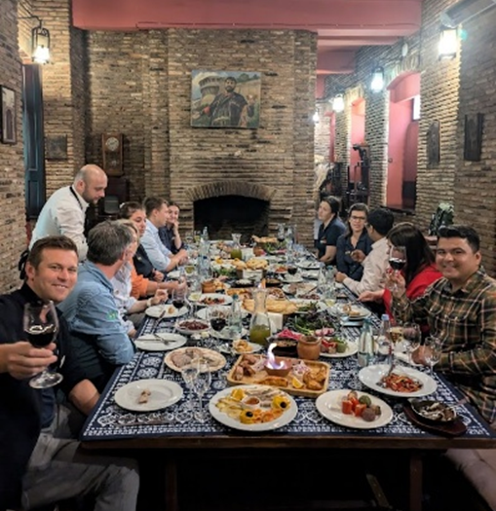
Figure 31 Our Global Focus Program experiencing Georgian food, wine and hospitality
The theme of connection (to land, food and community) emerged repeatedly in different production systems across the world. For many, this meant building a relationship between producers and consumers. In Saskatchewan, Canada, Derek and Tannis Axten are an example of this in both principle and practice. Derek and Tannis run Axten Farms, where they grow 15 different grain crops each year with biological inputs and management practices centred around soil health and crop nutrition. While their farming system is impressive, so too is their commitment to building resilience and connection in their local community and broader customer base.
We do not want to be wasteful, but we should not base everything on efficiency. This has been a downfall of rural regions – bigger machines, less people, and prioritising efficiency over community. We are regenerating the soils and working to bring life back to our soil, farm and community (Axten, pers. comm., 2025).
The Axtens have invested in an on-farm grain grading facility and flour mill to shorten their supply chain, produce value-added products, provide traceable home-grown and nutritious food to consumers, create local job opportunities and grow regional industry. The social aspect is just as important to them as the environmental and economic.
Derek and Tannis have worked hard to produce nutritionally dense products that maintain that quality through processing and have invested in getting the data to prove it. Even with this comparative nutritional data, however, encouraging consumers to shift purchasing habits and invest in producer-consumer connections remains an ongoing challenge.
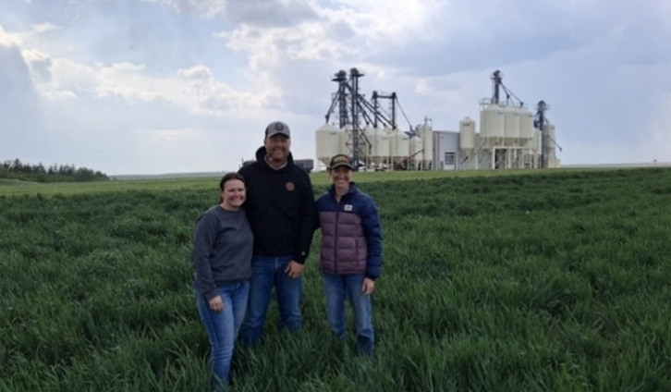
Figure 32 Tannis and Derek Axten in front of their grain grading and flour mill facility
Like the Axtens, others are also rethinking what connection to food and community can look like in modern agricultural systems. In another example of connecting producers and consumers, Casey, Jaclyn, Galen and Gwen Toews from Fishburn Ranch in Alberta are directly marketing their beef. Interestingly, despite also having detailed nutritional data on omega-three to six ratios and complete nutritional profiles to compare with other beef products on the market, Casey’s experience is that their customers buy into the story (and the flavour) more than the science. While it will certainly take time, we are starting to see a shift of consumers wanting to reconnect with their food, where it comes from, how it is grown and who is growing it.
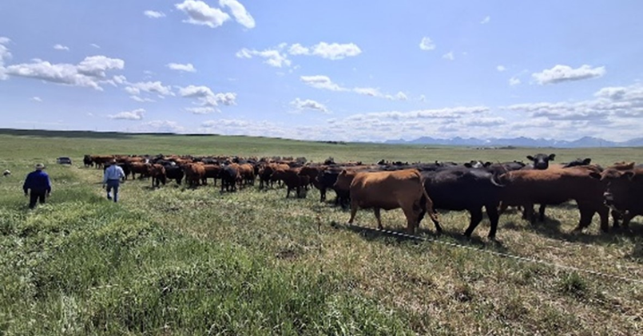
Figure 33 A total grazing system at Fishburn Ranch, Alberta
Building resilience in farming systems is about supporting connections at all levels. Not just farmer to land, but person to person. Community member to community member. Producer to consumer. Whether it is plants and microbes exchanging nutrients, livestock transferring knowledge, or people sharing stories over a meal, resilience is built through relationships. When production is infused with meaning and community, and when we choose to facilitate connections, it becomes more than an economic transaction. And perhaps, at its core, that is what resilience is – relationship.

Conclusion
Instead of offering a recipe for resilience or a checklist of specific management changes, this report aimed to provide a different perspective on what we do as farmers and food producers, one that embraces meaning and connection. By exploring the intelligence and complexity of the natural systems we farm within, we begin to see that resilience is relational, intergenerational and entwined in every living system.
There are extraordinary examples of resilient people, landscapes and farming systems across the globe, each unique, yet sharing common threads. These traits mirror those within nature that contribute to its own resilience. This report explored these traits by providing examples from both the natural world and global case studies, identifying lessons relevant to building resilience in our own lives and farming systems. Key insights included:
- Nature is resilient and adaptable; however, ongoing human and environmental pressures can still drive it to decline. It is we who must adapt and adjust our practices to support ecosystem function in a changing climate.
- Change is constant, and resilience lies in acknowledging what we can control, letting go of what we cannot, and choosing how we respond.
- Complexity and diversity are nature’s insurance policies. From plant-microbe interactions to livestock nutrition, systems rich in diversity and complexity are more stable, productive and resilient.
- Life is not purely competitive; it is also collaborative. Plants, microbes and animals can function as social communities that engage in complex interactions to build stronger systems. Can we learn from this to support our rural communities?
- Resilience spans generations and knowledge sharing is foundational. Plants pass microbiomes on through seeds, and livestock pass down nutritional wisdom to build local adaptability. Likewise, farmers can build long-term resilience by contributing to knowledge sharing across generations.
- Connection brings meaning and strength to ecosystems and communities. When we connect deeply with ourselves, the land, animals and our communities, farming becomes about more than just production.
Increasing resilience in Australian agriculture is as much social and cultural as it is ecological. It builds over time and through relationships. Answers do not lie in replicating someone else’s system, but in understanding our own more deeply. That requires slowing down to listen to and observe the land with humility and open curiosity. By embracing complexity rather than resisting it, by working with life rather than against it, we may find not just greater resilience to events like drought, but a deeper sense of meaning in what we do as farmers and food producers.

Recommendations
Read books and study nature. When the two do not agree, throw out the books (William Albrecht).
There is no instruction manual for building resilience or supporting biological relationships, nor should there be. Every farmer, landscape and relationship is unique and the most powerful tool you have is your own observations and curiosity. These recommendations offer guiding principles, not prescriptions.

Embrace change
- Change is inevitable, the opportunity lies in how we accept and respond.
- Learn from adversity and use the experience to reflect, adapt and strengthen.
- Focus on what you can control, let go of what you can’t and know the difference.

Build ecological literacy
- Find a balance between reductionist and systems thinking. Both have value when learning about ecosystem functions.
- Learn from science and experts but also look, listen, smell and feel to learn about your own system deeply. Observe, question and experiment.
- Use visual cues, animal behaviour and landscape indicators to inform management decisions. Be open, listen to the land and adapt based on what you observe.
- In a world increasingly dependent on tech and data driven decisions, certainly use these tools, but don’t lose the human connection component of farming. Experience, gut feel, observation and intuition still matter.
- Learn with a sense of humility, curiosity and creativity.

Foster complexity and diversity
- Vegetation diversity: incorporate companion cropping, intercropping, crop rotations and multi-species cover crops or forages.
- Microbial diversity: incorporate biological fertilisers, consider the impact of excessive antimicrobials and source seed from healthy soils.
- Livestock nutrition: support pasture diversity to allow expression of nutritional wisdom, consider free choice or microbially complexed mineral supplementation, consider social structures and learning in mob management, foster vegetation diversity through grazing.

Prioritise connection and community
- Take inspiration from fungal networks and forest ecosystems which actively collaborate to support collective health and diversity.
- Support generational (vertical) and peer-to-peer (horizontal) knowledge sharing.
- Let food systems be about more than just production. Remember why we do it. Build connection, culture and meaning into the way food is grown, shared and valued.
- Reconnect with yourself, the land, livestock and all facets of biological communities.

References
APA Dictionary of Psychology n.d., Resilience, American Psychological Association, Washington DC, accessed 20 June 2025.
Babikova, Z, Gilbert, L, Bruce, T, Birkett, M, Caulfield, J, Woodcock, C, Pickett, J & Johnson, D 2013, Underground signals carried through common mycelial networks warn neighbouring plants of aphid attack, Ecology Letters, vol. 16, no. 7, pp. 835–843, DOI: 10.1111/ele.12115, accessed 10 April, 2025.
Buhner, SH 2004a, The lost language of plants: The ecological importance of plant medicines for life on earth, Chelsea Green Publishing, Vermont.
Bullock, J, Fuentes-Montemayor, E, McCarthy, B, Park, K, Hails, R, Woodcock, B, Watts, K, Corstanje, R & Harris, J 2022, Future restoration should enhance ecological complexity and emergent properties at multiple scales, Ecography, vol. 2022, no. 4, DOI: 10.1111/ecog.05780, accessed 15 April 2025.
Chadwick, M, Williams, I, Philip, V & Revell, D 2009, Feeding pregnant ewes a high-salt diet or saltbush suppresses their offsprings postnatal renin activity, Animal, vol. 3, no. 7, pp. 972-979, DOI: 10.1017/S175173110900425X, accessed 6 May 2025.
Curcio, S n.d., Cultivating Wellness, accessed 4 April 2025.
Elians, P 2024, Plant communication: Do trees really talk to each other?, International Research Journal of Plant Science, vol. 15, no. 5, pp. 1–2, DOI: 10.14303/irjps.2024.49, accessed 10 April 2025.
Goldstein, W 2022, The evolution of a partnership-based breeding program for organic corn, Journal of Agriculture, Food Systems, and Community Development, vol. 13, no. 1, pp. 71–90, DOI: 10.5304/jafscd.2023.131.011, accessed 7 June 2025.
Griffith News 2022, What Australians really think about climate change: survey, Griffith News, accessed 17 May 2025.
Harris, W 2023, A bold return to giving a damn: One farm, six generations, and the future of food, Viking, New York.
Holling, CS 1973, Resilience and Stability of Ecological Systems, Annual Review of Ecology, Evolution and Systematics, vol. 4, pp. 1-23, DOI: 10.1146/annurev.es.04.110173.000245, accessed 17 May 2025.
The Jena Experiment 2002, The Jena Experiment: A long-term biodiversity study, The Jena Experiment, accessed 13 June 2025.
Kempf 2020, Direct absorption of molecules, John Kempf, accessed 21 March 2025.
Kuo, TF, Yang, G, Chen, TY, Wu, YC, Minh, HTN, Chen, LS, Chen, WC, Huang, MG, Liang, YC & Yang, WC 2021, Bidens pilosa: Nutritional value and benefits for metabolic syndrome, Food Frontiers, vol. 2, no. 1, pp. 32–45, DOI: 10.1002/fft2.63, accessed 6 May 2025.
Lemke, M & Desalle, R 2023, The role of microbial ecology in restoration ecology in the age of genomics: a summary of the microbial ecology special issue, Microbial Ecology, vol. 85, no. 3, pp. 1136-1141, DOI: 10.1007/s00248-023-02206-w, accessed 6 May 2025.
Massey, C 2017, Call of the reed warbler: A new agriculture – a new earth, University of Queensland Press, Queensland.
McCaman, JL 2013, When weeds talk (2nd ed.), JL McCaman.
Meuret, M & Provenza, F 2014, The art and science of shepherding: Tapping the wisdom of French herders, Acres U.S.A, Texas.
Provenza, F 2018, Nourishment: What animals can teach us about rediscovering our nutritional wisdom, Chelsea Green Publishing, White River Junction, Vermont.
Rodriguez, C, Carlsson, G, Englund, JE, Flohr, A, Pelzer, E, Jeuffroy, MH, Makowski, D & Jensen, E 2020, Grain legume-cereal intercropping enhances the use of soil-derived and biologically fixed nitrogen in temperate agroecosystems. A meta-analysis, European Journal of Agronomy, vol. 118, DOI: 10.1016/j.eja.2020.126077, accessed 7 June 2025.
Russell, M, Rezacova, V, Miller, KS, Nardi, WH, Brown, M & Weremijewicz, J 2025, Common mycorrhizal networks improve survival and mediate facilitative plant interactions among Andropogon gerardii seedlings under drought stress, Mycorrhiza, vol. 35, no. 1, p. 8, DOI: 10.1007/s00572-025-01181-z, accessed 21 March 2025.
Thompson, RP, Nilsson, E & Skinner, M 2020, Environmental epigenetics and epigenetic inheritance in domestic farm animals, Animal Reproduction Science, vol. 220, DOI: 10.1016/j.anireprosci.2020.106316, accessed 6 May 2025.
Watershed Landcare Incorporated 2020, Multispecies forage crops for lamb production, soil carbon sequestration and offsetting livestock emissions, Watershed Landcare Incorporated, accessed 18 March 2025.
White Gum Wool n.d., Ethical superfine merino from the Tasmanian Midlands, White Gum Wool, accessed 25 March 2024.
White, JF, Kingsley, KL, Verma, SK & Kowalski, KP 2018, Rhizophagy cycle: An oxidative process in plants for nutrient extraction from symbiotic microbes, Microorganisms, vol. 6, no. 3, p. 95, DOI: 10.3390/microorganisms6030095, accessed 21 March 2025.
Wohlleben, P 2016, The hidden life of trees: What they feel, how they communicate, Greystone Books, Vancouver, Canada.
WWF 2019, 50 foods for healthier people and a healthier planet, World Wildlife Fund for Nature, accessed 19 June 2025.

Bibliography
Buhner, SH 2004, The secret teachings of plants: The intelligence of the heart in the direct perception of nature, Bear & Company, Vermont.
Griffith, DF 2021, Wild like flowers: The restoration of relationship through regeneration. Robinia Press, Virginia.
Griffith, DF 2024, Stagtine: Kincentric rewilding, science, & a tale of letting go. Robinia Press, Virginia.
Hennecke, J, Bassi, L, Albracht, C, Amyntas, A, Bergmann, J, Eisenhauer, N, Fox, A, Heimbold, L, Heintz-Buschart, A, Kuyper, TW, Lange, M, Pinheiro Alves de Souza, Y, Rai, A, Solbach, MD, Mommer, L & Weigelt, A 2025, Plant species richness and the root economics space drive soil fungal communities, Ecology Letters, vol. 28. no. 1, pp. 1-14, DOI: 10.1111/ele.70032, accessed 7 June 2025.
Langer, EJ 1975, The illusion of control, Journal of Personality and Social Psychology, vol. 32, no. 2, pp. 311-328, accessed 12 March 2025.
Leopold, A 1970, A sand county almanac: With essays on conservation from Round River, Ballantine Books, New York.
Smallwood, R, Curcio, A & Rebar, AL 2023, Internal locus of control buffers the impact of daily stressors on Australian Farmer’s well-being: A cross-sectional study, The Australian Journal of Rural Health, vol. 31, no. 2, pp. 285-293, DOI: 10.1111/ajr.12948, accessed 12 March 2025.

