USER GUIDE

NEXDOC
How to view my Client Group Token and Client Group ID in the NEXDOC portal

__________________________________________________________________________________
In this document
This document contains the following topics.
Purpose of this document 2
How to view my Client Group Token and Client Group ID in the NEXDOC portal 2
Contact the NEXDOC help desk 6

Purpose of this document
The purpose of this document is to provide guidance on how to view your Client Group Token and Client Group ID in the NEXDOC portal.
Note: You must register via the online service portal before you can use the NEXDOC portal. Please refer to Create and Manage your account user guide for instructions on how to complete this registration.
Note: If you have registered for a client group administrator, you are able to:
- View your client group token.
- Add/ remove people from your client group.

How to view my Client Group Token and Client Group ID in the NEXDOC portal
Step 1  Log in to the Online services portal | 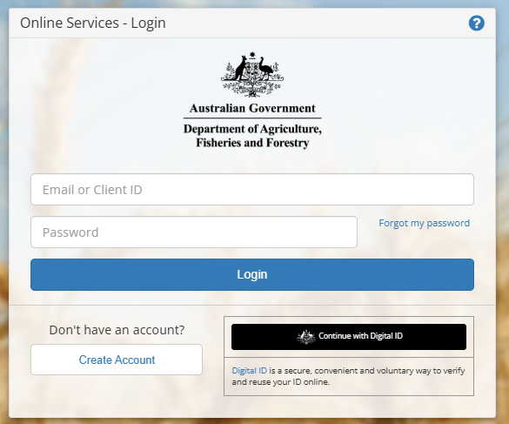
Step 2  Select Go to NEXDOC Homepage | 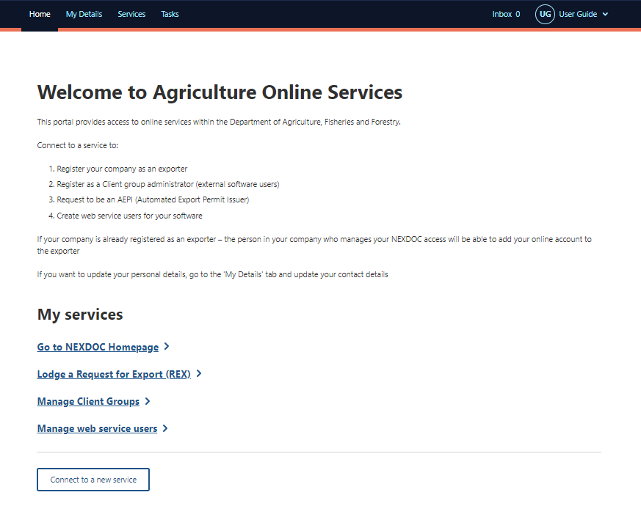
Step 3  Select the Account tab | 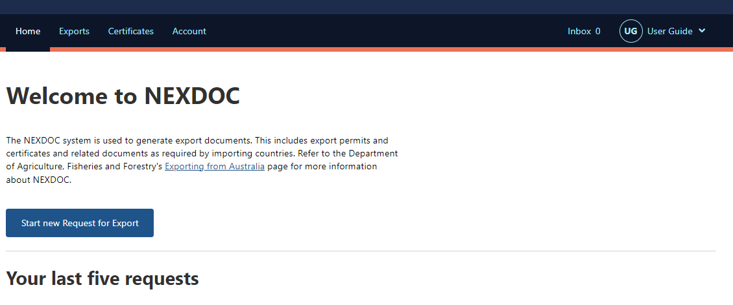
Step 4  Select the NEXDOC services | 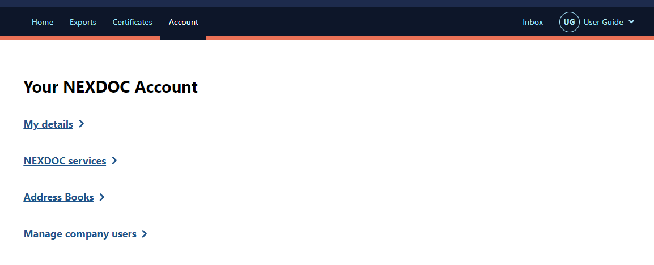
Step 5  Select the Client Groups tab | 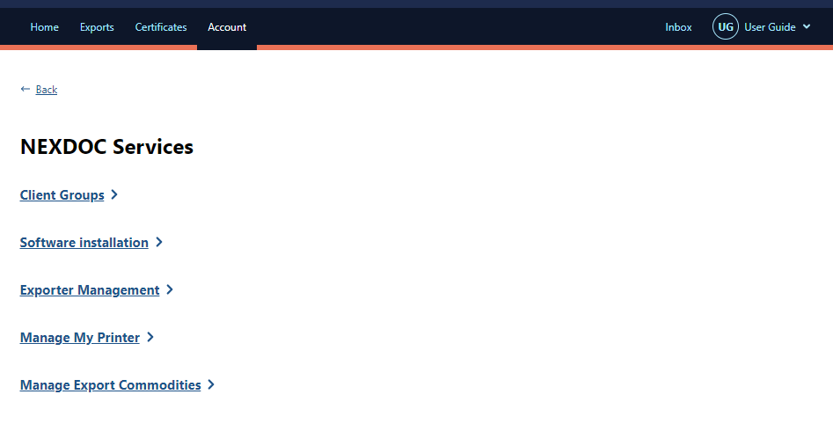
Step 6  Client Group Tokens for all client groups can be viewed from this screen. | 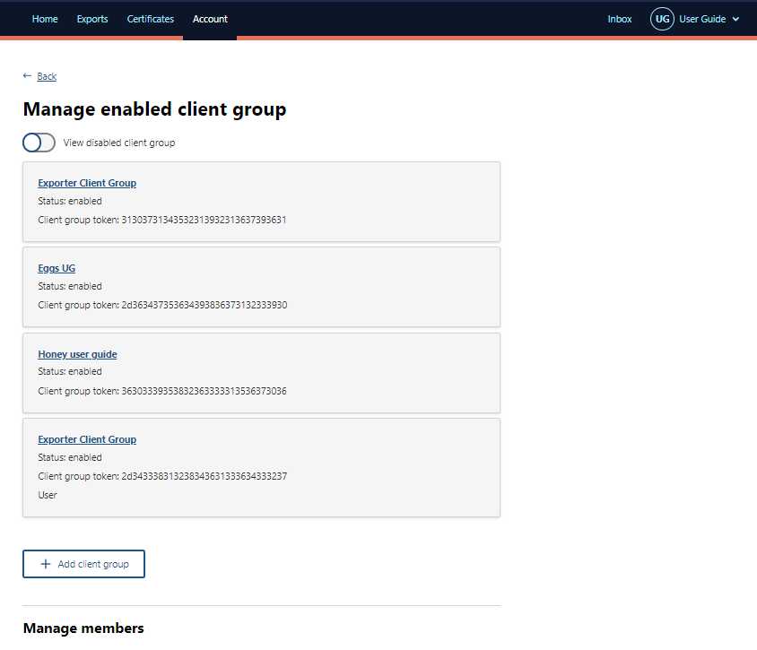
Step 7
Select the Client Group you wish to view.

Step 8  Select the Change under the Export Client Group detail heading to view the Client Group information. | 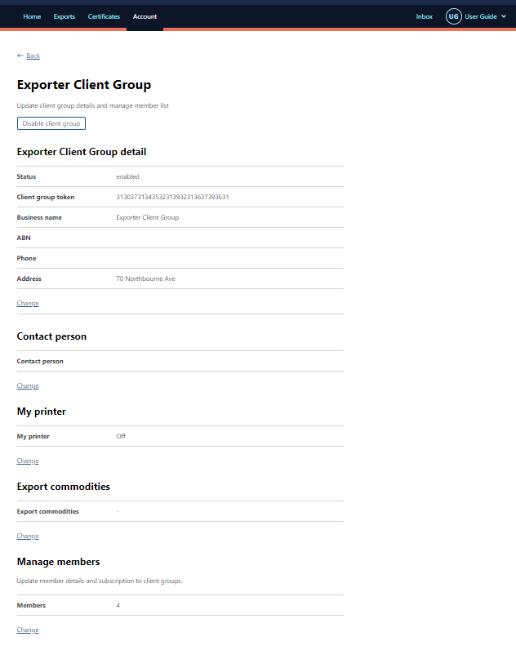
Step 9  Your Client Group Token and Client Group ID can be seen on the right-hand side of the screen. | 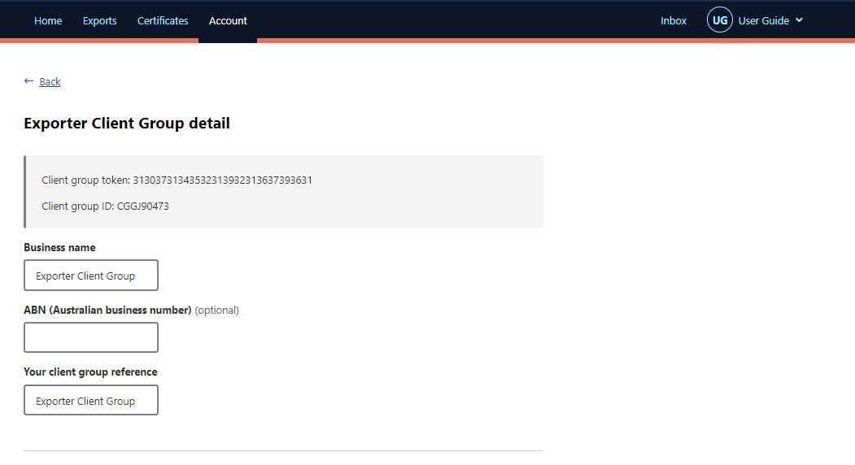

Contact the NEXDOC help desk
For more information or assistance, please contact NEXDOC@aff.gov.au

