**PRN 1213-0264**

**Climate Modelling to Determine the Impacts of *Phytophthora cinnamomi* under Future Climate Scenarios**

**FINAL REPORT**

**11th September 2013**

**Dr John Scott (CSIRO)**

**Dr Treena Burgess, Prof Giles Hardy (Murdoch University)**

**Dr Chris Dunne (DPaW)**

**Prof David Cahill (Deakin University)**

with the collaboration in gathering samples from

Dr Bill Dunstan (CPSM)

Dr Angus Carnegie (Forestry Corporation NSW)

Dr Keith McDougal (NSW Office of the Environment and Heritage)

Dr Vera Andjic (DAFF)

Mr Tim Rudman (Department of Primary Industries, Parks and Environment)

Mr Mike Stukely (DPaW)

Mr Colin Crane (DPaW)

**CPSM logo.tiff**

# Executive Summary

*Phytophthora cinnamomi* is listed as a 'Key Threatening Process to Australia's Biodiversity' and has had considerable impact on many plant communities throughout much of Australia. However, how the distribution and impact of *P. cinnamomi* will change with future climate change is unknown. This study used existing datasets on *P. cinnamomi* distribution together with strategic soil surveys from regions outside the pathogen's known distribution range and used CLIMEX modeling to determine its likely distribution in 2070 based on the CSIRO-Mk3.0 global climate model. The modeling demonstrates that in the future, areas with previously unfavourable conditions, particularly at altitudes above 700 m may result in an increase in disease incidence, as these regions become warmer over time. In addition, in areas where rainfall is predicted to decrease, disease incidence is likely to decline. This is the most comprehensive study of *P. cinnamomi* distribution undertaken to date. The information will be useful to managers and policy makers involved in ensuring the spread and impact of *P. cinnamomi* is contained in the future

**Table of Contents**

Executive Summary 2

Introduction 5

Methodology 6

Data sources for presence and absence of P. cinnamomi in Australia 6

World data sources 6

New collections (2013) 6

Sampling and molecular identification 7

Environmental samples 7

DNA extraction 7

Amplicon library generation, quantification and 454-pyrosequencing 7

Quantitative polymerase chain reaction (qPCR) for detection of Phytophthora cinnamomi 7

CLIMEX parameters 8

Climate datasets 8

Findings 9

Distribution of P. cinnamomi 9

CLIMEX models 9

qPCR results 10

Comparison to earlier models 10

Climate change scenario 10

Concluding remarks 11

Acknowledgements 11

References 12

Tables 15

Table 1. Sources of locality data for *P. cinnamomi* and locality data that were negative for *P. cinnamomi* in Australia and Papua New Guinea. 15

Table 2. Information sources used to initiate the CLIMEX modelling process in various models. The parameter set in Sutherst et al. (1999) is undocumented. 17

Table 3. CLIMEX parameters values used for modelling the distribution of *Phytophthora cinnamomi* based on the temperature and moisture requirements for development, the Australian and world distribution. Note that parameters without units are a dimensionless index of available soil moisture scaled from 0 (oven dry) to 1.0 (field capacity). 19

Table 4. Numbers of pixels (10x10’) within six CLIMEX models with and without records of *P. cinnamomi* presence in Australia. Model sensitivity is the percentage of known distribution records in Australia covered by the model values of EI > 0 and model prevalence is the proportion of the model universe (Australia) estimated to be climatically suitable. The total pixels in Australia is 25,339. The total number of pixels with positive records of *P. cinnamomi* is 672. 20

Figures 21

Figure 1. Positive records of *Phytophthora cinnamomi* in Australia based on data sources given in Table 1. 21

Figure 2. Negative records of *Phytophthora cinnamomi* in Australia based on data sources given in Table 1. 22

Figure 3. World distribution of *Phytophthora cinnamomi* based on country or region presence or absence based on EPPO/CABI (1998). 23

Figure 4. Historical climate suitability for *Phytophthora cinnamomi* (“pathogen” model) in Australia as indicated by the CLIMEX Ecoclimatic Index (EI). 24

Figure 5. Historical climate suitability for *Phytophthora cinnamomi* (“pathogen” model) in south-west Western Australia. 25

Figure 6. Historical climate suitability for *Phytophthora cinnamomi* (“pathogen” model) in Tasmania. 26

Figure 7. Historical climate suitability for *Phytophthora cinnamomi* (“pathogen” model) in Victoria and NSW. 27

Figure 8. Historical climate suitability for *Phytophthora cinnamomi* (“pathogen” model) in Australia and qPCR results. 28

Figure 9. Historical climate suitability for *Phytophthora cinnamomi* (“pathogen” model) in south-west Australia and qPCR. 29

Figure 10. Historical climate suitability for *Phytophthora cinnamomi* (“pathogen” model) in Tasmania and qPCR results. 30

Figure 11. Climate suitability for *Phytophthora cinnamomi* Australia as indicated by the CLIMEX Ecoclimatic Index (EI) using CSIRO Mk3 projections for 2070 based on the A1B SRES scenario contrasted to the EI calculated on historical climate data centred on 1975. 31

Appendix 1 32

Localities of soil samples collected during the current study. Samples testing positive for *Phytophthora cinnamomi* (PC) are given in the final column. 32

Appendix 2 44

CLIMEX world distribution model for *Phytophthora cinnamomi* based on parameters (Table 3) given in Scott and Brasier (1994). 45

CLIMEX world distribution model for *Phytophthora cinnamomi* based on parameters (Table 3, roots) given in Desprez-Loustau et al. (2007) 46

CLIMEX world distribution model for *Phytophthora cinnamomi* based on parameters (Table 3, stems) given in Desprez-Loustau et al. (2007). 47

CLIMEX world distribution model for *Phytophthora cinnamomi* based on parameters (Table 3) given Sutherst (1999) 48

CLIMEX world distribution model for *Phytophthora cinnamomi* based on parameters (Table 3, disease) 49

CLIMEX world distribution model for *Phytophthora cinnamomi* based on parameters (Table 3, pathogen). 50

# Introduction

*Phytophthora cinnamomi* is widespread throughout much of the high rainfall areas along the eastern seaboard, most of Tasmania and the south-west of Western Australia. It has been mapped based largely on the symptoms (plant deaths) it produces in susceptible plant species and plant communities. In addition, to mapping based on the death of indicator species, soil baiting and the plating of necrotic tissues onto *Phytophthora* selective agar is also used to confirm the presence of *P. cinnamomi* as the cause of the plant deaths. Although frequently, due to the costs and time required to bait and plate, this step is not undertaken and diagnosis in many landscapes relies on the mapping of susceptible ‘indicator’ plant species. In urban areas and other artificial environments (e.g. plant nurseries and horticultural crops) records are numerous, but do not reflect where the pathogen is in the natural environment. Consequently, while the pathogen is widespread in Australia, the overall quality of mapping both presence and absence in the natural environment is poor and this will affect development of a species distribution model.

Due to the ability of *P. cinnamomi* to be vectored by anthropogenic activities (e.g. vehicle and heavy machinery carrying infested soil, poor nursery hygiene spreading the pathogen in container plants for out-planting, bushwalkers, and apiarists to name a few) it is likely that the pathogen if far more widely distributed than has been mapped based on disease symptoms. There are a number of reasons as to why plant communities/ecosystems are not succumbing to the pathogen despite its presence including non-conducive climatic conditions (too cold, too dry), disease suppressive soils or resistant plant species/communities.

Recent work in our laboratory has shown that *P. cinnamomi* can survive as a biotroph and/or endophyte on native annuals and herbaceous perennial species in the absence of disease symptoms (Crone et al. 2012, 2013). Therefore, in the future it is possible with climate change that these ‘symptomless’ areas will start to express disease as conditions come more conducive to the pathogen and more adverse to the plant species/communities.

By modelling the distribution of *Phytophthora cinnamomi* we can assess its potential to spread, both under current and future climates. Modelling the distribution may also identify hypotheses that explain the limits to the distribution. These hypotheses can be tested. Broadly, the distribution of any organism is limited by climate. It is within the climate “envelop” that other factors, such as edaphic, can be identified for the role they might play in determining the observed distribution.

CLIMEX has been used previously to model potential distribution and relative disease risk of important plant pathogens on both continental (Scherm, 1999; Venette, 2006; Pinkard, 2010) and global scales (Watt, 2009; Yonow, 2004). CLIMEX has been used previously for *P. cinnamomi* (Brasier and Scott, 1994; Desprez-Loustau et al. 2007) and to model *P. ramorum* and its projected range in the US (Venette and Cohen, 2006; Ireland et al. 2013). In this project we developed a CLIMEX model based on information on the environmental factors suitable for growth and use the distribution records to fine tune and test the fit of the model. We then compare with existing models and identify areas where further research will lead to improved distribution models of *P. cinnamomi*.

# Methodology

## Data sources for presence and absence of *P. cinnamomi* in Australia

Data sources for the presence (and absence if available) of *P. cinnamomi* were obtained from around Australia (Table 1). Initially the data were downloaded, transferred or entered into Excel spreadsheets (except one WA dataset which was supplied as a shape file). In the data cleaning process, data were checked for formatting, various degree, minute, second formats were converted to decimal degrees, the zone determined for eastings and northings values, missing hemisphere signs corrected, and absent, impossible and obviously incorrect and zero grid data removed. Many duplicates were removed although not all may have been detected. The data were then imported into GIS to enable the detection of other obvious errors such as extra planetary records and biologically impossible records such as in oceans. At a finer scale, records were removed if they were in the ocean, adjacent to valid records. Once cleaned, the data were converted into shapefiles and decimal degrees values added for cases were only easting and northings were available, so that data sets could be combined.

## World data sources

When assessing biosecurity risks it is desirable to have information from the entire range of the species because different parts of the world may demonstrate different aspects of the climatic conditions that determine a species distribution. For example a species may be susceptible to cold stress and this will determine the northern limit to the distribution in North America or Eurasia, but this may not be shown in Australia because the continent does not go far enough to the south.

In stark contrast to the records from Australia, it proved impossible to obtain accurate point source data for *P. cinnamomi* from elsewhere in the world despite extensive searches and contacts overseas. Point source data were not obtained for regions outside of Australia, except for Papua New Guinea (Table 1). International data aggregators (e.g. GBIF) do not include *P. cinnamomi* in their datasets and to obtain datasets for individual regions or countries (and the extensive negotiation required) was beyond the resources available to this project. No published datasets were found during a review of online literature sources. The world distribution is summarised as presence/absence for countries in EPPO/CABI 1998. Undoubtedly such databases exist and obtaining access will take more time than is available for this project.

## New collections (2013)

The two regions with the most new collections made in 2013 were Tasmania and Western Australia. In the original proposal we had intended to sample soils in all states of Australia, However, based on climate predictions and available data on the presence and absence of *P.* *cinnamomi*, we decided to focus our sampling to alpine areas above 700m. Of particular interest to us were altitude transects which began at a lower altitude in areas known to harbour *P.* *cinnamomi*. Such transects were available from Tasmania and New South Wales (Appendix 1). Additional sampling was made in Victoria from regions poorly sampled previously (Appendix 1). Sampling in Western Australia covered areas where the impact of *P. cinnamomi* is considered low or in regions where it is not commonly isolated (Appendix 1)

## Sampling and molecular identification

### Environmental samples

Soils were sampled during summer and autumn in 2013 (Appendix 1). At each sampling site between 8-12 scoops of soil (approx 150 g) were taken at random within a 5 m radius. Each soil sample (up to 2 kg) was air-dried, homogenized by sieving (2-mm mesh size), and a portion (60-80 g) was crushed to a fine powder by using the TissueLyser LT (Qiagen). All samples were stored frozen after disruption.

### DNA extraction

DNA was extracted using the Mo Bio PowerSoil DNA isolation kit (M) (Carlsbad, CA), used according to the manufacturer’s protocol, except for the first step where we replaced the buffer from the kit with 1 ml of saturated phosphate buffer (Na2HPO4; 0.12 M; pH 8) to the soil sample (500 mg), according to the methodology proposed by Taberlet et al. (2012) for extracellular DNA isolation. Final elutions were done in 60 µL of TE buffer. All DNA was stored frozen until used in the qPCR assay or for amplicon generation for next generation sequencing (NGS). All environmental DNA’s were subjected to quantitative PCR for the template amount optimization.

### Amplicon library generation, quantification and 454-pyrosequencing

Genomic DNAs from the soil samples were amplified separately in duplicate. Amplicon libraries were performed using a Nested PCR approach as described in Scibetta et al. (2012), with the *Phytophthora*-specific primers 18Ph2F and 5.8S-1R in the first PCR round. For the second PCR round, fusion primers were designed following the GS Junior System Guidelines for Amplicon Experimental Design, and the unidirectional sequencing protocol was selected (Lib-L chemistry for emPCR, ‘One-Way Reads’). Forward fusion barcoded primers were based on the 5.8S-1R primer (5’-A-KEY-MID-5.8S-1R -3’) and the universal ITS6 primer (Cooke et al., 2000) was used for amplification (5’-B-KEY-ITS6-3’), where A and B represents the NGS Lib-L adaptors, and the MID (1 to 37 from Roche’s Technical Bulletin) was added for post sequencing sample identification. This allows us to pool 35 soil samples in a single run. 2 μl of the genomic DNA from soils and roots samples was used in the first PCR round. 2 μl of the PCR product from the first round was used as template for the second round.

PCR products were cleaned two times with AMPure XP Beads (Beckman Coulter Genomics) following the Short Fragment removal protocol according to manufacturers instructions. After purification, the amplicons were visualized in an ethidium bromide stained agarose gel (2%), and then pooled based on the intensity. The final pooling was diluted up to 1/5000 and then 50 μl of the dilution was again cleaned with AMPure XP Beads. The 1/5000 cleaned dilution was quantified following the methodology proposed for DNA by Bunce et al. (2012). The libraries were sequenced using Junior Genome Sequencer plates (454 Life Sciences/Roche Applied Biosystems, Nutley, NJ, USA). After the completion of the optimisation runs we tested all the soil samples for Western Australia. Simultaneously, the *Phytophthora cinnamomi* specific qPCR assay was also completed, this enabled us to compare results between the two methods.

### Quantitative polymerase chain reaction (qPCR) for detection of Phytophthora cinnamomi

All DNA extracts from all soil samples that tested positive for the presence of *Phytophthora* were subjected to a *P.* *cinnamomi*-specific qPCR assay. This enabled us to cross check the results from this assay with the results from the 454 sequencing. After checking the first 50 samples we determined that the *P.* *cinnamomi*-specific assay correctly detected *P.* *cinnamomi* in all soil samples tested, and thereafter we used this more rapid technique (qPCR) for the detection of *P.* *cinnamomi* in the remaining soil samples.

## CLIMEX parameters

Our aim was initially to build a species distribution model that reflected both the presence and true known absences of *Phytophthora* *cinnamomi*. To do this we developed a distribution model using the mechanistic niche model CLIMEX and methods outlined in previous studies (Michael et al. 2012, Webber et al. 2011). CLIMEX models the response of a species to climate based on the organism’s physiology, biology, seasonal phenology and geographical distribution (Sutherst and Maywald 1985, Sutherst et al. 2007). The model is then projected to regions of the world using current climate (to test the model) and projected with a future climate scenario to account for climate change. It is an approach particularly suited to invasion and biosecurity issues (and detecting presence and absence in novel current and future climates), that which is not possible with standard correlation models (see Sutherst and Bourne 2009, Webber et al. 2011).

CLIMEX contains a parameter set of five meteorological variables, average minimum monthly temperature (Tmin), average maximum monthly temperature (Tmax), average monthly precipitation (Ptotal) and relative humidity at 09:00 h (H09:00) and 15:00 h (H15:00). These are used to define weekly and annual indices that determine the species response to temperature and soil moisture. CLIMEX calculates an annual growth index (GI) based on the growth of a species under favourable conditions of temperature, moisture and light. Stress indices (cold, hot, wet and dry) and their interactions may also be added to the model to indicate species restriction during unfavourable conditions. The Growth and Stress indices are combined to create the Ecoclimatic Index (EI), an annual measure of the favourableness of a particular location for the species.

The parameter values used in CLIMEX were initially determined from published sources (Table 2) or experiments (e.g. Desprez-Loustau et al. 2007). The distribution and annual phenology (where this information is available) are used to guide iteration of the parameter values so that a justifiable fit between the biology and distribution is obtained.

## Climate datasets

We used the CliMond gridded world climate dataset (Kriticos et al. 2012, see http://www.climond.org/), for both projected current climate (recent historical data centred on 1975) and future climate change scenario models. For the future climate scenario, the CSIRO-Mk3.0 global climate model projected to 2070 was used, a time considered to provide a sufficient period to allow a different distribution for a short-lived and readily dispersed species such as *P. cinnamomi* to develop. The climate change scenario for 2070 is based on the IPCC emissions scenarios (the SRES scenarios or the Special Report on Emissions Scenarios) (Nakićenović and Swart 2000). We used the A1B scenario (IPPC 2007), which describes a future of very rapid economic growth, global populations that peak mid-century and decline thereafter and balanced for future technological changes in fossil intensive and non-fossil energy sources. It provides a set of near mid-range values for global warming. The observed global carbon dioxide emissions during the 2000 – 2006 period are in line with, but above the IPCC’s A1B emission scenario (Raupach et al. 2007). The 2012 observations on emissions (Peters et al. 2012) continue to be in line with this scenario.

# Findings

## Distribution of *P. cinnamomi*

The Australian records of *P. cinnamomi* include 13,830 for presence (Figure 1) and 20,890 for absence (Figure 2) in Australia. The sampling is most comprehensive in south-west Western Australia and in Tasmania. The relative lack of sample points in South Australia, Victoria and Queensland is more a reflection of the data sources obtained than lack of actual samples. For example, we excluded a Victorian data source (Marks et al. 1975) with 720 data records (380 present, but circa 410 mapped into two broad areas, of presence and absence) because the original data set was apparently not available and the data points in the publication were difficult to interpret. In addition, some known potential data sources have yet to be added to the national map (e.g. Gibson et al. 2002).

The world distribution is summarised as presence/absence for countries in Figure 3. In addition there are 18 positive records for Papua New Guinea (Table 1, not shown on Figure 3).

## CLIMEX models

The original distribution model for Australia (Brasier and Scott, 1994) was based on the known biology of *P.* *cinnamomi* and did not include any assessment against presence and absence data because it was not available at the time (Table 2). Being a parameter-based mechanistic model, it is possible to re-visit the distribution models and incorporate new knowledge. Subsequently three other models have been published, one with the CLIMEX program material (Sutherst et al. 1999) and two models for the French distribution of *P.* *cinnamomi* (Desprez-Loustau et al. 2007). Two further models were produced for this project, one attempting to model the distribution of the disease the other the distribution of the pathogen.

Table 3 lists the parameters and their values for each of the six CLIMEX models. The six world distributions for each model are shown in Appendix 2. The original model (Brasier and Scott 1994) did not have an Australian distribution as a guide and yet it gives a reasonable approximation to the observed distribution covering 89% of data points (Table 4). The Sutherst et al. (1999) model has a similar result (Table 4). However, the models based on French material (Desprez-Loustau et al. 2007) are even better at predicting the Australian distribution (sensitivity = 91 and 99%) (Table 4). The revised pathogen model used as its starting point the Desprez-Loustau et al. 2007 model for *P.* *cinnamomi* on roots and changed two aspects, the moisture index, so that wet tropical areas were included (see Appendix 2), and slight changes to the hot stress accumulation rate to better define the distribution in south-west Western Australia. This revised model also covers 99% of Australian records while making a slight improvement in Prevalence (Table 4, Figure 4). Model specificity, the proportion of true absences occurring in climatically unsuitable areas, was not calculated because a new method will need to be developed to analyse the large number of records of both true presence and true absences both within the climatically suitable and unsuitable areas.

The ten Australian pixels with positive records that were not included in the model (Table 4) required further investigation. There was one pixel in south-west Western Australia (at Lake Magenta) with five records that may be an easting and northing zone misclassification. A second and third pixel (with one and two points) are beside the South Coast Highway near the Fitzgerald NP and would likely be included in the modelled area, but for the scale of the pixel used in this study (Figure 5). Similarly for the one missed record in central Tasmania (Figure 6). Four missed records in Vic and NSW were associated with horticultural situations (potting mix, avocado, peach, and protea) (Figure 7). In Queensland one record was associated with horticulture and the other lacked details.

The negative values support the model distribution in south-west Western Australia (Figure 5) in particular at the northern and inland edges of the distribution. The model in Tasmania has a lack of positive records in the centre (Figure 6) and negative records are present. The remainder of Australia lacks in negative records that occur separate from positive records, hence are not informative.

## qPCR results

The 88 positive and 279 negative samples of qPCR are plotted in Figure 8 along with the EI. These values bring into question part of the extensive information gathered by classical means. Positive qPCR records were found outside of the model (and the records of presence) in the south-west (Figure 9), the Australian Alps and Tasmania (Figure 10). Even so, the negative values help confirm the northern and eastern extent in south-west Western Australia (Figure 9).

## Comparison to earlier models

Twenty years ago one of us published a distribution model for the major plant pathogen, *Phytophthora* *cinnamomi*, accompanied by a climate change projection for Europe (Brasier and Scott 1994). Since then there has been improvements in modelling techniques and understanding of the types of models that are applicable for biosecurity and climate change situations. Considerably more data have also been collected on both the presence and absence of the soil pathogen, including evidence of further spread, enabling the early model to be tested and the development of a revised model.

## Climate change scenario

Figure 11 shows the projection to 2070 of the “pathogen” model. Overall, the climate change model shows a retreat from dryer regions in the south west and south east while the Kimberly and most of the northern parts of the Northern Territory and inland Queensland become unsuitable. Despite this, most areas currently susceptible to *P.* *cinnamomi* will remain susceptible. Increases in favourability were observed in the Australian Alps and central Tasmania.

**Western Australia:** decrease favourability in the Kimberley and a contraction of the favourable range in the south west of Western Australia toward the coast

**Northern Territory:** dramatic reduction in suitability of the region for the survival of *Phytophthora cinnamomi*

**Queensland:** contraction of suitable region toward the coast with a marked decreased in the suitability inland from the region between Rockhampton and Townsville (the Far North and Northern Regions).

**New South Wales:** contraction toward the coast, but still highly susceptible in Clarence River and Coffs Harbour region and the costal regions bordering with southern Queensland (including the Gondwana rainforest), Additionally there will be an increase in suitability in the Australia Alps.

**Victoria:** Contraction toward the coast, marked decrease in most regions with the most suitable range shrinking toward Wilson Promontory and around Croajinolong NP. However, suitability in all but the higher elavations of the Australian Alps will increase.

**South Australia:** there will be decreased suitability in most regions contracting toward Talisker NP and Kangaroo Island

**Tasmania:** sutibality remains the same or increase throughout Tasmania, the central plateau which was unsuitable in the earlier models will become suitable.

# Concluding remarks

This is the most comprehensive study of *P. cinnamomi* distribution undertaken to date. The model generated fits very well with the known presence of the disease. However, the pathogen appears to be present but not actively causing disease in other areas. In a changing climate, previously unfavourable conditions, especially at altitudes above 700 m, may result in an increase in disease incidence. Concurrently, a reduction of rainfall in other areas may results in decreased disease incidence.

# Acknowledgements

This project was possible due to the numerous collaborations and the willingness of colleagues to provide assistance with the provision of datasets and the collections of soils. We would like to thank everyone involved in the process (many listed on the first page or in data sources for Table 1). Staff at the CPSM at Murdoch University most particularly Diane White and Michael Crone have made a huge contribution to the project as has a visiting occupational trainee from the University of Valencia, Santi Catalá.We thank Noboru Ota for advice on GIS processing. We believe that the valuable information gathered will provide the backbone for several papers and a framework for future projects and collaborations.

# References

Abbott, I. and Loneragan, O., 1986. Ecology of jarrah (*Eucalyptus marginata*) in the northern jarrah forest of Western Australia. Western Australian Department of Conservation and Land Management, Bulletin, 1: 1-137.

Arentz, F., 1986. A key to *Phytophthora* species found in Papua New Guinea with notes on their distribution and morphology. Papua New Guinea Journal of Agriculture, Forestry and Fisheries, 34(1-4): 9-18.

Benson, D.M., 1982. Cold inactivation of *Phytophthora cinnamomi*. Phytopathology, 72(5): 560-563.

Bishop, T.F.A., Daniel, R., Guest, D.I., Nelson, M.A. and Chang, C., 2012. A digital soil map of *Phytophthora cinnamomi* in the Gondwana Rainforests of eastern Australia. In: B. Minasny, B.P*.* Malone and A.B. McBratney (Editors), Digital Soil Assessments and Beyond: Proceedings of the Fifth Global Workshop on Digital Soil Mapping. CRC Press, Sydney, Australia, 10-13 April 2012, p*.* 65-68.

Brasier, C.M. and Scott, J.K., 1994. European oak declines and global warming: a theoretical assessment with special reference to the activity of *Phytophthora cinnamomi*. EPPO Bulletin, 24(1): 221-232.

Brown, B., 1999. Occurrence and impact of *Phytophthora cinnamomi* and other *Phytophthora* species in rainforests of the Wet Tropics World Heritage area, and of the Makay region Qld. In: P*.*A. Gadek (Editor), Patch deaths in tropical Queensland rainforests: association and impact of *Phytophthora cinnamomi* and other soil borne organisms. Cooperative Research Centre for Tropical Rainforest Ecology and Management, Cairns, Australia, p*.* 41-76.

Bunce M, Oskam C, Allentoft M (2012) The Use of Quantitative Real-Time PCR in Ancient DNA Research. In: B Shapiro, M Hofreiter (eds), Methods in Molecular Biology - Ancient DNA.: pp. 121-132. Humana Press Series.

CABI, 2007. Distribution maps of plant diseases, 1991, April (Edition 6), Map 302.

Cooke DEL, Drenth A, Duncan JM, Wagels G, Brasier CM (2000) A molecular phylogeny of *Phytophthora* and related Oomycetes. Fungal Genetics and Biology 30: 17-32.

Crone M, McComb JA, O'Brien PA, Hardy GESJ (2013a) Annual and herbaceous perennial native Australian plant species are symptomless hosts of *Phytophthora cinnamomi* in the *Eucalyptus marginata* (jarrah) forest of Western Australia. Plant Pathology: Doi: 10.1111/ppa.12016.

Crone M, McComb JA, O'Brien PA, Hardy GESJ (2013b) Survival of *Phytophthora cinnamomi* as oospores, stromata, and thick-walled chlamydospores in roots of symptomatic and asymptomatic annual and herbaceous perennial plant species. Fungal Biology 117: 112-123.

Desprez-Loustau, M.L. et al., 2007. Simulating the effects of a climate-change scenario on the geographical range and activity of forest-pathogenic fungi. Canadian Journal of Plant Pathology, 29(2): 101-120.

EPPO/CABI, 1998. Distribution Maps of Quarantine Pests for Europe, no. 231. CAB International, Wallingford (GB).

Gisi, U., Zentmyer, G.A. and Klure, L.J., 1980. Production of sporangia by *Phytophthora cinnamomi* and *Phytophthora palmivora* in soils at difference matric potentials. Phytopathology, 70(4): 301-306.

Grant, B.R. and Byrt, *P.*N., 1984. Root temperature effects on the growth of *Phytophthora cinnamomi* in the roots of *Eucalyptus marginata* and *E. calophylla*. Phytopathology, 74(2): 179-184.

Keith, D.A., McDougall, K.L., Simpson, C.C. and Walsh, J.L., 2012. Spatial analysis of risks posed by root rot pathogen, *Phytophthora cinnamomi*: implications for disease management. Proceedings of the Linnean Society of New South Wales, 134: B147-B179.

Kriticos, D.J., Webber, B.L., Leriche, A., Ota, N., Macadam, I., Bathols, J. and Scott, J.K. (2012) CliMond: global high resolution historical and future scenario climate surfaces for bioclimatic modelling. Methods in Ecology and Evolution 3, 53–64.

Marcais, B., Bergot, M., Perarnaud, V., Levy, A. and Desprez-Loustau, M.L., 2004. Prediction and mapping of the impact of winter temperature on the development of *Phytophthora cinnamomi* induced cankers on red and pedunculate oak in France. Phytopathology, 94(8): 826-831.

Marks, G.C., Fagg, *P.*C. and Kassaby, F.Y., 1975. The distribution of *Phytophthora cinnamomi* in forests of Eastern Gippsland, Victoria. Australian Journal of Botany, 23: 263-275.

Michael, P.J., Yeoh, P.B., and Scott, J.K. (2012) Potential distribution of the Australian native *Chloris truncata* based on modelling both the successful and failed global introductions. PLOS One 7, e42140.

Nakićenović ´ N, Swart R (2000) Special Report on Emissions Scenarios. A Special Report of Working Group III of the Intergovernmental Panel on Climate Change. http://www.grida.no/publications/other/ipcc_sr/?src=/ climate/ipcc/emission/. Cambridge: Cambridge University Press. 570 p.

Old, K.M., Moran, G.F. and Bell, J.C., 1984. Isozyme variability among isolates of *Phytophthora cinnamomi* from Australia and Papua New Guinea. Canadian Journal of Botany, 62: 2016-2022.

Peters, G.P., Andrew, R.M., Boden, T., Canadell, J.G., Ciais, P., Le Quéré, C., Marland, G., Raupach, M.R. and Wilson, C, (2012) The challenge to keep global warming below 2 °C http://www.nature.com/nclimate/journal/vaop/ncurrent/pdf/nclimate1783.pdf

Phillips, D. and Weste, G., 1985. Growth rates of four Australian isolates of *Phytophthora cinnamomi* in relation to temperature. Transactions of the British Mycological Society, 84(JAN): 183-185.

Raupach MR, Marland G, Ciais P, Le Quéré C, Canadell JG, et al. (2007) Global and regional drivers of accelerating CO2 emissions. Proceedings of the National Academy of Sciences of the USA 104: 10288–10293.

Scibetta S, Schena L, Chimento A, Cacciola SO, Cooke DEL (2012) A molecular method to assess Phytophthora diversity in environmental samples. Journal of Microbiological Methods 88: 356-368.

Scott-Walker, G. and Francis, R., 2012. Post-flood surveillance of *Phytophthora cinnamomi* infestations at Grampians and Wilsons Promontory National Parks. Parks Victoria, Report 12027-1, Version 1.0.

Shearer, B.L. and Tippett, J.T., 1989. Jarrah dieback: The dynamics and management of *Phytophthora cinnamomi* in the Jarrah (*Eucalyptus marginata*) forest of south-western Australia. Department of Conservation and Land Management, Western Australia: Research Bulletin, 3: 1-76.

Shew, H.D. and Benson, D.M., 1983. Influence of soil temperature and inoculum density of *Phytophthora cinnamomi* on root rot of Fraser fir. Plant Disease, 67(5): 522-524.

Shivas RG, Beasley DR, Pascoe IG, Cunnington JH, Pitkethley RN, Priest MJ (2006) Specimen-based databases of Australian plant pathogens: past, present and future. Australasian Plant Pathology 35: 195-198.

Sterne, R.E., Zentmyer, G.A. and Kaufmann, M.R., 1977. Effect of matric and osmotic potential of soil on *Phytophthora* root disease of *Persea indica*. Phytopathology, 67(12): 1491-1494.

Suddaby, T., 2008. Report: Survey of the distribution of *Phytophthora cinnamomi* in bushland of the Sydney Metropolitan Catchment Management Authority area, Sydney Metropolitan Catchment Management Authority.

Taberlet P, Coissac E, Hajibabaei M, Rieseberg LH (2012) Environmental DNA. Molecular Ecology 21: 1789-1793.

Sutherst RW, Bourne AS (2009) Modelling non-equilibrium distributions of invasive species: A tale of two modelling paradigms. Biological Invasions 11: 1231–1237

Sutherst RW, Maywald G (1985) A computerised system for matching climates in ecology. Agriculture, Ecosystems and Environment 13: 281–299

Sutherst, R. W., G. F. Maywald and D. J. Kriticos (2007). "CLIMEX Version 3: User's Guide", Hearne Scientific Software Pty Ltd. Available at: http://www.hearne.com.au/attachments/ClimexUserGuide3.pdf. Verified 3rd April 2011

Sutherst, R.W., Maywald, G.F., Yonow, T. and Stevens, *P.*M., 1999. CLIMEX - predicting the effects of climate on plants and animals. CSIRO, Melbourne, Australia.

Webber, B.L., Yates, C.J., Le Maitre, D.C., Scott, J.K., Kriticos, D.J., Ota, N., McNeill, A., Le Roux, J.J. and Midgley, G.F. (2011) Modelling horses for novel climate courses: insights from projecting potential distributions of native and alien Australian acacias with correlative and mechanistic models. Diversity and Distributions 17, 978-1000.

Zentmyer, G.A., 1980. *Phytophthora cinnamomi* and the diseases it causes. Monograph no. 10. American Phytopathological Society, St Paul USA, 96 p*.*

Zentmyer, G.A., 1981. The effect of temperature on growth and pathogenesis of *Phytophthora cinnamomi* and on growth of its avocado host. Phytopathology, 71(9): 925-928.

Zentmyer, G.A., Klure, L.J. and Pond, E.C., 1979. Influence of temperature and nutrition on formation of sexual structures by *Phytophthora cinnamomi*. Mycologia, 71(1): 55-67.

Zentmyer, G.A., Leary, J.V., Klure, L.J. and Grantham, G.L., 1976. Variability in growth of *Phytophthora cinnamomi* in relation to temperature. Phytopathology, 66(8): 982-986.

# Tables

#### Table 1. Sources of locality data for *P. cinnamomi* and locality data that were negative for *P. cinnamomi* in Australia and Papua New Guinea.

| **Area covered by the data** | **Time span of data** | **Number of presence data points** | **Number of absence data points** | **Total (number used)** | **Data owner/source** |
| --- | --- | --- | --- | --- | --- |
| New South Wales (Royal National Park) | 2001 - 2002 | 35 |  | 35 (35) | Keith et al. 2012 |
| New South Wales (south east) | No date | 17 | 5 | 22 (22) | Keith McDougall (Office of Environment and Heritage) pers. com. |
| NSW, Sydney Metropolitan Catchment Management Authority area (includes Garigal and Lane Cove National Park | 2005-2008 | 201 | 472 | 673 (671) | Suddaby 2008 |
| NSW, Garigal National Park | April-May 2007 | 2 | 67 | 69 |  |
| NSW, Lane Cove National Park | April-May 2007 | 10 | 80 | 90 |  |
| NSW, Berrowra | June 2007 | 1 | 19 | 20 | Ed Liew pers. com. |
| NSW northern tablelands: Dorrigo, Gibraltar Range, Mummel Gulf, New England, Nightcap, Oxley Wild River, Werrikimbe, National Parks | May 2007 | 0 | 242 | 242 | Craig Wall and Ed Liew pers. com. |
| NSW, Smoky Mouse sites near Eden | April 2013 | 31 | 60 | 91 | Linda Broome and Ed Liew pers. com. |
| |  | | --- | | NSW (northern) and Qld (southern) Gondwana Rainforests of eastern Australia | | 2004-2007 | 360 | 1366 | 1726 | |  | | --- | | Rosalie Daniel, David Guest and Thomas Bishop pers. com. 2013, Bishop et al. 2012 | |
| Victoria (Grampians and Wilsons Promontory National Parks) | April 2012 | 45 | 17 | 63 (45) | Scott-Walker and Francis 2012 |
| Victoria (Warby Ovens National Park) | 2011-2012 | 6 |  | 10 (6) | David Cahill pers. com. |
| Western Australia (south west) | 1982 - 2012 | 9,962 | 17,106 | 28,742 (27,068) | Mike Stukely (Western Australian Department of Parks and Wildlife) pers. com. |
| Tasmania (whole state) | 1972 - 2012 | 1,199 | 640 | 1839 (1829) | Tim Rudman (Department of Primary Industries, Parks, Water and the Environment) pers. com. |
| Queensland (Wet Tropics World Heritage area, and MacKay region) | 1975 - 1982 | 104 | 209 | 646 sites1 | Brown 1999 |
| Australia | 1965 - 2012 | 2,048 |  | 2,092 (2,048)2 | Atlas of Living Australia (http://www.ala.org.au/) |
| Australia | 1947 - 2007 | 1,003 |  | 1,065 (1,003) | Australian Plant Disease Database (Shivas et al. 2006) |
| Papua New Guinea | 1975- 1980 |  |  | 17 | Frans Arentz pers. com. 2013; Arentz 1985; Old et al. 1984 |

1646 sites had *P. cinnamomi* present. Figures 3 and 4 in Brown (1999), showing 1 km2 grids with presences (104) and absences (209), were digitize to include in the database.

2Note: considerable overlap with records from Tasmania.

#### Table 2. Information sources used to initiate the CLIMEX modelling process in various models. The parameter set in Sutherst et al. (1999) is undocumented.

|  |  |  |  |
| --- | --- | --- | --- |
| **Index** | **Information informing parameter values** | **Source** | **Model informed** |
| Temperature | Absolute lower limit known for growth is 5°C | Zentmyer 1980 | All models |
| Growth occurs between 5 and 35°C with an optimum between 28 and 30°C | Grant and Byrt 1984 | All models |
| Growth of Australian isolates was between 5 and 35°C with an optimum between 25 to 30°C | Phillips and Weste 1985 | Revised pathogen model |
| Cardinal temperatures of minimum 5-16°C, optimum 20-32.5°C and maximum 30-36°C based on growth in laboratory culture of 187 isolates from 24 countries and 59 hosts. | Zentmyer et al. 1976 | All models |
| Gametangia were formed from 9 to 33°C, and oospores from 12 to 30°C. The optimum temperatures ranged from 15 to 24°C | Zentmyer et al. 1979 | Revised pathogen model |
| Temperature range was based on daily linear growth over a range of temperatures (see Table 3) | Desprez-Loustau et al. 2007 | Revised pathogen model |
| Growth on avocado was greatest between 21 to 27°C, some disease occurred at 15°C and the pathogen did not cause disease at 33°C, indicating the upper value in the temperature range | Zentmyer 1981 | Revised disease model |
| Optimum temperatures for infection were between 15 to 25°C in soil | Shew and Benson 1983 | Revised disease model |
| Moisture | The distribution of jarrah, *Eucalyptus marginata,* was used to indicate starting values for the moisture index | Abbott and Loneragan 1986 | Brasier and Scott 1994 |
| The maximum numbers of sporangia were produced on the soil surface under flooded and saturated conditions indicating that SM2 and SM3 values should be well above 1 | Gisi et al. 1980 | Revised pathogen model |
| Disease in avocados is evident when soil is near to saturation (MI = 1) | Sterne et al. 1977 | Desprez-Loustau et al. 2007, Revised disease model |
| Fitted to geographical distribution and seasonal variation data in France | Desprez-Loustau et al. 2007 | Desprez-Loustau et al. 2007 |
| Cold stress | *P. cinnamomi* does not survive in soil below zero degrees | Benson 1982 | Desprez-Loustau et al. 2007, Revised pathogen model |
| Frost (0°C) limits the presence of *P. cinnamomi* in France | Marcais et al. 2004 | Desprez-Loustau et al. 2007, Revised pathogen model |
| Heat stress | The values for heat stress were retained from Desprez-Loustau et al. 2007, as the parameter contributes to reducing the projected distribution in northern Australia | Desprez-Loustau et al. 2007 | Revised pathogen model |
| Dry stress | The northern extent of records in south west Australia was used to define dry stress using the parameter values in Desprez-Loustau et al. 2007 as a starting point | Desprez-Loustau et al. 2007 | Revised pathogen model |
| Distribution databases used to train the model | The distribution of *P. cinnamomi* in south western Australia | Shearer and Tippett 1989 | Brasier and Scott 1994 |
| World distribution based on presence or absence in countries or regions as given in CABI map 302 | CABI 1991 | Desprez-Loustau et al. 2007 |
| Distribution records for Australia  World distribution based on presence or absence in countries or regions | EPPO/CABI 1998 | Revised pathogen model |

#### Table 3. CLIMEX parameters values used for modelling the distribution of *Phytophthora cinnamomi* based on the temperature and moisture requirements for development, the Australian and world distribution. Note that parameters without units are a dimensionless index of available soil moisture scaled from 0 (oven dry) to 1.0 (field capacity).

|  |  |  |  |  |  |  |  |  |
| --- | --- | --- | --- | --- | --- | --- | --- | --- |
| **Index** | **Parameter** | **CLIMEX model** | | | | | | |
|  |  | Brasier and Scott 1994 | Sutherst et al. 1999 | Desprez-Loustau et al. 2007 (in roots) | Desprez-Loustau et al. 2007 (in stems) | Revised 2013  (Pathogen) | Revised 2013  (Disease) | Units |
| Temperature | DV0 = lower threshold | 15 | 5 | 8 | 8 | 8 | 15 | °C |
| DV1 = lower optimum temperature | 22 | 23 | 22 | 22 | 22 | 22 | °C |
| DV2 = upper optimum temperature | 27 | 28 | 32 | 32 | 32 | 27 | °C |
| DV3 = upper threshold | 31 | 32 | 34 | 34 | 34 | 31 | °C |
| Moisture | SM0 = lower soil moisture threshold | 0.5 | 0.4 | 0.4 | 0.4 | 0.4 | 0.6 |  |
| SM1 = lower optimum soil moisture | 0.6 | 0.7 | 0.7 | 0.7 | 0.7 | 0.75 |  |
| SM2 = upper optimum soil moisture | 1.3 | 1.3 | 1.3 | 1.3 | 3 | 3 |  |
| SM3 = upper soil moisture threshold | 2 | 3.0 | 3.0 | 3.0 | 4 | 4 |  |
| Cold stress | TTCS = cold stress temperature threshold | 5 |  | 0 | 2 | 0 | 5 | °C |
| THCS = cold stress temperature rate | 0.001 |  | 0.005 | 0.100 | 0.005 | 0.001 |  |
| DTCS = cold stress degree day threshold |  | 10 | 10 | 10 | 10 |  |  |
| DHCS = cold stress degree day rate |  | 0.0007 | 0.0001 | 0.0001 | 0.0001 |  |  |
| Heat stress | TTHS = temperature threshold |  | 30 | 34 | 34 | 34 |  | °C |
| THHS = heat stress accumulation rate |  | 0.005 | 0.002 | 0.002 | 0.002 |  | Week-1 |
| Dry stress | SMDS = dry stress threshold |  | 0.10 | 0.10 | 0.10 | 0.10 |  |  |
| HDS = dry stress rate |  | 0.05 | 0.05 | 0.05 | 0.055 |  |  |
| Hot dry stress | TTHD = hot dry temperature threshold |  | 32 |  |  |  |  |  |
|  | MTHD = hot dry moisture threshold |  | 0.05 |  |  |  |  |  |
|  | PHD = hot dry stress accumulation rate |  | 0.005 |  |  |  |  |  |

Note: Empty cells indicate unused values (not all parameters need to be included in CLIMEX).

#### Table 4. Numbers of pixels (10x10’) within six CLIMEX models with and without records of *P. cinnamomi* presence in Australia. Model sensitivity is the percentage of known distribution records in Australia covered by the model values of EI > 0 and model prevalence is the proportion of the model universe (Australia) estimated to be climatically suitable. The total pixels in Australia is 25,339. The total number of pixels with positive records of *P. cinnamomi* is 672.

|  |  |  |  |  |  |  |
| --- | --- | --- | --- | --- | --- | --- |
|  | Pixels without records | Records within unsuitable area | Pixels within suitable area without records | Records within suitable area | Sensitivity  (%) | Prevalence |
| EI values of pixels | EI=0 | EI=0 | EI>0 | EI>0 |  |  |
| Numbers of pixels with/without presence records | Records=0 | Records>0 | Records=0 | Records>0 |  |  |
| Brasier and Scott 1994 | 22604 | 74 | 2063 | 598 | 89% | 0.11 |
| Sutherst et al. 1999 | 21943 | 107 | 2724 | 565 | 84% | 0.13 |
| Desprez-Loustau et al. 2007 roots | 21145 | 10 | 3522 | 662 | 99% | 0.17 |
| Desprez-Loustau et al. 2007 stems | 21635 | 60 | 3032 | 612 | 91% | 0.14 |
| Current model based on disease | 22976 | 105 | 1691 | 567 | 84% | 0.09 |
| Current model based on pathogen | 21329 | 10 | 3338 | 662 | 99% | 0.16 |

# Figures

#### Figure 1. Positive records of *Phytophthora cinnamomi* in Australia based on data sources given in Table 1.

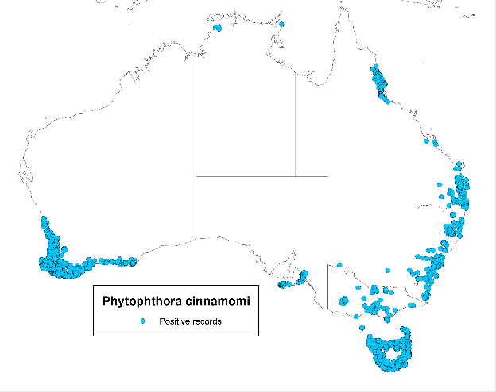

#### Figure 2. Negative records of *Phytophthora cinnamomi* in Australia based on data sources given in Table 1.

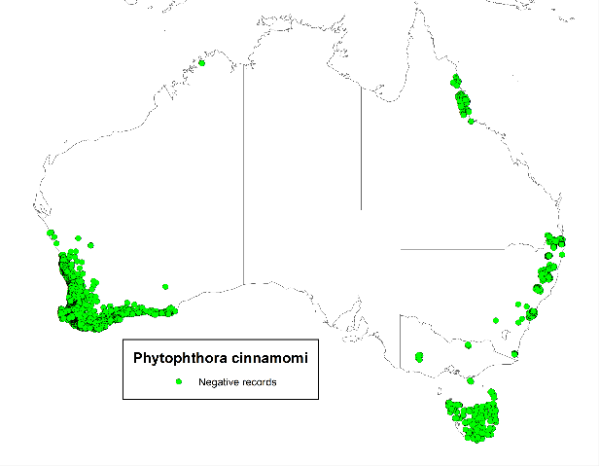

#### Figure 3. World distribution of *Phytophthora cinnamomi* based on country or region presence or absence based on EPPO/CABI (1998).

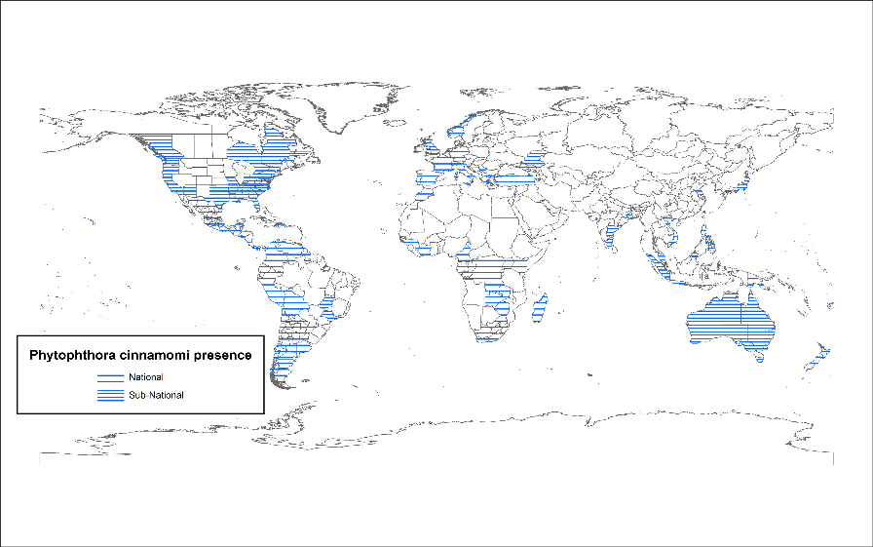

#### Figure 4. Historical climate suitability for *Phytophthora cinnamomi* (“pathogen” model) in Australia as indicated by the CLIMEX Ecoclimatic Index (EI).

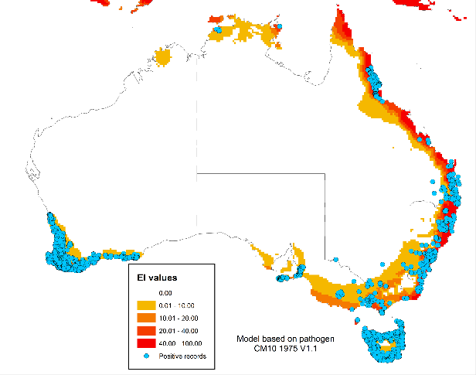

#### Figure 5. Historical climate suitability for *Phytophthora cinnamomi* (“pathogen” model) in south-west Western Australia.

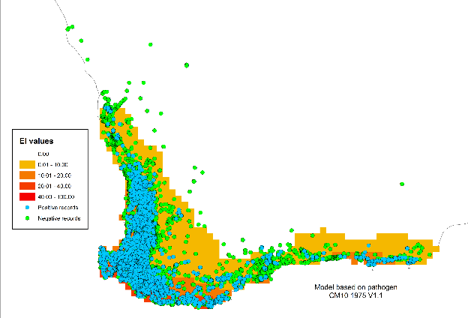

#### Figure 6. Historical climate suitability for *Phytophthora cinnamomi* (“pathogen” model) in Tasmania.

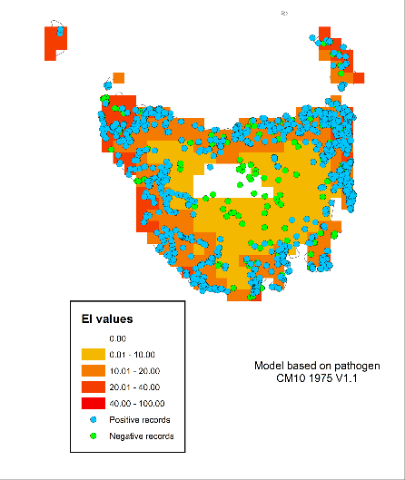

#### Figure 7. Historical climate suitability for *Phytophthora cinnamomi* (“pathogen” model) in Victoria and NSW.

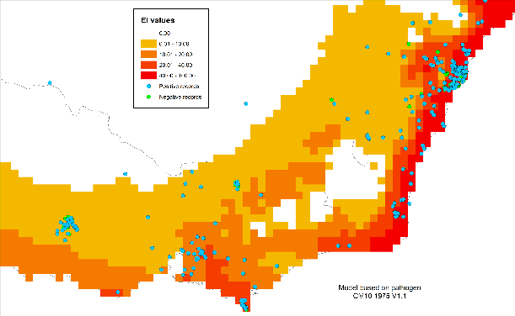

#### Figure 8. Historical climate suitability for *Phytophthora cinnamomi* (“pathogen” model) in Australia and qPCR results.

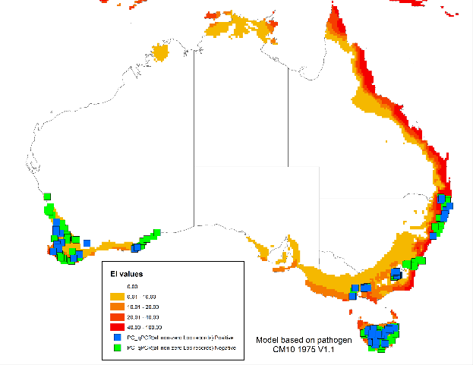

#### Figure 9. Historical climate suitability for *Phytophthora cinnamomi* (“pathogen” model) in south-west Australia and qPCR.

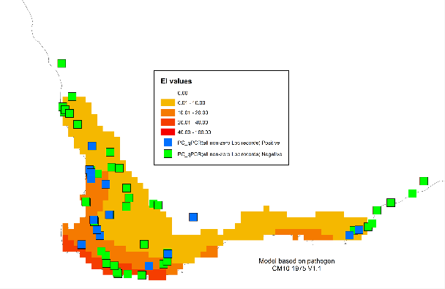

#### Figure 10. Historical climate suitability for *Phytophthora cinnamomi* (“pathogen” model) in Tasmania and qPCR results.

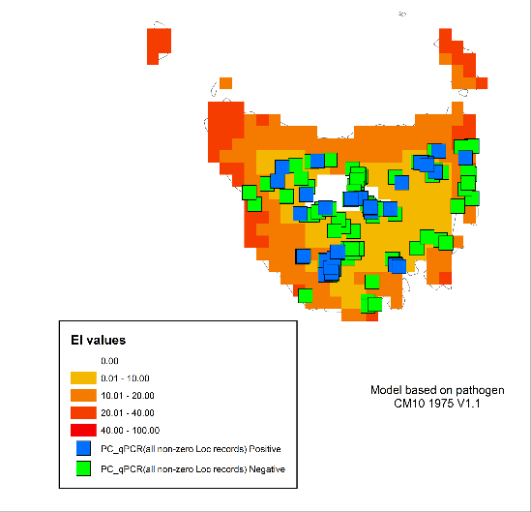

#### Figure 11. Climate suitability for *Phytophthora cinnamomi* Australia as indicated by the CLIMEX Ecoclimatic Index (EI) using CSIRO Mk3 projections for 2070 based on the A1B SRES scenario contrasted to the EI calculated on historical climate data centred on 1975.

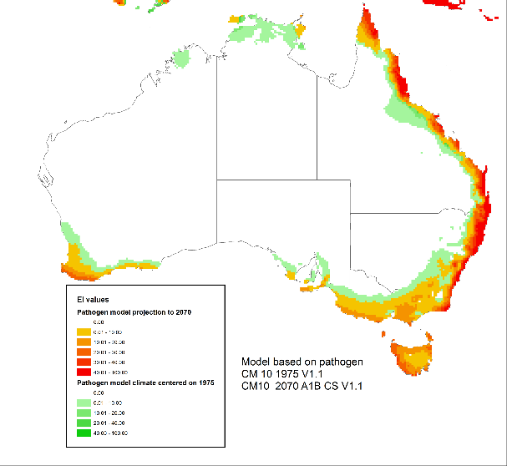

# Appendix 1

#### Localities of soil samples collected during the current study. Samples testing positive for *Phytophthora cinnamomi* (PC) are given in the final column.

| **State** | **code** | **Latitude** | **Longitude** | **Altitude** | **Vegetation** | **collected_by** | **PC** |
| --- | --- | --- | --- | --- | --- | --- | --- |
| TAS | TAS1 | -43.3967 | 146.8607 | 25 | wet eucalypt | TI Burgess |  |
| TAS | TAS2 | -43.4627 | 146.8595 | 110 | wet eucalypt | TI Burgess |  |
| TAS | TAS3 | -43.4385 | 146.9557 | 47 | heath | TI Burgess |  |
| TAS | TAS4 | -43.1315 | 146.9186 | 186 | eucalypt | TI Burgess |  |
| TAS | TAS5 | -42.8159 | 147.2036 | 380 | dry eucalypt | TI Burgess |  |
| TAS | TAS6 | -42.8181 | 147.1906 | 307 | dry eucalypt | TI Burgess |  |
| TAS | TAS7 | -42.7251 | 146.4528 | 652 | moreland | TI Burgess |  |
| TAS | TAS8 | -42.8322 | 146.3848 | 580 | rainforest | TI Burgess |  |
| TAS | TAS9 | -43.0373 | 146.2776 | 462 | moorland | TI Burgess | yes |
| TAS | TAS10 | -42.9583 | 146.3621 | 339 | moorland | TI Burgess |  |
| TAS | TAS11 | -42.7629 | 146.5360 | 310 | wet eucalypt | TI Burgess |  |
| TAS | TAS12 | -42.8055 | 146.5846 | 529 | *E. nitens* plantation | TI Burgess |  |
| TAS | TAS13 | -42.7275 | 146.6731 | 227 | wet eucalypt | TI Burgess |  |
| TAS | TAS14 | -42.4407 | 146.6601 | 248 | dry eucalypt | TI Burgess |  |
| TAS | TAS15 | -42.3732 | 146.5266 | 277 | wet eucalypt | TI Burgess |  |
| TAS | TAS16 | -42.2804 | 146.4572 | 683 | wet eucalypt | TI Burgess |  |
| TAS | TAS17 | -42.1363 | 146.2303 | 693 | wet eucalypt | TI Burgess |  |
| TAS | TAS18 | -42.1363 | 146.2303 | 696 | rainforest | TI Burgess |
| TAS | TAS19 | -42.1962 | 145.9339 | 546 | moorland | TI Burgess | yes |
| TAS | TAS20 | -42.0674 | 145.3086 | 264 | moorland | TI Burgess |  |
| TAS | TAS21 | -41.9129 | 145.2345 | 204 | coastal heath | TI Burgess |  |
| TAS | TAS22 | -41.9061 | 145.2390 | 212 | wet eucalypt | TI Burgess |  |
| TAS | TAS23 | -41.7915 | 145.4800 | 175 | wet eucalypt | TI Burgess |  |
| TAS | TAS24 | -41.7532 | 145.6242 | 193 | wet eucalypt | TI Burgess | yes |
| TAS | TAS25 | -41.5612 | 145.6891 | 690 | wet eucalypt | TI Burgess |  |
| TAS | TAS26 | -41.5396 | 145.8682 | 935 | moorland | TI Burgess |
| TAS | TAS27 | -41.4829 | 146.0906 | 605 | dry eucalypt | TI Burgess |  |
| TAS | TAS28 | -41.4778 | 146.1693 | 423 | dry eucalypt | TI Burgess | yes |
| TAS | TAS29 | -41.4650 | 146.3415 | 260 | dry eucalypt | TI Burgess |  |
| TAS | TAS30 | -41.5848 | 146.6481 | 278 | Podocarp | TI Burgess |  |
| TAS | TAS31 | -41.6594 | 146.7225 | 748 | wet Eucalypt | TI Burgess |  |
| TAS | TAS32 | -41.7014 | 146.7231 | 946 | wet Eucalypt | TI Burgess |  |
| TAS | TAS33 | -41.7207 | 146.7250 | 1098 | gymnosperm - dieback | TI Burgess |  |
| TAS | TAS34 | -41.7407 | 146.7061 | 1207 | pencil pines/ moorland | TI Burgess |  |
| TAS | TAS35 | -41.7776 | 146.7121 | 1069 | eucalypt/typical snow gum | TI Burgess |  |
| TAS | TAS36 | -41.9197 | 146.6872 | 1062 | grassland | TI Burgess |  |
| TAS | TAS37 | -42.1003 | 146.8920 | 860 | eucalypt | TI Burgess |  |
| TAS | TAS38 | -42.6699 | 147.5290 | 275 | dry eucalypt | TI Burgess |  |
| TAS | TAS39 | -42.5589 | 147.8495 | 18 | dry eucalypt | TI Burgess |  |
| TAS | TAS40 | -42.6008 | 147.9262 | 95 | dry eucalypt | TI Burgess |  |
| TAS | TAS41 | -42.0964 | 148.0857 | 3 | dry eucalypt | TI Burgess |  |
| TAS | TAS42 | -41.9950 | 148.2799 | 63 | coastal heath | TI Burgess |  |
| TAS | TAS43 | -41.9917 | 148.2820 | 37 | coastal heath - dieback | TI Burgess |  |
| TAS | TAS44 | -41.8644 | 148.1877 | 92 | dry eucalypt | TI Burgess |  |
| TAS | TAS45 | -41.6586 | 148.2502 | 98 | eucalypt | TI Burgess |  |
| TAS | TAS46 | -41.6245 | 148.2234 | 337 | eucalypt | TI Burgess |  |
| TAS | TAS47 | -41.2730 | 148.2831 | 50 | dry eucalypt | TI Burgess |  |
| TAS | TAS48 | -41.2841 | 148.1347 | 90 | eucalypt | TI Burgess |  |
| TAS | TAS49 | -41.4348 | 148.1937 | 65 | eucalypt | TI Burgess | Yes |
| TAS | TAS50 | -41.6351 | 147.8515 | 558 | eucalypt | TI Burgess |  |
| TAS | TAS51 | -41.6258 | 147.7817 | 654 | eucalypt | TI Burgess | yes |
| TAS | TAS52 | -41.5967 | 147.7902 | 667 | rainforest | TI Burgess |  |
| TAS | TAS53 | -41.6700 | 147.7411 | 584 | eucalypt | TI Burgess |  |
| TAS | TAS54 | -41.5242 | 147.6633 | 1395 | alpine heath | T Rudman | yes |
| TAS | TAS55 | -41.5115 | 147.6617 | 1252 | subalpine shrubland | T Rudman | yes |
| TAS | TAS56 | -41.5037 | 147.6119 | 985 | wet sclerophyll | T Rudman |  |
| TAS | TAS57 | -41.4983 | 147.5829 | 768 | inland forest | T Rudman | yes |
| TAS | TAS58 | -42.8898 | 147.2364 | 990 | inland woodland | T Rudman |  |
| TAS | TAS59 | -41.7741 | 147.3231 | 213 | inland forest | T Rudman | yes |
| TAS | TAS60 | -41.6994 | 147.2359 | 201 | inland forest | T Rudman |  |
| TAS | TAS61 | -41.5024 | 147.6148 | 1013 | wet sclerophyll | T Rudman |  |
| TAS | TAS62 | -41.5326 | 147.6686 | 1433 | alpine heathland | T Rudman | yes |
| TAS | TAS63 | -41.5003 | 147.6045 | 850 | wet sclerophyll | T Rudman |  |
| TAS | TAS64 | -41.4909 | 147.5461 | 596 | inland forest | T Rudman |  |
| TAS | TAS65 | -42.8948 | 147.2436 | 894 | inland forest | T Rudman | yes |
| TAS | TAS66 | -42.8965 | 147.2353 | 1268 | alpine heathland | T Rudman | yes |
| TAS | TAS67 | -42.9213 | 147.2859 | 350 | inland forest | T Rudman | yes |
| TAS | TAS68 | -42.5142 | 147.6699 | 230 | inland forest | T Rudman |  |
| TAS | TAS69 | -41.7779 | 148.2312 | 95 | inland forest | T Rudman |  |
| TAS | TAS70 | -41.9384 | 146.0180 | 1424 | alpine heath | T Rudman | yes |
| TAS | TAS71 | -42.2160 | 146.0197 | 383 | scrub | W Dunstan |  |
| TAS | TAS72 | -42.2167 | 146.0762 | 557 | scrub | W Dunstan |  |
| TAS | TAS73 | -42.2113 | 146.1041 | 831 | sub-alpine scrub | W Dunstan |  |
| TAS | TAS74 | -42.1713 | 146.1821 | 738 | buttongrass plain | W Dunstan |  |
| TAS | TAS75 | -42.1162 | 146.2805 | 790 | wet sclerophyll | W Dunstan | yes |
| TAS | TAS76 | -42.1333 | 146.3338 | 745 | riparian | W Dunstan |  |
| TAS | TAS77 | -42.7332 | 146.4498 | 1006 | wet sclerophyll | W Dunstan | yes |
| TAS | TAS78 | -42.7311 | 146.4529 | 902 | sub-alpine scrub | W Dunstan |  |
| TAS | TAS79 | -42.7283 | 146.4547 | 775 | sub-alpine scrub | W Dunstan |  |
| TAS | TAS80 | -42.7250 | 146.4556 | 668 | sphagnum bog | W Dunstan |  |
| TAS | TAS81 | -42.7242 | 146.4560 | 658 | alpine moorland | W Dunstan | yes |
| TAS | TAS82 | -42.7244 | 146.4551 | 651 | alpine moorland | W Dunstan |  |
| TAS | TAS83 | -42.7248 | 146.4527 | 646 | sub-alpine woodland | W Dunstan |  |
| TAS | TAS84 | -42.8452 | 146.2969 | 1147 | wet sclerophyll | W Dunstan |  |
| TAS | TAS85 | -42.8432 | 146.2928 | 1051 | wet sclerophyll | W Dunstan |  |
| TAS | TAS86 | -42.8425 | 146.2899 | 937 | wet sclerophyll | W Dunstan | yes |
| TAS | TAS87 | -42.8423 | 146.2881 | 878 | wet sclerophyll | W Dunstan | yes |
| TAS | TAS88 | -42.8420 | 146.2843 | 776 | tussock grass plain | W Dunstan |  |
| TAS | TAS89 | -42.8383 | 146.2808 | 642 | tussock grass plain | W Dunstan |  |
| TAS | TAS90 | -42.8324 | 146.2776 | 424 | tussock grass plain | W Dunstan |  |
| TAS | TAS91 | -42.1730 | 146.9040 | 650 | open woodland | W Dunstan | yes |
| TAS | TAS92 | -42.1067 | 146.8925 | 848 | sphagnum bog | W Dunstan | yes |
| TAS | TAS93 | -42.1274 | 146.8939 | 882 | wet sclerophyll | W Dunstan | yes |
| TAS | TAS94 | -42.0519 | 146.8454 | 898 | rainforest | W Dunstan |  |
| TAS | TAS95 | -41.9873 | 146.7629 | 1047 | sclerophyll | W Dunstan | yes |
| TAS | TAS96 | -41.9905 | 146.6887 | 1041 | wet sclerophyll | W Dunstan | yes |
| TAS | TAS97 | -41.8884 | 146.6839 | 1059 | wet sclerophyll | W Dunstan |  |
| TAS | TAS98 | -41.7738 | 146.7094 | 1137 | wet sclerophyll | W Dunstan |  |
| TAS | TAS99 | -41.6601 | 146.7203 | 768 | bog | W Dunstan |  |
| TAS | TAS100 | -41.6986 | 146.7570 | 533 | rainforest | W Dunstan |  |
| TAS | TAS101 | -41.6880 | 146.7611 | 703 | rainforest | W Dunstan |  |
| TAS | TAS102 | -41.6720 | 146.7365 | 764 | buttongrass plain | W Dunstan |  |
| TAS | TAS103 | -41.7105 | 146.7283 | 656 | wet woodland | W Dunstan |  |
| TAS | TAS104 | -41.7305 | 146.7159 | 817 | wet woodland | W Dunstan |  |
| TAS | TAS105 | -41.7427 | 146.7058 | 829 | wet woodland | W Dunstan |  |
| TAS | TAS106 | -41.7434 | 146.7060 | 828 | alpine heathland | W Dunstan |  |
| TAS | TAS107 | -42.7872 | 145.9633 | 960 | alpine heathland | W Dunstan |  |
| TAS | TAS108 | -42.7918 | 145.9636 | 1063 | alpine heathland | W Dunstan |  |
| TAS | TAS109 | -42.7828 | 145.9662 | 851 | wet woodland | W Dunstan | yes |
| TAS | TAS110 | -42.7796 | 145.9741 | 656 | wet woodland | W Dunstan | yes |
| TAS | TAS111 | -42.7778 | 145.9801 | 457 | buttongrass plain | W Dunstan | yes |
| TAS | TAS112 | -42.7742 | 145.9804 | 301 | heathland | W Dunstan |  |
| TAS | TAS113 | -42.9626 | 146.4018 | 1053 | buttongrass plain | W Dunstan |  |
| TAS | TAS114 | -42.9622 | 146.4011 | 1042 | alpine heathland | W Dunstan |  |
| TAS | TAS115 | -42.9625 | 146.3917 | 894 | alpine heathland | W Dunstan |  |
| TAS | TAS116 | -42.9599 | 146.3849 | 663 | imbricate rainforest | W Dunstan | yes |
| TAS | TAS117 | -42.9584 | 146.3704 | 475 | imbricate rainforest | W Dunstan |  |
| TAS | TAS118 | -42.9582 | 146.3622 | 338 | rainforest | W Dunstan |  |
| TAS | TAS119 | -42.6767 | 146.7115 | 250 | rainforest | W Dunstan |  |
| TAS | TAS120 | -42.6850 | 146.5912 | 1037 | riparian rainforest | W Dunstan |  |
| TAS | TAS121 | -42.6821 | 146.5905 | 1054 | alpine heathland | W Dunstan |  |
| TAS | TAS122 | -42.6788 | 146.5904 | 1059 | alpine heathland | W Dunstan |  |
| TAS | TAS123 | -42.6806 | 146.5805 | 1256 | buttongrass plain | W Dunstan |  |
| TAS | TAS124 | -42.6826 | 146.6089 | 1070 | buttongrass plain | W Dunstan |  |
| TAS | TAS125 | -42.6791 | 146.6304 | 962 | buttongrass plain | W Dunstan |  |
| TAS | TAS126 | -42.6817 | 146.6470 | 1029 | riparian rainforest | W Dunstan |  |
| TAS | TAS127 | -42.1354 | 147.1674 | 820 | inland woodland | T Rudman | yes |
| TAS | TAS128 | -43.0186 | 146.3659 | 353 | wet sclerophyll | T Rudman | yes |
| TAS | TAS129 | -43.0091 | 146.3623 | 358 | short rainforest | T Rudman | yes |
| TAS | TAS130 | -42.9358 | 146.3460 | 337 | Buttongrass moorland | T Rudman | yes |
| TAS | TAS131 | -42.8048 | 146.3945 | 560 | buttongrass | T Rudman | yes |
| TAS | TAS132 | -42.7212 | 146.4396 | 580 | disturbed roadside | T Rudman | yes |
| TAS | TAS133 | -42.7214 | 146.4386 | 570 | wet sclerophyll | T Rudman |  |
| TAS | TAS134 | -42.7244 | 146.4493 | 640 | buttongrass moorland | T Rudman |  |
| TAS | TAS135 | -42.7244 | 146.4489 | 640 | Disturbed roadside | T Rudman |  |
| TAS | TAS136 | -42.2321 | 146.9283 | 590 | Agricultural land roadside | T Rudman |  |
| TAS | TAS137 | -42.1564 | 146.9029 | 700 | Disturbed roadsid | T Rudman |  |
| TAS | TAS138 | -42.1395 | 146.8920 | 765 | Disturbed roadside | T Rudman |  |
| TAS | TAS139 | -42.1275 | 146.8929 | 855 | Disturbed roadside | T Rudman | yes |
| TAS | TAS140 | -42.0840 | 146.8708 | 885 | Disturbed roadside | T Rudman |  |
| TAS | TAS141 | -42.1066 | 146.8925 | 853 | inland woodland | T Rudman |  |
| TAS | TAS142 | -42.1132 | 146.9345 | 770 | wet sclerophyll | T Rudman |  |
| TAS | TAS143 | -42.1287 | 146.9716 | 797 | Disturbed roadside | T Rudman |  |
| TAS | TAS144 | -42.1324 | 147.0072 | 957 | Disturbed roadside | T Rudman |  |
| TAS | TAS145 | -42.1331 | 147.0826 | 900 | Disturbed roadside | T Rudman |  |
| TAS | TAS147 | -43.0401 | 146.2895 | 322 | wet sclerophyll | T Rudman |  |
| TAS | TAS148 | -43.0404 | 146.3497 | 335 | wet sclerophyll | T Rudman |  |
| TAS | TAS149 | -42.1278 | 146.8936 | 860 | inland forest | T Rudman |  |
| TAS | TAS150 | -42.1091 | 146.8929 | 848 | inland woodland | T Rudman | yes |
| TAS | TAS151 | -42.2052 | 147.2309 | 805 | wet sclerophyll | T Rudman |  |
| TAS | TAS152 | -41.8186 | 146.6755 | 1058 | inland woodland | T Rudman |  |
| TAS | TAS153 | -41.8187 | 146.6755 | 1053 | inland woodland | T Rudman |  |
| TAS | TAS154 | -41.7426 | 146.7060 | 1198 | bog | T Rudman |  |
| TAS | TAS155 | -41.7409 | 146.7060 | 1198 | bog | T Rudman |  |
| TAS | TAS156 | -41.9998 | 146.6100 | 1031 | bog | T Rudman |  |
| TAS | TAS157 | -41.9999 | 146.6097 | 1029 | bog | T Rudman |  |
| TAS | TAS158 | -41.8993 | 146.6713 |  | inland woodland | T Rudman |  |
| TAS | TAS159 | -41.8992 | 146.6712 |  | inland woodland | T Rudman |  |
| TAS | TAS160 | -41.9951 | 146.6283 | 1032 | inland woodland | T Rudman | yes |
| TAS | TAS161 | -42.0011 | 146.6328 | 1019 | inland woodland | T Rudman |  |
| TAS | TAS162 | -42.8322 | 146.3849 | 580 | short rainforest | T Rudman |  |
| TAS | TAS162 | -42.8322 | 146.3849 | 580 |  | T Rudman |  |
| TAS | TAS165 | -43.3198 | 146.0051 | 10 |  | T Rudman |  |
| TAS | TAS166 | -42.4333 | 146.4018 | 1197 |  | T Rudman |  |
| TAS | TAS167 | -41.9660 | 145.7534 | 840 |  | T Rudman |  |
| TAS | TAS168 | -41.9578 | 145.7448 | 850 |  | T Rudman |  |
| TAS | TAS169 | -41.8293 | 146.0379 | 860 |  | T Rudman |  |
| TAS | TAS170 | -41.3423 | 147.7687 | 810 |  | T Rudman |  |
| TAS | TAS171 | -41.3436 | 147.8270 | 800 |  | T Rudman | yes |
| TAS | TAS172 | -41.7150 | 145.9471 | 1020 |  | T Rudman |  |
| TAS | TAS173 | -41.6356 | 147.8674 | 510 |  | T Rudman |  |
| NSW | NSW1 | -36.3578 | 148.5872 | 980 | open forest | K. McDougall | yes |
| NSW | NSW2 | -36.3497 | 148.5822 | 1050 | open forest | K. McDougall |  |
| NSW | NSW3 | -36.3444 | 148.5789 | 1110 | open forest | K. McDougall |  |
| NSW | NSW4 | -36.3467 | 148.5696 | 1170 | riparian woodland | K. McDougall |  |
| NSW | NSW5 | -36.3549 | 148.5617 | 1220 | open forest | K. McDougall |  |
| NSW | NSW6 | -36.3518 | 148.5466 | 1290 | open forest | K. McDougall |  |
| NSW | NSW7 | -36.3458 | 148.5388 | 1375 | open forest | K. McDougall |  |
| NSW | NSW8 | -36.3483 | 148.5317 | 1405 | riparian shrubland | K. McDougall |  |
| NSW | NSW9 | -36.3525 | 148.5188 | 1460 | wetland | K. McDougall |  |
| NSW | NSW10 | -36.3580 | 148.5123 | 1530 | woodland | K. McDougall | yes |
| NSW | NSW11 | -36.3632 | 148.5020 | 1580 | grassland | K. McDougall |  |
| NSW | NSW12 | -36.3889 | 148.4463 | 1620 | wetland | K. McDougall | yes |
| NSW | NSW13 | -36.3986 | 148.4233 | 1700 | woodland | K. McDougall | yes |
| NSW | NSW14 | -36.4250 | 148.3771 | 1750 | open heathland | K. McDougall |  |
| NSW | NSW15 | -36.4323 | 148.3310 | 1820 | shrubland | K. McDougall |  |
| NSW | NSW16 | -36.4428 | 148.3142 | 1875 | shrubland | K. McDougall |  |
| NSW | NSW17 | -36.4577 | 148.3004 | 1940 | wetland / grassland | K. McDougall |  |
| NSW | NSW18 | -36.4525 | 148.2837 | 2000 | grassland | K. McDougall |  |
| NSW | NSW19 | -36.4539 | 148.2735 | 2065 | wetland / grassland | K. McDougall |  |
| NSW | NSW20 | -36.4584 | 148.2687 | 2125 | open heathland | K. McDougall |  |
| NSW | NSW21 | -36.1758 | 148.1525 | 455 | open forest | K. McDougall |  |
| NSW | NSW22 | -36.1677 | 148.1560 | 500 | shrubland | K. McDougall | yes |
| NSW | NSW23 | -36.1571 | 148.1566 | 565 | open forest | K. McDougall |  |
| NSW | NSW24 | -36.1459 | 148.1561 | 640 | tall forest | K. McDougall | yes |
| NSW | NSW25 | -36.1415 | 148.1563 | 700 | tall forest | K. McDougall |  |
| NSW | NSW26 | -36.0947 | 148.1694 | 740 | tall forest | K. McDougall |  |
| NSW | NSW27 | -36.0925 | 148.1758 | 800 | tall forest | K. McDougall |  |
| NSW | NSW28 | -36.0897 | 148.1812 | 860 | open forest | K. McDougall | yes |
| NSW | NSW29 | -36.0883 | 148.1832 | 920 | tall forest | K. McDougall |  |
| NSW | NSW30 | -36.0826 | 148.1854 | 980 | tall forest | K. McDougall | yes |
| NSW | NSW31 | -36.0770 | 148.1917 | 1060 | tall forest | K. McDougall |  |
| NSW | NSW32 | -36.0787 | 148.2059 | 1100 | tall forest | K. McDougall |  |
| NSW | NSW33 | -36.0711 | 148.2222 | 1140 | tall riparian forest | K. McDougall |  |
| NSW | NSW34 | -36.0690 | 148.2334 | 1200 | tall forest | K. McDougall |  |
| NSW | NSW35 | -36.0518 | 148.3000 | 1280 | tall forest | K. McDougall |  |
| NSW | NSW36 | -36.0387 | 148.3228 | 1320 | grassland / shrubland | K. McDougall | yes |
| NSW | NSW37 | -36.0364 | 148.3264 | 1340 | tall forest | K. McDougall |  |
| NSW | NSW38 | -36.0379 | 148.3369 | 1440 | tall forest | K. McDougall |  |
| NSW | NSW39 | -36.0410 | 148.3474 | 1520 | woodland | K. McDougall |  |
| NSW | NSW40 | -36.0208 | 148.3745 | 1580 | grassland | K. McDougall | yes |
| NSW | NSW41 | -35.2041 | 150.0514 | 580 | open forest | K. McDougall |  |
| NSW | NSW42 | -35.1489 | 150.0692 | 600 | shrubland | K. McDougall |  |
| NSW | NSW43 | -35.0800 | 150.1478 | 775 | heathland on sandstone | K. McDougall |  |
| NSW | NSW44 | -34.9686 | 150.5028 | 170 | woodland | K. McDougall |  |
| NSW | NSW45 | -34.8936 | 150.5436 | 60 | open forest | K. McDougall |  |
| NSW | NSW46 | -35.0067 | 150.8336 | 20 | woodland | K. McDougall |  |
| NSW | NSW47 | -34.9646 | 150.6513 | 70 | open forest | K. McDougall |  |
| NSW | NSW48 | -35.5344 | 149.9568 | 760 | rainforest | K. McDougall |  |
| NSW | NSW49 | -35.5519 | 149.9519 | 785 | shrubland / wetland | K. McDougall |  |
| NSW | NSW50 | -36.5261 | 148.1936 | 1010 | tall forest | K. McDougall |  |
| NSW | NSW51 | -36.5383 | 148.1344 | 525 | cleared woodland | K. McDougall |  |
| NSW | NSW52 | -36.3853 | 148.1811 | 425 | cleared forest | K. McDougall |  |
| NSW | NSW53 | -35.4269 | 149.7144 | 625 | shrubland | K. McDougall |  |
| NSW | NSW54 | -35.2830 | 149.4400 | 710 | grassland | K. McDougall |  |
| NSW | NSW55 | -35.3450 | 149.2790 | 720 | woodland | K. McDougall |
| NSW | NSW56 | -35.4861 | 150.0838 | 275 | woodland | K. McDougall |  |
| NSW | NSW59 | -36.0378 | 146.9894 | 195 | Disturbed riparian | K. McDougall | yes |
| NSW | NSW60 | -35.9875 | 146.6228 | 145 | *Eucalyptus camaldulensis* | K. McDougall |  |
| NSW | NSW63 | -30.9938 | 152.7937 |  |  | M. Nagel+M. Horwood |  |
| NSW | NSW64 | -30.1369 | 153.1062 |  |  | A. Carnegie | yes |
| NSW | NSW65 | -30.1507 | 153.1091 |  |  | A. Carnegie | yes |
| NSW | NSW66 | -31.5925 | 152.6070 |  |  | M. Nagel+M. Horwood |  |
| NSW | NSW67 | -32.0153 | 152.4661 |  |  | A. Carnegie |  |
| NSW | NSW68 | -32.3667 | 152.2401 |  | wet sclerophyll | A. Carnegie |  |
| NSW | NSW69 | -30.5234 | 152.9935 |  | wet sclerophyll | A. Carnegie | yes |
| NSW | NSW70 | -29.1971 | 152.6036 |  |  | A. Carnegie | yes |
| NSW | NSW71 | -29.7434 | 153.4442 |  |  | A. Carnegie | yes |
| NSW | NSW72 | -32.6214 | 151.8884 |  | dry sclerophyll | A. Carnegie | yes |
| NSW | NSW73 | -29.0925 | 153.2672 |  | plantation | A. Carnegie |  |
| NSW | NSW74 | -29.2626 | 153.2186 |  | wet sclerophyll | A. Carnegie |  |
| NSW | NSW75 | -28.9233 | 152.5983 |  | dry sclerophyll | A. Carnegie |  |
| NSW | NSW76 | -29.0330 | 152.7063 |  |  | A. Carnegie | yes |
| NSW | NSW77 | -30.8983 | 152.9097 |  |  | A. Carnegie | yes |
| NSW | NSW78 | -31.7312 | 152.0485 |  |  | M. Nagel+M. Horwood |  |
| NSW | NSW79 |  |  |  | wet sclerophyll | A. Carnegie |  |
| NSW | NSW80 | -29.8325 | 152.9750 |  |  | A. Carnegie |  |
| NSW | NSW81 | -30.8792 | 152.4707 |  |  | M. Nagel+M. Horwood |  |
| NSW | NSW82 | -37.179 | 149.75 | 430 | *Eucalyptus sieberi* forest | K. McDougall |  |
| NSW | NSW83 | -36.514 | 149.282 | 1080 | Disturbed creek | K. McDougall | yes |
| NSW | NSW84 | -36.594 | 149.444 | 840 | tall wet forest | K. McDougall |  |
| NSW | NSW85 | -37.013 | 149.908 | 190 | Dry forest | K. McDougall |  |
| VIC | VIC1 | -37.5917 | 145.6425 | 580 |  | D. Cahill |  |
| VIC | VIC2 | -37.5917 | 145.6425 | 580 |  | D. Cahill |  |
| VIC | VIC3 | -37.5917 | 145.6425 | 580 |  | D. Cahill |  |
| VIC | VIC4 | -37.5917 | 145.6425 | 580 |  | D. Cahill | yes |
| VIC | VIC5 | -37.5917 | 145.6425 | 580 |  | D. Cahill |  |
| VIC | VIC6 | -37.5917 | 145.6425 | 580 |  | D. Cahill | yes |
| VIC | VIC7 | -37.4803 | 145.5456 | 420 |  | D. Cahill |  |
| VIC | VIC8 | -37.4803 | 145.5456 | 420 |  | D. Cahill |  |
| VIC | VIC9 | -37.4803 | 145.5456 | 420 |  | D. Cahill |  |
| VIC | VIC10 | -37.4803 | 145.5456 | 420 |  | D. Cahill |  |
| VIC | VIC11 | -37.5306 | 145.2436 | 581 |  | D. Cahill | yes |
| VIC | VIC12 | -37.5306 | 145.2436 | 581 |  | D. Cahill |  |
| VIC | VIC13 | -37.5306 | 145.2436 | 581 |  | D. Cahill |  |
| VIC | VIC14 | -37.5306 | 145.2436 | 581 |  | D. Cahill |  |
| VIC | VIC15 | -37.6156 | 145.2511 |  |  | D. Cahill |  |
| VIC | VIC16 | -37.6156 | 145.2511 |  |  | D. Cahill | yes |
| VIC | VIC17 | -37.6156 | 145.2511 |  |  | D. Cahill |  |
| VIC | VIC18 | -37.6156 | 145.2511 |  |  | D. Cahill |  |
| VIC | VIC19 | -37.6017 | 144.4256 | 157 |  | D. Cahill |  |
| VIC | VIC20 | -37.6017 | 144.4256 | 157 |  | D. Cahill |  |
| VIC | VIC21 | -37.6017 | 144.4256 | 157 |  | D. Cahill | yes |
| VIC | VIC22 | -37.6017 | 144.4256 | 157 |  | D. Cahill |  |
| VIC | VIC23 | -37.8664 | 144.2486 | 362 |  | D. Cahill |  |
| VIC | VIC24 | -37.8664 | 144.2486 | 362 |  | D. Cahill |  |
| VIC | VIC25 | -37.8664 | 144.2486 | 362 |  | D. Cahill |  |
| VIC | VIC26 | -37.8664 | 144.2486 | 362 |  | D. Cahill |  |
| VIC | VIC27 | -37.8664 | 144.2486 | 362 |  | D. Cahill |  |
| VIC | VIC28 | -37.8664 | 144.2486 | 362 |  | D. Cahill |  |
| VIC | VIC29 | -38.3956 | 144.2536 |  | Ironbark | D. Cahill | yes |
| VIC | VIC30 | -38.3956 | 144.2536 |  | Isopogon | D. Cahill |  |
| VIC | VIC31 | -38.3956 | 144.2536 |  | Isopogon | D. Cahill |  |
| VIC | VIC32 | -38.3956 | 144.2536 |  | Xanthorrhoea | D. Cahill |  |
| VIC | VIC33 | -38.3956 | 144.2536 |  | Xanthorrhoea | D. Cahill | yes |
| VIC | VIC34 | -38.3956 | 144.2536 |  | Xanthorrhoea | D. Cahill | yes |
| VIC | VIC35 | -38.4072 | 144.1858 |  | Xanthorrhoea | D. Cahill |  |
| VIC | VIC36 | -38.4072 | 144.1858 |  | Xanthorrhoea | D. Cahill | yes |
| VIC | VIC37 | -38.4072 | 144.1858 |  | Xanthorrhoea | D. Cahill |  |
| VIC | VIC38 | -38.4072 | 144.1858 |  | Xanthorrhoea | D. Cahill |  |
| VIC | VIC39 | -38.4072 | 144.1858 |  | Xanthorrhoea | D. Cahill |  |
| VIC | VIC40 | -38.4072 | 144.1858 |  | Xanthorrhoea | D. Cahill |  |
| VIC | VIC41 | -38.3624 | 144.1514 |  | Xanthorrhoea | D. Cahill | yes |
| VIC | VIC42 | -38.3624 | 144.1514 |  | Xanthorrhoea | D. Cahill |  |
| VIC | VIC43 | -38.3624 | 144.1514 |  | Xanthorrhoea | D. Cahill |  |
| VIC | VIC44 | -38.3624 | 144.1514 |  | Xanthorrhoea | D. Cahill |  |
| WA | WA1 | -33.4644 | 115.9110 |  | jarrah forest | T. Burgess |  |
| WA | WA2 | -33.4644 | 115.9110 |  | riparian | T. Burgess |  |
| WA | WA3 | -33.4558 | 115.9223 |  | jarrah forest | T. Burgess |  |
| WA | WA4 | -32.8909 | 115.6918 | 9 | tuart forest | T. Burgess |  |
| WA | WA5 | -32.8731 | 115.6728 | 4 | tuart forest | T. Burgess |  |
| WA | WA6 | -35.0017 | 117.3066 |  | karri forest | T. Burgess |  |
| WA | WA7 | -35.0084 | 117.3046 |  | karri forest | T. Burgess |  |
| WA | WA8 | -35.0145 | 117.2952 |  | coastal heath | T. Burgess |  |
| WA | WA9 | -32.2145 | 115.8320 | 0 | Melaluca swamp | T. Burgess | yes |
| WA | WA10 | -32.2148 | 115.8323 | 3 | *E. rudis* | T. Burgess |  |
| WA | WA11 | -32.2150 | 115.8308 | 20 | Banksia woodland | T. Burgess | yes |
| WA | WA12 | -31.8781 | 116.4282 | 313 | marri woodland | T. Paap |  |
| WA | WA13 | -31.8997 | 116.6480 | 314 | wandoo woodland | T. Paap |
| WA | WA14 | -32.4823 | 116.8565 | 320 | powderbark woodland | T. Paap |
| WA | WA15 | -32.9369 | 117.6335 | 337 | sheoak woodland | T. Paap |  |
| WA | WA16 | -32.7684 | 116.9264 |  | marri woodland | T. Paap |  |
| WA | WA17 | -32.0177 | 115.7988 | 0 | Melaluca swamp | T. Burgess |  |
| WA | WA18 | -31.9468 | 115.7792 |  | coastal woodland | T. Burgess | yes |
| WA | WA19 | -31.9593 | 115.8290 |  | Banksia woodland | T. Burgess |  |
| WA | WA20 | -30.2754 | 115.0467 |  | kwongan vegetation | T. Burgess |  |
| WA | WA21 | -30.1150 | 115.0067 |  | kwongan vegetation | T. Burgess |  |
| WA | WA22 | -30.1189 | 115.0050 |  | kwongan vegetation | T. Burgess |  |
| WA | WA23 | -30.1967 | 115.0735 |  | kwongan vegetation | T. Burgess |  |
| WA | WA24 | -30.2014 | 115.0729 |  | kwongan vegetation | T. Burgess |  |
| WA | WA25 | -32.0926 | 115.8212 | 18 | disturbed, dying *E. rudis* | T. Burgess |  |
| WA | WA26 | -32.3676 | 116.2535 | 457 | jarrah forest | T. Burgess | yes |
| WA | WA27 | -32.3699 | 116.2522 | 409 | jarrah forest | T. Burgess |  |
| WA | WA28 | -33.0163 | 116.8533 |  | wandoo woodland | T. Burgess |  |
| WA | WA29 | -33.0239 | 116.8536 |  | york gum woodland | T. Burgess |  |
| WA | WA30 | -34.1122 | 117.3674 |  | wandoo woodland | T. Burgess |  |
| WA | WA31 | -34.3838 | 118.0490 | 1052 | wandoo woodland | T. Burgess | yes |
| WA | WA32 | -34.3845 | 118.0485 | 988 | callistemon | T. Burgess |  |
| WA | WA33 | -34.3850 | 118.0488 | 851 | callistemon | T. Burgess | yes |
| WA | WA34 | -34.3862 | 118.0497 | 786 | acacia | T. Burgess |  |
| WA | WA35 | -34.3883 | 118.0519 | 638 | marri | T. Burgess |  |
| WA | WA36 | -34.3902 | 118.0537 | 633 | scree slope | T. Burgess | Yes |
| WA | WA37 | -34.3910 | 118.0566 | 516 | marri/heath | T. Burgess | Yes |
| WA | WA38 | -34.3919 | 118.0629 | 441 | bottom | T. Burgess |  |
| WA | WA39 | -34.3584 | 118.0391 | 317 | heathland | T. Burgess |  |
| WA | WA40 | -34.6870 | 117.9311 |  | karri | T. Burgess |  |
| WA | WA41 | -34.7436 | 117.5059 | 108 | banksia heathlands | T. Burgess | Yes |
| WA | WA42 | -34.9784 | 116.8943 | 182 | tingle, sheoak | T. Burgess |  |
| WA | WA43 | -34.9655 | 116.6053 | 50 | karri | T. Burgess |  |
| WA | WA44 | -34.9175 | 116.5692 | 16 | marri/heath | T. Burgess |  |
| WA | WA45 | -34.7364 | 116.4997 | 116 | karri | T. Burgess |  |
| WA | WA46 | -34.4394 | 116.2558 | 156 | karri/marri/healthy understory | T. Burgess |  |
| WA | WA47 | -34.3199 | 116.1206 | 317 | karri | T. Burgess |  |
| WA | WA48 | -33.8646 | 116.0882 |  | jarrah/marri | T. Burgess | Yes |
| WA | WA49 | -31.4341 | 116.3780 | 264 | wandoo woodland | T. Paap |  |
| WA | WA50 | -30.6321 | 115.4338 |  | kwongan vegetation | T. Paap |  |
| WA | WA51 | -30.3102 | 115.2014 | 53 | kwongan vegetation | T. Paap |  |
| WA | WA52 | -28.8599 | 114.9720 | 108 | kwongan vegetation | T. Paap |  |
| WA | WA53 | -31.2606 | 115.8570 | 101 | kwongan vegetation | T. Paap | Yes |
| WA | WA54 | -32.9768 | 117.7710 |  |  | T. Paap |  |
| WA | WA55 | -32.0635 | 116.0202 |  | banksia woodland | M. Stukely |  |
| WA | WA56 | -34.6698 | 116.2668 |  | coastal heath | M. Stukely |  |
| WA | WA57 | -29.8191 | 115.2806 |  | kwongan vegetation | M. Stukely |  |
| WA | WA58 | -33.2601 | 116.3727 |  |  | M. Stukely |  |
| WA | WA59 | -33.2556 | 116.3546 |  |  | M. Stukely |  |
| WA | WA60 | -33.2528 | 116.3521 |  |  | M. Stukely | Yes |
| WA | WA61 | -33.4046 | 115.9054 |  |  | M. Stukely | Yes |
| WA | WA62 | -33.6899 | 116.0033 |  |  | M. Stukely | Yes |
| WA | WA63 | -33.3243 | 118.7910 |  |  | M. Stukely | Yes |
| WA | WA64 | -32.0276 | 115.8272 |  | coastal woodland | M. Stukely | Yes |
| WA | WA65 | -34.1206 | 115.5577 |  |  | M. Stukely | Yes |
| WA | WA66 | -34.1319 | 115.5460 |  |  | M. Stukely |  |
| WA | WA67 | -34.6100 | 118.0312 |  |  | M. Stukely |  |
| WA | WA68 | -33.8526 | 123.3202 |  | coastal heath | C. Crane |  |
| WA | WA69 | -33.8529 | 123.3208 |  | coastal heath | C. Crane |  |
| WA | WA70 | -33.8525 | 123.3209 |  | coastal heath | C. Crane | Yes |
| WA | WA71 | -33.7062 | 123.4451 |  | coastal heath | C. Crane |  |
| WA | WA72 | -33.6962 | 123.5942 |  | coastal heath | C. Crane | Yes |
| WA | WA73 | -33.6102 | 123.8628 |  | coastal heath | C. Crane |  |
| WA | WA74 | -33.5081 | 123.9780 |  | coastal heath | C. Crane |  |
| WA | WA75 | -33.1289 | 124.1198 |  | coastal heath | C. Crane |  |
| WA | WA76 | -32.9083 | 124.5220 |  | coastal heath | C. Crane |  |
| WA | WA77 | -32.6403 | 125.1466 |  | coastal heath | C. Crane |  |
| WA | WA78 | -32.2803 | 125.4786 |  | coastal heath | C. Crane |  |

# Appendix 2

#### CLIMEX world distribution model for *Phytophthora cinnamomi* based on parameters (Table 3) given in Scott and Brasier (1994).

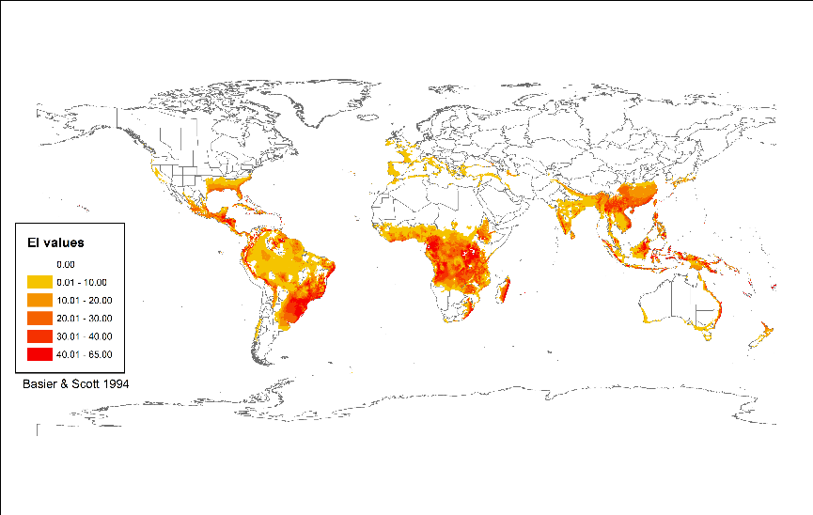

#### CLIMEX world distribution model for *Phytophthora cinnamomi* based on parameters (Table 3, roots) given in Desprez-Loustau et al. (2007)

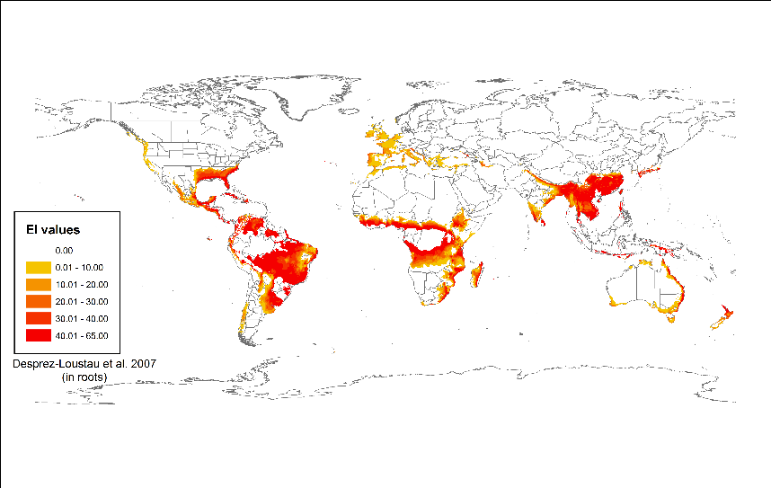

#### CLIMEX world distribution model for *Phytophthora cinnamomi* based on parameters (Table 3, stems) given in Desprez-Loustau et al. (2007).

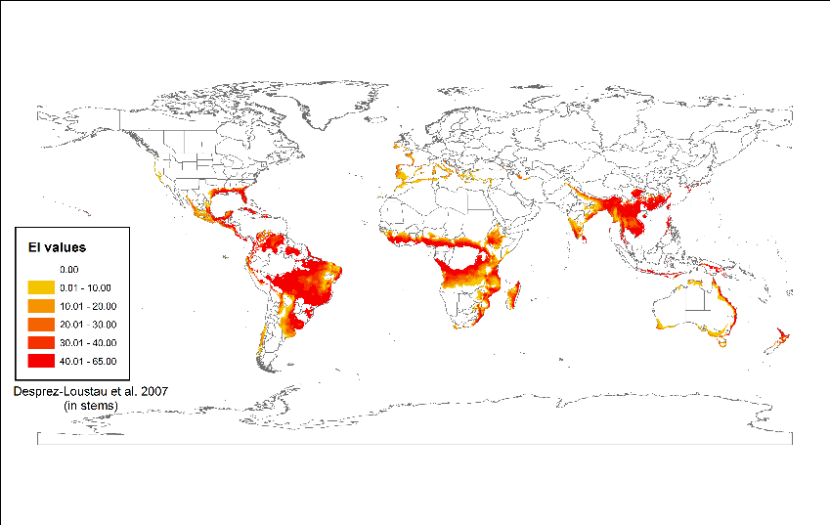

#### CLIMEX world distribution model for *Phytophthora cinnamomi* based on parameters (Table 3) given Sutherst (1999)

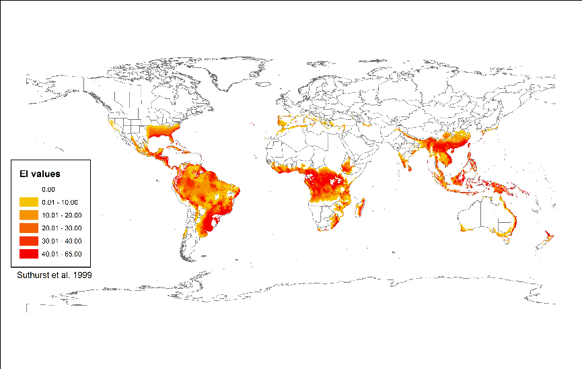

#### CLIMEX world distribution model for *Phytophthora cinnamomi* based on parameters (Table 3, disease)

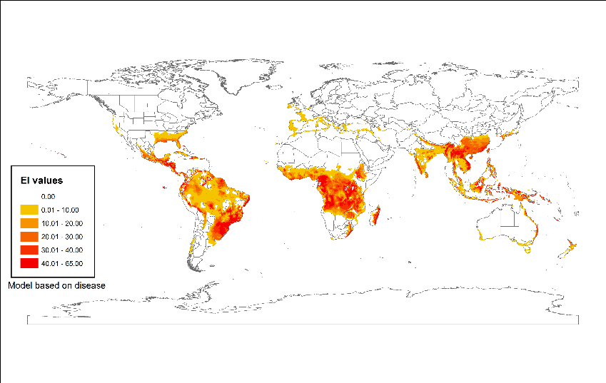

#### CLIMEX world distribution model for *Phytophthora cinnamomi* based on parameters (Table 3, pathogen).

