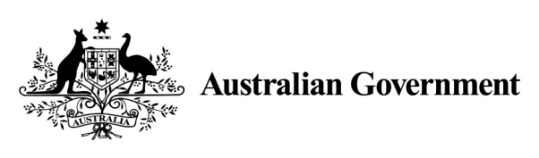

Climate Solutions Package

**The Climate Solutions Package is a fully costed $3.5 billion package to deliver on Australia’s 2030 climate commitments. Our plan builds on our existing policies, and our success in comprehensively beating our Kyoto commitments:**

* $2 billion **Climate Solutions Fund** to reduce greenhouse gas emissions across the economy through the existing Emissions Reduction Fund, including giving farmers, small businesses and Indigenous communities the chance to improve the local environment and benefit from new revenue opportunities.
* Continued support for the transition to reliable renewables underway in the National Electricity Market through **Snowy 2.0** and funding for the **Battery of the Nation Project in Tasmania and MarinusLink**. These projects will boost pumped hydro storage potential and allow more clean energy to be exported to the mainland, while maintaining a reliable energy supply.
* Developing a **National Electric Vehicle Strategy** to ensure a planned and managed transition to new vehicle technology and infrastructure so all Australians can reap the benefits.
* Helping households and businesses **improve energy efficiency** and lower energy bills.
* **Green and clean local environments** by supporting local communities.

Australia has a strong track record on climate change action

The Australian Government is committed to taking action on climate change while growing the economy and keeping energy prices down.

Climate change is a global issue that requires a global solution. This government is committed to Australia playing its part in that global solution to reduce emissions.

We beat our first greenhouse gas reduction target under the Kyoto Protocol (2008–2012) by 128 million tonnes of greenhouse gases and we are on track to overachieve our second Kyoto Protocol target (2013–2020) by 240 million tonnes.

Australia’s 2030 target to reduce emissions by 26 to 28 per cent below 2005 levels is responsible and achievable. This target will see us reduce the emissions intensity of our economy by two thirds, and our emissions per person halve by 2030. This is one of the strongest efforts among G20 countries – stronger than Japan, Canada, the EU, Germany and New Zealand.

We are already making progress. In 2008, official projections showed we would need to reduce greenhouse gases by 3.3 billion tonnes to meet our target. Today, we’ve reduced that task to just 328 million tonnes.

We will bridge this gap with new practical measures across the economy, including giving farmers, small businesses and Indigenous communities the chance to benefit from new revenue opportunities.

We are reducing emissions while growing the economy and without putting pressure on electricity prices.

We have a strong record on renewable energy, with an unprecedented wave of investment currently underway and new records being set. Australia now has one of the world’s highest levels of uptake of household solar panels, with one in five households having solar panels on their roof. In the National Electricity Market renewables are projected to contribute 39 per cent of electricity supply in 2030, up from about 12 per cent in 2012.

**Change in the cumulative greenhouse gas reduction task over time, 2030 target (26 per cent below 2005 levels)**[1]**,**[2]

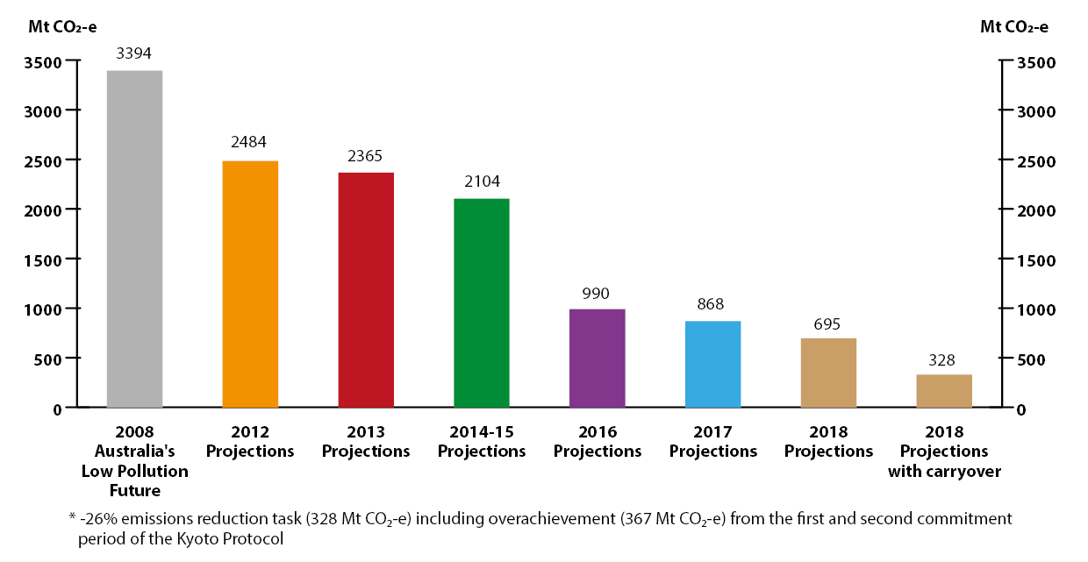

Comparison of 2030 targets per capita and per unit of GDP

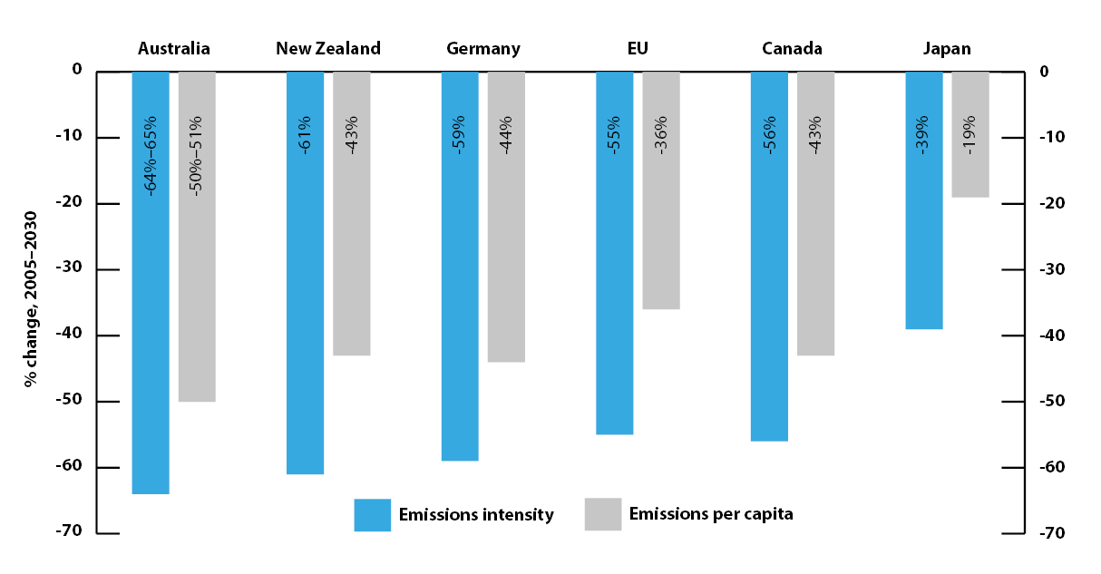

Our existing policies are reducing greenhouse gases

Australia has a comprehensive set of climate change polices covering all sectors of the economy.

The Emissions Reduction Fund (ERF) is the centrepiece of the Government’s climate response, successfully supporting Australian businesses, communities and landholders to reduce greenhouse gases. It covers multiple sectors and supports practical projects in agriculture, manufacturing, energy, mining, oil and gas, transport, vegetation management, waste and wastewater.

So far, the ERF has secured 193 million tonnes of greenhouse gas reduction at a low average price of $12 a tonne. This is the largest ever greenhouse gas reduction commitment by Australian businesses and landholders. ERF projects also improve biodiversity, agricultural productivity and create employment for Indigenous Australians.

Through the ERF’s Safeguard Mechanism, Australia’s largest emitters now have legislated obligations to measure, report and manage their greenhouse gas emissions.

Through the Australian Renewable Energy Agency (ARENA) and the Clean Energy Finance Corporation (CEFC) – the world’s largest green bank – we continue to make major investments in low emissions technologies while ensuring reliable and affordable energy. ARENA has provided $1.347 billion in grant funding to 441 projects including large scale solar and pumped hydro. The CEFC has invested over $6.4 billion to more than 110 projects with a total value of more than $21 billion. We are also backing emerging technology by developing a national hydrogen strategy.

Snowy 2.0 is a pumped hydro storage project which can provide an additional 2000 MW of generation capacity and 350,000 MWh of energy storage to help support the reliability and security of the National Electricity Market. The Snowy 2.0 project will help make renewables reliable, reduce volatility in energy markets and provide other services critical to the security of the NEM.

The Renewable Energy Target is driving significant uptake of wind, solar and hydro power in our electricity grid, and the National Energy Productivity Plan is achieving low-cost greenhouse gas reductions and helping Australian businesses get more out of the energy they consume.

Using energy more efficiently can have significant productivity benefits for businesses and keep costs down for households. Our National Energy Productivity Plan is improving Australia’s energy productivity by 40 per cent, over the 15 years to 2030. The NEPP has already delivered stronger energy standards for products such air conditioners, swimming pool pumps and white goods. Minimum performance standards for new buildings and major renovations are also having positive impacts, providing low-cost emissions reductions as well as providing owners and tenants with more affordable, comfortable buildings.

We have legislated the phase-down of hydrofluorocarbons (HFCs), the potent greenhouse gas used in refrigeration and air conditioning equipment. Our ambitious phase down – 85 per cent by 2036 – is ahead of the global response agreed under the Montreal Protocol.

The Australian Government’s carbon neutral certification is helping businesses voluntarily measure, reduce and offset greenhouse gas emissions. These important contributions not only reduce greenhouse gases but also give participating businesses a competitive edge in the market place.

We are cleaning and greening our communities through Landcare and other community grants to support local communities to take practical actions to reduce emissions, and improve air and water quality to improve the environment and make Australians healthier.

|  |
| --- |
| Tambua Regeneration Project, NSW  Tambua Station is a farm located near Cobar, NSW that produces fine quality wool and cattle products. The Evans family own the property and recently celebrated 100 years and five generations on the land. Over the years the family has overcome a number of challenges that so often occur when farming, including financial hardship, drought and bushfires.  The Tambua Regeneration Project, supported with an Emissions Reduction Fund contract over 10 years, establishes permanent native forests on the property, which reduce greenhouse gas emissions by storing carbon. The Evans family encourages forest regeneration from seed on land that was previously cleared and where regrowth has been suppressed for over 10 years. The project manages the timing and extent of grazing and has stopped mechanical clearing to allow native forests to germinate and develop. |

|  |
| --- |
| Increasing soil carbon to improve farm productivity and resilience, VIC  Soil carbon sequestration projects are being conducted across a number of properties in Victoria. Across Australia these projects will remove more than 7.5 million tonnes of greenhouse gas from the atmosphere through sequestration in soil on land used for grazing.  The projects are increasing the amount of stored soil organic carbon, retaining moisture, regenerating the landscape and improving farm productivity and resilience, particularly on marginal agricultural land.  In addition, a wide range of community and environmental co-benefits are also delivered, including the creation of new jobs in regional Victoria and across Australia. |

|  |
| --- |
| Savanna fire management projects in Arnhem Land, NT  The Coalition Government has invested in direct climate solutions in northern Australia, where traditional fire management practices and research is used to better control the extent and severity of savanna wildfires.  Savanna fire management methods are used to reduce methane and nitrous oxide emissions released by fire, through the use of strategic early dry season fire management as well as late dry season fire suppression across savannas in the tropical north of Australia. They also account for increased sequestration of carbon in dead organic matter.  In Arnhem Land in the Northern Territory, Arnhem Land Fire Abatement projects are being carried out by Indigenous ranger groups, consisting of traditional custodians and their families. These projects partner thousands of years of Aboriginal traditional land management practice with modern scientific knowledge and remote sensing technology. To date, projects have contracted more than 2.4 million tonnes of emissions reductions. |

The Climate Solutions Package

This Climate Solutions Package builds on the Government’s success in beating our 2020 target to reach our 2030 target.

A 2017 review of our climate change policies found our existing measures are scalable and can respond to new opportunities as they arise.

The Climate Solutions Fund

The Coalition Government’s $2 billion Climate Solutions Fund will continue investment in practical climate solutions and low-cost abatement currently underway through the Emissions Reduction Fund. This will deliver over an additional 100 million tonnes of greenhouse gas reductions by 2030: almost a third of a minimum amount of reductions needed to meet our target.

This new funding ensures Australian farmers, businesses, and Indigenous communities have ongoing opportunities to reduce emissions, derive additional revenue, and provide direct, local benefits.

* Remote Indigenous communities will be supported to reduce emissions from uncontrolled wildfires creating employment for Indigenous Australians living on Country.
* Small businesses will benefit through support to replace lighting, air conditioning and refrigeration systems to help reduce energy costs.
* Farmers will be supported to revegetate degraded land, improving water quality, reducing erosion and salinity, and drought proofing farms.
* Local communities will benefit through support to reduce emissions from waste.

Helping households and businesses improve energy efficiency and lower energy bills

Improving energy efficiency for households and businesses can provide low-cost greenhouse gas reductions as well as lower energy bills.

Energy rating labels on appliances and equipment allow consumers to compare the running costs of different models and the financial savings of buying a more efficient appliance. The Australian Government will work with industry and state and territory governments to expand the Energy Rating Label to include heating appliances, such as gas heaters and electric heaters, which make up 26 per cent of household energy use.

Improving the energy efficiency of buildings will allow households and businesses to save money. Through the Climate Solutions Package we will provide resources, training and tools to help commercial and residential building owners and occupiers reduce energy. We will also improve rating tools, such as the voluntary National Australian Built Environment Rating System (NABERS) and consider expanding the Commercial Building Disclosure Program following the current review of the Program.

The Australian Government will work with industry and state and territory governments to improve energy efficiency standards for both commercial and residential buildings.

The Energy Efficient Communities Program will work with businesses and community organisations to help them save energy.

These new energy efficiency measures are expected to reduce emissions by 63 million tonnes by 2030.

Investing in Australia’s world-class renewable hydro electricity

The Australian Government is working with the Tasmanian Government to deliver additional reliable electricity generation to the mainland. We are committing new funding to fast track the development of a second electricity transmission interconnector and the Battery of the Nation – an initiative to increase pumped hydro projects in Tasmania.

Tasmania has about 400 MW of surplus low cost, zero emission hydroelectric capacity. Building an additional interconnector to the mainland will help deliver clean and reliable power needed to keep the lights on when demand for electricity is at its peak.

The Battery of the Nation project will deliver more reliable generation through pumped hydro storage that will hold more energy than 300 SA grid-scale batteries. Already, more than 2500 MW of potential new capacity is being investigated by Hydro Tasmania, more than double Tasmania’s existing hydro scheme. Accelerating high potential projects will deliver the storage needed to back up renewables in the National Electricity Market when the wind is not blowing and the sun is not shining. Along with Marinus Link, the second interconnector between Tasmania and the mainland, this will help ensure the security of electricity supplies in Victoria and South Australia.

Battery of the Nation is expected to reduce emissions by 25 million tonnes by 2030.

A national strategy for electric vehicles

A national electric vehicle strategy will ensure the transition to new vehicle technology and infrastructure is carefully planned and managed, so all Australians can reap the benefits.

These benefits include cleaner air, better health, smarter cities, lower transport costs and lower greenhouse gas emissions. Managed well, the shift to electric vehicles could support a more efficient electricity system by smoothing out peak demand and avoiding costly generation and network investments.

The strategy will build on grants from ARENA, finance from CEFC, and the work of the COAG Transport and Infrastructure Council to coordinate action across governments, industry and community in both urban and regional areas. This work will include consultation on whether mandating an electric vehicle plug type could improve the consistency of public charging.

An electric vehicles strategy is expected to reduce emissions by up to 10 million tonnes by 2030.

Other measures to lower emissions and improve the operation of our policies

* An information program to inform owners of refrigeration and air conditioning equipment of the benefits of regular maintenance. This will reduce refrigerant leaks, improve the energy performance of refrigeration and air conditioning equipment and reduce emissions from HFCs. These measures are expected to reduce emissions by 35 million tonnes by 2030.
* Following extensive stakeholder consultation in 2018, the Australian Government is making changes to the ERF’s Safeguard Mechanism, to improve operation of the scheme, reduce costs for business and make it fairer and simpler. We have committed to further review the mechanism by the end of 2020 to ensure it remains effective in managing our greenhouse gas emissions.
* Improving Australia’s fuel quality standards. The benefits include access to the latest vehicle technology, savings for motorists from more fuel efficient vehicles and health benefits to the community from cleaner air.
* Further technology changes, improved economic efficiency and other sources of abatement will ensure that the Australia will meet its 2030 target. In the 2018 Australian Emissions Projections, Australia’s task to reach its 2030 Target improved by 173 million tonnes to 328 million tonnes. Technology changes, improved economic efficiency and other sources of abatement are expected to reduce emissions by over 100 million tonnes by 2030.
* The Government has committed to continue developing its long-term emissions reduction strategy by the end of 2020. The strategy will explore how Australia can benefit from new opportunities that arise from continued advances in technology as we, along with all other countries, transition our economies in the decades ahead.

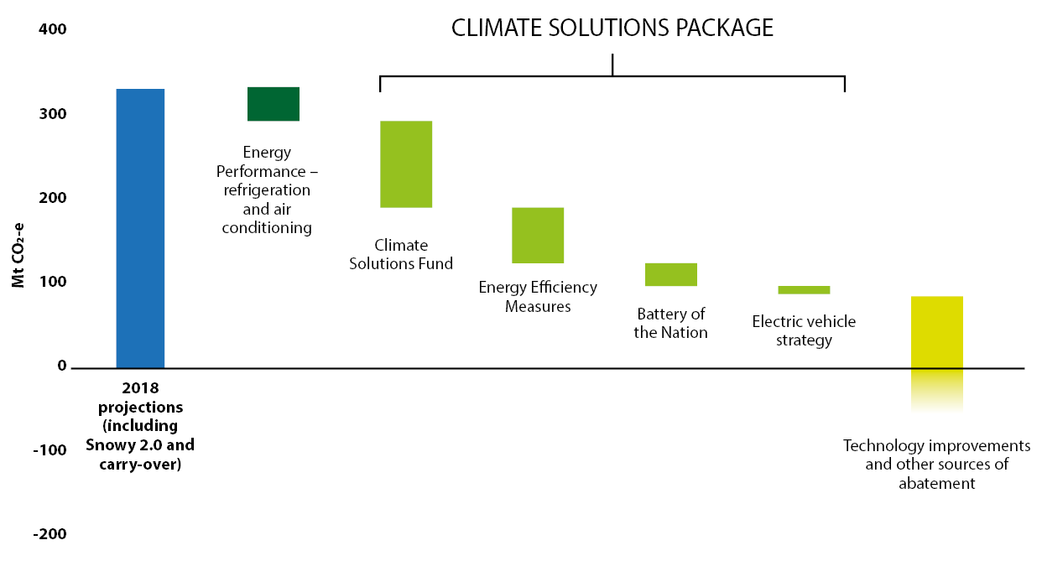

© Commonwealth of Australia, 2019.

This publication is licensed by Commonwealth of Australia under a Creative Commons Attribution 4.0 International licence.

1. For a target of 26 per cent below 2005 levels.
2. Source: Tracking Australia’s emissions reduction targets (2018): <http://www.environment.gov.au/system/files/resources/128ae060-ac07-4874-857e-dced2ca22347/files/tracking-australias-emissions-reduction-targets-2018-factsheet.docx>