Advice for truck drivers collecting horses released from the Mickleham Post-Entry Quarantine Facility (PEQ) also known as the Mickleham Quarantine Facility (MQF)

Facility Address
135 Donnybrook Road, Mickleham, VIC 3064

Directions from Melbourne:
- Take Tullamarine Freeway (M2) toward Melbourne Airport
- Exit onto the Ring Road (M80) towards the Hume Freeway/Greensborough
- Exit onto the Hume Freeway (M31) towards Seymour
- Take the Donnybrook Road exit
- Turn left onto Donnybrook Road, then at the traffic lights, turn left onto Polaris Road.
- Enter the PEQ (Plant & Animal) facility through the first gate on the right ‘Deliveries Gate.’
*Please note – the facility entrance may not appear on GPS or other road maps. Using the site address through GPS Navigation may mark your destination on Donnybrook Rd at the centre of the facility where the ‘Emergency Access Gate’ is located, access will not be granted through this gate*
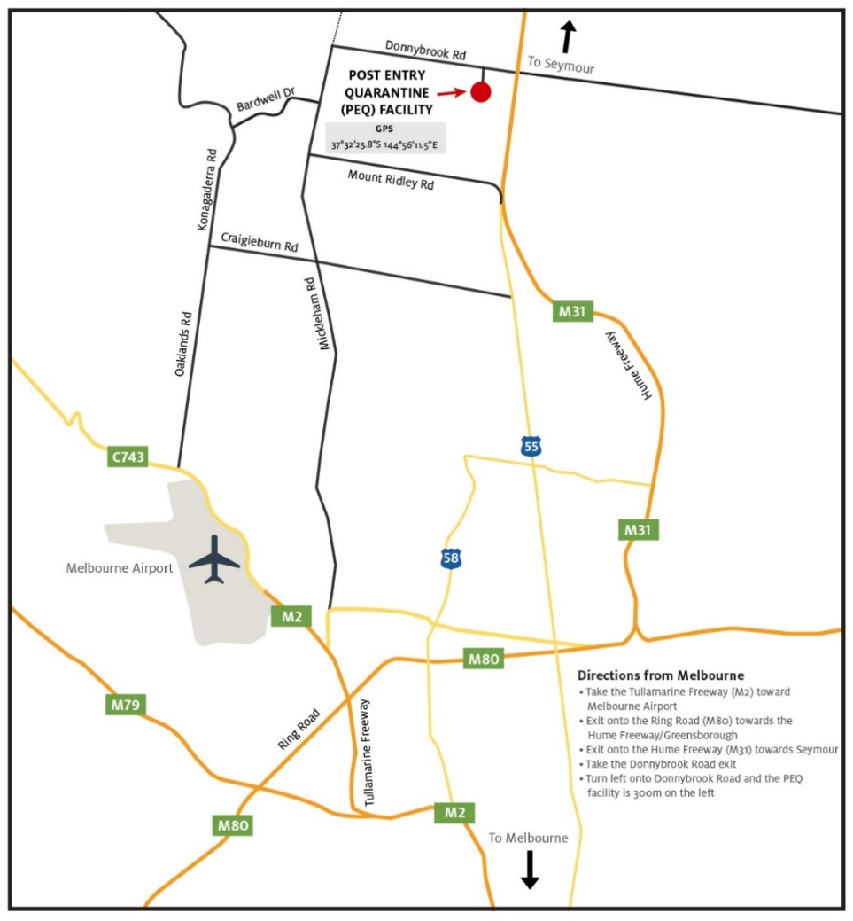
Map showing location of the Mickleham Post-Entry Quarantine Facility

Entering the site for the collection of horses
- Entry to the MQF site will only be permitted after the agreed release times.
Note: Agreed release times will be no earlier than 6.00am.
- Drivers are responsible for the lawful parking of their vehicle outside of the PEQ facility. Vehicles are not to obstruct the roadway or other access gates at the main entrance.
- On arrival at the ‘Deliveries’ gate, the driver will press the intercom button for Security. Security will require the name of the authorised driver and the name of any passengers.
- Once Security have granted access to the facility, drivers are to follow instructions from the Security team which will escort them to the horse compound.

Requirements for visitors accessing site
- Only authorised visitors listed on the access list provided by the importing agent will be allowed on site. Photo ID may be required.
- All visitors must be over the age of 16.
- A maximum of 2 people per vehicle will be allowed on site to collect horses.
- Persons believed to be under the influence of drugs or alcohol will not be permitted entry to the facility.
- Persons acting in an antisocial or aggressive manner will be refused access or immediately asked to leave the facility.
- Other animals of any kind are strictly prohibited on site (including other horses, dogs etc.).
- All visitors to the site must follow any direction given to them by on-site security and biosecurity officers.
- If at any time, you do not meet these requirements you will be asked to leave the facility immediately.
- MQF is a no smoking site.

Requirements for the collection of horses
- Horses must be collected from MQF in commercial transport vehicles (trucks with/without truck trailers) only. Private trucks are not permitted. Horse floats are not permitted. The height of horse trucks must be less than 4.2m.
- Transport vehicles must be clean and free of manure, debris, feed etc on arrival at site. Any vehicle found to be in an unfit/unclean state, will be required to leave site and to be cleaned before the collection of horses can occur.
- All visitors must remain in their vehicle until further directions are provided by a biosecurity officer.
- The authorised person for the collection of horses must ensure that all state animal welfare requirements in relation to the movement of horses are met, including all required documentation.
- If visitors to site fail to comply with entry and exit requirements, including the requirement to follow any direction given by a security or biosecurity official, they may be:
- prosecuted for a serious offence;
- liable to pay a civil penalty;
- required to undergo decontamination;
- excluded from these premises in the future.
Note: The information above relates to the collection of horses from MQF. For procedures and biosecurity requirements for horse transport vehicle drivers who move imported horses from the airport to MQF, please refer to Notice to Industry 3: Horse transport vehicle drivers and imported horses – biosecurity requirements.

