BMSB Seasonal Measures – Guide to insect collecting, recording, storage and diagnostic images

Hitchhiker seasonal pests on vessels

Inspect and collect
Vessels must be thoroughly inspected by crew for insects.
Inspect all cargo decks, stairwells, vehicles and high and heavy cargo.
Look for insects seeking shelter in crevices or moving toward well-lit areas during periods of darkness.
Pay attention to areas close to cargo holds/decks; insects can emerge from vehicles and break bulk items after periods of inactivity.

Recording and storage
Collect and retain any live or dead insects (specimens) found at any time during the voyage.
- Record all detections on the Crew Vessel Inspection report; note deck and hold location which they were found in; and note what type of cargo was involved or nearby.
- Store live and dead specimens in separate bags/containers by deck and hold location. Clearly label each bag.
- Store all bagged specimens in the fridge (NOT the freezer) until arrival in Australia.
- Submit all specimens to an Australian Biosecurity Officer at the first port of arrival in Australia.

Image quality
For assessment and identification of reported insects, photos must be submitted and clearly show the specimen’s colour, shape and body patterns (e.g. spots, stripes).

Image tips
Do not pile specimens on top of each other.
Do not photograph specimens covered by plastic bag.
On a flat surface, space the specimens and display them so that body details are unobscured.
Ensure good lighting, use a plain light-coloured background, and minimise shadows.
Ensure specimens are in focus, and large enough to see their details in the image (not zoomed out).

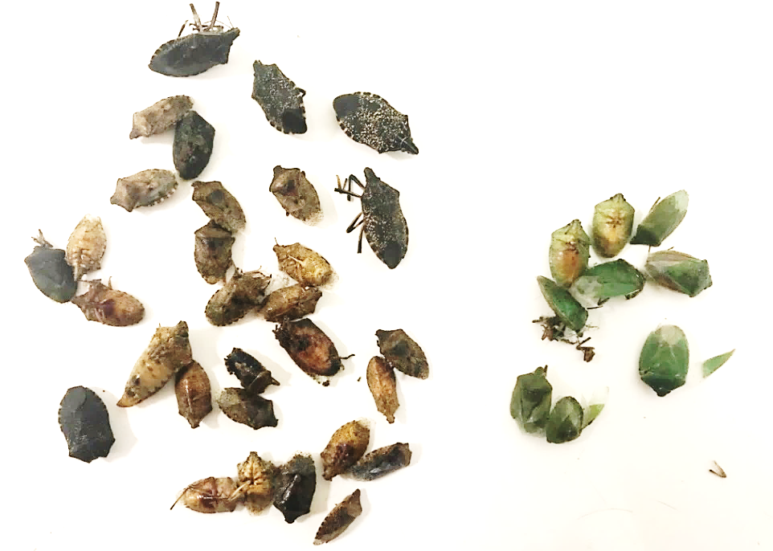


Ideal image
  - Good lighting
  - Minimal shadows
  - Specimens separated to clearly show colour, body patterns and shape
  - Sorted by colour

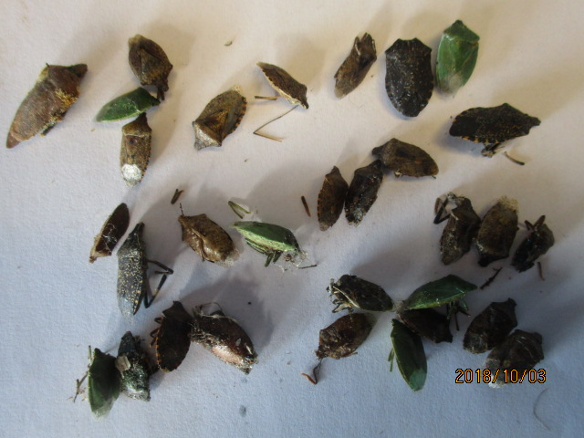

Acceptable image
  - Reasonable lighting
  - Specimens showing colour, body patterns and shape
  - High resolution to allow image enlargement

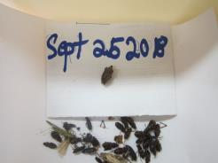

Poor image
  - Image blurry
  - Specimens piled together, image distance too far for identification
  - Low resolution image
Acknowledgement of Country
We acknowledge the Traditional Custodians of Australia and their continuing connection to land and sea, waters, environment and community. We pay our respects to the Traditional Custodians of the lands we live and work on, their culture, and their Elders past and present.
© Commonwealth of Australia 2022
Unless otherwise noted, copyright (and any other intellectual property rights) in this publication is owned by the Commonwealth of Australia (referred to as the Commonwealth).
All material in this publication is licensed under a Creative Commons Attribution 4.0 International Licence except content supplied by third parties, logos and the Commonwealth Coat of Arms.
The Australian Government acting through the Department of Agriculture, Fisheries and Forestry has exercised due care and skill in preparing and compiling the information and data in this publication. Notwithstanding, the Department of Agriculture, Fisheries and Forestry, its employees and advisers disclaim all liability, including liability for negligence and for any loss, damage, injury, expense or cost incurred by any person as a result of accessing, using or relying on any of the information or data in this publication to the maximum extent permitted by law.

