

Colonial Waterbird Monitoring in the Lower Lachlan 2016
Dr Kate Brandis and Dr Mitch Lyons, Centre for Ecosystem Science, UNSW
13th December 2016

Introduction
Significant rainfall within the catchment during mid 2016 produced large volumes of unregulated inflow to the Lachlan River, triggering the delivery of translucent releases as required under the Lachlan Regulated River Water Sharing Plan. The translucent flows inundated significant areas of the Booligal wetlands and the Great Cumbung Swamp.
Thousands of straw necked ibis were observed in the Booligal area, exhibiting nest preparation behaviour (trampling of lignum and other nesting vegetation). Breeding was confirmed on the 26th August with around 4000 birds on nests in the Lignum and eggs. Nest monitoring began in mid-September and continued fortnightly until the end of November. At its peak the colony exceeded 200,000 birds. Reproductive success is expected to be high, with large numbers of fledged juveniles observed, low predation rates, and no significant abandonment of nests.

Methods and Results
Three techniques were used collect data for this colony; ground based nest surveys, aerial survey and UAV image capture.

Ground based nest surveys
Ground based nest surveys were conducted fortnightly (Table 1). A total of 499 nests at 23 clumps were marked throughout the colony.
Table 1 Ground survey dates for Booligal colony monitoring
Survey | Date
1 | 16 to 17 September
2 | 4 to 5 October
3 | 19 to 20 October
4 | 4 to 5 November
5 | 15 November
6 | 30 November

Figure 1 Composition of chick development stages at each survey.

Chick development
Typical development of straw-necked ibis chicks takes approximately 48 days from laying to fledging (Table 2) with two weeks of post fledging parental care (Brandis and Bino 2016) shows the age composition of chicks in the colonies during each survey. Records from the final survey show that majority of chicks have now fledged and left the nest. They have been observed roosting and foraging in areas around the colonies. It is anticipated that the juveniles will remain in the wetland while conditions are suitable and food resources available. Mortality of young waterbirds is often highest in the first year of life (McKilligan 2005). Therefore, providing the best feeding opportunities to build up condition during this post fledging period may assist in increasing changes of survival during the first 12 months.

Table 2 Chick development stages and corresponding age (days).
Age(days) | Development stage
1-20 | Egg
21-25 | Chick
26-30 | Squirter
31-35 | Runner
36-40 | Flapper
41-47 | Flyer
>48 | Fledged

Water depth
Water depth was recorded at nests during each survey (Figure 2). Water depths remained relatively stable throughout the breeding event, with depths at the start of breeding similar to those at completion of breeding.

Figure 2 Mean water depth at nests in colony for each survey.

UAV survey and image capture
UAV image capture was done on the 12th October. Image capture was successful with both video and still photos collected. Still photos were used to create an orthomosaic of the entire colony site from which total nests were counted and vegetation layers derived. A total of 101,360 nests were marked for the 12th Oct. 2016 (Figure 3).
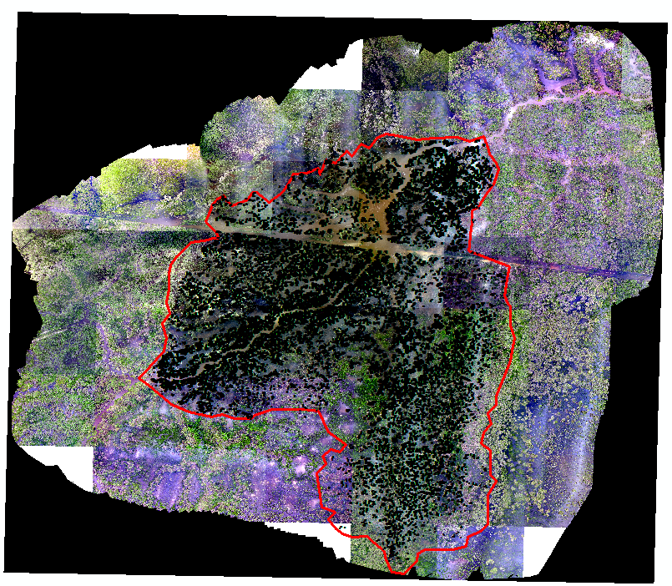
Figure 3 Orthomosaic compiled from UAV imagery (background) with colony boundary (red) and nests (black dots) marked.
Links to examples of the UAV video imagery can be found at the following links:
https://goo.gl/photos/YBAMn9ZXwMZmtiEr5

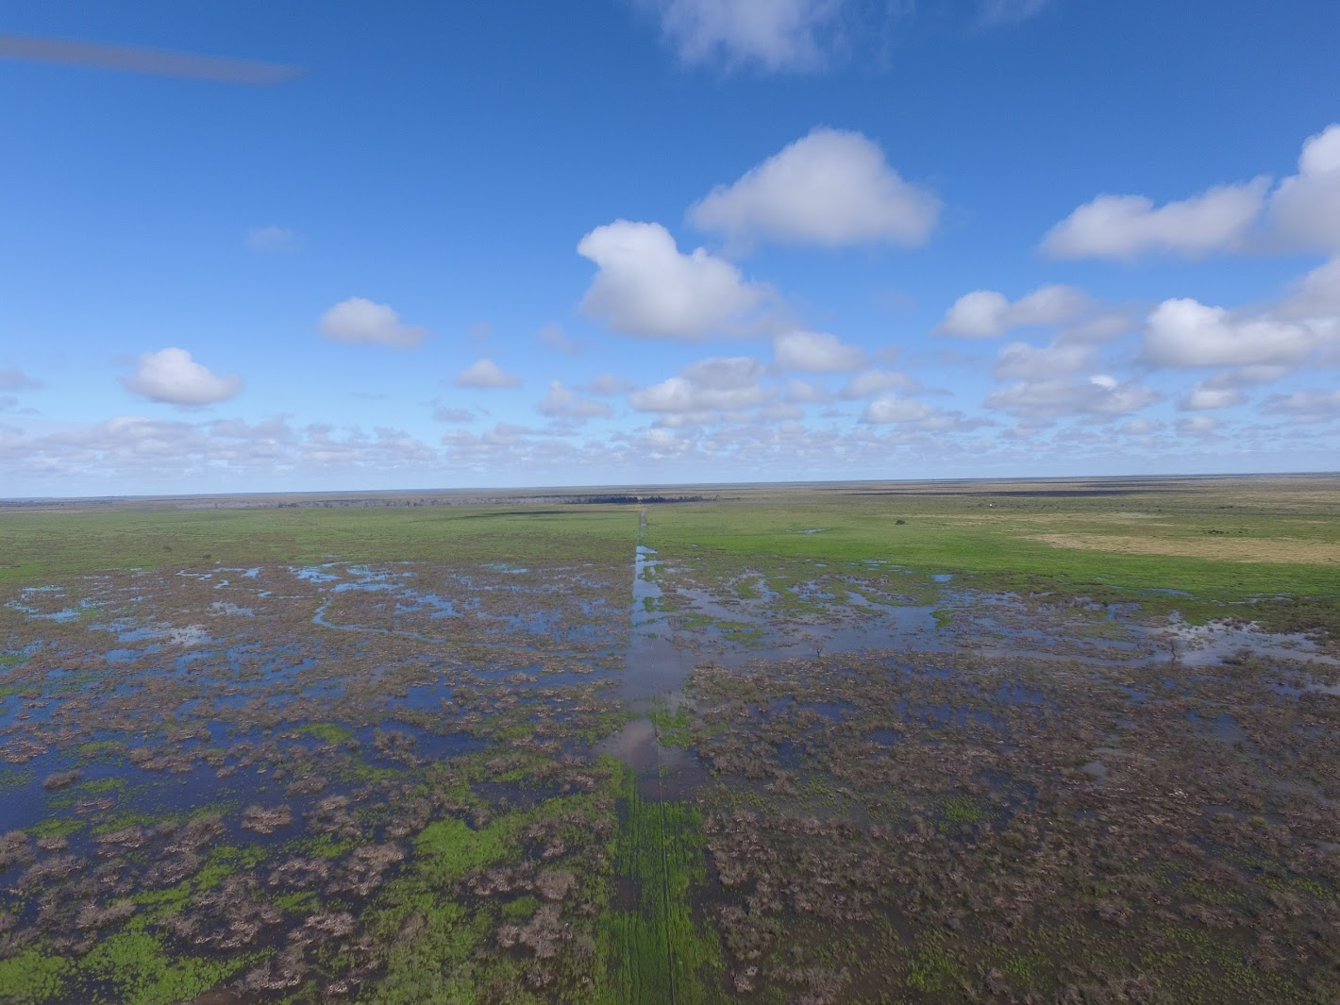
Figure 4 Aerial view of colony area from UAV 12th Oct. 2016. Photo: M. Lyons
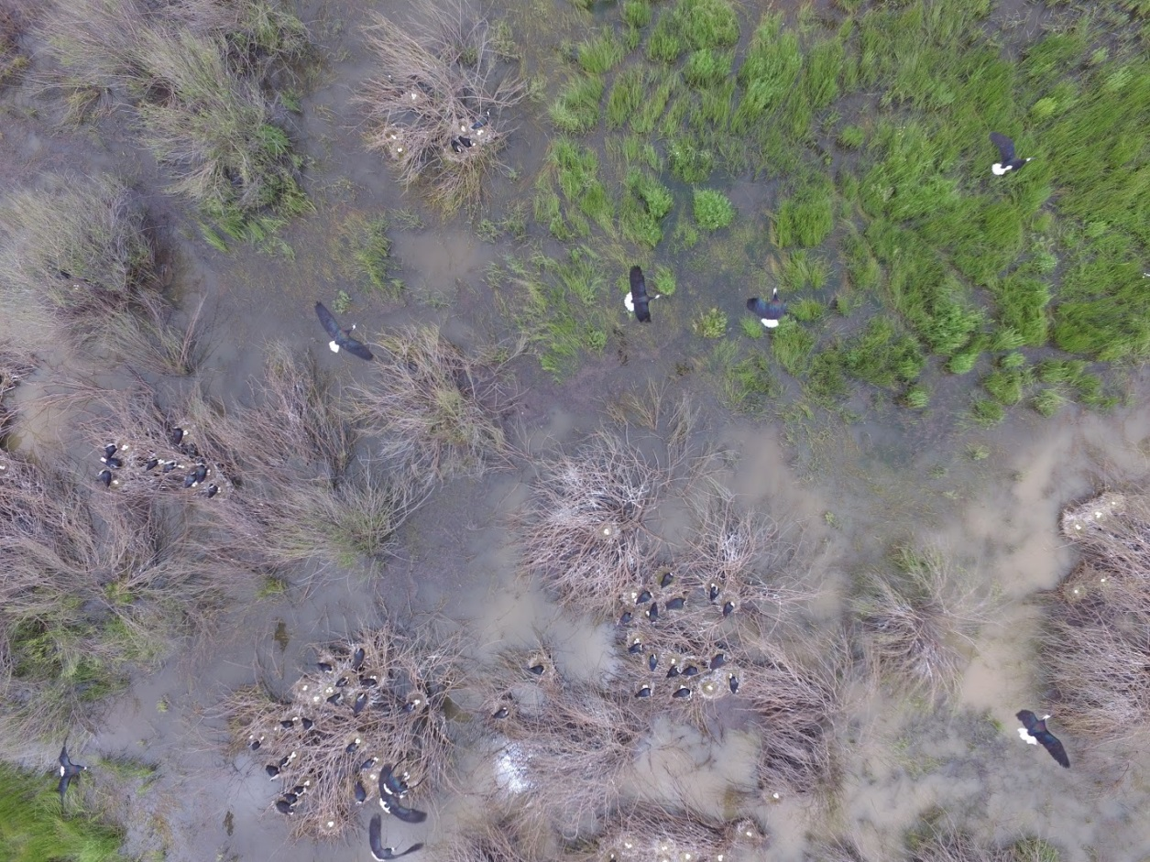
Figure 5 Image of straw-necked ibis on nests captured by UAV. Photo: M. Lyons
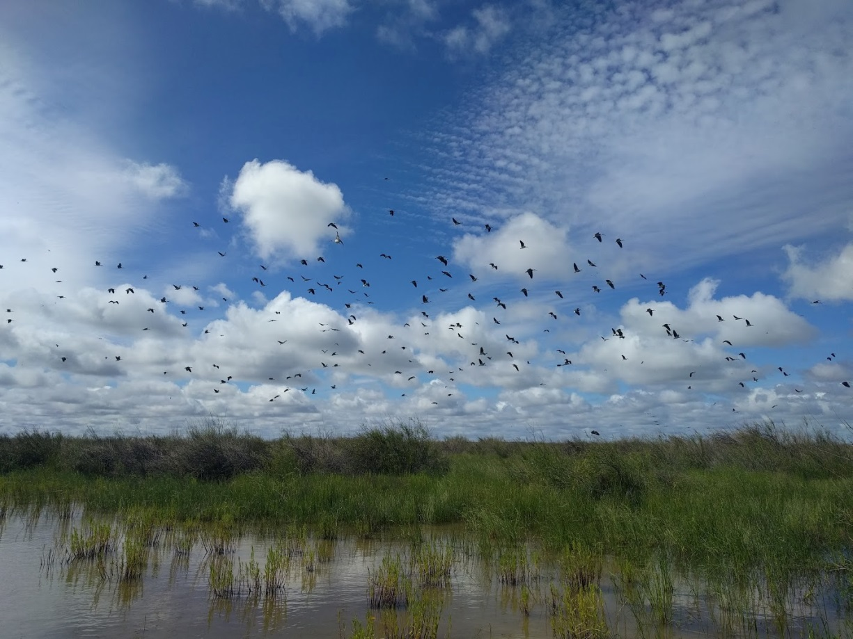
Figure 6 Straw-necked ibis in the Booligal colony. Photo. M. Lyons

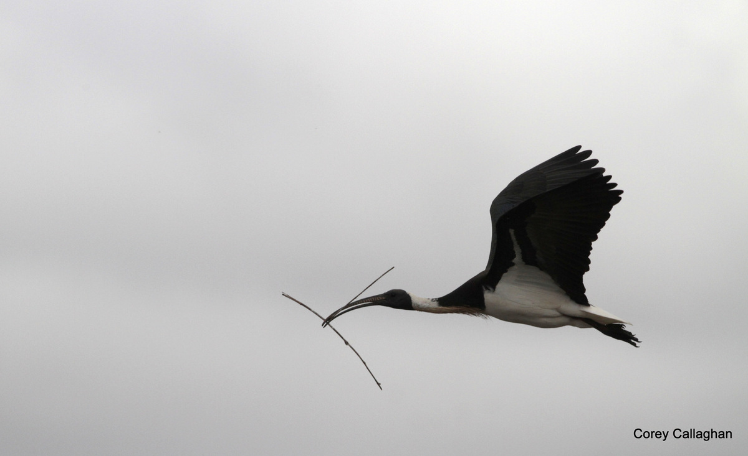
Figure 7 Straw-necked ibis carrying nesting material. Photo. C. Callaghan

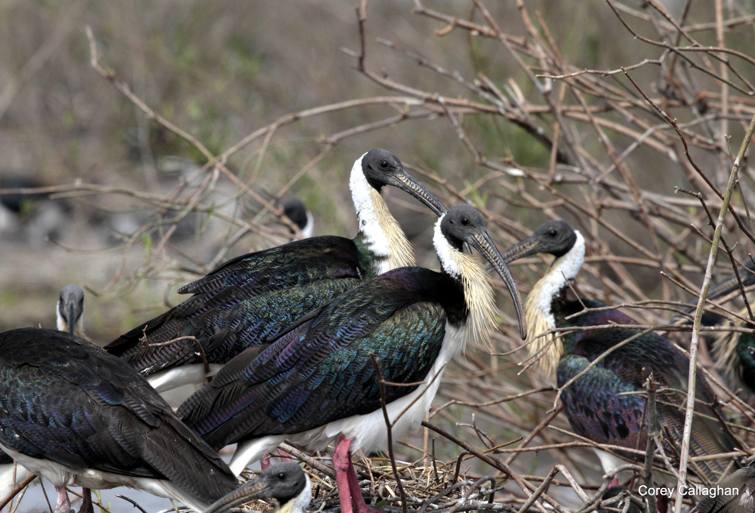
Figure 8 Straw-necked ibis in breeding plumage. Photo. C. Callaghan

Aerial Survey
An aerial survey was completed of the lower Lachlan wetlands on the 7th November as part of the Eastern Australia Waterbird Survey (Figure 9).
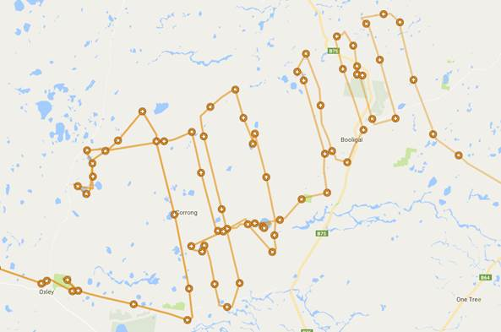
Figure 9 Flight path of aerial survey of lower Lachlan wetlands 7th November 2016.
The blog for this part of the survey can be found at: https://ecosystem.unsw.edu.au/logs/eastern-australian-waterbird-survey/aerial-survey-7th-november-2016

Table 3 Birds observed during aerial survey of the Booligal wetlands in addition to Straw-necked ibis.
Common Name | Scientific Name
Grey teal | Anas gracilis
Hard head duck | Aythya australis
Pacific black duck | Anas superciliosa
Australian wood duck | Chenonetta jubata
Royal spoonbill | Platalea regia
Yellow billed spoonbill | Platalea flavipes
Eurasian coot | Fulica atra
Black tailed native hen | Tribonyx ventralis
Grebes | Podicipedidae
Great crested grebe | Podiceps cristatus
Red necked avocet | Recurvirostra novaehollandiae
Black winged stilt | Himantopus himantopus
Black swan | Cygnus atratus
White-faced heron | Egretta novaehollandiae
Glossy ibis | Plegadis falcinellus

Acknowledgements
Many thanks to research staff, the local landholders to NSW OEH.

References
Brandis, K., and Bino, G. (2016). A review of the relationship between flow and waterbird ecology in the Condamine-Balonne and Barwon-Darling River.
McKilligan, N. (2005). Herons, Egrets and Bitterns. Their biology and conservation in Australia, CSIRO Publishing.

