Prepared for the

The Commonwealth Environmental Water Office

A comparative assessment of event-based mechanisms for providing water to the Narran Lakes

16 October 2017





**Acknowledgement**

The Commonwealth Environmental Water Office (CEWO) commissioned this report for the purpose of receiving information from which it can draw to support the functions of the Commonwealth Environmental Water Holder (CEWH). This report investigates a number of potential options and opportunities for event-based mechanisms to support Commonwealth environmental water delivery.

The report has benefited from the feedback and ongoing cooperation of the CEWO, the Queensland Department of Natural Resources and Mines, and regional stakeholders on the Lower Balonne. Despite every effort to verify data and clarify issues raised, any remaining errors or omissions are the responsibility of the authors.

**Disclaimer**

The views and opinions expressed in this report do not necessarily represent the views of the CEWO. This publication does not indicate commitment by Commonwealth government to a particular course of action nor has the CEWO made any decision on options identified in this study.

The CEWO reserves the right to, in the future, further consider any of the options proposed in the report or options in addition to those identified.

The content of this report does not constitute advice to any third party. Although due care and skill has been applied in the preparation and compilation of the information and data in this publication, no reliance may be placed on it by any other party. No representation expressed or implied is made as to the currency, accuracy, reliability, completeness or fitness for purpose of the information contained in this publication. Readers should rely on their own inquiries to independently confirm any information and comment on which they may intend to act.

The Commonwealth of Australia, its officers, employees, agents and the other parties involved in creating this report disclaim, to the maximum extent permitted by law, responsibility to any other party for any liability, including liability for negligence, loss howsoever caused, damage, injury, expense or cost incurred by any person as a result of accessing, using or relying upon any of the information or data in the report.

The Department acknowledges the traditional owners of country throughout Australia and their continuing connection to land, sea and community. We pay our respects to them and their cultures and to their elders both past and present.

**Contact Details**

Drew Collins Stuart Whitten

Managing Director Group Leader Material and Energy Systems

BDA Group CSIRO Land and Water

PO Box 4022 GPO Box 1700

Manuka ACT 2603 Canberra, ACT 2601

Ph: 02 - 6282 1443 02 - 6246 4359

Web: bdagroup.net www.csiro.au

Email: [drewcollins@bdagroup.net](mailto:drewcollins@bdagroup.net) stuart.whitten@csiro.au

All surveys, forecasts, projections and recommendations made in reports or studies associated with the project are made in good faith on the basis of information available at the time; and achievement of objectives, projections or forecasts set out in such reports or studies will depend among other things on the actions of the Commonwealth government and their agents, over which we have no control. Notwithstanding anything contained therein, neither BDA Group nor its servants or agents will, except as the law may require, be liable for any loss or other consequences arising out of the project.

© Copyright Commonwealth of Australia, 2017, except where otherwise identified.

cid:image001.jpg@01D26FD9.6997AD20

This report, with the exception of the Coat of Arms of the Commonwealth of Australia and third party material (which includes signatures and logos, and photographs, images and other content marked as supplied by third parties),is licensed by the Commonwealth of Australia for use under a Creative Commons Attribution 4.0 International licence. For licence conditions see: <https://creativecommons.org/licenses/by/4.0/>.

Material subject to the above licence should be attributed as ‘*BDA Group and CSIRO (2017). A Comparative assessment of event-based mechanisms for providing water to the Narran Lakes’. A report prepared for the Commonwealth Environmental Water Office*’.

No licence is given in relation to any third party material that may be incorporated in this report.

**Table of Contents**

DEFINITIONS 6

EXECUTIVE SUMMARY 8

1. INTRODUCTION 16

1.1 The Lower Balonne floodplain system and Narran Lakes 17

1.2 Identifying key flow components for the Narran Lakes 18

1.3 The potential role for event-based mechanisms 19

2. WATER USE ON THE LOWER BALONNE 21

2.1 Lower Balonne water supply 21

2.2 Water resource management framework for zone LBU-05 of the Lower Balonne 26

2.3 Irrigated agriculture in Zone LBU-05 on the Lower Balonne floodplain 29

3. TYPES OF EVENT-BASED MECHANISMS 32

3.1 Temporary ‘no-pump’ contracts 32

3.2 Purchase of temporary harvesting entitlements (seasonal assignments) 33

3.3 Store and release mechanisms 33

3.4 Forward and conditional purchase mechanisms 34

3.5 Option mechanisms 35

3.6 Mechanism combinations 36

4. CASE STUDIES TO ILLUSTRATE MECHANISM APPLICATION 38

Case Study 1: Waterbird habitat inundation 38

Case Study 2: Augmenting flows to support waterbird breeding events 42

Case Study 3: Augmenting flows during no and low flow periods 46

5. RISK ASSESSMENT OF MECHANISMS 50

5.1 Risk assessment framework 50

5.2 General risks with event-based mechanisms 51

5.3 No-pump contracts 52

5.4 Purchase of seasonal assignments 54

5.5 Store and release mechanisms 54

5.6 Forward purchase, conditional and option mechanisms 56

6. COMPARATIVE ASSESSMENT OF MECHANISMS 62

6.1 Institutional compatibility 62

6.2 Effectiveness and cost 65

6.3 Workability and risk 69

6.4 Mechanism summary and recommendations 71

7. IMPLEMENTATION ISSUES FOR RECOMMENDED MECHANISMS 76

7.1 Purchase of seasonal assignments 76

7.2 Buy already stored water 81

7.3 Conditional / option store and release contracts 84

8. POTENTIAL TO SCALE MECHANISMS AND APPLY IN OTHER CATCHMENTS 95

8.1 Practicality of mechanisms at different augmentation volumes to Narran Lakes 95

8.2 Applicability of mechanisms in other unregulated catchments 96

REFERENCES 99

# **DEFINITIONS**

|  |  |
| --- | --- |
| Allocation | An authority to take water, and an entitlement to a share of the available water resource in a catchment. |
| Announced period | A period of time during which water may be taken under a water entitlement, adjusted for the location of the entitlement relative to the location where the announcement is made. |
| Antecedent conditions | The preceding climatic and hydrologic conditions that influence river flows—for example, recent rainfall locally and in the broader catchment, recent flows in the river and condition of waterholes. |
| Augmentation success | For this study, achieving a targeted flow indicator, which involves hydrological considerations such as volume, duration, and timing. |
| Commonwealth Environmental Water Holder (CEWH) | A statutory position created under the Water Act 2007 (Cwlth) to manage the water entitlements acquired by the Commonwealth government for environmental purposes. |
| Commonwealth Environmental Water Office (CEWO) | The office in the Commonwealth Department of the Environment and Energy that supports the CEWH. |
| DNRM | Department of Natural Resources and Mines |
| DSITI | Department of Science, Information Technology and Innovation (Queensland). |
| Event-based mechanism (EBM) | For this report, refers to a means to temporarily source water (generally through purchase) to augment the magnitude and/or duration of a flow event. |
| Flow event | Means a flow of a volume above the threshold for water harvesting. |
| Forward purchase mechanism | Refers to the purchase and legal transfer of rights to harvest water, or rights to stored water, at a future time. |
| Gigalitre (GL) | One thousand megalitres. |
| Horizontal slicing of allocations | Where the rates of take stated on the water allocation that is being seasonally assigned relate to only one or some flow thresholds in the volumetric account. |
| Instantaneous volumetric limit (IVL) | Sets the maximum volume that may be stored at any time on the land shown on the entitlement. |
| Mechanism success | For this study, achieving a targeted flow indicator, which involves hydrological considerations such as volume, duration, frequency and timing. |
| Megalitre (ML) | One million litres. |
| Multi-year volumetric limit (MVL) | For each water allocation, specifies the maximum volume that can be taken, with harvested volumes debited from a volumetric account (unrelated to storage capacities). |
| MDBA | Murray-Darling Basin Authority |
| No-pump mechanism | Where contracts are entered into with irrigators for them to forgo water harvesting at some or all flow thresholds stated on a water allocation during a specified event(s). |
| Overland flow water | Means water, including floodwater, that is flowing over land, otherwise than in a watercourse or lake. |
| Option mechanism | Contractual arrangements between parties that specify who has the right (but not the obligation) to water under certain conditions (the ‘trigger’). |
| Passing flow | Means the flow in a watercourse past a specified location, usually measured in megalitres per day (ML/day). |
| Resource Operations Plan (ROP) | Implements a water plan through outlining the rules for taking water in a water management area. |
| Seasonal water assignment | Means the assignment by the holder of the allocation, for a water year, of all or part of the water that may be taken under the allocation to another person. |
| Store and Release Code of Practice | *Code of practice for the release of stored water from privately owned farm storages to receiving waters*. This code provides guidance to storage operators in complying with the Queensland Environmental Protection Act 1994. |
| Store and release mechanism | Involves contractual arrangements for private storage operators to discharge water from a storage to the river to augment a flow event. The mechanism may also involve the harvesting of allocations or overland flow for the purpose of storage and subsequent release. |
| Temporary trade | For the Lower Balonne refers to a seasonal water assignment. |
| Unsupplemented water | Means surface or ground water that is not reliant on public infrastructure to store or distribute water. |
| Vertical slicing of allocations | Where the rates of take for all flow thresholds stated on the water allocation that is being seasonally assigned are in the same proportion as the unused volume in the volumetric account. |
| Water allocation | An authority to take water, and an entitlement to a share of the available water resource in a catchment. |
| Water harvesting | For the Lower Balonne, means the taking of water under a water allocation for unsupplemented water, and the taking of overland flow water under a water licence subject to an announced period. |
| Water harvesting entitlement | For the Lower Balonne, means a water allocation for the take of unsupplemented water and a water licence subject to an announced period for the take of overland flow water. |
| Water plan | Defines the availability of water in an area and the framework for establishing water allocations, the taking of overland flow water and sustainably managing water resources. |
| Water user | Water user means the holder of an authority to take water. |

# **EXECUTIVE SUMMARY**

This report examines the relative merits of event-based mechanisms for providing a 10 GL flow enhancement to the Narran Lakes in the Lower Balonne river system. The Narran Lakes system is one of the more significant sites for water bird breeding in Australia, and is an internationally significant wetland, being listed under the Ramsar convention.

The water needed to meet ecosystem objectives at the Narran Lakes has been identified and captured in key environmental water requirements (volume, magnitude, duration, timing and frequency). As flow events are highly variable in this unregulated catchment, meeting ecological objectives largely relies on unsupplemented flows delivering the right quantity of water at the right time.

Current Commonwealth environmental water holdings in the Lower Balonne are insufficient to always support flow events to achieve ecological outcomes such as maintaining core rookery habitat, or supporting large-scale waterbird breeding events. Additional water will be required during some flow events to strategically achieve additional ecological outcomes. A major consideration is the lack of large public storages on the unregulated river system that supplies water to the Narran Lakes. The successful augmentation of flow events will by necessity require access to private water harvesting entitlements and/or already stored water in private on-farm storages.

The idea of using event-based mechanisms to strategically source private water has been discussed for over a decade. For example, the Productivity Commission (2010) concluded that purchasing temporary changes in the private use of water rights might be an effective means of augmenting events in unregulated systems targeting environmental assets such as a terminal wetland like the Narran Lakes. They noted that this is likely to require the use of new approaches, such as no-pump agreements, the temporary purchase of harvesting rights or stored water, and perhaps the use of options contracts, as collectively these mechanisms offer flexibility to shape hydrographs and meet specific environmental watering objectives.

Support in the Lower Balonne for the use of event-based mechanisms grew following a successful application in 2008. In this event, the Murray Darling Basin Authority (MDBA) purchased around 10 GL of water from a private storage along the Narran River to sustain water levels in the Narran Lakes to support waterbird breeding. The purchase was viewed as an emergency one-off, as there had been very limited waterbird breeding for several years during the Millennium Drought. The purchase was conducted over a very short timeframe and made possible only through the goodwill of a water seller. While providing useful insights to the development of event-based mechanisms, it is apparent that significant design work is required if these mechanisms are to be more widely employed.

In this study, a scoping of available mechanisms is provided, as well as a comparative assessment of mechanisms, identification of key risks, and preliminary design for three practical mechanisms.

The focus in this report of providing 10 GL of additional flow to the Narran Lakes is just an example. There are many ecological outcomes in the Commonwealth Environmental Water Holder’s (CEWH's) portfolio management plan for the northern unregulated rivers that could be achieved with well-designed event-based mechanisms.

This study has highlighted that there is no one preferred mechanism, nor a standard design for each. Mechanisms will need to be selected and tailored to the unique context of different environmental assets, river systems and water management regimes. Key considerations and design issues are highlighted in this study.

**Overview of the Narran Lakes**

The Lower Balonne River system includes major bifurcations, with flows down each of the distributary channels typically controlled by a series of weirs. Only a small proportion of the flow at St George makes it to the Narran Lakes in most events. This limits water sourcing to augment flows to the Narran Lakes to the Narran River itself, which lies below the bifurcation of the Balonne Minor River into the Narran and Bokhara Rivers.

The Commonwealth government has purchased several entitlements in the Lower Balonne River system, with entitlements on the Narran River including water harvesting (WH) allocations (‘allocations’), as well as licences to harvest overland flows (OLF licences), with allocations primarily at the lower flow levels. There remain three properties with private allocations, while these three and two others hold OLF licenses. As these OLF licenses only provide access during relatively high flow events which are of lesser importance to the water augmentation needs of the environment, event-based mechanisms must focus on the remaining private allocations and the availability of stored water. This ‘thin’ market will complicate both the ability of the CEWH to source sufficient volumes when needed as well as ensuring a competitive price to access the water is struck.

At a broad level for this investigation, the kinds of ecological outcomes that would be the objective of event augmentation in the Narran system are inundation of waterbird habitat, including core rookery habitat such as lignum; supporting waterbird breeding events; and providing flows that contribute to longitudinal connectivity and refresh waterholes. In turn, the key types of water augmentation actions related to these are:

* Increasing the magnitude (volume) of flow events;
* Extending the duration of flow events; and
* Augmenting to promote beneficial flow event timing and frequency.

In this study, the relative merit of mechanisms in sourcing 10 GL of water to support these watering objectives has been examined through consideration of mechanism compatibility with the institutional framework for water management on the Lower Balonne, including with the Resource Operations Plan (or ROP), their effectiveness and cost, their workability and a risk assessment (given stakeholder concerns, implementation timeframes, ability to monitor compliance, and so on).

In addition, three case studies broadly reflective of the above types of water augmentation needs were developed and analysed through detailed modelling, with summary findings presented in this report.

**Mechanism selection**

A range of alternative mechanisms that could temporarily source additional water to augment flow events was canvassed. The outright purchase of water entitlements was not considered, as this represents a permanent rather than temporary mechanism targeting specific flow events.

The event-based mechanisms considered were:

* ***Temporary ‘no-pump’ contracts***

Where contracts are entered into with irrigators for them to forgo water harvesting at some or all flow thresholds stated on a water allocation during a specified event(s).

* ***Purchase of temporary harvesting rights (seasonal assignments)***

The temporary purchase of rights (held under an allocation) to harvest water from flow events in a water year is termed a seasonal assignment. All or part of the water harvesting rights under an allocation may be purchased.

* ***Store and release arrangements***

Involves contractual arrangements for private storage operators to discharge water from a storage to the river to augment a flow event. The mechanism may involve only water already stored privately at a specific time, or also involve the harvesting of private or Commonwealth government allocations or overland flow for the purpose of storage and subsequent release.

* ***Forward purchase***

Refers to the purchase and transfer of rights to harvest water, or rights to stored water, at a future time.

* ***Conditional purchase***

Refers to the contracting of access to water (via a no-pump arrangement, stored water or seasonal assignment of water harvesting rights) at a future date, subject to certain circumstances as specified by a nominated trigger (such as an announced flow event).

* ***Options***

Contractual arrangements between parties that specify who has the right (but not the obligation) to water under certain circumstances (the ‘trigger’).

* ***Combinations of mechanisms***

Mechanism cost and effectiveness varies across water sourcing needs and circumstances, and a combination of mechanisms may be needed to facilitate a specific water sourcing objective, or be employed in a portfolio of mechanisms to ensure the overall suite of water augmentation needs are efficiently met.

A summary of the available mechanisms is provided in Table E1. The more practical mechanisms, to provide 10 GL of additional flows to the Narran Lakes in the context of the ROP, are:

* The purchase of seasonal assignments of allocations;
* Buy already stored water; and
* A combined mechanism involving option contracts to purchase private allocations and to store the harvested water on the same property selling the allocations, with consideration to also storing Commonwealth allocations in these private storages.

These more practical mechanisms are highlighted in Table E1.

**Figure E1: Summary of comparative assessment of mechanisms**

| **Event-based Mechanism** | **Possible under ROP** | **Implement *within* an event** | **Can increase event:** | | **Key risks / comment** |
| --- | --- | --- | --- | --- | --- |
| **magnitude** | **duration** |
| ***Temporary no-pump contracts*** | | | | | |
| * WH allocations | √ | √ | √ | X | Flexible mechanism and can help reinstate low – medium flows. As water accounting not overseen by DNRM, and there is a risk that the entitlement holder could make-up volumes later if allocations held under IVL, CEWO water accounting would need to be robust. |
| * OLF licences | √ | √ | √ | X | Only applicable at high end of hydrograph where poor alignment with key environmental needs. High delivery losses. |
| ***Seasonal assignment of entitlements*** | | | | | |
| * WH allocations | √ | √  (subject to prior change to MVL) | √ | X | Flexible mechanism to increase event magnitude, although limited scope re no/low flow augmentation. Thin market reduces competition. |
| * OLF licences | X | - | - | - | Not allowed under ROP |
| ***Store and release mechanisms*** | | | | | |
| * Buy already stored water | √ | √ | √ | √ | Opportunistic, so alignment with water sourcing needs is variable. There is precedent of this working. Use of stored water is the only means to extend event duration, but seller has a strong negotiating position. |
| * Store Commonwealth allocations in a single contracted storage | √  (subject to assessed changes re point of take) | X  (Water from an earlier event needs to be stored) | √  (but reduce event volume when take) | √ | Constrained by available volumes of Commonwealth environmental water. Stored water subject to significant evaporative losses. Potentially significant budget outlay and issues associated with storage maintenance and integrity. |
| * Purchase harvested water for storage on same property as point of take | √ | X  (Water from an earlier event needs to be stored) | √ | √ | Without effective targeting of water sourcing, alignment with augmentation needs may be poor, and costly subject to on-property use of water when not required. |
| * Source water for storage from a *different* point of take | √  (subject to assessed changes re point of take) | X  (Water from an earlier event needs to be stored) | √ | √ | Difficulties in managing temporary access to allocations which would require a change in the point of take and subsequent reversal. Increased costs if transfers impact value of remaining volumes under the MVL. |
| ***Forward purchase, conditional, option and combined mechanisms*** | | | | | |
| * Conditional / option no-pump contracts | √ | √ | √ | X | Mechanism effectiveness critically dependent on robust triggers. Promising mechanism if can design well. Thin market and CEWO water accounting would need to be robust and supported by monitoring. |
| * Combined option contracts involving the storage of harvested water on same property as point of take | √ | X  (Water from an earlier event needs to be stored) | √ | √ | Involves storage of harvested water from private allocations at same property as purchased. Capacity to use in conjunction with storage of Commonwealth-owned allocations.  Strategically increases stored volumes available to achieve environmental outcomes; Critical issues are store & release trigger efficacy, storage capacity, and a thin allocations market. |
| * Conditional / option contract for privately stored water | √ | √ | √ | √ | Critical issue is trigger efficacy, and volumes limited without mechanism to source additional water from events. |

Event-based mechanisms have focussed on stored water and/or water harvest allocations. The key event augmentation needs for environmental benefit are likely to focus on the small to medium flow events, and these events are not well matched to additional OLF. In addition, this water cannot be seasonally assigned (only accessed through no-pump contracts), and any OLF left unpumped and not captured in private storages would incur high delivery losses before reaching the Narran Lakes.

For the scale of event-based mechanisms assumed for this project, indicative modelling suggests available privately held allocations will be insufficient to provide the additional water needed to provide a 10 GL flow augmentation until the flow event volume at the Wilby Wilby gauge (close to the Narran Lakes) reaches around 30 GL. The purchase of stored water could be used to supplement water sourced from privately held allocations.

However as shown in case studies, this approach may still only meet a fraction of water sourcing needs seeking to increase the volume of an event.

A similar situation occurs when targeting already stored water as a means to extend an event’s duration, for example, to support a waterbird breeding event. When irrigators have had access to a moderate level flow event, storage volumes are likely to be significant, and able to provide the volumes needed for a 10 GL augmentation at the Wilby Wilby gauge. But at lower flow levels, storage volumes will be more modest and rarely sufficient. Facilitating larger storage levels will be required.

To ensure both event magnitude and duration can be effectively augmented across the range of circumstances to meet environmental requirements, a means to strategically store additional water is needed. This can be assisted through the harvesting and storage of allocations managed by the CEWH. The disadvantages however are twofold. Firstly, the harvesting of Commonwealth-owned allocations that otherwise would be left in-stream will impact the environmental benefits of that event. Secondly, the Commonwealth allocations, in themselves, would be insufficient to provide the additional storage volumes needed.

Therefore, these mechanisms (the seasonal assignment of allocations and purchase of already stored water) need to be combined with a mechanism which can strategically access privately held allocations to harvest and store water *ahead* of when it is needed.

To ensure both the private and Commonwealth allocations are managed in line with variable flow augmentation needs, the harvesting of allocations, storage management and releases would need to be negotiated in advance, and subject to operational rules captured in a conditional or option type contract.

Given there are only three remaining properties with WH allocations along the Narran River, if water in excess of that available under one property’s allocations was needed, then the CEWH could consider seeking to enter an agreement for harvesting and storage at another property, or indeed all three if necessary.

Finally, the recommended mechanisms provide a diversity of approaches that may work for the diversity of environmental needs, hydrological conditions, and prospective sellers. The analysis presented illustrates that more than one mechanism will be needed, with the use of multiple mechanisms likely between, if not within, years. Having multiple mechanisms in effect at any time would provide considerable flexibility to meet environmental requirements.

**Mechanism design**

The analysis in this study has shown that context is important. For the Narran, securing temporary access to river WH allocations rather than OLF licences is critical, because the low and medium flows in the system have been significantly affected by diversions, rather than the harvest of overland flows. Also, promoting ecological outcomes in the Narran Lakes will at times require mechanisms that can affect the peak or volumes of a flow event, while at other times extending the duration of events will be the primary need. And further, the limited availability of private water harvesting entitlements along the Narran River close to the Narran Lakes has meant that mechanism application within an event will often not be sufficient. More strategic access to allocations ahead of when the water is needed, and securing appropriate storage for this water, will be needed.

Therefore, no mechanism will always be the best. Moreover, the analysis has shown that mechanism design and risk management may be more important than the mechanism type chosen.

The thin market on the Narran River presents a challenge. If water sourcing is pursued within events when a water augmentation need is identified and is purely opportunistic, then the sellers would have a strong bargaining position. To ensure cost-effective water sourcing, the CEWO would be well served by developing a range of purchasing opportunities for possible endorsement by the CEWH, such as seasonal assignments, access to stored water, and option contracts, that will provide some competition among potential suppliers. To be as informed as possible, water opportunity costs and available market data should be benchmarked, and most importantly, consultation should occur early resulting in contracting in advance where feasible. There may also be times when the CEWH may consider being a seller in the system, when environmental needs have been met for the imminent future.

The significant variability in flow events and environmental watering needs presents a challenge in predicting when and what water to source. The use of water sourcing ‘triggers’ within mechanisms will need to be a focus if water purchases are to be effectively tailored to priority needs. This will require extensive upfront developmental work and the crafting of mechanisms designed to learn.

Progressively, there is benefit in the CEWO developing a portfolio investment approach for consideration by the CEWH, rather than a deterministic, risk minimisation approach. So, for example, water purchased on some occasions may not be able to be used for its intended purpose, and selling it back to irrigators may be the best way to capture its value for environmental use at another time. In addition, some water augmentations may fall short of the volumes required for the targeted environmental watering need. This will be an occasional outcome when employing a risk-based mechanism. Success will need to be measured over the long-term and from a portfolio investment perspective.

Compliance and enforcement strategies will also need thought. Water management on the Queensland Narran River is underpinned by Queensland regulations and well-developed monitoring, reporting and auditing regimes. These compliance programs are expected to protect water under purchased WH allocations or OLF licenses for use for environmental purposes, and this is a key advantage of seasonal assignments rather than no-pump agreements.

Some mechanisms however, will necessitate contract-based agreements, and risks will need to be managed through a rigorous mechanism development process, consultation with stakeholders, comparative analysis, development of due diligence processes, piloting, learning, and adaptive management. State government flow gauging, river modelling and event analysis will remain an important means to determine event augmentation volumes, and to assess whether water purchases are in fact delivered to the Narran River and their effectiveness in delivering targeted flow enhancements to the Narran Lakes. Commonwealth and state government collaboration will remain of critical importance across all mechanisms.

Finally, further water recovery by the Commonwealth Department of Agriculture and Water Resources, changes to regulations (such as in the ROP) or financial considerations may influence the water augmentation context and priorities for the implementation of mechanisms to meet environmental requirements. Some refinements to foundational assumptions of this study and analysis may be needed. Nevertheless, the findings in this report will broadly remain relevant for environmental water management on the Narran, as well as more broadly across unregulated catchments which experience highly variable flows.

# **1. INTRODUCTION**

The Commonwealth Environmental Water Office (CEWO) recently concluded its portfolio management planning process for 2016–17[1]. This planning process identified the benefit of augmenting water supply at key times to meet high environmental water demands, such as the environmental demands at the Narran Lakes. Such augmentation could assist in achieving greater environmental benefit by delivering the right quantity of water at the right time in the right place to protect and restore aquatic ecosystems.

To this end, the CEWO engaged BDA Group, in collaboration with CSIRO Land and Water, to examine the relative merits of event-based mechanisms for providing a 10 GL flow enhancement to the Narran Lakes in the Lower Balonne river system. Specifically, the CEWO has sought:

* A review of the relevant literature, legislation and frameworks regarding event-based mechanisms, and to consult with environmental managers at the CEWO, Queensland government officials and water licence holders;
* Develop event-based store and release mechanisms, including consideration of the 2008 waterbird breeding event and to undertake a risk assessment of these mechanisms;
* Develop other event-based mechanisms and analyse circumstances when they may be efficiently and effectively used;
* Compare all event-based mechanisms, and provide advice on the relative benefits / costs / feasibility / circumstances when it might be efficient and effective to implement each mechanism, including analysing the historical sequence of flows;
* Undertake a preliminary design of three event-based mechanisms. Identify steps to implement each mechanism, how any outstanding issues may be resolved. Provide advice on the procurement approach and the duration of the arrangement;
* Provide advice on whether the event-based mechanisms can be applied in distributary channels, and whether they can be readily up-scaled or down-scaled in volume, and practical limits to such increases or decreases.

To understand the context for the use of these mechanisms, the study has involved a review of the Lower Balonne floodplain system and the key environmental watering requirements of the Narran Lakes, which are briefly reported in this section of the report. The prevailing water resource management framework on the Lower Balonne (Section 2), and the range of event-based mechanisms available were then identified (Section 3).

The analysis of the event-based mechanisms has involved:

* The development of a scenario model of water availability and use on the Narran River;
* Application of the scenario model to examine three case studies in the use of event-based mechanisms to promote the types of water augmentation that may be required for the Narran Lakes (Section 4);
* A risk assessment of mechanisms drawing on feedback from stakeholder consultations (Section 5);
* A comparative assessment of mechanisms, drawing on their compatibility with the water resource management framework on the Lower Balonne, effectiveness and cost in sourcing water to augment flows, as well as an assessment of mechanism workability and risk (Section 6);
* The development of preliminary implementation strategies for selected mechanisms (Section 7); and
* An assessment of the applicability of the mechanisms to sourcing smaller or larger volumes for the Narran Lakes, along with comment on the applicability of the mechanism in other unregulated catchments (Section 8).

## **1.1 The Lower Balonne floodplain system and Narran Lakes**

The Lower Balonne floodplain area is a complex floodplain channel system which includes the Ramsar-listed Narran Lakes, a large terminal wetland system (Figure 1.1).

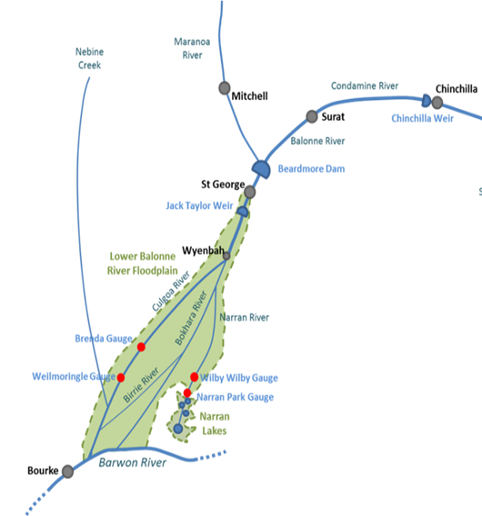**Figure 1.1: Stylised map of the Lower Balonne River Floodplain and Narran Lakes**

Source: MDBA (2016), Figure 1

Narran lake

Clear, Back and Long Arm Lakes

Flows in the Lower Balonne system are highly variable with extended periods of low or no-flow. The Narran River is one of a network of distributary channels that make up the Lower Balonne Floodplain, with other branches including the Culgoa, Birrie and Bokhara Rivers.

The Narran River has a small, shallow main channel and a contiguous floodplain. Several lakes lie along the floodplain and the river terminates in the Narran Lakes wetlands system east of Brewarrina in northern NSW. The Narran Lakes system includes portions of the Narran Lake Nature Reserve, a Ramsar-listed site centred on the systems three northern Lakes (Clear, Back and Long Arm). The main Narran Lake is located to the south of the Reserve and is also a key part of the system.

The Narran Lake Nature Reserve contains extensive areas of habitat for key waterbird species - Ibis, spoonbills, cormorants, pelicans and several waterfowl species which breed in fringing lignum; with river cooba used for nesting and roosting by egrets, herons, spoonbills, cormorants and darters. In addition, many swan and duck species breed on Narran Lake and associated channels.

As a result, the Narran Lakes system is one of the more significant sites for water bird breeding in Australia.

## **1.2** **Identifying key flow components for the Narran Lakes**

The physical character and inundation requirements of the lakes are relatively well known, and the Murray-Darling Basin Authority (MDBA) has assessed the environmental watering requirements of the Narran Lakes as part of its preparation of the Basin Plan and work associated with the Northern Basin Review. The following overview has been drawn from MDBA (2016).

The flow regime is a primary determinant of the structure and function of ecosystems in rivers, and alterations to flow regimes have been shown to result in ecological change in many systems. Accordingly, the assessment of environmental water requirements by the MDBA focuses on the different flow components required to meet the key needs of ecosystem components (fish, waterbirds, vegetation). This has allowed site-specific flow indicators to be developed based on four hydrologic metrics:

* ***Magnitude***: either a specified minimum daily flow rate (ML/d); or a volume (ML), which is a specified minimum quantity of inflows over a period of time (and may or may not specify a minimum daily flow);
* ***Duration***: for flow, the number of days a flow remains at or above the specified magnitude (ML/d); for volume, the period of time flow contributes to meeting the specified quantity of water (ML);
* ***Timing***: the months of the year a flow of a specified magnitude and duration is sought; and
* ***Frequency***: frequency is expressed in several ways depending on the context of the flow indicator: the maximum number of days between flow events (eg: 350 days); or the percentage of years in which there is at least one flow event of a specified magnitude, duration and timing (eg: 60%); or the average period between events (eg: 6 years); or a maximum return interval (eg: once in every 10 years).

The water needed to fulfil ecosystem functions at the Narran Lakes was assessed by the MDBA for the purpose of setting Sustainable Diversion Limits based on identified ecological values and targets, known flow-ecology relationships, and hydrological analysis. The resulting site-specific flow indicators, specified by the above hydrologic metrics were then selected to represent the water requirements of each of these ecological functions.

These indicators are shown in Table 1.1. Notwithstanding the indicators shown, the CEWH as the manager of Commonwealth environmental water holdings and associated funds may decide to respond differently as environmental opportunities arise from time to time.

**Table 1.1: Site-specific flow indicators for the Narran Lakes** (as at the Wilby Wilby flow gauge)

|  |  |  |  |  |
| --- | --- | --- | --- | --- |
| **Ecological process** | **Magnitude (ML)** | **Duration (days)** | **Timing** | **Frequency** |
| Drought refugia (vital habitat) in the Narran River | Any flow | 1 | Anytime of the year | 350-470 days maximum period between events |
| Longitudinal connectivity (small fresh) of the Narran River | 1,700* | 14 | August - May | 40-60% of years with at least 1 event |
| Key rookery habitat of the northern lakes in the Narran system | 25,000 | 60 | Anytime of the year | Average of 1–1.3 years between events |
| Habitat vigour of lignum surrounding core habitat in the Narran Lakes | 50,000 | 90 | Anytime of the year | Average of 1.3–1.7 years between events |
| Large-scale waterbird breeding events and habitat of the northern lakes and northern floodplains | 154,000 | 90 | Anytime of the year | Two events in any 8-10-year period |
| Habitat in all of the northern and central floodplains | 250,000 | 180 | Anytime of the year | Average of 8-10 years between events |

Source: MDBA (2016)

* ML / day

## **1.3 The potential role for event-based mechanisms**

The potential for event-based mechanisms, particularly ‘market-based’ mechanisms, to be employed to source water for environmental needs has been the subject of investigation in Australia for over 20 years. This has included several research papers from organisations such as the Australian Bureau of Agricultural and Resource Economics, CSIRO, MDBA and the Productivity Commission[2]. The Productivity Commission (2010) concluded:

*The effectiveness of purchasing water in unregulated systems depends on the nature of the environmental objectives being targeted. These might include achieving permanent reductions in diversions, maintaining river flows in times of water scarcity, or supplementing beneficial flooding to floodplains and wetlands.*

*Purchasing individual licences in unregulated systems may provide little flexibility, both temporally and spatially, in targeting environmental objectives because of limited control over environmental flows in the absence of infrastructure or storage facilities. The potential to use the water recovered from purchasing entitlements in unregulated systems to target a particular environmental asset will depend on geographical proximity and the potential for conveyance losses and extraction by downstream users.*

*That said, purchasing changes in licence conditions, such as cease-to-pump rules or rostering rules, might be an effective means of shepherding water resulting from a high-flow event through a river system for environmental benefit, such as to water a terminal wetland.*

*The use of options or lease contracts in unregulated systems could provide flexibility in targeting environmental objectives where these can be clearly identified and aligned with the conditions of such contracts (for example, linking cease-to-pump triggers to river height or flow-rate thresholds).[3]*

These comments show considerable foresight given the circumstances of the Narran Lakes.

The CEWH, supported by the CEWO, manages a suite of water entitlements on the Lower Balonne purchased by the Commonwealth, consistent with the Basin Plan. Modelling by the MDBA suggests that passive use of these entitlements - simply allowing water that would otherwise have been extracted under consumptive licences to stay in-stream or to flow across the landscape - will be insufficient to maintain the health of the Narran Lakes, particularly in some years. More innovative use of these entitlements and participation in water markets will be needed. How this could be done is the focus of this report.

# **2. WATER USE ON THE LOWER BALONNE**

In this section, an overview of the water supply and agricultural production systems on the Lower Balonne is provided.

## **2.1 Lower Balonne water supply**

A stylised representation of the Lower Balonne River system is shown in Figure 2.1.

**Figure 2.1: The Lower Balonne River system connected to the Narran Lakes**

The system includes major bifurcations, with flows down each of the distributary channels typically controlled by a series of weirs. For example, bifurcation 1 (B1) is located where the Balonne River divides into the Culgoa and Balonne Minor rivers.

The Balonne Minor River subsequently divides into the Narran and Bokhara system at B2. At low flows, only about 30% of the water reaching each bifurcation flows into channels connected to the Narran Lakes, significantly reducing opportunities to redirect water above these weirs to the Lakes.

Only the Lower Balonne river management Zones LBU- 01, 02, 04 and 05 are directly linked to the Narran Lakes. The only regulated water supply scheme on the Lower Balonne is around St George. The dam has a storage capacity of 82 GL.

Most irrigation needs in the Lower Balonne are met from harvesting water from rainfall events, either directly from overland flows (OLF) or water harvesting (WH) from ‘unregulated’ flows in the rivers and distributary channels. Irrigators must hold allocations for water harvesting which outline the times and quantities of water that can be harvested.

Typically, captured OLF and WH are held in on-farm storages until the water is needed.

The likely effectiveness of mechanisms in securing and delivering 10 GL to the Narran Lakes will be dictated by the available water that can be purchased from irrigators or already owned by the Commonwealth and managed by the CEWH, and the hydrology of the Lower Balonne that impacts transmission losses along channels, the loss of flows at bifurcation weirs, and the loss of stored water on-farm (principally due to evaporation).

Announced periods for water harvesting by irrigators is dictated by rain events in the upper catchment, the amount of water stored in Beardmore Dam and ‘notifications’ issued by the Queensland Department of Natural Resources and Mines (DNRM). Specifically, notifications outline water harvesting periods, and are referenced to the St George gauge (although determined by inflows into Beardmore Dam and the volume of water allocations that can be accessed within each flow threshold - ie: harvesting window)[4].

Water harvesting entitlements outline when water can be harvested from rivers / channels or overland flows, daily maximum ‘take’ rates and on-farm water storage limits. Specifically, irrigator access to flows is based on rolling Water Harvesting Notification announcements (henceforth referred to as ‘announcements’) based on flows passing the St George gauge. Water must not be taken under a water harvesting entitlement except during an announced period. The maximum daily pumping rates by flow thresholds in Zone LBU-05 are shown in Figure 2.2.

**Figure 2.2: Maximum daily pumping rates in Zone LBU-05 by flow thresholds\***

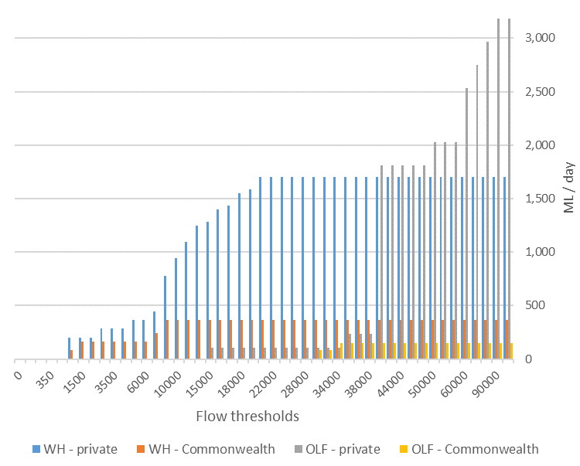

Source: Department of Science, Information Technology and Innovation

* Excludes OLF licences where on-farm storages holding captured OLF are not connected to the Narran River.

The announcements are based on assessments which take into account licenced water harvesting volumes, transmission losses and channel breakouts, such that all licenced extractions at each announcement level should be possible without crowding out any licenced pumping.

Inflows to Beardmore dam up to 730 ML/day (as measured at the St George gauge) are allowed to pass through to support water extraction for stock, domestic and environmental needs. An announcement of 1,200 ML/day is the lowest announcement level allowing irrigation water harvesting. At this level, there will be high transmission losses early as streams are ‘wetted up’ and some minor breakout to the floodplain.

For announcement from 3,000+ ML/day, significant breakouts will occur to the floodplain. Nevertheless, the most hydrologically efficient announcement level to get water to the Narran Lakes is around 7,000 ML/day. This flow level is associated with actual flows at St George of around 8,500 ML/day and there is the least crowding of water harvest extractions and breakouts are still modest. For an announcement of 8,000 ML/day, actual flows at St George must reach around 14,800 ML/day, and breakout volumes increase significantly[5].

From announcement of 20,000+ ML/day, the bifurcation weirs are fully drowned out and have no effect. An announcement of 22,000 ML/day is the highest announcement level for licensed river water harvesting in Zone LBU-05, with licensees allowed to pump at their highest rate above this level. Licenced overland flow harvesting in Zone LBU-05 largely commences from an announcement of 30,000 ML/day.[6]

Due to the likely impact of the bifurcation weirs, transmission losses and water harvesting during flow events, any water secured at a distance from the Narran Lakes system will incur large delivery losses. For example, recent advice from the MDBA suggests some 3-5% of modelled flows at the St George gauge, on average, reach the Narran Lakes.

For this reason, the sourcing of water above St George in Zone LBU-01, or regulated water from the St George Water Supply Scheme in Zone LBU-02 or unregulated water in Zone LBU-02 has not been considered as a source of water for augmenting flows to the Narran Lakes system (but may be pertinent for augmenting flows to other environmental assets in the Lower Balonne system).

Similarly, sourcing water from Zone LBU-04 faces significant challenges. Firstly, of the six properties in the zone with water harvesting allocations, only two properties are connected to the Narran River – the others access water through distributary channels which do not return to the Narran. The WH allocation of one of these properties has already been purchased by the Commonwealth government, while the WH allocation for the other property has a long-term average annual take of only 1.9 GL. Finally, under the ROP, water allocations from one zone in the Lower Balonne cannot be traded for extraction in another zone, which some mechanisms may require.

Similarly, the Commonwealth government has purchased several WH and OLF entitlements in Zone LBU-05, with the collective maximum daily pumping volumes by announcement level and ownership class shown in Figure 2.2. As can be seen in the figure, WH purchases by the Commonwealth government are largely within the lower flow thresholds, with most privately held WH allocations commencing within the 8,000 to 20,000 ML/day announcement windows.

The collective daily pumping volumes under the Commonwealth OLF licenses are relatively small in comparison, and apply from the 30,000 ML/day announcement level. The privately held OLF licences are also relatively modest until the 40,000 ML/day announcement level, and then markedly increase from the 50,000 ML/day level.

Importantly, when WH or OLF entitlements are sold to the Commonwealth and the property retains some water entitlement, a volumetric limit on take is placed on the remaining entitlement and the allowable storage capacity on that property is adjusted so that the prior harvest limit on the other licence class is not effectively increased. In addition to the licensed WH and OLF pumping rates, the actual water volumes that could be sourced to augment flows to the Narran Lakes will depend on the frequency of announcements and the number of days each announcement level is maintained.

Figure 2.3 shows the average number of days per year at which each announcement level is exceeded, while Figure 2.4 shows the percentage of years in which each flow threshold is exceeded. Both are based on Queensland Department of Science, Information Technology, and Innovation (DSITI) modelling of seasonal conditions under Basin Plan conditions.

**Figure 2.3: Average and median number of days per year at each announcement level**

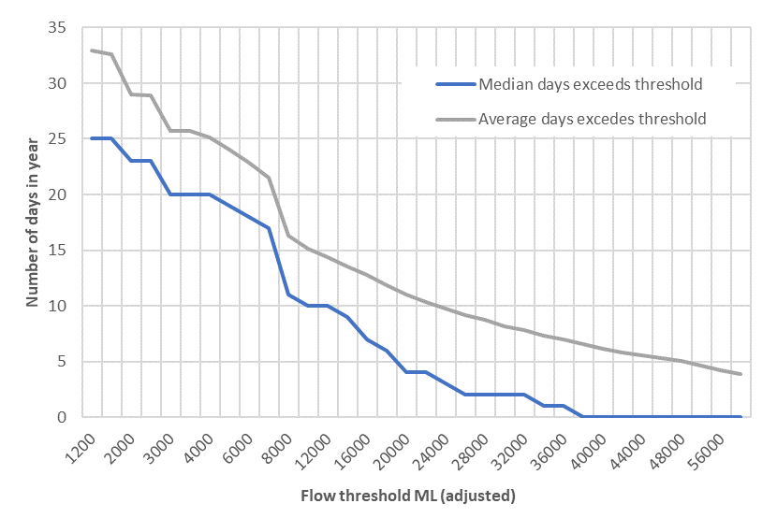

Source: Department of Science, Information Technology and Innovation

Small flow events are received in most years, but the frequency of larger flow events falls below 50% at around the 32,000 ML/day announcement level, with only some 2 days a year on average (median) at or exceeding this level.

**Figure 2.4: Percentage of years in which flow threshold is exceeded**

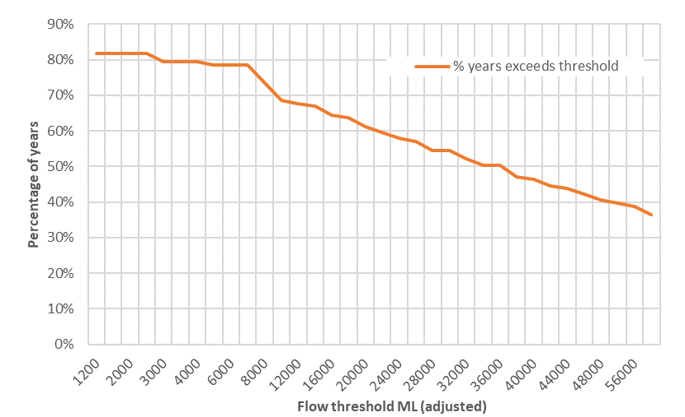

Source: Department of Science, Information Technology and Innovation

The timing of water harvesting events within the year will also be important, both for irrigation and for augmenting environmental watering. Figure 2.5 identifies the modelled average annual water harvesting volumes available by month based on the period 1895 to 2016, illustrating its summer dominance.

**Figure 2.5: Average monthly water harvesting volumes Zone LBU-05 by licence class**

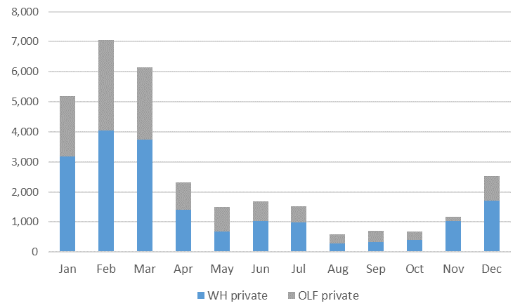

Source: Department of Science, Information Technology and Innovation

## **2.2 Water resource management framework for zone LBU-05 of the Lower Balonne**

The water planning framework in Queensland is outlined in the Water Act 2000. Consistent with the Act, the key water management documents for the Lower Balonne catchment are the Water Plan (Condamine and Balonne) 2004 and the Condamine and Balonne Resource Operations Plan (ROP) 2008, amended July 2015 (Revision 5).

The Water Plan provides the management framework for water resources, outlining outcomes, objectives and strategies for achieving a balance between water for industry, irrigators, town water supply and the environment.

The plan manages all surface and groundwater in the Condamine and Balonne catchment. The original plan introduced the flow event management provisions for the Lower Balonne. Amendments to the Plan in 2014 included groundwater to bring it into alignment with the Basin Plan. The Condamine and Balonne Water Resource Plan (WRP) is scheduled to expire in 2019, and is currently under review. Issues being considered in the review include:

* Improving access for trade in surface water allocations; and
* Considering whether new rules for environmental flows in the Lower Balonne could deliver better environmental outcomes. [7]

The Condamine and Balonne ROP, implements the outcomes and strategies specified in the Water Plan. The ROP specifies the day-to-day rules and management arrangement for water users and infrastructure operators. Issues addressed in the ROP include water releases from Beardmore Dam, distribution to users, environmental flows, conversion of licences to water allocations and water trading rules. An amendment to the ROP in 2015 allows water users in the Lower Balonne Water Management Area to change the management of their entitlements from a 'multiyear accounting' to an 'instantaneous volumetric limit' water sharing rule (these rules are described below).[8]

Waters users on the Narran River fall within Zone LBU-05 of the Lower Balonne Water Management Area. Under the ROP, there are two classes of surface water harvesting entitlements available:

* Water allocations[9] for the take of unsupplemented water from watercourses subject to an announced period; and
* Water licences to take overland flow water subject to an announced period (s70).

Unsupplemented water allocations is surface water that is not reliant on infrastructure to store or distribute. Unsupplemented water is harvested from the Narran River during ‘announced periods’ of flow events, and stored in large on-farm storage dams under water entitlements (water harvesting and overland flows). Water taken under a water entitlement must only be harvested during an announced period and must not exceed the rate of take (ML/day) specified on the water entitlement (s76). The water entitlements on the Narran River are also typically subject to an ‘instantaneous volumetric limit’ (IVL). This sets the maximum volume that may be stored *at any time* on the land shown on the entitlement (s73).

Water licences for taking overland flow water state at least one of - a maximum rate; a volumetric limit; an average annual diversion; and/or a storage volume. In addition, the licence may state a limit on the amount of water that can be taken in a period or a limit on the volume that can be stored at any time (s34).

A water allocation or overland flow licence may provide a range of rates of take across flow thresholds. An allocation holder may wish to permanently subdivide the allocations into two or more entitlements / licences. Alternative divisions are commonly referred to as either vertical or horizontal slicing. Vertical slicing is where an allocation is subdivided proportionally to the original allocation, such that the new allocation contains a fixed proportion of the original allocation across all flow thresholds. A horizontal slice is where the new allocation contains all or a proportion of the original allocation at only one or some flow thresholds.

This is facilitated in the ROP through provisions which allow the subdivision of allocations. Specifically:

* s81 allows water allocations to be sub-divided vertically (s81-3) or horizontally (s81-4) as long as the rates of take and volumetric limits are not increased relative to the prior allocation; and
* s28 allows amendments to overland flow water licences as long as it does not increase water take, change the location of take or adversely affect other licence holders or natural ecosystems.

Water licences for OLF can be bought and sold but cannot be relocated and must remain attached to land. Water allocations to take unsupplemented water have titles separate from a land title and can be bought and sold, in whole or in part, independently in a similar way to land. In addition, water allocations can be temporarily traded.

Temporary trades in this system are termed ‘seasonal water assignments’. Under these assignments, some or all of the volume of a water allocation can be assigned to another person. There is no limit to the number of assignments of unused water that can be made in any water year. Also, any unused part of the assigned water can be reassigned to a third party during the remainder of the water year.[10] The seasonal assignment provides the legal basis for the transfer of rights, with all the associated monitoring, reporting and legal protection. Some 91% of DNRM approvals for intra-state seasonal water assignments are processed within 5 days[11].

Allocations in the Lower Balonne held under an IVL condition, must have their allocation re-specified into a multiyear volume limit (MVL) before selling to another individual or the Commonwealth government (s102). Under a multiyear accounting water sharing rule, for each water allocation the volume that can be pumped is limited by and debited from a volumetric account unrelated to storage capacities. Any unused volume in an account can be carried forward to the next water year, subject to a limit equal to two times the volumetric limit (s69).

To facilitate trade, s90 provides for a change to replace an IVL water sharing rule condition with a MVL water sharing rule. Once converted and purchased, the buyer can seek to have the allocations managed under an IVL water sharing rule applicable to their property (s90A). The rules managing changes to allocations and the associated compliance regime require that the average annual take does not exceed the nominal volume stated on the water allocation.

The conversion to a MVL accounting water sharing rule is an ‘assessed change’ as part of a water trade. The conditions of an assessed change to remove an IVL water sharing rule are set out in s90 of Ch.4 Subdivision 2 of the ROP. Once the IVL has been replaced with a MVL, the allocation can be transferred to a new owner under s157 of the Water Act. If a new location of take is desired, this is also an assessed change under s86 of the ROP.

Assessed changes are permanent, although the entitlement holder can apply for the change to be reversed[12]. The outcome of the assessment may be to disallow the trade or involve a reduction in average annual take to account for increased in-stream losses with a change in the location of take or to ensure other pumping rights are not compromised.

With the conversion of the allocations to a MVL accounting water sharing rule, the use of the water by the buyer is no longer limited by conditions relating to its conjunctive storage with overland flow or storage limit on the seller’s property. And to ensure the seller does not replace water harvested from the river with overland flow, their licence is amended so there can be no increase in the average annual volume of overland flow water take (s40).

The assessment required to support the change involves some modelling work by the DNRM, and approvals under an assessed trade typically take around a month. If the application to trade unsupplemented water allocations was neither permitted nor prohibited under the ROP rules (eg: a change in the rate of take in allocations or licences), it would still be considered but would require a more detailed assessment. DNRM refer to this as a ‘long-form’ trade, which would involve a 2-3 month assessment process, including a 30-day public notification of proposals.

A further limitation for seasonal assignments in the Lower Balonne Water Management Area is provided in s103, which states that the rates of take for *all* flow thresholds stated on the water allocation that is being seasonally assigned are in the same proportion as the unused volume in the volumetric account. In other words, this prevents seasonal assignments based on horizontal slicing. All trades must be for the whole entitlement or vertical slices of it.

The ROP does not specifically outline rules for the storage of water held under alternative ownership to that of a storage owner. This situation could arise if the CEWH seeks to harvest water under allocations it has purchased to have stored for later release and environmental benefit.

The Commonwealth purchases of unsupplemented water allocations to date have been converted to a MVL, as will any future purchases. The point of take for harvesting water under these allocations will remain linked to each seller’s property. Harvesting water under the allocations for storage on the seller’s property will therefore require no approvals, but the landholder will still need to inform DNRM of the volume of water taken against each allocation, so that it can be accounted. However, if the CEWO wished to harvest allocations at a different point of take – such as to divert water to a storage on a different property – then an assessed change would be required with attendant assessment requirements and processing delays.

Where the Commonwealth environmental water is already held in storage on a property – irrespective of whether it was sourced from water allocations or overland flow harvesting – no approvals are required for its release to the Narran River for environmental flow purposes. There are potential water quality issues with the release of stored water, and this is not specifically addressed in the ROP. However, the water owner would still be subject to fulfilling the general environmental duty under the Environmental Protection Act 1994. To assist compliance with this duty, a code of practice for the release of stored water from privately owned farm storages to receiving waters has been prepared (Store and Release Code of Practice). Complying with this code provides the operator with a defence against a charge of unlawfully causing environmental harm and several other charges to the extent the code is relevant.

Under current state legislation, the CEWH could not make an instruction to release stored water for extraction at another location – such as to sell the allocations for use by an irrigator at another property. This action would require a water supply licence under separate legislation. That is, all water in a watercourse (whether naturally or artificially returned there) is the property of the state. DNRM does not permit the use of watercourses as a conduit except in exceptional circumstances. This is due to several factors, such as instream losses and the timing of extraction (making sure it is taken back out again at the right time when the flow is going past the second storage). Water services (eg: collection and transmission of water) are regulated under the Water Supply (Safety and Reliability) Act 2008 and water service providers must comply with the requirements of that Act.

## **2.3 Irrigated agriculture in Zone LBU-05 on the Lower Balonne floodplain**

Cotton growing dominates water usage and profitability and has driven the development of the irrigation industry in the region. Data from the Australian Bureau of Statistics (ABS) indicates that the clear majority (97%) of water used for irrigation in the Lower Balonne since the year 2000 has been applied to cotton, and provides over 50% of total agricultural production in the Balonne local government area.

Cotton production in the Lower Balonne is entirely dependent on irrigation with no dryland cotton production. Production therefore moves in line with the high variability in available water. For example, across the drought affected decade 2000-2009, the area of cotton grown in Dirranbandi varied from over 20,000ha to none or almost no crop in four out of the nine years. This indicates the risk associated with production in the region, and in consequence the role that on-farm storage plays as the only source of water for irrigation.

Although cotton is by far the dominant water use, the high evaporation and water loss rates, alongside favourable crop prices, have stimulated an increase in the area of winter cropping (mainly wheat with some chickpeas) and some opportunistic late summer cropping (predominantly mung beans). Cotton planting decisions are made in October with planting taking place in November. Although the recent introduction of Monsanto Bollgard III™ GM cotton has led to removal of the ‘planting window’ under the resistance management plan and allowed later planting, it is unlikely planting would occur beyond early December.

Cotton planting decisions are generally based on a rule of thumb according to the amount of water in storage on a property. Water use efficiency per hectare and per bale of cotton produced has been measured in the Condamine and Lower Balonne at a lower rate of around 5.9 ML/ha and 1.6 bales/ML respectively (or 9.5 - 10 bales/ha), although this varies substantially across farms (Montgomery and Wigginton, 2012). However, a 2014-15 grower survey indicates a figure closer to 7.5 ML/Ha yielding 12.4 bales/Ha (Roth Rural, 2016). There are likely to be variations according to individual farm storage and irrigation management characteristics which determine likely losses during the growing season. Importantly, landholders may plant some additional speculative area depending on their individual risk appetite, in the knowledge that they may need to abandon some planted area if water harvesting opportunities during the growing season do not eventuate.

However, the opportunity for deficit irrigation in the event of limited announcements is unclear. The potential may be partly dependent on the Bollgard III™ varietal planted, with anecdotal evidence that some varietals suffer large yield losses under deficit irrigation. Furthermore, the high costs associated with cotton establishment mean that the opportunity costs of water once crops are commenced make purchases prohibitive. Therefore, mechanisms which are able to secure water either prior to planting decisions or surplus to crop requirements are likely to be much more cost effective.

The timing and volume of announced events are critical to when crops other than cotton can be grown. Storing water from summer flow events for the following cotton season will entail large losses in shallow and sometimes leaky ring tanks. These water losses could otherwise be used to irrigate crops in the intervening periods, particularly for smaller water harvesting events after the cotton planting decision has passed. Small events in early summer may be used to irrigate mung beans. Mung beans have a very short cropping period (90-100 days) and a lower water requirement per hectare (4-5 ML/ha plus losses), allowing the crop to be planted several weeks later than cotton.

Wheat is a later cropping option, typically planted in May and may be planted following cotton. The advantage of wheat is the opportunity to take advantage of any winter rains and the ability to strategically manage the available water to maximise yields (between 2 and 5 ML/ha plus losses are required depending on yield targets).

Figure 2.6 shows the estimated average volumes of water held in on-farm storages that is not committed to an already planted crop.

Storage volumes increase with increased water harvesting volumes early in the year (as shown in Figure 2.5), with little of this being committed to late summer or winter crop plantings. Even accounting for storage losses with seepage and evaporation, this results in average stored volumes steadily increasing until cotton areas are planted in October. With cotton areas planted generally based on available water volumes[13], uncommitted storage volumes fall to near zero in October, before increasing again with further flow events and harvesting opportunities. Note that cotton planting can now be delayed until the start of December with the introduction of Bollgard III cotton.

It should be noted however, that due to the high variability in flow and harvesting opportunities, annual water storage profiles may differ significantly from the statistical average shown in the figure. To indicate how often 10 GL may be available to purchase for environmental purposes, the orange line shows the frequency (%) of years when the volume of uncommitted stored water exceeds 10 GL in total in each month.

**Figure 2.6: Average water held in on-farm storages along the Narran River not committed to an in-ground crop (ML)**

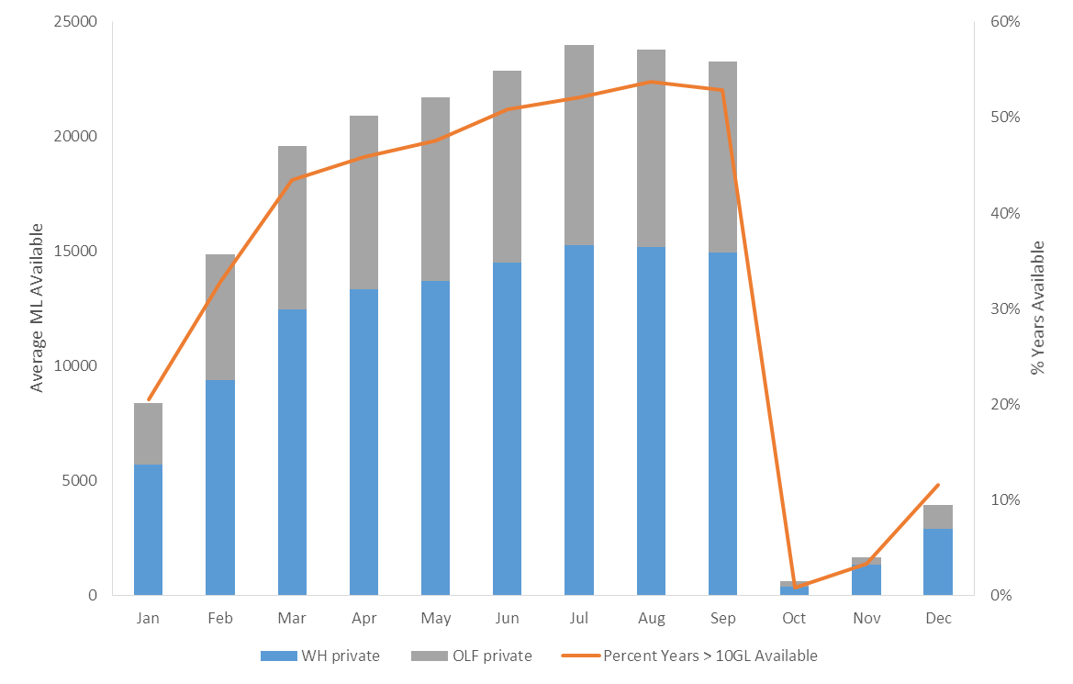

Source: Derived from data provided by Department of Science, Information Technology and Innovation

# **3. TYPES OF EVENT-BASED MECHANISMS**

The focus in this report is on mechanisms to enhance environmental outcomes for the Narran Lakes through temporary changes in the use of water entitlements to augment river flow events. This involves temporary access to harvesting entitlements held by private water users, and can be applicable to WH allocations or OLF licences. The permanent purchase of additional water entitlements by the Commonwealth is not considered, but the strategic use of the current Commonwealth entitlements to supplement temporarily sourced private water is considered.

In the case of tradeable supplemented allocations, these are also not considered for the reasons outlined in Section 2.1. That is, high transmission losses in excess of 70% would be incurred in redirecting regulated water from the St George Water Supply Scheme in Zone LBU-02 to the Narran Lakes. Therefore, the focus of mechanisms is on the use of annual harvesting rights provided from unsupplemented water entitlements held in zone LBU-05 of the Lower Balonne system – ie: extractive users along the Narran River.

The mechanisms (listed below) are briefly introduced in this section. A brief description is provided as well as comment on the broad benefits and limitations of each. In the following sections of the report, the merits of each mechanism in the specific circumstances of the Narran are explored in more detail.

* Temporary ‘no-pump’ contracts;
* Purchase of temporary harvesting entitlements (seasonal assignments)
* Store and release arrangements;
* Forward purchase;
* Option mechanisms; and
* Combinations of mechanisms

## **3.1 Temporary ‘no-pump’ contracts**

In many environmental water sourcing circumstances, water purchased from irrigators would not need to be redirected for extraction at another location, rather simply left in-stream to reach the Narran Lakes. This can be achieved through the CEWH entering into ‘no-pump’ contracts with irrigators to simply forgo water harvesting during a targeted event. Under these circumstances, DNRM would have no role in assessing the flows under the contract.

In the case of OLF, the volume of water that might reach the Narran Lakes if an irrigator simply did not take some of their allocation is highly uncertain, but only a fraction of any ‘no-pump’ volumes left to move across the floodplain may reach the Narran Lakes. This severely restricts the effectiveness of OLF no-pump contracts. Alternatively, the CEWH could contract irrigators holding WH allocations to forgo pumping allocations under an announced event.

The mechanism would provide a relatively simple means to increase the magnitude of a flow event, require minimal development, have low upfront costs (as expenditure is only made when water is needed), and would be suitable for adaptive management (as no long-term arrangements would be locked in). However, the mechanism would not involve DNRM assessment, and water accounting would be an issue to demonstrate whether the Commonwealth received what it paid for.

Importantly, the mechanism would give environmental managers significant flexibility as to the timing and flow conditions when the water would be made available. So, for example, the CEWH could contract for ‘take’ not to be harvested during a proportion of an unsupplemented water licence, providing a (vertical) slice of water extraction rights across the announcement levels. Alternatively, the CEWH could contract for take not to be harvested during say one or more announcement levels (a horizontal slice of the licence).

Potential limitations include difficulties in negotiating no-pump arrangements quickly when a flow augmentation opportunity arises, that purchase volumes would be limited to the pumping rights under the announcement level at that time; that the Queensland government would not be involved in accounting for water, and the mechanism cannot provide water outside of announcement times, say to extend the duration of a flow event.

## **3.2 Purchase of temporary harvesting entitlements (seasonal assignments)**

The Productivity Commission (2006) notes that temporary trade in seasonal water allocations is relatively unconstrained within the Murray-Darling Basin, with remaining restrictions reflecting hydrological realities or complexity in regulatory and administrative systems, such as associated with some unregulated catchments.

Temporary trade on the Lower Balonne has been thin, and constrained to trade between years. The temporary trading of unsupplemented water allocations is termed ‘seasonal assignment’.

The temporary purchase of water under allocations through seasonal assignment, to passively manage with allowable harvesting volumes left in-stream, would offer similar benefits and limitations offered by no-pump contracts with respect to achieving environmental outcomes. However, seasonal assignment would bring with it the water monitoring and accounting oversight of DNRM, as the purchase represents a transfer of rights and the new owner (the Commonwealth) would receive the state’s protection and enforcement of those rights. No-pump contracts would need to be overseen by the CEWO on behalf of the CEWH and enforced under civil law.

## **3.3 Store and release mechanisms**

Several large-scale irrigators along the Narran and connected rivers have large on-farm storages and high capacity off-takes that could be used to store and harvest both river water and overland flows. There is potential for these private storages to be used to return water to the river to augment the delivery of water to the Narran Lakes. Unlike the opportunistic mechanisms identified above, these mechanisms would allow water to be made available for environmental use *outside* of periods of announcements.

This could be done through either purchasing water already stored on properties, to enter contracts for future (WH allocation or OLF licence) water to be harvested on a property to be held in storage, and / or for the CEWH to enter arrangements for water owned by the Commonwealth to be harvested and stored in an irrigator’s on-farm storage until it is needed. It may also be attractive to source water under allocations held by another property for harvesting and storage at the secured storage, but this cannot be done on a temporary basis. That is, a change in the location of take would require an assessed change, and therefore be ongoing. That is, explicit provision for a temporary trade does not exist in the ROP. It would however be possible to subsequently seek another assessed change to have the location of take returned to its original location.

Experience with purchasing already stored water was gained in 2008, when the MDBA purchased around 10 GL of water from private storages to sustain water levels in the Narran Lakes to support a major waterbird breeding event (MDBA 2009). The purchase was viewed as an emergency one-off, conducted over a very short timeframe and made possible through the goodwill of participants. It provides useful insights to the development of strategic and operational approaches to the regular use of this type of mechanism. The average volume and proportion of years in which at least 10 GL is available in storages was shown in Figure 2.6 drawing on Department of Science, Information Technology and Innovation modelled data.

A contractual arrangement whereby irrigators agree to harvest and store water has not been trialled to date, but could facilitate larger environmental watering opportunities. The available on-farm storage capacity in Zone LBU-05 suggests significant opportunity may exist, although it may introduce more complexity in water sourcing.

There are a range of operational issues that could impact the effectiveness of store and release mechanisms, such as available pump capacity; water losses (associated with evaporation and leakage in storages and transmission losses in canals taking water to and from the river); accounting for water stored and released, the quality of water that would be returned to the Narran River and so on. These issues are discussed in latter sections of the report.

Finally, consideration would need to be given to what to do with any stored environmental water not drawn on that season. Storing the water until the following season may incur significant losses through seepage and evaporation. It may however be possible to sell the water to the storage operator for use on winter cropping or for storage for the following season’s cotton crop, with revenues potentially funding new environmental water purchases of temporary water in following years on the Narran River or in other systems.

## **3.4 Forward and conditional purchase mechanisms**

The temporary purchase mechanisms can be used to increase the magnitude of flow events, while the store and release mechanisms can be used in extend the duration of events. However, transaction costs may limit the effectiveness or efficiency of these mechanisms. For example, the:

* Water available under no-pump arrangements or seasonal assignment, or that is already stored on-farm, may be insufficient to meet targeted flow augmentation needs; or
* Necessity to negotiate transfers quickly and / or often, may prevent transfers from taking place or significantly increase costs.

These constraints may be addressed through forward purchase or option mechanisms. Forward purchase simply refers to circumstances where the transfer of water at a future time is purchased. So, for example, a seasonal assignment could be purchased and paid for in advance of an irrigation season, providing the certainty that targeted volumes would be available when the environment requires it.

DNRM have allowed some permanent trade based on both ‘vertical’ and ‘horizontal’ licence slices, but all temporary trades have been for entire licences or a vertical slice of a WH allocation. The flexibility for temporary trade based on horizontal slicing does not exist under current legislation as under the ROP:

*‘The seasonal water assignment notice must include a condition that the rates of take for all flow thresholds stated on the water allocation that is being seasonally assigned are in the same proportion as the volume being assigned relative to the unused volume in the volumetric account’.*

These rules significantly constrain the effectiveness of forward purchases of seasonal assignments, as currently only vertical slices of harvesting rights can be traded.[14]

A further limitation with the forward purchase mechanism, is that it requires the CEWO to know in advance the time and volume of water that will be needed for environmental outcomes. Given the significant variability in flow events on the Narran, this is simply not possible on a year-to-year basis - some flexibility will be needed. Therefore, contracted volumes are unlikely to match actual needs.

This problem could be overcome through a conditional purchase arrangement (contract). Conditional contracting is where the water no-pump arrangements or harvesting rights at a future date is subject to certain circumstances as specified by a nominated trigger (for example, the circumstances could be seasonal conditions, as specified via a flow level trigger(s)). In the absence of the trigger being met, transfer of the temporary rights may be delayed or cancelled, with agreed conditions outlining any financial liabilities that would accompany the delay or cancellation.

Conditional contracting has some similarities with options contracts (which are discussed below), particularly the need to establish a robust condition (trigger) as to when water access is transferred. However, unlike option contracts, there is no discretion as to whether the transfer of ownership of the water occurs when the trigger conditions are met - that is, the buyer is under a contractual obligation to purchase.

Under a leasing arrangement, all or part of a water right is transferred for a period of years, with all the rights reverting to the seller automatically at the end of the lease period. This would overcome the need for annual negotiations. Water leasing is already a common practice in South Australia, and is permitted in Victoria and some irrigation areas in NSW. Typically, a long-term contract between an entitlement holder and water user establishes the price at the beginning of the lease period, providing a means for the buyer to manage price risk. Leases could be for as long as say 99 years. However, as leases do not relate to specific events, they are not considered further in this study.

## **3.5 Option mechanisms**

Water options have had limited application to date, but there is growing confidence in the potential of these mechanisms (for example see National Water Commission 2013).

Option contracts are contractual arrangements between parties that specify who has the right (but not the obligation) to water under certain conditions (the ‘trigger’). In the case of an environmental call option, the CEWH would buy the right to use (some) water allocated to an irrigator under the irrigators licence when a trigger is met.

Options generally involve the payment of an upfront fee (the ‘premium’) and then another fee (the ‘exercise price’) if and when the party holding the right to the option chooses to exercise that right.

The benefits of options to the trading parties are that the seller (eg: irrigator) is paid a premium, irrespective of whether the option is later exercised, and the purchaser (eg: environmental water manager) has secured, at a low price relative to the actual purchase, the right to purchase the water at a later time if conditions (including the exercise price) are attractive.

As with the other forward purchase mechanisms, options could be based on either no-pump arrangements or the purchases of seasonal assignments (in whole or in part).

While alternative types of options can be crafted, a ‘call option’ appears best suited for use on the Narran. Under such an option, the CEWH buys the right to impose no-pump conditions or for the transfer of (some) water harvesting rights under an irrigator’s licence when a trigger is met.

A call option would provide flexibility as to when water was actually transferred from irrigation use for environmental uses. This may be of significant value as environmental watering demands are still being finalised, and access to some water is likely to be needed on an opportunistic basis.

However, flexibility comes at a cost, as irrigators must be compensated for taking on the uncertainty of when water will be called upon for environmental use. If trigger conditions are set to be activated more frequently than when water will be called upon, the ‘compensation’ costs will be higher. On the other hand, setting a too restrictive trigger would keep costs down, but result in increasing situations when water is needed for environmental purposes but not available as the trigger conditions have not been met.

Therefore, a critical issue with options contracts is the ability to establish a robust trigger that suitably balances contract costs with water access risks. A precautionary strategy could be to initially enter into only relatively short duration contracts (say 2 – 5 years). This would allow irrigators to become familiar with the products, develop appropriate management regimes and price expectations. Also, it would allow environmental managers to become more experienced and skilful in the use of event-based mechanisms. It would also provide time for refinements in our understanding of environmental watering needs of the Narran Lakes and experimentation with alternative triggers. However, a program of ‘rolling’ contracts would result in additional administrative and transaction costs.

## **3.6 Mechanism combinations**

The mechanisms above can provide water at different times to enhance the magnitude and/or duration of flow events, and in doing so promote different environmental benefits for fish, birds, vegetation, and water quality. Previous research has demonstrated that a water planning portfolio that includes a number of mechanisms can reduce costs and risks[15], and so attention to the bundling of mechanisms may be needed.

That is, to maintain flexibility to respond opportunistically as well as targeting regular watering needs, a suite of mechanisms could be employed, reducing risk, increasing water that may be called upon and reducing costs. So, for example, and drawing on the case study circumstances outlined in the next section, access to temporary purchases early in an irrigation seasons may provide a means to increase the magnitude of events that enhance waterbird breeding events, while access to off-river storage may provide the means to store the water from these purchases if it turns out that the water is not needed at that time. The stored water may then assist with augmenting watering opportunities later in the season, say with maintaining waterbird habitat or extending the duration of events to allow the completion of waterbird breeding events.

Considerable flexibility in bundling mechanisms exists, and could be expected to become more common as experience with the individual mechanisms is gained.

# **4.** **CASE STUDIES TO ILLUSTRATE MECHANISM APPLICATION**

Due to significant variability in both rainfall and the environmental requirements of the Narran Lakes, there is a range of situations in which there may be an environmental benefit from augmenting flow events[16] to the Lakes.

To illustrate how the various mechanisms operate, three *hypothetical* case studies have been investigated, namely:

* Augmenting flows to maintain waterbird habitat;
* Augmenting flows to support waterbird breeding events; and
* Augmenting flows during no and low flow periods.

The case studies have been selected to be reflective of the types of watering needs that the event-based mechanisms may assist in meeting (see Table 1.1). It should be noted that the case studies have been crafted solely to illustrate mechanism workability, not to pre-empt in any way the circumstances in which the CEWH may choose to augment flows to the Narran Lakes system. That is, while the case studies were developed after reference to the circumstances of the Narran Lakes, they are hypothetical.

In each case study, a Narran Lakes water augmentation target is postulated, followed by three potential event-based mechanisms that could be applied to source the required water volumes at the required times to satisfy the target. The relative effectiveness of each mechanism is then compared in terms of their ability to source the volumes required and cost-effectiveness in doing so. In practice, significant refinement and optimisation of mechanism design would be needed. As the purpose with the hypothetical case studies is only to demonstrate mechanism application, such optimisation has not been undertaken.

**Case Study 1: Waterbird habitat inundation**

The Narran Lakes is listed under the Ramsar Convention for reasons including the habitat that it provides waterbirds (MDBA 2016). The Narran Lakes Nature Reserve contains extensive beds of lignum that are used by many waterbird species for breeding. ANU Enterprise (2011) found that to maintain vigorous shrubs of lignum in the Narran system, it needs to be inundated for a duration of 60 - 90 days in at least 3 out of every 4 years. This will significantly increase the cover, height and perimeter of lignum, suitable to provide rookery habitat for nesting waterbirds. Therefore, to maintain the condition of lignum vegetation communities across the Narran Lakes, regular periods of inundation are needed (MDBA 2016).

Based on the current understanding of the flows required to support waterbird breeding events through the maintenance of core breeding habitat in the Narran Lakes, under this case study we examine a water sourcing need defined as:

* To augment all flows *anticipated* to be between 15 and 40 GL at the Wilby Wilby gauge (close to the Narran Lakes) over a 45-day period.

The cumulative flow trigger is made on the assumption that there is a 15-day lag between a weather event and water from that event reaching LBU-05 on the Narran River[17]. This effectively means that a decision could be made at or before day 30 anticipating the size of the event by day 45.

It is estimated that there were 29 flow events across the 114-year modelled historical sequence where this flow event trigger would have been met (ie: on average in 25% of years).

***Note: to account for transmission losses in this example, 12 GL would need to be released within zone LBU-05 to deliver 10 GL of additional flows to be measured at the Wilby Wilby gauge.***

For illustrative purposes, three diverse mechanisms are investigated as a means to increase the magnitude of the targeted flow events (shown in Figure 4.1):

* No-pump mechanism – contracted irrigators forgo water harvesting from an event for up to 12 GL once the flow trigger is activated. The actual amount of water which is not-pumped will depend on the event profile following the trigger;
* Conditional purchase mechanism – contracted irrigators would provide 12 GL from ‘unallocated’ stored water and/or water that could be harvested during the event once the flow trigger is activated. Unallocated water is defined as stored water surplus to the irrigation needs of crops planted at that time. Water would only be provided if the full 12 GL were available.
* Option mechanism – from the day the contract is activated, contracted irrigators would need to reserve the first 12 GL harvested to storage for use to achieve environmental outcomes if and when the flow trigger is activated. If not activated in 6 months, the irrigator would take ownership of the stored water and a new option would be entered into from that date.

**Figure 4.1: Mechanisms for waterbird habitat inundation flow augmentation**

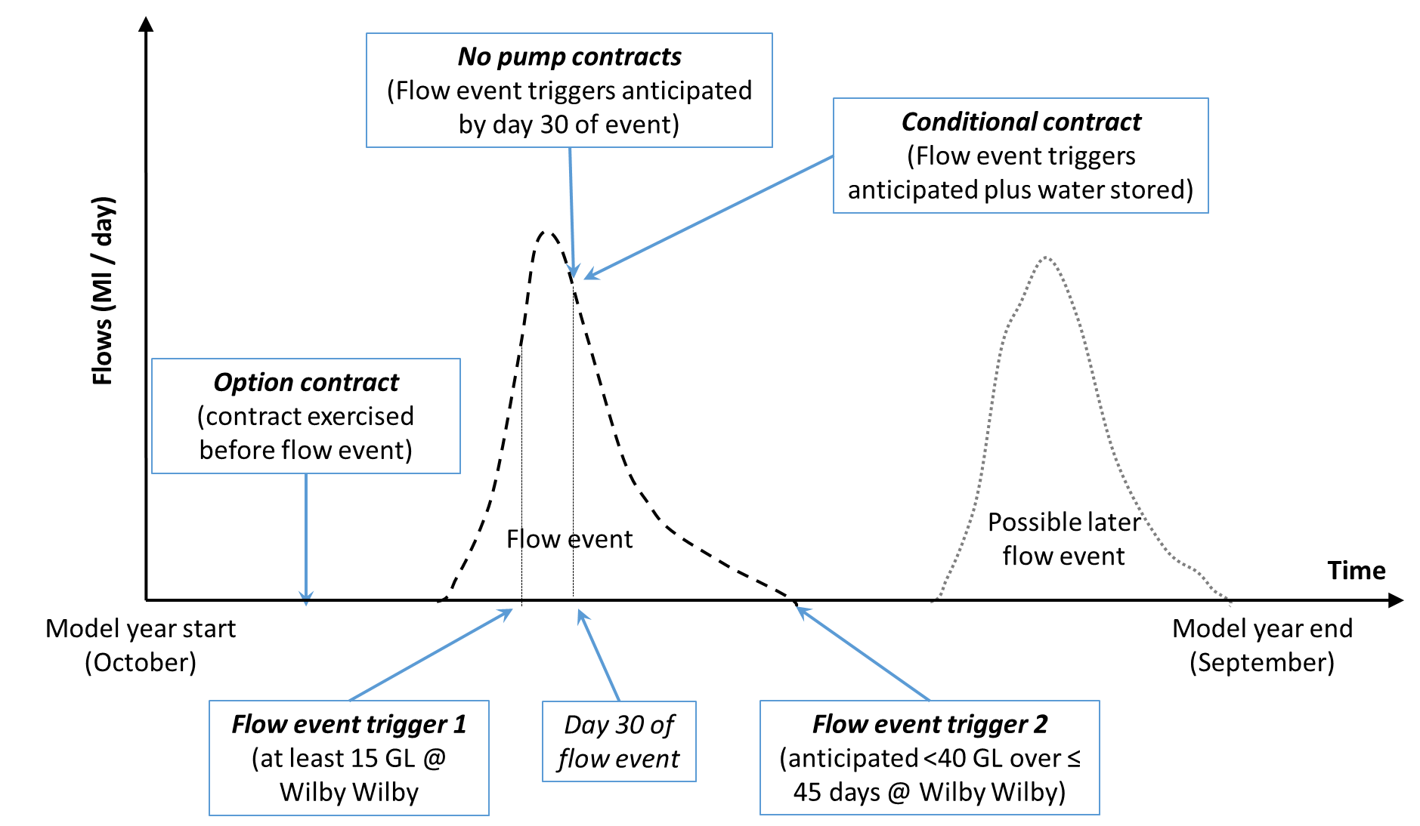

The effectiveness of the mechanisms to provide the required 12 GL across the 29 events where the flow trigger would be met is shown in Figure 4.2.

**Figure 4.2: Effectiveness of mechanisms for waterbird habitat inundation flow augmentation**

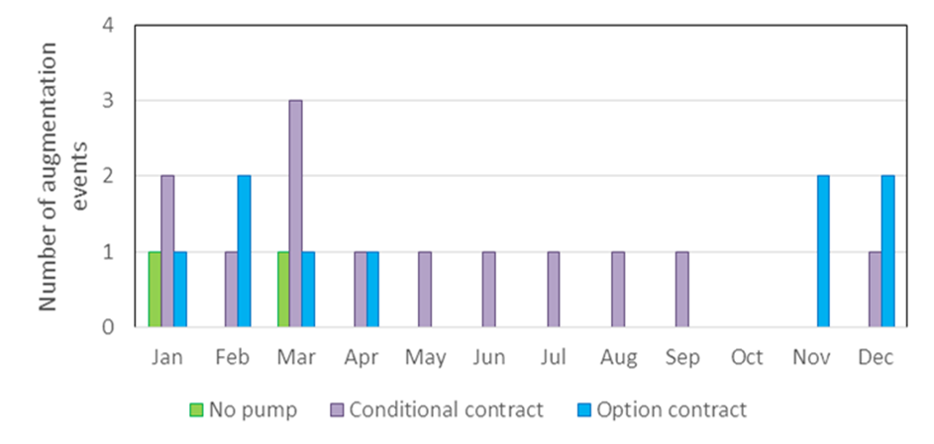

The no-pump contracts would only provide the full targeted volumes on two occasions. As well as largely being ineffective given the assumptions used in this example, the mechanism would be costly as significant volumes (albeit less than 12 GL) will be left in-stream on the other 27 occasions (ie: 93% of targeted events), at significant opportunity cost to irrigators. This results in the average cost per successful augmentation under the no-pump contracts exceeding $21m.

Because the conditional contract can make use of stored water as well as water that can be harvested during the flow event of interest, this mechanism is more effective, providing the required volume on 13 occasions. In addition, as the water is only provided when the full 12 GL is available, there are no opportunity costs associated with unsuccessful augmentations. The opportunity cost of a successful augmentation will depend upon the lost cropping opportunity at that time. Accordingly, the cost per successful augmentation will be several times less than for the no pump contract, and about twice as much when summer cropping is impacted than when winter cropping is impacted.

The option contract mechanism, as defined, has the advantage of securing and storing water from earlier events and dedicating this for environmental use rather than allowing it to be allocated for cropping. This serves to increase stored volumes over the summer period. However, once these contracts lapse, and despite the use of rolling option contracts, there can be prolonged periods before a replacement 12 GL could be harvested from a new event.

Therefore, as shown in Figure 4.2, the option mechanism performs poorly in augmenting flow events triggered outside of the late spring to early summer period. Overall, the option contracts were found to successfully augment triggered flow events on only 9 occasions. Stored water not called under an option reverts for irrigation use at the end of the contract, helping to defray opportunity costs. However, opportunity costs will be dominated by instances where water that would otherwise be used to grow summer crops is stored, and only available for use in winter cropping at the end of a contract. Across the nine successful augmentations, and taking into account the cost of option contracts not exercised, the average cost per successful augmentation was estimated to be over $50m.

Overall, it was expected that relying solely on water harvesting allocations (under no-pump contracts) from targeted flow events may not provide sufficient water to meet augmentation targets, and this was indeed the finding in this case study. The conditional purchase mechanism provided access to stored water to increase mechanism effectiveness (and this could have been increased further with access to ‘allocated’ water, but with a significant cost penalty).

The option contract was intended to further increase effectiveness through the pre-purchase and storage of water for use in a *future* trigger event. However, as specified, the option contract was less effective and greatly more expensive, as the mechanism design fitted poorly with the watering augmentation need. A key finding demonstrated in this case study, is that in some instances, mechanism design may be more important than mechanism type.

The potential for the CEWH to source water under alternative trigger levels was also examined. The flow event trigger analysed above was a flow event ‘window’ of between 15 GL and 40 GL at the Wilby Wilby gauge over a 45-day period. Table 4.1 shows the frequency of trigger events under alternative trigger windows, as well as the ability of alternative sources of water to provide the target 12 GL.

**Table 4.1. Flow events and water sourcing at alternative flow windows**

|  |  |  |  |
| --- | --- | --- | --- |
|  | **Flow event window volume (GL at Wilby Wilby)** | | |
|  | **5 - 15** | **15 - 40** | **40 - 60** |
| Number of events | 34 | 29 | 12 |
| Occasions when 12 GL available from that event | 3 | 5 | 11 |
| Occasions when 12 GL uncommitted water available from previous events | 4 | 12 | 11 |
| Occasions when 12 GL uncommitted water available from previous & current events | 7 | 13 | 11 |
| Occasions when 12 GL any stored water available from previous & current events | 21 (62%) | 23 (79%) | 12 (100%) |

Overall, the ability to source 12 GL predictably increases as the event window moves to larger events, as irrigation extraction entitlements (and therefore potential sources of water for environmental use) will also increase. The sensitivity analysis found that an event flow of at least 30 GL is generally needed to source the 12 GL from *within* the event itself.

Otherwise, access to additional water from previous events is needed, and that water will have a potentially high cost if stored for long periods or is already committed to crop.

**Case Study 2: Augmenting flows to support waterbird breeding events**

This case study has been focussed on strategically augmenting flows to support a waterbird breeding event and increase the likelihood of successful recruitment.

Waterbird breeding events in the Narran Lakes system often commence based on a flow pulse at Wilby Wilby which contains more than 20 GL in the first 10 days (Brandis and Bino, 2016); with a total inflow to the Narran Lakes of *at least* 50 GL over a 1 to 3 month period between October and March to complete breeding. It is noted that this volume is considerably less than that recommended in Table 1.1 of 154 GL. It is around the minimum volume into Narran Lakes at which large-scale breeding can occur.

Based on this background, we have examined a *hypothetical* water sourcing need defined as:

* A *flow event trigger* - when there is a flow event of at least 20 GL at Wilby Wilby over 10 days between October and March (as preffered timing has been identified as summer / autumn); and
* A *cumulative flow minimum trigger* – when the cumulative volume of the flow event at Wilby Wilby reaches at least 40 GL; and
* A *cumulative flow maximum limit* – for the cumulative volume of flows at Wilby Wilby of all flow events until the end of March to remain under 70 GL.[18]

It is estimated that there were 17 occasions across the modelled historical sequence where the first two flow triggers would be activated, but on 6 occasions subsequent flows would breach the cumulative flow maximum limit. Therefore, overall there were 11 occasions (ie: in almost 10% of years) satisfying the water augmentation flow objectives.

***Note: to account for transmission losses in this example, 12 GL would need to be released within zone LBU-05 to deliver 10 GL of additional flows to be measured at the Wilby Wilby gauge.***

This environmental water is assumed to be released at the end of March. For illustrative purposes, three mechanisms are investigated as means to extend the overall flow to a suitable volume and duration (shown in Figure 4.3):

**Figure 4.3: Mechanisms for augmenting flows to support waterbird breeding events**

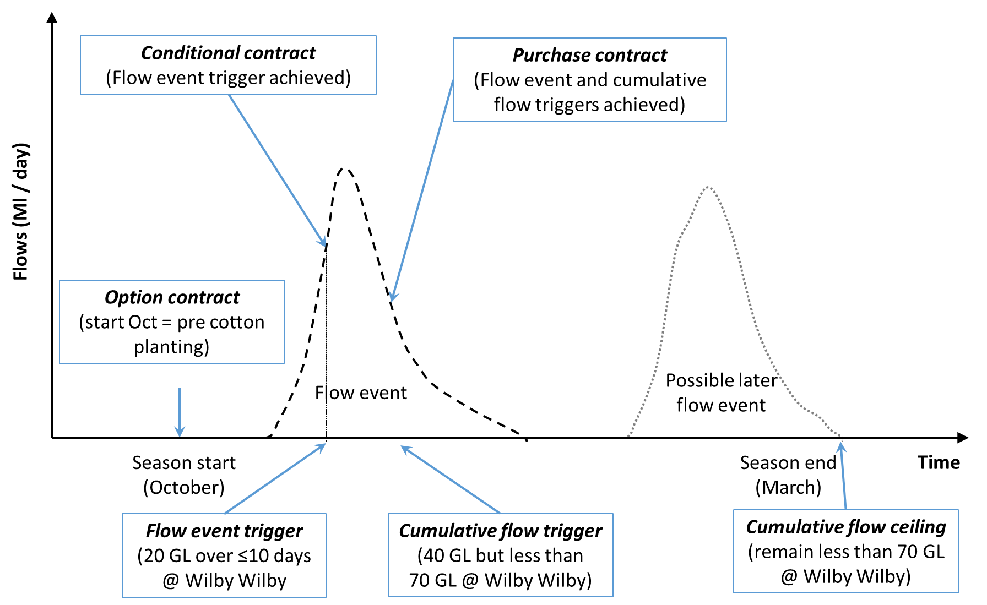

* Purchase already stored and uncommitted private water once the flow trigger is met and the cumulative flow reaches 40 GL. At the end of March, 12 GL would be released if the cumulative flow remained under 70 GL;
* Commonwealth allocations and conditional contracts – once the first flow event trigger is met, Commonwealth allocations are harvested and stored, and to achieve target volumes, additional private water purchased under conditional contracts is also sourced and stored. At the end of March, 12 GL is released if the cumulative flow remains within the 40 to 70 GL window; and
* Source and store water using option contracts – from the day the option contract commences, contracted irrigators would need to reserve the first 18 GL harvested to storage for use by the CEWH if and when the flow and cumulative flow triggers are met.

To enable 12 GL to be available for release at the end of March if the cumulative flow maximum of 70 GL is not exceeded, the volumes sourced and stored under the mechanisms need to allow for storage losses (principally from evaporation). Therefore, the volumes that need to be stored based upon when the water is directed to storage, is 18 GL on 1 October, 16 GL on 1 December, 14 GL on 1 February or 12 GL on 1 March. In the years when the cumulative flow at the end of March exceeds 70 GL, it is assumed the CEWH sells the stored water for use in winter cropping.

The effectiveness of the mechanisms to provide the required 12 GL across the 11 events where the water augmentation objectives are met is shown in Figure 4.4. The results show the summer dominated characteristic of the system.

**Figure 4.4: Effectiveness of mechanisms to enhance waterbird breeding events**

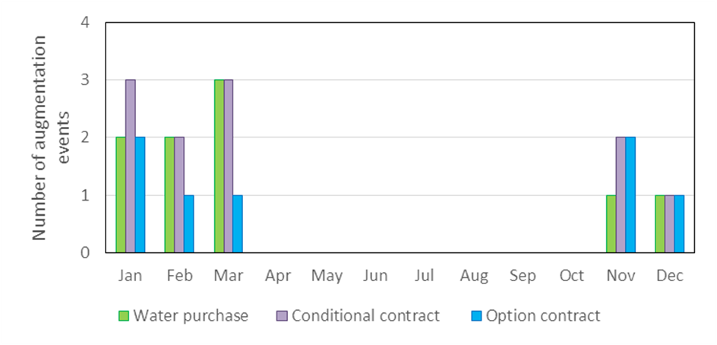

Under the direct purchase of stored water, it was estimated that sufficient uncommitted water would be available for purchase in 15 of the 17 years that the flow trigger and minimum cumulative flow trigger of 40 GL is met. However, in 6 of those years a later flow event would take the cumulative flow above 70 GL, meaning that water augmentation is no longer needed. In these years, the stored water is assumed to be sold back to the storage owner for winter cropping. Therefore, the mechanism was successful in 9 of the 11 water augmentation events targeted in this case study. The cost of this mechanism varies depending upon when the purchase trigger is activated and lost cropping opportunities. On average, and accounting for years when stored water is bought but not released, the average cost per augmentation was in excess of $4m.

Under the second mechanism, conditional contracts would be established giving the CEWH access to a quantity of private seasonal assignments once the first flow trigger is met[19]. The private allocations targeted would be based on expected volumes available from Commonwealth allocations. The water available from water harvesting and overland flows under Commonwealth held entitlements were found in themselves insufficient. Combining Commonwealth and private seasonal assignments under a conditional purchase contract did however provide sufficient water to meet the water augmentation volume on all but 2 occasions when the purchase triggers were met.[20] On 15 other occasions when the purchase triggers were met, sufficient water was sourced under the Commonwealth allocations and conditional contracts. However, on 4 of these occasions, later flow events took the cumulative flow above the 70 GL level, and this water was sold back to the storage owner.

On average, and accounting for years when stored water is bought but not released, the cost per augmentation is under $4m, assuming a similar opportunity cost for Commonwealth water and private allocations.

Under the option contracts, previously harvested water is held in storage for potential environmental release rather than allocated to summer cropping, but then resold for winter irrigation use if the stored water is not called for use as environmental flows. There are 62 years in which 18 GL would be held in storage under the contracts before the commencement of cotton planting. Successful augmentation is possible using this mechanism alone in only 7 years in which both flow event and the cumulative flow minimum and maximums are met. In the remaining 4 years when water augmentation was sought, insufficient water was available in storage to meet the required augmentation volume.

Like the option contract designs considered in case study 1, opportunity costs are dominated by instances where water that would otherwise be used to grow summer crops is stored, and only available for use in winter cropping at the end of the contract. Across the 7 successful augmentations, and taking into account the cost of option contracts not exercised, the average cost per successful augmentation was estimated of the order of $20m.

Overall, mechanisms differed in terms of which and how many flow augmentations they could support. Option contracts tended to be more effective in augmenting events triggered early in the season, the purchase of already stored water favoured later events, and conditional contracts were found effective across the season, satisfying all identified augmentation need.

The mechanism designs investigated meant that conditional contracts and the purchase of already stored water could provide required volumes when the option contract could not. This proved a significant advantage, particularly where the inclusion of water from Commonwealth allocations allowed for 2 additional augmentations. In effect, accessing water stored from previous events using an option contract proved costly, as the volume of the flow event trigger meant that the mechanism fitted poorly with both the water sourcing and augmentation need relative to the other mechanisms investigated.

The conditional contract was intended to reduce the financial cost of water augmentation through access to Commonwealth entitlements and the reselling of water not required. The mechanism fitted well with the water sourcing and demonstrated the lowest cost per augmentation event. This case study supports the finding from case study 1 that mechanism design may be more important than mechanism type.

**Case Study 3: Augmenting flows during no and low flow periods**

Access to in-stream habitat that persists during no and low flow periods is critical to the survival of many native aquatic species. Waterholes are the primary in-stream refuge habitat in the Condamine-Balonne system during prolonged dry periods.

The Condamine and Balonne ROP incorporates specific rules to manage low and medium flow events for the Lower Balonne, in accordance with s39 of the Water Resource (Condamine and Balonne) Plan 2008. These rules are designed to restrict irrigation water take and maximise the likelihood of flow events following prolonged dry periods.

However, despite the ROP low flow and environmental flow provisions, and the water allocations held by the Commonwealth, the lack of sufficient flows in dry periods may not be able to maintain all key refugial waterholes in the Lower Balonne floodplain, and hence a potential mechanism watering objective.

For illustrative purposes, we assume a *hypothetical* low flow water sourcing need to be:

* The provision of 4 GL at Wilby Wilby over 19 days or less once it has been 12 months without a flow event

It is estimated that there were 20 times in the historical sequence when no flow events at Wilby Wilby would have occurred over a 12 month or greater period. Once 12 months have passed without a flow, a substantial volume of water would be required to ‘wet up’ the system.

***Note: to account for transmission losses in this example, 12 GL would need to be released within zone LBU-05 to deliver 4 GL of additional flows to be measured at the Wilby Wilby gauge.***

For illustrative purposes, three mechanisms are investigated as a means to increase the magnitude of the targeted flow events (shown in Figure 4.5):

* Conditional no-pump contracts – once there have been no flow events for 12 months, the first 12 GL of subsequent WH allocations must be left in-stream;
* Purchase of privately stored water – once there have been no flow events for 12 months, 12 GL of any stored water (whether allocated to a crop or not) is sought for purchase and release;
* Storage of Commonwealth allocations as a contingency – the strategy is to direct Commonwealth water (up to a maximum of 24 GL, which would allow evaporation losses and still provide 12 GL in 12 months) to be held in storage at the end of all flow events.[21]

**Figure 4.5: Mechanisms for** **augmenting flows during no and low flow periods**

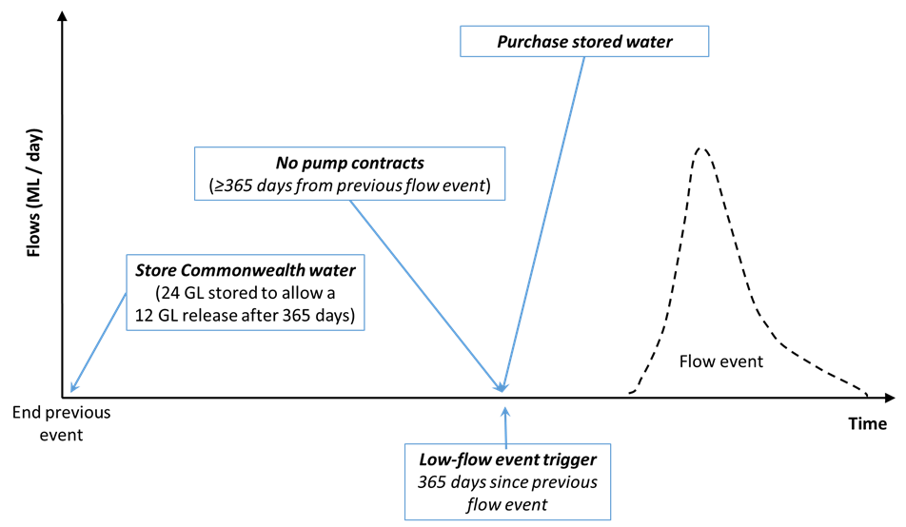

The effectiveness of the mechanisms to provide the required 12 GL augmentation into the Narran River across the 20 occasions where the flow trigger would be met is shown in Figure 4.6.

**Figure 4.6: Effectiveness of mechanisms for augmenting flows during no and low flow periods**

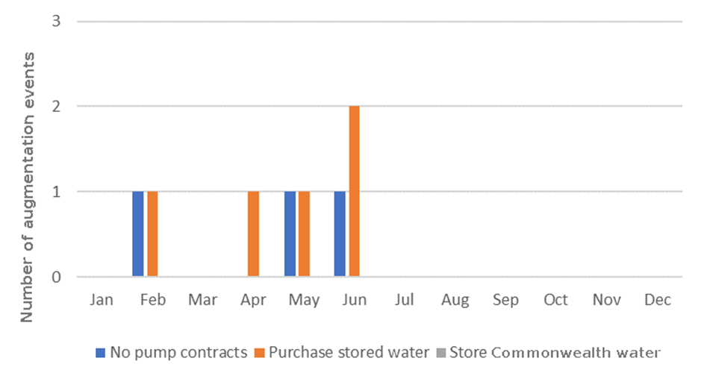

The conditional no-pump contracts were aimed at ensuring that the next event, once the no-flow trigger was met, would be sufficient size to provide the targeted volume at Wilby Wilby. On average (median), these events came within 2 months following the no flow trigger being met.

The full 12 GL augmentation goal under the conditional no-pump contracts was only achieved in 3 of the 20 years being targeted.[22] Reducing the augmentation goal to 6 GL was found to double the number of years in which the augmentation goal was met.

The opportunity cost of a no-pump contract is dependent on when the water would otherwise be harvested, the next cropping opportunity and how long the water would otherwise be stored for until planting (as this affects evaporative losses). The average cost per full augmentation for this mechanism was estimated to be in the range of $2m to $3m, and less than the cost of using stored water.

Under the second mechanism where already stored water is sought, sufficient water to meet the full 12 GL augmentation goal was available in 5 of the 20 years. Stored water was found only to be available after 12 months without a flow event when storages had been filled from a previous and large event. On one occasion, the stored water would have largely been committed to a cotton crop, and purchase of this water (in February) would lead to the loss of some crop area. The augmentation cost on this occasion was estimated to be about twice the cost of a no-pump contract. On the other 4 occasions, due to limits on the area of summer crop land available, the stored water will have been held and allocated to winter cropping (wheat). As wheat can be grown without irrigation, albeit with reduced yield, the opportunity cost of the stored water is much less, with the average augmentation cost in these instances being considerably less than $1m.

The third mechanism examined was for the CEWH to approve that water from Commonwealth WH and OLF entitlements are harvested and held in storage. However, the water available under these entitlements was found insufficient to provide the required 12 GL on *any* occasion, and the agricultural opportunity cost of holding this water was estimated at three to four times the cost of a no pump contract.

As this case study found that sufficient water is rarely available from *any* source following a long dry period, an alternative may be to augment low flows before a dry period to enhance system resilience to naturally occurring dry periods. Furthermore, a much smaller augmentation volume would be required to complement an existing low flow event. By way of example, Table 4.2 shows the number of events of less than 3 GL at the Wilby Wilby gauge in winter/spring and summer/autumn that occur after 120 days without a flow event.

**Table 4.2: Opportunities to augment small flow events following 120 days without a flow event**

|  |  |  |
| --- | --- | --- |
|  | **Augment winter / spring event** | **Augment summer / autumn event** |
| Flow Events | 17 | 22 |
| Available private water not committed to crops | 7 | 2 |
| Available Commonwealth water | 2 | 5 |
| Available water all sources | 7 | 17 |

A number of opportunities to augment these low flow events were identified. Private water not committed to crops is more commonly available in winter/spring, while Commonwealth environmental water and private water held in storage but committed to an in-ground crop would more commonly be available in summer/autumn.

Unfortunately, across the modelled historical sequence, only 2 of the low flow augmentations identified in Table 4.2 were found to be prior to the 20 no flow events at the Wilby Wilby gauge that would have occurred over a 12 month or greater period.

# **5. RISK ASSESSMENT OF MECHANISMS**

In this section, a risk assessment framework is outlined, followed by an application of the framework to the classes of event-based mechanisms, drawing on stakeholder feedback, consideration of their workability within the water rights framework applicable to the Lower Balonne, and insights from the water sourcing case studies described in the preceding section.

Some risk issues identified are equally pertinent to the management of current water allocations. For example, several stakeholders have indicated compliance issues, where some irrigators can be ‘tardy’ in turning pumps off once allocated harvest volumes have been reached. Similar compliance issues can be expected and need to be managed whether the water harvesting relates to private irrigation water or water purchased by the Commonwealth to augment environmental flows. Accordingly, these sources of risk are not raised here unless there are specific issues that arise with mechanism application.

**5.1 Risk assessment framework**

Risk analysis is the process of defining and analysing the outcomes to the environment, individuals, businesses or government posed by potential natural and human-caused events. Risk is characterized by two factors:

* The magnitude (severity) of the possible consequences; and
* The likelihood (probability) of occurrence of each consequence within some specified timeframe.

Qualitative risk analysis uses a scale of words or descriptions to examine the impacts of each event arising and its likelihood. A risk matrix based on these qualitative measures of consequences and likelihood may then be used as a means of combining this information to give a measure of risk (Standards Australia 2006). A typical risk matrix, and that which has been adopted for this project, is shown in Figure 5.1.

**Figure 5.1 Risk assessment framework**



The likelihood measures reflect the anticipated frequency with which the risk may materialise, and are straight-forward. The consequence measures need some anchoring to reflect the relative size of impacts pertinent to the objectives of employing the mechanisms. For this assessment, we have anchored the ‘moderate’ consequence as broadly equal to the loss to the CEWH of 10 GL of purchased water or its financial equivalent. Where the risk would not lead to the loss of water but failure to meet an environmental watering opportunity, we conservatively assume the environmental impact of the missed watering equal to the agricultural opportunity value of the water that otherwise would have been used.

A major impact would be loss of a greater volume, such as spread over a couple of years, while catastrophic would be circumstances where say a financial outlay over many years led to virtually no delivered water to the Narran Lakes.

After identifying each source of risk, applicable ‘mitigation’ measures which would be employed to minimise the likelihood or severity of impacts are scoped, ahead of identifying the *residual* likelihood and severity of each risk and the scale of the risk outcome.

**5.2 General risks with event-based mechanisms**

Several general sources of risk across event-based mechanisms are shown in Table 5.1. They variously relate to planning, implementation or operational factors.

The mechanism design risks relate to potential deficiencies in selecting and designing mechanisms. These risks can be mitigated through a rigorous mechanism development process, consultation with stakeholders, comparative analysis and piloting. There may be additional risks introduced with the bundling of mechanisms. Such bundling offers potential gains in accessing larger volumes and flexibility in the scheduling of flow augmentation, but coordination will be important. While residual risks and consequences cannot be eliminated, they should not be significant and hence a low to moderate overall risk weighting has been assigned.

The next group of risks in the table may arise with poor mechanism implementation. This could arise if poor judgements are made with respect to transmission losses or the sequencing of releases. However, existing processes already account for these losses and they should be readily incorporated in planning by the CEWO.

The mechanisms are also reliant on negotiated trades, rather than streamlined or automated trading through brokers or web-based trading platforms. This is in part due to the small number of likely participating parties, but also due to the significant tailoring required for each trade. A risk therefore is that negotiations are scheduled at busy times for potential sellers which excludes their participation or leads to sub-standard arrangements. While key production cycles are well known, opportunities to augment environmental flows are more opportunistic. Therefore, negotiation risks are likely to be greater with those mechanisms that are not negotiated in advance of water needs.

The remaining general risks are more of an operational nature, often outside of the direct management of the CEWO. The foremost of these would appear to be whether there would be enough potential sellers to form a competitive market. There are only three potential WH sellers, with these three properties and one other having OLF licences that could be sold.

The development of several mechanisms to provide alternative purchasing strategies, and hence competition between sellers, would help mitigate this risk. Nevertheless, common properties are likely to be involved across the mechanisms, particularly those with larger harvesting entitlements and / or dam storage capacity. Accordingly, there is likely to be some ongoing risk. However, the minor consequence would manifest through only moderately higher payments as the CEWO will have a good understanding of irrigation opportunity costs. Overall, the residual risk is assessed as significant and will require significant attention by the CEWO.

Mechanisms such as store and release may involve transferring the physical location of ‘take’, which would require around a month for DNRM to process the ‘assessed’ licence change. Similarly, there will be a lag between event announcements (based on flows at the St George gauge) and when irrigators on the Narran can harvest water from the event, as well as lags between changes in water harvesting or storage releases along the Narran and when this water will reach the Narran Lakes. Insufficiently allowing for these lags could reduce the effectiveness of mechanisms. However, careful prediction of flows after rainfall could also reduce some risks and open up opportunities not otherwise available. Overall, residual risks are deemed to be low as DNRM processing times are known and generally adhered to, and in-stream flow lags along the Narran are well understood.

Once environmental water releases have been made, there are risks surrounding their security. That is, actual delivery volumes may be diminished if other water users were to access these flows. This issue of the protection of environmental flows has been considered by DNRM who do not foresee significant risks outside of the existing water rights framework and current DNRM compliance enforcement measures. Certainly, flow announcements will account for additional environmental water inflows secured via licence purchases or seasonal assignment. However no-pump contracts would fall outside of this compliance framework. While this suggests some residual risks may remain with these types of mechanisms, the small number of irrigators involved would allow a level of cost-effective oversight.

The remaining operational risk relates to third party impacts. These are not anticipated to be significant issues, they will be routinely considered by DNRM when assessing applications for the trade of seasonal assignments, and can otherwise be negated through a thorough scoping of mechanisms before their implementation. Nevertheless, there may be ‘non-price’ factors constraining irrigator participation, such as preferences to maintain irrigation areas and staffing levels, unwillingness to sell to the Commonwealth, and so on. Failure to recognise these may impact mechanism effectiveness.

**5.3 No-pump contracts**

Within season contracting of irrigators to not exercise their pumping rights under WH allocations held does not involve the transfer of seasonal assignments and hence no DNRM approvals would be needed. In addition, the development of contract terms should be relatively straightforward. Negotiated prices could be expected to reflect alternative purchase times and cropping opportunities that may be forgone if water is not pumped. Irrigators would be well placed to estimate such opportunity costs and develop appropriate bid prices reflective of their risk preferences.

The biggest risk appears to be whether there would be sufficient time to negotiate contracts. As noted above, there will typically be only 3-5 days between the announcement of an event and the time when water must be taken under allocations along the Narran River. This provides very little time to identify a potential seller and to negotiate contracts. The risk could in part be mitigated through *prior* negotiations with potential sellers as to anticipated contract terms. Irrigators have indicated a willingness for the advance negotiation of contracts, with only price to be negotiated at the time of purchase[23]. This would significantly reduce potential delay risks.

An issue with no-pump contracts is that, unlike with seasonal assignments, there would be limited compliance oversight by DNRM. The ROP provides detailed rules for monitoring and reporting of water harvesting entitlements in the Lower Balonne (s80B). This includes taking and reporting meter readings at the start and end of taking water, total volumes taken, and volumes stored. It would also include compliance activities to check the efficacy of metering, and monitoring incidents of unmetered harvesting (largely following-up on community reporting). In addition, DNRM field staff undertake a water balance to identify if downstream flow volumes are consistent with the licences upstream extraction rights.

If a water user did harvest water that was subject to a no-pump contract with the CEWH, this *may* be identified by DNRM and reported to the CEWO. But the primary responsibility to negotiate and oversee appropriate monitoring, reporting and compliance measures under no-pump contracts will fall to the CEWO. If the CEWO were to follow the approach of DNRM, requiring the reporting of meter readings at the start and end of taking water, supported by some in-field meter checking, then the residual risk is considered minor.

Related to the above, is volumetric uncertainty. That is, the volume of unpumped water will simply not be measured. Entitlements to unsupplemented water allocations on the Narran are typically held under the instantaneous volumetric limit (IVL) water sharing rule, which specifies the rate of take and maximum volume of water that may be taken during an announced period. With existing meters unable to identify volumes not pumped, actual volumes secured for environmental purposes under a no-pump contract must be estimated. This can be done with reference to flow announcements and pumping rights under allocations subject to a no-pump contract. With the flow lag between St George and the Narran River, there will be some time for the CEWO to develop an estimate of these potential volumes after taking advice from DNRM. Nevertheless, at the completion of the event, volumes secured will remain an estimate rather than a measured volume, representing a low risk.

A further risk is that an irrigator under a no-pump agreement could make up ‘lost’ volumes in a later event, at the environmental expense of in-stream flows. In principle, this could be guarded against in the contractual terms with the CEWO, but in practice it would be challenging for the CEWO to enforce, and potentially costly. This issue is therefore assessed as a moderate risk.

In the case of OLF no-pump contracts, there will be additional uncertainty as to how much of the ‘unpumped’ water, left to move freely over the floodplain, will reach the Narran Lakes. Under an OLF no-pump arrangement, much of the water allowed to flow past the pumping site will be lost to seepage, evaporation or the filling of pools across the floodplain before it reaches the Narran River. Potentially lost volumes are uncertain, but up to 80% can be expected. For this reason, the mechanism is considered a significant risk.

**5.4 Purchase of seasonal assignments**

The first risk associated with the purchase of seasonal assignments revolves around the timing and availability of DNRM approval of transfers. As already noted, processing delays to secure a seasonal assignment are only a matter of days if the allocations are held under MVL. This means no-pump arrangements could alternatively be achieved through a seasonal assignment, with the benefit of DNRM’s water accounting compliance framework.

If the allocations were held under IVL, this would require an assessed change and associated approval delays. This could be mitigated through negotiating with potential sellers to switch their licences to MVL in advance of potential seasonal assignments. There appear no disadvantages to irrigators in switching to MVL, and DNRM officers have indicated a likely willingness if it then makes irrigators eligible to seasonally assign water to the Commonwealth and other irrigators. That said, feedback from some irrigators directly to the CEWO during consultations in 2015 indicated a desire to stay with IVL specifically to enable catch-up pumping[24].

Another risk is the potentially poor alignment of purchased seasonal assignments with the water sourcing objective. As seasonal assignments based on horizontal slices of allocations is prohibited, it may be difficult to target specific parts of the hydrograph, potentially leading to the sourcing of water in excess of needs, as vertical slices would be vulnerable to uncertainty as to event volume and duration. With allocations held under MVL, any remaining volume in the seasonally assigned volumetric account after an event could readily be assigned back to the original entitlement holder, who could access the unharvested volume in a following event that year, or the following year.

A consideration here is that volumes under the return assignment are likely to be valued at less than before the event, as later harvesting may only allow the water to be put to lower value winter cropping or it would need to be held over to the following summer and be subject to evaporative losses. In addition, apart from leaving the ‘surplus’ volumes in-stream for other environmental purposes, the CEWO can only sell the water to the original entitlement holder, it cannot be seasonally assigned to another point of take. This would place the original entitlement holder in a monopolistic bargaining position for unused volumes. This later issue could be in part mitigated by agreeing to prices for returned surplus water when negotiating the seasonal assignment in the first instance.

**5.5 Store and release mechanisms**

Store and release mechanisms have more technical and operational issues, such as storage integrity, river connectivity, available pumping capacity, water quality, evaporation, and so on.

Connectivity of storages to the river will need to be assessed, as some storages are not easily able to release water either to the river, or at a rate which is desired. Some storages are only able to access overland flows and there may be no connecting infrastructure to the river, or they may not be designed to release water by gravity at relatively high flow rates, and may require additional works. Again, thorough investigation and implementation should eliminate residual problems.

To the extent that a storage has connectivity, the purchase and release of WH allocations or OLF harvested by the storage owner and held in storage is feasible. It is also possible for Commonwealth WH allocations to be harvested at that property for storage, following the seasonal assignment of the allocations to that point of take. This would provide the CEWO more certainty as to volumes that can be secured and held in storage, but it will require an assessed change.

One issue raised is the potential for the crowding out of pumping, where both the landholder and the CEWO may seek the use of available pumping capacity at the same time – say where an irrigator wishes to harvest from an event while the CEWO may want to release previously stored water to augment the event. While this is an unlikely possibility, contract terms could provide for a ‘quid pro quo’ where a period of no-pumping is credited as a storage release. This would introduce some uncertainties as to volumes involved, as well as any implications to the irrigator’s carry-over volume if the harvesting rights were held under a MVL rule.

A similar issue is the potential crowding out of storage capacity, where the CEWO and the storage owner want access to available capacity at the same time. Storage capacity is rarely constraining at current licence levels, with CEWO less likely to want to store water for environmental benefit at the very high flow levels when capacity limits may be reached. Nevertheless, contract terms for the storage of Commonwealth water could clearly set out storage rights to each party, including where capacity may become limiting. Accordingly, attendant risks are considered low if appropriate attention is afforded to developing contract terms.

Poor accounting for evaporation, leakage and spills from storages poses another risk. It would be possible for the CEWO to install/require real time storage monitoring in addition to what already exists on the storage. Alternatively, the storage operator could absorb all losses out of their stored volume account, deliver contracted volumes and factor expected losses which they effectively make good into negotiated prices. Some irrigators / storage owners consulted with expressed a willingness to do this, while the CEWO would place some premium on the volumetric security this would provide. Whatever approach taken, contract terms should clearly set out storage rights to each party, including how water lost through seepage, evaporation or spills would be accounted. Such details would need to be considered in the detailed design phase.

Buying stored water held under an IVL also poses the risk that an irrigator under a no-pump agreement could make up ‘lost’ volumes in a later event, at the environmental expense of in-stream flows. As was the case with no-pump agreements, this could pose a moderate risk. However, if the Commonwealth were only to purchase stored water harvested under a MVL, catch-up harvesting would not be allowed. This would effectively mitigate the risk.

Another risk factor is the quality of stored water, due to contaminants, temperature or other factors. Irrigation tail-water is often returned to dams and can contain a range of contaminants. There exists a risk that contaminated water from on-farm storages used under a store and release mechanism could be released into the Narran River. The risk could be largely mitigated by exerting a preference for storages that do not receive irrigation tail-water, but also through ensuring compliance with the recently developed Store and Release Code of Practice[25].

Any risk of non-compliance with the Store and Release Code of Practice could be factored into contract terms. Indeed, this would be important to prevent a perverse incentive for storage managers. That is, if the storage manager were also the party who would gain free or cheap access to any water the CEWO did not wish to use, and there were no contractual requirements relating to the management of water quality. Overall, the CEWO should consider how to adequately address a range of risks when drafting contracts for potential sign-off by the CEWH.

A minor risk may be ensuring timely compliance with CEWO directions for the release of stored water. This includes ensuring sufficient notice to storage managers and effectively timing releases with targeted flow events. No approvals are required from DNRM for the release of stored water to the Narran, and contract terms could have provision for timely release of water once CEWO notification is provided.

Consideration will also have to be given to the use of any stored water once opportunities for augmenting environmental flows in that year have passed. This will typically be around April, and the CEWO would need to consider potential losses if remaining volumes stored were carried over to the following summer. Contract terms could allow the storage operator access to the water at this time, and specify the terms for that access. Residual risks should be low if contract terms are clearly specified.

The CEWH cannot own or manage land, under the Land Acquisitions Act 1989[26]. Therefore, the CEWH cannot purchase the land on which a private storage resides.

If the CEWH funded the rehabilitation of an existing storage, there would be financial risks that might not be able to be addressed in an initial budget. This strategy would represent large budget outlays and be subject to planning and due diligence. A related issue would be to manage risks associated with a storage ‘failure’ or operator bankruptcy.

**5.6 Forward purchase, conditional and option mechanisms**

The remaining mechanisms introduce entering agreements for no-pump arrangements or the transfer of seasonal assignments, *prior* to the flow event they relate to. This raises risk issues associated with regulatory approvals and the specification of transfer triggers.

The prior arrangement of no-pump contracts would not require DNRM approvals. However, the forward purchase of seasonal assignments would. This in itself should not be a significant issue, as seasonal assignments have been traded for some time. However, DNRM will not assess and approve conditional trades. Approval would need to be sought at the time change of ownership was sought. This should not present a significant risk as DNRM approvals for seasonal assignments take only a few days, which should provide sufficient time between mechanism purchase triggers (such as flow event announcements) and the action required under the contract (say harvesting from that flow event).

The main risk with these mechanisms is developing effective and efficient triggers. Announcement levels seem ideal, since river flows and irrigation extractions are directly linked to them. However, the impact of transfers may also depend upon antecedent conditions (as may also the environmental effectiveness of the flow augmentation, as for example, it may affect in-stream ‘losses’ as pools fill). Insufficient specification of triggers is therefore a risk. Extensive upfront developmental work may help mitigate this risk, but this will increase costs and possible irrigator resistance if time consuming.

Another risk issue is an understanding of irrigation economics and risk preferences. Whilst this issue was not considered significant for within season purchases, the greater complexity that is introduced with conditional and option contracts introduces complications. This occurs because these mechanisms require consideration of ‘expected’ conditions – essentially a probabilistic assessment of water availability and cropping implications under mechanism triggers. Secondly, option contracts typically provide an upfront payment for entering the contract and further payments *when and if* transfers are triggered. This necessitates consideration of the cost to irrigators of taking on the uncertainty of whether transfers will take place and setting a commensurate upfront fee.

**Table 5.1: Risk assessment of event-based mechanisms**

|  |  |  |  |  |
| --- | --- | --- | --- | --- |
| **Risk** | **Mitigation** | **Residual post-mitigation risk** | | |
|  |  | **Likelihood** | **Consequence** | **Risk rating** |
| **A) General risks with** **mechanisms** | | | | | |
| *Mechanism design* | | | | | |
| **Not identifying the best performing mechanism,** leading to higher opportunity and financial costs | Preliminary design work. Modelling. Comprehensive risk assessment. Allow flexibility in the way in which landholders can propose approaches that meet objective. | Possible | Minor | Moderate |
| **Mechanism misspecification**. Includes issues such as whether the mechanism is able to deliver expected volumes when required | Review mechanisms with state officials, including checking definitions, language and simulations across a range of historical conditions. Undertake a pilot and design to learn. | Unlikely | Moderate | Moderate |
| **Unknown financial considerations - possible poor efficiency and effectiveness** | Understanding water’s alternative uses (eg: cotton in summer, wheat in winter) and how this changes over the season. Benchmarking against water trade data. | Unlikely | Minor | Moderate |
| *Implementation* | | | | | |
| **Poor sequencing of mechanisms** | Clear plan on how to consolidate multiple contracts / seasonal assignments / storages releases. | Rare | Minor | Low |
| **Poor accounting for in-stream transmission losses** | Existing processes of Qld government account for these losses, which can be incorporated in purchasing strategies. | Rare | Minor | Low |
| **Poor timeliness in negotiations** with water users. | Avoiding negotiations during extremely busy times within the season. Plan lead times to give transparency to process. Investigate forward purchase mechanism, including options. | Possible | Minor | Moderate |
| *Operational* | | | | | |
| **Thin market –** will there beenough potential sellers to form a competitive market | Development of several mechanisms to provide alternative purchasing strategies and competition between sellers. | Likely | Moderate | Significant |
| **Poorly accounting for lags** (administrative and flow related) | DNRM processing times are known and generally adhered to, and flow lags along the Narran are well understood. | Rare | Minor | Low |
| **Protection of environmental water** | Less risk if environmental water held under licence or seasonal assignment; Notify landholders of environmental releases; Very few licenced offtakes in zone allows cost-effective monitoring. | Rare | Minor | Low |
| **Third party impacts**. eg: ability of others to access their flow rights; flooding | Existing water use and trading processes of Queensland government are designed to minimise this risk; Greater risk if trade is contract based (see below). The CEWH has a ‘good neighbour’ policy that addresses issues such as floodplain inundation. | Rare | Minor | Low |
| **B) No-pump contracts** | | | | |
| **Negotiation time needed** | Prior negotiation of contract terms (excluding price) | Unlikely | Moderate | Moderate |
| **Compliance oversight** to ensure pumping is consistent with contractual terms | CEWO would need to provide oversight, such as requiring the reporting of meter readings and some in-field meter checking. | Possible | Minor | Moderate |
| **Volumetric uncertainty** as ‘unpumped’ volumes must be estimated | Can be reasonably estimated with reference to harvesting times, pump capacity and allowed pumping rates. | Unlikely | Insignificant | Low |
| **Potential for irrigator to ‘make-up’ lost volumes in a later event** | Harvesting limits under IVL or MVL would not be adjusted under a no-pump contract allowing catch-up pumping. Difficult to constrain and enforce under contract. | Possible | Moderate | Significant |
| **Loss of ‘unpumped’ OLF** as it moves across the floodplain before reaching the Narran Lakes | Large but uncertain losses (up to 80%) can be expected, making OLF no-pump contracts unviable. | Likely | Moderate | Significant |
| **C) Purchase of seasonal assignments** | | | | |
| **Delays in the approval of seasonal assignments** where allocations are held under IVL | Allocations must be converted to MVL, with associated delays, before can be seasonal assigned. Mitigate through seeking the advance transfer of targeted licences to MVL. | Rare | Minor | Low |
| **Poor alignment with water sourcing objective.** Inability to horizontally slice allocations results in under / over purchasing, and increased water sourcing costs. | Unneeded volumes in seasonally assigned volumetric account after an event could be assigned back to the original entitlement holder, subject to price discounts. Agreeing to prices for returned surplus water when negotiating the seasonal assignment in the first instance could limit monopolistic pricing. | Possible | Minor | Moderate |
| **D) Store & release mechanisms (excluding issues with water sourcing)** | | | | |
| **Poor physical connectivity to storages** | Appropriate planning and lead times should ensure storages are fit for purpose. | Unlikely | Minor | Moderate |
| **Crowding out of pumping**, where the landholder and CEWH seek simultaneous use of pumping capacity | Contract terms could allow no-pumping times where unpumped allocations are taken in lieu of storage releases. Introduces some volumetric uncertainty. | Unlikely | Insignificant | Low |
| **Crowding out storage** and thesharing of evaporation and spills. | As above. Storage capacity rarely constraining at current licence levels. | Unlikely | Insignificant | Low |
| **Poor accounting for evaporation, leakage or spills from storages** | Identify likely losses based on historical data, storage depth and operation or install/require real time storage monitoring. Factor expected losses into negotiated price. | Possible | Minor | Moderate |
| **Potential for irrigator to ‘make-up’ lost volumes in a later event if licence held under IVL** | The release of stored water would allow an irrigator to replace that water through harvesting from a later event if held under IVL. Difficult to constrain and enforce under contract, but effectively protect via prior conversion of licence to MVL. | Unlikely | Insignificant | Low |
| **Poor quality of stored water**, such as due to contaminants, temperature or other factors. | Ensure compliance with the Store and Release Code of Practice, and that contractual risk for water quality is placed with storage manager. If necessary, avoid dams with return flows of tail-water. | Unlikely | Moderate | Moderate |
| **Poor compliance** with release directions | Contractual terms and monitoring. Clear plan for release processes and the steps and timing that need to be followed. | Rare | Minor | Low |
| **Uncertainty as to the use of end of season residual stored water** | Mitigate risk by planning for trade-out in advance and specify use rights in contract. | Rare | Minor | Low |
| **Excessive costs** for storage modification or purchase. | Benchmark costs and promote competition among storage owners. Investment due diligence. | Unlikely | Minor | Moderate |
| **E) Forward purchase, conditional and option mechanisms** | | | | |
| **DNRM trade approvals are not provided on ‘potential’ trades.** | Unlikely to be a material issue as DNRM approvals for seasonal transfer take only a few days, and this time is provided with the lag between announcements (at St George) and harvesting opportunities on the Narran. | Rare | Minor | Low |
| **Poor contract security**. Includes the extent to which long-term contracts can be enforced and could be at risk from other events | Craft contracts to ensure ongoing incentive for compliance and reduced financial exposure. Include option to continue contract with subsequent owner. | Rare | Minor | Low |
| **Ability to craft robust purchasing triggers** | Stochastic nature of flow events and often opportunistic watering needs presents challenge in predicting when and what water to source. Extensive upfront developmental work needed. | Possible | Moderate | Significant |
| **Need to assess likely conditions**, in terms of water availability and cropping implications under mechanism triggers | Provide irrigators with an overview of modelled flows and analyses of harvesting volumes under Basin Plan conditions. | Possible | Minor | Moderate |

# **6. COMPARATIVE ASSESSMENT OF MECHANISMS**

This section provides a comparative assessment of alternative mechanisms. The assessment draws together the findings of the institutional framework (Section 2), case studies (Section 4), risk assessment (Section 6) and further modelling analysis.

The comparative assessment focuses on mechanism:

* Institutional compatibility;
* Effectiveness and cost; and
* Workability and risk.

In the final section, a summary of the advantages and disadvantages of mechanisms is provided ahead of nominating three mechanisms for further design.

**6.1 Institutional compatibility**

Successful mechanisms will need to be consistent with prevailing water regulations. A summary of how actions involving Commonwealth environmental water required under the various mechanisms would comply with the current water resource management framework applicable under the Condamine and Balonne ROP is provided in Table 6.1.

The availability of overland flows under various flow events is location specific, and therefore harvesting rights cannot be transferred to another allocation, whether on a temporary or permanent basis. Therefore, mechanisms to temporarily source water available under OLF licenses are limited to either:

* Entering no-pump contracts with the licence holder that would allow overland flows to continue across the floodplain (with some of it finding its way the Narran Lakes); or
* Purchasing water harvested under OLF licenses that has been stored on farms.

Neither of these mechanisms involve a change in the OLF licence rights, require DNRM approvals or would otherwise be inconsistent with water regulations.

Similar strategies can be applied to WH allocations. That is, no-pump arrangements or the purchase of water harvested from WH allocations and stored on farm can be done contractually without impacting the irrigators’ rights under their licence and without need for any DNRM approvals.

Once the Commonwealth has ownership of water held in on-farm storages, whether sourced from OLF licences or WH allocations, there are no regulatory constraints on discharging that water to the Narran River to augment environmental flows. However, the discharge of polluted water (say due to the presence of farm chemicals) would risk non-compliance with the Queensland Environmental Protection Act 1994 and face penalty provisions under that Act. To assist compliance with environmental duties, a ‘Store and Release Code of Practice’ has been gazetted and published.

**Table 6.1: Regulatory compliance of potential CEWO water market actions**

|  |  |
| --- | --- |
| **Desired CEWH action** | **Compliance with water resource management framework** |
| **Buy seasonal WH allocations, and:** | | |
| * Leave unharvested | s102 allows the seasonal assignment of vertical slices of WH allocations. s103 prohibits the seasonal assignment of horizontal slices.  DNRM approval for seasonal assignment takes around 3-5 days. However, there are no provisions in the ROP for the assignment of water held under an IVL. An assessed change and approval time in the order of 1 month would be required. |
| * Harvest & store on seller’s property | As above |
| * Harvest & store at another location | Requires the seasonal assignment of water (ie: temporary legal transfer of water right) *as well as* assessed change to replace an IVL water sharing rule with a MVL rule (s90), and to change the location of take for the water allocation (s86).  Other assessed changes may also relate to a change to remove an associated storage condition from a water allocation (s87) and/or a change to remove a conjunctive storage condition from a water allocation (s88)  The removal of the conjunctive storage condition must follow amendment of the overland flow water licence as per s40 (so there can be no increase in the average annual volume of water that can be taken)  DNRM approval times for these assessed changes are in the order of 1 month.  Any application to trade unsupplemented water allocations where not specifically addressed within the ROP rules will still be considered – a ‘long-form’ trade – but will be subject to a more detailed 2-3 month assessment process. |
| **Buy OLF take**, **and:** | | |
| * Leave unharvested | Cannot seasonally assign on a temporary basis. Would need to purchase licence or seek an amendment of the water licence so that partial rights could be bought (s39, s28). |
| * Harvest at a different location | Not allowed under ROP |
| **Temporarily divert Commonwealth WH allocations to storage** **at:** | | |
| * Point of take on entitlement | No approvals needed |
| * A different point of take | An assessed change would be needed. Note Commonwealth allocations have already been amended to MVL which would simplify the assessment task and possibly reduce approval time A seasonal assignment would only be needed if a change in ownership was involved. |
| **Release of stored water:** |  |
| * To the Narran River as an environmental flow | No approval needed; but subject to complying with the Environmental Protection Act 1994 and the Store and Release Code of Practice. |
| * To the Narran River for harvesting at another location | Not allowed. |

Discharged water cannot be sold to another party, such as a downstream irrigator. This has implications for the store and release mechanism, because as shown in the case studies, there are likely to be many situations where water stored for environmental use cannot be beneficially used in the current season, and stored volumes would face significant losses through evaporation if held over for future use. In these situations, the sale of unneeded water to irrigators would provide an important means to manage this risk.

The only strategy is therefore to sell the stored water to an irrigator who can directly access the storage (generally the storage owner). Irrigators have indicated a strong willingness to buy water stored on their properties in such situations, but leaving price negotiation to the time of sale would place the storage owner in a monopoly purchasing situation and reduce prices received. Therefore, clauses covering the use of unneeded water should be included when negotiating store and release contracts in the first instance, as competition provided at that time through other potential mechanisms may improve the bargaining position of the CEWH when entering into contracts.

An alternative to no-pump contracts would be the purchase of seasonal assignments, and passively managing them. That is, not exercising the rights to harvest during announced events, and letting the water stay in-stream. Such a seasonal assignment of water rights requires DNRM approval, but as there would be no change in the point of take, the approval is generally provided in 3-5 days.

However, the seasonal assignment will be delayed if the allocations are held under an IVL. There are no provisions in the ROP for the seasonal assignment of water held under IVL, and so the seasonal assignment would first require conversion of the licence to a MVL. This constitutes an ‘assessed’ change, with DNRM approvals for this typically taking around a month.

Allocations cannot be seasonally assigned where there would be a change in the point of take. Such transfers would require an assessed change to ensure there would be no third-party impacts and would be permanent, although the entitlement holder could apply for the change in point of take to be reversed.

Under seasonal assignment, some or all of the volume of a water allocation can be assigned to another person, however partial assignments must relate to ‘vertical’ slices of the water allocation. That is, a water allocation may provide a range of rates of take across flow thresholds, and the seasonally assigned component must be proportionally similar across the range of takes as the original allocation.

For Commonwealth environmental water to be harvested, such as to store the water for future use, an assessed change will be required if the point of take is to change – effectively if the water is to be harvested at a property different to the one who sold the allocations to the Commonwealth.

In summary, there are no significant institutional constraints to:

* The use of no-pump contracts for WH allocations or OLF licences;
* The seasonal assignment of full or vertical (but not horizontal) slices of WH allocations held under a MVL licence;
* The storage and subsequent release of purchased water to the Narran River; and
* The sale of stored water to irrigators connected to a storage (but not to irrigators who would require the release of stored volumes in the first instance to the Narran for them to access the water).

**6.2** **Effectiveness and cost**

The effectiveness of mechanisms can be evaluated in terms of the extent to which they can meet the specified environmental watering demands (such as those outlined in Table 1.1), in the volumes required and at the specified time and frequency.

The economic cost of mechanisms relates to the opportunity cost of water diverted from agricultural uses, allowing for storage and transmission losses in either agricultural or environmental uses, and taking into account any capital or operating expenses involved (such as for pumping and monitoring harvest, storage and release volumes). There are also likely to be transaction costs associated with irrigators and the CEWO identifying trading partners, developing trading arrangements / contractual terms, monitoring and enforcing trades. There will be costs incurred by the Queensland Government in assessing, approving, monitoring and ensuring compliance with trades involving assessment and approvals. And finally, the Commonwealth is likely to incur costs in monitoring and reporting the use of mechanisms to internal and external stakeholders.

The CEWO may also face additional financial costs associated with securing water, such as paying prices higher than an irrigator’s opportunity and transaction cost would indicate, at the margin, due to the bargaining position of sellers. This may occur due to there being few sellers, asymmetric information (ie: seller having better information on opportunity costs) and/or due to trading preferences held by some sellers (such as reluctance to sell to the Commonwealth). Economic and financial costs may also diverge due to taxation and other fiscal implications associated with government expenditures (such as GST liabilities).

For the comparative cost analysis, we consider only the direct agricultural opportunity costs associated with mechanisms. At a broad level, the effectiveness and cost of mechanisms can be assessed in terms of their performance against the key types of water sourcing needs:

* Increasing the magnitude of flow events;
* Extending the duration of flow events; and
* Augmenting low flows;

As the case studies were broadly crafted to be illustrative of these types of water sourcing needs, the analysis undertaken provides insights into relative mechanism performance.

Firstly, is consideration of the role that can be played by incorporating water from current Commonwealth allocations and OLF licences. Figure 6.1 indicates that available Commonwealth water almost never exceeds the targeted volume needed to provide 10 GL at the Wilby Wilby gauge in any single event.

In addition, the harvesting of Commonwealth allocations under a store and release mechanism would reduce flow volumes in that harvesting event. This may present trade-offs in relation to ensuring the event is itself of sufficient scale to deliver target volumes to the Narran Lakes, against the benefit that may be realised by having this volume available to increase the scale or duration of a latter event.

In any case, while the use of Commonwealth entitlements as part of a mechanism may help achieve targeted volumes and reduce budgetary costs, access to at least some privately held harvesting rights or stored water will generally be required.

**Figure 6.1: Commonwealth water available by flow event volume (ML) for flows less than 100 GL**

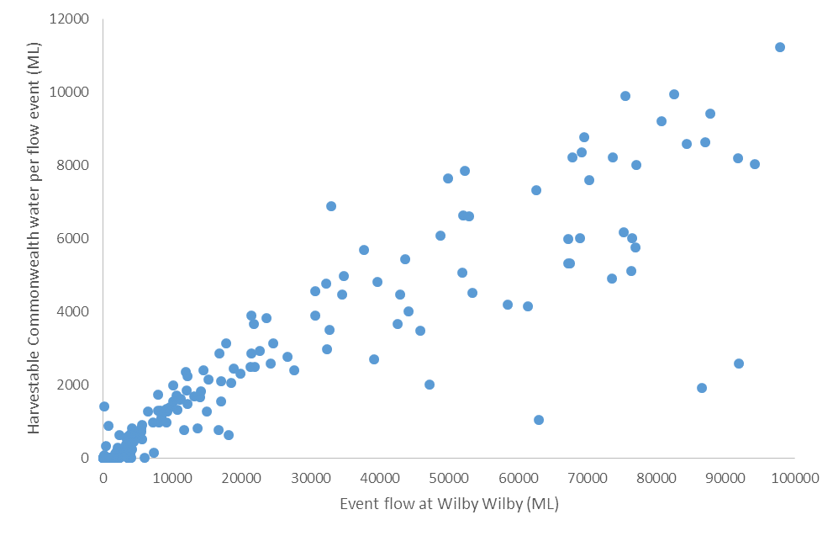

Source: Derived from Murray Darling Basin Authority IQQM model output for Barwon-Darling river system

Turning then to the use of private WH allocations, mechanism effectiveness and cost will depend upon the environmental watering demand, and the supply of water under available harvesting rights. The volume and duration of flow events measured at the Wilby Wilby gauge are shown in Figure 6.2.

**Figure 6.2: Flow events at the Wilby Wilby gauge by volume and duration**

Source: Derived from Murray Darling Basin Authority IQQM model output for Barwon-Darling river system

The dashed purple rectangle in Figure 6.2 represents the flow events targeted in case study 1, the solid red rectangle represents case study 2 and the no / low flow situation of case study 3 is also indicated. Around 25% of flow events are less than 1 GL measured at the Wilby Wilby gauge, and 55% less than 15 GL. Also, in 65% of years there are 2 or less flow events, resulting in cumulative flows in any year reaching Wilby Wilby generally remaining relatively modest.

This means mid-level flow events, an important target for water augmentation, will be few. For example, under case study 1, only 29 events of between 15 – 40 GL over a 45-day period were identified over the 114-year historical sequence. For case study 2, with a larger event volume of 40 – 70 GL and extending the event window to 6 months, only 11 occasions over the historical sequence were identified.

If sufficient water cannot be sourced within these events to meet the desired water augmentation goals, then water will need to be stored for potentially long times (and face large evaporative losses) or ‘turned over’ regularly by selling at a loss stored water late in irrigation seasons.

Figure 6.3 shows annual water diversions over the modelled historical profile in zone LBU-05 by Wilby Wilby annual flow levels, with the borders of the case study events shown similar to Figure 6.2.

**Figure 6.3: Total private diversions available by annual flows at Wilby Wilby for annual flows less than 100 GL**

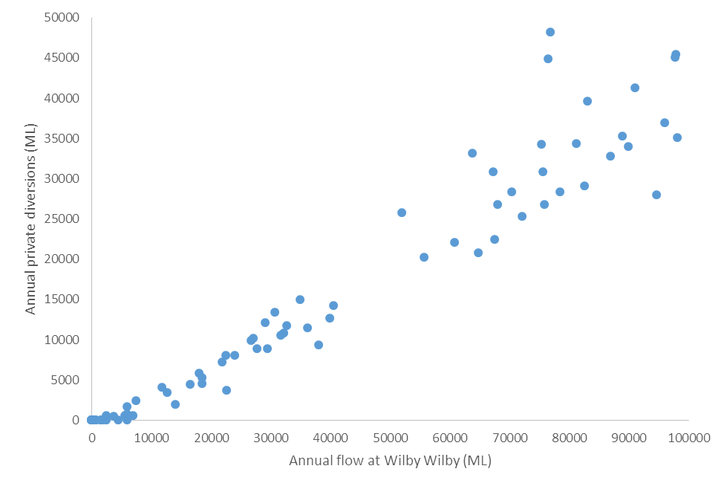

**Case study 2**

**Case study 1**

Source: Derived from Murray Darling Basin Authority IQQM model output for Barwon-Darling river system

It is apparent that potential water harvesting volumes under a flow event satisfying the water augmentation triggers for case study 2 can provide sufficient water to provide a 10 GL at Narran water augmentation need. So, for example, under the case study, combining Commonwealth and private seasonal assignments under a conditional purchase contract allowed all 11 targeted water augmentation needs to be met. Alternatively, there was found sufficient ‘uncommitted’ water available to meet 9 of the 11 augmentations, reducing the opportunity cost of water sourcing.

However, the situation under case study 1 is different. Potential water harvesting volumes under a flow event satisfying the water augmentation triggers for case study 1 can only provide sufficient water to meet the water augmentation need on a few occasions. Therefore, to source water to provide 10 GL at Narran under these circumstances, access to water secured *prior* to the targeted flow event is crucial. The effectiveness of mechanisms designed and explored under case study 2 for this purpose was however poor.

So, for example, the no-pump contract mechanism was found to provide the full targeted volumes on only 2 of 29 occasions. The conditional contract mechanism which could make use of stored water as well as water that could be harvested during the flow event increased successful augmentations to 13. The option contract mechanism had the advantage of securing and storing water from *earlier* events. However due to poor design assumptions, it failed to further increase successful augmentations.

Finally, is the effectiveness of mechanisms to provide flows after extended dry periods with little or no flows. Case study 3 found that sufficient water is rarely available from *any* source following a long dry period. Waiting to augment the next available flow event had significant limitations, as these events, consistent with figures 6.2 and 6.3 typically have limited available allocations[27], and delay times until an event occurs will prolong the no/low flow periods. Storing water for long periods was not found effective and potentially expensive.

An alternative may be to augment low flows before a prolonged dry period to enhance system resilience to naturally occurring dry periods. The benefit of using mechanisms to complement planned environmental water releases should explicitly be examined.

In summary:

* *Augmenting flows with water from within a flow event* appears to be limited until event volume reaches around 30 GL;
* *Storing water for future events is difficult* asthere is likely to be substantive gaps between events from which substantial water can be taken, so that storage periods may be long, evaporative losses large and costs high; and
* *Opportunities to augment low flows* are highly constrained. No-pump arrangements will not be effective at augmenting low flow events, and storing water for long periods will be costly. The large number of very small events (less than 1 GL) suggests that it may be possible to strategically augment some low flow events to enhance the condition of the Lakes system as an alternative to attempting to store water for long periods.

**6.3 Workability and risk**

The workability of mechanisms and implementation risks vary between mechanisms, across different flow event ranges, and for differing water sourcing objectives.

***Physical access to some OLF stored water may be difficult***

Many of the dams used to capture OLF are surge dams which are gravity fed and unable to redirect stored water to the Narran River. On some properties, captured OLF is redirected to more efficient storages which may also hold water sourced through WH allocations and so have access to the Narran.

***OLF no-pump contracts can only operate at the high end of the hydrograph and with little effectiveness***

Figure 6.3 indicated that water harvesting rights could only provide the 10 GL at Narran sought from within a flow event larger than around 30 GL. However as shown in Figure 6.4, the contribution from OLF would be minimal at this level. Significant volumes can only be harvested under OLF licences once annual flows at Wilby Wilby reach around 65 GL.

This restricts the potential use of OLF no-pump contracts. In addition, at these flow levels, only a fraction of any ‘no-pump’ volumes left to move across the floodplain would reach the Narran Lakes.

**Figure 6.4: Annual WH and OLF diversions by annual flows at Wilby Wilby**

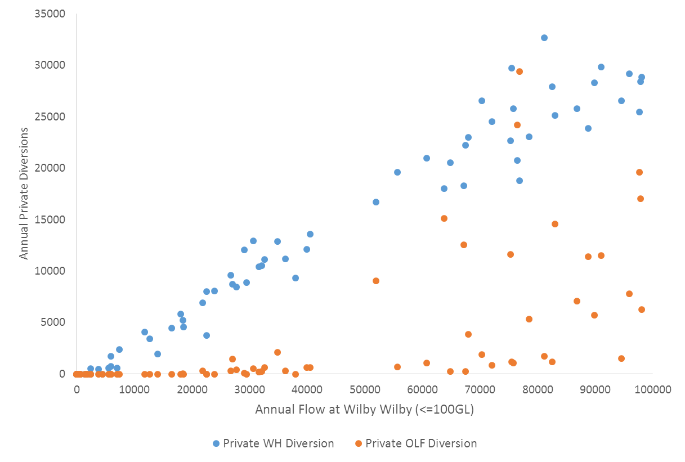

Source: Derived from Murray Darling Basin Authority IQQM model output for Barwon-Darling river system

***OLF No-pump contracts for WH allocations likely to need prior negotiation***

No-pump arrangements can be done contractually without impacting the irrigators’ rights under their allocation and without need for any DNRM approvals. In addition, the water being sought may relate to horizontal slices of harvesting rights, and volumetric or time limits could be applied.

While flexible, the time available to secure a no-pump contract once the CEWH determines the water is required (say related to a flow announcement or flow level at Wilby Wilby), will be relatively short, possibly a few days. To ensure delays in the negotiation of contract terms does not prevent a trade, prior negotiation of contract terms would assist. Irrigators have indicated a reluctance to fix price too early, as the value of the water to them will change with seasonal conditions and planting decisions made. Therefore, draft contracts, excluding price, could be prepared in advance with only the negotiation of price needed at the time the contract is to be exchanged. This involves risk in setting a price.

***Seasonal assignments with prior conversion to MVL preferable to no-pump contracts for WH allocations***

The 3-5 day delay for a seasonal assignment to be approved by the DNRM may be no different to the time it would take to complete contractual no-pump arrangements with an irrigator, and would fall within the time between an announcement being made based on flows at St George gauge and the time when extraction under the allocations along the Narran are allowed. The advantage of sourcing the water this way compared to no-pump contracts, is that the formal transfer of rights would bring DNRM oversight and associated monitoring, water accounting, reporting and auditing.

On the other hand, if the WH allocations are held under an IVL, as most are in zone LBU-05, then conversion of the allocation to a MVL is needed. Approval for this will typically take around a month, precluding use of the mechanism *within* an event. There simply would not be enough time once an event was announced to effect the change of ownership. This constraint could be relatively easily overcome through prior conversion of the allocation to MVL. There may be some irrigator resistance to converting to MVL, but ultimately, if they want to trade allocations, conversion is a pre-requisite.

***Storing water from several sources in a single storage***

The case study analysis did not differentiate between entitlement holders, effectively assuming any water purchased under these mechanisms was stored on the same property selling the water. Operationally it may appear attractive for Commonwealth environmental water from several sources to be stored water from several sources in a single storage. This may particularly be the case where Commonwealth allocations are to be stored, as the CEWO may not have access to operational storage on the properties which sold the licences to them.

For Commonwealth allocations, this would require an assessed change, need to be done ahead of targeted events and would be permanent (although reversible – see Section 2.2). More problematic will be sourcing allocations from other properties. As noted earlier, allocations cannot be seasonally assigned where there would be a change in the point of take. An assessed change would be needed ahead of any seasonal assignment. This provides complications where a temporary transfer is sought to allow the CEWO to harvest the allocations at a property not owned by the entitlement owner.

So, for example, if the CEWO only sought a vertical slice of the allocations, the owner could not access the remaining volumes not assigned as the point of take would no longer be at their property. Alternatively, the owner could enter a contract with the CEWH to take only a given volume of water under a full seasonal assignment, and for the CEWH to assign the allocations back to the entitlement holder after the targeted event. The entitlement holder could then seek an assessed change to return the point of take back to their property, and they could then access subsequent events and remaining volumes under their MVL.

The contractual basis to facilitate this would not be straightforward, and may represent a source of risk to both parties. Moreover, assessed changes typically take around a month, so there would be a risk of missing an event while waiting for an approval. In addition, there would be no guarantee that remaining volumes could be made up later (notwithstanding the carryover rules under MVL), and the possibility that volumes harvested late in the season may be worth less with the opportunity to apply the water to summer cropping missed.

**Conditional purchase and option mechanisms face additional challenges**

The appeal of these mechanisms is their ability to target specific water harvesting rights with the times water is required, and to not take ownership of water at times it is not required.

In the absence of comprehensive research into trigger specification and the broader design of conditional and option based mechanisms in the context of the Narran system, poor design represents a major risk. As shown in the case studies, defining robust purchasing triggers in a highly stochastic environment is at best problematic.

Where seasonal assignments under conditional or option mechanisms are sought, the limited time between likely purchasing triggers and when the water transfers are needed, means approval delays must be avoided. Ideally, DNRM approval would be locked in when the conditional or option contract was executed. However, these contracts relate to *potential* trades, and DNRM will not process and provide approval for a ‘potential’ trade. This should not pose a problem if the allocations are converted to MVL ahead of entering a conditional or option contract, as DNRM approval for seasonal assignments (ie: where there is no change in point of take and allocations are already expressed as MVL) will take only a few days.

Also, these mechanisms may face irrigator resistance, as it requires them to assess forward water availability risks and opportunity costs. While irrigators will be well aware of the water supply variability they face, the mechanism may require an assessment of opportunity costs (based on a forecast of likely crop yields and prices) and the likelihood of a purchase being exercised under the mechanism throughout the season. This is a significant task even with access to the historical profile of water harvesting. Risk aversion among irrigators may further reduce their appetite for these mechanisms.

**6.4 Mechanism summary and recommendations**

A brief summary of available mechanisms is provided in Table 6.1. Purchasing WH allocations is not included as this represents a permanent rather than temporary mechanism. The mechanisms recommended for further design (highlighted in the table) are:

* Seasonal assignment of WH allocations;
* Buy already stored water; and
* Conditional / option contracts involving purchase and storage of harvested private allocations on the same property as point of take, with consideration to also storing Commonwealth allocations in the storage.

The privately held OLF licences are modest until the 40,000 ML/day announcement level, and then markedly increase from the 50,000 ML/day event level. The Commonwealth already holds a high proportion of OLF licences in its portfolio, which contribute to high flow events. The key event augmentation for environmental needs are likely to focus on the small to medium events, and these events are poorly aligned with additional OLF. In addition, any additional water sourced through OLF no-pump contracts, would be left to flow across the floodplain with only a small fraction finding its way to the Narran Lakes system. OLF water harvested to storage is considered in Table 6.1 under the ‘store and release’ mechanisms, but some of these storages do not have connectivity to the Narran River and there are relatively few (and large) flow events from which to source OLF, making them less reliable. Therefore, augmentation mechanisms primarily need to focus on WH allocations.

The purchase of seasonal assignments rather than no-pump contracts appears preferable given the DNRM water accounting and oversight they bring to water rights trading, and this would also prevent irrigators ‘making-up’ for volumes sold to the Commonwealth where allocations were held under IVL. However, the purchase of seasonal assignments will be insufficient to meet the range of potential environmental watering needs.

For the scale of event-based mechanisms assumed for this project, indicative modelling suggests available privately held allocations will be insufficient to provide the additional water needed to provide a 10 GL flow augmentation until the flow event volume at Wilby Wilby reaches around 30 GL. The purchase of stored water could be used to supplement water sourced from privately held allocations. However as shown in the case studies, this approach may still only meet a fraction of water sourcing needs seeking to increase the volume of an event.

A similar situation occurs when targeting already stored water as a means to extend an event’s duration. When irrigators have had access to a moderate level flow event, storage volumes are likely to be significant, and able to provide the volumes needed for a 10 GL augmentation at Wilby Wilby. But at lower flow levels, storage volumes will be more modest and rarely sufficient. Facilitating larger storage levels will be required.

To ensure both event magnitude and duration can be effectively augmented across the range of circumstances that the environment may need, a means to strategically store additional water is needed. This can be assisted through the harvesting and storage of Commonwealth allocations. The disadvantages however are twofold. Firstly, the harvesting of Commonwealth allocations that otherwise would be left in-stream will impact the environmental benefits of that event (in the hope of greater benefits when the water is subsequently used), Secondly, the Commonwealth allocations, in themselves, would be insufficient to provide the additional storage volumes needed.

Therefore, these mechanisms (the seasonal assignment of allocations and purchase of already stored water) need to be supported with one which can *strategically* access privately held allocations to harvest and store water ahead of when it is needed. Where the harvested water would be stored at the same point of take, the CEWH can access this water through contractual arrangements without the need for seasonal assignment. Subject to the available storage, Commonwealth allocations could also be harvested and stored at this site, although the allocations would need an assessed change to relocate their point of take to the storage location. The storage owner would report CEWH take in their meter readings to DNRM, ensuring ongoing regulatory oversight.

To ensure both the private and Commonwealth allocations are managed in line with variable flow augmentation needs to achieve environmental outcomes, the harvesting of allocations, storage management and releases would need to be negotiated in advance, and preferably subject to operational rules captured in a conditional or option type contract.

Given there are only 3 remaining properties with WH allocations in LBU-05, if water in excess of that available under one property’s allocations was needed, then the CEWH could seek to enter an agreement for harvesting and storage at another property, or indeed all three if necessary. The situation on the Lower Balonne is not one where a large number of separate allocations would need to be concentrated at one storage to minimise transaction costs, improve management flexibility, and so on. Moreover, a strategy to source allocations for storage from different points of take would be unwieldy, due to the need for the seller to seek assessed changes for the transfer of the allocation’s point of take to, and back from, the location of storage holding Commonwealth environmental water.

Finally, the recommended mechanisms provide a diversity of approaches that may work for the diversity of environmental needs, hydrological conditions, and prospective sellers. The analysis summarised here illustrates that more than one mechanism will be needed, with the use of multiple mechanisms likely between, if not within, years. Having multiple mechanisms in effect at any time provides considerable flexibility at any point of time.

**Table 6.1: Summary of mechanisms**

| **Event-based Mechanism** | **Possible under ROP** | **Implement *within* an event** | **Can increase event:** | | **Key risks / comment** |
| --- | --- | --- | --- | --- | --- |
| **magnitude** | **duration** |
| ***Temporary no-pump contracts*** | | | | | |
| * WH allocations | √ | √ | √ | X | Flexible mechanism and can help reinstate low – medium flows. But loose benefit of water accounting being overseen by DNRM, and risk entitlement holder could make-up volumes later if allocations held under IVL |
| * OLF licences | √ | √ | √ | X | Only applicable at high end of hydrograph where poor alignment with CEWO needs. High delivery losses. |
| ***Seasonal assignment of entitlements*** | | | | | |
| * WH allocations | √ | √  (subject to prior change to MVL) | √ | X | Flexible mechanism to increase event magnitude, although limited scope re no/low flow augmentation. Thin market reduces competition. |
| * OLF licences | X | - | - | - | Not allowed under ROP |
| ***Store and release mechanisms*** | | | | | |
| * Buy already stored water | √ | √ | √ | √ | Opportunistic, so alignment with water sourcing needs is variable and seller has a strong negotiating position. There is precedent of this working. Use of stored water only means to extend event duration. |
| * Store Commonwealth allocations in a single contracted storage | √  (subject to assessed changes re point of take) | X  (Water from an earlier event needs to be stored) | √  (but reduce event volume when take) | √ | Constrained by available Commonwealth volumes. Stored water subject to significant evaporative losses. Potentially significant budget outlay and issues associated with storage maintenance and integrity. |
| * Purchase harvested water for storage on same property as point of take | √ | X  (Water from an earlier event needs to be stored) | √ | √ | Without effective targeting of water sourcing, alignment with augmentation needs may be poor, and costly subject to on-property use of water when not required. |
| * Source water for storage from a *different* point of take | √  (subject to assessed changes re point of take) | X  (Water from an earlier event needs to be stored) | √ | √ | Difficulties in managing temporary access to allocations which require a permanent change in point of take and subsequent reversal. Increased costs if transfers impact value of remaining volumes under the MVL. |
| ***Forward purchase, conditional, option and combined mechanisms*** | | | | | |
| * Conditional / option no-pump contracts | √ | √ | √ | X | Mechanism effectiveness critically dependent on robust triggers. Promising mechanism if can design well. Thin market and CEWO would need to provide water accounting oversight. |
| * Combined option contracts involving the storage of harvested water on same property as point of take | √ | X  (Water from an earlier event needs to be stored) | √ | √ | Involves storage of harvested water from private allocations at same property as purchased. Capacity to use in conjunction with storage of Commonwealth allocations.  Strategically increases stored volumes available to the CEWO; Critical issues are store & release trigger efficacy, storage capacity, and a thin allocations market. |
| * Conditional / option contract for privately stored water | √ | √ | √ | √ | Critical issue is trigger efficacy, and volumes limited without mechanism to source additional water from events. |

# **7. IMPLEMENTATION ISSUES FOR RECOMMENDED MECHANISMS**

This section provides further comment on the development of the recommended mechanisms – purchase of seasonal assignments; purchase of already stored water; and use of conditional or option contracts to support the purchase and storage of harvested private allocations. Any future implementation of event-based mechanisms would need to be consistent with legislation (state and Commonwealth), the Basin Plan and Commonwealth Procurement Rules, and take account of:

* The extent to which intend environmental outcomes are achieved;
* Whether the option will deliver value of money;
* Availability of resources and funds;
* State regulations including rules for water trade; and
* Any relevant frameworks that the CEWH has established.

The CEWO is seeking to be treated like any other water entitlement holder, and many of the implementation issues would be in common with other water entitlement holders. Some repetition of steps between mechanisms has been unavoidable.

It is also recognised that the CEWO will need to consider advice and adapt as appropriate to the context of the regulatory and compliance regime in place at the time of implementing mechanisms. In particular, recent media reports have highlighted issues of water sector regulatory non-compliance, particularly in NSW (Matthews 2017). This serves to undermine the rights of many water entitlement holders, including holdings held for environmental purposes. Due diligence and the assessment of the efficacy of prevailing regulatory and compliance programs should be undertaken by the CEWO ahead of significant investments in mechanisms. Such assessments are listed as an implementation issue, but undertaking them is outside the scope of this study.

**7.1 Purchase of seasonal assignments**

The trade in seasonal assignments is well developed and understood by entitlement holders. However key aspects of the proposed purchases of seasonal assignments by the Commonwealth include that:

* Participating irrigators are willing to convert any allocations still held under IVL to MVL in advance of the targeted irrigation season(s);
* Price negotiation and approvals for seasonal assignment can be completed in a relatively short timeframe necessary to enable event augmentation; and
* Irrigators willing to seasonally assign allocations to the Commonwealth are also willing to purchase back any unused volumes under the assignments at a price agreed when the initial assignments are purchased.

The circumstances when the purchase of seasonal assignments could be used to augment flow events to the Narran Lakes will need to be considered in relation to the priority watering objectives for the Narran Lakes, such as summarised at a broad level in Section 1.2 and further outlined in the CEWO’s Portfolio Management Plan for Northern Unregulated Rivers (Commonwealth of Australia 2016). Without focussing on specific water needs, it is apparent that the purchase of seasonal assignments and their passive management – that is, allowing harvestable volumes under the allocations to remain in-stream, will assist increase the magnitude of events rather than significantly impact the duration of events.

The effectiveness and efficiency of purchased seasonal allocations to increase the magnitude of events will critically depend upon their targeting, taking into account the in-stream volumes required net of transmission losses, the available seasonal assignments and the scale and frequency of events in the season of interest that will determine both cumulative stream flows and the volumes available under Commonwealth allocations and private seasonal assignments.

Simulation modelling indicated that augmenting flows to provide 10 GL at Narran via the seasonal assignment of private allocations will be difficult until event volume at the Wilby Wilby gauge reaches around 30 GL. Nevertheless, this may be sufficient to meet some watering objectives, or to supplement water under alternative mechanisms. In addition, any water that flows to the Narran Lakes has some environmental benefit, such as priming areas for future flows

Also, as outlined in the Lower Balonne water supply (Section 2.1) and shown in the case studies (Section 4), the highly stochastic nature of flow events means that success, in any one year, cannot be guaranteed. Rather judgements will be needed in relation to the *likely* effectiveness and efficiency of potential purchases, and success measured over the longer term. Flow targeting and purchasing decisions will inevitably improve over time with experience, while other factors such as climate change will present ongoing challenges.

The key steps suggested to plan and implement the strategic purchase of seasonal assignments in the Lower Balonne are described below.

**7.1.1 Seasonal assignments - Development**

1. Identify water sourcing objective(s) that seasonal assignments will be used for:

A.1 What is the specific environmental watering objective;

A.2 What event(s) types should be targeted (volume, duration, frequency, antecedent conditions, etc);

A.3 What is the process to identify feasible event augmentation opportunities and volumes (inclusive of delivery losses);

A.3.1 This identification would take into account the various flow protection rules on the Lower Balonne (eg: low flow protection).

A.4 Definition of water augmentation trigger(s) (eg: event announcement of specified scale and timing).

A.5 Likely time available from when the augmentation trigger is met to secure seasonal assignments – ie: identify sellers, negotiate price and sale terms, and secure seasonal assignment approval from DNRM:

A.5.1 Some feedback received by CEWO indicated irrigator uncertainty about forthcoming event volume and duration, and the time that would be available to formulate a price bid; and

A.5.2 The lag from an announcement to pumping on Narran is 3 - 5 days; with DNRM seasonal assignment typically taking 3 days – DNRM and water entitlement holders may scope potential to develop trading rules that allow more rapid transactions, possibly based on forecast announcements based on upper catchment rainfall, flows, etc.

1. Identify preferred procurement method:

B.1 Need to consider requirements under the Commonwealth Procurement Rules applicable to the CEWO and MDBA:

B.1.1 The purchase of seasonal assignments represents an in-market transaction and transfer of rights supported by the *Queensland Water Act 2000*. The key issues for the CEWO are therefore not legal security and the enforcement of rights, but rather ensuring competition among sellers and compliance with Commonwealth Procurement Rules (which reflect considerations such as value for money);

B.1.2 A related issue will be negotiating any return assignment of unused volumes with security for the trade and negotiated price.

B.2 Key elements of procurement suggested are:

B.2.1 Liaison with potential sellers in advance to tailor / streamline subsequent assignments;

B.2.2 Invited bids when the water augmentation trigger is met;

B.2.3 Reserve the right to negotiate and seek revised bids;

B.2.4 Include agreement as to terms for any return assignment of unused volumes in procurement process.

B.3 Potential collusion risk given a thin market and highly visible procurement:

B.3.1 Position in competition with other mechanisms (eg: purchase of stored water);

B.3.2 Benchmark opportunity costs and seek any market sales data;

B.3.3 Consider merit of forward purchase (with a premium, if necessary) to ensure that the CEWO is in a reasonable buying position *within* an event.

B.4 Ensure internal CEWO procurement process fit-for-purpose:

B.4.1 Acquisition of water allocations by the Commonwealth is provided for under section 105 of the Commonwealth Water Act (2007), and would comply with the Basin Plan (2012) and Queensland Water Act (2000);

B.4.2 Uncommitted funds from the Environmental Water Holdings Special Account can be used for these acquisitions;

B.4.3 The CEWH has delegated authority for purchases from this account, and therefore approval delays in funding are unlikely.

B.5 Discuss with DNRM the potential for assistance to support implementation of mechanisms, in the context that at least one other water entitlement holder would be involved in the mechanism, and of what it is reasonable for any water entitlement holder to request. Potential discussion items include:

B.5.1 Time to process seasonal assignment applications;

B.5.2 Any modelling support (consultants or DNRM) to identify augmentation volumes required to meet water sourcing objective(s);

B.5.3 Process for DNRM to notify water entitlement holders re announcements, estimated event volume and duration, transmission lags, including estimated Wilby Wilby flows with / without purchased assignments, etc;

B.5.4 Any assistance with the interpretation of post event reporting routinely conducted by DNRM and provided to water entitlement holders, drawing on real-time flow gauging and flow modelling. For example, whether it would be possible to estimate additional environmental flow volumes achieved through the Commonwealth purchases.

1. Identify approach to compliance monitoring and enforcement to ensure transparency and confidence (particularly given recent investigations in NSW such as Matthews 2017):

C.1 Clarify state responsibilities and capabilities for water access surveillance and compliance (eg: surveillance of event harvesting activity, pump meter readings and storage level records, recorded in-stream flow levels, analysis of flow volumes, etc);

C.2 Assess adequacy of available state compliance data and, if necessary, consider what options there are to augment it for specific flow events in agreement with the seller (eg: review of aerial photographs or satellite images).

1. Liaise with potential sellers:

D.1 Identify willingness of potential sellers re targeted events and volumes, and key issues that would impact their willingness to trade - eg: time of year, indicative pricing, full or partial assignments, available time to negotiate price, any separate monitoring and compliance requirements, procurement method, ‘swaps’ with Commonwealth allocations at other times, etc[28];

D.2 Negotiate terms for unused volumes under assignment’s MVL (eg: agree resale price for CEWO to assign back to entitlement holder);

D.3 Reach agreement for allocations of interest that are held under IVL to be converted to MVL:

D.3.1 Entitlement holder to provide evidence of change to CEWO when completed.

1. Liaise with other stakeholders if necessary, possibly through the Lower Balonne Water Network.
2. Document mechanism strategy, including objectives, augmentation triggers, procurement approach, communications plan, risk assessment, contingencies, monitoring and compliance plan, reporting, etc.

**7.1.2 Seasonal assignments - Implementation**

1. Initiate process to identify target event(s), augmentation opportunities and in-stream volumes required.
2. Once an augmentation trigger has been met:

H.1 Consider seeking initial DNRM advice as to assignment volumes required to meet targeted augmentation objective (as any other water entitlement holder may seek DNRM advice regarding whether seasonally assigned volumes coming in an event may meet their objectives);

H.2 Identify potential seller and volume combinations (eg: could a partial assignment meet required volume; or full; or will allocations from more than 1 seller be needed);

H.3 Invite bids from potential sellers;

H.4 Benchmark opportunity costs taking into account seasonal and within season factors, current and past market data and relative cost-effectiveness compared to alternative mechanisms (such as purchase of stored water, if available) to assist price negotiation;

H.5 Negotiate final contract terms (eg: unused volumes) and price.

1. Execute agreement with seller and complete application for seasonal assignment:

I.1 To apply for seasonal water assignment of a water allocation, the buyer and seller must complete and sign DNRM application form W2F020 and submit the original to the DNRM;

I.2 The prescribed fee for the assignment is payable at the time of application by the seller. Any outstanding accounts must be paid by the seller before the application will be considered. Both the buyer and the seller will remain liable for their respective water charges (ie: the CEWO pays for any usage components of the water charges for the assigned water).

1. Once a seasonal assignment is approved, DNRM will issue the assignor (the water entitlement holder that is selling water temporarily) with an information notice stating that the assigned water has been debited against their entitlement for the water year:

J.1 The assignee (the CEWH) will be issued a seasonal water assignment notice, which enables the CEWH to reassign any unused portion of the water in that same water year;

J.2 If the assignee has been issued such notice and the original water entitlement is subsequently sold, the assignee’s authority to take water will not be affected in any way.

1. Inform stakeholders across the Lower Balonne in Queensland and NSW of the environmental watering objectives and operational details of the purchases by the Commonwealth.
2. Monitor the event, and if required, initiate application for return of unused volumes under the assignments at completion of the event.
3. Receive post-event compliance reports:

M.1 Following due diligence, pay invoices based on agreed prices re cost of assignments less value of volumes in return assignments.

1. Evaluate post-event re effectiveness and efficiency of augmentation:

N.1 Identify what worked well or not;

N.2 Develop recommendations for future use of the mechanism.

**7.2 Buy already stored water**

This mechanism would, like the purchase of seasonal assignments, be opportunistic. No strategic action is considered to increase storage volumes or discourage the extraction of the water for irrigation. Simply, when a water augmentation opportunity presented, the CEWO would identify what volumes were held in storage across the five properties connected to the Narran River, and seek to contract the most cost-effective property(s) to discharge the targeted volumes at the target time.

Access to stored water could be employed to increase the magnitude and/or duration of a flow event. Further, case study 2 demonstrated that sufficient volumes are likely to be held in storage to meet some augmentation needs (Section 4). This will particularly be when water is needed later in the season, and less so when there has been a period of relatively small or infrequent flow events. The effectiveness and efficiency of a mechanism based on opportunistically purchasing already stored water will depend upon the specific water augmentation need. And as indicated when using seasonal assignments, mechanism success in a highly stochastic environment will need to be measured over the longer term. Initially, the yardstick of mechanism performance will be relative imperfection. No mechanism will deliver on all occasions – this is an important application of adaptive management.

The key steps suggested to develop the ‘buy already stored water’ mechanism and implement it in the Lower Balonne are described below.

**7.2.1 Buy stored water - Planning**

1. Identify water sourcing objective(s) that access to stored water could assist:

A.1 What is the specific environmental watering objective;

A.2 What event(s) types are to be targeted (volume, magnitude, duration, frequency, antecedent conditions, etc);

A.3 What process to identify feasible event augmentation opportunities and volumes (gross of delivery losses);

A.4 Definition of water augmentation trigger(s) (eg: event announcement of specified scale and timing);

A.5 Likely time available from when the augmentation trigger is met to secure storage releases;

A.6 The strategy for releases:

A.6.1 For example, releases could be made immediately following water harvesting from an event, as weirs and waterholes will be full and therefore transmission losses smaller.

1. Identify potential sellers:

B.1 Liaise with potential sellers and identify willingness to participate (including licence conversion to MVL) and their capacity to supply stored water to the Narran[29].

1. Identify preferred procurement method:

C.1 The purchase and release of stored water would not be registered as a change in ownership under the Queensland water trading framework, and the contract-based purchases will need to be administered consistent with Commonwealth Procurement Rules;

C.2 This can be done by the CEWO establishing contracts in advance that set out the majority of the conditions for the purchase (Standing Water Arrangement). This arrangement would not oblige either party to go ahead with a purchase, but would allow both parties to agree quickly on a specific purchase and form contracts under Arrangement during a suitable event;

C.3 Given the small number of potential suppliers, an invited tender could be issued. Key information that would be sought would include:

C.3.1 Available storage capacity, the source(s) of stored water, indicative volumes that may be available for purchase throughout the irrigation season under various seasonal conditions (dry, average, wet); the location of releases;

C.3.2 The release mechanism for discharges (and if pumped or gravity), capacity (rate of discharge) and nature of connectivity to the Narran;

C.3.3 Ability to monitor / measure releases (pump metering[30], storage level gauging, etc), and the accuracy of equipment (eg: independent test results) and the volumetric accounting of release volumes;

C.3.4 A statement that the released water would comply with the Store and Release Code of Practice, and agreement to accept full liability for the quality of releases and compliance with the Environmental Protection Act 1994.

C.4 When the water augmentation trigger(s) is met, CEWO would issue a Request for Water to suppliers who are signatories to the Standing Water Arrangement:

C.4.1 Interested properties would submit their Water Order indicating available volumes, price and any other conditions outside of the Standing Agreement;

C.4.2 The CEWO would assess submitted orders, negotiate as necessary and select those that could most cost-effectively provide the target volumes within Commonwealth Procurement Rules;

C.4.3 CEWO would sign Water Orders, establishing a contract with each chosen supplier.

C.5 Successful suppliers would make the releases as contracted and submit an invoice and associated compliance information (meter readings, storage gauge records, etc).

1. Ensure internal CEWO procurement process fit-for-purpose:

D.1 Acquisition of stored water by the Commonwealth is provided for under section 105 of the Commonwealth Water Act (2007), and would comply with the Basin Plan (2012) and Queensland Water Act (2000);

D.2 Uncommitted funds from the Environmental Water Holdings Special Account can be used for these acquisitions;

D.3 The CEWH has delegated authority for purchases from this account, and therefore approval delays unlikely.

1. Explore options for metering and monitoring support, noting that the purchase and release of stored water is outside DNRM’s regulatory framework and hence release volumes will not routinely be included in their surveillance and compliance activities. Alternative, external support could be considered for a targeted flow event. Such support could include:

E.1 Event modelling to identify augmentation volumes required to meet water sourcing objective(s);

E.2 Prediction of future re announcements, estimated event volume and duration, transmission lags, estimated Wilby Wilby flows with / without purchased storage releases, etc;

E.3 Any arrangements to monitor and report storage releases (ie: water storage gauging); and need to supplement with third-party support (eg: CEWO engaged personnel to undertake physical spot-checks) and/or information to be provided by storage operators;

E.4 Post event water balance reporting to the CEWO re event flow volumes and estimated flow augmentation volumes.

1. Liaise with other stakeholders if necessary, possibly through the Lower Balonne Water Network.
2. Document mechanism strategy, including objectives, augmentation triggers, procurement approach, communications plan, risk assessment, contingencies, monitoring and compliance plan, reporting, etc.

**7.2.1 Buy stored water - Implementation**

1. Initiate process to identify target event(s) and augmentation opportunities.
2. Once an augmentation trigger has been met:

I.1 Consider seeking technical advice as to release volumes required to meet targeted augmentation objective;

I.2 Issue a Request for Water to suppliers:

I.2.1 Assess Water Orders considering volumes, price and cost-competitiveness based on benchmarked[31] opportunity costs taking into account seasonal and within season factors, current and past market data and relative cost-effectiveness compared to alternative mechanisms;

I.2.2 Negotiate and execute chosen Water Orders;

I.2.3 Provide a quote for the offered volumes or part thereof.

1. Inform stakeholders across the Lower Balonne in Queensland and NSW of the environmental watering objectives and operational details of the purchased storage releases.
2. Monitor the event, and contracted storage releases.
3. Receive post-event compliance report:

L.1 Following due diligence, pay invoices based on agreed prices.

1. Evaluate post-event re effectiveness and efficiency of augmentation:

M.1 Identify what worked well or not;

M.2 Develop recommendations for future use of the mechanism.

**7.3 Conditional / option store and release contracts**

This section focuses on the purchase and storage of private water for a potential future environmental use – that is, ‘store and release’. As indicated previously, recommended store and release contracts may relate to water already stored on properties or to future water available under the property’s allocations and harvested and stored on the property. We also consider the arrangements under which Commonwealth water could be stored and released conjunctively with private water. We do not consider CEWH store and release in isolation as analysis reported in previous sections has identified that the environmental watering need is unlikely to be met from this source alone.

Under store and release approaches, some or all of the volume harvested by a landholder is stored against a future environmental need. They are intended to offer certainty of supply for a future environmental use, albeit potentially at high cost as described previously. As detailed above, store and release contracts would typically specify who has the right (but not the obligation) to water under certain conditions (the ‘trigger’). Although store and release mechanisms are relatively novel, the Narran has some experience in at least some aspects of the arrangements from the 2008 MDBA purchase of around 10 GL of private water. Effective use of store and release arrangements by the CEWO will require:

* Participating irrigators are willing to sell and continue to store (part of) their water on behalf of the CEWO, and for Commonwealth water, a willingness to store water that remains owned by the Commonwealth. The primary focus is on water harvesting rather than overland flows, because of the greater likelihood that water would be available for storage;
* Irrigators willing to store water are also willing to purchase any unused volumes stored at a price agreed when the water is stored;
* Overcoming practical constraints such as river connectivity, available pumping capacity, water quality and so on, only some of which can be fully dealt with in contracting arrangements; and
* In the case of Commonwealth water, that landholders are willing to harvest and store Commonwealth water for future release (albeit with the opportunity to purchase that water if it is not used for environmental releases). This would also include provisions to ensure that storage of Commonwealth water does not adversely interact with their own private water storage needs.

As with the purchase of seasonal assignments and purchase of already stored water, the circumstances when store and release approaches could be used to augment flow events to the Narran Lakes will need to be considered in relation to the priority watering objectives for the Narran Lakes, such as summarised at a broad level in Section 1.2. Across the range of potential watering needs evaluated, it is apparent that store and release approaches can be tailored towards a range of needs including augmenting flow volumes at different times as well as extending the duration of events.

The effectiveness and efficiency of purchased seasonal allocations to increase the magnitude of events will critically depend upon:

* Whether water has been available for purchase (storage) given the scale and frequency of events in the season of interest; and
* The potential for releases to meet environmental needs taking into account evaporation as well as the in-stream volumes required net of transmission losses, and the scale and frequency of events in the season of interest.

As previously, the highly stochastic nature of flow events means that success, in any one year, cannot be guaranteed. Success would need to be measured over the longer term, is likely to improve over time with experience, and factors such as climate change will present ongoing challenges.

The key steps suggested to develop the mechanism and implement it in the Lower Balonne are described below, in relation to firstly planning steps (for storage of private and Commonwealth water, and then in relation to storage releases), and secondly implementation steps (for these actions as well as instances when release triggers are not met and the water is instead sold to the irrigator).

**7.3.1 Store and release – Planning**

**Private water**

1. Identify water sourcing objective(s) that a store and release mechanism would target:

A.1. What event(s) types are to be targeted (volume, magnitude, duration, frequency, antecedent conditions, etc);

A.1.1 Will any timing constraints apply to purchases (such as to avoid impacting high value cropping);

A.1.2 Identify management elements that will need to be specified in contracts eg: total volume contracted and how evaporation and other losses are to be handled;

A.1.3 Identify constraints to storage locations posed by available release outlets, rates and total volumes (and any interaction with Commonwealth water store and release).

A.2 Identify feasible flow event harvest opportunities and volumes (gross of estimated evaporation losses):

A.2.1 Identify combinations of volumes and contractors, and whether procurement is prior to a flow event or after the event once allocations have been harvested.

A.3 Definition of flow event trigger(s) (eg: event announcement of specified scale and timing).

A.4 Likely time available from when the augmentation trigger is met to secure seasonal assignments – ie: identify sellers, negotiate price and sale terms, and secure seasonal assignment approval from DNRM:

A.4.1 Some feedback received by CEWO indicated irrigator uncertainty about forthcoming event volume and duration, and the time that would be available to formulate a price bid;

A.4.2 The lag from an announcement to pumping on the Narran is some 3 - 5 days. With DNRM seasonal assignment typically taking 3 days, DNRM and water entitlement holders may scope potential to develop trading rules that allow more rapid transactions, possibly based on forecast announcements of upper catchment rainfall, flows, etc.

1. Identify preferred procurement method:

B.1 It is assumed that contracts would be agreed well in advance of a flow event from which water is stored because the primary objective of a store and release contract is certainty over water availability for a future augmentation need;

B.2 This can be done by the CEWO establishing contracts in advance of flow events from which water is harvested that set out the conditions for the purchase (Standing Water Arrangement);

B.3 Contracts made well in advance of the event may need to have subsequent finalisation of pricing arrangements to manage uncertainty around the opportunity costs to irrigators. For example, prices may vary relating to seasonal constraints on which crops water can be applied to, or across longer term commodity price variations;

B.4 The purchase and release of stored water will need to be conducted outside of the Queensland water trading framework. There will be a need to consider requirements under the Commonwealth Procurement Rules for supply under contract:

B.4.1 Procurement is contract based, however as ownership of water until released stays with the storage operator, oversight re extraction volumes and storage levels to ensure that the stored water remains available will be required;

B.4.2 A related issue will be negotiating any return sales of unreleased volumes with security for the trade and negotiated price.

B.5 Key elements of procurement should be as per Section 7.1;

B.6 Potential collusion risk should be managed as per Section 7.1;

B.7 Ensure internal CEWO procurement process fit-for-purpose as per Section 7.1;

1. Identify preferred approach to compliance monitoring and enforcement:

C.1 Identify data that would be needed from contractors (eg: location of stored water, whether other private water planned for crop use is stored at same location, release timing and amounts for private use);

C.2 Agree a method for how losses (evaporation, leakage, transmission losses to and from storage) will be estimated and factored into contracted volumes. This needs to be carefully considered because landholders are able to strategically manage storage to minimise evaporation and leakage losses and this will change their management incentives. Options include collection of data directly from storage owner, third party monitoring, making use of any DNRM storage level monitoring or a combination of these;

C.3 Identify scope for external or DNRM assistance. Eg: for volume of water stored standard records to DNRM around pumping and storage level, for management after storage identify whether crop area records are kept;

C.4 Potential third-party support (eg: personnel to undertake physical spot-checks of stored water, confirm real time monitoring of storages etc.).

1. Liaise with potential sellers:

D.1 Identify willingness of potential contractors to enter contracts for targeted events and volumes, and key issues that would impact their willingness (eg: indicative pricing such as based on crop opportunity costs, whether prices would need to be negotiated before event, nature of monitoring & compliance activities, procurement method, etc);

D.2 Identify potential release locations and constraints such as release rates and total volumes;

D.3 Identify any issues that present difficulty in compliance with the Store and Release Code of Practice;

D.4 Negotiate key contract terms (other than price) and prepare a draft contract;

D.5 Agree timeline for any additional steps in contract once a targeted event is identified – for example if water prices are to be finalised by event this would be required.

1. Consider approaches to address hydrology issues – such as a monitoring strategy and modelling to estimate elements of the water balance (this may require external assistance as DNRM assistance may be minimal for the storage part of a store and release mechanism):

E.1 CEWO would likely need to have a monitoring strategy for storage level, for example with storage level records sent directly to them;

E.2 Consultant or DNRM may provide assistance by modelling likely extractions against cropping area, historical evaporation and other loss data.

1. Liaise with other stakeholders if necessary, possibly through the Lower Balonne Water Network.
2. Document purchasing strategy, including objectives, augmentation triggers, procurement approach, communications plan, risk assessment, contingencies, monitoring and compliance plan, reporting, etc.

**Commonwealth water**

1. Identify circumstances where CEWH managed water could be used:

H.1 Likely event(s) and process to identify event(s)/timing under which Commonwealth water will be sourced. These may not fully overlap with use of private water, as extraction of Commonwealth allocations would directly reduce the downstream flow rate and aggregate volume vis-à-vis passive management of allocations;

H.2 Consider the extent to which a conjunctive Commonwealth and private water store and release strategy may increase flexibility over a private water strategy alone;

H.3 Identify any relevant constraints such as rate-of-fill and dam stability requirements (ie: if storages are filled too fast they can burst (water needs to seep into the dam wall as it fills. This could be a larger issue if pumping Commonwealth water would exceed the desired fill rates in the pumping windows they apply to);

H.4 Seek a DNRM assessed change to Commonwealth allocations for relocation of take point to chosen storage location.

1. Consider what a Commonwealth water storage contract would need to encompass to be effective:

I.1 Identify any maximum or minimum volumes to be stored;

I.2 Specifics about how evaporation and other losses are to be handled. This will particularly be the case if private water is also held in the same storage;

I.3 Conditions under which Commonwealth water would be released to the landholder for private use, and pricing arrangements in such situations;

I.4 Priority given to pumping Commonwealth and private water if for example, rate-of-fill constraints or pump failure restrict water harvesting.

1. Identify preferred procurement method for storage for Commonwealth water:

J.1 With only few potential contractors (a maximum of 6 if properties with and without water rights but with storages included), key aspects may be:

J.1.1 Advance negotiation of contract terms is a given because Commonwealth allocation take locations will need to be changed (and insufficient time within events to do this);

J.1.2 How to structure the components of procurement across storage, pumping capacity and release infrastructure;

J.1.3 Reserve right to negotiate and seek revised bids;

J.1.4 Optimal period for contracting (see below on CEWO fit-for-purpose procurement process).

J.2 Potential collusion risk given thin market and highly visible procurement (similar to private storage).

1. Ensure internal CEWO procurement process fit-for-purpose:

K.1 Ensure that storage of Commonwealth water complies with the relevant acts and that uncommitted funds from the Environmental Water Holdings Special Account can be used for these acquisitions;

K.2 A mix of payments that may need to include:

K.2.1 Retain access to storage (and pumping);

K.2.2 A volumetric payment for pumping to storage;

K.2.3 Identify whether there are additional costs associated with release (some storage arrangements may require pumping to release, others may require infrastructure modification).

K.3 Identify whether there are opportunities or constraints to future flexibility (eg: moving licence take point is relatively fixed in the short term but can be shifted again in the future).

1. Identify preferred approach to monitoring and enforcement of contract (as per private water storage).
2. Liaise with potential contractors (largely as per private storage step with some differences to tailor pumping Commonwealth water and to release for farm use if not used for environmental purpose):

M.1 Identify willingness of potential contractors to enter contracts for storing Commonwealth water for the targeted events and volumes, and key issues that would impact their willingness (eg: infrastructure constraints, pricing structures and risk, whether prices for water released for farm use would need to be negotiated before event, nature of monitoring & compliance activities, procurement method, etc);

M.2 Identify potential release locations and constraints such as release rates and total volumes (and any interaction with private water store and release);

M.3 Identify any issues that present difficulty in compliance with the Store and Release Code of Practice;

M.4 Negotiate key contract terms (other than price) and prepare a draft contract;

M.5 Agree timeline for triggering the actions contracted once a targeted event is identified.

1. If appropriate, liaise with DNRM as to each of the steps above, and particularly for the store and release of Commonwealth water:

N.1 Interaction with event volumes (ie: comfort with store and release on these event scales);

N.2 Discuss with DNRM whether it is able to incorporate Commonwealth water harvested and stored and private water purchased and stored for future release in overall flow accounting.

1. Liaise with other stakeholders if necessary, possibly through the Lower Balonne Water Network.
2. Document storage procurement strategy, including objectives, storage and release triggers, communications plan, risk assessment, contingencies, monitoring and compliance plan, reporting, etc.

**Release of stored water**

Note that this step would be undertaken prior to the water storage planning step above but much of this step will be implemented post storage and is set out in the same order for simplicity.

1. Likely time available from when the augmentation need is triggered until water would need to be released ie: time until release, any checks such as for water quality required, secure DNRM or external cooperation for event monitoring:

Q.1 The lag from a release to reach Wilby Wilby ~ 5-7 days;

Q.2 The lag from a suitable flow event for augmentation being identified until release is required (minimum of 12 days with potential to forecast flow events based on upper catchment rainfall, flows, etc).

1. Irrigators who are contracted to store and release water will need to comply with the Store and Release Code of Practice. The code contains a description of the general obligations and specific monitoring programs to be conducted during initial releases of water from privately owned farm storages. Planning steps will include:

R.1 Ensuring contracted irrigators implement Level 2 compliance with the myBMP program;

R.2 Identifying who is responsible for water sampling before and during the event;

R.3 Steps to be taken in the event that contaminants are identified.

1. Identify the actions that will be required prior to a release event trigger and a suitable time-frame to ensure that they are completed:

S.1 A process to finalise and notify contract holders of the volume, timing and release rate with contract holder. This will especially be required if multiple releases are to be coordinated across different storages or release points;

S.2 Any process to protect the environmental releases through private weirs, including Clyde (weir 47), Cavillon (weir 48), and Wynella (weir 49) as well as NSW landholders such as Bangate. If water were released outside of announcement periods (such as immediately following), the protection of flows would not be needed as irrigation harvesting would be precluded and subject to DNRM compliance oversight.

1. Liaise with DNRM re any support sought in environmental release planning.
2. Liaise with other stakeholders if necessary, possibly through the Lower Balonne Water Network.
3. Document purchasing strategy, including objectives, augmentation triggers, procurement approach, communications plan, risk assessment, contingencies, monitoring and compliance plan, reporting, etc.

**7.3.2 Store and release - Implementation**

**Private water**

1. Initiate process to identify target event(s) and augmentation opportunities.
2. Initiate procurement process (decision made in planning as to whether to initiate before or after flow event trigger is met):

B.1 Consider seeking hydrology / ecology advice (external or from within government eg: DNRM) as to volumes required in storage to meet targeted environmental need;

B.2 Identify potential seller and volume combinations (eg: could a one irrigator meet required volume; or will allocations from more than 1 seller be needed);

B.3 Invite bids from potential contractors;

B.4 Benchmark opportunity taking into account seasonal and within season factors, current and past market data and relative cost-effectiveness compared to alternative mechanisms (such as purchase of stored water, if available) to assist price negotiation;

B.5 Negotiate final contract terms and price (including finalising any terms for unused volumes);

B.6 Benchmark opportunity costs taking into account seasonal and within season factors, current and past market data and relative cost-effectiveness compared to alternative mechanisms (such as purchase of stored water, if available) to assist price negotiation;

B.7 Note that the irrigator will remain liable for the relevant water charges which would need to be included in the pricing.

1. Seek advice from DNRM or external parties with respect to any monitoring, reporting or compliance issues.
2. Inform stakeholders across the Lower Balonne in Queensland and NSW of the environmental watering objectives and operational details of the store and release strategy.
3. Once an augmentation trigger has been met:

E.1 Confirm flow event storage arrangements with irrigators;

E.2 Monitor the event.

1. Receive post-event compliance report:

F.1 Following due diligence, pay invoices based on agreed prices re cost of water stored including pumping costs.

1. Evaluate post-event re effectiveness and efficiency of augmentation:

G.1 Identify what worked well or not;

G.2 Develop recommendations for future use of the mechanism.

**Commonwealth water**

1. Prior to a storage event trigger for Commonwealth water being met:

H.1 Consider seeking advice (DNRM or other parties) as to assignment volumes required to meet targeted augmentation objective and finalise the volumetric parameters for storage of Commonwealth water;

H.2 Seek any DNRM advice as to any issues with storage management and options for changes to take or release locations including elements such as:

H.2.1 Rate-of-fill constraints;

H.2.2 Interaction with existing private licence pump rates for example;

H.3.3 Whether additional development permits would be required, for example for additional pumping capacity.

H.3 Invite bids from irrigators able to provide storage and release services and the conditions under which these are required (volumes, flow event parameters, operational pumping to storage and release from storage requirements etc.).

H.4 Revise and update benchmark costs and prices (pumping, infrastructure modification, storage maintenance);

H.5 Negotiate final contract terms and price.

1. Execute contracts with selected contractor(s).
2. Formally apply to shift the location of take of Commonwealth allocations to that agreed for the contracted storage arrangements:

J.1 CEWH to complete and submit to DNRM for assessment an ‘Application to change a water allocation’ (W2F 151) to change the location of the point of take for the Commonwealth water allocation to the proposed storage take point;

J.2 Irrigator to submit any additional permissions required such as a development permit for additional pumping capacity at the proposed point of take;

J.3 Liaise with DNRM on any concerns / ROP compliance etc;

J.4 Note that the CEWH will remain liable for any relevant water charges.

1. Once a change of location of take is approved, DNRM will issue the Commonwealth with a dealing certificate which will need to be lodged with the Titles Office for recording:

K.1 Caution may be required that if the Commonwealth water licence is subsequently moved to another location of take the irrigators authority to take water would not be affected in any way.

1. Once satisfied that contracted release arrangements have been effected, receive and pay contractor invoices for agreed payments prior to a flow event trigger being met.
2. Advise DNRM of contracted storage agreements.
3. Employ process to identify target event(s) for Commonwealth water harvesting. eg: monitor rainfall, stream flows, announcements, etc.
4. Once an event trigger met:

O.1 Notify contracted landholder to trigger the contracted pumping of Commonwealth water (against the relevant entitlement conditions);

O.2 Negotiate / ensure notification of any limitations on pumping that affect the volume of Commonwealth water taken (eg: rate of fill restrictions).

1. Implement CEWO monitoring and compliance program:

P.1 Following due diligence that Commonwealth water has been stored for future release, receive and pay contractor invoices (pumping costs and any additional costs agreed for payment at this point).

1. Evaluate post-event re effectiveness and efficiency of augmentation:

Q.1 Identify what worked well or not;

Q.2 Develop recommendations for future use of the mechanism.

**Release of stored water**

1. Initiate process to identify target flow event(s) and other augmentation opportunities for environmental water releases.
2. Prior to a release event trigger being met:

S.1 Finalise strategy for coordinating volume, timing and release rate with contract holder. This will especially be required if multiple releases are to be coordinated across different storages or release points;

S.2 Ensure myBMP provisions underpinning the Store and Release Code of Practice provisions are met on properties/storages where water is stored;

S.3 Implement a water quality sampling process in storages to support the Store and Release Code of Practice.

1. Once a release event trigger is met:

T.1 Request (previously negotiated) event monitoring and compliance assistance (eg: flows in Narran at Hebel Rd, downstream storage levels/metering checks to ensure any pumping is within event announcements and does not impact on release);

T.2 Conduct pre-release, within release, upstream and downstream water quality monitoring as per the Store and Release Code of Practice;

T.3 Request DNRM and NSW assistance to monitor flows including sharing of event auditing and for downstream flows into NSW (would include flows at Dirranbandi-Hebel Rd, Wilby Wilby and Narran Park, water level gauges in Narran lakes as relevant to trigger event);

T.4 Implement CEWO monitoring and compliance program.

1. Receive post-event compliance report from DNRM:

U.1 Following due diligence, pay invoices based on agreed prices associated with release (for example, time and labour, pumping if required etc.).

1. Evaluate post-event re effectiveness and efficiency of augmentation:

V.1 Identify what worked well or not;

V.2 Develop recommendations for future use of the mechanism.

**Instances when water release trigger is NOT met**

1. Process to identify when release trigger within the designated time-frame has not been met and stored water to be transferred to storage owner’s account.
2. Consider seeking DNRM advice on a decision to sell stored water – i.e. confirm that there is not a specific environmental water need to which the stored water could be used for.
3. Trigger the contract provisions relating to sale of (remaining) stored water to irrigator:

Y.1 Implement contract provisions relating to sale of water from CEWH to landholder;

Y.2 Conclude final contract terms (i.e. volume available and date at which it becomes available);

Y.3 Execute agreement with seller.

1. Following due diligence, issue invoices based on agreed prices associated with sale.
2. Evaluate event and effectiveness and efficiency of Commonwealth store and release as part of mechanism bundle:

AA.1 Identify what worked well or not;

AA.2 Develop recommendations for future use of the mechanism.

# **8. POTENTIAL TO SCALE MECHANISMS AND APPLY IN OTHER CATCHMENTS**

This section provides brief comment on the applicability of mechanisms to source alternative volumes for event flow augmentation to the Narran Lakes, as well as the applicability of mechanism to other unregulated catchments

**8.1 Practicality of mechanisms at different augmentation volumes to Narran Lakes**

It is worth briefly outlining the main constraints that any water augmentation would need to overcome to identify where and under what conditions event-based mechanisms can be readily up-scaled or down-scaled. In brief, they are:

* For flows of less than 12-15 GL measured at Wilby Wilby, there will be very little water harvesting, which effectively precludes any within event water augmentation.
* For flows of 15-30 GL there is an opportunity for water augmentation within the flow event but generally available volumes will be insufficient to provide a 10 GL at Wilby Wilby flow augmentation.
* For flows between 30-70 GL there is a high likelihood that either a 10 GL augmentation objective can be achieved within the flow event, or that sufficient water can be stored to achieve a future 10 GL augmentation objective.
* For flows above 70 GL there are likely to be significant overbank flows which are both an opportunity (more water is stored) and a complexity (any augmentation within the peak will be lost).

There are also a range of issues that need to be considered in supporting augmentation itself:

* Infrequent flow events (~2.6 per year, a quarter of which are <1 GL and more than 50% less than 15 GL, and high losses in storing for significant periods) mean that storing water to augment future events of significant scale (ie: 20-30 GL or more) is high risk (ie: relatively few successful augmentations against water needs assumed for this study).
* Augmentations within a flow event need to consider the channel capacity (to avoid/minimise floodplain losses).
* Augmentations outside of a flow event need to consider the dry channel losses. Dry channel losses in the Narran River may be up to 8 GL depending on timing, evaporation, previous water hole pumping for stock and domestic etc.
* All augmentations need to consider any infrastructure constraints such as rate of release constraints.

Following from this thinking we identify the following down-scale opportunities:

* There is an opportunity for small augmentations (ie: <10 GL) in the 15-30 GL at Wilby Wilby flow event range. These were broadly evaluated in case study 2 and the associated sensitivity analysis.
* There are some, albeit relatively few, modelled opportunities to add storage releases on smaller flows (<15 GL, see sensitivity analysis). There are likely to be additional opportunities that could not be modelled where relatively small amounts of water remain at the end of cropping seasons which could be released to augment smaller flows. These would need to be opportunistic but likely to be favourably considered by landholders where remaining water is insufficient to be carried over to a future cropping season.
* Scale-down opportunities will be less limited by factors such as channel capacity and therefore more able to increase either flow peak or flow duration depending on the flow objective.
* Scale-down opportunities may reduce the market constraints because fewer landholder participants may be required to deliver the desired augmentation objective.

Scaling up opportunities:

* Augmentation options are limited by the availability of water. The larger the volume of water required for augmentation the less likely it will be available – this is simply a function of the distribution of flow events.
* Any scaling up will require water to be stored and then released because of channel capacity constraints. (This also means an increasing impact on water use for private agriculture.)
* Effectively the upper limit on scaling up is the maximum private on farm storage available (~100 GL subject to infrastructure constraints on release). Any release profile will need to take into account:
  + The event profile, avoiding release until channel capacity becomes available (ie: extending flow duration rather than increasing flow peak).
  + Release constraints (pumping and other infrastructure).
* Scaling up will increasingly require all landholders to participate in some form, thus increasing the market difficulties.

**8.2 Applicability of mechanisms in other unregulated catchments**

Existing information can do much to identify where event based mechanisms may be applied in other unregulated catchments. Clarity around EWRs, which outline flow event conditions desired, and where existing arrangements fall short allow event based mechanism goals to be defined. In some instances, there may already have been some previous work done further simplifying the task. Identifying the applicability and relevant features of possible event based mechanisms can then be thought of across six key areas as follows:

* What are the water augmentation needs and how can they be met?
  + In particular do they relate to flow event conditions (volume, peak flow or duration), end of system flows, floodplain health or other factors?
  + Defining these needs facilitates assessment of how the augmentation goal interacts with availability.
* Flow frequency, distribution and interaction with the proportion and timing of water harvest (is the water available?):
  + The higher the number of harvestable flow events, and especially the higher the volume of water harvested within each event, the more water will be available for within flow event augmentation or storage for future augmentation activities.
  + The greater the gap between flow events the less likely and higher the cost of water storage to augment future flow events (evaporation and other storage losses in addition to opportunity costs of crops).
* Storage parameters and constraints (can the water be delivered to the system at all?):
  + The larger and more reliable the private storage capacity relative to environmental augmentation needs, the easier it will be to augment.
  + Similarly, factors such as storages closer to, and equipped to release to river channels favour easy augmentation.
* Hydrological parameters of the channel and floodplain (can the water be supplied where and when it is needed?):
  + The higher the floodplain losses the greater the need for effective augmentation to be limited to channel capacity (assuming the augmentation need is met through downstream channel flows and not on the immediate floodplain).
  + The lower the losses from factors such as dry channel, the fewer and more dominant the target channel relative to other distributary channels (reference B1 and B2 in the case of the Narran limiting effective supply to zone LBU-05), the lower losses from evaporation etc., then the greater the potential for effective augmentation outside flow events and the larger the potential source area for augmentation.
* Market parameters and constraints (can an event-based mechanism be applied?):
  + Fewer landholders (and as a proportion of the market) required to deliver successful augmentation makes for a more competitive market and more ‘liquid’ market.
  + Fewer landholders required overall also makes for simpler contracting.
  + Although fewer targeted landholders can make it easier to communicate with landholders (albeit at the risk of additional impacts if they are unwilling to participate).
  + If primary cropping seasonality favours augmentation (meaning water is likely to be available outside of cropping windows).
* Compatibility of event based mechanisms with water resource management frameworks including:
  + Compatibility of existing entitlement and allocation frameworks with event based mechanisms which will define the degree of legal and administrative flexibility to contract on changes to water harvesting regimes.
  + Legal protections that support compliance with event based contracts (for example the no-pump contracts investigated in this study).
  + Frameworks that allow for water to be returned to streams (and with appropriate protection, legal or otherwise, once it has been returned).

Following from this, the water potential for event-based mechanisms can be distilled into three key questions:

* How often and under what conditions is water available to meet the defined water augmentation need? This would take into account the relative influence of harvesting at different flow event levels and storage capacity and use. This information would identify the types of contract that might be suitable (no-pump/within event, option/conditional contracts for future events/augmentation or opportunistic).
* Who/how many landholders would be required to participate and what are their constraints or incentives to participate? From a market perspective this would define whether single or multiple contracts are required and the opportunity for monopolistic behaviour by large water entitlement holders in the river system. From a financial perspective this will identify the nature of the opportunity and other costs landholders face and therefore the likely cost magnitude.
* What opportunities or constraints does the water resource management framework place on the opportunity to implement event based mechanisms, including whether there is compliance support or other regulatory arrangements to support implementation).

Comparative assessment of event based mechanisms across these questions will identify key risks and identify practical options. Overall, the smaller the augmentation need, the larger the private water harvesting/storage (and lower the losses), and the fewer participants as a proportion of landholders the simpler and more likely an event-based mechanism will be effective. The more compatible event based mechanisms are with the water resource management framework the greater the ease of implementation. Larger augmentation needs, either in isolation or relative to water harvesting/storage or with other complications due to hydrology, availability, infrastructure or water resource management frameworks make event-based mechanisms more difficult (but not necessarily prohibitive).

# **REFERENCES**

ANU (Australian National University) Enterprise 2011, 'Decision Support System for the Narran Lakes', final report to the NSW Department of Environment, Sydney

BDA Group 2006, Natural resource buybacks and their use to secure environmental fl ows. Project funded by Land and Water Australia and the Murray-Darling Basin Commission

Brandis, K and Bino, G. 2016, A review of the relationships between flow and waterbird ecology in the Condamine–Balonne and Barwon-Darling River Systems, report prepared for the MDBA by Centre for Ecosystem Science, UNSW, Sydney

Collins, D. and Scoccimarro, M. 1995, ‘Economic issues in the creation of environmental water allocations’ ABARE paper presented at the National Agricultural and Resources Outlook Conference, Australian Bureau of Agricultural and Resource Economics, Canberra, 2-4 February.

Commonwealth of Australia, 2016, Portfolio Management Planning: Approach to planning for the use, carryover and trade of commonwealth environmental water 2016–17

Department of Sustainability, Environment, Water, Population and Communities 2011, Commonwealth Environmental Water – Trading Arrangements, A Discussion Paper, November

DSITI (Department of Science, Information Technology and Innovation) 2015, *Waterhole refuge mapping and persistence analysis in the Lower Balonne and Barwon-Darling rivers*, Department of Science, Information Technology and Innovation, Brisbane

Hafi, A., Beare, S., Heaney, A. and Page, S. 2005, Water options for environmental flows. Australian Bureau of Agricultural and Resource Economics, Natural Resource Management Division, Australian Government Department of Agriculture, Fisheries and Forestry

Heaney, A., Beare, S. and Hafi, A. 2004, Trading with the environment: using water options to meet environmental flows, Australian Commodities 11, 606–610

Matthews, K 2017, Independent investigation into NSW water management and compliance, Interim report to the NSW Department of Industry, September

Murray-Darling Basin Authority 2009, Options for environmental water: An evaluation of the 2008 Narran Lakes environmental water purchase, Northern Basin Program, Pub no. 24/09

Murray-Darling Basin Authority 2016 Assessment of environmental water requirements: Condamine−Balonne river system, Murray-Darling Basin Authority, Canberra. October

Murray-Darling Basin Commission 2006, Issues and Options in applying market based measures in the Living Murray First Step Murray-Darling Basin Commission, Canberra. MDBC Publication No. 26/06

NWC 2013, Current Issues Influencing Australian Water Markets. National Water Commission, Australian Government, Canberra

Productivity Commission 2006, Rural Water Use and the Environment: The Role of Market Mechanisms, Research Report, Melbourne, August

Productivity Commission 2010, Market Mechanisms for Recovering Water in the Murray-Darling Basin, Final Report, March

Rey, D., Calatrava J. and Garrido, A. 2016, Optimisation of water procurement decisions in an irrigation district: the role of option contracts, Australian Journal of Agricultural and Resource Economics, 60, pp. 130–154

1. The resulting Portfolio Management Plans are available from the website of the Commonwealth Environmental Water Office (under ‘publications’). The relevant Portfolio Management Plan is for the Northern Unregulated Rivers.
2. See for example, Collins and Scoccimarro (1995), BDA Group (2006), Murray-Darling Basin Commission (2006) and Productivity Commission (2006) and (2010).
3. Productivity Commission (2010), page 167
4. Section 70 of the Condamine Balonne Resource Operation Plan 2008, as Amended July 2015 (Revision 5)
5. Pers Com. DNRM
6. The exception being one licence allowing a maximum of 108 ML/day to be harvested from an announcement of 15,000 ML/day
7. Department of Natural Resources and Mines 2016, Statement of Proposals to prepare a draft Water Resource (Condamine and Balonne) Plan, July
8. www.dnrm.qld.gov.au/water/catchments-planning/catchments/condamine-balonne
9. Allocations are the permanent tradeable entitlements, and the volume of water they are able to access at any time or in any year is their volumetric limit. Allocations are issued for supplemented and unsupplemented water
10. www.business.qld.gov.au/industries/mining-energy-water/water/water-markets/seasonal
11. www.business.qld.gov.au/industries/mining-energy-water/water/water-markets/service-standards
12. Noting that this may not be permitted if reversal would result in an outcome unacceptable under the ROP.
13. For Figure 2.6, it is assumed that on average, one hectare of cotton is planted for every 12 ML held in storage at planting time. This allows for storage and on-farm conveyancing losses, with an average of 8 ML applied per hectare per crop.
14. As part of a review of Water Resource Plans and the state water planning framework, DNRM are consulting on several issues, including the rules governing the trade of water during announced flow events. Progress in this area in the near future could overcome the existing constraint in trading seasonal water assignments.
15. See for example, BDA Group (2006) and Rey, Calatrava. and Garrido (2016)
16. A flow event is defined as each period where flows at the Wilby Wilby gauge, close to the Narran Lakes, are positive (with zero flows recorded between flow events)
17. A lag of 10 days before flows reach the St George gauge and another 5 days until these flows then reach the Dirranbandi-Hebel gauge in zone LBU-05
18. This reduces the possibility that augmentation volumes would be sourced from a large event that would negate the water augmentation need.
19. Note the required trigger level was adjusted to account for the impact of harvesting Commonwealth environmental water on the size of the targeted flow event.
20. On both these occasions a later flow event also occurred making for the six later events in total
21. No particular storage has been assumed, with evaporative losses based on the regional average
22. In the other years, some in-stream benefits would also be realised from the smaller volumes (ie: < 12 GL) left unpumped under the mechanism
23. Discussions with representatives of the Lower Balonne Working Group 21/2/17
24. Lower Balonne Working Group June 2016
25. The Store and Release Code of Practice, and accompanying explanatory guide, can be accessed at www.ehp.qld.gov.au/management/planning-guidelines/codes-of-practise/industry_environmental_ codes.html
26. Only the Commonwealth or a Commonwealth authority can acquire an interest in relation to land under that Act. The CEWH is an individual statutory office holder and not an authority or an agency.
27. There are no significant water harvest opportunities until 10-15 GL has reached Wilby Wilby.
28. Options for the Commonwealth to provide a return to an irrigator for agreeing to an arrangement for an event-based mechanism could include financial transfers or alternatives. Financial transfers may be up front, annual, or per event payments. Alternative forms of return to an irrigator include an exchange of water or storage access under an event-based mechanism for a water allocation in another catchment. Such alternative returns to irrigators are out of scope of this project and not analysed further here.
29. Some of the dams used to capture OLF are surge dams, which are gravity fed and may be unable to redirect stored water to the Narran River
30. Ensuring pump metering can separately measure returns to the river vis-à-vis harvesting under allocations
31. Some of the benchmarking of price could be undertaken by independent analysts