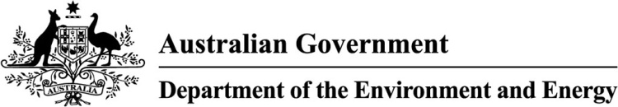

Compliance Policy

1. Introduction

The Department of the Environment and Energy

The Department designs and implements Australian Government policy and programs to protect and conserve the environment, water and heritage, promote climate action, and promote affordable and reliable energy. The Department uses a range of approaches to influence national outcomes including policy making, regulation, program delivery and scientific research. Compliance is an important element of our system of regulation, and helps to ensure our laws are achieving the outcomes they were designed to deliver.

Our regulatory context

Our [Regulatory Framework](http://www.environment.gov.au/system/files/resources/f992a66c-ff2f-4698-b816-c578f4511954/files/dept-environment-energy-regulatory-framework.pdf) outlines how we develop and administer national environment and energy laws, and the principles which underpin our approach to regulation.

We administer national laws that protect the environment and human health, and laws to regulate energy productivity, efficiency, security and supply. We use a range of activities to help you – the individuals and businesses operating in Australia – to understand and comply with these laws.

Under our Regulatory Framework, we work together with our stakeholders towards outcomes. We consider risks and respond accordingly. We look for better ways to do things. We are clear about expectations and processes, and we engage honestly, clearly and accurately.

More information about our Regulatory Framework can be obtained from our website at: [www.environment.gov.au/about-us/accountability-reporting/regulatory-framework](https://www.environment.gov.au/about-us/accountability-reporting/regulatory-framework)

A list of the legislation administered by the Department can be found on the Department’s website at:   
[www.environment.gov.au/about-us/legislation](http://www.environment.gov.au/about-us/legislation)

About this Policy

The Policy supports the Regulatory Framework by outlining our approach to compliance. The policy aims to help the community understand how we encourage compliance and respond to potential contraventions of our laws. It sits within the context of broader Australian Government law enforcement policies.

This policy should be read in conjunction with our [Compliance Plan for 2019-23](http://www.environment.gov.au/about-us/publications/compliance-plan-2019-23) which sets out the annual priority compliance outcomes for the Department.

In this policy, we describe the principles we follow when carrying out our compliance activities.

Our approach to compliance

In the Office of Compliance, we work with co-regulators and stakeholders to improve compliance with national environmental laws. We use a range of compliance tools with the aim of supporting regulatory outcomes. Our compliance activities are risk-based, and informed by intelligence.

We use the information we collect and analyse to prioritise our activities and allocate resources. We identify the potential for environmental harm and make a determination on the likelihood and consequences of that harm happening (see Figure 1 below). Our compliance activities may be informed by allegations, risk assessments, intelligence and monitoring programs. We aim to encourage compliance, promote leading practice, establish trust with the regulated community, and assist businesses and individuals to understand and comply with the law.

All alleged contraventions of our legislation or program requirements are assessed to determine the priorities for further action.

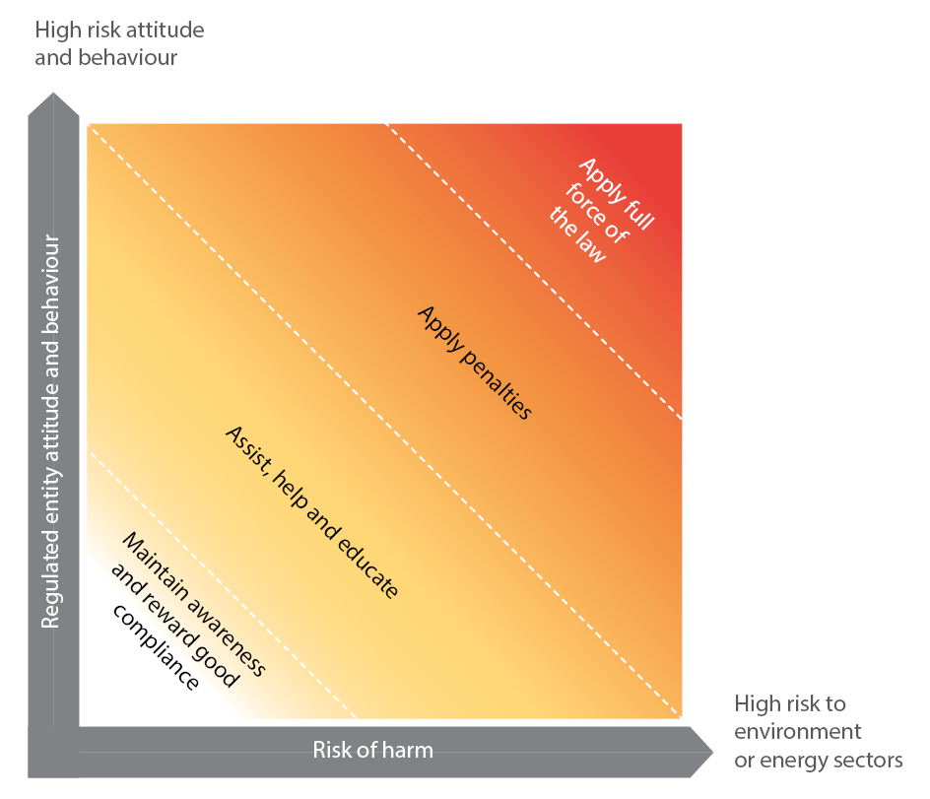

Figure 1: Our risk based approach to compliance

(Source: Department of Environment and Energy Regulatory Framework)

We use a broad range of compliance activities to deliver compliance outcomes. Some of our compliance activities are listed below.

Routine Monitoring

The Department routinely monitors compliance with administered legislation. Routine monitoring may include (but not necessarily be limited to) reviewing intelligence data, allegations made to the Department, and aerial or satellite imagery. We may also conduct field inspections and check compliance with any reporting requirements.

We also conduct compliance audits. Compliance audits help to ensure that projects with the potential to impact on matters of national environmental significance are implemented in accordance with approval conditions.

Preliminary enquiries

Where allegations or intelligence indicates potential non-compliance with environmental laws, the Department may make preliminary enquiries. Preliminary enquiries may include (but not necessarily be limited to) reviewing aerial or satellite imagery, field inspections, seeking expert advice, making enquiries with proponents and landholders, and making enquiries with co-regulators.

Investigation

Where the Department has reason to believe a breach of an environmental law may have occurred, the Department may conduct an investigation. This may include (but not necessarily be limited to) site inspections (including site inspections under a monitoring warrant, or search warrants), conducting interviews, seeking expert assessments and requesting information (including under statutory notices).

Enforcement action

At the conclusion of an investigation, if a breach of environmental legislation has been determined, it may be appropriate to issue an infringement notice or warning, commence civil or criminal proceedings, or take other enforcement action.

Engagement

Where patterns of potential non-compliance arise, the Department will engage with affected communities and industries to seek an understanding of potential drivers of non-compliance.

Where appropriate, the Department may implement policy or other practical solutions to enhance the effectiveness of national laws.

2. Our regulatory principles

The Department’s compliance activities are guided by regulatory principles set out in our Regulatory Framework. We undertake our compliance work in line with these principles, which means:

* Our regulatory responses will be consistent, efficient and proportionate to the risk
* Our decisions and actions will be informed by evidence
* Our decisions will be fair, reasonable, respectful and reliable
* We will be transparent, and accountable for our decisions and actions
* We will monitor, review and report on our effectiveness
* We will continue to improve the way we regulate
* We will engage to listen, learn and respond.

2a. Consistent, efficient and proportionate

Our approach to compliance activities will be consistent, efficient and proportionate to risk (see Figure 1). Any compliance action we take will consider your willingness to comply, your compliance history and the severity of the harm caused by non-compliance.

We know that having a range of compliance options creates an effective deterrent to non-compliance and provides a flexible regulatory system. The Department will consider the circumstances to determine the most appropriate response.

We recognise that the majority of people comply with environmental laws. We will work hard to give you the information you need to support this. Within appropriate limitations to protect private and sensitive data, we will work to ensure you have access to the same information we use in our decision making.

How we determine our response to non-compliance

We assess all alleged contraventions of our legislation or program requirements to determine the priorities for further action.

Our initial assessment may include a preliminary examination to decide:

* if there is an applicable offence
* the likelihood that the offence occurred
* any relevant history of non-compliance
* the likely consequences and seriousness of the non-compliance.

|  |
| --- |
| Serious non-compliance  Serious non-compliance is defined as any behaviour, action or omission that results in substantive harm (to the values protected by the legislation), an increased risk of substantive harm, or failure to prevent a substantive harm; and involves one or more of the following:   * Repeated actions of non-compliance * Wilful or knowing misconduct * Threatens the objectives of the regulatory system. |

We will determine the appropriate level of investigation and compliance response based on the outcome of the initial assessment.

We may:

* elect to not pursue the matter further (for example, where an allegation does not relate to a breach of a law)
* take action to increase awareness and encourage compliance (such as using educational materials and engaging relevant stakeholder groups)
* use a compliance response (such as seizing a prohibited item)
* proceed with further investigation.

We investigate to:

* determine whether or not the law has been breached
* improve compliance to ensure the objects of the legislation are being met
* deter further or similar non-compliance
* maintain public confidence in the integrity of the regulatory system
* gather additional evidence that would assist in taking appropriate compliance and enforcement actions.

When we choose to use an enforcement measure, we consider factors such as:

* the nature and severity of the harm caused
* the co-operation and intent of the alleged offender
* the threat to the objectives of the legislation we administer.

We may refer a matter to the Australian Federal Police or other enforcement agencies as required by Australian Government laws and guidelines. When this happens, we may support the investigating agencies if needed. We only share information as required or permitted by law.

2b. Informed by evidence

Being informed by evidence means that we analyse all available information to target our compliance activities and make informed, objective decisions.

We collect and use a wide range of information

We collect information and manage it to build an ever improving knowledge base on the state of Australia’s environment in relation to the things we regulate. We capture this information when we speak to stakeholders, attend meetings with industry groups, conduct site inspections, or receive referrals for development applications. Our partners and co-regulators[1] do the same and we collaborate with them where appropriate.

We receive valuable insight and information from the community, including local groups, non-government organisations and the media. If something seems unusual or you think a national environmental law may have been breached, we encourage you to contact us.

All information we handle is managed confidentially by compliance officers in accordance with the Australian Government’s privacy laws.

We also carry out targeted intelligence operations to collect new information. We have strict rules about when and how we can conduct these operations. We use the latest technology to assist us to collect intelligence information, such as time series remote sensing, including satellite imagery.

|  |
| --- |
| Case Study – Intelligence and Hazardous Waste Permits  We administer legislation that controls the import and export of hazardous waste (the Hazardous Waste (Regulation of Exports and Imports) Act 1989).  An intelligence review examined the international trends and projections in industries that generate hazardous waste. The intelligence highlighted trends in permit applications, and identified some irregularities.  The findings of the report helped us commence a review of permits, and improved our monitoring and stakeholder engagement with the industry. |

2c. Fair, reasonable, respectful and reliable

We will help you to be aware of and understand your obligations by providing you with the right tools and information so that you can comply with our laws.

We promote voluntary compliance

We know that most people comply with the law. We encourage people to comply with our laws by:

* providing the right tools and information to support compliance with the law
* promoting the goals and reasons for the law
* publishing compliance outcomes where it will provide an effective general deterrence to future non-compliance.

We check whether people and businesses are complying with our laws through a range of monitoring programs, such as inspections and audits.

We encourage you to engage with us if you want advice before you take an action, or if you suspect or are concerned you may have breached one of our laws.

|  |
| --- |
| Did you know …?  The GEMS Regulator, who administers the Greenhouse and Energy Minimum Standards Act 2012 (GEMS Act), has a YouTube channel.  The first products are a series of step-by-step videos designed to help entrants to the GEMS program navigate the GEMS registration system and meet the registration requirements. Each video focusses on a different aspect of the system and provides instructions on how to complete that section.  These videos are an interactive accompaniment to the existing Suppliers’/Registrants’ Guide. They are embedded into the Help section in the registration system.  [Click here to go to the YouTube channel (link is external)](https://www.youtube.com/channel/UCN5ipWSt8FaIiMYXBggkVBA). |

We take non-compliance seriously

We will take a proportionate regulatory response to identified non-compliance. We have a range of enforcement tools that may be applied. These include:

* administrative responses, including warnings, notices or cautions
* excluding individuals and companies from programs
* seizing goods
* suspending, varying or cancelling approvals, permits, licences or registrations
* applying for injunctions
* issuing remediation orders
* negotiating enforceable undertakings
* issuing fines
* applying to the court for criminal prosecution and/or civil penalties.

The Department complies with the [Australian Government Investigations Standards](https://www.ag.gov.au/CrimeAndCorruption/FraudControl/Documents/AGIS%202011.pdf), the [Prosecution Policy of Commonwealth](https://www.cdpp.gov.au/prosecution-process/prosecution-policy), and other policy documents as required.

2d. Transparent and accountable

We operate in accordance with Australian Government procedures and standards, and in accordance with the legislation we administer.

We undertake compliance activities in a manner that is procedurally fair and ethical. Where possible, we are open about what we do.

We invest in our people and processes

We train our staff to ensure they are experts in compliance. We aim to build and maintain a competent, experienced and technically skilled workforce, and look for creative and innovative ways to support you to comply with our laws.

Responding to requests for information

We answer requests for information when we can, subject to our confidentiality obligations, and the laws about information security and privacy.

Our Public Affairs team is available to respond to media enquiries. The media can greatly assist us by informing the regulated community of its obligations under our laws. This includes communicating the consequences of not complying with our laws. Our Service Charter, available on our website, guides our responses:

[www.environment.gov.au/about-us/publications/service-charter](https://www.environment.gov.au/about-us/publications/service-charter)

We do not release information to the public about compliance and enforcement activities, such as current investigations, unless it is absolutely necessary or required by the investigative process. We do not release any information that might:

* prejudice a person’s right to a fair hearing or legal process
* impinge upon the privacy or safety of others involved in the investigation (such as complainants, witnesses and suspects)
* prejudice any of our past or future activities.

Even once complete, the details of investigation activities normally remain confidential.

We may publish outcomes from court decisions and enforcement actions as permitted by legislation. Some of our compliance outcomes can be found on our websites:

[www.environment.gov.au/](https://www.environment.gov.au/)

[www.energyrating.gov.au/](http://www.energyrating.gov.au/)

Freedom of information

The Freedom of Information Act 1982 (the FOI Act) provides a legislative framework to request information from us. Before you make an FOI request, you can ask us for the information you want. If we are able to release this information, this is often faster and easier than making a formal FOI request. You can find more about this on our website:

[www.environment.gov.au/about-us/freedom-information](https://www.environment.gov.au/about-us/freedom-information)

We consider each FOI request on a case-by-case basis. We decide to release or refuse to release information in accordance with the provisions of the FOI Act.

2e. We will monitor, review and report on our effectiveness

We aim to continually improve the effectiveness of our compliance activities. To do this, we monitor, review and report on our activities.

We use the information and intelligence available to the Department to determine our compliance priorities. We then monitor our activities and outcomes against our priorities, and review our outcomes to inform an assessment of our effectiveness.

Reporting on our performance

We evaluate and report on our performance. Our outcomes are reported in the Department’s annual corporate reports and budget statements. These are published on our website at:

[www.environment.gov.au/about-us/publications](https://www.environment.gov.au/about-us/publications)

2f. We will continue to improve the way we regulate

We work towards national outcomes for Australia’s environment, society and economy. We work together with other regulators at all levels of government, and internationally, to maximise our impact and efficiency, and where possible avoid duplication.

We collaborate

Sometimes our regulations intersect with other Commonwealth and state regulations. Where multiple jurisdictions are involved, we work with co-regulators to ensure an appropriate approach is taken. We:

* build strategic partnerships to support our compliance outcomes.
* may share information and analysis with other agencies, where required or permitted by law.

We are active participants in environmental law enforcement networks. Through these networks we maintain awareness of, and contribute to, the development of leading practices in compliance and regulation.

2g. We will engage, listen and learn

We engage broadly to build understanding of the purpose and intended outcome of regulation, and to ensure our approach to regulating is effective and efficient in achieving those outcomes. We will listen to you to improve our understanding of your business needs.

We listen and learn

We welcome your feedback so we can improve our processes. We use what we learn from you to regularly review our policies and procedures.

|  |
| --- |
| Case Study: Regulating Impacts from Changing Land Use  Regulating land-use change that affects Australia’s native vegetation is primarily managed by state and local governments. However, there are plants, animals and ecosystems that are protected under national environmental law.  In 2017, native vegetation management laws in New South Wales were changed and this increased the risk of NSW land owners inadvertently breaking Commonwealth laws, even if they were complying with state laws.  That is why we partnered with NSW Local Land Services and agriculture industry representatives to run an information campaign to make sure landowners have access to clear information about their obligations under national environmental laws. Through our engagement we identified the need for more regional-specific guidance in some areas to give land owners the confidence to determine if and when Commonwealth laws may apply to their proposed activities. This guidance will be published on our website. |

3. Our response to non-compliance

Our response to non-compliance

When we detect non-compliance, we take action. Our response is proportionate to risk, and is determined on a case-by-case basis. When we take enforcement action, we consider factors such as the nature and severity of the harm caused, the compliance history and cooperation of the offender, public concern and the deterrence value of the enforcement measure.

We use a range of enforcement actions. Although we work hard to give you the information you need to comply with the laws we administer, if this approach fails, we may apply significant administrative, civil and/or criminal sanctions.

What you can expect from us

When enforcing compliance, our staff will:

* help you understand your obligations under national environment and energy laws
* act in a manner that is procedurally fair and ethical
* collect, store and use a wide range of information to inform compliance decisions
* ensure our decision-making is consistent and proportionate to risk.

We will work with other regulators, where appropriate, and we welcome your feedback.

What we expect from you

When we seek to resolve a potential breach of our laws, we engage with you in good faith and ask the same in return.

We work to help you understand our laws; however, the final responsibility for complying with Australian laws rests with the individual or organisation affected.

We understand that dealing with a compliance matter may create uncertainty for you. If you need further information, we recommend that you obtain independent, professional advice relevant to your circumstances.

|  |
| --- |
| Case Study: Fuel Quality Monitoring for public health and better environment  We work with industry to ensure the quality of Australian petrol and diesel (and other fuels such as autogas) meets the standards set under the Fuel Quality Standards Act 2000. We need to make sure all our fuel complies with the fuel standards which are designed to protect our health and the environment by ensuring healthy air quality. This also means that Australians can have more fuel efficient vehicles and the latest engine technology.  Australian fuel labelling requirements ensure that consumers can be confident in the petrol they buy. For example, there are environmental and other benefits in blending ethanol in petrol, but it is not suitable for all engines. Similarly, proper record keeping ensures that information on fuel quality is available for inspectors and others at the point of sale.  Our inspectors identified widespread non-compliance in how fuel is labelled and the records that fuel companies keep. The solution was to develop clear and simple fact sheets to assist petrol station operators and other fuel suppliers to meet their legislative requirements, and ensure that customers can be confident in the quality of Australian petrol and diesel. We conduct random and targeted inspections at petrol stations across Australia to monitor improvements in labelling and record-keeping.    Click here for more information on the [fuel compliance program](http://www.environment.gov.au/topics/environment-protection/fuel-quality/compliance-act), and [here](http://www.environment.gov.au/resource/are-you-selling-ethanol-blends-dont-keep-it-secret) and [here](http://www.environment.gov.au/resource/documentation-requirements-fuel-deliveries) for the industry fact sheets. |

4. Contacts

How to contact us

We can be contacted through our Community Information Unit on 1800 803 772. You can report an incident to our compliance teams or provide feedback. If you want to report a suspected breach of our laws, you can also email [compliance@environment.gov.au](mailto:compliance@environment.gov.au).   
The information you provide is held in strict confidence.

You can also contact us and access many of our regulatory services at:

[onlineservices.environment.gov.au/](https://onlineservices.environment.gov.au/)

More information about the legislation we administer, and information about the compliance with these Acts can be obtained from our website at:

[www.environment.gov.au/about-us/legislation](https://www.environment.gov.au/about-us/legislation) and [www.environment.gov.au/about-us/compliance](http://www.environment.gov.au/about-us/compliance)

If you would like to stay informed, you can subscribe to our news feeds at:

[www.environment.gov.au/about-us/media-centre/news-feeds](https://www.environment.gov.au/about-us/media-centre/news-feeds)

© Commonwealth of Australia, 2019.

*Compliance Policy* is licensed by the Commonwealth of Australia for use under a Creative Commons Attribution 4.0 International licence with the exception of the Coat of Arms of the Commonwealth of Australia, the logo of the agency responsible for publishing the report, content supplied by third parties, and any images depicting people. For licence conditions see: <http://creativecommons.org/licenses/by/4.0/>

This report should be attributed as ‘*Compliance Policy*, Commonwealth of Australia 2019’.

The Commonwealth of Australia has made all reasonable efforts to identify content supplied by third parties using the following format ‘© Copyright, [name of third party] ’.

**Disclaimer**

The views and opinions expressed in this publication are those of the authors and do not necessarily reflect those of the Australian Government or the Minister for the Environment and Energy.

**Cover images**

(Front) Carnaby’s Black Cockatoo (*C. latirostris*) © Copyright Department of the Environment and Energy.

(Back) Pip and Selwyn Job’s property ‘Peedamulla’ near Yeoval; NSW; is part of the Environmental Stewardship program to protect box gum grassy woodland. © Copyright Department of the Environment and Energy.

1. Our partners and co-regulators include other Commonwealth agencies, state, territory and local governments, international and other organisations. They operate as partners or as parallel regulators.