# Compliance statement for the export of livestock

December 2021



© Commonwealth of Australia 2021

**Ownership of intellectual property rights**

Unless otherwise noted, copyright (and any other intellectual property rights) in this publication is owned by the Commonwealth of Australia (referred to as the Commonwealth).

**Creative Commons licence**

All material in this publication is licensed under a [Creative Commons Attribution 4.0 International Licence](https://creativecommons.org/licenses/by/4.0/legalcode) except content supplied by third parties, logos and the Commonwealth Coat of Arms.

Inquiries about the licence and any use of this document should be emailed to [copyright@awe.gov.au](mailto:copyright@awe.gov.au).



**Cataloguing data**

This publication (and any material sourced from it) should be attributed as: DAWE 2021, *Compliance statement for the export of livestock*, Department of Agriculture, Water and the Environment, Canberra, December. CC BY 4.0.

ISBN 978-1-76003-490-0

This publication is available at [awe.gov.au/publications](https://www.awe.gov.au/publications).

Department of Agriculture, Water and the Environment

GPO Box 858 Canberra ACT 2601

Telephone 1800 900 090

Web [awe.gov.au](https://www.awe.gov.au/)

**Disclaimer**

The Australian Government acting through the Department of Agriculture, Water and the Environment has exercised due care and skill in preparing and compiling the information and data in this publication. Notwithstanding, the Department of Agriculture, Water and the Environment, its employees and advisers disclaim all liability, including liability for negligence and for any loss, damage, injury, expense or cost incurred by any person as a result of accessing, using or relying on any of the information or data in this publication to the maximum extent permitted by law.

**Acknowledgement of Country**

We acknowledge the Traditional Custodians of Australia and their continuing connection to land and sea, waters, environment and community. We pay our respects to the Traditional Custodians of the lands we live and work on, their culture, and their Elders past and present.

## Foreword

The Department of Agriculture, Water and the Environment regulates the export of live animals under the *Export Control Act 2020* and associated rules and standards. This includes the Australian Standards for the Export of Livestock (ASEL) and the Exporter Supply Chain Assurance System (ESCAS).

The Compliance statement for the export of livestockoutlines our regulatory approach in ensuring compliance with Commonwealth legislation, animal welfare standards and importing country requirements for the export of livestock.

The Australian Government requires that we exercise the necessary powers, regulatory capabilities and investigative capacity to ensure that animal welfare standards are met and export markets remain open.

We work to ensure that participants of the trade understand and comply with their regulatory obligations and that appropriate and proportionate action can be taken when non-compliance is suspected or detected. This work helps ensure the ongoing integrity of the livestock export regulatory system.

Previous reviews into livestock exports have recommended changes to improve the health and welfare of exported livestock. These include revised export conditions and animal welfare standards, and a more transparent and consistent regulatory approach.

Mr Philip Moss AM was commissioned to review our regulatory approach and its capabilities, powers, practices and culture in relation to livestock exports. The report was released on 31 October 2018.

We remain committed to ensuring animal health and welfare standards are appropriately managed through the regulation of the livestock export industry. We encourage voluntary compliance within the livestock export industry and this is addressed as part of this document.

Through this regulatory approach, we aim to be a modern, trusted and mature regulator that fosters a strong compliance culture within the livestock export industry.

Department of Agriculture, Water and the Environment

Contents

Foreword iii

Introduction 1

1 Livestock export regulatory framework 2

2 Objectives and guiding principles 4

3 Industry responsibilities 5

4 Compliance statement 6

5 Compliance education 7

6 Compliance monitoring 8

6.1 Inspection and audit 8

6.2 Independent observers 9

7 Compliance performance 10

8 Responding to non-compliance 11

8.1 Graduated response 11

8.2 Enforcement options 12

9 Communicating non-compliance 14

9.1 Informing industry and community 14

9.2 Contact details 14

Document control 15

**Figures**

Figure 1: Regulatory framework summary 3

Figure 2: Our proportionate compliance response model 6

## Introduction

The Department of Agriculture, Water and the Environment is responsible for regulating the export of livestock from Australia, under a framework that includes Australian Government livestock export legislation, animal welfare standards, control and traceability requirements, and importing country requirements.

Previous reviews into the export of livestock have recommended changes to improve the health and welfare of exported livestock. These include revised export conditions, revised animal welfare standards and a more transparent and consistent regulatory approach.

According to the [Moss review 2018](https://www.awe.gov.au/agriculture-land/animal/welfare/export-trade/independent-review-of-regulation), ‘the department as a regulator needs to respond appropriately to non-compliance. The industry overall needs to comply with the required standards and support the regulator to ensure long-term sustainability of the industry’.

We are legally empowered to impose a range of compliance measures on regulated entities that do not comply with [Australian Government livestock export legislation](https://www.awe.gov.au/biosecurity-trade/export/controlled-goods/live-animals/livestock/regulatory-framework/acts-regulations-orders-standards), animal welfare standards and importing country requirements. Measures include sanctions and, where deliberate breaches of livestock export legislation occur, referral to the Commonwealth Director of Public Prosecutions for consideration of criminal prosecution. This may result in fines or imprisonment.

Under Australian Government livestock export legislation, we regulate:

* licensed livestock exporters
* operators of registered establishments
* Accredited Veterinarians.

## Livestock export regulatory framework

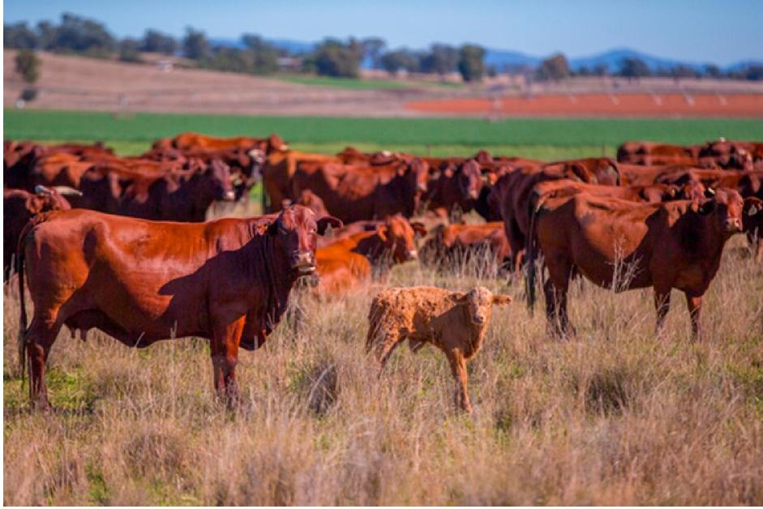

We regulate the export of livestock under the *Export Control Act 2020* and associated rules and standards. Livestock is defined as cattle, calves, buffalo, sheep, lamb, goats, camelids and deer.

The Australian Standards for the Export of Livestock (ASEL) provides the conditions for the export of livestock. It details standards for:

* sourcing and preparation of livestock for export by sea
* land transport of livestock
* management of livestock in registered establishments
* vessel preparation and general management for export by sea
* loading and onboard management
* air transport of livestock.

ASEL requires compliance with Australian Government livestock export legislation, state and territory legislation (including animal welfare legislation) and animal codes of practice.

The Exporter Supply Chain Assurance System (ESCAS) operates under the Export Control (Animals) Rules 2021. ESCAS is an assurance system based on 4 key principles:

1. Animal welfare– animal handling and slaughter in the importing country conforms to World Organisation for Animal Health (OIE) animal welfare recommendations.
2. Control through the supply chain – the exporter has control of all supply chain arrangements for livestock transport, management and slaughter. All livestock remain in the supply chain.
3. Traceability through the supply chain – the exporter can trace all livestock through the supply chain.
4. Independent audit– the supply chain in the importing country is independently audited.

Figure 1: Regulatory framework summary

Figure detailing a summary of the regulatory framework for the export of livestock.

The Department of Agriculture, Water and the Environment regulates the trade of live animals and reproductive material in accordance with the regulatory framework comprised of legislation, standards and policies.

The key piece of legislation is the Export Control Act 2020. The two subordinate pieces of legislation are the Export Control (Animals) Rules 2021 and the Export Control (Fees and Payments) Rules 2021.

The legislation, standards and policies set out arrangements for live animal exports, including for approved arrangements, government certificates, registered establishments, accredited veterinarians, audits, the Exporter Supply Chain Assurance System (ESCAS) and the Australian Standards for the Export of Livestock (ASEL).

## Objectives and guiding principles

One of our key objectives is to strengthen our regulatory approach for the export of livestock and encourage compliance within the livestock export industry to ensure:

* support for the long-term sustainability of the livestock export industry
* animal welfare is at the centre of export activities
* exporters adhere to OIE animal welfare standards
* importing country requirements are met.

We are committed to strengthening our livestock export regulatory framework and implementing changes to our compliance approach in order to ensure improvement. We will achieve this by:

* Encouraging voluntary compliance within the livestock export industry – we will help regulated entities understand their obligations.
* Demonstrating governance and transparency – our decisions will be underpinned by clear governance processes that are regularly reviewed, transparent, robust and defensible.
* Undertaking proportionate measures – our compliance measures will be proportionate to the conduct and the resulting harm or potential harm to
  + animal welfare
  + trading relationships
  + Australia’s reputation as a reliable trading partner.
* Being fair – including balancing voluntary compliance with enforcement measures.
* Undertaking investigations in a timely manner – our investigations and the resolution of compliance and enforcement measures are undertaken efficiently.
* Maintaining confidentiality – we conduct investigations on the principle of balancing confidentiality and the need for transparency. We do not comment on matters that are subject to a current investigation. However, we may disclose the outcomes of compliance investigations and the compliance measures undertaken where deemed important to public confidence in the trade or to promote wider compliance in the industry. We will publish independent observer summary reports, reportable mortalities and ESCAS breach investigation reports when these investigations are complete.

Under the Australian Government’s Regulator Performance Framework, Commonwealth entities with a regulatory function must undertake an annual self-assessment of their regulatory performance.

## Industry responsibilities

In order to export livestock, a range of legislative requirements have to be met. These include managing, monitoring and reporting on the sourcing, preparation, handling, loading and transport of livestock for export.

Members of the livestock export industry are responsible for adhering to the appropriate standards of animal health and welfare, control and traceability requirements under ESCAS and importing country requirements. Understanding legal obligations and proactively seeking to comply with Australian Government livestock export legislation will help ensure the long-term sustainability of the industry.

We regulate:

* licensed livestock exporters
  + approved arrangements form part of our compliance program
  + ESCAS forms part of our compliance program
* operators of registered establishments
* Accredited Veterinarians (AAVs).

For more information see:

* [Exporter requirements](https://www.awe.gov.au/biosecurity-trade/export/controlled-goods/live-animals/livestock/information-exporters-industry/exporting-livestock)
* [Registered establishments](https://www.awe.gov.au/biosecurity-trade/export/controlled-goods/live-animals/livestock/information-exporters-industry/registered-establishments)
* [Veterinary work required to be undertaken by an AAV](https://www.awe.gov.au/biosecurity-trade/export/controlled-goods/live-animals/livestock/information-exporters-industry/vet)
* [Approved arrangements](https://www.awe.gov.au/biosecurity-trade/export/controlled-goods/live-animals/livestock/information-exporters-industry/approved-arrangements).

## Compliance statement

The purpose of this statement is to:

* help regulated entities understand their obligations
* help regulated entities meet their regulatory obligations
* support regulated entities who comply with requirements
* provide clarity on the actions we take to address non-compliance.

Our approach will focus on encouraging and promoting voluntary compliance. We will respond to non-compliance in a way that is proportionate to the behaviours of those involved and the compliance risk.

Our compliance posture is dependent on client behaviours.

Figure : Our proportionate compliance response model

**Graph illustrating our proportionate compliance response model.

The x-axis represents the risk of harm, increasing from low to high.

The y-axis represents the risk presented by attitude and behaviour increasing from low to high.

For lower risk non-compliance, we maintain awareness of requirements. 

As the risk of harm and the risk presented by attitude and behaviour increases, we respond to non-compliance by providing education and advice. 

Where the risk of harm and the risk presented by attitude and behaviour is higher, we apply penalties and revoke permissions for non-compliance. 

Where the risk of harm and the risk presented by attitude and behaviour is at its highest we apply the full force of the law for non-compliance.

Good compliance is recognised in public recognition, providing permissions and reducing intervention.**

**High risk**

## Compliance education

We are committed to educating regulated entities on their compliance obligations and supporting them in their efforts to comply. To help regulated entities achieve voluntary compliance, we:

* provide export advisory notices that outline changes to legislative, policy and operational requirements
* provide easy-to-understand technical guidelines that explain requirements and legislation
* address queries and concerns via email, phone, teleconference, video conference and face-to-face
* encourage involvement in industry teleconferences and meetings
* maintain and update importing country requirements on the [Manual of Importing Country Requirements](https://micor.agriculture.gov.au/Pages/default.aspx) (MICoR)
* provide approval documents that outline the requirements and conditions for exporters in relation to export licences, registered establishments, AAVs and approved arrangements
* give targeted feedback from consignment inspections and audits
* provide targeted feedback through the independent observer program
* consult industry on changes to reporting standards and settings.

## Compliance monitoring

Compliance monitoring is an essential part of regulating livestock exports. It enables us to determine the level of compliance within the industry.

As soon as they become aware of issues or non-compliance, regulated entities must contact us and outline corrective actions. Some non-compliance incidents have a regulated time frame for reporting. For example, entities must report ESCAS incidents within 5 days and ASEL notifiable incidents such as mortality events greater than the specified rate within 12 hours.

If required, we work with the regulated entity to determine an appropriate course of action. We consider legislative requirements, animal welfare standards, control and traceability under ESCAS, and importing country requirements.

We also consider compliance information from sources, including:

* Regional Veterinary Officer livestock export consignment reports prepared prior to export
* independent audit reports (ESCAS)
* our audits of the regulated entity
* reports from third parties such as other regulated entities, industry bodies, animal welfare organisations and the media
* reports from importing countries.

We expect direct and timely notification of any potential non-compliances by non-regulated entities operating within or with an interest in the livestock export supply chain.

### Inspection and audit

We undertake assurance activities to effectively determine compliance levels within the livestock export industry.

Our assurance activities include:

* physical inspection of livestock to ensure health, welfare and importing country requirements are observed (may include a sample of animals or all the animals in the consignment)
* physical on-site, virtual or desktop audits of an exporter’s approved arrangement to ensure suitable controls are in place, the approved arrangement is effective and all requirements are complied with
* audits of registered establishments for the purposes of registration and renewal of registration
* audits of Accredited Veterinarians (AAVs)
* audits of the licensed exporter’s ESCAS arrangements
* reviews of core export documents or all export documents, depending on the licensed exporter’s performance
* risk-based, targeted audits of consignments, AAVs, approved arrangements, registered establishments and ESCAS in response to identified issues or other incidents as appropriate
* increased frequency and complexity of audits in response to non-compliance or where a risk of non-compliance has been detected.

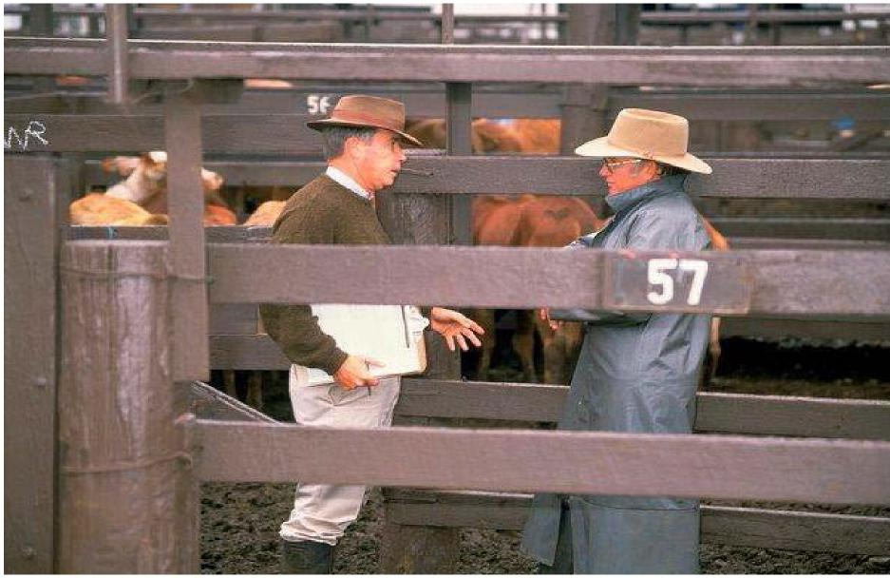

### Independent observers

There is an independent observer program for livestock exports by sea. The role of the independent observer is to monitor and review livestock management practices during export voyages to ensure animal welfare standards are being met. The independent observer provides regular reporting to assess compliance against ASEL and the exporter’s or secretary’s approved export programs.

The primary purpose of the program is to provide assurance that the welfare of animals being transported on ships is being appropriately and humanely managed in accordance with the relevant standards and requirements. We recognise the high level of interest in conditions onboard livestock vessels. We publish [summaries of independent observer reports](https://www.awe.gov.au/biosecurity-trade/export/controlled-goods/live-animals/livestock/regulatory-framework/compliance-investigations/independent-observations-livestock-export-sea) to provide transparency about the industry to interested parties such as the livestock export industry, interest groups and the public.

## Compliance performance

When we determine compliance measures for regulated entities, we consider the performance of the individual entity. This includes adherence to legislative requirements and importing country requirements.

Indicators that can affect an entity’s compliance performance include:

* importing country rejections
* reportable mortality incidents
* mortality rates
* previous responses to identified non-compliance.

Some regulated entities inadvertently fail to meet their obligations. In such cases, we may increase compliance monitoring measures until the entity demonstrates acceptable compliance performance.

## Responding to non-compliance

Non-compliance is defined as exporters, operators of registered establishments and AAVs not conforming or adhering to the requirements of Australian Government livestock export legislation, animal welfare standards, control and traceability requirements under ESCAS or importing country requirements.

Enforcement action is defined as the actions we take when the relevant legislation, rules, standards and requirements are not followed. These actions are intended to ensure a return to compliance with the law.

If we detect non-compliance, we will take enforcement action. We will use a graduated response that appropriately responds to the nature and gravity of the non-compliant behaviour.

### Graduated response

Where appropriate, we will adopt a graduated approach to non-compliance (Figure 2). This involves the initial use of informal, non-legislative options such as requesting further information from the regulated entity and providing technical information via guidelines. If these measures do not achieve compliance, we may pursue more significant enforcement options.

Decisions about a graduated response will be balanced against the severity of the alleged non­compliance. A graduated response may not be appropriate in circumstances where non­compliance is considered serious, the risk to animal welfare is high, when importing country requirements have not been met or if an importing country rejection has occurred.

In these circumstances, we may take immediate action against those who are responsible for the non-compliance.

When determining the level of response required under the proportionate response approach, we consider:

* the nature of the non-compliance such as animal welfare issue, market access issue, administrative issue
* the nature or level of the harm caused by the non-compliance, to livestock and trade
* degree of co-operation and proactivity of the regulated entity in undertaking measures to become compliant
* whether or not the contravention was intentional, reckless, negligent or a mistake
* history of previous non-compliance and level of non-compliance or fraud
* the level of previous compliance sanctions applied and the effectiveness of that response to ensure that the entity complies with the law
* suitability, level, degree and timeliness of corrective action initiated and implemented in response to a suspected or confirmed non-compliance
* likelihood that the problem will reoccur
* aggravating or mitigating circumstances such as the degree of control over the incident leading to non-compliance
* standard of evidence collected
* need to deter entity from committing further offences.

### Enforcement options

Australian Government livestock export legislation provides for several enforcement options.

#### Administrative measures

We use administrative measures to respond in a manner that is flexible, proportionate and appropriate for the non-compliance. Administrative measures often enable earlier resolution of non-compliance. Administrative measures often achieve sound and timely outcomes.

We may use administrative measures for non-compliance following completion of an investigation. In some circumstances, we use these measures during an investigation.

Standard administrative measures include:

* seeking additional information about a livestock export consignment
* issuing directions with additional conditions to be complied with for specific livestock export consignments and the market (supply chain)
* issuing a show cause notice
* refusing to approve a notice of intent to export
* refusing to grant an export permit or revoking an existing export permit.

We can also apply additional administrative measures in the following areas:

* licensing
* approved arrangements
* registered establishments
* ESCAS.

##### Licensing

Additional administrative measures for licensing non-compliance include:

* applying conditions to an exporter’s licence
* reprimanding the licence holder
* suspending an export licence for a period specified in the show cause notice
* cancelling an export licence.

##### Approved arrangements

Additional administrative measures for non-compliance by approved arrangements (AA) include:

* auditing the licensed exporter to validate governance, operations and quality assurance systems, processes and procedures that match those stipulated in the AA
* applying corrective action to part of an AA
* suspending or revoking part of an AA (for example, a Standard Export Plan)
* reducing intervention when exporters demonstrate they are capable of operating under the AA process.

##### Registered establishment

Additional administrative measures for non-compliance by registered establishments include:

* requiring changes to race or pen design to improve handling of animals.

**ESCAS**

ESCAS breaches are classified in our [Biosecurity guideline for management of non-compliance](https://www.awe.gov.au/sites/default/files/sitecollectiondocuments/biosecurity/export/live-animals/livestock/escas/guideline-for-management-of-non-compliance-all-markets.pdf).

Additional administrative measures for non-compliance with ESCAS include:

* requiring exporters to work with supply chain partners to address non-compliance
* requiring exporters to train workers and directly supervise ESCAS facilities
* ceasing supply or removing livestock from affected facilities
* varying or revoking ESCAS approval
* refusing approval of ESCAS supply-chain facilities.

#### Civil and criminal measures

Legislation governing the export of livestock provides a range of civil and criminal penalty provisions for certain non-compliant activities. Civil penalties do not result in imprisonment or criminal conviction. However, fines issued by the court may be sizeable.

Criminal prosecutions are the most severe compliance measure available to us. We generally resort to prosecution where a regulated entity has deliberately taken an action they know to be in breach of Australian Government livestock export legislation. A person found guilty of committing a criminal offence may receive a criminal record, a fine and/or imprisonment.

For more information on our approach to non-compliance see:

* [Management of non-compliance](https://www.awe.gov.au/biosecurity-trade/export/controlled-goods/live-animals/livestock/regulatory-framework/compliance-investigations/non-compliance)
* [Investigations](https://www.awe.gov.au/biosecurity-trade/export/controlled-goods/live-animals/livestock/regulatory-framework/compliance-investigations/investigations-mortalities)
* [Performance management compliance guidelines](https://www.awe.gov.au/biosecurity-trade/export/controlled-goods/live-animals/livestock/information-exporters-industry/approved-arrangements).

## Communicating non-compliance

### Informing industry and community

We publish information about our approach to regulating the export of livestock. This information includes:

* regulatory compliance investigations
* findings collected by independent observers
* ESCAS quarterly regulatory performance reports and mortality investigations.

Learn more about [compliance and investigations](https://www.awe.gov.au/biosecurity-trade/export/controlled-goods/live-animals/livestock/regulatory-framework/compliance-investigations/non-compliance).

### Contact details

Phone the Live Animal Exports Hotline 1800 808 869

Email [LAE.Compliance@agriculture.gov.au](mailto:LAE.Compliance@agriculture.gov.au) or write to us:

Director of LAE Regulatory Performance

Plant and Live Animal Export Division

Department of Agriculture, Water and the Environment

GPO Box 858

Canberra ACT 2601

## Document control

The *­Compliance statement for the export of livestock* is maintained by the Live Animal Exports Branch.

|  |  |  |  |
| --- | --- | --- | --- |
| **Version** | **Date of issue** | **Author** | **Reason for change** |
| 1.0 | November 2019 | Live Animal Exports Branch | Original document |
| 2.0 | December 2021 | Live Animal Exports Branch | Updated to reflect changes to the *Export Control Act 2020*, the Australian Standards for the Export of Livestock (ASEL) and related legislation. |