October 2024

Dairy, Eggs and Fish Exports

# ComplyAI external user guide

The Dairy, Eggs and Fish Exports Program from the Department of Agriculture, Fisheries and Forestry (the department) is trialling a new approach for the way low-risk dairy, eggs and fish export establishments are regulated.

ComplyAI is a new portal where establishments will upload information to the department to meet compliance regulation. Uploaded information will include business and operational details, a declaration of conformity, photos and videos for Artificial Intelligence (AI) verification, and other information as requested.

This document provides a quick reference guide for external users to navigate and use the ComplyAI portal.

## User login

When your establishment is first required to provide information to the department through ComplyAI, email addresses that you have previously nominated for the department will receive a notification of your access and include a link to the portal ([you can also access ComplyAI through this link](https://dairyeggsfish.complyai.unearth.ai/))

The first time you login you will be required to set up Windows authentication to ensure ongoing verification of your identity and login security (see Attachment A for further details).

Username and password screen:

Account sign in and password screens

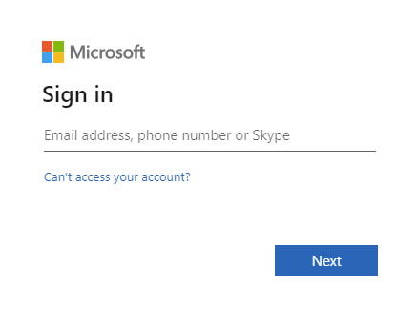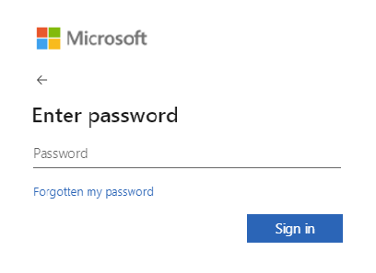

If the user has previously signed in, select the correct account to login via single sign on:

A screenshot showing the account selection on a computer screen
Account selection

# Locating your login and password

When your account was first created, an email was sent to you from [DoNotReply@unearth.ai](mailto:DoNotReply@unearth.ai) requesting you to create a login for the Comply AI portal in preparation for receiving your request for information.

If you are unable to locate the email, please contact us at [dairyexportreform@aff.gov.au](mailto:dairyexportreform@aff.gov.au) and we will arrange for a new password to be sent to you.

## Logging into the portal

If you are having issues logging into the Portal, a common resolution can be to log in via a new InPrivate window using Microsoft Edge or a new Incognito window using Chrome.

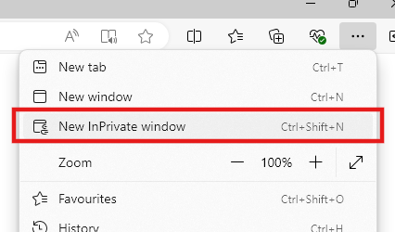Microsoft Edge browser highlighting where to select InPrivate window in settings and more tab

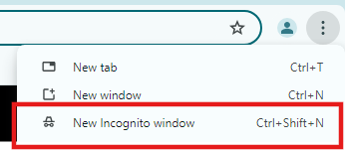Chrome browser highlighting where to select Incognito window in settings and more tab

Remember to save your username and password in a secure location, as they will be required each time you log in to the portal.

The first time you login you will be required to set up Windows authentication to ensure ongoing verification of your identity and login security. Instructions on Windows authentication can be found in the ComplyAI external user guide or at [Microsoft Support – Set up an authenticator app as a two-step verification method.](https://support.microsoft.com/en-au/account-billing/set-up-an-authenticator-app-as-a-two-step-verification-method-2db39828-15e1-4614-b825-6e2b524e7c95)

## Multiple establishments

If you are the contact for multiple establishments and you would prefer to have access to them through a single login, please let us know the establishments you are responsible for. We will then update your account and advise you of your new login details.

Further, if you have an existing personal Office365 account and would like to have this as another option to log into the Portal for your establishment(s), please let us know your email address and we will set up access for you to login.

## Home page navigation

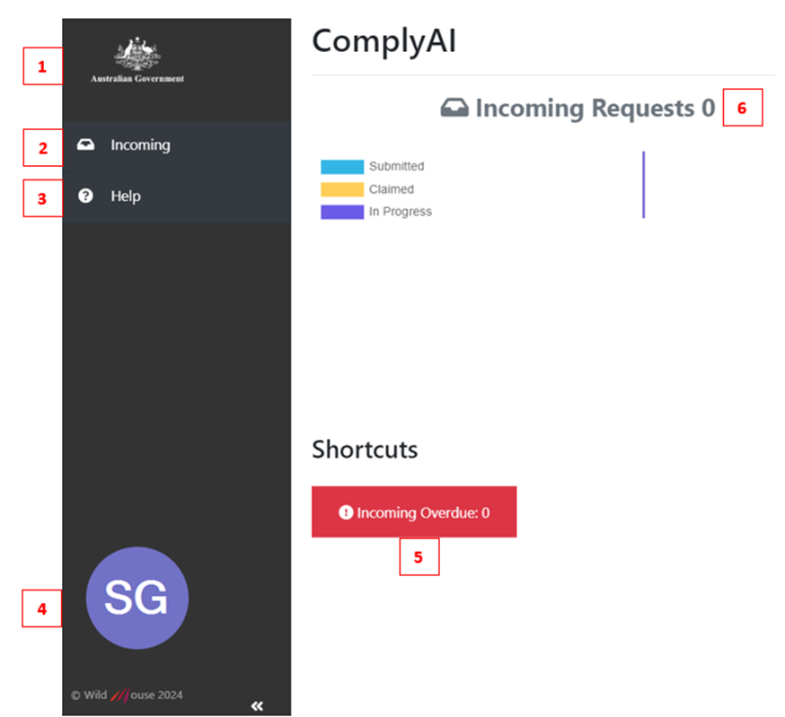ComplyAI home screen

1. Shortcut to homepage from any page.
2. Navigate to a list of incoming requests for information from the department. On this page, requests can be accessed to fill out and submit.
3. View a flowchart and descriptions of each stage of the information request process.
4. View your personal user information or sign out from the system.
5. Shortcut to all overdue requests for information (navigates to 2 ‘Incoming’).
6. A summary of all requests and status of each.

## Receiving and assessing an information request

When a new information request has been sent to you by the department, you will receive notification via email advising that annual requirements are ready to be submitted, with a link to fact sheets, user guides, and the information request in ComplyAI.

You can also navigate to the request on the ‘Incoming’ page in ComplyAI.

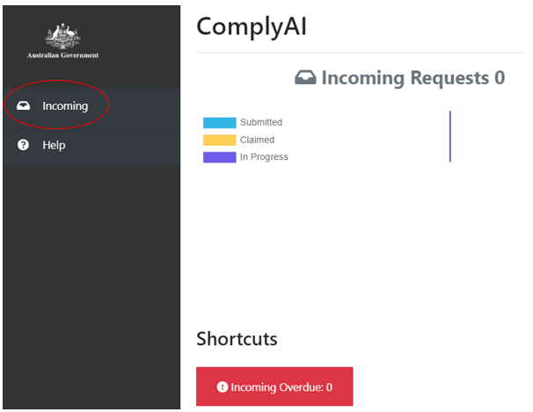Comply AI home screen, highlighting incoming tab

A list of current and historical information requests from the department are displayed on the ‘Incoming’ page. The list can be filtered via column headers. To access a new request form and provide information to the department, please click on the blue ‘Submit response’ icon.

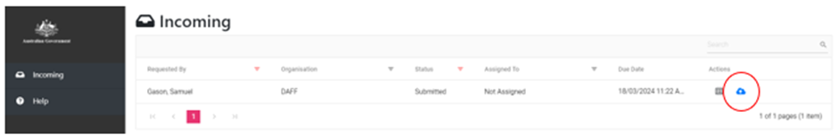Incoming request page

## Filling out and submitting an information request

After clicking on the “Submit response” icon, you should now be at the ‘Upload Documents’ page. Please provide requested information as detailed on the form, which may include:

* Business and operational details (establishment questionnaire)
* Declaration of conformity
* Photos and videos for Artificial Intelligence (AI) verification
* Other information as requested.

All mandatory information is denoted with a red asterisk (*)

A comments field is available at the bottom of the page. If you have any questions regarding the information request process, please ask as a comment and a member of the Dairy, Eggs and Fish Program will respond.

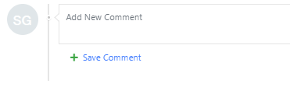Example of comment field

You can save your answers at any time to come back and finalise later. Once all information has been entered, please submit.

The department will then assess your information provided and you will be notified of the outcome through ComplyAI.

Depending on your responses for certain questions, there may be some instances where follow-up investigation or action is required (e.g. if you have made certain changes to your contact details or registration details). In these circumstances, the Dairy, Eggs and Fish Export Program will be in touch to advise of next steps.

If the department advises that no further information is required and your establishment has been assessed as compliant, your annual information requirements are now complete.

## More information

Learn more about [exporting dairy products from Australia](https://www.agriculture.gov.au/biosecurity-trade/export/controlled-goods/dairy).

Web [Low-risk audit trials - DAFF (agriculture.gov.au)](https://www.agriculture.gov.au/biosecurity-trade/export/controlled-goods/fish/seafood-video-resources/low-risk-audit-trials)

Email [dairyeggsfish@aff.gov.au](mailto:dairyeggsfish@aff.gov.au)

**Acknowledgement of Country**

We acknowledge the Traditional Custodians of Australia and their continuing connection to land and sea, waters, environment and community. We pay our respects to the Traditional Custodians of the lands we live and work on, their culture, and their Elders past and present.

© Commonwealth of Australia 2024

Unless otherwise noted, copyright (and any other intellectual property rights) in this publication is owned by the Commonwealth of Australia (referred to as the Commonwealth).

All material in this publication is licensed under a [Creative Commons Attribution 4.0 International Licence](https://creativecommons.org/licenses/by/4.0/legalcode) except content supplied by third parties, logos and the Commonwealth Coat of Arms.

The Australian Government acting through the Department of Agriculture, Fisheries and Forestry has exercised due care and skill in preparing and compiling the information and data in this publication. Notwithstanding, the Department of Agriculture, Fisheries and Forestry, its employees and advisers disclaim all liability, including liability for negligence and for any loss, damage, injury, expense or cost incurred by any person as a result of accessing, using or relying on any of the information or data in this publication to the maximum extent permitted by law.

## Attachment A

[Set up an authenticator app as a two-step verification method - Microsoft Support](https://support.microsoft.com/en-au/account-billing/set-up-an-authenticator-app-as-a-two-step-verification-method-2db39828-15e1-4614-b825-6e2b524e7c95)

1. On the [Additional security verification page](https://account.activedirectory.windowsazure.com/proofup.aspx?proofup=1), select Mobile app from the Step 1: How should we contact you area.
2. Select Receive notifications for verification from the How do you want to use the mobile app area, and then select Set up.

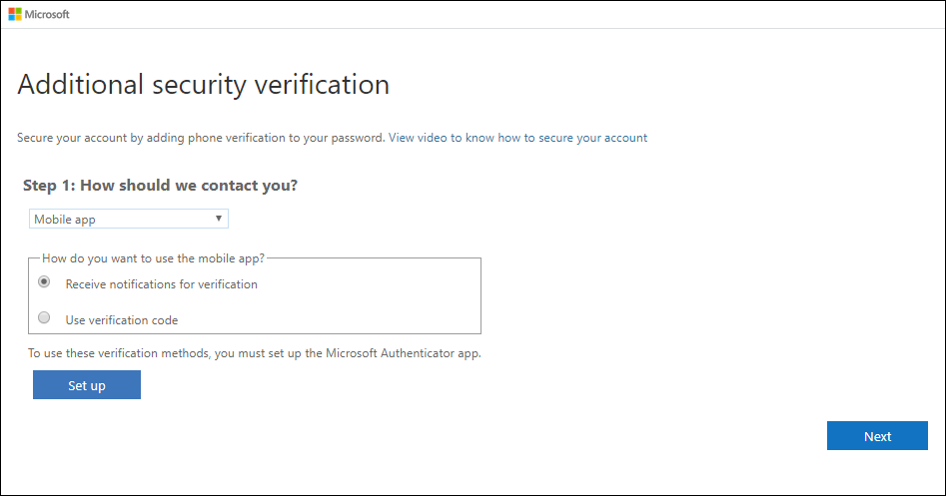

The **Configure mobile app** page appears.

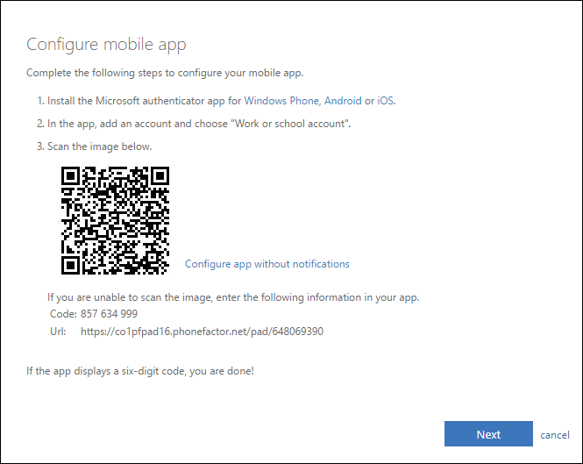

1. Open the Microsoft Authenticator app, select Add account from the Customize and control icon in the upper-right, and then select Work or school account.

Note: If you receive a prompt asking whether to allow the app to access your camera (iOS) or to allow the app to take pictures and record video (Android). select Allow so the authenticator app can access your camera to take a picture of the QR code in the next step. If you don't allow the camera, you can still set up the authenticator app as described in [Manually add an account to the app](https://docs.microsoft.com/azure/active-directory/user-help/user-help-auth-app-add-account-manual).

1. Use your device's camera to scan the QR code from the Configure mobile app screen on your computer, and then choose Next.
2. Return to your computer and the Additional security verification page, make sure you get the message that says your configuration was successful, and then select Next. The authenticator app will send a notification to your mobile device as a test.

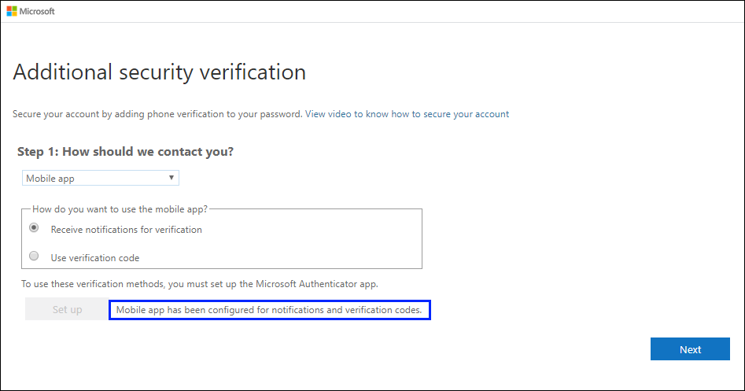

1. On your mobile device, select Approve.
2. On your computer, add your mobile device phone number to the Step 3: In case you lose access to the mobile app area, and then select Next. Microsoft recommends adding your mobile device phone number to act as a backup if you're unable to access or use the mobile app for any reason.
3. From the Step 4: Keep using your existing applications area, copy the provided app password and paste it somewhere safe.

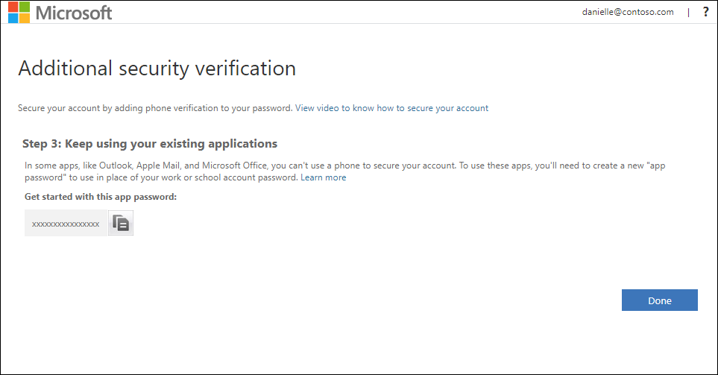

Note: For information about how to use the app password with your older apps, see [Manage app passwords](https://support.microsoft.com/en-au/account-billing/manage-app-passwords-for-two-step-verification-d6dc8c6d-4bf7-4851-ad95-6d07799387e9). You only need to use app passwords if you're continuing to use older apps that don't support two-factor verification.

1. Select Done.

## More information

Learn more about [exporting dairy products from Australia](https://www.agriculture.gov.au/biosecurity-trade/export/controlled-goods/dairy).

Web [Low-risk audit trials - DAFF (agriculture.gov.au)](https://www.agriculture.gov.au/biosecurity-trade/export/controlled-goods/fish/seafood-video-resources/low-risk-audit-trials)

Email [dairyeggsfish@aff.gov.au](mailto:dairyeggsfish@aff.gov.au)

**Acknowledgement of Country**

We acknowledge the Traditional Custodians of Australia and their continuing connection to land and sea, waters, environment and community. We pay our respects to the Traditional Custodians of the lands we live and work on, their culture, and their Elders past and present.

© Commonwealth of Australia 2024

Unless otherwise noted, copyright (and any other intellectual property rights) in this publication is owned by the Commonwealth of Australia (referred to as the Commonwealth).

All material in this publication is licensed under a [Creative Commons Attribution 4.0 International Licence](https://creativecommons.org/licenses/by/4.0/legalcode) except content supplied by third parties, logos and the Commonwealth Coat of Arms.

The Australian Government acting through the Department of Agriculture, Fisheries and Forestry has exercised due care and skill in preparing and compiling the information and data in this publication. Notwithstanding, the Department of Agriculture, Fisheries and Forestry, its employees and advisers disclaim all liability, including liability for negligence and for any loss, damage, injury, expense or cost incurred by any person as a result of accessing, using or relying on any of the information or data in this publication to the maximum extent permitted by law.