

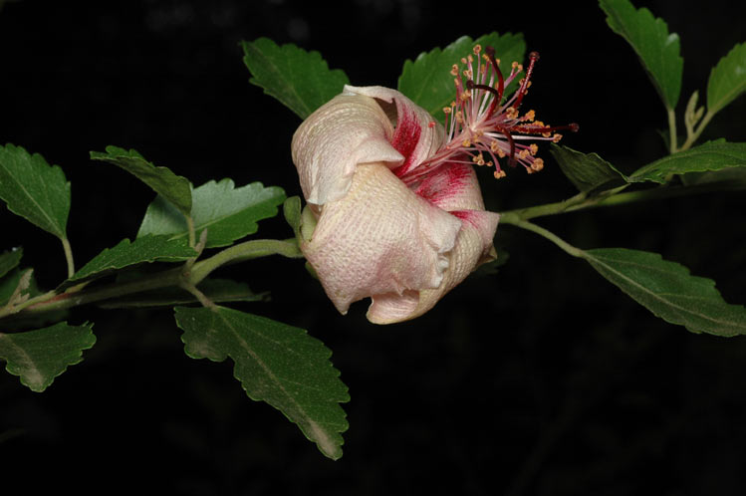
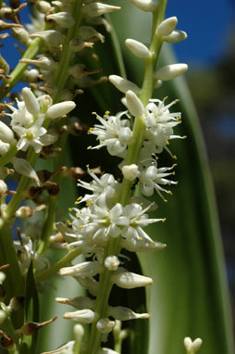
Constraints to Threatened Plant Recovery in Commonwealth National Parks

Linda Broadhurst, Bronwyn Clarke and Thekla Pleines
National Research Collections Australia
28 February 2016
Department of the Environment

Citation
Broadhurst L, Clarke B and Pleines T (2016) Constraints to Threatened Species in Commonwealth National Parks. CSIRO, Australia.
Copyright
© Commonwealth Scientific and Industrial Research Organisation 2016. To the extent permitted by law, all rights are reserved and no part of this publication covered by copyright may be reproduced or copied in any form or by any means except with the written permission of CSIRO.
Important disclaimer
CSIRO advises that the information contained in this publication comprises general statements based on scientific research. The reader is advised and needs to be aware that such information may be incomplete or unable to be used in any specific situation. No reliance or actions must therefore be made on that information without seeking prior expert professional, scientific and technical advice. To the extent permitted by law, CSIRO (including its employees and consultants) excludes all liability to any person for any consequences, including but not limited to all losses, damages, costs, expenses and any other compensation, arising directly or indirectly from using this publication (in part or in whole) and any information or material contained in it.
CSIRO is committed to providing web accessible content wherever possible. If you are having difficulties with accessing this document please contact csiroenquiries@csiro.au.

Cover photos
LEFT - Phillip Island Hibiscus (Hibiscus insularis) ©M. Fagg. RIGHT - Ti/Norfolk Isand Cabbage Tree (Cordyline obteta) ©M. Fagg.

Contents
Contents i
Acknowledgments i
Executive summary ii
1 Introduction 2
1.1 Threatened plants in Australia 2
1.2 Commonwealth national parks 2
1.3 Project objective 4
1.4 Background 5
2 Materials and methods 7
2.1 Species selection 7
2.2 Information gathering 8
2.3 Threat and gap analyses 9
3 Findings 10
3.1 Initial observations 10
3.2 Threats common across Commonwealth national parks 12
3.3 Knowledge gaps limiting species recovery 16
4 Recommendations 18
5 References 21
B.1 Cryptostylis hunteriana (Orchidaceae) – Leafless Tongue Orchid, Furred Tongue Orchid, Booderee National Park 26
B.2 Dracophyllum oceanicum (Ericaceae) – Jervis Bay Dragon Leaf, Booderee National Park……. ….31
B.3 Galium australe (Rubiaceae) – Tangled Bedstraw, Booderee National Park 34
B.4 Syzygium paniculatum (Myrtaceae) – Magenta Lilly Pilly, Booderee National Park 37
B.5 Zieria arborescens subsp. decurrens (Rutaceae) – Stinkwood, Booderee National Park 41
B.6 Asplenium listeri (Aspleniaceae) – Christmas Island Spleenwort, Christmas Island National Park 44
B.7 Asystasia alba (Acanthaceae) – Christmas Island National Park 47
B.8 Dicliptera maclearii Hemsl. (Acanthaceae) – Christmas Island National Park 50
B.9 Grewia insularis (Malvaceae) – Christmas Island National Park 53
B.10 Pneumatopteris truncata (Thelypteridaceae)– Christmas Island fern, Christmas Island National Park 55
B.11 Tectaria devexa var. minor (Dryopteridaceae) – A fern, Christmas Island National Park 58
B.12 Acacia equisetifolia (Fabaceae) – Graveside Gorge Wattle, Kakadu National Park 61
B.13 Hibbertia brennanii, H. pancerea, H. tricornis and Hibbertia sp. South Magela (K.G.Brennan 896) (Dilleniaceae) – four Guinea flowers, Kakadu National Park 65
B.14 Hibiscus brennanii (Malvaceae) – Brennan’s Hibiscus, Kakadu National Park 68
B.15 Jacksonia divisa (Fabaceae) – Kakadu National Park 71
B.16 Lithomyrtus linariifolia (Myrtaceae) – Kakadu National Park 74
B.17 Abutilon julianae (Malvaceae) – Norfolk Island Abutilon, Norfolk Island National Park 77
B.18 Anthosachne multiflora subsp. kingiana (Poaceae) – Phillip Island Wheat Grass, Norfolk Island National Park 80
B.19 Boehmeria australis subsp. australis (Urticaceae) – Tree Nettle/ Nettletree, Norfolk Island National Park 83
B.20 Calystegia affinis (Convolvulaceae) – Norfolk Island National Park 86
B.21 Clematis dubia (Ranunculaceae) – Clematis, Norfolk Island National Park 89
B.22 Coprosma baueri and Coprosma pilosa (Rubiaceae) – Coastal Coprosma and Mountain Coprosma, Norfolk Island Nation Park 92
B.23 Cordyline obtecta (Asparagaceae) – Ti/ Norfolk Island Cabbage Tree, Norfolk Island National Park 95
B.24 Elatostema montanum (Urticaceae) – Mountain Procris, Norfolk Island National Park 98
B.25 Hibiscus insularis (Malvaceae) – Phillip Island Hibiscus, Norfolk Island National Park 101
B.26 Ileostylus micranthus (Loranthaceae) – Mistletoe, Norfolk Island National Park 104
B.27 Melicytus latifolius (Violaceae) – Norfolk Island Mahoe, Norfolk Island National Park 107
B.28 Myoporum obscurum (Scrophulariaceae) – Popwood, Sandalwood, Norfolk Island National Park 110
B.29 Plexaure limenophylax (Orchidaceae) – Norfolk Island National Park 113
B.30 Senecio evansianus, Senecio australis and Senecio hooglandii (Asteraceae) – Daisies, Norfolk Island National Park 116
B.31 Streblus pendulinus (Moraceae) – Siah’s Backbone, Norfolk National Park 119
B.32 Wikstroemia australis (Thymelaeaceae) – Kurrajong, Norfolk Island National Park 122
B.33 Eremophila alternifolia (Scrophulariaceae) – Narrow-leaved Emu Bush, Uluru-Kata Tjuta National Park 125
B.34 Eriachne scleranthoides (Poaceae) – Mount Olga Wanderrie Grass, Uluru-Kata Tjuta National Park 128
B.35 Santalum acuminatum (Poaceae) – Desert Quandong, Uluru-Kata Tjuta National Park……. 131

Acknowledgments
This project would not have been possible without the many people willing to share their knowledge and exchange information. Firstly, we would like to thank B. Brown, M. Goumas and M. Greenfield from the Department of the Environment for their support and facilitation of our communications with the national parks staff. Furthermore, we are greatly indebted to Parks Australia staff for sharing valuable first-hand information about the species in their parks with us. In particular, we would like to thank S. Pedersen and N. Dexter (Booderee National Park), D. Maple and A. Grigg (Christmas Island National Park), K. Gabrys and A. Simms (Kakadu National Park), J. Christian, C. Jones and A. Smith (Norfolk Island National Park), and K. Bennison (Uluru-Kata Tjuta National Park). T. North and L. Guja from the National Seed Bank at the Australian National Botanic Gardens (Parks Australia) kindly provided information about the seed collections of our study species, and Z. Knapp and M. Henery provided information about the threatened species in the Living Collection at the Australian National Botanic Gardens. We thank N. Knerr for creating species distribution maps. The funding provided by the Threatened Species Commissioner and the Australian Government Department of the Environment in support of this project is greatly acknowledged.

Executive summary
This report reviews the current knowledge for a range of threatened and endangered species across Commonwealth national parks. The overall aim of this assessment was to improve our understanding of key processes that threaten the long term persistence of plants found in national parks that are currently listed under the Environment Protection and Biodiversity Conservation Act 1999 (EPBC Act). We sought to do this by:
- Assessing the current conservation status and security of these species with respect to in- and ex-situ (living and germplasm) collections.
- Determining knowledge gaps with respect to species distribution, reproductive biology, ecology and taxonomy to help develop and prioritise research and conservation management plans within Commonwealth national parks.
- Building a compendium of threatening processes to understand the range of risks that are impacting on species recovery at the Park and National levels as well as to develop a more collective approach to threat management.

Using available information from 41 endangered or significant species that occur in national parks we found that
- A large proportion of these species are only found in national parks highlighting the significant role and responsibilities that these parks play in their conservation and management.
- Very few of the species are held in ex-situ collections (living or seed bank) and collections that do exist are small indicating that opportunities to re-establish populations following extinction events are extremely limited.
- Very few of the species are regularly monitored and population trajectories are unclear.
- Too little information on the impacts of threats or species biology exists, limiting our ability to secure these species against further loss.

We also make the following broad recommendations:
Onground activities
- Survey all endangered plant species in national parks not currently part of a formal monitoring program or that have not been surveyed within the last two years.
- Partner with researchers and NGOs with restoration experience to draw on available scientific and onground knowledge to improve the outcomes of these activities.
- Consider establishing ‘insurance’ populations for some species outside of national parks in a similar manner to ex-situ breeding programs for vertebrates.
- Secure ex-situ collections (living and seed) of all threatened species not currently held as a matter of priority.

Research
- Initiate a five, but preferably ten, year research program dedicated to investigating the biology of endangered plants species across national parks.
- Undertake genetic assessments where this will directly benefit species recovery and ensure that ex-situ seed collections are genetically representative and appropriate for restoration if required.
- Explore opportunities such as partnering with research institutions and citizen science initiatives to develop long term monitoring programs (i.e. 10s of years).
- Explore opportunities with the horticulutre and nursery industries to develop rare species to broaden the current product base.
- Develop a risk framework using information about a species biology, location and threat sensitivities to help define and prioritise actions under climate change.
Training
- Provide national park staff with development opportunities to enhance their understanding and use of methodologies such as Adaptation Pathways in future planning exercises.

Abbreviations
The following abbreviations are used throughout the text:
ACT Australian Capital Territory
ALA Atlas of Living Australia
ANBG Australian National Botanic Gardens (Canberra)
APC Australian Plant Census
APII Australian Plant Image Index
APNI Australian Plant Name Index
ASBP Australian Seed Bank Partnership
BNP Booderee National Park
CHAH Council of Heads of Australasian Herbaria
CINP Christmas Island National Park
DNP Director of National Parks
DoE Department of the Environment
EPBC Act Environment Protection and Biodiversity Conservation Act 1999
KNP Kakadu National Park
NINP Norfolk Island National Park
NSW New South Wales
NT Northern Territory
Qld Queensland
TPWC Act Territory Parks and Wildlife Conservation Act 2006
TSC Act Threatened Species Conservation Act 1995
TSSC Threatened Species Scientific Committee
UKTNP Uluru-Kata Tjuta National Park
Vic Victoria

Introduction

Threatened plants in Australia
Some 84% of plants that occur naturally in Australia are found nowhere else in the world but changes to the Australian landscape have put many of these unique species at risk (DoE, http://www.environment.gov.au/biodiversity‌/threat‌ened accessed 6 January 2016). Plant species are protected nationally by the Environmental Protection and Biodiversity Conservation Act 1999 (EPBC Act). Plant species are listed under the Act in one of four categories - “Extinct”, “Critically Endangered”, “Endangered” and “Vulnerable”. The criteria used to define these categories mostly align with the International Union for Conservation of Nature (IUCN) Red List category criteria and are based on information such as the size of the species distribution, the estimated number of mature individuals, and, whether one or both of these measures are declining.
Key threats across Australia to our plant species include ongoing habitat destruction or alteration due to human activities, the impacts of invasive species and changes to fire management, frequency and intensity. Vegetation fragmentation resulting in population reductions and isolation have also reduced genetic diversity and elevated inbreeding. This can lead to ongoing population decline by impacting on the reproductive success and recruitment of plant populations. Fragmentation can also facilitate the spread of invasive species while declines in other species such as pollinators and seed dispersers also pose a threat to the sustainability of plant populations.

Commonwealth national parks
Australia has six Commonwealth national parks that are managed by Parks Australia (Fig 1). Three of these are on mainland Australia - Booderee National Park, Kakadu National Park and Uluru-Kata Tjuta National Park with the others being on islands - Pulu Keeling National Park, Norfolk Island National Park and Christmas Island National Park. The Commonwealth Government also manages the Australian National Botanic Gardens in Canberra which holds a Living Collection and the Australian National Seed Bank. These national parks play an important role in the conservation of some of Australia’s most endangered plant species, especially for species that are only found within these parks. But the ecosystems conserved in national parks are diverse and complex and have to be managed for a multiplicity of benefits such as biodiversity conservation, tourism and cultural values. This is a difficult and challenging task often requiring difficult decisions regarding the use of limited resources.

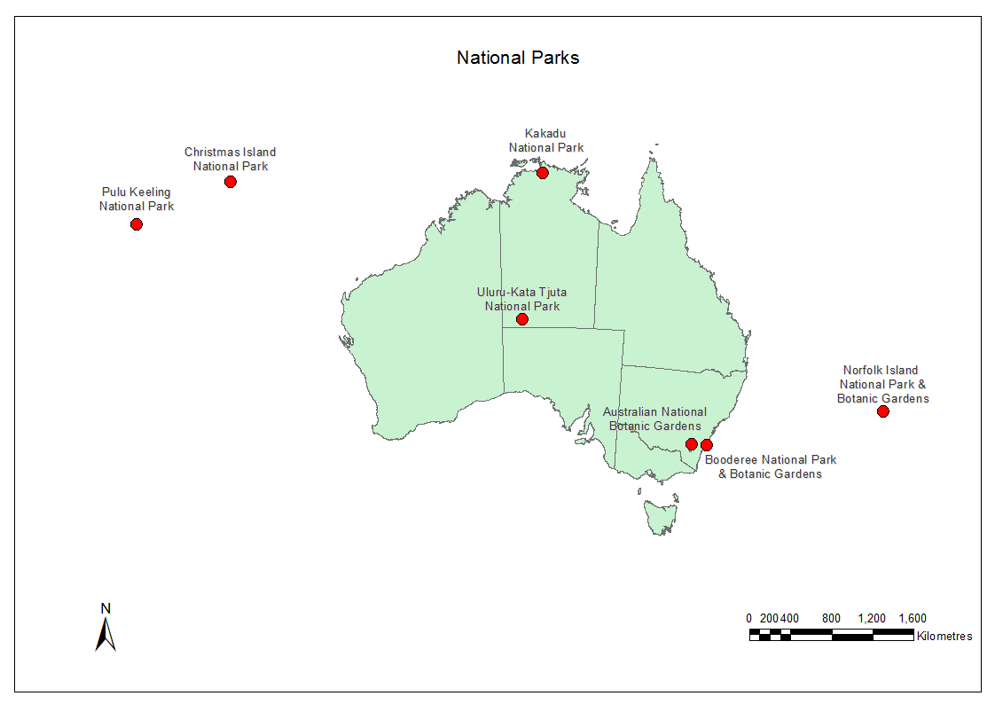
Figure 1 Location of Commonwealth national parks.

Australian National Botanic Garden
The Australian National Botanic Garden is located in Canberra and maintains a scientific collection of native plants from across Australia (http://www.anbg.gov.au/gardens/index.html). Although part of the national park estate, the ANBG differs from the other national parks in terms of plant species composition and management and was excluded from this report.

Booderee National Park
Booderee National Park is on the moist sub-tropical New South Wales south coast at Jervis Bay and sits in a transition zone between northern and southern biogeographical regions. The park covers more than 6,000 h and contains many species at the edge of their bio-geographical range. It also includes examples of several south-eastern Australian coastal communities that are threatened by a range of activities such as urban development elsewhere (DoE http://www.environment.gov.au‌/topics/national-parks/booderee-national-park accessed 7 January ‌2015).

Kakadu National Park
Kakadu National Park is located east of Darwin in Australia’s tropical north and is Australia’s largest terrestrial national park (almost 20,000 square kilometres). It is ecologically diverse and covers coastal and estuarine systems as well as floodplains, billabongs and lowlands to rocky ridges and stone country. Consequently, a broad range of biodiversity is found within the park including rare and endemic plants (DoE http://www.environment.gov.au/topics/national-parks/kakadu-national-park accessed 7 January 2015.

Uluru-Kata Tjuta National Park
Uluru-Kata Tjuta National Park (1,325 square kilometres) is situated in the Northern Territory southwest of Alice Springs in the Greater Sandy Desert bioregion. Despite being an arid environment, this park supports many species in habitats that range from sand dunes and spinifex plains to acacia scrubland and creek lines. The park includes representatives of several Central Australian arid ecosystems and includes several regionally significant plant species (DoE, http://www.environment.gov.au/topics/national-parks/uluru-kata-tjuta-national-park accessed 7 January 2015).

Christmas Island National Park
This park is located on the isolated oceanic Christmas Island in the Indian Ocean some 2,600 km northwest of Perth and 360 km south of Jakarta. It covers almost two thirds of the island and supports a high proportion of endemic species, some of which are endangered. The park protects much of the island’s uniquely structured rainforests, two wetlands of international importance, tens of millions of red crabs and a small but environmentally significant marine area (DoE http://www.environment.gov.au/topics/national-parks/christmas-island-national-park accessed 7 January 2015).

Norfolk Island National Park
Norfolk Island National Park is located some 1,500 km east of Brisbane and protects some 6.5 square kilometres of the Mount Pitt section on Norfolk Island and the neighbouring Phillip Island. The park has important biological significance as its flora and fauna are derived from the chance dispersal of plants and animals over vast distances of ocean. Many species on these islands are endemic including 40 of the 200 native plants (DoE http://www.environment.gov.au‌/topics‌/national-parks/norfolk-island-national-park accessed 7 January 2015).

Pulu Keeling National Park
Pulu Keeling National Park is an isolated coral atoll and part of the Cocos (Keeling) Islands found in the Indian Ocean some 2,000 km northwest of Perth. The national park is centred on North Keeling Island, which is comprised of one C-shaped island, a nearly closed atoll ring with a small opening into the lagoon. North Keeling Island is characterised by low habitat diversity with the flora and fauna forming a unique assemblage of ‘travelling’ species. (DoE http://www.‌environment‌‌.gov.au/topics/national-parks/pulu-keeling-national-park accessed 7 January 2015). No Pulu Keeling plant species are listed as threatened under the EPBC Act.

Project objective
The overall aim of this assessment was to improve our understanding of key processes threatening the long term persistence of plants found in Commonwealth national parks that are currently listed under the Environment Protection and Biodiversity Conservation Act 1999 (EPBC Act). We sought to do this by
- Assessing the current conservation status and security of these species with respect to in- and ex-situ (living and germplasm) collections.
- Determining knowledge gaps with respect to species distribution, reproductive biology, ecology and taxonomy to help develop and prioritise research and conservation management plans within Commonwealth national parks.
- Building a compendium of threatening processes to understand the range of risks that are impacting on species recovery at the Park and National levels as well as to develop a more collective approach to threat management.

Background
Some 1294 plant taxa are listed under the EPBC Act at the time of this assessment with many more species protected under State and Territory legislation (Broadhurst et al. 2011). Optimal species conservation and recovery depends on understanding not only about threatening processes but also the biological characteristics of target species. For example, a plant’s breeding system, biological interactions, dispersal, and genetic diversity can significantly impact on species persistence and influence recovery but are often rarely considered to be as critical as managing more visible threats such as weeds and vertebrate pests.
Species recovery plans which outline the state of knowledge of a species as well as research and management actions are often used to secure species against extinction. But these are often developed on a species-by-species basis and do not necessarily reflect the broader impact of threats to plant persistence that occur over spatial and temporal scales. Below we outline some of the most critical threats to plant persistence likely to impact on EPBC-listed species within Commonwealth national parks. It is important to remember that these threats do not often act alone. For example, increased storm severity may not damage plants but may also exacerbate soil erosion resulting in plant damage and/or death. After an initial assessment of threat information we identified four major threat categories likely to be impacting on species persistence and recovery across the national parks:

Climate-related effects (Climate)
The challenges of climate change are outlined in strategies prepared for each Commonwealth national park (http://www.environment.gov.au/topics/national-parks/parks-australia/climate-change‌‌, accessed 21 February 2016). The effects of climate change are likely to vary widely across the parks but some of the major changes likely to influence species persistence are considered below.
- Droughts occur periodically across much of Australia impacting on plant species in many ways, especially those that are less adapted to extended dry periods. This impact can include reducing plant fitness through reduced flowering and/or seed production as well as plant death (Broadhurst et al. 2016).
- Severe weather events also occur naturally across Australia (e.g. cyclones Larry in 2006 and Yasi in 2011) and can damage or destroy large tracts of vegetation (Turton 2012). This is especially challenging for species with few small populations and/or restricted geographic distributions.
- Fire is a common and natural phenomenon across Australian with much of the flora being fire-adapted. But climate change is expected to impact on plant population persistence through altered fire interval windows (Enright et al. 2015) which may impact on plants in many ways including changing vegetation composition, damaging or destroying plants and reducing opportunities for reproduction.

Biophysical effects (Biophysical)
- Soil degradation and erosion can impact on population persistence through increased nutrient loads, loss of soil and exposure of roots.
- Water usage and availability is likely to change over the coming decades as climates become hotter and drier climate. For some parks this may also include increased extraction from local water sources (e.g. aquifers) for human use which could have important effects on plants that also utilise this resource.
- Other effects including human-induced changes such as land clearing for urban and rural development, mining, or infrastructure, trampling and illegal collection can also impact on population and species persistence. These effects, however, are much less likely to occur in national parks.

Invasive species (Invasives)
Many exotic species have been introduced into Australia that have subsequently become serious threats to plant species.
- Weeds threaten many of our native plants through competition, changing local habitats, harbouring pests and diseases and producing chemicals that inhibit germination or growth of neighbouring plants (Gallagher and Leishman 2014; Grice et al. 2013).
- Pest animals can impact plants directly through herbivory and habitat change (Krull et al. 2014).
- Diseases and pathogens can impact on plant health and reproduction and in some cases lead to plant death. The most well-known recent example of a serious plant disease in Australia is myrtle rust (guava rust) which is a fungal disease affecting trees and shrubs in the Myrtaceae (Carnegie et al. 2015).

Genetic and demographic effects (Gen/Dem)
Small population size and restricted geographic distributions are characteristic of endangered plants and are often associated with
- Low genetic diversity (genetic erosion) which elevates inbreeding and mating among closely-related plants (Barrett and Kohn 1991) leading to poor seed production and/or seedlings that fail to thrive. It may also limit a species ability to respond to environmental change (Helenurm 1998).
- Few population and low plant numbers increase the vulnerability of endangered species to extinction from stochastic events such as storms or fire or through human-mediated changes such as vegetation clearing.

Materials and methods

Species selection
There are currently 54 EPBC-listed plant species in Commonwealth national parks (Table 1). This project initially intended to only assess those species categorized as Critically Endangered, however, the majority of species in this category (15 of 18 species) were found in the Norfolk Island National Park so using this approach would overly bias our findings towards this park. We subsequently refined our approach to include a range of species from Norfolk Island that representative of plant life histories in that park as well as all species listed in other EPBC categories from Booderee, Christmas Island, Kakadu and Uluru Kata Tjuta National Parks. In addition, we included several keystone or significant species that were identified in park management plans or by national parks staff as being important to this assessment making a total of 41 species assessed.
Table 1 EPBC-listed and significant species in Commonwealth national parks. *indicates species included in this project. VU = Vulnerable, EN = Endangered, CR = Critically Endangered, SS = Significant species.
National Park | Species | Common name | EPBC Act category
Booderee | Cryptostylis hunteriana* | Leafless Tongue Orchid | VU
 | Syzygium paniculatum* | Magenta Lilly Pilly | VU
 | Dracophyllum oceanicum* | Jervis Bay Dragon Leaf | SS
 | Galium australe* | Tangled Bedstraw | SS
 | Zieria arborescens subsp. decurrens* | Stinkwood | SS
Christmas Island | Asplenium listeri* | Christmas Island Spleenwort | CR
 | Pneumatopteris truncata* | a fern | CR
 | Tectaria devexa var. minor* | a fern | EN
 | Asystasia alba* | a herb | SS
 | Dicliptera maclearii* | a herb | SS
 | Grewia insularis* | a shrub or tree | SS
Kakadu | Acacia equisetifolia* | a shrub (D19063 graveside gorge) | CR
 | Hibiscus brennanii* | a shrub | VU
 | Hibbertia brennanii* | Guinea flower | SS
 | Hibbertia pancerea* | Guinea flower | SS
 | Hibbertia tricornis* | Guinea flower | SS
 | Hibbertia sp. South Magela* | Guinea flower | SS
 | Jacksonia divisa* | a shrub | SS
 | Lithomyrtus linariifolia* | sub-shrub or small shrub | SS
Norfolk Island | Abutilon julianae* | Norfolk Island Abutilon | CR
 | Achyranthes arborescens | Chaff-tree | CR
 | Achyranthes margaretarum | Phillip Island Chaff-tree | CR
 | Blechnum norfolkianum | Norfolk Island Water-fern | EN
 | Boehmeria australis var. australis* | Tree Nettle | CR
 | Calystegia affinis* | a creeper | CR
 | Clematis dubia* | Clematis | CR
 | Coprosma bauera* | Coastal Coprosma | EN
 | Coprosma pilosa* | Mountain Coprosma | EN
 | Cordyline obtecta* | Ti | VU
 | Crepidomanes endlicherianum  Renamed as Polyphlebum endlicherianum | Middle Filmy Fern | EN
 | Dysoxylum bijugum | Sharkwood | VU
 | Elatostema montanum* | Mountain Procris | CR
 | Elymus multiflorus subsp. kingianus  Renamed as Anthosachne multiflora subsp. kingiana* | Phillip Island Wheat Grass | CR
 | Euphorbia norfolkiana | Norfolk Island Euphorbia | CR
 | Euphorbia oblique | a herb | VU
 | Hibiscus insularis* | Phillip Island Hibiscus | CR
 | Hypolepis dicksonioides | Downy Ground-fern | VU
 | Ileostylus micranthus* | Mistletoe | VU
 | Lastreopsis calantha | Shield-fern | EN
 | Marattia salicina | King Fern | EN
 | Melicope littoralis | Shade Tree | VU
 | Melicytus latifolius* | Norfolk Island Mahoe | CR
 | Melicytus ramiflorus subsp. oblongifolius | Whiteywood | VU
 | Meryta angustifolia | a tree | VU
 | Meryta latifolia | a tree | CR
 | Muehlenbeckia australis | Pohuehue | EN
 | Myoporum obscurum* | Popwood | CR
 | Pennantia endlicheri | Pennantia | EN
 | Phreatia limenophylax  Renamed as Plexaure limenophylax* | an orchid | CR
 | Phreatia paleata | an orchid | EN
 | Pittosporum bracteolatum | Oleander | VU
 | Planchonella costata | Bastard Ironwood | EN
 | Pteris kingiana | King's Brakefern | EN
 | Pteris zahlbruckneriana | Netted Brakefern | EN
 | Myrsine ralstoniae | Beech | VU
 | Senecio australis* | a daisy | VU
 | Senecio evansianus* | a daisy | EN
 | Senecio hooglandii* | a daisy | VU
 | Streblus pendulinus* | Siah's Backbone | EN
 | Taeniophyllum norfolkianum | Ribbon-root Orchid | VU
 | Dendrobium brachypus | Norfolk Island Orchid | EN
 | Tmesipteris norfolkensis | Hanging Fork-fern | VU
 | Ungeria floribunda | Bastard Oak | VU
 | Wikstroemia australis* | Kurrajong | CR
 | Zehneria baueriana | Native Cucumber | EN
Uluru Kata-Tjuta | Eremophila alternifolia* | Narrow-leaved Emu Bush | SS
 | Eriachne scleranthoides* | Mount Olga Wanderrie Grass | SS
 | Santalum acuminatum* | Desert Quandong | SS

Information gathering
A template was developed to ensure that the information gathered was consistent for across all of the species being assessed (Appendix A). Four major threat categories were used: i). climate-related effects, ii). biophysical effects, iii). invasive species, and, iv). genetic and demographic effects. The template also included information about each species name (nomenclature), distribution, population number(s) and size(s), and insurance collections (in- and ex-situ). Information about threats identified from EPBC listing advices as well as park management and species recovery plans were documented as was information on plant traits that are potentially important for understanding the effects of threatening processes. This included information on plant pollinators, breeding systems, plant age to maturation, longevity, seed dormancy/viability, germination requirements, and genetic diversity assessments. The following data sources were used:
- Information about the EPBC listed species was sourced from the publically available SPRAT database (http://www.environment.gov.au/cgi-bin/sprat/public/publicthreatenedlist.pl?‌wanted‌‌‌=flora) with links and references to other information sources on these pages also reviewed. Google (www.google.com.au) and Google Scholar (https://scholar.google.‌com‌.au/) were interrogated for published and grey literature for each species or where no information was available, searches for closely related species were undertaken. All data unless otherwise referenced was sourced directly from SPRAT.
- The validity of species names was determined using the Australian Plant Census (APC, www.anbg.gov.au/chah/apc) or the Australian Plant Names Index (http://www.anbg.gov‌.au/apni/).
- Ploidy information was obtained from the Tropicos Index to Plant Chromosome numbers (www.tropicos.org/Project/IPCN, Missouri Botanical Garden) and the Chromosome Counts database [http://ccdb.tau.ac.il/home/, (Rice et al. 2015)].
- Photographs of the species were sourced from the Australian Plant Images Index (APII, www.‌‌anbg.gov.au/photo/genus-photo-search.html) or provided by national park staff.
- Specimen data were downloaded from the Atlas of Living Australia (ALA, http://www‌.ala‌.org.au/), cleaned to removed records that were misidentified, incorrectly located, misnamed or were cultivated. Additional locations of species not represented by specimen records provided by national parks staff or found in the literature were also included and the distribution of each species within the national parks were then generated. Some records of cultivated plants were retained if these were part of a national park restoration program.
- In- and ex-situ holdings in the form of cultivated plants or seed collections were obtained from the Australian National Botanic Gardens, Booderee Botanic Garden and national parks staff where available. Information on collections held in other botanic gardens or seed banks was also included when available using Australian Seed Bank Partnership records (http://asbp.ala.org.au/).
These data were collated into a single Excel spreadsheet for analysis while all information sourced for each species is provided in Appendix B.

Threat and gap analyses
Information for 16 sub-categories of the four threat categories was gathered and the data ranked as being:
- A ‘Known threat’ when there was documented evidence that the threat was impacting on a species,
- ‘Data deficient’ where the threat was inferred to be a problem or following our assessment of a species biology could potentially impact on a species but for which no direct data were available, and,
- ‘No threat’ where an evaluation of a threat had occurred and was considered to be extremely unlikely or of very low impact.

These rankings were collated into a single table and used to identify major threats across the national parks as well as critical knowledge gaps. These data are provided separately in the associated Excel spreadsheet.

Findings

Initial observations
One of our most important observations during our literature searching was the considerable lack of in-depth and up-to-date information available for almost all of the 41 species assessed. This lack of information ranged from being unable to source verified photographs of species to having to evaluate the utility of information from closely-related species as surrogates for species for which no information existed. We were unable to source a verified photograph from Australian Plant Image Index (APII) for 13 of the EPBC listed species and 12 of the non-EPBC listed species. Park staff were able to supply photos of an additional 5 EPBC listed species and 9 non-EPBC listed species. However, the value of having images available through APII is that these can be linked to a verified herbarium specimen and we can consequently be confident that the photo is assigned to the correct species. For 7 of the EPBC listed species there was no photo available at all. A lack of photographic information may limit species recognition and identification in the field and reduces the ability of national park staff to engage and educate visitors about the role and importance of these species.
Our second observation was that for just over half of the species assessed almost all of the populations primarily occur within national parks (Fig 2) making these species highly vulnerable to local extinction. In addition, the distributions of a further six species could not be rigorously determined but since these occur in CINP and NINP it is likely that populations of these species are also primarily located within national parks. These data highlight the critical role that national parks are playing in the conservation and management of endangered species including being responsible for an entire species in many cases. It also indicates that establishing ex-situ collections (both living and seed) is critical to provide a means for species recovery should an extinction event occur.

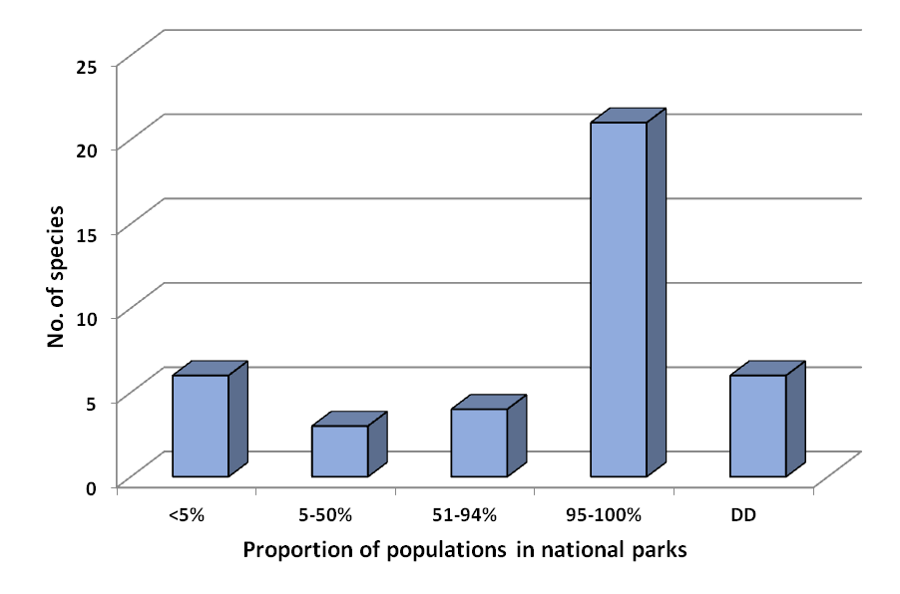
Figure 2: Number of populations of each species occurring in Commonwealth national parks. DD, data deficient.

Our third observation was that as far as we can ascertain, few of these species have been recently monitored (Fig 3) and few are subject to periodic evaluation. The large number of species surveyed in 2003 are from NINP only. This does not suggest that these endangered species require annual monitoring but it does suggest that regular monitoring programs would greatly assist in species recovery by providing critical information on population trends as well as threat impacts. It would also provide critical information to help improve species recovery such as recruitment, longevity, flowering and pollinators – much of which is unknown for the majority of species assessed here (see Section 3.3 Knowledge gaps limiting species recovery).
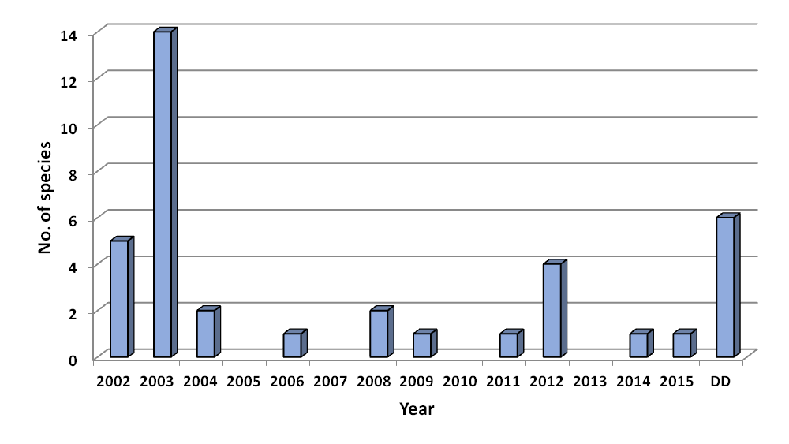
Figure 3: Year that endangered species in Commonwealth national parks were last monitored. DD, data deficient.
Our fourth observation was that we had very little information regarding the threats for these species irrespective of the park being assessed (Fig 4). For a small number of species we had clear evidence of threats impacting on species (i.e. ‘Known’) while for several others some threats had been evaluated and there was good evidence to suggest that there was no threat or at least a very low threat risk (i.e. “No threat”). But, for the majority of species we had no data to determine whether inferred threats were really a concern for species persistence. This suggests that there is insufficient information to help national park staff make critical decisions about species management and recovery.
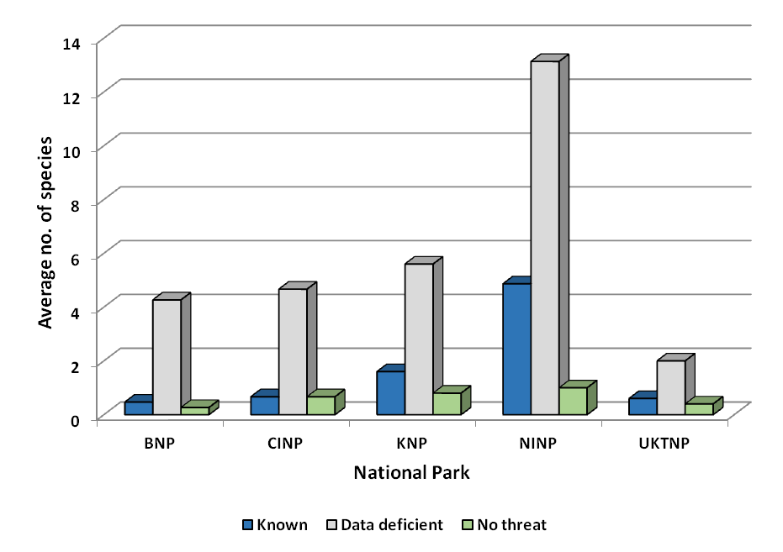
Figure 4: Average number of species in each data category for each Commonwealth national park.

Our final observation was that very few of these species are held in ex-situ collections outside of the national parks (Fig 5) with most of the ex-situ collections being held in the Australian National Botanic Garden and the National Seed Bank. Several species that are difficult to place under long term storage, such as those with recalcitrant seed, are among the species assessed here. There are also several orchids which require both the seed and their associated mycorrhizal fungi to be stored if these are to be used for re-introduction programs. The ferns assessed here pose some of the most significant challenges for storage and possible reintroduction due to the complexity of their life cycle. This suggests that these limited ex-situ holdings provide little security for species recovery following stochastic extinction events or ongoing population decline. This is especially concerning for species that reside solely or almost solely within national parks that have a high extinction risk due to their small population size and limited geographic distributions.
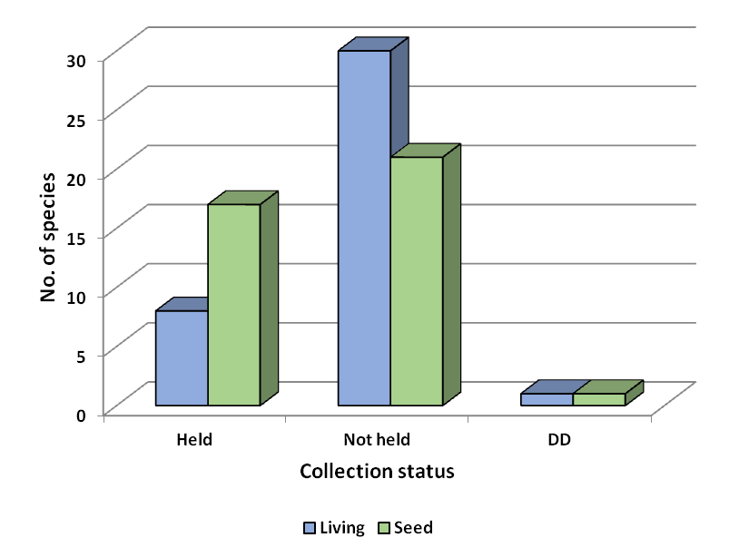
Figure 5: Number of endangered species in Commonwealth national parks held in ex-situ collections.

Threats common across Commonwealth national parks
While a broad range of threats were identified across these species occurring in Commonwealth national parks, here we report only on those sub-categories that were observed in four or more of the parks (Fig 6). Two of the threats for which we have the most data are limited geographic distribution and low numbers of individuals which is not unexpected given that these are two of the most frequently used listing criteria under the EPBC Act. Changing the geographic distributions for these species to remove them from EPBC listing is highly unlikely but removing or limiting threats in other sub-categories may change the status of these species to a less threatened category under the EPBC Act. For example, increasing the number of populations and their size can reduce multiple threats and may change the thresholds for listing. But increasing the number of plants within these species relies heavily on
- Having sufficient propagules (seed and/or cuttings) to create new population or add to existing sites;
- An appropriate location and site preparation for planting new populations;
- Ongoing management of threats such as weeds, grazing and pests;
- An understanding of germination and growth requirements, and;
- For some species, an understanding the impacts of low genetic diversity and inbreeding on seed quality and seedling survival.

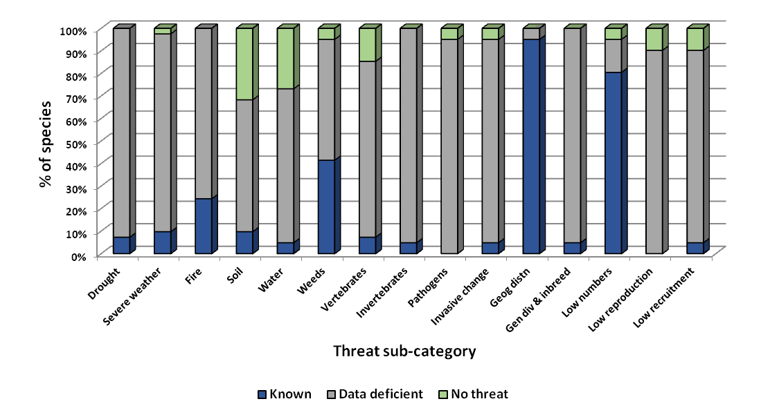
Figure 6: Percentage of endangered species in Commonwealth national parks for each threat sub-category.

The average levels of information available for species across the four major threat categories is shown in Fig 7. Very similar patterns of data availability characterised the Climate, Biophysical and Invasives categories with little data being available for the majority of species (i.e. ‘Data deficient’). Higher levels of available information in the Genetic and Demographic category reflect threats associated with restricted geographic distributions. Climate-related and biophysical threats had been evaluated for several species and were considered to be of no or low threat. These data suggest that:
- Species are potentially being impacted by a broader range of threats than currently recognised, and,
- Management actions are possibly being undertaken to mitigate threats for which there is as yet no evidence that the action is required or that it will improve species persistence and recovery.

These findings may reflect the age of some of the available information. This may be especially so for Species Recovery Plans which do not recognise threats that have emerged since the plans were prepared. This suggests that Species Recovery Plans require regular re-assessment if these are to be a useful tool to drive species recovery.

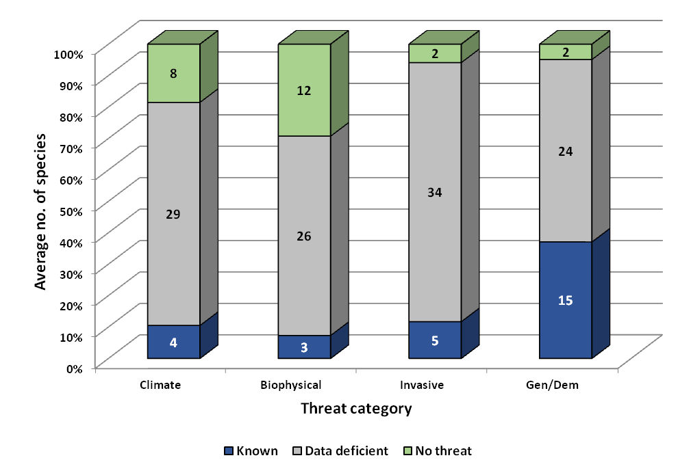
Figure 7: Average number of endangered plants found in Commonwealth national parks assigned to major threat categories. Number indicates the average number of species for each data type.

Threats across national parks for the sub-categories within the four major threat categories were extremely similar reflecting a general lack of knowledge irrespective of the type of threat (Fig 8) although the risks associated with fire are somewhat more well-known (Fig 8a). While we have limited information on the likely effects of soil degradation and erosion and water management we do not see these as being the most challenging threats to manage at the moment (Fig 8b). Weeds are the most well recognisable invasive threat (Fig 8c) but despite reports of pathogens and pests impacting on some of these plant species, very few investigations have occurred. The most pressing of these at the moment is likely to be Myrtle Rust although this is primarily a threat only to Syzygium paniculatum in Booderee National Park and Lithomyrtus linariifolia in Kakadu National Park. But some other pests have been noted in the seed of some of the species assessed here which may be impacting on species persistence. Vertebrates have been discounted as a threat in only a small number of species but vertebrate pest management is often undertaken by national parks and may only be relevant to a few species. As previously highlighted, restricted geographic distribution and low plant numbers are the best known threat in the genetic and demographic category (Fig 8d). This highlights the substantial lack of information available for national parks to make informed decisions regarding the impacts of threats.

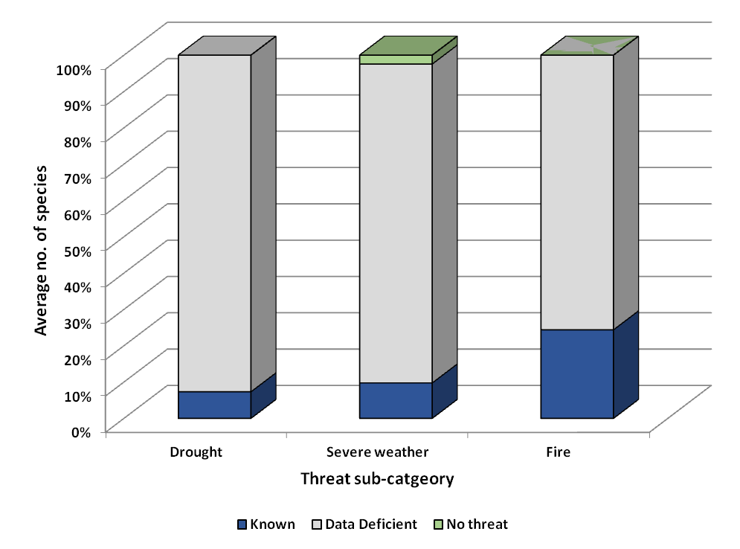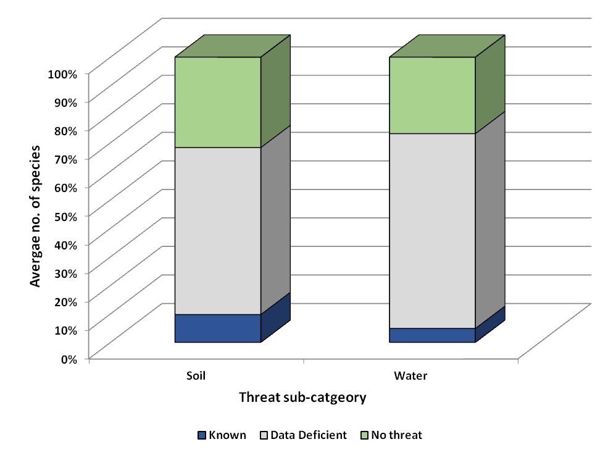
b
a
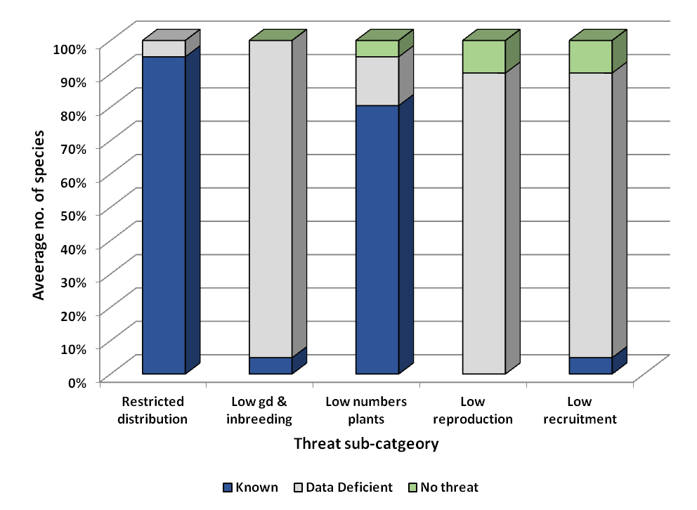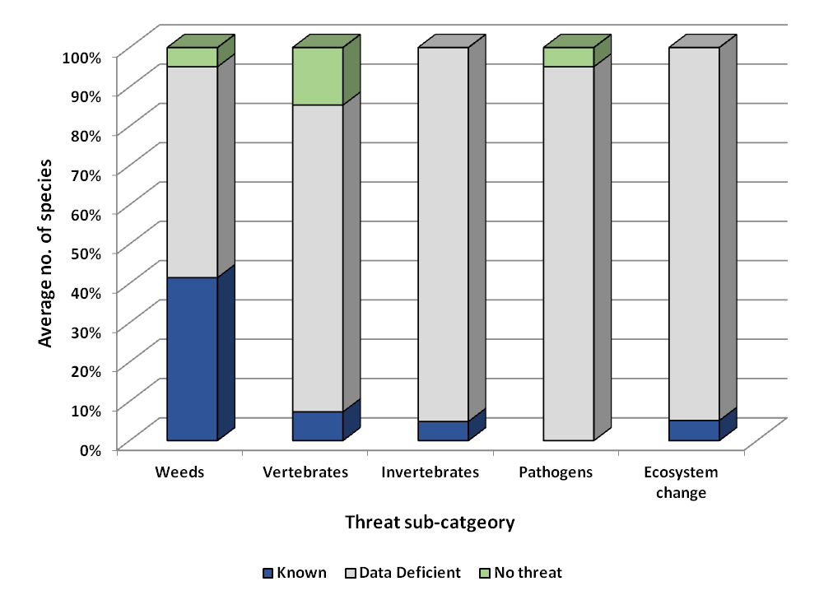
d
c
Figure 8: Average number of endangered species found in Commonwealth national parks assigned to sub-category threats for Climate (a), Biophysical (b), Invasives (c) and Genetic and demographic (d).

Knowledge gaps limiting species recovery
A synopsis of the biological knowledge gaps for the species assessed here is presented in Fig 9 with species-level gaps highlighted in Appendix C. These data were derived by assigning the available information to one of these following categories:

Information category | Information source
Available | Detailed information available for a species
Some | Some information available for a species
Inferred | Inferred using information from a closely related species or general species biology
None | No information available

Overall there was a general lack of information available on key plant traits likely to impact on persistence and recovery for most of these species. We know or could infer the main pollinators or pollinator groups to many of these species; we are also reasonable confident of the primary dispersal mechanisms. This does not, however, tell us whether these pollinators and dispersers necessary for species persistence still co-occur. This could be problematic for species that have specific plant-pollinator or -disperser associations if reduced population sizes have led to pollinator/disperser decline or extinction. A lack of pollinators is likely to lead to population decline through poor seed production while a limited disperser population will reduce opportunities for natural establishment in other parts of the national parks. Recovery efforts for some species are likely to be constrained if suitable pollinators and dispersers no longer exist.
Although we have reasonable confidence in the information available on germination and dormancy mechanisms of these species these traits are best assessed under experimental conditions. This will be challenging since these species are producing small quantities of seed, limiting the amount of experimentation that can be undertaken.
Other plant traits such as flowering time, reproductive strategy, clonality, longevity and polyploidy are poorly known for most species but are extremely important in terms of management and recovery. For example, knowing the reproductive strategy can help determine where new populations should be established to maintain pollinator interactions and gene flow. Polyploidy can be an issue if plants with different chromosomal background are brought together and produce sterile seed although we do not anticipate that this is a significant issue for most of these species. Understanding the longevity of these species allows parks staff to differentiate between threat-induced population decline and natural plant turnover. Knowing species flowering times can help to determine seed collection windows and may be important to track if climate change induces a shift in flowering that is not associated with a shift in pollinator activity (Parmesan 2006). If clonality occurs naturally within a species then inbreeding and low seed production may be less of a concern. This lack of basic biological information is a significant constraint to the recovery of these species.
The two categories for which we have the least information are symbiotic interactions and genetic diversity. Soil symbiotic interactions are primarily important for orchids as these require mycorrhizal fungi for germination (Arditti 1967) while legumes form associations with nitrogen-fixing bacteria; some highly restricted legumes are often associated with very specific bacterial types that are also highly geographically restricted (Thrall et al. 2000). Including nitrogen-fixing bacteria in restoration projects is known to have a beneficial effect on plant growth and survival (Thrall et al. 2005). Myrtaceous species also have mycorrhizal associations (Orians and Milewski 2007) and possibly also the ferns (Field et al. 2015). Understanding the nature, importance and role of soil symbionts will assist in the recovery of these species.
Genetic diversity is a key factor in population persistence and recovery. Only two of the 41 species assessed here have had a genetic diversity study undertaken. For some of these species there are now so few plants that a genetic assessment is unlikely to help in their recovery but there are several species that would benefit from having genetic information. Establishing how much genetic diversity exists within natural populations and where this diversity is distributed in the landscape will guide seed collection and restoration protocols. Genetic assessments of restored populations will determine whether these have a sufficient genetic base to ensure species persistence. This is especially important for populations that have already been established using cuttings as this process can often narrow the genetic base.

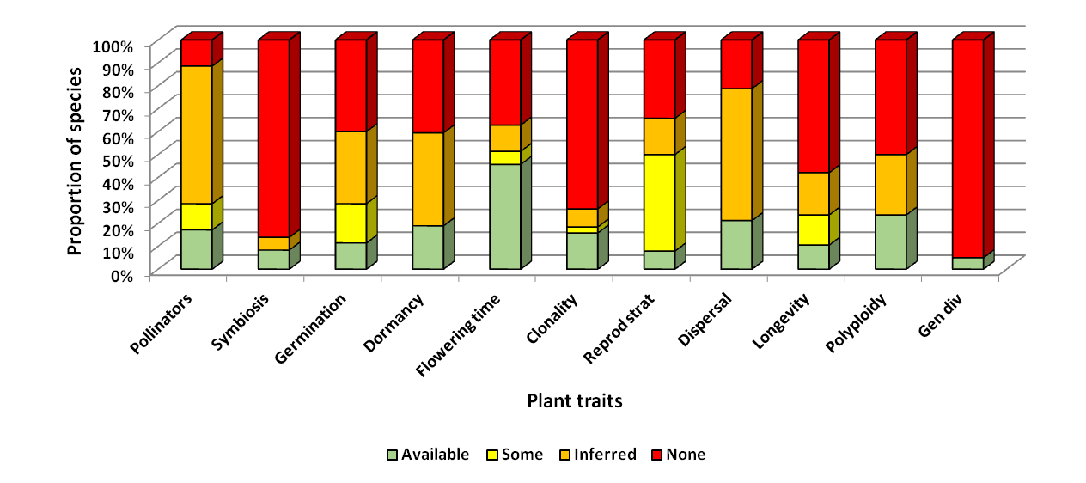
Figure 9: Information available on key plant traits that are likely to impact on species persistence.

Recommendations
This report does not constitute a recovery plan and it is not intended to replace existing species recovery and park management plans. Rather, it aims to identify key threats and knowledge gaps that are constraining species recovery and to provide recommendations for some of the most vulnerable plant species in Commonwealth national parks. Research recommendations are also provided to generate the critical information required to improve species management and recovery.
Not unexpectedly restricted distributions, low genetic diversity and low numbers of individuals are major threats to the persistence of many of these species in Commonwealth national parks. Although being geographically restricted will always characterise many species, especially those found on islands, increasing the number and size of populations will significantly reduce the likelihood of extinction. To do this, however, requires a basic understanding of species biology, having suitable germplasm (i.e. seed and/or cuttings), removal of threats from existing populations and appropriate restoration methods and planting sites. Consequently, we make the following recommendations:
- Develop a 5-10 year research program dedicated to investigating the biology of endangered plants species across national parks. To ensure the cost-effectiveness and utility of this program it will be necessary to prioritise species according to the likely improvement that this research will have on species recovery.

- Undertake genetic assessments for species where understanding the reproductive strategy, levels of genetic diversity and population genetic structure will directly improve species recovery by reducing the risks of inbreeding, helping to maximise the genetic base of restoration projects, and, ensuring that ex-situ seed collections are genetically representative and capable of restoring populations in the event of an extinction event.

- Partner with researchers and NGOs with restoration experience to draw on available scientific and onground knowledge to improve the outcomes of these activities.

- Explore opportunities to engage with the horticulture and nursery industries to provide the community and trade with access to rare plants to improve the understanding of these species and biodiversity more generally.

Climate change is predicted to have multiple consequences for endangered plants in Commonwealth national parks including an amplified risk of extinction associated with increases in drought, severe weather and fire events. Since these threats are already challenging to manage, it is unclear what actions can be taken to reduce these risks apart from spreading the likelihood of loss by increasing the number and size of populations and ensuring that ex-situ collections are appropriate for population re-establishment in the event of loss. At this stage climate change risks are inferred for the national parks through their climate change strategies but it is likely that some species will be less affected by change than others. Determining this, however, will be challenging without more information about the biology of these species. We suggest the following may help improve species management and recovery in light of the predicted changes:
- Develop a risk framework using information about a species biology, location and threat sensitivities to help define and prioritise actions under climate change.

- Provide national park staff with development opportunities to enhance their understanding and use of methodologies such as Adaptation Pathways when planning actions associated with climate change.

- Secure ex-situ collections (living and seed) of all threatened species not currently held as a matter of priority. An understanding of the storage and germination requirements of these species is also required to ensure that these can be successfully re-established under natural conditions.

- Consider the establishment of genetically diverse ‘insurance’ populations for some species which could be used to produce high quality seed/cuttings for re-introductions in a similar manner to ex-situ breeding programs for vertebrates. Including landholders and the horticultural industry in this process may help to improve community engagement and education regarding plants and their critical roles in our unique Australian ecosystems.

It will be extremely challenging to successfully recover some of these species as plant numbers appear to be already at critically low thresholds for species persistence and we have concerns that some may already be extinct. But for many species we were unable to ascertain current population numbers and sizes or their trajectories. Consequently, we strongly recommend that:
- Surveys of all endangered plant species in national parks not currently part of a formal monitoring program or that have not been surveyed within the last 2 years be undertaken. This will establish baseline data to assess population trajectories and measure the success of recovery programs as well as evaluate the risk and impact of threats. Ongoing monitoring at regular intervals will then be required.

- Explore opportunities for partnering with research institutions to develop long term monitoring programs (i.e. 10s of years) that will detect impacts associated with climate change, have clearly defined measures of success, and that avoid wasting resources by over-monitoring. Citizen science monitoring may also be helpful but these initiatives can require considerable time and some financial investment to be effective.

Many of the recommendations made here are likely to be beyond the current financial resources of the parks and additional resourcing will be required. However, some of this will be ‘one-off’ investments (e.g. genetic assessments) that will significantly improve our ability to recover these species whereas other recommendations will require additional ongoing resourcing (e.g. monitoring).
Finally, we strongly wish to point out that this assessment should not be viewed as a criticism of national parks staff or management – our findings simply reflect the challenges of managing the highly complex ecosystems that occur within Commonwealth national parks for multiple benefits that includes biodiversity conservation, tourism and cultural values.

References
Arditti J (1967) Factors affecting the germination of orchid seeds. The Botanical Review 33, 1-97.

Barrett SCH, Kohn JR (1991) Genetic and evolutionary consequences of small population size in plants: implications for conservation. In 'Genetics and Conservation of Rare Plants. (Eds DA Falk and KE Holsinger) pp. 3-30. (Oxford University Press: New York).

Broadhurst L, Cunningham S, Godfree R, Harwood T, Kirkegaard J, Williams K, Young A (2011) An Evaluation of Biodiversity Assets in the High Rainfall Cropping Zone (HRZ). CSIRO, Canberra.

Broadhurst LM, Jones TA, Smith F, North T, Guja L (2016) Maximizing Seed Resources for Restoration in an Uncertain Future. Bioscience 66, 73-79.

Carnegie AJ, Kathuria A, Pegg GS, Entwistle P, Nagel M, Giblin FR (2015) 'Impact of the invasive rust Puccinia psidii (myrtle rust) on native Myrtaceae in natural ecosystems in Australia.'

Enright NJ, Fontaine JB, Bowman DMJS, Bradstock RA, Williams RJ (2015) Interval squeeze: altered fire regimes and demographic responses interact to threaten woody species persistence as climate changes. Frontiers in Ecology and the Environment 13, 265-272.

Field KJ, Pressel S, Duckett JG, Rimington WR, Bidartondo MI (2015) Symbiotic options for the conquest of land. Trends in Ecology & Evolution 30, 477-486.

Gallagher RV, Leishman MR (2014) Invasive plants in Australia: implications for biodiversity. In 'Austral Ark. (Eds A Stow, N Maclean and G Howell) pp. 105-133. (Cambridge University Press: Cambridge).

Grice AC, Vanderduys EP, Perry JJ, Cook GD (2013) Patterns and processes of invasive grass impacts on wildlife in Australia. Wildlife Society Bulletin 37, 478-485.

Helenurm K (1998) Outplanting and differential source population success in Lupinus guadalupensis. Conservation Biology 12, 118-127.

Krull C, Galbraith JA, Glen AS, Nathan H (2014) Invasive vertebrates in Australia and New Zealand. In 'Austral Ark. (Eds A Stow, N Maclean and G Howell) pp. 197-226. (Cambridge University Press: Cambridge).

Orians GH, Milewski AV (2007) Ecology of Australia: the effects of nutrient-poor soils and intense fires. Biological Reviews 82, 393-423.

Parmesan C (2006) Ecological and evolutionary responses to recent climate change. Annual Review of Ecology, Evolution and Systematics 37, 637-669.

Rice A, Glick L, Abadi S, Einhorn M, Kopelman N, Salman-Minkov A, Mayzel J, Chay O, Mayrose I (2015) The Chromosome Counts Database (CCDB) – a community resource of plant chromosome numbers. New Phytologist 206, 19-26.

Thrall PH, Burdon JJ, Woods MJ (2000) Variation in the effectiveness of symbiotic associations between native rhizobia and temperate Australian legumes: interactions within and between genera. Journal of Applied Ecology 37, 52-65.

Thrall PH, Millsom DA, Jeavons AC, Waayers M, Harvey GR, Bagnall DJ, Brockwell J (2005) Seed inoculation with effective root-nodule bacteria enhances revegetation success. Journal of Applied Ecology 42, 740-751.

Turton SM (2012) Securing Landscape Resilience to Tropical Cyclones in Australia's Wet Tropics under a Changing Climate: Lessons from Cyclones Larry (and Yasi). Geographical Research 50, 15-30.

Information gathering template
National Park
Genus
Species
Family
Common Name
EPBC Act Category
% in CNP
Date last census
POSSIBLE IMPACTS | Climate-related | Drought
 |  | Habitat shifting and alteration
 |  | Severe weather events
 |  | Fire, including inappropriate fire regimes
 | Physical and biophysical | Soil degradation and erosion
 |  | Grazing
 |  | Pesticides
 |  | Water management and use
 |  | Mining and Quarrying
 |  | Roads and Railroads
 |  | Residential and Commercial Development
 | Human direct | Inappropriate conservation measures
 |  | Illegal collection
 |  | Trampling / Bushwalking
 | Invasive non-native / alien species | Weeds
 |  | Vertebrates
 |  | Invertebrates
 |  | Pathogens
 |  | Ecosystem changes by invasive species
 | Genetic and demographic risks | Restricted geographical distribution
 |  | Low genetic diversity and genetic inbreeding
 |  | Low numbers of individuals
 |  | Low reproduction
 |  | Low recruitment
 |  | Hybridisation

Species Information
The following summaries include all information and data sourced for each of the species assessed in this project. Shortened versions of this information are provided separately as Factsheets for each Commonwealth national park.

- Cryptostylis hunteriana (Orchidaceae) – Leafless Tongue Orchid, Furred Tongue Orchid, Booderee National Park
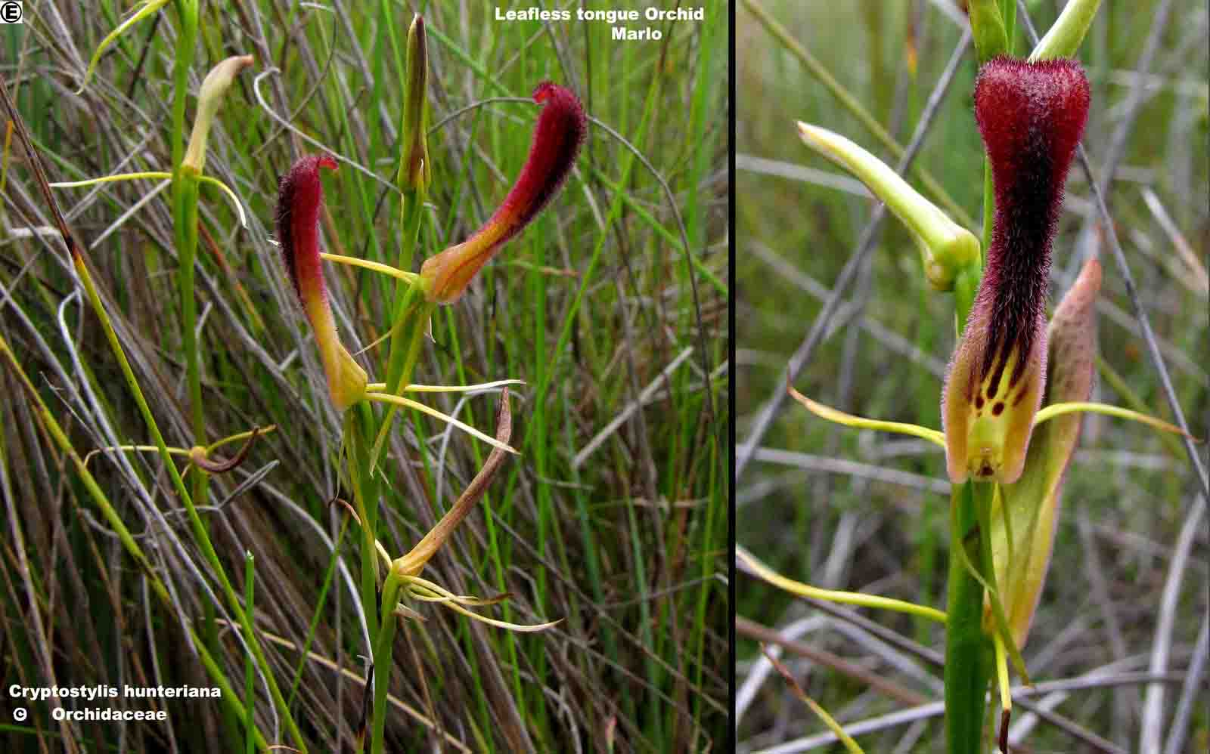
Figure B1.1 ©Orchidaceae (sourced from the Atlas of Living Australia)
The leafless tongue orchid is a small, perennial terrestrial orchid that lacks leaves and receives its nourishment from dead organic matter (saprophytic) in particular in partnership with a mycorrhizal fungus. The only time the plant is visible is when it is in flower. The flower is dominated by an erect, narrow and very hairy maroon ‘tongue’ (the labellum) with a black central band. (TSSC 2008, OEH 2014)
Taxonomy: Conventionally accepted as Cryptostylis hunteriana Nicholls (CHAH 2015, verified 9 July 2015).
Status: Listed as Vulnerable under the EPBC Act on 16 July 2000. Listed as Vulnerable under the NSW Threatened Species Conservation Act 1995 in May 2015. Listed as Threatened under the Victorian Flora and Fauna Guarantee Act in 2015.
Recovery Plan: Recovery plan not required, included on the ‘Not Commenced’ List (1 November 2009). (DoE 2009 and 2015).
This information is taken from SPRAT EPBC Listing (DoE 2015) unless otherwise referenced.

Number of populations inside and outside parks and reserves
The bulk of the known populations occur in NSW in highly localised populations of single plants or small colonies. There may be several hundred plants in Victorian populations but there is no available information on population size in Queensland. Bell (2001) recorded 13 populations outside of NSW national parks while a further 10 populations of unknown size occur in NSW national parks and two in nature reserves; two populations occur in Victorian National Parks and is not known to occur in Qld reserves (TSSC 2008).

Population size – range
The range, or extent of occurrence, is 132,117 km² based on Australia’s Virtual Herbarium data and area of occupancy is estimated at 38 km² based on 1 km² grid squares in which the species is thought to occur but these two measures are considered to have low reliability due to a lack of recent ground surveys (TSSC 2008). This species can be easily missed given that the species distribution is very broad, plants are only visible during flowering and that plants do not flower every season (Nov–Feb in NSW and Victoria; June–August in Qld; de Lacey et al. 2012).
Total population size is unknown but most of the populations occur in NSW. De Lacey et al. (2012) found this species occurred in a much wider range of habitats than previously known including heathlands, heathy woodlands, sedgelands, Xanthorrhoea spp. plains, dry sclerophyll forests (shrub/grass sub-formation and shrubby sub-formation), forested wetlands, freshwater wetlands, grasslands, grassy woodlands, rainforests and wet sclerophyll forests (grassy sub-formation) and across an altitudinal range of 10–1200 m ASL. De Lacey et al. (2012) also suggest that predictive modelling of potential habitat may be an important tool to determine other locations where this cryptic and rare species might occur.
In NSW, Alum Mountain State Forest near Bulahdelah is thought to be the largest population of this species with 104 plants north of Bulahdelah and 359 plants east of the town (TSSC 2008). It appears to be most common in the Shoalhaven area where 25 populations generally with <30 individuals occur (TSSC 2008). Plants in the South Coast populations include the Pigeon House Mountain area (20 plants) and the Manyana-Bendalong area (20 plants) were last observed or collected in 1996 and in 1970 for Lake Burrill (Bell 2001). Population information is not noted for Booderee (Jervis Bay) but population size varies between years.
In northern NSW, several coastal populations are known as well as two isolated inland sites on the tablelands in Gibraltar Range and Washpool National Parks but population sizes are unknown (TSSC 2008). Other North Coast populations of Nelson Bay (30–40 plants) and Lemon Tree Passage (50 plants) (Bell, 2001). Based on surveys in different areas of the Central Coast that took place between 1955–1999, populations are generally small or single plants. The total population size in NSW is estimated to be 1300–1500 plants. (TSSC 2008)
Victorian populations occur over 113 km in East Gippsland between Orbost and Mallacoota and are considered to consist of several hundred plants (TSSC 2008). The species is present in Croajingalong National Park, William Hunter Flora Reserve and one State Forest Estate (TSSC 2008). In Queensland the species is known from one plant near the village of Tinnanbar and four coastal populations north of the Glasshouse Mountains to Tin Can Bay (1998, Logan in TSSC, 2008). The Brisbane Herbarium and the Australian National Herbarium have records of populations occurring around Toowoomba (the closest Australian Virtual Herbarium record was collected north east of Toowoomba in 1998), Cooloola (2004), Maroochydore (possibly 2011 record - Emu Mtn, Cooloola National Park), D’agular Range (1998) and Tin Can Bay (1998) (AVH 2015).

Geographical distribution
Widespread but disjunct.
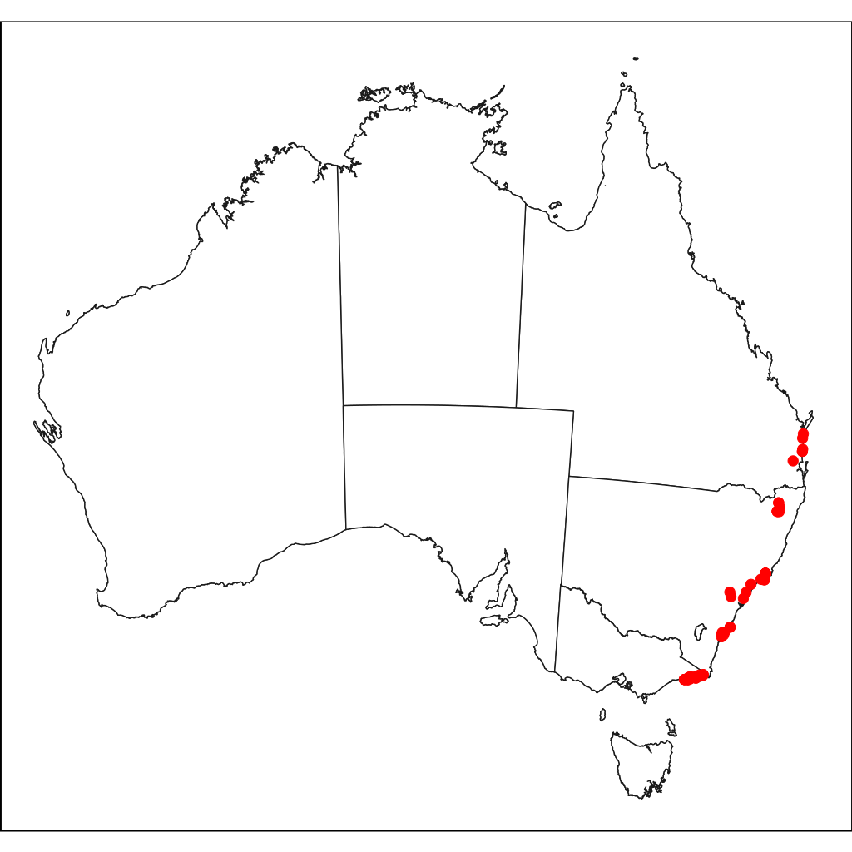
Figure B1.2 Distribution of Leafless Tongue Orchid in Australia. Red dots are specimen collections.
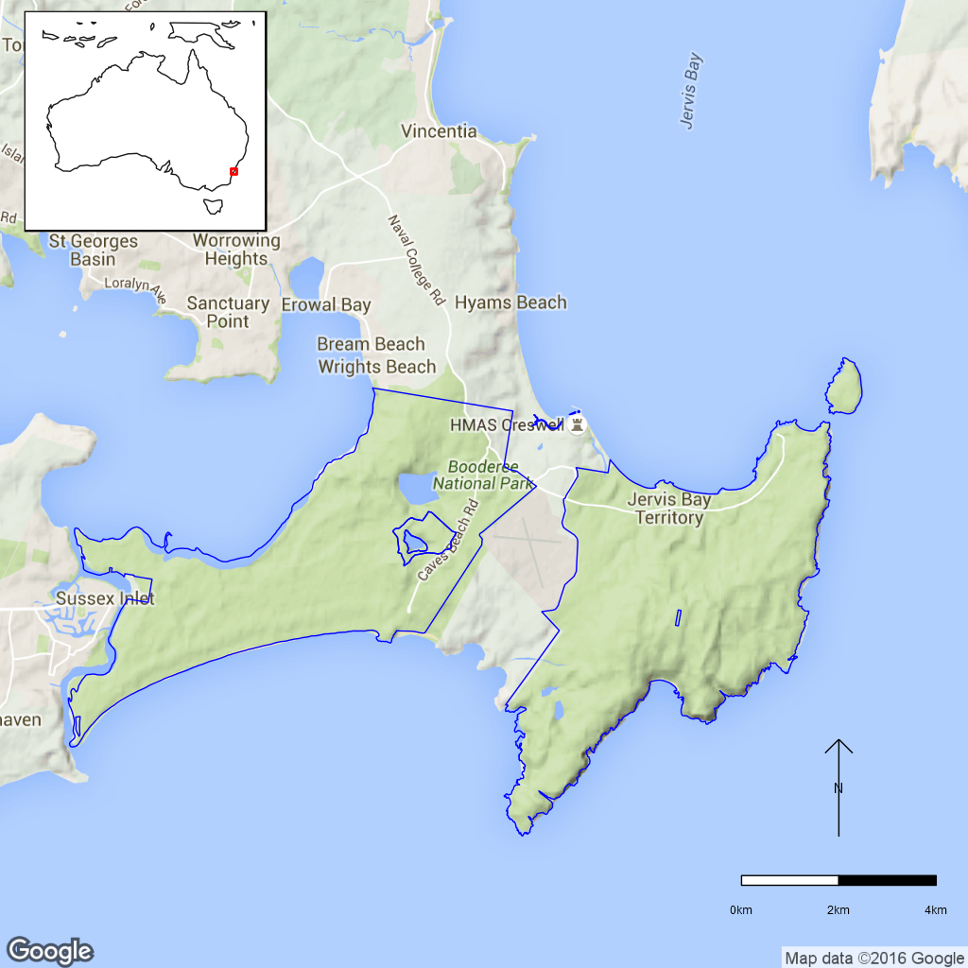
Figure B1.3 No specimen collections of Leafless Tongue Orchid exist for Booderee National
Park, however, there are specimens from the adjacent Conjola National Park (not shown).
The blue line is the park boundary.
A report from ngh environmental (2004) states that NSW NPWS Wildlife Atlas Database shows 18 records of this species clustered in five locations in the nearby Conjola National Park (west of Booderee across Sussex Inlet). Given the species occurrence across a wide range of habitats and its occurrence in an adjacent national park it is quite likely that this species does occur in Booderee National Park but surveying to find it might best be done 12–36 months after fire and during the flowering season (Bell, 2001).

Ex-situ collections (Living and Seed Bank)
The species is not conserved in Living Collections at the Australian National Botanic Gardens or Booderee Botanical Gardens or in the National Seed Bank (Zoe Knapp pers. comm. 12 October 2015 and Tom North pers. comm. 11 September 2015). No other ex-situ collections in any other Botanic Garden or Seed Bank have been located (ASBP 2016).

Biology
Pollinators: Pollination by male Ichneumon Wasp, Lissopimpla excelsa.
Symbiotic relationships: The orchid is a myco-heterotroph, it requires a symbiotic relationship with a mycorrhizal fungus to provide nutrition and is dependent on this relationship for germination and growth.
Germination requirements: The EPBC listing in 2008 states that this species has not been successfully propagated (http://www.‌environment.‌gov.au/sprat). Mycorrhizal fungi are essential for germination of this orchid’s seed (Anonymous, 2010, Clements and Howard 2011). Orchid seed imbibed in a petri dish can resist ‘deleterious’ fungi for about one month before running out of energy; if a fungi with which it could form a symbiosis arrives during that time then a germinant could survive, otherwise it will succumb to the deleterious fungi (Mark Clements pers. comm. 5 August 2015).
Dormancy class: Unknown. Some orchids have dormancy mechanisms that may allow them to take advantage of suitable germination and growing conditions or to wait until suitable fungi are available (Baskin and Baskin, 2014).
Flowering: November–February in NSW and Vic, June–August in Qld (de Lacey et al., 2012). Flowering intensity may be stimulated by fire events.
Breeding system: Sexual. Pollinated through pseudocopulation by the male Ichneumon Wasp (Lissopimpla excelsa) which are attracted to the flower by mimicking the sex pheromones of this species. Vegetative reproduction to form localised clumps is also suggested but has been questioned by Bell (2001) due to the species’ poorly developed root system. However, Mark Clements (pers. comm. 5 August 2015) suggests that almost half of the Bulahdelah population may not form clumps and may act as ephemerals while the remainder are clump-forming. This species is self-compatible (M. Clements pers. comm. 5 August 2015). At the Bulahdelah site Clements has also noticed low natural seed set with <5% of flowers ever setting seed. Seed capsules can have around 3,500 seed per capsule. While the seed have a resilient coat these do not last long in the soil. Alan Stephenson (pers. comm. 2015) has also found the species to have low natural seed set in the Booderee region based on over 30 years of observations.
Dispersal: Leafless Tongue-orchid is spread either by wind or by seed being dropped in the immediate vicinity of the parent plant once the flower head has fallen over.
Longevity: Perennial (length unknown). At the Bulahdelah site it appears that many plants (possibly 40% of the population) are acting as ephemerals by germinating rapidly, flowering within 18 months and then dying. Many plants that were dug up during translocations at this site had very small, thins stems and small, simple underground rhizomes (2–5cm long) which were often shrivelled. The other part of the population produce bigger rhizomes and form perennial clumps (M. Clements pers. comm. 5 August 2015).
Life form: Orchid.
Ploidy levels: Unknown.
Role of the plant in the environment: Unknown.

Threats

Listed Threats (EPBC Act)
- Illegal collection
- Loss or fragmentation of habitat and/ or subpopulations
- Human induced disturbance due to unspecified activities
- Competition and/or habitat degradation: Bitou Bush
- Competition and/or habitat degradation by weeds
- Predation, competition, habitat degradation and/or spread of pathogens by introduced species
- Alteration of hydrological regimes and water quality
- Inappropriate and/or changed fire regimes (frequency, timing, intensity)
- Habitat loss, modification and fragmentation due to urban development
- Pesticide application
Outside of national parks the biggest threat to populations are development pressures in many coastal regions such as earthworks, housing developments and road construction (e.g. Bulahdelah Bypass). This may be especially so if surveys have missed the presence of this species due to lack of flowering at the time of the survey or its small size. Development may also lead to site fragmentation and result in disruption to pollination and seed dispersal for this species, by creating barriers between populations. (TSSC 2008). Also, changes in drainage resulting in unsuitable soil micro-climatic conditions, and loss of the mycorrhizal fungi upon which this species entirely depends (TSSC 2008). The leafless tongue orchid does appear to be susceptible to slight changes in soil moisture content. Flowers at the Bulahdelah site sometimes wilted prior to setting seed in both dry and wet years (Mark Clements pers. comm. 5 August 2015).
Fire, which can stimulate flowering, can also damage populations if it occurs at the wrong time of the year (e.g. during flowering and before seed set). Frequent or inappropriate fire regimes, resulting in significant alteration of the site ecology will also affect populations (TSSC 2008).
This species is also potentially at risk from illegal collection and invasion by weeds such as Bitou Bush (Chrysanthemoides monoilifera) in some localised areas close to roads, settlements and coastal locations. This is only likely to impact on BNP populations where the two species habitats overlap.

Other Threats/Potential New threats
For Leafless Tongue Orchid to persist in an area, the size of the habitat must be large enough to support both the plant and the associated pollinator. The area needed to maintain a population of Ichneumon Wasp pollinators is estimated to be 50 ha. (A. Stephenson pers. comm. 20 December 2015).

Knowledge Gaps
Species biology and life history including symbiotic relationships, seed dormancy, seed germination, genetic diversity, time to maturity and longevity of this species are unknown or poorly understood.
There are no records that this species has been found in BNP even though it is presumed to have suitable habitat. If it does occur here, determining the current population size is necessary although surveying for this species can be difficult as it is small and does not flower every year. Preliminary work has been done on propagation but seed storage and propagation are still problematic.

Suggested research and actions
Research priorities listed in the Conservation advice (TSSC 2008) that apply to the whole of the species are:
- Develop and implement a monitoring program.
- More precisely assess population size, distribution, ecological requirements and the relative impacts of threatening processes.
- Undertake survey work in suitable habitat and potential habitat to locate any additional populations.
- Undertake seed germination and mycorrhizal association trials to determine the requirements for successful establishment of Leafless Tongue-orchid.
- Identify pollinators (N.B. the Bulahdelah work has subsequently identified that pollination was through pseudocopulation by male Ichneumon Wasp, Lissopimpla excelsa).
Specific priorities for BNP:
- Survey at the appropriate time of year in suitable habitat for presence of the Leafless Tongue Orchid in the national park. The chance of finding this species is likely to increase after fire.

Species management
Mark Clements (pers. comm. 5 August 2015) suggests that the two main management tools for successful retention of this species at a site are hand pollination and a fire frequency interval of 10–15 years. A report on implications of fire for this species (ngh environmental 2004) is only able to highlight examples where fire may be helpful for recruitment but does mention other authors (Backhouse and Jeanes 1995) who list ‘altered fire regimes’ as a potential threat to this species if fires occur during flowering period and prevent seed production. Given the ephemeral nature of some plants noted by Clements (2015) seed is likely to be the major method of recruitment for the species and for its persistence at a particular site. Translocation at the Bulahdelah site had a low success rate, around 2–5%, due to many plants being small with simple underground rhizomes 2–5 cm. Hand pollination on the other hand appeared to be quite successful (M. Clements pers. comm. 5 August 2015).
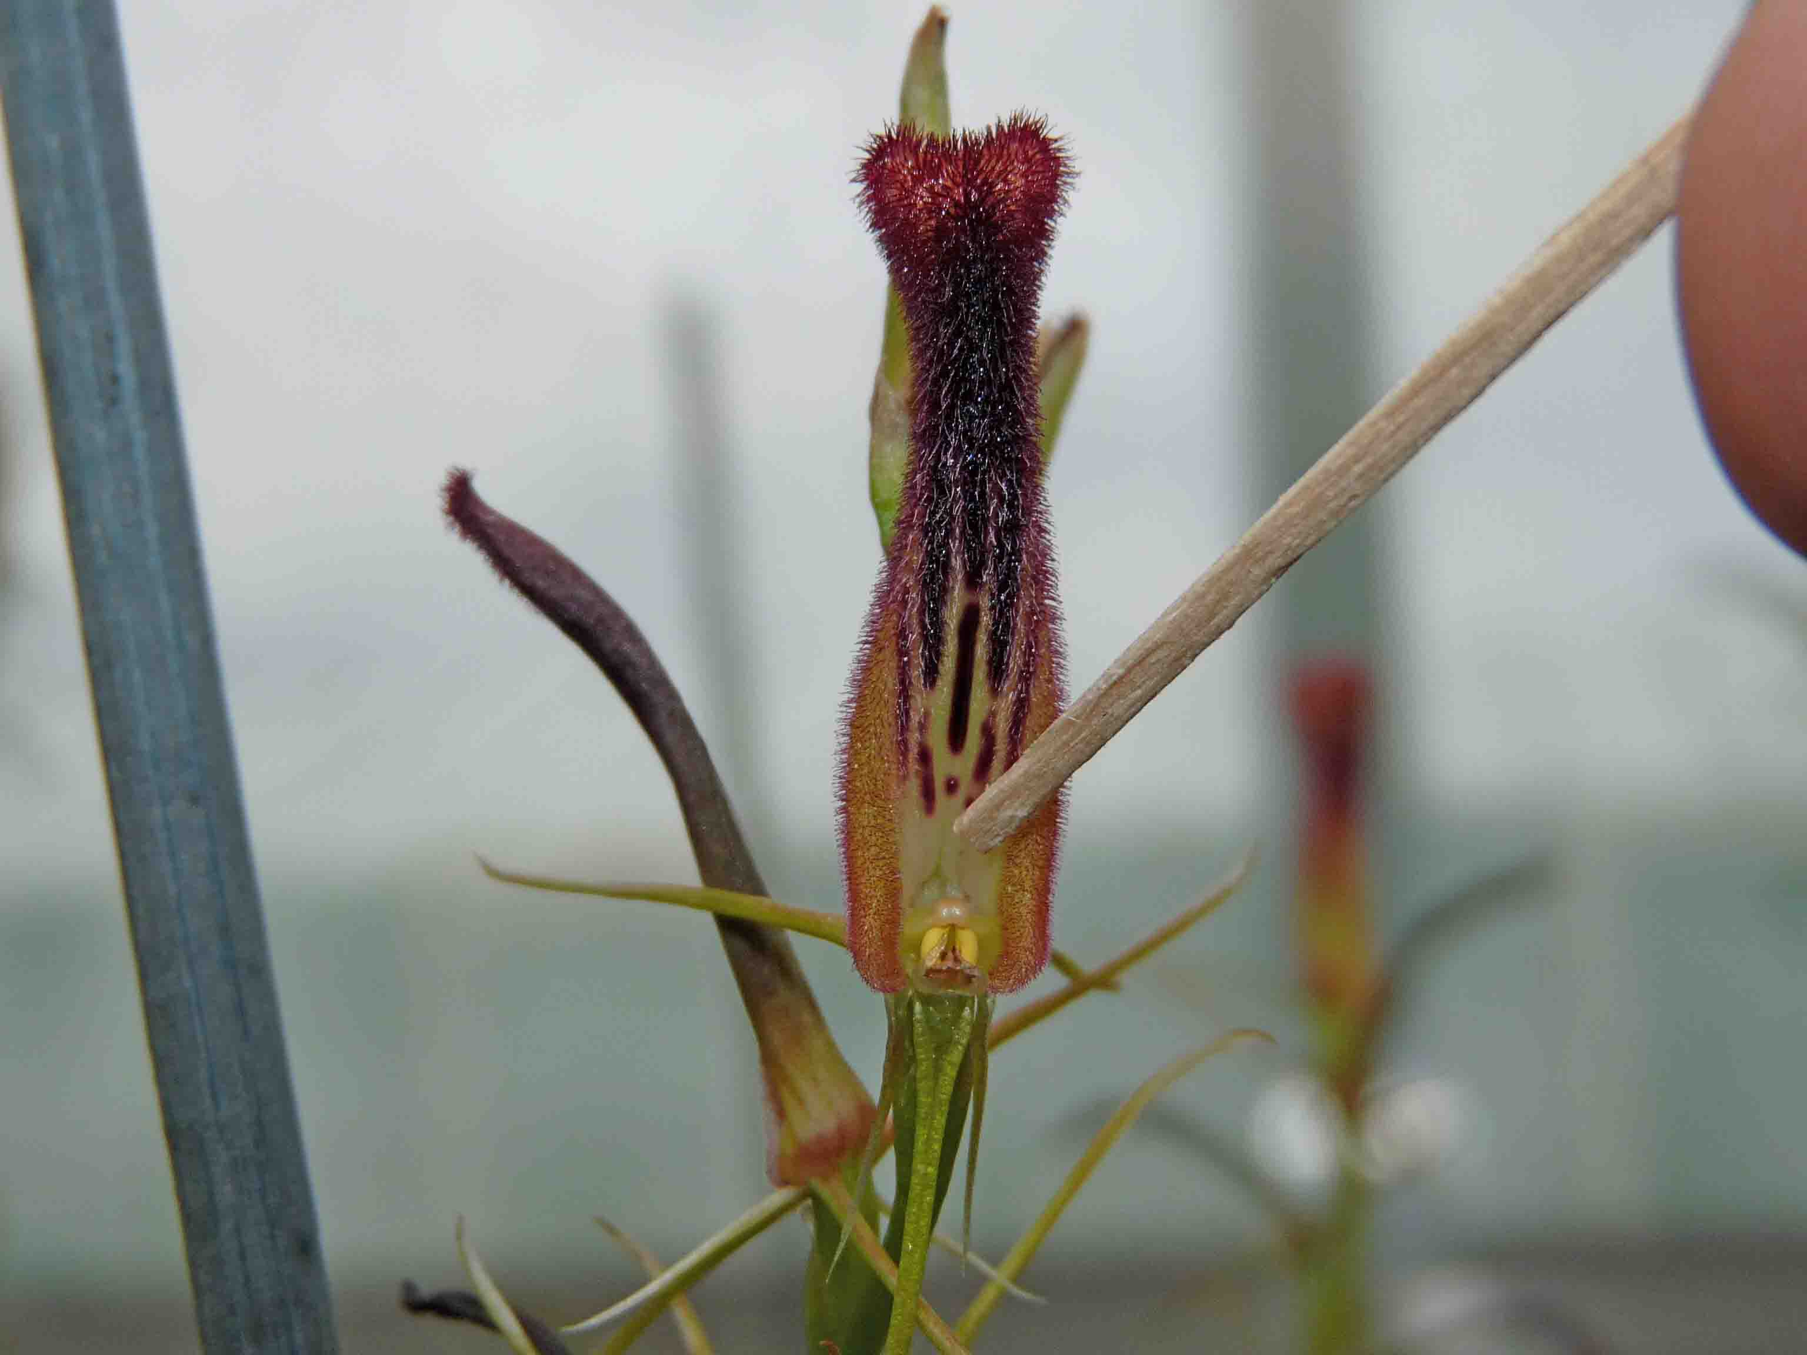
Figure B1.4 Hand pollination of a Cryptostylis hunteriana flower.
©Dr Chris Howard CSIRO science image.

References:
Anonymous, 2010. CSIRO: Scientists find new home for threatened orchids. M2 Presswire. Newspaper Article. ProQuest search. Available from http://search.proquest.com/. Accessed 21 April 2015.
Atlas of Living Australia (2015). Cryptostylis hunteriana Herbarium specimen records [Online]. Available from http://www.ala.org.au/. Accessed 21 April 2015.
Australian Seed Bank Partnership (2016). Search for records in the Australian Seed Bank [Online]. Council of Heads of Australian Botanic Gardens Inc. Cryptostylis hunteriana. Available from http://asbp.ala.org.au/search. Accessed 11 February 2016.
Australian Virtual Herbarium (2015). Australian Plant Census. [Online]. Available from http://biodiversity.org.au/nsl/services/apc. Accessed 21 April 2015.
Backhouse G and Jeanes J (1995).The Orchids of Victoria. Melbourne University Press, Melbourne.
Baskin CC and Baskin JM (2014). Seeds. Ecology, Biogeography, and Evolution of Dormancy and Germination. Elsevier, Academic Press, San Diego, CA, USA.
Bell AJ (2001). Notes on population size and habitat of the vulnerable Cryptostylis hunteriana (Orchidaceae) from the Central Coast of New South Wales. Cunninghamia. 7:195–203.
Clements MA and Howard C (2009). Bulahdelah Bypass Orchid recovery Project. PowerPoint presentation. Available from https://www.anbg.‌gov.au/cpbr/program/ha/Bulahdelah/Bulahdelah-Bypass-Project-Jan-2009.pdf. Accessed 13 July 2015.
Council of Heads of Australian Herbaria (CHAH) (2015). Australian Plant Census. [Online]. Available from http://biodiversity.org.au/nsl/services/apc. Accessed 21 April 2015.
CSIRO Science Image (2010). Scientists find new home for threatened orchids. CSIRO Media Release – 3 June 2010. Ref 10/78. Hand pollination of a Cryptostylis hunteriana flower [Image]. Available from http://www.scienceimage.csiro.au/. Accessed 13 July 2015.
de Lacey C, Bell S, Chamberlain S, Bossard K (2012). Habitat of the Leafless Tongue Orchid (Cryptostylis hunteriana) throughout its known Australian distribution. Australasian Plant Conservation. 20:23–25.
Department of the Environment (2009). Recovery planning action not commenced list at the time of EPBC Act amendments. February 2007 (revised June 2009, corrected November 2009). Available from http://www.environment.gov.au/biodiversity/threatened/recovery-plans. Accessed 11 August 2015.
Department of the Environment (2015). Cryptostylis hunteriana in Species Profile and Threats Database, Department of the Environment, Canberra. Available from http://www.environment.gov.au/sprat. Accessed 11 August 2015.
Department of Environment (2015). Species of National Environmental Significance Map Summary Version 2, Commonwealth of Australia. Available from https://www.environment.gov.au/science/erin/databases-maps/snes. Accessed 24 February 2015.
Director of National Parks (2015). Booderee National Park Management Plan 2015-2025 [Online]. Australian Government, Department of the Environment. Available from https://www.environment.gov.au/resource/booderee-national-park-management-plan-2015-2025. Accessed 3 February 2016.
Hartland, R. Photograph from gallery for Cryptostylis hunteriana in Atlas of Living Australia (ALA) website. Available from http://www.ala.org.au/. Accessed 5 July 2015.
ngh environmental (2004). Vegetation Response to Fire Monitoring in Narrawallee Creek Nature Reserve, Conjola and Morton National Parks. Available from https://www.environment.nsw.gov.au/resources/nature/UlladullaVegetationResponse.pdf. Accessed 13 July 2015.
Office of Environment and Heritage, NSW (2014). Leafless Tongue Orchid – profile. NSW Government Office of Environment and Heritage. Available from http://www.environment.nsw.gov.au/threatenedspeciesapp/profile.aspx?id=10187. Accessed 13 July 2015.
Threatened Species Scientific Committee (2008). Approved Conservation Advice for Cryptostylis hunteriana (Leafless Tongue-orchid). Approved by the Minister / Delegate of the Minister on: 3/07/2008. Available from http://www.environment.gov.au/sprat. Accessed 11 August 2015.


- Dracophyllum oceanicum (Ericaceae) – Jervis Bay Dragon Leaf, Booderee National Park
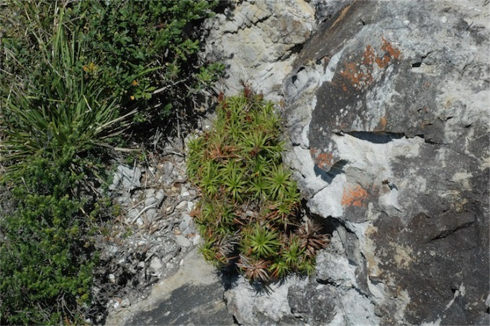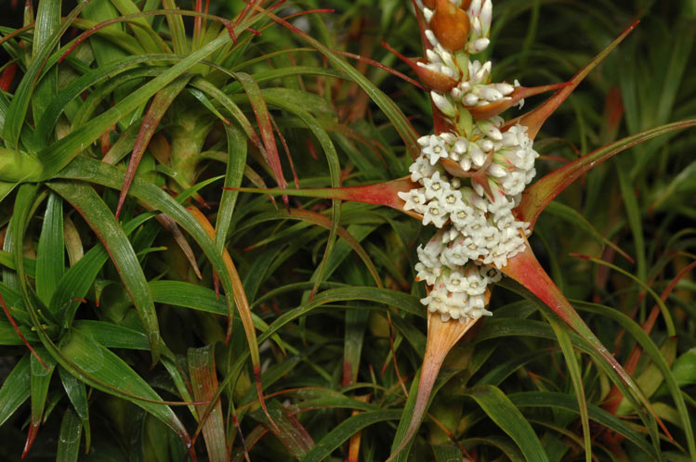
Figure B2.1 Dracophyllum oceanicum on cliff tops at Jervis Bay NSW (left) and of flowers at Australian National Botanic Gardens (right). ©M. Fagg Australian National Botanic Gardens Photo No’s. dig 33201 and dig 30757.
The NSW Flora Online (The Royal Botanic Gardens and Domain Trust 2015) describes this species as a shrub varying from low and prostrate to robust and erect and spreading in more sheltered positions. It can grow up to 2.5 m tall and stems often branch extensively near the base. Leaves (1.2–1.7 cm long and 1.4–2.1 cm wide) are erect and become recurved and sheathing at the base. The flowers are white, erect to spreading with bracts that are often distinctively rose-coloured becoming brown with age. The fruit are brown.
Taxonomy: Conventionally accepted as Dracophyllum oceanicum E.A.Br. and N.Streiber (CHAH 2012, verified 5 November 2015).
- Synonym: Dracophyllum sp. ‘Jervis Bay’ (Brown 98/80) (APNI).
Status: This species is not listed under the EPBC Act but is listed as a Significant Species in the Draft Booderee National Park Management Plan (2011) because it grows only in the Jervis Bay area on cliff faces at Booderee and Beecroft Peninsulas.
Recovery Plan: A recovery plan is not required for this species as it is not listed under the EPBC Act.

Number of populations inside and outside parks and reserves
Only one site of this species is known in Booderee National Park at the Cape St George Ruined Lighthouse site (S. Pedersen pers. comm., 26 November 2015). Other specimen collections have been made outside the national park on Beecroft Peninsula on the Northern side of Jervis Bay (ALA 2015).

Population size – range
This species is probably restricted to the coastal cliffs and small bays of the north and south heads of Jervis Bay (The Royal Botanic Gardens and Domain Trust 2015) but population sizes are unknown.

Geographical distribution
Regional and disjunct.
Dracophyllum occurs in Australia, New Zealand and New Caledonia with Australian Dracophyllum being remnants of older lineages that are now fragmented and disjunct. There are five Australian Dracophyllum species that appear to the remaining relicts of a more widely distributed forest flora (Wagstaff et al. 2010). Dracophyllum oceanicum is restricted to coastal cliffs and small bays on the north and south heads of Jervis Bay, NSW. It is rarely found more than 50 m from the sea typically between 10–60 m ASL (S. Pedersen pers. comm. 26 November 2015, Wagstaff et al. 2010). It occurs on coastal cliffs overlooking the ocean, or at the base of cliffs and on stream margins in sheltered bays on a sandstone substrate. This sandstone is of the Conjola Formation which is part of the Permian Shoalhaven group (The Royal Botanic Gardens and Domain Trust 2015).
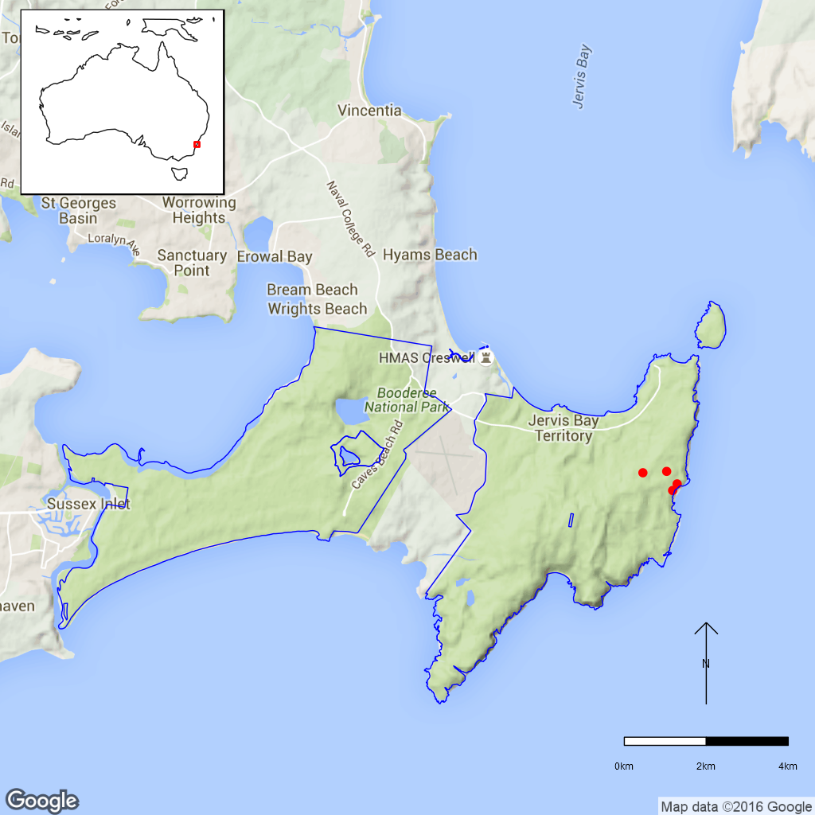
Figure B2.2 Distribution of Dracophyllum oceanicum in Booderee National Park.
Red dots are specimen collections, the blue line is the park boundary.

Ex-situ collections (Living and Seed Bank)
Dracophyllum oceanicum is held as ex-situ plantings at the Australian National Botanic Gardens and Booderee Botanical Gardens but no seed collections are held at the National Seed Bank (M. Henery pers. comm. 26 November 2015). Currently four plants at Booderee Botanic Gardens have been propagated from seed with another 12 plants being propagated by cuttings (S. Pedersen pers. comm. 26 November 2015). No other ex-situ collections in any other Botanic Garden or Seed Bank have been located (ASBP 2016).

Biology
Pollinators: Unknown.
Symbiotic relationships: Ericoid mycorrhizal fungi occur in the closely-related D. secundum, but it was hypothesised that these may be seasonal and vary with location (Allan et al. 1989).
Germination requirements: Australian growers have found seed from this Ericaceae sub-family (Styphelioideae) difficult to collect as seed ripen and are dispersed very quickly (ANPSA 2009). It can also be technologically difficult to work with both the seed and seedlings of the Styphelioideae as the seed is very fine and seedlings are tiny with fragile, fine hair roots (ANPSA 1999). The closely-related species, D. secundum, is known to be difficult to propagate from cuttings (ANPSA 2010). A study on heat and smoke effects on D. secundum germination showed that neither pre-treatment improved germination rates (Thomas et al. 2003). At Booderee National Park success with cuttings has been quite low, 10% and 20% respectively for two different events (S. Pedersen pers. comm. 26 November 2015).
Dormancy class: Unknown.
Flowering: August–December (April) (The Royal Botanic Gardens and Domain Trust, 2015).
Breeding system: Unknown.
Dispersal: Dracophyllum species have a capsular fruit and produce numerous small seed within each capsule; these could be dispersed by wind, birds or water (Wagstaff et al. 2010).
Longevity: Unknown.
Life form: Shrub.
Ploidy levels: The chromosome number of D. oceanicum is unknown. All Dracophyllum chromosome numbers available in the Chromosome Counts Database (Rice et al. 2015) have 2n = 26 so there is no indication of polyploidy in the genus.
Role of the plant in the environment: Unknown.

Threats

Listed Threats (EPBC Act)
As Dracophyllum oceanicum is not currently listed under Commonwealth or State Legislation threats to this species are unknown.

Other Threats/Potential New threats
- The populations of Dracophyllum oceanicum appear to be disjunct and it is likely that individual plant numbers are low.
- Small population sizes suggest that genetic diversity is low.
- Climate change is predicted to result in increasing periods of drought, increased frequency and intensity of fires, and increasing frequency and intensity of storm activity (DNP 2010, DNP 2015). Increased storm intensity could cause loss of individuals and populations given their habitat on steep cliff faces.
- Weeds – currently no infestation at sites observed at Booderee and Beecroft Peninsula (S. Pedersen pers. comm. 26 November 2015)

Knowledge Gaps
Species biology and life history including pollination syndrome, symbiotic relationships, seed dormancy, breeding system, genetic diversity, and time to maturity and longevity of this species are unknown.

Suggested research and actions
- Establish a monitoring program to provide baseline and ongoing data for determining population trajectories and the relative impacts of threatening processes.
- Survey suitable habitat for new populations although this may be challenging given the location on cliffs.
- Determine key life history parameters including pollination syndrome, symbiotic relationships, seed dormancy, breeding system, age to maturity, longevity to assist with species management.
- Secure genetically representative ex-situ seed collections, in multiple locations if appropriate, to mitigate against the loss of natural populations and provide for re-establishment should sever losses or extinction occur.
- Undertake a genetic assessment to determine the reproductive strategy, levels of genetic diversity and inbreeding and if any genetic structure exists to assist with any future translocation program.

References
Allan WK, Allaway WG, Cox GC and Valder PG (1989). Ultrastructure of mycorrhizas of Dracophyllum secundum R.Br. (Ericales: Epacridaceae). Australian Journal of Plant Physiology 16: 147–153.
Atlas of Living Australia (ALA) (2015). Australia’s species, Dracophyllum oceanicum. Available from http://www.ala.org.au/. Accessed 9 November 2015.
Australian Native Plant Society (Australia) (1999). Epacrids from Cuttings. Australian Plants online – December 1999. Available from http://anpsa‌.org.au/. Accessed 13 November 2015.
Australian Native Plant Society (Australia), 2009. The Australian Heath Family – Propagation. Available from http://anpsa.org.au/. Accessed 13 November 2015.
Australian Native Plant Society (Australia) (2010). Dracophyllum secundum. Available from http://anpsa.org.au/. Accessed 13 November 2015.
Australian Plant Name Index (APNI). National Species List. [Online]. Australian National Herbarium, Australian National Botanic Gardens and Australian Biological Resources Study. Available from https://biodiversity.org.au/boa/name/apni/239416. Accessed 9 November 2015.
Australian Plants Online (1999). Epacrids from Cuttings by Ross Doig. Available from http://anpsa.org.au/APOL16/dec99-6.html. Accessed 13 November 2015.
Australian Seed Bank Partnership (2016). Search for records in the Australian Seed Bank [Online]. Council of Heads of Australian Botanic Gardens Inc. Dracophyllum oceanicum. Available from http://asbp.ala.org.au/search. Accessed 11 February 2016.
Council of Heads of Australian Herbaria (CHAH) (2012). Australian Plant Census. [Online]. Australian Plant Census. [Online]. Available from http://biodiversity.org.au/nsl/services/apc. Accessed 9 November 2015.
Director of National Parks (2010). Booderee National Park Climate Change Strategy 2010-2015. [Online]. Australian Government, Department of Environment. Available from https://www.environment.gov.au/resource/climate-change-strategy-2010-2015-booderee-national-park. Accessed 6 November 2015.
Director of National Parks (2015). Booderee National Park Management Plan 2015-2025 [Online]. Australian Government, Department of the Environment. Available from https://www.environment.gov.au/resource/booderee-national-park-management-plan-2015-2025. Accessed 3 February 2016.
Rice A, Glick L, Abadi S, Einhorn M, Kopelman NM, Salman-Minkov A, Mayzel J, Chay O and Mayrose I (2015). The Chromosome Counts Database (CCDB) – a community resource of plant chromosome numbers. New Phytologist 206: 19–26. Available from http://ccdb.tau.ac.il/home/. Accessed 13 November 2015.
The Royal Botanic Gardens and Domain Trust (2015). PlantNET – the Plant information Network System of the Royal Botanic Gardens and Domain Trust, Sydney (version 2.0). Available from http://plantnet.rbgsyd.nsw.gov.au. Accessed 9 November 2015.
Thomas PB, Morris EC and Auld TD (2003). Interactive effects of heat shock and smoke on germination of nine species forming soil seed banks within the Sydney region. Austral Ecology 28: 674–683.
Wagstaff SJ, Dawson MI, Venter S, Munzinger J, Crayn DM (2010). Origin, diversification and classification of the Australasian genus Dracophyllum (Richeeae, Ericaceae). Annals of the Missouri Botanical Garden 97: 235–258.
- Galium australe (Rubiaceae) – Tangled Bedstraw, Booderee National Park
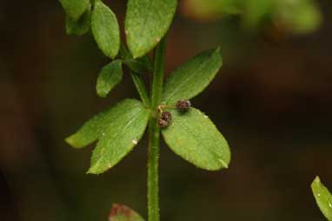
Figure B3.1 Galium australe at Yanununbeyan State Conservation Area near Captain’s Flat NSW.
© M. Fagg, Australian National Botanic Garden, Photo No. dig 21660.
Tangled Bedstraw is a straggling or intertwining perennial with weak, hairy stems up to 60 cm long; leaves (1.2 cm long and 0.4 cm wide) are in whorls of four; the flowers are white and the fruit that has many, transparent hooked hairs (The Royal Botanic Gardens and Domain Trust, 2015). Thompson (2009) indicates that the flowers are cream or greenish-cream, occasionally tinged purplish-red and are glabrous (i.e. not hairy). The fruit are dull dark brown and 1–1.3 mm long and c. 0.8 mm wide (Thompson 2009).
Taxonomy: Conventionally accepted as Galium australe DC. (CHAH 2011, verified 5 November 2015).
Status: Listed as Endangered under the NSW Threatened Species Conservation Act 1995 (TSC Act) on 17 December 2004.
Recovery Plan: There is no recovery plan for this species. It is relatively abundant in Victoria and Tasmania with relatively large populations within reserves in those states; <10% of the species’ population occurs in NSW. The NSW Office of Environment and Heritage (OEH) Species Action Statement for Tangled Bedstraw states that this species has been assigned to the Partnership species management stream under the ‘Saving our Species’ program. OEH are currently developing a targeted approach for managing Partnership Species, but in the interim have a range of management actions identified for this species. These include fencing of populations adjoining urban development and conserving all populations and carrying out experimental burning in a dense shrubland population (OEH 2014).
This information is taken from the NSW Department of Environment and Heritage Listing (OEH 2014) unless otherwise referenced.

Number of populations inside and outside parks and reserves
“Tangled Bedstraw is widespread in Victoria and Tasmania and is also found in South Australia and Australian Capital Territory in Jervis Bay. Following a taxonomic revision, many records in NSW have been re-determined as other species. Tangled Bedstraw has been recorded historically in the Nowra (Colymea) and Narooma areas and is extant in Nadgee Nature Reserve, south of Eden. Records in the Sydney area are yet to be confirmed.” (OEH 2014).
“In NSW it is currently known from 13 locations between Sydney and Eden, with an outlying record to the north from near Byabarra on the north coast. Two populations occur in nature Reserves, four in National Parks, two in a Regional Park and the remainder on freehold and crown land. Populations of G. australe are generally small, comprising few individuals.” (OEH 2011).

Population size – range
Tangled Bedstraw occurs in southern NSW, southern Victoria, far south-eastern South Australia and Tasmania. It grows mostly on or near coasts, often in sandy soils in shrub land and forest (Thompson 2009). The NSW Scientific Committee recommended Tangled Bedstraw for listing as Endangered in NSW and estimates the total number of plants in NSW to be <200. In Booderee National Park this species was last recorded in 2002 in the Lake Windermere area where the number of plants was estimated to be <10 (S. Pedersen pers. comm. 27 November 2015). ‘Quite a bit of Tangled Bedstraw’ was observed one year after fires in 2009 but it has not been observed since (N. Dexter pers. comm. 27 November 2015).

Geographical distribution
Regional and disjunct. In NSW, the species is known to occur in the following regions and habitats:
- Comboyne Plateau and Macleay Hastings regions in the Northern Rivers district.
- Cumberland and Pittwater in Sydney Blue Gum – Blackbutt – Smooth-barked Apple moist shrubby open forest on shale ridges of the Hornsby Plateau, Sydney Basin Bioregion.
- Southern Rivers – Bateman, Bungonia (east of Shoalhaven River), Ettrema (areas not on Hawkesbury sandstone), Jervis, Kybeyan-Gourock (Part A), South east Coastal Plains and predicted to occur in the South East Coastal Ranges (Part C) in the following habitats: 1. Bangalay – Old-man Banksia open forest on coastal sands; 2. River Peppermint – Rough-barked Apple – River Oak herb/grass riparian forest of coastal lowlands; 3. Woollybutt – White Stringybark – Forest Red Gum grassy woodland on coastal lowlands; 4. Coast Banksia – Coast Tea-tree low moist forest on coastal sands and headlands; 5. Blackbutt – Turpentine – Bangalay moist open forest on sheltered slopes and gullies. (OEH 2011).
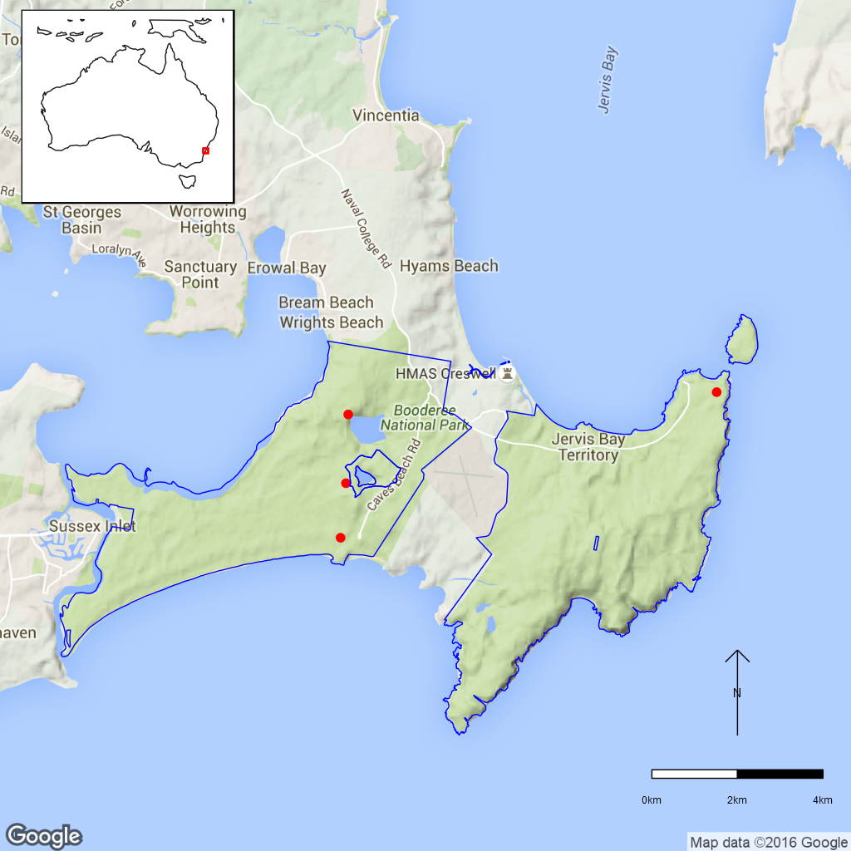
Figure B3.2 Distribution of Galium australe in Booderee National Park. Red dots
are specimen collections, the blue line is the park boundary.

Ex-situ collections (Living and Seed Bank)
This species is not conserved in the Living Collections at the Australian National Botanic Gardens or Booderee Botanical Gardens or in the National Seed Bank (M. Henery pers. comm. 26 November 2015, S. Pedersen pers. comm. 27 November 2015). No other ex-situ collections in any other Botanic Garden or Seed Bank have been located (ASBP 2016).

Biology
Pollinators: Unknown.
Symbiotic relationships: Unknown.
Germination requirements: Unknown.
Dormancy class: Unknown.
Flowering: Spring and summer.
Breeding system: Based on the percentage of fruit set, Thompson (2009) suggests that many Galium species are inbreeding but that some are also outbreeding. Fruit set in Tangled Bedstraw is generally high suggesting that it is outbreeding. Rhizomes not seen (Thompson 2009).
Dispersal: Fruits are described as having numerous hooked hairs. Dempster (1981) states that these hooked (uncinate) hairs cause the fruit to stick to clothing suggesting that dispersal by vertebrate is likely.
Longevity: species in this genera can be either annual or perennial herbs (Thompson 2009) so research is required to determine Tangled Bedstraws likely life-span.
Life form: Intertwining herb.
Ploidy levels: Unknown.
Role of the plant in the environment: Unknown.

Threats

Listed Threats [NSW Threatened Species Conservation Act (TSC Act)]
- Critically low population numbers in some populations.
- Grazing by domestic stock.
- Absence of a forest or woodland buffer around remnants exacerbates the other threats.
- Rubbish dumping and visitor use.

Other Threats/Potential New threats
- In the final determination for Tangled Bedstraw under the NSW TSC Act the Scientific Committee identify that at least three Galium australe populations are potentially threatened with weed invasion, inappropriate fire regimes and other threats associated with the close proximity of urban areas (OEH 2011),.
- Predicted increases in temperature, and fire frequency and intensity with climate change are also a potential threat to Galium australe (DNP 2015).
- Grazing by Swamp Wallabies is also a possible threat (S. Pedersen pers. comm. 27 November 2015).

Knowledge Gaps
Species biology and life history including pollination syndrome, symbiotic relationships, germination requirements, seed dormancy, breeding system, genetic diversity, and time to maturity and longevity of this species are unknown.

Suggested research and actions
- Survey suitable habitat for new populations although this may be challenging as it is a small and insignificant plant (S. Pedersen pers. comm. 27 November 2015).
- Establish a monitoring program to provide baseline and ongoing data for determining population trajectories and the relative impacts of threatening processes.
- Determine key life history parameters including time to maturity, plant longevity, seed dormancy, germination, seed soil bank parameters and response to fire to assist with species management.
- Determine the reproductive strategy to help assess whether inbreeding is an issue for this outbreeding species.

References
Australian Seed Bank Partnership (2016). Search for records in the Australian Seed Bank [Online]. Council of Heads of Australian Botanic Gardens Inc. Galium australe. Available from http://asbp.ala.org.au/search. Accessed 3 February 2016.
Atlas of Living Australia (ALA) (2015). Galium australe. Herbarium specimen records [Online]. Available from http://www.ala.org.au/. Accessed 25 August 2015.
Australian Plant Image Index. Fagg, M. Galium australe taken at Yanununbeyan State Conservation Area, near Captain’s Flat, NSW. APII Photo No. dig.21660. Available from http://www.anbg.gov.au/photo/apii/id/dig/21660. Accessed 5 November 2015.
Council of Heads of Australian Herbaria (CHAH) (2011). Australian Plant Census. [Online]. Available from http://biodiversity.org.au/nsl/services/apc. Accessed 5 November 2015.
Dempster LT (1981). The Genus Galium (Rubiaceae) in South America. II. Allertonia, National Tropical Botanical Garden, 2: 393–426.
Department of Sustainability and Environment, Victoria (2004). EVC/Bioregion Benchmark for Vegetation Quality Assessment. Gippsland Plain bioregion. EVC 2: Coast Banksia Woodland. Available from http://www.dse.vic.gov.au/__data/assets‌‌/pdf_file/‌0017/‌241910‌/GipP_EVCs_combined.pdf. Accessed 5 November 2015.
Director of National Parks (2015). Booderee National Park Management Plan 2015-2025 [Online]. Australian Government, Department of the Environment. Available from https://www.environment.gov.au/resource/booderee-national-park-management-plan-2015-2025. Accessed 3 February 2016.
Office of Environment and Heritage, NSW (2011). Galium australe (a herb) – endangered species listing. NSW Scientific Committee – final determination. Available from http://www.environment.nsw.gov.au/determinations/GaliumAustraleEndSpListing.htm. Accessed 5 November 2015.
Office of Environment and Heritage, NSW (2014). Tangled Bedstraw – profile. Available from http://www.environment.nsw.‌gov.au/threatened‌speices/index.htm. Accessed 5 November 2015.
The Royal Botanic Gardens and Domain Trust (2015). PlantNET – the Plant information Network System of the Royal Botanic Gardens and Domain Trust, Sydney (version 2.0). Available from http://plantnet.rbgsyd.nsw.gov.au. Accessed 5 November 2015.
Thompson IR (2009). A revision of Asperula and Galium (Rubiaea: Rubiaceae) in Australia. Muelleria, Royal Botanic Gardens Melbourne, 27(1): 36–112.

- Syzygium paniculatum (Myrtaceae) – Magenta Lilly Pilly, Booderee National Park
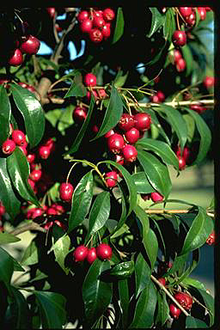
Figure B4.1 Syzygium paniculatum at the Australian Botanic Garden Mount
Annan NSW. © M. Fagg, Australian National Botanic Gardens, Photo No. a 9871.
Magenta Lilly Pilly is variable in size ranging from a low shrub to a medium sized tree to 15 m (but can reach 25 m) that is estimated to live for 75–200 years. It has flaky bark and shiny and dark-green leaves above that are paler underneath. The white flowers are clustered at the end of each branch and the spherical or egg-shaped magenta fruits contain a single seed.
Taxonomy: Conventionally accepted as Syzygium paniculatum Gaertn. (CHAH 2015, verified 10 July 2015).
Status: Listed as Vulnerable under the EPBC Act on 16 July 2000 and as Endangered under the NSW TSC Act on 31 July 2009.
Recovery Plan: NSW Recovery Plan adopted 6 July 2012 (ComLaw 2012). Plan accurate to January 2011.
This species occurs in the ‘littoral rainforest and coast vine thickets’ threatened ecological community listed under the EPBC Act and NSW TSC Act, ‘littoral rainforest in the NSW North Coast, Sydney Basin and South East Corner bioregions (OEH 2012).
This information is taken from SPRAT (DoE 2015) unless otherwise referenced.

Number of populations inside and outside parks and reserves
Of the 44 subpopulations currently verified, 18 occur partly or wholly within conservation reserves (16 in NSW reserves and two in Booderee National Park). A further ten subpopulations occur entirely on private property with the remaining 16 populations found on publicly managed land or straddling public/private property boundaries (OEH 2012).

Population size – range
The total number of plants in NSW is estimated to be 1200 plants distributed in 44 subpopulations along a 400 km stretch of coastal NSW (accurate to Jan 2011 in OEH 2012) from Upper Lansdowne (north of Taree) to Conjola National Park.

Geographical distribution
Regional and disjunct.
These populations are disjunct with five metapopulations identified based on foraging range of dispersal agents (flying fox and White headed pigeon): (i) Jervis Bay; (ii) Coalcliff; (iii) Botany Bay; (iv) Central Coast; and (v) Karuah-Manning. Other potential subpopulations require further investigation. The Jervis Bay (12 subpopulations) and Central Coast (24 subpopulations) metapopulations support the largest number of individuals and subpopulations. Up to two thirds of all individuals occur in three major subpopulations on the central coast, one in Wyrrabalong National Park the other two on private property. (OEH 2012).

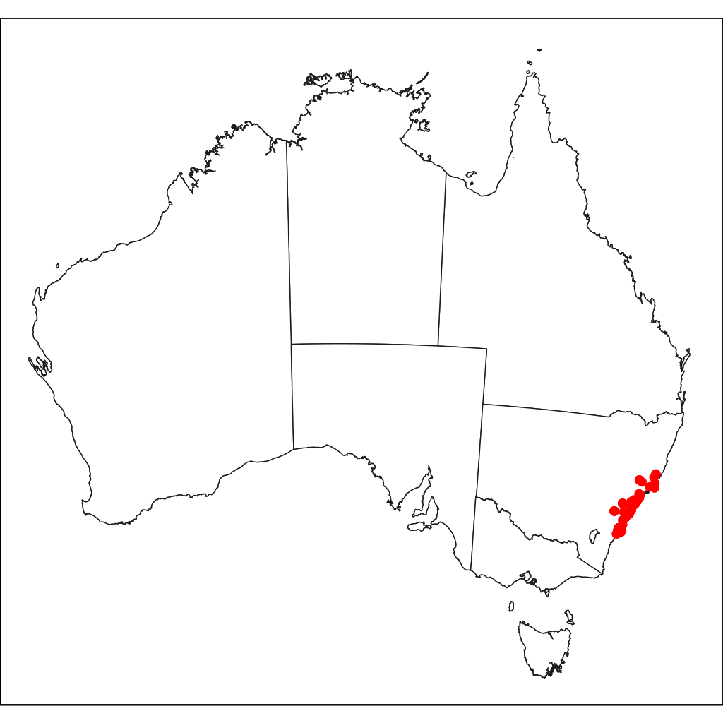
Figure B4.2 Full distribution of Syzygium paniculatum in Australia.
Red dots are specimen collections.
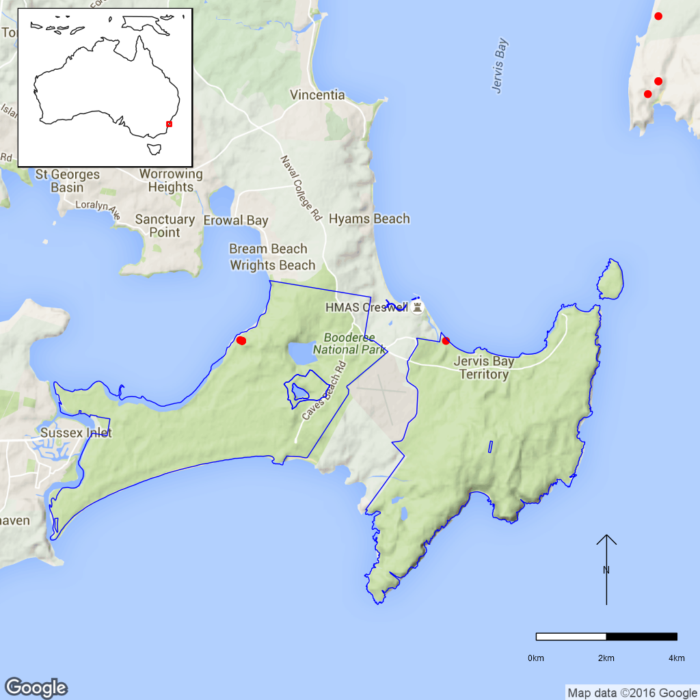
Figure B4.2 Distribution of Syzygium paniculatum in Booderee National Park.
Red dots are specimen collections, the blue line is the park boundary.

Ex-situ collections (Living and Seed Bank)
One plant is known from the Royal Botanic Gardens Melbourne (2010) [Atlas of Living Australia (ALA) accessed 10 July 2015]. This species is also known to be in cultivation in botanic gardens located at Adelaide, Canberra, Sydney, Melbourne, Coffs Harbour, Toowoomba and Mount Annan (Quinn, 1995 in OEH 2012) but it is not known if these collections represent wild plants of known provenance (OEH 2012). There are 19 plants in the Australian National Botanic Gardens and a further 31 cuttings in the nursery and 46 plants at Booderee Botanical Gardens (Z. Knapp pers. comm. 12 October 2015, Stig Pedersen pers. comm. 16 November 2015).
Magenta Lilly Pilly is unsuitable for storage in conventional seed banks as it cannot tolerate desiccation and ex-situ conservation is therefore limited to living plant collections. Alternative technologies for the long term ex-situ storage of such species are being investigated as part of the Rainforest Seed Project at Mt Annan. (OEH 2012). There are therefore no seed stocks of this species at the National Seed Bank (T. North pers. comm. 11 September 2015).

Biology
Pollinators: Pollination is likely to be aided by nectar and pollen feeding vertebrates e.g. flying foxes, possums, honeyeaters, lorikeets as well as bees, beetles, moths and butterflies. It can also self-pollinate (OEH 2012).
Symbiotic relationships: Unknown.
Germination requirements: Rapid germination within 20 days (OEH 2012).
Dormancy class: Recalcitrant with seed longevity thought to be <3 months (OEH 2012).
Flowering: December–March (occasionally to May), fruit January–May (sometimes as late as September) (OEH 2012).
Breeding system: The species is apomictic, i.e. able to produce fertile seed both sexually (following pollination) and asexually (without pollination). The seed produced asexually (apomictically) produces plants that are clones of the maternal plant. Seed are polyembryonic, i.e. having more than one embryo in each seed. This species is also known to coppice after low intensity fire (OEH 2012).
Dispersal: Several agents are likely including water in riparian habitats subject to flooding and gravity and animals which feed on the fruits (OEH 2012).
Longevity: Perennial, estimated 75–200 years (OEH 2012).
Life form: Small tree, but variable from a low shrub to medium sized tree to 25 m (OEH 2012).
Ploidy levels: Genotyping suggests that the species is a polyploid (Thurlby et al. 2012).
Role of the plant in the environment: Likely to be an important food source for a range of vertebrates and invertebrates that feed on the pollen, nectar and fruit.

Threats

Listed Threats (EPBC Act and NSW TSC Act)
- Habitat loss and fragmentation (resulting from development).
- Vegetation clearing.
- Grazing in close proximity to creek lines causing root damage, prevention of seedling establishment and erosion.
- Weed invasion from common coastal weeds.
- High frequency/ intensity fires.

Habitat clearing and fragmentation
Habitat likely to support Magenta Lilly Pilly continues to be cleared for urban expansion and infrastructure development, particularly in the Central Coast and Jervis Bay regions.

Inappropriate grazing regimes
Trampling by livestock grazing in riparian areas is contributing to a decline in some of the largest subpopulations along Ourimbah Creek and watercourses in the Martinsville area. There is little or no evidence of recruitment in these areas. This is unlikely in Booderee National Park.

Weed infestations
Numerous weeds pose a threat to Magenta Lilly Pilly or its habitat, particularly Lantana and Bitou Bush. However Bitou Bush is not a threat in Booderee National Park as it prefers different habitats to Magenta Lilly Pilly. Bitou Bush prefers sand dunes and dry sclerophyll forest (sand plain Bangalay forest) whereas Syzygium paniculatum grows in moist gullies, wet sclerophyll forest, littoral rainforest and moist soils (S. Pedersen and N. Dexter pers. comm. 16 November 2015).

Inappropriate Fire Regimes
High frequency/ intensity fires. While the species is known to coppice after low intensity fires, high fire frequency or intensity kill or weaken plants, interfere with reproduction and alter or destroy rainforest habitat. Fires can also encourage weed invasion along remnant edges (OEH 2012).

Other Threats/Potential New Threats

Low genetic diversity
Extremely low genetic diversity was found within 11 subpopulations across the species range with a distinct north-south genetic divide centred on the Central Coast near Cams Wharf and Green Point with subpopulations sampled north of this divide having higher genetic diversity than those sampled to the south (Thurlby 2010). There was almost no genetic diversity among the southern subpopulations (OEH 2012) suggesting that this species may have difficulty adapting to future environmental change. This may be of concern for the Booderee National Park populations.
Seed produced apomictically is clonal and offspring produced this way are genetically identical. The low genetic diversity found in many populations of this species may reflect this method of reproduction which can be a means of reproductive assurance if pollinators are lacking.

Climate Change
Sea level rise could threaten some populations and low genetic diversity could mean that the species is unable to adapt to new conditions (OEH 2012).

Introduced Vertebrate Pests
Feral deer occur in many conservation reserves including Bouddi National Park and Illawarra Escarpment State Conservation Area. Browsing Javan Rusa Deer can damage or kill plants through defoliation, bark stripping and stem breaking. Deer may also disturb seedlings of other species that occur in Magenta Lilly Pilly habitat (OEH 2012). Deer do not occur in Booderee National Park and this threat is considered to be a low risk.

Recreational Activities
Some subpopulations are subjected to frequent human visitation and are threatened by the construction and maintenance of roads, walking tracks and car parks. Human visitation may impact regeneration, as trampling of the understorey and soil compaction can inhibit seedling establishment (OEH 2012).

Pathogens
Myrtle/ Guava Rust (Puccinia psidii) is a pathogen that affects species from the Myrtaceae family and Magenta Lilly Pilly has been identified as a known host in the field (Primary Industries Biosecurity, 2012) along with several other Myrtaceous species occurring in the same habitat. The entire distribution of Magenta Lilly Pilly occurs within the known or predicted distribution of Myrtle Rust in NSW (OEH 2012). In a study of 118 plant taxa from this family, a single experiment on cuttings of Syzygium paniculatum showed no sign of rust infection (Morin et al. 2011). Myrtle Rust does not appear to affect Syzygium paniculatum at Booderee National Park (S. Pedersen and N. Dexter pers. comm. 16 November 2015).

Changes to local water regimes through water extraction
Temporary supplementation of Central Coast’s water supply by pumping up to four million litres per day from Ourimbah Creek was recently approved by the NSW Government. This may lead to reduction in the frequency of flood events and a drop in the water table which is likely to result in the loss of remnant riparian vegetation, including Syzygium paniculatum, along much of the creek’s middle and lower reaches (OEH 2012).

Knowledge Gaps
The level of susceptibility to Myrtle Rust is unknown and should be investigated.

Suggested research and actions
The 2012 Recovery Plan suggests
- Determine if viable forms of ex-situ germplasm storage exist.
- Undertake further genotyping of offspring using larger sample size and greater number of populations.
- Determine the species’ effective population size.
- Investigate the species response to potential climate change across its genetic and geographical range.
- Research into level of susceptibility to Myrtle Rust of Booderee/other populations and associated Myrtaceous species (i.e. to determine viability of its broader habitat).
- Investigate the species response to disturbance, including fire.
- Include Booderee populations in this work.
It is recommended that the genetic assessment needs to include Booderee National Park.
Other actions include
- Establish a monitoring program to provide baseline and ongoing data for determining population trajectories and the relative impacts of threatening processes.

References
Atlas of Living Australia (2015). Syzygium paniculatum Herbarium specimen records [Online]. Available from http://www.ala.org.au/. Accessed 25 August 2015.
Office of Environment and Heritage, NSW (2012). National Recovery Plan, Magenta Lilly Pilly Syzygium paniculatum. Office of Environment and Heritage, NSW. Goulburn St, Sydney.
ComLaw, 2012. Environment Protection and Biodiversity Conservation Act 1999 – section 269A – Instrument Adopting and Revoking Recovery Plans (NSW, QLD, SA, TAS and WA) (06/07/2012) – F2012L01594. Available from https://www.comlaw.gov.au/Details/F2012L01594. Accessed 19 October 2015.
Council of Heads of Australian Herbaria (CHAH) (2015). Australian Plant Census. [Online]. Australian Plant Census. [Online]. Available from http://biodiversity.org.au/nsl/services/apc. Accessed 25 August 2015.
Department of the Environment (2015). Syzygium paniculatum in Species Profile and Threats Database, Department of the Environment, Canberra. Available from http://www.environment.gov.au/sprat. Accessed 27 October 2015.
Director of National Parks (2015). Booderee National Park Management Plan 2015-2025 [Online]. Australian Government, Department of the Environment. Available from https://www.environment.gov.au/resource/booderee-national-park-management-plan-2015-2025. Accessed 3 February 2016.
Morin L, Aveyard R, Lidbetter J (2011). Myrtle rust: host testing under controlled conditions. CSIRO Ecosystem Sciences.
Primary Industries Biosecurity (2012). Myrtle Rust. Available from http://www.dpi.nsw.gov.au/biosecurity/plant/myrtle-rust. Accessed 1 October 2015.
Thurlby KAG (2010). The Population and Reproductive Biology of the Magenta Lilly Pilly (Syzygium paniculatum) and its Implications for Conservation. Bachelor of Sciens/Arts (Honours) Thesis, University of New South Wales.
Thurlby KAG, Wilson PG, Sherwin WB, Connelly C, Rossetto, M (2012). Reproductive bet-hedging in a rare yet widespread rainforest tree, Syzygium paniculatum (Myrtaceae). Austral Ecology 37: 936–944.
- Zieria arborescens subsp. decurrens (Rutaceae) – Stinkwood, Booderee National Park
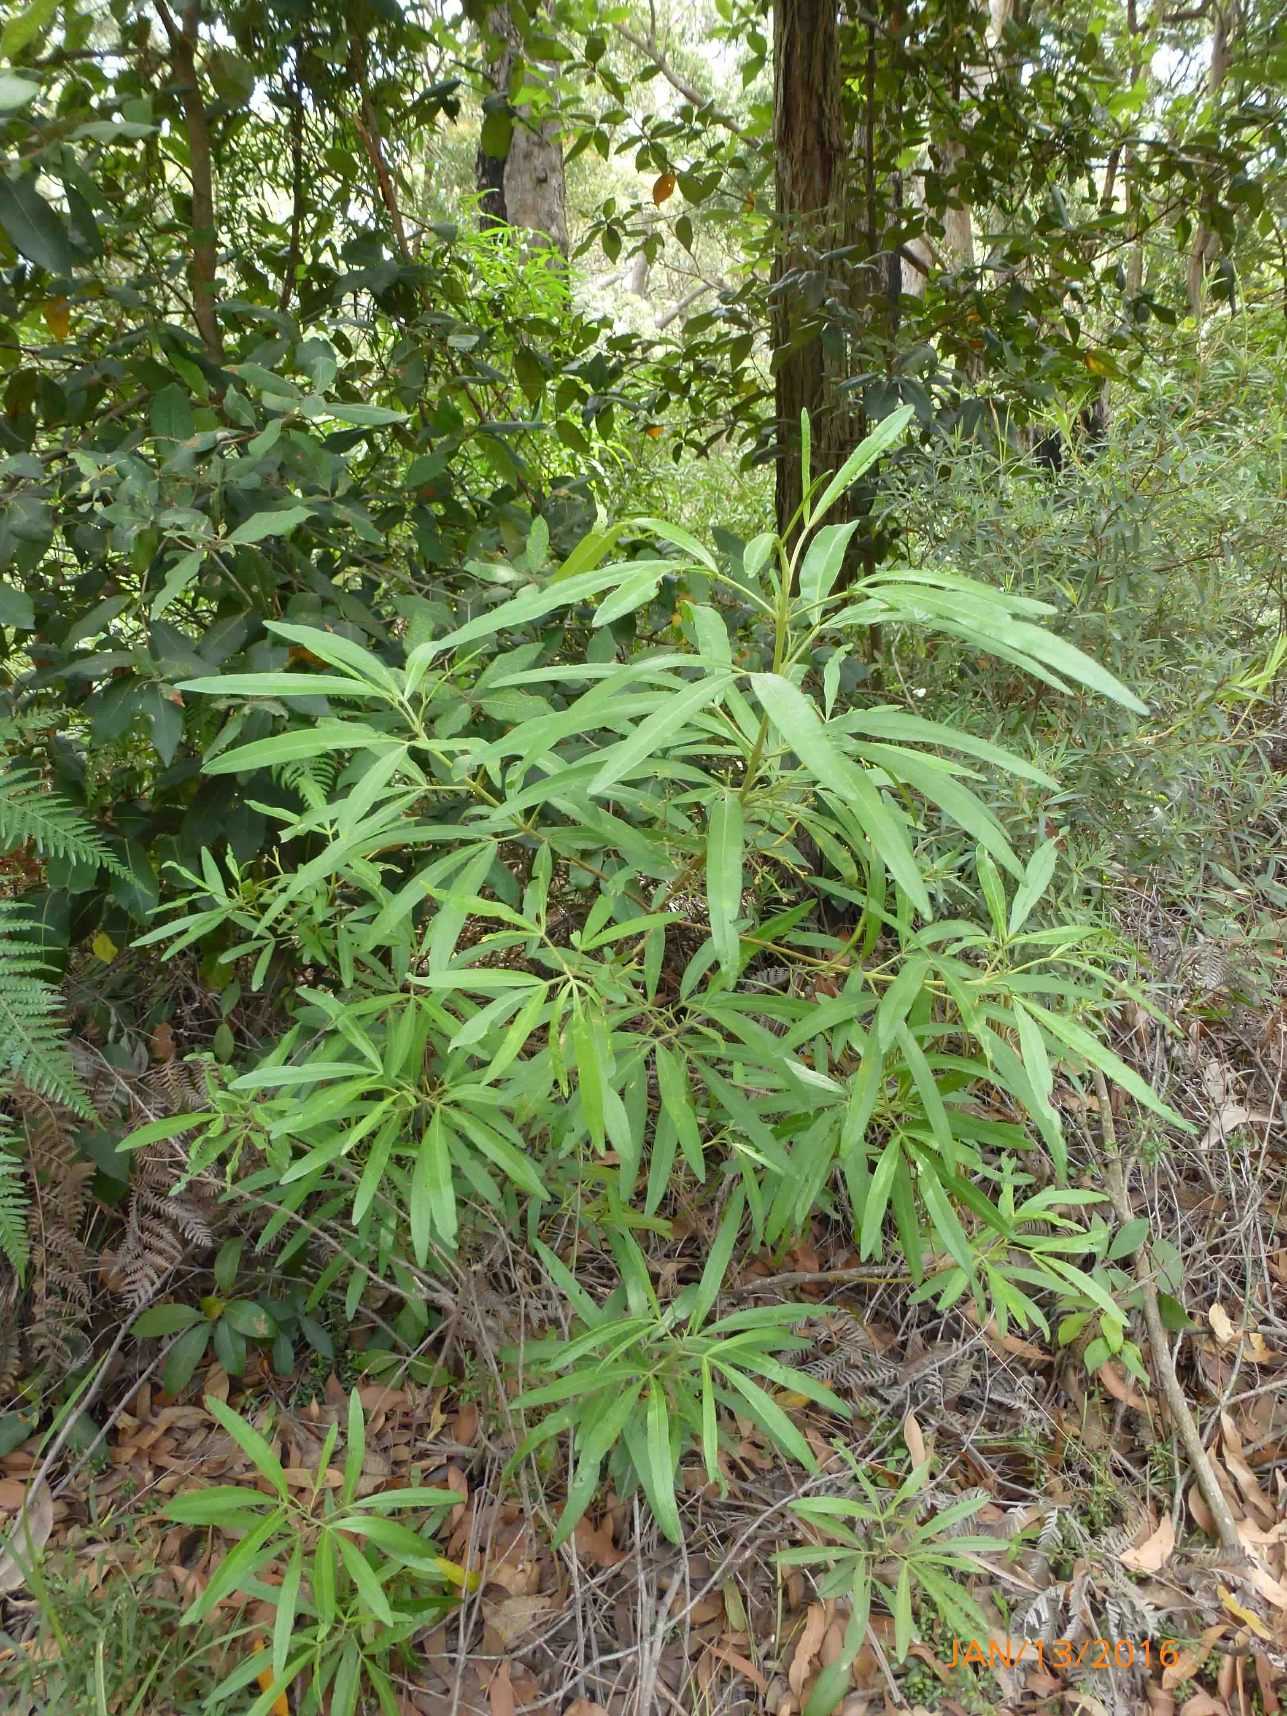
Figure B5.1 Zieria arborescens in Booderee National Park.
©S. Pedersen 2016.
Zieria arborescens subsp. decurrens is a shrub to 3 m high. The leaves are entire and variable in size and shape. The white flowers are arranged in many-flowered inflorescences. This species differs from the more widespread subsp. arborescens being shorter and with distinctly ridged branches (The Royal Botanic Gardens and Domain Trust, 2015).
Taxonomy: Conventionally accepted as Zieria arborescens subsp. decurrens J.A.Armstr. (CHAH 2007, verified 5 November 2015).
- Synonym: Zieria arborescens subsp. B sensu Armstrong (1991) Sims (The Royal Botanic Gardens and Domain Trust, 2015).
Status: This species is not listed under the EPBC Act but is listed as a significant species in the Booderee National Park Management Plan 2015–2025 (DNP 2015).
Recovery Plan: There is no recovery plan for this species.

Number of populations inside and outside parks and reserves
This species is restricted to the Caves Beach area of Jervis Bay on the NSW south coast (Armstrong 2002).

Population size – range
The species is locally common as an undershrub growing on sandy soils in Eucalyptus pilularis-E. botryoides open forests with Syncarpia glomulifera and Elaeocarpus reticulatus as well as in Eucalyptus pilularis-E. gummifera woodland with Acacia longifolia and Banksia serrata (Armstrong 2002).

Geographical distribution
Regional and disjunct.
This species is only known to occur in the southern Jervis Bay region of New South Wales with the majority of the populations occurring in the Booderee National Park.
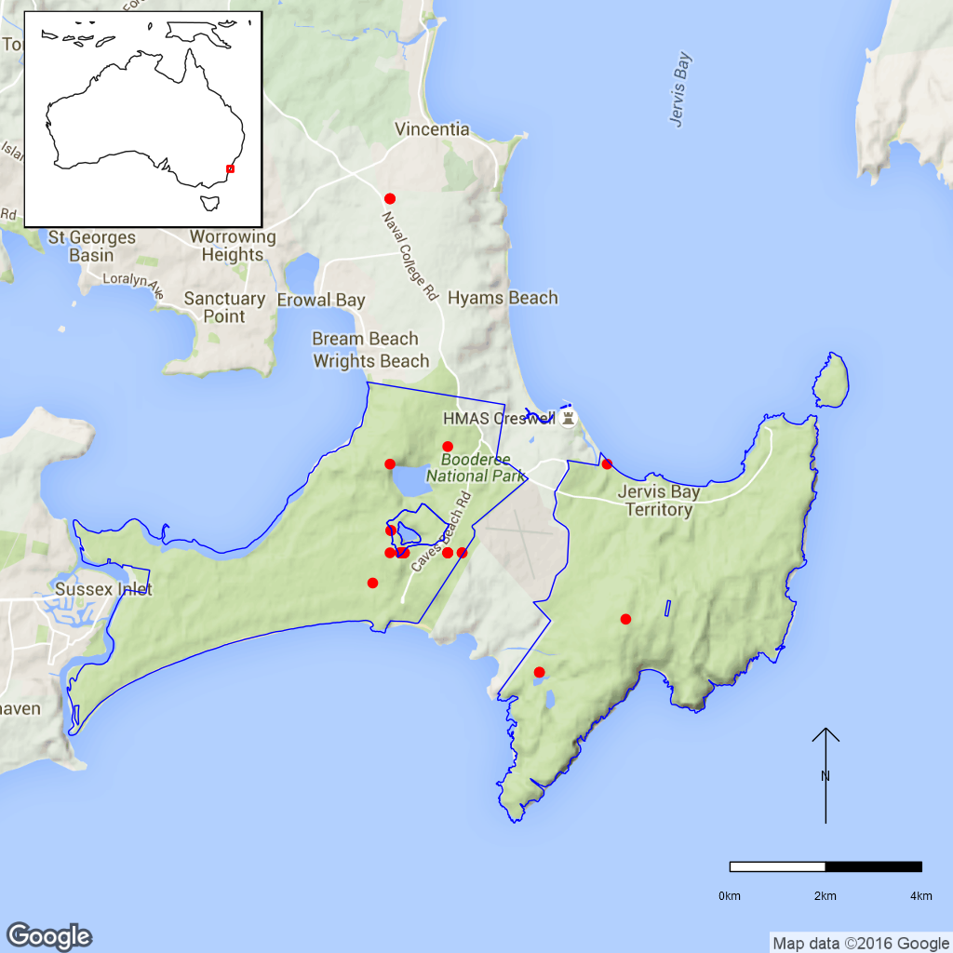
Figure B5.2 Distribution of Zieria arborescens subsp. decurrens in
Booderee National Park. Red dots are specimen collections,
the blue line is the park boundary.

Ex-situ collections (Living and Seed Bank)
This species is conserved in the National Seed Bank (ASBP 2016) and in Living Collections at the Australian National Botanic Gardens and Booderee Botanical Gardens (Stig Pedersen pers. comm. 27 November 2015). No other ex-situ collections in any other Botanic Garden or Seed Bank have been located (ASBP 2016).

Biology
Pollinators: Zieria flowers are insect pollinated with nectar- and pollen-seeking flies and pollen-seeking beetles frequently observed vectors of Zieria pollen. Nectar-seeking flies have been seen frequently on blossoms of subsp. arborescens (Armstrong 2002).
Symbiotic relationships: Unknown.
Germination requirements: Armstrong noted that embryo dormancy is suspected in Z. arborescens as seed failed to germinate in controlled germination experiments. This dormancy is thought to be in the embryo rather than the seed coat (Armstrong 1989 in Armstrong 2002). Armstrong (1999, 2002) suggests that the presence of a pH-sensitive enzyme in dormant-seeded Zieria species would explain the prolific germination that occurs in these taxa following fire. Based on this research it is likely that a pre-treatment will be required to germinate seed of this species.
Dormancy class: Possibly orthodox (the closely-related subspecies Zieria arborescens subsp. arborescens is described as having a persistent soil seedbank by Floyd (1976) and Wang (1997) in Armstrong (2002).
Flowering: Unknown.
Breeding system: Zieria arborescens subsp. decurrens is pollen fertile and genetically self-incompatible. Vegetative apomixis has not been observed and regeneration from subsurface epicormic outgrowths has not been reported (Armstrong 2002).
Dispersal: In general Zieria seed are forcibly ejected from the fruit along with the placental endocarp which remains attached to the mature seed as a sub-fleshy piece of tissue (elaiosome). This ant-attracting elaiosome aids in short distance seed dispersal (Armstrong 2002).
Longevity: Unknown.
Life form: Large shrub to 3 m high (Armstrong 2001).
Ploidy levels: Unknown although most Zieria species seem to be based on x=18 and Zieria arborescens is predicted to have a chromosome number of 2n=36 (Armstrong 2002).
Role of the plant in the environment: This may be a post-fire colonising species as the closely-related Zieria arborescens subsp. arborescens was observed to rapidly colonise burnt sites and to mature quickly (Armstrong 2002). The 2003 Booderee fire encouraged rapid regeneration of Zieria arborescens subsp. decurrens (S. Pedersen pers. comm. 27 November 2015).

Threats

Listed threats
As Zieria arborescens subsp. decurrens is not currently listed under Commonwealth or State Legislation threats to this species are unknown. However, the species is considered to be rare and has a very restricted geographical distribution (DNP 2015) and has rarely been collected leading Armstrong (2002) to suggest that its conservation status cannot be reliably determined until more information is available.

Other Threats/Potential New threats
As Zieria arborescens subsp. decurrens is a rare species with a restricted distribution making it vulnerable to a range of threats including
- Habitat clearing and fragmentation.
- Low genetic diversity.
- Inappropriate grazing regimes.
- Inappropriate fire regimes.
- Climate change.
- Introduced vertebrate pests.
- Recreational activities.
However, it is unclear whether any or all of these are impacting this species in BNP. The taxon is also susceptible to extensive leafminer damage, sometimes leading to plant death in the ex-situ collections at Booderee (S. Pedersen pers. comm. 27 November 2015).

Knowledge Gaps
Species biology and life history including pollination syndrome, symbiotic relationships, seed germination, seed dormancy, genetic diversity, time to maturity and longevity of this species are unknown.
Many of the biological attributes provided here are inferred from data available for the genus and may be unreliable for this subspecies.

Suggested research and actions
- Establish a monitoring program to provide baseline and ongoing data for determining population trajectories and the relative impacts of threatening processes.
- Determine key life history parameters such as flowering, time to maturity, and longevity to assist with species management.
- Secure genetically representative ex-situ seed collections, in multiple locations if appropriate, to mitigate against the loss of natural populations and provide for re-establishment should severe losses or extinction occur.
- Determine the appropriate conditions for long term storage and seed germination.
- Determine the fire frequency and intensity requirements for natural population turnover.
- Develop and implement a restoration program to increase population numbers and/or sizes.

References
Armstrong JA (2002). Zieria (Rutaceae): a systematic and evolutionary study. Australian Systematic Botany 15: 277–463.
Australian Seed Bank Partnership (2016). Search for records in the Australian Seed Bank [Online]. Council of Heads of Australian Botanic Gardens Inc. Zieria arborescens subsp. decurrens. Available from http://asbp.ala.org.au/search. Accessed 3 February 2016.
Atlas of Living Australia (ALA) (2015). Zieria arborescens subsp. decurrens. Herbarium specimen records [Online]. Available from http://www.ala.org.au/. Accessed 10 November 2015.
Council of Heads of Australian Herbaria (CHAH) (2007). Australian Plant Census. [Online]. Available from http://biodiversity.org.au/nsl/services/apc. Accessed 10 November 2015.
Director of National Parks (2015). Booderee National Park Management Plan 2015-2025 [Online]. Australian Government, Department of the Environment. Available from https://www.environment.gov.au/resource/booderee-national-park-management-plan-2015-2025. Accessed 3 February 2016.
The Royal Botanic Gardens and Domain Trust (2015). PlantNET – the Plant information Network System of the Royal Botanic Gardens and Domain Trust, Sydney (version 2.0). Available from http://plantnet.rbgsyd.nsw.gov.au. Accessed 10 November 2015.
- Asplenium listeri (Aspleniaceae) – Christmas Island Spleenwort, Christmas Island National Park
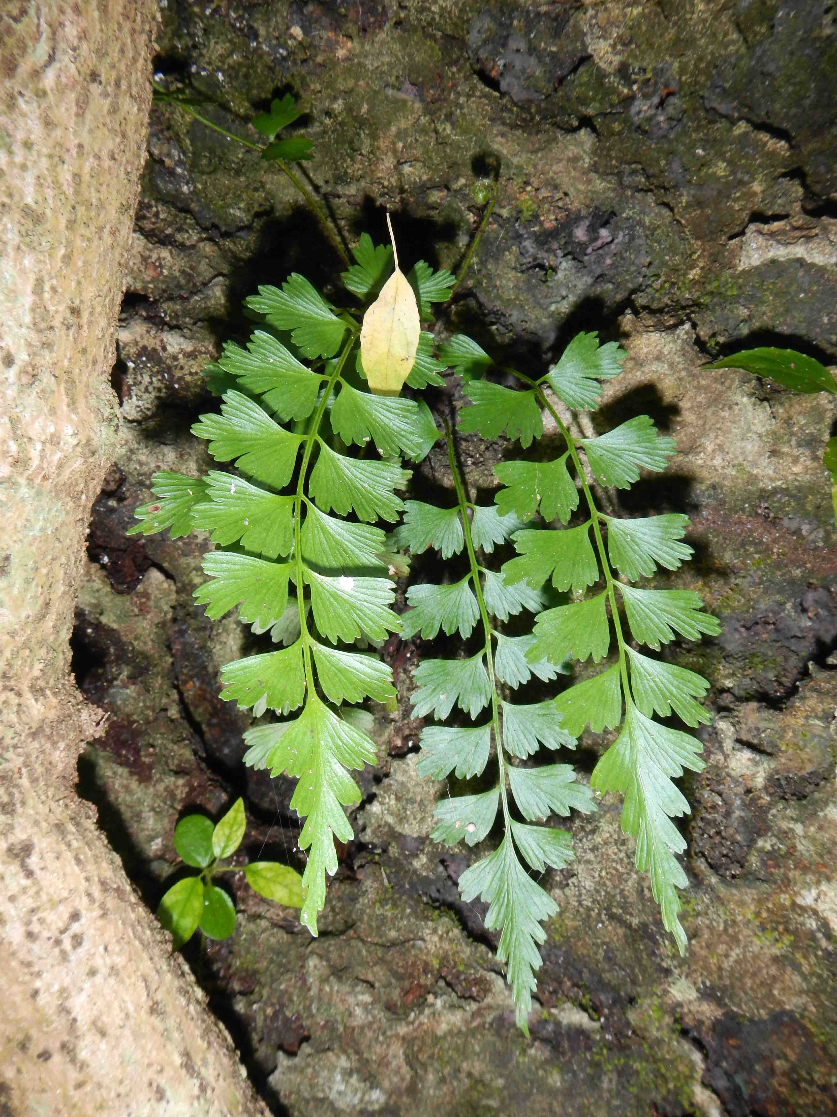
Figure B6.1 Asplenium listeri from North West point on
Christmas Island. ©Alasdair Grigg.
Asplenium listeri is a lithophytic fern with shortly creeping rhizomes that are covered with dark brown scales. The fronds are 3.5–9 cm long, have 8–18 pinnae and are held in a crown. The sori are linear and located along the lateral veins (Du Puy 1993).
Taxonomy: The name Asplenium listeri C.Chr. is accepted in the Australian Plant Census (CHAH 2015, verified 13 July 2015).
Status: Listed as Critically Endangered under the EPBC Act on 23 July 2002.
Recovery plans:
- National Recovery Plan for the Christmas Island Spleenwort Asplenium listeri (Butz 2004)
- Christmas Island Biodiversity Conservation Plan (Draft, DNP 2014)

Information in this fact sheet is taken from the SPRAT Listing Page (DoE 2015) unless otherwise referenced.

Number of populations inside and outside parks and reserves
There are six populations of A. listeri on Christmas Island with four of these located inside the national park boundaries at Gannet Hill, Aldrich Hill, Sydney’s Dale and North West Point (Butz 2004, D. Maple pers. comm. 28 January 2016).

Population size – range
In 2002, the total number of individuals in four of the six populations was estimated to be <300 with an extent of occurrence of <100 km². A fifth population was located in 2003 by an ecologist during an environmental impact assessment for an expansion to phosphate mining but details of the exact location and plant numbers are not reported (Butz 2004). A sixth population was located during an Island wide survey in 2015; the size of this population is unknown but a site visit by CINP staff to determine this is planned (D. Maple pers. comm. 28 January 2016).

Geographical distribution
The species is widespread but with a highly fragmented distribution and occurs in small and isolated populations.
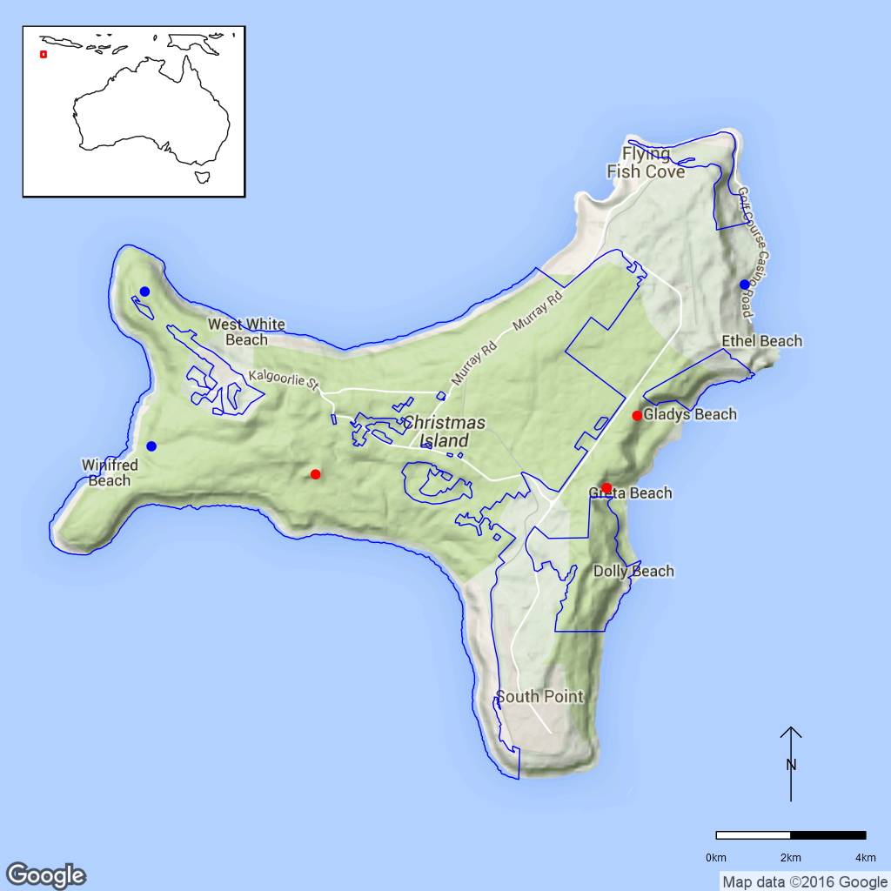
Figure B6.2 Distribution of Asplenium listeri. Red dots are specimen
locations, blue dots are CINP survey observations, blue line is the
park boundary.

Ex-situ collections (Living and Seed Bank)
Butz (2004) mentions that specimens of A. listeri were kept at a nursery on Christmas Island in 2001, however, the species is no longer cultivated (D. Maple and A. Grigg pers. comm. 9 October 2015). The species is not conserved in the Living Collection at the Australian National Botanic Gardens (Z. Knapp pers. comm. 30 September 2015) and no other ex-situ collections in any other Botanic Garden have been located (ASBP 2016). It is also not conserved in the National Seed Bank as ferns do not produce seed.

Biology
Pollinators: N/A
Symbiotic relationships: Unknown.
Germination requirements: Unknown.
Dormancy class: N/A
Flowering: N/A
Breeding system: Unknown.
Dispersal: Fern spores are usually dispersed over a few meters but can be transported over thousands of kilometres via air currents. Fern spores without developed chloroplasts and can survive for months to years (Kessler 2010).
Longevity: Unknown.
Life form: Fern.
Ploidy levels: Chromosome counts are not available for A. listeri. In the genus, polyploidy is frequent (CCDB, Rice et al. 2015).
Role of the plant in the environment: Asplenium listeri grows on narrow limestone cliff-top strips with an open aspect to the sea and in forest on the inland side where it is found in rock crevices, often beneath or near Ficus microcarpa (Butz 2004, DNP 2014).

Threats

Listed threats (EPBC Act)
- Illegal collection.
- Habitat destruction, disturbance and/or modification due to mining activities.
- Soil disturbance and/or trampling due to bushwalking.
- Invasive Non-Native/Alien Species.
- Competition and/or habitat degradation by weeds.
- Predation, competition, habitat degradation and/or spread of pathogens by introduced species.
- Inappropriate and/or changed fire regimes (frequency, timing, intensity).
- Low numbers of individuals.
- Development and/or maintenance of roads.

Genetic and demographic effects
Asplenium listeri is known from only six locations on Christmas Island and has a fragmented distribution on the island. The last available combined population size for four known locations was <300 individuals in 2002 (Butz 2004). This low number of individuals and the restricted geographical distribution make the species vulnerable to stochastic events like cyclones. The implications of low genetic diversity and inbreeding for this fern are unknown.

Climate-related factors
Climatic events such as drought and cyclones potentially threaten populations both inside and outside the national park (DNP 2014). Climate change scenarios predict an increase in annual average temperature and the number of hot days. Together with a predicted decrease in rainfall this may increase the number of days with high or extreme forest fire danger; fires could also become more frequent and severe. Furthermore, although overall cyclone activity is predicted to decrease, high intensity cyclones will become more frequent, potentially leading to vegetation damage on the island (DNP 2011).

Invasive and other problematic species
Weeds are a potential future threat to A. listeri should these invade this species habitat (DNP 2014). Antigonon leptopus (Polygonaceae) and Pluchea indica (Asteraceae) are two weeds already recorded as invading inland cliffs while other weeds occur throughout the island (Swarbrick and Hart 2001). No data exist to determine if weeds are impacting on this species. Another potential future threat is the invasive Giant African Snail (Achatina fulica). While this species does not yet occur in A. listeri habitat changes to the abundance and distribution of vegetation associated with this species and its complex associations with red crabs (Gecarcoidea natalis) and invasive yellow crazy ants (Anoplolepis gracilipes) (Butz 2004) have the potential to impact on A. listeri. Future introductions of invasive species as well as sleeper weeds already present on the island also present potential threats (DNP 2014).

Biophysical impacts
Removal or modification of habitat through vegetation clearing and disturbance such as road construction, infrastructure development and/or mining is a threat to the populations that occur outside the national park. Habitat disturbance caused by road construction is also a threat inside the national park (DNP 2014).

Direct human impacts
The Gannet Hill population is at risk from trampling as it is located close to a site frequently visited by tourists and visitors (DNP 2014). Illegal collection of A. listeri was considered to be a threat in the first species recovery plan (Butz 2004) but since that time there has been no indication of collection or special interest in this species by fern enthusiasts and it is now considered to be an unlikely threat (DNP 2014).

Current management
The species is currently not monitored or included in the biennial island wide survey that is conducted during the dry season. However, if found it would be reported, as was the case with the population newly located in 2015 (D. Maple pers. comm. 9 October 2015). A search for rare flora conducted in 2012 by the Australian National Herbarium did not locate this species (M. Goumas pers. comm. 6 August 2015).

Knowledge Gaps
Species biology and life history including symbiotic relationships, spore germination, spore storage, genetic diversity, and time to maturity and longevity of both life stages are unknown.

Suggested research and actions
- Compile a comprehensive list of environmental factors (physical and biological) and use this data to develop predictive models to assist locate additional populations (Butz 2004).
- Establish a monitoring program to provide baseline and ongoing data for determining population trajectories and the relative impacts of threatening processes.
- Determine life history traits such as maturity and longevity to assist with population management to assist with species management.
- Evaluate whether long term storage of spores is possible and germination requirements.
- Ohlsen et al. (2015) determined that lithophytic, limestone-dwelling A. polyodon populations on Vanuatu and New Caledonia were A. listeri indicating that the distribution of this species extends beyond Christmas Island. Genomic assessments to determine evolutionary relationships within this species complex may be useful should translocation material be required.

References
Australian Seed Bank Partnership (2016). Search for records in the Australian Seed Bank [Online]. Council of Heads of Australian Botanic Gardens Inc. Asplenium listeri. Available from http://asbp.ala.org.au/search. Accessed 11 February 2016.
Butz M (2004). National Recovery Plan for the Christmas Island Spleenwort Asplenium listeri. Commonwealth of Australia. Available from http://www.environment.gov.au/resource/national-recovery-plan-christmas-island-spleenwort-asplenium-listeri. Accessed 10 October 2015.
Council of Heads of Australasian Herbaria (CHAH) (2015). APC – Australian Plant Census. Available from http://biodiversity.org.au/nsl/services/apc. Accessed 20 October 2015.
Department of the Environment (DoE) (2015). Asplenium listeri in Species Profile and Threats Database, Department of the Environment, Canberra. Available from http://www.environment.gov.au/sprat. Accessed 10 September 2015.
Director of National Parks (DNP) (2011). Christmas Island National Park Climate Change Strategy 2011–2016. Department of Sustainability, Environment, Water, Population and Communities, Canberra, Australia. Available from http://www.environment.gov.au/system‌/files/resources/7fb545e2-5c09-4a74-b12d-3afd79b9537d/files/christmasstrategy.pdf. Accessed 10 September 2015.
Director of National Parks (DNP) (2014). Christmas Island Biodiversity Conservation Plan (Draft). Department of the Environment, Canberra. Available from http://www.environment.gov.au/resource/draft-christmas-island-biodiversity-conservation-plan. Accessed 10 September 2015.
Du Puy DJ (1993b). Aspleniaceae. In Commonwealth of Australia (1993). Flora of Australia vol. 50 Oceanic islands 2, pp. 554–558. Australian Government Publishing Service, Canberra.
Kessler M (2010). Biogeography of ferns. In Mehltreter K, Walker LR, Sharpe JM (eds.). Fern Ecology. Cambridge University Press. pp: 22–60. Available from http://ebooks.cambridge.org/chapter.jsf?bid=CBO9780511844898&cid=CBO9780511844898A016. Accessed 10 September 2015.
Ohlsen D, Perrie L, Sheppard L, Bayly M. (2015). Taxonomic status and distribution of the critically endangered Christmas Island spleenwort (Asplenium listeri, Aspleniaceae): it is not as rare as we thought. Australian Systematic Botany 27: 972–377.
Rice A, Glick L, Abadi S, Einhorn M, Kopelman NM, Salman-Minkov A, Mayzel J, Chay O, Mayrose I (2015) The Chromosome Counts Database (CCDB) – a community resource of plant chromosome numbers. New Phytologist 206: 19-26. Available from http://ccdb.tau.ac.il/home. Accessed 10 September 2015.
Swarbrick JT and Hart R (2001). Environmental weeds of Christmas Island (Indian Ocean) and their management. Plant Protection Quarterly 16: 54–57.

- Asystasia alba (Acanthaceae) – Christmas Island National Park
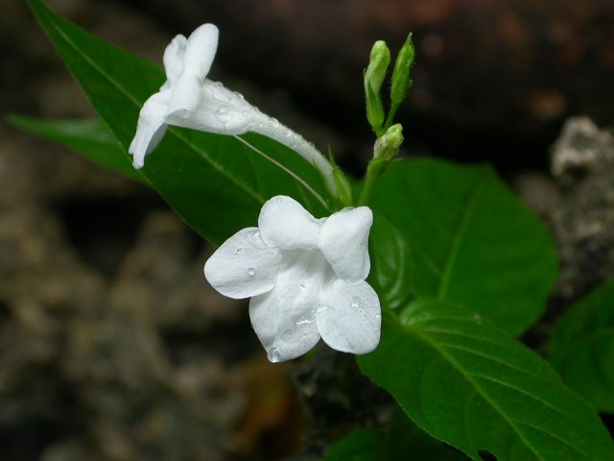
Figure B7.1 Asystasia alba flowers Christmas Island. ©Jeff Claussen.

Asystasia alba is an erect woody herb usually 50–75 cm high. The flowers are arranged singly or more rarely paired in an inflorescence that is 6–8 cm long. The corolla is white or violet and glandular-pubescent on the outside. The corolla tube is 14–18 mm long, the throat 8–10 mm and the corolla lobes are 4.5–7 mm. The flowers have four stamens, the longer ones usually just exserted. The fruit is a two-seeded capsule. The species is variable and probably closely-related to A. australasica and A. oppositiflora (Barker and Telford 1993).
Taxonomy: The name Asystasia alba Ridl. is accepted in the Australian Plant Census (CHAH 2015, verified 12 October 2015).
Status: Not listed.
Recovery Plan: A recovery plan is not required as the species is not listed.

Number of populations inside and outside parks and reserves
Asystasia alba has been collected from locations in the western and north-eastern parts of Christmas Island. A survey in 2002 located four populations in the western part of the island (Holmes and Holmes 2002). Most of the populations appear to be located within the national park.

Population size – range
Ridley (1906) described A. alba as being locally abundant. A total of about 200 plants were recorded in the four populations in 2002 and the number of individuals was inferred to be declining (Holmes and Holmes 2002).

Geographical distribution
The species is endemic to Christmas Island where it has a localised distribution.
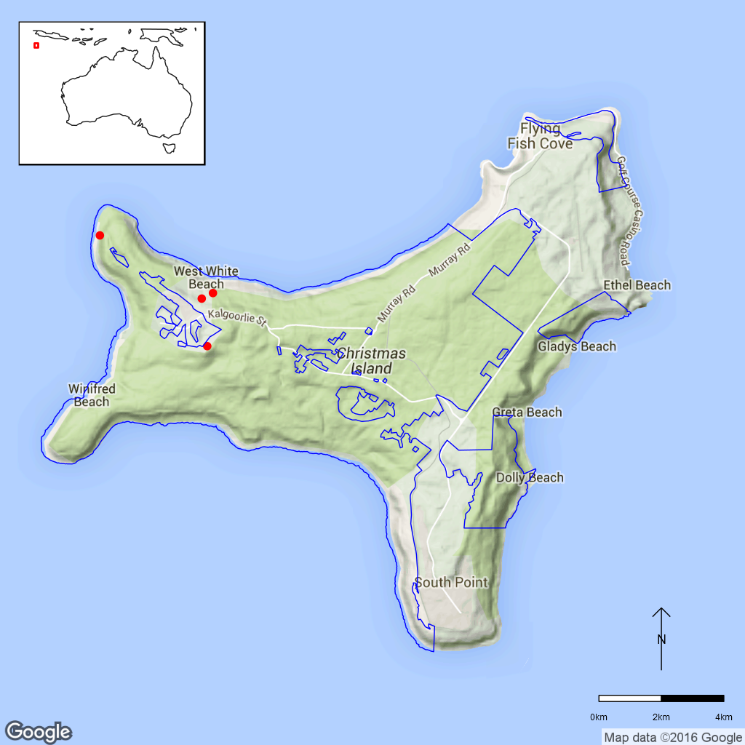
Figure B7.1 Distribution of Asystasia alba on Christmas Island.
Red dots indicate specimens, blue line is the park boundary.

Ex-situ collections (Living and Seed Bank)
The species is not conserved in the Living Collection at the Australian National Botanic Gardens or in the National Seed Bank (M. Henery pers. comm. 5 November 2015). No other ex-situ collections in any other Botanic Garden or Seed Bank have been located (ASBP 2016).

Biology
Pollinators: The species is probably insect-pollinated. The long corolla tube indicates that the pollinators probably have long tongues and Barker (1986) suggests that moths and butterflies as probable pollinators for this type of flower.
Symbiotic relationships: Unknown.
Germination requirements: Unknown. In a germination study for A. gangetica, seed that were older than 135 days germinated at room temperature. However, fresher seeds could only be germinated following treatment such as alternations in temperatures (Akamine et al. 1947).
Dormancy class: Unknown. Asystasia gangetica was shown to have dormant seed with the cause of dormancy possibly being in the seed coat (Akamine et al. 1947).
Flowering: Unknown.
Breeding system: Unknown.
Dispersal: Asystasia alba, like many other Acanthaceae, has capsules with an exploding mechanism, ejecting the seeds (Ridley, 1906).
Longevity: Unknown.
Life form: Woody herb (Du Puy 1993).
Ploidy levels: Unknown.
Role of the plant in the environment: Asystasia alba grows on phosphatic soils in forests of the terraces where the canopy is less dense (Holmes and Holmes 2002).

Threats
Listed Threats
As Asystasia alba is not currently listed under Commonwealth or State Legislation threats to this species are unknown.

Other Threats/Potential New threats
- Genetic and demographic effects.
- Climate related effects.
- Invasive weed species.
- Invasive vertebrates.

Genetic and demographic effects
The relatively small population sizes and distribution area probably make A. alba vulnerable to inbreeding effects associated with low genetic diversity. The species is also vulnerable to destructive stochastic events. The population appears to have declined significantly within the last century.

Climate-related factors
Dry periods may have reduced the population size (Holmes and Holmes 2002). Climate change is predicted to lead to lower rainfall and higher temperatures and probably more dry periods as well as an increased forest fire risk (DNP 2011).

Invasive and other problematic species
Holmes and Holmes (2002) state that the species might be vulnerable to predation by native crabs as well as competition from invasive weeds. The introduced weeds Mikania micrantha (Asteraceae) and Clausena excavata (Rutaceae), which are spreading in the north-west of the island, could potentially compete with A. alba, especially in areas with a less dense canopy (D. Maple pers. comm. 9 October 2015).

Current management
The species is currently not monitored and not included in the biennial island wide survey.

Knowledge Gaps
Species biology and life history including pollination syndrome, symbiotic relationships, seed germination, seed dormancy, flowering, breeding system, genetic diversity, and time to maturity and longevity of this species are unknown.

Suggested research and actions
- Assess whether EPBC listing is required (D. Maple pers. comm. 9 October 2015).
- Establish a monitoring program to provide baseline and ongoing data for determining population trajectories and the relative impacts of threatening processes.
- Survey suitable habitat for new populations.
- Determine life history traits including flowering, breeding system, maturity and longevity to assist with species management.
- Secure genetically representative ex-situ seed collections, in multiple locations if appropriate, to mitigate against the loss of natural populations and provide for re-establishment should severe losses or extinction occur.
- Determine the appropriate conditions for long term storage and seed germination.
- Develop and implement a restoration program to increase population numbers and/or sizes.

References
Akamine EK (1947). Germination of Asystasia gangetica L. seed with special reference to the effect of age on the temperature requirement for germination. Plant Physiology 22: 603–607.
Australian Seed Bank Partnership (2016). Search for records in the Australian Seed Bank [Online]. Council of Heads of Australian Botanic Gardens Inc. Asystasia alba. Available from http://asbp.ala.org.au/search Accessed 11 February 2016.
Barker RM (1986). A taxonomic revision of Australian Acanthaceae. Journal of the Adelaide Botanic Gardens 9: 1–286.
Barker RM and Telford IRH (1993). Acanthaceae. Flora of Australia 50: 379–388.
Council of Heads of Australasian Herbaria (CHAH) (2015). Australian Plant Census. [Online]. Available from http://biodiversity.org.au/nsl/services/apc. Accessed 12 October 2015.
Director of National Parks (DNP) (2011). Christmas Island National Park Climate Change Strategy 2011–2016. Department of Sustainability, Environment, Water, Population and Communities, Canberra, Australia. Available from http://www.environment.gov.au/system‌/files‌/resources‌/7fb545e2-5c09-4a74-b12d-3afd79b9537d/files/christmasstrategy.pdf. Accessed 12 October 2015.
Holmes J and Holmes G (2002). Conservation status of the flora of Christmas Island, Indian Ocean. Report to Environment Australia / Parks Australia North. Glenn Holmes and Associates, Atherton, Queensland.
Ridley HN (1906). Expedition to Christmas Island / The botany of Christmas Island. Journal of the Straits Branch of the Royal Asiatic Society 45: 121–271.
- Dicliptera maclearii Hemsl. (Acanthaceae) – Christmas Island National Park

Dicliptera maclearii is an erect herb up to 1 m high. The pink flowers are densely clustered in leaf axils and subtended by pairs of bracts. The corolla tube is c. 3.5 mm long and the corolla lobes c. 5.5 mm long. The species is morphologically similar to D. ciliata (Barker and Telford 1993).
Taxonomy: The name Dicliptera maclearii Hemsl. is accepted in the Australian Plant Census (CHAH 2015, verified 14 October 2015).
Status: Not listed.
Recovery Plan: No recovery plan is required for this species as it is not listed.

Number of populations inside and outside parks and reserves
The current distribution of D. maclearii on Christmas Island is unknown. Historically it has been described as common on the lower terraces at Flying Fish Cove, Waterfall and Cemetery Rd and at North West Point. A few historical collections exist from Toms Ridge, Phosphate Hill and North West Point but a survey in 2002 was unable to locate any populations (Holmes and Holmes 2002).

Population size – range
The species was apparently quite abundant at the beginning of the last century as E. G. Baker described D. maclearii as being “common on shore platforms” (Andrews 1900) while Ridley (1905) considered it to be “very common on the lower terraces”. However, no plants of D. maclearii were found in a survey conducted in 2002 (Holmes and Holmes 2002). According to collection information available in GBIF.org (2015), the species was last collected in 1984.

Geographical distribution
The species is endemic to Christmas Island. There are no specimen records of this species in Australian Herbaria and Fig B8.1 is based on locations mapped by Holmes and Holmes (2002) from specimens located in overseas Herbaria.
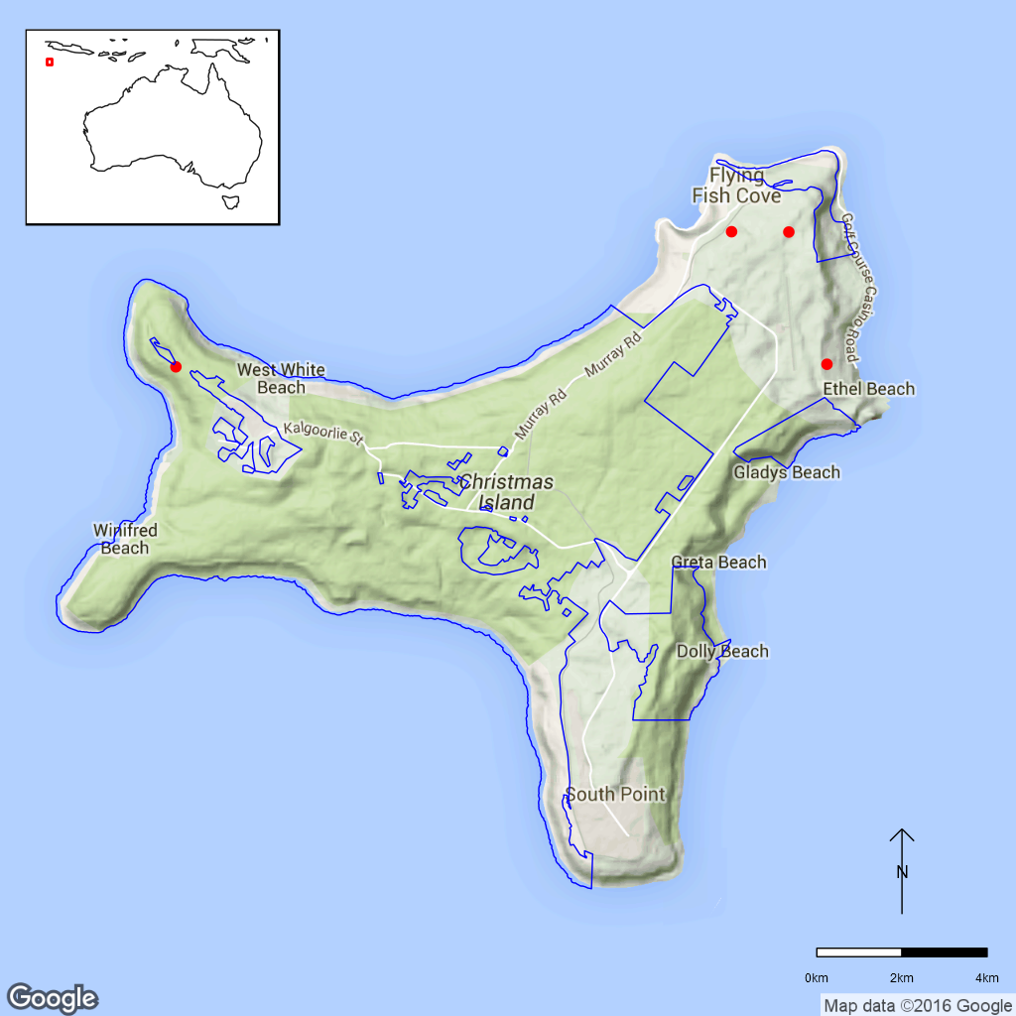
Figure B8.1 Historic records of Dicliptera maclearii distribution on
Christmas Island. Red dots indicate specimens from overseas Herbaria
(as mapped in Holmes and Holmes 2002) (DuPuy 1993), blue line is the
park boundary.

Ex-situ collections (Living and Seed Bank)
The species is not conserved in the Living Collection at the Australian National Botanic Gardens or in the National Seed Bank (M. Henery pers. comm. 5 November 2015). No other ex-situ collections in any other Botanic Garden or Seed Bank have been located (ASBP 2016).

Biology
Pollinators: Unknown. The corolla size, shape and colour suggest that this species is insect-pollinated. Barker (1986) describes the flower as a flag blossom and mentions moths, butterflies, larger bees, and pollen-collecting bees as possible pollinators.
Symbiotic relationships: Unknown.
Germination requirements: Unknown.
Dormancy class: Unknown.
Flowering: Unknown.
Breeding system: Some Dicliptera species have cleistogamous flowers that do not open but self-pollinate while still closed, e.g. the closely-related species D. ciliata (Barker and Telford 1993).
Dispersal: The capsule is small and falls off enclosed in the broad bracts and adheres to cloth (Ridley 1906) suggesting that these many be vertebrate-dispersed.
Longevity: Unknown.
Life form: Unknown.
Ploidy levels: Unknown.
Role of the plant in the environment: Dicliptera maclearii has been reported to grow on phosphatic soils in terrace forests to an elevation of about 200 m (Holmes and Holmes 2002).

Threats

Listed Threats
As Dicliptera maclearii is not currently listed under Commonwealth or State Legislation threats to this species are unknown.

Other Threats/Potential New threats
- Genetic and demographic effects.
- Climate related effects.
- Invasive weed species.
- Invasive vertebrates.

Genetic and demographic effects
Since the population has seriously declined at some time during the last century, a significant loss of genetic diversity is highly likely which could have significant consequences for population persistence through inbreeding if the species still exists on Christmas Island. The small population size and distribution also make it vulnerable to loss through stochastic events.

Climate-related factors
Dry periods may have played a role in reducing the population (Holmes and Holmes 2002).

Invasive and other problematic species
Holmes and Holmes (2002) suggest that the species might be vulnerable to predation by native crabs as well as competition by invasive weeds.

Current management
The species is currently not monitored and not included in the biennial island wide survey. A survey for populations is planned (D. Maple pers. comm. 9 October 2015).

Knowledge Gaps
Species biology and life history including pollination syndrome, symbiotic relationships, seed germination, seed dormancy, flowering, breeding system, genetic diversity, and time to maturity and longevity of this species are unknown.
Current locations and population sizes are unavailable.

Suggested research and actions
- Assess whether EPBC listing is required (D. Maple pers. comm. 9 October 2015).
- If the proposed survey relocates this species establish a monitoring program to provide baseline and ongoing data for determining population trajectories and the relative impacts of threatening processes.
- Determine key life history parameters including pollinators, symbiotic relationships, dormancy, flowering, dispersal and longevity to assist with species management.
- Secure genetically representative ex-situ seed collections, in multiple locations if appropriate, to mitigate against the loss of natural populations and provide for re-establishment should severe losses or extinction occur.
- Determine the appropriate conditions for long term storage and seed germination.
- Evaluate whether populations of pollinators and dispersal agents still exist.
- Develop and implement a restoration program to increase population numbers and/or sizes if possible.
- Evaluate the need to establish ‘insurance’ populations off-park until stable populations have been established on-island.

References
Australian Seed Bank Partnership (2016). Search for records in the Australian Seed Bank [Online]. Council of Heads of Australian Botanic Gardens Inc. Dicliptera maclearii. Available from http://asbp.ala.org.au/search. Accessed 11 February 2016.
Barker RM (1986). A taxonomic revision of Australian Acanthaceae. Journal of the Adelaide Botanic Gardens 9: 1–286.
Barker RM and Telford IRH (1993). Acanthaceae. Flora of Australia 50: 379–388.
Council of Heads of Australian Herbaria (CHAH) (2015). Australian Plant Census. [Online]. Available from http://biodiversity.org.au/nsl/services/apc. Accessed 12 October 2015.
DuPuy DJ (1993). 2. Dicliptera maclearii, Flora of Australia 50: 387.
GBIF.org (2015). GBIF Occurrence Download http://doi.org/10.15468/dl.n9reyp. Accessed 21 October 2015.
Hoban S, Arntzen JA, Bruford MW, Godoy JA, Hoelzel AR, Segelbacher G, Vilà C, Bertorelle G (2014). Comparative evaluation of potential indicators and temporal sampling protocols for monitoring genetic erosion. Evolutionary Applications 7: 984–998.
Holmes J and Holmes G (2002). Conservation status of the flora of Christmas Island, Indian Ocean. Report to Environment Australia / Parks Australia North. Glenn Holmes and Associates, Atherton, Queensland.
Ridley HN (1906). Expedition to Christmas Island / The botany of Christmas Island. Journal of the Straits Branch of the Royal Asiatic Society 45: 121–271.
- Grewia insularis (Malvaceae) – Christmas Island National Park
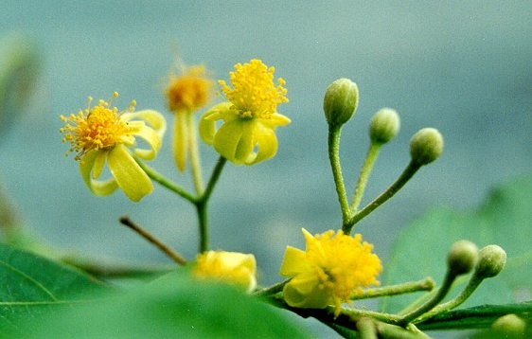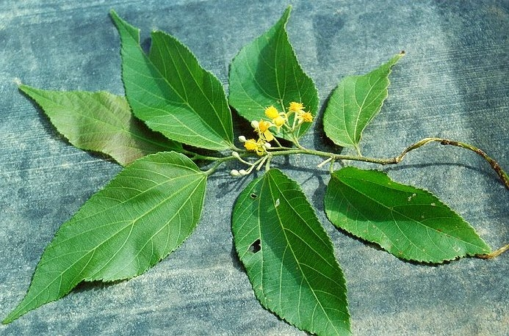
Figure B9.1 Grewia insularis Christmas Island a) flowers and b) leaves and flowers. ©Jeff Claussen.

Grewia insularis is a shrub or tree with a dense cover of stellate hairs on the tips of the branchlets, petioles and inflorescences. The leaves are lanceolate to ovate with the lamina 2–7 cm long and 0.5–3 cm wide. The inflorescences are umbels of mostly 1–3 flowers and there are usually several umbels per leaf axil. The sepals are linear (6–8 mm), pubescent and yellow. The petals are c. 3 mm and the fruit is purple (Du Puy and Telford 1993).
Taxonomy: The name Grewia insularis Ridl. is accepted in the Australian Plant Census (CHAH 2015, verified 15 October 2015).
Status: Not listed.
Recovery Plan: A recovery plan is not required for this species as it is not listed.

Number of populations inside and outside parks and reserves
Grewia insularis has been reported to grow singly or in small groups or dispersed stands (Holmes and Holmes 2002). The last survey does not report how many locations or populations were found or how many of these were located inside the national park (Holmes and Holmes 2002).

Population size – range
Ridley (1906) found the species at “North East point, fairly common”. In a 2002 survey, a total of 66 plants were found, 49 of which were mature (Holmes and Holmes 2002).

Geographical distribution
The species is endemic to Christmas Island where it has a localised distribution.
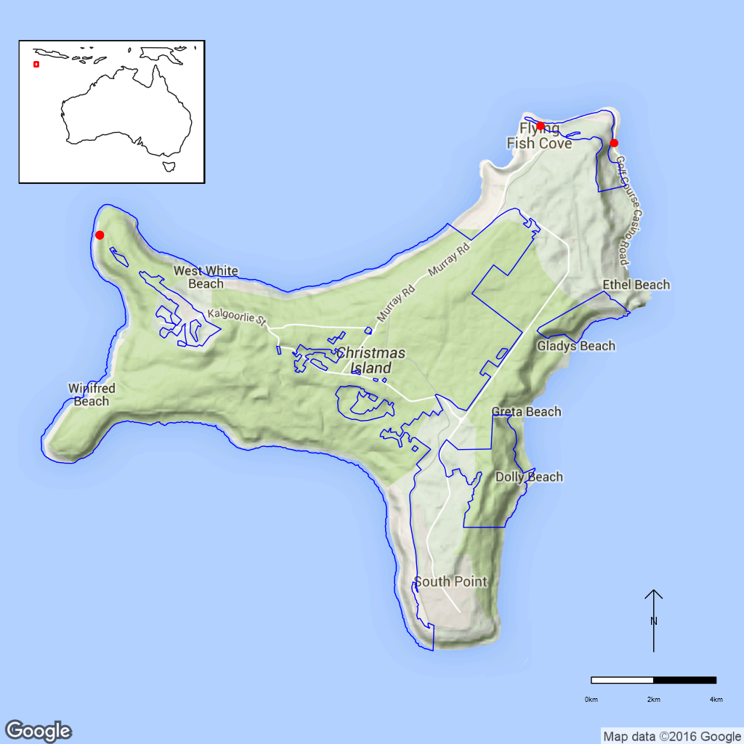
Figure B9.1 Distribution of Grewia insularis on Christmas Island.
Red dots indicate specimen collections, blue line is the park boundary.

Ex-situ collections (Living and Seed Bank)
The species is not conserved in the Living Collection at the Australian National Botanic Gardens or in the National Seed Bank (M. Henery pers. comm. 2015). No other ex-situ collections in any other Botanic Garden or Seed Bank have been located (ASBP 2016).

Biology
Pollinators: Probably insect-pollinated. Flowers of other Grewia species (G. eriocarpa and G. asiatica) were observed to be visited mostly by several bee species as well as beetles, flies and butterflies (Kato et al. 2008, Wani et al. 2015).
Symbiotic relationships: Unknown.
Germination requirements: Unknown. The seed of the related Grewia asiatica germinated readily after separation from the fruit (Wani et al., 2015).
Dormancy class: Grewia asiatica seed does not exhibit any signs of dormancy (Wani et al. 2015).
Flowering: Unknown.
Breeding system: Unknown. Grewia asiatica is self-compatible (Wani et al. 2015).
Dispersal: Unknown.
Longevity: Unknown.
Life form: Shrub or tree.
Ploidy levels: Unknown.
Role of the plant in the environment: This species grows mainly in terrace forests (Holmes and Holmes 2002).

Threats

Listed Threats
As Grewia asiatica is not currently listed under Commonwealth or State Legislation threats to this species are unknown.

Other Threats/Potential New threats

Genetic and demographic effects
The low number of individuals counted in the last survey and small distribution of this species make it vulnerable to inbreeding effects associated with low genetic diversity. The species is also vulnerable to destructive stochastic events.
Holmes and Holmes (2002) state that they found “no conceivable current threats” to G. insularis during their survey.

Current management
The species is currently not monitored and not included in the biennial island wide survey.

Knowledge Gaps
Species biology and life history including pollination syndrome, symbiotic relationships, seed germination, seed dormancy, flowering, breeding system, genetic diversity, seed dispersal, time to maturity and longevity of this species are unknown.

Suggested research and actions
- Assess whether EPBC listing is required (D. Maple pers. comm. 9 October 2015).
- Establish a monitoring program to provide baseline and ongoing data for determining population trajectories and the relative impacts of threatening processes.
- Survey suitable habitat for new populations.
- Determine key life history parameters including pollination, symbiotic relationships, flowering, breeding system, maturity and longevity to assist with species management.
- Secure genetically representative ex-situ seed collections, in multiple locations if appropriate, to mitigate against the loss of natural populations and provide for re-establishment should severe losses or extinction occur.
- Determine the appropriate conditions for long term storage and seed germination.
- Undertake a genetic assessment to determine the reproductive strategy, levels of genetic diversity and inbreeding and if any genetic structure exists to assist with any future translocation program.

References
Australian Seed Bank Partnership (2016). Search for records in the Australian Seed Bank [Online]. Council of Heads of Australian Botanic Gardens Inc. Grewia insularis. Available from http://asbp.ala.org.au/search. Accessed 11 February 2016.
Council of Heads of Australian Herbaria (CHAH) (2015). Australian Plant Census. [Online]. Available from http://biodiversity.org.au/nsl/services/apc. Accessed 15 October 2015.
Du Puy DJ and Telford IRH (1993). Tiliaceae. Flora of Australia 50: 135–140.
Holmes J and Holmes G (2002). Conservation status of the flora of Christmas Island, Indian Ocean. Report to Environment Australia / Parks Australia North. Glenn Holmes and Associates, Atherton, Queensland.
Kato M, Kosaka Y, Kawakita A, Okuyama Y, Kobayashi C, Phimminith T, Thongphan D (2008). Plant-pollinator interactions in tropical monsoon forests in Southeast Asia. American Journal of Botany 95: 1375–1394.
Ridley HN (1906). Expedition to Christmas Island / The botany of Christmas Island. Journal of the Straits Branch of the Royal Asiatic Society 45: 121–271.
Wani TA, Pandith SA, Rana S, Bhat WW, Dhar N, Razdan S, Chandra S, Kitchly S, Sharma N, Lattoo SK (2015). Promiscuous breeding behaviour in relation to reproductive success in Grewia asiatica (Malvaceae). Flora 211: 62–71.
- Pneumatopteris truncata (Thelypteridaceae)– Christmas Island fern, Christmas Island National Park
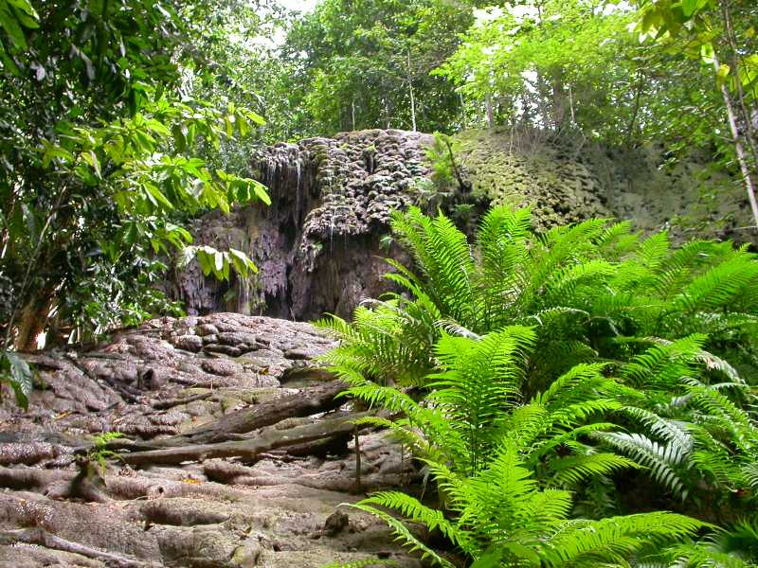
Figure B10.1 Pneumatopteris truncata Christmas Island. Photo credit – ©Dion Maple.

Pneumatopteris truncata is a large terrestrial fern with erect rhizomes. The bipinnatifid fronds are 80–120 cm long and held in a crown. The sori are circular and distributed in rows on either side of the midveins of the pinna lobes (Du Puy 1993).
Taxonomy: The name Pneumatopteris truncata (Poir.) Holttum is accepted in the Australian Plant Census (CHAH 2015, verified 13 July 2015).
Status: Listed as Critically Endangered under the EPBC Act on 6 July 2004.
Recovery Plan: Christmas Island Biodiversity Conservation Plan (Draft DNP 2014).
Information in this fact sheet is taken from the SPRAT Listing Page (DoE 2015) unless otherwise referenced.

Number of populations inside and outside parks and reserves
Two known populations are located on the south-west side of the island at Hugh’s Dale and Blowholes Ravine. All known occurrences occur inside the national park boundaries (DNP 2014).

Population size – range
A 2002 survey recorded 45 mature individuals, 30 in one location and 15 in the other (Holmes and Holmes 2002, TSSC 2004). The extent of occurrence for these two populations was estimated to be 0.4 km² (TSSC 2004). The population size has since declined and as few as five individuals now occur at the High’s Dale site and possibly <5 at Blowholes Ravine (D. Maple pers. comm. 9 October 2015).

Geographical distribution
Apart from Christmas Island, the species also occurs from India and southern China, through Indo-China and western Malesia, to the Philippines, the Lesser Sunda Islands and the Mariana Islands (Du Puy 1993). The species has a widespread but fragmented distribution. The distribution on Christmas Island is localised and fragmented.
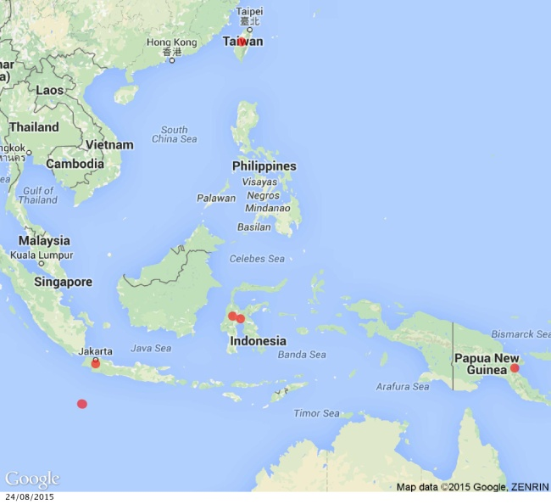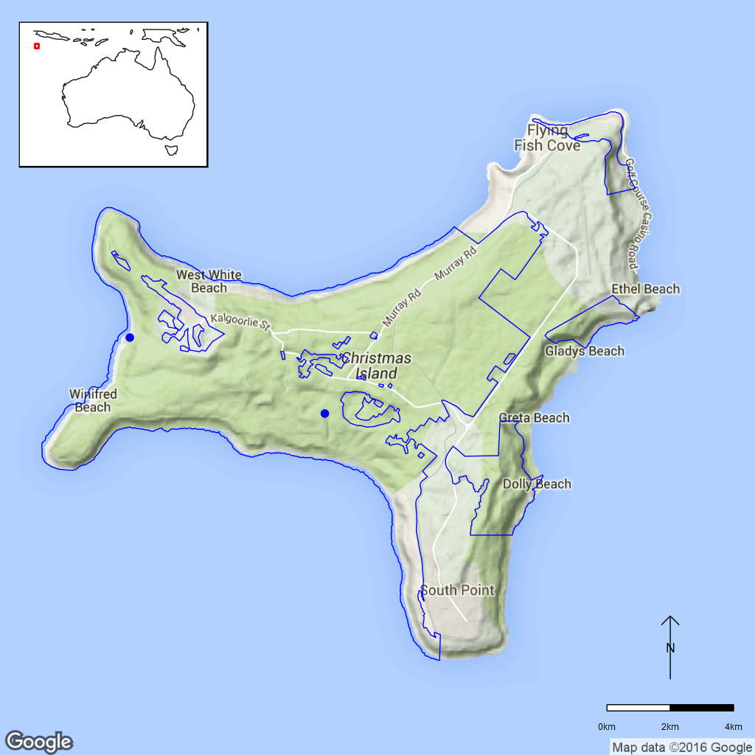
Figure B10.1 Distribution of Pneumatopteris truncata in SE Asia (left) and distribution on Christmas Island (right). Blue dots indicate locations verified by CINP Staff, blue line is the park boundary.

Ex-situ collections (Living and Seed Bank)
The species is not conserved in the Living Collection at the Australian National Botanic Gardens or in the National Seed Bank (Z. Knapp pers. comm. 30 September 2015). No other ex-situ collections in any other Botanic Garden or Seed Bank have been located (ASBP 2016).

Biology
Pollinators: N/A
Symbiotic relationships: Unknown.
Germination requirements: Unknown.
Dormancy class: N/A
Flowering: N/A
Breeding system: Unknown.
Dispersal: Fern spores are usually dispersed over a few meters, but transport over thousands of km via air currents is possible. Fern spores without developed chloroplasts and can survive for months to years (Kessler 2010).
Longevity: Unknown.
Life form: Fern
Ploidy levels: Unknown.
Role of the plant in the environment: Pneumatopteris truncata grows in semi-deciduous forest in 50–140 m elevation. Here, it forms colonies on permanently moist sites (DNP 2014).

Threats

Listed threats (EPBC Act)
- Low numbers of individuals.

Genetic and demographic effects
The very low population size and small distribution area on Christmas Island suggest that limited genetic diversity exists which may be even lower if the plants are reproducing clonally. This may make is susceptible to inbreeding but the effects of this in ferns is unknown. It is also vulnerable to stochastic events such as cyclones.

Other Threats/Potential New threats

Climate-related factors
Cyclones occur in the vicinity of Christmas Island on average about once a year and plants growing along waterways can be swept away or their substrate eroded. Wind damage to the canopy during cyclones and severe tropical storms can also lead to falling branches destroying plants and create canopy gaps that make the habitat unsuitable for the Christmas Island Fern (TSSC 2004). Although overall cyclone activity is predicted to decrease under climate change, high intensity cyclones will become more frequent, potentially leading to vegetation damage on the island (DNP 2011).
Fire is a potential threat to P. truncata (DNP 2014). Climate change scenarios predict an increase in annual average temperature and of the number of hot days. Together with a predicted decrease in rainfall amounts this leads to an increase in the number of days with high or extreme forest fire danger, and fires could become more frequent and severe (DNP 2011).

Invasive and other problematic species
Several weeds occur in the forests of Christmas Island such as Clausena excavata (Rutaceae, Swarbrick and Hart 2001) but no data exist to assess if any weeds threaten this species. Invasive species such as the invasive Giant African Snail (Achatina fulica) present a potential threat for P. truncata. Future introduction of invasive species as well as sleeper weeds also present potential threats (DNP 2014).

Biophysical impacts
Outside the national park, road construction, development or mining pose potential threats to any undiscovered P. truncata populations (DNP 2014).

Current management
Not currently monitored or included in the biennial island-wide survey, but if found it would be reported. A rare flora search was conducted in 2012 by the Australian National Herbarium and the species was not found (M. Goumas pers. comm. 6 August 2015).

Knowledge Gaps
Species biology and life history including symbiotic relationships, spore germination, spore storage, genetic diversity, time to maturity and longevity of both life stages are unknown.
Habitat preferences are not well defined.

Suggested research and actions
- Researching the ecology and habitat requirements of P. truncata is included under the proposed Action 6.2 in the Christmas Island Biodiversity Conservation Plan (DNP 2014).
- Establish a monitoring program to provide baseline and ongoing data for determining population trajectories and the relative impacts of threatening processes.
- Determine life history traits such as maturity and longevity to assist with population management to assist with species management.
- Evaluate whether long term storage of spores is possible and germination requirements.
- A broader phylogenetic study would determine relatedness between this population and the nearest neighbours in the event that translocation programs were required.
- Develop and implement a restoration program to increase population numbers and/or sizes.
- Evaluate the need to establish ‘insurance’ populations off-park.

References
Australian Seed Bank Partnership (2016). Search for records in the Australian Seed Bank [Online]. Council of Heads of Australian Botanic Gardens Inc. Pneumatopteris truncata. Available from http://asbp.ala.org.au/search. Accessed 11 February 2016.
Council of Heads of Australian Herbaria (CHAH) (2015). Australian Plant Census. [Online]. Available from http://biodiversity.org.au/nsl/services/apc. Accessed 13 July 2015.
Department of the Environment (DoE) (2015). Pneumatopteris truncata in Species Profile and Threats Database, Department of the Environment, Canberra. Available from http://www.environment.gov.au/sprat. Accessed 12 August 2015.
Director of National Parks (DNP) (2011). Christmas Island National Park Climate Change Strategy 2011–2016. Department of Sustainability, Environment, Water, Population and Communities, Canberra, Australia. Available from http://www.environment.gov.au/system/‌files/resources‌/7fb545e2-5c09-4a74-b12d-3afd79b9537d/files/christmasstrategy.pdf. Accessed 12 August 2015.
Director of National Parks (DNP) (2014). Christmas Island Biodiversity Conservation Plan (Draft). Department of the Environment, Canberra. Available from http://www.environment.gov.au/resource/draft-christmas-island-biodiversity-conservation-plan. Accessed 12 August 2015.
Du Puy DJ (1993). Thelypteridaceae. In Commonwealth of Australia (1993). Flora of Australia vol. 50 Oceanic islands 2, pp. 550–553. Australian Government Publishing Service, Canberra.
Holmes J and Holmes G (2002). Conservation status of the flora of Christmas Island, Indian Ocean. Report to Environment Australia / Parks Australia North. Glenn Holmes and Associates, Atherton, Queensland.
Kessler M (2010). Biogeography of ferns. In Mehltreter K, Walker LR and Sharpe JM (eds.). Fern Ecology. Cambridge University Press. pp: 22–60. Available from http://ebooks.cambridge.org/chapter.jsf?bid=CBO9780511844898&cid=CBO9780511844898A016. Accessed 12 August 2015.
Swarbrick JT and Hart R (2001). Environmental weeds of Christmas Island (Indian Ocean) and their management. Plant Protection Quarterly 16: 54–57.
Threatened Species Scientific Committee (TSSC) (2004). Commonwealth listing advice on Pneumatopteris truncata (fern). Available from http://www.environment.gov.au/node/16472. Accessed 12 August 2015.
- Tectaria devexa var. minor (Dryopteridaceae) – A fern, Christmas Island National Park
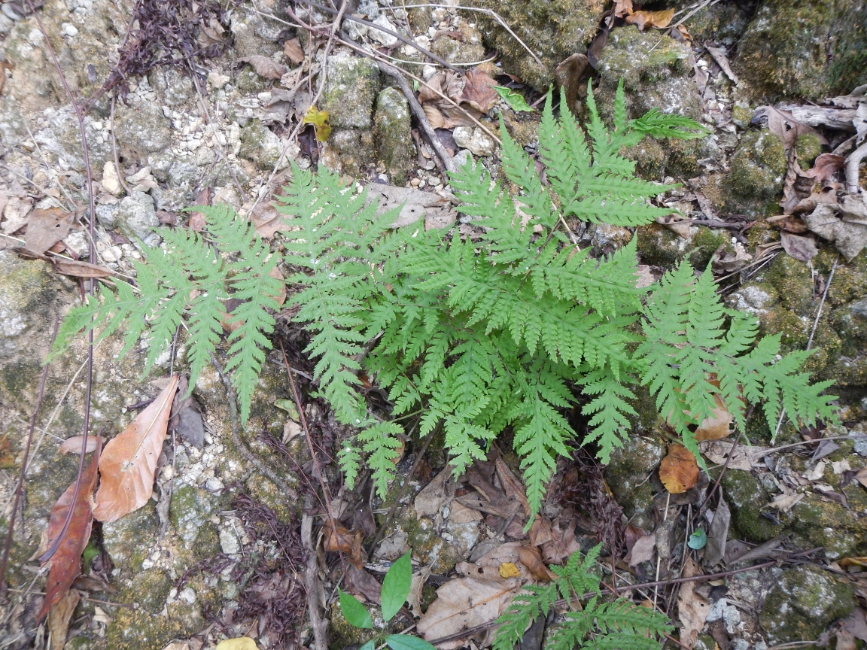
Figure B11.1 Tectaria devexa var. minor Christmas Island. Photo credit – ©Dion Maple.

Tectaria devexa is a fern with procumbent or nearly erect rhizomes with dark brown scales that are 6–9 mm long. The tripinnatisect leaves (fronds) are 20–40 cm, arching and arranged in a crown. They have anastomosing veins. The sori are small and circular, with a reniform indusium. The var. minor occurring on Christmas Island has leaves with lower sides that are mainly hairy on the veins. In Australia the only occurrences of var. devexa, which differs by having leaves that are hairy on the whole lower surface, are in Queensland (Du Puy and Orchard 1993).
Tectaria devexa is very similar to Tectaria dissecta, a species also occurring on Christmas Island, however, Tectaria dissecta has less finely divided leaves without anastomosing veins (Du Puy and Orchard 1993).
Taxonomy: The name Tectaria devexa (Kunze ex Mett.) Copel. var. minor (Hook.) Holttum is accepted in the Australian Plant Census (CHAH 2015, verified 13 July 2015).
Status: The species (including both of varieties) was listed as Endangered under the EPBC Act on 16 July 2000.
Recovery Plans:
  - National Recovery Plan for Tectaria devexa (Butz 2004)
  - Christmas Island Biodiversity Conservation Plan (Draft, DNP 2014)
This information is sourced from the SPRAT webpage associated with this species (DoE 2015) unless otherwise referenced.

Number of populations inside and outside parks and reserves
The species is currently known from eleven locations (D. Maple pers. comm. 9 October 2015) most of which are located inside the national park. However, the distribution of Tectaria devexa on Christmas Island is not well known and unknown population are suspected to exist (DNP 2014, D. Maple pers. comm. 9 October 2015).

Population size – range
In 2002, population sizes ranged from 210 individuals in one population, 170 in another with the remaining plants distributed among small and scattered colonies. In 2004, the total number of mature individuals of var. minor on Christmas Island was estimated to be <500 (Butz 2004). In the last few years, more populations have been found (D. Maple and A. Grigg pers. comm. 9 October 2015) but current species numbers are not available.

Geographical distribution
Outside of Christmas Island, T. devexa var. minor also occurs in Sri Lanka (Holttum 1988). It has a fragmented distribution on Christmas Island (DNP 2014).
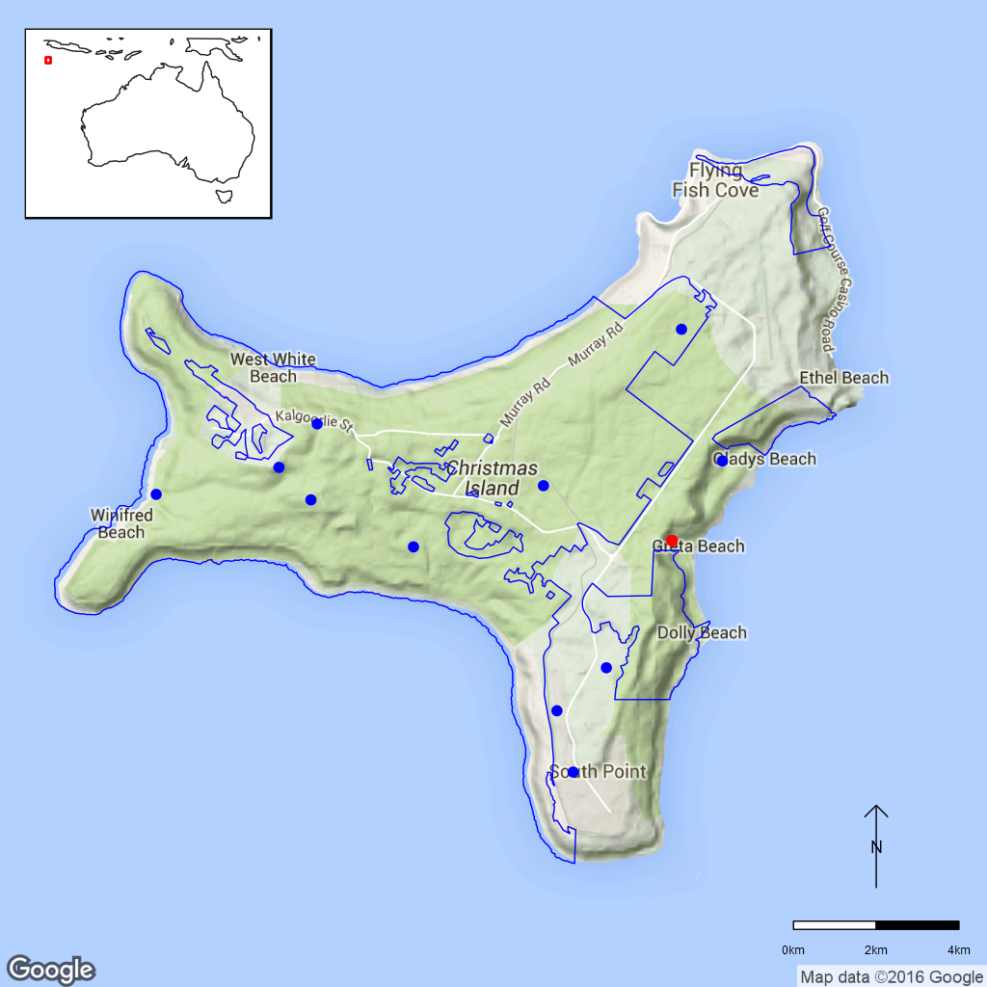
Figure 11.1 Distribution of Tectaria devexa var. minor on Christmas Island.
Blue dots indicate locations verified by CINP Staff, red dots are specimen
collections, blue is the park boundary.

Ex-situ collections (Living and Seed Bank)
The species is not conserved in the Living Collection at the Australian National Botanic Gardens or in the National Seed Bank (Z. Knapp pers. comm. 30 September 2015). It is also not conserved in the National Seed Bank as ferns do not produce seed.

Biology
Pollinators: N/A
Symbiotic relationships: Unknown.
Germination requirements: Unknown.
Dormancy class: N/A
Flowering: N/A
Breeding system: Unknown.
Dispersal: The tendency of the species to be found in clumps on Christmas Island indicate vegetative propagation but this has not been confirmed (Butz 2004). Fern spores are usually dispersed over a few meters, but transport over thousands of kilometres via air currents is possible. Fern spores without developed chloroplasts and can survive for months to years (Kessler 2010).
Longevity: Unknown.
Life form: Fern.
Ploidy Levels: Unknown.
Role of the plant in the environment: Tectaria devexa var. minor grows in the evergreen tall closed forest growing on the plateau of Christmas Island, where it may be the only forest floor species in some places (DNP 2014).

Threats

Listed threats (EPBC Act)
- Illegal collection.
- Restricted geographical distribution.
- Habitat destruction, disturbance and/or modification due to mining activities.
- Competition and/or habitat degradation by weeds.
- Low numbers of individuals.

Genetic and demographic effects
The likely low population size and its restricted geographical distribution make Tectaria devexa var. minor vulnerable to stochastic events such as cyclones (DNP 2014). It may also be vulnerable to inbreeding although the effects of small population size are not well known for ferns.

Invasive and other problematic species
Weeds that are reported to occur in the evergreen rainforest include Castilla elastica (Moraceae), Hevea brasiliensis (Euphorbiaceae) and Clausena excavata (Rutaceae, Swarbrick and Hart 2001) but it is unknown if these woody weeds pose a direct threat to T. devexa var. minor. Competition by the very hardy native Scurfy Sword Fern (Nephrolepis multiflora, Lomariopsidaceae) and Broad Sword Fern (N. biserrata) is also a possible threat.
While the invasive Giant African Snail (Achatina fulica) does not yet occur in T. devexa var. minor habitat it may pose a problem if it does become invasive. Future introduction of invasive species as well as sleeper weeds already present on Christmas Island are also potential threats (DNP 2014).

Biophysical impacts
Outside of the national park, road construction, development and mining pose could impact on populations not yet discovered.

Direct human impacts
Illegal collection was considered a threat by Butz (2004) but is now considered unlikely to occur (DNP 2014).

Other Threats/Potential New threats

Climate-related factors
Populations of Tectaria devexa var. minor are generally threatened by droughts and cyclones (DNP 2014). Since climate change is predicted to lead to a decrease in rainfall and a rise in temperature, droughts might become more severe or frequent. Furthermore, although overall cyclone activity is predicted to decrease, high intensity cyclones will become more frequent, potentially leading to vegetation damage on the island (DNP 2011).
Fire is a potential threat to T. minor var. devexa (DNP 2014). Climate change scenarios predict an increase in annual average temperature and of the number of hot days. Together with a predicted decrease in rainfall amounts this leads to an increase in the number of days with high or extreme forest fire danger, and fires could become more frequent and severe (DNP 2011).

Current management
The taxon is included in the biennial island-wide survey. A rare flora search conducted in 2012 by the Australian National Herbarium (pers. comm. M. Goumas 6 August 2015) does not appear to have found this species.

Knowledge Gaps
Species biology and life history including symbiotic relationships, spore germination, spore storage, genetic diversity, and time to maturity and longevity of both life stages are unknown. This species habitat requirements is poorly understood.

Suggested research and actions
- Researching the biology and ecology of T. devexa var. minor is included under the proposed Action 6.2 in the Christmas Island Biodiversity Conservation Plan (DNP 2014).
- Clarify whether the current monitoring program is providing sufficient data to determine population trajectories and the relative impacts of threatening processes.
- Cultivation of Tectaria devexa var. minor may assist with understanding the life cycle as well as habitat and regeneration requirements (DNP 2014).
- Evaluate whether long term storage of spores is possible and germination requirements.

References
Australian Seed Bank Partnership (2016). Search for records in the Australian Seed Bank [Online]. Council of Heads of Australian Botanic Gardens Inc. Tectaria devexa. Available from http://asbp.ala.org.au/search. Accessed 11 February 2016.
Butz M (2004). National Recovery Plan for Tectaria devexa. Department of the Environment and Heritage, Canberra.
Council of Heads of Australasian Herbaria (CHAH) (2015). APC – Australian Plant Census. Available from http://biodiversity.org.au/nsl/services/apc. Accessed 13 July 2015.
Department of the Environment (DoE) (2015). Tectaria devexa in Species Profile and Threats Database, Department of the Environment, Canberra. Available from http://www.environment.gov.au/sprat. Accessed 18 August 2015
Director of National Parks (DNP) (2011). Christmas Island National Park Climate Change Strategy 2011–2016. Department of Sustainability, Environment, Water, Population and Communities, Canberra, Australia. Available from: http://www.environment.gov‌.au/system‌/files/resources/7fb545e2-5c09-4a74-b12d-3afd79b9537d/files/christmasstrategy.pdf.
Director of National Parks (DNP) (2014). Christmas Island Biodiversity Conservation Plan (Draft). Department of the Environment, Canberra. Available from: http://www.environment.gov.au/resource/draft-christmas-island-biodiversity-conservation-plan.
Du Puy DJ and Orchard AE (1993). Dryopteridaceae. In Commonwealth of Australia (1993). Flora of Australia vol. 50 Oceanic islands 2, pp. 559–562. Australian Government Publishing Service, Canberra.
Holttum RE (1988). Studies in the fern genera allied to Tectaria Cav. VII. Species of Tectaria sect. Sagenia (Presl) Holttum in Asia excluding Malesia. Kew Bulletin 43: 475–489.
Kessler M (2010). Biogeography of ferns. In Mehltreter K, Walker LR and Sharpe JM (eds.). Fern Ecology. Cambridge University Press. pp. 22–60. Available from http://ebooks.cambridge.org/chapter.jsf?bid=CBO9780511844898&cid=CBO9780511844898A016. Accessed 18 August 2015.
Swarbrick JT and Hart R (2001). Environmental weeds of Christmas Island (Indian Ocean) and their management. Plant Protection Quarterly 16: 54–57.
- Acacia equisetifolia (Fabaceae) – Graveside Gorge Wattle, Kakadu National Park
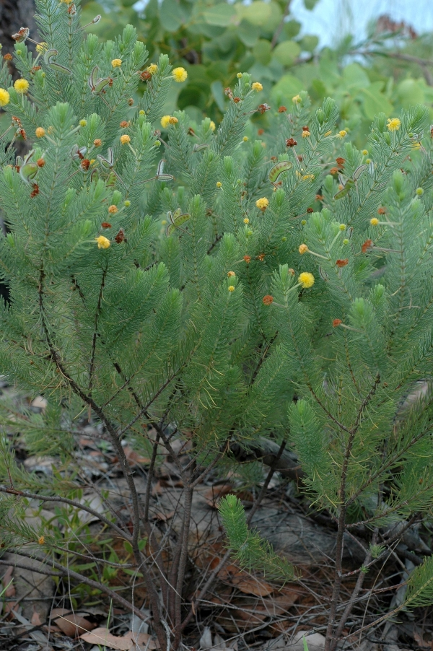
Figure B12.1 Acacia equisetifolia Kakadu National Park. ©K Brennan.

Acacia equisetifolia is a shrub up to 1 m tall. The hairy phyllodes are arranged in crowded whorls of 10–17. The yellow flowers are arranged into globular inflorescences, with inflorescences solitary on whorls of phyllodes (Maslin and Cowie 2014).
Taxonomy: The name Acacia equisetifolia Maslin and Cowie is accepted in the Australian Plant Census (CHAH 2015, verified 13 July 2015).
Status: Listed as Critically Endangered under the EPBC Act on 14 August 2006 as Acacia sp. Graveside Gorge (V.J.Levitzke 806). Listed as Critically Endangered under the Territory Parks and Wildlife Conservation Act 2000 (Northern Territory) on the 2012 list as Acacia sp. Graveside Gorge (V.J.Levitzke 806) NT Herbarium.
Recovery Plan: Recovery Plan not required, included on the Not Commenced List (1 November 2009). Management prescriptions and research recommendations are included in ‘A strategy for the conservation of threatened species and threatened ecological communities in Kakadu National Park’ (Woinarski and Winderlich 2014).
This Information is sourced from SPRAT (DoE 2015) unless otherwise referenced.

Number of populations inside and outside parks and reserves
When the species was first collected in 1981 only vague locality data was given. Surveys found one population (Kerrigan 2004) and later a second population about 1 km away (Kerrigan et al. 2007). Both known populations are inside Kakadu National Park.

Population size – range
Population sizes apparently strongly fluctuate. The first known population consisted of one mature plant and about 20 seedlings in 2004 (Kerrigan 2004) but in 2006 150 plants, many flowering and fruiting, were found at the same location; the second population consisted of 700–800 individuals (Kerrigan et al. 2007). The total population size of the species was thus estimated as 850–950 individuals with an extent of occurrence of <1 km² (Cowie and Liddle 2014).

Geographical distribution
The species has a localised distribution.
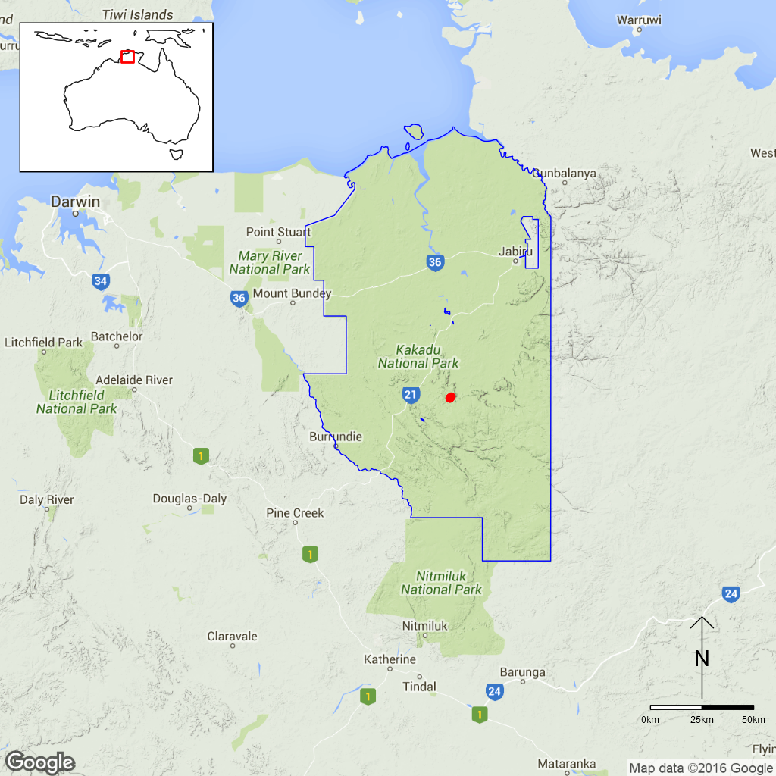
Figure B12.1 Distribution of Acacia equisetifolia. Red dots are specimen
collections, blue line is the park boundary.

Ex-situ collections (Living and Seed Bank)
The species is not conserved in the Living Collection at the Australian National Botanic Gardens (ANBG) (Z. Knapp pers. comm. 30 September 2015). Kakadu and the ANBG have a collaborative project to collect seed for storage in the National Seed Bank (O’Dea 2014) and this species has been identified as a priority target for collection, propagation and experimental translocation (KNP TS Project 4, M. Goumas pers. comm. 6 August 2015). One seed accession (21.2 g) is held at the National Seed Bank and collection from the second population is planned for April 2016 (Tom North pers. comm. 11 September 2015). The George Brown Darwin Botanic Gardens, Northern Territory, currently holds seed collections of this species (Wedd 2013). No other ex-situ collections in any other Botanic Garden or Seed Bank have been located (ASBP 2016).

Biology
Pollinators: Acacias support an array of insect species (Bernhardt 1989).
Symbiotic relationships: Unknown but likely to have associations with nodulating nitrogen-fixing bacteria.
Germination requirements: This species apparently produces mass recruitment from soil-stored seed following a fire (Cowie and Liddle 2014). Seed of the related species A. porcata, which occurs in the same section of the genus, are easily germinated by scarifying the seed coat or soaking in boiling water; fire might break dormancy (Leverington 2001).
Dormancy class: Orthodox.
Flowering: Not precisely known but flowers at anthesis have been collected in February (Maslin and Cowie 2014).
Breeding system: This species probably only reproduces sexually (Kerrigan et al. 2007). The flowers are bisexual. It is likely to be self-incompatible (Kenrick et al. 1986, Kenrick and Knox 1989).
Dispersal: Unknown but the seed have an aril (Maslin and Cowie 2014) suggesting that they might be dispersed by ants.
Longevity: Unknown. The time to maturity in other obligate seeder species of the same section of Acacia is 2–4 years (Russell-Smith et al. 2010). In A. equisetifolia, time to maturity is probably 1–2 years (Kerrigan 2004, Kerrigan et al. 2007).
Life form: Shrub.
Ploidy levels: Unknown.
Role of the plant in the environment: The species grows on west- to southwest-facing rocky sandstone slopes and ledges at the top of cliff lines (Woinarski and Winderlich 2014).

Threats

Listed threats (EPBC Act)
- Restricted geographical distribution (area of occupancy and extent of occurrence)
- Inappropriate and/or changed fire regimes (frequency, timing, intensity)
- Low numbers of individuals

Genetic and demographic effects
Population sizes can apparently fluctuate strongly and although further plants have been located since the time of listing, this species still has a relatively low number of individuals overall (Kerrigan et al. 2007). Small population sizes can reduce genetic diversity and lead to inbreeding. In Acacia dealbata this resulted in reduced seed set in small populations (Broadhurst and Young 2006). Selfed seed can sometimes be produced in acacias but the seedlings are often less fit and fail to thrive (Moffat and Nixon 1974, Harwood et al. 2004). The species also has a very restricted distribution making it vulnerable to stochastic events such as fire.

Climate-related factors
The main threat to A. equisetifolia is fire, especially those that are too frequent or intense. Too frequent fires could kill the plants before they have had a chance to reproduce (DOE 2008). Climate change is predicted to lead to a significantly higher number of hot days (>35°C) in the Top End region, as well as more frequent and intense extreme weather events and possibly increased rainfall during the wet season. These conditions might in turn lead to higher fuel loads and more frequent and severe fires (Hyder Consulting 2008).

Other Threats/Potential New threats

Invasive and other problematic species
The invasive pasture grasses Andropogon gayanus (Gamba Grass) and Cenchrus pedicellatus (Annual Mission Grass) have been observed growing on sandstone could spread to the habitat of A. equisetifolia in the future. Significant populations of these invasive grasses would lead to the build-up of higher fuel loads and more severe wildfires (Woinarski and Winderlich 2014).

Current management
A monitoring plot was established in 2004 and re-sampled in 2005 and 2006 but there has been no subsequent monitoring. The species also receives consideration in the Stone Country fire management plan where the objective is to reduce fire frequency and patch size for the protection of the highly localised threatened species (Petty et al. 2007, cited in Woinarski and Winderlich 2014).

Knowledge gaps
Species biology and life history including pollination syndrome, symbiotic relationships, seed germination, flowering, breeding system, genetic diversity, seed dispersal, time to maturity and longevity of this species are unknown or poorly understood. The role of fire and other ecological processes in the distribution and abundance of the species are also unknown.

Suggested research and actions
- Continue monitoring to assess of population size, distribution, fire ecology and the relative impacts of threatening processes (DoE 2008).
- Survey for additional subpopulations (Woinarski and Winderlich 2014).
- Determine key life history parameters such as age to maturity, longevity and seed survival should be determined to be able to help establish fire regime thresholds (Woinarski and Winderlich 2014).
- The species is morphologically similar to Acacia hippuroides from the Kimberley region in Western Australia, and it has been suggested it might be possible treat A. equisetifolia as an infraspecific taxon within A. hippuroides (Maslin and Cowie 2014). While this could be investigated the listing status would probably not change.
- Assessing population genetic structure would determine whether the two populations are genetically distinct and assist with making decisions regarding mixing seed and translocations of material.

References
Australian Seed Bank Partnership (2016). Search for records in the Australian Seed Bank [Online]. Council of Heads of Australian Botanic Gardens Inc. Acacia equisetifolia. Available from http://asbp.ala.org.au/search. Accessed 11 February 2016.
Broadhurst LM and Young AG (2006). Reproductive constraints to the long-term persistence of fragmented Acacia dealbata (Mimosaceae) populations in southeast Australia. Biological Conservation 133: 512–526.
Council of Heads of Australian Herbaria (CHAH) (2015). Australian Plant Census. [Online]. Available from http://biodiversity.org.au/nsl/services/apc. Accessed 13 July 2015.
Department of the Environment (DoE) (2008). Approved conservation advice for Acacia sp. Graveside Gorge (V.J. Levitzke 806) NT Herbarium. Available from http://www.environment.gov.au/biodiversity/threatened/species/pubs/87480-conservation-advice.pdf. Accessed 1 September 2015.
Department of the Environment (DoE) (2015). Acacia equisetifolia in Species Profile and Threats Database, Department of the Environment, Canberra. Available from: http://www.environment.gov.au/sprat. Accessed 1 September 2015.
Harwood CE, Thinh H, Quang T, Butcher PA, Williams ER (2004). The effect of inbreeding on early growth of Acacia mangium in Vietnam. Silvae Genetica 53: 65–69.
Hyder Consulting (2008). The Impacts and Management Implications of Climate Change for the Australian Government’s Protected Areas. A report to the Department of the Environment, Water, Heritage and the Arts and the Department of Climate Change. Commonwealth of Australia, Canberra.
Kenrick J, Kaul V, Williams EG (1986). Self-incompatibility in Acacia retinoides: site of pollen-tube arrest is the nucellus. Planta 169: 245–250.
Kenrick J and Knox RB (1989). Pollen-pistil interactions in Leguminosae (Mimosoideae). In Stirton CH, Zarucchi JL (eds.) Advances In Legume Biology, vol. 29. St Louis Missouri: Missouri Botanic Gardens. pp 127–156.
Kerrigan R (2004). Kakadu threatened flora report (vol. 2). Results of a threatened flora survey 2004. Department Infrastructure, Planning and Environment, Darwin. Available from http://www.territorystories.nt.gov.au/bitstream/10070/222425/1/2004_Kerrigan_R.pdf. Accessed 1 September 2015.
Kerrigan RA, Cowie ID, Brennan KG (2007). Acacia sp. Graveside Gorge. In Woinarski JCZ, Pavey C, Kerrigan RL, Cowie ID and Ward S (eds.) Lost from our Landscape: Threatened Species in the Northern Territory. Department of Natural Resources, Environment and the Arts, Palmerston. pp. 28.
Leverington A (2001). Recovery plan for Acacia porcata 1999–2001. Queensland Parks and Wildlife Service. ISBN: 0724282459. Available from http://www.environment.gov.au/system/files/resources/4a6b3dfe-1e33-48e8-b366-c9978357e26e/files/porcata.pdf. Accessed 1 September 2015.
Maslin BR and Cowie ID (2014). Acacia equisetifolia, a rare, new species of Acacia sect Lycopodiifoliae (Fabaceae: Mimosoideae) from the Top End of the Northern Territory. Nuytsia 24: 1–5.
Moffett AA, Nixon KM (1974). The effects of self-fertilization in green wattle (Acacia decurrens (J.Wendl.) Willd.) and black wattle (A. mearnsii de Wild.). Natal: Wattle Research Institute Report 1973–74.
O’Dea A (2014). Guide to Threatened species of Kakadu National Park including other plants and animals of interest. Book. Available from http://‌www.‌nespnorthern.edu.au/wp-content/uploads/2016/01/kakadu_guide_to_threatened_species_lr_final.pdf. Accessed 1 September 2015.
Petty A, Alderson J, Muller R, Scheibe O, Wilson K, Winderlich S (2007). Kakadu National Park: Arnhemland Plateau fire management plan. Kakadu National Park, Jabiru.
Russell-Smith J, Yates CP, Brock C, Westcott VC (2010). Fire regimes and interval-sensitive vegetation in semiarid Gregory National Park, northern Australia. Australian Journal of Botany 58: 300–317.
Wedd D (2013). Captive Breeding – is there a role in species conservation? In: Winderlich S and Woinarski J (eds.) Kakadu National Park Landscape Symposia Series. Symposium 7: Conservation of threatened species, 26–27 March 2013, Bowali Visitor Centre, Kakadu National Park. Internal Report 623, Supervising Scientist, Darwin. Available from http://www.environment.gov.au/science/supervising-scientist/publications‌/internal-reports/kakadu-national-park-landscape-symposia-series-symposium-7-conservation-threatened-species. Accessed 1 September 2015.
Woinarski JCZ and Winderlich S (2014). A strategy for the conservation of threatened species and threatened ecological communities in Kakadu National Park | 2014–2024. Report. ISBN 987-1-925167-07-8. Available from http://www.nespnorthern.edu.au/wp-content/‌uploads‌/2015‌/10/‌kakadu_strategy_-_31-10-14_0.pdf. Accessed 1 September 2015.
- Hibbertia brennanii, H. pancerea, H. tricornis and Hibbertia sp. South Magela (K.G.Brennan 896) (Dilleniaceae) – four Guinea flowers, Kakadu National Park
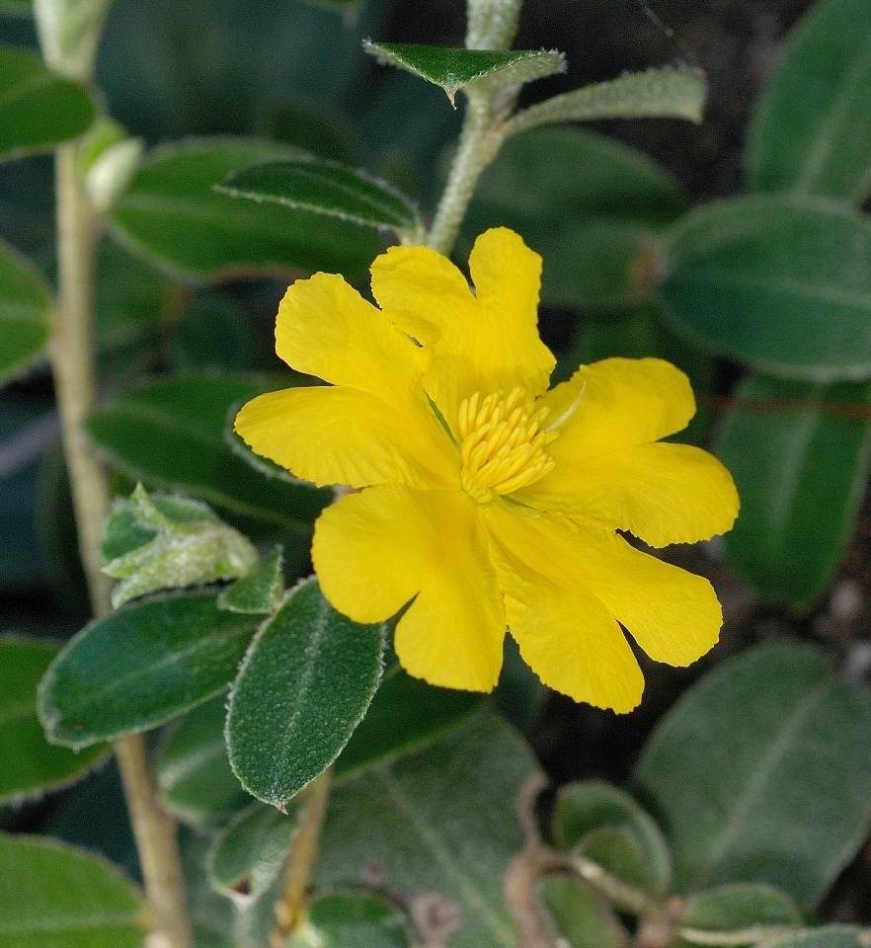
Figure B13.1 Hibbertia pancerea Kakadu National Park. ©K Brennan.

- Hibbertia brennanii is a low spreading subshrub to 0.3 m. The branches are wiry, becoming stiffly woody when older.
- Hibbertia pancerea is a spreading shrub to 1.5 m with angular or ridged branches.
- Hibbertia tricornis is a more or less prostrate and little branched subshrub to 0.2 m high.
- These three species have one-flowered axillary inflorescences. The yellow petals are lobed and 3.6–4.2 mm long in H. brennanii, 4–5.6 mm long in H. pancerea and 7–8.9 mm long in H. tricornis (Toelken 2010).
- Hibbertia sp. South Magela is a pendulous multi-stemmed subshrub, with stems up to 0.5 m long. The flowers are bright yellow (Westaway and Cowie 2012d).
Taxonomy: The names Hibbertia brennanii Toelken, H. pancerea Toelken and H. tricornis Toelken are accepted in the Australian Plant Census (CHAH 2015, verified 23 September 2015).
- Hibbertia brennanii was formerly known under the phrase name Hibbertia sp. Stellate above (J.L.Egan 4812).
- Hibbertia pancerea was formerly known as Hibbertia sp. Fire Plot 121 (K.G.Brennan 3821).
Status: All four species are listed as Vulnerable under the Northern Territory TPWC Act (Woinarski and Winderlich 2014).
Recovery Plan: A recovery plan does not exist. Management prescriptions and research recommendations are included in the conservation strategy for threatened species and ecological communities in Kakadu National Park (Woinarski and Winderlich 2014).

Number of populations inside and outside parks and reserves
It is estimated that about 50% of Hibbertia brennanii populations, 90% of Hibbertia sp. South Magela and all Hibbertia pancerea and H. tricornis populations occur the national park (Cowie and Liddle 2014).

Population size – range
Hibbertia brennanii has an estimated extent of occurrence of 18 km² and a population size of >1000 mature individuals (K. Brennan pers. comm. 2010, cited in Westaway and Cowie 2012a). Hibbertia pancerea has an estimated extent of occurrence of 2 ha and an unknown but probably very small population size. The extent of occurrence and the population size of Hibbertia tricornis is unknown but presumed to be very small. Hibbertia sp. South Magela has an estimated extent of occurrence of 1 km² and a population size of <1000 mature individuals (Westaway and Cowie 2012a,b,c,d, Cowie and Liddle 2014).

Geographical distribution
All the species have a very localised distribution.
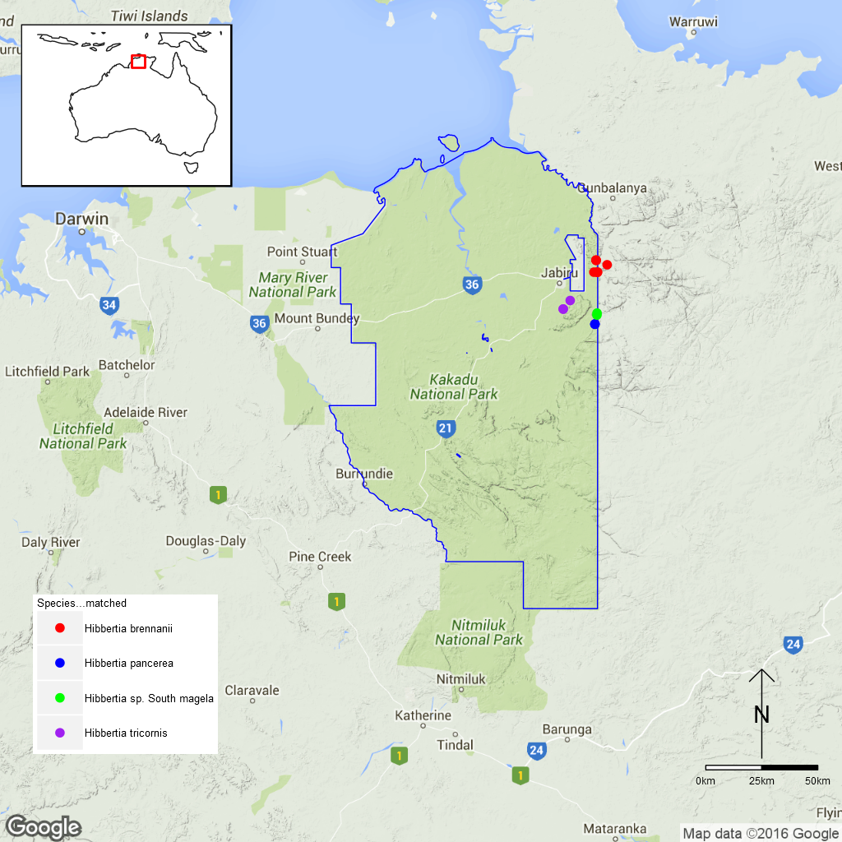
Figure 13.1 Distribution of Hibbertia brennanii (red), H. pancerea (blue),
H. tricornis (purple) and H. sp. South Magela (green) in Kakadu National Park.
Locations based on specimen records, blue line is the park boundary.

Ex-situ collections (Living and Seed Bank)
Seed of H. brennanii and H. sp. South Magela are held in the National Seed Bank and the other species have been identified as priority species for collection, propagation and experimental translocation (KNP TS Project 4, M. Goumas pers. comm. 6 August 2015). None of the species are conserved in Living Collection at the Australian National Botanic Gardens (M. Henery pers. comm. 5 November 2015). No other ex-situ collections within any other Botanic Garden or Seed Bank have been located (ASBP 2016).

Biology
Pollinators: The species are insect-pollinated, most likely by bees since many Hibbertia species are pollinated by large bees (>7-22 mm long) that use thoracic vibration to shake pollen out of the anthers; other species have loose pollen that is collected by smaller bees or eaten by hoverflies (syrphids, Tucker and Bernhardt 2000). Hibbertia species do not generally produce nectar, but the anthers can have a strong smell (Keighery 1975). The pollination syndrome of these species in unknown.
Symbiotic relationships: Unknown.
Germination requirements: Germination in the few Hibbertia species that have been studied indicates that some pre-treatment is required. Some species responded weakly to smoke treatment (Kingsley et al. 1995) while seed coat removal or scarification has led to higher germination which can be improved further by smoke treatment in some species (Roche et al. 1997, Allen et al. 2004). However, germination requirements apparently vary among species Hibbertia, even those growing in the same region (Hidayati et al. 2012).
Dormancy class: The seed of Hibbertia species seem to be dormant, probably at least partly due to physical dormancy (Roche et al. 1997).
Flowering: Many Hibbertia species flower opportunistically, so that flowering is sparse throughout the year whenever conditions are suitable. The main flowering times for these species are unknown and too few herbarium specimens exist to provide any information (Toelken 2010).
Breeding system: The flowers are bisexual. It is unknown if these species are able to reproduce vegetatively (Westaway and Cowie 2012a,b,c) but are reported to be obligate seeders (Cowie and Liddle 2014).
Dispersal: Three of these species have a fleshy aril attached to their seed (Toelken 2010), suggesting dispersal by ants. It seems likely that the fourth species, Hibbertia sp. South Magela, also has this feature but this is yet to be confirmed.
Longevity: Unknown.
Life form: Shrub.
Ploidy levels: There are different ploidy levels in the genus Hibbertia, and sometimes also within the same species. Known chromosome numbers are 2n=16,18,32,64 (Chromosome Counts Database, ccdb.tau.ac.il). Chromosome numbers are unavailable for these four Hibbertia species.
Role of the plant in the environment: All four species grow in different habitats in the sandstone shrubland complex (Toelken 2010, Cowie and Liddle 2014).

Threats

Listed Threats (Northern Territory TPWC Act)
- Restricted to an area of less than 20 km².
- Known from a single location (H. brennanii); fewer than five known locations (H. pancerea, H. tricornis and H. sp. South Magela).
- Threats from human activities and inappropriate fire regimes.

Genetic and demographic effects
The small or very small distribution areas and low numbers of individuals suggest that these species have low genetic diversity and may be vulnerable to inbreeding. A small population size and the limited geographical distribution also make these species vulnerable to further loss through stochastic events such as fires (Westaway and Cowie 2012a,b,c,d).

Other Threats/Potential New threats

Climate-related factors
Although these Hibbertia species partly grow in very rocky habitats where they may have some protection from fire (especially Hibbertia sp. South Magela, Westaway and Cowie 2012d), fire is the main threat to these species. Frequent, severe late dry season fires, could kill populations of obligate seeder species (Westaway and Cowie 2012a,b,c,d; Cowie and Liddle 2014) but the precise fire response of these Hibbertia species is unknown.
Climate change is predicted to lead to a significantly more hot days (> 35 C) in the Top End region of Australia, as well as more frequent and intense extreme weather events and possibly increased rainfall during the wet season. These conditions might in turn lead to more frequent and more severe fires (Hyder Consulting 2008).

Invasive and other problematic species
Generally, an invasion of the Hibbertia species habitat by exotic pasture grasses could lead to higher fuel loads and more severe or frequent fires (Cowie and Liddle 2014).

Current management
There is no specific management protocol in place for these species, but the four species are included broadly in the Stone Country fire management plan (Petty et al. 2007, cited in Woinarski and Winderlich 2014). Hibbertia pancerea occurs on one of the fire monitoring plots in Kakadu National Park that are monitored every five years (Westaway and Cowie 2012b). Therefore it is included in the fire plot monitoring program described in Edwards et al. (2003). Baseline monitoring has been performed for Hibbertia sp. South Magela (Cowie and Liddle 2014).

Knowledge gaps
Species biology and life history including pollination syndrome, symbiotic relationships, seed germination, seed dormancy, flowering, breeding system, genetic diversity, seed dispersal, time to maturity and longevity of this species are unknown or poorly understood. It is also unclear what effects fire would have and how likely it is in the species’ habitats.

Suggested research and actions
- Continue or establish monitoring programs to data for determining population trajectories and the relative impacts of threatening processes.
- Determine key life history parameters including age to maturity, longevity, survival of seed should be determined to be able to provide fire regime thresholds and improve species management.
- Monitor fire and weeds in the vicinity of the populations.
- Determine the appropriate conditions for long term storage and seed germination.

References
Alllen SM, Adkins SW, Preston CA, Bellairs SM (2004). Improved germination of the Australian natives: Hibbertia commutata, Hibbertia amplexicaulis (Dilleniaceae), Chameascilla corymbosa (Liliaceae) and Leucopogon nutans (Epacridaceae). Australian Journal of Botany 52: 345–351.
Australian Seed Bank Partnership (2016). Search for records in the Australian Seed Bank [Online]. Council of Heads of Australian Botanic Gardens Inc. Hibbertia brennanii, H. pancerea, H. tricornis, H. sp. South Magela. Available from http://asbp.ala.org.au/search. Accessed 11 February 2016.
Council of Heads of Australian Herbaria (CHAH) (2015). Australian Plant Census. [Online]. Available from http://biodiversity.org.au/nsl/services/apc. Accessed 23 September 15.
Cowie ID and Liddle DT (2014). Threatened plants in Kakadu: past, present and future. In Winderlich S and Woinarski J (eds.). Kakadu National Park Landscape Symposia Series. Symposium 7: Conservation of threatened species, 26–27 March 2013, Bowali Visitor Centre, Kakadu National Park. Internal Report 623, Supervising Scientist, Darwin.
Dixon KW, Roche S, Pate JS (1995). The promotive effect of smoke derived from burnt native vegetation on seed germination of Western Australian plants. Oecologia 101: 185–192.
Edwards A, Kennett R, Price O, Russell-Smith J, Spiers, Woinarski J (2003). Monitoring the impacts of fire regimes on vegetation in northern Australia: an example from Kakadu National Park. International Journal of Wildland Fire 12: 427–440.
Hidayati SN, Walck JL, Merritt DJ, Turner SR, Turner DW, Dixon KW (2012). Sympatric species of Hibbertia (Dilleniaceae) vary in dormancy break and germination requirements: implications for classifying morphophysiological dormancy in Mediterranean biomes. Annals of Botany 109: 1111–1123.
Hyder Consulting (2008). The Impacts and Management Implications of Climate Change for the Australian Government’s Protected Areas. A report to the Department of the Environment, Water, Heritage and the Arts and the Department of Climate Change. Commonwealth of Australia, Canberra.
Keighery GJ (1975). Pollination of Hibbertia hypericoides (Dilleniaceae) and its evolutionary significance. Journal of Natural History 9: 681–684.
Petty A, Alderson J, Muller R, Scheibe O, Wilson K, Winderlich S (2007). Kakadu National Park: Arnhemland Plateau fire management plan. Kakadu National Park, Jabiru.
Roche S, Dixon KW, Pate JS (1997). Seed ageing and smoke: partner cues in the amelioration of seed dormancy in selected Australian native species. Australian Journal of Botany 45: 783–815.
Toelken HR (2010). Notes on Hibbertia (Dilleniaceae) 5. H. melhanioides and H. tomentosa groups from tropical Australia. Journal of the Adelaide Botanic Gardens 23: 1–117.
Tucker SC and Bernhardt P (2000). Floral ontogeny, pattern formation, and evolution in Hibbertia and Adrastaea (Dilleniaceae). American Journal of Botany 87: 1915–1936.
Westaway J and Cowie I (2012a). Threatened species of the Northern Territory – Hibbertia brennanii. Northern Territory Government, Department of Land Resource Management. Available from http://www.lrm.nt.gov.au/plants-and-animals/threatened-species/specieslist#plants. Accessed 23 September 2015.
Westaway J and Cowie I (2012b). Threatened species of the Northern Territory – Hibbertia pancerea. Northern Territory Government, Department of Land Resource Management. Available from http://www.lrm.nt.gov.au/plants-and-animals/threatened-species/specieslist#plants. Accessed 23 September 2015.
Westaway J and Cowie I (2012c). Threatened species of the Northern Territory – Hibbertia tricornis. Northern Territory Government, Department of Land Resource Management. Available from http://www.lrm.nt.gov.au/plants-and-animals/threatened-species/specieslist#plants. Accessed 23 September 2015.
Westaway J and Cowie I (2012d). Threatened species of the Northern Territory – Hibbertia sp. South Magela. Northern Territory Government, Department of Land Resource Management. Available from http://www.lrm.nt.gov.au/plants-and-animals/threatened-species‌/species‌list#plants. Accessed 23 September 2015.
Woinarski JCZ and Winderlich S (2014). A strategy for the conservation of threatened species and threatened ecological communities in Kakadu National Park | 2014–2024. Report. ISBN 987-1-925167-07-8. Available from http://www.nespnorthern.edu.au/wp-content‌/uploads‌/2015/10/kakadu_strategy_-_31-10-14_0.pdf. Accessed 23 September 2015.
- Hibiscus brennanii (Malvaceae) – Brennan’s Hibiscus, Kakadu National Park
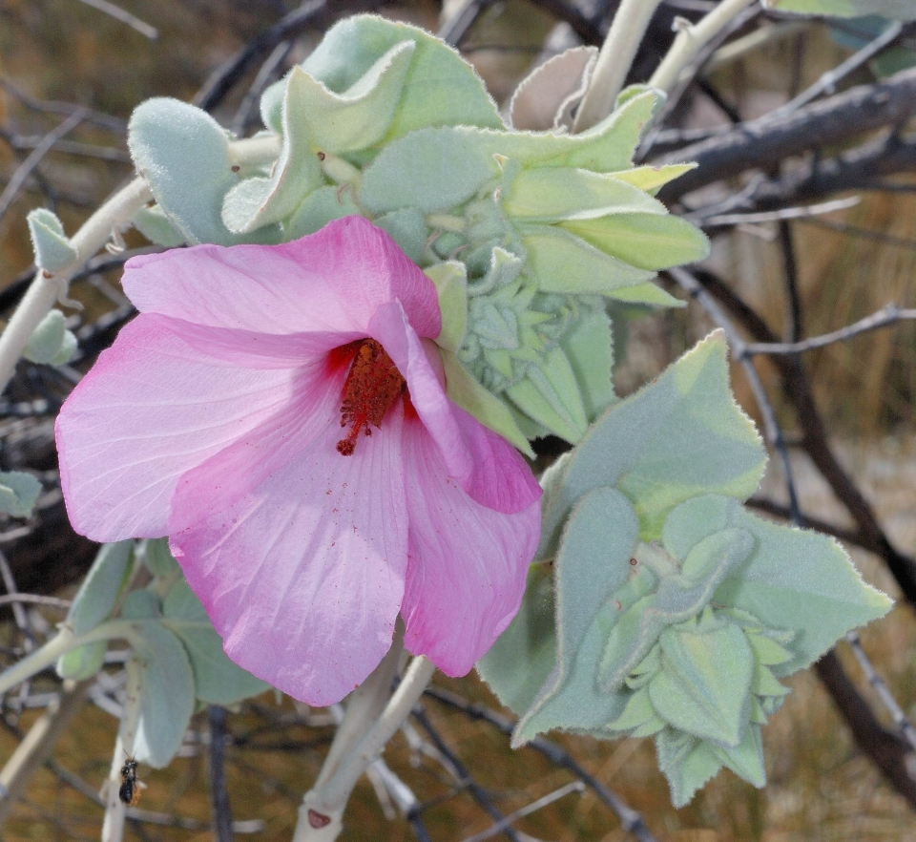
Figure B14.1 Hibiscus brennanii Kakadu National Park. ©K Brennan.

Hibiscus brennanii is a shrub up to 3 m tall with grey-green hairy leaves and pink flowers (Kerrigan 2004).
Taxonomy: The name Hibiscus brennanii Craven and Fryxell is accepted in the Australian Plant Census (CHAH 2015, verified 13 July 2015).
Status: Listed as Vulnerable under the EPBC Act on 14 August 2006. Listed as Vulnerable under the Northern Territory Territory Parks and Wildlife Conservation Act 2000 on the 2012 list.
Recovery Plan: Recovery Plan not required, included on the Not Commenced List (1 November 2009). Management prescriptions and research recommendations are included in the conservation strategy for threatened species and ecological communities in Kakadu National Park (Woinarski and Winderlich 2014).
Information in this fact sheet is taken from the SPRAT Listing Page (DoE 2015) unless otherwise referenced.

Number of populations inside and outside parks and reserves
The species is restricted to the Mt Brockman outlier of the western Arnhem Land sandstone massif (Kerrigan and Cowie 2006). Only one population is known and is located inside Kakadu National Park.

Population size – range
In 2003, the population size was estimated to be 432 individuals. In 2004, a further survey found an additional nine mature individuals and 87 seedlings along a transect of approximately 2 km. The extent of occurrence was estimated to be approximately 1.5 km² (Kerrigan 2004).

Geographical distribution
Hibiscus brennanii has a localised distribution.
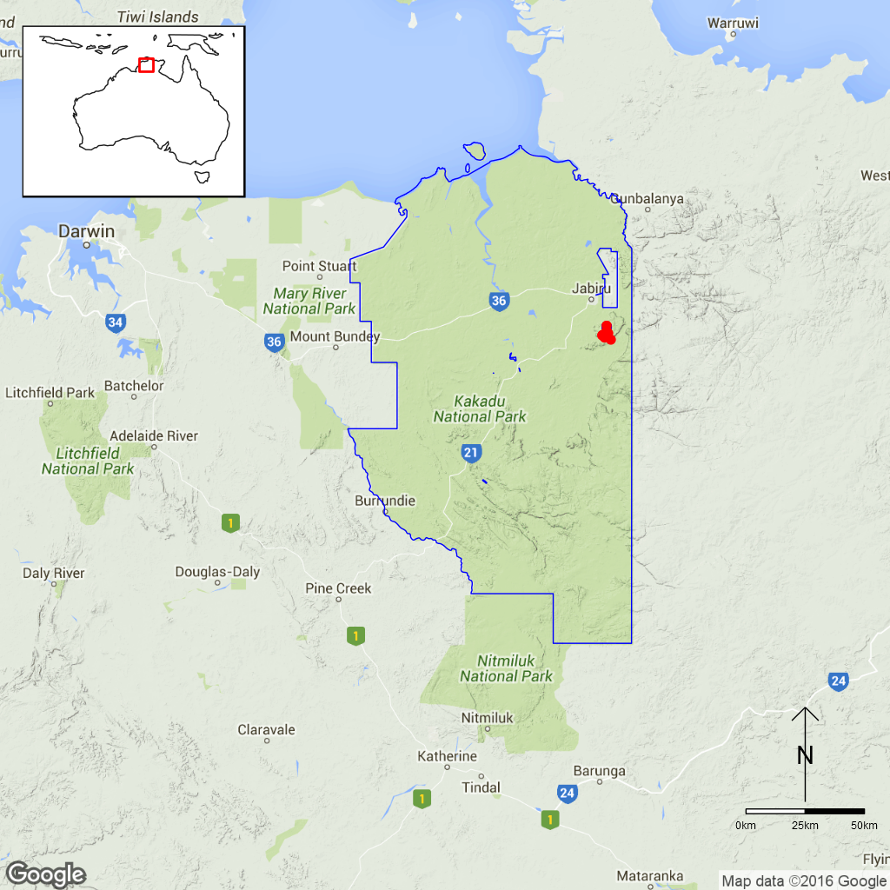
Figure B14.1 Distribution of Brennan’s Hibiscus in Kakadu National Park.
Red dots are specimen collections and the blue line is the park boundary.

Ex-situ collections (Living and Seed Bank)
The species has been identified as a priority target for Seed Bank collection, propagation and experimental translocation (KNP TS Project 4, M. Goumas pers. comm. 6 August 2015). An accession of 9.82 g of seed was collected by ANBG staff and is held in the National Seed Bank. Further collection by ANBG staff is planned for April 2016 (Tom North pers. comm. 11 September 2015). No other ex-situ collections in any other Botanic Garden or Seed Bank have been located (ASBP 2016).

Biology
Pollinators: Unknown, but observations in other Hibiscus species suggest that bees are a potential pollinator (Armstrong 1976).
Symbiotic relationships: Unknown.
Germination requirements: Unknown. The species seems to have a long-lived soil seed bank (Cowie and Liddle 2014). Seed of other Hibiscus species stored in the USDA NPGS collection had a germination rate of 66% or higher after nearly 40 years storage (Walters et al. 2005). Seed of H. sturtii need a fire-related cue to break dormancy (e.g. boiling water, potassium nitrate or 10% smoke water, Gamage et al. 2014).
Dormancy class: Orthodox.
Flowering: March–May (Kerrigan and Cowie 2006).
Breeding system: Probably only reproduces sexually (Craven and Fryxell 1993, Kerrigan and Cowie 2006).
Dispersal: Unknown.
Longevity: “short-lived perennial” (Kerrigan and Cowie 2006).
Life form: Shrub.
Ploidy levels: Unknown.
Role of the plant in the environment: Hibiscus brennanii grows on sandstone cliffs, in gullies and on broken sandstone pavement (Woinarski and Winderlich 2014).

Threats

Listed threats (EPBC Act)
- Restricted geographical distribution (area of occupancy and extent of occurrence).
- Inappropriate and/or changed fire regimes (frequency, timing, intensity).
- Low numbers of individuals.

Genetic and demographic effects
The small or very small distribution areas and low numbers of individuals suggest that this species has low genetic diversity and may be vulnerable to inbreeding. A small population size and the limited geographical distribution also make this species vulnerable to stochastic events (DoE 2008).

Climate-related factors
The main threat to H. brennanii is fire, especially if this is too frequent or intense. Too frequent fires could kill the plants before they have had a chance to reproduce (DoE 2008). Climate change is predicted to lead to significantly more hot days (> 35C) in the Top End region of Australia, as well as more frequent and intense extreme weather events and possibly increased rainfall during the wet season. These conditions might lead to more frequent and more severe fires (Hyder Consulting 2008).

Other Threats/Potential New threats

Invasive and other problematic species
The invasive pasture grasses Andropogon gayanus (Gamba Grass) and Cenchrus pedicellatus (Annual Mission Grass) have been observed growing on sandstone and could spread to the habitat of H. brennanii in the future. Significant populations of these invasive grasses would lead to the build-up of higher fuel loads and more severe wildfires (Woinarski and Winderlich 2014).

Current management
No monitoring is currently conducted. A baseline for monitoring was established by R. Kerrigan in 2003 and 2004, but there has been no subsequent resampling. There is no also targeted management of this species (M. Goumas pers. comm. 6 August 2015), however, it is broadly included in the Stone Country fire plan (Petty et al. 2007, cited in Woinarski and Winderlich 2014).

Knowledge Gaps
Species biology and life history including pollination syndrome, symbiotic relationships, seed germination, breeding system, genetic diversity, seed dispersal, and time to maturity and longevity of this species are unknown or poorly understood.

Suggested research and actions
- Monitoring should be recommenced to phenology, reproductive success, response of seeds and adults to fire, and time to reach maturity (Kerrigan and Cowie 2006).
- Determine seed longevity, conditions required for recruitment, life history parameters to help develop optimum fire free periods (Cowie and Liddle 2014).
- Undertake a genetic assessment to determine the reproductive strategy, levels of genetic diversity and inbreeding and if any genetic structure exists to assist with any future translocation program.

References
Armstrong JA (1979). Biotic pollination mechanisms in the Australian flora – a review. New Zealand Journal of Botany 17: 467–508.
Australian Seed Bank Partnership (2016). Search for records in the Australian Seed Bank [Online]. Council of Heads of Australian Botanic Gardens Inc. Hibiscus brennanii. Available from http://asbp.ala.org.au/search. Accessed 11 February 2016.
Council of Heads of Australasian Herbaria (CHAH) (2015). APC – Australian Plant Census. Available from http://biodiversity.org.au/nsl/services/apc. Accessed 13 July 2015.
Cowie ID and Liddle DT (2014). Threatened plants in Kakadu: past, present and future. In Winderlich S and Woinarski J (eds.). Kakadu National Park Landscape Symposia Series. Symposium 7: Conservation of threatened species, 26–27 March 2013, Bowali Visitor Centre, Kakadu National Park. Internal Report 623, Supervising Scientist, Darwin.
Craven LA and Fryxell PA (1993). Additions to Australian Hibiscus (Malvaceae): A new species and a new record. The Beagle 10: 1–6.
Department of the Environment (2008). Approved conservation advice for Hibiscus brennanii. Available from http://www.environment‌.gov.au‌/biodiversity/threatened/species/pubs/65592-conservation-advice.pdf. Accessed 13 July 2015.
Department of the Environment (2015). Hibiscus brennanii in Species Profile and Threats Database, Department of the Environment, Canberra. Available from: http://www.environment.gov.au/sprat Accessed 1 September 2015.
Gamage HK, Memmott P, Firn J and Schmidt S (2014). Harvesting as an alternative to burning for managing Spinifex grasslands in Australia. Advances in Ecology. Available from: http://dx.doi.org/10.1155/2014/430431. Accessed 13 July 2015.
Hyder Consulting (2008). The Impacts and Management Implications of Climate Change for the Australian Government’s Protected Areas. A report to the Department of the Environment, Water, Heritage and the Arts and the Department of Climate Change. Commonwealth of Australia, Canberra.
Kerrigan R (2004). Kakadu threatened flora report (vol. 2). Results of a threatened flora survey 2004. Department Infrastructure, Planning and Environment, Darwin. Available from: http://www.territorystories.nt.gov.au/bitstream/10070/222425/1/2004_Kerrigan_R.pdf. Accessed 13 July 2015.
Kerrigan R and Cowie I (2006). Hibiscus brennanii. Threatened species of the Northern Territory information sheet. Department of Natural Resources, Environment and the Arts, Darwin. Available from: http://www.lrm.nt.gov.au/__data‌/assets/pdf_file/0006/10977‌/Hibiscus_‌brennanii‌_VU.pdf. Accessed 13 July 2015.
Petty A, Alderson J, Muller R, Scheibe O, Wilson K and Winderlich S (2007). Kakadu National Park: Arnhemland Plateau fire management plan. Kakadu National Park, Jabiru.
Walters C, Wheeler LM and Grotenhuis JM (2005). Longevity of seeds stored in a genebank: species characteristics. Seed Science Research 15: 1–20.
Woinarski JCZ and Winderlich S (2014). A strategy for the conservation of threatened species and threatened ecological communities in Kakadu National Park | 2014–2024. Report. ISBN 987-1-925167-07-8. Available from http://www.nespnorthern.edu.au/wp-content/‌uploads‌/2015/10/kakadu_strategy_-_31-10-14_0.pdf. Accessed 13 July 2015.
- Jacksonia divisa (Fabaceae) – Kakadu National Park
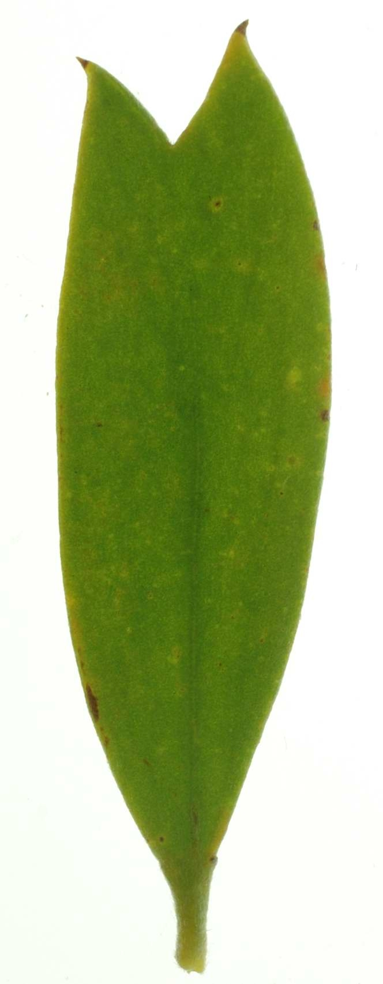
Figure B15.1 Jacksonia divisa cladode Kakadu National Park. ©K Brennan.

Jacksonia divisa is a shrub up to 3 m high with yellow flowers and pods that are around 9 mm long (O’Dea 2014). The leaves are reduced and inconspicuous but the plant has grey-green phyllodes with a bifid or trifid apex (Cowie and Westaway 2012).
Taxonomy: The name Jacksonia divisa Chappill is accepted in the Australian Plant Census (CHAH, 2015, verified 22 September 2015). The species was formerly known under the phrase name Jacksonia sp. Bloomfield Springs (K.Menkhorst 349) (Chappill et al. 2007).
Status: Listed as Vulnerable under the Northern Territory Territory Parks and Wildlife Conservation Act 2000 (Woinarski and Winderlich 2014).
Recovery Plan: A recovery plan does not exist. Management prescriptions and research recommendations are included in the conservation strategy for threatened species and ecological communities in Kakadu National Park (Woinarski and Winderlich 2014).

Number of populations inside and outside parks and reserves
The species is known from one general location along the edges of a gorge on the western margin of the Marrawal Plateau near Bloomfield Springs (Cowie and Westaway 2012) where it occurs at two sites (K. Brennan, cited in Cowie and Westaway 2012). The whole population is located within Kakadu National Park (Cowie and Westaway 2012).

Population size – range
Jacksonia divisa has a very small extent of occurrence of about 2 km² and limited available habitat suggesting that the area of occupancy is probably much smaller than this. Seemingly very similar habitat to the south at Douglas Springs and to the east at Kekwick Springs is not occupied by J. divisa. Additional subpopulations might exist but none were not located in an intensive survey of adjoining Nitmiluk National Park (Cowie and Westaway 2012). One site is recorded as having “probably only hundreds of individuals” (K. Brennan cited in Cowie and Westaway 2012) and the total number of mature individuals is estimated to be <1000 (Cowie and Westaway 2012). Population trends in recent years are unknown (Woinarski and Winderlich 2014).

Geographical distribution
The species has a localised distribution.
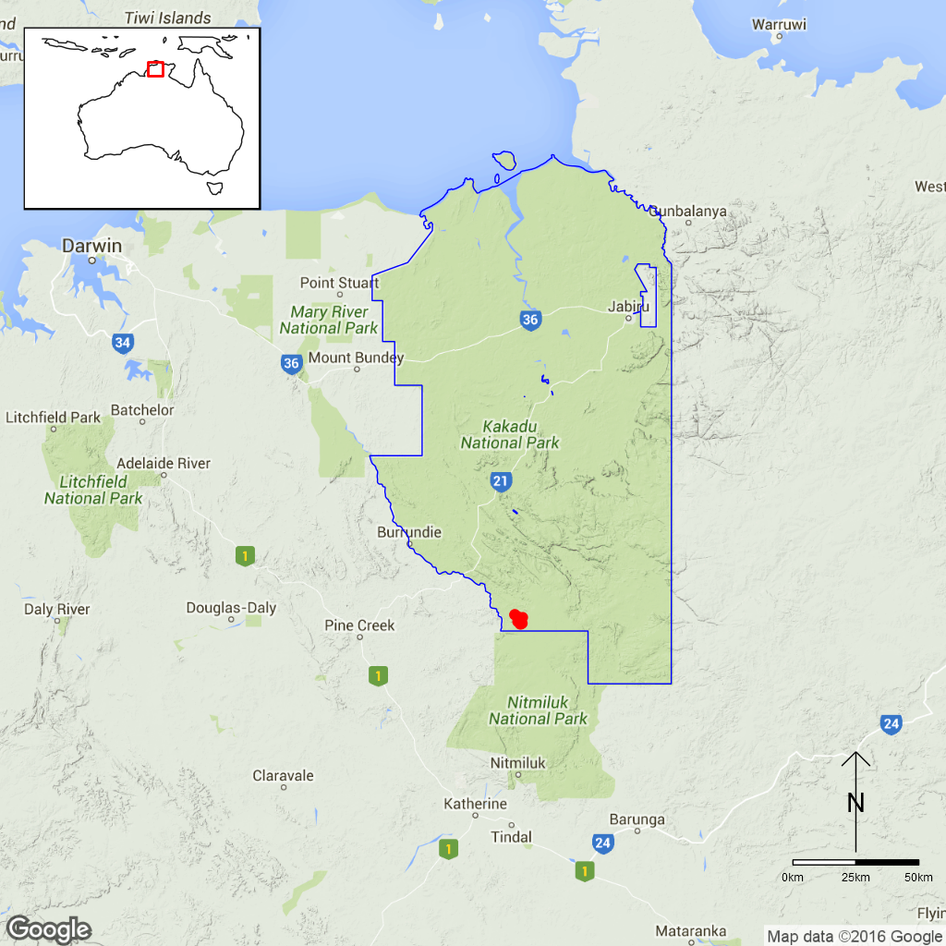
Figure B21.1 Distribution of Jacksonia divisa in Kakadu National Park.
Red dots are specimen collections, the blue line is the park boundary.

Ex-situ collections (Living and Seed Bank)
The species is not conserved in the Living Collection at the Australian National Botanic Gardens or in the National Seed Bank (M. Henery, pers. comm. 5 November 2015). No other ex-situ collections in any other Botanic Garden or Seed Bank have been located (ASBP 2016).

Biology
Pollinators: Probably insect-pollinated.
Symbiotic relationships: Legume nodules as well as ectomycorrhiza and vesicular-arbuscular mycorrhiza were observed in the related species J. dilatata collected from the Kakadu area (Reddell and Milnes 1992). Legume nodules are present in most Fabaceae and therefore probably also in J. divisa.
Germination requirements: Jacksonia species are commonly propagated from seed. After the seed coat has been removed to allow water absorption, seed germinate readily (Evans and English 1999).
Dormancy class: Some Jacksonia species probably have long-lived soil seed banks and can show mass recruitment following fire (Cowie and Liddle 2014).
Flowering: Flowering and fruiting occurs from April–June (Chappill et al. 2007).
Breeding system: The species is considered to be an obligate seeder (Cowie and Westaway 2012).
Dispersal: Unknown.
Longevity: Unknown.
Life form: Shrub.
Ploidy levels: To date, all species counted in the genus had 2n=18 (Chappill et al. 2007, Chromosome Counts Database http://ccdb.tau.ac.il/) but no counts are available for J. divisa.
Role of the plant in the environment: This species grows in shrubland on sandy kaolinite clay (Cowie and Westaway, 2012).

Threats

Listed Threats (Northern Territory Territory Parks and Wildlife Conservation Act)
- Number of mature individuals <1000.
- Restricted to a very small area (<2 km2) with fewer than five locations.
- A plausible threat from inappropriate fire regimes that could drive the taxon to Critically Endangered or Extinct in a very short time period.

Genetic and demographic effects
The small or very small distribution areas and low numbers of individuals suggest that this species has low genetic diversity and may be vulnerable to inbreeding. A small population size and the limited geographical distribution also make these species vulnerable to further loss through stochastic events such as fires (Cowie and Westaway 2012).

Climate-related factors
Because the species probably is an obligate seeder, too frequent fires might kill the plants before these can set seed, threatening species persistence (Cowie and Westaway 2012). Severe effects of fire have been observed in one location (K. Brennan, cited in Cowie and Westaway 2012). Climate change is predicted to lead to a significantly higher number of hot days (> 35 C) in the Top End region of Australia as well as more frequent and intense extreme weather events and possibly increased rainfall during the wet season. These conditions might in turn lead to more frequent and more severe fires (Hyder Consulting 2008).

Other Threats/Potential New threats

Invasive and other problematic species
Invasive pasture grasses could spread into the habitat of J. divisa in the future and lead to more severe and frequent fires if these become more prevalent (Woinarski and Winderlich 2014).

Current management
A specific management protocol for this species does not exist but it is included broadly in the Stone Country fire management plan (Petty et al. 2007, cited in Woinarski and Winderlich 2014).

Knowledge Gaps
Species biology and life history including pollination syndrome, symbiotic relationships, seed germination, seed dormancy, breeding system, genetic diversity, seed dispersal, time to maturity and longevity of this species are unknown or poorly understood. The species is considered an obligate seeder (Cowie and Liddle 2014), but fire response has not been studied to verify that the species does not resprout after fire.

Suggested research and actions
- Monitoring should continue to provide ongoing data for determining population trajectories and the relative impacts of threatening processes.
- Key life history parameters including age to maturity, longevity, survival of seed should be determined to be able to provide fire regime thresholds and to improve species management.
- Secure genetically representative ex-situ seed collections, in multiple locations if appropriate, to mitigate against the loss of natural populations and provide for re-establishment should severe losses or extinction occur.
- Determine the appropriate conditions for long term storage and seed germination.
- Evaluate the need to establish ‘insurance’ populations off-park.

References
Australian Seed Bank Partnership (2016). Search for records in the Australian Seed Bank [Online]. Council of Heads of Australian Botanic Gardens Inc. Jacksonia divisa. Available from http://asbp.ala.org.au/search. Accessed 11 February 2016.
Chappill JA, Wilkins CF and Crisp MD (2007). Taxonomic revision of Jacksonia (Leguminosae: Mirbelieae). Australian Systematic Botany 20: 473–623.
Council of Heads of Australian Herbaria (CHAH) (2015). Australian Plant Census. [Online]. Available from http://biodiversity.org.au/nsl/services/apc. Accessed 22 September 2015.
Cowie ID and Liddle DT (2014). Threatened plants in Kakadu: past, present and future. In Winderlich S and Woinarski J (eds.). Kakadu National Park Landscape Symposia Series. Symposium 7: Conservation of threatened species, 26–27 March 2013, Bowali Visitor Centre, Kakadu National Park. Internal Report 623, Supervising Scientist, Darwin.
Cowie ID and Westaway J (2012). Threatened Species of the Northern Territory – Jacksonia divisa. Northern Territory Government, Department of Land Resource Management. Available from http://www.lrm.nt.gov.au/__data/assets‌/pdf_file/0020/143174/Jacksonia_divisa_VU_‌FINAL.‌pdf. Accessed 22 September 2015.
Evans R and English V (1999). Pungent Jacksonia (Jacksonia pungens ms) interim recovery plan. Department of Conservation and Land Management, Western Australian Threatened Species and Communities Unit, Wanneroo, WA. Available from http://laptop.deh.gov.au/biodiversity‌‌/threatened‌/publications/recovery/j-pungens/pubs/j-pungens.pdf. Accessed 22 September 2015.
Hyder Consulting (2008). The Impacts and Management Implications of Climate Change for the Australian Government’s Protected Areas. A report to the Department of the Environment, Water, Heritage and the Arts and the Department of Climate Change. Commonwealth of Australia, Canberra.
O’Dea A (2014). Guide to Threatened species of Kakadu National Park including other plants and animals of interest. Book. Available from http://www‌.nesp‌northern.edu.au/wp-content/uploads/2016/01/kakadu_guide_to_threatened_species_lr_final.pdf. Accessed 22 September 2015.
Petty A, Alderson J, Muller R, Scheibe O, Wilson K, Winderlich S (2007). Kakadu National Park: Arnhemland Plateau fire management plan. Kakadu National Park, Jabiru.
Reddell P and Milnes AR (1992). Mycorrhizas and other specialised nutrient-acquisition strategies: their occurrence in woodland plants from Kakadu and their role in rehabilitation of waste rock dumps at a local uranium mine. Australian Journal of Botany 40: 223–240.
Woinarski JCZ and Winderlich S (2014). A strategy for the conservation of threatened species and threatened ecological communities in Kakadu National Park | 2014–2024. Report. ISBN 987-1-925167-07-8. Available from http://www.nespnorthern.edu.au/wp-content/uploads‌/2015/10/kakadu_strategy_-_31-10-14_0.pdf. Accessed 22 September 2015.
- Lithomyrtus linariifolia (Myrtaceae) – Kakadu National Park
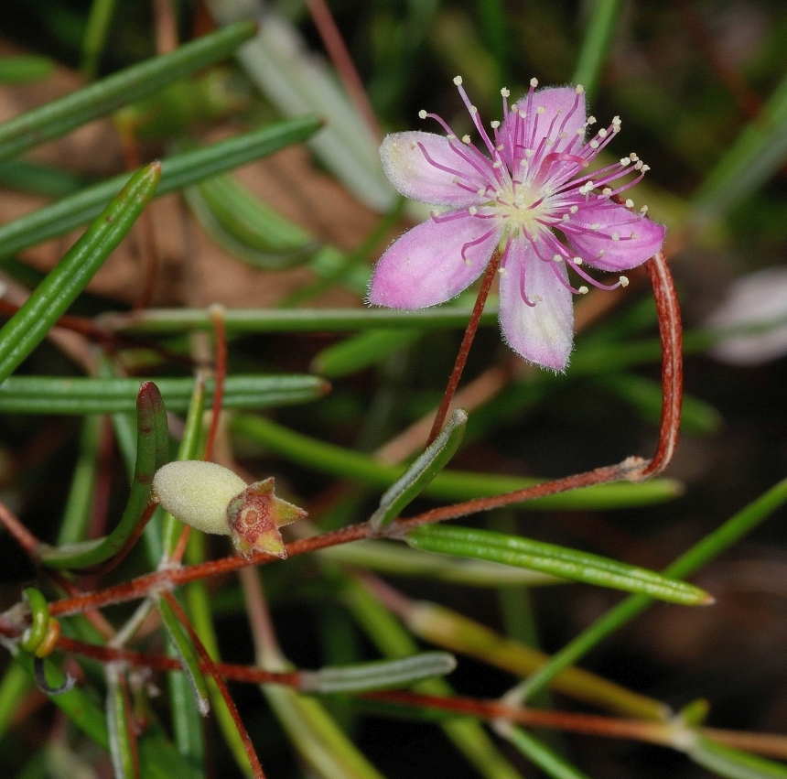
Figure B16.1 Lithomyrtus linariifolia Kakadu National Park. ©K Brennan.

Lithomyrtus linariifolia is a subshrub or small shrub, usually low spreading and sprawling over sandstone boulders and rubble, 10–20 cm tall. Rarely, erect plants up to 1 m tall can be found (Kerrigan and Cowie 2006). The species has stringy, brown to orangish bark. The leaves are opposite, linear and coriaceous, about 10–51 x 1–3 mm. The pink petals are 5–7 mm long. The fruit is fusiform, 8.5–11 mm long and 3.5–4 mm wide, glabrescent and yellow-green to olive-green (Snow and Guymer 1999).
Taxonomy: The name Lithomyrtus linariifolia N.Snow and Guymer is accepted in the Australian Plant Census (CHAH 2015, verified 8 October 2015).
Status: Listed as Vulnerable under the Northern Territory Territory Parks and Wildlife Conservation Act 2000 (Woinarski and Winderlich 2014).
Recovery Plan: A recovery plan does not exist. Management prescriptions and research recommendations are included in the conservation strategy for threatened species and ecological communities in Kakadu National Park (Woinarski and Winderlich 2014).

Number of populations inside and outside parks and reserves
Lithomyrtus linariifolia is known from 14 locations, however, some of these are very close together and may not represent different populations. The species occurs mostly in Kakadu National Park but is also found in Arnhem Land and Nitmiluk National Park (Kerrigan 2004). According to the spatial data available from Herbarium collections, approximately two thirds of the known locations have been collected from within Kakadu National Park.

Population size – range
In 2002, Lithomyrtus linariifolia was known from only seven collections in five localities but surveys in 2003 identified 132 mature individuals from ten localities. Surveys in 2004 identified >200 mature plants from 14 locations. The extent of occurrence was estimated to be 3411 km² at that time (Kerrigan 2004).

Geographical distribution
The species has a regional, fragmented distribution.
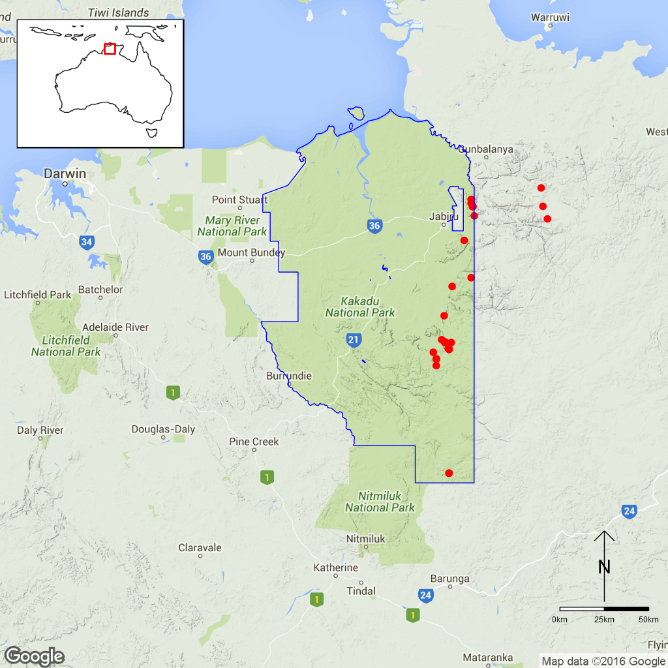
Figure B22.1 Distribution of Lithomyrtus linariifolia in Kakadu National Park.
Red dots are specimen collections, the blue line is the park boundary.

Ex-situ collections (Living and Seed Bank)
The species is not conserved in the Living Collection at the Australian National Botanic Gardens or in the National Seed Bank (M. Henery, pers. comm. 5 November 2016). No other ex-situ collections in any other Botanic Garden or Seed Bank have been located (ASBP 2016).

Biology
Pollinators: Probably insect-pollinated.
Symbiotic relationships: Unknown.
Germination requirements: Unknown and attempts to germinate seven other Lithomyrtus species were unsuccessful (Snow and Guymer 1999).
Dormancy class: The fruits are fleshy and the seed might be short-lived (Cowie and Liddle 2014). The seed coats are hard but have openings possibly for the radicle to grow through (Snow and Guymer 1999).
Flowering: March-April with fruiting specimens known from April (Snow and Guymer 1999).
Breeding system: Bisexual flowers.
Dispersal: Unknown.
Longevity: Unknown.
Life form: Subshrub or small shrub.
Ploidy levels: Unknown.
Role of the plant in the environment: Lithomyrtus linariifolia grows on sandy or skeletal soils in heaths or eucalypt woodlands of sandstone escarpments (Snow and Guymer 1999). It is often found along margins of Allosyncarpia ternata (An-binik, Myrtaceae) stands and mostly growing amongst Triodia microstachya (Poaceae, Kerrigan 2004).

Threats

Listed Threats (NT TPWC Act)
- Small population size estimated at <1000 mature individuals (listed as Vulnerable on this basis by Snow and Guymer 1999)

Genetic and demographic effects
Lithomyrtus linariifolia seems to be relatively widespread but uncommon. The small population sizes suggest that this species has low genetic diversity and may be vulnerable to inbreeding. The relatively low population size also make the species vulnerable to further loss through stochastic effects.

Other Threats/Potential New threats

Climate-related factors
Lithomyrtus linariifolia is probably a fire-sensitive plant as it is only found in unburnt and fire protected locations among sandstone boulders and outcrops (A. Gibbons and I. Cowie pers. obs. cited in Kerrigan and Cowie 2006). It also seems to be an obligate seeder. Fire is therefore assumed to be a threat (Kerrigan and Cowie 2006). Climate change is predicted to lead to a significantly more hot days (> 35C) in the Top End region of Australia as well as more frequent and intense extreme weather events and possibly higher rainfall during the wet season. These conditions might lead to more frequent and more severe fires (Hyder Consulting 2008).

Invasive and other problematic species
Seed predation may be an issue since Snow and Guymer (1999) state that ripe Lithomyrtus fruit are often attacked by insects.
As with other fire-sensitive species growing in the stone country of Kakadu National Park, the risk of severe or frequent fires would become higher if invasive pasture grasses spread to this habitat in the future (Cowie and Liddle 2014).

Current management
A specific management protocol for this species does not exist but it is included broadly in the Stone Country fire management plan (Petty et al. 2007, cited in Woinarski and Winderlich 2014).

Knowledge Gaps
Species biology and life history including pollination syndrome, symbiotic relationships, seed germination, seed dormancy, breeding system, genetic diversity, seed dispersal, time to maturity and longevity of this species are unknown or poorly understood. Fire sensitivity is also largely unknown.

Suggested research and actions:
- The importance of fire in shaping the species’ distribution area should be studied (Kerrigan and Cowie 2006).
- Establish a monitoring program to provide baseline and ongoing data for determining population trajectories and the relative impacts of threatening processes.
- Determine key life history parameters including age to maturity, longevity, survival of seed to improve species management.
- Secure genetically representative ex-situ seed collections, in multiple locations if appropriate, to mitigate against the loss of natural populations and provide for re-establishment should severe losses or extinction occur.
- Determine the appropriate conditions for long term storage and seed germination.
- Assess the impact of seed predation since Snow and Guymer (1999) state that ripe Lithomyrtus fruit are often attacked by insects.
- Survey suitable habitat for new populations.
- Undertake a genetic assessment to determine the reproductive strategy, levels of genetic diversity and inbreeding and if any genetic structure exists to assist with any future translocation program.
- Evaluate the need to establish ‘insurance’ populations off-park.

References
Australian Seed Bank Partnership (2016). Search for records in the Australian Seed Bank [Online]. Council of Heads of Australian Botanic Gardens Inc. Lithomyrtus linariifolia. Available from http://asbp.ala.org.au/search. Accessed 11 February 2016.
Council of Heads of Australian Herbaria (CHAH) (2015). Australian Plant Census. [Online]. Available from http://biodiversity.org.au/nsl/services/apc. Accessed 8 October 2015.
Cowie ID and Liddle DT (2014). Threatened plants in Kakadu: past, present and future. In Winderlich S and Woinarski J (eds.). Kakadu National Park Landscape Symposia Series. Symposium 7: Conservation of threatened species, 26–27 March 2013, Bowali Visitor Centre, Kakadu National Park. Internal Report 623, Supervising Scientist, Darwin.
Kerrigan R and Cowie I (2006). Lithomyrtus linariifolia. Threatened species of the Northern Territory information sheet. Department of Natural Resources, Environment and the Arts, Darwin. http://www.lrm.nt.gov.au/__data/assets/pdf_file/0006/10986‌/Lithomyrtus_linariifolia‍‌_VU.‌pdf. Accessed 9 October 2015.
Hyder Consulting (2008). The Impacts and Management Implications of Climate Change for the Australian Government’s Protected Areas. A report to the Department of the Environment, Water, Heritage and the Arts and the Department of Climate Change. Commonwealth of Australia, Canberra.
O’Dea A (2014). Guide to Threatened species of Kakadu National Park including other plants and animals of interest. Book. Available from http://www‌.nespnorthern.edu.au/wp-content/uploads/2016/01/kakadu_guide_to_threatened_species_lr_final.pdf. Accessed 9 October 2015.
Petty A, Alderson J, Muller R, Scheibe O, Wilson K, Winderlich S (2007). Kakadu National Park: Arnhemland Plateau fire management plan. Kakadu National Park, Jabiru.
Snow N and Guymer GP (1999). Systematic and cladistic studies of Myrtella F.Muell. and Lithomyrtus F.Muell (Myrtaceae). Austrobaileya 5: 173–207.
Woinarski JCZ and Winderlich S (2014). A strategy for the conservation of threatened species and threatened ecological communities in Kakadu National Park | 2014–2024. Report. ISBN 987-1-925167-07-8. Available from http://www.nespnorthern.edu.au/wp-content‌/uploads/‌2015/10/kakadu_strategy_-_31-10-14_0.pdf. Accessed 9 October 2015.
- Abutilon julianae (Malvaceae) – Norfolk Island Abutilon, Norfolk Island National Park
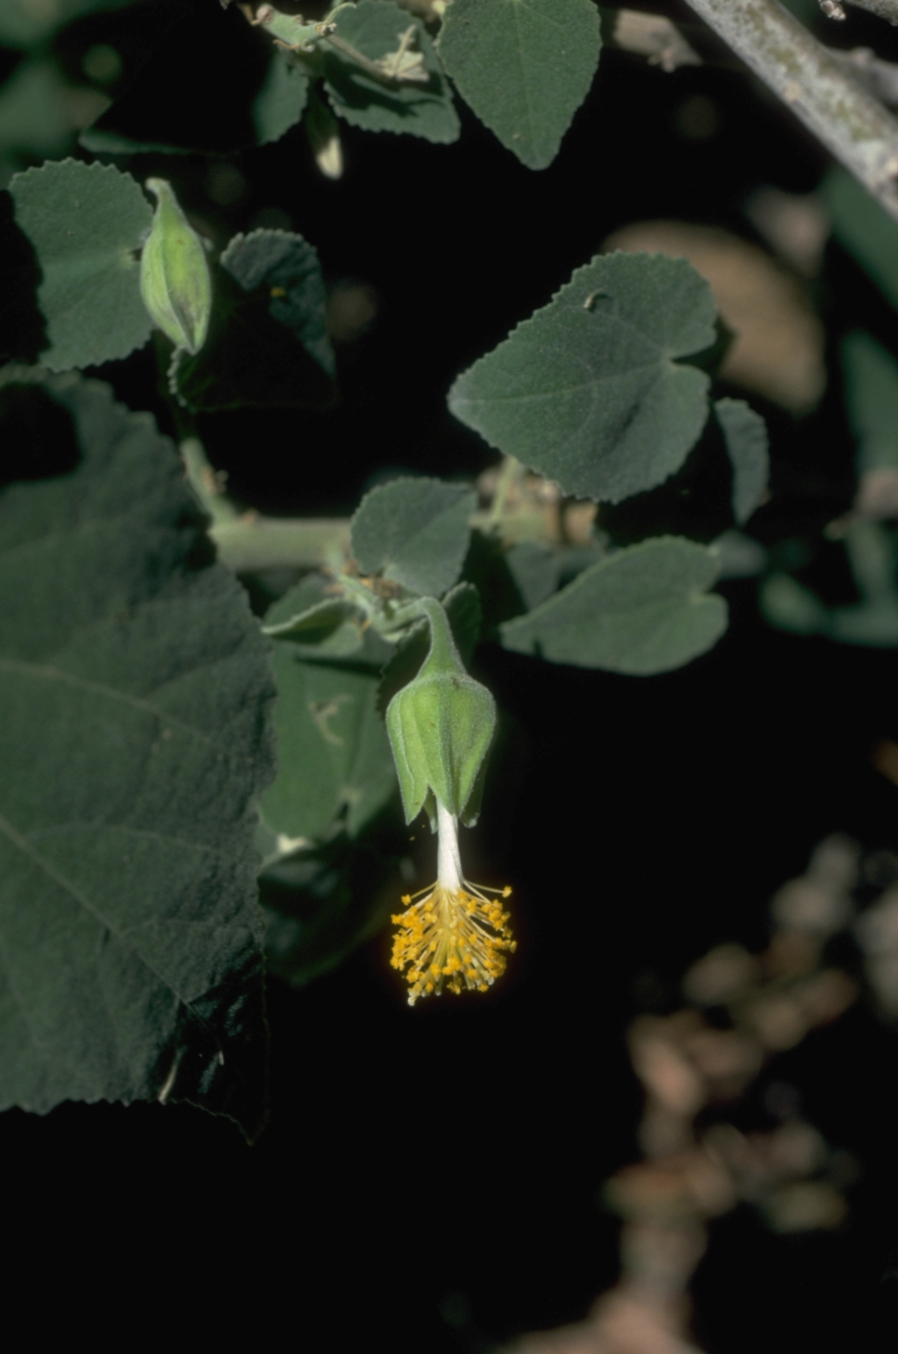
Figure B17.1 Abutilon julianae in the Norfolk Island Botanic Gardens.
©M. Fagg Australian National Botanic Gardens Photo No ni.86.
Abutilon julianae is a subshrub up to 1 m tall. The leaves are heart-shaped and hairy below. The solitary flowers are yellow (DNP, 2010).
Taxonomy: The name Abutilon julianae Endl. is accepted in the Australian Plant Census (CHAH 2015, verified 24 July 2015).
Status: Listed as Critically Endangered under the EPBC Act on 3 November 2003.
Recovery Plan: Norfolk Island Region Threatened Species Recovery Plan (DNP 2010)
Information in this fact sheet is taken from SPRAT (DoE 2015) unless otherwise referenced.

Number of populations inside and outside parks and reserves
Both populations (Norfolk Island and Phillip Island) occur within the Norfolk Island National Park.

Population size – range
In 1988, there were three main patches on Phillip Island, one of approximately 100 plants, one of 18 and one with approximately 10 plants (Sykes and Atkinson 1988). In 2003, the total number of mature individuals was estimated to be less than 50 (TSSC 2003). The population on Phillip Island is increasing since the eradication of rabbits. The population on Norfolk Island was temporarily extinct, but plants from Phillip Island have been used in rehabilitation programs (DNP 2010). On Phillip Island, the species has been planted in several locations and occurs in several main areas of the island (Mills 2009).

Geographical distribution
The species has a localised and fragmented distribution.
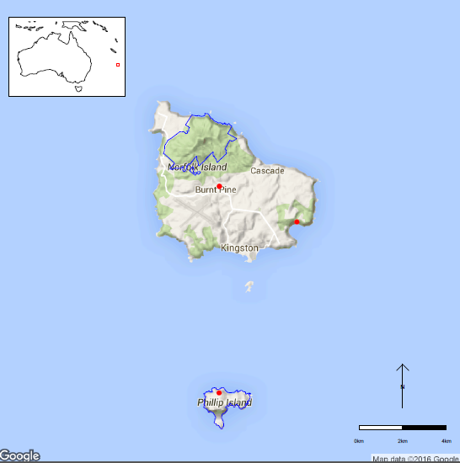
Figure B17.2 Distribution of Abutilon julianae in the Norfolk Island National Park.
Red dots are specimen collections, blue line is park boundary.

Ex-situ collections (Living and Seed Bank)
The species is not conserved in the Living Collection at the Australian National Botanic Garden or in the National Seed Bank (Z. Knapp pers. comm. 30 September 2015), however, it is planted in the Norfolk Island Botanic Garden (Mills 2009) but it is unclear whether this is from cuttings or seed. One seed collection from cultivated individuals by ANBG staff is stored on Norfolk Island (T. North pers. comm. 11 September 2015). No other ex-situ collections in any other Botanic Garden or Seed Bank have been located (ASBP 2016).

Biology
Pollinators: Unknown.
Symbiotic relationships: Unknown.
Germination requirements: Unknown.
Dormancy class: Probably orthodox
Flowering: The species flowers and sets seed annually (Lydia Guja pers. comm. 10 September 2015). Flowering has been observed from September-March and fruiting from October-March (Mills 2007).
Breeding system: Unknown. Bisexual flowers, not showy.
Dispersal: Unknown.
Longevity: Perennial.
Life form: Low, spreading subshrub, to about 1 m tall and 5 m wide (Mills 2009).
Ploidy levels: Abutilon julianae is probably an octoploid since most Abutilon species seem to be based on x=7 and the chromosome number of A. julianae was counted as 2n=56 (de Lange and Murray 2003).
Role of the plant in the environment: Abutilon julianae grows in open vegetation among grasses. The species has been used in rehabilitation work on Norfolk Island (DNP 2010).

Threats

Listed threats (EPBC Act)
- Competition and/or habitat degradation by weeds.
- Low numbers of individuals (TSSC 2003).

Invasive and other problematic species
Competition by weeds is a major threat to A. julianae (DNP 2010). A moth species identified on Phillip Island feeds on a range of plants from the Malvaceae family (DNP 2010) but it is unknown whether this species is also a threat to A. julianae. Future introductions of weeds, competitors or pathogens are a potential problem to the flora of NINP in general (DNP 2008).

Other Threats/Potential New threats

Genetic and demographic effects
The small distribution area and low numbers of individuals suggest that this species has low genetic diversity and may be vulnerable to inbreeding. Propagation by cuttings may increase inbreeding if limited clonal diversity is used. A small population size and limited geographical distribution also make these species vulnerable to further loss through stochastic events such as cyclones.
Soil degradation
Grazing by feral animals removed almost all the vegetation on Phillip Island and as a result lost most of its topsoil through erosion, this reduced the ability of Norfolk Island Abutilon to colonise the island.

Climate-related factors
The lack of vegetation and severe erosion on Phillip Island makes this island more vulnerable to the impacts of heavy rain. Climate change is predicted to increase the frequency and intensity of storms, which might lead to further erosion on Phillip Island (Hyder Consulting 2008).
Climate change is predicted to bring about an increasing frequency and intensity of droughts and cyclonic activity. Given the small population size, these events may directly and indirectly impact this species. Fire which does not currently occur in the national park, may become a threat. Invasive weeds and pests will be more likely to establish due to increased disturbance and less suitable conditions for local species. (DNP 2010, DNP 2011).

Current management
The species has been extensively planted on Norfolk Island in the national park in open areas and the population is now increasing with active management and use of this species in rehabilitation works (M. Goumas pers. comm. 6 August 2015) although no monitoring program of this species is in place (Joel Christian pers. comm. 4 August 2015). Mills (2009) indicates that the species is successfully regenerating naturally on Phillip Island, so further planting is not a priority. Weed management is also conducted in the national park.

Knowledge Gaps
Species biology and life history including pollination syndrome, symbiotic relationships, seed germination, seed dormancy, breeding system, genetic diversity, seed dispersal, time to maturity and longevity of this species are unknown or poorly understood.

Suggested research and actions
- Genetic assessment of levels of genetic diversity and inbreeding in natural and planted populations to ensure that planted populations contain sufficient genetic diversity to become self-sustaining over time and that inbreeding populations have not been created.
- Endeavour to secure additional seed collections off-island to reduce the risk of stochastic loss of the NINP seed collections (e.g. destruction by a tropical cyclone).
- Develop and implement a restoration program to increase population numbers and/or sizes.
- Evaluate the need to establish ‘insurance’ populations off-park.

References
Australian Seed Bank Partnership (2016). Search for records in the Australian Seed Bank [Online]. Council of Heads of Australian Botanic Gardens Inc. Abutilon julianae. Available from http://asbp.ala.org.au/search. Accessed 11 February 2016.
Council of Heads of Australasian Herbaria (CHAH) (2015). APC – Australian Plant Census. Available from http://biodiversity.org.au/nsl/services/apc. Accessed 24 July 2015.
de Lange PJ and Murray BG (2003). Chromosome numbers of Norfolk Island endemic plants. Australian Journal of Botany 51: 211–215.
Department of the Environment (DoE) (2015). Abutilon julianae in Species Profile and Threats Database, Department of the Environment, Canberra. Available from http://www.environment.gov.au/sprat. Accessed 3 June 2015.
Director of National Parks (DNP) (2008). Norfolk Island National Park and Norfolk Island Botanic Garden Management Plan 2008-2018. Available from http://www.environment.gov.au/resource/management-plan-2008-18-norfolk-island-national-park-and-norfolk-island-botanic-garden. Accessed 3 June 2015.
Director of National Parks (DNP) (2010). Norfolk Island Region Threatened Species Recovery Plan. Department of the Environment, Water, Heritage and the Arts, Canberra. Available from http://www.environment.gov.au/resource/national-recovery-plan-norfolk-island. Accessed 3 June 2015.
Director of National Parks (DNP) (2011). Norfolk Island National Park and Botanic Garden Climate Change Strategy 2011-2016 [Online]. Department of the Environment, Water, Heritage and the Arts, Canberra. Available from http://www.environment.gov.au/resource/climate-change-strategy-2011-2016-norfolk-island-national-park-and-botanic-garden. Accessed 3 June 2015.
Hyder Consulting (2008). The Impacts and Management Implications of Climate Change for the Australian Government’s Protected Areas. A report to the Department of the Environment, Water, Heritage and the Arts and the Department of Climate Change. Commonwealth of Australia, Canberra.
Mills K (2007). The Flora of Norfolk Island. 1. The Indigenous Flora. Appendix 2 - Flowering and Fruiting Months – Indigenous Flora of Norfolk Island, updated January 2015. The Author, Jamberoo, New South Wales, June.
Mills K (2009). The Vegetation of Phillip Island, Norfolk Island Group. Available from http://www.econorfolk.nf/pdf/Kevin%20Mills%20Report%20‌Body.pdf. Accessed 3 June 2015.
Sykes W and Atkinson I (1988). Rare and Endangered Plants of Norfolk Island. Unpublished report to the Australian National Parks and Wildlife Service, Norfolk Island.
Threatened Species Scientific Committee (TSSC) (2003). Commonwealth Listing Advice for Norfolk Island Flora - 11 Critically Endangered Species. [Online]. Available from http://www.environment.gov.au/biodiversity/threatened/species/norfolk-island-flora-critically.html. Accessed 3 June 2013.
- Anthosachne multiflora subsp. kingiana (Poaceae) – Phillip Island Wheat Grass, Norfolk Island National Park
This is a short lived, tufted perennial grass, 30–100 cm tall with a low, spreading habit and narrow glaucous (waxy) leaves 3–5 mm wide.
Taxonomy: Conventionally accepted as Anthosachne multiflora subsp. kingiana (Endl.) Barkworth and S.W.L. Jacobs (CHAH 2015, verified 22 July 2015).
- Synonyms:
Anthosachne kingiana (Endl.) Govaerts subsp. kingiana (EPBC listing page uses this name 22 July 2015)
Elymus multiflorus subsp. kingianus (Endl.) de Lange and R.O.Gardner (EPBC listed under this name)
Status: Listed as Critically Endangered under the EPBC Act on 3 November 2003 as Elymus multiflorus var. kingianus (listed name updated 15 December 2008 to Elymus multiflorus subsp. kingianus). Listed as Critically Endangered under the NSW Threatened Species Conservation Act 1995 in October 2015 as Elymus multiflorus subsp. kingianus.
Recovery Plans: Norfolk Island Region Threatened Species Recovery Plan, 2010.
Lord Howe Island Biodiversity Management Plan, 2007.
This information is taken from SPRAT (DoE 2015) unless otherwise referenced.

Number of populations inside and outside parks and reserves
In 2003 there were <50 individuals of Phillip Island Wheat Grass growing on Phillip Island. It is thought to have been confined to Phillip Island in the Norfolk group where it was believed to have become extinct due to grazing by rabbits, goats and pigs. Following removal of these feral animals Phillip Island Wheat Grass was able to recolonise the area and was rediscovered on Phillip Island in 1987 where it grows on north-facing slopes in higher areas in a herb community dominated by pigface (Carpobrotus glaucescens, DNP 2010). The species is presumed to have survived on the steep cliffs around the island which were inaccessible to grazing animals. A specimen of Phillip Island Wheat Grass was discovered on Norfolk Island in 1963 but current occurrences on Norfolk Island are possibly due to propagation and translocation of specimens from Phillip Island.
This sub-species also occurs on Lord Howe Island where the population is also extremely small and is estimated to be <50 mature plants (Auld et al. 2011). At the species-level this plant is also found in New Zealand (de Lange et al. 2005) and coastal eastern Australia (Auld et al. 2011). On Lord Howe Island the subspecies occurs between exposed basalt-derived cliffs and upslope littoral rainforest and is often found growing with Melaleuca howeana, Poa poiformis, Bully Bush (Cassinia tenuifolia), Sand Couch (Sporobolus virginicus), Sticky Hop-bush (Dodonaea viscosa), Melanthera biflora and Coast Beard Heath (Leucopogon parviflorus).

Population size – range
On Phillip Island this species was found in several small patches on the upper part of the island in 1988. In 2003 it was reported that there were <50 mature individuals but no indication of their range was provided. In 2009 two populations were found, one on a cliff edge on the southern side of Stony Valley and one above ‘the dykes’ (Director of National Parks 2010). Only a few plants were found in each location (Mills 2009). Information on the species from Lord Howe Island suggests that plant numbers can rapidly change from year to year (Auld et al. 2011).

Geographical distribution
Localised on Phillip Island and Lord Howe Island.
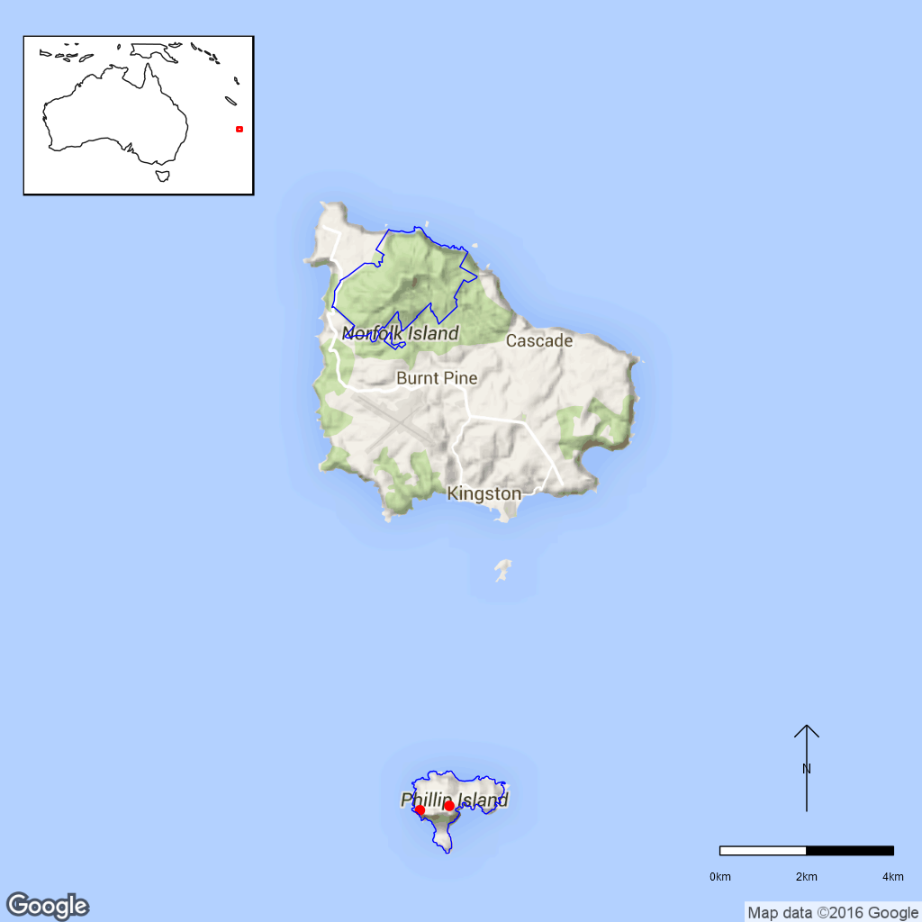
Figure B18.1 Distribution of Phillip Island Wheat Grass in Norfolk Island National Park.
Red dots are specimen collections, blue line is the park boundary.

Ex-situ collections (Living and Seed Bank)
The species is not conserved in the Living Collection at the Australian National Botanic Gardens or in the National Seed Bank (Zoe Knapp pers. comm. 12 October 2015 and Tom North pers. comm. 11 September 2015). No other ex-situ collections in any other Botanic Garden or Seed Bank have been located (ASBP 2016).

Biology
Pollinators: Likely to be wind-pollinated like most grasses.
Symbiotic relationships: Unknown.
Germination requirements: Unknown but seed dormancy as well as water and temperature impacts on germination have been observed in a related species, Anthosachne scabra (Auld et al. 2011).
Dormancy class: Possibly dormant based on data from a related species Anthosachne scabra (Auld et al. 2011).
Flowering: Unknown.
Breeding system: Unknown but It is unlikely to clonal based on related species Anthosachne scabra from Lord Howe Island (Auld et al. 2011).
Dispersal: The long awns suggest that the seed are adhesive and are dispersed by vertebrates. Auld et al. (2011) also note that there are no mammals on Lord Howe Island except for a bat, so the ability of this species to move to potential habitat around its current locations is unknown.
Longevity: Perennial but likely to be short-lived (Auld et al. 2011).
Life form: Grass.
Ploidy levels: Unknown.
Role of this plant in the environment: Unknown.

Threats

Listed Threats (EPBC Act)
- Grazing pressures and associated habitat changes.
- Competition and/or habitat degradation by weeds (e.g. Kikuyu and Buffalo Grass).
- Low numbers of individuals.

Genetic and demographic effects
The small distribution area and low numbers of individuals suggest that this species has low genetic diversity and may be vulnerable to inbreeding. A small population size and limited geographical distribution also make these species vulnerable to further loss through stochastic events.

Invasive and other problematic species
In the past this species was threatened by grazing of feral rabbits, goats and pigs but these have been removed from Philip Island. However, erosion due to loss of vegetation from over-grazing has reduced opportunities for this species to recolonise.

Other Threats/Potential New threats

Climate-related factors
The lack of vegetation and severe erosion on Phillip Island makes this island more vulnerable to the impacts of heavy rain. Climate change is predicted to increase the frequency and intensity of storms, which might lead to further erosion on Phillip Island (Hyder Consulting 2008).
Climate change is predicted to bring about an increasing frequency and intensity of droughts and cyclonic activity. Given the small population size, these events may directly and indirectly impact this species. Fire which does not currently occur in the national park, may become a threat. Invasive weeds and pests will be more likely to establish due to increased disturbance and less suitable conditions for local species. (DNP 2010, DNP 2011).

Current Management
Weed management is conducted in the national park but there is no monitoring program for threatened species (J.Christian pers. comm. 4 August 2015).

Knowledge Gaps
Species biology and life history including pollination syndrome, symbiotic relationships, seed germination, seed dormancy, flowering, breeding system, genetic diversity, seed dispersal, time to maturity and longevity of this species are unknown or poorly understood.

Suggested research and actions
- Monitoring in late spring (DNP 2010) to provide ongoing data for determining population trajectories and the relative impacts of threatening processes.
- Determine key life history parameters including pollination syndrome, symbiotic relationships, flowering, breeding system, maturity and longevity to improve species management.
- Secure genetically representative ex-situ seed collections, in multiple locations if appropriate, to mitigate against the loss of natural populations and provide for re-establishment should severe losses or extinction occur.
- Determine the appropriate conditions for long term storage and seed germination.
- Undertake a genetic assessment to determine the reproductive strategy, levels of genetic diversity and inbreeding and if any genetic structure exists in association with populations from Lord Howe Island and New Zealand to determine whether the regions to assist with any future translocation program.
- Evaluate the need to establish ‘insurance’ populations off-park.

References:
Auld TD, Bower S, Hutton I. (2011). Assessing the conservation status of the grass Elymus multiflorus subsp. kingianus on Lord Howe Island, NSW. Short Communication. Cunninghamia 12: 2011.
Australian Seed Bank Partnership (2016). Search for records in the Australian Seed Bank [Online]. Council of Heads of Australian Botanic Gardens Inc. Anthosachne multiflora subsp. kingiana. Available from http://asbp.ala.org.au/search. Accessed 11 February 2016.
Council of Heads of Australian Herbaria (CHAH) (2015). Australian Plant Census. [Online]. Available from http://biodiversity.org.au/nsl/services/apc. Accessed 27 October 2015.
de Lange PJ, Gardner RO, Sykes WR, Crowcroft GM, Cameron EK, Stalker F, Christian ML, Braggins JE (2005). Vascular flora of Norfolk Island: some additions and taxonomic notes. New Zealand Journal of Botany 43: 563–596.
Department of the Environment (DoE) (2015). Anthosachne kingiana subsp. kingiana in Species Profile and Threats Database, Department of the Environment, Canberra. Available from http://www.environment.gov.au/sprat. Accessed 27 October 2015.
Department of Environment (DoE) (2015). Species of National Environmental Significance Map Summary Version 2, Commonwealth of Australia 2015. https://www.environment.gov.au/science/erin/databases-maps/snes
Department of Environment and Climate Change, NSW (DECC) (2007). Lord Howe Island Biodiversity Management Plan. Department of Environment and Climate Change, Sydney.
Director of National Parks (DNP) (2010). Norfolk Island Region Threatened Species Recovery Plan. Department of the Environment, Water, Heritage and the Arts, Canberra.
Director of National Parks (DNP) (2011). Norfolk Island National Park and Botanic Garden Climate Change Strategy 2011-2016 [Online]. Department of the Environment, Water, Heritage and the Arts, Canberra. Available from http://www.environment.gov.au/resource/climate-change-strategy-2011-2016-norfolk-island-national-park-and-botanic-garden. Accessed 27 October 2015.
Mills K. (2009). The Vegetation of Phillip Island Norfolk Island Group. Envirofund Report.
- Boehmeria australis subsp. australis (Urticaceae) – Tree Nettle/ Nettletree, Norfolk Island National Park
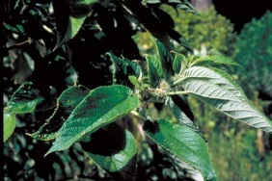
Figure B19.1 Boehmeria australis subsp. australis in the Norfolk Island National Park.
©M. Fagg Australian National Botanic Garden Photo No. ni. 94.
It is a large spreading shrub or tree to 5 m tall. The sandpapery textured leaves (8–12 cm long) have a serrated margin with prominent veins and a silvery or pale grey underside. The species is monoecious but with male and female flower separate but found on the same tree). Tree Nettle flowers from September–January and fruits from March–April. It is a rapidly growing species with a short life span. Tree Nettle is similar to the closely-related sub-species, Boehmeria australis subsp. dealbata, which occurs on the Kermadec Islands (New Zealand) (DNP 2010, Coyne 2011 and DoE 2015, DNP Brochure).
Taxonomy: Conventionally accepted as Boehmeria australis Endl. subsp. australis (CHAH 2015, verified 22 July 2015).
- Synonyms: Boehmeria australis Endl. var. australis. Procris splendens Lindl.
Status: Listed as Critically Endangered under the EPBC Act on 3 November 2003
Recovery Plan: Norfolk Island Threatened Species Recovery Plan, 2010
This Information is taken from SPRAT (DoE 2015) unless otherwise referenced.

Number of populations inside and outside parks and reserves
In 2003 there were 33 mature individuals, the majority of the population is located within the Norfolk Island National Park.

Population size – range
In 2003 there were only 33 mature plants surviving in the wild, with a few healthy trees occurring in the northeast corner of the national park (DNP 2010).

Geographical distribution
This species is endemic to Norfolk Island.
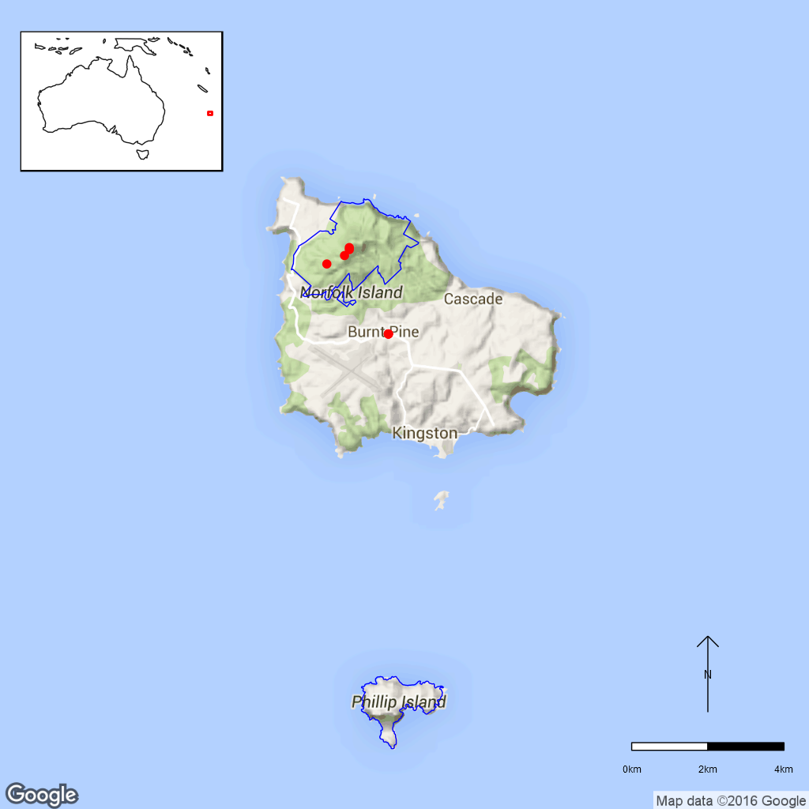
Figure 19.2 Distribution of Boehmeria australis subsp. australis in Norfolk Island
National Park. Red dots are specimen collections and the blue line is the park boundary.

Ex-situ collections (Living and Seed Bank)
The species is not conserved in the Living Collection at the Australian National Botanic Gardens or in the National Seed Bank, however, one seed collection is stored on Norfolk Island (Zoe Knapp pers. comm. 12 October 2015 and Tom North pers. comm. 11 September 2015). No other ex-situ collections in any other Botanic Garden or Seed Bank have been located (ASBP 2016).

Biology
Pollinators: Most likely bees and insects (Cassandra Jones pers. comm. 6 November 2015).
Symbiotic relationships: Unknown.
Germination requirements: It can be propagated from seed (DNP 2010) this has been done with fresh mature seed. Cuttings have not been tried (Cassandra Jones pers. comm. 6 November 2015).
Dormancy class: Unknown.
Flowering: Observed in September–January, March–April and in June. Fruit was observed December–January and March–April. (Mills 2007).
Breeding system: Unknown.
Dispersal: Most likely to be by wind (Cassandra Jones pers. comm. 6 November 2015)
Longevity: Perennial.
Life form: Large spreading shrub or small tree.
Ploidy Levels: The chromosome number of another subspecies, B. australis subsp. dealbata, was counted as 2n=28 (CCDB). This seems to be the diploid chromosome number in the genus. In other Boehmeria species triploids, tetraploids and pentaploids have been recorded (i.e. 2n=28, 42, 56, 70).
Role of the plant in the environment: Colonises open sites but is now being replaced by introduced colonising species.

Threats

Listed Threats (EPBC Act)
- Grazing pressures and associated habitat changes.
- Invasive non-native/ alien species: competition and/or habitat degradation by weeds such as Lantana, wild tobacco tree, mist-flower.
- Low numbers of individuals.

Genetic and demographic effects
The small distribution area and low numbers of individuals suggest that this species has low genetic diversity and may be vulnerable to inbreeding. A small population size and limited geographical distribution also make these species vulnerable to further loss through stochastic events.

Invasive and other problematic species
Threatened by weeds which colonise open sites rapidly, competing for its habitat. It is highly palatable to stock and especially susceptible to insect attack. The species is adapted to colonising open sites where the ground has been bared. (DNP 2010)

Other Threats/Potential New threats

Climate-related factors
Climate change is predicted to bring about an increasing frequency and intensity of droughts and cyclonic activity. Given the small population size, these events may directly and indirectly impact this species. Fire which does not currently occur in the national park, may become a threat. Invasive weeds and pests will be more likely to establish due to increased disturbance and less suitable conditions for local species. (DNP 2010, DNP 2011).

Pests and diseases
Cultivated plants all seem to be susceptible to insect plaque which appears as lumps on the leaves. This is currently being investigated by Australian Quarantine staff (Cassandra Jones pers. comm. 6 November 2015).

Current management
Weed management is conducted in the national park but there is no monitoring program for threatened species (J.Christian pers. comm. 4 August 2015).

Knowledge Gaps
Species biology and life history including pollination syndrome, symbiotic relationships, seed germination, seed dormancy, breeding system, genetic diversity, seed dispersal, time to maturity and longevity of this species are unknown or poorly understood.

Suggested research and actions
- Establish a monitoring program to provide baseline and ongoing data for determining population trajectories and the relative impacts of threatening processes.
- The Norfolk Island Recovery Plan suggests that this species should be propagated and planted as part of the rehabilitation and weed control program where it can be used as a colonising species (DNP 2010).
- Determine key life history parameters including pollination, breeding system, maturity and longevity to assist with species management.
- Determine seed germination and long term storage requirements.
- Secure genetically representative ex-situ seed collections, in multiple locations if appropriate, to mitigate against the loss of natural populations and provide for re-establishment should severe losses or extinction occur.
- Undertake a genetic assessment to determine the reproductive strategy, levels of genetic diversity and inbreeding to assist with any future translocation program.
- Investigate the impacts of pathogens observed on cultivated trees.
- Develop and implement a restoration program to increase population numbers and/or sizes.
- Evaluate the need to establish ‘insurance’ populations off-park.

References:
Atlas of Living Australia (ALA) (2015). Boehmeria australis var. australis. Herbarium specimen records [Online]. Available from http://www.ala.org.au/. Accessed 29 September 2015.
Australian Seed Bank Partnership (2016). Search for records in the Australian Seed Bank [Online]. Council of Heads of Australian Botanic Gardens Inc. Boehmeria australis var. australis. Available from http://asbp.ala.org.au/search. Accessed 11 February 2016.
Coyne P (2011). Norfolk Island’s Fascinating Flora. Petaurus Press, Canberra.
Chromosome Counts Database (CCDB). Chromosome numbers of indigenous New Zealand plants (Dawson, New Zealand). Obtained as a CSV file via personal communication from Murray Dawson.
Council of Heads of Australian Herbaria (CHAH) (2015). Australian Plant Census. [Online]. Available from http://biodiversity.org.au/nsl/services/apc. Accessed 7 October 2015.
Department of the Environment (DoE) (2015). Boehmeria australis subsp. australis in Species Profile and Threats Database, Department of the Environment, Canberra. Available from: http://www.environment.gov.au/sprat. Accessed 7 October 2015.
Director of National Parks (DNP) (2010). Norfolk Island Region Threatened Species Recovery Plan. Department of the Environment, Water, Heritage and the Arts, Canberra.
Director of National Parks (DNP) (2011). Norfolk Island National Park and Botanic Garden Climate Change Strategy 2011-2016 [Online]. Department of the Environment, Water, Heritage and the Arts, Canberra. Available from http://www.environment.gov.au/resource/climate-change-strategy-2011-2016-norfolk-island-national-park-and-botanic-garden. Accessed 7 October 2015.
Director of National Parks (DNP Brochure). Plant Guide - Plants of Norfolk Island National Park and Botanic Garden. Department of the Environment, Water, Heritage and the Arts, Canberra. Available from https://www.environment.gov.au/resource/plant-guide. Accessed 27 October 2015.
Mills K (2007). The Flora of Norfolk Island. 1. The Indigenous Flora. Appendix 2 - Flowering and Fruiting Months – Indigenous Flora of Norfolk Island, updated January 2015. The Author, Jamberoo, New South Wales, June.
- Calystegia affinis (Convolvulaceae) – Norfolk Island National Park
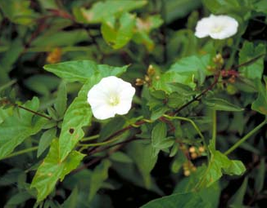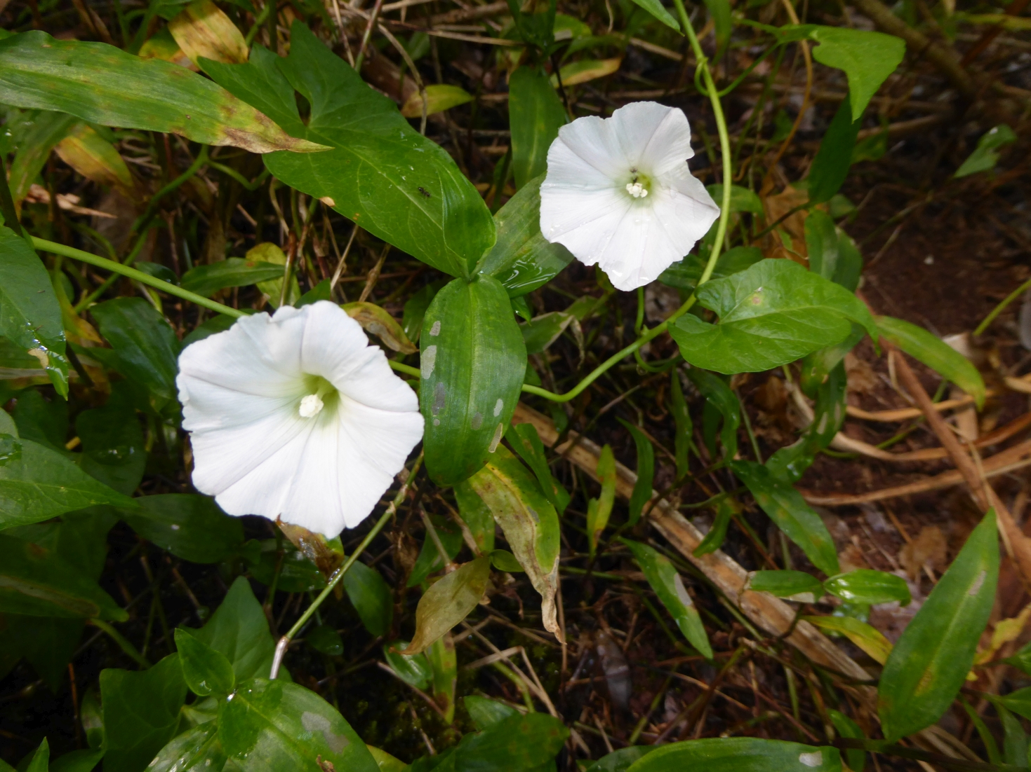
Figure 20.1 Calystegia affinis at Mount Pitt, Norfolk Island. (left, ©G. Butler
Australian National Botanic Gardens Photo No. ni.9) and Calystegia affinis Norfolk Island (right, ©C. Jones).
Calystegia affinis has thin climbing or creeping stems with sagittate (arrow-shaped) leaves and solitary flowers. The white corolla is shortly funnel-shaped but pink with five creamy longitudinal bands on Lord Howe Island (Flora of Australia 1994, DoE 2015).
Taxonomy: The name Calystegia affinis Endl. is accepted in the Australian Plant Census (CHAH 2015, verified 14 July 2015).
Plants from Lord Howe Island, at least those found at Old Settlement, differ from those found on Norfolk Island in several morphological characters suggesting that two subspecies may be present (Flora of Australia 1994, NSW Scientific Committee 2007). The species may also be of hybrid origin with C. soldanella and C. marginata as parental species (Papadopulos et al. 2011). Hybridisation is known to occur between Calystegia species (Ushimaru and Kikuzawa 1999).
Status: Listed as Critically Endangered under the EPBC Act on 3 November 2003. Listed as Critically Endangered in New South Wales under the Threatened Species Conservation Act 1995 on 16 November 2012.
Recovery Plans:
- Norfolk Island Region Threatened Species Recovery Plan (DNP 2010).
- Lord Howe Island Biodiversity Management Plan (DECC 2007).

This information is taken from SPRAT (DoE 2015) unless otherwise referenced.

Number of populations inside and outside parks and reserves
An unknown number of populations occur on Norfolk Island but all known locations appear to be within the national park. Older specimens have been collected more broadly across the island.

Population size – range
In 2003, the total population was estimated to be about 45 mature individuals (TSSC 2003). On Norfolk Island, 95% of the plants are found in the open higher parts of Mt Pitt and Mt Bates.

Geographical distribution
The species is endemic to Norfolk Island and Lord Howe Island and has a fragmented distribution.
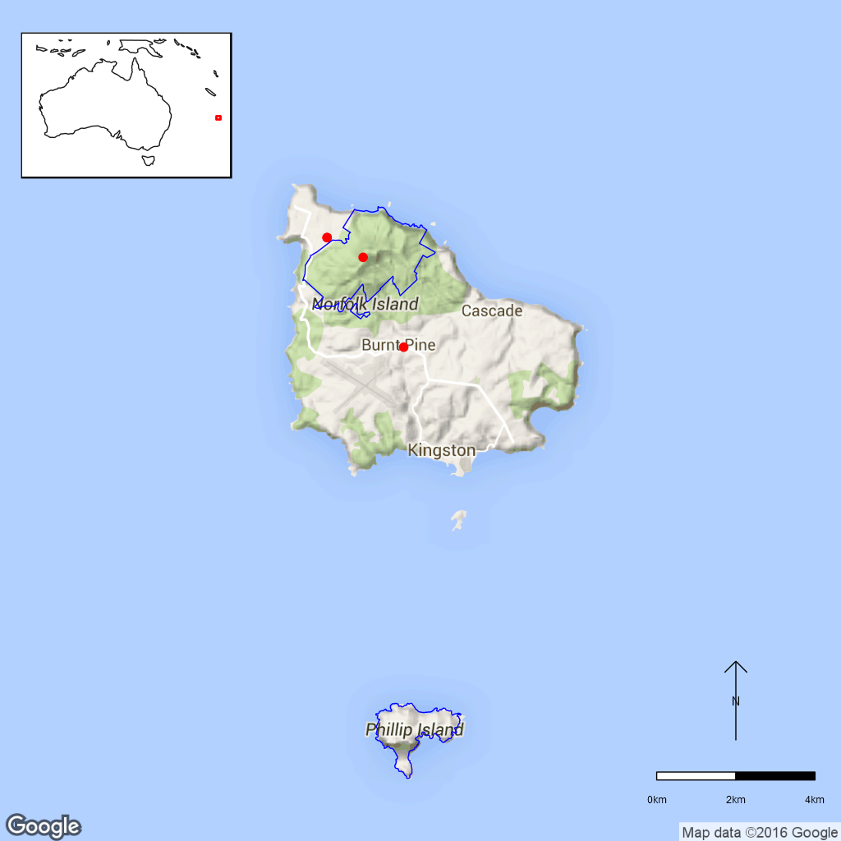
Figure 20.2 Distribution of Calystegia affinis in Norfolk Island National Park.
Red dots are specimen collections, blue line is the park boundary.

Ex-situ collections (Living and Seed Bank)
The species is not conserved in the Living Collection at the Australian National Botanic Gardens or in the National Seed Bank but seed has been collected by the ANBG and is stored on Norfolk Island (Collection No. TGN036, M. Goumas pers. comm. on 6 August 2015, T. North pers. comm. 11 September 2015, Z. Knapp pers. comm. 30 September 2015). A Living specimen is held by the Royal Botanic Gardens and Domain Trust (http://asbp.ala.org.au/occurrence/5901e3f5-0f7d-4df0-9d3e-9a141fa7e1ea). No other ex-situ collections in any other Botanic Garden or Seed Bank have been located (ASBP 2016).

Biology
Pollinators: Probably insect-pollinated as other Calystegia species are primarily visited by different bee species (Ushimaru and Kikuzawa, 1999).
Symbiotic relationships: Unknown.
Germination requirements: Seed should be set out in shady areas but plants need light to grow (DNP 2010).
Dormancy class: Orthodox. Apparently forms a soil seed bank (DNP 2010).
Flowering: Flowering has been observed in September, October and December and fruit in December (Mills 2007).
Breeding system: Bisexual flowers (NSW Scientific Committee 2002). Some Calystegia species are largely self-incompatible (Ushimaru and Kikuzawa 1999). Calystegia affinis is likely to reproduce clonally, since it is sprawling and can root at the nodes. Seed set and germination have been observed on Lord Howe Island (NSW Scientific Committee 2007 and references therein).
Dispersal: Seed of some Calystegia species (e.g. C. soldanella) can float on water while other are considered to be gravity dispersed (Ushimaru and Kikuzawa 1999).
Longevity: Unknown.
Life form: Climbing or creeping vine.
Ploidy levels: The chromosome number of this species is unknown but there is no indication for polyploidy in the genus from the chromosome numbers available (CCDB accessed September 2015).
Role of the plant in the environment: The species is mostly found in the higher parts of mountain tops (DNP 2010), where it occurs in rather open areas (Sykes and Atkinson 1988 cited in DECC 2007).

Threats

Listed Threats (EPBC Act)
- Habitat loss, modification and/or degradation.
- Restricted geographical distribution.
- Competition and/or habitat degradation by weeds.
- Low numbers of individuals.

Genetic and demographic effects
The small distribution area and low numbers of individuals suggest that this species has low genetic diversity and may be vulnerable to inbreeding. A small population size and limited geographical distribution also make these species vulnerable to further loss through stochastic events such as cyclones.

Invasive and other problematic species
The main threat on Norfolk Island is competition from invasive weeds. Currently, Cairo Morning Glory (Ipomoea cairica) and Blue Morning Glory (Ipomoea indica, Convolvulaceae) are the most problematic weeds competing with C. affinis (C. Jones pers. comm. 05/11/2015). Weeds are also a major problem on Lord Howe Island (DECC 2007) where Kikuyu grass (Pennisetum clandestinum, Poaceae) and Crofton weed (Ageratina adenophora, Asteraceae) are the major threats although Buffalo grass (Stenotaphrum secundatum, Poaceae) is also invading C. affinis habitat (Hutton et al. 2008). Habitat clearance is also a threat but unlikely to occur within the national park (DNP 2010).
On Lord Howe Island the introduced beetle Arsipoda parvula feeds on Calystegia affinis and may be affecting flower and seed production (DECC 2007). Rodents (especially rats) also consume seed and inhibit reproduction (OEH 2014); rats also occur on Norfolk Island and could impact this species. Future introductions of pathogens, weeds or predators also present a risk on Lord Howe Island (OEH 2014) which also holds true for Norfolk Island.

Other Threats/Potential New threats

Climate-related factors
Climate change is predicted to bring about an increasing frequency and intensity of droughts and cyclonic activity. Given the small population size, these events may directly and indirectly impact this species. Fire which does not currently occur in the national park, may become a threat. Invasive weeds and pests will be more likely to establish due to increased disturbance and less suitable conditions for local species. (DNP 2010, DNP 2011).
The prediction of increased frequency and intensity of storms, which has been recognised as a threat for this species on Lord Howe Island through damage or loss of plants is also likely to apply on Norfolk Island (OEH, 2014).

Current management
Weed management is conducted in the national park but there is no monitoring program for threatened species (J.Christian pers. comm. 4 August 2015).

Knowledge Gaps
Species biology and life history including pollination syndrome, symbiotic relationships, seed germination, flowering, breeding system, genetic diversity, seed dispersal, time to maturity and longevity of this species are unknown or poorly understood.

Suggested research and actions
- Establish a monitoring program to provide baseline and ongoing data for determining population trajectories and the relative impacts of threatening processes.
- Develop and implement a restoration program to increase population numbers and/or sizes.
- Determine key life history parameters including pollination, flowering, breeding system, maturity and longevity to assist with species management.
- Secure genetically representative ex-situ seed collections, in multiple locations if appropriate, to mitigate against the loss of natural populations and provide for re-establishment should severe losses or extinction occur.
- Determine the appropriate conditions for long term storage and seed germination.
- Undertake a genetic assessment to determine the reproductive strategy, levels of genetic diversity and inbreeding to assist with any future translocation program.
- Determine genetic relationships between the populations on Norfolk and Lord Howe Islands to assist with translocation programs should a catastrophic event occur on either island.
- Develop and implement a restoration program to increase population numbers and/or sizes.
- Evaluate the need to establish ‘insurance’ populations off-park.

References
Australian Seed Bank Partnership (2016). Search for records in the Australian Seed Bank [Online]. Council of Heads of Australian Botanic Gardens Inc. Calystegia affinis. http://asbp.ala.org.au/search Accessed 11 February 2016.
Council of Heads of Australian Herbaria (CHAH) (2015). Australian Plant Census. [Online]. Available from http://biodiversity.org.au/nsl/services/apc. Accessed 14 July 2015.
Department of the Environment (DoE) (2015). Calystegia affinis in Species Profile and Threats Database, Department of the Environment, Canberra. Available from http://www.environment.gov.au/cgi-bin/sprat/public/sprat.pl. Accessed 13 July 2015.
Director of National Parks (DNP) (2010). Norfolk Island Region Threatened Species Recovery Plan. Department of the Environment, Water, Heritage and the Arts, Canberra. Available from http://www.environment.gov.au/resource/national-recovery-plan-norfolk-island. Accessed 13 July 2015.
Director of National Parks (DNP) (2011). Norfolk Island National Park and Botanic Garden Climate Change Strategy 2011-2016 [Online]. Department of the Environment, Water, Heritage and the Arts, Canberra. Available from http://www.environment.gov.au/resource/climate-change- strategy-2011-2016-norfolk-island-national-park-and-botanic-garden.Accessed 13 July 2015.
Flora of Australia (1994). Volume 49, Oceanic Islands 1. Australian Government Publishing Service, Canberra.
Hutton I, Coenraads R, Auld TD, Denham AJ, Ooi MKJ, Brown D (2008). Herbicide impacts on exotic grasses and a population of the critically endangered herb Calystegia affinis (Convolvulaceae) on Lord Howe Island. Cunninghamiana 10: 539–545.
New South Wales Department of Environment and Climate Change (DECC) (2007). Lord Howe Island Biodiversity Management Plan. Department of Environment and Climate Change (NSW), Sydney.
New South Wales Office of Environment and Heritage (OEH) (2014). Lord Howe Island Morning Glory – profile. Available from http://www.‌environment‌.nsw.gov.au/threatenedspecies. Accessed 13 July 2015.
New South Wales Scientific Committee (2007). New Final Determination, Calystegia affinis. Available from http://www.environment.nsw.gov.au‌/resources/threatenedspecies/CalyaffinCRFD.pdf. Accessed 13 July 2015.
Mills K (2007). The Flora of Norfolk Island. 1. The Indigenous Flora. Appendix 2 - Flowering and Fruiting Months – Indigenous Flora of Norfolk Island, updated January 2015. The Author, Jamberoo, New South Wales, June.
Papadopulos AST, Baker WJ, Crayn D, Butlin RK, Kynast RG, Hutton I, Savolainen V (2011). Speciation with gene flow on Lord Howe Island. PNAS 108: 13188–13193.
Sykes W and Atkinson I (1988). Rare and Endangered Plants of Norfolk Island. Unpublished report to the Australian National Parks and Wildlife Service, Norfolk Island.
Threatened Species Scientific Committee (TSSC) (2003). Commonwealth Listing Advice for Norfolk Island Flora - 11 Critically Endangered Species. [Online]. Available from http://www.environment.gov.au/biodiversity/threatened/species/norfolk-island-flora-critically.html. Accessed 13 July 2015.
Ushimaru A and Kikuzawa K (1999). Variation of breeding system, floral rewards and reproductive success in clonal Calystegia species (Convolvulaceae). American Journal of Botany 86: 436–446.
- Clematis dubia (Ranunculaceae) – Clematis, Norfolk Island National Park
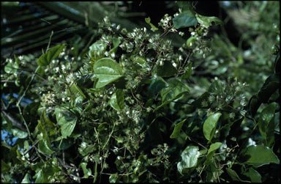
Figure B21.1 Clematis dubia on Norfolk Island. ©G. Sattler Australian National Botanic
Gardens Photo No. ni.149.
Clematis dubia is a woody climber with simple or more rarely trifoliate glabrous leaves. The flowers are white and hairy (DNP 2010).
Taxonomy: The name Clematis dubia (Endl.) P.S.Green is accepted in the Australian Plant Census (CHAH 2015, verified 14 July 2015).
Status: Listed as Critically Endangered under the EPBC Act on 3 November 2003.
Recovery Plan: Norfolk Island Region Threatened Species Recovery Plan (DNP 2010).
This information is taken from SPRAT (DoE 2015) unless otherwise referenced.

Number of populations inside and outside parks and reserves
The species was once common in the area of Mt Pitt and Mt Bates. The Norfolk Island Threatened Species Recovery Plan states that all locations are within the National Park but also records the species in an area called “North of Cascade” outside of NINP (DNP 2010).

Population size – range
Clematis dubia grows in small, isolated subpopulations. In 2003, there were about 15 mature plants (TSSC 2003). Flora of Australia (1994) states that the species was formerly widespread.

Geographical distribution
Localised and fragmented distribution.
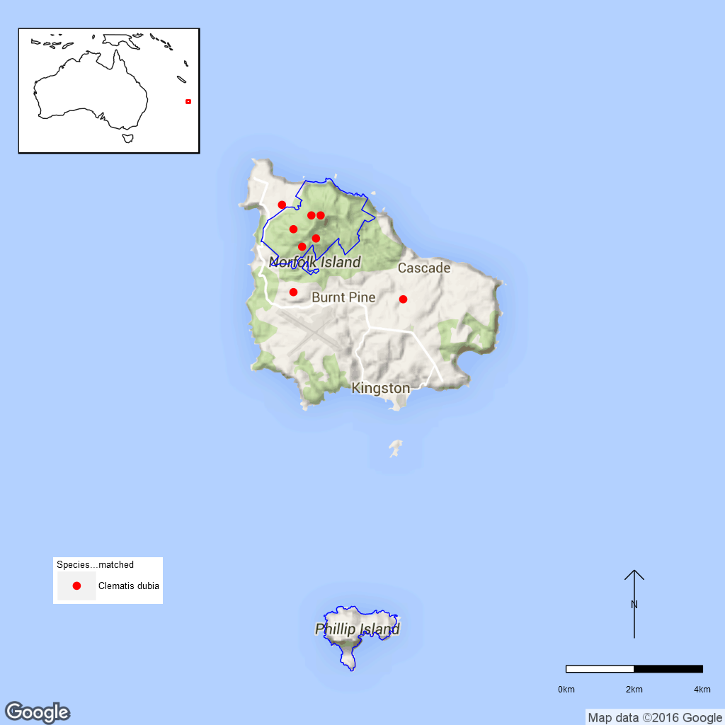
Figure B21.2 Distribution of Clematis dubia in Norfolk Island National Park.
Red dots are specimen collections, the blue line is the park boundary.

Ex-situ collections (Living and Seed Bank)
The species is not conserved in the Living Collection at the Australian National Botanic Gardens or in the National Seed Bank (Z. Knapp pers. comm. 30 September 2015. No other ex-situ collections in any other Botanic Garden or Seed Bank have been located (ASBP 2016).

Biology
Pollinators: Probably insect-pollinated.
Symbiotic relationships: Unknown.
Germination requirements: Unknown.
Dormancy class: Possibly orthodox. Seed viability is apparently very variable (L. Guja pers. comm. 10 September 2015).
Flowering: Unknown. Flowering plant specimens in the Australian national herbarium have been collected in April, May and June (four specimens in total) and a fruiting plant has been collected in July.
Breeding system: The inflorescences of C. dubia are unisexual (Flora of Australia 1994). The species can be grown from cuttings (DNP 2010).
Dispersal: Clematis dubia rarely sets seed (every 4–5 years, DNP 2010). The small achenes (seed) are probably dispersed by wind.
Longevity: Unknown.
Life form: Climbing vine.
Ploidy levels: Unknown.
Role of the plant in the environment: Clematis dubia grows in light gaps, on forest margins and in clearings (DNP 2010).

Threats

Listed Threats (EPBC Act)
- Competition and/or habitat degradation by weeds.
- Low numbers of individuals.

Genetic and demographic effects
The small distribution area and low numbers of individuals suggest that this species has low genetic diversity and may be vulnerable to inbreeding. A small population size and limited geographical distribution also make these species vulnerable to further loss through stochastic events such as cyclones.

Invasive and other problematic species
Competition by weeds is a major threat to Clematis dubia (DNP 2010).

Other Threats/Potential New threats

Climate-related factors
Climate change is predicted to bring about an increasing frequency and intensity of droughts and cyclonic activity. Given the small population size, these events may directly and indirectly impact this species. Fire which does not currently occur in the national park, may become a threat. Invasive weeds and pests will be more likely to establish due to increased disturbance and less suitable conditions for local species. (DNP 2010, DNP 2011).

Biophysical impacts
The soil around Mt Pitt is prone to landslip after heavy rain (Hyder Consulting 2008).

Current management
Weed management is conducted in the national park but there is no monitoring program for threatened species (J.Christian pers. comm. 4 August 2015).

Knowledge Gaps
Species biology and life history including pollination syndrome, symbiotic relationships, seed germination, seed dormancy, flowering, breeding system, genetic diversity, seed dispersal, time to maturity and longevity of this species are unknown or poorly understood.

Suggested research and actions
- Establish a monitoring to assess population size, distribution, and the relative impacts of threatening processes.
- Improved weed control where possible.
- Determine key life history parameters including age to maturity, longevity, survival of seed should be determined to be able to establish population thresholds and natural demographic cycles.
- Determine seed germination and long term storage requirements.
- Secure seed collections both on NINP and at the ANBG or a suitable second Seed Bank to mitigate against the loss of populations in the wild and/or destruction of the NINP Seed Bank.
- Determine reproductive strategy to determine if inbreeding is an issue and contributes to low seed set.
- Develop and implement a restoration program to increase population numbers and/or sizes.
- Evaluate the need to establish ‘insurance’ populations off-park.

References
Australian Seed Bank Partnership (2016). Search for records in the Australian Seed Bank [Online]. Council of Heads of Australian Botanic Gardens Inc. Clematis dubia. Available from http://asbp.ala.org.au/search. Accessed 11 February 2016.
Council of Heads of Australasian Herbaria (CHAH) (2015). APC – Australian Plant Census. Available from http://biodiversity.org.au/nsl/services/apc. Accessed 14 July 2015.
Department of the Environment (DoE) (2015). Clematis dubia in Species Profile and Threats Database, Department of the Environment, Canberra. Available from http://www.environment.gov.au/sprat. Accessed 14 July 2015.
Director of National Parks (DNP) (2010). Norfolk Island Region Threatened Species Recovery Plan [Online]. Department of the Environment, Water, Heritage and the Arts, Canberra. Available from http://www.environment.gov.au/resource/national-recovery-plan-norfolk-island. Accessed 14 July 2015.
Director of National Parks (DNP) (2011). Norfolk Island National Park and Botanic Garden Climate Change Strategy 2011-2016 [Online]. Department of the Environment, Water, Heritage and the Arts, Canberra. Available from http://www.environment.gov.au/resource/climate-change- strategy-2011-2016-norfolk-island-national-park-and-botanic-garden. Accessed 14 July 2015.
Flora of Australia (1994). Volume 49, Oceanic Islands 1. Australian Government Publishing Service, Canberra.
Hyder Consulting (2008). The Impacts and Management Implications of Climate Change for the Australian Government’s Protected Areas. A report to the Department of the Environment, Water, Heritage and the Arts and the Department of Climate Change. Commonwealth of Australia, Canberra.
Threatened Species Scientific Committee (TSSC) (2003). Commonwealth Listing Advice for Norfolk Island Flora – 11 Critically Endangered Species. [Online]. Available from: http://www.environment.gov.au/biodiversity/threatened/species/norfolk-island-flora-critically.html. Accessed 14 July 2015.
- Coprosma baueri and Coprosma pilosa (Rubiaceae) – Coastal Coprosma and Mountain Coprosma, Norfolk Island Nation Park
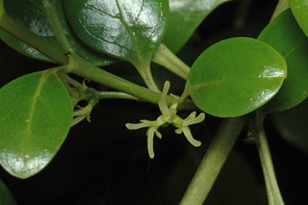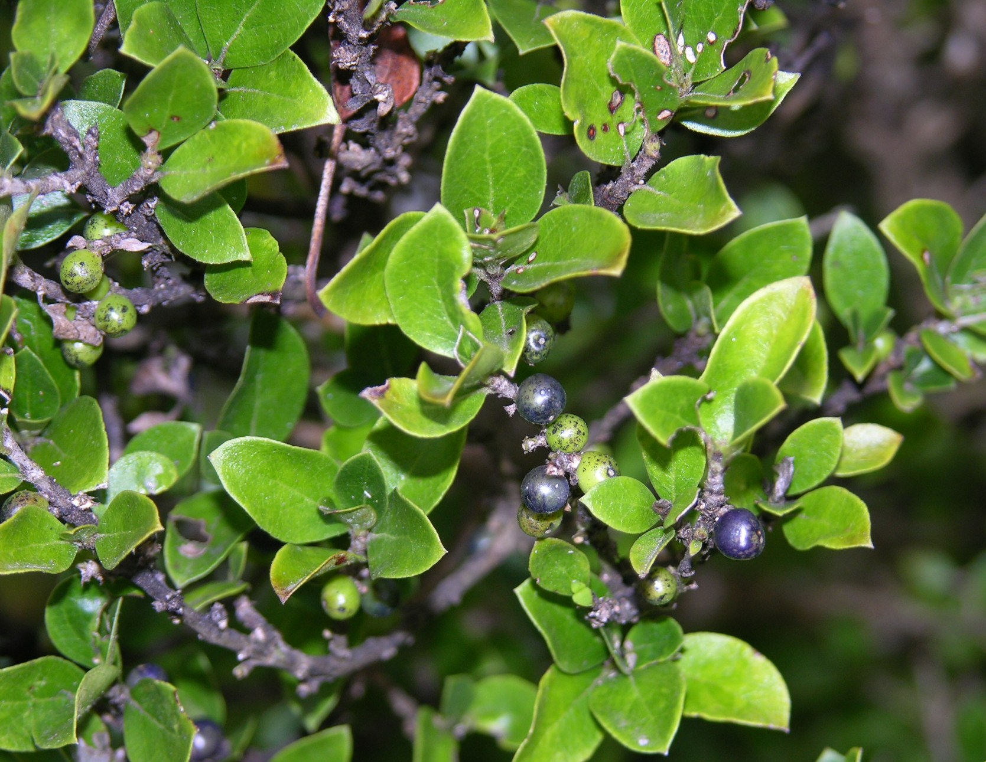
Figure 22.1 Female flowers of Coprosma baueri growing in the ANBG (left, ©M. Fagg Australian National Botanic Gardens Photo No. dig. 9922) and Coprosma pilosa on Norfolk Island (right, ©K. Mills, supplied by NINP staff).
Coprosma baueri (Coastal coprosma) is a shrub or small tree with small green flowers and orange, egg-shaped fruits. The leaves are light green and glossy (Flora of Australia 1994). On exposed cliff habitat it usually forms compact shrubs to 1.5 m, but can grow taller and rather spindly in sheltered places under trees (Mills 2009).
Coprosma pilosa (Mountain coprosma) is a shrub or small tree growing up to 6 m tall. It has small green flowers and dark bluish-purple fruits (Flora of Australia 1994).
Taxonomy: The names Coprosma baueri Endl. and Coprosma pilosa Endl. are accepted according to the Australian Plant Census (CHAH 2015, verified 10 September 2015).
Status: Listed as Endangered under the EPBC Act on 3 November 2003.
Recovery Plan: Norfolk Island Region Threatened Species Recovery Plan (DNP 2010).

Number of populations inside and outside parks and reserves
Coprosma baueri occurs on both Phillip and Norfolk Island. On Norfolk Island it mainly occurs outside the national park and is reported form the Anson Bay-Duncombe Bay area, Selwyn Reserve, Two Chimneys Reserve and Kingston Common Reserve (DNP 2010). However, it has been planted as part of rehabilitation works along the Mt Pitt Road (DNP 2010).
The entire population of C. pilosa occurs inside the Mt Pitt section of Norfolk Island National Park (DNP 2010).

Population size – range
At the time of listing, there were 228 mature individuals of Coprosma baueri (TSSC 2003). On Phillip Island, Coprosma baueri was observed to be very common along the southern and western cliffs in 2007 with a good range of plant sizes including seedlings suggesting a healthy population (Mills 2009). Due to plantings in the national park (DNP 2010) it seems to occur in good numbers in both sections of the park (C. Jones pers. comm. 11 November 2015).
187 mature individuals of C. pilosa were known at the time of listing (TSSC 2003).

Geographical distribution
Coprosma baueri occurs on Norfolk Island as well as Phillip Island. Coprosma pilosa is endemic to Norfolk Island (DNP 2010). Both species have a localised distribution.
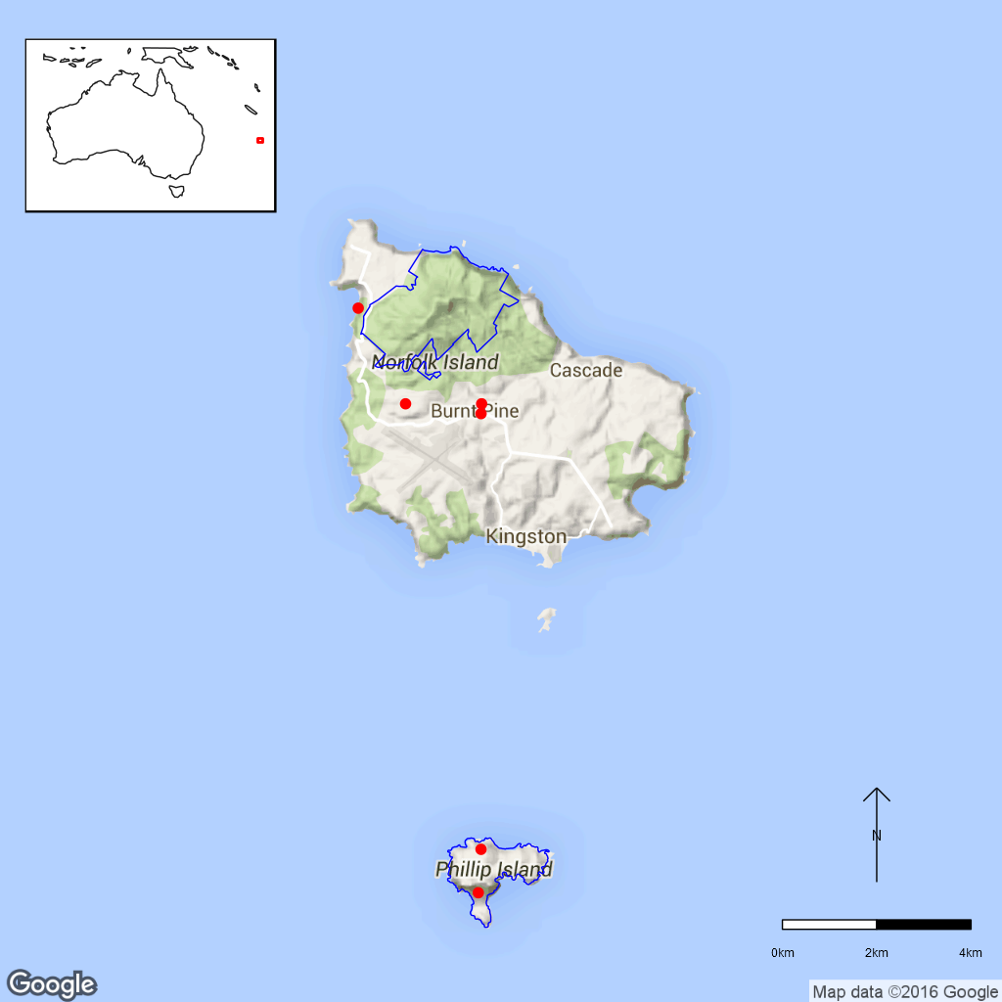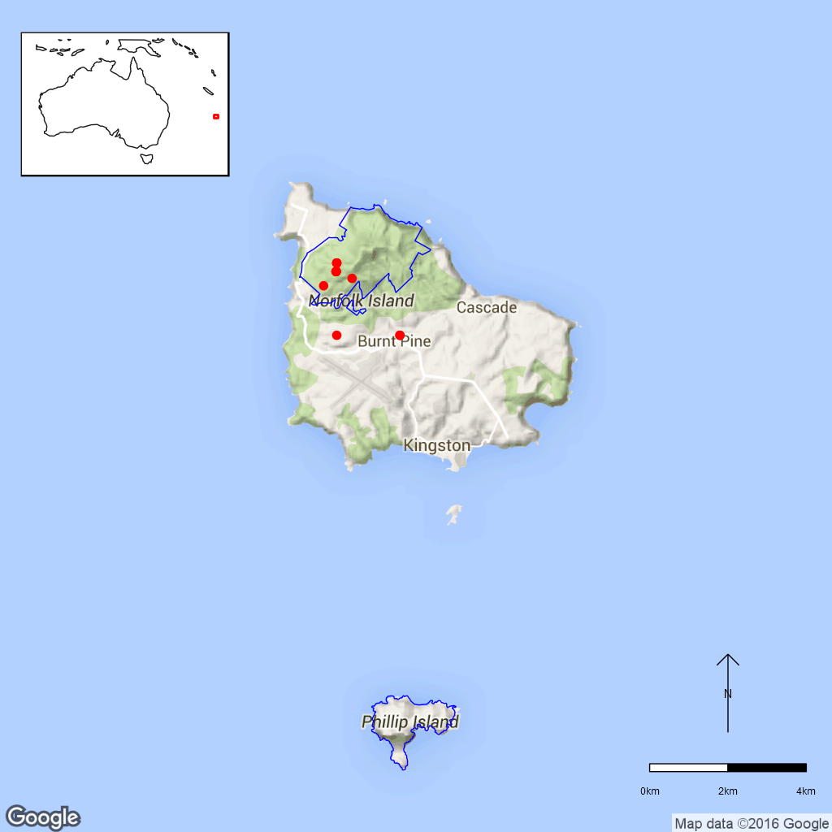
Figure B22.2 Distribution of Coprosma baueri (left) and C. pilosa (right) in Norfolk Island National Park.
Red dots are specimen collections, the blue line is the park boundary.

Ex-situ collections (Living and Seed Bank)
Three seed collections (277, 187 and 440 seed) of C. baueri are held at the National Seed Bank (T. North pers. comm. 11 September 2015). Seed of both Coprosma species are also held on Norfolk Island (L. Guja pers. comm. 10 September 2015). However, due to hybridisation between C. baueri and the non-native C. repens on Norfolk Island, seed collections from Phillip Island are required (L. Guja pers. comm. 10 September 2015). Eight plants of C. baueri are cultivated in the Living Collection of the Australian National Botanic Gardens (Z. Knapp on 30 September 2015). No other ex-situ collections in any other Botanic Garden or Seed Bank have been located (ASBP 2016).

Biology
Pollinators: Both Coprosma species are wind-pollinated (DNP 2010).
Symbiotic relationships: Both species have domatia on their lower leaf surfaces (Flora of Australia 1994). Domatia are also found in many other Coprosma species and are part of a plant – mite mutualism. These small pits or pouches are found in the axils of leaf veins and provide shelter for mites and act as mite nurseries. The mites protect the leaf by feeding fungal hyphae, fungal spores, pollen and partly also small herbivorous arthropods. This leads to a longer life span of the leaves, as shown in a study on the New Zealand species C. lucida (Monks et al. 2007). The EPBC listed mistletoe Ileostylus micranthus favours C. pilosa as its host (DNP 2010) which suggests that at least one bird species is also reliant on this Coprosma.
Germination requirements: Not known. Seedlings were observed on Phillip Island in November 2007 (Mills 2009).
Dormancy class: Unknown.
Flowering: Coprosma baueri is reported to flower and set seed annually (L. Guja pers. comm. 10 September 2015) whereas C. pilosa sets seed only occasionally (DNP 2010). Specimens at the Australian National Herbarium indicate that both species flower winter- spring and have fruits spring-summer.
Breeding system: Both species are dioecious (DNP 2010).
Dispersal: The seed of both species are dispersed by birds who eat the fruits (DNP 2010).
Longevity: Unknown.
Life form: shrub or small tree
Ploidy levels: Coprosma baueri is diploid (2n=44) whereas C. pilosa is hexaploid (2n=132, Beuzenberg 1983).
Role of the plant in the environment: Coprosma baueri mostly grows near the coast, including areas that are affected by salt water spray. It is sometimes severely chewed by insects (DNP 2010). On Phillip Island, it grows on cliff edges, where it can be a co-dominant species (Mills 2009). Here, it thrives well in nesting habitat of wedge-tailed shearwaters (Puffinus pacificus, Procellariidae) that fertilise the soil and keep it loose and the habitat open with their burrowing (Sykes and Atkinson 1988).
Coprosma pilosa is found in the palm forests of sheltered mountain gullies and upper slopes in the Mt Pitt Section of the National Park that are dominated by Norfolk Island Palm (Rophalostylis baueri, Arecaceae).There is a suggestion that it might be adapted to a certain altitude, as it does not grow well in the nursery (C. Jones pers. comm. 11 November 2016). Coprosma pilosa is a favoured host of the mistletoe Ileostylus micranthus which is also listed under the EPBC Act (DNP 2010).

Threats

Listed threats (EPBC Act)
- Restricted geographical distribution.
- Competition and/or habitat degradation by weeds.
- Wind damage (C. baueri only).
- Negative impacts caused by insects (C. baueri only).
- Reduction of genetic integrity of a species due to hybridisation (C. baueri only).
- Competition and/or habitat degradation by Ileostylus micranthus (C. pilosa only).
- Low numbers of individuals (C. pilosa only).

Genetic and demographic effects
The small distribution area and low numbers of individuals suggest that both species have low genetic diversity and may be vulnerable to inbreeding. A small population size and limited geographical distribution also makes these species vulnerable to further loss through stochastic events such as cyclones (DNP 2010). The genetic integrity of C. baueri is possibly threatened by hybridisation with C. repens, a species introduced from New Zealand (DNP 2010).

Invasive and other problematic species
Competition from weeds is a major threat to both Coprosma species (DNP 2010). The mistletoe Ileostylus micranthus favours Coprosma pilosa as its host and is able to kill the host with heavy infestations (DNP 2010). Seed predation is occurring in Coprosma pilosa (L. Guja pers. comm. 10 September 2015). Coprosma baueri leaves are often severely chewed by insects (DNP 2010), but it is not known whether this is a threat to the species.

Other Threats/Potential New threats

Climate-related factors
Climate change is predicted to lead to an increased frequency of storm events and to changes in rainfall patterns (Hyder Consulting 2008) potentially increasing climate-related threats. Coprosma baueri is threatened by strong wind that can damage plants growing in exposed coastal locations (DoE 2015). Good self-regeneration of C. baueri populations might be impacted during drought (Mills 2009). Coprosma pilosa seems to be quite restricted in its habitat preferences at higher elevations since it cannot be easily grown in the nursery suggesting that increasing temperatures associated with climate change are a potential threat to this species.
In addition, fire which does not currently occur in the national park, may become a threat. Invasive weeds and pests will be more likely to establish due to increased disturbance and less suitable conditions for local species. (DNP 2010, DNP 2011).

Current management
Weed management is conducted in the national park but there is no monitoring program for threatened species (J.Christian pers. comm. 4 August 2015). Coprosma baueri has been planted in the Mt Pitt section of the national park as part of a rehabilitation program as the species is very hardy and survives planting in rehabilitation areas very well (C. Jones pers. comm. 6 November 2015). Mills (2009) indicates that C. baueri is successfully regenerating on Phillip Island so further planting is not a priority.

Knowledge Gaps
Species biology and life history including seed germination, flowering, breeding system, genetic diversity, time to maturity and longevity of this species are unknown or poorly understood.

Suggested research and actions
- Establish a monitoring program to provide baseline and ongoing data for determining population trajectories and the relative impacts of threatening processes.
- Determine key life history parameters including age to maturity, longevity, flowering and fruiting and reproductive strategy to assist with species management.
- Secure genetically representative ex-situ seed collections, in multiple locations if appropriate, to mitigate against the loss of natural populations and provide for re-establishment should severe losses or extinction occur.
- Determine the appropriate conditions for long term storage and seed germination.
- Determine reproductive strategy to determine if inbreeding is an issue that contributes to low seed set in C. pilosa and/or poor propagation of C. baueri.
- Establish the biological linkages between Mountain coprosma, the mistletoe and associated bird(s) to ensure that this group of species is collectively managed.
- A better understanding of the mites including what species co-occur and how these are dispersal may better inform rehabilitation programs to ensure that this important species is included in these programs.
- Determine the growing requirements of Mountain coprosma to ensure to improve the success of propagated material.

References
Australian Seed Bank Partnership (2016). Search for records in the Australian Seed Bank [Online]. Council of Heads of Australian Botanic Gardens Inc. Coprosma bauera and C. pilosa. Available from http://asbp.ala.org.au/search. Accessed 11 February 2016.
Beuzenberg EJ (1983). Contributions to a chromosome atlas of the New Zealand flora – 24: Coprosma (Rubiaceae). New Zealand Journal of Botany 21: 9–12.
Council of Heads of Australasian Herbaria (CHAH) (2015). APC – Australian Plant Census. Available from http://biodiversity.org.au/nsl/services/apc. Accessed 10 September 2015.
Department of the Environment (DoE) (2015). Coprosma baueri in Species Profile and Threats Database, Department of the Environment, Canberra. Available from http://www.environment.gov.au/sprat. Accessed 13 July 2015.
Director of National Parks (DNP) (2010). Norfolk Island Region Threatened Species Recovery Plan. Department of the Environment, Water, Heritage and the Arts, Canberra. Available from http://www.environment.gov.au/resource/national-recovery-plan-norfolk-island. Accessed 13 July 2015.
Director of National Parks (DNP) (2011). Norfolk Island National Park and Botanic Garden Climate Change Strategy 2011-2016 [Online]. Department of Sustainability, Environment, Water, Population and Communities, Canberra, Australia. Available from http://www.environment.‌gov.au‌/resource/climate-change-strategy-2011-2016-norfolk-island-national-park-and-botanic-garden. Accessed 13 July 2015.
Flora of Australia (1994). Volume 49, Oceanic Islands 1. Australian Government Publishing Service, Canberra.
Hyder Consulting (2008). The Impacts and Management Implications of Climate Change for the Australian Government’s Protected Areas. A report to the Department of the Environment, Water, Heritage and the Arts and the Department of Climate Change. Commonwealth of Australia, Canberra.
Mills K (2009). The Vegetation of Phillip Island, Norfolk Island Group. Available from http://www.econorfolk.nf/pdf/Kevin%20Mills%20Report‌%20Body.pdf. Accessed 13 July 2015.
Monks A, O’Connell DM, Lee WG, Bannister JM, Dickinson KJM (2007). Benefits associated with the domatia mediated tritrophic mutualism in the shrub Coprosma lucida. Oikos 116: 873–881.
Sykes W and Atkinson I (1988). Rare and Endangered Plants of Norfolk Island. Unpublished report to the Australian National Parks and Wildlife Service, Norfolk Island.
Threatened Species Scientific Committee (TSSC) (2003). Commonwealth Listing Advice for Norfolk Island Flora – 16 Endangered Species. [Online]. Available from: http://www.environment.gov.au/biodiversity/threatened/species/norfolk-island-flora-endangered. Accessed 13 July 2015.
- Cordyline obtecta (Asparagaceae) – Ti/ Norfolk Island Cabbage Tree, Norfolk Island National Park
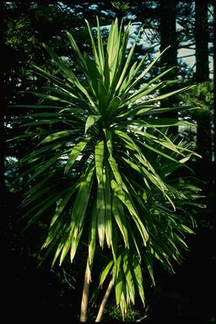
Figure 23.1 Cordyline obtecta flowers at ANBG (left, ©M. Fagg Australian National Botanic Gardens No. dig.14369) and on Norfolk Island (right, ©G. Sattler Australian National Botanic Gardens No. ni.151).
This species has been described as a tree lily and grows up to 10 m tall with strap-like leaves and lily-like flowers. Plants are occasionally multi-stemmed. Can grow very tall (>8 m) with numerous stems and branching with several heads (Cassandra Jones pers. comm. 6 November 2015). The white flower are borne on an erect pyramidal flower spikes about 30 cm long on the top of the stem. It has grey bark and bluey purple fruit. (Ho 2006, DNP 2010). This species is now considered to be synonymous with the New Zealand Three Kings Cabbage Tree (C. kaspar) (de Lange 2005).
Taxonomy: Conventionally accepted as Cordyline obtecta (Graham) Baker (CHAH 2006, verified 12 August 2015).
Family is given as Agavaceae on EPBC listing page, however, in APNI site it is Asparagaceae
Cordyline kaspar W.R.B.Oliv. is a synonym of Cordyline obtecta, this species is listed as At Risk/Range restricted in New Zealand (de Lange 2005)
Status: Listed as Vulnerable under the EPBC Act on 3 November 2003
Recovery Plan: Norfolk Island Region Threatened Species Recovery Plan, 2010.
This information is taken from SPRAT (DoE 2015) unless otherwise referenced.

Number of populations inside and outside parks and reserves
Most populations of this species occur inside Norfolk Island National Park. This species occurs in hardwood sub-tropical rainforest areas of Norfolk Island on the upper slopes of Mt Pitt-Mt Bates and occasionally on sheltered ridges, slopes and in gullies at lower altitudes.

Population size – range
At the time of listing in 2003 there were 818 mature individuals (TSSC 2003) with 65% of these occurring within the national park. Due to the ease with which it can be propagated this species has been planted in several public areas and on Phillip Island. The population was reported to have greatly increased since 2003 (McCoy in DNP 2010) but it is not clear whether this was done with seedlings, cuttings or a mixture of both.

Geographical distribution
Localised, discontinuous. Found in open areas as well as forest understorey.
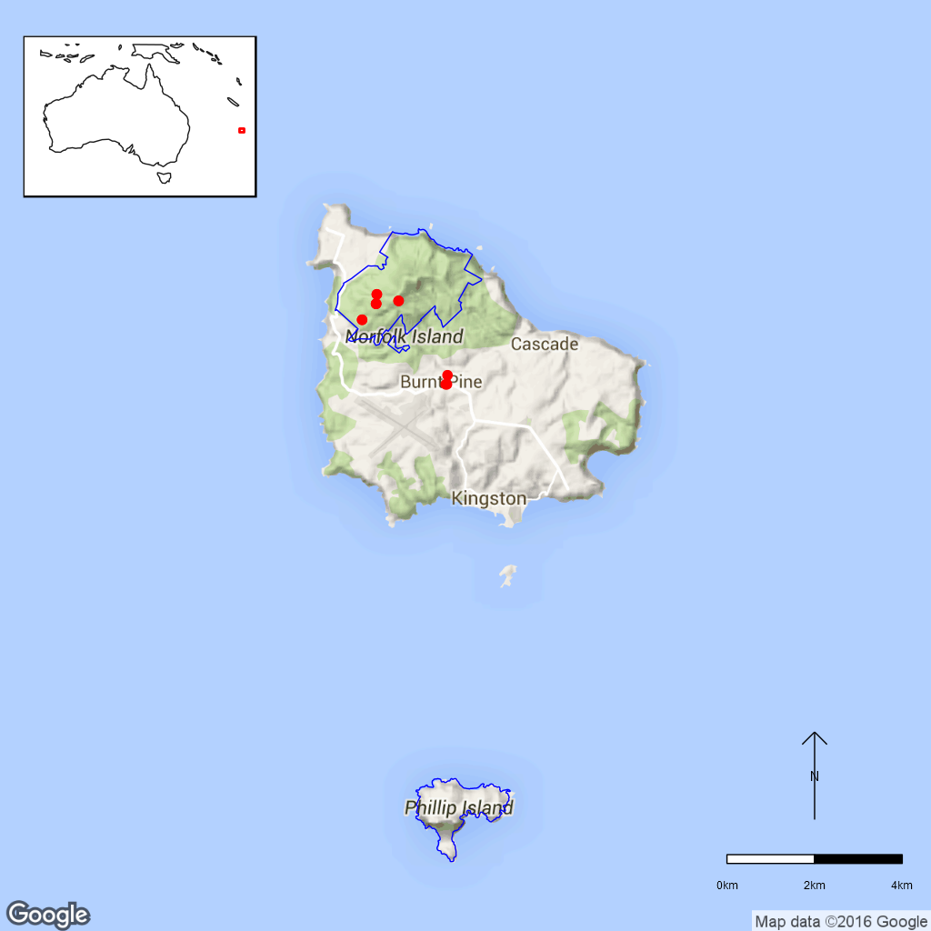
Figure 23.2 Distribution of Cordyline obtecta (Ti) in Norfolk Island National Park.
Red dots are specimen collections, blue line is the park boundary.

Ex-situ collections (Living and Seed Bank)
This species is currently conserved in the Australian National Botanic Gardens (97 plants) and the National Seed Bank (two accession) with additional seed collections are proposed in 2016 (T. North pers. comm. 11 September 2015, Z. Knapp pers. comm. 30 September 2015). No other ex-situ collections in any other Botanic Garden or Seed Bank have been located (ASBP 2016).

Biology
Pollinators: Probably insect and/or bee pollinated as C. kaspar, C. australis and hybrids were visited by many insects and honey bees (Beever 1981).
Symbiotic relationships: Unknown.
Germination requirements: No pre-treatment required (Ho 2006).
Dormancy class: Orthodox, said to live for several years in the soil (Arkins 2003, in Lough 2006).
Flowering: Flowers were observed by Mills (2007) from September-November and fruit in November-January, March, April and June and produce copious amounts of nectar (Beever 1981).
Breeding system: C. kaspar, now believed to be synonymous with C. obtecta, is self-incompatible (Beever 1981) but also produces parthenocarpic (seedless) fruit. A large amount of fruit is produced on each tree (Cassandra Jones pers. comm. 6 November 2015). The plant is easy to strike from cuttings and broken sections have been found to send down roots and grow (Cassandra Jones pers. comm. 6 November 2015).
Dispersal: In New Zealand the seed fall when ripe or are eaten by birds (Beever 1981).
Longevity: Unknown.
Life form: Tree lily.
Ploidy levels: 2n = 38 (Moore and Edgar 1970, CCDB).
Role of the plant in the environment: The older larger trees often hollow out and are one of the favourite nest sites for the Green Parrot (Cyanoramphys cookii) (C. Jones pers. comm. 6 November 2015).

Threats

Listed Threats (EPBC Act)
- Grazing pressures and associated habitat changes
- Competition and/or habitat degradation by weeds
- Low numbers of individuals

Genetic and demographic effects
The small distribution area and low numbers of individuals suggest that both species have low genetic diversity and may be vulnerable to inbreeding. A small population size and limited geographical distribution also makes these species vulnerable to further loss through stochastic events such as cyclones.

Invasive and other problematic species
Grazing by cattle outside the park and weed competition threaten natural recruitment.

Other Threats/Potential New threats

Climate-related factors
Climate change is predicted to bring about an increasing frequency and intensity of droughts and cyclonic activity. Given the small population size, these events may directly and indirectly impact this species. Fire which does not currently occur in the national park, may become a threat. Invasive weeds and pests will be more likely to establish due to increased disturbance and less suitable conditions for local species. (DNP 2010, DNP 2011).

Current management
Weed management is conducted in the national park but there is no monitoring program for threatened species (J.Christian pers. comm. 4 August 2015).

Knowledge Gaps
Species biology and life history including pollination syndrome, symbiotic relationships, seed germination, flowering, breeding system, genetic diversity, seed dispersal, time to maturity and longevity of this species are unknown or poorly understood.

Suggested research and actions
- Establish a monitoring program to provide baseline and ongoing data for determining population trajectories and the relative impacts of threatening processes.
- Determine key life history parameters including pollination, reproductive strategy, flowering and fruiting times, maturity and longevity to assist with species management
- Secure genetically representative ex-situ seed collections, in multiple locations if appropriate, to mitigate against the loss of natural populations and provide for re-establishment should severe losses or extinction occur.
- Determine the appropriate conditions for long term storage and seed germination.

References:
Arkins A (2003). The Cabbage Tree. Auckland, Reed publishing.
Atlas of Living Australia (ALA) (2015). Cordyline obtecta. Herbarium specimen records [Online]. Available from http://www.ala.org.au/. Accessed 12 August 2015.
Australian Seed Bank Partnership (2016). Search for records in the Australian Seed Bank [Online]. Council of Heads of Australian Botanic Gardens Inc. Cordyline obtecta. Available from http://asbp.ala.org.au/search. Accessed 11 February 2016.
Beever RE (1981). Self-Incompatibility in Cordyline kaspar (Agavaceae). New Zealand Journal of Botany 19: 13–16.
Chromosome Counts Database (CCDB). 3 References: 1. Chromosome numbers of indigenous New Zealand plants (Dawson, New Zealand). Obtained as a CSV file via personal communication from Murray Dawson. 2. De Lange, P.J., Murray, B.G., 2003. Chromosome numbers of Norfolk Island endemic plants. Austral. J. Bot. 51: 211-215. 3. Hair, J.B., Beuzenberg, E.J., 1968. Contributions to a chromosome atlas of the New Zealand flora. 11. Miscellaneous families. New Zealand Journal of Botany 6: 19-24.
Council of Heads of Australian Herbaria (CHAH) (2006). Australian Plant Census. [Online]. Available from http://biodiversity.org.au/nsl/services/apc. Accessed 5 October 2015.
de Lange PJ, Gardner RO, Crowcroft GM, Stalker F, Cameron EK, Braggins JE, Christian ML (2005). Vascular flora of Norfolk Island: some additions and taxonomic notes. New Zealand Journal of Botany 43: 563–596.
Department of the Environment (DoE) (2015). Cordyline obtecta in Species Profile and Threats Database, Department of the Environment, Canberra. Available from http://www.environment.gov.au/sprat. Accessed 5 October 2015.
Director of National Parks (DNP) (2010). Norfolk Island Region Threatened Species Recovery Plan. Department of the Environment, Water, Heritage and the Arts, Canberra.
Director of National Parks (DNP) (2011). Norfolk Island National Park and Botanic Garden Climate Change Strategy 2011-2016 [Online]. Department of Sustainability, Environment, Water, Population and Communities, Canberra, Australia. Available from http://www.environment‌.gov.au/resource/climate-change-strategy-2011-2016-norfolk-island-national-park-and-botanic-garden. Accessed 5 October 2015.
Ho Bok-mun (2006). Cordyline obtecta, Norfolk Island Cordyline. Growing Native Plants, ANBG. Available from https://www.anbg.gov.au/gnp‌/interns-2006/cordyline-obtecta.html. Accessed 5 October 2015.
Lough J (2006). Species profile: Cabbage Tree. Canterbury Nature. Available from http://www.canterburynature.org/species/lincoln_essays/‌cabbage‌tree‌.php. Accessed 5 October 2015.
Mills K (2007). The Flora of Norfolk Island. 1. The Indigenous Flora. Appendix 2 - Flowering and Fruiting Months – Indigenous Flora of Norfolk Island, updated January 2015. The Author, Jamberoo, New South Wales, June.
Moore LB, Edgar E (1970). Flora of New Zealand, Volume II. Wellington, A.R. Shearer, Government Printer
Threatened Species Scientific Committee (TSSC) (2003). Commonwealth Listing Advice for Norfolk Island Flora - 15 Vulnerable Species. Available from http://www.environment.gov.au/biodiversity/threatened/species/norfolk-island-flora-vulnerable. Accessed 12 August 2015.
- Elatostema montanum (Urticaceae) – Mountain Procris, Norfolk Island National Park
Elatostema montanum is a perennial herb or subshrub with a straggling growth of up to 1 m. The plant is fleshy with a succulent stem. The leaves are falcate or obliquely oblanceolate, 7–15 cm long and 2–5 cm broad, with abundant cystoliths. Male inflorescences are 1–2 cm long, female inflorescences shortly pedunculate and globose (Flora of Australia 1994).
Taxonomy: The name Elatostema montanum Endl. is accepted according to the Australian Plant Census (CHAH 2015, verified 16 September 2015).
- Synonym: Procris montana (Endl.) Steud.
Status: Listed as Critically Endangered under the EPBC Act on 03 November 2003.
Recovery Plan: Norfolk Island Region Threatened Species Recovery Plan (DNP 2010).
This information is taken from SPRAT (DoE 2015) unless otherwise referenced.

Number of populations inside and outside parks and reserves
At the time of listing, Elatostema montanum was known from seven locations, all situated within the Mt Pitt section of Norfolk Island National Park (TSSC 2003), but currently there are only three known locations (L. Guja pers. comm. 10 September 2015).

Population size – range
At the time of listing, there were 76 mature individuals of Elatostema montanum in seven locations. The extent of occurrence was estimated at 0.399 km². The single locations contained mostly six or less plants with the highest number of individuals in one location being 26 (TSSC 2003). More recently, there are only three locations with a total of <20 plants (L. Guja pers. comm. 10 September 2015).

Geographical distribution
The species has a localised and very fragmented distribution (TSSC 2003).
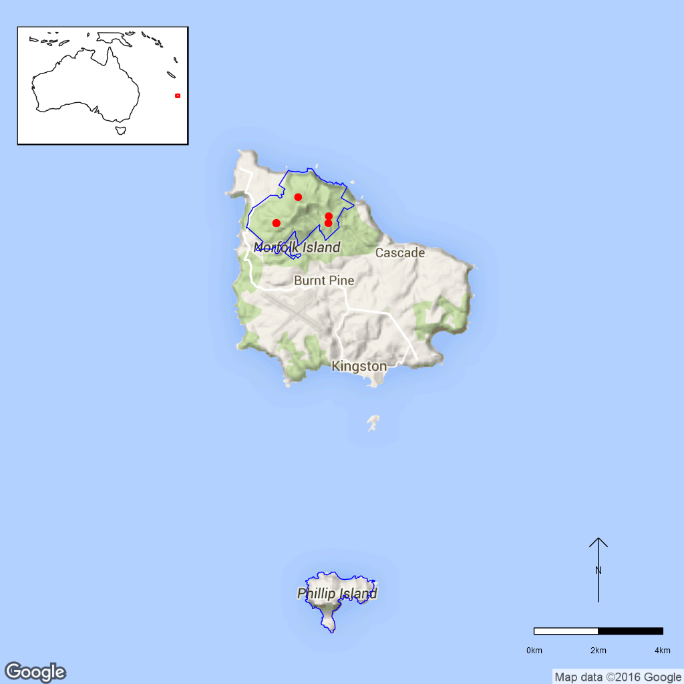
Figure 24.1 Distribution of Elatostema montanum in Norfolk Island National Park.
Red dots are specimen collections, blue line is the park boundary.

Ex-situ collections (Living and Seed bank)
The species is not conserved in the Living Collection at the Australian National Botanic Gardens or in the National Seed Bank (Z. Knapp pers. comm. 30 September 2015). No other ex-situ collections in any other Botanic Garden or Seed Bank have been located (ASBP 2016).

Biology
Pollinators: Wind-pollinated. In the family Urticaceae, stamens are inflexed in the bud and bend outwards suddenly and elastically when the flowers open, facilitating an explosive pollen release (Berg 1989).
Symbiotic relationships: Unknown.
Germination requirements: Unknown.
Dormancy class: Unknown.
Flowering: Unknown.
Breeding system: Elatostema montanum is monoecious but with male and female inflorescences (Flora of Australia 1994). The species rarely sets seed but can be propagated from cuttings (DNP 2010).
Dispersal: The achenes in Elatostema are ejected by the staminodes of the female flowers (Berg 1989).
Longevity: Possibly relatively short-lived.
Life form: Perennial herb.
Ploidy levels: Unknown.
Role of the plant in the environment: The species is confined to a few damp, shaded localities (Flora of Australia 1994). It is apparently very site specific and is restricted to very steep rocky bands and cliffs in shaded valley bottoms that do not dry out. The species is dependent on the erosion regime of the island. Streams might open up new sites, but could also wash population’s away (Sykes and Atkinson 1988, cited in DNP 2010).

Threats

Listed threats (EPBC Act)
- Grazing pressures and associated habitat changes.
- Climate change altering atmosphere/hydrosphere temperatures, rainfall patterns and/or frequency of severe weather events.
- Loss and/ or fragmentation of habitat and/ or subpopulations.
- Restricted geographical distribution.
- Competition and/ or habitat degradation by Ageratina riparia (Mist Flower) and Lantana camara (Lantana) and other weeds.
- Low numbers of individuals.

Genetic and demographic effects
The small population size at the time of listing and the very small extent of occurrence make the species vulnerable to stochastic disturbance events such as cyclones (TSSC 2003). The apparent reduction in population size since 2003 has probably led to a loss of genetic diversity in this species potentially increasing inbreeding and reducing reproductive output and/or seed quality. This may impact on this species ability to respond to changes in the environment.

Climate-related factors
Severe weather events such as storms or cyclones can damage or eradicate very small populations (TSSC 2003). The preferred habitat along drainage lines in steep terrain makes this species susceptible to flood damage (TSSC 2003).
Climate change is predicted to bring about an increasing frequency and intensity of droughts and cyclonic activity. Given the small population size, these events may directly and indirectly impact this species. Fire which does not currently occur in the national park, may become a threat. Invasive weeds and pests will be more likely to establish due to increased disturbance and less suitable conditions for local species. (DNP 2010, DNP 2011).

Invasive and other problematic species
Habitat competition by weeds, especially Lantana camara (Lantana) and Ageratina riparia (William Taylor) threaten E. montanum populations (TSSC 2003). Seed predation by black rats (Rattus rattus) is also a possible threat to E. montanum (Department of the Environment 2015).

Biophysical impacts
Between surveys undertaken in 1984 and the time of listing, some populations have apparently been destroyed by cattle grazing (TSSC 2003) but it is unclear if these sites were located within the national parks boundaries.

Current management
Weed management is conducted in the national park but there is no monitoring program for threatened species (J.Christian pers. comm. 4 August 2015). Weed control must be undertaken with care to maintain a shady habitat for E. montanum shady (DNP 2010).

Knowledge Gaps
Species biology and life history including symbiotic relationships, seed germination, seed dormancy, flowering, breeding system, genetic diversity, time to maturity and longevity of this species are unknown or poorly understood.

Suggested research and actions:
- Establish a monitoring program to provide baseline and ongoing data for determining population trajectories and the relative impacts of threatening processes.
- Determine key life history parameters including symbiotic relationships, flowering, breeding system, maturity and longevity to assist with species management.
- Secure genetically representative ex-situ seed collections, in multiple locations if appropriate, to mitigate against the loss of natural populations and provide for re-establishment should severe losses or extinction occur.
- Determine the appropriate conditions for long term storage and seed germination.
- Undertake a genetic assessment to determine the reproductive strategy and levels of genetic diversity to assist with any future translocation program.

References
Australian Seed Bank Partnership (2016). Search for records in the Australian Seed Bank [Online]. Council of Heads of Australian Botanic Gardens Inc. Elatostema montanum. Available from http://asbp.ala.org.au/search. Accessed 11 February 2016.
Berg CC (1989). Systematics and phylogeny of the Urticales. In Crane PR and Blackmore S (eds.). Evolution, Systematics, and Fossil History of the Hamamelidae. The Systematics Association Special Volume No. 40B. Clarendon Press, Oxford. pp. 193–220.
Council of Heads of Australasian Herbaria (CHAH) (2015). Australian Plant Census. [Online]. Available from http://biodiversity.org.au/nsl/services/apc. Accessed 16 September 2015.
Department of the Environment (DoE) (2015). Elatostema montanum in Species Profile and Threats Database, Department of the Environment, Canberra. Available from http://www.environment.gov.au/sprat. Accessed 16 September 2015.
Director of National Parks (DNP) (2010). Norfolk Island Region Threatened Species Recovery Plan. Department of the Environment, Water, Heritage and the Arts, Canberra. Available from http://www.environment.gov.au/resource/national-recovery-plan-norfolk-island. Accessed 15 September 2015.
Director of National Parks (DNP) (2011). Norfolk Island National Park and Botanic Garden Climate Change Strategy 2011-2016 [Online]. Department of Sustainability, Environment, Water, Population and Communities, Canberra, Australia. Available from http://www.environment‌.gov.au/resource/climate-change-strategy-2011-2016-norfolk-island-national-park-and-botanic-garden. Accessed 15 September 2015.
Flora of Australia (1994). Volume 49, Oceanic Islands 1. Australian Government Publishing Service, Canberra.
Sykes W and Atkinson I (1988). Rare and Endangered Plants of Norfolk Island. Unpublished report to the Australian National Parks and Wildlife Service, Norfolk Island.
Threatened Species Scientific Committee (TSSC) (2003). Commonwealth Listing Advice for Elatostema montanum – (Mountain Procris, a herb). Available from http://www.environment.gov.au/node/16372.
- Hibiscus insularis (Malvaceae) – Phillip Island Hibiscus, Norfolk Island National Park
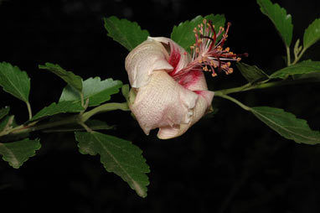
Figure B25.1 Hibiscus insularis in the Australian National Botanic Gardens.
©M. Fagg Australian National Botanic Gardens Photo no. dig.5897.
Hibiscus insularis is a shrub or small tree up to 2.5 m tall. The solitary flowers are pale yellow with a green tinge and a red throat that turn purple with age (DNP 2010). The leaves are highly variable in shape (Mills 2009).
Taxonomy: The name Hibiscus insularis Endl. is accepted in the Australian Plant Census (CHAH 2015, verified 24 July 2015).
Status: Critically Endangered under the EPBC Act (3 November 2003).
Recovery Plan: Norfolk Island Region Threatened Species Recovery Plan (DNP 2010)
Information in this fact sheet is taken from the SPRAT Listing Page (DoE 2015) unless otherwise referenced.

Number of populations inside and outside parks and reserves
One population located inside Norfolk Island National Park (Phillip Island section).

Population size – range
At the beginning of the 20th century, visitors to Phillip Island recorded a “few” plants in not very good condition (Maiden 1903, Laing 1914). In 1939 there were 13 known plants (Flora of Australia 1994) and in 1988 it was restricted to one site with a major and a minor patch on the northern slopes of the island (Sykes and Atkinson 1988). In 2003, the total number of mature individuals was estimated to be <50 (TSSC 2003) but by 2010 over 100 plants were known on Phillip Island (DNP 2010).

Geographical distribution
Localised and fragmented distribution.
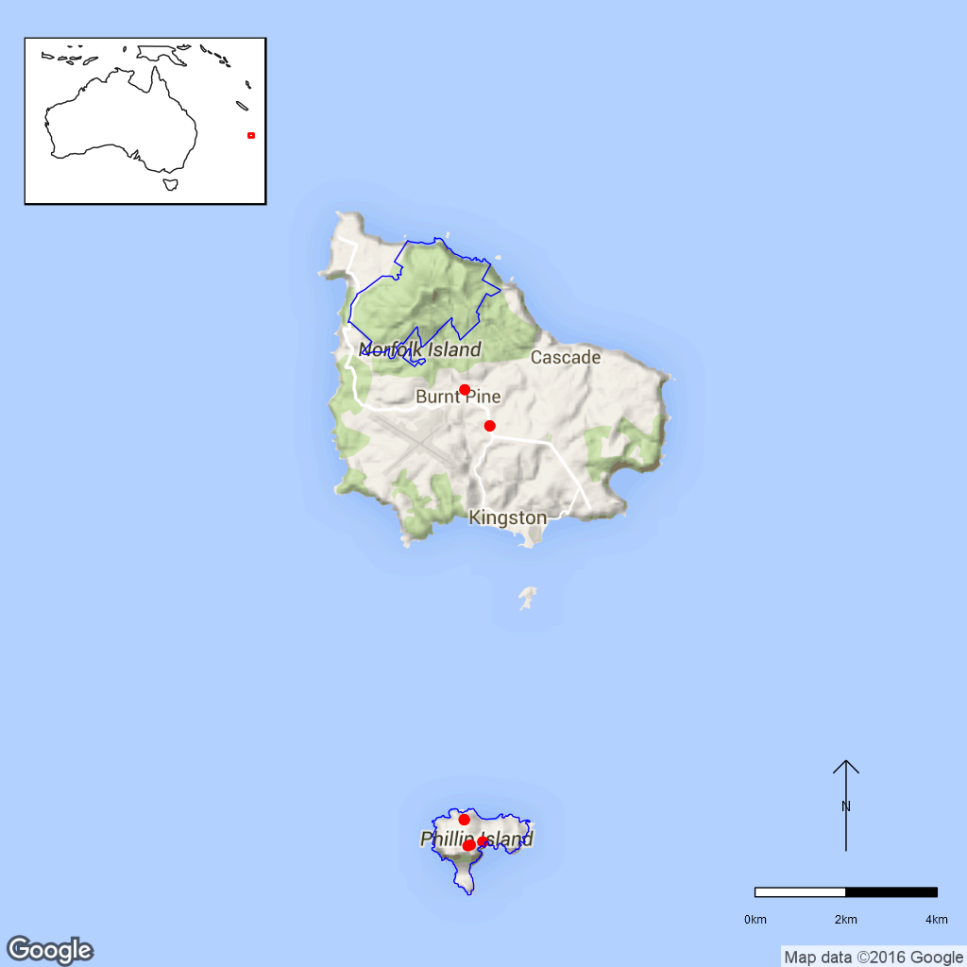
Figure B25.2 Distribution of Hibiscus insularis in Norfolk Island National Park.
Red dots are specimen collections, blue line is the park boundary. Specimens
located outside of the national park are cultivated not natural plants.

Ex-situ collections (Living and Seed Bank)
Four seed accessions (1394, 843, 48 and 142 seed) are held by the National Seed Bank (T. North pers. comm. 11 September 2015). Two of these collections are from known wild source locations. Additionally, ten H. insularis plants sourced from the wild are growing in the Living Collection of the Australian National Botanic Gardens (Z. Knapp pers. comm. 30 September 2015). The species is cultivated in the Norfolk Island Botanic Gardens and other botanic gardens in Australia and is also commonly planted in home gardens on Norfolk Island (Mills, 2009).

Biology
Pollinators: Nectar-feeding birds are thought to be the main pollinators, however, no nectar-feeding birds currently occur on Phillip Island. Possible pollinators in the past may have been two Silvereye species (Zosterops albogularis and Z. tenuirostris) that occur on Norfolk Island and may have also existed on Phillip Island. Another possible pollinator could have been the Norfolk Island Kaka (Nestor productus), a large parrot that became extinct around 1800 and is reported to have fed on “hibiscus” flowers (Groeneveld 1989). The Lord Howe Island Gecko (Christinus guentheri) has been observed feeding on H. insularis nectar but it is unclear if this species is a significant pollinator (Groeneveld 1989, DNP 2010).
Symbiotic relationships: Unknown.
Germination requirements: Unknown.
Dormancy class: Probably orthodox.
Flowering: Long flowering season.
Breeding system: Self-compatible. Hibiscus insularis has bisexual flowers but the female and the male stage of the flower are separated by one day with the flower being in a female phase first. When the male stage if fertile, self-pollination is possible (Groeneveld 1989).
Dispersal: The capsules stay on mother plants and degrade over time to release the seed which probably fall to the ground as there are no specialised dispersal mechanisms apparent. The species also reproduces vegetatively in the wild by rooting of branches that touch the ground. It can also be propagated by stem-layering (Groeneveld 1989).
Longevity: Individuals are mature after approximately 18 years when grown from seed but less when vegetatively propagated (DNP 2010).
Life form: Perennial shrub or small tree up to 2.5 m (DNP 2010).
Ploidy levels: Unknown.
Role of the plant in the environment: The larvae of two moth species (Pectinophora scutigera and Anisoplaca cosmia) destroy the seed and may be reducing reproductive success. Observations also revealed two wasp species, possibly parasites of the moth larvae occur on this species while invasive ants (Plagiolepis alluaudi) are frequently found nesting in seed capsules but probably do not have a significant detrimental effect on seed number (Groeneveld 1989).

Threats

Listed Threats (EPBC Act)
- Drought.
- Restricted geographical distribution.
- Competition and/ or habitat degradation by Olea europaea subsp. cuspidata (African Wild Olive).
- Low genetic diversity and genetic inbreeding.
- Low numbers of individuals.

Genetic and demographic effects
The species has a very restricted distribution and a low number of individuals, making it more susceptible to stochastic loss. The current population is probably derived from only two individuals (DNP 2010) and is therefore highly likely to have very low genetic diversity (Groeneveld 1989).

Invasive and other problematic species
Invasive weeds, especially Olea europaea subsp. cuspidata (African Wild Olive) compete with Hibiscus insularis. Future introductions of weeds, competitors or pathogens are a potential problem to the flora in general (DNP 2008).

Other Threats/Potential New threats

Climate-related factors
Hibiscus insularis is affected by drought which often occurs during El Niño events. The lack of vegetation and severe erosion on Phillip Island make this island more vulnerable to the effects of heavy rains.
Climate change is predicted to bring about an increasing frequency and intensity of droughts and cyclonic activity. Given the small population size, these events may directly and indirectly impact this species. Fire which does not currently occur in the national park, may become a threat. Invasive weeds and pests will be more likely to establish due to increased disturbance and less suitable conditions for local species. (DNP 2010, DNP 2011).

Current management
Weed management is conducted in the national park but there is no monitoring program for threatened species (J.Christian pers. comm. 4 August 2015).

Knowledge Gaps
Species biology and life history including pollination syndrome, symbiotic relationships, seed germination, seed dormancy, flowering, genetic diversity, seed dispersal and longevity of this species are unknown or poorly understood.

Suggested research and actions
- Establish a monitoring program to provide baseline and ongoing data for determining population trajectories and the relative impacts of threatening processes
- Determine how critical this species is for the life cycle of the two moth species.
- Evaluate whether pollinators should/can be reintroduced to Phillip Island.
- A genetic assessment of ex-situ holdings and nursery cultivars may uncover additional genetic diversity that could be re-introduced to Norfolk Island.

References
Australian Seed Bank Partnership (2016). Search for records in the Australian Seed Bank [Online]. Council of Heads of Australian Botanic Gardens Inc. Hibiscus insularis. Available from http://asbp.ala.org.au/search. Accessed 11 February 2016.
Council of Heads of Australasian Herbaria (CHAH) (2015). Australian Plant Census. [Online]. Available from http://biodiversity.org.au/nsl/services/apc. Accessed 24 July 2015.
Department of the Environment (DoE) (2015). Hibiscus insularis in Species Profile and Threats Database, Department of the Environment, Canberra. Available from http://www.environment.gov.au/sprat. Accessed 13 December 2015
Director of National Parks (DNP) (2008) Norfolk Island National Park and Norfolk Island Botanic Garden Management Plan 2008–2018. Available from http://www.environment.gov.au/resource/management-plan-2008-18-norfolk-island-national-park-and-norfolk-island-botanic-garden. Accessed 13 December 2015.
Director of National Parks (DNP) (2010). Norfolk Island Region Threatened Species Recovery Plan. Department of the Environment, Water, Heritage and the Arts, Canberra. Available from http://www.environment.gov.au/resource/national-recovery-plan-norfolk-island. Accessed 13 December 2015.
Director of National Parks (DNP) (2011). Norfolk Island National Park and Botanic Garden Climate Change Strategy 2011-2016 [Online]. Department of Sustainability, Environment, Water, Population and Communities, Canberra, Australia. Available from http://www.environment.gov.au‌/resource/climate-change-strategy-2011-2016-norfolk-island-national-park-and-botanic-garden. Accessed 13 December 2015.
Flora of Australia (1994). Volume 49, Oceanic Islands 1. Australian Government Publishing Service, Canberra.
Groeneveld KM (1989). Conservation biology of the endangered species Hibiscus insularis. Unpublished Report to the Australian National Parks and Wildlife Service.
Hyder Consulting (2008). The Impacts and Management Implications of Climate Change for the Australian Government’s Protected Areas. A report to the Department of the Environment, Water, Heritage and the Arts and the Department of Climate Change. Commonwealth of Australia, Canberra.
Laing RM (1914). A revised list of the Norfolk Island Flora, with some notes on the species. Transactions of the New Zealand Institute 47: 1–39.
Maiden JH (1903). The Flora of Norfolk Island, Part I. Proceedings of the Linnean Society of New South Wales 28: 692–785.
Mills K (2009). The Vegetation of Phillip Island, Norfolk Island Group. Available from http://www.econorfolk.nf/pdf/Kevin%20Mills%20Report%20‌Body.pdf. Accessed 13 December 2015.
Sykes W and Atkinson I (1988). Rare and Endangered Plants of Norfolk Island. Unpublished report to the Australian National Parks and Wildlife Service, Norfolk Island.
Threatened Species Scientific Committee (TSSC) (2003). Commonwealth Listing Advice for Norfolk Island Flora – 11 Critically Endangered Species. [Online]. Available from http://www.environment.gov.au/biodiversity/threatened/species/norfolk-island-flora-critically.html. Accessed 13 December 2015.
- Ileostylus micranthus (Loranthaceae) – Mistletoe, Norfolk Island National Park
Ileostylus micranthus is a bushy epiphyte with green flowers and yellow fruits (DNP 2010).
Taxonomy: The name Ileostylus micranthus (Hook.f.) Tiegh. is accepted according to the Australian Plant Census (CHAH 2015, verified 5 August 2015).
  - Synonym: Loranthus micranthus Hook.f.
Status: Listed as Vulnerable under the EPBC Act on 3 November 2003.
Recovery Plan: Norfolk Island Region Threatened Species Recovery Plan (DNP 2010).
Information in this fact sheet is taken from the SPRAT Listing Page (DoE 2015) unless otherwise referenced.

Number of populations inside and outside parks and reserves
All known locations on Norfolk Island are inside the national park boundaries (DNP 2010). In New Zealand, the plant is more common and not threatened.

Population size – range
At the time of listing, there were less than 500 mature plants on Norfolk Island (TSSC 2003).

Geographical distribution
Ileostylus micranthus occurs on Norfolk Island and in New Zealand. It is thought to have arrived on Norfolk Island during the 1930s, since it was not known from the island before. On Norfolk Island, it is found above 200 m on the upper slopes of Mt Pitt and along the track leading to Red Road on Mt Bates (DNP 2010). The species has a localised distribution on Norfolk Island and is widespread in New Zealand.
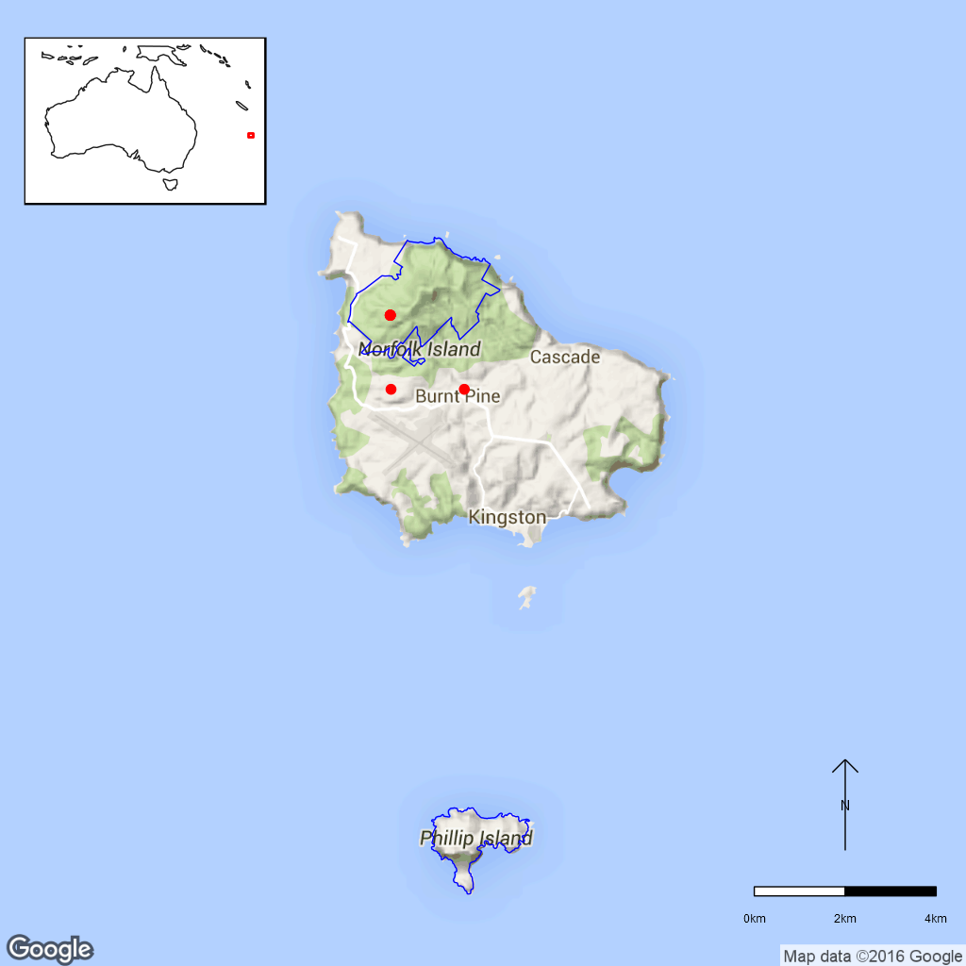
Figure B26. Distribution of Ileostylus micranthus in Norfolk Island National Park.
Red dots are specimen collections, the blue line is the park boundary.

Ex-situ collections (Living and Seed Bank)
The species is not conserved in the Living Collection at the Australian National Botanic Gardens or in the National Seed Bank (Z. Knapp pers. comm. 30 September 2015). No other ex-situ collections in any other Botanic Garden or Seed Bank have been located (ASBP 2016).

Biology
Pollinators: Insect-pollinated (Ladley 1997).
Symbiotic relationships: Unknown.
Germination requirements: Usually, the fruit is ingested by birds and the skin is removed as it passes through the gut. If a seed is defecated on a branch, it can germinate (Ladley 1997). Propagation is difficult and it is best to use fresh fruit. The seed should be squeezed out gently, preferably on the same host plant the seed has been collected from. While most seed germinate, not all seedlings manage to attach to a host plant (de Lange 2011).
Dormancy class: Recalcitrant.
Flowering: In New Zealand, the species flowers from September-December (de Lange 2011).
Breeding system: In New Zealand, male, female and hermaphroditic plants have been reported (de Lange 2011) with hermaphroditic plants often being self-compatible (Ladley et al. 1997).
Dispersal: The fruit is a one-seeded berry produced between December-July in New Zealand (de Lange 2011). The berries are eaten by birds and thus dispersed. In New Zealand, bellbirds (Anthornis melanura) feed on fruits of I. micranthus and seem to have a high preference for this species (MacFarlane 2012). Silvereyes (Zosterops lateralis), tui (Prosthemadera novaeseelandiae), and a gecko have also been recorded eating the fruit (Dopson 1997). Silvereyes occur on Norfolk Island.
Longevity: A study to investigate non-destructive age indices in mistletoes sampled plants that were up to 16–17 years old (Norton et al. 1997).
Life form: Perennial bushy epiphyte.
Ploidy levels: 2n=22 (de Lange 2011), diploid.
Role of the plant in the environment: This species has a wide range of host plants, but favours Coprosma pilosa (Mountain Coprosma, Rubiaceae) as its host, a species listed as Endangered under the EPBC Act. Heavy infestations with I. micranthus can kill the Coprosma hosts (DNP 2010). In New Zealand, there are a number of moth species (native moths from the families Geometridae and Yponomeutidae and some generalist moths (e.g. Liothula omnivora) that use mistletoes as host species (Patrick and Dugdale 1997).

Threats

Listed Threats (EPBC Act)
- Climate change and severe weather i.e. causing storm damage or habitat modification, destruction and alteration due to changes in land use patterns.
- Low numbers of individuals.

Genetic and demographic effects
The small distribution area and low numbers of individuals suggest that this species has low genetic diversity and may be vulnerable to inbreeding. A small population size and limited geographical distribution also makes these species vulnerable to further loss through stochastic events such as cyclones.

Climate-related factors
Ileostylus micranthus is susceptible to storm damage and other irregular disturbance events (DNP 2010). Climate change is predicted to bring about an increasing frequency and intensity of droughts and cyclonic activity. Given the small population size, these events may directly and indirectly impact this species. Fire which does not currently occur in the national park, may become a threat. Invasive weeds and pests will be more likely to establish due to increased disturbance and less suitable conditions for local species. (DNP 2010, DNP 2011).

Other Threats/Potential New threats

Biophysical impacts
A decline in the general health of the forest due to diverse threats would also threaten I. micranthus (DNP 2010).

Current Management
There is no monitoring program for threatened species (J.Christian pers. comm. 4 August 2015).

Knowledge Gaps
Species biology and life history including pollination syndrome, symbiotic relationships, seed germination, seed dormancy, flowering, breeding system, genetic diversity, time to maturity and longevity of this species are unknown or poorly understood.
It is unclear whether this species occurs naturally on Norfolk Island and it could be a recent introduction (in accordance with the hypothesis that it was introduced during the 1930’s, DNP 2010, Mills 2010). However, given the species biology it is unclear how this species could have arrived on Norfolk Island, found a suitable host and established a new population; the successful plants would also have to be hermaphrodites or both male and female plants to successfully reproduce. If this is a recent migrant to Norfolk Island EPBC listing may not be appropriate. This would also enable national park staff to remove I. micranthus from heavily infested plants of the Critically Endangered Coprosma pilosa.

Suggested research and actions
- Establish a monitoring program to provide baseline and ongoing data for determining population trajectories and the relative impacts of threatening processes.
- A genetic assessment of Norfolk Island and New Zealand populations may shed light on whether this is a recent migrant to Norfolk Island.
- Determine if the moths utilising this species in New Zealand also occurs on Norfolk Island.
- Evaluate the role this species is playing as a food source for island birds.

References
Australian Seed Bank Partnership (2016). Search for records in the Australian Seed Bank [Online]. Council of Heads of Australian Botanic Gardens Inc. Ileostylus micranthus. Available from http://asbp.ala.org.au/search. Accessed 11 February 2016.
Council of Heads of Australasian Herbaria (CHAH) (2015). Australian Plant Census. [Online]. Available from http://biodiversity.org.au/nsl/services/apc. Accessed 5 August 2015.
de Lange PJ (2011). Ileostylus micranthus. Website of the New Zealand Plant Conservation Network, last updated on 30 May 2015. Available from http://www.nzpcn.org.nz/flora_details.aspx?ID=858. Accessed 5 August 2015.
Department of the Environment (DoE) (2015). Ileostylus micranthus in Species Profile and Threats Database, Department of the Environment, Canberra. Available from http://www.environment.gov.au/sprat. Accessed 13 July 2015.
Director of National Parks (DNP) (2010). Norfolk Island Region Threatened Species Recovery Plan. Department of the Environment, Water, Heritage and the Arts, Canberra. Available from http://www.environment.gov.au/resource/national-recovery-plan-norfolk-island. Accessed 13 July 2015.
Director of National Parks (DNP) (2011). Norfolk Island National Park and Botanic Garden Climate Change Strategy 2011-2016 [Online]. Department of Sustainability, Environment, Water, Population and Communities, Canberra, Australia. Available from http://www.environment.gov.au‌/resource/climate-change-strategy-2011-2016-norfolk-island-national-park-and-botanic-garden. Accessed 13 July 2015.
Dopson S (1997). Some aspects of reproduction and possum control of five loranthaceous mistletoes in the Central North Island and comparisons with South Island studies. In de Lange PJ and Norton DA (eds.) New Zealand’s loranthaceous mistletoes. Proceedings of a workshop hosted by Threatened Species Unit, Department of Conservation, Cass, 17 – 20 July 1995. Department of Conservation, Wellington, New Zealand. pp. 115–124.
Ladley JJ (1997). Reproductive ecology of the loranthaceous mistletoes of New Zealand. In de Lange PJ and Norton DA (eds.) New Zealand’s loranthaceous mistletoes. Proceedings of a workshop hosted by Threatened Species Unit, Department of Conservation, Cass, 17 – 20 July 1995. Department of Conservation, Wellington, New Zealand. pp. 110–114.
Ladley JJ, Kelly D, Robertson AW (1997). Explosive flowering, nectar production, breeding systems, and pollinators of New Zealand mistletoes (Loranthaceae). New Zealand Journal of Botany 35: 345–360.
MacFarlane A (2012). Frugivorous mutualisms in a native New Zealand forest: the good the bad and the ugly. Master’s thesis, University of Canterbury, Biological Sciences.
Mills K (2010). Defining indigenous plants: some problematic species from Norfolk Island. Cunninghamia 11: 407–412.
Norton DA, Ladley JJ, Sparrow AD (1997). Development of non-destructive age indices for three New Zealand loranthaceous mistletoes. New Zealand Journal of Botany 35: 337–343.
Patrick BH and Dugdale JS (1997). Mistletoe moths. In de Lange PJ and Norton DA (eds.) New Zealand’s loranthaceous mistletoes. Proceedings of a workshop hosted by Threatened Species Unit, Department of Conservation, Cass, 17 – 20 July 1995. Department of Conservation, Wellington, New Zealand. pp. 125–132.
Threatened Species Scientific Committee (TSSC) (2003). Commonwealth Listing Advice for Norfolk Island Flora – 15 Vulnerable Species.
- Melicytus latifolius (Violaceae) – Norfolk Island Mahoe, Norfolk Island National Park
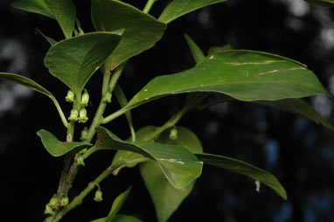
Figure B27.1 Melicytus latifolius in the Australian National Botanic Gardens.
©M. Fagg Australian National Botanic Gardens Photo No. dig.992.
Melicytus latifolius is a small tree that usually grows up to 4 m high but can sometimes reach 9 m (DNP 2010).
Taxonomy: The name Melicytus latifolius (Engl.) P.S.Green is accepted in the Australian Plant Census (CHAH 2015, verified 3 August 2015).
Status: Critically Endangered under the EPBC Act on 3 November 2003.
Recovery Plan: Norfolk Island Region Threatened Species Recovery Plan (DNP 2010).
Information in this fact sheet is taken from the SPRAT Listing Page (DoE 2015) unless otherwise referenced.

Number of populations inside and outside parks and reserves
Melicytus latifolius occurs inside the Mt Pitt section of the National Park but is also found in several areas outside of the national park (Anson Bay-Duncombe Bay, Mission Road North and Steels Point). These areas are protected to varying degrees (DNP 2010).

Population size – range
In 2003, the number of mature plants was 17 (TSSC 2003) and the species was thought to be rare prior to that report (DNP 2010, and references therein).

Geographical distribution
Melicytus latifolius has a localised distribution and is endemic to Norfolk Island.
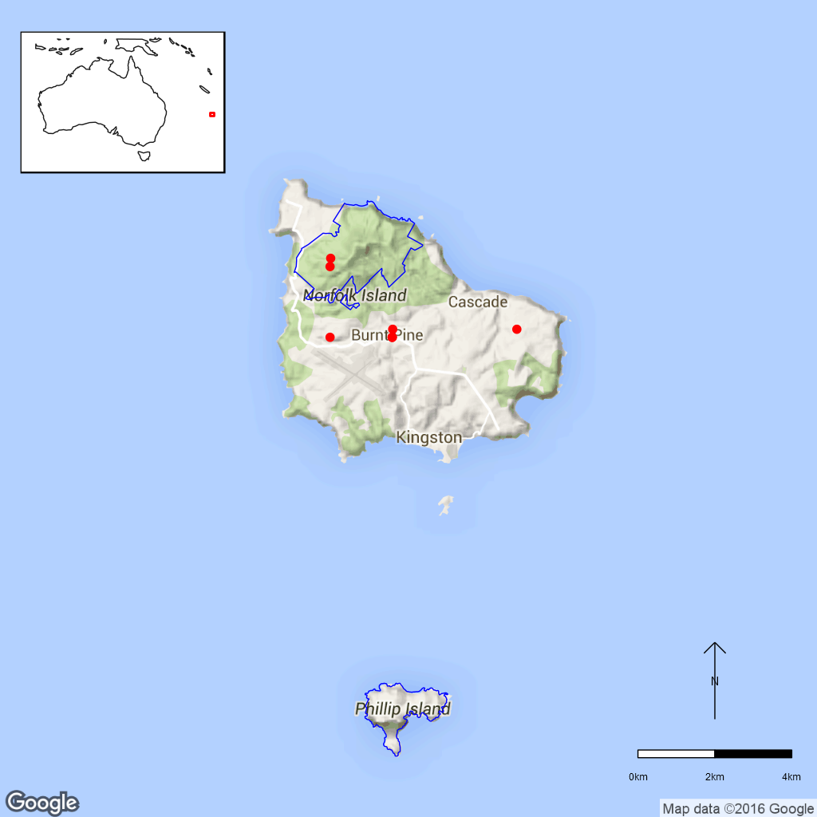
Figure B27.2 Distribution of Melicytus latifolius in Norfolk Island National Park.
Red dots are specimen collections, blue line is the park boundary.

Ex-situ collections (Living and Seed Bank)
Seed of M. latifolius is stored on Norfolk Island (L. Guja pers. comm. 10 September 2015) and staff from the ANBG plan to collect this species in February 2016 (T. North pers. comm. 11 September 2015). Eighteen Melicytus latifolius plants sourced directly from known wild locations are held in the Living Collection at the ANBG (Z. Knapp pers. comm. 30 September 2015). No other ex-situ collections in any other Botanic Garden or Seed Bank have been located (ASBP 2016).

Biology
Pollinators: Insect-pollinated. Melicytus crassifolius, a New Zealand plant with similarly shaped flowers, is visited mostly by flies (Heine 1937).
Symbiotic relationships: Unknown.
Germination requirements: Unknown.
Dormancy class: Orthodox in M. ramiflorus (Herron and Clemens 2001). Melicytus dentatus seed are also orthodox and have physiological dormancy (saseedbank.com.au).
Flowering: Unknown.
Breeding system: Dioecious, therefore self-pollination is not possible.
Dispersal: Unknown. The fruit is a berry, and seed of some Melicytus species have elaiosomes (Feng 2005) and may be dispersed by ants.
Longevity: Unknown.
Life form: Tree, up to 4 m, but can reach 9 m.
Ploidy levels: 2n=32. Most other Melicytus species have recorded chromosome numbers of 2n=32. The basic chromosome number in neighbouring genera is x=8, so M. latifolius could be regarded as tetraploid (Mitchell et al. 2009).
Role of the plant in the environment: Melicytus latifolius grows in moist shaded valleys and on broad ridges. It can tolerate dense shade, but is sometimes found at the edges of canopy gaps (Sykes and Atkinson 1988).

Threats

Listed Threats (EPBC Act)
- Drought.
- Competition and/ or habitat degradation by Solanum mauritianum (Wild Tobacco), Psidium cattleianum (Cherry Guava) and other weeds.
- Low fecundity, reproductive rate and/or poor recruitment.
- Low numbers of individuals.

Genetic and demographic effects
Melicytus latifolius has very low numbers of individuals and consequently also a very small area of occupancy, which makes the species vulnerable to stochastic events. The species flowers and sets seed only rarely, leading to poor recruitment (DNP 2010). Low seed set may reflect low mate availability and high inbreeding impacting on seed production.

Invasive and other problematic species
A major threat to M. latifolius is competition from weeds, especially Solanum mauritianum (Wild Tobacco) and Psidium cattleianum (Cherry Guava, DNP 2010). Seed/fruit predation occurs in Melicytus ramiflorus (L. Guja pers. comm. 10 September 2015) and may also be a threat.

Other Threats/Potential new threats

Climate-related factors
The species does not flower and reproduce well during drought (DNP 2010). Climate change is predicted to bring about an increasing frequency and intensity of droughts and cyclonic activity. Given the small population size, these events may directly and indirectly impact this species. Fire which does not currently occur in the national park, may become a threat. Invasive weeds and pests will be more likely to establish due to increased disturbance and less suitable conditions for local species. (DNP 2010, DNP 2011).

Current management
Weed management is conducted in the national park but there is no monitoring program for threatened species (J.Christian pers. comm. 4 August 2015).

Knowledge Gaps
Species biology and life history including pollination syndrome, symbiotic relationships, seed germination, seed dormancy, flowering, breeding system, genetic diversity, seed dispersal, time to maturity and longevity of this species are unknown or poorly understood.

Suggested research and actions
- Establish a monitoring program to provide baseline and ongoing data for determining population trajectories and the relative impacts of threatening processes.
- Determine the appropriate conditions for long term storage and seed germination.
- Develop and implement a restoration program to increase population numbers and/or sizes.
- Undertake a genetic assessment to determine the reproductive strategy, levels of genetic diversity and inbreeding to assist with any future translocation program.
- Determine whether pollinators and dispersers of this species still exist.
- Evaluate the need to establish ‘insurance’ populations off-park.
- Explore whether a soil seed bank exists if ants are found to be dispersing seed and assess whether opportunities exist to stimulate this to encourage germination.

References
Australian Seed Bank Partnership (2016). Search for records in the Australian Seed Bank [Online]. Council of Heads of Australian Botanic Gardens Inc. Melicytus latifolius. Available from http://asbp.ala.org.au/search. Accessed 11 February 2016.
Council of Heads of Australasian Herbaria (CHAH) (2015). Australian Plant Census. [Online]. Available from http://biodiversity.org.au/nsl/services/apc. Accessed 3 August 2015.
Department of the Environment (DoE) (2015). Melicytus latifolius in Species Profile and Threats Database, Department of the Environment, Canberra. Available from http://www.environment.gov.au/sprat. Accessed 19 October 2015.
Director of National Parks (DNP) (2010). Norfolk Island Region Threatened Species Recovery Plan. Department of the Environment, Water, Heritage and the Arts, Canberra. Available from http://www.environment.gov.au/resource/national-recovery-plan-norfolk-island. Accessed 19 October 2015.
Director of National Parks (DNP) (2011). Norfolk Island National Park and Botanic Garden Climate Change Strategy 2011-2016 [Online]. Department of Sustainability, Environment, Water, Population and Communities, Canberra, Australia. Available from http://www.environment.gov.au‌/resource/climate-change-strategy-2011-2016-norfolk-island-national-park-and-botanic-garden. Accessed 19 October 2015.
Feng M (2005). Floral morphogenesis and molecular systematic of the family Violaceae. Dissertation, Ohio University.
Heine EM (1937). Observations on the pollination of New Zealand flowering plants. Transactions and Proceedings of the Royal Society of New Zealand 67: 133–148.
Herron H and Clemens J (2001). Seed dormancy and germination in Melicytus ramiflorus (Violaceae). New Zealand Journal of Botany 39: 245–249.
Hyder Consulting (2008). The Impacts and Management Implications of Climate Change for the Australian Government’s Protected Areas. A report to the Department of the Environment, Water, Heritage and the Arts and the Department of Climate Change. Commonwealth of Australia, Canberra.
Mitchell AD, Heenan PB, Murray BG, Molloy BPJ, de Lange PJ (2009). Evolution of the south-western Pacific genus Melicytus (Violaceae): evidence from DNA sequence data, cytology and sex expression. Australian Systematic Botany 22: 143–157.
Sykes W and Atkinson I (1988). Rare and Endangered Plants of Norfolk Island. Unpublished report to the Australian National Parks and Wildlife Service, Norfolk Island.
Threatened Species Scientific Committee (TSSC) (2003). Commonwealth Listing Advice for Norfolk Island Flora – 11 Critically Endangered Species. [Online]. Available from http://www.environment.gov.au/biodiversity/threatened/species/norfolk-island-flora-critically.html. Accessed 19 October 2015.
- Myoporum obscurum (Scrophulariaceae) – Popwood, Sandalwood, Norfolk Island National Park
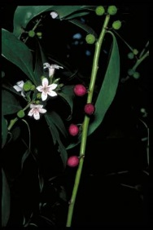
Figure B28.1 Myoporum obscurum in the Norfolk Island Botanic Gardens.
©M. Fagg Australian National Botanic Gardens Photo No. ni.109.
This species often grows as a shrub or small spreading tree to 7 m tall. The leaves are smooth, shiny green with a black tip and often black margins. It has prolific, scented white flowers which are followed by pea-sized purple berries (DNP 2010, DNP Brochure).
Taxonomy: Conventionally accepted as Myoporum obscurum Endl. (CHAH 2015, verified 22 July 2015).
Family is given as Myoporaceae on EPBC listing page, however on APC site it is given as Scrophulariaceae
Status: Listed as Critically Endangered under the EPBC Act on 3 November 2003.
Recovery Plan: Norfolk Island Region Threatened Species Recovery Plan 2010
Information in this fact sheet is taken from the SPRAT Listing Page (DoE 2015) unless otherwise referenced.

Number of populations inside and outside parks and reserves
The entire natural population is now to be found in the Mt Pitt section of the national park where only five mature seed-producing trees were found in 1995 and which had increased to seven in 2003 at the time of EPBC listing. A planting program began in 1995 and the species has been planted throughout the national park (DNP 2010) as well as outside (Coyne 2011).

Population size – range
This species currently only occurs on Norfolk Island but in the 1830’s Cunningham recorded this species on Phillip Island as well (Coyne 2011). Only seven mature wild trees were recorded on Norfolk Island in 2003 (TSSC 2003) but it has subsequently been planted across Norfolk Island (DNP 2010, Coyne 2011).

Geographical distribution
Localised.
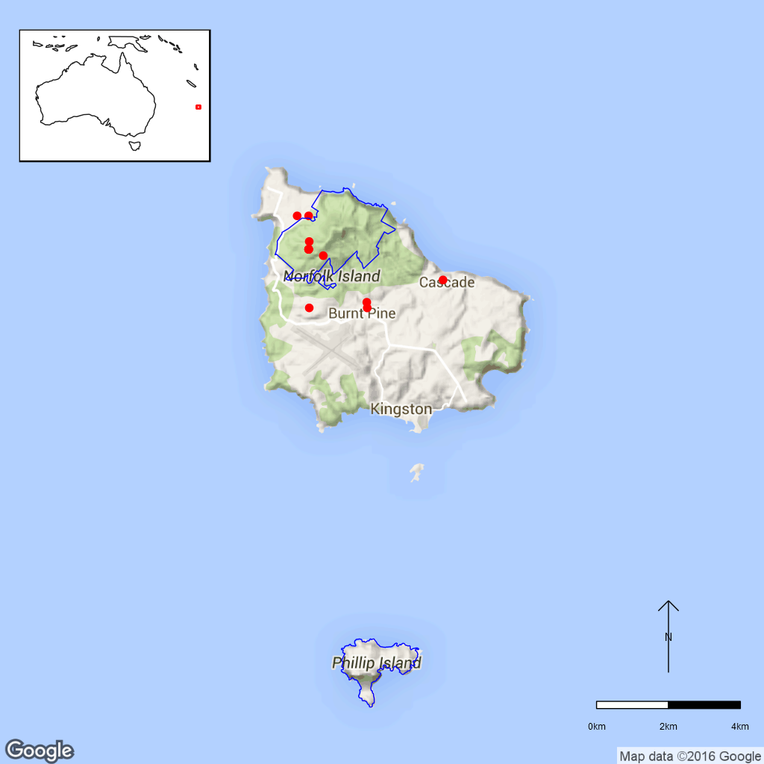
Figure B28.2 Distribution of Myoporum obscurum in Norfolk Island National Park.
Red dots are specimen collections, blue line is the park boundary.

Ex-situ collections (Living and Seed Bank)
The species is not conserved in the Living Collection at the Australian National Botanic Gardens or in the National Seed Bank but there are plans to collect seed in February 2016 (Zoe Knapp pers. comm. 12 October 2015 and Tom North pers. comm. 11 September 2015). No other ex-situ collections in any other Botanic Garden or Seed Bank have been located (ASBP 2016).

Biology
Pollinators: Flowers of the related M. laetum were observed to be visited by flies and moths as well as bees, beetles and thrips (Heine 1937).
Symbiotic relationships: Unknown.
Germination requirements: Cassandra Jones (pers. comm. 6 November 2015) advises that it has never been propagated by cuttings but they have had success with seed and no pre-treatment was required.
Dormancy class: Unknown.
Flowering: Flowers in summer. Mills (2007) observed flowers on M. obscurum in September, December, January, March, April and June. Fruit were observed in September, December, January, March and April (Mills 2007).
Breeding system: Unknown.
Dispersal: Unknown.
Longevity: Unknown.
Life form: Shrub or small spreading tree to 7 m.
Ploidy levels: Unknown.
Role of the plant in the environment: This species is intolerant of much shade and away from the coast grows on forest margins and in clearings or canopy gaps or open areas (Sykes and Atkinson 1988 in DNP 2010).

Threats

Listed Threats (EPBC Act)
- Competition and/or habitat degradation by weeds.
- Low numbers of individuals.
- Reduction of genetic integrity due to hybridisation*.
*The inclusion of the listed threat, reduction of genetic integrity due to hybridisation, is questioned in the Norfolk Island Species Recovery Plan (DNP 2010) since M. insulare is the species cited as being most likely to hybridise with M. obscuru and it is considered to be unlikely to occur on the Norfolk Island Group.

Invasive and other problematic species
Weed competition is a major threat. The small population size makes this species vulnerable to stochastic events (DNP 2010). Inbreeding may also be an issues given the extremely low number of plants in the natural population. Propagated trees are also likely to have a very low genetic base and also suffer from inbreeding effects.

Other Threats/Potential New threats
Climate related factors
Climate change is predicted to bring about an increasing frequency and intensity of droughts and cyclonic activity. Given the small population size, these events may directly and indirectly impact this species. Fire which does not currently occur in the national park, may become a threat. Invasive weeds and pests will be more likely to establish due to increased disturbance and less suitable conditions for local species. (DNP 2010, DNP 2011).

Current management
Weed management is conducted in the national park but there is no monitoring program for threatened species (J.Christian pers. comm. 4 August 2015).

Knowledge Gaps
Species biology and life history including pollination syndrome, symbiotic relationships, seed germination, seed dormancy, breeding system, seed dispersal, genetic diversity, seed dispersal, time to maturity and longevity of this species are unknown or poorly understood.

Suggested research and actions
- Regular systematic census for all plants (DNP 2010).
- Determine the appropriate conditions for long term storage and seed germination.
- Determine whether pollinators and dispersers still occur on the island.
- Develop and implement a restoration program to increase population numbers and/or sizes.
- Evaluate the need to establish ‘insurance’ populations on Phillip Island and off-Island.

References:
Atlas of Living Australia (ALA) (2015). Myoporum obscurum. Herbarium specimen records [Online]. Available from http://www.ala.org.au/. Accessed 7 September 2015.
Australian Seed Bank Partnership (2016). Search for records in the Australian Seed Bank [Online]. Council of Heads of Australian Botanic Gardens Inc. Myoporum obscurum. Available from http://asbp.ala.org.au/search. Accessed 11 February 2016.
Council of Heads of Australian Herbaria (CHAH) (2015). Australian Plant Census. [Online]. Available from http://biodiversity.org.au/nsl/services/apc. Accessed 27 October 2015.
Coyne P (2011). Norfolk Island’s Fascinating Flora. Petaurus Press, Canberra.
Department of the Environment (DoE) (2015). Myoporum obscurum in Species Profile and Threats Database, Department of the Environment, Canberra. Available from http://www.environment.gov.au/sprat. Accessed 27 October 2015.
Director of National Parks (DNP) (2010). Norfolk Island Region Threatened Species Recovery Plan. Department of the Environment, Water, Heritage and the Arts, Canberra.
Director of National Parks (DNP) (2011). Norfolk Island National Park and Botanic Garden Climate Change Strategy 2011-2016 [Online]. Department of Sustainability, Environment, Water, Population and Communities, Canberra, Australia. Available from http://www.environment.gov.au‌/resource/climate-change-strategy-2011-2016-norfolk-island-national-park-and-botanic-garden. Accessed 27 October 2015.
Director of National Parks (DNP Brochure). Plant Guide - Plants of Norfolk Island National Park and Botanic Garden. Department of the Environment, Water, Heritage and the Arts, Canberra. Available from https://www.environment.gov.au/resource/plant-guide. Accessed 27 October 2015.
Heine EM (1937). Observations on the pollination of New Zealand flowering plants. Transactions and Proceedings of the Royal Society of New Zealand 67: 133–148.
Mills K (2007). The Flora of Norfolk Island. 1. The Indigenous Flora. Appendix 2 - Flowering and Fruiting Months – Indigenous Flora of Norfolk Island, updated January 2015. The Author, Jamberoo, New South Wales, June.
Threatened Species Scientific Committee (TSSC) (2003). Listing Advice - 11 Critically Endangered Norfolk Island Flora Species. http://www.‌environment.gov.au/node/16449 Accessed 29 June 2015.
- Plexaure limenophylax (Orchidaceae) – Norfolk Island National Park
A small, tufted, epiphytic orchid growing to 3–6 cm high with 2–3 cm a long inflorescences of many tiny greenish–white flowers, growing on the branches of trees (DNP 2010).
Taxonomy: Listed as Plexaure limenophylax Endl. on APNI (not listed on the APC website), accessed APC and APNI 20 June 2015
- Synonym: Phreatia limenophylax
Status: Critically Endangered under the EPBC Act (3 November 2003) as Phreatia limenophylax
Recovery Plan: Norfolk Island Threatened Species Recovery Plan 2010 (as Phreatia limenophylax). There is a draft National Recovery Plan being prepared for this species.
Information in this fact sheet is taken from the SPRAT Listing Page (DoE 2015) unless otherwise referenced.

Number of populations inside and outside parks and reserves
In 2003 there were five mature plants surviving in the wild, all occurring within in the Norfolk Island National Park.

Population size – range
Five mature plants (TSSC 2003). The species has been recorded from Anson Bay but all currently known plants are within the Mt Pitt section of the national park (DNP 2010).

Geographical distribution
Localised.
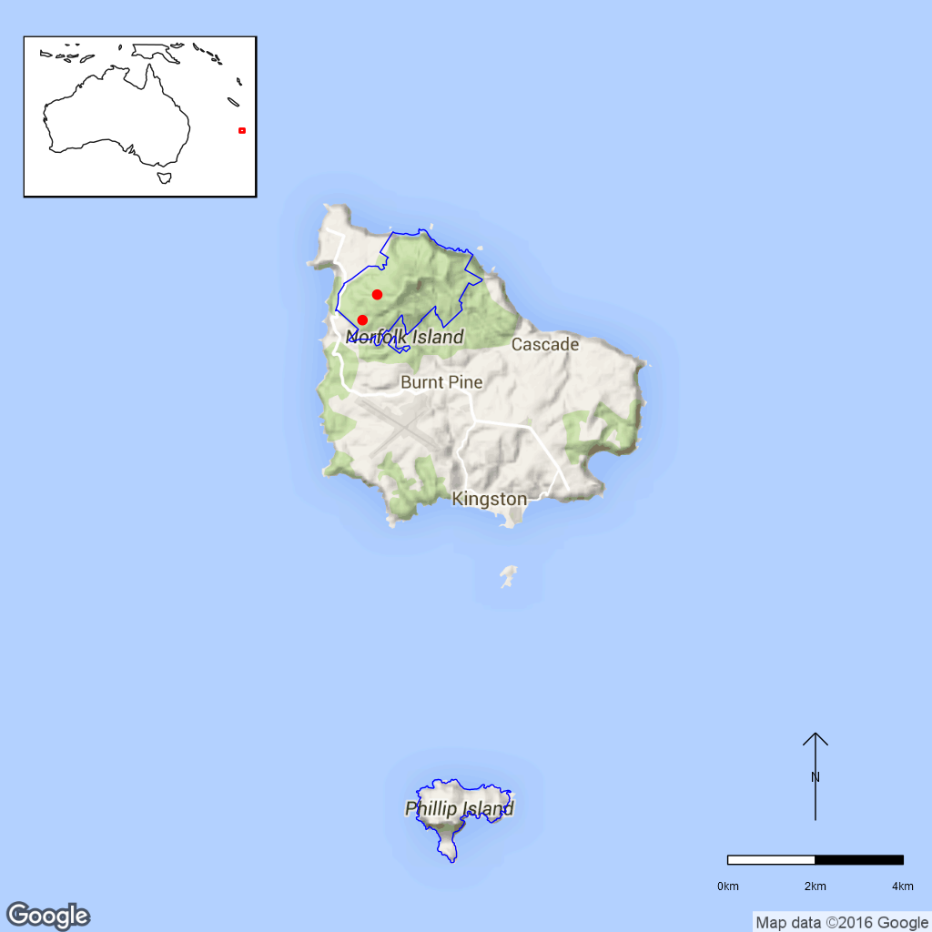
Figure B29.1 Distribution of Plexaure limenophylax in Norfolk Island National Park.
Red dots are specimen collections, the blue line is the park boundary.

Ex-situ collections (Living and Seed Bank)
The species is not conserved in the Living Collection at the Australian National Botanic Gardens or in the National Seed Bank (Zoe Knapp pers. comm. 12 October 2015 and Tom North pers. comm. 11 September 2015).No other ex-situ collections in any other Botanic Garden or Seed Bank have been located (ASBP 2016).

Biology
Pollinators: Species of Plexaure have tiny flowers that are relatively short-lived. Little is known of their pollination syndrome with some species probably self-pollinating while others are possibly pollinated by rain splash (Jones et al. 2006).
Symbiotic relationships: Unknown for this species but many orchids utilise a fungal symbiont for germination and all orchids require these fungi for growth of the protocorm that precedes root and leaf development (Baskin and Baskin 2014).
Germination requirements: Unknown.
Dormancy class: Unknown for this species but some orchids have forms of dormancy to allow them to take advantage of the appropriate conditions for growth or when the correct fungi are available (Baskin and Baskin 2014).
Flowering: January–April (Jones et al. 2006).
Breeding system: Some species of the closely-related Phreatia have cleistogamic flowers (Uphof 1938) which are almost always self-fertilised. Reproduction of Plexaure species is solely from seed with these being dispersed 1–2 months after pollination. Apomixis is unknown in the genus. Natural hybrids are unknown in these orchids. (Jones et al. 2006).
Dispersal: Not observed for this species, but likely to be wind or water. Orchid seeds are very small, dust like seeds, in general, with a high seed/embryo volume ratio making them very buoyant so they can float on water or be carried by wind (Baskin and Baskin 2014).
Longevity: Perennial (how long is not known).
Life form: Epiphytic orchid (very small 3–6 cm high, grows on the branches of trees).
Ploidy levels: Unknown.
Role of the plant in the environment: Unknown.

Threats

Listed Threats (EPBC Act)
- Climate Change and Severe Weather i.e. storms and cyclones leading to habitat destruction and flora mortality.
- Alteration of hydrological regimes and water quality – changes to the hydrology of the forest.
- Low numbers of individuals.
Alteration of hydrological regimes and water quality
As moisture dependent sub-tropical plant species any changes to the hydrology of Norfolk Island would affect most species (DNP 2010).
Other Threats/Potential New threats
Climate related factors
Climate change is predicted to bring about an increasing frequency and intensity of droughts and cyclonic activity. Given the small population size, these events may directly and indirectly impact this species. Fire which does not currently occur in the national park, may become a threat. Invasive weeds and pests will be more likely to establish due to increased disturbance and less suitable conditions for local species. (DNP 2010, DNP 2011).

Current management
Restore and maintain the health of the forest rough weed control and rehabilitation work (DNP 2010). Weed management is conducted in the national park but there is no monitoring program for threatened species (J.Christian pers. comm. 4 August 2015). The threatened species recovery plan also states that for all epiphytic orchids, likely areas of the national park should be monitored after storms and any fallen specimens should be rescued and an attempt to cultivate them in the botanic garden be made (DNP 2010).

Knowledge Gaps
Species biology and life history including pollination syndrome, symbiotic relationships, seed germination, seed dormancy, breeding system, seed dispersal, genetic diversity, seed dispersal, time to maturity and longevity of this species are unknown or poorly understood.

Suggested research and actions:
- Research propagation and establishment techniques (DNP 2010) (i.e. seed germination and mycorrhizal fungal relationships) to increase local population size.
- Establish a monitoring program to provide baseline and ongoing data for determining population trajectories and the relative impacts of threatening processes.
- Secure genetically representative ex-situ seed collections, in multiple locations if appropriate, to mitigate against the loss of natural populations and provide for re-establishment should severe losses or extinction occur.
- Determine the appropriate conditions for long term storage and seed germination.
- Determine whether the pollinators of this species still occur on the island.
- Develop and implement a restoration program to increase population numbers and/or sizes.
- Evaluate the need to establish ‘insurance’ populations off-park.

References:
Australian Plant Name Index (APNI). Plexaure limenophylax Endl. Available from https://biodiversity.org.au/nsl/services/apni. Accessed 12 August 2015.
Australian Seed Bank Partnership (2016). Search for records in the Australian Seed Bank [Online]. Council of Heads of Australian Botanic Gardens Inc. Plexaure limenophylax. Available from http://asbp.ala.org.au/search. Accessed 12 February 2016.
Baskin CC and Baskin JM (2014). Seeds: Ecology, Biogeography, and Evolution of Dormancy and Germination. Elsevier, San Diego, USA.
Coyne P (2011). Norfolk Island’s Fascinating Flora. Petaurus Press, ACT, Australia.
Department of the Environment (DoE) (2015). Plexaure limenophylax in Species Profile and Threats Database, Department of the Environment, Canberra. Available from http://www.environment.gov.au/sprat. Accessed 12 August 2015
Director of National Parks (DNP) (2010). Norfolk Island Region Threatened Species Recovery Plan. Department of the Environment, Water, Heritage and the Arts, Canberra.
Director of National Parks (DNP) (2011). Norfolk Island National Park and Botanic Garden Climate Change Strategy 2011-2016 [Online]. Department of Sustainability, Environment, Water, Population and Communities, Canberra, Australia. Available from http://www.environment.gov.au‌/resource/climate-change-strategy-2011-2016-norfolk-island-national-park-and-botanic-garden. Accessed 12 August 2015.
Jones DL, Hopley T, Duffy SM, Richards KJ, Clements MA, Zhang X (2006). Australian Orchid Genera: an information and identification system. CSIRO Publishing. Accessed on website of CPBR Australian Tropical Rainforest Orchids Key, version 1.1, 2010. Available from http://keys.trin.org.au/. Accessed 12 August 2015.
Threatened Species Scientific Committee (TSSC) (2003). Listing Advice - 11 Critically Endangered Norfolk Island Flora Species. Available from http://www.environment.gov.au/node/16449. Accessed 29 June 2015.
Uphof JCTh (1938). Cleistogamic Flowers. Botanical Review 4: 21–49. Retrieved from http://www.jstor.org/stable/4353169. Accessed 29 June 2015.
- Senecio evansianus, Senecio australis and Senecio hooglandii (Asteraceae) – Daisies, Norfolk Island National Park
All three Senecio species are probably annuals or short-lived perennials. The stem bases of S. evansianus and S. australis are known to become woody. Senecio evansianus is the smallest of the three species, mostly only reaching 10–20 cm. The other two species can grow taller, S. hooglandii up to 60 cm and S. australis up to 90 cm. The capitula (flower heads) are few per plant in S. evansianus and S. australis, and numerous in S. hooglandii. The outer flowers per head are ligulate in S. australis, narrowly funnel-shaped in S. evansianus and filiform in S. hooglandii (Belcher 1994).
Taxonomy: The names Senecio evansianus Belcher, Senecio australis Willd. and Senecio hooglandii Belcher are accepted according to the Australian Plant Census (CHAH 2015, verified 7 August 2015).
Status: Listed as Endangered (Senecio evansianus) and Vulnerable (Senecio australis and S. hooglandii) under the EPBC Act on 3 November 2003.
Recovery Plan: Norfolk Island Region Threatened Species Recovery Plan (DNP 2010).
This information is taken from SPRAT (DoE 2015) unless otherwise referenced.

Number of populations inside and outside parks and reserves
Numbers of populations/locations are not provided in the species recovery plan. Senecio evansianus has been recorded from Rocky Point, Bumbora Reserve above Creswell Bay, and Bloody Bridge (Belcher 1994, DNP 2010). Senecio australis has been recorded from several areas outside the national park, namely Barney Duffy, Anson Bay, the Chord at Duncombe Bay, Hundred Acres Reserve, the Creswell Bay area, Two Chimneys Reserve and Ball Bay (Belcher 1994, DNP 2010). Inside national park boundaries, it occurs on Phillip Island (DNP 2010). Senecio hooglandii has been recorded from near the cemetery on Norfolk Island, from the Point Hunter Reserve, and from the north side of Phillip Island (Belcher 1994, DNP 2010).

Population size – range
In 2003, there were <200 mature plants of S. evansianus (TSSC 2003a), <500 mature plants of S. australis and <550 mature plants of S. hooglandii (TSSC 2003b).

Geographical distribution
Senecio evansianus and S. hooglandii are endemic to the Norfolk Island Group whereas S. australis also occurs in New Zealand where it is thought to be indigenous (de Lange et al. 2014). Senecio evansianus is only known from Norfolk Island itself (Belcher 1994). Senecio australis and S. hooglandii were widely sown on Phillip Island for revegetation (Mills 2009) and S. hooglandii was probably only introduced to Phillip Island during this process (Belcher 1994). Senecio australis also occurs on Nepean Island (DNP 2010).
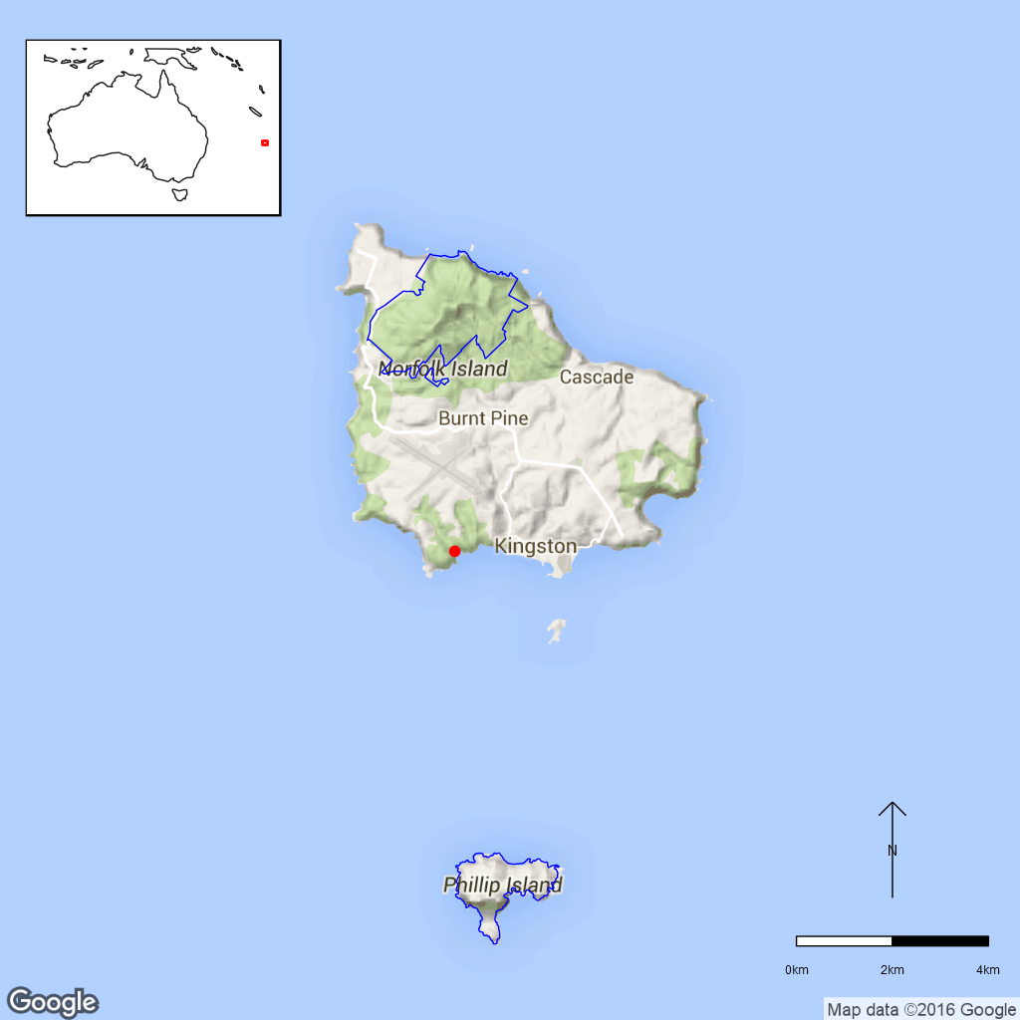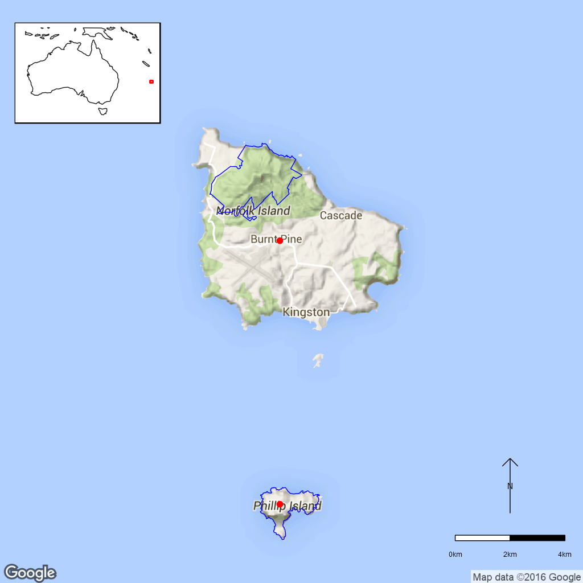
c
b
a
Figure B30.1 Distributions of Senecio evansianus (a), S. australis (b) and S. hooglandii (c) in Norfolk Island National Park. Red dots are specimen collections, blue line is the park boundary.

Ex-situ collections (Living and Seed Bank)
Seed of S. australis has also been collected by ANBG staff and is currently held on Norfolk Island. Seed collection of the other two species is planned for 2016 (T. North pers. comm. 11 September 2015). The species is not conserved in the Living Collection at the Australian National Botanic Gardens (Z. Knapp pers. comm. 30 September 2015). No other ex-situ collections in any other Botanic Garden or Seed Bank have been located (ASBP 2016).

Biology
Pollinators: Insect-pollinated. Lawrence (1985) observed native bees, honeybees and to a lesser extent hoverflies on other outbreeding Australian Senecio species. Thrips also occurred on the capitula in large numbers, but whether these are effective pollinators is unknown (Lawrence 1985).
Symbiotic relationships: Unknown.
Germination requirements: Several Senecio species show improved germination under light than in the dark (Robinson 2003).
Dormancy class: Unknown.
Flowering: Unknown.
Breeding system: The ray florets in S. australis and the marginal florets of the other two species are female, while the disc florets are bisexual (Belcher 1994). In Australian Senecio species studied by Lawrence (1985), perennial species with showy capitula were mostly self-incompatible outbreeders. However, self-compatibility has not been studied in these three species.
Dispersal: For Senecio australis, seed dispersal by sea birds was suggested (de Lange et al. 2014). The pappus hairs probably also facilitate wind dispersal.
Longevity: Senecio australis is an annual or short-lived perennial (Belcher, 1994) while the other two species are probably also annuals or short-lived perennials. All perennial Australian Senecio species studied by Lawrence (1985) reached maturity in the first year and this probably holds true for the three species discussed here.
Life form: Herbs.
Ploidy levels: Senecio evansianus and S. australis have a chromosome number of 2n=80 (de Lange and Murray 2003, de Lange et al. 2004) and can be considered to be octoploid since the basic chromosome number in the genus is x=10. Polyploidy is very common in the genus (Lawrence 1980). Senecio hooglandii may have the same chromosome number since the species are considered closely-related (Belcher 1992).
Role of the plants in the environment: Senecio evansianus seems to be restricted to well-watered clay soils beneath open stands of Norfolk Island pine (Belcher 1994) but the habitats or habitat requirements of the other two species are not known.

Threats

Listed threats (EPBC Act)
- Restricted geographical distribution (area of occupancy and extent of occurrence).
- Competition and/or habitat degradation by Pennisetum clandestinum (Kikuyu Grass) and other weeds.
- Low numbers of individuals.

Genetic and demographic effects
All three Senecio species have relatively low numbers of individuals and a relatively restricted geographical distribution area which probably makes them vulnerable to stochastic events. These species may also have low genetic diversity and may be vulnerable to inbreeding.

Invasive and other problematic species
The three Senecio species are threatened by competition from weeds, especially Pennisetum clandestinum (Kikuyu Grass, Poaceae).
Other Threats/Potential New threats
Climate related factors
Climate change is predicted to bring about an increasing frequency and intensity of droughts and cyclonic activity. Given the small population size, these events may directly and/or indirectly impact this species. Fire which does not currently occur in the national park, may become a threat. Invasive weeds and pests will be more likely to establish due to increased disturbance and less suitable conditions for local species. (DNP 2010, DNP 2011).

Current management
Weed management is conducted in the national park but there is no monitoring program for threatened species (J.Christian pers. comm. 4 August 2015).

Knowledge Gaps
Species biology and life history including pollination syndrome, symbiotic relationships, seed germination, seed dormancy, flowering, breeding system, seed dispersal, genetic diversity, seed dispersal, time to maturity and longevity of this species are unknown or poorly understood.
Up to date information regarding locations and population sizes is not available.

Suggested research and actions
- Establish a monitoring program to provide baseline and ongoing data for determining population trajectories and the relative impacts of threatening processes.
- Genetic assessment of levels of genetic diversity and inbreeding in natural and planted populations to ensure that planted populations contain sufficient genetic diversity to become self-sustaining over time and that inbreeding populations have not been created.

References
Australian Seed Bank Partnership (2016). Search for records in the Australian Seed Bank [Online]. Council of Heads of Australian Botanic Gardens Inc. Senecio australis, S. evansianus and S. hooglandii. Available from http://asbp.ala.org.au/search. Accessed 12 February 2016.
Belcher RO (1992). The genus Senecio (Compositae) on Lord Howe and Norfolk Islands. Kew Bulletin 47: 765–773.
Belcher RO (1994). Senecio. In Orchard AE (ed.) Flora of Australia 49. pp. 391–395.
Council of Heads of Australasian Herbaria (CHAH) (2015). Australian Plant Census. [Online]. Available from http://biodiversity.org.au/nsl/services/apc. Accessed 7 August 15.
de Lange PJ and Murray BG (2003). Chromosome numbers of Norfolk Island endemic plants. Australian Journal of Botany 51: 211–215.
de Lange PJ, Murray BG, Datson PM (2004). Contributions to a chromosome atlas of the New Zealand flora – 38. Counts for 50 families. New Zealand Journal of Botany 42: 873–904.
de Lange PJ, Rolfe JR, Liew CS and Pelser PB (2014). Senecio australis Willd. (Asteraceae: Senecioneae) – a new and uncommon addition to the indigenous vascular flora of New Zealand. New Zealand Journal of Botany 52: 417–428.
Department of the Environment (DoE) (2015). Senecio australis, Senecio evansianus, Senecio hooglandii, in Species Profile and Threats Database, Department of the Environment, Canberra. Available from http://www.environment.gov.au/sprat. Accessed 21 September 2015.
Director of National Parks (DNP) (2010). Norfolk Island Region Threatened Species Recovery Plan. Department of the Environment, Water, Heritage and the Arts, Canberra. Available from http://www.environment.gov.au/resource/national-recovery-plan-norfolk-island. Accessed 21 September 2015.
Director of National Parks (DNP) (2011). Norfolk Island National Park and Botanic Garden Climate Change Strategy 2011-2016 [Online]. Department of Sustainability, Environment, Water, Population and Communities, Canberra, Australia. Available from http://www.environment.gov.au‌/resource/climate-change-strategy-2011-2016-norfolk-island-national-park-and-botanic-garden. Accessed 21 September 2015.
Lawrence ME (1980). Senecio L. (Asteraceae) in Australia: Chromosome numbers and the occurrence of polyploidy. Australian Journal of Botany 28: 151–165.
Lawrence ME (1985). Senecio L. (Asteraceae) in Australia: Reproductive biology of a genus found primarily in unstable environments. Australian Journal of Botany 33: 197–208.
Mills K (2009). The Vegetation of Phillip Island, Norfolk Island Group. Available from http://www.econorfolk.nf/pdf/Kevin%20Mills%20Report%‌20Body.pdf. Accessed 21 September 2015.
Robinson RW (2003). Natural Recruitment of Native Forbs in the Grassy Ecosystems of South-Eastern Australia. Thesis for Master of Science, Victoria University, Faculty of Science, Engineering and Technology.
Threatened Species Scientific Committee (TSSC) (2003a). Commonwealth Listing Advice for Norfolk Island Flora – 16 Endangered Species. [Online]. Available from http://www.environment.gov.au/biodiversity/threatened/species/norfolk-island-flora-endangered. Accessed 21 September 2015.
Threatened Species Scientific Committee (TSSC) (2003b). Commonwealth Listing Advice for Norfolk Island Flora – 15 Vulnerable Species. [Online]. Available from http://www.environment.gov.au/biodiversity/threatened/species/norfolk-island-flora-vulnerable. Accessed 21 September 2015.
- Streblus pendulinus (Moraceae) – Siah’s Backbone, Norfolk National Park
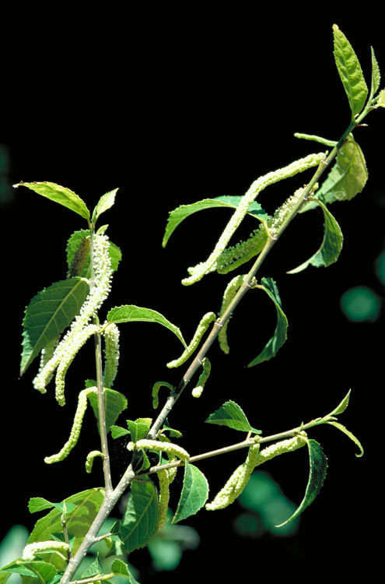
Figure B31.1 Streblus pendulinus male flowers. ©Australian
Tropical Rainforest Plants Key, Australian Plant Image Index No. rfk.3487.
This species is a dioecious tall shrub or tree to around 6 m. It has discolorous leaves which are rough and lumpy (scabrous) with finely serrated margins. The leaves are 3–15 cm long and 2–5 cm wide. The male flowers are 20 cm long catkins, while female flowers are solitary or with a few in a spike and 5–10 mm long. It has red, fleshy somewhat globular fruit around 5 mm long. It exudes a white latex when damaged. (Conn 2015, DNP 2010, Flora of Australia 1994).
Taxonomy: Conventionally accepted as Streblus pendulinus (Endl.) F.Muell. (CHAH 2015, verified 18 November 2015).
Previously, subpopulations on mainland Australia and in Melanesia, Micronesia and Polynesia have variously been included with Streblus pendulinus, however, S. brunonianus has been reinstated for non-Norfolk Island populations with S. pendulinus now treated as a Norfolk Island endemic. (DoE 2015a, Conn 2015).
Status: Listed as Endangered under the EPBC Act on 3 November 2003.
Recovery Plan: Norfolk Island Threatened Species Recovery Plan 2010.
Information in this fact sheet is taken from the SPRAT Listing Page (DoE 2015b) unless otherwise referenced.

Number of populations inside and outside parks and reserves
The majority of known individuals occur in the Norfolk Island National Park (NINP). In 2003, 167 of the 187 mature individuals were located inside the national park (TSSC 2003, DNP 2010). Outside the park the species has been found in the Mission Road rainforest remnants, near Steels Point and in the Ball Bay reserve (DNP 2010) and also occurs on private property as isolated paddock trees (Mills 2007 in DoE 2015a). More than 95% of mature individuals occur in Norfolk Island National Park (Mills 2015 pers. comm. in DoE 2015a).

Population size – range
Streblus pendulinus is a Norfolk Island endemic. The extent of occurrence is 4.41 km² with an area of occupancy of 16 km² (DoE 2015a). Transect surveys in NINP observed 107 Streblus pendulinus plants along 15 km of transects (Mills 2012 in DoE 2015a). Based on this, Mills (2015 pers. comm. in DoE 2015) estimates that there are between 250 and 1000 mature plants on Norfolk Island.

Geographical distribution
Localised, discontinuous.
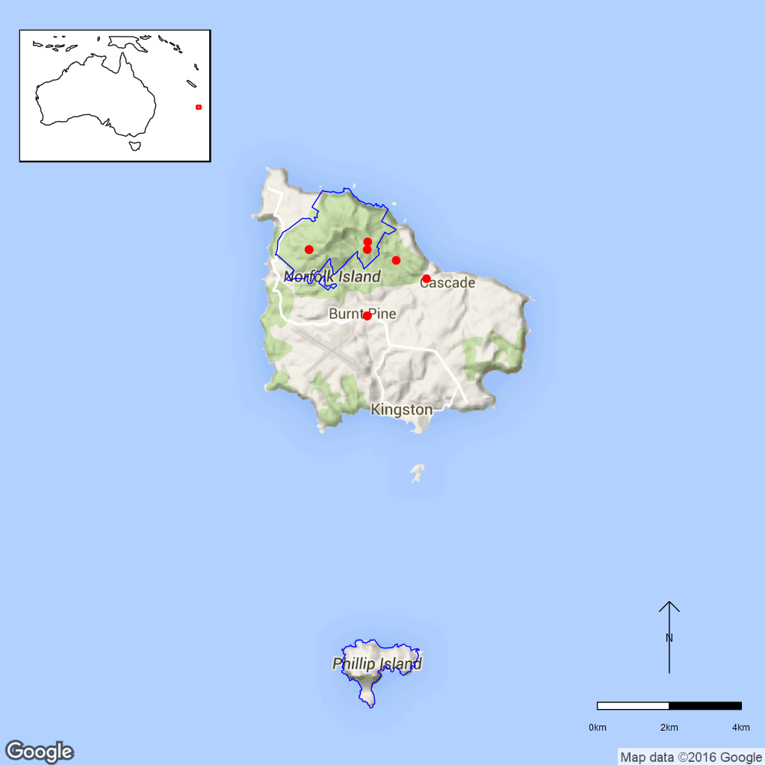
Figure B31.2 Map of distribution of Siah’s Backbone based on herbarium specimens (not
necessarily indicative of current populations). Red dots are specimen collections, blue line
is the park boundary.

Ex-situ collections (Living and Seed Bank)
This species is currently conserved in the Living Collection at the Australian National Botanic Gardens (Z. Knapp pers. comm. 30 September 2015) but not in the National Seed Bank (T. North pers. comm. 11 September) but ANBG staff plan to collect it in February 2016 (T. North pers. comm. 11 September). No other ex-situ collections in any other Botanic Garden or Seed Bank have been located (ASBP 2016).

Biology
Pollinators: Although insect pollination may occur for this species, Streblus species have a flower structure that is specialised for wind pollination (Datwyler and Weiblen 2004, Williams and Adam 2010, cited in DoE 2015a).
Symbiotic relationships: Unknown.
Germination requirements: Germinates readily (DoE 2015a).
Dormancy class: Unknown.
Flowering: It has been observed flowering on Norfolk from December to February and in April (Mills 2007). Closely-related mainland Australian species, S. brunonianus, flowers from September to May (Floyd 1989).
Breeding system: Siah’s backbone is usually dioecious (plants are either male or female) DNP 2010; many trees are male and therefore do not produce seed (Sykes and Atkinson 1988, Cited in DNP 2010).
Dispersal: Fruit is palatable to birds (DNP 2010) and seed of other Streblus species are known to be dispersed by birds (White et al. 2003 in DoE 2015a). Fruit of related mainland Australian species, Streblus brunonianus ripens January to April (Royal Botanic Gardens and Domain Trust 2015).
Longevity: Perennial. Some remaining large trees on NI are probably decades old (Mills 2015, pers. comm. in D0E 2015a) and trees in all age classes are observed on the island, which indicates that the species is regenerating (Mills 2012 pers. comm. in DOE 2015a).
Life form: Large shrub or tree to 6 m.
Ploidy levels: The chromosome number of S. pendulinus is unknown but for those Streblus species that have been studied (e.g. S. smithii (NZ); S. banksia (NZ) and S. ilicifolius) a chromosome numbers of 2n=28 has been recorded. The basic chromosome number of S. asper is x=14 which would suggest that it is likely they are a diploid genus. (Tropicos.org).
Role of the plant in the environment: Unknown.

Threats

Listed Threats (EPBC Act)
- Grazing pressures and associated habitat changes
- Restricted geographical distribution (area of occupancy and extent of occurrence)
- Competition and/or habitat degradation by weeds
- Infection by parasites
- Low numbers of individuals

Other Threats/Potential New threats

Pests and diseases
A parasite appears to be stopping seed set in many individuals (DNP 2010) but it is unclear what type of parasite this is.

Genetic and demographic effects
Outside the national park when old trees die they are not being replaced as grazing and weeds suppress recruitment (Mills 2015 pers. comm. in DoE 2015a).

Human intervention
Historic clearing has significantly reduced the area of suitable habitat and it is likely that the species occurred in higher densities in the lowland rainforest, a vegetation association that has mostly been cleared on the island (Mills 2015 pers. comm. in DoE 2015a).

Climate related factors
Climate change is predicted to bring about an increasing frequency and intensity of droughts and cyclonic activity. Given the small population size, these events may directly and indirectly impact this species. Fire which does not currently occur in the national park, may become a threat. Invasive weeds and pests will be more likely to establish due to increased disturbance and less suitable conditions for local species. (DNP 2010, DNP 2011).

Current management
Weed management is conducted in the national park but there is no monitoring program for threatened species (J.Christian pers. comm. 4 August 2015).

Knowledge Gaps
Species biology and life history including pollination syndrome, symbiotic relationships, seed germination, seed dormancy, breeding system, seed dispersal, genetic diversity, seed dispersal, time to maturity and longevity of this species are unknown or poorly understood. It is also unclear whether the parasite poses a significant threat to the species and, if so, how it can be managed.

Suggested research and actions
- Avoid actions that are likely to exacerbate weed invasion in this species habitat and continue broad scale weed control in the national park (DoE 2015a).
- Undertake rehabilitation of native vegetation in Norfolk Island National Park and Norfolk Island public reserves (DNP 2010, DoE 2015a).
- Investigate whether the parasite that may be preventing seed set is a significant threat to the species and, if necessary, determine the best method of treating the parasite (DNP 2010 in DoE 2015a).
- Establish an ex-situ subpopulation and investigate options for linking, enhancing or establishing additional subpopulations. (DoE 2015a).
- Establish a monitoring program to provide baseline and ongoing data for determining population trajectories and the relative impacts of threatening processes.
- Determine the appropriate conditions for long term storage and seed germination.

References:
Atlas of Living Australia (ALA) (2015). Streblus pendulinus. Herbarium specimen records [Online]. Available from http://www.ala.org.au/. Accessed 18 November 2015.
Australian Seed Bank Partnership (2016). Search for records in the Australian Seed Bank [Online]. Council of Heads of Australian Botanic Gardens Inc. Streblus pendulinus. Available from http://asbp.ala.org.au/search Accessed 12 February 2016.
Chew WL (1989). Streblus pendulinus. Flora of Australia Online. Australian Biological Resources Study, Canberra. Available from http://www.‌environment.‌gov.au/biodiversity/abrs/online-resources/flora/49/index.html. Accessed 23 November 2015.
Conn BJ (2015). Re-straightening the story of Streblus brunonianus and S. pendulinus (Moraceae). Telopea 18: 73–78.
Council of Heads of Australian Herbaria (CHAH) (2015). Australian Plant Census. [Online]. Available from http://biodiversity.org.au/nsl/services/apc. Accessed 23 November 2015.
Department of the Environment (DoE) (2015a). Consultation Document on Listing Eligibility and Conservation Actions Streblus pendulinus, Siah’s Backbone. Available from https://www.environment.gov.au/biodiversity/threatened/nominations/comment/streblus-pendulinus. Accessed 19 November 2015.
Department of the Environment (DoE) (2015b). Streblus pendulinus in Species Profile and Threats Database, Department of the Environment, Canberra. Available from http://www.environment.gov.au/sprat. Accessed 18 November 2015.
Director of National Parks (DNP) (2010). Norfolk Island Region Threatened Species Recovery Plan. Department of the Environment, Water, Heritage and the Arts, Canberra.
Director of National Parks (DNP) (2011). Norfolk Island National Park and Botanic Garden Climate Change Strategy 2011-2016 [Online]. Department of Sustainability, Environment, Water, Population and Communities, Canberra, Australia. Available from http://www.environment.gov.au‌/resource/climate-change-strategy-2011-2016-norfolk-island-national-park-and-botanic-garden. Accessed 18 November 2015.
Floyd AG (1989). Rainforest Trees of Mainland South-eastern Australia. Inkata Press.
Flora of Australia (1994). Volume 49, Oceanic Islands 1. Australian Government Publishing Service, Canberra.
Mills K (2007). The Flora of Norfolk Island. 1. The Indigenous Flora. Appendix 2 - Flowering and Fruiting Months – Indigenous Flora of Norfolk Island, updated January 2015. The Author, Jamberoo, New South Wales, June.
The Royal Botanic Gardens and Domain Trust (2015). PlantNET – the Plant information Network System of the Royal Botanic Gardens and Domain Trust, Sydney (version 2.0). Available from http://plantnet.rbgsyd.nsw.gov.au. Accessed 14 November 2015.
Threatened Species Scientific Committee (TSSC) (2003). Listing Advice – 16 Endangered Norfolk Island Flora Species. Available from http://www.environment.gov.au/biodiversity/threatened/species/norfolk-island-flora-endangered. Accessed 20 November 2015.
Tropicos.org (2015). Missouri Botanical Garden. Available from http://www.tropicos.org/Name/50064863. Accessed 19 November 2015.
- Wikstroemia australis (Thymelaeaceae) – Kurrajong, Norfolk Island National Park
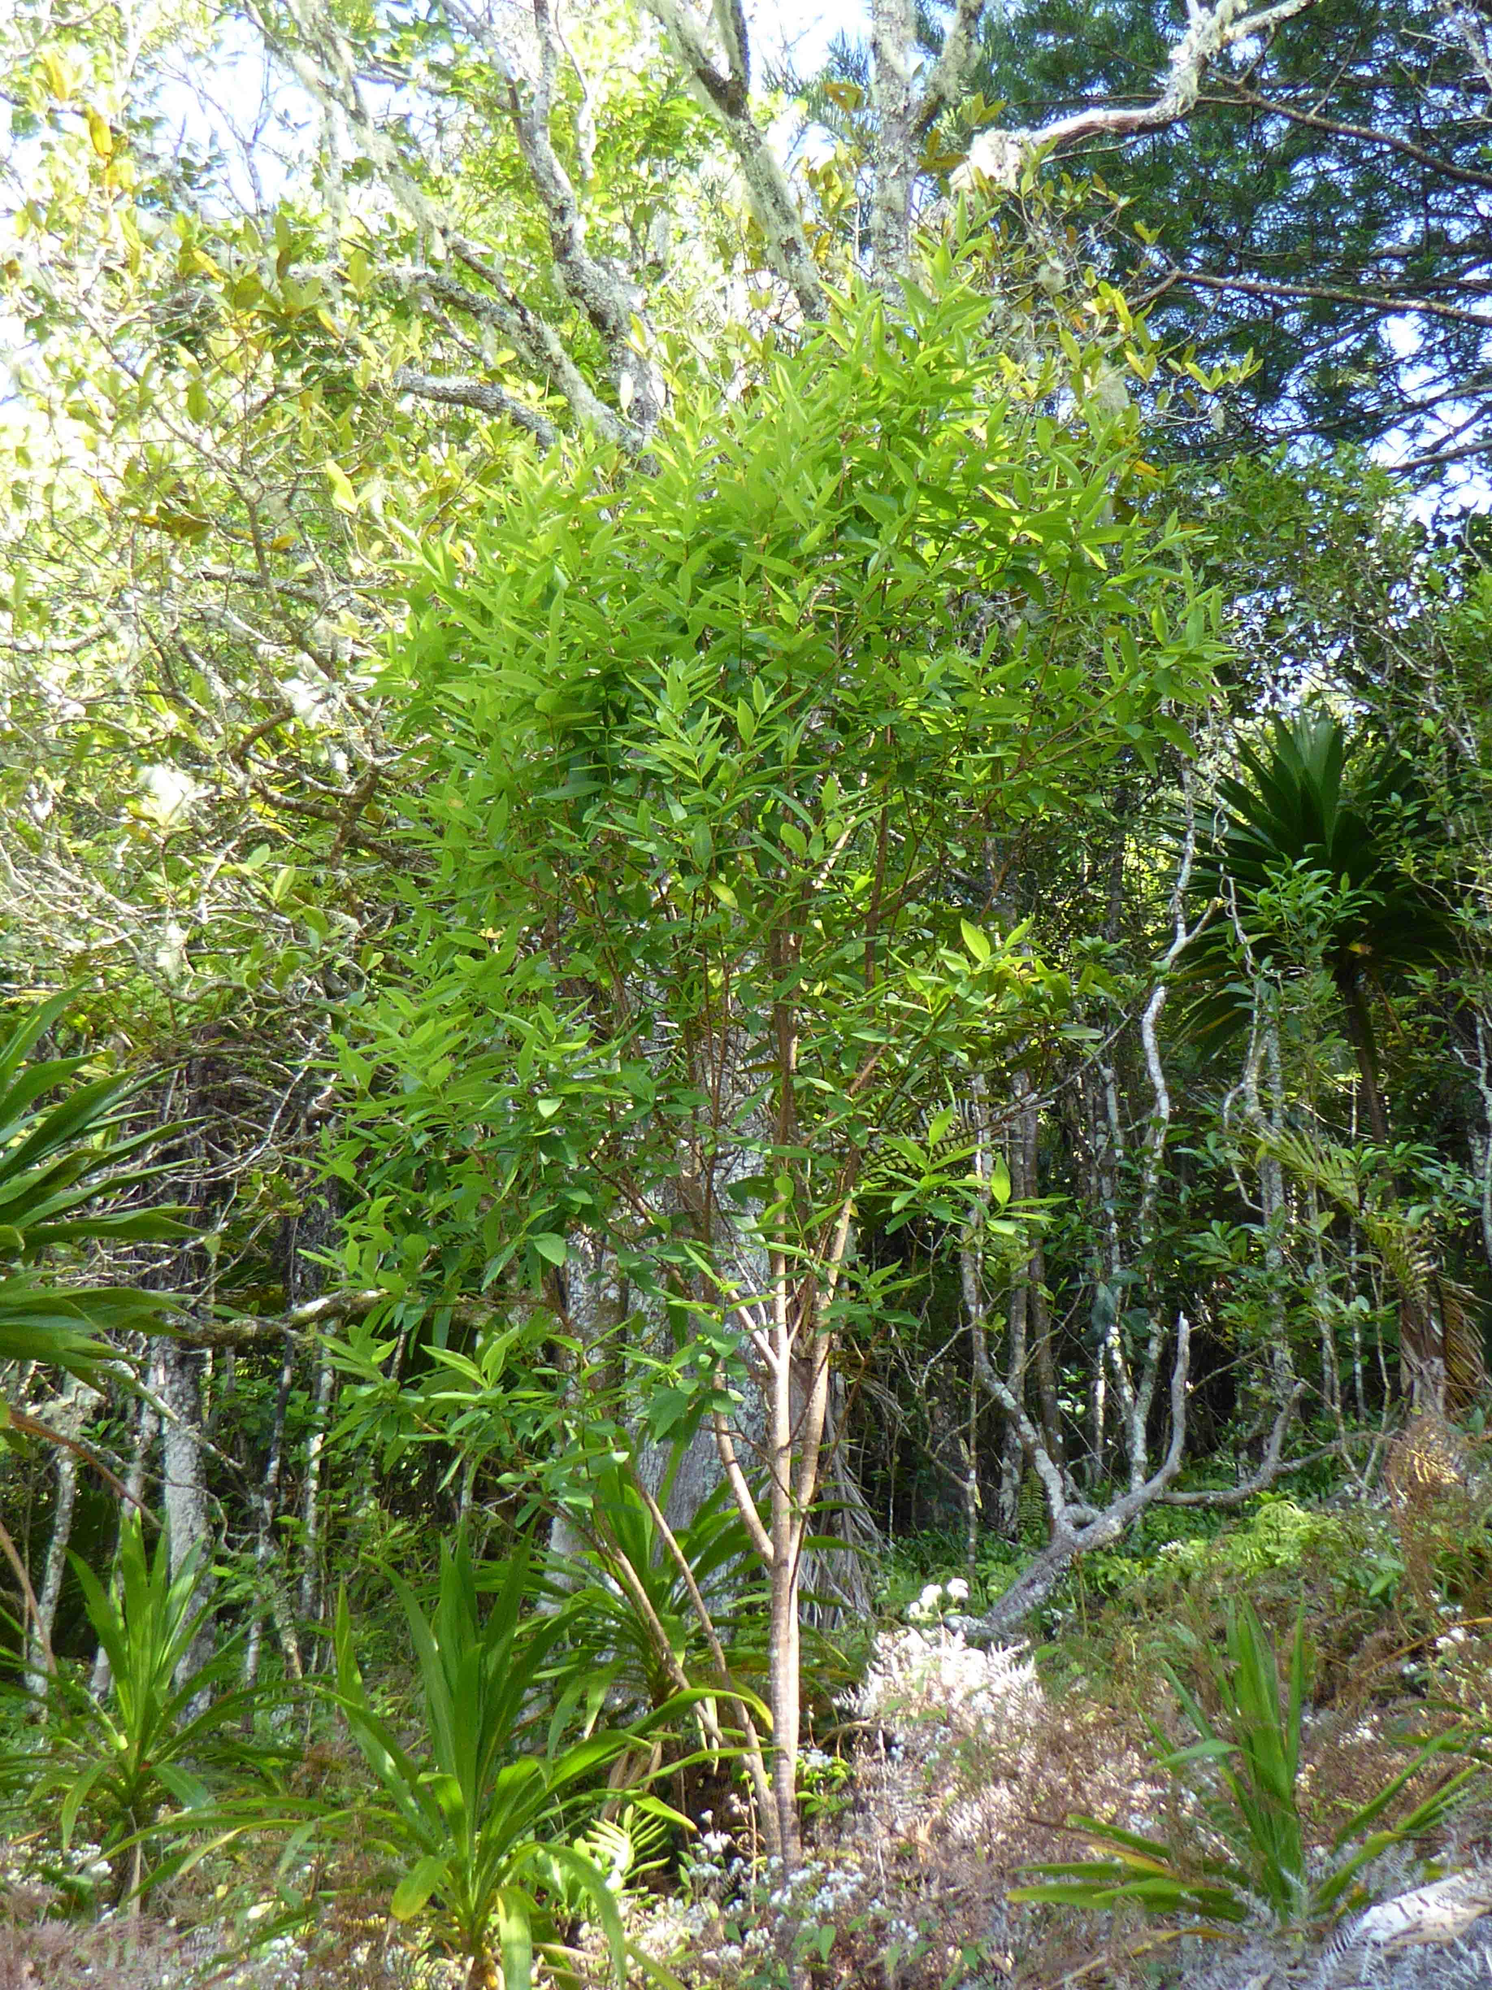
Figure 32.1 Wikstroemia australis in Norfolk Island National Park. ©C. Jones 2015.
Kurrajong is a shrub or small tree to 4 m or more tall with very tough, fibrous bark. The tubular flowers are greenish yellow and occur in groups of 3–10. The leaves are hairless, 3–7cm long and 2–3cm wide. The fruit are a berry like drupe, 4 mm long and reddish in colour (FoA 1994, DNP 2010, DoE 2015).
Taxonomy: Conventionally accepted as Wikstroemia australis Endl. (CHAH 2005, verified 8 September 2015).
Previously known as Wikstroemia cunninghamii Meisn.
Status: Listed as Critically Endangered under the EPBC Act on 3 November 2003.
Recovery Plan: Norfolk Island Region Threatened Species Recovery Plan, 2010.
This information is taken from SPRAT (DoE 2015) unless otherwise referenced.

Number of populations inside and outside parks and reserves
Endemic to Norfolk Island, it was once widespread over much of Norfolk Island but since the 1930’s has been declining. Most of the population now occurs in scattered pockets inside Norfolk Island National Park (DNP 2010).

Population size – range
155 mature individuals recorded at time of listing (TSSC 2003).

Geographical distribution
Localised and discontinuous.
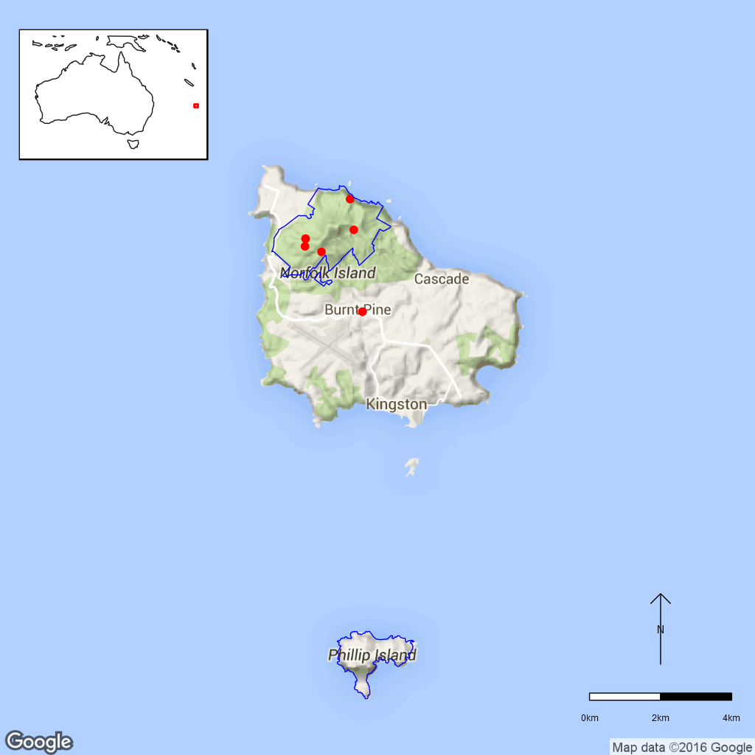
Figure B32.2 Distribution of Wikstroemia australis in the Norfolk Island National Park.
Red dots are specimen collections, blue line is the park boundary.

Ex-situ collections (Living and Seed Bank)
Seed of this species is conserved in the National Seed Bank (five collections from cultivated sources grown from unknown wild plants) with plans to collect this species in February 2016 as well as nine plants from an unknown source in Booderee National Park (T. North pers. comm. 11 September 2015 and Z. Knapp pers. comm. 12 October 2015). No other ex-situ collections in any other Botanic Garden or Seed Bank have been located (ASBP 2016).

Biology
Pollinators: Unknown.
Symbiotic relationships: Mycorrhizal fungi association.
Germination requirements: Difficult to propagate, will not grow from cuttings, requires high light for establishment, low levels of natural recruitment have been observed. (DNP 2010).
Dormancy class: Unknown.
Flowering: Mills (2007) observed flowering in Wikstroemia australis in September, November, December, March and April. Fruit were observed in December (Mills 2007).
Breeding system: Unknown.
Dispersal: Unknown.
Longevity: Probably short lived (DNP 2010).
Life form: Small tree to 4 m.
Ploidy levels: Unknown.
Role of the plant in the environment: It is found growing on ridges and upper sides of valleys in forest areas, most often in canopy gaps or alongside tracks and roads.

Threats

Listed Threats (EPBC Act)
- Loss and/or fragmentation of habitat and/or subpopulations.
- Restricted geographical distribution.
- Competition and/or habitat degradation by weeds, in particular Psidium cattleianum (Cherry Guava).
- Competition and/or predation by rats.
- Presence of pathogens and resulting disease.
- Low fecundity, reproductive rate and/or poor recruitment.
- Low numbers of individual.
- Population senescence and lack of recruitment.

Invasive and other problematic species
A key problem weed is red guava which competes for habitat and is also thought to change soil acidity making recruitment difficult for some species (J. Christian pers. comm. 4 September 2015).

Other Threats/Potential New threats

Competition and/ or habitat degradation by vertebrates
High levels of seed predation by rats are noted in the EPBC listing advice (TSSC 2003)

Pests and Diseases
A survey in 1989 suggested that decline was ongoing and many diseased plants were observed (disease not identified) (Gilmour and Helman 1989 in DNP 2010).

Climate related factors
The soil around Mt Pitt is susceptible to land slip after heavy rain, such as that associated with cyclones which Norfolk Island experiences. This poses a threat to Kurrajongs that grow in this area. Climate change predictions of increased drought and storms and tropical cyclones may impact on this species as it prefers protected sunny and moist areas while landslips associated with increased rainfall may damage or kill trees.
Climate change is also predicted to bring about an increasing frequency and intensity of droughts. Given the small population size, these events may directly and indirectly impact this species. Fire which does not currently occur in the national park, may become a threat. Invasive weeds and pests will be more likely to establish due to increased disturbance and less suitable conditions for local species. (DNP 2010, DNP 2011).

Human intervention
Kurrajong is potentially threatened by habitat alteration associated with land use change; this is primarily a threat to trees outside of the national park. These changes may be suppressing the mycorrhizal fungi associated with the species. This change may also increase the vulnerability of Kurrajong to soil-based fungi and bacterial pathogens (TSSC 2003).

Current management
Weeds are a problem throughout the park and a major threat to Wikstroemia australis and many other native species. (DNP 2010). Weed management is conducted in the national park but there is no monitoring program for threatened species (J.Christian pers. comm. 4 August 2015). A rat control program has been implemented within Norfolk Island National Park since 1992 and in March 2006 predation by exotic rats on Australian offshore islands of <1,000 square kilometres (100,000 h) was listed as a key threatening process under the EPBC Act (DNP 2008).

Knowledge Gaps
Species biology and life history including pollination syndrome, symbiotic relationships, seed germination, seed dormancy, breeding system, seed dispersal, genetic diversity, seed dispersal, time to maturity and longevity of this species are unknown or poorly understood. Inbreeding depression is a possible cause of the difficulty experienced in germinating seed and of the low recruitment being experienced. Identification of diseases and affecting this species and the impact this is having is also required.

Suggested research and actions
- Study by an arborist to identify the causal agent for the disease and possible management of it (DNP 2010).
- Clearing of red guava and other woody weeds around reproductively mature trees and maintaining gaps created to facilitate establishment of young Wikstroemia australis (DNP 2010).
- Establish a monitoring program to provide baseline and ongoing data for determining population trajectories and the relative impacts of threatening processes.
- Research into seed storage and germination and other methods of propagation (DNP 2010).
- Determine key life history parameters including pollination, symbiotic relationships, breeding system, maturity and longevity to assist with species management.
- Undertake a genetic assessment to determine the reproductive strategy, levels of genetic diversity and inbreeding to assist with any future translocation program.

References:
Atlas of Living Australia (ALA) (2015). Wikstroemia australis. Herbarium specimen records [Online]. Available from http://www.ala.org.au/. Accessed 9 October 2015.
Australian Seed Bank Partnership (2016). Search for records in the Australian Seed Bank [Online]. Council of Heads of Australian Botanic Gardens Inc. Wikstroemia australis. Available from http://asbp.ala.org.au/search. Accessed 12 February 2016.
Council of Heads of Australian Herbaria (CHAH) (2015). Australian Plant Census. [Online]. Available from http://biodiversity.org.au/nsl/services/apc. Accessed 9 October 2015.
Department of the Environment (DoE) (2015). Wikstroemia australis in Species Profile and Threats Database, Department of the Environment, Canberra. Available from http://www.environment.gov.au/sprat. Accessed 9 October 2015.
Director of National Parks (DNP) (2008). Norfolk Island Region Threatened Species Recovery Plan [Online]. Canberra. Available from http://www.environment.gov.au/biodiversity/threatened/publications/recovery/norfolk-island.html. Accessed 22 July 2015.
Director of National Parks (DNP) (2010). Norfolk Island Region Threatened Species Recovery Plan. Department of the Environment, Water, Heritage and the Arts, Canberra.
Director of National Parks (DNP) (2011). Norfolk Island National Park and Botanic Garden Climate Change Strategy 2011-2016 [Online]. Department of Sustainability, Environment, Water, Population and Communities, Canberra, Australia. Available from http://www.environment‌‌‌.gov.au/resource/climate-change-strategy-2011-2016-norfolk-island-national-park-and-botanic-garden. Accessed 9 October 2015.
Flora of Australia (FoA) (1994). Volume 49, Oceanic Islands 1. Australian Government Publishing Service, Canberra.
Mills K (2007). The Flora of Norfolk Island. 1. The Indigenous Flora. Appendix 2 - Flowering and Fruiting Months – Indigenous Flora of Norfolk Island, updated January 2015. The Author, Jamberoo, New South Wales.
Threatened Species Scientific Committee (TSSC) (2003). Commonwealth Listing Advice for Norfolk Island Flora – Wikstroemia australis (Kurrajong). Available from http://www.environment.gov.au/node/16534. Accessed 11 December 2015.
- Eremophila alternifolia (Scrophulariaceae) – Narrow-leaved Emu Bush, Uluru-Kata Tjuta National Park
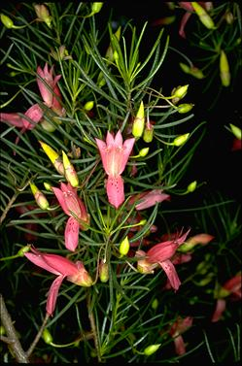
Figure B33.1 Eremophila alternifolia at the Burrendong Arboretum Wellington, NSW.
©M. Fagg Australian National Botanic Gardens Photo No. a.20000).
Eremophila alternifolia is an erect shrub to 3 m high. The leaves are linear-terete, 2–5.5 cm long and 1–1.5 cm wide. The flowers are solitary in leaf axils. The pedicels are 13–20 mm long. The corolla is 18–30 mm long and of variable colour. It can be carmine or more rarely pink or yellow, with or without spots and glabrous outside. The fruit is woody, glabrous and 5–7 mm long (The Royal Botanic Gardens and Domain Trust 30 October 2015).
Taxonomy: The name Eremophila alternifolia R.Br. is accepted in the Australian Plant Census (CHAH 2015, verified 30 October 2015).
Status: Listed as ‘Near Threatened’ under the Northern Territory Territory Parks and Wildlife Conservation Act 2000 (TPWC Act, Northern Territory Herbarium 2015).
Recovery Plan: A recovery plan does not exist.

Number of populations inside and outside parks and reserves
The number of populations is unknown. The only population in Uluru-Kata Tjuta National Park is found in drainage lines to the East of Uluru (Uluru-Kata Tjuta National Park 2015 unpublished data).

Population size – range
The species is considered to be rare in the Northern Territory, and population size is thought to be declining. A survey of four areas within Uluru-Kata Tjuta National Park found 200 plants with overall numbers remaining steady during the three years covered by the study (Uluru-Kata Tjuta National Park 2015 unpubl. data).

Geographical distribution
The species is widespread in Australia.
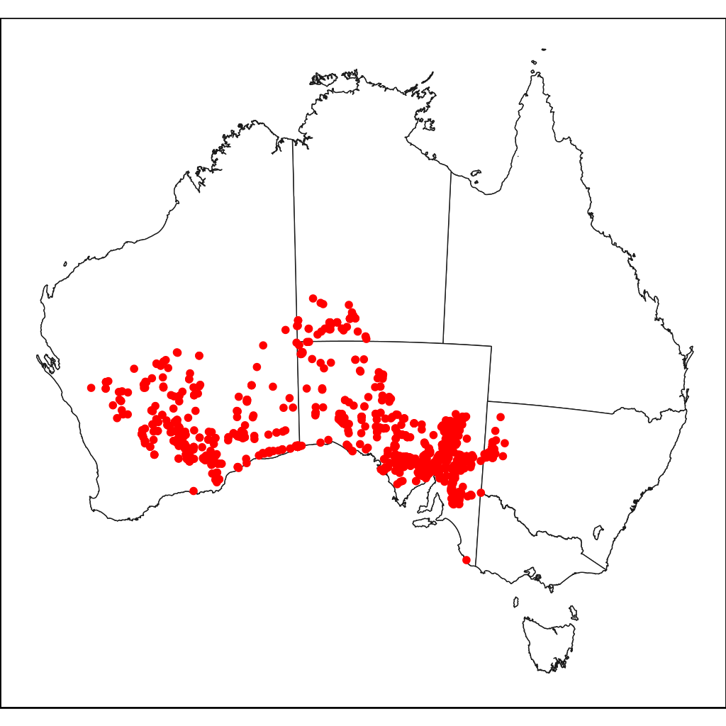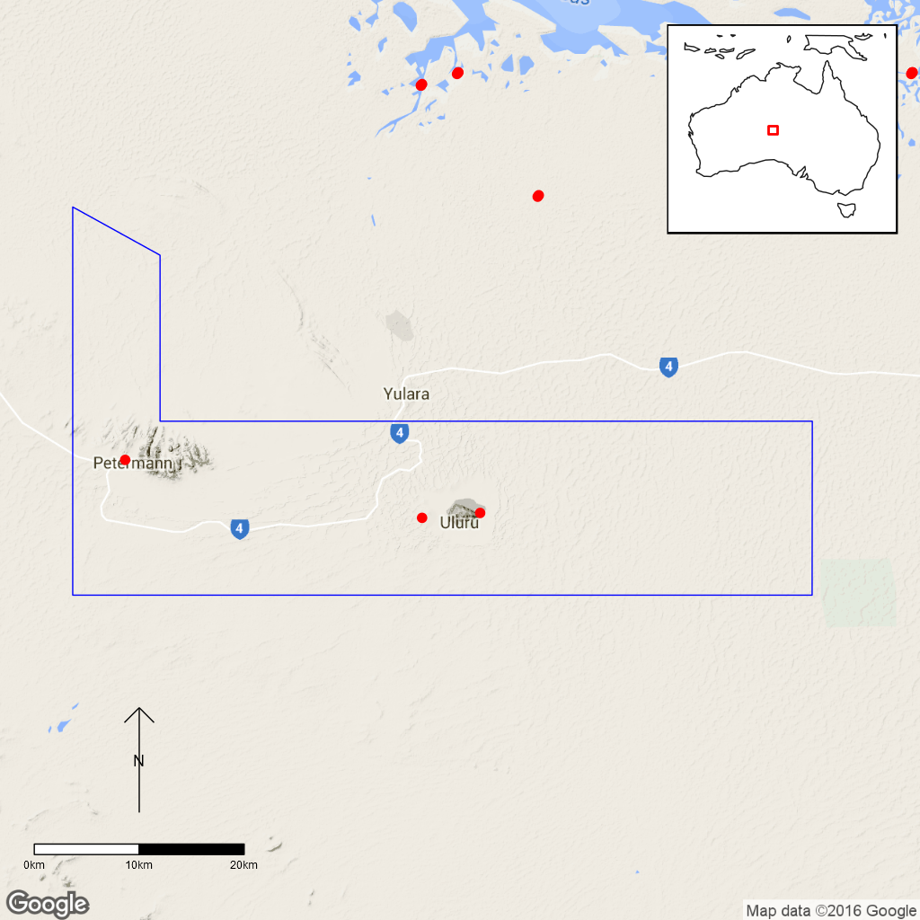
Figure B33.2 Distribution of Eremophila alternifolia across Australia (left) and within Uluru
Kata-Tjuta National Park (right). Red dots indicate specimen collection, blue line is the park boundary.

Ex-situ collections (Living and Seed Bank)
The species is propagated in the national park nursery for cultural use by the Mutitjulu community (Uluru-Kata Tjuta National Park 2015 unpubl. data). The species is also held in the Living Collection at the Australian National Botanic Gardens (M. Henery pers. comm. 5 November 2015). No other ex-situ collections in any other Botanic Garden or Seed Bank have been located (ASBP 2016).

Biology
Pollinators: Bird-pollinated (Chinnock 2007).
Symbiotic relationships: Unknown.
Germination requirements: Seed of the genus Eremophila generally germinates poorly. In natural populations, the seeds germinate after heavy rain in autumn and winter (Richmond and Chinnock 1994). However, seed of Eremophila alternifolia germinated readily in the nursery at Uluru-Kata Tjuta National Park (K. Bennison pers. comm. 23 November 2015).
Dormancy class: The seeds exhibit physical dormancy from the hard woody fruits. There may also be a chemical mechanism (Richmond and Chinnock 1994).
Flowering: The species flowers more or less all year round, fruits have been observed from April–October (Northern Territory Herbarium 2015).
Breeding system: Unknown.
Dispersal: Emus are considered to be the primary dispersers of Eremophila seed (Moore 2005).
Longevity: Perennial.
Life form: Shrub.
Ploidy levels: According to the available chromosome counts, E. alternifolia is diploid with 2n=36 although tetraploid and hexaploid taxa are known with a few species having more than one ploidy level (Barlow 1971).
Role of the plant in the environment: In Uluru-Kata Tjuta National Park, the species grows on red, loamy soil in drainage lines (Uluru-Kata Tjuta National Park 2015 unpubl. data). Like other Eremophila species, E. alternifolia is traditionally used for medicinal and cultural purposes by Aboriginal people. Eremophila alternifolia may be the most important one of the species and is used both internally and externally (Richmond 1993).

Threats

Listed threats
As Eremophila alternifolia is not currently listed under Commonwealth or State Legislation threats to this species are unknown.

Other Threats/Potential New threats
- Climate related factors.
- Invasive weed species.

Climate-related factors
Climate change is predicted to bring higher temperatures and a potential increase in the frequency and severity of drought conditions due to higher evaporation (Hyder Consulting, 2008). The risk of fire might also increase.

Invasive and other problematic species
In many parts of the Northern Territory where E. alternifolia is distributed, Buffel Grass (Cenchrus ciliaris) and other invasive plants can out-compete native plant species (DNP 2010).

Current management
Fire management, erosion control and invasive species control are undertaken in Uluru-Kata Tjuta National Park (DoE 2015). Four survey areas were established in 2008 and surveyed for three consecutive years. As numbers remained stable over the survey period, the species is now not surveyed regularly. However, the population is easily accessible and close to a road, so that changes in the population would be recognised (K. Bennison pers. comm. 23 November 2015). The species is propagated in the national park nursery to be planted in the Mutitjulu community for cultural medicinal use (Uluru-Kata Tjuta National Park 2015 unpubl. data)

Knowledge Gaps
The tolerance to fire and fire response are unknown (Uluru-Kata Tjuta National Park 2015 unpubl. data). Species biology and life history including pollination syndrome, symbiotic relationships, seed germination, seed dormancy, breeding system, seed dispersal, genetic diversity, seed dispersal, time to maturity and longevity of this species are unknown or poorly understood.

Suggested research and actions
- Undertake a fire response trial (Uluru-Kata Tjuta National Park 2015 unpubl. data).
- Regularly monitor survey areas established in 2008 to provide ongoing data for determining population trajectories and the relative impacts of threatening processes.

References
Australian Seed Bank Partnership (2016). Search for records in the Australian Seed Bank [Online]. Council of Heads of Australian Botanic Gardens Inc. Eremophila alternifolia. Available from http://asbp.ala.org.au/search. Accessed 12 February 2016.
Barlow BA (1971). Cytogeography of the genus Eremophila. Australian Journal of Botany 19: 295–310.
Council of Heads of Australasian Herbaria (CHAH) (2015). Australian Plant Census. [Online]. Available from http://biodiversity.org.au/nsl/services/apc. Accessed 13 July 2015.
Chinnock RJ (2007). Eremophila and allied genera: A monograph of the plant family Myoporaceae. Rosenberg Publishing, Kenthurst, NSW.
Department of the Environment (DoE) (2015). Uluru-Kata Tjuta National Park – Science. Available from https://www.environment.gov‌.au/topics‌/national-parks/uluru-kata-tjuta-national-park/management-and-conservation/science. Accessed 3 November 2015.
Director of National Parks (DNP) (2010). Uluru-Kata Tjuta National Park Management Plan 2010–2020. Available from https://www.‌environment‌.gov.au/system/files/resources/f7d3c167-8bd1-470a-a502-ba222067e1ac/files/management-plan.pdf. Accessed 3 November 2015.
Hyder Consulting (2008). The Impacts and Management Implications of Climate Change for the Australian Government’s Protected Areas. A report to the Department of the Environment, Water, Heritage and the Arts and the Department of Climate Change. Commonwealth of Australia, Canberra.
Moore, P. (2005). Plants of Inland Australia. Reed New Holland.
Northern Territory Herbarium (2015). FloraNT Northern Territory Flora Online. Department of Land Resource Management. Available from http://eflora.nt.gov.au. Accessed 28 October 2015.
Richmond GS (1993). A review of the use of Eremophila (Myoporaceae) by Australian Aborigines. Journal of the Adelaide Botanic Gardens 15(2): 101–107.
Richmond GS and Chinnock RJ (1994). Seed germination of the Australian desert shrub Eremophila (Myoporaceae). The Botanical Review 60(4): 483–503.
The Royal Botanic Gardens and Domain Trust (2015). Eremophila alternifolia in PlantNET – the Plant Information Network System of the Royal Botanic Gardens and Domain Trust, Sydney, Australia. Available from http://plantnet.rbgsyd.nsw.gov.au/. Accessed 28 October 2015.
- Eriachne scleranthoides (Poaceae) – Mount Olga Wanderrie Grass, Uluru-Kata Tjuta National Park
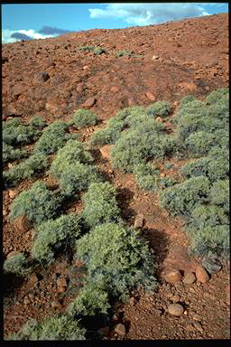
Figure 34.1 Eriachne scleranthoides at Kata Tjuta, NT. ©K. Thiele
Australian National Botanic Gardens Photo No. a.1626.
Eriachne scleranthoides is a perennial grass with a shrubby growth 60–105 cm high. The culms are strongly branched and woolly, the leaves mostly glabrous. The leaf blades are up to 2.5 cm long, recurved and up to 1.5 cm wide with scabrous or tuberculate margins and ending in a spine. The inflorescence is a raceme of 1–3 spikelets. The glumes are 3.5–4 mm long and diverge widely at maturity (Lazarides et al. 2005). The species is morphologically similar to xerophytic forms of E. mucronata, but has florets that are longer than the glumes, recurved leaf blades and reduced and scarcely exserted inflorescences (Lazarides et al. 2005).
Taxonomy: The name Eriachne scleranthoides F.Muell. is accepted in the Australian Plant Census (CHAH 2015, verified 28 October 2015).
- Synonym: Eriachne mucronata subsp. scleranthoides (F.Muell.) Domin.
Status: Listed as ‘Near Threatened’ under the Northern Territory TPWC Act (Northern Territory Herbarium 2015).
Recovery Plan: A recovery plan does not exist.

Number of populations inside and outside parks and reserves
According to Lazarides et al. (2005), the species is endemic to the Northern Territory and specimens collected from other regions of Australia are misidentifications that are likely to be E. mucronata. Eriachne scleranthoides is known from Kata Tjuta (Mt Olga) and Mt Currie (Lazarides et al. 2005) with only Kata Tjuta being inside the National Park.

Population size – range
A baseline survey conducted in 2008 at Kata Tjuta estimated approximately 1943 plants along the Valley of the Winds walking track and 5122 plants in Walpa Gorge. The survey was mostly restricted to within 30 m of either side of the walking tracks (Uluru-Kata Tjuta National Park 2015 unpubl. data).
Population sizes at Mount Currie are unknown.

Geographical distribution
The species has a localised distribution in the national park.
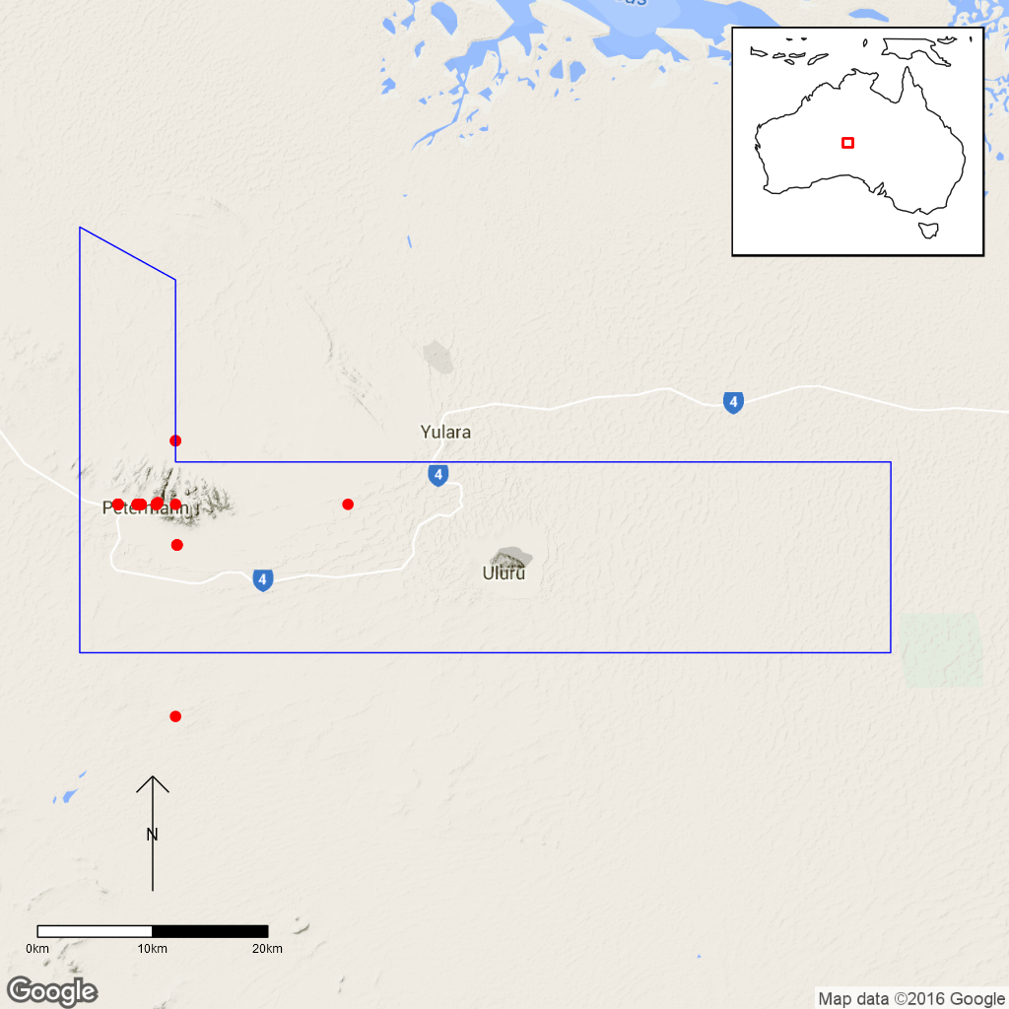
Figure B34.2 Distribution of Eriachne scleranthoides in Uluru Kata-Tjuta National Park.
Red dots are specimen collections, blue line is park boundary.

Ex-situ collections (Living and Seed Bank)
Seed collections are stored at Uluru-Kata Tjuta National Park (Uluru-Kata Tjuta National Park, 2015 unpubl. data) although the quantity and condition are unknown (K. Bennison pers. comm. 23 November 2015). Eriachne scleranthoides is not conserved in the Living Collection at the Australian National Botanic Gardens or in the National Seed Bank (M. Henery pers. comm. 5 November 2015). No other ex-situ collections in any other Botanic Garden or Seed Bank have been located (ASBP 2016).

Biology
Pollinators: The species is probably wind-pollinated, like the vast majority of grass species.
Symbiotic relationships: Unknown
Germination requirements: Unknown. Seed from the related species E. mucronata has physical dormancy when still enclosed in the spikelets. Following removal seed up to three year old seed germinates well on filter paper under 12 h night at 25°C and 12 h day at 35°C (Silcock et al. 1990). Seed older that three years do not germinate well (Silcock et al. 1990).
Dormancy class: Seed of the related species E. mucronata exhibit physical.
Flowering: Primarily in May and then from August–October (Lazarides et al. 2005).
Breeding system: Unknown.
Dispersal: Seed of related species E. helmsii, E. mucronata and E. pulchella were reported to be wind-dispersed (Jurado et al. 1991).
Longevity: Perennial. Other perennial Eriachne species were reported to live for <20 years (E. helmsii) and <50 years (E. mucronata, Jurado et al. 1991).
Life form: Grass
Ploidy levels: No chromosome counts of any Eriachne species are available.
Role of the plant in the environment: Eriachne scleranthoides grows on conglomerate monoliths, mostly on the seepage areas of scree slopes, at the base of domes as well as in chasms and crevices (Uluru-Kata Tjuta National Park 2015 unpubl. data). The substrate is shallow sand, gravel or shallow stony red soil (Lazarides et al. 2005). The species is susceptible to a fungal disease, Eriachne smut (Macalpinomyces eriachnes, Ustilaginaceae), that has been found on several other Eriachne species.

Threats

Listed threats
As Eriachne scleranthoides is not currently listed under Commonwealth or State Legislation threats to this species are unknown.

Other Threats/Potential New threats
- Genetic and demographic effects
- Climate related factors
- Invasive weed species
- Direct human impacts

Genetic and demographic effects
The small distribution area and moderately low numbers of individuals suggest that this species is vulnerable to loss through stochastic events such as fires and prolonged drought.

Climate-related factors
Although the species is well adapted to dry and hot conditions, an increase in the severity and length of droughts due to climate change (Hyder Consulting 2008) might affect the species in its exposed habitats. However, not enough is known to confirm this as a potential threat. Similarly, it is not known if fire is a threat to the species, since fire does not usually occur in E. scleranthoides habitat (Uluru-Kata Tjuta National Park 2015 unpubl. data). The threat of competition by invasive Buffel Grass (Cenchrus ciliaris) might increase with higher CO₂ concentrations associated with climate change (DNP 2012).

Invasive and other problematic species
Buffel Grass (Cenchrus ciliaris) is an invasive pasture grass that occurs in the area and has the ability to out-compete native plants. Invasion of Buffel Grass and other weeds are a potential threat to E. scleranthoides (Uluru-Kata Tjuta National Park 2015 unpubl. data). Infection with Eriachne smut may impair seed development but this has not been assessed.

Direct human impacts
Kata Tjuta is frequented by tourists and plants growing directly adjacent to footpaths can be affected by trampling (K. Bennison pers. comm. 23 November 2015).

Current management
Because of the high numbers of individuals found in the 2008 survey at Kata Tjuta, the species is not regularly surveyed. Weeds are removed from Walpa Gorge when present (Uluru-Kata Tjuta National Park 2015 unpubl. data).

Knowledge Gaps
Seed traits such as seed longevity and germination requirements might be similar to those in E. mucronata, but this could warrant further investigation. Longevity and ploidy level of the plants are not known.

Suggested research and actions
- Establish a monitoring program to provide ongoing data for determining population trajectories and the relative impacts of threatening processes.
- Undertake a fire response trial (K. Bennison pers. comm. 23 November 2015).
- Determine the appropriate conditions for long term storage and seed germination.
- Undertake a genetic assessment to determine if any genetic structure exists to assist with any future translocation program.

References
Australian Seed Bank Partnership (2016). Search for records in the Australian Seed Bank [Online]. Council of Heads of Australian Botanic Gardens Inc. Eriachne scleranthoides. Available from http://asbp.ala.org.au/search. Accessed 12 February 2016.
Council of Heads of Australasian Herbaria (CHAH) (2015). APC – Australian Plant Census. Available from http://biodiversity.org.au/nsl/services/apc. Accessed 28 October 2015.
Department of the Environment (DoE) (2015). Uluru-Kata Tjuta National Park – Science. Available from https://www.environment.gov.au‌/topics/national-parks/uluru-kata-tjuta-national-park/management-and-conservation/science. Accessed 3 November 2015.
Director of National Parks (DNP) (2010). Uluru-Kata Tjuta National Park Management Plan 2010–2020. Available from https://www.environment.‌gov.au/system/files/resources/f7d3c167-8bd1-470a-a502-ba222067e1ac/files/management-plan.pdf. Accessed 03 November 2015.
Director of National Parks (DNP) (2012). Uluru-Kata Tjuta National Park Climate Change Strategy 2012–2017. Department of Sustainability, Environment, Water, Population and Communities, Canberra.
Hyder Consulting (2008). The Impacts and Management Implications of Climate Change for the Australian Government’s Protected Areas. A report to the Department of the Environment, Water, Heritage and the Arts and the Department of Climate Change. Commonwealth of Australia, Canberra.
Jurado E, Westoby M, Nelson D (1991). Diaspore weight, dispersal, growth form and perenniality of Central Australian plants. Journal of Ecology 79: 811–830.
Lazarides M, van den Borre A, Weiller CM (2005). Eriachne. Flora of Australia 44B: 132–175.
Northern Territory Herbarium (2015). FloraNT Northern Territory Flora Online. Department of Land Resource Management. Available from http:‌//eflora.nt.gov.au. Accessed 28 October 2015.
Silcock RG, Williams LM, Smith FT (1990). Quality and storage characteristics of the seeds of important native pasture species in south-west Queensland. Australian Rangeland Journal 12: 14–20.
- Santalum acuminatum (Poaceae) – Desert Quandong, Uluru-Kata Tjuta National Park
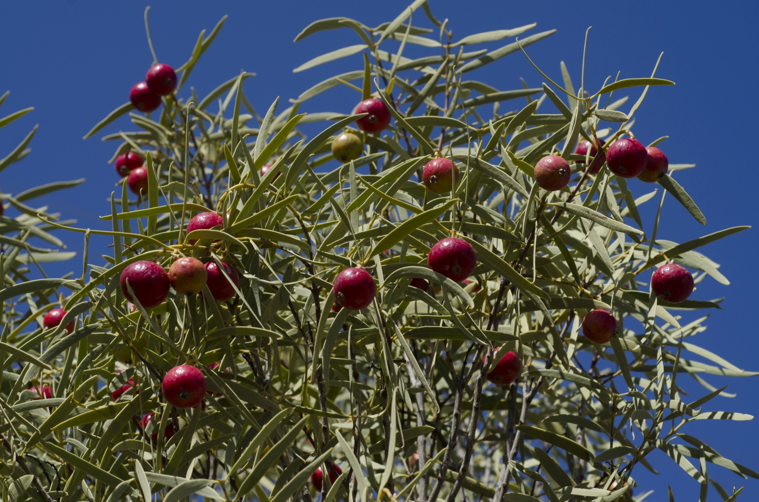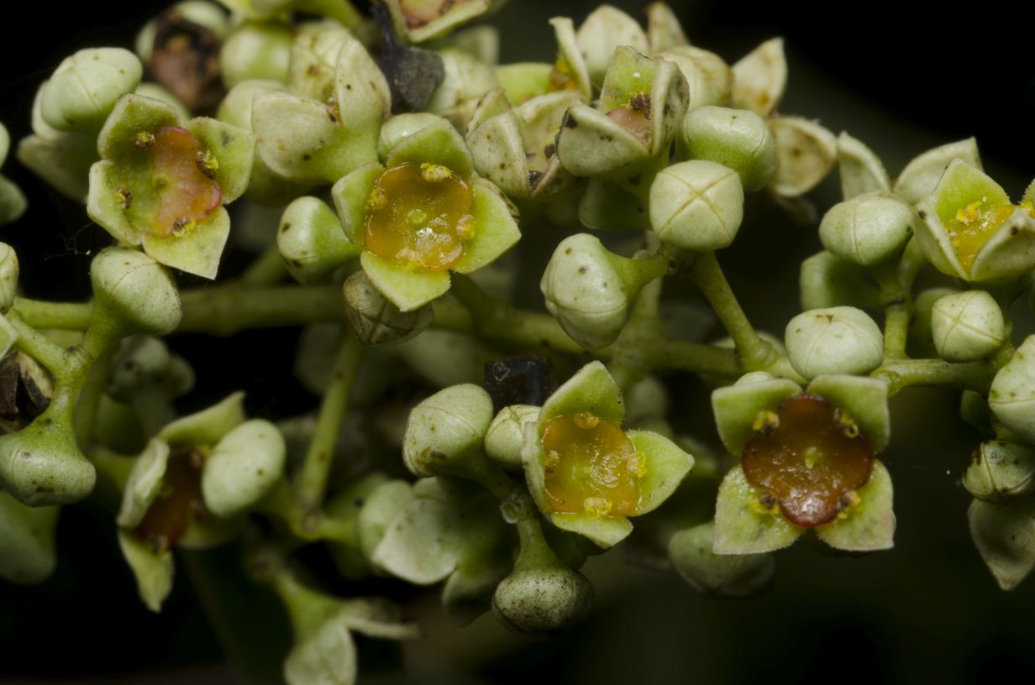
Figure B35.1 Santalum acuminatum at Gammon Ranges National Park, Flinders Ranges, South Australia. (left) and
Santalum acuminatum flowers (right), ©M. Fagg Australian National Botanic Gardens Photo No’s dig.32146 and dig.36540)
.
Santalum acuminatum is a shrub or small tree to 6 m high, with spreading to pendent branches. The leaves are lanceolate, often falcate, 3–9 cm long and 0.3–1.5 cm wide. The inflorescences are mostly terminal panicles and consist of numerous flowers. The tepals are ovate and 1–2 mm long. The fruit is a globose drupe, 15–25 mm long, red or rarely yellow and edible (The Royal Botanic Gardens and Domain Trust 30 October 2015).
Taxonomy: The name Santalum acuminatum (R.Br.) A.DC. is accepted in the Australian Plant Census (CHAH 2015, verified 30 October 2015).
Status: Listed as Vulnerable under the Northern Territory TPWC Act (Northern Territory Herbarium 2015).
Recovery Plan: A recovery plan does not exist.

Number of populations inside and outside parks and reserves
Santalum acuminatum is widespread throughout southern Australia. In the Northern Territory, it occurs in many locations south and west of Alice Springs. Populations also occur within in Uluru-Kata Tjuta National Park and Watarrka National Park (Nano et al. 2012). The plants conserved in Uluru-Kata Tjuta National Park are only a tiny fraction of the total population of this species.

Population size – range
Most populations in the Northern Territory are small with less than ten plants that are probably often part of one clone. The population in Watarrka National Park is the largest with more than 120 plants recorded in 2012 (Nano et al. 2012). In Uluru-Kata Tjuta National Park, most trees occur near buildings or residential areas. In 2011, only 13 wild individuals were known, and only seven of these were in a healthy condition. In 2014, ten wild S. acuminatum plants were left (Uluru-Kata Tjuta National Park 2015 unpubl. data).

Geographical distribution
Santalum acuminatum is common and widespread in Victoria, South Australia and south-western Western Australia. It also occurs in New South Wales and Queensland, and has the northernmost extent of its range in the Northern Territory (Nano et al. 2012).
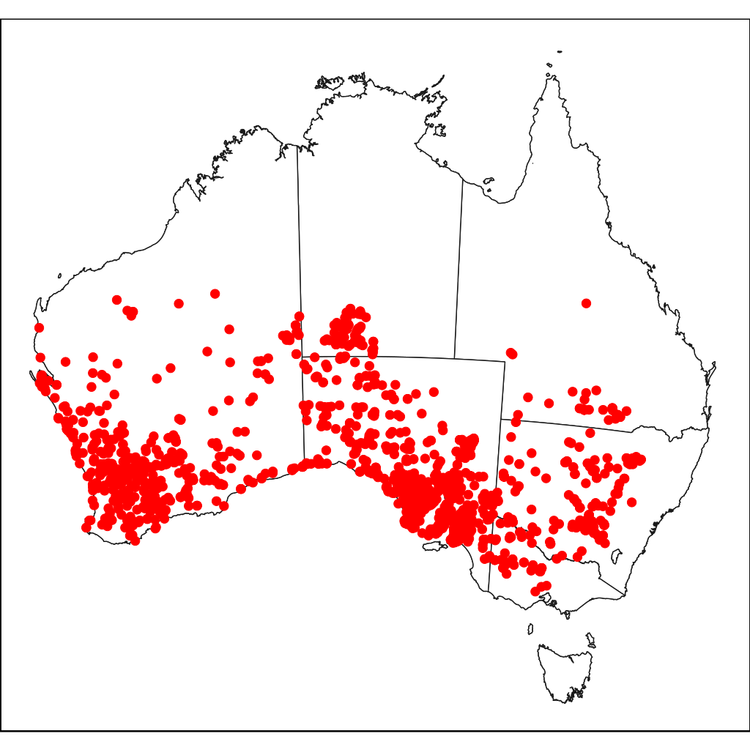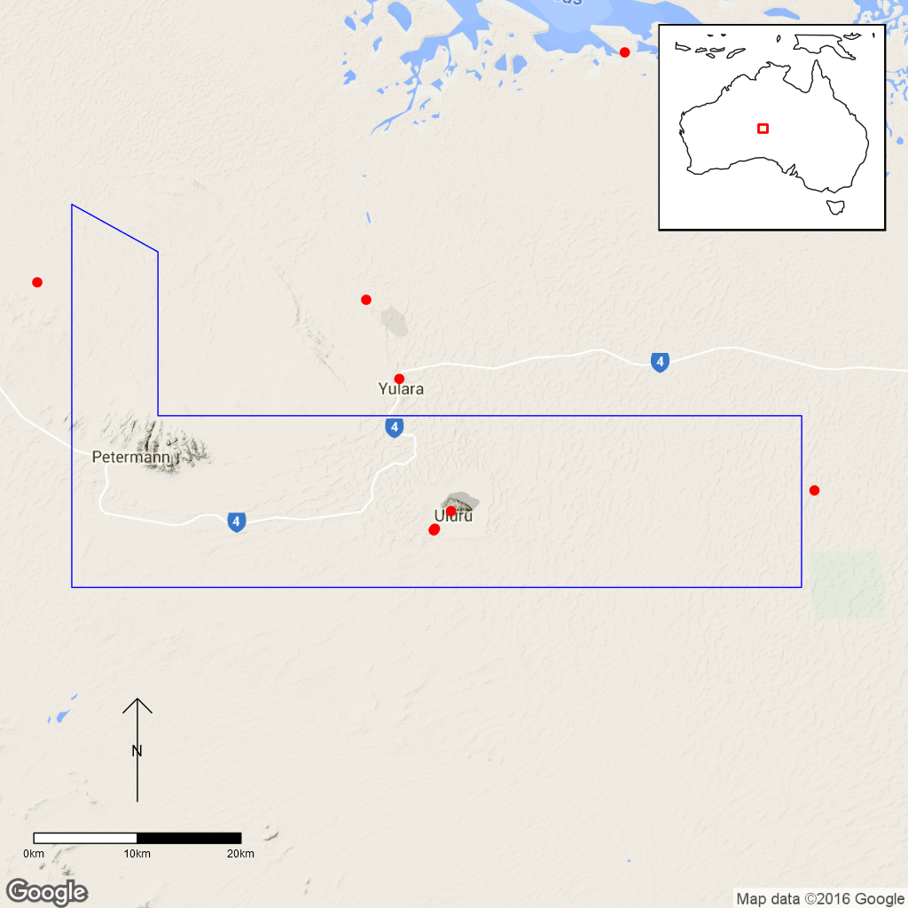
Figure B35.2 Australian distribution of Santalum acuminatum (left) and distribution of Santalum acuminatum in Uluru-Kata-Tjuta
National Park (right). Red dots indicate specimen collections, blue line is the park boundary.

Ex-situ collections (Living and Seed Bank)
Seed collections were made in 2011 and are stored in Uluru-Kata Tjuta National Park (Uluru-Kata Tjuta National Park, 2015, unpubl. data). The Australian National Botanic Gardens in Canberra have S. acuminatum plants in the Living Collection as well as several seed collections from Uluru-Kata-Tjuta National Park in the National Seed Bank (M. Henery pers. comm. 5 November 2015 and ASBP 2016). No other ex-situ collections taken from the national park have been located in any other Botanic Garden or Seed Bank (ASBP 2016).

Biology
Pollinators: Not known. Possible pollinators might be native bees or flies (K. Bennison, pers. comm. 23 November 2015). Bees, butterflies and beetles are known to pollinate the related species, S. album (Veerendra and Padmanabha 1996).
Symbiotic relationships: Unknown.
Germination requirements: To germinate fresh seed, gibberellin GA4 applied by vacuum filtration has been successful as has cracking the seed coat. Applying gibberellic acid by vacuum filtration also increases the germination rate of already cracked seed. Higher germination rates have been observed in older seed and can be enhanced by gibberellin GA4 (Loveys and Jusaitis 1994). In wild populations, seedling emergence and establishment are low (Nano et al. 2012).
Dormancy class: S. acuminatum seed has a hard seed coat and does not germinate readily. Abscisic acid is likely involved in the expression of dormancy. The seed do not survive high temperatures (Loveys and Jusaitis 1994).
Flowering: The species flowers predominantly from September–January (Nano et al., 2012), and fruits mostly in August–October (Nano et al. 2012), however, flowers and fruits have been found in most months (Northern Territory Herbarium 2015).
Breeding system: Santalum acuminatum is possibly self-compatible (Segley 1982). The related species, S. album, has been found to be predominantly outbreeding although selfing can occur (Veerendra and Padmanabha 1996).
Dispersal: The species can spread clonally by root/rhizome suckering with suckers up to 10 m long. It can also resprout strongly after fire although this response probably varies among populations and it is suggested that large adult trees are less able to resprout (Nano et al. 2012). The seed are most likely dispersed by emus (Nano et al. 2012) which swallow the fruit whole without damaging the seed (Calviño-Cancela et al. 2006).
Longevity: In cultivation, seedlings take at least four years to reach reproductive maturity (Nano et al. 2012). Basal resprouts in the wild take up to eight years to mature and have been reported to be fast-growing with a growth rate of about 25 cm per year (Nano and Schubert unpubl. data 2010 cited in Nano et al. 2012).
Life form: Shrub or tree.
Ploidy levels: The base chromosome number in Santalum is x=10 with four ploidy levels from diploid to octoploid recorded in the genus. All Santalum acuminatum specimens examined so far are diploid with 2n≈20 (Harbaugh 2008).
Role of the plant in the environment: Like most Santalaceae, S. acuminatum is hemiparasitic, extracting xylem sap from host plant species. The species can use a wide variety of host plants such as Acacia and Casuarina species, but also other shrubs and trees, and even herbs and grasses (Tennakoon et al. 1997). The species is found in dune swales, along creeks, on plains and low rises, only rarely growing on hills. It mostly occurs on sandy and loamy soils on limestone or sandstone. The soils can be relatively shallow (Nano et al. 2012).

Threats

Listed Threats (Northern Territory TPWC Act)
- Suspected past and future population reduction where causes have not ceased based on
  - Direct observation.
  - Decline in Area of Occupancy and Extent of Occurrence and habitat quality (weed invasion, fire and camels).
  - Exploitation due to wood harvesting.
- Effects of introduced taxa (viz. Buffel Grass and camels).
- Small population size (<10,000 mature individuals) and continuing decline of at least ten percent in ten years or three generations.
- <1,000 mature individuals in each subpopulation.

Genetic and demographic effects
The very small population that exists in Uluru-Kata Tjuta National Park is susceptible to inbreeding and ongoing genetic decline and any loss of plants through grazing by camels and/or severe fires will further erode genetic diversity. It is also vulnerable to stochastic loss.

Invasive and other problematic species
Invasive weeds, especially Buffel Grass (Cenchrus ciliaris), can lead to a diminished habitat quality. Buffel Grass invasion was identified as a threat to some plants in surveys of wild S. acuminatum in Uluru-Kata Tjuta National Park (Uluru-Kata Tjuta National Park 2015 unpubl. data).
Camels eat S. acuminatum leaves, tear off branches and destroy seedlings, resprouting plants and even adults. Rabbits also feed on S. acuminatum (Nano et al. 2012, Uluru-Kata Tjuta National Park 2015 unpubl. data). Camels are a known threat to plants in Uluru-Kata Tjuta National Park with surveyed plants being damaged by camel grazing. This damage can impact on plant health and lead to a cessation of flowering (Uluru-Kata Tjuta National Park 2015 unpubl. data).
Santalum acuminatum appears to be more readily colonised by mistletoes (Loranthaceae) than other woody species in the area (K. Bennison pers. comm. 23 November 2015). Infestation by mistletoes could be another factor reducing the fitness of S. acuminatum individuals.

Climate-related factors
Shorter plants may be vulnerable to the effects of grass fires and also produce fewer seed. Fire is therefore seen as a threat to S. acuminatum (Nano et al. 2012). Inappropriate fire regimes can damage plants, for example, one surveyed plant in Uluru-Kata Tjuta National Park was severely burned in a protection burn and died as a result. A few other individuals also show signs of fire damage (Uluru-Kata Tjuta National Park 2015 unpubl. data). In a study set in south Western Australia, it was reported that whole clones died after particularly intense fires (Tennakoon et al. 1997). The risk of frequent and severe fire is predicted to increase with climate change, as a result of higher temperatures and possible higher fuel loads (DNP 2012).
Surveys in Uluru-Kata Tjuta National Park found that S. acuminatum plants drop leaves during times of low rainfall and do not flower or produce fruit (Uluru-Kata Tjuta National Park 2015 unpubl. data).

Direct human impacts
Santalum acuminatum plants have sometimes been cut to harvest the wood for carving (Nano et al. 2012).

Current management
The Santalum acuminatum plants in Uluru-Kata Tjuta National Park are regularly surveyed. The first seed germination trials with over 100 seeds only produced two seedlings so collected seed is being stored until better germination methods are developed (Uluru-Kata Tjuta National Park 2015 unpubl. data). There are measures in place to restrict wood harvesting for carving (T. Guest pers. comm., cited in Nano et al. 2012). Fire management, erosion control and invasive species control are undertaken in Uluru-Kata Tjuta National Park (DoE 2015).

Knowledge Gaps
The genetic diversity of individual populations and the genetic variation between populations are not known. It is also unclear whether the species is self-compatible. Further research is also required into the species’ preferred and, other possible host plants and their influence on S. acuminatum (e.g. differences in growth, cf. Radomiljac et al. 1999 for S. album), including how well the species grows without a host.

Suggested research and actions
- Develop and implement a restoration program to increase population numbers and/or sizes.
- Determine the appropriate conditions for long term storage and seed germination.
- Undertake a genetic assessment to determine the reproductive strategy, levels of genetic diversity and inbreeding to assist with any future translocation program.

References
Australian Seed Bank Partnership (2016). Search for records in the Australian Seed Bank [Online]. Council of Heads of Australian Botanic Gardens Inc. Santalum acuminatum. Available from http://asbp.ala.org.au/search. Accessed 12 February 2016.
Calviño-Cancela M, Dunn RR, van Etten EJB, Lamont BB (2006). Emus as non-standard seed dispersers and their potential for long-distance dispersal. Ecography 29: 632–640.
Council of Heads of Australasian Herbaria (CHAH) (2015). Australian Plant Census. [Online]. Available from http://biodiversity.org.au/nsl/services/apc. Accessed 3 November 2015.
Department of the Environment (DoE) (2015). Uluru-Kata Tjuta National Park – Science. Available from https://www.environment.‌gov.au/topics‌/national-parks/uluru-kata-tjuta-national-park/management-and-conservation/science. Accessed 3 November 2015.
Director of National Parks (DNP) (2010). Uluru-Kata Tjuta National Park Management Plan 2010–2020. Available from https:‌//www‌.environment.gov.au/system/files/resources/f7d3c167-8bd1-470a-a502-ba222067e1ac/files/management-plan.pdf. Accessed 3 November 2015.
Director of National Parks (DNP) (2012). Uluru-Kata Tjuta National Park Climate Change Strategy 2012–2017. Department of Sustainability, Environment, Water, Population and Communities, Canberra.
Fountain M, Macfayden A, Papworth N, Cane J (1999). ‘Weeds By Nature’: The plants of Macquarie Island. In Bishop, AC., Boersma, M., Barnes, CD. 12th Australian Weeds Conference proceedings – weed management into the 21st Century: do we know where we’re going? Tasmanian Weed Society, Hobart.
Harbaugh DT (2008). Polyploid and hybrid origins of Pacific island Sandalwoods (Santalum, Santalaceae) inferred from low-copy nuclear and flow cytometry data. International Journal of Plant Sciences 169(5): 677–685.
Loveys BR and Jusaitis M (1994). Stimulation of germination of Quandong (Santalum acuminatum) and other Australian native plant seeds. Australian Journal of Botany 42: 565–674.
Nano C, Kerrigan R, Albrecht D, Latz P (2012). Santalum acuminatum. Threatened species of the Northern Territory information sheet. Department of Land Resource Management, Northern Territory Government, Darwin.
Northern Territory Herbarium (2015). FloraNT Northern Territory Flora Online. Department of Land Resource Management. Available from http://eflora.nt.gov.au. Accessed 28 October 2015.
Radomiljac AM, McComb JA, McGrath JF (1999). Intermediate host influences on the root hemiparasite Santalum album L. biomass partitioning. Forest Ecology and Management 113: 143–153.
Segley M (1982). Floral anatomy and pollen tube growth in the Quandong (Santalum acuminatum (R.Br.) A.DC.). Australian Journal of Botany 30: 601–609.
Tennakoon KU, Pate JS, Arthur D (1997). Ecophysiological aspects of the woody root hemiparasite Santalum acuminatum (R.Br.) A.DC. and its common hosts in south Western Australia. Annals of Botany 80: 245–256.
The Royal Botanic Gardens and Domain Trust (30 /10/2015). Santalum acuminatum in PlantNET – the Plant Information Network System of the Royal Botanic Gardens and Domain Trust, Sydney, Australia. Available from http://plantnet.rbgsyd.nsw.gov.au. Accessed 3 November 2015.
Veerendra HC and Padmanabha HS (1996). The breeding system in sandal (Santalum album L.). Silvae Genetica 4: 188–190.

Gap analysis for individual species
National Park | Species | Common Name | Life form | Pollinators | Symbiosis | Germination | Dormancy | Flowering time | Clonality | Reproductive Strategy | Dispersal | Longevity | Polyploidy | Genetic diversity
BNP | Cryptostylis hunteriana | Leafless Tongue Orchid | Orchid
 | Dracophyllum oceanicum |  | Shrub
 | Galium australe | Tangled Bedstraw | Herb
 | Syzygium paniculatum | Magenta Lilly Pilly | Tree
 | Zieria arborescens subsp. decurrens |  | Shrub
CINP | Asplenium listeri | Christmas Island Spleenwort | Fern | N/A |  |  | N/A | N/A
 | Asystasia alba |  | Herb
 | Dicliptera maclearii |  | Herb
 | Grewia insularis |  | Vine
 | Pneumatopteris truncata |  | Fern | N/A |  |  | N/A | N/A
 | Tectaria devexa var. minor |  | Fern | N/A |  |  | N/A | N/A
KNP | Acacia equisetifolia |  | Shrub
 | Hibbertia brennanii |  | Shrub
 | Hibbertia pancerea |  | Shrub
 | Hibbertia tricornis |  | Shrub
 | Hibiscus brennanii |  | Shrub
 | Jacksonia divisa |  | Shrub
 | Lithomyrtus linariifolia |  | Shrub
Key
 | Good information
 | Some information
 | Inferred
 | No information
National Park | Species | Common Name | Life form | Pollinators | Symbiosis | Germination | Dormancy | Flowering time | Clonality | Reproductive Strategy | Dispersal | Longevity | Polyploidy | Genetic diversity
NINP | Abutilon julianae | Norfolk Island Abutilon | Shrub
 | Anthosachne kingiana subsp. kingiana | Phillip Island Wheat Grass | Grass
 | Boehmeria australis var. australis | Tree Nettle | Shrub/small Tree
 | Calystegia affinis |  | Creeper
 | Clematis dubia | Clematis | Creeper
 | Coprosma baueri | Coastal Coprosma | Shrub
 | Coprosma pilosa | Mountain Coprosoma | Shrub/small Tree
 | Cordyline obtecta | Ti | Shrub/ Tree
 | Elatostema montanum | Mountain Procris | Herb
 | Hibiscus insularis | Phillip Island Hibiscus | Shrub/small Tree
 | Ileostylus micranthus | Mistletoe | Epiphytic mistletoe
 | Melicytus latifolius | Norfolk Island Mahoe | Small Tree
 | Myoporum obscurum | Popwood | Tree
 | Plexaure limenophylax |  | Orchid
 | Senecio australis |  | Herb
 | Senecio evansianus |  | Herb
 | Senecio hooglandii |  | Herb
 | Streblus pendulinus | Siah's Backbone | Shrub/small Tree
 | Wikstroemia australis | Kurrajong | Tree
Key
 | Good information
 | Some information
 | Inferred
 | No information
National Park | Species | Common Name | Life form | Pollinators | Symbiosis | Germination | Dormancy | Flowering time | Clonality | Reproductive Strategy | Dispersal | Longevity | Polyploidy | Genetic diversity
UKTNP | Eremophila alternifolia | Narrow-leaved emu bush | Shrub
 | Eriachne scleranthoides |  | Grass
 | Santalum acuminatum | Native peach | Tree
Key
 | Good information
 | Some information
 | Inferred
 | No information

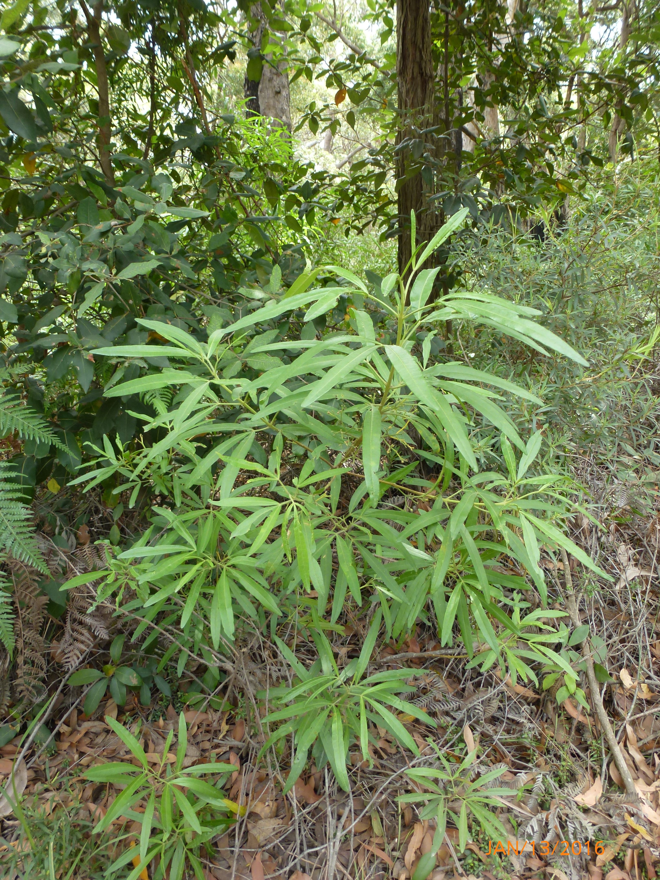
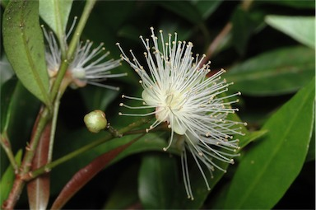
For further information

National Research Collections Australia
Dr Linda Broadhurst
t +61 2 62646 4988
e Linda.Broadhurst@csiro.au

