# C:\Users\A15617\AppData\Local\Microsoft\Windows\Temporary Internet Files\Content.Outlook\11P2B3SX\7405 Environment - NationalLandcareProgramme logo_FINAL.JPG

# NATIONAL LANDCARE PROGRAMME – *outcomes of community consultation*

## 1. Overview

Under the National Landcare Programme, $454 million over four years will be delivered through the 56 regional natural resource management (NRM) organisations across the country. To inform the design and delivery of the Regional Stream, the Australian Government ran a public consultation process to seek feedback from the community on the following topics:

* Partnering with the natural resource management community, including landcare
* Facilitating landcare
* Community engagement in regional natural resource management planning and delivery
* Organisational performance expectations
* Simplified administrative processes
* Simplified reporting.

The consultation process was undertaken in two parts: 19 community information sessions held across the country in late August and early September 2014, and an online consultation survey.

Targeted consultation sessions with agricultural industries were also held to help fine-tune the Regional Stream of the National Landcare Programme. These were designed to elicit industry views on topics such as emerging natural resource management issues and how to develop better government-industry-NRM partnerships.

**2. Breakdown of respondents**

Over 600 people attended the 19 National Landcare Programme community information sessions held in every capital city and a number of regional centres across the country.   
Twenty-seven industry representatives provided input to the industry consultation sessions. A further 7 written submissions were provided.

The National Landcare Programme consultation survey received 333 submissions overall:   
45 per cent of submissions were from organisations and 55 per cent from individuals.

***Individuals***

Respondents to the survey were asked to select from a list of groups they identified with. Options included: regional NRM organisation; Landcare Network; Indigenous community group; local landcare group; farming/agriculture community group; environment community group; individual land manager; peak industry body; local, state or federal government; and NGO.

***Over 60 per cent of all individual respondents belonged to a local landcare group or Landcare Network.***

**Approximately 30 per cent of individuals identified as belonging to a farming or agriculture group.**

**Approximately 36 per cent of individuals identified as belonging to an environment group.**

**Over 80 per cent of land manager respondents identified as a member of a local landcare group.**

**Relative to their role and significance in NRM, major landholders such as Indigenous Australians and individual land managers were an underrepresented stakeholder group at 2 per cent and 7 per cent of individual respondents respectively.**

***Organisations***

The majority of responses by organisations were from local landcare groups and regional NRM organisations. A breakdown of responses from different sectors is shown below. The figures in the pie charts below represent online submissions only and do not include submissions that were submitted informally.

***Distribution of respondents across Australia***

A representative number of responses were received from each state and territory.

**3. Messages by stakeholder groups**

A number of common messages, for how to improve natural resource management delivery and outcomes, were identified from the feedback for each stakeholder group. These are summarised in the diagram below.

**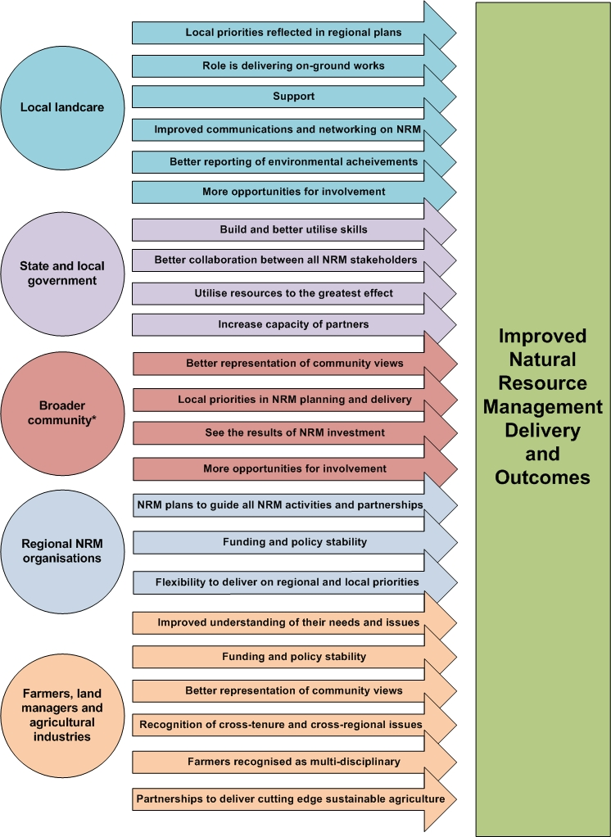**

**\*** The broader community refers to all individuals and organisations who did not identify with one of the specified groups above, including NGO’s, peak industry bodies, environment groups and those individuals who identified as belonging to an environment community group.

**4. Key themes and Australian Government response**

The common messages were analysed and five key themes were identified. The tables below present the key themes, with some examples of the feedback provided and how the design of the Regional Stream has been improved to address the feedback.

***Local agenda and community engagement***

| **Feedback** | **Design Improvements** |
| --- | --- |
| * The community needs to have a ‘seat at the table’ and a voice in regional NRM. Participatory approaches to NRM planning and prioritisation are important so that “everyone is on the same page” and working towards agreed priorities. Not only does this promote collaborations and community engagement, but can also maximise environmental outcomes. * There needs to be sufficient flexibility to deliver against local and regional priorities determined with the community. * Long-term funding and projects are needed to get the community ‘on board’ and to achieve meaningful sustainable agriculture and environmental outcomes given the nature of NRM issues. * It is important to share local stories of NRM and sustainable agricultural achievements so that the efforts of landcare and other groups are acknowledged, valued and supported by the community. * Decision-making for regional investment should be transparent. | * There will be an increased focus on local community engagement in the delivery and prioritisation of activities, including a requirement that regional NRM organisations report on their performance in community engagement. * Regional NRM organisations will have greater autonomy in setting and delivering on their regional and local priorities with the community and agricultural industries. With this they will be accountable for NRM outcomes and ensuring appropriate local industry and landcare community participation. * NRM investment decisions will be aligned with regional NRM plans that have community and agricultural industry support and a strong scientific basis and provide a strategic basis for investment under the National Landcare Programme. * Through the MERIT online reporting tool, regional NRM organisations will report progress against project outcomes, including the NRM community’s participation in the planning and delivery of projects. The community will be able to view information about the progress of projects funded through the Regional Stream. Regional NRM organisations will be able to share information on their Regional Stream delivery, such as attaching their regional NRM plans, promoting events and good news stories using the ‘news and events’ function. * To ensure there is a local voice in the National Landcare Programme, the newly established National Landcare Advisory Committee has been formed to directly advise Ministers on matters such as landcare investment priorities, implementation and whether the National Landcare Programme is meeting its objectives. The committee is made up of members with skills and expertise in areas such as land management, community leadership, project development, agriculture, Indigenous affairs, accounting and finance. |

***Effective natural resource management settings***

| **Feedback** | **Design Improvements** |
| --- | --- |
| * Shifting policy and funding instability has led to change apathy and disengagement in some communities. There is a need for funding stability and consistent policy priorities to engage the community and achieve meaningful NRM outcomes. * Retention of skilled, local NRM staff in regional NRM organisations and landcare groups is essential for effective community engagement and maintaining progress towards NRM outcomes. | * Long-term funding will be available to regional NRM organisations through multi-year contracts that provide surety of investment. This will enable them to maintain regional infrastructure for NRM planning and delivery and retain key staff, including a Regional Landcare Facilitator. |

***Collaborations***

| **Feedback** | **Design Improvements** |
| --- | --- |
| * Stakeholders have different capacity issues, interests, skills and experience. There are many opportunities for improved collaboration, sustainable agriculture and environmental outcomes can be enhanced by better utilising the respective skills, resources and capacity of NRM stakeholders in regional delivery. However, improvements are needed in the way that NRM stakeholders communicate and work together at a local and regional scale. * Greater Indigenous engagement in NRM planning and delivery is important for the NRM community but it needs to go beyond ‘consultation’ to be meaningful. Mechanisms may include: Indigenous advisory groups and Indigenous membership on NRM boards. * Regional NRM organisations could be important brokers and facilitators – building networks, supporting and coordinating on-ground works, sharing information and building capacity. This role needs developing, including through better linkages with industry and RDC’s. * Facilitator roles are important for engaging and supporting the community and local groups, building partnerships and establishing or maintaining networks. | * Regional NRM organisations will have greater flexibility and autonomy in setting priorities with the community and delivering against their NRM plans. This will allow them to expand how they initiate, develop and support collaborations. * Regional NRM organisations will be required to maintain a Regional Landcare Facilitator to build community capacity for sustainable agriculture and environmental management and provide a conduit of information for stakeholders to support Landcare and production groups adopt sustainable farm and land management practices to protect Australia’s landscapes. * Regional NRM organisations have a central role in supporting Indigenous people and organisations to participate in the delivery of NRM and contribute to wider economic and social benefits. They can achieve progress in this area through activities such as planning support, utilising and respecting Indigenous ecological knowledge, capacity building and the delivery of on-ground activities including employment and contracting opportunities. * The National Landcare Advisory Committee includes a prominent Indigenous representative. * Regional NRM organisations are expected to involve Indigenous people in both the planning and delivery of all National Landcare Programme investment. This will ensure that Indigenous engagement and participation features strongly as an investment, project and employment outcome for the National Landcare Programme. Regional NRM organisations should investigate and identify opportunities in conjunction with Indigenous communities and either include these as a part of their projects or provide a satisfactory reason for not doing so. |

***Supporting local delivery***

| **Feedback** | **Design Improvements** |
| --- | --- |
| * Direct funding to community, including landcare and farming groups, is important. It allows groups to do what they do best – deliver on-ground works that engage, and are meaningful to, the community. * Volunteer ‘burn out’ is a constant challenge and Landcare and other community groups and individuals need support to effectively deliver on-ground works and to contribute to regional NRM planning and delivery. This may include access to information, funding, other resources, as well as capacity building. | * Under the Regional Stream, regional NRM organisations will be required to invest a minimum of 20% of their annual regional allocations in projects delivered by, or directly engage with, the community. * The Australian Government has committed $1 million per annum for state, territory and national Landcare networks to build network capacity, share knowledge and deliver projects, involve groups in Australian Government programmes and strengthen links between NRM organisations and Landcare networks. * Under the 25th Anniversary Landcare Grants 2014‑15, a total of up to $5 million (GST exclusive) will be available in 2014-15 for community groups to undertake local projects that contribute to environmental or NRM outcomes in the national interest. * The Green Army is a separate, but complementary programme to the National Landcare Programme. It will provide 17-24 year olds with valuable NRM experience and an opportunity to work alongside and learn from experienced NRM practitioners, including the landcare community - helping to develop the next generation of landcarers. |

***Performance and reporting***

| **Feedback** | **Design Improvements** |
| --- | --- |
| * Reporting and application processes should be as simple as possible but it is essential to capture practice change and environmental outcomes to measure change and assess the efficacy of NRM interventions. Capturing outcomes is also essential for promoting the ‘value’ of NRM investment and engaging the community. * The performance of an NRM organisation should be measured against their ability to: achieve measurable, on-ground environmental and sustainable agriculture outcomes; engage the community; effect practice change to achieve natural resource outcomes; and increase awareness. These should be articulated in NRM plans and reported in a way that the community can see progress. * Independent checks, audits and environmental monitoring are important. | * Regional NRM organisations will be accountable for delivering outcomes in the national interest based on priorities arising from their regional NRM plans. * A set of clear and auditable performance expectations will be established, with both project and organisational performance indicators and an emphasis on assessing the strength of community engagement. The performance expectations will be a key quality assurance and risk management tool for the programme. * Regional NRM organisations will undertake an annual self assessment of their capacity against the performance expectations of: * financial governance; * organisational governance; * regional NRM planning; * community engagement; and * monitoring and reporting. * Regional NRM organisations are encouraged to consult with their stakeholders in undertaking their self-assessment. Best practice would be to consult widely in completing the self-assessment. * A rolling programme of detailed reviews will be implemented by the Australian Government, including testing the self assessment with third parties. * Reporting under the Regional Stream will be simpler and more streamlined. Regional NRM organisations will use the MERIT online reporting tool to report environmental and natural resource management data, information and project achievements. The Australian Government will closely monitor reporting and ensure strong compliance. |

**5. Outcomes from the consultation**

The Australian Government received considerable input to the National Landcare Programme public consultation. This feedback has significantly informed the design of the Regional Stream of the Programme and instigated a number of positive reforms to strengthen the Programme and put landcare back at the centre of land management.

Regional NRM organisations will continue to be key delivery agents for regional investment under the National Landcare Programme. Although there are always improvements to be made, these organisations are instrumental to sustainably managing Australian landscapes and conserving our natural assets. They are also central to the NRM infrastructure; bringing the NRM community together, working across governments and creating links with industry. Importantly too, they will provide essential support to local efforts; informing landholders of sustainable land management, building capacity of local landcare and other community groups, supporting partnerships and networks and sharing lessons learned.

The reforms to the Regional Stream of the National Landcare Programme will continue the journey to building a best practice NRM sector.