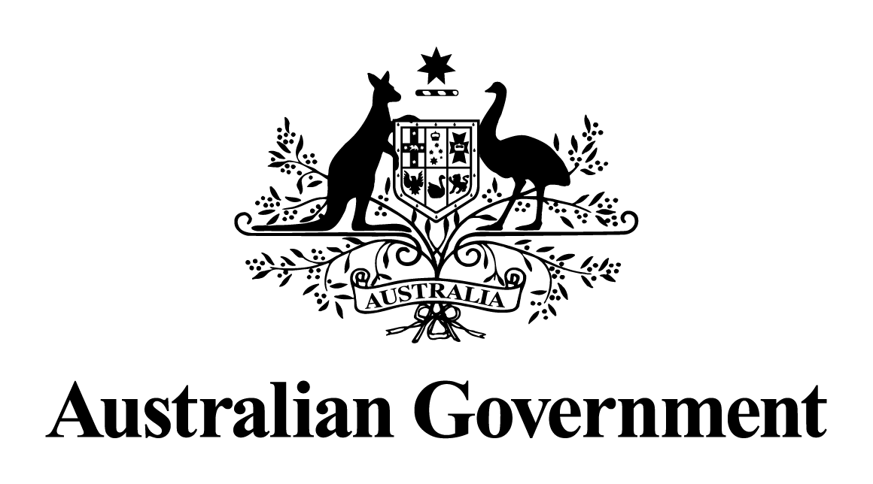

Australian Government response to the   
Senate Environment and Communications References Committee report:

Operation of the South Australian and Northern Territory container deposit schemes

JUne 2013

**CONTEXT**

On 11 October 2012 the Senate referred an inquiry on the operation of the South Australian and Northern Territory container deposit schemes to the Senate Environment and Communications References Committee. The Senate Committee was to have particular reference to:

The pricing and revenue allocation practices of the beverage industry in the container deposit schemes operating in South Australia and the Northern Territory, including:

1. management of the operation of container deposit schemes in South Australia and the Northern Territory;
2. the cost structure of the beverage industry's involvement in these container deposit schemes;
3. the use of unredeemed deposits and unused handling and transport fees;
4. alternative scheme structures which ensure beverage producers cannot pass on unreasonable costs from these recycling schemes if such schemes are implemented in additional states or nationally;
5. structures to ensure schemes managed under the Product Stewardship Act 2011 do not result in producers passing on unreasonable costs; and
6. Any other related matters.

The Senate Environment and Communications References Committee tabled its report, *Operation of the South Australian and Northern Territory container deposit schemes* on 22 November 2012. The report outlines six recommendations; two directed at the Council of Australian Governments (COAG) Packaging Impacts Decision Regulation Impact Statement (RIS) process, two directed at state and territory governments should they decide to introduce their own container deposit schemes, and two directed at the South Australian and Northern Territory governments relating to the operation of their schemes. The inquiry also produced a dissenting report by Senator Xenophon and Senator Whish-Wilson which contained three recommendations.

**INTRODUCTION**

The management of waste is primarily the responsibility of state, territory, and local governments. The role of the Australian Government in this area has evolved in the past few years, a particular focus of which has been harmonising national approaches to waste management through forums such as the COAG Standing Council on Environment and Water (SCEW) (previously known as the Environment Protection and Heritage Council (EPHC)). Through SCEW Australia’s environment ministers endorsed the *National Waste Policy* which provides a coherent, efficient, and environmentally responsible approach to waste management in Australia. At the EPHC meeting on 5 July 2010 the Packaging Impacts Regulation Impact Statement process was announced which addressed Strategy Three of the National Waste Policy:

“The Australian Government, in collaboration with state and territory governments, industry and the community will better manage packaging to improve the use of resources, reduce the environmental impacts of packaging design, enhance away-from-home recycling and reduce litter (EPHC 2009, p. 10).”

The Packaging Impacts Consultation RIS was released on 7 December 2011 and provided a three month consultation period (closed on 30 March 2012) for interested parties and individuals to contribute comments and feedback. There were also public forums organised in all capital cities across Australia, along with three regional areas. Hundreds of submissions from individuals, industry, environmental groups, and local governments were received.

At the SCEW meeting on 24 August 2012 Australia’s environment ministers agreed to move ahead with a Decision RIS. The Decision RIS will further analyse the seven options from the Consultation RIS, as well as three new options based on feedback from consultation from the Consultation RIS including: a container deposit scheme based on the model that is operating in South Australia, and two additional co-regulatory product stewardship options.

The Decision RIS will be presented to Australia’s environment ministers for consideration on the best approach to harmonised action across Australia from all levels of government.

**RESPONSE TO RECOMMENDATIONS**

**Recommendation 1**

**3.36 The committee recommends that should a national container deposit scheme be agreed to and implemented through the COAG process, steps similar to those used during the GST and carbon pricing policies be taken to ensure it is not used as a justification for price rises beyond those warranted by the scheme.**

**Commonwealth Position:** Noted

The Commonwealth notes the recommendation of the committee which relate to issues currently under consideration by the Standing Council of Environment and Water through development of the Packaging Impacts Decision Regulation Impact Statement (RIS). The Packaging Impacts Decision RIS process is a Council of Australian Governments process involving state, territory, and local governments, as well as the Commonwealth.

**Recommendation 2**

**3.37 The committee recommends that should any other state implement a container deposit scheme, they be mindful of taking steps to ensure it is not used as a justification for price rises beyond those warranted by the scheme.**

**Commonwealth Position:** Noted

This is a matter for state and territory governments.

**Recommendation 3**

**3.72 The committee recommends that should a national container deposit scheme be agreed to and implemented through the COAG processes, there should be appropriate measures to ensure transparency in estimating and reporting return rates for various products and appropriate measures to assist in dispute resolution between any beverage manufacturers and super collectors.**

**Commonwealth Position:** Noted

The Commonwealth notes the recommendation of the committee which relate to issues currently under consideration by the Standing Council of Environment and Water through development of the Packaging Impacts Decision Regulation Impact Statement (RIS). The Packaging Impacts Decision RIS process is a Council of Australian Governments process involving state, territory, and local governments, as well as the Commonwealth.

**Recommendation 4**

**3.73 The committee recommends that should any other state implement a container deposit scheme, they be mindful of implementing appropriate measures to ensure transparency in estimating and reporting return rates for various products and appropriate measures to assist in dispute resolution between any beverage manufacturers and super collectors.**

**Commonwealth Position:** Noted

This is a matter for state and territory governments.

**Recommendation 5**

**3.74 The committee recommends that the South Australian and Northern Territory governments should review their schemes to ensure confidence in estimating and reporting return rates for various products and that appropriate measures are in place to assist in dispute resolution between any beverage manufacturers and super collectors.**

**Commonwealth Position:** Noted

This is a matter for state and territory governments.

**Recommendation 6**

**3.80 The committee recommends that the South Australian and Northern Territory governments give consideration to removing products that are sold in containers less than 100 millilitres and that need to be kept refrigerated from being included in their container deposit schemes.**

**Commonwealth Position:** Noted

This is a matter for state and territory governments.

**RESPONSE TO DISSENTING RECOMMENDATIONS**

**1. The committee should initially request and if necessary compel beverage companies to provide in-confidence time series information (over a period of 18 months) on wholesale prices in South Australia and the Northern Territory and a non CDL state as a comparison.**

**2. The committee should also request and if necessary compel the ‘super collectors’ to provide in-confidence information on their annual profits, including a breakdown by state.**

**Commonwealth Position:** Not supported

The Commonwealth notes that beverage companies and ‘super-collectors’ participated in this Senate Inquiry through both written submissions and oral evidence at the public hearing.

**3. If a national container deposit scheme is established or any other state introduces a container deposit scheme, evidence from this inquiry – relating to the existence of inefficiencies and profiteering -suggests that serious consideration should be given to excluding beverage companies from involvement with future super collection operations (ie co-ordinator roles).**

**Commonwealth Position:** Noted

The Commonwealth notes the recommendation relates to issues currently under consideration by the Standing Council of Environment and Water through development of the Packaging Impacts Decision Regulation Impact Statement (RIS). The Packaging Impacts Decision RIS process is a Council of Australian Governments process involving state, territory, and local governments, as well as the Commonwealth.