

REFERENCE

# Plant Exports Management System (PEMS) Authorised officer user guide – Grain and Plant Product Inspections

**In this document**

This document contains the following topics.

Purpose of this document 3

Initiating the Grain and Plant Product inspection 3

Grain and Plant Product Inspection page 5

Opening the Request for Permit (RFP) details 6

Returning to the inspection page 7

Recording additional declarations 8

Edit Exporter name (*if applicable*) 10

Recording reinspection of a consignment 11

Verifying import permit details 11

Verifying treatment details 12

Recording flow path inspection results 13

Changing outcome type details 17

Selecting sampling rate 20

Sampling type for hay and straw inspections 21

Splitting lines on the inspection record 22

Recording inspection results for Grain and Plant Products 24

Navigating between line inspection windows 27

Checking container approvals in PEMS 28

Revoking container approval status 30

Completing and submitting the inspection record 32

Expiration date of Grain and Plant Product inspection 35

Appendix 1: Logs 36

Completing and submitting the inspection record 41

Related material 42

Contact information 42

Document information 43

Version history 43

## Purpose of this document

This reference outlines how to use PEMS to record Grain and Plant Product Inspections.

**Note:** An overview of PEMS and general functions can be found in the Reference: *Plant Exports Management System (PEMS) Authorised Officer User Guide – Overview and general functions*.

### Initiating the Grain and Plant Product inspection

To initiate a Grain and Plant Product inspection, click on the **Home1** PEMS menu tab and then click the **Grain and Plant Product inspection2** button.

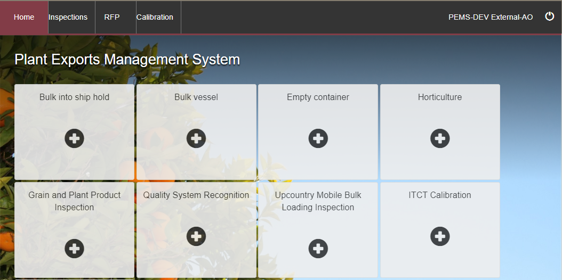

**1**

**2**

The *Create Grain and Plant Product* *Inspection* window will display.

Enter the **RFP number1**. The RFP number should be 7 digits long.

Enter the **Establishment number2** (mandatory for third party AOs). The establishment number should be 3 to 4 digits long.

Click **Create3**.

**3**

**2**

**4**

**1**



Where a change is made to the RFP in EXDOC, you can select the **Reload RFP from EXDOC4** checkbox to update the relevant inspection record in PEMS. For more information see Section 4.1 Reload RFP from EXDOCof*Reference: PEMS AO user guide – Overview and General Functions**.*

.

PEMS extracts RFP information from EXDOC to populate the *Grain and Plant Product* *Inspection* page. The inspection page will display by default.

****The inspection record will remain **Active1** until the record is withdrawn, submitted or cancelled.

While the inspection record is active, the date provided on the inspection record is the date the inspection record was initiated.

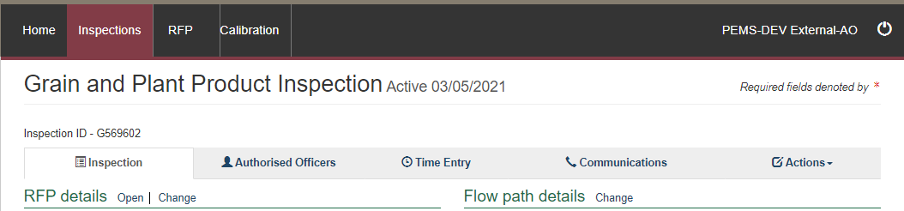

**1**

### Grain and Plant Product Inspection page

The *Grain and Plant Product* *Inspection* page displays the following key sections:

* **RFP details1 –** populated based on RFP information extracted from EXDOC
* **Flow path details2 –** allows you to record or change the flow path inspection result
* **Outcome details3** **–** allows you to select sampling rate and track the inspection outcomes
* **Results4 –** where you record the inspection results
* **Comments5** **–** wheregeneral comments regarding the inspection can be recorded here   
  (see Section 3.8 Adding comments to a recordof Reference:*PEMS AO user guide – Overview and General Functions**)*.

Step-by-step instructions on how to record or change data on this page is provided below.

**2**

**3**

**4**

**5**

**1**

### Opening the Request for Permit (RFP) details

To open the RFP record, click the **Inspection1** tab and then click **Open2** under the RFP details section.

**2**

**1**

The *Request For Permit (RFP)* page will display.

The *Request For Permit* page will display a **Summary1** of the RFP from EXDOC, as well as the **Request for permit lines2** that make up the inspection record. For more information on the **RFP tabs3** see Section 4: RFP functions in PEMS (commodity inspections)of Reference: *PEMS AO user guide – Overview and General Functions*.

Click **Open4** beside any RFP line to view the details of that line.

Click **View containers5** to view containers linked to RFP.

The **Import Permits6** details will be displayed.

**5**

**6**

**4**

**3**

**2**

**1**

The *RFP Line* window will display the details of the line as they were provided on the RFP in EXDOC.

Click **Previous** and **Next1** to navigate between the *RFP line* windows.

Click **Close2** to exit the *RFP line* windows at any time and return to the *Request For Permit* page.

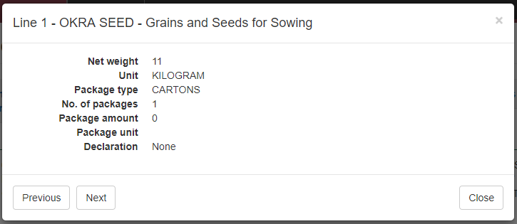

**1**

**2**

### Returning to the inspection page

To return to the *Grain and Plant Product Inspection* page, click the **Inspections1** tab. The full list of inspections relating to the RFP will display. For more information see Section 4.3 Navigating to related inspections/calibrations from the RFP screen ofReference: *PEMS AO user guide – Overview and General Functions*.

Click **Open2** beside the ‘Active’ inspection record.

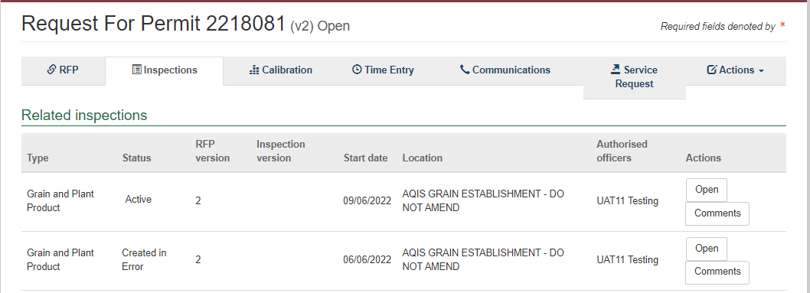

**2**

**1**

### Recording additional declarations

Where applicable, additional declaration information will be extracted from EXDOC and should be recorded for the consignment. To record additional declaration information, click the **Inspection1** tab and then click **Change2** under the RFP details section.

**2**

**1**

The *Change Details* window will display.

Where applicable, you must **View1** the *Link to Micor.* This will open another window and link you to the relevant Micor case for the commodity and country. Select the **Additional declaration Verified2** checkbox in the *Change Details* window. You will not be able to click the checkbox if you have not verified the Micor case.

Click **Save3**.

**2**

**3**

**1**

****The *Grain and Plant Product* *Inspection* page will display the updated **Additional declaration1** **i**nformation.

Inspection results grid will be enabled only when the additional declaration is set either to ‘No’ or ‘Verified’.

**1**

### Edit Exporter name (*if applicable*)

There is a field length limitation of 35 characters when the exporter name is extracted into PEMS from EXDOC (system constraint). This means that in some instances the entire exporter name will not appear in PEMS. This change can no longer be made by the AO.

You must check that the exporter name that appears in the inspection record in PEMS matches the exporter name on the RFP.

If the exporter nameis not correct, you need to contact [PEMS@agriculture.gov.au](mailto:PEMS@agriculture.gov.au) to have the name corrected in the PEMS reference table. Once this is corrected you will not need to request the change again for future inspections/calibrations, as PEMS will save the corrected version of the exporter name for all future records.

If the exporter name is different due to another reason (for example, legal change of entity name) then these changes must be made in EXDOC through the appropriate process.

### Recording reinspection of a consignment

For more information see Section 4.4 Creating inspection records where a record already exists for an RFPofReference:*PEMS AO user guide – Overview and General Functions*.

### Verifying import permit details

Where an import permit is required, the information will be extracted from EXDOC and should be verified for the consignment.

To verify import permit details, click the **Inspection1** tab and then click **Change2** under the RFP details section.

**2**

**1**

The *Change Details* window will display.

You must verify the **Import Permit1** details relevant to the consignment.

Click **Save2.**

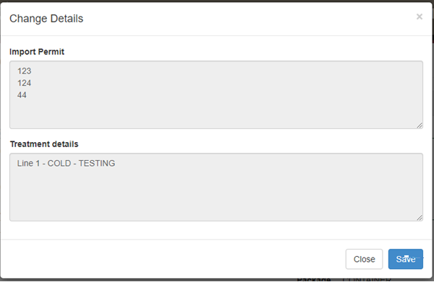

**2**

**1**

### Verifying treatment details

Where treatment details are required, they will be extracted from EXDOC, and the treatment details should be verified for the consignment. To verify the treatment details, click the **Inspection1** tab and then click **Change2** under the RFP details section.

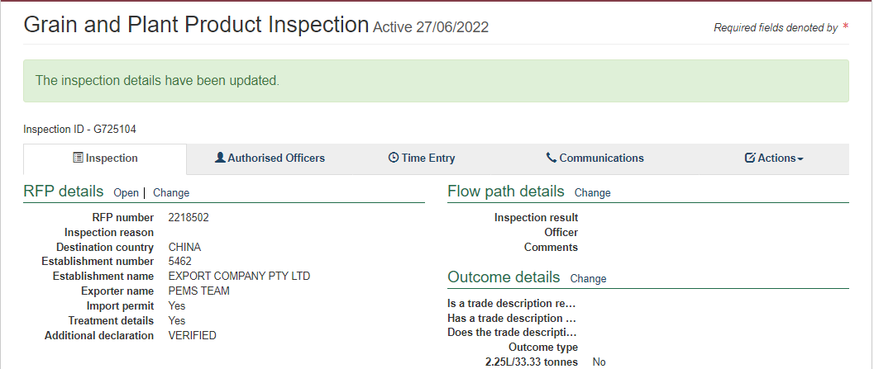

**2**

**1**

The *Change Details* window will display.

You must verify **Treatment details1** relevant to the consignment.

Click **Save2.** 

**2**

**1**

### Recording flow path inspection results

Flow path inspection results must be recorded before entering the commodity inspection results and can be changed at any time until the record is submitted, cancelled or withdrawn.

To record the flow path inspection result, click the **Inspection1** tab and then click **Change2** under the flow path details section.

**2**

**1**

The *Flow Path Details* window will display (next screenshot).

Select a flow path **Inspection result1** of ‘Passed’ or ‘Failed’. The *Flow Path Details* window will expand, and you must select the **Authorised Officer2** and record the **Result date3** and **Result time4**.

If the flow path is failed at any time, you will need to record the **Failed date** and **Failed time** in the result date and result time fields.

****Click **Save5**.

If the loading of containers takes place over multiple days for a single consignment consult the relevant work instruction.

All AOs assigned to the inspection will be available to be chosen against a flow path result.

***If the flow path is failed, you then have the option to change the flow path inspection result to **Passed after rectification1**, if applicable. If the flow path fails, you should not submit the inspection record. The flow path must be passed after rectification. See Section 3.3 Recording a passed after rectification flow path result of Reference: *PEMS AO user guide – Overview and General Functions*, before submitting the inspection.

**5**

The whole consignment presented for inspection will fail if the flow path receives a ‘Failed’ result. Do not continue with the commodity inspection as you will not be able to add results against RFP line. You must enter an appropriate time entry record. See Section 3.4 Time Entry of Reference: *PEMS AO user guide – Overview and General Functions*.

) before the inspection record is submitted on PEMS.

The flow path date/time must not be in the future and must be equal to or greater than the start time/date and equal to, or less than the end time/date of the inspection.

If you fail the flow path initially and then provide a ‘Passed after rectification’ result, rectification date/time must be after the flow path failed date/time.

**3**

**4**

**2**

**1**

If ‘Passed after rectification’ is selected, the *Flow Path Details* window will expand, and you can select the **Authorised Officer2.** It will also show the **Failed date3** and **Failed time4** from when it was failed. You must enter a **Result date5** and **Result time6**.

If applicable, provide **Comments7** on the flow path inspection (mandatory when the flow path fails or is passed after rectification).

Click **Save8**.

**8**

**7**

**6**

**5**

**4**

**3**

**2**

**1**

The *Grain and Plant Product* *Inspection* page will display the updated **flow path** **inspection result1** and PEMS will populate the name of the Authorised **Officer2** who recorded the flow path inspection results in PEMS.

**2**

**1**

### Changing outcome type details

An exporter can describe the Grain and Plant Product consignment in EXDOC by either:

* number of containers and approximate net weight of the RFP line (mandatory requirement on EXDOC) where the goods will be loaded as bulk into container, or
* number of packages and package weight.

These descriptions are reflected respectively in PEMS as outcome types:

* container

or

* packaged.

To change the outcome type, click the **Inspection1** tab and click **Change2** under the Outcome details section.

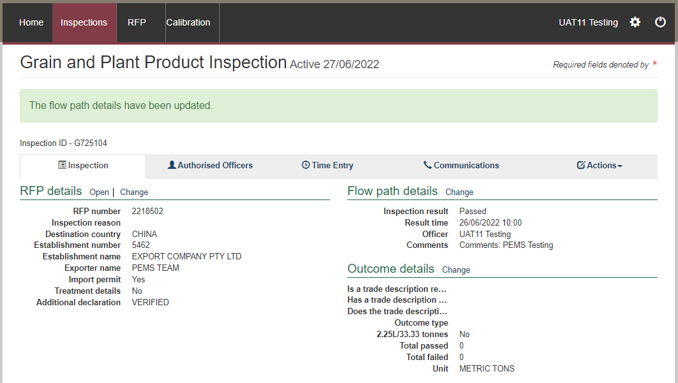

**2**

**1**

The *Outcome Details* window will display.

Record whether a physically applied trade description complies with the policy in the relevant guideline and any specific importing-country requirements listed in Micor (and the protocol where applicable) in the comments (see Section 3.8 Adding comments to a record ofReference: *PEMS AO user guide – Overview and General Functions*).

Some **Trade description1** declarations need to be made. Where 'Yes' is selected, this will prompt the system to generate further declarations until all required declarations are complete.

Click **Outcome type2** and select ‘*Packaged*’ or bulk into ‘*Container*’. Then click **Save3**

For Logs see Appendix 1.

**3**

**1**

**2**

The Outcome Details section will display the updated **Trade description and Outcome type1** and PEMS will reflect the outcome type selected in the **Results2** section columns on the *Grain and Plant Product* *Inspection* page.

**2**

**1**



Inspection results grid will be enabled only when the trade description and outcome type is chosen by the AO.

### Selecting sampling rate

The only sampling rate provided in PEMS for Grain and Plant Product inspections is 2.25L/33.33 tonnes.

The sampling rate is not mandatory. If the sampling rate is not selected, a sampled number or sampling rate will need to be entered for each line when recording inspection results.

To select the 2.25L/33.33 tonnes sampling rate (including equivalent), click the **Inspection1** tab and then click **Change2** under the *Outcome details* section.

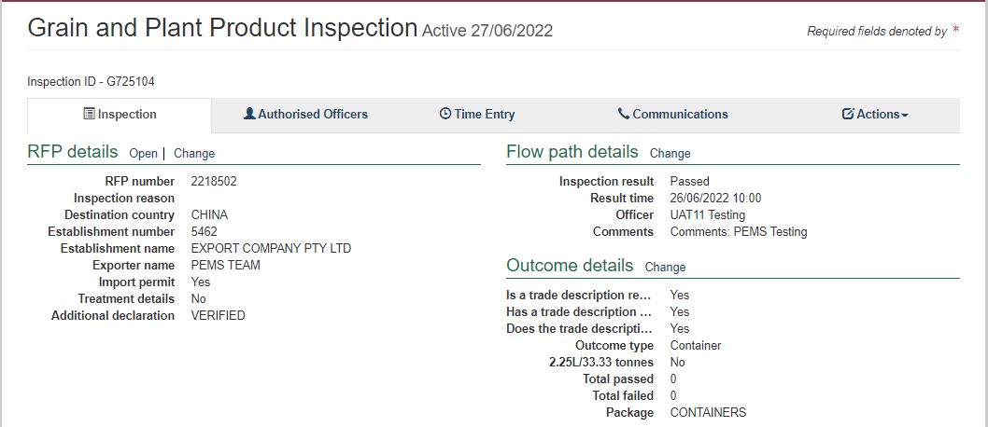

**2**

**1**

The *Outcome Details* window will display.

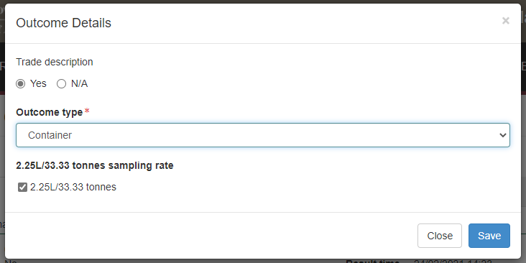Select the **2.25L/33.33 tonnes sampling rate1** checkbox and then click **Save2**.

**2**

**1**

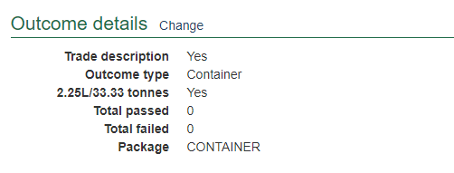The *Grain and Plant Product* *Inspection* page will display the updated **sampling rate details1.**

**1**

### Sampling type for hay and straw inspections

The sampling type will only be displayed for hay and straw inspections. The **Sampling Type1** field must be completed with details of the sampling method.

**1**

If ‘In-line’ is selected as the **Sampling type1** another drop-down field titled **In-line Sampling Type2** will appear. This field must be completed with further details of the in-line sampling method used.

**2**

**1**

There will no longer be the option to select the **2.25L/33.33 tonne sampling rate1** checkbox. Click **Save2**.

**2**

**1**

### Splitting lines on the inspection record

For *Grain and Plant Product* *Inspection* records, you can split lines of the record where key information regarding the inspected consignment is not provided on the RFP in EXDOC, or does not extract from the RFP into PEMS, but is important for the traceability of goods. There are different requirements for splitting lines on a Grain and Plant Product inspection record depending on the nature of the consignment.

**Bulk into container**

RFP lines for bulk into container should only be split on the Grain and Plant Product inspection record where an additional container needs to be added to the inspection record.

**Packaged products into container**

RFP lines for packaged products should be split on the Grain and Plant Product inspection records to identify, where applicable:

* each container that is being loaded (including any additional containers that must be added to the inspection record)
* each individual commodity source, such as by the silo, bin, stack, or lot number associated with the packages.

To split lines on the inspection record, click **Split line1** beside the appropriate commodity line. Any line presented for inspection can be split any number of times.

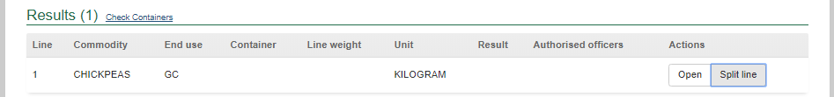

**1**

The inspection *Results* window for the new line will display (see second screenshot in the **Recording inspection results for Grain and Plant Products** section below and continue to record the results for each line).

### Recording inspection results for Grain and Plant Products

To enter or change inspection results, click **Open1** beside the appropriate line.

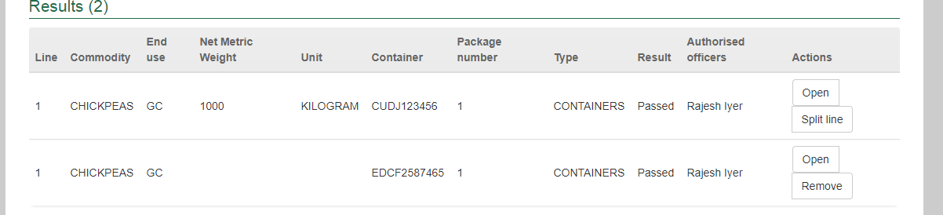

**1**

The inspection *Results* window for the line will display (next 2 screen shots).

For each inspection result window:

* If applicable, enter the **Container number1** (must be four letters followed by six or seven digits, for example: ABCD1234567).
* Check the container number you have entered is correct by clicking on **Check2**.
* Enter the **Source3** of the commodity being inspected (for example, silo, bin, stack, or lot number) and brand or commercial names of products.
* Enter the package **Number4** presented if the information is not prepopulated (where split lines is used, you may need to amend the number of units specified in the parent RFP line).
* Packaging **Type5** of the goods will be prepopulated from EXDOC (for example, container, bales, bags, bulk etc.).
* Enter the package **Weight6** of the unit(s) and select appropriate package **Unit7** of measurement, provided on RFP (the unit of measurement must be the same for all lines).
* Enter the **Sampled8** number or rate (only mandatory where the 2.25L/33.33 tonnes sampling rate has not been selected).
* PEMS will populate **sub-total Line weight9** with the net weight provided on the RFP in EXDOC or, if the package weight is provided in EXDOC, PEMS will calculate the **sub-total Line weight9** as the product of the package number and package weight.
* ****If applicable, amend the **Net Metric Weight10** (weight is extracted from EXDOC in the parent RFP line only, and will be visible if the user chooses the packaged/container option under outcome details section).

**Check2** performs a 2-step validation process via a check digit algorithm and by checking if the container number recorded is available in the *BIC Global Container Database*. This database captures approximately 70% of all containers globally. If the container you have inspected is not captured in the database a warning message is generated, encouraging you to double check the details on the container. You will still be able to submit the inspection.

****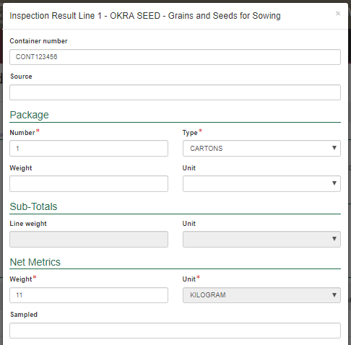

Subtotal line weight unit must be the same as that of the package weight unit. Package weight unit can be amended and PEMS will default the subtotal line weight unit to the package weight unit.

The packaged weight and outcomes allow for 4 decimal values.

Additional containers can be added to the PEMS inspection record by entering the additional container number into the container number field. Once additional containers are added to the inspection record, you must remind the exporter to update the RFP record in EXDOC to reflect the inclusion of the additional containers.

If the same container number is used on different container lines, PEMS will consider it as a distinct container for calculating total passed and total failed. For example, RFP line 1 and 2 has the same container number ABCD1234567 with a passed result, total passed will be 1 instead of 2.

You can check whether containers included in the inspection record have current container approval recorded on the PEMS database, see the Checking container approvals in PEMSsection in this user guide.

**1**

**2**

**6**

**4**

**5**

**7**

**3**

**8**

**9**

**10**

For each inspection *Results* window you should also:

* Select a **Result1** of ‘Pass’, ‘Fail’ or N/A for the line.
* If applicable, select one or more **Remarks2** checkboxes (mandatory if the line fails the inspection).
* When a remark is selected the **Tolerance Level3** drop down will appear, select the appropriate tolerance ‘above’ or ‘below’.
* **Comment4** becomes mandatory about the tolerance level.
* Select the checkbox of all **Authorised officers5** who performed the inspection.   
  See Section 3.1: Assigning authorised officers (inspection records only) of Reference: *PEMS AO user guide – Overview and General Functions*.)

Click **Save6** to save the inspection result and exit the window.

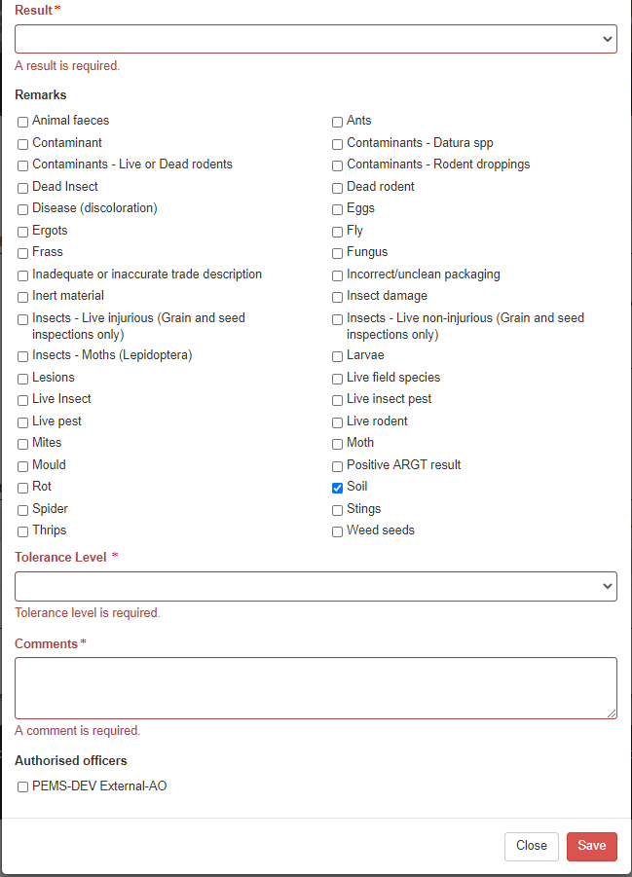

**6**

**5**

**4**

**3**

**2**

**1**

****Once the inspection result is saved, the *Grain and Plant Product* *Inspection* page will display the **new split line(s)1**. You can **Remove2** the split line(s) up until the inspection is submitted, withdrawn, or cancelled.

At least one line in the inspection must be “Passed” or “Failed”.

Where split lines are entered on the inspection record you must manually amend the number of units or line weight specified in the parent RFP line to ensure the inspection record is consistent with the RFP in EXDOC.

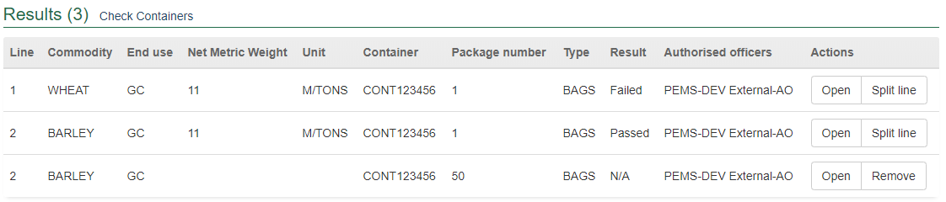

**2**

**1**

### Navigating between line inspection windows

You can navigate between line inspection *Results* windows by clicking **Previous** or **Next1** at the bottom of the window. The inspection result for each line will automatically save when you navigate between the windows in this manner.

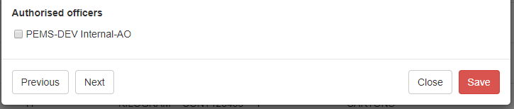

**1**

### Checking container approvals in PEMS

****You can use the PEMS database to confirm whether containers selected for loading on the inspection record have the appropriate approvals recorded in PEMS. PEMS may not always include records of all current container approvals.

PEMS will not prevent you from submitting the grain and plant product inspection record where current inspection validity is not recorded for all containers on the inspection record. However, AOs must operate consistent with the approved work instructions for their appointed job functions when undertaking and submitting grain and plant product inspection records.

To check PEMS for a record of a container approvals, click the **Actions1** tab and then click **Check containers2**. Alternatively, you can select **Check Containers3** beside the Results.

**3**

**2**

**1**

The *Containers* window will display the list of containers provided on the inspection record.

To search for a specific container, you can **Filter containers1** by entering all or part of a container number into the field. Select **Clear2** to display the full list of containers on the inspection record.

If there is an issue with a particular listed container it will be highlighted in bold, and red. Click **Show3** to display the error message.

If a container was approved but has since been revoked, it will show the **Remarks** that have been made on the container.

Hover on **Show Reason4** and a box will appear. This will provide the details why the container was revoked, the revocation date and time and the details of the person who revoked the container.

If a container has been allocated as used on a different RFP with a completed inspection in PEMS, the **Used5** flag status would display as Yes. If the container is available, then it should be reinspected again to allow the status of the **Used5** flag to be reset to No.

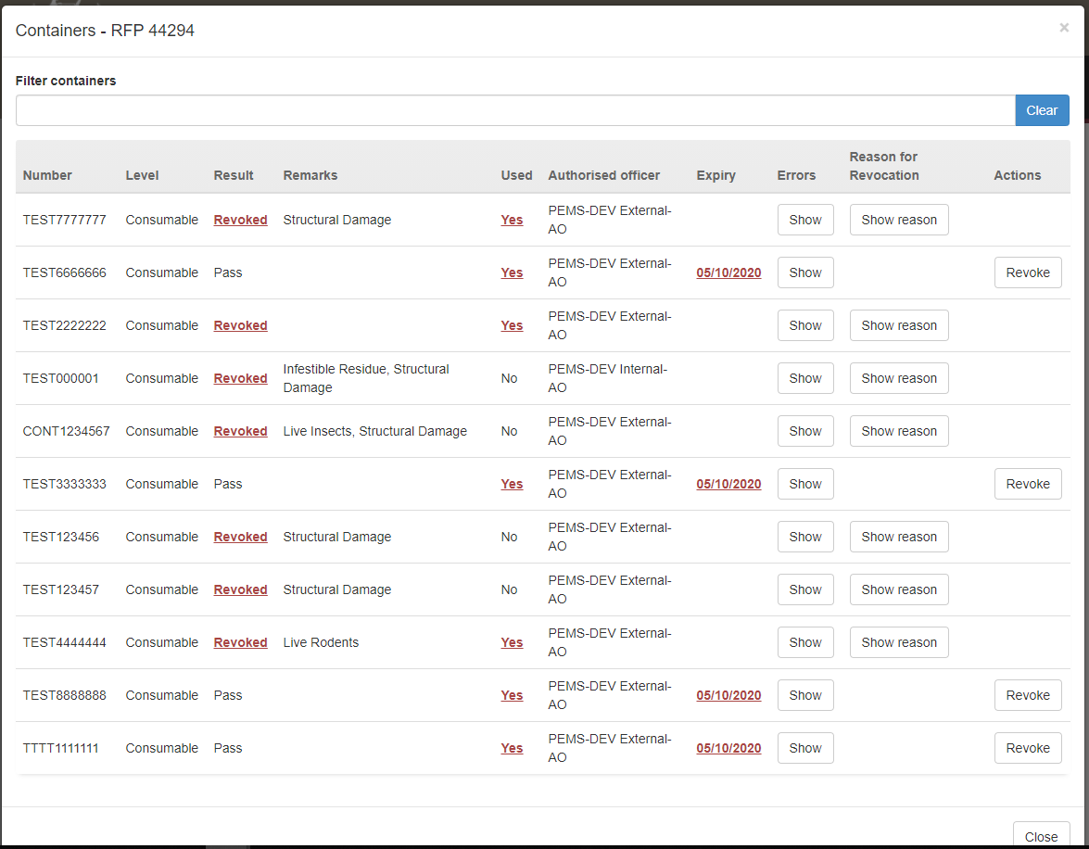

**5**

**4**

**3**

**2**

**1**

### Revoking container approval status

If the condition of an empty container has changed from when it was originally passed, and it no longer complies with the department’s requirements, the approval status of the container can be changed from Pass to Revoked. This action can be performed by any authorised officer that has the Grain and Plant Product inspection job function.

Select the container/s that need to be to have the approval status revoked and click **Revoke1**.



**1**

The *Revoke Details will appear at the top of the* window.

Select the appropriate **Remarks1**.

Enter the **Reason for Revocation2**. This reason will appear in the body of the email and can be up to 500 characters.

Enter the **Email Address3** of the client to notify them that the container approval has been revoked. Multiple email addresses can be added to the email address field and each address should be separated by a comma and a space.

Click **Save4**.

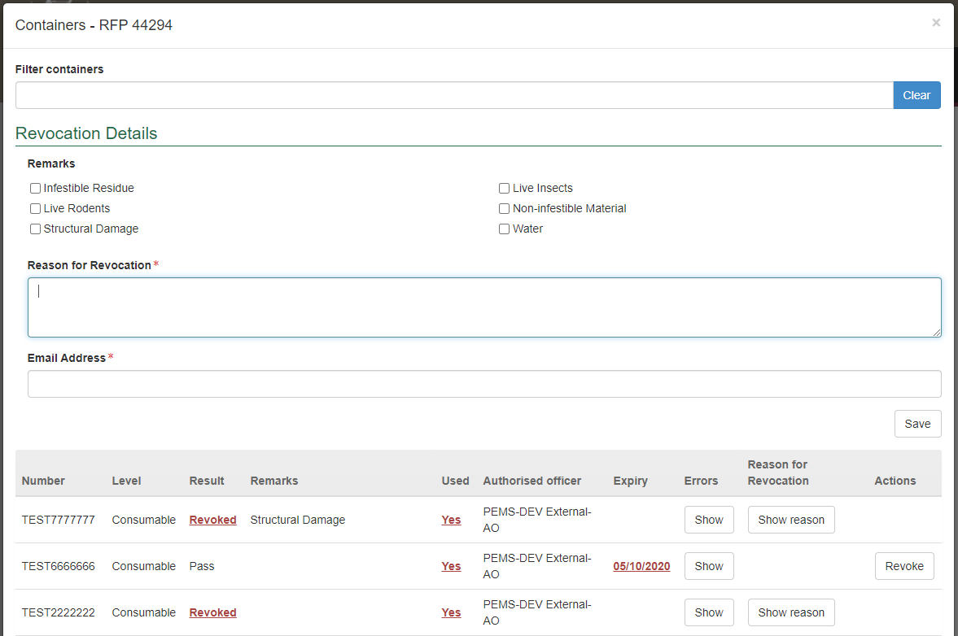

**4**

**3**

**2**

**1**

The containers that have been revoked will have the Result changed to **Revoked1**.

This revocation cannot be removed until a new empty container inspection is completed.

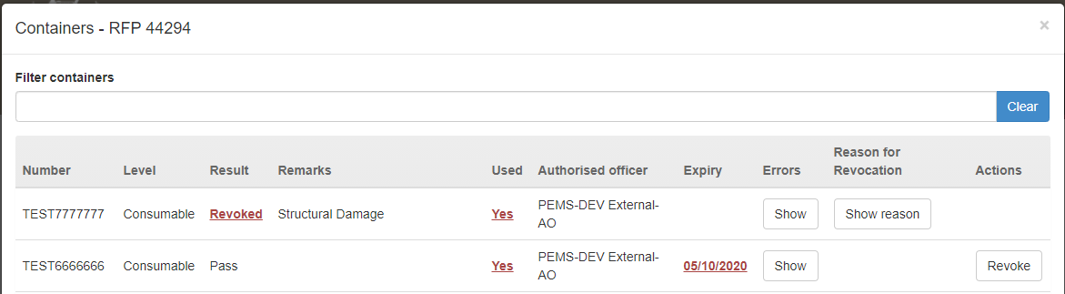

**1**

### Completing and submitting the inspection record

The inspection can only be submitted in PEMS after:

* All inspection results and data are recorded appropriately unless the flow path failed inspection
* **Time Entry1** is provided for all AOs who recorded inspection results
* If applicable, attachments and correspondence relating to the inspection are recorded under the **Communications2** tab.

Details on the Time Entry and Communications tabs can be found in Section 3: General PEMS functions of Reference: *PEMS AO user guide – Overview and General Functions.*

When you are ready to submit the inspection record, click the **Actions3**tab and then click **Submit4**.

For more information on **Downloading**, **Cancelling** or **Withdrawing5** the inspection, see Section 3.6 Actions tab of Reference: *PEMS AO user guide – Overview and General Functions*.

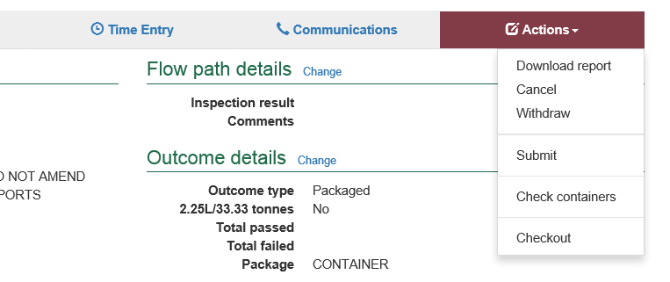

**4**

**3**

**1**

**2**

**5**



PEMS will prompt to confirm you have estimated the net metric weight of the consignment and you want to submit the inspection.

Once the inspection record is submitted the record will become read-only and you will be unable to make changes to the data provided. However, you will be able to attach a new document, and add invoice numbers (for departmental AOs).

A pop-up window will ask you to confirm that you want to **submit this inspection1**.

It will also ask if you want to **email the exporter/EDI user on the submission of the inspection2**. When selecting this option, the Inspection submit confirmation box will expand.

Enter the **email address3**, this can be multiple email addresses each separated by a comma.

Enter in any **Comments4** that are to be included in the email.

Click **Save5**.

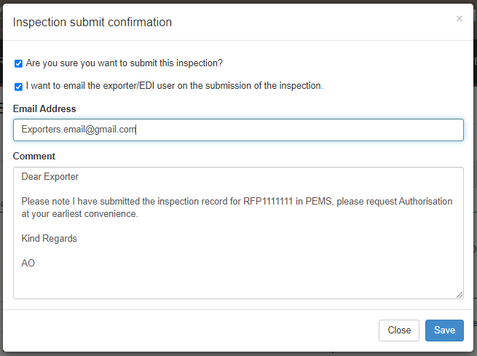

**5**

**4**

**3**

**2**

**1**

The *Grain and Plant Product* *Inspection* record status will display as **Completed1.**

****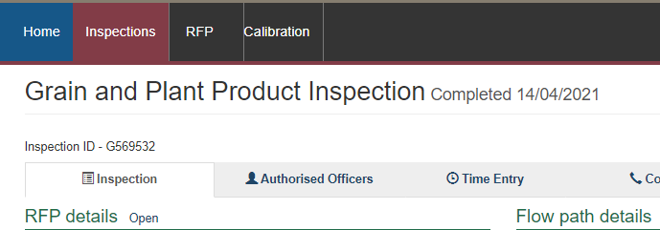

**1**

The date(s) specified on the completed inspection record will be the start date and end date for the inspection. The inspection record date corresponds with the earliest and latest time entry across all AOs for the inspection.

### Expiration date of Grain and Plant Product inspection

Following the submission of the Grain and Plant Product inspection record, an expiry date will be allocated to all goods which have passed assessment. The expiry date is automatically calculated as 28 days from the first date of the first-time entry.

To view the expiration date, click the **Inspection1** tab and the **Expiry date2** will display under the inspection validity section.

If the Grain and Plant Product expiry date is extended, you can view the reason for the expiry date extension by clicking **History3** under the inspection validity section.

**3**

**2**

**1**

The *Expiry History* window will display.

Click **Close1** to exit the window.

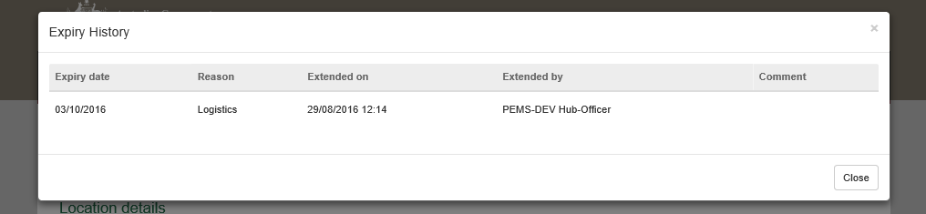

**1**

### Appendix 1: Logs

This Appendix outlines how to complete the Logs flowpath when it deviates from the standard Grain and Plant Product Inspection format. Where the format is the same you will need to refer to the primary user guide.

Due to Logs being a raw product it is expected that contaminates will always be present, therefore the flow path will always include an initial failed inspection, fumigation, and a reinspection.

**Trade description**

Record whether a physically applied trade description complies with the policy in the relevant guideline and any specific importing-country requirements listed in Micor (and the protocol where applicable) in the comments (see Section 3.8 Adding comments to a record of Reference: *PEMS AO user guide – Overview and General Functions*).

Several **Trade description1** declarations need to be made. Where 'Yes' is selected, this will prompt the system to generate further declarations until all required declarations are complete.

**Outcome Details**

PEMS will recognise the commodity and by default, *Logs* will be selected as the **Outcome type2**, and no other option will be available from the drop down.

Then select **Save3**.

**3**

**2**

**1**

The Outcome Details section will display the updated **Trade description and Outcome type1** and PEMS will reflect the outcome type selected in the **Results2** section columns on the *Grain and Plant Product* *Inspection* page.

**2**

**1**

**Splitting lines on the inspection record**

For information on how to split lines see Splitting lines on the inspection recordsection in this user guide.

**Recording inspection results for Grain and Plant Product - Logs**

To enter or change inspection results, click **Open1** beside the appropriate line.

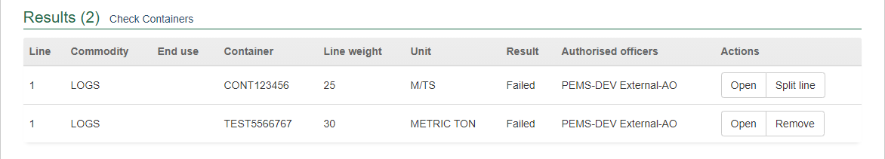

**1**

The inspection *Results* window for the line will display (next 2 screen shots).

For each inspection result window:

* If applicable, enter the **Container number1** (must be 4 letters followed by 6 or 7 digits, for example: ABCD1234567)
* Check the container number you have entered is correct by clicking on **Check2**.
* Enter the **Source3** of the commodity being inspected (for example, stack or lot number) and brand or commercial names of products
* Enter the package **Number4** presented if the information is not prepopulated (where split lines is used, you may need to amend the number of units specified in the parent RFP line). If Bulk is selected as the ‘type’ the number will appear as N/A
* Packaging **Type5** of the goods will be prepopulated from EXDOC (for example bulk)
* Enter the package **Weight/Volume6** of the unit(s) and then select appropriate package **Unit7** of measurement, provided on RFP (the unit of measurement must be the same for all lines)
* Enter the **Sampled8** number or rate (mandatory when the 2.25L/33.33 tonnes sampling rate has not been selected)
* PEMS will populate **sub-total Line weight9** with the net weight provided on the RFP in EXDOC or, if the package weight is provided in EXDOC, PEMS will calculate the **sub-total Line weight9** as the product of the package number and/or package Weight/Volume
* ****If applicable, amend the **Net Metric Weight10** (weight is extracted from EXDOC in the parent RFP line only, and will be visible if the user chooses the packaged/container option under outcome details section).

**Check2** performs a 2-step validation process via a check digit algorithm and by checking if the container number recorded is available in the *BIC Global Container Database*. This database captures approximately 70% of all containers globally. If the container you have inspected is not captured in the database a warning message is generated, encouraging you to double check the details on the container. You will still be able to submit the inspection.

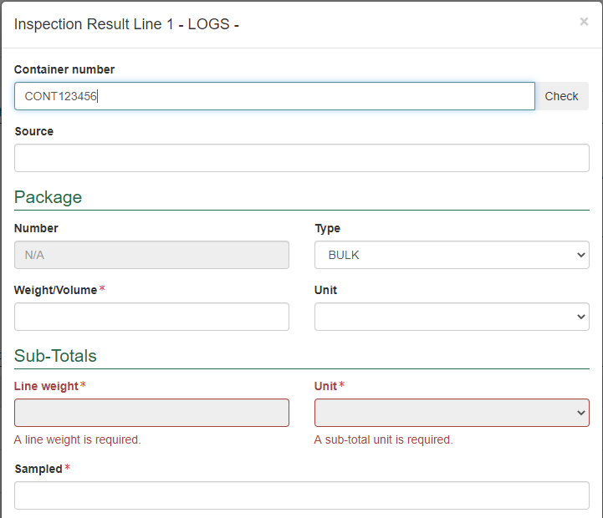

**3**

**4**

**7**

**9**

**8**

**5**

**6**

**10**

**2**

**1**



You can check whether containers included in the inspection record have current container approval recorded on the PEMS database, see the Checking container approvals in PEMSsection in this user guide.

Additional containers can be added to the PEMS inspection record by entering the additional container number into the container number field. Once additional containers are added to the inspection record, you must remind the exporter to update the RFP record in EXDOC to reflect the inclusion of the additional containers.

If the same container number is used on different container lines, PEMS will consider it as a distinct container for calculating total passed and total failed. For example, RFP line 1 and 2 has the same container number ABCD1234567 with a passed result, total passed will be 1 instead of 2.

For each inspection *Results* window:

* Select a **Result1** of ‘N/A’, ‘Pass’ or ‘Fail’ for the line
* If applicable, select one or more **Remarks2** checkboxes (mandatory if the line fails the inspection)
* When a remark is selected the **Tolerance Level3** drop down will appear, select the appropriate tolerance ‘above’ or ‘below’
* **Comment4** becomes mandatory about the tolerance level
* select the checkbox of all **Authorised officers5** who performed the inspection.   
  See Section 3.1: Assigning authorised officers (inspection records only) of Reference: *PEMS AO user guide – Overview and General Functions* for more information.

Click **Save6** to save the inspection result and exit the window.

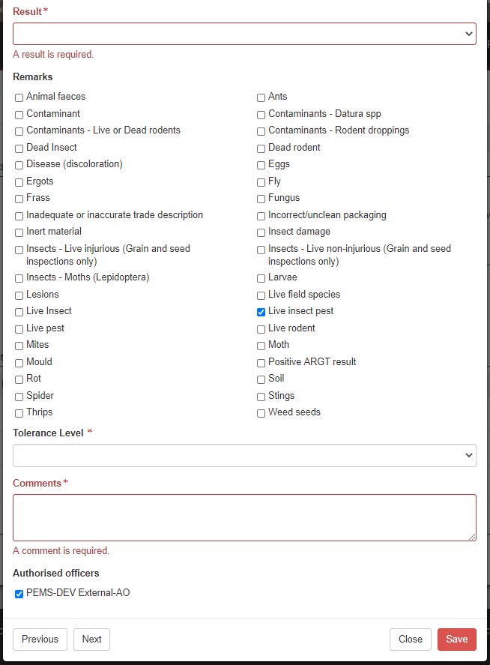

**1**

**6**

**5**

**4**

**3**

**2**

Once the inspection result is saved, the *Grain and Plant Product* *Inspection* page will display the **new split line(s)1**. You can **Remove2** the split line(s) up until the inspection is submitted, withdrawn, or cancelled.

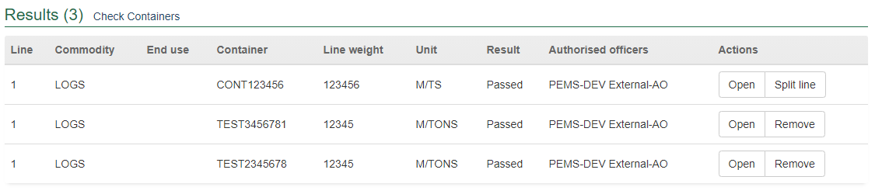

**2**

**1**

### Completing and submitting the inspection record

To complete the log inspection record, refer to section Completing and submitting the inspection record in this user guide.

## Related material

The following related material is available on the [website](http://iml.agdaff.gov.au/Draft/General/agriculture.gov.au):

* Manual of Importing Country Requirements (Micor)
* Protocols and Work Plans
* [Plant Export Operations Manual](http://www.agriculture.gov.au/export/controlled-goods/plants-plant-products/plantexportsmanual)
* Reference: *PEMS AO user guide – Overview and General Functions*
  + *Empty container inspections*

The following related material is available on [Learnhub](https://learnhub.ssc.gov.au/login/):

* Plant Exports Management System (PEMS) video tutorials

## Contact information

* Authorised Officer Hotline: 1800 851 305
* Authorised Officer Program: PlantExportTraining@agriculture.gov.au
* PEMS Administration: [PEMS@agriculture.gov.au](mailto:PEMS@agriculture.gov.au).

## Document information

The following table contains administrative metadata.

| Instructional Material Library document ID | Instructional material owner |
| --- | --- |
| IMLS-9-7600 | Director, Change Management, Digital Clearance Service, Digital Trade Initiative |

## Version history

The following table details the published date and amendment details for this document.

| Version | Date | Amendment details |
| --- | --- | --- |
| 1.0 | 08/07/2016 | New user guide. |
| 1.1 | 12/07/2016 | Minor variations for accuracy and clarity. |
| 2.0 | 30/09/2016 | * Complete document restructure. * Addition of sections on: * Logging into PEMS * Calibration records * Calibration search. |
| 2.1 | 16/12/2016 | * Minor variations for accuracy and clarity * Removal of Appendix F – Calibrations and loading * Removal of Section 2.3 – Calibration search. |
| 3.0 | 09/10/2018 | AO user guide updated with PEMS v2.1 enhancements. |
| 4.0 | 23/05/2019 | AO user guide updated with PEMS v3.1 and v3.2 enhancements. |
| 5.0 | 4/11/2019 | Updated with PEMS v.3.3 and 3.4 enhancements. |
| 6.0 | 3/06/2020 | Updated with PEMS 3.5 enhancements. |
| 7.0 | 28/08/2020 | Removal of appendices from Plant Exports Management System (PEMS) Authorised Officer user guide to make each its own user guide. |
| 8.0 | 30/10/2020 | Updated with PEMS v3.8 enhancements. |
| 9.0 | 18/01/2021 | Minor wording change request by GESP. |
| 10 | 28/03/2021 | Updated for commencement of the *Export Control Act 2020* and associated Plant Rules. |
| 11 | 7/06/2021 | Updated with PEMS May 2021 Release – name changed from CGI. |
| 12 | 5/07/2021 | Updated ‘edit exporter name’ section in line with July 2021 PEMS release. |
| 13 | 13/09/2021 | Updated email notification on submission in line with September 2021 release. |
| 14 | 20/12/2021 | Updated in line with PEMS December 2021 release. |
| 15 | 21/02/2022 | Updated in line with PEMS February 2022 release. |
| 16 | 04/04/2022 | Updated in line with PEMS April 2022 release. |
| 17 | 26/07/2022 | Updated in line with PEMS June 2022 release. |
| 18 | 5/10/2022 | Updated in line with PEMS September 2022 release. |