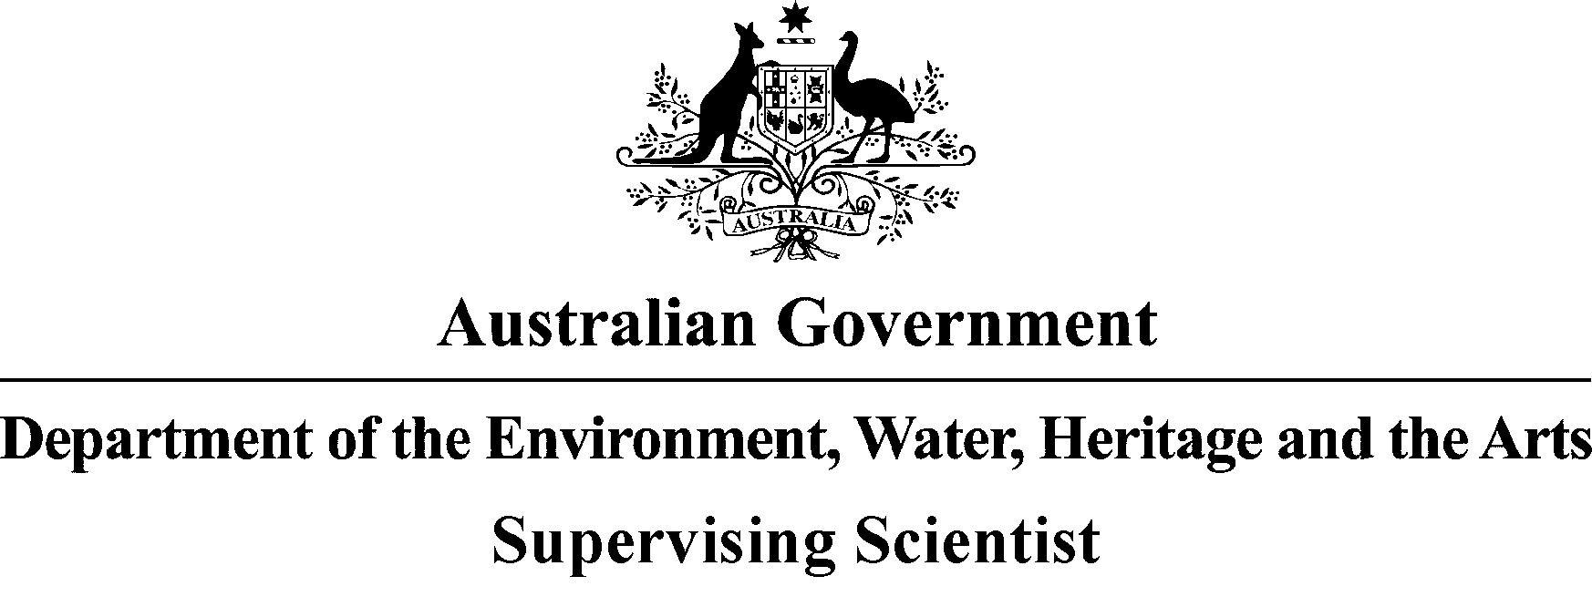

SUPERVISING
SCIENTIST


Annual Report
2009–2010
© Commonwealth of Australia 2010
This work is copyright. Apart from any use as permitted under the Copyright Act 1968, no part may be reproduced by any process without prior written permission from the Supervising Scientist.

This report should be cited as follows:
Supervising Scientist 2010. Annual Report 2009–2010. Supervising Scientist, Darwin.

ISSN 0 158-4030
ISBN-13: 978-1-921069-13-0

The Supervising Scientist is part of the environmental program of the Australian Government Department of Sustainability, Environment, Water, Population and Communities

Contact
The contact officer for queries relating to this report is:
Ann Webb
Supervising Scientist Division
Department of Sustainability, Environment, Water, Population and Communities
Postal: GPO Box 461, Darwin NT 0801 Australia
Street: SEWPAC Building, Pederson Road/Fenton Court, Marrara NT 0812 Australia
Telephone 61 8 8920 1100
Facsimile 61 8 8920 1199
E-mail enquiries_ssd@environment.gov.au

Supervising Scientist homepage address is www.environment.gov.au/ssd
Annual Report address: www.environment.gov.au/ssd/publications/ss09-10/index.html

For more information about Supervising Scientist publications contact:
Publications Inquiries
Supervising Scientist Division
Department of Sustainability, Environment, Water, Population and Communities
GPO Box 461, Darwin NT 0801 Australia
Telephone 61 8 8920 1100
Facsimile 61 8 8920 1199
E-mail publications_ssd@environment.gov.au

Design and layout: Supervising Scientist Division
Cover design: Carolyn Brooks, Canberra
Printed in Canberra by Union Offset on Australian paper from sustainable plantation timber.

The Hon Tony Burke MP
Minister for Sustainability, Environment, Water, Population and Communities
Parliament House
CANBERRA ACT 2600

18 October 2010

Dear Minister
In accordance with subsection 36(1) of the Environment Protection (Alligator Rivers Region) Act 1978 (the Act), I submit to you the thirty-second Annual Report of the Supervising Scientist on the operation of the Act during the period of 1 July 2009 to 30 June 2010.

Yours sincerely


Alan Hughes
Supervising Scientist

Photos (from top left) Measuring stream discharge, sieving soil, field spectral calibration on Jabiluka billabong, testing probes on Ranger trial landform (TL), bushtucker collecting and (inset) green plums, community liaison, ground calibration of satellite image (and below that) soil sampling, spectral sampling on Ranger TL, ARRTC members field trip, biomass survey on Magela floodplain, seminar at SSD, snail aquaculture tanks at Jabiru Field Station, (bottom right) deployment of uranium-spiked sediments.

Contents
Letter of transmittal III
Foreword xii
Supervising Scientist’s overview xiii
Abbreviations xix
Glossary xx
1 Introduction 1
1.1 Role and function of the Supervising Scientist 1
1.2 Performance summary 2
1.3 Business planning 2
1.4 The Alligator Rivers Region and its uranium deposits 2
1.4.1 Ranger 3
1.4.2 Jabiluka 3
1.4.3 Nabarlek 3
1.4.4 Koongarra 4
1.4.5 South Alligator Valley mines 4
2 Environmental assessments of uranium mines 5
2.1 Supervision process 5
2.1.1 Minesite Technical Committees 5
2.1.2 Audits and inspections 5
2.1.3 Assessment of reports, plans and applications 6
2.2 Ranger 7
2.2.1 Developments 7
2.2.2 On-site environmental management 9
2.2.3 Off-site environmental protection 17
2.3 Jabiluka 36
2.3.1 Developments 36
2.3.2 On-site environmental management 36
2.3.3 Off-site environmental protection 38
2.4 Nabarlek 39
2.4.1 Developments 39
2.4.2 On-site conditions 40
2.4.3 Off-site environmental protection 41
2.5 Other activities in the Alligator Rivers Region 41
2.5.1 Rehabilitation of the South Alligator Valley uranium mines 41
2.5.2 Exploration 42
2.6 Radiological issues 42
2.6.1 Background 42
2.6.2 Radiation at and from Ranger 44
2.6.3 Jabiluka 48
2.7 EPBC assessment advice 49
3 Environmental research and monitoring 50
3.1 Monitoring of erosion and solute loads from the Ranger trial landform 53
3.2 In situ biological monitoring in Gulungul Creek 63
3.3 Developing sediment quality criteria for uranium 65
3.4 Toxicity testing of Ranger process water permeate 69
3.5 Influence of dissolved organic carbon on the toxicity of aluminium to tropical freshwater biota 72
3.6 Characterisation of the pre-mining radiological footprint at Ranger 76
3.7 Radiological characterisation of Ranger mine land application areas 81
3.8 Remote sensing framework for environmental monitoring within the Alligator Rivers Region 88
3.9 The Bushtucker database 91
3.10 Conceptual models of contaminant pathways for operational phase of Ranger uranium mine 94
4 Statutory committees 97
4.1 Introduction 97
4.2 Alligator Rivers Region Advisory Committee 97
4.3 Alligator Rivers Region Technical Committee 98
5 Communication and liaison 100
5.1 Introduction 100
5.2 Research support and communication 100
5.2.1 Indigenous employment and consultation 100
5.2.2 Research protocols for Kakadu National Park 102
5.2.3 Internal communication 103
5.2.4 Communication with technical stakeholders and the general community 103
5.2.5 Australia Day awards 104
5.3 National and international environmental protection activities 105
5.3.1 Revision of National Water Quality Guidelines 105
5.3.2 Basslink 105
5.3.3 Northern Australian Water Futures Assessment 105
5.3.4 Tropical Rivers and Coastal Knowledge Research Program 106
5.3.5 Kakadu Research Advisory Committee 106
5.3.6 Special Feature in the Journal of Spatial Science 106
5.3.7 EPBC compliance audits 107
5.3.8 Rum Jungle collaboration 107
5.3.9 Other contributions 108
5.4 Science communication (including conferences) 108
6 Administrative arrangements 112
6.1 Human resource management 112
6.1.1 Supervising Scientist 112
6.1.2 Structure 112
6.1.3 Investors in People 113
6.1.4 Occupational Health and Safety 114
6.2 Finance 115
6.3 Facilities 115
6.3.1 Darwin facility 115
6.3.2 Jabiru Field Station 116
6.4 Information management 116
6.5 Interpretation of Ranger Environmental Requirements 117
6.6 Ministerial directions 117
6.7 Environmental performance 117
6.8 Animal experimentation ethics approvals 117
Appendix 1 ARRTC Key Knowledge Needs 2008–2010: Uranium mining in the Alligator Rivers Region 119
Appendix 2 Publications for 2009–2010 132
Appendix 3 Presentations to conferences and symposia, 2009–2010 136
Index 138

Tables
Table 2.1 Ranger production activity for 2009–2010 by quarter 7
Table 2.2 Ranger production activity for 2005–2006 to 2009–2010 7
Table 2.3 Audit and RPI 12
Table 2.4 Grading System 13
Table 2.5 Ranger Minesite Technical Committee meetings 15
Table 2.6 RPI Focus during the reporting period 36
Table 2.7 Jabiluka Minesite Technical Committee meetings 38
Table 2.8 Annual radiation doses received by workers at ranger mine 44
Table 2.9 Radon decay product concentrations at Jabiru and Jabiru East and total and mine-derived annual doses received at Jabiru 2006–09 47
Table 3.1 Total bedload collected for 2009–10 wet season 58
Table 3.2 Bedload particle size distribution data for samples collected on 17 March 2010 and 15 April 2010 59
Table 3.3 Rainfall events during the week prior to bedload collection 59
Table 3.4 Water quality of Magela Creek water and untreated and treated process water from Ranger uranium mine 70
Table 3.5 Toxicity estimates for treated process water from Ranger uranium mine 71
Table 3.6 Effect of two different forms of dissolved organic carbon on the toxicity of aluminium to three local freshwater species 74
Table 3.7 Sources of water for land application areas at Ranger uranium mine 82
Table 3.8 Spectral bands for the world-view 2 sensor 88
Table 3.9 Potential stressors and transport mechanisms associated with Ranger uranium mine operational phase 96
Table 5.1 Researchers and other visitors, 2009–10 110
Table 6.1 Staffing numbers and locations 113
Table 6.2 Summary of direct program expenses 115
Table 6.3 Animal experimentation ethics approvals 118

Figures
Map 1 Alligator Rivers Region xvi
Map 2 Ranger minesite xvii
Map 3 Sampling locations used in SSD’s research and monitoring programs xviii
Figure 2.1 Annual rainfall Jabiru Airport 1980–81 to 2009–10 9
Figure 2.2 Electrical conductivity and discharge measurements in Magela Creek between December 2009 and July 2010 – continuous monitoring data 18
Figure 2.3 Uranium concentrations measured in Magela Creek by SSD between December 2009 and June 2010 19
Figure 2.4 Electrical conductivity measurements in Magela Creek between December 2009 and June 2010 – grab sample data 20
Figure 2.5 Electrical conductivity measurements and water level (lower trace) in Magela Creek between December 2005 and July 2010 – continuous monitoring data 20
Figure 2.6 Electrical conductivity measurements in Magela Creek (SSD data) between December 2002 and July 2010 – grab sample data
Figure 2.7 Uranium concentrations in Magela Creek since the 2002–03 wet season – grab sample data 21
Figure 2.8 Radium-226 in Magela Creek 2001–2010 22
Figure 2.9 Electrical conductivity measurements in Gulungul Creek between December 2002 and June 2010 – grab sample measurements 23
Figure 2.10 Electrical conductivity measurements in Gulungul Creek between December 2009 and June 2010 – continuous monitoring data 24
Figure 2.11 Uranium concentrations measured in Gulungul Creek by SSD between December 2009 and June 2010 – grab sample measurements. 24
Figure 2.12 Uranium concentrations measured in Gulungul Creek by SSD between December 2002 and June 2010 – grab sample measurements 25
Figure 2.13 Time-series of snail egg production data from toxicity monitoring tests conducted in Magela Creek using creekside tests and in situ tests 27
Figure 2.14 Mean concentrations of U measured in mussel soft-parts, sediment and water samples collected from Mudginberri Billabong and Sandy Billabong since 2000 29
Figure 2.15 Annual committed effective doses from Ra226 and Pb210 for a 10 year old child eating 2 kg of mussels (wet) collected at Mudginberri Billabong 30
Figure 2.16 Paired upstream-downstream dissimilarity values calculated for community structure of macroinvertebrate families in several streams in the vicinity of the Ranger mine for the period 1988 to 2010 32
Figure 2.17 Ordination plot of macroinvertebrate community structure data from sites sampled in several streams in the vicinity of Ranger mine for the period 1988 to 2010 33
Figure 2.18 Paired control-exposed dissimilarity values calculated for community structure of fish in Mudginberri (‘exposed’) and Sandy (‘control’) Billabongs in the vicinity of the Ranger mine over time 34
Figure 2.19 Relative abundance of chequered rainbowfish in Mudginberri and Sandy billabongs from 1989 to 2010 with associated total discharge in Magela Creek 35
Figure 2.20 Electrical conductivity measurements in Ngarradj between December 2009 and June 2010 – continuous monitoring data 39
Figure 2.21 Radon decay product concentration measured by SSD and ERA in Jabiru and Jabiru East from January 2004 to March 2010 46
Figure 2.22 Long lived alpha activity concentration measured by SSD and ERA in Jabiru and Jabiru East from January 2004 to March 2010 46
Figure 2.23 Radon decay product and long lived alpha activity concentrations measured at SSD’s Mudginberri Four Gates Rd radon station from July 2004 to March 2010 48
Figure 3.1 Layout of the plots on the trial landform 53
Figure 3.2 Runoff through flume on trial landform erosion plot 3 during a storm event 54
Figure 3.3 Digital Elevation Model of trial landform produced from December 2009 survey 55
Figure 3.4 Locations of scanning laser instrument 56
Figure 3.5 High resolution digital elevation model of erosion plot 2 57
Figure 3.6 Rainfall induced turbidity events occurring between 4 and 11am on 13 April 2010 57
Figure 3.7 Box plot summarising the mean, maximum, minimum, third quartile and first quartiles of the maximum first flush EC values and scatter plot of maximum first flush EC values and total event rainfall 60
Figure 3.8 Box plots showing the mean, maximum, minimum, third quartile and first quartile values of Mg, SO4, U and EC measured in the water samples collected from each plot over the 2009–10 wet season 61
Figure 3.9 Rainfall event between 4 and 7 am on 1 February 2010 62
Figure 3.10 Rainfall event between 3 and 4 pm on 23 March 2010 62
Figure 3.11 In situ toxicity monitoring results for freshwater snail egg production for Gulungul Creek compared with results from Magela Creek, 2009–10 wet season 64
Figure 3.12 Deployment of uranium-spiked sediments for pilot experiment at Gulungul Billabong study site, 9 December 2009, and Gulungul Billabong study site, 7 January 2010 68
Figure 3.13 Responses of five tropical freshwater species to treated process water from Ranger uranium mine 71
Figure 3.14 Concentration-response plots for Al exposures: Suwannee River fulvic acid in dilute Magela Creek water; Sandy Billabong Water diluted in synthetic Magela Creek water; 75
Figure 3.15 Linear regression fits of IC50 values from Figure 3.14 against DOC concentrations for each of the three test species and the two types of DOC 76
Figure 3.16 1997 AGS data and the results of on ground gamma dose rate measurements performed from 2007 to 2009, overlaid on a 2006 Quickbird image of the area immediately south of the Ranger lease 78
Figure 3.17 Radon flux densities plotted versus soil radium activity concentrations measured at Anomaly 2 79
Figure 3.18 Radon concentration in air for various heights (30 cm, 50 cm, 150 cm) above the ground 80
Figure 3.19 226Ra/210Pb activity ratios and 226Ra activity concentrations of the soils collected and data overlaid on results from a 1976 airborne gamma survey 84
Figure 3.20 Radon flux densities measured in the dry and wet season, respectively, at various distances from the sprinklers at LAAs on the Ranger lease 86
Figure 3.21 Total alpha activity at various heights above ground in the dry season 2008 along a transect in Magela B land application area 87
Figure 3.22 Distribution of the Ground Control Points (GCPs) across the WV-2 imagery, example of tarpaulin GCP (site 2) captured by the WV-2 satellite in the panchromatic band, and collection of the dGPS data from the site 2 GCP 89
Figure 3.23 Calibration tarpaulins as captured by the WV-2 satellite (panchromatic band), photographs of target set up on Jabiru Oval, and the spectral signal of each tarpaulin as measured with the ASD SpecPro spectrometer 90
Figure 3.24 Google Earth snapshot with an information callout box and customised icons 93
Figure 3.25 Another Google Earth snapshot showing a callout box with icons for the bushtucker species sampled at that site 93
Figure 3.26 Conceptual model diagram for transport of inorganic toxicants from Ranger uranium mine via surface water to surface water pathway 95
Figure 5.1 SSD staff discuss research activities with local residents 102
Figure 5.2 Schoolchildren from West Arnhem College attending a presentation on ecosystem protection at Jabiru Field Station 102
Figure 5.3 The Kakadu Junior Ranger program visits Jabiru Field Station 102
Figure 5.4 Macroinvertebrate display at ‘Friends of Fogg Dam’ Field Day
Figure 5.5 SSD staff at Mahbilil 104
Figure 5.6 Wendy Murray shows the IAEA delegates around the Jabiru Field Station
Figure 6.1 Organisational structure of the Supervising Scientist Division (as at 30 June 2010) 112
Figure 6.2 JFS aquaculture facility after installation of new roof and snail tubs 116

Foreword
Subsection 36(1) of the Environment Protection (Alligator Rivers Region) Act 1978 requires the Supervising Scientist to provide an Annual Report to Parliament on the operation of the Act and on certain related matters. The Act requires the following information to be reported:
- all directions given to the Supervising Scientist by the Minister who, for this reporting period, was the Minister for Environment Protection, Heritage and the Arts;
- information on the collection and assessment of scientific data relating to the environmental effects of mining in the Alligator Rivers Region;
- standards, practices and procedures in relation to mining operations adopted or changed during the year, and the environmental effects of those changes;
- measures taken to protect the environment, or restore it from the effects of mining in the region;
- requirements under prescribed instruments that were enacted, made, adopted or issued and that relate to mining operations in the Alligator Rivers Region and the environment;
- implementation of the above requirements; and
- a statement of the cost of operations of the Supervising Scientist.

Supervising Scientist’s overview
The Supervising Scientist plays an important role in the protection of the environment of the Alligator Rivers Region of the Northern Territory through the supervision, monitoring and audit of uranium mines in the Region, as well as research into the possible impact of uranium mining on the environment of the Region.
Ranger is currently the only operational uranium mine in the Region, and is owned and operated by Energy Resources of Australia Ltd (ERA). Production commenced at Ranger in August 1981, and current plans will see mining of the Ranger 3 deposit cease in 2012 with milling of stockpiled ore expected to continue through until 2020. Recent proposals by ERA to include a heap leach facility at Ranger have not affected the current mining and milling operations timetable but could potentially increase production over the same period.
As the time of mine closure and rehabilitation draws closer, the work of the Supervising Scientist includes a focus on these themes as well as on current operational issues. Staff have been engaged with stakeholders in discussions and research activities associated with rehabilitation and closure.
Staff of the Division remain active in ongoing supervision, inspection and audit, radiological, biological and chemical monitoring, and research activities in relation to both present and past uranium mining activities in the Region. Significant work has continued in developing improvements to the Supervising Scientist’s surface water monitoring program. This program is relevant to both the operational and rehabilitation phases of mining.
At Ranger mine the 2009–10 wet season was around average with rainfall of 1596 mm. During the year there were no reported incidents that resulted in any environmental impact off the immediate minesite. The extensive monitoring and research programs of the Supervising Scientist Division confirm that the environment has remained protected through the period.
Over the past year ERA achieved a small reduction in the process water volumes stored on site by reducing additions to the process water systems through measures including reducing the area of surface runoff catchment reporting to it. However, delays in commissioning of the process water treatment facility and deferred implementation of a proposed enhanced evaporation program mean that the process water inventory at the mine remains a focus.
Monitoring programs by ERA, the NT Department of Resources and SSD continue to indicate that there is no evidence of seepage from the base of the Ranger tailings storage facility (TSF) impacting on Kakadu National Park. ERA has installed additional monitoring bores around the TSF at the request of stakeholders, including SSD.
The SSD surface water quality monitoring program continues to be improved with refinements to the operation of continuous monitoring of pH, electrical conductivity (EC) and turbidity in Magela and Gulungul Creeks upstream and downstream of Ranger mine. Continuous monitoring results indicate that water quality variations, both natural and mine-related, can occur on a time base measured in hours rather than days. This method of monitoring has therefore proven to be superior to the statutory weekly grab sampling technique that is currently employed.
The SSD monitoring stations have also been equipped with autosamplers that collect water samples triggered by in-stream events such as increases in EC or turbidity exceeding defined threshold levels. This has enhanced the capability of the monitoring program by allowing collection of samples outside of normal working hours or when conditions in the creeks are unsafe for manual grab sampling.
During April 2010 there were occasions where EC spikes in Magela Creek triggered the SSD autosampler at the downstream monitoring station. Subsequent analysis of the samples confirmed that the cause was elevated levels of magnesium sulfate in the water and that these events did not contain significantly elevated levels of uranium or radium. It was concluded that the anomalous EC readings were mine-related, having resulted from elevated salt levels in Retention Pond 1.
The principal biologically-based toxicity monitoring approach for 2009–10 was in situ monitoring using fresh water snails, with test organisms deployed in containers floating in the creek water. This program was extended from Magela Creek to include Gulungul Creek during the 2009–10 wet season.
Determination of radionuclide levels in mussels from Mudginberri Billabong has been a continuing element of the SSD monitoring program downstream of Ranger. Results for 2009–10 are similar to previous years and it is concluded that the consistently low levels of uranium and radium in mussels collected downstream of Ranger pose no risk to human or ecological health.
Ecotoxicology research programs in progress include determination of responses for a variety of organisms to pulse event durations for a range of magnesium concentrations. Previous work has confirmed a strong correlation between magnesium and EC in Magela Creek. Use of EC as a surrogate for magnesium has the obvious advantage of being suitable for direct measurement rather than relying on sampling and analysis at a remote laboratory.
An eight hectare trial landform was constructed by ERA during late 2008 and early 2009 adjacent to the north-western wall of the tailings storage facility at Ranger mine. SSD is involved in erosion studies on the trial landform to assist in longer term modelling of the performance of ultimate landform created during rehabilitation of the site.
The Jabiluka project remains in long-term care and maintenance, and the next stage of the project is a matter for discussion between ERA and the area’s traditional owners.
The Nabarlek mine in western Arnhem Land was decommissioned in 1995 and the rehabilitation of this site remains under ongoing assessment. During the year Uranium Equities Limited undertook exploration and rehabilitation activities at Nabarlek. SSD participated in stakeholder inspections and audits of these activities and there were no significant environmental issues identified.
Detailed research outcomes of the Environmental Research Institute of the Supervising Scientist (eriss) are published in journal and conference papers and in the Supervising Scientist and Internal Report series. Highlights of this work are described in this annual report.
In May 2006, the Australian Government announced funding to undertake rehabilitation of former uranium mining sites in the South Alligator River Valley in the southern part of Kakadu National Park. Most of the work associated with this project has now been completed. SSD continues to provide advice and assistance to the Director of National Parks as the rehabilitation works are completed and post works monitoring progresses.
The Alligator Rivers Region Technical Committee (ARRTC) continues to play a vital role in assessing the science used in making judgements about the protection of the environment from the impacts of uranium mining. Dr Gavin Mudd was appointed to ARRTC as a technical member representing environmental non-government organisations. Dr Carl Grant and Professor Peter Johnston resigned as independent members during 2009–10 and replacement members were appointed in early 2010–11. The new members are Professor David Mulligan and Mr Andrew Johnston. Their areas of expertise are in plant ecology and rehabilitation and in radiation protection respectively.
During the reporting period, SSD provided advice to the Approvals and Wildlife Division of the department on referrals submitted in accordance with the EPBC Act for proposed new and expanding uranium mines, including the following projects:
- Olympic Dam Expansion, SA
- Ranger Mine Heap Leach proposal, NT
- Beverley North Project, SA
- Yeelirrie WA
Funds were provided in the 2009–10 Federal Budget for a four-year program to progress and implement environmental maintenance activities, conduct appropriate environmental monitoring programs and develop contemporary site rehabilitation strategies at Rum Jungle under a national partnership agreement between the Northern Territory and the Australian Government. The Rum Jungle Technical Working Group (RJTWG) comprises representatives from the NT Department of Resources, NT Department of Natural Resources, Environment, the Arts and Sport, Australian Government Department of Resources, Energy and Tourism, the Northern Land Council and SSD. SSD has contributed to the work of the RJTWG during the reporting period.
Finally, I would like to offer my personal thanks to all the staff of the Supervising Scientist Division for their continued enthusiasm and efforts during the year. The commitment and professionalism of the Division’s staff remain vital factors in the Division being able to fulfil its role in environmental protection.

Alan Hughes
Supervising Scientist
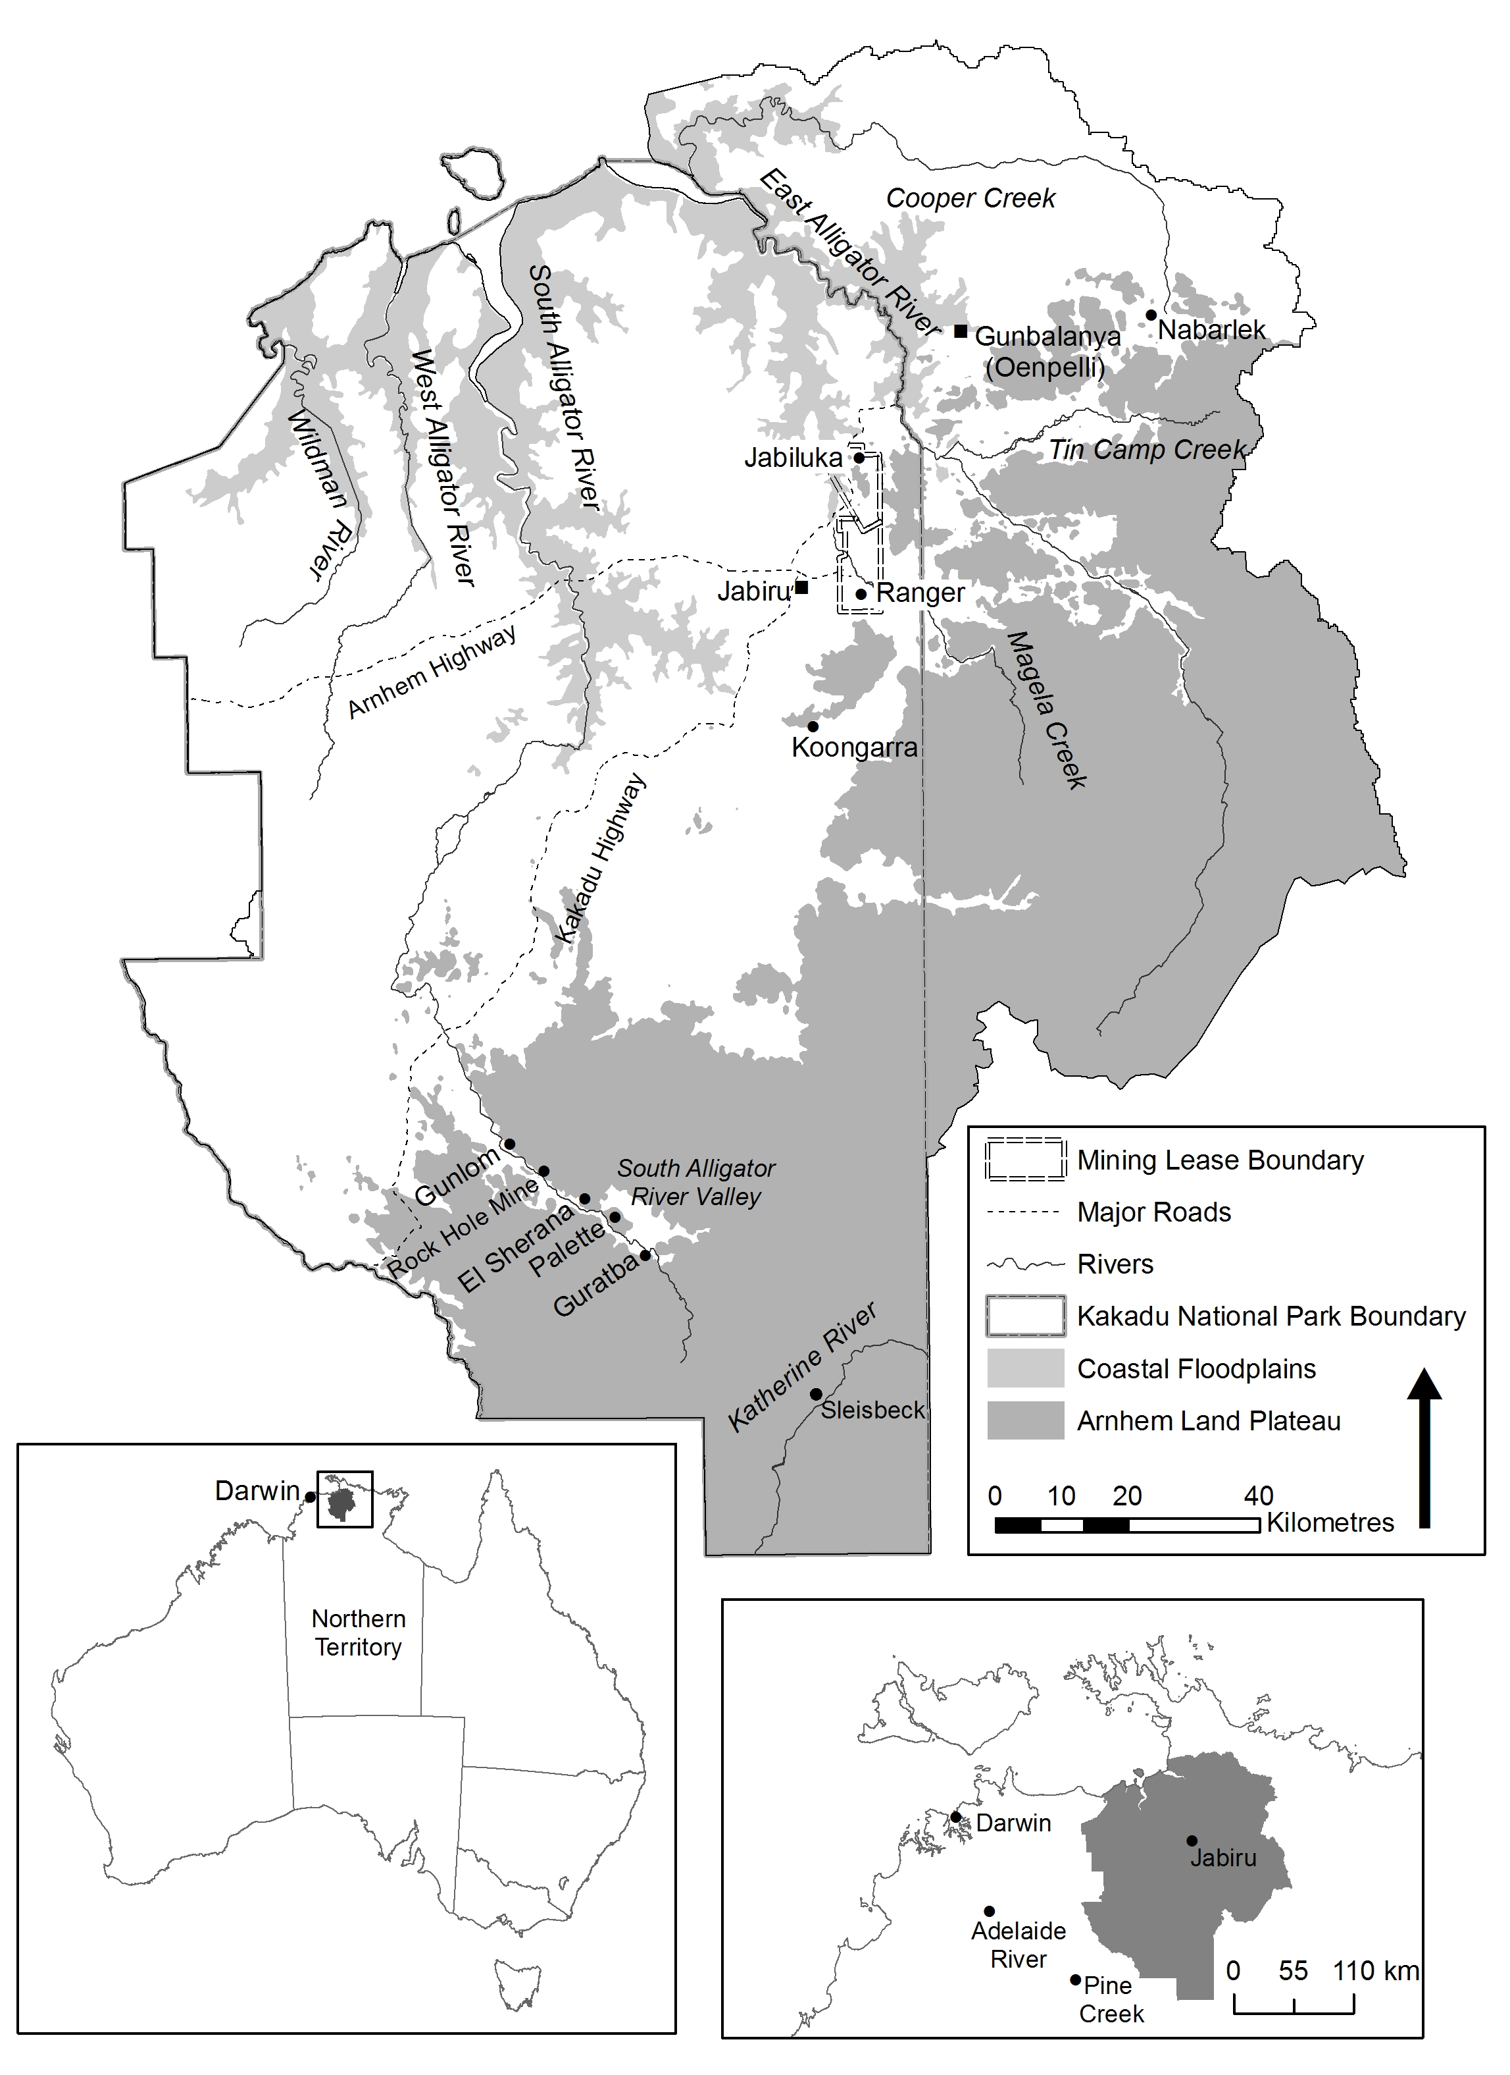
Map 1 Alligator Rivers Region
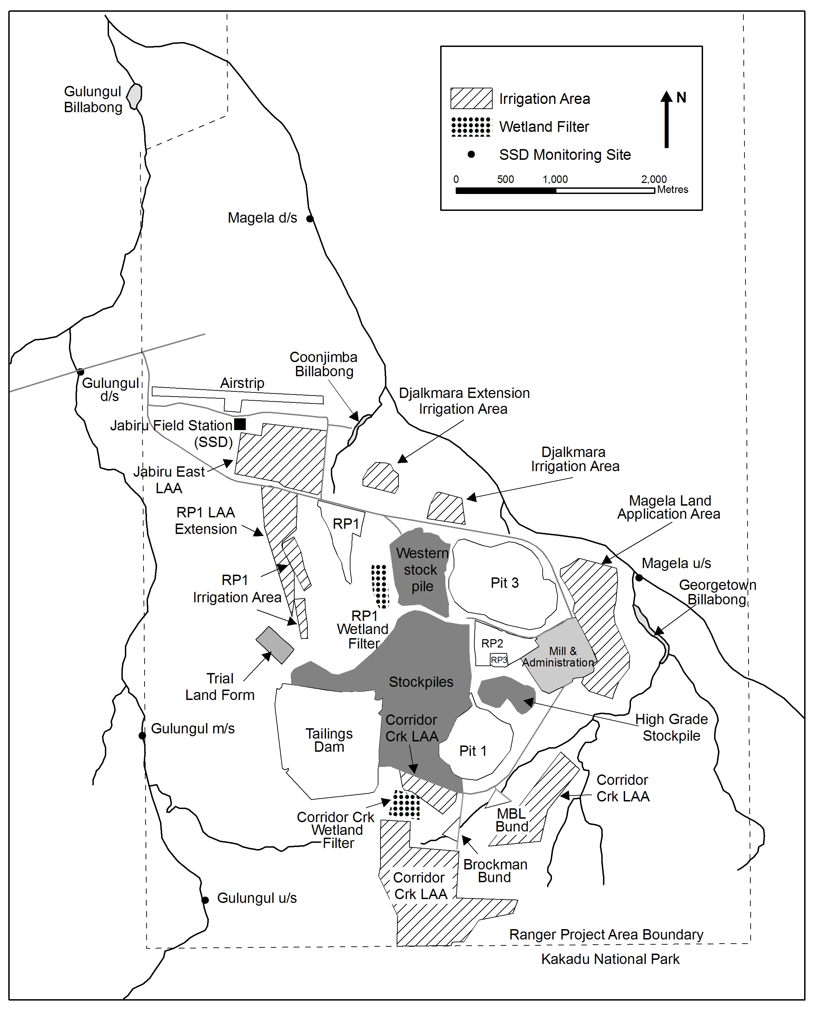
Map 2 Ranger minesite

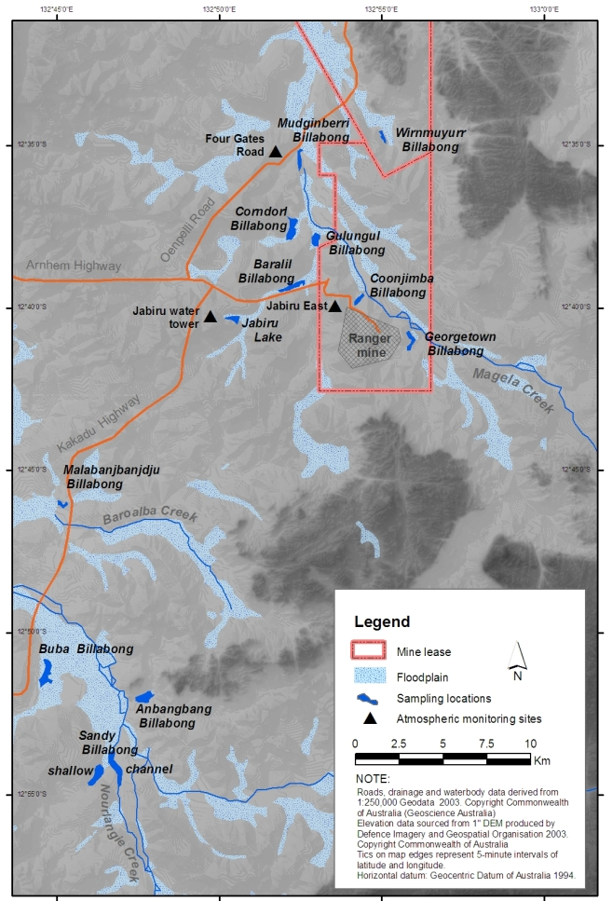
Map 3 Sampling locations used in SSD’s research and monitoring programs

Abbreviations
ARR Alligator Rivers Region
ARRAC Alligator Rivers Region Advisory Committee
ARRTC Alligator Rivers Region Technical Committee
DEWHA Department of the Environment, Water, Heritage and the Arts
DRET Department of Resources, Energy and Tourism
DoR Department of Resources (formerly Department of Regional Development, Primary Industry, Fisheries and Resources)
EMS Environmental Management System
ERA Energy Resources of Australia Ltd
ERAES ERA Environmental Strategy (formerly EWLS)
eriss Environmental Research Institute of the Supervising Scientist
ERs Environmental Requirements
G8210009 Magela Creek d/s (downstream) gauging station
GAC Gundjeihmi Aboriginal Corporation
IAEA International Atomic Energy Agency
ICRP International Commission on Radiological Protection
KKN Key Knowledge Needs
LAA Land application area
MCUGT Magela Creek u/s (upstream) site (formerly described as MCUS)
MTC Minesite Technical Committee
NLC Northern Land Council
NRETAS Department of Natural Resources, Environment, the Arts and Sport
oss Office of the Supervising Scientist
POSS Parks Operational Support Section
POT Parks Operation and Tourism Branch
RJTWG Rum Jungle Technical Working Group
RL Reduced Level – the number after RL denotes metres above or below a chosen datum
RMC Rockhole Mine Creek
RPI Routine Periodic Inspection
SEWPAC Department of Sustainability, Environment, Water, Population and Communities
SSAR Supervising Scientist Annual Report
SSD Supervising Scientist Division
TRaCK CERF Tropical Rivers and Coastal Knowledge Commonwealth Environmental Research Facility
TSF Tailings Storage Facility
UEL Uranium Equities Limited

Glossary
1s – 7s | When referring to ore and stockpiles indicates the amount of extractable uranium in the ore (grade). At Ranger, 1s indicates the lowest grade (waste) and 7s indicates the highest grade ore.
airborne gamma survey | Aerial measurements of the terrestrial gamma radiation using a large volume sodium iodide (NaI) detector on board an aircraft.
alpha radiation (α) | A positively charged helium (He2+) nucleus (two protons + two neutrons) that is spontaneously emitted by an energetically unstable heavy atomic nucleus (such as 226Ra or 238U).
application | A document stating how the mining operator proposes to change the conditions set out in the mining Authorisation. These changes need to be approved by all MTC stakeholders.
authorisation | For mining activities authorisation is required under the Northern Territory Mining Management Act (MMA) for activities that will result in substantial disturbance of the ground. It details the authorised operations of a mine, based on the submitted mining management plan and any other conditions that the Northern Territory Minister considers appropriate.
becquerel (Bq) | SI unit for the activity of a radioactive substance in decays per second [s-1].
beta radiation (β) | A high energy electron or positron emitted when an unstable atomic nucleus (such as 90Sr or 40K) loses its excess energy.
bioaccumulation | Occurs when the rate of uptake by biota of a chemical substance, such as metals, radionuclides or pesticides is greater than the rate of loss. These substances may be taken up directly, or indirectly, through consumption of food containing the chemicals.
bioavailable | The proportion of the total present (in water, sediment, soil or food) of metals and radionuclides, that can be taken up by biota (see also bioaccumulation).
biodiversity (biological diversity) | The variety of life forms, including plants, animals and micro-organisms, the genes they contain and the ecosystems and ecological processes of which they are a part.
biological assessment | Use and measurement of the biota to monitor and assess the ecological health of an ecosystem.
biological community | An assemblage of organisms characterised by a distinctive combination of species occupying a common environment and interacting with one another.
bund | Embankment or wall designed to retain contents (usually liquids) in the event of leakage or spillage from a storage facility.
concentration factor | The metal or radionuclide activity concentration measured in biota divided by the respective concentration measured in the underlying soil (for terrestrial biota) or water (for aquatic biota).
damp-proof course | A waterproof barrier comprising bitumen and aluminium.
direct seeding | Vegetation is established by broadcasting seed across the area to be revegetated.
dissolved organic carbon | Natural organic material from plants and animals that has broken down and is able to pass through a very fine (0.45 micrometre) filter.
dose coefficient | The committed tissue equivalent dose or committed effective dose Sievert [Sv] per unit intake Becquerel [Bq] of a radionuclide. See definition of Sievert and Becquerel.
dose constraint | The International Commission on Radiation Protection (ICRP) defines dose constraint as ‘a prospective restriction on anticipated dose, primarily intended to be used to discard undesirable options in an optimization calculation’ for assessing site remediation options.
early detection | Measurable early warning biological, physical or chemical response in relation to a particular stress, prior to significant adverse affects occurring on the system of interest.
flume | A channel control structure with known cross-sectional area used to measure flow rate of runoff water.
fulvic acid | A component of dissolved organic carbon that is especially reactive and forms strong complexes with metals. Fulvic acids account for a large part of the dissolved organic matter in natural water.
gamma radiation (γ) | High energy electromagnetic radiation emitted by excited nuclei (for example after an alpha or beta decay) in their transition to lower-lying nuclear levels.
grab sampling | Collection of a discrete water sample for chemical analysis
Gray (Gy) | Name for absorbed dose 1 Gray = 1 Joule∙kg-1. The absorbed dose gives a measure for the energy imparted by ionising radiation to the mass of the matter contained in a given volume element.
half-life | Time required to reduce by one-half the concentration (or activity in the case of a radionuclide) of a material in a medium (eg soil or water) or organism (eg fish tissue) by transport, degradation or transformation.
Hydstra | Hydrology data management software package.
IC50 | The concentration of a compound that causes a 50% inhibition in a particular response (eg growth, reproduction) of an organism relative to that of a control organism (ie an organism not exposed to the compound).
ionising radiation | Sub-atomic particles (α, β) or electromagnetic (γ, x-rays) radiation that have enough energy to knock out an electron from the electron shell of molecules or atoms, thereby ionising them.
land application | A method for management of excess accumulated water by spray irrigation. The method depends on the evaporation from spray droplets, and from vegetation and ground surfaces once its reaches them.
laterite | In the Ranger mine context, laterite is a local term used to describe well weathered rock and soil profile material that consists primarily of a mixture of sand and silt/clay size particles. It may or may not exhibit characteristics of a fully-developed laterite profile.
LC50 | The concentration of a compound that causes the death of 50% of a group of organisms relative to that of a control group of organisms (ie a group of organisms not exposed to the compound).
MOL | Maximum Operating Level. The maximum level at which a liquid containing impoundment can be operated.
MCUGT | Current acronym for the upstream station u/s (formerly described as MCUS).
ore | A type of rock that bears minerals, or metal, which can be extracted.
permeate | The higher purity stream produced by passage of water through a reverse osmosis (RO) treatment process.
polished | Water that has been passed through a wetland filter.
pond water | Water derived from seepage and surface water runoff from mineralised rock stockpiles as well as runoff from the processing areas that are not part of the process water circuit.
potable water | Water suitable for human consumption.
process water | Water that has passed through the uranium extraction circuit, and all water that has come into contact with the circuit. It has a relatively high dissolved salt load constituting the most impacted water class on site.
radiologically anomalous area | Area that displays significantly above background levels of radioactivity.
radionuclide | An atom with an unstable nucleus that loses its excess energy via radioactive decay. There are natural and artificial radionuclides. Natural radionuclides are those in the uranium (238U), actinium (235U) and thorium (232Th) decay series for example, which are characteristic of the naturally occurring radioactive material in uranium orebodies.
radium | A radioactive chemical element that is found in trace amounts in uranium ores.
radon | Colourless, odourless, tasteless, naturally-occurring radioactive noble gas formed from the decay of radium.
Sievert (Sv) | Name for equivalent dose and effective dose 1 Sievert = 1 Joule∙kg-1. In contrast to the Gray, the Sievert takes into account both the type of radiation and the radiological sensitivities of the organs irradiated, by introducing dimensionless radiation and tissue weighting factors, respectively.
sonde | A water quality instrument that is immersed in water for measuring (typically) electrical conductivity, pH, turbidity and dissolved oxygen.
speciation (of an element) | The forms in which an element exists within a particular sample or matrix.
stable lead isotopes | Lead has four stable isotopes, three of which, 206Pb, 207Pb and 208Pb, are end members of the natural uranium, actinium and thorium decay series, respectively. 204Pb is primordial only.
tailings | A slurry of ground rock and process effluents left over once the target product, in this case uranium, has been extracted from mineralised ore.
thoriferous | Containing thorium.
toxicity monitoring | The means by which the toxicity of a chemical or other test material is determined in the field over time. The monitoring comprises field toxicity tests which are used to measure the degree of response produced by exposure to a specific level of stimulus (or concentration of chemical).
tube stock | Seeds are germinated in a plant nursery and the young seedlings are then planted out.
uraniferous | Containing uranium.
uranium oxide | An oxide of uranium which occurs naturally or is produced by a uranium extraction process. This is the product from the Ranger mine.
water treatment plant (WTP) | The process system that removes undesirable chemicals, materials, and biological contaminants from water thereby decreasing its ability to harm the environment.

Following machinery of government changes on 14 September 2010 the department’s name was changed in line with the restructure of its portfolio responsibilities.

