# Controlled atmosphere treatment methodology

Consultation draft



© Commonwealth of Australia 2021

**Ownership of intellectual property rights**

Unless otherwise noted, copyright (and any other intellectual property rights) in this publication is owned by the Commonwealth of Australia (referred to as the Commonwealth).

**Creative Commons licence**

All material in this publication is licensed under a [Creative Commons Attribution 4.0 International Licence](https://creativecommons.org/licenses/by/4.0/legalcode) except content supplied by third parties, logos and the Commonwealth Coat of Arms.

Inquiries about the licence and any use of this document should be emailed to [copyright@awe.gov.au](mailto:copyright@awe.gov.au).



**Cataloguing data**

This publication (and any material sourced from it) should be attributed as: Department of Agriculture, Water and the Environment 2021, *Controlled atmosphere* *treatment* *methodology – version 1.0*, Department of Agriculture, Water and the Environment, Canberra, August 2021. CC BY 4.0.

ISBN TBC

This publication is available at [agriculture.gov.au/import/arrival/treatments/treatments-fumigants](https://www.agriculture.gov.au/import/arrival/treatments/treatments-fumigants).

Department of Agriculture, Water and the Environment

GPO Box 858 Canberra ACT 2601

Telephone 1800 900 090

Web [awe.gov.au](http://agriculture.gov.au/)

**Disclaimer**

The Australian Government acting through the Department of Agriculture, Water and the Environment has exercised due care and skill in preparing and compiling the information and data in this publication. Notwithstanding, the Department of Agriculture, Water and the Environment, its employees and advisers disclaim all liability, including liability for negligence and for any loss, damage, injury, expense or cost incurred by any person as a result of accessing, using or relying on any of the information or data in this publication to the maximum extent permitted by law.

## Purpose

This methodology sets out the minimum requirements for treatment providers performing controlled atmosphere treatments on commodities and/or associated packaging for Quarantine and Pre-shipment (QPS) purposes. This methodology is the basis for compliance auditing of treatment providers and is used to monitor their performance of effective treatments with controlled atmospheres.

## Scope

This document applies to commercial and government treatment providers performing QPS controlled atmosphere treatments for countries that have adopted a specific controlled atmosphere treatment schedule.

Controlled atmosphere treatments involve applying a modified atmosphere, with elevated carbon dioxide (CO2) content (hypercarbia), reduced oxygen (O2) content (hypoxia or anoxia), or both, then maintaining or controlling that modified atmosphere within an enclosure or environment to create an atmosphere lethal to target pests.

The controlled atmosphere treatments referred to in this document include high carbon dioxide and/or low oxygen treatments conducted at normal atmospheric pressure.

Controlled atmosphere treatments conducted under altered pressure or vacuum, in-transit treatments, or packaging containing modified atmospheres, are out of scope of this document.

## General

Best practice application of controlled atmosphere treatments is achieved through a practical combination of all procedures required during a treatment to ensure that:

* the risk of the target pest is managed
* the people conducting the treatment remain safe
* all people in the area around the treatment area remain safe
* the environment is not harmed
* the goods, product, or equipment being treated is not damaged or adversely affected.

Treatment providers performing treatments in accordance with these requirements must have the equipment, facilities, personnel and administrative procedures necessary to ensure that all relevant treatments comply with these requirements.

Importing countries have the right to impose more stringent treatment conditions to address their individual biosecurity risks. In such cases, those additional conditions take precedence over the requirements of this methodology and must be complied with to the satisfaction of the relevant authority of the importing country.

Jurisdictions receiving treatments subject to this methodology, expect the treatment has been undertaken effectively and that they comply with the requirements of this methodology. Treatment providers found to be wilfully and consistently not complying with the requirements of this methodology and/or other specified treatment conditions will have their registration status changed to 'unacceptable' until they can demonstrate satisfactory compliance.

## How to use this document

This document outlines the minimum set of requirements for performing controlled atmosphere treatments.

This document should be read in conjunction with the *Guide to packaging suitability for performing QPS treatments*. While not intended to specifically cover controlled atmosphere treatments, some of the concepts discussed in the *Guide to performing QPS fumigations with methyl bromide* are transferable.

It is important for treatment providers and compliance auditors to understand the purpose of the requirements, the outcomes they are intended to achieve and the circumstances in which they apply.

The technical terms used in this methodology are defined in the glossary at the back of the document. For all terms not defined in the glossary, refer to the definition used by the Macquarie Dictionary.

Contents

Purpose 3

Scope 3

General 3

How to use this document 4

1 Prior to treatment 7

1.1 Target of the treatment 7

1.2 Consignment suitability 7

1.3 Impervious wrappings, coatings and surfaces 7

1.4 Impervious wrapping perforation requirements 7

1.5 Site suitability 7

2 Safety 8

2.1 Risk assessment 8

2.2 Risk area 8

3 Treatment enclosures 9

3.1 Gas-tightness 9

3.2 Sheeted enclosures 9

3.3 Un-sheeted shipping containers 9

3.4 Treatment chambers 9

4 Preparing the treatment enclosure 10

4.1 Gas supply and outlet 10

4.2 Concentration monitoring location 10

4.3 Temperature monitoring location 11

5 Applying the modified atmosphere 12

5.1 For all gases 12

5.2 Applying carbon dioxide 12

5.3 Applying nitrogen 12

6 Monitoring the treatment 13

6.1 Monitoring equipment 13

6.2 Gas concentrations 13

6.3 Temperature 13

6.4 Start of the exposure period 13

6.5 During the exposure period 14

6.6 End of the exposure period 14

7 Ventilating the enclosure 15

7.1 Releasing the modified atmosphere from the enclosure 15

8 Documentation 16

8.1 Record of Treatment 16

8.2 Modified Atmosphere Treatment Certificate 17

Appendix 1: Example Record of Treatment 19

Appendix 2: Example Modified Atmosphere Treatment Certificate 20

Glossary 21

## Prior to treatment

### Target of the treatment

* + 1. The treatment provider must identify the target of the treatment.
    2. The target of the treatment must be recorded on the treatment documentation.

### Consignment suitability

The treatment provider must determine if the consignment is suitable for controlled atmosphere treatment.

Where the consignment does not conform to the suitability requirements, remedial action must be taken, or an alternative acceptable treatment method used.

### Impermeable packaging and wrappings

The target of the treatment must not be covered by impermeable material that will prevent the modified atmosphere accessing the target of the treatment.

Impermeable wrappings must be removed, opened or slashed prior to treatment in such a way to allow the modified atmosphere to access the target of the treatment.

Requirement 1.3.2 is not necessary if the wrapping complies with 1.4 Impermeable wrapping perforation requirements.

### Impermeable packaging and wrapping perforation requirements

Impermeable wrappings must have 4 or more holes of 6 mm diameter or 5 or more holes of 5 mm diameter for every 100 mm x 100 mm of surface area. Wrappings with at least 6 pinholes per 10 mm x 10 mm surface area are also acceptable.

The wrapping must be in a single layer, so the perforations are not blocked by the wrapping overlapping itself.

### Site suitability

All treatment sites must:

* have adequate space to establish a risk area around the enclosure
* allow for safe ventilation
* be flat and even
* be well ventilated.

Where the enclosure is established inside a building or structure, the site must also have a means of active ventilation.

For treatments using gases heavier than air (including carbon dioxide), the ground within the risk area must be impermeable, flat and free from cracks, drains and access points to other below ground features, including sewers and elevator shafts.

For treatments using gases heavier than air, sheeted enclosures must be established at ground level.

## Safety

### Risk assessment

Before commencing treatment, a risk assessment must be carried out to determine if any hazards are present and evaluate the potential consequences to:

* treatment personnel
* people in the vicinity
* occupants of surrounding buildings.

Control measures must be in place to address the hazards identified.

The risks must be reviewed as needed to respond to changing circumstances, and the control measures must be adjusted accordingly.

The treatment provider-in-charge is responsible for the safe conduct of the treatment.

### Risk area

Where a treatment is conducted in a sheeted enclosure, a risk area must be established around the perimeter of the enclosure.

The risk area must be demarcated by a physical barrier for the duration of the treatment.

The size of the risk area must be set according to the risk but must not be less than:

* 3 metres from the enclosure, where the enclosure is less than 100m3 or where the enclosure is established outdoors
* 6 meters from the enclosure, where the enclosure is larger than 100m3 and where the enclosure is established inside a building or structure.

Warning signs must be placed around the enclosure. They must:

* be large enough to be visible from a reasonable distance
* be visible from all angles of approach
* display easily understood symbols indicating danger
* provide contact details of the treatment provider
* be in a language or languages appropriate to the location.

The risk area must be in force from the time immediately prior to gas introduction until the enclosure has been ventilated.

## Treatment enclosures

### Sheeted enclosures

The surface on which the sheeted enclosure will be created must be flat and hard, and free of debris that might damage the sheet or otherwise prevent a gas-tight seal.

The sheeted enclosure must completely enclose the target of the treatment, including between the target of the treatment and the surface on which the enclosure is created.

A gas-tight seal must be created where there is a join or seam in the sheet and where inlet valves and monitoring devices are located and other openings of the enclosure.

All sheeted enclosures must pass a pressure test within 24 hours prior to introducing the modified atmosphere. The pressure test must be conducted after the consignment has been loaded into the enclosure. See section 3.4 Pressure (and vacuum) testing.

Where shipping containers are treated in a sheeted enclosure, at least one door of each container must be open during the treatment.

Where shipping containers are treated in a sheeted enclosure, a gas supply system must be in place for each container.

### Un-sheeted enclosures

A shipping container or other structure, such as a silo bin, can be used as a treatment enclosure if it can be sealed to make it adequately gas-tight to pass a pressure test.

Un-sheeted enclosures must pass a pressure test within 24 hours prior to introducing the modified atmosphere. The pressure test must be conducted after the consignment has been loaded into the enclosure. See section 3.4 Pressure (and vacuum) testing

The treatment provider must:

* check the container or structure for any visible holes or damage that would make it unsuitable
* seal any air vents from the outside.

### Treatment chambers

Chambers are permanent structures designed specifically for controlled atmosphere treatments. To be considered a treatment chamber, they must:

* be constructed from rigid materials on all sides, including the door
* be permanently sealed along all joins between the walls, roof and floor
* be gas-tight once the door is closed without the need to use tape, sealant, sand snakes or any other means
* Pass a pressure test within 6 months prior to introducing the modified atmosphere. See section 3.4 Pressure (and vacuum) testing.

### Pressure (and vacuum) testing

Pressure testing must be performed with the enclosure set up ready for treatment. All sampling tubes or monitoring equipment, and gas supply and outlet systems must be in place during pressure testing, as they would be for a treatment.

For sheeted enclosures, to conduct a pressure test, the pressure within the enclosure must be lowered by 200 pascals relative to atmospheric pressure. To pass the pressure test, it must take 5 minutes or greater for the pressure in the enclosure to fall from 200 to 100 pascals relative to atmospheric pressure.

For pressure tests conducted on sheeted enclosures, the details of the pressure test must be included on the Record of Treatment.

For treatment chambers and un-sheeted enclosures, including un-sheeted containers and silo bins, to conduct a pressure test, the pressure within the enclosure must be either raised or lowered by 250 pascals relative to atmospheric pressure. To pass the pressure test, it must take 10 seconds or greater for the pressure in the enclosure to fall from 200 to 100 pascals relative to atmospheric pressure.

For pressure tests conducted on un-sheeted enclosures, the details of the pressure test must be included on the Record of Treatment.

For pressure tests conducted on treatment chambers, a record of pressure test must be completed for every pressure test and kept for a minimum of two years.

The following information must be recorded on a record of pressure test:

* location – the site address where the pressure test was performed
* chamber identification
* time and date the pressure test was conducted
* the name and signature of the person who conducted the pressure test
* initial pressure of the chamber (ambient atmospheric pressure)
* maximum pressure achieved (where the pressure within the enclosure was raised) or minimum pressure achieved (where the pressure within the enclosure was lower)
* the time taken for the pressure in the enclosure to fall from 200 Pa to 100 Pa relative to atmospheric pressure.

The information recorded on the record of pressure test must be accurate and demonstrate that the pressure test complied with the requirements of section 3.4.4.

## Preparing the treatment enclosure

### Gas supply and outlet

All enclosures must have a gas supply and outlet system.

The supply and outlet systems must be sealed when not introducing or venting gas.

### Gas concentration monitoring location

The gas concentration for each treatment must be monitored in at least three locations.

For all treatments, two of these locations must be within the enclosure as close as practicable to:

* the outlet of the enclosure
* among the target of the treatment in the centre of the enclosure, inside any packaging surrounding the target of treatment.

Where the enclosure is a chamber or un-sheeted container, one sensor must be placed within the enclosure within 10 cm of the door seals.

Where the enclosure is sheeted, one sensor must be placed within the enclosure as close as practicable to the sheet at the top of the enclosure.

Where there are multiple targets of the treatment, surrounded by different types of packaging material, additional gas concentration monitoring must be conducted inside each type of packaging.

Where multiple containers are treated under sheet, additional gas concentration monitoring must be conducted among the goods as close as practicable to the centre of each container, inside any packaging surrounding the target of the treatment.

The placement of monitoring equipment among the goods, inside any packaging surrounding the target of the treatment, must not affect the gas permeability of that packaging. The location of the monitoring equipment must remain representative of the rest of the consignment.

Where using sampling tubes through which gas concentration samples can be drawn from within the enclosure, each sampling tube must:

* extend outside of the risk area
* be clearly identified according to their location within the enclosure
* be free from kinks and blockages
* be of a diameter suitable to fit the inlet of the concentration measuring instrument.

Where using monitoring sensors placed within the enclosure, each device must:

* allow for readings to be accessed outside of the risk area
* be clearly identified according to their location within the enclosure.

### Temperature monitoring location

All treatments must be measured by a minimum of two temperature sensors.

One sensor must be placed within the enclosure in a way that indicates that the free airspace temperature throughout the enclosure has been raised and maintained above the required treatment temperature for the required treatment period.

The free air space temperature sensors must be placed away from any heat source so as to not adversely affect the measurement readings.

One sensor must be placed among the target of the treatment, as close as practical to the centre of the enclosure.

## Applying the modified atmosphere

### For all gases

Any time gas is applied to the enclosure, the time the gas started to be applied, the time the gas started being applied, the time the gas finished being applied and the amount of gas introduced must be recorded.

### Applying carbon dioxide

Carbon dioxide gas applied to the enclosure must be generated from either a liquid (cylinderised or bulk) or a solid (dry ice) source. A burner must not be used to generate carbon dioxide to apply to the enclosure.

A vaporiser must be used when carbon dioxide is applied to the enclosure.

The heat source for the vaporiser must be capable of heating the water in the vaporiser to at least 25 °C and maintaining the temperature at or above this while the carbon dioxide is being applied to the enclosure.

If the temperature of the water falls below 25 °C, the rate of carbon dioxide release must be slowed or stopped until the water temperature is heated back above 25 °C.

### Applying nitrogen

Nitrogen gas applied to the enclosure must be generated from either a liquid (cylinderised or bulk) or extracted from the atmosphere (nitrogen generator). A burner must not be used to remove oxygen from the enclosure or gas supply.

## Monitoring the treatment

### Monitoring equipment

All monitoring equipment must be fit for purpose and in good working order.

Gas concentration and temperature measuring instruments must be operated, calibrated and/or serviced according to the manufacturer’s instructions.

Temperature sensors must be accurate to within plus or minus (+/-) 1 °C.

Temperature sensors must be individually identified for data recording and calibration.

Temperature sensors must be capable of measuring the range between 10°C and a temperature above the required treatment temperature.

### Gas concentrations

For high carbon dioxide treatments, the carbon dioxide concentrations must be monitored at the locations specified in 4.2 gas concentration monitoring location.

For low oxygen treatments, the oxygen concentration must be monitored at the locations specified in 4.2 gas concentration monitoring location.

Gas concentrations must be monitored from the start of the gas introduction, until the end of the exposure period and recorded at least every hour.

The time all gas concentration readings were taken must be recorded.

### Temperature

The temperature must be monitored at the locations specified in 4.3 temperature monitoring location.

The temperature must be monitored from the start of the introduction of gas to the end of the treatment period and be recorded at least every hour.

The time all temperature readings were taken must be recorded.

### Start of the exposure period

The treatment exposure period starts when:

* all gas concentrations meet or exceed the parameters of the treatment schedule

AND

* all temperature readings meet or exceed the parameters of the treatment schedule.

The start time of the exposure period must be recorded.

### During the exposure period

All gas concentrations must meet or exceed the parameters of the treatment schedule throughout the whole exposure period, otherwise the treatment has failed.

All temperature readings must meet or exceed the parameters of the treatment schedule throughout the whole exposure period, otherwise the treatment has failed.

Additional gas added during the exposure period must be applied according to Section 5 applying the modified atmosphere.

### End of the exposure period

The elapsed time between the start and the end of the treatment must meet or exceed the parameters of the treatment schedule, otherwise the treatment has failed.

After the specified exposure period has elapsed, final concentration readings must be taken from all monitoring locations. The readings and the time they were taken must be recorded.

The final concentration readings must meet or exceed the parameters of the treatment schedule, otherwise the treatment has failed.

## Ventilating the enclosure

### Releasing the modified atmosphere from the enclosure

When ventilating the enclosure, the atmosphere must be fully ventilated in a controlled and safe manner.

For un-sheeted enclosures and chambers, a fan must be used during ventilation.

Before commencing ventilation, a risk assessment must be carried out to determine if any hazards are present and evaluate the potential consequences to:

* treatment personnel
* people in the vicinity
* occupants of surrounding buildings.

Control measures must be in place to address the hazards identified.

The risks must be reviewed as needed to respond to changing circumstances and the control measures must be adjusted accordingly.

The treatment provider-in-charge is responsible for the safe conduct of the ventilation.

## Documentation

### Controlled Atmosphere Record of Treatment

The treatment provider must record sufficient information to demonstrate that the treatment complied with these requirements.

At a minimum the Record of Treatment must include the following:

* job identification
* customer name
* location—the site address where the treatment was performed
* a description of the consignment
* the target of the treatment—why is the treatment being performed
* consignment identification—container number(s), bill of lading, or other means to clearly identify the consignment
* a declaration that the consignment and any associated packaging is suitable for treatment and complies with the requirements in section 1 prior to treatment
* type of enclosure used
* for chamber treatments, the date the last pressure test was conducted on the chamber
* for all non-chamber enclosures, the following must also be recorded:
  + - * time and date the pressure test was conducted
      * initial pressure of the enclosure (ambient atmospheric pressure)
      * maximum pressure achieved (where the pressure within the enclosure was raised) or minimum pressure achieved (where the pressure within the enclosure was lower)
      * the time taken for the pressure in the enclosure to fall from 1000 Pa to 00 Pa relative to atmospheric pressure.
* enclosure volume
* the type of controlled atmosphere treatment being conducted
* the specified treatment rate and exposure period
* the minimum temperature achieved within the enclosure
* the amount of gas used throughout the treatment
* the time and date gas started to be applied to the enclosure
* the start time and concentration readings
* the end time and concentration readings
* the time and amount of any additional gas added during the exposure period
* the time and date ventilation commenced
* the time and date ventilation concluded
* the name and signature of the treatment provider-in-charge

**Note:** See Appendix 1: Example Record of Treatment

Any gas introduced during the exposure period must be document and included as an attachment to the Record of Treatment. The time the gas started being applied, the time the gas finished being applied and the amount of gas must be recorded.

All gas concentration readings must be documented and included as an attachment to the Record of Treatment. The time and location of each monitoring reading must be documented.

All temperature readings must be documented and included as an attachment to the Record of Treatment. The time of each reading and the sensor location must be documented.

The Record of Treatment must be completed on the treatment site as the tasks are performed.

Recording of false or misleading information is not permitted under any circumstances.

The treatment provider must make all Records of Treatment available for audit purposes for a minimum of two years.

### Controlled Atmosphere Treatment Certificate

A Controlled Atmosphere Treatment Certificate can be issued by the treatment provider once they determine that the treatment has been performed in accordance with the requirements of this methodology.

All sections of the Controlled Atmosphere Treatment Certificate are mandatory and must be filled out accurately.

At a minimum the Controlled Atmosphere Treatment Certificate must include the following:

* treatment provider’s letterhead including company name, physical address and company details
* certificate number
* registration number (where relevant)
* the target of the treatment (commodity, packing, or combination)
* a description of the consignment
* quantity/volume of goods
* consignment link
* country of origin
* port of loading
* country of destination
* name and address of exporter and importer
* place of treatment (town/city)
* date treatment completed
* time and date ventilation commenced
* the type of controlled atmosphere treatment conducted
* specified treatment pressure
* actual treatment pressure
* exposure period (hours/days)
* specified minimum temperature
* minimum temperature achieved in the enclosure (oC or oF)
* specified gas concentration
* actual gas concentration achieved
* type of enclosure used
* container number(s) (if applicable)
* container seal number (if applicable)
* a declaration that the consignment was suitable for treatment and complied with the consignment suitability requirements of the Controlled Atmosphere Treatment Methodology.
* a declaration that the treatment was conducted in accordance with the Controlled Atmosphere Treatment Methodology
* signature of the treatment provider-in-charge including the date and accreditation number (if applicable)

Note: An example Controlled Atmosphere Treatment Certificate is provided at Appendix 2: Example Controlled Atmosphere Treatment Certificate.

Recording of false or misleading information is not permitted under any circumstances.

The treatment provider must make all Controlled Atmosphere Treatment Certificates available for audit purposes for a minimum of two years.

The Controlled Atmosphere Treatment Certificate must travel with the consignment related documentation to state that it has been effectively treated for QPS purposes.

## Appendix 1: Example Record of Treatment

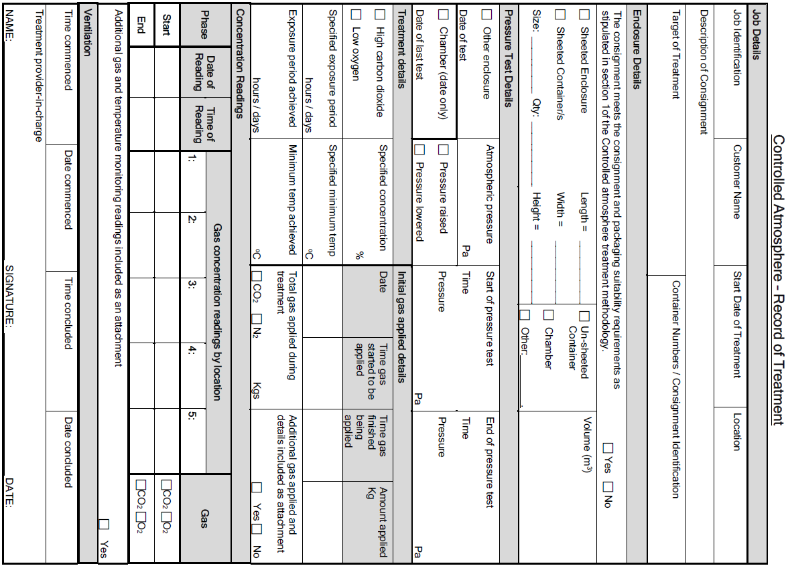

## Appendix 2: Example Controlled Atmosphere Treatment Certificate

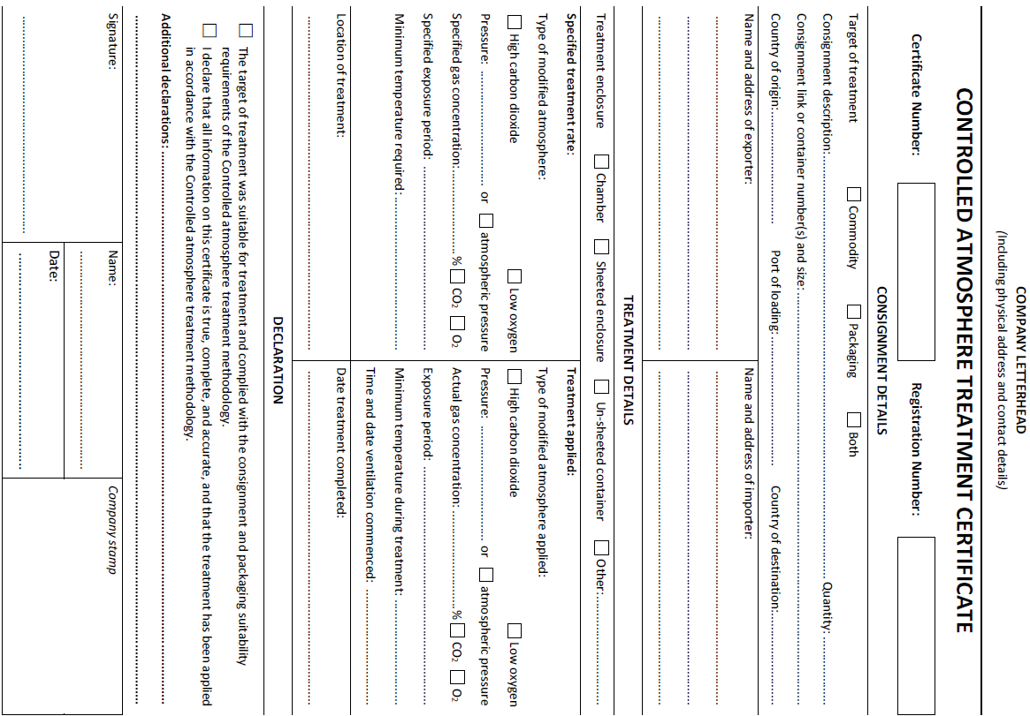

## Glossary

| **Term** | **Definition** |
| --- | --- |
| Ambient temperature | The air temperature of the surrounding area where the fumigation will be conducted. |
| Commodity | The item or goods that are being exported or imported. |
| Concentration sampling tube | A small diameter tube used to draw a sample of gas/air mixture from within a treatment enclosure to measure the gas concentration. |
| Consignment | Refers collectively to the commodity, any packing materials used and the mode of transport such as a shipping container. |
| Controlled atmosphere treatment | The process of applying a modified atmosphere to an enclosure and maintaining that modified atmosphere throughout the treatment. Processes that introduce a modified atmosphere but do not monitor or maintain that atmosphere are not controlled atmosphere treatments. |
| Cylinderised | Gas stored or transported in purpose-built gas cylinders, tanks or containers. |
| Dosage | The amount of a gas introduced to a treatment enclosure. |
| Enclosure | Any sufficiently well sealed space intended to contain sufficient concentrations of modified atmospheres for a period of time. Common examples of treatment enclosures used for QPS controlled atmosphere treatments are (but not limited to) un-sheeted shipping containers, semi-permanent or permanent structures or chambers, sheeted enclosures, silo bins and bunkers. |
| Exposure period | The amount of time, in one continuous, consecutive block, that the consignment must be exposed to sufficient concentration levels of specified gases to be lethal to the targeted pests. |
| Fit for purpose | Equipment that is appropriate for the way they are being used i.e. capable of measuring required gases or temperature specifically and in the concentration and ranges necessary to meet the requirements of this methodology. |
| Gas concentration | The amount of a specific gas present at a certain point in the treatment enclosure, usually expressed as a percentage (%). |
| Goods | Goods includes an animal, a plant, a sample or specimen, a pest, mail or any other article, substance or thing (including, but not limited to, any kind of moveable property). |
| Impermeable packaging and wrappings | Intact and solid plastic films and wrappings that prevent or impede gas exchange. |
| Manufacturer’s instructions | Specific details on equipment produced by the equipment manufacturer. May include instruction manuals, operating instructions, conditions of use or calibration information in written, online or otherwise documented form (e.g. video). |
| Modified atmosphere | Gas concentrations with either elevated carbon dioxide (CO2) content (hypercarbia), or reduced oxygen (O2) content (hypoxia or anoxia), or both. |
| Outlet | The area of the treatment enclosure purposefully designed or constructed to allow gas out of the enclosure. Also commonly known as an exhaust, outflow or gas exit point. Usually either an active extraction system with a fan or other way of drawing the gas through, or a passive system releasing pressure built up in the enclosure during gas introduction. |
| Pest | Any animal, plant or other organism that may pose a threat to the community or the natural environment. |
| Quarantine pest | A pest of potential economic and/or environmental importance to an area where it is not yet present, or is present but not widely distributed and is being officially controlled. |
| Quarantine and Pre-shipment (QPS) | 1) ‘Quarantine applications’ are treatments to prevent the introduction, establishment and/or spread of quarantine pests (including diseases), or to ensure their official control, where:  a) Official control is that performed by, or authorised by, a national plant, animal or environmental protection or health authority.  b) Quarantine pests are pests of potential importance to the areas endangered thereby and not yet present there, or present but not widely distributed and being officially controlled.  2) ‘Pre-shipment applications’ are those non–quarantine applications applied within 21 days prior to export to meet the official requirements of the importing country or existing official requirements of the exporting country.  This definition is based on the Montreal Protocol on Substances that Deplete the Ozone Layer. While modified atmospheres are not specifically referenced by the Montreal Protocol, this definition remains. |
| Record of Treatment | An official document or electronic record that records the information of section 8.1 to demonstrate the treatment complied with requirements. |
| Relevant authority | The government department, ministry, or agency responsible for animal and plant biosecurity in the importing or exporting jurisdiction. |
| Risk area | A physical area around the enclosure that warns personnel of a treatment being undertaken. |
| Risk assessment | An assessment conducted and recorded according to any instructions on the product label, safety data sheet or jurisdictional licence requirements. In the absence of this, a visual inspection to meet the requirements of this methodology that the treatment provider-in-charge is able to verbally describe. |
| Sheeted enclosure | An enclosure created under a gas-proof sheet that is covering/enclosing the commodities to be treated. |
| Shipping container | Standardised transportation units that can be moved from one mode of transport to another without needing to unload the contents. |
| Target of the treatment | The target of the treatment may be the commodity, packaging material or both. |
| Treatment | Application of a set of specified requirements intended to kill pests and diseases that may be associated with a consignment. |
| Treatment documentation | Documents and records associated with a particular treatment that is not a Record of Treatment. May be hardcopy or softcopy. |
| Treatment provider | The company or individual applying the treatment. |
| Treatment provider-in-charge | The individual that is responsible for the conduct of the treatment at the time that specific treatment activities are undertaken. |
| Treatment schedule | Specific treatment rates, exposure period and rules as imposed by the relevant authority – usually the importing jurisdiction. |
| Treatment sheets | A sheet (or tarpaulin) used to create a sheeted enclosure that is made of material with low gas permeability. Can include sheets made from nylon and polyvinyl chloride (PVC). |
| Treatment temperature | The lowest temperature at which the treatment was maintained. |
| Ventilating | The process of removing or releasing the modified atmosphere from the treatment enclosure and replacing it with air. |